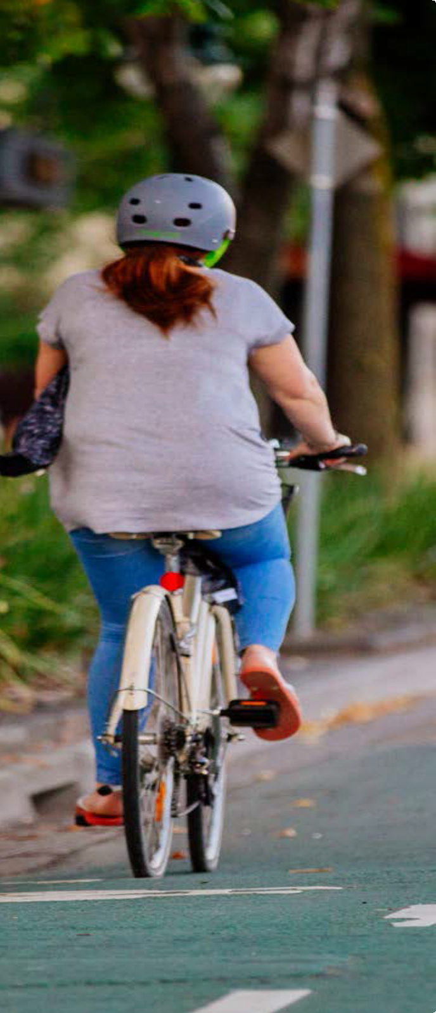
APPLICATION FORM

You must complete every item on the application form. If there are items you don’t understand, or if you want any help with the form, please contact the Community Road Safety Grants Officer at the TAC (tel: (03) 5225 7517) or email crsg@tac.vic.gov.au

An electronic version of your completed application form and supporting documents must be received by 4.00pm on the closing date in order for it to
be eligible for assessment. The original signed application, including supporting documentation, plus four (4) copies of the application must be sent to the address below, postmarked no later than 4:00pm on the closing date. Submissions may
be hand delivered to the mail room at the courier address below:

By EMAIL
Community Road Safety Grants crsg@tac.vic.gov.au

By POST
Transport Accident Commission Community Road Safety Grants PO Box 742
GEELONG VIC 3220

By COURIER
Transport Accident Commission Community Road Safety Grants 60 Brougham Street
GEELONG VIC 3220

Organisation name:

PAGE 1

APPLICANT DETAILS

Provide the following information about your organisation and your role. There is also space where
someone in your organisation with the authority to approve the application should sign the form.

Organisation:

ABN:

Telephone: Mailing Address:

*Contact person who is responsible for the project: Role or position:
Direct Telephone:

Email:

*Should the key contact leave the project, the organisation must notify the TAC as soon as possible with the details of the new key contact.

Authorisation (the person who has authority to sign an agreement)

Name: Position: Signature:

Project Details

Project Name:

Start Date: End Date:

Level of TAC funding sought: $

PAGE 2

PROJECT PARTNER DETAILS

It is anticipated that projects will involve the applicant's organisation working with other local partners, and that the partner organisations will have been involved in planning the application. Please provide details of any partner organisations along with a signature from an authorised person in each organisation to indicate that they support the application.

Partner 1

Organisation: Telephone: Mailing Address:

Authorisation

Name: Position: Signature:

Partner 2

Organisation: Telephone: Mailing Address:

Authorisation

Name: Position: Signature:

PAGE 3

SUMMARY

Describe your community road safety project in a few sentences:

ROAD SAFETY ISSUE

Describe the specific road safety issue you want to address. You should include information about
the problem, including recent (within the last five years) local road trauma statistics or crash information, and what you think is causing the problem.

PAGE 4

GOAL, OBJECTIVES AND ACTIVITIES

Describe your project's goals, objectives, and activities. The goal should be a short statement about why you are conducting the project. The objectives are the things you want to achieve to meet your goal. The activities are the things you plan to do to achieve your objectives. You can have more than one objective, and you will almost certainly have more than one activity.

Goal

Objectives

Activities

RATIONALE FOR YOUR PROJECT

Describe what leads you to think your project will help you achieve your objectives and goals. Is there any research suggesting this approach, or what general principles lead you to think your project will be successful?

EVALUATING YOUR PROJECT’S SUCCESS

Describe what you plan to do to collect information and evaluate your project to help ensure it meets its
objectives. There is information on evaluating projects in the Appendix.

PROJECT PLAN AND TIMELINE

For each of the activities you listed above, describe the things you need to do to conduct the activity, and provide a timeline that shows when you expect to finish each of these tasks. Try to give as much detail as possible. These activities should not include tasks that should have been completed prior to submitting your application, such as gathering partner support or researching the road issue.

ACTIVITY | TASKS | START DATE | EXPECTED COMPLETION DATE

RISKS

Please identify potential or actual risks that may affect your project. This is an important aspect of all
projects and will help you to plan to manage those risks.

SUSTAINABILITY

Describe how you think the project could continue after the TAC's funding period is complete.
What new sources of funding will be available?

ROLES AND RESPONSIBILITIES

Describe how each of the organisations involved in the project will contribute to its success. We will

Our first partner will

Our second partner will

BUDGET AND FUNDING REQUEST

Describe your project’s budget in detail, and provide information about any funding being provided from other sources. Please list the supplier, item and costs related to your project. Amounts above the line include all costs related to the project while amounts below the line relate to costs that will be covered by other sources. Amounts in the ‘Total Cost’ column should be inclusive of GST. Please view the example below:

PROJECT COSTS | ITEM | GST  (INCLUDED IN PRICE) | TOTAL COST
TOTAL COST
Other funding (including in-kind)
TOTAL FUNDING FROM OTHER SOURCES
FUNDING REQUESTED FROM TAC

BACKGROUND INTELLECTUAL PROPERTY

Provide a description of all background intellectual property required for the project, including details of any third party rights to which the background intellectual property is subject. ‘Background intellectual property’ means any intellectual property (e.g. copyright, patents, designs, trademarks) created by a party independently of the project. It may include, for example, a trademark of a project partner. You should also provide details of any agreement regarding your use of any background intellectual property.

INSURANCES

Provide information about insurance policies held by your organisation and those that you will need to obtain that are relevant to your proposed project – e.g. public risk insurance, comprehensive motor vehicle insurance, workers compensation insurance, etc. If your application is successful, you will need to demonstrate appropriate insurance cover.

CHECKLIST

Make sure you can tick each of these before submitting your application:

- You are eligible to apply for funding (see page 6 of the Guidelines)

- Your application identifies a local road safety problem and proposes a local community
based project.

- You have discussed your proposal with other groups in your community.

- You, and (if relevant) a person with authority to commit your organisation to the project, have signed the application form.

- You have responded to every question in the application form.

- You have included relevant financial details about your organisation with your application.

- Your project’s partner groups have signed the application form.

- You have included four (4) copies (in addition to the original) of the application form. Only one (1) copy of any supporting information is required.

- You have submitted an electronic version of the completed application form and supporting documents to the community road safety grant mailbox (crsg@tac.vic.gov.au).

ROUND NUMBER | PROJECT NAME | SUCCESSFUL  Please answer Yes or No

