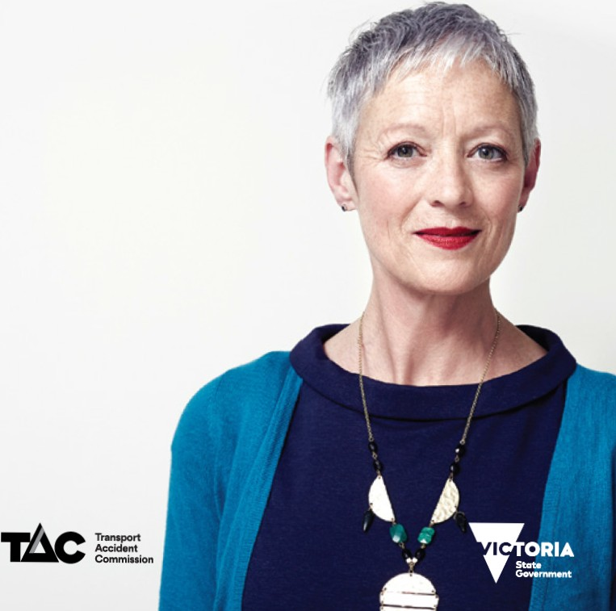

TAC

vocational

providers

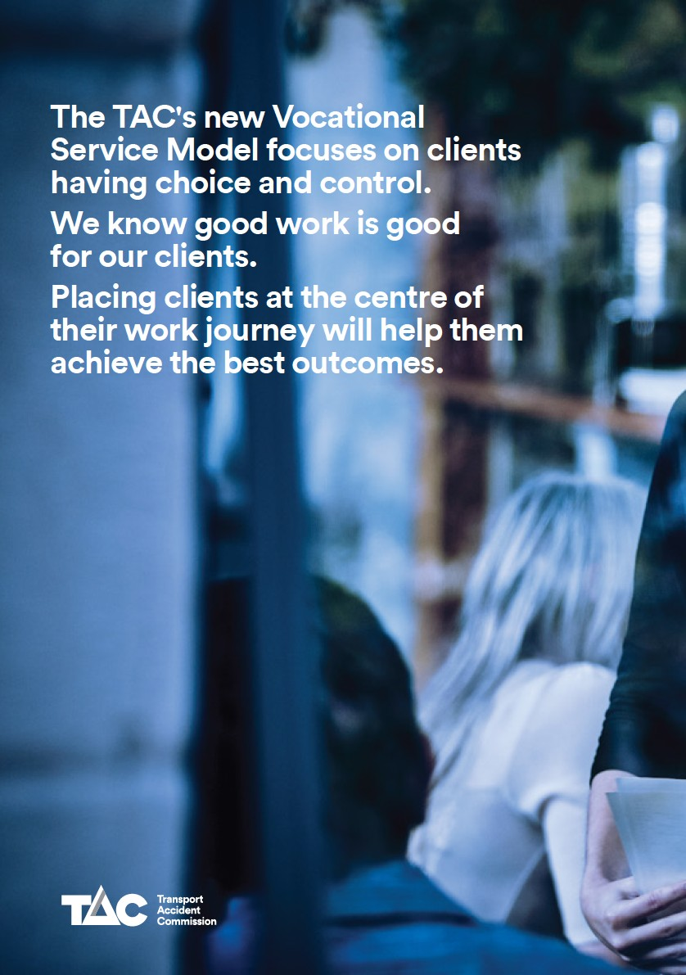

**Acumen**

**lt's all about you. At Acumen we recognise that your recovery should encompass everything that you want to achieve or regain in your life.**

Our team of highly experienced health

professionals are committed to

client-centred care that puts you at the

heart of everything we do.

**We focus on delivering better outcomes at every stage of engagement through our 'Steps to Recovery' program:**

•

Your doctors and other health care

providers. and

Your employer and/or insurance company

•

**3.** Your plan is developed with your input

and in consultationwith all people

involved to ensure:

•

The focus is on your recovery and what

you can do

Everyone is working together; and Everyone understands your particular needs

•

•

•

We take the time to understand your

circumstances

We listencarefully to ensure we understand what is important to you We work with you to determine your personal and return to work goals. and We partner with you to improve your overall quality of life

•

**4.** Our consultant will check inwith

you every step ofthe way to ensure:

•

•

•

•

Youfeel supported

Your achievements are celebrated. and

Youcan discuss your progress

•

1. We constantly look at how your plan is

progressing and will change things if needed

1. By working together and putting you at the heart of all we do. we are gettingyou back to life the best way possible.

**1.** Your consultant will listento your

needs and explains what you can expect onyour journey to recovery including:

•

•

•

The role of different people

Key milestones inyour recovery How long your recovery may take

**2.** You consultant ensures everyone

is working together; including

* Your family and friends

**Te lephone**

1300436432

**Website** generationhealth.com.au/ acumen-health-management

\a) **Email**

[reception®generationhealth.com.au](mailto:reception@generationhealth.com.au)

**Advanced**

**Personal**

**Management (APM)**

**Your path to recovery:**

**At APM we know how challenging and emotional it can be to recover from a motor vehicle accident.**

We've been helping people return to

work and adapt to big changes in their

lives for more than 20 years.

Our experienced rehabilitation consultants work with you andyour employer to get you back on track. This can be back to your pre-accident role or to ajob more suited to your individual needs.

We help give you a clear path for your

successful return to work .

Thisincludes:

•

Identifying your strengths and

developingyour personal return to

work plan

Setting realistic goals to move you forwa rd while buildingyour skills for managing change

Assessingyou and your workplace to ensure you are set upfor success. and If required, helpingyou secure more suitable work with an alternative

employer.

•

•

•

**Telephone**

1800276276

@ **Website**

apm.net.au

-**A**-**P**-**M**­

(a) **Email**

[support®apm.net.au](mailto:support@apm.net.au)

**workcare**



**Altius Rehabilitation Services**

**Altius Rehabilitation Services**

**is an industry leading provider of Vocational Rehabilitation.**

Our purpose is to help individuals

to realise their health potential regardless ofwhere their recovery journey begins.

Altius will partner with you and support you through each step of

your recovery and return to health. Our five step approach to your recovery includes:

**Step 1-**An initial meeting to understand your needs

**Step 2-** Confirm your goals with you

and your treatment team

**Step 3-**Develop a tailored recovery

plan to ensure progress

**Step 4**-Implement the plan, with

reassurance and confidence

**Step 5-**Monitor progress towards

your goals

One of our team of health professionals

will partner with you by:

Listening and understanding your

goals

Building a trusting relationship Responding to your priorities Working with your treating parties, and

Helping you navigate the TAC scheme so you can focus on your recovery.

**Telephone**

1300782183

@ **Website**

rehabservices.com.au

(a) **Email**

[referrals®rehabservices.com.au](mailto:referrals@rehabservices.com.au)

**Rehabilitation Services**

**by Altius**

I**ipar**



**IPAR**

**Since partnering with TAC in 2011, IPAR has helped more than 2,400 people to recover from a transport accident and return to health.**

We know that an accident can have a

profound effect on you. your family and community. Our focus is on empathetic support to get you through this time.

We focus on your needs and listen to your feedback. Thejourney to wellbeing is different for everybody,

so we tailor our services to suit your progress.

We will provide you with a local.

experienced consultant who will partner with you as a key point of contact for you. your TAC coordinator. medical treaters. family and employer.

We simplify the experience. so that you

can focus on getting better.

With 17 offices across Victoria, it's likely we have an office near you.

**lt would be our privilege to help you with your journey to recovery.**

**Telephone**

03 86480900

@ **Website**

ipar.com.au

la) **Email**

[rehab®ipar.com.a u](mailto:rehab@ipar.com.au)

**Procare**

**Procare is a leading provider of wellness,**

**recovery and return to work services.**

**We're here to help.**

Operating since 1998, our approach is

proven to deliver results. We use best practice and collaborative goal setting to achieve outcomes tailored to your needs.

We deliver client-centred, personalised and effective services. Our approach is to be respectful, tailored. expertand flexible.

We work in partnershipwithyou and the TAC, to help simplify the process. We support you to be in control of your recovery.

We have offices across metropolitan and regionalVictoria, a nd offer flexible options to meet with you.

Our values are proactivity.

professionalism. innovation and

partnership.

Our commitment to you. is:

•

•

•

•

•

**We're here to help.**

**Telephone**

(02) 9086 8000

@ **Website**

procaregroup.com.au/wellness-injury-management

(a) **Email**

[info®procaregroup.com.au](mailto:info@procaregroup.com.au)



To listen and be respectful

Provide best practice expertise

Trust and transparency Be a genuine partner, and

Deliver results tailored to you

**We focus on community**

**Engagement and sustainable vocational outcomes**

**Rehab Management**

**Rehab Management is an**

**award-winning, nationally accredited**

**vocational rehabilitation provider.**

Our multidisciplinary team delivers a

wide range of individual services and integrated rehabilitation and workplace health solutions.

Our commitment to diversity, social inclusion and respect for cultural differences supports our business goals and strategic objectives.

**Our Mission**

People are at the centre of our business. We help them achieve their best outcomes through innovation. dedication and best practice.

**Our Vision**

Our 2020 vision is to lead Australia in occupational rehabilitation excellence and be a provider of choice for

individuals and organisations.

**Our Values**

Our values underpin the essence of our rehab team. They shape how we deliver services. communicate and define our roles as representatives of the company.

People - People are our business. Quality - Excellence is our standard in all things.

Customer focus - Commitment to customer satisfaction/expe rience and positive outcomes is the essence of our success.

Innovation- We have a commitment to innovative solutions and strive to be innovative industry leaders.

Health benefits of good work are

entrenched inour company philosophy.

**Telephone**

1300762989

@ **Website**

rehabmanagement.com.au

(a) **Email**

[referrals®rehabmanagement.com.au](mailto:referrals@rehabmanagement.com.au)

**rehab**

**MANAGEMENT**

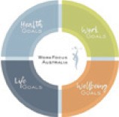

**WorkFocus Australia**

**WorkFocus Australia coaches you through your recovery to meet your health, work, well-being and life goals.**

We know an accident can disrupt your

health and all aspects of your life. so we work with you to get you back to your life as quickly as possible, while still ensuring a sustainable recovery.

You can think of us as your recovery

'life coach'.

We take the hassle out of everything. We liaise with TAC, health professionals and other providers,

keeping everyone in the loop and

ensuring a smooth process.

We listen to you.

What's more, our proven service is

delivered in person, on the phone, via video or in your chosen language whatever you need. You can speak with us when you need us, where and how

you need us.

**Our whole approach is centred**

**on your needs**

We determine what is going to be

the most appropriate and reasonable

treatment and services for you.

**Telephone**

1300570181

[@ **Website**](http://www.workfocus.com/)

[workfocus .com](http://www.workfocus.com/)

(a) **Email**

[help®workfocus.com](mailto:help@workfocus.com)

**at the**

**your work**

**You are centre of journey**

