4



Home, leisure and work

**TAC information for**

**people with major injuries**

4

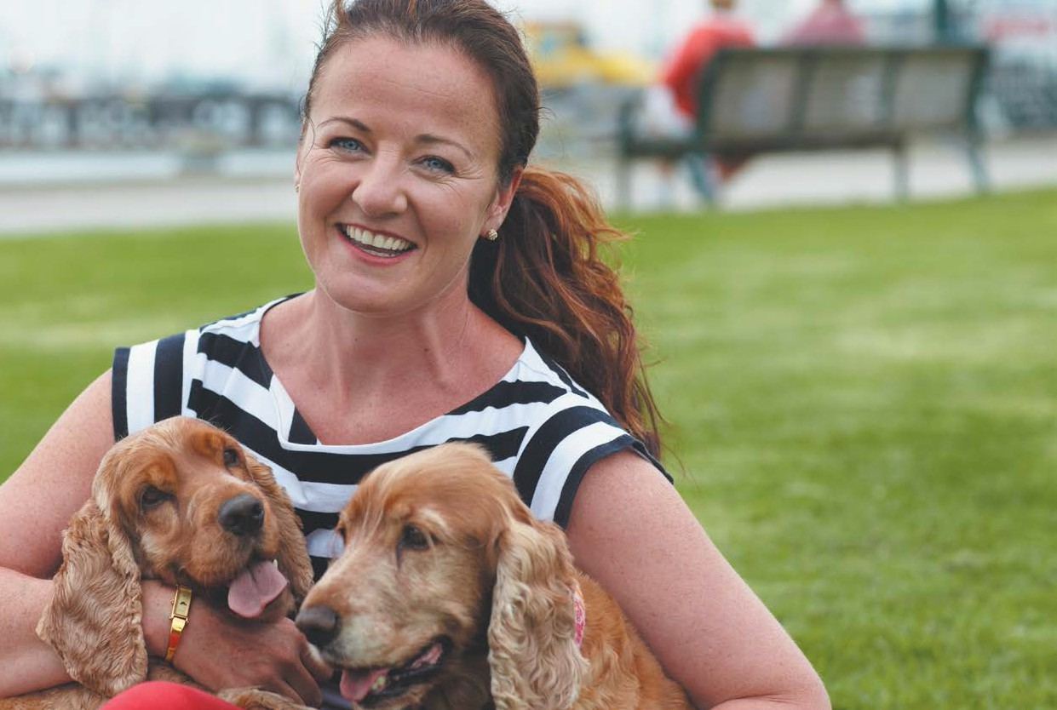

About home, leisure and work

This brochure provides basic information about the support services funded by the

TAC for people who have sustained major injuries as a result of a transport accident,

and their families.

Major injuries are defined as: spinal cord injuries such as quadriplegia or paraplegia;

moderate or severe acquired brain injuries; extensive burns; and/or amputations.

If you would like more detailed information about support services, please contact

your TAC Early Support Coordinator or the TAC on 1300 654 329.

For information about the TAC in your own language, call one of the numbers listed

on the back of this booklet.

1300 654 329

[www.tac.vic.gov.au](http://www.tac.vic.gov.au/)

myTAC

2

At the age of 21, Milly Parker acquired a brain injury in a car accident. Through hard work and determination she has become a successful business woman and a passionate advocate for people with disabilities. She runs her dog biscuit business ‘Happy Yappers’

from home and enjoys spending time walking her beloved furry companions.

[www.tac.vic.gov.au](http://www.tac.vic.gov.au/)

myTAC

1300 654 329

Getting information and support

The aim of this booklet is to give you

information and the advice you need

to make your return to day-to-day life

as successful and as satisfying as possible.

Below are a series of suggestions that

may help you adjust to life at home and

available with this booklet is a reference

list of community services that can give

you further useful information and advice.

As you adjust to your life at home, you face a fresh set of challenges and may be questioning your ability to face them. Can I, and the people around me, make the necessary adjustments to enable me to continue

enjoying important personal relationships, a comfortable home environment, a satisfying job and rewarding leisure interests?

Your Early Support Coordinator will organise the visit at

a time that suits you and step you through exactly what to expect before the visit so that you will be prepared. This visit is a great opportunity to discuss the things that are and aren’t working. Rest assured, your Early Support Coordinator will regularly monitor your progress and as your goals and needs change they will work with you to update your Independence Plan. They will also share your Independence Plan with the health professionals involved in your care so that everyone can work together to assist you to achieve your goals.

Put simply, when your goals and needs change, your

Independence Plan will be updated and your health care team will be informed.

Remember a successful Independence Plan relies heavily

on your input. Don’t hesitate to regularly speak to the Early Support Coordinator about your goals at home, work and in the community and the steps you think are needed to achieve them.

The answer is yes – as long as you think about what you

want to achieve in the short and longer term and share issues or ideas with the people who can support you.

The following pages in this booklet may help you think

about how you’d like to achieve your goals and become more independent. They provide information about the wide range of supports and services available in the

community to support people with disabilities. If you think any of these supports or services could be the right fit for you, please contact your Early Support Coordinator.

Your Early Support Coordinator will continue to give you advice, support or suggestions as appropriate.

Talk to your family, a trusted friend, Early Support

Coordinator or doctor. Let them know how you are coping. Regularly communicating your needs and wishes may help you access a wide range of supports and services available in the community to help people with disabilities.

**How your Early Support**

**Coordinator can help**

Your TAC Early Support Coordinator will continue to be your key point of contact at the TAC and meet you face to face when you need it. They will manage your claim and ensure that the medical, rehabilitation and disability services you need as a result of your accident injuries are paid for. They will work with you, your family and health professional team on your journey to independence.

One of the first things they will organise is an occupational

therapist to visit you at home between five to six weeks of your discharge from hospital.

This occupational therapist will talk to you about how you

are adjusting to life at home and in the community and review the services and supports in place to help you.

3

Getting information and support

**Take advantage of**

**community services**

You are entitled to pursue your own individual lifestyle in the community with the same rights, responsibilities and opportunities as everyone else. More and more public organisations acknowledge this and honour their obligation to offer you the level of service required to enable you to access their facilities.

And you can be confident of your ability to get to

these places in safety and comfort: public transport is becoming more accessible and better equipped.

Victorian public transport operators Public Transport

Victoria (PTV) and V/Line have handy information on their websites about train, bus and tram access for people with disabilities.

**Visit** [**www.ptv.vic.gov.au**](http://www.ptv.vic.gov.au/) **or** [**www.vline.com.au.**](http://www.vline.com.au/)

**PTV also offers a free Access Travel pass to people with disabilities who cannot use the ticketing system. Application forms for this pass are available on their website or by calling 1800 800 007.**

You may find, for example, that your local library and

health centre have taken measures to ensure that you can access their facilities. Many have staff members who are experienced in working with people with disabilities and who can help you make the most of your visit.

Apply for a Companion Card if you require the assistance

of a friend or carer to attend a community event such as a concert or football match. The card allows your companion to be admitted to participating venues free of charge.

Educational organisations understand that you have

the right to pursue learning and training opportunities. Many TAFE colleges, for example, employ disability liaison officers who can help you find a course you are interested in.

**To find out if you are eligible for**

**a Companion Card, call toll-free on 1800 650 611.**

**The Council of Adult Education (CAE) also**

**may be able to offer you a suitable short course of study. You can visit their website on** [**www.cae.edu.au**](http://www.cae.edu.au/) **or contact 9652 0611.**

A great website with plenty of useful information is

[www.divine.vic.gov.au.](http://www.divine.vic.gov.au/) DiVine is an online community for and by people with a disability. It aims to inform, engage and entertain and encourages participation from everyone. The range of topics it covers reflects the wide range of interests and information needs of people with a disability. For example, you can find out the latest news, learn more about your rights or read the stories of people who have experienced similar injuries and challenges to you.

A big part of returning to the community and

independence is being able to enjoy simple things with family or friends such as going to a café, cinema, shopping centre or sporting venue. Most venues have facilities to meet your needs, but if you are unsure, you can call the venue before you go out.

4

A big part of returning to the community is being able to enjoy simple things with family or friends.

[www.tac.vic.gov.au](http://www.tac.vic.gov.au/)

myTAC

1300 654 329

you, it’s important to work out what your physical and

social needs are and then match these needs with the right accommodation.

Your Early Support Coordinator, the occupational

therapist that will visit your home and other relevant health professionals will help you to do this.

Accommodation options range from returning to

your own home, living with family or friends or living in residential supported accommodation. Supported accommodation allows you to live away from home with other people and still receive the support and care you need.

**Contact support**

**organisations**

There are a number of organisations that provide information and advice to people with disabilities. Such organisations include Independence Australia and A.Q.A. Victoria (for people with spinal injuries) and

Brainlink (for people with brain injuries). Contact them for information on just about anything, from accommodation to health services to recreational and social activities. They also offer advice that can help clarify your rights and entitlements.

**For more information on what options**

**are available, talk to your Early Support Coordinator or contact Independence Australia or A.Q.A Victoria.**

**Consider your work options**

Returning to work or study is an important way of reconnecting with the community and getting on with life again. Together you and your Early Support Coordinator may have already addressed your work options in your Independence Plan.

Organisations such as these can direct you to support

groups that cater for your individual circumstances. Their aim is to help people with different injuries and abilities participate actively in the community.

You may be experiencing feelings of isolation after your

accident. The Community Friend Program may be able to introduce you to someone from your local area with whom you can develop a friendship, and from that, the confidence to enjoy a wider range of social activities. Contact 9487 9245 to find out more.

If you haven’t discussed this yet, please contact your

Early Support Coordinator. It’s important to think about how your work situation may have changed since your discharge from hospital.

Do you need retraining to re-enter the workforce?

Do you need to arrange a different set of duties at your workplace? Does your workplace need to be modified? Do you need to change from full-time to part-time employment, or vice versa? Would working as a volunteer help you ease back into the workforce?

**For more information on these and other**

**organisations, please refer to the list of community services available with this booklet or talk to your Early Support Coordinator.**

If issues like these affect you, or if the work goals

currently listed in your Independence Plan have changed, discuss your situation with your Early Support Coordinator. Your Early Support Coordinator may refer you to an agency that can help you with

a return to work program. The agency can organise

a working environment that best suits your needs and abilities. There are several agencies that can help you

find alternative employment or offer you an opportunity to retrain and develop new skills.

**Consider your**

**accommodation options**

Your Early Support Coordinator will have already discussed your accommodation options and the steps required to make you as comfortable as possible at home. These steps and the key people involved in this process have been detailed in your Independence Plan. In identifying what type of accommodation is right for

5

Regularly communicating your needs and wishes may help you access a wide range of supports and services available in the community to help people with disabilities.

Getting information and support

You may even be considering starting your own

business and working from home.

You can also ask your Early Support Coordinator about

Community Group Programs, which are organised activities you can enjoy with people who share similar interests. Suitably trained staff are available at each activity to support those who choose to participate and activities are available on a ‘come and try’ basis.

**If you are thinking about self-employment**

**and need some business advice or support contact Business Victoria on 13 22 15 or visit** [**www.business.vic.gov.au.**](http://www.business.vic.gov.au/) **They will be happy to discuss your idea or other resources to help with the initial stages of starting a business.**

**To find out which organisations offer the**

**activities you are interested in, refer to the list enclosed in this booklet or talk to your Early Support Coordinator.**

**Consider your leisure**

**options**

Your Early Support Coordinator will continue to encourage you to think about your abilities and interests and to focus on what you can do to rebuild your life and have fun again.

**Work with the TAC**

**into the future**

The TAC’s goal is the same as yours: to have you return to as independent a lifestyle as possible. To help achieve this, we can provide you with information and support, but the person with the most important role in ensuring an enjoyable day-to-day life is you. You are in the best position to know which support services are working most effectively, so help us to help you by letting your Early Support Coordinator know.

All activities and interests you would like to pursue will

be captured in your Independence Plan. As your interests change, so will your Independence Plan.

Since your accident, you may be able to return to the

activities you used to enjoy. Or you may be faced with the challenge of developing a new set of leisure interests

to suit your new circumstances. There are organisations you can contact that will help you meet this challenge.

Tell your Early Support Coordinator about your

changing needs and goals as you and your family tackle the challenges ahead.

**Contact Sport and Recreation Victoria on**

**1300 650 172 and enquire about your Access for All Abilities (AAA) regional provider.**

There will also come a time when your Early Support

Coordinator will no longer manage your claim and you will be assigned another TAC Support Coordinator to take you through the next phase of your journey to independence. Like the Early Support Coordinator, your TAC Support Coordinator will keep a close eye on your progress and together you will regularly reassess and update your Independence Plan. Others involved in your rehabilitation and treatment will also contribute

to the process to ensure the right services and supports are in place at the right time.

AAA regional providers work in partnership with

sport, recreation, local government and community organisations to assist people with disabilities to access sport and recreation opportunities. They can help you pursue a range of activities with people who share interests similar to your own. They can help you participate in sports, or activities such as gardening, painting, cooking, craft and woodwork. You may discover talents you didn’t know you had. They can also suggest activities that you, your family and friends can enjoy together.

Your local council has a Community Resource book that

lists a range of leisure activities available in your area. You can contact them for more information.

6



**What you need to do**

You need to ensure that you:

•

Discuss your injuries, treatment, hopes, plans

and fears with your Early Support Coordinator

Keep your family, friends and the TAC updated on your changing needs and goals

Review how well you are coping with day-to-day activities and how you are managing your injuries

Continue to think about your work and living arrangements, interests and abilities

Review the list of Community Services enclosed in this booklet and contact the organisations you are interested in

Contact Your Early Support Coordinator if you have any questions or concerns

•

•

•

•

•

**Please contact your Early Support**

**Coordinator if you have questions or concerns. Your Early Support Coordinator will be happy to visit you to discuss things in more detail and to provide you with relevant booklets or information sheets.**

7

You play the most important role in successfully returning to your day-to-day life.



**Contact us**

8.30am to 5.30pm, Monday to Friday

1300 654 329 (local call)

1800 332 556 (toll-free outside the Melbourne metropolitan area)

Address

60 Brougham Street, Geelong VIC 3220

Mailing address

TAC, Reply Paid 2751, Melbourne VIC 3001

[www.tac.vic.gov.au](http://www.tac.vic.gov.au/) myTAC

Manage your TAC claim with ease using myTAC, our new mobile app and web portal. Use myTAC to submit reimbursement forms, send us an enquiry and find out what

services you can use without having to call us for approval.

Download myTAC from the Apple iTunes Store, Google Play Store or visit our website.

©Copyright Transport Accident Commission, 2017.

For information about the TAC in your own language, call one of the numbers listed here:



Tieng Viet