ROAD SAFETY STATISTICAL SUMMARY
May 2014



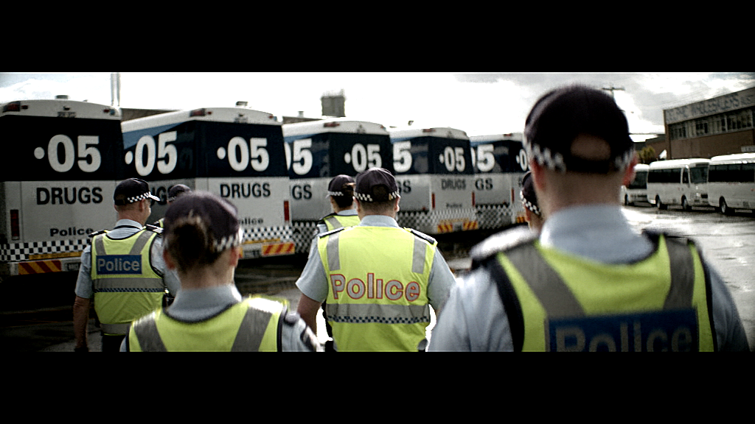




TRANSPORT  ACCIDENT  COMMISSION | 60 Brougham Street  Geelong Vic 3220  PO Box 742  Geelong Vic 3220  Ausdoc DX 216079 Geelong | Telephone 1300 654 329  STD Toll Free 1800 332 556  Fax: 03 9656 9300  www.tac.vic.gov.au  ABN 22 033 947 623

Contents
Status Report 4
Fatalities 4
Claims involving an acute hospital admission* 5
Fatalities: 12 months to May 2014 6
Claims involving acute hospitalisation over 14 days: 12 months to November 2013 (claim acceptance date) 8
Claims involving an acute hospital admission: 12 months to November 2013 (claim acceptance date) 10
Fatalities: Victorian monthly totals since 1951 12
Fatalities by Week (2009 to 2014) 13
Alcohol Related Fatalities 14
The National Picture 15
Booze-Bus Random Breath Testing 16
Mobile Safety Camera Data 16
Explanations and References 17
Useful Internet Sites 18
Figures 19

Note about the data in this report
- All data provided in this report is the data most recently available at time of production. Fatalities, breath-test data and safety camera data are updated to the end of report month. A 6-month lag applies to TAC claims data, and a 2-month lag applies to alcohol related fatalities data.
- Reported data will have one extra day of exposure for leap years.
- Data is subject to revision as additional information about known accidents/claims is received, and as new accident/claim reports are received and processed.
*An acute hospital admission refers to a hospital admission that occurred within 7 days of accident.

Status Report

Fatalities
- The rolling 12 month number of road fatalities in May 2014 stands at 251, 13% less than in 2013 (264).
- 22 people were fatally injured in May 2014 on Victorian roads. This compares to 18 in May 2013.

Fatalities (rolling 12 month, to end May 2014)
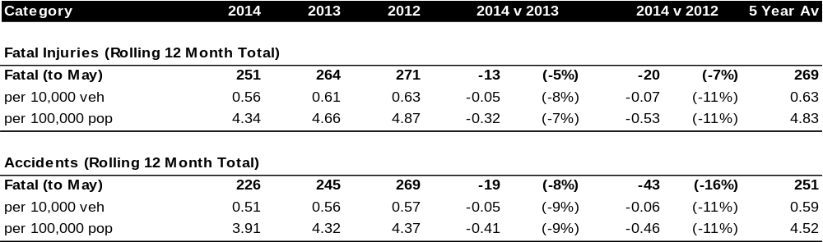

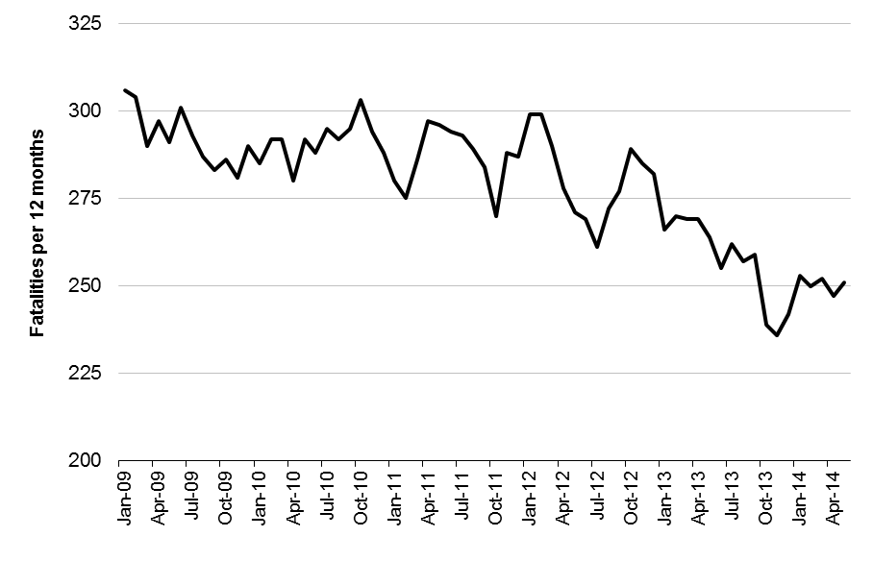
Victoria – Fatalities, rolling 12 months total

Claims involving an acute hospital admission*
(by claim acceptance date – rolling 12 month, to midnight 30 November 2013)
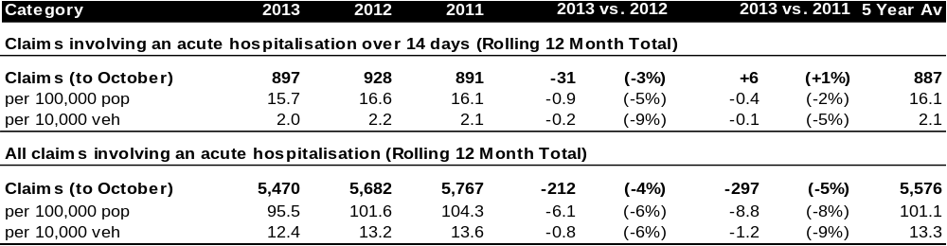
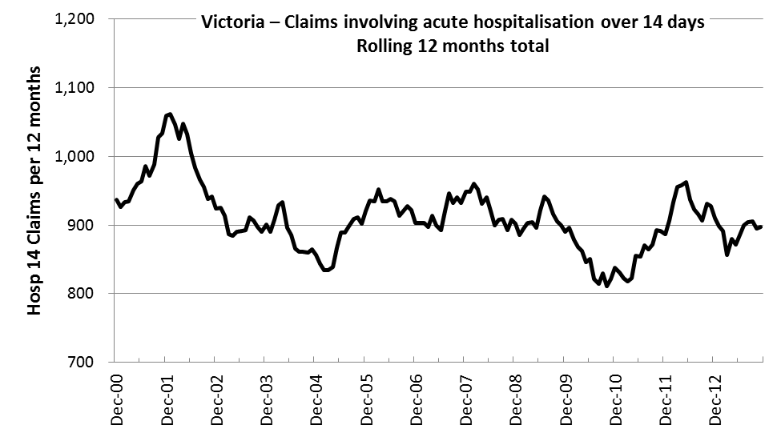
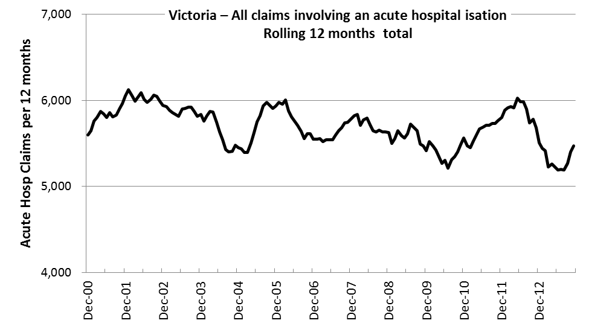

*An acute hospital admission refers to a hospital admission that occurred within 7 days of accident.

Fatalities: 12 months to May 2014
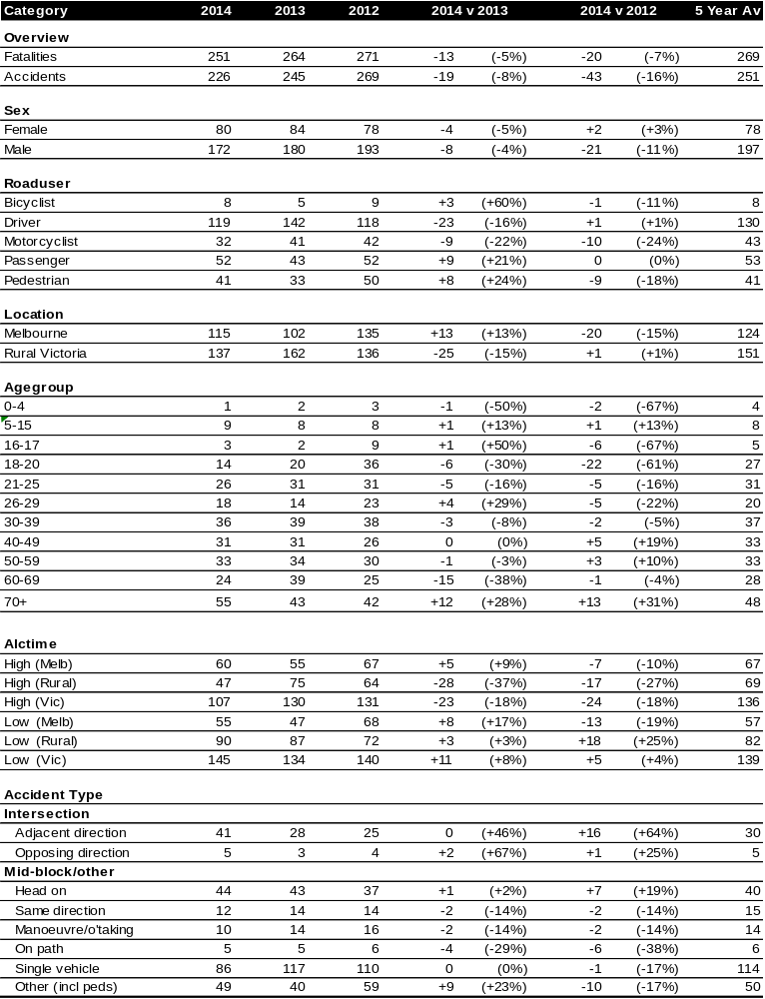

Fatalities: 12 months to May 2014 – Continued
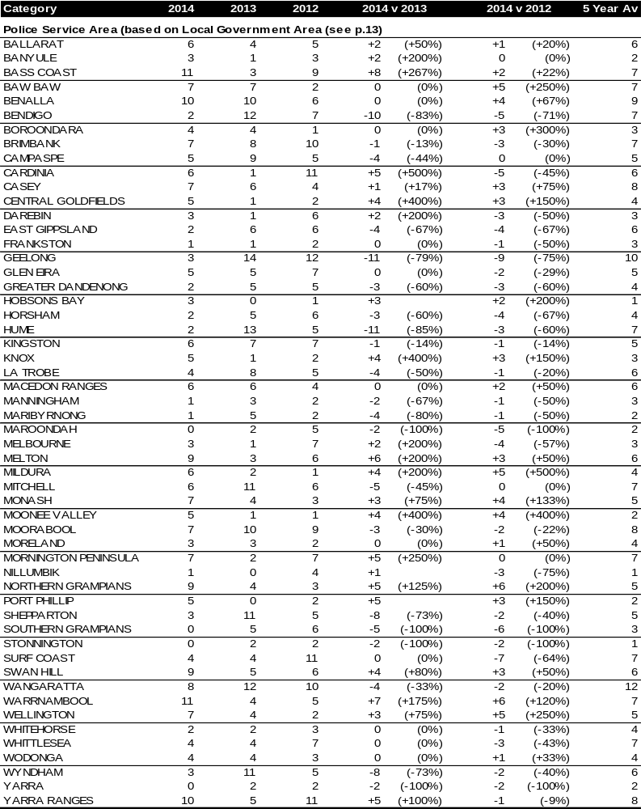

Claims involving acute hospitalisation over 14 days: 12 months to November 2013 (claim acceptance date)
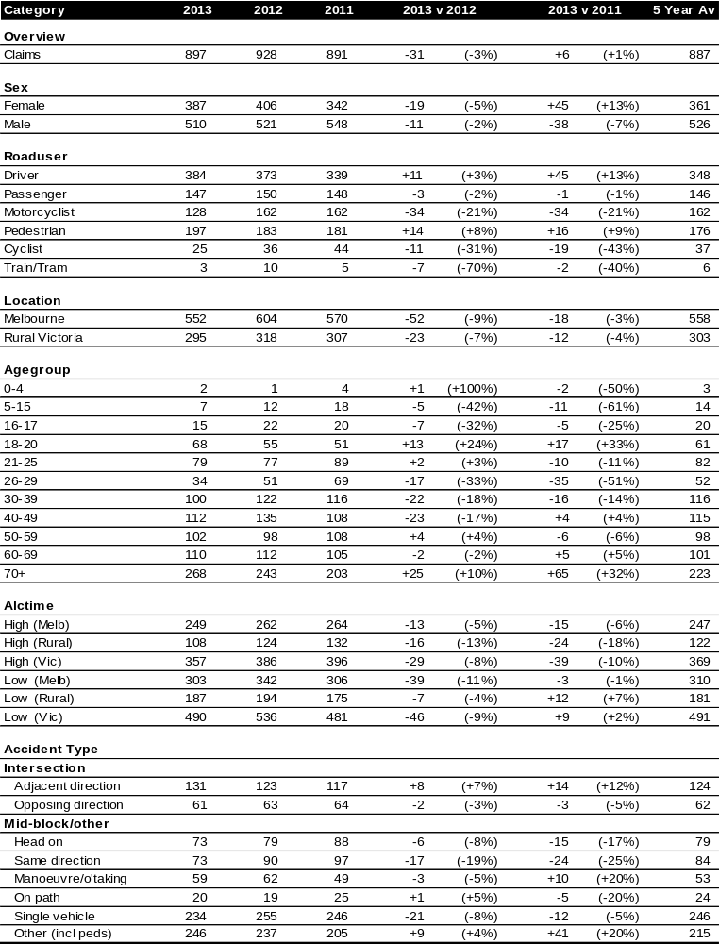
Note: excludes rejected claims and claims for interstate crashes
Claims involving acute hospitalisation over 14 days: 12 months to November 2013 (claim acceptance date) – Continued
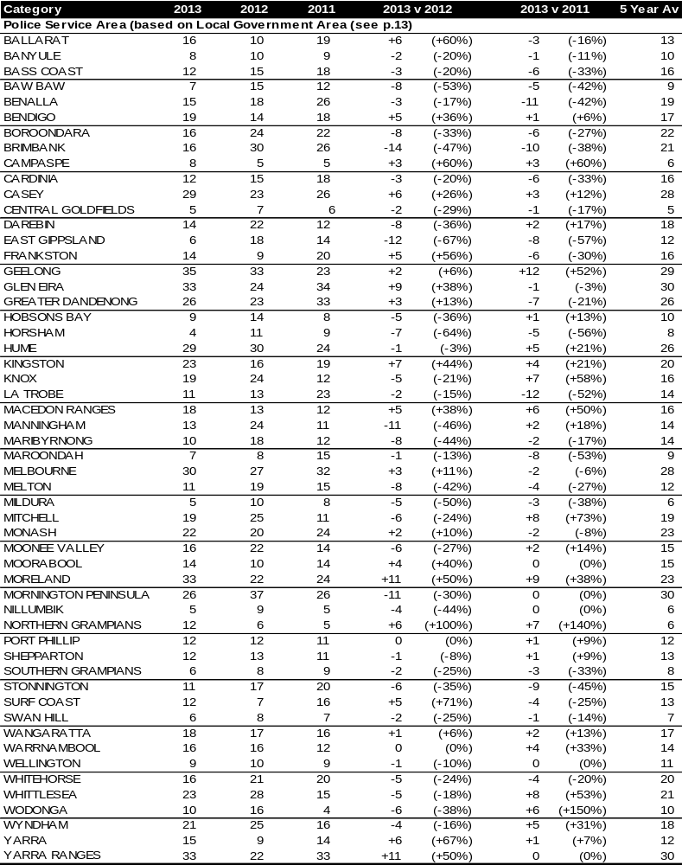

Note: excludes rejected claims and claims for interstate crashes

Claims involving an acute hospital admission: 12 months to November 2013 (claim acceptance date)
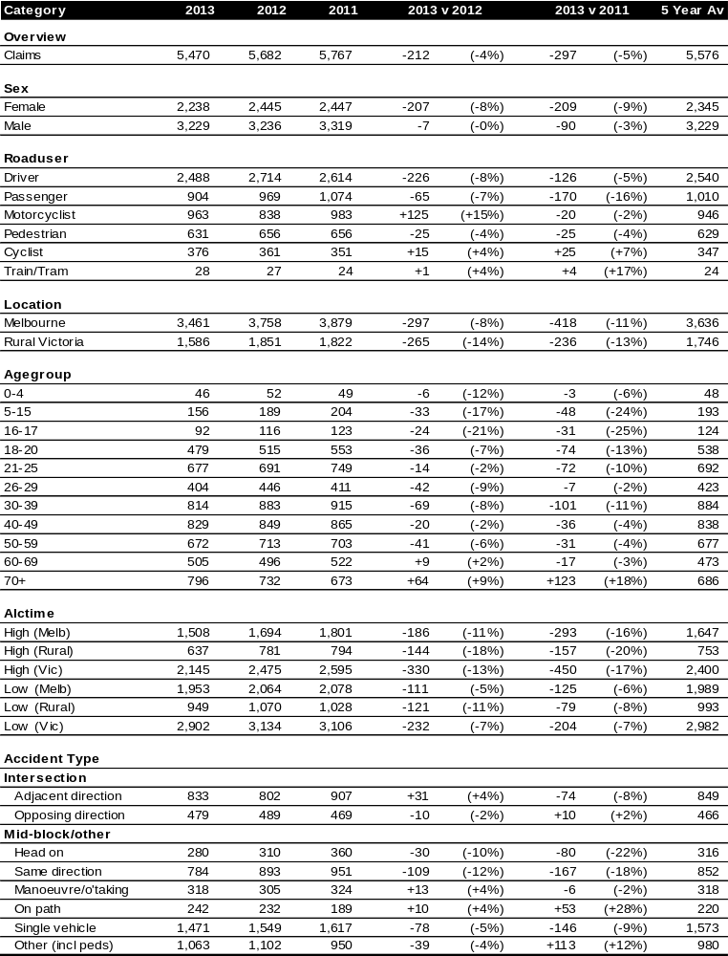

Note: excludes rejected claims and claims for interstate crashes
Claims involving an acute hospital admission: 12 months to November 2013 (claim acceptance date) – Continued
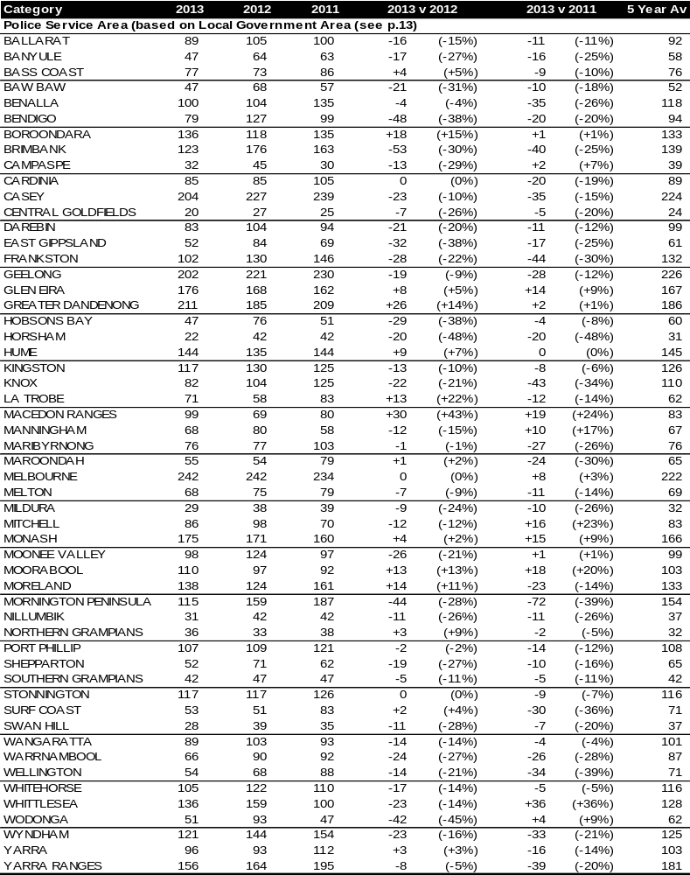

Note: excludes rejected claims and claims for interstate crashes

Fatalities: Victorian monthly totals since 1951
Year | Jan | Feb | Mar | Apr | May | Jun | Jul | Aug | Sep | Oct | Nov | Dec | Totals
1951 |  |  |  |  |  |  | 61 | 59 | 52 | 38 | 29 | 41
1952 | 45 | 40 | 54 | 61 | 54 | 69 | 67 | 55 | 44 | 44 | 31 | 20 | 584
1953 | 23 | 28 | 54 | 58 | 49 | 42 | 50 | 37 | 44 | 27 | 36 | 32 | 480
1954 | 44 | 42 | 28 | 60 | 55 | 36 | 63 | 33 | 25 | 52 | 30 | 41 | 509
1955 | 44 | 36 | 45 | 55 | 48 | 56 | 64 | 44 | 44 | 32 | 40 | 40 | 548
1956 | 34 | 48 | 51 | 67 | 53 | 65 | 71 | 47 | 39 | 39 | 44 | 48 | 606
1957 | 50 | 41 | 46 | 58 | 52 | 54 | 57 | 53 | 51 | 46 | 32 | 49 | 589
1958 | 50 | 38 | 42 | 58 | 54 | 41 | 54 | 53 | 57 | 40 | 57 | 52 | 596
1959 | 50 | 57 | 61 | 50 | 75 | 55 | 42 | 48 | 52 | 55 | 63 | 63 | 671
1960 | 49 | 53 | 57 | 76 | 70 | 70 | 67 | 62 | 61 | 77 | 52 | 66 | 760
1961 | 63 | 57 | 68 | 74 | 58 | 68 | 78 | 82 | 59 | 62 | 60 | 65 | 794
1962 | 65 | 41 | 76 | 78 | 72 | 80 | 70 | 77 | 62 | 53 | 64 | 70 | 808
1963 | 67 | 56 | 65 | 85 | 66 | 68 | 77 | 55 | 55 | 58 | 61 | 67 | 780
1964 | 73 | 71 | 78 | 71 | 83 | 89 | 80 | 89 | 67 | 66 | 62 | 75 | 904
1965 | 63 | 64 | 86 | 88 | 80 | 87 | 79 | 69 | 81 | 77 | 68 | 87 | 929
1966 | 75 | 59 | 75 | 103 | 74 | 86 | 87 | 80 | 75 | 66 | 90 | 85 | 955
1967 | 61 | 79 | 91 | 97 | 81 | 71 | 59 | 67 | 70 | 68 | 60 | 83 | 887
1968 | 70 | 78 | 86 | 78 | 73 | 76 | 73 | 77 | 72 | 80 | 81 | 105 | 949
1969 | 79 | 68 | 79 | 87 | 86 | 77 | 87 | 83 | 87 | 83 | 94 | 101 | 1,011
1970 | 85 | 84 | 106 | 80 | 87 | 88 | 110 | 106 | 78 | 95 | 68 | 74 | 1,061
1971 | 83 | 75 | 77 | 68 | 76 | 86 | 85 | 72 | 78 | 73 | 74 | 76 | 923
1972 | 61 | 62 | 75 | 82 | 75 | 71 | 98 | 85 | 83 | 62 | 80 | 81 | 915
1973 | 75 | 75 | 95 | 85 | 64 | 66 | 61 | 85 | 89 | 88 | 66 | 86 | 935
1974 | 56 | 62 | 81 | 60 | 70 | 73 | 67 | 62 | 53 | 70 | 80 | 72 | 806
1975 | 67 | 65 | 87 | 73 | 97 | 94 | 57 | 75 | 69 | 66 | 71 | 89 | 910
1976 | 79 | 78 | 88 | 78 | 69 | 79 | 60 | 70 | 82 | 78 | 77 | 100 | 938
1977 | 65 | 71 | 89 | 79 | 65 | 79 | 70 | 91 | 68 | 74 | 96 | 107 | 954
1978 | 75 | 54 | 95 | 63 | 64 | 69 | 68 | 77 | 65 | 84 | 83 | 72 | 869
1979 | 63 | 60 | 86 | 75 | 45 | 64 | 66 | 75 | 69 | 79 | 72 | 93 | 847
1980 | 48 | 55 | 66 | 59 | 47 | 56 | 60 | 53 | 45 | 58 | 61 | 49 | 657
1981 | 69 | 60 | 58 | 61 | 74 | 65 | 61 | 63 | 68 | 71 | 59 | 57 | 766
1982 | 55 | 53 | 59 | 59 | 67 | 45 | 47 | 71 | 53 | 69 | 65 | 66 | 709
1983 | 42 | 59 | 53 | 63 | 62 | 61 | 65 | 51 | 59 | 43 | 54 | 52 | 664
1984 | 65 | 48 | 58 | 50 | 56 | 48 | 46 | 50 | 71 | 53 | 55 | 58 | 658
1985 | 56 | 47 | 50 | 65 | 75 | 50 | 51 | 50 | 58 | 61 | 56 | 64 | 683
1986 | 56 | 50 | 70 | 69 | 59 | 53 | 42 | 54 | 54 | 52 | 59 | 51 | 669
1987 | 62 | 43 | 57 | 52 | 63 | 59 | 62 | 49 | 62 | 61 | 55 | 80 | 705
1988 | 49 | 58 | 69 | 54 | 79 | 50 | 54 | 52 | 64 | 59 | 43 | 70 | 701
1989 | 76 | 65 | 80 | 59 | 67 | 73 | 52 | 65 | 82 | 50 | 41 | 66 | 776
1990 | 48 | 44 | 55 | 39 | 56 | 64 | 41 | 34 | 48 | 35 | 40 | 44 | 548
1991 | 45 | 39 | 70 | 30 | 34 | 29 | 44 | 47 | 41 | 36 | 35 | 53 | 503
1992 | 34 | 33 | 34 | 47 | 33 | 29 | 23 | 27 | 28 | 38 | 30 | 40 | 396
1993 | 27 | 40 | 37 | 39 | 44 | 33 | 33 | 27 | 34 | 39 | 43 | 40 | 436
1994 | 36 | 31 | 44 | 35 | 27 | 33 | 29 | 37 | 17 | 27 | 32 | 30 | 378
1995 | 38 | 35 | 26 | 33 | 34 | 41 | 27 | 34 | 34 | 32 | 38 | 46 | 418
1996 | 40 | 47 | 35 | 38 | 28 | 29 | 30 | 35 | 49 | 24 | 33 | 30 | 418
1997 | 36 | 25 | 30 | 30 | 40 | 22 | 39 | 26 | 26 | 29 | 39 | 35 | 377
1998 | 29 | 29 | 32 | 36 | 31 | 22 | 40 | 19 | 37 | 36 | 49 | 30 | 390
1999 | 32 | 31 | 35 | 35 | 34 | 24 | 35 | 26 | 28 | 38 | 29 | 37 | 384
2000 | 32 | 26 | 46 | 32 | 39 | 32 | 33 | 29 | 36 | 29 | 44 | 29 | 407
2001 | 44 | 30 | 31 | 32 | 31 | 41 | 34 | 37 | 35 | 51 | 41 | 37 | 444
2002 | 32 | 31 | 45 | 31 | 45 | 32 | 27 | 25 | 31 | 30 | 31 | 37 | 397
2003 | 21 | 41 | 36 | 28 | 31 | 28 | 20 | 23 | 23 | 24 | 24 | 31 | 330
2004 | 32 | 22 | 30 | 30 | 46 | 28 | 27 | 26 | 22 | 28 | 25 | 27 | 343
2005 | 33 | 27 | 47 | 21 | 29 | 23 | 30 | 25 | 25 | 33 | 17 | 36 | 346
2006 | 24 | 37 | 23 | 23 | 27 | 23 | 25 | 22 | 43 | 20 | 31 | 39 | 337
2007 | 23 | 23 | 32 | 25 | 26 | 28 | 28 | 20 | 23 | 37 | 26 | 41 | 332
2008 | 28 | 20 | 37 | 25 | 25 | 20 | 27 | 27 | 18 | 25 | 26 | 25 | 303
2009 | 31 | 18 | 23 | 32 | 19 | 30 | 19 | 21 | 14 | 28 | 21 | 34 | 290
2010 | 26 | 25 | 23 | 20 | 31 | 26 | 26 | 18 | 17 | 36 | 12 | 28 | 288
2011 | 18 | 20 | 34 | 31 | 30 | 24 | 25 | 14 | 12 | 22 | 30 | 27 | 287
2012 | 30 | 20 | 25 | 19 | 23 | 22 | 17 | 25 | 17 | 34 | 26 | 24 | 282
2013 | 14 | 24 | 24 | 19 | 18 | 13 | 24 | 20 | 19 | 14 | 23 | 30 | 242
2014 | 25 | 21 | 26 | 14 | 22
Ave | 49 | 46 | 56 | 54 | 53 | 52 | 52 | 50 | 50 | 50 | 49 | 56 | 619
Max | 85 | 84 | 106 | 103 | 97 | 94 | 110 | 106 | 89 | 95 | 96 | 107 | 1,061
Min | 14 | 18 | 23 | 14 | 18 | 13 | 17 | 14 | 12 | 14 | 12 | 20 | 242

Fatalities by Week (2009 to 2014)
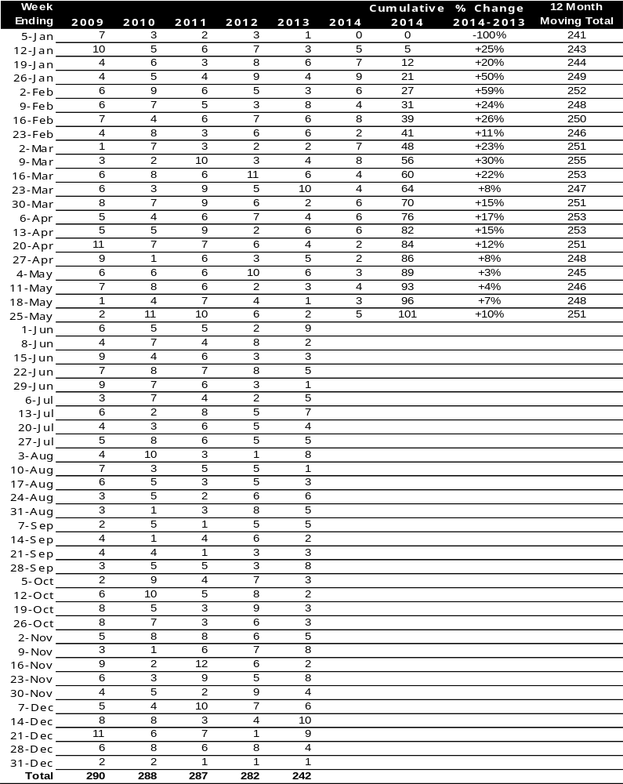

Alcohol Related Fatalities
NOTE: UPDATES TO THIS DATA WERE NOT AVAILABLE AT TIME OF REPORT
- 24% of fatally injured and tested drivers and riders had a BAC at 0.05 g/100ml or over (41 of 172) compared to 25% over the previous 12 month period (43 of 169).
- In Melbourne, 21 drivers/riders fatally injured and tested were at or over 0.05, with 38% of these having a BAC in excess of 0.15 g/100ml. Across rural Victoria, 20 drivers/riders fatally injured and tested were at or over 0.05, with 65% of these having a BAC over 0.15.
- Of the 41 drivers and riders fatally injured and tested at or over 0.05, 15% (6) were aged under 21, 39% (16) were aged 21-29, 27% (11) were aged 30-39 and 20% (8) were aged 40 years and over. In the previous year (43 fatally injured) the corresponding figures were 19% (8), 28% (12), 19% (8) and 35% (15), respectively.

BAC Fatalities (12 months to April 2010)
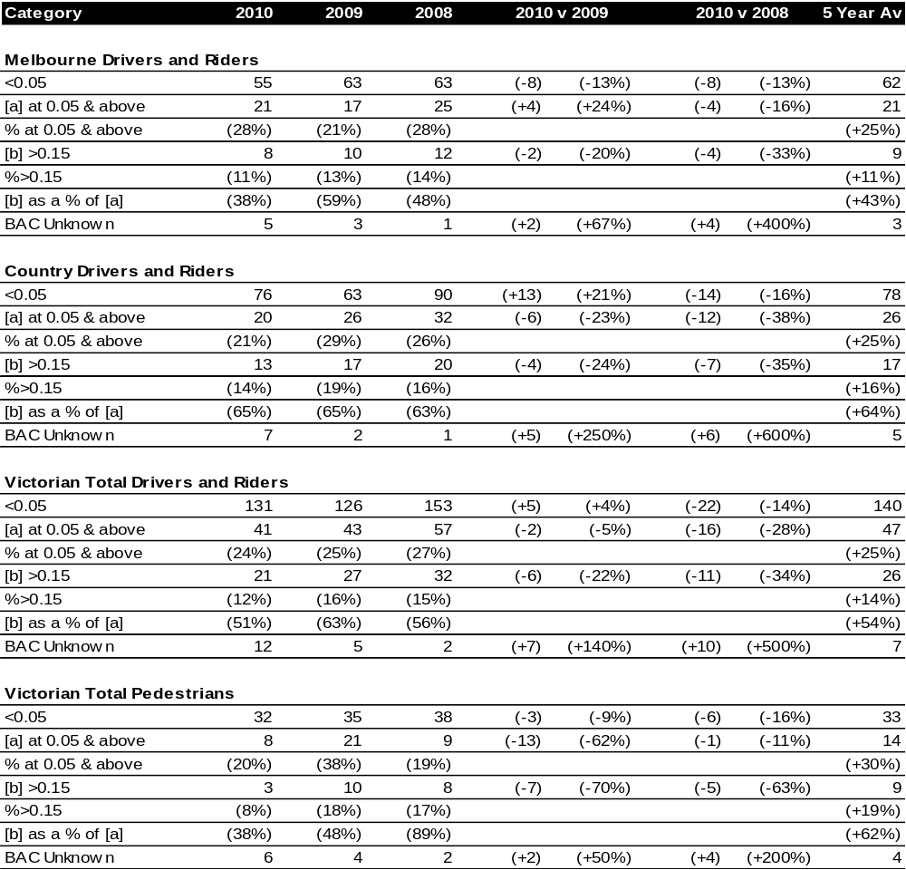

The National Picture
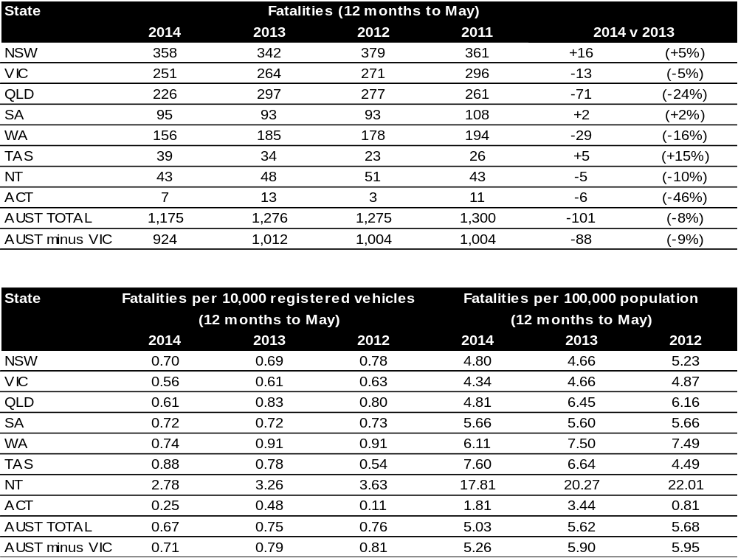

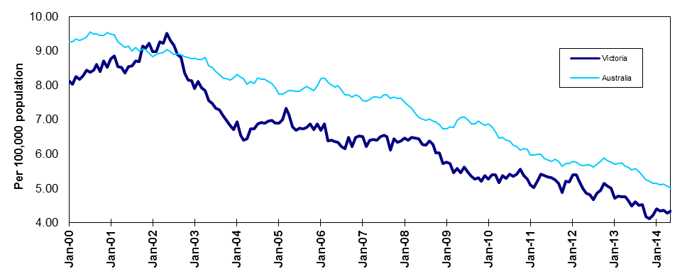
Victoria v Australia – 12 Month Moving Fatality Rate

Booze-Bus Random Breath Testing
12 months to March 2014 (monthly totals)*
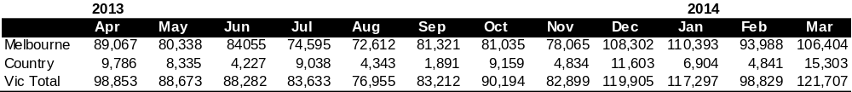
12 months to March 2014 vs previous 12 months
*Due to police industrial action, reliable random breath testing data is not available from May to October 2011. For the rolling 12 month totals, 2010 data has been used as a substitute in the relevant months.

Mobile Safety Camera Data
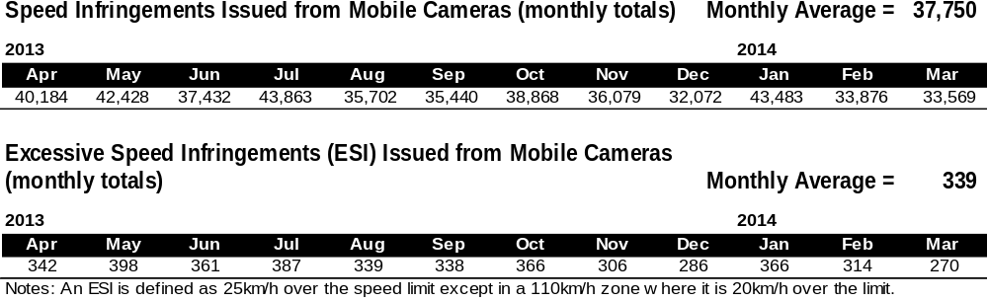
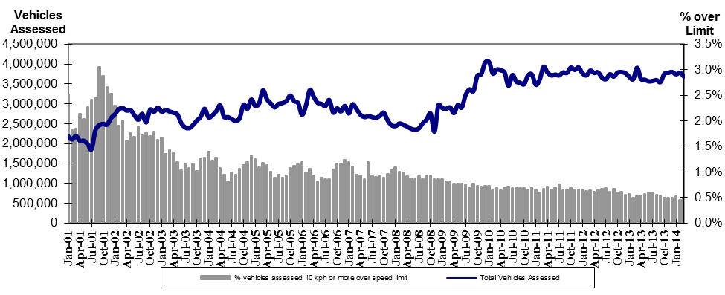
Mobile Safety Cameras – Vehicles assessed and percentage of vehicles assessed 10km/h or more over speed limit per month

Explanations and References
Hi-Alctime is those times of the day and week (shaded in the table below) when casualty crashes are ten times more likely to involve alcohol than casualty crashes at other (Lo-Alctime) times.
 | 12am - 6am | 6am - 8am | 8am - 10am | 10am - 2pm | 2pm - 4pm | 4pm - 6pm | 6pm - 12pm
Monday
Tuesday
Wednesday
Thursday
Friday
Saturday
Sunday

Police Service Areas align with Local Government Areas. Most Police Service Areas are equivalent to a single Local Government Area, while the remainder comprise two or three Local Government Areas.
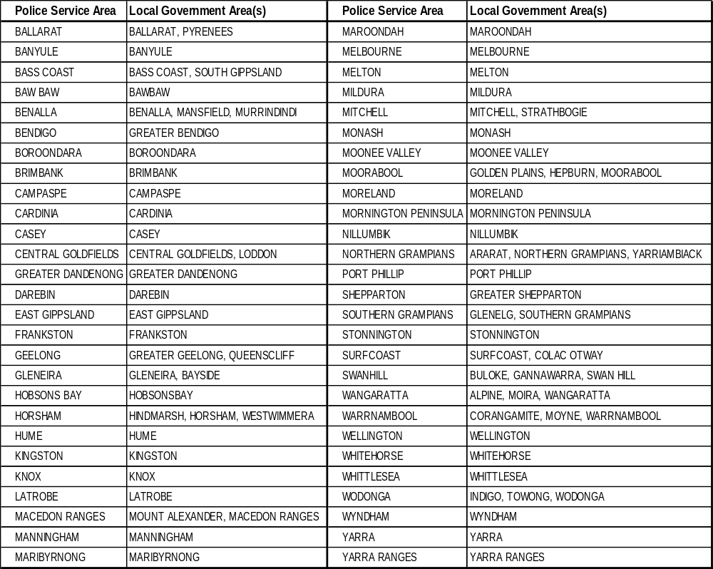

Useful Internet Sites
TAC Sites
- TAC Safety (Road Safety) www.tacsafety.com.au
- TAC How safe is your car www.howsafeisyourcar.com.au
- TAC Learners Log www.learnerslog.com.au
- TAC Motorcycle Safety Website www.spokes.com.au
- TAC Corporate site www.tac.vic.gov.au
Victorian Sites:
- VicRoads www.vicroads.vic.gov.au
- Victoria Police www.police.vic.gov.au
- Parliamentary Road Safety Committee www.parliament.vic.gov.au/rsc/
- ARRB Transport Research www.arrb.com.au
- RACV www.racv.com.au
- Monash University Accident Research Centre www.monash.edu.au/muarc
- Roadsafe www.roadsafe.org.au
- Cameras Save Lives www.camerassavelives.vic.gov.au
National and Interstate Sites:
- Australian Transport Safety Bureau www.atsb.gov.au
- Roads and Traffic Authority (NSW) www.rta.nsw.gov.au
- Queensland Transport - Road Safety transport.qld.gov.au/Home/Safety/Road
- Department of Transport (SA) www.transport.sa.gov.au/index.htm
- Main Roads Western Australia - Road Safety www.mrwa.wa.gov.au
International Sites:
- National Highway Traffic Safety Admin (USA) www.nhtsa.dot.gov
- Swedish Road and Transport Institute (VTI) www.vti.se
- SWOV Institute for Road Safety Research www.swov.nl
Related Sites:
- Australian Drug Foundation www.adf.org.au
- Amy Gillett Foundation www.amygillett.org.au

Figures

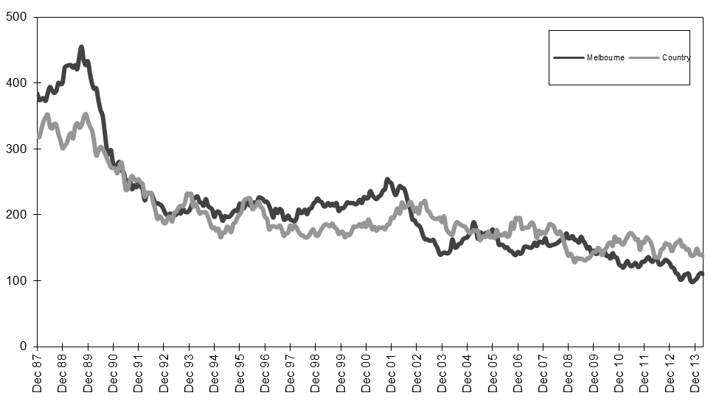
Graph 1a – Melbourne/country fatalities

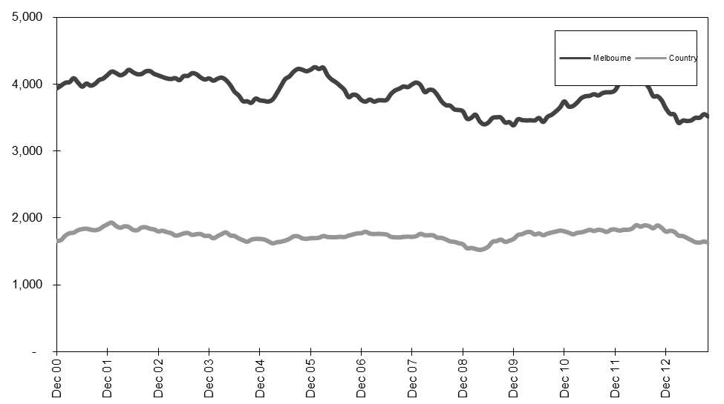
Graph 1b – Melbourne/country Claims involving an acute hospital admission

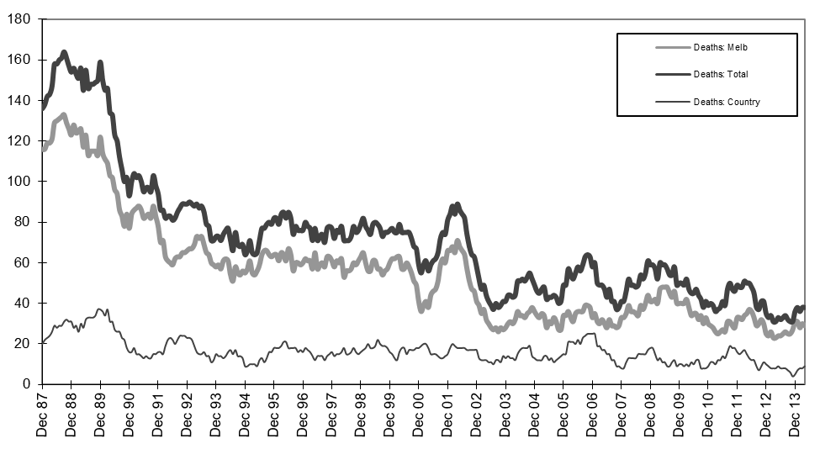
Graph 2a – Pedestrian fatalities (Melbourne/country)

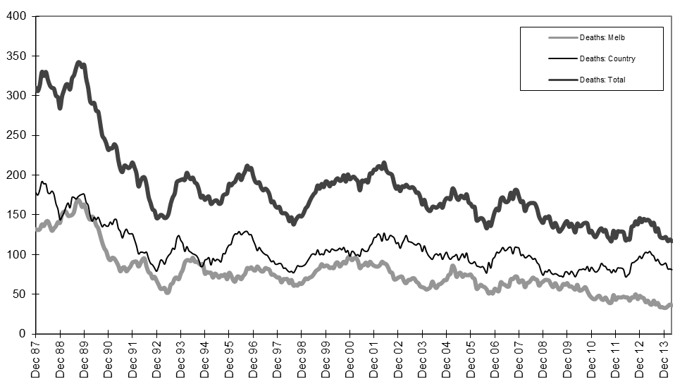
Graph 2b – Driver fatalities (Melbourne/country)

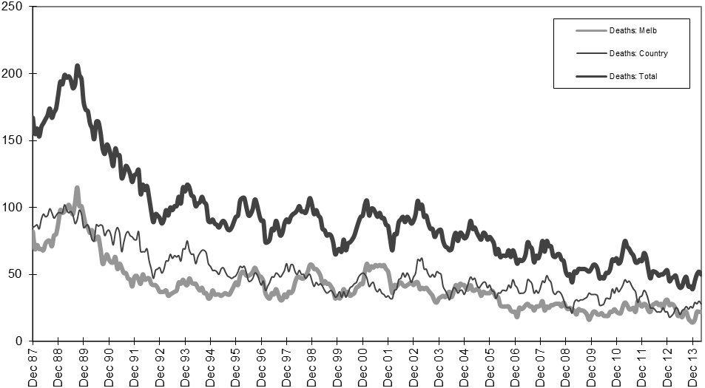
Graph 2c – Passenger fatalities (Melbourne/country)

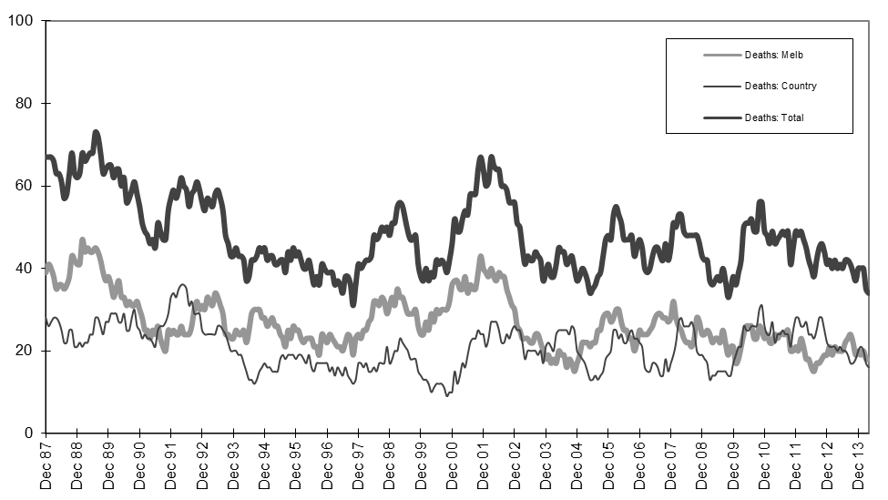
Graph 2d –Motorcyclist fatalities (Melbourne/country)

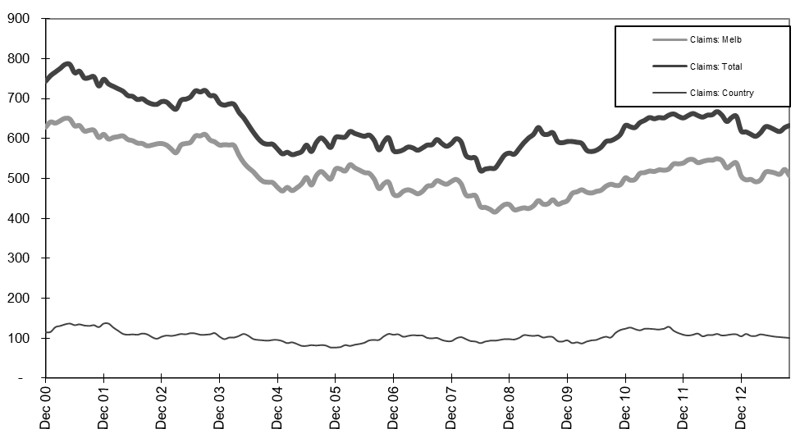
Graph 3a – Pedestrian Claims involving an acute hospital admission (Melbourne/country)

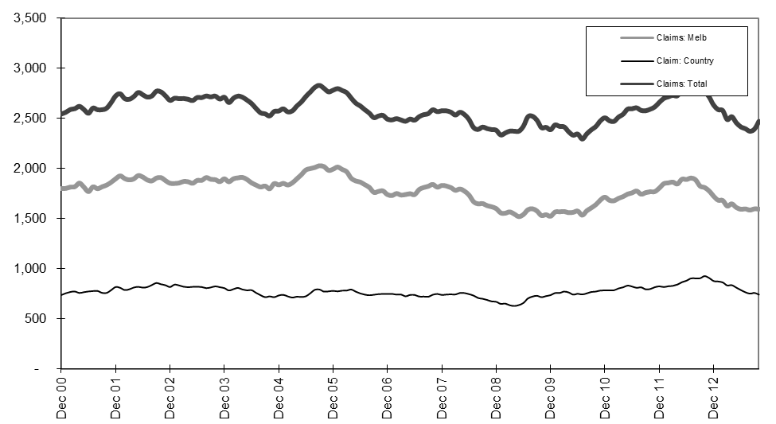
Graph 3b – Driver Claims involving an acute hospital admission (Melbourne/country)

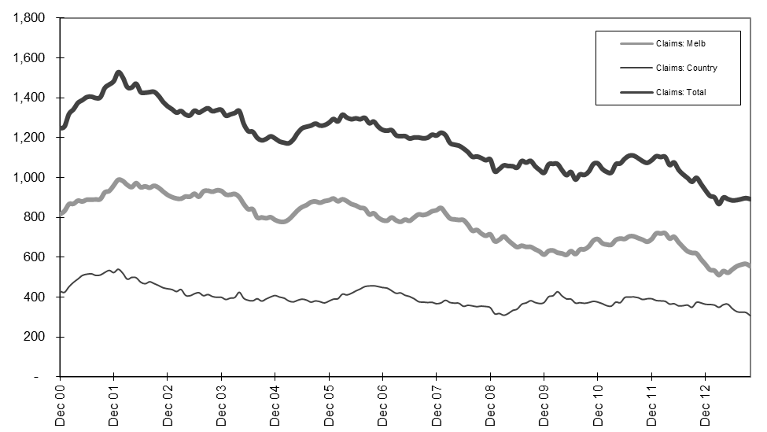
Graph 3c – Passenger Claims involving an acute hospital admission (Melbourne/country)

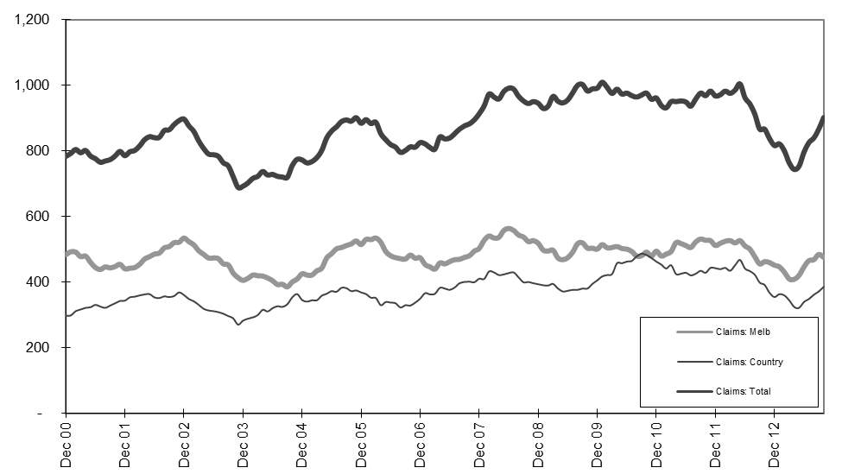
Graph 3d –Motorcyclist Claims involving an acute hospital admission (Melbourne/country)

