Ipsos Project: 15-025299-01

Motorcycle Monitor 2015
Prepared for the Transport and Accident Commission
REPORT OF FINDINGS
November 2015

Project Contacts: Julie Young
Sumedha Gaindhar

Contact address: Building 1, Level 2
658 Church St, Richmond
VIC 3121

Office phone: (03) 9946 0888

Email: julie.young@ipsos.com
sumedha.gaindhar@ipsos.com

Contents
1. Executive summary and research implications 4
2. Research Context 9
2.1 Background to project 9
3. Survey Design 10
Research findings 15
4. Learning to ride 16
4.1 Age respondents started riding a motorcycle 16
4.2 Motorcycle licence status 18
4.3 Age motorcyclists applied for their licence 20
5. Riding activity 38
5.1 Riding history 39
5.2 Riding activity segments 47
5.3 Riding vs. driving 50
5.4 Riding for commuting and recreational purposes 55
5.5 Distances ridden in last 12 months 63
5.6 Rider fatigue 67
6. Attitudes towards speeding and speeding behaviour 71
7. Random Breath and Drug Testing 87
8. Motorcycle/scooter ownership 90
8.1 Number of motorcycles in household 91
8.2 Details of motorcycle ridden most often 93
8.3 Motorcycle safety features 100
9. Protective motorcycle clothing 102
9.1 Protective gear ownership 103
9.2 Protective gear usage 108
9.3 Attitude statements about motorcycle safety clothing 117
10. Motorcycle crash history 118
10.1 Crash history 119
10.2 Crashes requiring medical treatment 120
10.3 Circumstances of most recent crash 122
10.4 Compensation 126
11. Respondent suggestions for improving rider safety 127
Appendices 130
Demographics 130
Questionnaire 132

Executive summary and research implications
In 2015, the Transport and Accident Commission (TAC) commissioned Ipsos to conduct the Motorcycle Monitor for the fourth time since 2012. The study was undertaken to gather detailed information about motorcycle riders, their attitudes toward road safety, and behaviour while riding. The intention was to gain a fully representative sample of the motorcycle rider population. The survey was completed by respondents either online, via telephone or by hardcopy. A total of 800 motorcycle licence or registration holders completed the survey in May to July 2015 from a sample of 2,350 random motorcycle licence and registration holders from the VicRoads database.
For the most part, the results between 2014 and 2015 have remained steady. However, there have been noteworthy increases in those who reported they wear protective riding pants all the time compared to previous years. Boot wearing has also improved over the last few years.
Of concern, is the slight but noticeable change in rider attitudes towards the acceptability of low level speeding in both 60km and 100km zones (i.e. riding a few kilometres over the sign-posted speed limit before being fined). In adddtion, compared to other ‘questionable’ riding practices such as riding under the influence or while drowsy, it was low level speeding that was least likely to be deemed dangerous.
Where other differences in results were observed, this has largely been in comparison to 2013 results where the survey population included a higher proportion who had not ridden in the previous year, and where there was a higher incidence of off-road riding compared to other survey years.
Other key findings from the research are summarised below.

Learning to ride
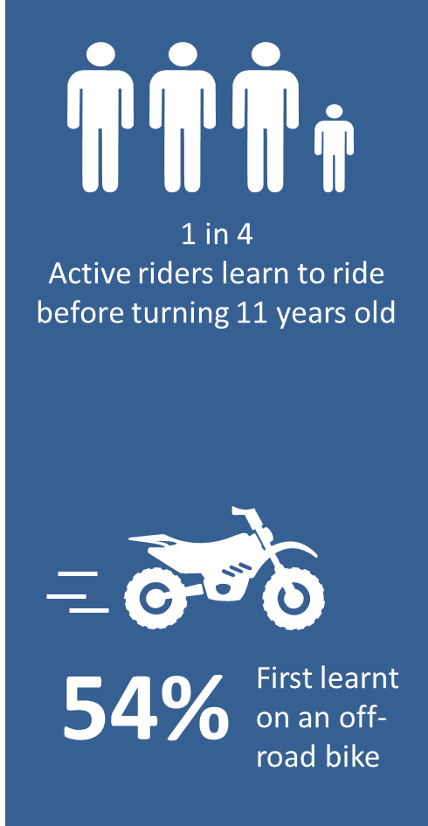
Respondents started riding at an average age of 18.2 years, consistent with results from previous surveys. Male respondents were more likely to start riding at a younger age (17.6 years compared to 23.3 years); as were those who rode recreationally off-road (12.8 years old) and those from regional Victoria (17.3). One in four (27%) active riders started riding before the age of 11.
Nine in ten respondents held a full motorcycle licence (89%) with 7% holding either a learners permit or probationary licence. The average age that respondents first got their full or probationary licence was at 24.8 years old. One quarter (25%) of respondents with L or P licences reported that they learnt to ride and applied for their licence at the same time. Thirty four percent (34%) reported a gap of 1-5 years between learning and applying for a licence and 38% reported a gap of six years or more. Respondents riding experience prior to getting their learner licence was fairly spread out, with 42% saying they were experienced riders, 31% reporting minimal experience and 27% with moderate experience.
Nearly half (48%) said that they were self-taught, with males, those aged over 40 and those living outside of Melbourne being significantly more likely to say this was the case. Just over half (52%) of respondents said that they learnt to ride on private property, with one-third (33%) saying they did a learners’ course. In 2015, 58% of respondents said that they had undertaken a rider training course of some sort (consistent with 56% in 2014). Fifty-four percent (54%) of respondents learnt on an off-road bike with 36% first learning on a road bike.
Implications:
Given the early start that is common among riders, there is an opportunity to instil good habits among young off-road riders, particularly in terms of wearing protective gear. That many learn from parents, family and friends, it is likely these older mentors are seen as role models so encouraging older off-road riders to ‘walk the walk’ and encourage younger riders to do the same is also of value. The challenge is to communicate that this behaviour is also necessary when transitioning from off-road to on-road riding.

Riding activity
Two in three respondents (66%) had ridden in the last 12 months (compared to 62% in 2014). Males and younger riders aged 18-25 years were significantly more likely to say that they had ridden in the previous year (70% and 92% respectively). On average, respondents rode 341.3km per month, or 4,292.4km in a year.
There were some significant differences found when comparing riding history from previous years. Results in 2015 saw a slight but significant increase in the proportion of respondents that had stopped riding and did not intend to ride again (9% vs. 5%). Notably, looking back at the 2013 results, a higher proportion of respondents had not ridden in the previous year compared to other survey years (43% in 2013 vs. 34% in 2015) and a higher proportion who said they had stopped riding but may decide to do so in the future (34% vs. 46% in 2015). It is likely that these are the key drivers behind differences between 2013 and other survey years when looking at the total riding population.
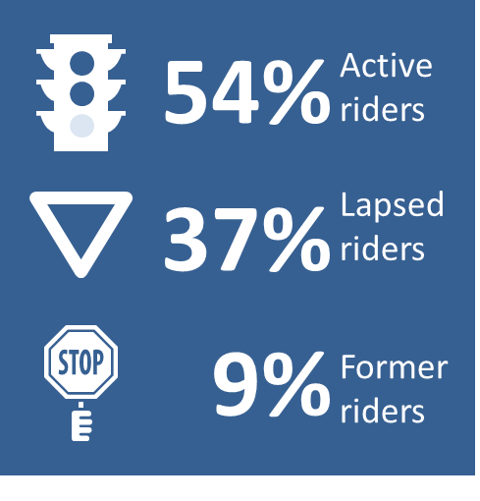
In total, in 2015, 54% of respondents were classified as active riders and 37% as lapsed riders. However, there was a slight but significant increase in former riders compared to 2014 (9% vs. 5%). Active riders were significantly more likely to say they rode recreationally on-road (79%). One in three (37%) respondents said that they rode off-road recreationally - this was significantly higher in 2013 (54%) – another feature behind the differences in survey results in 2013 compared to other years.
Over four out of ten (46%) of the respondents who had not ridden in the last 12 months or said they may resume in the future, said there was a high chance that they would ride again. Males were more likely than females to give a higher rating of their likelihood of riding again (6.2 compared to 4.8 out of 10). Key reasons for no longer riding included no longer owning a bike; and changes to family commitments or lifestyle.
Implications:
Once people have started riding, it seems there is a high proportion that is reluctant to let go of the dream.
Ensuring that those who may decide to pick up riding again after a break are appropriately equipped; both in terms of possessing up to date protective gear; and being mentally equipped for the hazards they may face from road conditions to other road users is important, especially in the lead up to long weekends, or the warmer seasons.

Attitudes towards speeding and speeding behaviour
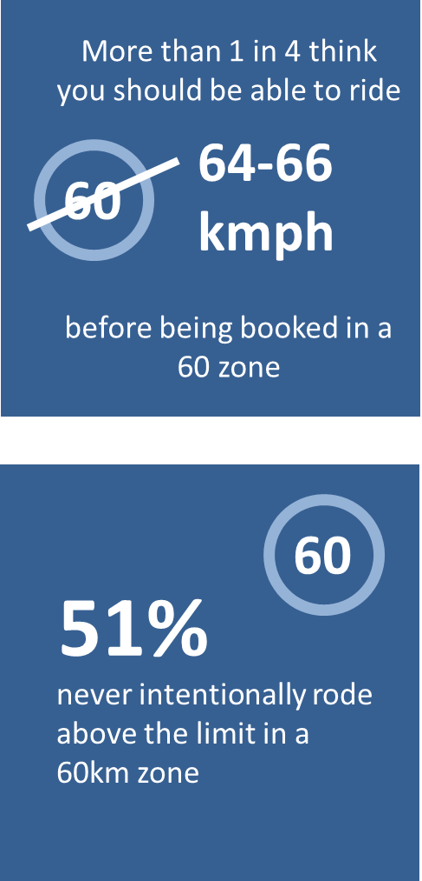
Attitudes towards speeding have changed over recent years, with low level speeding of particular concern. Just under half (45%) of respondents said that you should only be able to go up to 60km per hour in a 60 zone before being booked for speeding – a significantly lower proportion than in previous years (vs. 58% in 2014 and 64% in 2013). When asked the same about 100km zones, 40% of respondents nominated a speed of 100km per hour or less (compared to 48% in 2014 and 55% in both 2012 and 2013). In both speed zones, there have been increases in those who feel that a few kilometres over the limit should be acceptable before being fined. For 60km zones, 28% felt that going over 64-66 km per hour should be the point before people should be fined (up from 18% last year). For 100km zones, 22% reported 101-105 km should be acceptable with a further 21% reporting 106-110 should be allowed.
In terms of reported speeding behaviour, the majority of respondents said they would not ride over the speed limit if they were sure they could get away with it (60% disagreed with the statement - consistent with results from 2014). However, only half (51%) of respondents who rode in the last 12 months reported they never intentionally rode above the limit in a 60km zone. More than one in four (29%) said they did so some of the time.
The perception of the lack of danger associated with riding a few kilometres over the limit is likely to be a factor. Riding a few kilometres over the limit in a 60km or 100km zone was deemed dangerous by approximately half of respondents (51% for a 60km zone; and 48% for 100km zone). However, low level speeding was significantly less likely to be deemed dangerous compared to driving under the influence of drugs or alcohol (over 80% extremely dangerous) or even while drowsy (65% extremely dangerous).
Implications:
Respondents’ changing attitudes towards speeding, ‘a little bit’ is of concern, given the increased vulnerability of motorcyclists from taking evasive action at the last minute. The TAC may see value in focusing on this human aspect of the ‘Road Safety System’ among motorcyclists to highlight that there is a real danger associated with going a few kilometres over the limit, at both low and high speed zones.
Whether this attitude is evident among other road users is also worthwhile as this may not be a trend that is exclusive to motorcyclists.

Random breath and drug testing
Consistent with previous years, few respondents (18%) said they had been pulled over by the police in the last 12 months. The most common reason for being pulled over was reported to be breath resting (51%).
One in five respondents (20%) said they had been breath tested at least once in the past year and only 2% reported that they had been randomly drug tested while riding a motorcycle.
The perception that driving under the influence was extremely dangerous was pervasive among motorcycle riders. Riding after using stimulant drugs (such as speed, methamphetamine, ice, ecstasy) was most likely to be deemed extremely dangerous (86%); with similar proportions of respondents also rating riding with an illegal Blood Alcohol Content (BAC) level; after using depressant drugs (such as marijuana, heroin, GHB); and after using drugs and alcohol was also extremely dangerous (83%). In contrast, only two in three respondents (68%) felt that riding after drinking a small amount of alcohol while using prescriptive medicines was extremely dangerous.
Consistent with the above, only a small proportion of respondents (2%) reported that they had ridden their motorcycle when they knew or thought that they were possibly over the legal blood alcohol limit.
Implications:
Drug and alcohol consumption before riding continue to be considered a taboo amongst motorcycle riders; however, there are opportunities to highlight that there are risks to riding when concurrently taking prescriptive medicine and alcohol.
There is also an opportunity to further communicate the dangers of riding while fatigued, particularly as the imminent danger is perceived to be lower than driving under the influence of drugs and or alcohol when the actual impact of doing so has similar effects.

Motorcycle/scooter ownership
One in three (32%) respondents said they had one bike at their home address and 21% had 2-4 bikes at home. A small proportion (4%) owned five or more bikes. In total, 43% of respondents did not have a motorcycle at their home address.
When looking at active riders specifically, nine in ten (88%) active riders had at least one bike at home. This included two-thirds (69%) who mainly rode a road bike, followed by 23% who said they rode an off-road bike. Five percent (5%) of active riders said they mainly rode a scooter.
Yamaha (17%), Honda (17%) and Harley Davidson (13%) were the most common brands of motorcycles that respondents mainly rode. A third of respondents (31%) rode a bike that had been manufactured in the last five years but most commonly rode a 2000-2009 model (49%). Forty-four percent (44%) reported riding a bike with engine size of 701+cc with a third (31%) riding a bike with a 251-700cc motor.
Nearly all road bikes (93%) and scooters (100%) were registered to ride on the road (compared to only 24% of off-road/trail bikes).
When asked about safety features, Antilock Braking System (ABS) was the most common feature that riders had heard of (81%). Interest in having ABS on a bike they would purchase in the future was moderately high (57%) although one in four were undecided about this feature (26%).
Implications:
Technology is one of the pillars of the Safe Systems approach to road safety. While the awareness of ABS is high, other features that help protect riders are less widely known.

Protective motorcycle clothing
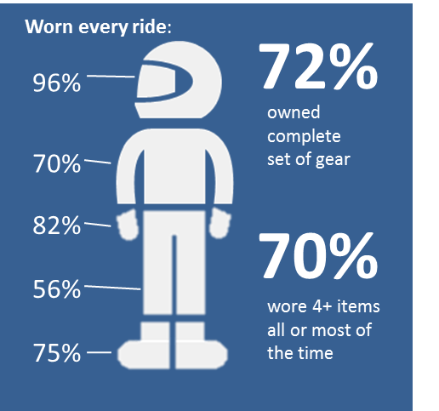
Nearly all respondents owned at least one helmet and a pair of riding gloves (97% and 94% respectively). Riding pants and boots were relatively less likely to be owned by respondents (83% and 80% respectively).
In total, half (50%) of respondents in 2015 reported that they wore 4-5 of the items listed all the time, significantly increasing from 37% doing so in 2014. The majority (96%) said they wore a motorcycle helmet all the time and 82% reported wearing gloves all the time. On a positive note, compared previous years, there has been a significant increase in the proportion of respondents who said they wore riding pants all of the time (56% compared to 46%). Among those who owned a complete set of protective gear, 67% wore pants all the time (compared to 57% in 2014). Nearly all respondents (97%) agreed with the statement “wearing boots that cover my ankles will protect my feet better than other shoes would”. In terms of behaviour, there was also an increase in those who reported wearing boots of any type every time they rode (75%, up from 66% in 2014).
Implications:
After several years, it seems that there have been some in-roads to encouraging people to wear riding pants every time they ride. While this may be due to changes in technology allowing for motorcycle clothing to appear more like regular clothing, it is still worth noting that ownership of this item is still lower than other items of protective clothing.
Similarly, while it is likely that regulation changes may have impacted boot wearing while riding, boots also remain an item that is less likely to be owned and worn by motorcyclists relative to helmets or gloves.
Communicating that these items are as vital in injury prevention as gloves and helmets may be one avenue worth pursuing although barriers such as convenience and habit are hard to break.

Motorcycle crash history
Similar proportions of respondents had experienced a crash while riding a motorcycle as reported in previous years (41% in 2015 compared to 47% in 2014), with the majority (72%) only crashing once. Approximately half (48%) of respondents who had experienced a crash required medical treatment as a result, with 7% reporting that this had happened in the last year. The majority however, 57%, reported that this happened 11 or more years ago.
Crashes most likely occurred on-road (77%) with sealed roads in built up areas the most common location (52%). Almost one in five crashes occurring on sealed roads in rural locations (18%). The remainder of on-road crashes occurred on unsealed roads (7%). Off-road surfaces accounted for 21% of crashes requiring medical treatment.
Those who had crashed off-road most commonly reported rider error (54%) as the cause of their crash. For those who crashed on-road, 42% reported they were not at all responsible for the crash; with 55% who claimed partial (32%) or total (23%) responsibility for the crash. Most reported they knew the crash area well (79%); or that the terrain or road conditions contributed to the crash (65%). Fatigue, unfamiliarity with riding or the bike itself, or retuning after a break were less likely to be reported as factors.
One-fifth (19%) of respondents said that they had received compensation for their injuries from a motorcycle crash – the majority (71%) of this group received this from the TAC.

Improving motorcyclist safety from the rider’s point of view
Respondents overwhelming believed in shared responsibility when it comes to motorcyclist safety. Therefore it is not surprising that the most common theme relating to how the TAC could improve rider safety was to improve the awareness of road users or providing training on motorcycle safety and road sharing (18%). In line with the theme of shared responsibility, a notable proportion felt it was up to the individual (16%), but to also increase rider awareness or responsibility on the roads (14%).
Implications:
Respondent feedback on shared responsibility supports the TAC’s efforts ensuring drivers and motorcyclists are aware and considerate of each other when using the road.

Research Context

Background to project

The Transport Accident Commission’s (TAC) objectives
The TAC’s objectives under the Act include:
- reducing the cost of compensation for transport accidents to the Victorian community;
- reducing the incidence of transport accidents;
- providing suitable and just compensation in respect of persons injured or who die as a result of transport accidents in the most socially and economically appropriate manner;
- determining claims for compensation speedily and efficiently;
- providing suitable systems for the effective rehabilitation of persons injured as a result of transport accidents;
- managing the Transport Accident Scheme (the Scheme) as effectively, efficiently and economically as possible; and
- ensuring the Scheme emphasises accident prevention and effective rehabilitation.

TAC Road Safety Motorcycle Research Program
In 2009, the TAC commissioned a survey to specifically track motorcycle rider attitudes and behaviours in relation to road safety issues, and to measure the prompted recall of motorcycle advertising campaigns when on air. To add to this suite of research, in 2012 the TAC commissioned the Motorcycle Monitor Survey to gather detailed information about motorcycle riders, their attitudes toward road safety and their behaviour while riding their motorcycles with the intention to gain a fully representative view of the motorcycle rider population. Since then, the Motorcycle Monitor has been undertaken on an annual basis. The 2015 survey is the fourth iteration of the survey.

Research objectives
The core aims of the study were to explore the characteristics of the Victorian motorcycle rider population in terms of their:
- general demographic characteristics;
- riding attitudes and behaviours; and
- attitudes toward motorcycle related road safety issues.
Specifically, the key issues included:
- how motorcyclists learnt to ride;
- how often motorcyclists ride and riding purpose;
- the types/number of bikes owned;
- awareness of motorcycle safety features; and
- attitudes and behaviour regarding risk taking and, protective gear.
In 2015, there were some additional questions added to the survey, including questions around how dangerous they thought certain riding behaviours are (such as speeding, riding after using drugs or alcohol etc.); whether they had intentionally ridden above the limit in a 60km/h zone in the last few months; their family and friends’ perceptions of riding without wearing full protective clothing and circumstances around crashes.

Survey Design

Data collection method
The 2015 survey was administered using the same methodology as 2014 with online, hardcopy and telephone options. All respondents were sent an invitation letter in the mail with details on how to complete the survey online or over the phone. A reminder letter including a hardcopy version of the survey was sent to those who had not completed the survey within 10 days of receiving the initial invitation.
Approximately 10 days after the reminder letters and hardcopy surveys were received; reminder calls were made to people who had not yet completed the survey. At this stage, potential participants were offered the opportunity to complete the survey over the phone if they preferred to do so or sent a reminder email if requested.
Overall, Ipsos was able to contact 2,316 of the motorcycle licence or registration holders in the sample of 2,350 by mail or a telephone to invite them to take part in the study. The remainder had either opted out of the survey, or their letters had been ‘returned to sender’, or there was no valid phone number in which to contact them with a reminder call.
The Motorcycle Monitor 2012 was administered with a slightly different methodology, using an online survey with a telephone option if they preferred. No hardcopy option was included in 2012.
The fieldwork period in 2015 was from 18 May 2015 through to 17 July 2015.

Sampling
A random selection of 2,350 Victorians who had a motorcycle licence and/or a motorcycle registered in their name drawn from the VicRoads database to be invited to take part in the survey. The survey sample included a booster of 350 Victorians who held either a Learners’ or Probationary motorcycle licence to ensure a there was a sufficient sample of this active rider group to analyse post data collection.
The overall sample structure took into account the anticipated participation rates for different rider segments but also allowed for enough sample to conduct analyses within key groups such as young male riders, and female riders. This was the same approach that was used to draw the sample in 2014.
Table 1: Key fieldwork figures
 | 2014 |  | 2015
 | n= | % of total mail-out | n= | % of total mail-out
Mail-out 1 – Survey invitation | 2,350 | 100% | 2,350 | 100%
Mail-out 2 – Survey reminder | 2,120 | 90% | 2,210 | 94%
Reminder calls attempted | 1,475 | 63% | 1,461 | 62%
Reminder calls completed | 680 | 29% | 614 | 29%
TOTAL Survey completions online | 432 | 18% | 372 | 16%
TOTAL Survey completions hardcopy | 304 | 13% | 282 | 12%
TOTAL Survey completions by phone | 51 | 2% | 146 | 6%
TOTAL completions | 787 | 33% | 800 | 34%
Opt-outs | 2 | <1% | 6 | <1%
Return to senders/unusable questionnaires | 65 | 3% | 28 | 1%
Subtotal Out of scope (return to sender with no valid phone number) | 47 | 2% | 34 | 1%
Hardcopy surveys received after closing date | 2 | <1% | 1 | <1%

An analysis of the respondent characteristics by mode of completion showed that in 2015, while half (52%) of younger respondents aged 18-39 completed the survey online, there was also a relatively higher proportion of these respondents who completed the survey via telephone (22% for 18-39 year olds vs. 14% for those 40+) - perhaps through being convinced by interviewers that their feedback was important to the study at this stage.
Online respondents were more likely to be from metropolitan Melbourne areas (59%) with hardcopy or telephone completion favoured by regional respondents. While there were some attitudinal differences between respondents by completion mode, these differences were generally in line with differences in age and location. Given that this was the case, the data from each of the collection modes were merged into the one data file for the purposes of conducting the analysis for this report.

Response rates
The overall response rate for the study was 35% compared to 33% in 2014 and 30% in 2013.
There were 800 usable survey completions in total. Approximately half of respondents completed the survey online (47% or n=372). This compares to 55% and 63% who completed the survey online in 2014 and 2013 respectively. We received 282 usable hardcopy returns (35%). A higher proportion of respondents (18% or n=146) chose to complete the survey over the telephone in 2015 than in previous years (6% in 2014 and 2% in 2013).
There were noticeable variances in response rates between different rider groups. Response rates tended to be higher among:
- those who were aged 40+ (46% vs. 27% of those aged 18-25 and 30% for 26-39 year olds);
- females (40% vs. 34% for males);
- those with full licences (39% vs. 27% for those with Ls or Ps);
- those with a registration and licence (38% vs. 33% of those with registration or licence only).
Of note, the make-up of the 2015 survey population was much more consistent with that observed in 2014 and 2012 than in 2013. In 2015, approximately half (54%) of respondents were categorised as active riders with similar proportions observed in 2012 (55%) and 2014 (55%). In contrast, in 2013, the proportion of active riders was significantly smaller than other years due to a higher share of lapsed riders. In 2013, close to half of all survey respondents were categorised as lapsed riders compared to 37-40% for the other survey years. It is likely that these differences in survey populations are the key reasons for differences between 2013 and other survey years.

Weighting
A weighting scheme was developed to realign the number of responses received so that the data would reflect the characteristics of the Victorian motorcyclist population and responses from oversampled sub-groups or groups with higher response rates were not overstated in the results. The weighting scheme that was developed was based on motorcycle licence and registration population statistics from the VicRoads database extracted in May 2015 and took into account the following attributes:
- age;
- gender;
- location;
- licence type and/or whether they had a registered motorcycle linked to their home address.
The following table compares the characteristics of the actual riding population in May 2015 compared to the mail-out and the survey population. The 2015 data was weighted to realign the number of completions to the proportion of these rider groups observed in the population. For example, 35% of the mailing sample was sent to those with a learners or probationary licence due a lower response rate expected from this group and in order to have sufficient data to further investigate this active rider group. In total, more than one in four returns received were from this cohort (28% or n=225), however this group only constitutes for 7% of the motorcycling population. Therefore the number of returns for this group was ‘weighted’ down so that the proportion in the sample was in line with the proportion in the overall motorcycling population and their views were not over-represented in the results
Table 2: Sample attributes and population comparisons
Sample attributes and population figures | % of mail-out | % of completions (unweighted) | % in Population | % of completions (weighted)
Registration and licence status
Both registration and licence** | 35% | 38% | 33% | 33%
Registration or licence only*** | 65% | 62% | 67% | 67%
Licence type
Full motorcycle licence** | 62% | 71% | 89% | 90%
Learner or probationary licence*** | 36% | 15% | 7% | 9%
No licence** | 2% | 1% | 3% | 1%
Gender
Female*** | 18% | 18% | 13% | 13%
Male** | 82% | 82% | 87% | 87%
Age
18-25** | 37% | 28% | 7% | 8%
26-39** | 27% | 24% | 25% | 25%
40+*** | 36% | 48% | 68% | 67%
Location
Metropolitan Melbourne*** | 57% | 54% | 62% | 62%
Balance of Victoria** | 43% | 46% | 38% | 38%

** “weighted down” to be in line with the proportions in the population as mail-out higher than proportion in population (over-sampled)
*** “weighted up” to be in line with the proportions in the population as mail-out lower than proportion in population (under-sampled)
Note: Table based on attributes from sample file as of June 2015
Based on VicRoads data, Victorian motorcyclists were predominately male (87%) and aged 40 years and over (68%). A quarter (25%) of the respondents was aged between the ages of 26 and 39, and 7% under the age of 25. These weighted figures for 2015 are shown in Figure 1 below.
Figure 1: Age and gender (weighted sample) – 2015
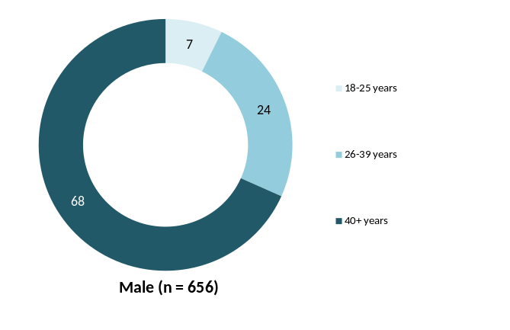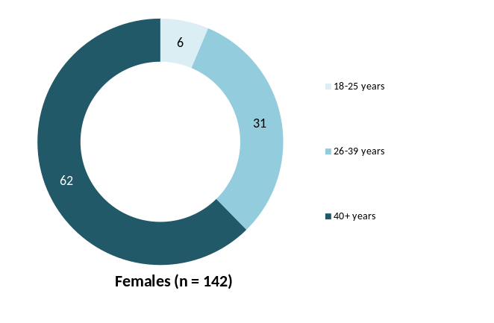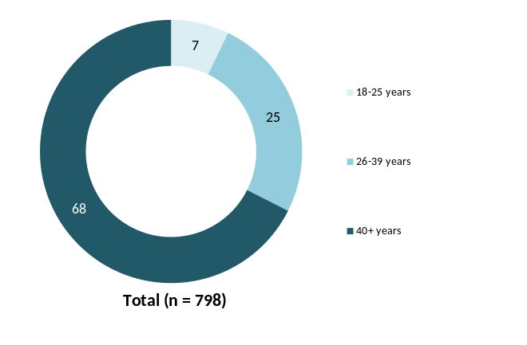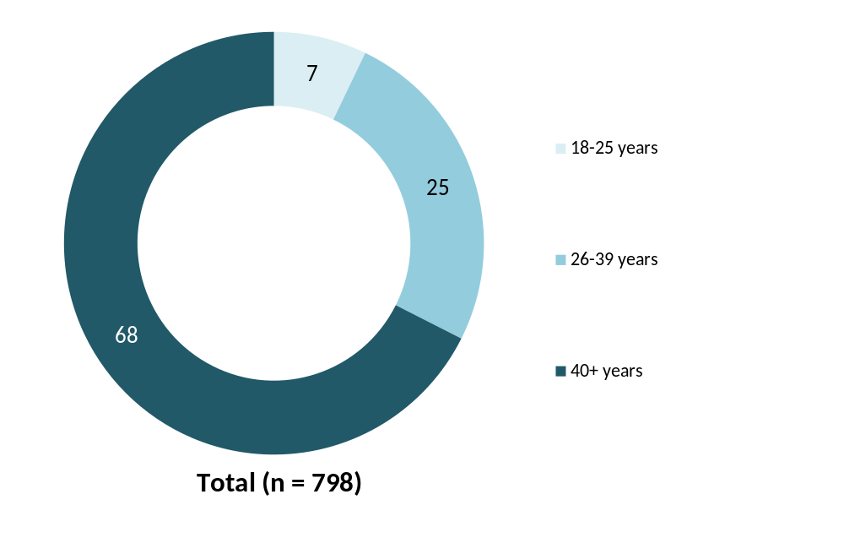
Q1 Age
Q2 Gender
Weighted sample; Base n = 798
Note: Figure based on reported age at time of survey and excludes those who did not provide an age

Reading this report
With the exception of the demographics in the appendix, the research results presented in this report are weighted to be representative of the whole motorcycle riding population rather than just those who completed the survey.
The historical data has been included in this report for illustrative purposes however, results are only statistically different where stated. Note that most questions in the hardcopy questionnaire were addressed to those who had ridden in the last 12 months. Where questions were asked of different rider groups between completion methods in 2015, the results in this report cover respondents common across all completion methods.
Tests of significance were conducted between key rider characteristics such as age, gender, riding purpose and ownership characteristics. These were conducted at the 95% level of confidence and are reported where appropriate.
A sample of n=800 enables us to be 95% confident that, at the overall level, a feature of the Victorian motorcycle rider population we are testing is within a range of ±3.5% of what the survey tells us. For example, this means that if we find that 50% of respondents said they had ridden a motorcycle in the last 12 months, we can be 95% confident that between 46.5% and 53.5% of the population represented by the sample actually did this.
A ‘significant difference’ means we can be 95% confident the difference observed between the two samples reflects a true difference in the population of interest, and is not a result of chance. Such descriptions are not value judgements on the importance of the difference. The reader is encouraged to make a judgement as to whether the differences are ‘meaningful’ or not.
Where significance testing has occurred between pairs such as male vs. female riders this has been undertaken as an independent samples tests. However, where significance testing has occurred between more than two categories within a group e.g. main motorcycle type ridden (road bike, off-road bike; and scooter), the significance testing used tests one category against the average of the others that are not in that category combined. Such a test is ideal for multiple comparisons as it reduces the likelihood of displaying a significant difference where one does not exist.
Statistically significant differences within tables are displayed by green (9↑) and red figures/arrows (2↓). Green figures indicate the figure reported is statistically higher; red indicate the figure is statistically lower.
Note that figures may not add up to 100% due to rounding or questions where multiple responses were allowed.

Research findings

Learning to ride
The average age that respondents started riding was reported to be 18.2 years, consistent with results from previous surveys. Male respondents were more likely than females to start riding at a younger age (17.6 years compared to 23.3 years) as were those who rode recreationally off-road (12.8 years old) and those from regional Victoria (17.3). One in four (27%) active riders started riding before the age of 11.
Nine in ten (89%) respondents held a full motorcycle licence with 7% holding either a learners or probationary licence. The average age that respondents first got their full or probationary licence was at 24.8 years. Consistent with 2014, one quarter (25%) of respondents with L or P licences reported that they learnt to ride and applied for their licence at the same time, 34% reported a gap of one to five years between learning and applying and 38% reported a gap of six years or more.
Nearly half (48%) of the respondents were self-taught, with males, those aged over 40 and those living outside of Melbourne being significantly more likely to say so. Just over half (52%) of respondents said that they learnt to ride on private property, with one-third (33%) saying they did a learners’ course. Respondents riding experience prior to getting their learner licence was fairly spread out, with 42% saying they were experienced, 31% reporting minimal experience and 27% with moderate experience.
Fifty-four (54%) of respondents learnt to ride on an off-road bike, and just over one-third (36%) reported learning on a road bike.

Age respondents started riding a motorcycle
The average age respondents started riding a motorcycle was 18.2 years, consistent with results found in 2014 (18.8 years). Respondents were most likely to have learnt to ride between the ages of 11-17 years (32%); however this was significantly lower than last year (39% in 2014). A further 31% reported learning to ride between the ages of 18-25 years, significantly higher than the previous year’s result of 24%.
On average women started riding a motorcycle at an older age compared to males (23.3 years vs. 17.6 years). Over one-third (35%) of males reported that they started riding between the ages of 11-17 (compared to 17% of women). Just over one-fifth of male respondents said that they had started riding before turning 11 years old (22% vs. 16% of women).
Residents of regional Victoria were more likely than their metropolitan counterparts to say that they had started riding a motorcycle before the age of 11 (27% compared to 17%) (See Figure 2).
Figure 2: Distribution and average age respondents started riding a motorcycle by selected rider characteristics – 2015
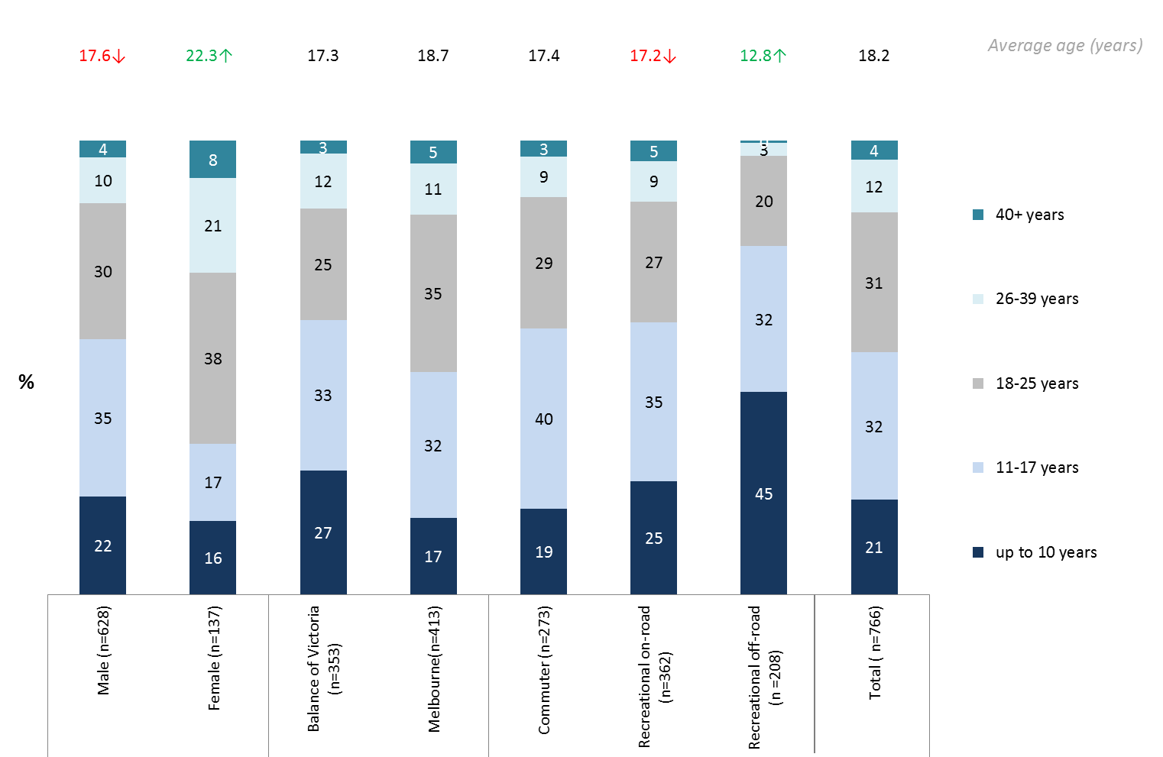
Q11. At what age did you start riding a motorcycle?
Total sample; Weighted sample; total n =766
↓↑ indicates statistically significant difference compared to respondents not in that category
Note: Excludes those who had never ridden a motorcycle
Riders who mainly rode recreationally off-road were more likely have started riding a motorcycle at a younger age, (average of 12.8 years old vs. 17.2 years for on-road riders and 17.4 for commuters). Close to half (45%) of recreational off-road riders reported that they started to ride before the age of 11 (compared to 19% of commuters).
Respondents in the ‘active riders’ segment were more likely to say that they had started to ride under the age of 11, with 27% of them reporting this in comparison to only 6% of former riders and 15% of lapsed riders suggesting that starting at a younger age is linked to longevity.

Motorcycle licence status
Approximately 402,678 Victorians held a motorcycle licence or registration (based on VicRoads database of motorcycle licence holders extracted in May 2015). Consistent with previous years, the majority of respondents in 2015 held a full motorcycle licence (89%). A probationary licence was held by 4% and a learner’s by 3%. Five percent (5%) of respondents indicated they no longer had or had never held a licence (higher than in 2014 at 2%).
Figure 3: Motorcycle licence status - (2012-2015)
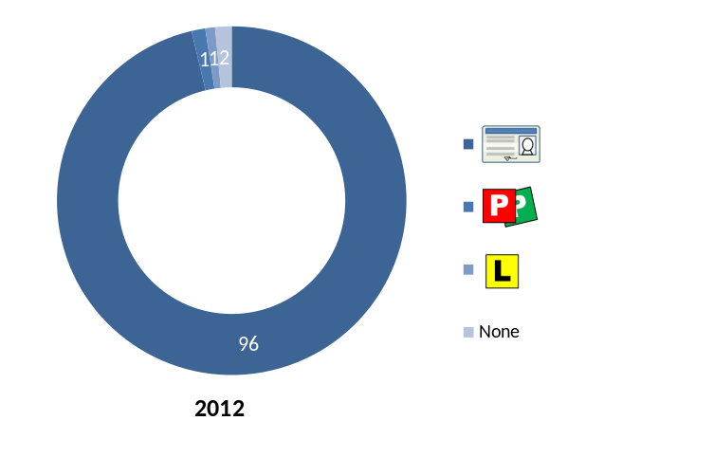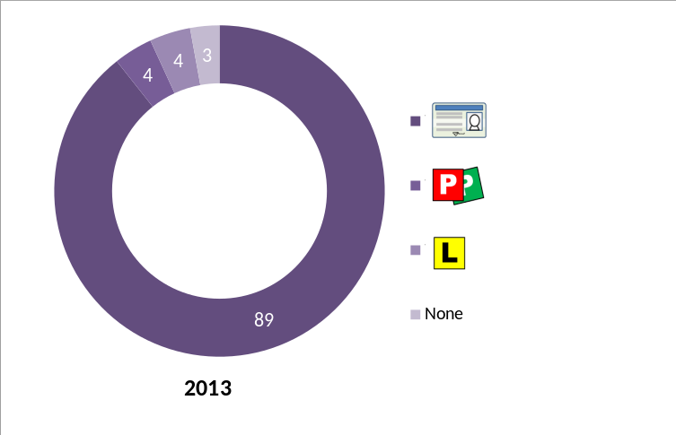
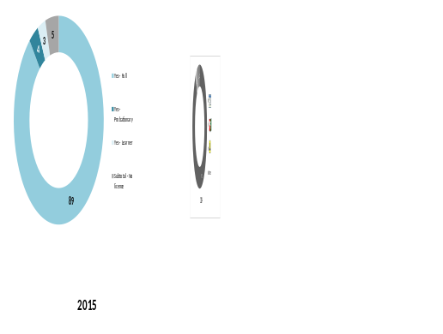
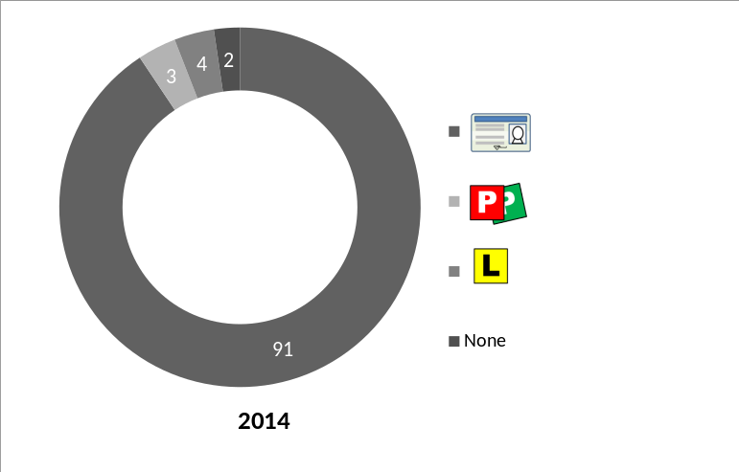
2014 2015
Q4. Do you have a motorcycle licence?
Total sample; Weighted sample; 2012 base n = 548, 2013 base n=703; 2014 base n = 781, 2015 base n = 799
As expected, Figure 4 shows learner’s and probationary licences were more likely to be held by those aged 18-25 compared to older age groups, with 21% holding a learner’s permit and 22% holding a probationary licence
Figure 4: Motorcycle licence status by age – 2015
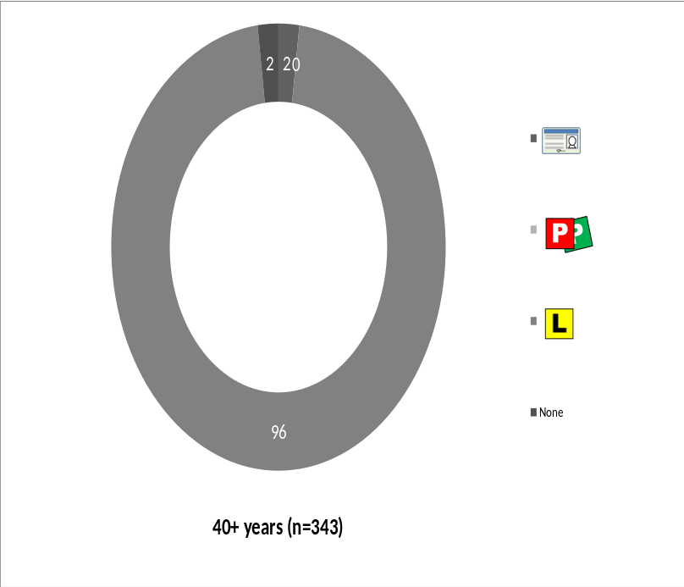

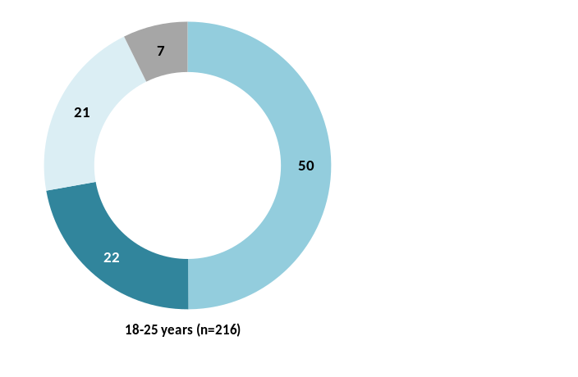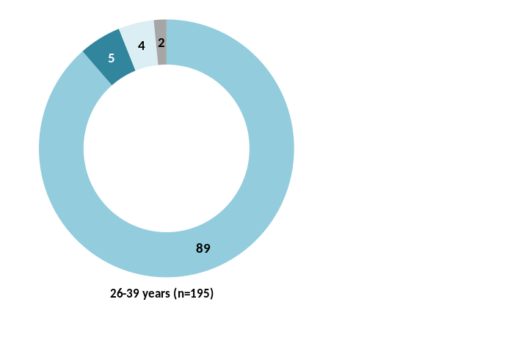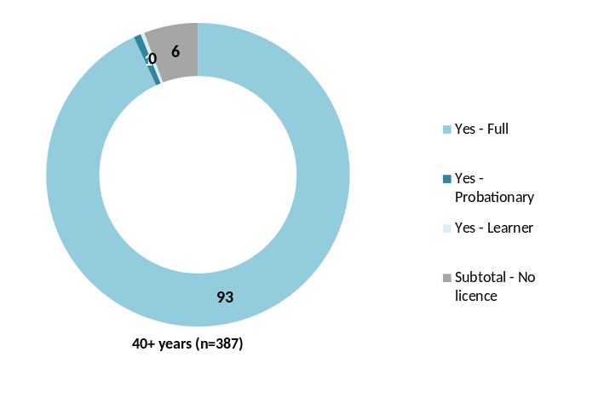
Q4. Do you have a motorcycle licence?
Total sample; Weighted sample; base n=799

Age motorcyclists applied for their licence

Full licence holders
In 2015, the average age for full or probationary licence holders to first get their licence was at 24.8 years, consistent with previous years (25.0 years in 2014).
Figure 5: Age full/probationary licence holders got their licence (2012-2015)
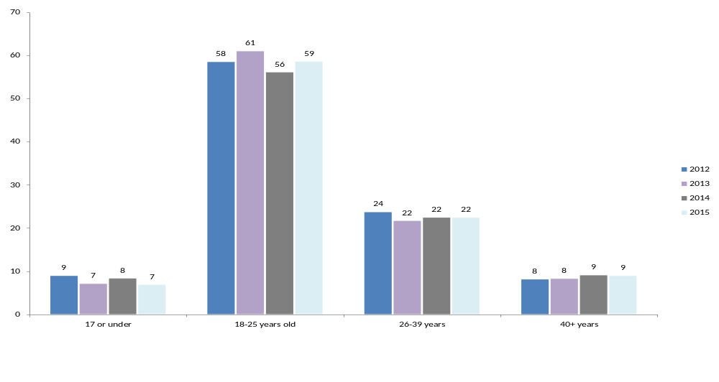
%
Q5. How old were you when you got your motorcycle licence?
Filter: Full and probationary licence only; Weighted sample; 2012 base n = 501, 2013 base n=555, 2014 base n = 692, 2015 base n = 722
Fifteen percent (15%) of the respondents said that they had applied for their licence in the last 5 years. One quarter (25%) had applied between 2000 and 2009. Approximately one in five had applied in each of the two decades prior and a further 25% prior to 1980 (See Figure 6).
Figure 6: Year applied for licence (Full and probationary licence holders) - 2015
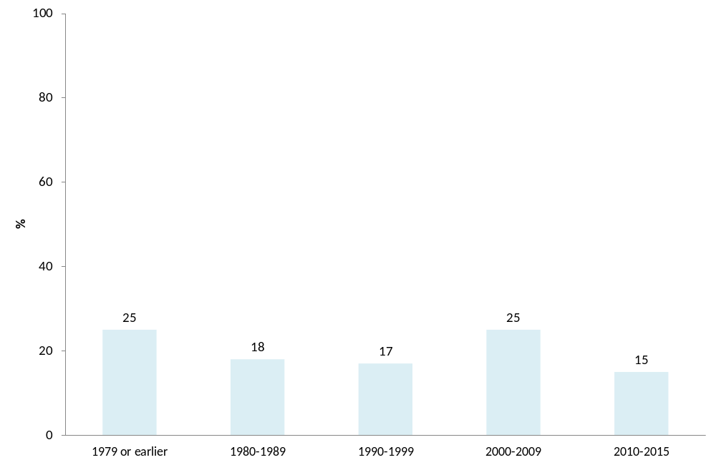
Q5. How old were you when you got your motorcycle licence?
Q1. Age
Filter: Full and probationary licence only; Weighted sample; base n=630 (excluding don’t know and respondent error)
For full or probationary licence holders, a quarter (25%) reported that there was no gap between them first learning to ride and eventually applying for their licence. Just over one-third (34%) learnt to ride one to five years after getting their licence and 39% did so six years or more after learning to ride. Similar results were observed for 2014 although in 2013, there was a higher proportion who had received their licence within 1-5 years of learning to ride.

Learner licence holders
Respondents with learner licences reported that the average age they applied for their licence was 26.3 years old (no significant change from what was reported last year with an average of 32.1 years old). Nearly two-thirds (61%) of this cohort got their learner’s licence between the ages of 18-25 including 2% who said they had gotten their licence before they were 18 years old. Less than a third (30%) were between the ages of 26-39 and 8% were 40 years or older when they got their learners. Compared to previous years, there has been a noticeable change in the number of older learners (25% in 2014 down to 8% in 2015).
While the sample size for learner riders who mainly rode scooters was small (n=25), this group of learners were most likely to have gotten their L plates at 40 years of age or older (58%).
Figure 7: Age first got learners motorcycle licence (Learners only) (2012 – 2015)
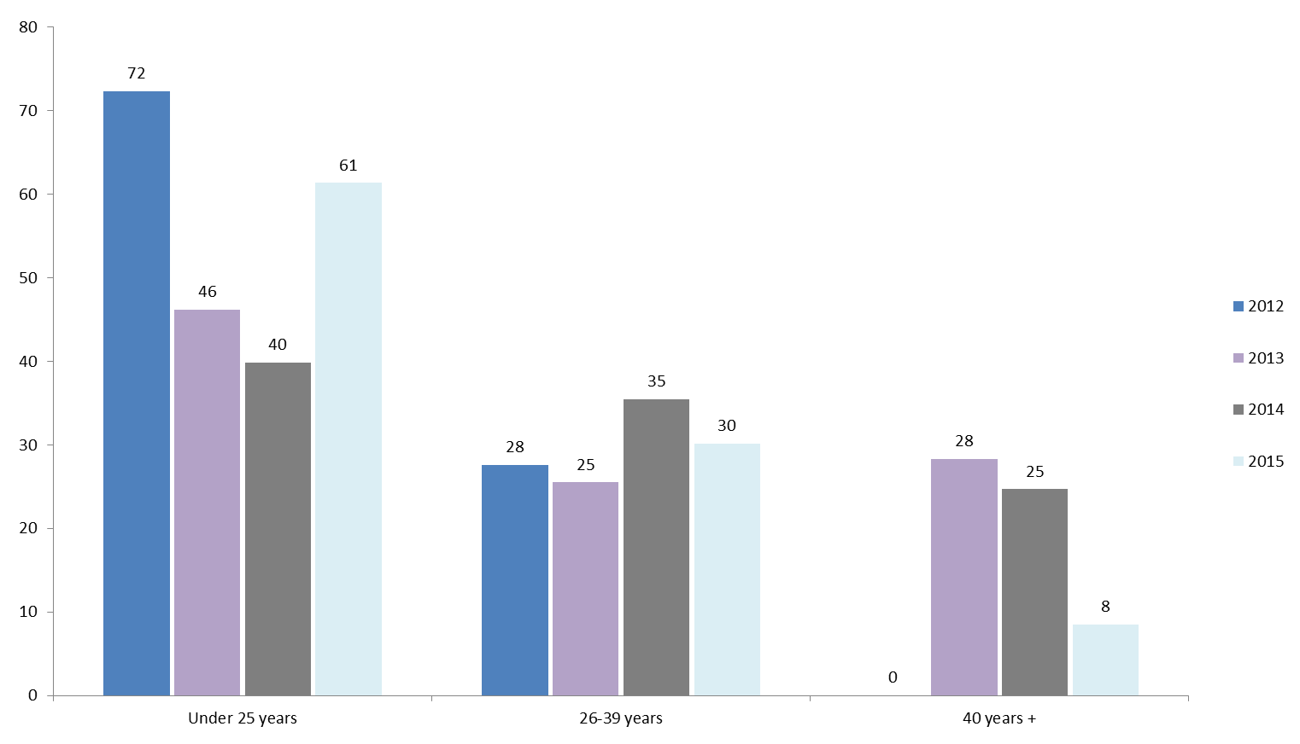
Q6. How old were you when you got your learners licence?
Filter: Learner licence only; Weighted sample; 2012 base n = 22, 2013 base n=117, 2014 base n = 79, 2015 n = 83
Forty three percent (43%) of respondents with learner permits had no gap between learning to ride and getting their Ls. Half (49%) of respondents got their learner’s six or more years after they had first learnt to ride. For a further 5%, there had been a gap of one to five years between learning to ride and applying for their licence (See Figure 8). There were no differences compared to 2014.
Figure 8: Gap between learning to ride and gaining learners licence (Learners only) - 2015
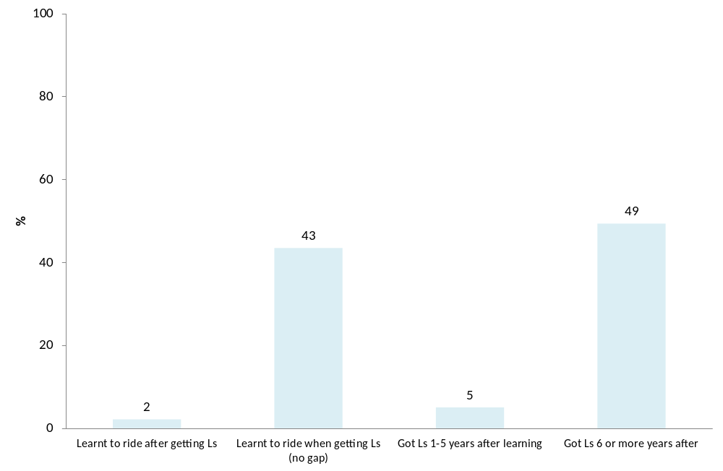
Q6. How old were you when you got your learners licence?
Filter: Learners only; Weighted sample; base n=83
Learners who reported mainly riding a road bike were significantly more likely to report that they did not have a gap between learning to ride and getting their licence (48% compared to 5% of off-road bike riders and 40% of scooter riders). Male riders were more likely than females to report having a gap of one year or more between learning to ride and getting their licence (55% vs. 27% of females).

Who taught motorcyclists to ride
Consistent with previous years, motorcyclists were most likely to report that they had taught themselves how to ride (48%). Just over a quarter (27%) said that they were taught by an accredited riding instructor and just under one-fifth (18%) were taught by their parents (See Figure 9).
Figure 9: Who taught motorcyclists to ride - 2015
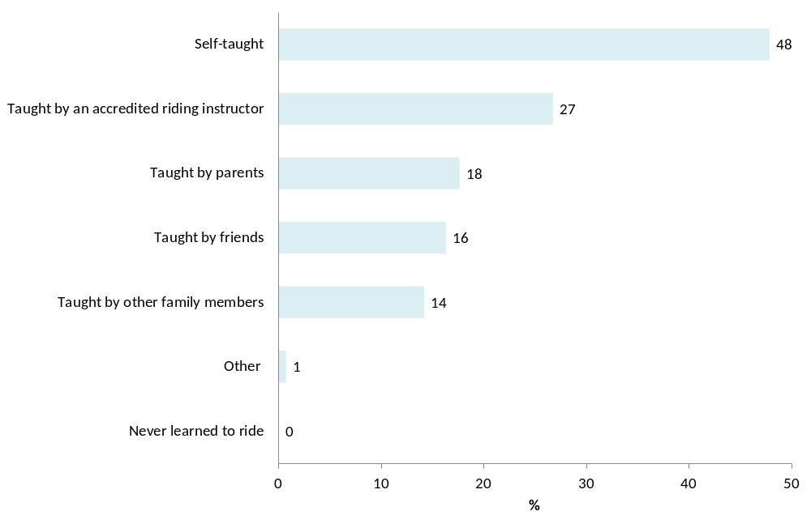
Q11b. Who taught you to ride a motorcycle?
Weighted; base n= 789
Results in 2015 found that riders were significantly more likely to say they were self-taught if they were males (51% vs. 28% of females); aged over 40 years (57% vs. 28% for 18-39 year-olds); or living outside of the capital city (55% vs. 44% of those living in Melbourne).
On the other hand, females (39% vs. 25%); those aged between 26-39 (48% vs. 29% of those aged under 26 and 19% of those aged 40 and over); and those from Melbourne (32% vs. 18% of those from regional Victoria) were more likely to report being taught by an accredited riding instructor.
Active riders were more likely to have been taught by their parents (21% vs. 10% of former riders and 15% of lapsed riders), as were recreational off-road riders (33% compared to 17% of recreational on-road riders and 18% of commuters) (See Table 3). Both groups reported learning to ride at a younger age than other rider groups.
Table 3: Who taught motorcyclists to ride by demographic characteristics – 2015
Column % | Gender |  | Age |  |  | Location |  | Total (n=789)
Column % | Male (n=648) | Female (n=140) | 18-25 (n=212) | 26-39 (n=191) | 40+ (n=385) | Balance of Victoria (n=364) | Melbourne (n=425) | Total (n=789)
Self-taught | 51↑ | 28↓ | 28↓ | 28↓ | 57↑ | 55↑ | 44↓ | 48
Taught by an accredited riding instructor | 25↓ | 39↑ | 29 | 48↑ | 19↓ | 18↓ | 32↑ | 27
Taught by parents | 18 | 16 | 46↑ | 22 | 13↓ | 22↑ | 15↓ | 18
Taught by friends | 16 | 17 | 16 | 14 | 17 | 17 | 16 | 16
Taught by other family members | 13↓ | 24↑ | 14 | 18 | 13 | 14 | 14 | 14
Never learned to ride | 0 | 0 | 0 | 0 | 0 | 0 | 0 | 0
Other | 1 | 1 | 1 | 0 | 1 | 2↑ | 0↓ | 1
Q11B. Who taught you to ride a motorcycle?
Total sample; Weighted sample; Base n = 789
↓↑ indicates statistically significant difference compared to respondents not in that category
As shown in Table 4, respondents who learnt to ride at a young age (10 years or younger) were significantly more likely to say that they had been taught by their parents (54%) or by other family members (26%) compared to those who learnt when they were older. Being self-taught was most likely to be reported by those who learnt between the ages of 11-17 (60%).
Respondents who learnt over the age of 18 were more likely to say they were taught by an accredited riding instructor (41% for 18-25 years, 58% for 26-39 years and 48% for 40+ years).
These results suggest that exposure to riding at a younger age, as well as family connection can be factors for riders continuing to ride as adults.
Table 4: Who taught motorcyclists to ride by age learnt to ride – 2015
% | Up to 10 years  (n=187) | 11-17 years  (n=218) | 18-25 years  (n=253) | 26-39 years  (n=78) | 40+ years  (n=29) | Total  (n=765)
Self-taught | 31↓ | 60↑ | 49 | 36 | 40 | 47
Taught by an accredited riding instructor | 6↓ | 14↓ | 41↑ | 58↑ | 48↑ | 27
Taught by parents | 54↑ | 14 | 7↓ | 3↓ | 0↓ | 18
Taught by friends | 12 | 28↑ | 13 | 8 | 8 | 17
Taught by other family members | 26↑ | 12 | 12 | 12 | 8 | 15
Other | 0 | 1 | 1 | 1 | 3 | 1
Q11B. Who taught you to ride a motorcycle?
Total sample; Weighted sample; Base n = 765
↓↑ indicates statistically significant difference compared to respondents not in that category

Locations motorcyclists learnt to ride
Similar to results from 2014, the majority of respondents in 2015 learnt to ride by riding off-road on private property (52%). One-third (33%) of respondents took a learners’ course (such as Stay Upright). Just under one-fifth (19%) learnt on quiet back streets (See Figure 10).
Figure 10: Where leant to ride - 2015
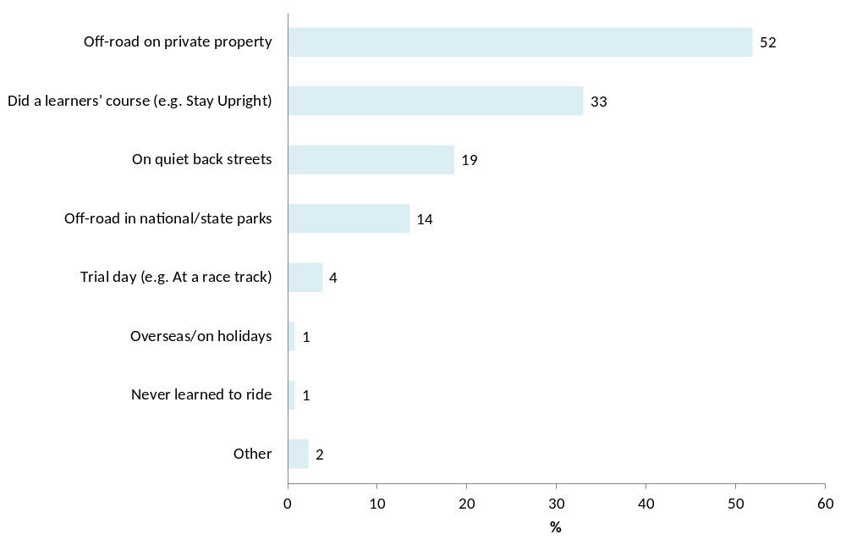
Q11C. Where did you learn to ride?
Total sample; Weighted sample; Base n = 790

As shown in Table 5, male riders were significantly more likely to say they learnt off-road on private property (54% vs. 40% of females). However, females were more likely than males to do a learners’ course (47% vs. 31%).
Older respondents (aged 40 years and over) were more likely to say that they learnt to ride on quiet back streets (23%) and off-road in national or state parks (16%) compared to younger riders. Regional Victorians were more likely to report that they learnt to ride off-road on private property (65% vs. 44% of those from Melbourne) and less likely to report doing a learners’ course (21% vs. 40%).
As expected, active riders (who were more likely to have learnt to ride at a younger age), were significantly more likely to have learnt riding off-road on private property (57%) compared to 44% of former riders and 47% of lapsed riders.
Table 5: Locations learnt to ride - by selected demographic variables - 2015
Column % | Gender |  | Age |  |  | Location
Column % | Male  (n=649) | Female  (n=140) | 18-25  (n=214) | 26-39  (n=191) | 40+  (n=385) | Balance of Victoria  (n=365) | Melbourne  (n=425)
Off-road on private property | 54↑ | 40↓ | 60 | 48 | 53 | 65↑ | 44↓
Did a learners' course (e.g. Stay Upright) | 31↓ | 47↑ | 39 | 54↑ | 25↓ | 21↓ | 40↑
On quiet back streets | 18 | 25 | 12↓ | 9↓ | 23↑ | 19 | 19
Off-road in national/state parks | 14 | 9 | 14 | 8↓ | 16↑ | 13 | 14
Trial day (e.g. At a race track) | 4 | 4 | 4 | 4 | 4 | 5 | 4
Overseas/on holidays | 1 | 2 | 0 | 0 | 1↑ | 1 | 1
Other | 2 | 2 | 1↓ | 0↓ | 3↑ | 3 | 2
Q11C.Where did you learn to ride?
Multiple responses accepted
Total sample; Weighted sample; Base n =790
↓↑ indicates statistically significant difference compared to respondents not in that category

Those who reported being taught by parents (84%), friends (69%) or other family members (73%) were significantly more likely to have learnt to ride off-road on private property compared to those who were self-taught or taught by an accredited instructor. Nearly a quarter (23%) of those who had taught themselves how to ride had done so on quiet back streets and 17% off-road in national/state parks.
Table 6: Where did you learn to ride by who taught respondents to ride – 2015
Column % | Self-taught (n=340) | Taught by an accredited riding instructor  (n=222) | Taught by parents (n=193) | Taught by friends (n=143) | Taught by other family members (n=116)
Off-road on private property | 55 | 22↓ | 84↑ | 69↑ | 73↑
Did a learners' course (e.g. Stay Upright) | 25↓ | 87↑ | 13↓ | 32 | 17↓
On quiet back streets | 23↑ | 13↓ | 11↓ | 21 | 17
Off-road in national/state parks | 17↑ | 6↓ | 16 | 30↑ | 6↓
Trial day (e.g. At a race track) | 4 | 7↑ | 7 | 2 | 4
Overseas/on holidays | 0 | 3↑ | 2 | 3↑ | 0
Other | 3 | 4 | 0↓ | 1 | 1
Q11C.Where did you learn to ride?
Q11B. Who taught you to ride a motorcycle?
Total sample; Weighted sample; Base n =789
Multiple responses accepted
↓↑ indicates statistically significant difference compared to respondents not in that category
The majority (81%) of respondents who reported that they had learnt to ride before the age of 11 had done so off-road on private property, as did nearly three-quarters (71%) of those who had learnt between the ages of 11-17 years old. Those who had learnt to ride over the age of 18, were more likely to say that they had undertaken a learner’s course (47% of those aged 18-25, 58% of 26-39 year-olds and 80% of those aged 40+).
Table 7: Where did you learn to ride by age learnt to ride – 2015
Column % | Up to 10 years (n=189) | 11-17 years (n=224) | 18-25 years (n=263) | 26-39 years (n=82) | 40+ years (n=32) | Total  (n=790)
Off-road on private property | 81↑ | 71↑ | 30↓ | 22↓ | 19↓ | 52
Did a learners' course (e.g. Stay Upright) | 13↓ | 17↓ | 47↑ | 58↑ | 80↑ | 33
On quiet back streets | 5↓ | 16 | 25↑ | 32↑ | 23 | 19
Off-road in national/state parks | 17 | 18↑ | 10 | 8 | 10 | 14
Trial day (e.g. At a race track) | 7 | 4 | 1↓ | 5 | 7 | 4
Overseas/on holidays | 0 | 1 | 1 | 0 | 0 | 1
Never learned to ride | 0 | 1 | 2 | 0 | 0 | 1
Other | 1↓ | 1 | 4↑ | 4 | 1 | 2
Q11C.Where did you learn to ride?
Total sample; Weighted sample; Base n =790
Multiple responses accepted
↓↑ indicates statistically significant difference compared to respondents not in that category

Riding experience prior to gaining learner licence
When describing their riding experience prior to obtaining their learner permits, just over two in five riders (42%) said that considered themselves to be ‘experienced’ riders (i.e. they were a capable rider when they attained their Ls). This was followed by one in three (31%) who indicated that they had ‘minimal’ experience (i.e. had never ridden or only ridden a few times before getting Ls). Just over a quarter (27%) had moderate experience (were a capable rider when getting their permit).
Figure 11: Riding experience prior to gaining a learner's permit - 2015
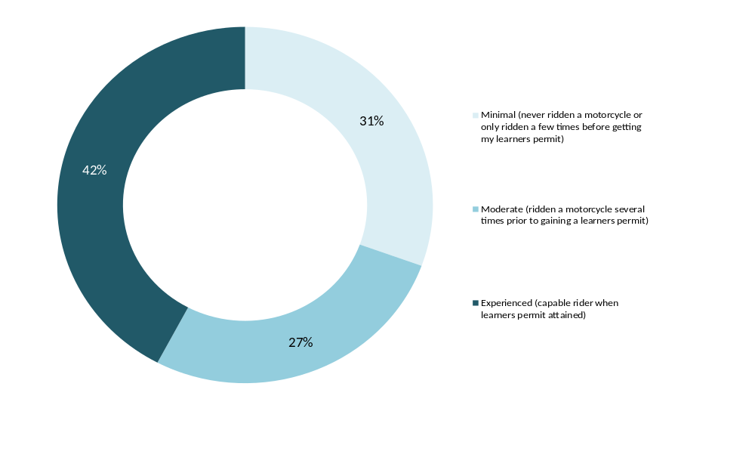
Q11D. How would you describe your riding experience prior to gaining your motorcycle learner’s permit?
Total sample; Weighted sample; Base n =780
Excludes those who never learnt to ride
As shown in Table 8 and Table 9, characteristics of those who reported having minimal riding experience prior to getting their learner permits included:
- female riders (60% compared to 26% of males);
- those residing in Melbourne (35% vs. 24% of those living in regional Victoria);
- lapsed riders (38% compared to 25% of active riders); and
- commuters (30% compared to 9% of recreational off-road riders).
Table 8: Riding experience prior to gaining a learner's permit gender and location - 2015
Column % | Gender |  | Location
Column % | Male  (n=640) | Female  (n=139) | Balance of Victoria (n=358) | Melbourne (n=422)
Minimal experience (never ridden a motorcycle or only ridden a few times before getting learners permit) | 26↓ | 60↑ | 24↓ | 35↑
Moderate experience (ridden a motorcycle several times prior to gaining learners permit) | 27 | 27 | 27 | 27
Experienced (capable rider when learners permit attained) | 47↑ | 13↓ | 49↑ | 38↓
Q11D. How would you describe your riding experience prior to gaining your motorcycle learner’s permit?
Total sample; Weighted sample; Base n =780
Excludes those who never learnt to ride
↓↑ indicates statistically significant difference compared to respondents not in that category

Table 9: Riding experience prior to gaining a learner's permit by rider type - 2015
Column % | Riding activity segments |  |  | Riding purpose (Active riders)
Column % | Active riders (n=485) | Lapsed riders (n=242) | Former riders (n=51) | Commuter (n=274) | Rec. on-road rider (n=361) | Rec. off-road rider (n=210)
Minimal experience (never ridden a motorcycle or only ridden a few times before getting learners permit) | 25↓ | 38↑ | 36 | 30↑ | 27↑ | 9↓
Moderate experience (ridden a motorcycle several times prior to gaining learners permit) | 23↓ | 31 | 35 | 24 | 23 | 17↓
Experienced (capable rider when learners permit attained) | 52↑ | 30↓ | 30 | 46↓ | 49↓ | 74↑
Q11D. How would you describe your riding experience prior to gaining your motorcycle learner’s permit?
Total sample; Weighted sample; Base n =778
Excludes those who never learnt to ride
↓↑ indicates statistically significant difference compared to respondents not in that category
Consistent with the results above, looking at the type of bike mainly ridden by respondents, road bike riders were significantly more likely have minimal riding experience prior to getting their permit (32% vs. 12% of off-road/trail bike riders) (See Table 10).
Table 10: Riding experience prior to gaining a learner's permit by type of bike - 2015
Column % | Type of bike (main bike)
Column % | Off road bike/  trail bike  (n=145) | Road bike  (n=310) | Scooter  (n=35)*
Minimal experience (never ridden a motorcycle or only ridden a few times before getting learners permit) | 12↓ | 32↑ | 32
Moderate experience (ridden a motorcycle several times prior to gaining learners permit) | 28 | 22 | 35
Experienced (capable rider when learners permit attained) | 60↑ | 43 | 33↓
Q11D. How would you describe your riding experience prior to gaining your motorcycle learner’s permit?
Active riders only; Weighted sample; Base n =509
Excludes those who never learnt to ride
↓↑ indicates statistically significant difference compared to respondents not in that category
*Note small sample sizes
As expected, those who had learnt to ride at a younger age were more likely to say that they were experienced riders when they gained their learners’ permit (79% of those who learnt at the age of 10 years or younger and 52% of those who learnt between the ages of 11-17). In contrast, those who learnt to ride over the age of 18, were more likely to say that they had minimal experience prior to getting their licence (46% of those aged 18-25, 71% of those between 26-39 and 57% of those who learnt 40 years old or older) (See Table 11).
Table 11: Riding experience prior to gaining a learner's permit by age learnt to ride – 2015
Column % | Up to 10 years old (n=189) | 11-17  years old (n=220) | 18-25  years old (n=257) | 26-39 years (n=82) | 40+ years (n=32)
Minimal (never ridden a motorcycle or only ridden a few times before getting my learners permit) | 5↓ | 13↓ | 46↑ | 71↑ | 57↑
Moderate (ridden a motorcycle several times prior to gaining a learners permit) | 17↓ | 35↑ | 28 | 17↓ | 40↓
Experienced (capable rider when learners permit attained) | 79↑ | 52↑ | 25↓ | 12↓ | 3↓
Q11D. How would you describe your riding experience prior to gaining your motorcycle learner’s permit?
Q11. At what age did you start riding a motorcycle?
Total sample; Weighted sample; Base n =780
Excludes those who never learnt to ride
↓↑ indicates statistically significant difference compared to respondents not in that category

Type of bikes motorcyclists learnt to ride on
When asked what type of motorcycle they had first learnt to ride on, over half (54%) of respondents learnt on an off-road bike. Over a third (36%) learnt on a road bike and a small proportion learnt on a scooter (7%). Results were similar to previous years.
Figure 12: Type of motorcycle learnt to ride on - 2015
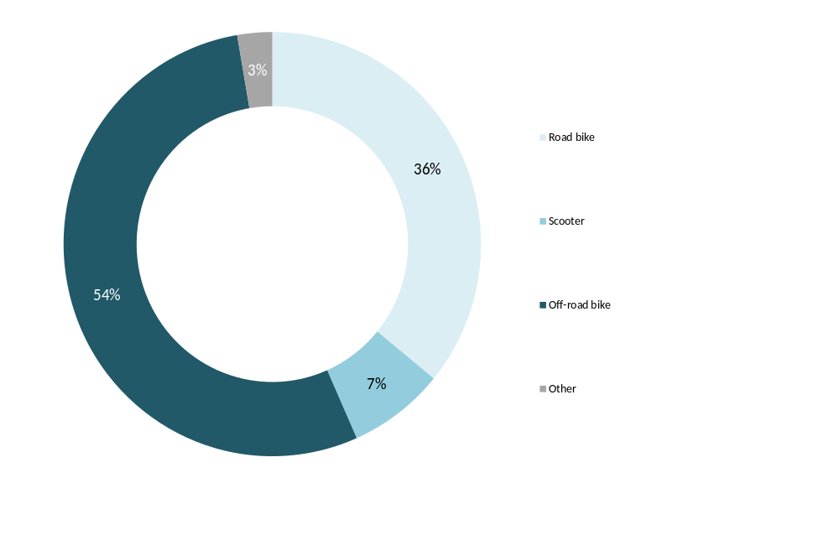

Q11E. What kind of motorcycle did you first learn to ride on?
Total sample; Weighted sample; Base n = 783
Male riders were more likely to report that they first learnt to ride on an off-road motorcycle (57% compared to 36% of females). Female riders were more likely than men to indicate that they had first learnt to ride on a scooter (19% vs. 6%). Those from regional Victoria were more likely than those from Melbourne to say that they had first learnt to ride on an off-road bike (61% vs. 50%).
Active riders were significantly more likely to report that they first learnt on an off-road bike (60% vs. 33% of former riders and 50% of lapsed riders).
Respondents who learnt to ride at a younger age (under 18) were also significantly more likely to report that they learnt on an off-road bike (87% of those who learnt at 10 years or younger and 65% between the ages on 11-17). Learning on road bikes was more likely to be reported by those who learned to ride at 18 or older (55% vs. 19% of those who learned to ride aged 17 or younger). Close to one in three (32%) of those who learnt ride when they were 18 or older learnt to do so on an off-road bike (See Table 12).
Table 12: Type of motorcycle learnt to ride on by age learnt to ride – 2015
Column % | Up to 10 years  (n=188) | 11-17 years  (n=223) | 18-25 years  (n=258) | 26-39 years  (n=82) | 40+ years  (n=32) | Total  (n=783)
Road bike | 7↓ | 27↓ | 52↑ | 65↑ | 47 | 36
Scooter | 1↓ | 5 | 12↑ | 7 | 22↑ | 7
Off-road bike | 87↑ | 65↑ | 34↓ | 27↓ | 31↓ | 54
Other | 6 | 3 | 2 | 1 | 0 | 3
Q11E. What kind of motorcycle did you first learn to ride on?
Total sample; Weighted sample; Base n =783
↓↑ indicates statistically significant difference compared to respondents not in that category (i.e. those who learnt aged 18-25 compared to those who learnt at other ages)

Rider training courses
While 27% of the respondents in 2015 said that they had been taught to ride by an accredited instructor, over half (58%) of all respondents had undertaken some sort of a rider training course (similar to 2014 at 56%). This suggests that even though most riders attend an ‘official’ riding course, this was not where they had been taught or primarily learnt to ride a bike.
One-third (33%) of the respondents specifically said they had taken a learner’s course such as Stay Upright, 16% mentioned taking a HART course and 7% mentioned a DECA course. Similar results were observed for the pervious years with the exception of learners’ courses such as Stay Upright which were mentioned by 26% of respondents in 2012 (See Table 13).
Table 13: Rider training courses attended (2012-2015)
% | 2012 | 2013 | 2014 | 2015
Subtotal - Attended any rider training course | 55 | 59 | 56 | 58
Learners’ course (e.g. Stay Upright) | 26 | 37 | 33 | 33
HART course | 19 | 14 | 17 | 16
DECA course | 7 | 7 | 5 | 7
Track day riding courses | 7 | 8 | 5 | 7
Advanced rider training | 7 | 8 | 8 | 7
Australian Superbike School | 2 | 3 | 1 | 2
Other | 3 | 3 | 3 | 3
None of the above | 45 | 41 | 44 | 42
Q13. Have you ever done any of the following motorcycle rider training courses?
Total sample; Weighted sample; 2013 - Base n = 692, 2014 - Base n=779, 2015 – Base n = 797
Multiple responses accepted
↓↑ indicates statistically significant differences between 2014 and 2015 only
As Table 14 shows, those aged under 40 were significantly more likely to report that they had attended a rider training course (71% of those aged18-25 and 82% of those aged 26-39 compared to 47% of those aged 40 or over). Residents of Melbourne were also more likely than those living in regional Victoria to say that they had undertaken a rider course (64% vs. 47%).
Table 14: Rider training courses attended by selected demographic variables - 2015
Column % | Gender |  | Age |  |  | Location |  | Total  (n=797)
Column % | Male  (n=655) | Female  (n=140) | 18-25  (n=215) | 26-39  (n=195) | 40+  (n=386) | Balance of Victoria  (n=368) | Melbourne  (n=429) | Total  (n=797)
Subtotal - Attended rider training course | 57 | 63 | 71↑ | 82↑ | 47↓ | 47↓ | 64↑ | 58
Learners’ course (e.g. Stay Upright) | 32 | 38 | 52↑ | 52↑ | 24↓ | 27 | 37↑ | 33
HART course | 16 | 17 | 13 | 24↑ | 13↓ | 5↓ | 22↑ | 16
DECA course | 7 | 9 | 5 | 6 | 8 | 7 | 7 | 7
Track day riding courses | 6 | 11 | 7 | 11 | 5 | 6 | 7 | 7
Advanced rider training | 7 | 8 | 5 | 11↑ | 6 | 5 | 8 | 7
Australian Superbike School | 2 | 2 | 0 | 4↑ | 1 | 0↓ | 3↑ | 2
Other | 3 | 3 | 2 | 4 | 3 | 5 | 2↓ | 3
None of the above | 42 | 36 | 27↓ | 17↓ | 52↑ | 53↑ | 35↓ | 42
Q13. Have you ever done any of the following motorcycle rider training courses?
Total sample; Weighted sample; Base n = 797
↓↑ indicates statistically significant difference compared to respondents not in that category
More than half (56%) of the respondents who reported that they had been in a crash had undertaken a rider training course – with no statistical difference between those who had completed a course or had not in terms of whether they had experienced a crash (59% for those who had not completed a course) (See Table 15). This was the same story for the three different age groups.
Table 15: Rider training courses attended by crash history - 2015
Column % | Crash history
Column % | Yes  (n=312) | No  (n=477)
Subtotal - Attended rider training course | 56 | 59
Learners’ course (e.g. Stay Upright) | 31 | 34
HART course | 16 | 16
DECA course | 7 | 7
Track day riding courses | 9 | 5
Advanced rider training | 10 | 5
Australian Superbike School | 3 | 1
Other | 4 | 3
None of the above | 43 | 41
Q13. Have you ever done any of the following motorcycle rider training courses? Total sample; Weighted sample; Base n = 789
↓↑ indicates statistically significant difference compared to respondents not in that category
Approximately eight in ten (83%) respondents who learnt to ride between 2010-2015 attended a training course of some sort. Courses of any sort tended to be less common for those who had attained their full licence prior to 2000 (See Figure 13).
Figure 13: Rider training courses attended by year full licence attained - 2015
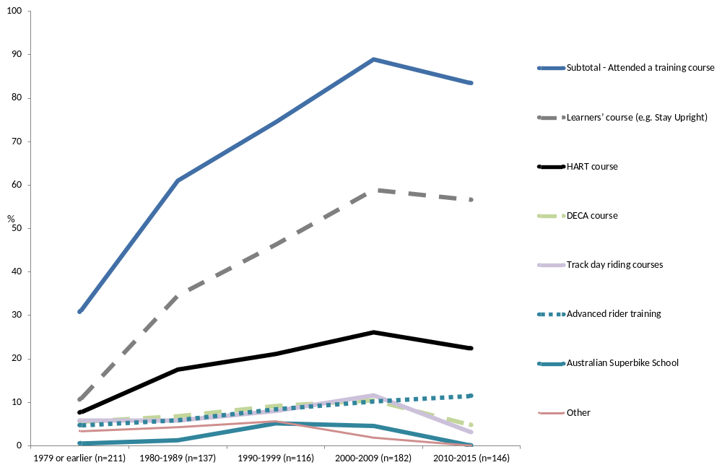Q13. Have you ever done any of the following motorcycle rider training courses? By year full licence attained
Total sample; Weighted sample; Base n = 792

Attitudes towards riding training courses after a break
When asked about opinions on people returning to riding having to take a motorcycle training course, opinions were divided. In 2015, around two-fifths (41%) of respondents agreed (somewhat or strongly) that people returning to riding after taking a break should have to undertake a motorcycle training course. A similar proportion, 40% disagreed (somewhat or strongly) with this statement. These results are unchanged from 2014. Note in 2013, when looking at riding history, there was a relatively lower proportion of those who had been on break but had returned to riding in (9% compared to 17% in 2014 and 16% in 2013).
Recreational on-road riders were significantly more likely to agree with the statement that riders returning to riding should undertake a training course (44% vs. 35% of recreational off-road riders). Those who had experienced a crash in the past were also more likely to be supportive of this notion (49% vs. 34% who had not crashed).
Full licence holders were more likely to disagree than those on their Ls or Ps (41% vs. 30%).
Figure 14: Agree/disagree: People returning to riding after a break should have to undertake a motorcycle training course (2013-2015)
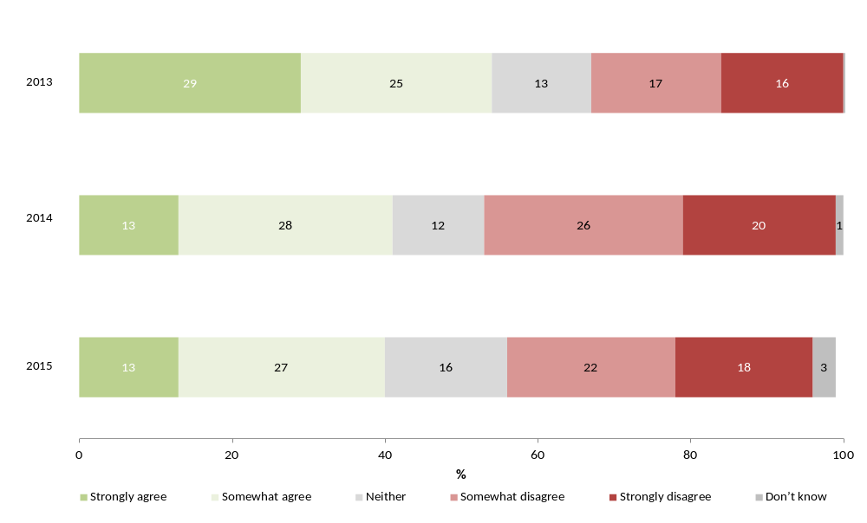
Q55h. Agree/disagree: People returning to riding after a break should have to undertake a motorcycle training course
Base: Those who have ridden in the last 12 months;
Weighted sample; 2013 Base n=491, 2014 Base n =572, 2015 base n = 592

Riding activity
Results were consistent with last year with 66% reporting they had ridden in the last year (compared to 62% in 2014). Males and younger riders aged 18-25 years were significantly more likely to say that they had ridden in the previous year (70% and 92% respectively).
There were some other significant differences found when comparing riding history with previous years. Results in 2015 saw a slight but significant increase in the proportion of respondents who reported that they had stopped riding and did not intend to ride again (9% vs. 5%). Notably, looking at the 2013 results, a higher proportion of respondents had not ridden in the previous year compared to other survey years and there also a higher proportion of respondents who said they had stopped riding but may decide to do so in the future (34% vs. 46% in 2015) and a lower proportion who had been on a break but had started again (9% vs. 16% in 2015). It is likely that these are the key drivers behind differences between 2013 and other survey years when looking at the total riding population.
Consistent with the previous year, 54% of respondents were classified as active riders and 37% were lapsed riders; however, there was an increase in the number of former riders compared to last year (9% compared to 5% in 2014). Active riders were significantly more likely to say that rode recreationally on road (79%), consistent with previous years. One in three (37%) respondents said that they rode off-road recreationally - this was significantly higher in 2013 (54%) – another feature behind the differences in survey results in 2013 compared to other years.
Over four out of ten (46%) of the respondents who had not ridden in the last 12 months or said they may resume in the future, said that there was a high chance that they would ride again. Males were more likely than females to give a higher rating of their likelihood of riding again (6.2 compared to 4.8 out of 10). Key reasons for no longer riding included no longer owning a bike; and changes to family commitments or lifestyle.
The average distance ridden on a motorbike by respondents was 341.3km per month, or 4,292.4km in a year.

Riding history

Riding activity in last 12 months
Riding activity was consistent with last year, with 66% of respondents saying that they had ridden in the last 12 months (compared to 62% in 2014). A significantly higher proportion of respondents in 2013 had not ridden in the previous year which is likely to be the cause between changes in 2013 vs. 2014 – differences which have not been observed in this wave of the research.
Figure 15: Whether ridden in last 12 months (2012-2015)

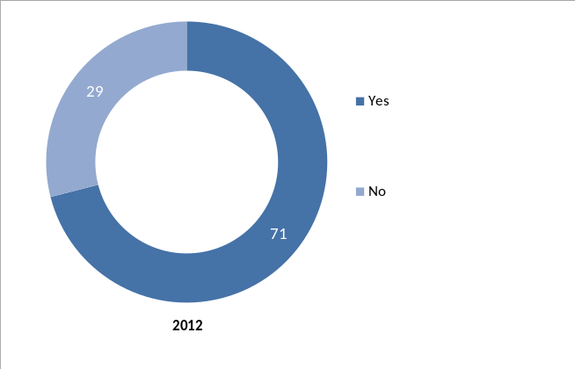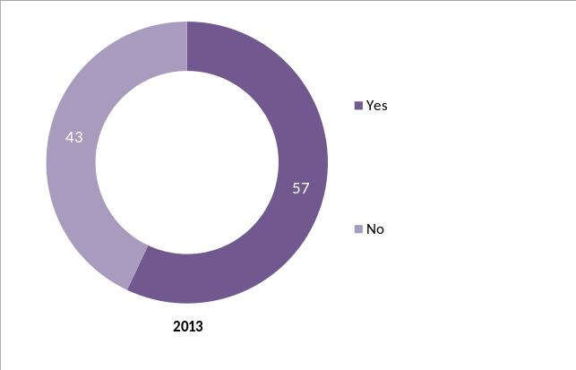
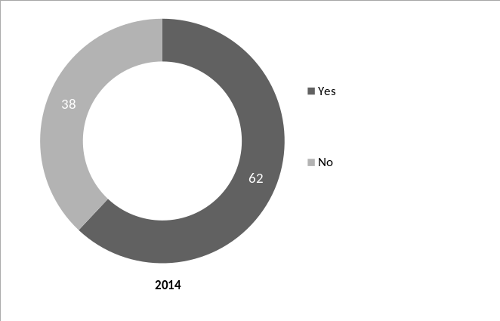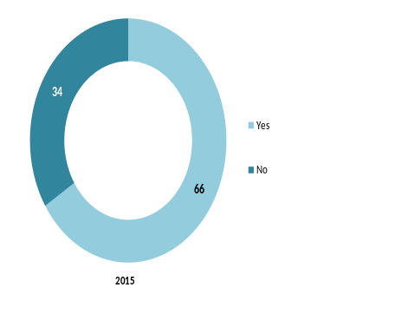
Q7 Have you ridden a motorcycle in the last 12 months (either on or off-road)?
Filter: excludes never ridden a motorcycle; Weighted sample; 2012 Base n =545; 2013 Base n = 694; 2014 base n = 777; 2015 base n = 793
As in previous years, males were more likely to say that they had ridden in the 12 months (70% vs. 41% for females).
As shown in Figure 16 below, the youngest age group, 18-25 year olds were significantly more likely to say that they had ridden in the 12 months (92% compared to 62% of those aged 40 and over). The same was found for those on their learner or probationary permits, with 94% reporting that they had ridden in the last 12 months (compared to 65% of full licence holders).
Figure 16: Whether ridden in last 12 months by selected rider groups – 2015
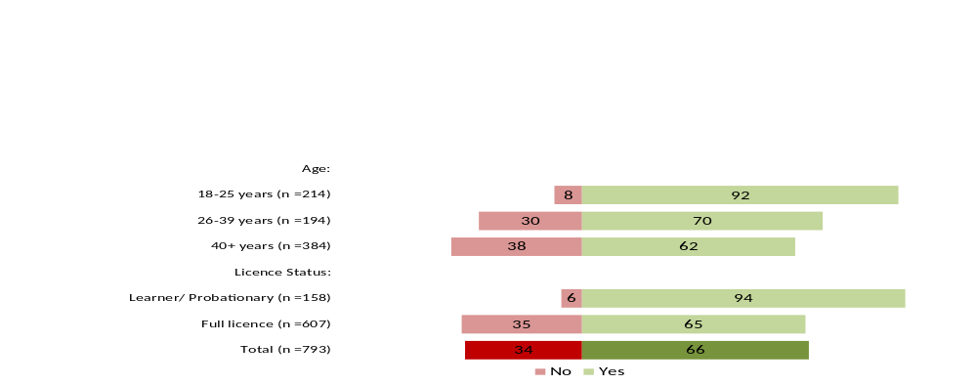
Q7 Have you ridden a motorcycle in the last 12 months (either on or off-road)?
Filter: excludes never ridden a motorcycle; Weighted sample; Base n = 793

As expected, those who owned a motorcycle were more likely to have ridden in the last 12 months (91% vs. 33% who did not own a bike). (See Figure 17)
Figure 17: Whether ridden in last 12 months by motorcycle ownership – 2015
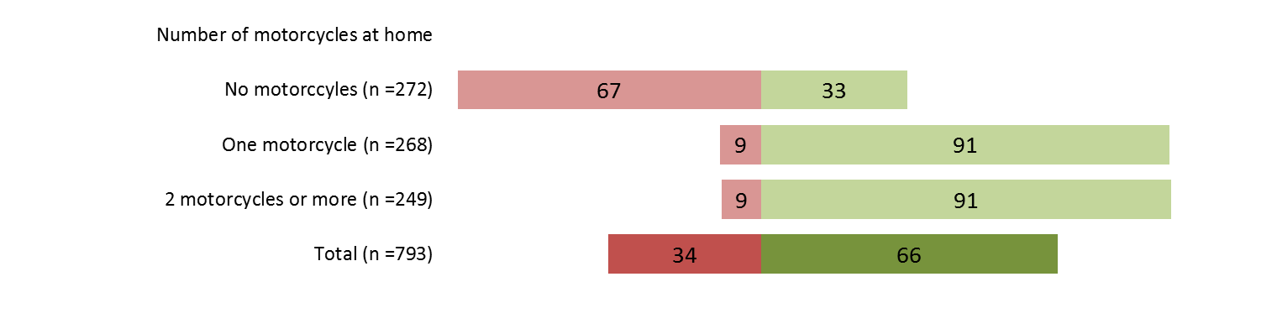
Q7 Have you ridden a motorcycle in the last 12 months (either on or off-road)?
Filter: excludes never ridden a motorcycle; Weighted sample; Base n = 793

Riding history
Similar to the results found last year, over half of the participants were regular riders, occasional riders or had started riding again after taking a break (56% vs. 58% in 2014). Specifically, just under a fifth (18%) of respondents said they had never taken a break from riding since learning to ride and ride regularly and 22% reported that they had never had a break from riding since learning but only ride occasionally.
Compared to 2014 results, there was a slight but significant increase this year in the number of people who said that they had stopped riding and do not intend to ride again (9% vs. 5% in 2014).
Some of the characteristics that make 2013 different to other survey years include a notably higher proportion of the sample who had stopped riding but may decide to do so in the future (46% in 2013 vs. 34% in 2015) and fewer who said they had been on a break but had started again (9% in 2013 vs. 16% in 2015) (See Figure 18).
Figure 18: Riding history (2012-2015)
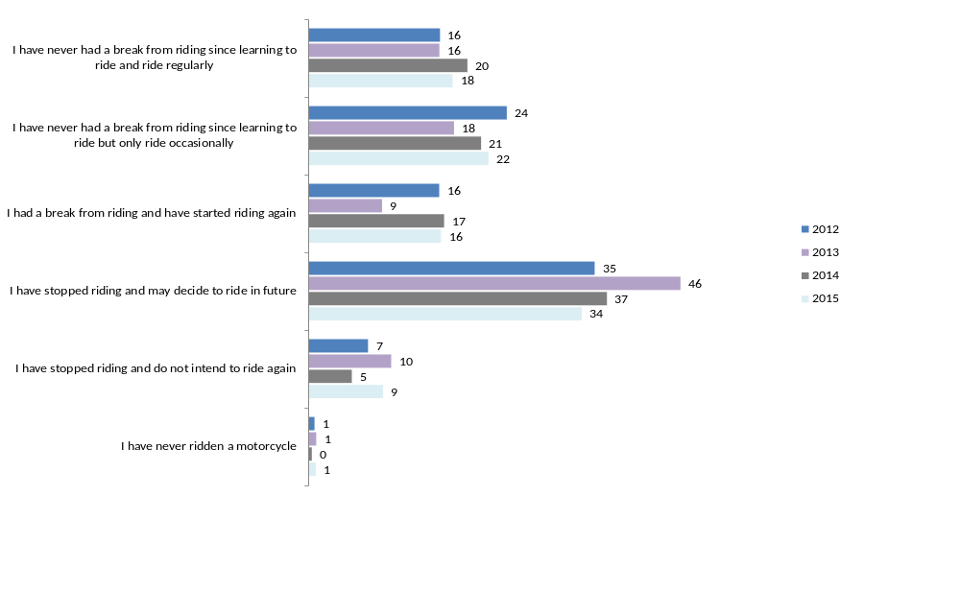
Q10. Which of the following best describes your motorbike riding history?
Total sample; Weighted; Base 2012 n = 545; 2013 n=692; 2014 base n = 776; 2015 base n = 798

Break from riding
For those who had taken a break from riding and had started riding again, half (50%) had said that their break was six years or longer. One in five (18%) reported a break of 3-5 years. A similar proportion reported that the break was under a year (18%) (See Figure 19).
While the proportion of riders who had started again after a break was smaller in 2013 compared to 2015 (See Figure 18), in 2013, there was a notably smaller proportion whose break had been three or more years long (69% in 2015 and 70% in 2014 vs. 47% in 2013).
Figure 19: Duration of most recent break from riding – 2015
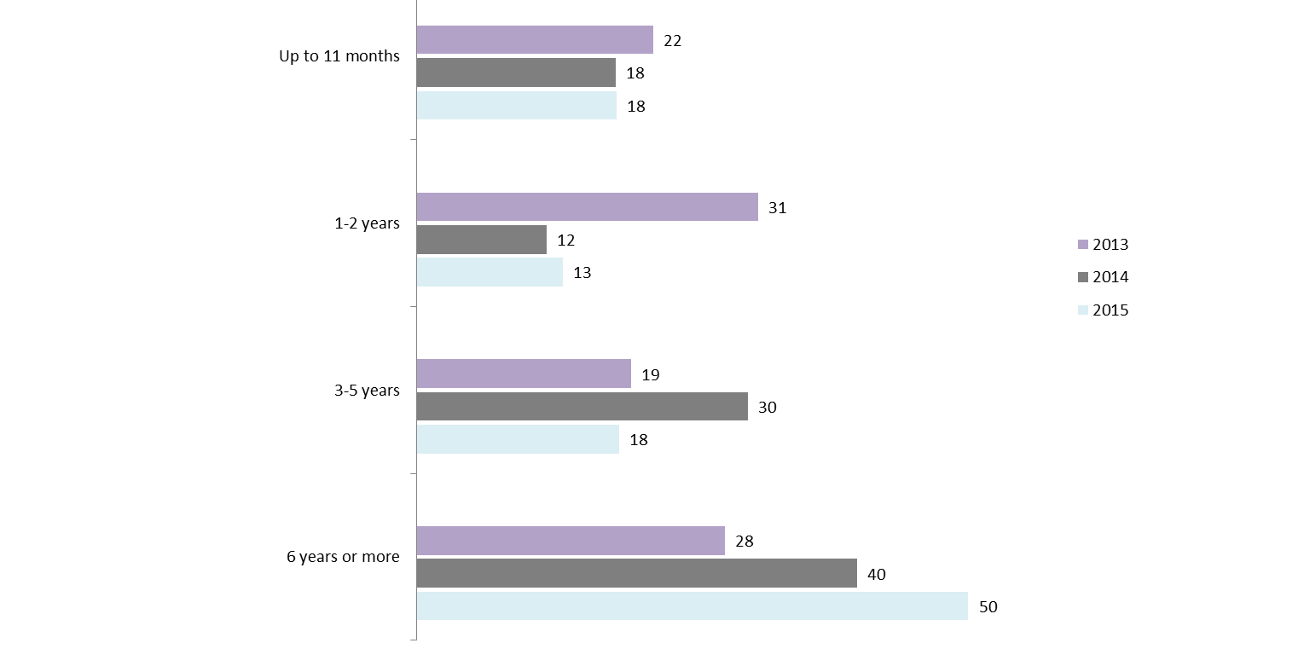
Q7B. You have said you had a break from riding and had started riding again. Approximately, how long was your most recent break?
Total sample; Weighted sample; 2013 Base n = 72; 2014 Base n = 114; 2015 Base n = 117
In 2015, female riders (52% vs. 15% of males) and those aged between 18-25 years (58% vs. 11% of those aged over 40) were significantly more likely to report riding again after a shorter break of up to 11 months. Nearly two thirds of older respondents (aged 40+) had a long break of 6 years or longer (61% compared to 31% of those aged 18-25) (See Table 16.
Table 16: Most recent break from riding by demographic groups – 2015
Column % | Gender |  | Age |  |  | Location
Column % | Male (n=97) | Female (n=20)* | 18-25 (n=21)* | 26-39 (n=31)* | 40+  (n=65) | Balance of Victoria (n=44) | Melbourne (n=52)
Up to 11 months | 15↓ | 52↑ | 58↑ | 31 | 11↓ | 20 | 17
1-2 years | 14 | 9 | 23 | 29↑ | 7↓ | 11 | 15
3-5 years | 18 | 19 | 18 | 10 | 22 | 23 | 16
6 years or more | 53↑ | 20↓ | 0↓ | 31↓ | 61↑ | 47 | 52
Q7B. You have said you had a break from riding and had started riding again. Approximately, how long was your most recent break?
If had a break from riding and started again; Weighted sample; Base n = 117;
↓↑ indicates statistically significant difference compared to respondents not in that category
* Note: Small sample sizes
When asked about the likelihood of riding again, among the respondents who had not ridden in the last 12 months or had stopped riding but said they may resume in the future, a substantial proportion had high intentions of riding again. Just under half (46%) rated the likelihood 7 out of 10 or higher.
One in four reported that there was a moderate chance of riding again (26% with a likelihood score of 4-6 out of 10). A similar proportion said there was a low chance of getting back on a bike (27% reporting a likelihood of 0-3 out of 10).
Results are not significantly different compared to last year (56% rated a high likelihood of retuning to riding).
Figure 20: Likelihood of lapsed riders riding again in the future - 2015
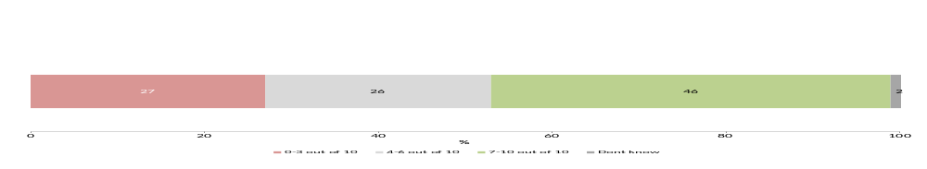
Q7A. What is the likelihood that you will ride again in the future?
Base: Stopped riding but may ride again in the future or not ridden in the last 12 months
Weighted sample; Base n = 224
As seen in Table 17, male riders were significantly more likely than females to say that there was a high likelihood that they would return to riding in the future (50% vs. 27% of females reporting a likelihood of 7-10 out of 10). The same was found for younger respondents with 73% of 18-25 year-olds and 65% of 26-39 year-olds indicating high intentions of riding again, compared to just 36% of those aged 40 and over (See Table 17).
Table 17: Likelihood of lapsed riders to ride again in the future by demographic groups - 2015
Column % | Gender |  | Age |  |  | Location
Column % | Male (n=176) | Female (n=48) | 18-25 (n=41) | 26-39 (n=58) | 40+ (n=125) | Melbourne (n=121) | Balance of Victoria (n=103) | Total (n=224)
0-3 out of 10 | 25 | 34 | 8↓ | 20 | 31↑ | 27 | 27 | 27
4-6 out of 10 | 23 | 36 | 17 | 14 | 31↑ | 23 | 30 | 26
7-10 out of 10 | 50↑ | 27↓ | 73↑ | 65↑ | 36↓ | 48 | 40 | 46
Don’t know | 2 | 2 | 2 | 0 | 3↑ | 2 | 2 | 2
Average out of 10 | 6.2↑ | 4.8↓ | 8.1↑ | 7.1↑ | 5.3↓ | 6.0 | 5.7 | 5.9
Q7A. What is the likelihood that you will ride again in the future?
Base: Stopped riding but may ride again in the future or not ridden in the last 12 months
Weighted sample; Base n = 224
↓↑ indicates statistically significant difference compared to respondents not in that category

Reasons for no longer riding a motorcycle
Of the respondents who had stopped riding, the average age they had stopped riding was 36.7 years (consistent with last year’s results - 36.1 years old).
Among those who had not ridden in the last 12 months but had not ruled out riding again, the most common reasons for not riding included were no longer owning a motorcycle (61% vs. 65% in 2014); and family commitments or a change in lifestyle (37% vs. 47% in 2014) (See Figure 21). There were no significant changes between 2015 and 2014.
Figure 21: Main reasons why lapsed riders have not ridden a motorcycle in the last 12 months
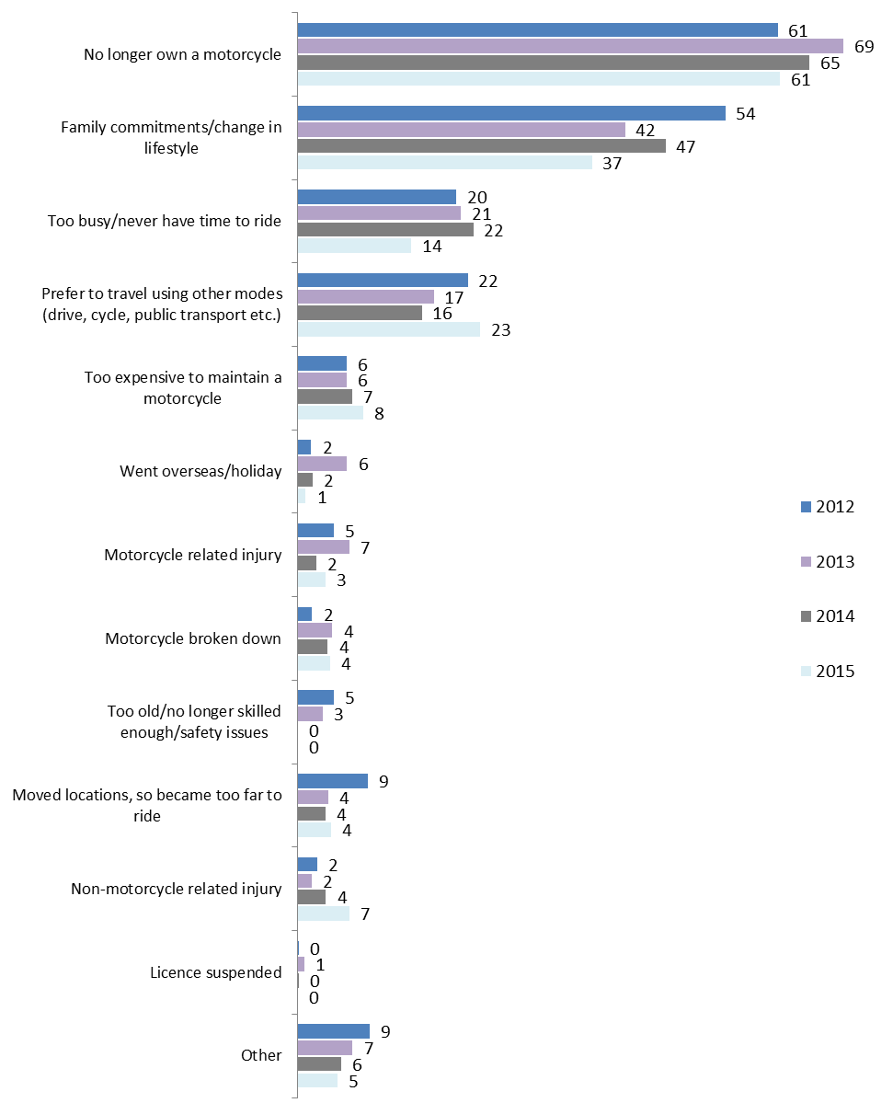
Q9. What are the main reasons why you haven’t ridden a motorcycle in the last 12 months? Multiple responses
Filter: Not ridden in last 12 months but may ride again; Weighted; 2012 base n = 89; 2013 base n=164; 2014 base n = 163; 2014 base n = 143
While sample sizes were small, a motorcycle related injury was more likely to be a reason amongst younger riders (24% for those aged 18-25 compared to 3% for those aged 26-39 and 0% for those aged 40+). Family commitments were more likely to be the reason behind older respondents becoming lapsed riders (52% for 26-39 year olds and 33% for 40+ compared to 11% for 18-25 years old) (See Table 18).
Table 18: Main reasons why lapsed riders have not ridden a motorcycle in the last 12 months – 2015
Column % | Gender |  | Age |  |  | Location
Column % | Male  (n=107) | Female (n=36) | 18-25 (n=11)* | 26-39 (n=35) | 40+  (n=97) | Melbourne (n=72) | Balance of Victoria (n=71)
No longer own a motorcycle | 60 | 67 | 55 | 46 | 67 | 70 | 56
Family commitments/change in lifestyle | 36 | 41 | 11↓ | 52 | 33 | 33 | 40
Too busy/never have time to ride | 15 | 14 | 31 | 19 | 12 | 17 | 13
Prefer to travel using other modes (drive, cycle, public transport etc.) | 25 | 16 | 5 | 18 | 26 | 20 | 25
Too expensive to maintain a motorcycle | 10 | 3 | 5 | 13 | 7 | 5 | 10
Went overseas/holiday | 1 | 0 | 15↑ | 3 | 0↓ | 2 | 1
Motorcycle related injury | 4 | 0 | 24↑ | 0 | 4 | 3 | 4
Motorcycle broken down | 5 | 1 | 0 | 6 | 4 | 4 | 4
Too old/no longer skilled enough/safety issues | 0 | 0 | 0 | 0 | 0 | 0 | 0
Moved locations, so became too far to ride | 4 | 6 | 0 | 5 | 4 | 3 | 5
Non-motorcycle related injury | 6 | 8 | 4 | 5 | 7 | 5 | 8
Licence suspended | 0 | 0 | 0 | 0 | 0 | 0 | 0
Other | 4 | 8 | 0 | 7 | 4 | 7 | 4
Q9. What are the main reasons why you haven’t ridden a motorcycle in the last 12 months? Multiple responses
Filter: Not ridden in last 12 months but may ride again; base n=143
*Note: Small sample size
Similar to 2014, among the small number of those who had stopped riding but were not planning to take it up again in the future (n=53) the most common reasons were similar. Around half of respondents mentioned safety concerns (47%), family commitments/change in lifestyle (35%), and a preference for different modes of transport (25%). Just under one in four (23%) mentioned no longer being interested in riding/motorcycles as a reason for not riding anymore.

Riding activity segments
Participants were grouped into three riding activity groups based on their riding history and recent riding behaviours. These groups were:
- Active riders – those who had ridden in the last 12 months either regularly or occasionally or had started riding again after a break;
- Lapsed riders – those who had stopped riding but may decide to ride again the future or had not ridden in the last 12 months but still considered themselves regular riders; or
- Former riders – those who had stopped riding and did not intend to ride again.
While the proportions of active and lapsed riders were similar to those from last year, there has been a slight but significant increase in the number of former riders this year compared to 2014.
Specifically, over half (54%) of the participants were classified into the active riders (consistent with 55% from last year). Over one in three (37%) would be considered lapsed riders (unchanged from 40% in 2014). Less than one in ten respondents (9%) would be considered former riders in 2015 (compared to 5% in 2014).
Notably, in 2013, there was a significantly higher proportion of lapsed riders. This is likely to be the cause of the differences between 2014 and 2013 results. Overall, the distribution of segments among the rider population in 2012, 2014 and 2015 were similar.
Figure 22: Riding activity segments (2012-2015)
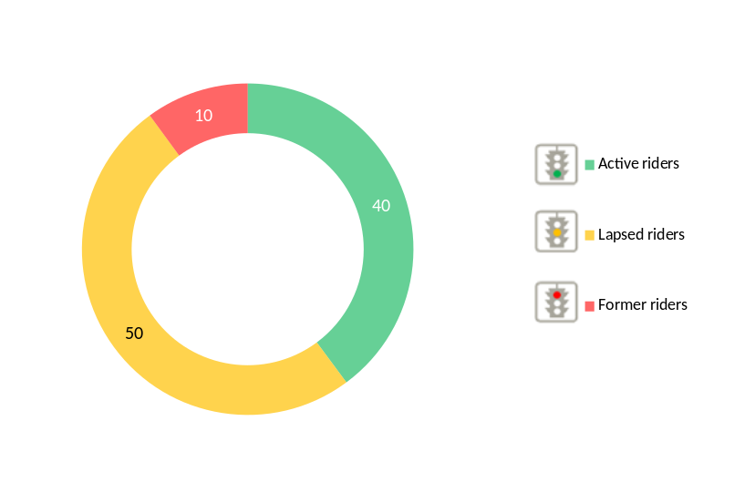
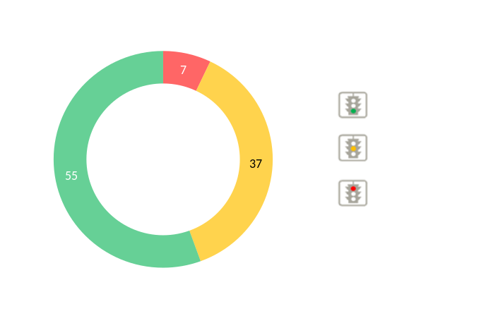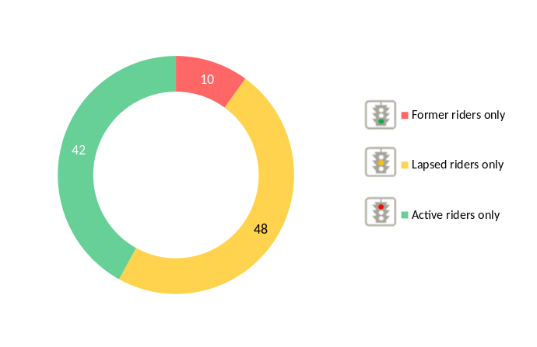
2012 2013

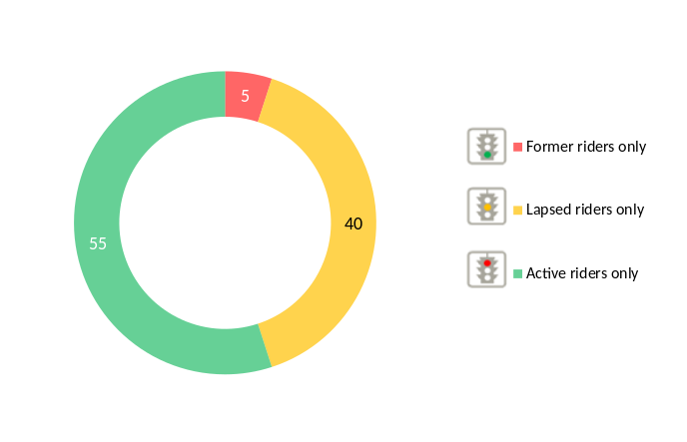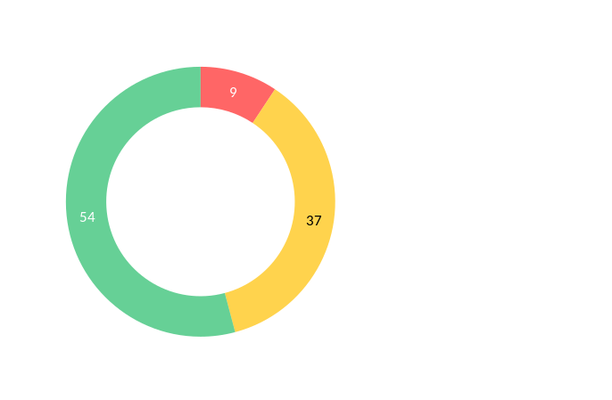
2014 2015
Q10. Which of the following best describes your motorbike riding history?
Q7. Have you ridden a motorcycle in the last 12 months (either on or off-road)?
All respondents; Weighted; 2012 base n = 545; 2013 base n=690; 2014 base n = 774; 2015 base n = 791
In regards to the demographic profiles of these riding segments:
- Males (57% vs. 35% of females) and 18-25 year-olds (72% vs. 55% of 26-39 year olds and 52% of those aged 40+) were more likely to be active riders;
- Females were significantly more likely to be categorised as lapsed riders (50% vs. 35% of males); and
- Those aged 40 and over were more likely to be former riders (12% vs. 4% of 26-39 year-olds and 1% of 18-25 year-olds), as well as those from Melbourne (11% compared to 6% of regional Victorians).
Figure 23: Riding activity segments by selected rider characteristics - 2015
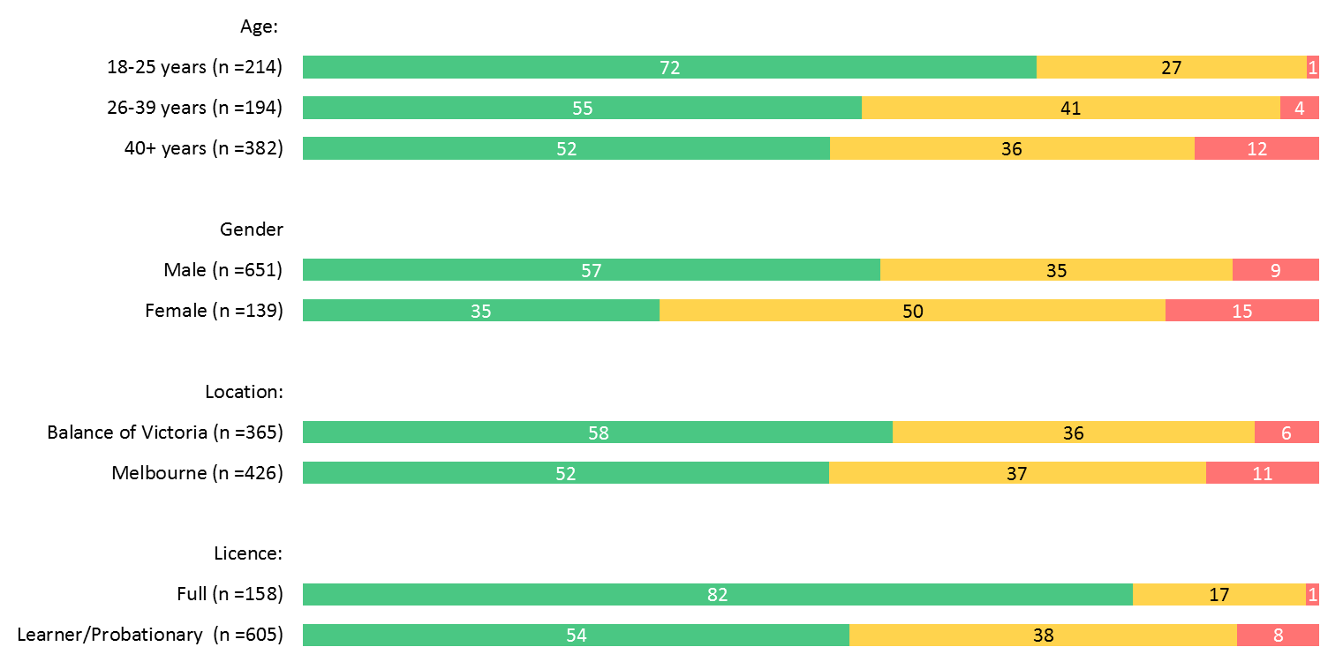
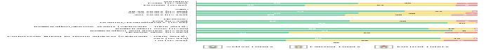

Q10. Which of the following best describes your motorbike riding history?
Q7. Have you ridden a motorcycle in the last 12 months (either on or off-road)?
Filter: Excluding never ridden a motorcycle; Weighted; Base n = 791
The majority of the questions in the Motorcycle Monitor survey were directed towards active riders only. However, survey results have been analysed in terms of these riding segments where relevant.

Riding vs. driving
Respondents were asked the extent to which they agreed/disagreed that Drivers don’t understand what it is like to be a motorcyclist’. The vast majority (91%) of respondents who had ridden in the last 12 months agreed (59% strongly and 31% somewhat agreed). Results were similar to 2014.
Those who lived in Melbourne were more likely to strongly agree than those living in regional areas (62% vs. 52%).
Figure 24: Agree/disagree: Drivers don’t understand what it’s like to be a motorcyclist – 2013-15
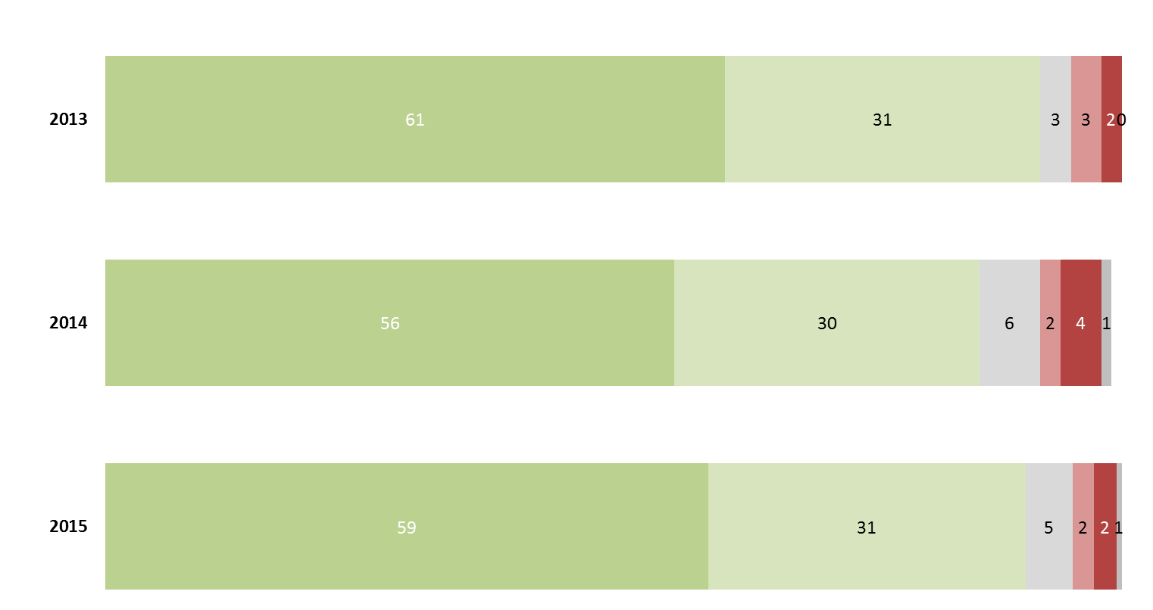
Q55i. To what extent do you agree or disagree with the following statements – Drivers don’t understand what it is like to be a motorcyclist?
Those who rode in the last 12 months: Weighted; 2013 base n = 491, 2014 base n = 574; 2015 base n = 592
When asked whether they drivers were aware of motorcyclists when they were driving, views were mixed with half (52%) of respondents disagreeing with the statement and 41% of respondents agreeing with the statement. Results were similar to last year’s figures (See Figure 25).
Figure 25: Agree/disagree: Most drivers are aware of motorcyclists when they are driving – 2014-2015
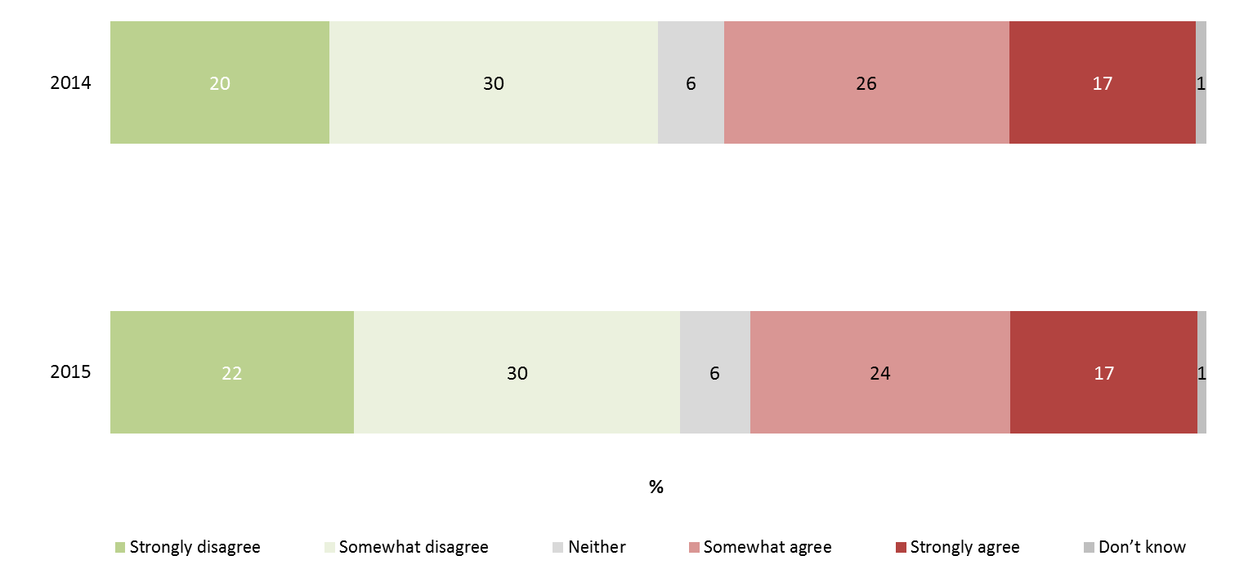
Q55k. To what extent do you agree or disagree with the following statements – Most drivers are aware of motorcyclists when they are driving
Ridden in the last 12 months; Weighted; base n = 592
Respondents were asked about the proportion of time they rode their motorcycle in comparison to a car. As can be seen in Figure 26, results have been consistent since 2012.
In 2015, just under one in ten reported relying on their bike for than 50% of the time they travelled (9% compared to 12% in 2014). The majority (62%) of riders indicated that they used their bike up to 10% of the time, spending the rest of the time (90%) driving.
Figure 26: Proportion of time spent riding a motorcycle vs. driving a car (2012-2015)
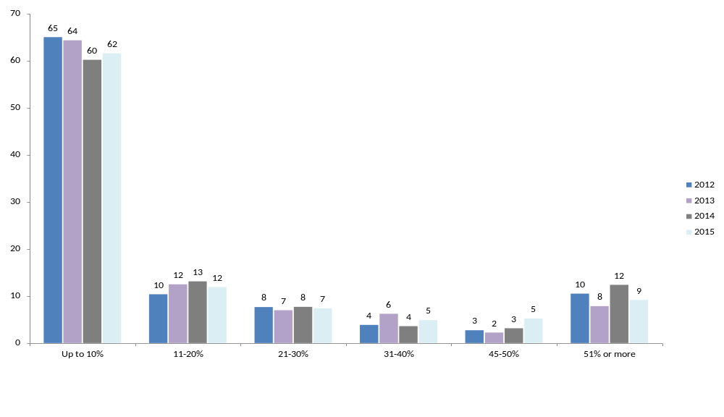
Q8. Thinking about your time spent riding and driving over the last 12 months, approximately what percentage of the time would you say you rode a motorcycle (on or off-road) compared to driving a car?
Filter: Ridden in the last 12 months; Weighted; 2012 base n = 440, 2013 base n=493, 2014 base n = 582, 2015 base n = 596
Demographically, younger respondents, aged 18-25 years were significantly more likely than their older counterparts to say that they used their bike more than 20% of the time in comparison to driving a car (38% compared to 28% of 26-39 year-olds and 24% of 40+ years).
Those with L/P plates were also significantly more likely to report using their bikes 20% or more of the time in comparison to driving their cars, 47% reporting this compared to 25% of those with full licences.
Figure 27: Proportion of time spent riding a motorcycle vs. driving a car – differences between selected groups – 2015
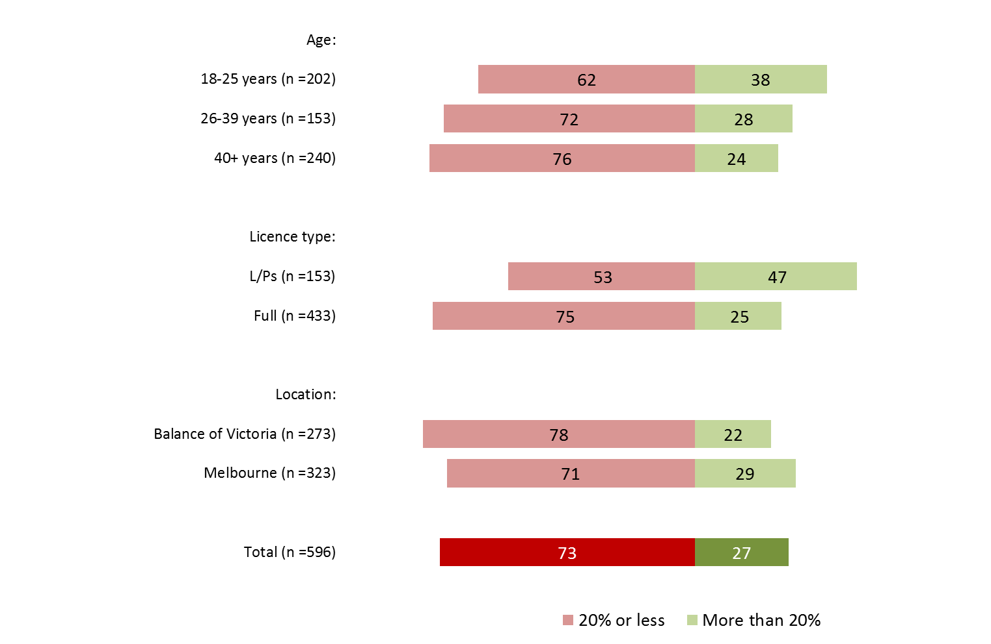
Q8. Thinking about your time spent riding and driving over the last 12 months, approximately what percentage of the time would you say you rode a motorcycle (on or off-road) compared to driving a car?
Filter: Ridden in the last 12 months; Weighted; Base n =596

Those who mainly rode on-road bikes were significantly more likely to use their bike as a form of transport more than 20% of the time (38% vs. 11% who mainly ride off-road bikes).
Those who owned a newer bike were also more likely to ride more often with 49% of those with a bike manufactured in 2010 or later reporting that they rode more than 20% of the time. Note that younger riders were more likely to own late model bikes and were more likely to use their bike more often.
Figure 28: Proportion of time spent riding a motorcycle vs. driving a car – differences between rider groups - 2015
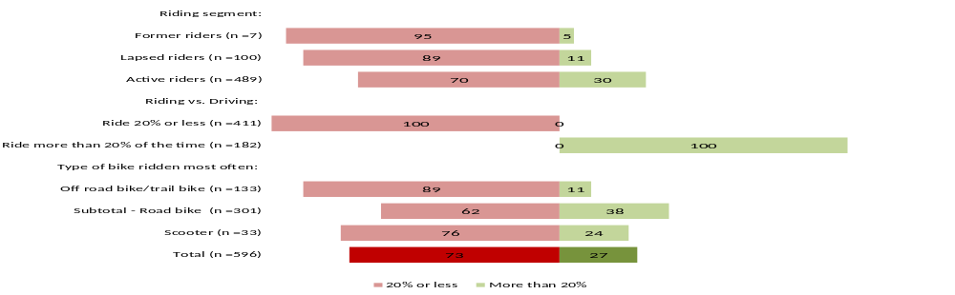
Q8. Thinking about your time spent riding and driving over the last 12 months, approximately what percentage of the time would you say you rode a motorcycle (on or off-road) compared to driving a car?
Filter: Ridden in the last 12 months; Weighted; Base n = 596
*Note: Small sample size
As expected, respondents who mainly rode for commuting purposes (33%) or for riding recreationally on-road (33%) were more likely to use their bike more than 20% of the time compared to driving (vs. 25% of those who mainly rode recreationally off-road) (See Table 19).
Table 19: Proportion of time spent riding a motorcycle vs. driving a car – differences between riding purpose – 2015
 | Commuter | Recreational on-road rider | Recreational off-road rider
 | n=273 | n=364 | n=212
Riding 20% or less of the time (driving 80%+ of the time) | 56↓ | 67↓ | 75
Riding more than 20% of the time (driving less than 80% of the time) | 33↑ | 33↑ | 25
Q8. Thinking about your time spent riding and driving over the last 12 months, approximately what percentage of the time would you say you rode a motorcycle (on or off-road) compared to driving a car?
Filter: Ridden in the last 12 months; Weighted; Base n = 596
↓↑ indicates statistically significant difference compared to respondents not in that category

Riding for commuting and recreational purposes
Respondents in the active rider category were asked about the type of motorcycle riding they did in the last 12 months as a proportion of all the time they spent riding a motorcycle. The three purposes they were asked to indicate approximate proportions of time they spent riding were with regard to:
- Riding for commuting purposes (i.e. going to work, study, shops);
- Riding for recreational purposes on-road (i.e. riding for leisure on public roads, highways, freeways); and
- Riding for recreational purposes off-road (i.e. riding on racks in national parks on private property).
Based on whether participants had undertaken any riding for any of these purposes, they were grouped into the three categories.
The active riders were most likely to report that they rode recreationally on-road (79%), consistent with the previous years (79% in both 2014 and 2013). Just over half (53%) reported riding for commuting. More than one in three (37%) rode off-road recreationally, unchanged from results in 2014, but lower than in 2013 (54%).
Figure 29: Proportion of respondents who commuted and/or rode recreationally in last 12 months (2012-2015)
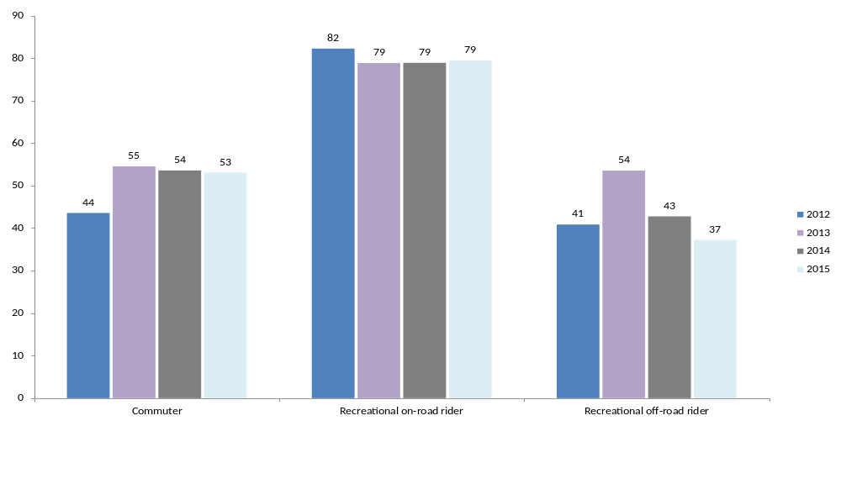
Q18 Approximately what percentage of the time did you ride in the following categories excluding any riding you might do for work purposes?
Filter: Active riders excluding commuter/recreational riding response error; Weighted; 2012 base n = 354; 2013 base n=399; 2014 base n = 495, 2015 base n = 473
Note: Does not add to 100% as respondents could ride with more than one purpose
The prevalence of the different combinations of riding purposes is shown in Figure 30 below. The results were similar to those found last year, with the most common combination being commuting in conjunction with riding recreationally on-road (35%), followed by riding on-road recreational purposes only (24%).
Figure 30: Proportion of respondents who commuted and/or rode recreationally in last 12 months – riding purpose combinations - 2015
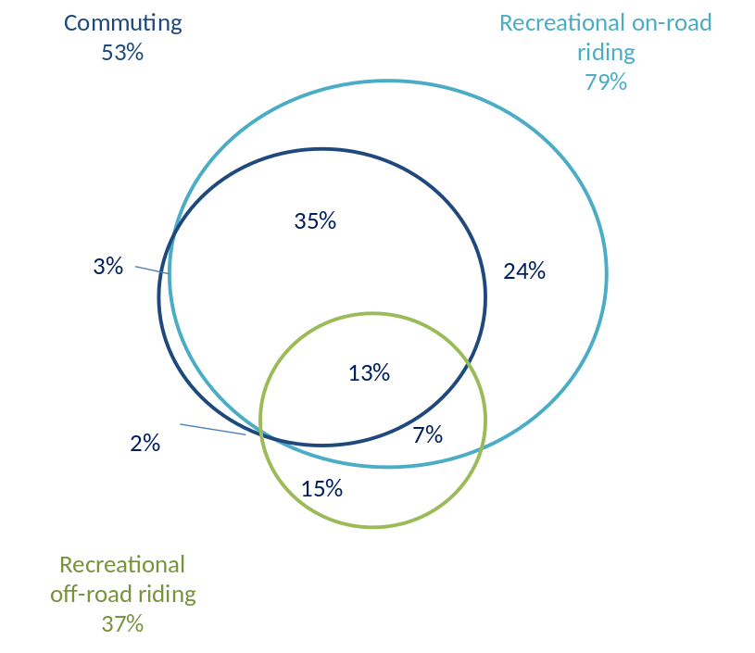
Q18 Approximately what percentage of the time did you ride in the following categories excluding any riding you might do for work purposes?
Filter: Active riders excluding commuter/recreational riding response error; Weighted; Base n = 473
The different types of riding being undertaken by different ride groups are shown below in Table 20. These included:
- A higher incidence of commuting among those who:
  - were aged 18-25 (67%); and
  - lived in Melbourne (59% compared to 43% of regional residents).
- A higher incidence of recreational on-road riding by those:
  - who live in Melbourne (85% compared to 72% of those in regional Victoria).
- A higher incidence of recreational off-road riding by those:
  - who are males (39% compared to 22% of females); and
  - who are aged between 18-25 (57% compared to 31% of those aged 40 or over); and
  - who live in regional Victoria (51% compared to 28% of Melbourne residents).
Table 20: Proportion of respondents who commuted and/or rode recreationally in last 12 months – by selected demographic variables - 2015
Row % | Commuter | Recreational on-road rider | Recreational off-road rider
Gender
Male (n=401) | 53 | 80 | 39↑
Female (n=72) | 59 | 78 | 22↓
Age
18-25 (n=160) | 67↑ | 80 | 57↑
26-39 (n=120) | 56 | 75 | 45
40+ (n=193) | 50 | 81↑ | 31↓
Location
Melbourne (n=207) | 59↑ | 85↑ | 28↓
Balance of Victoria (n=266) | 43↓ | 72↓ | 51↑
Q18 Approximately what percentage of the time did you ride in the following categories excluding any riding you might do for work purposes?
Filter: Active riders excluding commuter/recreational riding response error; Weighted; Base n = 473
↓↑ indicates statistically significant difference compared to respondents not in that category
Note: Does not add to 100% due to riders being able to do multiple types of riding

Share of time spent riding for commuting or recreational purposes among active riders
As in previous years, on average, respondents spent the most time on their bikes riding on-road for recreational purposes. The average amount of time spent riding recreationally on-road was 49% (vs. 47% in 2014). The average amount of time riding that was spent commuting was 27% (vs. 24% in the previous year). The average time spent riding recreationally off-road was 24% (compared to 29% last year). Findings in 2015 were unchanged from 2014.
In 2013, a greater proportion of respondents rode recreationally off-road (34% vs. 34% in 2015); and fewer to rode recreationally on-road. This is likely to be the cause of the key differences between 2013 and other survey years...
Figure 31: Average proportion of time spent commuting vs. riding recreationally in last 12 months - 2012 - 2015
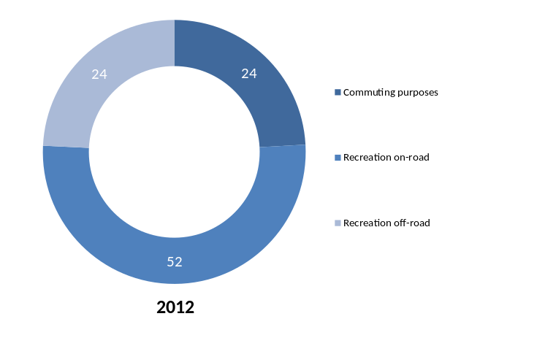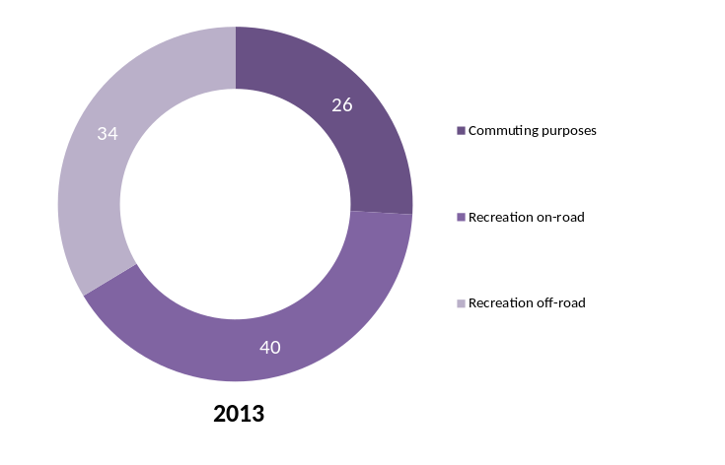
2012 2013

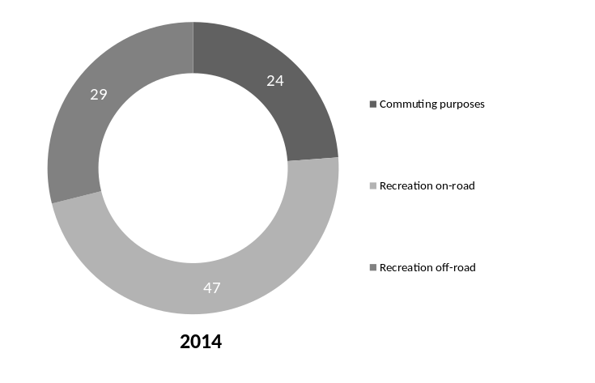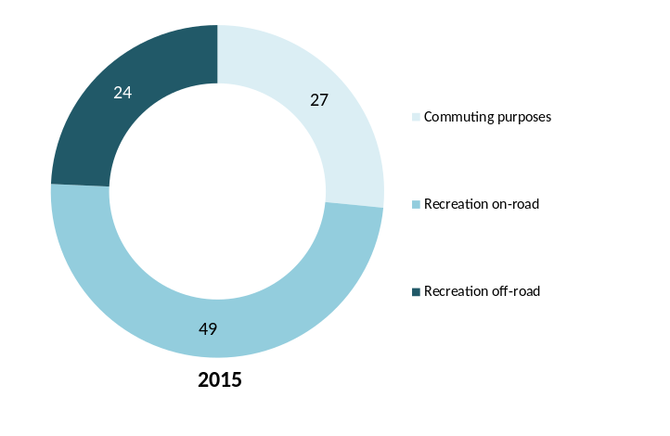
2014 2015
Q18 Approximately what percentage of the time did you ride in the following categories excluding any riding you might do for work purposes?
Filter: Active riders excluding commuter/recreational riding response error; Weighted; 2012 base n = 354; 2013 base n=399; 2014 base n = 495; 2015 base n = 473
Respondents aged 40 years or older spent a significantly higher proportion of their time riding recreationally on-road compared to younger riders (55% compared to 33% of 19-25 year olds and 40% of 26-39 year-olds).
As expected, a higher amount of time was spent commuting among those who lived in Melbourne (32% compared to 18% of those living in regional areas).
The proportion of time spent riding recreationally off-road was significantly higher for younger respondents (35% for those aged 18-25 years compare to 21% of those aged 40 or over), as well as for residents of regional Victoria (35% compared to 17% for those living in Melbourne) (See Table 21).
Table 21: Average proportion of time spent commuting vs. riding recreationally in last 12 months by demographic characteristics - 2015
Average time spent riding  (Row %) | Commuting | Recreational on-road riding | Recreational off-road riding
Age
18-25 (n=160) | 32 | 33↓ | 35↑
26-39 (n=120) | 32 | 40↓ | 28
40+ (n=193) | 24↓ | 55↑ | 21↓
Location
Balance of Victoria (n=207) | 18↓ | 47 | 35↑
Melbourne (n=266) | 32↑ | 51 | 17↓
Q18 Approximately what percentage of the time did you ride in the following categories excluding any riding you might do for work purposes?
Filter: Active riders excluding commuter/recreational riding response error; Weighted; Base n = 473
↓↑ indicates statistically significant difference compared to respondents not in that category i.e. between male and female
Note: Table adds across. Where totals do not add to 100%, this is due to rounding.
In terms of riding experience, on average, full licence holders tended to spend more time riding recreationally on-road compared to learner/probationary licence holders (full licence holders spent 51% of the time riding recreationally on-road vs. 33% of the time for L/P platers). In contrast, those on their L/P plates, on average, spent more time commuting (38% vs. 26% of the time for full licence holders).
Those who had started riding at a very young age (up to 10 years old) reported they spent more time riding off-road than commuting or riding on road (41% of the time riding off-road compared to 16% and 43% commuting or riding recreationally on-road respectively). Those who started riding at 18 or older tended to spend the least amount of time riding off-road (16% of the time for those who started at 18-25 years old and 9% for those who started riding when they were 26 or older) (See Table 22).
Table 22: Average proportion of time spent commuting vs. riding recreationally in last 12 months by rider experience characteristics - 2015
Average time spent riding  (Row %) | Commuter | Recreational on-road rider | Recreational off-road rider
Motorcycle licence
Learner/Probationary (n=129) | 38↑ | 33↓ | 29
Full licence (n=337) | 26↓ | 51↑ | 23
Age when started riding
up to 10 years (n=141) | 16↓ | 43↓ | 41↑
11-17 years (n=138) | 28 | 50↑ | 22
18-25 years (n=141) | 35↑ | 49 | 16↓
26 or older (n=50) | 30 | 61 | 9↓
Q18 Approximately what percentage of the time did you ride in the following categories excluding any riding you might do for work purposes?
Filter: Active riders AND Excluding commuter/recreational riding response error; Weighted; Base n = 473
↓↑ indicates statistically significant difference compared to respondents not in that category i.e. between learner and probationary and full licence holders
There were also some differences in the amount of time spent riding for recreational or utilitarian purposes by the number of bikes kept at home, type of bike, and engine capacity of the bike they mainly rode (See Table 23).
Table 23: Average proportion of time spent commuting vs. riding recreationally in last 12 months by motorcycle ownership characteristics -2015
Average time spent riding for commuting/recreational purposes  (Row %) | Commuting | Recreational on-road riding | Recreational off-road riding
Number of bikes kept at home
None (n=47) | 26 | 34↓ | 40↑
One only (n=214) | 31 | 56↑ | 13↓
2 or more (n=208) | 22↓ | 45 | 34↑
Type of bike (main bike ridden)
Off road/ trail bike (n=108) | 5↓ | 10↓ | 85↑
Road bike (n=275) | 30↑ | 64↑ | 5↓
Scooter (n=25)* | 54↑ | 41↑ | 5↓
Engine capacity (main bike ridden)
Up to 250cc (n=137) | 30 | 30↓ | 40↑
251-700cc (n=157) | 27 | 37↓ | 36↑
701+ (n=127) | 25 | 72↑ | 4↓
Q18 Approximately what percentage of the time did you ride in the following categories excluding any riding you might do for work purposes?
Filter: Active riders AND Excluding commuter/recreational riding response error; Weighted; Base n = 370 to 473
↓↑ indicates statistically significant difference compared to respondents not in that category
*Note: Small sample size

Recreational riding locations
Consistent with 2014 results, the majority (58%) of recreational riders did their riding on public roads in rural/non-built up areas. Over a third (36%) of respondents indicated they rode in public roads in metro areas, 23% in state/national parks and 22% on private land with no significant differences to 2014.
Compared to 2012, respondents in 2015 were significantly less likely to report that they rode on public roads in rural/non-built up areas (67% vs. 58%). In 2013, there was a notably higher proportion of respondents who said they rode recreationally on private land compared to other years (32% vs. 22%).
In 2015, those from regional Victoria were more likely to say that they rode recreationally on private land (35% vs. 14% of those from Melbourne). Metropolitan Melbourne residents however, were more likely than regional residents to say that they rode recreationally on public roads in metro areas (47% vs. 19%).
Table 24: Recreational riding locations (2012-2015)
Column % | 2012 | 2013 | 2014 | 2015
Public roads in rural/non-built up areas | 67 | 52 | 56 | 58
Public roads in metro areas | 36 | 29 | 34 | 36
State/national parks | 31 | 29 | 30 | 23
Private land | 23 | 32 | 22 | 22
Other | - | - | 5 | 2
Q25. Where do you do most of your recreational riding (on-road or off-road)?
Filter: Recreational riding on or off-road; Weighted; 2012 base n = 340; 2013 base n = 369, 2014 base n=480, 2015 base = 466
↓↑ indicates statistically significant differences between 2014 and 2015 only
State/national parks and private lands were more likely to have been frequented by those who were riding off-road for recreational purposes (52% for both). On the other hand, public roads in metro areas and public roads in rural/non-built up areas were more likely to have been used for recreational purposes by commuters and on-road recreational riders (See Table 25).
Table 25: Recreational riding locations by riding purpose – 2015
Column % | Commuter (n=259) | Recreational on-road rider (n=365) | Recreational off-road rider (n=212)
State/national parks | 18↓ | 16↓ | 52↑
Private land | 12↓ | 13↓ | 52↑
Public roads in metro areas | 44↑ | 43↑ | 16↓
Public roads in rural/non-built up areas | 68↑ | 68↑ | 33↓
Other | 3 | 2 | 4
Q25. Where do you do most of your recreational riding (on-road or off-road)?
Filter: Active riders; Recreational riding on or off-road; Weighted; Base n = 466
↓↑ indicates statistically significant difference compared to respondents not in that category
Note: Commuters, on-road recreational and off-road recreational riders defined as riding for this purpose at least 1% of the time in the last 12 months

Riding with others
Consistent with last year’s findings, respondents were most likely to say they rode alone (46%). One in four (27%) rode with 2-3 other people and 18% rode with just one other person.
As shown in Table 26 below, those who mainly rode a road bike were significantly more likely to say that they rode on their own (50% compared to 22% of off-road/trail bike users). Off-road/trail bike riders were more likely to say that they rode with 2-3 other people (49%).
Table 26: Whether ride with others when riding recreationally (on or off-road) with others by type of bike – 2015
 | Type of bike |  |  | Total
Column % | Off road bike/trail bike  (n=111) | Road bike  (n=269) | Scooter  (n=19)* | n=459
On your own | 22↓ | 50↑ | 72 | 46
With 1 other person | 14 | 21↑ | 5↓ | 18
With 2-3 other people | 49↑ | 19↓ | 16 | 27
With 4 or more other people | 15 | 10 | 6 | 10
Q25a. When riding recreationally (on-road or off-road), do you mainly ride?
Filter: Recreational riding on or off-road; Weighted; Base n = 459
↓↑ indicates statistically significant difference compared to respondents not in that category
Note: Commuters, on-road recreational and off-road recreational riders defined as riding for this purpose at least 1% of the time in the last 12 months

Distances ridden in last 12 months
When estimating the distances they had ridden on a motorcycle for any reason in the 12 months, in 2015, respondents were most likely to estimate riding 101-500km per month (32%), followed closely by 29% who indicated that they rode up to 100km per month. The distribution of approximate kilometres ridden per month is shown below in Figure 32.
At 44%, recreational on-road riders were most likely to ride 101-500km per month followed by 41% of commuters. Off-road riders (32%) were most likely to report that they ride up to 100km per month.
As expected, active riders tended to ride greater distances than former or lapsed riders (37% rode between 101-500km per month compared to 9% for former and lapsed riders). Close to half (47%) of former or lapsed riders said they rode 100km or less a month.
In 2015, the average distance ridden on a motorbike by respondents was 341.3km per month, or 4,292.4km in a year. These distances are consistent with those reported in 2014 (average of 370.6km per month or 4,447.6km per year).
Figure 32: Distance ridden in last 12 months for any purpose – approximate km per month (2012-2015)
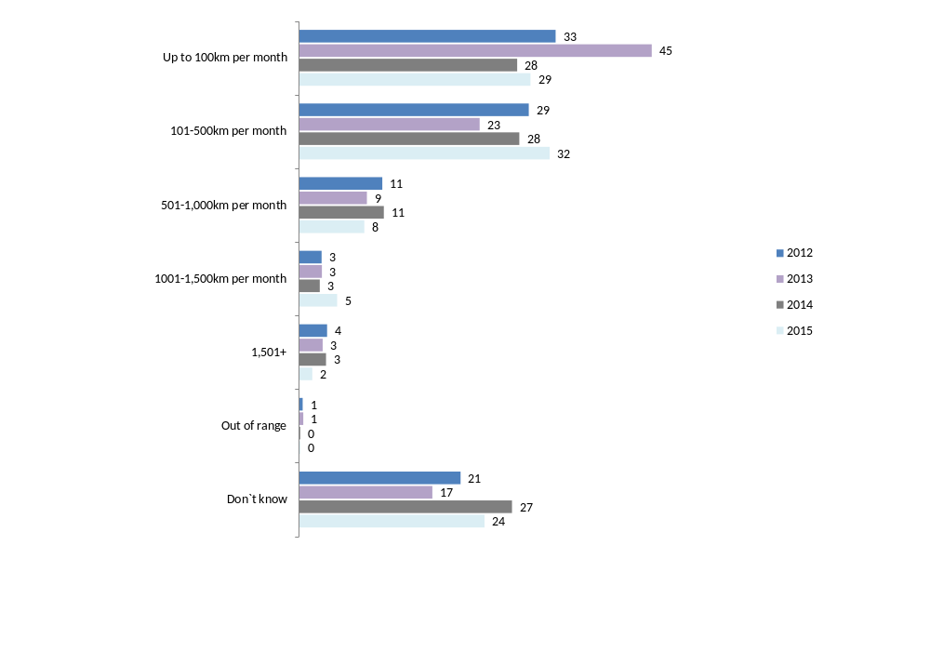
Q29. In the last 12 months, how many kilometres did you ride ON ANY motorcycle on the road for any reason? (Per week; per month or per year).
Filter: Ridden in the last 12 months; Weighted; 2012 base n = 440, 2013 base n=496; 2014 base n = 583, 2015 base n = 603
Demographically, male riders were more likely to have travelled further than female motorcyclists (an average of 386 km per month vs. 137.7km per month).
There was also some correlation between kilometres ridden per month and the different types of riders. For example, road bikes (approximately 473.1km per month) travelled significantly greater distances than off-road/trail bike riders (138.2km per month) and scooter riders (approximately 159.5km per month). Larger vehicles also travelled relatively greater distances (See Figure 33).
Figure 33: Distance ridden in last 12 months – approximate km per month by motorcycle characteristics - 2015
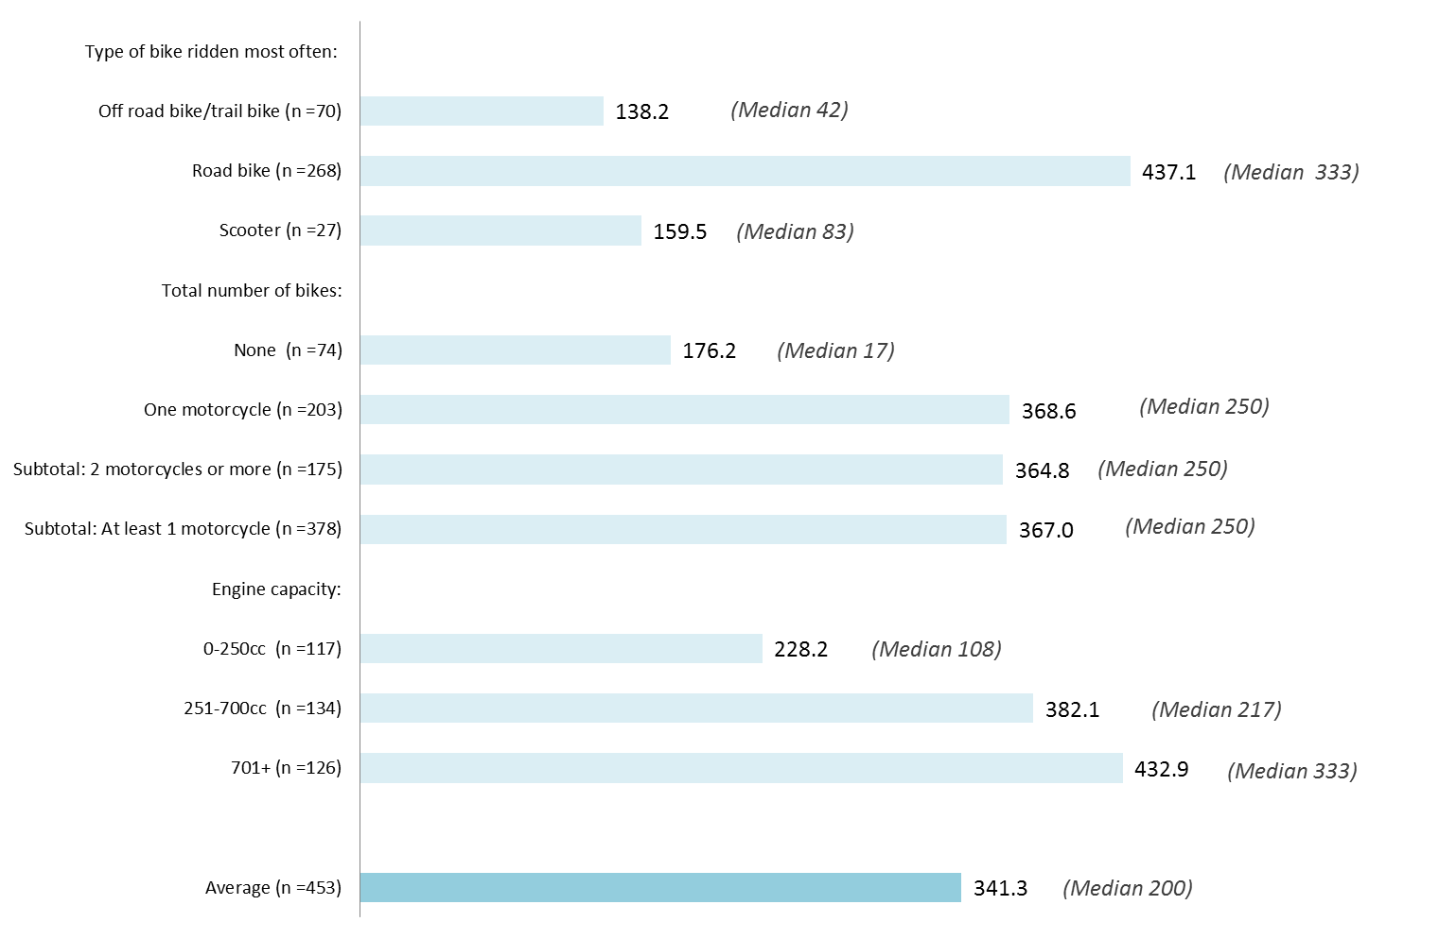
(Median km per month in brackets)
Q29. In the last 12 months, how many kilometres did you ride ON ANY motorcycle on the road for any reason?
Filter: Ridden in the last 12 months; Weighted; Base n=453

Average distance ridden for commuting, on-road and off-road recreational purposes among active riders
Respondents were asked the distances travelled in the last 12 months for any purpose. Comparisons of total distance travelled among those who had done some commuting, or recreational riding in the last year is shown in Figure 34. Distance travelled per month tended to be higher where respondents indicated they commuted at least some of the time and as expected was lowest for those who did recreational off-road riding only.
Figure 34: Distance ridden in last 12 months – approximate km per month by riding purpose (mean and median)
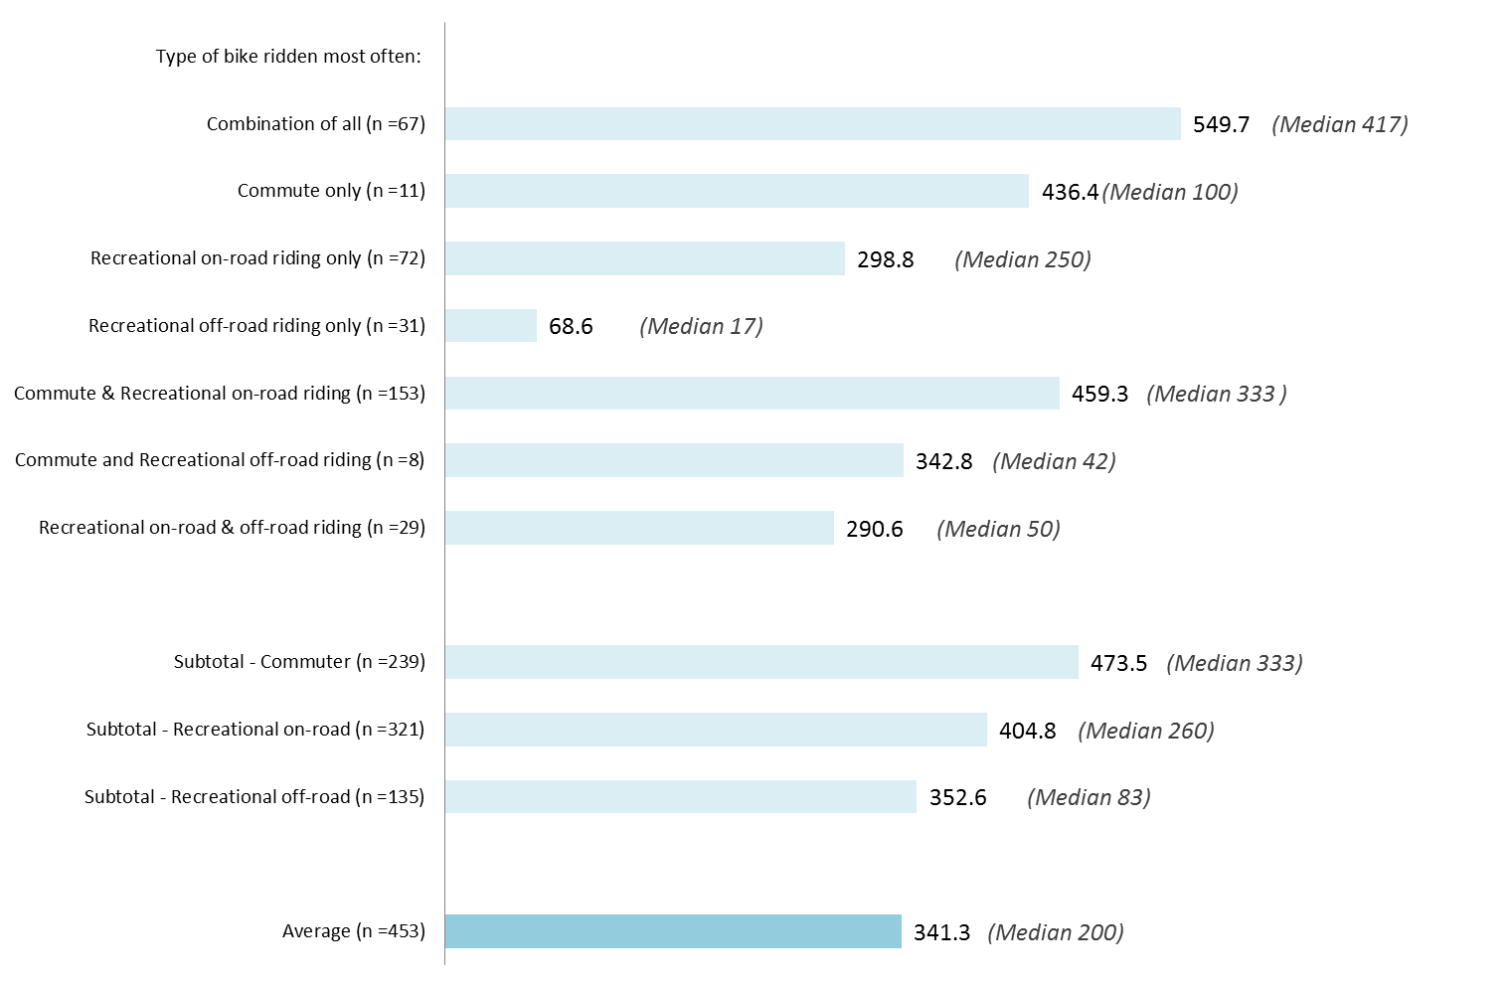
Q29. In the last 12 months, how many kilometres did you ride ON ANY motorcycle on the road for any reason? (Per week; per month or per year).
Filter: Active riders AND excluding commuter/recreational riding response error; Weighted; Total n = 453
Hours spent riding off-road
Over two-fifths (44%) of respondents who had said that they had ridden a bike in the past 12 months, said that they had not ridden off-road at all. More than one in four respondents (27%) stated they rode up to 8 hours off-road in a month. Another 12% reported riding 8-20 hours off-road per month. Only 5% of those who had ridden in the last 12 months rode off-road for more than 21 hours per month. Results in 2015 are similar to 2014.
Figure 35: Hours spent riding off road – approximate hours per month (mean) – 2015
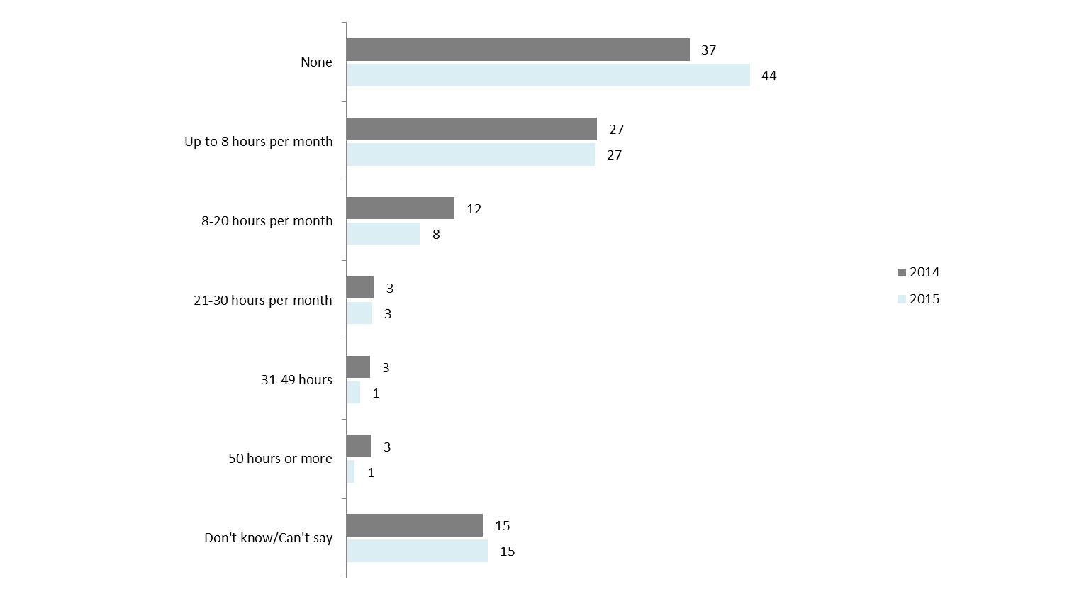
Q29B. In the last 12 months, how many hours did you ride on any motorcycle off-road for any reason? An approximate number is OK.
Filter: If ridden in the last 12 months AND excluding commuter/recreational riding response error; Weighted; Base n = 601
Older riders were more likely to say that they had done no off-road riding at all in the last 12 months (50% vs. 34% of those aged 26 and under).
Interestingly, close to half (49%) of those who had started riding under the age of 17 reported they had done some off-road riding in the last 12 months (vs. 28% for those who learnt at an older age).
Among those who mainly rode an off-road bike, more than half (56%) reported they rode up to 8 hours a month with one in five (21%) riding 8-20 hours per month off-road. Just under one in five (17%) of those who mainly rode an on-road bike also said they rode off-road around 8-20 hours per month.

Rider fatigue
Respondents were asked the extent they agreed or disagreed with statements around fatigue. When asked about the extent that they agreed or disagreed that ‘the only remedy for fatigue while riding is to stop riding and rest’, the vast majority of respondents (85%) strongly agreed with this statement (no significant change compared to 2014 at 80%).
While agreement was still high, those aged 18-25 were less likely to agree that the only remedy was to stop riding and rest compared to older respondents (92% for 18-39 vs. 97% of those aged 40+).
The majority also strongly agreed that riding while tired can be as dangerous as drink driving (66%).
Figure 36: Agree/disagree statements about fatigue – 2013-2015
Riding while tired can be as dangerous as drink-riding
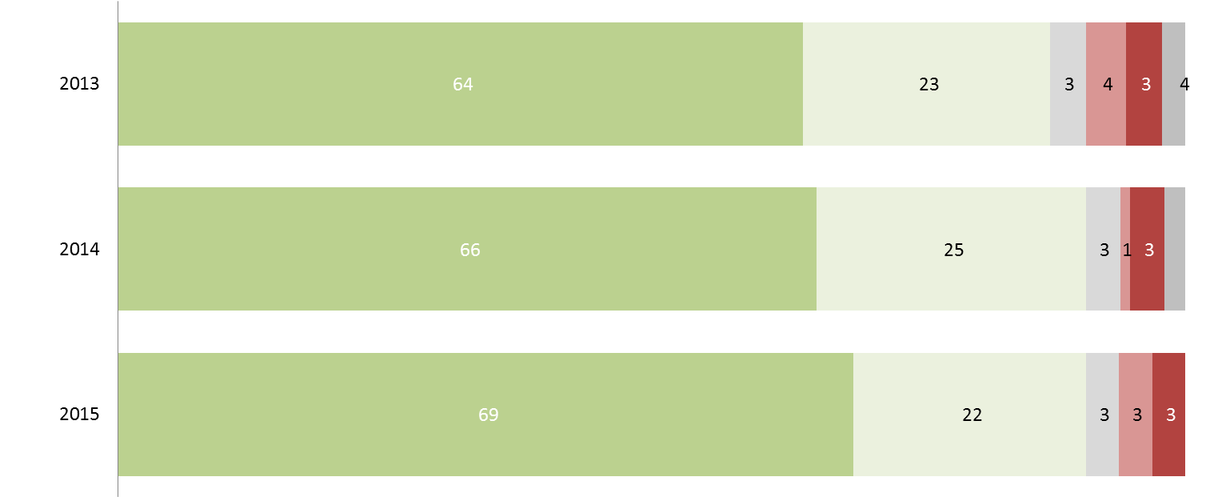

Q55f-g. Agreement/disagreement with statements about fatigue
Weighted; 2013 Base n = 490; 2014 Base n= 573; 2015 Base n= 591

Figure 38 cont… Agree/disagree statements about fatigue – 2013-2015
The only remedy for fatigue while riding is to stop riding and rest
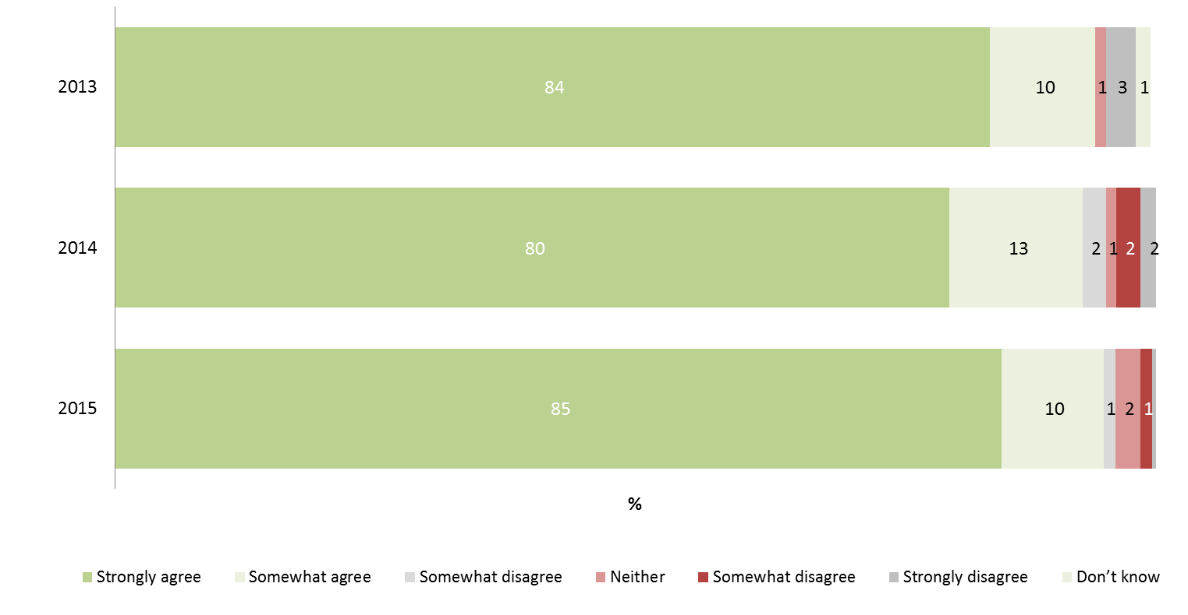
Q55f-g. Agreement/disagreement with statements about fatigue
Weighted; 2013 Base n = 490; 2014 Base n= 573; 2015 Base n= 591
When asked the degree of danger of riding while drowsy, using a scale of 0 to 10, where 0 was not dangerous at all and 10 was extremely dangerous, respondents were in agreement that doing so was dangerous with close to nine in ten providing ratings of 7 or above. While at the overall level, the perceived danger was similar to that of driving under the influence of drugs or alcohol, only two thirds of respondents felt the deed was extremely dangerous (65%); on par with riding after drinking a small amount of alcohol while also using prescription medicines (68%). In comparison, respondents were most likely to deem riding under the influence of stimulant drugs extremely dangerous (86% provided a rating of 10).
Figure 37: Perception of danger associated with riding while drowsy and riding under the influence– 2015
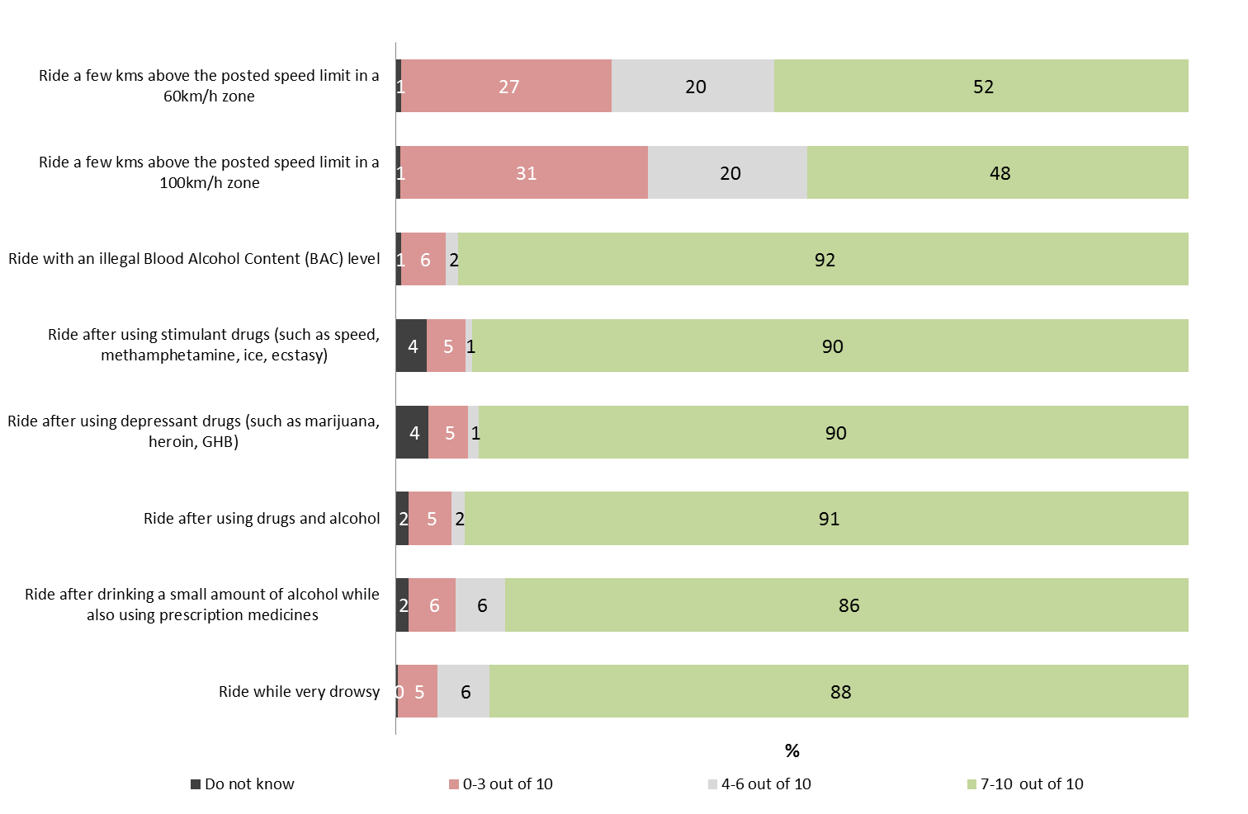
Q46A. Using a scale where 0 is not at all dangerous and 10 is extremely dangerous, how dangerous do you think is?
Active riders only; Weighted; 2015 base n = n=491

When asked what they normally do when feeling drowsy while riding a motorbike, the majority of respondents said that they would have a break or have a rest (73%). This was followed by over half (57%) saying that they would pull over somewhere. Overall, 97% of respondents in 2015 mentioned they stop riding when feeling drowsy (98% in 2014).
Table 27: Actions taken when feeling drowsy when riding a motorcycle – 2014 vs.2015
Column % | 2014 | 2015
Have a break/have a rest | 68 | 73
Pull over somewhere | 53 | 57
Stop riding | 34↓ | 47↑
Have something to eat or drink | 42 | 47
Take regular stops | 44 | 46
Do some exercise | 35 | 42
Have a powernap | - | 24
Subtotal: Mentions of stopping | 98 | 97
Keep riding but more slowly | 2 | 4
Keep riding to get to destination quicker then rest | 3 | 4
Other | 1 | 1
Q55ii. If you are feeling drowsy when riding a motorcycle, which of the following would you normally do?
Base: Ridden in last 12 months - Weighted; Base n = 589
↓↑ indicates statistically significant difference compared to respondents not in that category
While at the overall level, almost all riders said they would stop, younger respondents, aged between 18-25 years were more likely to say that they would specifically have something to eat or drink (61%), whereas those aged 26-39 were more likely to say they would do some exercise (51%) or stop riding (58%).
Notably, it was the youngest group who were most likely to say they would keep riding but more slowly (10%) or keep riding to get to the destination quicker then rest (13%) compared to older riders.
Those with learner or probationary licences were more likely to specifically say that they would have a break compared to those with full licences (80% compared to 70%) but were also more likely to say they would keep riding but more slowly (10% vs. 3%).
Table 28: Actions taken when feeling drowsy when riding a motorcycle by demographics - 2015
Column % | Gender |  | Age |  |  | Location
Column % | Male (n=497) | Female (n=91) | 18-25 (n=201) | 26-39 (n=153) | 40+ (n=234) | Balance of Victoria (n=267) | Melbourne (n=322)
Have a break/have a rest | 73 | 79 | 77 | 74 | 72 | 73 | 74
Stop riding | 46 | 57 | 48 | 58↑ | 42↓ | 43 | 50
Pull over somewhere | 56 | 61 | 60 | 57 | 56 | 56 | 57
Have something to eat or drink | 46 | 60 | 61↑ | 51 | 42↓ | 51 | 44
Do some exercise | 41 | 47 | 45 | 51↑ | 37↓ | 42 | 42
Take regular stops | 45 | 55 | 49 | 43 | 47 | 51 | 43
Have a powernap | 25 | 20 | 25 | 23 | 25 | 17↓ | 29↑
Subtotal: Mentions of stopping | 99 | 97 | 97 | 98 | 99 | 100↑ | 98
Keep riding but more slowly | 4 | 6 | 10↑ | 7↑ | 1↓ | 3 | 4
Keep riding to get to destination quicker then rest | 4 | 2 | 13↑ | 4 | 3 | 4 | 4
Other | 1 | 0 | 1 | 1 | 0 | 0↓ | 1↑
Q55ii. If you are feeling drowsy when riding a motorcycle, which of the following would you normally do?
Base: Ridden in last 12 months - Weighted; Base n = 589
↓↑ indicates statistically significant difference compared to respondents not in that category

Attitudes towards speeding and speeding behaviour
Attitudes towards speeding have been changing with attitudes towards low level speeding of particular concern.
Just under half (45%) of respondents said that you should only be able to go 60km per hour or less in a 60km/h zone before being booked for speeding – significantly lower than previous years. When asked the same about 100km zones, 40% of respondents nominated a speed of 100km per hour or less (compared to 48% in 2014 and 55% in both 2012 and 2013). In both speed zones, there have been increases in those who feel that a few kilometres over the limit should be acceptable. For 60km zones, 28% felt that going over 64-66 km per hour should be the point at which people should be fined (up from 18% last year); and for 100km zones, 22% reported 101-105 km should be acceptable and a further 21% reported 106-110 should be allowed.
In terms of behaviour, the majority of respondents said they would not ride over the speed limit if they were sure they could get away with it (60% disagreed with the statement - consistent with results from 2014). However, only half (51%) of respondents who rode in the last 12 months reported they never intentionally ride above the limit in a 60km zone with 29% reporting they did this some of the time.
Perceptions that there is a lower level of danger associated with going a few kilometres over the limit is likely to be a cause. Speeding a few kilometres over the limit in a 60km or 100km zone was deemed dangerous by approximately half of respondents (51% for a 60km zone; and 48% for 100km zone). However, low level speeding was significantly less likely to be deemed dangerous compared to driving under the influence of drugs or alcohol or even while drowsy.
Consistent with previous years, few respondents (18%) said they had been pulled over by the police in the last 12 months. The most common reason for being pulled over was reported to be breath testing (51%).

Speeding behaviour
Respondents who had ridden a motorcycle in the last year were asked the degree to which they agreed to the statement, “I ride over the speed limit if I’m sure I’ll get away with it”. As with last year, the majority of respondents disagreed with this statement implying that they would not ride over the speed limit even if they thought they could get away with it. Three-fifths (60%) strongly disagreed or somewhat disagreed, consistent with the 62% reported last year (See Figure 38).
Figure 38: Agree/disagree: I ride over the speed limit if I’m sure I’ll get away with it (2012-2015)
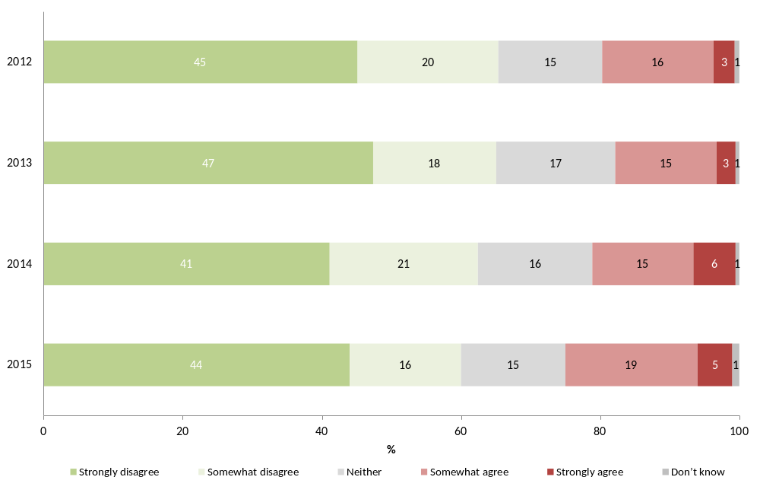
Q55a. To what extent do you agree or disagree with the following statements? I ride over the speed limit if I’m sure I’ll get away with it.
Those who have ridden in the last 12 months; Weighted; 2012 Base n = 440; 2013 Base n= 489, 2014 Base n = 569, 2015 base n = 592
Compared to males, females were significantly more likely to say that they would not ride over the speed limit even if they were sure they could get away with it (84% disagreeing with the statement compared to only 58% of males). No differences were found between riders of different age groups.
Table 29: Agree/disagree: I ride over the speed limit if I’m sure I’ll get away with it by key demographic groups - 2015
Column % | Gender |  | Age
Column % | Male (n=500) | Female (n=91) | 18-25 (n=202) | 26-39 (n=154) | 40+ (n=235)
Strongly/Somewhat disagree | 58↓ | 84↑ | 61 | 61 | 59
Neither | 16 | 11 | 15 | 17 | 15
Somewhat/Strongly agree | 26↑ | 3↓ | 24 | 22 | 25
Don’t know | 1 | 2 | 1 | 1 | 1
Q55a. To what extent do you agree or disagree with the following statements? I ride over the speed limit if I’m sure I’ll get away with it.
Those who rode in the last 12 months; Weighted; Base n = 592
↓↑ indicates statistically significant difference compared to respondents not in that category
Riders who mainly used a road bike were significantly more likely to agree that they would ride over the speed limit if they were sure they would get away with it (28% compared to 14% of off-road bike users and 3% of scooter riders).
Those who owned a motorcycle with a relatively larger engine capacity were significantly less likely to agree with the statement compared to those with smaller bikes (23% agreed for 251-700cc and 29% 701+cc sized engines compared to 15% for those with 0-250cc engines) (See Table 30).
Notably, respondents who had crashed while riding a motorcycle in the past were significantly more likely to say that they agreed that “I ride over the speed limit if I’m sure I’ll get away with it” (31% vs. 19% of those who had not crashed on their bike before) (See Table 31).
Table 30: Agree/disagree: I ride over the speed limit if I’m sure I’ll get away with it by type of bike
Column % | Type of bike (main bike) |  |  | Engine capacity
Column % | Off road bike/trail bike (n=134) | Road bike (n=299) | Scooter (n=34) | 0-250cc (n=164) | 251-700cc (n=176) | 701+cc (n=139)
Strongly/Somewhat disagree | 68 | 56↓ | 76 | 65 | 64 | 55
Neither | 17 | 15 | 19 | 19 | 13 | 15
Somewhat/Strongly agree | 14↓ | 28↑ | 3↓ | 15↓ | 23 | 29
Don’t know | 1 | 1 | 2 | 0 | 1 | 1
Q55a. To what extent do you agree or disagree with the following statements? I ride over the speed limit if I’m sure I’ll get away with it.
Those who rode in the last 12 months; Base n = 592
↓↑ indicates statistically significant difference compared to respondents not in that category
Table 31: Agree/disagree: I ride over the speed limit if I’m sure I’ll get away with it by crash history
Column % | Crash while riding motorcycle
Column % | Yes  (n=235) | No  (n=353)
Strongly/Somewhat disagree | 52↓ | 66↑
Neither | 16 | 14
Somewhat/Strongly agree | 31↑ | 19↓
Don’t know | 1 | 0
Q55a. To what extent do you agree or disagree with the following statements? I ride over the speed limit if I’m sure I’ll get away with it.
Those who rode in the last 12 months; Base n = 591
↓↑ indicates statistically significant difference compared to respondents not in that category
When asked about intentionally going over the speed limit in a 60km zone, half (51%) of respondents who had ridden in the last 12 months said that they would never intentionally ride above the speed limit in a 60km/h zone. This was followed by over a quarter (29%) who said that they would do this some of the time (See Table 32).
Table 32: Intentionally riding above limit in 60km/h zone
Column % | 2015
None of the time | 51
Some of the time (less than half but not never) | 29
About half the time | 7
Most of the time (more than half but not all) | 6
All of the time | 1
Don’t know | 5
Q46B How often have you intentionally ridden above the limit in a 60km/h zone, even if only a few km’s per hour, in the last three months?
Those who rode in the last 12 months; Base n = 591
As with the finding regarding speeding if they would be able to get away with it, younger riders were less likely to say they never intentionally rode above the limit (38% vs. 51% of those above 26). Those who lived in metropolitan Melbourne were also less likely to say they would never intentionally go over the sign-posted limit (40% vs. 65% for regional Victorians). Other rider groups who were less likely to say they would adhere to the speed limit included riders who commuted or rode on-road for recreational purposes (38% and 44% vs. 55% for off-road riders).

Whether pulled over by police in last 12 months
No significant changes were found between 2014 and 2015 participants in terms of being pulled over by the police in the past year. Nearly one-fifth (18%) of respondents said that they had been pulled over in 2015 compared to 16% who reported this last year.
Table 33: Whether pulled over by police in last 12 months (2012-2015)
Column % | 2012 | 2013 | 2014 | 2015
Yes | 22 | 20 | 16 | 18
No | 77 | 80 | 82 | 81
Prefer not to say/Can’t recall | 0 | 0 | 1 | 2
Q47 Have you been pulled over by police for any reason while riding your motorcycle in the last 12 months?
Filter: Active riders; Weighted; 2012 base n = 359, 2014 base n=506, 2013 base n= 404, 2015 base n = 486
↓↑ indicates statistically significant differences between 2014 and 2015 only
Among those who had been pulled over in the last 12 months, the most common reason was being breath testing (51%), followed by a routine licence check (48%) and speeding (8%). No significant differences were observed compared to 2014. In addition, those who had ridden in the last 12 months were asked if they had been caught speeding while riding their motorcycle. In 2014, only 3% (n=23) of respondents indicated that they had and all of those reported it had only been the one time.
Figure 39: Reasons for being pulled over by police in last 12 months
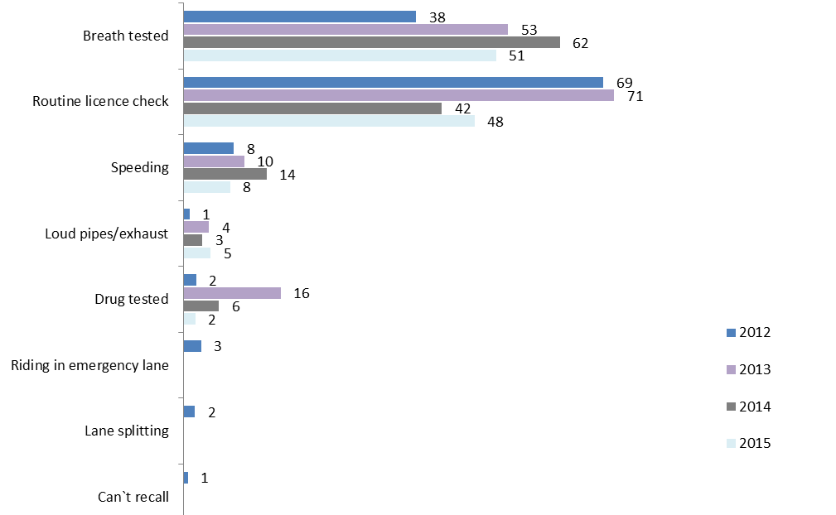
Q48 Why were you pulled over? Filter: Active riders pulled over by police for any reason in the last 12 months; Weighted; 2012 base n = 88, 2013 base n= 65, 2014 base n = 94; 2015 base n=92
Note: Does not add to 100% due to multiple responses

Speed limit in a 60km zone
When respondents were asked how fast people should be allowed to ride their bike in a 60km per hour zone without being booked for speeding, under half of respondents (45%) nominated a speed of exactly 60km per hour or less – significantly lower than in previous years (58% in 2014 and 64% in 2013). This is largely due to the increase in those who have reported that speeds of 64-66 km per hour should be allowed before people get booked (28% vs. 18% in 2014)..
Overall, the average speed nominated by respondents was 62.6 km per hour before someone should be booked (vs. 62.3 in the previous year and 61.7 for both 2012 and 2013).
Figure 40: Speed people should be allowed to ride a motorcycle in a 60kph zone without being booked for speeding
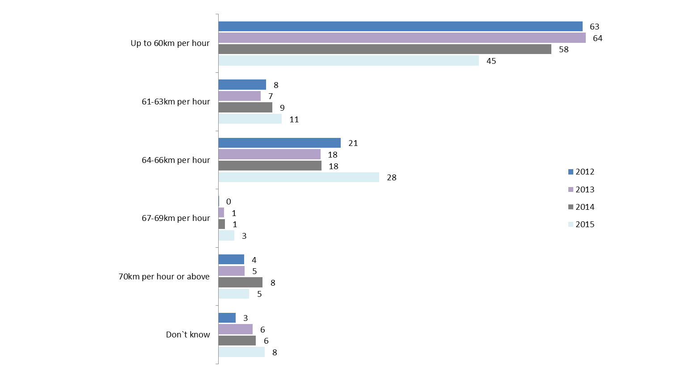
Q51. How fast should people be allowed to ride a motorcycle in a 60kph zone without being booked for speeding?
Filtered: Active riders; Weighted; 2012 base n = 358; 2013 base n =403; 2014 base n = 510, 2015 base n = 488
Excludes respondent error
Respondents were then asked how often they rode at or above the speed they had nominated. The frequency at which respondents in 2015 would ride their motorcycle above their nominated speed is shown in Figure 41. Similar to the previous year, seven in ten (71%) of those who said people should only be able ride at 60km or lower in a 60km zone said they would never go above this speed. However, approximately one in five (22%) said they would go over this speed some of the time.
Among the respondents who nominated speeds greater than 60km per hour (46%), less than half (42%) said they would never ride faster than the speed they nominated if they had the opportunity. More than four in ten (43%) reported going over this speed some of the time. This suggests that those who thought there should be more leeway in speed zones were more likely to say they would act upon it if the opportunity presented itself (at least some of the time).
Figure 41: Speed people should be allowed to ride a motorcycle in a 60kph zone without being booked for speeding and frequency they would ride above this speed – 2015
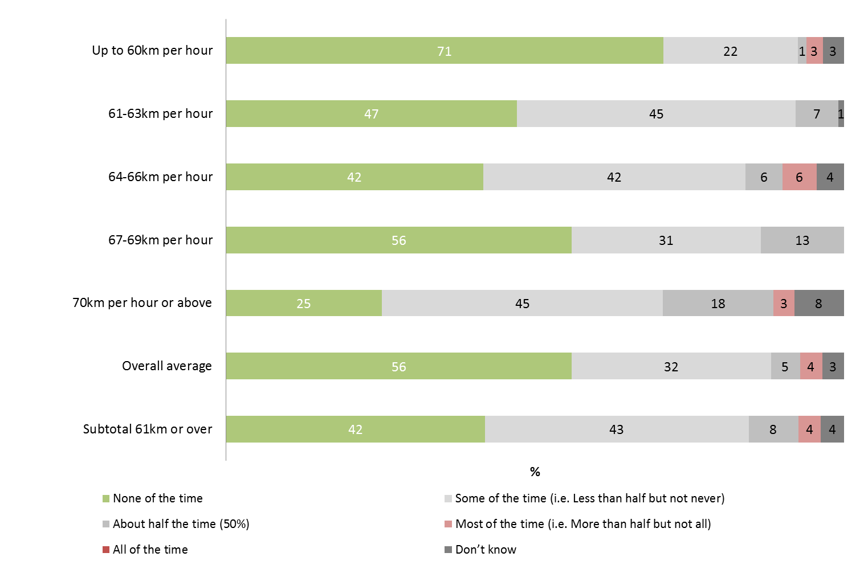
Q51 How fast should people be allowed to ride a motorcycle in a 60 km per hour zone without being booked for speeding?
Q52 and a When you have the opportunity, how often do you ride above 60km per hour in a 60kph zone?
Filter: Active riders; Weighted; 2015 Base n = 473
Excluding respondent error
Regardless of the speed nominated, the majority of active riders in 2015 reported they would never ride above the speed limit they felt people should be able to ride at without being booked (56%). More than four in ten (41%) reported they rode above the speed some of the time to all the time. These results are similar to those found in previous years.
Figure 42: Frequency respondents would ride above nominated speed in a 60km zone (2012-2015)
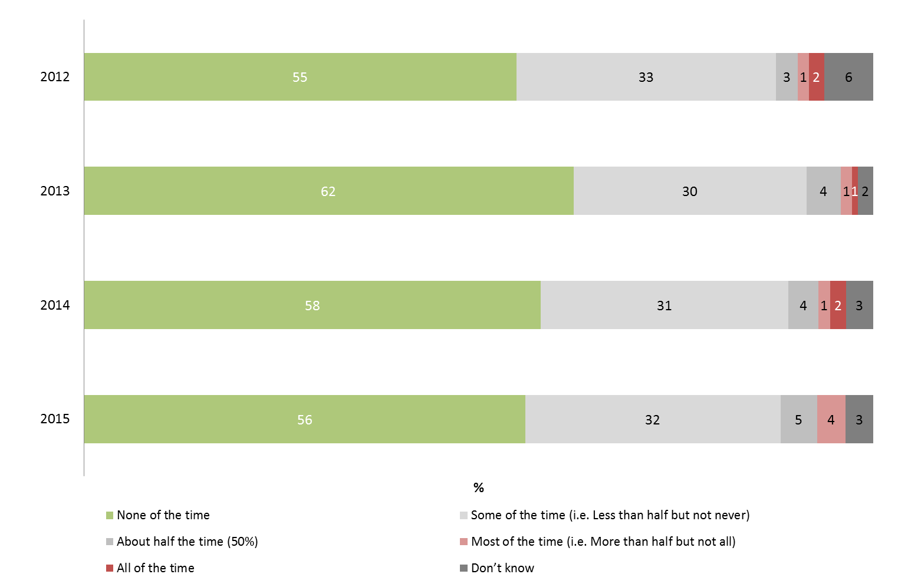
Q52 & Q52a When you have the opportunity, how often do you ride above X km per hour in a 60kph zone?
Filter: Active riders; Weighted; 2012 Base n = 359; 2013 Base n=4395; 2014 Base n=496; 2015 Base n=476
Excludes: Respondents who could not nominate a speed
Excluding respondent error
Those who said they had ridden off-road for recreational purposes in the last year were more likely to say they never rode above their nominated speed limit (60% compared to 50% of those who did some recreational on-road riding and 48% of those who did some commuting) (See Figure 43).
Figure 43: Frequency respondents would ride above nominated speed in a 60km zone by riding purpose - 2015
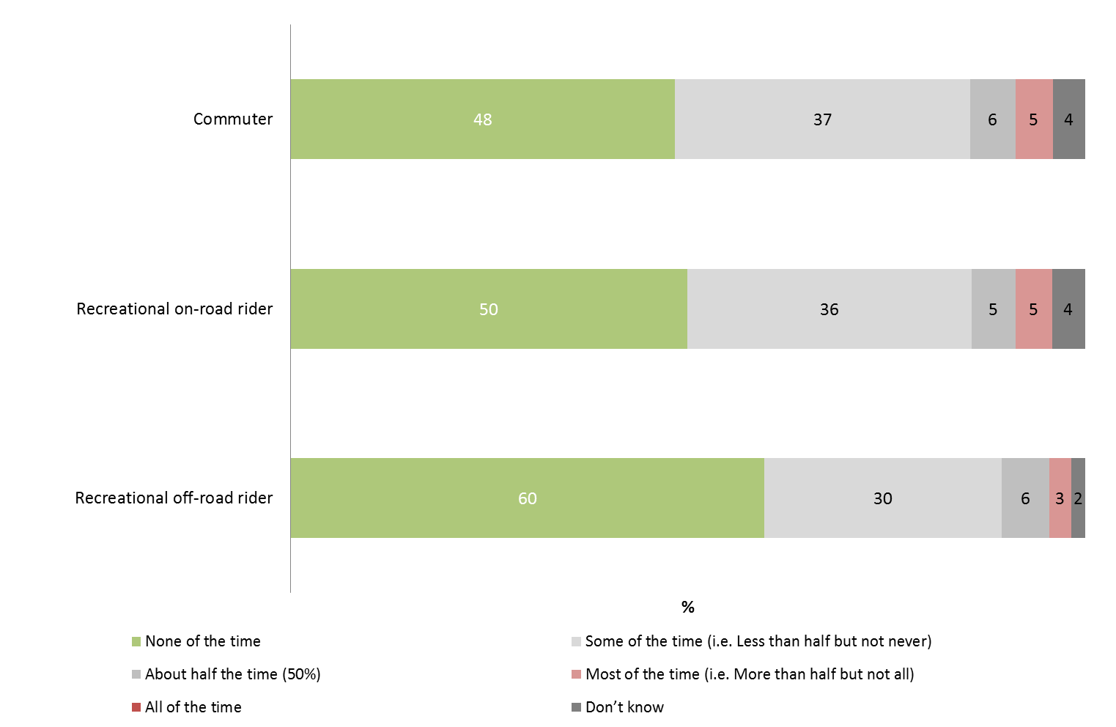
Q52 & Q52a When you have the opportunity, how often do you ride above X km per hour in a 60kph zone?
Filter: Active riders; Weighted; 2015 Base n = 461
Excluding respondent error

Speed limit in a 100km zone
Respondents were asked how fast people should be able to ride in a 100km zone without being booked for speeding. Forty percent (40%) of respondents felt you should only ride 100km per hour or less or be booked. Approximately one-fifth of respondents (22%) nominated a speed of 101-105km per hour, and a similar proportion (21%) said 106-110km per hour.
There were no significant changes from last year although, similar to the findings for 60km per hour zones, there has been a decrease in those who had nominated a speed of up to the signposted limit compared to 2012 and 2013 (40% vs. 55% in 2012 and 2013). This has been due to a slight increase in those who reported that speeds of just over 100 should be okay, but also an increase in those who were not sure what speed should be in place before you got booked (8% in 2015).
Figure 44: Speed people should be allowed to ride a motorcycle in a 100kph zone without being booked for speeding (2012-2015)
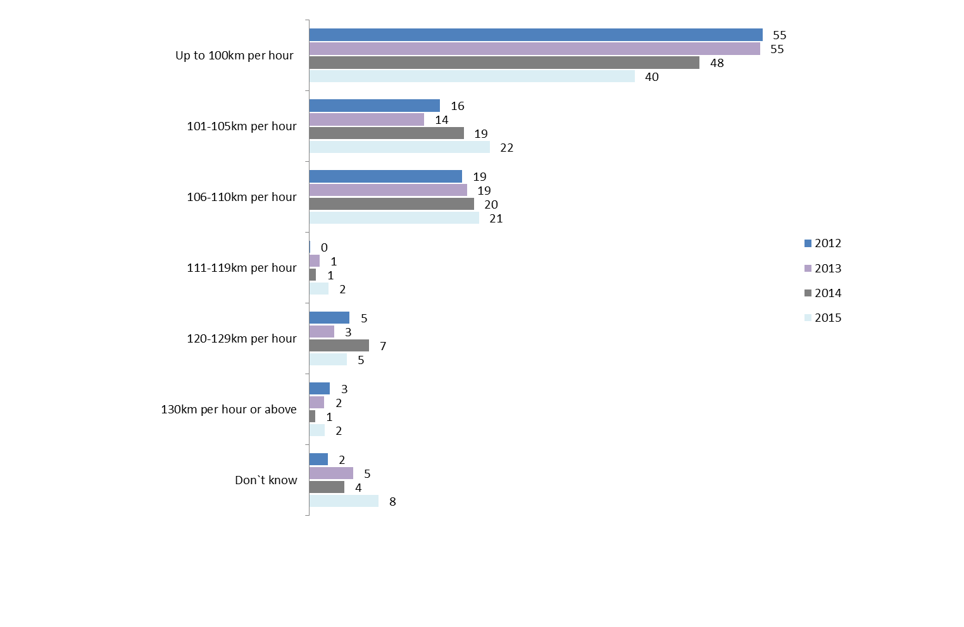
Q53. How fast should people be allowed to ride a motorcycle in a 100kph zone without being booked for speeding?
Filter: Active riders; Weighted; 2012 base n = 357, 2013 base n=403, 2014 base n = 506, 2015 base n = 487
Excluding respondent error
Overall, the average speed respondents said you should be able to ride without being booked was similar to last year at 105.4km per hour (104.8 km per hour in 2014 and 104.1 km in 2013).
Notably, the average speed that you should be able to go before being booked was significantly higher for those who had been involved in a crash (average speed of 106.8km per hour vs 104.4km per hour for those who had not experienced a crash). Recreational on-road riders were also more likely to nominate higher speeds compared to commuters or recreational off-road riders (106.2km/h vs. 105.4km/h for commuters and 105.0km/h for recreational off-road riders).
Notably, younger respondents aged 18-25 years were significantly less likely to nominate that you should only be able to go up to 100km per hour before being booked (22% compared to 38% for those aged 26-39 and 52% of those aged 40 and over) and were more likely to nominate speeds that were ‘just over’ the limit (33% nominated speeds of 101-105km per hour) (See Table 34).
Table 34: Speed people should be allowed to ride a motorcycle in a 100kph zone without being booked for speeding by selected demographic characteristics - 2015
Column % | Age |  |  | Location
Column % | 18-25 (n=162) | 26-39 (n=124) | 40+ (n=246) | Balance of Victoria (n=220) | Melbourne (n=267)
Up to 100km per hour | 22↓ | 38 | 44 | 44 | 37
101-105km per hour | 33↑ | 23 | 20 | 28↑ | 18↓
106-110km per hour | 24 | 21 | 20 | 16 | 24
111-119km per hour | 4 | 3 | 2 | 1 | 3
120-129km per hour | 7 | 6 | 4 | 3 | 5
130km per hour or above | 3 | 1 | 2 | 2 | 2
Don`t know | 7 | 9 | 8 | 6 | 10
Subtotal - 101km per hour or above | 71↑ | 53 | 48 | 43 | 43
Q53. How fast should people be allowed to ride a motorcycle in a 100kph zone without being booked for speeding?
Weighted; Base n = 487
↓↑ indicates statistically significant difference compared to respondents not in that category
Excluding respondent error
The frequency at which respondents rode their motorcycle above the speed they nominated as permissible in a 100 km per hour zone is shown in Figure 45. Two-thirds of those who said people should only be able to ride up to 100km per hour in a 100 zone would never ride above this speed (69%). In comparison, those who nominated a speed higher than 100km were less likely to say they would adhere to the speed they nominated (34%).
Figure 45: Speed people should be allowed to ride a motorcycle in a 100kph zone without being booked for speeding and frequency they would ride above this speed - 2015
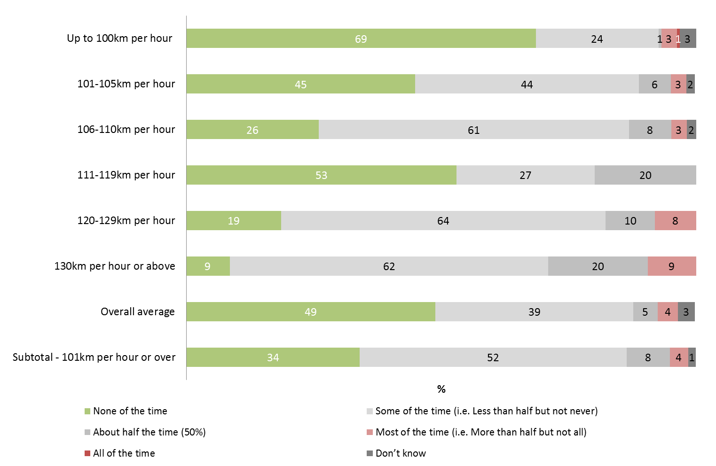
Q54 & Q54a When you have the opportunity, how often do you ride above X kph in a 100kph zone?
Filter: Active riders; Weighted; 2015Base n =487
Excluding respondent error
Regardless of the speed nominated, half of respondents who had ridden in the last 12 months reported they would never ride above the limit they felt people should be able to ride at without being booked (49%). More than one in three (39%) reported they rode above the speed they nominated some of the time. The results for 2015 are similar to those found in 2014.
Figure 46: Frequency respondents would ride above nominated speed in a 100km zone (2012-2015)
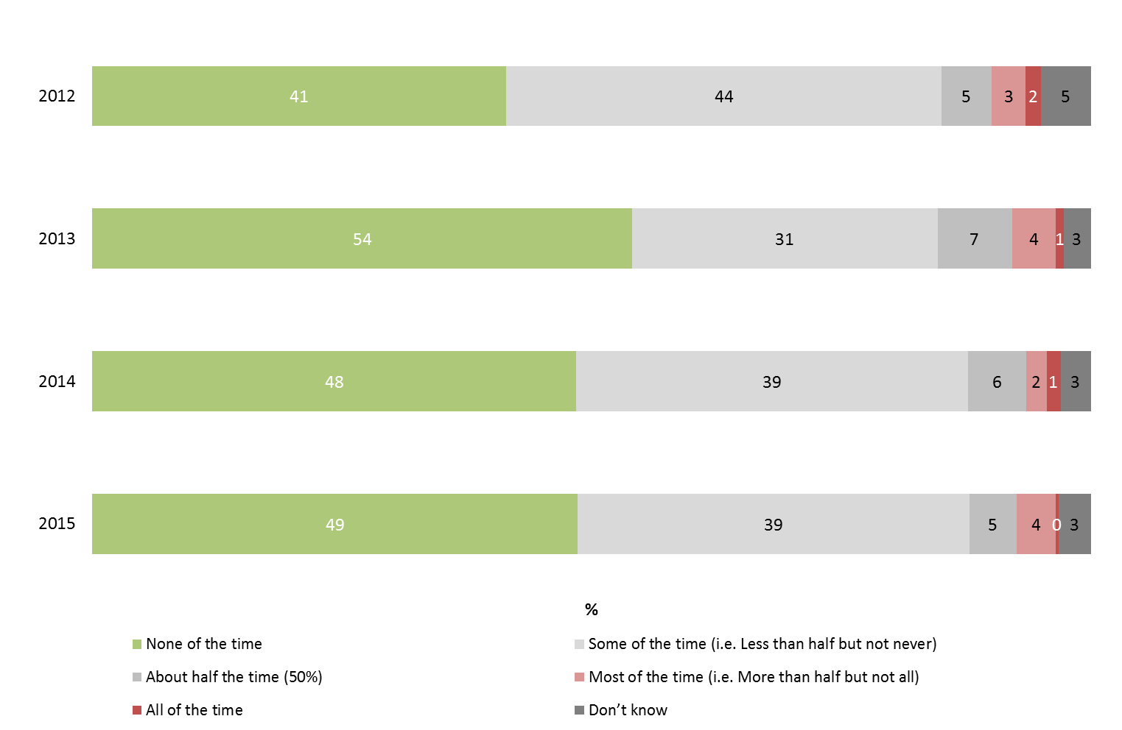
Q54 & Q54a When you have the opportunity, how often do you ride above X kph in a 100kph zone?
Filter: Active riders only; Weighted; 2012 Base n=357; 2013 Base n = 382; 2014 Base n = 491; 2015 Base n = 472
Excluding respondent error
When comparing attitudes towards speeding in the two zones (regardless of the speed they nominated as the point where people should be booked), although not a significant difference, more riders reported they would never ride above the speed limit in a 60km zone than a 100km zone (56% vs. 49% in a 100km zone) and were more likely to ride above the speed they nominated ‘some of the time’ to ‘all the time’ when referring to a 100km zone (48% in a 100km zone vs. 41% in a 60km zone) (See Figure 47). These results are on par with 2014 figures.
While this should be of concern, it should be also noted that these results are consistent with attitudes towards speed among car drivers where reported speeding was more prevalent in the higher speed zones. Of most concern is the slight but significant change to those who believe they should be able to travel at a higher speed before being booked.
Figure 47: Frequency respondents would ride above nominated speed in a 60km zone compared to a 100km zone – 2015
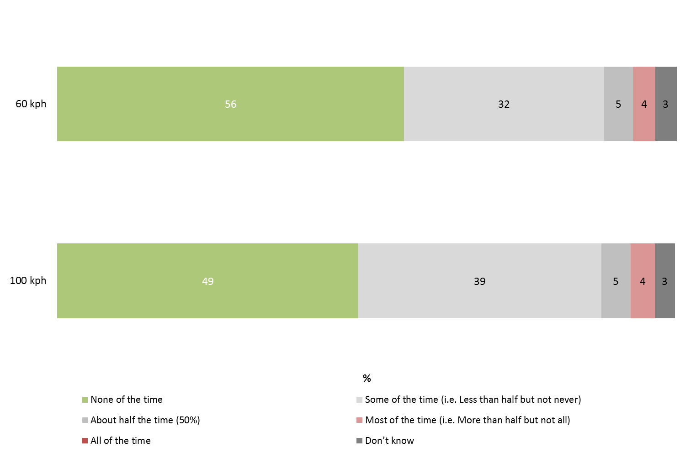
Q52 & Q52a When you have the opportunity, how often do you ride above X km per hour in a 60kph zone?
Q54 & Q54a When you have the opportunity, how often do you ride above X kph in a 100kph zone?
Filter: Active riders; Weighted; Base n = 476

Perceptions of danger associated with driving over the speed limit
In addition to asking riding behaviour in 60 and 100 km zones, for the first time in 2015, active riders were also asked how dangerous they thought riding a few kilometres above the sign posted speed limit, using a scale of 0 to 10, where 0 was not at all dangerous and 10 was extremely dangerous.
Just over half (51%) of respondents felt riding a few kilometres over the limit in a 60km/h zone was dangerous, nominating a score of 7-10 out of 10. This included one in four (27%) who reported it was extremely dangerous. A similar proportion (27%) rating riding a few kilometres over the limit in a 60 zone was not dangerous (0-3 out of 10). One in five (20%) active riders neither felt it was dangerous or safe to ride a few kilometres over the limit.
In comparison, a slight but significantly smaller proportion of active riders felt that riding a few kilometres over the limit in a 100km zone was dangerous. This is consistent with the findings above where respondents were more likely to say they rode above the sign-posted limit at least some of the time compared to in a 60km zone. In total, 48% of active riders reported that they felt riding a few kilometres over the limit in a 100km zone was dangerous including 26% who felt it was extremely dangerous. Just under one in three (31%) felt riding a few kilometres over the limit was not dangerous providing ratings of 3 or lower.
Figure 48: Perception of danger associated with riding a few kilometres over the posted speed limit – 2015
Q46A. Using a scale where 0 is not at all dangerous and 10 is extremely dangerous, how dangerous do you think is?
Active riders only; Weighted; 2015 base n = n=491
Of all the driving behaviours covered in the survey (covering low level speeding, driving under the influence, and riding while drowsy); low level speeding in a 100km zone was the least likely to be deemed dangerous, followed by low level speeding in a 60km zone. Given the slight but significant increase in the speed that riders believe that you should be able to ride before being fined, this is an issue that is worth addressing with motorcycle riders (See Figure 49).
Low level speeding in a 60km or 100km zone was less likely to be deemed dangerous among male riders and younger riders aged 18-25. For 60 km zones specifically, those in metropolitan Melbourne and those who commute were also less likely to think that riding a few km over the limit was dangerous.
Figure 49: Perception of danger associated various riding behaviour – 2015
Q46A. Using a scale where 0 is not at all dangerous and 10 is extremely dangerous, how dangerous do you think is?
Active riders only; Weighted; 2015 base n = n=491

Random Breath and Drug Testing
In summary, one in five respondents (20%) said they had been breath tested at least once in the past year and only 2% reported that they had been randomly drug tested while riding a motorcycle.
The perception that driving under the influence was extremely dangerous was pervasive among motorcycle riders. Riding after using stimulant drugs (such as speed, methamphetamine, ice, ecstasy) was most likely to be deemed extremely dangerous (86%) with 83% of respondents also rating riding with an illegal Blood Alcohol Content (BAC) level; after using depressant drugs (such as marijuana, heroin, GHB); and after using drugs and alcohol was also extremely dangerous. In contrast, only two in three respondents (68%) felt that riding after drinking a small amount of alcohol while using prescriptive medicines was extremely dangerous.
Consistent with the above, only a small proportion of respondents (2%) reported that they had ridden their motorcycle when they knew or thought that they were possibly over the legal blood alcohol limit.
Participants were asked about experiences with random breath and drug testing when riding their motorcycle. As with 2014 results, the majority (79%) of respondents in 2015 said that they had not been breath tested in the last 12 months. One-fifth (20%) of the respondents were tested at least once including 10% who reported being tested more than one time in the last 12 months (See Figure 50).
Those who rode more than 20% of the time (compared to driving) were more likely to have breath tested at least once in the past 12 months (34% compared to 14% who rode less than 20% of the time). Commuters (31%) and on-road recreational riders (24%) were also more likely to have been tested at least once compared to those who rode off-road (11%) suggesting being tested was related to how much time riders spent on the road.
A small number of respondents said they had been randomly drug tested while riding a motorcycle in the last 12 months (2% vs. 1% in 2014). However, there does seem to be some confusion given that one in three (31% of the 12 respondents drug tested); said that this had been a breath test when drug tests use a saliva kit.
Figure 50: Proportion of active riders breath tested - 2015
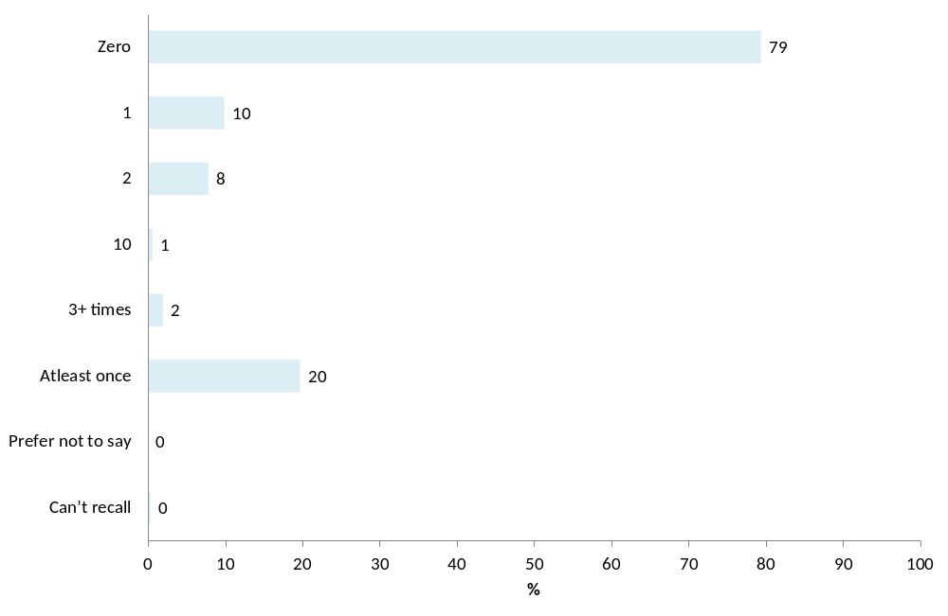
Q48a In the last 12 months, how many times, if any have you been breath-tested when riding your motorcycle?
Filter: Active riders; Weighted; Base n = 491

Riding when over the limit
Similar to last year’s results, excluding non-drinkers (5% of active riders), only a small minority of respondents (2%) they had ridden their motorcycle when they knew or thought they were possibly over the legal blood alcohol limit.
From the n=12 people that had said yes, their reasons included thinking they were only slightly over, having alcohol in their system from the night before, or riding on private property.
“Been out for a ride and had a pot of beer on the way home
- 3KM from my house...On P Plates so supposed to be zero.”
“It was the next day, thought I would more than likely be under the limit,
but could have possibly still been over.”

Perceptions of danger associated with driving under the influence
Using a scale of 0 to 10, where 0 was not dangerous at all and 10 was extremely dangerous; respondents were asked how dangerous they thought riding was:
- with an illegal Blood Alcohol Content (BAC) level;
- after using stimulant drugs (such as speed, methamphetamine, ice, ecstasy);
- after using depressant drugs (such as marijuana, heroin, GHB);
- after using drugs and alcohol; and
- after drinking a small amount of alcohol while also using prescription medicines.
Approximately nine-in-ten respondents felt that all the examples of driving under the influence were dangerous providing scores of 7-10 out of 10.
Riding after using stimulant drugs (such as speed, methamphetamine, ice, ecstasy) was most likely to be deemed extremely dangerous (86%) with 83% of respondents also rating riding with an illegal Blood Alcohol Content (BAC) level; after using depressant drugs (such as marijuana, heroin, GHB); and after using drugs and alcohol as extremely dangerous.
In contrast only two thirds (68%) reported that riding after drinking a small amount of alcohol while also using prescription medicines was extremely dangerous – on par with riding while extremely drowsy (65%).
Figure 51: Perception of danger associated with riding under the influence– 2015
Q46A. Using a scale where 0 is not at all dangerous and 10 is extremely dangerous, how dangerous do you think is?
Active riders only; Weighted; 2015 base n = n=491

Motorcycle/scooter ownership
In summary, 32% of respondents indicated they had one bike at their home address and 21% had 2-4 bikes at home. A small proportion (4%) had five or more bikes at home. In total, 43% of respondents did not have a motorcycle at their home address.
Nearly nine in ten (88%) active riders had at least one bike at home. This included two-thirds (69%) who mainly rode a road bike, followed by 23% who said they road an off-road bike. Five percent (5%) of active riders said they mainly rode a scooter.
Yamaha (17%), Honda (17%) and Harley Davidson (13%) were the most common brands of motorcycles that respondents mainly rode. Almost a third of respondents (31%) rode a bike that had been manufactured in the last five years but most commonly rode a 2000-2009 model (49%). Forty-four percent (44%) reported riding a bike with engine size of 701+cc with a three in ten (31%) riding a bike with a 251-700cc motor.
Nearly all road bikes (93%) and scooters (100%) were registered to ride on the road (compared to only 24% of off-road/trail bikes).
When asked about safety features, Antilock Braking System (ABS) was the most common feature that riders had heard of (81%). Interest in having ABS on a bike they would purchase in the future was moderately high (57%) although one in four were undecided about this feature (26%)

Number of motorcycles in household
Over two-fifths (43%) of all respondents said that they did not have a motorcycle at home. Approximately one-third (32%) said that they had one motorcycle at their home address and 21% reported having 2-4 bikes. Only 4% of respondents had five or more bikes at home (See Figure 52).
Figure 52: Number of motorcycles kept at home - 2015
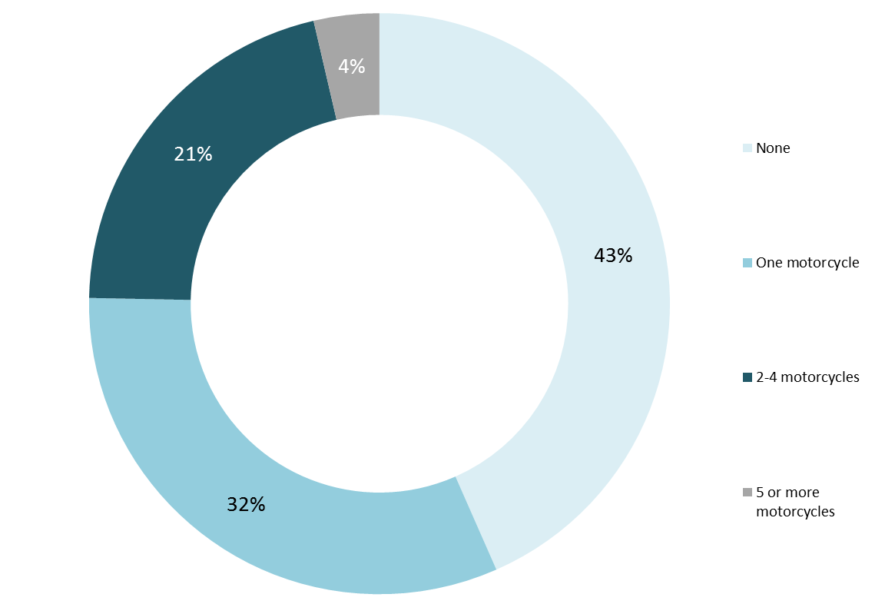

Q15. How many motorcycles are kept at your home address regardless of who owns them or registration status?
Filter: all respondents; Weighted; base n=800
Nine in ten (88%) active riders in 2015 reported having at least one bike at home (compared to 25% of lapsed riders and only 2% of former riders) (See Table 35).
Table 35: Number of motorcycles kept at home by rider activity segment - 2015
Column % | Rider activity segment
Column % | Active riders  (n=491) | Lapsed riders (n=247) | Former riders  (n=53)
None | 12↓ | 75↑ | 98↑
One motorcycle | 48↑ | 17↓ | 1↓
2-4 motorcycles | 34↑ | 8↓ | 1↓
5 or more motorcycles | 6↑ | 1↓ | 0
Subtotal: At least 1 motorcycle at home | 88↑ | 25↓ | 2↓
Q15 How many motorcycles are kept at your home address?
All respondents; Weighted; Base n = 791
↓↑ indicates statistically significant difference compared to respondents not in that category
As shown in Table 36 below, respondents who lived in the least disadvantaged (i.e. most advantaged) areas of Victoria (SEIFA quintiles 4 and 5) were significantly less likely to say that they had a bike at their home address (52% compared to 60% of quintiles 1 and 2 and 64% of quintile 3) – which shows that motorcycles are more common in disadvantaged households.
Table 36: Number of motorcycles kept at home by SEIFA quintiles - 2015
Column % | Quintile 1 and 2  (n=226) | Quintile 3  (n=156) | Quintile 4 and 5 (n=414)
None | 40 | 36 | 48↑
One motorcycle only | 33 | 34 | 31
Two or more motorcycles | 23 | 24 | 19↓
Subtotal: At least 1 motorcycle at home | 60 | 64 | 52↓
Q15 How many motorcycles are kept at your home address?
Filter: All respondents; Weighted; Base n = 796
↓↑ indicates statistically significant difference compared to respondents not in that category

Details of motorcycle ridden most often

Type of motorcycle mainly ridden
Active riders were asked what type of bike they mainly rode. These results were similar to those found in 2014.
In 2015, the largest proportion of riders mainly rode a road bike (69% vs. 65% in 2014). Nearly a quarter (23%) said that they rode an off-road/trail bike (25% in 2014) and a scooter was ridden by 5% of the population (8% in 2014).
Of the types of road bikes, the most common was a sports bike (26%), followed closely by 22% who said they rode a tourer/cruiser.
Figure 53: Type of bike (Main motorcycle) (2012-2015)
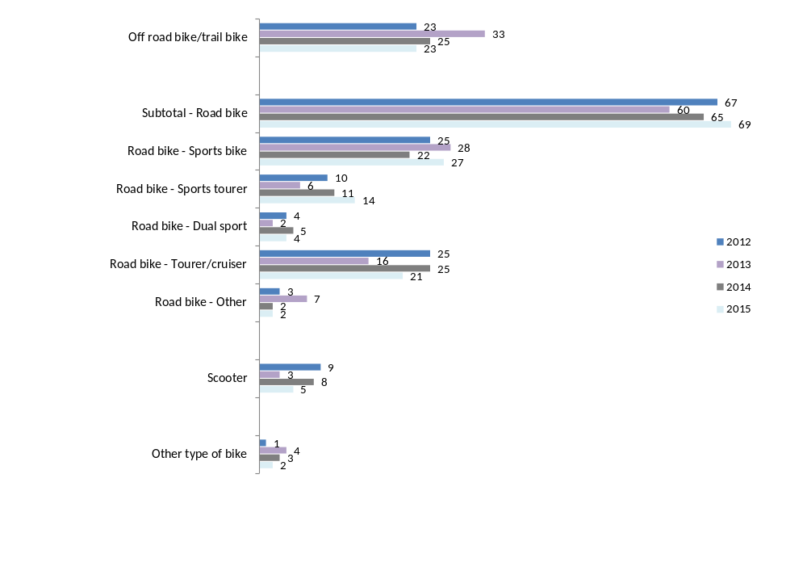
Q16 Please provide details of the motorcycle you ride most of the time – Type of bike
Filter: Active riders and keep at least one bike at home; Weighted; 2012 base n = 329; 2013 base n=350; 2014 Base n = 450, 2015 base n = 435
Differences in the types of motorcycles mainly ridden by selected characteristics can be found below, see Table 37. These included:
- Those living in regional Victoria were significantly more likely to report an off-road/trail bike as their main bike (34% vs. 15%).
- Melbourne residents were more likely to report that their main bike was a road bike (74% compared to 61%).
- Learner or probationary licence holders were significant more likely to mainly ride a sports bike (42% vs. 25%), as were younger respondents (42% of those aged 18-25 compared to 19% of those aged 40 and over).
- Dual sport bikes were popular among those aged 40+ (26% vs. 17% for 26-39 year olds and 9% for under 25s).
- Females were more likely than males to have scooters as their main bike (18% compared to 4% of males).
Table 37: Type of bike (Main motorcycle) by selected characteristics – 2015
Column % | Gender |  | Age |  |  | Location |  | Licence type
Column % | Male (n=361) | Female (n=69) | 18-25 (n=145) | 26-39 (n=108) | 40+ (n=177) | Balance of Vic. (n=190) | Melbourne (n=240) | Learner/  probationary (n=118) | Full licence (n=306)
Off road bike/trail bike | 24 | 14 | 31 | 25 | 21 | 34↑ | 15↓ | 27 | 22
Subtotal - Road bikes | 70 | 60 | 61 | 70 | 69 | 61↓ | 74↑ | 64 | 70
- Sports bike | 26 | 33 | 42↑ | 39↑ | 19↓ | 17↓ | 33↑ | 42↑ | 25↓
- Sports tourer | 15 | 11 | 5↓ | 12 | 17 | 14 | 15 | 6↓ | 16↑
-Tourer/cruiser | 4 | 3 | 4 | 3 | 4 | 5 | 3 | 2 | 4
- Dual sport | 23 | 12 | 9↓ | 17 | 26↑ | 23 | 21 | 13 | 23
- Other | 3 | 1 | 0↓ | 0 | 4↑ | 2 | 3 | 1 | 3
Scooter | 4↓ | 18↑ | 4 | 2 | 7 | 4 | 7 | 6 | 5
Other type of bike | 2 | 5 | 4 | 1 | 2 | 2 | 2 | 2 | 2
Don’t know | 1 | 3 | 0 | 1 | 1 | 0 | 2 | 2 | 1
Q16. Please provide details of the motorcycle you ride most of the time – Type of bike
Filter: Active riders and keep at least one bike at home; Weighted; Base n = 430
↓↑ indicates statistically significant difference compared to respondents not in that category

Make/brand of main motorcycle
The mix of the most popular brands was similar to previous years with the top three brands for active riders comprising Yamaha (17%), Honda (17%), and Harley Davidson (13%). Suzuki and Kawasaki motorcycles rounded out the top five brands (13% and 11% respectively).
Figure 54: Brand of bike (Main motorcycle) (2012-2015)
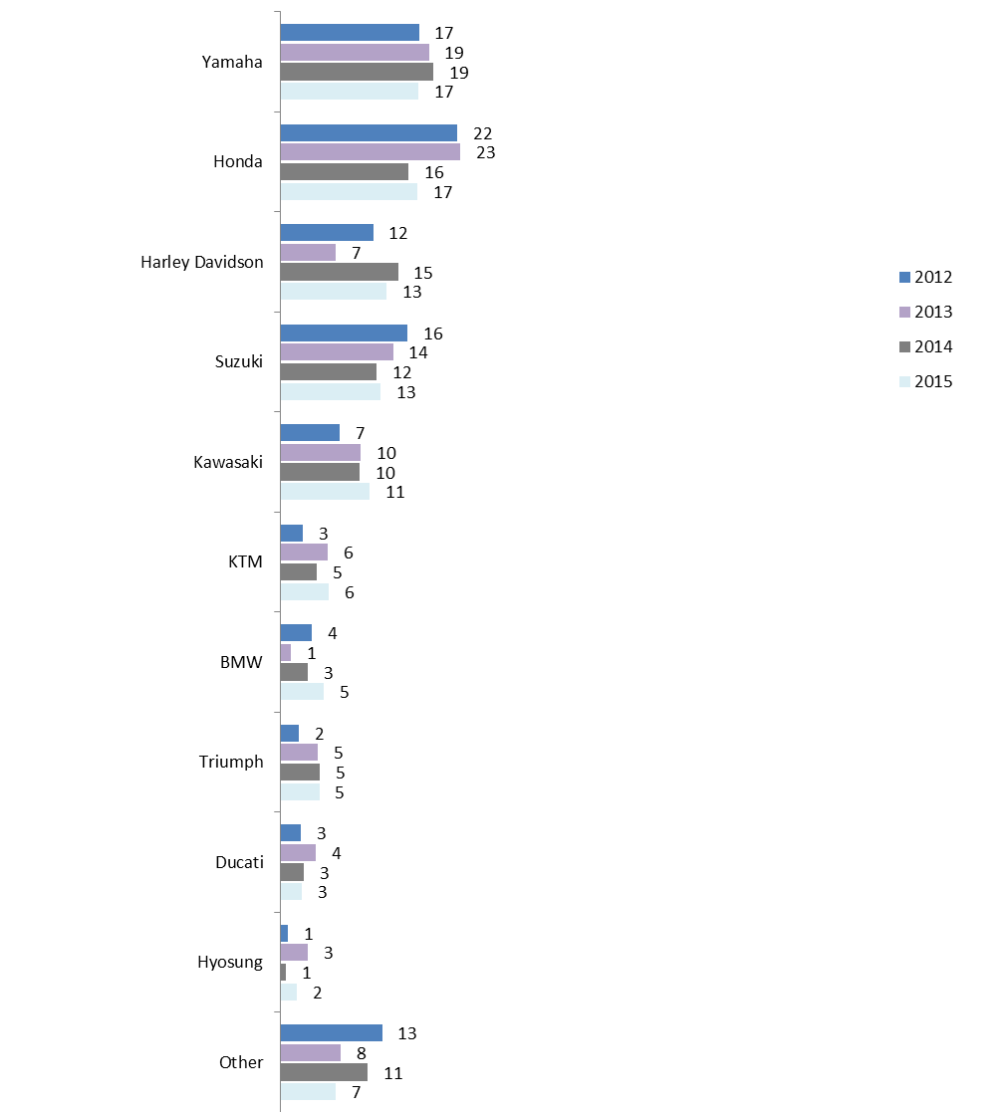
Q16 Please provide details of the motorcycle you ride most of the time – Make/brand
Filter: Active riders; Weighted; 2012 base n = 329; 2013 base n = 422; 2014 base n = 446; 2015 base n = 430

Year of manufacture of main motorcycle
Newly manufactured motorcycles made in 2010-2015 were ridden by 31% of active riders. Active riders were most likely to ride motorcycles manufactured between 2000 and 2009 (49%).
Younger respondents tended to ride newer bikes (made in 2010-2014 - 42% for those aged 18-25 or 48% for those with L or P plates). Those who rode more frequently were more likely to ride a newer model of motorcycle (however, this group consisted largely of the young or inexperienced riders mentioned above) (See Table 38).
Table 38: Year of manufacture of main motorcycle by selected rider characteristics - 2015
Column % | Age |  |  | Licence type |  | Riding vs. driving
Column % | 18-25  (n=129) | 26-39  (n=90) | 40+  (n=157) | L/Ps (n=100) | Full (n=269) | Ride less than 20% (n=262) | Ride 20% or more (n=153)
1999 or earlier | 10↓ | 14↓ | 23↑ | 11↓ | 21↑ | 26↑ | 12↓
2000-2009 | 48 | 47 | 50 | 42 | 51 | 50 | 47
2010-2014 | 42↑ | 39 | 26↓ | 48↑ | 28↓ | 24↓ | 43↑
Q16 Bike ridden most often - Year of manufacture
Filter: Active riders who kept at least one bike at home; Weighted; Base n = 369
↓↑ indicates statistically significant difference compared to respondents not in that category
Table 39 shows the vintage of the bike that people bought and the year in which they purchased it. Half of those who had purchased their bike in the last five years had brought a relatively new bike (47% of the bikes were also made in 2010-2015).
Table 39: Year of purchase and year of manufacture (2015)
 | Year of purchase
Year of manufacture | 1999 or earlier (n=19) | 2000-2004  (n=27) | 2005-2009  (n=52) | 2010-2015  (n=302) | Total  (n=400)
1999 or earlier | 96↑ | 54↑ | 2↓ | 14↓ | 22
2000-2009 | 4↓ | 46 | 98↑ | 39↓ | 47
2010-2014 | - | - | - | 47↑ | 31
Q16 Bike ridden most often - Year of manufacture
Q16 Bike ridden most often - Year purchased
Filter: Riders who owned at least one bike; Weighted; Base n = 400
↓↑ indicates statistically significant difference compared to respondents not in that category

Odometer reading
When asked about the odometer reading of the motorcycle they mainly ride, the largest proportion of respondents (21%) stated that their reading was between 10,001-20,000kms (See Table 40).
On average, bikes made 1999 or earlier had an odometer reading of approximately 79,000km. Those manufactured in 2000-2009 had an average odometer reading of approximately 27,000 and the newer bikes made in the last five years had readings that averaged approximately 8,000km.
Table 40: Odometer reading on bike mainly ridden by year of manufacture- 2014
Column % | Total  (n=340) | 1999 or earlier  (n=55) | 2000-2009  (n=163) | 2010-2014  (n=122)
Up to 500 | 3 | 0 | 0↓ | 9↑
501-1,000 | 3 | 0 | 1↓ | 9↑
1,001-2000 | 6 | 0 | 5 | 12↑
2,001-5000 | 15 | 0↓ | 12 | 28↑
5,001-10000 | 13 | 7 | 13 | 17
10,001-20000 | 20 | 20 | 22 | 17
20,001-30000 | 9 | 10 | 11 | 6
30,001-50000 | 18 | 32↑ | 22 | 2↓
50,001+ | 13 | 31↑ | 14 | 0↓
Average reading | 31052.7 | 78696.8 | 26872.1 | 7726.4↓
Q16viii. What is the odometer reading on the bike you mainly ride?
Those who own at least one motorcycle; Weighted; 2015 Base n = 340 (excludes don’t know or refused)
↓↑ indicates statistically significant difference compared to respondents not in that category

Engine size of main motorcycle
A range of motorcycle engine sizes were reported among active riders, with the majority of respondents (44%) reporting that their bike had an engine size of 701+cc. This was consistent with last year’s result (42%). Just under one-third (31%) reported an engine size of 251-700cc (30% in 2014).
Female respondents were significantly more likely to report having an engine size of 250cc or less (42% vs. 24% of males), as were younger respondents aged between 18-25 years (47% compared to 22% of those aged 40 or over). Older respondents were significantly more likely to have a motorbike with a larger engine size, with 53% reporting an engine size of 701+cc.
Road bike users were more likely to report having a bike with a larger engine, with 62% reporting an engine size of 701+cc (compared to 1% of off-road bike users).

Registration status
Nearly all road bikes (93%) and scooters (100%) were registered to ride on the road (compared to only 24% of off-road/trail bikes).
Those with off-road or trail bikes were more likely to have them recreational registration only (40%) followed by not having a registration at all (31%) (See Table 41).
Table 41: Registration status of main bike (Active riders) - 2015
 | Type of bike (main bike)
Column % | Off road bike/trail bike  (n=111) | Road bike  (n=270) | Scooter  (n=25) | Total  (n=420)
Road registered | 24↓ | 93↑ | 100↑ | 77
Recreational registered | 40↑ | 2↓ | 0 | 11
Farm bike registered | 5↑ | 0↓ | 0 | 2
Not registered | 31↑ | 4↓ | 0 | 10
Unknown | 0 | 0 | 0 | 1
Q16 Bike ridden most often - Is the bike registered?
Filter: Active riders only; Weighted: base n = 420
↓↑ indicates statistically significant difference compared to respondents not in that category

Details of other motorcycles ridden in household
Participants who owned more than one motorcycle were asked to list the details of up to three other motorcycles that were kept at their home address, excluding any motorcycles that had not been ridden in the last year or were unlikely to be ridden in the next year. Only 4% of all respondents had more than four motorcycles at home.
The types of other motorcycles kept at home were similar to the bikes respondents mainly rode: 50% of all ‘other’ bikes kept at home were off-road bike/trail bikes and the total proportion of road bikes owned by respondents was 55%.
Table 42 shows that among active riders, the other types of bikes kept at home were usually other models of the main bike they rode. For example, 82% of those who mainly rode an off-road bike owned other off road bikes, although one in five (19%) also owned a road bike.
In comparison, road bike owners who owned more than one bike were most likely to own other road bikes (67%) but 36% also had off-road bikes at home.
Table 42: Other types of bikes owned
 | Type of bike (Main bike)
Column % | Off road bike/trail bike (n=74) | Subtotal - Road bikes (n=118) | - Sports bike  (n=56) | - Sports tourer  (n=23)* | - Dual sport  (n=11)* | - Tourer/cruiser  (n=25)* | Scooter (n=10)*
Type of other bikes:
Off road bike/trail bike | 82↑ | 36↓ | 29↓ | 49 | 34 | 34 | 22
Subtotal - Road bike | 19↓ | 67↑ | 73↑ | 69 | 51 | 66 | 77
- Sports bike | 4↓ | 29↑ | 38↑ | 11 | 21 | 34 | 42
- Sports tourer | 7 | 19 | 19 | 43↑ | 0 | 6 | 0
- Dual sport | 2 | 3 | 0 | 0 | 30↑ | 0 | 0
- Tourer/cruiser | 7↓ | 20 | 17 | 15 | 0 | 36↑ | 46↑
- Other | 0 | 2 | 0 | 0 | 0 | 7↑ | 0
Scooter | 4 | 3 | 7 | 2 | 0 | 0 | 23↑
Other type of bike | 1 | 2 | 2 | 7 | 0 | 0 | 0
Q17 Other Bike - Type of bike
Filter: Active riders AND Own more than one motorcycle; Weighted; Base n = 207
↓↑ indicates statistically significant difference compared to respondents not in that category
*Note: Small sample sizes

Motorcycle safety features
Active riders were asked if they had heard of a number of safety features currently available on some motorcycles and/or clothing (See Figure 55). The most common feature that respondents had heard of was ABS (Antilock Braking Systems) (81%). Half of riders had heard of traction control (57%). There were a number of features recalled by around one in three respondents, including: speed limiter function (38%, up from 29%); low tyre pressure indicators (38%), emergency brake assist (34%), electronic stability control (33%), and airbags (in clothing) (30%).
More than one in ten (12%) said they had not heard of any of the features listed in the survey.
Figure 55: Awareness of motorcycle safety features (2012-2015)
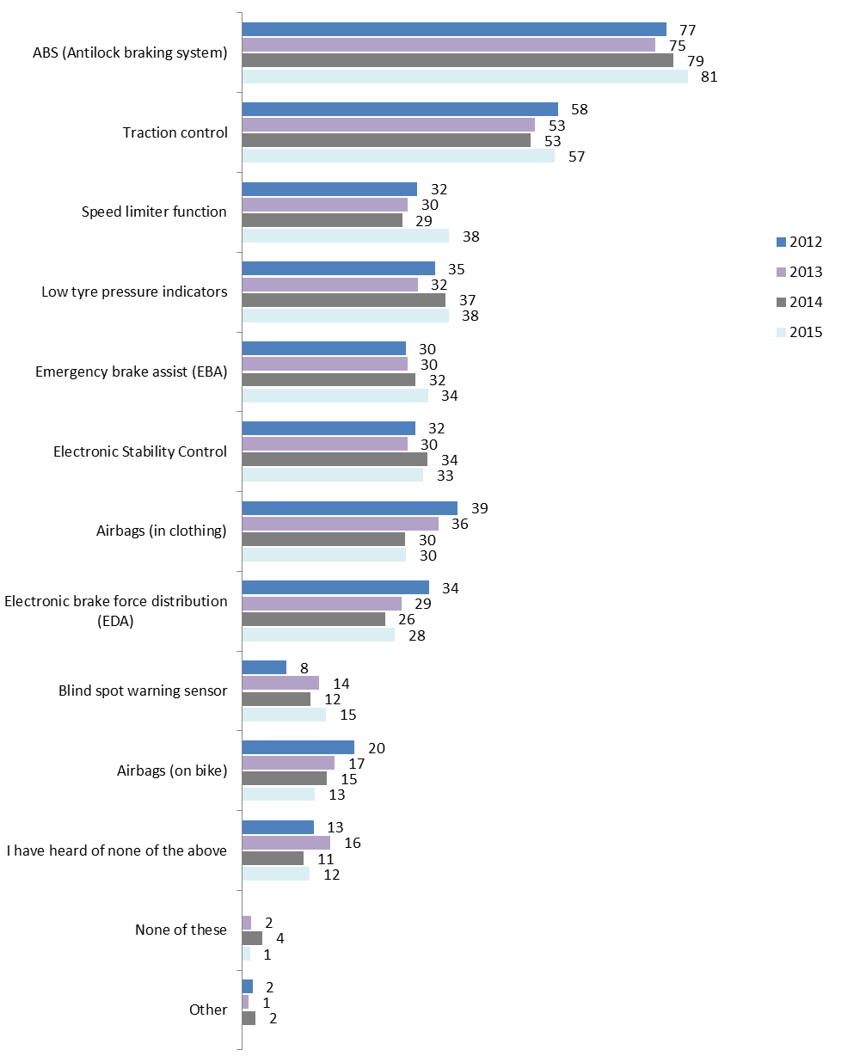
Q36 Have you heard of any of the following motorcycle safety features?
Filter: active riders; Weighted; 2012 base n =359; 2013 base n=405; 2014 base n = 511; 2015 base n = 491
While historically, males tended to report higher awareness for a number of the safety features than their female counterparts, 2015, males were only more likely to be aware of Electronic Stability Control (34% vs. 16%).
Those who had a crash were significantly more likely than those who had not to report they had heard of airbags (in clothing) (37% vs. 22%), airbags (on bike) (21% vs. 9%), and blind spot warning sensor (17% vs. 8%).
On a positive note, awareness among the younger riders was relatively high with those aged 18-25 more likely to have heard of a number of the technologies including: traction control (71%); speed limiter function (48%); Emergency Brake Assist (EBA) (45%); Electronic Stability Control (48%); and Blind spot warning sensor (26%).
There has been an increase in those with a road bike reporting having ABS on their bike, with 30% stating that their bike did have this feature (vs. 17% in 2014).
Respondents were also asked about their interest in ABS when they are in the market for a bike in the future. More than half (57%) reported they would look for ABS with 26% still undecided. A minority (3%) were not aware that ABS was available on motorcycles. Results were similar to 2014 on this front.

Protective motorcycle clothing
Consistent with previous years, nearly all respondents owned at least one helmet and a pair of riding gloves (97% and 94% respectively). Riding pants and boots were relatively less likely to be owned by respondents (83% and 80% respectively) Those who owned multiple items of protective clothing, listed weather conditions/day vs. night time as the most common reason for doing so (44%).
The majority of respondents (96%) said that they wore a motorcycle helmet all the time and 82% reported wearing gloves all the time. On a positive note, compared previous years, there has been a significant increase in the proportion of respondents who said they wore riding pants all of the time (56% compared to 46%). Among those who owned a complete set of protective gear, this was 67% (compared to 57% in 2014).
Nearly all respondents (97%) agreed with the statement “wearing boots that cover my ankles will protect my feet better than other shoes would”, similar to results found last year. However, there was also an increase in those who reported wearing boots of any type every time they rode (75%, up from 66% in 2014).
In total, half (50%) of respondents in 2015 reported that they wore 4-5 of the items listed all the time, significantly increasing from 37% doing so in 2014.
Over half (57%) of respondents said that they intended to purchase protective gear in the future.

Protective gear ownership
As in previous years, close to all respondents in 2015 said they owned at least one helmet (97%) and pair of riding gloves (94%). Four in ten (40%) owned an open face helmet and 86% owned a full face helmet. Close to one in three (28%) of respondents owned both a full faced and open faced helmet.
In 2015, 90% of respondents owned a motorcycle jacket and 83% owned motorcycle boots. Riding pants were owned by four-fifths of respondents (80%). These results were similar to that found last year (See Figure 56).
Figure 56: At least one protective motorcycle clothing item owned (2012-2015)
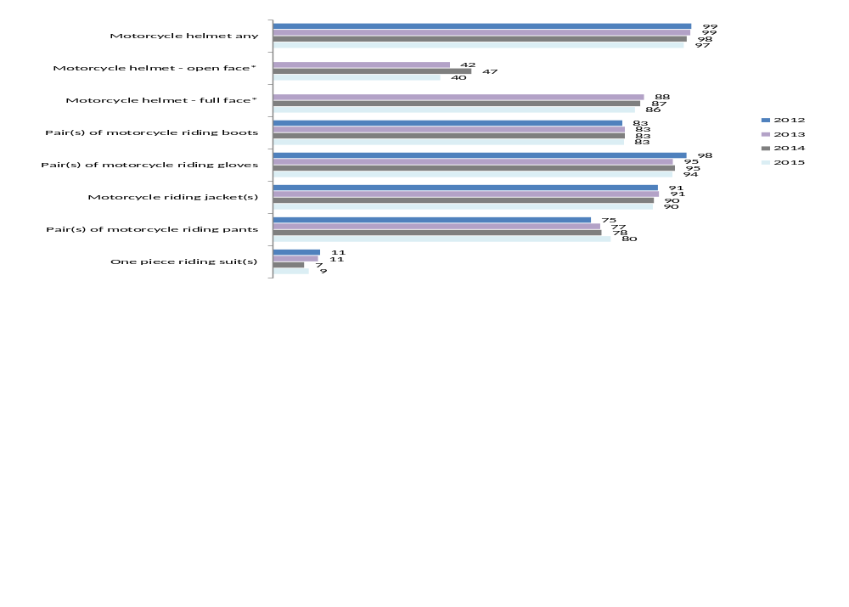
Q39 How many of the following do you own?
Filter: Active riders; Weighted; 2012 base n = 429; 2013 base n=405; 2014 base n = 511; 2015 base n = 491
* Note: the 2012 survey did not distinguish between types of helmet
As in 2014, this year’s respondents were most likely to own at least one pair of motorcycle gloves (94%) or a motorcycle jacket (90%), followed by full faced helmet (85%) (See Figure 57).
Figure 57: Number of protective motorcycle clothing items owned - 2015
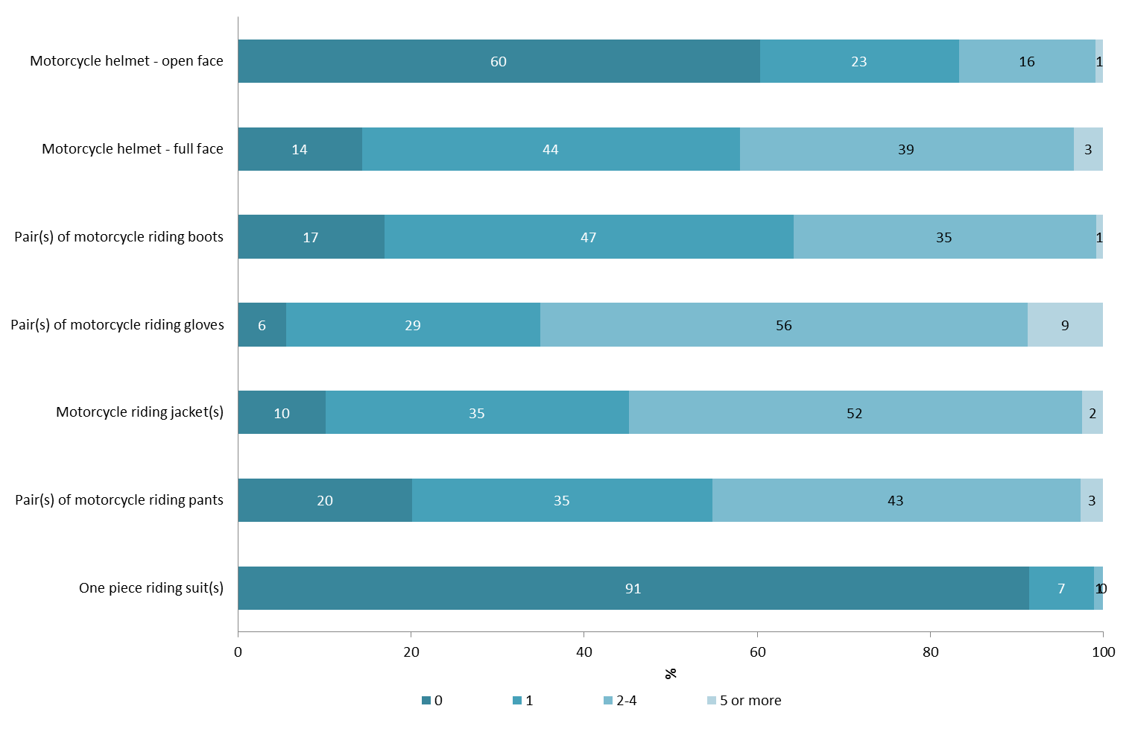
Q39a-f How many of the following do you own?
Filter: Active riders; Weighted; Base n = 491
In 2015, on average, active riders reported having 2.4 pairs of riding gloves. The average number of full faced helmets was reported to be 1.6 and open face helmets as 0.6. An average of 1.8 motorcycle jackets and 1.6 pairs of riding pants were owned by respondents.
As shown in the table below, riders who had crashed while riding a motorcycle were significantly more likely to own more pieces of protective gear although those who had experienced a crash were also more likely to have a longer history on the road compared to those who had not ever crashed.
Table 43: Average number of items by rider experience - 2015
Average | Motorcycle licence |  | Crash while riding motorcycle
Average | Learner/ Probationary  (n=131) | Full licence  (n=353) | Yes  (n=191) | No  (n=296)
Motorcycle helmet - open face | 0.4 | 0.7↑ | 0.8 | 0.6
Motorcycle helmet - full face | 1.8 | 1.6 | 1.9↑ | 1.4↓
Pair(s) of motorcycle riding boots | 1.4 | 1.3 | 1.6↑ | 1.1↓
Motorcycle riding jacket(s) | 1.7 | 1.8 | 2.2↑ | 1.5↓
Pair(s) of motorcycle riding pants | 1.9 | 1.6 | 1.9↑ | 1.4↓
Pair(s) of motorcycle riding gloves | 2.5 | 2.4 | 3.0↑ | 1.9↓
One piece riding suit(s) | 0.1 | 0.1 | 0.1 | 0.1
Q39a-f How many of the following do you own?
Filter: Active riders; Weighted; Base n = 490
↓↑ indicates statistically significant difference compared to respondents not in that category
A correlation was also found between protective gear ownership and the number and types of bikes kept at home. As shown in Table 44 below, those who owned more than one bike and those who owned bikes with 701+cc engines were more likely to own more items of protective clothing.
Table 44: Average number of items by ownership characteristics - 2015
Average | Type of bike (main bike) |  |  |  | Number of bikes at home |  |  | Capacity of main bike
Average | Off road bike/ trail bike (n=116) | Road bike (n=279) | Scooter (n=25)* | None (n=53) |  | 1 only (n=220) | 2 or more (n=214) | 0-250cc (n=144) | 251-700cc (n=159) | 701+cc (n=129)
Motorcycle helmet - open face | 0.5 | 0.7 | 1.1↑ | 0.4↓ |  | 0.6 | 0.8 | 0.6 | 0.4↓ | 0.9↑
Motorcycle helmet - full face | 1.8 | 1.7 | 0.9↓ | 1.3↓ |  | 1.3↓ | 2.1↑ | 1.4↓ | 1.9 | 1.8
Pair(s) of motorcycle riding boots | 1.6 | 1.4 | 0.5↓ | 0.8↓ |  | 1.2↓ | 1.7↑ | 1.1↓ | 1.4 | 1.6↑
Motorcycle riding jacket(s) | 1.3↓ | 2.2↑ | 1.2↓ | 1.2↓ |  | 1.7 | 2.2↑ | 1.4↓ | 1.7↓ | 2.3↑
Pair(s) of motorcycle riding pants | 1.7 | 1.8 | 0.9↓ | 0.7↓ |  | 1.5 | 1.9↑ | 1.2↓ | 1.8 | 1.9↑
Pair(s) of motorcycle riding gloves | 2.5 | 2.6 | 1.6↓ | 1.6↓ |  | 1.9↓ | 3.0↑ | 2.0↓ | 2.3 | 2.8↑
One piece riding suit(s) | 0.1 | 0.1 | 0.1 | 0.0↓ |  | 0.1 | 0.2↑ | 0.0↓ | 0.1 | 0.2↑
Q39a-f How many of the following do you own?
Filter: Active riders; Weighted; Base n = 491
↓↑ indicates statistically significant difference compared to respondents not in that category
*Note: small sample size
Similar to previous years, the most common response for owning multiple items of protective clothing was for different weather conditions or day vs. night (44%). This was followed by close to one in four (22%) saying that they had different items for different types of riding such as off-road gear vs. on-road gear (See Table 45).
Table 45: Reasons for owning multiple items of protective gear
Column % | 2013 | 2014 | 2015
For different weather conditions/seasons/day vs. night | 45 | 50 | 44
For different riding purposes/conditions i.e. off-road vs. on-road, recreation vs. commuting | 27 | 23 | 22
Replacement/upgrade/kept outgrown/old/damaged/out-dated/better safety gear | 19 | 15 | 19
For other riders/passengers to use | 18 | 13 | 14
To have a choice/have a spare/just wanted multiples | 10 | 11 | 14
Ride frequently and often need a change of riding gear/if gear is wet | 5 | 6 | 7
Aesthetics/different style | 4 | 9 | 6
Safety reasons | - | 5 | 3
Comfort | 2 | 1 | 3
For different bikes | 3 | 1 | 2
Work gear | 1 | 0 | 2↑
Different materials | - | 0 | 0
Other reasons | 3 | 5 | 6
Q40 You have mentioned that you own multiple pieces of protective clothing. What are the main reasons you have more than one of the above?
Filter: Active riders with multiple items of gear; Weighted; 2013 Base n =269 2014 Base n=345, 2015 base n = 363
↓↑ indicates statistically significant difference compared 2014
Male riders were more likely to say that they had multiple pieces of protective gear to have a choice (15% vs. 6% of females). Older riders aged 40 and over were significantly more likely to mention that they had gear for other riders/passengers to use (17% vs. 6% of those aged 26-29).
Those who rode less often (less than 20% of the time) were more likely to have items for aesthetics (8% vs. 1% of those who rode more often). Recreational on-road riders and commuters were significantly more likely to say that they had multiple items for different weather conditions (49% for recreational on-road and 47% for commuters vs. 30% of recreational off-road riders) (See Table 46).
Table 46: Reasons for owning multiple items of protective gear by riding activity - 2015
Column % | Riding vs. driving |  | Riding purpose (Active riders)
Column % | Ride less than 20% (n=220) | Ride more than 20% (n=141) | Commute (n=215) | Recreational on-road (n=285) | Recreational off-road (n=152)
For different weather conditions/seasons/day vs. night | 43 | 48 | 47 | 49↑ | 30↓
For different riding purposes/conditions i.e. off-road vs. on-road, recreation vs. commuting | 20 | 27 | 24 | 23 | 32
Replacement/upgrade/kept outgrown/old/damaged/out-dated/better safety gear | 22 | 14 | 17 | 19 | 17
For other riders/passengers to use | 13 | 15 | 17 | 14 | 13
To have a choice/have a spare/just wanted multiples | 12 | 18 | 13 | 14 | 17
Safety reasons | 2 | 4 | 2 | 3 | 2
Ride frequently and often need a change of riding gear/if gear is wet | 8 | 5 | 4↓ | 6 | 8
Aesthetics/different style | 8↑ | 1↓ | 5 | 7 | 5
For different bikes | 0↓ | 3↑ | 2 | 2↑ | 0↓
Other reasons | 6 | 6 | 3↓ | 5 | 9
Different materials | 0 | 0 | 0 | 0 | 0
Comfort | 3 | 1 | 1 | 3 | 1
Work gear | 1 | 3 | 3 | 2 | 0
Q40 You have mentioned that you own multiple pieces of protective clothing. What are the main reasons you have more than one of the above?
Filter: Active riders with multiple items of gear; Weighted; 2015 base n = 363
↓↑ indicates statistically significant difference compared to respondents not in that category
A total of 72% of active riders owned a complete set of gear i.e. at least one helmet, pair of riding gloves and boots, jacket and pants (or one piece riding suit) (See Table 47).
Table 47: Complete set of protective motorcycle (2012-2015)
Column % | 2012  (n=359) | 2013  (n=405) | 2014  (n=511) | 2015  (n=491)
Own complete set of gear | 68 | 69 | 71 | 72
Do not own complete set of gear | 32 | 31 | 29 | 28
Q39a-f How many of the following do you own?
Filter: Active riders; Weighted; 2012 Base n = 359; 2013 Base n = 405; 2014 base n = 511; 2015 base n = 491
↓↑ indicates statistically significant difference compared to respondents not in that category
Those who did not own a complete set of gear - i.e. at least one helmet, pair of riding gloves and boots, jacket and pants (or one piece riding suit) - were asked the reasons why they did not own more gear. In 2015, the most common reason was that it was too expensive (32%). Others mentioned:
- they did not think they needed it (18%);
- they hadn’t gotten around to buying it (16%);
- they only rode for short trips (16%); and
- they only rode in the country or off-road (12%).

Protective gear usage
Riders were asked how often they wore protective gear when riding a motorcycle. As shown in Figure 58, almost all respondents (96%) said they wore a motorcycle helmet all the time. Eight in ten respondents (82%) reported they wore gloves all the time. Boots were worn all of the time by three quarters of respondents (75%, up from 66% in 2014) and riding jackets were worn all the time by 70% of respondents.
Fifty six percent (56%) reported that they wore riding pants all of the time (a significant increase from 46% in 2014). A one piece riding suit was only reported be worn all of the time by 4%, making it the least likely item to be worn.
Figure 58: Usage of protective motorcycle clothing regardless of ownership – 2015
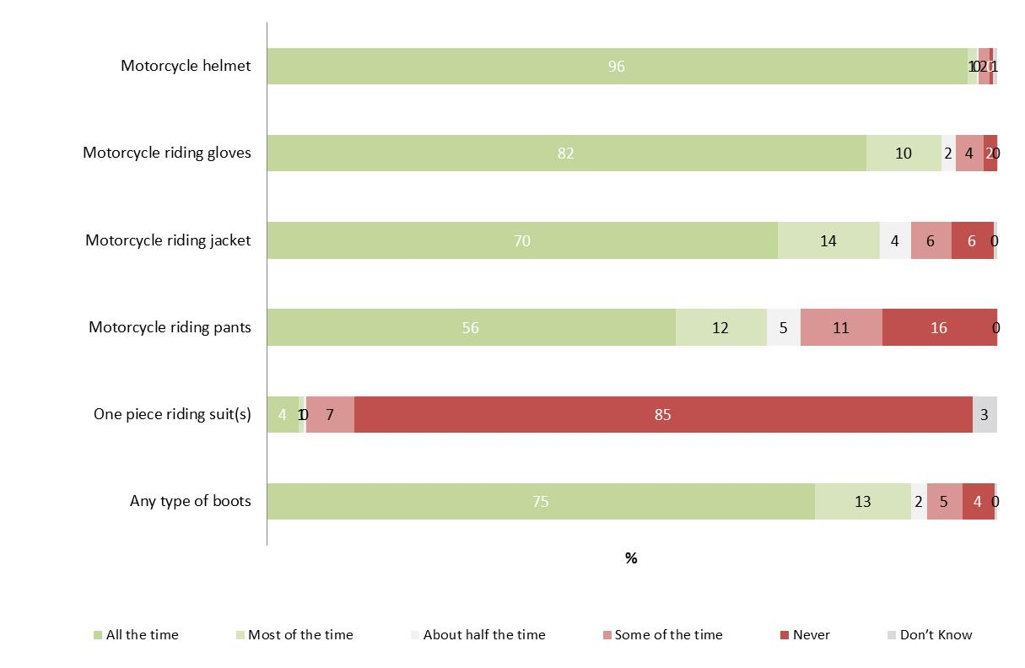
Q42a-f When riding a motorcycle, how often do you wear the following items of protective motorcycle clothing?
Filter: Active riders; Weighted; Base n = 491
Figure 59 shows the frequency of usage taking into account those who actually owned the items worn. While the proportion of those who always wore respective items of gear was slightly higher if ownership was taken into account, only three quarters (74%) of those who owned a jacket wore it all the time; 80% of respondents who had any boots wore them all the time; and around two thirds (66%) of those who owned motorcycle pants wore them all the time. On a positive note, the increasing trend of wearing riding pants all the time continues among owners (66% in 2015 compared to 56% in 2014). There was also an increase among those owned and wore their boots all the time (80% vs. 70% in 2014).
Figure 59: Usage of protective motorcycle clothing where owned by respondent – 2015
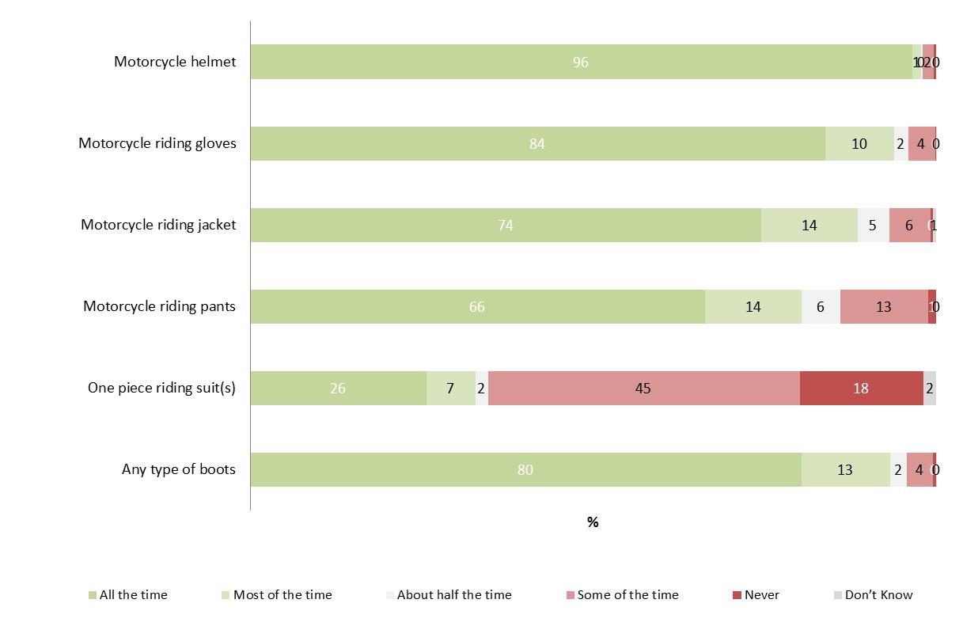
Q42a-f When riding a motorcycle, how often do you wear the following items of protective motorcycle clothing?
Filtered: Active riders; Weighted; Base n = from 42-480

Figure 60 shows the usage of protective gear among those who owned a complete set of gear (i.e. helmet, gloves, boots, jacket and pants (or a one piece suit). Riding pants were worn on every ride by two in three (67%) respondents who had a complete set of protective gear (up from 57% for those who owned a full kit in 2014).
Figure 60: Usage of protective motorcycle clothing where owned by respondent (among those who owned a complete set of gear) - 2015
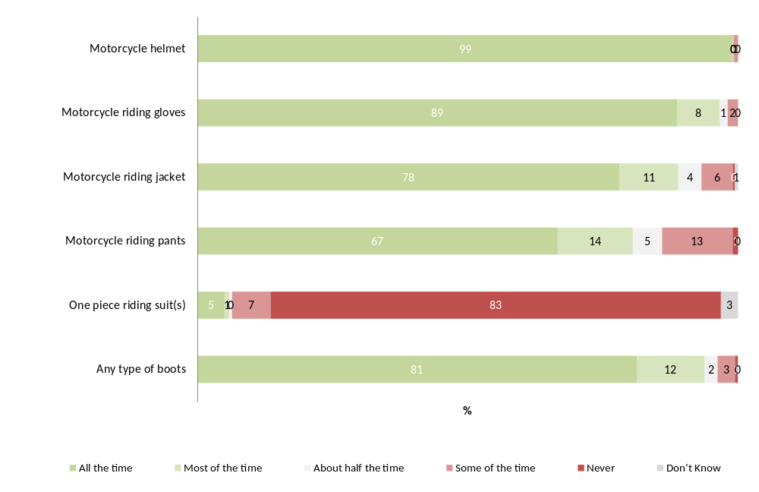
Q42a-f When riding a motorcycle, how often do you wear the following items of protective motorcycle clothing?
Filter: Own complete set of gear; Weighted; Base n = 311 to 344
Note: Excludes those who own none of the items
Looking at the number of items worn by active riders (including helmets), 50% of respondents said they wore four or five of the items listed all the time – up from 37% in 2014. However when looking those who wore three or more items, the proportions showed no statistical difference since last year (64% vs. 71%). In total, 86% of respondents said they wore three or more items (including a helmet) most or all the time.
Table 48: Number of items worn when riding - 2015
Number of items of protective clothing - worn all the time (%) | 2014 | 2015
0 | 1 | 2
1 | 11 | 9
2 | 24 | 18
3 | 27 | 21
4 | 36↓ | 46↑
5 | 1↓ | 4↑
Number of items of protective clothing - worn all  or most of the time (%) | 2014 | 2015
0 | 0 | 1
1 | 3 | 3
2 | 11 | 11
3 | 21 | 16
4 | 50 | 58
5 | 14 | 12
Q42a-f When riding a motorcycle, how often do you wear the following items of protective motorcycle clothing?
Filter: Active riders only; Weighted; 2014 Base n = 462; 2015 Base n = 442
Respondents were asked specifically about the type of footwear they wore when riding a motorcycle. As mentioned, there was an increase in those who said they either riding boots or other boots all the time (75% vs. 66%).
When asked the proportion of the time active riders wore different types of footwear while riding, respondents said they wore specific riding boots two thirds of the time (67% - this was similar to 2014). For 26% of the time, respondents said they wore other types of boots (27% in 2014). Other footwear was worn 8% of the time and no footwear was worn for less than 1% of the time they rode a motorcycle.
When asked whether they agreed or disagreed with the statement “wearing boots that cover my ankles will protect my feet better than other shoes would”, the vast majority of respondents (97%) agreed with the statement (with 86% strongly agreeing and 11% agreeing somewhat). Results were similar to 2014.
Table 49: Average proportion of time different footwear was worn while riding – 2014 vs. 2015
Average % of time wearing footwear types | 2014 | 2015
Boots made specifically for motorcycle riding | 63.6 | 66.6
Other boots | 27.2 | 25.8
Other footwear | 9.0 | 7.5
No footwear/thongs/bare feet | 0.2 | 0.1
Q42a What percentage of the time do you wear the following when riding a motorcycle?
Filter: Active riders only; Weighted; 2014 Base n = 448; 2015 Base n = 480

In 2015, 28% of active riders reported that they always wore a complete set of gear - i.e. that they always wore either both jacket and pants (or a one piece suit) with a helmet, gloves, and boots when they rode. Those who did not wear the full kit of gear all the time were asked why this was the case. Overall, it depended on the riding style and type of trip (mentioned by 40%), followed by weather conditions (21%). For other commonly mentioned reasons, see Table 54 below.
Table 50: Main reasons for not wearing protective gear every time - 2015
Column % | 2015
Depends on the destination / riding style / length of trip / speed | 40
Depends on the weather /only wear for cold / rainy weather / humidity and summer temperatures | 21
I do wear (item of protective clothing) a jacket, boots, gloves, etc. | 10
I do always wear the gear that I own / I don't own all the protective clothing listed | 13
Inconvenient to change clothes / need to wear other clothing for work / need a changing area / hassle to carry extra clothing | 5
Clothing is cumbersome / restrictive / impractical / unwieldy / get in the way / other clothing is more comfortable | 16
Too dear / expensive / difficult to find in my size | 8
Convenience / easier / too much of a hassle / I`m lazy | 6
Other mentions | 11
Don’t know | 1
Q43 You have said you don’t wear all your protective motorcycle clothing every time you ride… What are the main reasons for this? Filtered: Active riders; those who did not wear full kit all the time; Weighted; Base 2015 n = 230
In 2015, there were no significant differences between female and male riders for not wearing protective gear every time they rode. However, younger active riders aged 18-25 were more likely to say they always wore the gear they own (i.e. they didn’t own all the protective clothing listed) (26% vs. 16% for 26-39 year olds and 11% for 40+); or that it was inconvenient to change clothes (20% vs. 3% for 26+) (See Table 51).
Table 51: Main reasons for not wearing protective gear every time – by gender – 2015
% | Gender |  | Age
% | Male  (n = 191) | Female  (n = 39) | 18-25 years  (n = 73) | 26-39 years  (n = 53) | 40+ years  (n = 126)
Depends on the destination / riding style / length of trip / speed | 40 | 37 | 35 | 29 | 44
Depends on the weather /only wear for cold / rainy weather / humidity and summer temperatures | 20 | 24 | 6↓ | 20 | 23
I do wear (item of protective clothing) a jacket, boots, gloves, etc. | 10 | 8 | 20 | 10 | 9
I do always wear the gear that I own / I don't own all the protective clothing listed | 14 | 9 | 26↑ | 16 | 11
Inconvenient to change clothes / need to wear other clothing for work / need a changing area / hassle to carry extra clothing | 4 | 10 | 20↑ | 3 | 3
Clothing is cumbersome / restrictive / impractical / unwieldy / get in the way / other clothing is more comfortable | 16 | 12 | 11 | 10 | 19
Too dear / expensive / difficult to find in my size | 7 | 13 | 11 | 20↑ | 4↓
Convenience / easier / too much of a hassle / I`m lazy | 6 | 9 | 4 | 6 | 7
None / Nothing | 2 | 0 | 1 | 0 | 3
Don’t know | 0 | 0 | 0 | 0 | 0
Other mentions | 10 | 22 | 7 | 5 | 13
Q43 You have said you don’t wear all your protective motorcycle clothing every time you ride… What are the main reasons for this? Filtered: those who did not wear full kit all the time; Weighted; Base 2015 n = 230
↓↑ indicates statistically significant difference between genders

Protective gear purchase intentions
When asked what, if any, motorcycle clothing they intended to buy in the next six months, over half (57%) of respondents intended to purchase something in the near future. The items most likely to be bought in the near future were pants (15%) and helmet (14%). There were no significant differences compared to 2014.
Table 52: Motorcycle clothing purchase intentions for next 6 months (2012-2015)
Column % | 2012 | 2013 | 2014 | 2015
Don’t intend to buy any | 48 | 45 | 37 | 43
Pants | 21 | 17 | 19 | 15
Helmet | 14 | 18 | 15 | 14
Gloves | 15 | 18 | 12 | 12
Boots | 10 | 14 | 15 | 12
Jacket | 11 | 15 | 11 | 11
Body Armour | 4 | 6 | 5 | 3
LEATT Neck Brace | 4 | 5 | 3 | 2
Other | 1 | 1 | 1 | 2
None of the above | 11 | 17 | 19 | 20
Q45. What, if any, motorcycle clothing do you intend to buy in the next 6 months?
Filter: Active riders; Weighted; 2012 base n = 359, 2013 Base n = 405; 2014 Base n = 511, 2015 base n = 491
When asked about their intentions to purchase gear, intentions to purchase gear were highest among riders aged 18-25 years (53%) and lowest among those aged 40+ (31%). Young riders aged 18-25 were significantly more likely to report that they intended to buy a helmet (25%), jacket (18%), boots (19%) or body armour (9%) compared to other riders.
Table 53: Motorcycle clothing purchase intentions for next 6 months by age - 2015
Column % | Age
Column % | 18-25  (n=162) | 26-39  (n=124) | 40+  (n=204)
Don’t intend to buy any | 36 | 36 | 47
Subtotal – Intend to buy at least 1 item | 53 | 49 | 31↓
- Helmet | 25↑ | 22↑ | 10↓
- Gloves | 17 | 14 | 10
- Pants | 18 | 17 | 13
- Jacket | 18↑ | 15 | 8↓
- Boots | 19↑ | 21↑ | 8↓
- Body Armour | 9↑ | 3 | 1
- LEATT Neck Brace | 3 | 3 | 1
- Other | 3 | 3 | 1
None of the above | 10↓ | 16 | 23
Q45 What, if any, motorcycle clothing do you intend to buy in the next 6 months?
Filter: Active riders; Weighted; Base n = 490
↓↑ indicates statistically significant difference compared to those not in that category

Respondents who already owned a complete set of gear were statistically no more or less likely to report they intended to purchase some gear in the future than those who did not (46% compared to 36%). However, those who did not own a complete set of gear were more likely to say that they intended to buy boots in the next six months (19% vs. 10%).
Table 54: Motorcycle clothing purchase intentions for next 6 months by whether riders currently own a complete set of protective gear - 2015
Column % | Own complete set of gear (n=344) | Do not own complete set of gear (n=147)
Don’t intend to buy any | 46 | 36
Subtotal - At least one item | 36 | 41
Helmet | 14 | 16
Gloves | 13 | 8
Boots | 10↓ | 19↑
Jacket | 11 | 11
Pants | 14 | 17
Body Armour | 2 | 3
LEATT Neck Brace | 2 | 2
Other verbatim | 2 | 2
None of the above | 18 | 23
Q45 What, if any, motorcycle clothing do you intend to buy in the next 6 months?
Filter: Active riders; Weighted; Base n = 491
↓↑ indicates statistically significant difference compared to those not in that category
Respondents were also asked whether they looked for the CE (European Union) standard or Snell logo when looking to purchase motorcycle clothing. Results were similar to last year, with 44% saying they would (40% in 2014) and nearly one-third (30%) reporting that they were not aware of the CE standard or Snell standards. Respondents from regional Victoria were significantly more likely to say that they were unaware compared to those from Melbourne (36% compared to 25%).

Body armour
As shown in Table 55, over two thirds of active riders said they owned at least one piece of body armour (69%). The most common pieces of armour owned were inserts for riding jackets (49%); followed by inserts for riding pants (33%) and back protectors (separate piece) (32%) - all consistent with 2014.
In 2015, riders were significantly more likely to say they owned a chest protector (separate piece) (17% compared to 11% last year).
Table 55: Body armour owned by year – 2012 - 2015
Column % | 2012 | 2013 | 2014 | 2015
Subtotal – at least one item | 63 | 66 | 64 | 69
Back protector (separate piece) | 30 | 32 | 26 | 32
Chest protector (separate piece) | 19 | 21 | 11 | 17↑
Inserts for riding jackets | 44 | 43 | 45 | 49
Inserts for riding pants | 32 | 36 | 31 | 33
Body armour kit | 0 | 15 | 23 | 22
LEATT Neck brace | 2 | 10 | 4 | 6
Other body armour | 4 | 21 | 7 | 6
None of the above | 37 | 35 | 36 | 31
Q44. Do you own any of the following pieces of body armour?
Filter: Active riders; Weighted; 2014; base n = 491
↓↑ indicates statistically significant difference compared to 2014
Those who mainly rode road bikes were significantly more likely to own inserts for riding jackets (65%) and inserts for riding pants (40%). Those who mainly rode off-road bikes were significantly more likely to own chest protectors (35%), body armour kit (54%), LEATT neck braces (17%) and other body armour (14%) (See Table 56).
Table 56: Body armour owned by main bike ridden - 2015
Column % | Type of bike (main bike)
Column % | Off road bike/trail bike (n=116) | Road bike  (n=279) | Scooter  (n=25)*
Inserts for riding jackets | 21↓ | 65↑ | 36
Inserts for riding pants | 24↓ | 40↑ | 26
Back protector (separate piece) | 29 | 38 | 29
Chest protector (separate piece) | 35↑ | 14↓ | 8
Body armour kit | 54↑ | 13↓ | 0↓
LEATT Neck brace | 17↑ | 2↓ | 5
Other body armour | 14↑ | 4↓ | 2
None of the above | 33 | 23↓ | 47
Q44. Do you own any of the following pieces of body armour?
Filter: Active riders who have at least one bike at home; Weighted; 2015 Base n = 491
↓↑ indicates statistically significant difference compared to those not in that category
*Note: Small sample size

Attitude statements about motorcycle safety clothing
A series of statements regarding motorcycle clothing was put to respondents. The level of agreement/disagreement with these statements is shown in Figure 61.
There was a strong belief that motorcycle clothing did provide protection in the event of a crash, with nearly two-thirds (65%) of those who had ridden in the last 12 months strongly agreeing with this statement (no change compared to 2014 – 62%).
Just under three quarters (73%) of respondents strongly agreed that ‘motorcyclists should always wear motorcycle clothing (jacket, pants, boots and gloves) while riding’ (again, no change compared to 2014 – 71%).
Figure 61: Agreement/disagreement with statements regarding motorcycle safety clothing - 2015
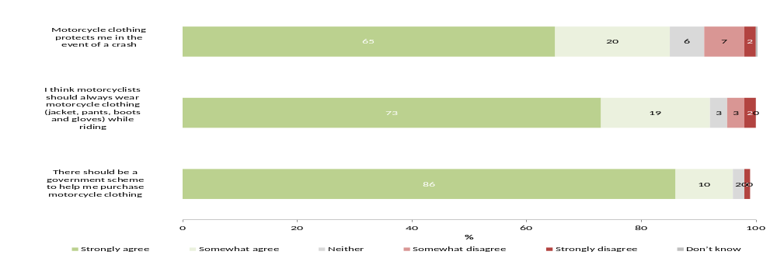
Q55. To what extent do you agree or disagree with the following statements...
Filter: Ridden in the last 12 months; Weighted; Base n = 592

Motorcycle crash history
Similar proportions of respondents had experienced a crash while riding a motorcycle as reported in previous years (41% in 2015 compared to 47% in 2014), with the majority (72%) only crashing once.
Approximately half (48%) of respondents who had experienced a crash required medical treatment as a result, with 7% reporting that this had happened in the last year. The majority however, 57%, reported that this happened 11 or more years ago.
Crashes were most likely to have occurred on-road (77%) with the most common location being sealed roads in built up areas (52%), and a further one in five crashes occurring on sealed roads in rural locations (18%). The remainder of crashes that occurred on-road occurred on unsealed roads (7%). Off-road surfaces accounted for 21% of crashes requiring medical treatment.
Those who had crashed off-road most commonly reported rider error (54%) as the cause of their crash. For those who crashed on-road, 42% reported they were not at all responsible for the crash, with 55% who claimed partial (32%) or total (23%) responsibility for the crash. Most reported they knew the crash area well (79%); or that the terrain or road conditions contributed to the crash (65%). Fatigue, unfamiliarity with riding or the bike itself, or returning after a break seemed less likely to be factors from the respondent’s point of view.
One-fifth (19%) of respondents said that they had received compensation for their injuries from a motorcycle crash – the majority (71%) of this group received this from the TAC.

Crash history
Respondents were asked whether they had ever experienced a crash while riding a motorcycle (excluding dropping their bike while stationary or crashing while taking part in motorcycle sport). Forty one percent (41%) of respondents in 2015 had reported to have done so (compared to 47% in 2014 – although this was not a significant change).
Of those that had crashed in the last 12 months, the majority (72%) had crashed only once. Just under one in five had crashed 2-4 times (18%) and 11% reported crashing five or more times.
Figure 62: Motorcycle crash history (2012-2015)
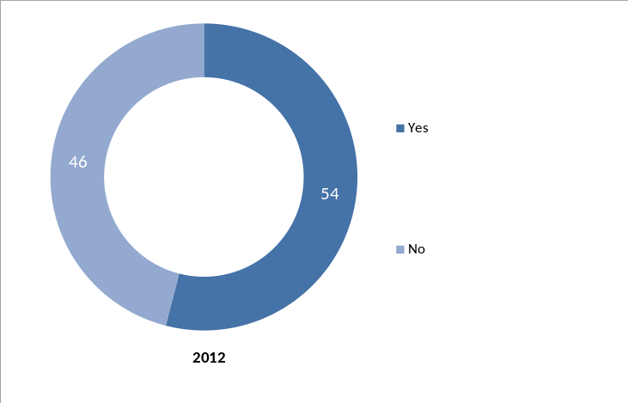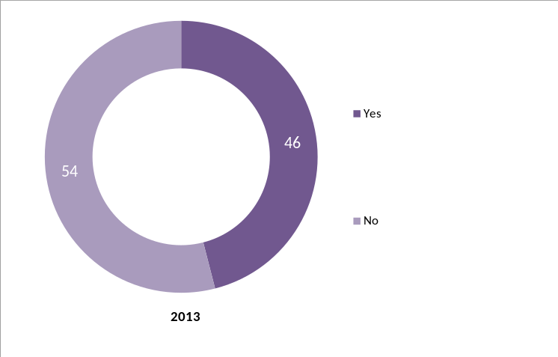
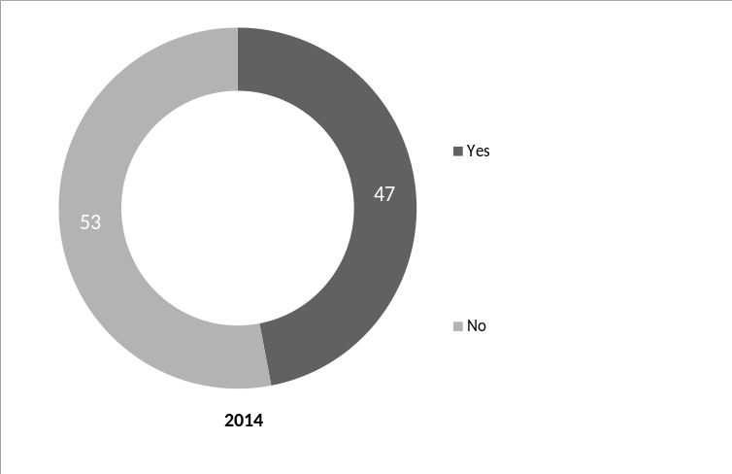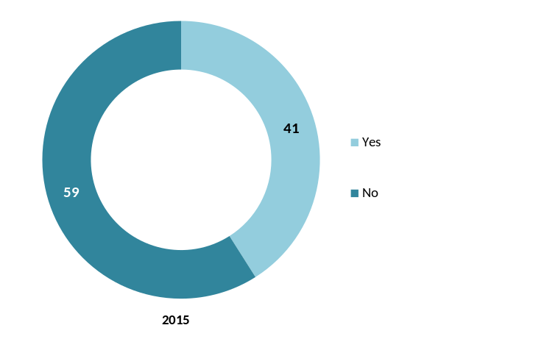
Q56 Have you ever had a crash while riding a motorcycle?
Total sample; Weighted; 2012 base n = 545; 2013 base n = 694; 2014 base n = 778, 2015 base n = 794
Note: excludes prefer not to say and never ridden
Male riders were significantly more likely than females to have experienced a crash (43% vs. 29%). No significant differences were found between ages and location.
Table 57: Motorcycle crash history by rider characteristics - 2015
 | % Yes
Gender
Male | 43↑
Female | 29↓
Age
18-25 | 38
26-39 | 35
40+ | 44
Location
Melbourne | 42
Balance of Victoria | 39
Q56 Have you ever had a crash while riding a motorcycle?
Total sample; Weighted; Base n= 794
↓↑ indicates statistically significant difference compared to respondents not in that category
Note: excludes prefer not to say and never ridden

Crashes requiring medical treatment
Similar to previous years, nearly half of those who reported that they had experienced a crash, required medical treatment as a result (48% vs. 50% in 2014 – a non-significant difference).
With riders in the population skewed towards older age groups, it is not surprising that the majority of those who had needed medical treatment for their most recent crash reported this had been 11 years ago or more (57% vs. 52% in 2014).
A small percentage (7%) of riders who had needed medical treatment for their most recent crash reported that this had occurred in the last 12 months. One in five reported that this had been between 1-5 years ago (20%) (See Table 58).
Table 58: Details of most recent crash requiring medical treatment –Time of crash 2012 - 2015
% | 2012 | 2013 | 2014 | 2015
Required medical treatment as a result of crash | 45 | 49 | 50 | 48

Time of crash % | 2012 | 2013 | 2014 | 2015
Within the last 12 months | 3 | 6 | 8 | 7
1 to 5 years ago | 17 | 20 | 19 | 20
6 to 10 years ago | 16 | 17 | 19 | 15
11 or more years ago | 65 | 56 | 52 | 57
Can’t say | 0 | 1 | 3 | 1
Q57 Have you required medical treatment as a result of any motorcycle accident?
Filter: Ever experienced crash; Weighted; 2012 base n = 220, 2013 base: n=116; 2014 base n=139, 2015 base n = 241
Q58 When did the crash occur?
Filter: Excluding never ridden a motorcycle; Weighted; 2012 base n=108; 2013 base n=115, 2014 base n = 139, 2015 base n = 139
↓↑ indicates statistically significant difference compared to respondents not in that category
Filter: Required medical treatment
Although off a small base, nearly one third (31%) of those aged 18-25, the crash requiring medical treatment was within the last 12 months, and 61% reported it had been 1-5 years ago. Nearly three-quarters of those aged 40 and over reported having a crash 11 or more years ago, suggesting that crashes tended to occur in the early stages of a rider’s motorcycling experience.
Table 59: Details of most recent crash requiring medical treatment – time of crash by age – 2015
Column % | Age
Column % | 18-25  (n=27)* | 26-39  (n=31)* | 40+  (n=81)
Within the last 12 months | 31↑ | 16↑ | 3↓
1 to 5 years ago | 61↑ | 52↑ | 10↓
6 to 10 years ago | 6 | 23 | 17
11 or more years ago | 3↓ | 9↓ | 71↑
Can’t say | 0 | 0 | 2
Q58 When did the crash occur?
Filter: Excluding never ridden a motorcycle; Weighted; base n = 139
↓↑ indicates statistically significant difference compared to respondents not in that category
Filter: Required medical treatment
*Note small sample size
The majority of respondents who had been in a crash requiring medical treatment said that they went to the Emergency Department for their medical treatment (61%). This was followed by 35% who said that they had gone to the doctor for their treatment and 25% who had been admitted to a ward. Respondents in 2015 were significantly less likely to say that they had been admitted to a rehabilitation facility than in 2014 (2% vs. 8%).
Table 60: Details of most recent crash requiring medical treatment – 2012 - 2015
% | 2012 | 2013 | 2014 | 2015
Required medical treatment as a result of crash | 45 | 49 | 50 | 48

Type of treatment | 2012 | 2013 | 2014 | 2015
Went to Emergency | 52 | 47 | 58 | 61
Went to my doctor | 28 | 20 | 23 | 35
Admitted to hospital (in a ward) | 34 | 32 | 39 | 25
Treated by ambulance at the scene | 19 | 12 | 32 | 23
Saw a physiotherapist/chiropractor or similar | 21 | 14 | 17 | 18
Admitted to a rehabilitation facility | 5 | 2 | 8 | 2↓
Radiologist/x-ray | 1 | - | - | -
Other verbatim | 4 | 10 | 1 | 4
Can’t say / don’t recall | 0 | 1 | 1 | 0
Q56 Have you ever had a crash while riding a motorcycle?
Filter: Excluding never ridden a motorcycle; Weighted; 2012 base n = 220, 2013 base: n=116; 2014 base n=139, 2015 base n = 241
Q57 Have you required medical treatment as a result of any motorcycle accident?
Q62 What sort of treatment did you require?
↓↑ indicates statistically significant difference compared to 2014
Filter: Required medical treatment; 2012 base n=112; 2013 base n=136, 2014 base n = 136, 2015 base n = 135

Circumstances of most recent crash
Nearly two-thirds (62%) of those who crashed and required medical treatment had been riding a road bike. Thirty percent (30%) reported that they had been riding an off-road or trail bike.
Scooters were ridden by only 4% those who had experienced a crash requiring medical attention.
Table 61: Details of most recent crash requiring medical treatment (2012-2015)
Type of bike ridden during crash | 2012 | 2013 | 2014 | 2015
Off-road bike/trail bike | 26 | 39 | 32 | 30
Subtotal – Road bike (excluding scooters and other types of bikes) | 69 | 50 | 56 | 62
- Sports bike | 24 | 22 | 26 | 28
- Sports tourer | 15 | 5 | 16 | 10
- Dual sport | 0 | 0 | 2 | 3
- Tourer/cruiser | 23 | 20 | 11 | 18
- Other road bike | 7 | 2 | 1 | 3
Scooter | 3 | 4 | 6 | 4
Other type of bike | 2 | 7 | 5 | 3
Can’t recall | 0 | 1 | 0 | 0
Q60. What type of bike were you riding?
Filter: Required medical treatment; Weighted; 2012 base n = 108; 2013 base n = 2014 base n=141, 2015 base n = 136
↓↑ indicates statistically significant differences between 2014 and 2015 only
Sealed roads in built-up areas were the most common location for crashes (52% in 2015 and 45% in 2014). Just under one-fifth (18%) of incidents requiring medical treatment occurred on sealed roads in rural areas. In total, three in four (77%) occurred on an on-road surface compared to 21% on an off-road surface. No significant differences were found between 2015 and 2014 (See Table 61).
Table 62: Details of most recent crash requiring medical treatment – Location of crash (2012-2015)
Location of crash | 2012 | 2013 | 2014 | 2015
Sealed road, built-up area | 57 | 51 | 45 | 52
Sealed-road, rural area | 14 | 12 | 23 | 18
Unsealed road | 9 | 8 | 6 | 7
Track in state park /forest/plantation | 10 | 15 | 13 | 10
Private property | 5 | 6 | 6 | 11
Public land in residential areas (e.g. park, reserve, bicycle track) | 3 | 1 | 1 | 1
On a race track (on a track day or as part of a riding course) | 1 | 5 | 4 | 1
Other | 0 | 3 | 1 | 1
Subtotal – On-road surface | 81 | 70 | 75 | 77
Subtotal – Off-road surface | 18 | 21 | 20 | 21
Q61. Where did the crash occur?
Filter: Required medical treatment; Weighted; 2012 base n = 108; 2013 base n = 116; 2014 base n=142, 2015 base n = 139
↓↑ indicates statistically significant difference compared to respondents not in that category
This year, of those whose most recent crash required medical treatment while on a road bike, the most common location was on a sealed road in a built-up area (69%), followed by 24% on a sealed road in a rural area.
Those who had been riding scooters when they crashed almost exclusively crashed on a sealed road on a built up area (97%).
Respondents who had been riding an off-road/trail bike were most likely to report the location as a trail in a state park/forest/plantation (32%) (See Table 63).
Table 63: Details of most recent crash requiring medical treatment – Location of crash by type of bike - 2015
Column % | Off road bike/trail bike (n=49) | Road bike (n=72) | Scooter (n=11)* | Total (n=139)
Sealed road, built-up area | 12↓ | 69↑ | 97↑ | 52
Sealed-road, rural area | 2↓ | 24↑ | 0 | 18
Unsealed road | 15↑ | 4↓ | 0 | 7
Track in state park /forest/plantation | 32↑ | 0↓ | 0 | 10
Private property | 37↑ | 0↓ | 0 | 11
Public land in residential areas (e.g. park, reserve, bicycle track) | 0 | 1 | 0 | 1
On a race track (on a track day or as part of a riding course) | 1 | 1 | 3 | 1
Other | 1 | 0 | 0 | 1
Q61 Where did the crash occur?
Q60 What type of bike were you riding?
Filter: Required medical treatment; Weighted; 2015 base n=139
“Other type of bike” not shown in table above
↓↑ indicates statistically significant difference compared to respondents not in that category
* Small sample size
Respondents who crashed on an on-road surface and required medical treatment were asked their view of who was responsible for the crash. Respondents were most likely to say they were not responsible at all for the crash (42%). One in three (32%) felt they were partially responsible. Just under one in four (23%) felt they were at fault.
Table 64: Details of most recent crash off-road requiring medical treatment – Perceived responsibility (on-road only)
Column % | 2015
Not responsible at all for the accident | 42
Partially responsible for the accident | 32
Totally responsible for the accident | 23
Don’t know / Can’t remember | 2
Prefer not to say | 1
Q59AA Your perception of who was responsible for your accident. Would you say you were….?
Filter: Required medical treatment and crashed on-road; Weighted; 2015 base n =
↓↑ indicates statistically significant difference compared to 2014
Respondents whose crash occurred off-road were most likely to say a rider error caused their crash (54%), followed by road/train conditions (43%). There were no significant changes from results in 2014.
Table 65: Details of most recent crash off-road requiring medical treatment – Perceived cause (off-road only) – 2013-2015
Column % | 2013 | 2014 | 2015
Rider error | 30 | 42 | 54
Road/trail conditions | 17 | 38 | 43
Terrain | 8 | 24 | 33
Lapse in concentration | 18 | 9 | 19
Trees (e.g. fallen logs, overhanging branches) | 13 | 9 | 10
Doing tricks | 8 | 2 | 3
Mechanical failure of the motorcycle | 7 | 3 | 0
Weather conditions | 4 | 8 | 3
Other | 3 | 8 | 15
Q59a What caused your crash?
Q61 Where did the crash occur?
Filter: Required medical treatment and crashed off-road; Weighted; 2015 base n = 43; 2014 base n=44; Weighted 2013 base n=42;
↓↑ indicates statistically significant difference compared to 2014
Note: small sample sizes
Respondents who had crashed and had required medical attention were asked their opinion on a range of statements about their views on the circumstances their crash.
Three quarters (75%) of respondents strongly agreed with the statement “Wearing protective clothing helped reduce my injuries” (unchanged compared to 2014 – 70%).
There was an overall disagreement with statements related to their unfamiliarity with the motorcycle, tiredness, returning to riding after a break and being new to riding (see Table 58).
Just under one third (32%) of those in crashes needing medical treatment agreed strongly that another vehicle contributed to the crash.
Most reported they knew the crash area well (79%); or that the terrain or road conditions contributed to the crash (65%). However, there was a significant difference in the agreement in 2015 that respondents knew the crash area well compared to last year (79% vs. 64% in 2014). Respondents were also less likely to state that terrain and road conditions had been a factor (25% vs. 39% in 2014). While there was no significant difference, those who had crashed on an off-road surface were more likely to say that terrain had been a factor (78% vs. 61%).
Four in ten (45%) felt there was nothing they could have done to prevent the crash however, a similar proportion felt that if they were riding more slowly, they could have done something to avoid the crash (41%).
Fatigue, unfamiliarity with riding or the bike itself, or returning after a break seemed less likely to be factors among the 2015 cohort who had crashed.
Figure 63: Agreement/disagreement with statements regarding their most recent crash - 2015

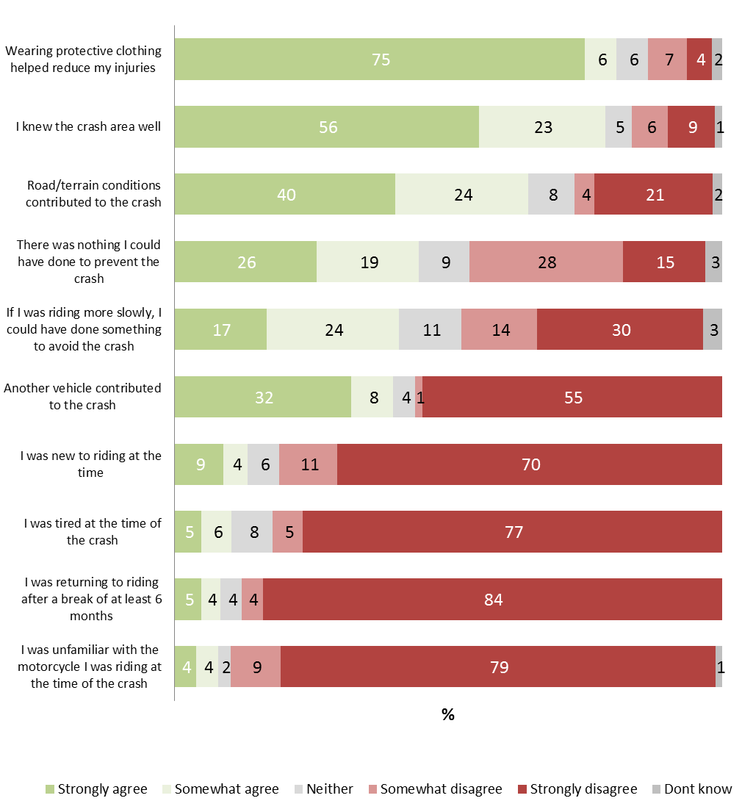
Q59B. Thinking about your most recent crash that required medical treatment, to what extent do you agree or disagree with the following statements?
Filter: Crashed and needed medical treatment; Weighted; Base n = 133
Some demographic differences included:
- Males were more likely to agree that if they were riding more slowly, they could have done something to avoid the crash (45% vs. 14% of females);
- Females were more likely to agree that they were new to riding at the time (38% vs. 10%) and wearing protective clothing helped reduce their injuries (98% vs. 78% of males);
- Younger riders aged between 18-25 years were significantly less likely to agree that they knew the crash area well (56% compared to 81% of those aged 26-39 and 80% of those aged over 40); and
- Those from Melbourne were significantly more likely to agree that wearing protective clothing helped reduce their injuries (87% vs. 71% of those from regional Victoria).

Compensation
Approximately one in five riders (19%) said they received compensation for injuries from a motorcycle crash. Among the 26 respondents who had received compensation or income support, the vast majority said they had received this from the TAC (71%). No differences were observed compared to 2014 results (See Table 66).
Table 66: Details of compensation received (2012-2015)
Source of compensation | 2012* | 2013* | 2014* | 2015*
TAC | 85 | 76 | 75 | 71
WorkSafe/WorkCover/Comcare | 8 | 4 | 2 | 10
Property/vehicle insurance organisation | 4 | 14 | 8 | 0
Centrelink (e.g. Disability Support Pension or Sickness Allowance) | 0 | 17 | 2 | 0
Personal insurance organisation (e.g. health, income protection) | 11 | 0 | 24 | 0
Other | 22 | 11 | 19 | 10
Prefer not to say | 0 | 0 | 0 | 10
Q64 From whom did you receive this compensation?
Filter: Ever crashed AND ever received compensation as a result of injuries from a motorcycle crash; Weighted; 2013 base n =30; 2014 base n=26; 2015 base n=26
↓↑ indicates statistically significant differences between 2014 and 2015 only
*Note: Small sample base

Respondent suggestions for improving rider safety
Respondents were asked their opinion about the statement “motorcyclists can only be safe on the road if both riders and drivers share responsibility for their safety”. A large majority of respondents (94%) agreed with this statement, with 83% strongly agreeing and 10% somewhat agreeing. A small proportion, 4%, disagreed with the sentiment. Similar findings were observed in 2014 (93% agreed).
Respondents were asked (unprompted) if they had any suggestions about what the TAC could do to improve rider safety (See Table 67).
The most common theme related to improving the awareness of road users or providing education on motorcycle safety and road sharing (18%). This was followed by 16% who said that it’s up the individual rider and that riders are responsible for their own actions. Increasing rider awareness was reported by 14% of respondents.
Table 67: Suggestions to the TAC about what they can do to improve rider safety - 2015
 | %
Improve road user awareness /education (include training in motorcycle and push bike safety/sharing the road etc.) | 18
None / it’s up to the individual / riders are responsible for their own actions | 16
Increase rider awareness/responsibilities on roads e.g. abide by road rules/consideration of other road users etc. | 14
Awareness campaigns / continue the advertising | 12
More dedicated rider training/awareness e.g. refresher courses/advanced driving/safety issues etc. | 12
Improvement in attitude / consideration for riders from car drivers and other road users | 10
Make the wearing of protective clothing mandatory | 10
Education / provide driver and rider training in schools | 9
Increase awareness among riders of what to do in different riding conditions / ride safely - observe speed limits | 8
Maintain the roads / fix defects / remove pot holes / clean up after road works | 7
Comprehensive learner rider courses / more supervised training | 7
Make the wearing of high visibility vests and jackets mandatory | 7
Make licence harder to obtain - after 12 months / after obtaining full car licence… | 6
Other mentions | 6
Refresher courses / compulsory re-sitting of tests for foreign licence holders | 4
Dedicated lanes for bike riders | 3
Q72 Would you like to make any suggestions to the TAC about what they can do to improve rider safety
Total sample; Weighted; Base n = 593

Respondents were also asked how many motorcyclists they thought had died on the roads in the previous year. Thirty riders and pillions died on Victorian roads in 2014. Twelve percent (12%) of respondents estimated that the number of deaths was in the range of 26-40. An additional 14% estimated the range was 41-50. Nearly a quarter (23%) of respondents thought that between 51-100 motorcyclists died on the roads last year.
Table 68: Perception of motorcycle deaths - 2015
 | %
0 | 13
1-25 | 13
26-40 | 12
41-50 | 14
51-100 | 23
101-150 | 8
151-200 | 3
200+ | 3
Q64B. How many motorcyclists do you think died on Victoria’s roads last year?
Ridden in the last 12 months; Weighted; Base n =603

When asked what they thought were the main causes of motorcycle deaths on the road, the most common response from those who had ridden in the last 12 months included drivers not paying attention to riders, or driver errors (55%), followed by speed (drivers and riders) (51%) and poor riding skills or inexperience (25%). In comparison to 2014, 15% mentioned road conditions, higher than in 2014 (10%). Other mentions are highlighted in Table 69 below.
Table 69: Main causes of motorcycle deaths on the road - 2015
% | 2014 | 2015
Drivers lack of awareness/ cars not seeing motorcycles /Driver errors/careless driving/ not looking out for others | 51 | 55
Speed/speeding | 43 | 51
Bad riders/poor riding skills/inexperienced riders | 27 | 25
Hooning/recklessness/risk taking/danger etc. | 16 | 15
Cars/other drivers/car drivers/motorists/road users (no further information) | 15 | 11
Road conditions/bad roads/poor road surface | 10↓ | 15↑
Riders not paying attention/lack of concentration/tired/careless | 7 | 9
Alcohol/drugs (drivers and/or riders) | 9 | 9
Driver behaviour/bad drivers/inexperienced drivers/uneducated drivers | 6 | 5
Fatigue/tiredness/drowsiness | 5 | 4
Lack of protection for a rider/not wearing the right protective gear | 5 | 7
Weather conditions/environmental factors | 4 | 6
Collisions with cars/accidents with vehicles | 4 | 3
Not riding to the conditions/traffic conditions | 3 | 2
Drivers speeding/dangerous driving/hoons/drivers not following the road rules | 3 | 3
Rider error/motorcyclists fault | 3 | 4
Crashing/accidents/collisions with objects | 2 | 1
Lane splitting | 2 | 1
Riding overpowered bikes | 2 | 1
Stupidity/idiots/lack of intelligence etc. | 2 | 3
Blind spots | 1 | 1
Other mentions | 6↑ | 3↓
Don’t know | 2 | 2
Q64C Would you like to make any suggestions to the TAC about what they can do to improve rider safety
Ridden in last 12 months; Weighted; 2014 n=568; 2015 Base n = 576

Appendices
Demographics
Table 70: Gender
 | Unweighted % | Weighted %
Male | 81% | 88%
Female | 19% | 12%
Total | 100% | 100%
Q2 Gender
Filter: 2015 ONLY; base n = 798
Table 71: Age
 | Unweighted % | Weighted %
18-25 years | 27% | 7%
26-39 years | 24% | 25%
40+ years | 49% | 67%
Total | 100% | 100%
Q1 Age (Categories)
Filter: 2015 ONLY; base n = 799
Table 72: Location (based on sample information)
 | Unweighted % | Weighted %
Balance of Victoria | 46% | 38%
Melbourne | 54% | 62%
Total | 100% | 100%
Sample variable - location
Filter: 2015 ONLY; base n = 800
Table 73: Socio-Economic Index for Area Quintiles (based on sample information)
 | Unweighted % | Weighted %
Quintile 1 (Most disadvantaged) | 13% | 12%
Quintile 2 | 15% | 15%
Quintile 3 | 20% | 19%
Quintile 4 | 30% | 30%
Quintile 5 (Least disadvantaged) | 22% | 24%
Not classified | 0% | 0%
Total | 100% | 100%
Sample variable – SEIFA Quintile
Filter: 2015 ONLY; base n = 796

Table 74: Motorcycle licence
 | Unweighted % | Weighted %
Yes - Learner | 11 | 3%
Yes - Probationary | 9 | 4%
Yes - Full | 76 | 89%
No - no motorcycle/motor-scooter licence | 0 | 0%
No - Never held a motorcycle/motor-scooter licence | 1 | 2%
No – No longer hold a motorcycle/motor-scooter licence | 3 | 3%
Subtotal - No licence |  | 5%
Total | 100% | 100%
Q4 Do you have a motorcycle licence?
Filter: 2015 ONLY; base n = 799
Table 75: Main paid occupation
 | Unweighted % | Weighted %
Managers and administrators | 14% | 19%
Professionals and associate professionals | 22% | 24%
Technicians and trade workers | 29% | 25%
Clerical and administrative workers | 5% | 5%
Community and personal service workers | 4% | 4%
Sales workers | 6% | 5%
Machinery operators and drivers | 7% | 9%
Labourers and related workers | 10% | 8%
Other | 3% | 2%
Total | 100% | 100%
Q65 How would you describe your main paid occupation?
Filter: 2015 ONLY; Employed; base n = 673
Table 76: Interest in taking part in future TAC research
 | Unweighted % | Weighted %
No, I would not be interested | 52% | 53%
Yes, I would be interested | 48% | 47%
Total | 100% | 100%
Q78. Would you be interested in participating in other TAC research into motorcycle safety or other road safety related research?
Filter: 2015 ONLY; base n = 793
Questionnaire
The online questionnaire has been included as an appendix of the report.
The hardcopy and/or the telephone survey differ slightly in the wording of instructions and have been included as appendices to a separate technical report.
QUESTION SECTIONS
INTRODUCTION
SECTION A: DEMOGRAPHICS
SECTION B: HISTORY OF MOTORCYCLE USE
SECTION C: LEARNING TO RIDE
SECTION D: RIDING HISTORY
SECTION E: MOTORCYCLES IN YOUR HOUSEHOLD
SECTION F: YOUR RECENT MOTORCYCLING ACTIVITY
SECTION G: PROTECTIVE MOTORCYCLE CLOTHING
SECTION H: ATTITUDES AND BEHAVIOURS
SECTION G: CRASH HISTORY
SECTION A: DEMOGRAPHICS (PART 2)

INTRODUCTION

Welcome to the TAC Motorcycle Survey 2015
Thank you for agreeing to participate in this important survey.
The Transport Accident Commission (the TAC) has commissioned the Ipsos Social Research Institute as an independent research organisation to conduct this survey on their behalf. This survey will provide you the opportunity to have a say about road safety issues that are important to motorcyclists whether you ride regularly, occasionally or used to ride.

This survey will take approximately 15 minutes to complete.
At the end of the survey, you will have an opportunity to enter a draw for one of five cash prizes of $250.
Surveys completed online by 31 May 2015 will also be entered into an extra draw for a $250 prize.
Please log-in using the username and password provided on the letter you received
Username and passwords are not case sensitive
Username:
Password:
If you have any questions about this study, with accessing the survey online or would prefer to complete the survey over the phone please call the Ipsos Survey Hotline on 1800 796 666 (freecall).
Results of this survey will be made available on www.tac.vic.gov.au/surveys in December 2015
Privacy statement:
The results of this study will be reported in aggregate and your responses will remain anonymous. You should be aware that your name and contact details will be removed from your responses to this survey once all surveying is complete. When this has been done we will no longer be able to identify you with the responses you provided.
If you choose to enter the prize draw, your name and contact details will not be linked to your responses. However, for the period until the prize draw, your name and contact details will remain on file separate to your survey responses.
You will also be asked if you would be interested in taking part in other research for the Transport Accident Commission (the TAC). Your name and contact details will be collected separately to the prize draw and will only be forwarded to the TAC if you agree. Your personal details will remain separate to your responses.
You are able to contact us to request that we delete all of your personal information. If you wish to do this, please email motorcyclesurvey@ipsos-research.com or feel free to contact the survey Completion Line on 1800 796 666.
Your name was randomly selected to take part in this research from a list of all Victorian motorcycle licence holders and those with registered motorcycles in their name from the VicRoads database. To view VicRoad’s privacy statement online please click here
Note: The Australian Market and Social Research Society’s Surveyline on 1300 364 830 is available for you to call if you would like to check if Ipsos is recognised by the society as a bona fide research company
----------------------------------------- [NEW SCREEN] ----------------------------------------
Please note your responses will be anonymous. The results of this survey will be reported as a summary of the overall findings and will not contain details of who took part.
INSTRUCTIONS:
Please DO NOT USE the 'Back' and 'Forward' buttons in the browser. Doing so means you may have to start the survey again. Please use the buttons at the bottom of each screen.
If you are unable to finish the survey in one sitting, you can re-visit the survey by going to the link in your invitation letter and re-entering your username and password. The survey should open where you left off.
----------------------------------------- [NEW SCREEN] ----------------------------------------
Please note for the purposes of this survey, a motorcycle includes: all registered and unregistered motorcycles that you own including all types of road bikes, off-road/trail bikes, scooters, or mopeds.
[INSERT IMAGE OF MOTORCYLES INCLUDED]
This survey EXCLUDES motorised bicycles, quad bikes and toy motorcycles such as monkey bikes when referring to motorcycles.
[INSERT IMAGE OF MOTORCYLES NOT INCLUDED]

[PROGRAMMING NOTE: PLEASE DO NOT INCLUDE SECTION HEADINGS ON SCREEN]
----------------------------------------- [NEW SCREEN] ----------------------------------------

- DEMOGRAPHICS
[ASK ALL]
- How old are you? (type in number of years) [OPEN RESPONSE]
Years
[LOGIC CHECK MUST BE AT LEAST 18 years but less than 99 years]

- Are you…?
Male 01
Female 02

- What is your current employment status? Select all that apply [MULTIPLE RESPONSE]
Employed full-time 01
Employed part-time or casual 02
Self-employed 03
Student 04
Unemployed 05
Home duties 06
Retired 07
Other [SPECIFY] 97
----------------------------------------- [NEW SCREEN] ----------------------------------------
- HISTORY OF MOTORCYCLE USE
[ASK ALL]
- Do you have a motorcycle licence? Select one only
Yes - Learner 01
Yes - Probationary 02
Yes - Full 03
No - no motorcycle/motor-scooter licence [REMOVED 2013] 04
No - Never held a motorcycle/motor-scooter licence 05
No – No longer hold a motorcycle/motor-scooter licence 06
----------------------------------------- [NEW SCREEN] ----------------------------------------

[DISPLAY FOLLOWING TEXT]
Please note:
For the purposes of this survey, a motorcycle includes all types of road bikes, off-road/trail bikes, scooters, or mopeds.
The following are NOT considered to be motorcycles: quad bikes, motorised bicycles; and toy motorcycles such as monkey bikes.
----------------------------------------- [NEW SCREEN] ----------------------------------------

- LEARNING TO RIDE

[Q11 MOVED HERE]
[NOTE CHANGE IN FILTER in 2013]
[ASK IF Q4 NOT = 05]
- At what age did you start riding a motorcycle? Please type in number of years

Years
[LOGIC CHECK FOR AGE – MUST BE Q1 (Age) AT THE MOST; MUST BE <=5 – Error message – “You must enter 5 or older”]
----------------------------------------- [NEW SCREEN] ----------------------------------------
[NEW in 2013]

Q11B. Who taught you to ride a motorcycle? Select all that apply [MULITPLE RESPONSE]

Self-taught 01
Taught by parents 02
Taught by other family members 03
Taught by friends 04
Taught by an accredited riding instructor 05
Never learned to ride 06
Other [SPECIFY] 97

[NEW in 2013]
Q11C. Where did you learn to ride? Select all that apply [MULTIPLE RESPONSE]

Did a learners’ course (e.g. Stay Upright) 01
Trial day (e.g. at a race track) 02
Off-road in national/state parks 03
Off-road on private property 04
On quiet back streets 05
Never learned to ride 06
Other [SPECIFY] 97

[IF Q11C = 06 – GO TO Q10]

----------------------------------------- [NEW SCREEN] ----------------------------------------
[NEW in 2013]
Q11D. How would you describe your riding experience prior to gaining your motorcycle learners permit? Select one only

Minimal (never ridden a motorcycle or only ridden a few times before getting my learners permit) 01
Moderate (ridden a motorcycle several times prior to gaining a learners permit) 02
Experienced (capable rider when learners permit attained) 03
----------------------------------------- [NEW SCREEN] ----------------------------------------

[NEW in 2013]
Q11E. What kind of motorcycle did you first learn to ride on? Select one only

Road bike 01
Scooter 02
Off-road bike 03
Other [SPECIFY] 97

----------------------------------------- [NEW SCREEN] ----------------------------------------
- RIDING HISTORY
[IF Q4=2 OR 3 OR 6 (Full or Probationary licence holder), ASK]
- How old were you when you got your motorcycle licence? Please exclude any time on L plates
Years
[LOGIC CHECK FOR AGE – MUST =< Q1 AGE]
----------------------------------------- [NEW SCREEN] ----------------------------------------
[IF Q4=1 (Learner licence holder), ASK]
- How old were you when you got your motorcycle learner’s permit? Please type in number of years

Years
[LOGIC CHECK FOR AGE – MUST =< Q1 AGE]
----------------------------------------- [NEW SCREEN] ----------------------------------------
[ASK ALL]

Which of the following best describes your motorcycle riding history since you got your permit or licence? Select one only

I have never had a break from riding since learning to ride and ride regularly 01
I have never had a break from riding since learning to ride but only ride occasionally 02
I had a break from riding and have started riding again 03
I have stopped riding and may decide to ride in future 04
I have stopped riding and do not intend to ride again 05
I have never ridden a motorcycle 06

[NOTE SHOW CODES 1-6 IF Q4=5; SHOW CODES 1-5 if Q4 =1-3 OR 6]
[IF Q10= 06 GO TO Q53]
----------------------------------------- [NEW SCREEN] ----------------------------------------

- Have you ridden a motorcycle in the last 12 months (either on or off-road)?
Yes 01
No 02
----------------------------------------- [NEW SCREEN] ----------------------------------------
[NEW IN 2013]
[ASK IF Q10= 04 OR IF Q7 = 2 (If stopped riding but may ride in the future OR not ridden in last 12 months)]
Q7A. What is the likelihood that you will ride again in the future? Please use a 0-10 scale where 0 is extremely unlikely and 10 is extremely likely.

Extremely unlikely |  |  |  |  |  |  |  |  |  | Extremely likely | Don’t know
0 | 1 | 2 | 3 | 4 | 5 | 6 | 7 | 8 | 9 | 10 | 99

----------------------------------------- [NEW SCREEN] ----------------------------------------
[NEW IN 2013]
[ASK IF Q10= 03 (If had a break from riding and started again)]
Q7B. You have said you have had a break from riding and have started riding again. Approximately, how long was the most recent break?
Up to 11 months 01
1-2 years 02
3-5 years 02
6-10 years 04
11-15 years 05
16-20 years 06
21 years or more 07

----------------------------------------- [NEW SCREEN] ----------------------------------------
[IF Q7 = 1 (RIDDEN IN LAST 12 MONTHS), ASK]
- Thinking about your time spent riding and driving over the last 12 months, approximately what percentage of the time would you say you rode a motorcycle (on or off-road) compared to driving a car? Please enter percentages
- Drive a car %
- Ride a motorcycle %

TOTAL 100%

[USE TALLY TO SHOW WHEN TOTAL EQUALS 100%; NOTE: Ride a motorcycle must be more than 0%]
[PROGRAMMING INSTRUCTION – DRIVING CAN BE 0%)
----------------------------------------- [NEW SCREEN] ----------------------------------------

- [NOT ASKED IN IN 2013 – REPLACED WITH Q11E]
----------------------------------------- [NEW SCREEN] ----------------------------------------
- Have you ever done any motorcycle rider training courses? Select all that apply [MULTIPLE RESPONSE, RANDOMISE]
Learners’ course (e.g. Stay Upright) 01
Advanced rider training 02
Track day riding courses 03
HART course 04
DECA course 05
Australian /California Superbike School [NEW IN 2013] 06
Other [SPECIFY] 97

None of the above [EXCLUSIVE] 99

----------------------------------------- [NEW SCREEN] ----------------------------------------
[(Q10 = 4 AND Q7=2) OR (Q10 =5 AND Q7=2) (If stopped riding) ASK]
- How old were you when you stopped riding?

Years
[LOGIC CHECK FOR AGE –MUST BE >= Q5 OR >= Q5 AND <= Q1 (Age)]
----------------------------------------- [NEW SCREEN] ----------------------------------------
[IF Q7 = 2 (NOT Ridden in last 12 months) AND Q10 =1,2,3 OR 4 ASK]
- What are the main reasons why you haven’t ridden a motorcycle in the last 12 months? Select all that apply [MULTIPLE RESPONSE; RANDOMISE]
Motorcycle related injury 01
Non-motorcycle related injury 02
Went overseas/holiday 03
No longer own a motorcycle 04
Too expensive to maintain a motorcycle 05
Family commitments/change in lifestyle 06
Motorcycle broken down 07
Moved locations, so became too far to ride 08
Too busy/never have time to ride 09
Prefer to travel using other modes (drive, cycle, public transport etc. 10
Licence suspended [NEW IN 2013] 11
Other [SPECIFY] 97

----------------------------------------- [NEW SCREEN] ----------------------------------------

[IF Q10 = 5 (Stopped riding and won’t ride again), ASK]
Q9A. What are the main reasons you stopped riding? Select all that apply [MULTIPLE RESPONSE; RANDOMISE]
Motorcycle related injury 01
Non-motorcycle related injury 02
Too expensive to maintain a motorcycle 03
Family commitments/change in lifestyle 04
Moved locations, so became too far to ride 05
Too busy/never have time to ride 06
Prefer to travel using other modes (drive, cycle, public transport etc. 07
Licence suspended [NEW IN 2013] 08
Safety concerns 09
No longer interested in riding/motorcycles 10
Other [SPECIFY] 97
----------------------------------------- [NEW SCREEN] ----------------------------------------
- MOTORCYCLES IN YOUR HOUSEHOLD
[NOTE CHANGE IN FILTER IN 2013]
[ASK ALL]
- How many motorcycles are kept at your home address regardless of who owns them or registration status? Please exclude any motorcycles that have not been ridden in at least 12 months and that are not likely to be ridden in the next 12 months.

[ADD IMAGES OF MOTORCYCLES TO INCLUDE AND MOTORCYCLES TO EXCLUDE HERE]
[SPLIT UP ROAD AND OFF ROAD IN 2013]

Q15_1 |  | Road Motorcycles
Q15_2 |  | Off-road motorcycles

I have no motorcycles kept at my home address 99 [EXCLUSIVE]
----------------------------------------- [NEW SCREEN] ----------------------------------------
[ANALYSIS NOTE: NOTE CHANGE IN FILTER in 2013]
[ASK IF ( Q15a) + Q15b) ) >=1 AND NOT 99 (At least 1 bike kept at home address)]
- Please provide details of the motorcycle you ride most of the time:
 | Q8  - TYPE OF BIKE  Please select | Q8  - MAKE/BRAND  Please select | Q8  - YEAR OF MANUFACTURE  Please type year i.e. 1980  (Optional)  [LOGIC CHECK 1900-2015 - OPTIONAL] | Q8  - CAPACITY  Please select | Q8  - [NOT ASKED IN 2014] | Q8  - Registered? | Q8 vii) [NEW IN 2014] YEAR PURCHASED  Please type year i.e. 1980 (Optional) [LOGIC CHECK 1900-2015 AND MUST BE GREATER OR EQUAL TO Q8iii– OPTIONAL]
 | DROP DOWN | DROP DOWN | PLEASE TYPE | DROP DOWN |  | DROP DOWN | PLEASE TYPE

[‘Drop down menus’ BELOW:]
Type of bike  PLEASE SELECT | MAKE/BRAND | CAPACITY | Registered?
Off road bike/trail bike 01  Road bike- Sports bike 02  Road bike- Sports tourer 03  Road bike - Dual sport 04  Road bike - Tourer/cruiser 05  Road bike  - Other please specify 06  Scooter 08  Other specify 97  Don’t know 99 | Aprilia 01  Bolwell 02  BMW 03  Bug 04  Buell 05  Ducati 06  Harley Davidson 07  Honda 08  Husqvarna 09  Hyosung 10  Kawasaki 11  KTM 12  Moto Guzzi 13  MV Agusta 14  Piaggio 15  Suzuki 16  TGB 17  Triumph 18  Vespa 19  Victory 20  VMoto 21  Yamaha 22  Other: Specify 97 Don’t know 99 | 0-125cc 01  126-250cc 02  251-400cc 03  401-550cc 04  551-700cc 05  701-850cc 06  851-1000cc 07  1001-1200cc 08  1201-1400cc 09  1401cc+ 10  Don’t know 99 | Road registered 01  Recreational registered 03  Farm bike registered 04  Not registered 05  Unknown 99
----------------------------------------- [NEW SCREEN] ----------------------------------------
[ASK IF Q8 i = 6]
Q16i(6)Specify:
You selected “other road bike”, please provide details of the type of road bike you ride most of the time. [OPEN ENDED]

[ASK IF Q8 i = 97]
Q16i (97)Specify:
You selected “other type of bike”, please provide details of the type of bike you ride most of the time. [OPEN ENDED]

[ASK IF Q8ii) = 97]
Q16ii(97)Specify:
You selected “other make/brand”, please provide details of the make/brand of bike you ride most of the time. [OPEN ENDED]
----------------------------------------- [NEW SCREEN] ----------------------------------------
[ASK IF ( Q15a) + Q15b) ) >=1 AND NOT 99 (At least 1 bike kept at home address)]
Q8viii) [NEW IN 2014]
What is the odometer reading on the bike you mainly ride? An approximate number of kms is okay. (Optional)
km
----------------------------------------- [NEW SCREEN] ----------------------------------------
[CHANGE IN FILTER IN 2013]
[ASK IF ( Q15_1 + Q15_2 ) >=2 AND Q15_99 NOT = 1 (At least 2 bikes kept at home address)]

- Please provide details of any other motorcycles (excluding the one you ride most often) that are kept at your home address:
[Programming: CREATE TABLE WITH ( Q15_1 + Q15_2 ) MINUS 1 ROWS TO MAX OF 3 ROWS]
[Programming: INSERT TEXT IF MORE THAN 4 MOTORCYCLES IN TOTAL: You have listed that there are [INSERT NUMBER MINUS 1] other motorcycles held at your home address, please provide details of the 3 that are ridden most often.]
 | Q9  - TYPE OF BIKE  Please select | Q9  - MAKE/ BRAND  Please select | Q9  - YEAR OF MANUFACTURE  Please type year i.e. 1980 (Optional)  [LOGIC CHECK 1900-2015 - OPTIONAL] | Q9  - CAPACITY  Please select | Q9  [NOT ASKED IN 2014] | Q9 [NEW IN 2013]  - Registered? | Q9 vii) YEAR PURCHASED  Please type year i.e. 1980 (Optional)  [LOGIC CHECK 1900-2015 - OPTIONAL]
 | DROP DOWN | DROP DOWN | PLEASE TYPE | DROP DOWN |  | DROP DOWN | PLEASE TYPE
 | DROP DOWN | DROP DOWN | PLEASE TYPE | DROP DOWN |  | DROP DOWN | PLEASE TYPE
 | DROP DOWN | DROP DOWN | PLEASE TYPE | DROP DOWN |  | DROP DOWN | PLEASE TYPE
[‘Drop down menus’ BELOW:]
Type of bike  PLEASE SELECT | MAKE/BRAND | CAPACITY | Registered?
Off road bike/trail bike 01  Road bike- Sports bike 02  Road bike- Sports tourer 03  Road bike- Dual sport 04  Road bike- Tourer/cruiser 05  Road bike- Other please specify 06  Scooter 08  Other specify 97  Don’t know 99 | Aprilia 01  Bolwell 02  BMW 03  Bug 04  Buell 05  Ducati 06  Harley Davidson 07  Honda 08  Husqvarna 09  Hyosung 10  Kawasaki 11  KTM 12  Moto Guzzi 13  MV Agusta 14  Piaggio 15  Suzuki 16  TGB 17  Triumph 18  Vespa 19  Victory 20  VMoto 21  Yamaha 22  Other: Specify 97  Don’t know 99 | 0-125cc 01  126-250cc 02  251-400cc 03  401-550cc 04  551-700cc 05  701-850cc 06  851-1000cc 07  1001-1200cc 08  1201-1400cc 09  1401cc+ 10  Don’t know 99 | Road registered 01  Recreational registered 03  Farm bike registered 04  Not registered 05  Unknown 99

[PROGRAMMING NOTE: HOVER OVER TEXT OVER FIRST “MOTORCYCLES”
Please note: For the purposes of this survey, a motorcycle includes all registered and unregistered motorcycles that you own including all types of road bikes, off-road/trail bikes, scooters, or mopeds.
For the purposes of this survey, the following are NOT considered to be motorcycles: motorised bicycles; toy motorbikes such as monkey bikes; and quad bikes.]
----------------------------------------- [NEW SCREEN] ----------------------------------------

[ASK IF Q9b-d i)= 6]
Q9i)b (6)Specify:
You selected “other road bike” for the second bike you ride, please provide details of what type of road bike it is. [OPEN ENDED]

Q9i)c (6)Specify:
You selected “other road bike” for the third bike you ride, please provide details of what type of road bike it is [OPEN ENDED]

Q9i)d (6)Specify:
You selected “other road bike” for the fourth bike you ride, provide details of what type of road bike it is [OPEN ENDED]

[ASK IF Q9b-d i) = 97]
Q9i)(97)Specify:
You selected “other type of bike”, for the second bike you ride, please provide details of what type of bike it is. [OPEN ENDED]

Q9i)c (97)Specify:
You selected “other type of bike”, for the third bike you ride, please provide details of what type of bike it is. [OPEN ENDED]

Q9i)d (97)Specify:
You selected “other type of bike”, for the fourth bike you ride, please provide details of what type of bike it is. [OPEN ENDED]

[ASK IF Q9ii)= 97]
Q9ii)b (97)Specify:
You selected “other make/brand”, for the second bike you ride, please provide details of what make/brand it is. [OPEN ENDED]

Q9ii)c (97)Specify:
You selected “other make/brand”, for the third bike you ride, please provide details of what type of bike this is. [OPEN ENDED]

Q9ii)d (97)Specify:
You selected “other make/brand”, for the fourth bike you ride, please provide details of what type of bike this is. [OPEN ENDED]

----------------------------------------- [NEW SCREEN] ----------------------------------------

- YOUR RECENT MOTORCYCLING ACTIVITY
[ASK IF Q7 = 1 (If ridden in last 12 months) AND Q10 = 1, 2, OR 3]
- Thinking about your riding over the last 12 months, approximately what percentage of the time did you ride in the following categories excluding any riding you might do for work purposes? Please enter percentages.

- Commuting purposes (going to work, study, shops) %
- Recreation on-road (public roads, highways, freeways) %
- Recreation off-road (tracks in national parks or on private property) %
TOTAL 100%
[USE TALLY TO SHOW WHEN TOTAL EQUALS 100%]
----------------------------------------- [NEW SCREEN] ----------------------------------------
- [NOT ASKED IN 2013]
- [NOT ASKED IN 2013]
- [NOT ASKED IN 2013]
- [NOT ASKED IN 2013]
- [NOT ASKED IN 2013]
- [NOT ASKED IN 2013]
----------------------------------------- [NEW SCREEN] ----------------------------------------
[IF Q10 b)> 0% OR Q10 c)> 0% (If ride recreationally on or off road), ASK]
- Where do you do most of your recreational riding (on-road or off-road)? Select all that apply [MULTIPLE RESPONSE]
State/national parks 01
Private land 02
Public roads in metro areas 03
Public roads in rural/non-built up areas 04
Other [SPECIFY] 97

[NEW IN 2013]
[IF Q10 b)> 0% OR Q10 c)> 0% (If ride recreationally on or off road), ASK]
Q17A. When riding recreationally (on-road or off-road), do you mainly ride...?
On your own 01
With 1 other person 02
With 2-3 other people 03
4 -6 other people 04
7 or more other people 05

----------------------------------------- [NEW SCREEN] ----------------------------------------
- [NOT ASKED IN 2013]
Q18A. [NOT ASKED IN 2014]
Q18B. [NOT ASKED IN 2014]
- [NOT ASKED IN 2013]
- [NOT ASKED IN 2013]
----------------------------------------- [NEW SCREEN] ----------------------------------------
[IF Q7= 1, ASK]

- In the last 12 months, how many kilometres did you ride ON ANY motorcycle on the road for any reason? An approximate number is OK. If you have not ridden on the road just enter ‘0’
Please answer one of the below only.

 |  | Km | In an average WEEK
[FOR WEEK LOGIC CHECK FOR MUST BE LESS THAN 9999 Error message: “Response must be lower than 9999 in an average week” ]
OR
 |  | Km | In an average MONTH
[LOGIC CHECK FOR MONTH MUST BE LESS THAN 25,000 – Error message: “Must be lower than 25000 for an average month” ]
OR
 |  | Km | In the last YEAR
[LOGIC CHECK FOR YEAR MUST BE LESS THAN 250,000 – Error message: “Response must be less than 250000 in a year”]

Don’t know/can’t say 99

----------------------------------------- [NEW SCREEN] ----------------------------------------
NEW IN 2014
[IF Q7= 1, ASK]

Q21B. In the last 12 months, how many hours did you ride ON ANY motorcycle off road for any reason? An approximate number is OK. If you have not ridden off-road just enter ‘0’
Please answer one of the below only.

 |  | hours | In an average WEEK
[FOR WEEK LOGIC CHECK FOR MUST BE LESS THAN 168 Error message: “Response must be lower than 168 in an average week” ]
OR
 |  | hours | In an average MONTH
[LOGIC CHECK FOR MONTH MUST BE LESS THAN 744 – Error message: “Must be lower than 744 for an average month” ]
OR
 |  | hours | In the last YEAR
[LOGIC CHECK FOR YEAR MUST BE LESS THAN 8,760 – Error message: “Response must be less than 8,760 in a year”]
Don’t know/can’t say 99
----------------------------------------- [NEW SCREEN] ----------------------------------------

- [REMOVED FOR 2015]
----------------------------------------- [NEW SCREEN] ----------------------------------------
- [REMOVED FOR 2015]
- [REMOVED FOR 2015]
- [REMOVED FOR 2015]
----------------------------------------- [NEW SCREEN] ----------------------------------------
- [REMOVED FOR 2015]
----------------------------------------- [NEW SCREEN] ----------------------------------------
- [REMOVED FOR 2015]
----------------------------------------- [NEW SCREEN] ----------------------------------------
[IF Q10 = 1, 2 OR 3 ASK ]
** ANALYSIS NOTE - HARDCOPY – RIDDEN IN THE LAST 12 MONTHS

- Have you heard of any of the following motorcycle safety features? Select all that apply. [MULTIPLE RESPONSE, RANDOMISE]

ABS (Anti-lock braking system) 01
Low tyre pressure indicators 02
Speed limiter function 03
Blind spot warning sensor 04
Traction control 05
Emergency brake assist (EBA) 06
Electronic brake force distribution (EDA) 07
Airbags (on bike) 10
Airbags (in clothing) 11
Electronic Stability Control 12
Other [SPECIFY] 97

I have heard of none of the above 99
----------------------------------------- [NEW SCREEN] ----------------------------------------
[[ASK IF Q15 >=1 AND NOT 99 (At least 1 bike kept at home address)]
AND IF Q8ai NOT 01 (i.e. MAIN MOTORCYLE IS NOT OFF ROAD)]
** ANALYSIS NOTE - HARDCOPY – RIDDEN IN THE LAST 12 MONTHS

- Does your current road motorcycle (the one you mostly ride) have ABS (Anti-lock braking system)?
Yes 01
No 02
Don’t know 99

----------------------------------------- [NEW SCREEN] ----------------------------------------
- [DELETED IN 2015] – Replaced by Q38A.

[IF Q10 = 1, 2 OR 3 ASK]
** ANALYSIS NOTE - HARDCOPY – RIDDEN IN THE LAST 12 MONTHS

[NEW IN 2015]
Q38A. When you are next in the market, would you look for ABS (Anti-lock braking system) on the next motorcycle you buy?
Yes 01
No 02
Haven’t decided yet 99
Didn’t know it was available 97
Not intending to buy a motorcycle in the future 96

----------------------------------------- [NEW SCREEN] ----------------------------------------

- PROTECTIVE MOTORCYCLE CLOTHING
[ASK ALL OF SECTION E IF Q7 = 1 (Ridden in last 12 months) AND Q10 = 1, 2 OR 3 (Currently riding)]
** ANALYSIS NOTE - HARDCOPY – RIDDEN IN THE LAST 12 MONTHS
- How many of the following do you own? If you do not own any, please insert ‘O’ [MULTIPLE RESPONSE]
Please hover mouse over the items for an image of relevant item if you are not sure
[INSERT IMAGES TO APPEAR WHEN MOUSE HOVERS OVER PROTECTIVE GEAR]
Item | Insert number
aa) Motorcycle helmet – open face [NEW IN 2013]
ab) Motorcycle helmet – full face [NEW IN 2013]
- REMOVED IN 2013
- Pair(s) of motorcycle riding boots
- Pair(s) of motorcycle riding gloves
- Motorcycle riding jacket(s)
- Pair(s) of motorcycle riding pants
- One piece riding suit(s) (Note: this refers to a suit where parts cannot be detached to be worn as separate pieces)

----------------------------------------- [NEW SCREEN] ----------------------------------------
[IF ANY Q31 a-f >1 ASK:]
** ANALYSIS NOTE - HARDCOPY – RIDDEN IN THE LAST 12 MONTHS

- You have mentioned that you own multiple:

[INSERT PROTECTIVE ITEMS FROM Q31 IF GREATER THAN 1
IF Q31 aa) + ab) >1 INSERT Motorcycle helmets
IF Q31 b) >1 INSERT Pairs of motorcycle riding boots
IF Q31 c) >1 INSERT Pairs of motorcycle riding gloves
IF Q31 d) >1 INSERT Motorcycle riding jackets
IF Q31 e) >1 INSERT Pairs of motorcycle riding pants
IF Q31 f) >1 INSERT One piece riding suits]

What are the main reasons you have more than one of the above? [OPEN ENDED]
----------------------------------------- [NEW SCREEN] ----------------------------------------
[IF Q31 NOT (AB, C D AND E = ALL AT LEAST 1) OR (AB, C AND F = ALL AT LEAST 1), ASK]
[IF Q31 NOT (AA, C D AND E = ALL AT LEAST 1) OR (AA, C AND F = ALL AT LEAST 1), ASK]
[Note: Programming filter changed in 2014]
** ANALYSIS NOTE - HARDCOPY – RIDDEN IN THE LAST 12 MONTHS

- What are the main reasons you don’t own more protective motorcycle clothing? Select all that apply [MULTIPLE RESPONSE, RANDOMISE]

Too expensive 01
Don’t think I need it 02
Haven’t gotten around to buying it 03
Inconvenient to put on/wear 04
Only do country/off-road riding 05
Uncomfortable to wear / restrictive to wear 06
I rarely ride my bike 07
I only ride for short trips 08
Other [SPECIFY] 97
----------------------------------------- [NEW SCREEN] ----------------------------------------
[ASK IF Q7 = 1 (Ridden in last 12 months) AND Q10 = 1, 2 OR 3 (Currently riding)]
** ANALYSIS NOTE - HARDCOPY – RIDDEN IN THE LAST 12 MONTHS
- When riding a motorcycle, how often do you wear the following items of protective motorcycle clothing?

 | All the time | Most of the time | About half the time | Some of the time | Never | Don’t Know
- Motorcycle helmet | 05 | 04 | 03 | 02 | 01 | 99
- [NOT ASKED IN 2014] | 05 | 04 | 03 | 02 | 01 | 99
- Motorcycle riding gloves | 05 | 04 | 03 | 02 | 01 | 99
- Motorcycle riding jacket | 05 | 04 | 03 | 02 | 01 | 99
- Motorcycle riding pants | 05 | 04 | 03 | 02 | 01 | 99
- One piece riding suit (Note: this refers to a suit where parts cannot be detached to be worn as separate pieces) | 05 | 04 | 03 | 02 | 01 | 99
- [NOT ASKED IN 2014] | 05 | 04 | 03 | 02 | 01 | 99
- [NEW IN 2014]  Any type of boots (i.e. motorcycle specific riding boots or any other shoes that cover your ankles) | 05 | 04 | 03 | 02 | 01 | 99

----------------------------------------- [NEW SCREEN] ----------------------------------------
[ASK IF Q7 = 1 (Ridden in last 12 months) AND Q10 = 1, 2 OR 3 (Currently riding)]
[NEW IN 2014]
Q34A. What percentage of the time do you wear the following when riding a motorcycle? Please enter percentages.
- Boots made specifically for motorcycle riding %
- Other boots (i.e. boots that cover your ankles) %
- Other footwear (i.e. sneakers or other shoes) %
- No footwear/thongs/bare feet %
TOTAL 100%
[USE TALLY TO SHOW WHEN TOTAL EQUALS 100%]
----------------------------------------- [NEW SCREEN] ----------------------------------------
[NOTE NEW FILTER IN 2014]
[SKIP Q35 IF Q34 A, C, D AND E ALL = 5 AND Q34A. a) + b) EQUAL TO 100% (Full gear with any boots all the time) OR Q34 A, C, AND F ALL = 5 AND Q34A. a) + b) EQUAL TO 100% (One piece suit with riding boots)]
** Analysis note - HARDCOPY – RIDDEN IN THE LAST 12 MONTHS
- You have said you do not wear a jacket with pants (or one piece suit) with boots, gloves and helmet every time you ride. What are the main reasons you do not wear a complete set of gear every time you ride?
[OPEN RESPONSE]
----------------------------------------- [NEW SCREEN] ----------------------------------------
** ANALYSIS NOTE - HARDCOPY – RIDDEN IN THE LAST 12 MONTHS
- Do you own any of the following pieces of body armour? Select all that apply This includes body armour that forms part of other gear i.e. inside a jacket etc. [MULTIPLE RESPONSE]

Back protector (separate piece) 01
Chest protector (separate piece) 02
Inserts for riding jackets 03
Inserts for riding pants 04
Pressure suit [REMOVED 2014] 05
Body armour kit 08
LEATT Neck brace 06
Other body armour [PLEASE SPECIFY] 07

None of the above 99
----------------------------------------- [NEW SCREEN] ----------------------------------------
** ANALYSIS NOTE - HARDCOPY – RIDDEN IN THE LAST 12 MONTHS
- What, if any, motorcycle clothing do you intend to buy in the next 6 months? Select all that apply [MULTIPLE RESPONSE – EXCLUSIVE 01]

Don’t intend to buy any 01
Helmet 02
Gloves 03
Boots 04
Jacket 05
Pants 06
Body Armour 07
LEATT Neck Brace 08
Other [SPECIFY] 97
Don’t know 99
----------------------------------------- [NEW SCREEN] ----------------------------------------
** ANALYSIS NOTE - HARDCOPY: RIDDEN IN LAST 12 MONTHS

[REVISED IN 2014]

- When purchasing motorcycle clothing, do you look for the CE (European Union), the Snell logo or other motorcycle protective clothing standard marks on garments? [INSERT NEW image of CE logo and SNELL LOGO BSI logo]

Yes 01
No 02
Don’t know what the CE (European Union) standard and/or Snell is 99
----------------------------------------- [NEW SCREEN] ----------------------------------------
- ATTITUDES AND BEHAVIOURS
[ASK SECTION H Q46A-Q48E IF Q7=1 (If ridden in last 12 months) AND Q10 = 1-3 (Haven’t had a break from riding or had a break and are riding again)]
** ANALYSIS NOTE - HARDCOPY: RIDDEN IN LAST 12 MONTHS
[NEW IN 2015]
For the following questions, we are asking about what you do when you’re riding your motorcycle on the road, not when you are driving a car.
Q46A. Using a scale where 0 is not at all dangerous and 10 is extremely dangerous, how dangerous do you think it is to:
[RANDOMISE]
 |  | 0 – Not at all dangerous | 1 | 2 | 3 | 4 | 5 | 6 | 7 | 8 | 9 | 10 – extremely dangerous | Do not know
a) | Ride a few kms above the posted speed limit in a 60km/h zone | 0 | 1 | 2 | 3 | 4 | 5 | 6 | 7 | 8 | 9 | 10 | 99
b) | Ride a few kms above the posted speed limit in a 100km/h zone | 0 | 1 | 2 | 3 | 4 | 5 | 6 | 7 | 8 | 9 | 10 | 99
c) | Ride with an illegal Blood Alcohol Content (BAC) level | 0 | 1 | 2 | 3 | 4 | 5 | 6 | 7 | 8 | 9 | 10 | 99
d) | Ride after using stimulant drugs (such as speed, methamphetamine, ice, ecstasy) | 0 | 1 | 2 | 3 | 4 | 5 | 6 | 7 | 8 | 9 | 10 | 99
e) | Ride after using depressant drugs (such as marijuana, heroin, GHB) | 0 | 1 | 2 | 3 | 4 | 5 | 6 | 7 | 8 | 9 | 10 | 99
f) | Ride after using drugs and alcohol | 0 | 1 | 2 | 3 | 4 | 5 | 6 | 7 | 8 | 9 | 10 | 99
g) | Ride after drinking a small amount of alcohol while also using prescription medicines | 0 | 1 | 2 | 3 | 4 | 5 | 6 | 7 | 8 | 9 | 10 | 99
h) | Ride while very drowsy | 0 | 1 | 2 | 3 | 4 | 5 | 6 | 7 | 8 | 9 | 10 | 99
----------------------------------------- [NEW SCREEN] ----------------------------------------
Q46B. How often have you intentionally ridden above the limit in a 60km/h zone, even if by only a few km’s per hour, in the last three months?

Please select one response only.
None of the time 01
Some of the time (Less than half but not never) 02
About half the time (50%) 03
Most of the time, or (More than half but not all) 04
All of the time 05
Don’t know 99
----------------------------------------- [NEW SCREEN] ----------------------------------------
- Have you been pulled over by police for any reason while riding your motorcycle in the last 12 months?

Yes 01
No 02
Prefer not to say 98
Can’t recall 99
----------------------------------------- [NEW SCREEN] ----------------------------------------
[ASK IF Q39=1]
- Why were you pulled over? If you have been pulled over more than once, or for multiple reasons, please select all that apply. [MULTIPLE RESPONSE, RANDOMISE]

Breath tested 01
Drug tested 02
Loud pipes/exhaust 03
Routine licence check 04
Speeding 05
Other [PLEASE SPECIFY] 06
Prefer not to say 98
Can’t recall 99

----------------------------------------- [NEW SCREEN] ----------------------------------------
[NEW IN 2013]
[IF Q7=1 (If ridden in last 12 months) AND Q10 = 1-3 (Haven’t had a break from riding or had a break and are riding again)]
Q40A. In the last 12 months, how many times, if any, have you been breath-tested when riding your motorcycle?
Please select from below or type in number of times
Zero 00

times

Prefer not to say 98
Can’t recall 99

----------------------------------------- [NEW SCREEN] ----------------------------------------
[NEW IN 2013]
[IF Q7=1 (If ridden in last 12 months) AND Q10 = 1-3 (Haven’t had a break from riding or had a break and are riding again)]
Q40B. In the last 12 months, how many times, if any, have you been drug-tested when riding your motorcycle? Please select from below or type in number of times
Zero 00

times

Prefer not to say 98
Can’t recall 99

----------------------------------------- [NEW SCREEN] ----------------------------------------
[NEW IN 2013]
[ASK IF Q40B NOT 0, 98 or 99]
Q40C. Thinking of the most recent time, what type of drug test was it? Select one only
Saliva test 01
Breath test 02
Other test [PLEASE SPECIFY] 03

----------------------------------------- [NEW SCREEN] ----------------------------------------
[NEW IN 2013]
[IF Q7=1 (If ridden in last 12 months) AND Q10 = 1-3 (Haven’t had a break from riding or had a break and are riding again)]
Q40D. In the last 12 months, have you ridden your motorcycle when you knew, or thought you were possibly over the legal blood alcohol limit?
Yes 01
No 02
Not applicable (I don’t drink alcohol) 03
I’d prefer not to say 99
----------------------------------------- [NEW SCREEN] ----------------------------------------
[NEW IN 2013]
[ASK IF Q40D = 01 (Drove over limit) ]
Q40E. What was the main reason for riding your motorcycle when you knew or thought you were over the legal blood alcohol limit? [OPEN ENDED]
----------------------------------------- [NEW SCREEN] ----------------------------------------
[NOTE NEW FILTER IN 2013]
[ASK ALL
(ANALYSIS NOTE: CHECK ** ANALYSIS NOTE - HARDCOPY FILTER Q7 = 1)]
- Have you been caught speeding while riding your motorcycle (not in your car or other vehicle) in the last 12 months (either by police or a fixed/mobile camera)?

Yes 01
No 02
I’d prefer not to say 99

----------------------------------------- [NEW SCREEN] ----------------------------------------
[IF Q41 = 01 (if caught speeding), ASK

(ANALYSIS NOTE: CHECK ** ANALYSIS NOTE - HARDCOPY FILTER Q7 = 1)]
- How many times have you been caught speeding on your motorcycle in the last 12 months?
times

I’d prefer not to say 99

----------------------------------------- [NEW SCREEN] ----------------------------------------
[ASK ALL IN 2013]
(ANALYSIS NOTE: (XXXX CHECK ** ANALYSIS NOTE - HARDCOPY FILTER Q7 = 1)]
- How fast should people be allowed to ride a motorcycle in a 60km/h zone without being booked for speeding?

km per hour

Don’t know 99
----------------------------------------- [NEW SCREEN] ----------------------------------------
[IF >60 NOT 99, ASK
(ANALYSIS NOTE: CHECK ** ANALYSIS NOTE - HARDCOPY FILTER Q7 = 1)]
- When you have the opportunity, how often do you ride above [INSERT ] km per hour in a 60km/h zone? Select one only

None of the time 01
Some of the time (Less than half but not never) 02
About half the time (50%) 03
Most of the time (More than half but not all) 04
All of the time 05
Don’t know 99

----------------------------------------- [NEW SCREEN] ----------------------------------------
IF <=60 OR = 99, ASK
(ANALYSIS NOTE - HARDCOPY FILTER Q7 = 1)]
Q52A. When you have the opportunity, how often do you ride above 60km per hour in a 60km/h zone? Select one only

None of the time 01
Some of the time (Less than half but not never) 02
About half the time (50%) 03
Most of the time (More than half but not all) 04
All of the time 05
Don’t know 99

----------------------------------------- [NEW SCREEN] ----------------------------------------
[ASK ALL IN 2013]
(ANALYSIS NOTE - HARDCOPY FILTER Q7 = 1)]
- How fast should people be allowed to ride a motorcycle in a 100km/h zone without being booked for speeding?

km per hour
Don’t know 99
----------------------------------------- [NEW SCREEN] ----------------------------------------
[IF Q45>100 ASK:]
(CHECK ** ANALYSIS NOTE - HARDCOPY FILTER Q7 = 1)
- When you have the opportunity, how often do you ride above [INSERT Q45] kph in a 100km/h zone? Select one only

None of the time 01
Some of the time (Less than half but not never) 02
About half the time (50%) 03
Most of the time (More than half but not all) 04
All of the time 05
Don’t know 99

----------------------------------------- [NEW SCREEN] ----------------------------------------
[IF Q45<=100 OR Q45=99 ASK:]
(** ANALYSIS NOTE - HARDCOPY FILTER Q7 = 1)]

Q54A. When you have the opportunity, how often do you ride above 100kph in a 100km/h zone? Select one only

None of the time 01
Some of the time (Less than half but not never) 02
About half the time (50%) 03
Most of the time (More than half but not all) 04
All of the time 05
Don’t know 99

----------------------------------------- [NEW SCREEN] ----------------------------------------
[ASK ALL]
(** ANALYSIS NOTE - HARDCOPY FILTER Q7 = 1)
- To what extent do you agree or disagree with the following statements? [RANDOMISE STATEMENTS]
 |  | Strongly disagree | Somewhat disagree | Neither | Somewhat agree | Strongly agree | Don’t know
 | I ride over the speed limit if I’m sure I’ll get away with it | 01 | 02 | 03 | 04 | 05 | 99
 | I think motorcyclists should always wear motorcycle clothing (jacket, pants, boots and gloves) while riding | 01 | 02 | 03 | 04 | 05 | 99
 | [REMOVED IN 2013] | 01 | 02 | 03 | 04 | 05 | 99
 | [REMOVED IN 2014] | 01 | 02 | 03 | 04 | 05 | 99
 | Motorcycle clothing protects me in the event of a crash | 01 | 02 | 03 | 04 | 05 | 99
 | [NEW in 2013]  Riding while tired can be as dangerous as drink-riding | 01 | 02 | 03 | 04 | 05 | 99
 | [NEW IN 2013- CHANGE IN WORDING 2014]  The only remedy for fatigue feeling drowsy while riding is to stop riding and rest | 01 | 02 | 03 | 04 | 05 | 99
 | [NEW IN 2013]  People returning to motorcycling after a break should have to undertake a motorcycle training course | 01 | 02 | 03 | 04 | 05 | 99
 | [NEW IN 2013]  Drivers don’t understand what it is like to be a motorcyclist | 01 | 02 | 03 | 04 | 05 | 99
 | [NEW IN 2014]  Wearing boots that cover my ankles will protect my feet better than other shoes would | 01 | 02 | 03 | 04 | 05 | 99
 | [NEW IN 2014]  Most drivers are aware of motorcyclists when they are driving | 01 | 02 | 03 | 04 | 05 | 99
 | [NEW IN 2014]  Motorcyclists can only be safe on the road if both riders and drivers share responsibility for their safety | 01 | 02 | 03 | 04 | 05 | 99
 | [NEW IN 2015]  My family and friends think it’s ok to ride a motorcycle without wearing full protective clothing | 01 | 02 | 03 | 04 | 05 | 99
----------------------------------------- [NEW SCREEN] ----------------------------------------
[NEW IN 2013]
[ASK ALL]
Q47I. [NOT ASKED IN IN 2014 – REPLACED Q47ii. - MULTIPLE RESPONSE]
If you are feeling tired when riding a motorcycle, what do you normally do? [OPEN ENDED]
----------------------------------------- [NEW SCREEN] ----------------------------------------
[NEW IN 2014]
[ASK ALL]
Q47ii. If you are feeling drowsy when riding a motorcycle, which of the following would you normally do? Select all that apply
[RANDOMISE]
Have a break/have a rest 01
Stop riding 02
Pull over somewhere e.g. a safe spot or rest area 03
Have something to eat or drink 04
Do some exercise e.g. Stretches/walk a bit etc. 05
Take regular stops e.g. every 2 hours or every 200km etc. 06
Keep riding but more slowly 07
Keep riding to get to destination quicker then rest 08
Have a powernap [NEW IN 2015] 09
Other [PLEASE SPECIFY] 98
----------------------------------------- [NEW SCREEN] ----------------------------------------

- CRASH HISTORY

[ASK ALL]

- Have you ever had a crash while riding a motorcycle?
Please do not include dropping your bike while stationary or a crash that occurred while participating in motorcycle sport.

Yes 01
No 02
Prefer not to say 99
----------------------------------------- [NEW SCREEN] ----------------------------------------
NEW IN 2014
[IF Q48 = 1 (experienced a crash) AND Q7=1 (ridden in the last year), ASK]

Q48B. How many times have you had a crash in the last 12 months? (Type in number of times in box)

----------------------------------------- [NEW SCREEN] ----------------------------------------
[IF Q48 = 1 (experienced a crash), ASK]

- Have you required medical treatment as a result of any motorcycle accident?
Yes 01
No 02
----------------------------------------- [NEW SCREEN] ----------------------------------------
[IF Q49= 1 (experienced a crash that required medical treatment) ASK]
Thinking about the most recent crash where you required medical treatment…
- When did the crash occur? Select one only
Within the last 12 months 01
1 to 5 years ago 02
6 to 10 years ago 03
11 or more years ago 04
Can’t say 99
----------------------------------------- [NEW SCREEN] ----------------------------------------
[IF Q49= 1 (experienced a crash that required medical treatment) ASK]

- What type of bike were you riding? Select one only

Off-road bike [HEADING ONLY]
Off road bike/trail bike 01

Road bike [HEADING ONLY]
Sports bike 02
Tourer/cruiser 05
Scooter 07
Sports tourer 03
Dual sport 04
Other road bike [PLEASE SPECIFY] 08

Other specify 97
Can’t recall 99
----------------------------------------- [NEW SCREEN] ----------------------------------------
IF Q49= 1, ASK]
- Where did the crash occur? Select one only
Sealed road, built-up area 01
Sealed-road, rural area 02
Unsealed road 03
Track in state park /forest/plantation 04
Private property 05
Public land in residential areas (e.g. park, reserve, bicycle track) 06
On a race track (on a track day or as part of a riding course) 07
Other [SPECIFY] 97
[IF Q61 = 07 GO TO Q52B]
----------------------------------------- [NEW SCREEN] ----------------------------------------
[NOTE NEW FILTER IN 2013]
[IF Q49= 1 (experienced a crash that required medical treatment) AND Q61 =01 OR 02 OR 3 (On sealed or unsealed road) ASK]
- [REMOVE FOR 2015] – Replaced with Q59AA.
Q59AA. [NEW IN 2015]
The next question is about your perception of who was responsible for your accident. Would you say you were….?
[SINGLE RESPONSE]
Not responsible at all for the accident 1
Partially responsible for the accident 2
Totally responsible for the accident 3
Don’t know / can’t remember 98
Prefer not to say 99

----------------------------------------- [NEW SCREEN] ----------------------------------------
[NEW IN 2013]
[IF Q49= 1 (experienced a crash that required medical treatment) AND Q61 =03 OR 04 OR 05 OR 06 off road surface ASK]
Q59A What caused your crash? Select as many as apply
Road/trail conditions 01
Terrain 02
Trees (e.g. fallen logs, overhanging branches) 03
Weather conditions 04
Rider error 05
Lapse in concentration 06
Mechanical failure of the motorcycle 07
Doing tricks 08
Other [SPECIFY] 97
Can’t say 99
----------------------------------------- [NEW SCREEN] ----------------------------------------

[NEW IN 2015]
[IF Q49= 1 (experienced a crash that required medical treatment) AND Q61 =01 OR 02 OR 3 (On sealed or unsealed road)
Q59A1. Did your crash involve…
{MULTIPLE RESPONSE}
A moving vehicle(s) or a vehicle(s) that was stopped in traffic (even if you did not collide with the other vehicle(s)) 01
A parked vehicle 02
No other vehicles were involved 97 (EXCLUSIVE)
Don’t know / Can’t remember 98 (EXCLUSIVE)
Prefer not to say 99 (EXCLUSIVE)
----------------------------------------- [NEW SCREEN] ----------------------------------------
[NEW IN 2015]
[IF Q59A1= 1 (OTHER MOVING VEHICLES INVOLVED)]
Q59A2. Did you or your motorcycle and the other vehicle make direct contact?
{SINGLE RESPONSE}
Yes 01
No 02
Don’t know/ Can’t remember 98
Prefer not to say 99
----------------------------------------- [NEW SCREEN] ----------------------------------------
[NEW IN 2014]
[IF Q49= 1 (experienced a crash that required medical treatment)]
Q59B Thinking of your most recent crash that required medical treatment, to what extent do you agree or disagree with the following statements? [RANDOMISE STATEMENTS]
 |  | Strongly disagree | Somewhat disagree | Neither | Somewhat agree | Strongly agree | Don’t know
 | I knew the crash area well | 01 | 02 | 03 | 04 | 05 | 99
 | I was unfamiliar with the motorcycle I was riding at the time of the crash (i.e. a new bike or borrowed bike) | 01 | 02 | 03 | 04 | 05 | 99
 | If I was riding more slowly, I could have done something to avoid the crash | 01 | 02 | 03 | 04 | 05 | 99
 | Road/terrain conditions contributed to the crash | 01 | 02 | 03 | 04 | 05 | 99
 | I was new to riding at the time | 01 | 02 | 03 | 04 | 05 | 99
 | I was returning to riding after a break of a least six months | 01 | 02 | 03 | 04 | 05 | 99
 | Another vehicle contributed to the crash | 01 | 02 | 03 | 04 | 05 | 99
 | I was tired at the time of the crash | 01 | 02 | 03 | 04 | 05 | 99
 | There was nothing I could have done to prevent the crash | 01 | 02 | 03 | 04 | 05 | 99
 | Wearing protective clothing helped reduce my injuries | 01 | 02 | 03 | 04 | 05 | 99
----------------------------------------- [NEW SCREEN] ----------------------------------------
[IF Q49= 1, AND NOT Q61 = 07 ASK]
- What sort of treatment did you require? Select all that apply [MULTI RESPONSE]

Admitted to hospital (in a ward) 01
Went to Emergency 02
Treated by ambulance at the scene 03
Went to my doctor 04
Saw a physiotherapist/chiropractor or similar 05
Admitted to a rehabilitation facility 06
Other [SPECIFY] 97
Can’t say/don’t recall 99
----------------------------------------- [NEW SCREEN] ----------------------------------------
[IF Q49= 1, ASK]
- Have you ever received any compensation or income support as a result of injuries received from a motorcycle crash? Select one only

Yes 01
No 02
Prefer not to say 98
----------------------------------------- [NEW SCREEN] ----------------------------------------
[IF = 01, ASK]
- From whom did you receive this compensation? Select all that apply

TAC 01
WorkSafe/WorkCover /Comcare [CHANGED IN 2014] 02
Comcare [CHANGED IN 2014] 03
Personal insurance organisation (e.g. health, or income protection) [CHANGED IN 2014] 04
Property/vehicle insurance organisation 05
Centrelink (e.g. Disability Support Pension or Sickness Allowance) 06
Other [SPECIFY] 97
Prefer not to say 98
----------------------------------------- [NEW SCREEN] ----------------------------------------
[NEW IN 2014]
[ASK ALL]
Q52B. In 2014, 249 people were killed on Victorian roads.

How many motorcyclists do you think died on Victoria’s roads last year?

[LOGIC CHECK MUST BE <= 249]
----------------------------------------- [NEW SCREEN] ----------------------------------------
[ASK ALL]
Q52C In the last ten years, more than 400 motorcycle riders and pillion passengers have been killed, and close to 9,000 riders and pillions have been seriously injured on Victorian roads.
What do you think are the main causes of motorcycle deaths and serious injuries on the roads?
[OPEN ENDED – TO BE CODED]
----------------------------------------- [NEW SCREEN] ----------------------------------------
- DEMOGRAPHICS (PART 2)
We now have a few questions to help us with the analysis:
[IF Q3 = 1, 2 OR 3 (If employed or self employed) ASK]
- How would you describe your main paid occupation? Select one category only
Managers and administrators 01
For example: Hospitality, retail and service managers, Specialist managers, Farmers and farm managers, Chief executives, General managers and legislators
Professionals & Associate professionals 02
For example: Legal, social and welfare professionals, ICT professionals, Health professionals, Education professionals, Design, engineering, science and transport professionals, Business, human resource and marketing professionals, Arts and media professionals
Technicians and trade workers 03
For example: Other technicians and trades workers, Skilled animal and horticultural workers, Food trades workers, Electro-technology and telecommunications trades workers, Construction trades workers, Automotive and engineering trades workers, Engineering, ICT and science technicians
Clerical and administrative workers 04
For example: Other clerical and administrative workers, Clerical and office support workers, Numerical clerks, Inquiry clerks and receptionists, General clerical workers, Personal assistants and secretaries, Office managers and program administrators
Community and personal service workers 05
For example: Sports and personal service workers, Protective service workers, Hospitality workers, Carers and aides, Health and welfare support workers
Sales workers 06
For example: Sales support workers, Sales assistants and salespersons, Sales representatives and agents
Machinery operators and drivers 07
For example: Store person, Road and rail drivers, Mobile plant operators, Machine and stationary plant operators
Labourers and related workers 08
For example: Food preparation assistants, Farm, forestry and garden workers, Factory process workers, Construction and mining labourers, Cleaners and laundry workers
Other [SPECIFY] 97
----------------------------------------- [NEW SCREEN] ----------------------------------------
[IF Q3 = 1, 2 OR 3 (If employed or self employed) ASK]
- How many hours do you work in an average week?
Hours per week
[LOGIC CHECK – MAX OF 168 HOURS]
----------------------------------------- [NEW SCREEN] ----------------------------------------
[ASK IF Q10 = 1-3 AND Q3 = 1-3]
- Do you ride a motorcycle as part of your employment (excluding any riding to and from work)? Select one only
Yes 01
No 02
----------------------------------------- [NEW SCREEN] ----------------------------------------
- [NOT ASKED IN 2013]

[NEW IN 2013]
Q56A. What is your residential postcode?
----------------------------------------- [NEW SCREEN] ----------------------------------------
[NEW IN 2013]
Q56B [NOT ASKED IN 2014]
Q56C [NOT ASKED IN 2014]

----------------------------------------- [NEW SCREEN] ----------------------------------------
SECTION K: TELEPHONE SERVICES [NOT ASKED IN 2014]
[NOT ASKED IN 2014 Q69-71]
----------------------------------------- [NEW SCREEN] ----------------------------------------
SECTION L: CLOSING

- Lastly, would you like to make any suggestions to the TAC about what they can do to improve rider safety? [OPEN ENDED; OPTIONAL]
----------------------------------------- [NEW SCREEN] ----------------------------------------
- Would you be interested in participating in other TAC research into motorcycle safety or other road safety related research?

If you are interested in taking part in other research, your name and contact details will be forwarded to the TAC. Please be assured that your personal details will be treated in strict confidence and will remain separate to your responses to this survey.

No, I would not be interested 01

Yes, I would be interested (please provide your details below) 02

Name:
Contact phone:

OR

Email address:
----------------------------------------- [NEW SCREEN] ----------------------------------------

- Thank you. You have reached the end of this survey. The results of this survey will be published on www.tac.vic.gov.au/surveys in December 2015.

If you would like to enter the prize draw, please enter your details below

[IF DATE IS 31 May 2015 OR EARLIER – Surveys completed prior to 31 May 2015 will also be entered into an additional prize draw]

Note: Your personal details will be treated in strict confidence and will only be used for the purpose of the prize draw. All of your personal details will be NOT ASKED IN once prize draws have been completed. (Please note: this will be kept separate to the details provided in the previous question about future research).

No, I would not be interested in the prize draw 01
Yes, I would like to enter the prize draw 03

[IF NOT PROVIDED DETAILS IN Q57 INSERT BOX]:

Please complete your details for the prize draw below
Name:
Contact phone:

OR

Email address:
[CONTACT NUMBER OR EMAIL ADDRESS REQUIRED ONLY]
[BIG BUTTON TO SUBMIT SURVEY RESPONSES]
[REDIRECT TO www.spokes.com.au ]

Note that respondents who rode on or off-road for recreational were asked this question and that some respondents did do both types of recreational riding.
http://www.tac.vic.gov.au/road-safety/statistics/summaries/motorcycle-crash-data

