ACCESSIBLE HOUSING
FOR PEOPLE WITH SIGNIFICANT DISABILITIES
THE NEED FOR A MORE CONTEMPORARY DESIGN FRAMEWORK
A DISCUSSION PAPER
A COLLABORATION BETWEEN SUPPORTING PARTNER
INNOVATIVE HOUSING FOR PEOPLE WITH SIGNIFICANT DISABILITIES

MMSM & AssSociates PtMy Ltd

We appreciate your feedback on this report. Please click on the link for this short survey: https://www.surveymonkey.com/r/KPHXRVG

This report was commissioned by the Summer Foundation and the Transport Accident Commission (TAC)

WRITTEN BY:
Justin Nix
Equitable Access Solutions justin@equitableaccess.com.au

CITATION GUIDE
Nix, J. (2016), Innovative Housing for People with Significant Disabilities:
The need for a more contemporary design framework – A Discussion Paper, Melbourne: Summer Foundation Ltd / Transport Accident Commission.

© 2016 by the Summer Foundation Ltd and the Transport Accident Commission. A copy of this report is made available under a Creative
Commons Attribution 4.0 License (international) ISBN 978-0-9805980-8-7

DISCLAIMERS
The Summer Foundation and the TAC has contributed information towards this report and believes it to be accurate and reliable. Neither the Summer Foundation nor any of its
collaborators make any warranty, expressed or implied, regarding any information, including warranties to the accuracy, validity or completeness of the information. This report is
for educational purposes. The Summer Foundation and it’s collaborators cannot be held responsible for any actions taken on the basis of information outlined in this report.

Summer Foundation Ltd ABN 90 117 719 516
PO Box 208
Blackburn 3180 VIC Australia
Telephone: +613 9894 7006 info@summerfoundation.org.au
Transport Accident Commission GPO Box 2751
Melbourne 3001 VIC Australia
Telephone: +61 3 5225 2676 info@tac.vic.gov.au www.tac.vic.gov.au

ACKNOWLEDGEMENTS
We wish to thank the following individuals for providing supporting images, as follows: Michele Cobelens, Ashleigh Darville, Astrid Reynolds, Sophie Ryan, Steve Vandenberg.

MMSM & AssSociates PtMy Ltd

www.summerfoundation.org.au
Email: info@summerfoundation.org.au
Email: info@tac.vic.gov.au Email: mcobelens@msmarchitects.com.au

CONTENTS
- EXECUTIVE SUMMARY 2
- INTRODUCTION 4
  - HOUSING AND PEOPLE WITH SIGNIFICANT DISABILITIES 4
  - BACKGROUND TO DEVELOPMENT OF THIS DISCUSSION DOCUMENT 4
  - THE CONTENT OF THE DISCUSSION DOCUMENT 5
  - THE INTENTION OF THIS DOCUMENT 5
- DESIGN OBJECTIVES OF THE INNOVATIVE HOUSING PROJECTS 6
- CURRENT DESIGN GUIDELINES AND AUSTRALIAN STANDARDS 7
  - AUSTRALIAN STANDARDS FOR ACCESS 8
  - LIVABLE HOUSING DESIGN GUIDELINES (LHDG) 9
  - UNIVERSAL DESIGN PRINCIPALS 9
- SUMMARY OF KEY DESIGN ASPECTS 10
- INSIGHTS, ISSUES AND IMPLICATIONS 16
  - OVERALL CONTRIBUTION OF AS1428.1 AND LHDG PLATINUM LEVEL 16
  - COST EFFECTIVENESS 17
  - SPATIAL CONSIDERATIONS 17
  - CONSUMER NEED (INDIVIDUAL FACILITATION) 18
  - HOME-LIKE, SUPPORTING DAILY LIVING 18
  - MAINTENANCE AND DURABILITY 18
  - INDUSTRY AND COMMUNITY EXPECTATIONS 19
  - RE-DEFINING ADAPTABILITY 19
- WHAT IS A REASONABLE DESIGN FRAMEWORK AND WHERE TO FROM HERE? 20
- APPENDIX A – DESIGN ASSESSMENTS 22

PURPOSE OF THIS DISCUSSION DOCUMENT
This report is the result of a collaboration between the Summer Foundation and the Transport Accident Commission (TAC), with support from MSM Architects. Equitable Access Solutions has also assisted with preparation of this report. This discussion document has been developed to share their collective insights arising from practical experience in exploring how to design more innovative housing options for people with significant disabilities that support people to live with as much independence as possible.

THE NEED AND IMPETUS FOR CHANGE
People with significant disabilities have limited suitable housing options. The introduction of the National Disability Insurance Scheme (NDIS) provides impetus to rethink past approaches and to examine new options to support people with significant disabilities to live with greater independence and to have more choice and control over their lives.
It is the intention that this document acts as a catalyst for stimulating wider discussion about the need for development of a more contemporary design framework for housing for people with significant disabilities.

NEW MODELS AND DESIGN APPROACHES
The Summer Foundation and the TAC via its wholly owned subsidiary Residential Independence Pty Ltd (RIPL) have been developing new innovative housing and support models to demonstrate new living options for people with significant disabilities. One joint project was established over 2 years ago (Abbotsford) and the buildings for two newer projects are now complete (i.e. Summer Foundation’s project in the Hunter region and RIPL’s project in Frankston (it’s fourth project completed). These projects deliver new models where accessible and adaptable design in conjunction with innovative approaches to support, and the use of assistive technology support people with significant disabilities to live with greater independence.

The underpinning design objectives of these projects are as follows:
- Design is driven by Universal Design Principles and Livable Housing Design Guidelines (Platinum level) to ensure the housing is appropriate for a diverse range of people as they move through various life stages
- Supporting people to live with the greatest level of independence possible
- Creation of home environments, rather than institutional environments, using mainstream rather than disability-specific design, features and products wherever possible
- Provision of housing that supports people to stay connected with family and friends (i.e enough space and a place that is private and comfortable for family and friends to visit)
- The housing is designed to be functional, durable, flexible and cost effective
- It will be possible to sell a property on the open market, if ever required

The design briefs for these projects have been evolving, based on research findings, tenant feedback and practical insights, and have been driven by the project objectives, rather than just compliance with specific design standards. The Summer Foundation has a design
resource document that can be downloaded from (https://www.summerfoundation.org.au/ resources/design-report/). The TAC design brief is available on request from the TAC.

ASSESSMENT OF DESIGN APPROACH AGAINST COMMONLY USED DESIGN STANDARDS
This document reports on an exercise that systematically assessed the design specifications for Hunter and Frankston demonstration projects against two commonly used ‘standards’ for access provision.
- AS 1428.1 General requirements for access – New building work
- Livable Housing Design Guidelines (LHDG)

The reason for undertaking this exercise was to be able to better understand the convergence and divergence of the design briefs driven by tenant and project outcomes, against commonly used design standards for housing for people with disabilities. A more general analysis also considered the applicability of AS 4299 Adaptable Housing and it was determined that this standard has little relevance to the designs, and the term ‘adaptability’ is used in a different context.
The key conclusions arising from this analysis are:
• AS1428.1 (2009)
- AS1428.1 has an overwhelming negative impact on an accessible residential home for a person with significant disability, as it has little relevance to residential housing. Specifically, compliance with AS 1428.1 in a private residential home results in:
  - a significant overall increased cost impact
  - larger than needed net floor footprint
  - inflexible fixtures and fittings in bathrooms that are not adaptable and often do not meet the needs of the individual occupants
  - institutional/commercial public type features, rather than private residential features
- Platinum level of LHDG
  - Is a positive platform for design, however Platinum level still does not provide all the necessary design requirements for good accessible housing for people with significant disability. Furthermore, Silver or Gold levels of compliance are simply not sufficient.
  - Has some cost impacts from spatial requirements
- Housing for people with disability needs to be adaptable, but not in the traditional method of compliance with AS 4299 1995 (Adaptable Housing)
- There are many key design features required to achieve accessibility and adaptability that are not addressed in any existing national standard or guideline
THE NEED FOR A COMPREHENSIVE DESIGN FRAMEWORK
In order to achieve design approaches that support people with significant disabilities to be able to live with greater independence there is a need to develop a new design framework to guide development of housing design. This framework should include the following:
- Incorporation of Universal Design Principles
- Compliance to Platinum level of Livable Housing Design Guidelines (however this is not enough as a singular compliance standard)
- Creation of home like, rather than institutional environments
- Flexibility and adaptability to suit the different needs of various individual tenants of a property across time
- Provision for integration of assistive technology, where it will assist immediate or future installation of smart home technology
- Durability and low maintenance and
- Ability to sell property as an attractive asset on the open market

The development for example of a new Australian Standard for accessible housing is an option that could streamline the design process and result in much improved outcomes (and housing options) for people with significant disabilities. The objective of such a standard would be to provide a mixture of design compliance and design guidance leading to highly accessible home environments which are also adaptable in terms of meeting the changing needs of various occupants with significant disability.
Development of such a standard would require significant input and review from all stakeholders including insights from people with disabilities who are dependent on effective accessible and adaptable design in order to live with as much independence as they can.
This is a particularly important and relevant issue considering the current implementation of the NDIS, discussion regarding proposed review and changes to AS 4299, and the further development of the AS 1428 series of standards relating to access.

HOUSING AND PEOPLE WITH SIGNIFICANT DISABILITIES
People with significant disabilities (including physical, sensory, intellectual and cognitive) have limited suitable housing options. Many people with significant disabilities live constrained lives due to these limited options, including living in aged care and group homes when this is not their preference. The introduction of the NDIS will expand the support options available to people who have not had access to state-based injury and accident insurance schemes. However, unless there is a significant increase in the supply of appropriate, accessible and affordable housing, people with significant disabilities will continue to have limited housing options.
Much work is needed to identify effective strategies for increasing the supply of affordable housing. Work is also required to identify appropriate housing design approaches that enable more people with significant disabilities to live in housing that supports their independence as well as their choice and control over how they live and with whom they live.
The vision outlined in Australia’s National Disability Strategy is of an inclusive Australian society that enables people with disability to fulfil their potential as equal citizens.
Furthermore, Article 19 of the United Nations Convention on the Rights of Persons with Disabilities states “Living independently and being included in the community: Requires that people with a disability have access to specialist and generic services that are necessary to support independent living and inclusion in the community”.
Truly inclusive and equitable independent living can only be delivered through both an increase in the amount of affordable housing as well as appropriate accessible and adaptable housing design.
The focus of this document is on housing design.

BACKGROUND TO DEVELOPMENT OF THIS DISCUSSION DOCUMENT
Summer Foundation and the TAC have both delivered demonstration projects (collaboratively and individually) whilst MSM Architects have been the principal project architect in a variety of different projects for both organisations.
One of the cornerstones of supporting people with significant disabilities to live with greater independence and control is the physical design of the built environment. Appropriate design works in conjunction with innovative approaches to support, the use of assistive technology and tenant selection to deliver new models for supporting people with significant disabilities.
Summer Foundation and the TAC have both developed design briefs to guide the development of their accessible housing projects. These design briefs have been informed by lessons learned as a result of an evidence based clinical and academic post-occupancy evaluation, and most importantly, significant input and feedback from the people who live in these environments.
The design briefs for these innovative projects have been driven by the project objectives, rather than specific Australian design standards. These objectives are underpinned by universal design principles and a focus on supporting people to live their daily life with as much independence and autonomy as possible in their own home. The only formal requirement for full compliance with design ‘standards’ in the design briefs has been the requirement to achieve certification under Liveable Housing Design Guidelines Platinum level. This has been used, as it is considered the best option currently available to deliver reasonable levels of accessibility.
The design insights developed by Summer Foundation and the TAC have largely resulted from the following demonstration projects:
  - Abbotsford Project: a collaboration between Summer Foundation, the TAC and Common Equity Housing Limited, which consists of six project units located in a fifty-nine unit apartment development, incorporating a mix of social housing and private investment housing
  - Hunter Project: a collaboration between the Summer Foundation and a private developer, which consists of ten project units for people with significant disabilities in a new development of one hundred and ten apartments and a mix of commercial tenancies
  - Frankston Project: a TAC project, which consists of nine independent living units, eight of which are for tenants and one is for the delivery of shared support.

THE CONTENT OF THE DISCUSSION DOCUMENT
This document reports on an exercise undertaken to systematically assess the design specifications for the Hunter and Frankston demonstration projects against two commonly used ‘standards’ for designing housing for people with disabilities.
- AS 1428.1 General requirements for access – new building work
- Livable Housing Design Guidelines
The reason for doing this was to better understand the convergence and divergence of the design briefs driven by tenant and project outcomes, against commonly used design standards for housing for people with disabilities.
This report evaluates the consequence of utilising various existing design standards / guidelines alone and also highlights the gap in existing building codes for delivering flexible, innovative and sustainable independent living options for people with significant disabilities.
The three projects provide a context for establishing an evidence-based evaluation of existing design requirements and their practical application.

THE INTENTION OF THIS DOCUMENT
The intention of this document is to act as a catalyst for stimulating wider discussion about development of a more appropriate design framework for housing for people with significant disabilities. Such a framework would focus on flexible and adaptable design approaches that supports people to live with more independence, while also paying attention to affordability and sustainability.
The NDIS provides opportunities to rethink past approaches and to examine new options to support people with significant disabilities to live with greater independence and to have more choice and control over their lives.
As we embrace this new paradigm of empowering people with disability, the housing and disability sectors face a significant challenge of delivering ‘suitable’ housing. The National Disability Insurance Agency (NDIA) has the potential to play a pivotal role in facilitating innovative sector partnerships, guidelines and policy to deliver the most appropriate housing options for people with disabilities. However, appropriately addressing the housing needs of people with disabilities is also the responsibility of the whole community.
The introduction of the NDIS, with its focus on participant independence, inclusion, control and insurance framework, which gives consideration to life time care costs, rather than short term care costs, provides a new environment within which to test and refine these innovative housing and support approaches. Our experience indicates that good design which is well located close to shops and services, supports people to live with greater independence. Technology and support services focused on building tenant capability have the potential to contribute to long term cost savings.
The reality is however, that there is currently no single design standard or design framework that the housing sector can use to deliver such outcomes. This assessment undertaken
as part of this project demonstrates that existing accessible design guidelines can result in housing which does not meet the needs of people with significant disabilities thus, highlighting an urgent need for a new design framework.

DESIGN OBJECTIVES OF THE INNOVATIVE HOUSING PROJECTS

THERE IS CONSIDERABLE CONSISTENCY BETWEEN THE TAC AND SUMMER FOUNDATION IN THE KEY HIGH-LEVEL OBJECTIVES FOR OUR APPROACH TO DESIGN FOR NEW INNOVATIVE HOUSING FOR PEOPLE WITH SIGNIFICANT DISABILITIES. IN SUMMARY:
  - Design is driven by Universal Design Principles and Livable Housing Design Guidelines (Platinum level) to ensure the housing is appropriate for a diverse range of people as they move through various life stages
  - Supporting people to live with the greatest level of independence
  - Creation of home environments, rather than institutional environments, using mainstream rather than disability-specific design, features and products wherever possible
  - Provision of housing that supports people to stay connected with family and friends,
i.e enough space that is private and comfortable for family and friends to visit and the privacy to do this
  - The housing is designed to be functional, durable, flexible and cost effective
  - It will be possible to sell a property on the open market, if ever required.

Both organisations have a strong focus on ensuring housing is well-located close to shops, services and accessible transport in order to access local resources more independently (i.e without support staff) and have good access to amenities central to daily living.
The demonstration housing projects that have been delivered by the Summer Foundation and the TAC have highlighted the need to continue to test and refine new innovative housing and support options. Developing the design specifications for these projects has been a journey of continuous learning.
A key learning from the first demonstration project (Abbotsford) was how the design detail and design customisation in response to a tenant’s specific abilities can have a very significant impact on what tenants can do for themselves. Thus the apartments in the next
demonstration projects have been designed to have a number of features that can be easily adaptable in a cost-effective manner to meet the needs of individual tenants.
The work on these innovative housing projects continues to contribute to an understanding of the key design frameworks required to deliver sustainable housing options for people with significant disabilities.
Two resources are available that demonstrate the design approach and design learnings from the innovative projects.
  - The TAC has developed its own design specification which can be made available by contacting the TAC directly.
  - The Summer Foundation has published a ‘Design Insights’ report which outlines design learnings and design options for achieving cost effective adaptability. This document has been developed as a resource for the housing and disability sectors (https://www.summerfoundation.org.au/resources/design-report/)

CURRENT DESIGN GUIDELINES AND AUSTRALIAN STANDARDS

THERE IS VERY LITTLE IN THE WAY OF REQUIRED LEGISLATIVE COMPLIANCE IN ACCESS PROVISIONS FOR RESIDENTIAL HOUSING. SPECIFICALLY, IN RELATION TO THE BUILDING CODE AUSTRALIA (BCA):
- Class 1 dwellings (residential houses) have no legislative compliance for access.
- Class 2 dwellings (apartment buildings) have some compliance provision in accordance with the Access to Premises Standards, however this is limited to accessible paths of travel from street boundaries to individual floor levels and apartment doors, and the provision of access to common areas such as swimming pools, gyms, laundries etc. within developments.
- Class 3 dwellings (a group home or joined cluster of units) require significant legislative compliance. A particularly apt example is the requirement to comply with the requirements of AS 1428.1 for an accessible bathroom. This legislative compliance for a Class 3 building results in an institutional space (requiring grab rails, shower seat, disabled toilet and back rest, which will often not suit the functional needs of the occupant with a severe disability) rather than a space that is home-like and easily
adapted to meet the specific needs of the current occupant. It is therefore important to understand the design impact that a BCA Class 3 building will deliver versus a residential type housing option that is classified as a BCA Class 1 or 2 dwelling.

The Livable Housing Design Guidelines (LHDG) have not been legislated in Australia (under the National Construction Code), and are therefore optional to adopt during a design process. Even if they did become legislatively adopted in future, these requirements in isolation will not ensure an adequate level of access provision to accommodate the needs of people with severe disability. This applies to even the highest ‘Platinum’ level of LHDG. This is because there are many design features that are not addressed in the LHDG, such as access to external entertainment areas and only very limited access provision within
the kitchen.
The government and the housing and disability sectors often choose to use parts of
AS 1428.1 or AS 1428.2, however it must be noted that these standards largely relate to access provision to public buildings, and these standards only accommodate approximately 80% of disability users. The majority of references relate to wheelchair access provision only.
Finally, AS 4299 (Adaptable Housing) is effectively aimed at supporting future adaption of an existing dwelling to accommodate ageing occupants or occupants who acquire a disability
at some stage in life whilst living in that particular adaptable house. One of the findings of this evaluation is that the term ‘adaptable’ is quite different in the context of designing for people with significant disability in the early stage of a new building project.
In order to achieve a truly inclusive design for people with significant disability, design features that in some cases exceed Australian Standards and LHDG are necessary to achieve a successful Universal Design. On the other hand, complying with the requirements of some aspects of Australian Standards results in unnecessary cost and a feel of institutional type design, rather than home-like environment.
The following is an outline and summary of each design guideline considered in this project’s assessment of design specification and existing standards/guidelines used for housing for people with disabilities.

INNOVATIVE HOUSING FOR PEOPLE WITH SIGNIFICANT DISABILITIES

AUSTRALIAN STANDARDS FOR ACCESS
While Universal Design outlines the design principles aimed at achieving functional environments for people of all abilities, it is the accessible and adaptable Australian Standards that attempt to capture and codify these principles into specific elements in the AS 1428 suite and AS 4299.
AS 1428.1 (2009) DESIGN FOR ACCESS AND MOBILITY. PART 1:
GENERAL REQUIREMENTS FOR ACCESS – NEW BUILDING WORK
is Part 1 of the AS 1428 suite of Australian Standards – Design for access and mobility.
The objective of AS 1428.1 (2009) is to “provide building designers and users ... with the minimum design requirements for new building work to enable access for people with disabilities” (AS 1428.1: 2009 p.2). When referring to accessible design, it is commonly understood that the design complies with AS 1428.1. Some issues to note with AS 1428.1 (2009), include:
  - The standard is applicable to public buildings, workplaces, commercial and multi-unit residential developments, rather than buildings for individual users, such as homes. However, it is often prescribed as a compliance standard for use for individual housing for people with disabilities.
  - This standard is largely focused on design for wheelchair users, with some design requirements for people with ambulant disabilities and people with vision impairments. This standard may not fully address the specific needs of other people with disabilities, such as people with acquired brain injuries, hearing impairments, learning difficulties or mental illness.
  - The intention of the standard is to accommodate 80% of people with disability. Not all people with disability will be accommodated.
  - The standard outlines minimum design requirements only. Because this standard refers to minimum requirements only, many people using a mobility aid still find environments designed in accordance with AS 1428.1 difficult to navigate or not suited to their specific needs.

AS 1428.2 (1992) DESIGN FOR ACCESS AND MOBILITY. PART 2:
ENHANCED AND ADDITIONAL REQUIREMENTS – BUILDINGS AND FACILITIES
is Part 2 of the AS 1428 suite of Australian Standards – Design for access and mobility.
This standard provides enhanced requirements for access beyond the requirements outlined in AS 1428.1 (2001). In this respect, it is largely superseded by AS 1428.1 (2009). However, AS1428.2 (1992) also covers items (such as fit out and furnishings) which are outside of the scope of AS 1428.1 (2009). AS1428.1 (2001) also provides requirements for items within public buildings or areas such as sound levels, reach ranges, height of controls, viewing ranges, vending machines, street furniture and post boxes.
There is an informative appendix (A) of AS1428.2 (1992) which provides general recommendations for kitchen and laundries to ensure these areas are accessible for a range of people with disabilities. It should be noted that even many of these informative requirements will not suit all people with significant disability.

AS 4299 (1995) ADAPTABLE HOUSING
The intention of the adaptable housing standard is to provide information and guidelines specifically for the design of accessible residential buildings. The standard provides information and guidance on the detailed design of housing including joinery, fixtures and fittings. AS 4299 recognises that in designing only in accordance with AS 1428.1, a home may be built for a ‘generic’ person, while not being well-suited for any particular individual.
By definition an adaptable house is one that, while it may not be initially accessible for all individuals, it has the ability - with relatively minor adaptation - to be suitable for a variety of people with varying abilities and disabilities. The requirements of this standard will not typically provide an environment which is immediately accessible for a person with a significant disability to live in and perform daily living tasks to the greatest extent possible.
Adaptable housing is designed with consideration of features that are difficult to change later, such as:
  - Locations of structural walls
  - Door widths, and
  - Locations of some services.
For example, an adaptable house may have a non-structural partition wall between a bathroom and a toilet that may enable the provision of a larger accessible bathroom in the future, or, a bathroom may have the toilet pan suitably located to avoid the need for alterations to the sewer.

INNOVATIVE HOUSING FOR PEOPLE WITH SIGNIFICANT DISABILITIES

LIVABLE HOUSING DESIGN GUIDELINES (LHDG)
The Livable Housing Design Guidelines, developed by Livable Housing Australia, describe 16 livable housing design elements. Each element provides guidance on what performance is expected to achieve either silver, gold or platinum level accreditation. It must be noted that the three levels of performance are voluntary only, and ‘compliance’ with even the highest platinum level alone will not satisfy the complete design solution for people with significant disability.
The 16 design elements of the LHDG are:

- Dwelling Access
- Dwelling Entrance
- Car Parking
- Internal Doors and Corridors
- Toilet
- Shower
- Reinforcement of Bathroom and Toilet Walls
- Internal Stairways
- Kitchen Space
- Laundry Space
- Ground (or entry level) Bedroom
- Switches and Power points
- Door and Tap Hardware
- Family/Living Room Space
- Window Sills
- Flooring
  - UNIVERSAL DESIGN PRINCIPLES
Universal design is the design of products and environments to be usable by all people, to the greatest extent possible, without the need for adaptation or specialised design. The seven Principles of Universal Design were developed in 1997 by a working group of architects, product designers, engineers and environmental design researchers, led by the late Ronald Mace at the North Carolina State University (NCSU). The purpose of the
principles is to guide the design of environments, products and communications. According to the Center for Universal Design at NCSU, the principles “may be applied to evaluate existing designs, guide the design process and educate both designers and consumers about the characteristics of more usable products and environments.”
Application of universal design principals are internationally accepted as supporting more equitable environments that support greater inclusiveness of people with a range of abilities and disabilities.
PRINCIPLE ONE: EQUITABLE USE
The design is useful and marketable to people with diverse abilities.
PRINCIPLE TWO: FLEXIBILITY IN USE
The design accommodates a wide range of individual preferences and abilities.
PRINCIPLE THREE: SIMPLE AND INTUITIVE USE
Use of design is easy to understand, regardless of the user’s experience, knowledge, language skills or current concentration levels.
PRINCIPLE FOUR: PERCEPTIBLE INFORMATION
The design communicates necessary information effectively to the user, regardless of ambient conditions or the user’s sensory abilities.
PRINCIPLE FIVE: TOLERANCE FOR ERROR
The design minimises hazards and the adverse consequences of accidental or unintended actions.
PRINCIPLE SIX: LOW PHYSICAL EFFORT
A design that can be used efficiently and comfortably with a minimum of fatigue.
PRINCIPLE SEVEN: SIZE AND SPACE FOR APPROACH AND USE
Appropriate size and space is provided for approach, reach, manipulation and use regardless of user’s body size, posture or mobility.

SUMMARY OF KEY DESIGN ASPECTS

A DETAILED ANALYSIS OF THE DESIGN SPECIFICATIONS FOR THE HUNTER AND FRANKSTON PROJECTS WAS CONDUCTED AGAINST THE ELEMENTS OF AS 1428.1, AND LHDG PLATINUM LEVEL.
Appendix A details these assessments. This design analysis has informed the development of the following table which considers each aspect or element of the home. By analysing the
specific design outcomes established for the Hunter and Frankston projects, we were then able to translate these design outcomes and compare them to single compliance to either of these two standards, or what the impact would have been compared with a standard dwelling. The analysis of the Hunter and Frankston designs also highlighted that there are many aspects of the designs that are not covered at all by either of these two standards. The Adaptable Housing Standard AS 4299 was not used in this evaluation as it was determined that this standard has little relevance to the designs, and the term ‘adaptability’ is used in a different context.
A reasonable and pragmatic approach was taken when considering the necessary extent of accessibility in the homes, during the design phase. An assumption was made that only one bathroom and bedroom should be fully accessible, however it should also be reasonable to assume that an occupant with a severe disability should have access to other areas within their home such as external balconies/decking, external entertaining areas, clothes lines, other external entrances etc. There are in fact many areas of a residential environment where there are currently no access guidelines.
The table below provides a high level overview summary of the insights gained through this assessment. This summary table has been developed as a tool to identify:
  - Important elements of design which these ‘standards’ do not cover.
  - How adequately a prescribed element meets the Summer Foundation and the TAC design outcome requirement, against a set of criteria and impacts.

ASPECT | ASSESSMENT CRITERIA | AS 1428.1 | LIVABLE HOUSING DESIGN GUIDELINES ‘PLATINUM’
CAR PARKING | Does this design requirement suit the needs of people with significant disability? | No compliance requirements | Yes  Provides good design framework
 | Is there a spatial impact compared with standard residential construction? | No compliance requirements | No  Reasonable to expect that the majority of new residential homes have provision for 2 standard car parking spaces (1 accessible car parking space)
 | Is there an increased financial impact compared with standard residential construction? | No compliance requirements | No  Reasonable to expect that the majority of new residential homes have provision for 2 standard car parking spaces (1 accessible car parking space)
 | Does this design requirement result in an environment which is less home-like? | No compliance requirements | No
 | Does this design requirement result in a lack of design flexibility? | No compliance requirements | No
 | OVERALL CONCLUSION: | NEGATIVE  No compliance requirement for any accessible car parking provision | POSITIVE  Suitable car parking provision

ASPECT | ASSESSMENT CRITERIA | AS 1428.1 | LIVABLE HOUSING DESIGN GUIDELINES ‘PLATINUM’
EXTERNAL PATHS | Does this design requirement suit the needs of people with significant | Yes | Yes
OF TRAVEL | disability? |  | Provides good design framework
AND DWELLING | Is there a spatial impact compared with standard residential construction? | No | No
ACCESS
 | Is there an increased financial impact compared with standard residential construction? | Yes  Additional cost to provide handrails and kerbrails to external ramped surfaces | No
 | Does this design requirement result in an environment which is less home-like? | Yes  Delivers a commercial type public ramped surface requiring compliant handrails and kerbrails | No
 | Does this design requirement result in a lack of design flexibility? | Yes  Allows no flexibility for requirement of grabrails and kerbrails for ramped paths | No
 | OVERALL CONCLUSION: | NEGATIVE  Compliance requirements are not appropriate for residential home like property | POSITIVE  Compliance requirements are appropriate for residential home like property
DWELLING ENTRANCE | Does this design requirement suit the needs of people with significant disability? | Yes – To a limited extent  Door minimum clear opening width of 850mm is slightly restrictive for some large wheelchairs | Yes– To a limited extent  Door minimum clear opening width of 900mm is reasonable however 950mm is better suited for large wheelchairs
 | Is there a spatial impact compared with standard residential construction? | Yes  Additional floor circulation on both sides of the door | Yes – Slight  Additional floor circulation space on the external landing only
 | Is there an increased financial impact compared with standard residential construction? | No | Yes - Slight
 | Does this design requirement result in an environment which is less home-like? | No | No
 | Does this design requirement result in a lack of design flexibility? | Yes  The required circulation space on the internal side of the door is significant | No
 | OVERALL CONCLUSION: | POSITIVE  Compliance requirements are reasonable however door clear opening width should be minimum 950mm | POSITIVE  Compliance requirements are reasonable however door clear opening width should be minimum 950mm

ASPECT | ASSESSMENT CRITERIA | AS 1428.1 | LIVABLE HOUSING DESIGN GUIDELINES ‘PLATINUM’
INTERNAL DOORS AND CORRIDORS | Does this design requirement suit the needs of people with significant disability? | Yes, however not for a residential home  Having to comply with circulation space requirements for all internal doors within a home is not reasonable due to excessive spatial requirements. This can be mitigated by installing auto door openers for individuals that need them. | Yes – To a limited extent  Door minimum clear opening width of 900mm is reasonable however 950mm is better suited for large wheelchairs.
 | Is there a spatial impact compared with standard residential construction? | Yes – Significant  Additional floor circulation on both sides of internal doors | Yes - Slight  Slightly wider internal corridor widths
 | Is there an increased financial impact compared with standard residential construction? | Yes  Additional cost for floor area and wider doors | Yes – Slight  Additional slight cost for floor area and wider doors
 | Does this design requirement result in an environment which is less home-like? | No | No
 | Does this design requirement result in a lack of design flexibility? | Yes – Significant  The required circulation space on both sides of internal doors is significant | No  1200mm wide corridors are reasonable
 | OVERALL CONCLUSION: | NEGATIVE  Compliance requirements are too restrictive in terms of circulation space at internal doors | POSITIVE  Compliance requirements are reasonable however door clear opening width should be minimum 950mm
ACCESSIBLE | Does this design requirement suit the needs of people with significant disability? | Yes – To a limited extent  Grabrail provision doesn’t always suit the individual Many occasions the individual won’t require them | Yes – To a limited extent  Doesn’t deliver complete requirements for an accessible bathroom
BATHROOM,
TOILET AND
SHOWER
 | Is there a spatial impact compared with standard residential construction? | Yes – Significant  Additional floor circulation space that is not always required | Yes – Slight  Additional floor circulation space for toilet and shower. More flexibility in application than AS 1428.1
 | Is there an increased financial impact compared with standard residential construction? | Yes – Significant  Additional cost for floor area, fixtures and fittings | Yes – Slight  Additional slight cost for floor area and reinforcement of walls. Allows less expensive fixtures and fittings than 1428.1
 | Does this design requirement result in an environment which is less home-like? | Yes  Delivers a commercial type public accessible bathroom with grabrails that may not be required | No  Delivers home-like bathroom environment
 | Does this design requirement result in a lack of design flexibility? | Yes – Significant  Allows almost no design flexibility | No  Allows good design flexibility particularly for grabrail provision
 | OVERALL CONCLUSION: | NEGATIVE  Compliance requirements are not appropriate for residential home-like property | POSITIVE  Compliance requirements are appropriate however do not deliver complete design framework.  Require ‘Platinum Plus’ design requirements

ASPECT | ASSESSMENT CRITERIA | AS 1428.1 | LIVABLE HOUSING DESIGN GUIDELINES ‘PLATINUM’
KITCHEN AND LAUNDRY | Does this design requirement suit the needs of people with significant disability? | No compliance requirements | No  Doesn’t deliver complete requirements for an accessible kitchen
 | Is there a spatial impact compared with standard residential construction? | No compliance requirements | Yes – Slight  Additional floor circulation space for clearance between benches
 | Is there an increased financial impact compared with standard residential construction? | No compliance requirements | Yes – Slight  Additional slight cost for floor area
 | Does this design requirement result in an environment which is less home-like? | No compliance requirements | No  Delivers home like kitchen and laundry environment
 | Does this design requirement result in a lack of design flexibility? | No compliance requirements | Yes - Slight  Additional floor circulation space for clearance between benches
 | OVERALL CONCLUSION: | NEGATIVE  No compliance requirement for any accessible kitchen or laundry provision | NEGATIVE  Compliance requirements deliver reasonably accessible circulation space however do not deliver a fully accessible and functional kitchen
LIVING ROOM | Does this design requirement suit the needs of people with significant disability? | No compliance requirements | Yes
 | Is there a spatial impact compared with standard residential construction? | No compliance requirements | Yes – Slight  Floor circulation space requirement is reasonable
 | Is there an increased financial impact compared with standard residential construction? | No compliance requirements | Yes – Slight  Additional slight cost for floor area
 | Does this design requirement result in an environment which is less home-like? | No compliance requirements | No
 | Does this design requirement result in a lack of design flexibility? | No compliance requirements | No
 | OVERALL CONCLUSION: | NEGATIVE  No compliance requirement for any accessible living room provision | POSITIVE  Compliance requirements are appropriate  .

ASPECT | ASSESSMENT CRITERIA | AS 1428.1 | LIVABLE HOUSING DESIGN GUIDELINES ‘PLATINUM’
FLOORING (TYPE | Does this design requirement suit the needs of people with significant | Yes | Yes
AND TRANSITION | disability?
BETWEEN
SURFACES)
 | Is there a spatial impact compared with standard residential construction? | No | No
 | Is there an increased financial impact compared with standard residential construction? | No | No
 | Does this design requirement result in an environment which is less home-like? | No | No
 | Does this design requirement result in a lack of design flexibility? | No | No
 | OVERALL CONCLUSION: | POSITIVE  Compliance requirements are appropriate | POSITIVE  Compliance requirements are appropriate
HANDLES, SWITCHES, TAPS AND GPOS | Does this design requirement suit the needs of people with significant disability? | Yes | Yes – To a limited extent  Doesn’t deliver complete requirements for an accessible bathroom
 | Is there a spatial impact compared with standard residential construction? | No | Yes – Slight  Additional floor circulation space for toilet and shower.  Not as onerous as AS 1428.1
 | Is there an increased financial impact compared with standard residential construction? | Yes – Slight  Additional cost for ‘specialised’ fixtures & fittings such as extended lever taps and large rocker switches | Yes – Slight  Additional cost for ‘specialised’ fixtures and fittings such as extended lever taps and large rocker switches
 | Does this design requirement result in an environment which is less home-like? | Yes  Specialised fixtures and fittings such as extended lever taps are not always required | No  Greater flexibility to use more home like fixtures and fittings
 | Does this design requirement result in a lack of design flexibility? | Yes  Allows little design flexibility when selecting fixtures and fittings | No
 | OVERALL CONCLUSION: | NEGATIVE  Compliance requirements are not appropriate for residential home like property | POSITIVE  Compliance requirements are appropriate  .

ASPECT | ASSESSMENT CRITERIA | AS 1428.1 | LIVABLE HOUSING DESIGN GUIDELINES ‘PLATINUM’
HOME AUTOMATION AND FUTURE PROVISIONS | Does this design requirement suit the needs of people with significant disability? | No compliance requirement or design guideline. | No – No compliance requirement or design guideline.
BALCONY OR EXT. DECKING | Does this design requirement suit the needs of people with significant disability? | No compliance requirement or design guideline. | No – No compliance requirement or design guideline.
EXT. DOORS (OTHER THAN MAIN ENTRANCE) | Does this design requirement suit the needs of people with significant disability? | No compliance requirement or design guideline. | No – No compliance requirement or design guideline.
CLOTHES LINE | Does this design requirement suit the needs of people with significant disability? | No compliance requirement or design guideline. | No – No compliance requirement or design guideline.
STUDY AREA | Does this design requirement suit the needs of people with significant disability? | No compliance requirement or design guideline. | No – No compliance requirement or design guideline.
COMMON AREAS AND AMENITIES (EXT. BBQ, ENTERTAINING AREAS ETC.) | Does this design requirement suit the needs of people with significant disability? | No compliance requirement or design guideline. | No – No compliance requirement or design guideline.
LETTERBOX | Does this design requirement suit the needs of people with significant disability? | No compliance requirement or design guideline. | No – No compliance requirement or design guideline.
HEATING AND AIR CONDITIONING | Does this design requirement suit the needs of people with significant disability? | No compliance requirement or design guideline. | No – No compliance requirement or design guideline.
STRUCTURAL PROVISION FOR CEILING HOIST | Does this design requirement suit the needs of people with significant disability? | No compliance requirement or design guideline. | No – No compliance requirement or design guideline.
ADDITIONAL GPO’S FOR EQUIPMENT | Does this design requirement suit the needs of people with significant disability? | No compliance requirement or design guideline. | No – No compliance requirement or design guideline.
ACCESSIBLE APPLIANCES | Does this design requirement suit the needs of people with significant disability? | No compliance requirement or design guideline. | No – No compliance requirement or design guideline.
EMERGENCY COMMUNICATION | Does this design requirement suit the needs of people with significant disability? | No compliance requirement or design guideline. | No – No compliance requirement or design guideline.
FIRE DETECTION AND SUPPRESSION | Does this design requirement suit the needs of people with significant disability? | No compliance requirement or design guideline. | No – No compliance requirement or design guideline.
OCCUPATIONAL HEALTH AND SAFETY | Does this design requirement suit the needs of people with significant disability? | No compliance requirement or design guideline. | No – No compliance requirement or design guideline.
COMMUNICATION TECHNOLOGY TO CARE PROVIDERS | Does this design requirement suit the needs of people with significant disability? | No compliance requirement or design guideline. | No – No compliance requirement or design guideline.
STORAGE | Does this design requirement suit the needs of people with significant disability? | No compliance requirement or design guideline. | No – No compliance requirement or design guideline.

INSIGHTS, ISSUES AND IMPLICATIONS

THE DESIGN ANALYSIS OF THE DEMONSTRATION PROJECTS (CONTAINED IN APPENDIX) HAS PROVIDED A NUMBER OF IMPORTANT INSIGHTS. THE TABLE IN SECTION 5 PROVIDES A SUMMARY OF THE ANALYSIS AND REFLECTION ON THE INSIGHTS FROM THE MORE DETAILED ASSESSMENT.

THIS SECTION OF THE REPORT PROVIDES A SYNTHESIS OF THE OVERALL INSIGHTS AND ISSUES IDENTIFIED FROM THE MORE DETAILED ANALYSIS.

OVERALL CONTRIBUTION OF AS1428.1 AND LHDG PLATINUM LEVEL

Access guidelines/standards need to be relevant and support specific outcome objectives for the people who will live in the properties to which the guidelines/standards apply.
A key outcome of this project is development of a better insight into the overall level of relevance and impact of both AS 1428.1 and the Livable Housing Design Guidelines on design of housing for people with significant disabilities.
Section 5, Summary of Design Assessment, clearly demonstrates that AS 1428.1 has an overwhelming negative impact on an accessible residential home for a person with significant disability. It has very little or no relevance to residential housing.
The design assessment also demonstrates that Platinum level of LHDG is a positive platform from which to start, however platinum level still does not provide all the necessary
design requirements for good accessible housing for people with significant disability. Furthermore, silver or gold levels of compliance are simply not sufficient.
For example, LHDG platinum compliance does not specify any requirement for access provision for:
  - External doors other than the main entrance
  - External entertaining areas, balconies, backyards and clothes line
  - Kitchen fixtures such as sink, hot plate, oven, benchtops and accessible storage
  - Bathroom fixtures such as vanity and accessible storage
  - Environmental control of air conditioning and heating
  - Assistive technology and communication

It also needs to be noted that a BCA Class 3 type development (eg. a group home) introduces significant legislative compliance requirements, in particular AS 1428.1 compliance for bathrooms. The consequence is an institutional type bathroom, which may not meet the needs of the user. For example there is great individual variance with some people not needing grab rails, while others might need them on a specific side or need them at a different height and location.
The process of this project whereby specific project designs have been carefully evaluated in detail, has led to these conclusions and themes. Of particular interest is the impact of AS 1428.1 and platinum level of LHDG in appendix A.

COST EFFECTIVENESS

Housing for people with significant disabilities needs to be affordable in terms of initial construction and tenancy (through outright purchase, mixed equity ownership or affordable rent). Housing also needs to support greater independence which will ultimately have significant potential to reduce long-term care and support costs.

AS 1428 COMPLIANCE
Compliance with AS 1428.1 in a private residential home results in a significant overall cost impact and may not be sustainable in the disability and housing sector or for the consumer. The main areas that impact on cost effectiveness when complying with this standard are:
- Required circulation space to bathroom and doors
- Cost of ‘compliant’ fixtures and fittings (many of which will be redundant for an individual occupant and not suit their individual needs). As an example, the cost of many reputable brands of AS 1428 compliant toilet suites are approximately $3,000, versus a functional domestic toilet pan at a cost of approximately $500.

LHDG PLATINUM COMPLIANCE
Complete compliance with LHDG Platinum level results in only a marginal overall cost impact which can be reasonably absorbed by the disability and housing sector and some consumers. Industry impact cost analysis have been conducted by various peak bodies and developers in support of the Livable Housing Australia’s objectives and aspirational targets for compliance to various levels.
The Australian Housing and Urban Research Institute (AHURI) has estimated that if 20% of new homes incorporated LHDG compliance, then cost savings to the Australian health system would range from $37 million to $54.5 million per annum. Assuming 100% compliance for all new homes the cost savings ranged from $187 million to $273 million per annum.

SPATIAL CONSIDERATIONS

Housing for people with significant disabilities needs to be large enough to accommodate reasonable circulation space and function, however not too large that the cost becomes a prohibitive factor.

AS 1428 COMPLIANCE
Complete compliance with AS 1428.1 results in a marginally increased net floor footprint area due to the increased requirement for circulation space within:
- Accessible bathroom (vanity, shower and toilet pan)
- Internal and external door approaches (latch side and hinge side)
- Corridor widths

LHDG PLATINUM COMPLIANCE
Complete compliance with LHA Platinum level results in an increased net floor footprint area due to the increased requirement for circulation space within:
- Accessible bathroom (shower and toilet pan)
- External main door entrance (external under cover landing)
- Corridor widths
- Main bedroom
- Living room

INNOVATIVE HOUSING FOR PEOPLE WITH SIGNIFICANT DISABILITIES

  - CONSUMER NEED
(INDIVIDUAL FACILITATION)

Housing for people with significant disabilities needs to be universally designed to suit as wide a range of people as possible and to be adaptable in a cost-effective manner to facilitate the specific needs of the individual tenant.

AS 1428 COMPLIANCE
Complete compliance with AS 1428.1 in an individual residential property results in the provision of specific fixtures and fittings, which in many cases are not functional, are not adaptable and are often even redundant. This is particularly evident in the case of
‘AS 1428 compliant’:
  - Shower grabrails
  - Toilet grabrails
  - Shower seat
  - Toilet back rest

In many cases, people with significant disability are unable to use grabrails for the purpose of individual transfer and balance.
Also AS 1428 compliant heights and knee/foot clearance under vanity basins, benchtops etc. in many cases do not suit the individual needs of the user, as many people with significant disability use a larger wheelchair, sometimes in a reclined position and some need much lower heights. Greater flexibility with bench heights and vanity basins is required
(eg. adjustable height vanity basins).

LHDG PLATINUM COMPLIANCE
Complete compliance with LHA Platinum level results in a layout and provision of fixtures and fittings that are more universally designed and more likely to be adapted to suit the needs of the individual. A good example is the requirement for reinforced bathroom
and toilet walls, which allows grabrails (if required) to be fixed in any position to suit the individual needs of the user.

HOME-LIKE, SUPPORTING DAILY LIVING

Housing for people with significant disabilities needs to be home-like and not institutional or commercial in appearance, layout and feel.

AS 1428 COMPLIANCE
Complete compliance with AS 1428.1 results in the provision of an institutional or commercial public type facility. This is particularly evident in the provision of a compliant AS 1428 bathroom/toilet/shower and compliant AS 1428 circulation space at internal doors. The excessive circulation space resulting in very wide corridors and spaces at internal doors can be mitigated by the use of auto opening doors to suit the individual needs of the user. However, it should also be noted that providing scope for manual control was also important when developing the design brief for Summer Foundation and the TAC. This provides opportunities for as physical a lifestyle as possible, without automation, unless absolutely needed.

LHDG PLATINUM COMPLIANCE
Complete compliance with LHDG Platinum level results in the provision of a more home-like design, which does not stipulate requirements that contribute to institutional or commercial public type facilities within the home.
It should be noted however that delivering a personalised home-like environment is very much in the hands of the designer following consultation with key stakeholders such as people with disabilities.

MAINTENANCE AND DURABILITY

Housing for people with significant disabilities needs to be durable due to the increased wear and tear created by mobility devices, equipment and the lack of mobility control experienced by some people.
Accessible housing needs to be designed in a manner that will reduce long-term lifetime maintenance costs. The selection of materials, products and fixtures are extremely important to ensure that they are robust and hard wearing, whilst maintaining mainstream home-like appearances. Disability access standards do not take this issue into consideration; however, a good design framework will incorporate this requirement.

INDUSTRY AND COMMUNITY EXPECTATIONS

Housing for people with significant disabilities requires an awareness within the industry and community that it can be delivered and integrated into mainstream residential housing.

AS 1428 COMPLIANCE
There is still an assumption within the housing sector that any housing for people with significant disability, including a BCA Class 1 dwelling, must comply with the requirements of AS 1428.1. This is not true; however, it is often specified as a requirement by government and organisations.

LHDG PLATINUM COMPLIANCE
There is no legislative requirement to comply with the requirements of any level of the Livable Housing Design Guidelines (LHDG), except through targets set by some state governments. Also in some cases, government conditions attached to funding require compliance to platinum level of the LHDG.
Compliance with silver or gold level of LHDG does not meet the access needs of people with significant disability. Whilst compliance to Platinum level of LHDG is a good foundation for producing home-like accessible properties, it does not solely deliver the required design outcomes that people with significant disabilities require.

RE-DEFINING ADAPTABILITY

Housing for people with significant disabilities needs to be adaptable in a cost effective way; however, not in the traditional method of compliance to AS 4299.
The housing sector generally assumes that adaptable housing means compliance to
AS 4299 Adaptable Housing. The term adaptability needs to be re-considered in terms of flexibility for housing people with significant disability who have a range of different needs. Much has been learned from the housing demonstration projects and various cost effective concepts around adaptability as illustrated in the Summer Foundation publication,
New Housing Options for People with Significant Disability – Design Insights
(https://www.summerfoundation.org.au/resources/design-report/).

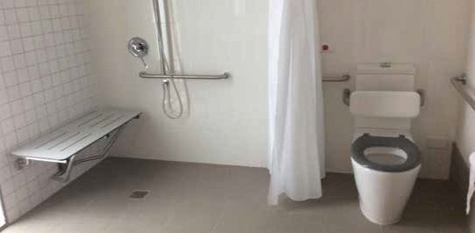
An example of an ‘institutionalised’ bathroom compliant to AS 1428.1 within a BCA Class 3 development. Note the requirement for grabrails, shower seat, shower curtain and backrest behind the toilet.

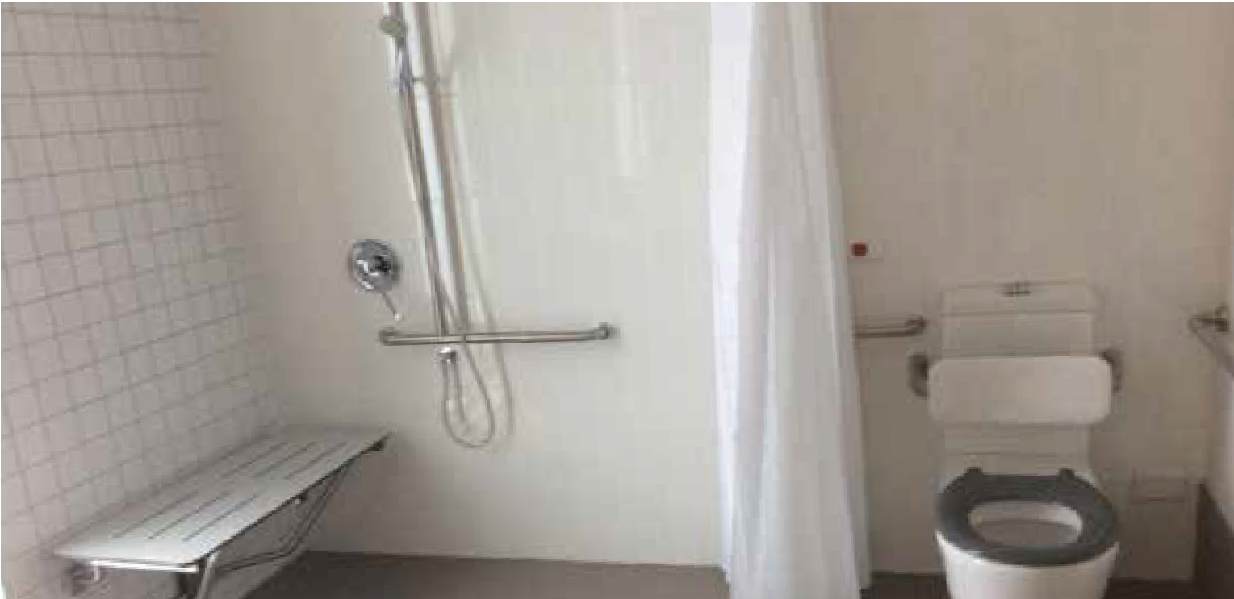
Example of a home like bathroom compliant to Platinum Standard in a BCA Class 2 dwelling.

WHAT IS A REASONABLE DESIGN FRAMEWORK AND WHERE TO FROM HERE?

IN CONCLUSION, MUCH HAS BEEN LEARNT FROM THE HOUSING DEMONSTRATION PROJECTS DEVELOPED BY SUMMER FOUNDATION AND THE TAC. THESE LEARNINGS, SUPPORTED BY THIS ASSESSMENT OF VARIOUS DESIGN REQUIREMENTS AND THEIR PRACTICAL APPLICATIONS, VERIFY THAT THERE IS CURRENTLY NO ONE PARTICULAR DESIGN STANDARD WHICH WILL DELIVER THE DESIGN OUTCOMES THAT ARE REQUIRED FOR PEOPLE WITH SIGNIFICANT DISABILITY.
This analysis has highlighted a significant gap in the availability of accessible residential design requirements. It supports the need to consider development in Australia of an appropriate design framework to assist the housing sector in delivering suitable housing for people with significant disability. This is particularly important to support people to exercise choices for more independent living.
The development of a new Australian Standard specifically for accessible residential housing would help to fill this gap and provide industry with greater guidance. This new Standard would articulate the requirements of a good design framework and document design features that will support people with significant disability to live more independently in home-like environments.
Development of an appropriate design framework is critical for people with significant disability as the design of their home, along with appropriate supports, has a major impact on their ability to live as independently as possible. Some people with significant disability spend a large portion of their time in their home. Therefore, the ability to access all areas of an individual’s home environment such as the garden or the balcony, not just their bedroom, bathroom and the front door, is critical to the wellbeing of the occupant.
Above all, an appropriate design standard that delivers well-designed and accessible home-like environments that are well-located has significant potential to reduce long- term care costs and improve people’s wellbeing. The potential savings associated with long-term care costs need to be taken into consideration when evaluating any initial increases in the construction cost associated with more accessible and adaptable design. A design framework that is appropriate for people with significant disability living more independently in their home will also support ‘ageing in place’.
The integration of assistive technology or home automation is another critical design element not referenced in any existing design guideline. Assistive technology can greatly enhance independence and safety. There are also people with a significant disability who are not able to live independently without the use of assistive technology, no matter how accessible the home environment is. There is growing recognition (including by the
NDIA) that assistive technology, including home automation, can change life opportunities for people with significant disability. In the development of any new design framework, guidance should be included about key considerations for future cost-effective installation of home automation and other technologies.
It is proposed that an appropriate design framework for people with significant disabilities addresses all of the following:
  - Incorporation of Universal Design Principles
  - Compliance to Platinum level of Livable Housing Design Guidelines (however this is not enough as a singular compliance standard)
  - Creation of home-like, rather than institutional environment
  - Flexibility and adaptability to suit the different needs of various individual tenants of a property across time
  - Provision for integration of assistive technology, where it will assist the occupant’s independence
  - Durability and low maintenance
  - Ability to sell property as an attractive asset on the open market

All of the above components need to be articulated in a carefully considered design brief in order to achieve the desired design objectives. A successful design brief should be
created in collaboration with an access consultant, clinical therapists, an architect and project manager with experience in innovative housing models. Above all, it should take into account feedback from people with disabilities about what design features support them to live with greater independence.
Ultimately, this project has highlighted that there is currently no one particular design standard that can be applied to deliver well-designed, highly accessible home environments for people with significant disabilities. A new Australian Standard could provide the solution.

APPENDIX A – DESIGN ASSESSMENTS

HUNTER PROJECT (NSW) AND FRANKSTON RIPL PROJECT UNITS (VIC)
AS1428.1-2009 DESIGN FOR ACCESS AND MOBILITY REVIEW

DOCUMENT PURPOSE
The purpose of this document is to review the design specifications developed and applied in the Hunter Housing Project and the Frankston Project (for the Summer Foundation and the TAC, respectively) and to assess how these conform to the Australian Standard – Design for Access and Mobility 1428.9-2009 Part 1. A varied selection (4 from a total of 10) of accessible Summer Foundation apartments and 1 (of a total of 9) TAC units have been reviewed. Common areas in these projects have not been reviewed.
Note: Due to the nature of these building projects, as-built outcomes may vary from initial design specifications.

COMPLIANCE REQUIREMENTS – EXPLANATORY NOTE
Compliance with the standard is not mandatory under the BCA within the residential units of these projects.
The TAC Frankston Project is a Class 1 development (‘a single dwelling separated by fire-rated walls’) and as such, the standard does not apply.
The Hunter Housing Project is a Class 2 development (‘a building containing 2 or more
sole-occupancy units, each being a separate dwelling’) and as such the Standard does apply to some common areas (in accordance with the BCA and the Premises Standard), but not within apartments themselves.
Note: All principles within the standard have been applied to components within the unit, regardless of the intent of the requirement of the standard (e.g. whether it is intended to apply to common areas or areas within the unit).
LEGEND
If standard is applied:  NO (haven’t complied) TYPICALLY INDICATES AN ISSUE WITH STANDARD
 YES (met the min. compliance)
 EXCEEDED (above and beyond min. compliance)
N/A = not applicable to the subject reviewed documents AFFL = above finished floor level
LH / RH = left hand / right hand (referring to transfer) CAPT = continuous accessible path of travel

AS1428.1-2009 - PART 1: GENERAL REQUIREMENTS FOR ACCESS - NEW BUILDING WORK – TABLE ONE.
6.0 CONTINUOUS ACCESSIBLE PATHS OF TRAVEL (APPLIED WITHIN THE UNIT)

AS1428.1-2009
CLAUSE NUMBER
STANDARD STANDARD
MET HUNTER MET TAC UNITS UNITS
HUNTER UNITS – DIFFERENCES / ENHANCEMENTS TO
THE CLAUSE
TAC UNITS - DIFFERENCES
/ ENHANCEMENTS TO THE CLAUSE
OVERALL IMPACT OF DIFFERENCES / ENHANCEMENTS TO
THE CLAUSE
COMMENTS

  - GENERAL
shall not include any impediment (e.g. step, stair, turnstile, revolving door, escalator, moving walkway)
  - HEIGHTS ON A CONTINUOUS PATH OF TRAVEL min. height of 2m & 1.98m at doors, unobstructed
 YES  YES

 EXCEEDED  EXCEEDED Min. ceiling height of 2.4m

Min clear door height of 2m specified

As per Hunter Project. Less institutional (more spacious)

Increased design flexibility (e.g. space for equipment such as mobile hoists)

AS1428.1-2009 CLAUSE NUMBER | STANDARD MET HUNTER UNITS | STANDARD MET TAC UNITS | HUNTER UNITS – DIFFERENCES / ENHANCEMENTS TO THE CLAUSE | TAC UNITS - DIFFERENCES  / ENHANCEMENTS TO THE CLAUSE | OVERALL IMPACT OF DIFFERENCES / ENHANCEMENTS TO THE CLAUSE | COMMENTS
06.3 WIDTH OF A CAPT |  EXCEEDED |  EXCEEDED | Minimum passage width | As per Hunter Project | Increased design flexibility (e.g. | Enhancements cater for large
min. 1m wide unobstructed path | (increased | (increased | increased from 1m to 1.2m |  | improved access) | motorised wheelchair users
 | width) | width) | unit |  | Less institutional (more space for
 |  |  |  |  | furnishing / personalisation)
06.4 PASSING SPACE FOR |  YES |  YES | Some corridors narrower | As per Hunter Project | Reduced spatial impact (e.g. demand | Open plan design and furniture
WHEELCHAIRS  zone 1.8m W x 2m L | (within Living) | (within Living) | than 1.8m wide, however turning circle with 2.25m DIA |  | for wider corridors) | layout impact on this element
(for two wheelchair users to pass) |  |  | provided within Living

06.5 CIRCULATION SPACE FOR WHEELCHAIR TURN
space to turn 90-180°: provide min. 2070 x 1540mm
living and bedrooms
Open plan design, to reduced
 |  |  | amount of corners
06.6 VISUAL INDICATORS ON |  NO |  NO | Decals installed to satisfy | As per Hunter Project | Less institutional (general glazing | Majority of individuals in
GLAZING |  |  | general glazing requirements |  | decals are less visually prominent) | project units do not have visual

 YES  YES Space allocated in accessible
bedroom.
Turning circle of 2250 DIA. in
As per Hunter Project Furniture layout important to
maintain this element

to be within 900-1000mm AFFL, with min 30% luminance contrast
under BCA only; no visual indicators as per Clause

Reduced cost (item can be retrofitted if needed)
impairment

7.0 FLOOR OR GROUND SURFACES

  - CONSTRUCTION TOLERANCES FOR ABUTMENT OF SURFACES Shall have a smooth transition

Low maintenance, robust products selected (timber- look vinyl & carpet-look vinyl; ‘Bolon’)
Marmoleum specified for one unit (material which is easy to repair)
Residential-look products selected, patterns/colours not visually confusing
 YES  YES Specification required upgrade of developer’s
standard external surface material to include level threshold between indoors and out, gaps between 1-12mm

Level threshold between indoors and out, gaps between 1-12mm
arm strength)

robust, easy-care, repairable materials)
AS1428.1-2009 CLAUSE NUMBER | STANDARD MET HUNTER UNITS | STANDARD MET TAC UNITS | HUNTER UNITS – DIFFERENCES / ENHANCEMENTS TO THE CLAUSE | TAC UNITS - DIFFERENCES / ENHANCEMENTS TO THE CLAUSE | OVERALL IMPACT COMMENTS OF DIFFERENCES /  ENHANCEMENTS TO THE CLAUSE
07.1 GENERAL |  YES |  YES | 3 selected finishes | As per Hunter Project | Less institutional
Slip resistant surface and Direct stuck (non-standard install method to provide  traversable texture, suitable for harder surface)  those who use a wheelchair, or  have an ambulant or sensory Thicknesses of adjacent flooring matched for more  disability seamless transition |  |  |  |  | Increased design flexibility (e.g. harder surface = improved access for those with reduced
 |  |  |  |  | Reduced cost (long-term; via

  - CHANGES IN LEVEL
No more than 5mm vertical between abutment of 2 surfaces
07.4.1 CARPETS & OTHER SOFT FLEXIBLE MATERIALS
Max. pile height 6mm, continuous fastening of exposed edges, leading edge max height 3mm
 YES  YES

 YES  YES Floor covering thickness matched; transition strips at
edges not needed
Carpet tile & vinyl direct stuck to slab, with combined tolerance (leading edge) of 3mm

As per Hunter Project,
except marmoleum in lieu of vinyl, and combined tolerance (leading edge) of 2.5mm

Less institutional (no transition strips)

Product thicknesses: Bolon : 4mm
Vinyl : 2mm Carpet Tile: 5mm
Marmoleum: 2.5mm

The following extracts from specified flooring suppliers outline product data, including thicknesses.

Bolon - 2.9mm
Standard tile size is 500 x 500mm at 2.9mm thick. Weight of tiles 3.8kg/m2. Also available in a variety of pre-cut shapes – ask TAGf:I for more information. Roll size is 25mm x 2m at 2.4mm thick. Weight of rolls: 2.8kg/ m2.

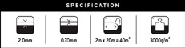Vinyl - 2.0mm
Carpet Tiles - 6.5mm
product friendly tiles, kinetic
construction tufted high & low loop
yarn/fibre Antron Lumena®
pile weight 640g/m2
pile height 5.0mm to 3.0mm
gauge 1/10
tile size 500mm x 500mm
total thickness 6.5mm
total weight 4.8kg/m2
carton size 5sqm
co-ordinates all friendly carpet tiles
Marmoleum - 2.0mm
Thickness 2.5 mm
Length Width 32 mm x 200 cm
NCS S 2010-G90Y
LRV 49%

13.0 DOORWAYS, DOORS AND CIRCULATION SPACE AT DOORS

AS1428.1-2009 | STANDARD | STANDARD | HUNTER UNITS – | TAC UNITS - | OVERALL IMPACT OF DIFFERENCES / | COMMENTS
CLAUSE NUMBER | MET HUNTER | MET TAC | DIFFERENCES / | DIFFERENCES / | ENHANCEMENTS TO THE CLAUSE
 | UNITS | UNITS | ENHANCEMENTS TO | ENHANCEMENTS
 |  |  | THE CLAUSE | TO THE CLAUSE
13.1 LUMINANCE |  NO |  YES | All internal door finishes as | Concealed door jambs; | Hunter Project: Less institutional (‘specialist’ aesthetic not applied | Hunter unit doors
CONTRAST | (preference for |  | per developer’s standard | luminance contrast | unless needed) | could be repainted

Min. 30% contrast between door/jamb, door leaf and wall
developer’s standard instead)
(doors and walls one colour) so project and non- project units look the same
achieved between door panel and wall surface
Hunter Project: Suits the needs of those with significant disability (de-identified units provide privacy for potentially more vulnerable individuals)
if required by an occupier

13.2 CLEAR DOOR OPENINGS
Min. 850mm clear width
 EXCEEDED
(increased door leaf width)
 EXCEEDED
(increased door leaf width)
Clearance widths: 950 min. specified to all doors
Doors located for straight access paths where possible
Capacity for automation provided
As per Hunter Project Increased design flexibility (e.g. improved access and manoeuvrability)
Suit the needs of those with significant disability (esp. those who may use larger motorised wheelchairs)
Increased build cost (larger floor area, prewiring) Spatial impact (larger floor area)
Reduced cost (longterm; reduced damage / maintenance requirements)
Actual as-built clear openings larger than specified due to door construction:
Swing doors 953mm Sliding Doors 953mm

AS1428.1-2009 CLAUSE | STANDARD | STANDARD | HUNTER UNITS – | TAC UNITS - | OVERALL IMPACT OF DIFFERENCES / COMMENTS
NUMBER | MET HUNTER | MET TAC | DIFFERENCES / | DIFFERENCES / | ENHANCEMENTS TO THE CLAUSE
 | UNITS | UNITS | ENHANCEMENTS TO | ENHANCEMENTS TO
 |  |  | THE CLAUSE | THE CLAUSE
13.3 CIRCULATION SPACES AT |  NO |  NO | Clearance zones forward of | Clearance zones forward of | Latch side clearance would increase
DOORWAYS ON CAPT | (HOWEVER | (HOWEVER | doors are met; latch side | doors are met; latch side | (greater floor area)

No cross fall steeper than 1:40, if door is power- operated the dimension adjacent to the door does not apply for a front of approach
automation can achieve element)
automation can achieve element)
clearances met except for E006 bath, bed 1 external door, bed 1 and 2 and M400 second Bath
Pre-wiring to all doors provided to allow automation if needed
clearances met except for bathrooms and entry doors
Pre-wiring to all doors provided to allow automation if needed
Some increase in build cost (pre-wiring)
Design flexibility preferred to increased cost = retrofit of door motorisation hardware possible

  - DISTANCE BETWEEN PASSAGES DOORS ON CAPT Max. length 1450mm
  - DOOR CONTROLS Lock controllable with one hand

Distance between handle and back plate/door (in the centre) between 35 - 45mm
 YES  YES

 YES  YES Door hardware requested to comply with standard, mounted at 1000mm AFFL

 YES  YES

As per Hunter Project Pre-wiring provisions increase building cost
Suit the needs of those with significant disability (esp. those who have significantly reduced arm / hand strength)

D pull handle, requiring less than 20N of force to operate door
 YES
(no door closers to manual doors)
 YES
(no door closers to manual doors)
Door closers omitted on manual doors (typical) to keep force to operate less than 20N

Min. 25mm DIA push button (powered doors) proud of the surface; shall activate door before button fully pressed

 EXCEEDED
(sensitive touch alternative provided)

 EXCEEDED
(sensitive touch alternative provided)

All internal and external door heads pre-wired for future door opening devices
Pre-wiring to external doors provides capacity for control via tablet or wall button

The following table is an extract from the Hunter Project Technology Specification, which outlines options for automation of doors/gates, depending on the occupier’s needs.

ELECTRICAL / TECHNOLOGY WORK IN BASE CONTRACT – SUMMARY Page 3 6/06/16

Note: Shading indicates Essential Service | Hardware/Software/ Work in Contract  (INSERT PRODUCTS HERE) | Level of Integration / type of control in Contract | E.001 | E.005 | E.006  (Display Unit) | E.107 | E.111 | E.112 | M.112 | E.207  (Display Unit) | M.212 | E.307 | M.400
2. DOORS & ACCESS
Unit Entry Door, External Doors & Gate (if provided) |  | Electric strike | X  Main unit  (entry only) | X | X | X | X | X | X | X | X | X | X
Unit Entry door & main Living Room door | - RF fob for unlocking | - Manual opening  power & data pre- wiring | X  (quantity TBC) | X | X | X | X | X | X | X | X | X | X
 | - RF fob for unlocking + Automation hardware (with battery backup & free-release)  (Dorma ED100 Swing Door Operator / Dorma HD200 Single Slide Operator or similar product.) | - Automatic opener  - Wall switch control (internally)  + tablet control (via Home Automation) |  |  | X |  |  |  |  | X
Private entry gates | - RF fob for unlocking | - Manual opening  power & data pre- wiring |  | X |  | X | X | X
 | - RF fob for unlocking + Automation hardware (with battery backup & free-release) | - Automatic opener  - RF control  + tablet control (via Home Automation) |  |  | X
All Internal Doors |  | power & data pre- wiring |  | X | X | X | X | X | X | X | X | X | X

14.0 SWITCHES AND GENERAL PURPOSE OUTLETS (POWER POINTS)

AS1428.1-2009 CLAUSE | STANDARD | STANDARD | HUNTER UNITS – | TAC UNITS - | OVERALL IMPACT OF DIFFERENCES / COMMENTS
NUMBER | MET HUNTER | MET TAC | DIFFERENCES / | DIFFERENCES / | ENHANCEMENTS TO THE CLAUSE
 | UNITS | UNITS | ENHANCEMENTS TO | ENHANCEMENTS TO
 |  |  | THE CLAUSE | THE CLAUSE
14.1 LIGHTSWITCHES & GPO’S |  EXCEEDED |  YES | GPO’s / switches at least 600mm | As per Hunter Project, | Suits the needs of those with significant disability
Generally located between | (corner offset |  | from corners, at 1000 mm AFFL | except corner offset is | (e.g. increased options for control, requiring less strength)

900-1100 AFFL on the path of travel, not less than 500mm from internal corner

14.2 ACCESSIBLE SOLE- OCCUPANCY UNITS & ACCESSIBLE SANITARY FACILITIES
increased from 500 to 600mm)
Pre-wiring provides capacity for lighting control via tablet / smartphone
Range of optional automation programming features e.g. “arrive-home-everything-on” command
500mm as per standard
Pre-wiring provisions increase building costs but anticipated independence reduces long-term support costs
Hunter Project:
Suit the needs of those with significant disability (esp. those who use a larger motorised wheelchair; as corner is more difficult to access)

Light switches & GPO’s to be rocker and toggle action, min. 30 x 30 or push pad with min. 25mm DIA.

Installed between 600mm and 1100mm AFFL
 YES  YES All light & power switches rocker type, with GPO’s between 600- 1100 AFFL
Appliance GPO’s located to enable maximum control

 YES  YES
As per Hunter Project, except for 500mm min corner offset of GPO’s
Less institutional (individuals have more opportunity to independently control appliances)
Hunter Project:
Suit the needs of those with significant disability (esp. those who use a larger motorised wheelchair; as corner is more difficult to access)

Not less than 500mm from an internal corner
 EXCEEDED
(600mm corner offset)
 YES

15.0 SANITARY FACILITIES

AS1428.1-2009 CLAUSE | STANDARD | STANDARD | HUNTER UNITS – | TAC UNITS - | OVERALL IMPACT OF DIFFERENCES / | COMMENTS
NUMBER | MET HUNTER UNITS | MET TAC UNITS | DIFFERENCES / ENHANCEMENTS TO THE CLAUSE | DIFFERENCES / ENHANCEMENTS TO THE CLAUSE | ENHANCEMENTS TO THE CLAUSE
15.1 GENERAL |  EXCEEDED |  YES | Low height mid-wall “nib |  | Hunter Project:

Combination of facilities required; those that support LH transfer to WC, and those that support RH transfer to WC; may be achieved by mirroring facility layout

15.2 ACCESSIBLE UNISEX SANITARY FACILITIES
(outcome achieved within the one facility)
(mirrored layouts)
wall” allows for toilet relocation, to suit either preferred transfer side
Increased design flexibility
Suits needs of those with significant disability (allows for modifications in dwelling over time, to suit individual’s changing needs)
Increased capital cost but reduced long-term support costs (potential increase in independence, when toilet suitably located)

Frankston TAC Project: due to builder’s selected HWS

15.21 TAPS
Tempered mixer required with lever
 YES  YES Standard applies As per Hunter Project
(gas boosted with push-pad control, max. hot water temperatures can more easily be lowered for individuals if needed

Below are plans of typical bathrooms from the Hunter and Frankston Projects, indicating circulation spaces around the WC.
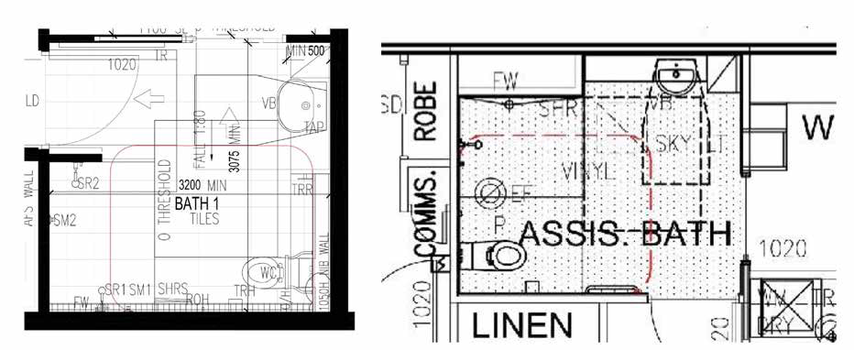
Disabled toilet clearance - Hunter Project typical bathroom configuration Disabled toilet clearance – Frankston Project typical bathroom configuration

AS1428.1-2009 | STANDARD | STANDARD | HUNTER UNITS – | TAC UNITS - | OVERALL IMPACT OF DIFFERENCES / | COMMENTS
CLAUSE NUMBER | MET HUNTER UNITS | MET TAC UNITS | DIFFERENCES / ENHANCEMENTS TO THE CLAUSE | DIFFERENCES / ENHANCEMENTS TO THE CLAUSE | ENHANCEMENTS TO THE CLAUSE
15.2.2 WC PAN CLEARANCES |  NO |  YES | Typical WC install is non-compliant | Compliant WC | Hunter Project: | High proportion of

Top of pan 440-460mm, top of seat 460-480mm AFFL
Front of pan offset 800mm from wall

Front of pan 600mm from front of cistern
(can be achieved if needed)
 NO
can be achieved if needed)
 NO
can be achieved if needed)

 YES

 YES
model; flexible toilet nib wall allows for easy replacement with compliant WC model if needed
Location also alterable, to suit individual’s preferred transfer side
specified
Design flexibility (for most usable toilet type & location) Nib wall = increase in capital cost
Standard WC in lieu of disability compliant WC = capital cost saving
Reduced future costs (for support) due to anticipated increase in independence
population in project units do not require a compliant toilet- model

Centre of pan offset from side wall by 450 to 460mm
 YES  YES

15.2.3 WC SEAT
Full round type, securely fixed, with lateral stability, load-rated to 150kg, min. luminance contrast of 30% between background, pan, wall or floor
 NO
(can be achieved if needed)
 NO (can be achieved if needed)
Developer’s standard used typically
– no contrasting seat colour
Flexibility to replace toilet seat if needed
As per Hunter Project Less institutional (one colour for all components looks more
mainstream)

The extract below from the Summer Foundation’s Design Insights Report (pg. 48) demonstrates various options for altering the toilet type and location, to increase opportunities for independent use.

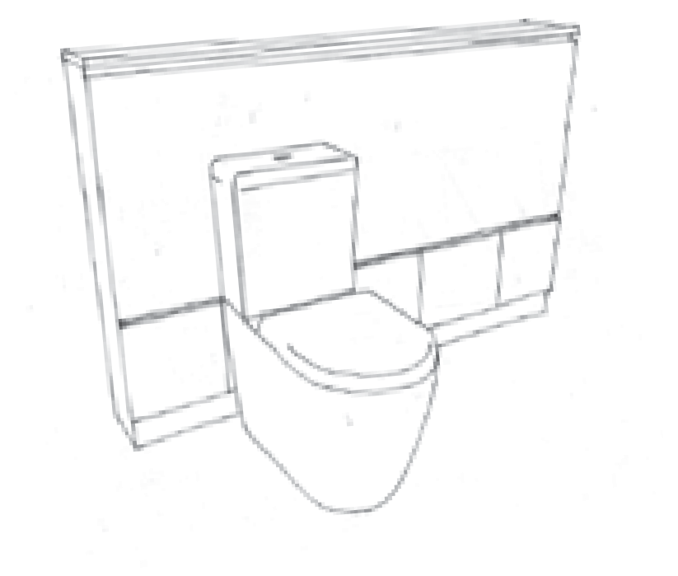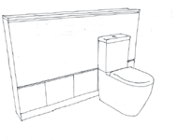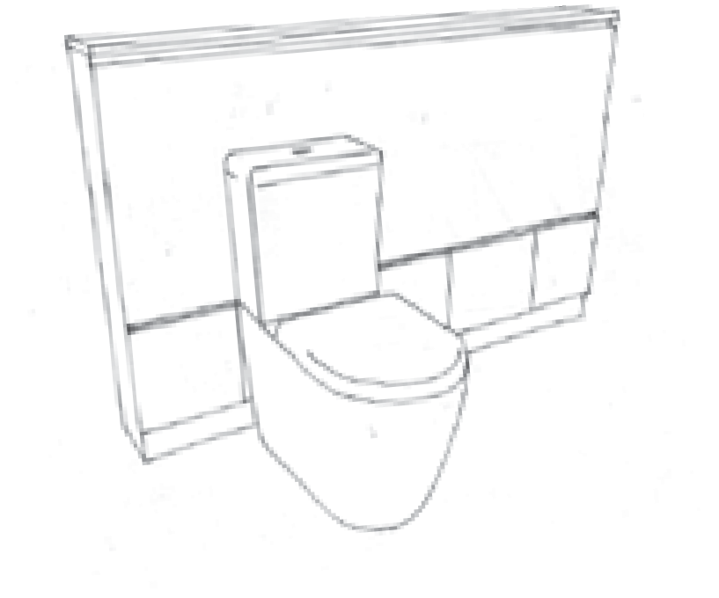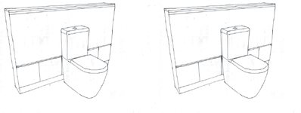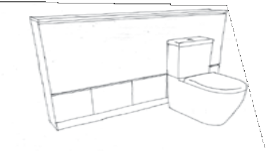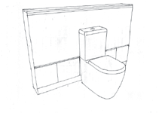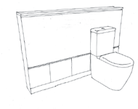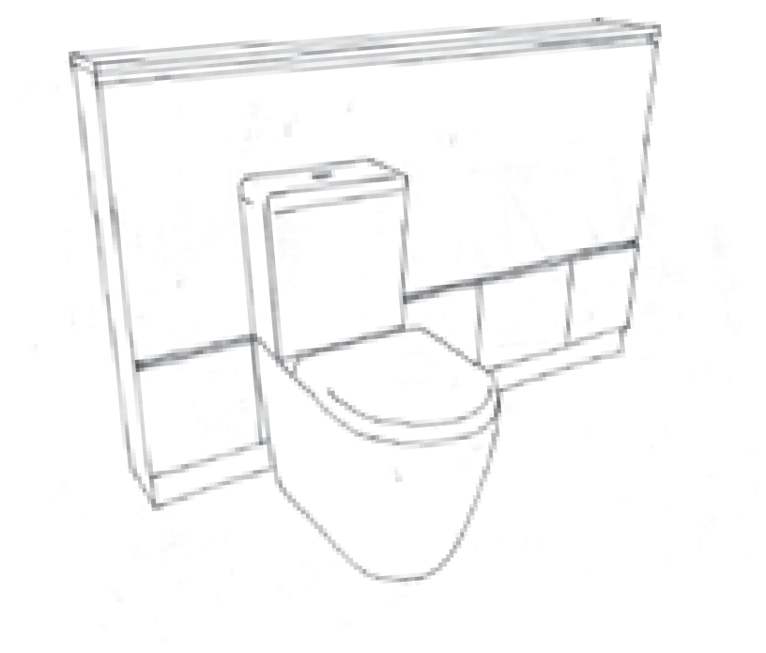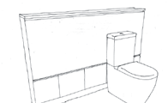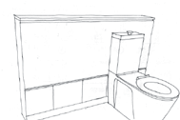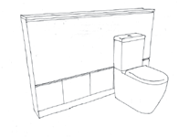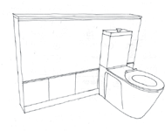 ACCESSIBLE BATHROOMS D. KEY SPACES | DESIGN AND ADAPTABILITY FEATURES

FLEXIBLE TOILET
FLEXIBLE TOILET

FLEXIBLE LOCATION
Toilets in Accessible Bathrooms can be located in 3 different positions, to suit an individual user’s
preferred side of transfer.

This feature is designed to maximise the
opportunity for independent self-transfer, reducing the potential need for installation of grabrails and
support staff assistance.
Position 1 - standard location as per Position 2 - alternative central location Position 3 - alternative location for
LHD Platinum requirements (left- right-sided transfer
sided transfer)

Position 1 - standard location as per LHD Platinum requirements (left-
FLEXIBLE LOCATION
Toilets in Accessible Bathrooms can be located in 3 different positions, to suit an individual user’s
preferred side of transfer.

This feature is designed to maximise the
opportunity for independent self-transfer, reducing the potential need for installation of grabrails and
support staff assistance.
sided transfer)

Position 2 - alternative central location Position 3 - alternative location for
right-sided transfer

A standard toilet and DDA-compliant toilet can be easily and cost-effectively swapped in future if necessary.

FLEXIBLE TOILET TYPE
Any toilet with a P-trap (rear waste point) with
a similar setout point may be installed, including either a standard toilet (approx. RRP of $300) or a DDA-compliant toilet (approx. RRP of $2400). Hence this design feature can save the cost of
FLEXIBLE TOILET TYPE
Any toilet with a P-trap (rear waste point) with
a similar setout point may be installed, including either a standard toilet (approx. RRP of $300) or a DDA-compliant toilet (approx. RRP of $2400).
Hence this design feature can save the cost of purchasing a DDA-compliant toilet, if it is not needed.

AS1428.1-2009 | STANDARD | STANDARD | HUNTER UNITS – DIFFERENCES / | TAC UNITS - | OVERALL IMPACT | COMMENTS
CLAUSE NUMBER | MET HUNTER UNITS | MET TAC UNITS | ENHANCEMENTS TO THE CLAUSE | DIFFERENCES / ENHANCEMENTS TO THE CLAUSE | OF DIFFERENCES / ENHANCEMENTS TO THE CLAUSE
15.2.4 WC BACKREST |  NO |  NO | Typical install – none provided | As per Hunter | Less institutional | Backrests likely to impede

Located & with loading as outlined
(can be achieved if needed)
(can be achieved if needed)
Optional install depending on individual’s requirements
Project
Reduced capital cost if element not needed
use of WC for individuals in larger, reclining, shower commode chairs

15.2.5 FLUSHING CONTROLS Installed in zone as outlined in standard
 EXCEEDED
(enhanced access option)
 YES Flush controls centrally located as per code
GPO provided for addition of sensor-activated flush if individual cannot reach controls (no pushing / twisting
 |  |  | needed) |  | mobility)
15.2.6 TOILET PAPER |  NO |  YES | Element to be installed once individual occupier identified | Installed as per code | Hunter Project: | Element installed to code

As per Hunter Project, except no GPO for sensor was installed.
Improved design flexibility
Suits needs of those with significant disability (e.g. with limited strength,

DISPENSER
Installed in zone as outlined in standard
(can be achieved if needed)

Non-tiled wall surfaces provided to enable easy relocation in future if needed

Improved design flexibility
(tailored location maximises capacity for independent use)
may not be reachable if WC located in alternative position

15.2.7 GRABRAILS Installed as per Standard
 NO
(can be achieved
 NO
(can be
Grabrails only installed if required by individual occupier Provision of AFS concrete walls, ply sheeting and steel-
As per Hunter Project, except WC
Improved design flexibility (to install most usable type of rail for individual)
Grabrails may not always be useful

except for fittings as outlined in clause
 | if needed) | achieved if  needed) | framed toilet nib wall allow for install of fixed wall- grabrails or drop-down grabrails as required | position fixed | Less institutional  Reduced upfront cost (omit grabrails | (particularly for occupiers who do not use toilet)
 |  |  |  |  | if not needed)
15.2.8 CIRCULATION SPACE |  NO |  NO | As noted in 15.1 WC clearances cause the vanity unit to | No encroachment | Less institutional | A baby change table is
Unobstructed circulation | (due to | (due to baby | protrude 320mm into the zone, however generally all | into the circulation |  | required for a commercial
space between 0 & 2m AFFL, | circulation space | change – can | other areas are met | zone beyond the |  | or institutional project;

& baby change – can be achieved if needed)
be achieved if needed)

Flexible toilet pan location enables space clearances outlined in Standard if needed however vanity will still encroach into clearances to varying degrees, depending on toilet pan locations
allowed items
not a home

15.2.8.2 BABY CHANGE TABLES
No baby change facilities No baby change facilities

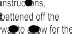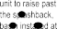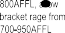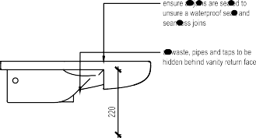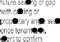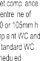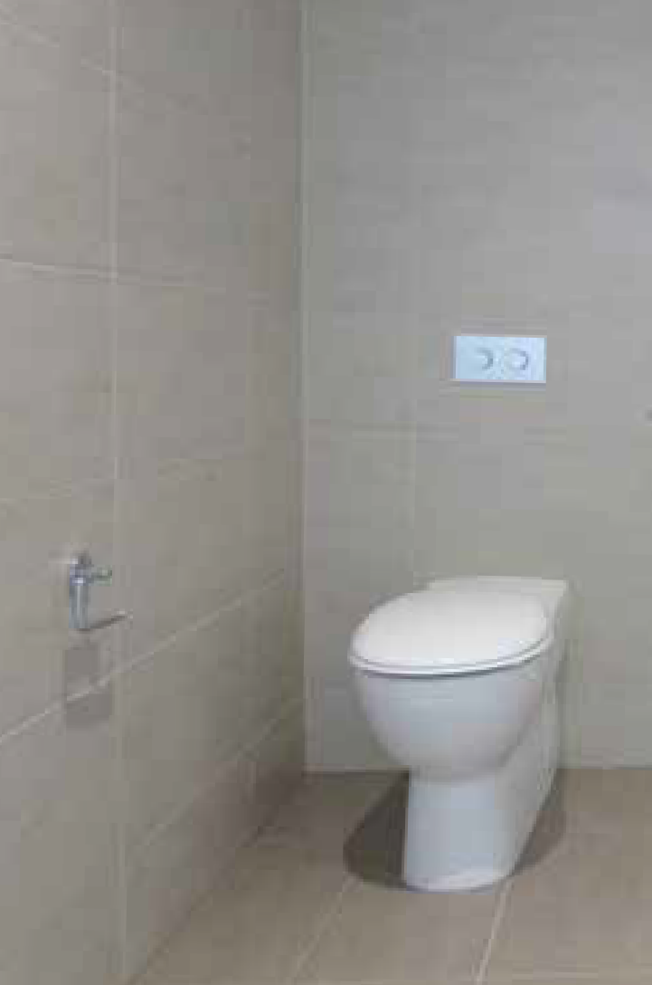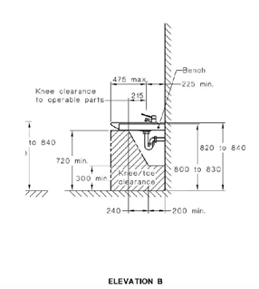Below is an example of a compliant bathroom with WC grab rails, along with a non-complaint WC that meets an individual’s needs, relative to section 15.
1 DETAIL
1:10
Compliant design for Sole-Occupancy Unit
Design for the Hunter & TAC Projects

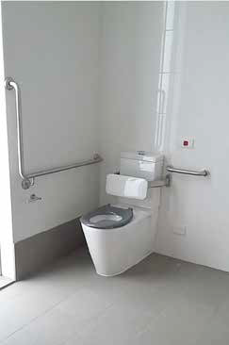

Compliant WC setup, with grabrails Non-compliant WC setup, without grabrails; suitable for an individual who does not toilet or who does not need assistance to toilet
Below is an extract from AS1428.1-2009 showing the sole-occupancy basin unit (pg. 79), along with a sketch of the height-adjustable basin developed in the Hunter and TAC Projects.

AS1428.1-2009 CLAUSE  NUMBER | STANDARD  MET HUNTER UNITS | STANDARD MET  TAC UNITS | HUNTER UNITS –  DIFFERENCES / ENHANCEMENTS TO THE CLAUSE | TAC UNITS - DIFFERENCES  / ENHANCEMENTS TO THE CLAUSE | OVERALL IMPACT OF  DIFFERENCES / ENHANCEMENTS TO THE CLAUSE | COMMENTS
15.2.9 WC DOORS |  NO |  NO | Door snibs, without indicators | As per Hunter Project | Less institutional aesthetic (indicators not
Doors to have in-use indicators, force and handles as per clause 13.5 | (HOWEVER the  outcome is met) | (HOWEVER the  outcome is met) | (not a public facility), door handles are compliant |  | suitable for home)
15.2.10 |  EXCEEDED |  EXCEEDED | Selected washbasin compliant | As per Hunter Project | Improved design flexibility | Height adjustment

WASHBASINS FOR UNISEX ACCESSIBLE SANITARY FACILITY

  - WASHBASINS

    - GENERAL Installation of washbasin

    - ACCESSIBLE SOLE OCCUPANCY UNITS
For vanity installation and height
(height- adjustability)
(height-adjustability)
with diagram below
Washbasin incorporated into height-adjustable vanity to cater for larger motorised wheelchair users / person of smaller stature
Increased capital cost (once-off) but lower modification costs (potentially multiple times)
achieved through inclusion of height- adjustable brackets and sink plumbing

AS1428.1- | STANDARD MET | STANDARD MET | HUNTER UNITS – | TAC UNITS - | OVERALL IMPACT OF | COMMENTS
2009 CLAUSE NUMBER | HUNTER UNITS | TAC UNITS | DIFFERENCES / ENHANCEMENTS TO THE CLAUSE | DIFFERENCES / ENHANCEMENTS TO THE CLAUSE | DIFFERENCES / ENHANCEMENTS TO THE CLAUSE
15.4 FIXTURES |  EXCEEDED |  EXCEEDED | Lengthened mirror included | As per Hunter Project, except | Increased design flexibility | Location of fixtures outlined in

AND FITTINGS WITHIN A SANITARY FACILITY

    - MIRRORS
(longer mirror)
(longer mirror)
to match height-adjustment range of basin (caters for persons of smaller stature and simplifies wall linings)
storage unit is deeper to cater for storage of larger bulk items (may impact on usability of shelving for those with limited reach)
Less institutional
Standard suits access from a shower seat;
Use of mobile shower commode more common than seat, hence fixture location need review

    - SHELVES  EXCEEDED
(increased height range available)
 EXCEEDED
(increased height range available)
Tower shelving unit offers options for access at range of heights; removable panel offers choice for easy access or privacy to items

    - – SOAP DISPENSERS, TOWEL DISPENSERS, ETC
    - CLOTHES HANGING DEVICES
    - SANITARY DISPOSAL UNITS
    - –SWITCHES & GPO’s
 NO
(can be achieved if needed)

 EXCEEDED
(side-fixing)
 NO
(can be achieved if needed)

 EXCEEDED
(side-fixing)
Sanity disposal unit, soap and towel dispensers omitted (domestic context)
Clothes hooks not installed until individual identified to ensure access

GPO located at height as per Standard; side-fixed to cater for those with minimum reach capacity (i.e. rather than on rear wall)

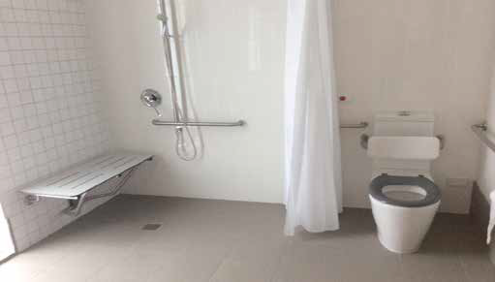

AS 1428.1 Compliant WC Facility

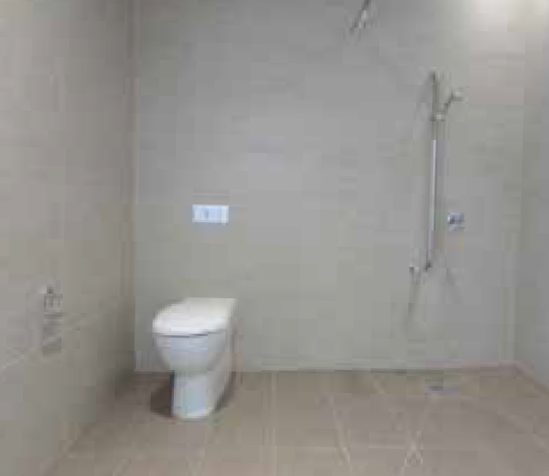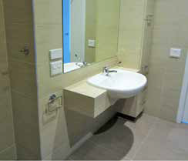
Non-compliant WC, however occupier needs are met.

AS1428.1-2009 CLAUSE | STANDARD MET | STANDARD | HUNTER UNITS – DIFFERENCES | TAC UNITS - DIFFERENCES | OVERALL IMPACT OF | COMMENTS
NUMBER | HUNTER UNITS | MET TAC UNITS | / ENHANCEMENTS TO THE CLAUSE | / ENHANCEMENTS TO THE CLAUSE | DIFFERENCES / ENHANCEMENTS TO THE CLAUSE
15.5 SHOWERS |  NO |  NO | 1:80 floor fall provided | The shower waste is centrally located | Improved design flexibility | Omission of

    - GENERAL, SHOWER RECESSES, GRABRAILS, FITTINGS & TAPS
    - floor waste outlet centrally located with even falls 1:60 - 1:80
(However the outcome is met)
(HOWEVER
the outcome is met)
Strip drain provided in lieu of centrally- located shower floor waste (simplifies self-propelled manoeuvring, enables seamless removal of fixed end panel if needed & looks less institutional)
No grabrails or seat installed unless needed; fittings installed once occupier is identified
within the shower zone, at a grade of 1:60 and 1:80 outside the shower
Required circulation space of 1400x1600 has been allowed for on the shower chair side, as per clause
Clothes hooks aren’t located as per the clause (would suit access from seated position, seat unlikely to be needed by project population)
Less institutional
Reduced unnecessary capital costs
grabrails and seat makes design non-compliant, although these items may be easy retrofitted if needed

    - OPENING SHOWER SCREENS
Shower screening shall be either a curtain or door system that maintains the required circulation space
 EXCEEDED
(screening enables greater circulation space than required in standard)
 EXCEEDED
(shower curtain enables greater circulation space than required in standard)
(removable) folding glass panel specified; maintains the shower zone and doesn’t impede the use of the circulation space, with optional (removable) glass fixed end panel to enclose the space
Screening curtain provided Glass provides less institutional aesthetic than curtains, is easy to control independently (won’t stick to body)
Optional fixed end panel increases capital costs but considerably improves circulation options (provides design flexibility)

AS1428.1- | STANDARD | STANDARD | HUNTER UNITS – DIFFERENCES | TAC UNITS - DIFFERENCES | OVERALL IMPACT OF COMMENTS
2009 CLAUSE | MET HUNTER | MET TAC | / ENHANCEMENTS TO | / ENHANCEMENTS TO THE | DIFFERENCES /
NUMBER | UNITS | UNITS | THE CLAUSE | CLAUSE | ENHANCEMENTS TO THE CLAUSE
15.5.8 SHOWER |  EXCEEDED |  YES | Two mixers/shower heads provided |  | Increased design flexibility (provides

TAPS
Taps as specified in Clause 15.2.1 and located in the zone in Figure 48

15.5.9 FOLDING SEAT
Installed as shown in Figures 47 and 48
(two sets provided)

 NO
(HOWEVER can be retrofitted)

 NO
(HOWEVER can
be retrofitted)
First set as per standard
Second set located for use by support provider (less reaching and less splash)
Two sets enable one for washing use and one for keeping the body warm (relevant issue for individuals with ABI)

None provided. Wall linings and space clearances enable retrofit
Configuration of shower slightly different to code – no reduction in access

As per Hunter Project but configuration as per standard
greater options for occupiers who either shower independently or with assistance)
Suits people with significant disability (i.e. improved safety, health and wellness)
Increased capital cost and associated with 2 sets
Less institutional (maximises individual comfort and control)
Reduced unnecessary capital cost
Increased design flexibility (increased circulation space available)

Project group largely use shower commodes; hence seat not needed. Seat reduces space available

AS1428.1-2009 CLAUSE | STANDARD | STANDARD | HUNTER UNITS – | TAC UNITS - DIFFERENCES | OVERALL IMPACT OF | COMMENTS
NUMBER | MET HUNTER UNITS | MET TAC UNITS | DIFFERENCES / ENHANCEMENTS TO THE CLAUSE | / ENHANCEMENTS TO THE CLAUSE | DIFFERENCES / ENHANCEMENTS TO THE CLAUSE
15.5.4 GRABRAILS |  NO |  NO | Horizontal rail is omitted hence | As per Hunter Project | Reduced unnecessary | Consideration needed around

As specified in Clause 17 fixed in position (figures 47 & 48)
(can retrofit)
(can retrofit)
design is non complaint
Reinforcement to all walls to enable grabrail install where needed
capital cost
Greater customisation to individual need
appropriate wall lining material where items may need to be altered several times

    - SHOWER HEAD VERTICAL SUPPORT RAIL
As specified in clause 17 shall be fixed in position shown in Figure 48
 YES  YES Compliant product with non- institutional aesthetic selected
As per Hunter Project Vertical rail allows for height
adjustment of shower head; this must be grabrail strength in case individual relies upon it for stability

    - SHOWER HEAD
A flexible hose of 1500mm long min. installed onto grab rail, able to be grasped at various positions, allow to be located with 1000-1800mm above FFL
 EXCEEDED
2m hose installed
 EXCEEDED
2m hose installed
Compliant product with non- institutional aesthetic selected (brushed steel finish), however the water outlet is located different to the code so that the hose does not hang in water (improved product longevity)
As per Hunter Project Less institutional aesthetic

Improved product lifespan (reduced long-term costs)

The images below show a compliant shower (horizontal grabrail provided) and a partially compliant shower (no horizontal grabrail provided).

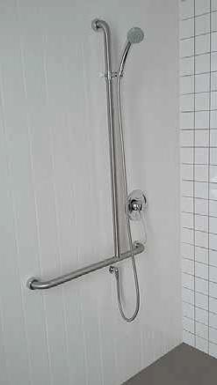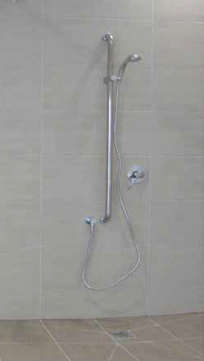

Compliant shower, in corner position with offsets from wall and integrated horizontal grab rail; shower mixer in corner
Partially compliant shower – not in corner position, without offsets from wall, shower mixer in corner, or horizontal grab rail

AS1428.1-2009  CLAUSE NUMBER | STANDARD  MET HUNTER UNITS | STANDARD MET  TAC UNITS | HUNTER UNITS –  DIFFERENCES / ENHANCEMENTS TO THE CLAUSE | TAC UNITS - DIFFERENCES  / ENHANCEMENTS TO THE CLAUSE | OVERALL IMPACT OF  DIFFERENCES / ENHANCEMENTS TO THE CLAUSE | COMMENTS
15.5.7 SOAP HOLDER |  NO |  NO | Suction cap-backed product | Soap holder and shower recess installed | Increased design flexibility (suction | Code location suits seated
Provided in zone as | (HOWEVER | (HOWEVER location | selected, for installation in most | on opposite side to what is outlined in | cap product offers small-scale | access from folding seat
outlined | location can be | can be achieved) | accessible position | standard | customisation to suit individual) | position. Project population

15.6 CIRCULATION SPACE IN ACCESSIBLE SANITARY FACILITIES
Circulation spaces in accordance to Clause
15.2.8 and Figures 43 to 47 and 50.
Circulation spaces, including doors can overlap; fixtures must not encroach space, except those items noted in clause.
achieved)

 NO (DUE to the minor basin
encroachment)

 EXCEEDED
(increased spatial provisions)

As noted in 15.1 this is not met due to the vanity unit encroaching into the WC circulation zone
So as to aid with flexibility for assistance and larger space on opposite side allowing for more storage/shelf space
Space provided for bathroom is more than required due to layout
No encroachment on the WC circulation zone
Less institutional (inclusion of shower recess)

Increased spatial dimensions improve access options; particularly suit those with significant disability, and those using tilting long-backed shower commodes
unlikely to use seat, hence soap holder location required review in project.

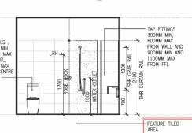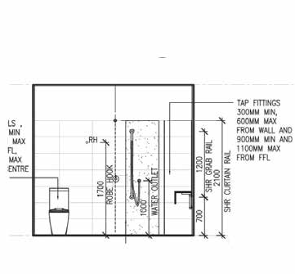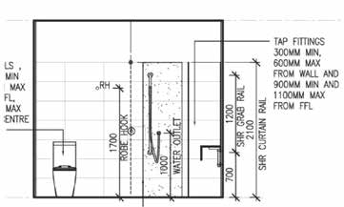Below is an extract from AS1428.1-2009 outlining shower requirements, alongside shower drawings for the Hunter and Frankston Projects.

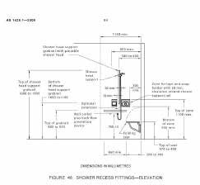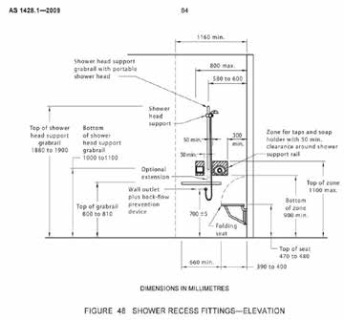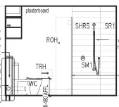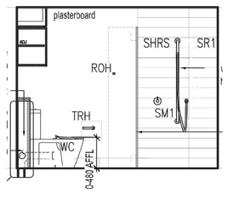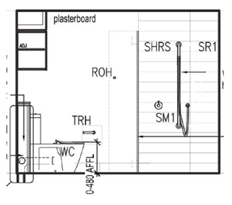

Australian Standard excerpt (pg. 84) Hunter Project shower drawing Frankston Project shower drawing

17.0 GRAB RAILS

AS1428.1-2009
CLAUSE NUMBER
STANDARD MET STANDARD MET
HUNTER UNITS TAC UNITS
HUNTER UNITS –
DIFFERENCES / ENHANCEMENTS TO THE CLAUSE
TAC UNITS - DIFFERENCES
/ ENHANCEMENTS TO THE CLAUSE
OVERALL IMPACT OF
DIFFERENCES / ENHANCEMENTS TO THE CLAUSE
COMMENTS

17.0 GRABRAILS
Must be between 30-40mm DIA
Exposed edges to be a radius no less than 5mm
Fastenings to withstand 1100N of force applied in any direction
Clearance between wall surface to be between 50-60mm
Grabrails to external corner must be fixed so there is no obstruction to passage of the hand
 YES
(HOWEVER only where grabrails installed)
 YES
(HOWEVER only where grabrails installed)
Size, clearances and force for grabrail applied as per code.
Future modifications will need to ensure compliant models are selected
x1 no. grabrail provided as towel rail
As per Hunter Project Grabrails installed do not cater for individuals with bariatric requirements
- such an occupant would require an upgrade of grabrails above 1100N force
Wall construction will impact which units can cater for bariatric
requirements e.g. those with more concrete walls will be more suitable

HUNTER PROJECT (NSW) AND
LEGEND
If standard is applied:
 NO (haven’t complied)
TYPICALLY INDICATES AN ISSUE WITH STANDARD
 YES (met the min. compliance)
 EXCEEDED (above and beyond min. compliance) TYPICALLY FOR ENHANCED FUTUREPROOFING
N/A = not applicable to the subject reviewed documents AFFL = above finished floor level
LH / RH = left hand / right hand (referring to transfer) CAPT = continuous accessible path of travel
FRANKSTON PROJECT UNITS (VIC) LIVABLE HOUSING DESIGN GUIDELINE REVIEW (GOLD AND PLATINUM RATINGS)
DOCUMENT PURPOSE
The purpose of this document is to review a varied selection (4 from a total of 10) of accessible units within the Hunter Project for the Summer Foundation, and to review one 2-bedroom dwelling for the TAC. This analysis is based on minimum compliance (or exceeding compliance) with the Livable Housing Design Guidelines - Platinum.
Note: Some strictly non-complying elements within this report have obtained approval for use within the specific project, where these elements meet the design objectives of the guidelines via alternative means (e.g. via a Livable Housing Australia ‘Ruling’ application).
There are 16 Livable Housing Design Elements that are assessed under the Design Guidelines, with Silver, Gold and Platinum certified levels. Each element outlines specific provisions and dimensions, and are as follows:

- Dwelling access
- Dwelling entrance
- Car parking
- Internal doors and corridors
- Toilet
- Shower
- Reinforcement of bathroom and toilet walls
- Internal stairways
- Kitchen space
- Laundry space
- Ground (or entry level) bedroom space
- Switches and power points
- Doors and tap hardware
- Family/living room space
- Window sills
- Flooring

LIVABLE HOUSING AUSTRALIA - DESIGN GUIDELINES, THIRD EDITION

TABLE ONE - WHERE THE REVIEWED DESIGN MET OR EXCEEDED PLATINUM LEVEL REQUIREMENTS

EXTERNAL ELEMENTS

LHA REQUIREMENT | REQUIREMENT MET OR | REQUIREMENT MET OR | HUNTER UNITS – DIFFERENCES  / ENHANCEMENTS TO | TAC UNITS - DIFFERENCES  / ENHANCEMENTS TO | OVERALL IMPACT OF DIFFERENCES / | COMMENTS
(PLATINUM) | EXCEEDED | EXCEEDED TAC | REQUIREMENT | REQUIREMENT | ENHANCEMENTS TO
 | HUNTER UNITS | UNITS |  |  | REQUIREMENT
Element 1 | N/A |  YES | Developer’s core design provided | 1200mm wide pedestrian paths from the | Hunter Project: | Hunter Project: The

External access paths of travel to the main entry door from the front allotment
(Class 1 or 2) - to apartment door (Class
2) min 1200mm wide, and from any car parking space
Step free entry
min 1280mm - 1915mm wide path to dwelling entries, in lieu of 1200mm wide, from the parking space or building entry and a building lift
(Two items enabled compliance without additional necessary specification)
Step free access along accessible path of travel specified
Battery backup specified for lift
front boundary of the allotment to all dwelling entrances
Increased design flexibility (e.g. battery back-up to lift allows occupants to live on higher floor levels, as fire escape options are improved)
Increased capital cost due to battery backup
Increased design flexibility
(e.g. improved access in corridors for larger wheelchairs)
developer’s specification has provided better outcomes for additional access to the subject apartment doors (?)

LHA REQUIREMENT | REQUIREMENT MET OR | REQUIREMENT MET OR | HUNTER UNITS – DIFFERENCES  / ENHANCEMENTS TO | TAC UNITS - DIFFERENCES  / ENHANCEMENTS TO | OVERALL IMPACT OF DIFFERENCES / | COMMENTS
(PLATINUM) | EXCEEDED | EXCEEDED TAC | REQUIREMENT | REQUIREMENT | ENHANCEMENTS TO
 | HUNTER UNITS | UNITS |  |  | REQUIREMENT
Element 2 |  EXCEEDED |  EXCEEDED | 953mm clear opening width door | As per Hunter Project | Improved design flexibility
Dwelling Entry | (due to door size) | (due to door size) | with 1500 x1500 level landing |  | (e.g. manoeuvrability for larger
Minimum clear door |  |  |  |  | motorised wheelchairs)
opening 900mm with
a level landing of 1500 |  |  |  |  | Anticipated reduced cost
x1500, with a level |  |  |  |  | (e.g. less damage and
transition of max 5mm |  |  |  |  | maintenance)
between abutting
surfaces
Element 3 |  YES | N/A | Class 2 | Class 1a | Improved design flexibility | Car parking and dwelling

Car parking space
Class 1a 3800mm wide x 6000mm long
(with the car park dimensions)
Car spaces are min. 2400mm wide x 5400mm long with shared spaces in- between as per AS2890.6
The parking space allocated is 3705mm x 6000mm long however not part of the dwelling access, hence exempt from assessment
(e.g. greater head height for alternative roof-mounted equipment)
entry separate in TAC Project; consultant ruled carparking to be exempt from assessment

Class 2 car parking to comply with AS2890.6 (2009)
 EXCEEDED
(head height)

The following example is a copy of the report for the As Built Check for TAC Project, used in the successful application for a ruling.

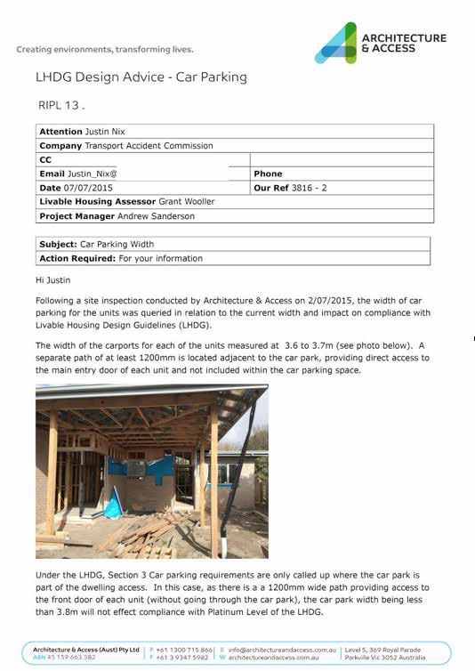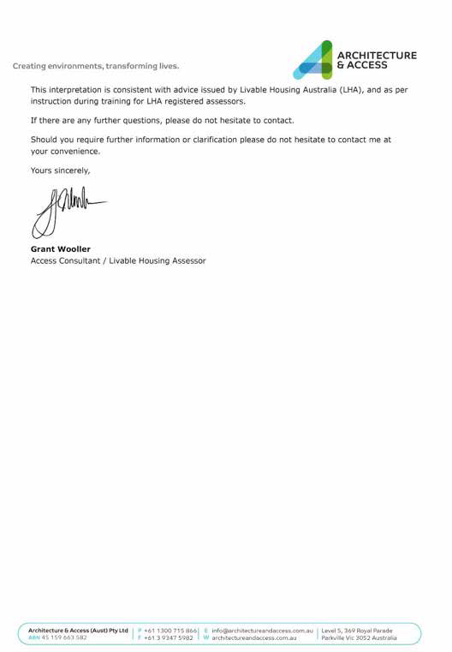

INTERNAL ELEMENTS (WITHIN THE RESIDENTIAL DWELLING)

LHA REQUIREMENT REQUIREMENT
(PLATINUM) MET OR EXCEEDED
HUNTER UNITS
REQUIREMENT
MET OR EXCEEDED TAC UNITS
HUNTER UNITS – DIFFERENCES TAC UNITS - DIFFERENCES
/ ENHANCEMENTS TO / ENHANCEMENTS TO
REQUIREMENT REQUIREMENT
OVERALL IMPACT
OF DIFFERENCES / ENHANCEMENTS TO REQUIREMENT
COMMENTS

Element 4
Internal paths of travel (corridors within the dwelling)
Doors min 900mm clear opening width
Corridors min 1200mm wide
 EXCEEDED
(due to door size)
 EXCEEDED
(due to door size)
Internal doors are 1020 leaf (953mm clear opening)
to all rooms (where accessible) Corridors min 1450mm.
1020 leaf
(min 953mm clear opening) to all internal doors
Corridors min 1510 wide
Improved design flexibility (e.g. wider doors and corridors allow greater access and manoeuvrability for larger sized wheelchairs)
Minimal spatial impact resulting from wider doors, given wider corridors

Element 5 Toilets:
To be positioned between 450-460mm from the nearest wall, 600mm clear forward of the cistern to the front of the WC pan, a pan height of 460-480mm AFFL
 EXCEEDED
Inbuilt flexibility exceeds the intended level of access provisions
 YES A ruling was issued and approved for attached toilet design (flexible nib wall), which doesn’t meet the 450-460mm location or the 600mm clearance to the front of the pan, and a height of 460- 480 however; it meets the intent of the guidelines
As per element; disabled compliant WC installed
Increased design flexibility (e.g. capacity to alter toilet location and type to suit individual need)
Reduced cost through providing standard WC if disabled WC is not needed

The successful application for LHA to consider an alternative toilet configuration in the Hunter Project is provided below.
RULING
APPLICATION
This form is used by project applicants that wish to obtain a Ruling from Livable Housing Australia’s (LHA’s) Technical Advisory Panel (TAP). The fee for consideration of a Ruling is $500 + GST. Payment of the application fee must be received by LHA before the TAP is convened to consider the application. Should insufficient information be provided in this application, the TAP may respond that a Ruling cannot be made. Any re-application with additional information or more clear instructions or discussion will attract an additional $500 + GST fee.
The individual TAP members will not contact the applicant to discuss this application. The identity of the TAP members considering this Ruling is confidential and will not be disclosed to the applicant.
Applicants should expect a response to their Ruling application within three weeks of submitting this form and payment of the Ruling fee.
This form can be saved as a Word document or as a PDF document before being emailed to info@lha.org.au.
1

Project: | 551 Pacific Highway Belmont NSW 2280
Applicant: | Summer Foundation
Contact Person: | Sophie Ryan
Contact Email: | sophie.ryan@summerfoundation.org.au
Contact Phone:
Issue: | Flexibility of toilet type and toilet positioning, via use of flexible nib wall
Discussion: | BACKGROUND  Our platinum-rated approved drawings indicated that DDA-compliant toilets would be located in all Type 1 (fully accessible) Bathrooms, in the traditional DDA-compliant position (i.e. centred 450mm away from a corner).  Some of our Tenants (currently unidentified) may require the toilet to be located in a different position to this.  Some of our Tenants may not need a DDA-compliant toilet at all, in which case it would be preferable to instead install a standard toilet.  Current documentation indicates all toilets in Type 1 Bathrooms be located in the traditional position, however only Apartment E.207 has a DDA-compliant toilet (one of two apartments, which will be used as a display to showcase flexible design features).  If a Tenant is identified for a unit during construction, who requires their toilet to be located in a non-traditional position, we anticipate requesting a variation to the current documentation.  We are undertaking this ruling to support our altered documentation, and to support any altered locations of toilets, which may be raised as an issue during the As-Built Inspection.

RULING APPLICATION
LEARNINGS & PREMISE FOR FLEXIBILITY

1. Toilet location needs to be flexible

Different individuals need toilets to be located in different positions. Particularly the corner location is not suitable for everyone. (Please see Occupational Therapist's letter, attached, which outlines the reasons for this.)
The proposed flexible nib wall allows for a toilet to be easily positioned and re-positioned in 3 different positions to suit the particular individual (450 mm centre offset from either end of the nib wall, or in the centre of the nib wall).
Having the flexibility to position a toilet where it is most usable by an individual supports independent use, through reducing reliance on support staff and assistive devices, such as drop-down grabrails.

Design Features for flexible location:

- Toilet sits on tiling allowing it to be easily moved without damaging floor surfaces
- Modular panel fronts are easily removed for access to PVC piping, via lift-off batten fixings
- P-Trap cutout in one nib wall panel is easily swapped to a different location via use of modular panel sizes
- Rear waste in nib wall cavity leads to floor slab waste point, allowing alterations to the PVC piping to be concealed within the nib wall
- PVC piping is cost effective to replace & refit to suit new toilet position

2. Toilet type needs to be flexible

People’s needs change across time and an individual may not always need a DDA-compliant toilet, or a toilet at all for toileting. In this case, the cost of installing a DDA-compliant toilet can be saved by installing a standard toilet. More of a mainstream aesthetic can also be achieved. A standard toilet can easily be replaced in the future with a DDA-compliant toilet if needed.

Design features for flexible toilet type:

- Waste point cutout has enough tolerance in size to accommodate a waste required at height of either 180 or 185mm H (to suit either the base build toilet used typically in the development, or the specified DDA-compliant toilet).

3. Adaptability needs to be cost-effective and attractive

Without a flexible nib wall, re-positioning a toilet would involve the addition of unsightly additional waste pipes, which to box in would incur additional cost. Standard laminate is used to keep this feature as cost-effective as possible.
The nib wall allows for a toilet to be repositioned in a way that is seamless with a bathroom’s

2

RULING
APPLICATION
3

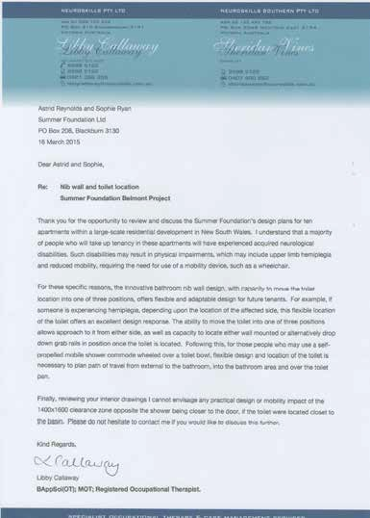
aesthetic, which helps to create a more attractive environment for an individual, as well as to retain a property's value.

4. Grabrails need to be retrofittable

Not all individuals will require grabrails. It is preferred to avoid installation of grabrails if these are not required, to reduce unnecessary cost and to avoid an institutional feel. Structural provisions in the nib wall allow for retrofitting of grab rails, if an individual does need these.

Structural features:

- 12mm ply backing to the potential grabrail ‘fixing zone’
- 20 x 20 steel framing to the potential grabrail ‘fixing zone’, to accommodate grabrails with at least 112kg loading capacity (1100 N of force in any direction)
- ‘fixing zone’ allows for grabrails to be installed at a height between 700 and 900 mm high (top of grabrail)
Proposed Ruling: | pWhere a flexible nib wall behind a toilet is provided, a toilet must not necessarily be located 450mm offset from a corner, it must not necessarily be a DDA-compliant toilet, and a 1400x1600 clearance zone does not need to be directly adjacent to the shower.  The flexible nib wall must allow for the toilet to be easily re-positioned/replaced to achieve the above.  Structural provisions are required to enable retofit of grabrails. This ruling specifically relating to Guidelines:  5b & 5biii - toilet needs to be in a corner  5b iv & v - toilet needs to be a DDA-compiant toilet model 6 cii - 1400x1600 clearance required forward of shower
Notes: | Please see attached:  ITEM 1: platinum-rated approved interior drawings (Rev A) from LHA Desktop assessment - sheets A13 and A14 for nib wall details  ITEM 2: updated interior drawings (Rev C) incorporating new panel layout & structural provisions for addition of drop-down grab rails.  ITEM 3: sketch indicating where 1400x1600 clearance zone would be located if toilet located in alternative position  ITEM 4: letter from Neuroskills Occupational Therapist

1 ELEVATION
TYPICAL BATH 1

1:50
2 ELEVATION
TYPICAL BATH 1

1:50

1
4 2
3

3 ELEVATION
TYPICAL BATH 1

1:50
4 ELEVATION
TYPICAL BATH 1
1:50

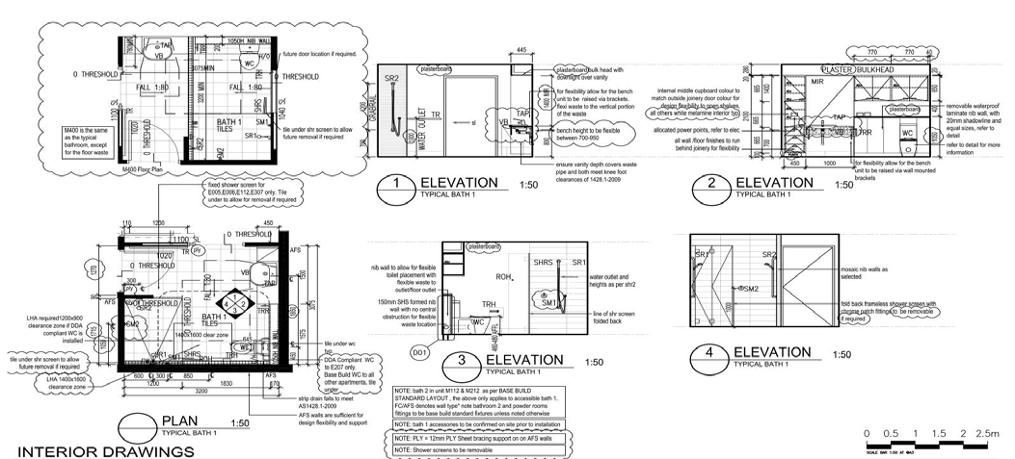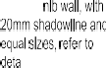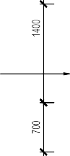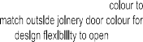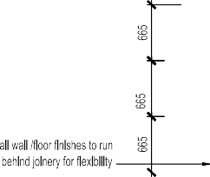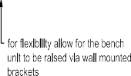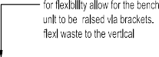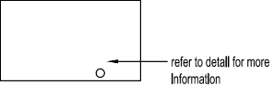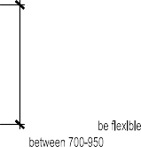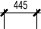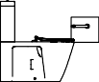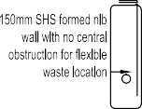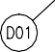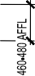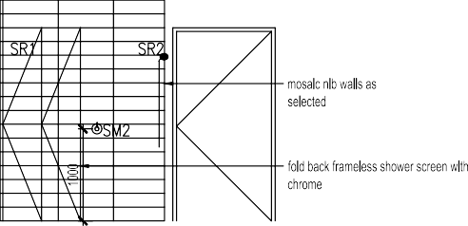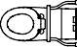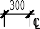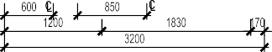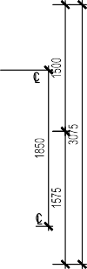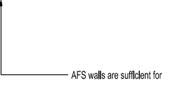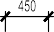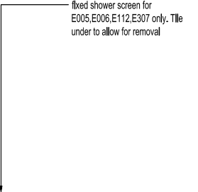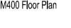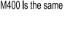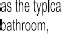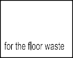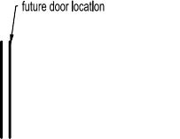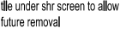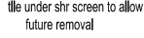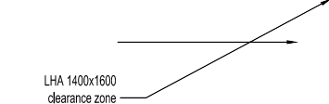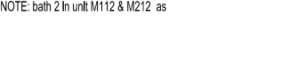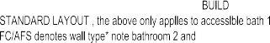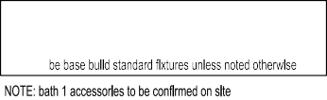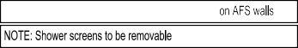
PLAN
TYPICAL BATH 1

INTERIOR DRAWINGS

1:50

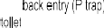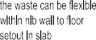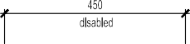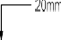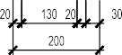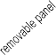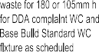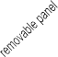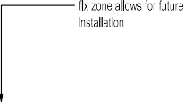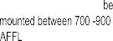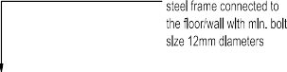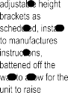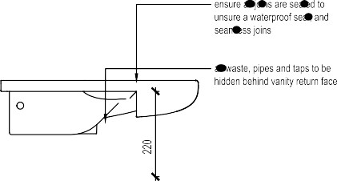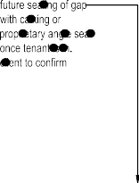
1
DETAIL
TYPICAL BATH 1
1:10
1
DETAIL
TYPICAL BATH VANITY UNIT
1:10

INTERIOR DRAWINGS

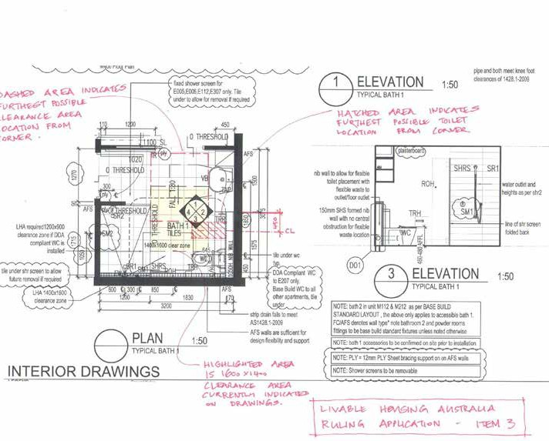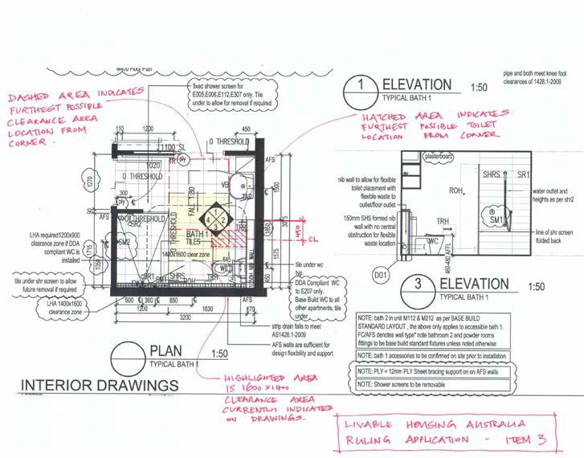Below is an example of ply-sheeted walls, installed in the Frankston Project.

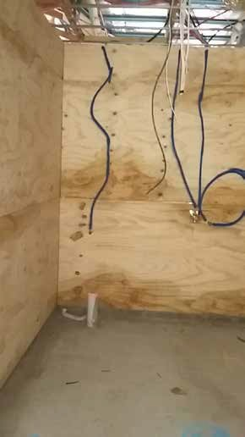

Example of the bathroom plywood-sheeted walls.

LHA REQUIREMENT
(PLATINUM)
REQUIREMENT
MET OR EXCEEDED HUNTER UNITS
REQUIREMENT
MET OR EXCEEDED TAC UNITS
HUNTER UNITS – DIFFERENCES / ENHANCEMENTS TO
REQUIREMENT
TAC UNITS - DIFFERENCES
/ ENHANCEMENTS TO REQUIREMENT
OVERALL IMPACT
OF DIFFERENCES / ENHANCEMENTS TO REQUIREMENT
COMMENTS

Element 6
Showers:
To be hobless and min 1160 mm x1100 mm and provide a clear space 1600x1400mm forward of the shower recess for entry
 YES
EXCEEDED (due to increased dimensions)
 YES
EXCEEDED (due
to increased dimensions)
Step free
Min shower dimensions increased to 1675mm long x 1180mm wide
A ruling was sought as the clear space 1600mm wide x 1400mm long isn’t directly in front of the shower on one side
Step free
Min shower dimensions increased to 1500mm long x 1200mm wide
Clear space forward of the shower is met, with no protrusion into this space
Shower enclosed by a curtain
Increased design flexibility (e.g. larger shower and flexible
screening allows more space for support workers to manoeuvre a commode chair if needed)
As per the above report example, the reviewed position on the clearance was slightly shifted, but meets the guidelines outcomes

Element 7
Reinforcement to bathroom and WC locations
 EXCEEDED
(due to additional bracing)
 EXCEEDED
(due to additional bracing)
Reinforcement to all walls of the bathroom, floor to ceiling, with either FC sheet or concrete walls
Structural ply reinforcement to all walls, floor to ceiling of the bathroom
Increased design flexibility (e.g. capacity to install grabrails where needed)
Increased capital cost associated with ply sheeting

LHA REQUIREMENT  (PLATINUM) | REQUIREMENT MET OR | REQUIREMENT MET OR | HUNTER UNITS – DIFFERENCES  / ENHANCEMENTS TO | TAC UNITS - DIFFERENCES / | OVERALL IMPACT COMMENTS OF DIFFERENCES /
 | EXCEEDED | EXCEEDED TAC | REQUIREMENT | ENHANCEMENTS TO | ENHANCEMENTS TO
 | HUNTER UNITS | UNITS |  | REQUIREMENT | REQUIREMENT
Element 8 | N/A | N/A
Internal stairways | (single-level) | (single-level)
Element 9 |  YES |  YES | 1550mm clear space between | As per Hunter Project | Increased design flexibility

Kitchen space
At least 1550mm clearance in front of fixed benches and appliances
Slip resistant flooring extending under removable cabinetry and
fixed benches
mobile island (if needed) allows for increased circulation as needed
R10 slip-resistant flooring
LED task lighting under the overhead units directly onto the benches, detailed to work in with heigh-adjustable overhead shelving units.
Task lighting to benches |  |  |  |  | handy man to refit lighting  (needed when overhead units raised or lowered)
Element 10  Laundry space |  YES |  YES | 1550 clear space  R10 slip rated | As per Hunter Project. | Reduced costs:  ‘Rather than specify strip

(e.g. via improved access options with mobile island bench)
Increased design flexibility (e.g. options to alter layout of kitchen to suit occupant’s needs)
Minimal cost incurred for

At least 1550mm clear in front on the unit,
Slip resistant flooring extending under cabinetry
Task lighting to benches

Gimbal downlight installed for task lighting, tilted to appropriate angle
lighting to WM, developer’s standard ceiling light was upgraded to gimbal type to achieve outcome.
Impact: reduced use of additional features (and hence cost) through altered product specification

LHA REQUIREMENT
(PLATINUM)
REQUIREMENT
MET OR EXCEEDED HUNTER UNITS
REQUIREMENT MET
OR EXCEEDED TAC UNITS
HUNTER UNITS – DIFFERENCES / ENHANCEMENTS TO
REQUIREMENT
TAC UNITS - DIFFERENCES / ENHANCEMENTS TO
REQUIREMENT
OVERALL IMPACT
OF DIFFERENCES / ENHANCEMENTS TO REQUIREMENT
COMMENTS

Element 11
Ground floor bedroom is at least 10 square meters with at least one wall 4040mm
Provides a space 1540x2070 in the direction of travel on one side of the bed that is closest to the door approach
Provide a min 1000mm travel path to the remaining sides of the bed
 YES  YES Minimum standard dimensions met
Minimum standard dimensions met
The length of the room is 4040mm
If a queen bed is required, the bed size increases therefore the floor area increases. LHA dimensions are based on a 1500mm wide bed

Element 12
Switches and power points should be positioned in consistent locations between 900-1100 AFFL - horizontally aligned with door handle - power points min 300AFFL
Rocker toggle or push pad type
 YES
If no minimal distance form corner specified, would say EXCEEDED
 YES
If no minimal distance form corner specified, would say EXCEEDED
Rocker type paddle switches at 1000mm AFFL i
and power points 600mm AFFL and not within 500mm of an internal corner for access
Wiring provisions made to lighting to enable future automation via tablet, if wall switches not usable for occupant
As per Hunter Project. Increased design flexibility (e.g. minimum corner offsets increase usability by occupants in larger motorised wheelchairs)

Element 13
LHA REQUIREMENT
(PLATINUM)
REQUIREMENT
MET OR EXCEEDED HUNTER UNITS
REQUIREMENT MET
OR EXCEEDED TAC UNITS
HUNTER UNITS – DIFFERENCES / ENHANCEMENTS TO
REQUIREMENT
TAC UNITS - DIFFERENCES / ENHANCEMENTS TO
REQUIREMENT
OVERALL IMPACT
OF DIFFERENCES / ENHANCEMENTS TO REQUIREMENT
COMMENTS
Door and tap hardware
Door hardware to be installed between 900-1100mm AFFL
Doors to feature lever handles or D-pull style
Basins sinks and taps should feature leaver, or capsan style tap hardware within a central
 YES  YES Door handles lever or D-pull type, installed at 1000mm AFFL.
Wiring provisions made to doors to enable future automation, with control
via wall switches or tablet, if handles not usable by occupant
Standard-length lever-type tap
As per Hunter Project
With exception of long levers in bathrooms installed as part of the build.
Less institutional (e.g. standard length lever tap installed for mainstream aesthetic, with flexibility to upgrade where needed)
Reduced capital costs associated with less disability specific product, unless needed
Increased design flexibility

spout |  |  | mixers; model selected which  enables replacement of lever with longer lever handle if needed in future |  | (e.g. increased options for  control of door)
Element 14 |  YES |  YES | 2250 DIA turning space | As per Hunter Project

The family and living space to accommodate a free space 2250mm in diameter to enable ease of movement
allocated; zone is dependant on occupant’s furnishing of space

The following is an example of the tapware selected for both projects.

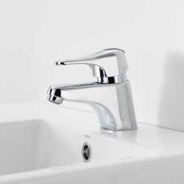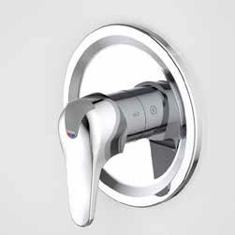

Basin mixer without care handle added Shower mixer without care handle added

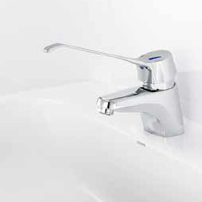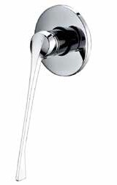
Basin mixer with care handle added Shower mixer with care handle added

LHA REQUIREMENT
(PLATINUM)
REQUIREMENT
MET OR EXCEEDED HUNTER UNITS
REQUIREMENT
MET OR EXCEEDED TAC UNITS
HUNTER UNITS – DIFFERENCES / ENHANCEMENTS TO
REQUIREMENT
TAC UNITS - DIFFERENCES / ENHANCEMENTS TO
REQUIREMENT
OVERALL IMPACT
OF DIFFERENCES / ENHANCEMENTS TO REQUIREMENT
COMMENTS

Element 15 Window sills
Sills on ground (entry level) in living and bedrooms to be no higher than 1000mm AFFL
Window controls to be able to be operated with one hand, and easy to reach
Element 16 Flooring
Floor coverings to be firm and even
Feature level transitions between abutting surfaces (a max vertical tolerance of 5mm, if rounded or bevelled)
 YES  YES Living and bedroom window sills at floor level in developer’s core design, hence element required no additional specification
Manual window winders installed no higher than 1100mm AFFL

 YES  YES Easy to clean finishes: vinyl, tiles, and carpet tiles
Minimal tolerances specified
direct stuck install and dense weave (carpets) for firmer surface (trafficability and reduced tracking of carpet)
Carpet tiles specified to enable replacement if needed
Any transition strips required will meet 1428.1-2009
Window sills are at floor level or 300mm above FFL which allow views out to the private garden areas
Manual window winders are installed at no higher
than 1100mm AFFL, if above 1100mm AFFL they are motorised

Easy to clean finishes: vinyl, marmoleum and bolon (carpet- look-vinyl) tiles.
Minimal tolerances specified
Direct stuck install for firmer surface (trafficability)
Bolon flooring in bedrooms

Increased design flexibility (e.g. firmness for improve trafficablity for those with limited strength)
Less institutional (e.g. Bolon selected to provide properties of vinyl but homely aesthetic of carpet
Increased capital cost (of Bolon in comparison to commercial carpet or vinyl)
Hunter Project: element satisfied by default due to developer’s standard full height glazing (local town planning requirement)

We appreciate your feedback on this report. Please click on the link for this short survey: https://www.surveymonkey.com/r/KPHXRVG

