Occupational Therapists:
Client Home Modifications Assessment
This form is for use by occupational therapists when assessing if home modifications are required to maximise a client’s safety and/or independence in their home.
Please complete the form and email it to the requesting TAC staff member as per the referral.
The information in this form is for use by TAC and WorkSafe Victoria (WorkSafe) and will not otherwise be exchanged with any other party, except in accordance with law. Please refer to the last page of this form for further information

Important
- Approval from TAC/WorkSafe agent must be obtained prior to completing a home assessment
- Occupational therapists should consider alternatives including modification of technique
and/or equipment prior to providing home modification recommendations
- Please include photographs of any areas of the property/home requiring modifications
- Please provide reasons if you are unable to complete a section
- All incomplete forms will be returned

Section 1 – Client and property details
Client /worker details (Please refer to TAC OT Referral)
Client’s name: | Click or tap here to enter text.
Claim number: | Click or tap here to enter text.
Client’s address: | Click or tap here to enter text.
Client’s date of birth: | Click or tap here to enter text.
Date of accident: | Click or tap here to enter text.
Type of client (TAC or WS CIP): | Click or tap here to enter text.
Client’s phone number: | Click or tap here to enter text.
Client’s email address: | Click or tap here to enter text.
Language: | Click or tap here to enter text.
Name of key contact if not the client: | Click or tap here to enter text.
Key contact phone number: | Click or tap here to enter text.
Relationship of key contact  (e.g., parent, partner, guardian): | Click or tap here to enter text.
Accident Injuries: | Click or tap here to enter text.
Co-morbidity and effects of these  on client’s functionality: | Click or tap here to enter text.

Property details (Please refer to TAC OT Referral)
Address of property to be assessed: | Click or tap here to enter text.
Ownership status of the property: | Click or tap here to enter text.
Is property owner aware of potential modifications? | Click or tap here to enter text.
Description of home  (flat or block, 1 or 2 baths, etc.): | Click or tap here to enter text.

Section 1 – Client and property details
Client’s current living arrangements
Who does the client currently live with? | Click or tap here to enter text.
Describe the home environment. | Click or tap here to enter text.
Is the client intending to remain in this property for the foreseeable future? | Click or tap here to enter text.
Is the property well positioned for community access (e.g. public transport)? | Click or tap here to enter text.
Other: | Click or tap here to enter text.

Section 2 – Occupational therapist
and assessment details
Date of assessment: | DD / MM / YYYY
Date of report: | Click or tap here to enter text.
Occupational therapist’s name: | Click or tap here to enter text.
Occupational therapist’s availability (days/hours): | Click or tap here to enter text.
Occupational therapist’s phone number: | Click or tap here to enter text.
Occupational therapist’s email address: | Click or tap here to enter text.
Individuals contributing to this report: | Click or tap here to enter text.
Attendees at the property assessment: | Click or tap here to enter text.

Section 3 – Client’s functional status
 | Expected abilities and equipment used on return to home/community living
Indoor mobility | Click or tap here to enter text.
Outdoor mobility | Click or tap here to enter text.
Upper limb function | Click or tap here to enter text.
Lower limb function | Click or tap here to enter text.
Transfers | Click or tap here to enter text.
Toileting | Click or tap here to enter text.
Dressing | Click or tap here to enter text.
Bathing | Click or tap here to enter text.
Grooming | Click or tap here to enter text.
Eating | Click or tap here to enter text.
Meal preparation | Click or tap here to enter text.
Cleaning | Click or tap here to enter text.
Laundry | Click or tap here to enter text.
Community mobility and transportation | Click or tap here to enter text.
Work/education/ recreation  (within the home environment) | Click or tap here to enter text.
Overnight care requirements | Click or tap here to enter text.
Functional cognitive status | Click or tap here to enter text.
Behavioural issues | Click or tap here to enter text.

Section 4 – Client’s expected
outcomes post home modifications
Discuss how the home modifications may affect the client’s independence
Current services  provided | Hours per  billing period  (Please refer to TAC  OT Referral) | Post home modifications services required | Hours per  billing period
Personal care | Enter hours. | Personal care | Enter hours.
Therapy support | Enter hours. | Therapy support | Enter hours.
Community access | Enter hours. | Community access | Enter hours.
Inactive sleepovers | Enter hours. | Inactive sleepovers | Enter hours.
Active sleepovers | Enter hours. | Active sleepovers | Enter hours.
Domestic support /  home services | Enter hours. | Domestic support /  home services | Enter hours.
Meal preparation | Enter hours. | Meal preparation | Enter hours.
Gardening | Enter hours. | Gardening | Enter hours.
Other (please specify) | Enter hours. | Other (please specify) | Enter hours.
Comments: Click or tap here to enter text.

Evaluation of modifications
Please specify how the modifications recommended will increase the client’s independence. | Click or tap here to enter text.
Describe the alternatives trialled or considered. | Click or tap here to enter text.

Section 4 – Client’s expected
outcomes post home modifications

Consider gratuitous supports provided
Click or tap here to enter text.

Section 5 – Summary of recommendations
For each section, insert photos and add brief descriptions. First reduce image file sizes to make it easier to email this document.

Car parking
Is modification required? | Choose Yes or No.
Does the client have a modified vehicle or is one being provided (consider maxi-taxi access if appropriate): | Click or tap here to enter text.
Current status (e.g. driveway width, carpark access height and width): | Click or tap here to enter text.
Recommendation: | Click or tap here to enter text.
Clinical justification: | Click or tap here to enter text.
Client smart goal: | Click or tap here to enter text.

Insert photos and add brief descriptions:
Click or tap here to enter text. | Click or tap here to enter text. | Click or tap here to enter text.

Click or tap here to enter text. | Click or tap here to enter text. | Click or tap here to enter text.

Before inserting your images, reduce their file sizes. This will make it easier to email this document.

Section 5 – Summary of recommendations

Front access
Is modification required? | Choose Yes or No.
Current status: | Click or tap here to enter text.
Recommendation: | Click or tap here to enter text.
Clinical justification: | Click or tap here to enter text.
Client smart goal: | Click or tap here to enter text.

Insert photos and add brief descriptions:
Click or tap here to enter text. | Click or tap here to enter text. | Click or tap here to enter text.

Click or tap here to enter text. | Click or tap here to enter text. | Click or tap here to enter text.

Before inserting your images, reduce their file sizes. This will make it easier to email this document.

Section 5 – Summary of recommendations

Rear access
Is modification required? | Choose Yes or No.
Current status: | Click or tap here to enter text.
Recommendation: | Click or tap here to enter text.
Clinical justification: | Click or tap here to enter text.
Client smart goal: | Click or tap here to enter text.

Insert photos and add brief descriptions:
Click or tap here to enter text. | Click or tap here to enter text. | Click or tap here to enter text.

Click or tap here to enter text. | Click or tap here to enter text. | Click or tap here to enter text.

Before inserting your images, reduce their file sizes. This will make it easier to email this document.

Section 5 – Summary of recommendations

Internal steps
Is modification required? | Choose Yes or No.
Current status: | Click or tap here to enter text.
Recommendation: | Click or tap here to enter text.
Clinical justification: | Click or tap here to enter text.
Client smart goal: | Click or tap here to enter text.

Insert photos and add brief descriptions:
Click or tap here to enter text. | Click or tap here to enter text. | Click or tap here to enter text.

Click or tap here to enter text. | Click or tap here to enter text. | Click or tap here to enter text.

Before inserting your images, reduce their file sizes. This will make it easier to email this document.

Section 5 – Summary of recommendations

Bedroom
Is modification required? | Choose Yes or No.
Current status: | Click or tap here to enter text.
Recommendation: | Click or tap here to enter text.
Clinical justification: | Click or tap here to enter text.
Client smart goal: | Click or tap here to enter text.

Insert photos and add brief descriptions:
Click or tap here to enter text. | Click or tap here to enter text. | Click or tap here to enter text.

Click or tap here to enter text. | Click or tap here to enter text. | Click or tap here to enter text.

Before inserting your images, reduce their file sizes. This will make it easier to email this document.

Section 5 – Summary of recommendations

Bathroom & Toilet
Is modification required? | Choose Yes or No.
Current status: | Click or tap here to enter text.
• shower | Click or tap here to enter text.
• toilet | Click or tap here to enter text.
• vanity | Click or tap here to enter text.
• floors | Click or tap here to enter text.
• tapwear | Click or tap here to enter text.
Recommendation: | Click or tap here to enter text.
Clinical justification: | Click or tap here to enter text.
Client smart goal: | Click or tap here to enter text.

Insert photos (and/or plan) and add brief descriptions:
Click or tap here to enter text. | Click or tap here to enter text. | Click or tap here to enter text.

Click or tap here to enter text. | Click or tap here to enter text. | Click or tap here to enter text.

Before inserting your images, reduce their file sizes. This will make it easier to email this document.

Section 5 – Summary of recommendations

Kitchen
Is modification required? | Choose Yes or No.
Current status: | Click or tap here to enter text.
Recommendation: | Click or tap here to enter text.
Clinical justification: | Click or tap here to enter text.
Client smart goal: | Click or tap here to enter text.

Insert photos (and/or plan) and add brief descriptions:
Click or tap here to enter text. | Click or tap here to enter text. | Click or tap here to enter text.

Click or tap here to enter text. | Click or tap here to enter text. | Click or tap here to enter text.

Before inserting your images, reduce their file sizes. This will make it easier to email this document.

Section 5 – Summary of recommendations

Laundry
Is modification required? | Choose Yes or No.
Current status | Click or tap here to enter text.
Recommendation: | Click or tap here to enter text.
Clinical justification: | Click or tap here to enter text.
Client smart goal: | Click or tap here to enter text.

Insert photos and add brief descriptions:
Click or tap here to enter text. | Click or tap here to enter text. | Click or tap here to enter text.

Click or tap here to enter text. | Click or tap here to enter text. | Click or tap here to enter text.

Before inserting your images, reduce their file sizes. This will make it easier to email this document.

Section 5 – Summary of recommendations

Living area
Is modification required? | Choose Yes or No.
Current status | Click or tap here to enter text.
Recommendation: | Click or tap here to enter text.
Clinical justification: | Click or tap here to enter text.
Client smart goal: | Click or tap here to enter text.

Insert photos and add brief descriptions:
Click or tap here to enter text. | Click or tap here to enter text. | Click or tap here to enter text.

Click or tap here to enter text. | Click or tap here to enter text. | Click or tap here to enter text.

Before inserting your images, reduce their file sizes. This will make it easier to email this document.

Section 5 – Summary of recommendations

Hallways
Is modification required? | Choose Yes or No.
Current status (e.g. width,  circulation space for turning): | Click or tap here to enter text.
Recommendation: | Click or tap here to enter text.
Clinical justification: | Click or tap here to enter text.
Client smart goal: | Click or tap here to enter text.
Hallways | Click or tap here to enter text.

Insert photos and add brief descriptions:
Click or tap here to enter text. | Click or tap here to enter text. | Click or tap here to enter text.

Click or tap here to enter text. | Click or tap here to enter text. | Click or tap here to enter text.

Before inserting your images, reduce their file sizes. This will make it easier to email this document.

Section 5 – Summary of recommendations

Other (please specify)
Is modification required? | Choose Yes or No.
Current status: | Click or tap here to enter text.
Recommendation: | Click or tap here to enter text.
Clinical justification: | Click or tap here to enter text.
Client smart goal: | Click or tap here to enter text.

Insert photos and add brief descriptions:
Click or tap here to enter text. | Click or tap here to enter text. | Click or tap here to enter text.

Click or tap here to enter text. | Click or tap here to enter text. | Click or tap here to enter text.

Before inserting your images, reduce their file sizes. This will make it easier to email this document.

Section 5 – Summary of recommendations

Please provide details of current heating and cooling systems. (This modification only applies to clients with medically diagnosed thermoregulation impairment.)
Click or tap here to enter text.

Identify any areas of risk for future visits to the property. These risks may include home condition (e.g. structurally unsafe, hoarding) and security (e.g. firearms, hostile dogs, drug paraphernalia, remote location, fire risk).
Click or tap here to enter text.

Section 6 – Diagrams
Review and complete these diagrams as appl icable. Diagrams do not constitute recommendations.

Wheelchair
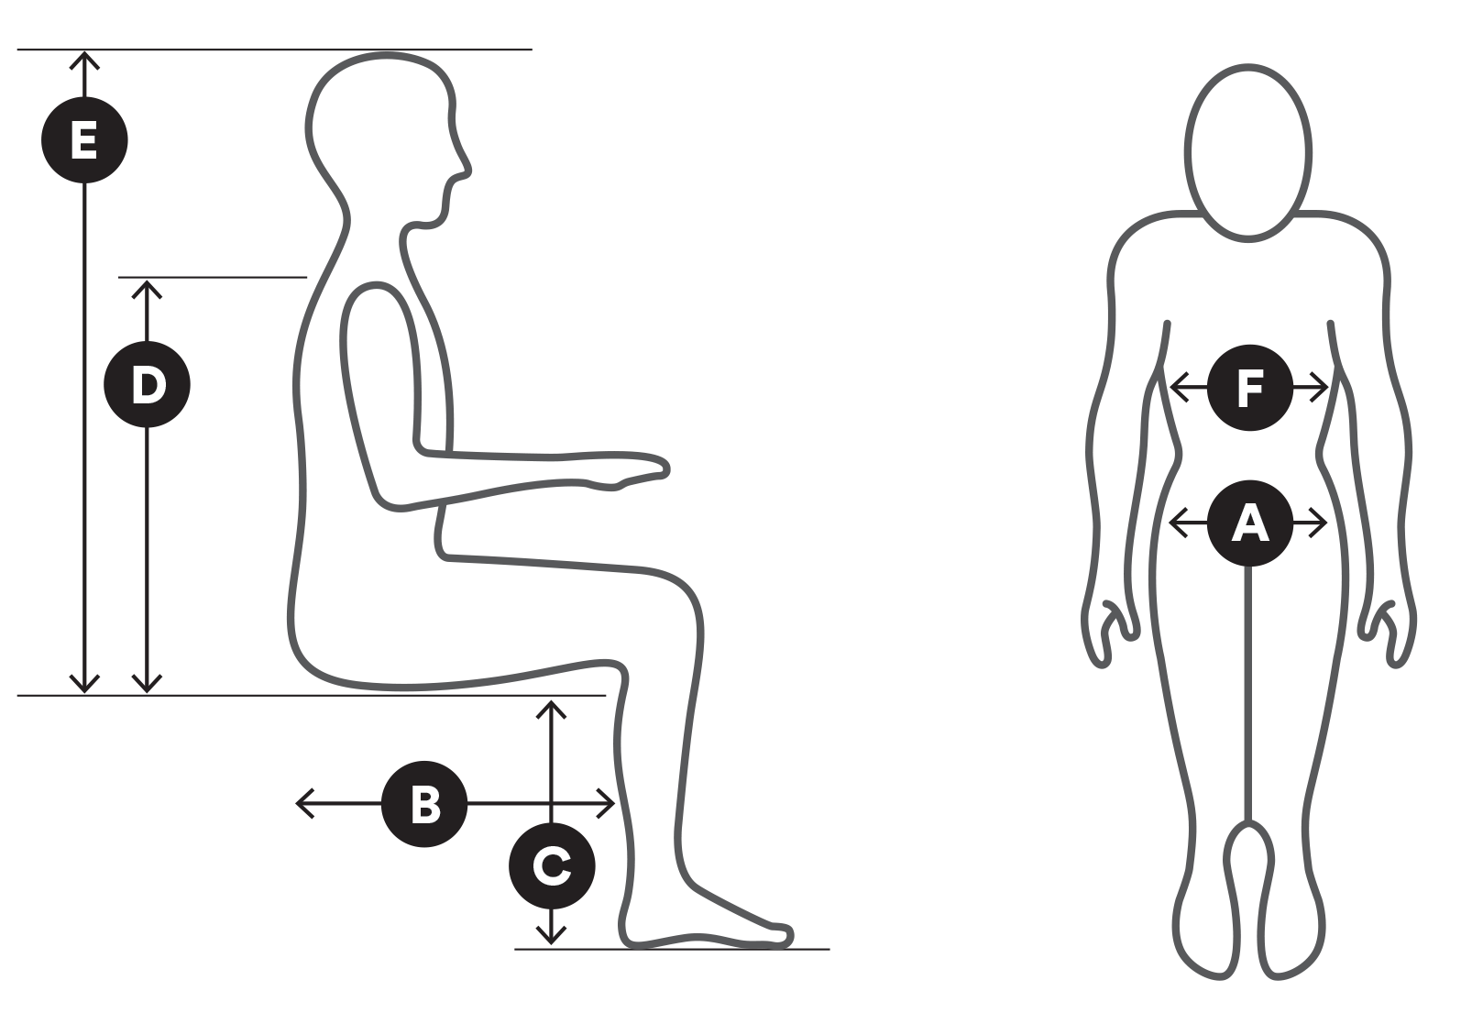 |  |  |  | 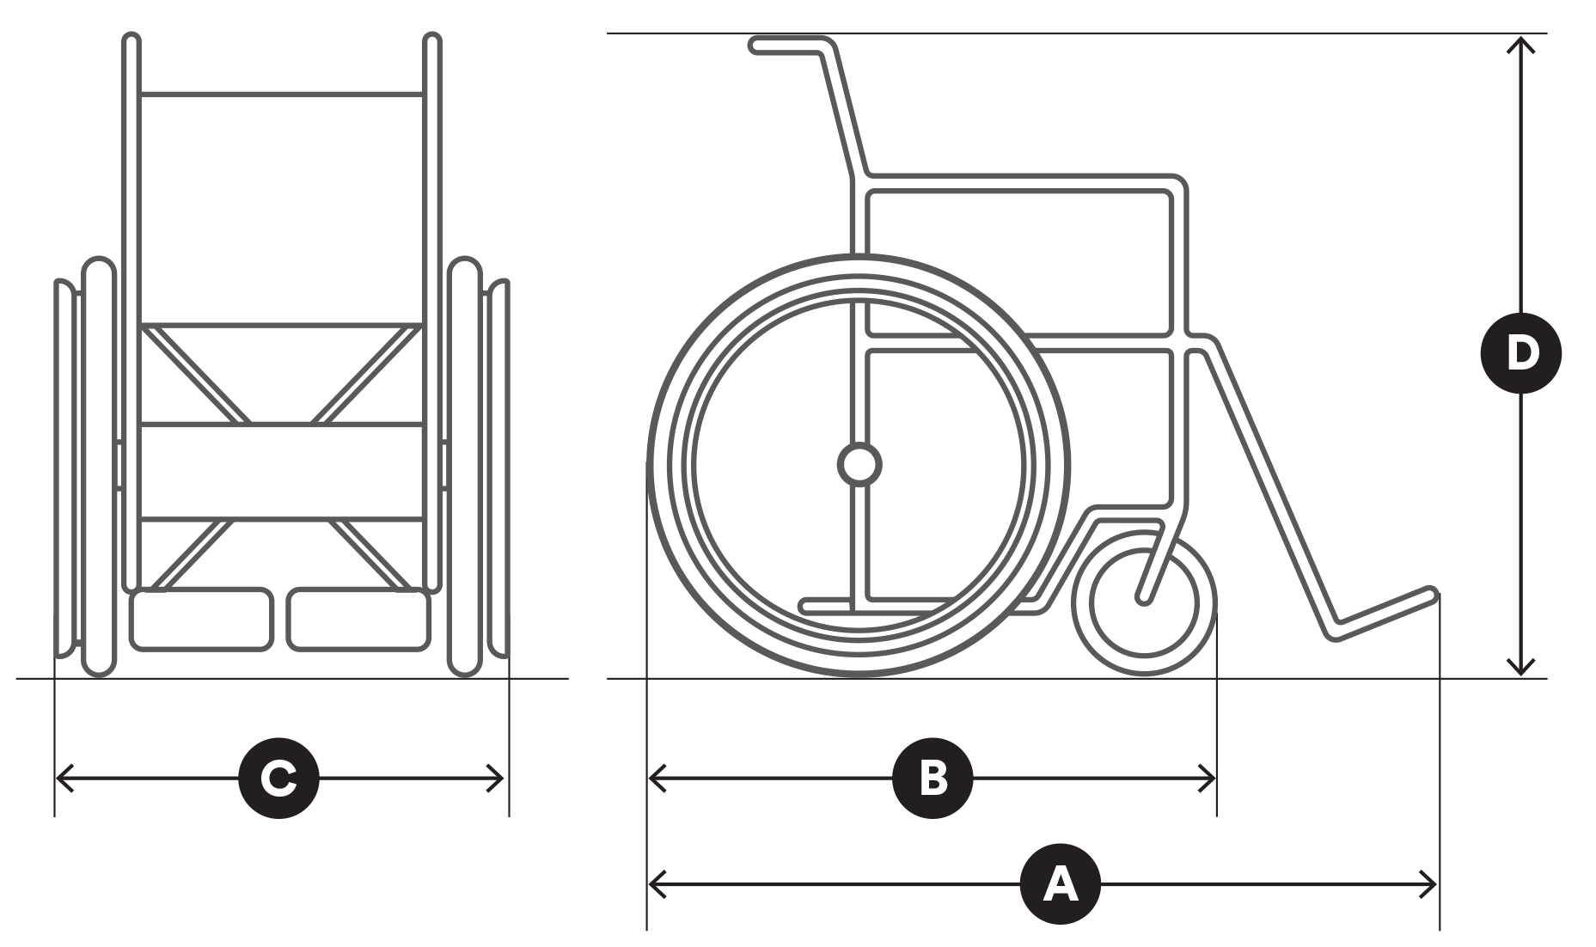
Measurements |  | mm |  | Measurements |  | mm
 | Hip width | Enter mm. |  |  | Length of chair | Enter mm.
 | Upper leg length | Enter mm. |  |  | Wheel base | Enter mm.
 | Lower leg length | Enter mm. |  |  | Chair width | Enter mm.
 | Bottom to top of shoulder | Enter mm. |  |  | Chair height | Enter mm.
 | Bottom to top of head | Enter mm.
 | Chest width | Enter mm.

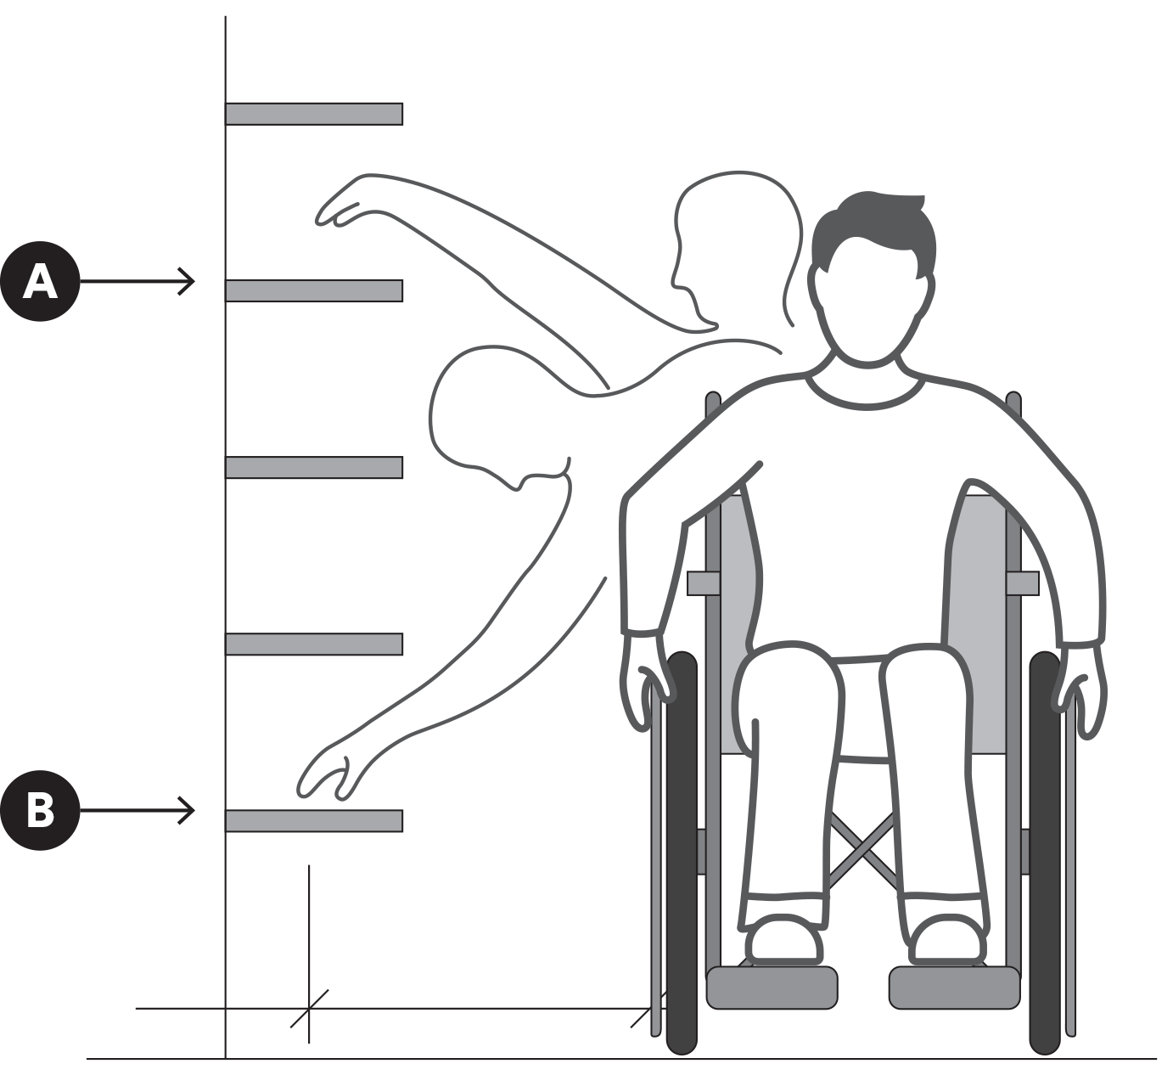 |  |  |  | 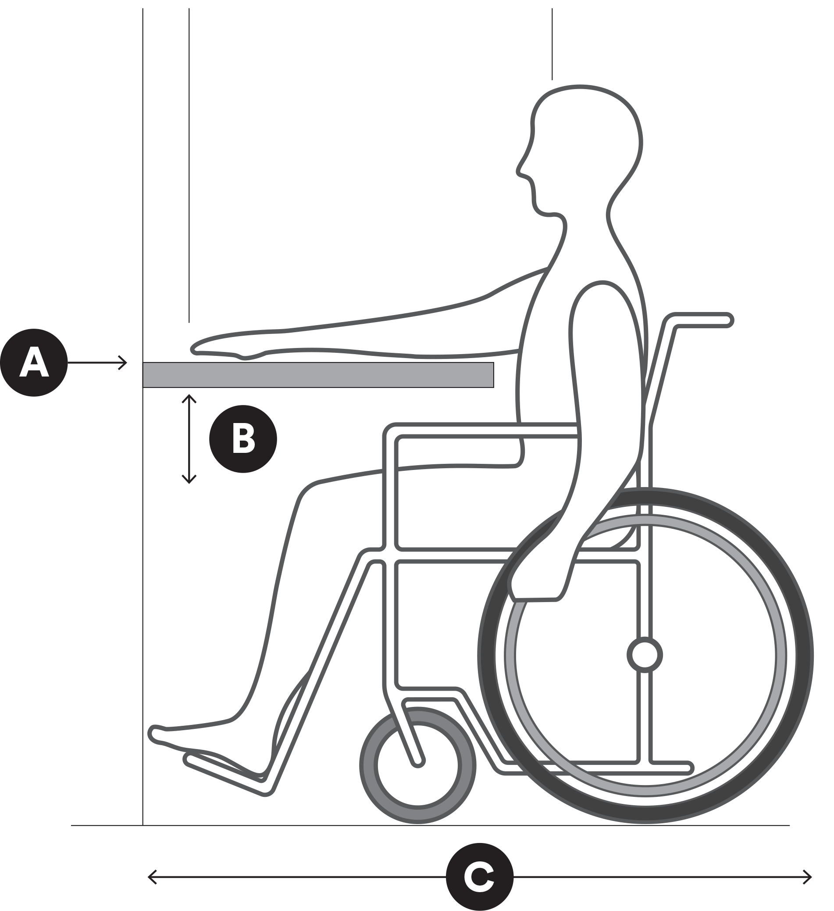
 |  |  |  | Measurements |  | mm
Measurements |  | mm |  |  | Bench height | Enter mm.
 | Functional vertical reach | Enter mm. |  |  | Leg clearance | Enter mm.
 | Functional horizontal reach | Enter mm. |  |  | Wheelchair length, incl. feet | Enter mm.

Section 6 – Diagrams

Kitchen
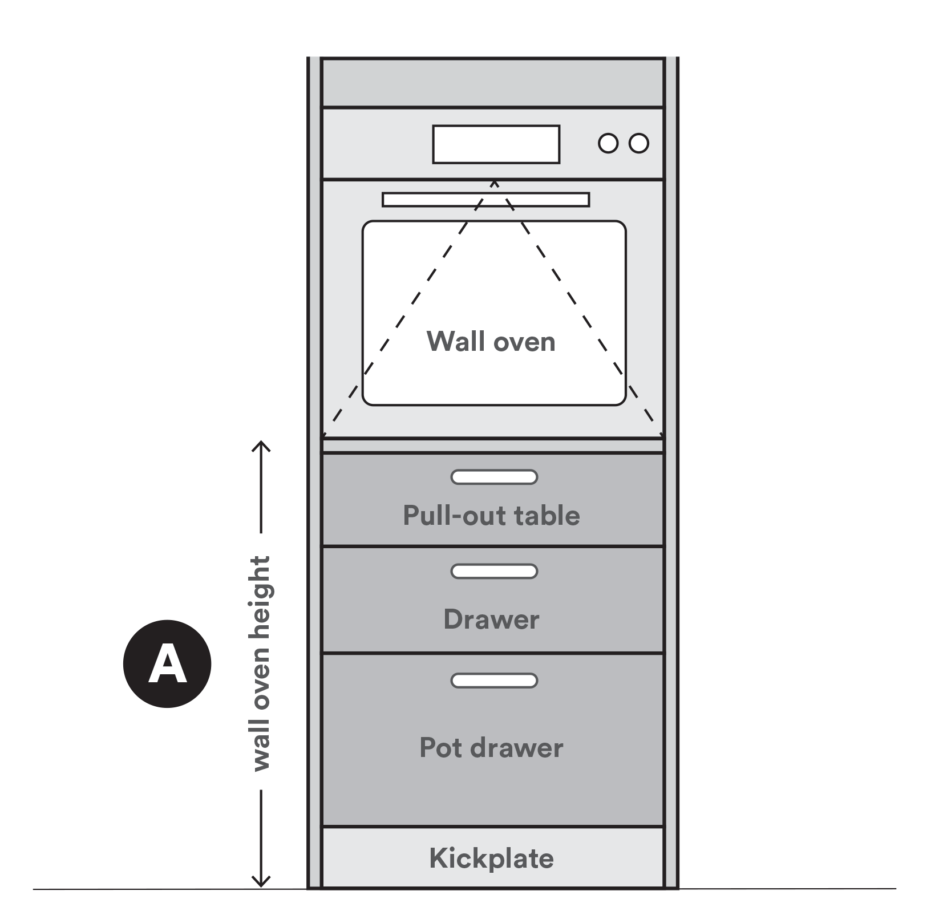 |  |  |  | 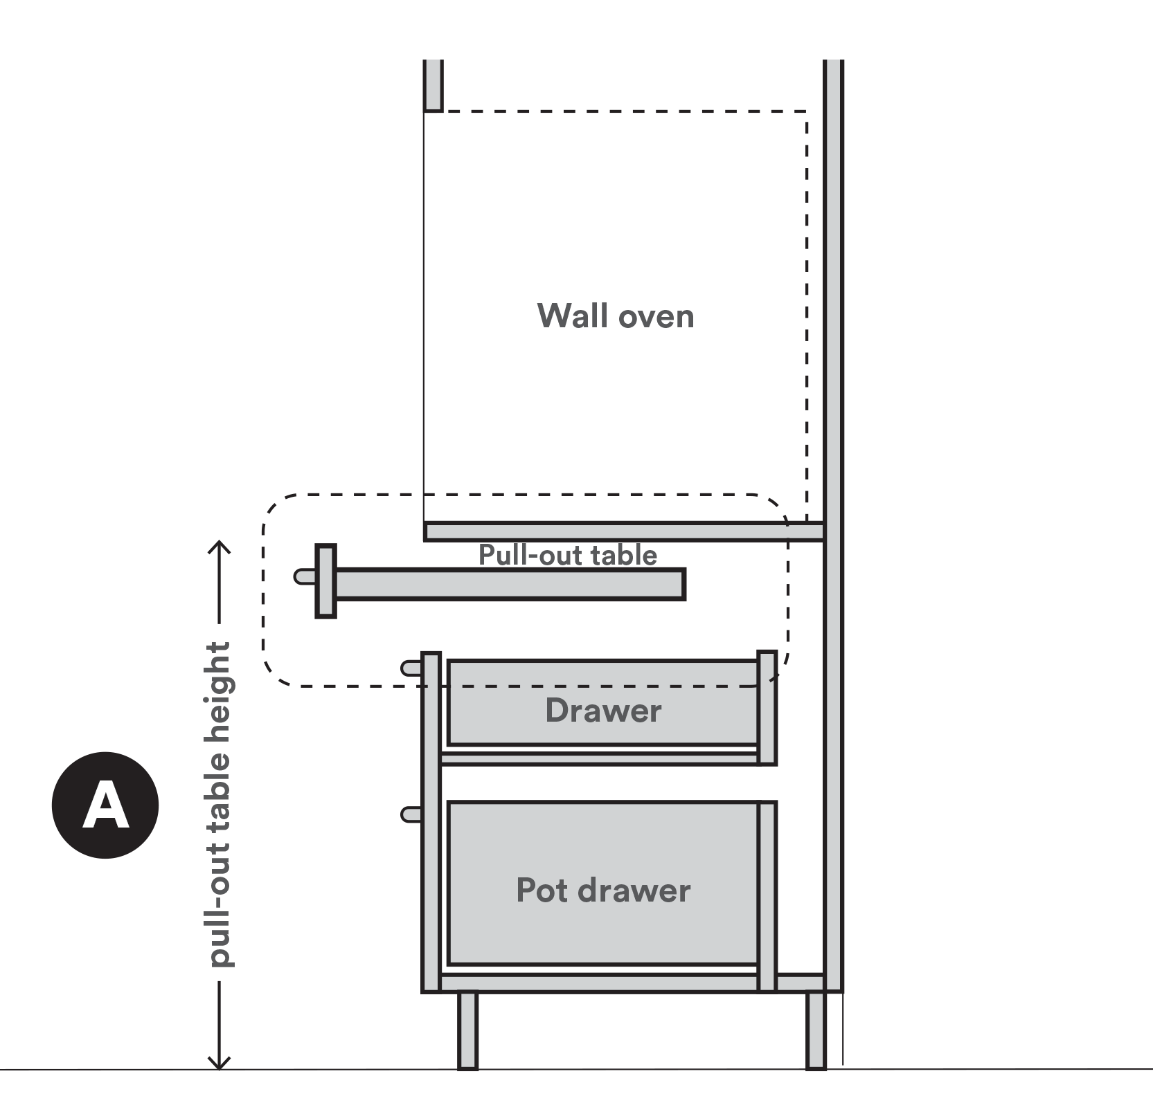
Measurements |  | mm |  | Measurements |  | mm
 | Wall oven height | Enter mm. |  |  | Pull-out table height | Enter mm.

Section 6 – Diagrams

Sink (vanity basin, kitchen, laundry)
Single sink with drainer tray and bench apron

 | Measurements |  | mm
 |  | Maximum bench height | Enter mm.
 |  | Clearance under bench | Enter mm.
 |  | Clearance under sink | Enter mm.

Section 6 – Diagrams

Toilet and rails
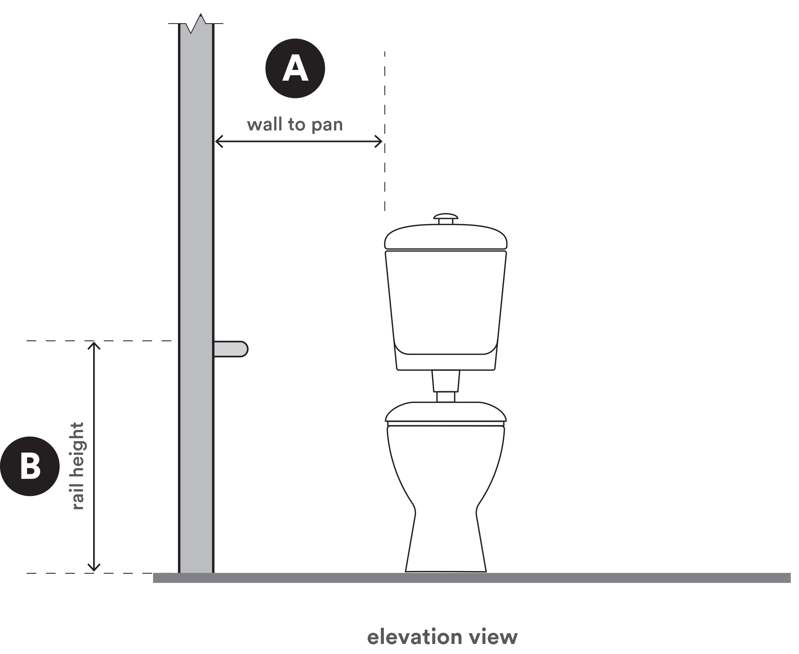 |  |  |  | 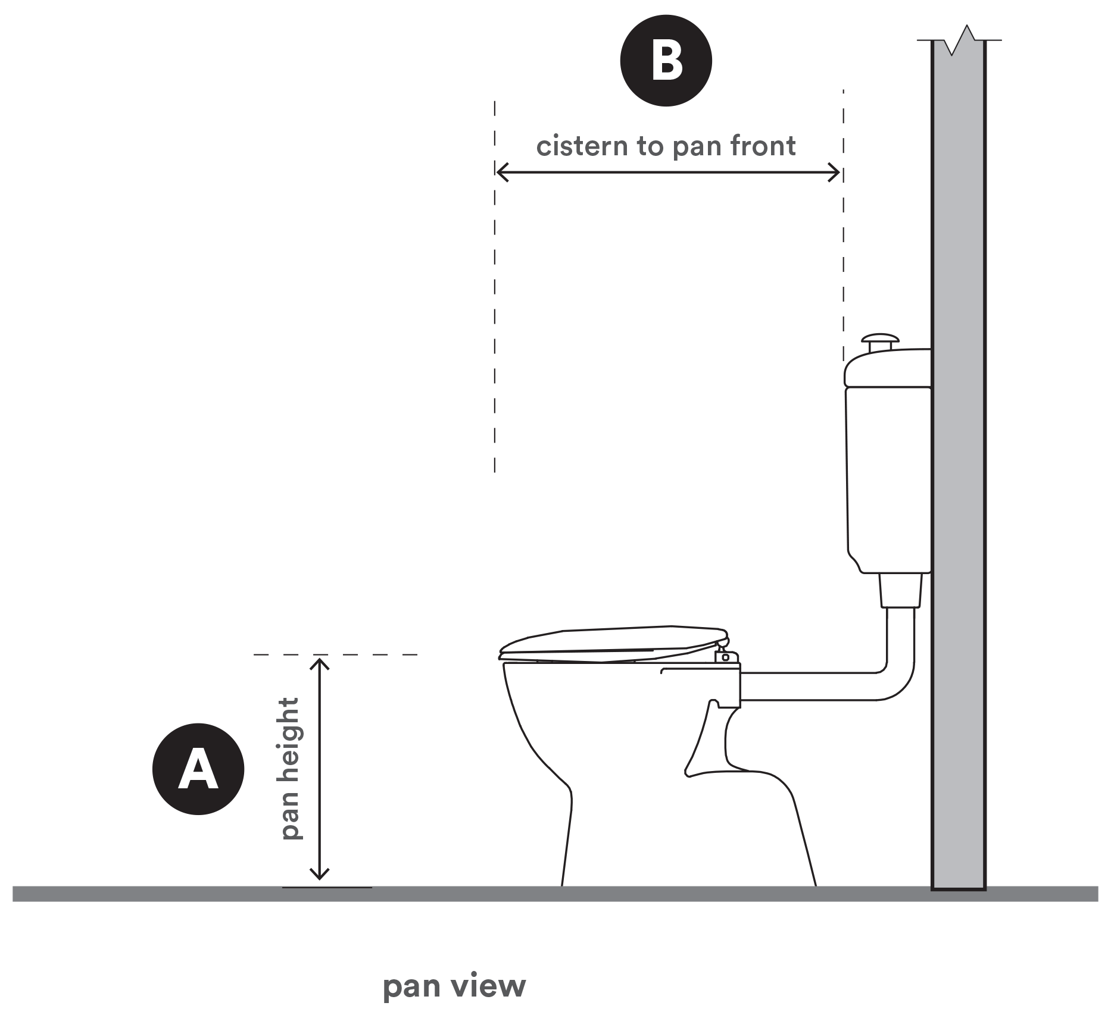
Measurements |  | mm |  | Measurements |  |  | mm
 | Wall to pan | Enter mm. |  |  | Pan height |  | Enter mm.
 | Rail height | Enter mm. |  |  | Cistern to pan front |  | Enter mm.
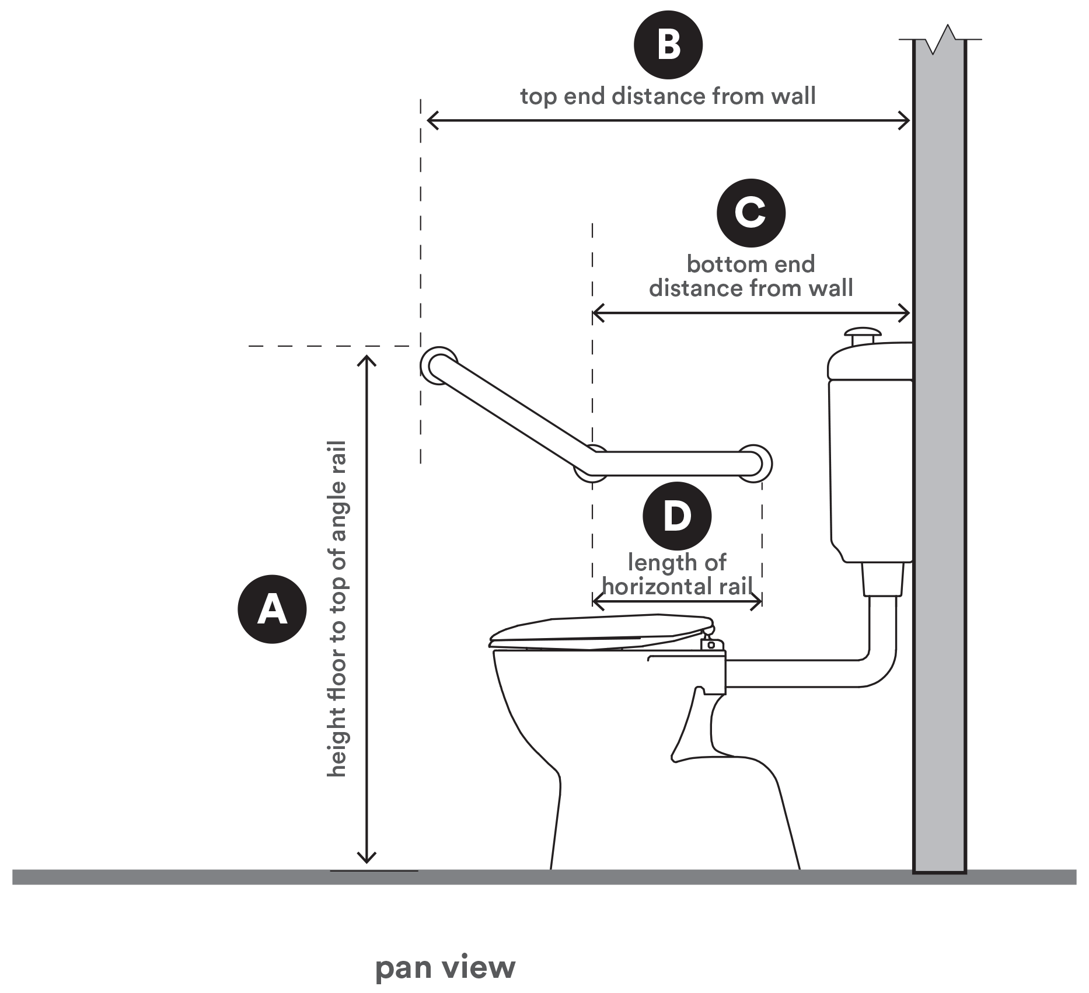
Measurements |  | mm
 | Height floor to top of angle rail | Enter mm. |  | Choose if applicable.
 | Top end distance from wall | Enter mm.
 | Bottom end distance from wall | Enter mm.
 | Length of horizontal rail | Enter mm.

Section 6 – Diagrams

Showerhead and grab rails
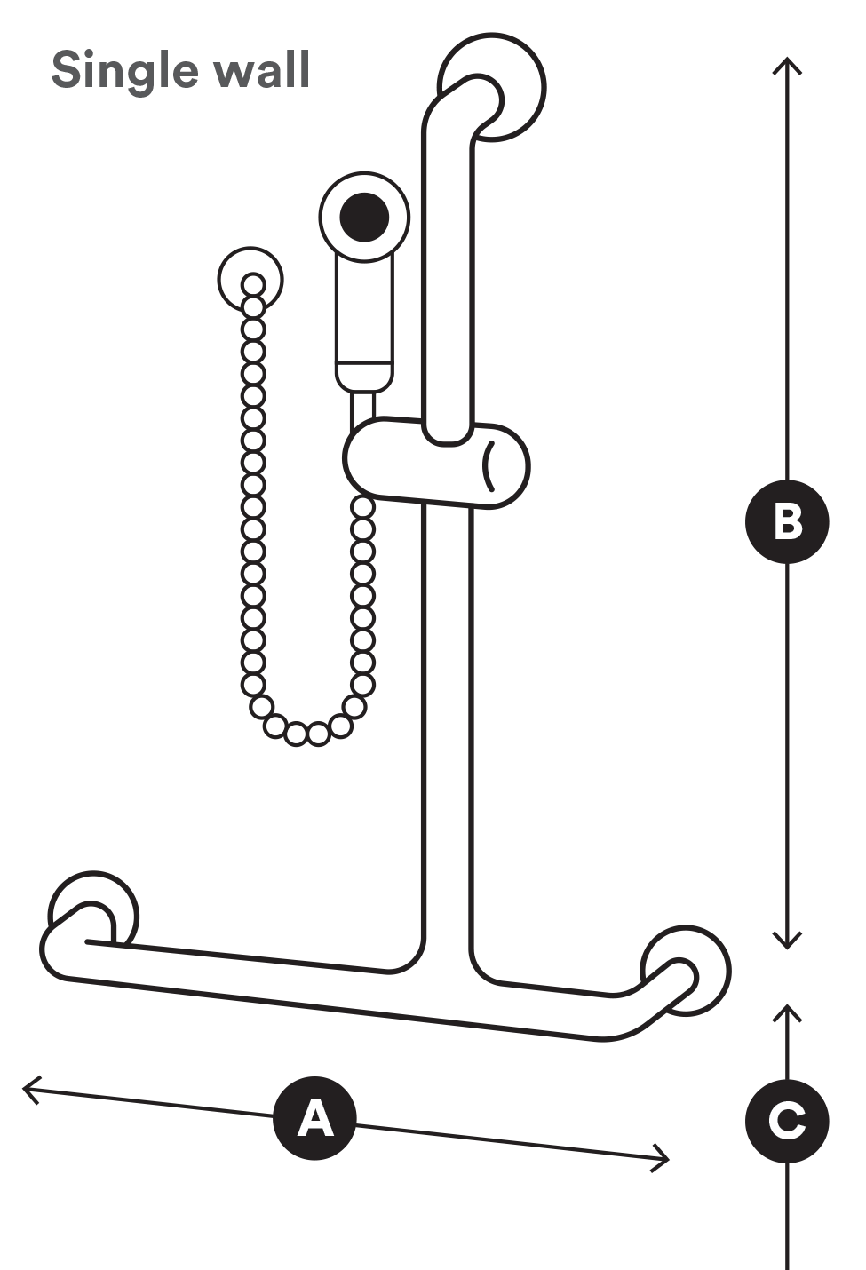 |  |  |  | 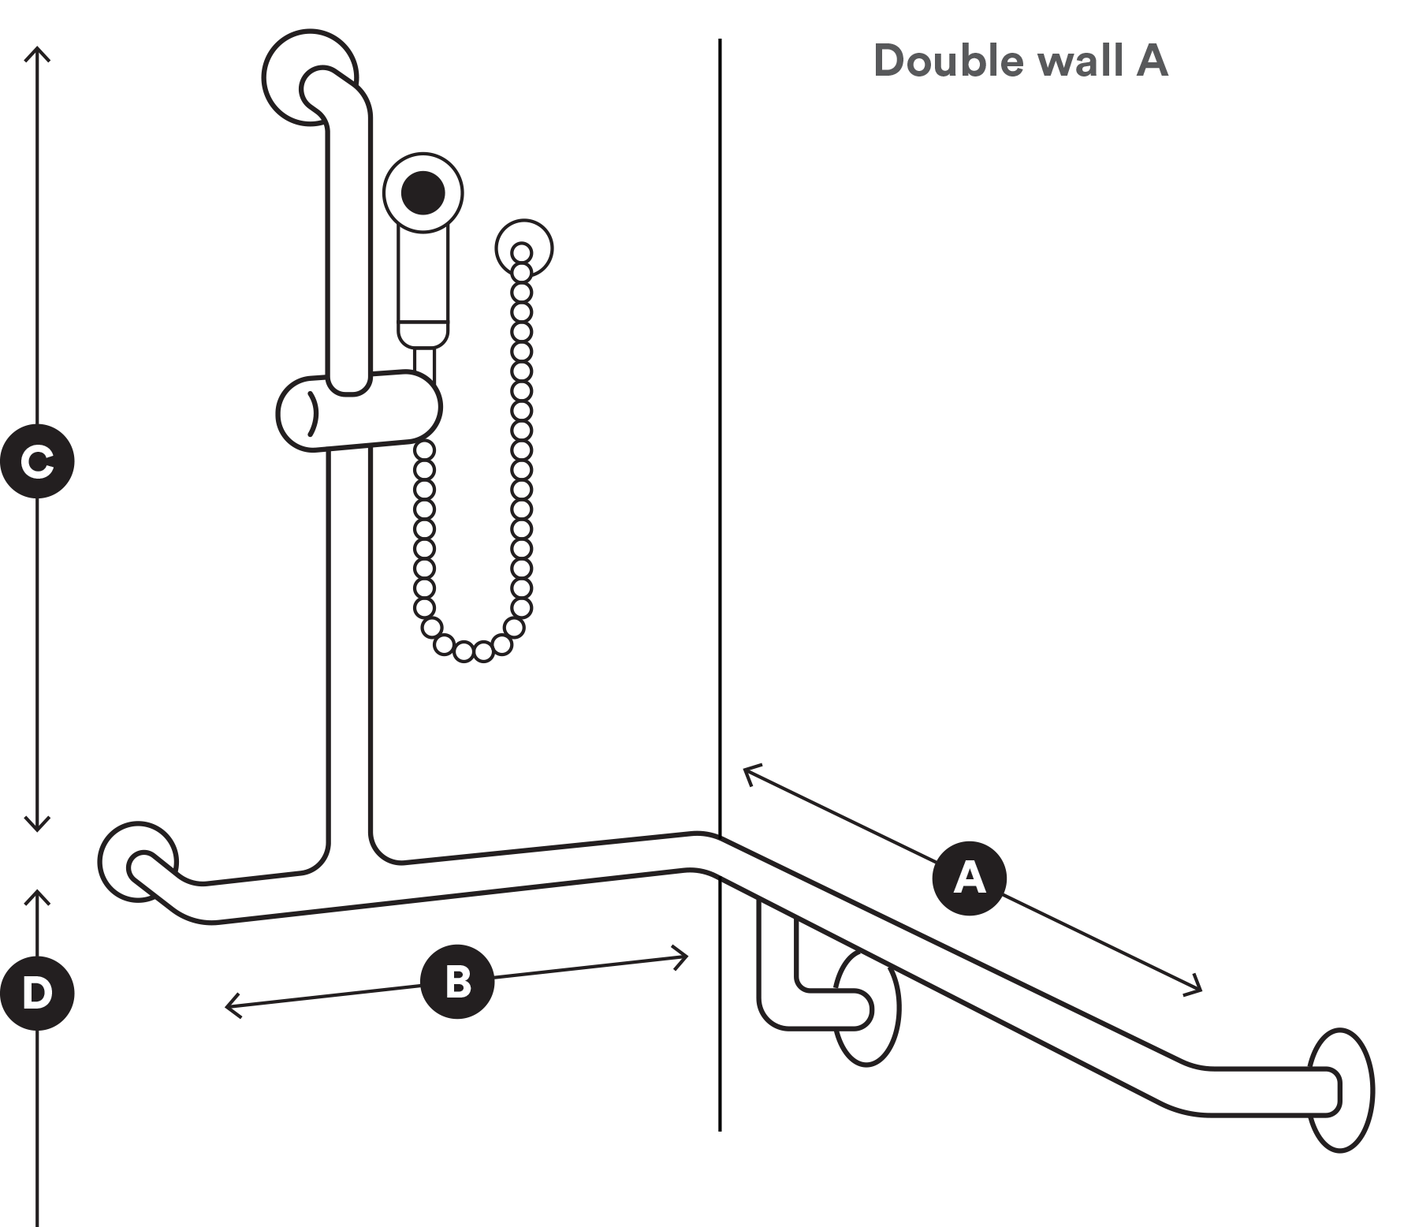
Measurements |  | mm |  | Measurements |  | mm
 | Horizontal rail length | Enter mm. |  |  | Horizontal rail length | Enter mm.
 | Vertical rail height | Enter mm. |  |  | Horizontal rail length | Enter mm.
 | Height from floor level | Enter mm. |  |  | Vertical rail height | Enter mm.
 |  |  |  |  | Height from floor level | Enter mm.

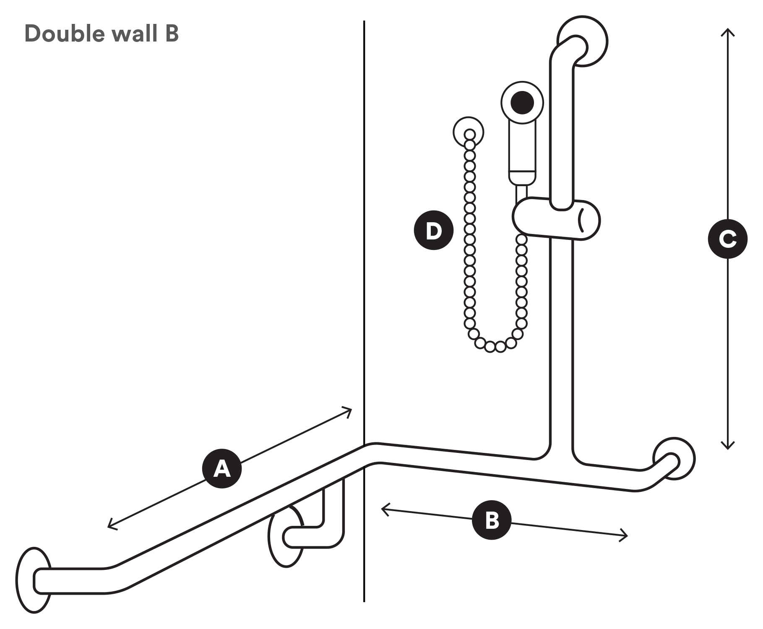
Measurements |  | mm
 | Horizontal rail length | Enter mm.
 | Horizontal rail length | Enter mm.
 | Vertical rail height | Enter mm.
 | Hose length | Enter mm.

Please email the completed form to the requesting TAC staff member.
Date of submission
DD / MM / YYYY

Personal and Health Information

TAC
The TAC will retain the information provided and may use or disclose it to make further inquiries or assist in the ongoing management of the claim or any claim for common law damages. The TAC may also be required by law to disclose this information. Without this information the TAC may be unable to determine entitlements or assess whether treatment is reasonable and may not be able to approve further benefits and treatment. If you require further information about our privacy policy, please call the TAC on 1300 654 329 or visit our website at www.tac.vic.gov.au

WorkSafe
Personal and health information collected by WorkSafe on this form is used for the purpose of processing, assessing and managing claims under Victorian Workers’ compensation legislation. It may also be used for other related purposes including legal proceedings arising under legislation, to assist with a worker’s rehabilitation and return to work and to assist WorkSafe and its Agents to better manage claims generally.
For the purposes of processing, assessing and managing a claim, WorkSafe and the Agent of the injuries worker’s employer may disclose personal and health information about the worker to each other and to the following types of organisations:
- Employees, contractors and agents of WorkSafe and WorkSafe Agents;
- Employers of the injured worker;
- Solicitors, medical practitioners and other health service providers, private investigators, loss adjusters and other service providers acting on behalf of WorkSafe or the Agent in relation to the claim;
- The Accident Compensation Conciliation Service and Medical Panels;
- Any other person, organisation or government agency authorised by you, or by law, to obtain the information.
An individual may request access to personal and health information about them collected by WorkSafe or an Agent by contacting Agent.
WorkSafe’s Privacy Policy is available at the nearest WorkSafe office or at www.worksafe.vic.gov.au
We welcome feedback on the information we provide to help us make further improvements that meet your needs.
Please email home_modifications@tac.vic.gov.au with any comments about this form.

