

Road Safety Monitor 2015

Wave 17 Report

December 2015

Prepared for:

Hafez Alavi & Michael Nieuwesteeg

The Transport Accident Commission Victoria

PO Box 742

Geelong VIC 3220

Prepared by:

Kim Borg & Shane Compton

The Social Research Centre

Level 9, 277 William Street

Melbourne VIC 3051

Ph: (613) 9236 8500 Fax: (613) 9602 5422

[www.srcentre.com.au](http://www.srcentre.com.au) Info@srcentre.com.au

Contents

Executive summary i

1. Introduction 1

1.1. Background and objectives 1

1.2. Reading this report 5

2. Driver demographics and characteristics 10

2.1. Driver profile 10

2.2. Individual characteristics 12

3. Driving attitudes and behaviours 17

3.1. Perceived cause of road accidents 17

3.2. Personal safety 17

3.3. Level of danger in driving behaviours 20

4. Towards zero 23

4.1. Acceptable number of deaths 23

4.2. Belief in ‘zero’ 24

4.3. Regression analysis (Towards Zero) 26

5. Speed 28

5.1. Definition of speeding 28

5.2. Frequency of speeding 29

5.3. Speeding behaviour 30

5.4. Attitudes toward speeding 32

5.5. Regression analysis (Speeding) 33

6. Impaired driving 36

6.1. Use of drugs & alcohol 36

6.2. Attitudes to impaired driving 37

6.3. Drink and drug driving 38

6.4. Regression analysis (drink driving) 43

7. Drowsy driving 46

7.1. Regular drowsy driving 46

7.2. Attitudes to drowsy driving 47

7.3. Regression analysis (drowsy driving) 48

8. Distractions 49

8.1. Distractions while driving 49

8.2. Mobile phone use 51

8.3. Regression analysis (phone use while driving) 54

9. Vehicle ownership & purchasing 55

9.1. Vehicle ownership 55

9.2. Purchasing behaviour 58

Appendix 1 – Hardcopy Questionnaire 62

Appendix 2 – Online Questionnaire 63

Appendix 3 – CATI Follow-up Script 64

List of figures

Figure 1.1: Example Odds ratios for model of mobile phone use while driving 8

Figure 2.1: Work status – time series (%) 10

Figure 2.2: Type of vehicle used for work related purposes (%) (2015) 11

Figure 2.3: Average kilometres driven per year (2012 to 2015 total sample) 12

Figure 2.4: Road accidents in last five years (%) – time series 14

Figure 2.5: Rating of driving (%) (2012 to 2015 total sample) 15

Figure 3.1: Factors that lead to serious road accidents (%) (2015) 17

Figure 3.2: Concerns about personal safety on the road (%) (2015) 17

Figure 3.3: Wears a seatbelt all the time (%) - time series 19

Figure 3.4: Level of danger in driving behaviours (mean) (2015) 20

Figure 4.1: Accident acceptability (2015) 23

Figure 4.2: Odds ratios for model of perceived a*cceptability of current road toll* 26

Figure 4.3: Odds ratios for model of *Belief that zero deaths from road accidents is possible* 27

Figure 5.1: Definition of speeding in a 60km/h and 100km/h zone – time series 28

Figure 5.2: Frequency of driving over THE POSTED speed (2015) 29

Figure 5.3: Frequency of driving over SELF-DEFINED speed (2015) 29

Figure 5.4: Incidence of being caught speeding in last 12 months – time series 30

Figure 5.5: Odds ratios for model of Speeding 33

Figure 5.6: Odds ratios for model of *High chance of being caught speeding* 34

Figure 5.7: Odds ratios for model of *Easy to avoid being caught while speeding* 35

Figure 6.1: Alcohol and drug use* – time series 36

Figure 6.2: Plan for getting home the last time drinking – time series 38

Figure 6.3: Drivers tested in the last 12 months – time series 39

Figure 6.4: Reasons for being a passenger when driver over the legal limit (%) (2015) 41

Figure 6.5: Reasons for driving when over the legal limit (%) (2015) 42

Figure 6.6: Number of times driven under the limit (%) (2015 Pulse and Main) 42

Figure 6.7: Odds ratios for model of Drink driving 43

Figure 6.8: Odds ratios for model of *Easy to avoid being caught while driving over 0.05 limit* 44

Figure 6.9: Odds ratios for model of *High change of being caught while driving over 0.05 limit* 45

Figure 7.1: Regularly driving while drowsy (2013 to 2015 total sample) 46

Figure 7.2: Why drove while drowsy (%) (2015) 47

Figure 7.3: Odds ratios for model of *Drowsy driving* 48

Figure 8.1: Use of handheld mobile while driving – time series 49

Figure 8.2: Distractions while driving (multiple response) (2013 to 2015 total sample) 49

Figure 8.3: Normal phone use in car (%) (2012 to 2015 total sample) 51

Figure 8.4: Odds ratios for model of mobile phone use while driving 54

Figure 9.1: Car ownership (%) (2015) 55

Figure 9.2: Importance of car to respondent (2015) 56

Figure 9.3: Forms of transport (2015) 57

Figure 9.4: Future car purchase intent – time series 58

Figure 9.5: New versus used car purchase intent – time series 58

Figure 9.6: Type of car purchase (2015) 59

Figure 9.7: Factors influencing vehicle selection (mean) (2015) 59

Figure 9.8: Safety factors influencing vehicle selection (mean) (2015) 61

List of tables

Table 1.1: Overview of the RSM schedule 2

Table 1.2: Cooperation rate by mode of completion and basic demographic characteristics 3

Table 1.3: Weighting parameters 6

Table 1.4: Categories for occupation (Q5) and vehicle type (Q49 type) 9

Table 2.1: Licence type by demographics (2015) 10

Table 2.2: Occupation by demographics (2015) 11

Table 2.3: Average kilometres by demographics (2015) 12

Table 2.4: Average kilometres by behaviours (2015) 13

Table 2.5: Road accidents in last five years and personal injury by demographics (2015) 14

Table 2.6: Road accidents in last five years and personal injury by behaviours (2015) 15

Table 2.7: Self-reported driving competency by demographics (2015) 16

Table 2.8: Self-reported driving competency by behaviour (2015) 16

Table 3.1: Concerns about personal safety on the road by demographics (2015) 18

Table 3.2: Concerns about personal safety on the road by behaviours (2015) 19

Table 3.3: Level of danger in driving behaviours by demographics (2015) 21

Table 3.4: Level of danger in driving behaviours by behaviours (2015) 22

Table 4.1: Accident acceptability (number of deaths) by demographics (2015) 23

Table 4.2: Accident acceptability (number of deaths) by behaviours (2015) 24

Table 4.3: Believe in no deaths as a result of road accidents by demographics (2015) 24

Table 4.4: Believe in no deaths as a result of road accidents by behaviours (2015) 25

Table 5.1: Frequency of self-defined speeding by demographics (2015) 30

Table 5.2: Speeding behaviour by demographics (2015) 31

Table 5.3: Speeding behaviour by behaviours (2015) 31

Table 5.4: Attitudes towards speeding (total agree %) by demographics (2015) 32

Table 5.5: Attitudes towards speeding (total agree %) by behaviours (2015) 32

Table 6.1: Alcohol and drug use by demographics (2015) 36

Table 6.2: Alcohol and drug use by behaviours (2015) 37

Table 6.3: Attitudes to impaired driving (total agree %) by demographics (2015) 37

Table 6.4: Attitudes to impaired driving (total agree %) by behaviours (2015) 38

Table 6.5: Drivers tested in the last 12 months by demographics (2015) 39

Table 6.6: Driver & passenger who got into car by demographics (2015) 40

Table 6.7: Driver & passenger who got into car by behaviours (2015) 41

Table 7.1: Regularly driving while drowsy by demographics (2015) 46

Table 7.2: Regularly driving while drowsy by behaviours (2015) 46

Table 7.3: Attitudes to drowsy driving (total agree and mean) by demographics (2015) 47

Table 7.4: Attitudes to drowsy driving (total agree %) by behaviours (2015) 47

Table 8.1: Attitudes to distracted driving (total agree %) by demographics (2015) 50

Table 8.2: Attitudes to distracted driving (total agree %) by behaviours (2015) 50

Table 8.3: Normal phone use in car by demographics (2015) 51

Table 8.4: Normal phone use in car by behaviours (2015) 52

Table 8.5: Use of handheld mobile for calls in car by demographics (2015) 52

Table 8.6: Use of handheld mobile for texting in car by demographics (2015) 53

Table 9.1: Most common makes of car by demographics (top 10) (2015) 56

Table 9.2: Mean number of vehicles in household by demographics (2015) 57

Table 9.3: Factors influencing vehicle selection (mean) by demographics (2015) 60

Table 9.4: Consider crash test results when purchasing by demographics (2015) 61

Executive summary

### Overview

This report presents the findings from the 17th wave of the Transport Accident Commission’s (TAC) Road Safety Monitor (RSM) – the ‘Main’ 2015 survey. In total, 2,000 licence holders and registered vehicle owners from Victoria were invited to participate and 961 (48.1%) completed the survey. Participants were randomly selected from the VicRoads driver licence and registration database, within a number of sampling categories (age, gender, location and socioeconomic quintile) to ensure a representative sample was achieved.

All participants were mailed a paper questionnaire and a return envelope on September 14, 2015. The letter also contained a username and password to enable the respondent to complete the survey online or to call the Social Research Centre to complete the survey over the phone. Follow-up phone calls were conducted from October 7 with non-responders after the initial survey distribution and reminder letter activity, in which respondents were encouraged to complete the survey and offered the option of completing the survey over the phone.

### Driver demographics and characteristics

Similar to previous waves, the vast majority of licence holders were employed with around one in ten not in the workforce or unemployed. Respondents who drove a vehicle for work related purposes typically drove a car (65%), a utility/pick up (15%), or a commercial van (6%).

Just over 50% of drivers were classified as ‘long distance drivers’ that is, driving more than 15,000km per year or 300km per week. More regional respondents were classified as long distance drivers compared to metropolitan respondents.

Remaining relatively consistent with previous waves, 16% of respondents reported that they had been involved in a road accident within the last five years. Of those involved in an accident, 17% reported that someone involved in the accident sustained personal injury. Driver confidence remains similar to previous waves with around two thirds (65%) rating themselves as ‘better than average’.

### Driving attitudes and behaviours

When asked about major contributing factors that could lead to serious road accidents, seven in ten (70%) mentioned alcohol and more than half (54%) believed that speed was a key factor. In 2015 a question was introduced which asked respondents to nominate their greatest concern about their own safety on the road as a driver or passenger. While ‘speed’ (13%) and ‘alcohol’ (12%) were nominated by around one in ten respondents, the most common responses were general mentions of ‘aggressive or reckless drivers’ (28%), and simply ‘other drivers’ (24%).

Similar to previous waves, the vast majority of licence holders aged 18 to 60 years (98%) reported always wearing a seatbelt when they drive. Also consistent with previous waves, respondents generally rated driving while impaired (drugs or alcohol) and driving while using a hand held phone as ‘very dangerous’, with slightly lower ratings for driving with a hands free phone and speeding.

### Towards Zero

In the 2015 ‘Main’ and the 2015 ‘Pulse’ questions were included in the RSM to assess community attitudes around the concept of ‘Towards Zero’. At the start of the 2015 ‘Main’ surveying period Phase 1 of the Towards Zero campaign was run (‘Man on the street’).

In the 2015 Main, around three quarters (76%) of respondents felt that the current road toll of around 250 was unacceptable – this was significantly lower than the 2015 Pulse (84%). Males were twice as likely as females to find the road toll acceptable; respondents aged 61 or older were less likely to agree than those aged 18 to 25 years. When respondents were asked about their belief in the possibility of a zero road toll in the future, one in ten (11%) believed that ‘zero deaths’ could be achieved. Most of those who believed in the possibility of a zero road toll felt it would take up to 20 years to achieve (61%).

### Speed

When road users nominated an ‘acceptable speed limit’, the proportion who believed that they should be able to drive in excess of 5km over the limit in a 100km/h zone increased marginally compared to 2014 but has remained relatively consistent in recent years. Around half of respondents stated that they never drive over the posted speed, while around one in ten drive above the posted speed limit at least half of the time in a 60km/ zone and 100km/h zone. This finding was very similar for driving over their *self-defined limit* in both speed zones. After accounting for other characteristics, male drivers were almost three times as likely to drive over their self-defined speed limit compared to females; older drivers were significantly less likely to driver over their self-defined limit than 18 to 25 year olds; and ‘blue collar’ workers (technicians and trade workers, labourers, and machinery operators and drivers) were four times as likely as those not in the workforce.

When all respondents are included, around one in six (16%) had been caught speeding in the last twelve months with an average of 1.26 times. Typically, more males and respondents from metropolitan areas had been caught speeding than females and those from regional areas.

When asked to rate their level of agreement toward specific speeding attitude statements, more than half (53%) of respondents agreed that they had a high chance of being caught speeding – regional respondents were twice as likely to agree compared to metropolitan respondents. Around a third (32%) believed that it was easy to avoid being caught driving over the limit – young respondents (aged 18 to 25) were significantly more likely to agree compared to those aged 26 years or older. And a quarter (25%) agreed that their family and friends felt it was okay to speed a few kilometres over in a 60km/h zone.

### Impaired driving

Three quarters of respondents (75%) stated that they drank alcohol, compared to only 6% who admitted to using recreational drugs. Of those who drank alcohol, around one in ten (9%) had driven after drinking when they thought they were *over* the legal limit, and 6% had been a passenger when they thought the driver may have been over the limit. In contrast, 57% said that they had never driven after they had been drinking even when they thought they were *under* the legal limit.

Males were twice as likely as females to have driven when they suspected they were over the limit; those aged 61 or older were less likely than those aged 18 to 25; and SUV/4WD drivers were less likely to have driven after drinking compared to drivers of passenger cars. Of the 60 respondents who reported that they use drugs, 10 stated that they had driven after taking drugs in the last twelve months.

Just over half (57%) of all respondents agreed that if they were even just slightly over the limit, they were likely to be caught – those aged 40 to 60 were twice as likely to agree compared to 18 to 25 year olds. Around one in four (23%) agreed that it was easy to avoid being caught if they were driving over the legal alcohol limit – 18 to 25 year olds were significantly more likely to agree than 40 to 60 year olds. Similarly, 19% of respondents agreed that it was easy to avoid being caught if they drive after using drugs. Just 9% believed that their family and friends thought it was okay to drive slightly over the legal 0.05 limit.

### Drowsy driving

Similar to previous waves, a small proportion (9%) of respondents admitted that they regularly drive while feeling drowsy. Drowsy driving was significantly more likely among those aged 18 to 25, and among ‘blue collar’ workers (compared to those not in the workforce). Around a third (34%) believed that it was easy to keep themselves awake if they needed to drive, despite the general view that driving while drowsy was dangerous – considered just as dangerous as driving after taking drugs or drinking alcohol.

### Distractions

The most common driving distractions reported by respondents were other drivers (40%), their own thoughts (36%), and passengers (24%). Mobile phones were only mentioned by 18% of respondents. Since 2013 there has also been a gradual decline in the proportion of licence holders aged 18 to 60 years who use a handheld mobile while driving. When asked how they use their mobile when driving, most respondents said they either do not use their phone at all while driving (42%), or they use a hands free kit such as Bluetooth (41%).

The minority of respondents continue to use handheld mobile phone for calls while driving – most commonly to answer a call but placing the phone on their lap or using the in-built speaker (22%). Almost one in ten (9%) said they would make a call while actively driving. When asked about texting while driving the most common behaviour was reading a text while stopped at the lights (34%). Only 5% said they would write and send a message while actively driving.

A large proportion of respondents believed that taking their eyes off the road for two seconds is dangerous (88%) and agreed that they could ignore their phone if a message or phone call was to arrive while they were driving (87%). Meanwhile, almost two in ten (18%) believe that their family and friends thought it was okay to use a mobile phone without using a hands free kit.

### Vehicle ownership & purchasing

Most respondents (79%) personally owned the car they drive with just 2% not owning or ever driving a car. More females owned the car they drove (while males were more likely to have both a company car and a personal car). Many young drivers used a car belonging to someone else. A large proportion of respondents felt that the car they drove was important to them to some extent, with just 11% reporting they don’t care about the car they drive. On average, there were 2.18 cars, 0.20 motorbikes, 0.07 trucks or buses registered to each household. Regional households more often had trucks or buses registered than metropolitan households.

Four in ten (41%) respondents indicated that they intended to purchase a car in the future with 18% intending to purchase within the next twelve months. Of those who were planning to make a purchase, 43% intended to buy a used car and 34% intended to buy a new car.

# Introduction

## Background and objectives

### Background

The Transport Accident Commission (TAC) was formed in 1986 by the Victorian Government. The primary statutory roles of the TAC are a) to provide personal injury insurance to people injured in transport accidents and b) to promote road safety in Victoria.

The TAC Road Safety Monitor (RSM) has been conducted annually since the benchmark survey in 2001. During that time a number of different research agencies have undertaken the fieldwork and reporting for this research. Since 2010, the Social Research Centre has been commissioned to undertake the research, implementing a number of changes to improve the research tool and reporting. As of 2014, two waves of the RSM are run – a shorter ‘Pulse’ version, and the standard ‘Main’ version.

This document reports on findings from the 2015 ‘Main’ RSM specifically (hereafter referred to as the 2015 RSM) but also highlights key changes over time (particularly between 2014 and 2015) and discusses how different groups of Victorian drivers and registered vehicle owners think and behave with respect to road safety issues.

This research has been undertaken in accordance with the Privacy Act (1988) and the Australian Privacy Principles contained therein, the Privacy (Market and Social Research) Code 2014, the Australian Market and Social Research Society’s Code of Professional Practice, and ISO 20252 standards.

### Research objectives

The broad objectives of the RSM are to:

* Monitor driver attitudes and self-reported behaviour in regards to road safety issues;
* Identify potential areas of concern for the TAC in the community; and
* Provide information that assists in the development of programs that address these community concerns.

The specific objectives of the RSM are to:

* Monitor the change in attitudes and behaviours of drivers regarding a range of road safety issues, including:
  + Speed;
  + Impaired driving;
  + Drowsy driving
  + Distractions; and
  + Vehicle ownership and purchasing.
  + Identify groups of Victorian drivers who have different attitudes, behaviours and histories

### Research methodology

The RSM has evolved over time and changes in methodology may have impacted historical results contained within this report:

* From 2001 to 2007 the RSM was conducted exclusively via telephone interviewing. An internet pilot was conducted in 2007.
* In 2008 and 2009 the research simultaneously used both telephone and online methodologies for data collection.
* From 2010 the methodology was altered to allow flexible participation, so that paper, online and CATI surveying are all employed.
* From 2014 the Monitor was extended to be conducted twice yearly as a (smaller) ‘Pulse’ survey and a (full) ‘Main’ survey.

In 2010, the TAC was granted access to the VicRoads driver licence and registration database. This database is used to randomly select individuals to represent the State, and these individuals are posted an invitation to participate in the survey, along with a paper copy of the questionnaire. In 2015 (Main), 2,000 individuals were sampled from the VicRoads database and sent a hard copy survey.

Participants were also provided with the option of completing the survey online or over the phone (by using a free call 1800 number). One week after the surveys were mailed, a reminder letter was sent to participants yet to complete the survey, with another following approximately one week after that. Reminder calls targeted low-response groups who had an active and identifiable phone number. Table 1.1 provides an overview of the RSM schedule for 2015.

Table .: Overview of the RSM schedule

|  |  |
| --- | --- |
| **Phase / task** | **Date** |
| Finalisation of questionnaire | 18-Aug-2015 |
| Finalisation of sample | 21-Aug-2015 |
| Initial mail out | 14-Sep-2015 |
| 1800 number operational | 15-Sep-2015 |
| Online survey launch | 15-Sep-2015 |
| Reminder letter mailing | 23-Sep-2015 |
| Second reminder letter mailing | 1-Oct-2015 |
| Commence telephone response maximisation activity | 7-Oct-2015 |
| Complete telephone response maximisation activity | 27-Oct-2015 |
| Online survey close | 2-Nov-2015 |
| Cut off for data processing (hard copy returns) | 3-Nov-2015 |

As part of this methodology, an incentive of entry into a draw for one of six $250 prizes was offered to all of those who completed the survey (two were offered to those responding within the first weeks of the survey), with an additional $500 prize draw for those who responded online. This additional incentive for online completion was offered to encourage respondents to choose this option as it is more cost effective and ensures appropriate questions are asked through programmed sequencing (e.g. only asking drink-driving questions of those who drink alcohol).

### Fieldwork overview

The 2015 survey is based on a sample of 961 licence holders and registered vehicle owners from across Victoria. In total, 2,000 Victorians were invited to participate in the survey. The overall cooperation rate was 48.1%. The cooperation rate was slightly higher than previous years (typically averaging around 47%). It is suspected that the improvement in cooperation rate may was most likely influenced by improved sample quality.

The initial survey invitation was sent by mail on September 14, 2015. Two reminder letters were also sent to non-responders, the first on September 23 and the second on October 1. One week after the second reminder letter was sent, reminder calls began (October 7) for those respondents who had not completed the survey and for whom a phone number was identified by the TAC using Sensis’ MacroMatch service. The survey remained open for seven weeks, closing on November 2.

Almost half of the surveys were completed via hard copy (446), with 418 completed online. The CATI reminder component achieved 97 interviews. The average interview length for CATI completes was just over 22 minutes.

### Sample performance

Table 1.2 below summarises the final cooperation rate by mode of completion and basic demographic characteristics. As in previous years, gender differences were observed where cooperation rates for males were lower than females (44.3% and 51.7% respectively) and those aged 61+ were more likely to respond (59.8%) than younger age groups (38.2% for 18-24 year olds, 38.5% for 25-39 year olds). Young adults (18-25 years) were more likely to complete online (20.1%) or via CATI (8.2%) compared to older adults (61+ years) who were more likely to complete via hardcopy (43.5%).

Table .: Cooperation rate by mode of completion and basic demographic characteristics

|  |  |  |  |  |  |  |  |  |
| --- | --- | --- | --- | --- | --- | --- | --- | --- |
|  |  |  | |  | | **Completion Mode** | | |
|  |  | **Total sample** | **Completes** | | **Coop.**  **rate** | **Online complete** | **Hardcopy complete** | **Phone interview** |
| **Total** |  | **2000** | **961** | | 48.1% | 20.9% | 22.3% | 4.9% |
| **SEIFA Index** | 1st Quintile | 265 | 123 | | 46.4% | 17.0% | 25.7% | 3.8% |
| 2nd Quintile | 214 | 101 | | 47.2% | 17.3% | 24.3% | 5.6% |
| 3rd Quintile | 344 | 157 | | 45.6% | 18.3% | 21.5% | 5.8% |
| 4th Quintile | 583 | 288 | | 49.4% | 24.0% | 20.6% | 4.8% |
| 5th Quintile | 594 | 292 | | 49.2% | 22.4% | 22.2% | 4.5% |
| **Gender** | Male | 1092 | 483 | | 44.2% | 19.1% | 19.8% | 5.3% |
| Female | 908 | 470 | | 51.8% | 22.8% | 24.7% | 4.3% |
| Refused | - | 8 | |  |  |  |  |
| **Age group** | 18-25 | 353 | 135 | | 38.2% | 20.1% | 9.9% | 8.2% |
| 26-39 | 645 | 248 | | 38.4% | 20.3% | 12.7% | 5.4% |
| 40-60 | 627 | 330 | | 52.6% | 24.4% | 25.4% | 2.9% |
| 61-90 | 375 | 225 | | 60.0% | 12.5% | 43.5% | 4.0% |
|  | Refused | - | 23 | |  |  |  |  |
| **Location** | Metro | 1428 | 695 | | 48.7% | 21.7% | 22.0% | 5.0% |
| Regional | 572 | 266 | | 46.5% | 18.9% | 23.1% | 4.5% |

### Road Safety in Victoria during the survey period (September – November 2015)

The single biggest focus for the TAC during the survey period for this iteration of the Road Safety Monitor has been *Towards Zero.* Towards Zero is a vision for a future free of deaths and serious injuries on our roads. Latest road safety data show that in the twelve months to September 2015, 250 people died on Victorian roads[1] and while this is approximately a quarter*[2]* of what it was four decades ago we are aspiring for zero fatalities and serious injuries.

Towards Zero represents a philosophy that acknowledges that humans are fallible – they make errors of judgement or deliberately refuse to do the right thing. This reality, coupled with the fact that road crashes frequently involve impacts that our bodies cannot withstand, means humans will almost always come off badly when mistakes happen[3] unless we improve the system. The most ethical and pragmatic way then to seek to reduce road trauma is to design a transport system within which human frailty and fallibility are accommodated[4]. The components of this system are: safe roads, safe speeds, safe vehicles and safe people.

The Towards Zero vision is a partnership between the TAC, VicRoads, Victoria Police, the Department of Justice and Regulation and the Department of Health and Human Services[5]. Most importantly Towards Zero is a collaborative effort with the Victorian community to improve road safety. If we all understand the key principles of Towards Zero and work together everyone will be better off.

The 2013-2022 Road Safety Strategy[6] embodies the Towards Zero philosophy and outlines an approach to achieving major safety improvements. This ten year strategy aims to reduce the road toll by more than 30%, to fewer than 200 deaths per year. Of course, the TAC’s vision is ultimately *zero* deaths or serious injuries.

In addition to Toward Zero, TAC’s campaign activity[7] during this reporting period also focussed on drink driving and motorcycles. Using the full range of online, sponsorship, print and media channels these campaigns targeted the general Victorian community as well as higher risk audiences such as younger males and regional Victorians.

This iteration of the Road Safety Monitor maintains its focus on key tracking measures around road safety attitudes and behaviours (e.g. speeding, drink driving, drowsy driving, and distractions) but it also includes a number of enhancements to reflect the focus for the TAC on Towards Zero:

* Inclusion of an open ended question about road safety concerns (see 3.2. Personal safety)
* Inclusion of three questions to assess attitudes to ‘Towards Zero’;
  + In the current number of deaths Acceptable/Unacceptable? (Section 4.1.)
  + Will there be no deaths as a result of road accidents one day in Victoria? (Section 4.2.)
  + How long will it take to reach zero road deaths in Victoria? (Section 4.2.)

## Reading this report

### Time series reporting

Prior to 2012, only drivers with a current licence aged 18 to 60 years were invited to participate in the RSM. In recent years, all Victorians who held a drivers licence (regardless of status) or vehicle registration were invited to participate (selected from the VicRoads database). This included drivers whose licence was currently disqualified as well as drivers aged 61 years and over. For comparability with previous years, time series data only is filtered to respondents with a valid licence aged 18 to 60 years. Where only 2015 data is presented, all respondents are included.

Information is provided below each chart and table to report the sample base, question filtering, question format (prompted or unprompted, single or multiple response) and question text. In some instances, total proportions may not add up to 100%. This may be due to either rounding and/or multiple responses being permitted.

### Subgroup reporting

Throughout this report results are presented in summary for 2015 and by demographic subgroups (location, gender and age group). In order to better understand the relationship between driving behaviours and attitudes towards road safety, analysis was also conducted according to certain driving behaviours. The following categories are used throughout this report to analyse driver behaviour:

* Speeding: those who indicated they drove above either the posted or their self-defined speeding limit at least half of the time (‘speeders’) vs. those who drove above their self-defined speeding limit none to some of the time (‘non-speeders’).
* Drink driving: those who said they had driven a car when they knew or thought they were over the legal blood alcohol limit within the last 12 months (‘drink drivers’) vs. those who had not (‘non-drink drivers’).
* Drowsy driving: those who indicated they regularly drove while drowsy (at least once a week) (‘drowsy drivers’) vs. those who do not (‘non-drowsy drivers’).
* Using mobile phones: those who used a handheld mobile while driving to answer a call, make a call, read a text message, or write a text message (‘phone users’) vs. those who do not use their phone while driving, or who only use it while stopped at the lights (‘non-phone users’).
* Accident involvement: those who indicated they had been involved in a road accident within the past five years vs. those who had not.

When comparing the overlap between ‘risk taking’ behaviours (speeding, drink driving, drowsy driving, and phone use) only n=4 respondents were flagged in all four subgroups. In contrast, 390 respondents were non-speeders, non-drink drivers, non-drowsy drivers, and non-phone users. The overlap was a little higher for respondents who engaged in three of the four behaviours:

* Drink driving + drowsy driving + phone use = 9 respondents
* Speeding + drowsy driving + phone use = 17 respondents
* Speeding + drink driving + phone use = 14 respondents
* Speeding + drink driving + drowsy driving = 4 respondents

### Statistical significance

A number of methods have been used within this report to highlight statistically significant differences (at 95% confidence), as follows:

In charts shows a significant increase or decrease at the 95% confidence level between data points (noted in text). Where time series data are shown, statistical significance is only calculated between 2015 and 2014 data.

In tables, when two columns are compared, cell colouring is used to indicate the presence of significant differences in column proportions or mean scores between the two groups (at the 95% level of confidence). As demonstrated in Example 1 below, colouring indicates a significant difference where green highlights the larger number and orange highlights the smaller number.

Example 1 Example 2

|  |  |  |  |  |  |
| --- | --- | --- | --- | --- | --- |
| Column  **‘A ’** | Column  ‘**B**’ |  | Column  **‘C’** | Column  **‘D’** | Column  **‘E’** |
| 95% | 5% |  | 15%  **D,E** | 17%  **C** | 18% |

Where more than two columns are compared, significant differences are indicated by letters below the figure showing which column(s) they differ from. In Example 2, in the columns above, Column ‘C’ varies significantly from Columns ‘D’ and ‘E’, while Column ‘D’ differs from Column ‘C’, only.

### Weighting

To correct biases in the sample, the data has been weighted to reflect the general Victorian driver and registered vehicle owner population with respect to gender and age characteristics and hence the results can be generalised as representing all Victorian drivers/vehicle owners.

The VicRoads population data were obtained in June, 2015. Throughout this report, the results presented show weighted data, unless otherwise specified. The base “n” figure in charts and tables (number in brackets) represents the *unweighted* number of people who responded to the survey.

Table .: Weighting parameters

|  |  |  |  |  |  |
| --- | --- | --- | --- | --- | --- |
| **Proportional Weights** | | | | | |
| **Gender** | Age | **Actual population** | **Achieved sample** | **Target sample** | **Weight** |
| Male | 18-25 | 292,623 | 70 | 65 | 0.93 |
| Male | 26-39 | 606,365 | 129 | 135 | 1.05 |
| Male | 40+ | 1,304,267 | 288 | 291 | 1.01 |
| Female | 18-25 | 277,992 | 65 | 62 | 0.95 |
| Female | 26-39 | 581,446 | 127 | 130 | 1.02 |
| Female | 40+ | 1,251,199 | 282 | 279 | 0.99 |

### Regression analysis

Throughout this report results are presented from regression modelling analyses which were conducted for the 2015 RSM. The regression analyses explore the relationship between respondent attitudes and behaviours and selected demographic characteristics. In contrast to cross-tabulations, regression models can simultaneously account for a number of different variables in assessing their association with an attitude or behaviour of interest[8]. The particular approach applied was logistic regression modelling which predicts the likelihood that a respondent will fall in a given category, conditional upon their characteristics.

The outcome categories of interest (with the corresponding Questionnaire number) were:

1. Speeding (Q11, Q12, Q14 & Q15)

* Speeder (drives above self-defined speeding limit at least half of the time) vs Non-speeder;

1. Drink driving (Q22)

* Yes (has driven a car while over the legal limit in the last 12 months) vs No;

1. Drowsy driving (Q17);

* Yes (drives at least once a week while drowsy) vs No;

1. Mobile phone use while driving (Q30a to Q30j)

* Has used mobile while driving in past month vs Has not used mobile while driving;

1. Acceptable number of deaths on Victorian roads (Q45a)

* Thinks 250 deaths is acceptable (somewhat or completely) vs Unacceptable (somewhat or completely);

1. Believes Towards Zero is achievable (Q45b)

* Yes (believes that one day there will be no deaths) vs No (does not believe);

1. Easy to avoid being caught while driving over the speed limit (Q16a)

* Somewhat or strongly agree vs Somewhat or strongly disagree;

1. High chance of being caught speeding in 60km/h zone (Q16b)

* Somewhat or strongly agree vs Somewhat or strongly disagree;

1. Easy to avoid being caught while driving over the BAC limit (Q29a)

* Somewhat or strongly agree vs Somewhat or strongly disagree;

1. High chance of being caught while driving over the BAC limit (Q29b)

* Somewhat or strongly agree vs Somewhat or strongly disagree.

The characteristics (and variables) that were tested for association with the outcome measures were:

* Completion mode;
* Metro/Regional;
* Section of State;
* Gender;
* Age;
* Occupation;
* Vehicle type.

Graphs are presented showing which characteristics, if any, seemed to be associated with an attitude or behaviour of interest. Results for logistic regression models are expressed in terms of the "odds ratio" and its 95% confidence interval, which show the relative likelihood of a respondent having the outcome of interest compared to respondents in a reference group (for completion mode, the reference group is hardcopy; for age, the reference group is 18 to 25 year olds; for vehicle type, the reference group is sedan; and so on). Where an odds ratio is not significantly different from 1 (that is, no difference from the reference category), its confidence interval is expected to contain 1.

For example, Figure 1.1 below shows two of the variables associated with using a mobile phone while driving (completion mode and location). Statistically significant associations are shown in red. The graph may be interpreted as follows:

* Compared to respondents who completed a hardcopy questionnaire, online respondents were 1.26 times as likely to use a mobile phone while driving whereas CATI respondents were 0.64 times as likely. However, none of these “odds ratios” was significantly different from 1, so we cannot conclude that completion mode was notably associated with the propensity to admit to using a mobile phone while driving.
* On the other hand, regional respondents were only 0.54 times as likely to use a mobile phone while driving as metropolitan respondents. This ratio was significantly different from 1.

Figure .: Example Odds ratios for model of mobile phone use while driving

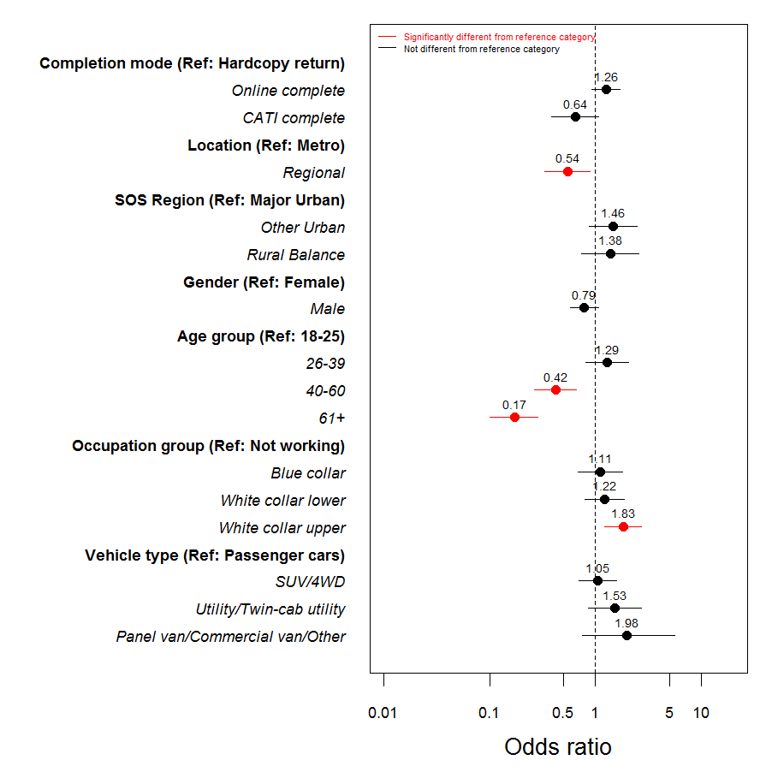

As already stated, a regression model accounts for the simultaneous effects of all included variables; therefore the odds ratios displayed are all “net” – this is what is left over after all other differences have been taken into account. For example, if two respondents are otherwise identical in all their characteristics, except that one is female and the other is male, the “net” effect is that the male is 0.79 times as likely to use his mobile phone while driving compared to the female (albeit, not significantly).

Categories were collapsed for two of the explanatory variables (occupation and vehicle type) (Table 1.4). Categories were removed from models where there were too few cases for reliable estimation.

Table .: Categories for occupation (Q5) and vehicle type (Q49 type)

|  |  |  |
| --- | --- | --- |
|  | **Questionnaire category** | **Collapsed category** |
| ***Occupation (Q5)*** | Clerical and administrative workers | White collar lower |
| Community and personal service workers | White collar lower |
| Labourers and related workers | Blue collar |
| Machinery operators and drivers | Blue collar |
| Managers and administrators | White collar upper |
| Not applicable (*those not asked Q5*) | Not in workforce |
| Professionals & Associate professionals | White collar upper |
| Sales workers | White collar lower |
| Technicians and trade workers | Blue collar |
| ***Vehicle type (Q49 type)*** | Sedan | Passenger cars |
| Wagon | Passenger cars |
| People mover | Passenger cars |
| Hatchback | Passenger cars |
| Coupe | Passenger cars |
| SUV/4WD | SUV/4WD |
| Utility | Utility/Twin-cab utility |
| Twin-cab utility | Utility/Twin-cab utility |
| Commercial van | Panel van/Commercial van/Other |
| Panel van | Panel van/Commercial van/Other |
| Other | Panel van/Commercial van/ Other |

# Driver demographics and characteristics

## Driver profile

As seen in previous waves, over two thirds (71%) of respondents were born in Australia; consistent with the 2011 ABS census (69%). A further 5% were born in the United Kingdom (ABS: 3%).

### Licence type

In the 2015 RSM, 87% of respondents held a full drivers licence. A further 7% stated that they held some form of a probationary licence with 1% indicating they held a red and 6% indicating they held a green probationary licence. Only 3% held a learner’s permit. Just over a third (35%) of 18 to 25 year olds held a full licence, while the majority held a green probationary licence (40%).

Table .: Licence type by demographics (2015)

|  |  |  |  |  |  |  |  |  |  |
| --- | --- | --- | --- | --- | --- | --- | --- | --- | --- |
|  | Total | Region | | Gender | | Age group | | | |
| 2015M (961) | Metro (695) | Regional (266) | Males  (483) | Females  (470) | 18-25  (135) | 26-39 (248) | 40-60 (330) | 61+ (225) |
|  |  | A | **B** | **C** | **D** | **E** | **F** | **G** | **H** |
| Full licence | 87% | 88% | 86% | 88% | 87% | 35% | 93%  **E** | 98%  **E,F** | 96%  **E** |
| Red Probationary | 1% | 1% | 2% | 1% | 2% | 9%  **F,G,H** | - | - | - |
| Green Probationary | 6% | 6% | 7% | 5% | 7% | 40%  **F,G,H** | 2% | - | - |
| Learners Permit | 3% | 3% | 2% | 4% | 2% | 15%  **F,G,H** | 3%  **G,H** | 1% | - |
| Other | 1% | 1% | 2% | 2% | 1% | - | 2% | 1% | 1% |

Base: All respondents (n=961)

Q1 What type of care licence do you hold? [single response]

### Work status

As found in previous waves, the majority (79%) of licence holders aged 18 to 60 years were employed at the time of the interview. An additional 9% indicated that they were studying while one in ten (11%) reported that they were either unemployed or not in the workforce.

Figure .: Work status – time series (%)

Base: Licence holders aged 18-60 (n=700)



Q4 What is your current employment status? [single response]

### Occupation

Similar to previous years, a greater proportion of respondents from a metropolitan area indicated that they were working as professionals or associate professionals than those in a regional area (34% vs. 25%). A significantly greater proportion of males were working in an occupation with a trade or technical focus than females (21% vs. 3%). And young workers were overrepresented in sales (24%) and technical and trade jobs (22%).

Table .: Occupation by demographics (2015)

|  |  |  |  |  |  |  |  |  |  |
| --- | --- | --- | --- | --- | --- | --- | --- | --- | --- |
|  | Total | Region | | Gender | | Age group | | | |
| 2015M (620) | Metro (464) | Regional (156) | Males  (322) | Females  (296) | 18-25  (71) | 26-39 (209) | 40-60 (271) | 61+ (54) |
|  |  | A | **B** | **C** | **D** | **E** | **F** | **G** | **H** |
| Managers and administrators | 14% | 14% | 16% | 17% | 11% | 6% | 14% | 17%  **E** | 13% |
| Professionals and associate professionals | 32% | 34% | 25% | 28% | 36% | 14% | 37%  **E** | 33%  **E** | 26% |
| Technicians and trade workers | 13% | 12% | 14% | 21% | 3% | 22%  **F,G** | 12% | 11% | 13% |
| Clerical and administrative workers | 12% | 11% | 15% | 4% | 22% | 17% | 10% | 12% | 20%  **F** |
| Community and personal service workers | 6% | 7% | 4% | 3% | 10% | 9% | 7% | 5% | 7% |
| Sales workers | 8% | 7% | 10% | 7% | 9% | 24%  **F,G,H** | 7% | 4% | 7% |
| Machinery operators and drivers | 4% | 4% | 6% | 6% | 2% | - | 4% | 6%  **E** | 2% |
| Labourers and related workers | 8% | 7% | 10% | 10% | 5% | 7% | 8% | 7% | 6% |

Base: Respondents in paid employment (n=620)

Q5 How would you describe you main paid employment? [single response]

### Work related driving

Respondents were asked about the amount of work related driving they do. Overall, 65% drive for work related purposes (29% on a daily basis). Of those who drove a vehicle for work related purposes, 65% drove a car, 15% drove a utility/pick up, 6% drove a commercial van and 3% drove a truck. Males and regional respondents tended to drive a utility/pick up compared to female and metropolitan respondents.

Figure .: Type of vehicle used for work related purposes (%) (2015)



Base: Respondents who drive a vehicle for work purposes (n=401)

Q63: What type of vehicle do you usually drive as part of your job? [single response]

## Individual characteristics

### Typical driving distance per year

The average kilometres driven per year in the 2015 were consistent with previous waves. More than a quarter of respondents (28%) stated they drove between 15,000kms and 30,000kms per year while just one in ten (14%) claimed to drive more than 30,000kms per year.

Figure .: Average kilometres driven per year (2012 to 2015 total sample)



Base: All respondents with a valid response (n=937)

Q60: In a typical year, how many kilometres would you drive for any reason? [single response]

Significant differences between demographic groups include:

* 26% of drivers aged 61 or over drove less than 10,000km per year compared to all other age groups,
* Males (20%) were more likely than females (8%) to drive more than 30,000km per year,
* Regional respondents were more likely to drive between 15,000km and 29,999km per year (34%) compared to metropolitan respondents (26%).

### Long distance drivers

Those who indicated they drove 15,000km or more in a year, or who said they drove 300km or more in a week (‘long distance drivers’) were grouped together and compared to those who drove less (‘short distance drivers’). More than half (56%) of respondents drove long distances, comprised largely of regional respondents (68%), and males (65%). Of those driving shorter distances, the proportion skewed towards drivers aged 61 and over (59%).

Table .: Average kilometres by demographics (2015)

|  |  |  |  |  |  |  |  |  |  |
| --- | --- | --- | --- | --- | --- | --- | --- | --- | --- |
|  | Total | Region | | Gender | | Age group | | | |
| 2015M (795) | Metro (573) | Regional (222) | Males  (418) | Females  (370) | 18-25  (101) | 26-39 (211) | 40-60 (282) | 61+ (187) |
|  |  | A | **B** | **C** | **D** | **E** | **F** | **G** | **H** |
| Short distance drivers | 44% | 48% | 32% | 35% | 53% | 46% | 36% | 38% | 59%  **E,F,G** |
| Long distance drivers | 56% | 52% | 68% | 65% | 47% | 54%  **H** | 64%  **H** | 62%  **H** | 41% |

Base: All respondents with a valid response (n=795)

Q60: In a typical year, how many kilometres would you drive for any reason? [single response]

Q61: In a typical week, how many kilometres would you drive for any reason? [single response]

Respondents who reported speeding (71%) were more likely to be long distance drivers, as were those who reported drink driving (72%), who regularly drove while drowsy (73%), and who used a mobile phone while driving (68%). Speeders were also more likely to be long distance drivers (82%) than non-speeders (albeit not significantly).

Table .: Average kilometres by behaviours (2015)

|  |  |  |  |  |  |  |  |  |  |  |  |
| --- | --- | --- | --- | --- | --- | --- | --- | --- | --- | --- | --- |
|  | Total | Speeding | | Drink driving | | Drowsy driving | | Phone use | | Road accident | |
| 2015M (795) | Yes (95) | No (694) | Yes (58) | No (548) | Yes (80) | No (709) | Yes (254) | No (538) | Yes (118) | No (675) |
|  |  | A | **B** | **C** | **D** | **E** | **F** | **G** | **H** | **I** | **J** |
| Short distance drivers | 44% | 29% | 46% | 28% | 41% | 27% | 45% | 32% | 49% | 39% | 45% |
| Long distance drivers | 56% | 71% | 54% | 72% | 59% | 73% | 55% | 68% | 51% | 61% | 55% |

Base: All respondents with a valid response (n=795)

Q60: In a typical year, how many kilometres would you drive for any reason? [single response]

Q61: In a typical week, how many kilometres would you drive for any reason? [single response]

Additional analysis was conducted which compared short distance drivers (n=349) and long distance drivers (n=446) across a variety of measures, attitudes and behaviours. There were some significant differences between the two groups as follows:

*Short distance drivers were:*

* More likely to drive a car for work related purposes (74%) (long distance drivers more likely to drive a utility/pickup (21%) or a truck (4%)),
* More concerned about aggressive or reckless driving when it comes to personal safety (33% vs. 26%).

*Long distance drivers were:*

* More confident in their driving ability, 73% rated themselves as a ‘better than average’ driver (while short distance drivers were more likely to rate themselves as ‘average’ (62%)),
* More likely to agree that if they were to speed in a 60km/h zone they would have a high chance of being caught (56% vs. 47%),
* More likely to agree that it easy to avoid being caught driving over the legal blood alcohol limit (60% vs. 53%),
* More likely to have been breath tested in the last twelve months (72% vs. 53%),
* More likely to have been a passenger in a car where the driver was over the limit (8% vs. 3%),
* More likely to use their mobile phone with the assistance of a hands free device such as Bluetooth (55% vs. 30%)

### Accident involvement

Self-reported involvement in a road accident remained consistent with previous waves, recording levels between 15% and 20% since 2010. The proportion of those involved in a road accident who stated that someone sustained a personal injury, however, increased significantly compared to 2014 (9%) to reach a peak level of 18%.

The significant increase in the proportion of accidents involving a personal injury was most prominent among females (significant increase from 7% in 2014 to 20% in 2015), and respondents aged 40 to 60 (significant increase from 5% in 2014 to 20% in 2015).

Figure 2.4: Road accidents in last five years (%) – time series

Base: Q40 All respondents (n=700); Q41 respondents involved in a road accident (n=114)



Q40 In the past five years, have you been involved in any road accidents as a driver regardless of who was at fault? (This does not include accidents in car parks and driveways) [single response]

Q41 Did anyone in the accident(s) sustain personal injury? [single response]

Involvement in a road accident was significantly lower among those aged 61 and over (7%). Of those involved in a road accident, personal injury was marginally greater in regional areas (21%) and among females (20%) although not significantly.

**Table 2.5: Road accidents in last five years and personal injury by demographics (2015)**

|  |  |  |  |  |  |  |  |  |  |
| --- | --- | --- | --- | --- | --- | --- | --- | --- | --- |
|  | Total | Region | | Gender | | Age group | | | |
| 2015M (961) | Metro (695) | Regional (266) | Males  (483) | Females  (470) | 18-25  (135) | 26-39 (248) | 40-60 (330) | 61+ (225) |
|  |  | A | **B** | **C** | **D** | **E** | **F** | **G** | **H** |
| Involved in road accident | 14% | 16% | 11% | 15% | 14% | 16%  **H** | 17%  **H** | 17%  **H** | 7% |
| Personal injury | 17% | 16% | 21% | 15% | 20% | 14% | 19% | 20% | 12% |

Base: Q40 All respondents (n=961); Q41 respondents involved in a road accident (n=139)

Q40 In the past five years, have you been involved in any road accidents as a driver regardless of who was at fault? (This does not include accidents in car parks and driveways) [single response]

Q41 Did anyone in the accident(s) sustain personal injury? [single response]

As seen in Table 2.6, involvement in road accidents was significantly more common among respondents who admitted to using a mobile phone while driving (17%), compared to those who did not use a mobile while driving (12%). Of those involved in an accident, personal injury was more common among regular drowsy drivers (44%) (not significant).

**Table 2.6: Road accidents in last five years and personal injury by behaviours (2015)**

|  |  |  |  |  |  |  |  |  |  |  |  |
| --- | --- | --- | --- | --- | --- | --- | --- | --- | --- | --- | --- |
|  | Total | Speeding | | Drink driving | | Drowsy driving | | Phone use | | Road accident | |
| 2015M (961) | Yes (108) | No (838) | Yes (64) | No (650) | Yes (91) | No (856) | Yes (295) | No (662) | Yes (139) | No (815) |
|  |  | A | **B** | **C** | **D** | **E** | **F** | **G** | **H** | **I** | **J** |
| Involved in road accident | 14% | 12% | 15% | 15% | 14% | 17% | 14% | 18% | 13% | 100% | - |
| Personal injury | 17% | 7% | 19% | 9% | 21% | 44% | 14% | 15% | 19% | 17% | - |

Base: Q40 All respondents (n=961); Q41 respondents involved in a road accident (n=139)

Q40 In the past five years, have you been involved in any road accidents as a driver regardless of who was at fault? (This does not include accidents in car parks and driveways) [single response]

Q41 Did anyone in the accident(s) sustain personal injury? [single response]

### Perceptions of driving competence

Consistent with recent years, around a third of respondents (65%) rated their driving as ‘better’ compared to the average Victorian driver (14% felt they were ‘much’ better, 31% felt they were ‘better’, and 20% felt they were ‘slightly’ better). A further three in ten (30%) believed their driving to be ‘average’. A small proportion reported that their driving was ‘worse’ than average (1%), or were unsure (3%) how they compared.

Figure .: Rating of driving (%) (2012 to 2015 total sample)



Base: All respondents (n=961)

Q59: Thinking about how you compare to the average driver on Victorian roads, would you say that you were a…[single response]

Table 2.7 compares self-reported driving competency by demographic characteristics. Drivers aged between 26 to 39 years (74%) and 40 to 60 years (67%) rated themselves as ‘better’ than the average driver, significantly greater when compared to drivers aged 61+ years (53%). Significantly more respondents from metropolitan areas (67%) also rated themselves as ‘better’ compared to regional respondents. Drivers who rated themselves as an ‘about average’ driver were typically in the youngest (18-25 years, 33%) or oldest (61+, 42%) age brackets.

Table .: Self-reported driving competency by demographics (2015)

|  |  |  |  |  |  |  |  |  |  |
| --- | --- | --- | --- | --- | --- | --- | --- | --- | --- |
|  | Total | Region | | Gender | | Age group | | | |
| 2015M (961) | Metro (695) | Regional (266) | Males  (483) | Females  (470) | 18-25  (135) | 26-39 (248) | 40-60 (330) | 61+ (225) |
|  |  | A | **B** | **C** | **D** | **E** | **F** | **G** | **H** |
| Total 'better than average' drivers | 65% | 67% | 60% | 68% | 62% | 62% | 74%  **E,H** | 67%  **H** | 53% |
| ‘About average’ drivers | 30% | 28% | 35% | 28% | 32% | 33%  **F** | 23% | 28% | 42%  **F,G** |
| Total 'worse than average' drivers | 1% | 1% | - | 1% | 1% | 2% | - | 2% | - |

Base: All respondents (n=961)

Q59: Thinking about how you compare to the average driver on Victorian roads, would you say that you were a…[single response]

Significantly more ‘speeders’ rated themselves as ‘better than average’ (75%) compared to ‘non-speeders’. All other sub-groups were relatively similar in their self-perceived driving competence.

Table .: Self-reported driving competency by behaviour (2015)

|  |  |  |  |  |  |  |  |  |  |  |  |
| --- | --- | --- | --- | --- | --- | --- | --- | --- | --- | --- | --- |
|  | Total | Speeding | | Drink driving | | Drowsy driving | | Phone use | | Road accident | |
| 2015M (961) | Yes (108) | No (838) | Yes (64) | No (650) | Yes (91) | No (856) | Yes (295) | No (662) | Yes (139) | No (815) |
|  |  | A | **B** | **C** | **D** | **E** | **F** | **G** | **H** | **I** | **J** |
| Total 'better than average' drivers | 65% | 74% | 64% | 69% | 66% | 67% | 66% | 69% | 64% | 67% | 65% |
| ‘About average’ drivers | 30% | 24% | 31% | 28% | 30% | 27% | 30% | 27% | 31% | 28% | 31% |
| Total 'worse than average' drivers | 1% | 1% | 1% | 1% | 1% | 1% | 1% | 1% | 1% | 2% | 1% |

Base: All respondents (n=961)

Q59: Thinking about how you compare to the average driver on Victorian roads, would you say that you were a…[single response]

# Driving attitudes and behaviours

## Perceived cause of road accidents

Respondents were asked about the key factors that lead to serious road accidents. Figure 3.1 shows that alcohol is perceived as the factor most likely to contribute to serious accidents (70%), with speed the second most commonly mentioned factor (54%). This finding is consistent with previous waves.

Figure 3.1: Factors that lead to serious road accidents (%) (2015)



Base: All respondents (n=961)

Q6 What do you think are the three main factors that most often lead to serious road accidents? [3 mentions]

## Personal safety

In the 2015 RSM, respondents were also asked to nominate their greatest concern about *their own* safety on the road, either as a driver or passenger. Figure 3.2 shows that of respondents who provided a response, ‘aggressive or reckless driving’ (28%) and other drivers (24%) were the most commonly cited concerns. ‘Distractions’ (17%), ‘speed’ (13%), and ‘drugs’ and ‘alcohol’ (both 12%) were also among the top five concerns. It is worth noting that just under a quarter of survey respondents (23%) did not provide an answer.

Figure 3.2: Concerns about personal safety on the road (%) (2015)



Base: All respondents who provided an answer (n=742)

Q7 Either as a driver or a passenger, what concerns you most about your safety on the road?

When looking at concerns for personal safety by demographics, respondents in metropolitan areas were more likely than regional respondents to mention ‘aggressive or reckless driving’ (30%); in comparison, regional respondents were more likely to mention ‘other drivers’ (30%) in general. ‘Drivers ignoring road rules’ was a greater concern for female respondents (9%) compared to males (4%). Those aged 26 to 39 years were more concerned about ‘young drivers’ (4%), compared to those aged 18 to 25.

Table .: Concerns about personal safety on the road by demographics (2015)

|  |  |  |  |  |  |  |  |  |  |
| --- | --- | --- | --- | --- | --- | --- | --- | --- | --- |
|  | Total | Region | | Gender | | Age group | | | |
| 2015M (742) | Metro (528) | Regional (214) | Males  (365) | Females  (373) | 18-25  (111) | 26-39 (183) | 40-60 (264) | 61+ (170) |
|  |  | A | **B** | **C** | **D** | **E** | **F** | **G** | **H** |
| Young Drivers | 3% | 3% | 2% | 3% | 3% | - | 4%  **E** | 3% | 2% |
| Alcohol | 12% | 11% | 14% | 10% | 14% | 16%  **G** | 17%  **GH** | 9% | 9% |
| Distraction(s) | 17% | 17% | 15% | 16% | 17% | 8% | 23%  **EH** | 19%  **EH** | 11% |
| Drugs | 12% | 11% | 15% | 10% | 14% | 11% | 16% | 12% | 10% |
| Speed | 13% | 14% | 13% | 12% | 14% | 13% | 15% | 11% | 15% |
| Tiredness / fatigue | 1% | - | 1% | 1% | 1% | 1% | 2%  **G** | - | - |
| Aggressive or reckless driving | 28% | 30% | 22% | 29% | 27% | 26% | 27% | 30% | 28% |
| Older drivers | 1% | 1% | - | 1% | 1% | 3% | 1% | 2% | 1% |
| Inexperienced drivers | 8% | 9% | 6% | 8% | 7% | 10%  **H** | 8% | 10%  **H** | 4% |
| Poor road condition or design | 7% | 6% | 10% | 8% | 6% | 7% | 7% | 7% | 6% |
| Drivers ignoring road rules | 7% | 6% | 8% | 4% | 9% | 6% | 7% | 6% | 7% |
| Other drivers | 24% | 21% | 30% | 23% | 25% | 29% | 22% | 22% | 26% |

Base: All respondents who provided an answer (n=742)

Q7 Either as a driver or a passenger, what concerns you most about your safety on the road?

Compared to those who do not use a mobile phone while driving, mobile phone users were significantly more likely to mention ‘drugs’ (15%), ‘alcohol’ (14%), ‘inexperienced drivers’ (11%) and ‘tiredness or fatigue’ (1%). Of drivers who drink drive (4%) or drive drowsy (4%), ‘older drivers’ were seen as more of a concern compared to those who do not drink drive or regularly drive when drowsy (both 1%). ‘Speeders’ were more concerned about poor road condition or design (13%) than ‘non-speeders’ (6%).

Table .: Concerns about personal safety on the road by behaviours (2015)

|  |  |  |  |  |  |  |  |  |  |  |  |
| --- | --- | --- | --- | --- | --- | --- | --- | --- | --- | --- | --- |
|  | Total | Speeding | | Drink driving | | Drowsy driving | | Phone use | | Road accident | |
| 2015M (742) | Yes (84) | No (647) | Yes (51) | No (512) | Yes (75) | No (661) | Yes (226) | No (513) | Yes (105) | No (634) |
|  |  | A | **B** | **C** | **D** | **E** | **F** | **G** | **H** | **I** | **J** |
| Young Drivers | 3% | 1% | 3% | 6% | 2% | 3% | 3% | 4% | 3% | 3% | 3% |
| Alcohol | 12% | 9% | 12% | 6% | 12% | 13% | 12% | 16% | 10% | 7% | 13% |
| Distraction(s) | 17% | 16% | 17% | 16% | 17% | 22% | 16% | 17% | 17% | 15% | 17% |
| Drugs | 12% | 13% | 12% | 8% | 12% | 12% | 12% | 16% | 10% | 8% | 13% |
| Speed | 13% | 9% | 14% | 8% | 13% | 15% | 13% | 17% | 12% | 10% | 14% |
| Tiredness / fatigue | 1% | 1% | 1% | - | 1% | 1% | 1% | 1% | * | - | 1% |
| Aggressive or reckless driving | 28% | 20% | 29% | 20% | 29% | 27% | 28% | 23% | 30% | 34% | 27% |
| Older drivers | 1% | 2% | 1% | 4% | 1% | 4% | 1% | 1% | 1% | 2% | 1% |
| Inexperienced drivers | 8% | 9% | 8% | 10% | 9% | 8% | 8% | 12% | 6% | 11% | 7% |
| Poor road condition or design | 7% | 13% | 6% | 12% | 8% | 11% | 6% | 8% | 6% | 7% | 7% |
| Drivers ignoring road rules | 7% | 6% | 7% | 4% | 7% | 5% | 7% | 6% | 7% | 9% | 6% |
| Other drivers | 24% | 31% | 23% | 25% | 24% | 25% | 24% | 22% | 25% | 22% | 24% |

Base: All respondents who provided an answer (n=742)

Q7 Either as a driver or a passenger, what concerns you most about your safety on the road?

### Restraint wearing

Consistent with previous waves, the vast majority of licence holders aged 18 to 60 years reported wearing a seatbelt ‘all the time’ when they drive (98%). There were no differences in wearing a seatbelt by demographic characteristics. Looking at driving behaviours however, those who reported drink driving and drowsy driving were marginally less likely to report wearing a seatbelt ‘all the time’ (both 93%) compared to those who did not drink drive or drive while drowsy (both 99%).

Figure .: Wears a seatbelt all the time (%) - time series

Base: All licence holders aged 18-60 (n=700)



Q9 When you drive a car (or other vehicle) do you wear a seatbelt...? [single response]

## Level of danger in driving behaviours

Respondents were asked to rate a series of driving behaviours on a scale of 0 (not dangerous at all) to 10 (extremely dangerous). Figure 3.4 shows that behaviours which impair driving ability, in particular, drink and drug driving, were viewed as the most dangerous (mean between 9.4 and 9.7 out of 10). The activity of driving while drowsy was viewed as extremely dangerous (rating of 9.0 out of 10) and considered just as dangerous as driving after taking drugs or drinking alcohol. The use of a handheld mobile phone (8.7) was considered far more dangerous than hands free (5.5), while speeding a few kilometres over the speed limit in a 100km zone (5.6) or 60km zone (5.4) were considered less dangerous activities.

**Figure 3.4: Level of danger in driving behaviours (mean) (2015)**



Base: All respondents (n=961)

Q8 Using a scale where 0 is not dangerous at all and 10 is extremely dangerous, how dangerous do you think it is to… [single response]

Compared to males, female drivers provided higher ratings for driving over the speed limit in a 60km zone (5.8) and a 100km zone (6.2), driving with an illegal BAC (9.6), driving after using depressant drugs (9.6), and using a mobile phone either handheld (8.9) or hands free (5.8). Drivers living in regional areas viewed driving a few kilometres over the limit in a 60km zone (5.9) and using a mobile either handheld (9.0) or hands free (5.8) as more dangerous than those living in metropolitan areas. Older drivers (aged 40-60 and aged 61+) provided higher ratings for using a mobile phone compared to younger drivers (18-25 and 26-39). Females and older adults tended to provide higher ratings on average for drowsy driving than males and young drivers.

**Table 3.3: Level of danger in driving behaviours by demographics (2015)**

|  |  |  |  |  |  |  |  |  |  |
| --- | --- | --- | --- | --- | --- | --- | --- | --- | --- |
|  | Total | Region | | Gender | | Age group | | | |
| 2015M (961) | Metro (695) | Regional (266) | Males  (483) | Females  (470) | 18-25  (135) | 26-39 (248) | 40-60 (330) | 61+ (225) |
|  |  | A | **B** | **C** | **D** | **E** | **F** | **G** | **H** |
| Drive a few kms above the speed limit (60 zone) | 5.4 | 5.3 | 5.9 | 5.2 | 5.8 | 5.2 | 5.6 | 5.5 | 5.5 |
| Drive a few kms above the speed limit (100 zone) | 5.6 | 5.6 | 5.7 | 5.1 | 6.2 | 5.4 | 5.5 | 5.6 | 5.9 |
| Drive with an illegal BAC level | 9.4 | 9.4 | 9.5 | 9.2 | 9.6 | 9.3 | 9.4 | 9.4 | 9.6 |
| Drive after using stimulant drugs | 9.7 | 9.7 | 9.7 | 9.6 | 9.7 | 9.7 | 9.7 | 9.6 | 9.8 |
| Drive after using depressant drugs | 9.5 | 9.5 | 9.6 | 9.4 | 9.6 | 9.3 | 9.5 | 9.5 | 9.6  **E** |
| Drive after using drugs and alcohol | 9.7 | 9.7 | 9.8 | 9.7 | 9.7 | 9.7 | 9.7 | 9.6 | 9.8 |
| Drive after drinking alcohol and using prescription medicines | 8.5 | 8.4 | 8.6 | 8.4 | 8.6 | 8.6 | 8.4 | 8.4 | 8.6 |
| Drive while drowsy | 9.0 | 9.0 | 9.0 | 8.8 | 9.1 | 8.5 | 8.8  **E** | 9.1  **E** | 9.3  **E,F** |
| Drive while using a handheld mobile phone | 8.7 | 8.6 | 9.0 | 8.5 | 8.9 | 8.3 | 8.4 | 8.8  **E,F** | 9.2  **E,F,G** |
| Drive while using a hands free mobile phone | 5.5 | 5.3 | 5.8 | 5.2 | 5.8 | 5.2 | 5.0 | 5.6  **F** | 6.2  **E,F,G** |

Base: All respondents (n=961)

Q8 Using a scale where 0 is not dangerous at all and 10 is extremely dangerous, how dangerous do you think it is to… [single response]

Drivers who had driven when they suspected they were over the limit provided significantly lower mean ratings on almost every type of driving behaviour (with exception of driving a few kilometres over the limit in a 60km zone). Similarly, those who use their mobile phone while driving provided significantly lower ratings than those who do not use their phone, with the exception of driving after using drugs and alcohol. ‘Speeders’ tended to perceive driving a few kilometres over the limit, as well as driving with an illegal BAC, driving while drowsy, and driving while using a mobile phone as less dangerous than ‘non-speeders’. Drowsy drivers also provided lower ratings for speeding in a 100km zone, driving while drowsy, and driving while using a hands free phone.

**Table 3.4: Level of danger in driving behaviours by behaviours (2015)**

|  |  |  |  |  |  |  |  |  |  |  |  |
| --- | --- | --- | --- | --- | --- | --- | --- | --- | --- | --- | --- |
|  | Total | Speeding | | Drink driving | | Drowsy driving | | Phone use | | Road accident | |
| 2015M (961) | Yes (108) | No (838) | Yes (64) | No (650) | Yes (91) | No (856) | Yes (295) | No (662) | Yes (139) | No (815) |
|  |  | A | **B** | **C** | **D** | **E** | **F** | **G** | **H** | **I** | **J** |
| Drive a few kms above the speed limit (60 zone) | 5.4 | 3.9 | 5.7 | 4.9 | 5.3 | 5.1 | 5.5 | 5.0 | 5.6 | 5.4 | 5.5 |
| Drive a few kms above the speed limit (100 zone) | 5.6 | 3.6 | 5.9 | 4.1 | 5.3 | 4.9 | 5.7 | 4.8 | 5.9 | 5.7 | 5.6 |
| Drive with an illegal BAC level | 9.4 | 9.1 | 9.5 | 8.7 | 9.4 | 9.2 | 9.5 | 9.3 | 9.5 | 9.4 | 9.4 |
| Drive after using stimulant drugs | 9.7 | 9.6 | 9.7 | 9.3 | 9.7 | 9.5 | 9.7 | 9.6 | 9.7 | 9.7 | 9.7 |
| Drive after using depressant drugs | 9.5 | 9.4 | 9.5 | 9.0 | 9.5 | 9.5 | 9.5 | 9.3 | 9.6 | 9.5 | 9.5 |
| Drive after using drugs and alcohol | 9.7 | 9.6 | 9.7 | 9.3 | 9.7 | 9.6 | 9.7 | 9.6 | 9.8 | 9.8 | 9.7 |
| Drive after drinking alcohol and using prescription medicines | 8.5 | 7.8 | 8.5 | 7.7 | 8.4 | 8.4 | 8.5 | 8.1 | 8.6 | 8.4 | 8.5 |
| Drive while drowsy | 9.0 | 8.2 | 9.1 | 8.3 | 9.0 | 8.6 | 9.0 | 8.6 | 9.1 | 9.0 | 9.0 |
| Drive while using a handheld mobile phone | 8.7 | 7.9 | 8.8 | 8.0 | 8.7 | 8.4 | 8.8 | 8.1 | 9.0 | 8.7 | 8.7 |
| Drive while using a hands free mobile phone | 5.5 | 4.0 | 5.7 | 4.5 | 5.4 | 4.7 | 5.5 | 4.9 | 5.7 | 5.2 | 5.5 |

Base: All respondents (n=961)

Q8 Using a scale where 0 is not dangerous at all and 10 is extremely dangerous, how dangerous do you think it is to… [single response]

# Towards zero

The 2015 ‘Main’ RSM continued to monitor the questions introduced in the 2015 ‘Pulse’ to assess community attitudes around the concept of ‘Towards Zero’ – a vision for a future free of deaths and serious injuries in Victoria. It is a collaborative effort with the community to improve road safety to ultimately reach *zero* deaths or serious injuries. At the start of the 2015 ‘Main’ surveying period (26 August to 20 September, 2015) Phase 1 of the Towards Zero campaign was run (‘Man on the street’) which targeted all Victorian road users via TV, radio, online, social media, outdoor and out of home.

## Acceptable number of deaths

Respondents were asked their opinion on the acceptability of the current number of Victorians killed on the road each year. Figure 4.1 shows that of all respondents, more than three quarters (76%) believed that the road toll is unacceptable. Compared to the 2015 Pulse, this proportion has declined significantly from 84%. Just over one in ten (13%) respondents believed the road toll to be neither acceptable nor unacceptable, an increase from 7% in the 2015 Pulse. Only 6% believe the road toll is acceptable – consistent with the 2015 Pulse.

Figure .: Accident acceptability (2015)



Base: All respondents (n=961)

Q45a Fifteen years ago, more than 400 people were killed on Victorian roads each year. This number has now fallen to almost 250. In your opinion is this number of deaths . . . [single response]

Table 4.1 shows that perceived acceptability of the road toll is largely consistent between demographic groups. That said, the proportion of drivers who stated that they believe the road toll is currently ‘acceptable’ was higher among males (8%) and those aged between 18 and 25 (10%) and 26 to 39 years (8%); while drivers aged 61 and over were significantly more likely to state that the road toll is unacceptable (83%).

**Table 4.1:** Accident acceptability (number of deaths) by demographics **(2015)**

|  |  |  |  |  |  |  |  |  |  |
| --- | --- | --- | --- | --- | --- | --- | --- | --- | --- |
|  | Total | Region | | Gender | | Age group | | | |
| 2015M (961) | Metro (695) | Regional (266) | Males  (483) | Females  (470) | 18-25  (135) | 26-39 (248) | 40-60 (330) | 61+ (225) |
|  |  | A | **B** | **C** | **D** | **E** | **F** | **G** | **H** |
| Total acceptable | 6% | 7% | 4% | 8% | 4% | 10%  **H** | 8%  **H** | 5% | 3% |
| Neither acceptable nor unacceptable | 13% | 13% | 13% | 12% | 14% | 18%  **H** | 14% | 13% | 9% |
| Total unacceptable | 76% | 74% | 80% | 74% | 78% | 69% | 73% | 77% | 83%  **E,F** |

Base: All respondents (n=961)

Q45a Fifteen years ago, more than 400 people were killed on Victorian roads each year. This number has now fallen to almost 250. In your opinion is this number of deaths . . . [single response]

As seen in Table 4.2, the road toll was generally more accepted by respondents who participated in ‘risky’ behaviours such as speeding (13%), drink driving (13%), and using their phone while driving (10%). Interestingly, while the number is small, respondents who had been in a road accident in the last five years were more likely to rate the road toll as acceptable (11%) compared to those not involved in an accident (5%) – possibly influenced by their involvement in an accident.

**Table 4.2:** Accident acceptability (number of deaths) **by behaviours (2015)**

|  |  |  |  |  |  |  |  |  |  |  |  |
| --- | --- | --- | --- | --- | --- | --- | --- | --- | --- | --- | --- |
|  | Total | Speeding | | Drink driving | | Drowsy driving | | Phone use | | Road accident | |
| 2015M (961) | Yes (108) | No (838) | Yes (64) | No (650) | Yes (91) | No (856) | Yes (295) | No (662) | Yes (139) | No (815) |
|  |  | A | **B** | **C** | **D** | **E** | **F** | **G** | **H** | **I** | **J** |
| Total acceptable | 6% | 13% | 5% | 13% | 6% | 9% | 6% | 10% | 5% | 11% | 5% |
| Neither acceptable nor unacceptable | 13% | 12% | 13% | 9% | 14% | 14% | 13% | 12% | 13% | 14% | 13% |
| Total unacceptable | 76% | 69% | 77% | 76% | 77% | 74% | 77% | 74% | 77% | 71% | 77% |

Base: All respondents (n=961)

Q45a Fifteen years ago, more than 400 people were killed on Victorian roads each year. This number has now fallen to almost 250. In your opinion is this number of deaths . . . [single response]

## Belief in ‘zero’

In light of the Towards Zero goals, respondents were asked if they believed the road toll could be reduced to zero and if so, how long it would take to reach zero deaths on Victorian roads.

As seen in Table 4.3, one in ten (11%) respondents believed that the road toll could be reduced to zero in the future, this remains consistent with the 2015 Pulse (10%). Respondents living in metropolitan areas (13%) were more optimistic than those in regional areas (7%); as were younger respondents (18-25, 14%; 26-39, 17%).

Of those who believed that the road toll could one day reach zero, the majority (61%) believed it would take less than 20 years to achieve. In contrast, 48% of respondents in the 2015 Pulse believed zero could be achieved within 20 years (not significant). A notable difference between the 2015 Pulse and 2015 Main is an 11 percentage point shift in those who believed it would take between 20 and 29 years, moving towards a shorter time frame.

**Table 4.3:** Believe in no deaths as a result of road accidents by demographics **(2015)**

|  |  |  |  |  |  |  |  |  |  |
| --- | --- | --- | --- | --- | --- | --- | --- | --- | --- |
|  | Total | Region | | Gender | | Age group | | | |
| 2015M (961) | Metro (695) | Regional (266) | Males  (483) | Females  (470) | 18-25  (135) | 26-39 (248) | 40-60 (330) | 61+ (225) |
|  |  | A | **B** | **C** | **D** | **E** | **F** | **G** | **H** |
| Believe there will be no deaths one day | 11% | 13% | 7% | 13% | 10% | 14%  **H** | 17%  **G,H** | 10% | 6% |
| *Less than 10 years* | 20% | 21% | 12% | 20% | 19% | 5% | 24% | 15% | 31% |
| *10 to 19 years* | 41% | 43% | 33% | 43% | 39% | 37% | 46% | 42% | 38% |
| *20 to 29 years* | 10% | 9% | 16% | 7% | 15% | 21% | 7% | 9% | 8% |
| *30 years or more* | 29% | 27% | 39% | 30% | 28% | 37% | 22% | 33% | 23% |

Base: Q49b All respondents (n=961); Q49c believes 0 deaths is achievable (n=109)

Q45b Do you believe that one day in Victoria there will be no deaths as a result of road accidents? [single response]

Q45c How long do you think it will take to reach zero road deaths in Victoria? [single response]

Significantly fewer respondents who had driven when they suspected they were over the limit (2%) believed that one day there would be zero deaths on Victorian roads, compared to those who had not driven after drinking (12%). Despite being more inclined to agree that the current road toll is acceptable, those who had been involved in an accident were actually more likely to believe that a zero road toll was achievable (17%) than those who had not been in an accident (10%).

**Table 4.4:** Believe in no deaths as a result of road accidents **by behaviours (2015)**

|  |  |  |  |  |  |  |  |  |  |  |  |
| --- | --- | --- | --- | --- | --- | --- | --- | --- | --- | --- | --- |
|  | Total | Speeding | | Drink driving | | Drowsy driving | | Phone use | | Road accident | |
| 2015M (961) | Yes (108) | No (838) | Yes (64) | No (650) | Yes (91) | No (856) | Yes (295) | No (662) | Yes (139) | No (815) |
|  |  | A | **B** | **C** | **D** | **E** | **F** | **G** | **H** | **I** | **J** |
| Believe there will be no deaths one day | 11% | 13% | 11% | 2% | 12% | 11% | 11% | 11% | 11% | 17% | 10% |
| *Less than 10 years* | 20% | 14% | 21% | - | 19% | 20% | 20% | 21% | 19% | 13% | 21% |
| *10 to 19 years* | 41% | 29% | 42% | - | 35% | 61% | 39% | 50% | 37% | 54% | 38% |
| *20 to 29 years* | 10% | 7% | 11% | - | 13% | - | 11% | 9% | 11% | - | 13% |
| *30 years or more* | 29% | 50% | 27% | 100% | 33% | 19% | 31% | 20% | 33% | 34% | 28% |

Base: Q49b All respondents (n=961); Q49c believes 0 deaths is achievable (n=109)

Q45b Do you believe that one day in Victoria there will be no deaths as a result of road accidents? [single response]

Q45c How long do you think it will take to reach zero road deaths in Victoria? [single response]

Additional analysis was conducted which compared respondents who believed that a zero road toll was achievable (‘believers’) (n=109) and those who did not think it was possible (‘non-believers’) (n=763). It is interesting to note that there were some significant differences in attitudes between the two groups, largely involving attitudes toward speeding. This included:

* ‘Believers’ provided significantly higher ratings for the dangerousness of driving a few kilometres above the posted speed limit in both a 60km/h zone (6.12 vs. 5.28) and a 100km/h zone (6.45 vs. 5.33).
* ‘Believers’ were more likely to agree that they would have a high chance of being caught if they were to speed a few kilometres over the speed limit in a 60km/h zone (66% vs. 51%).

## Regression analysis (Towards Zero)

### Perceived acceptability of current road toll

After accounting for other differences, there remained some significant effects across region, gender, age group and vehicle type in terms of the propensity to agree that the number of deaths on Victorian roads is acceptable:

* Respondents in Other Urban areas were less likely to agree than respondents in Major Urban areas;
* Males were twice as likely as females to agree;
* Respondents aged 61 or older were less likely to agree than those aged 18 to 25 years; and
* SUV/4WD drivers were significantly less likely to agree compared to drivers of passenger cars. Note that there were too few respondents in the Panel van/Commercial van/Other category for reliable estimation so this group has been omitted from the figure.

**Figure 4.2:** Odds ratios for model of perceived a*cceptability of current road toll*

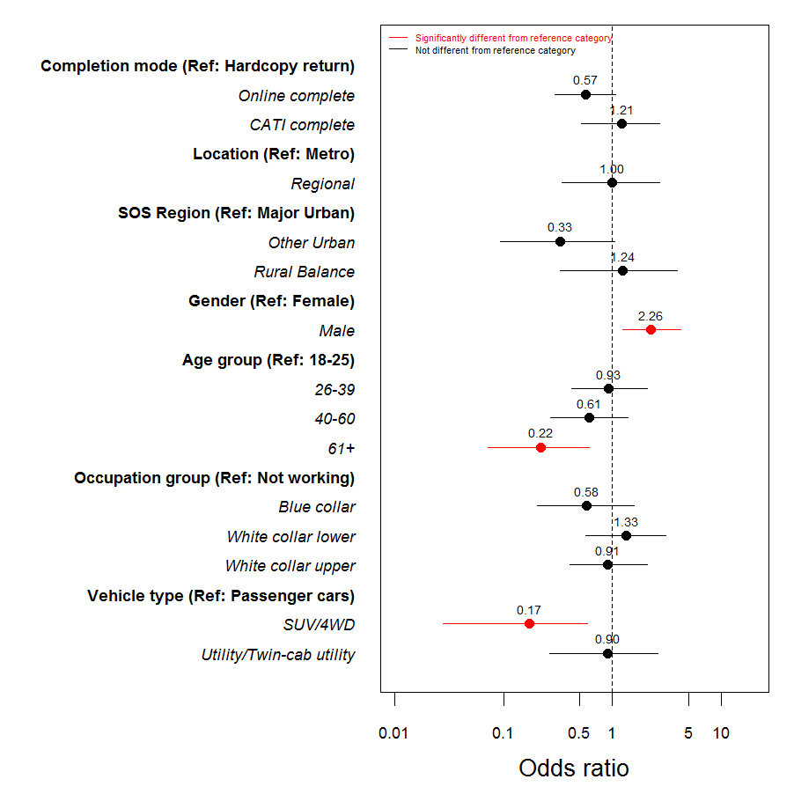

### Belief in possibility of zero road toll

There were no significant differences across demographic characteristics for the likelihood of agreeing that it is possible to achieve zero road deaths in Victoria.

**Figure 4.3:** Odds ratios for model of *Belief that zero deaths from road accidents is possible*

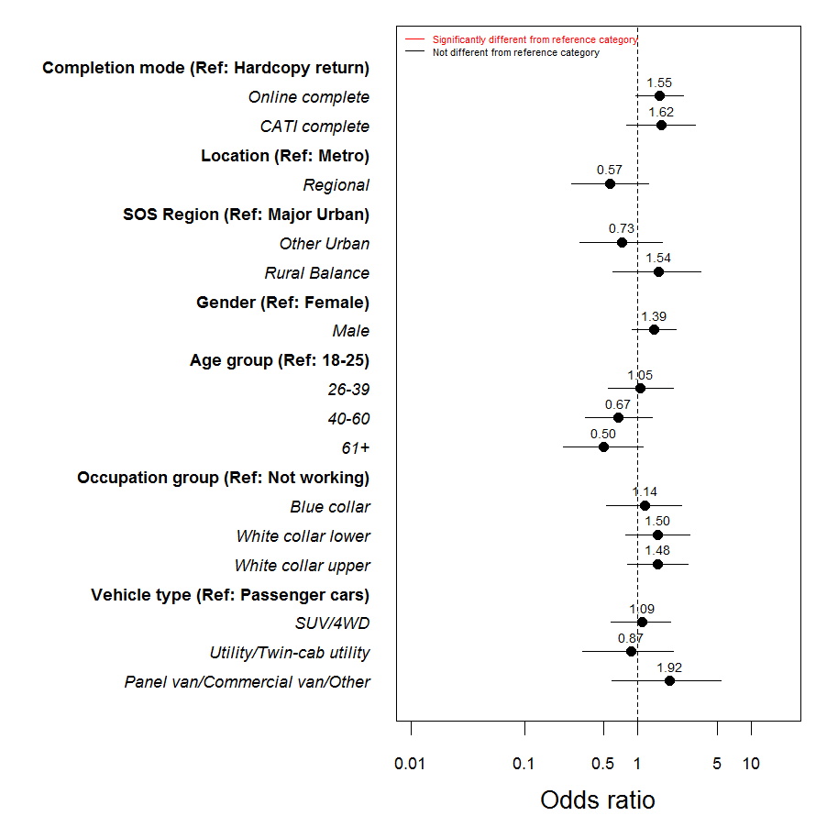

# Speed

## Definition of speeding

To understand how road users defined speeding, respondents were asked to indicate how fast they thought people should be allowed to drive in a 60km/h and a 100km/h zone without being booked for speeding. Prior to 2010, respondents were asked how many kilometres over the defined speed limit they considered to be speeding (i.e. 1km/h or more) regardless of what the law states. This methodological change impacts on the series and should be considered when interpreting the results.

Figure 5.1 shows that the majority of respondents (89%) believe they should only be able to drive up to 65km/h in a 60km/h zone; meanwhile, almost three quarters (73%) provided a speed of up to 105km/h above in a 100 zone. Consistent with previous years, around one in ten (11%) believe they should be allowed to drive in excess of 65km/h in a 60km/h zone; in contrast, 27% felt they should be able to drive in excess of 105km/h in a 100km/h zone.

Figure .: Definition of speeding in a 60km/h and 100km/h zone – time series



Base: Respondents aged 18-60 who could specify a number and not below 60km/h (n=700)

Q11 How fast should people be allowed to drive in a 60km/h zone without being booked for speeding? [single response]

Q14 How fast should people be allowed to drive in a 100km/h without being booked for speeding? [single response]

## Frequency of speeding

Respondents were asked how often they intentionally drove above the posted speed limit in the last three months. Figure 5.2 shows that around half of respondents (52% in a 60km/h zone; 50% in a 100km/h) never speed about the posted speed limit. Only 8% indicated that they speed at least half of the time over the posted speed limit in a 60km/h and 11% indicated that they speed at least half of the time in a 100km/h zone.

Figure .: Frequency of driving over THE POSTED speed (2015)



Base: All respondents (n=961)

Q10 How often have you intentionally driven above the limit in a 60km/h zone, even if by only a few kms per hour, in the last three months? [single response]

Q13 How often have you intentionally driven above the limit in a 100km/h zone, even if by only a few kms per hour, in the last three months? [single response]

Respondents who nominated a speed greater than the posted limit as an acceptable limit were asked how often they travel above the speed which they nominated. Similar to driving over the posted limit, 47% of respondents in a 60km/h zone and 48% in a 100km/h zone stated that they never drove over their self-defined speed limit. A small proportion (2% and 4%) reported that they drive at or above their self-defined speed limit ‘all of the time’ in a 60km/h zone and 100km/h zone respectively. As anticipated, there was a strong relationship between those who drive over the posted limit and over their own self-defined limit.

Figure .: Frequency of driving over SELF-DEFINED speed (2015)



Base: Respondents who nominated a speed greater than 60/100 as acceptable (n=655)

Q12 When you have the opportunity, how often do you travel at or above that speed in a 60km/h zone? [single response]

Q15 When you have the opportunity, how often do you travel at or above that speed in a 100km/h zone? [single response]

As seen in Table 5.1, responses were relatively consistent among demographic groups for self-defined speeding in a 60km/h zone however, significantly more male respondents reported driving at or above the self-defined speed limit in a 100km/h zone ‘all of the time’ (6%), compared to females (2%). Similarly, those aged 18 to 25 years (7%) were more likely to speed ‘all of the time’ compared to drivers aged 61 or over (2%).

**Table 5.1:** Frequency of self-defined speeding by demographics **(2015)**

|  |  |  |  |  |  |  |  |  |  |
| --- | --- | --- | --- | --- | --- | --- | --- | --- | --- |
|  | Total | Region | | Gender | | Age group | | | |
| 2015M (655) | Metro (483) | Regional (172) | Males  (341) | Females  (306) | 18-25  (109) | 26-39 (180) | 40-60 (225) | 61+ (124) |
|  |  | A | **B** | **C** | **D** | **E** | **F** | **G** | **H** |
| 60km: None of the time | 47% | 46% | 51% | 47% | 47% | 51% | 43% | 48% | 50% |
| 60km: Some to half of the time | 45% | 45% | 45% | 45% | 46% | 43% | 49% | 45% | 44% |
| 60km: Most to all of the time | 2% | 2% | 1% | 2% | 2% | 2% | 2% | 2% | 1% |
| 100km: None of the time | 48% | 50% | 43% | 47% | 49% | 49% | 41% | 48% | 56%  **F** |
| 100km: Some to half of the time | 43% | 41% | 48% | 42% | 44% | 42% | 49%  **H** | 42% | 37% |
| 100km: Most to all of the time | 4% | 3% | 6% | 6% | 2% | 7%  **H** | 4% | 4% | 2% |

Base: Respondents who nominated a speed greater than 60/100 as acceptable (n=655)

Q12 When you have the opportunity, how often do you travel at or above that speed in a 60km/h zone? [single response]

Q15 When you have the opportunity, how often do you travel at or above that speed in a 100km/h zone? [single response]

## Speeding behaviour

Respondents were asked if they had been caught speeding in the last twelve months by either the police or a fixed/mobile camera. Figure 5.3 shows that among licence holders aged up to 60, there was a small decline in the proportion who reported being caught speeding (17%) compared to the last wave, however this is comparable to levels seen in 2012/13.

Figure .: Incidence of being caught speeding in last 12 months – time series

Base: Licence holders aged 18-60 with a valid response (n=700)



Q35 Have you been caught speeding in the last 12 months (either by police or a fixed/mobile camera)? [single response]

Overall, one in ten (16%) respondents reported that they had been caught speeding in the last twelve months (Table 5.2). More drivers in metropolitan areas reported being caught speeding (18%) than drivers in regional areas (8%). Similarly, more male drivers had been caught speeding (18%) than female drivers (13%). Overall, drivers were caught speeding at an average of 1.26 times with no significant differences between demographics.

**Table 5.2:** Speeding behaviour by demographics **(2015)**

|  |  |  |  |  |  |  |  |  |  |
| --- | --- | --- | --- | --- | --- | --- | --- | --- | --- |
|  | Total | Region | | Gender | | Age group | | | |
| 2015M (961) | Metro (695) | Regional (266) | Males  (483) | Females  (470) | 18-25  (135) | 26-39 (248) | 40-60 (330) | 61+ (225) |
|  |  | A | **B** | **C** | **D** | **E** | **F** | **G** | **H** |
| Caught speeding | 16% | 18% | 8% | 18% | 13% | 15% | 18%  **H** | 17%  **H** | 11% |
| Average number of times caught | 1.26 | 1.25 | 1.29 | 1.22 | 1.31 | 1.25 | 1.28 | 1.23 | 1.26 |

Base: Q35 All respondents (n=961): Q36 Caught speeding (n=149)

Q35 Have you been caught speeding in the last 12 months (either by police or a fixed/mobile camera)? [single response]

Q36 How many times have you been caught speeding in the last 12 months? [numeric response]

When looking at speeding behaviour by behaviours, Table 5.3 shows that drivers who reported driving over the posted or their own speed limit were more likely to be caught speeding (25%), as were those who reported drink driving (30%), and using mobile phones while driving (23%); compared to those who do not speed (14%), drink drive (16%), or use their phone while driving (12%). Interestingly, drivers who reported not using a mobile phone had been caught more frequently on average than those who use a mobile phone (mean of 1.41 times compared to 1.18 times).

**Table 5.3:** Speeding behaviour **by behaviours (2015)**

|  |  |  |  |  |  |  |  |  |  |  |  |
| --- | --- | --- | --- | --- | --- | --- | --- | --- | --- | --- | --- |
|  | Total | Speeding | | Drink driving | | Drowsy driving | | Phone use | | Road accident | |
| 2015M (961) | Yes (108) | No (838) | Yes (64) | No (650) | Yes (91) | No (856) | Yes (295) | No (662) | Yes (139) | No (815) |
|  |  | A | **B** | **C** | **D** | **E** | **F** | **G** | **H** | **I** | **J** |
| Caught speeding | 16% | 25% | 14% | 30% | 16% | 21% | 15% | 23% | 12% | 22% | 15% |
| Average number of times caught | 1.26 | 1.16 | 1.28 | 1.26 | 1.23 | 1.34 | 1.24 | 1.17 | 1.34 | 1.25 | 1.26 |

Base: Q35 All respondents (n=961): Q36 Caught speeding (n=149)

Q35 Have you been caught speeding in the last 12 months (either by police or a fixed/mobile camera)? [single response]

Q36 How many times have you been caught speeding in the last 12 months? [numeric response]

## Attitudes toward speeding

Respondents were asked about their level of agreement with a range of speeding statements. Drivers aged 18 to 25 years were significantly more likely to agree that it is easy to avoid being caught driving over the limit (44%) compared to any other age group. Drivers in regional areas were more likely to agree that there was a high chance of being caught speeding (60% vs. 51%); as were drivers aged 40 to 60 years (56%) and 61+ years (59%) compared to 18 to 25 year olds (42%).

It is interesting to note that there were no significant differences in attitudes toward the chances of being caught speeding between those who had been caught in the last 12 months and those who had not been caught.

**Table 5.4:** Attitudes towards speeding (total agree %) by demographics **(2015)**

|  |  |  |  |  |  |  |  |  |  |
| --- | --- | --- | --- | --- | --- | --- | --- | --- | --- |
|  | Total | Region | | Gender | | Age group | | | |
| 2015M (961) | Metro (695) | Regional (266) | Males  (483) | Females  (470) | 18-25  (135) | 26-39 (248) | 40-60 (330) | 61+ (225) |
|  |  | A | **B** | **C** | **D** | **E** | **F** | **G** | **H** |
| Easy to avoid being caught driving over the limit | 32% | 31% | 33% | 32% | 32% | 44%  **F,G,H** | 31% | 28% | 33% |
| If I speed by a few kms in a 60 zone, I have a high chance of being caught | 53% | 51% | 60% | 53% | 53% | 42% | 52% | 56%  **E** | 59%  **E** |
| My family and friends think it’s okay to speed by a few kms in a 60 zone | 25% | 27% | 22% | 26% | 24% | 33%  **G,H** | 27% | 23% | 23% |

Base: All respondents (n=961)

Q16 On a scale of 1 to 5, where 1 is “Strongly disagree” and 5 is “Strongly agree”, to what extent do you agree or disagree with the following statements? [single response]

Respondents who participated in risk taking behaviours, particularly speeding (37%), driving while drowsy (35%) and using a mobile phone while driving (33%), were significantly more likely to agree that their family and friends think it is okay to speed a few kilometres over in a 60 zone, compared to those who do not regularly drive while drowsy (24%), and do not use their phone while driving (22%). There was also a higher level of agreement among non-drink drivers who felt there was a high chance of being caught speeding (53%) compared to drink drivers (37%).

**Table 5.5:** Attitudes towards speeding (total agree %) **by behaviours (2015)**

|  |  |  |  |  |  |  |  |  |  |  |  |
| --- | --- | --- | --- | --- | --- | --- | --- | --- | --- | --- | --- |
|  | Total | Speeding | | Drink driving | | Drowsy driving | | Phone use | | Road accident | |
| 2015M (961) | Yes (108) | No (838) | Yes (64) | No (650) | Yes (91) | No (856) | Yes (295) | No (662) | Yes (139) | No (815) |
|  |  | A | **B** | **C** | **D** | **E** | **F** | **G** | **H** | **I** | **J** |
| Easy to avoid being caught driving over the limit | 32% | 34% | 32% | 44% | 33% | 36% | 32% | 35% | 30% | 33% | 32% |
| If I speed by a few kms in a 60 zone, I have a high chance of being caught | 53% | 46% | 54% | 37% | 53% | 49% | 54% | 44% | 58% | 58% | 52% |
| My family and friends think it’s okay to speed by a few kms in a 60 zone | 25% | 37% | 24% | 35% | 26% | 35% | 24% | 33% | 22% | 24% | 26% |

Base: All respondents (n=961)

Q16 On a scale of 1 to 5, where 1 is “Strongly disagree” and 5 is “Strongly agree”, to what extent do you agree or disagree with the following statements? [single response]

## Regression analysis (Speeding)

### Self-defined speeding regression

After accounting for other characteristics, the likelihood of speeding was:

* Significantly higher for males compared to females;
* Significantly lower for older respondents (aged 61 and over) compared to those aged 18 to 25; and
* Significantly higher for respondents in ‘blue collar’ occupations compared to those who were not working.

Figure .: Odds ratios for model of Speeding

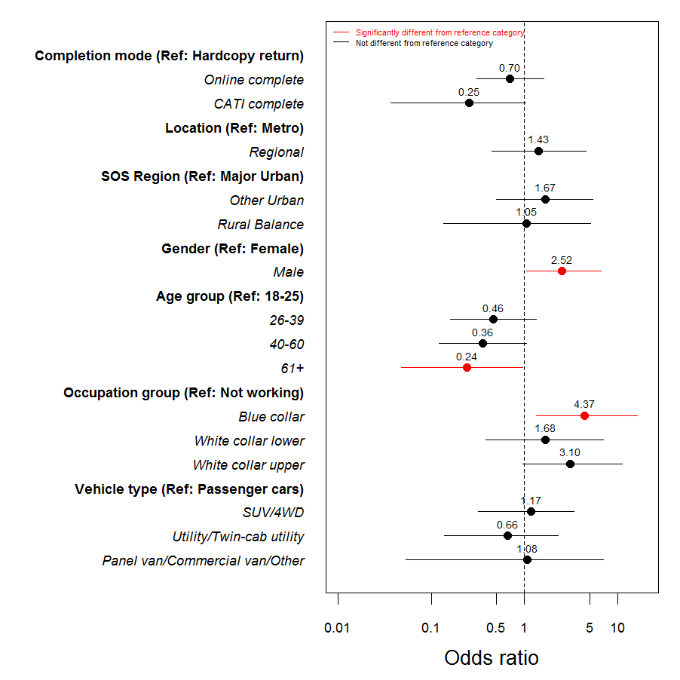

### Perceptions of being caught speeding regression

After accounting for other differences between respondents, only location remained as significantly associated with the propensity to agree that there is a high chance of being caught speeding. Respondents in regional areas were approximately twice as likely to agree compared to those in metropolitan areas. All age groups were more likely to agree than 18-25 year olds, with those aged 26-39 years being significantly more likely.

**Figure 5.6:** Odds ratios for model of *High chance of being caught speeding*

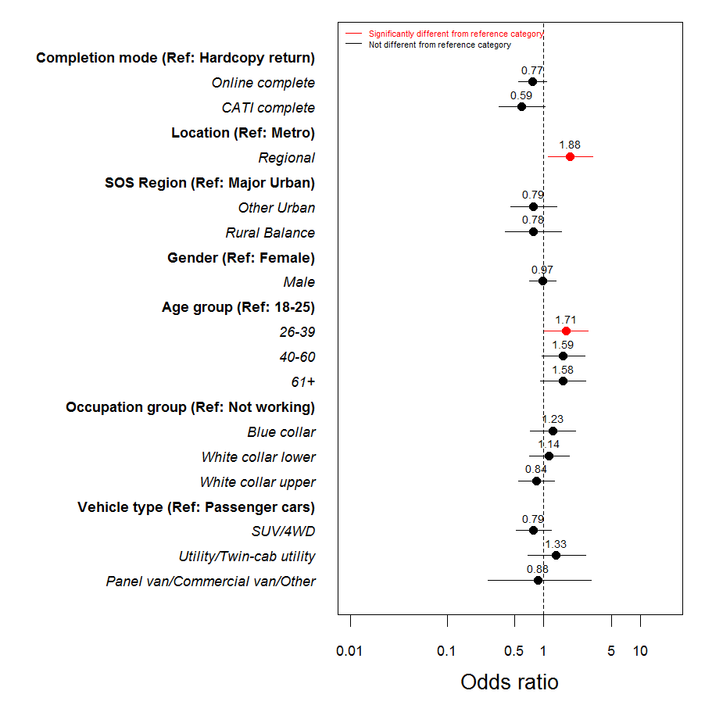

After accounting for other differences between respondents, only age remained as significantly associated with the propensity to agree that it is easy to avoid being caught speeding. Respondents aged 26 years or older were approximately half as likely to agree compared to those aged 18 to 25 years.

**Figure 5.7:** Odds ratios for model of *Easy to avoid being caught while speeding*

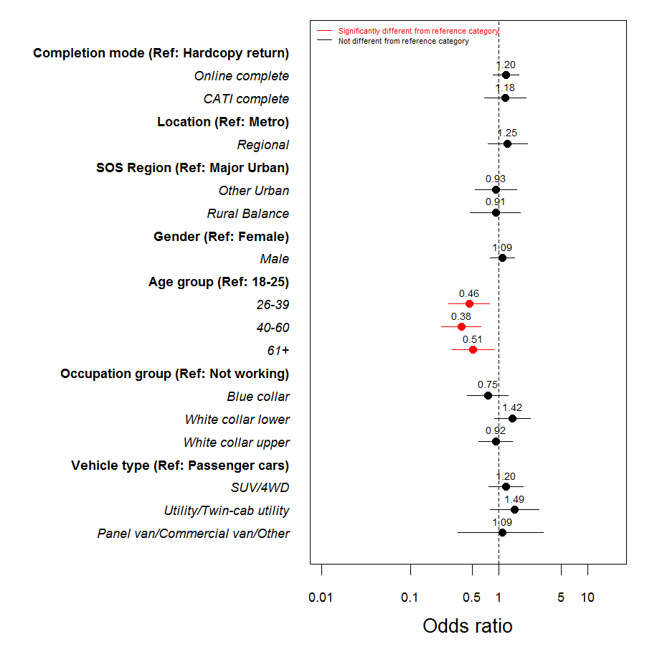

# Impaired driving

## Use of drugs & alcohol

All respondents were asked whether they drink and if they had used recreational drugs in the last twelve months. Figure 6.1 shows that among licence holders aged 18 to 60, around four in five (79%) drink alcohol, while less than one in ten (8%) have used recreational drugs in the last twelve months. While the proportion of those who drink alcohol in 2015 is generally consistent with previous years, there was a significant decrease in the 2014 (74%).

Figure .: Alcohol and drug use* – time series

Base: Licence holders aged 18-60 with a valid response (n=700)



Q21 Do you drink alcohol? [single response]

Q26 Have you used recreational drugs (for example, methamphetamine, ice, marijuana etc.) in the last 12 months? [single response]

*Note: ‘Drug use’ was introduced in 2014

As shown in Table 6.1, males were significantly more likely to drink alcohol (79%) compared to females (72%), while drivers aged 61 and over were significantly *less* likely to drink alcohol (66%) than all other age groups. Although a small proportion admitted to using drugs in the last twelve months, usage was considerably higher among respondents aged 18 to 25 years (16%) than any other age group. It is interesting to note that all respondents who reported using drugs also drank alcohol.

**Table 6.1:** Alcohol and drug use by demographics **(2015)**

|  |  |  |  |  |  |  |  |  |  |
| --- | --- | --- | --- | --- | --- | --- | --- | --- | --- |
|  | Total | Region | | Gender | | Age group | | | |
| 2015M (961) | Metro (695) | Regional (266) | Males  (483) | Females  (470) | 18-25  (135) | 26-39 (248) | 40-60 (330) | 61+ (225) |
|  |  | A | **B** | **C** | **D** | **E** | **F** | **G** | **H** |
| Drinks alcohol | 75% | 74% | 79% | 79% | 72% | 84%  **H** | 79%  **H** | 76%  **H** | 66% |
| Uses drugs | 6% | 7% | 5% | 7% | 6% | 16%  **F,G,H** | 7%  **H** | 5%  **H** | 1% |

Base: All respondents (n=961)

Q21 Do you drink alcohol? [single response]

Q26 Have you used recreational drugs (for example, methamphetamine, ice, marijuana etc.) in the last 12 months? [single response]

Table 6.2 looks at alcohol and drug use by behaviours. The proportion of drivers who drink alcohol was significantly higher among speeders (85%), drowsy drivers (88%) and mobile phone users (85%). It is worth noting that the question about ‘drink driving’ was only asked of those respondents who indicated they drank alcohol. Drivers who participated in any ‘risky’ driving behaviour reported significantly higher levels of drug usage than those who did not participate in ‘risky’ driving behaviours.

**Table 6.2:** Alcohol and drug use **by behaviours (2015)**

|  |  |  |  |  |  |  |  |  |  |  |  |
| --- | --- | --- | --- | --- | --- | --- | --- | --- | --- | --- | --- |
|  | Total | Speeding | | Drink driving | | Drowsy driving | | Phone use | | Road accident | |
| 2015M (961) | Yes (108) | No (838) | Yes (64) | No (650) | Yes (91) | No (856) | Yes (295) | No (662) | Yes (139) | No (815) |
|  |  | A | **B** | **C** | **D** | **E** | **F** | **G** | **H** | **I** | **J** |
| Drinks alcohol | 75% | 85% | 74% | 100% | 100% | 88% | 75% | 85% | 71% | 73% | 76% |
| Uses drugs | 6% | 17% | 5% | 31% | 5% | 14% | 5% | 12% | 4% | 5% | 6% |

Base: All respondents (n=961)

Q21 Do you drink alcohol? [single response]

Q26 Have you used recreational drugs (for example, methamphetamine, ice, marijuana etc.) in the last 12 months? [single response]

## Attitudes to impaired driving

Respondents were asked about their attitudes towards impaired driving (e.g. drink and drug driving). Overall, more than half (57%) of respondents agreed that if they drove, even slightly over the legal limit they were likely to be caught. Around one in five agreed that it was easy to avoid being caught driving over the legal limit (23%) or after using drugs (19%). Less than one ten (9%) respondents agreed that their family and friends thought it was okay to drive slightly over the legal alcohol limit.

Table 6.3 shows that a greater proportion of drivers aged 18 to 25 years (29%) and 61+ years (27%) agreed that it is easy to avoid being caught if driving over the 0.05 limit compared to those aged 40 to 60 years (19%). More regional respondents (64%) agreed they were likely to be caught driving over the legal limit even if it was slightly over compared to metropolitan drivers (55%), fewer drivers aged 18 to 25 years (44%) agreed with this same statement compared to other age groups.

**Table 6.3:** Attitudes to impaired driving (total agree %) by demographics **(2015)**

|  |  |  |  |  |  |  |  |  |  |
| --- | --- | --- | --- | --- | --- | --- | --- | --- | --- |
|  | Total | Region | | Gender | | Age group | | | |
| 2015M (961) | Metro (695) | Regional (266) | Males  (483) | Females  (470) | 18-25  (135) | 26-39 (248) | 40-60 (330) | 61+ (225) |
|  |  | A | **B** | **C** | **D** | **E** | **F** | **G** | **H** |
| Easy to avoid being caught if driving over the 0.05 limit | 23% | 24% | 23% | 23% | 25% | 29%  **G** | 25% | 19% | 27%  **G** |
| If I was driving (slightly) over the (0.05) limit, I am likely to be caught | 57% | 55% | 64% | 57% | 59% | 44% | 57%  **E** | 60%  **E** | 63%  **E** |
| My family and friends think it’s OK to drive slightly over the 0.05 limit | 9% | 9% | 9% | 10% | 9% | 6% | 12% | 7% | 12% |
| It’s easy to avoid being caught if I was driving after using drugs | 19% | 19% | 20% | 18% | 21% | 17% | 22% | 17% | 23% |

Base: All respondents (n=961)

Q29a,b,c,e To what extent do you agree or disagree with the following statements, using a scale of 1 to 5, where 1 is “Strongly disagree” and 5 is “Strongly agree”? [single response]

Table 6.4 looks at attitudes towards impaired driving by behaviours. A higher proportion of drivers who did not participate in ‘risky’ driving behaviours (speeding and drink driving) agreed that they were likely to be caught drink driving, while those who have been involved in a road accident tended to agree more than those not involved in an accident.

**Table 6.4:** Attitudes to impaired driving (total agree %) **by behaviours (2015)**

|  |  |  |  |  |  |  |  |  |  |  |  |
| --- | --- | --- | --- | --- | --- | --- | --- | --- | --- | --- | --- |
|  | Total | Speeding | | Drink driving | | Drowsy driving | | Phone use | | Road accident | |
| 2015M (961) | Yes (108) | No (838) | Yes (64) | No (650) | Yes (91) | No (856) | Yes (295) | No (662) | Yes (139) | No (815) |
|  |  | A | **B** | **C** | **D** | **E** | **F** | **G** | **H** | **I** | **J** |
| Easy to avoid being caught if driving over the 0.05 limit | 23% | 25% | 23% | 28% | 22% | 24% | 23% | 29% | 21% | 26% | 23% |
| If I was driving (slightly) over the (0.05) limit, I am likely to be caught | 57% | 48% | 59% | 39% | 60% | 51% | 58% | 53% | 59% | 68% | 56% |
| My family and friends think it’s OK to drive slightly over the 0.05 limit | 9% | 13% | 9% | 11% | 9% | 13% | 9% | 12% | 8% | 12% | 9% |
| It’s easy to avoid being caught if I was driving after using drugs | 19% | 18% | 20% | 13% | 20% | 15% | 20% | 20% | 19% | 21% | 19% |

Base: All respondents (n=961)

Q29a,b,c,e To what extent do you agree or disagree with the following statements, using a scale of 1 to 5, where 1 is “Strongly disagree” and 5 is “Strongly agree”? [single response]

## Drink and drug driving

### Getting home after drinking

Respondents were asked about the last time they went out and drank alcohol and at what point they decided how they would get home. Consistent with previous waves, nine in ten (93%) licence holders aged 18 to 60 reported that they made plans before they went out drinking, 4% made plans after.

Figure .: Plan for getting home the last time drinking – time series



Base: Licence holders aged 18-60 who drink alcohol and do not always drink at home (n=552)

Q25 Please think about the last time you went out (not at home) and drank alcohol. Did you decide how you would get home…? [single response]

### Breath and drug testing

When asked about breath and drug testing, the proportion of licence holders aged 18 to 60 who reported being drug tested was comparable with previous waves (9%). The proportion who reported being breath tested was consistent with recent years.

Figure .: Drivers tested in the last 12 months – time series

Base: Licence holders aged 18-60 (n=700)



Q37 Over the past 12 months have you been breath tested or been in a car when the driver was breath tested? [single response]

Q39 Over the past 12 months have you been drug tested or been in a car when the driver was drug tested? [single response]

The proportion of drivers aged 61 and over (46%) who reported being breath tested was significantly lower when compared to other age groups. Significantly more metropolitan respondents reported being drug tested in the last twelve months (10%) compared to regional drivers (5%).

**Table 6.5:** Drivers tested in the last 12 months by demographics **(2015)**

|  |  |  |  |  |  |  |  |  |  |
| --- | --- | --- | --- | --- | --- | --- | --- | --- | --- |
|  | Total | Region | | Gender | | Age group | | | |
| 2015M (961) | Metro (695) | Regional (266) | Males  (483) | Females  (470) | 18-25  (135) | 26-39 (248) | 40-60 (330) | 61+ (225) |
|  |  | A | **B** | **C** | **D** | **E** | **F** | **G** | **H** |
| Breath tested in last 12 months | 61% | 59% | 65% | 64% | 58% | 64%  **H** | 70%  **H** | 63%  **H** | 46% |
| Drug tested in last 12 months | 8% | 10% | 5% | 9% | 7% | 11% | 10% | 7% | 7% |

Base: All respondents (n=961)

Q37 Over the past 12 months have you been breath tested or been in a car when the driver was breath tested? [single response]

Q39 Over the past 12 months have you been drug tested or been in a car when the driver was drug tested? [single response]

### Driver or passenger after drinking or drug use

Less than one in ten drivers aged 18 to 60 (7%) reported being a passenger in a car when they knew or suspected the driver was over the legal blood alcohol limit. In comparison, among licence holders aged 18 and 60 years who drink alcohol, one in ten (11%) reported driving when they knew or suspected *they* were over the legal limit. This figure is comparable to 2014 where the proportion returned to 2009 rates. It is worth noting that the proportion of respondents who had driven when they suspected that they were over the limit decreases to 9% when the whole sample is included – this figure is consistent with previous waves.

Questions around drug use and drug driving were introduced in 2014 and are typically applicable to a small proportion of respondents. Of the 60 respondents who reported taken drugs in the last twelve months, 10 indicated that they had driven after taking drugs.

As seen in Table 6.6, while proportions are generally small, respondents aged 18 to 25 years were significantly more likely to report being a passenger when they knew or thought that the driver was over the limit (11%), and driving when they suspected that they were over the limit, compared to older respondents.

**Table 6.6:** Driver & passenger who got into car by demographics **(2015)**

|  |  |  |  |  |  |  |  |  |  |
| --- | --- | --- | --- | --- | --- | --- | --- | --- | --- |
|  | Total | Region | | Gender | | Age group | | | |
| 2015M (961) | Metro (695) | Regional (266) | Males  (483) | Females  (470) | 18-25  (135) | 26-39 (248) | 40-60 (330) | 61+ (225) |
|  |  | A | **B** | **C** | **D** | **E** | **F** | **G** | **H** |
| Been in car when driver over the limit | 6% | 5% | 8% | 6% | 6% | 11%  **G,H** | 8%  **H** | 5%  **H** | 1% |
| Driven over the limit | 9% | 8% | 11% | 10% | 7% | 11%  **H** | 10%  **H** | 12%  **H** | 2% |
| Driven on drugs* | 17% | 19% | 9% | 21% | 12% | 9% | 22% | 22% | - |

Base: Q19 all respondents (n=961); Q22 respondents who drink alcohol (n=724); Q27 respondents who have taken drugs (n=61)

Q19 Have you ever gotten into a car when you knew or thought the driver was over the legal blood alcohol limit over the last 12 months? [single response]

Q22 During the last 12 months, have you driven a car when you knew or thought you were over the legal blood alcohol limit? [single response]

Q27 Have you driven a car after using recreational drugs in the last 12 months? [single response]

*Note: caution should be taken when interpreting drug driving figures due to small sample size (n=61)

Generally speaking, respondents who participated in ‘risky’ driving behaviours were more likely to report being a passenger when they suspected the driver was over the limit, and were more likely to or have themselves driven when they suspected they were over the limit compared to those who do not engage in ‘risky’ driving behaviours.

**Table 6.7:** Driver & passenger who got into car **by behaviours (2015)**

|  |  |  |  |  |  |  |  |  |  |  |  |
| --- | --- | --- | --- | --- | --- | --- | --- | --- | --- | --- | --- |
|  | Total | Speeding | | Drink driving | | Drowsy driving | | Phone use | | Road accident | |
| 2015M (961) | Yes (108) | No (383) | Yes (64) | No (650) | Yes (91) | No (856) | Yes (295) | No (662) | Yes (139) | No (815) |
|  |  | A | **B** | **C** | **D** | **E** | **F** | **G** | **H** | **I** | **J** |
| Been in car when driver over the limit | 6% | 17% | 5% | 37% | 4% | 13% | 5% | 13% | 3% | 6% | 6% |
| Driven over the limit | 9% | 22% | 7% | 100% | - | 17% | 8% | 18% | 4% | 10% | 9% |
| Driven on drugs* | 17% | 28% | 12% | 35% | 6% | 30% | 13% | 17% | 16% | - | 19% |

Base: Q19 all respondents (n=961); Q22 respondents who drink alcohol (n=724); Q27 respondents who have taken drugs (n=61)

Q19 Have you ever gotten into a car when you knew or thought the driver was over the legal blood alcohol limit over the last 12 months? [single response]

Q22 During the last 12 months, have you driven a car when you knew or thought you were over the legal blood alcohol limit? [single response]

Q27 Have you driven a car after using recreational drugs in the last 12 months? [single response]

*Note: caution should be taken when interpreting drug driving figures due to small sample size (n=61)

Respondents who had been a passenger in a car where they knew or thought that the driver was over the limit were asked the main reason they got into the car. Figure 6.4 shows that the main reason for being a passenger was that they believed the driver was capable (26%). Other notable mentions include just wanting to get home (14%) and that the trip was short (10%).

Figure .: Reasons for being a passenger when driver over the legal limit (%) **(2015)**



Base: Respondents who had been a passenger when they thought the driver was over the legal limit (n=57)

Q20 What was the main reason you got into a car when you knew or thought the driver was over the over the legal blood alcohol limit? [multiple response]

Respondents were also asked the main reason why they *drove* while over the legal limit. As seen in Figure 6.5, a quarter of respondents drove because they ‘just wanted to get home’ (25%), a further 20% drove because it was a short trip. One in ten (11%) respondents claimed that there was no other method to get home.

Figure .: Reasons for driving when over the legal limit (%) **(2015)**

Base: Respondents who had driven when they thought the driver was over the legal limit (n=64)



Q23 What was the main reason for you driving a car when you knew or thought you were over the legal limit? [multiple response]

The small group who had driven on drugs (n=10) were asked to provide the main reason why they had done so. The responses provided by those who had used drugs were similar to those that had driven after consuming alcohol. A sample of responses is provided below:

* *“Was the next day, didn’t think I would still have it in my system.”*
* *“Still felt in control to drive.”*
* *“To get home.”*

In the 2015 ‘Pulse’ RSM, a question was introduced which asked respondents how many times in the last four weeks they had driven a car after drinking when they knew or thought they were **under** the limit. More than half (53%) of respondents reported that they had not driven after drinking even if they thought they were under the limit in the ‘Pulse’, increasing marginally to 57% in the 2015 ‘Main’. Just over a quarter (26%) reported driving 1 to 3 times. A small proportion (5%) reported having not driven a car at all in the last four weeks.

Figure .: Number of times driven under the limit (%) (2015 Pulse and Main)

Base: All respondents (n=961)



Q24 How many times have you driven a car after drinking when you knew or thought you were **under** the legal blood alcohol limit in the last four weeks?

## Regression analysis (drink driving)

### Self-reported drink driving regression

After accounting for other differences, there remained some significant effects across gender, age group and vehicle type in terms of the propensity to drive while over the legal limit:

* Males were more than twice as likely as females to have driven while drunk in the past year;
* Respondents aged 61 or older were less likely to have driven while drunk than those aged 18 to 25 years; and
* SUV/4WD drivers were less likely to have driven while drunk compared to drivers of passenger cars.

Figure .: Odds ratios for model of Drink driving

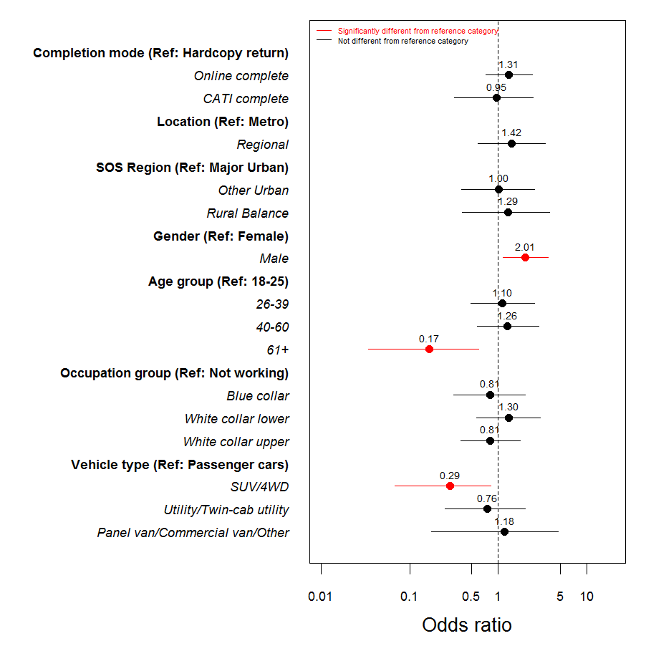

### Perceptions of being caught driving over 0.05 regression

After accounting for other differences between respondents, only age remained as significantly associated with the propensity to agree that it is easy to avoid being caught while driving over the 0.05 limit. Respondents aged 40-60 years were approximately half as likely to be in this category compared to those aged 18-25 years.

**Figure 6.8:** Odds ratios for model of *Easy to avoid being caught while driving over 0.05 limit*

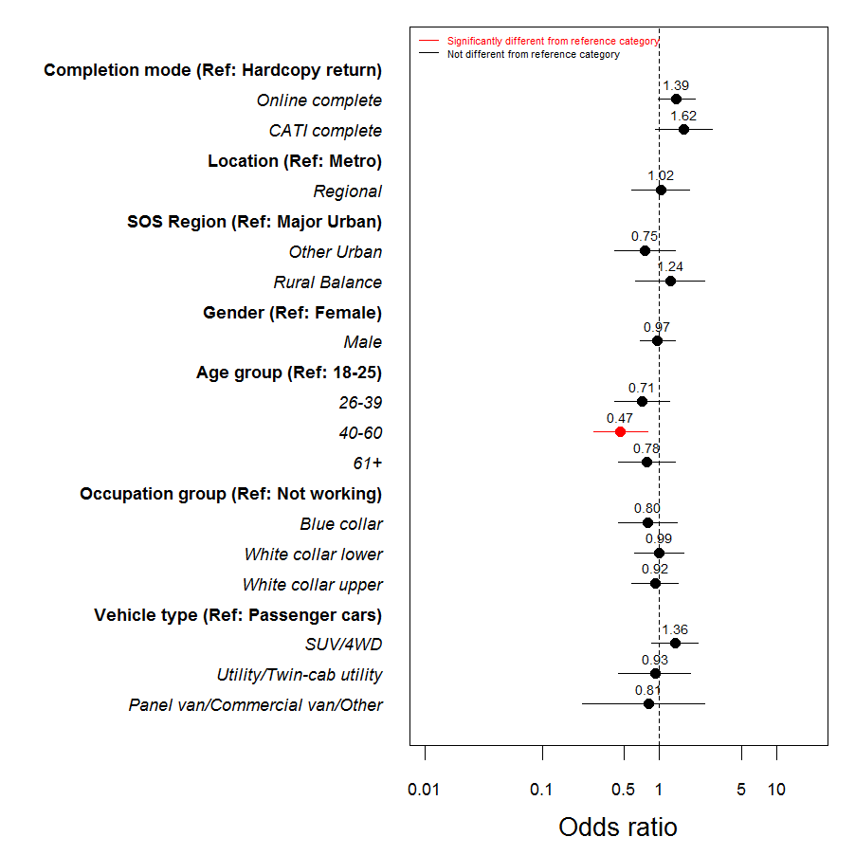

After accounting for other differences between respondents, only age remained as significantly associated with the propensity to agree that there is a high chance of being caught while driving over the legal limit. Respondents aged 40-60 years were approximately twice as likely to agree compared to those aged 18-25 years.

**Figure 6.9:** Odds ratios for model of *High change of being caught while driving over 0.05 limit*

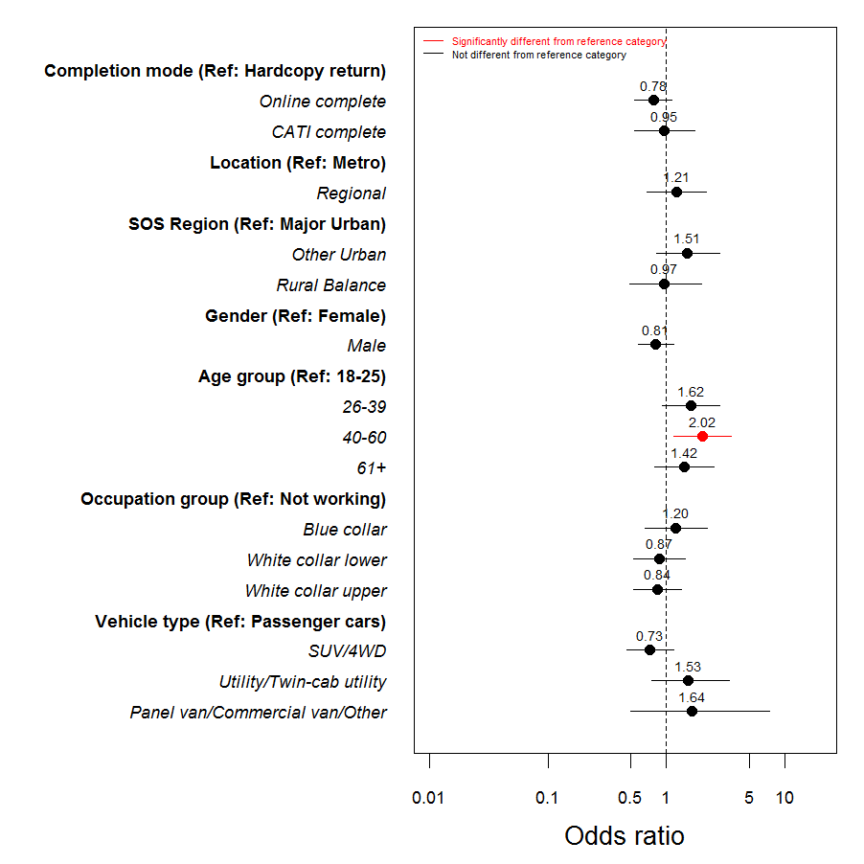

# Drowsy driving

## Regular drowsy driving

In 2013 a question was introduced which asked respondents if they regularly drove while drowsy (at least once a week). As seen in Figure 7.1, the proportion of respondents who report regularly driving while drowsy has gradually declined from 18% in 2013 to 9% in 2015.

Figure .: Regularly driving while drowsy (2013 to 2015 total sample)



Base: All respondents (n=960)

Q17 Do you find yourself regularly (at least once a week) driving while drowsy? [single response]

There were no demographic differences in drowsy driving according to region or gender. However, a greater proportion of young respondents (aged 18 to 25 years) reported driving while drowsy regularly (19%) compared to those aged 40 to 60 years (9%) and aged 61 and over years (1%). Older drivers (aged 61+) were the least likely group to regularly drive while drowsy.

**Table 7.1:** Regularly driving while drowsy by demographics **(2015)**

|  |  |  |  |  |  |  |  |  |  |
| --- | --- | --- | --- | --- | --- | --- | --- | --- | --- |
|  | Total | Region | | Gender | | Age group | | | |
| 2015M (960) | Metro (694) | Regional (266) | Males  (482) | Females  (470) | 18-25  (135) | 26-39 (248) | 40-60 (329) | 61+ (225) |
|  |  | A | **B** | **C** | **D** | **E** | **F** | **G** | **H** |
| Regularly driving while drowsy | 9% | 9% | 10% | 10% | 9% | 19%  **G,H** | 13%  **H** | 9%  **H** | 1% |

Base: All respondents (n=960)

Q17 Do you find yourself regularly (at least once a week) driving while drowsy? [single response]

As can be seen in Table 7.2, those who engage in certain ‘risky’ driving behaviours have a higher tendency to engage in multiple behaviours. Significantly more speeders (19%), drink drivers (22%), and mobile phone users (18%) regularly drove while drowsy compared to non-speeders (8%), non-drink drivers (10%), and those who did not use their phone (6%).

**Table 7.2:** Regularly driving while drowsy **by behaviours (2015)**

|  |  |  |  |  |  |  |  |  |  |  |  |
| --- | --- | --- | --- | --- | --- | --- | --- | --- | --- | --- | --- |
|  | Total | Speeding | | Drink driving | | Drowsy driving | | Phone use | | Road accident | |
| 2015M (960) | Yes (108) | No (838) | Yes (64) | No (650) | Yes (91) | No (856) | Yes (295) | No (662) | Yes (138) | No (815) |
|  |  | A | **B** | **C** | **D** | **E** | **F** | **G** | **H** | **I** | **J** |
| Regularly driving while drowsy | 9% | 19% | 8% | 22% | 10% | 100% | - | 18% | 6% | 11% | 9% |

Base: All respondents (n=960)

Q17 Do you find yourself regularly (at least once a week) driving while drowsy? [single response]

The main reasons that respondents provided for regularly driving while feeling drowsy are presented in Figure 7.2. It can be seen that the requirement for work (36%) and the desire to ‘just get home’ (32%) accounted for the majority of mentions. More than a quarter (27%) stated that they ‘had to travel somewhere’ but no further information was provided.

Figure .: Why drove while drowsy (%) (2015)

Base: Respondents who regularly drive while drowsy (n=91)



Q18 Thinking about the last time you drove while drowsy, what was the main reason you did this? [single response]

## Attitudes to drowsy driving

Overall, around a third (34%) of respondents agreed that they found it easy to keep themselves awake if they needed to drive. Table 7.3 shows attitudes towards drowsy driving by demographics. A greater proportion of drivers aged 18 to 25 years (45%) and 26 to 39 years (41%) agreed that it is easy to keep themselves awake if they need to drive compared to those aged 61 or over (32%).

**Table 7.3:** Attitudes to drowsy driving (total agree and mean) by demographics **(2015)**

|  |  |  |  |  |  |  |  |  |  |
| --- | --- | --- | --- | --- | --- | --- | --- | --- | --- |
|  | Total | Region | | Gender | | Age group | | | |
| 2015M (961) | Metro (695) | Regional (266) | Males  (483) | Females  (470) | 18-25  (135) | 26-39 (248) | 40-60 (330) | 61+ (225) |
|  |  | A | **B** | **C** | **D** | **E** | **F** | **G** | **H** |
| It’s easy to keep myself awake if I need to drive | 34% | 36% | 31% | 33% | 36% | 45%  **G,H** | 41%  **G** | 27% | 32% |

Base: All respondents (n=961)

Q29d To what extent do you agree or disagree with the following statements, using a scale of 1 to 5, where 1 is “Strongly disagree” and 5 is “Strongly agree”? [single response]

Q8 Using a scale where 0 is not dangerous at all and 10 is extremely dangerous, how dangerous do you think it is to… [single response]

While few differences were recorded in the extent of agreement with the statement “it’s easy to keep myself awake if I need to drive” according to the various driving behaviour groups, there were significant differences in the perceived level of danger associated with driving while drowsy.

**Table 7.4:** Attitudes to drowsy driving (total agree %) **by behaviours (2015)**

|  |  |  |  |  |  |  |  |  |  |  |  |
| --- | --- | --- | --- | --- | --- | --- | --- | --- | --- | --- | --- |
|  | Total | Speeding | | Drink driving | | Drowsy driving | | Phone use | | Road accident | |
| 2015M (961) | Yes (108) | No (838) | Yes (64) | No (650) | Yes (91) | No (856) | Yes (442) | No (515) | Yes (139) | No (815) |
|  |  | A | **B** | **C** | **D** | **E** | **F** | **G** | **H** | **I** | **J** |
| It’s easy to keep myself awake if I need to drive | 34% | 34% | 34% | 38% | 33% | 43% | 33% | 36% | 34% | 38% | 34% |

Base: All respondents (n=961)

Q29d To what extent do you agree or disagree with the following statements, using a scale of 1 to 5, where 1 is “Strongly disagree” and 5 is “Strongly agree”? [single response]

Q8 Using a scale where 0 is not dangerous at all and 10 is extremely dangerous, how dangerous do you think it is to… [single response]

## Regression analysis (drowsy driving)

After accounting for other characteristics, the likelihood of driving while drowsy was:

* Significantly lower for all age groups compared to those aged 18 to 25 years; and
* Significantly higher for ‘blue collar’ workers compared to those who were not working.

Figure .: Odds ratios for model of *Drowsy driving*

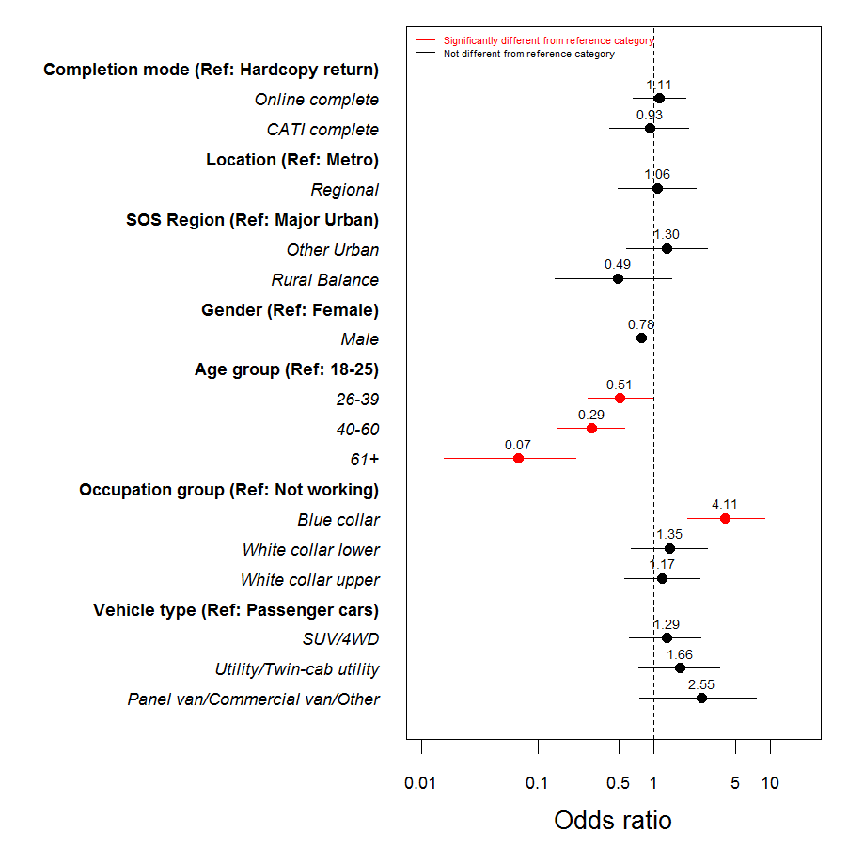

# Distractions

## Distractions while driving

Respondents were asked whether or not they had used a handheld mobile phone within the last month. Among licence holders aged 18 to 60 years, just over half (55%) admitted to using a mobile phone while driving in the last month. As can be seen in Figure 8.1, since 2011 the use of a handheld mobile phone has been gradually declining.

Figure .: Use of handheld mobile while driving – time series



Base: Licence holders aged 18-60 years (n=698)

Q30 During the last month, have you used a HANDHELD mobile phone? [single response]

Respondents were also asked whether or not they had been distracted by other factors in the last week. As seen in previous years, the most common distraction was other drivers (40%), followed by ‘your own thoughts’ (36%). Compared to 2014, there was a significant drop in mentions of street signs (20%).

Figure .: Distractions while driving (multiple response) (2013 to 2015 total sample)

Base: All respondents (n=961)



Q34 In the last week, have you been distracted while driving by any of the following? [multiple response]

Overall, a large proportion of respondents agreed that taking their eyes off the road for two seconds is dangerous (88%) and drivers can ignore their phone if a message or call arrives while driving (87%). Almost two in ten (18%) drivers agree that their family and friends think it is okay to use a mobile phone without a hands free kit.

As seen in Table 8.1, significantly more females agreed that taking their eyes off the road for two seconds is dangerous (91%) compared to males (86%). Also, a significantly greater proportion of drivers aged 18 to 25 years agreed that they could ignore their phone if a message or call arrived while they were driving (91%) compared to those aged 26 to 39 (82%); and that their family and friends think it is okay to use a mobile phone without a hands free kit (24%) compared to those aged 40 to 60 (15%).

Table .: Attitudes to distracted driving (total agree %) by demographics (2015)

|  |  |  |  |  |  |  |  |  |  |
| --- | --- | --- | --- | --- | --- | --- | --- | --- | --- |
|  | Total | Region | | Gender | | Age group | | | |
| 2015M (961) | Metro (695) | Regional (266) | Males  (483) | Females  (470) | 18-25  (135) | 26-39 (248) | 40-60 (330) | 61+ (225) |
|  |  | A | **B** | **C** | **D** | **E** | **F** | **G** | **H** |
| Taking my eyes off the road for two seconds is dangerous | 88% | 88% | 87% | 86% | 91% | 87% | 90% | 89% | 85% |
| I can ignore my mobile phone if a message or call arrives while I am driving | 87% | 87% | 87% | 85% | 89% | 91%  **F** | 82% | 88% | 88% |
| My family and friends think it is ok to use a mobile phone without using a hands free kit | 18% | 18% | 19% | 19% | 17% | 24%  **G** | 20% | 15% | 18% |

Base: All respondents (n=961)

Q33 To what extent do you agree or disagree with the following statements, using a scale of 1 to 5, where 1 is “Strongly disagree” and 5 is “Strongly agree”? [single response]

As seen in Table 8.2, those who reported speeding above the posted or their own speed limit were less likely to agree that taking their eyes off the road is dangerous (82%) and that they can ignore their phone while driving (80%) compared to those who do not speed (89% and 88% respectively). Also, a significantly greater proportion of drivers who did not drive while drowsy who agreed that taking their eyes off the road for a couple of seconds was dangerous (89%) compared to those who regularly drove while drowsy (81%). As expected, phone users were less likely to agree that they can ignore their phone while driving (77% compared to 91%).

Table .: Attitudes to distracted driving (total agree %) by behaviours (2015)

|  |  |  |  |  |  |  |  |  |  |  |  |
| --- | --- | --- | --- | --- | --- | --- | --- | --- | --- | --- | --- |
|  | Total | Speeding | | Drink driving | | Drowsy driving | | Phone use | | Road accident | |
| 2015M (961) | Yes (108) | No (838) | Yes (64) | No (650) | Yes (91) | No (856) | Yes (295) | No (662) | Yes (139) | No (815) |
|  |  | A | **B** | **C** | **D** | **E** | **F** | **G** | **H** | **I** | **J** |
| Taking my eyes off the road for two seconds is dangerous | 88% | 82% | 89% | 89% | 87% | 81% | 89% | 86% | 89% | 90% | 88% |
| I can ignore my mobile phone if a message or call arrives while I am driving | 87% | 80% | 88% | 81% | 87% | 84% | 88% | 77% | 91% | 83% | 88% |
| My family and friends think it is ok to use a mobile phone without using a hands free kit | 18% | 24% | 18% | 25% | 17% | 24% | 18% | 21% | 17% | 16% | 18% |

Base: All respondents (n=961)

Q33 To what extent do you agree or disagree with the following statements, using a scale of 1 to 5, where 1 is “Strongly disagree” and 5 is “Strongly agree”? [single response]

## Mobile phone use

Respondents were asked how they used their phone to make or answer calls when driving. Four in ten (42%) respondents reported that they did not use their phone at all while driving. A further 41% reported that they normally used a hands free kit – this represents a significant increase from 2014 (34%).

Figure .: Normal phone use in car (%) (2012 to 2015 total sample)

Base: All respondents (n=961)



Q31 When you use your phone to make or answer calls while driving, do you normally …[single response]

As with previous years, there were a number of differences in phone answering behaviour according to demographic groups. Some notable differences include:

* Male drivers were more likely to hold the phone to their ear (4% vs. 1%), while females were more likely to put the phone on their lap or console (16% vs 10%).
* Drivers aged 18 to 39 years were more likely to place the phone on their lap or console.
* Metropolitan drivers use a hands free device such as Bluetooth compared to regional drivers (44% vs. 34%), and regional drivers were most likely to report not answering their phone while driving (49% vs. 39%).
* Drivers aged 61+ (71%) were the most likely group to report not answering or making calls while driving.

Table .: Normal phone use in car by demographics (2015)

|  |  |  |  |  |  |  |  |  |  |
| --- | --- | --- | --- | --- | --- | --- | --- | --- | --- |
|  | Total | Region | | Gender | | Age group | | | |
| 2015M (961) | Metro (695) | Regional (266) | Males  (483) | Females  (470) | 18-25  (135) | 26-39 (248) | 40-60 (330) | 61+ (225) |
|  |  | A | **B** | **C** | **D** | **E** | **F** | **G** | **H** |
| Hold phone to/away from ear | 3% | 3% | 3% | 4% | 2% | 1% | 4% | 3% | 2% |
| Put phone in lap or on console | 13% | 13% | 13% | 10% | 16% | 26%  **G,H** | 24%  **G,H** | 7% | 3% |
| Only use hands free kit such as Bluetooth | 41% | 44% | 34% | 43% | 39% | 28% | 54%  **E,H** | 49%  **E,H** | 21% |
| I never make or answer call while driving | 42% | 39% | 49% | 42% | 42% | 44%  **F** | 17% | 40%  **F** | 71%  **E,F,G** |

Base: All respondents (n=961)

Q31 When you use your phone to make or answer calls while driving, do you normally… [single response]

Table 8.4 looks at phone use by driving behaviour. Of those who had used a mobile phone while driving in the last month, 40% indicated that when they use their phone to make or answer calls while driving they normally put the phone in their lap or on the console. Speeders (26%), drink drivers (31%), and drowsy drivers (23%) also reported higher levels of using a phone by placing it on their lap or console than those who did not speed (11%), drink drive (13%) or drive while drowsy (12%).

Table .: Normal phone use in car by behaviours (2015)

|  |  |  |  |  |  |  |  |  |  |  |  |
| --- | --- | --- | --- | --- | --- | --- | --- | --- | --- | --- | --- |
|  | Total | Speeding | | Drink driving | | Drowsy driving | | Phone use | | Road accident | |
| 2015M (961) | Yes (108) | No (838) | Yes (64) | No (650) | Yes (91) | No (856) | Yes (295) | No (662) | Yes (139) | No (815) |
|  |  | A | **B** | **C** | **D** | **E** | **F** | **G** | **H** | **I** | **J** |
| Hold phone to/away from ear | 3% | 5% | 3% | 5% | 4% | 4% | 3% | 8% | 1% | 6% | 2% |
| Put phone in lap or on console | 13% | 26% | 11% | 31% | 13% | 23% | 12% | 40% | 1% | 16% | 12% |
| Only use hands free kit such as Bluetooth | 41% | 50% | 40% | 47% | 44% | 59% | 39% | 44% | 40% | 48% | 40% |
| I never make or answer call while driving | 42% | 18% | 45% | 17% | 38% | 14% | 45% | 6% | 58% | 29% | 44% |

Base: All respondents (n=961)

Q31 When you use your phone to make or answer calls while driving, do you normally… [single response]

Respondents were also asked if they had used their phone in the last month to answer calls, make calls, and text in various driving situations. As seen in Table 8.5, around one in five (22%) respondents had answered a call but used their lap or the in-built speaker; with around 18% who had answered a call while stopped at the lights (18%). Less than one in ten (9%) had used their phone to make a call while actively driving.

Metropolitan (20%) respondents were more likely to answer a call while stopped at the lights compared to regional respondents (13%). Older adults (aged 61+) were less likely than all other age groups to use their phone for calls while driving in any situation.

Table .: Use of handheld mobile for calls in car by demographics (2015)

|  |  |  |  |  |  |  |  |  |  |
| --- | --- | --- | --- | --- | --- | --- | --- | --- | --- |
|  | Total | Region | | Gender | | Age group | | | |
| 2015M (961) | Metro (695) | Regional (266) | Males  (483) | Females  (470) | 18-25  (135) | 26-39 (248) | 40-60 (330) | 61+ (225) |
|  |  | A | **B** | **C** | **D** | **E** | **F** | **G** | **H** |
| To answer a call while stopped at the lights | 18% | 20% | 13% | 19% | 17% | 27%  **G,H** | 25%  **G,H** | 16%  **H** | 9% |
| To make a call while stopped at the lights | 13% | 14% | 9% | 13% | 12% | 21%  **G,H** | 19%  **G,H** | 12%  **H** | 2% |
| To answer a call but phone on lap and used in-built speaker | 22% | 22% | 20% | 20% | 23% | 36%  **G,H** | 37%  **G,H** | 16%  **H** | 5% |
| To make a call but phone on lap and used in-built speaker | 14% | 15% | 14% | 14% | 15% | 26%  **G,H** | 27%  **G,H** | 10%  **H** | 2% |
| To answer a call while actively driving | 16% | 16% | 17% | 18% | 15% | 22%  **H** | 22%  **H** | 16%  **H** | 8% |
| To make a call while actively driving | 9% | 9% | 9% | 10% | 7% | 14%  **G,H** | 13%  **G,H** | 8%  **H** | 2% |

Base: All respondents (n=961)

Q30a, c, e, f, i, j During the last month, have you used a HANDHELD mobile phone [single response]

As seen in Table 8.6 around a third (34%) of respondents read a text message while stopped at the lights, while less than two in ten (18%) sent a message while stopped at the lights. One in ten (10%) actively read a message while driving while only 5% sent a message while actively driving.

Females (40%) were more likely than males (28%) to read a text while stopped at the lights, while males (12%) were more likely than females (8%) to read a text while actively driving. Texting while stopped at the lights was more common among metropolitan respondents; in contrast, regional respondents were more likely to read a text while actively driving. Again, older adults were the least likely group to text while driving in any situation.

Table .: Use of handheld mobile for texting in car by demographics (2015)

|  |  |  |  |  |  |  |  |  |  |
| --- | --- | --- | --- | --- | --- | --- | --- | --- | --- |
|  | Total | Region | | Gender | | Age group | | | |
| 2015M (961) | Metro (695) | Regional (266) | Males  (483) | Females  (470) | 18-25  (135) | 26-39 (248) | 40-60 (330) | 61+ (225) |
|  |  | A | **B** | **C** | **D** | **E** | **F** | **G** | **H** |
| To read a text message while stopped at the lights | 34% | 36% | 27% | 28% | 40% | 47%  **G,H** | 53%  **G,H** | 31%  **H** | 10% |
| To write and send a text message while stopped at the lights | 18% | 20% | 13% | 18% | 19% | 31%  **G,H** | 31%  **G,H** | 15%  **H** | 1% |
| To read a text message while actively driving | 10% | 9% | 14% | 12% | 8% | 18%  **G,H** | 14%  **H** | 11%  **H** | 2% |
| To write and send a text message while actively driving | 5% | 5% | 6% | 6% | 4% | 9%  **H** | 8%  **H** | 5%  **H** | - |

Base: All respondents (n=961)

Q30b,d,g,h During the last month, have you used a HANDHELD mobile phone? [single response]

## Regression analysis (phone use while driving)

The results for mobile phone use while driving are presented below:

* Regional respondents were significantly less likely than metropolitan respondents to driving while using a phone;
* Older respondents (aged 40 years and over) were significantly less likely to use their mobile while driving than those aged 18 to 25 years;
* Respondents in ‘white collar upper’ occupations were almost twice as likely as those who were not working to state that they used their mobile while driving; and
* Respondents who drove a panel, commercial or other sort of van were more than two times as likely to use a mobile phone compared to sedan drivers.

**Figure 8.4:** Odds ratios for model of mobile phone use while driving



# Vehicle ownership & purchasing

## Vehicle ownership

Respondents were asked about ownership of the car they usually drove. Figure 9.1 shows that around eight in ten (79%) respondents personally owned the car they drove, with a further 10% reporting that the car they drove was owned by someone within their household. A small proportion (2%) did not own or drive a car.

Notable differences in terms of vehicle ownership by demographics include:

* Females were more likely to own the car they drove compared to males (84% vs. 74%).
* Older drivers (61 year and over) reported owning their car more than any other age group (90%).
* Young drivers aged 18 to 25 years were most likely to be driving a car that was owned by someone else in the household (32%) compared to all other ages.
* Male drivers were more likely to have both a company and personal car compared to females (8% compared to 1%).

Figure .: Car ownership (%) (2015)

Base: All respondents (n=961)



Q48 Which of the following statements best describe the car (not motorcycle or truck) you usually drive? Personally owned includes cars that are under finance or leased. [single response]

Respondents were asked to provide the make, model and year of car they drove. The most common makes in 2015 were Toyota (19%), Holden (15%), Ford (11%) and Mazda (8%). Regional drivers were more likely to drive a Ford (16%), while metropolitan drivers were more likely to drive a Honda (6%) or Volkswagen (5%). Males tended to drive a Holden (19%) and females were most commonly driving a Mazda (10%) or a Hyundai (8%).

Table .: Most common makes of car by demographics (top 10) (2015)

|  |  |  |  |  |  |  |  |  |  |
| --- | --- | --- | --- | --- | --- | --- | --- | --- | --- |
|  | Total | Region | | Gender | | Age group | | | |
| 2015M (937) | Metro (675) | Regional (262) | Males  (469) | Females  (460) | 18-25  (127) | 26-39 (241) | 40-60 (324) | 61+ (223) |
|  |  | A | **B** | **C** | **D** | **E** | **F** | **G** | **H** |
| Toyota | 19% | 18% | 21% | 19% | 19% | 24%  **G** | 17% | 15% | 22% |
| Holden | 15% | 14% | 18% | 19% | 10% | 16% | 16% | 15% | 14% |
| Ford | 11% | 9% | 16% | 11% | 11% | 9% | 8% | 15%  **F** | 10% |
| Mazda | 8% | 8% | 6% | 6% | 10% | 8% | 8% | 8% | 7% |
| Hyundai | 6% | 7% | 5% | 5% | 8% | 5% | 5% | 6% | 11%  **F,G** |
| Mitsubishi | 6% | 6% | 7% | 6% | 5% | 6% | 8% | 5% | 5% |
| Nissan | 6% | 6% | 7% | 6% | 6% | 3% | 8% | 6% | 4% |
| Honda | 5% | 6% | 2% | 5% | 5% | 7%  **G** | 7%  **G** | 2% | 7%  **G** |
| Volkswagen | 4% | 5% | 1% | 4% | 3% | 4% | 4% | 5% | 2% |
| Subaru | 3% | 3% | 2% | 2% | 4% | 1% | 4% | 3% | 2% |

Base: Respondents who do drive a car (n=937)

Q49 What type of car do you usually drive? [single response]

Respondents were also asked about the importance of the car they drove. A small proportion (7%) felt that their car was everything to them, while around a third (34%) felt their car was important to them but not everything. Around a quarter (28%) said they cared a little but not all that much, while a further 20% reported that they don’t mind.

Figure .: Importance of car to respondent (2015)



Base: All respondents (n=961)

Q46 Which of the following statements best describes how important the type of car you drive is to you? [single response]

### Household vehicles

Respondents were asked about any registered vehicles were at their home address. Table 9.2 presents the mean number of vehicles in a household by demographics. Overall, there was an average of 2.18 cars per household, an average of 0.20 motorbikes and 0.07 trucks or buses per household.

Generally, regional properties were more likely to have a truck or bus registered (0.17) than metropolitan areas (0.03). The average number of cars was considerably higher among drivers aged 18 to 25 years (2.95) than any other age group. Drivers aged 61 or over were less likely than other age groups to have vehicles registered.

Table .: Mean number of vehicles in household by demographics (2015)

|  |  |  |  |  |  |  |  |  |  |
| --- | --- | --- | --- | --- | --- | --- | --- | --- | --- |
|  | Total | Region | | Gender | | Age group | | | |
| 2015M (961) | Metro (695) | Regional (266) | Males  (483) | Females  (470) | 18-25  (135) | 26-39 (248) | 40-60 (330) | 61+ (225) |
|  |  | A | **B** | **C** | **D** | **E** | **F** | **G** | **H** |
| Cars | 2.18 | 2.18 | 2.20 | 2.16 | 2.22 | 2.95  **F,G,H** | 2.09  **H** | 2.25  **H** | 1.80 |
| Trucks or buses | 0.07 | 0.03 | 0.17 | 0.07 | 0.07 | 0.07 | 0.07 | 0.08 | 0.06 |
| Motorbikes | 0.20 | 0.19 | 0.23 | 0.22 | 0.18 | 0.22 | 0.16 | 0.25 | 0.14 |

Base: All respondents (n=961)

Q47 How many of each of the following types of registered vehicles are there at your home address? [numeric]

### Forms of transport

In addition to using a car, respondents were asked the frequency of which they use different forms of transport. As anticipated, the vast majority use a car daily as a driver (71%), with around one in three reporting that they walked daily (34%). The least frequent forms of transport were riding a motorcycle (84% ‘never’) and driving a truck (85% ‘never’).

Figure .: Forms of transport (2015)

Base: All respondents (n=961)



Q64 How often do you use the following forms of transport? [single response]

## Purchasing behaviour

### Intent to buy

Respondents were asked about their intent regarding a future vehicle purchase. Consistent with previous waves, around four in ten (41%) reported that they intended to purchase a car in the future, with 18% intending to purchase in the next twelve months.

Figure .: Future car purchase intent – time series

Base: Licence holders aged 18-60 (n=700)



Q51 Are you planning to purchase a car in future? [single response]

Similar to previous years, around two in five respondents who were planning to purchase a vehicle in the future were planning to purchase a used car (43%). Whereas around one in three (34%) were planning to purchase a new car.

Figure .: New versus used car purchase intent – time series



Base: Respondents who plan to purchase a car aged 18-60 (n=286)

Q52 Do you intend to buy a new or used car? [single response]

Figure 9.6 illustrates the type of vehicle that respondents indicated that they planned to purchase in the future. The most commonly mentioned vehicle types were a sedan (34%), followed by an SUV/4WD (31%). Less than one in ten planned to purchase a twin-cab utility (6%), wagon (5%) or utility (2%) while a further 15% had not yet made a decision.

Figure .: Type of car purchase (2015)



Base: Respondents who plan to purchase a car (n=339)

Q54 What type of vehicle are you planning to buy in the future? [single response]

### Factors influencing selection

Once a budget had been set, respondents were asked to rate the importance of features that would influence their vehicle selection from a scale of 1 (not important at all) to 5 (very important). The condition of the vehicle (4.8) and the safety features of the vehicle (4.5) were considered the most important features that influenced vehicle selection decision, while the towing or load capacity rated as the least important influencing factor (2.7).

Figure .: Factors influencing vehicle selection (mean) (2015)



Base: Respondents who may purchase a car (n=517)

Q56 Once you have decided your budget, please give each of the following factors a score out of five (with 1 being not important at all and 5 being very important) [single response]

Female respondents tended to place a higher level of importance on vehicle condition (4.8), fuel economy (4.3), safety features (4.7) and transmission type (4.3); whereas males felt that power / performance of the vehicle was of greater importance (3.5). Drivers in metropolitan areas placed a greater emphasis on the manufacturer (3.4) and style (3.6), while those in regional areas were more concerned with fuel economy (4.3). Older age groups tended to place greater importance on most areas compared to younger drivers.

Table .: Factors influencing vehicle selection (mean) by demographics (2015)

|  |  |  |  |  |  |  |  |  |  |
| --- | --- | --- | --- | --- | --- | --- | --- | --- | --- |
|  | Total | Region | | Gender | | Age group | | | |
| 2015M (961) | Metro (389) | Regional (131) | Males  (276) | Females  (243) | 18-25  (98) | 26-39 (158) | 40-60 (163) | 61+ (90) |
|  |  | A | **B** | **C** | **D** | **E** | **F** | **G** | **H** |
| Condition of the vehicle | 4.8 | 4.8 | 4.9 | 4.7 | 4.8 | 4.7 | 4.7 | 4.8 | 4.8 |
| Features of vehicle | 4.1 | 4.1 | 4.1 | 4.0 | 4.2 | 3.7 | 4.1  **E** | 4.1  **E** | 4.5  **E,F,G** |
| Fuel economy / fuel cost | 4.2 | 4.1 | 4.3 | 4.1 | 4.3 | 4.0 | 4.2 | 4.2 | 4.3  **E** |
| Manufacturer | 3.3 | 3.4 | 3.1 | 3.3 | 3.2 | 3.0 | 3.4  **E** | 3.4  **E** | 3.3 |
| Power / performance | 3.4 | 3.4 | 3.3 | 3.5 | 3.3 | 3.3 | 3.4 | 3.5 | 3.3 |
| Safety features of the vehicle | 4.5 | 4.5 | 4.6 | 4.4 | 4.7 | 4.5 | 4.6 | 4.5 | 4.6 |
| Size of vehicle | 3.8 | 3.9 | 3.7 | 3.8 | 3.9 | 3.1 | 4.0  **E** | 4.0  **E** | 3.9  **E** |
| Style / appearance / image | 3.5 | 3.6 | 3.3 | 3.6 | 3.5 | 3.5 | 3.6 | 3.5 | 3.5 |
| Transmission type | 4.1 | 4.1 | 4.1 | 3.9 | 4.3 | 3.9 | 4.0 | 4.0 | 4.7  **E,F,G** |
| Type of vehicle | 4.0 | 4.0 | 3.8 | 3.9 | 4.0 | 3.5 | 4.0  **E** | 4.1  **E** | 4.0  **E** |
| Towing or load carrying capacity | 2.7 | 2.6 | 2.9 | 2.8 | 2.6 | 2.0 | 2.8  **E** | 3.0  **E** | 2.6  **E** |

Base: Respondents who may purchase a car (n=520)

Q56 Once you have decided on your budget, please give each of the factors a score out of five (with 1 being not important at all and 5 being very important) [single response]

When asked specifically about the importance of various safety factors, airbags (including driver and passenger frontal (4.6), side curtain (4.3) and side airbags (4.3)) were considered the most important safety features. Lane departure warnings were considered least important on average (3.5).

Figure .: Safety factors influencing vehicle selection (mean) (2015)

Base: Respondents who may purchase a car (n=525)



Q57 From this list, please give each of the features a score out of five (with 1 being not important at all and 5 being very important) [single response]

Respondents who were planning to purchase a car in the future were also asked if they would consider the crash test results when they purchase their vehicle. Table 9.4 shows that overall, around two thirds (67%) would consider crash test results when looking to purchase a vehicle, while just over one in ten (16%) would not.

The proportion that would not consider the crash test results skewed towards males while females tended to be unsure of their consideration.

Table .: Consider crash test results when purchasing by demographics (2015)

|  |  |  |  |  |  |  |  |  |  |
| --- | --- | --- | --- | --- | --- | --- | --- | --- | --- |
|  | Total | Region | | Gender | | Age group | | | |
| 2015M (534) | Metro (401) | Regional (133) | Males  (285) | Females  (247) | 18-25  (99) | 26-39 (163) | 40-60 (167) | 61+ (92) |
|  |  | A | **B** | **C** | **D** | **E** | **F** | **G** | **H** |
| Would consider results | 67% | 69% | 63% | 66% | 70% | 67% | 69% | 64% | 73% |
| Would not consider results | 16% | 15% | 18% | 20% | 10% | 15% | 16% | 17% | 12% |
| Don’t know | 16% | 16% | 18% | 13% | 20% | 18% | 15% | 18% | 13% |

Base: Respondents who may purchase a car (n=534)

Q58 Would you consider crash test results or safety ratings before you purchase your next car? This includes ANCAP Used Car Safety Ratings and 5 star ratings. [single response]

Appendix 1 – Hardcopy Questionnaire

Appendix 2 – Online Questionnaire

Appendix 3 – CATI Follow-up Script

1. Road Safety Statistical Summary, September 2015 (RSSS_SEP15.pdf)
2. <https://www.towardszero.vic.gov.au/>
3. <https://www.towardszero.vic.gov.au/what-is-towards-zero/what-is-towards-zero>
4. <https://www.towardszero.vic.gov.au/making-progress/articles/vision-zero-and-swedens-approach-to-road-safety>
5. <https://www.towardszero.vic.gov.au/what-is-towards-zero/whos-behind-towards-zero>
6. <https://www.towardszero.vic.gov.au/__data/assets/pdf_file/0011/171659/road_safety_strategy.pdf>
7. TAC campaigns during the reporting period (TAC Campaigns Sept - Nov 2015.xls)
8. For instance, a cross-tabulation may show that a certain attitude appears to be more prevalent in some regions than others. A regression model may show that, after accounting for the different demographic profiles of respondents in these regions, there is in fact no net geographic effect. Attitudes are different because the respondents are different and there is likely nothing intrinsically noteworthy about the regions for that particular variable.