Individualised Funding

Easy English
Some words in this sheet are in blue. You can find out what these words mean at the end of this sheet. Go to pages 17 to 22.

What is Individualised Funding?
Individualised Funding means you are in charge of the services you get after your accident.

If you choose Individualised Funding you can
- choose what services you need

- pay for the services yourself with the money you get from the TAC

and
- make changes to your services if you want to.

How does Individualised Funding work?

If you choose Individualised Funding
- we will set up a bank account for you
and
- put money in there every month.

You will have to
- organise your services
and
- pay for them with this money.

Should I choose Individualised Funding?

If you choose Individualised Funding you can do more for yourself. You can
- decide what services you want

- choose your services in your own time

- change your services if you want to

- pay for your services with
  - a debit card
or
  - online banking.

- keep track of your money and payments.

What if I’m not sure?
You can talk to your Support Coordinator
- if you are not sure if you should choose Individualised Funding
or
- to find out what help you can get with Individualised Funding.

You might need to learn some new skills before you use Individualised Funding. For example
- how to use the internet
or
- how to look after your money.

You can add this goal to your Independence Plan.

How do I get started?
You need to tell us if you want to use Individualised Funding.

Someone from the TAC will
- set up your Individualised Funding
and
- help you get started.

This person is called an Individualised Funding Specialist.

You will still get help from the TAC if you choose Individualised Funding.

More about Individualised Funding

If you choose Individualised Funding
- you will work with the TAC to plan how much money you need each month
- you will have a special bank account just for your Individualised Funding money

- you will need to
  - keep track of the money in your bank account
and
  - make sure you have enough to pay for services

- you will need to keep records of your payments. For example
  - receipts
and
  - invoices
- you will work with your provider to make sure the service is right for you

- you will need to talk to your provider
  - if you are unhappy about your service
or
  - if you want to change your service.

You can ask someone to help you with these things if you want to. You can ask

- someone from your family

- a friend
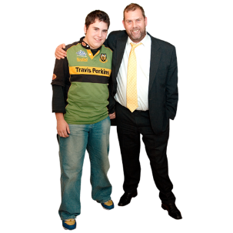
or

- a person you trust.

What happens if I do not choose Individualised Funding?

If you do not choose Individualised Funding your services will stay the same.

You will still need to
- ask the TAC if you want to change your services
and
- talk to the TAC if you are not happy with your services.

?
You can choose Individualised Funding later if you do not choose it now.

What services can I pay for with Individualised Funding?

You can use your Individualised Funding money to pay for

- acupuncture

- attendant care

- audiology

- child care. There are special rules about this. You need to ask your Support Coordinator if you can use this service.
- chiropractic

- community group programs

- continence equipment

- dietetics

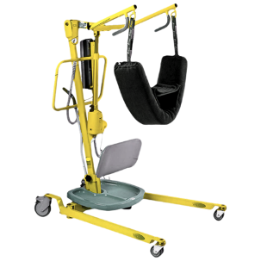
- equipment that costs less than $1000. The $1000 must include the cost of delivery.

- exercise physiology
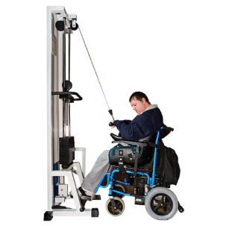
- gym and swimming programs

- home services. For example cleaning and gardening.

- laundry services for people with disability

- nursing

- occupational therapy

- orthoptics

- osteopathy

- physiotherapy

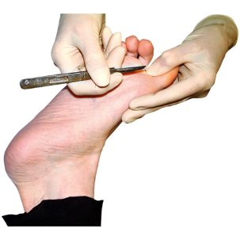
- podiatry

- psychology

- respite

- speech pathology

If you need services that are not on this list you can still get them.

You do not need to pay for them with your Individualised Funding money. They will be paid for by the TAC.

How can I find out more?
You can ask questions about Individualised Funding. You can ask your Support Coordinator.

You can also go to the TAC website.

Go to www.tac.vic.gov.au
and
Search for ‘IF’ to watch videos about Individualised Funding. Other TAC clients talk about their Individualised Funding in the videos.

What do these words mean?

Support Coordinator | The person from the TAC who makes sure you get the supports you need.
goal | Something you want to do in the future. For example  - learn something new  - get a job  or  - live by yourself.
Independence Plan | A plan about how you can reach your goals. Your plan may include  - what services you need  - what treatment you need  - things you want to learn  - where you want to live  - activities you want to do  - and more.  This plan is made by you and your Support Coordinator.
provider | An organisation or person who gives you a service. For example  - a doctor  - an attendant carer  - house cleaner  or  - a community group.
acupuncture | A treatment where small needles are put in your body to help with pain.
attendant care | Help with daily activities that you cannot do yourself. For example  - having a shower  - going out  - cooking  - and more.
audiology | Treatment for problems with your ears.
chiropractic  continence equipment | A treatment where someone pushes or moves your spine and bones to help with pain and other health problems.  Something you use if you cannot control your bladder or bowel. For example a  - pad or special underpants  - special sheet or chair cover  - a bed pan or bag.
dietetics | A treatment where someone tells you what type of food is best for your health. This person must have special training and is called a Dietician.
exercise physiology | A treatment where someone helps you to use exercise to  - improve your health  and  - manage your injuries.
occupational therapy | Help you get to make daily activities easier after your accident. An occupational therapist can  - help you make changes to your home  - teach you how to use equipment  - and more.
osteopathy | A treatment where someone moves, stretches and massages your body to help with pain.
orthoptics | Treatment for problems with your eyes.
physiotherapy | Treatment to help you to move your body after your accident. It can help you  - move better  and  - have less pain.
podiatry | Treatment for problems with your feet.
psychology | The help you get if you are having difficult  - thoughts  - feelings  or  - behaviours.  The person who helps you must be specially trained. The person is called a Psychologist.
respite | An activity you do  or  a place to stay  while your carer takes a break.
speech pathology | The help you get if you find it hard to  - speak  - eat  or  - swallow.

The Easy English in this sheet was written by Clear Words. May 2016. www.clearwords.com.au

The images in this sheet are from
- Photosymbols. www.photosymbols.com
- Google images
- IStock. www.istockphoto.com
- Open Clip Art. www.openclipart.org

