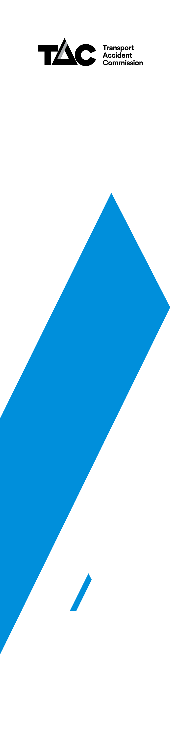
Guidelines for the funding designated scheme test cases

Updated August 2019

1.1 Background
Historically, the Motor Accidents Board and the Transport Accident Commission have agreed to pay the party and party costs and agreed Counsel’s fees of its clients’ lawyers in test cases which have been appealed from the Tribunal to the Supreme Court or to the Court of Appeal. The guidelines have been prepared in order to establish the circumstances in which the TAC may agree to fund a client’s costs, the procedures to be followed and the contribution which the TAC will make to those costs.

1.2 The Guidelines
The TAC will prospectively consider funding a TAC client’s costs on a standard basis of reviewing a decision at VCAT where:
- In the TAC’s opinion the Application for Review raises a novel issue of statutory interpretation of a provision of the Transport Accident Act affecting the rights of a category of the TAC’s clients; or

- A provision of the Act, (after an amendment for example), has not previously been tested.
The TAC will prospectively consider funding a TAC client’s, costs on a standard basis including Counsel fees of an appeal to the Supreme Court where:
- The TAC seeks to appeal a decision of the VCAT, the County Court or a Judge of the Trial Division, to the Supreme Court or Court of Appeal; or

- a TAC client seeks to appeal a decision of the VCAT, the County Court or a Judge of the Trial Division, to the Supreme Court or Court of Appeal; and
in either case, a question of law which in the TAC’s opinion affects the administration of the TAC Scheme or affects the rights of a category of TAC’s clients is to be considered.

1.3 The Procedures
The TAC reserves the right to determine whether an Application for Review or an appeal to a Superior Court meets the criteria for funding described in the Guidelines.
- Where the TAC determines that a client’s costs and disbursements will be funded in accordance with the Guidelines it will notify the client and the client’s lawyer of its decision to fund and the terms upon which funding is offered or will be offered.

- If a client or their lawyer wishes to approach the TAC for consideration for funding, where it is considered that the Guidelines apply, written application should be made to the Senior Manager – Legal, Transport Accident Commission, 60 Brougham Street, Geelong VIC 3220. The Senior Manager – Legal will escalate any such application to the Head of the relevant Client Division who will consider the request and will then notify the client and the client’s lawyer of the TAC’s decision.

