 |  |  |  | High Risk Zone Postcodes
3000 | 3026 | 3050 | 3073 | 3106 | 3136 | 3163 | 3184 | 3206
3001 | 3027 | 3051 | 3074 | 3107 | 3137 | 3164 | 3185 | 3207
3002 | 3028 | 3052 | 3075 | 3108 | 3138 | 3165 | 3186 | 3428
3003 | 3031 | 3053 | 3076 | 3109 | 3141 | 3166 | 3187 | 3800
3004 | 3032 | 3054 | 3078 | 3110 | 3142 | 3167 | 3188 | 3802
3005 | 3033 | 3055 | 3079 | 3111 | 3143 | 3168 | 3189 | 3803
3006 | 3034 | 3056 | 3081 | 3121 | 3144 | 3169 | 3190 | 3975
3008 | 3036 | 3057 | 3082 | 3122 | 3145 | 3170 | 3191 | 3976
3010 | 3037 | 3058 | 3083 | 3123 | 3146 | 3171 | 3192
3011 | 3038 | 3059 | 3084 | 3124 | 3147 | 3172 | 3193
3012 | 3039 | 3060 | 3085 | 3125 | 3148 | 3173 | 3194
3013 | 3040 | 3061 | 3086 | 3126 | 3149 | 3174 | 3195
3015 | 3041 | 3062 | 3087 | 3127 | 3150 | 3175 | 3196
3016 | 3042 | 3064 | 3088 | 3128 | 3151 | 3176 | 3197
3018 | 3043 | 3065 | 3093 | 3129 | 3152 | 3177 | 3198
3019 | 3044 | 3066 | 3094 | 3130 | 3153 | 3178 | 3199
3020 | 3045 | 3067 | 3101 | 3131 | 3154 | 3179 | 3200
3021 | 3046 | 3068 | 3102 | 3132 | 3155 | 3180 | 3201
3022 | 3047 | 3070 | 3103 | 3133 | 3156 | 3181 | 3202
3023 | 3048 | 3071 | 3104 | 3134 | 3161 | 3182 | 3204
3025 | 3049 | 3072 | 3105 | 3135 | 3162 | 3183 | 3205

 |  |  | Medium Risk Zone Postcodes
3024 | 3116 | 3219 | 3759 | 3785 | 3807 | 3926 | 3941
3029 | 3139 | 3220 | 3760 | 3786 | 3808 | 3927 | 3942
3030 | 3140 | 3335 | 3761 | 3787 | 3809 | 3928 | 3943
3089 | 3158 | 3337 | 3763 | 3788 | 3810 | 3929 | 3944
3090 | 3159 | 3338 | 3765 | 3789 | 3910 | 3930 | 3977
3091 | 3160 | 3427 | 3766 | 3791 | 3911 | 3931 | 3978
3095 | 3211 | 3429 | 3767 | 3792 | 3912 | 3933 | 3980
3096 | 3212 | 3750 | 3770 | 3793 | 3913 | 3934
3097 | 3214 | 3751 | 3775 | 3795 | 3915 | 3936
3099 | 3215 | 3752 | 3777 | 3796 | 3916 | 3937
3113 | 3216 | 3754 | 3781 | 3804 | 3918 | 3938
3114 | 3217 | 3755 | 3782 | 3805 | 3919 | 3939
3115 | 3218 | 3757 | 3783 | 3806 | 3920 | 3940

- 05/13 | 60 Brougham Street | T. 1300 654 329 | tac.vic.gov.au
- 05/13 | Geelong VIC 3220 | STD Toll free.
152 | PO Box 742 | 1800 332 556
152 | Geelong VIC 3220 | ABN 22 033 947 623
TAC | Geelong VIC 3220 | ABN 22 033 947 623
TAC | DX 216079 Geelong


TRANSPORT ACCIDENT CHARGES INCLUDING GST AND DUTY


- Annual Standard Rates

- Annual Pensioner Concession Rates

- Six-Monthly Pensioner Concession Rates

- Six-Monthly Health Care Card Rates

Effective date: 1 July 2013

Pensioner concession rates

The Transport Accident Charges Order (No.1) 2013 makes provision for reduced charges for certain classes of pensioners.

The reduced charge applies in respect of one motor vehicle used solely for social, domestic and pleasure purposes, owned by the applicant, and entitled to concessional registration under the Road Safety Act 1986.

Enquiries about and applications for the concession should be referred to VicRoads.

Six-Monthly registration periods for Pensioners and Beneficiaries (Health Care Card Holders)

The Transport Accident Charges Order (No.1) 2013 makes provision for pensioners and beneficiaries whose vehicle is registered for six months to pay a transport accident charge for the corresponding period.

The six-monthly charges shown apply only to vehicles where the owner has elected a six-monthly registration period under regulations 43, 68 and 69 of the Road Safety (Vehicles) Regulations 2009.

Enquiries about six-monthly registration should be referred to VicRoads.

Motorcycles

Under the Transport Accident Charges Order (No.1) 2013:

“general- use motorcycle” means a motorcycle that is not classified, or to be classified, under 4(b), 4(c), 5(b)(ii) or 5(d); (Code 431, 432, 433, 451, 452, 453, 561, 562, 563, 591, 592 or 593)

“exempt general-use motorcycle” means a general-use motorcycle which,–

- at the time when application is made for registration or renewal of registration, application is made by a person who has another general-use motorcycle registered under the Road Safety Act 1986 that is classified under 3(a)(iii) or 3(a)(iv) (Code 331, 332, 333, 351, 352 or 353)
- is fitted with an engine with a capacity greater than 125 cc, and

- is the subject of an application for registration or renewal of registration by an individual.

60 Brougham Street | T. 1300 654 329 | tac.vic.gov.au
Geelong VIC 3220 | STD Toll free.
PO Box 742 | 1800 332 556
Geelong VIC 3220 | ABN 22 033 947 623
DX 216079 Geelong
Annual Pensioner Concession Rates
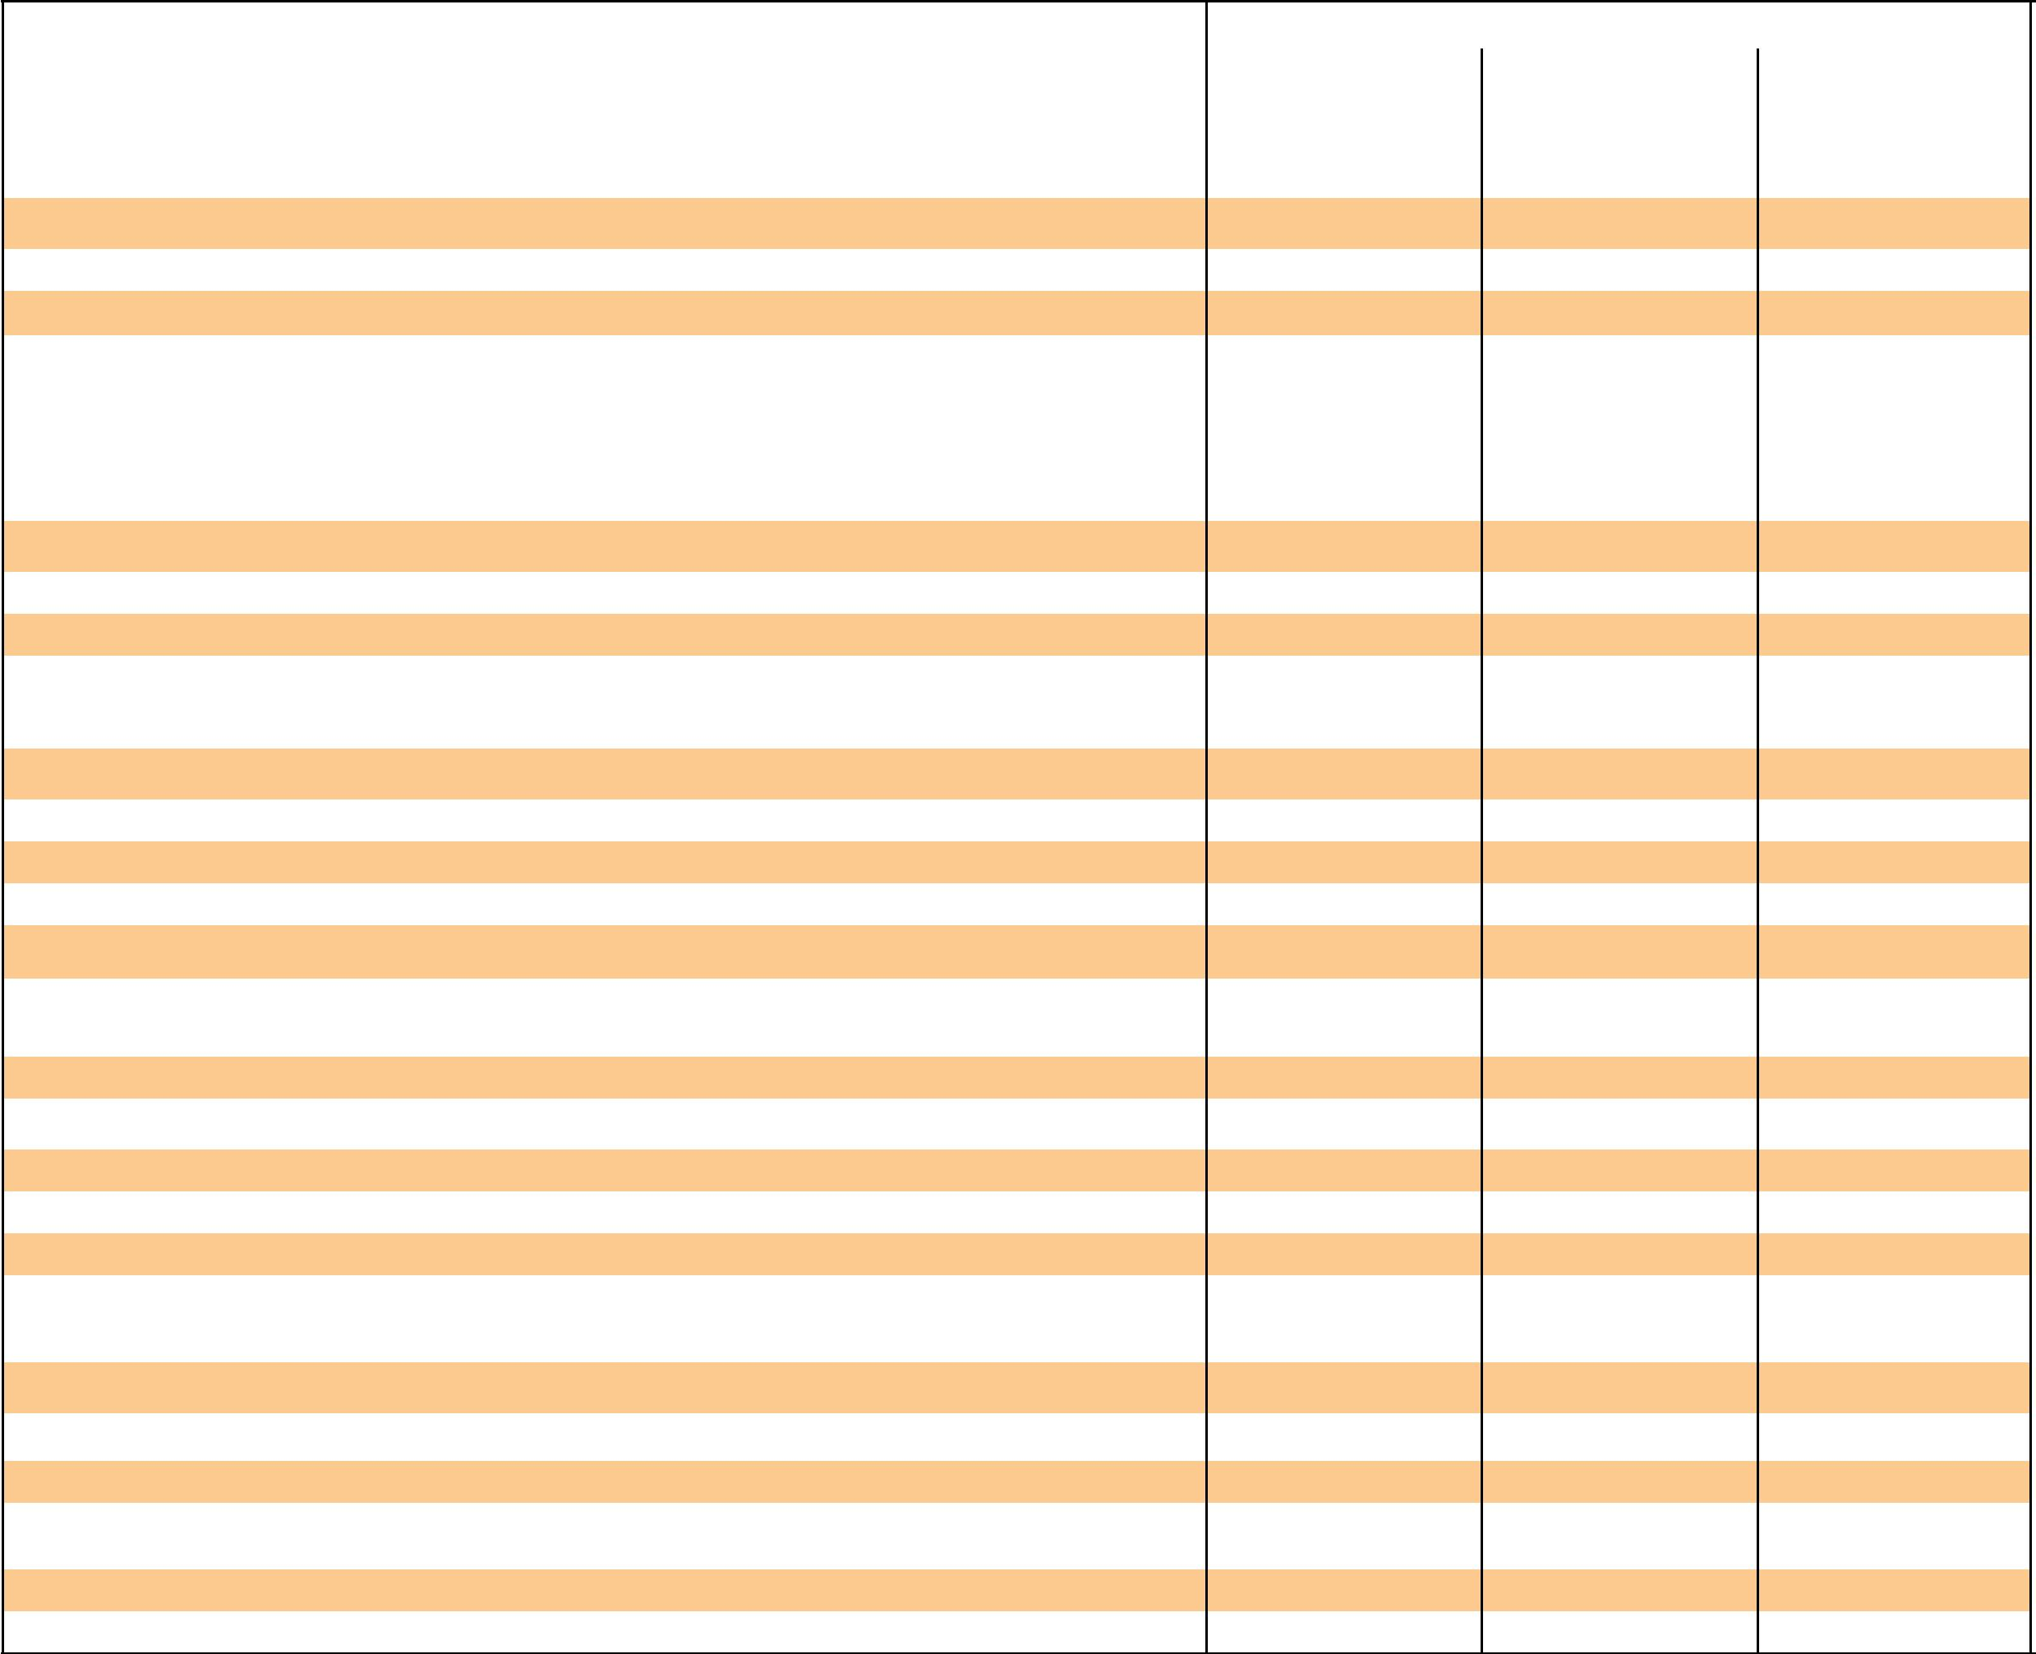
Class of motor vehicle |  |  | Amount payable – TAC Charge shown includes GST (shown in brackets)
 |  | High Risk Zone |  |  |  |  | Medium Risk Zone |  |  |  |  | Low Risk Zone
 |  | TAC |  |  |  |  | TAC |  |  |  |  | TAC
1. Passenger Vehicles | Code | Charge | (GST) | Duty | Total | Code | Charge | (GST) | Duty | Total | Code | Charge | (GST) | Duty | Total
(a) Any motor vehicle with sedan, station wagon or related body-type (including 4WD passenger vehicle) not included in any other class; | Code | $ | $ | $ | $ | Code | $ | $ | $ | $ | Code | $ | $ | $ | $
self-propelled caravan; ambulance; hearse; mourning coach; private hire car licensed under the Transport Act 1983 ....................................................................... | 101 | 215.50 | (19.59) | 21.55 | 237.05 | 102 | 192.50 | (17.50) | 19.25 | 211.75 | 103 | 167.00 | (15.18) | 16.70 | 183.70
(b) Any motor vehicle with a bus or forward-control body-type constructed and primarily used for carrying passengers, but not for hire, fare or reward -
(i) Seating fewer than 10 people (including the driver) ................................................................................................................................................................................................................ | 111 | 215.50 | (19.59) | 21.55 | 237.05 | 112 | 192.00 | (17.45) | 19.20 | 211.20 | 113 | 158.50 | (14.41) | 15.85 | 174.35
(ii) Seating more than 9 people (including the driver) ..................................................................................................................................................................................................................... | 121 | 304.50 | (27.68) | 30.45 | 334.95 | 122 | 192.00 | (17.45) | 19.20 | 211.20 | 123 | 158.50 | (14.41) | 15.85 | 174.35
(c) Taxi – licensed under the Transport Act 1983 ................................................................................................................................................................................................................................... | 131 |  |  |  |  | 132 |  |  |  |  | 133
(d) Bus – any motor vehicle, other than a taxi cab or private hire car, licensed for or primarily used for carrying passengers for hire, fare or reward -
– seating fewer than 10 people (including the driver) ................................................................................................................................................................................................................. | 141 |  |  |  |  | 142 |  |  |  |  | 143

– seating more than 9 but fewer than 31 people (including the driver), the charge for a bus seating fewer than 10, plus for each additional seat

over 9 .................................................................................................................................................................................................................................................................................................................... | 151 |  |  |  |  | 152 |  |  |  |  | 153
– seating 31 people or more ....................................................................................................................................................................................................................................................................... | 161 |  |  |  |  | 162 |  |  |  |  | 163
2. Goods Vehicles
Any motor vehicle designed, constructed or primarily used for carrying goods -
(a) up to and including two tonnes carrying capacity (including utility) ........................................................................................................................................................................................ | 201 | 216.00 | (19.64) | 21.60 | 237.60 | 202 | 163.50 | (14.86) | 16.35 | 179.85 | 203 | 113.50 | (10.32) | 11.35 | 124.85
(b) over two tonnes carrying capacity, but excluding motor vehicles classified under 2(c) or 2(d) ............................................................................................................................... | 221 | 314.50 | (28.59) | 31.45 | 345.95 | 222 | 274.50 | (24.95) | 27.45 | 301.95 | 223 | 236.00 | (21.45) | 23.60 | 259.60
(c) prime mover type motor vehicle, but excluding motor vehicles classified under 2(d) and motor vehicles having a tare weight of 5 tonnes or less .............. | 241 | 872.00 | (79.27) | 87.20 | 959.20 | 242 | 697.00 | (63.36) | 69.70 | 766.70 | 243 | 525.00 | (47.73) | 52.50 | 577.50
(d) owned by a primary producer that would otherwise be classified under 2(b) or 2(c) that is used solely in connection with the primary production
operations of the owner ..................................................................................................................................................................................................................................................................................... | 261 |  |  |  |  | 262 |  |  |  |  | 263
3. Motorcycles – (*See front page for further explanation)

(a) | Any general-use motorcycle, other than an exempt general-use motorcycle with
 | (i) | engine capacity less than 61 cc ........................................................................................................................................................................................................................................... | 291 | 36.00 | (3.27) | 3.60 | 39.60 | 292 | 36.00 | (3.27) | 3.60 | 39.60 | 293 | 36.00 | (3.27) | 3.60 | 39.60
 | (ii) | engine capacity greater than 60cc but less than 126cc ...................................................................................................................................................................................... | 311 | 142.50 | (12.95) | 14.25 | 156.75 | 312 | 124.50 | (11.32) | 12.45 | 136.95 | 313 | 108.00 | (9.82) | 10.80 | 118.80
 | (iii) | engine capacity greater than 125 cc but less than 501cc ................................................................................................................................................................................. | 331 | 189.00 | (17.18) | 18.90 | 207.90 | 332 | 169.50 | (15.41) | 16.95 | 186.45 | 333 | 150.00 | (13.64) | 15.00 | 165.00
 | (iv) engine capacity greater than 500cc ................................................................................................................................................................................................................................. |  | 351 | 257.50 | (23.41) | 25.75 | 283.25 | 352 | 229.50 | (20.86) | 22.95 | 252.45 | 353 | 201.00 | (18.27) | 20.10 | 221.10
(b) | Any exempt general-use motorcycle with
 | (i) | engine capacity greater than 125 cc but less than 501cc .......................................................................................................................................................................................... | 371 | 158.50 | (14.41) | 15.85 | 174.35 | 372 | 139.00 | (12.64) | 13.90 | 152.90 | 373 | 119.50 | (10.86) | 11.95 | 131.45
 | (ii) | engine capacity greater than 500cc ............................................................................................................................................................................................................................................. | 391 | 227.00 | (20.64) | 22.70 | 249.70 | 392 | 199.00 | (18.09) | 19.90 | 218.90 | 393 | 170.50 | (15.50) | 17.05 | 187.55
4. Miscellaneous motor vehicles
(a) | Any motor vehicle not otherwise classified: including road making motor vehicle, mobile crane, tractor (except those classified under 4(b)) |  | 411 | 163.00 | (14.82) | 16.30 | 179.30 | 412 | 129.00 | (11.73) | 12.90 | 141.90 | 413 | 41.00 | (3.73) | 4.10 | 45.10
(b) | Any tractor, self-propelled farm machine or motor cycle owned by a primary producer and used solely in connection with the primary production |  | 431 | 36.00 | (3.27) | 3.60 | 39.60 | 432 | 36.00 | (3.27) | 3.60 | 39.60 | 433 | 36.00 | (3.27) | 3.60 | 39.60
 | operations of the owner .....................................................................................................................................................................................................................................................................................
(c) | Any recreation motor vehicle registered under the Road Safety Act 1986 ..................................................................................................................................................................... |  | 451 | 30.00 | (2.73) | 3.00 | 33.00 | 452 | 30.00 | (2.73) | 3.00 | 33.00 | 453 | 30.00 | (2.73) | 3.00 | 33.00
(d) | Any veteran, vintage, classic and historic motor vehicle or replica, or motorcycle operating on a 45 day club permit ................................................................................................ |  | 461 |  |  |  |  | 462 |  |  |  |  | 463
(e) | Any veteran, vintage, classic and historic motor vehicle or replica, or motorcycle operating on a 90 day club permit ................................................................................................ |  | 471 |  |  |  |  | 472 |  |  |  |  | 473
5. Special purpose motor vehicles
(a) | Fire brigade
 | (i) | Any motor vehicle owned by the Metropolitan Fire Brigades Board which is used to combat outbreaks of fire ................................................................................. | 501 |  |  |  |  | 502 |  |  |  |  | 503
 | (ii) | Any motor vehicle owned by the Country Fire Authority or any brigade or group of brigades registered with the Country Fire Authority which is
 |  | used to combat outbreaks of fire ......................................................................................................................................................................................................................................................... | 521 |  |  |  |  | 522 |  |  |  |  | 523
(b) | Police
 | (i) | Any motor vehicle (excluding a motor cycle) registered in the name of the Victoria Police .............................................................................................................................. | 551 |  |  |  |  | 552 |  |  |  |  | 553
 | (ii) | Any motor cycle registered in the name of the Victoria Police ........................................................................................................................................................................................... | 561 |  |  |  |  | 562 |  |  |  |  | 563

- Motor trades
  - Motor vehicle used by a manufacturer of vehicles, a dealer in vehicles, a fleet owner or a licensed tester of vehicles as defined in the

vehicles regulations with general identification mark (trade plate) attached ........................................................................................................................................................... | 571 | 572 | 573
(ii) Tow truck licensed under the Accident Towing Services Act 2007 ............................................................................................................................................................................ | 581 | 582 | 583
(d) Hire and drive yourself motor vehicle or motor cycle, but excluding a prime mover classified under item 2(c). ........................................................................................... | 591 | 592 | 593

Six-Monthly Pensioner Concession Rates
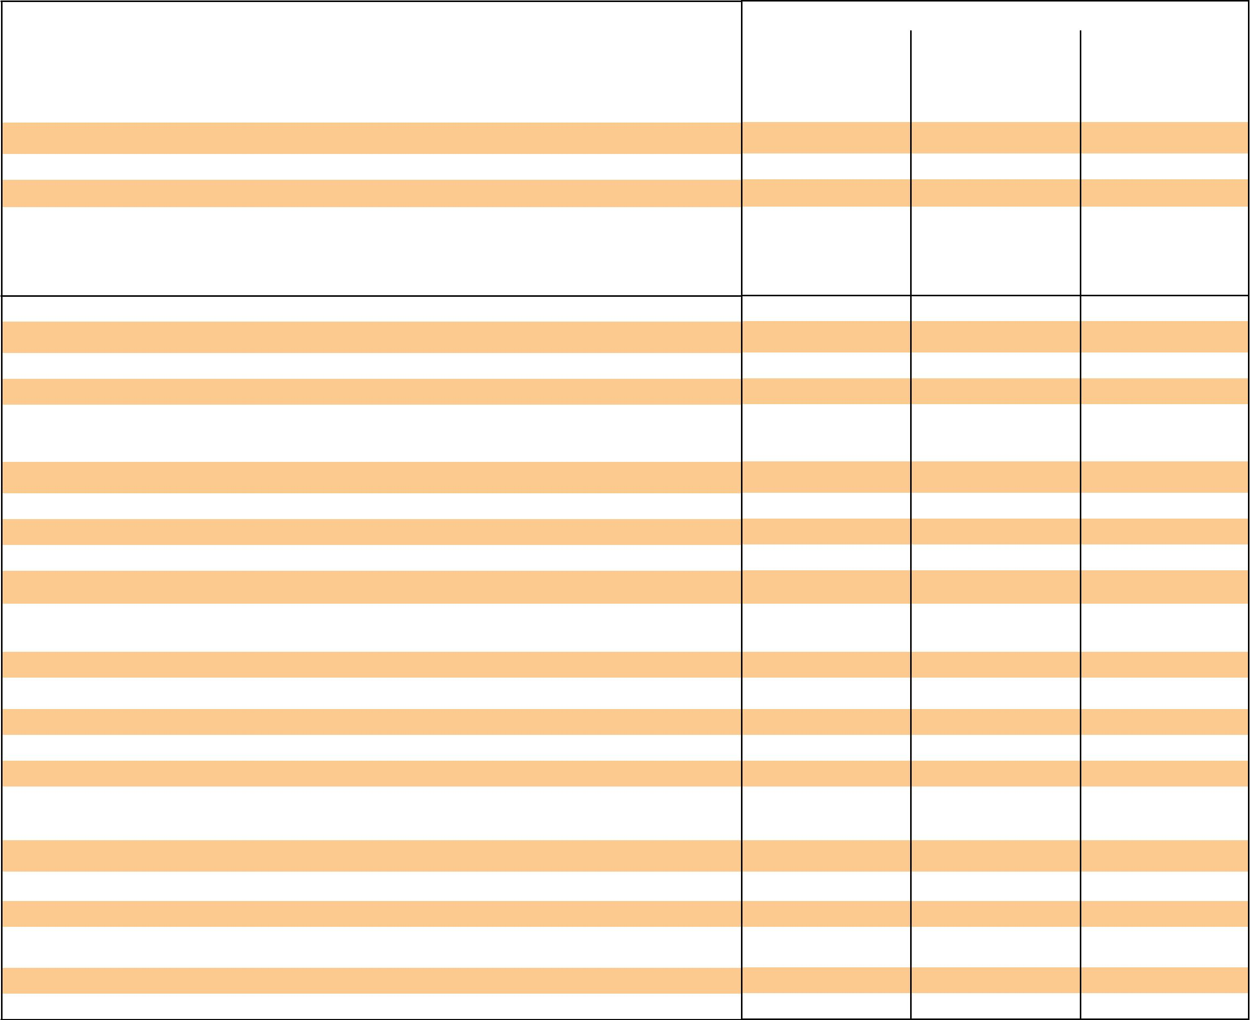
Class of motor vehicle |  |  | Amount payable – TAC Charge shown includes GST (shown in brackets)
 |  | High Risk Zone |  |  |  |  | Medium Risk Zone |  |  |  |  | Low Risk Zone
 |  | TAC |  |  |  |  | TAC |  |  |  |  | TAC
1. Passenger Vehicles | Code | Charge | (GST) | Duty | Total | Code | Charge | (GST) | Duty | Total | Code | Charge | (GST) | Duty | Total
(a) Any motor vehicle with sedan, station wagon or related body-type (including 4WD passenger vehicle) not included in any other class; | Code | $ | $ | $ | $ | Code | $ | $ | $ | $ | Code | $ | $ | $ | $
self-propelled caravan; ambulance; hearse; mourning coach; private hire car licensed under the Transport Act 1983 ....................................................................... | 101 | 107.50 | (9.77) | 10.75 | 118.25 | 102 | 96.00 | (8.73) | 9.60 | 105.60 | 103 | 83.50 | (7.59) | 8.35 | 91.85
(b) Any motor vehicle with a bus or forward-control body-type constructed and primarily used for carrying passengers, but not for hire, fare or reward -
(i) Seating fewer than 10 people (including the driver) ................................................................................................................................................................................................................ | 111 | 107.50 | (9.77) | 10.75 | 118.25 | 112 | 96.00 | (8.73) | 9.60 | 105.60 | 113 | 79.00 | (7.18) | 7.90 | 86.90
(ii) Seating more than 9 people (including the driver) ..................................................................................................................................................................................................................... | 121 | 152.00 | (13.82) | 15.20 | 167.20 | 122 | 96.00 | (8.73) | 9.60 | 105.60 | 123 | 79.00 | (7.18) | 7.90 | 86.90
(c) Taxi – licensed under the Transport Act 1983 ................................................................................................................................................................................................................................... | 131 |  |  |  |  | 132 |  |  |  |  | 133
(d) Bus – any motor vehicle, other than a taxi cab or private hire car, licensed for or primarily used for carrying passengers for hire, fare or reward -
– seating fewer than 10 people (including the driver) ................................................................................................................................................................................................................. | 141 |  |  |  |  | 142 |  |  |  |  | 143

– seating more than 9 but fewer than 31 people (including the driver), the charge for a bus seating fewer than 10, plus for each additional seat

over 9 .................................................................................................................................................................................................................................................................................................................... | 151 | 152 | 153
– seating 31 people or more ....................................................................................................................................................................................................................................................................... | 161 | 162 | 163

2. Goods Vehicles

Any motor vehicle designed, constructed or primarily used for carrying goods -
(a) | up to and including two tonnes carrying capacity (including utility) ........................................................................................................................................................................................ | 201 | 108.00 | (9.82) | 10.80 | 118.80 | 202 | 81.50 | (7.41) | 8.15 | 89.65 | 203 | 56.50 | (5.14) | 5.65 | 62.15
(b) | over two tonnes carrying capacity, but excluding motor vehicles classified under 2(c) or 2(d) ............................................................................................................................... | 221 | 157.00 | (14.27) | 15.70 | 172.70 | 222 | 137.00 | (12.45) | 13.70 | 150.70 | 223 | 118.00 | (10.73) | 11.80 | 129.80
(c) | prime mover type motor vehicle, but excluding motor vehicles classified under 2(d) and motor vehicles having a tare weight of 5 tonnes or less .............. | 241 | 436.00 | (39.64) | 43.60 | 479.60 | 242 | 348.50 | (31.68) | 34.85 | 383.35 | 243 | 262.50 | (23.86) | 26.25 | 288.75
(d) | owned by a primary producer that would otherwise be classified under 2(b) or 2(c) that is used solely in connection with the primary production
 | operations of the owner ..................................................................................................................................................................................................................................................................................... | 261 |  |  |  |  | 262 |  |  |  |  | 263
3. Motorcycles – (*See front page for further explanation)
(a) | Any general-use motorcycle, other than an exempt general-use motorcycle with
 | (i) engine capacity less than 61 cc ........................................................................................................................................................................................................................................... | 291 | 18.00 | (1.64) | 1.80 | 19.80 | 292 | 18.00 | (1.64) | 1.80 | 19.80 | 293 | 18.00 | (1.64) | 1.80 | 19.80
 | (ii) engine capacity greater than 60cc but less than 126cc ...................................................................................................................................................................................... | 311 | 71.00 | (6.45) | 7.10 | 78.10 | 312 | 62.00 | (5.64) | 6.20 | 68.20 | 313 | 54.00 | (4.91) | 5.40 | 59.40
 | (iii) engine capacity greater than 125 cc but less than 501cc ................................................................................................................................................................................. | 331 | 94.50 | (8.59) | 9.45 | 103.95 | 332 | 84.50 | (7.68) | 8.45 | 92.95 | 333 | 75.00 | (6.82) | 7.50 | 82.50
 | (iv) engine capacity greater than 500cc ................................................................................................................................................................................................................................. | 351 | 128.50 | (11.68) | 12.85 | 141.35 | 352 | 114.50 | (10.41) | 11.45 | 125.95 | 353 | 100.50 | (9.14) | 10.05 | 110.55
(b) | Any exempt general-use motorcycle with
 | (i) engine capacity greater than 125 cc but less than 501cc .......................................................................................................................................................................................... | 371 | 79.00 | (7.18) | 7.90 | 86.90 | 372 | 69.50 | (6.32) | 6.95 | 76.45 | 373 | 59.50 | (5.41) | 5.95 | 65.45
 | (ii) engine capacity greater than 500cc ............................................................................................................................................................................................................................................. | 391 | 113.50 | (10.32) | 11.35 | 124.85 | 392 | 99.50 | (9.05) | 9.95 | 109.45 | 393 | 85.00 | (7.73) | 8.50 | 93.50
4. Miscellaneous motor vehicles
(a) | Any motor vehicle not otherwise classified: including road making motor vehicle, mobile crane, tractor (except those classified under 4(b)) | 411 | 81.50 | (7.41) | 8.15 | 89.65 | 412 | 64.50 | (5.86) | 6.45 | 70.95 | 413 | 20.50 | (1.86) | 2.05 | 22.55
(b) | Any tractor, self-propelled farm machine or motor cycle owned by a primary producer and used solely in connection with the primary production | 431 | 18.00 | (1.64) | 1.80 | 19.80 | 432 | 18.00 | (1.64) | 1.80 | 19.80 | 433 | 18.00 | (1.64) | 1.80 | 19.80
 | operations of the owner .....................................................................................................................................................................................................................................................................................
(c) | Any recreation motor vehicle registered under the Road Safety Act 1986 ..................................................................................................................................................................... | 451 | 15.00 | (1.36) | 1.50 | 16.50 | 452 | 15.00 | (1.36) | 1.50 | 16.50 | 453 | 15.00 | (1.36) | 1.50 | 16.50
(d) | Any veteran, vintage, classic and historic motor vehicle or replica, or motorcycle operating on a 45 day club permit ................................................................................................ | 461 |  |  |  |  | 462 |  |  |  |  | 463
(e) | Any veteran, vintage, classic and historic motor vehicle or replica, or motorcycle operating on a 90 day club permit ................................................................................................ | 471 |  |  |  |  | 472 |  |  |  |  | 473
5. Special purpose motor vehicles
(a) | Fire brigade
 | (i) Any motor vehicle owned by the Metropolitan Fire Brigades Board which is used to combat outbreaks of fire ................................................................................. | 501 |  |  |  |  | 502 |  |  |  |  | 503
 | (ii) Any motor vehicle owned by the Country Fire Authority or any brigade or group of brigades registered with the Country Fire Authority which is
 | used to combat outbreaks of fire ......................................................................................................................................................................................................................................................... | 521 |  |  |  |  | 522 |  |  |  |  | 523
(b) | Police
 | (i) Any motor vehicle (excluding a motor cycle) registered in the name of the Victoria Police .............................................................................................................................. | 551 |  |  |  |  | 552 |  |  |  |  | 553
 | (ii) Any motor cycle registered in the name of the Victoria Police ........................................................................................................................................................................................... | 561 |  |  |  |  | 562 |  |  |  |  | 563

- Motor trades
  - Motor vehicle used by a manufacturer of vehicles, a dealer in vehicles, a fleet owner or a licensed tester of vehicles as defined in the

vehicles regulations with general identification mark (trade plate) attached ........................................................................................................................................................... | 571 | 572 | 573
(ii) Tow truck licensed under the Accident Towing Services Act 2007 ............................................................................................................................................................................ | 581 | 582 | 583
(d) Hire and drive yourself motor vehicle or motor cycle, but excluding a prime mover classified under item 2(c). ........................................................................................... | 591 | 592 | 593

Six-Monthly Health Care Card Rates
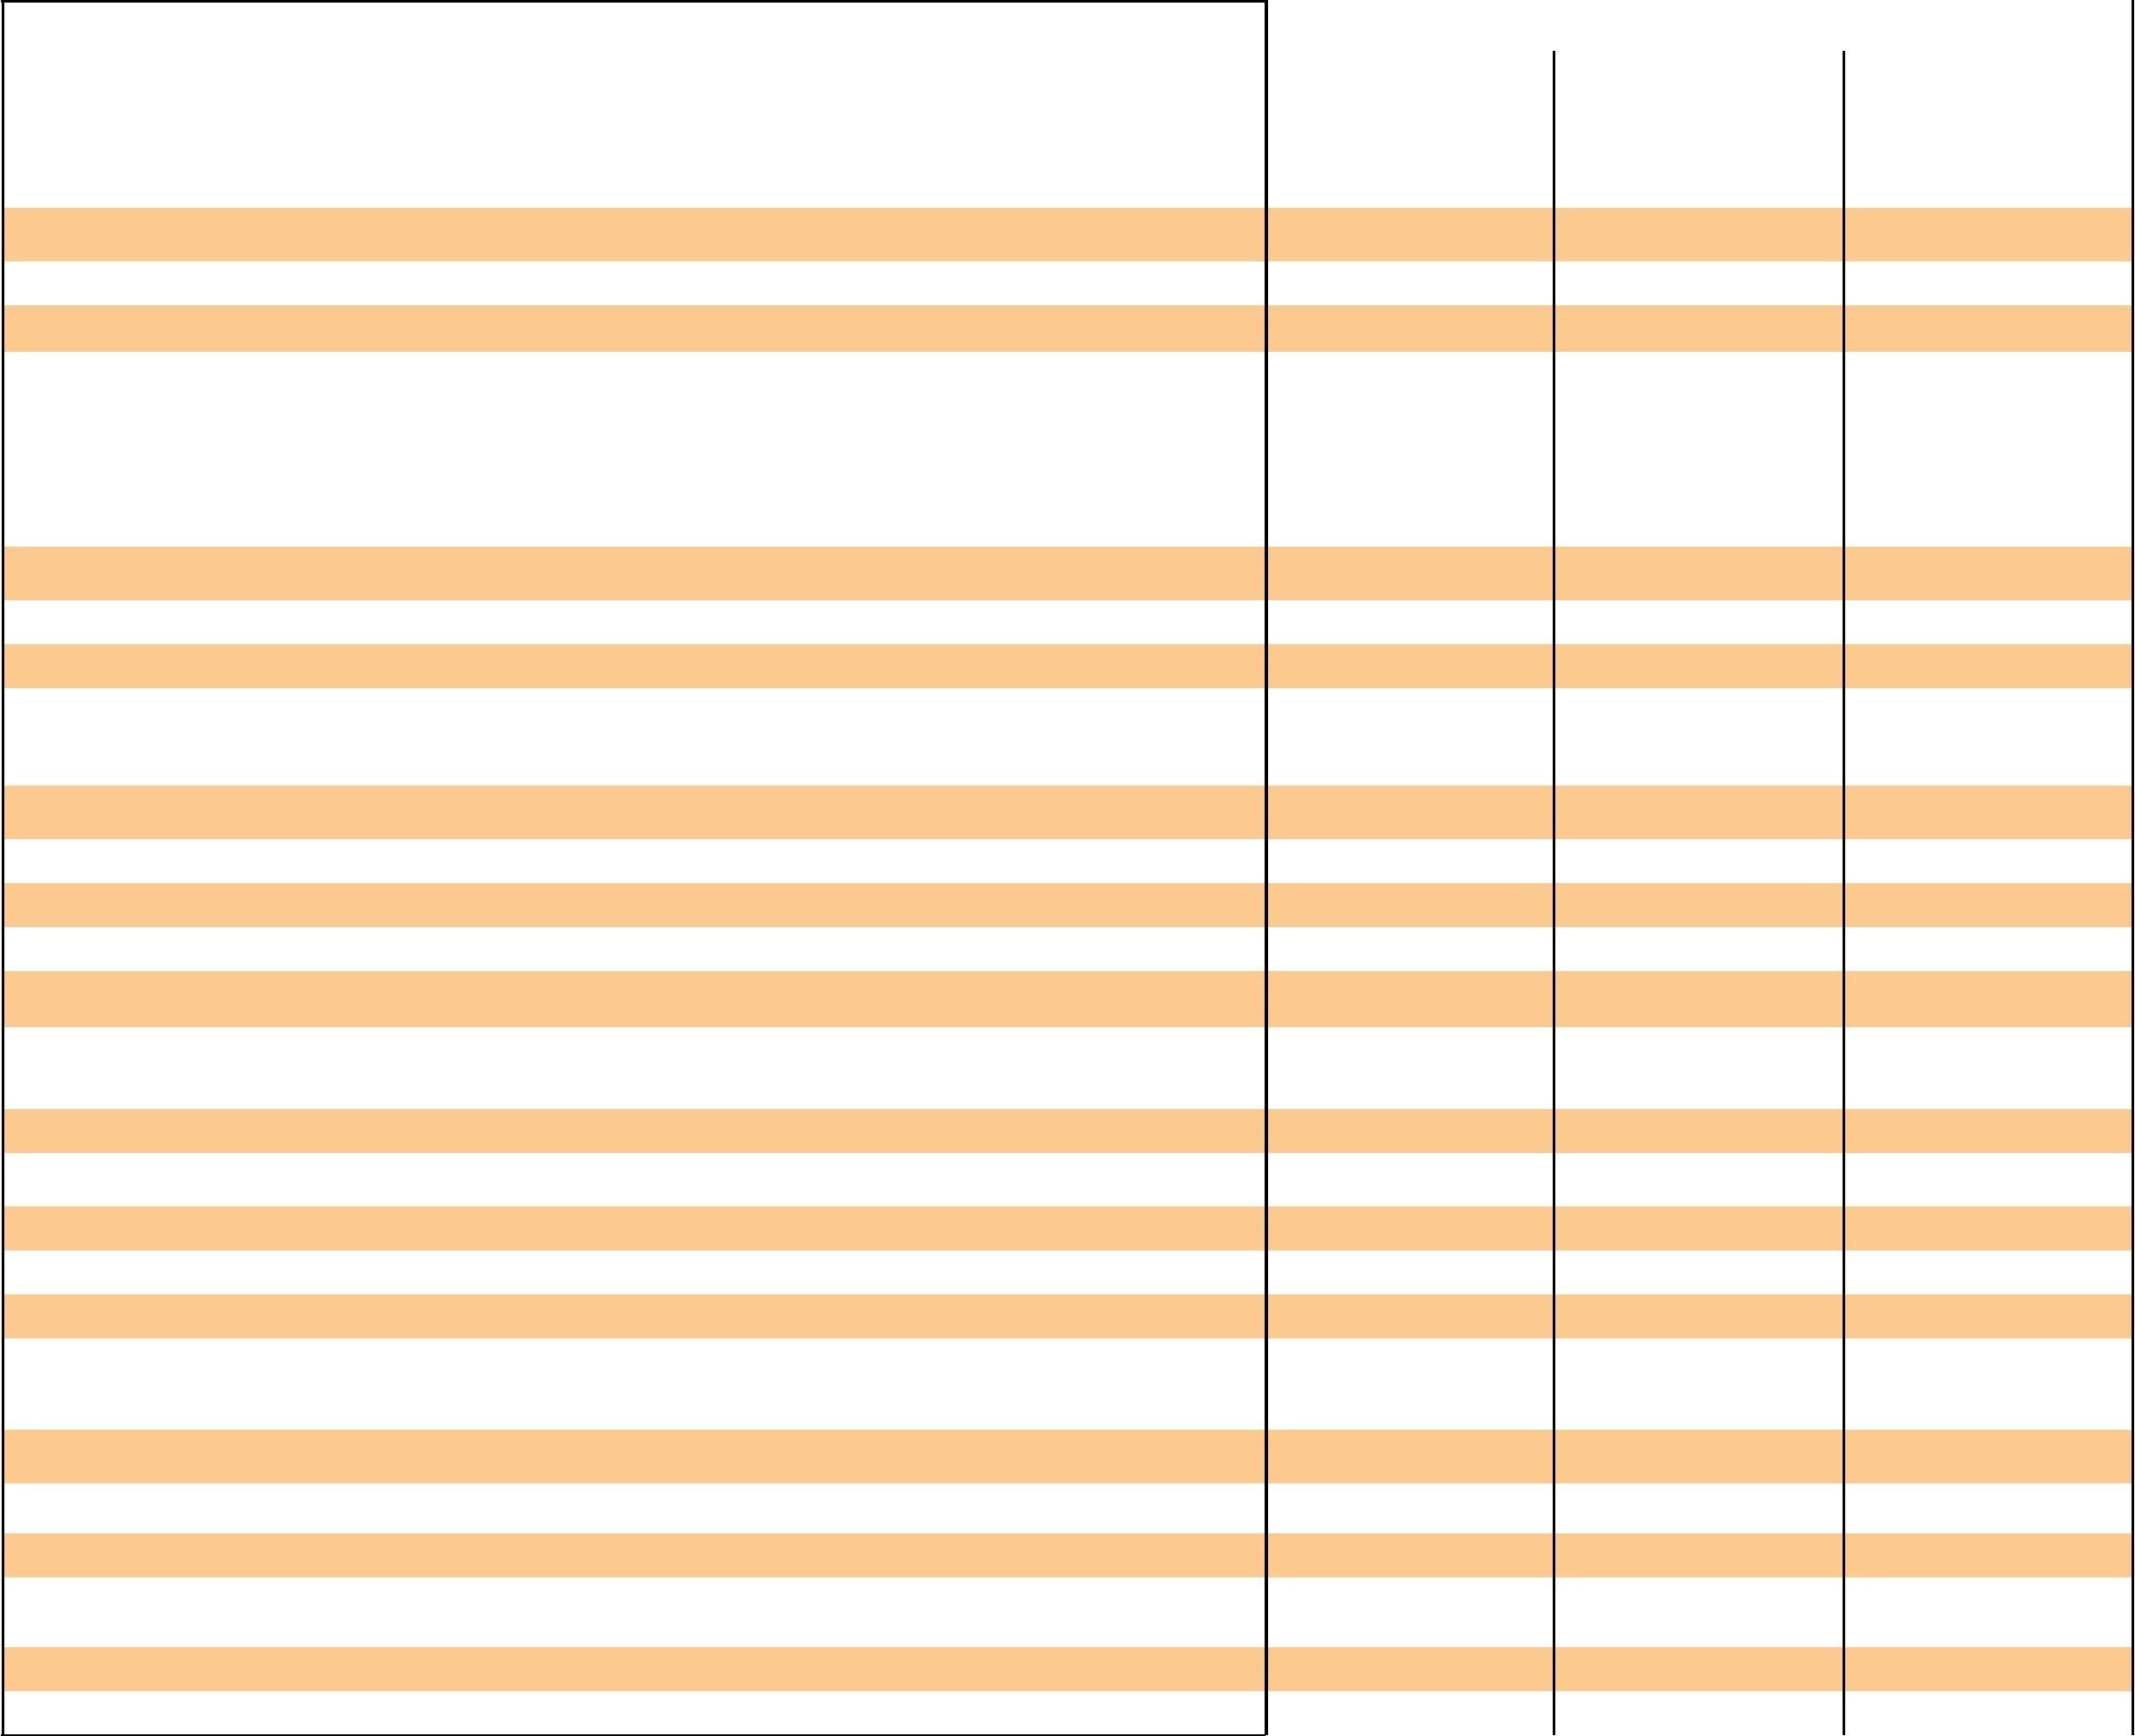
Class of motor vehicle |  |  | Amount payable – TAC Charge shown includes GST (shown in brackets)
 |  | High Risk Zone |  |  |  |  | Medium Risk Zone |  |  |  |  | Low Risk Zone
 |  | TAC |  |  |  |  | TAC |  |  |  |  | TAC
1. Passenger Vehicles | Code | Charge | (GST) | Duty | Total | Code | Charge | (GST) | Duty | Total | Code | Charge | (GST) | Duty | Total
(a) Any motor vehicle with sedan, station wagon or related body-type (including 4WD passenger vehicle) not included in any other class; | Code | $ | $ | $ | $ | Code | $ | $ | $ | $ | Code | $ | $ | $ | $
self-propelled caravan; ambulance; hearse; mourning coach; private hire car licensed under the Transport Act 1983 ....................................................................... | 101 | 215.50 | (19.59) | 21.55 | 237.05 | 102 | 192.50 | (17.50) | 19.25 | 211.75 | 103 | 167.00 | (15.18) | 16.70 | 183.70
(b) Any motor vehicle with a bus or forward-control body-type constructed and primarily used for carrying passengers, but not for hire, fare or reward -
(i) Seating fewer than 10 people (including the driver) ................................................................................................................................................................................................................ | 111 | 215.50 | (19.59) | 21.55 | 237.05 | 112 | 192.00 | (17.45) | 19.20 | 211.20 | 113 | 158.50 | (14.41) | 15.85 | 174.35
(ii) Seating more than 9 people (including the driver) ..................................................................................................................................................................................................................... | 121 | 304.50 | (27.68) | 30.45 | 334.95 | 122 | 192.00 | (17.45) | 19.20 | 211.20 | 123 | 158.50 | (14.41) | 15.85 | 174.35
(c) Taxi – licensed under the Transport Act 1983 ................................................................................................................................................................................................................................... | 131 |  |  |  |  | 132 |  |  |  |  | 133
(d) Bus – any motor vehicle, other than a taxi cab or private hire car, licensed for or primarily used for carrying passengers for hire, fare or reward -
– seating fewer than 10 people (including the driver) ................................................................................................................................................................................................................. | 141 |  |  |  |  | 142 |  |  |  |  | 143

– seating more than 9 but fewer than 31 people (including the driver), the charge for a bus seating fewer than 10, plus for each additional seat

over 9 .................................................................................................................................................................................................................................................................................................................... | 151 |  |  |  |  | 152 |  |  |  |  | 153
– seating 31 people or more ....................................................................................................................................................................................................................................................................... | 161 |  |  |  |  | 162 |  |  |  |  | 163
2. Goods Vehicles
Any motor vehicle designed, constructed or primarily used for carrying goods -
(a) up to and including two tonnes carrying capacity (including utility) ........................................................................................................................................................................................ | 201 | 216.00 | (19.64) | 21.60 | 237.60 | 202 | 163.50 | (14.86) | 16.35 | 179.85 | 203 | 113.50 | (10.32) | 11.35 | 124.85
(b) over two tonnes carrying capacity, but excluding motor vehicles classified under 2(c) or 2(d) ............................................................................................................................... | 221 | 314.50 | (28.59) | 31.45 | 345.95 | 222 | 274.50 | (24.95) | 27.45 | 301.95 | 223 | 236.00 | (21.45) | 23.60 | 259.60
(c) prime mover type motor vehicle, but excluding motor vehicles classified under 2(d) and motor vehicles having a tare weight of 5 tonnes or less .............. | 241 | 872.00 | (79.27) | 87.20 | 959.20 | 242 | 697.00 | (63.36) | 69.70 | 766.70 | 243 | 525.00 | (47.73) | 52.50 | 577.50
(d) owned by a primary producer that would otherwise be classified under 2(b) or 2(c) that is used solely in connection with the primary production
operations of the owner ..................................................................................................................................................................................................................................................................................... | 261 |  |  |  |  | 262 |  |  |  |  | 263
3. Motorcycles – (*See front page for further explanation)

(a) | Any general-use motorcycle, other than an exempt general-use motorcycle with
 | (i) | engine capacity less than 61 cc ........................................................................................................................................................................................................................................... | 291 | 36.00 | (3.27) | 3.60 | 39.60 | 292 | 36.00 | (3.27) | 3.60 | 39.60 | 293 | 36.00 | (3.27) | 3.60 | 39.60
 | (ii) | engine capacity greater than 60cc but less than 126cc ...................................................................................................................................................................................... | 311 | 142.50 | (12.95) | 14.25 | 156.75 | 312 | 124.50 | (11.32) | 12.45 | 136.95 | 313 | 108.00 | (9.82) | 10.80 | 118.80
 | (iii) | engine capacity greater than 125 cc but less than 501cc ................................................................................................................................................................................. | 331 | 189.00 | (17.18) | 18.90 | 207.90 | 332 | 169.50 | (15.41) | 16.95 | 186.45 | 333 | 150.00 | (13.64) | 15.00 | 165.00
 | (iv) engine capacity greater than 500cc ................................................................................................................................................................................................................................. |  | 351 | 257.50 | (23.41) | 25.75 | 283.25 | 352 | 229.50 | (20.86) | 22.95 | 252.45 | 353 | 201.00 | (18.27) | 20.10 | 221.10
(b) | Any exempt general-use motorcycle with
 | (i) | engine capacity greater than 125 cc but less than 501cc .......................................................................................................................................................................................... | 371 | 158.50 | (14.41) | 15.85 | 174.35 | 372 | 139.00 | (12.64) | 13.90 | 152.90 | 373 | 119.50 | (10.86) | 11.95 | 131.45
 | (ii) | engine capacity greater than 500cc ............................................................................................................................................................................................................................................. | 391 | 227.00 | (20.64) | 22.70 | 249.70 | 392 | 199.00 | (18.09) | 19.90 | 218.90 | 393 | 170.50 | (15.50) | 17.05 | 187.55
4. Miscellaneous motor vehicles
(a) | Any motor vehicle not otherwise classified: including road making motor vehicle, mobile crane, tractor (except those classified under 4(b)) |  | 411 | 163.00 | (14.82) | 16.30 | 179.30 | 412 | 129.00 | (11.73) | 12.90 | 141.90 | 413 | 41.00 | (3.73) | 4.10 | 45.10
(b) | Any tractor, self-propelled farm machine or motor cycle owned by a primary producer and used solely in connection with the primary production |  | 431 | 36.00 | (3.27) | 3.60 | 39.60 | 432 | 36.00 | (3.27) | 3.60 | 39.60 | 433 | 36.00 | (3.27) | 3.60 | 39.60
 | operations of the owner .....................................................................................................................................................................................................................................................................................
(c) | Any recreation motor vehicle registered under the Road Safety Act 1986 ..................................................................................................................................................................... |  | 451 | 30.00 | (2.73) | 3.00 | 33.00 | 452 | 30.00 | (2.73) | 3.00 | 33.00 | 453 | 30.00 | (2.73) | 3.00 | 33.00
(d) | Any veteran, vintage, classic and historic motor vehicle or replica, or motorcycle operating on a 45 day club permit ................................................................................................ |  | 461 |  |  |  |  | 462 |  |  |  |  | 463
(e) | Any veteran, vintage, classic and historic motor vehicle or replica, or motorcycle operating on a 90 day club permit ................................................................................................ |  | 471 |  |  |  |  | 472 |  |  |  |  | 473
5. Special purpose motor vehicles
(a) | Fire brigade
 | (i) | Any motor vehicle owned by the Metropolitan Fire Brigades Board which is used to combat outbreaks of fire ................................................................................. | 501 |  |  |  |  | 502 |  |  |  |  | 503
 | (ii) | Any motor vehicle owned by the Country Fire Authority or any brigade or group of brigades registered with the Country Fire Authority which is
 |  | used to combat outbreaks of fire ......................................................................................................................................................................................................................................................... | 521 |  |  |  |  | 522 |  |  |  |  | 523
(b) | Police
 | (i) | Any motor vehicle (excluding a motor cycle) registered in the name of the Victoria Police .............................................................................................................................. | 551 |  |  |  |  | 552 |  |  |  |  | 553
 | (ii) | Any motor cycle registered in the name of the Victoria Police ........................................................................................................................................................................................... | 561 |  |  |  |  | 562 |  |  |  |  | 563

- Motor trades
  - Motor vehicle used by a manufacturer of vehicles, a dealer in vehicles, a fleet owner or a licensed tester of vehicles as defined in the

vehicles regulations with general identification mark (trade plate) attached ........................................................................................................................................................... | 571 | 572 | 573
(ii) Tow truck licensed under the Accident Towing Services Act 2007 ............................................................................................................................................................................ | 581 | 582 | 583
(d) Hire and drive yourself motor vehicle or motor cycle, but excluding a prime mover classified under item 2(c). ........................................................................................... | 591 | 592 | 593

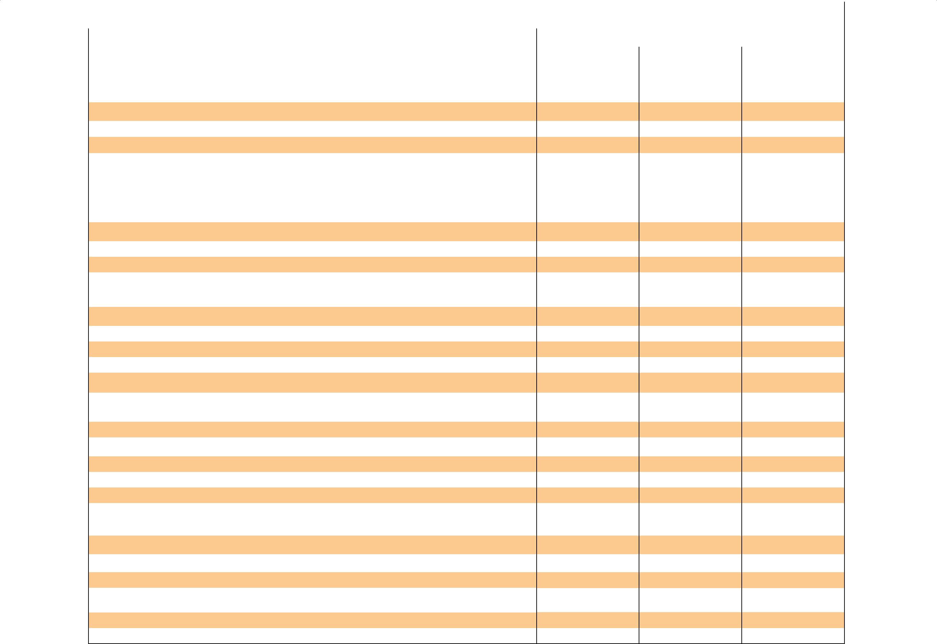 |  |  |  |  | Annual Standard Rates
Class of motor vehicle |  |  | Amount payable – TAC Charge shown includes GST (shown in brackets)
 |  | High Risk Zone |  |  |  |  | Medium Risk Zone |  |  |  |  | Low Risk Zone
 |  | TAC |  |  |  |  | TAC |  |  |  |  | TAC
1. Passenger Vehicles | Code | Charge | (GST) | Duty | Total | Code | Charge | (GST) | Duty | Total | Code | Charge | (GST) | Duty | Total
(a) Any motor vehicle with sedan, station wagon or related body-type (including 4WD passenger vehicle) not included in any other class; | Code | $ | $ | $ | $ | Code | $ | $ | $ | $ | Code | $ | $ | $ | $
self-propelled caravan; ambulance; hearse; mourning coach; private hire car licensed under the Transport Act 1983 ....................................................................... | 101 | 431.00 | (39.18) | 43.10 | 474.10 | 102 | 385.00 | (35.00) | 38.50 | 423.50 | 103 | 334.00 | (30.36) | 33.40 | 367.40
(b) Any motor vehicle with a bus or forward-control body-type constructed and primarily used for carrying passengers, but not for hire, fare or reward -
(i) Seating fewer than 10 people (including the driver) ................................................................................................................................................................................................................ | 111 | 431.00 | (39.18) | 43.10 | 474.10 | 112 | 384.00 | (34.91) | 38.40 | 422.40 | 113 | 317.00 | (28.82) | 31.70 | 348.70
(ii) Seating more than 9 people (including the driver) ..................................................................................................................................................................................................................... | 121 | 609.00 | (55.36) | 60.90 | 669.90 | 122 | 384.00 | (34.91) | 38.40 | 422.40 | 123 | 317.00 | (28.82) | 31.70 | 348.70
(c) Taxi – licensed under the Transport Act 1983 ................................................................................................................................................................................................................................... | 131 | 2182.00 (198.36) |  | 218.20 | 2400.20 | 132 | 1633.00 (148.45) |  | 163.30 | 1796.30 | 133 | 1088.00 | (98.91) | 108.80 | 1196.80
(d) Bus – any motor vehicle, other than a taxi cab or private hire car, licensed for or primarily used for carrying passengers for hire, fare or reward -
– seating fewer than 10 people (including the driver) ................................................................................................................................................................................................................. | 141 | 1424.00 (129.45) |  | 142.40 | 1566.40 | 142 | 954.00 | (86.73) | 95.40 | 1049.40 | 143 | 330.00 | (30.00) | 33.00 | 363.00

– seating more than 9 but fewer than 31 people (including the driver), the charge for a bus seating fewer than 10, plus for each additional seat

over 9 .................................................................................................................................................................................................................................................................................................................... | 151 | 36.00 | (3.27) | 3.60 | 39.60 | 152 | 16.00 | (1.45) | 1.60 | 17.60 | 153 | 4.00 | (0.36) | 0.40 | 4.40
– seating 31 people or more ....................................................................................................................................................................................................................................................................... | 161 | 2182.00 (198.36) |  | 218.20 | 2400.20 | 162 | 1306.00 (118.73) |  | 130.60 | 1436.60 | 163 | 432.00 | (39.27) | 43.20 | 475.20
2. Goods Vehicles
Any motor vehicle designed, constructed or primarily used for carrying goods -
(a) up to and including two tonnes carrying capacity (including utility) ........................................................................................................................................................................................ | 201 | 432.00 | (39.27) | 43.20 | 475.20 | 202 | 327.00 | (29.73) | 32.70 | 359.70 | 203 | 227.00 | (20.64) | 22.70 | 249.70
(b) over two tonnes carrying capacity, but excluding motor vehicles classified under 2(c) or 2(d) ............................................................................................................................... | 221 | 629.00 | (57.18) | 62.90 | 691.90 | 222 | 549.00 | (49.91) | 54.90 | 603.90 | 223 | 472.00 | (42.91) | 47.20 | 519.20
(c) prime mover type motor vehicle, but excluding motor vehicles classified under 2(d) and motor vehicles having a tare weight of 5 tonnes or less .............. | 241 | 1744.00 (158.55) |  | 174.40 | 1918.40 | 242 | 1394.00 (126.73) |  | 139.40 | 1533.40 | 243 | 1050.00 | (95.45) | 105.00 | 1155.00
(d) owned by a primary producer that would otherwise be classified under 2(b) or 2(c) that is used solely in connection with the primary production
operations of the owner ..................................................................................................................................................................................................................................................................................... | 261 | 191.00 | (17.36) | 19.10 | 210.10 | 262 | 160.00 | (14.55) | 16.00 | 176.00 | 263 | 130.00 | (11.82) | 13.00 | 143.00
3. Motorcycles – (*See front page for further explanation)

(a) | Any general-use motorcycle, other than an exempt general-use motorcycle with
 | (i) | engine capacity less than 61 cc ........................................................................................................................................................................................................................................... | 291 | 72.00 | (6.55) | 7.20 | 79.20 | 292 | 72.00 | (6.55) | 7.20 | 79.20 | 293 | 72.00 | (6.55) | 7.20 | 79.20
 | (ii) | engine capacity greater than 60cc but less than 126cc ...................................................................................................................................................................................... | 311 | 285.00 | (25.91) | 28.50 | 313.50 | 312 | 249.00 | (22.64) | 24.90 | 273.90 | 313 | 216.00 | (19.64) | 21.60 | 237.60
 | (iii) | engine capacity greater than 125 cc but less than 501cc ................................................................................................................................................................................. | 331 | 378.00 | (34.36) | 37.80 | 415.80 | 332 | 339.00 | (30.82) | 33.90 | 372.90 | 333 | 300.00 | (27.27) | 30.00 | 330.00
 | (iv) engine capacity greater than 500cc ................................................................................................................................................................................................................................. |  | 351 | 515.00 | (46.82) | 51.50 | 566.50 | 352 | 459.00 | (41.73) | 45.90 | 504.90 | 353 | 402.00 | (36.55) | 40.20 | 442.20
(b) | Any exempt general-use motorcycle with
 | (i) | engine capacity greater than 125 cc but less than 501cc .......................................................................................................................................................................................... | 371 | 317.00 | (28.82) | 31.70 | 348.70 | 372 | 278.00 | (25.27) | 27.80 | 305.80 | 373 | 239.00 | (21.73) | 23.90 | 262.90
 | (ii) | engine capacity greater than 500cc ............................................................................................................................................................................................................................................. | 391 | 454.00 | (41.27) | 45.40 | 499.40 | 392 | 398.00 | (36.18) | 39.80 | 437.80 | 393 | 341.00 | (31.00) | 34.10 | 375.10
4. Miscellaneous motor vehicles
(a) | Any motor vehicle not otherwise classified: including road making motor vehicle, mobile crane, tractor (except those classified under 4(b)) |  | 411 | 326.00 | (29.64) | 32.60 | 358.60 | 412 | 258.00 | (23.45) | 25.80 | 283.80 | 413 | 82.00 | (7.45) | 8.20 | 90.20
(b) | Any tractor, self-propelled farm machine or motor cycle owned by a primary producer and used solely in connection with the primary production
 | operations of the owner ..................................................................................................................................................................................................................................................................................... |  | 431 | 72.00 | (6.55) | 7.20 | 79.20 | 432 | 72.00 | (6.55) | 7.20 | 79.20 | 433 | 72.00 | (6.55) | 7.20 | 79.20
(c) | Any recreation motor vehicle registered under the Road Safety Act 1986 ..................................................................................................................................................................... |  | 451 | 60.00 | (5.45) | 6.00 | 66.00 | 452 | 60.00 | (5.45) | 6.00 | 66.00 | 453 | 60.00 | (5.45) | 6.00 | 66.00
(d) | Any veteran, vintage, classic and historic motor vehicle or replica, or motorcycle operating on a 45 day club permit ................................................................................................ |  | 461 | 42.00 | (3.82) | 4.20 | 46.20 | 462 | 42.00 | (3.82) | 4.20 | 46.20 | 463 | 42.00 | (3.82) | 4.20 | 46.20
(e) | Any veteran, vintage, classic and historic motor vehicle or replica, or motorcycle operating on a 90 day club permit ................................................................................................ |  | 471 | 84.00 | (7.64) | 8.40 | 92.40 | 472 | 84.00 | (7.64) | 8.40 | 92.40 | 473 | 84.00 | (7.64) | 8.40 | 92.40
5. Special purpose motor vehicles
(a) | Fire brigade
 | (i) | Any motor vehicle owned by the Metropolitan Fire Brigades Board which is used to combat outbreaks of fire ................................................................................. | 501 | 1088.00 | (98.91) | 108.80 | 1196.80 | 502 | 1088.00 | (98.91) | 108.80 | 1196.80 | 503 | 1088.00 | (98.91) | 108.80 | 1196.80
 | (ii) | Any motor vehicle owned by the Country Fire Authority or any brigade or group of brigades registered with the Country Fire Authority which is
 |  | used to combat outbreaks of fire ......................................................................................................................................................................................................................................................... | 521 | 173.00 | (15.73) | 17.30 | 190.30 | 522 | 173.00 | (15.73) | 17.30 | 190.30 | 523 | 173.00 | (15.73) | 17.30 | 190.30
(b) | Police |  | 551 | 1526.00 (138.73) |  | 152.60 |  | 552 | 1526.00 (138.73) |  | 152.60 |  | 553 | 1526.00 (138.73) |  | 152.60
 | (i) | Any motor vehicle (excluding a motor cycle) registered in the name of the Victoria Police .............................................................................................................................. | 551 |  |  | 152.60 | 1678.60 | 552 |  |  | 152.60 | 1678.60 | 553 |  |  | 152.60 | 1678.60
 | (ii) | Any motor cycle registered in the name of the Victoria Police ........................................................................................................................................................................................... | 561 | 432.00 | (39.27) | 43.20 | 475.20 | 562 | 432.00 | (39.27) | 43.20 | 475.20 | 563 | 432.00 | (39.27) | 43.20 | 475.20

- Motor trades
  - Motor vehicle used by a manufacturer of vehicles, a dealer in vehicles, a fleet owner or a licensed tester of vehicles as defined in the

vehicles regulations with general identification mark (trade plate) attached ........................................................................................................................................................... | 571 | 282.00 | (25.64) | 28.20 | 310.20 | 572 | 212.00 | (19.27) | 21.20 | 233.20 | 573 | 139.00 | (12.64) | 13.90 | 152.90
(ii) Tow truck licensed under the Accident Towing Services Act 2007 ............................................................................................................................................................................ | 581 | 804.00 | (73.09) | 80.40 | 884.40 | 582 | 602.00 | (54.73) | 60.20 | 662.20 | 583 | 403.00 | (36.64) | 40.30 | 443.30
(d) Hire and drive yourself motor vehicle or motor cycle, but excluding a prime mover classified under item 2(c). ........................................................................................... | 591 | 683.00 | (62.09) | 68.30 | 751.30 | 592 | 573.00 | (52.09) | 57.30 | 630.30 | 593 | 493.00 | (44.82) | 49.30 | 542.30

