August 2015

Ipsos Project: 14-042544-01

Transport Accident Commission
Motorcycle Client Research
Off-road crashes

Project Contact: Julie Young
Winnie Wong
Sumedha Gaindhar

Contact address: Level 2, Building 1,
658 Church St
Richmond
VIC 3121

Office phone: (03) 9946 0888

Email: julie.young@ipsos.com
winnie.wong@ipsos.com
sumedha.gaindhar@ipsos.com

Contents
Executive summary 5
Key statistics from the research: 6
Summary of key findings 7
1. Research Context 10
1.1 Background 10
1.1.1 Transport Accident Commission 10
1.2 Research Objectives 10
2. Research Design 11
2.1 Data Collection Method 11
2.2 Sample Sizes and Participation Rate 11
2.3 Respondents vs. Motorcycle Client Population 12
2.4 Analysis and reporting of statistical significance 12
2.5 Reading this report 13
Research findings 14
3. Off-road crashes 15
3.1 Summary characteristics of off-road crash respondents 15
3.2 Riding behaviour in the year before the crash 16
3.2.1 Type of motorcycle ridden prior to the crash 17
3.2.2 Type of riding prior to the crash 19
3.2.3 Frequency of riding prior to the crash 21
3.2.4 Time spent riding vs. driving prior to the crash 23
3.2.5 Break prior to the crash 25
Length of break 26
3.3 At the time of the crash 27
3.3.1 Motorcycle type and riding purpose at time of crash 27
Type of motorcycle ridden at time of crash 27
Reasons for riding at the time of the crash 30
Whether riding alone or with other riders at the time of the crash 30
3.3.2 Where the crash occurred 31
3.3.3 Crash circumstances 33
Whether other parties were involved 33
Involvement of other parties 34
3.3.4 Categorising motorcycle crashes 35
Introduction to categorising crashes 35
Summary of all off-road crashes 37
Non-interaction crashes 39
Details of non-interaction crashes 40
Accident type according to TAC Claims database 43
Off-road crash case studies 44
Case study 1: Off road crash with interaction with other vehicle 44
3.3.5 Details of motorcycle and rider collisions 46
What the rider’s motorcycle collided with 46
What the rider’s body collided with 48
3.3.6 Factors contributing to the crash 49
Perceived responsibility of crash 49
Whether another person was responsible for the crash 51
Reasons for the crash 53
Rider opinions of crash factors 55
Whether distracted by anything immediately before the crash 56
Alcohol consumption prior to the crash 57
3.3.7 Track and weather conditions 57
Other four wheel or off-road riders/pedestrians involved 58
Track and terrain conditions 60
Weather conditions 63
Visibility and light conditions at the time of the crash 64
3.3.8 Protective gear 66
Protective gear worn at the time of the crash 66
Impact protection / body armour worn at the time of the crash 71
Reflective or high-vis gear worn at the time of the crash 73
Technological gadgets carried at the time of the crash 74
3.3.9 Injuries from the crash 75
Severity of crashes 75
Injury types 76
Level of vehicle damage 79
3.4 After the crash 80
3.4.1 Riding again after the crash 80
Likelihood of riding again in the future 80
Reasons for not riding again after their crash 81
Things that need to happen to ride again 82
Average time between crash and riding after the crash 83
Frequency of riding before vs. after the crash 84
Riding more or less cautiously after the crash 85
Driving more or less cautiously after the crash 86
Reasons for riding after the crash 87
3.4.2 Getting life back on track 88
Reasons for the rating 89
3.4.3 Employment before and after the crash 91
Employment status 91
Main paid occupation 92
Non-working respondents 92
3.5 Client suggestions for improvement 93
Improving off-road motorcycling 93
3.6 Profile of off-road crash respondents 94
Appendices 97
Questionnaire 97

Executive summary
In 2014, Ipsos was commissioned by the TAC to undertake a survey with clients who had been injured while riding a motorcycle. The aim of the research was to better understand the factors contributing to crashes, crash circumstances and to understand the key differences between injured on-road and off-road motorcyclists. A random sample of TAC clients who had been injured in motorcycle crashes occurring between 2010 -2014 were approached to take part.
Telephone surveys were conducted with a total n=964 TAC clients. The average survey length was 26 minutes.
For the purposes of this study, crashes have been categorised as either on-road or off-road based on the location where the crash occurred. On-road crashes were determined to be those that either occurred on a:
- sealed road in a built-up area;
- sealed road in a rural area;
- sealed road on a private property;
- public unsealed road; or
- another on-road surface/area.
Off-road crashes were those that occurred on a:
- track in state park, forest etc.;
- private property;
- public land in residential areas (e.g. park, reserve, track); or
- another off-road surface/area.
This document primarily covers the findings from the n=201 who said they had crashed on an off-road surface with key differences between on-road and off-road crashes noted where relevant.
Findings from the off-road crash respondents have been documented in a separate report.
Key statistics from the research:
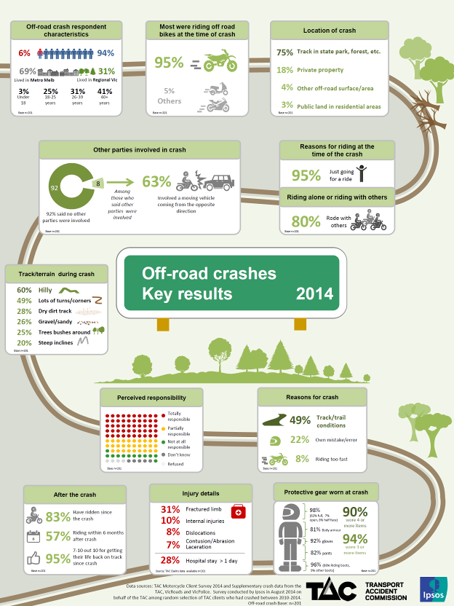

Summary of key findings
Off-road crashes
Summary characteristics of off-road crash respondents
In total, 79% of respondents said they had experienced an on-road crash (n=763) and 21% experienced a crash at an off-road location (n=201).
Among the off-road crashes, 94% of respondents were male (compared to 87% with a motorcycle licence or registration according to the VicRoads database).
Twenty-eight percent (28%) of respondents were aged up to 25 years old at the time of the crash. One in three (31%) were aged 26-39 years and 41% were aged 40+ at the time. In comparison, only 18% of those who were involved in an on-road crash were aged up to 25 years old.
More than two thirds (69%) of respondents lived in metropolitan Melbourne. The proportion among on-road crashes was similar.
Ninety-five percent (95%) of those who had been involved in a crash on an off-road surface rode an off-road or trail bike before the crash. Very few said they were riding either a road bike (4%) or a scooter (1%) when they crashed.
Riding behaviour in the year before the crash
The majority of those who crashed off-road said they normally rode an off-road or trail bike before the crash (89%). One in ten (9%) said their main bike before the crash had been a road bike. This tended to be the case for more frequent riders (33% of those who rode 5+ days a week in the spring/summer months rode a road bike).
Those who had an off-road crash were most likely to say they rode 1-2 times a week in summer (31%) or once a fortnight (25%). In the autumn/winter months, one in five (22%) rode 1-2 times a week; and a similar proportion rode once a fortnight (19%). Few rode five or more days a week (9% in spring/summer and 5% in the autumn/winter months). Frequency of riding was lower among those who had crashed off-road compared to on-road crashes. However, this does not necessarily reflect their level of experience. Based on other research undertaken by the TAC, those who rode off-road for recreational purposes started riding at a younger age than commuters who may ride more frequently on a day to day basis. This suggests while they may not ride as many hours on a yearly basis, an off-road rider’s experience is more likely to be gained over many years.
Seventy-two percent (72%) of those who had crashed off-road said they had never had a break from riding since learning to ride. Among those who had had a break, more than half had a break of less than a year (39% had been on a break for up to 6 months and 18% on a break for 7-11 months).
At the time of the crash
Almost all those involved in an off-road crash had been riding on an off-road or trail bike at the time of the crash (95%). A minority said they had been riding a road bike when they crashed (4%).
Most said they normally rode an off-road or trail bike prior to the crash suggesting that familiarity with off-road bikes was unlikely to be a common cause of crashes.
Three-quarters (75%) of off-road crashes occurred on a track in a state park or forest etc. Just under one in five (18%) occurred on private property.
The vast majority of off-road crash respondents said they had been just going for a ride (95%) – more so than for those involved in an on-road crash (43%) where there was a higher proportion who had been commuting at the time. Eight in ten (80%) of those who crashed off-road had been riding with others at the time. Forty percent (40%) of all respondents had been riding in a group of up to four riders with the same proportion riding in groups bigger than this (40%).
The majority of respondents indicated there were no other parties involved in the crash (92%). In comparison, only 64% of those in on-road crashes mentioned no other parties such as a pillion rider, other vehicles or pedestrians had been involved in the crash.
Close to two thirds of respondents said their motorcycle had not collided with anything and had just hit the ground (63%). Among those whose motorcycle had collided with an object, the most common object had been a tree or bush (17%) followed by rocks (12%). Off-road respondents were more likely than on-road respondents to say their motorcycle had not collided with anything (63% vs. 51% for on-road).
Similarly, the majority of respondents said their body had not collided with anything apart from the ground (71%).
Types of crashes
Details of each respondent’s crashes were analysed to order to categorise each of the crashes according to the first event in the chain of events that lead to the motorcyclist crashing.
Perhaps unsurprisingly, almost all (93%) off-road crashes did not involve any interaction with other vehicles The most common types of crashes were ones where the motorcyclist lost control due to a handling error (34%), followed by losing control due to hitting unfavourable surface conditions (28%) and colliding with a physical object (25%). A further 2% of crashes involved avoiding hitting a physical object.
In comparison, just over half (56%) of crashes that occurred on on-road surfaces had no interaction with another vehicle in the first instance.
Of the small proportion of off-road crashes where another vehicle had been involved in the lead up to crashing, these crashes were most likely to occur between intersections (6%).
Factors contributing to the crash
Half (50%) of those involved in off-road crashes felt they were totally responsible for the crash. Approximately one third (29%) claimed that they were partially responsible and slightly more than one in ten (12%) felt that they were not at all responsible for the crash. Those involved in on-road crashes were more likely to say they had not been at all responsible for the crash (44% vs. 12% for off-road). Where a respondent felt they were partially or not at all at fault, 14% stated another person had been responsible for the crash.
Track and/or trail conditions were most likely to be attributed by respondents as one of the main factors of the crash (49% of mentions). In addition, one in five (22%) felt their own mistake also was one of the reasons for the crash.
One in ten respondents (10%) agreed they were tired/fatigued at the time and 6% reported they were tense or stressed. Forty-four percent (44%) of respondents said if they had been riding more slowly they could have done something to avoid the crash, with younger respondents more likely to agree this was the case (60%). Forty-one percent (41%) disagreed there was nothing they could have done to prevent the crash (i.e. they could have done something).
Four percent (4%) mentioned they had been distracted by something immediately before the crash including being distracted by animals, other vehicles, and scenery.
Two percent (2%) of respondents indicated they had consumed some alcohol in the three hours prior to their crash.
Track and weather conditions
The majority of respondents said the terrain/track where they had crashed was hilly (60%) or had steep inclines (20%). Close to half mentioned the track had lots of turns or corners (49%). Dirt tracks were ridden by 28% of respondents with a similar proportion saying the area they had been riding had been gravelly or sandy (26%). One in four (25%) also mentioned there were trees and bushes in the area they had been riding where the crash occurred. For those who mentioned that the track/terrain had contributed to the crash (49%), the most common mentions included water on the track (23%) and tree roots or fallen branches/logs (17%).
Close to two thirds (63%) of respondents said there had not been any other people using the track at the time of the crash. Where there had been other people around, these tended to be other off-road motorcyclists (30%).
Given that most of the off-road respondents had been riding for recreational purposes, it is unsurprising that the majority of respondents said the weather had been clear/sunny/hot/warm (85%). Descriptions of the visibility and lighting conditions are consistent with this - 85% said they were riding on a clear day.
Protective gear
The majority of respondents who were involved in an off-road crash were wearing a motorcycle helmet (98%), boots (96%), motorcycle riding gloves (92%), motorcycle riding pants (82%) and body armour (81%) at the time of their crash. In total, half of respondents wore all six items listed in the survey (53% vs. 38% of on-road crash respondents).
Around half (54%) said they had been wearing a body armour kit, riding pants (50%) or knee guards (49%) at the time of the crash. Only 12% of off-road crash respondents said they were not wearing any of the impact protective or body armour listed in the survey.
More than one in three (37%) reported they had been wearing either high visibility (26%) and/or reflective clothing (13%) at the time of the crash.
As to technological gadgets, 85% indicated that they were carrying a mobile phone and close to one in three (30%) mentioned that they had a GPS device with them at the time of their crash. Respondents who were riding alone were more likely to say they were not carrying any devices with them compared to those who were riding with others at the time of the crash (15% vs. 6%).
Level of injury
According to the supplementary data from VicRoads database on the crash, the split between minor injury accidents and serious injury accidents was relatively even (48% minor and 52% serious). This was similar to that recorded for on-road crashes.
Fractured limbs were the most common type of main injury for off-road crashes (34%). Sixty-two percent (62%) did not get admitted to hospital in the seven days following the accident. However, one in five did stay in hospital more than one day but less than one week (22%).
After the crash
The majority of respondents had ridden again since the crash (83%). This was similar for on-road crashes (80%). While the sample size was small (n=35), among those who had not yet ridden again, half showed high intentions of returning to their motorcycle (54% provided a likelihood rating of 7-10 out of 10). Concern shown by friends and family and still suffering from the injuries from the crash were the most common reasons for not riding since the crash. Recovering from injuries and rebuilding their confidence were the things that would need to change for respondents to return to riding.
One in three (35%) returned to riding within three months of the crash; with a similar proportion (28%) returning to riding after 4-6 months. Similar proportions of on-road and off-road respondents had returned to riding within six months (68% vs. 64% for off-road respondents).
Forty percent (40%) of respondents who had returned to riding said they rode as frequently after the crash as they had beforehand, although 48% reported they rode less frequently. As to the level of cautiousness that those involved in off-road crashes rode after their crash, 58% said there was no change. The off-road crash also seemed to have little impact on how respondents drove a car with 90% reporting there was no difference to how cautiously they drove since the crash.
Two thirds (66%) of those impacted by off-road crashes gave a rating of 10 out of 10 as to the extent to which they felt they had been able to get their life back on track. In total, 95% provided a rating of at least 7out of 10. The most common reasons for these high ratings included that they were healing or were fully recovered or the injuries were not major and they were able to walk away from the crash.

Research Context

Background

Transport Accident Commission
The TAC is a Victorian Government-owned organisation created to promote road safety using road safety campaigns, paying benefits to people injured in traffic accidents, increasing the awareness of traffic issues, and reducing the incidence of road trauma.
The TAC’s objectives under the Act include:
- reducing the cost of compensation for transport accidents to the Victorian community;
- reducing the incidence of transport accidents;
- providing, in the most socially and economically appropriate manner, suitable and just compensation in respect of persons injured or who die as a result of transport accidents;
- determining claims for compensation speedily and efficiently;
- providing suitable systems for the effective rehabilitation of persons injured as a result of transport accidents;
- managing the Scheme as effectively, efficiently and economically as possible; and
- ensuring the Scheme emphasises accident prevention and effective rehabilitation.

Research Objectives
The main aim of this research was to collect information on TAC motorcycle clients who were injured while riding a motorcycle. Research objectives include:
- Understanding factors contributing to the crash, crash circumstances and risk factors for motorcyclists riding in both on- and off-road settings.
- Understanding the differences between injured on-road and off-road motorcyclists, including accident factors, types of injuries sustained and wearing of protective clothing.
- Providing profiles of on-road and off-road motorcyclists.

Research Design

Data Collection Method
The data collection method for this study was Computer Assisted Telephone Interviewing (CATI).
Ipsos worked closely with the TAC to design a survey instrument to interview TAC motorcycle clients who had experienced a motorcycle accident within the last four years. The final version of the questionnaire is included in the Appendix of this report.
All respondents were initially sent a primary approach letter a week before the fieldwork commenced to notify them about the upcoming research – the overall aim of the project; to inform them about linking survey responses to other data sources, such as information from police reports (if there was one); and to provide an opportunity to opt-out should they wish to.
Fieldwork was conducted from the 19 August 2014 to 18 September 2014. Average interview length was 26.37 minutes.
The surveys conducted on the first day of fieldwork were used as pilot surveys to check that fieldwork was being administered as planned and that the data was captured as it should have been.
Respondents who took part in the survey were also asked whether they would like to provide a detailed sketch of their crash. Those who agreed to take part were sent a stationary pack including a pencil, ruler and eraser to complete the sketch. This sketch letter is also included in the Appendix.

Sample Sizes and Participation Rate
A client list of n=3200 TAC clients aged between 14-79 years who had experienced a motorcycle crash within the last four years was provided by the TAC. Of these, 1,441 people were contacted by telephone and invited to take part in the research. A total of n=964 participated in the survey.
The response rate from those who were contacted was 71%.
Sample | % | n
Total number of TAC clients in sample |  | 3200
Sample exhausted | 58% | 1866
Clients successfully contacted | 45% | 1441
Soft refusal (did not want to be involved in this research) | 21% | 291
Hard refusal (did not want to be involved in any future TAC research) | 7% | 108

Completes | % | n
Total |  | 964
On-road crashes | 79% | 763
Off-road crashes | 21% | 201
Opt outs from sketch | 19% | 180
Returned sketches | 20%* | 155
* Of those who did not opt out

Respondents vs. Motorcycle Client Population
For the most part, the key characteristics of respondents were generally in line with known characteristics of the motorcycle client population, such as age, gender, location and life of claim. As such, the data was not weighted for the analysis in this study.
Table 1: Completions compared to sample and population statistics
Age | % Client population with < 4 year life of claim | % in  total sample | %  completions
Below 18 years old | 1% | <1% | <1%
18-25 years old | 17% | 16% | 16%
26-39 years old | 32% | 31% | 29%
40-59 years old | 42% | 42% | 43%
60-79 years old | 8% | 10% | 11%
Gender
Male | 88% | 92% | 91%
Female | 12% | 8% | 9%
Location
Metro | 71% | 72% | 72%
Rural | 29% | 28% | 28%
Life of claim
0-6 months | 9% | 8% | 10%
7-12 months | 14% | 28% | 15%
13-24 months | 27% | 30% | 30%
25-36 months | 25% | 21% | 28%
37-48 months | 24% | 14% | 18%

Analysis and reporting of statistical significance
All statistical significance testing in this report was performed using the Q software package. Significance testing was performed using independent samples t-tests for comparison of means, and z-tests for comparisons of proportions. All tests were conducted at the 95% confidence level using the effective sample size. Only statistically different results are stated throughout this report.
A ‘significant difference’ means we can be 95% confident the difference observed between the two samples reflects a true difference in the population of interest, and is not a result of chance. Such descriptions are not value judgements on the importance of the difference. The reader is encouraged to make a judgement as to whether the differences are ‘meaningful’ or not.
A sample of n=984 enables us to be 95% confident that at the overall level, a feature of the Victorian motorcycle rider population we are testing is within a range of ±3.12% of what the survey tells us. For example, this means that if we find that 50% of respondents indicated they were riding with other riders at the time of the crash, we can be 95% confident that between 46.88% and 53.12% of the population represented by the sample actually did this.
Where significance testing has occurred between pairs such as male vs. female riders this has been undertaken as an independent samples t-test. However, where significance testing has occurred between more than two categories within a group (e.g. main motorcycle type ridden – road bike, off-road bike and scooter), the significance testing used tested one category against the average of the others that are not in that category combined. Such a test is ideal for multiple comparisons as it reduces the likelihood of displaying a significant difference where one does not exist. Green figures indicate the figure reported is statistically higher (9↑); red figures indicate the figure is statistically lower (2↓).
Note that figures may not add up to 100% due to rounding or questions where multiple responses were allowed.

Reading this report
This report is divided into three main sections covering crashes that have occurred on on-road locations; crashes that have occurred off-road; and a summary of comparisons between on-road versus off-road crashes. The sections have been divided into three parts, covering riders’ characteristics pre-crash; details of the crash itself; and riders’ feedback on life after the crash. The data analysis throughout the report also includes identifying statistical differences between subgroups within the rider community – such as demographic characteristics, and motorcycle ownership.
Wherever relevant, supplementary case-level data has also been incorporated into the report. Supplementary data about the respondent and the crash was provided to Ipsos by the TAC. This data came from a number of sources including VicRoads and Victoria Police, as well as the TAC Claims databases. This supplementary data provided further insight into some of the areas that were not covered in the survey, including (but not limited to) injury severity, location details such as road geometry and speed zones; and the number of other vehicles involved. Supplementary data was not available for all respondents so base sizes used in the analysis varied. For example, we were able to link n=615 of on-road crash respondents and n=46 of off-road crash respondents from VicRoads. Off-road crashes were much less likely to have VicRoads data available for additional analysis (n=46 or 23% of off-road crash respondents). Overall, respondents where we were unable to link data were more likely to be from regional locations (36% vs. 29% of metropolitan respondents). We were able to link data for the majority of respondents with the cases of TAC Claims data, with the exception of two on-road crash respondents (where the respondent said they would prefer that the supplementary data was not used in the analysis).
Research findings

Off-road crashes
For the purposes of this study, crashes have been categorised as either on-road or off-road based on the location where they occurred. On-road crashes were determined to be those that either occurred on a:
- sealed road in a built-up area;
- sealed road in a rural area;
- sealed road on a private property;
- public unsealed road; or
- another on-road surface/area.
Off-road crashes were those that occurred on a:
- track in state park, forest etc.;
- private property;
- public land in residential areas (e.g. park, reserve, track); or
- another off-road surface/area.

Please note that when crashes are referred to as an ‘on-road’ crash or an ‘off-road’ crash that this is referring to the location and not the type of motorcycle that respondents were riding at the time of the crash. Respondents who could not recall the location of the crash were asked to classify whether it had been on ‘another on-road surface/area’ or ‘another off-road surface/area’.
This report predominately covers the results from off-road crash respondents. The on-road crash results have been covered in a separate report.

Summary characteristics of off-road crash respondents
In total, 79% of respondents said they had experienced an on-road crash (n=763) and 21% experienced a crash at an off-road location (n=201).
Among the off-road crashes, 94% of respondents were male (compared to 87% with a motorcycle licence or registration according to the VicRoads database).
Twenty-eight percent (28%) of respondents were aged up to 25 years old at the time of the crash. One in three (31%) were aged 26-39 years and 41% were aged 40+ at the time of the crash. In comparison, only 18% of those who were involved in an on-road crash were aged up to 25 years old.
More than two thirds (69%) of respondents lived in metropolitan Melbourne. The proportion among on-road riders was similar.
Ninety-five percent (95%) of those who had been involved in an off-road crash had been riding an off-road or trail bike. Very few said they were riding either a road bike (4%) or a scooter (1%) when they crashed.
Further details of the characteristics of respondents who had an off-road crash have been included in Section 3.6 - Profile of off-road crash respondents.

Riding behaviour in the year before the crash
The majority of those who crashed off-road said they normally rode an off-road or trail bike before the crash (89%). One in ten (9%) said their main bike before the crash had been a road bike. This tended to be the case for more frequent riders (33% of those who rode 5+ days a week in the spring/summer months rode a road bike).
While almost all reported they rode recreationally off-road in the year before their crash, one in three also said they rode recreationally on-road (32%) and one in five (19%) had commuted in that time.
Those who had an off-road crash were most likely to say they rode 1-2 times a week in summer (31%) or once a fortnight (25%). In the autumn/winter months, one in five (22%) rode 1-2 times a week; and a similar proportion rode once a fortnight (19%). Few rode five or more days a week (9% in spring/summer and 5% in the autumn/winter months). Frequency of riding was lower among those who had crashed off-road compared to on-road crashes. However, this does not necessarily reflect their level of experience. Based on other research undertaken by the TAC’s, those who rode off-road for recreational purposes often started to ride at a younger age than commuters who may ride more frequently on a day to day basis. This suggests while they may not ride as many hours on a yearly basis, an off-road rider’s experience is more likely to be gained over many years.
Seventy-two percent (72%) of those who had crashed off-road said they had never had a break from riding since learning to ride. Among those who had had a break, more than half had a break of less than a year (39% up to 6 months and 18% had a break of 7-11 months).

Type of motorcycle ridden prior to the crash
The majority (89%) of respondents involved in crashes in off-road locations said they normally rode an off-road bike or trail bike in the year before their crash. Just under one in ten (9%) reported they usually rode a road bike (See Figure 1).

Figure 1: Type of motorcycle ridden prior to crash (off-road crashes only)

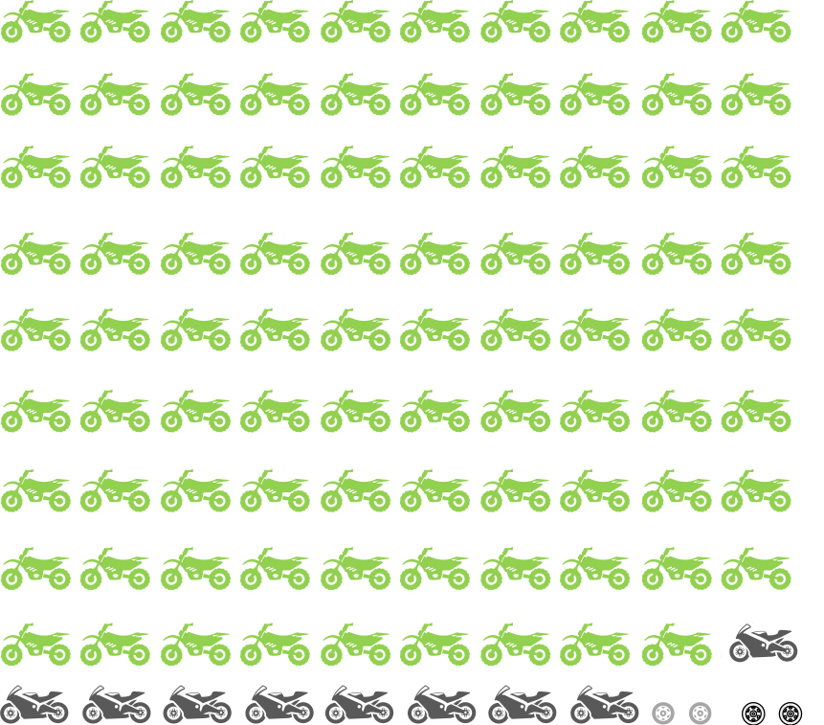
89%
Off-road Trail Bikes
9%
Road Bikes
1%
Other Bikes
1%
Don’t Know / Can’t Remember / Refused
Q3. What type of motorcycle did you ride most often before the crash?
Filter: Off-road crashes; base n = 201

Although the sample size was small, those who rode frequently in the warmer months (5 or more days a week), were more likely to say they mainly used a road bike before the crash (33% vs. 4% who rode once a month or less). Similarly, those who were more reliant on a motorcycle for transport compared to driving were more likely to say their main motorcycle was a road bike (29% vs. 4% of those who only used their bike 20% of the time or less) (See Table 2).
Table 2: Type of motorcycle ridden prior to crash by riding prior to crash (off-road crashes only)
Column % | Riding in spring/summer months before crash |  |  | Riding in autumn/winter months before crash |  |  | Riding vs. Driving before the crash
Column % | 5+ days a week | 1-4 times a week | Once a month or less | 5+ days a week | 1-4 times a week | Once a month or less | Rode <= 20% of the time | Rode 21-80% of the time | Rode 81%+ of the time
n= | 18* | 73 | 108 | 10* | 55 | 134 | 157 | 35* | 7*
Off-road bike/trail bike | 61↓ | 88 | 94↑ | 70↓ | 85 | 92 | 94↑ | 69↓ | 71
Subtotal Road bikes (exc Scooters) | 33↑ | 12 | 4↓ | 20 | 15 | 7 | 4↓ | 29↑ | 29
- Sports bike | 22↑ | 1 | 1 | 10 | 5 | 1 | 1↓ | 11↑ | 14
-Sports tourer | 0 | 4↑ | 0 | 0 | 2 | 1 | 1 | 6↑ | 0
-Dual sport | 11↑ | 4 | 1 | 10 | 7↑ | 1↓ | 1↓ | 9↑ | 14
-Tourer /cruiser | 0 | 3 | 2 | 0 | 0 | 3 | 2 | 3 | 0
-Other type of road bike | 0 | 0 | 0 | 0 | 0 | 0 | 0 | 0 | 0
Scooter | 0 | 0 | 0 | 0 | 0 | 0 | 0 | 0 | 0
Other type of bike | 6 | 0 | 1 | 10↑ | 0 | 1 | 1 | 3 | 0
Don’t know /can’t remember | 0 | 0 | 0 | 0 | 0 | 0 | 0 | 0 | 0
Refused | 0 | 0 | 1 | 0 | 0 | 1 | 1 | 0 | 0
Q3. What type of motorcycle did you ride most often before the crash?
Filter: Off-road crashes; base n = 201
↓↑ indicates statistically significant difference compared to respondents not in that category
*Note small sample size

Type of riding prior to the crash
Figure 2 shows the different reasons people usually rode before their crash and the prevalence of each type of riding.
Almost all respondents (97%) said they had ridden off-road for recreational purposes at some point in the year before they crashed. Three in five (60%) indicated that they had only ridden recreationally off-road, while one in five (19%) stated that they had ridden recreationally off-road and on-road.
In total, one in five (19%) involved in an off-road crash said they had commuted by motorcycle in the year before the crash and one in three (32%), reported they had ridden recreationally on-road in the year before the crash. (See Figure 2).
Figure 2: Time spent riding vs. recreation prior to crash (off-road crashes only)
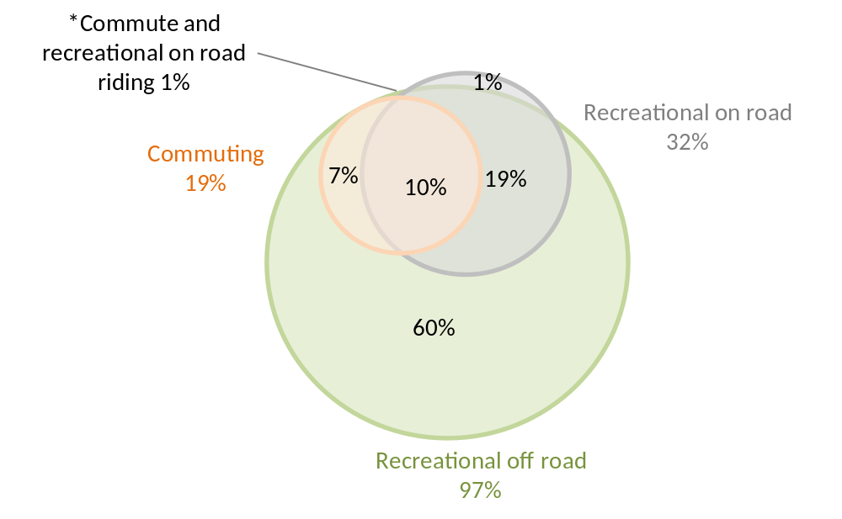
Q10. In the last 12 months before your crash, approximately what percentage of the time did you ride in the following categories? Please exclude any riding you might do for work purposes.
Filter: Off-road crashes; base n = 201

On-road vs. off-road crashes
Respondents who crashed off-road were more likely than those who had an on-road crash to have ridden recreationally off-road in the year before the crash (97% vs. 26%).
Commuting and recreational on-road riding were more common among those who had an on-road crash compared with those who had an off-road crash (67% vs. 19% for commuting and 79% vs. 32% subtotal recreational on-road riding).

Among those who crashed off-road, the majority of their riding time was spent doing recreational off-road riding compared to other types of riding (81% of the time). An average of 12% of the time was spent recreational on-road riding, and 7% of the time was spent riding for commuting purposes (See Figure 3).
Figure 3: Time spent riding vs. recreation prior to crash (off-road crashes only)
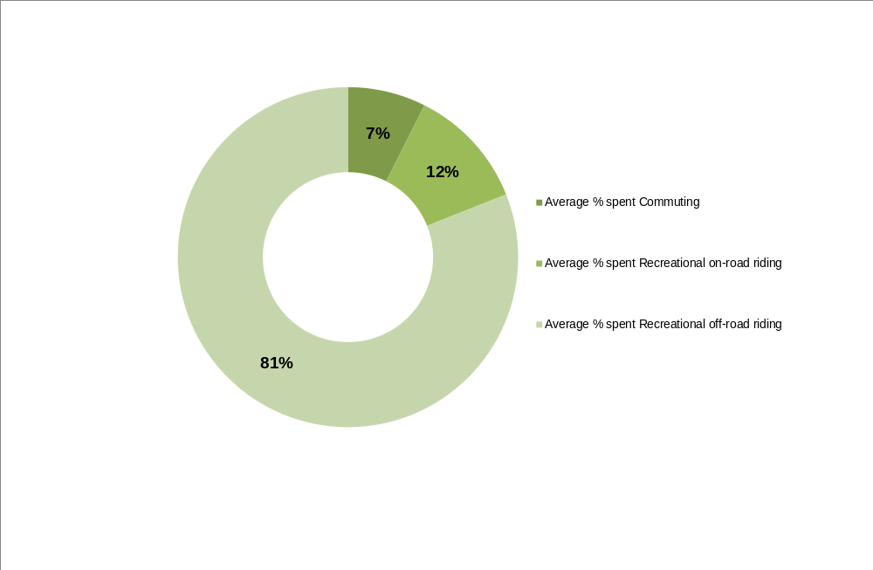
Q10. In the last 12 months before your crash, approximately what percentage of the time did you ride in the following categories? Please exclude any riding you might do for work purposes.
Filter: Off-road crashes; base n = 201

As seen in Table 3, there were some differences in how respondents spent their riding time according to age. On average, respondents aged under 40 were more likely to have spent time commuting in comparison to older respondents (24% of the time vs. 12% for older respondents). Younger respondents aged up to 25 spent less time riding on-road for recreational purposes in comparison to respondents aged 26 and over years old (21% vs. 37%).
Table 3: Time spent riding for commuting vs. recreation prior to the crash by demographics (off-road crashes only)
Column % | Gender |  | Age (at accident) |  |  | Metro/Regional (residence)
Column % | Male | Female | Up to 25 years | 26-39 years | 40+  years | Metro | Rural
n= | 188 | 13* | 57 | 62 | 82 | 139 | 62
Commuting purposes (going to work, study, shops) | 19 | 17 | 19 | 28↑ | 12↓ | 21 | 15
Recreation on-road (public roads, highways, freeways) | 33 | 17 | 21↓ | 33 | 40 | 32 | 33
Recreation off-road (tracks in state forests, parks or on private property) | 97 | 100 | 98 | 100 | 95 | 98 | 97
Don't know/refused | 1↓ | 8↑ | 0 | 2 | 1 | 1 | 2
Q10. In the last 12 months before your crash, approximately what percentage of the time did you ride in the following categories?
Filter: Off-road crashes; base n = 201
↓↑ indicates statistically significant difference compared to respondents not in that category
*Note small sample size

Frequency of riding prior to the crash
Overall, riding was more frequent during the spring/summer months than autumn/winter months.
Those who crashed off-road were most likely to say they rode between 1-2 times a week (31%) or once a fortnight (25%) in spring/summer. In the autumn/winter months, one in five (22%) rode 1-2 times a week; with a similar proportion riding once a fortnight (19%).
Fewer than one in ten (9%) of those who crashed off-road rode at least five days in a week in the spring and summer months. In the autumn and winter months, only 5% rode at least 5 days in a week.
Respondents up to 25 years old were more likely than their older counterparts to have ridden more frequently before the crash during the spring/summer months (58% vs. 40% for those aged 26+) or autumn and winter (49% vs. 26%).
Figure 4: Frequency of riding in the spring/summer and autumn/winter months prior to crash (off-road crashes only)
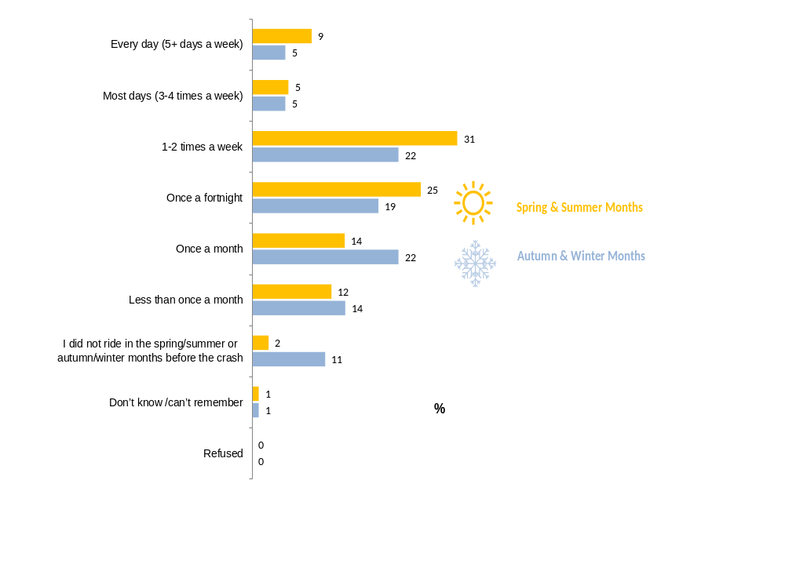
Q8. How often would you say you rode a motorcycle in the spring or summer months before your crash?
Q9. How often would you say you rode a motorcycle in the autumn or winter months before your crash?
Filter: Off-road crashes; base n = 201
↓↑ indicates statistically significant difference compared to respondents not in that category

On-road vs. off-road crashes
Respondents involved in on-road crashes tended to ride more frequently in both the spring/summer and the autumn/winter months of the year compared to off-road crash respondents. For those who crashed off-road, off-road riding was clearly an intermittent event rather than a part of their day to day life.
During the spring/summer months, on-road crash respondents were significantly more likely to ride their bike everyday (39% vs. 9% of off-road crashes) or most days (20% vs. 5% of off-road crashes). The same was found in autumn/winter months, with 31% of all those involved in on-road crashes riding almost every day and 14% riding 3-4 days a week compared to just 10% of those involved in off-road crashes who rode daily or rode most days (See Figure 5).
However, the TAC’s Motorcycle Monitor 2014 study found that recreational off-road riders tended to start learning to ride at a young age (an average of 14.7 years old) and more than half of all respondents (57%) had learnt to ride a motorcycle on an off-road bike. Therefore while off-road riders may be less likely to ride daily, the lack of frequency may be balanced by riding regularly over several years.
Figure 5: Frequency of riding in the spring/summer and autumn/winter months prior to crash by crash location (on-road vs. off-road)
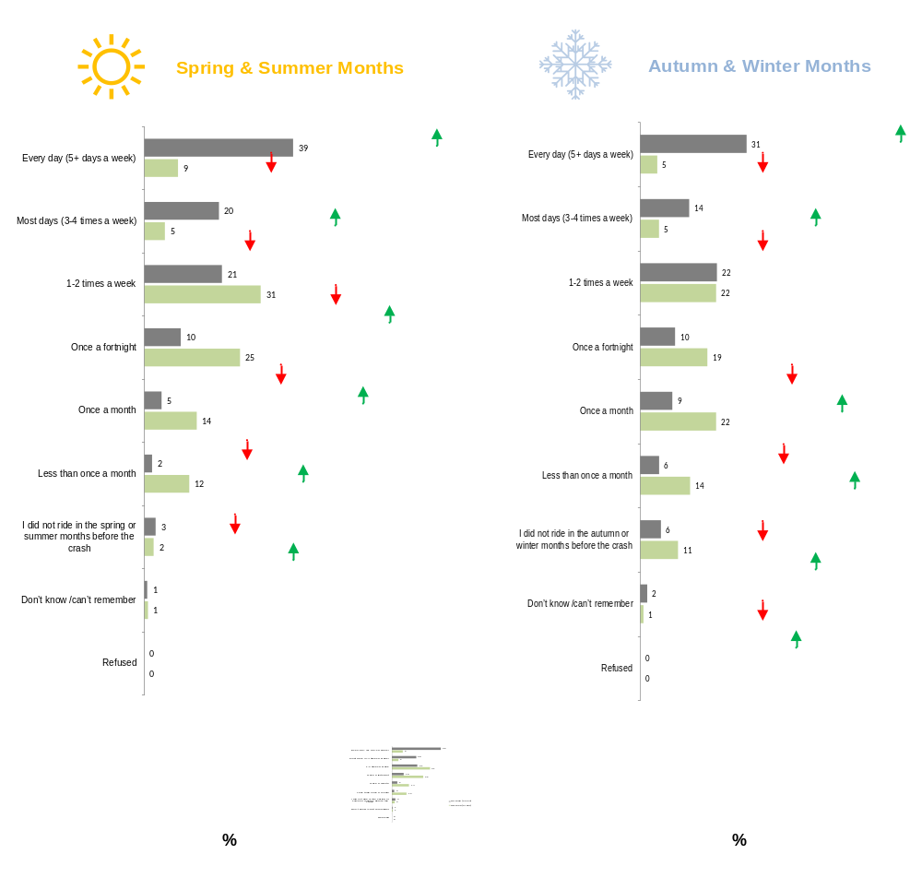
Q8. How often would you say you rode a motorcycle in the spring or summer months before your crash?
Q9. How often would you say you rode a motorcycle in the autumn or winter months before your crash?
Total sample; base n = 964
↓↑ indicates statistically significant difference compared to respondents not in that category

Time spent riding vs. driving prior to the crash
Overall, the average amount of time spent on a motorcycle was low compared to the amount of time driving a car. As seen in Figure 6, approximately three out of five respondents (62%) who had an off-road crash reported that they rode only up to 10% of the time and 90% or more of the time driving a car.
Figure 6: Time spent riding prior to crash compared to driving a car (off-road crashes only)
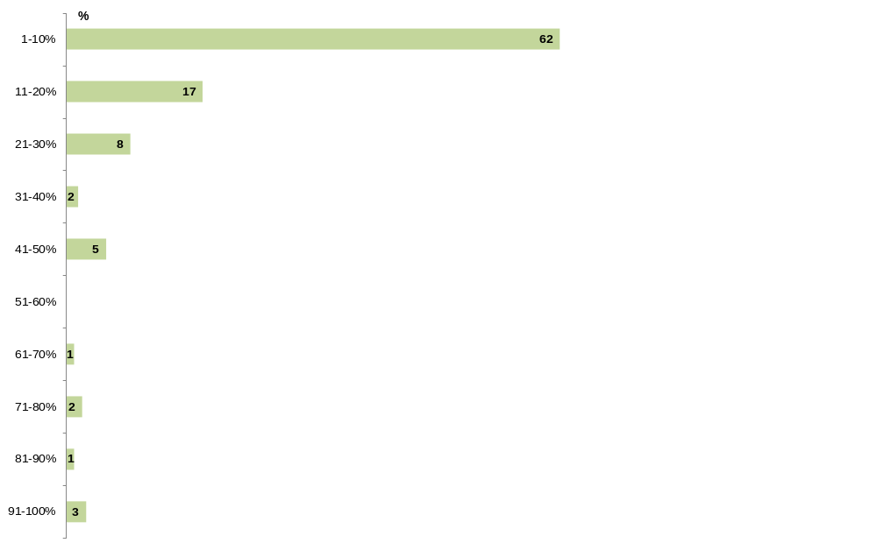
%
Q4. Thinking about your time spent riding and driving in the last 12 months before the crash, approximately what percentage of the time would you say you rode a motorcycle (on or off-road) compared to driving a car?
Filter: Off-road crashes; base n = 201

On-road vs. off-road crashes
Respondents were asked the proportion of time of the time they rode a motorcycle compared to driving a car prior to the crash. Off-road respondents tended to ride less frequently compared to on-road respondents. Two in three (62%) off-road respondents said there was a 10:90 split between the time they rode and the time they drove a car (i.e. 10% of the time they rode a bike and 90% of the time they drove their car). In comparison, for on-road respondents, only 28% said they rode up to 10% of the time while driving the other 90% of the time (See Figure 7).

Figure 7: Time spent riding prior to crash compared to driving a car by crash location (on-road vs. off-road)
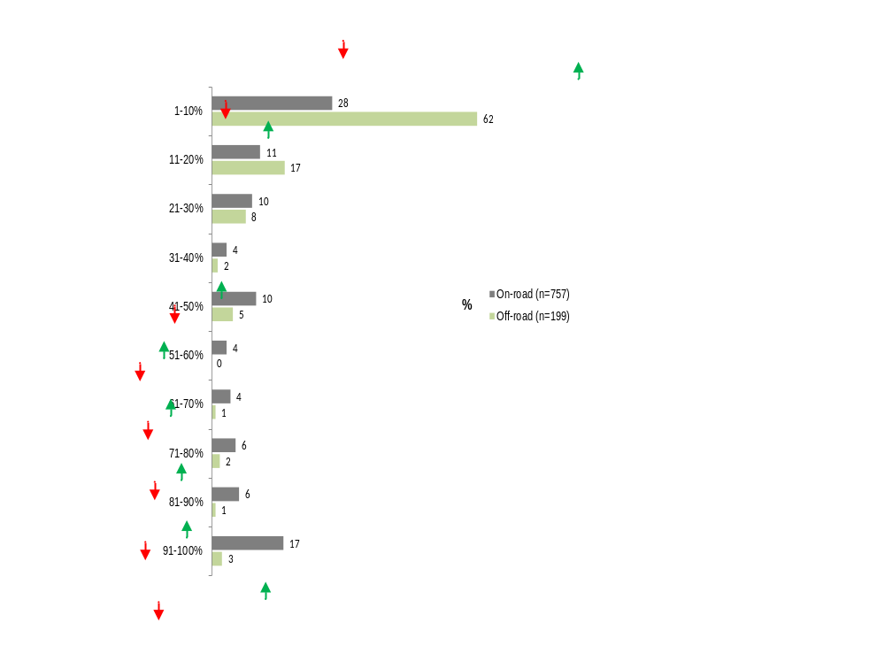
%
Q4. Thinking about your time spent riding and driving in the last 12 months before the crash, approximately what percentage of the time would you say you rode a motorcycle (on or off-road) compared to driving a car?
Total sample; base n = 956 (excludes ‘don’t know/can’t remember’/refused’)
↓↑ indicates statistically significant difference compared to respondents not in that category

Break prior to the crash
Similar with respondents who had an on-road crash, the majority of off-road respondents had never had a break from riding since learning to ride (72%).
Figure 8: Whether there was a break prior to the crash (off-road crashes only)
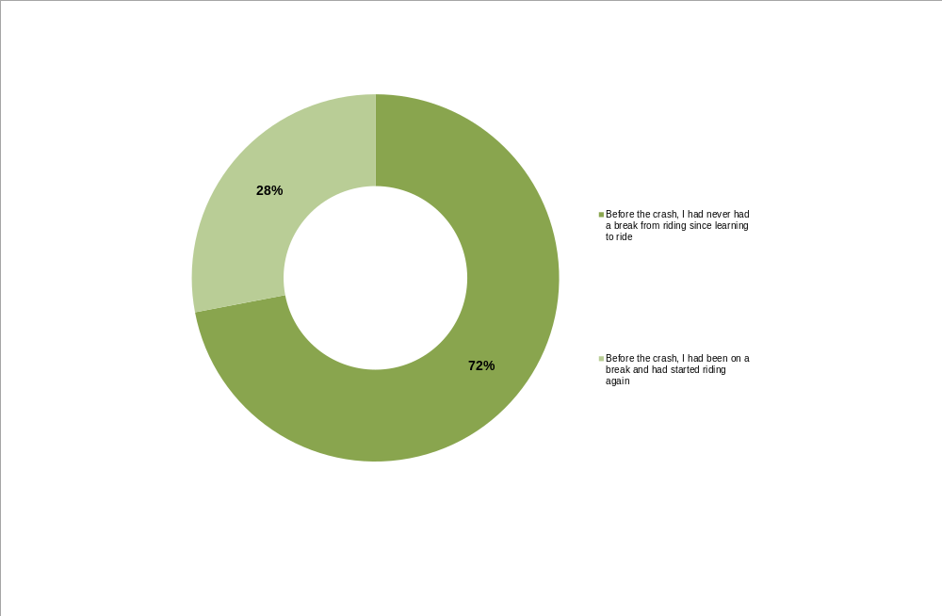
Q5. Which of the following best describes your motorcycle riding history before the crash?
Filter: Off-road crashes; base n = 201

Length of break
Among the 28% of off-road crash respondents who did have a break prior to their crash, 39% indicated they had a break of up to six months before riding again. Close to one in five (18%) said that they had a break of 7-11 months and a similar proportion (16%) stated that they had a 1-2 year break before riding again before the crash.

Figure 9: Length of break (off-road crashes only)
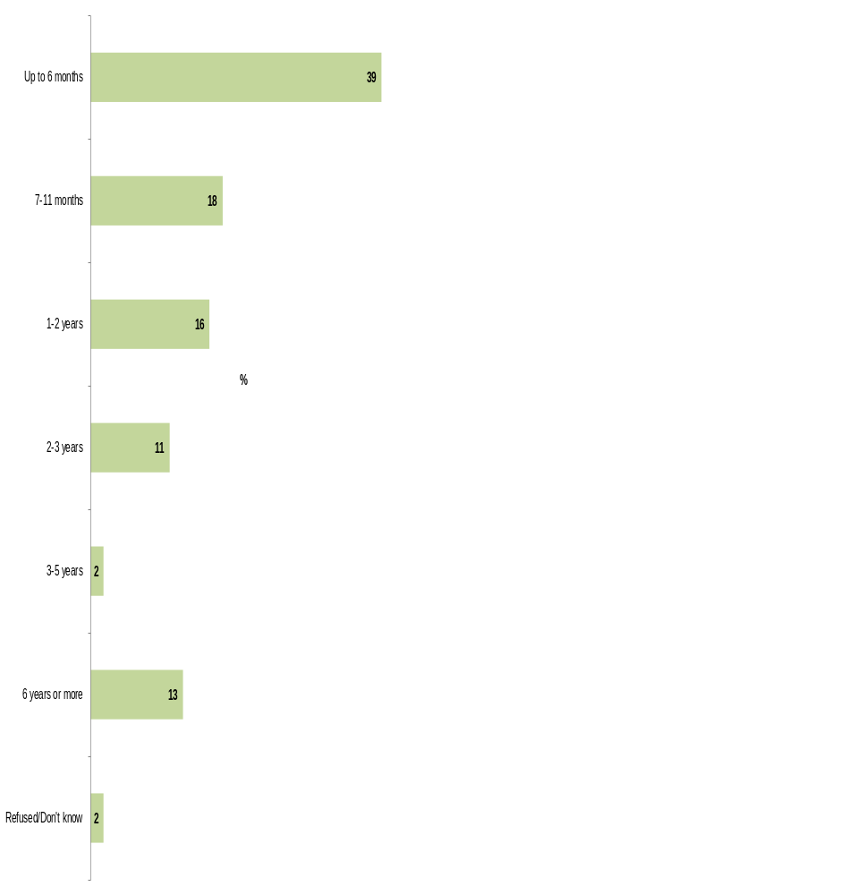
Q6. How long was the break? Please answer in months or years.
Filter: Off-road crashes; if had break from riding; base n = 56

Although the sample size was small (n=56), there was an even spread across the year as to when off-road riders returned after their break. Thirty-one percent (31%, n=10) returned in the winter months from June to August; 28% returned in summer time between December and February, 25% in spring and 17% recalled getting back into riding in autumn.

At the time of the crash
Almost all those involved in an off-road crash had been riding on an off-road or trail bike at the time (95%). A minority said they had been riding a road bike at the time of the crash (4%). Most also said they normally rode an off-road or trail bike prior to the crash suggesting that familiarity with off-road vehicles was unlikely to be a common cause of crashes.
The vast majority of off-road crash respondents said they had been just going for a ride (95%) – more so than for those involved in an on-road crash (43%) where there was a higher proportion who were commuting at the time of the crash.
Eight in ten (80%) of those involved in an off-road crash had been riding with other people at the time. Forty percent (40%) of all respondents had been riding in a group of up to four riders with the same proportion riding in groups bigger than this (40%).
Three-quarters (75%) of the crashes occurred on a track in a state park or forest etc. Just under one in five (18%) occurred on private property.
The majority of respondents indicated there were no other parties involved in the crash (92%). In comparison, only 64% of those in on-road crashes mentioned no other parties such as a pillion rider, other vehicles or pedestrians had been involved in the crash.
Close to two thirds of respondents said their motorcycle had not collided with anything and had just it the ground (63%). Among those whose motorcycle had collided with an object, the most common mention had been colliding with a tree or bush (17%) followed by colliding with rocks (12%). Off-road respondents were more likely than on-road respondents to say their motorcycle had not collided with anything (63% vs. 51% for on-road).
Similarly, the majority said their body had not collided with anything apart from the ground (71%).
Section 3.3.4 includes further details on the different type of crashes based on the first event in the chain of events that caused the crash.

Motorcycle type and riding purpose at time of crash

Type of motorcycle ridden at time of crash
The vast majority (95%) of respondents who had an off-road crash were riding an off-road bike at the time while only 4% said had been riding a road bike when they had crashed at an off-road location.
Figure 10: Type of motorcycle ridden during the crash (off-road crashes only)
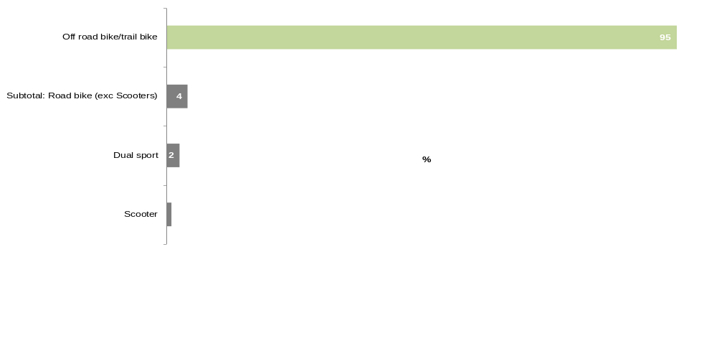
Q11. Firstly, what type of motorcycle were you riding at the time of the crash?
Filter: Off-road crashes; base n = 201

The majority (92%) who were riding an off-road bike at the time of the crash indicated they normally rode the same type of bike before the crash. For those who had been riding a road bike at the time, 88% said they mainly rode this type of bike prior to the crash. Overall, 90% indicated they were riding the same type of bike at the time of the crash as they normally rode in the year before the crash which suggests few crashes could be attributed to a lack of familiarity with the type of bike they had been riding.

Table 4: Type of bike ridden during the crash by bike usually ridden before crash (off-road crashes only)
Column % | Off road bike/trail bike | Subtotal: Road bike | Sports bike | Dual sport | Tourer/cruiser | Scooter | Other type of road bike | Other type of bike
n= | 190 | 8* | 1* | 5* | 1* | 2* | 1* | 1*
Off road bike/trail bike | 92↑ | 13↓ | 0 | 0↓ | 0 | 100 | 100 | 100
Subtotal: Road bike | 6↓ | 88↑ | 100 | 100↑ | 100 | 0 | 0 | 0
Sports bike | 3 | 13 | 100 | 0 | 0 | 0 | 0 | 0
Dual sport | 1↓ | 63↑ | 0 | 100↑ | 0 | 0 | 0 | 0
Tourer/cruiser | 2 | 0 | 0 | 0 | 0 | 0 | 0 | 0
Scooter | 0 | 0 | 0 | 0 | 0 | 0 | 0 | 0
Other type of road bike | 0 | 0 | 0 | 0 | 0 | 0 | 0 | 0
Other type of bike | 1 | 0 | 0 | 0 | 0 | 0 | 0 | 0
Don’t know /can’t remember | 0 | 0 | 0 | 0 | 0 | 0 | 0 | 0
Refused | 1 | 0 | 0 | 0 | 0 | 0 | 0 | 0
Q11. Firstly, what type of motorcycle were you riding at the time of the crash?
Q3.What type of motorcycle did you ride most often before the crash?
Filter: Off-road crashes; base n = 201
↓↑ indicates statistically significant difference compared to respondents not in that category
*Note small sample size

Reasons for riding at the time of the crash
The majority (95%) of respondents said they were riding for recreation purposes or just going for a ride at the time of their crash. A minority said they were riding to or from work (1%).
Respondents who had crashed at an off-road location were more likely to say they were riding for recreation purposes or had just been going for a ride compared to those who had crashed on-road (95% vs. 43%) and were less likely to have ridden for commuting purposes (1% vs. 50% of those who crashed on-road).

Whether riding alone or with other riders at the time of the crash
Eight in ten (80%) of those who crashed off-road had been riding with other people at the time. Seventeen percent (17%) had been riding with one other person; and a further 23% said they were riding with 2-3 other riders at the time of the crash. Forty percent (40%) of respondents had been riding in a group of 5 or more riders.
On-road vs. off-road crashes
Respondents who had an off-road crash were more likely to have been riding with others at the time of the crash compared to those who crashed on-road (80% vs. 28%). Seventy-one percent (71%) of on-road respondents said they had been riding alone. This is consistent with the proportion of riders commuting at the time of the on-road crash.
Table 5: Whether riding alone or with others during the crash by crash location (on-road vs off-road)
Column % | On-road | Off-road
n= | 763 | 201
Riding alone | 71↑ | 20↓
Subtotal: Riding with others | 28↓ | 80↑
Riding with 1 other rider (2 riders in total) | 10↓ | 17↑
Riding with 2-3 other riders (3-4 riders in total) | 6↓ | 23↑
Riding with 4-6 other riders (5-7 riders in total) | 5↓ | 18↑
Riding with 7 or more riders (8 or more riders in total) | 7↓ | 22↑
Q13. At the time of your crash, were you riding alone or with other riders?
Total sample; base n = 964
↓↑ indicates statistically significant difference compared to respondents not in that category

Where the crash occurred
Among the off-road crashes, three quarters (75%) of respondents said that they had crashed at a track in state park, forest, etc. Close to one in five (18%) stated they had crashed on private property. A minority (3%) mentioned crashing on public land in residential areas such as a park, reserve or track or at another off-road location such as access roads, dirt roads around a forest or other motorcycle tracks/parks (4%).
Figure 11: Where the crash occurred (off-road crashes only)
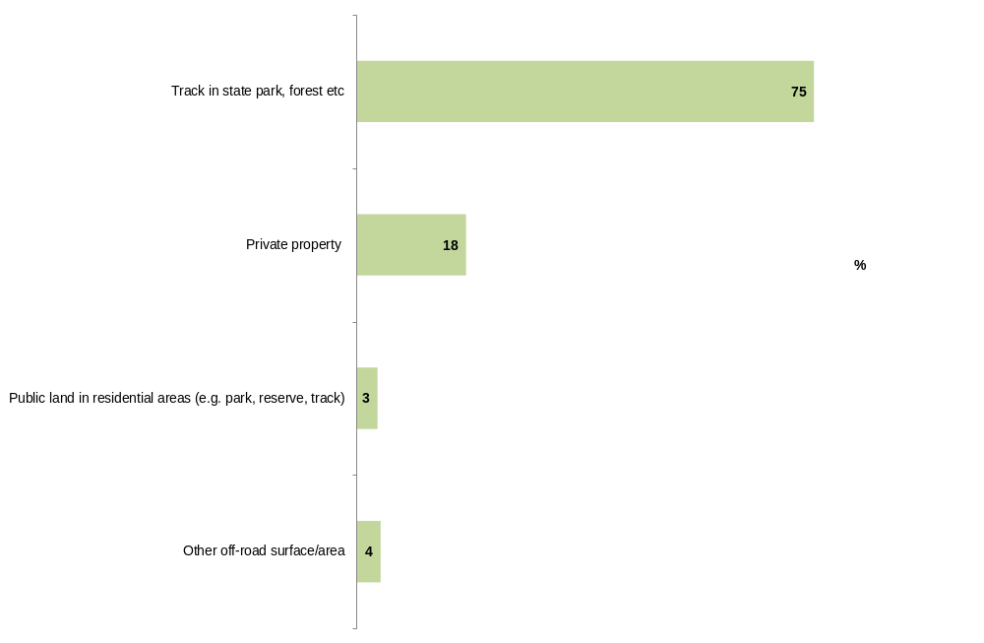
Q14. Where did the crash occur?
Filter: Off-road crashes; base n = 201

Respondents who were riding with others when they crashed were more likely to have crashed in a state park or forest compared with those who were riding alone (80% vs. 53%). In comparison, those who were riding alone were more likely to have been riding on private property or public land in residential areas (33% of those riding alone rode on private property vs. 14% in a group and 10% of those riding alone riding on public land in a residential area vs. 2% who had been in a group) (See Table 6).
Table 6: Where the crash occurred by riding alone or with others (off-road crashes only)
Column % | Riding alone or with others
Column % | Riding alone | Riding with others
n= | 40 | 160
Track in state park, forest etc. | 53↓ | 80↑
Private property | 33↑ | 14↓
Public land in residential areas (e.g. park, reserve, track) | 10↑ | 2↓
Other off-road surface/area | 5 | 4
Q14. Where did the crash occur?
Filter: Off-road crashes; base n = 201
↓↑ indicates statistically significant difference compared to respondents not in that category

Crash circumstances

Whether other parties were involved
Nine in ten (92%) respondents who had an off-road crash reported that there was no pillion rider, other vehicles or pedestrians involved in the off-road crash (See Figure 12).
Notably, those who crashed off-road were more likely to report that there were no other parties involved in the crash compared to those who had an on-road crash (92% vs. 64%).
Figure 12: Whether other parties were involved (off-road crashes only)
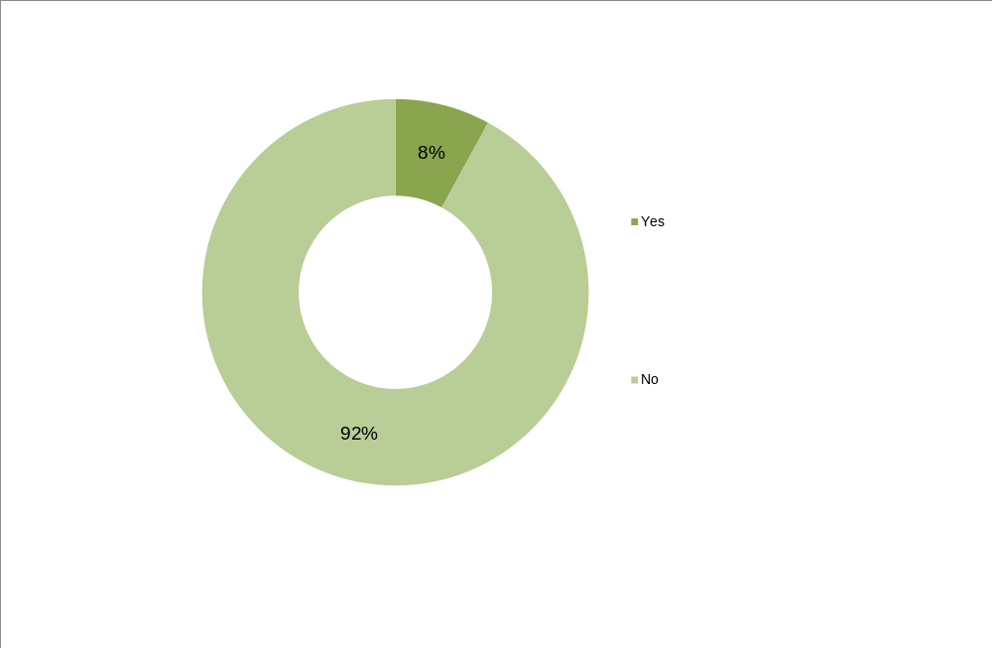
Q16. Apart from yourself, were there any other parties (that is passengers (pillion riders), other vehicles or pedestrians etc.) involved in the crash?
Filter: Off-road crashes; base n = 201

As seen in Table 7, respondents aged 26 or older were more likely than their younger counterparts to state that no other parties were involved in their off-road crash (95% vs. 84% of those aged up to 25).
Table 7: Whether other parties were involved by age at accident (off-road crashes only)
Column % | Age (at accident)
Column % | Up to 25 years | 26-39 years | 40+¶years
n= | 57 | 62 | 82
Yes | 16↑ | 8 | 2↓
No | 84↓ | 92 | 98↑
Don’t know /can’t remember | 0 | 0 | 0
Refused | 0 | 0 | 0
Q16. Apart from yourself, were there any other parties (that is passengers (pillion riders), other vehicles or pedestrians etc. involved in the crash?
Filter: Off-road crashes; base n = 201
↓↑ indicates statistically significant difference compared to respondents not in that category

While the sample size is small, among the 8% (n=16) of those who had an off-road crash who reported that other parties were involved in their crash, approximately three out of five (63%) mentioned that there was another motorcycle coming from the opposite direction involved in the crash and one in four (25%) mentioned that another motorcycle was going in the same direction as them (See Table 8).
Table 8: Whether anyone else or other vehicles involved (off-road crashes only)
 | %
n= | 16*
Another motorcycle going in the opposite direction as you (i.e. coming towards you) | 63
Another motorcycle going in the same direction as you | 25
Another vehicle going in the opposite direction as you (i.e. coming towards you) | 13
Another vehicle going in the same direction as you | 6
Q27. And did your crash involve…?
Filter: Off-road crashes; other parties involved; base n = 16
↓↑ indicates statistically significant difference compared to respondents not in that category
*Note small sample size

Involvement of other parties
Supplementary data for respondents was supplied by the TAC from a number of different sources including VicRoads, VicPolice and the TAC Claims database. The supplementary data provided further insight in some of the areas that were not covered in the survey including (but not limited to) injury severity, road characteristics such as geometry and speed zones etc. The following section covers some of the results relating to injuries incurred at the time of the crash.
As to the number of vehicles involved in the crash, similar results were captured in the supplementary data about the crash from the TAC Claim database. Based on the supplementary data, 84% of the n=201 cases where supplementary data was available were classified as single vehicle accidents.
In comparison, on-road crashes were more likely to be classified as involving multiple vehicles (46% vs. 16% involving two or more vehicles). Just over half (54%) of on-road crashes were classified as single vehicle crashes.
Table 9. Involvement of other vehicles according to TAC Claims database (on-road vs. off-road crash)
Column % | On-road | Off-road
n= | 761 | 201
Single vehicle | 54↓ | 84↑
Two or more vehicles | 46↑ | 16↓
Source: TAC Claims database, Number of vehicles
Filter: On-road crashes; base n = 761; off-road crashes, base n=201
↓↑ indicates statistically significant difference compared to respondents not in that category

Categorising motorcycle crashes
Details of each respondent’s crashes including their descriptions of the crash were analysed to order to categorise each of the crashes according to the first event in the chain of events that lead to the motorcyclist crashing.
Perhaps unsurprisingly, almost all (93%) off-road crashes did not involve any interaction with other vehicles The most common types of crashes were ones where the motorcyclist lost control due to a handling error (34%), followed by losing control due to hitting unfavourable surface conditions (28%) and colliding with a physical object (25%). A further 2% of crashes involved avoiding hitting a physical object.
Of the small proportion of off-road crashes where another vehicle had been involved in the lead up to crashing, these crashes were most likely to occur between intersections (6%)

Introduction to categorising crashes
One of the objectives of this research was to better understand motorcycle crashes and determine whether there were any commonalities between respondent crashes. The supplementary crash data from the TAC and VicRoads included details of the Definition for Classifying the Accident (DCA) which is used to categorise crashes in terms of the general direction of vehicles at the time of the crash. While it is not the purpose of the DCA to assign the cause for the crash, it was evident that the codes assigned did not always completely reflect what had happened in the lead up to the crash or concentrated on the last moments of the crash.
For example, more than half of all crashes (56%) were classified according to the assigned DCA as a vehicle going off-path either on a curve or a straight. However, upon further investigation of the survey information including the respondents’ descriptions of the crash, was clear there were a number of different reasons for losing control of their motorcycle. In fact, in one in five of these crashes (19%), respondents recalled that they had crashed as a result of reacting to another vehicle’s actions.
An outcome of this initial analysis of the DCA codes was to re-examine the details of each crash through respondents’ open-ended descriptions, their survey responses, sketches (where available) and the supplementary data from the VicRoads, TAC and Victoria Police databases and group crashes by the first event in the chain of events that lead to the crash rather than focussing on the final moment of the crash or where the motorcyclist ended up. For example, respondents commonly described rear-ending another vehicle in traffic after hitting some gravel on the road. In this this situation, for the purposes of this exercise, the crash was categorised as the rider losing control due surface conditions rather than focus on the collision with the other vehicle, deemed as a secondary outcome of losing control over gravel.
The crashes were grouped in categories determined in consultation with the TAC team and were based on the following factors:
- Whether there had been an interaction with another vehicle in the first instance (regardless of if there had been a collision);
- Whether there had been a collision or not with the primary vehicle;
- The location of the crash (i.e. intersection or driveway or midblock crash); and
- The direction the motorcycle was heading in relation to other vehicles.
Further details about the crash were also gathered through this task including:
- Who did not give way;
- Whether the crash occurred on a curve or straight road;
- The type of collision and the direction of the impact from the motorcyclist point of view.
A structure for categorising the different types of crashes where there had been an interaction with another vehicle is outlined below:
Figure 13: Structure for categorising crashes with interaction with other vehicles
First point interaction with vehicle) | Collision with vehicle in traffic or object | Crash location intersection or mid-block | Motorcyclist location in relation to other vehicle | Key types of crashes
Interaction with vehicle | Collision | Intersection or driveway | Adjacent direction | Near side
 |  |  |  | Far side
 |  |  |  | Unknown
Interaction with vehicle | Collision | Intersection or driveway | Opposing direction | Far side
 |  |  |  | U-turning
Interaction with vehicle | Collision | Intersection or driveway | Same direction | Rear end
 |  |  |  | Turning
Interaction with vehicle | Collision | Intersection or driveway | Roundabout | Near side
Interaction with vehicle | Collision | Midblock (not at an intersection) | Opposing direction | Head on (not overtaking)
 |  |  |  | U-turning
 |  |  |  | Other
Interaction with vehicle | Collision | Midblock (not at an intersection) | Same direction | Changing lanes
 |  |  |  | Rear end
 |  |  |  | U-turning
 |  |  |  | Overtaking
 |  |  |  | Other
Interaction with vehicle | No collision with primary vehicle - Avoid/miss vehicle | Intersection or driveway | Adjacent direction | Near side
 |  |  |  | Unknown
Interaction with vehicle | No collision with primary vehicle - Avoid/miss vehicle | Intersection or driveway | Opposing direction | Far side
Interaction with vehicle | No collision with primary vehicle - Avoid/miss vehicle | Intersection or driveway | Same direction | Rear end
Interaction with vehicle | No collision with primary vehicle - Avoid/miss vehicle | Intersection or driveway | Roundabout | Near side
Interaction with vehicle | No collision with primary vehicle - Avoid/miss vehicle | Midblock (not at an intersection) | Opposing direction | Head on (not overtaking)
 |  |  |  | U-turning
Interaction with vehicle | No collision with primary vehicle - Avoid/miss vehicle | Midblock (not at an intersection) | Same direction | Changing lanes
 |  |  |  | Rear end
 |  |  |  | U-turning
 |  |  |  | Overtaking
 |  |  |  | Other

The crashes where there had been no interaction with other vehicles were categorised into six distinct groups:
- Losing control of the motorcycle due to surface conditions
- Avoiding surface conditions;
- Losing control due to a motorcyclist error;
- Colliding with a physical object;
- Losing control avoiding an object; or
- Losing control due to other reasons.
While some information was gained from the police description of the incident, it should be noted that the information used to categorise the crashes was predominately based on the respondent’s feedback and description of the crash. The following section covers the results from categorising the crashes by the factors above.

Summary of all off-road crashes
Only 7% of all off-road crashes involved another vehicle in the first instance. Of these, 6% had collided with another vehicle. All collisions occurred ‘mid-block’ that is, not at an intersection or driveway.
On-road vs. off-road crashes
Compared to on-road crashes, respondents who had an off-road crash were much less likely to have an interaction with another vehicle prior to the accident (93% vs. 56% for off-road).
Among crashes where there had been no interaction with another vehicle, respondents who had an off-road crash were more likely to indicate that they had lost control due to a handling error on their part (34% vs. 17% on-road) or that they collided with an object (25% vs. 9% on-road).
As can be seen in Figure 14, almost all respondents (93%) who had an off-road crash had no interaction with another vehicle in the first instance. The most common reasons for the crash where no other vehicles were involved included losing control due to a motorcyclist error (34%), followed by losing control due to hitting unfavourable surface conditions (28%) and colliding with a physical object (25%). A further 2% of crashes involved avoiding hitting a physical object.

Figure 14: Types of motorcycle crashes – on road surface crashes vs. off road surface crashes (as % of all on-road crashes)
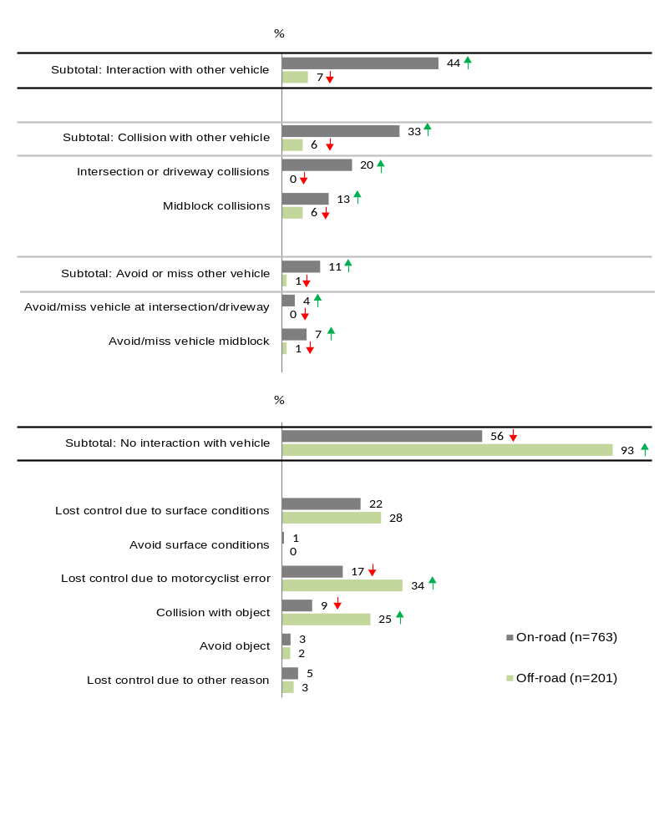Crash categories
Total sample; Unweighted; base n = 964

In regards to perceived responsibility, while the sample size was small (n=15), among respondents who had an interaction with another vehicle in the first instance, 40% reported they had been partially at fault in these scenarios. One in three (33%) did not feel they were at all responsible.
In comparison, more than half (54%) of respondents who did not have an interaction with another vehicle felt they were totally responsible for the crash.
Seven in ten (69%) of those who had lost control due to a handling error said they were totally responsible for the accident –this was the category where the highest proportion of respondents admitted complete responsibility (See Table 10).
Close to half (48%) of those who had lost control due to surface conditions said that they were totally responsible for the crash compared to only 2% percent who said that they were not at all responsible for the accident.
Table 10: Crash categories – Perceived responsibility (off-road crashes only)
Row % | Not responsible at all | Partially responsible | Totally responsible | Don’t know /can’t remember | Refused | n=
Subtotal: Interaction with other vehicle in first instance | 33 | 40 | 7 | 13 | 7 | 15
Subtotal: No interaction with vehicle in first instance | 11 | 28 | 54 | 4 | 3 | 186
- Lost control due to surface conditions | 2 | 39 | 48 | 5 | 5 | 56
- Lost control due to motorcyclist error | 7 | 18 | 69 | 3 | 3 | 68
- Collision with object | 24 | 26 | 42 | 6 | 2 | 50
- Lost control due to other reason | 14 | 43 | 43 | 0 | 0 | 7
- Avoid object | 20 | 40 | 40 | 0 | 0 | 5
Crash categories
Off-road crashes; Unweighted; base n = 201

Non-interaction crashes
Differences between crash categories / reasons among those who had no interaction with another vehicle
As discussed, the top three types of off-road crashes were losing control due to a handling error, losing control due to hitting unfavourable surface conditions and colliding with a physical object.
The below are some of the differences observed between the types of crashes where there had been no interaction with other vehicles:
- Responsibility for crash: Those who had collided with an object were more likely than those who had lost control because of surface conditions to indicate that they were not responsible at all for the accident (24% vs. 4%). On the other hand and unsurprisingly, those who had lost control due to handling error were more likely to indicate that they were totally responsible for the accident (69% vs. 48% for those who lost control due to surface conditions and 42% for those who collided with an object).
- Attitudinal statements: Respondents who had lost control due to surface conditions were less likely to know the crash area well (36% strongly disagreed vs. 21%). On the other hand, those who lost control while avoiding an object were more likely to agree strongly that they knew the crash area well (80% vs. 31% for other crash types).
- Other riders in the crash area: Respondents who had lost control due to surface conditions were more likely to indicate that there were other off-road motorcycles apart from themselves in the area at the time (43% vs. 22% crashed due to other reasons).
- Number of other riders in the group: Those who had lost control whilst avoiding an object were more likely to have ridden alone compared with other respondents who had crashed because of other factors (60% vs. 19%).
- Demographic characteristics: Participants from metro Melbourne were less likely to have had collisions with physical objects (58% vs. 75% other types of crashes).

Details of non-interaction crashes
Each of the types of non-interaction crashes is covered in the below.
As can be seen in Table 13, the most common type of off-road crashes among those where no other vehicles were involved was due to losing control due a motorcyclist error.
The most common reason for the motorcyclist losing control was due a handling error on a corner or bend in the road/track or losing control performing stunts or tricks (13% and 5% respectively).
Table 11 Crashes where no vehicles were involved – Motorcyclist error crashes (off-road crashes only)
 | % of all off road crashes with no interaction with other vehicle | n=
No interaction with other vehicle in first instance | 100 | 186
Lost control due to motorcyclist error | 37 | 68
At corner or bend in road/track | 13 | 25
Performing stunt / tricks | 5 | 10
Speed | 3 | 5
While braking | 2 | 3
While accelerating | 1 | 1
While manoeuvring | 1 | 1
Other motorcyclist error | 12 | 23
Crash categories
Off-road crashes; Unweighted; base n = 201

The next most common type of off-road crashes where no other vehicles were involved was losing control due to hitting unfavourable surface conditions.
The most common surface to have ‘caused’ the crash was uneven ground or bump or mound in the track (10%). This was followed by potholes or ruts in the ground (9%), wet ground / mud / ice / oil on ground (7%) and gravel / sand / dirt on ground (5%).

Table 12 Crashes where no vehicles were involved – Surface condition crashes (off-road crashes only)
 | % of all off road crashes with no interaction with other vehicle | n=
No interaction with other vehicle in first instance | 100 | 186
Lost control due to road surface conditions | 30 | 56
Uneven ground / bump / mound | 10 | 18
Pothole / rut | 9 | 16
Wet ground / mud / ice / oil on ground | 7 | 13
Gravel / Sand / Dirt / Rocks / Debris | 5 | 9
Crash categories
Off-road crashes; Unweighted; base n = 201

A collision with an object was the third most common type of off-road crash where there was no interaction with another vehicle (27%). Among respondents who had collided with an object, fallen log or tree branch was the main object that they collided with (16%) followed by rocks (9%).
A minority of respondents also had lost control trying to avoid an object (3%). Again this was mainly fallen logs, trees, stumps or branches (2%).

Table 13 Crashes where no vehicles were involved – Collision or avoiding objects (off-road crashes only)
 | % of all off road crashes with no interaction with other vehicle | n=
No interaction with other vehicle in first instance | 100 | 186
Collision with object | 27 | 50
Fallen Log / Tree / Stump / Branch | 16 | 29
Rock | 9 | 16
Animal | 2 | 4
Other object | 1 | 1
Avoid object | 3 | 5
Fallen Log / Tree / Stump / Branch | 2 | 3
Animal | 1 | 2
Crash categories
Off-road crashes; Unweighted; base n = 201

Lastly, a handful of respondents said they had lost control due to other reasons including 3% of all non-interaction crashes that occurred due to a mechanical issue.

Table 14 Crashes where no vehicles were involved – Other types of non-interaction crashes (off-road crashes only)
 | % of all off road crashes with no interaction with other vehicle | n=
No interaction with other vehicle in first instance | 100 | 186
Lost control due to other reasons | 4 | 7
Mechanical issue | 3 | 5
Atmospheric conditions | 1 | 1
Unknown | 1 | 1
Crash categories
Off-road crashes; Unweighted; base n = 201

When looking at the types of crashes and the individual ‘causes’ at an overall level, as can be seen in Figure 15 below, overall, the most common factor was fallen log / tree / stump / branch (17%), followed by corner or bend in road (13%), uneven ground / bump / mound (10%) and pothole / rut and rocks (9% for both).
Figure 15. Reasons for crashes in detail – among those who had no interaction with other vehicle in the first instance
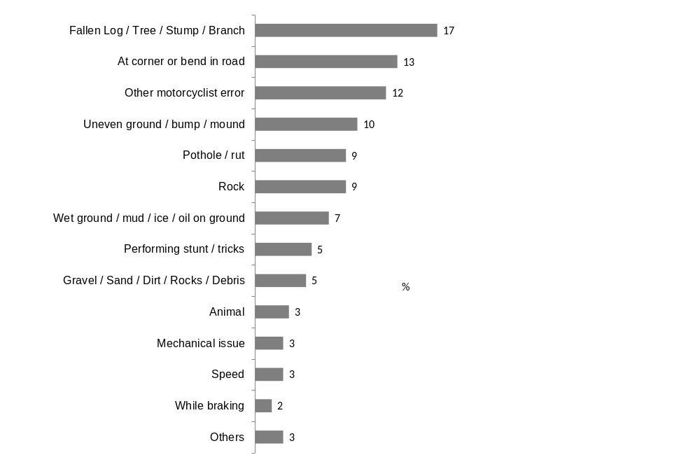
Crash categories
Off-road crashes; Filter: FILTER Off-road surface crashes AND FILTER No Interaction; Unweighted; base n = 186; 81% filtered out

Accident type according to TAC Claims database
The TAC Claims database also classified the crashes into broad categories.
According to the supplementary data, a third (36%) of the crashes were due to the rider falling from their motorcycle. One in five (19%) were crashes where there had been no collision at all. The same proportion (19%) indicated they had a collision. One in ten (11%) of the crashes involved an overturned vehicle without colliding with another vehicle.
As can be seen in Figure 23, those who had an off-road crash were more likely to have fallen from a moving vehicle (36% vs. 23%), have no collision at all (19% vs. 14%) or a collision with a fixed object compared to on-road crashes (19% vs. 11%).
Off-road crashes were less likely to involve colliding with another vehicle at all (5% vs. 35%).
Figure 16. Accident type (on-road vs. off-road)
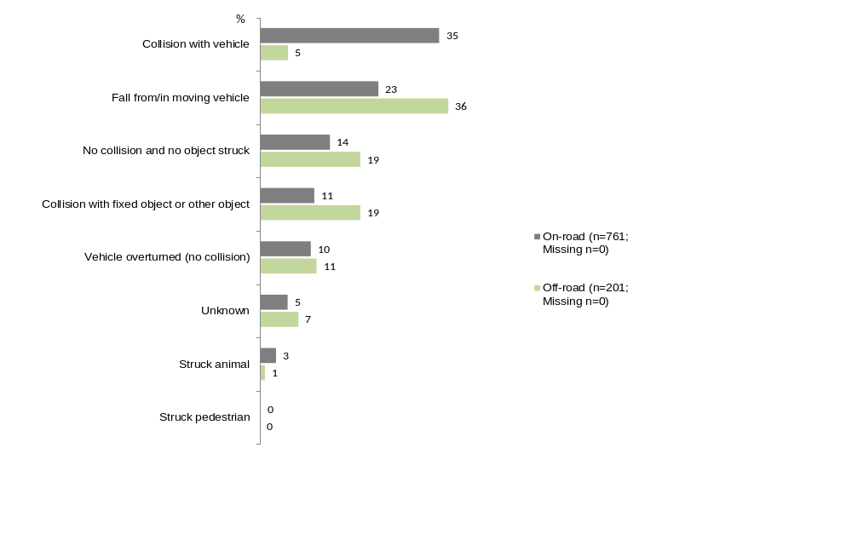
Source: TAC Claims database – Accident type
Filter: On-road crashes; base n = 761; off-road crashes, base n=201
↓↑ indicates statistically significant difference compared to respondents not in that category

Off-road crash case studies

Case study 1: Off road crash with interaction with other vehicle
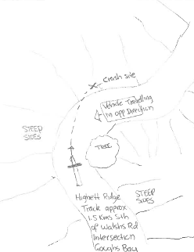
This example of an off-road crash occurred at a narrow bend in the road where the rider tried to avoid colliding with another vehicle from the opposite direction.
Overall, there were only n=15 off-road crashes that involved another vehicle in the first instance.
The respondent had been riding with one other rider and that the track where they were riding was a dry dirt track, rocky, with steep inclines and trees bushes around. The weather was clear with no cloud or light cloud cover during the crash.
The respondent’s description of what happened was as follows:
“Travelling uphill on narrow ridge track and failed to see oncoming vehicle until last second.
Served to avoid head on collision and applied too much pressure to front brakes causing me to come off motorcycle”.

The respondent selected “corner on track” and “own mistake” as the two factors that contributed to the crash during the survey. The respondent also indicated that they were “partially responsible for the accident” when asked.
The respondent had agreed strongly that they knew the crash area well and were very familiar with the motorcycle he was riding at the time of the crash.
The respondent added that they had been wearing at least five of the items protective gear that was listed in the survey. According to the supplementary data from the TAC Claims database about the crash, the respondent was not admitted to the hospital within the first seven days after the accident.
This respondent had scored a ten out of ten (completely back on track) when asked to rate the extent to which they were able to get their life back on track and had ridden again since the crash.

Case study 2 – Crash with no interaction with other vehicles - Collision with object
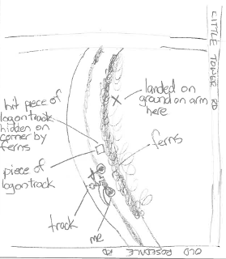
In this example, the collision had occurred at a bend in the road where the rider had collided with a log on the ground.
Overall, there were n=50 off-road crashes where the respondent had a collision with an object.
At the time of the crash, the respondent was riding with two or three other riders. The respondent indicated that it had been a clear day with no cloud or light cloud cover only and that they had been riding from sun into shade.
The respondent’s description of what happened was as follows:
“Coming around right hand bend and hit something on track obscured by ferns on side, bike bucked up into the air and threw me over the handle bars.
They added:
“I was riding on a trail and came around a corner and there was something loose on the track, part of a tree, and the motorcycle kicked up after it hit it which threw me over the handlebars.
I landed on my arm which broke it”.

During the survey, the respondent had indicated that track conditions, particularly tree roots / fallen branch were key contributors to this crash. The respondent also indicated that they were “not responsible at all for the accident” when asked.
The respondent had been wearing at least six protective gears at the time of the crash.
According to supplementary data from the TAC, the respondent had sustained fractured limb(s) because of the accident and was admitted to the hospital for at least a week following the accident.
The respondent added it had been one to three years before they began riding again. The respondent had provided a raging of eight out of ten when asked to rate the extent to which they had been able to get your life back on track. The respondent added, “There’s still some persistent pain in the arm which prevents me from being back to 100%”.

Case study 3 - Crash with no interaction with other vehicles – motorcyclist error / performing stunts
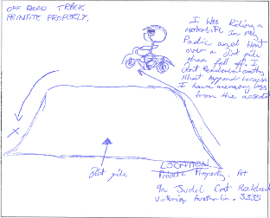
This is a crash that occurred on a private property where the respondent had lost control whilst performing stunts / tricks.
Overall, there were 68 off-road crashes where the respondent had lost control due to handling error and 10 cases where they were performing stunts or tricks at the time of crash.
The respondent had indicated that he had no recollection of the accident although he wore a motorcycle helmet at the time.
The respondent had indicated that track / trail condition, particularly steep hill / mound were the main reasons for the crash.
In regards to perceived responsibility, the respondent indicated that he was “totally responsible for the accident”. The respondent agreed somewhat that he knew the crash area well, and disagreed somewhat that if he was riding more slowly he could have done something to avoid the crash.
At the time of the crash, the respondent indicated that he was riding with another rider and that it was a clear day with no cloud or light cloud cover. He was also wearing a full face motorcycle helmet, motorcycle boots and body armour during the crash.
The respondent had a break of 7-12 months following the accident before riding again.
According to the supplementary data from the TAC, the respondent had mild brain injury / head injury because of the accident.
The respondent had provided a rating of 7 out of 10 when asked to rate the extent to which they were able to get their life back on track. The reason why the respondent provided this score was: “I feel tired and I have a sore back and weakness in my right side and I have a short temper/ also concentration”.

Details of motorcycle and rider collisions
As part of the survey, riders were asked whether they or their motorcycle collided with anything at the time of the crash.

What the rider’s motorcycle collided with
When asked what their motorcycle had collided with at the time of the crash, three in five respondents (63%) mentioned that their motorcycle did not collide with anything or it had just hit the ground.
Those aged 40 years and above were more likely to say their motorcycle had just hit the ground compared to younger respondents (72% vs. 56%).
Among those who said their motorcycle had collided with something in the crash, close to one in five (17%) indicated that their motorcycle collided with a tree/bush, followed by 12% who mentioned rocks. One in ten (11%) said they had hit something else such as a fence, other bikes or vehicles, logs, or animals.
In comparison, those involved in on-road bike crashes were significantly less likely to say their motorcycle had not collided with anything (51% vs. 63% for off-road crash respondents).
Figure 17: Motorcycle collision (off-road crashes only)
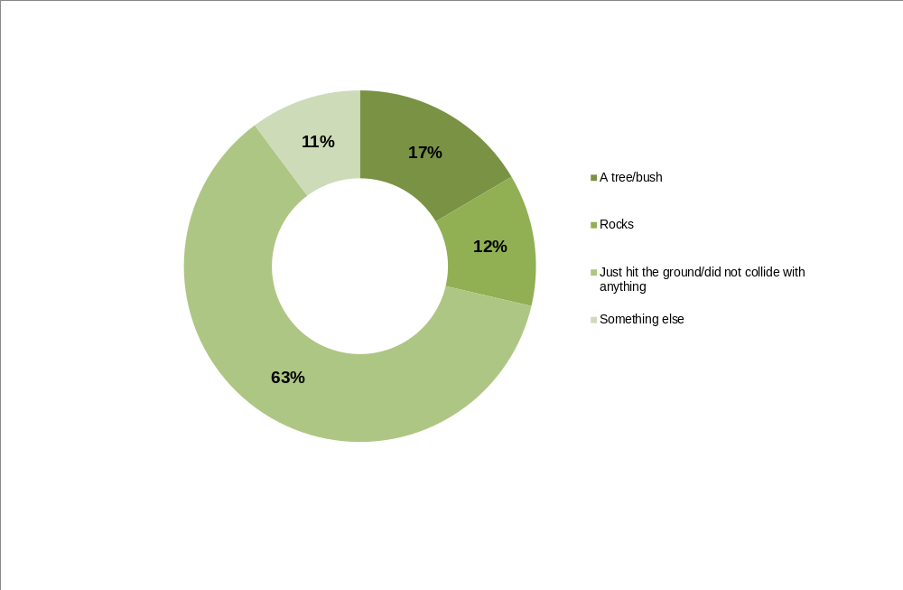
Q30. Did your motorcycle collide with any of the following at the time of the crash? Please answer yes to any that apply.
Filter: Off-road crashes; base n = 201

What the rider’s body collided with
Similar to what respondents’ motorcycles collided with, the majority of respondents (71%) indicated that their body did not collide with anything during the crash.
Those aged 40 years and above were more likely to say this was the case compared to younger respondents (76% vs. 60%). In addition, those who were riding alone were also more likely to mention that they did not collide with anything compared with those riding with others at the time of the crash (85% vs. 68%).
Approximately one in ten (12%) mentioned that their body collided with a tree or bush and a similar proportion (11%) indicated that their body had hit some rocks during the crash (See Figure 18).
Again, those involved in off-road crashes were more likely to say that their body did not collide with anything (71% vs. 61% for on-road crashes).
Figure 18: Body collision (off-road crashes only)
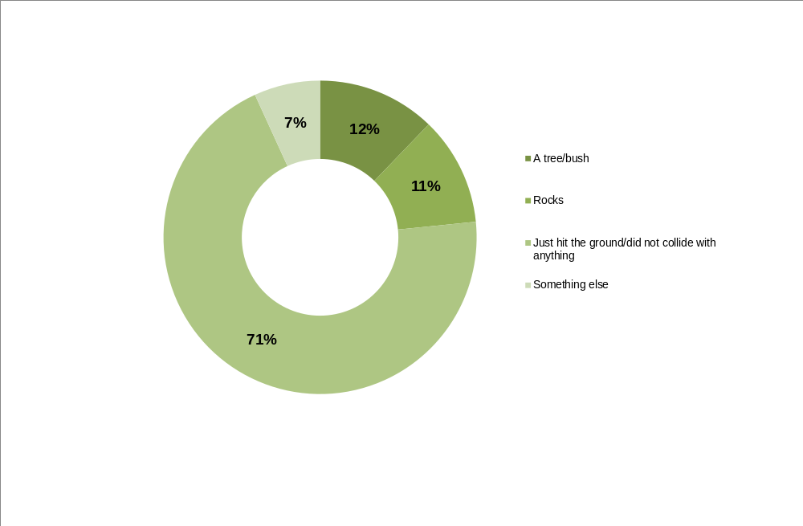
Q31. Did your body collide with any of the following at the time of the crash? Please answer yes for any that apply.
Filter: Off-road crashes; base n = 201

Factors contributing to the crash
Half (50%) of those involved in off-road crashes felt they were totally responsible for the crash. Approximately one third (29%) claimed that they were partially responsible and slightly more than one in ten (12%) felt that they were not at all responsible for the crash. Those involved in on-road crashes were more likely to say they had not been at all responsible for the crash (44% vs. 12% for off-road).
Where a respondent felt they were partially or not at all at fault, 14% stated another person had been responsible for the crash.
Track and/or trail conditions were most likely to be attributed to causing the crash (49% of mentions). In addition, one in five (22%) felt their own mistake also was a factor.
One in ten respondents (10%) agreed they were tired or fatigued at the time of the crash and 6% reported they were tense or stressed. Forty-four percent (44%) of respondents said if they had been riding more slowly they could have done something to avoid the crash with younger respondents more likely to agree this was the case (60%). Forty-one percent (41%) also disagreed there was nothing they could have done to prevent the crash.
Four percent (4%) mentioned they had been distracted by something immediately before the crash including being distracted by animals, other vehicles, and scenery.
Two percent (2%) of respondents indicated they had consumed some alcohol in the three hours prior to their crash.

Perceived responsibility of crash
Respondents were asked who they believed had been responsible for the crash. Half (50%) said that they were totally responsible, approximately one third (29%) claimed that they were partially responsible and slightly more than a tenth (12%) felt that they were not responsible at all for the crash.
Figure 19: Perceived responsibility of crash (off-road crashes only)
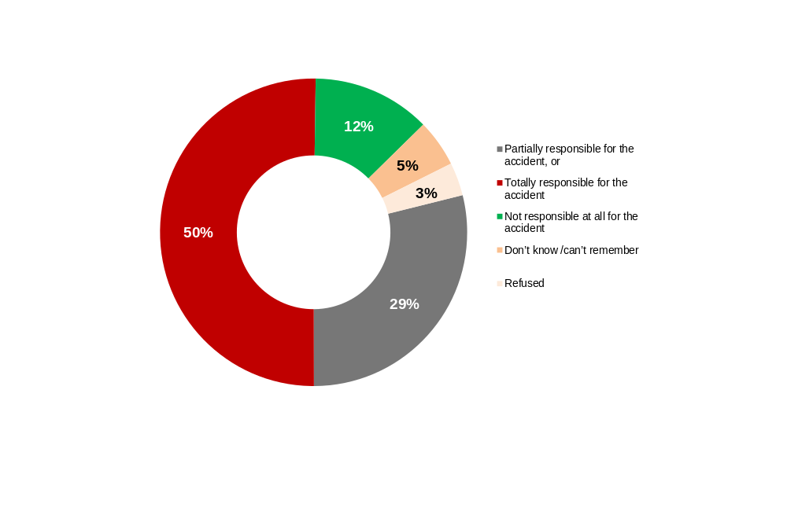
Q17. The next question is about your perception of who was responsible for your accident. If you do not wish to answer this question I can move on. Would you say you were?
Filter: Off-road crashes; base n = 201
On-road vs. off-road crashes
Respondents involved in off-road crashes were more likely to report that they felt they were totally responsible for the accident compared to those who were involved in on-road crashes (50% vs. 23%). While similar proportions of off-road and on-road crash respondents felt they were partially responsible (25% vs. 29% respectively), off-road crash respondents were less likely to say they felt they were not at all responsible for the crash (12% vs. 44%).
Figure 20: Perceived responsibility of crash by crash location (on-road vs. off-road)
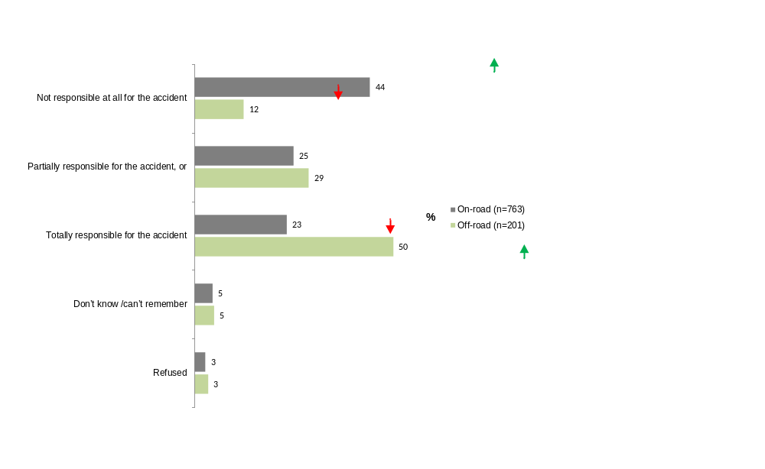
Q17. The next question is about your perception of who was responsible for your accident. If you do not wish to answer this question I can move on. Would you say you were?
Total sample; base n = 964

Whether another person was responsible for the crash
Among respondents who had an off-road crash who claimed that they were either partially responsible or not responsible at all for the incident, only 14% stated another person was responsible.
Figure 21: Another person responsible for crash (off-road crashes only)
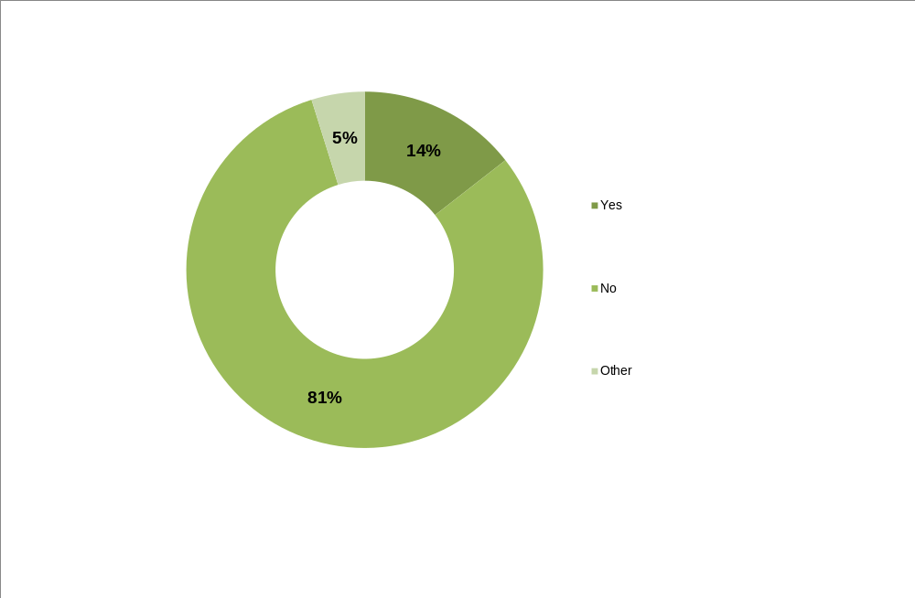
Q18. Was another person responsible for the accident?
Filter: Off-road crashes; If partially or not at fault; base n = 83
On-road vs. off-road crashes
As depicted in Figure 22, those involved in on-road crashes were significantly more likely to report that it had been another person who was responsible for the accident compared to those involved in off-road crashes (61% vs. 14%).
Figure 22: Another person responsible for accident by crash location (on-road vs. off-road)
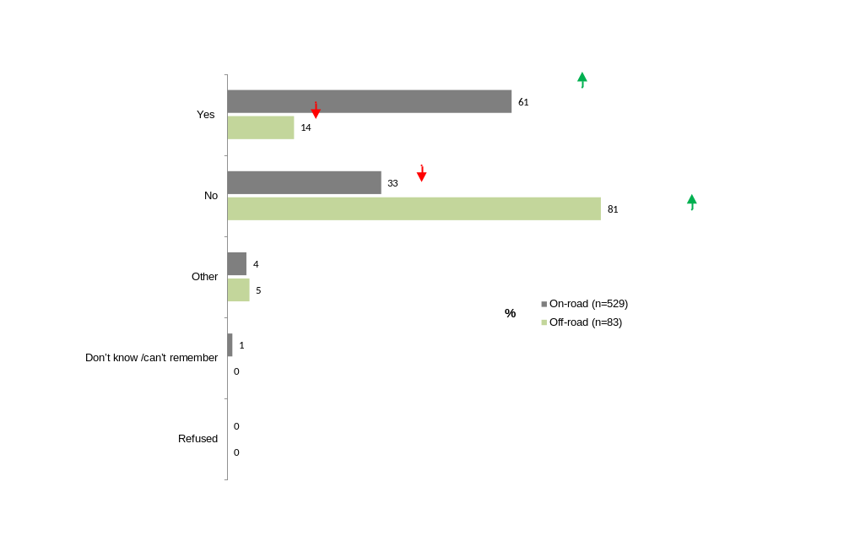
Q18. Was another person responsible for the accident?
If partially or not at fault; base n = 612
↓↑ indicates statistically significant difference compared to respondents not in that category

Reasons for the crash
Track/trail conditions were most commonly mentioned as one of the main reasons for off-road crashes (49%).
More than one in five respondents (22%) said their own mistake was one of the factors that contributed to the crash.
Respondents who agreed to the statement ‘I knew the crash area well’ were less likely to indicate that track/trail conditions were one of the contributing factors to their crash (41% vs. 60% those who did not know the crash area well).
The more familiar a rider was with the crash area, the less likely they were to attribute trail conditions to the crash (41% vs. 60% those who did not know the crash area well).

Eight percent (8%) of respondents admitted they had been riding too fast for the conditions and that their riding speed could have been a factor in the crash.
Figure 23: Main reasons for crash (off-road crashes only)
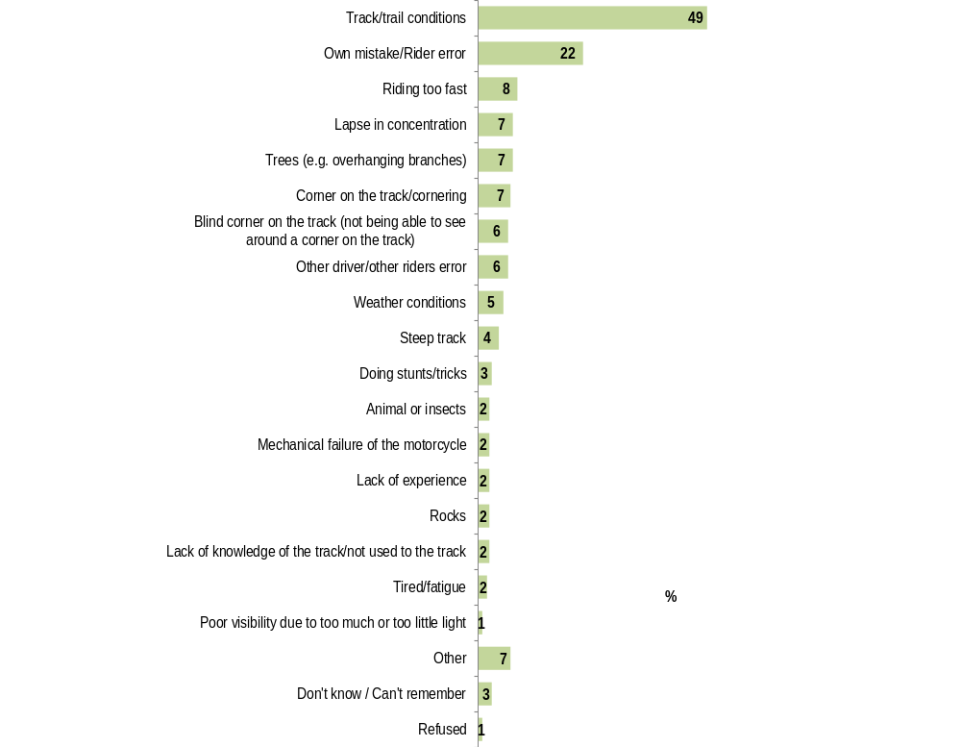
Q28. What were the main reasons you crashed your motorcycle or what would you say caused your crash?
Filter: Off-road crashes; base n = 201

Track and trail conditions were most likely to be mentioned as a contributor to the crash regardless of respondents’ perception of who was responsible for the crash.
Table 15: Main reasons for crash by responsibility of the crash (off-road crashes only)
Column % | Not responsible at all for the accident |  | Partially responsible for the accident | Totally responsible for the accident
n= | 25* |  | 58 | 101
Track/trail conditions | 40 |  | 67↑ | 43↓
Other driver/other riders error | 20↑ |  | 2 | 3
Animal or insects | 12↑ |  | 2 | 1
Blind corner on the track (not being able to see around a corner on the track) | 8 |  | 12↑ | 2↓
Trees (e.g. overhanging branches) | 8 |  | 5 | 7
Weather conditions | 4 |  | 9 | 4
Rocks | 4 |  | 3 | 2
Own mistake/Rider error | 0↓ |  | 14↓ | 37↑
Corner on the track/cornering | 0 |  | 7 | 8
Doing stunts/tricks | 0 |  | 2 | 5
Lapse in concentration | 0 |  | 7 | 11
Mechanical failure of the motorcycle | 0 |  | 2 | 4
Poor visibility due to the weather conditions | 0 |  | 2 | 0
Poor visibility due to too much or too little light | 0 |  | 3↑ | 0
Riding too fast | 0 |  | 7 | 13
Steep track | 0 |  | 9 | 3
Tired/fatigue | 0 |  | 2 | 3
Lack of experience | 0 |  | 2 | 4
Lack of knowledge of the track/not used to the track | 0 |  | 2 | 4
Other | 16 | 7 |  | 5
Don't know / Can't remember | 4 | 0 |  | 4
Refused | 0 | 0 |  | 0
Q28. What are the main reasons you crashed your motorcycle or what would you say caused your crash?
Q17.The next question is about your perception of who was responsible for your accident. If you do not wish to answer this question I can move on. Would you say you were…?
Filter: Off-road crashes; other parties involved; base n = 184 (excluding don’t know/refused)
↓↑ indicates statistically significant difference compared to respondents not in that category
*Note small sample size

On-road vs. off-road crashes
Factors that tended to be more common among off-road crash respondents than for on-road crashes included:
- blind corner on the road (not being able to see around a corner) (6% vs. 3% for on-road);
- doing stunts/tricks (3% vs. <1% for on-road);
- riding too fast (8% vs. 2%);
- steep track/road (4% vs. <1%); and
- trees (e.g. overhanging branches) (7% vs. 2%).
On the other hand, on-road respondents were more likely to say that it was another driver or person’s mistake that caused the crash (38% vs. 6%).
Similar proportions attributed some of the blame to their own mistake or error (20% of on-road respondents vs. 22% of off-road respondents).

Rider opinions of crash factors
Respondents were asked a number of statements about the possible factors to the crash and asked the extent to which they agreed to the statements.
The majority of respondents reported that they were very familiar with the motorcycle they were riding at the time of the crash (93% agree vs. 5% disagree). In regards to familiarity of the crash area in particular, slightly more than half (53%) of respondents said they strongly or somewhat agreed with the statement, ‘I knew the crash area well’ compared to two out of five (40%) who strongly somewhat disagreed with this statement.
Respondents who rode less frequently before the crash, riding once a month or less, were less likely to agree that they were familiar with the crash area (46% vs. 60% agree for spring/summer months and 47% vs. 65% agree for autumn/winter months).
Figure 24: Agree/disagree statements on crash factors (off-road crashes only)
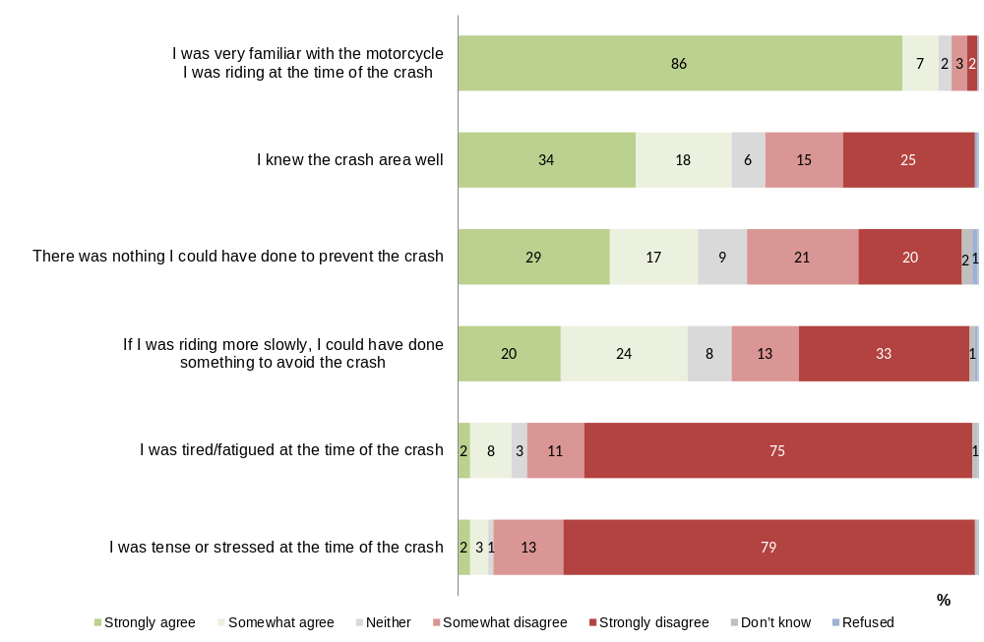
Q32. To what extent do you agree or disagree with the following statements?
Filter: Off-road crashes; base n = 201

Similar with respondents who were involved in on-road crashes, the majority of those who had an off-road crash reported they did not think fatigue and/or stress were factors in their crash. Respondents were more likely to disagree than agree to the statement, ‘I was tired/fatigued at the time of the crash’ (86% disagree vs. 10% agree). Although, those living in metropolitan areas were more likely to say they agreed that they were tired at the time (14% vs. 3% of regional respondents).
Similarly, respondents were more likely to disagree than agree with the statement ‘I was tense or stressed at the time of the crash’ (93% disagree vs. 6% agree).
When asked whether respondents could have done anything to prevent the crash or whether they could have avoided the crash if they were riding more slowly, opinions of those who had an off-road crash were split (44% agree vs. 46% disagree for ‘if I was riding more slowly, I could have done something to avoid the crash’ and 46% agree vs. 41% disagree for ‘there was nothing I could have done to prevent the crash’).
Younger respondents aged up to 25 years old were more likely to agree ‘If I was riding more slowly, I could have done something to avoid the crash’ compared to older respondents (60% vs. 38%). Respondents who were riding with others were also more likely to agree to this statement compared with those who were riding alone (49% vs. 25%).
On-road vs. off-road crashes
In comparison to those who were involved in on-road crashes, off-road crash respondents were less likely to agree that they knew the crash area well (53% vs. 74% agree).
Those involved in off-road crashes were more likely to say that they could have done something to avoid the crash if they were riding slower (44% compared to 32% on-road crash).
Off-road crash respondents were also more likely to disagree to the statement ‘I was tense or stressed at the time of the crash’ than on-road respondents (93% vs. 86% on-road crashes).

Whether distracted by anything immediately before the crash
The majority (94%) of respondents who had an off-road crash indicated that they were not distracted by anything immediately before the crash.
Four percent (4%) of respondents mentioned they had been distracted by something immediately before the crash. Distractions included animals, other vehicles, running late and the scenery around them.
Those involved in on-road crashes were significantly more likely than respondents involved in off-road crashes to report being distracted by something immediately before their crash (11% vs. 4%)
Figure 25: Whether distracted by anything immediately before the crash by crash location (on-road vs. off-road)
On-road
Off-road
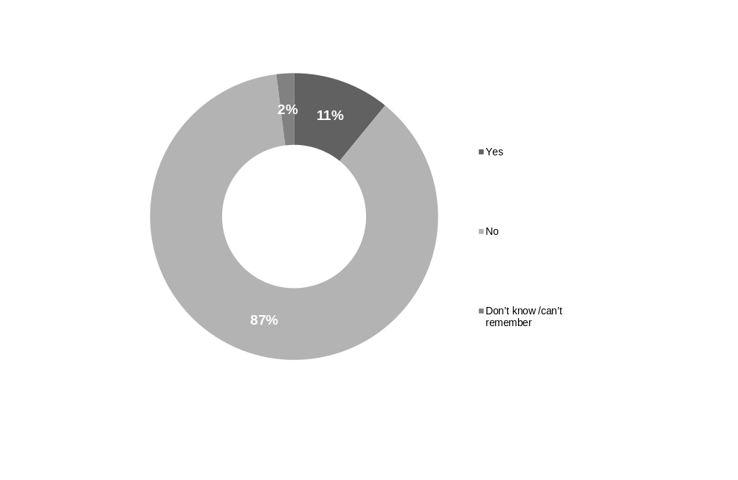
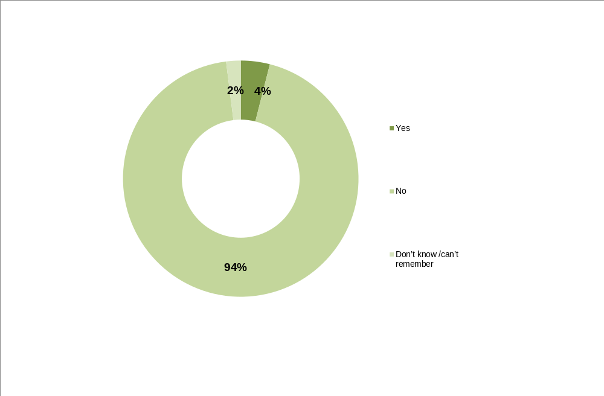

Q44. Would you say you were distracted by anything immediately before your crash?
Total sample; base n = 964

Alcohol consumption prior to the crash
Nearly all respondents (98%) reported that they did not have any alcohol in the three hours before the crash with only 1% saying they had one standard drink beforehand.
Table 16: Alcohol consumption prior to the crash by how many standard drinks (off-road crashes only)
 | %
n= | 201
Subtotal: Did not drink beforehand | 98
Subtotal: Had drink beforehand | 2
-1 standard drink beforehand | 1
-2 or more standard drinks beforehand | <1
Don't know/refused to say how many | <1
Q46. Had you been drinking alcohol in the three hours prior to the crash? If you prefer to say, just let me know.
Q47. Roughly how many standard drinks did you have over the 3 hours prior to your crash? If you prefer not to say, just let me know.
Filter: Off-road crashes; base n = 201
↓↑ indicates statistically significant difference compared to respondents not in that category

Track and weather conditions
Close to two thirds (63%) of respondents said there had not been any other people using the track at the time of their crash. Where there had been other people around, these tended to be other off-road motorcyclists (30% reported other motorcyclists in the area).
The majority of respondents said the terrain/track they had been riding was hilly (60%) or had steep inclines (20%). Close to half mentioned the track had lots of turns or corners (49%). Dirt tracks were ridden by 28% of respondents with a similar proportion saying the area they had been riding had been gravelly or sandy (26%). One in four (25%) also mentioned there were trees and bushes in the area they had been riding where the crash occurred.
For those who mentioned that the track/terrain had contributed to the crash (49%), the most common mentions included water on the track (23%) and tree roots or fallen branches/logs (17%).
Given that most of the off-road respondents had been riding for recreational purposes, it is unsurprising that the majority of respondents said the weather had been clear/sunny/hot/warm (85%). Descriptions of the visibility and lighting conditions are consistent with this (85% said they were riding on a clear day).

Other four wheel or off-road riders/pedestrians involved
Close to two in three respondents (63%) said there were no other people or vehicles in the area they were riding. One in three (30%) indicated there had been other off-road motorcycles apart from themselves or their group using the track with a minority (8%) reporting other four wheel vehicles in the area..
Figure 26: Other four wheel or off-road riders/pedestrians in the area (off-road crashes only)
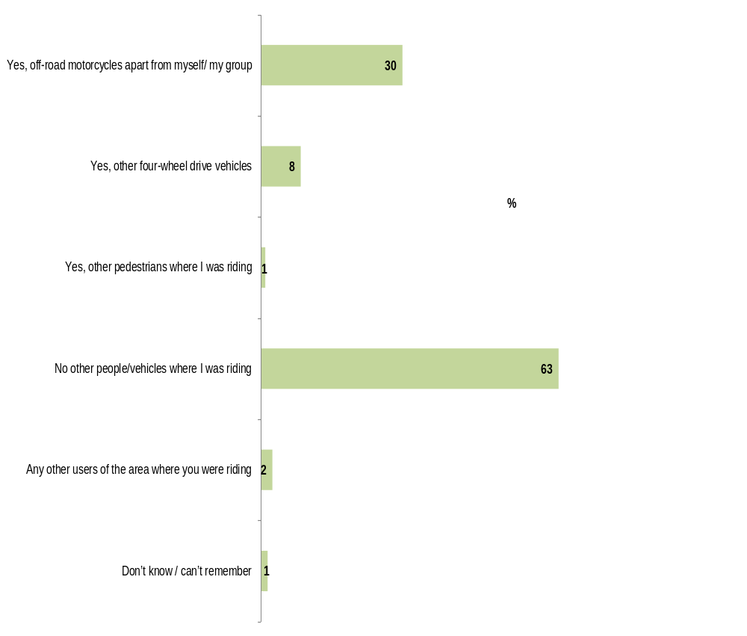
Q34. Were there other four wheel or off-road riders or pedestrians where in the area where you were riding?
Filter: Off-road crashes; base n = 201

Among those who mentioned that there was other off-road motorcycles in the area they were riding (30% of all respondents), half (50%) mentioned there were five or more other off-road riders and approximately two in five (45%) mentioned that there were fewer than this.
Figure 27: Number of off-road riders (off-road crashes only)
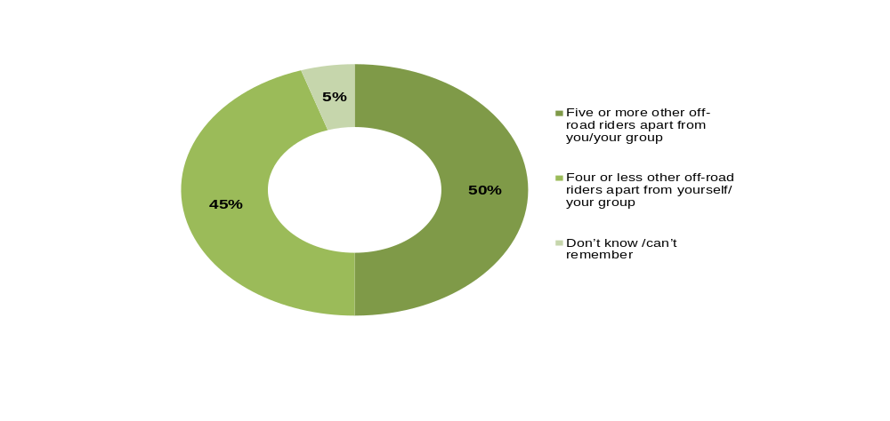

Q35. Were there…?
Filter: Off-road crashes; other off=road riders in the area; base n = 60

While the sample size was small (n=17) among those who mentioned that there were other four-wheel drive vehicles in the area they were riding, most (76%) indicated that there were four or fewer four-wheel drives in the area and 6% mentioned there were five or more other vehicles.

Track and terrain conditions
Respondents were asked to describe the track/terrain where they were riding. The majority of respondents (60%) indicated that the track/ terrain where they were riding was hilly and a further 20% mentioned it had steep inclines. Close to half (49%) mentioned that the track had lots of turns or corners. More than a quarter (28%) of respondents indicated that they had been riding on a dry dirt track with a similar proportion (26%) saying the terrain was gravelly or sandy. One in four (25%) reported that there were tree bushes around where they were riding.

Figure 28: Track/terrain during the crash (off-road crashes only)
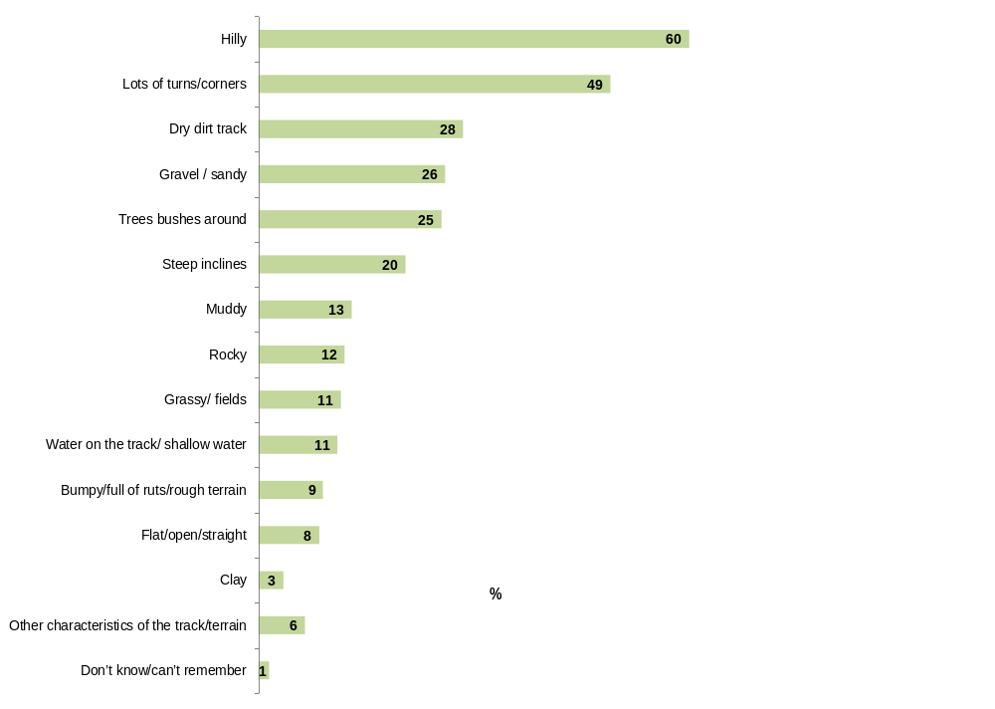
Q37. How would you describe the track/terrain where you were riding? For example, was it a hilly course with lots of turns?
Filter: Off-road crashes; other parties involved; base n = 201

Respondents who were riding with others during the crash were more likely than those who were riding alone to report that they were riding in a hilly area (63% vs. 45%). They were also more likely to say they were riding in an area with lots of turns and corners (53% vs. 35%).
Those who were riding alone were more likely to say that the area they were riding had been grassy compared with those who were riding with others (25% vs. 8%).
Table 17: Track/terrain during the crash by whether riding alone or with others (off-road crashes only)
Column % | Riding alone or with others
Column % | Riding alone | Riding with others
n= | 40 | 160
Hilly | 45↓ | 63↑
Lots of turns/corners | 35↓ | 53↑
Grassy/ fields | 25↑ | 8↓
Trees bushes around | 33 | 24
Dry dirt track | 30 | 28
Steep inclines | 20 | 21
Gravel / sandy | 15 | 28
Muddy | 10 | 14
Water on the track/ shallow water | 10 | 11
Flat/open/straight | 10 | 8
Rocky | 8 | 13
Clay | 5 | 3
Bumpy/full of ruts/rough terrain | 3 | 11
Other characteristics of the track/terrain | 8 | 6
Don’t know/can’t remember | 5↑ | 1↓
Q37. How would you describe the track/terrain where you were riding? For example, was it a hilly course with lots of turns?
Filter: Off-road crashes; other parties involved; base n = 201
↓↑ indicates statistically significant difference compared to respondents not in that category

As previously mentioned, nearly half of those who had an off-road crash (49%) mentioned the track/terrain as the main reason for their crash.
Among those who indicated that their crash was caused by track or trail conditions, nearly a quarter (23%) mentioned that there was water on the track or a water bar. Seventeen percent (17%) mentioned tree roots or a fallen branch. A further 14% mentioned that rocks on the track or trail caused the crash (See Figure 29).
Figure 29: Track or trail conditions (off-road crashes only)
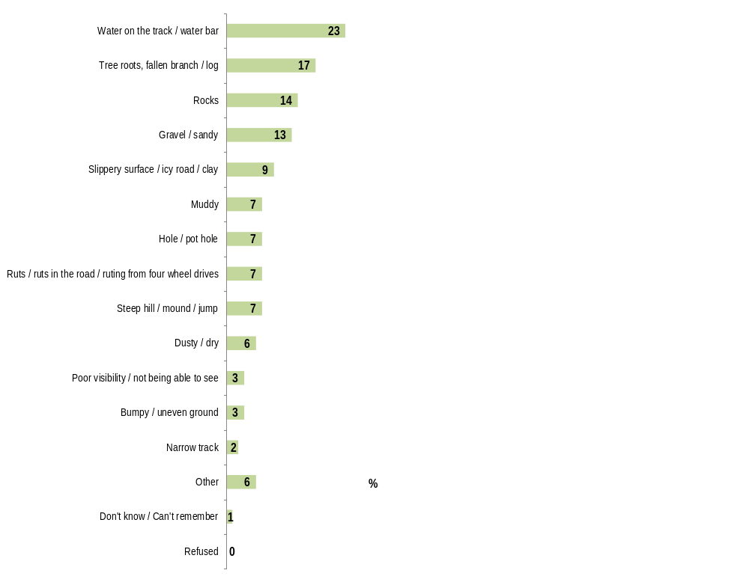
Q29. What was it about the track or trail conditions that caused your crash?
Filter: Off-road crashes; if track/trail conditions caused the crash; base n = 86

Weather conditions
Nearly nine out of ten (88%) respondents indicated that the weather was clear/sunny/hot/warm at the time of the crash. Just over one in ten (13%) stated that it had been raining or that the ground was wet from rain at the time of the crash. Respondents who resided in metropolitan areas were more likely to been riding when it was raining (17% vs. 3%) or after the rain (12% vs. 3%) than those who lived in rural areas.
In comparison to those who had an on-road crash, off-road respondents were more likely have been riding during clear/sunny/hot warm weather (88% vs. 77%) and less likely to have ridden during light rain at the time of the crash (2% vs. 7%). This is likely to commuters more likely to ride in inclement conditions than those riding for recreational purposes.
Figure 30: Weather conditions during the crash (off-road crashes only)
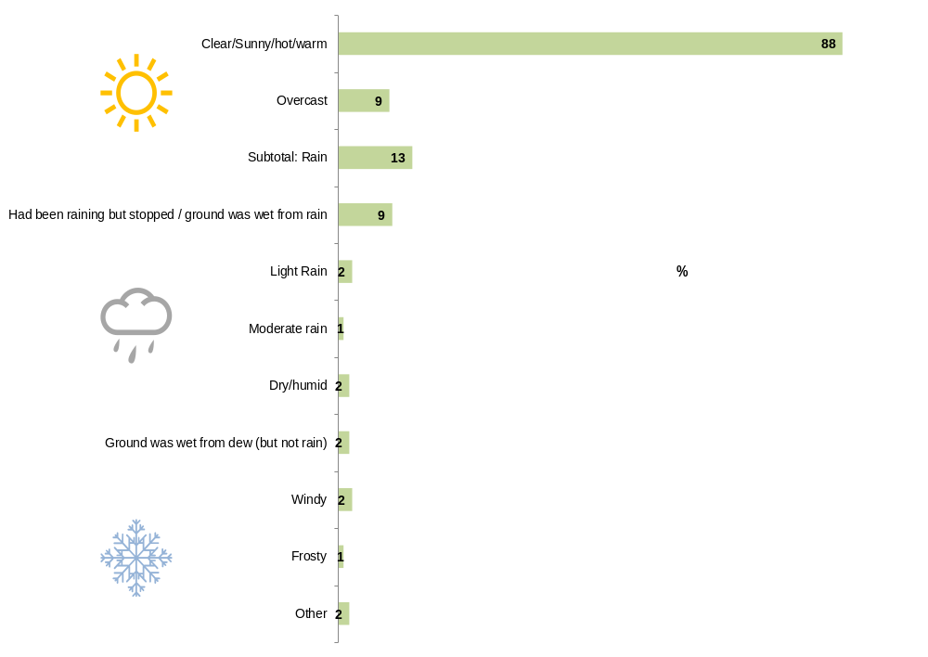
Q39. How would you describe the weather conditions at the time of your crash?
Filter: Off-road crashes; other parties involved; base n = 201

Visibility and light conditions at the time of the crash
The majority indicated that they were riding on a clear day on the day of the crash (85%); including three out of five respondents (60%) who said that it was a clear day with no cloud or light cloud cover. Sixteen percent (16%) mentioned it was a clear day where they were riding from sun into the shade, and 11% reported that they were riding during the day time on an overcast day. Just under one in ten (8%) stated that they were riding on a clear day with sun glare.

Figure 31: Visibility and light conditions during the crash (off-road crashes only)*
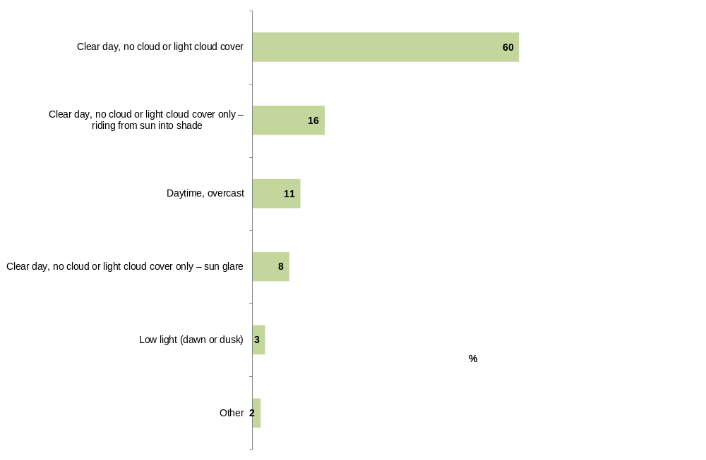
Q38. How would you describe the visibility or light conditions at the time of your crash?
Filter: Off-road crashes; other parties involved; base n = 201
* Note: Percentages less than 2% not charted
On-road vs. off-road crashes
Off-road respondents were more likely than on-road crashes to say the crash happened on a clear day (85% vs. 65%). Similarly, off-road riders were less likely to say they had been riding in low light at the time of the crash (3% vs. 9%).
Table 18: Visibility and light conditions by crash location
Column % | On-road | Off-road
n= | 763 | 201
Clear day, no cloud or light cloud cover | 53 | 60
Clear day, no cloud or light cloud cover only – riding from sun into shade | 6↓ | 16↑
Daytime, overcast | 14 | 11
Clear day, no cloud or light cloud cover only – sun glare | 7 | 8
Low light (dawn or dusk) | 9↑ | 3↓
Night, good street lighting | 5↑ | 0↓
Night, poor street lighting | 4↑ | 0↓
Night, no street lighting | 2 | 0
Foggy | 1 | 0
Other | 2 | 2
Don’t know / Can’t remember | 2 | 0
Sub-total: Clear day | 65↓ | 85↑
Sub-total: Night | 11↑ | 0↓
Q38. How would you describe the visibility or light conditions at the time of your crash?
Total sample; base n = 964
↓↑ indicates statistically significant difference compared to respondents not in that category

Protective gear
The majority of respondents who were involved in an off-road crash were wearing a motorcycle helmet (98%), boots (96%), motorcycle riding gloves (92%), motorcycle riding pants (82%) and body armour (81%) at the time of the off-road crash. In total, half of respondents wore all six items listed in the survey (53% vs. 38% of on-road crash respondents).
Around half said they had been wearing a body armour kit (54%), riding pants (50%) or knee guards (49%) at the time of the crash. Only 12% of off-road crash respondents said they were not wearing any of the impact protective or body armour listed in the survey.
More than one in three (37%) reported they had been wearing either high visibility (26%) or reflective clothing (13%) at the time of the crash.
As to technological gadgets, 85% indicated that they were carrying a mobile phone and close to one in three (30%) mentioned that they had a GPS device with them at the time of their crash.

Protective gear worn at the time of the crash
Half of all respondents (53%) had been wearing six or more items of protective gear at the time of the off-road crash. A further one in three (31%) were wearing five items.
Nearly all respondents were wearing motorcycle helmet (98%), boots (96%), and riding gloves (92%) at the time of their off-road crash. While the proportion was still high, fewer respondents wore motorcycle riding pants (82%) and a similar proportion of respondents said they wore body armour at the time of crash (81%). Only 63% reported wearing a riding jacket however, this may be due to the high proportion of respondents wearing body armour to ride off-road or the terminology used to describe ‘tops’ worn for off-road riding.
Younger respondents were less likely to wear riding gloves (86% vs. 94% of those aged 26+) and riding jacket (51% vs. 68%) at the time of the crash.
Table 19: Protective gear worn during crash if any by age at accident (off-road crashes only)
Column % | Age (at accident)
Column % | Up to 25 years | 26-39 years | 40+ years | Total
n= | 57 | 62 | 82 | 201
Subtotal: Motorcycle Helmet | 95 | 100 | 98 | 98
-Motorcycle helmet (full face) | 70↓ | 92↑ | 83 | 82
-Motorcycle helmet (open face) | 11 | 2↓ | 9 | 7
-Motorcycle helmet (half face) | 14 | 6 | 6 | 8
Motorcycle riding gloves | 86↓ | 97 | 93 | 92
Subtotal: Motorcycle boots or other boots | 95 | 97 | 96 | 96
-Riding boots specifically made for motorcycling | 88 | 90 | 85 | 88
-Other boots (i.e. boots that cover your ankles) | 7 | 6 | 12 | 9
Other footwear such as sneakers or other shoes | 5 | 3 | 2 | 3
Motorcycle riding jacket | 51↓ | 63 | 72↑ | 63
Motorcycle riding pants | 77 | 89 | 79 | 82
Body armour | 82 | 84 | 78 | 81
One piece riding suit (This is a suit where parts cannot be detached to be worn as separate pieces) | 5 | 0 | 4 | 3
Don’t know / can’t remember | 0 | 0 | 0 | 0
Refused | 0 | 0 | 0 | 0
Q40. Were you wearing any of the following items at the time of your crash? Say yes to any that apply.
Filter: Off-road crashes; other parties involved; base n = 201
↓↑ indicates statistically significant difference compared to respondents not in that category

Respondents who were riding with others were significantly more likely to wear protective gear at the time of the crash compared to those who were riding alone. Compared with respondents who were riding alone, those who were riding with others were more likely to have worn boots (98% vs. 90%), motorcycle riding pants (86% vs. 65%) and body armour (84% vs. 68%).
Table 20: Protective gear worn during crash if any by whether riding alone or with others (off-road crashes only)
Column % | Riding alone or with others
Column % | Riding alone | Riding with others
n= | 40 | 160
Subtotal: Motorcycle Helmet | 93↓ | 99↑
-Motorcycle helmet (full face) | 65↓ | 86↑
-Motorcycle helmet (open face) | 20 | 4↓
-Motorcycle helmet (half face) | 8 | 9
Motorcycle riding gloves | 85 | 94
Subtotal: Motorcycle boots or other boots | 90↓ | 98↑
-Riding boots specifically made for motorcycling | 73↓ | 91↑
-Other boots (i.e. boots that cover your ankles) | 20↑ | 6↓
Other footwear such as sneakers or other shoes | 8 | 3
Motorcycle riding jacket | 58 | 64
Motorcycle riding pants | 65↓ | 86↑
Body armour | 68↓ | 84↑
One piece riding suit (This is a suit where parts cannot be detached to be worn as separate pieces) | 3 | 3
Don’t know / can’t remember | 0 | 0
Refused | 0 | 0
Q40. Were you wearing any of the following items at the time of your crash? Say yes to any that apply.
Filter: Off-road crashes; other parties involved; base n = 201
↓↑ indicates statistically significant difference compared to respondents not in that category

Table 21 shows that there were some differences in terms of the types and the number of items worn according to the location of the off-road crash. Those who were riding on a track in a state park, forest etc. were more likely to be wearing motorcycle riding gloves (96%), motorcycle boots or other boots (96%), motorcycle riding jacket (70%), riding pants (90%) and body armour (87%) relative to those riding on other surfaces. While sample sizes for those who had been riding on private property had been small, this group was less likely to have been wearing a number of the items listed in the survey. Notably, those who had been riding on a track in a state park, forest etc. were more likely to report they had been wearing five or more of the items listed. While the sample sizes were small, only 60% of those who had been riding on private property had been wearing the same number of items.
Table 21: Protective gear worn during crash if any and number of items worn by location (off-road crashes only)
Column % | Location of crash
Column % | Track in state park, forest etc. | Private property | Public land in residential areas (e.g. park, reserve, track) or other off-road surface/area
n= | 150 | 36* | 15
Subtotal: Motorcycle Helmet | 100↑ | 92↓ | 87↓
-Motorcycle helmet (full face) | 87↑ | 67↓ | 73
-Motorcycle helmet (open face) | 5↓ | 17↑ | 7
-Motorcycle helmet (half face) | 9 | 8 | 7
Motorcycle riding gloves | 96↑ | 78↓ | 87
Subtotal: Motorcycle boots or other boots | 98↑ | 92 | 87
-Riding boots specifically made for motorcycling | 96↑ | 61↓ | 67↓
-Other boots (i.e. boots that cover your ankles) | 3↓ | 31↑ | 20
Other footwear such as sneakers or other shoes | 1↓ | 8 | 13↑
Motorcycle riding jacket | 70↑ | 44↓ | 40
Motorcycle riding pants | 90↑ | 56↓ | 60↓
Body armour | 87↑ | 61↓ | 67
One piece riding suit (This is a suit where parts cannot be detached to be worn as separate pieces) | 3 | 0 | 7
Number of items worn:
Up to four items | 8↓ | 40↑ | 29
Five or more items | 92↑ | 60↓ | 71
Q40. Were you wearing any of the following items at the time of your crash? Say yes to any that apply.
Filter: Off-road crashes; other parties involved; base n = 201
↓↑ indicates statistically significant difference compared to respondents not in that category
*Note: small sample sizes

On-road vs. off-road crashes
Off-road respondents tended to wear more items of protective gear compared to on-road respondents (53% wore all six items listed vs. 38% for on-road riders).
Compared against those who had an on-road crash, respondents involved in off-road crashes were significantly more likely to be wearing motorcycle boots or other boots (96% vs. 88%), motorcycle riding pants (82% vs. 69%) and body armour (81% vs. 51%).
Motorcycle riding jackets were significantly more likely to be worn by those who had an on-road crash (86% vs. 63%) but again, this may be due to the terminology used to describe off-road riding tops (See Figure 32).
Figure 32: Protective gear worn during the crash by crash location (on-road vs. off-road)
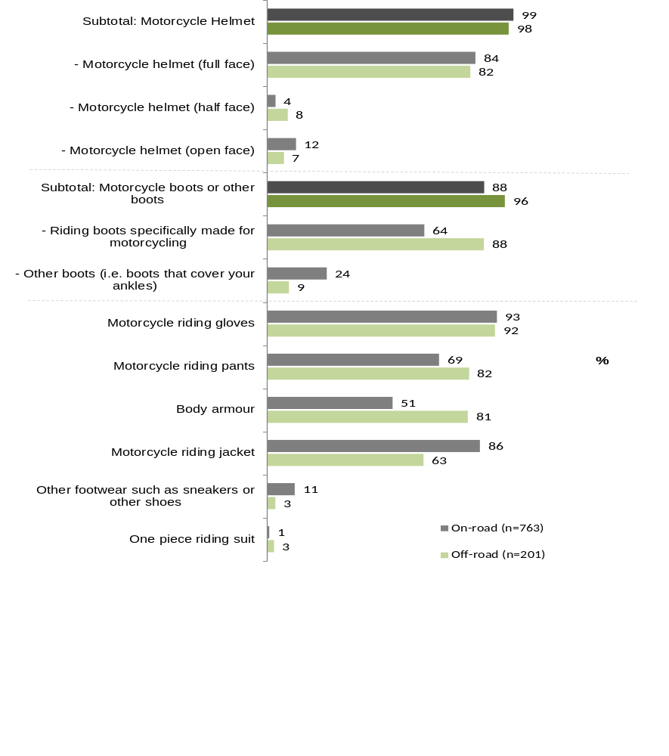
Q40. Were you wearing any of the following items at the time of your crash? Say any that apply.
Note: 0% for don’t know and refused not reported
Total sample; base n = 964
↓↑ indicates statistically significant difference compared to respondents not in that category

Impact protection / body armour worn at the time of the crash
Most of those who had an off-road crash were wearing some form of impact protection/body armour items with only 12% saying they were not wearing any of the items listed in the survey at the time of the crash.
Approximately half of respondents stated that they were wearing a body armour kit (54%), riding pants with in-built impact protection (50%) or wearing knee guards (49%). Respondents aged 26 years and older were more likely to have worn knee guards than their younger counterparts (55% vs. 35%).
Similar with the above findings of protective gear worn between those who ride with others and those who ride alone, it can be seen in Table 22 that respondents who were riding alone at the time of the crash were more likely to report that they did not wear any body armour/impact protection during the crash (28% vs. 9%). Those who were riding with others were more likely to wear knee guards and chest protector/roost guard during the crash in comparison to those who were riding alone (53% vs. 33% and 36% vs. 13% respectively).
Table 22: Impact protection / body armour worn during the crash if any by whether riding alone or with others (off-road crashes only)
Column % | Riding alone or with others
Column % | Riding alone | Riding with others | Total
n= | 40 | 160 | 201
Riding jacket with built-in impact protection | 25 | 27 | 26
Riding pants with in-built impact protection | 43 | 52 | 50
Back protector (separate item) | 15 | 26 | 24
Elbow guards (separate item) | 20 | 24 | 23
Knee guards | 33↓ | 53↑ | 49
Body armour kit / One piece body armour/pressure suit (covering chest, back, shoulders, elbows) | 55 | 53 | 54
Chest protector/roost guard (separate item) | 13↓ | 36↑ | 31
Knee braces | 20 | 29 | 27
Neck brace | 8 | 20 | 17
Other body armour | 15 | 21 | 19
Not wearing body armour / impact protection | 28↑ | 9↓ | 12
Don’t know / Can’t remember | 0 | 0 | 0
Refused | 0 | 0 | 0
Q41. Were you wearing any of the following items of impact protection / body armour at the time of your crash? This includes body armour that forms part of other gear i.e. inside a jacket etc. Please say yes to any that apply.
Filter: Off-road crashes; base n = 201
↓↑ indicates statistically significant difference compared to respondents not in that category
On-road vs. off-road crashes
Riders involved in off-road crashes were more likely than those involved in on-road crashes to wear all impact protection/body armour items listed below with the exception of riding jacket with built-in impact protection (26% vs. 71% on-road crashes).
Figure 33: Impact protection / body armour worn during the crash by crash location (on-road vs. off-road)
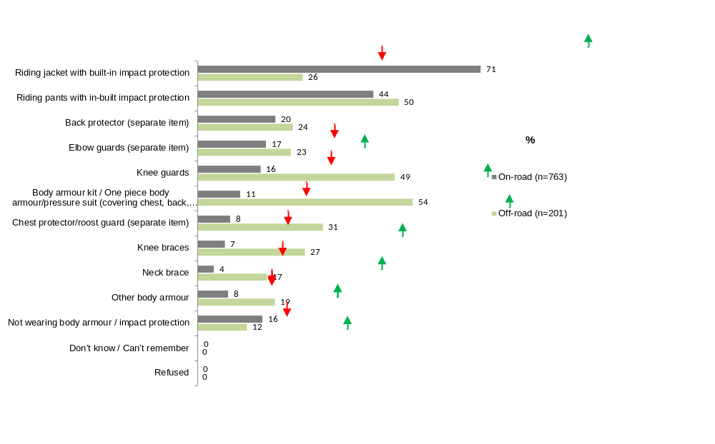
Q41. Were you wearing any of the following items of impact protection/body armour at the time of your crash? This includes body armour that forms part of other gear i.e. inside a jacket etc. Please say yes to any that apply.
Total sample; base n = 964
↓↑ indicates statistically significant difference compared to respondents not in that category

Reflective or high-vis gear worn at the time of the crash
While the majority of off-road respondents said they had been riding on clear sunny day (See Section 3.3.7 - Track and weather conditions), more than one in three (37%) reported they wore either high visibility (26%) and/or reflective clothing (13%) at the time of the crash.

On-road vs. off-road crashes
While respondents who had an off-road crash were more likely to have worn protective gear or impact protection / body armour at the time of the crash, they were less likely to have worn a high visibility/reflective gear (37% vs. 48% on-road crash).
Figure 34: Reflective or high-vis gear worn during crash by crash location (on-road vs. off-road)
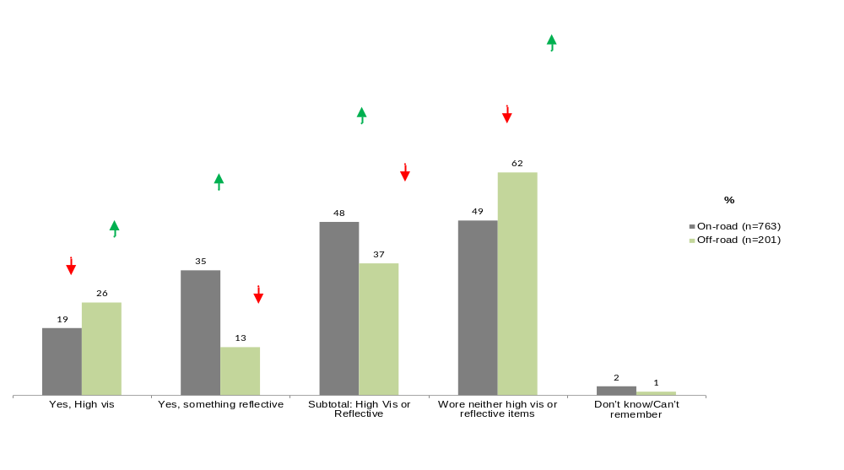
Q42. Were you wearing anything reflective or “high-vis” at the time of your crash?
Total sample; base n = 964
↓↑ indicates statistically significant difference compared to respondents not in that category

Technological gadgets carried at the time of the crash
At the time of the crash, the majority of respondents (85%) indicated that they were carrying their mobile phone and close to one in three (30%) mentioned that they had a GPS device with them at the time of their crash.
Respondents who were riding alone were a particular group of concern given they were more likely to say they were not carrying any item/device with them compared to those who were riding with others at the time of the crash (15% vs. 6%). Respondents who were riding with others were also more likely to carry a GPS device at the time of the crash compared with those who were riding alone (34% vs. 10%).
On-road vs. off-road crashes
Mobile phones were significantly more likely to be carried by those involved in an on-road crash (93% vs. 85% of those off-road crashes). On the other hand, a GPS was more likely to be carried by those involved in an off-road crash (30% vs. 19%)

Figure 35: Technological gadgets carried during the crash by crash location (on-road vs. off-road)
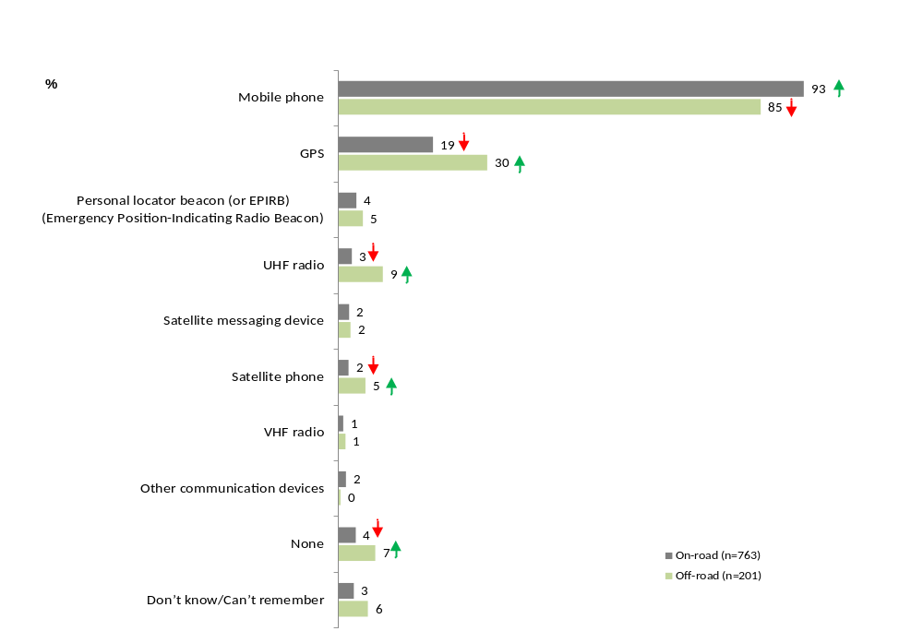
Q43. Were you or another rider in your group carrying any of the following items at the time of your crash? Please say yes to any that apply.
Total sample; base n = 964
↓↑ indicates statistically significant difference compared to respondents not in that category

Injuries from the crash
According to the supplementary data on the crashes from the VicRoads database, the split between minor injury accidents and serious injury accidents was relatively even (48% minor and 52% serious). This was similar to that recorded for on-road accidents
Fractured limbs were the most common type of ‘main’ injury (34%). Sixty-two percent (62%) did not get admitted to hospital in the seven days following the accident; however, one in five did stay in hospital more than one day but less than one week (22%).

Severity of crashes
The VicRoads Road Crash Information System database categorises the severity of crashes as causing either minor injury or serious injury. This information was only available for n=46 of the off-road respondents. There was no statistical difference between the on-road and off-road crash respondents with around half of the crashes classified as minor injury accidents (48%, n=22) and half serious injury accidents (52%, n=24).
The sample size was too small to conduct further analysis on the seriousness of the crash and the types of protective gear worn by respondents.
Figure 36. Accident severity (on-road vs. off-road)
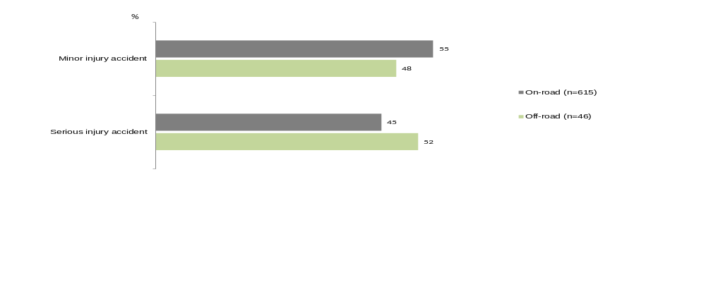
Source: VicRoads RCIS Accident Severity
Filter: On-road crashes; base n = 615; off-road crashes, base n=46 (where data was available)

Injury types
Based on the supplementary data from the TAC Claims database on the most serious injury incurred by respondents, a third (34%) of respondents’ main injury had been a fractured limb(s). The next most common ‘main’ injuries for off-road crash respondents were internal injuries (10%), dislocations (8%) and contusions, abrasions or lacerations (7%). Slightly more than one in five (23%) sustained other injuries.
Figure 37. Injury types (off-road crashes only)
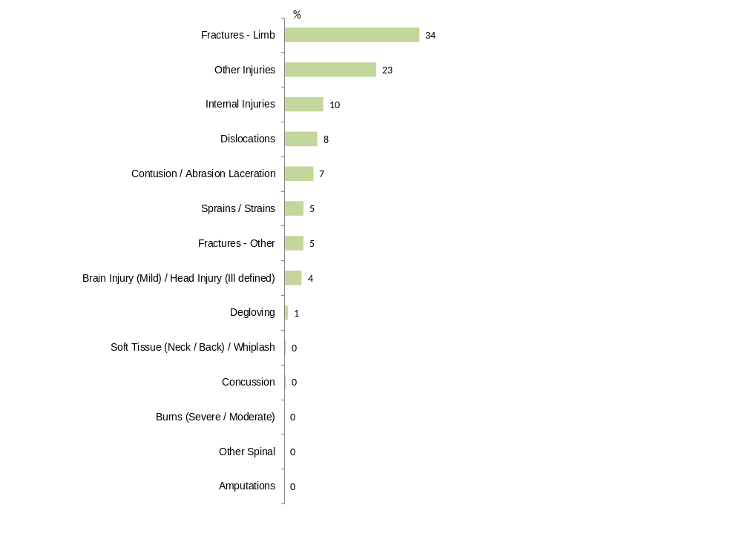
Source: TAC Claims database, Injury detail
Filter: Off-road crashes; base n = 201

Those who had an off-road crash were less likely to obtain contusion/abrasion laceration and soft tissue (neck/back)/whiplash in comparison to those who had an on-road crash (7% vs. 15% and 0% vs. 5% respectively).
Although sample sizes are small, those who had crashed on private property were more likely to have incurred internal injuries (19%) compared to those who had crashed in a state park/forest (7%).
Those who had been riding on gravelly terrain were also more likely to have incurred an injury from a dislocation (15% vs. an average of 8%).

Number of days in hospital within seven days of the accident
The TAC Claims database also included information on the number of days a person was in hospital within the first seven days of the crash. Three in five off-road respondents (62%) did not visit a hospital in the first seven days after the crash while less than one in ten (8%) had stayed in the hospital for a day. One in five (22%) stayed in the hospital for more than one day but less than a week.
Figure 38. Number of days in hospital for first admission within seven days of the accident (off-road crashes only)
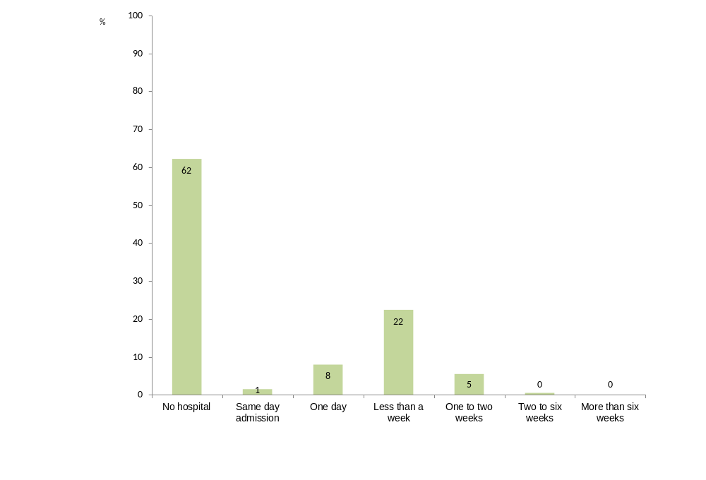
Source: TAC Claims database, Days in hospital for first admission with seven days of the accident
Filter: Off-road crashes; base n = 201

While the majority of all respondents did not go to hospital in the seven days after their crash, among those who went to one, off -road crash respondents were more likely to have stayed in the hospital for one to two weeks (5% vs. 2%) while those who had an on-road crash were more likely to have a same day hospital admission (6% vs. 1%) or stay two to six weeks in the hospital (4% vs. 0%).
Figure 39. Number of days in hospital for first admission within seven days of the accident (on-road vs off-road)
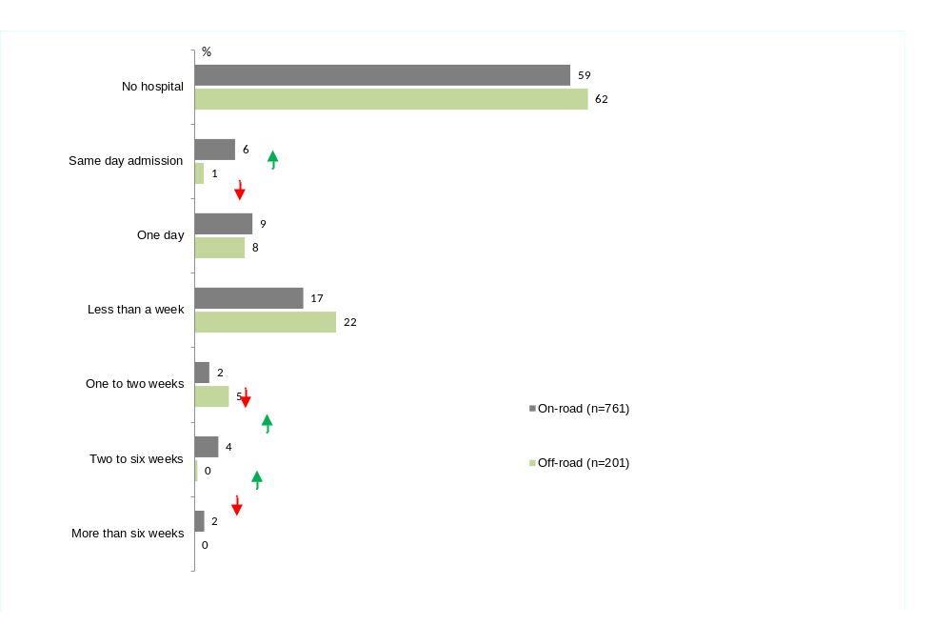
Source: TAC Claims database, Days in hospital for first admission with seven days of the accident
Filter: On-road crashes; base n = 615; off-road crashes, base n=201
↓↑ indicates statistically significant difference compared to respondents not in that category

Level of vehicle damage
While the supplementary data only included data for n=46 off-road crash respondents, the VicRoads RCIS database showed that motorcycle damage for who crashed off-road was most likely to be minor (37%, n=17). Twenty-eight percent (28%, n=13) of respondents’ crashes did not result in any vehicle damage. An additional 13% (n=6) respondents’ bikes were moderately damaged but they could still be ridden.
Table 23: Level of vehicle damage (on-road vs. off-road)
Column % | On-road | Off-road
Minor | 36 | 37
Undamaged | 7↓ | 28↑
Moderate/driveable | 19 | 13
Irreparable | 6 | 4
Moderate/tow-away | 20↑ | 7↓
Major tow-away | 8 | 2
Subtotal: Tow away or not ‘driveable’ | 33↑ | 13↓
Unknown | 6 | 9
Source: VicRoads RCIS database, Vehicle damage
Filter: On-road crashes; base n = 615; Off-road crashes; base n = 46 (where data was available)
On-road vs. off-road
The vehicle damage among on-road crashes tended to be more serious than off-road crashes with 33% being classified as either tow-away or where the motorcycle could no longer be ridden after the crash (compared to 13% for off-road respondents).

After the crash
The majority of respondents indicated they had ridden again since the crash (83%). This was similar for on-road crashes (80%).
While the sample size was small (n=35), among those who had not yet ridden again, half showed high intentions of returning to their motorcycle (54% provided a likelihood rating of 7-10 out of 10).
Concern shown by friends and family and still suffering from the injuries from the crash were the most common reasons for not riding since the crash. Recovering from injuries and rebuilding their confidence were the things that would need to change for respondents to return to riding.
One in three returned to riding within three months of the crash (35%); with a similar proportion (28%) returning to riding after 4-6 months. Similar proportions of on-road and off-road respondents had returned to riding within six months (68% vs. 64% for off-road respondents).
Forty percent (40%) of respondents who had returned to riding said they rode as frequently after the crash as they did before, although 48% reported they rode less frequently.
As to the level of cautiousness that those involved in off-road crashes rode after their crash, 58% said there was no change. The off-road crash also seemed to have little impact on how respondents drove with 90% reporting there was no difference to how cautiously they drove a car since the crash.
Two thirds (66%) of those impacted by off-road crashes gave a rating of 10 out of 10 as to the extent to which they felt they had been able to get their life back on track. In total, 95% provided a rating of 7-10 out of 10. The most common reasons for these high ratings included that they were healing or were fully recovered or the injuries were not major and they were able to walk away from the crash.
The majority of respondents indicated their employment status or occupation had not changed since the crash (both 88%). Among the minority (n=14) of those who were not working, just under half were temporarily or permanently unable to work due to the crash.

Riding again after the crash
The majority of those who had an off-road crash (83%) have ridden again since the crash. Similar proportions of riders who were involved in on-road crashes had also ridden again since their crash (80%).
Table 24: Whether ridden again after the crash by crash location
Column % | On-road | Off-road
n= | 763 | 201
Yes | 80 | 83
No | 20 | 17
Refused | 0 | 0
Q48. Have you ridden a motorcycle again following your crash?
Total sample; base n = from 964
↓↑ indicates statistically significant difference compared to respondents not in that category

Likelihood of riding again in the future
Respondents who had not ridden again since their crash were asked the likelihood of riding again in the future using a scale of zero to ten where a zero was extremely unlikely and ten was extremely likely. While the sample size was small (n=35), more than half of those who had an off-road crash (54%) indicated a high likelihood of returning to riding in the future with ratings of seven to ten. Only one in five (20%) respondents who had not ridden since the crash said the likelihood was low providing a rating of zero to three. (See Figure 40).
Figure 40: Likelihood of riding again in the future (off-road crashes only)
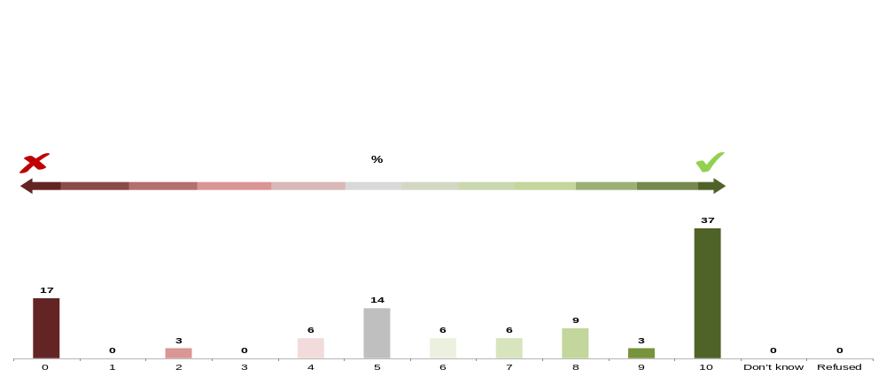
Q50. What is the likelihood that you will ride again in the future? Please use a 0-10 scale where 0 is extremely unlikely and 10 in extremely likely.
Filter: Off-road crashes; Not ridden again following accident; base n = 35
Note small sample size

Reasons for not riding again after their crash
As seen in Table 25, after effects or injuries from the crash were the main reason for not riding again among those who have not ridden (54%), followed by those who indicated that their partner/family would prefer them not to ride (46%) and who were still injured (43%).
In comparison to those who had crashed on-road, respondents who had an off-road crash were less likely to say that no longer owning a bike was a key factor (29% vs. 56%).
Table 25: Main reasons for not riding again (off-road crashes only)
 | %
n= | 35*
Still have after effects of injuries from the crash | 54
Partner / family would prefer I wouldn’t ride | 46
Still injured | 43
No longer own a bike | 29
No longer interested in riding | 29
Not had the opportunity | 26
Family commitments prevents me from riding | 14
Scared of getting back on bike | 6
Other | 14
Don’t know | 0
Q49. What are the main reasons for this? Please say yes to any that apply
Filter: Not ridden again following accident; base n = 35
↓↑ indicates statistically significant difference compared to respondents not in that category
*Note: small sample sizes

Things that need to happen to ride again
Among those who had an off-road crash who had not yet ridden since the crash, one in three (34%) stated that they would need to get better or fully recover to ride again before riding again and slightly less than a third (29%) indicated that they would need to gain confidence or overcome their fear.
On-road vs. off-road crashes
While off-road respondents were most likely to list a full recovery from their injuries, respondents who had an off-road crash were significantly more likely to say that they would need to gain more confidence (29% vs. 9% for on-road crashes), not do trail riding (6% vs. 1%) and get some protective gear (6% vs. 1%).
Those who had an on-road crash were more likely to say that they would need to get a new motorcycle (29% vs. 3% of off-road crashes) –likely due to the higher level of damage to motorcycles incurred for on-road crashes.
Table 26: What needs to happen to ride again by crash location (on-road vs. off-road)
Column % | On-road | Off-road
n= | 153 | 35*
Get a motorcycle/new motorbike/buy a new bike | 29↑ | 3↓
Get better/no injuries/full recovery | 21 | 34
Convince my wife to let me/my family to be OK with it/family commitments etc. | 14 | 11
Money/get some money/money for a bike/finances etc. | 12 | 6
Confidence/gain confidence/overcome my fear/improve psychologically etc. | 9↓ | 29↑
Have a reason to ride/If someone asks me to go for a ride/If my friends are riding etc. | 7 | 11
I will not ride again/I don't want to ride again | 7 | 9
Nice weather/dry weather/summer time/good conditions/during the day etc. | 5 | 9
Time/free time/have more time | 5 | 6
Get more training/lessons/improve skills | 5 | 0
In an emergency/no other transport available | 4 | 6
Repair the bike/fix my motorcycle/get the bike roadworthy | 4 | 0
Get a motorcycle license/get my motorcycle registered | 3 | 3
Have a less powerful bike/get a slower bike | 3 | 0
I have a car/prefer driving a car/having a car/deciding if it's a better alternative than a car etc. | 3 | 0
Get bad drivers off the road e.g. Taxi drivers, not indicating, not checking blind spot, tailgating etc. | 3 | 0
Don't know/can't remember/not answered | 3 | 0
Live in a different area/move to the country | 2 | 0
Injury will prevent me from riding again | 1 | 0
Safer off-road environment/recreational area to ride | 1 | 0
I will not do trail riding/off-road riding I will only ride on the road | 1↓ | 6↑
Get some protective gear/new protective gear | 1↓ | 6↑
I prefer riding in the country/I don't want to ride in the city | 1 | 3
Other | 3 | 3
None | 1 | 0
Q51. What would need to happen for you to ride again?
Filter: Not ridden again following accident; base n = 188
↓↑ indicates statistically significant difference compared to respondents not in that category
*Note small sample size

Average time between crash and riding after the crash
In total 83% of respondents who crashed off-road had ridden again after the crash. Fifty-seven percent (57%) reported that they took up to six months to get back onto a motorcycle after their crash.
Figure 41: How long after crash riding again (off-road crashes only)
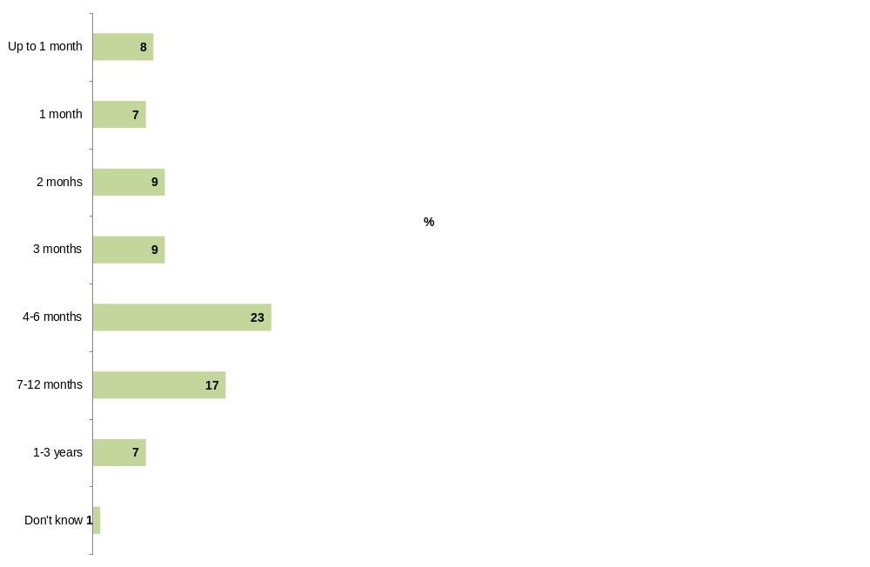
Q52. How long after your crash did you begin to ride a motorcycle again?
Filter: Off-road crashes; Ridden again following accident; base n = 201

On-road vs. off-road crash
Similar proportions of all off-road and on-road crash respondents had returned to riding overall, however, on-road crash respondents were more likely to have returned to riding after six months (66% vs. 57% for off-road crashes).
Table 27: How long after crash you rode again by crash location
Column % | On-road | Off-road
n= | 763 | 201
Not ridden again since crash | 20 | 17
Subtotal: up to 6 months | 66↑ | 57↓
Subtotal: up to 12 months | 75 | 75
Don't know | 1 | 1
Refused | 0 | 0
Q52. How long after your crash did you begin to ride a motorcycle again?
Filter: Ridden again following accident; base n = 964
↓↑ indicates statistically significant difference compared to respondents not in that category

Frequency of riding before vs. after the crash
While 40% of respondents who had returned to riding indicated that they rode the same amount of time now as they did before the crash, close to half of respondents (48%) reported that they rode less often after their crash. A minority (11%) indicated that they ride more often now (See Figure 42).
Figure 42: Riding more, less or the same after crash (off-road crashes only)
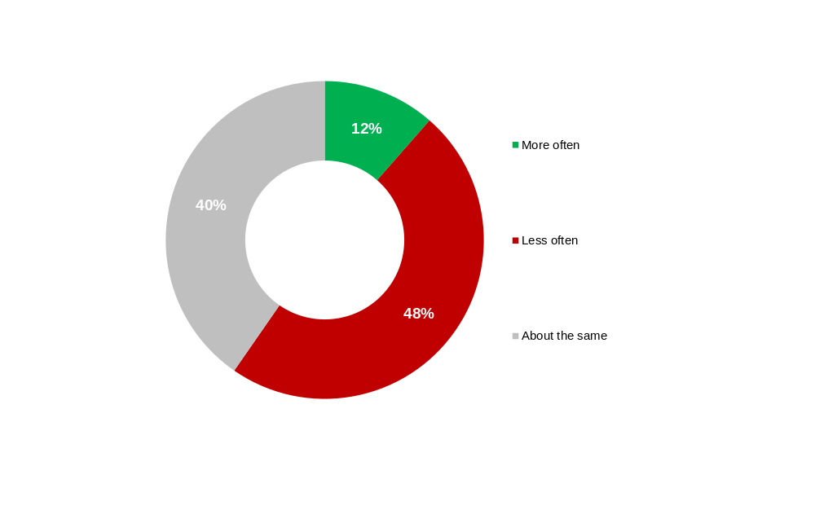
Q53. Compared to before the crash would you say you are now riding…?
Filter: Off-road crashes; Ridden again following accident; base n = 166

Riding more or less cautiously after the crash
When asked whether respondents were riding more or less cautiously after the crash compared to before the crash, more than half (58%) reported that they were riding with a similar level of cautiousness. Four in ten respondents (42%) indicated that they were riding their motorcycle more cautiously.
On-road vs. off-road crashes
Those involved in off-road crashes were significantly more likely to say that they rode with about the same level of cautiousness as before the crash (58% compared to 49% of those involved in an on-road crash).

Figure 43: Riding more or less cautiously after the crash by crash location (on-road vs. off-road)
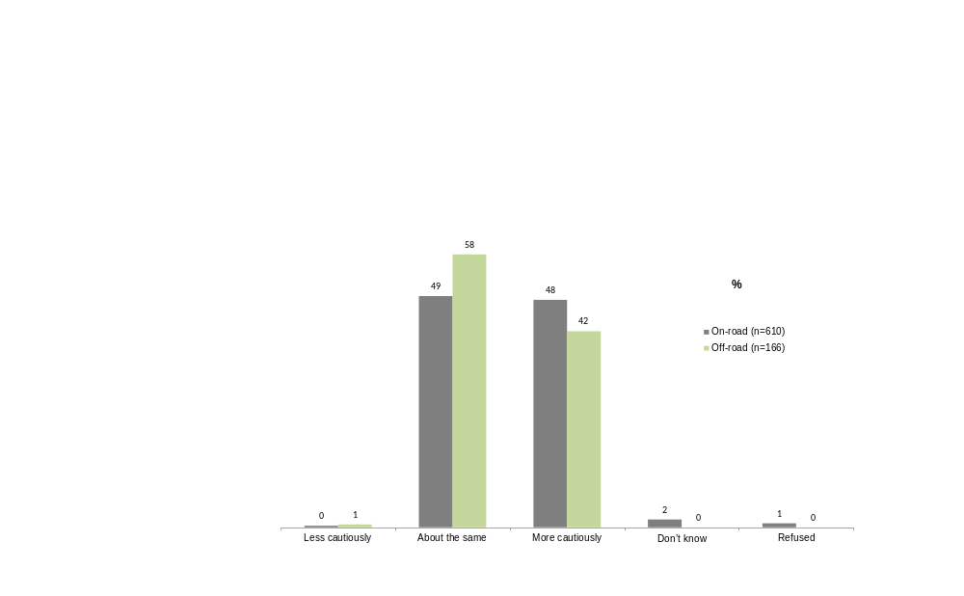
Q54. And compared to before the crash, would you say you are now riding…?
Filter: Ridden again following accident; base n = 776

Driving more or less cautiously after the crash
As to how respondents approached driving a car following their crash, off-road respondents’ style of driving was generally unaffected by their crash. Ninety percent (90%) of those who had an off-road crash said that they drove with ‘about the same’ level of caution after the crash (compared to 72% of those who had an on-road crash).
Those involved in an on-road crash were more likely to drive more cautiously after the crash (27% vs. 10% off-road crash).
Those who were relatively more reliant on their motorcycle before the crash riding more than 20% of the time compared to driving a car were more likely to drive more cautiously now than they did before the crash (24% vs. 6% of those who rode less than 20% of the time).
Table 28: Whether driving more or less cautiously after the crash by crash location (on-road vs. off-road)
Column % | On-road | Off-road
n= | 660 | 195
Less cautiously | 0 | 1
About the same | 72↓ | 90↑
More cautiously | 27↑ | 10↓
I don't drive | 1 | 0
Don’t know /can’t remember | 0 | 0
Refused | 0 | 0
Q57. And compared to before the crash has the motorcycle crash affected the way you drive any other vehicles? If you don’t drive, just let me know.
Filter: Time spent driving a car > 0% (compared to riding); base n = 885
↓↑ indicates statistically significant difference compared to respondents not in that category

Reasons for riding after the crash
The majority of those who had returned to riding following their off-road crash said they rode for recreational purposes or just going for a ride after the accident (95%). They were more likely to indicate this compared to those who had an on-road crash (95% vs. 76%).
A greater proportion of those who had an on-road crash had ridden for commuting purposes after the crash (46% vs. 16%).
Figure 44: Reasons for riding after the crash (off-road crashes only)
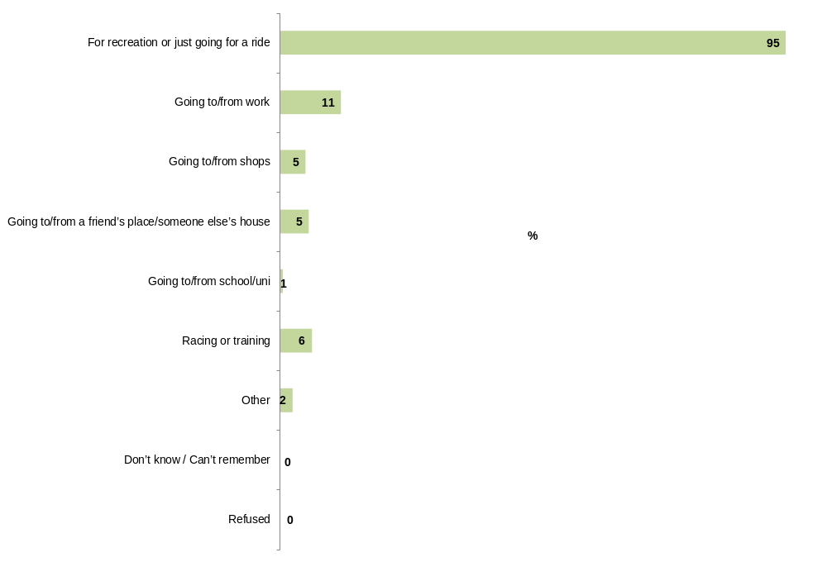
Q56. For what reasons have you ridden?
Filter: Off-road crashes; Ridden again following accident; base n = 166

Getting life back on track
Two thirds of respondents (66%) who had been in an off-road crash gave a rating of 10 out of 10 as to the extent to which they have been able to ‘get their life back on track’ (on a scale where 0 meant not at all, and 10 meant completely back on track).
The majority of those who had an off-road crash (95%) provided a rating of 7-10 out 10 in terms of getting their life back on track.
On-road vs. off-road crashes
Those involved in an off-road crash were significantly more likely to give a higher rating on their ability to ‘get their life back on track’ following their crash (95% with a rating of 7-10 out of 10 compared to 86% of on-road crashes).
Figure 45: Ratings on ability to ‘get their life back on track’ by crash location (on-road vs. off-road)
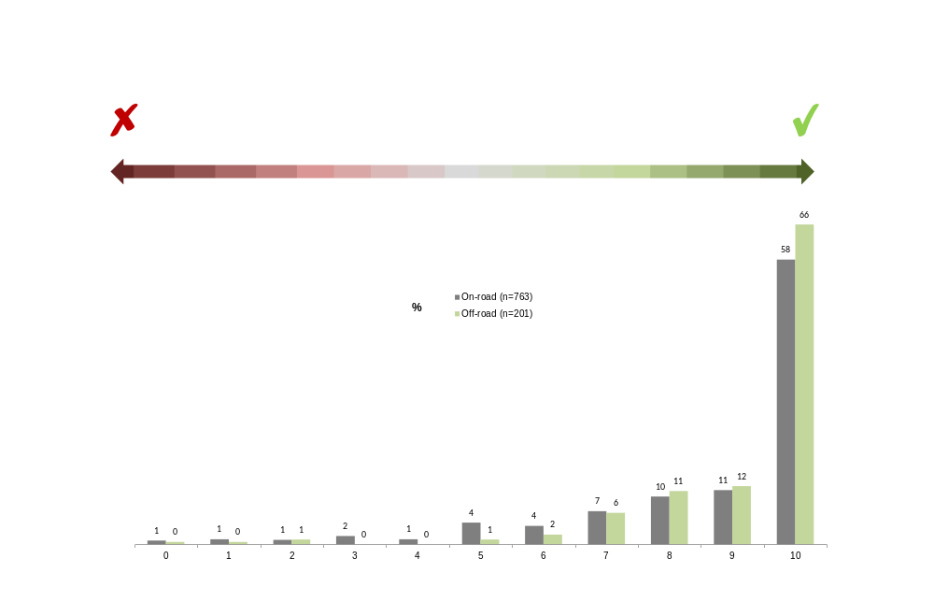
Q69. In other research, TAC clients often talk about trying to ‘get their life back on track’ following a transport crash. This can mean different things to different people. Thinking about your circumstances right now (today), how would you rate the extent to which you have been able to ‘get your life back on track’, on a scale from 1 to 10, where 1 means not at all, and 10 means completely back on track?
Total sample; base n = 964

Reasons for the rating
Respondents were asked to give reasons for their rating on their ability to get their life back on track. A list of these reasons is provided in Table 29.
Those who believed they were ‘on track’ providing ratings of 7-10 out of 10 (95% of respondents) were most likely to say they were healing or that they had fully recovered (24%), or they were only minor injuries and they were able to walk away from it (17%). Sixteen percent (16%) also mentioned they were back at work or that it had not disrupted their work too much.
While a high proportion of respondents rated their progress highly, close to one in four (23%) of those who gave high ‘back on track’ ratings said they were still affected by injuries saying they were not fully recovered in pain or with permanent injuries.
Table 29: Reasons for the rating by ratings on ability to ‘get their life back on track’ (off-road crashes only)
Column % | 0-3 out of 10 | 4-6 out of 10 | 7-10 out of 10
n= | 4* | 6* | 189
Subtotal – positive reasons | 0↓ | 17↓ | 75↑
I'm healing/I've had surgery/I'm good physically/I've gotten over the injuries/I've fully recovered | 0 | 0 | 24
Minor injury/no major injuries/no permanent injuries/I survived/I walked away from it | 0 | 0 | 17
I can work/I'm back at work/it didn't disrupt work too much/work was supportive | 0 | 17 | 16
It wasn't a major crash/the accident wasn't that bad/the crash didn't affect me/had no impact on my life | 0 | 0 | 12
I'm fine/good/life is good/recovered emotionally | 0 | 0 | 11
Life goes on/just get on with it/get on with life/accidents happen/move on/don't let it get you down | 0 | 0 | 10
I was never off track/my life wasn't off track/my life is back on track | 0 | 0 | 3
Everything is back to normal/have gone back to what I normally do/life is back no normal | 0 | 0 | 7
I'm riding again/I got my bike fixed/I got a new bike/I can still ride my motorcycle | 0 | 0 | 4
Positive comments towards TAC e.g. They were good, supportive, helped me financially etc. | 0 | 0 | 4
Good medical treatment/doctor/physiotherapy/rehabilitation etc. | 0 | 0 | 6
My attitude/positive attitude/my will to get back up/pick myself up/will learn from this | 0 | 0 | 6
I can do what I want to do/I can play sport/I can do physical activity etc. | 0 | 0 | 6
No issues/no issues after crash | 0 | 0 | 1
I have had support/help from/motivated by friends/partner/family | 0 | 0 | 3
I was covered/I had insurance/financially good | 0 | 0 | 2
Subtotal – negative reasons | 100↑ | 100↑ | 33↓
I'm not fully recovered/I'm in pain/I have not healed/need surgery/I have permanent injuries | 100↑ | 83↑ | 23↓
It's affected work/had to take time off work/I can't go back to work/I can't work | 25 | 33↑ | 4↓
Mentally I'm bad/I have not recovered emotionally/confidence is poor/I'm now more cautious | 25↑ | 0 | 3
I can't do as much physical activity/play sport/run/pursue my hobbies etc. | 0 | 33↑ | 3↓
I can't do basic tasks/there are things I can't do e.g. Basic movement, mobility, walking, lifting, cleaning, gardening etc. | 0 | 0 | 4
It's affected my riding/I'm not riding/I can't ride/I don't have a bike/I don't want to ride | 0 | 17↑ | 2
Financial pressure/loss of income/cost of medical expenses/no insurance/no pay out etc. | 25↑ | 0 | 1↓
Poor medical treatment/doctor/ongoing physiotherapy/rehabilitation etc. | 0 | 17↑ | 2
It has affected my family/relationship | 0 | 17↑ | 1↓
Life is not the same/It's effected my life/impairs on day to day life | 0 | 0 | 1
Negative comments towards TAC e.g. They didn't help me, poor service, no coverage etc. | 0 | 0 | 3
It's affected my social life/lifestyle | 0 | 0 | 0
I can't get back on track/I can't get my life back on track | 0 | 0 | 0
Subtotal – neutral reasons | 0 | 17 | 11
Nothing has changed/everything is the same/nothing has changed in my life/nothing is different etc. | 0 | 0 | 10
Injury NFI | 0 | 0 | 1
Financial NFI | 0 | 17↑ | 1↓
Other | 0 | 0 | 3
Don't know/can't remember/not answered | 0 | 0 | 0
Q70. And what are the main reasons for that rating?
Q69. In other research, TAC clients often talk about trying to ‘get their life back on track’ following a transport crash. This can mean different things to different people. Thinking about your circumstances right now (today), how would you rate the extent to which you have been able to ‘get your life back on track’, on a scale from 1 to 10, where 1 means not at all, and 10 means completely back on track?
Filter: Off-road crashes; base n = 199 (excludes ‘don’t know/refused’ responses)
↓↑ indicates statistically significant difference compared to respondents not in that category
*Note small sample sizes

Employment before and after the crash

Employment status
The majority of those who had an off-road crash (93%) reported that they were currently working. Among those who are working, four in five respondents (80%) were employed full time, one in four (25%) were self-employed and one in ten (10%) were employed part time or casual.
Table 30: Employment status (off-road crashes only)
 | %
n= | 187
Employed full-time | 80
Employed part-time or casual | 10
Self-employed | 25
Retired | 0
Home duties/caring for children | 6
A carer for another person | 0
Student | 3
Doing voluntary or community work or | 4
Something else | 0
Don’t know | 0
Refused | 0
Subtotal Employed PT/FT/Casual | 99
Q65. How would you describe your employment status…? Say yes to any that apply.
Filter: Off-road; currently working; base n = 187
↓↑ indicates statistically significant difference compared to respondents not in that category

The majority of respondents indicated their employment status had not changed since the crash (88%).
Those involved in an on-road crash were significantly more likely than those involved in an off-road crash to have a changed employment status than as prior to their crash (20% compared to 12%).
Table 31: Whether employment status is the same as prior to crash by crash location (on-road vs. off-road)
Column % | On-road | Off-road
n= | 632 | 187
Yes | 80↓ | 88↑
No | 20↑ | 12↓
Don’t know | 0 | 0
Refused | 0 | 0
Q66. Is this the same as before your crash?
Filter: Excludes ‘don’t know’ and ‘refused’ employment statuses; base n = 819
↓↑ indicates statistically significant difference compared to respondents not in that category

Main paid occupation
Among those who are currently working, those who had an off-road crash were most likely to be technicians and trade workers (45%) with 16% saying they were labourers or similar.
Table 32: Main paid occupation (off-road crashes only)
 | %
n= | 187
Managers and administrators | 8
Professionals & Associate professionals | 8
Technicians and trade workers | 45
Clerical and administrative workers | 2
Community and personal service workers | 5
Sales workers | 4
Machinery operators and drivers | 7
Labourers and related workers | 16
Other | 5
Don’t know | 0
Refused | 0
Q67. How would you describe your main paid occupation?
Filter: Off-road crashes; currently working; base n = 187
↓↑ indicates statistically significant difference compared to respondents not in that category

The majority of off-road and on-road respondents said their main paid occupation was the same as before the crash (88% and 80% respectively). However, respondents involved in on-road crashes were significantly more likely to have a different occupation compared to before the crash (19% compared to 12% of off-road crashes).
Table 33: Whether main paid occupation is the same as prior to crash by crash location
Column % | On-road | Off-road
n= | 629 | 187
Yes | 80↓ | 88↑
No | 19↑ | 12↓
Don’t know | 0 | 0
Refused | 0 | 0
Q68. Is this the same as before your crash?
Filter: Excludes ‘don’t know’ and ‘refused’ employment descriptions; Total sample; base n = 816
↓↑ indicates statistically significant difference compared to respondents not in that category

Non-working respondents
While the sample size of respondents who were not working was small (n=14), among those who were not currently working, 36% mentioned that they were temporarily and 7% were permanently unable to work due to the crash.
The majority (77%) of those not permanently impacted planned to return to work or seek employment at some stage.

Client suggestions for improvement
Respondents involved in an off-road crash were asked to give suggestions on how to make off-road motorcycling safer. Off-road crash respondents suggestions ranged from training for off-road riders, physical improvements to tracks and signage, improving driver awareness of motorcyclists as well as off-road riders, and riders taking responsibility for their own safety through protective gear, reducing speed and being aware of their own limitations.

Improving off-road motorcycling
When respondents were asked how off-road motorcycling safety could be improved, a variety of suggestions were provided by off-road respondents. The most common suggestion was related to rider training/training for off-road motorcycling/a course for off-road motorcycling (10%). A further 6% suggested that licences and registrations should be made available to those aged under 18.
In terms of physical changes to off-road riding locations, improving tracks (6%) or signage (4%) were some of the ideas put forward.
Similar to the views of on-road respondents, improving driver awareness of motorcyclists including off-road riding (5%) was also raised by off-road riders. Four percent (4%) mentioned addressing issues related to inconsiderate drivers and how they used the tracks.
One in ten respondents (10%) made suggestions that riders should wear protective gear when riding.
Seven percent (7%) mentioned that it was up to the individual to improve safety and riders should stick to the speed limit or know their limitations (4%).
Table 34: How to improve off-road motorcycling safety (off-road crashes only)
 | %
n= | 201
None | 30
Rider training / training for off-road motorcycling / a course for off-road motorcycling | 10
Wear safety gear / body armour / clothing / make safety gear compulsory / body armour / clothing | 10
It's up to the individual / It's up to the rider | 7
Improve tracks / better track maintenance / one way tracks | 6
Junior licenses for riding / allow registration for people under 18 | 6
Better education / more driver education / education about off-road riding | 5
Awareness / be more aware / drivers more aware of motorcyclists / awareness for off-road riding | 5
Crack down on unregistered off-road riders / licensed off-road riders | 5
Better signage / signs on tracks | 4
Don't go so fast / stick to the speed limit / know your limitations | 4
Issues with cars / four wheel drives e.g. Using the tracks, damaging the tracks, not considerate of riders etc. | 4
More places to ride / make more tracks for people to ride / safely designed tracks etc. | 3
Carry a phone / GPS / UHF radio / tracking device etc. | 3
Gaining experience / riding groups to help gain experience | 2
Greater policing / more police presence for off-road | 2
Other | 1
Don't know / can't remember / not answered | 10
Q60. What, if anything, do you believe should be changed or introduced to make motorcycling off-road safer?
Filter: Off-road crashes; base n = 201
↓↑ indicates statistically significant difference compared to respondents not in that category
*Note: Only responses with 2% or more responses shown in table

Profile of off-road crash respondents
In total 201 respondents said they had crashed off-road.
At the time of the crash, just over one in five of those who crashed off-road were aged up to 25 years old (28%). One in three were aged between 26-39 years old at the time of the crash (31%).
There was a higher proportion of males who crashed off-road compared to the overall proportion of males in VicRoads database with either a motorcycle licence or registration (94% compared to 87% in 2014). More than two thirds of respondents (69%) lived in metro areas. There was no significant difference compared to on-road crashes where 72% lived in metropolitan Melbourne.
Table 35: Demographics (off-road crashes only)
Age at time of crash
Below 18 years old | 3%
18-25 years old | 25%
26-39 years old | 31%
40 years old and above | 41%
Gender
Male | 94%
Female | 6%
Location (sample)
Metro | 69%
Rural | 31%
Filter: Off-road crashes; base n = 201
The majority were riding off-road bikes or trail bikes at the time of the crash (95%). Only 4% were riding a road bike and 1% were riding a scooter at the time.
Few respondents were heavily dependent on their bikes – only 4% rode their bike more than 80% of the time compared to the amount of time they drove a car. Approximately four out of five (79%) indicated that they rode 20% of the time or less. Almost all of respondents (97%) rode recreationally off-road at some point in the year before their crash while approximately on in three (32%) said they rode recreationally on-road in the year prior to the crash.
Table 36: Ownership and usage (off-road crashes only)
Type of motorcycle ridden at time of the crash
Off-road bike/trail bike | 95%
Subtotal Road bikes (exc Scooters) | 4%
-Sports bike | 0%
-Sports tourer | 0%
-Dual sport | 2%
-Tourer/cruiser | 0%
-Other type of road bike | 0%
Scooter | 1%
Other type of bike | 0%
Don’t know /can’t remember | 0%
Refused | 0%
Time spent riding vs. driving
Up to 20% of the time | 79%
Between 20% to 80% of the time | 18%
More than 80% of the time | 4%
Time spent riding for commuting vs. recreation prior to the crash
Commuting purposes (going to work, study, shops) | 19%
Recreation on-road (public roads, highways, freeways) | 32%
Recreation off-road (tracks in state forests, parks or on private property) | 97%
Don't know/refused | 1%
Filter: Off-road crashes; base n = 201
Respondents who had a motorcycle crash of no more than four years ago were asked to participate in this survey. Based on the sample characteristics, close to half of the crashes (46%) occurred between 2013 and 2014. One in five (23%) had a crash in 2012, and nearly a third (27%) in 2011. With regards to the time of year, while overall, accidents were most likely to occur in January (17%), followed by March (14%).
Table 37: Accident date (off-road crashes only)
Accident Year
2010 | 3%
2011 | 27%
2012 | 23%
2013 | 33%
2014 | 13%
Accident month
January | 17%
February | 6%
March | 14%
April | 13%
May | 7%
June | 5%
July | 0%
August | 2%
September | 5%
October | 9%
November | 12%
December | 8%
Filter: Off-road crashes; base n = 201

Appendices
Questionnaire
MOTORCYCLE CLIENT RESEARCH 2014

Job Name | Motorcycle Client Research
Client | Transport Accident Commission
Date | 19 August 2014
Authors | Julie Young, Winnie Wong

SECTION A: SCREENER QUESTIONS

- [GENDER – FROM SAMPLE - DO NOT ASK]
{SINGLE RESPONSE}
Male | 1
Female | 2

- Could you please tell me your age?
{SINGLE RESPONSE}
[READ OUT ONLY IF NECESSARY 1-8]
[NOTE IF PREFER NOT TO SAY – CAN I CONFIRM YOU ARE 18 OR OVER?]
13 years and under [GO TO TEXT BELOW] | 1
14-17 years [MUST SPEAK TO PARENT OR GUARDIAN FOR CONSENT FIRST] | 2
18-24 years | 3
25-34 years | 4
35-44 years | 5
45-54 years | 6
55-64 years | 7
65+ years | 8
[DNRO] I’d prefer not to say (but over 18) | 99

[IF SQ1 = 1: Thank you for agreeing to take part. Unfortunately we are looking to speak to people aged over 14]

[IF SQ1 = 2: Thank you for agreeing to take part. BEFORE WE GO ANY FURTHER, COULD I PLEASE SPEAK TO YOUR PARENT OR GUARDIAN?
- GO TO UNDER 18 INTRO TO PARENT / GUARDIAN ]

CONFIRMING DETAILS OF CRASH
Throughout this survey, we will be asking you about your crash but if there is anything you do not feel comfortable talking about or do not remember, that is okay, just let me know.

- Based on the information we have, you were involved in a motorcycle related crash in [insert <MONTH of CRASH> and <YEAR OF CRASH> from sample file]. Is this right?
[PROBE IF DATE INCORRECT OR WHETHER NOT IN ACCIDENT AT ALL]

[DNRO]
Yes, been in a motorcycle crash AND date is correct | 1
Involved in a motorcycle crash BUT INCORRECT DATE | 2
Not involved in a crash involving a motorcycle at all [THANK YOU AND TERMINATE] | 97

[IF SQ2= 97: Thank you for agreeing to take part. Unfortunately we are looking to speak to people who have been in a motorcycle crash]

[IFSQ2 = 2 (Involved in crash but incorrect date) ]
[PROBE for only month or year if they can only remember one of it]
- Can you tell me what month and year the motorcycle crash happened?
DROP DOWN MONTH | 1
DROP DOWN YEAR | 2
Don’t know/ can’t remember [DNRO] | 98
Refused [DNRO] | 99

- Were you riding the motorcycle during the crash?
[do not read out]
Yes | 1
No, I was the pillion passenger during the crash [THANK YOU AND TERMINATE] | 2

[IF SQ4 = 2: Thank you for agreeing to take part. Unfortunately we are looking to speak to people who were riding the motorcycle during the crash]

[ASK ALL]
[if no location of crash from sample file, skip to Q2]
- Based on the information we have, the location of the crash was at [insert <location of crash> from sample file]. Is this right?
Yes | 1
No | 2

[If Q1 = 2 (LOCATION INCORRECT), or LCTY FROM SAMPLE = BLANK (NO LOCATION)]
- Can you please tell me where the crash occurred? This does not have to be specific; your best description the suburb or area of where it happened is okay
[INTERVIEWER NOTE: WE ARE LOOKING FOR A LOCATION, NOT NECESSARILY AN EXACT STREET ADDRESS]
location of crash (OPEN-ENDED) | 1

PRE-CRASH RIDING CHARACTERISTICS
[ALL]

Before we talk about the crash itself, we have a few questions to understand what type of rider you were before the crash:

[ASK ALL]
- What type of motorcycle did you ride most often before the crash?
[READ OUT]
INTERVIEWER NOTE: A POSTIE BIKE IS A ROAD BIKE OTHER
{SINGLE RESPONSE}
Off road bike/trail bike | 1
Sports bike | 2
Sports tourer | 3
Dual sport | 4
Tourer/cruiser | 5
Scooter | 6
Other type of road bike [SPECIFY] | 96
Other type of bike [SPECIFY] | 97
Don’t know/ can’t remember [DO NOT READ OUT] | 98
Refused [DNRO] | 99

- Thinking about your time spent riding and driving in the 12 months before the crash, approximately what percentage of the time would you say you rode a motorcycle (on or off-road) compared to driving a car? Please answer in percentages
[INTERVIEWER NOTE: Ride a motorcycle must be more than 0%; driving can be 0%]
[PROGRAMMING INSTRUCTION –[USE TALLY TO SHOW WHEN TOTAL EQUALS 100%; RIDING A MOTORCYCLE MUST BE >0% BUT DRIVING >=0%)

1 | Drive a car | INSERT NUMBER
2 | Ride a motorcycle | INSERT NUMBER
 | TOTAL | 3
 | Don’t know/can’t remember [DNRO] | 98
 | Refused [DNRO] | 99

- Which of the following best describes your motorcycle riding history before the crash?
[READ OUT]
{SINGLE}
Before the crash, I had never had a break from riding since learning to ride | 01
Before the crash, I had been on a break and had started riding again | 02
Refused [DNRO] | 99

[If Q5 =2 HAD A BREAK FROM RIDING]
- How long was the break? Please answer in months or years
[DNRO]
{INTEGER} – to include decimals if needed eg. 2.5 months
Months | INSERT
OR
Years | INSERT
OR
Don’t know/can’t remember [DNRO] | 98
Refused [DNRO] | 99

[If Q5 =2 HAD A BREAK FROM RIDING]
- Can you tell me what month and year you started riding again?
DROP DOWN MONTH | 1
DROP DOWN YEAR | 2

Don’t know/can’t remember [DNRO] | 98
Refused [DNRO] | 99

[ASK ALL]
- How often would you say you rode a motorcycle in the spring or summer months before your crash?
[DO NOT READ OUT – PROMPT IF NECESSARY]
{SINGLE}
Every day (5+ days a week) | 1
Most days (3-4 times a week) | 2
1-2 times a week | 3
Once a fortnight | 4
Once a month | 5
Less than once a month | 6
I did not ride in the spring or summer months before the crash | 7
Don’t know/can’t remember [DNRO] | 98
Refused [DNRO] | 99

- How often would you say you rode a motorcycle in the autumn or winter months before your crash?
[DO NOT READ OUT – PROMPT IF NECESSARY]
{SINGLE}
Every day (5+ days a week) | 1
Most days (3-4 times a week) | 2
1-2 times a week | 3
Once a fortnight | 4
Once a month | 5
Less than once a month | 6
I did not ride in the autumn or winter months before the crash | 7
Don’t know/can’t remember [DNRO] | 98
Refused [DNRO] | 99

- In the last 12 months before your crash, approximately what percentage of the time did you ride in the following categories? Please exclude any riding you might do for work purposes

Please provide your answers in percentages. We have three broad categories…
[IF NECESSARY, PROVIDE THE SUBTOTAL]
[PLEASE ENSURE THAT PERCENTAGE OF TIME IF ASKED]

1 | Commuting purposes (going to work, study, shops) | %
2 | Recreation on-road (public roads, highways, freeways) | %
3 | Recreation off-road (tracks in state forests, parks or on private property) | %
 | Total [PROVIDE TALLY FOR INTERVIEWERS] | 100 %

Don’t know /can’t remember [DNRO] | 98
Refused [DNRO] | 99

CRASH CIRCUMSTANCES
Now, we are moving on to talking about the crash and the circumstances around it, but if there is anything you do not feel comfortable talking about or do not remember, that is okay, just let me know.

- Firstly, what type of motorcycle were you riding at the time of the crash?
[READ OUT – SINGLE RESPONSE]
INTERVIEWER NOTE: A POSTIE BIKE IS AN OTHER TYPE OF ROAD BIKE
Off road bike/trail bike | 1
Sports bike | 2
Sports tourer | 3
Dual sport | 4
Tourer/cruiser | 5
Scooter | 6
Other type of road bike [SPECIFY] | 96
Other type of bike [SPECIFY] | 97
Don’t know/ can’t remember [DNRO] | 98
Refused [DNRO] | 99

- Which of the following best describes the reason you were riding at the time of your crash?
[READ OUT – SINGLE RESPONSE]
Going to/from work | 1
Going to/from school/uni | 2
Going to/from shops | 3
Going to/from friend’s place/someone else’s house | 4
Learning to ride | 5
For recreation or just going for a ride | 6
Other [SPECIFY] | 96
Don’t know / Can’t remember [DNRO] | 98
Refused [DNRO] | 99

- At the time of your crash, were you riding alone or with other riders?
[DO NOT READ OUT – SINGLE RESPONSE]
[INTERVIEWER NOTE: PROBE FOR HOW MANY OTHERS IF NOT RIDING ALONE]
Riding alone | 1
Riding with 1 other rider (2 riders in total) | 2
Riding with 2-3 other riders (3-4 riders in total) | 3
Riding with 4-6 other riders (5-7 riders in total) | 4
Riding with 7 or more riders (8 or more riders in total) | 5
Don’t know / Can’t remember [DNRO] | 98
Refused [DNRO] | 99

- Where did the crash occur?
[READ OUT – SINGLE RESPONSE]
[IF OTHER – PROBE IF IT WAS ON-ROAD OR AN OFF ROAD AREA/SURFACE]
Sealed road in a built-up area | 1
Sealed road in a rural area | 2
Sealed road on a private property | 3
Public unsealed road | 4
Track in state park, forest etc. | 5
Private property | 6
Public land in residential areas (e.g. park, reserve, track) | 7
Other on-road surface/area [SPECIFY] [DNRO] | 96
Other off-road surface/area [SPECIFY] [DNRO] | 97

- Can you briefly describe to me what happened?
OPEN-ENDED

[READ OUT]
Now, we have a few questions about some of the details of the crash. Some of these you might have already mentioned in your description but we just need to make sure we’ve covered some of the specific details of the crash.

- Apart from yourself, were there any other parties (that is passengers (pillion riders), other vehicles or pedestrians etc.) involved in the crash?
[DNRO]
[SINGLE RESPONSE]
Yes | 1
No | 2
Don’t know / Can’t remember [DNRO] | 98
Refused [DNRO] | 99

- The next question is about your perception of who was responsible for your accident. If you do not wish to answer this question I can move on. Would you say you were….?
(READ OUT)
[SINGLE RESPONSE]
Not responsible at all for the accident | 1
Partially responsible for the accident, or | 2
Totally responsible for the accident | 3
Don’t know / Can’t remember [DNRO] | 98
Refused [DNRO] | 99

[ASK IF Q17 = 1 OR 2]
- Was another person [IF Q17 =2 DISPLAY: partially] responsible for the accident?
(DO NOT READ OUT)
[SINGLE RESPONSE]
Yes | 1
No | 2
Other (Specify) | 96
Don’t know / Can’t remember [DNRO] | 98
Refused [DNRO] | 99

ON ROAD CRASH CIRCUMSTANCES
[IF Q14 = 1-4 OR 96 (ON ROAD CRASH) AND Q16 = 1 (OTHER PARTIES INVOLVED)]
- Did your crash involve…
[READ OUT]
{MULTIPLE RESPONSE}
A moving vehicle(s) or a vehicle(s) that was stopped in traffic | 1
A parked vehicle | 2
No other vehicle involved | 97
Don’t know / Can’t remember [DNRO] | 98
Refused [DNRO] | 99

[ASK IF Q19=1 – INVOLVED MOVING VEHICLE]
- Did you or your motorcycle and the other vehicle make direct contact?
[DNRO]
{SINGLE RESPONSE}
Yes | 1
No | 2
Don’t know/ Can’t remember [DNRO] | 98
Refused [DNRO] | 99

[ASK IF Q20=1 – CONTACT WITH MOVING VEHICLE]
- And which of the following best describes the crash?
[READ OUT – MULTIPLE RESPONSE]
[INTERVIEWER NOTE: INTERSECTIONS ALSO INCLUDE T INTERSECTIONS]
Hit from behind by a vehicle (in the same lane) | 1
Hit the back of a vehicle (in the same lane) | 2
Hit on the side/side-swiped/due to lane change or being cut-off (by a vehicle from a different lane) | 3
Hit by vehicle that was exiting/entering car park or driveway | 4
Other vehicle failed to give way at an intersection | 5
You failed to give way at an intersection | 6
It was a head on collision (vehicles were in opposing directions but not in an intersection) | 7
Other (Specify) | 96
Don’t know / Can’t remember [DNRO] | 98
Refused [DNRO] | 99

[IF Q14 = 1-4 OR 96 (ON ROAD CRASH)]
- What did your motorcycle collide with at the time of the crash?
(PROMPT IF NECESSARY)
[DO NOT READ OUT]
[MULTIPLE RESPONSE]
A tree/bush | 1
A pole | 2
Road side barriers | 3
Fence | 4
A vehicle (i.e. the primary vehicle in the crash) | 5
Another vehicle in traffic (i.e. a secondary vehicle not the main vehicle in the crash) | 6
Something else [SPECIFY] | 96
Did not collide with anything else | 97
Don’t know / Can’t remember [DNRO] | 98
Refused [DNRO] | 99

[IF Q22=3 COLLIDED WITH BARRIERS]
- And what type of barrier was it?
[DO NOT READ OUT]
[MULTIPLE RESPONSE]
Wire rope barrier / Wire cable barrier | 1
Concrete barrier | 2
Metal traffic barrier / W-beam / W-barrier / Armco barrier | 3
Steel rail | 4
Something else [SPECIFY] | 96
Don’t know/ can’t remember [DNRO] | 98
Refused [DNRO] | 99

- Did your body collide with anything at the time of the crash?
(PROMPT IF NECESSARY)
[DO NOT READ OUT]
[MULTIPLE RESPONSE]
A tree/bush | 1
A pole | 2
Road side barriers | 3
Fence | 4
A vehicle (i.e. the primary vehicle in the crash) | 5
Another vehicle in traffic (i.e. a secondary vehicle not the main vehicle in the crash) | 6
Something else [SPECIFY] | 96
Did not collide with anything else | 97
Don’t know/ can’t remember [DNRO] | 98
Refused [DNRO] | 99

[IF Q24=3 (Hit road side barrier)]
- And what type of barrier is that?
[DO NOT READ OUT]
[MULTIPLE RESPONSE]
Wire rope barrier / Wire cable barrier | 1
Concrete barrier | 2
Metal traffic barrier / W-beam / W-barrier / Armco barrier/ | 3
Steel rail | 4
Something else [SPECIFY] | 96
Don’t know/ can’t remember [DNRO] | 98
Refused [DNRO] | 99

[IF Q14 = 1-4 OR 96 (ON ROAD CRASH)]
- What were the main reasons you crashed your motorcycle or what would you say caused your crash?
[DO READ OUT – MULTIPLE RESPONSE PROMPT IF NECESSARY]
Animal or insect | 1
Blind corner on the road (not being able to see around a corner) | 2
Corner on a road/cornering | 3
Doing stunts/tricks | 4
Lapse in concentration | 5
Level of traffic congestion | 6
Mechanical failure of the motorcycle | 7
Other driver/other person’s error | 8
Own mistake/error | 9
Poor visibility due to too much or too little light | 10
Poor visibility due to weather conditions | 11
Riding too fast | 12
Road conditions | 13
Steep road | 14
Trees (e.g. fallen logs, overhanging branches) | 15
Weather conditions | 16
Tired/fatigue | 17
Other [SPECIFY] | 97
Don’t know/ can’t remember [DNRO] | 98
Refused [DNRO] | 99

OFF ROAD CRASH CIRCUMSTANCES
[IF Q14 = 5-7 OR 97 (OFF ROAD CRASH) AND Q16 = 1 – (OTHER PARTIES INVOLVED)]
- And did your crash involve...
[READ OUT – MULTIPLE RESPONSE]
Another motorcycle going in the same direction as you | 1
Another motorcycle going in the opposite direction as you (i.e. coming towards you) | 2
Another vehicle going in the same direction as you | 3
Another vehicle going in the opposite direction as you (i.e. coming towards you) | 4
Pedestrian/cyclist | 5
Something else [SPECIFY] | 96
Don’t know/ can’t remember [DNRO] | 98
Refused [DNRO] | 99

[IF Q14 = 5-7 OR 97 (OFF-ROAD CRASH)]
- What were the main reasons you crashed your motorcycle or what would you say caused your crash?
[DO READ OUT – MULTIPLE RESPONSE; PROMPT IF NECESSARY]
Animal or insects | 1
Blind corner on the track (not being able to see around a corner on the track) | 2
Corner on the track/cornering | 3
Doing stunts/tricks | 4
Lapse in concentration | 5
Mechanical failure of the motorcycle | 7
Other driver/other rider’s error | 8
Own mistake/Rider error | 9
Poor visibility due to the weather conditions | 10
Poor visibility due to too much or too little light | 11
Riding too fast | 12
Steep track | 13
Track/trail conditions | 14
Trees (e.g. overhanging branches) | 15
Weather conditions | 16
Tired/fatigue | 17
Other [SPECIFY] | 96
Don’t know/ can’t remember [DNRO] | 98
Refused [DNRO] | 99

[IF Q14= 14 (Track / trail conditions CAUSED THE CRASH)]
- What was it about the track or trail conditions that caused your crash?
[DNRO]
[MULTIPLE RESPONSE]
Narrow track | 1
Muddy | 2
Gravel / sandy | 3
Rocks | 4
Tree roots, fallen branch/ log | 5
Water on the track / Water bar | 6
Other [specify] | 96
Don’t know/ can’t remember [DNRO] | 98
Refused [DNRO] | 99

[IF Q14 = 5-7 OR 97 (OFF ROAD CRASH)]
- Did your motorcycle collide with any of the following at the time of the crash? Please answer Yes for any that apply
[READ OUT MULTIPLE RESPONSE]
[RANDOMISE]
[code 4 to be mutually exclusive]
A tree/bush | 1
Fence | 2
Rocks | 3
Just hit the ground/did not collide with anything [ANCHOR] | 4
Something else [SPECIFY] [ANCHOR] | 96

[IF Q14 = 5-7 OR 97 (OFF ROAD CRASH)]
- Did your body collide with any of the following at the time of the crash? Please answer Yes for any that apply
[READ OUT MULTIPLE RESPONSE]
[RANDOMISE]
[code 4 to be mutually exclusive]
A tree/bush | 1
Fence | 2
Rocks | 3
Just hit the ground/did not collide with anything [ANCHOR] | 4
Something else [SPECIFY] [ANCHOR] | 96

[ASK ALL]
- To what extent do you agree or disagree with the following statements?
[RANDOMISE STATEMENTS]
 |  | Strongly disagree | Somewhat disagree | Neither | Somewhat agree | Strongly agree | Don’t know [DNRO] | Refused [DNRO]
1 | I knew the crash area well | 01 | 02 | 03 | 04 | 05 | 98 | 99
2 | I was very familiar with the motorcycle I was riding at the time of the crash | 01 | 02 | 03 | 04 | 05 | 98 | 99
3 | If I was riding more slowly, I could have done something to avoid the crash | 01 | 02 | 03 | 04 | 05 | 98 | 99
4 | I was tired/fatigued at the time of the crash | 01 | 02 | 03 | 04 | 05 | 98 | 99
5 | There was nothing I could have done to prevent the crash | 01 | 02 | 03 | 04 | 05 | 98 | 99
6 | I was tense or stressed at the time of the crash | 01 | 02 | 03 | 04 | 05 | 98 | 99

ROAD AND WEATHER CONDITIONS
[IF Q14 = 1-4 OR 96 (ON ROAD CRASH)]
- How would you describe the traffic conditions at the time you had your crash?
[READ OUT]
[SINGLE RESPONSE]
Congested, stop-start traffic / or bumper to bumper traffic | 1
Heavy traffic, flowing well | 2
Medium traffic | 3
Low numbers of vehicles | 4
Don’t know / can’t remember [DNRO] | 97
Refused [DNRO] | 99

[ifQ14 = 5-7 OR 97 off-road accident]
- Were there other four wheel or off-road riders or pedestrians where in the area where you were riding?
[MULTIPLE RESPONSE]
Yes, off-road motorcycles apart from myself/ my group | 1
Yes, other four-wheel drive vehicles | 2
Yes, other pedestrians where I was riding | 3
No other people/vehicles where I was riding | 4
Any other users of the area where you were riding [Specify] | 96
Don’t know / can’t remember [DNRO] | 98

[ifQ34 = 1 OTHER OFF ROAD RIDERS]
- Were there...
Five or more other off-road riders apart from yourself/ your group, or | 1
Four or less other off-road riders apart from yourself/ your group | 2
Don’t know / can’t remember [DNRO] | 98

[ifQ34 = 2 (OTHER FOUR WHEEL VEHICLES)]
- Were there...
[READ OUT – RANDOMISE]
Five or more four-wheel drive vehicles in the area you were riding or | 1
Four or less four-wheel drive vehicles | 2
Don’t know / can’t remember [DNRO] | 98

[ifQ14 = 5-7 OR 97 off-road accident]
- How would you describe the track/terrain where you were riding? For example was it a hilly course with lots of turns?
[DO NOT READ OUT - MULTIPLE RESPONSE]
Hilly | 1
Steep inclines | 2
Gravel / sandy | 3
Muddy | 5
Grassy/ fields | 6
Water on the track/ shallow water | 7
Trees bushes around | 8
Lots of turns/corners | 9
Dry dirt track | 10
Other characteristics of the track/terrain [SPECIFY] | 96
Don’t know/can’t remember [DNRO] | 99

[ASK ALL]
- How would you describe the visibility or light conditions at the time of your crash?
[READ OUT – MULTIPLE RESPONSE]
[CAN ONLY SELECT CODE 1 OR 2 OR 3 – MUTUALLY EXCLUSIVE]
[CAN ONLY SELECT CODE 6 OR 7 OR 8 – MUTUALLY EXCLUSIVE]
Clear day, no cloud or light cloud cover only – sun glare | 1
Clear day, no cloud or light cloud cover only – riding from sun into shade | 2
Clear day, no cloud or light cloud cover | 3
Daytime, overcast | 4
Low light (dawn or dusk) | 5
Night, no street lighting | 6
Night, poor street lighting | 7
Night, good street lighting | 8
Foggy | 9
Other [SPECIFY] | 10
Don’t know / Can’t remember [DNRO] | 97

[ASK ALL]
- How would you describe the weather conditions at the time of your crash?
(INTERVIEWER NOTE: If response is ‘rain’, try to determine how heavy by reading out CODES 6-8.)
[DNRO - MULTIPLE RESPONSE]
[CAN ONY SELECT CODE 6 OR 7 OR 8]
Clear | 1
Overcast | 2
Fog | 3
Windy | 4
Frosty | 5
Light Rain | 6
Moderate rain | 7
Heavy rain | 8
Had been raining but stopped / ground was wet from rain | 9
Ground was wet from dew (but not rain) | 10
Other (specify) | 96
Don’t know / Can’t remember [DNRO] | 98
Refused [DNRO] | 99

PROTECTIVE GEAR DURING CRASH
[ASK ALL]
- Were you wearing any of the following items at the time of your crash? Say yes to any that apply
[READ OUT]
[please do not read code 7 (one piece riding suit) if code 4 (Motorcycle riding jacket) or code 5 (motorcycle riding pants is answered)]

[MULTIPLE RESPONSE]
[PROGRAMMING CAN ONLY BE CODE 1 OR 2 or 11 NOT BOTH]
[PROGRAMMING CAN ONLY BE CODE 4 OR 7 NOT BOTH]
[PROGRAMMING CAN ONLY BE CODE 5 OR 7 NOT BOTH]
Motorcycle helmet (full face) | 1
Motorcycle helmet (open face) | 2
Motorcycle helmet (half face) | 11
Motorcycle riding gloves | 3
Motorcycle riding jacket | 4
Motorcycle riding pants | 5
Body armour | 6
One piece riding suit (This is a suit where parts cannot be detached to be worn as separate pieces) | 7
Riding boots specifically made for motorcycling | 8
Other boots (i.e. boots that cover your ankles) | 9
Other footwear such as sneakers or other shoes | 10
Don’t know/Can’t remember [DNRO] | 98
Refused [DNRO] | 99

[ASK ALL]
- Were you wearing any of the following items of impact protection / body armour at the time of your crash? This includes body armour that forms part of other gear i.e. inside a jacket etc. Please say yes to any that apply.
[READ OUT]
[MULTIPLE RESPONSE]
Riding jacket with built-in impact protection | 1
Riding pants with in-built impact protection | 2
Chest protector/roost guard (separate item) | 3
Back protector (separate item) | 4
Elbow guards (separate item) | 5
Body armour kit / One piece body armour/pressure suit (covering chest, back, shoulders, elbows) | 6
Neck brace | 7
Knee braces | 8
Knee guards | 9
Other body armour [PLEASE SPECIFY] | 96
Not wearing body armour / impact protection [DNRO] | 97
Don’t know/Can’t remember [DNRO] | 98
Refused [DNRO] | 99

- Were you wearing anything reflective or ”high vis” at the time of your crash?
[dnro – MULTIPLE RESPONSE]
Yes, High vis | 1
Yes, something reflective | 2
None of the above | 3
Don’t know/Can’t remember [DNRO] | 98
Refused [DNRO] | 99

- Were you or another rider in your group carrying any of the following items at the time of your crash? Please say yes to any that apply
[READ OUT; multiplE RESPONSE]
Personal locator beacon (or EPIRB) (Emergency Position-Indicating Radio Beacon) | 1
Satellite messaging device | 2
Satellite phone | 3
VHF radio | 4
UHF radio | 5
Mobile phone | 6
GPS | 7
Other communication devices (Specify) | 96
Don’t know/Can’t remember [DNRO] | 99

OTHER CONTRIBUTING FACTORS
I am going to ask you about some other factors that may have contributed to your crash – but again, if there is anything you do not feel comfortable talking about or do not remember, that is okay, just let me know.

- Would you say you were distracted by anything immediately before your crash?
[DNRO– SINGLE RESPONSE]

Yes | 1
No | 2
Don’t know/Can’t remember [DNRO] | 98
Refused [DNRO] | 99

[if Q44=1 – DISTRACTED BY SOMETHING]
- Briefly, can you tell me what were you distracted by?
(INTERVIEWER NOTE: Open ended response. Do not prompt. Brief response ONLY 1-5 words)
OPEN ENDED

- Had you been drinking alcohol in the three hours prior to your crash? If you prefer not to say, just let me know
[dnro– SINGLE RESPONSE]

Yes | 1
No | 2
Don’t know/Can’t remember [DNRO] | 98
Prefer not to say [DNRO] | 99

[if Q46=1 – IF HAD ALCOHOL]
- Roughly how many standard drinks did you have over the 3 hours prior to your crash? If you prefer not to say, just let me know
(INTERVIEWER NOTE: If required explain that 1 standard drink would be approximately 1 pot/half-pint of beer, 1 small glass of wine, 1 shot glass of spirits)

ENTER NUMBER (specify) | 96
Don’t know/Can’t remember [DNRO] | 98
Prefer not to say [DNRO] | 99

POST CRASH
Now I am going to ask you some questions about riding following your crash.

We do not know your personal situation or anything about your injuries from the crash and we understand the following questions may be sensitive. If the questions don’t apply to your situation, you do not have to answer any of these questions if you wish. Just let me know.

[ASK ALL]
- Have you ridden a motorcycle again following your crash?
[DNRO– SINGLE RESPONSE]
Yes | 1
No | 2
Refused [DNRO] | 99

[if Q48=2 – NOT RIDDEN AGAIN following ACCIDENT]
- What are the main reasons for this? Please say yes to any that apply
[READ OUT – MULTIPLE RESPONSE]
Still injured | 1
Still have after effects of injuries from the crash | 2
No longer interested in riding | 3
No longer own a bike | 4
Not had the opportunity | 5
Family commitments prevents me from riding | 6
Partner / family would prefer I wouldn’t ride | 7
Other (Specify) | 96
Don’t know [DNRO] | 99

[If Q48=2 – NOT RIDDEN AGAIN FOLLOWING ACCIDENT]
- What is the likelihood that you will ride again in the future? Please use a 0-10 scale where 0 is extremely unlikely and 10 is extremely likely.

Extremely unlikely |  |  |  |  |  |  |  |  |  | Extremely likely | Don’t know | Refused
0 | 1 | 2 | 3 | 4 | 5 | 6 | 7 | 8 | 9 | 10 | 98 | 99

[IF Q48=2 – NOT RIDDEN AGAIN FOLLOWING ACCIDENT]
- What would need to happen for you to ride again?
[PROBE FULLY]
[OPEN ENDED]

[IF Q48=1 –RIDDEN AGAIN FOLLOWING ACCIDENT]
- How long after your crash did you begin to ride a motorcycle again?

Days (specify) | 1
OR
Months (specify) | 2
OR
Years (specify) | 3

Don’t know [DNRO] | 98
Refused [DNRO] | 99

[IF Q48=1 –RIDDEN AGAIN FOLLOWING ACCIDENT]
- Compared to before the crash would you say you are now riding…?
[READ OUT– SINGLE RESPONSE]
More often | 1
Less often | 2
About the same | 3
Don’t know [DNRO] | 98
Refused [DNRO] | 99

[IF Q48=1 –RIDDEN AGAIN FOLLOWING ACCIDENT]
- And compared to before the crash, would you say you are now riding. ?
[READ OUT– SINGLE RESPONSE]
More cautiously | 1
Less cautiously | 2
About the same | 3
Don’t know [DNRO] | 98
Refused [DNRO] | 99

[IF Q48=1 –RIDDEN AGAIN FOLLOWING ACCIDENT]
- How often would you say you ride a motorcycle now?
[DO read out– SINGLE RESPONSE – PROMPT IF NECESSARY]
Every day | 1
Most days | 2
1-2 times a week | 3
Once a fortnight | 4
Once a month | 5
Less than once a month | 6
Seasonally (e.g. in spring/summer) | 7
Other [SPECIFY] | 96
Don’t know [DNRO] | 98
Refused [DNRO] | 99

[IF Q48=1 –RIDDEN AGAIN FOLLOWING ACCIDENT]
- For what reasons have you ridden?
[DO NOT READ OUT– MULTIPLE RESPONSE]
Going to/from work | 1
Going to/from school/uni | 2
Going to/from shops | 3
Going to/from a friend’s place/someone else’s house | 4
Racing or training | 5
For recreation or just going for a ride | 6
Other [SPECIFY] | 96
Don’t know / Can’t remember [DNRO] | 97
Refused [DNRO] | 99

[IF Q4_2<100% (RIDE MOTORCYCLE LESS THAN 100% OF THE TIME)]
[if Q4_1>0% (time spent driving a car > 0%)]
- And compared to before the crash has the motorcycle crash affected the way you drive any other vehicles? If you don’t drive, just let me know.
Would you say since the crash you drive…?
[READ OUT– SINGLE RESPONSE]
More cautiously | 1
Less cautiously | 2
About the same | 3
I don’t drive [DO NOT READ OUT] | 4
Don’t know [DO NOT READ OUT] | 98
Refused [DO NOT READ OUT] | 99

SUGGESTIONS FOR IMPROVEMENTS
[IF Q14 = 1-4 OR 96 (ON ROAD CRASH)]
- Do you have any suggestions on how motorcycle rider safety at the location of your crash can be improved?

[OPEN ENDED]

[IF Q14 = 1-4 OR 96 (ON ROAD CRASH)]
- And do you have any suggestions on how motorcycle rider safety could be improved generally?

[OPEN ENDED]

[ifQ14 = 5-7 OR 97 off-road CRASH]
- What, if anything, do you believe should be changed or introduced to make motorcycling off-road safer?

[OPEN ENDED]

DEMOGRAPHICS
We are nearly finished with the survey. We just have a few questions to help us with the analysis:
[ASK ALL]

- Are you currently working? By that I mean do you do any paid work in a job, business or farm?
[INTERVIEWER NOTE: WORKING STILL INCLUDES THOSE ON MATERNITY LEAVE/LONG SERVICE LEAVE]
Yes | 01
No | 02
Don’t know [DNRO] | 98
Refused [DNRO] | 99

[IF Q61 = 2 (NOT CURRENTLY WORKING), ASK]
- Just to confirm, which one of the following best describes your current situation?
[SINGLE RESPONSE]
(READ OUT)
Permanently unable to work due to the accident | 01
Temporarily unable to work due to the accident, or | 02
Not working for some other reason | 03
Don’t know [DNRO] | 98
Refused [DNRO] | 99

[IF Q62 = 2 OR 3 NOT CURRENTLY WORKING, NOT PERMANENTLY UNABLE TO WORK DUE TO ACCIDENT]
- Do you plan to return to work / seek employment at some stage?
[SINGLE RESPONSE]
[DNRO]
Yes | 01
No | 02
Don’t know [DNRO] | 98
Refused [DNRO] | 99

[IF 62 = 3 (NOT CURRENTLY WORKING FOR SOME OTHER REASON), ASK]
- And would you currently regard yourself as…
(READ OUT)
[SINGLE RESPONSE]
Retired | 01
Home duties/caring for children | 02
A carer for another person | 03
Student | 04
Not needing to work | 05
Doing voluntary or community work or | 06
SOMETHING ELSE (Please specify) | 96
Don’t know [DNRO] | 98
Refused [DNRO] | 99

[IF Q61 = 1 (CURRENTLY WORKING), ASK]
- How would you describe your employment status? Say yes to any that apply
[READ OUT– MULTIPLE RESPONSE]
Employed full-time | 01
Employed part-time or casual | 02
Self-employed | 03
Retired | 04
Home duties/caring for children | 05
A carer for another person | 06
Student | 07
Doing voluntary or community work or | 08
SOMETHING ELSE (Please specify) | 96
Don’t know [DNRO] | 98
Refused [DNRO] | 99

[IF Q65 = 1-96]
- Is this the same as before your crash?
[SINGLE RESPONSE]
[DNRO]
Yes | 01
No | 02
Don’t know [DNRO] | 98
Refused [DNRO] | 99
[IF Q61 = 1 (CURRENTLY WORKING), ASK]
- How would you describe your main paid occupation?
[DO NOT READ OUT– SINGLE RESPONSE – PROBE AND CLARIFY IF NECESSARY]

Managers and administrators  For example: Hospitality, retail and service managers, Specialist managers, Farmers and farm managers, Chief executives, General managers and legislators | 1
Professionals & Associate professionals  For example: Legal, social and welfare professionals, ICT professionals, Health professionals, Education professionals, Design, engineering, science and transport professionals, Business, human resource and marketing professionals, Arts and media professionals | 2
Technicians and trade workers  For example: Other technicians and trades workers, Skilled animal and horticultural workers, Food trades workers, Electro-technology and telecommunications trades workers, Construction trades workers, Automotive and engineering trades workers, Engineering, ICT and science technicians | 3
Clerical and administrative workers  For example: Other clerical and administrative workers, Clerical and office support workers, Numerical clerks, Inquiry clerks and receptionists, General clerical workers, Personal assistants and secretaries, Office managers and program administrators | 4
Community and personal service workers  For example: Sports and personal service workers, Protective service workers, Hospitality workers, Carers and aides, Health and welfare support workers | 5
Sales workers  For example: Sales support workers, Sales assistants and salespersons, Sales representatives and agents | 6
Machinery operators and drivers  For example: Store person, Road and rail drivers, Mobile plant operators, Machine and stationary plant operators | 7
Labourers and related workers  For example: Food preparation assistants, Farm, forestry and garden workers, Factory process workers, Construction and mining labourers, Cleaners and laundry workers | 8
Other (Please specify) | 96
Don’t know [DNRO] | 98
Refused [DNRO] | 99

[IF Q67 = 1-96]
- Is this the same as before your crash?
[DO NOT READ OUT]
Yes | 01
No | 02
Refused [DNRO] | 99

[ASK ALL]
- In other research, TAC clients often talk about trying to 'GET THEIR LIFE BACK ON TRACK' following a transport crash.

This can mean different things to different people. Thinking about your circumstances right now (today), how would you rate the extent to which you have been able to 'get your life back on track', on a scale from 1 to 10, where 1 means not at all, and 10 means completely back on track?
INSERT NUMBER 1-10

Don’t know [DNRO] | 98
Refused [DNRO] | 99

[ASK ALL]
- And what are the main reasons for that rating?
(PROBE: Anything else?)
[OPEN ENDED] | 01
Don’t know [DNRO] | 98
Refused [DNRO] | 99

SKETCHING THE CRASH (ALL CLIENTS TO BE INFORMED):
Lastly, it is important for this research that the TAC has a reasonable level of detail of your crash circumstances and what happened.

While we have covered a lot of information about the crash in the survey with you, we would also like to ask if you could provide a detailed sketch of your crash.

We will be sending everyone who takes part, a letter, with some stationary and a reply paid envelope with instructions of what should be included in the sketch of the crash, such as the roads, the point of impact, the directions people were travelling, any footpaths, parked cars, and so on.

This is voluntary but we’d appreciate it if you could take the time to sketch details of the crash as this would help us with getting your point of view of what happened and add value to the findings.

If you would not like us to send the sketch letter and stationary pack to you, please just let me know.

- Can you please confirm your postal address for me so we can send this material to you?
Is your address? [READ OUT]
Street 1 [From sample]
Street 2 [From sample]
Suburb [From sample]
State [From sample]
Postcode [From sample]

Are these details correct?
Yes | 1
No | 2
Don’t want to take part in sketch [DNRO] | 99

- [IF Q71=2] Could you tell me the right details for us to send the material to you?
TYPE - Street 1
TYPE - Street 2
TYPE - Suburb
TYPE - State
TYPE - Postcode

Refused [DO NOT READ OUT] | 99

[SQ1 = 3-99 – AGED OVER 18]
- Thank you <INSERT FIRST NAME>.

Your story and experiences are important to the TAC and we were wondering if you would be willing to be recontacted about other research that the TAC may be undertaking?

[IF NECESSARY: Sometimes the TAC conducts other research over the telephone, online and sometimes in person or in a focus group.]
Yes | 01
No | 02
Not this year | 03
Other (specify) | 96
Refused | 99

IF Q73= 1 IF YES]:
- In that case, I will pass your name, number and email address to the TAC. What will happen is that your name will be kept on a list and a couple of times a year a sample of people on the list are contacted about participating in surveys, focus groups or face-to-face interviews.
So can I get the..
Best number to contact you on: | [OPEN ENDED]
Your email address [SPECIFY] | 96
No email address | 98
Refused | 99
[PROGRAMMING NOTE: 96 AND 98 EXCLUSIVE]

THANK YOU AND CLOSE

Source TAC http://www.tac.vic.gov.au/about-the-tac
It should be noted, in the questionnaire both water on the track and water bar were combined as the same code in error. Water on the track relates to the moisture on the surface on the track where a water bar is used to divert water off the surface on steep sections of a track. A water bar presents itself as a pronounced mound which riders may not see what is beyond a water bar on the track. It is acknowledged that while both may cause a rider to lose control but for very different reasons. In future surveys, these track conditions will be listed as separate options.

