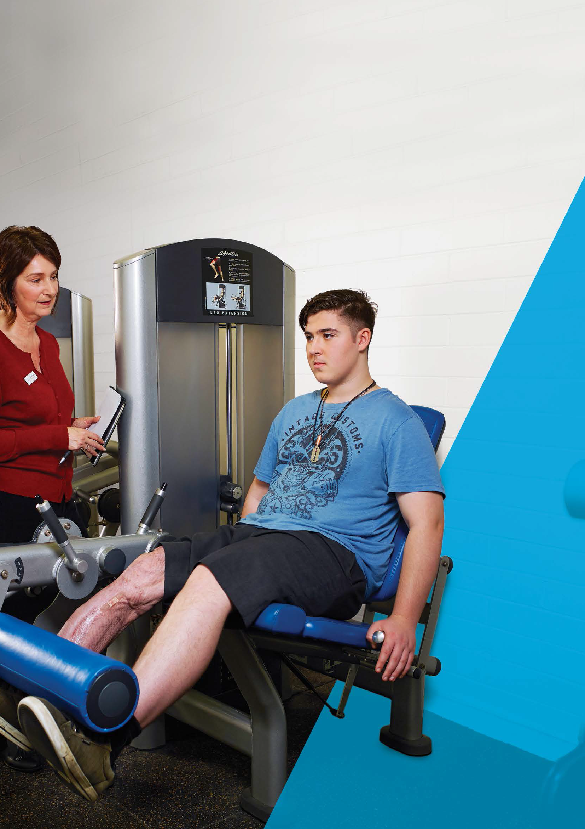

At the rehabilitation hospital

**TAC information for**

**people with major injuries**

2

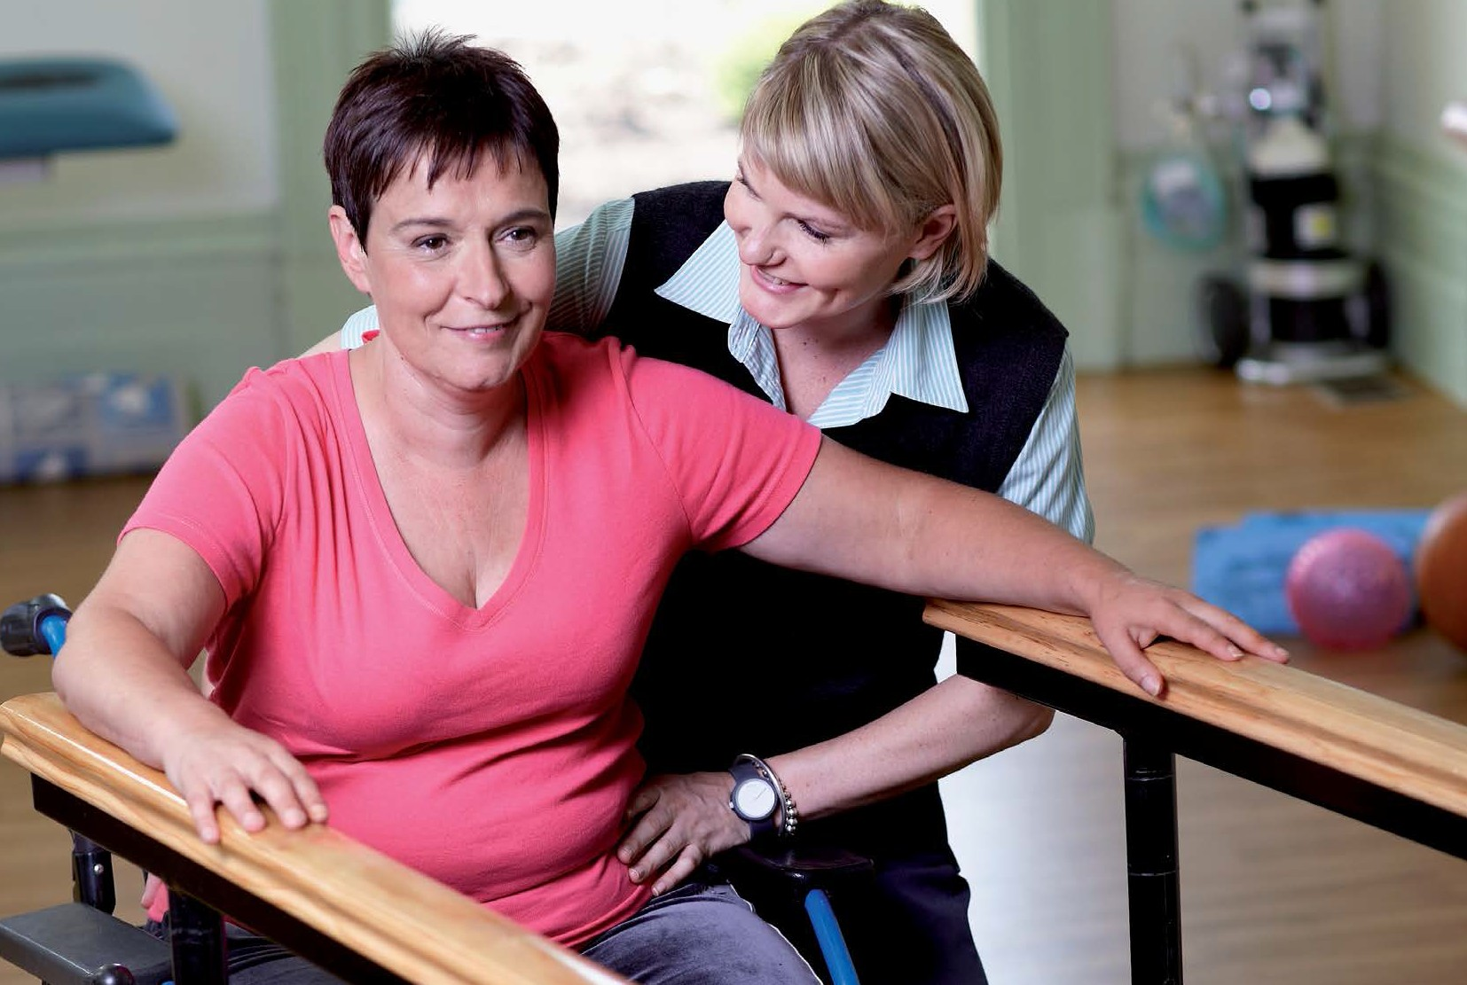

About at the rehabilitation hospital

This brochure provides basic information about the support services funded by the

TAC for people who have sustained major injuries as a result of a transport accident,

and their families.

Major injuries are defined as: spinal cord injuries such as quadriplegia or paraplegia;

moderate or severe acquired brain injuries; extensive burns; and/or amputations.

If you would like more detailed information about support services, please contact

your TAC Early Support Coordinator or the TAC on 1300 654 329.

For information about the TAC in your own language, call one of the numbers listed

on the back of this booklet.

1300 654 329

[www.tac.vic.gov.au](http://www.tac.vic.gov.au/)

myTAC

2

Rehabilitation can involve a range of therapies that focus on improving your health and independence.

[www.tac.vic.gov.au](http://www.tac.vic.gov.au/)

myTAC

1300 654 329

Getting information and support

When you move to a rehabilitation hospital,

you may be unsure about the steps that are

ahead. You may be dealing with the shock

of your accident and be worried about your

health and future. During this time your

TAC Early Support Coordinator and the

health professionals at the hospital will

be there to help you.

The health professionals will monitor your progress and talk to you about the steps you need to follow. They will work with you to develop a rehabilitation program. It is important that you take an active part in this process so you understand as much as possible about your injuries and the rehabilitation program you are undertaking.

**What is rehabilitation?**

Rehabilitation is the process of helping you back to your highest level of functioning following injury. Through relearning and retraining, you can acquire the skills to live as independent a lifestyle as possible.

Your rehabilitation may have different stages and may

take place over an extended period of time. This is the first stage of your rehabilitation.

When you arrive at the rehabilitation hospital, a team

of health professionals will look at how well you manage day-to-day functions integral to your lifestyle. Depending on your injuries, they will assess such things as your capacity to move around safely or your ability to remember things and express yourself. They will work with you to develop an appropriate treatment program that caters to your individual needs, abilities and preferences.

This can involve a range of therapies. Their focus will be on improving your health and independence and getting you to the point where you can leave the hospital and continue rehabilitation in your day-to-day life.

They will also work with you and the Early Support

Coordinator to plan your safe discharge from hospital.

Remember, your Early Support Coordinator is your

key point of contact at the TAC and will there for you throughout this challenging phase of your journey.

Don’t hesitate to ask the hospital staff or your Early

Support Coordinator if you have any questions or concerns.

It is important that you discuss your progress with the

health professionals and your appointed Early Support Coordinator. You may wish to organise a team meeting to give you and your family, where appropriate, the opportunity to talk about how you are progressing

and to provide input into your rehabilitation program.

3

“You play the most important role in your rehabilitation. You can take an active role in the process by discussing your injuries and treatment with the health professionals at the hospital.”

Gavin Williams, Physiotherapist

Getting information and support

**Your Independence Plan**

An Independence Plan is your own individual plan that represents the short and long term goals you want to achieve when you leave the hospital setting. It maps your journey to independence. It will list the goals you want to achieve at home, at work/study and in the community.

It will also capture all your goals, no matter how big or small – whether it’s going to the movies with friends, managing housework or rejoining the workforce. Most importantly, it will detail the necessary steps and the key people involved to achieve these goals. The aim is to meet these goals with the support of the TAC and allocated health professionals, and most importantly, with involvement from you.

**How the TAC can help**

The TAC funds support services for people injured

in transport accidents. These services include paying for appropriate medical, rehabilitation and disability services provided by qualified health professionals and service providers.

The things you may need to consider include:

•

•

•

•

•

•

•

•

•

Managing household and day-to-day tasks

Caring for your children Treatment

Your social life Activities you enjoy

New interests you may have

**For more detail on these services, please**

**refer to our brochure Supporting you after a transport accident or visit our website at** [**www.tac.vic.gov.au**](http://www.tac.vic.gov.au/)

The TAC’s ability to fund support services is dependent

on legislation (Transport Accident Act, 1986), your needs (as determined by a qualified health professional) and the relationship between these needs and your accident injuries.

Work or study

Travel arrangements

Modifications to your home or vehicle

Your Early Support Coordinator will work with you

and your health professional team to plan your safe discharge from hospital. This is very important because it will ensure you have supports and services in place when you return home.

The things your Independence Plan

will include are:

•

•

Key contact people

Your Early Support Coordinator will also talk to you about

the different support options that may suit your needs when you return home. For example, you may need help travelling to your local doctor’s office when you return home. Do you need support or training to use public transport? Do you need help to return to the workforce? Thinking about issues such as this can help you plan your return to day-to-day life.

Summary of your goals in the home, at work,

within the community

How your goals and sub-goals will be achieved Dates for goals and sub-goals to be achieved Services that need to be provided like

physiotherapy, home care

Work and educational arrangements Community, sporting and hobby activities

•

•

•

Based on these discussions, and if you feel ready, your

Early Support Coordinator may begin to develop an Independence Plan with you.

•

•

4

We aim to develop a good working relationship with you, your family and the health professionals involved in your treatment and support, as working together is vital to ensure appropriate plans are in place to support you.

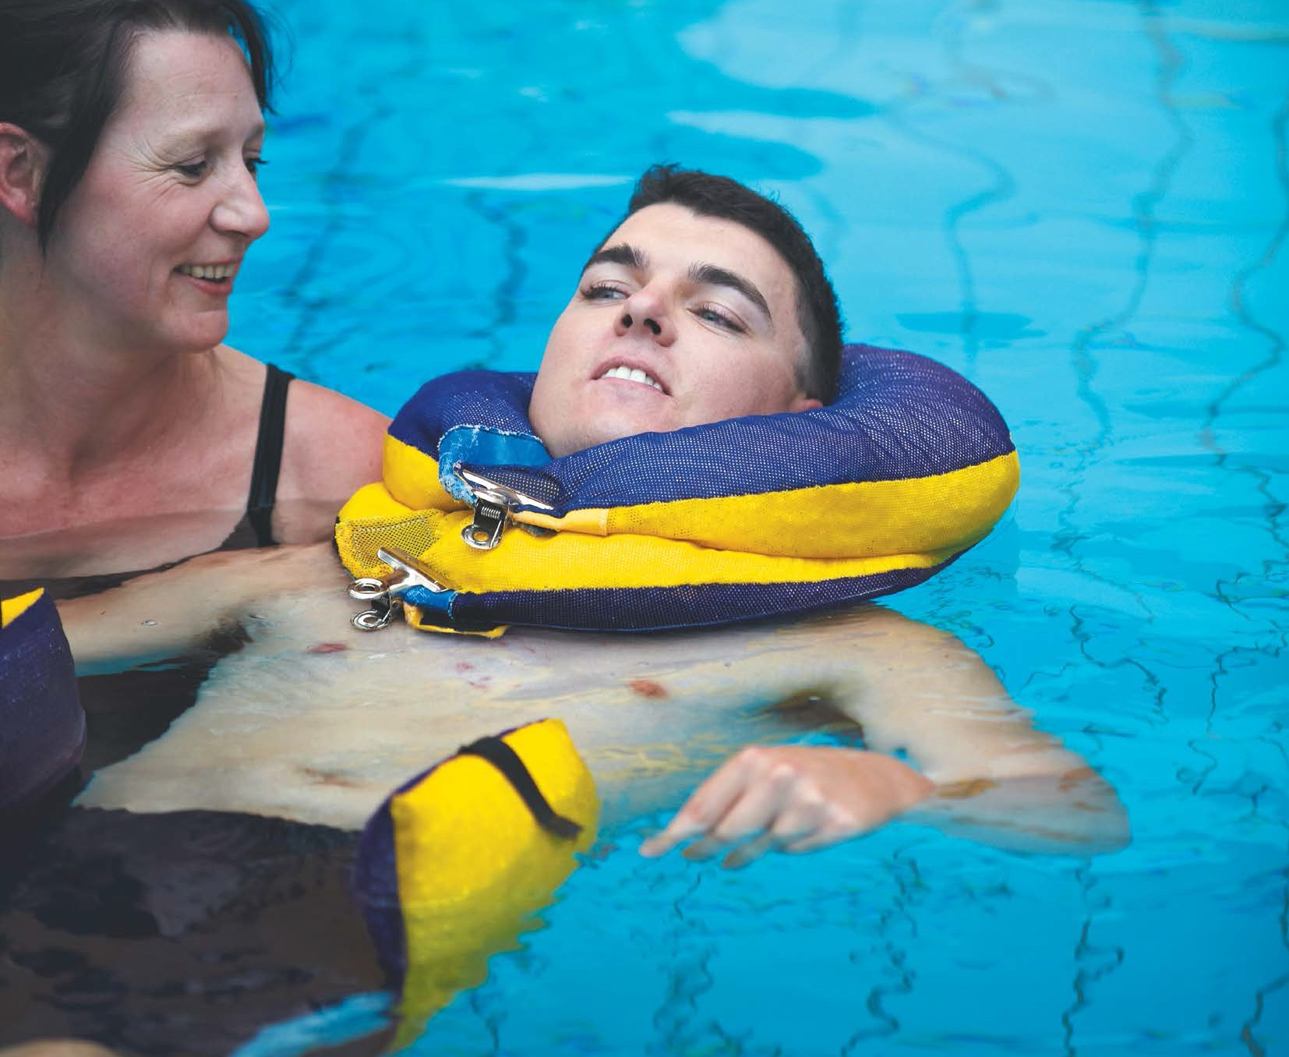

With time your needs will change and so will your

Independence Plan. Your Early Support Coordinator will keep a close eye on your progress and when you or they feel it is time, your plan will be reassessed. With both you and your Early Support Coordinator monitoring how and if your goals are being achieved, the right services and support will be provided to you at the right time.

**Support for friends**

**and family**

Your relatives and friends may also need support after your accident. Hospital social workers can advise you on how to obtain this type of assistance. You can ask a nurse or other hospital staff members for an appointment with a social worker or for a referral to an outside agency.

Remember, the plan relies heavily on your input, so

although it may be early in your journey it’s important to start thinking about the goals you would like to achieve in the short and longer term.

**There are several organisations that can help**

**and many of their services are free. (Ask for our information sheet on Community Services).**

Don’t hesitate to speak to your Early Support Coordinator

for more information on your Independence Plan. Together you will decide the best time to start working on it – whether it is now or in several weeks or months.

The Road Trauma Support Services, for example,

provides counselling referral and information to families affected by road trauma. The number is 1300 367 797.

The parents, partner, siblings and children of an injured

person may be eligible to receive TAC-funded counselling from a doctor, psychologist or qualified social worker.

If you would like more information about counselling, please speak to your Early Support Coordinator.

Their aim is to develop a good working relationship with you,

your family and the health professionals involved in your treatment and support, as working together is vital to ensure appropriate plans are in place to support you. By working together you will be able to maximise your independence.

5

Sam Richards acquired a brain injury in a transport accident in 2003. Since then, he has worked hard to regain some independence. Today his journey to independence continues with the support of his treating provider team and the TAC. Sam lives in a unit behind his mother’s house and wants to be an actor one day.

What happens next

**Returning to day-to-day life**

The following outlines what you can expect to happen throughout your rehabilitation and move back to day-to-day life.

**What happens at the hospital**

**What happens at the TAC**

**What to do if you have**

**a problem**

If you are concerned about any aspect of service provided at the hospital, you can speak to the social worker, your Early Support Coordinator or patient advocate about your concerns.

**Preparing to return**

**to day-to-day life**

As your rehabilitation program progresses, you will gradually take charge of your life again and be actively involved in plans for the future. Your Early Support Coordinator and the health professionals will work with you to plan and prepare for your move back to day-to-day life.

If you are concerned about a TAC decision or you have

a complaint, we encourage you to speak directly to your Early Support Coordinator, who will be happy to discuss your concerns with you. In most cases, issues can be resolved at this point.

The TAC will also continue to support you when you return

to your day-to-day life. Your Early Support Coordinator will work with you, your family and the health professionals to respond to your goals and needs for the short and longer-term. You need to think about what is important to you and what options you might like to pursue so your Early Support Coordinator can capture this in your Independence Plan.

**If you are still concerned, there are a number**

**of options available to you. Call the TAC for more information. Our contact details are listed on the back of this booklet.**

We realise that each person has different ideas about leaving

their rehabilitation hospital and moving back to day-to-day life. Many of our clients tell us that this is a big adjustment with both ‘ups and downs’. Your family and friends will play an important role in helping you make this adjustment smoothly.

6

**Stage 1:**

**The emergency hospital**

Immediately after the accident emergency treatment is given.

Ambulance and hospital bills are paid. You are assigned an Early Support Coordinator who will look after you and manage your claim.

**Stage 2:**

**The rehabilitation hospital**

The health professionals work out the treatment you need and together with you, plan your rehabilitation program. You, your Early Support Coordinator, family and the health professionals make plans to ensure your adjustment to day-to-day life is as smooth as possible.

In consultation with you and your treating team, your Early Support Coordinator will develop a discharge plan to ensure the right supports are in place when you return home. They will pay for services and offer options appropriate to your needs and begin discussing your Independence Plan with you.

**Stage 3: Returning to day-to-day life**

You leave the hospital and move back into day-to-day life with the right services in place to support you.

We continue to pay for services and offer options appropriate to your needs. The Independence Plan is regularly reviewed to match your goals.

[www.tac.vic.gov.au](http://www.tac.vic.gov.au/)

myTAC

1300 654 329

**An Early Support**

**Coordinator:**

**What you need to do**

You play the most important role in your recovery.

•

•

Is your key point of contact at the TAC

Meets face to face with you, your family and

the health professionals concerned throughout the journey from hospital to home

Manages your claim by making decisions on requests for treatment and services

Ensures the right supports and services are in place when you leave hospital and go home

You need to ensure that you:

•

Discuss your injuries and treatment with the health

professionals at the hospital and understand the process of rehabilitation

Are actively involved with your Early Support Coordinator and the health professionals in arranging an appropriate rehabilitation plan that suits your needs and type of injury

Actively participate in your rehabilitation program Start talking with your Early Support Coordinator and

treating health professionals about a discharge plan

and the support you may need at home. If you’re ready, begin discussing and developing your Independence Plan together

Read the brochure Supporting you after a transport accident and talk to your Early Support Coordinator about support services that may be appropriate to your situation

Contact Your Early Support Coordinator if you have any questions or concerns

•

•

•

•

•

•

Works closely with you to develop an Independence

Plan, that captures your goals at home, at work and in the community

Details the necessary steps to achieve these goals in the Independence Plan

Shares the Independence Plan with the relevant health professionals to ensure that everyone involved in your care is working towards helping you achieve your goals

Regularly monitors your Independence Plan to ensure it matches your changing goals and needs

Supports you on your journey to independence Is there to help address any questions, concerns

or fears you may have

•

•

•

•

•

•

•

**Please contact your Early Support Coordinator**

**if you have questions or concerns. Your Early Support Coordinator will be happy to visit you to discuss things in more detail and to provide you with relevant booklets or information sheets.**

7



**Contact us**

8.30am to 5.30pm, Monday to Friday

1300 654 329 (local call)

1800 332 556 (toll-free outside the Melbourne metropolitan area)

Address

60 Brougham Street, Geelong VIC 3220

Mailing address

TAC, Reply Paid 2751, Melbourne VIC 3001

[www.tac.vic.gov.au](http://www.tac.vic.gov.au/) myTAC

Manage your TAC claim with ease using myTAC, our new mobile app and web portal. Use myTAC to submit reimbursement forms, send us an enquiry and find out what

services you can use without having to call us for approval.

Download myTAC from the Apple iTunes Store, Google Play Store or visit our website.

©Copyright Transport Accident Commission, 2017.

For information about the TAC in your own language, call one of the numbers listed here:



Tieng Viet