

Quarterly Statistics – March 2020


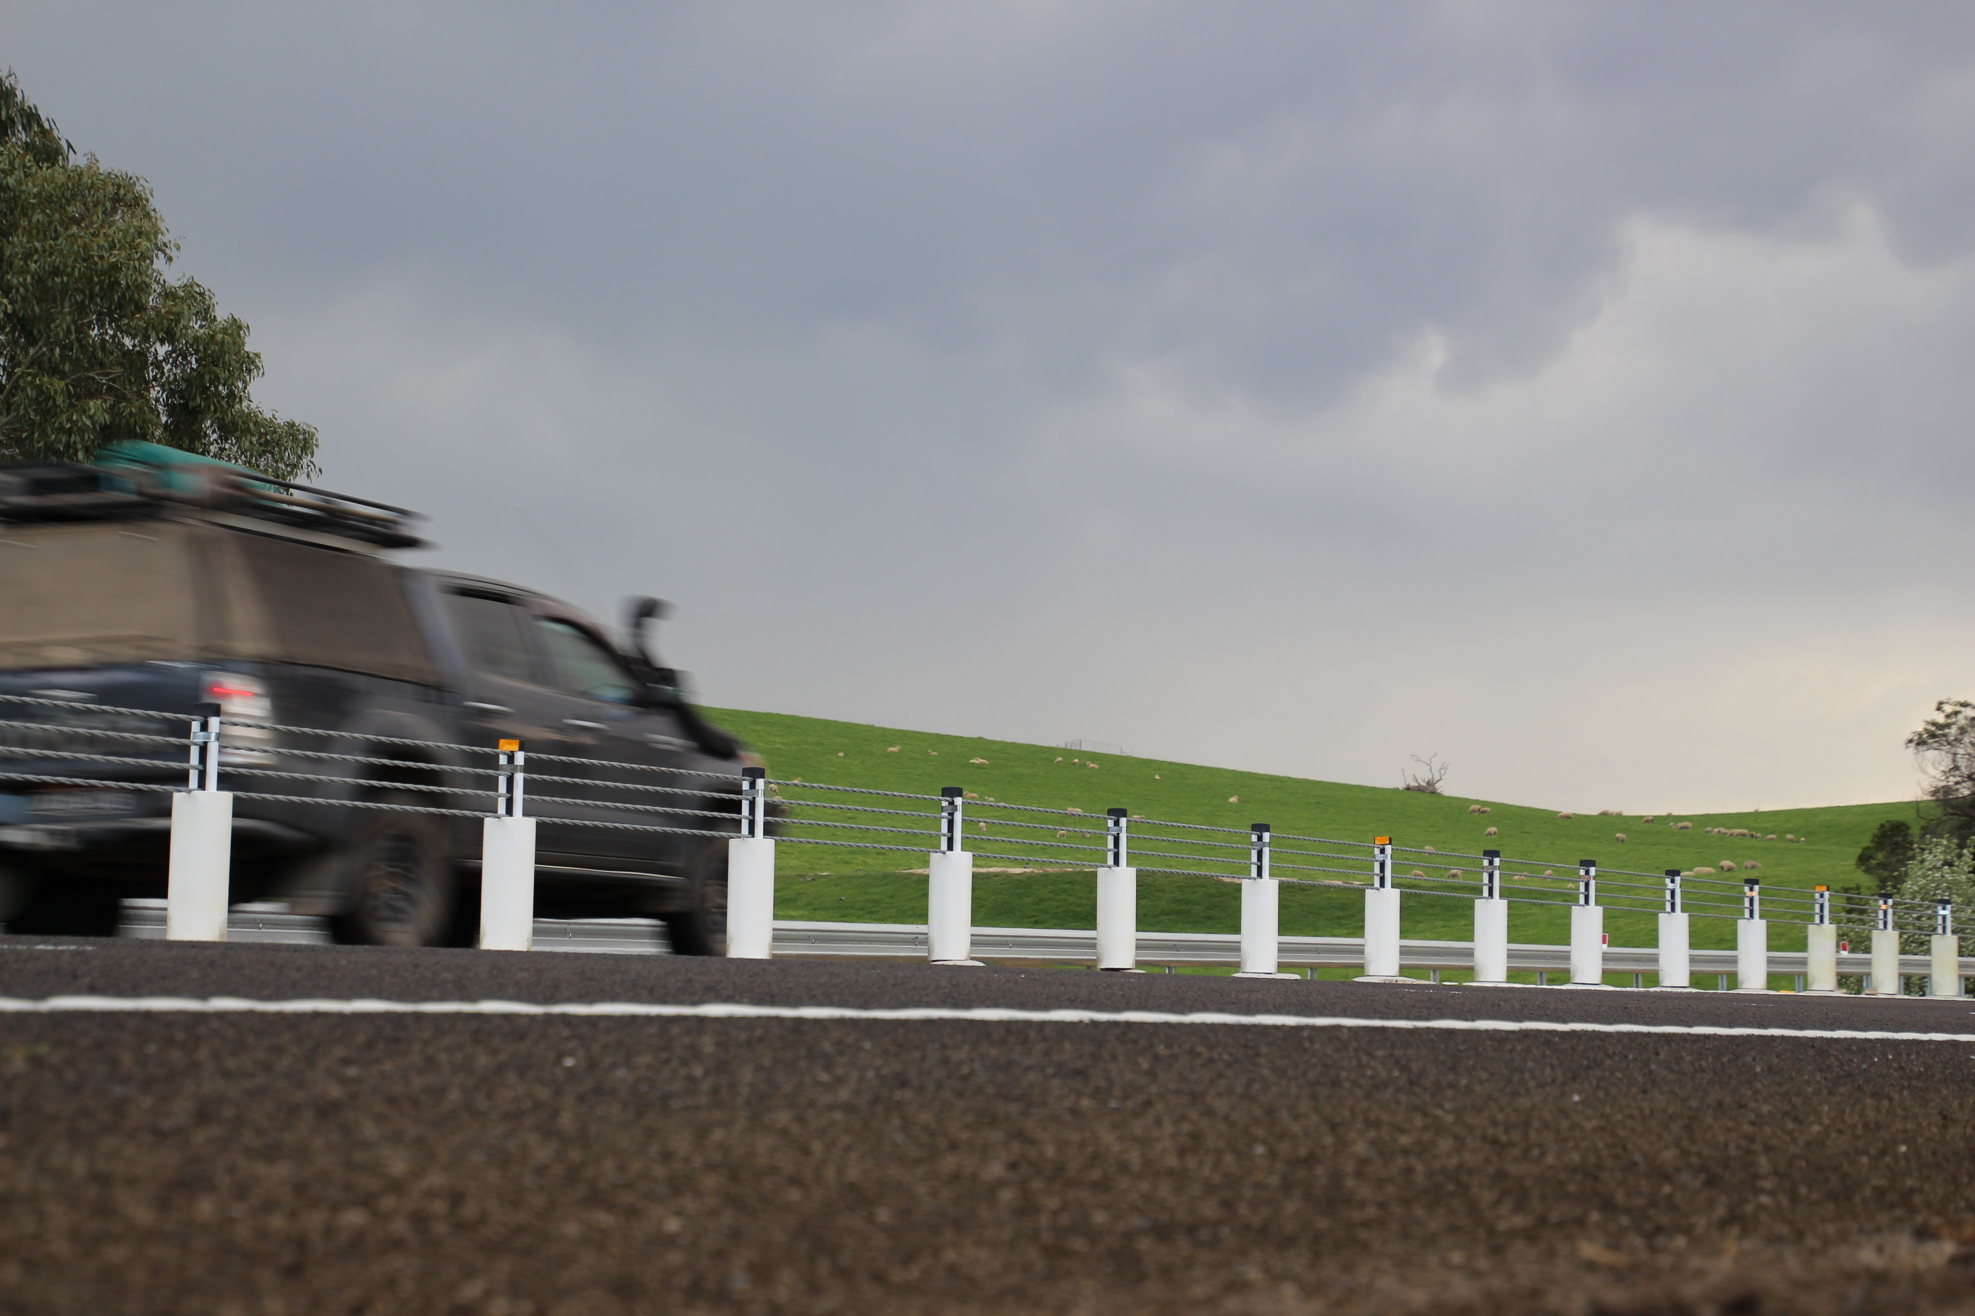

TRANSPORT  ACCIDENT  COMMISSION | 60 Brougham Street  Geelong Vic 3220  PO Box 742  Geelong Vic 3220  Ausdoc DX 216079 Geelong | Telephone 1300 654 329  STD Toll Free 1800 332 556  Fax: 03 9656 9300  www.tac.vic.gov.au  ABN 22 033 947 623

Contents

Status Report 3
Lives lost on Victorian roads 3
Injured claimants who were admitted to hospital within 7 days of accident, rolling 12 month to 30th June 2019 4
Lives lost: 12 months to 31st March 2020 5
Injured claimants who were admitted to hospital within 7 days of accident, 12 months to 30th June 2019 (claim acceptance date) 9
Lives Lost by Week (2015 to 2020) 11
The National Picture 12
Explanations and References 14
Useful Internet Sites 15
Victorian monthly lives lost since 1951 18

Notes about the data in this report
- All data provided in this report is the data most recently available at time of production. Fatality data are updated to the end of report month. A 6-month lag applies to TAC claims data.
- Reported data will have one extra day of exposure for leap years.
- Data is subject to revision as additional information about known accidents/claims is received, and as new accident/claim reports are received and processed.

Status Report

Lives lost on Victorian roads

- The rolling 12 months number of lives lost to 31st March 2020 is 257. The rolling 12 months number of lives lost to 31st March 2019 stood at 232 (an increase of 25 lives lost).
- 66 people lost their lives year to date to the end of March 2020 on Victorian roads. This compares to 75 lives lost year to date to the end of March 2019 (an increase of 9).

Category | 2020 | 2019 | 2018 | 2020 v 2019 | 2020 v 2018 | 5 Year Average
Lives Lost (Rolling 12 Month Total)
Lives Lost (to March) | 257 | 232 | 258 | +25 | -1 | 256
per 10,000 veh | 0.50 | 0.46 | 0.53 | +0.04 | -0.03 | 0.53
per 100,000 pop | 3.88 | 3.57 | 4.06 | +0.31 | -0.18 | 4.08
Crashes (Rolling 12 Month Total)
Fatal crashes (to March) | 239 | 219 | 238 | +20 | +1 | 240
per 10,000 veh | 0.47 | 0.44 | 0.49 | +0.03 | -0.02 | 0.50
per 100,000 pop | 3.61 | 3.37 | 3.74 | +0.24 | -0.13 | 3.82

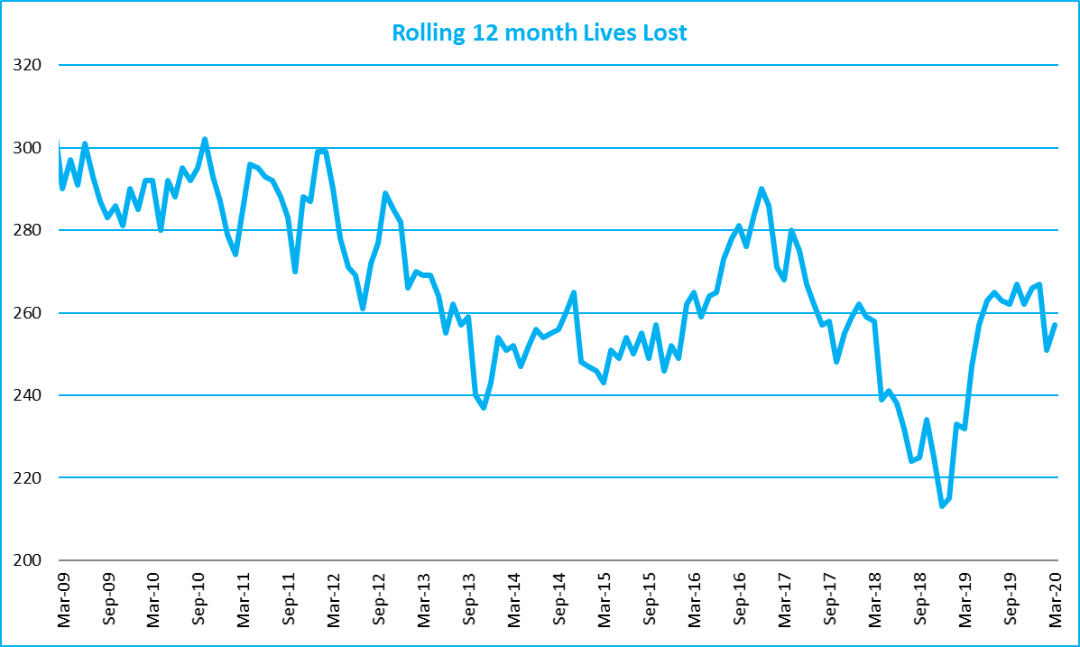
Victoria – Lives Lost, rolling 12 months total

Injured claimants who were admitted to hospital within 7 days of accident, rolling 12 month to 30th June 2019
Category | 2019 | 2018 | 2017 | 2019 v 2018 |  | 2019 v 2017 |  | 5 Year Average
Claims involving an hospitalisation over 14 days (Rolling 12 Month Total)
Claims (to June) | 900 | 925 | 959 | -25.0 | (-3%) | -59 | (-6%) | 940
per 100,000 pop | 13.8 | 14.5 | 15.2 | -0.7 | (-5%) | -1.4 | (-9%) | 15.3
per 10,000 veh | 1.8 | 1.9 | 2.0 | -0.1 | (-5%) | -0.2 | (-10%) | 2.0
All claims involving an hospitalisation (Rolling 12 Month Total)
Claims (to June) | 8,243 | 7,960 | 7,494 | +283.0 | (+4%) | +749 | (+10%) | 7,293
per 100,000 pop | 126.3 | 124.5 | 119.0 | +1.8 | (+1%) | +7.3 | (+6%) | 114.7
per 10,000 veh | 16.4 | 16.2 | 15.7 | +0.2 | (+1%) | +0.7 | (+4%) | 14.9

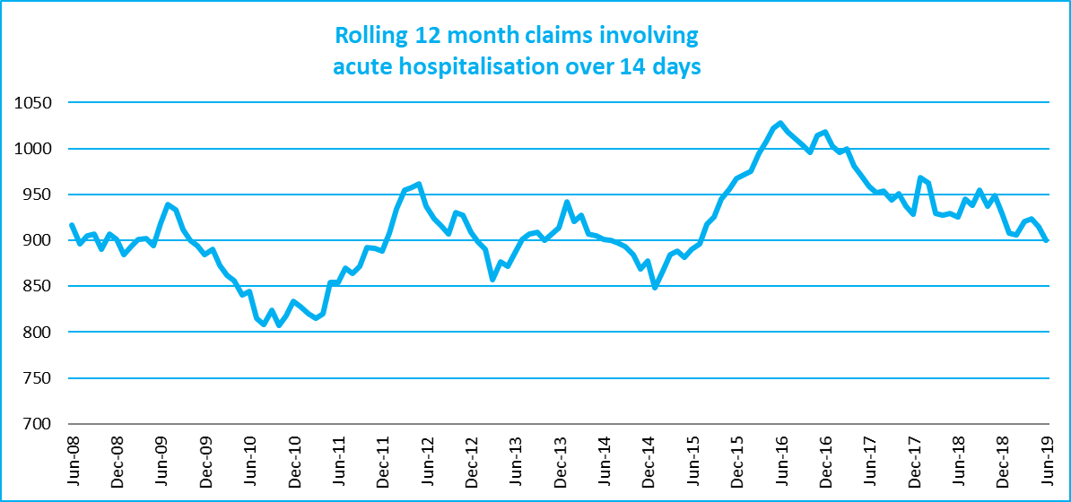
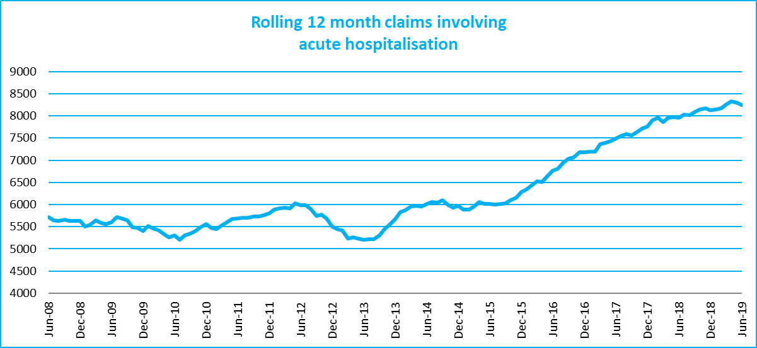

Lives lost: 12 months to 31st March 2020
Category | 2020 | 2019 | 2018 | 2020 v 2019 | 2020 v 2018 | 5 Year Average
Overview
Lives Lost | 257 | 232 | 258 | +25 | -1 | 256
Fatal Crashes | 239 | 219 | 238 | +20 | +1 | 240
Sex
Female | 66 | 64 | 69 | +2 | -3 | 70
Male | 191 | 168 | 189 | +23 | +2 | 186
Road user
Bicyclist | 13 | 10 | 11 | +3 | +2 | 10
Driver | 113 | 102 | 125 | +11 | -12 | 123
Motorcyclist | 36 | 46 | 41 | -10 | -5 | 41
Passenger | 46 | 35 | 47 | +11 | -1 | 44
Pedestrian | 49 | 39 | 34 | +10 | +15 | 38
Location
Melbourne | 120 | 105 | 110 | +15 | +10 | 116
Rural Victoria | 137 | 127 | 148 | +10 | -11 | 140
Age group
0-4 | 1 | 2 | 1 | -1 | 0 | 2
5-15 | 5 | 9 | 3 | -4 | +2 | 5
16-17 | 4 | 3 | 4 | +1 | 0 | 6
18-20 | 21 | 13 | 21 | +8 | 0 | 20
21-25 | 28 | 18 | 24 | +10 | +4 | 23
26-29 | 23 | 18 | 13 | +5 | +10 | 20
30-39 | 40 | 38 | 39 | +2 | +1 | 37
40-49 | 29 | 21 | 38 | +8 | -9 | 35
50-59 | 27 | 31 | 30 | -4 | -3 | 31
60-69 | 28 | 28 | 32 |  | -4 | 28
70+ | 51 | 50 | 53 | +1 | -2 | 50
Accident Type
Intersection
Adjacent direction | 31 | 33 | 34 | -2 | -3 | 32
Opposing direction | 13 | 8 | 11 | +5 | +2 | 9
Mid-block/other
Head on | 35 | 29 | 41 | +6 | -6 | 40
Same direction | 15 | 22 | 19 | -7 | -4 | 19
Manoeuvre/o'taking | 18 | 14 | 15 | +4 | +3 | 15
On path | 5 | 2 | 7 | +3 | -2 | 5
Single vehicle | 84 | 82 | 94 | +2 | -10 | 93
Other (incl peds) | 56 | 42 | 36 | +14 | +20 | 41

Lives Lost: 12 months to 31st March 2020 – Continued

Category | 2020 | 2019 | 2018 | 5 Year Average | Category | 2020 | 2019 | 2018 | 5 Year Average
Local Government Area |  |  |  |  | Local Government Area
ALPINE | 2 | 3 | 1 | 1 | MANSFIELD | 1 | 2 | 3 | 2
ARARAT | 3 | 1 | 1 | 1 | MARIBYRNONG | 2 | 3 | 5 | 3
BALLARAT | 2 | 3 | 4 | 3 | MAROONDAH | 1 | 6 | 1 | 2
BANYULE | 0 | 2 | 4 | 2 | MELBOURNE | 2 | 2 | 3 | 3
BASS COAST | 4 | 0 | 2 | 1 | MELTON | 2 | 7 | 3 | 4
BAW BAW | 4 | 4 | 2 | 2 | MILDURA | 5 | 5 | 1 | 3
BAYSIDE | 0 | 1 | 4 | 2 | MITCHELL | 3 | 1 | 5 | 4
BENALLA | 0 | 3 | 3 | 2 | MOIRA | 4 | 4 | 6 | 4
BOROONDARA | 2 | 3 | 3 | 2 | MONASH | 10 | 5 | 6 | 4
BRIMBANK | 9 | 4 | 4 | 6 | MOONEE VALLEY | 2 | 3 | 2 | 2
BULOKE | 1 | 1 | 1 | 1 | MOORABOOL | 3 | 4 | 5 | 4
CAMPASPE | 2 | 2 | 5 | 3 | MORELAND | 1 | 4 | 1 | 3
CARDINIA | 3 | 4 | 9 | 6 | MORNINGTON PENINSULA | 17 | 3 | 4 | 5
CASEY | 7 | 3 | 7 | 5 | MOUNT ALEXANDER | 4 | 2 | 3 | 1
CENTRAL GOLDFIELDS | 3 | 1 | 1 | 1 | MOYNE | 3 | 1 | 2 | 1
COLAC-OTWAY | 3 | 1 | 8 | 3 | MURRINDINDI | 3 | 4 | 6 | 5
CORANGAMITE | 4 | 2 | 3 | 2 | NILLUMBIK | 0 | 2 | 2 | 2
DAREBIN | 8 | 2 | 4 | 2 | NORTHERN GRAMPIANS | 3 | 6 | 3 | 3
EAST GIPPSLAND | 2 | 6 | 8 | 6 | PORT PHILLIP | 2 | 0 | 2 | 1
FRANKSTON | 9 | 1 | 6 | 2 | PYRENEES | 2 | 1 | 4 | 2
GANNAWARRA | 0 | 3 | 4 | 1 | QUEENSCLIFFE | 0 | 0 | 0 | 0
GLEN EIRA | 4 | 0 | 1 | 1 | SOUTH GIPPSLAND | 6 | 7 | 3 | 4
GLENELG | 0 | 4 | 4 | 4 | SOUTHERN GRAMPIANS | 2 | 2 | 1 | 2
GOLDEN PLAINS | 0 | 7 | 4 | 4 | STONNINGTON | 0 | 5 | 1 | 2
GREATER BENDIGO | 7 | 6 | 5 | 5 | STRATHBOGIE | 1 | 2 | 3 | 2
GREATER DANDENONG | 4 | 3 | 6 | 3 | SURF COAST | 0 | 1 | 3 | 2
GREATER GEELONG | 15 | 5 | 8 | 6 | SWAN HILL | 3 | 0 | 1 | 1
GREATER SHEPPARTON | 5 | 6 | 9 | 7 | TOWONG | 3 | 1 | 2 | 1
HEPBURN | 6 | 4 | 2 | 3 | WANGARATTA | 0 | 1 | 3 | 3
HINDMARSH | 0 | 0 | 0 | 1 | WARRNAMBOOL | 3 | 2 | 0 | 1
HORSHAM | 6 | 1 | 1 | 2 | WEST WIMMERA | 3 | 1 | 0 | 0
HUME | 9 | 7 | 3 | 4 | WHITEHORSE | 1 | 1 | 3 | 2
INDIGO | 1 | 2 | 2 | 2 | WHITTLESEA | 3 | 4 | 4 | 3
KINGSTON | 4 | 5 | 4 | 4 | WODONGA | 1 | 0 | 1 | 1
KNOX | 1 | 7 | 1 | 4 | WYNDHAM | 6 | 6 | 3 | 5
LATROBE | 6 | 5 | 3 | 3 | YARRA | 1 | 0 | 2 | 1
LODDON | 3 | 2 | 1 | 1 | YARRA RANGES | 8 | 8 | 8 | 7
MACEDON RANGES | 2 | 6 | 3 | 4 | YARRIAMBIACK | 1 | 0 | 1 | 1
MANNINGHAM | 2 | 2 | 3 | 2

Injured claimants admitted to hospital within 7 days of the accident with a hospital stay of more than 14 days, 12 months to 30th June 2019 (claim acceptance date)

Category | 2019 | 2018 | 2017 | 2019 v 2018 |  | 2019 v 2017 |  | 5 Year Average
Overview
Claims | 900 | 925 | 959 | -25 | -3% | -59 | -6% | 940
Sex
Female | 370 | 363 | 401 | +7 | 2% | -31 | -8% | 388
Male | 530 | 562 | 558 | -32 | -6% | -28 | -5% | 552
Road user
Bicyclist | 31 | 37 | 33 | -6 | -16% | -2 | -6% | 37
Driver | 329 | 333 | 360 | -4 | -1% | -31 | -9% | 351
Motorcyclist | 183 | 188 | 182 | -5 | -3% | +1 | 1% | 181
Passenger | 132 | 137 | 135 | -5 | -4% | -3 | -2% | 140
Pedestrian | 186 | 195 | 215 | -9 | -5% | -29 | -13% | 197
Train/Tram | 12 | 11 | 10 | +1 | 9% | +2 | 20% | 10
Location
Melbourne | 527 | 556 | 586 | -29 | -5% | -59 | -10% | 583
Rural Victoria | 311 | 292 | 333 | +19 | 7% | -22 | -7% | 307
Age group
0-4 | 3 | 4 | 5 | -1 | -25% | -2 | -40% | 4
5-15 | 16 | 8 | 10 | +8 | 100% | 6 | 60% | 14
16-17 | 15 | 9 | 15 | +6 | 67% | 0 | 0% | 13
18-20 | 45 | 33 | 57 | +12 | 36% | -12 | -21% | 48
21-25 | 72 | 94 | 89 | -22 | -23% | -17 | -19% | 84
26-29 | 51 | 61 | 47 | -10 | -16% | 4 | 9% | 54
30-39 | 104 | 113 | 132 | -9 | -8% | -28 | -21% | 118
40-49 | 100 | 105 | 116 | -5 | -5% | -16 | -14% | 109
50-59 | 127 | 122 | 120 | +5 | 4% | 7 | 6% | 119
60-69 | 101 | 119 | 120 | -18 | -15% | -19 | -16% | 114
70+ | 266 | 257 | 248 | +9 | 4% | 18 | 7% | 264
Accident Type
Intersection
Adjacent direction | 82 | 78 | 97 | +4 | 5% | -15 | -15% | 94
Opposing direction | 51 | 53 | 58 | -2 | -4% | -7 | -12% | 57
Mid-block/other
Head on | 72 | 48 | 80 | +24 | 50% | -8 | -10% | 77
Same direction | 82 | 54 | 72 | +28 | 52% | 10 | 14% | 75
Manoeuvre/o'taking | 42 | 45 | 48 | -3 | -7% | -6 | -13% | 49
On path | 23 | 28 | 19 | -5 | -18% | 4 | 21% | 28
Single vehicle | 220 | 218 | 251 | +2 | 1% | -31 | -12% | 250
Other (incl peds) | 328 | 401 | 334 | -73 | -18% | -6 | -2% | 310

Note: excludes rejected claims and claims for interstate crashes.

Injured claimants who were admitted to hospital within 7 days of the accident with a hospital stay of more than 14 days, 12 months to 30th June 2019 (claim acceptance date) – Continued

Category | 2019 | 2018 | 2017 | 5 Year Average | Category | 2019 | 2018 | 2017 | 5 Year Average
Local Government Area |  |  |  |  | Local Government Area
ALPINE | 8 | 5 | 5 | 3 | MANSFIELD | 4 | 8 | 12 | 6
ARARAT | 3 | 1 | 3 | 4 | MARIBYRNONG | 7 | 19 | 11 | 11
BALLARAT | 20 | 10 | 16 | 14 | MAROONDAH | 7 | 7 | 9 | 6
BANYULE | 11 | 12 | 9 | 9 | MELBOURNE | 27 | 44 | 30 | 32
BASS COAST | 12 | 5 | 5 | 7 | MELTON | 9 | 12 | 8 | 12
BAW BAW | 7 | 11 | 10 | 8 | MILDURA | 8 | 7 | 8 | 6
BAYSIDE | 11 | 7 | 13 | 8 | MITCHELL | 9 | 8 | 11 | 8
BENALLA | 3 | 7 | 3 | 4 | MOIRA | 7 | 14 | 10 | 8
BOROONDARA | 17 | 12 | 14 | 16 | MONASH | 23 | 19 | 23 | 20
BRIMBANK | 20 | 18 | 25 | 24 | MOONEE VALLEY | 11 | 19 | 13 | 17
BULOKE | 5 | 1 | 0 | 3 | MOORABOOL | 3 | 9 | 10 | 9
CAMPASPE | 8 | 4 | 14 | 7 | MORELAND | 29 | 27 | 31 | 26
CARDINIA | 13 | 14 | 20 | 14 | MORNINGTON PENINSULA | 22 | 21 | 26 | 23
CASEY | 22 | 29 | 31 | 29 | MOUNT ALEXANDER | 2 | 3 | 0 | 3
CENTRAL GOLDFIELDS | 6 | 3 | 1 | 2 | MOYNE | 6 | 7 | 4 | 3
COLAC-OTWAY | 6 | 7 | 8 | 8 | MURRINDINDI | 4 | 16 | 13 | 12
CORANGAMITE | 2 | 11 | 7 | 5 | NILLUMBIK | 10 | 4 | 6 | 6
DAREBIN | 17 | 17 | 26 | 18 | NORTHERN GRAMPIANS | 0 | 8 | 5 | 4
EAST GIPPSLAND | 12 | 8 | 16 | 9 | PORT PHILLIP | 7 | 13 | 15 | 15
FRANKSTON | 7 | 17 | 19 | 14 | PYRENEES | 4 | 0 | 1 | 2
GANNAWARRA | 2 | 2 | 2 | 2 | QUEENSCLIFFE | 2 | 1 | 0 | 0
GLEN EIRA | 20 | 15 | 9 | 13 | SOUTH GIPPSLAND | 5 | 7 | 9 | 8
GLENELG | 4 | 3 | 4 | 4 | SOUTHERN GRAMPIANS | 4 | 3 | 2 | 3
GOLDEN PLAINS | 6 | 2 | 6 | 5 | STONNINGTON | 12 | 13 | 12 | 13
GREATER BENDIGO | 20 | 22 | 16 | 14 | STRATHBOGIE | 3 | 2 | 6 | 6
GREATER DANDENONG | 30 | 18 | 24 | 21 | SURF COAST | 2 | 7 | 8 | 5
GREATER GEELONG | 33 | 28 | 28 | 23 | SWAN HILL | 5 | 4 | 4 | 4
GREATER SHEPPARTON | 11 | 14 | 22 | 14 | TOWONG | 4 | 5 | 1 | 2
HEPBURN | 5 | 3 | 2 | 3 | WANGARATTA | 6 | 2 | 7 | 5
HINDMARSH | 0 | 0 | 5 | 1 | WARRNAMBOOL | 4 | 2 | 4 | 3
HOBSONS BAY | 7 | 6 | 10 | 8 | WELLINGTON | 9 | 6 | 15 | 8
HORSHAM | 5 | 4 | 1 | 3 | WEST WIMMERA | 1 | 0 | 2 | 1
HUME | 27 | 24 | 30 | 26 | WHITEHORSE | 24 | 24 | 23 | 18
INDIGO | 4 | 4 | 3 | 4 | WHITTLESEA | 29 | 21 | 31 | 23
KINGSTON | 19 | 18 | 14 | 17 | WODONGA | 3 | 4 | 1 | 4
KNOX | 20 | 20 | 18 | 16 | WYNDHAM | 18 | 19 | 27 | 23
LATROBE | 17 | 8 | 6 | 9 | YARRA | 17 | 11 | 12 | 12
LODDON | 3 | 0 | 1 | 1 | YARRA RANGES | 25 | 34 | 30 | 31
MACEDON RANGES | 11 | 5 | 15 | 11 | YARRIAMBIACK | 3 | 1 | 1 | 1
MANNINGHAM | 9 | 22 | 17 | 13

Note: excludes rejected claims and claims for interstate crashes

Injured claimants who were admitted to hospital within 7 days of accident, 12 months to 30th June 2019 (claim acceptance date)
Category | 2019 | 2018 | 2017 | 2019 v 2018 |  | 2019 v 2017 |  | 5 Year Average
Overview
Claims | 8,243 | 7,960 | 7,494 | +283 | 4% | +749 | 10% | 7,293
Sex
Female | 3,551 | 3,439 | 3,264 | +112 | 3% | +287 | 9% | 3,161
Male | 4,681 | 4,512 | 4,222 | +169 | 4% | +459 | 11% | 4,122
Road user
Bicyclist | 532 | 548 | 433 | -16 | -3% | +99 | 23% | 467
Driver | 3,995 | 3,714 | 3,637 | +281 | 8% | +358 | 10% | 3,439
Motorcyclist | 1,412 | 1,354 | 1,231 | +58 | 4% | +181 | 15% | 1,248
Passenger | 1,191 | 1,140 | 1,063 | +51 | 4% | +128 | 12% | 1,110
Pedestrian | 785 | 824 | 774 | -39 | -5% | +11 | 1% | 738
Train/Tram | 41 | 51 | 53 | -10 | -20% | -12 | -23% | 40
Location
Melbourne | 4,989 | 4,545 | 4,748 | +444 | 10% | +241 | 5% | 4,573
Rural Victoria | 2,377 | 2,198 | 2,215 | +179 | 8% | +162 | 7% | 2,090
Age group
0-4 | 67 | 71 | 59 | -4 | -6% | +8 | 14% | 59
5-15 | 240 | 238 | 198 | +2 | 1% | +42 | 21% | 226
16-17 | 144 | 135 | 114 | +9 | 7% | +30 | 26% | 124
18-20 | 646 | 558 | 546 | +88 | 16% | +100 | 18% | 546
21-25 | 1,027 | 1,012 | 947 | +15 | 1% | +80 | 8% | 904
26-29 | 662 | 695 | 649 | -33 | -5% | +13 | 2% | 615
30-39 | 1,325 | 1,274 | 1,210 | +51 | 4% | +115 | 10% | 1,165
40-49 | 1,076 | 1,141 | 1,126 | -65 | -6% | -50 | -4% | 1,040
50-59 | 1,094 | 1,090 | 974 | +4 | 0% | +120 | 12% | 952
60-69 | 807 | 777 | 705 | +30 | 4% | +102 | 14% | 702
70+ | 1,155 | 969 | 966 | +186 | 19% | +189 | 20% | 960
Accident Type
Intersection
Adjacent direction | 953 | 782 | 884 | +171 | 22% | +69 | 8% | 851
Opposing direction | 539 | 456 | 574 | +83 | 18% | -35 | -6% | 532
Mid-block/other
Head on | 332 | 298 | 354 | +34 | 11% | -22 | -6% | 327
Same direction | 1,032 | 800 | 1,061 | +232 | 29% | -29 | -3% | 968
Manoeuvre/o'taking | 336 | 321 | 368 | +15 | 5% | -32 | -9% | 354
On path | 226 | 222 | 277 | +4 | 2% | -51 | -18% | 267
Single vehicle | 1,411 | 1,332 | 1,647 | +79 | 6% | -236 | -14% | 1,583
Other (incl peds) | 3,414 | 3,749 | 2,329 | -335 | -9% | +1085 | 47% | 2,412

Note: excludes rejected claims and claims for interstate crashes
Injured claimants who were admitted to hospital within 7 days of accident, 12 months to
30th June 2019 (claim acceptance date) – Continued

Category | 2019 | 2018 | 2017 | 5 Year Average | Category | 2019 | 2018 | 2017 | 5 Year Average
Local Government Area |  |  |  |  | Local Government Area
ALPINE | 34 | 29 | 27 | 24 | MANSFIELD | 37 | 41 | 37 | 32
ARARAT | 18 | 9 | 22 | 16 | MARIBYRNONG | 100 | 95 | 88 | 71
BALLARAT | 109 | 73 | 104 | 78 | MAROONDAH | 80 | 57 | 64 | 53
BANYULE | 78 | 65 | 56 | 54 | MELBOURNE | 289 | 319 | 312 | 266
BASS COAST | 54 | 46 | 26 | 41 | MELTON | 90 | 72 | 90 | 72
BAW BAW | 57 | 54 | 54 | 48 | MILDURA | 32 | 21 | 25 | 25
BAYSIDE | 98 | 77 | 85 | 75 | MITCHELL | 70 | 68 | 88 | 62
BENALLA | 31 | 17 | 23 | 19 | MOIRA | 30 | 41 | 41 | 34
BOROONDARA | 151 | 146 | 138 | 122 | MONASH | 190 | 200 | 214 | 181
BRIMBANK | 176 | 175 | 158 | 135 | MOONEE VALLEY | 150 | 139 | 127 | 118
BULOKE | 15 | 2 | 11 | 9 | MOORABOOL | 58 | 55 | 50 | 44
CAMPASPE | 52 | 42 | 55 | 41 | MORELAND | 192 | 198 | 185 | 153
CARDINIA | 113 | 128 | 138 | 116 | MORNINGTON PENINSULA | 199 | 162 | 196 | 151
CASEY | 355 | 309 | 355 | 283 | MOUNT ALEXANDER | 26 | 22 | 17 | 22
CENTRAL GOLDFIELDS | 25 | 15 | 20 | 13 | MOYNE | 34 | 48 | 23 | 23
COLAC-OTWAY | 49 | 81 | 61 | 48 | MURRINDINDI | 60 | 56 | 73 | 55
CORANGAMITE | 31 | 40 | 46 | 29 | NILLUMBIK | 46 | 36 | 39 | 36
DAREBIN | 128 | 96 | 131 | 94 | NORTHERN GRAMPIANS | 18 | 39 | 17 | 21
EAST GIPPSLAND | 53 | 56 | 73 | 54 | PORT PHILLIP | 160 | 149 | 147 | 134
FRANKSTON | 152 | 142 | 142 | 122 | PYRENEES | 18 | 7 | 12 | 10
GANNAWARRA | 13 | 8 | 10 | 10 | QUEENSCLIFFE | 10 | 7 | 2 | 2
GLEN EIRA | 139 | 124 | 123 | 107 | SOUTH GIPPSLAND | 44 | 41 | 45 | 37
GLENELG | 22 | 30 | 21 | 20 | SOUTHERN GRAMPIANS | 24 | 21 | 14 | 20
GOLDEN PLAINS | 44 | 50 | 55 | 39 | STONNINGTON | 150 | 133 | 122 | 127
GREATER BENDIGO | 142 | 141 | 117 | 102 | STRATHBOGIE | 35 | 32 | 35 | 33
GREATER DANDENONG | 324 | 221 | 266 | 230 | SURF COAST | 68 | 70 | 60 | 48
GREATER GEELONG | 450 | 431 | 360 | 269 | SWAN HILL | 22 | 14 | 19 | 17
GREATER SHEPPARTON | 94 | 89 | 120 | 85 | TOWONG | 17 | 24 | 14 | 16
HEPBURN | 34 | 25 | 28 | 25 | WANGARATTA | 40 | 30 | 29 | 31
HINDMARSH | 21 | 6 | 12 | 8 | WARRNAMBOOL | 28 | 30 | 31 | 23
HOBSONS BAY | 86 | 79 | 75 | 64 | WELLINGTON | 83 | 53 | 74 | 63
HORSHAM | 20 | 31 | 25 | 22 | WEST WIMMERA | 2 | 7 | 10 | 5
HUME | 264 | 245 | 254 | 203 | WHITEHORSE | 155 | 145 | 173 | 116
INDIGO | 28 | 20 | 29 | 20 | WHITTLESEA | 237 | 219 | 242 | 172
KINGSTON | 138 | 122 | 126 | 124 | WODONGA | 20 | 27 | 24 | 24
KNOX | 148 | 129 | 154 | 117 | WYNDHAM | 211 | 175 | 159 | 146
LATROBE | 97 | 59 | 73 | 54 | YARRA | 125 | 102 | 121 | 105
LODDON | 20 | 9 | 8 | 11 | YARRA RANGES | 171 | 193 | 169 | 161
MACEDON RANGES | 82 | 67 | 90 | 65 | YARRIAMBIACK | 6 | 13 | 5 | 6
MANNINGHAM | 94 | 93 | 99 | 76

Note: excludes rejected claims and claims for interstate crashes

Lives Lost by Week (2015 to 2020)

Week |  |  |  |  |  |  | Cumulative | 12 Month
Ending | 2015 | 2016 | 2017 | 2018 | 2019 | 2020 | 2020 | Moving Total
5-Jan | 3 | 2 | 1 | 5 | 0 | 5 | 5 | 271
12-Jan | 6 | 3 | 5 | 5 | 5 | 4 | 9 | 270
19-Jan | 5 | 3 | 5 | 2 | 3 | 4 | 13 | 271
26-Jan | 2 | 5 | 4 | 2 | 8 | 3 | 16 | 266
2-Feb | 11 | 10 | 3 | 6 | 8 | 9 | 25 | 267
9-Feb | 4 | 8 | 4 | 3 | 8 | 4 | 29 | 263
16-Feb | 5 | 9 | 3 | 5 | 10 | 6 | 35 | 259
23-Feb | 5 | 6 | 6 | 6 | 7 | 4 | 39 | 256
1-Mar | 4 | 8 | 4 | 3 | 8 | 1 | 40 | 249
8-Mar | 8 | 12 | 3 | 7 | 1 | 3 | 43 | 251
15-Mar | 6 | 7 | 6 | 4 | 6 | 11 | 54 | 256
22-Mar | 2 | 4 | 4 | 5 | 5 | 9 | 63 | 260
29-Mar | 5 | 2 | 9 | 2 | 6 | 1 | 64 | 255
5-Apr | 4 | 0 | 3 | 3 | 4
12-Apr | 4 | 2 | 12 | 0 | 9
19-Apr | 7 | 6 | 6 | 1 | 6
26-Apr | 7 | 5 | 6 | 5 | 4
3-May | 2 | 5 | 4 | 3 | 6
10-May | 6 | 7 | 6 | 13 | 8
17-May | 4 | 5 | 4 | 3 | 8
24-May | 5 | 7 | 3 | 4 | 6
31-May | 4 | 5 | 5 | 1 | 7
7-Jun | 5 | 4 | 3 | 3 | 5
14-Jun | 5 | 5 | 2 | 6 | 2
21-Jun | 3 | 5 | 4 | 1 | 4
28-Jun | 5 | 9 | 5 | 2 | 5
5-Jul | 10 | 2 | 5 | 1 | 7
12-Jul | 2 | 3 | 5 | 4 | 2
19-Jul | 3 | 7 | 10 | 6 | 4
26-Jul | 2 | 10 | 2 | 3 | 4
2-Aug | 6 | 6 | 1 | 2 | 2
9-Aug | 4 | 6 | 7 | 4 | 4
16-Aug | 10 | 6 | 9 | 3 | 4
23-Aug | 6 | 8 | 1 | 7 | 4
30-Aug | 5 | 9 | 8 | 3 | 3
6-Sep | 2 | 2 | 7 | 4 | 4
13-Sep | 3 | 3 | 5 | 7 | 4
20-Sep | 2 | 5 | 3 | 3 | 6
27-Sep | 7 | 6 | 3 | 3 | 2
4-Oct | 4 | 1 | 2 | 5 | 5
11-Oct | 6 | 7 | 4 | 7 | 6
18-Oct | 5 | 3 | 6 | 1 | 6
25-Oct | 9 | 9 | 0 | 4 | 4
1-Nov | 4 | 3 | 2 | 9 | 8
8-Nov | 4 | 2 | 10 | 2 | 4
15-Nov | 4 | 8 | 5 | 3 | 4
22-Nov | 2 | 9 | 6 | 11 | 5
29-Nov | 6 | 4 | 9 | 4 | 4
6-Dec | 7 | 9 | 4 | 2 | 4
13-Dec | 3 | 5 | 6 | 3 | 6
20-Dec | 1 | 5 | 7 | 6 | 7
27-Dec | 5 | 5 | 10 | 4 | 1
31-Dec | 3 | 3 | 2 | 2 | 3
Total | 252 | 290 | 259 | 213 | 266 | 64

The National Picture
State | Lives Lost (12 months to March)
 | 2020 | 2019 | 2018 | 2017 | 2020 v 2019
NSW | 335 | 361 | 406 | 367 | -26 | (-7%)
VIC | 257 | 232 | 258 | 268 | +25 | (+11%)
QLD | 219 | 229 | 256 | 250 | -10 | (-4%)
SA | 114 | 91 | 102 | 84 | +23 | (+25%)
WA | 150 | 167 | 161 | 181 | -17 | (-10%)
TAS | 36 | 29 | 41 | 30 | +7 | (+24%)
NT | 34 | 42 | 38 | 44 | -8 | (-19%)
ACT | 5 | 7 | 5 | 12 | -2 | (-29%)
AUST TOTAL | 1,150 | 1,158 | 1,267 | 1,236 | -8 | (-1%)
AUST minus VIC | 893 | 926 | 1,009 | 968 | -33 | (-4%)

State | Lives Lost per 10,000 registered vehicles |  |  | Fatalities per 100,000 population
 | (12 months to March) |  |  | (12 months to March)
 | 2020 | 2019 | 2018 | 2020 | 2019 | 2018
NSW | 0.58 | 0.64 | 0.73 | 4.13 | 4.51 | 5.14
VIC | 0.50 | 0.46 | 0.53 | 3.88 | 3.57 | 4.06
QLD | 0.52 | 0.56 | 0.64 | 4.28 | 4.55 | 5.17
SA | 0.79 | 0.64 | 0.73 | 6.49 | 5.23 | 5.91
WA | 0.67 | 0.75 | 0.72 | 5.71 | 6.42 | 6.24
TAS | 0.72 | 0.59 | 0.86 | 6.72 | 5.48 | 7.83
NT | 2.11 | 2.59 | 2.47 | 13.85 | 17.01 | 15.36
ACT | 0.16 | 0.23 | 0.17 | 1.17 | 1.66 | 1.21
AUST TOTAL | 0.58 | 0.60 | 0.67 | 4.52 | 4.62 | 5.13
AUST minus VIC | 0.61 | 0.64 | 0.71 | 4.74 | 4.98 | 5.50

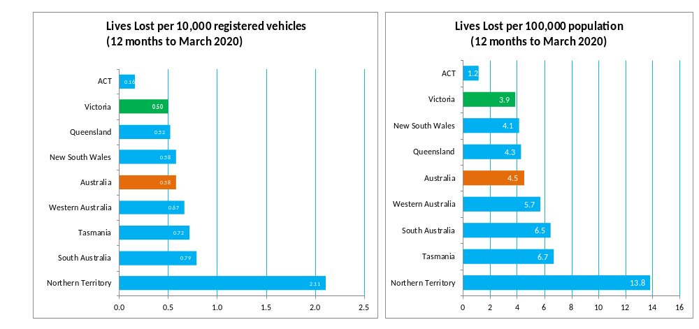

Booze Bus Random Breath Testing
Booze-bus Random Breath Tests (12 months to March 2020 vs previous 12 months)
 | 2020 | 2019 | 2018 | 2020 v 2019 |  | 2020 v 2018
Melbourne | 1,025,495 | 1,226,599 | 1,143,717 | -201,104 | (-16%) | -118,222 | (-10%)
Country | 183,858 | 115,731 | 142,698 | +68,127 | (+59%) | +41,160 | (+29%)
Vic Total | 1,209,353 | 1,342,330 | 1,286,415 | -132,977 | (-10%) | -77,062 | (-6%)

12 months to March 2020 (monthly totals)
 | 2019 |  |  |  |  |  |  |  |  | 2020
 | Apr | May | Jun | Jul | Aug | Sep | Oct | Nov | Dec | Jan | Feb | Mar
Melbourne | 79,988 | 84,478 | 101,799 | 98,380 | 102,592 | 96,574 | 89,177 | 88,460 | 82,298 | 62,544 | 103,896 | 35,309
Country | 19,119 | 14,068 | 10,318 | 5,826 | 11,098 | 12,571 | 17,551 | 25,867 | 16,566 | 15,206 | 23,588 | 12,080
Vic Total | 99,107 | 98,546 | 112,117 | 104,206 | 113,690 | 109,145 | 106,728 | 114,327 | 98,864 | 77,750 | 127,484 | 47,389

Random Drug Testing
Random Drug Tests (12 months to March 2020 vs previous 12 months)
 | 2020 | 2019 | 2018 | 2020 v 2019 |  | 2020 v 2018
Victoria | 161,283 | 122,730 | 102,551 | +38553 | (+31%) | +58732 | (+57%)
12 months to September 2019 (monthly totals)
 | 2019 |  |  |  |  |  |  |  |  | 2020
 | Apr | May | Jun | Jul | Aug | Sep | Oct | Nov | Dec | Jan | Feb | Mar
Victoria | 17,337 | 19,571 | 15,441 | 13,817 | 18,692 | 15,244 | 12,181 | 12,646 | 11,000 | 9,157 | 7,904 | 8,293

Mobile Safety Camera Data

Speed Infringements Issued from Mobile Cameras (monthly totals) |  |  |  |  |  |  |  |  | Monthly Average = |  | 30,329
2019 |  |  |  |  |  |  |  |  | 2020
Apr | May | Jun | Jul | Aug | Sep | Oct | Nov | Dec | Jan | Feb | Mar
31,098 | 33,847 | 27,636 | 32,116 | 31,545 | 26,050 | 31,401 | 24,187 | 26,143 | 29,313 | 28,757 | 41,849
Excessive Speed Infringements (ESI) Issued from Mobile Cameras (monthly totals) |  |  |  |  |  |  |  | Monthly Average = |  |  | 267
2019 |  |  |  |  |  |  |  |  | 2020
Apr | May | Jun | Jul | Aug | Sep | Oct | Nov | Dec | Jan | Feb | Mar
264 | 261 | 216 | 263 | 291 | 201 | 280 | 192 | 192 | 322 | 317 | 404
Notes: An ESI is defined as 25km/h over the speed limit except in a 110km/h zone where it is 20km/h over the limit.
Notes: 1. The definition of ESIs changed on 15 December 2002 to 25km/h over the speed limit from 30km/h over the speed limit except in a 110km/h zone where it has always been 20km/h over the limit.

Explanations and References
LGA: Local Government Areas. Crash locations for acute hospitalised claims are assigned to LGA’s based on the crash postcode recorded by Victoria Police. Crash locations for fatal crashes are coded exactly to an LGA by Victoria Police.
Claimants: Refers to people injured in transport accidents who have an accepted claim with the TAC.
Hospitalisation: refers to all hospital admission that occurred within 7 days of accident.

Useful Internet Sites
TAC Sites
- TAC Safety (Road Safety) www.tacsafety.com.au
- TAC How safe is your car www.howsafeisyourcar.com.au
- TAC How safe is your first car www.howsafeisyourfirstcar.com.au
- TAC Motorcycle Safety Website www.spokes.com.au
- TAC Corporate site www.tac.vic.gov.au
- Drivesmart www.drivesmart.vic.gov.au
- Ridesmart www.ridesmartonline.com.au
Victorian Sites:
- VicRoads www.vicroads.vic.gov.au
- Victoria Police www.police.vic.gov.au
- Parliamentary Road Safety Committee https://www.parliament.vic.gov.au/57th-parliament/rsc
- RACV www.racv.com.au
- Monash University Accident Research Centre www.monash.edu.au/muarc
- Cameras Save Lives www.camerassavelives.vic.gov.au
- VicRoads Learner Driver Site www.lsite.vicroads.vic.gov.au/Learners
- Road Safety Education Victoria www.roadsafetyeducation.vic.gov.au
National and Interstate Sites:
- ARRB Transport Research www.arrb.com.au
- Australian Transport Safety Bureau www.atsb.gov.au
- Motor Accidents Authority (NSW) www.maa.nsw.gov.au
- Motor Accidents Insurance Board (TAS) www.maib.tas.gov.au
- Motor Accident Commission, Allianz (SA) www.mac.sa.gov.au
- Motor Accidents Compensation, TIO, (NT) www.tiofi.com.au/mac
- Insurance Commission of Western Australia www.icwa.wa.gov.au
- Motor Accident Insurance Commission (QLD) www.maic.qld.gov.au
International Sites:
- National Highway Traffic Safety Admin (USA) www.nhtsa.dot.gov
- Swedish Road and Transport Institute (VTI) www.vti.se
- SWOV Institute for Road Safety Research www.swov.nl
Related Sites:
- Alcohol and Drug Foundation www.adf.org.au
Figures

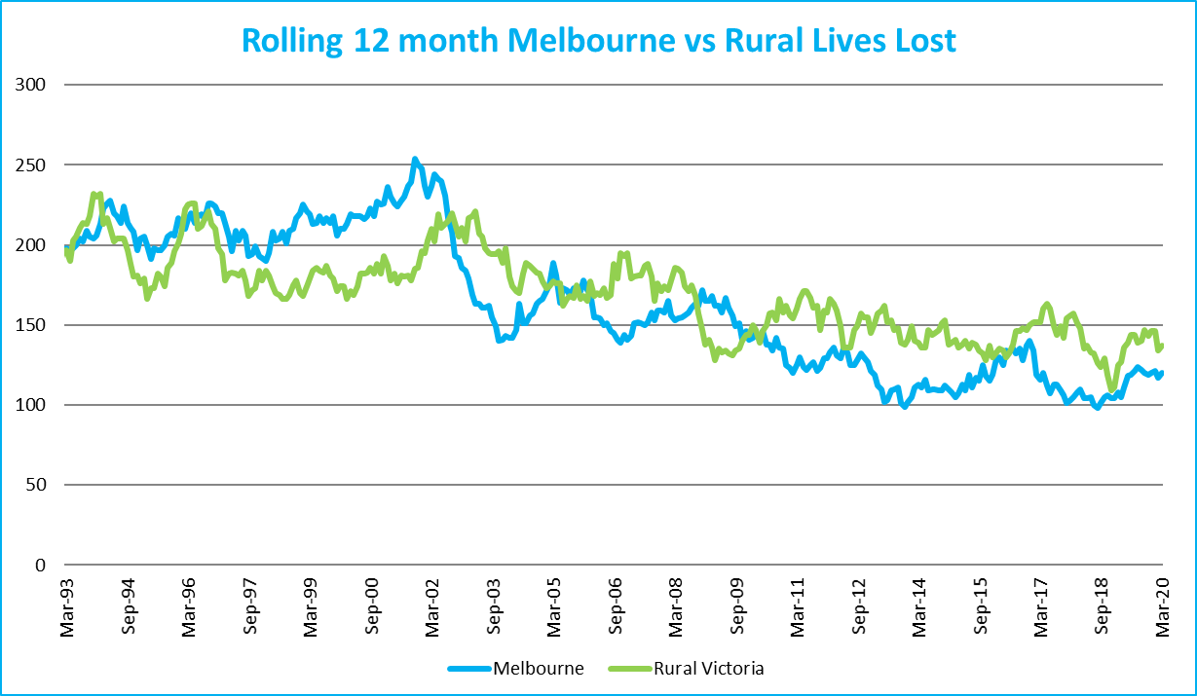
Graph 1a – Melbourne/Rural lives lost
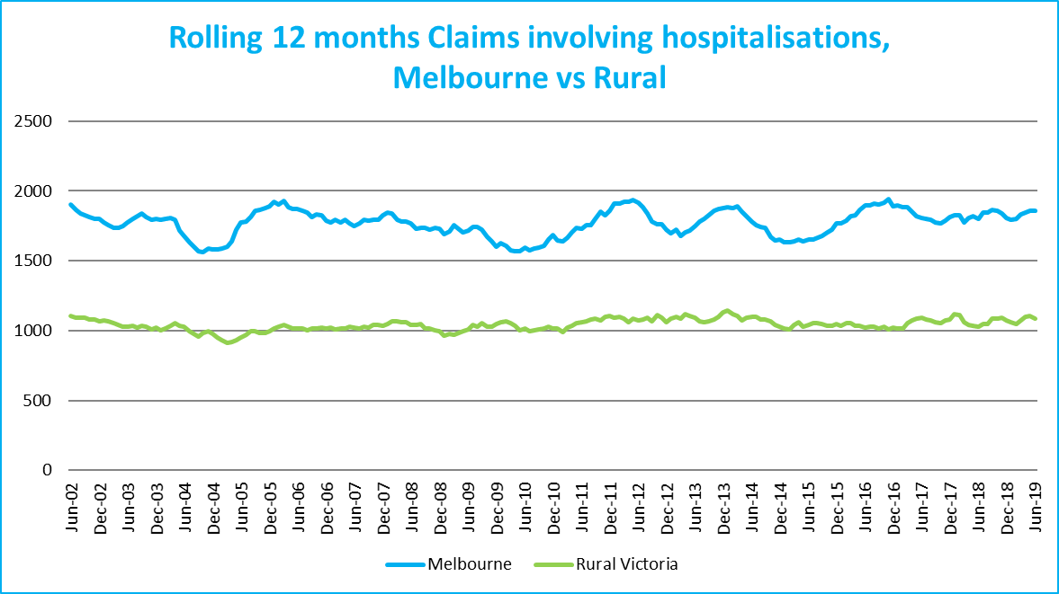
Graph 1b – Melbourne/Rural claims involving an acute hospital admission

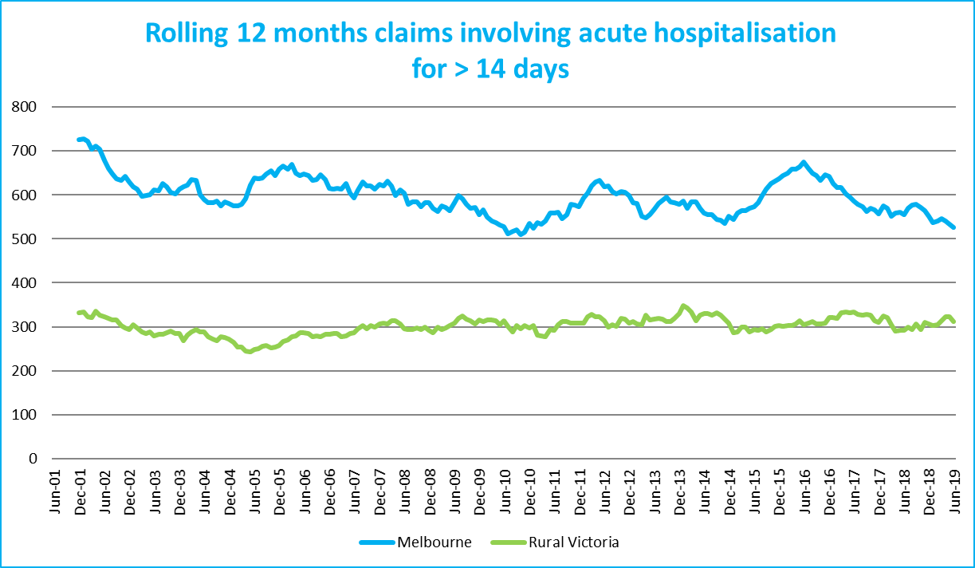
Graph 1c – Melbourne/Rural Claims involving hospital admission greater than 14 days

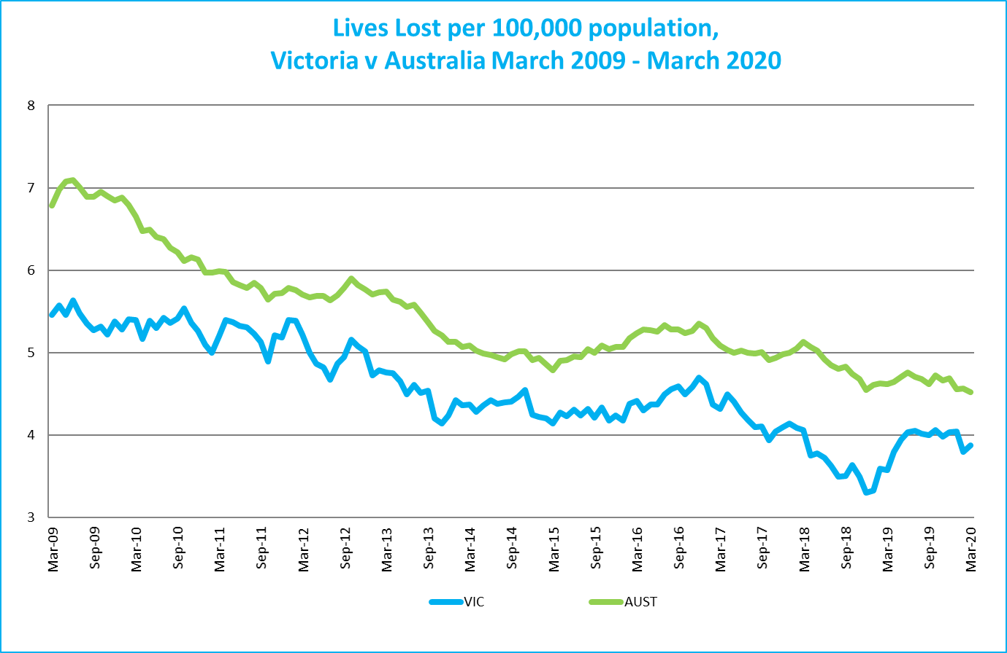
Graph 1d – Victoria/Australia lives lost per 100,000 population

Victorian monthly lives lost since 1951



