

Quarterly Statistics – June 2019


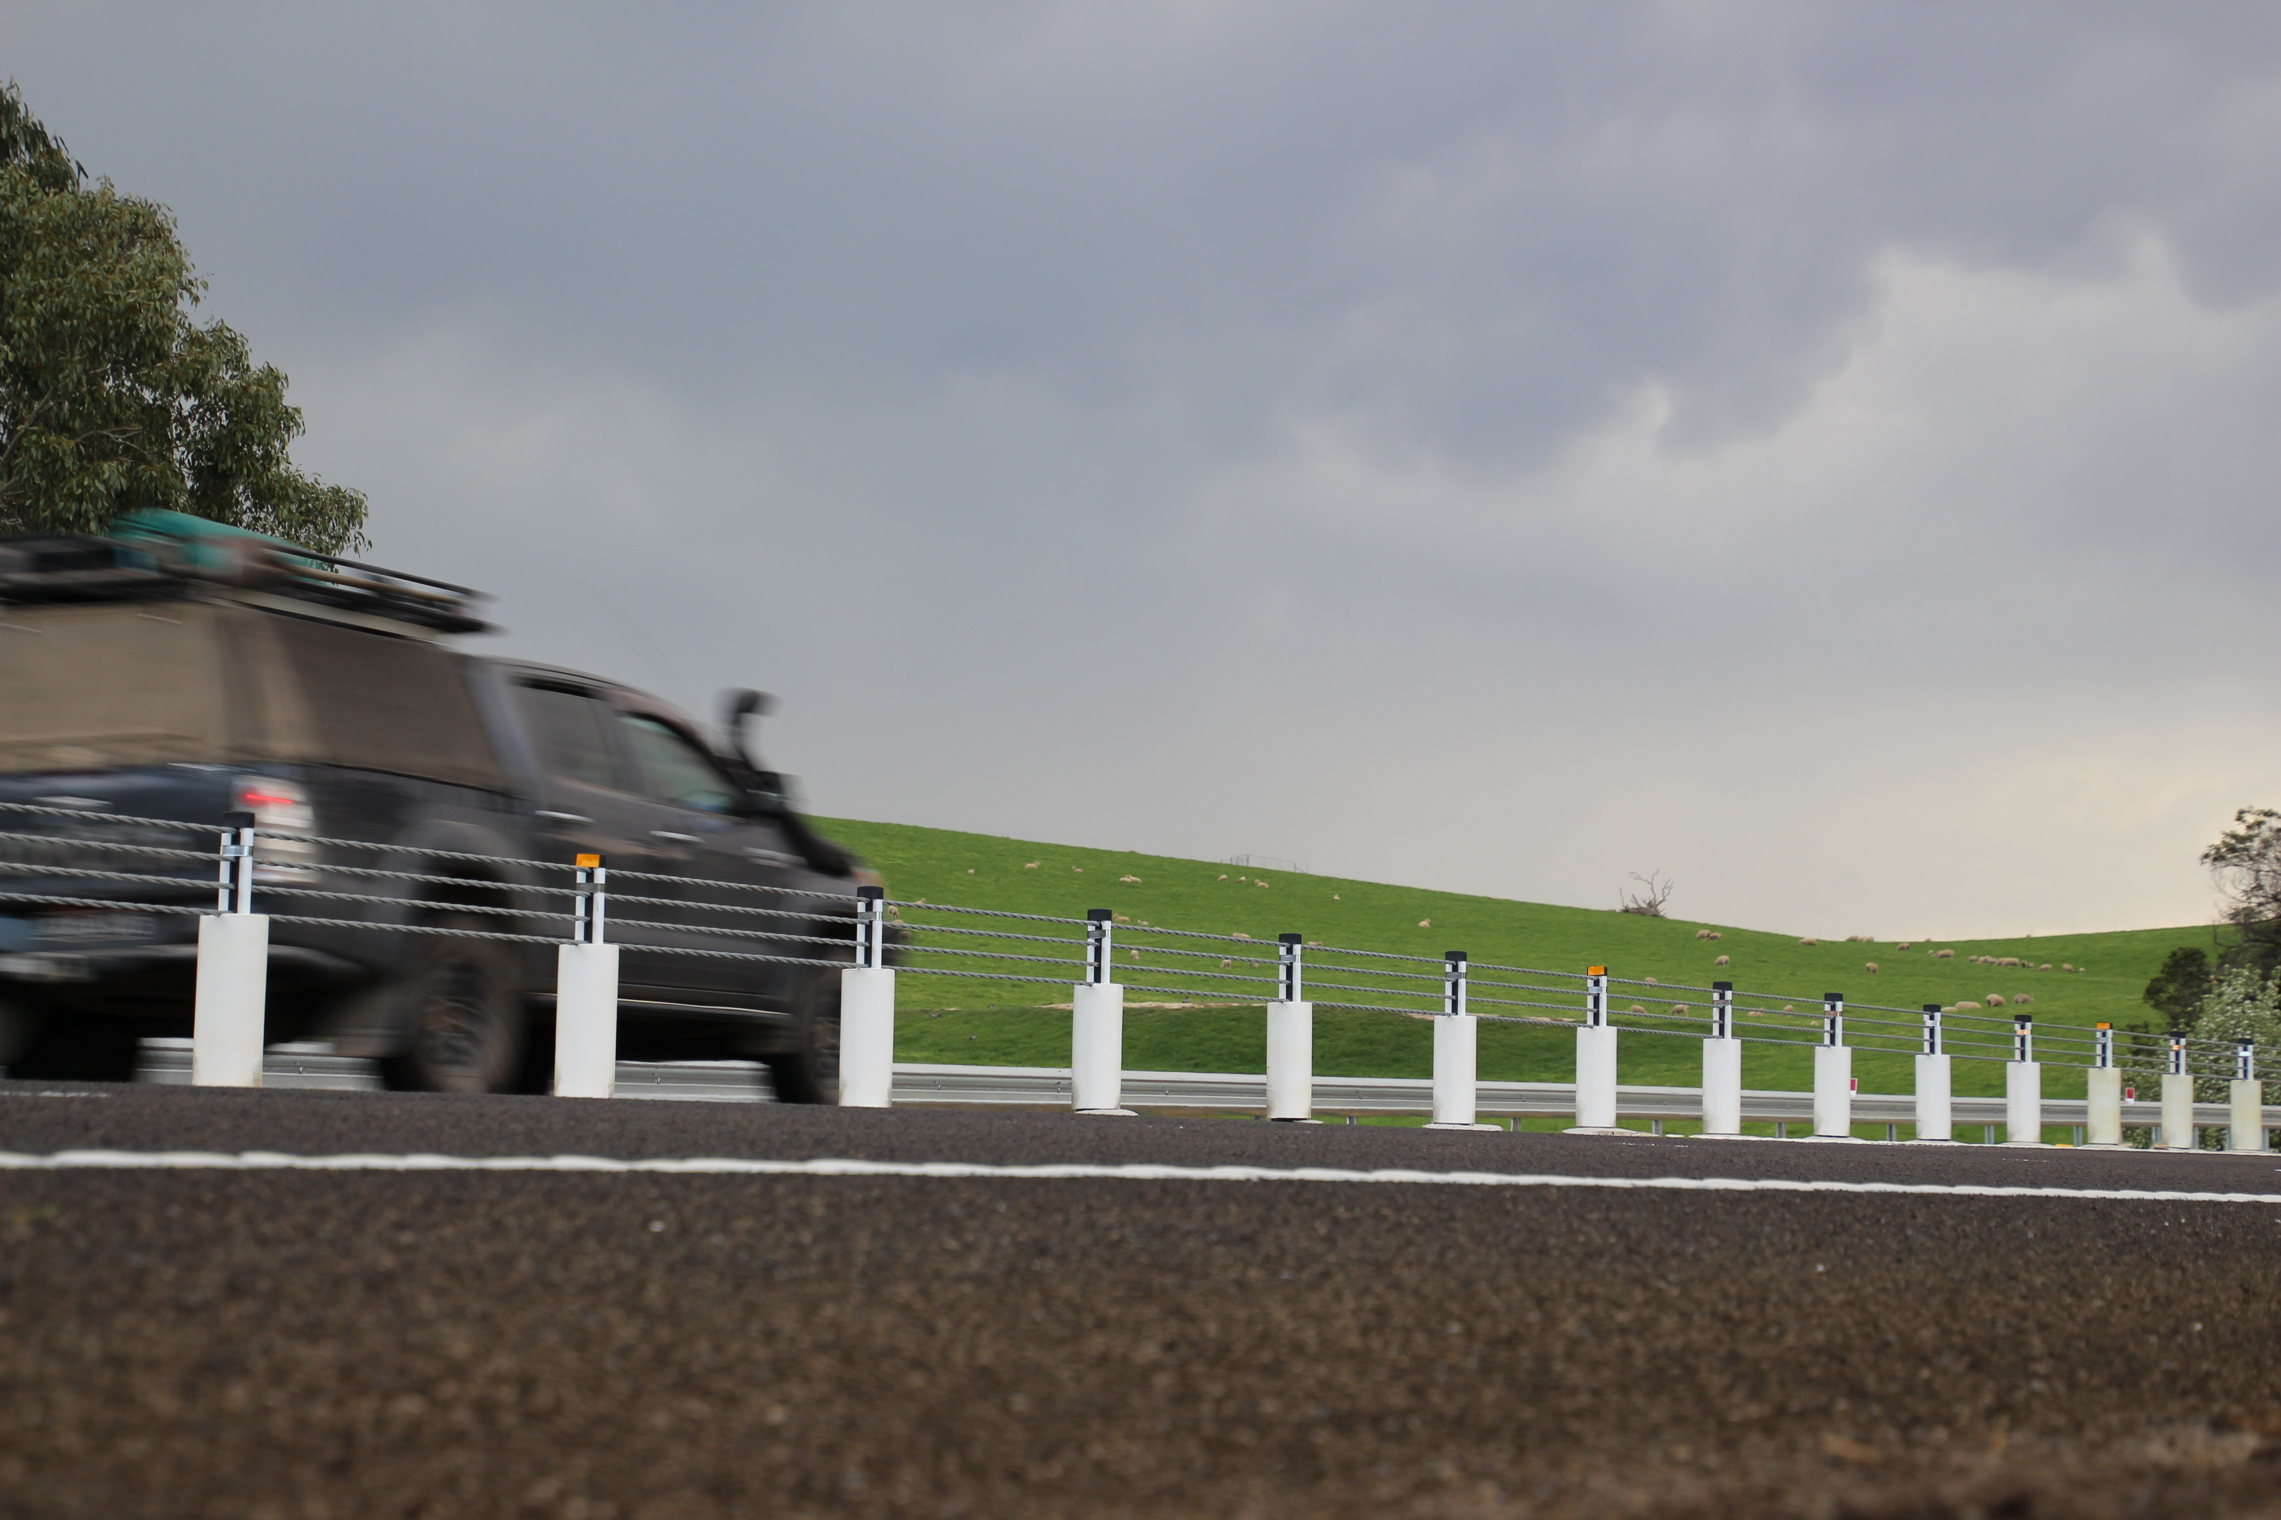

TRANSPORT  ACCIDENT  COMMISSION | 60 Brougham Street  Geelong Vic 3220  PO Box 742  Geelong Vic 3220  Ausdoc DX 216079 Geelong | Telephone 1300 654 329  STD Toll Free 1800 332 556  Fax: 03 9656 9300  www.tac.vic.gov.au  ABN 22 033 947 623

Contents

Status Report 4
Lives lost on Victorian roads 4
Injured claimants who were admitted to hospital within 7 days of accident, rolling 12 month to 31st December 2018 5
Lives lost: 12 months to 30th June 2019 6
Injured claimants who were admitted to hospital within 7 days of accident, 12 months to 31st December 2018 (claim acceptance date) 10
Lives Lost by Week (2014 to 2019) 12
The National Picture 13
Explanations and References 14
Useful Internet Sites 15
Victorian monthly lives lost since 1951 18

Notes about the data in this report
- All data provided in this report is the data most recently available at time of production. Fatality data are updated to the end of report month. A 6-month lag applies to TAC claims data.
- Reported data will have one extra day of exposure for leap years.
- Data is subject to revision as additional information about known accidents/claims is received, and as new accident/claim reports are received and processed.

Status Report

Lives lost on Victorian roads

- The rolling 12 month number of lives lost to 30th June 2019 is 268. The rolling 12 month number of lives lost to 30th June 2018 stood at 238 (an increase 30).
- 155 people lost their lives year to date to the end of June 2019 on Victorian roads. This compares to 100 lives lost year to date to the end of June 2018 (an increase of 55).

Category | 2019 | 2018 | 2017 | 2019 v 2018 | 2019 v 2017 | 5 Year  Average
Lives Lost (Rolling 12 Month Total)
Lives Lost (to June) | 268 | 238 | 267 | +30 | +1 | 258
per 10,000 veh | 0.53 | 0.49 | 0.56 | +0.04 | -0.03 | 0.54
per 100,000 pop | 4.10 | 3.72 | 4.24 | +0.38 | -0.14 | 4.14
Crashes (Rolling 12 Month Total)
Fatal crashes (to June) | 253 | 219 | 257 | +34 | -4 | 242
per 10,000 veh | 0.50 | 0.45 | 0.54 | +0.05 | -0.04 | 0.50
per 100,000 pop | 3.88 | 3.43 | 4.08 | +0.45 | -0.20 | 3.78

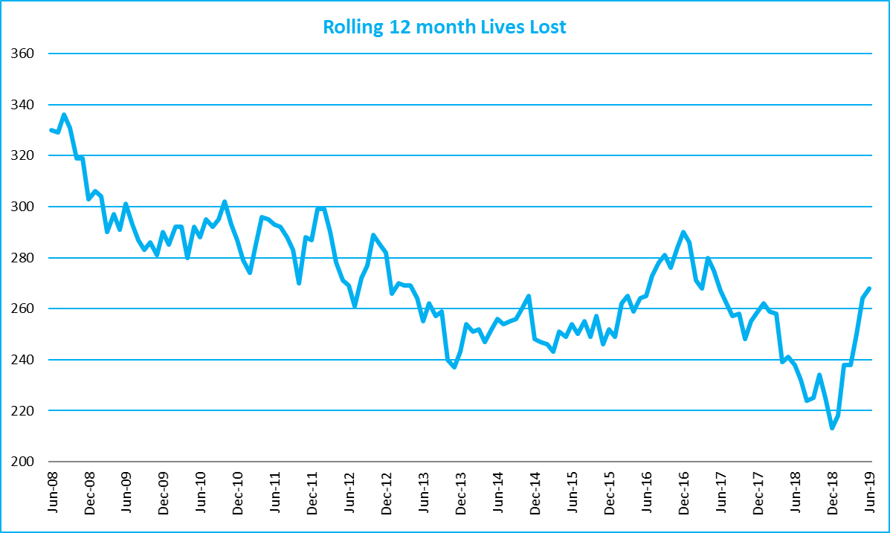

Victoria – Lives Lost, rolling 12 months total

Injured claimants who were admitted to hospital within 7 days of accident, rolling 12 month to 31st December 2018
Category | 2018 | 2017 | 2016 | 2018 v 2017 |  | 2018 v 2016 |  | 5 Year Average
Claims involving hospitalisation over 14 days (Rolling 12 Month Total)
Claims (to December) | 910 | 929 | 1,019 | -19.0 | (-2%) | -110 | (-11%) | 941
per 100,000 pop | 14.1 | 14.7 | 16.5 | -0.6 | (-4%) | -2.4 | (-15%) | 15.5
per 10,000 veh | 1.8 | 1.9 | 2.2 | -0.1 | (-5%) | -0.4 | (-18%) | 2.0
All claims involving hospitalisation (Rolling 12 Month Total)
Claims (to December) | 7,953 | 7,768 | 7,176 | +175 | (+2%) | +766 | (+11%) | 7,031
per 100,000 pop | 123.1 | 122.9 | 116.1 | +0.1 | (+0%) | +6.9 | (+6%) | 112.2
per 10,000 veh | 16.0 | 16.0 | 15.2 | 0.0 | (+0%) | +0.8 | (+5%) | 14.6

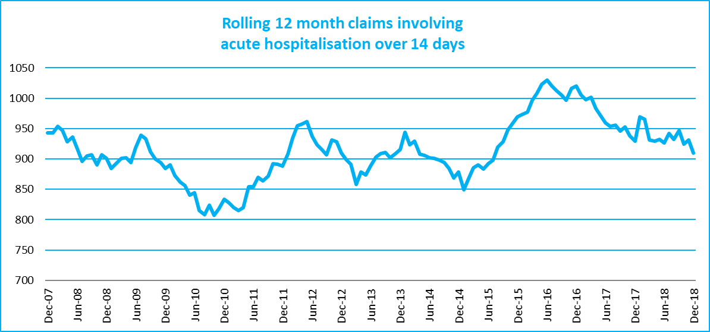
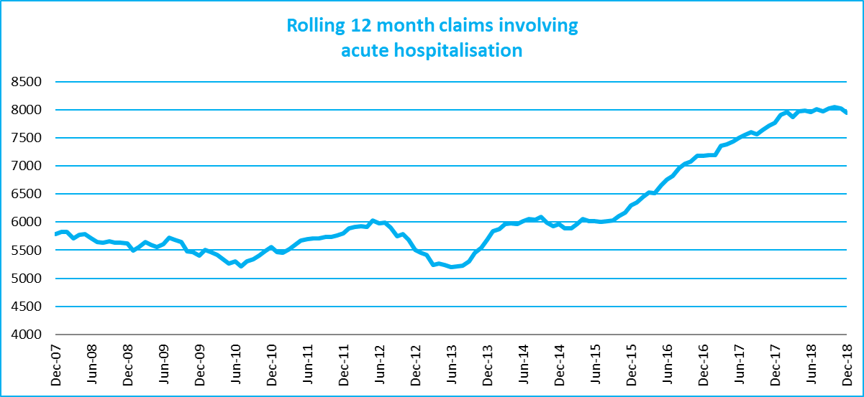

Lives lost: 12 months to 30th June 2019

Category | 2019 | 2018 | 2017 | 2019 v 2018 | 2019 v 2017 | 5 Year Average
Overview
Lives Lost | 268 | 238 | 267 | +30 | +1 | 258
Fatal Crashes | 253 | 219 | 257 | +34 | -4 | 241
Sex
Female | 69 | 67 | 72 | +2 | -3 | 71
Male | 198 | 171 | 195 | +27 | +3 | 187
Road user
Bicyclist | 11 | 8 | 9 | +3 | +2 | 10
Driver | 117 | 115 | 146 | +2 | -29 | 126
Motorcyclist | 49 | 37 | 41 | +12 | +8 | 41
Passenger | 44 | 44 | 35 |  | +9 | 44
Pedestrian | 46 | 34 | 36 | +12 | +10 | 37
Location
Melbourne | 117 | 104 | 107 | +13 | +10 | 116
Rural Victoria | 150 | 133 | 160 | +17 | -10 | 142
Age group
0-4 | 2 | 0 | 4 | +2 | -2 | 2
5-15 | 10 | 4 | 3 | +6 | +7 | 5
16-17 | 4 | 4 | 3 |  | +1 | 7
18-20 | 19 | 16 | 15 | +3 | +4 | 19
21-25 | 20 | 24 | 26 | -4 | -6 | 23
26-29 | 24 | 10 | 22 | +14 | +2 | 20
30-39 | 37 | 38 | 40 | -1 | -3 | 36
40-49 | 30 | 35 | 41 | -5 | -11 | 37
50-59 | 31 | 34 | 31 | -3 | 0 | 31
60-69 | 30 | 29 | 26 | +1 | +4 | 28
70+ | 59 | 44 | 55 | +15 | +4 | 50
Accident Type
Intersection
Adjacent direction | 32 | 31 | 35 | +1 | -3 | 32
Opposing direction | 10 | 10 | 7 | 0 | +3 | 9
Mid-block/other
Head on | 41 | 39 | 42 | +2 | -1 | 42
Same direction | 18 | 19 | 19 | -1 | -1 | 18
Manoeuvre/o'taking | 15 | 13 | 9 | +2 | +6 | 14
On path | 1 | 7 | 7 | -6 | -6 | 5
Single vehicle | 99 | 80 | 107 | +19 | -8 | 98
Other (incl peds) | 49 | 37 | 41 | +12 | +8 | 40

Lives Lost: 12 months to 30th June 2019 – Continued

Category | 2019 | 2018 | 2017 | 5 Year Average | Category | 2019 | 2018 | 2017 | 5 Year Average
Local Government Area |  |  |  |  | Local Government Area
ALPINE | 3 | 2 | 0 | 1 | MANSFIELD | 2 | 3 | 3 | 2
ARARAT | 3 | 1 | 1 | 2 | MARIBYRNONG | 3 | 4 | 3 | 2
BALLARAT | 2 | 4 | 3 | 4 | MAROONDAH | 5 | 2 | 2 | 1
BANYULE | 2 | 2 | 3 | 2 | MELBOURNE | 2 | 3 | 4 | 4
BASS COAST | 3 | 2 | 2 | 2 | MELTON | 7 | 3 | 4 | 4
BAW BAW | 3 | 1 | 5 | 3 | MILDURA | 8 | 0 | 2 | 2
BAYSIDE | 1 | 3 | 4 | 3 | MITCHELL | 1 | 5 | 2 | 4
BENALLA | 2 | 2 | 4 | 2 | MOIRA | 2 | 7 | 5 | 5
BOROONDARA | 4 | 3 | 3 | 2 | MONASH | 7 | 8 | 6 | 4
BRIMBANK | 5 | 4 | 10 | 6 | MOONEE VALLEY | 2 | 3 | 2 | 2
BULOKE | 4 | 0 | 3 | 1 | MOORABOOL | 5 | 3 | 8 | 3
CAMPASPE | 4 | 5 | 4 | 4 | MORELAND | 4 | 2 | 4 | 3
CARDINIA | 4 | 6 | 7 | 7 | MORNINGTON PENINSULA | 9 | 3 | 5 | 7
CASEY | 4 | 5 | 10 | 6 | MOUNT ALEXANDER | 1 | 4 | 0 | 2
CENTRAL GOLDFIELDS | 2 | 0 | 2 | 1 | MOYNE | 2 | 2 | 2 | 2
COLAC-OTWAY | 0 | 8 | 2 | 4 | MURRINDINDI | 5 | 3 | 6 | 5
CORANGAMITE | 5 | 3 | 1 | 3 | NILLUMBIK | 2 | 2 | 1 | 2
DAREBIN | 1 | 4 | 1 | 2 | NORTHERN GRAMPIANS | 0 | 8 | 3 | 3
EAST GIPPSLAND | 9 | 7 | 3 | 6 | PORT PHILLIP | 0 | 0 | 2 | 1
FRANKSTON | 3 | 5 | 2 | 3 | PYRENEES | 3 | 4 | 3 | 1
GANNAWARRA | 3 | 4 | 0 | 1 | QUEENSCLIFFE | 0 | 0 | 0 | 0
GLEN EIRA | 1 | 1 | 3 | 1 | SOUTH GIPPSLAND | 7 | 4 | 3 | 4
GLENELG | 4 | 3 | 4 | 4 | SOUTHERN GRAMPIANS | 2 | 1 | 3 | 2
GOLDEN PLAINS | 7 | 1 | 6 | 3 | STONNINGTON | 4 | 2 | 0 | 2
GREATER BENDIGO | 5 | 7 | 6 | 5 | STRATHBOGIE | 2 | 2 | 2 | 3
GREATER DANDENONG | 4 | 5 | 3 | 4 | SURF COAST | 1 | 3 | 2 | 3
GREATER GEELONG | 9 | 6 | 14 | 6 | SWAN HILL | 2 | 1 | 4 | 2
GREATER SHEPPARTON | 7 | 5 | 11 | 6 | TOWONG | 2 | 1 | 1 | 1
HEPBURN | 3 | 3 | 5 | 2 | WANGARATTA | 1 | 1 | 6 | 3
HINDMARSH | 0 | 0 | 0 | 1 | WARRNAMBOOL | 2 | 0 | 0 | 0
HORSHAM | 2 | 1 | 4 | 2 | WEST WIMMERA | 2 | 0 | 1 | 0
HUME | 7 | 4 | 1 | 4 | WHITEHORSE | 1 | 2 | 3 | 3
INDIGO | 3 | 2 | 3 | 3 | WHITTLESEA | 3 | 5 | 1 | 4
KINGSTON | 7 | 4 | 3 | 3 | WODONGA | 0 | 1 | 3 | 2
KNOX | 5 | 3 | 4 | 4 | WYNDHAM | 6 | 4 | 7 | 5
LATROBE | 4 | 3 | 4 | 4 | YARRA | 1 | 2 | 1 | 1
LODDON | 4 | 1 | 1 | 1 | YARRA RANGES | 10 | 7 | 5 | 7
MACEDON RANGES | 7 | 3 | 3 | 4 | YARRIAMBIACK | 0 | 1 | 1 | 1
MANNINGHAM | 2 | 3 | 3 | 2

Injured claimants who were admitted to hospital within 7 days of the accident with a hospital stay of more than 14 days, 12 months to 31st December 2018 (claim acceptance date)

Category | 2018 | 2017 | 2016 | 2018 v 2017 |  | 2018 v 2016 |  | 5 Year Average
Overview
Claims | 910 | 929 | 1,019 | -19 | -2% | -110 | -11% | 941
Sex
Female | 386 | 353 | 423 | +33 | 9% | -38 | -9% | 387
Male | 524 | 576 | 596 | -52 | -9% | -72 | -12% | 554
Road user
Bicyclist | 29 | 41 | 31 | -12 | -29% | -2 | -6% | 37
Driver | 347 | 313 | 398 | +34 | 11% | -51 | -13% | 355
Motorcyclist | 180 | 195 | 186 | -15 | -8% | -6 | -3% | 179
Passenger | 141 | 132 | 151 | +9 | 7% | -10 | -7% | 141
Pedestrian | 175 | 208 | 224 | -33 | -16% | -50 | -22% | 196
Train/Tram | 9 | 14 | 7 | -5 | -36% | +2 | 29% | 10
Location
Melbourne | 537 | 556 | 643 | -19 | -3% | -107 | -17% | 586
Rural Victoria | 300 | 311 | 322 | -11 | -4% | -22 | -7% | 309
Age group
0-4 | 1 | 5 | 4 | -4 | -80% | -3 | -75% | 3
5-15 | 4 | 6 | 12 | -2 | -33% | -8 | -67% | 12
16-17 | 12 | 13 | 13 | -1 | -8% | -1 | -8% | 13
18-20 | 30 | 47 | 74 | -17 | -36% | -44 | -59% | 49
21-25 | 88 | 90 | 82 | -2 | -2% | 6 | 7% | 86
26-29 | 51 | 60 | 57 | -9 | -15% | -6 | -11% | 54
30-39 | 96 | 124 | 135 | -28 | -23% | -39 | -29% | 117
40-49 | 121 | 102 | 120 | +19 | 19% | 1 | 1% | 114
50-59 | 126 | 120 | 108 | +6 | 5% | 18 | 17% | 117
60-69 | 97 | 126 | 130 | -29 | -23% | -33 | -25% | 111
70+ | 284 | 236 | 284 | +48 | 20% | -1 | 0% | 265
Accident Type
Intersection
Adjacent direction | 85 | 93 | 107 | -8 | -9% | -22 | -21% | 97
Opposing direction | 50 | 53 | 63 | -3 | -6% | -13 | -21% | 58
Mid-block/other
Head on | 43 | 66 | 97 | -23 | -35% | -54 | -56% | 77
Same direction | 67 | 57 | 77 | +10 | 18% | -10 | -13% | 72
Manoeuvre/overtaking | 41 | 48 | 59 | -7 | -15% | -18 | -31% | 51
On path | 21 | 21 | 32 |  | 0% | -11 | -34% | 26
Single vehicle | 208 | 233 | 274 | -25 | -11% | -66 | -24% | 256
Other (incl pedestrians) | 395 | 358 | 311 | +37 | 10% | 84 | 27% | 304
Note: excludes rejected claims and claims for interstate crashes.

Injured claimants who were admitted to hospital within 7 days of the accident with a hospital stay of more than 14 days, 12 months to 31th December 2018 (claim acceptance date) – Continued
Category | 2018 | 2017 | 2016 | 5 Year Average | Category | 2018 | 2017 | 2016 | 5 Year Average
Local Government Area |  |  |  |  | Local Government Area
ALPINE | 3 | 4 | 3 | 3 | MANSFIELD | 9 | 5 | 9 | 4
ARARAT | 1 | 2 | 3 | 4 | MARIBYRNONG | 8 | 22 | 10 | 10
BALLARAT | 17 | 17 | 12 | 13 | MAROONDAH | 5 | 9 | 8 | 5
BANYULE | 11 | 10 | 9 | 8 | MELBOURNE | 27 | 44 | 39 | 29
BASS COAST | 11 | 4 | 5 | 6 | MELTON | 9 | 9 | 11 | 10
BAW BAW | 10 | 10 | 5 | 7 | MILDURA | 6 | 12 | 4 | 5
BAYSIDE | 8 | 11 | 11 | 8 | MITCHELL | 8 | 7 | 11 | 7
BENALLA | 4 | 6 | 2 | 4 | MOIRA | 9 | 13 | 9 | 7
BOROONDARA | 12 | 16 | 12 | 15 | MONASH | 19 | 22 | 23 | 18
BRIMBANK | 17 | 20 | 32 | 23 | MOONEE VALLEY | 18 | 14 | 19 | 15
BULOKE | 4 | 0 | 3 | 2 | MOORABOOL | 5 | 7 | 11 | 8
CAMPASPE | 4 | 11 | 9 | 7 | MORELAND | 30 | 21 | 35 | 22
CARDINIA | 15 | 20 | 14 | 13 | MORNINGTON PENINSULA | 20 | 19 | 30 | 21
CASEY | 28 | 29 | 39 | 25 | MOUNT ALEXANDER | 4 | 0 | 1 | 3
CENTRAL GOLDFIELDS | 3 | 2 | 2 | 2 | MOYNE | 3 | 9 | 4 | 3
COLAC-OTWAY | 7 | 11 | 7 | 7 | MURRINDINDI | 8 | 20 | 7 | 11
CORANGAMITE | 8 | 6 | 8 | 4 | NILLUMBIK | 4 | 5 | 7 | 6
DAREBIN | 18 | 14 | 31 | 16 | NORTHERN GRAMPIANS | 4 | 6 | 3 | 3
EAST GIPPSLAND | 11 | 13 | 7 | 8 | PORT PHILLIP | 11 | 10 | 21 | 14
FRANKSTON | 13 | 16 | 19 | 13 | PYRENEES | 2 | 0 | 3 | 2
GANNAWARRA | 2 | 4 | 2 | 2 | QUEENSCLIFFE | 0 | 1 | 1 | 0
GLEN EIRA | 16 | 12 | 15 | 11 | SOUTH GIPPSLAND | 7 | 5 | 14 | 7
GLENELG | 4 | 1 | 7 | 4 | SOUTHERN GRAMPIANS | 3 | 2 | 3 | 2
GOLDEN PLAINS | 3 | 5 | 10 | 5 | STONNINGTON | 12 | 14 | 10 | 12
GREATER BENDIGO | 21 | 21 | 12 | 12 | STRATHBOGIE | 4 | 2 | 9 | 5
GREATER DANDENONG | 29 | 24 | 27 | 19 | SURF COAST | 6 | 4 | 7 | 4
GREATER GEELONG | 28 | 35 | 17 | 21 | SWAN HILL | 3 | 4 | 7 | 4
GREATER SHEPPARTON | 15 | 17 | 20 | 12 | TOWONG | 0 | 4 | 4 | 2
HEPBURN | 5 | 2 | 2 | 2 | WANGARATTA | 5 | 5 | 8 | 4
HINDMARSH | 0 | 2 | 3 | 1 | WARRNAMBOOL | 1 | 4 | 3 | 3
HOBSONS BAY | 8 | 9 | 6 | 7 | WELLINGTON | 10 | 7 | 14 | 8
HORSHAM | 4 | 2 | 4 | 3 | WEST WIMMERA | 1 | 1 | 1 | 1
HUME | 29 | 21 | 39 | 23 | WHITEHORSE | 20 | 21 | 26 | 16
INDIGO | 5 | 3 | 9 | 4 | WHITTLESEA | 28 | 21 | 33 | 20
KINGSTON | 21 | 16 | 12 | 15 | WODONGA | 3 | 3 | 4 | 4
KNOX | 22 | 21 | 17 | 14 | WYNDHAM | 23 | 23 | 26 | 20
LATROBE | 16 | 4 | 10 | 8 | YARRA | 10 | 12 | 18 | 11
LODDON | 1 | 0 | 2 | 1 | YARRA RANGES | 32 | 29 | 28 | 26
MACEDON RANGES | 11 | 6 | 20 | 10 | YARRIAMBIACK | 1 | 2 | 1 | 1
MANNINGHAM | 14 | 22 | 17 | 12

Note: excludes rejected claims and claims for interstate crashes

Injured claimants who were admitted to hospital within 7 days of accident, 12 months to 31st December 2018 (claim acceptance date)

Category | 2018 | 2017 | 2016 | 2018 v 2017 |  | 2018 v 2016 |  | 5 Year Average
Overview
Claims | 7,953 | 7,768 | 7,176 | +185 | 2% | +777 | 11% | 7,031
Sex
Female | 3,440 | 3,338 | 3,170 | +102 | 3% | +270 | 9% | 3,044
Male | 4,505 | 4,424 | 3,994 | +81 | 2% | +511 | 13% | 3,978
Road user
Bicyclist | 514 | 510 | 423 | +4 | 1% | +91 | 22% | 445
Driver | 3,862 | 3,626 | 3,438 | +236 | 7% | +424 | 12% | 3,299
Motorcyclist | 1,364 | 1,330 | 1,174 | +34 | 3% | +190 | 16% | 1,217
Passenger | 1,103 | 1,141 | 1,103 | -38 | -3% |  | 0% | 1,088
Pedestrian | 765 | 787 | 750 | -22 | -3% | +15 | 2% | 713
Train/Tram | 46 | 56 | 36 | -10 | -18% | +10 | 28% | 40
Location
Melbourne | 4,663 | 4,589 | 4,734 | +74 | 2% | -71 | -1% | 4,450
Rural Victoria | 2,269 | 2,251 | 2,035 | +18 | 1% | +234 | 11% | 2,026
Age group
0-4 | 58 | 62 | 60 | -4 | -6% | -2 | -3% | 54
5-15 | 189 | 213 | 222 | -24 | -11% | -33 | -15% | 211
16-17 | 136 | 121 | 122 | +15 | 12% | +14 | 11% | 120
18-20 | 587 | 566 | 567 | +21 | 4% | +20 | 4% | 533
21-25 | 1,019 | 1,000 | 886 | +19 | 2% | +133 | 15% | 882
26-29 | 652 | 652 | 625 |  | 0% | +27 | 4% | 587
30-39 | 1,267 | 1,237 | 1,121 | +30 | 2% | +146 | 13% | 1,108
40-49 | 1,151 | 1,133 | 1,036 | +18 | 2% | +115 | 11% | 1,023
50-59 | 1,054 | 1,084 | 880 | -30 | -3% | +174 | 20% | 918
60-69 | 780 | 722 | 733 | +58 | 8% | +47 | 6% | 671
70+ | 1,060 | 978 | 924 | +82 | 8% | +136 | 15% | 923
Accident Type
Intersection
Adjacent direction | 806 | 909 | 905 | -103 | -11% | -99 | -11% | 836
Opposing direction | 440 | 568 | 560 | -128 | -23% | -120 | -21% | 523
Mid-block/other
Head on | 259 | 347 | 360 | -88 | -25% | -101 | -28% | 321
Same direction | 905 | 920 | 1,087 | -15 | -2% | -182 | -17% | 950
Manoeuvre/o'taking | 321 | 373 | 388 | -52 | -14% | -67 | -17% | 358
On path | 212 | 236 | 320 | -24 | -10% | -108 | -34% | 268
Single vehicle | 1,259 | 1,568 | 1,758 | -309 | -20% | -499 | -28% | 1,610
Other (incl peds) | 3,751 | 2,847 | 1,798 | +904 | 32% | +1953 | 109% | 2,165

Note: excludes rejected claims and claims for interstate crashes
Injured claimants who were admitted to hospital within 7 days of accident, 12 months to
31st December 2018 (claim acceptance date) – Continued

Category | 2018 | 2017 | 2016 | 5 Year Average | Category | 2018 | 2017 | 2016 | 5 Year Average
Local Government Area |  |  |  |  | Local Government Area
ALPINE | 29 | 28 | 19 | 20 | MANSFIELD | 43 | 29 | 40 | 26
ARARAT | 12 | 11 | 22 | 15 | MARIBYRNONG | 97 | 92 | 88 | 63
BALLARAT | 87 | 88 | 105 | 71 | MAROONDAH | 69 | 49 | 70 | 46
BANYULE | 69 | 67 | 62 | 48 | MELBOURNE | 300 | 345 | 335 | 236
BASS COAST | 57 | 35 | 41 | 35 | MELTON | 74 | 71 | 87 | 65
BAW BAW | 50 | 60 | 44 | 44 | MILDURA | 26 | 28 | 28 | 24
BAYSIDE | 78 | 89 | 90 | 68 | MITCHELL | 67 | 71 | 77 | 54
BENALLA | 21 | 23 | 17 | 17 | MOIRA | 34 | 43 | 43 | 30
BOROONDARA | 152 | 133 | 125 | 107 | MONASH | 192 | 195 | 203 | 160
BRIMBANK | 168 | 169 | 133 | 117 | MOONEE VALLEY | 143 | 126 | 140 | 104
BULOKE | 9 | 7 | 11 | 8 | MOORABOOL | 58 | 45 | 54 | 38
CAMPASPE | 42 | 58 | 48 | 37 | MORELAND | 205 | 180 | 180 | 131
CARDINIA | 123 | 128 | 149 | 102 | MORNINGTON PENINSULA | 183 | 149 | 192 | 132
CASEY | 329 | 330 | 359 | 250 | MOUNT ALEXANDER | 29 | 20 | 15 | 19
CENTRAL GOLDFIELDS | 15 | 20 | 14 | 11 | MOYNE | 32 | 39 | 24 | 19
COLAC-OTWAY | 67 | 77 | 43 | 39 | MURRINDINDI | 54 | 75 | 61 | 49
CORANGAMITE | 32 | 39 | 41 | 25 | NILLUMBIK | 36 | 37 | 47 | 32
DAREBIN | 101 | 105 | 122 | 83 | NORTHERN GRAMPIANS | 23 | 34 | 11 | 17
EAST GIPPSLAND | 66 | 64 | 61 | 48 | PORT PHILLIP | 159 | 150 | 141 | 118
FRANKSTON | 145 | 136 | 149 | 108 | PYRENEES | 11 | 9 | 15 | 9
GANNAWARRA | 10 | 13 | 8 | 10 | QUEENSCLIFFE | 6 | 6 | 1 | 2
GLEN EIRA | 139 | 120 | 127 | 94 | SOUTH GIPPSLAND | 30 | 47 | 55 | 34
GLENELG | 33 | 14 | 24 | 15 | SOUTHERN GRAMPIANS | 12 | 18 | 24 | 19
GOLDEN PLAINS | 44 | 53 | 49 | 33 | STONNINGTON | 141 | 133 | 140 | 115
GREATER BENDIGO | 122 | 142 | 94 | 88 | STRATHBOGIE | 33 | 33 | 39 | 30
GREATER DANDENONG | 265 | 252 | 277 | 208 | SURF COAST | 67 | 72 | 49 | 41
GREATER GEELONG | 466 | 421 | 252 | 223 | SWAN HILL | 17 | 16 | 25 | 15
GREATER SHEPPARTON | 90 | 108 | 114 | 76 | TOWONG | 22 | 16 | 19 | 13
HEPBURN | 35 | 21 | 34 | 21 | WANGARATTA | 40 | 26 | 43 | 27
HINDMARSH | 8 | 12 | 10 | 8 | WARRNAMBOOL | 28 | 34 | 33 | 20
HOBSONS BAY | 85 | 74 | 73 | 56 | WELLINGTON | 77 | 62 | 72 | 57
HORSHAM | 35 | 21 | 14 | 17 | WEST WIMMERA | 7 | 3 | 8 | 4
HUME | 247 | 254 | 245 | 177 | WHITEHORSE | 140 | 163 | 149 | 103
INDIGO | 28 | 23 | 31 | 18 | WHITTLESEA | 243 | 216 | 242 | 148
KINGSTON | 135 | 118 | 144 | 111 | WODONGA | 20 | 25 | 28 | 21
KNOX | 143 | 141 | 133 | 103 | WYNDHAM | 164 | 170 | 148 | 130
LATROBE | 79 | 60 | 72 | 48 | YARRA | 104 | 96 | 138 | 93
LODDON | 11 | 9 | 10 | 10 | YARRA RANGES | 154 | 197 | 152 | 142
MACEDON RANGES | 75 | 83 | 90 | 59 | YARRIAMBIACK | 10 | 9 | 3 | 5
MANNINGHAM | 80 | 104 | 94 | 68

Note: excludes rejected claims and claims for interstate crashes

Lives Lost by Week (2014 to 2019)
Week |  |  |  |  |  |  | Cumulative | 12 Month
Ending | 2014 | 2015 | 2016 | 2017 | 2018 | 2019 | 2019 | Moving Total
6-Jan | 0 | 3 | 2 | 2 | 6 | 1 | 1 | 208
13-Jan | 7 | 7 | 4 | 5 | 4 | 7 | 8 | 211
20-Jan | 5 | 5 | 3 | 4 | 3 | 2 | 10 | 210
27-Jan | 9 | 2 | 9 | 5 | 2 | 9 | 19 | 217
3-Feb | 6 | 10 | 5 | 3 | 6 | 6 | 25 | 217
10-Feb | 6 | 4 | 11 | 3 | 2 | 9 | 34 | 224
17-Feb | 7 | 7 | 6 | 5 | 6 | 11 | 45 | 229
24-Feb | 1 | 3 | 8 | 5 | 5 | 6 | 51 | 230
3-Mar | 6 | 4 | 7 | 4 | 4 | 7 | 58 | 233
10-Mar | 10 | 8 | 11 | 3 | 7 | 2 | 60 | 228
17-Mar | 2 | 7 | 7 | 6 | 4 | 7 | 67 | 231
24-Mar | 4 | 1 | 4 | 7 | 4 | 6 | 73 | 233
31-Mar | 8 | 5 | 2 | 5 | 3 | 4 | 77 | 234
7-Apr | 5 | 5 | 0 | 7 | 2 | 8 | 85 | 240
14-Apr | 5 | 4 | 3 | 9 | 0 | 7 | 92 | 247
21-Apr | 2 | 6 | 7 | 9 | 3 | 5 | 97 | 249
28-Apr | 2 | 7 | 3 | 2 | 3 | 4 | 101 | 250
5-May | 3 | 2 | 7 | 5 | 10 | 8 | 109 | 248
12-May | 4 | 7 | 5 | 7 | 6 | 8 | 117 | 250
19-May | 4 | 3 | 6 | 3 | 3 | 10 | 127 | 257
26-May | 7 | 5 | 6 | 2 | 5 | 5 | 132 | 257
2-Jun | 6 | 4 | 6 | 5 | 0 | 9 | 141 | 266
9-Jun | 2 | 5 | 3 | 3 | 3 | 4 | 145 | 267
16-Jun | 2 | 5 | 6 | 2 | 7 | 4 | 149 | 264
23-Jun | 3 | 3 | 5 | 6 | 0 | 1 | 150 | 265
30-Jun | 9 | 9 | 8 | 4 | 2 | 5 | 155 | 268
7-Jul | 6 | 7 | 2 | 7 | 1
14-Jul | 6 | 1 | 5 | 4 | 4
21-Jul | 3 | 3 | 6 | 8 | 6
28-Jul | 4 | 2 | 10 | 2 | 3
4-Aug | 4 | 6 | 6 | 1 | 5
11-Aug | 5 | 5 | 6 | 9 | 2
18-Aug | 6 | 12 | 5 | 8 | 3
25-Aug | 4 | 3 | 10 | 2 | 7
1-Sep | 6 | 5 | 7 | 7 | 2
8-Sep | 6 | 2 | 3 | 7 | 4
15-Sep | 4 | 3 | 4 | 4 | 7
22-Sep | 5 | 3 | 3 | 3 | 3
29-Sep | 2 | 6 | 7 | 3 | 5
6-Oct | 4 | 5 | 1 | 2 | 5
13-Oct | 8 | 5 | 6 | 5 | 5
20-Oct | 0 | 6 | 3 | 5 | 1
27-Oct | 8 | 8 | 9 | 0 | 7
3-Nov | 2 | 4 | 3 | 3 | 7
10-Nov | 5 | 4 | 7 | 10 | 1
17-Nov | 9 | 4 | 4 | 5 | 6
24-Nov | 1 | 3 | 9 | 6 | 9
1-Dec | 12 | 5 | 5 | 8 | 3
8-Dec | 5 | 8 | 7 | 5 | 2
15-Dec | 3 | 2 | 6 | 6 | 5
22-Dec | 2 | 2 | 4 | 8 | 5
29-Dec | 3 | 6 | 6 | 9 | 4
31-Dec | 0 | 1 | 2 | 1 | 1
Total | 248 | 252 | 290 | 259 | 213 | 155

The National Picture
State | Lives Lost (12 months to June)
 | 2019 | 2018 | 2017 | 2016 | 2019 v 2018
NSW | 367 | 393 | 356 | 386 | -26 | (-7%)
VIC | 272 | 239 | 267 | 265 | +33 | (+14%)
QLD | 228 | 247 | 251 | 244 | -19 | (-8%)
SA | 103 | 99 | 82 | 97 | +4 | (+4%)
WA | 172 | 166 | 184 | 171 | +6 | (+4%)
TAS | 32 | 35 | 31 | 40 | -3 | (-9%)
NT | 37 | 42 | 44 | 44 | -5 | (-12%)
ACT | 6 | 7 | 11 | 13 | -1 | (-14%)
AUST TOTAL | 1,207 | 1,228 | 1,226 | 1,260 | -21 | (-2%)
AUST minus VIC | 935 | 989 | 959 | 995 | -54 | (-5%)

State | Lives Lost per 10,000 registered vehicles |  |  | Fatalities per 100,000 population
 | (12 months to June) |  |  | (12 months to June)
 | 2019 | 2018 | 2017 | 2019 | 2018 | 2017
NSW | 0.64 | 0.70 | 0.65 | 4.56 | 4.88 | 4.56
VIC | 0.54 | 0.49 | 0.56 | 4.17 | 3.72 | 4.27
QLD | 0.55 | 0.61 | 0.64 | 4.51 | 4.95 | 5.13
SA | 0.72 | 0.70 | 0.59 | 5.91 | 5.72 | 4.77
WA | 0.77 | 0.74 | 0.83 | 6.60 | 6.46 | 7.13
TAS | 0.65 | 0.73 | 0.66 | 6.03 | 6.66 | 5.96
NT | 2.29 | 2.74 | 2.82 | 14.97 | 16.98 | 17.84
ACT | 0.19 | 0.23 | 0.37 | 1.41 | 1.68 | 2.69
AUST TOTAL | 0.62 | 0.64 | 0.65 | 4.79 | 4.92 | 5.02
AUST minus VIC | 0.65 | 0.69 | 0.69 | 5.01 | 5.34 | 5.28

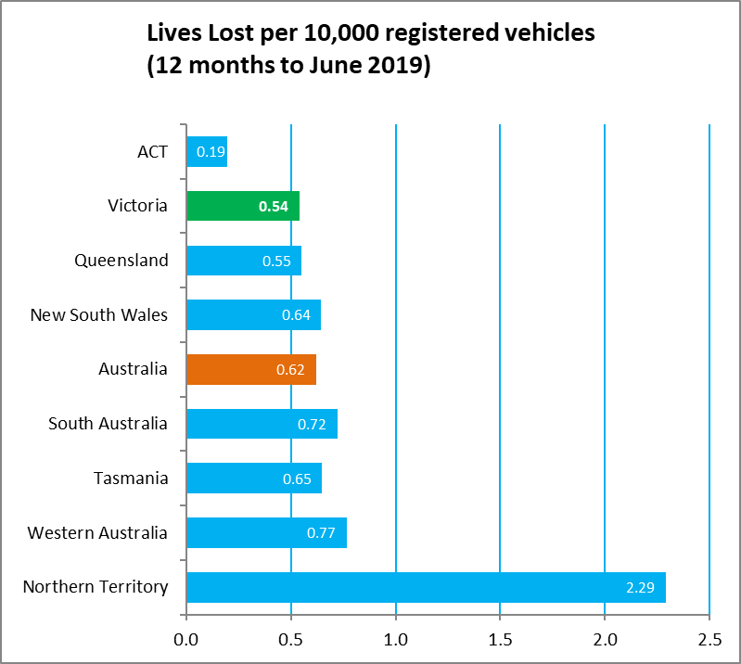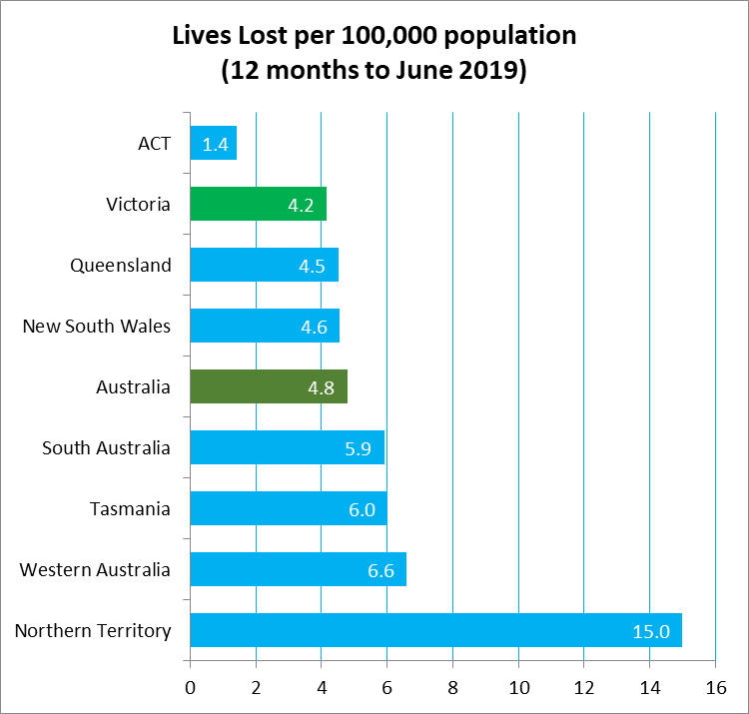

Explanations and References
LGA: Local Government Areas. Crash locations for acute hospitalised claims are assigned to LGA’s based on the crash postcode recorded by Victoria Police. Crash locations for fatal crashes are coded exactly to an LGA by Victoria Police.
Claimants: Refers to people injured in transport accidents who have an accepted claim with the TAC.
Hospitalisation: refers to all hospital admission that occurred within 7 days of accident.

Useful Internet Sites
TAC Sites
- TAC Safety (Road Safety) www.tacsafety.com.au
- TAC How safe is your car www.howsafeisyourcar.com.au
- TAC How safe is your first car www.howsafeisyourfirstcar.com.au
- TAC Motorcycle Safety Website www.spokes.com.au
- TAC Corporate site www.tac.vic.gov.au
- Drivesmart www.drivesmart.vic.gov.au
- Ridesmart www.ridesmartonline.com.au
Victorian Sites:
- VicRoads www.vicroads.vic.gov.au
- Victoria Police www.police.vic.gov.au
- Parliamentary Road Safety Committee https://www.parliament.vic.gov.au/57th-parliament/rsc
- RACV www.racv.com.au
- Monash University Accident Research Centre www.monash.edu.au/muarc
- Cameras Save Lives www.camerassavelives.vic.gov.au
- VicRoads Learner Driver Site www.lsite.vicroads.vic.gov.au/Learners
- Road Safety Education Victoria www.roadsafetyeducation.vic.gov.au
National and Interstate Sites:
- ARRB Transport Research www.arrb.com.au
- Australian Transport Safety Bureau www.atsb.gov.au
- Motor Accidents Authority (NSW) www.maa.nsw.gov.au
- Motor Accidents Insurance Board (TAS) www.maib.tas.gov.au
- Motor Accident Commission, Allianz (SA) www.mac.sa.gov.au
- Motor Accidents Compensation, TIO, (NT) www.tiofi.com.au/mac
- Insurance Commission of Western Australia www.icwa.wa.gov.au
- Motor Accident Insurance Commission (QLD) www.maic.qld.gov.au
International Sites:
- National Highway Traffic Safety Admin (USA) www.nhtsa.dot.gov
- Swedish Road and Transport Institute (VTI) www.vti.se
- SWOV Institute for Road Safety Research www.swov.nl
Related Sites:
- Alcohol and Drug Foundation www.adf.org.au
Figures

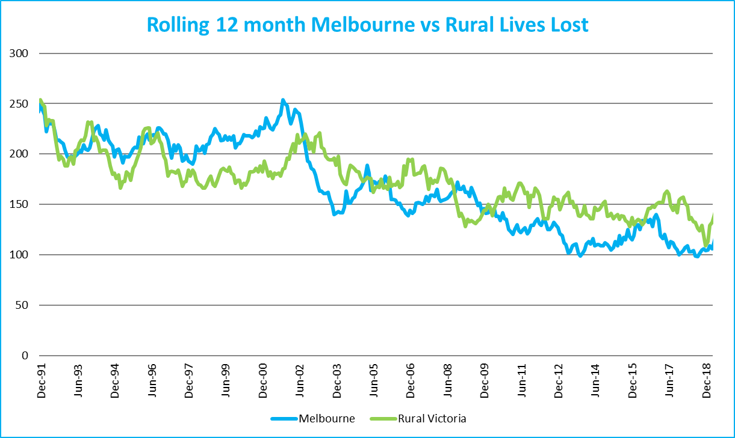
Graph 1a – Melbourne/Rural lives lost

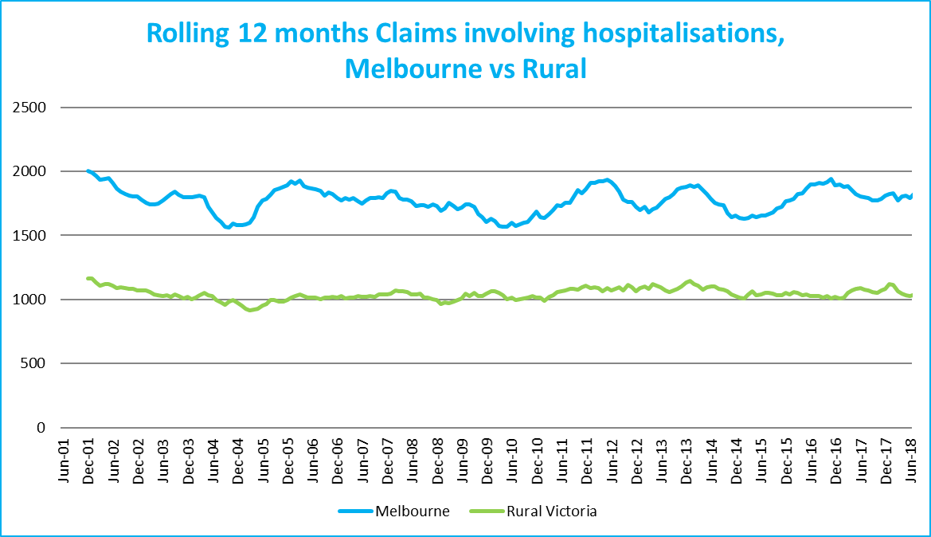

Graph 1b – Melbourne/Rural claims involving an acute hospital admission

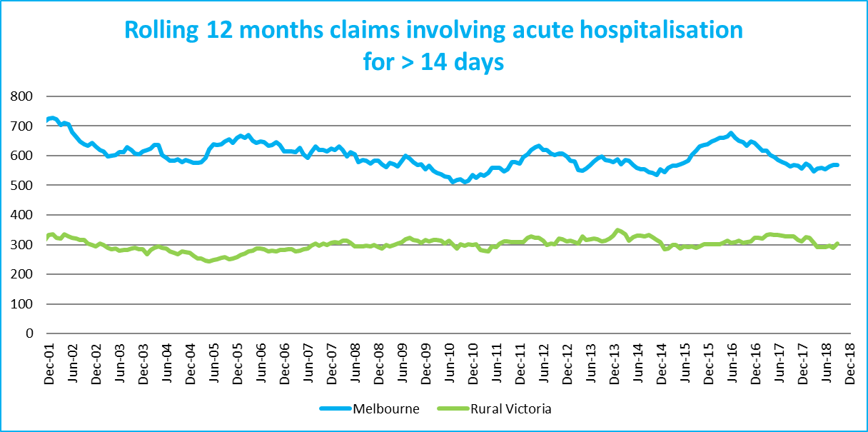
Graph 1c – Melbourne/Rural Claims involving hospital admission greater than 14 days

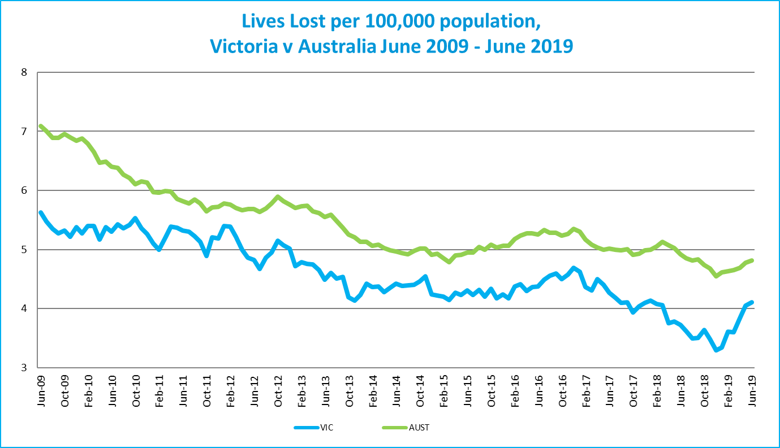
Graph 1d – Victoria/Australia lives lost per 100,000 population

Victorian monthly lives lost since 1951


