

Quarterly Statistics - JUNE 2016


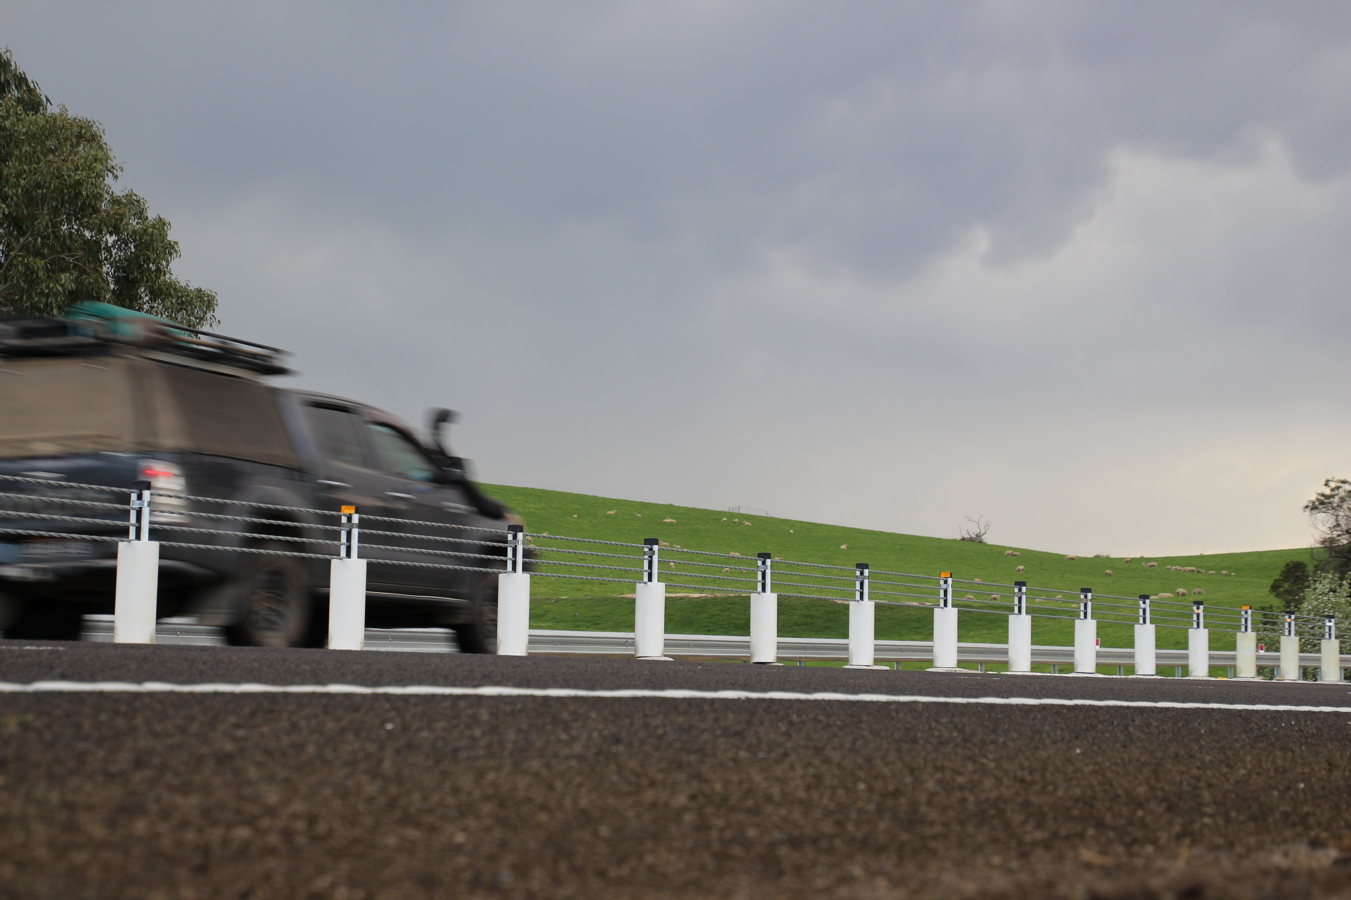

TRANSPORT  ACCIDENT  COMMISSION | 60 Brougham Street  Geelong Vic 3220  PO Box 742  Geelong Vic 3220  Ausdoc DX 216079 Geelong | Telephone 1300 654 329  STD Toll Free 1800 332 556  Fax: 03 9656 9300  www.tac.vic.gov.au  ABN 22 033 947 623

Contents
Status Report 4
Lives lost on Victorian roads 4
Injured claimants who were admitted to hospital within 7 days of accident, (by claim acceptance date – rolling 12 month, to midnight 31 December 2015) 5
Lives lost: 12 months to June 2016 6
Injured claimants who were admitted to hospital within 7 days of accident, 12 months to December 2015 (claim acceptance date) 10
Lives Lost by Week (2009 to 2016) 12
The National Picture 13
Explanations and References 14
Useful Internet Sites 15
Figures 16
Victorian monthly lives lost since 1951 17

Notes about the data in this report
- All data provided in this report is the data most recently available at time of production. Fatality data are updated to the end of report month. A 6-month lag applies to TAC claims data.
- Reported data will have one extra day of exposure for leap years.
- Data is subject to revision as additional information about known accidents/claims is received, and as new accident/claim reports are received and processed.
*An acute hospital admission refers to a hospital admission that occurred within 7 days of accident.

Status Report

Lives lost on Victorian roads
- The rolling 12 month number of lives lost until June 2016 stands at 270. The number of lives lost in 2015 stood at 254 (an increase of 16).
- There were 24 people’s lives lost in June 2016 on Victorian roads. This compares to 22 in June 2015.

Lives lost (rolling 12 month, to end June 2016)

Category | 2016 | 2015 | 2014 | 2016 v 2015 | 2016 v 2014 |  | 5 Year Av
Lives Lost (Rolling 12 Month Total)
Lives Lost (to June) | 270 | 254 | 256 | +16 | +14 | 261
per 10,000 veh | 0.58 | 0.56 | 0.57 | +0.02 | +0.01 | 0.58
per 100,000 pop | 4.51 | 4.31 | 4.42 | +0.20 | +0.09 | 4.51
Accidents (Rolling 12 Month Total)
Lives Lost (to June) | 254 | 230 | 229 | +24 | +25 | 239
per 10,000 veh | 0.55 | 0.50 | 0.51 | +0.05 | +0.04 | 0.51
per 100,000 pop | 4.24 | 3.90 | 3.96 | 0.34 | +0.28 | 3.96

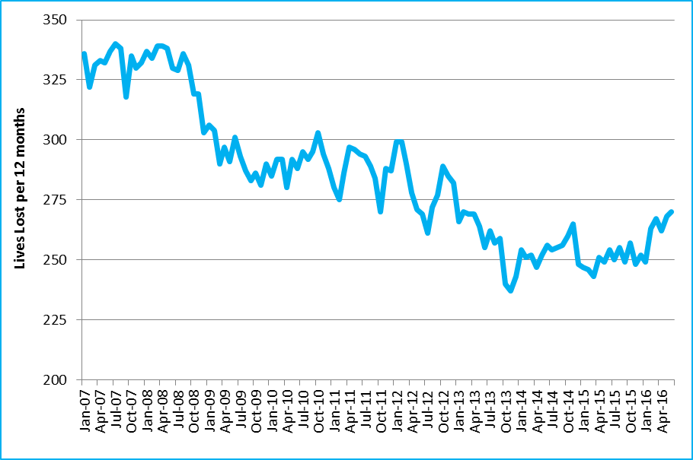
Victoria – Lives Lost, rolling 12 months total

Injured claimants who were admitted to hospital within 7 days of accident, (by claim acceptance date – rolling 12 month, to midnight 31 December 2015)
Category | 2015 | 2014 | 2013 | 2015 v 2014 |  | 2015 v 2013 |  | 5 Year Average
Claims involving an acute hospitalisation over 14 days (Rolling 12 Month Total)
Claims (to December) | 969 | 883 | 919 | +86 | (+10%) | +50 | (+5%) | 915
per 100,000 pop | 16.3 | 15.1 | 16.0 | +1.2 | (+8%) | +0.3 | (+2%) | 15.8
per 10,000 veh | 2.1 | 2.0 | 2.1 | +0.1 | (+5%) | 0.0 | (+0%) | 2.1
All claims involving an acute hospitalisation (Rolling 12 Month Total)
Claims (to December) | 6,266 | 5,974 | 5,682 | +292 | (+5%) | +584 | (+10%) | 5,849
per 100,000 pop | 105.7 | 102.3 | 99.0 | +3.4 | (+3%) | +6.7 | (+7%) | 101.5
per 10,000 veh | 13.6 | 13.2 | 12.8 | +0.4 | (+3%) | +0.8 | (+6%) | 13.2

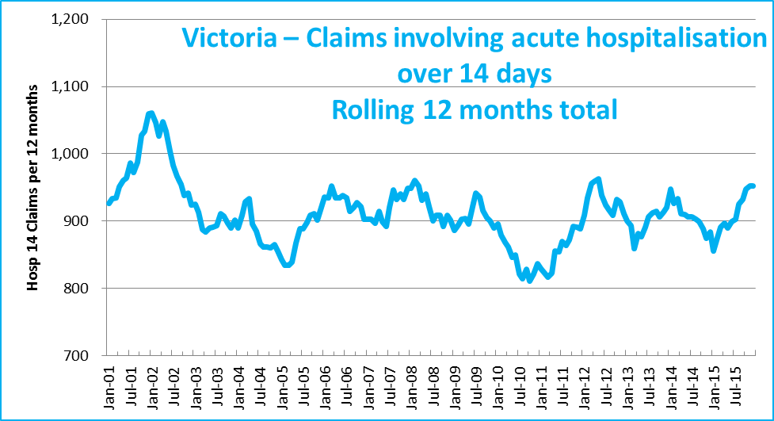
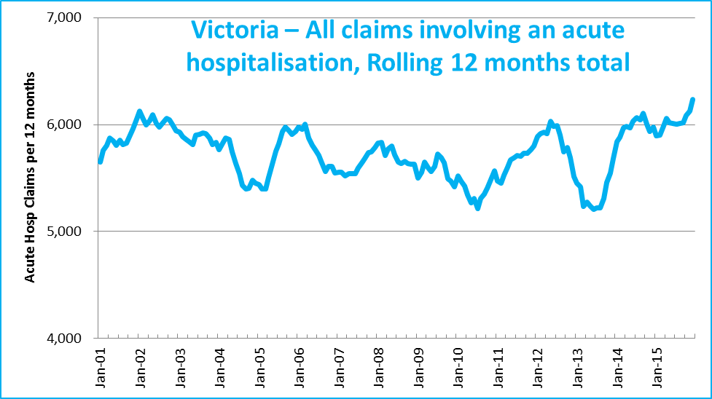

Lives lost: 12 months to June 2016
Category | 2016 | 2015 | 2014 | 2016 v 2015 | 2016 v 2014 | 5 Year Average
Overview
Lives Lost | 270 | 254 | 256 | +16 | +14 | 261
Accidents | 254 | 230 | 229 | +24 | +25 | 239
Sex
Female | 76 | 72 | 77 | +4 | -1 | 77
Male | 193 | 182 | 179 | +11 | +14 | 183
Road user
Bicyclist | 9 | 11 | 7 | -2 | +2 | 8
Driver | 132 | 122 | 120 | +10 | +12 | 126
Motorcyclist | 49 | 31 | 34 | +18 | +15 | 39
Passenger | 48 | 52 | 52 | -4 | -4 | 49
Pedestrian | 32 | 38 | 43 | -6 | -11 | 39
Location
Melbourne | 134 | 119 | 109 | +15 | +25 | 120
Rural Victoria | 136 | 135 | 147 | +1 | -11 | 141
Age group
0-4 | 3 | 3 | 2 |  | +1 | 3
5-15 | 4 | 4 | 9 |  | -5 | 7
16-17 | 9 | 14 | 2 | -5 | +7 | 7
18-20 | 25 | 21 | 14 | +4 | +11 | 23
21-25 | 18 | 28 | 26 | -10 | -8 | 26
26-29 | 21 | 23 | 18 | -2 | +3 | 20
30-39 | 37 | 28 | 40 | +9 | -3 | 36
40-49 | 45 | 33 | 31 | +12 | +14 | 33
50-59 | 33 | 27 | 35 | +6 | -2 | 32
60-69 | 30 | 25 | 27 | +5 | +3 | 29
70+ | 45 | 48 | 52 | -3 | -7 | 46
Accident Type
Intersection
Adjacent direction | 31 | 30 | 38 | +1 | -7 | 30
Opposing direction | 8 | 11 | 5 | -3 | +3 | 6
Mid-block/other
Head on | 23 | 35 | 43 | -12 | -20 | 14
Same direction | 18 | 10 | 13 | +8 | +5 | 14
Manoeuvre/o'taking | 7 | 14 | 12 | -7 | -5 | 6
On path | 98 | 3 | 8 | +95 | +90 | 104
Single vehicle | 33 | 109 | 88 | -76 | -55 | 44
Other (incl peds) | 2 | 42 | 49 | -40 | -47 | 2

Lives Lost: 12 months to June 2016 – Continued
Category | 2016 | 2015 | 2014 | 5 Year Average | Category | 2016 | 2015 | 2014 | 5 Year Average
Local Government Area |  |  |  |  | Local Government Area
ALPINE | 1 | 0 | 3 | 1 | MANSFIELD | 1 | 3 | 4 | 2
ARARAT | 3 | 1 | 2 | 2 | MARIBYRNONG | 2 | 3 | 1 | 3
BALLARAT | 6 | 5 | 4 | 4 | MAROONDAH | 0 | 3 | 0 | 2
BANYULE | 2 | 1 | 1 | 2 | MELBOURNE | 1 | 8 | 2 | 4
BASS COAST | 2 | 1 | 4 | 2 | MELTON | 3 | 6 | 10 | 6
BAW BAW | 2 | 2 | 7 | 4 | MILDURA | 5 | 1 | 7 | 3
BAYSIDE | 1 | 4 | 3 | 3 | MITCHELL | 4 | 7 | 2 | 5
BENALLA | 1 | 3 | 1 | 2 | MOIRA | 7 | 1 | 4 | 5
BOROONDARA | 3 | 2 | 3 | 3 | MONASH | 3 | 2 | 4 | 3
BRIMBANK | 11 | 3 | 7 | 8 | MOONEE VALLEY | 3 | 3 | 5 | 3
BULOKE | 1 | 1 | 5 | 2 | MOORABOOL | 3 | 2 | 2 | 4
CAMPASPE | 3 | 4 | 5 | 5 | MORELAND | 3 | 5 | 3 | 3
CARDINIA | 7 | 8 | 6 | 7 | MORNINGTON PENINSULA | 11 | 10 | 7 | 7
CASEY | 7 | 5 | 7 | 6 | MOUNT ALEXANDER | 2 | 2 | 4 | 2
CENTRAL GOLDFIELDS | 1 | 0 | 5 | 2 | MOYNE | 0 | 3 | 5 | 2
COLAC-OTWAY | 4 | 2 | 3 | 3 | MURRINDINDI | 6 | 8 | 5 | 5
CORANGAMITE | 3 | 7 | 9 | 5 | NILLUMBIK | 4 | 3 | 0 | 2
DAREBIN | 3 | 2 | 3 | 3 | NORTHERN GRAMPIANS | 1 | 1 | 5 | 2
EAST GIPPSLAND | 8 | 8 | 3 | 6 | PORT PHILLIP | 2 | 0 | 4 | 2
FRANKSTON | 3 | 4 | 2 | 2 | PYRENEES | 0 | 0 | 2 | 1
GANNAWARRA | 0 | 1 | 2 | 1 | QUEENSCLIFFE | 0 | 0 | 0 | 0
GLEN EIRA | 2 | 1 | 1 | 2 | SOUTH GIPPSLAND | 4 | 5 | 7 | 4
GLENELG | 1 | 7 | 3 | 2 | SOUTHERN GRAMPIANS | 3 | 0 | 1 | 3
GOLDEN PLAINS | 2 | 4 | 4 | 2 | STONNINGTON | 2 | 4 | 3 | 3
GREATER BENDIGO | 4 | 5 | 3 | 6 | STRATHBOGIE | 5 | 2 | 4 | 3
GREATER DANDENONG | 6 | 6 | 2 | 5 | SURF COAST | 4 | 4 | 1 | 3
GREATER GEELONG | 4 | 7 | 3 | 7 | SWAN HILL | 2 | 2 | 2 | 2
GREATER SHEPPARTON | 7 | 5 | 2 | 6 | TOWONG | 1 | 1 | 0 | 1
HEPBURN | 2 | 2 | 1 | 2 | WANGARATTA | 5 | 2 | 3 | 4
HINDMARSH | 2 | 1 | 0 | 1 | WARRNAMBOOL | 3 | 0 | 1 | 1
HOBSONS BAY | 6 | 1 | 2 | 2 | WELLINGTON | 1 | 4 | 7 | 4
HORSHAM | 4 | 0 | 1 | 3 | WEST WIMMERA | 0 | 0 | 1 | 1
HUME | 7 | 6 | 2 | 6 | WHITEHORSE | 4 | 4 | 3 | 3
INDIGO | 4 | 7 | 0 | 3 | WHITTLESEA | 7 | 4 | 5 | 5
KINGSTON | 5 | 2 | 6 | 5 | WODONGA | 1 | 1 | 3 | 2
KNOX | 5 | 7 | 4 | 4 | WYNDHAM | 7 | 7 | 3 | 6
LATROBE | 7 | 4 | 4 | 6 | YARRA | 2 | 1 | 0 | 1
LODDON | 2 | 1 | 0 | 1 | YARRA RANGES | 12 | 5 | 9 | 9
MACEDON RANGES | 4 | 7 | 3 | 4 | YARRIAMBIACK | 1 | 0 | 0 | 0
MANNINGHAM | 1 | 0 | 1 | 1

Injured claimants who were admitted to hospital within 7 days of the accident with a hospital stay of more than 14 days, 12 months to December 2015 (claim acceptance date)
Category | 2015 | 2014 | 2013 | 2015 v 2014 |  | 2015 v 2013 |  | 5 Year Av
Overview
Claims | 969 | 883 | 919 | +86 | 10% | 50 | 5% | 915
Sex
Female | 427 | 348 | 385 | +79 | 23% | 42 | 11% | 381
Male | 542 | 533 | 534 | +9 | 2% | 8 | 1% | 532
Road user
Driver | 367 | 353 | 382 | +14 | 4% | -15 | -4% | 363
Passenger | 139 | 135 | 150 | +4 | 3% | -11 | -7% | 145
Motorcyclist | 166 | 164 | 142 | +2 | 1% | 24 | 17% | 157
Pedestrian | 198 | 168 | 206 | +30 | 18% | -8 | -4% | 186
Cyclist | 48 | 35 | 26 | +13 | 37% | 22 | 85% | 37
Train/Tram | 7 | 11 | 3 | -4 | -36% | 4 | 133% | 7
Location
Melbourne | 641 | 552 | 581 | +89 | 16% | 60 | 10% | 589
Rural Victoria | 299 | 309 | 332 | -10 | -3% | -33 | -10% | 312
Age group
0-4 | 4 | 3 | 3 | +1 | 33% | 1 | 33% | 3
5-15 | 20 | 16 | 10 | +4 | 25% | 10 | 100% | 15
16-17 | 14 | 13 | 14 | +1 | 8% | 0 | 0% | 16
18-20 | 43 | 53 | 67 | -10 | -19% | -24 | -36% | 54
21-25 | 88 | 83 | 79 | +5 | 6% | 9 | 11% | 84
26-29 | 51 | 55 | 41 | -4 | -7% | 10 | 24% | 52
30-39 | 121 | 106 | 101 | +15 | 14% | 20 | 20% | 113
40-49 | 119 | 109 | 111 | +10 | 9% | 8 | 7% | 115
50-59 | 122 | 106 | 105 | +16 | 15% | 17 | 16% | 108
60-69 | 109 | 94 | 112 | +15 | 16% | -3 | -3% | 106
70+ | 278 | 245 | 276 | +33 | 13% | 2 | 1% | 249
Accident Type
Intersection
Adjacent direction | 103 | 99 | 133 | +4 | 4% | -30 | -23% | 114
Opposing direction | 66 | 58 | 64 | +8 | 14% | 2 | 3% | 63
Mid-block/other
Head on | 94 | 82 | 78 | +12 | 15% | 16 | 21% | 85
Same direction | 82 | 78 | 70 | +4 | 5% | 12 | 17% | 82
Manoeuvre/o'taking | 63 | 47 | 63 | +16 | 34% | 0 | 0% | 56
On path | 27 | 29 | 24 | -2 | -7% | 3 | 13% | 24
Single vehicle | 290 | 275 | 238 | +15 | 5% | 52 | 22% | 261
Other (incl peds) | 244 | 215 | 249 | +29 | 13% | -5 | -2% | 229

Note: Excludes rejected claims and claims for interstate crashes.
Injured claimants who were admitted to hospital within 7 days of the accident with a hospital stay of more than 14 days, 12 months to December 2015 (claim acceptance date) - Continued
Category | 2015 | 2014 | 2013 | 5 Year Average | Category | 2015 | 2014 | 2013 | 5 Year Average
Local Government Area |  |  |  |  | Local Government Area
ALPINE | 2 | 5 | 1 | 3 | MANSFIELD | 2 | 5 | 4 | 3
ARARAT | 9 | 7 | 8 | 6 | MARIBYRNONG | 13 | 5 | 10 | 11
BALLARAT | 18 | 16 | 17 | 15 | MAROONDAH | 6 | 4 | 6 | 7
BANYULE | 13 | 8 | 11 | 10 | MELBOURNE | 26 | 36 | 28 | 30
BASS COAST | 9 | 10 | 12 | 10 | MELTON | 20 | 11 | 10 | 15
BAW BAW | 12 | 7 | 7 | 11 | MILDURA | 4 | 7 | 9 | 7
BAYSIDE | 11 | 8 | 11 | 11 | MITCHELL | 8 | 10 | 14 | 10
BENALLA | 7 | 3 | 6 | 5 | MOIRA | 7 | 5 | 10 | 7
BOROONDARA | 22 | 26 | 18 | 23 | MONASH | 29 | 18 | 22 | 23
BRIMBANK | 34 | 29 | 16 | 27 | MOONEE VALLEY | 20 | 24 | 18 | 19
BULOKE | 6 | 3 | 1 | 3 | MOORABOOL | 10 | 11 | 7 | 7
CAMPASPE | 8 | 7 | 8 | 7 | MORELAND | 29 | 24 | 32 | 27
CARDINIA | 20 | 12 | 12 | 15 | MORNINGTON PENINSULA | 26 | 28 | 25 | 29
CASEY | 34 | 26 | 32 | 28 | MOUNT ALEXANDER | 3 | 10 | 7 | 5
CENTRAL GOLDFIELDS | 2 | 2 | 7 | 4 | MOYNE | 2 | 1 | 7 | 4
COLAC-OTWAY | 12 | 6 | 9 | 8 | MURRINDINDI | 14 | 12 | 8 | 13
CORANGAMITE | 4 | 2 | 10 | 5 | NILLUMBIK | 13 | 4 | 6 | 7
DAREBIN | 15 | 18 | 16 | 17 | NORTHERN GRAMPIANS | 1 | 5 | 4 | 3
EAST GIPPSLAND | 8 | 11 | 6 | 10 | PORT PHILLIP | 17 | 21 | 12 | 14
FRANKSTON | 15 | 14 | 14 | 14 | PYRENEES | 2 | 3 |  | 1
GANNAWARRA | 2 | 4 | 3 | 2 | QUEENSCLIFFE |  |  |  | 0
GLEN EIRA | 15 | 15 | 24 | 17 | SOUTH GIPPSLAND | 8 | 9 | 4 | 7
GLENELG | 4 | 7 | 3 | 5 | SOUTHERN GRAMPIANS | 3 | 3 | 6 | 4
GOLDEN PLAINS | 5 | 5 | 7 | 5 | STONNINGTON | 21 | 15 | 12 | 17
GREATER BENDIGO | 16 | 10 | 20 | 15 | STRATHBOGIE | 9 | 6 | 9 | 9
GREATER DANDENONG | 17 | 27 | 30 | 26 | SURF COAST | 5 | 4 | 5 | 5
GREATER GEELONG | 20 | 31 | 34 | 28 | SWAN HILL | 3 | 4 | 1 | 3
GREATER SHEPPARTON | 15 | 10 | 13 | 12 | TOWONG | 1 | 2 | 4 | 2
HEPBURN | 4 | 4 | 3 | 3 | WANGARATTA | 5 | 4 | 7 | 4
HINDMARSH | 1 |  | 1 | 1 | WARRNAMBOOL | 2 | 5 | 4 | 9
HOBSONS BAY | 11 | 8 | 11 | 10 | WELLINGTON | 5 | 12 | 7 | 2
HORSHAM | 3 | 5 | 3 | 4 | WEST WIMMERA | 1 | 2 | 1 | 18
HUME | 37 | 17 | 26 | 27 | WHITEHORSE | 14 | 19 | 20 | 24
INDIGO | 5 | 1 | 2 | 3 | WHITTLESEA | 28 | 20 | 26 | 5
KINGSTON | 27 | 22 | 24 | 22 | WODONGA | 3 | 7 | 5 | 23
KNOX | 19 | 11 | 17 | 17 | WYNDHAM | 24 | 27 | 23 | 13
LATROBE | 16 | 10 | 10 | 14 | YARRA | 11 | 14 | 17 | 33
LODDON | 2 | 2 | 1 | 2 | YARRA RANGES | 43 | 32 | 36 | 1
MACEDON RANGES | 11 | 14 | 15 | 11 | YARRIAMBIACK |  |  | 2 | 1
MANNINGHAM | 11 | 9 | 16 | 14

Note: excludes rejected claims and claims for interstate crashes

Injured claimants who were admitted to hospital within 7 days of accident, 12 months to December 2015 (claim acceptance date)
Category | 2015 | 2014 | 2013 | 2015 v 2014 |  | 2015 v 2013 |  | 5 Year Av
Overview
Claims | 6,266 | 5,974 | 5,682 | +292 | 5% | +584 | 10% | 5,849
Sex
Female | 2,717 | 2,548 | 2,312 | +169 | 7% | +405 | 18% | 2,482
Male | 3,536 | 3,419 | 3,366 | +117 | 3% | +170 | 5% | 3,360
Road user
Driver | 2,880 | 2,664 | 2,559 | +216 | 8% | +321 | 13% | 2,679
Passenger | 1,022 | 1,047 | 950 | -25 | -2% | +72 | 8% | 1,009
Motorcyclist | 1,082 | 1,117 | 1,023 | -35 | -3% | +59 | 6% | 1,002
Pedestrian | 641 | 615 | 657 | +26 | 4% | -16 | -2% | 637
Cyclist | 389 | 385 | 390 | +4 | 1% | -1 | 0% | 374
Train/Tram | 27 | 32 | 28 | -5 | -16% | -1 | -4% | 27
Location
Melbourne | 4,193 | 4,050 | 3,835 | +143 | 4% | +358 | 9% | 3,936
Rural Victoria | 1,828 | 1,728 | 1,781 | +100 | 6% | +47 | 3% | 1,798
Age group
0-4 | 42 | 49 | 51 | -7 | -14% | -9 | -18% | 48
5-15 | 235 | 195 | 166 | +40 | 21% | +69 | 42% | 196
16-17 | 117 | 105 | 92 | +12 | 11% | +25 | 27% | 110
18-20 | 451 | 494 | 498 | -43 | -9% | -47 | -9% | 500
21-25 | 740 | 763 | 703 | -23 | -3% | +37 | 5% | 726
26-29 | 528 | 475 | 427 | +53 | 11% | +101 | 24% | 454
30-39 | 993 | 916 | 838 | +77 | 8% | +155 | 18% | 905
40-49 | 885 | 908 | 856 | -23 | -3% | +29 | 3% | 869
50-59 | 813 | 759 | 695 | +54 | 7% | +118 | 17% | 735
60-69 | 584 | 534 | 528 | +50 | 9% | +56 | 11% | 530
70+ | 878 | 776 | 828 | +102 | 13% | +50 | 6% | 774
Accident Type
Intersection
Adjacent direction | 795 | 768 | 855 | +27 | 4% | -60 | -7% | 823
Opposing direction | 537 | 498 | 507 | +39 | 8% | +30 | 6% | 501
Mid-block/other
Head on | 313 | 326 | 299 | -13 | -4% | +14 | 5% | 321
Same direction | 927 | 903 | 796 | +24 | 3% | +131 | 16% | 886
Manoeuvre/o'taking | 392 | 316 | 327 | +76 | 24% | +65 | 20% | 331
On path | 291 | 277 | 259 | +14 | 5% | +32 | 12% | 248
Single vehicle | 1,709 | 1,722 | 1,528 | -13 | -1% | +181 | 12% | 1,617
Other (incl peds) | 1,302 | 1,164 | 1,111 | +138 | 12% | +191 | 17% | 1,120

Note: excludes rejected claims and claims for interstate crashes
Injured claimants who were admitted to hospital within 7 days of accident, 12 months to December 2015 (claim acceptance date) – Continued
Category | 2015 | 2014 | 2013 | 5 Year Average | Category | 2015 | 2014 | 2013 | 5 Year Average
Local Government Area |  |  |  |  | Local Government Area
ALPINE | 19 | 25 | 40 | 31 | MANSFIELD | 25 | 27 | 31 | 33
ARARAT | 14 | 12 | 11 | 16 | MARIBYRNONG | 60 | 57 | 72 | 79
BALLARAT | 68 | 58 | 74 | 86 | MAROONDAH | 56 | 45 | 52 | 61
BANYULE | 28 | 63 | 44 | 57 | MELBOURNE | 231 | 205 | 228 | 246
BASS COAST | 49 | 32 | 33 | 47 | MELTON | 85 | 49 | 70 | 80
BAW BAW | 33 | 63 | 46 | 59 | MILDURA | 28 | 23 | 36 | 37
BAYSIDE | 75 | 65 | 62 | 70 | MITCHELL | 50 | 56 | 50 | 59
BENALLA | 26 | 11 | 14 | 21 | MOIRA | 28 | 26 | 27 | 33
BOROONDARA | 116 | 111 | 129 | 134 | MONASH | 166 | 189 | 175 | 185
BRIMBANK | 102 | 119 | 122 | 153 | MOONEE VALLEY | 102 | 105 | 93 | 116
BULOKE | 6 | 8 | 7 | 11 | MOORABOOL | 33 | 35 | 47 | 48
CAMPASPE | 34 | 31 | 23 | 38 | MORELAND | 114 | 127 | 119 | 146
CARDINIA | 98 | 107 | 82 | 102 | MORNINGTON PENINSULA | 132 | 131 | 97 | 157
CASEY | 276 | 226 | 214 | 253 | MOUNT ALEXANDER | 25 | 24 | 21 | 26
CENTRAL GOLDFIELDS | 5 | 13 | 9 | 15 | MOYNE | 14 | 17 | 14 | 19
COLAC-OTWAY | 30 | 26 | 20 | 30 | MURRINDINDI | 40 | 41 | 61 | 60
CORANGAMITE | 16 | 24 | 21 | 30 | NILLUMBIK | 35 | 24 | 25 | 39
DAREBIN | 76 | 80 | 78 | 95 | NORTHERN GRAMPIANS | 14 | 22 | 11 | 20
EAST GIPPSLAND | 48 | 47 | 53 | 64 | PORT PHILLIP | 126 | 132 | 103 | 129
FRANKSTON | 119 | 104 | 96 | 128 | PYRENEES | 10 | 6 | 6 | 9
GANNAWARRA | 10 | 11 | 11 | 13 | QUEENSCLIFFE | 1 | 1 |  | 3
GLEN EIRA | 95 | 95 | 91 | 108 | SOUTH GIPPSLAND | 17 | 34 | 37 | 35
GLENELG | 15 | 13 | 16 | 22 | SOUTHERN GRAMPIANS | 23 | 23 | 26 | 24
GOLDEN PLAINS | 27 | 23 | 22 | 27 | STONNINGTON | 120 | 145 | 117 | 135
GREATER BENDIGO | 108 | 69 | 65 | 103 | STRATHBOGIE | 35 | 27 | 20 | 35
GREATER DANDENONG | 223 | 241 | 211 | 229 | SURF COAST | 44 | 29 | 33 | 41
GREATER GEELONG | 203 | 187 | 180 | 220 | SWAN HILL | 11 | 18 | 5 | 14
GREATER SHEPPARTON | 78 | 57 | 47 | 70 | TOWONG | 13 | 14 | 10 | 15
HEPBURN | 24 | 20 | 36 | 28 | WANGARATTA | 30 | 28 | 17 | 32
HINDMARSH | 7 | 9 | 8 | 9 | WARRNAMBOOL | 16 | 11 | 20 | 25
HOBSONS BAY | 53 | 60 | 50 | 64 | WELLINGTON | 62 | 72 | 51 | 74
HORSHAM | 32 | 10 | 12 | 22 | WEST WIMMERA | 5 | 2 | 4 | 6
HUME | 167 | 166 | 121 | 164 | WHITEHORSE | 89 | 79 | 97 | 109
INDIGO | 12 | 14 | 14 | 20 | WHITTLESEA | 115 | 117 | 130 | 140
KINGSTON | 108 | 135 | 106 | 136 | WODONGA | 24 | 14 | 22 | 26
KNOX | 105 | 107 | 76 | 112 | WYNDHAM | 135 | 143 | 122 | 154
LATROBE | 42 | 42 | 64 | 65 | YARRA | 105 | 101 | 90 | 108
LODDON | 11 | 18 | 8 | 11 | YARRA RANGES | 156 | 132 | 124 | 177
MACEDON RANGES | 54 | 44 | 64 | 62 | YARRIAMBIACK | 10 | 2 | 2 | 5
MANNINGHAM | 84 | 38 | 58 | 72

Note: excludes rejected claims and claims for interstate crashes

Lives Lost by Week (2009 to 2016)
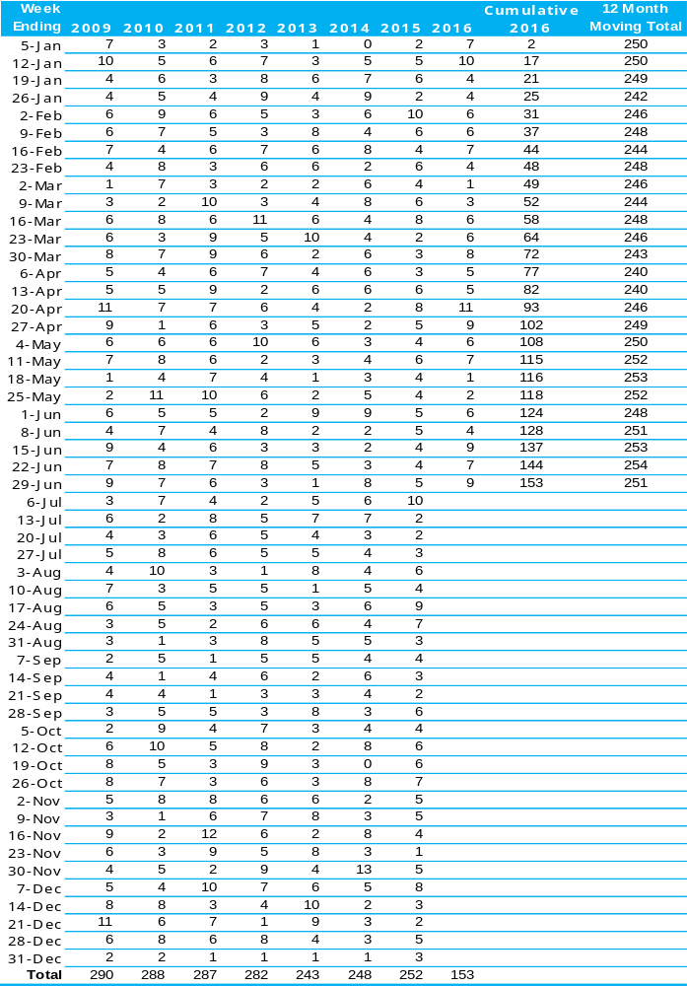

The National Picture
State | Lives Lost (12 months to June)
 | 2016 | 2015 | 2014 | 2013 | 2016 v 2015
NSW | 391 | 304 | 337 | 341 | +87 | (+29%)
VIC | 270 | 254 | 256 | 255 | +16 | (+6%)
QLD | 243 | 235 | 229 | 297 | +8 | (+3%)
SA | 100 | 113 | 88 | 99 | -13 | (-12%)
WA | 170 | 179 | 159 | 179 | -9 | (-5%)
TAS | 41 | 34 | 39 | 34 | +7 | (+21%)
NT | 44 | 41 | 42 | 46 | +3 | (+7%)
ACT | 12 | 11 | 8 | 11 | +1 | (+9%)
AUST TOTAL | 1,273 | 1,171 | 1,158 | 1,262 | +102 | (+9%)
AUST minus VIC | 1,001 | 917 | 902 | 1,007 | +84 | (+9%)
State | Lives Lost per 10,000 registered vehicles |  |  | Fatalities per 100,000 population
 | (12 months to June) |  |  | (12 months to June)
 | 2016 | 2015 | 2014 | 2016 | 2015 | 2014
NSW | 0.73 | 0.58 | 0.66 | 5.10 | 4.02 | 4.52
VIC | 0.59 | 0.56 | 0.57 | 4.54 | 4.31 | 4.42
QLD | 0.63 | 0.62 | 0.62 | 5.05 | 4.95 | 4.88
SA | 0.73 | 0.84 | 0.66 | 5.86 | 6.68 | 5.24
WA | 0.76 | 0.82 | 0.74 | 6.54 | 6.93 | 6.25
TAS | 0.90 | 0.76 | 0.88 | 7.92 | 6.59 | 7.59
NT | 2.79 | 2.65 | 2.77 | 18.01 | 16.75 | 17.33
ACT | 0.42 | 0.39 | 0.29 | 3.05 | 2.83 | 2.08
AUST TOTAL | 0.69 | 0.65 | 0.66 | 5.32 | 4.95 | 4.97
AUST minus VIC | 0.73 | 0.68 | 0.69 | 5.60 | 5.15 | 5.13

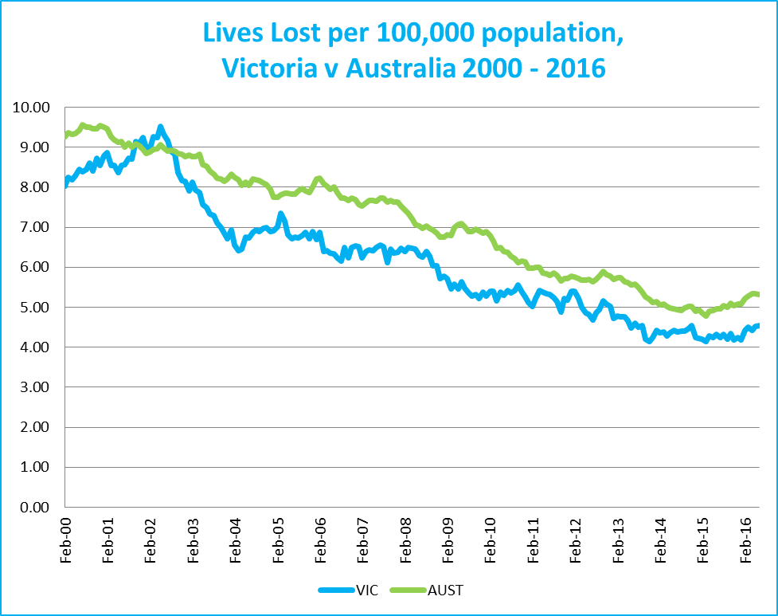
Victoria v Australia – 12 Month Moving Lives Lost Rate

Explanations and References
LGA: Local Government Areas, as per Australian Bureau of Statistics definition.
Claimants: Refers to people injured in transport accidents who have an accepted claim with the TAC.

Useful Internet Sites
TAC Sites
- TAC Safety (Road Safety) www.tacsafety.com.au
- TAC How safe is your car www.howsafeisyourcar.com.au
- TAC How safe is your first car www.howsafeisyourfirstcar.com.au
- TAC Motorcycle Safety Website www.spokes.com.au
- TAC Corporate site www.tac.vic.gov.au
- Drivesmart www.drivesmart.vic.gov.au
- Ridesmart www.ridesmartonline.com.au
Victorian Sites:
- VicRoads www.vicroads.vic.gov.au
- Victoria Police www.police.vic.gov.au
- Parliamentary Road Safety Committee www.parliament.vic.gov.au/rsc/
- RACV www.racv.com.au
- Monash University Accident Research Centre www.monash.edu.au/muarc
- Cameras Save Lives www.camerassavelives.vic.gov.au
- VicRoads Learner Driver Site www.lsite.vicroads.vic.gov.au/Learners
- Road Safety Education Victoria www.roadsafetyeducation.vic.gov.au
National and Interstate Sites:
- ARRB Transport Research www.arrb.com.au
- Australian Transport Safety Bureau www.atsb.gov.au
- Motor Accidents Authority (NSW) www.maa.nsw.gov.au
- Motor Accidents Insurance Board (TAS) www.maib.tas.gov.au
- Motor Accident Commission, Allianz (SA) www.mac.sa.gov.au
- Motor Accidents Compensation, TIO, (NT) www.tiofi.com.au/mac
- Insurance Commission of Western Australia www.icwa.wa.gov.au
- Motor Accident Insurance Commission (QLD) www.maic.qld.gov.au
International Sites:
- National Highway Traffic Safety Admin (USA) www.nhtsa.dot.gov
- Swedish Road and Transport Institute (VTI) www.vti.se
- SWOV Institute for Road Safety Research www.swov.nl
Related Sites:
- Alcohol and Drug Foundation www.adf.org.au
Figures
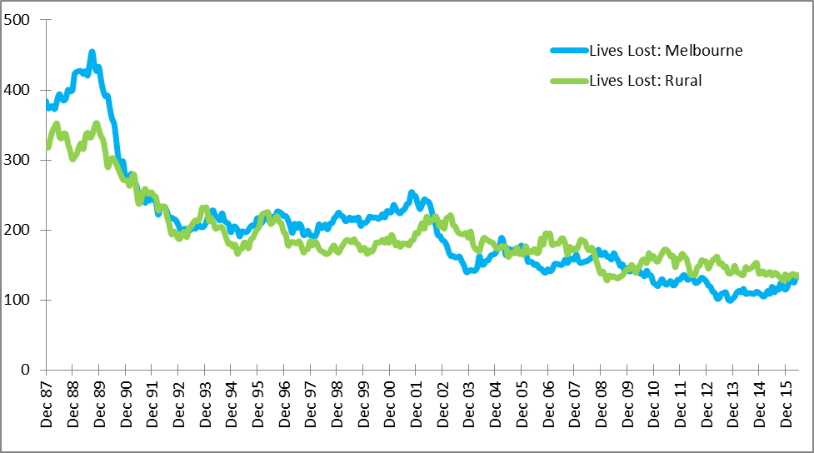
Graph 1a – Melbourne/country lives lost

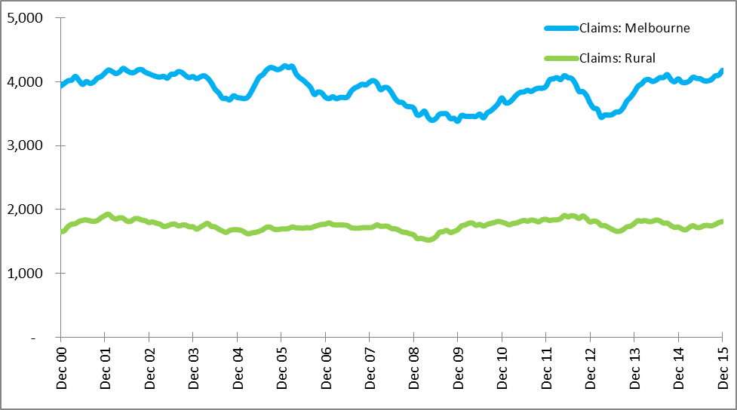
Graph 1b – Melbourne/country Claims involving an acute hospital admission

Victorian monthly lives lost since 1951


