PaymentsPlus
Aggregated Date View Guide

Version 1.0
22 April 2013
The information contained in this publication is provided for learning purposes only and is subject to change. Revisions may be issued from time to time that encompass changes or additions to this module.
This is a guide only and it is not comprehensive. It does not impinge on or overrule any formal arrangement you may enter into with the Bank. The Bank and its officers shall not have any liability for any losses of any kind incurred in connection with any action, inaction or decision taken in reliance on the information herein or for any inaccuracies, errors or omissions. In this publication references to the "Bank" are to Westpac Banking Corporation ABN 33 007 457 141 and to any of its operating Divisions, including BankSA and St.George.

Contents
PaymentsPlus Aggregated Date View Guide 1
Introduction 1
Generating an invitation code 2
Linking a user account to additional payment data 8

Introduction
PaymentsPlus offers recipient (supplier) users the ability to access multiple sets of invoice and payment data using a single recipient user account.
This removes the need for recipients to remember multiple sets of usernames and passwords, and also allows a recipient to see a more comprehensive view of the current receivables position and schedule.
The process by which this aggregated data view is created can be broken down into three steps:
- Accessing the portal using a recipient user account.
- Generating an invitation code to access additional data.
- Linking a recipient user account to additional data using an invitation code.
For the purposes of this guide it is assumed you already have access to the portal so the following sections will only describe steps 2) and 3).

Generating an invitation code
Invitation codes are generated and sent to recipient users either as a result of their portal sponsor (payee) providing them as part of an portal introduction exercise, or they can be generated by existing portal recipient administrators as part of the process by which new recipient users can be introduced to the portal.
The following section describes the process by which a portal recipient administrator can generate a new invitation code (presumably to be used as part of the aggregated data view setup process).

Sign into the portal as an administrator for the recipient that you wish to generate an invitation code for.

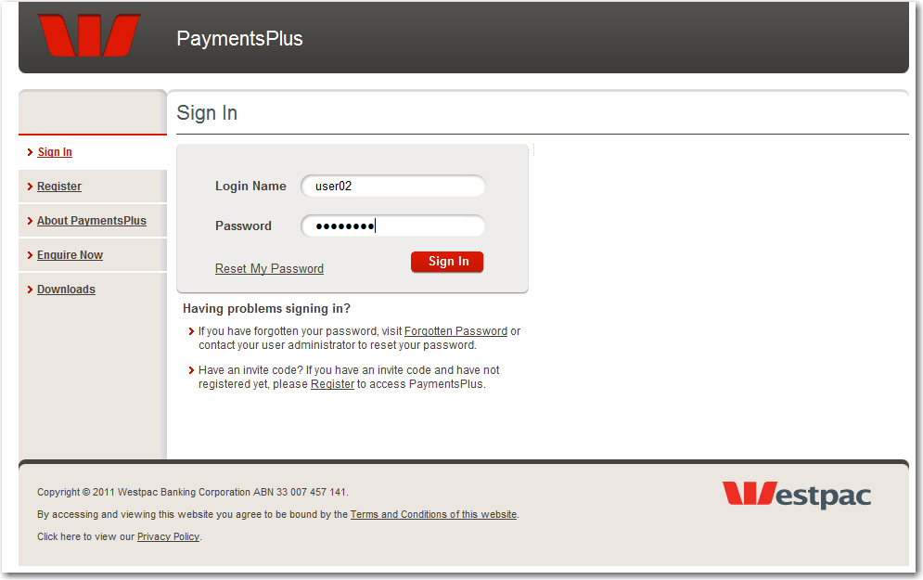

Click on the “Administration Tab”.

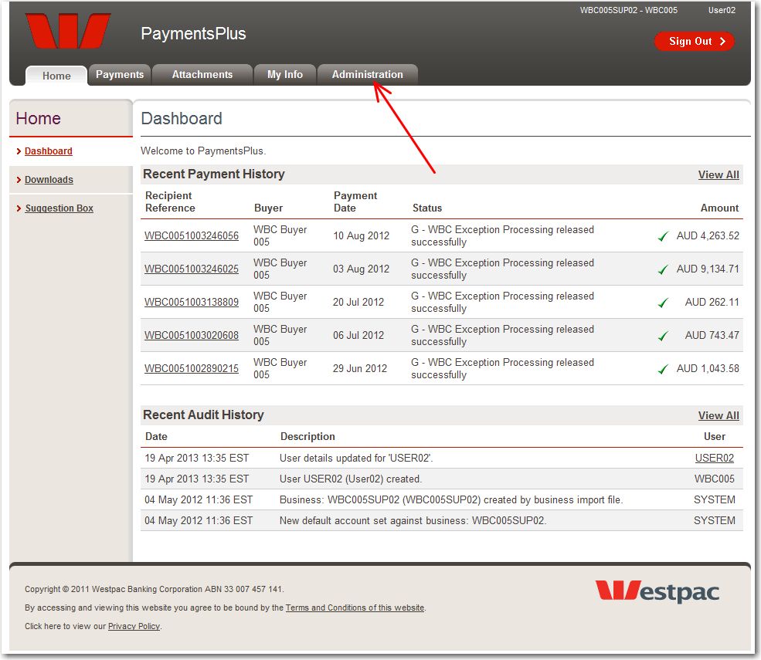

Click on the “Payment Data Access” link from the left hand side menu bar.

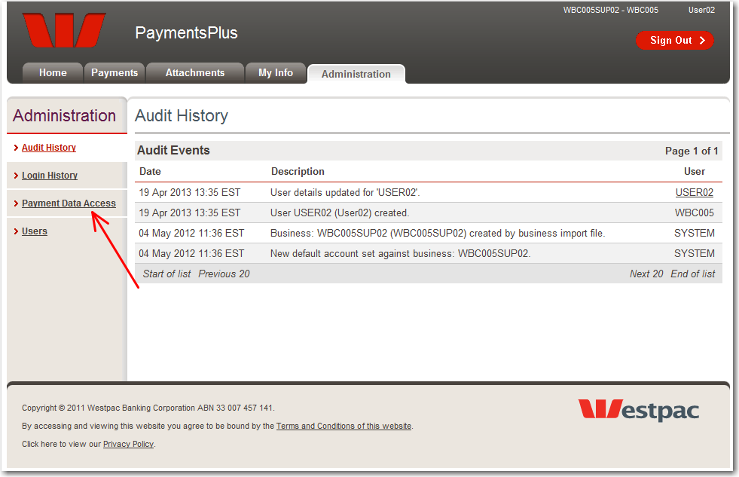

Click on the recipient code that you wish to generate an invitation code for.

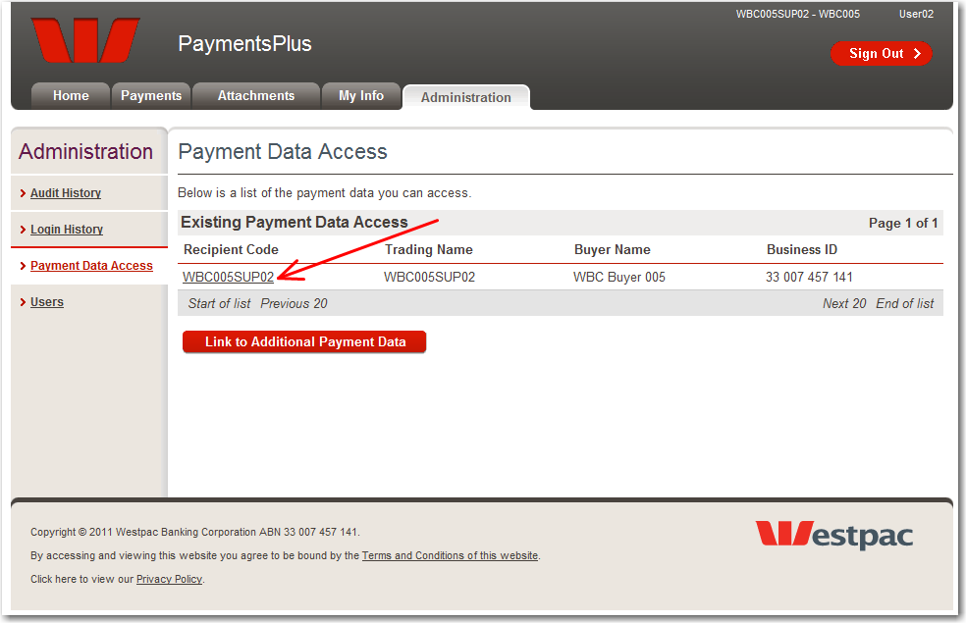

Click on the “Invite” tab.

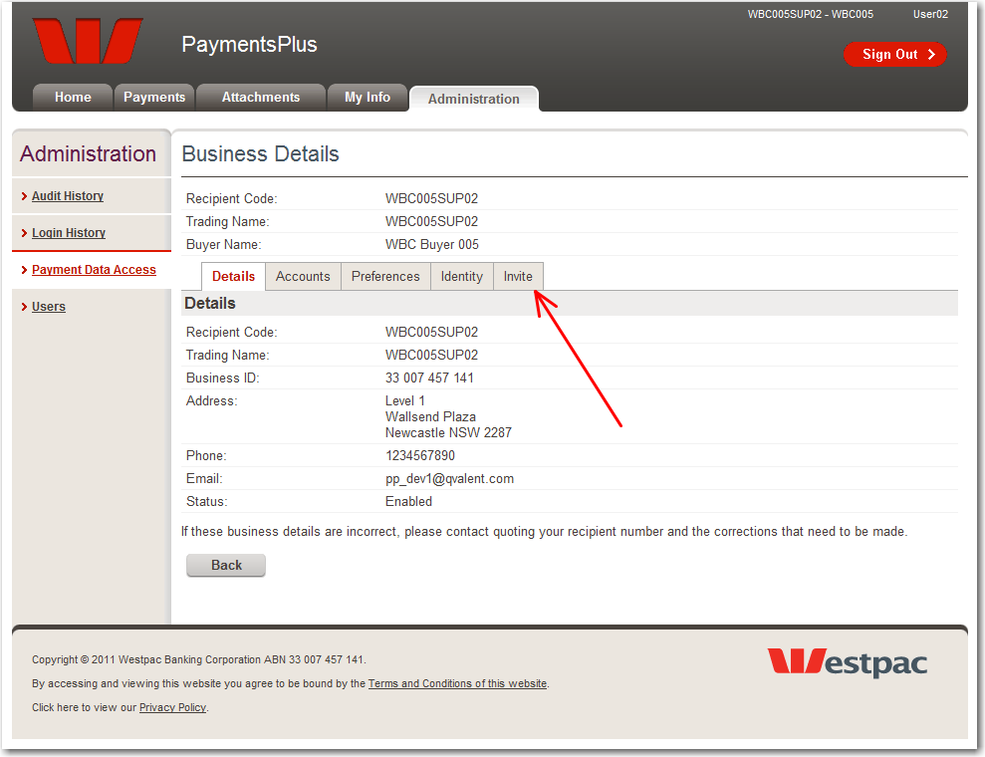

Enter an email address and click on the “Send Invite” button.

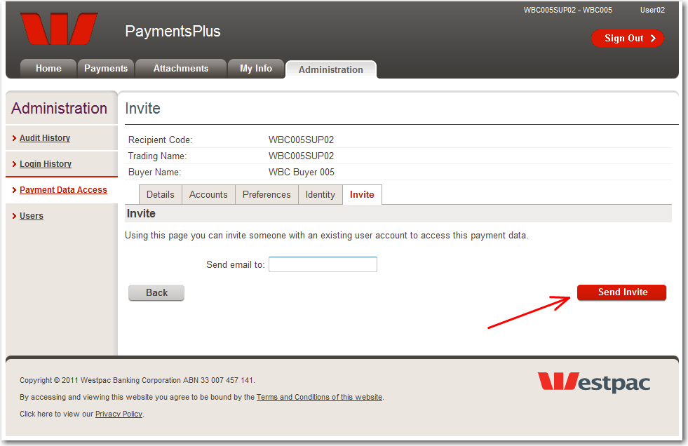

An invitation code will be generated by the portal and sent to the email address that was specified.

Linking a user account to additional payment data
A recipient user can link their user account to any set of payment or invoice data for which they have been given an invitation code for.
This allows a recipient user to configure their portal data view to include a more useful / comprehensive set of data more tailored to their own requirements, rather than it being restricted to the structure provided by or inherent in their portal sponsor’s ERP system. It also provides a method by which a recipient user can access ALL of their payment data using a single username and password, thus removing the potential requirement of having to remember multiple sets of username / password pairs for different sets of payment or invoice data.
The following section describes the process by which a recipient user can use the list of invitation codes they have been given to modify their user account so that it will allow access to an aggregated view spanning multiple sets of payment or invoice data.

Note any invitation codes that you have been sent. These are usually provided as part of an invitation email (see below).

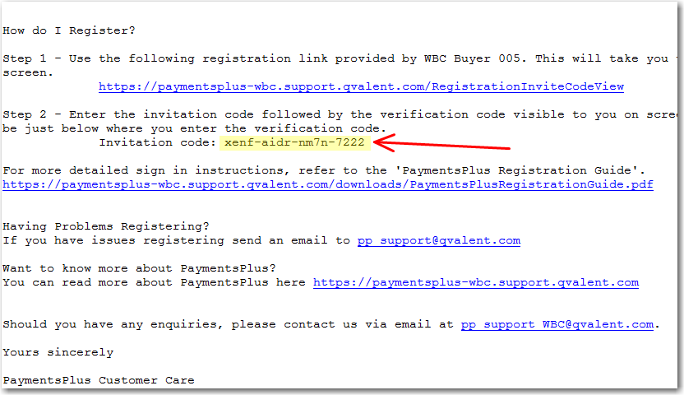

Sign into the portal using the recipient account that you wish to modify to have access to multiple sets of payment or invoice data.

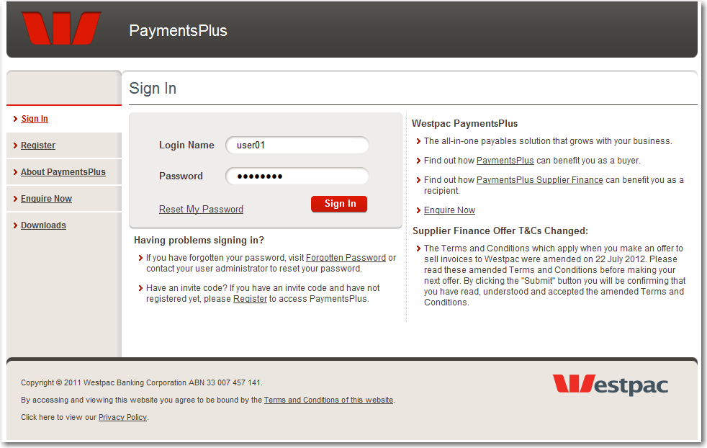

Click on the “Administration Tab”.

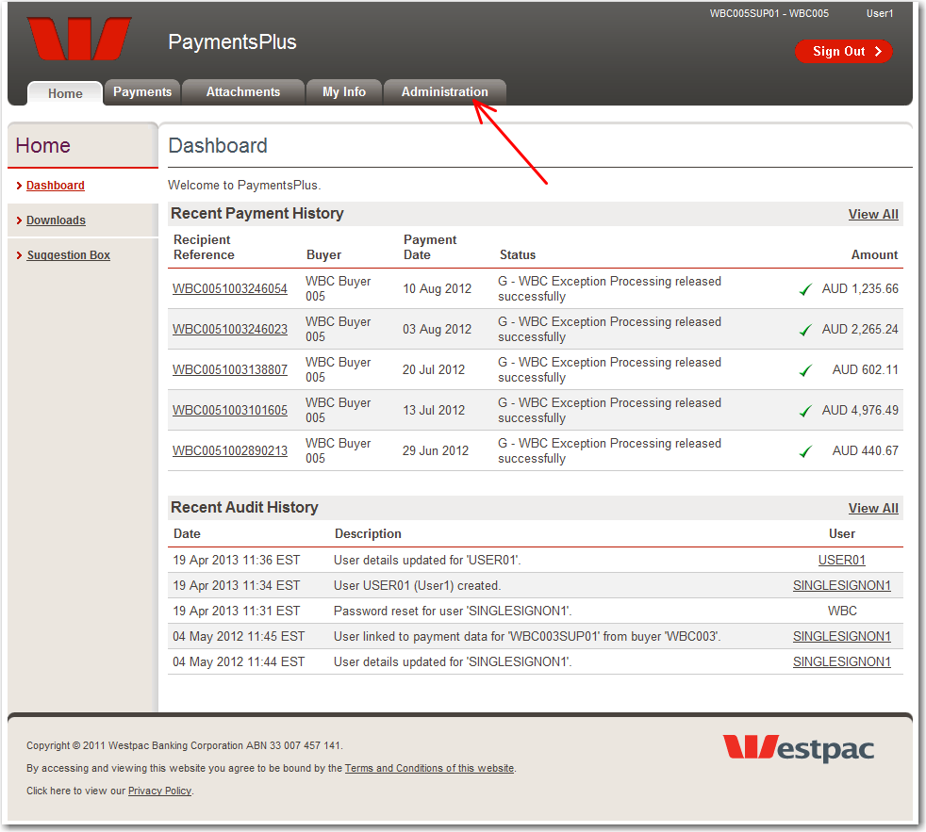

Click on the “Payment Data Access” link from the left hand side menu bar.

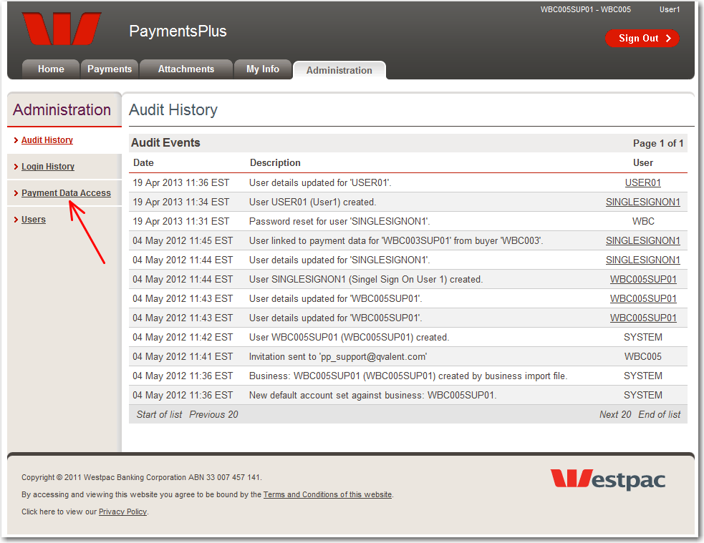

Click on the “Link to Additional Payment Data” button.

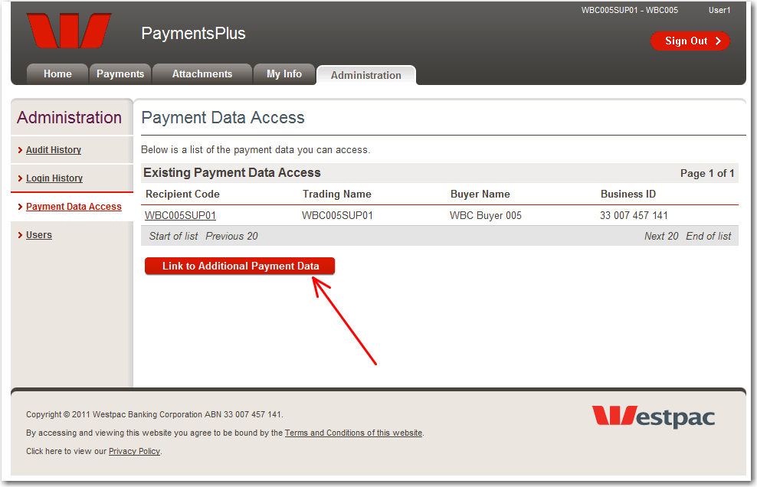

Enter the invitation code that you wish to link your currently signed in recipient user account to.

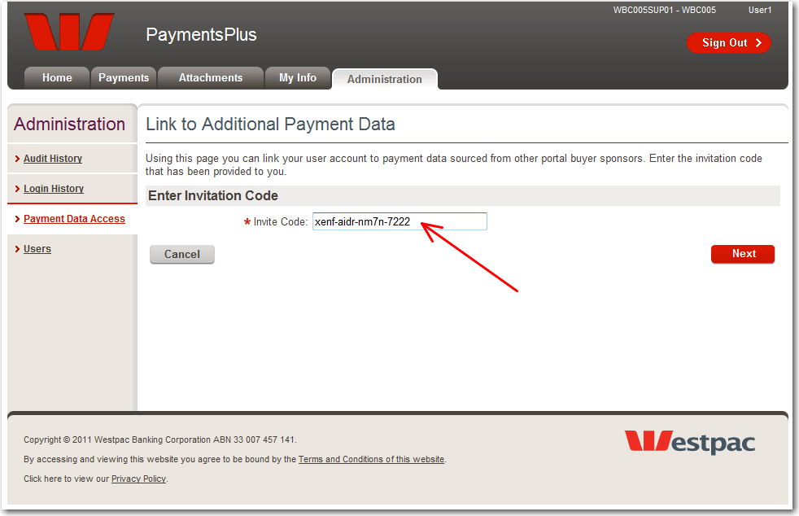

Confirm that the invitation code you entered is for the correct business that your payment or invoice data is assigned to, check the confirmation checkbox, and then click on the “Next” button.

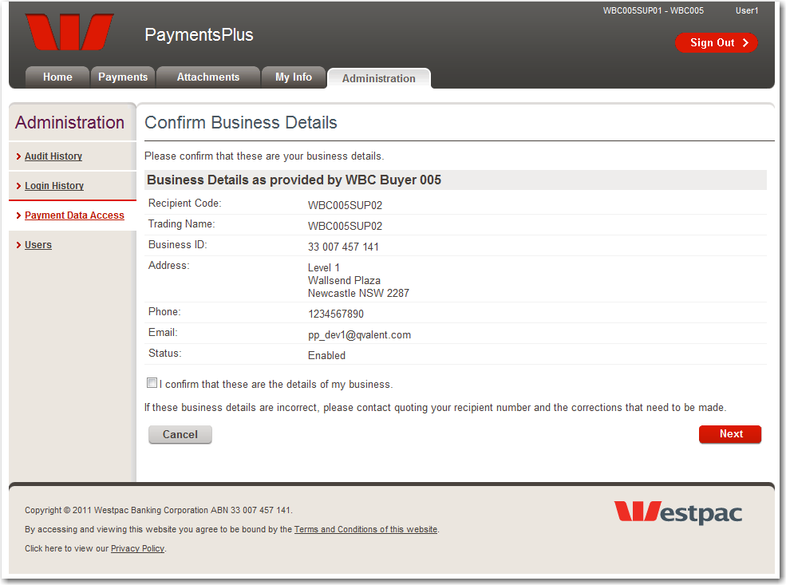

The portal will confirm that this new set of payment or invoice data has been linked to the currently signed in recipient user account.

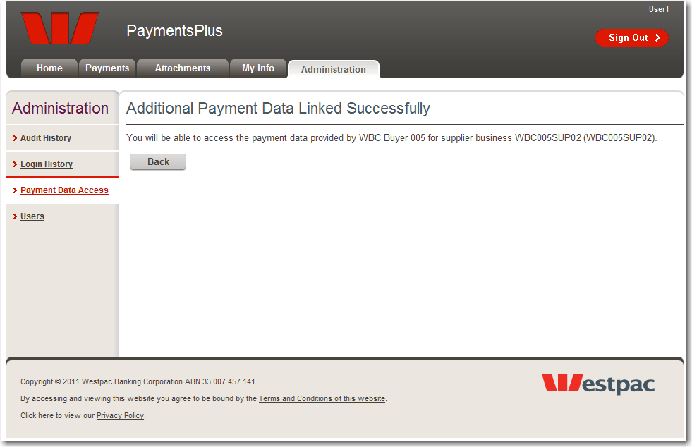

The “Payment Data Access” page will now list the additional payment or invoice data that the currently signed in recipient user account now has access to.

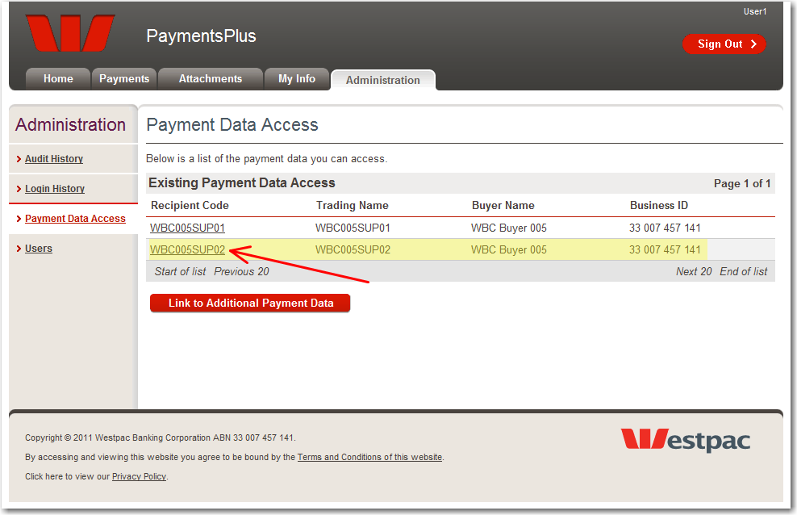

Repeat steps 5 to 8 for any other invitation codes that you wish to link to the currently signed in recipient user account to.

