
Instructions
This form is to be used by occupational therapists to make recommendations for simple home modifications.
Modifications are considered simple when changes require basic installation or fitting by a qualified tradesperson, but do not involve complex design, structural work or building permits. These modifications become fixed or semi-permanent features of the home once installed. See home modifications policy.
Examples include:
- Temporary or simple ramps, and simple platform steps
- Bathroom modifications such as removal of a shower screen, handheld shower installation, installation of a weighted shower curtain, shower insert and wedge ramps. This may include installing lever taps and grab rails
- Simple modifications to kitchen or bathroom relating to cabinetry or floor lay out.
Please note: small building fixtures such as grab rails and items that do not require professional installation e.g. a small permanent wedge ramp, can be requested using the basic equipment report template.
This form may also be used to support the need for complex home modifications (involving major building/structural work, such as widening doorways or installing stepless showers). In these cases, keep the justification brief as it will be used for consideration by the TAC home modifications panel. If progressed, the client will be referred to a TAC home modifications specialist, and a suitably qualified occupational therapist will be required to complete the complex home modifications assessment and recommendations form.
Please ensure the TAC’s occupational therapy service requirements are followed, found at: tac.vic.gov.au/ot-dashboard and recommendations in line with TAC home modification policy.

Section 1

TAC client details
First name

Last name

TAC claim number |  | Date of accident | / /

Date of birth | / /

Key contact if not client
(name/relationship/ phone number)

Section 2

assessment details
Date of assessment | / /

Is this form being used to recommend simple home modifications or for consideration to progress with a complex home modification assessment?

SECTION 3

CLIENT GOALS
Outline the client goals related to the proposed home modifications.

Section 4

Contributors to the assessment
List any people who were present at the property for the assessment or have contributed information.
Name | Relationship to client  (e.g. family member, support worker etc) | Contact phone/email | Date and type of engagement  (e.g. present at assessment, phone call)
 |  |  | / /
 |  |  | / /
 |  |  | / /

Section 5

Medical status
Accident-related injuries

Pre-existing/non accident-related injuries

Section 6

Property details & current living arrangement
Address of property assessed

Ownership status of the property
If the client does not own the property, provide the name and contact details of the person/organisation authorised to consent to the modifications at this property.

Is the property owner aware of the proposed modifications?
Description of home environment
(flat or hilly block, single or double storey, number of bedroom and bathrooms, type of flooring etc.)
Who lives/will live with the client at the property assessed (including relationships and ages) and any anticipated changes to this in the future?

Does the client intend to remain living in this home for the foreseeable future?
If no, provide further details.

For the areas where home modifications are recommended, describe the supports currently in place (funded and gratuitous/informal). Include who provides the support, for what tasks and frequency.

SectION 7

recommendations and CLINICAL JUSTIFICATION
Complete the below section for each area of the home where modifications are required, by first selecting the area of the home to be modified. Repeat for each area where modifications are recommended by copy and pasting the template.
If complex home modifications are recommended for consideration, provide a summary only. If a complex home modification assessment is approved to progress, further detail will be required to be provided on the complex home modifications assessment and recommendation template.
Area of the home to be modified

Current issue/barrier

Recommendation
Clinical justification (how will the modification address the issue and what is the expected functional or safety outcome). Describe any alternative solutions such as equipment considered.
Insert photos/drawings and add brief descriptions as relevant.
(Nb. Reducing image file sizes will make it easier to email this document)


Optional additional request. Delete the following information if further recommendations are not required:
Area of the home to be modified

Current issue/barrier

Recommendation
Clinical justification (how will the modification address the issue and what is the expected functional or safety outcome). Describe any alternative solutions such as equipment considered.
Insert photos/drawings and add brief descriptions as relevant.
(Nb. Reducing image file sizes will make it easier to email this document)

Section 8

Diagrams
Review and complete these diagrams as applicable. Diagrams do not constitute recommendations.
The diagrams and measurements are to capture the key measurements of the person, their equipment and what the modifications need to be.

Wheelchair
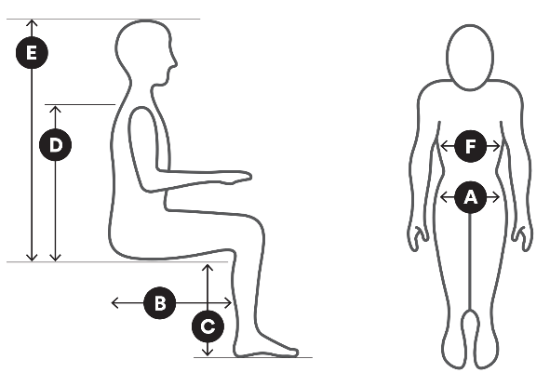 |  |  |  | 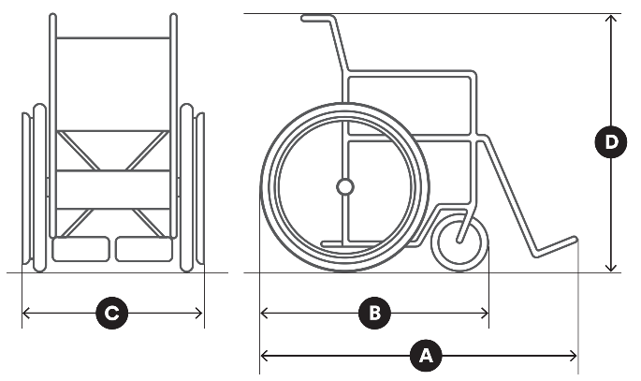
Measurements |  | mm |  | Measurements |  | mm
 | Hip width | mm |  |  | Length of chair | mm
 | Upper leg length | mm |  |  | Wheel base | mm
 | Lower leg length | mm |  |  | Chair width | mm
 | Bottom to top of shoulder | mm |  |  | Chair height | mm
 | Bottom to top of head | mm
 | Chest width | mm

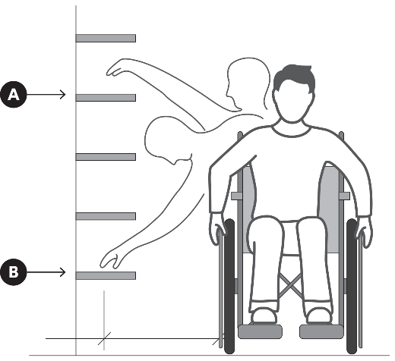 |  |  |  | 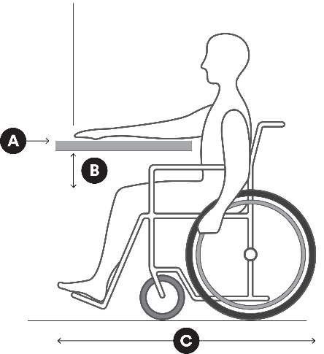
 |  |  |  | Measurements |  | mm
Measurements |  | mm |  |  | Bench height | mm
 | Functional vertical reach | mm |  |  | Leg clearance | mm
 | Functional horizontal reach | mm |  |  | Wheelchair length, incl. feet | mm

Toilet and rails
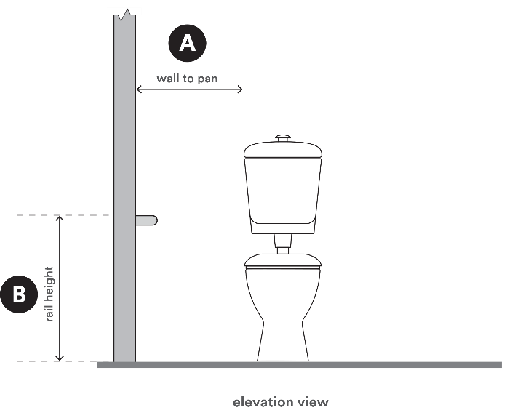 |  |  |  | 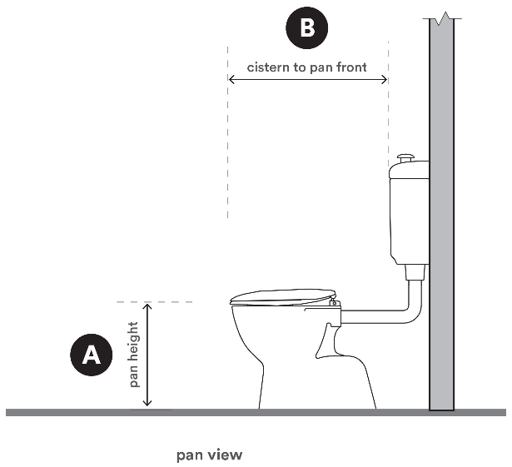
Measurements |  | mm |  | Measurements |  | mm
 | Wall to pan | mm |  |  | Pan height | mm
 | Rail height | mm |  |  | Cistern to pan front | mm
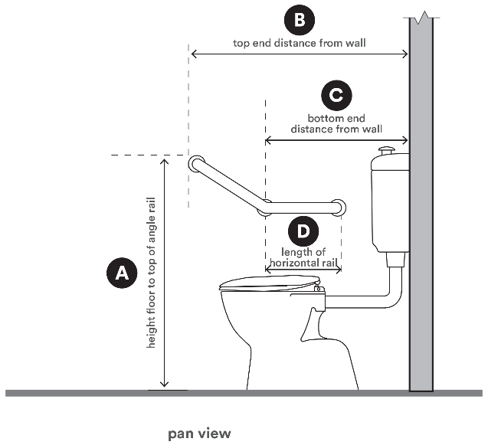
Measurements |  | mm |  | Further details if required
 | Height floor to top of angle rail | mm
 | Top end distance from wall | mm
 | Bottom end distance from wall | mm
 | Length of horizontal rail | mm

Showerhead and grab rails
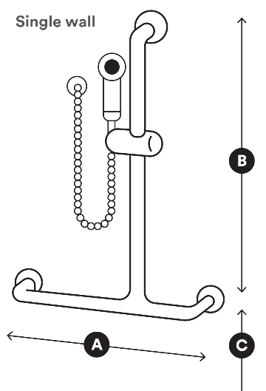 |  |  |  | 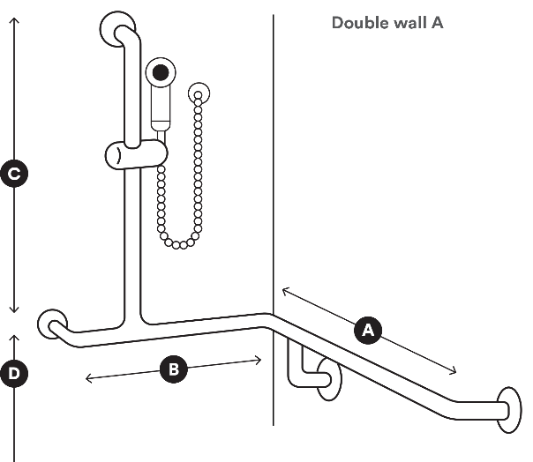
Measurements |  | mm |  | Measurements |  | mm
 | Horizontal rail length | mm |  |  | Horizontal rail length | mm
 | Vertical rail height | mm |  |  | Horizontal rail length | mm
 | Height from floor level | mm |  |  | Vertical rail height | mm
 |  |  |  |  | Height from floor level | mm

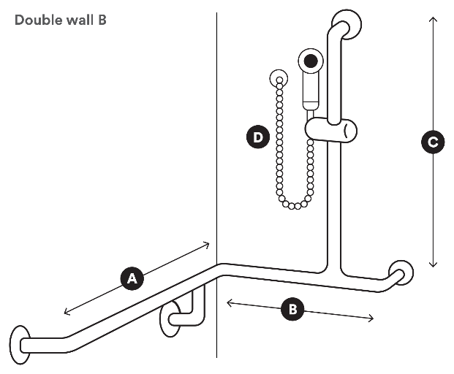
Measurements |  | mm
 | Horizontal rail length | mm
 | Horizontal rail length | mm
 | Vertical rail height | mm
 | Hose length | mm

Other
Insert your own sketches or measurements if different to what has been provided.

Measurements and details | Measurements and details

Section 9

anticipated impact on independence and paid supports
The information below is an anticipated change in funded support following the recommended home modifications. Actual support needs will be confirmed after completion of the home modifications via referral to a suitable OT to compete a review of capability assessment.

Service | Expected change | Current approved hours  (per billing period) | Estimated hours post home modifications  (per billing period)
Personal care
Therapy support
Community access
Inactive sleepovers
Active sleepovers
Domestic support /
home services
Meal preparation
Gardening
Other (please specify)

Comments

☐ | The recommendations made in this report and the anticipated changes to the client’s support needs, after the home modifications have been completed, have been discussed with the client

Section 10

quotation
Attach/insert a quote where suitable for the recommended modifications (itemised for supply/installation).
If a quote is not required or not yet available, provide further detail including an expected timeframe for submission if relevant.

Section 11

Provider details
Provider name, address,
email and phone number
(Type details or insert image of
practice stamp)

Days/hours available

Signature
Insert image (jpg/png) of signature.
(Or print, sign and scan the form)

Date | / /

Submitting this form
Email your completed form to the TAC claim decision maker or to info@tac.vic.gov.au with the client’s TAC claim number in the subject line. Please also attach any supporting documentation.

Privacy
The TAC will retain the information provided and may use or disclose it to make further inquiries to assist
in the ongoing management of the claim or any claim for common law damages. The TAC may also be required by law to disclose this information. Without this information, the TAC may be unable to determine entitlements or assess whether the treatment is reasonable and may not be able to approve further benefits and treatment. If you require further information about our privacy policy, please call the TAC on
1300 654 329 or visit our website at www.tac.vic.gov.au

