I
): . }I · :i,' '; S=
-\;,.{•
,l ; Ur..t... ,,,., ·.
, \' ,<y - i.•,1 ,.

,,
,: •'
' '
' f. '
r • •:'t/' ,• '
,.;­;
I •
. ;.1•. '
,,..r,,., y,-N, f '' ·
I I ... 1 \ ( , "1/
); / :.{,

....

Transport Accident Commission

Road Safety Monitor 2020 Report

Accreditations
Wallis Market and Social Research achieved accreditation to the International Standard ISO20252 in September 2007. The Company is committed to maintaining administrative and operational procedures which comply with these accreditation requirements and to improving its performance in all aspects of the service it delivers to its customers.

In 2020 Wallis sought and attained certification to ISO 27001. This is the highest standard for information and data security. Wallis made the strategic decision to become certified to ISO 27001 because we recognise the absolute necessity for our clients to be assured that their data is secure. Wallis is one of the first research companies in Australia to achieve certification to this standard.

Wallis is an active participant in the market research industry, with senior staff making significant contributions to the Research Society (TRS) and the Australian Data and Insights Association (ADIA). As such we actively pursue the ethical objectives of the industry.

In addition to having attained the highest Industry accreditation, Wallis also participates in the Australian Achiever Awards, which recognises the customer service excellence of Australian companies. The Company has been awarded a high commendation every year since the inception of these awards in 1999.

Wallis is an acknowledged leader in data protection and privacy. Our system is regularly subjected to external penetration testing and we are a Privacy Awareness Week supporter – committed to sharing our knowledge with others.

Level 2, 273 Camberwell Road Camberwell VIC 3124
+61 3 9621 1066 | wallis@wallisgroup.com.au | www.wallis.social

Executive summary

The 2020 Road Safety Monitor (RSM) report presents the findings collected in RSM surveys over the course of 2020. This year was marked by the COVID-19 pandemic and travel restrictions imposed by the lockdowns in response to COVID-19. It was also the final year of the ‘The Road Safety Strategy and Action Plan – Towards Zero 2016-2020’. The new ‘Victorian Road Safety Strategy 2021-2030’ continues the strong focus on reducing road trauma in Victoria with the goal of halving the number of lives lost and serious injury on Victoria’s roads by 2030.
In 2020, the RSM included additional regional sample to provide more robust data for Victorians living outside of Melbourne. This adjustment to the methodology was driven by overrepresentation of regional Victorians in road trauma statistics and an acknowledgement of the different driving and lifestyle experiences of those living in regional Victoria.

Key trends in 2020
The travel patterns reported in 2020 differ in comparison to 2019, with respondents driving less distance, less at night, less often while feeling stressed and travelling more by an active mode of transport (walking or cycling).
- While respondents continued to drive in 2020 (92% driving weekly vs 94% in 2019), they drove fewer kilometres in 2020 (27% of respondents driving 15,000 km or more per year vs 33% in 2019).
- Travelling as a passenger in a car or on a motorbike at least once per week declined from 60% in 2019 to 55% in 2020.
- Respondents were less likely to drive while feeling stressed at least once per week in 2020 (29%) compared to 2019 (34%).
- Respondents were less likely to drive between the hours on 10pm and 6am at least once per week in 2020 (20%) compared to 2019 (25%).
- Use of active transport increased, with ‘walking to go somewhere’ at least once per week increasing from 55% in 2019 to 60% in 2020 and riding a bicycle on the roads at least once per week increasing from 8% in 2019 to 10% in 2020. Notably, riding a bicycle on the road was highest in the October-December quarter (16%).
In April-June 2020, a third of respondents (32%) noticed differences in driving behaviour while COVID- 19 restrictions were in place. Just over half (54%)
reported positive changes while four in ten (40%) reported negative changes. Between July and December, just over a third or respondents (36%) noted that drivers were more patient during restrictions while one in six (16%) noted that drivers were more aggressive.

Perception of danger
Driving behaviours such as driving while over the legal BAC (an average rating of 9.6 out of 10), driving while using a handheld mobile phone (9.2) and driving while very tired (9.0) continue to be perceived as having a high level of danger. In contrast, exceeding the speed limit by a few kilometres in a 60 km/h zone (6.0) or a 100 km/h zone (6.3) and driving a short time after having one alcoholic drink (5.7) are perceived to be less dangerous.

Driving behaviours
The incidence of self-reported driving over the legal BAC in the past 12 months (5% of respondents) remains consistent in 2020 with previous years.
However, the incidence of driving under the legal BAC after drinking alcohol declined from 50% in January-March 2019 to 41% in 2020.
While most drivers (71%) used their mobile phone ‘at all’ while driving in the past three months, less than one in three (28%) held their phone while driving. The percentage of drivers using their phone hand-held while driving has declined from 37% in 2016 to 28% in 2020.
Intentionally exceeding the speed limit in a 60 km/h zone (39%) or a 100 km/h zone (40%) remained consistent with previous years.
Just under four in ten respondents (38%) report driving while feeling very tired, which is consistent with 2019 (37%). This behaviour is most prevalent among those aged 18-25 (55%).

Police enforcement
Respondents reported seeing more police on the road compared to the same time last year (24% in 2020 vs 20% in 2019). However, fewer interactions with police were reported in 2020 compared to 2019. About half of respondents (51%) report being breath- tested (vs 61% in 2019) and about one in twenty (6%) report being drug tested (vs 10% in 2019).
Compared to 2019, respondents are less likely to agree that ‘seeing police on the road makes me feel safer’ (65% vs 70% in 2019).

Table of Contents

- Introduction 1
  - Background and objectives 1
  - Research objectives 3
  - Reading this report 3
- Key shifts between 2019 and 2020 6
  - Travel 6
  - Drink driving 7
  - Enforcement 8
  - Hand-held mobile phone use while driving 10
- Impact of COVID-19 11
  - Travel patterns and COVID-19 11
  - COVID-19 specific questions 13
  - Driving behaviours and COVID-19 16
- Detailed Findings 17
  - How people get around 17
  - Driving behaviour 26
  - Vehicle ownership 30
  - Road user attitudes and behaviours 34
  - Speeding 39
  - Impaired driving 51
  - Fatigue 58
  - Distractions 59
  - Pedestrian distractions 62
  - Police enforcement 66
  - Social norms 73
  - Infrastructure 75
  - Towards zero 76
  - Crashes 82
  - Seatbelts 85
  - Cycling 87
  - General attitudes to transport and road safety 88
- Summary of findings 97
  - How people get around 97
  - Vehicle ownership 97
  - Driving behaviour 97
  - Speeding 98
  - Drugs and alcohol 98
  - Fatigue 99
  - Distractions 99
  - Pedestrian distractions 99
  - Enforcement 100
  - Social norms 100
  - Infrastructure 100
  - Towards zero 100
  - Crashes 101
  - Seatbelts 101
  - Cycling 101
  - General attitudes to transport and road safety 102
- Research methodology 103

Appendix 1 Question list for 2020 RSM Appendix 2 Reminder letter
Appendix 3 Example questionnaire (hard copy and Primary Approach Letter)

List of Figures

Figure 1 Driving while under the legal BAC after drinking alcohol (2019 vs 2010) 7
Figure 2 Number of police on the road compared to the same time last year (2019 vs 2020) 8
Figure 3 Interactions with police (2019 vs 2020) 8
Figure 4 Perceptions of police (% agree) (2019 vs 2020) 9
Figure 5 Use of a hand-held mobile phone while driving (time series) 10
Figure 6 Changes in driving behaviour during pandemic lockdowns (April-June 2020) 15
Figure 7 How people get around 17
Figure 8 Frequency of driving among the 18-25 age group 18
Figure 9 Type of vehicle usually driven infographic 33
Figure 10 Perceived danger – incidence matrix 38
Figure 11 Perceptions of Danger (speeding highlighted) 39
Figure 12 Definition of speeding by year 42
Figure 13 Intentionally driving over the speed limit in a 60 km/h zone over time by year 43
Figure 14 Intentionally driving over the speed limit in a 100 km/h zone over time 44
Figure 15 Driving over the speed limit 60 km/h infographic 44
Figure 16 Driving over the speed limit 100 km/h infographic 45
Figure 17 Attitudes towards speeding 46
Figure 18 Caught speeding by year 50
Figure 19 Use of drugs and alcohol by year 51
Figure 20 Pedestrian distractions on a mobile phone 65
Figure 21 Effectiveness of police in catching someone while driving illegally 66
Figure 22 Effectiveness of current penalties 68
Figure 23 Frequency of friends engaging dangerous driving 73
Figure 24 Support for road safety infrastructure 75
Figure 25 Lowest achievable number of lives lost in one year over the next 30 years 78
Figure 26 Actions taken by the Victorian government to achieve Towards Zero 80
Figure 27 Community understanding of the number of road fatalities per year 81
Figure 28 Community understanding of the number of serious injuries per year 81
Figure 29 Main cause of serious injury and loss of life in Victoria 83
Figure 30 Someone Injured in a car crash to the point of going to hospital by year 84
Figure 31 Agreement with statements relating to cyclists 87
Figure 32 Attitudes towards speeding statements 88
Figure 33 Relative importance of issues relating to roads and transport 93

List of Tables

Table 1 Significance reporting example table 5
Table 2 Weekly travel by mode by quarter in 2020 12
Table 3 Distance travelled by quarter in 2020 12
Table 4 Noticed differences in driving behaviour (April-June 2020) 13
Table 5 Differences in driving behaviour (July-December 2020) 14
Table 6 Driving behaviours by year and by quarter in 2020 16
Table 7 Frequency of driving a car – gender by age 18
Table 8 Frequency of riding a motorcycle on the road by demographic 19
Table 9 Frequency of riding a bicycle on the road by demographic 20
Table 10 Frequency of driving a heavy vehicle on the road by demographic 21
Table 11 Frequency of going somewhere by public transport by demographic 22
Table 12 Frequency of taking a commercial ride share by demographic 23
Table 13 Frequency of walking by demographic 24
Table 14 Frequency of travelling in a car or on a motorbike as a passenger by demographic 25

Table 15 Frequency of commuting to and from work in a car by demographic 26
Table 16 Frequency of driving between 10pm and 6am by demographic 27
Table 17 Frequency of driving while feeling stressed by demographic 28
Table 18 Frequency of driving while feeling stressed by behaviour (18-60 years) by behaviour 29
Table 19 Bought a car in the last 12 months by demographic 30
Table 20 Most important things when buying a car by demographic 31
Table 21 Type of vehicle usually driven by demographic 32
Table 22 Perceptions of danger 34
Table 23 Perception of danger by demographic 35
Table 24 Perception of the danger of speeding by demographic 40
Table 25 Perception of the danger of speeding by behaviour 41
Table 26 Attitudes towards speeding by year 47
Table 27 Attitudes towards speeding by demographic 48
Table 28 Attitudes towards speeding by behaviour 49
Table 29 Caught speeding in the past 12 months by demographic 50
Table 30 Use of alcohol and recreational drugs by demographic 51
Table 31 Use of alcohol and recreational drugs by behaviour 52
Table 32 Illegal drink driving by demographic 53
Table 33 Legal drink driving by demographic 54
Table 34 Number of drinks by demographic 55
Table 35 Use of alcohol and recreational drugs by demographic 56
Table 36 Frequency of driving after using recreational drugs by year 57
Table 37 How often driven when very tired in the past three months by demographic 58
Table 38 Use of a mobile phone while driving by demographic 60
Table 39 Awareness of mobile phone detection cameras by demographic 61
Table 40 Impact of cameras on the frequency of using a handheld mobile phone while driving by demographic 61
Table 41 Frequency of crossing the street with headphones by demographic 62
Table 42 Frequency of crossing the street looking at a mobile phone by demographic 63
Table 43 What distracts pedestrians by demographic 64
Table 44 Near misses due to pedestrian distractions by demographic 65
Table 45 Perception of police effectiveness by demographic 67
Table 46 Effectiveness of current mobile phone penalties by behaviour 68
Table 47 Perceptions of police by demographic 69
Table 48 Perceptions of police by behaviour 70
Table 49 Perception of police presence by demographic 71
Table 50 Interaction with police on the roads (NET and frequency) 72
Table 51 Frequency of friends engaging dangerous driving by demographic 74
Table 52 Frequency of friends engaging dangerous driving by behaviour 74
Table 53 Awareness of Towards Zero Strategy by demographic 76
Table 54 Belief that Victoria should aim for zero by demographic 77
Table 55 Lowest number of lives lost within one year by demographic 79
Table 56 Involvement in crash in the past five years by demographic 82
Table 57 Involvement in crash in the past five years by behaviour 82
Table 58 Change in behaviour after a crash by demographic 84
Table 59 Wearing seatbelts while driving by demographic 85
Table 60 Wearing seatbelts while driving by behaviour 85
Table 61 Wearing a seatbelt while travelling in a vehicle as passenger by demographic 86
Table 62 Wearing a seatbelt while travelling in a vehicle as passenger by behaviour 86
Table 63 Attitudes towards travel speed by demographic 89
Table 64 Attitudes towards travel speed by behaviour 90
Table 65 Attitudes towards quality of driving by demographic 91
Table 66 Attitudes towards quality of driving by behaviour 91
Table 67 Attitudes towards car usage by demographic 92
Table 68 Attitudes towards local traffic by demographic 92
Table 69 Perceived importance of the quality of the road and transport system by demographic 94
Table 70 Perceived importance of the access to transport options by demographic 95

Table 71 Perceived importance of quality of life issues and the environment by demographic 96
Table 72 Fieldwork schedule 105
Table 73 Sample performance 106

Introduction

Background and objectives
This section provides background to this report, including the research objectives and methodology.

The TAC and road safety

The Transport Accident Commission (TAC) is a government-owned organisation which was established in Victoria in 1986 through the Transport Accident Act (1986). Funding for the TAC is derived from vehicle registrations fees collected by VicRoads. The TAC has three main roles, each of which is directed towards reducing the impact of adverse health effects caused by traffic accidents:

To improve road safety | To improve the State’s trauma system | To support those who have been injured on Victorian roads
The focus of the Road Safety Monitor (RSM) is largely on the first role – promoting road safety. This important role is somewhat atypical of organisations that administer compensation schemes, but the TAC has been very successful in promoting road safety. The most visible aspect of this role for the public is the social public education efforts, which have been on air in Victoria since 1989. However, promoting road safety is a collaborative process involving the TAC, VicRoads, Department of Justice and Victoria Police, as well as many other organisations including research institutes, health organisations, industry, and other government departments at all levels. This work involves understanding the many facets of and trends in road safety in Victoria, determining interventions that balance mobility and safety to benefit road users, and implementing these interventions.

Road fatalities and interventions over time

Prior to the establishment of the TAC, one of the most significant road safety interventions introduced was compulsory seatbelts in 1970. At that time, there were 1,061 road deaths in Victoria - the highest ever recorded. Following this intervention, random breath tests were introduced in 1976, red light cameras in 1983, and speed cameras in 1986.
The TAC still invests in strategies that promote safe driving by drivers and motorcycle riders. However, the TAC is also delivering safer roads through promotion and support for Victoria Police activities, increased partnership with VicRoads, and through the Safe System Road Infrastructure Program (SSRIP). The primary initiatives of SSRIP include flexible barriers on the sides and centres of roads in high risk locations and audio tactile line markings.
These initiatives are part of the Towards Zero strategy, which is discussed in the next section.

Towards Zero

‘The Road Safety Strategy and Action Plan – Towards Zero 2016-2020’, usually known simply as simply ‘Towards Zero’, aimed to reduce fatalities on Victoria’s roads to fewer than 200 per annum by 2020, as well as reduce serious injuries by 15% over five years.
Towards Zero is inspired by the Swedish Vision Zero model that takes a series of core tenets and applies them across a wide range of areas with the objective of reducing road fatalities to zero. Unlike previous approaches which have been, by comparison, siloed and largely focused on driver behaviour, Visions Zero takes a comprehensive and systemic approach that is guided by the following principles (paraphrased and expanded here):

- It is not acceptable for people to be killed as a result of using the transportation system.

- An effective transportation system must provide mobility.

- Humans are vulnerable.

- Humans make mistakes.

- The transportation system must be designed to allow mobility, while being tolerant of human vulnerability and error.

- There is a shared responsibility to make our roads safe (both organisational and individual).

While driving behaviour is still an important part of Towards Zero, and community engagement as well as enforcement will continue, there is an increased emphasis on planning and implementing safe infrastructure. For instance, there has been an allocation of $1 billion in funding for safe infrastructure over five years. There is also an allowance in that allocation to take measures to improve the safety of the Victorian vehicle fleet.
While the TAC is the lead organisation for implementation, Towards Zero at its heart is a collaborative effort between VicRoads, Victoria Police, the Department of Justice and Regulation, the Department of Health as well as many other organisations - with each having a part to play.

Lives lost

Road safety continues to be a pressing issue for Victoria. Although significant reductions in lives lost on Victorian roads have been achieved over time, 2016 saw the largest increase in lives lost since 2001. In 2016 292 people were killed, up from 252 in 2015 – an increase of 16% overall.
In 2017, the number of lives lost fell to 258 – below the 2012-2016 five-year average of 263 lives lost per year. In 2018, there was a further reduction in the number of lives lost, with 213 lives lost that year.
There was an increase in the number of lives lost in 2019, with 266 deaths recorded on Victorian roads. This was a 25% increase on 2018 and above the five-year average of 252 for 2014-2018. Fatalities were higher in the first half of the year with 150 occurring between January and June versus 116 between July and December.
Over 2020, 211 lives were lost on Victorian roads due to road trauma. While this is the lowest annual number of lives lost since (and before) the establishment of the TAC, the reduced travel due to the COVID-19 pandemic provided a different road environment to previous years.
Victorian Road Safety Strategy 2021-2030
Looking beyond 2020, the ‘Victorian Road Safety Strategy 2021-2030’ is designed to reduce and eventually eliminate the unacceptable loss of life on Victoria’s roads. It aims to halve lives lost and reduce serious injuries by 2030.
The focus of the Strategy is on creating a safe road environment and supporting road users to make safe choices by:
ensuring all Victorians are safe and feel safe, on and around our roads
seeing progressive reduction in fatalities and serious injuries from road trauma over the next 10 years embedding a culture of road safety within the Victorian community
delivering initiatives that have an immediate impact while also preparing for future changes to road safety technology.
The Strategy also acknowledges that road safety is complex and that it takes a collective response from government agencies, the TAC’s industry partners, and the Victorian community to deliver safer roads.

Research objectives
The primary research objectives of the RSM are to:

Monitor road safety behaviour and the factors which influence behaviour, including attitudes and social norms.
Identify behaviours and attitudes that are relevant to road safety.

In addition, the secondary objectives of the RSM are to:

Profile those who are model road users and those who are at risk on Victorian roads.
Provide evidence to assist with the evaluation of road safety programs.

Reading this report
Rounding and multiple response questions

The sums of percentages in tables have been rounded to the nearest integer. This means that in some tables the total may add to 99% or 101% rather than 100%. This is due to rounding and is not an error.
Where questions allow multiple responses from respondents, the sum of response percentages may add to more than 100%. In these cases, the total percentage reflects the average number of responses per respondent. i.e., a multiple response question which adds to a total of 243% has an average of 2.43 responses per respondent.

Time series reporting

The profile for Victorians in scope to participate in the RSM changed in 2012. Prior to 2012, only drivers aged 18- 60 years who held a current drivers’ licence were eligible to participate in the study. From 2012, Victorians aged 18-90 are eligible to take part. To allow valid comparison with pre-2013 data where a time series is presented, results for surveys since 2012 are filtered to respondents aged 18-60 years who have a valid driving licence.
Elsewhere, results are presented for the total sample.

Sub-group reporting

Location sub-groups were changed in 2017. Until 2016, location was defined as either ‘Melbourne’ or ‘Elsewhere in Victoria’. From 2017, however, locations have been defined per ABS SOS definitions. The table below indicates how these locations are now defined.

Major Urban | Major Urban represents a combination of all Urban Centres with a population of 100,000 or more (for example, Melbourne, Geelong, Ballarat).
Other Urban | Other Urban represents a combination of all Urban Centres with a population between 1,000 and 99,999 (for example, Warrnambool, Sale, Benalla).
Rural Balance | Rural Balance represents the Remainder of State/Territory and includes Bounded Localities (centres with population of between 200 and 999 (for example, Taradale, Venus Bay, Fish Creek) and smaller centres.

In addition to demographic variables used to analyse differences between groups, results are regularly shown for five driving behaviour sub-groups. The following table explains how each of these groups has been derived. Codes refer to the questions in the question list provided in Appendix 1.
Speeding
Frequently exceeds the posted speed limit, even if only by a few km/h (DB1A or DB1B) is ‘All of the time’, ‘Most of the time’, ‘Half of the time’ or ‘Some of the time’.
Drink driving
Answered ‘Yes’ to DK3: In the last 12 months, have you driven a car when you knew or thought you were over your legal blood alcohol limit, even slightly?
Mobile phone use
Makes or answers calls, or writes or reads text messages (DB2C, DB2D, DB2E or DB2F) is ‘All of the time’, ‘Most of the time’, ‘Half of the time’ or ‘Some of the time’.
Driving fatigued
Drives when feeling very tired (DB2G) ‘All of the time’, ‘Most of the time’, ‘Half of the time’ or ‘Some of the time’.
Involvement
in an accident
Answered ‘Yes’ to CR1: In the last five years, have you been involved in any crashes on the road as a driver or rider?

Statistical significance and question codes

The data in this report have been tested for statistical significance, typically between subgroups. Tests are conducted between the subgroup and the total excluding the subgroup and are at the 95% confidence interval, unless stated otherwise. A multiple comparison correction has been used to adjust the statistical significance where several comparisons are made in the one table.
To illustrate, in Table 1 below, the blue arrow indicates that 18-25 year olds are significantly more likely to use recreational drugs than those of all other ages combined. Similarly, the red arrows indicate that 61-90 year olds are significantly less likely to use recreational drugs than those of all other ages combined.

Information below each table shows question numbers as codes. An example is provided in Table 1 below where DK2 and DG3 reference question numbers in the questionnaire. A copy of the questionnaire, which includes the question codes, is provided in Appendix 1.
Table 1 Significance reporting example table

Column % | Total | 18 - 25 | Age  26 - 39 40 - 60 | 61 - 90 | Gender  Male Female |  | Major Urban | Location  Other Urban | Rural Balance
Drinks alcohol | 76 | 82 ↑ | 75 78 | 72 ↓ | 79 ↑ | 73 ↓ | 76 | 76 | 81
Uses recreational drugs | 8 | 19 ↑ | 12 ↑ 5 ↓ | 3 ↓ | 10 ↑ | 6 ↓ | 9 | 7 | 8
Sample size | 2476 | 394 | 639 825 | 618 | 1245 | 1231 | 1448 | 707 | 321

DK2 - Do you ever drink alcohol?
DG3 - In the last 12 months, have you used recreational drugs (for example, methamphetamine, ice, marijuana etc.)? Filter: Licence holders aged 18-60 with a valid response

Weighting

The sample for the survey is drawn from the VicRoads Registration and Licensing Database and has a correction applied for known response rates of the previous waves of the survey. Therefore, the profile of the sample is generally very close to the Victorian population. Weighting by location, age and gender is then applied to correct the sample to the known licence holder population as derived from the VicRoads Registration and Licencing Database.
The weighting efficiency is 82% (meaning there is an effective base of 2,058 from a sample of 2,505 respondents).

Key shifts between 2019 and 2020
This section discusses key shifts in attitudes and behaviours measured in the RSM from 2019 to 2020.

Travel
From a road safety perspective, the COVID-19 restrictions caused a range of changes in travel patterns. We cover these changes in more detail in Section 3. However, the key trends recorded in the RSM, at a glance, are:
Driving at all in a week remained stable with 2019 (92% in 2020 vs 94% in 2019).
Driving distance declined (33% drove15,000 km or more per year in 2019 vs 27% in 2020).
Night-time driving (between the hours of 10pm and 6pm) at least one per week declined from 25% in 2019 to 20% in 2020.
Feeling stressed while driving at least once per week declined from 34% in 2019 to 29% in 2020.
Travelling in a car as a passenger at least once per week declined from 60% in 2019 to 55% in 2020. Taking public transport at least once per week declined from 23% in 2019 to 21% in 2020.
Going somewhere by walking at least once per week increased from 55% in 2019 to 60% in 2020.
While there was a small year-on-year change for riding a bicycle on the road (8% report riding weekly in 2019 vs 10% in 2020), there was a larger increase in weekly bicycle riding in the Oct-Dec quarter 2020 (16%).
While these shifts may seem small, they are recorded over the entire year and have historically been stable year- on-year. The results indicate that over 2020 Victorians still drove, but drove less distance, drove less at night-time and were driving stressed less often. Victorians were also less likely to take public transport and more likely to walk or, later in the year, ride a bicycle.

Drink driving
The incidence of self-reported drink driving in 2020 (5%) is stable compared to 2019 (5%). However, as shown in Figure 1, among all drivers the rate of ‘legal drink driving’ (driving under a person’s legal BAC after drinking alcohol) declined from 50% in 2019 to 41% in 2020. High frequency ‘legal drink driving’ (ten or more times) declined from 9% of all drivers in 2019 to 4% of all drivers in 2020.
Figure 1 Driving while under the legal BAC after drinking alcohol (2019 vs 2010)

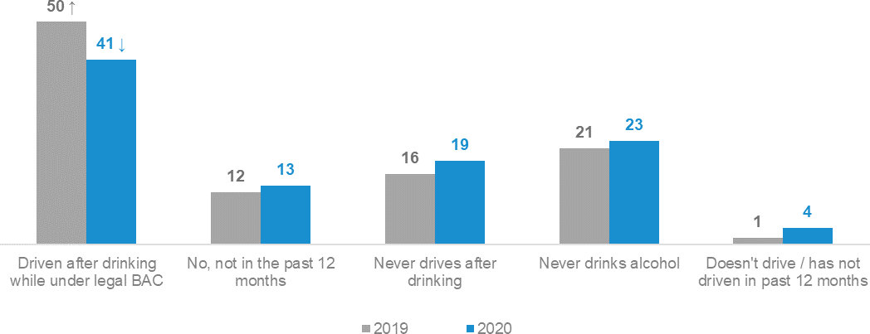

DK8 - In the last 12 months, have you driven a car after drinking alcohol when you knew or thought you were under the legal blood alcohol limit? Filter: Total sample; Weighted sample; 2019 base n= 422; 2020 base n=1927

Enforcement
As shown in Figure 2, respondents reported an increase in the number of police on the road in 2020 compared to 2019, with a quarter of respondents (24%) reporting more police on the road in 2020 versus one in five (20%) in 2019 (and 16% in 2018). This increase was compensated by a decrease in the percentage reporting ‘the same number of police compared to this time last year’ (36% in 2020 vs 43% in 2019). The percentage of respondents reporting ‘fewer police on the road’ remained stable (16% in both 2019 and 2020).
Figure 2 Number of police on the road compared to the same time last year (2019 vs 2020)

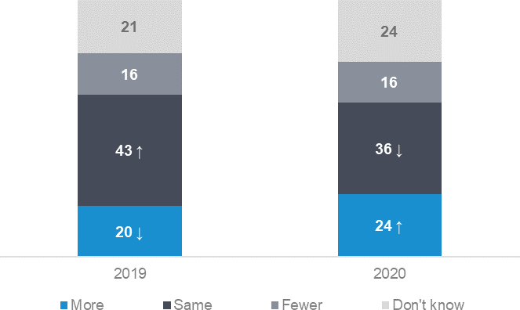

POL1: Do you believe that compared to this time last year, there are fewer, more or the same number of police on the roads? Total sample; weighted data; 2019 base n= 887; 2020 base n=1200

Despite a perception of more police on the road, as shown in Figure 3, respondents were less likely to report having interactions with police. The percentage of respondents reporting they had been pulled over, breath tested, or drug tested declined from 63% in 2019 to 54% in 2020. Being pulled over for any reason remained stable (30% in 2020 vs 32% in 2019), while being breath tested declined (51% in 2020 vs 61% in 2019) and being drug tested
declined (10% in 2020 vs 6% in 2019).
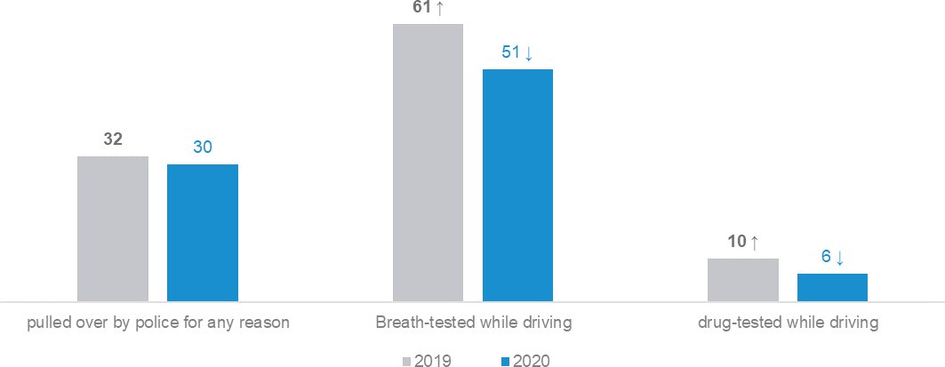
Figure 3 Interactions with police (2019 vs 2020)

EN3 In the past 12 months, how many times have you been… Drivers; weighted data; 2019 base n= 855; 2020 base n=1155

Perceptions of police enforcement changed from 2019 to 2020. As shown in Figure 4, while there was a decrease in agreement with the statement that ‘Enforcing speed limits just raises revenue and doesn’t make our roads safer’ (30% in 2019 vs 25% in 2020), agreement that ‘Seeing police on the roads makes me feel safer’ also declined (65% in 2020 vs 70% in 2019).
Further analysis shows that this change in perception of police enforcement is most prevalent among those aged 40-90 years. Among this age group, agreement with the statement that ‘Seeing police on the roads makes me feel safer’ declined from eight in ten (81%) in 2019 to seven in ten (70%) in 2020. Agreement that ‘Police play an important role in reducing fatal crashes on Victoria’s roads’ also declined from three-quarters (75%) in 2019 to seven in ten (69%) in 2020. Agreement among 18-39 year olds with these statements remained stable from 2019 to 2020.
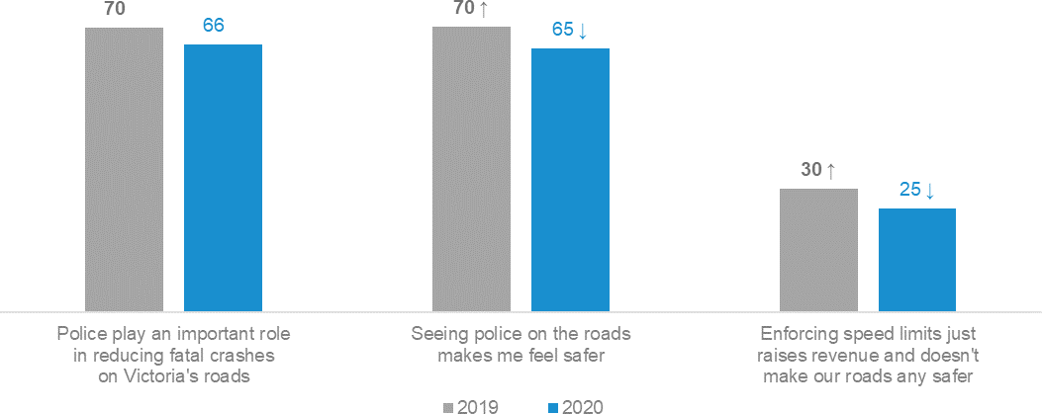
Figure 4 Perceptions of police (% agree) (2019 vs 2020)

EN2 to what extent do you agree or disagree with the following statements… Total sample; weighted data; 2019 base n= 886; 2020 base n=1192

Hand-held mobile phone use while driving
While use of a hand-held mobile phone while driving is stable in 2020 compared to 2019, this behaviour exhibits a long-term downwards trend. As shown in Figure 5, reported use of a hand-held mobile phone while driving is at 28% in 2020. In 2016 37% of drivers reported using a hand-held mobile phone while driving. Incremental declines year-on-year have led to lower incidence of this driving behaviour compared to five years ago.
Drivers still use mobile phones while driving but are less likely to use them hand-held. Considering ‘answering a call behaviour’ for example, they are more likely to answer a call via Bluetooth (64%) than by picking up their mobile phone (13%).
Figure 5 Use of a hand-held mobile phone while driving (time series)

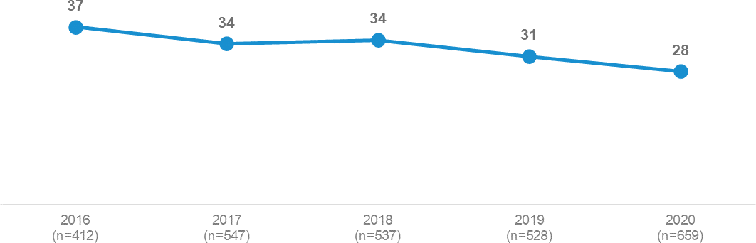

DB2ABCD In the past three months, how often did you X (Any of Some / Half / Most / All the time)
NET: Read a text message while driving, answer a call with a hand-held phone while driving, write and send a text message while driving, make a call with a hand-held phone while driving, use a messaging app while driving.
Filter: Drivers; weighted sample

Impact of COVID-19
The COVID-19 pandemic had a significant impact on how people travelled in Victoria over 2020. On 16 March 2020, a state of emergency was declared in Victoria with restrictions on activities and directions to stay at home. These restrictions eased in mid-May. On 30 June, Victoria entered a second lockdown. On 7 July, Metropolitan Melbourne and Mitchell Shire were placed into strict lockdown while more moderate measures were in place in regional Victoria. On 2 August, a state of disaster was declared in Victoria from 6 p.m. that day, with the increased restrictions set to last for at least six weeks; Metropolitan Melbourne moved to stage 4 restrictions and regional Victoria to stage 3 restrictions. On 8 November, the lockdown eased, with some restrictions remaining in place across all Victoria.
This section examines travel and behaviour by quarter over 2020 to highlight any notable patterns which may be the result of COVID-19 lockdowns. Additionally, specific questions relating to the pandemic are reported.
The following summarises the approximate correlation between lockdowns and quarters over 2020: Quarter 1 (Jan-Mar): Unaffected by COVID-19
Quarter 2 (Apr-Jun): First lockdown
Quarter 3 (Jul-Sep): Second lockdown
Quarter 4 (Oct-Dec): Moderate restrictions
It is important to bear in mind that for many questions in the RSM, respondents are asked to consider time periods such as the previous three months or the previous twelve months. As such, activities may encompass periods greater than that in which they are reported.

Travel patterns and COVID-19
Table 2 on the next page shows the weekly use of a range of transport modes by quarter over 2020. With regard to using these modes of transport at all in a given week, most remained stable throughout the year. Differences which are observed include:
Travelling by public transport declined from 26% in Jan-Mar 2020 to 16% in Oct-Dec 2020
Riding a bicycle on the road increased to 13% in Oct-Dec, averaging 9% across the previous three quarters of 2020.

Table 2 Weekly travel by mode by quarter in 2020

Column %
Quarter
Jan-Mar Apr-Jun Jul-Sep Oct-Dec

Drive a car 92 94 91 93
Walk 55 60 61 63
Travel in a car or on a motorbike as a passenger 56 59 54 51
Take public transport 26 ↑ 22 19 16 ↓
Ride a bicycle (on the road) 9 8 9 13 ↑
Take a taxi or similar (e.g. Uber) 8 5 5 4
Drive a heavy vehicle 2 2 4 3
Ride a motorcycle (on the road) 2 2 1 2
Sample size 472 517 786 730

M1A-D / M2A-D: How often do you (go somewhere by)… Total sample; Weighted sample
Blue up arrows (↑) and red down arrows (↓) indicate statistically significant difference compared to respondents not in that category. Figures may not add to 100% due to rounding

Respondents were asked how many kilometres they have driven in the previous year. In Oct-Dec 2020, a third (33%) of drivers reported they had driven 0-4,999 km compared to Jan-Mar 2020 where just over one in five (22%) reported driving this distance. Considering drivers who report driving 15,000 km or more in the previous year, the percentage declined from about a third (34%) in Jan-Mar 2020 to about a quarter (23%) in Oct-Dec 2020.
Table 3 Distance travelled by quarter in 2020

Column %
Quarter
Jan-Mar Apr-Jun Jul-Sep Oct-Dec

0 - 4,999 (0 to 96km per week) | 22 ↓ | 25 | 29 | 33 ↑
5,000 - 9,999 (97 to 192km per week) | 22 | 26 | 25 | 26
10,000 -14,999 (193 to 288km per week) | 21 | 22 | 18 | 18
15,000 -19,999 (289 to 385km per week) | 18 ↑ | 14 | 12 | 9 ↓
20,000 - 29,999 (386 to 577km per week) | 9 | 8 | 10 | 8
30,000+ (578km+ per week) | 7 | 4 | 7 | 6
15,000km or more per year | 34 ↑ | 27 | 28 | 23 ↓
Sample size | 453 | 502 | 748 | 708
D0: In the past year, how many kilometres have you driven? Filter: Drivers; Weighted sample
Blue up arrows (↑) and red down arrows (↓) indicate statistically significant difference compared to respondents not in that category. Figures may not add to 100% due to rounding

COVID-19 specific questions
In the Apr-Jun quarter of 2020, respondents were asked whether they had noticed any difference in driving behaviour and, if they had, what differences they had observed.
As shown in Table 4, about a third (32%) noticed differences in driving behaviour in the Apr-Jun quarter. Respondents living in Major Urban areas (35%) were more likely to notice a difference than those living in Other Urban (24%) or Rural Balance (20%) areas.
Table 4 Noticed differences in driving behaviour (April-June 2020)

Column % |  | Total | 18 - 25 | Age  26 - 39 40 - 60 |  | 61 - 90 | Gender  Male Female |  | Major Urban | Location  Other Urban | Rural Balance
Yes |  | 32 | 41 | 26 | 37 | 26 | 32 | 32 | 35 ↑ | 24 ↓ | 20 ↓
No |  | 68 | 59 | 74 | 63 | 74 | 68 | 68 | 65 ↓ | 76 ↑ | 80 ↑
Sample size |  | 792 | 124 | 211 | 269 | 188 | 409 | 383 | 384 | 277 | 131

C19a: We’d like you to think about the COVID-19 restrictions. During this time, aside from there being fewer vehicles on the road, have you noticed any difference in how people drive?
Total sample (Apr-Jun 2020); Weighted sample
Blue up arrows (↑) and red down arrows (↓) indicate statistically significant difference compared to respondents not in that category. Figures may not add to 100% due to rounding

Table 5 shows perceived differences in driving behaviour from July to December 2020. During this period respondents were asked whether they believed drivers during the pandemic were more patient, more aggressive or there was no difference. Respondents aged 18-25 (25%) are more likely to believe drivers were more aggressive than those aged 61 and older (10%). Respondents in Major Urban areas (38%) are more likely than those in Rural Balance areas (26%) to believe that drivers were more patient. Respondents in Other Urban (56%) and Rural Balance (61%) areas are more likely to have reported ‘no difference’ than those in Major Urban areas (45%).
Table 5 Differences in driving behaviour (July-December 2020)

Column % | Total | 18 - 25 | Age  26 - 39 40 - 60 |  | 61 - 90 | Gender  Male Female |  | Location  Major Other Rural Urban Urban Balance
NET: More patient | 36 | 28 | 36 | 38 | 37 | 35 | 36 | 38 ↑ 32 26 ↓
NET: More aggressive | 16 | 25 ↑ | 19 | 13 | 10 ↓ | 16 | 16 | 17 12 12
Much more patient | 11 | 6 | 12 | 12 | 12 | 11 | 11 | 12 9 6
More patient | 24 | 23 | 23 | 26 | 25 | 24 | 25 | 25 23 20
No difference | 48 | 47 | 45 | 48 | 53 | 49 | 48 | 45 ↓ 56 ↑ 61 ↑
More aggressive | 13 | 22 ↑ | 15 | 11 | 8 ↓ | 13 | 13 | 14 10 12
Much more aggressive | 3 | 3 | 4 | 2 | 3 | 3 | 3 | 4 2 1
Sample size | 1500 | 233 | 382 | 496 | 389 | 737 | 763 | 721 532 247

C19C: Please think about the COVID19 restrictions. During this time would you say the driving you observed was… Total sample (Jul-Dec 2020); Weighted sample
Blue up arrows (↑) and red down arrows (↓) indicate statistically significant difference compared to respondents not in that category. Figures may not add to 100% due to rounding

As shown in Figure 6 below, perceptions of positive and negative driving behaviours were mixed, with just over half (54%) noticing positive driving behaviours such as people driving slower (25%) or being more patient (15%). Four in ten (40%) noticed negative driving behaviours such as driving faster (22%) or more recklessly (19%).
Further analysis reveals that respondents in Major Urban areas (57%) are more likely to have noticed positive behaviours than those living in Other Urban or Rural Balance areas (40%).
Figure 6 Changes in driving behaviour during pandemic lockdowns (April-June 2020)

NET: Positive | 54
People are driving slower/not in a hurry | 25
People are more patient/calmer/relaxed | 15
Drivers are more courteous/considerate/respectful | 9
Drivers are more cautious/careful | 6
People driving less aggressively/erratically/recklessly | 4
Drivers are more aware/paying attention more/less distracted | 3
Drivers are less stressed/frustrated | 2
Other positive effect | 8
NET: Negative | 40
Driving faster/speeding | 22
People driving more aggressively/erratically/recklessly | 19
Drivers are more distracted | 2
Drivers are more impatient | 2
Drivers are more selfish/inconsiderate | 2
Other negative effect | 7
No comment | 5
Other | 7
Don’t know | 2

C19B: What differences did you notice?
Filter: Noticed a difference at C19A; Weighted sample (base n=232)

Driving behaviours and COVID-19
There were differences observed in risky driving behaviour over 2020, shown in Table 6. However, some of these differences are unlikely to relate to the pandemic. The following discusses these differences and their timing in relation to the lockdowns:
While speeding in either a 60 km/h or 100 km/h zone was higher in Jan-Mar 2020, overall speeding was at 49% in 2019 and 50% in 2020. It is notable that incidence of speeding was also higher in the Oct-Dec quarter of 2019 (54%). This result does not appear to be related to the pandemic.
Incidence of mobile phone use remained consistent across 2020. Overall, over 2020 hand-held use of a mobile phone while driving is at 28%, lower than the 31% recorded in 2019. This follows a long-term trend of declining hand-held mobile phone use while driving.
Drink driving (driving over the legal BAC) was stable across 2020 (at 5%) and in 2019 (5%).
Legal drink driving (driving under the legal limit) was lower in the Jul-Sep 2020 quarter (37%) during the second lockdown compared to the Jan-Mar 2020 quarter (44%) and the Oct-Dec 2020 quarter (43%). All 2020 quarters recorded lower incidence of legal drink driving compared to the last time this was measured in the RSM (Jan- Mar 2019: 50%).
Driving fatigued was highest during the Apr-Jun quarter (43%), coinciding with the start of the lockdown in 2020 in response to the pandemic. The percentage driving fatigued at other times ranged from 35% to 37%. Over 2019, the percentage driving fatigued was 37%.
Table 6 Driving behaviours by year and by quarter in 2020

Column % |  | 2019 | 2020 | 2020 by Quarter
 |  |  |  | Jan-Mar | Apr-Jun | Jul-Sep | Oct-Dec
 | Speeding | 49 | 50 | 56 ↑ | 49 | 47 | 50
 | Mobile phone use | 31 ↑ | 28 ↓ | 31 | 29 | 26 | 27
 | Drink driving | 5 | 5 | 5 | 5 | 5 | 5
 | Legal drink driving (Under BAC) | 50 ↑ | 41 ↓ | 44 |  | 37 ↓ | 43
 | Driving fatigued | 37 | 38 | 36 | 43 ↑ | 35 | 37
 | Sample size | 1835 | 2505 | 472 | 517 | 786 | 730

Derived behaviours (DB1/DB2/DK3/DK8)
DK8 (Legal drink driving behaviour) was not asked in Apr-Jun 2020 Total sample; Weighted sample
Blue up arrows (↑) and red down arrows (↓) indicate statistically significant difference compared to respondents not in that category. Figures may not add to 100% due to rounding

Detailed Findings

How people get around
Respondents were asked how frequently they get around by various means of transportation. The categories are how often they use various vehicles on the road and how often they use other means of transportation such as:

Public transport | Commercial ride share | Walking | Passenger in a car or motorbike

Frequency of vehicle transportation compared to other transportation
As shown in Figure 7, the form of transportation used most often, by a large margin, is driving a car (used weekly by 92% of respondents), ahead of walking (60%), travelling in a car or on a motorbike as a passenger (55%), or taking public transport (21%). Smaller percentages make at least weekly use of a bicycle on the road (10%), catch a commercial ride share (taxi or similar) (5%), drive a heavy vehicle on the road (3%), or ride a motorcycle on the road (2%).
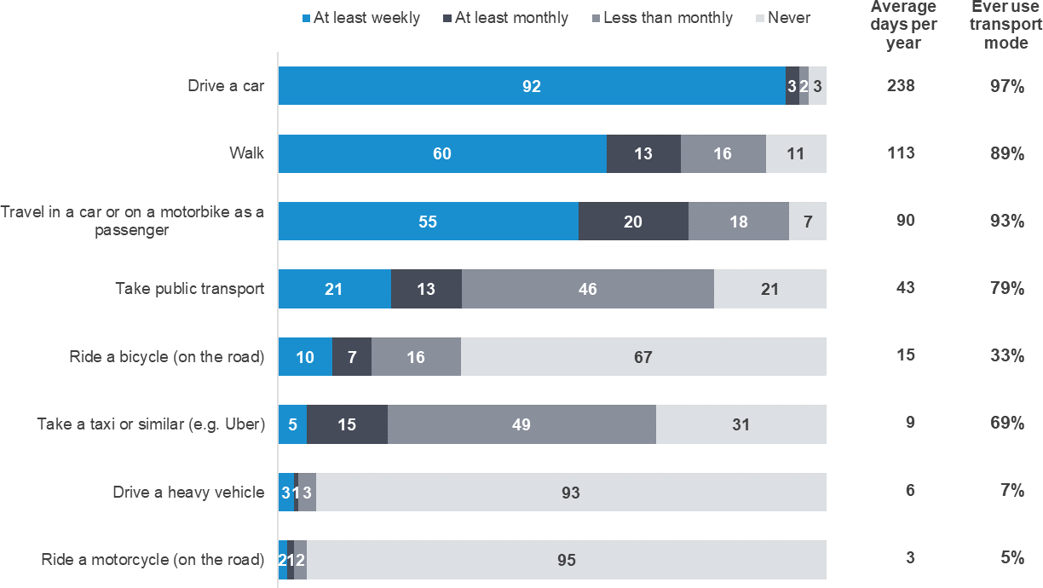
Figure 7 How people get around

M1A-D / M2A-D: How often do you (go somewhere by)… Total sample; Weighted sample; base n= from 2396 to 2489 Figures may not add to 100% due to rounding

Vehicle transportation
This section examines how usage of vehicle transportation (cars, motorcycles, heavy vehicles and bicycles) varies by demographic.

Driving a car

The vast majority of respondents (97%) ever drive a car, and 92% drive a car at least weekly. Table 7 shows the frequency of driving a car by gender and age.
Table 7 Frequency of driving a car – gender by age

 |  |  | Male |  |  | Female
Column % | Total | 18 - 25 | 26 - 39 40 - 60 | 61 - 90 | 18 - 25 | 26 - 39 40 - 60 | 61 - 90
At least weekly | 92 | 82 ↓ | 95 95 | 95 | 85 ↓ | 92 94 | 92
At least monthly | 3 | 5 | 1 2 | 3 | 3 | 2 3 | 4
Less than monthly | 2 | 5 ↑ | 2 1 | 0 | 3 | 3 1 | 2
NET: Ever drive a car | 97 | 92 ↓ | 98 98 | 98 | 91 ↓ | 96 98 | 98
Never drive a car | 3 | 8 ↑ | 2 2 | 2 | 9 ↑ | 4 2 | 2
Sample size 2489 |  | 239 | 332 394 | 286 | 162 | 311 436 | 329

M2A - How often do you drive a car?
Total sample; Weighted sample; base n = 2489
Blue up arrows (↑) and red down arrows (↓) indicate statistically significant difference compared to respondents not in that category. Figures may not add to 100% due to rounding

Those aged 18-25 are the group least likely to drive at least weekly. Both males and females in this age group have lower frequency of weekly driving, as shown in Figure 8.
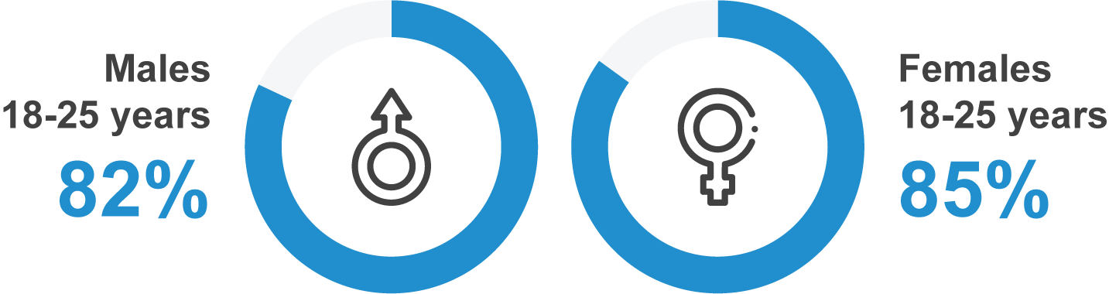
Figure 8 Frequency of driving among the 18-25 age group

M2A - How often do you drive a car?
Total sample; Weighted sample; Males 18-25 base n = 239; Females 18-25 base n = 162

Riding a motorcycle on the road

In 2020, one in twenty respondents (5%) said they ever ride a motorcycle on the road. The majority of active motorcyclists are male (9% of males vs 1% of females), and riding a motorcycle is more common among 40 to 60 year olds (7%). The frequency of motorcycle riding is also higher in Rural Balance areas (14%) than in Major Urban areas (4%).
Table 8 Frequency of riding a motorcycle on the road by demographic

Column % | Total | 18 - 25 | Age  26 - 39 40 - 60 |  | 61 - 90 | Gender  Male Female |  | Location  Major Other Rural Urban Urban Balance
At least weekly | 2 | 1 | 2 | 2 | 1 | 3 ↑ | 0 ↓ | 2 2 3
At least monthly | 1 | 0 ↓ | 1 | 2 ↑ | 1 | 2 ↑ | 0 ↓ | 1 ↓ 2 4 ↑
Less than monthly | 2 | 1 | 2 | 3 | 2 | 4 ↑ | 1 ↓ | 2 ↓ 4 ↑ 6 ↑
NET: Ever ride a motorcycle | 5 | 3 ↓ | 5 | 7 ↑ | 4 | 9 ↑ | 1 ↓ | 4 ↓ 8 ↑ 14 ↑
Never | 95 | 97 ↑ | 95 | 93 ↓ | 96 | 91 ↓ | 99 ↑ | 96 ↑ 92 ↓ 86 ↓
Sample size | 2400 | 393 | 638 | 808 | 561 | 1215 | 1185 | 1409 684 307

M2B - How often, if ever, do you ride a motorcycle on the road? Total sample; Weighted sample; base n=2400
Blue up arrows (↑) and red down arrows (↓) indicate statistically significant difference compared to respondents not in that category. Figures may not add to 100% due to rounding

Riding a bicycle on the road

Close to one in three respondents (33%) said they ever ride a bicycle on the road. A minority of people ride frequently – 10% of respondents ride a bicycle on the road once a week or more often.
Those who ever ride a bicycle on the road are more likely to be male (42% of males vs 24% of females), or aged 40 to 60 years old (45% vs 33% for all respondents), Respondents from this age group are also more likely to ride a bicycle on the road for all frequencies of riding.
Those who ride at least weekly are also more likely to be males (14% of males vs 6% of females).
Table 9 Frequency of riding a bicycle on the road by demographic

Column % | Total | 18 - 25 | Age  26 - 39 40 - 60 |  | 61 - 90 | Gender  Male Female |  | Major Urban | Location  Other Urban | Rural Balance
At least weekly | 10 | 8 | 10 | 13 ↑ | 7 ↓ | 14 ↑ | 6 ↓ | 10 | 9 | 9
At least monthly | 7 | 6 | 7 | 11 ↑ | 2 ↓ | 9 ↑ | 5 ↓ | 7 | 6 | 12 ↑
Less than monthly | 16 | 18 | 16 | 21 ↑ | 8 ↓ | 19 ↑ | 13 ↓ | 16 | 17 | 13
NET: Ever ride a bicycle | 33 | 32 | 33 | 45 ↑ | 17 ↓ | 42 ↑ | 24 ↓ | 33 | 32 | 34
Never | 67 | 68 | 67 | 55 ↓ | 83 ↑ | 58 ↓ | 76 ↑ | 67 | 68 | 66
Sample size | 2403 | 393 | 640 | 807 | 563 | 1217 | 1186 | 1412 | 684 | 307

M2D - How often, if ever, do you ride a bicycle on the road? Total sample; Weighted sample, base n=2403
Blue up arrows (↑) and red down arrows (↓) indicate statistically significant difference compared to respondents not in that category. Figures may not add to 100% due to rounding.

Driving a heavy vehicle on the road

About one in fourteen respondents (7%) said they ever drive a heavy vehicle on the road. Nearly half of these respondents (3% of all respondents) drive a heavy vehicle at least weekly.
Those who ever drive heavy vehicles on the road are more likely to be male (12% of males vs 2% of females) and to live in Rural Balance areas (18%) or Other Urban areas (12%).
Those who drive heavy vehicles on the road at least weekly are also more likely to be aged 26-39 and to be male (5% of males vs 1% of females). Respondents living in Major Urban areas are less likely to drive heavy vehicles at least weekly (2%) than respondents in Other Urban (5%) or Rural Balance (7%) areas.
Table 10 Frequency of driving a heavy vehicle on the road by demographic

Column % | Total | 18 - 25 | Age  26 - 39 40 - 60 |  |  | 61 - 90 | Gender  Male Female |  | Major Urban | Location  Other Urban | Rural Balance
At least weekly | 3 | 1 | 4 | ↑ | 3 | 1 ↓ | 5 ↑ | 1 ↓ | 2 ↓ | 5 ↑ | 7 ↑
At least monthly | 1 | 1 | 1 | 0 |  | 1 | 1 | 1 | 1 ↓ | 2 | 2 ↑
Less than monthly | 3 | 2 | 3 | 4 |  | 3 | 6 ↑ | 1 ↓ | 3 ↓ | 5 | 9 ↑
NET: Ever drive a heavy  vehicle | 7 | 5 | 9 | 8 |  | 5 ↓ | 12 ↑ | 2 ↓ | 5 ↓ | 12 ↑ | 18 ↑
Never | 93 | 95 | 91 | 92 |  | 95 ↑ | 88 ↓ | 98 ↑ | 95 ↑ | 88 ↓ | 82 ↓
Sample size | 2396 | 393 | 638 | 805 |  | 560 | 1212 | 1184 | 1407 | 681 | 308

M2D - How often, if ever, do you drive a heavy vehicle on the road? Total sample; Weighted sample; base n=2396
Blue up arrows (↑) and red down arrows (↓) indicate statistically significant difference compared to respondents not in that category. Figures may not add to 100% due to rounding.

Other transportation
In this section we describe to what extent respondents use other types of transportation such as public transport, taxis, walking, or travelling as a passenger in a car or on a motorcycle.

Public transport

As shown in Table 11 below, the majority (of respondents (79%) use public transport. Close to one in five (21%) use public transport weekly. Usage declines with age, both in terms of using public transport at all and frequency of use. Respondents aged 18-25 (88%) are more likely to ever use public transport, with over a third (37%) using it at least weekly. This compares to 68% of those aged 61-90 years who ever use public transport and one in nine (11%) of this age group using it at least weekly.
Frequency of use of public transport is also more common in Major Urban areas (83%) than in the rest of Victoria (68% in Other Urban areas and 57% in Rural Balance areas). Also, more respondents in Major Urban areas (24%) use public transport at least weekly than respondents in Other Urban areas (7%) and Rural Balance areas (4%).
Table 11 Frequency of going somewhere by public transport by demographic

Column % | Total | 18 - 25 | Age  26 - 39 40 - 60 |  | 61 - 90 | Gender  Male Female |  | Location  Major Other Rural Urban Urban Balance
At least weekly | 21 | 37 ↑ | 24 ↑ | 17 ↓ | 11 ↓ | 23 ↑ | 18 ↓ | 24 ↑ 7 ↓ 4 ↓
At least monthly | 13 | 17 ↑ | 14 | 11 | 11 | 15 ↑ | 11 ↓ | 15 ↑ 6 ↓ 4 ↓
Less than monthly | 46 | 34 ↓ | 46 | 51 ↑ | 46 | 43 ↓ | 49 ↑ | 45 ↓ 55 ↑ 48
NET: Ever take public  transport | 79 | 88 ↑ | 85 ↑ | 79 | 68 ↓ | 81 | 78 | 83 ↑ 68 ↓ 57 ↓
Never | 21 | 12 ↓ | 15 ↓ | 21 | 32 ↑ | 19 | 22 | 17 ↓ 32 ↑ 43 ↑
Sample size | 2442 | 396 | 642 | 818 | 586 | 1232 | 1210 | 1437 694 311

M1A - Thinking about ways you get around, apart from driving or riding yourself, how often do you go somewhere by taking public transport? Total sample; Weighted sample; base n=2442
Blue up arrows (↑) and red down arrows (↓) indicate statistically significant difference compared to respondents not in that category. Figures may not add to 100% due to rounding.

Commercial ride share

As shown in Table 12 below, in 2020 a majority of respondents (69%) indicated they ever use a taxi or other commercial ride share. Those in Major Urban areas (72%) are more likely to use this type of transport than respondents in Other Urban (56%) or Rural Balance (50%) areas.
However, only one in twenty (5%) take a taxi or similar at least weekly. Younger people aged 18-25 (29%) or 26-39 (22%) are more likely to take taxis or similar at least monthly, as are males (17%) and those living in Major Urban areas (17%). Males (72%) are more likely to use a commercial ride share than females (66%).
Table 12 Frequency of taking a commercial ride share by demographic

Column % | Total | 18 - 25 | Age  26 - 39 40 - 60 |  | 61 - 90 | Gender  Male Female |  | Major Urban | Location  Other Urban | Rural Balance
At least weekly | 5 | 13 ↑ | 6 | 4 | 2 ↓ | 7 ↑ | 4 ↓ | 6 ↑ | 1 ↓ | 1 ↓
At least monthly | 15 | 29 ↑ | 22 ↑ | 11 ↓ | 3 ↓ | 17 ↑ | 12 ↓ | 17 ↑ | 6 ↓ | 3 ↓
Less than monthly | 49 | 42 ↓ | 54 ↑ | 53 ↑ | 41 ↓ | 48 | 50 | 49 | 49 | 47
NET: Ever use rideshare | 69 | 84 ↑ | 81 ↑ | 68 | 46 ↓ | 72 ↑ | 66 ↓ | 72 ↑ | 56 ↓ | 50 ↓
Never | 31 | 16 ↓ | 19 ↓ | 32 | 54 ↑ | 28 ↓ | 34 ↑ | 28 ↓ | 44 ↑ | 50 ↑
Sample size | 2430 | 395 | 640 | 816 | 579 | 1226 | 1204 | 1428 | 693 | 309

M1B - How often do you go somewhere by taking a taxi or similar (e.g. Uber)? Total sample; Weighted sample; base n=2430
Blue up arrows (↑) and red down arrows (↓) indicate statistically significant difference compared to respondents not in that category. Figures may not add to 100% due to rounding.

Walking

Nearly all respondents said they ever go somewhere by walking (89%), and over half (60%) do so at least weekly. Respondents in Major Urban areas (62%) are more likely than respondents in Other Urban (52%) or Rural Balance (47%) areas to walk somewhere at least weekly. Also, those living in Rural Balance areas (72%) are less likely to ever go somewhere by walking than those based in Major Urban areas (91%).
Respondents aged 26-39 (93%) are more likely to ever go somewhere by walking than older people aged 61-90 (81%).
Table 13 Frequency of walking by demographic

Column % | Total | 18 - 25 | Age  26 - 39 40 - 60 |  | 61 - 90 | Gender  Male Female |  | Location  Major Other Rural Urban Urban Balance
At least weekly | 60 | 58 | 61 | 61 | 58 | 61 | 59 | 62 ↑ 52 ↓ 47 ↓
At least monthly | 13 | 17 | 14 | 13 | 11 | 14 | 13 | 13 16 13
Less than monthly | 16 | 17 | 18 | 15 | 12 | 14 | 17 | 15 18 13
NET: Ever go somewhere by  walking | 89 | 92 | 93 ↑ | 90 | 81 ↓ | 90 | 88 | 91 ↑ 86 72 ↓
Never | 11 | 8 | 7 ↓ | 10 | 19 ↑ | 10 | 12 | 9 ↓ 14 28 ↑
Sample size | 2447 | 396 | 640 | 821 | 590 | 1231 | 1216 | 1439 698 310

M1C - How often do you go somewhere by walking? Total sample; Weighted sample; base n=2447
Blue up arrows (↑) and red down arrows (↓) indicate statistically significant difference compared to respondents not in that category. Figures may not add to 100% due to rounding.

Travelling in a car or motorbike as a passenger

As shown in Table 14, the large majority of respondents (93%) said they ever travel in a car or motorbike as a passenger, and over half (55%) do so at least weekly.
Younger people aged 18-25 (67%) are more likely than older respondents to travel as a passenger at least weekly. Females (62%) are also more likely than males (47%) to travel as a passenger at least weekly.
Table 14 Frequency of travelling in a car or on a motorbike as a passenger by demographic

Column % | Total | 18 - 25 | Age  26 - 39 40 - 60 |  | 61 - 90 | Gender  Male Female |  | Major Urban | Location  Other Urban | Rural Balance
At least weekly | 55 | 67 ↑ | 56 | 52 | 50 ↓ | 47 ↓ | 62 ↑ | 54 | 59 | 58
At least monthly | 20 | 16 | 21 | 21 | 20 | 23 ↑ | 18 ↓ | 20 | 19 | 21
Less than monthly | 18 | 10 ↓ | 16 | 20 | 23 ↑ | 22 ↑ | 15 ↓ | 19 | 16 | 15
NET: Ever travel as a  passenger | 93 | 93 | 93 | 94 | 93 | 91 ↓ | 95 ↑ | 93 | 93 | 94
Never | 7 | 7 | 7 | 6 | 7 | 9 ↑ | 5 ↓ | 7 | 7 | 6
Sample size | 2461 | 400 | 640 | 823 | 598 | 1239 | 1222 | 1444 | 701 | 316

M1D - How often do you travel in a car or on a motorbike as a passenger? Total sample; Weighted sample; n=2461
Blue up arrows (↑) and red down arrows (↓) indicate statistically significant difference compared to respondents not in that category / Figures may not add to 100% due to rounding.

Driving behaviour
This section examines the general driving behaviour of respondents, including frequency of commuting, night-time driving and feeling stressed while driving.

Commuting to and from work in a car

As shown in Table 15, four in five respondents who are currently working (80%) commute to and from work in a car at least weekly, while close to nine in ten (89%) ever commute.
Commuting by car is most common among those living in Other Urban areas (93%). Those respondents are also more likely to commute to and from work by car at least weekly (89%) than respondents living in Major Urban areas (78%).
Table 15 Frequency of commuting to and from work in a car by demographic

Column % | Total | 18 - 25 | Age  26 - 39 40 - 60 |  | 61 - 90 | Gender  Male Female |  | Location  Major Other Rural Urban Urban Balance
At least weekly | 80 | 84 | 79 | 79 | 78 | 80 | 79 | 78 ↓ 89 ↑ 87 ↑
At least monthly | 4 | 2 | 4 | 4 | 3 | 4 | 4 | 4 ↑ 3 0 ↓
Less than monthly | 6 | 5 | 7 | 6 | 3 | 6 | 6 | 6 ↑ 2 ↓ 2 ↓
NET: Ever commute to and from work in a car | 89 | 91 | 89 | 90 | 85 | 90 | 89 | 89 93 ↑ 89
Never commute to and from  work in a car | 11 | 9 | 11 | 10 | 15 | 10 | 11 | 11 7 ↓ 11
Sample size | 1634 | 272 | 521 | 669 | 172 | 871 | 763 | 994 427 213

M3 Thinking about your driving, how often do you commute to and from work in a car? Filter: Driver, currently working; Weighted sample; base=1634
Blue up arrows (↑) and red down arrows (↓) indicate statistically significant difference compared to respondents not in that category. Figures may not add to 100% due to rounding.

Driving between 10pm and 6am
As shown in Table 16, three quarter of respondents (75%) said they ever drive at night between 10pm and 6am, with nearly one in five (21%) doing so at least weekly. It is more common for respondents aged 26-39 (84%) to drive at night than for older respondents aged 61-90 (65%). It is also more common for males (80%) than females (70%).
Other analysis shows that respondents who are more likely to drive between 10pm and 6am at least weekly include:
18-25 year olds (37% vs 19% of older drivers aged 26-90 years)
Respondents involved in a crash (31% vs 19% not involved in a crash)
Respondents who have driven fatigued (29% vs 16% who have not driven fatigued)
Respondents who have driven over the speed limit (25% vs 17% who have not driven over the speed limit).
Table 16 Frequency of driving between 10pm and 6am by demographic

Column % | Total | 18 - 25 | Age  26 - 39 40 - 60 |  | 61 - 90 | Gender  Male Female |  | Major Urban | Location  Other Urban | Rural Balance
At least weekly | 21 | 37 ↑ | 24 | 18 | 14 ↓ | 26 ↑ | 17 ↓ | 21 | 22 | 20
At least monthly | 15 | 19 | 17 | 17 | 9 ↓ | 18 | 12 | 15 | 13 | 19
Less than monthly | 39 | 25 ↓ | 43 | 40 | 42 | 37 | 41 | 38 | 41 | 40
NET: Ever drive between  10pm and 6am | 75 | 81 | 84 ↑ | 74 | 65 ↓ | 80 ↑ | 70 ↓ | 75 | 76 | 78
Never drive between 10pm  and 6am | 25 | 19 | 16 ↓ | 26 | 35 ↑ | 20 ↓ | 30 ↑ | 25 | 24 | 22
Sample size | 952 | 147 | 231 | 340 | 234 | 499 | 454 | 504 | 300 | 149

M3 How often do you drive between the hours of 10pm and 6am? Filter: Driver; Weighted sample; base n=952\
Blue up arrows (↑) and red down arrows (↓) indicate statistically significant difference compared to respondents not in that category Figures may not add to 100% due to rounding.

How often people feel stressed while driving

As shown in Table 17, most respondents (71%) said they have ever felt stressed when driving, with a third (29%) driving while feeling stressed at least weekly.
Those aged between 26-39 (37%) are more likely to feel stressed at least weekly compared to those aged 61-90 (15%).
Feeling stressed while driving at least monthly is more common for females (20%) than males (13%). Respondents living in Major Urban areas (31%) are more likely to feel stressed while driving at least weekly than respondents living in Other Urban areas (19%).
Other analysis shows that respondents who report driving while feeling very tired (84%) are more likely to say that they feel stressed while driving than respondents who do not drive while feeling very tired (63%). More than half (54%) of those who report driving while feeling very tired ‘half the time or more often’ also report driving while feeling stressed at least weekly.
Table 17 Frequency of driving while feeling stressed by demographic

Column % | Total | 18 - 25 | Age  26 - 39 40 - 60 |  | 61 - 90 | Gender  Male Female |  | Location  Major Other Rural Urban Urban Balance
At least weekly | 29 | 36 | 37 ↑ | 30 | 15 ↓ | 29 | 29 | 31 ↑ 19 ↓ 23
At least monthly | 16 | 21 | 18 | 17 | 12 | 13 ↓ | 20 ↑ | 17 14 12
Less than monthly | 26 | 22 | 22 | 27 | 31 | 26 | 26 | 24 ↓ 36 ↑ 30
NET: Ever feel stressed  when driving | 71 | 78 | 77 | 74 | 58 ↓ | 69 | 74 | 73 68 65
Never feel stressed when  driving | 29 | 22 | 23 | 26 | 42 ↑ | 31 | 26 | 27 32 35
Sample size | 1181 | 175 | 288 | 428 | 290 | 612 | 569 | 668 344 169

M3 – How often do you feel stressed when you are driving? Filter: Driver; Weighted sample; base=1181
Blue up arrows (↑) and red down arrows (↓) indicate statistically significant difference compared to respondents not in that category. Figures may not add to 100% due to rounding.

As shown in Table 18, drivers aged 18-60 who speed (81%) or drive while fatigued (84%) are more likely to report that they ever feel stressed while driving (75% of all drivers aged 18-60). Further, driving while feeling stressed at least weekly is more common among those who drive while fatigued (41%) than those who do not drive while feeling fatigued (26%).
Table 18 Frequency of driving while feeling stressed by behaviour (18-60 years) by behaviour

Column % | Total | Speeding  Yes No |  | Drink driving  Yes No |  | Mobile phone use  Yes No |  | Driving fatigued  Yes No |  | Involvement in a crash  Yes No
At least weekly | 33 | 37 | 29 | 22 | 34 | 38 | 31 | 41 ↑ | 26 ↓ | 40 | 31
At least monthly | 18 | 19 | 16 | 24 | 18 | 16 | 19 | 21 | 15 | 16 | 18
Less than monthly | 25 | 25 | 23 | 25 | 25 | 26 | 24 | 22 | 27 | 23 | 25
NET: Ever feel stressed  when driving | 75 | 81 ↑ | 69 ↓ | 71 | 76 | 80 | 73 | 84 ↑ | 68 ↓ | 80 | 74
Never feel stressed when  driving | 25 | 19 ↓ | 31 ↑ | 29 | 24 | 20 | 27 | 16 ↓ | 32 ↑ | 20 | 26
Sample size | 892 | 497 | 375 | 36 | 855 | 303 | 589 | 410 | 469 | 199 | 689

M3 – How often do you feel stressed when you are driving? Filter: Driver aged 18-60; Weighted sample; base =892
Blue up arrows (↑) and red down arrows (↓) indicate statistically significant difference compared to respondents not in that category Figures may not add to 100% due to rounding.

Vehicle ownership
The following section discusses vehicle purchasing behaviour and the types of vehicles respondents drive.

Car purchasing
As is shown in Table 19, close to a quarter of respondents (23%) who drive a car or ride a motorcycle bought a car in the last 12 months, with new car purchases (10%) being less likely than used car purchases (13%).
Respondents living in Other Urban areas (27%) were more likely to purchase a car in the last 12 months than respondents in Major Urban (22%) or Rural Balance (22%) areas, and 17% of them had purchased a used car.
Those aged 18-25 years (29%) and 26-39 years (29%) were more likely to purchase a car than older age groups (22% of those aged 40-60 years and 13% of those aged 61-90 years). Those aged 18-25 years were most likely to purchase a used car (24%) and least likely to purchase a new car (5%).
There is a consistent decline in the percentage of respondents who bought a car by age, decreasing from 29% of 18-25 year olds and 26-39 year olds to 13% of 61-90 year olds. This decline also occurs for the purchase of a used car (24% of 18-25 year olds, declining to 6% of 61-90 year olds). However, purchase of a new car by age is different, with the 18-25 year olds and 61-90 year olds being the least likely to purchase (5% and 7% respectively).
Table 19 Bought a car in the last 12 months by demographic

Column % | Total | 18 - 25 | Age  26 - 39 40 - 60 |  | 61 - 90 | Gender  Male Female |  | Major Urban | Location  Other Urban | Rural Balance
Yes, a new car | 10 | 5 ↓ | 11 | 12 | 7 | 10 | 9 | 10 | 10 | 10
Yes, a used car | 13 | 24 ↑ | 18 ↑ | 10 ↓ | 6 ↓ | 15 ↑ | 11 ↓ | 12 ↓ | 17 ↑ | 12
NET: Purchased a car | 23 | 29 ↑ | 29 ↑ | 22 | 13 ↓ | 26 ↑ | 20 ↓ | 22 | 27 ↑ | 22
No, I haven't bought a car in  the past 12 months | 77 | 71 ↓ | 71 ↓ | 78 | 87 ↑ | 74 ↓ | 80 ↑ | 78 | 73 ↓ | 78
Sample size | 2178 | 323 | 567 | 745 | 543 | 1090 | 1088 | 1226 | 654 | 298

VH4 - In the last 12 months, have you bought a car, either new or used? Filter: Driver or motorcycle rider; Weighted sample; base=2175
Blue up arrows (↑) and red down arrows (↓) indicate statistically significant difference compared to respondents not in that category. Figures may not add to 100% due to rounding.

As shown in the Table 20, when buying a car, respondents over 60 years old are more likely than other age groups to be interested in vehicle safety features (79%) and in the reliability/ low maintenance cost (63%). Young respondents aged between 18-25 years old (44%) paying more attention to the look and design of the car as well as to the in-car system (navigation, entertainment, Bluetooth).
Females (79%) are more likely to be interested in the vehicle safety features than males (64%) and are less interested (10%) in power and performance than males (22%).
Table 20 Most important things when buying a car by demographic

Column % | Total | 18 - 25 | Age  26 - 39 40 - 60 |  | 61 - 90 | Gender  Male Female |  | Location  Major Other Rural Urban Urban Balance
Vehicle Safety features | 71 | 63 | 64 ↓ | 75 | 79 ↑ | 64 ↓ | 79 ↑ | 71 77 62 ↓
Fuel economy | 55 | 53 | 52 | 55 | 61 | 51 ↓ | 59 ↑ | 55 56 56
Reliability/low maintenance  costs | 50 | 53 | 46 | 44 ↓ | 63 ↑ | 50 | 51 | 50 48 56
The look and design of the  car | 36 | 44 ↑ | 36 | 36 | 28 ↓ | 38 | 33 | 37 31 30
Passenger and/or cargo  space | 27 | 15 ↓ | 30 | 33 ↑ | 21 | 27 | 27 | 26 30 33
Reputation of brand | 25 | 18 | 26 | 26 | 29 | 28 | 23 | 24 ↓ 30 35 ↑
In-car system (navigation, entertainment, Bluetooth) | 19 | 31 ↑ | 25 ↑ | 16 | 11 ↓ | 21 | 18 | 21 ↑ 14 ↓ 12
Power and performance | 16 | 21 | 20 | 15 | 9 ↓ | 22 ↑ | 10 ↓ | 16 14 17
Sample size | 1176 | 190 | 319 | 408 | 259 | 592 | 584 | 706 323 147

VH7 - Three most important things to you when deciding which car to buy? Filter: Driver; Weighted sample; base=1176
Blue up arrows (↑) and red down arrows (↓) indicate statistically significant difference compared to respondents not in that category. Figures may not add to 100% due to rounding.

Type of vehicle usually driven
As shown in Table 21, close to two-thirds of respondents (62%) who drive a vehicle or ride a motorcycle usually drive a car, while 29% drive a SUV/4WD and 6% drive a ute or similar. Females (69%) are more likely to drive cars than males (55%).
Table 21 Type of vehicle usually driven by demographic

Column % | Total | 18 - 25 | Age  26 - 39 40 - 60 |  | 61 - 90 | Gender  Male Female |  | Location  Major Other Rural Urban Urban Balance
Car / Station wagon | 62 | 77 ↑ | 60 | 56 ↓ | 65 | 55 ↓ | 69 ↑ | 64 ↑ 56 ↓ 47 ↓
SUV / 4WD | 29 | 14 ↓ | 28 | 36 ↑ | 28 | 29 | 29 | 28 32 33
Ute / Utility / Pickup | 6 | 6 | 6 | 6 | 5 | 10 ↑ | 1 ↓ | 4 ↓ 9 ↑ 16 ↑
Truck | 1 | 1 | 1 | 1 | 0 | 1 ↑ | 0 ↓ | 1 1 1
Motorcycle | 0 | 0 | 1 | 0 | 0 | 1 ↑ | 0 ↓ | 1 0 1
Commercial van | 1 | 2 | 2 | 1 | 1 | 2 ↑ | 1 ↓ | 1 1 2
Bus | 0 | 0 | 0 ↑ | 0 | 0 | 0 | 0 | 0 0 0
Other | 0 | 0 | 0 | 0 | 0 | 0 | 0 | 0 0 0
Other (Specify) | 1 | 1 | 1 | 1 | 1 | 1 | 1 | 1 1 0
Sample size | 2343 | 368 | 612 | 789 | 574 | 1165 | 1178 | 1372 668 303

VH1 - What type of vehicle do you usually drive? Filter: Driver; Weighted sample; base=2343
Blue up arrows (↑) and red down arrows (↓) indicate statistically significant difference compared to respondents not in that category. Figures may not add to 100% due to rounding.

In addition, as shown in Figure 9:
Younger drivers aged 18-25 are more likely to drive ‘cars’ (77% vs 56% among drivers aged 40-60 and 65% among drivers aged 61-90 years old).
Drivers aged 40-60 are more likely to drive SUVs (36% vs 14% among drivers aged 18-25 years and vs 28% among drivers aged 61-90 years).
Utes are almost exclusively driven by males (10% vs 1% of females) and are more likely to be driven in Rural Balance areas (16%) than in Major Urban areas (4%).
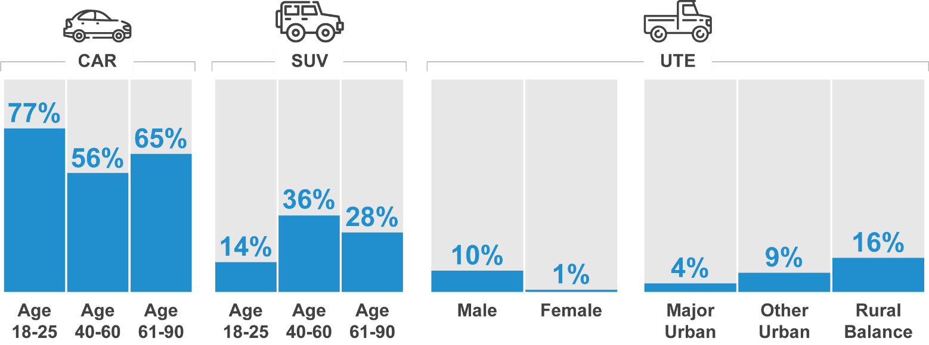
Figure 9 Type of vehicle usually driven infographic

Road user attitudes and behaviours
The following section details respondents’ attitudes towards driving and road safety and their behaviour.

Perceived level of danger in road-user behaviours
Respondents were asked to consider a range of road-user behaviours and to rate how dangerous they thought each was on a scale of 0 “not at all dangerous” to 10 “extremely dangerous”. A similar set of statements regarding perceptions of danger were asked in previous surveys. In Table 22, results are shown for the years 2016 to 2020 for all statements that were asked in 2020. Numbers in the table and the following text are mean ratings derived from the eleven-point scale from 0 to 10.
The behaviours described by these statements include driving while impaired by alcohol, driving while very tired, driving while using a mobile phone, speeding, and cycling.
Four behaviours stand out as being perceived by respondents to be of very high risk: Driving with an illegal B.A.C. (9.6)
Driving while very tired (9.0)
Driving while using a handheld mobile phone (9.2)
Crossing the street while looking at a mobile phone (8.9).
Riding bicycles, speeding behaviours and driving after drinking one alcoholic drink continue to be rated by respondents as the least dangerous of the behaviours they were asked to rate.
Table 22 Perceptions of danger

Average 2016 2017 2018 2019 2020

Drive with an illegal Blood Alcohol Content (BAC) level | 9.5 | 9.5 | 9.5 | 9.5 | 9.6 ↑
Drive while using a handheld mobile phone | 9.1 | 9.0 | 9.1 | 9.1 | 9.2
Drive while very tired | 9.2 | 9.2 | 9.2 | 9.2 | 9.0 ↓
Cross the street while looking at a mobile phone |  |  | 8.9 | 8.8 | 8.9
Glance at your mobile phone while driving |  |  |  |  | 8.2
Ride a bicycle on urban roads |  | 6.8 | 6.8 | 6.0 ↓ | 6.5
Drive a few kilometres above the posted speed limit in a 100 km/h zone | 6.2 | 6.2 | 6.1 | 6.1 | 6.3
Drive a few kilometres above the posted speed limit in a 60 km/h zone | 6.2 | 6.1 | 6.0 | 5.9 | 6.0
Ride a bicycle on sealed country roads |  | 6.0 | 6.3 | 6.8 | 5.9 ↓
Drive a short time after having one alcoholic drink | 5.7 | 5.7 | 5.7 | 5.6 | 5.7
Sample size 1180 1721 1661 1825 2479

Mean scores are shown as a heat map where the lowest value is white and the highest value is blue.
DAN1 Using a scale where 0 is “Not at all dangerous” and 10 is “Extremely dangerous”, how dangerous do you think it is to… (activity) Total sample (statements are not asked in every quarter), weighted sample
* wording of ‘driving while very tired’ was ‘driving while very drowsy’ prior to 2020 Apr-Jun quarter

Table 23 below shows the level of perceived danger of each behaviour in 2020 by demographic. Respondents aged 61-90 years old (9.5) are more likely to consider driving while using a handheld mobile phone as extremely dangerous than young respondents 18-25 (8.8). Females perceive the danger of all activities (except riding a bicycle on sealed country roads) higher than males. Driving a few kilometres above the posted speed limit in a 60 km/h zone is more likely to be perceived as dangerous in Other Urban areas (6.4) than in Major Urban areas (5.9).
Table 23 Perception of danger by demographic

Average | Total | 18 - 25 | Age  26 - 39 40 - 60 | 61 - 90 | Gender  Male Female |  | Location  Major Other Rural Urban Urban Balance
Drive with an illegal Blood Alcohol Content (BAC)  level  Drive while using a  handheld mobile phone  Drive while very tired | 9.6  9.2  9.0 | 9.5 | 9.6 9.6 | 9.7 ↑ | 9.5 ↓ | 9.7 ↑ | 9.6 9.5 9.6
 |  | 8.8 ↓ | 9.0 ↓ 9.3 ↑ | 9.5 ↑ | 9.0 ↓ | 9.3 ↑ | 9.2 9.2 9.3
 |  | 8.7 ↓ | 8.9 9.1 ↑ | 9.1 | 8.8 ↓ | 9.1 ↑ | 9.0 9.0 9.1
Cross the street while  looking at a mobile phone | 8.9 | 8.3 ↓ | 8.6 ↓ 9.1 | 9.5 ↑ | 8.8 ↓ | 9.1 ↑ | 8.9 9.0 9.1
Glance at your mobile phone while driving | 8.2 | 7.7 | 7.9 8.3 | 8.9 ↑ | 7.7 ↓ | 8.7 ↑ | 8.2 8.5 9.0
Ride a bicycle on urban  roads | 6.5 | 5.6 ↓ | 6.5 6.6 | 7.0 ↑ | 6.3 ↓ | 6.8 ↑ | 6.5 6.6 6.8
Drive a few kilometres above the posted speed limit in a 100 km/h zone | 6.3 | 5.9 ↓ | 6.4 6.2 | 6.6 | 5.7 ↓ | 6.8 ↑ | 6.3 6.3 6.1
Drive a few kilometres above the posted speed limit in a 60 km/h zone | 6.0 | 5.3 ↓ | 6.0 6.0 | 6.2 | 5.5 ↓ | 6.4 ↑ | 5.9 ↓ 6.4 ↑ 6.3
Ride a bicycle on sealed  country roads | 5.9 | 4.8 ↓ | 5.7 6.2 | 6.5 ↑ | 5.9 | 6.0 | 5.9 6.2 6.2
Drive a short time after having one alcoholic drink | 5.7 | 5.9 | 5.7 5.6 | 5.7 | 5.3 ↓ | 6.0 ↑ | 5.7 5.4 5.6
Sample size | 465-  2479 | 77-  399 | 114- 160-  642 829 | 114-  610 | 238-  1247 | 227-  1233 | 342- 89- 34-  1452 707 321

Mean scores are shown as a heat map where the lowest value is white and the highest value is blue.
DAN1 Using a scale where 0 is “Not at all dangerous” and 10 is “Extremely dangerous”, how dangerous do you think it is to… Total sample weighted sample
Blue up arrows (↑) and red down arrows (↓) indicate statistically significant difference compared to respondents not in that category.

The following section examines the perceived level of danger by additional respondent characteristics.

Drink driving
Respondents consider drink driving to be the most dangerous driving behaviour – in particular, driving with an illegal B.A.C (9.6). The following groups have a lower perception of danger for drink driving:
Males (9.5 vs 9.7 among females)
Those who had driven over the legal B.A.C in the past 12 months (8.8 vs 9.7 among those who had not)
However, respondents do not consider having only one alcoholic drink a short time before they drive as particularly dangerous (5.7). Having one alcoholic drink is considered more dangerous among females (6.0) than males (5.3).
Driving while very tired
Driving while very tired is also perceived to be a dangerous activity (9.0), although to a lesser extent than driving with an illegal B.A.C. (9.6).
Certain groups have a lower perception of danger for driving very tired, including: Those aged 18-25 (8.7 vs 9.1 among those aged between 40-90)
Those who have driven when fatigued (8.7 vs 9.1 among those who have not)
Males (8.8 vs 9.1 among females).
Driving while using a hand-held mobile phone
Driving while using a handheld mobile phone (9.2) is also considered to be dangerous. Respondents who have a lower perception of danger for driving while using a handheld phone include:
Those aged under 40 years (8.9 vs 9.4 among those aged 40 or over) Males 9.0 vs 9.3 among females)
Those who have used a mobile phone to make a call while driving (8.6 vs 9.4 of those who have not used a phone while driving).

Speeding

Respondents were asked how dangerous they believe it is to exceed the speed limit by a few kilometres per hour in a 60 km/h zone and in a 100 km/h zone. Compared to drink or driving very tired, or driving while using a hand-held mobile phone, the perceived danger of driving a few kilometres over the speed limit is lower for both a 60 km/h zone (6.0) and a 100 km/h zone (6.3). The differences across groups include the following:
Males are less likely to think speeding a few kilometres above the limit is dangerous in both 60 km/h zones (5.5 vs 6.4 among females) and 100 km/h zones (5.7 vs 6.8 among females).
Respondents in Major Urban areas are less likely to think speeding in a 60 km/h zone is dangerous (5.9 vs. 6.4 for those in other areas), as are those aged under 40 (5.3 vs 6.0 among those aged 40 and over).
Respondents who exceed the speed limit are less likely to think speeding a few kilometres above the limit is dangerous in both 60 km/h zones (5.2 vs 6.7 among those who do not exceed speed limits) and 100 km/h zones (5.2 vs 7.2).

Cycling

Respondents were also asked how dangerous they believe it is to ride a bicycle on urban roads and to ride a bicycle on sealed country roads. The perceived danger of riding a bicycle on urban roads (6.5) is greater than the perceived danger of riding a bicycle on sealed country roads (5.9).

Pedestrian distractions

Crossing a street while looking at a mobile phone is perceived as one of the more dangerous activities (8.9).
Differences observed among groups include:
Respondents aged 18-25 (8.3) are less likely to rate this activity as dangerous than respondents aged 26 and over (8.6),
Respondents who ever cross the street while looking at a mobile phone (8.1) are less likely to rate this activity as dangerous than respondents who never undertake this behaviour (9.3)

The relationship between perceived danger and incidence

The findings above regarding perceptions of danger often showed a lower perceived danger among respondents who engage in that behaviour. This is further illustrated in Figure 10 below, which shows perception of danger and likelihood of engaging in that behaviour in a matrix. Generally, behaviours which are perceived to be less dangerous are more likely to be performed by drivers (a correlation of -0.78).
Behaviours such as low-level speeding (in both 60 km/h and 100 km/h zones) and driving while under the legal BAC after drinking alcohol have relatively high incidence and are perceived to be less dangerous than other behaviours.
Driving while over the legal BAC is the behaviour with the highest perceived danger and the lowest incidence.
Behaviours relating to mobile phone use, such as driving while using a hand-held mobile phone and crossing the street while looking at mobile phone, are notable because they have relatively high incidence yet are also rated relatively highly with regard to perceived danger.
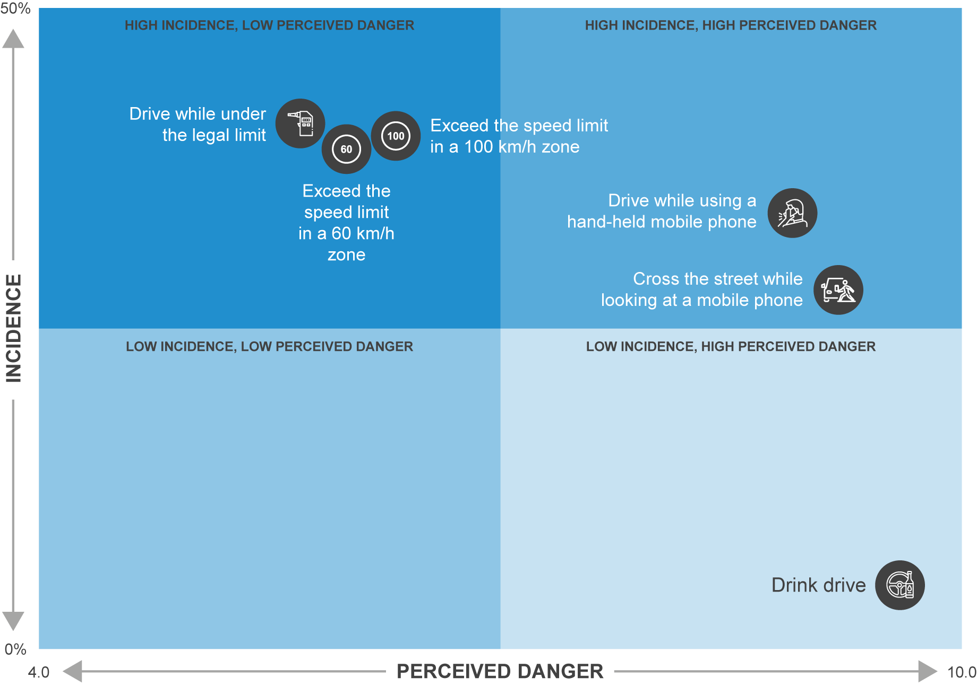
Figure 10 Perceived danger – incidence matrix

Speeding

Perceptions of the danger of speeding
In Figure 11 below, respondents’ perceived level of danger from driving a few kilometres over the speed limit (highlighted in blue) are compared with the perceived level of danger associated with other behaviours, such as driving with an illegal BAC, driving while very tired, or riding a bicycle on urban roads.
Respondents were asked to rate the perceived level of danger of someone performing each activity in a typical setting on an eleven-point scale from 0 to 10 where 0 is “not at all dangerous” and 10 is “extremely dangerous”. Numbers in the table and the following text are mean ratings out of 10.
Respondents do consider driving with an illegal blood alcohol content as more dangerous than behaviours such as driving while very tired or driving while using a handheld mobile phone or crossing the street while looking at the mobile phone.
However, the perceived level of danger from driving a few kilometres over the 100 km/h speed limit is greater than that of that of driving a few kilometres over the 60 km/h speed limit.
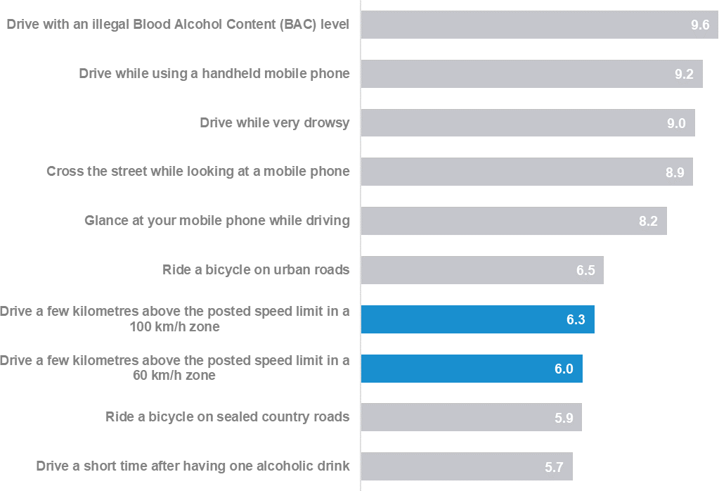
Figure 11 Perceptions of Danger (speeding highlighted)

Using a scale where 0 is “Not at all dangerous” and 10 is “Extremely dangerous”, how dangerous do you think it is to: Total sample; Weighted; base n = from 399 to 1452

Table 24 shows the perceived level of danger of driving a few kilometres over the speed limit (for both 60 km/h and 100 km/h zones) among respondents by demographic. Key findings include:
The perceived level of danger is lowest among 18-25 year olds (5.3 and 5.9 for 60 km/h and 100 km/h zones respectively) and highest among 61-90 year olds (6.2 and 6.6).
Males perceive less danger in driving a few kilometres over the speed limit (5.5 and 5.7 for 60 km/h and 100 km/h zones respectively) than females (6.4 and 6.8 respectively).
Respondents living in Other Urban areas (6.4) and Rural Balance areas (6.4) perceive the danger of driving a few kilometres per hour above the speed limit in a 60 km/h to be higher than respondents living in Major Urban areas (5.9).
Table 24 Perception of the danger of speeding by demographic

Average (rating 0-10) | Total | Age  18 - 25 26 - 39 40 - 60 |  |  | 61 - 90 | Gender  Male Female |  | Location  Major Other Urban Urban |  | Rural Balance
Drive a few kilometres above the posted speed limit in a  60km/h zone | 6.0 | 5.3 ↓ | 6.0 | 6.0 | 6.2 | 5.5 ↓ | 6.4 ↑ | 5.9 ↓ | 6.4 ↑ | 6.3 | ↑
Drive a few kilometres above the posted speed limit in a 100km/h zone | 6.3 | 5.9 ↓ | 6.4 | 6.2 | 6.6 ↑ | 5.7 ↓ | 6.8 ↑ | 6.3 | 6.3 | 6.1
Sample size | 2465 | 399 | 639 | 827 | 600 | 1241 | 1224 | 1446 | 703 | 316

DAN1A/B Using a scale where 0 is ‘Not at all dangerous’ and 10 is ‘Extremely dangerous’, how dangerous do you think it is to drive a few kilometres above the posted speed limit in a [60km/h/100km/h] zone
Filter: Total sample; weighted sample
Blue up arrows (↑) and red down arrows (↓) indicate statistically significant difference compared to respondents not in that category Figures may not add to 100% due to rounding

As shown in Table 25, respondents who engage in illegal behaviours (Speeding, Drink driving and Mobile phone use – see Section 1.3 for definitions) are less likely to perceive that driving a few kilometres over the speed limit is dangerous. For convenience, respondents in the speeding behaviour sub-group will be referred to in this report as ‘speeders’ and other respondents as ‘non-speeders’.
Most noticeably, speeders (5.2) are less likely than non-speeders (6.7) to perceive that driving a few kilometres over the speed limit in a 60 km/h zone is dangerous. The difference is even greater for 100 km/h zones (5.2 for speeders vs 7.2 for non-speeders).
Among all sub-groups (demographic and behavioural), non-speeders (7.2) have the highest rating for the perceived level of danger for driving over the speed limit.
Table 25 Perception of the danger of speeding by behaviour

Average | Total | Speeding  Yes No |  | Drink driving  Yes No |  | Mobile phone use  Yes No |  | Driving fatigued  Yes No |  | Involvement in a crash  Yes No
Drive a few kilometres above the posted speed limit in a  60km/h zone | 6.0 | 5.2 ↓ | 6.7 ↑ | 4.4 ↓ | 6.0 ↑ | 5.2 ↓ | 6.2 ↑ | 5.6 ↓ | 6.1 ↑ | 5.9 | 6.0
Drive a few kilometres above the posted speed limit in a 100km/h zone | 6.3 | 5.2 ↓ | 7.2 ↑ | 4.0 ↓ | 6.4 ↑ | 5.4 ↓ | 6.6 ↑ | 5.8 ↓ | 6.5 ↑ | 6.1 | 6.3
Sample size | 2465 | 1224 | 1109 | 127 | 2255 | 675 | 1708 | 942 | 1403 | 419 | 2027

DAN1A/B Using a scale where 0 is ‘Not at all dangerous’ and 10 is ‘Extremely dangerous’, how dangerous do you think it is to drive a few kilometres above the posted speed limit in a [60km/h/100km/h] zone
Filter: Total sample; weighted sample
Blue up arrows (↑) and red down arrows (↓) indicate statistically significant difference compared to respondents not in that category Figures may not add to 100% due to rounding

Definition of speeding
To understand how road users define speeding, respondents were asked to indicate how fast they think people should be allowed to drive in 60 km/h and 100 km/h speed zones without being booked for speeding. The results in this section are restricted to respondents aged 18-60 with a drivers’ licence to allow valid comparisons over time. (See Section 1.3 for further explanation.)
As shown in Figure 12, many respondents report that drivers should be allowed to drive up to 5 km/h over the speed limit in both 60 km/h and 100 km/h zones (88% and 65% respectively).
There has, however, been an increase in the percentage of respondents who report that drivers should be allowed to drive more than 5 km/h over the speed limit in 100 km/h zones. In 2013, 24% of respondents reported that drivers should be allowed to exceed 105 km/h in 100 km/h zones. In 2017, the percentage had risen to 35%. This belief has been maintained and has risen to 35% in 2020. In contrast, no trend is evident for 60 km/h zones.
Additional analysis shows that males (16%) are more likely than females (8%) to report that drivers should be allowed to drive faster than at 65 km/h in a 60 km/h zone. The difference is greater for 100 km/h zones; 41% of males report that drivers should be allowed to exceed 105 km/h in a 100 km/h zone compared with 29% of females.
Figure 12 Definition of speeding by year

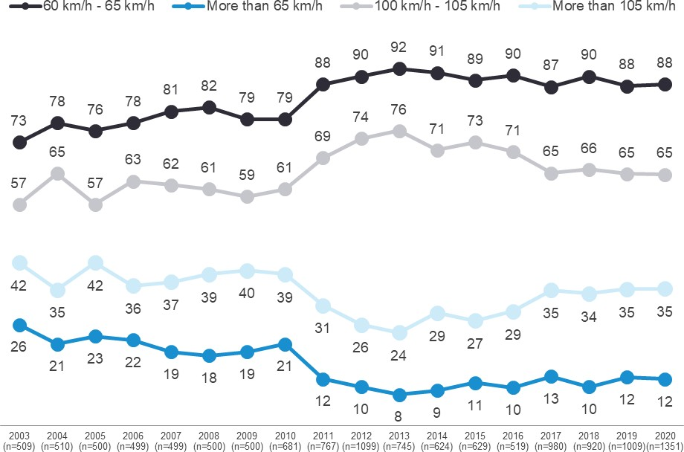
60-65 km/h
100-105 km/h
105 km/h +
65 km/h +

DAN2- How fast should people be allowed to drive in a 60km/h zone without being booked for speeding? Filter: Aged 18-60 years who could specify a number and not below 60km/h
DAN3 - How fast should people be allowed to drive in a 100km/h zone without being booked for speeding? Filter: Aged 18-60 years who could specify a number and not below 100km/h
Figures may not add to 100% due to rounding

Intentionally driving over the speed limit
Respondents were asked how often they intentionally drove above the posted speed limit in the last three months. Note that in contrast to Section 4.5.2, these questions were asked of all respondents aged 18-90 with a drivers’ licence.
As shown in Figure 13, nearly two thirds of respondents (61%) report never intentionally speeding in a 60 km/h zone. Since 2016, the percentage of respondents reporting that they never intentionally speed has increased from 57% to 61% in 2020.
Figure 13 Intentionally driving over the speed limit in a 60 km/h zone over time by year

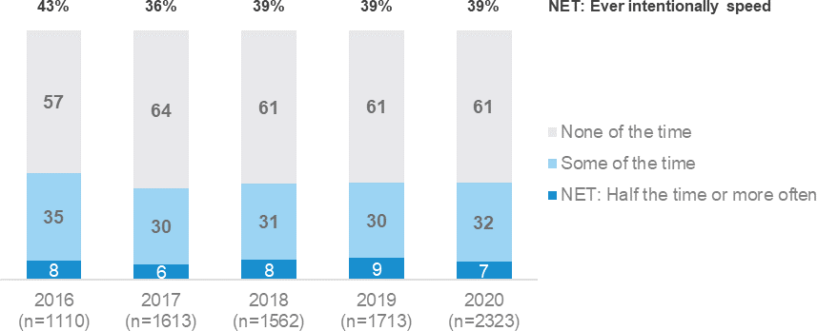

DB1 In the past three months, how often did you intentionally drive above the limit in a 60 km/h zone, even if by only a few km's per hour? (fine) by Year of interview (Date)
Filter: Drivers; Weighted sample; base=2323 Figures may not add to 100% due to rounding

As shown in Figure 14, the findings are similar for intentionally speeding in 100 km/h zones. Since 2016, the percentage of respondents reporting that they never intentionally speed has increased from 55% to 60% in 2020.
Figure 14 Intentionally driving over the speed limit in a 100 km/h zone over time

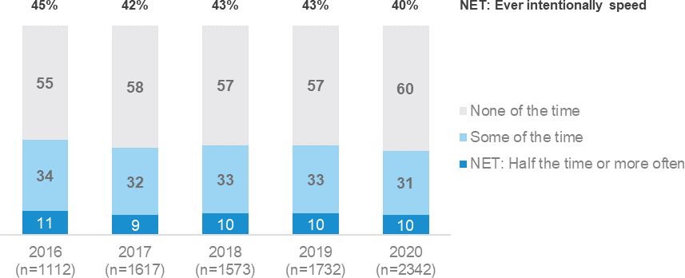

DB1 In the past three months, how often did you intentionally drive above the limit in a 100km/h zone, even if by only a few km's per hour? Weighted sample; base=2342 Filter: Drivers
Figures may not add to 100% due to rounding

As shown in Figure 15, the reported likelihood to drive above the 60km/hr speed limit is greater among younger respondents and males, as described below:
Respondents aged 18-39 (45%) are more likely than respondents aged 40 and over (35%) to ever speed in 60 km/h zones.
Males (45%) are more likely than females (33%) to ever speed in 60 km/h zones.

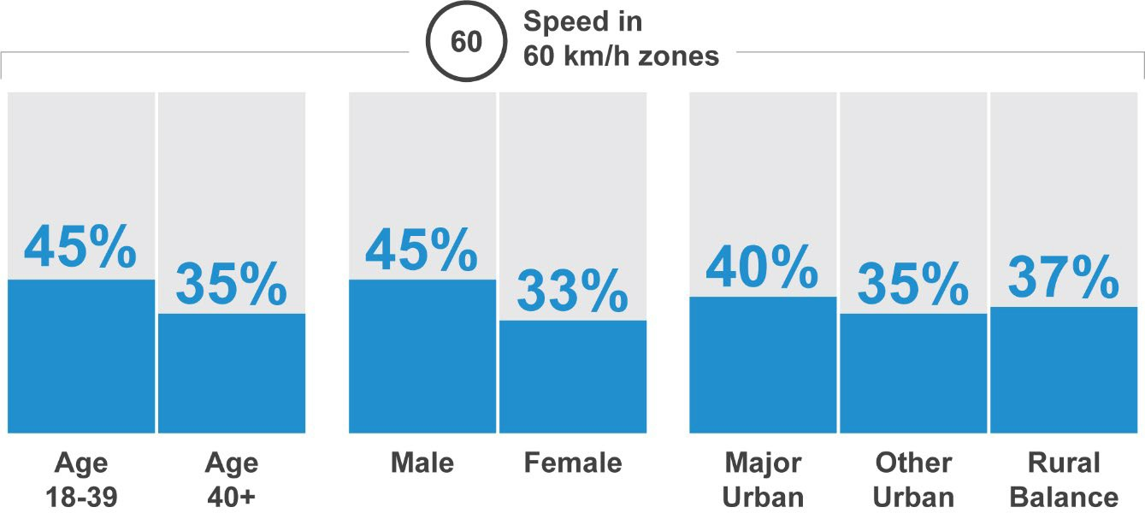
Figure 15 Driving over the speed limit 60 km/h infographic

As shown in Figure 16, the reported likelihood to drive above the 100km/hr speed limit is also greater among younger respondents and males, as described below:
In 100 km/h zones, respondents aged 18-39 (45%) are more likely than respondents aged 40 and over (37%) to ever speed.
In 100 km/h zones, males (48%) are more likely than females (33%) to ever speed.
In 100 km/h zones, respondents in Rural Balance areas (51%) and Other Urban areas (49%) are more likely than respondents in Major Urban areas (38%) to ever speed.
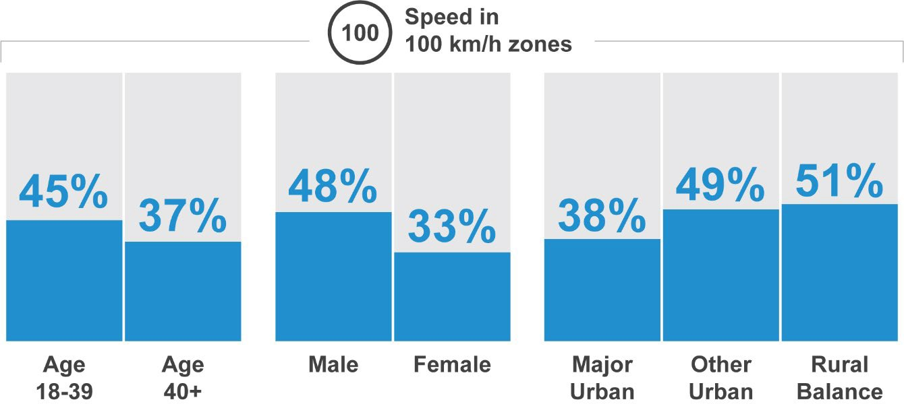
Figure 16 Driving over the speed limit 100 km/h infographic

Other analysis shows that respondents who are more likely to intentionally exceed the speed limit are also more likely to engage in other illegal behaviours such as using mobile phones while driving or drink driving. For example, respondents who make mobile phone calls while driving are more likely to report intentionally driving above the 60 km/h limit at least half the time (14% vs 4% among those who never make mobile calls while driving). Similarly, respondents who drink drive are more likely to intentionally drive above the 100 km/h speed limit at least half the time (29% vs 9% among those who do not drink drive).

Attitudes towards speeding
Respondents were asked to rate the extent to which they agreed or disagreed with a battery of statements about speeding using a five-point scale where 1 is ‘strongly disagree and 5 is ‘strongly agree’. Numbers in Figure 17 and the following text are the percentages of respondents who have a drivers’ licence who nominated a point on the scale.
A majority of respondents (84%) worry about getting a fine if they drive over the speed limit and
(69%) report that speeding makes them feel guilty. More than a half of respondents (58%) agree that speed cameras help save lives. Almost half of respondents (49%) report that they sometimes drive under the speed limit to reduce the chance of having an accident. Less than one in ten respondents (7%) agree with the statements ‘I enjoy speeding’ and ‘I am willing to drive over the speed limit and risk getting a speeding fine.’
Further analysis shows that attitudes to speeding differ by demographic. For example, a higher percentage of females and young respondents aged 18-25 hold somewhat stronger views regarding speeding. For example:
Females (75%) are more likely to strongly agree than males (61%) with the statement ‘I feel guilty if I speed’.
Respondents aged 18-25 (39%) are more likely to strongly disagree with the statement ‘Speed cameras help save lives’ than older respondents (61% of those aged 26-90).
Females (64%) were more likely to strongly agree than males (51%) with the statement ‘Speed cameras help save lives’
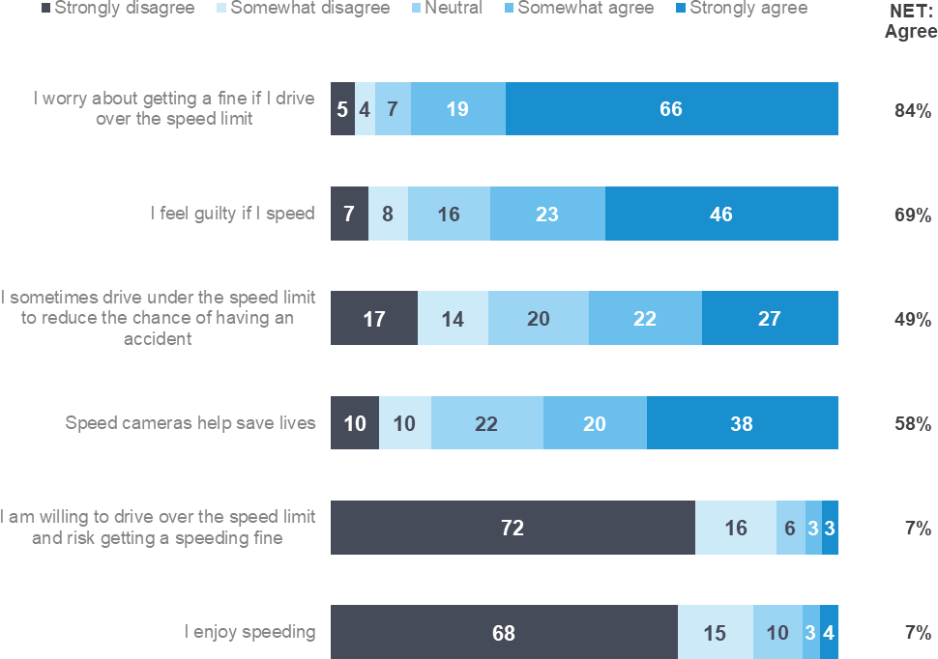
Figure 17 Attitudes towards speeding

SP1 - The following are some statements some people believe about speeding and speed limits. On a scale of 1 to 5, where 1 is “Strongly disagree” and 5 is “Strongly agree”, (to what extent do you agree or disagree / please tell us the extent to which you agree or disagree) with the following statements…
Weighted sample; base=from 459 to1184; Filter: Drivers, excludes don’t know and non-response Figures may not add to 100% due to rounding,

Table 26 shows changes in drivers’ attitudes towards speeding since 2016. In 2020 more than three quarters of respondents (69%) agree that ‘I feel guilty if I speed and almost half of respondents (49%) report that they ‘sometimes drive under the speed limit to reduce the chance of having an accident’. Less than one in ten respondents (7%) agree with the statements ‘I enjoy speeding’.

Table 26 Attitudes towards speeding by year
Column % | 2016 | 2017 | 2018 | 2019 | 2020
I worry about getting a fine if I drive over the speed limit | - | - | - | - | 84
I feel guilty if I speed | 63 | 63 | 67 | 63 | 69
Speed cameras help save lives | - | - | - | - | 58
I sometimes drive under the speed limit to reduce the chance of having
an accident
52
48
53
52
49

I enjoy speeding | 5 | 5 | 6 | 5 | 7
I am willing to drive over the speed limit and risk getting a speeding fine | - | - | - | - | 7
Sample size | 432 | 1606 | 1565 | 841 | 715

SP1 - Attitudes towards speeding statements (Summary) Weighted sample: base n = from 459 to 1184

As shown in Table 27, more females (75%) than males (61%) agree with the statement ‘I feel guilty if I speed’. There is a similar percentage difference between females (64%) and males (51%) who agree with the statement ‘Speed cameras help save lives’.
Respondents aged 18-25 (39%) are the least likely to agree with the statement that ‘Speed cameras help save lives’.
Table 27 Attitudes towards speeding by demographic

Column % | Total | 18 - 25 | Age  26 - 39 40 - 60 |  | 61 | - 90 | Gender  Male Female |  | Major Urban | Location  Other Urban | Rural Balance
I worry about getting a fine if I drive over the speed limit | 84 | 83 | 89 | 84 | 80 |  | 85 | 84 | 85 | 79 | 85
I feel guilty if I speed | 69 | 69 | 66 | 71 | 69 |  | 61 ↓ | 75 ↑ | 68 | 71 | 68
Speed cameras help save  lives | 58 | 39 ↓ | 59 | 61 | 63 |  | 51 ↓ | 64 ↑ | 59 | 59 | 47
I sometimes drive under the speed limit to reduce the chance of having an accident | 49 | 49 | 43 | 52 | 53 |  | 47 | 51 | 50 | 46 | 35
I enjoy speeding | 7 | 11 | 6 | 6 | 6 |  | 8 | 6 | 7 | 6 | 5
I am willing to drive over the speed limit and risk getting a  speeding fine | 7 | 6 | 8 | 6 | 7 |  | 8 | 5 | 6 | 7 | 11
Sample size | 459 | 89 | 124 | 151 | 95 |  | 235 | 224 | 346 | 74 | 32

SP1 - Attitudes towards speeding statements (Summary) Weighted sample: base n = from 459 to 1184

Table 28 shows attitudes towards speeding by driving behaviour. Speeders are less likely to agree with the first four attitudes in Table 28 and more likely to agree with the last two statements (‘I enjoy speeding’ and ‘I am willing to drive over the speed limit and risk getting a speeding fine’). Respondents in all four categories of unsafe or illegal driving behaviour (the first four columns of Table 28) are less likely to agree with the statement ‘I feel guilty if I speed’.
Table 28 Attitudes towards speeding by behaviour

Column % | Total | Speeding  Yes No |  | Drink driving  Yes No |  | Mobile phone use  Yes No |  | Driving fatigued  Yes No |  | Involvement in a crash  Yes No
I worry about getting a fine if I drive over the speed limit | 84 | 80 ↓ | 88 ↑ | 76 | 85 | 81 | 85 | 82 | 85 | 81 | 85
I feel guilty if I speed | 69 | 57 ↓ | 82 ↑ | 35 ↓ | 71 ↑ | 56 ↓ | 74 ↑ | 62 ↓ | 72 ↑ | 71 | 68
Speed cameras help save  lives | 58 | 53 ↓ | 63 ↑ | 53 | 59 | 54 | 60 | 52 ↓ | 62 ↑ | 56 | 59
I sometimes drive under the speed limit to reduce the chance of having an accident | 49 | 43 ↓ | 59 ↑ | 34 | 50 | 43 | 52 | 43 | 54 | 56 | 48
I enjoy speeding | 7 | 10 ↑ | 5 ↓ | 21 ↑ | 6 ↓ | 11 ↑ | 6 ↓ | 8 | 6 | 10 | 6
I am willing to drive over the speed limit and risk getting a  speeding fine | 7 | 10 ↑ | 4 ↓ | 16 ↑ | 6 ↓ | 11 ↑ | 5 ↓ | 9 | 5 | 6 | 7
Sample | 459 | 244 | 201 | 27 | 432 | 143 | 316 | 186 | 267 | 75 | 381

SP1 - Attitudes towards speeding statements (% Agree) by BANNER – Behaviours Weighted sample; base n = from 445 to 1184

Caught speeding
Respondents aged 18-60 who are licence holders were asked if they had been caught speeding in the last twelve months. Figure 18 below shows that the percentage of respondents who reported being caught speeding has declined from 2014 to 2017 but has since plateaued at 13%.
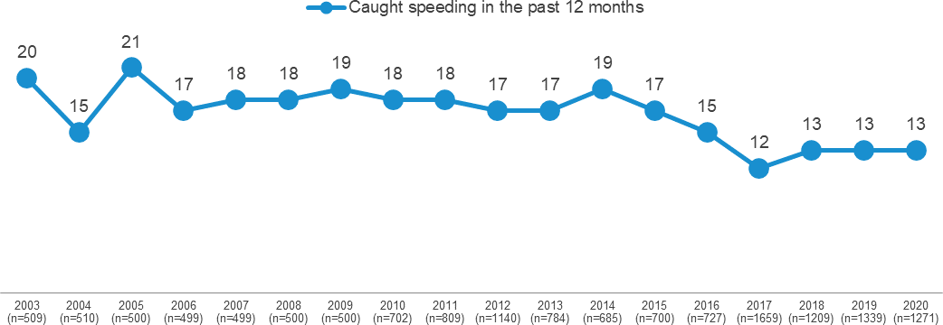
Figure 18 Caught speeding by year

SP2 - Have you been caught speeding in the last 12 months? Filter: Licence holders aged 18-60 with a valid response

Table 29 shows the incidence of being caught speeding by demographic. Males (14%) are more likely to have been caught speeding in the last twelve months than females (9%).
Table 29 Caught speeding in the past 12 months by demographic

Column % |  | Total | 18 - 25 | Age  26 - 39 40 - 60 |  | 61 - 90 | Gender  Male Female |  | Major Urban | Location  Other Urban | Rural Balance
Yes |  | 11 | 11 | 12 | 13 | 8 | 14 | 9 | 12 | 10 | 9
No |  | 89 | 89 | 88 | 87 | 92 | 86 | 91 | 88 | 90 | 91
Sample size |  | 1675 | 262 | 454 | 555 | 404 | 835 | 840 | 1053 | 434 | 188

SP2 - Have you been caught speeding in the last 12 months? Filter: Licence holders; base n=1675
Blue up arrows (↑) and red down arrows (↓) indicate statistically significant difference compared to respondents not in that category Figures may not add to 100% due to rounding.

Impaired driving

Use of drugs and alcohol
Respondents were asked whether they drink alcohol and if they had used recreational drugs in the last 12 months. Figure 19 below is filtered to respondents aged 18-60 who are licence holders to allow valid comparisons over time. Figure 19 shows that, filtered to these respondents, about four in five respondents (77%) ever drink alcohol, while about one in ten respondents (10%) have used recreational drugs in the last twelve months.
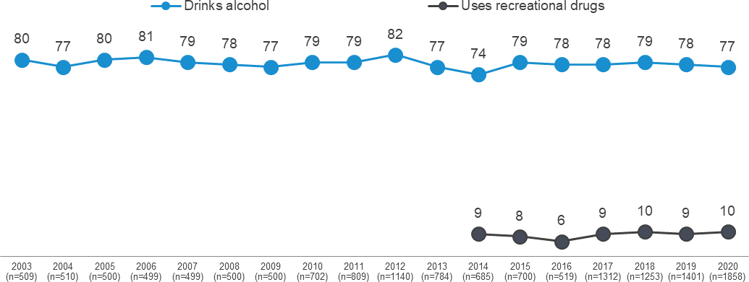
Figure 19 Use of drugs and alcohol by year

DK2 - Do you ever drink alcohol?
DG3 - In the last 12 months, have you used recreational drugs (for example, methamphetamine, ice, marijuana etc.)? Filter: Licence holders aged 18-60 with a valid response; base n=1858
* Note: 'Drug use' was introduced in 2014

Table 30 shows results for all drivers by demographic. Among all drivers, more males (80%) than females (74%) report they drink alcohol.
Usage of recreational drugs is higher among respondents aged 18-25 (19%) and 26-39 (11%) than among those aged 40-60 (5%) or 61-90 (3%).
Table 30 Use of alcohol and recreational drugs by demographic

Column % | Total | 18 - 25 | Age  26 - 39 40 - 60 | 61 - 90 | Gender  Male Female |  | Major Urban | Location  Other Urban | Rural Balance
Drinks alcohol | 77 | 82 ↑ | 76 78 | 73 ↓ | 80 ↑ | 74 ↓ | 77 | 76 | 82
Uses recreational drugs | 8 | 19 ↑ | 11 ↑ 5 ↓ | 3 ↓ | 10 ↑ | 6 ↓ | 8 | 7 | 8
Sample size | 2389 | 363 | 621 807 | 598 | 1200 | 1189 | 1388 | 688 | 313

DK2 - Do you ever drink alcohol?
DG3 - In the last 12 months, have you used recreational drugs (for example, methamphetamine, ice, marijuana etc.)?
Blue up arrows (↑) and red down arrows (↓) indicate statistically significant difference compared to respondents not in that category. Filter: Driver with a valid response; base n=2389
Figures may not add to 100% due to rounding

As shown in Table 31, drivers who engage in illegal behaviours such as drink driving, or who have been involved in a crash, (see Section 1.3 for definitions) are more likely to drink alcohol and use recreational drugs. For example:
Speeders (83%) are more likely to report ever drinking alcohol than non-speeders (72%).
Respondents who drink drive are more likely to use recreational drugs (30%) than respondents who do not drink drive (7%).
Respondents who have been involved in a crash in the past five years are more likely to have used recreational drugs (12%) than those who have not (7%).
Table 31 Use of alcohol and recreational drugs by behaviour

Column % | Total | Speeding  Yes No |  | Drink driving  Yes No |  | Mobile phone use  Yes No |  | Driving fatigued  Yes No |  | Involvement in a crash  Yes No
Drinks alcohol | 77 | 83 ↑ | 72 ↓ | 100 ↑ | 76 ↓ | 85 ↑ | 74 ↓ | 82 ↑ | 74 ↓ | 83 ↑ | 76 ↓
Uses recreational drugs | 8 | 11 ↑ | 5 ↓ | 30 ↑ | 7 ↓ | 18 ↑ | 5 ↓ | 12 ↑ | 6 ↓ | 12 ↑ | 7 ↓
Sample size | 2389 | 1226 | 1112 | 128 | 2261 | 672 | 1717 | 935 | 1413 | 409 | 1966

DK2 - Do you ever drink alcohol?
DG3 - In the last 12 months, have you used recreational drugs (for example, methamphetamine, ice, marijuana etc.)?
Blue up arrows (↑) and red down arrows (↓) indicate statistically significant difference compared to respondents not in that category Filter: Drivers with a valid response; base=2389
Figures may not add to 100% due to rounding.

Drink driving
Incidence of illegal drink driving

As shown in Table 32, in the last 12 months, 3% of respondents reported having been a passenger when they thought the driver was over the BAC limit.
Among respondents who drive, 5% report they had driven a car when they thought they were over their legal BAC limit. Those who drink drive are more likely to be male (7%) than female (3%).
Table 32 Illegal drink driving by demographic

Column % | Total | 18 - 25 | Age  26 - 39 40 - 60 |  | 61 - 90 | Gender  Male Female |  | Major Urban | Location  Other Urban | Rural Balance
Been a passenger in car when driver was over their  legal BAC | 3 | 5 | 3 | 2 | 3 | 4 | 3 | 3 | 4 | 3
Sample size | 2476 | 399 | 637 | 826 | 614 | 1245 | 1231 | 1452 | 702 | 322
Driven when over legal BAC | 5 | 6 | 6 | 4 | 6 | 7 ↑ | 3 ↓ | 5 | 5 | 8
Sample size | 2403 | 369 | 622 | 811 | 601 | 1206 | 1197 | 1395 | 691 | 317

DK1 - In the last 12 months, have you been a passenger in a car when you knew or thought the driver was over their legal blood alcohol limit? Total sample; Weighted; base n = 2476
DK3 - In the last 12 months, have you driven a car when you knew or thought you were over your legal blood alcohol limit, even slightly? Driver; Weighted; base n = 2403
Blue up arrows (↑) and red down arrows (↓) indicate statistically significant difference compared to respondents not in that category. Figures may not add to 100% due to rounding.

Legal drink driving

Respondents were asked whether they have driven after drinking alcohol, but while they believed they were under their legal blood alcohol limit. As shown in Table 33, four in ten respondents (41%) report driving after drinking when they believed they were under their legal blood alcohol limit. This behaviour is most common among those aged 40-60 (48%) and males (45%).
Respondents aged 18-25 (37%) are the most likely to ‘never drive after drinking’ and respondents aged 40-60 (14%) are the least likely.
Table 33 Legal drink driving by demographic

Column % | Total | 18 - 25 | Age  26 - 39 40 - 60 |  | 61 - 90 | Gender  Male Female |  | Major Urban | Location  Other Urban | Rural Balance
Driven after drinking while  under legal BAC | 41 | 23 ↓ | 46 | 48 ↑ | 37 | 45 ↑ | 37 ↓ | 41 | 44 | 42
NET: Has not driven after drinking alcohol in past 12  months | 59 | 77 ↑ | 54 | 52 ↓ | 63 | 55 ↓ | 63 ↑ | 59 | 56 | 58
No, not in the past 12  months | 13 | 13 | 12 | 12 | 16 | 12 | 15 | 13 | 13 | 16
Never drives after drinking | 19 | 37 ↑ | 16 | 14 ↓ | 17 | 18 | 19 | 19 | 17 | 21
Never drinks alcohol | 23 | 18 | 23 | 22 | 27 | 21 | 25 | 23 | 24 | 19
Doesn't drive / has not driven  in past 12 months | 4 | 9 ↑ | 3 | 3 | 3 | 4 | 4 | 4 ↑ | 2 | 2
Sample size | 1927 | 304 | 484 | 643 | 496 | 953 | 974 | 1048 | 607 | 272

DK8 - In the last 12 months, have you driven a car after drinking alcohol when you knew or thought you were under the legal blood alcohol limit? Filter: Total sample; Weighted sample; base n=1927
Blue up arrows (↑) and red down arrows (↓) indicate statistically significant difference compared to respondents not in that category Figures may not add to 100% due to rounding

Number of drinks

Nearly a quarter (23%) of those who drive and drink alcohol say they would not drive after drinking alcohol. About three in ten (29%) would have a maximum of one drink and consider driving. Just under half (48%) would still consider driving after drinking two or more alcoholic drinks. Considering differences by demographic:
Respondents aged between 18-25 (45%) are most likely to say would not drive after drinking at all.
Females (37%) are more likely than males (20%) to say that they would have a maximum of one drink and still consider driving. Males (56%) are more likely females (40%) to consider driving after two or more drinks.
More than half of respondents aged between 40-60 (55%) would consider driving after two or more drinks.

Table 34 Number of drinks by demographic

Column % | Total | 18 - 25 | Age  26 - 39 40 - 60 |  | 61 - 90 | Gender  Male Female |  | Major Urban | Location  Other Urban | Rural Balance
Would not drive after drinking | 23 | 45 ↑ | 21 | 18 ↓ | 21 | 24 | 23 | 24 | 21 | 20
One drink | 29 | 26 | 28 | 27 | 35 | 20 ↓ | 37 ↑ | 29 | 28 | 29
NET: Two or more drinks | 48 | 29 ↓ | 51 | 55 ↑ | 43 | 56 ↑ | 40 ↓ | 47 | 51 | 50
Two drinks | 42 | 26 ↓ | 45 | 50 ↑ | 39 | 46 | 39 | 42 | 45 | 45
Three or more drinks | 5 | 4 | 7 | 5 | 5 | 9 ↑ | 1 ↓ | 5 | 6 | 5
Sample size | 1090 | 169 | 274 | 378 | 269 | 552 | 538 | 518 | 386 | 186

DK5 What is the highest number of alcoholic drinks you would have and still consider driving. Filter: Driver/ Drink alcohol; Weighted sample; base n=1090
Blue up arrows (↑) and red down arrows (↓) indicate statistically significant difference compared to respondents not in that category. Figures may not add to 100% due to rounding.

Drug driving
Recreational drugs used in the total community

Respondents who used recreational drugs in the last 12 months are most likely to have used cannabis/marijuana (5.7%) or stimulants (3.0%) such as ecstasy, methamphetamine/ice, speed or cocaine. Drug use is highest among those aged 18-25, with 19% reporting they have used recreational drugs in the past 12 months. Recreational drugs are more likely to be used by males (10%) than females (6%).
Table 35 Use of alcohol and recreational drugs by demographic

Column % | Total | 18 - 25 | Age  26 - 39 40 - 60 |  | 61 - 90 | Gender  Male Female |  | Major Urban | Location  Other Urban | Rural Balance
NET: Used recreational drugs in the past 12 months | 8.4 | 19 ↑ | 12 ↑ | 5 ↓ | 3 ↓ | 10 ↑ | 6 ↓ | 9 | 7 | 8
Cannabis / marijuana | 5.7 | 15 ↑ | 8 ↑ | 3 ↓ | 2 ↓ | 7 ↑ | 4 ↓ | 6 | 4 | 5
Stimulants | 3 | 8 ↑ | 5 ↑ | 2 | 0 ↓ | 4 ↑ | 2 ↓ | 3 | 3 | 2
Prescription medications for non-medical purposes | 1.9 | 3 | 3 ↑ | 1 | 1 ↓ | 2 | 2 | 2 | 2 | 2
Hallucinogens | 1.6 | 5 ↑ | 3 ↑ | 0 ↓ | 0 ↓ | 2 ↑ | 1 ↓ | 2 | 1 | 1
Opioids | 0.2 | 0 | 1 | 0 | 0 | 0 | 0 | 0 | 0 | 0
Other | 0.3 | 0 | 0 | 0 | 1 | 1 ↑ | 0 ↓ | 0 | 0 | 0
Sample size | 2505 | 402 | 643 | 835 | 625 | 1261 | 1244 | 1464 | 714 | 327

DG3 - In the last 12 months, which of the following recreational drugs have you used? Weighted sample; base n=2505
Figures may not add to 100% due to rounding.

Driving after using recreational drugs

As shown in Table 36, the percentage of respondents who are drivers who drive after taking drugs is 1.7%. More than half of those who report driving after using drugs report doing so multiple times in the past year.
Additional analysis shows that a higher percentage of respondents who are aged under 40 years of age (3%) report driving after taking recreational drugs than those aged 40-90 (0.9%).
Table 36 Frequency of driving after using recreational drugs by year

Column % |  | 2017 | 2018 | 2019 | 2020
 | NET: Driven after using recreational drugs | 1.5 | 2.2 | 1.7 | 1.7
 | Once in the last 12 months | 0.5 | 1.0 | 0.5 | 0.5
 | Twice in the last 12 months | 0.3 | 0.3 | 0.4 | 0.3
 | 3 to 5 times in the last 12 months | 0.2 | 0.3 | 0.3 | 0.5
 | 6 to 10 times in the last 12 months | 0.2 | 0.2 | 0.2 | 0.1
 | More than 10 times in the last 12 months | 0.2 | 0.4 | 0.3 | 0.2
 | Not at all in the last 12 months | 6.7 | 5.9 | 5.8 | 6.3
 | Does not use recreational drugs or does not drive | 91.8 | 91.9 | 92.4 | 92.0
 | Sample size | 1250 | 1515 | 1745 | 2335

DG4 In the last 12 months, how often have you driven a vehicle, or ridden a motorbike, after using recreational drugs? Filter: Drivers with a valid response; base n=2335
Figures may not add to 100% due to rounding

Fatigue
Respondents who drive a vehicle or ride a motorcycle were asked how often they have driven while feeling very tired. As shown in Table 37, over a third of respondents (38%) report that they have driven while very tired in the past three months. The incidence of driving while very tired is higher among respondents aged 18-25 (55%) than all other age groups.
Table 37 How often driven when very tired in the past three months by demographic

Column % | Total | 18 - 25 | Age  26 - 39 40 - 60 |  | 61 - 90 | Gender  Male Female |  | Major Urban | Location  Other Urban | Rural Balance
NET: Ever | 38 | 55 ↑ | 48 ↑ | 34 ↓ | 23 ↓ | 40 | 36 | 37 | 41 | 43
Half the time or more often | 3 | 5 ↑ | 6 ↑ | 2 ↓ | 1 ↓ | 4 | 3 | 3 | 4 | 4
Some of the time | 35 | 49 ↑ | 42 ↑ | 33 | 22 ↓ | 36 | 34 | 34 | 37 | 39
None of the time | 62 | 45 ↓ | 52 ↓ | 66 ↑ | 77 ↑ | 60 | 64 | 63 | 59 | 57
Sample size | 2367 | 364 | 614 | 804 | 585 | 1182 | 1185 | 1370 | 683 | 314

DB2E In the past three months, how often did you drive when feeling very tired? *changed from ‘drowsy’ in 2020 Q2 (Apr-Jun) Filter: Driver; weighted sample; base n=2367
Blue up arrows (↑) and red down arrows (↓) indicate statistically significant difference compared to respondents not in that category. Figures may not add to 100% due to rounding.

Distractions
Respondents were asked how frequently they engaged in behaviours using their mobile phones while driving. Overall, seven in ten (71%) of respondents who drive have used a mobile phone at all (legally or illegally). While a majority of respondents had answered a call (64%) or made a call (55%) using Bluetooth while driving. Considering illegal (hand-held) use of mobile phones, respondents are more likely to use their phone in response to an incoming call or text than decide to instigate communication with someone while driving. For instance, to use a mobile phone hand-held to answer a call (13%) or read a text (23%) rather than write and send a message (10%) or make a call with hand-held phone (9%) while driving.
Additional analysis shows that, in the past three months, about seven in ten (71%) drivers report using a mobile phone at all while driving, including Bluetooth and hand-held. A substantial minority (28%) used a mobile phone hand-held while driving.
Figure 9 Mobile phone usage while driving

None of the time Some of the time Half/ most / all the time NET: Ever
Answer a call using Bluetooth while driving | 36 |  | 41 |  |  | 23 |  |  | 64%
Make a call using Bluetooth while driving | 45 |  |  | 35 |  | 21 |  |  | 55%
Read a text message while driving |  | 77 |  |  |  | 21 |  |  | 23%

2

Answer a call with a hand-held phone while driving | 87 |  | 12 1 13%
Write and send a text message while driving | 90 |  | 9 1 10%
Make a call with a hand-held phone while driving | 91 |  | 8 1 9%

Use a messaging app (eg Facebook Messenger, Whatsapp, Snapchat etc.) while driving
92
7 1 8%

DB2ABCD In the past three months, how often did you X (Any of Some / Half / Most / All the time) Filter: Driver; weighted sample; base n=1333
Figures may not add to 100% due to rounding

As shown in Table 38 on the next page, legal and illegal use of a mobile phone shows marked differences by demographic. For instance:

Mobile phone usage (both legal and illegal) is higher among those aged and 26-39 (84%) and 40-60 (78%) than among those aged 18-25 (71%) or 61-90 (47%). Respondents living in Major Urban areas (72%) are more likely to use mobile phone while driving than in Other Urban areas (65%).
Legal mobile phone usage (Bluetooth) is higher among drivers aged 26-39 (77%) and 40-60 (70%) than drivers aged over 61 years old (44%) Respondents living in Major Urban areas (66%) are more likely to use mobile phone with Bluetooth while driving than those living in Other Urban areas (58%).

Respondents aged 18-25 (41%) and 26-39 (38%) are more likely to use mobile phones illegally than drivers 60-91 years old (8%). Illegal mobile phone usage (hand-held) is also more likely among males (32%) than females (24%).
Table 38 Use of a mobile phone while driving by demographic

Column % | Total | 18 - 25 | Age  26 - 39 40 - 60 |  | 61 - 90 | Gender  Male Female |  | Major Urban | Location  Other Urban | Rural Balance
NET: Used a mobile phone at all while driving (including  Bluetooth) | 71 | 71 | 84 ↑ | 78 ↑ | 47 ↓ | 75 ↑ | 67 ↓ | 72 ↑ | 65 ↓ | 70
NET: Legal use of mobile phone (Bluetooth) | 65 | 64 | 77 ↑ | 70 ↑ | 44 ↓ | 70 ↑ | 59 ↓ | 66 ↑ | 58 ↓ | 63
Answer a call using Bluetooth while driving | 64 | 64 | 76 ↑ | 69 ↑ | 43 ↓ | 69 ↑ | 59 ↓ | 65 ↑ | 56 ↓ | 62
Make a call using Bluetooth  while driving | 55 | 55 | 73 ↑ | 61 ↑ | 27 ↓ | 60 ↑ | 51 ↓ | 57 ↑ | 48 ↓ | 51
NET: Illegal use of a mobile phone (non-Bluetooth) | 28 | 41 ↑ | 38 ↑ | 30 | 8 ↓ | 32 ↑ | 24 ↓ | 29 | 27 | 26
Read a text message while  driving | 23 | 33 ↑ | 33 ↑ | 22 | 6 ↓ | 26 ↑ | 19 ↓ | 23 ↑ | 20 | 18
Answer a call with a hand- held phone while driving | 13 | 21 ↑ | 18 ↑ | 12 | 4 ↓ | 15 ↑ | 11 ↓ | 13 | 14 | 15
Write and send a text message while driving | 10 | 15 ↑ | 15 ↑ | 9 | 1 ↓ | 11 ↑ | 8 ↓ | 10 | 9 | 9
Make a call with a hand-held  phone while driving | 9 | 15 ↑ | 13 ↑ | 8 | 2 ↓ | 10 ↑ | 7 ↓ | 9 | 10 | 8
Use a messaging app (eg Facebook Messenger, Whatsapp, Snapchat etc.)  while driving | 8 | 18 ↑ | 12 ↑ | 5 ↓ | 1 ↓ | 9 ↑ | 6 ↓ | 8 ↑ | 5 ↓ | 7
Sample size | 1897 | 285 | 498 | 643 | 471 | 953 | 944 | 1030 | 593 | 274
DB2ABCD - In the past three months, how often did you…. Filter: Driver; Weighted sample; base n=1897
Blue up arrows (↑) and red down arrows (↓) indicate statistically significant difference compared to respondents not in that category. Figures may not add to 100% due to rounding.

Mobile phone detection cameras
In 2020 Jan-Mar quarter, respondents were asked about mobile phone detection cameras. About two thirds (65%) of respondents are aware of mobile phone detection cameras. Awareness is consistent across demographic characteristics.
Table 39 Awareness of mobile phone detection cameras by demographic

Column % |  | Total | 18 - 25 | Age  26 - 39 40 - 60 |  | 61 - 90 | Gender  Male Female |  | Major Urban | Location  Other Urban | Rural Balance
Yes |  | 65 | 64 | 59 | 70 | 66 | 70 | 60 | 64 | 78 | 64
No |  | 29 | 29 | 31 | 26 | 32 | 26 | 33 | 30 | 21 | 33
Maybe |  | 6 | 7 | 10 | 4 | 2 | 4 | 7 | 6 | 1 | 3
Sample size |  | 467 | 77 | 114 | 162 | 114 | 241 | 226 | 345 | 88 | 34

EN6 - Are you aware that mobile phone detection cameras are being used in parts of Australia to detect drivers using a mobile phone while driving?
Filter: total sample; weighted; base n=467 Figures may not add to 100% due to rounding

Drivers who use a hand-held mobile phone while driving were asked how the introduction of mobile phone detection cameras would affect their use of a hand-held mobile phone while driving. Nearly six in ten (59%) respondents reported that they would use their mobile phone while driving less or not at all if the cameras were installed.
Table 40 Impact of cameras on the frequency of using a handheld mobile phone while driving by demographic

Column % | Total | 18 - 25 | Age  26 - 39 40 - 60 |  | 61 - 90 | Gender  Male Female |  | Major Urban | Location  Other Urban | Rural Balance
No change | 18 | 13 | 17 | 20 | 26 | 24 | 10 | 18 | 16 | 0
NET: Less or not at all | 59 | 56 | 58 | 65 | 44 | 55 | 63 | 58 | 66 | 63
A bit less | 10 | 18 | 7 | 6 | 12 | 11 | 8 | 9 | 15 | 0
A lot less | 20 | 27 | 24 | 14 | 7 | 20 | 20 | 19 | 29 | 14
Will not use it at all | 29 | 12 | 27 | 45 | 25 | 24 | 36 | 29 | 22 | 49
I do not use it at all now | 18 | 30 | 13 | 13 | 30 | 14 | 23 | 18 | 15 | 23
Don't know | 5 | 1 | 12 | 2 | 0 | 7 | 3 | 5 | 3 | 14
Sample size | 137 | 37 | 41 | 47 | 12 | 76 | 61 | 102 | 27 | 8

EN7 - If mobile phone detection cameras are installed in Victoria, how often would you use a handheld mobile phone while driving compared to now?
Filter: Uses a hand-held mobile phone while driving; base n=137 Figures may not add to 100% due to rounding

Pedestrian distractions
Respondents were asked several questions concerning the frequency and causes of pedestrian distractions.

Frequency of pedestrian distractions
Respondents were asked how often they crossed the street while listening to headphones in the last three months. Over one third (34%) report having done so in the last three months.
As shown in Table 41, fifteen per cent of respondents listen to headphones when they cross the street at least half the time. Younger respondents are more likely to listen to headphones while crossing the street; respondents aged 18-25 (38%) report listening at least half the time, compared to 24% of those aged 26-39, 8% of those aged 40-60 and 1% of those aged over 60.
Table 41 Frequency of crossing the street with headphones by demographic

Column % | Total | 18 - 25 | Age  26 - 39 40 - 60 |  | 61 - 90 | Gender  Male Female |  | Major Urban | Location  Other Urban | Rural Balance
All / Most / Half the time | 15 | 38 ↑ | 24 ↑ | 8 ↓ | 1 ↓ | 14 | 15 | 16 ↑ | 10 | 4 ↓
Some of the time | 19 | 25 | 27 ↑ | 18 | 7 ↓ | 19 | 19 | 20 | 15 | 10
NET: Ever | 34 | 63 ↑ | 51 ↑ | 25 ↓ | 8 ↓ | 33 | 34 | 37 ↑ | 25 ↓ | 14 ↓
None of the time | 66 | 37 ↓ | 49 ↓ | 74 ↑ | 92 ↑ | 67 | 65 | 63 ↓ | 74 ↑ | 86 ↑
Don't know | 0 | 0 | 0 | 1 | 0 | 0 | 0 | 0 | 1 | 0
Sample size | 638 | 107 | 155 | 227 | 149 | 335 | 303 | 369 | 183 | 86

PED1 In the last three months, how often did you cross the street while listening to headphones (calls, music, podcasts etc.)? Weighted sample; base n=638
Blue up arrows (↑) and red down arrows (↓) indicate statistically significant difference compared to respondents not in that category. Figures may not add to 100% due to rounding.

Respondents were asked how often they crossed the street while looking at a mobile phone in the last three months. As shown in Table 42, close to one-third of respondents (29%) report having done so in the last three months, while about one in fifty (2%) report having done so at least half the time. Respondents aged 18-25 (52%) and 26-39 (48%) are most likely to have crossed a road in the previous three months while looking at a mobile phone.
Table 42 Frequency of crossing the street looking at a mobile phone by demographic

Column % | Total | 18 - 25 | Age  26 - 39 40 - 60 |  | 61 - 90 | Gender  Male Female |  | Major Urban | Location  Other Urban | Rural Balance
All / Most / Half the time | 2 | 4 | 4 | 1 | 0 | 2 | 2 | 2 | 3 | 0
Some of the time | 26 | 47 ↑ | 44 ↑ | 20 ↓ | 4 ↓ | 29 | 23 | 28 | 17 ↓ | 25
NET: Ever | 29 | 52 ↑ | 48 ↑ | 21 ↓ | 4 ↓ | 32 | 25 | 30 | 20 ↓ | 25
None of the time | 71 | 48 ↓ | 50 ↓ | 78 ↑ | 96 ↑ | 67 | 74 | 69 ↓ | 79 ↑ | 75
Don't know | 1 | 0 | 2 | 1 | 0 | 1 | 1 | 1 | 1 | 0
Sample size | 636 | 106 | 155 | 227 | 148 | 335 | 301 | 368 | 183 | 85

PED1 In the last three months, how often did you cross the street while looking at a mobile phone? Weighted sample
Blue up arrows (↑) and red down arrows (↓) indicate statistically significant difference compared to respondents not in that category. Figures may not add to 100% due to rounding.

Causes of pedestrian distraction
Respondents were asked whether they had been distracted by a range of things while walking around. As shown in Table 43, respondents are most likely to have been distracted by the actions of other road users (36%), ahead of their own thoughts (32%), other pedestrians (29%), mobile phones (27%), and signs on the road (8%). Older respondents are least likely to report having been distracted by something, with 56% reporting ‘none of the above’.
Table 43 What distracts pedestrians by demographic

Column % | Total | 18 - 25 | Age  26 - 39 40 - 60 |  | 61 - 90 | Gender  Male Female |  | Location  Major Other Rural Urban Urban Balance
None of the above | 35 | 27 | 26 ↓ | 33 | 56 ↑ | 35 | 36 | 32 ↓ 49 ↑ 46
Actions of other road users (e.g. drivers, motorcyclists or  cyclists) | 36 | 51 ↑ | 36 | 35 | 28 | 35 | 37 | 38 ↑ 26 ↓ 27
Your own thoughts/thinking about something not related to what you are doing | 32 | 48 ↑ | 36 | 32 | 14 ↓ | 30 | 33 | 33 23 28
Mobile phone | 27 | 47 ↑ | 34 | 24 | 11 ↓ | 30 | 25 | 29 ↑ 19 22
People you are walking with or other pedestrians | 29 | 38 | 34 | 30 | 15 ↓ | 28 | 29 | 29 28 22
Signs on the road (e.g. street signs, roadworks, billboards) | 8 | 11 | 5 | 10 | 5 | 7 | 8 | 8 5 7
GPS/Map | 3 | 5 | 3 | 2 | 1 | 3 | 2 | 3 1 3
Don't know | 3 | 0 | 7 ↑ | 3 | 1 | 4 | 2 | 3 2 5
Other | 2 | 1 | 4 | 1 | 1 | 2 | 2 | 2 1 0
Sample size | 631 | 106 | 155 | 226 | 144 | 328 | 303 | 367 181 83

PED2 In the last week, have you been DISTRACTED by any of the following while you were walking around? Weighted sample; base n=631
Blue up arrows (↑) and red down arrows (↓) indicate statistically significant difference compared to respondents not in that category. Figures may not add to 100% due to rounding.

Distractions while using mobile phones
Respondents who report that they were distracted by their mobile phone while walking were asked what they were using on their mobile phone that was distracting them. As shown in Figure 20, respondents report they were most likely to be distracted by either SMS (52%) and phone calls (35%).
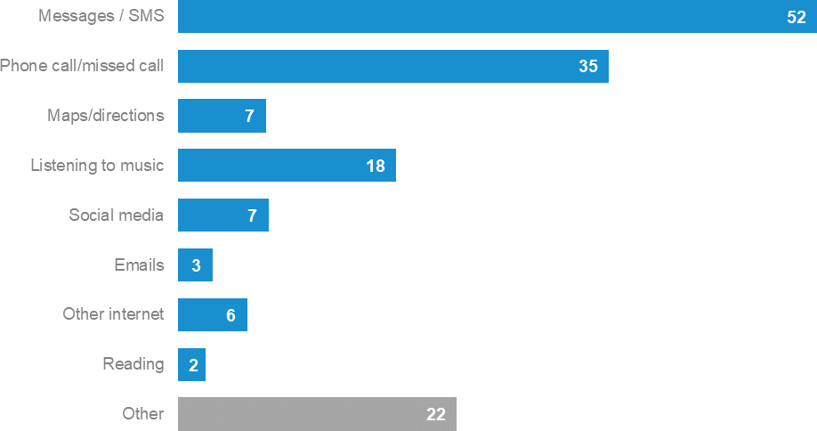
Figure 20 Pedestrian distractions on a mobile phone

PED3 What was distracting you on your phone?
Filter: Distracted by mobile phone (at PED2); Weighted sample; base n=166 Figures may not add to 100% due to rounding.

Near misses due to pedestrian distractions
As shown in Table 44, one in ten respondents (10%) report ever having a ‘near miss’ with a vehicle because they were distracted when walking.
Table 44 Near misses due to pedestrian distractions by demographic

Column % |  | Total | 18 - 25 | Age  26 - 39 40 - 60 |  | 61 - 90 | Gender  Male Female |  | Major Urban | Location  Other Urban | Rural Balance
Yes |  | 10 | 17 | 8 | 10 | 9 | 13 | 7 | 11 | 8 | 6
No |  | 90 | 83 | 92 | 90 | 91 | 87 | 93 | 89 | 92 | 94
Sample size |  | 633 | 106 | 155 | 223 | 149 | 332 | 301 | 367 | 181 | 85

PED4 Have you ever had a 'near miss', where you were almost hit by a vehicle, when you were walking because you were distracted? Weighted sample; base n=633
Blue up arrows (↑) and red down arrows (↓) indicate statistically significant difference compared to respondents not in that category Figures may not add to 100% due to rounding.

Police enforcement

Avoiding being caught
Views were polarised regarding how easy or difficult it is for people to be caught drink driving, driving over the speed limit, drug driving or using a mobile phone when driving.
As shown in Figure 21, close to two thirds of respondents (64%) say the police are effective in catching drivers who are driving above posted speed limit. Only about half of respondents (51%) say the police are effective in catching drivers who are using illegal drugs.
The findings do not vary significantly by demographic or by category of risky driving behaviour.
Figure 21 Effectiveness of police in catching someone while driving illegally

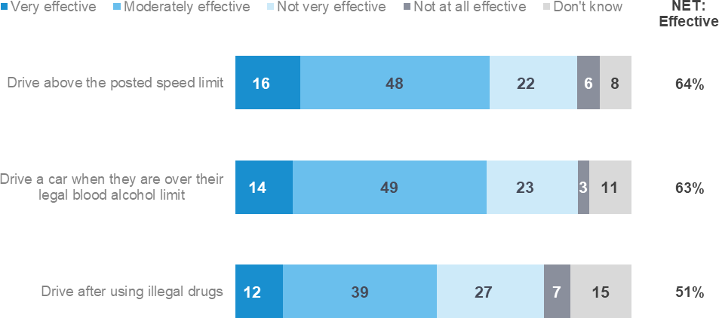

EN8 - Effectiveness of police in catching someone who drives. Weighted sample; base n = from 1192 to 1193

As shown in the Table 45, respondents in Major Urban areas (62%) say the police are less likely to be effective in catching someone who drives over their legal blood alcohol limit than respondents in other areas (69% in Other Urban areas and 75% in Rural Balance areas).
The findings do not vary significantly by other demographic or by category of risky driving behaviour.
Table 45 Perception of police effectiveness by demographic

Column % | Total | 18 - 25 | Age  26 - 39 40 - 60 |  | 61 - 90 | Gender  Male Female |  | Location  Major Other Rural Urban Urban Balance
Drive above the posted  speed limit | 64 | 61 | 68 | 62 | 64 | 67 | 61 | 63 67 71
Drive a car when they are over their legal blood alcohol  limit | 63 | 65 | 66 | 58 | 67 | 64 | 63 | 62 ↓ 69 75
Drive after using illegal drugs | 51 | 54 | 54 | 46 | 54 | 51 | 50 | 50 51 61
Sample size | 1189 | 189 | 301 | 388 | 311 | 599 | 590 | 687 348 154

EN8 - Effectiveness police in catching someone who drives - (% Very / moderately effective) Weighted sample; base n=1189

Respondents were asked to rate the extent to which they agreed or disagreed with two statements about the effectiveness of current penalties using a five-point scale where 1 is ‘strongly disagree’ and 5 is ‘strongly agree’. Numbers in Figure 22 and the following text are the percentages of respondents who nominated a point on the scale.
Nearly three quarter of respondents (74%) agree that the current penalties deter them from using a hand-held mobile phone while driving. More than half (55%) strongly agree that penalties deter them from using a mobile phone whole driving. Respondents are less likely to agree (43%) that the current penalties deter drivers from using a hand-held mobile phone while driving.
The findings do not vary by demographic.
Figure 22 Effectiveness of current penalties

Strongly disagree Disagree Neither Agree Strongly agree Don't know NET:
Agree

The current penalties are effectively deterring me personally from using a hand-held mobile phone while driving
2
55

19

11

8

6

The current penalties are effectively deterring drivers from using a hand- held mobile phone while driving

4

24

19

16

17

20

74%

43%

EN5 - The current penalty for using a mobile phone while driving is $484 and 4 demerit points. To what extent do you agree or disagree with the following…
Weighted sample: Weight base n = from 422 to 470

As shown in Table 46, drivers who use a hand-held mobile phone while driving (64%) are less likely to believe that the penalties for mobile phone are effective at deterring them from using a mobile phone those who do not use a hand-held mobile phone while driving (79%).
Table 46 Effectiveness of current mobile phone penalties by behaviour

Column % | Total | Speeding  Yes No |  | Drink driving  Yes No |  | Mobile phone use  Yes No |  |  | Driving fatigued  Yes No |  | Involvement in a crash  Yes No
The current penalties are effectively deterring me personally from using a hand-held mobile phone while  driving | 74 | 71 | 80 | 58 | 75 | 64 | ↓ | 79 ↑ | 72 | 76 | 82 | 72
The current penalties are effectively deterring drivers from using a hand- held mobile phone while driving | 43 | 41 | 43 | 47 | 42 | 39 | 44 |  | 39 | 45 | 44 | 43
Sample size | 422 | 238 | 169 | 22 | 400 | 138 | 284 |  | 156 | 255 | 81 | 338
EN5 - The current penalty for using a mobile phone while driving is $484 and 4 demerit points. To what extent do you agree or disagree with the following…
Weighted sample: Weight base n = from 422 to 470

Perceptions of police
Respondents were asked whether they agreed or disagreed with three statements regarding police and police enforcement. Overall, attitudes to police enforcement among respondents are positive, with the majority agreeing that:
‘Police play an important role in reducing fatal crashes on Victoria’s roads’ (66% of respondents), and
‘Seeing police on the roads makes me feel safer’ (65% of all respondents, and 76% of respondents aged 61- 90)
A quarter of respondents (25%) agree that enforcing speed limits just raises revenue and does not make our roads any safer.
Table 47 Perceptions of police by demographic

Column % | Total | 18 - 25 | Age  26 - 39 40 - 60 |  | 61 - 90 | Gender  Male Female |  | Major Urban | Location  Other Urban | Rural Balance
Police play an important role in reducing fatal crashes on  Victoria's roads | 66 | 60 | 63 | 68 | 70 | 64 | 67 | 66 | 65 | 72
Seeing police on the roads  makes me feel safer | 65 | 55 | 59 | 66 | 76 ↑ | 61 | 68 | 64 | 68 | 68
Enforcing speed limits just raises revenue and doesn't make our roads any safer | 25 | 17 | 27 | 25 | 30 | 28 | 23 | 25 | 28 | 25
Sample size | 1192 | 191 | 301 | 386 | 314 | 602 | 590 | 691 | 349 | 152

EN2 - Enforcement (attitudes towards police (agreement)) Weighted sample: base n=1192

As shown in Table 48, there is a pattern of more negative views of police among those who engage in risky behaviour - in particular, among those who drink drive. Among those who drink drive only 47% indicate that seeing police on the roads makes them feel safer compared to 59% of speeders, 59% of those who drive fatigued, and 53% of illegal mobile phone users. These findings compare to 65% of all respondents who say that seeing police on the road makes them feel safer.
Table 48 Perceptions of police by behaviour

Column % | Total | Speeding  Yes No |  | Drink driving  Yes No |  | Mobile phone use  Yes No |  | Driving fatigued  Yes No |  | Involvement in a crash  Yes No
Police play an important role in reducing fatal crashes on  Victoria's roads | 66 | 65 | 67 | 61 | 66 | 61 | 68 | 63 | 68 | 65 | 66
Seeing police on the roads  makes me feel safer | 65 | 59 ↓ | 70 ↑ | 47 ↓ | 65 ↑ | 53 ↓ | 69 ↑ | 59 ↓ | 68 ↑ | 60 | 66
Enforcing speed limits just raises revenue and doesn't make our roads any safer | 25 | 27 | 24 | 32 | 25 | 28 | 25 | 26 | 25 | 21 | 27
Sample size | 1192 | 617 | 509 | 60 | 1094 | 323 | 831 | 441 | 685 | 194 | 983

EN2 - Enforcement (attitudes towards police (agreement)) Weighted sample: base n=1192

Perception of police presence
In Jan-Mar 2020 and Oct-Dec 2020, respondents were asked whether they believe there are fewer, more or the same number of police on the roads compared to the same time a year ago. About a third of respondents (36%) say that the number of police on the roads has not changed, while about a quarter (24%) say there are more police on the roads. Only 16% say there are less police on the roads and about a quarter (24%) are unsure as to whether there has been a change or not.
The perception that there are more police on the road has increased from 2018 (16%) to 2019 (20%) and 2020 (24%).The perception of a change in the number of police on the roads differs by age: 18-25 year olds (35%) are more likely to say the number of police on the roads has increased, while only 19% of 61-90 year olds are likely to say that the number has increased.
There is no difference in the perception of police presence by those more likely to engage in illegal driving behaviours.

Table 49 Perception of police presence by demographic

Column % |  | Total | 18 - 25 | Age  26 - 39 40 - 60 |  | 61 - 90 | Gender  Male Female |  | Major Urban | Location  Other Urban | Rural Balance
More |  | 24 | 35 ↑ | 30 | 19 | 19 | 26 | 23 | 24 | 22 | 27
Same |  | 36 | 32 | 34 | 40 | 33 | 38 | 33 | 36 | 35 | 38
Fewer |  | 16 | 7 ↓ | 12 | 16 | 25 ↑ | 17 | 15 | 15 | 21 | 17
Don't know |  | 24 | 25 | 24 | 25 | 23 | 19 ↓ | 29 ↑ | 25 | 22 | 18
Sample size |  | 1200 | 191 | 300 | 389 | 320 | 606 | 594 | 694 | 349 | 157

Do you believe that compared to this time last year, there are fewer, more or the same number of police on the roads? Weighted sample: base n = 1200

Interaction with police on the roads
Respondents were asked how often they had interactions with police on the road, including being pulled over, breath-tested or drug-tested. Overall, six in ten respondents (61%) report having some interaction.
Breath testing is the most common interaction with more than half of drivers (51%) reporting they had a breath test while driving in the past 12 months. The next most common interaction was being pulled over by police for any reason (30%), followed by being drug-testing while driving (6%).
Table 50 Interaction with police on the roads (NET and frequency)

Row % |  | Not at all in the past 12 months | NET: At all in the past 12 months | Once in the past 12 months | Twice in the past 12 months | Three or more times in the past  12 months | Don't know | Sample size
Pulled | over by police for any reason | 69 | 30 | 19 | 8 | 3 | 1 ↑ | 1157
Breath-tested while driving |  | 49 ↓ | 51 ↑ | 30 ↑ | 16 ↑ | 6 ↑ | 0 | 1156
Drug-tested while driving |  | 94 ↑ | 6 ↓ | 5 ↓ | 1 ↓ | 0 ↓ | 0 | 1156

EN3 In the past 12 months, how many times have you been X (Summary) Weighted sample. base n = from 1156 to 1157

Social norms
A new section was added to the RSM in 2019 (and continued in 2020) which asked how often respondents thought their friends or family engage in illegal or dangerous driving behaviour, The following three behaviours were presented to respondents:
Intentionally driving above the posted speed limit in a 60 km/h zone Driving while very tired
Intentionally driving while over their legal BAC
As shown in Figure 23, more than half of respondents (60%) think that friends or family intentionally drive above the speed limit in a 60km/hr zone half the time or more often. A similar percentage (54%) think they drive while very tired half the time or more often. In contrast, a smaller percentage (17%) think they intentionally drive while over their legal BAC.
However, between 14% and 17% of respondents say they ‘don’t know’ how often friends or family engage in the three behaviours.
Figure 23 Frequency of friends engaging dangerous driving

NET: Half the time or more often Some of the time None of the time Don't know NET:
Ever

Intentionally drive while over their legal BAC 1

14
69

16

Drive while very tired

29
48

6

Intentionally drive above the limit in a 60km/h zone

25
48

12

17%

54%

17

60%

15

DB4 Now thinking about how your friends drive, how do you think your friends would… Weighted sample; base from n=1047 to1048

As shown in Table 51, the percentage of respondents who think that friends or family intentionally drive over the speed limit in a 60 km/h zone is highest for young people aged 18-25 (82%) and declines with age; respondents aged 61-90 (49%) are least likely to think that their friends and family ever engage in this behaviour. A similar trend is evident for respondents who think their friends or family drive while very tired; 69% of 18-25 year olds, decreasing to 36% of 61-90 year olds.
Table 51 Frequency of friends engaging dangerous driving by demographic

Column % | Total | 18 - 25 | Age  26 - 39 40 - 60 |  | 61 - 90 | Gender  Male Female |  | Major Urban | Location  Other Urban | Rural Balance
Intentionally drive above the limit in a 60 km/h zone | 60 | 82 ↑ | 67 | 55 | 49 ↓ | 64 | 57 | 60 | 59 | 60
Drive while very tired | 54 | 69 ↑ | 64 ↑ | 53 | 36 ↓ | 52 | 55 | 52 | 58 | 63
Intentionally drive while over  their legal BAC | 17 | 20 | 19 | 17 | 15 | 18 | 17 | 17 | 20 | 24
Sample size | 1046 | 157 | 265 | 345 | 279 | 514 | 532 | 623 | 294 | 129

DB4 How often you think friends/family would… Weighted sample; base n =1046

As shown in Table 52, respondents who engage in illegal or dangerous driving behaviour themselves (described in the column headings) are more likely to think their friends or family ever engage in the three behaviours described above (shown in the row labels). This finding is consistent across all illegal or dangerous behaviours. In contrast, there is no statistically significant differences for respondents who have or have not been involved in a crash.
Table 52 Frequency of friends engaging dangerous driving by behaviour

Column % | Total | Speeding  Yes No |  | Drink driving  Yes No |  | Mobile phone use  Yes No |  | Driving fatigued  Yes No |  | Involvement in a crash  Yes No
Intentionally drive above the  limit in a 60km/h zone | 60 | 81 ↑ | 40 ↓ | 81 ↑ | 59 ↓ | 76 ↑ | 55 ↓ | 74 ↑ | 53 ↓ | 66 | 59
Drive while very tired | 54 | 65 ↑ | 43 ↓ | 72 ↑ | 53 ↓ | 70 ↑ | 48 ↓ | 84 ↑ | 38 ↓ | 56 | 53
Intentionally drive while over  their legal BAC | 17 | 23 ↑ | 11 ↓ | 47 ↑ | 16 ↓ | 23 ↑ | 15 ↓ | 22 ↑ | 15 ↓ | 19 | 17
Sample size | 1046 | 521 | 469 | 60 | 956 | 272 | 744 | 378 | 624 | 175 | 868

DB4 Now thinking about how your friends drive, how often do you think your friends would… Total sample; Weighted sample; base n=1046
Figures may not add to 100% due to rounding

Infrastructure
Respondents were asked the extent to which they supported or opposed the building of more infrastructure of five types: centreline rumble strips, barriers (both centreline and roadside), roundabouts and point-to-point speed cameras.
As shown in Figure 24, respondents are most supportive of a further roll-out of centreline rumble strips, with support at 91%. Seven in ten respondents (70%) ‘completely support’ building more centreline rumble strips.
Of the other infrastructure types considered, both centreline and roadside barriers had the next highest level of support. Building more centreline barriers is supported by eight in ten respondents (83%) with more than half (57%) ‘completely’ supporting this type of infrastructure. Flexible roadside barriers have a similar level of support with eight in ten (82%) supportive of building more, and over half of respondents (59%) ‘completely’ supporting this.
Respondents are supportive of building more roundabouts – with almost three quarters (74%) supporting this. However, only about a third of respondents (36%) ‘completely’ support building more roundabouts (compared to more than half for both types of barrier).
Point-to-point speed cameras are the least supported type of road safety infrastructure. We note that, unlike the other types of infrastructure, point-to-point speed cameras are used for enforcement and installation may result in some drivers receiving penalties. Despite this, the majority of respondents (61%) support installation of more cameras. However, only 28% ‘completely’ support further roll-out and one in ten (11%) ‘completely’ oppose building more point-to-point speed cameras.
Figure 24 Support for road safety infrastructure

Oppose completely Oppose to some extent Neither support nor oppose Support to some extent Support completely
 |  |  |  |  |  |  |  |  |  |  |  |  | NET: Support
Centreline rumblestrips 1 |  |  | 2 7 |  |  | 21 |  |  |  | 70 |  |  | 91%
Centreline barriers |  |  | 5 |  | 9 |  | 26 |  |  |  | 57 |  | 83%
Flexible barriers on the side of the road |  | 4 | 5 |  | 10 |  | 24 |  |  |  | 59 |  | 82%
Roundabouts 2 |  |  | 9 |  |  | 15 |  |  | 37 |  |  | 36 | 74%

3

Point-to-point speed cameras on the roads 17
33
28
11
11
61%

P1_Support for infrastructure (summary) Weighted sample; base n = from 251 to 646;

Towards zero

Awareness of the Towards Zero strategy
More than half of respondents (52%) are aware of the Towards Zero strategy.
Awareness is highest among males (59% vs 44% of females). Those living in Rural Balance areas and in Other Urban areas (both 60%) have a higher level of awareness that those living in Major Urban areas (51%).
Table 53 Awareness of Towards Zero Strategy by demographic

Column % | Total | 18 - 25 | Age  26 - 39 40 - 60 |  | 61 - 90 | Gender  Male Female |  | Major Urban | Location  Other Urban | Rural Balance
Aware of Towards Zero  strategy | 52 | 57 | 50 | 50 | 52 | 59 ↑ | 44 ↓ | 51 ↓ | 60 | 60
Not aware of strategy | 48 | 43 | 50 | 50 | 48 | 41 ↓ | 56 ↑ | 49 ↑ | 40 | 40
Sample size | 981 | 168 | 260 | 333 | 220 | 511 | 470 | 728 | 178 | 75

TZ9 Are you aware of the Toward Zero Strategy?
Filter: All respondents excl. refused and not answered; Weighted sample; base n=981
Blue up arrows (↑) and red down arrows (↓) indicate statistically significant difference compared to respondents not in that category Figures may not add to 100% due to rounding

Reaching zero
Belief that Victoria should aim for zero lives lost

Respondents were asked whether Victoria should aim for zero road deaths. A majority of respondents (84%) say that Victoria should aim for zero road deaths.
Belief that Victoria should aim for zero road deaths is highest among:
- Respondents aged 18-25 years old (93% vs 78% of 61-90 year olds)
- Females (86% vs 81% of males)
- Respondents living in major urban areas (85% vs Other Urban: 81% and Rural Balance: 79%).
Table 54 Belief that Victoria should aim for zero by demographic

Column % | Total | 18 - 25 | Age  26 - 39 40 - 60 | 61 - 90 | Gender  Male Female |  | Location  Major Other Rural Urban Urban Balance
Victoria should aim for zero | 84 | 93 ↑ | 87 82 | 78 ↓ | 81 ↓ | 86 ↑ | 85 ↑ 81 79
Sample size | 1850 | 292 | 488 603 | 467 | 916 | 934 | 1087 529 234

TZ1 Should Victoria aim for zero road deaths?
Filter: All respondents excl. refused and not answered; Weighted sample; base n=1850
Blue up arrows (↑) and red down arrows (↓) indicate statistically significant difference compared to respondents not in that category. Figures may not add to 100% due to rounding.

Lowest number of lives lost on Victorian roads in the next 30 years

Respondents were asked what they thought the lowest number of lives lost in a single year could be achieved within the next 30 years. Respondents were given options of zero lives lost, between one and twenty lives lost or more than twenty. The results are shown in Figure 25.
Overall, about half of respondents (51%) think that, within the next 30 years, between one and twenty lives will be lost on Victorian roads. The remaining 48% believe that more than 20 lives will be lost each year. Only 12% of respondents think that zero lives lost could be achieved in a year within the next 30 years.
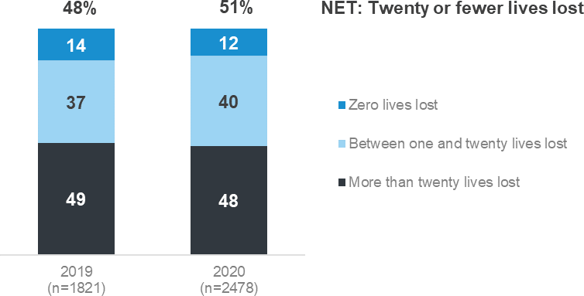
Figure 25 Lowest achievable number of lives lost in one year over the next 30 years

TZ8 Within the next 30 years, which of the following do you think can be achieved in one year Filter: All respondents excl. refused and not answered; weighted sample; base n= 2478

As shown in Table 55, belief regarding the lowest loss of life on the road that can be achieved in one year, within the next 30 years, varies by demographic. Respondents aged 18-25 (63%) and those aged 26-39 (63%) are most likely to think that Victoria could achieve a year with fewer than 20 lives lost within the next 30 years. Those aged over 60 years (39%) are the least likely. Females (56%) are also more likely to think that fewer than 20 lives lost could be achieved within the next 30 years than males (48%).
Table 55 Lowest number of lives lost within one year by demographic

Column % | Total | 18 - 25 | Age  26 - 39 40 - 60 | 61 - 90 | Gender  Male Female |  | Location  Major Other Rural Urban Urban Balance
Zero lives lost  Between one and twenty  lives lost | 12  40 | 15 | 15 ↑ 11 | 8 ↓ | 12 | 12 | 12 11 8
 |  | 48 ↑ | 48 ↑ 37 | 31 ↓ | 36 ↓ | 44 ↑ | 42 ↑ 32 ↓ 33 ↓
NET: Zero / Twenty or fewer  lives lost | 52 | 63 ↑ | 63 ↑ 48 ↓ | 39 ↓ | 48 ↓ | 56 ↑ | 54 ↑ 43 ↓ 42 ↓
More than twenty lives lost | 48 | 37 ↓ | 37 ↓ 52 ↑ | 61 ↑ | 52 ↑ | 44 ↓ | 46 ↓ 57 ↑ 58 ↑
Sample size | 2478 | 401 | 643 825 | 609 | 1247 | 1231 | 1453 706 319

TZ8 Within the next 30 years, which of the following do you think can be achieved in one year Filter: All respondents excl. refused and not answered; weighted sample; base n=2478
Blue up arrows (↑) and red down arrows (↓) indicate statistically significant difference compared to respondents not in that category Figures may not add to 100% due to rounding

Victorian government actions to achieve Towards Zero

From January to June in 2020, respondents who were aware of the Towards Zero strategy were asked an open question asking what action they believe the Victorian government is taking to achieve Towards Zero. The responses to this question reflect TAC and Victoria Police activities in relation to road safety. Verbatim responses were coded and grouped into broad themes relating to Advertising and education (24%), Enforcement (31%) and Infrastructure and vehicles (23%). Four in ten (39%) respondents were unable to recall any action taken by government.
Mentions of Enforcement are focused on testing drivers for alcohol (12%) and testing drivers for drugs (11%). Those who mention Infrastructure and vehicles are focused on improving infrastructure/safer roads (16%) with some (7%) specifically mentioning barriers. A similar percentage of respondents (7%) say focus on lowering of speed limits on some roads.
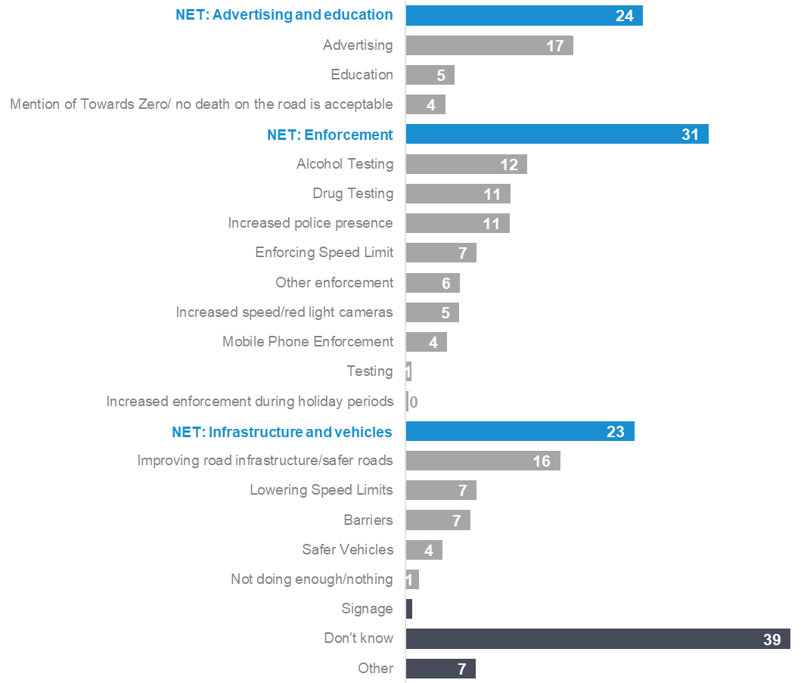
Figure 26 Actions taken by the Victorian government to achieve Towards Zero

TZ10 What actions are the Victorian government taking to achieve the Towards Zero Strategy?
Filter: Aware of Towards Zero strategy excl. refused and not answered; weighted sample; base n=511

Community understanding of the number of fatalities and serious injuries on Victorian roads
Since Oct-Dec 2018, respondents have been asked how many people they believed die each year due to crashes on Victorian roads. There is a wide range of responses. Only 10% of respondents give a response of between 201 and 250, which is close to the actual number of fatalities in 2020 (211). One in ten respondents (10%) say there are less than 100 deaths each year due to crashes while 17% say there are more than 300 deaths per year. Nearly a third of respondents (29%) say they ‘don’t know’.
Figure 27 Community understanding of the number of road fatalities per year
29
10
5
13
10
13
17

Don't know 100 or fewer 101-150 151-200 201-250 251-300 300+

TZ6 How many people do you believe die each year due to crashes on Victorian roads? Filter: All respondents excl. refused and not answered; Weighted sample; base n=2436

Respondents were also asked how many people they believed were seriously injured last year due to crashes on Victorian roads. Many respondents (41%) were unable to provide an answer. Among those that did nominate a figure, the median response was 1,000 which is close to the 903 TAC claims involving greater than 14 days hospitalisation in 2019. However, the actual figures provided varied with 16% believing the number was less than 500 and 9% believing it was 5,000 or more.
Figure 28 Community understanding of the number of serious injuries per year

Don't know
41

0-499
16

500-999
10
2
1000-1999 2000-2999 4000-4999
9
13

5000+
9

TZ11 How many serious injuries as a result of traffic crashes do you believe happened last year on Victorian roads? Filter: All respondents excl. refused and not answered; Weighted sample; base n=1003

Crashes
This section discusses the frequency of being involved in a crash on the road as a driver or rider (in the last five years) and subsequent changes in behaviour.

Involvement in a crash in the past five years

As shown in Table 56, almost one in five respondents (18%) report that they had been involved in any crashes on the road as a driver or rider in the last five years. Younger drivers aged 18-25 (26%) are the most likely to have been involved in any crashes on the road as a driver or rider in the last five years. There is a consistent decline, by age, in the percentage of respondents who have been involved in a crash; respondents aged 61-90 (9%) are the least likely to have been involved in a crash in the last five years.
Table 56 Involvement in crash in the past five years by demographic

Column % |  | Total | 18 - 25 | Age  26 - 39 40 - 60 | 61 - 90 | Gender  Male Female |  | Location  Major Other Rural Urban Urban Balance
 | Yes | 18 | 26 ↑ | 21 ↑ 18 | 9 ↓ | 19 ↑ | 16 ↓ | 18 ↑ 14 ↓ 15
 | No | 82 | 74 ↓ | 79 ↓ 82 | 91 ↑ | 81 ↓ | 84 ↑ | 82 ↓ 86 ↑ 85
 | Sample size | 2480 | 397 | 638 827 | 618 | 1247 | 1233 | 1449 711 320

CR1 - In the last five years, have you been involved in any crashes on the road as a driver or rider? Filter: Driver; Weighted sample; base n=2480
Blue up arrows (↑) and red down arrows (↓) indicate statistically significant difference compared to respondents not in that category. Figures may not add to 100% due to rounding.

As shown in Table 57, respondents who engage in dangerous or illegal behaviours such as driving fatigued or speeding (see Section 1.3 for definitions) are also more likely to have been involved in any crashes on the road in the last five years. For instance, speeders (21%) are more likely to have been involved in a crash in the last five years than non-speeders (15%).
Respondents who drive and use recreational drugs (whether or not they drive after using drugs) (26%) are more likely to have been involved in a crash than those who do not use drugs at all (17%).
Table 57 Involvement in crash in the past five years by behaviour

Column % |  | Total | Speeding  Yes No |  | Drink driving  Yes No |  | Mobile phone use  Yes No |  | Driving fatigued  Yes No |  | Uses recreactional drugs  Yes No
Yes |  | 18 | 21 ↑ | 15 ↓ | 21 | 18 | 24 ↑ | 16 ↓ | 20 ↑ | 16 ↓ | 26 ↑ | 17 ↓
No |  | 82 | 79 ↓ | 85 ↑ | 79 | 82 | 76 ↓ | 84 ↑ | 80 ↓ | 84 ↑ | 74 ↓ | 83 ↑
Sample size |  | 2480 | 1230 | 1114 | 127 | 2268 | 672 | 1724 | 940 | 1414 | 199 | 2196

CR1 - In the last five years, have you been involved in any crashes on the road as a driver or rider? Filter: Driver; Weighted sample; base n=2480
Blue up arrows (↑) and red down arrows (↓) indicate statistically significant difference compared to respondents not in that category. Figures may not add to 100% due to rounding.

As shown in Figure 29, respondents say that the main causes of serious injury and loss of life on Victorian roads are distractions (42%), impaired driving (39%) and speeding (32%).
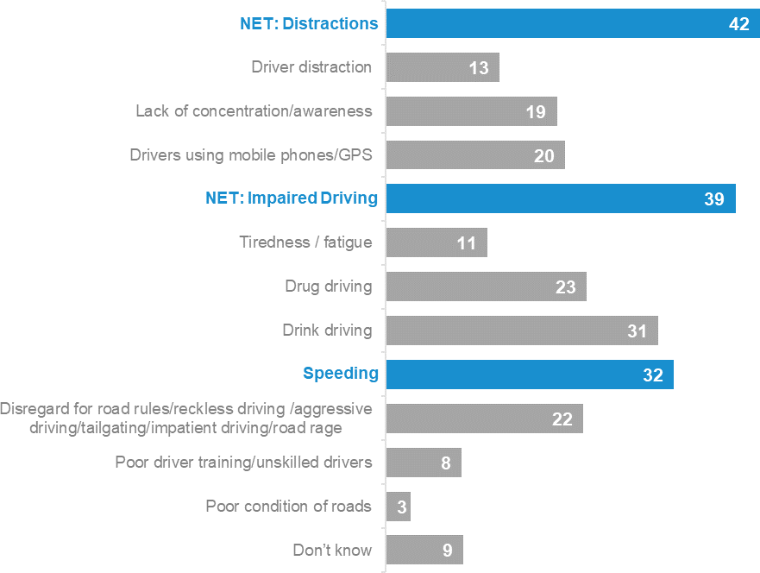
Figure 29 Main cause of serious injury and loss of life in Victoria

TOP1 - What do you think is the main cause of serious injury and loss of life on Victorian roads? Weighted sample; base n = 2281

Injury requiring hospitalisation

As shown in Figure 30, respondents who had been involved in a crash in the past five years were asked whether anyone was injured to the point where they needed to go to the hospital. About one in a hundred respondents (1%) say they were involved in a crash resulting in injury requiring hospitalisation and a further 16% were involved in a crash that did not results in injury requiring hospitalisation (in the last five years).
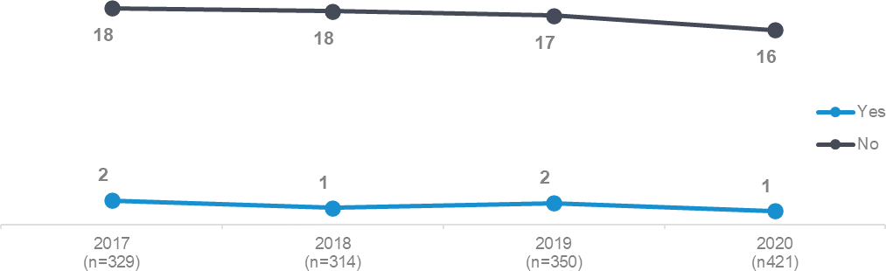
Figure 30 Someone Injured in a car crash to the point of going to hospital by year

CR2 Was anyone involved in any of the crash(es) injured to the point where they needed to go to hospital? Filter: Been involved in a crash in the past 5 years; Weighted sample; base n=2505

Change in behaviour after a crash

As shown in Table 58, respondents who had been in a crash were asked whether they had changed how they drive or ride since the crash. Over half of respondents (48%) indicate that they had changed how they drive or ride.
There are no differences by demographic. Also, other analysis shows that there are no differences by driving behaviour.
Table 58 Change in behaviour after a crash by demographic

Column % |  | Total | 18 - 25 | 26 | Age  - 39 40 | - 60 | 61 | - 90 | Gender  Male Female |  | Major Urban | Location  Other Urban | Rural Balance
Yes |  | 48 | 66 | 41 |  | 43 | 51 |  | 52 | 42 | 47 | 64 | 40
No |  | 45 | 28 | 46 |  | 54 | 46 |  | 43 | 49 | 46 | 29 | 38
Don't know |  | 7 | 7 | 13 |  | 3 | 3 |  | 5 | 9 | 6 | 7 | 22
Sample size |  | 96 | 21 | 30 |  | 32 | 13 |  | 59 | 37 | 79 | 12 | 5

CR3 - Since the crash, have you changed how you drive or ride?
Filter: Involved in a crash in the past five years; Weighted sample; base n=96
Blue up arrows (↑) and red down arrows (↓) indicate statistically significant difference compared to respondents not in that category. Figures may not add to 100% due to rounding.

Seatbelts

Wearing of seatbelts when driving a vehicle fitted with them
As shown in Table 59 almost all drivers (97%) report wearing a seatbelt ‘all the time’ in the last three months when driving. There are no significant differences in the likelihood of wearing a seatbelt by age, gender or location.
Table 59 Wearing seatbelts while driving by demographic

Column % | Total | 18 - 25 | Age  26 - 39 40 - 60 | 61 - 90 | Gender  Male Female |  | Major Urban | Location  Other Urban | Rural Balance
None / Some / Half / Most of  the time | 3 | 4 | 3 3 | 4 | 4 | 2 | 3 | 4 | 6
All of the time | 97 | 96 | 97 97 | 96 | 96 | 98 | 97 | 96 | 94
Sample size | 2389 | 368 | 624 808 | 589 | 1203 | 1186 | 1389 | 684 | 316

DB3 Thinking about the past three months, how often did you wear a seatbelt when driving a car? Weighted sample; base n=2389
Blue up arrows (↑) and red down arrows (↓) indicate statistically significant difference compared to respondents not in that category. Figures may not add to 100% due to rounding.

As shown in Table 60, respondents who have driven while over their legal BAC in the last 12 months (‘drink drivers’: 92%) are less likely to wear a seatbelt all of the time while driving compared to respondents who do not ‘drink drive’ (97%).
Table 60 Wearing seatbelts while driving by behaviour

Column % | Total | Speeding  Yes No |  | Drink driving  Yes No |  | Mobile phone use  Yes No |  | Driving fatigued  Yes No |  | Involvement in a crash  Yes No
None / Some / Half / Most of  the time | 3 | 3 | 3 | 8 ↑ | 3 ↓ | 4 | 3 | 4 | 3 | 3 | 3
All of the time | 97 | 97 | 97 | 92 ↓ | 97 ↑ | 96 | 97 | 96 | 97 | 97 | 97
Sample size | 2389 | 1230 | 1116 | 128 | 2260 | 673 | 1716 | 939 | 1418 | 410 | 1964

DB3 Thinking about the past three months, how often did you wear a seatbelt when driving a car? Weighted sample; base n=2389.
Blue up arrows (↑) and red down arrows (↓) indicate statistically significant difference compared to respondents not in that category. Figures may not add to 100% due to rounding.

Wearing of seatbelts when a passenger
As shown in Table 61 almost all respondents (97%) always wear a seatbelt when they are a passenger in a car or other vehicle. Respondents aged 18-25 (95%) are less likely to wear a seatbelt all the time when travelling as a passenger than older respondents (98%).
Table 61 Wearing a seatbelt while travelling in a vehicle as passenger by demographic

Column % | Total | 18 - 25 | Age  26 - 39 40 - 60 | 61 - 90 | Gender  Male Female |  | Major Urban | Location  Other Urban | Rural Balance
None / Some / Half / Most of  the time | 3 | 5 ↑ | 2 2 | 3 | 3 | 2 | 2 | 3 | 4
All of the time | 97 | 95 ↓ | 98 98 | 97 | 97 | 98 | 98 | 97 | 96
Sample size | 2246 | 366 | 587 758 | 535 | 1104 | 1142 | 1316 | 638 | 292

DB3 Thinking about the past three months, how often did you wear a seatbelt when you were a passenger in a car or other vehicle fitted with seatbelts?
Weighted sample; base n=2246.
Blue up arrows (↑) and red down arrows (↓) indicate statistically significant difference compared to respondents not in that category. Figures may not add to 100% due to rounding.

As shown in Table 62 there is no difference in the incidence of wearing a seatbelt while travelling as a passenger given respondent’s driving behaviour or involvement in a crash.
Table 62 Wearing a seatbelt while travelling in a vehicle as passenger by behaviour

Column % | Total | Speeding  Yes No |  | Drink driving  Yes No |  | Mobile phone use  Yes No |  | Driving fatigued  Yes No |  | Involvement in a crash  Yes No
None / Some / Half / Most of  the time | 3 | 2 | 2 | 5 | 2 | 3 | 2 | 3 | 2 | 4 | 2
All of the time | 97 | 98 | 98 | 95 | 98 | 97 | 98 | 97 | 98 | 96 | 98
Sample size | 2246 | 1138 | 998 | 124 | 2058 | 632 | 1550 | 869 | 1277 | 386 | 1846

DB3 Thinking about the past three months, how often did you wear a seatbelt when you were a passenger in a car or other vehicle fitted with seatbelts?
Weighted sample; base n=2246
Blue up arrows (↑) and red down arrows (↓) indicate statistically significant difference compared to respondents not in that category Figures may not add to 100% due to rounding.

Cycling
As shown in Figure 31, respondents are more likely to have a negative than positive view of cyclists and their interactions with drivers. For example,
Respondents are more likely to agree that most drivers do not understand what it is like to be a cyclist on the road (62% vs 12% who disagree).
Respondents are more likely to disagree (35%) than agree (29%) that cyclists and drivers show each other courtesy on the road.
The findings do not vary by demographic.
Figure 31 Agreement with statements relating to cyclists

Strongly agree Somewhat agree Neither Somewhat disagree Strongly disagree NET:
Agree

Most drivers don’t understand what it’s like to be a cyclist on the road.

Cyclists and drivers show each other courtesy on the roads

22

6

26 62%

36 29%

8 4

13

23

30

31

CYC1DE/CYC2CD - On a scale of 1 to 5, where 1 is “Strongly disagree” and 5 is “Strongly agree”, to what extent do you Agree or disagree with the following statements
Filter: Total sample; base n = from 681 to 709

General attitudes to transport and road safety

Level of agreement with statements relating to roads and transport
Respondents were asked to consider nine statements relating to attitudes and experiences concerning roads and transport, and to rate to what extent they agreed using a five-point scale of 1 “strongly disagree” to 5 “strongly agree”. The topics covered by these statements included attitudes to speed while driving, thoughts on the quality of driving, car usage and local traffic. These questions were asked of a random sub-set of respondents.
As shown in Figure 32, respondents’ attitudes relating to the importance of various facets of road safety align with some of the principles underpinning Towards Zero. More than nine in ten respondents (94%) agree with the statement that ‘I believe a safe journey is more important than a quick journey’ and 87% agree with the statement ‘Even good drivers make mistakes’. In addition, less than half of respondents (44%) agree that ‘Lower speed limits on local roads would have a big impact on how long it takes to get to places.’ However, less than two thirds of respondents (62%) agree with the statement that ‘How people drive is more important than road design in saving lives’.
Figure 32 Attitudes towards speeding statements

Strongly disagree Somewhat disagree Neither Somewhat agree Strongly agree
% Agree

I believe a safe journey is more important than a quick journey
15

11 4

94%
79

Even good drivers make mistakes 12 9
33
55

How people drive is more important
5
6
28
34
than road design in saving lives 27
It's safe for children to walk or ride
14
15
29
around my neighbourhood 23
Lower speed limits on local roads
15
13
20
would have a big impact on how long 29
it takes me to get to places
I'd like to be able use cars less, and
22
17
19
cycle or walk more 18
I'm concerned about traffic noise in
30
22
10
my area 20
I could get by without a car (or
48
21
motorbike) most of the time 7
I'm often in a hurry when I´m travelling 30
31
21
87%

62%

48%
19

44%
24

43%
23

28%
18

24%
10
13

18%
5

TZ4 - The following statements are about a broad range of attitudes and experiences relating to roads and transport. Please state the extent to which you agree or disagree with these statements where 1 is “Strongly disagree” and 5 is “Strongly Agree” Total sample; Weighted sample; base n= from 232 to 2488
13
Figures may not add to 100% due to rounding

Attitudes towards travel speed

Several statements relating to attitudes towards speed were presented to respondents. They were asked to rate the extent to which they agreed or disagreed with the statements using a five-point scale where 1 is ‘strongly disagree and 5 is ‘strongly agree’. Numbers in Table 63 and the following text are the percentages of respondents who nominated a point on the scale.
Respondents strongly agree (4.7) with the statement that ‘I believe a safe journey is more important than a quick journey’. Respondents are more likely to disagree (2.4) with the statement ‘I’m often in a hurry when travelling’. Nevertheless, respondents are more likely than not to agree that ‘Lower speed limits on local roads would have a big impact on how long it takes me to get to places’.
Other analysis shows that attitudes relating to speed and the time taken to travel between places indicate that older drivers are less concerned about how long it takes to travel between locations.
Respondents aged 61-90 years are most likely to agree that ‘I believe a safe journey is more important than a quick journey’ (4.8) than younger drivers, with drivers aged 18-25 (4.5) least likely to agree.
Females (4.7) are more likely than males (4.6) to agree that ‘I believe a safe journey is more important than a quick journey’.
Respondents aged 61-90 years (1.8) are least likely to agree with the statement ‘I’m often in a hurry when travelling’.
Table 63 Attitudes towards travel speed by demographic

Average | Total | 18 - 25 | Age  26 - 39 40 - 60 |  | 61 - 90 | Gender  Male Female |  | Major Urban | Location  Other Urban | Rural Balance
I believe a safe journey is more important than a quick  journey | 4.7 | 4.5 ↓ | 4.6 ↓ | 4.7 | 4.8 ↑ | 4.6 ↓ | 4.7 ↑ | 4.7 | 4.7 | 4.7
Lower speed limits on local roads would have a big  impact on how long it takes  me to get to places | 3.3 | 3.5 | 3.0 | 3.3 | 3.4 | 3.4 | 3.2 | 3.3 | 3.2 | 2.9
I'm often in a hurry when I´m  travelling | 2.4 | 2.9 ↑ | 2.7 ↑ | 2.4 | 1.8 ↓ | 2.4 | 2.4 | 2.4 | 2.3 | 2.0
Sample size | 230 | 27 | 55 | 89 | 59 | 117 | 113 | 164 | 48 | 18

TZ4 - The following statements are about a broad range of attitudes and experiences relating to roads and transport. Please state the extent to which you agree or disagree with these statements where 1 is “Strongly disagree” and 5 is “Strongly Agree”
Total sample; Weighted sample: base n= from 230 to 2488
Blue up arrows (↑) and red down arrows (↓) indicate statistically significant difference compared to respondents not in that category

As shown in Table 64, respondents who ever speed (4.5), drink drive (4.4), use a mobile phone illegally while driving (4.5) or drive fatigued (4.6) agree to a lesser extent than those who do not engage in these behaviours that ‘I believe a safe journey is more important than a quick journey’, which is rated at 4.7 by all respondents.

Respondents who speed (2.4), use a mobile phone illegally while driving (2.9) or drive fatigued (2.8) agree to a greater extent than other drivers that ‘I’m always in a hurry when I’m travelling’, which is rated at 2.4 by all respondents.
Table 64 Attitudes towards travel speed by behaviour

Average | Total | Speeding  Yes No |  | Drink driving  Yes No |  | Mobile phone use  Yes No |  | Driving fatigued  Yes No |  | Involvement in a crash  Yes No
I believe a safe journey is more important than a quick  journey | 4.7 | 4.5 ↓ | 4.8 ↑ | 4.4 ↓ | 4.7 ↑ | 4.5 ↓ | 4.8 ↑ | 4.6 ↓ | 4.8 ↑ | 4.6 | 4.7
Lower speed limits on local roads would have a big  impact on how long it takes  me to get to places | 3.3 | 3.3 | 3.2 | 2.9 | 3.3 | 3.4 | 3.2 | 3.3 | 3.2 | 3.2 | 3.3
I'm often in a hurry when I´m  travelling | 2.4 | 2.6 ↑ | 2.1 ↓ | 2.8 | 2.4 | 2.9 ↑ | 2.1 ↓ | 2.8 ↑ | 2.1 ↓ | 2.6 | 2.3
Sample size | 230 | 126 | 87 | 8 | 212 | 65 | 155 | 77 | 137 | 50 | 179

TZ4 - The following statements are about a broad range of attitudes and experiences relating to roads and transport. Please state the extent to which you agree or disagree with these statements where 1 is “Strongly disagree” and 5 is “Strongly Agree”
Weighted sample; base n=from 215 -2488
Blue up arrows (↑) and red down arrows (↓) indicate statistically significant difference compared to respondents not in that category

Quality of driving

Two statements concerning attitudes about the quality of respondents’ driving were also presented to respondents, using the same agree/disagree scale described in the previous section.
As shown in Table 65, most respondents agree (4.4) that ‘Even good drivers make mistakes’, Respondents aged 61-90 (4.3) are the least likely to agree with this statement. Fewer respondents (3.8) agree with the statement ‘How people drive is more important than road design in saving lives’. In contrast to the first statement, respondents aged 61-90 (4.1) are the most likely to agree.
Table 65 Attitudes towards quality of driving by demographic

Average | Total | 18 - 25 | Age  26 - 39 40 - 60 | 61 - 90 | Gender  Male Female |  | Major Urban | Location  Other Urban | Rural Balance
Even good drivers make  mistakes | 4.4 | 4.5 ↑ | 4.4 4.4 | 4.3 ↓ | 4.3 | 4.4 | 4.4 | 4.4 | 4.4
How people drive is more important than road design  in saving lives | 3.8 | 3.7 | 3.7 3.7 | 4.1 ↑ | 3.8 | 3.8 | 3.8 | 3.9 | 3.8
Sample size | 2391 | 379 | 628 796 | 588 | 1218 | 1173 | 1394 | 688 | 309

TZ4 - The following statements are about a broad range of attitudes and experiences relating to roads and transport. Please state the extent to which you agree or disagree with these statements where 1 is “Strongly disagree” and 5 is “Strongly Agree”
Total sample; Weighted sample; base n=from 2397 to 2477
Blue up arrows (↑) and red down arrows (↓) indicate statistically significant difference compared to respondents not in that category

As shown in Table 66, drivers who use a hand-held mobile phone (3.7), respondents who drive while fatigued (3.6) or who have been involved in the crash (3.6) are less likely to agree with the statement ‘How people drive is more important than road design in saving lives’ compared to those who do not use a hand-held mobile phone while driving (3.9), those who don’t drive while fatigued (3.9) or who have not been involved in a crash (3.8).
Table 66 Attitudes towards quality of driving by behaviour

Average | Total | Speeding  Yes No |  | Drink driving  Yes No |  | Mobile phone use  Yes No |  | Driving fatigued  Yes No |  | Involvement in a crash  Yes No
Even good drivers make  mistakes | 4.4 | 4.4 | 4.4 | 4.4 | 4.4 | 4.4 | 4.4 | 4.4 | 4.4 | 4.4 | 4.4
How people drive is more important than road design  in saving lives | 3.8 | 3.8 | 3.9 | 3.7 | 3.8 | 3.7 ↓ | 3.9 ↑ | 3.6 ↓ | 3.9 ↑ | 3.6 ↓ | 3.8 ↑
Sample size | 2391 | 1209 | 1064 | 123 | 2192 | 658 | 1658 | 918 | 1362 | 409 | 1965

TZ4 - Attitudes towards quality of driving (numeric) Weighted sample; base n= from 2277 to 2477
Blue up arrows (↑) and red down arrows (↓) indicate statistically significant difference compared to respondents not in that category

Car usage

Two statements concerning attitudes to car usage were also presented to respondents, using the same agree/disagree scale described in the previous sections.
As shown in Table 67, respondents (3.0) agree with the statement that ‘I’d like to be able to use cars less, and cycle and walk more’. Nevertheless, respondents are likely to disagree than agree (2.2) that ‘I could get by without a car (or motorbike) most of the time’.
Table 67 Attitudes towards car usage by demographic

Average | Total | 18 - 25 | Age  26 - 39 40 - 60 | 61 - 90 | Gender  Male Female |  | Major Urban | Location  Other Urban | Rural Balance
I'd like to be able use cars less, and cycle or walk more | 3.0 | 3.3 | 3.3 3.1 | 2.5 | 3.0 | 3.1 | 3.1 | 2.7 | 2.5
I could get by without a car (or motorbike) most of the  time | 2.2 | 2.7 | 2.0 2.1 | 2.3 | 2.3 | 2.1 | 2.2 | 1.7 | 2.2
Sample size | 242 | 33 | 58 89 | 62 | 125 | 117 | 174 | 49 | 19
TZ4 - The following statements are about a broad range of attitudes and experiences relating to roads and transport. Please state the extent to which you agree or disagree with these statements where 1 is “Strongly disagree” and 5 is “Strongly Agree”
Total sample; Weighted sample; base n=243 to 244
Blue up arrows (↑) and red down arrows (↓) indicate statistically significant difference compared to respondents not in that category

Local traffic

Two statements concerning attitudes to local traffic were also presented to respondents, using the same agree/disagree scale described in the previous sections.
As shown in Table 68 respondents agree (3.2) that ‘It’s safe for children to walk or ride around my neighbourhood’. Respondents (2.6) are less likely to agree that ‘I’m concerned about traffic noise in my area’. There is less concern about traffic noise among those in Rural Balance areas (1.5).
Table 68 Attitudes towards local traffic by demographic

Average | Total | 18 - 25 | 26 | Age  - 39 40 | - 60 | 61 | - 90 | Gender  Male Female |  | Major Urban | Location  Other Urban | Rural Balance
It's safe for children to walk  or ride around my neighbourhood | 3.2 | 3.4 | 3.3 |  | 3.2 | 3.1 |  | 3.2 | 3.2 | 3.2 | 3.4 | 3.8
I'm concerned about traffic  noise in my area | 2.6 | 2.4 | 2.4 |  | 2.8 | 2.8 |  | 2.8 | 2.5 | 2.7 | 2.5 | 1.5 ↓
Sample size | 231 | 29 | 56 |  | 90 | 56 |  | 117 | 114 | 164 | 48 | 19
TZ4 - The following statements are about a broad range of attitudes and experiences relating to roads and transport. Please state the extent to which you agree or disagree with these statements where 1 is “Strongly disagree” and 5 is “Strongly Agree”
Total sample; Weighted sample; base n=233 to 243
Blue up arrows (↑) and red down arrows (↓) indicate statistically significant difference compared to respondents not in that category

Perceived importance of statements relating to roads and transport
Respondents were asked to rate the importance of nine statements related to transport and road safety by using a five-point scale where 1 was “not at all important” and 5 was “extremely important”. Numbers in the following tables and text are mean ratings out of 5, except for the percentages shown in Figure 33. The topics covered by these statements included the quality of the road and transport system, having access to different transport options, and attitudes to quality of life in nearby streets and the environment.
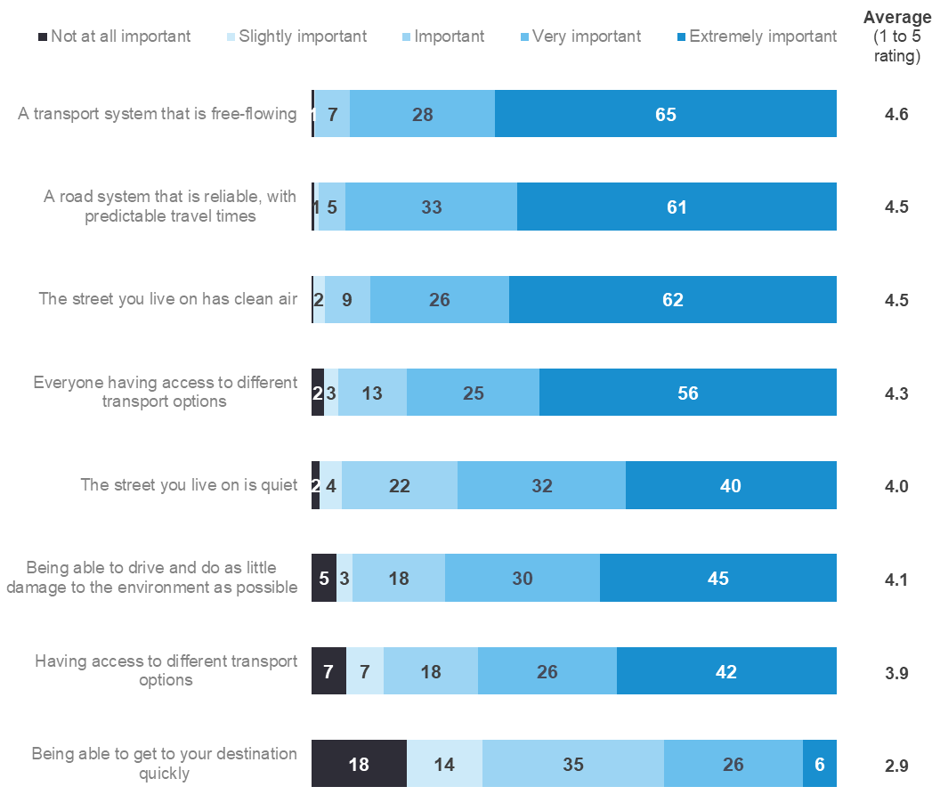
Figure 33 Relative importance of issues relating to roads and transport

TZ5 - On a scale of 1 to 5, where 1 is “Not at all important”, and 5 is “Extremely important”, how important are the following things to you? Total sample; Weighted sample; base n= from 579 to 584
Figures may not add to 100% due to rounding

Quality of the road and transport system

As shown in Figure 33, respondents say that the quality of the transport and road systems to be very important – with both ‘a transport system that is free flowing’ (4.6) and ‘a road system that is reliable, with predictable travel times’ (4.5) both being considered important by about two thirds of respondents (65% and 61% respectively).
Respondents’ views are more polarised concerning the statement ‘Being able to get to your destination quickly’ is important (2.9).
The largest demographic difference relates to the perceived importance of ‘Being able to get to your destination quickly’, with those aged under 40 (3.2) placing more importance than those aged 61-90 (2.4). This item is also more important for respondents in Major Urban areas (3.0) than for respondents in Other Urban areas (2.5).
Table 69 Perceived importance of the quality of the road and transport system by demographic

Average | Total | 18 - 25 | Age  26 - 39 40 - 60 |  | 61 - 90 | Gender  Male Female |  | Location  Major Other Rural Urban Urban Balance
A transport system that is  free-flowing | 4.6 | 4.6 | 4.5 | 4.6 | 4.6 | 4.6 | 4.6 | 4.6 4.5 4.4
A road system that is reliable, with predictable  travel times | 4.5 | 4.5 | 4.6 | 4.5 | 4.5 | 4.5 | 4.5 | 4.6 4.4 4.3
Being able to get to your destination quickly | 2.9 | 3.2 | 3.2 ↑ | 2.8 | 2.4 ↓ | 3.0 | 2.8 | 3.0 ↑ 2.5 ↓ 2.6
Sample size | 571 | 98 | 153 | 174 | 146 | 279 | 292 | 336 169 66

TZ5 - On a scale of 1 to 5, where 1 is “Not at all important”, and 5 is “Extremely important”, how important are the following things to you? Total sample; Weighted sample; base n = from 579 to 582
Blue up arrows (↑) and red down arrows (↓) indicate statistically significant difference compared to respondents not in that category

Access to transport options

As shown in Table 70, respondents state that it is important to have access to different transport options, although the level of perceived importance is greater when the statement referred to all people rather than the respondent themselves:
‘Everyone having access to different transport options’ (4.3) ‘Having access to different transport options’ (3.9).
Females rate the importance of ‘Everyone having access to different transport options’ higher than Males do (4.4 vs 4.2). Those from Major Urban (4.3) and Other Urban (4.3) rate the important of ‘Everyone having access to different transport options’ higher than those living in Rural Balance areas (4.0).
Respondents aged 18-25 (4.2) and those living in Major Urban areas (4.0) rate the importance of ‘Having access to different transport options’ higher than other respondents.
Table 70 Perceived importance of the access to transport options by demographic

Average | Total | 18 - 25 | Age  26 - 39 40 - 60 |  | 61 - 90 | Gender  Male Female |  | Major Urban | Location  Other Urban | Rural Balance
Everyone having access to different transport options | 4.3 | 4.5 | 4.2 | 4.4 | 4.3 | 4.2 ↓ | 4.4 ↑ | 4.3 | 4.3 | 4.0 ↓
Having access to different  transport options | 3.9 | 4.2 ↑ | 3.8 | 4.0 | 3.6 ↓ | 3.9 | 3.9 | 4.0 ↑ | 3.7 ↓ | 3.4 ↓
Sample size | 579 | 101 | 154 | 175 | 149 | 287 | 292 | 340 | 170 | 69

TZ5 - On a scale of 1 to 5, where 1 is “Not at all important”, and 5 is “Extremely important”, how important are the following things to you? Total sample; Weighted sample; base n= from 581 to 584
Blue up arrows (↑) and red down arrows (↓) indicate statistically significant difference compared to respondents not in that category

Quality of life and environment

Respondents rate three statements asked regarding the quality of life and the environment as important. As shown in Table 71:
‘The street you live in has clean air’ (4.5) ‘The street you live on is quiet’ (4.0)
‘Being able to drive and do as little damage to the environment as possible’ (4.1)
Table 71 Perceived importance of quality of life issues and the environment by demographic

Average | Total | 18 - 25 | Age  26 - 39 40 - 60 |  | 61 - 90 | Gender  Male Female |  | Major Urban | Location  Other Urban | Rural Balance
The street you live on has  clean air | 4.5 | 4.5 | 4.5 | 4.5 | 4.5 | 4.5 | 4.5 | 4.5 | 4.4 | 4.5
The street you live on is quiet | 4.0 | 3.8 | 4.1 | 4.1 | 4.1 | 4.1 | 4.0 | 4.1 | 4.0 | 4.0
Being able to drive and do as  little damage to the environment as possible | 4.1 | 4.2 | 4.0 | 4.0 | 4.2 | 3.9 | 4.2 | 4.1 | 4.1 | 4.1
Sample size | 571 | 100 | 149 | 175 | 147 | 282 | 289 | 335 | 168 | 68

TZ5 - On a scale of 1 to 5, where 1 is “Not at all important”, and 5 is “Extremely important”, how important are the following things to you? Total sample; Weighted sample; base n = from 579 to 582
Blue up arrows (↑) and red down arrows (↓) indicate statistically significant difference compared to respondents not in that category.

Summary of findings

How people get around
- Frequency of driving and riding differs by demographic.

While the percentage of respondents who ever drive a car does not differ for respondents aged over 25 years (96% to 98% for all age groups), younger respondents aged 18-25 are less likely to ever drive (92% and 91% for males and females respectively). This difference is largely a result of less frequent driving a car at least weekly for both males (82%) and females (85%) compared to the older age groups.
One in twenty respondents (5%) ever rides a motorcycle on the road. Motorcycle riding is more frequent in Rural Balance (14%) and Other Urban (8%) than in Major Urban (4%) areas. More males (9%) than females (1%) ever ride a motorcycle on the road.

- Less than a third of respondents ride a bicycle on the road.

One in three of respondents (31%) ride a bicycle on the road, with one in ten (10%) doing so weekly. Cycling is more frequent among males (42% vs 24% of females) and among those aged 40-60 years (45% vs 33% for all age groups).

- Respondents in Rural Balance areas are the most likely to drive a heavy vehicle.

One in fourteen respondents (7%) ever drive a heavy vehicle on the road. The frequency of ever driving a heavy vehicle on the road is highest in Rural Balance areas (18%) and lowest in Major Urban areas (5%). Frequency of ever driving is higher among males (12%) than females (2%).

- Younger people and those living in Major Urban areas are most likely to use alternative transport.

Nearly eight in ten respondents (79%) ever use public transport. However, less than a quarter of respondents (21%) use public transport weekly. Weekly public transport users are most likely to be aged 18-25 years (37%) or to live in Major Urban areas (24%).The percentage of respondents who ever use commercial ride share (such as taxis or Uber) is lower than public transport (69%). About one in twenty (5%) use commercial ride share at least weekly. Younger respondents aged 18-25 (13%) are the most likely to use commercial ride share at least weekly

Vehicle ownership
- Close to a quarter of respondents have purchased a new or used car in the past 12 months.

Close to a quarter of respondents (23%) report that they had bought a car in the past 12 months, with respondents being more likely to buy a used car (13%). Those aged 18-25 years (29%) and 26-39 years (29%) are more likely to purchase a car than older age groups. Respondents aged 18-25 years are more likely to buy a used car (24% used vs 5% new).

Driving behaviour
- Most respondents in paid employment commute to work by car.

Eight in ten of respondents (82%) in paid employment commute to work by car at least once a week.

- Most respondents drive between 10pm and 6am, but young respondents do so more frequently.

Three quarters of respondents (75%) ever drive between 10pm and 6am. While about one in five of all respondents (21%) do so weekly, the frequency is highest for respondents aged 18-25 (37%).

- Female drivers are more likely to feel stressed when driving than male drivers.

More than seven in ten respondent drivers (71%) ever feel stressed while driving. Female drivers (20%) are more likely to feel stressed while driving at least monthly than male drivers (13%).

Speeding
► The perceived danger of driving above the posted speed limit is lower than for most other activities.

The perception of danger associated with driving a few kilometres over the posted speed limit is rated at 6.0 for a 60 km/h zone and 6.3 for a 100 km/h zone (on a 0-10 point scale). These ratings are lower than for riding a bicycle on a sealed country road (6.9), crossing the street while looking at a mobile phone (8.9), or driving with an illegal BAC (9.6). The danger of low-level speeding is rated lower by males (5.5 for 60 km/h zones and
5.7 for 100 km/h zones) and those aged 18-25 (5.3 for 60 km/h zones and 5.9 for 100 km/h zones).

- Most drivers feel guilty if they speed.

Close to seven in ten respondents (69%) agree that they feel guilty if they speed. A minority of drivers (7%) agree that they enjoy speeding. Just under half of drivers (49%) agree that they sometimes drive under the speed limit to reduce the chance of having an accident.

- A sizeable minority of respondents ever speed.

While about six in ten respondent drivers intentionally drive above the limit ‘none of the time’ (61% in a 60 km/h zone and 60% in a 100 km/h zone), a sizable minority do intentionally speed. One in ten respondents (10%) intentionally drive above the speed limit half the time or more often in a 100 km/h zone and only slightly fewer (7%) do so in a 60km/h zone.

- The percentage of drivers caught speeding has plateaued since 2018.

The percentage of drivers who report they have been caught speeding in the last twelve months declined from 19% in 2014 to 12% in 2017. Since then, the percentage of drivers caught speeding has remained constant at 13%.

Drugs and alcohol
- Alcohol and drug usage is highest among younger age groups.

More than three quarters of drivers aged 18-60 years (77%) ever drink alcohol and 8% have used recreational drugs in the last twelve months. Among all drivers, males (80%) are more likely to ever drink alcohol than females (74%). Usage of recreational drugs in the last twelve months is higher among drivers aged 18-25 (19%) and 26-39 (11%) and lower among those aged 40-60 (5%) and 61-90 (3%).

- One in twenty drivers have driven while over their legal BAC in the past 12 months.

One in twenty (5%) drivers report driving over their legal BAC in the past 12 months. Four in ten (41%) respondents report driving after drinking when they believed they were under their legal BAC and this behaviour is most likely among those aged 40-60 (48%) and males (45%). Respondent drivers aged 18-25 are most likely to ‘never drive after drinking’ (37%). Less than 2% of respondents report driving or riding after taking recreational drugs

One in twelve of all respondents (8.4%) have used recreational drugs in the last 12 months; the percentage is higher among those aged 18-25 (19%). More males (10%) than females (6%) have done so.
Among respondents who drive, 1.7% have driven a vehicle or ridden a motorbike after taking recreational drugs.

Fatigue
- Respondents perceive driving while very tired to be dangerous.

The perceived level of danger associated with driving while very tired is rated at 9.0 (on a 0-10 point scale) This rating is the third highest for the activities measured and falls between ‘crossing the street while looking at a mobile phone’ (8.9) and driving ‘while using a handheld mobile phone’ (9.2).

- Driving while feeling very tired is prevalent among young drivers.

Nearly four in ten drivers (38%) reported driving when feeling very tired in the past three months. Younger drivers aged 18-25 (55%) are the most likely to report driving while feeling very tired in the past three months, and one in twenty (5%) do so half the time or more often.

Distractions
- Illegal mobile phone usage has declined since 2016.

About seven in ten respondents (71%) used a mobile phone, including Bluetooth, while driving in the past three months. While nearly two thirds of drivers (64%) either made or answered a call legally using Bluetooth in the last three months, more than a quarter (28%) used a mobile phone illegally. There has been a decline in the percentage of drivers using a mobile phone illegally in the past three months, from 37% in 2016 to 28% in 2020.
Reading a text message while driving (23%) is the most common illegal activity, particularly among drivers aged under 40 years (33%). Other uses of a mobile phone while driving are lower; answering a call using a hand-held (13%), writing and sending a text message (10%) and making a call hand-held (9%).

Pedestrian distractions
- One-third of respondents crossed a street while listening to headphones.

Over one third of respondents (34%) report ever crossing the street while listening to headphones in the last three months. Fifteen per cent do this at least half the time when they cross the street. Younger respondents aged 18-25 (38%) are the most likely to do so at least half the time, compared to 24% of those aged 26-39, and only 8% of those aged 40-60 and 1% of those aged over 60.

- About three in ten of respondents have crossed the street while looking at a mobile phone.

Close to three in ten respondents (29%) have crossed the street while looking at a mobile phone in the last three months. Respondents aged 18-25 (52%) and aged 26-39 (48%) are more likely to have done so than respondents aged 40-60 (21%) or 61-90 (4%).

- The pedestrian environment provides a range of distractions which can lead to risky situations.

More than a quarter of respondents (27%) have been distracted by a mobile phone while they were walking around in the last week. However, the most common distractions were the ‘actions of other road users’ (36%) and ‘own thoughts or thinking about something not related to what you are doing’ (32%). One in ten respondents (10%) have had a ‘near-miss’ where they were almost hit by a vehicle while walking because they were distracted.

Enforcement
- Police are more effective at catching speeders and drink drivers than drug drivers.

About two thirds of respondents (64%) say that Police are effective at catching people who drive above the posted limit or drive when they are over their legal BAC (63%). Only about half (51%) say they are effective at catching people who drive after using illegal drugs.

- Respondents tend to hold positive attitudes towards police.

Two-thirds of respondents (66%) agree that police ‘play an important role in reducing fatal crashes’, and a similar percentage (65%) agree that ‘seeing police on the road makes them feel safer’. However, a quarter of respondents (25%) agree that ‘enforcing speed limits just raises revenue and does not make our roads any safer’. Respondents aged 61-90 years (76%) are the most likely to agree that seeing police on the roads make them feel safer.

Social norms
- Respondents are more likely to think their friends speed than drive very tired or drive over their legal BAC.
Six in ten respondents (60%) think their friends ever intentionally drive above the limit in a 60 km/h zone, with 12% thinking they do this half the time or more often. Just over half of respondents (54%) think their friends ever drive while very tired, although only 6% believe they do this half the time or more often. Around one in six (17%) think their friends ever drive while over their legal BAC.

Infrastructure
- Respondents are supportive of building road safety infrastructure.

Respondents are most supportive of further roll-out of centreline rumble strips, with support at 91%. Building more centreline barriers is supported by eight in ten respondents (83%) while flexible roadside barriers enjoyed a similar level of support with eight in ten respondents (82%) supportive of building more.
Respondents are also supportive of building more roundabouts – with three quarters (74%) supporting this.
Further roll-out of point-to-point speed cameras was the least supported type of road safety infrastructure with support of 61% of respondents. It is worth noting that unlike the other infrastructure items included in this section, point-to-point speed cameras are used for enforcement and installation will result in some drivers receiving penalties.

Towards zero
- Half of respondents are aware of the Towards Zero strategy.

Just over half respondents (52%) are aware of the Towards Zero strategy. Awareness is higher among males (59%) than females (44%) and respondents living in Major Urban areas have lower awareness (51%) than those living in Other Urban or Rural Balance areas (60%).

- Respondents support achieving zero road deaths

More than eight in ten respondents (84%) say that Victoria should aim for zero road deaths. Respondents aged between 18-25 years old (93%) are more likely to support this goal than respondents aged 60-91 (78%). Also, more females (86%) than males (81%) say Victoria should aim for zero road deaths.

- Only 12% of respondents think zero lives lost in one year can be achieved (within the next 30 years).

One in eight respondents (12%) say that zero lives lost in one year can be achieved (within the next 30 years), while more than a third (40%) say that between one and twenty lives will be lost. Overall, about half (51%) say that in the next 30 years, a year where fewer than twenty lives are lost can be achieved. The remaining half (48%) say that more than 20 lives will be lost each year for the next 30 years.

- Respondents aware of Towards Zero say the Victorian government achieves the strategy via public education, enforcement and improving infrastructure and vehicles.
Among the half (52%) of respondents who are aware of the Towards Zero Strategy (see above), the highest percentage of respondents (31%) said that the actions the Victorian government was taking to achieve the Strategy were related to ‘Enforcement’. About a quarter of respondents said actions were related to ‘Advertising and Education’, and ‘Infrastructure and Vehicles’ (24% and 23% respectively).

- Respondents have a poor understanding of the number of fatalities on our roads.

When asked how many people they believe die each year due to crashes on Victorian roads, almost three in ten respondents (29%) were unable to provide an estimate. There was a wide range of responses, with only 13% giving a number of between 250 and 300, which is close to the actual number of fatalities in 2019 (266).

Crashes
- Half of drivers who report being involved in a crash in the past five years as a driver or rider report changing their behaviour as a result
Almost one in five respondents (18%) said they were involved in a crash on the road as a driver or rider in the past five years. Just under half of those involved in a crash in the last five years (48%) said that they had changed how they drive or ride as a result. Younger drivers are more likely to be involved in any crashes on the road as a driver or rider. Drivers aged 18-25 years (26%) and 26-39 (21%) are more likely to have had a crash than those aged 60-91 (9%).

Seatbelts
- Almost all respondents wear a seatbelt all the time while driving or as a passenger.

Nearly all respondents (97%) wear a seatbelt all the time while driving in the last three months or as passenger in the car or other vehicle. Respondents aged 18-25 (95%) are less likely to wear a seatbelt all the time when travelling as a passenger than older respondents (98%).

Cycling
- Respondents agree that most drivers do not understand what it’s like to be a cyclist on the road.

Respondents are more likely to agree that ‘most drivers don’t understand what it’s like to be a cyclist on the road’ (62% vs 12% who disagree). In addition, they are more likely to disagree (35%) than agree (29%) that cyclists and drivers show each other courtesy on the road.

General attitudes to transport and road safety
- Respondents agree that a safe journey is more important than a quick journey.

Most respondents (94%) agree that a safe journey is more important than a quick journey. However, nearly half of respondents (44%) agree that ‘lower speed limits on local roads would have a big impact on how long it takes to get places.’

- Respondents agree that even good drivers make mistakes.

Nearly nine in ten respondents (87%) agree that ‘Even good drivers make mistakes.’ However, more than half of respondents (62%) also agree that ‘How people drive is more important than road design in saving lives.’

- Respondents agree that neighbourhoods are safe for children to walk or ride around

Respondents agree that ‘It’s safe for children to walk or ride around my neighbourhood’, They provided an average rating of 3.2 for this statement, using a five-point scale where 1 meant ‘Strongly disagree’ and 5 meant ‘Strongly agree’. However, respondents rated the statement ‘I’m concerned about traffic noise in my area’ at 2.6 using the same scale.

Research methodology
This report contains some time series that cover periods in which the RSM employed different methodologies, dependent upon current research practice and available sample sources. In summary, the different methodologies employed over time included:
2001-2007: The RSM was conducted entirely via telephone;
2008-2009: After the conduct of a successful pilot in 2007, an online component was introduced to the study in 2008. This was run in combination with telephone;
2010-2013: The VicRoads registration and licencing database was made available to the TAC for research purposes, which allowed a refinement of the research methodology. From 2010 participation in the survey was allowed via paper, online or telephone;
2014-2015: A pulse survey was included to provide two measures per annum;
2016: The RSM was refined through a pilot phase over the first half of the year, with a view to moving to continuous tracking.
2017-2020: Continuous tracking with seven waves conducted over four quarters.
The current report includes data collected in quarters 1, 2, 3 and 4 in 2020. Quarterly measures are taken using a modular questionnaire to address road safety themes as well as maintain regular results for core measures.
The core features of the current methodology are as follows:
Sample is drawn from the VicRoads Registration and Licencing Database. Only Victorians with a licence (either learners’ permit or full licence for any vehicle type) or a registration in their name (car, motorbike or trailer) are included in the sample population. However, this sample is likely one of the most complete sample sources for the adult Victorian population – as close to nine in ten Victorians (87%) aged 18 or over has had a driving permit at some stage, or has a vehicle registered in their name.
Respondents are mailed a questionnaire pack including a Primary Approach Letter (PAL) which allows hard copy or online completion. The PAL advises the sample member of:
The purpose of the survey Eligibility
How they were selected and where their contact details were sourced from Privacy details
How to complete the survey
Relevant dates such as the date that telephone calling will commence and the date that the survey closes Contact details including an email address and 1800 number
Details of the prize draw including; that entry to the prize draw is voluntary, the number of prizes available, the amount and nature of the prize and the closing date for a separate ‘early bird’ prize draw and the date that the prize draw will be drawn.

Reminder SMS/letter

Two reminder SMS and one reminder letter were sent to each sample member who had not completed the survey. Following the initial mail/SMS approaches a CATI phase targeted non-responders with a valid phone number in order to maximise response.

Prize draw

All respondents are offered the opportunity to enter two prize draws, the main prize draw for $1,000, and an additional ‘early completion’ prize draw for $500, Prizes will be paid as either an Electronic Funds Transfer to a nominated bank account or as a GiftPay eGift card, as selected by the winner(s).

Fieldwork

The survey was launched in eight waves over the course of 2020. The fieldwork schedule is shown in Table 72 on the following page.

Table 72 Fieldwork schedule

Quarter Week Commencing

Data Collection Quartery - Wave 1

Date

Data Collection Quartery - Wave 2

Date

2020 -Q1
(Jan -Apr)

2020 -Q2
(Apr- Jul)

2020 -Q3
(Jul- Sep)

2020 -Q4
(Oct-Dec)

13/01/2020 Wave 1 - Sample loaded
20/01/2020 Wave 1 - Questionnaire Packs mailed 27/01/2020 Wave 1 - 1st Reminder SMS
3/02/2020 Wave 1 - Reminder Letter 10/02/2020 Wave 1 - 1st CATI Follow up 17/02/2020 Wave 1 - 2nd Reminder SMS 24/02/2020 Wave 1 - 2nd CATI Follow up
2/03/2020 Wave 1 - Closed 2/03/2020
16/03/2020
23/03/2020
30/03/2020
6/04/2020
13/04/2020
20/04/2020 Wave 3 - Sample loaded
27/04/2020 Wave 3 - Questionnaire Packs mailed 4/05/2020 Wave 3 - 1 st Reminder SMS
11/05/2020 Wave 3 - Reminder Letter 18/05/2020 Wave 3 - CATI Follow up 25/05/2020 Wave 3 - Closed
1/06/2020
8/06/2020
15/06/2020
22/06/2020
29/06/2020
6/07/2020
13/07/2020 Wave 5 - Sample loaded
20/07/2020 Wave 5 - Questionnaire Packs mailed 27/07/2020 Wave 5 - 1st Reminder SMS
3/08/2020 Wave 5 - Reminder Letter 10/08/2020 Wave 5 - CATI Follow up 17/08/2020 Wave 5 - 2nd Reminder SMS 24/08/2020 Wave 5 - Closed
31/08/2020
7/09/2020
14/09/2020
21/09/2020
28/09/2020
5/10/2020
12/10/2020 Wave 7 - Sample loaded
19/10/2020 Wave 7 - Questionnaire Packs mailed 26/10/2020 Wave 7 - 1st Reminder SMS
2/11/2020 Wave 7 - Reminder Letter 9/11/2020 Wave 7 - CATI Follow up
16/11/2020 Wave 7 - 2nd Reminder SMS 23/11/2020 Wave 7 - Closed
30/11/2020
7/12/2020
14/12/2020
21/12/2020
28/12/2020
4/01/2021

17/01/2020
22/01/2020
31/01/2020
5/02/2020
7/02/2020
17/02/2020
17/02/2020
18/02/2020

17/04/2020
17/04/2020
27/04/2020
29/04/2020
6/05/2020
19/05/2020

15/07/2020
15/07/2020
25/07/2020
27/07/2020
3/08/2020
5/08/2020
16/08/2020

14/10/2020
21/10/2020
24/10/2020
26/10/2020
2/11/2020
4/11/2020
30/11/2020

Wave 2 - Sample loaded
Wave 2 - Questionnaire Packs mailed Wave 2 - 1st Reminder SMS
Wave 2 - Reminder Letter Wave 2 - 1st CATI Follow up Wave 2 - 2nd Reminder SMS Wave 2 - Closed

Wave 4 - Sample loaded
Wave 4 - Questionnaire Packs mailed Wave 4 - 1st Reminder SMS
Wave 4 - Reminder Letter Wave 4 - CATI Follow up Wave 4 - 2nd Reminder SMS Wave 4 - Closed

Wave 6- Sample loaded
Wave 6 - Questionnaire Packs mailed Wave 6 - 1st Reminder SMS
Wave 6 - Reminder Letter Wave 6 - CATI Follow up Wave 6 - 2nd Reminder SMS Wave 6 - Closed

19/02/2020
28/02/2020
4/03/2020
11/03/2020
16/03/2020
1/04/2020

20/05/2020
29/05/2020
3/06/2020
10/06/2020
15/06/2020
1/07/2020

17/08/2020
26/08/2020
31/08/2020
7/09/2020
12/09/2020
28/09/2020

Sample performance

The 2020 survey period is comprised of responses from Victorians sampled from the VicRoads Registration and Licencing Database. In total, 6,208 people were selected from the database and invited to take part in the survey. This leads to an overall cooperation rate of 40%.
Table 73 shows the response rate by key demographics overall and by mode for each quarter. Consistent with previous iterations of the RSM, response was generally higher among those aged over 40 years.
With regard to the mode of completion, those over the age of 40 (and in particular those aged over 60 years) were more inclined to complete the survey in hard copy.
Table 73 Sample performance

 |  | Sample loaded  # | Completed surveys  # | Response rate  % | Online | Paper  Row % | Telephone
Total |  | 6,208 | 2,505 | 40% | 54% | 39% | 7%
 | Male | 3,392 | 1,261 | 37% | 56% | 36% ↓ | 8% ↑
Gender
 | Female | 2,816 | 1,244 | 44% | 53% | 42% ↑ | 6% ↓
18-25 |  | 1,186 | 402 | 34% | 66% ↑ | 23% ↓ | 11% ↑
Age | 26-39 | 1,852 | 643 | 35% | 71% ↑ | 22% ↓ | 7%
40-60 |  | 1,994 | 835 | 42% | 56% | 37% | 7%
61-90 |  | 1,176 | 625 | 53% | 29% ↓ | 66% ↑ | 5% ↓
Major urban |  | 3,720 | 1,464 | 39% | 61% ↑ | 32% ↓ | 7%
Location | Other urban | 1,706 | 714 | 42% | 50% ↓ | 43% ↑ | 7%
Rural balance |  | 782 | 327 | 42% | 46% ↓ | 47% ↑ | 7%

Appendix 1
Question list for 2020 RSM

Topic | Sub-topic | Question Name | Question text |  | Quarters
 |  |  |  | Q1 | Q2 | Q3 | Q4
Mobility | Alternative transport | M1A | Thinking about ways you get around, apart from driving or riding yourself, how often do you go somewhere by taking public transport? | Y | Y | Y | Y
 |  | M1B | How often do you go somewhere by taking a taxi or similar (e.g. Uber)? | Y | Y | Y | Y
 |  | M1C | How often do you go somewhere by walking? | Y | Y | Y | Y
 |  | M1D | How often do you go somewhere by travelling in a car or on a motorbike as a passenger? | Y | Y | Y | Y
 | Road vehicles | M2A | How often do you drive a car? | Y | Y | Y | Y
 |  | M2B | How often, if ever, do you ride a motorcycle on the road? | Y | Y | Y | Y
 |  | M2C | How often, if ever, do you drive a heavy vehicle on the road? | Y | Y | Y | Y
 |  | M2D | How often, if ever, do you ride a bicycle on the road? | Y | Y | Y | Y
Driving habits | Commuting | M3A | Thinking about your driving, how often do you commute to and from work in a car? | Y | Y | Y | Y
 | Stress | M3B | How often do you feel stressed when you are driving? | Y | Y | Y | Y
 | Late night driving | M3E | How often do you drive between the hours of 10pm and 6am? |  | Y | Y | Y
Perceptions of danger | Speed | DAN1A | How dangerous do you think it is to drive a few kilometres above the posted speed limit in a 60km/h zone? | Y | Y | Y | Y
 |  | DAN1B | How dangerous do you think it is to drive a few kilometres above the posted speed limit in a 100km/h zone? | Y | Y | Y | Y
 |  | TOP1 | What do you think is the main cause of  serious injury and loss of life on Victorian roads? |  | Y | Y | Y
 | Drink driving | DAN1C | How dangerous do you think it is to drive with an illegal Blood Alcohol Content (BAC) level? | Y | Y | Y | Y
 | Fatigue | DAN1D | How dangerous do you think it is to drive while very drowsy? | Y | Y | Y | Y
 | Drink driving | DAN1K | How dangerous do you think it is to drive a short time after having one alcoholic drink? | Y | Y | Y | Y
 | Cycling | DAN1L | How dangerous do you think it is to ride a bicycle on urban roads | Y | Y |  | Y
 |  | DAN1M | How dangerous do you think it is to ride a bicycle on sealed country roads | Y | Y |  | Y
 | Distractions | DAN1F | How dangerous do you think it is to drive while using a handheld mobile phone? | Y | Y | Y | Y
 |  | DAN1P | How dangerous do you think it is to glance at your mobile phone while driving? | Y | Y
 |  | DAN1N | How dangerous do you think it is to cross the street while looking at a mobile phone? |  | Y | Y | Y

Topic | Sub-topic | Question Name | Question text |  | Quarters
 |  |  |  | Q1 | Q2 | Q3 | Q4
Attitudes towards speeding | Speed limits | DAN2 | How fast should people be allowed to drive in  a 60km/h zone without being booked for speeding? | Y | Y | Y | Y
 | Speed attitudes | DAN3 | How fast should people be allowed to drive in a 100km/h zone without being booked for  speeding? | Y | Y | Y | Y
Speeding | Speeding attitudes | SP1B | I enjoy speeding | Y | Y | Y | Y
 |  | SP1D | I feel guilty if I speed | Y | Y | Y | Y
 |  | SP1F | I sometimes drive under the speed limit to reduce the chance of having an accident |  |  | Y | Y
 |  | SP1G | I feel uncomfortable when I drive over the speed limit |  |  | Y | Y
 |  | SP1_RF | I sometimes drive under the speed limit to reduce the chance of having an accident | Y | Y
 | Speeding penalties | SP2 | Have you been caught speeding in the last 12 months? | Y | Y | Y | Y
Driving behaviours | Speeding | DB1A | In the past three months, how often did you intentionally drive above the limit in a 60km/h zone, even if by only a few km's per hour? | Y | Y | Y | Y
 |  | DB1B | In the past three months, how often did you intentionally drive above the limit in a 100km/h zone, even if by only a few km's per hour? | Y | Y | Y | Y
 | Distractions (mobile) | DB2A | In the past three months, how often did you  make a call with a hand-held phone while driving? | Y | Y | Y | Y
 |  | DB2B | In the past three months, how often did you answer a call with a hand-held phone while  driving? | Y | Y | Y | Y
 |  | DB2F | In the past three months, how often did you make a call using Bluetooth while driving? |  | Y | Y | Y
 |  | DB2G | In the past three months, how often did you answer a call using Bluetooth while driving? |  | Y | Y | Y
 |  | DB2C | In the past three months, how often did you write and send a text message while driving? | Y | Y | Y | Y
 |  | DB2D | In the past three months, how often did you read a text message while driving? | Y | Y | Y | Y
 |  | DB2I | In the past three months, how often did you use a messaging app (e.g. Facebook Messenger, Whatsapp, Snapchat etc) while  driving? | Y | Y | Y | Y
 | Distractions (general) | DIS1 | In the last week, have you been DISTRACTED while driving by any of the  following? |  | Y | Y | Y
 |  | DIS2 | What was distracting you on your phone? |  | Y | Y | Y
 |  | DIS3 | Have you ever had a “near miss” (where you  almost had a crash) while driving because you were distracted? |  | Y | Y | Y
 | Fatigue | DB2E | In the past three months, how often did you drive when feeling drowsy? | Y | Y | Y | Y
 | Speeding behaviour | DB4A | Now thinking about when your friends drive, how often do you think your friends would intentionally drive above the speed limit in a  60km/h zone | Y |  | Y | Y

Topic Sub-topic Question Name
Question text Quarters
Q1 Q2 Q3 Q4

Driving behaviours Seatbelts | DB3A | Thinking about the past three months, how often did you wear a seatbelt when you were driving a vehicle fitted with seatbelts? | Y | Y | Y | Y
continued

DB3B Thinking about the past three months, how often did you wear a seatbelt when you were a passenger in a car or other vehicle fitted with seatbelts?

Y Y Y Y

Drink driving | DB4B | Now thinking about when your friends drive, how often do you think your friends would intentionally drive while over their legal BAC | Y | Y | Y

Fatigue DB4C Now thinking about when your friends drive,
how often do you think your friends would drive while drowsy

Y Y Y

Enforcement | Perception of police | EN8_A | How effective do you think the Police are in catching people who drive about the posted speed limit? Would you say? | Y | Y
EN8_B How effective do you think the Police are in
catching people who drive a car when they Y Y are over their legal blood alcohol limit? Would
you say?
EN8_C
How effective do you think the Police are in catching people who drive after using illegal drugs? Would you say?
Y Y
EN5_A The current penalties are effectively deterring
drivers from using a hand-held mobile phone Y Y while driving
EN5_B
The current penalties are effectively deterring me personally from using a hand-held mobile phone while driving
Y
Y
EN6 Are you aware that mobile phone detection
cameras are being used in parts of Australia Y Y to detect drivers using a mobile phone while
driving?
Y
Y
If movile phone detection cameras are installed in Victoria, how often would you use a handheld mobile phone while driving compare to now?
EN7

Pedestrians Pedestrian
Behaviour
PED1 In the last three months, how often did
you…Cross the street while listening to headphones (calls, music, podcasts etc.)

Y Y Y

 | PED1 | In the last three months, how often did you…Cross the street while looking at a  mobile phone | Y | Y | Y

Distractions PED2 In the last week, have you been
DISTRACTED by any of the following while you were walking around?
PED3 What was distracting you on your phone? (e.g. a phone call, listening to music or podcasts, writing or reading, messages, looking at directions, an app etc.)
PED4 Have you ever had a "near miss", where you almost hit by a vehicle, when you were walking because you were distracted?

Y Y Y

Y Y Y

Y Y Y

Topic | Sub-topic | Question Name | Question text |  | Quarters
 |  |  |  | Q1 | Q2 | Q3 | Q4
Impaired driving | Drink driving | DK1 | In the last 12 months, have you been a passenger in a car when you knew or thought the driver was over their legal blood alcohol  limit? | Y | Y | Y | Y
 |  | DK2 | Do you ever drink alcohol? | Y | Y | Y | Y
 |  | DK3 | In the last 12 months, have you driven a (car/vehicle) when you knew or thought you were over your legal blood alcohol limit, even  slightly? | Y | Y | Y | Y
 |  | DK4 | In the last 12 months, how many times have you driven a vehicle when you knew or  thought you were over your legal blood alcohol limit, even slightly? | Y | Y | Y | Y
 |  | DK5 | What is the highest number of alcoholic drinks you would have and still consider driving? |  |  |  | Y
 | Legal drink driving | DK8 | In the last 12 months, have you driven a car after drinking alcohol when you knew or thought you were under the legal blood  alcohol limit? | Y | Y |  | Y
 |  | DK9 | In the last 12 months, how many times have you driven a car after drinking alcohol when you knew or thought you were under the legal  blood alcohol limit? | Y | Y |  | Y
 | Drug driving | DG3 | In the last 12 months, which of the following recreational drugs have you used? | Y | Y | Y | Y
 |  | DG4 | In the last 12 months, how often have you driven a vehicle, or ridden a motorbike, after using recreational drugs? | Y | Y | Y | Y
 | General  perception of police | EN2_A | To what extent do you agree or disagree that  seeing police on the roads makes me feel safer | Y | Y
 |  | EN2_B | To what extent do you agree or disagree that police play an important role in reducing fatal crashes on Victoria's roads | Y | Y
 |  | EN2_C | To what extent do you agree or disagree that enforcing speed limits just raises revenue and doesn't make our roads any safer | Y | Y
 |  | POL1 | Thinking now about police presence on Victorian roads. Do you believe that compared to this time last year, there are fewer, more or the same number of police on  the roads? | Y | Y
 | Interaction with police | EN3A | In the past 12 months, how many times have you been…Pulled over by police for any  reason | Y | Y
 |  | EN3B | In the past 12 months, how many times have you been…Breath-tested while driving | Y | Y
 |  | EN3C | In the past 12 months, how many times have you been…Drug-tested while driving | Y | Y

Topic | Sub-topic | Question Name | Question text |  | Quarters
 |  |  |  | Q1 | Q2 | Q3 | Q4
Crashes | Crashes | CR1 | In the last five years, have you been involved  in any crashes on the road as a driver or rider? | Y | Y | Y | Y
 |  | CR2 | As far as you are aware, was anyone involved in any of the crashes injured to the point where they needed to go to hospital? | Y | Y | Y | Y
 |  | CR5 | Thinking about the most recent crash you were involved in, in which year did it occur? | Y | Y
 |  | CR3 | Since the crash, have you changed how you drive or ride? |  | Y | Y | Y
Cyclists | Attitudes towards cyclists | CYC1_D | Most drivers don’t understand what it’s like to be a cyclist on the road. |  |  |  | Y
 |  | CYC1_E | Cyclists and drivers show each other courtesy on the roads |  |  |  | Y
Vehicle safety | Vehicle ownership | VH1 | What type of vehicle do you usually drive? | Y | Y | Y | Y
 |  | VH2/4 | In the past 12 months, have you bought a car, either new or used? | Y | Y | Y | Y
 |  | VH7 | Which of the following are the three most important things to you when deciding which  car to buy? |  | Y | Y | Y
Covid19 |  | C19A | We'd like you to think about the COVID-19 restrictions. During this time, aside from there being fewer vehicles on the road, have you noticed any difference in how people drive? |  | Y | Y | Y
 |  | C19B | What differences did you notice |  | Y | Y | Y
General attitudes to road safety | Agreement | TZ4_A | The following statements are about a broad range of attitudes and experiences relating to roads and transport. Please (tell me / indicate) the extent to which you agree or disagree with these statements where 1 is “Strongly disagree” and 5 is “Strongly Agree” Lower speed limits on local roads would have a big impact on how long it takes me to get to  places | Y
 |  | TZ4_B | I´d like to be able use cars less, and cycle or walk more | Y
 |  | TZ4_C | It´s safe for children to walk or ride around my neighbourhood | Y
 |  | TZ4_D | I´m concerned about traffic noise in my area | Y
 |  | TZ4_E | I´m often in a hurry when I´m travelling | Y
 |  | TZ4_F | I could get by without a car (or motorbike) most of the time | Y
 |  | TZ4_G | How people drive is more important than road design in saving lives | Y | Y | Y | Y
 |  | TZ4_H | Even good drivers make mistakes | Y | Y | Y | Y
 |  | TZ4_I | I believe a safe journey is more important than a quick journey | Y | Y | Y | Y

Topic | Sub-topic | Question Name | Question text |  | Quarters
 |  |  |  | Q1 | Q2 | Q3 | Q4
General attitudes to road safety  continued | Importance | TZ5_A | Being able to get to your destination quickly | Y | Y
 |  | TZ5_B | Having access to different transport options | Y | Y
 |  | TZ5_C | Everyone having access to different transport options | Y | Y
 |  | TZ5_D | Being able to drive and do as little damage to the environment as possible | Y | Y
 |  | TZ5_E | The street you live on is quiet | Y | Y
 |  | TZ5_F | The street you live on has clean air | Y | Y
 |  | TZ5_G | A road system that is reliable, with predictable travel times | Y | Y
 |  | TZ5_H | A transport system that is free-flowing | Y | Y
Towards Zero Attitudes | Support | TZ1 | Should Victoria aim for zero road deaths? |  |  | Y | Y
 | Understanding | TZ6 | How many people do you believe die each year due to crashes on Victorian roads? | Y | Y | Y | Y
 | Reaching zero | TZ8 | Within the next 30 years, which of the  following do you think can be achieved in one year? | Y | Y | Y | Y
 | Awareness | TZ9 | Are you aware of the Toward Zero Strategy? | Y | Y | Y | Y
 |  | TZ10 | What actions are the Victorian government taking to achieve the Towards Zero Strategy? | Y | Y | Y | Y
 |  | TZ11 | How many serious injuries as a result of traffic crashes do you believe happened last year on  Victorian roads? |  | Y | Y | Y
 | Importance | TZ5_I | That streets are safe enough for children to play on | Y | Y
Infrastructure | Roundabouts | P1_A | Please tell us to what extent you support building more of the following road safety features on Victoria's roads.  Roundabouts to slow traffic and reduce the severity of crashes at intersections. |  |  | Y | Y
 | Flexible barriers | P1_B | Flexible barriers on the sides of roads that prevent vehicles from running off the side of  the road. |  |  | Y | Y
 | Centreline barriers | P1_E | Centreline barriers that prevent vehicles from running onto the wrong side of the road. |  |  | Y | Y
 | Tactile road markings | P1_F | Centreline rumble strips- partially raised lines that vibrate the vehicle and warn drivers they are crossing onto the wrong side of the road. |  |  | Y | Y
 | Point-to-point speed cameras | P1_G | Point-to-point speed cameras that detect speeding drivers and riders by taking an average speed over a distance. |  |  | Y | Y

Topic | Sub-topic | Question Name | Question text |  | Quarters
 |  |  |  | Q1 | Q2 | Q3 | Q4
Demographics | Driving behaviour | D0 | In the past year, how many kilometres have  you driven? If you are unsure, an estimate is okay. | Y | Y | Y | Y
 |  | D0A | Thinking about how much you have driven a vehicle or ridden a motorcycle in the past month, was this typical or did you drive or ride  more or less than usual ? |  | Y | Y | Y
 | Cultural background | D1 | In which country were you born? | Y | Y | Y | Y
 |  | D2 | How many years have you lived in Australia  for? | Y | Y | Y | Y
 | Location | D3 | What is the postcode of the area you live in? | Y | Y | Y | Y
 | Work | D4 | What is your current employment status? | Y | Y | Y | Y
 |  | D11 | How many hours do you work in an average week? | Y | Y | Y | Y
 |  | D5 | How would you describe your main PAID occupation? | Y | Y | Y | Y
 | Family | D7 | Do you have any children? | Y | Y | Y | Y
 |  | D8 | Which of the following do you have? (Children of driving age or not) | Y | Y | Y | Y
 | Education | D10 | What is the highest level of education you have completed? | Y | Y | Y | Y
Drivergraphics | Work | W1 | How often do you drive a vehicle for work related purposes? | Y | Y | Y | Y
 |  | W2 | What type of vehicle do you usually drive as part of your job? |  | Y | Y | Y
 |  | W4 | What type of driving do you do for work? | Y | Y |  | Y
Further comments |  | D9 | Do you have any further comments about road safety in Victoria? | Y | Y | Y | Y

Appendix 2
Reminder Letter

JOIN OTHER VICTORIANS IN MAKING OUR ROADS SAFER

{title} {given_nm} {surname}
{Add_Line1} {Add_Line2}
{suburb} {State} {Postcode}

{Lodgement Date} Project: {Job}
ID: {PIN}

Dear {Title} {given_nm} {surname}

We recently invited you to take part in a Road Safety Survey conducted by Wallis for the Transport Accident Commission. If you have already completed it, thank you! If not, there is still time.

Make sure your views and experiences are included by taking this survey. Your feedback does play an important part in improving road safety in Victoria.

Please remember all road users – drivers, cyclists and pedestrians are eligible to take part.

The survey takes around 15 minutes, and all participants will be able to enter a draw for one of five prizes.

HELP MAKE OUR ROADS SAFER AND WIN $1000

All participants will be able to enter a draw for $1,000, paid as an Electronic Funds Transfer to nominated bank account or as a GiftPay eGiftCard, as selected by the winner

You don’t have to enter to take part in the survey

The survey and the prize draw are voluntary. Wallis Market and Social Research is conducting the survey and any personally identifiable information you give us will remain confidential and will be de-identified. You can get more information about the study at www.wallisgroup.com.au/roadsafetysurvey. Alternatively you can call us on 1800 113 444.
We hope you decide to take part in this important study and thank you in advance for your time.
Kind Regards,
You can take part in one of three ways:

- Online

Just enter {Link} into your internet browser and you will be taken to the start of the survey.

- Mail

If you still have it, complete the survey and mail it back to Wallis in the supplied reply paid envelope.

- Phone

If we haven’t heard from you one of our interviewers may call you to do the interview on the phone. The survey will close on {CATICloseDate}. If you‘d like to make an appointment to do the survey by phone, please call us on 1800 113 444 or send an email to roadsafetysurvey@wallisgroup.com.au.

Samantha Cockfield
Senior Manager, Road Safety Transport Accident Commission (TAC)
Josephine Foti Director
Wallis Market & Social Research

Appendix 3
Example questionnaire
(Hard copy and Primary Approach Letter)

Road Safety Survey

<<DPID_RTS>>
{title} {given_nm} {surname}
{Add_Line1} {Add_Line2}
{suburb} {State} {Postcode}

{Lodgement Date}

Dear {given_nm}, Project: {Job} | ID: {PIN}

You have been randomly selected to take part in a study of Victorian road users for the Transport Accident Commission (TAC). All road users – drivers, cyclists and pedestrians are eligible to take part. Join other Victorians in playing an important role in improving road safety in Victoria.

Make your roads safer and win up to $1,500

The survey takes around 15 minutes

If you complete the survey online before {EarlyPrizeDate}, you can enter both the main prize draw for $1,000, and an additional ‘early completion’ prize draw for $500

As long as you complete the survey by {SurveyCloseDate}, you can still enter the main prize draw for $1,000

Prizes will be paid as either an Electronic Funds Transfer to a nominated bank account or as a GiftPay eGiftCard, as selected by the winner(s)

You don’t have to enter to take part in the survey

The survey and the prize draw are voluntary. Wallis Market and Social Research is conducting the survey and any personally identifiable information you give us will remain confidential and will be de-identified. You can get more information about the study at www.wallisgroup.com.au/roadsafetysurvey. Alternatively you can call us on 1800 113 444.
We hope you decide to take part in this important study and thank you in advance for your time.

Kind Regards,

Samantha Cockfield
Three ways
to complete the survey:
Online
Just enter {Link} into your internet browser and you will be taken to the start of the survey.
Mail
Complete the enclosed survey and mail it back to Wallis in the supplied reply paid envelope.
Phone
If we haven’t heard from you by the
{CATIStartDate} our interviewers may call you to do the interview on the phone. The survey will close on {CATICloseDate}. If you‘d like to make an appointment to do the survey by phone, please call us on 1800 113 444 or send an email to
roadsafetysurvey@wallisgroup.com.au.
Senior Manager, Road Safety Transport Accident Commission (TAC)
Josephine Foti
Principal
Wallis Market & Social Research

Is the information collected confidential?
Your individual responses will remain strictly confidential and will be reported only in aggregate form as part of the general findings from the survey. You can see examples of previous reports at:
www.tac.vic.gov.au/road-safety/statistics/about-tac-surveys/road-safety-and-marketing-surveys
The only identifying feature on the questionnaire is an ID number which we use to avoid sending you reminders after you have returned the completed questionnaire.
The link between this ID and your name and address on this page is securely stored. Wallis Market and Social Research is required to comply with applicable privacy laws and takes all reasonable steps to protect any personal information from unauthorised access, use, disclosure or loss. You can view our privacy policy on our website at: www.wallisgroup.com.au/privacy
Your personal information will not be disclosed to other organisations for marketing or research purposes. You can access your personal information held by Wallis by contacting them on 1800 113 444.

Where did you get my details?
Your name and address were randomly selected from the VicRoads database of licence holders and people with registered vehicles. This information was provided in accordance with the VicRoads privacy policy, which can be viewed on their website by opening the ‘Protecting your privacy brochure’ at the bottom of this web page:
www.vicroads.vic.gov.au/website-terms/privacy
More information can be found at www.tac.vic.gov.au/surveys, or you can contact the TAC on 1300 654 329.

Someone else in my house wants to fill it out instead of me. Is this OK?
The survey is designed to be filled out specifically by the person listed on the front of this booklet. In order to make sure we survey a representative selection of the population, we selected the recipient of this letter specifically to match certain characteristics (age and gender). If someone other than the named person fills it out, we can’t be sure that everyone is getting an equal say.

Why do people who complete the survey online get more chances at prizes?
The TAC aims to minimise the expense of this necessary research, so that the savings can be used for road safety programs. Collecting your responses online costs considerably less than over the phone or by mail, so we want to encourage people to choose the option which incurs less expense to the TAC. Other options are also provided (and people are still given a chance to enter the main prize draw) so that no one misses out if they don’t want to (or can’t) participate in the online version.

The survey link isn’t working. What do I do?
Please send us an email at roadsafetysurvey@wallisgroup.com.au or call us on 1800 113 444 (free call) and
someone will help you.
HOW TO FILL IN THIS QUESTIONNAIRE

To answer most of the questions you only need to mark a box with a tick or cross: 01 01
Please mark the box which is closest to your view—there are no right or wrong answers. If you make a mistake,
please colour the error box, like this: 01 and then mark the correct one.
Some boxes have instructions that look like this: ▶ GO TO 3 If you chose an answer with a ‘GO TO’, please follow this ‘GO TO’ instruction even if you miss out on some questions. If the instruction is ▶ CONTINUE then go to the next question.
Please read each question carefully. Where exact information is not known, please give the best answer you can. We hope you enjoy doing the questionnaire, and thank you very much for taking part in this study.
HOW TO SEND IT BACK
Simply fill in the survey, use the reply paid envelope and mail to:

Wallis - Level 2, 273 Camberwell Road - Camberwell VIC 3124

The following questions are about how often you do a number of things when driving, riding, or getting about in general. Please provide the answer that best describes how often you do these things. We understand it can be difficult to be exact.
1.1 Thinking about ways you get around apart from driving or riding yourself, how often do you go somewhere by…?

Please select one response per line
 | Once | Every
 | every six | couple | About | About | About | 2-4 | 5-7
 | months | of | once a | once a | once a | days | days
Never | or less | months | month | fortnight | week | a week | a week
01 | 02 | 03 | 04 | 05 | 06 | 07 | 08

 | Once | Every
 | every six | couple | About | About | About | 2-4 | 5-7
 | months | of | once a | once a | once a | days | days
Never | or less | months | month | fortnight | week | a week | a week
01 | 02 | 03 | 04 | 05 | 06 | 07 | 08

D Travelling in a car or on a motorbike as a passenger
C Walking
B Taking a taxi or similar (e.g. Uber)
A Taking public transport
1.2 How often do you drive or ride the following on the road…?

Please select one response per line
- Car

- Motorcycle

- Heavy vehicle

- Bicycle
IF YOU DO NOT DRIVE A CAR AT ALL ▶ GO TO Q2.1
1.3 Thinking about your driving, how often do you…?

Please select one response per line
 | Once | Every
 | every six | couple | About | About | About | 2-4 | 5-7
 | months | of | once a | once a | once a | days | days
Never | or less | months | month | fortnight | week | a week | a week
01 | 02 | 03 | 04 | 05 | 06 | 07 | 08

C Drive between the hours of 10pm and 6am
B Feel stressed when you are driving
A Commute to and from work in a car
SECTION 2: DRIVING ACTIVITIES
2.1 What do you think is the main cause of serious injury and loss of life on Victorian roads?
Write in the box below
99 Don’t know

2.2
We would like you to think about how dangerous it is to do a range of activities on the roads. Please think about someone doing these things in what you think is a typical setting.
Using a scale where 0 is “not at all dangerous” and 10 is “extremely dangerous”, how dangerous do you think it is to...?
Not at all dangerous |  |  |  |  |  |  |  |  |  | Extremely  dangerous | Don’t know
0 | 1 | 2 | 3 | 4 | 5 | 6 | 7 | 8 | 9 | 10 | 99
A Drive a few kilometres above the posted speed limit in a 0 | 1 | 2 | 3 | 4 | 5 | 6 | 7 | 8 | 9 | 10
B Drive a few kilometres above the posted speed limit in a 0 | 1 | 2 | 3 | 4 | 5 | 6 | 7 | 8 | 9 | 10
C Drive with an illegal Blood Alcohol Content (BAC) level 0 | 1 | 2 | 3 | 4 | 5 | 6 | 7 | 8 | 9 | 10
D Drive while very tired 0 | 1 | 2 | 3 | 4 | 5 | 6 | 7 | 8 | 9 | 10
E Drive while using a handheld mobile phone 0 | 1 | 2 | 3 | 4 | 5 | 6 | 7 | 8 | 9 | 10
F Drive a short time after having one alcoholic drink 0 | 1 | 2 | 3 | 4 | 5 | 6 | 7 | 8 | 9 | 10
G Ride a bicycle on urban roads 0 | 1 | 2 | 3 | 4 | 5 | 6 | 7 | 8 | 9 | 10
H Ride a bicycle on sealed country roads 0 | 1 | 2 | 3 | 4 | 5 | 6 | 7 | 8 | 9 | 10

Please select one response per line

60km/h zone 100km/h zone

2.3 How fast should people be allowed to drive in a 60km/h zone without being booked for speeding?
km/h

Write in kilometres per hour
2.4 How fast should people be allowed to drive in a 100km/h zone without being booked for speeding?
Prefer not to say
98
Don’t know
99

IF YOU DO NOT DRIVE A CAR AT ALL ▶ GO TO Q2.6
km/h

Write in kilometres per hour
Prefer not to say
98
Don’t know
99

The next questions are about behaviour that may be illegal, such as speeding, drink and drug driving etc. Although you may decline to answer these questions if you do not feel comfortable answering them, please remember all your answers are confidential and will not be linked back to you.
2.5 Thinking about the last three months, how often did you…?

Please select one response per line
About
None of Some of half the Most of All of the the time the time time the time time
Prefer Don’t not to know say
01 02 03 04 05 99 98
E Make a call using Bluetooth while driving
D Answer a call with a hand-held phone while driving
C Make a call with a hand-held phone while driving
Intentionally drive above the limit in a 100km/h zone, even if by only a few km’s per hour
B
Intentionally drive above the limit in a 60km/h zone, even if by only a few km’s per hour
A

Please select one response per line
About
None of Some of half the Most of All of the the time the time time the time time
Prefer Don’t not to know say
01 02 03 04 05 99 98
J Drive when feeling very tired
Use a messaging app (e.g. Facebook Messenger, Whatsapp, Snapchat etc.) while driving
I
H Read a text message while driving
G Write and send a text message while driving
F Answer a call using Bluetooth while driving
2.6 Now thinking about how your friends drive, how often do you think your friends would…?
2.5 (CONTINUED) Thinking about the last three months, how often did you…?

About  None of Some of half the Most of All of the  Please select one response per line the time the time time the time time |  |  |  |  |  | Prefer  Don’t not to know say
 | 01 | 02 | 03 | 04 | 05 | 99 | 98
A Intentionally drive above the limit in a 60km/h zone
B Intentionally drive while over their legal BAC
C Drive while very tired

IF YOU DO NOT DRIVE A CAR AT ALL ▶ GO TO Q2.8
2.7
Thinking about the last three months, how often did you wear a seatbelt when driving a vehicle fitted with seatbelts? Would you say…?
01 None of the time 02 Some of the time 03 About half the time 04 Most of the time 05 All of the time

IF YOU HAVE NOT BEEN A PASSENGER IN A VEHICLE IN THE LAST 3 MONTHS ▶ GO TO Q3.2
2.8
Thinking about the last three months, how often did you wear a seatbelt when you were a passenger in a car or other vehicle fitted with seatbelts?
01 None of the time 02 Some of the time 03 About half the time 04 Most of the time 05 All of the time
SECTION 3: DRINK AND DRUG DRIVING
3.1
In the last 12 months, have you been a passenger in a car when you knew or thought the driver was over their legal blood alcohol limit?
01
Yes
02
No
99
Don’t know
98
Prefer not to say
3.2 Do you ever drink alcohol?
01
Yes
02
No ▶ GO TO Q3.8
98
Prefer not to say ▶ GO TO Q3.8

3.3
In the last 12 months, have you driven a vehicle when you knew or thought you were over your legal blood
alcohol limit, even slightly?
01
Yes
02
No ▶ GO TO Q3.5
98
Prefer not to say ▶ GO TO Q3.5
3.4
In the last 12 months, how many times have you driven a vehicle when you knew or thought you were over
your legal blood alcohol limit, even slightly?
Prefer not to say
98
3 to 5 times in the last 12 months
03
More than 10 times in the last 12 months
05
Twice in the last 12 months
02
6 to 10 times in the last 12 months
04
Once in the last 12 months
01
3.5 What is the highest number of alcoholic drinks you would have and still consider driving?
03 Three or more drinks
98 Prefer not to say ▶ GO TO Q3.8
Two drinks
02
Would not drive after drinking ▶ GO TO Q3.8
04
One drink
01
3.6
In the last 12 months, have you driven a car after drinking alcohol when you knew or thought you were under
the legal blood alcohol limit?
03 I never drive after drinking ▶ GO TO Q3.8
Prefer not to say ▶ GO TO Q3.8
98
No ▶ GO TO Q3.8
02
04 Have not driven in the last 12 months ▶ GO TO Q3.8
Yes
01
3.7
In the last 12 months, how many times have you driven a vehicle when you knew or thought you were under
your legal blood alcohol limit, even slightly?
Prefer not to say
98
3 to 5 times in the last 12 months
03
More than 10 times in the last 12 months
05
Twice in the last 12 months
02
6 to 10 times in the last 12 months
04
Once in the last 12 months
01
3.8 In the last 12 months, which of the following recreational drugs have you used..?

Please tick all that apply

▶ CONTINUE
01 | Cannabis / marijuana | 02 Stimulants (Ecstasy, MDMA, ice, meth, speed, cocaine, etc.)
03 | Hallucinogens (LSD, acid, magic mushrooms, etc.) | 04 Opioids (Heroin, morphine, etc.)
05 | Prescription medications for non-medical purposes  (codeine, pseudoephedrine, dexamphetamine, benzodiazepines etc.) | 95 Other (write in)
97 | None of these | 98 Prefer not to say | ▶

GO TO Q4.1

3.9 In the last 12 months how often have you driven a vehicle after using recreational drugs?

01 | Once in the last 12 months | 04 | 6 to 10 times in the last 12 months
02 | Twice in the last 12 months | 05 | More than 10 times in the last 12 months
03 | 3 to 5 times in the last 12 months | 06 | Not at all in the last 12 months
98 | Prefer not to say

SECTION 4: CONSEQUENCES OF DRIVING BEHAVIOURS

4.1 How effective do you think the Police are in catching people who…?
Please select one response per line
Very Moderately Not very Not at all
effective effective effective effective
01 02 03 04
Don’t know
99
A
Drive above the posted speed limit
B
Drive a car when they are over their legal blood alcohol limit
C
Drive after using illegal drugs

4.2

The following statements are about police enforcement.
On a scale of 1 to 5, where 1 is “Strongly disagree” and 5 is “Strongly agree”, to what extent do you agree or disagree with the following statements...?

Strongly Strongly  Disagree Agree  Please select one response per line |  |  |  |  |  | Don’t know
 | 1 | 2 | 3 | 4 | 5 | 99
A Seeing police on the roads makes me feel safer | 1 | 2 | 3 | 4 | 5
B Police play an important role in reducing fatal crashes on Victoria’s roads | 1 | 2 | 3 | 4 | 5
C Enforcing speed limits just raises revenue and doesn’t make our roads any safer | 1 | 2 | 3 | 4 | 5

4.3

Thinking now about police presence on Victorian roads.
Do you believe that compared to this time last year, there are fewer, more or the same number of police on the roads?

99 Don’t know
02 Same
03 More
01 Fewer

4.4 In the last 12 months, how many times have you been…?
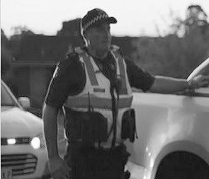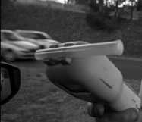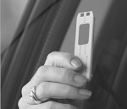Remember that your responses will be completely confidential Please select one response per line

Drug-tested while driving, where
C you wiped the testing device on
your tongue
Breath-tested for alcohol while driving, where you blew into the testing device
B

Prefer
not to Don’t say know
98 99
Three or more
Not at all Once Twice times
01 02 03 04
Pulled over by police for any reason
A

 |  |  | Three or more | Prefer not to | Don’t
Not at all | Once | Twice | times | say | know
01 | 02 | 03 | 04 | 98 | 99

 |  |  | Three or more | Prefer not to | Don’t
Not at all | Once | Twice | times | say | know
01 | 02 | 03 | 04 | 98 | 99

SECTION 5: CRASHES
5.1 Have you been caught speeding in the last 12 months?
01
Yes
02
No
98
Prefer not to say
5.2 In the last five years, have you been involved in any crashes on the road as a driver or rider?
01
Yes
02
No ▶ GO TO 6.1
98
Prefer not to say ▶ GO TO 6.1
5.3
As far as you are aware, was anyone involved in any of the crash(es) injured to the point where they needed to go to hospital?
01
Yes
02
No
98
Prefer not to say
SECTION 6: THE VEHICLES YOU DRIVE

IF YOU DO NOT DRIVE OR RIDE A VEHICLE AT ALL ▶ GO TO Q7.1
6.1 What type of vehicle do you usually drive? If you drive more than one, please select the type you use most often.

01 | Car / Station wagon | 04 Truck | 07 | Bus
02 | SUV / 4WD | 05 Motorcycle | 95 | Other (write in)
03 | Ute / Utility / Pickup | 06 Commercial van

6.2 In the last 12 months, have you bought a car, either new or used?
98 Prefer not to say
Yes, a used car
02
03 No, I haven’t bought a car in the past 12 months
Yes, a new car
01
SECTION 7: GENERAL ATTITUDES TO TRANSPORT AND ROAD SAFETY
7.1
The following statements are about cyclists and drivers on the roads.

On a scale of 1 to 5, where 1 is “Strongly disagree” and 5 is “Strongly agree”, to what extent do you agree or disagree with the following statements...?

Strongly Strongly  Disagree Agree  Please select one response per line |  |  |  |  |  | Don’t  know
 | 1 | 2 | 3 | 4 | 5 | 99
A Most drivers don’t understand what it’s like to be a cyclist on the road | 1 | 2 | 3 | 4 | 5
B Most cyclists and drivers show each other courtesy on the roads | 1 | 2 | 3 | 4 | 5

7.2
The following statements are about a broad range of attitudes and experiences relating to roads and transport.
On a scale of 1 to 5, where 1 is “Strongly disagree” and 5 is “Strongly agree”, to what extent do you agree or disagree with the following statements...?

Strongly Strongly  Disagree Agree  Please select one response per line |  |  |  |  |  | Don’t know
 | 1 | 2 | 3 | 4 | 5 | 99
A How people drive is more important than road design in saving lives | 1 | 2 | 3 | 4 | 5
B Even good drivers make mistakes | 1 | 2 | 3 | 4 | 5
C I believe a safe journey is more important than a quick journey | 1 | 2 | 3 | 4 | 5

We would like you to now think about the number of people killed each year on Victorian roads due to crashes.
7.2 How many people do you believe die each year due to crashes on Victorian roads?
Don’t know
99

Write in number
7.3
In 2002 there were 397 lives lost on Victorian roads, and last year 266 people were killed. Do you think Victoria should aim for zero road deaths?
01
Yes
02
No
99
Don’t know
98
Prefer not to say
7.4 Within the next 30 years, which of the following do you think can be achieved in one year?
01
Zero lives lost
02
Between one and twenty lives lost
03
More than twenty lives lost

FURTHER COMMENTS
A Please think about the COVID19 restrictions. During this time would you say the driving you observed was...
No difference
03
Much more aggressive
05
More patient
02
More aggressive
04
Much more patient
01
B
If you have any further comments about road safety please write them in below.
Write in the box below
97 Nothing further to add
SECTION 8: ABOUT YOU

Finally, we just have a few questions about you which will help us to interpret the data.
8.1 In the past year, how many kilometres have you driven? If you are unsure, an estimate is okay.
30,000+ (578km+ per week)
06
10,000 -14,999 (193 to 288km per week)
03
20,000 - 29,999 (386 to 577km per week)
05
5,000 - 9,999 (97 to 192km per week)
02
15,000 -19,999 (289 to 385km per week)
04
0 - 4,999 (0 to 96km per week)
01
8.2
Thinking about how much you have driven a vehicle or ridden a motorcycle in the past month, was this typical or did you drive or ride more or less than usual?
Don’t know
99
Less than I usually drive and/or ride
02
More than I usually drive and/or ride
03
Typical
01
8.3 In which country were you born?
01
Australia ▶ GO TO Q8.5
97
Elsewhere
8.4 How many years have you lived in Australia for?
Prefer not to say
98

Write in number of years

01 Employed full-time 04 Student (not working) ▶ GO TO Q8.10 07 Retired ▶ GO TO Q8.10
02 Employed part-time or casual 05 Unemployed ▶ GO TO Q8.10 98 Prefer not to say ▶ GO TO Q8.10
03 Self-employed 06 Home duties ▶ GO TO Q8.10 95 Other (write in) ▶ GO TO Q8.10
8.6 How many hours do you work in an average week?

Write number of hours per week
8.7 How would you describe your main paid occupation?
Please write in your job title and a brief description of what you do
8.8 How often do you drive a vehicle for work related purposes?

 | 01 | Daily ▶ CONTINUE | 05 | Never ▶ GO TO Q8.10
 | 02 | A few times a week ▶ CONTINUE | 97 | I only commute to and from work ▶ GO TO Q8.10
 | 03 | About once a week ▶ CONTINUE | 98 | Prefer not to say ▶ GO TO Q8.10
 | 04 | Less than once a week ▶ CONTINUE
8.9 |  | What type of driving do you do for work?

01 | Food delivery | 05 | Mobile services (e.g. maintenance, locksmith, doctor,  emergency services)
02 | Commercial ride share (e.g. Taxi, Uber, Didi, Ola etc) | 95 | Other (Please write in)
03 | Transport of goods
04 | Travelling to different work locations (meetings, site visits) | 98 | Prefer not to say
8.10 Do you have any children?
01
Yes
02
No ▶ GO TO Q8.12
98
Prefer not to say ▶ GO TO Q8.12
8.11 Which of the following do you have?
Please tick all that apply
Children who are on their P-Plates
03
Prefer not to say
98
Children who are learning to drive (L-Plates)
02
None of the above
97
Children who are not yet old enough to drive
01

98
Prefer not to say

Write in postcode
8.13 What is the highest level of education you have completed?
Please select one only
Completed high school (Completed Year 12 / Form 6)
03
Prefer not to say
98
TAFE / Technical college (Certificate / Diploma /
Advanced diploma)
02
Did not complete high school (Left before Year 12 / Form 6)
04
University degree or higher (Bachelor/Post-graduate degree / Graduate diploma)
01
SECTION 9: FURTHER RESEARCH AND PRIZE DRAW
9.1 Would you be interested in participating in other road safety related research conducted by the TAC?
01
Yes
02
No ▶ GO TO Q9.3

9.2
01 Yes 02 No ▶ GO TO 8.3
Your survey data will be stored in a de-identified format and your answers will remain confidential.
Please note, Wallis will keep your contact details separately from your survey answers, but may need to link them briefly so we can contact the appropriate people for specific TAC projects. Is this still okay?

01
Yes
02
No
9.3
Would you like to enter the draw to win a prize of $1,000? It will be drawn on the 15th of December 2020 at the Wallis office in Camberwell.
01
Yes
02
No

Please complete the box below if you answered “Yes” for Q9.2 or Q9.3

Name
Phone Email

Please note: Your personal details will be treated in strict confidence and will only be used for the purposes of contacting you for the reasons above. If you have indicated an interest in further research, please note your details will be forwarded to the TAC for this purpose. Please be assured that your personal details will be treated in strict confidence and will remain separate to your responses to this survey.
THAT IS THE END OF THE QUESTIONNAIRE
Please put the questionnaire into the pre-paid reply envelope and post it back to us.
Thank you again for your co-operation.
Prize draw details: Entry to the prize draw open to individuals as named on the cover letter who complete and return the survey. To enter, the invited respondent must complete the survey online at the website using the details listed on the cover letter, over the phone by calling 1800 113 444, or by returning this form in the reply paid envelope supplied. Winning individuals will be notified by telephone and in writing where contact details are available.

