
Instructions
This form is to be used by occupational therapists to make recommendations for the TAC to contribute to the purchase cost of a suitable vehicle with or without modifications, to ensure the safety, accessibility and independence of a TAC client as a driver or passenger.
If the client’s current vehicle is suitable to be modified, complete the Vehicle modification assessment and recommendations (modifications) template instead.
Please ensure that the TAC’s occupational therapy service requirements are followed, found at: tac.vic.gov.au/ot-dashboard and that recommendations are in line with the driving and vehicle modification policy.

Section 1

TAC client details
First name

Last name

TAC claim number |  | Date of accident | / /

Date of birth | / /

Section 2

assessment details
Date of assessment | / /

Has a community access and transport recommendations assessment been completed?
If no, please detail the reason.

☐ | Before proceeding, please confirm that a vehicle purchase contribution is recommended because the client’s current vehicle is unavailable (e.g., written off) or has been deemed unsuitable (lacks the required features such as automatic transmission, or cannot be modified to meet the client’s accident-related needs).

Detail the reasons why the client’s pre-accident vehicle, or any vehicle they have access to, is considered unsuitable for modifications

SECTION 3

CLIENT GOALS
Outline the client’s goals related to community access and vehicle use.

Section 4

Contributors to the assessment
List any people who were present for or contributed information to the assessment:
Name | Relationship to client  (e.g., family member, support worker etc) | Contact phone/email | Date and type of engagement  (e.g., present at assessment, phone call)
 |  |  | / /
 |  |  | / /
 |  |  | / /

Section 5

Medical status
Injuries and medical history
Provide any relevant information about the client’s current medical status and injuries, including recent changes and treatment updates that may affect their transport, vehicle access, driver/passenger safety and the need for vehicle modifications.
Outline any relevant information about the client’s non-accident-related or pre-existing medical conditions, including changes in diagnosis, treatment or how these conditions may influence their transport, vehicle access, driver/passenger safety and the need for vehicle modifications.

SECTION 6

CURRENT FUNCTION

Physical, sensory, mobility and transfers
Describe the clients’ physical, sensory and mobility function, including transfers and how this impacts their vehicle use and the need for vehicle modifications.

Cognitive and behavioural
Describe any cognitive/behavioural factors that may impact the client’s safe vehicle use including attention, concentration, memory, planning and judgement and ability to learn and use modifications.

Medication, fatigue, communication, and cultural considerations
Describe any medication, fatigue, communication needs, vision/hearing considerations and personal or cultural preferences that may impact safe vehicle use and the suitability, training requirements or ongoing use of a vehicle and modifications.

SECTION 7

CURRENT SUPPORTS
Describe any support currently in place (funded and unpaid/informal) for transportation and vehicle access/use. Include who provides the support, for what tasks, how much and frequency.

SECTION 8

Current VEHICLE DETAILS
For the TAC to determine a reasonable contribution towards the purchase cost of a suitable vehicle, please outline the details of the client’s existing or pre-accident vehicle/s and any other vehicles they have access to.
Vehicle details | Client’s current vehicle | Client’s pre-accident vehicle
Make and model
(e.g., Holden Commodore)
Variant/Badge
(e.g., Omega, SV6)
Year of manufacture
Current kilometres
Registration plate
Engine capacity
(1.5L, 2.0L)
Type of transmission
(auto or manual)
Fuel type
(diesel/petrol/hybrid)
Year of purchase
Ownership status
(e.g., owned, financed, leased)

Other vehicles the client has access to | Vehicle 1 | Vehicle 2
Who does the vehicle belong to?
(work, family, friend)
How often does the client have access to this vehicle?
Make & model
(e.g., Holden Commodore)
Variant/Badge
(e.g., Omega, SV6)
Year of manufacture
Current kilometres
Registration plate
Engine capacity
(1.5L, 2.0L)
Type of transmission
(auto or manual)
Fuel type
(diesel/petrol/hybrid)
Year of purchase

SECTION 9

WHEELCHAIR AND EQUIPMENT SPECIFICATIONS
If applicable, please outline the details of all wheelchairs the client will be seated in when travelling or transferring from/into vehicle.
Manual |  | Power
(folding/rigid frame)

Type & model

Wheelchair footprint
Provide overall dimensions when client sitting in wheelchair in usual travel posture and with accessories/ medical equipment attached. Include diagram if appropriate. 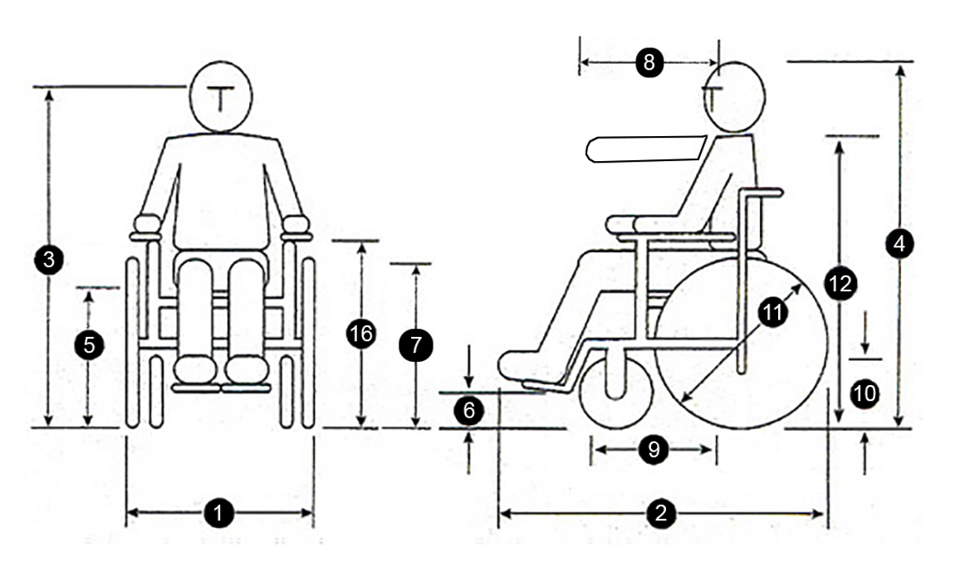
Type and model | Manual wheelchair | Power wheelchair
- Chair width | mm | mm
- Chair length | mm | mm
- Floor to eye height | mm | mm
- Floor to top of head | mm | mm
- Floor to seat height | mm | mm
- Floor to footplate height | mm | mm
- Floor to knee height | mm | mm
- Arm extension | mm | mm
- Thigh length | mm | mm
- Castor wheel size (front) | mm | mm
- Back wheel size/e-motion wheel size | mm | mm
- Floor to shoulder height | mm | mm
- Headrest fitted?
- Chair weight | kg | kg
- Combined weight in chair | kg | kg
- Floor to armrest height | mm | mm
- Is the chair suitable to have a docking pin fitted?

List any other mobility aids, medical equipment or assistive technology that the client needs to transport in the vehicle for community participation (e.g., portable commode, walker, portable hoist, power assist device). For each item provide key details including dimensions, weight and any attached accessories.

SECTION 10

Request details
Contribution to a standard vehicle with or without modifications

Contribution to a modified wheelchair accessible van
Please provide clinical rationale for recommendations

Section 11

ANTICIPATED DRIVING STATUS
What is the client’s anticipated use of the vehicle?

Anticipated kilometers per year

If client is a driver
License category
(specify, e.g., car, motorcycle)

Current valid driving license?

If yes, do they have any license conditions?
If yes, please outline license conditions.

Has the client had a driving assessment since their injury?

If yes, what was the date of their last assessment? | / /

If no, are they required to have a driving assessment?
If an OT driving assessment has been completed, please attach a copy of the Occupational Therapy Driving Assessment Report and VicRoads Medical Report Form.
Any additional comments

If client is a passenger:
Is an increase in paid supports anticipated to support the client to travel in the vehicle?
Who will be driving the vehicle, have they been consulted and are there any training requirements?

SECTION 12

RECOMMENDATIONS AND CLINICAL JUSTIFICATION
Before completing this table, ensure you have read the driving and vehicle modification policy and understand what the TAC can and cannot pay for in regards to the contribution towards the purchase of a vehicle.
Your recommendation must reflect your clinical opinion based on injury-related needs, even when this differs from the client’s preference (e.g., if a wheelchair-accessible vehicle is clinically required, however the client would prefer a standard vehicle with boot hoist).
Vehicles considered/trialed  (make and model) | Vehicle features | Suitability/clinical justification | Recommended

If more than one suitable vehicle has been identified, does the client have a preference?
Please specify the preferred vehicle and the reasons.

Does the client have any desires or preferences that are not clinically supported, and has the client agreed to self-fund these?
(e.g., colour, engine capacity, leather seats, infotainment)

If yes, please specify the items.

Section 13

Recommendations and clinical justification – vehicle modifications
Recommended client seating position: | Yes or No | Comments
Driver seated in wheelchair
Driver seated in vehicle seat
Passenger seated in wheelchair
(Note 1st,2nd or 3rd row)
Passenger seated in vehicle seat
(Note 1st,2nd or 3rd row)

Vehicle feature/consideration | Is a modification/s recommended? | Recommended modification/s | Clinical justification
Wheelchair access into and within vehicle
(ramp/hoist, door openings, rear/side entry, required clearance dimensions)
Other seats
(non-wheelchair seating)
Postural seating support, positioning and client securement
(e.g., seat belts, special seats, head supports, pressure management)
Driving controls and interfaces
(e.g., left foot accelerator, hand controls, steering aids)
Wheelchair restraints and occupant restraint systems
(e.g., docking station, tie downs)
Transporting equipment within the vehicle
(e.g., hoists/lifts, loading method, storage location and who will load/unload)

section 14

Other transport requirements
Indicate any other people or items that need to be transported in this vehicle now and in the future. Include whether equipment fits in available space in the vehicle. Note any expected changes to the client’s needs, including equipment already provided, planned or yet to be investigated.
 | Current status | Anticipated future status
People: number and relationship of people who would be using the vehicle apart from the client
Equipment
(e.g., ramps, wheelchair, scooter, mobile
hoist, gait aids)
Other (please specify):

SECTION 15

VEHICLE AVAILABILITY
Have you discussed with the client, their family and carers the need to ensure that the modified vehicle is readily available for the client to use?
(i.e. the vehicle must be free for use and readily accessible when needed)
Comments

SECTION 16

VEHICLE ACCESS AT HOME
Note
This section is designed to identify whether the proposed vehicle is compatible with the client’s current home environment. This means whether there is a suitable space for a client to enter and exit a vehicle via its access method, and whether the client can complete an undercover transfer where the TAC has accepted a diagnosis by a suitably qualified clinician for thermodysregulation. General preferences to garage or keep a vehicle covered are not considered as an injury-related, medical and like need.

Occupational therapist consideration | Yes or No | Comments  (e.g. location, images)
Is there a suitable parking location at the client’s home? Describe how the vehicle must be driven onto the location and parked.
(e.g., front in, reverse in, side to kerb)
Does the parking location enable safe loading/unloading practices for the TAC client and their equipment?
Are undercover transfers clinically required due to an accepted injury of thermodysregulation?
Can the proposed vehicle fit in the existing car port/garage?
Will the property require any modifications for the use of the recommended vehicle/modifications?
(e.g., for underbody clearance)
If Yes, include comment from the modification provider.
Will the property require any modifications to support clinically required, undercover transfers?

SECTION 17

VEHICLE ACCESS IN THE COMMUNITY
Describe the community locations that the client intends to access regularly in the proposed vehicle. Demonstrate that the proposed vehicle type and access configuration (e.g., seating position, ramp/hoist, door type) is compatible with typical access and parking conditions at these locations.
Location type  (e.g., local shopping Centre, GP clinic, family residences). | Typical access scenario  (e.g., kerb side, standard car park bay, undercover car park, gradient, overhead clearance etc.) | Key access requirements  (e.g., space to open door, deploy ramp, gradient tolerance, overhead clearance etc.) | Suitability rating | Comments/images

SECTION 18

ANTICIPATED IMPACT ON INDEPENDENCE AND PAID SUPPORTS
Do you anticipate a change in the client’s funded supports and independence after completion of the modification/s?
Please provide further detail. What supports may change (e.g., community access), by how much (e.g., 10 hrs a week), the expected timeframe post modification completion (e.g., 3 months after completion following OT review) and whether a reduction should be graded (e.g., 3 hour reduction in community access hours per fortnight, to commence 3 months post completion, gradually over a 3 month period.)
If the recommendations do not impact the current support services, or increase these services, please detail your reasoning.

☐ | The recommendations made in this report and the anticipated changes to the client’s support needs, after the vehicle modification has been completed, have been discussed with the client.

SECTION 19

ORDINARY VEHICLE COSTS
The TAC notes that owning and operating a vehicle carries costs and responsibilities regardless of injury and expects that if a client is unable or unwilling to meet those costs and responsibilities, we would provide taxis for medical and like services.
Has the client been made aware that they will be required to pay for the following and indicated that they understand this:
- Roadside assistance, comprehensive insurance inclusive of any desired extras such as vehicle hire and glass cover, and any excess incurred by client/carers in case of an accident

- TAC levy / registration fee

- Any additional options to the vehicle not required due to transport accident injuries

- All general maintenance, repairs and running costs of the vehicle, including but not limited to fuel, car cleaning, and other incidental ordinary costs of vehicle ownership

- Client will be required to sign a Vehicle Modifications Agreement before approval if modifications exceed $10,000

- Maintaining the vehicle in roadworthy condition at all times
Additional comments

SECTION 20

QUOTATION
Attach an itemised quote (for supply/installation) for the recommended modifications. If a quote is not required or not yet available, provide further detail including an expected timeframe for submission.

Section 21

Provider details
I have discussed with the client and/or representatives and other members of the treating team the information contained in this form, including the requested items, aims, predicted outcomes, maintenance and training requirements.

Provider name, address,
email and phone number
(Type details or insert image of
practice stamp)

Days/hours available

Signature  Insert image (jpg/png) of signature.  (Or print, sign and scan the form) | 

Date | / /

Submitting this form
Email your completed form to your TAC home modification specialist or to info@tac.vic.gov.au with the client’s TAC claim number in the subject line. Please also attach any supporting documentation.

Privacy
The TAC will retain the information provided and may use or disclose it to make further inquiries to assist
in the ongoing management of the claim or any claim for common law damages. The TAC may also be required by law to disclose this information. Without this information, the TAC may be unable to determine entitlements or assess whether the treatment is reasonable and may not be able to approve further benefits and treatment. If you require further information about our privacy policy, please call the TAC on
1300 654 329 or visit our website at www.tac.vic.gov.au

