

Quarterly Statistics - MARCH 2017


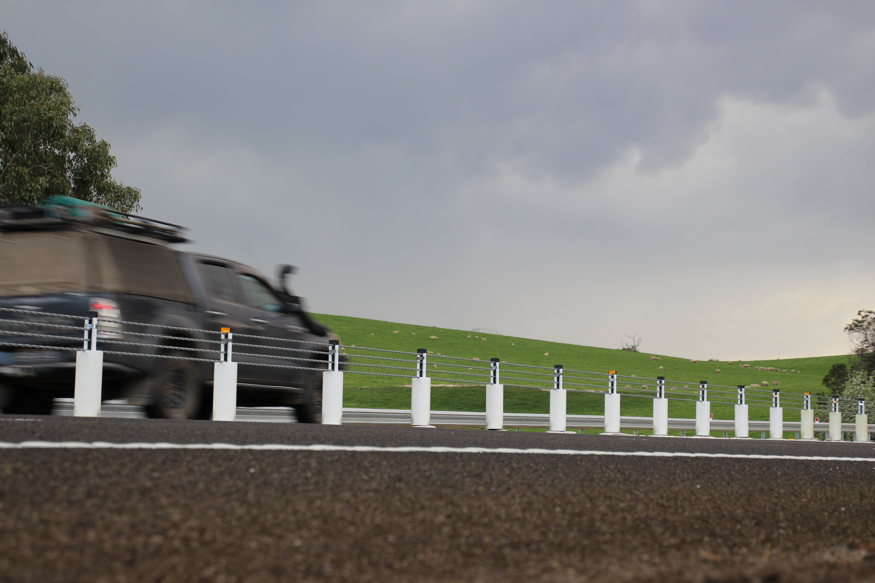

TRANSPORT  ACCIDENT  COMMISSION | 60 Brougham Street  Geelong Vic 3220  PO Box 742  Geelong Vic 3220  Ausdoc DX 216079 Geelong | Telephone 1300 654 329  STD Toll Free 1800 332 556  Fax: 03 9656 9300  www.tac.vic.gov.au  ABN 22 033 947 623

Contents
Lives lost on Victorian roads 7
Injured claimants who were admitted to hospital within 7 days of accident, (by claim acceptance date – rolling 12 month, to 30th September 2016) 8
Lives lost: 12 months to 31st March 2017 9
Injured claimants who were admitted to hospital within 7 days of accident, 12 months to 30th September 2016 (claim acceptance date) 13
Lives Lost by Week (2009 to 2016) 15
The National Picture 16
Booze Bus Random Breath Testing 17
Random Drug Testing 17
Mobile Safety Camera Data 17
Explanations and References 18
Useful Internet Sites 19
Victorian monthly lives lost since 1951 22

Notes about the data in this report
- All data provided in this report is the data most recently available at time of production. Fatality data are updated to the end of report month. A 6-month lag applies to TAC claims data.
- Reported data will have one extra day of exposure for leap years.
- Data is subject to revision as additional information about known accidents/claims is received, and as new accident/claim reports are received and processed.
Status Report

Lives lost on Victorian roads
- The rolling 12 month number of lives lost to 31st March 2017 stands at 272. The rolling 12 month number of lives lost to 31st March 2016 stood at 265 (an increase of 7).
- In January, 18 people’s lives were lost in 2017 compared to 21 in January 2016 (a decrease of 3).
- In February, 19 people lost their lives in 2017 compared to 33 in February 2016 (a decrease of 14).
- There were 23 people’s lives lost in March 2017 on Victorian roads. This compares to 25 in March 2016.

Lives lost (rolling 12 month, to 31^{sh} March 2017)
Category | 2017 | 2016 | 2015 | 2017 v 2016 | 2017 v 2015 | 5 Year Average
Lives Lost (Rolling 12 Month Total)
Lives Lost (to March) | 272 | 265 | 243 | +7 | +29 | 260
per 10,000 veh | 0.57 | 0.57 | 0.53 | 0.00 | +0.04 | 0.55
per 100,000 pop | 4.46 | 4.43 | 4.14 | +0.03 | +0.32 | 4.27
Crashes (Rolling 12 Month Total)
Fatal crashes | 261 | 248 | 222 | +13 | +39 | 241
per 10,000 veh | 0.55 | 0.54 | 0.49 | +0.01 | +0.06 | 0.50
per 100,000 pop | 4.45 | 4.17 | 3.78 | +0.28 | +0.67 | 3.94

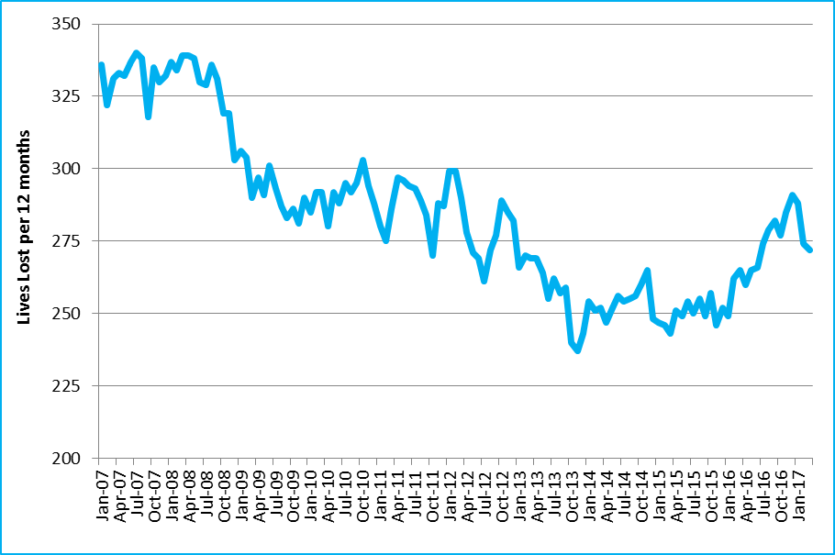
Victoria – Lives Lost, rolling 12 months total

Injured claimants who were admitted to hospital within 7 days of accident, (by claim acceptance date – rolling 12 month, to 30th September 2016)
Category | 2017 | 2016 | 2015 | 2017 v 2016 |  |  | 2017 v 2015 |  | 5 Year Average
Claims involving an acute hospitalisation over 14 days (Rolling 12 Month Total)
Claims (to September) | 1,002 | 934 | 896 | +68 |  | (+7%) | +106 | (+12%) | 885
per 100,000 pop | 16.6 | 15.8 | 15.5 | +0.8 |  | (+5%) | +1.1 | (+7%) | 16.0
per 10,000 veh | 2.1 | 2.0 | 2.0 | +0.1 |  | (+5%) | +0.1 | (+5%) | 2.1
All claims involving an acute hospitalisation (Rolling 12 Month Total)
Claims (to September) | 7,009 | 6,031 | 6,101 | +978 |  | (+16%) | +908 | (+15%) | 5,747
per 100,000 pop | 116.1 | 101.9 | 105.0 | +14.2 |  | (+14%) | +11.1 | (+11%) | 102.9
per 10,000 veh | 14.9 | 13.1 | 13.6 | +1.8 |  | (+14%) | +1.3 | (+10%) | 13.3

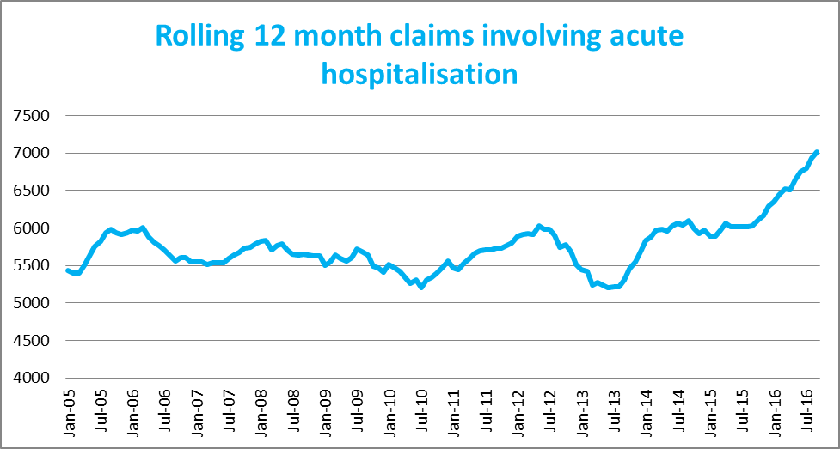
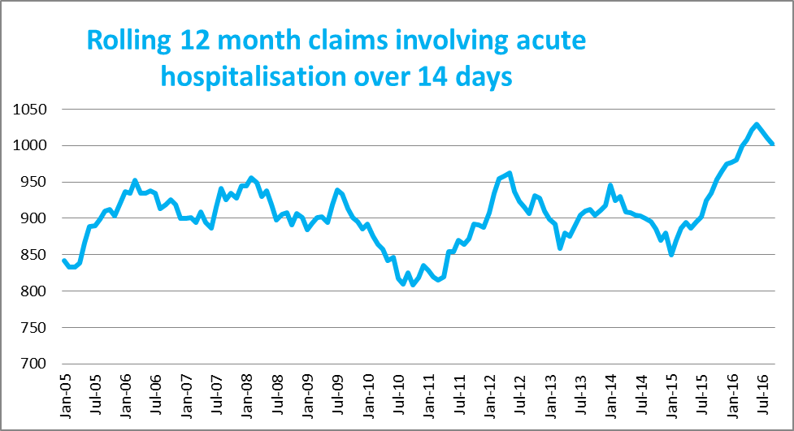

Lives lost: 12 months to 31st March 2017
Category | 2017 | 2016 | 2015 | 2017 v 2016 | 2017 v 2015 | 5 Year Average
Overview
Lives Lost | 272 | 265 | 243 | +7 | +29 | 260
Fatal Crashes | 261 | 248 | 222 | +13 | +39 | 241
Sex
Female | 78 | 76 | 61 | +2 | +17 | 77
Male | 194 | 189 | 182 | +5 | +12 | 183
Road user
Bicyclist | 6 | 12 | 8 | -6 | -2 | 8
Driver | 151 | 124 | 116 | +27 | +35 | 131
Motorcyclist | 40 | 44 | 31 | -4 | +9 | 39
Passenger | 36 | 54 | 42 | -18 | -6 | 46
Pedestrian | 40 | 31 | 46 | +9 | -6 | 36
Location
Melbourne | 116 | 130 | 107 | -14 | +9 | 116
Rural Victoria | 156 | 135 | 136 | +21 | +20 | 145
Age group
0-4 | 4 | 1 | 4 | +3 | 0 | 3
5-15 | 4 | 4 | 5 |  | -1 | 6
16-17 | 4 | 16 | 6 | -12 | -2 | 6
18-20 | 12 | 32 | 12 | -20 | 0 | 20
21-25 | 27 | 16 | 34 | +11 | -7 | 26
26-29 | 24 | 20 | 23 | +4 | +1 | 20
30-39 | 42 | 29 | 35 | +13 | +7 | 36
40-49 | 52 | 35 | 29 | +17 | +23 | 35
50-59 | 34 | 32 | 28 | +2 | +6 | 32
60-69 | 25 | 27 | 30 | -2 | -5 | 28
70+ | 43 | 53 | 37 | -10 | +6 | 48
Accident Type
Intersection
Adjacent direction | 28 | 34 | 25 | -6 | +3 | 31
Opposing direction | 5 | 10 | 10 | -5 | -5 | 6
Mid-block/other
Head on | 51 | 47 | 30 | +4 | +21 | 43
Same direction | 23 | 17 | 11 | +6 | +12 | 16
Manoeuvre/o'taking | 10 | 19 | 13 | -9 | -3 | 13
On path | 9 | 3 | 10 | +6 | -1 | 6
Single vehicle | 106 | 102 | 94 | +4 | +12 | 103
Other (incl peds) | 40 | 33 | 50 | +7 | -10 | 41

Lives Lost: 12 months to 31st March 2017 – Continued
Category | 2017 | 2016 | 2015 | 5 Year Average | Category | 2017 |  |  | 2016 | 2015 | 5 Year Average
Local Government Area |  |  |  |  | Local Government Area
ALPINE | 0 | 0 | 2 | 1 | MANSFIELD |  |  | 3 | 2 | 2 | 2
ARARAT | 1 | 3 | 2 | 2 | MARIBYRNONG |  |  | 2 | 4 | 0 | 2
BALLARAT | 7 | 2 | 3 | 3 | MAROONDAH |  |  | 2 | 1 | 2 | 1
BANYULE | 1 | 2 | 1 | 2 | MELBOURNE |  |  | 4 | 1 | 8 | 3
BASS COAST | 5 | 0 | 3 | 2 | MELTON |  |  | 4 | 5 | 6 | 5
BAW BAW | 3 | 2 | 4 | 4 | MILDURA |  |  | 2 | 5 | 1 | 3
BAYSIDE | 4 | 0 | 4 | 3 | MITCHELL |  |  | 3 | 4 | 5 | 4
BENALLA | 2 | 4 | 0 | 2 | MOIRA |  |  | 5 | 6 | 4 | 3
BOROONDARA | 4 | 2 | 2 | 2 | MONASH |  |  | 6 | 4 | 1 | 3
BRIMBANK | 11 | 8 | 4 | 5 | MOONEE VALLEY |  |  | 4 | 0 | 4 | 2
BULOKE | 2 | 2 | 1 | 1 | MOORABOOL |  |  | 7 | 3 | 1 | 3
CAMPASPE | 3 | 4 | 4 | 5 | MORELAND |  |  | 6 | 1 | 7 | 3
CARDINIA | 4 | 11 | 3 | 5 | MORNINGTON PENINSULA |  |  | 4 | 14 | 8 | 7
CASEY | 9 | 7 | 5 | 5 | MOUNT ALEXANDER |  |  | 0 | 2 | 2 | 2
CENTRAL GOLDFIELDS | 2 | 1 | 0 | 2 | MOYNE |  |  | 2 | 0 | 6 | 2
COLAC-OTWAY | 3 | 2 | 2 | 2 | MURRINDINDI |  |  | 5 | 5 | 7 | 4
CORANGAMITE | 1 | 4 | 8 | 4 | NILLUMBIK |  |  | 4 | 2 | 2 | 1
DAREBIN | 0 | 5 | 0 | 3 | NORTHERN GRAMPIANS |  |  | 3 | 1 | 1 | 2
EAST GIPPSLAND | 4 | 9 | 7 | 5 | PORT PHILLIP |  |  | 0 | 2 | 1 | 2
FRANKSTON | 1 | 3 | 5 | 2 | PYRENEES |  |  | 3 | 0 | 0 | 1
GANNAWARRA | 0 | 0 | 1 | 1 | QUEENSCLIFFE |  |  | 0 | 0 | 0 | 0
GLEN EIRA | 3 | 2 | 1 | 1 | SOUTH GIPPSLAND |  |  | 3 | 6 | 3 | 4
GLENELG | 4 | 2 | 9 | 2 | SOUTHERN GRAMPIANS |  |  | 4 | 2 | 1 | 1
GOLDEN PLAINS | 4 | 4 | 2 | 2 | STONNINGTON |  |  | 0 | 2 | 4 | 2
GREATER BENDIGO | 6 | 4 | 7 | 5 | STRATHBOGIE |  |  | 1 | 5 | 2 | 3
GREATER DANDENONG | 1 | 7 | 5 | 4 | SURF COAST |  |  | 2 | 4 | 4 | 2
GREATER GEELONG | 12 | 4 | 6 | 6 | SWAN HILL |  |  | 4 | 2 | 2 | 2
GREATER SHEPPARTON | 7 | 7 | 4 | 6 | TOWONG |  |  | 1 | 0 | 1 | 0
HEPBURN | 7 | 0 | 2 | 1 | WANGARATTA |  |  | 5 | 4 | 3 | 3
HINDMARSH | 0 | 2 | 1 | 1 | WARRNAMBOOL |  |  | 1 | 1 | 0 | 1
HOBSONS BAY | 1 | 5 | 1 | 2 | WELLINGTON |  |  | 6 | 3 | 4 | 3
HORSHAM | 4 | 4 | 1 | 2 | WEST WIMMERA |  |  | 1 | 0 | 0 | 0
HUME | 3 | 6 | 5 | 6 | WHITEHORSE |  |  | 4 | 2 | 5 | 2
INDIGO | 5 | 2 | 7 | 3 | WHITTLESEA |  |  | 5 | 3 | 5 | 4
KINGSTON | 4 | 4 | 4 | 5 | WODONGA |  |  | 3 | 2 | 0 | 1
KNOX | 6 | 6 | 4 | 3 | WYNDHAM |  |  | 10 | 8 | 5 | 5
LATROBE | 3 | 6 | 5 | 5 | YARRA |  |  | 1 | 2 | 1 | 1
LODDON | 2 | 2 | 0 | 0 | YARRA RANGES |  |  | 5 | 12 | 3 | 6
MACEDON RANGES | 3 | 6 | 6 | 4 | YARRIAMBIACK |  |  | 2 | 0 | 0 | 0
MANNINGHAM | 3 | 1 | 1 | 1

Injured claimants who were admitted to hospital within 7 days of the accident with a hospital stay of more than 14 days, 12 months to 30th September 2016 (claim acceptance date)
Category | 2016 | 2015 | 2014 | 2016 v 2015 |  | 2016 v 2014 |  | 5 Year Average
Overview
Claims | 1,002 | 934 | 896 | +68 | 7% | +106 | 12% | 885
Sex
Female | 422 | 404 | 358 | +18 | 4% | +64 | 18% | 375
Male | 580 | 529 | 537 | +51 | 10% | +43 | 8% | 510
Road user
Bicyclist | 37 | 40 | 35 | -3 | -8% | +2 | 6% | 34
Driver | 397 | 347 | 376 | +50 | 14% | +21 | 6% | 355
Motorcyclist | 159 | 187 | 157 | -28 | -15% | +2 | 1% | 152
Passenger | 141 | 146 | 131 | -5 | -3% | +10 | 8% | 136
Pedestrian | 211 | 185 | 177 | +26 | 14% | +34 | 19% | 181
Train/Tram | 5 | 9 | 9 | -4 | -44% | -4 | -44% | 7
Location
Melbourne | 644 | 620 | 544 | +24 | 4% | 100 | 18% | 570
Rural Victoria | 303 | 290 | 333 | +13 | 4% | -30 | -9% | 294
Age group
0-4 | 7 | 4 | 1 | +3 | 75% | 6 | 600% | 3
5-15 | 17 | 18 | 15 | -1 | -6% | 2 | 13% | 13
16-17 | 13 | 13 | 12 |  | 0% | 1 | 8% | 14
18-20 | 72 | 44 | 53 | +28 | 64% | 19 | 36% | 56
21-25 | 86 | 81 | 86 | +5 | 6% | 0 | 0% | 78
26-29 | 57 | 57 | 48 |  | 0% | 9 | 19% | 47
30-39 | 136 | 98 | 111 | +38 | 39% | 25 | 23% | 108
40-49 | 107 | 120 | 112 | -13 | -11% | -5 | -4% | 110
50-59 | 98 | 125 | 111 | -27 | -22% | -13 | -12% | 101
60-69 | 127 | 106 | 97 | +21 | 20% | 30 | 31% | 106
70+ | 282 | 268 | 250 | +14 | 5% | 32 | 13% | 248
Accident Type
Intersection
Adjacent direction | 107 | 102 | 98 | +5 | 5% | 9 | 9% | 107
Opposing direction | 57 | 61 | 60 | -4 | -7% | -3 | -5% | 59
Mid-block/other
Head on | 103 | 83 | 96 | +20 | 24% | 7 | 7% | 83
Same direction | 69 | 99 | 65 | -30 | -30% | 4 | 6% | 75
Manoeuvre/o'taking | 61 | 54 | 60 | +7 | 13% | 1 | 2% | 56
On path | 31 | 33 | 27 | -2 | -6% | 4 | 15% | 25
Single vehicle | 291 | 270 | 274 | +21 | 8% | 17 | 6% | 250
Other (incl peds) | 283 | 232 | 216 | +51 | 22% | 67 | 31% | 231

Note: Excludes rejected claims and claims for interstate crashes.
Injured claimants who were admitted to hospital within 7 days of the accident with a hospital stay of more than 14 days, 12 months to 30th September 2016 (claim acceptance date) – Continued
Category | 2016 | 2015 | 2014 | 5 Year Average | Category | 2016 | 2015 | 2014 | 5 Year Average
Local Government Area |  |  |  |  | Local Government Area
ALPINE | 2 | 5 | 2 | 2 | MANSFIELD | 5 | 2 | 5 | 3
ARARAT | 2 | 10 | 9 | 5 | MARIBYRNONG | 10 | 12 | 4 | 9
BALLARAT | 11 | 15 | 18 | 11 | MAROONDAH | 10 | 6 | 5 | 4
BANYULE | 9 | 12 | 9 | 8 | MELBOURNE | 32 | 34 | 29 | 24
BASS COAST | 4 | 11 | 13 | 8 | MELTON | 12 | 21 | 10 | 11
BAW BAW | 8 | 8 | 7 | 7 | MILDURA | 3 | 5 | 10 | 6
BAYSIDE | 9 | 8 | 8 | 8 | MITCHELL | 8 | 6 | 16 | 8
BENALLA | 3 | 6 | 4 | 3 | MOIRA | 6 | 6 | 7 | 6
BOROONDARA | 12 | 21 | 27 | 17 | MONASH | 21 | 25 | 23 | 17
BRIMBANK | 35 | 34 | 19 | 19 | MOONEE VALLEY | 25 | 21 | 22 | 15
BULOKE | 5 | 4 | 3 | 2 | MOORABOOL | 11 | 7 | 11 | 6
CAMPASPE | 7 | 9 | 8 | 5 | MORELAND | 28 | 28 | 22 | 21
CARDINIA | 16 | 15 | 11 | 10 | MORNINGTON PENINSULA | 32 | 25 | 23 | 21
CASEY | 39 | 32 | 26 | 21 | MOUNT ALEXANDER | 2 | 5 | 8 | 5
CENTRAL GOLDFIELDS | 4 | 1 | 3 | 2 | MOYNE | 3 | 2 | 4 | 3
COLAC-OTWAY | 8 | 10 | 9 | 6 | MURRINDINDI | 7 | 17 | 11 | 9
CORANGAMITE | 3 | 5 | 4 | 4 | NILLUMBIK | 9 | 11 | 6 | 6
DAREBIN | 30 | 15 | 14 | 13 | NORTHERN GRAMPIANS | 2 | 2 | 4 | 2
EAST GIPPSLAND | 8 | 11 | 9 | 8 | PORT PHILLIP | 18 | 17 | 20 | 12
FRANKSTON | 15 | 20 | 10 | 10 | PYRENEES | 2 | 2 | 3 | 1
GANNAWARRA | 2 | 2 | 5 | 2 | QUEENSCLIFFE | 1 | 0 | 0 | 0
GLEN EIRA | 17 | 14 | 18 | 12 | SOUTH GIPPSLAND | 15 | 8 | 7 | 4
GLENELG | 6 | 6 | 7 | 4 | SOUTHERN GRAMPIANS | 3 | 2 | 5 | 3
GOLDEN PLAINS | 9 | 5 | 6 | 4 | STONNINGTON | 14 | 15 | 16 | 11
GREATER BENDIGO | 14 | 13 | 12 | 11 | STRATHBOGIE | 11 | 7 | 7 | 7
GREATER DANDENONG | 27 | 15 | 29 | 18 | SURF COAST | 6 | 5 | 5 | 3
GREATER GEELONG | 17 | 21 | 28 | 22 | SWAN HILL | 8 | 5 | 1 | 2
GREATER SHEPPARTON | 20 | 9 | 11 | 9 | TOWONG | 2 | 1 | 4 | 2
HEPBURN | 3 | 5 | 2 | 2 | WANGARATTA | 6 | 6 | 2 | 4
HINDMARSH | 1 | 1 | 0 | 1 | WARRNAMBOOL | 3 | 2 | 7 | 4
HOBSONS BAY | 5 | 12 | 9 | 8 | WELLINGTON | 7 | 8 | 12 | 7
HORSHAM | 5 | 3 | 5 | 3 | WEST WIMMERA | 0 | 1 | 2 | 2
HUME | 34 | 35 | 17 | 21 | WHITEHORSE | 21 | 18 | 20 | 14
INDIGO | 8 | 5 | 1 | 3 | WHITTLESEA | 33 | 30 | 17 | 19
KINGSTON | 13 | 25 | 22 | 17 | WODONGA | 5 | 5 | 7 | 4
KNOX | 17 | 16 | 18 | 14 | WYNDHAM | 35 | 20 | 31 | 17
LATROBE | 13 | 14 | 7 | 9 | YARRA | 14 | 15 | 13 | 10
LODDON | 3 | 1 | 3 | 1 | YARRA RANGES | 34 | 37 | 33 | 23
MACEDON RANGES | 20 | 6 | 19 | 8 | YARRIAMBIACK | 1 | 0 | 0 | 1
MANNINGHAM | 18 | 11 | 13 | 11

Note: excludes rejected claims and claims for interstate crashes

Injured claimants who were admitted to hospital within 7 days of accident, 12 months to 30th September 2016 (claim acceptance date)
Category | 2016 | 2015 | 2014 | 2016 v 2015 |  | 2016 v 2014 |  |  | 5 Year Average
Overview
Claims | 7,009 | 6,031 | 6,101 | +978 | 16% | +908 | 15% | 5,747
Sex
Female | 3,070 | 2,613 | 2,566 | +457 | 17% | +504 | 20% | 2,457
Male | 3,925 | 3,411 | 3,527 | +514 | 15% | +398 | 11% | 3,284
Road user
Bicyclist | 422 | 389 | 386 | +33 | 8% | +36 | 9% | 369
Driver | 3,321 | 2,751 | 2,728 | +570 | 21% | +593 | 22% | 2,654
Motorcyclist | 1,158 | 1,093 | 1,157 | +65 | 6% | +1 | 0% | 985
Passenger | 1,079 | 1,005 | 1,062 | +74 | 7% | +17 | 2% | 955
Pedestrian | 712 | 607 | 640 | +105 | 17% | +72 | 11% | 615
Train/Tram | 28 | 30 | 35 | -2 | -7% | -7 | -20% | 28
Location
Melbourne | 4,673 | 4,042 | 4,117 | +631 | 16% | +556 | 14% | 3,854
Rural Victoria | 1,962 | 1,755 | 1,791 | +207 | 12% | +171 | 10% | 1,722
Age group
0-4 | 53 | 41 | 53 | +12 | 29% |  | 0% | 46
5-15 | 220 | 230 | 174 | -10 | -4% | +46 | 26% | 187
16-17 | 130 | 106 | 98 | +24 | 23% | +32 | 33% | 103
18-20 | 537 | 459 | 511 | +78 | 17% | +26 | 5% | 474
21-25 | 887 | 706 | 796 | +181 | 26% | +91 | 11% | 714
26-29 | 607 | 484 | 497 | +123 | 25% | +110 | 22% | 461
30-39 | 1,126 | 956 | 909 | +170 | 18% | +217 | 24% | 892
40-49 | 987 | 879 | 934 | +108 | 12% | +53 | 6% | 844
50-59 | 850 | 787 | 771 | +63 | 8% | +79 | 10% | 720
60-69 | 699 | 554 | 545 | +145 | 26% | +154 | 28% | 532
70+ | 913 | 829 | 813 | +84 | 10% | +100 | 12% | 775
Accident Type
Intersection
Adjacent direction | 903 | 775 | 801 | +128 | 17% | +102 | 13% | 777
Opposing direction | 577 | 519 | 518 | +58 | 11% | +59 | 11% | 496
Mid-block/other
Head on | 376 | 279 | 351 | +97 | -59% | +25 | 7% | 304
Same direction | 1,053 | 912 | 889 | +141 | 199% | +164 | 18% | 856
Manoeuvre/o'taking | 405 | 352 | 325 | +53 | 37% | +80 | 25% | 325
On path | 319 | 295 | 294 | +24 | -81% | +25 | 9% | 261
Single vehicle | 1,703 | 1,709 | 1,705 | -6 | 43% | -2 | 0% | 1,540
Other (incl peds) | 1,673 | 1,190 | 1,218 | +483 | 41% | +455 | 37% | 1,187

Note: excludes rejected claims and claims for interstate crashes
Injured claimants who were admitted to hospital within 7 days of accident, 12 months to 30th September 2016 (claim acceptance date) – Continued
Category | 2016 | 2015 | 2014 | 5 Year Average | Category | 2016 | 2015 | 2014 | 5 Year Average
Local Government Area |  |  |  |  | Local Government Area
ALPINE | 23 | 23 | 35 | 23 | MANSFIELD | 40 | 21 | 36 | 23
ARARAT | 15 | 25 | 20 | 14 | MARIBYRNONG | 73 | 77 | 63 | 55
BALLARAT | 104 | 69 | 81 | 61 | MAROONDAH | 69 | 58 | 58 | 41
BANYULE | 58 | 40 | 72 | 44 | MELBOURNE | 346 | 238 | 246 | 184
BASS COAST | 47 | 60 | 43 | 37 | MELTON | 94 | 90 | 69 | 57
BAW BAW | 48 | 46 | 64 | 43 | MILDURA | 30 | 30 | 43 | 28
BAYSIDE | 95 | 72 | 74 | 52 | MITCHELL | 70 | 60 | 73 | 46
BENALLA | 19 | 32 | 13 | 14 | MOIRA | 40 | 32 | 34 | 26
BOROONDARA | 121 | 138 | 133 | 100 | MONASH | 195 | 193 | 223 | 142
BRIMBANK | 134 | 143 | 141 | 111 | MOONEE VALLEY | 150 | 118 | 123 | 89
BULOKE | 9 | 10 | 14 | 8 | MOORABOOL | 53 | 33 | 48 | 35
CAMPASPE | 48 | 39 | 36 | 28 | MORELAND | 168 | 151 | 147 | 108
CARDINIA | 150 | 110 | 114 | 74 | MORNINGTON PENINSULA | 172 | 154 | 153 | 110
CASEY | 351 | 297 | 268 | 189 | MOUNT ALEXANDER | 21 | 29 | 35 | 20
CENTRAL GOLDFIELDS | 15 | 7 | 15 | 10 | MOYNE | 21 | 15 | 27 | 13
COLAC-OTWAY | 44 | 40 | 37 | 22 | MURRINDINDI | 60 | 59 | 58 | 45
CORANGAMITE | 23 | 25 | 24 | 21 | NILLUMBIK | 50 | 45 | 27 | 28
DAREBIN | 113 | 84 | 99 | 70 | NORTHERN GRAMPIANS | 15 | 16 | 21 | 14
EAST GIPPSLAND | 52 | 69 | 48 | 48 | PORT PHILLIP | 142 | 144 | 158 | 98
FRANKSTON | 139 | 141 | 116 | 92 | PYRENEES | 12 | 12 | 9 | 7
GANNAWARRA | 10 | 10 | 15 | 10 | QUEENSCLIFFE | 1 | 1 | 1 | 2
GLEN EIRA | 132 | 104 | 113 | 82 | SOUTH GIPPSLAND | 53 | 22 | 45 | 24
GLENELG | 26 | 16 | 23 | 14 | SOUTHERN GRAMPIANS | 29 | 20 | 30 | 20
GOLDEN PLAINS | 41 | 27 | 31 | 20 | STONNINGTON | 151 | 139 | 142 | 98
GREATER BENDIGO | 105 | 109 | 76 | 74 | STRATHBOGIE | 41 | 39 | 32 | 27
GREATER DANDENONG | 269 | 238 | 289 | 176 | SURF COAST | 56 | 41 | 35 | 28
GREATER GEELONG | 225 | 230 | 220 | 163 | SWAN HILL | 24 | 19 | 16 | 10
GREATER SHEPPARTON | 115 | 76 | 67 | 52 | TOWONG | 19 | 16 | 14 | 12
HEPBURN | 31 | 30 | 27 | 22 | WANGARATTA | 42 | 36 | 32 | 24
HINDMARSH | 8 | 6 | 10 | 6 | WARRNAMBOOL | 29 | 18 | 18 | 18
HOBSONS BAY | 69 | 69 | 64 | 48 | WELLINGTON | 73 | 70 | 80 | 52
HORSHAM | 17 | 28 | 18 | 16 | WEST WIMMERA | 5 | 4 | 5 | 4
HUME | 230 | 192 | 181 | 126 | WHITEHORSE | 134 | 96 | 110 | 82
INDIGO | 24 | 18 | 17 | 16 | WHITTLESEA | 213 | 155 | 137 | 111
KINGSTON | 141 | 136 | 155 | 105 | WODONGA | 22 | 27 | 20 | 21
KNOX | 144 | 105 | 125 | 79 | WYNDHAM | 155 | 140 | 186 | 111
LATROBE | 70 | 53 | 56 | 45 | YARRA | 141 | 118 | 106 | 80
LODDON | 10 | 15 | 19 | 10 | YARRA RANGES | 177 | 176 | 165 | 125
MACEDON RANGES | 74 | 63 | 68 | 48 | YARRIAMBIACK | 3 | 10 | 1 | 4
MANNINGHAM | 97 | 81 | 60 | 55

Note: excludes rejected claims and claims for interstate crashes

Lives Lost by Week (2009 to 2016)

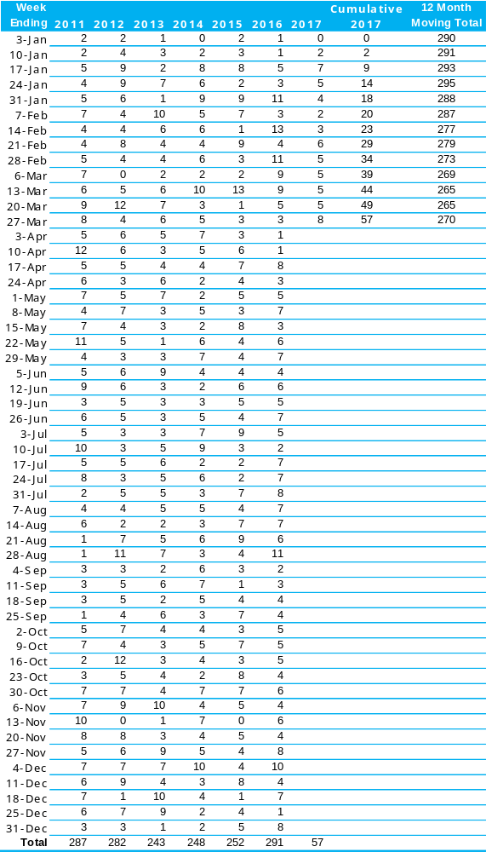

The National Picture
State | Lives Lost (12 months to 31st March)
 | 2017 | 2016 | 2015 | 2014 | 2017 v 2016
NSW | 375 | 363 | 295 | 344 | +12 | (+3%)
VIC | 273 | 265 | 243 | 252 | +8 | (+3%)
QLD | 251 | 252 | 218 | 248 | -1 | (-0%)
SA | 86 | 101 | 103 | 92 | -15 | (-15%)
WA | 181 | 171 | 184 | 161 | +10 | (+6%)
TAS | 31 | 34 | 39 | 34 | -3 | (-9%)
NT | 44 | 50 | 38 | 43 | -6 | (-12%)
ACT | 12 | 16 | 7 | 7 | -4 | (-25%)
AUST TOTAL | 1,253 | 1,252 | 1,127 | 1,181 | +1 | (+0%)
AUST minus VIC | 1,241 | 987 | 884 | 929 | +254 | (+26%)
State | Lives Lost per 10,000 registered vehicles |  |  | Fatalities per 100,000 population
 | (12 months to 31st March) |  |  | (12 months to 31st March)
 | 2017 | 2016 | 2015 | 2017 | 2016 | 2015
NSW | 0.69 | 0.68 | 0.57 | 4.84 | 4.75 | 3.91
VIC | 0.57 | 0.57 | 0.54 | 4.48 | 4.43 | 4.14
QLD | 0.64 | 0.66 | 0.58 | 5.16 | 5.25 | 4.60
SA | 0.62 | 0.74 | 0.77 | 5.01 | 6.01 | 6.12
WA | 0.81 | 0.78 | 0.85 | 7.17 | 5.90 | 6.87
TAS | 0.67 | 0.75 | 0.87 | 5.96 | 6.57 | 7.57
NT | 2.76 | 3.19 | 2.47 | 17.97 | 20.45 | 15.52
ACT | 0.41 | 0.56 | 0.25 | 3.02 | 4.08 | 1.81
AUST TOTAL | 0.67 | 0.69 | 0.63 | 5.18 | 5.24 | 4.78
AUST minus VIC | 0.71 | 0.72 | 0.66 | 5.41 | 5.51 | 4.96

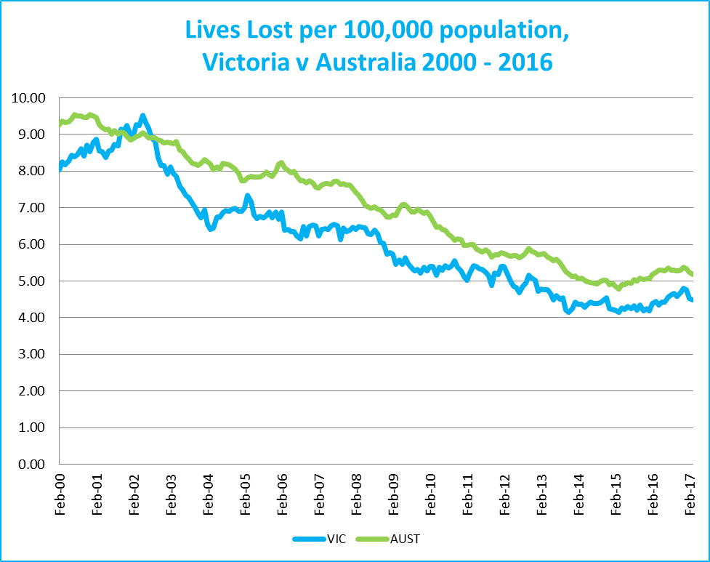
Victoria v Australia – 12 Month Moving Lives Lost Rate

Booze Bus Random Breath Testing
12 months to March 2017 (monthly totals)
 | 2017 |  |  | 2016
 | Jan | Feb | Mar | Apr | May | Jun | Jul | Aug | Sep | Oct | Nov | Dec
Melbourne | 93277 | 96341 | 83713 | 86772 | 74,442 | 77,858 | 71,619 | 77,436 | 96,219 | 89,056 | 73,087 | 82904
Country | 7061 | 7572 | 5230 | 13092 | 18,080 | 9,782 | 1,695 | 3,589 | 5,134 | 18,978 | 18,645 | 20090
Vic Total | 100,338 | 103,913 | 88,943 | 99,864 | 92,522 | 87,640 | 73,314 | 81,025 | 101,353 | 108,034 | 91,732 | 102,994

Random Drug Testing
Random Drug Tests (12 months to March 2017 vs previous 12 months)
 | 2017 | 2016 | 2015 | 2017 v 2016 |  | 2017 v 2015
Victoria | 95,121 | 110,527 | 63,680 | -15406 | (-14%) | +31441 | (+49%)

12 months to March 2017 (monthly totals)
 | 2017 |  |  | 2016
 | Jan | Feb | Mar | Apr | May | Jun | Jul | Aug | Sep | Oct | Nov | Dec
Victoria | 8,835 | 6,292 | 10,085 | 7,072 | 7,097 | 5,706 | 6,382 | 7,333 | 8,018 | 9,399 | 8,714 | 10,188

Mobile Safety Camera Data
Speed Infringements Issued from Mobile Cameras (monthly totals) |  |  |  |  |  |  |  |  |  | Monthly Average = | 33,375
2017 |  |  | 2016
Jan | Feb | Mar | Apr | May | Jun | Jul | Aug | Sep | Oct | Nov | Dec
32,310 | 30,732 | 33,179 | 35,369 | 35,090 | 32,595 | 34,752 | 33,587 | 30,215 | 34,516 | 36,590 | 31,560
Excessive Speed Infringements (ESI) Issued from Mobile Cameras
(monthly totals) |  |  |  |  |  |  |  |  |  | Monthly Average = | 344
2017 |  |  | 2016
Jan | Feb | Mar | Apr | May | Jun | Jul | Aug | Sep | Oct | Nov | Dec
305 | 335 | 354 | 333 | 398 | 308 | 349 | 370 | 309 | 343 | 402 | 321
Notes: An ESI is defined as 25km/h over the speed limit except in a 110km/h zone where it is 20km/h over the limit.

Explanations and References
LGA: Local Government Areas. Crash locations for acute hospitalised claims are assigned to LGA’s based on the crash postcode recorded by Victoria Police. Crash locations for fatal crashes are coded exactly to an LGA by Victoria Police.
Claimants: Refers to people injured in transport accidents who have an accepted claim with the TAC.
Acute hospital admission: refers to a hospital admission that occurred within 7 days of accident. All hospitalised admissions reported herein are acute hospital admissions.

Useful Internet Sites
TAC Sites
- TAC Safety (Road Safety) www.tacsafety.com.au
- TAC How safe is your car www.howsafeisyourcar.com.au
- TAC How safe is your first car www.howsafeisyourfirstcar.com.au
- TAC Motorcycle Safety Website www.spokes.com.au
- TAC Corporate site www.tac.vic.gov.au
- Drivesmart www.drivesmart.vic.gov.au
- Ridesmart www.ridesmartonline.com.au
Victorian Sites:
- VicRoads www.vicroads.vic.gov.au
- Victoria Police www.police.vic.gov.au
- Parliamentary Road Safety Committee www.parliament.vic.gov.au/rsc/
- RACV www.racv.com.au
- Monash University Accident Research Centre www.monash.edu.au/muarc
- Cameras Save Lives www.camerassavelives.vic.gov.au
- VicRoads Learner Driver Site www.lsite.vicroads.vic.gov.au/Learners
- Road Safety Education Victoria www.roadsafetyeducation.vic.gov.au
National and Interstate Sites:
- ARRB Transport Research www.arrb.com.au
- Australian Transport Safety Bureau www.atsb.gov.au
- Motor Accidents Authority (NSW) www.maa.nsw.gov.au
- Motor Accidents Insurance Board (TAS) www.maib.tas.gov.au
- Motor Accident Commission, Allianz (SA) www.mac.sa.gov.au
- Motor Accidents Compensation, TIO, (NT) www.tiofi.com.au/mac
- Insurance Commission of Western Australia www.icwa.wa.gov.au
- Motor Accident Insurance Commission (QLD) www.maic.qld.gov.au
International Sites:
- National Highway Traffic Safety Admin (USA) www.nhtsa.dot.gov
- Swedish Road and Transport Institute (VTI) www.vti.se
- SWOV Institute for Road Safety Research www.swov.nl
Related Sites:
- Alcohol and Drug Foundation www.adf.org.au
Figures
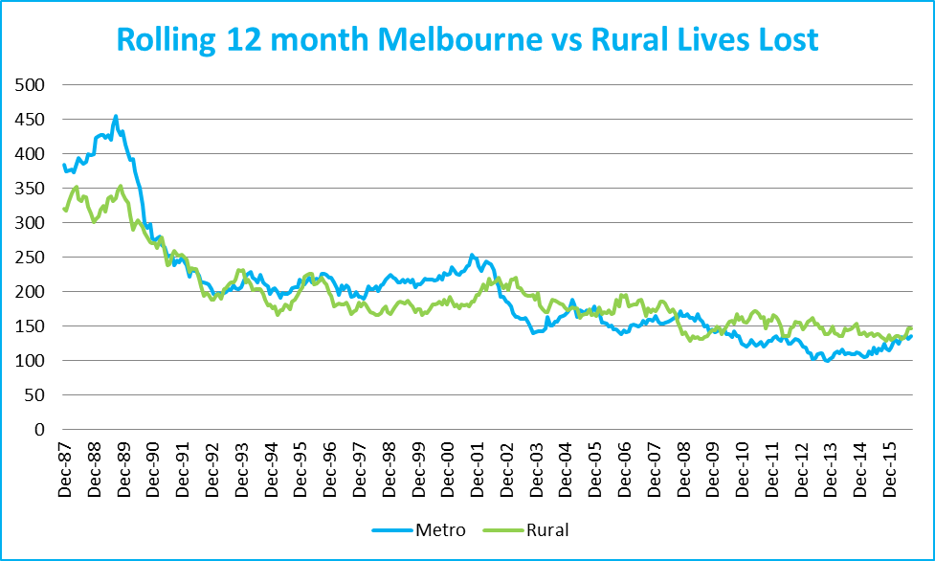
Graph 1a – Melbourne/country lives lost

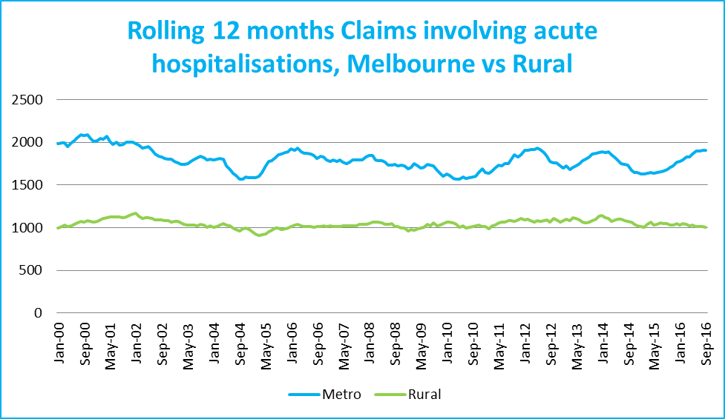
Graph 1b – Melbourne/country Claims involving an acute hospital admission
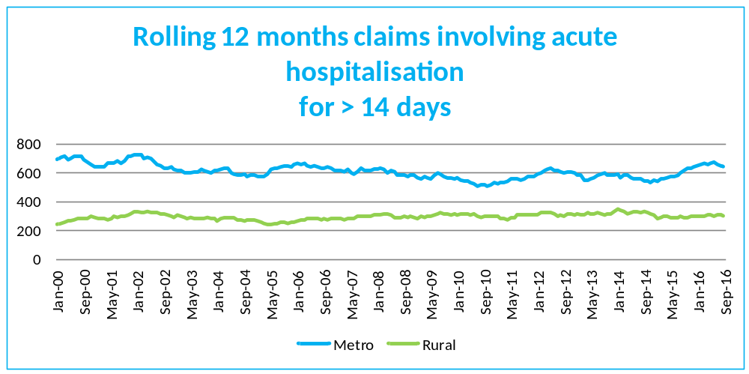
Graph 1c – Melbourne/country Claims involving hospital admission greater than 14 days

Victorian monthly lives lost since 1951


