Information Sheet for Healthcare Professionals Prescribing Rehabilitation Equipment

The TAC

The Transport Accident Commission (TAC) provides support and services to TAC clients and injured workers following a transport accident injury.

About Equipment

Equipment refers to a broad range of items that assist recovery and independence. They may address one or more of these aspects of a person’s life:
- mobility
- function
- community involvement (through return to work, educational or leisure activities)
- relief of pain or discomfort
- communication
- safety

Equipment Suppliers

The Equipment Purchasing team, on behalf of the TAC, manages equipment suppliers contracted to provide rehabilitation equipment to TAC clients.

These equipment suppliers can provide a wide range of rehabilitation equipment to assist TAC clients with their recovery and independence.

The following contracted equipment suppliers provide equipment related services including purchase, hire, repairs and maintenance of rehabilitation equipment.

Aidacare

Phone number 03 9981 2100

Email : tac@aidacare.com.au

www.aidacare.com.au

Country Care Group

Phone number 1800 843 224

Email: contracts@countrycaregroup.com.au

www.countrycaregroup.com.au

Independence Australia

Phone number 1800 625 530

Email: tac@mobilityaids.com.au

www.independenceaustralia.com

The Equipment List

The Equipment Lists are a list of items the 3 contracted equipment suppliers stock and is located on the TAC websites. The list includes the most commonly prescribed off-the-shelf items as well as customised options and should be the starting point for all equipment requested by the prescribing healthcare professional. Equipment requests for non equipment list items from non contracted suppliers will only be accepted if clinically justified and an alternative on the equipment lists will not meet the TAC client’s accident related needs. For high cost/complex equipment it is expected that the prescribing healthcare professional trials items from the equipment list (if available) before recommending an alternative equipment item. Non equipment list items should also be sourced from contracted suppliers where possible.

PROCESS FOR ORDERING EQUIPMENT

Standard equipment

Requests for standard equipment can be made to the TAC claims officer by submitting a report or request recommendation letter. In some instances, the TAC claims officer may request completion of an Equipment Prescription Form (EPF) when more information is required.

High Cost/Complex equipment

Requests for high cost/complex equipment needs must be submitted on an EPF by the prescribing healthcare professional. An EPF must be submitted when requesting the supply, hire, repair or maintenance of the following equipment:

- wheelchairs (manual & powered)
- pressure cushions
- hoists
- medical beds and related items
- powered conversion kits
- ramps
- scooters
- standing frames
- tilt tables lounge chairs
- treatment couches
- customised toilet/commode/shower chairs & trolleys
- large exercise equipment
- bikes and recumbent trikes
- Multi media/function technology (smart phones, tablets, computers)

Upon receipt of the EPF, the TAC claims officer will decide if the recommendation for the equipment is approved and if so, submit an Equipment Order Form to either the TACcontracted equipment supplier or the Equipment Purchasing Team for non contracted items

Customised equipment

If the request is for a high cost/complex item that requires customisation then the treater needs to request a standardised quote from the equipment supplier and submit it with the EPF. TAC will accept a standardised quote either in the template provided in the Equipment Prescription Form Quote Template & notes (EPF2 & EPFN2) or in the equipment supplier’s current business format provided the information requested in the standardised quote template is supplied. (See Standardised quotation process flowchart below)

Overview of equipment ordering process

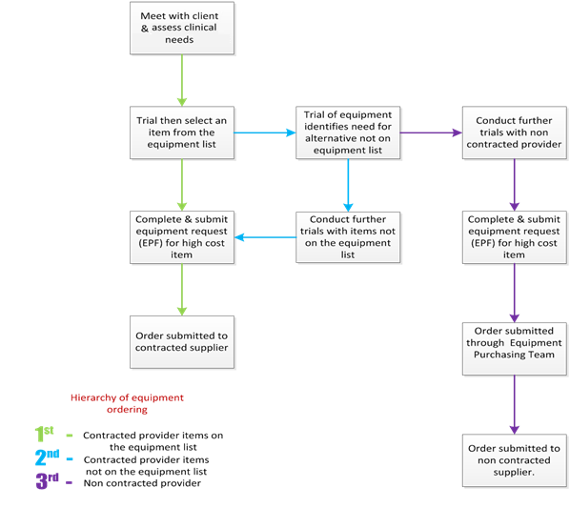

Equipment Hire process

The TAC has amended the current equipment hire process. It is expected that all equipment under $300 should be purchased as an alternative to hire. If the TAC claims officer receives a request for equipment hire under $300 they can amend the order to include the purchase of the item.

There will be certain exceptions to this process in the instance where the client requires the hire of equipment for a holiday or as part of an overnight stay in accommodation other than their regular place of residence. In these instances it is acceptable to hire equipment items under $300.

Urgency Levels for Equipment requests

When ordering equipment the TAC claims officer will specify on the Equipment Order Form the level of urgency required for the delivery and installation of the equipment. The table below details the requirements of urgency levels 1 to 4. (Please note that level 1 or 2 order will not be placed unless it meets the criteria specified in the table regardless of the TAC client demands)

Urgency Level | Definition and Examples
Level 1 Emergency  (fulfil within 8 business hours of receiving order) | Client’s mobility or safety is at risk requiring urgent equipment service or supply. (e.g. repairs to life support equipment, wheelchair or hoist )
Level 2 Urgent  (fulfil within 16 business hours of receiving order) | Client’s mobility, hygiene (bathing or toileting) or pain management is compromised but there is no safety risk
Level 3 Regular  (fulfil within 3-10 business days of receiving order) | Non-customised equipment item is required to enhance a client’s rehabilitation or independence
Level 4 Customised or specialist Equipment  (no time frame is specified for these orders. The order will be fulfilled depending on the  complexity and availability of the item) | Equipment item requires customisation to suit the client’s needs, e.g. particular specifications or enhancements

For more information

For more information about equipment policies for TAC clients go to:

  - www.tac.vic.gov.au click on “health and service providers/working-with-tac-clients/guidelines/policy/equipment-policy”

- Alternatively you can contact the Equipment Purchasing team, Equipment Contract Advisor, at equipment@tac.vic.gov.au if you have any questions. If you have any feedback regarding the equipment list or the broader equipment process please submit your comments or recommendations on the form below.

Suggestion form for Equipment List

The Equipment List includes more than 4,000 items that support functional improvement and independence for TAC clients.

To ensure the List reflects the needs of TAC clients, treating health practitioners are invited to submit equipment suggestions. All suggestions will be reviewed and responded to.

How to make a suggestion
Please follow the below prompts. Once complete, please save and email to equipment@tac.vic.gov.au

Name:

Date: / / _

Therapist discipline (if applicable):

 Occupational Therapist  Physiotherapist

 Continence Nurse  Occupational Rehab provider

 Other, please specify

Item to be ADDED to the list is (make, model, dimensions etc):

The reason is:

Is there an alternative item on the list?  Yes  No If yes, why is the alternative not a suitable option?

Item to be REMOVED from the list is (make, model, dimensions etc):
__

The reason is:

Is there an alternative item on the list?  Yes  No

If no, is there a more suitable item that should be included on the list?

