

TAC Road Safety

Quarterly Statistics

June 2023

Contents

Status Report 3

Lives lost: Rolling 12 months 5

Injured claimants admitted to hospital within 7 days of the accident with a hospital stay of more than 14 days 7

Injured claimants who were admitted to hospital within 7 days of accident 9

Mobile Safety Camera Data 12

The National Picture 13

International Road Safety Comparison 14

Lives lost rate per 100,000 population - OECD countries, 2021 15

Explanations and references 16

Useful websites 17

Graphs of Lives Lost and Hospitalised Claims 18

Victorian monthly lives lost since 1951 20

Notes about the data in this report

* All data provided in this report is the data most recently available at time of production. Fatality data updated to the end of report month. A 6-month lag applies to TAC claims data.
* Reported data will have one extra day of exposure for leap years.
* Data is subject to revision as additional information about known accidents/claims is received, and as new accident/claim reports are received and processed.

# Status Report

## Lives lost on Victorian roads

* In a 12-month period from 1st July 2022 to the end of June 2023, 274 people lost their lives compared to 246 lives lost during the previous 12-month period from July 2021 to the end of June 2022. This represents 28 more lives lost.

|  |  |  |  |  |  |  |
| --- | --- | --- | --- | --- | --- | --- |
| **Category** | **2023** | **2022** | **2021** | **2023 v 2022** | **2023 v 2021** | **5 Year Average** |
|  |  |  |  |  |  |  |
| **Lives Lost (Rolling 12 Month Total)** |  |  |  |  |  |  |
| **Lives Lost (to June)** | **274** | **246** | **203** | **+28** | **+71** | **243** |
| per 10,000 veh | 0.51 | 0.47 | 0.39 | +0.04 | +0.12 | 0.46 |
| per 100,000 pop | 4.12 | 3.74 | 3.01 | +0.38 | +1.11 | 3.61 |
|  |  |  |  |  |  |  |
| **Crashes (Rolling 12 Month Total)** |  |  |  |  |  |  |
| **Fatal crashes (to June)** | **255** | **229** | **195** | **+26** | **+60** | **228** |
| per 10,000 veh | 0.48 | 0.43 | 0.37 | +0.05 | +0.11 | 0.43 |
| per 100,000 pop | 3.83 | 3.48 | 2.89 | +0.35 | +0.94 | 3.39 |
|  |  |  |  |  |  |  |
|  |  |  |  |  |  |  |
|  |  |  |  |  |  |  |

Victoria – Lives Lost, 12 months to June 2023

## Injured claimants who were admitted to hospital within 7 days of accident

Rolling 12 month to 31st of December (claim acceptance date)

|  |  |  |  |  |  |  |  |  |
| --- | --- | --- | --- | --- | --- | --- | --- | --- |
| **Category** | **2022** | **2021** | **2020** | **2022 v 2021** | | **2022 v 2020** | | **5 Year Average** |
|  |  |  |  |  |  |  |  |  |
| **Claims involving an hospitalisation over 14 days (Rolling 12 Month Total)** | | | | | |  |  |  |
| **Claims (to December)** | **607** | **644** | **598** | **-37** | **(-6%)** | **9** | **(+2%)** | **735** |
| per 10,000 veh | 1.1 | 1.2 | 1.2 | -0.1 | (-5%) | -0.1 | (-5%) | 1.5 |
| per 100,000 pop | 9.2 | 9.8 | 8.9 | -0.6 | (-7%) | +0.3 | (+3%) | 11.7 |
|  |  |  |  |  |  |  |  |  |
| **All claims involving an hospitalisation (Rolling 12 Month Total)** | | | | | | | | |
| **Claims (to December)** | **5,281** | **5,789** | **5,451** | **-508** | **(-9%)** | **-170** | **(-3%)** | **6,537** |
| per 10,000 veh | 9.9 | 11.1 | 10.6 | -1.2 | (-10%) | -0.7 | (-6%) | 14.4 |
| per 100,000 pop | 79.8 | 88.4 | 81.4 | -8.6 | (-10%) | -1.6 | (-2%) | 103.2 |
|  |  |  |  |  |  |  |  |  |

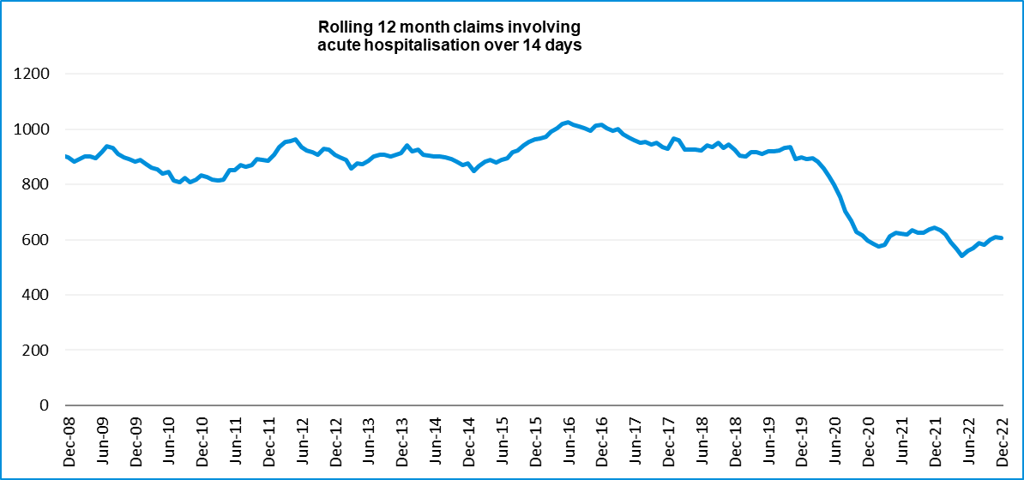

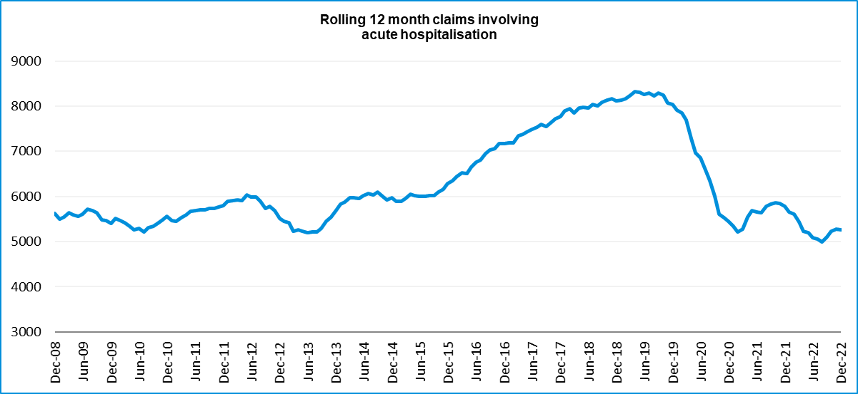

# Lives lost: Rolling 12 months

## 12 months to 30th June 2023

|  |  |  |  |  |  |  |
| --- | --- | --- | --- | --- | --- | --- |
| **Category** | **2023** | **2022** | **2021** | **2023 v 2022** | **2023 v 2021** | **5 Year Average** |
|  |  |  |  |  |  |  |
| **Overview** |  |  |  |  |  |  |
| Lives Lost | 274 | 246 | 203 | +28 | +71 | 243 |
| Fatal Crashes | 255 | 229 | 195 | +26 | +60 | 228 |
|  |  |  |  |  |  |  |
| **Sex** |  |  |  |  |  |  |
| Female | 80 | 68 | 50 | +12 | +30 | 66 |
| Male | 193 | 178 | 153 | +15 | +40 | 178 |
|  |  |  |  |  |  |  |
| **Road user** |  |  |  |  |  |  |
| Bicyclist | 12 | 14 | 9 | -2 | +3 | 12 |
| Driver | 124 | 106 | 107 | +18 | +17 | 111 |
| Motorcyclist | 52 | 45 | 38 | +7 | +14 | 43 |
| Passenger | 51 | 42 | 23 | +9 | +28 | 39 |
| Pedestrian | 35 | 38 | 26 | -3 | +9 | 37 |
|  |  |  |  |  |  |  |
| **Location** |  |  |  |  |  |  |
| Melbourne | 124 | 112 | 84 | +12 | +40 | 110 |
| Rural Victoria | 150 | 134 | 119 | +16 | +31 | 134 |
|  |  |  |  |  |  |  |
| **Age group** |  |  |  |  |  |  |
| 0-4 | 3 | 3 | 4 |  | -1 | 3 |
| 5-15 | 3 | 6 | 2 | -3 | +1 | 5 |
| 16-17 | 4 | 9 | 5 | -5 | -1 | 5 |
| 18-20 | 21 | 23 | 9 | -2 | +12 | 17 |
| 21-25 | 28 | 18 | 24 | +10 | +4 | 23 |
| 26-29 | 25 | 18 | 19 | +7 | +6 | 22 |
| 30-39 | 42 | 29 | 32 | +13 | +10 | 36 |
| 40-49 | 32 | 30 | 24 | +2 | +8 | 28 |
| 50-59 | 33 | 27 | 23 | +6 | +10 | 28 |
| 60-69 | 28 | 37 | 26 | -9 | +2 | 30 |
| **70+** | 50 | 44 | 35 | 6 | 15 | 46 |
|  |  |  |  |  |  |  |
| **Accident Type** |  |  |  |  |  |  |
| **Intersection** |  |  |  |  |  |  |
| Adjacent direction | 44 | 23 | 23 | +21 | +21 | 29 |
| Opposing direction | 12 | 9 | 8 | +3 | +4 | 10 |
| **Mid-block/other** |  |  |  |  |  |  |
| Head on | 36 | 29 | 19 | +7 | +17 | 30 |
| Same direction | 24 | 29 | 19 | -5 | +5 | 22 |
| Manoeuvre/o'taking | 11 | 10 | 9 | +1 | +2 | 13 |
| On path | 7 | 4 | 4 | +3 | +3 | 5 |
| Single vehicle | 100 | 100 | 91 | 0 | +9 | 92 |
| Other (incl peds) | 40 | 42 | 30 | -2 | +10 | 42 |

### Lives Lost: 12 months to 3oth JUNE 2023

|  |  |  |  |  |  |  |  |  |  |
| --- | --- | --- | --- | --- | --- | --- | --- | --- | --- |
| **Category** | **2023** | **2022** | **2021** | **5 Year Average** | **Category** | **2023** | **2022** | **2021** | **5 Year Average** |
|  |  |  |  |  |  |  |  |  |  |
| **Local Government Area** |  |  |  |  | **Local Government Area** |  |  |  |  |
| ALPINE | 1 | 2 | 1 | 2 | MANSFIELD | 1 | 1 | 0 | 1 |
| ARARAT | 0 | 1 | 1 | 1 | MARIBYRNONG | 2 | 0 | 1 | 1 |
| BALLARAT | 1 | 4 | 4 | 3 | MAROONDAH | 3 | 2 | 1 | 2 |
| BANYULE | 3 | 2 | 1 | 1 | MELBOURNE | 3 | 7 | 4 | 3 |
| BASS COAST | 5 | 0 | 1 | 1 | MELTON | 2 | 7 | 3 | 4 |
| BAW BAW | 5 | 5 | 5 | 4 | MILDURA | 2 | 4 | 3 | 3 |
| BAYSIDE | 0 | 0 | 1 | 1 | MITCHELL | 5 | 5 | 6 | 3 |
| BENALLA | 1 | 2 | 0 | 1 | MOIRA | 14 | 5 | 2 | 3 |
| BOROONDARA | 2 | 0 | 2 | 3 | MONASH | 7 | 2 | 5 | 5 |
| BRIMBANK | 10 | 9 | 3 | 5 | MOONEE VALLEY | 4 | 2 | 0 | 2 |
| BULOKE | 1 | 1 | 3 | 1 | MOORABOOL | 2 | 2 | 3 | 3 |
| CAMPASPE | 7 | 7 | 2 | 3 | Merri-Bek | 6 | 3 | 0 | 2 |
| CARDINIA | 2 | 6 | 13 | 6 | MORNINGTON PENINSULA | 4 | 5 | 9 | 7 |
| CASEY | 15 | 12 | 4 | 6 | MOUNT ALEXANDER | 1 | 1 | 4 | 3 |
| CENTRAL GOLDFIELDS | 1 | 0 | 1 | 1 | MOYNE | 3 | 3 | 1 | 2 |
| COLAC-OTWAY | 3 | 4 | 3 | 3 | MURRINDINDI | 5 | 5 | 1 | 3 |
| CORANGAMITE | 5 | 4 | 4 | 3 | NILLUMBIK | 0 | 2 | 2 | 2 |
| DAREBIN | 4 | 1 | 1 | 2 | NORTHERN GRAMPIANS | 2 | 7 | 2 | 4 |
| EAST GIPPSLAND | 2 | 2 | 8 | 4 | PORT PHILLIP | 2 | 3 | 1 | 1 |
| FRANKSTON | 4 | 2 | 1 | 3 | PYRENEES | 2 | 0 | 3 | 1 |
| GANNAWARRA | 2 | 0 | 1 | 1 | QUEENSCLIFFE | 0 | 0 | 0 | 0 |
| GLEN EIRA | 2 | 3 | 1 | 2 | SOUTH GIPPSLAND | 5 | 4 | 4 | 5 |
| GLENELG | 1 | 1 | 4 | 2 | SOUTHERN GRAMPIANS | 6 | 1 | 0 | 1 |
| GOLDEN PLAINS | 3 | 2 | 2 | 2 | STONNINGTON | 0 | 1 | 1 | 1 |
| GREATER BENDIGO | 4 | 7 | 5 | 6 | STRATHBOGIE | 4 | 4 | 1 | 2 |
| GREATER DANDENONG | 1 | 4 | 5 | 3 | SURF COAST | 0 | 1 | 2 | 1 |
| GREATER GEELONG | 11 | 10 | 7 | 9 | SWAN HILL | 0 | 1 | 3 | 2 |
| GREATER SHEPPARTON | 12 | 2 | 8 | 5 | TOWONG | 2 | 2 | 1 | 1 |
| HEPBURN | 0 | 3 | 1 | 3 | WANGARATTA | 4 | 5 | 0 | 2 |
| HINDMARSH | 0 | 0 | 1 | 0 | WARRNAMBOOL | 1 | 2 | 2 | 2 |
| HOBSONS BAY | 4 | 3 | 2 | 2 | WELLINGTON | 6 | 6 | 4 | 3 |
| HORSHAM | 2 | 4 | 1 | 3 | WEST WIMMERA | 2 | 0 | 1 | 1 |
| HUME | 4 | 8 | 3 | 6 | WHITEHORSE | 2 | 2 | 1 | 1 |
| INDIGO | 1 | 2 | 4 | 2 | WHITTLESEA | 8 | 7 | 4 | 4 |
| KINGSTON | 0 | 2 | 3 | 3 | WODONGA | 2 | 2 | 1 | 1 |
| KNOX | 3 | 1 | 1 | 2 | WYNDHAM | 9 | 7 | 4 | 5 |
| LATROBE | 6 | 5 | 2 | 4 | YARRA | 4 | 4 | 1 | 2 |
| LODDON | 2 | 2 | 3 | 2 | YARRA RANGES | 11 | 4 | 6 | 6 |
| MACEDON RANGES | 3 | 3 | 2 | 3 | YARRIAMBIACK | 2 | 0 | 1 | 1 |
| MANNINGHAM | 3 | 1 | 0 | 1 |  |  |  |  |  |

# Injured claimants admitted to hospital within 7 days of the accident with a hospital stay of more than 14 days

12 months to 31st December 2022 (claim acceptance date, excludes rejected claims and claims for interstate crashes.)

|  |  |  |  |  |  |  |  |  |
| --- | --- | --- | --- | --- | --- | --- | --- | --- |
| **Category** | **2022** | **2021** | **2020** | **2022 v 2021** | | **2022 v 2020** | | **5 Year Average** |
|  |  |  |  |  |  |  |  |  |
| **Overview** |  |  |  |  |  |  |  |  |
| Claims | 607 | 644 | 598 | -37 | -6% | 9 | 2% | 735 |
|  |  |  |  |  |  |  |  |  |
| **Sex** |  |  |  |  |  |  |  |  |
| Female | 213 | 238 | 211 | -25 | -11% | 2 | **1%** | 285 |
| Male | 393 | 406 | 387 | -13 | -3% | 6 | 2% | 450 |
|  |  |  |  |  |  |  |  |  |
| **Road user** |  |  |  |  |  |  |  |  |
| Bicyclist | 33 | 32 | 33 | +1 | 3% | 0 | 0% | 32 |
| Driver | 228 | 244 | 231 | -16 | -7% | -3 | -1% | 283 |
| Motorcyclist | 125 | 130 | 143 | -5 | -4% | -18 | -13% | 149 |
| Passenger | 64 | 90 | 73 | -26 | -29% | -9 | -12% | 100 |
| Pedestrian | 145 | 131 | 108 | +14 | 11% | 37 | 34% | 150 |
| Train/Tram | 5 | 8 | 0 | -3 | -38% | 5 | - | 7 |
|  |  |  |  |  |  |  |  |  |
| **Location** |  |  |  |  |  |  |  |  |
| Melbourne | 372 | 368 | 353 | +4 | 1% | 19 | 5% | 434 |
| Rural Victoria | 211 | 246 | 224 | -35 | -14% | -13 | -6% | 261 |
|  |  |  |  |  |  |  |  |  |
| **Age group** |  |  |  |  |  |  |  |  |
| 0-4 | 1 | 3 | 3 | -2 | -67% | -2 | -67% | 3 |
| 5-15 | 9 | 10 | 9 | -1 | -10% | 0 | 0% | 11 |
| 16-17 | 11 | 14 | 14 | -3 | -21% | -3 | -21% | 13 |
| 18-20 | 25 | 35 | 28 | -10 | -29% | -3 | -11% | 34 |
| 21-25 | 43 | 51 | 47 | -8 | -16% | -4 | -9% | 60 |
| 26-29 | 30 | 47 | 44 | -17 | -36% | -14 | -32% | 43 |
| 30-39 | 91 | 83 | 82 | +8 | 10% | 9 | 11% | 91 |
| 40-49 | 75 | 65 | 74 | +10 | 15% | 1 | 1% | 86 |
| 50-59 | 70 | 84 | 73 | -14 | -17% | -3 | -4% | 92 |
| 60-69 | 75 | 91 | 72 | -16 | -18% | 3 | 4% | 95 |
| 70+ | 177 | 161 | 152 | +16 | 10% | 25 | 16% | 207 |
|  |  |  |  |  |  |  |  |  |
|  |  |  |  |  |  |  |  |  |
| **Accident Type** |  |  |  |  |  |  |  |  |
| **Intersection** |  |  |  |  |  |  |  |  |
| Adjacent direction | 64 | 68 | 60 | -4 | -6% | 4 | 7% | 70 |
| Opposing direction | 47 | 46 | 30 | +1 | 2% | 17 | 57% | 46 |
| **Mid-block/other** |  |  |  |  |  |  |  |  |
| Head on | 47 | 35 | 44 | +12 | 34% | 3 | 7% | 49 |
| Same direction | 46 | 45 | 49 | +1 | 2% | -3 | -6% | 57 |
| Manoeuvre/o'taking | 40 | 42 | 33 | -2 | -5% | 7 | 21% | 41 |
| On path | 25 | 31 | 21 | -6 | -19% | 4 | 19% | 27 |
| Single vehicle | 146 | 194 | 202 | -48 | -25% | -56 | -28% | 201 |
| Other (incl peds) | 192 | 183 | 159 | +9 | 5% | 33 | 21% | 244 |

## Injured claimants who were admitted to hospital within 7 days of the accident with a hospital stay of more than 14 days

12 months to 31st December 2022 (claim acceptance date, excludes rejected claims and claims for interstate crashes.) – Continued

|  |  |  |  |  |  |  |  |  |  |
| --- | --- | --- | --- | --- | --- | --- | --- | --- | --- |
| **Category** | **2022** | **2021** | **2020** | **5 Year Average** | **Category** | **2022** | **2021** | **2020** | **5 Year Average** |
|  |  |  |  |  |  |  |  |  |  |
| **Local Government Area** |  |  |  |  | **Local Government Area** |  |  |  |  |
| ALPINE | 4 | 6 | 3 | 5 | MANSFIELD | 4 | 4 | 6 | 5 |
| ARARAT | 4 | 0 | 1 | 2 | MARIBYRNONG | 11 | 7 | 8 | 7 |
| BALLARAT | 10 | 14 | 12 | 13 | MAROONDAH | 4 | 8 | 10 | 7 |
| BANYULE | 11 | 7 | 5 | 6 | MELBOURNE | 18 | 23 | 19 | 21 |
| BASS COAST | 8 | 7 | 1 | 6 | MELTON | 12 | 6 | 4 | 6 |
| BAW BAW | 6 | 5 | 3 | 6 | MILDURA | 2 | 8 | 4 | 5 |
| BAYSIDE | 7 | 4 | 2 | 5 | MITCHELL | 6 | 7 | 11 | 7 |
| BENALLA | 6 | 1 | 1 | 2 | MOIRA | 5 | 7 | 5 | 6 |
| BOROONDARA | 5 | 12 | 8 | 10 | MONASH | 15 | 13 | 5 | 13 |
| BRIMBANK | 17 | 22 | 7 | 14 | MOONEE VALLEY | 15 | 13 | 7 | 10 |
| BULOKE | 1 | 0 | 2 | 2 | MOORABOOL | 9 | 7 | 5 | 5 |
| CAMPASPE | 6 | 6 | 9 | 6 | Merri-Bek | 0 | 0 | 0 | 0 |
| CARDINIA | 12 | 16 | 11 | 11 | MORNINGTON PENINSULA | 15 | 12 | 16 | 15 |
| CASEY | 27 | 16 | 23 | 20 | MOUNT ALEXANDER | 5 | 9 | 1 | 3 |
| CENTRAL GOLDFIELDS | 2 | 4 | 4 | 3 | MOYNE | 1 | 1 | 3 | 3 |
| COLAC-OTWAY | 5 | 8 | 4 | 4 | MURRINDINDI | 4 | 1 | 5 | 5 |
| CORANGAMITE | 3 | 3 | 3 | 3 | NILLUMBIK | 4 | 4 | 6 | 6 |
| DAREBIN | 14 | 14 | 10 | 13 | NORTHERN GRAMPIANS | 2 | 2 | 1 | 2 |
| EAST GIPPSLAND | 6 | 5 | 14 | 8 | PORT PHILLIP | 7 | 13 | 10 | 10 |
| FRANKSTON | 8 | 5 | 6 | 7 | PYRENEES | 0 | 2 | 2 | 2 |
| GANNAWARRA | 1 | 3 | 3 | 2 | QUEENSCLIFFE | 0 | 0 | 2 | 1 |
| GLEN EIRA | 2 | 6 | 8 | 10 | SOUTH GIPPSLAND | 4 | 5 | 5 | 5 |
| GLENELG | 4 | 1 | 1 | 2 | SOUTHERN GRAMPIANS | 0 | 2 | 3 | 3 |
| GOLDEN PLAINS | 4 | 5 | 3 | 4 | STONNINGTON | 15 | 9 | 8 | 8 |
| GREATER BENDIGO | 12 | 14 | 15 | 15 | STRATHBOGIE | 2 | 4 | 5 | 3 |
| GREATER DANDENONG | 10 | 23 | 18 | 19 | SURF COAST | 3 | 3 | 2 | 4 |
| GREATER GEELONG | 27 | 24 | 28 | 22 | SWAN HILL | 0 | 3 | 5 | 3 |
| GREATER SHEPPARTON | 8 | 24 | 9 | 11 | TOWONG | 2 | 1 | 1 | 2 |
| HEPBURN | 3 | 5 | 2 | 4 | WANGARATTA | 1 | 1 | 2 | 3 |
| HINDMARSH | 0 | 0 | 3 | 1 | WARRNAMBOOL | 5 | 3 | 4 | 3 |
| HOBSONS BAY | 6 | 6 | 5 | 5 | WELLINGTON | 5 | 12 | 8 | 8 |
| HORSHAM | 4 | 3 | 1 | 3 | WEST WIMMERA | 0 | 0 | 0 | 0 |
| HUME | 21 | 14 | 22 | 18 | WHITEHORSE | 18 | 5 | 17 | 15 |
| INDIGO | 3 | 6 | 3 | 4 | WHITTLESEA | 22 | 14 | 18 | 17 |
| KINGSTON | 11 | 11 | 11 | 12 | WODONGA | 6 | 1 | 2 | 2 |
| KNOX | 12 | 17 | 15 | 16 | WYNDHAM | 15 | 23 | 20 | 16 |
| LATROBE | 6 | 15 | 7 | 10 | YARRA | 4 | 8 | 10 | 8 |
| LODDON | 4 | 1 | 2 | 2 | YARRA RANGES | 15 | 13 | 25 | 19 |
| MACEDON RANGES | 8 | 2 | 7 | 6 | YARRIAMBIACK | 0 | 1 | 1 | 1 |
| MANNINGHAM | 6 | 8 | 8 | 10 |  |  |  |  |  |

# Injured claimants who were admitted to hospital within 7 days of accident

12 months to 31st December 2022 (claim acceptance date, excludes rejected claims and claims for interstate crashes.)

|  |  |  |  |  |  |  |  |  |
| --- | --- | --- | --- | --- | --- | --- | --- | --- |
| **Category** | **2022** | **2021** | **2020** | **2022 v 2021** | | **2022 v 2020** | | **5 Year Average** |
|  |  |  |  |  |  |  |  |  |
| **Overview** |  |  |  |  |  |  |  |  |
| Claims | 5,281 | 5,789 | 5,451 | -508 | -9% | -170 | -3% | 6,537 |
|  |  |  |  |  |  |  |  |  |
| **Sex** |  |  |  |  |  |  |  |  |
| Female | 2,216 | 2,409 | 2,185 | -193 | -8% | +31 | 1% | 2,768 |
| Male | 3,056 | 3,374 | 3,258 | -318 | -9% | -202 | -6% | 3,761 |
|  |  |  |  |  |  |  |  |  |
| **Road user** |  |  |  |  |  |  |  |  |
| Bicyclist | 350 | 417 | 423 | -67 | -16% | -73 | -17% | 446 |
| Driver | 2,511 | 2,860 | 2,690 | -349 | -12% | -179 | -7% | 3,201 |
| Motorcyclist | 921 | 996 | 962 | -75 | -8% | -41 | -4% | 1,098 |
| Passenger | 705 | 775 | 700 | -70 | -9% | +5 | 1% | 898 |
| Pedestrian | 618 | 547 | 460 | +71 | 13% | +158 | 34% | 641 |
| Train/Tram | 29 | 12 | 16 | +17 | 142% | +13 | 81% | 29 |
|  |  |  |  |  |  |  |  |  |
| **Location** |  |  |  |  |  |  |  |  |
| Melbourne | 3,388 | 3,621 | 3,436 | -233 | -6% | -48 | -1% | 4,021 |
| Rural Victoria | 1,661 | 1,931 | 1,782 | -270 | -14% | -121 | -7% | 2,021 |
|  |  |  |  |  |  |  |  |  |
| **Age group** |  |  |  |  |  |  |  |  |
| 0-4 | 24 | 42 | 33 | -18 | -43% | -9 | -27% | 44 |
| 5-15 | 137 | 157 | 121 | -20 | -13% | +16 | 13% | 174 |
| 16-17 | 82 | 106 | 92 | -24 | -23% | -10 | -11% | 109 |
| 18-20 | 318 | 411 | 404 | -93 | -23% | -86 | -21% | 460 |
| 21-25 | 550 | 671 | 649 | -121 | -18% | -99 | -15% | 771 |
| 26-29 | 405 | 500 | 479 | -95 | -19% | -74 | -15% | 549 |
| 30-39 | 926 | 1,026 | 926 | -100 | -10% |  | 0% | 1,094 |
| 40-49 | 710 | 773 | 790 | -63 | -8% | -80 | -10% | 902 |
| 50-59 | 721 | 812 | 739 | -91 | -11% | -18 | -2% | 883 |
| 60-69 | 644 | 597 | 555 | +47 | 8% | +89 | 16% | 692 |
| 70+ | 764 | 694 | 663 | +70 | 10% | +101 | 15% | 860 |
|  |  |  |  |  |  |  |  |  |
| **Accident Type** |  |  |  |  |  |  |  |  |
| **Intersection** |  |  |  |  |  |  |  |  |
| Adjacent direction | 802 | 860 | 808 | -58 | -7% | -6 | -1% | 858 |
| Opposing direction | 428 | 458 | 408 | -30 | -7% | +20 | 5% | 463 |
| **Mid-block/other** |  |  |  |  |  |  |  |  |
| Head on | 274 | 285 | 277 | -11 | -4% | -3 | -1% | 300 |
| Same direction | 855 | 930 | 789 | -75 | -8% | +66 | 8% | 916 |
| Manoeuvre/o'taking | 331 | 415 | 393 | -84 | -20% | -62 | -16% | 362 |
| On path | 238 | 316 | 274 | -78 | -25% | -36 | -13% | 264 |
| Single vehicle | 1,167 | 1,389 | 1,438 | -222 | -16% | -271 | -19% | 1,356 |
| Other (incl peds) | 1,186 | 1,136 | 1,064 | +50 | 4% | +122 | 11% | 2,017 |

## Injured claimants who were admitted to hospital within 7 days of accident

12 months to 31st December 2022 (claim acceptance date, excludes rejected claims and claims for interstate crashes.) – Continued

|  |  |  |  |  |  |  |  |  |  |
| --- | --- | --- | --- | --- | --- | --- | --- | --- | --- |
| **Category** | **2022** | **2021** | **2020** | **5 Year Average** | **Category** | **2022** | **2021** | **2020** | **5 Year Average** |
|  |  |  |  |  |  |  |  |  |  |
| **Local Government Area** |  |  |  |  | **Local Government Area** |  |  |  |  |
| ALPINE | 29 | 27 | 22 | 24 | MANSFIELD | 25 | 35 | 25 | 30 |
| ARARAT | 11 | 13 | 10 | 12 | MARIBYRNONG | 63 | 70 | 60 | 68 |
| BALLARAT | 84 | 118 | 81 | 82 | MAROONDAH | 39 | 40 | 50 | 47 |
| BANYULE | 44 | 39 | 31 | 42 | MELBOURNE | 179 | 189 | 156 | 187 |
| BASS COAST | 33 | 36 | 25 | 35 | MELTON | 109 | 71 | 70 | 64 |
| BAW BAW | 58 | 51 | 65 | 47 | MILDURA | 10 | 36 | 46 | 29 |
| BAYSIDE | 69 | 69 | 69 | 63 | MITCHELL | 42 | 64 | 66 | 55 |
| BENALLA | 17 | 10 | 11 | 14 | MOIRA | 24 | 36 | 36 | 30 |
| BOROONDARA | 83 | 100 | 78 | 100 | MONASH | 135 | 132 | 134 | 137 |
| BRIMBANK | 168 | 154 | 132 | 132 | MOONEE VALLEY | 119 | 139 | 88 | 110 |
| BULOKE | 7 | 7 | 6 | 7 | MOORABOOL | 73 | 35 | 41 | 40 |
| CAMPASPE | 30 | 48 | 37 | 35 | Merri-Bek | 0 | 0 | 0 | 0 |
| CARDINIA | 100 | 131 | 110 | 99 | MORNINGTON PENINSULA | 129 | 136 | 148 | 137 |
| CASEY | 277 | 323 | 282 | 258 | MOUNT ALEXANDER | 19 | 21 | 14 | 17 |
| CENTRAL GOLDFIELDS | 7 | 18 | 23 | 17 | MOYNE | 28 | 17 | 19 | 24 |
| COLAC-OTWAY | 61 | 54 | 46 | 50 | MURRINDINDI | 44 | 29 | 44 | 39 |
| CORANGAMITE | 16 | 30 | 21 | 26 | NILLUMBIK | 24 | 19 | 39 | 30 |
| DAREBIN | 73 | 56 | 77 | 79 | NORTHERN GRAMPIANS | 9 | 18 | 16 | 17 |
| EAST GIPPSLAND | 36 | 48 | 51 | 42 | PORT PHILLIP | 116 | 143 | 108 | 116 |
| FRANKSTON | 78 | 100 | 108 | 103 | PYRENEES | 15 | 6 | 11 | 9 |
| GANNAWARRA | 13 | 11 | 12 | 9 | QUEENSCLIFFE | 1 | 4 | 2 | 5 |
| GLEN EIRA | 84 | 92 | 118 | 97 | SOUTH GIPPSLAND | 25 | 33 | 37 | 32 |
| GLENELG | 15 | 27 | 14 | 20 | SOUTHERN GRAMPIANS | 9 | 13 | 32 | 17 |
| GOLDEN PLAINS | 31 | 32 | 42 | 35 | STONNINGTON | 117 | 93 | 100 | 96 |
| GREATER BENDIGO | 83 | 111 | 102 | 103 | STRATHBOGIE | 19 | 26 | 30 | 26 |
| GREATER DANDENONG | 168 | 260 | 206 | 209 | SURF COAST | 45 | 66 | 61 | 54 |
| GREATER GEELONG | 368 | 396 | 317 | 327 | SWAN HILL | 10 | 15 | 24 | 15 |
| GREATER SHEPPARTON | 46 | 86 | 53 | 65 | TOWONG | 9 | 12 | 8 | 13 |
| HEPBURN | 38 | 24 | 23 | 24 | WANGARATTA | 18 | 15 | 24 | 26 |
| HINDMARSH | 8 | 5 | 8 | 9 | WARRNAMBOOL | 21 | 28 | 20 | 22 |
| HOBSONS BAY | 62 | 59 | 61 | 62 | WELLINGTON | 30 | 63 | 43 | 50 |
| HORSHAM | 19 | 27 | 21 | 24 | WEST WIMMERA | 1 | 7 | 3 | 4 |
| HUME | 211 | 215 | 203 | 191 | WHITEHORSE | 58 | 79 | 74 | 91 |
| INDIGO | 14 | 23 | 16 | 19 | WHITTLESEA | 169 | 142 | 145 | 151 |
| KINGSTON | 102 | 123 | 127 | 107 | WODONGA | 37 | 28 | 26 | 21 |
| KNOX | 98 | 115 | 97 | 102 | WYNDHAM | 140 | 168 | 184 | 152 |
| LATROBE | 44 | 65 | 83 | 65 | YARRA | 95 | 72 | 67 | 78 |
| LODDON | 13 | 8 | 10 | 10 | YARRA RANGES | 113 | 119 | 155 | 127 |
| MACEDON RANGES | 59 | 41 | 48 | 49 | YARRIAMBIACK | 7 | 8 | 7 | 6 |
| MANNINGHAM | 35 | 40 | 39 | 52 |  |  |  |  |  |

**Lives lost by week (2018 to 2023)**

|  |  |  |  |  |  |  |  |  |
| --- | --- | --- | --- | --- | --- | --- | --- | --- |
| **Week Ending** | **2018** | **2019** | **2020** | **2021** | **2022** | **2023** | **2023 Cumulative** | **12 month Moving Total** |
| 1-Jan | 2 | 0 | 3 | 0 | 2 | 0 | 0 | 239 |
| 8-Jan | 6 | 2 | 5 | 3 | 7 | 10 | 10 | 242 |
| 15-Jan | 4 | 5 | 5 | 1 | 6 | 4 | 14 | 240 |
| 22-Jan | 2 | 5 | 2 | 4 | 3 | 9 | 23 | 246 |
| 29-Jan | 5 | 7 | 5 | 6 | 4 | 7 | 30 | 249 |
| 5-Feb | 4 | 12 | 8 | 4 | 9 | 9 | 39 | 249 |
| 12-Feb | 2 | 7 | 5 | 7 | 6 | 9 | 48 | 252 |
| 19-Feb | 6 | 6 | 6 | 4 | 3 | 4 | 52 | 253 |
| 26-Feb | 4 | 9 | 1 | 5 | 6 | 4 | 56 | 251 |
| 5-Mar | 4 | 4 | 4 | 7 | 3 | 8 | 64 | 256 |
| 12-Mar | 8 | 4 | 7 | 6 | 2 | 8 | 72 | 262 |
| 19-Mar | 3 | 7 | 10 | 5 | 6 | 3 | 75 | 259 |
| 26-Mar | 4 | 5 | 3 | 5 | 5 | 5 | 80 | 259 |
| 2-Apr | 2 | 4 | 5 | 7 | 4 | 6 | 86 | 261 |
| 9-Apr | 2 | 9 | 4 | 2 | 7 | 3 | 89 | 257 |
| 16-Apr | 1 | 5 | 1 | 3 | 3 | 4 | 93 | 258 |
| 23-Apr | 4 | 4 | 9 | 2 | 4 | 9 | 102 | 263 |
| 30-Apr | 3 | 6 | 1 | 3 | 3 | 4 | 106 | 264 |
| 7-May | 10 | 7 | 3 | 6 | 3 | 7 | 113 | 268 |
| 14-May | 5 | 8 | 5 | 4 | 2 | 3 | 116 | 269 |
| 21-May | 4 | 8 | 2 | 2 | 8 | 6 | 122 | 267 |
| 28-May | 3 | 7 | 4 | 1 | 1 | 12 | 134 | 278 |
| 4-Jun | 1 | 3 | 1 | 2 | 5 | 6 | 140 | 279 |
| 11-Jun | 6 | 4 | 3 | 6 | 4 | 2 | 142 | 277 |
| 18-Jun | 3 | 6 | 6 | 2 | 6 | 3 | 145 | 274 |
| 25-Jun | 1 | 2 | 3 | 5 | 5 | 3 | 148 | 272 |
| 2-Jul | 1 | 6 | 6 | 9 | 4 |  |  |  |
| 9-Jul | 4 | 4 | 2 | 3 | 4 |  |  |  |
| 16-Jul | 4 | 3 | 4 | 6 | 5 |  |  |  |
| 23-Jul | 4 | 6 | 1 | 4 | 7 |  |  |  |
| 30-Jul | 3 | 2 | 6 | 3 | 2 |  |  |  |
| 6-Aug | 5 | 4 | 4 | 1 | 3 |  |  |  |
| 13-Aug | 2 | 3 | 2 | 4 | 5 |  |  |  |
| 20-Aug | 6 | 4 | 5 | 8 | 4 |  |  |  |
| 27-Aug | 5 | 3 | 2 | 2 | 4 |  |  |  |
| 3-Sep | 3 | 2 | 2 | 4 | 8 |  |  |  |
| 10-Sep | 3 | 6 | 4 | 4 | 6 |  |  |  |
| 17-Sep | 8 | 5 | 3 | 7 | 5 |  |  |  |
| 24-Sep | 2 | 4 | 1 | 3 | 9 |  |  |  |
| 1-Oct | 4 | 4 | 6 | 8 | 4 |  |  |  |
| 8-Oct | 6 | 5 | 2 | 3 | 3 |  |  |  |
| 15-Oct | 4 | 8 | 6 | 3 | 6 |  |  |  |
| 22-Oct | 3 | 4 | 7 | 8 | 4 |  |  |  |
| 29-Oct | 6 | 7 | 5 | 2 | 4 |  |  |  |
| 5-Nov | 6 | 4 | 4 | 6 | 6 |  |  |  |
| 12-Nov | 2 | 5 | 3 | 7 | 3 |  |  |  |
| 19-Nov | 9 | 4 | 5 | 2 | 4 |  |  |  |
| 26-Nov | 5 | 4 | 3 | 7 | 8 |  |  |  |
| 3-Dec | 4 | 3 | 1 | 4 | 4 |  |  |  |
| 10-Dec | 1 | 5 | 5 | 7 | 3 |  |  |  |
| 17-Dec | 6 | 5 | 4 | 5 | 1 |  |  |  |
| 24-Dec | 5 | 6 | 6 | 3 | 5 |  |  |  |
| 31-Dec | 3 | 4 | 1 | 9 | 3 |  |  |  |
| Total | 213 | 266 | 211 | 234 | 241 | 148 |  |  |

# Mobile Safety Camera Data



# 

# The National Picture

|  |  |  |  |  |  |  |
| --- | --- | --- | --- | --- | --- | --- |
| **State** | **Lives Lost (12 months to June)** | | | | |  |
|  | **2023** | **2022** | **2021** | **2020** | **2023 v 2022** | |
| New South Wales | 275 | 281 | 287 | 314 | -6 | (-2%) |
| Victoria | 274 | 244 | 203 | 231 | +30 | (+12%) |
| Queensland | 274 | 292 | 296 | 237 | -18 | (-6%) |
| South Australia | 94 | 85 | 99 | 99 | +9 | (+11%) |
| Western Australia | 175 | 155 | 169 | 140 | +20 | (+13%) |
| Tasmania | 38 | 52 | 32 | 31 | -14 | (-27%) |
| Northern Territory | 31 | 45 | 37 | 31 | -14 | (-31%) |
| Australian Capital Territory | 10 | 15 | 11 | 5 | -5 | (-33%) |
| AUST TOTAL | 1,192 | 1,169 | 1,134 | 1,088 | +23 | (+2%) |
| Australia minus Victoria | 918 | 925 | 931 | 857 | -7 | (-1%) |
|  |  |  |  |  |  |  |
|  |  |  |  |  |  |  |
| **State** | **Lives Lost per 10,000 registered vehicles** | | | **Fatalities per 100,000 population** | | |
|  | **(12 months to June)** | | | **(12 months to June)** | | |
|  | **2023** | **2022** | **2021** | **2023** | **2022** | **2021** |
| New South Wales | 0.45 | 0.47 | 0.48 | 3.36 | 3.46 | 3.53 |
| Victoria | 0.51 | 0.46 | 0.39 | 4.12 | 3.71 | 3.09 |
| Queensland | 0.60 | 0.66 | 0.68 | 5.10 | 5.54 | 5.70 |
| South Australia | 0.61 | 0.56 | 0.67 | 5.14 | 4.69 | 5.50 |
| Western Australia | 0.72 | 0.66 | 0.73 | 6.24 | 5.60 | 6.18 |
| Tasmania | 0.71 | 1.00 | 0.63 | 6.63 | 9.13 | 5.66 |
| Northern Territory | 1.87 | 2.74 | 2.27 | 11.93 | 17.80 | 14.86 |
| Australian Capital Territory | 0.30 | 0.46 | 0.35 | 2.18 | 3.30 | 2.43 |
| Australia Total | 0.57 | 0.57 | 0.56 | 4.56 | 4.53 | 4.42 |
| Australia minus Victoria | 0.60 | 0.61 | 0.62 | 4.71 | 4.80 | 4.87 |
|  |  |  |  |  |  |  |

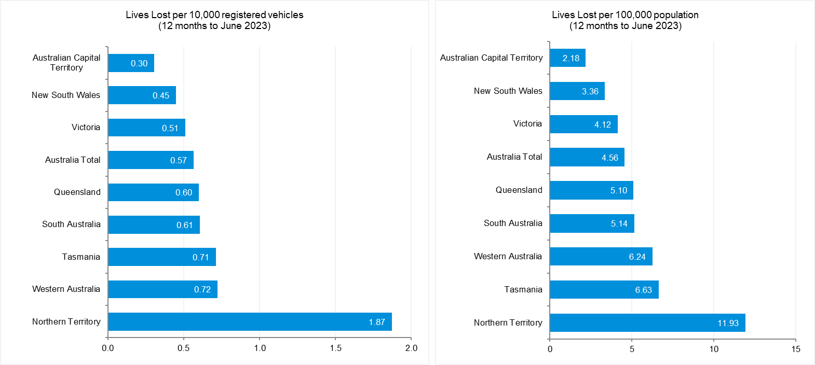

Source: Road Deaths Australia | Bureau of Infrastructure and Transport Research Economics (bitre.gov.au)

# International Road Safety Comparison

Selected OECD countries, Australia and Victoria, 2000, 2010, 2015 to 2021

**Lives lost rate per 100,000 population**

|  |  |  |  |  |  |  |  |  |  |
| --- | --- | --- | --- | --- | --- | --- | --- | --- | --- |
| **Countries** | **2000** | **2010** | **2015** | **2016** | **2017** | **2018** | **2019** | **2020** | **2021** |
| Australia | 9.5 | 6.1 | 5.1 | 5.4 | 5.0 | 4.5 | 4.7 | 4.3 | 4.3* |
| Canada | 9.5 | 6.6 | 5.3 | 5.2 | 5.1 | 5.2 | 4.7 | 4.6 | 4.6 |
| New Zealand | 12.0 | 8.6 | 6.9 | 7.0 | 7.9 | 7.7 | 7.1 | 6.0 | 6.2* |
| Norway | 7.6 | 4.3 | 2.3 | 2.6 | 2.0 | 2.0 | 2.0 | 1.7 | 1.5 |
| Sweden | 6.7 | 2.8 | 2.7 | 2.7 | 2.5 | 3.2 | 2.2 | 2.0 | 2.0 |
| Switzerland | 8.2 | 4.2 | 3.1 | 2.6 | 2.7 | 2.7 | 2.2 | 2.6 | 2.3 |
| United Kingdom | 6.1 | 3.0 | 2.8 | 2.8 | 2.8 | 2.8 | 2.7 | 2.3 | 2.4 |
| United States | 14.9 | 10.7 | 11.1 | 11.7 | 11.5 | 11.3 | 11.1 | 11.8 | 12.9 |
| Victoria | 8.7 | 5.3 | 4.2 | 4.7 | 4.1 | 3.3 | 4.1 | 3.2 | 3.5 |

**Lives lost rate per100 million vehicle kilometres travelled (VKT)**

|  |  |  |  |  |  |  |  |  |  |
| --- | --- | --- | --- | --- | --- | --- | --- | --- | --- |
| **Countries** | **2000** | **2010** | **2015** | **2016** | **2017** | **2018** | **2019** | **2020** | **2021** |
| Australia | 0.9 | 0.6 | 0.5 | 0.5 | 0.5 | 0.4 | 0.5 | 0.4 | 0.5 |
| Canada | 0.9 | 0.7 | 0.5 | 0.5 | 0.5 | 0.5 | 0.4 | 0.5 | 0.4 |
| New Zealand | 1.4 | 0.9 | 0.7 | 0.7 | 0.8 | 0.8 | 0.7 | 0.7 | 0.7 |
| Norway | 1.0 | 0.5 | 0.3 | 0.3 | 0.2 | 0.2 | 0.2 | 0.2 | 0.2 |
| Sweden | 0.9 | 0.3 | 0.3 | 0.3 | 0.3 | 0.4 | 0.3 | 0.3 | 0.4 |
| Switzerland | 1.1 | 0.5 | 0.4 | 0.3 | 0.3 | 0.3 | 0.3 | 0.4 | - |
| United Kingdom | - | - | 0.3 | 0.3 | 0.3 | 0.3 | 0.3 | 0.3 | - |
| United States | 0.9 | 0.7 | 0.7 | 0.7 | 0.7 | 0.7 | 0.7 | 0.8 | 0.8 |
| Victoria | 0.8 | 0.5 | 0.4 | 0.4 | 0.4 | 0.3 | 0.4 | 0.3 | - |

|  |  |  |  |
| --- | --- | --- | --- |
| **Lives lost rate per 10,000 registered vehicles** |  |  |  |

|  |  |  |  |  |  |  |  |  |  |
| --- | --- | --- | --- | --- | --- | --- | --- | --- | --- |
| **Countries** | **2000** | **2010** | **2015** | **2016** | **2017** | **2018** | **2019** | **2020** | **2021** |
| Australia | 1.5 | 0.8 | 0.7 | 0.7 | 0.7 | 0.6 | 0.6 | 0.6 | 0.6* |
| Canada | 1.6 | 1.0 | 0.8 | 0.8 | 0.8 | 0.8 | 0.7 | 0.7 | - |
| New Zealand | 1.8 | 1.2 | 0.9 | 0.9 | 1.0 | 1.0 | 0.8 | 0.7 | - |
| Norway | 1.2 | 0.6 | 0.3 | 0.3 | 0.3 | 0.3 | 0.3 | 0.2 | - |
| Sweden | 1.2 | 0.5 | 0.4 | 0.4 | 0.4 | 0.5 | 0.3 | 0.3 | 0.3 |
| Switzerland | 1.2 | 0.6 | 0.4 | 0.4 | 0.4 | 0.4 | 0.3 | 0.4 | 0.3 |
| United Kingdom | 1.2 | 0.5 | 0.5 | 0.5 | 0.5 | 0.5 | 0.5 | 0.4 | - |
| United States | 1.9 | 1.3 | 1.3 | 1.3 | 1.3 | 1.2 | 1.2 | 1.3 | - |
| Victoria | 1.2 | 0.7 | 0.6 | 0.6 | 0.5 | 0.4 | 0.5 | 0.4 | - |
|  |  |  |  |  |  |  |  |  |  |

Source: ABS 2022a, IRTAD 2022

# Lives lost rate per 100,000 population - OECD countries, 2021

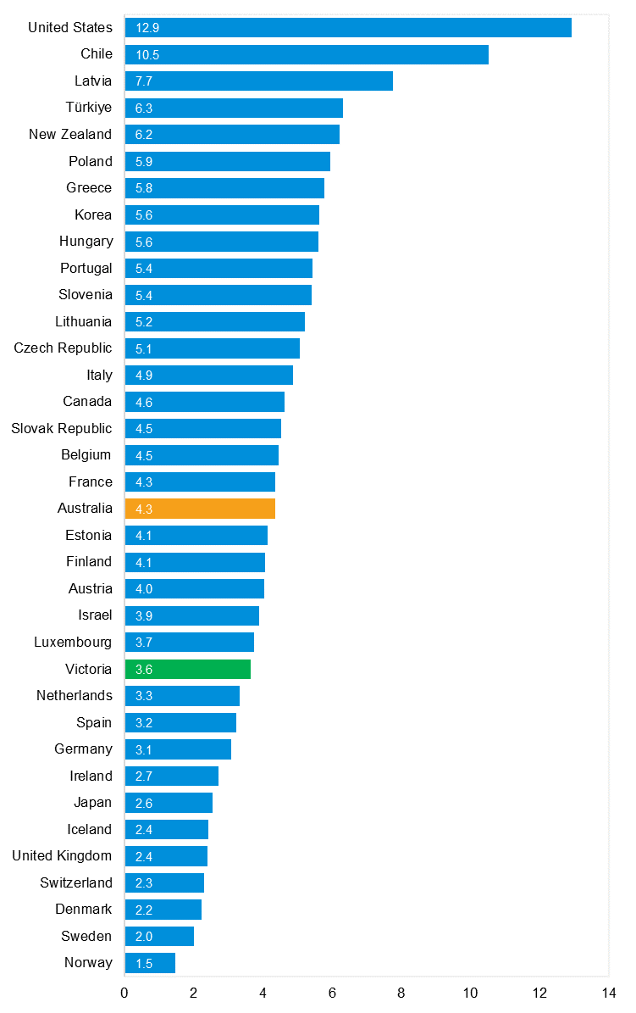

Source: Bureau of Infrastructure and Transport Research Economics

# Explanations and references

**LGA:** Local Government Areas. Crash locations for acute hospitalised claims are assigned to LGA’s based on the crash postcode recorded by Victoria Police. Crash locations for fatal crashes are coded exactly to an LGA by Victoria Police.

**Claimants:** Refers to people injured in transport accidents who have an accepted claim with the TAC.

**Hospitalisation:** refers to all hospital admission that occurred within 7 days of accident.

# Useful websites

TAC Sites

* TAC Safety (Road Safety) www.tacsafety.com.au
* TAC How safe is your car www.howsafeisyourcar.com.au
* TAC How safe is your first car www.howsafeisyourfirstcar.com.au
* TAC Motorcycle Safety Website www.spokes.com.au
* TAC Corporate site www.tac.vic.gov.au
* Drivesmart www.drivesmart.vic.gov.au
* Ridesmart www.ridesmartonline.com.au

Victorian Sites

* VicRoads www.vicroads.vic.gov.au
* Victoria Police www.police.vic.gov.au
* Parliamentary Road Safety Committee https://www.parliament.vic.gov.au/57th-parliament/rsc
* RACV www.racv.com.au
* Monash University Accident Research Centre www.monash.edu.au/muarc
* Cameras Save Lives www.camerassavelives.vic.gov.au
* VicRoads Learner Driver Site www.lsite.vicroads.vic.gov.au/Learners
* Road Safety Education Victoria www.roadsafetyeducation.vic.gov.au

National and Interstate Sites

* ARRB Transport Research www.arrb.com.au
* Australian Transport Safety Bureau www.atsb.gov.au
* Motor Accidents Authority (NSW) www.maa.nsw.gov.au
* Motor Accidents Insurance Board (TAS) www.maib.tas.gov.au
* Motor Accident Commission, Allianz (SA) www.mac.sa.gov.au
* Motor Accidents Compensation, TIO, (NT) www.tiofi.com.au/mac
* Insurance Commission of Western Australia www.icwa.wa.gov.au
* Motor Accident Insurance Commission (QLD) www.maic.qld.gov.au

International Sites

* National Highway Traffic Safety Admin (USA) www.nhtsa.dot.gov
* Swedish Road and Transport Institute (VTI) www.vti.se
* SWOV Institute for Road Safety Research www.swov.nl

Related Sites

* Alcohol and Drug Foundation www.adf.org.au

# Graphs of Lives Lost and Hospitalised Claims

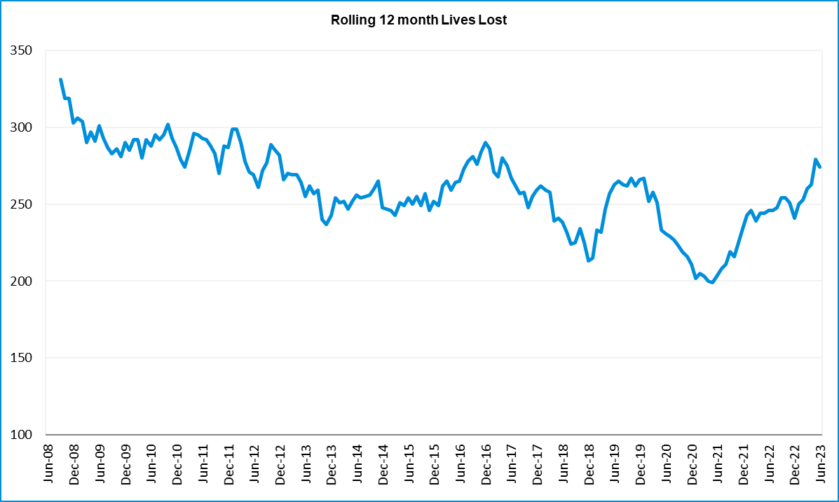

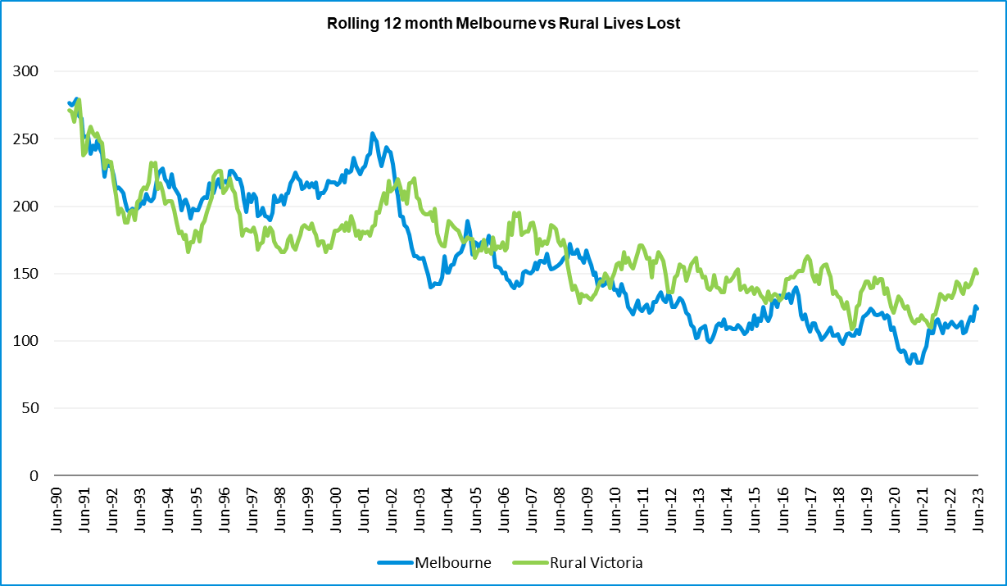

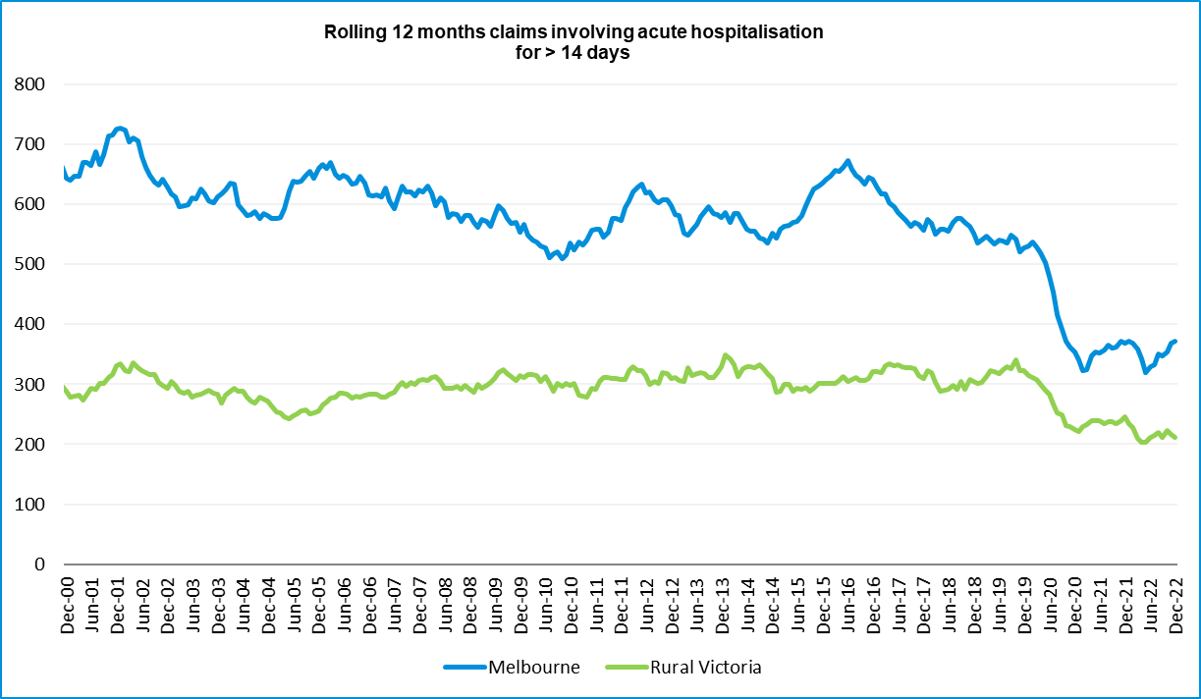

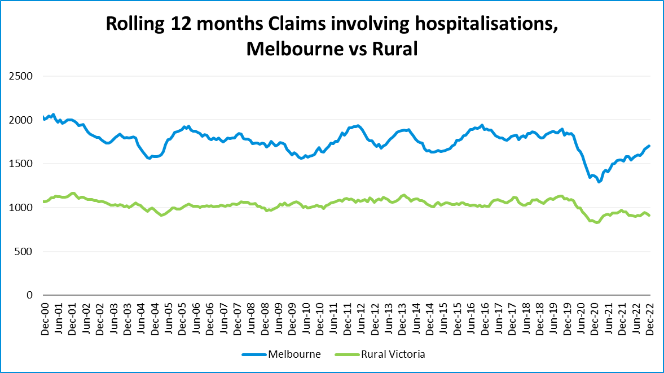

# Victorian monthly lives lost since 1951

|  |  |  |  |  |  |  |  |  |  |  |  |  |  |  |  |  |  |  |  |  |  |  |  |  |  |  |
| --- | --- | --- | --- | --- | --- | --- | --- | --- | --- | --- | --- | --- | --- | --- | --- | --- | --- | --- | --- | --- | --- | --- | --- | --- | --- | --- |
| **Year** | **Jan** | | **Feb** | | **Mar** | | **Apr** | | **May** | | **Jun** | | **Jul** | | **Aug** | | **Sep** | | **Oct** | | **Nov** | | **Dec** | | **Total** | |
| 1951 |  | |  | |  | |  | |  | |  | | 61 | | 59 | | 52 | | 38 | | 29 | | 41 | |  | |
| 1952 | 45 | | 40 | | 54 | | 61 | | 54 | | 69 | | 67 | | 55 | | 44 | | 44 | | 31 | | 20 | | 584 | |
| 1953 | 23 | | 28 | | 54 | | 58 | | 49 | | 42 | | 50 | | 37 | | 44 | | 27 | | 36 | | 32 | | 480 | |
| 1954 | 44 | | 42 | | 28 | | 60 | | 55 | | 36 | | 63 | | 33 | | 25 | | 52 | | 30 | | 41 | | 509 | |
| 1955 | 44 | | 36 | | 45 | | 55 | | 48 | | 56 | | 64 | | 44 | | 44 | | 32 | | 40 | | 40 | | 548 | |
| 1956 | 34 | | 48 | | 51 | | 67 | | 53 | | 65 | | 71 | | 47 | | 39 | | 39 | | 44 | | 48 | | 606 | |
| 1957 | 50 | | 41 | | 46 | | 58 | | 52 | | 54 | | 57 | | 53 | | 51 | | 46 | | 32 | | 49 | | 589 | |
| 1958 | 50 | | 38 | | 42 | | 58 | | 54 | | 41 | | 54 | | 53 | | 57 | | 40 | | 57 | | 52 | | 596 | |
| 1959 | 50 | | 57 | | 61 | | 50 | | 75 | | 55 | | 42 | | 48 | | 52 | | 55 | | 63 | | 63 | | 671 | |
| 1960 | 49 | | 53 | | 57 | | 76 | | 70 | | 70 | | 67 | | 62 | | 61 | | 77 | | 52 | | 66 | | 760 | |
| 1961 | 63 | | 57 | | 68 | | 74 | | 58 | | 68 | | 78 | | 82 | | 59 | | 62 | | 60 | | 65 | | 794 | |
| 1962 | 65 | | 41 | | 76 | | 78 | | 72 | | 80 | | 70 | | 77 | | 62 | | 53 | | 64 | | 70 | | 808 | |
| 1963 | 67 | | 56 | | 65 | | 85 | | 66 | | 68 | | 77 | | 55 | | 55 | | 58 | | 61 | | 67 | | 780 | |
| 1964 | 73 | | 71 | | 78 | | 71 | | 83 | | 89 | | 80 | | 89 | | 67 | | 66 | | 62 | | 75 | | 904 | |
| 1965 | 63 | | 64 | | 86 | | 88 | | 80 | | 87 | | 79 | | 69 | | 81 | | 77 | | 68 | | 87 | | 929 | |
| 1966 | 75 | | 59 | | 75 | | 103 | | 74 | | 86 | | 87 | | 80 | | 75 | | 66 | | 90 | | 85 | | 955 | |
| 1967 | 61 | | 79 | | 91 | | 97 | | 81 | | 71 | | 59 | | 67 | | 70 | | 68 | | 60 | | 83 | | 887 | |
| 1968 | 70 | | 78 | | 86 | | 78 | | 73 | | 76 | | 73 | | 77 | | 72 | | 80 | | 81 | | 105 | | 949 | |
| 1969 | 79 | | 68 | | 79 | | 87 | | 86 | | 77 | | 87 | | 83 | | 87 | | 83 | | 94 | | 101 | | 1011 | |
| 1970 | 85 | | 84 | | 106 | | 80 | | 87 | | 88 | | 110 | | 106 | | 78 | | 95 | | 68 | | 74 | | 1061 | |
| 1971 | 83 | | 75 | | 77 | | 68 | | 76 | | 86 | | 85 | | 72 | | 78 | | 73 | | 74 | | 76 | | 923 | |
| 1972 | 61 | | 62 | | 75 | | 82 | | 75 | | 71 | | 98 | | 85 | | 83 | | 62 | | 80 | | 81 | | 915 | |
| 1973 | 75 | | 75 | | 95 | | 85 | | 64 | | 66 | | 61 | | 85 | | 89 | | 88 | | 66 | | 86 | | 935 | |
| 1974 | 56 | | 62 | | 81 | | 60 | | 70 | | 73 | | 67 | | 62 | | 53 | | 70 | | 80 | | 72 | | 806 | |
| 1975 | 67 | | 65 | | 87 | | 73 | | 97 | | 94 | | 57 | | 75 | | 69 | | 66 | | 71 | | 89 | | 910 | |
| 1976 | 79 | | 78 | | 88 | | 78 | | 69 | | 79 | | 60 | | 70 | | 82 | | 78 | | 77 | | 100 | | 938 | |
| 1977 | 65 | | 71 | | 89 | | 79 | | 65 | | 79 | | 70 | | 91 | | 68 | | 74 | | 96 | | 107 | | 954 | |
| 1978 | 75 | | 54 | | 95 | | 63 | | 64 | | 69 | | 68 | | 77 | | 65 | | 84 | | 83 | | 72 | | 869 | |
| 1979 | 63 | | 60 | | 86 | | 75 | | 45 | | 64 | | 66 | | 75 | | 69 | | 79 | | 72 | | 93 | | 847 | |
| 1980 | 48 | | 55 | | 66 | | 59 | | 47 | | 56 | | 60 | | 53 | | 45 | | 58 | | 61 | | 49 | | 657 | |
| 1981 | 69 | | 60 | | 58 | | 61 | | 74 | | 65 | | 61 | | 63 | | 68 | | 71 | | 59 | | 57 | | 766 | |
| 1982 | 55 | | 53 | | 59 | | 59 | | 67 | | 45 | | 47 | | 71 | | 53 | | 69 | | 65 | | 66 | | 709 | |
| 1983 | 42 | | 59 | | 53 | | 63 | | 62 | | 61 | | 65 | | 51 | | 59 | | 43 | | 54 | | 52 | | 664 | |
| 1984 | 65 | | 48 | | 58 | | 50 | | 56 | | 48 | | 46 | | 50 | | 71 | | 53 | | 55 | | 58 | | 658 | |
| 1985 | 56 | | 47 | | 50 | | 65 | | 75 | | 50 | | 51 | | 50 | | 58 | | 61 | | 56 | | 64 | | 683 | |
| 1986 | 56 | | 50 | | 70 | | 69 | | 59 | | 53 | | 42 | | 54 | | 54 | | 52 | | 59 | | 51 | | 669 | |
| 1987 | 62 | | 43 | | 57 | | 52 | | 63 | | 59 | | 62 | | 49 | | 62 | | 61 | | 55 | | 80 | | 705 | |
| 1988 | 49 | | 58 | | 69 | | 54 | | 79 | | 50 | | 54 | | 52 | | 64 | | 59 | | 43 | | 70 | | 701 | |
| 1989 | 76 | | 65 | | 80 | | 59 | | 67 | | 73 | | 52 | | 65 | | 82 | | 50 | | 41 | | 66 | | 776 | |
| 1990 | 48 | | 44 | | 55 | | 39 | | 56 | | 64 | | 41 | | 34 | | 48 | | 35 | | 40 | | 44 | | 548 | |
| 1991 | 45 | | 39 | | 70 | | 30 | | 34 | | 29 | | 44 | | 47 | | 41 | | 36 | | 35 | | 53 | | 503 | |
| 1992 | 34 | | 33 | | 34 | | 47 | | 33 | | 29 | | 23 | | 27 | | 28 | | 38 | | 30 | | 40 | | 396 | |
| 1993 | 27 | | 40 | | 37 | | 39 | | 44 | | 33 | | 33 | | 27 | | 34 | | 39 | | 43 | | 40 | | 436 | |
| 1994 | 36 | | 31 | | 44 | | 35 | | 27 | | 33 | | 29 | | 37 | | 17 | | 27 | | 32 | | 30 | | 378 | |
| 1995 | 38 | | 35 | | 26 | | 33 | | 34 | | 41 | | 27 | | 34 | | 34 | | 32 | | 38 | | 46 | | 418 | |
| 1996 | 40 | | 47 | | 35 | | 38 | | 28 | | 29 | | 30 | | 35 | | 49 | | 24 | | 33 | | 30 | | 418 | |
| **Year** | | **Jan** | | **Feb** | | **Mar** | | **Apr** | | **May** | | **Jun** | | **Jul** | | **Aug** | | **Sep** | | **Oct** | | **Nov** | | **Dec** | | **Total** | |
| 1997 | | 36 | | 25 | | 30 | | 30 | | 40 | | 22 | | 39 | | 26 | | 26 | | 29 | | 39 | | 35 | | 377 | |
| 1998 | | 29 | | 29 | | 32 | | 36 | | 31 | | 22 | | 40 | | 19 | | 37 | | 36 | | 49 | | 30 | | 390 | |
| 1999 | | 32 | | 31 | | 35 | | 35 | | 34 | | 24 | | 35 | | 26 | | 28 | | 38 | | 29 | | 37 | | 384 | |
| 2000 | | 32 | | 26 | | 46 | | 32 | | 39 | | 32 | | 33 | | 29 | | 36 | | 29 | | 44 | | 29 | | 407 | |
| 2001 | | 44 | | 30 | | 31 | | 32 | | 31 | | 41 | | 34 | | 37 | | 35 | | 51 | | 41 | | 37 | | 444 | |
| 2002 | | 32 | | 31 | | 45 | | 31 | | 45 | | 32 | | 27 | | 25 | | 31 | | 30 | | 31 | | 37 | | 397 | |
| 2003 | | 21 | | 41 | | 36 | | 28 | | 31 | | 28 | | 20 | | 23 | | 23 | | 24 | | 24 | | 31 | | 330 | |
| 2004 | | 32 | | 22 | | 30 | | 30 | | 46 | | 28 | | 27 | | 26 | | 22 | | 28 | | 25 | | 27 | | 343 | |
| 2005 | | 33 | | 27 | | 47 | | 21 | | 29 | | 23 | | 30 | | 25 | | 25 | | 33 | | 17 | | 36 | | 346 | |
| 2006 | | 24 | | 37 | | 23 | | 23 | | 27 | | 23 | | 25 | | 22 | | 43 | | 20 | | 31 | | 39 | | 337 | |
| 2007 | | 23 | | 23 | | 32 | | 25 | | 26 | | 28 | | 28 | | 20 | | 23 | | 37 | | 26 | | 41 | | 332 | |
| 2008 | | 28 | | 20 | | 37 | | 25 | | 25 | | 20 | | 27 | | 27 | | 18 | | 25 | | 26 | | 25 | | 303 | |
| 2009 | | 31 | | 18 | | 23 | | 32 | | 19 | | 30 | | 19 | | 21 | | 14 | | 28 | | 21 | | 34 | | 290 | |
| 2010 | | 26 | | 25 | | 23 | | 20 | | 31 | | 26 | | 26 | | 18 | | 17 | | 35 | | 12 | | 28 | | 287 | |
| 2011 | | 18 | | 20 | | 34 | | 31 | | 30 | | 24 | | 25 | | 14 | | 12 | | 22 | | 30 | | 27 | | 287 | |
| 2012 | | 30 | | 20 | | 25 | | 19 | | 23 | | 22 | | 18 | | 25 | | 17 | | 33 | | 25 | | 22 | | 282 | |
| 2013 | | 14 | | 24 | | 24 | | 19 | | 18 | | 13 | | 24 | | 20 | | 19 | | 15 | | 23 | | 30 | | 243 | |
| 2014 | | 25 | | 21 | | 25 | | 14 | | 23 | | 17 | | 22 | | 21 | | 20 | | 19 | | 28 | | 13 | | 248 | |
| 2015 | | 24 | | 20 | | 22 | | 22 | | 21 | | 22 | | 18 | | 26 | | 14 | | 27 | | 17 | | 19 | | 252 | |
| 2016 | | 21 | | 33 | | 25 | | 16 | | 26 | | 23 | | 26 | | 31 | | 17 | | 22 | | 25 | | 25 | | 290 | |
| 2017 | | 17 | | 18 | | 22 | | 28 | | 21 | | 15 | | 21 | | 26 | | 18 | | 12 | | 32 | | 29 | | 259 | |
| 2018 | | 20 | | 15 | | 21 | | 9 | | 23 | | 12 | | 15 | | 18 | | 19 | | 21 | | 23 | | 17 | | 213 | |
| 2019 | | 22 | | 33 | | 20 | | 24 | | 33 | | 18 | | 17 | | 16 | | 18 | | 26 | | 18 | | 21 | | 266 | |
| 2020 | | 23 | | 18 | | 26 | | 17 | | 15 | | 16 | | 15 | | 14 | | 14 | | 22 | | 15 | | 16 | | 211 | |
| 2021 | | 14 | | 21 | | 24 | | 14 | | 14 | | 20 | | 20 | | 17 | | 22 | | 19 | | 24 | | 25 | | 234 | |
| 2022 | | 23 | | 24 | | 17 | | 19 | | 14 | | 22 | | 20 | | 19 | | 28 | | 19 | | 21 | | 15 | | 241 | |
| 2023 | | 32 | | 27 | | 24 | | 22 | | 30 | | 17 | |  | |  | |  | |  | |  | |  | |  | |
|  | |  | |  | |  | |  | |  | |  | |  | |  | |  | |  | |  | |  | |  | |
| Average | | 45 | | 43 | | 52 | | 49 | | 49 | | 47 | | 48 | | 47 | | 46 | | 46 | | 46 | | 51 | | 572 | |
| Maximum | | 85 | | 84 | | 106 | | 103 | | 97 | | 94 | | 110 | | 106 | | 89 | | 95 | | 96 | | 107 | | 1,061 | |
| Minimum | | 14 | | 15 | | 17 | | 9 | | 14 | | 12 | | 15 | | 14 | | 12 | | 12 | | 12 | | 13 | | 211 | |
| Past 10-years | | | |  | |  | |  | |  | |  | |  | |  | |  | |  | |  | |  | |  | |
| Average | | *21* | | *22* | | *23* | | *18* | | *21* | | *18* | | *20* | | *21* | | *18* | | *22* | | *23* | | *22* | | *250* | |
| Maximum | | 30 | | 33 | | 26 | | 28 | | 33 | | 23 | | 26 | | 31 | | 22 | | 33 | | 32 | | 30 | | 290 | |
| Minimum | | 14 | | 15 | | 17 | | 9 | | 14 | | 12 | | 15 | | 14 | | 14 | | 12 | | 15 | | 13 | | 211 | |
| Past 5-years | | | |  | |  | |  | |  | |  | |  | |  | |  | |  | |  | |  | |  | |
| Average | | *20* | | *22* | | *22* | | *19* | | *20* | | *17* | | *18* | | *18* | | *18* | | *20* | | *22* | | *22* | | *237* | |
| Maximum | | 23 | | 33 | | 26 | | 28 | | 33 | | 22 | | 21 | | 26 | | 22 | | 26 | | 32 | | 29 | | 266 | |
| Minimum | | 14 | | 15 | | 17 | | 9 | | 14 | | 12 | | 15 | | 14 | | 14 | | 12 | | 15 | | 16 | | 211 | |