Towards_ZERO_LOGO_REV_RGB.ai



**Quarterly Statistics –** **JUNE 2018**

**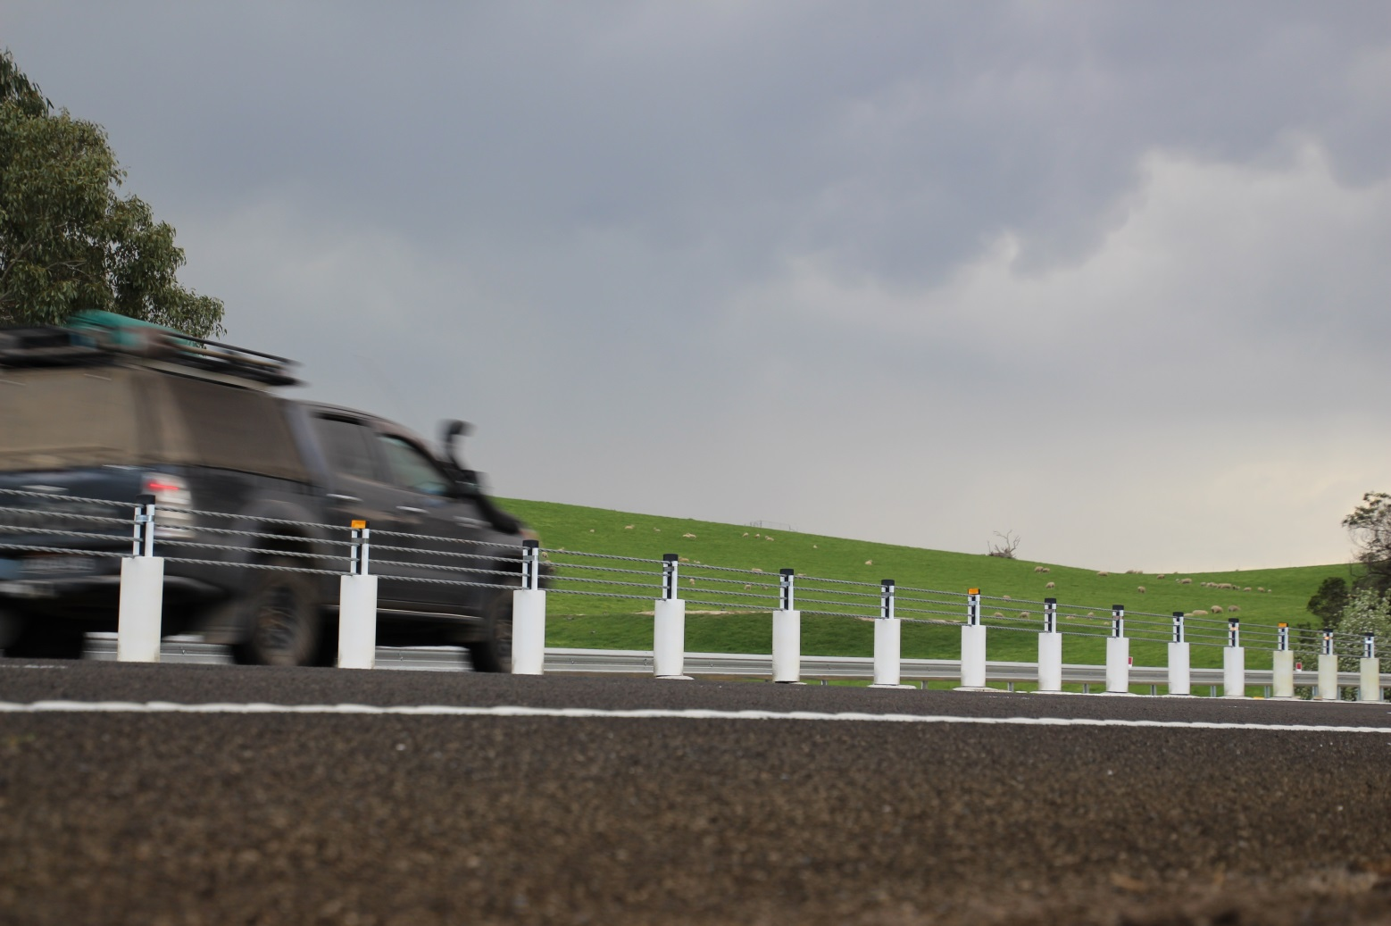**

|  |  |  |
| --- | --- | --- |
| **TRANSPORT ACCIDENT COMMISSION** | **60 Brougham Street Geelong Vic 3220**  **PO Box 742 Geelong Vic 3220**  **Ausdoc DX 216079 Geelong** | **Telephone 1300 654 329 STD Toll Free 1800 332 556 Fax: 03 9656 9300**  **www.tac.vic.gov.au ABN 22 033 947 623** |

**Contents**

[Status Report 4](#_Toc522194569)

[Lives lost on Victorian roads 4](#_Toc522194570)

[Injured claimants who were admitted to hospital within 7 days of accident, (by claim acceptance date – rolling 12 month, to 31st December 2017) 5](#_Toc522194571)

[Lives lost: 12 months to 30th June 2018 6](#_Toc522194572)

[Injured claimants who were admitted to hospital within 7 days of accident, 12 months to 31st December (claim acceptance date) 9](#_Toc522194573)

[Lives Lost by Week (2013 to 2018) 12](#_Toc522194574)

[The National Picture 13](#_Toc522194575)

[Explanations and References 15](#_Toc522194576)

[Useful Internet Sites 16](#_Toc522194577)

[Victorian monthly lives lost since 1951 19](#_Toc522194578)

Notes about the data in this report

* All data provided in this report is the data most recently available at time of production. Fatality data are updated to the end of report month. A 6-month lag applies to TAC claims data.
* Reported data will have one extra day of exposure for leap years.
* Data is subject to revision as additional information about known accidents/claims is received, and as new accident/claim reports are received and processed.

# Status Report

* The rolling 12 month number of lives lost to 30th June 2018 is 238. The rolling 12 month number of lives lost to 30th June 2017 stood at 267 (a decrease of 29).
* 101 people lost their lives year to date to the end of June 2018 on Victorian roads. This compares to 121 lives lost year to date to the end of June 2017.
* Four months (February, March, April and June) of the first half of 2018 had lowest number of lives lost since 1952.
* Lives lost by crash location: Melbourne 104 (44%), Rural Victoria 134 (56%)
* Victoria has the second lowest number of lives lost per 10,000 vehicles (0.49) and per 100,000 populations (3.74) among other states and territories after the ACT.

## Lives lost on Victorian roads

|  |  |  |  |  |  |  |
| --- | --- | --- | --- | --- | --- | --- |
| **Category** | **2018** | **2017** | **2016** | **2018 v 2017** | **2018 v 2016** | **5 Year Average** |
|  |  |  |  |  |  |  |
| **Lives Lost (Rolling 12 Month Total)** | |  |  |  |  |  |
| **Lives Lost (to June)** | **238** | **267** | **265** | **-29** | **-27** | **256** |
| per 10,000 veh | 0.49 | 0.56 | 0.57 | -0.07 | -0.08 | 0.56 |
| per 100,000 pop | 3.72 | 4.24 | 4.37 | -0.52 | -0.65 | 4.28 |
|  |  |  |  |  |  |  |
| **Crashes (Rolling 12 Month Total)** | |  |  |  |  |  |
| **Fatal crashes (to June)** | **220** | **258** | **249** | **-38** | **-29** | **237** |
| per 10,000 veh | 0.45 | 0.54 | 0.53 | -0.09 | -0.08 | 0.51 |
| per 100,000 pop | 3.43 | 4.10 | 4.11 | -0.67 | -0.68 | 3.96 |

**Victoria – Lives Lost, rolling 12 months total**

## Injured claimants who were admitted to hospital within 7 days of accident, (by claim acceptance date – rolling 12 month, to 31st December 2017)

|  |  |  |  |  |  |  |  |  |
| --- | --- | --- | --- | --- | --- | --- | --- | --- |
| **Category** | **2017** | **2016** | **2015** | **2017v 2016** | | **2017 v 2015** | | **5 Year Average** |
|  |  |  |  |  |  |  |  |  |
| **Claims involving hospitalisation over 14 days (Rolling 12 Month Total)** | | | | | |  |  |  |
|  |  |  |  |  |  |  |  |  |
| **Claims (to December)** | **928** | **1,021** | **970** | **-93.0** | **(-9%)** | **-42** | **(-4%)** | **943** |
| per 100,000 pop | 14.7 | 16.5 | 16.3 | -1.8 | (-11%) | -1.6 | (-10%) | 15.7 |
| per 10,000 veh | 1.9 | 2.2 | 2.1 | -0.3 | (-14%) | -0.2 | (-10%) | 2.0 |
|  |  |  |  |  |  |  |  |  |
| **All claims involving hospitalisation (Rolling 12 Month Total)** | | | | |  |  |  |  |
|  |  |  |  |  |  |  |  |  |
| **Claims (to December)** | **7,704** | **7,179** | **6,294** | **+525** | **(+7%)** | **+1410** | **(+22%)** | **6,565** |
| per 100,000 pop | 121.8 | 116.2 | 105.9 | +5.6 | (+5%) | +15.9 | (+15%) | 106.9 |
| per 10,000 veh | 15.9 | 15.2 | 13.6 | +0.7 | (+5%) | +2.3 | (+17%) | 13.8 |

# Lives lost: 12 months to 30th June

|  |  |  |  |  |  |  |
| --- | --- | --- | --- | --- | --- | --- |
| **Category** | **2018** | **2017** | **2016** | **2018 v 2017** | **2018 v 2016** | **5 Year Average** |
|  |  |  |  |  |  |  |
| **Overview** |  |  |  |  |  |  |
| Lives Lost | 238 | 267 | 265 | -29 | -27 | 256 |
| Fatal Crashes | 220 | 258 | 249 | -38 | -29 | 237 |
|  |  |  |  |  |  |  |
| **Sex** |  |  |  |  |  |  |
| Female | 67 | 72 | 74 | -5 | -7 | 72 |
| Male | 171 | 195 | 191 | -24 | -20 | 184 |
|  |  |  |  |  |  |  |
| **Road user** |  |  |  |  |  |  |
| Bicyclist | 8 | 9 | 9 | -1 | -1 | 9 |
| Driver | 116 | 147 | 128 | -31 | -12 | 127 |
| Motorcyclist | 37 | 41 | 49 | -4 | -12 | 38 |
| Passenger | 43 | 35 | 47 | +8 | -4 | 46 |
| Pedestrian | 34 | 35 | 32 | -1 | +2 | 36 |
|  |  |  |  |  |  |  |
| **Location** |  |  |  |  |  |  |
| Melbourne | 104 | 107 | 133 | -3 | -29 | 114 |
| Rural Victoria | 134 | 160 | 132 | -26 | +2 | 142 |
|  |  |  |  |  |  |  |
| **Age group** |  |  |  |  |  |  |
| 0-4 | 0 | 4 | 2 | -4 | -2 | 2 |
| 5-15 | 4 | 3 | 4 | +1 | 0 | 5 |
| 16-17 | 4 | 3 | 9 | +1 | -5 | 6 |
| 18-20 | 17 | 15 | 24 | +2 | -7 | 18 |
| 21-25 | 24 | 26 | 17 | -2 | +7 | 24 |
| 26-29 | 10 | 22 | 21 | -12 | -11 | 19 |
| 30-39 | 38 | 40 | 36 | -2 | +2 | 36 |
| 40-49 | 34 | 41 | 45 | -7 | -11 | 37 |
| 50-59 | 33 | 31 | 33 | +2 | 0 | 32 |
| 60-69 | 29 | 26 | 29 | +3 | 0 | 27 |
| 70+ | 44 | 55 | 45 | -11 | -1 | 49 |
|  |  |  |  |  |  |  |
| **Accident Type** |  |  |  |  |  |  |
| **Intersection** |  |  |  |  |  |  |
| Adjacent direction | 31 | 35 | 30 | -4 | +1 | 33 |
| Opposing direction | 10 | 7 | 8 | +3 | +2 | 8 |
| **Mid-block/other** |  |  |  |  |  |  |
| Head on | 39 | 42 | 51 | -3 | -12 | 42 |
| Same direction | 19 | 19 | 23 | 0 | -4 | 17 |
| Manoeuvre/overtaking | 13 | 9 | 18 | +4 | -5 | 13 |
| On path | 7 | 7 | 6 | 0 | +1 | 6 |
| Single vehicle | 81 | 107 | 96 | -26 | -15 | 96 |
| Other (incl pedestrians) | 37 | 41 | 33 | -4 | +4 | 40 |

Note: Excludes unknowns.

**Lives Lost: 12 months to 30th June – Continued**

|  |  |  |  |  |  |  |  |  |  |
| --- | --- | --- | --- | --- | --- | --- | --- | --- | --- |
| **Category** | **2018** | **2017** | **2016** | **5 Year Average** | **Category** | **2018** | **2017** | **2016** | **5 Year Average** |
|  |  |  |  |  |  |  |  |  |  |
| **Local Government area** |  |  |  |  | **Local Government Area** |  |  |  |  |
| ALPINE | 2 | 0 | 0 | 1 | MANSFIELD | 3 | 3 | 1 | 2 |
| ARARAT | 1 | 1 | 3 | 1 | MARIBYRNONG | 4 | 3 | 2 | 2 |
| BALLARAT | 4 | 3 | 5 | 4 | MAROONDAH | 2 | 2 | 0 | 1 |
| BANYULE | 2 | 3 | 2 | 2 | MELBOURNE | 3 | 4 | 2 | 3 |
| BASS COAST | 2 | 2 | 2 | 2 | MELTON | 3 | 4 | 3 | 5 |
| BAW BAW | 1 | 5 | 2 | 4 | MILDURA | 0 | 2 | 5 | 3 |
| BAYSIDE | 3 | 4 | 1 | 3 | MITCHELL | 5 | 2 | 4 | 4 |
| BENALLA | 2 | 4 | 1 | 2 | MOIRA | 7 | 5 | 7 | 4 |
| BOROONDARA | 3 | 3 | 3 | 3 | MONASH | 7 | 6 | 3 | 3 |
| BRIMBANK | 4 | 10 | 10 | 6 | MOONEE VALLEY | 3 | 2 | 2 | 2 |
| BULOKE | 0 | 3 | 1 | 2 | MOORABOOL | 2 | 8 | 3 | 4 |
| CAMPASPE | 5 | 4 | 3 | 4 | MORELAND | 2 | 4 | 3 | 3 |
| CARDINIA | 6 | 7 | 7 | 6 | MORNINGTON PENINSULA | 4 | 5 | 11 | 7 |
| CASEY | 5 | 10 | 7 | 6 | MOUNT ALEXANDER | 5 | 0 | 2 | 2 |
| CENTRAL GOLDFIELDS | 0 | 2 | 1 | 2 | MOYNE | 2 | 2 | 0 | 2 |
| COLAC-OTWAY | 8 | 2 | 4 | 2 | MURRINDINDI | 3 | 6 | 5 | 5 |
| CORANGAMITE | 3 | 1 | 3 | 4 | NILLUMBIK | 2 | 1 | 4 | 2 |
| DAREBIN | 4 | 1 | 3 | 2 | NORTHERN GRAMPIANS | 8 | 3 | 1 | 2 |
| EAST GIPPSLAND | 7 | 3 | 8 | 5 | PORT PHILLIP | 0 | 2 | 2 | 2 |
| FRANKSTON | 5 | 2 | 3 | 2 | PYRENEES | 4 | 3 | 0 | 1 |
| GANNAWARRA | 4 | 0 | 0 | 1 | QUEENSCLIFFE | 0 | 0 | 0 | 0 |
| GLEN EIRA | 1 | 3 | 2 | 2 | SOUTH GIPPSLAND | 4 | 3 | 4 | 4 |
| GLENELG | 3 | 4 | 2 | 3 | SOUTHERN GRAMPIANS | 1 | 3 | 3 | 1 |
| GOLDEN PLAINS | 1 | 6 | 1 | 3 | STONNINGTON | 2 | 0 | 2 | 2 |
| GREATER BENDIGO | 7 | 6 | 4 | 4 | STRATHBOGIE | 2 | 2 | 5 | 3 |
| GREATER DANDENONG | 5 | 3 | 6 | 4 | SURF COAST | 3 | 2 | 4 | 2 |
| GREATER GEELONG | 6 | 14 | 3 | 6 | SWAN HILL | 1 | 4 | 2 | 2 |
| GREATER SHEPPARTON | 5 | 11 | 7 | 6 | TOWONG | 1 | 1 | 1 | 1 |
| HEPBURN | 3 | 5 | 2 | 2 | WANGARATTA | 1 | 6 | 5 | 4 |
| HINDMARSH | 0 | 0 | 2 | 1 | WARRNAMBOOL | 0 | 0 | 2 | 1 |
| HORSHAM | 1 | 4 | 4 | 2 | WEST WIMMERA | 0 | 1 | 0 | 0 |
| HUME | 4 | 1 | 7 | 4 | WHITEHORSE | 2 | 3 | 4 | 3 |
| INDIGO | 2 | 3 | 4 | 3 | WHITTLESEA | 5 | 1 | 7 | 4 |
| KINGSTON | 4 | 3 | 5 | 4 | WODONGA | 1 | 3 | 1 | 2 |
| KNOX | 3 | 4 | 5 | 4 | WYNDHAM | 4 | 7 | 7 | 5 |
| LATROBE | 3 | 4 | 6 | 4 | YARRA | 2 | 1 | 2 | 1 |
| LODDON | 1 | 1 | 2 | 1 | YARRA RANGES | 7 | 5 | 12 | 7 |
| MACEDON RANGES | 3 | 3 | 4 | 4 | YARRIAMBIACK | 1 | 1 | 1 | 1 |
| MANNINGHAM | 3 | 3 | 1 | 1 |  |  |  |  |  |

Note: Excludes unknown local government area.

**Injured claimants who were admitted to hospital within 7 days of the accident with a hospital stay of more than 14 days, 12 months to 31st December (claim acceptance date)**

|  |  |  |  |  |  |  |  |  |  |  |  |  |  |  |  |  |  |  |  |  |
| --- | --- | --- | --- | --- | --- | --- | --- | --- | --- | --- | --- | --- | --- | --- | --- | --- | --- | --- | --- | --- |
| **Category** | | **2017** | | **2016** | | **2015** | | **2017 v 2016** | | | | | | **2017 v 2015** | | | | | | **5 Year Average** |
|  | |  | |  | |  | |  | | | |  | |  | |  | | | |  |
| **Overview** | |  | |  | |  | |  | | | |  | |  | |  | | | |  |
| Claims | | 928 | | 1,021 | | 970 | | -93 | | | | -9% | | -42 | | | -4% | | 943 | | |
|  | |  | |  | |  | |  | | | |  | |  | | |  | |  | | |
| **Sex** | |  | |  | |  | |  | | | |  | |  | | |  | |  | | |
| Female | | 353 | | 425 | | 429 | | -72 | | | | -17% | | -76 | | | -18% | | 388 | | |
| Male | | 575 | | 596 | | 541 | | -21 | | | | -4% | | +34 | | | 6% | | 555 | | |
|  | |  | |  | |  | |  | |  | | | | | |  | |  | |  | | |
| **Road user** | |  | |  | |  | |  | |  | | | | | |  | |  | |  | | |
| Bicyclist | | 41 | | 31 | | 48 | | +10 | | | | 32% | | -7 | | | -15% | | 37 | | |
| Driver | | 312 | | 397 | | 365 | | -85 | | | | -21% | | -53 | | | -15% | | 362 | | |
| Motorcyclist | | 193 | | 187 | | 169 | | +6 | | | | 3% | | +24 | | | 14% | | 171 | | |
| Passenger | | 135 | | 150 | | 147 | | -15 | | | | -10% | | -12 | | | -8% | | 143 | | |
| Pedestrian | | 209 | | 221 | | 199 | | -12 | | | | -5% | | +10 | | | 5% | | 201 | | |
| Train/Tram | | 14 | | 7 | | 8 | | +7 | | | | 100% | | +6 | | | 75% | | 9 | | |
|  | |  | |  | |  | |  | | | |  | |  | | |  | |  | | |
| **Location** | |  | |  | |  | |  | | | |  | |  | | |  | |  | | |
| Melbourne | | 554 | | 644 | | 639 | | -90 | | | | -14% | | -85 | | | -13% | | 594 | | |
| Rural Victoria | | 311 | | 322 | | 302 | | -11 | | | | -3% | | 9 | | | 3% | | 315 | | |
|  | |  | |  | |  | |  | | | |  | |  | | |  | |  | | |
| **Age group** | |  | |  | |  | |  | | | |  | |  | | |  | |  | | |
| 0-4 | | 5 | | 4 | | 4 | | +1 | | | | 25% | | 1 | | | 25% | | 4 | | |
| 5-15 | | 6 | | 13 | | 20 | | -7 | | | | -54% | | -14 | | | -70% | | 13 | | |
| 16-17 | | 13 | | 13 | | 14 | |  | | | | 0% | | -1 | | | -7% | | 13 | | |
| 18-20 | | 48 | | 74 | | 43 | | -26 | | | | -35% | | 5 | | | 12% | | 57 | | |
| 21-25 | | 90 | | 82 | | 88 | | +8 | | | | 10% | | 2 | | | 2% | | 84 | | |
| 26-29 | | 59 | | 57 | | 50 | | +2 | | | | 4% | | 9 | | | 18% | | 52 | | |
| 30-39 | | 125 | | 135 | | 122 | | -10 | | | | -7% | | 3 | | | 2% | | 118 | | |
| 40-49 | | 101 | | 120 | | 119 | | -19 | | | | -16% | | -18 | | | -15% | | 112 | | |
| 50-59 | | 119 | | 108 | | 124 | | +11 | | | | 10% | | -5 | | | -4% | | 112 | | |
| 60-69 | | 125 | | 130 | | 110 | | -5 | | | | -4% | | 15 | | | 14% | | 114 | | |
| 70+ | | 237 | | 285 | | 276 | | -48 | | | | -17% | | -39 | | | -14% | | 263 | | |
|  | |  | |  | |  | |  | |  | | | |  | |  | | | |  |
|  | |  | |  | |  | |  | |  | | | |  | |  | | | |  |
| **Accident Type** | |  | |  | |  | |  | |  | | | |  | |  | | | |  |
| **Intersection** | |  | |  | |  | |  | |  | | | |  | |  | | | |  |
| Adjacent direction | | 91 | | 108 | | 102 | | -17 | | -16% | | | | -11 | | -11% | | | | 106 |
| Opposing direction | | 52 | | 62 | | 66 | | -10 | | -16% | | | | -14 | | -21% | | | | 61 |
| **Mid-block/other** | |  | |  | |  | |  | |  | | | |  | |  | | | |  |
| Head on | | 63 | | 97 | | 96 | | -34 | | -35% | | | | -33 | | -34% | | | | 83 |
| Same direction | | 55 | | 77 | | 82 | | -22 | | -29% | | | | -27 | | -33% | | | | 72 |
| Manoeuvre/overtaking | | 47 | | 58 | | 62 | | -11 | | -19% | | | | -15 | | -24% | | | | 55 |
| On path | | 21 | | 31 | | 28 | | -10 | | -32% | | | | -7 | | -25% | | | | 27 |
| Single vehicle | | 226 | | 268 | | 290 | | -42 | | -16% | | | | -64 | | -22% | | | | 259 |
| Other (incl pedestrians) | | 373 | | 320 | | 244 | | +53 | | 17% | | | | 129 | | 53% | | | | 280 |

Note: Excludes unknown, rejected claims and claims for interstate crashes.

**Injured claimants who were admitted to hospital within 7 days of the accident with a hospital stay of more than 14 days, 12 months to 31st December (claim acceptance date) – Continued**

|  |  |  |  |  |  |  |  |  |  |
| --- | --- | --- | --- | --- | --- | --- | --- | --- | --- |
| **Category** | **2017** | **2016** | **2015** | **5 Year Average** | **Category** | **2017** | **2016** | **2015** | **5 Year Average** |
|  |  |  |  |  |  |  |  |  |  |
| **Local Government Area** | |  |  |  | **Local Government Area** | |  |  |  |
| ALPINE | 4 | 3 | 2 | 2 | MANSFIELD | 5 | 9 | 2 | 4 |
| ARARAT | 2 | 3 | 9 | 5 | MARIBYRNONG | 22 | 10 | 13 | 8 |
| BALLARAT | 17 | 12 | 18 | 13 | MAROONDAH | 9 | 8 | 6 | 5 |
| BANYULE | 10 | 9 | 12 | 8 | MELBOURNE | 43 | 39 | 26 | 26 |
| BASS COAST | 4 | 5 | 9 | 7 | MELTON | 9 | 11 | 20 | 10 |
| BAW BAW | 10 | 5 | 12 | 6 | MILDURA | 11 | 4 | 4 | 5 |
| BAYSIDE | 11 | 11 | 11 | 8 | MITCHELL | 7 | 11 | 8 | 9 |
| BENALLA | 6 | 2 | 7 | 4 | MOIRA | 13 | 9 | 7 | 6 |
| BOROONDARA | 16 | 12 | 22 | 16 | MONASH | 22 | 23 | 28 | 18 |
| BRIMBANK | 20 | 32 | 34 | 22 | MOONEE VALLEY | 14 | 19 | 20 | 16 |
| BULOKE | 0 | 3 | 6 | 3 | MOORABOOL | 7 | 11 | 10 | 8 |
| CAMPASPE | 12 | 9 | 8 | 6 | MORELAND | 21 | 35 | 29 | 24 |
| CARDINIA | 20 | 14 | 18 | 11 | MORNINGTON PENINSULA | 19 | 30 | 27 | 22 |
| CASEY | 29 | 39 | 34 | 26 | MOUNT ALEXANDER | 0 | 1 | 3 | 4 |
| CENTRAL GOLDFIELDS | 2 | 2 | 2 | 3 | MOYNE | 9 | 4 | 2 | 3 |
| COLAC-OTWAY | 11 | 7 | 12 | 7 | MURRINDINDI | 20 | 7 | 15 | 8 |
| CORANGAMITE | 6 | 8 | 4 | 5 | NILLUMBIK | 5 | 7 | 13 | 6 |
| DAREBIN | 13 | 31 | 15 | 16 | NORTHERN GRAMPIANS | 6 | 3 | 1 | 3 |
| EAST GIPPSLAND | 13 | 7 | 9 | 7 | PORT PHILLIP | 10 | 21 | 17 | 14 |
| FRANKSTON | 15 | 19 | 15 | 12 | PYRENEES | 0 | 3 | 2 | 2 |
| GANNAWARRA | 4 | 2 | 2 | 2 | QUEENSCLIFFE | 1 | 1 | 0 | 0 |
| GLEN EIRA | 12 | 15 | 15 | 14 | SOUTH GIPPSLAND | 5 | 14 | 8 | 7 |
| GLENELG | 1 | 7 | 4 | 4 | SOUTHERN GRAMPIANS | 2 | 3 | 3 | 3 |
| GOLDEN PLAINS | 5 | 10 | 5 | 5 | STONNINGTON | 14 | 10 | 21 | 12 |
| GREATER BENDIGO | 21 | 12 | 15 | 11 | STRATHBOGIE | 2 | 9 | 9 | 7 |
| GREATER DANDENONG | 24 | 27 | 17 | 20 | SURF COAST | 4 | 7 | 6 | 4 |
| GREATER GEELONG | 36 | 17 | 20 | 20 | SWAN HILL | 4 | 7 | 3 | 3 |
| GREATER SHEPPARTON | 17 | 20 | 15 | 12 | TOWONG | 3 | 4 | 1 | 2 |
| HEPBURN | 2 | 2 | 4 | 3 | WANGARATTA | 5 | 8 | 5 | 5 |
| HINDMARSH | 2 | 3 | 1 | 1 | WARRNAMBOOL | 4 | 3 | 2 | 3 |
| HOBSONS BAY | 9 | 6 | 11 | 7 | WELLINGTON | 7 | 14 | 5 | 8 |
| HORSHAM | 2 | 4 | 3 | 3 | WEST WIMMERA | 1 | 1 | 1 | 1 |
| HUME | 21 | 39 | 37 | 24 | WHITEHORSE | 21 | 26 | 14 | 16 |
| INDIGO | 3 | 9 | 5 | 3 | WHITTLESEA | 21 | 33 | 28 | 21 |
| KINGSTON | 16 | 12 | 27 | 17 | WODONGA | 3 | 4 | 4 | 4 |
| KNOX | 21 | 17 | 19 | 13 | WYNDHAM | 24 | 26 | 25 | 20 |
| LATROBE | 4 | 10 | 16 | 9 | YARRA | 12 | 18 | 11 | 12 |
| LODDON | 0 | 2 | 2 | 1 | YARRA RANGES | 29 | 28 | 43 | 28 |
| MACEDON RANGES | 6 | 20 | 11 | 12 | YARRIAMBIACK | 2 | 1 | 0 | 1 |
| MANNINGHAM | 22 | 17 | 11 | 11 |  |  |  |  |  |

Note: excludes unknown, rejected claims and claims for interstate crashes

# 

# Injured claimants who were admitted to hospital within 7 days of accident, 12 months to 31st December (claim acceptance date)

|  |  |  |  |  |  |  |  |  |
| --- | --- | --- | --- | --- | --- | --- | --- | --- |
| **Category** | **2017** | **2016** | **2015** | **2017 v 2016** | | **2017 v 2015** | | **5 Year Average** |
|  |  |  |  |  |  |  |  |  |
| **Overview** |  |  |  |  |  |  |  |  |
| Claims | 7,704 | 7,179 | 6,294 | +525 | 7% | +1410 | 22% | 6,565 |
|  |  |  |  |  |  |  |  |  |
| **Sex** |  |  |  |  |  |  |  |  |
| Female | 3,316 | 3,172 | 2,728 | +144 | 5% | +588 | 22% | 2,814 |
| Male | 4,382 | 3,995 | 3,553 | +387 | 10% | +829 | 23% | 3,743 |
|  |  |  |  |  |  |  |  |  |
| **Road user** |  |  |  |  |  |  |  |  |
| Bicyclist | 503 | 423 | 389 | +80 | 19% | +114 | 29% | 419 |
| Driver | 3,602 | 3,437 | 2,894 | +165 | 5% | +708 | 24% | 3,034 |
| Motorcyclist | 1,320 | 1,175 | 1,099 | +145 | 12% | +221 | 20% | 1,147 |
| Passenger | 1,128 | 1,096 | 1,044 | +32 | 3% | +84 | 8% | 1,054 |
| Pedestrian | 778 | 746 | 644 | +32 | 4% | +134 | 21% | 688 |
| Train/Tram | 55 | 36 | 28 | +19 | 53% | +27 | 96% | 36 |
|  |  |  |  |  |  |  |  |  |
| **Location** |  |  |  |  |  |  |  |  |
| Melbourne | 4,542 | 4,735 | 4,208 | -193 | -4% | +334 | 8% | 4,275 |
| Rural Victoria | 2,236 | 2,035 | 1,847 | +201 | 10% | +389 | 21% | 1,926 |
|  |  |  |  |  |  |  |  |  |
| **Age group** |  |  |  |  |  |  |  |  |
| 0-4 | 61 | 60 | 42 | +1 | 2% | +19 | 45% | 53 |
| 5-15 | 206 | 223 | 238 | -17 | -8% | -32 | -13% | 206 |
| 16-17 | 118 | 122 | 117 | -4 | -3% | +1 | 1% | 111 |
| 18-20 | 565 | 567 | 453 | -2 | 0% | +112 | 25% | 515 |
| 21-25 | 989 | 886 | 746 | +103 | 12% | +243 | 33% | 817 |
| 26-29 | 646 | 625 | 530 | +21 | 3% | +116 | 22% | 541 |
| 30-39 | 1,232 | 1,122 | 999 | +110 | 10% | +233 | 23% | 1,021 |
| 40-49 | 1,127 | 1,036 | 891 | +91 | 9% | +236 | 26% | 964 |
| 50-59 | 1,072 | 880 | 815 | +192 | 22% | +257 | 32% | 844 |
| 60-69 | 714 | 733 | 586 | -19 | -3% | +128 | 22% | 619 |
| 70+ | 974 | 925 | 877 | +49 | 5% | +97 | 11% | 876 |
|  |  |  |  |  |  |  |  |  |
| **Accident Type** |  |  |  |  |  |  |  |  |
| **Intersection** |  |  |  |  |  |  |  |  |
| Adjacent direction | 894 | 906 | 795 | -12 | -1% | +99 | 12% | 843 |
| Opposing direction | 560 | 558 | 546 | +2 | 0% | +14 | 3% | 534 |
| **Mid-block/other** |  |  |  |  |  |  |  |  |
| Head on | 339 | 360 | 315 | -21 | -6% | +24 | 8% | 328 |
| Same direction | 911 | 1,087 | 932 | -176 | -16% | -21 | -2% | 926 |
| Manoeuvre/overtaking | 365 | 388 | 391 | -23 | -6% | -26 | -7% | 358 |
| On path | 232 | 317 | 296 | -85 | -27% | -64 | -22% | 276 |
| Single vehicle | 1,465 | 1,659 | 1,725 | -194 | -12% | -260 | -15% | 1,620 |
| Other (incl pedestrians) | 2,938 | 1,904 | 1,294 | +1034 | 54% | +1644 | 127% | 1,680 |

Note: excludes unknown, rejected claims and claims for interstate crashes

**Injured claimants who were admitted to hospital within 7 days of accident, 12 months to 31st December (claim acceptance date) – Continued**

|  |  |  |  |  |  |  |  |  |  |
| --- | --- | --- | --- | --- | --- | --- | --- | --- | --- |
| **Category** | **2017** | **2016** | **2015** | **5 Year Average** | **Category** | **2017** | **2016** | **2015** | **5 Year Average** |
|  |  |  |  |  |  |  |  |  |  |
| **Local Government Area** |  |  |  |  | **Local Government Area** |  |  |  |  |
| ALPINE | 28 | 19 | 24 | 23 | MANSFIELD | 29 | 40 | 27 | 27 |
| ARARAT | 10 | 22 | 23 | 17 | MARIBYRNONG | 91 | 88 | 73 | 61 |
| BALLARAT | 88 | 105 | 86 | 71 | MAROONDAH | 48 | 70 | 62 | 48 |
| BANYULE | 67 | 62 | 40 | 46 | MELBOURNE | 341 | 335 | 259 | 218 |
| BASS COAST | 35 | 41 | 58 | 37 | MELTON | 69 | 87 | 105 | 66 |
| BAW BAW | 60 | 44 | 45 | 42 | MILDURA | 28 | 28 | 33 | 27 |
| BAYSIDE | 89 | 90 | 86 | 64 | MITCHELL | 70 | 77 | 58 | 53 |
| BENALLA | 24 | 17 | 33 | 17 | MOIRA | 42 | 43 | 35 | 29 |
| BOROONDARA | 133 | 125 | 138 | 109 | MONASH | 195 | 203 | 196 | 160 |
| BRIMBANK | 167 | 133 | 136 | 111 | MOONEE VALLEY | 120 | 140 | 122 | 101 |
| BULOKE | 7 | 11 | 12 | 8 | MOORABOOL | 45 | 54 | 43 | 40 |
| CAMPASPE | 59 | 48 | 42 | 32 | MORELAND | 177 | 180 | 145 | 125 |
| CARDINIA | 128 | 149 | 116 | 96 | MORNINGTON PENINSULA | 149 | 192 | 158 | 126 |
| CASEY | 330 | 359 | 311 | 233 | MOUNT ALEXANDER | 20 | 15 | 28 | 21 |
| CENTRAL GOLDFIELDS | 19 | 14 | 7 | 10 | MOYNE | 39 | 24 | 16 | 16 |
| COLAC-OTWAY | 77 | 43 | 42 | 29 | MURRINDINDI | 75 | 61 | 56 | 48 |
| CORANGAMITE | 38 | 41 | 20 | 24 | NILLUMBIK | 37 | 47 | 48 | 31 |
| DAREBIN | 103 | 122 | 91 | 81 | NORTHERN GRAMPIANS | 34 | 11 | 15 | 14 |
| EAST GIPPSLAND | 63 | 61 | 57 | 47 | PORT PHILLIP | 148 | 141 | 145 | 111 |
| FRANKSTON | 136 | 149 | 136 | 103 | PYRENEES | 9 | 15 | 12 | 8 |
| GANNAWARRA | 13 | 8 | 12 | 10 | QUEENSCLIFFE | 6 | 1 | 1 | 1 |
| GLEN EIRA | 118 | 128 | 111 | 93 | SOUTH GIPPSLAND | 46 | 55 | 25 | 33 |
| GLENELG | 14 | 24 | 19 | 16 | SOUTHERN GRAMPIANS | 17 | 24 | 26 | 22 |
| GOLDEN PLAINS | 52 | 49 | 33 | 28 | STONNINGTON | 134 | 140 | 141 | 114 |
| GREATER BENDIGO | 142 | 94 | 124 | 76 | STRATHBOGIE | 33 | 39 | 44 | 29 |
| GREATER DANDENONG | 252 | 277 | 242 | 206 | SURF COAST | 72 | 49 | 49 | 34 |
| GREATER GEELONG | 423 | 252 | 223 | 181 | SWAN HILL | 15 | 25 | 14 | 13 |
| GREATER SHEPPARTON | 109 | 114 | 93 | 67 | TOWONG | 15 | 19 | 16 | 13 |
| HEPBURN | 20 | 34 | 28 | 25 | WANGARATTA | 26 | 43 | 35 | 27 |
| HINDMARSH | 12 | 10 | 8 | 7 | WARRNAMBOOL | 34 | 33 | 18 | 18 |
| HOBSONS BAY | 74 | 73 | 64 | 53 | WELLINGTON | 62 | 72 | 67 | 56 |
| HORSHAM | 21 | 14 | 35 | 16 | WEST WIMMERA | 3 | 8 | 6 | 5 |
| HUME | 250 | 245 | 204 | 156 | WHITEHORSE | 161 | 149 | 104 | 94 |
| INDIGO | 21 | 31 | 20 | 16 | WHITTLESEA | 211 | 242 | 146 | 136 |
| KINGSTON | 118 | 144 | 135 | 113 | WODONGA | 24 | 28 | 33 | 22 |
| KNOX | 140 | 133 | 124 | 94 | WYNDHAM | 164 | 148 | 160 | 125 |
| LATROBE | 60 | 72 | 58 | 51 | YARRA | 94 | 138 | 116 | 95 |
| LODDON | 9 | 10 | 13 | 10 | YARRA RANGES | 195 | 152 | 199 | 135 |
| MACEDON RANGES | 78 | 90 | 65 | 58 | YARRIAMBIACK | 9 | 3 | 10 | 4 |
| MANNINGHAM | 103 | 94 | 95 | 62 |  |  |  |  |  |

Note: excludes unknown, rejected claims and claims for interstate crashes

# Lives Lost by Week (2013 to 2018)

|  |  |  |  |  |  |  |  |  |
| --- | --- | --- | --- | --- | --- | --- | --- | --- |
| **Week** |  |  |  |  |  |  | **Cumulative** | **12 Month** |
| **Ending** | **2013** | **2014** | **2015** | **2016** | **2017** | **2018** | **2018** | **Moving Total** |
| 7-Jan | 3 | 0 | 5 | 2 | 2 | 6 | 6 | 263 |
| 14-Jan | 2 | 8 | 6 | 5 | 6 | 4 | 10 | 261 |
| 21-Jan | 5 | 5 | 5 | 2 | 4 | 2 | 12 | 259 |
| 28-Jan | 4 | 8 | 7 | 11 | 4 | 4 | 16 | 259 |
| 4-Feb | 6 | 8 | 6 | 4 | 3 | 4 | 20 | 260 |
| 11-Feb | 7 | 4 | 4 | 10 | 3 | 4 | 24 | 261 |
| 18-Feb | 4 | 7 | 6 | 7 | 6 | 6 | 30 | 261 |
| 25-Feb | 7 | 2 | 3 | 9 | 4 | 3 | 33 | 260 |
| 4-Mar | 1 | 5 | 4 | 10 | 5 | 4 | 37 | 259 |
| 11-Mar | 5 | 10 | 11 | 9 | 3 | 7 | 44 | 263 |
| 18-Mar | 5 | 3 | 4 | 5 | 5 | 4 | 48 | 262 |
| 25-Mar | 10 | 3 | 2 | 4 | 9 | 4 | 52 | 257 |
| 1-Apr | 5 | 8 | 4 | 1 | 3 | 3 | 55 | 257 |
| 8-Apr | 3 | 7 | 5 | 1 | 7 | 3 | 58 | 253 |
| 15-Apr | 4 | 4 | 5 | 4 | 10 | 0 | 58 | 243 |
| 22-Apr | 5 | 1 | 6 | 5 | 8 | 3 | 61 | 238 |
| 29-Apr | 5 | 2 | 6 | 5 | 2 | 4 | 65 | 240 |
| 6-May | 6 | 3 | 2 | 6 | 5 | 11 | 76 | 246 |
| 13-May | 3 | 4 | 8 | 5 | 7 | 4 | 80 | 243 |
| 20-May | 0 | 5 | 4 | 6 | 3 | 3 | 83 | 243 |
| 27-May | 3 | 7 | 3 | 7 | 3 | 5 | 88 | 245 |
| 3-Jun | 10 | 5 | 4 | 4 | 4 | 0 | 88 | 241 |
| 10-Jun | 3 | 3 | 5 | 5 | 3 | 4 | 92 | 242 |
| 17-Jun | 1 | 2 | 7 | 5 | 2 | 6 | 98 | 246 |
| 24-Jun | 5 | 2 | 2 | 5 | 7 | 1 | 99 | 240 |
| 1-Jul | 2 | 10 | 9 | 7 | 3 |  |  |  |
| 8-Jul | 4 | 5 | 6 | 3 | 7 |  |  |  |
| 15-Jul | 7 | 6 | 1 | 5 | 5 |  |  |  |
| 22-Jul | 5 | 3 | 3 | 6 | 8 |  |  |  |
| 29-Jul | 3 | 5 | 3 | 10 | 1 |  |  |  |
| 5-Aug | 8 | 4 | 6 | 6 | 3 |  |  |  |
| 12-Aug | 1 | 4 | 7 | 7 | 7 |  |  |  |
| 19-Aug | 5 | 6 | 9 | 8 | 8 |  |  |  |
| 26-Aug | 5 | 4 | 4 | 11 | 2 |  |  |  |
| 2-Sep | 4 | 6 | 4 | 1 | 8 |  |  |  |
| 9-Sep | 6 | 6 | 2 | 4 | 8 |  |  |  |
| 16-Sep | 2 | 4 | 4 | 4 | 2 |  |  |  |
| 23-Sep | 4 | 6 | 4 | 4 | 3 |  |  |  |
| 30-Sep | 7 | 3 | 4 | 5 | 3 |  |  |  |
| 7-Oct | 3 | 3 | 7 | 3 | 3 |  |  |  |
| 14-Oct | 2 | 7 | 4 | 7 | 6 |  |  |  |
| 21-Oct | 3 | 0 | 5 | 3 | 3 |  |  |  |
| 28-Oct | 4 | 8 | 9 | 6 | 0 |  |  |  |
| 4-Nov | 8 | 2 | 3 | 3 | 3 |  |  |  |
| 11-Nov | 5 | 7 | 4 | 7 | 12 |  |  |  |
| 18-Nov | 2 | 7 | 5 | 5 | 5 |  |  |  |
| 25-Nov | 8 | 3 | 2 | 8 | 9 |  |  |  |
| 2-Dec | 3 | 10 | 5 | 9 | 3 |  |  |  |
| 9-Dec | 7 | 5 | 9 | 4 | 6 |  |  |  |
| 16-Dec | 12 | 3 | 1 | 7 | 5 |  |  |  |
| 23-Dec | 9 | 2 | 3 | 2 | 9 |  |  |  |
| 30-Dec | 2 | 3 | 5 | 8 | 9 |  |  |  |
| 31-Dec | 0 | 0 | 0 | 0 | 0 |  |  |  |
| **Total** | **243** | **248** | **252** | **290** | **259** | **99** |  |  |

# The National Picture

|  |  |  |  |  |  |  |
| --- | --- | --- | --- | --- | --- | --- |
| **State** | **Lives Lost (12 months to June)** | | | | |  |
|  | **2018** | **2017** | **2016** | **2015** | **2018 v 2017** | |
| NSW | 392 | 357 | 386 | 304 | +35 | (+10%) |
| VIC | 239 | 267 | 265 | 254 | -28 | (-10%) |
| QLD | 248 | 251 | 244 | 235 | -3 | (-1%) |
| SA | 99 | 82 | 97 | 113 | +17 | (+21%) |
| WA | 166 | 183 | 171 | 179 | -17 | (-9%) |
| TAS | 35 | 31 | 40 | 33 | +4 | (+13%) |
| NT | 42 | 44 | 44 | 41 | -2 | (-5%) |
| ACT | 7 | 11 | 13 | 11 | -4 | (-36%) |
| AUST TOTAL | 1,228 | 1,226 | 1,260 | 1,170 | +2 | (+0%) |
| AUST minus VIC | 989 | 959 | 995 | 916 | +30 | (+3%) |

|  |  |  |  |  |  |  |
| --- | --- | --- | --- | --- | --- | --- |
| **State** | **Lives Lost per 10,000 registered vehicles** | | | **Lives lost per 100,000 population** | | |
|  | **(12 months to June)** | | | **(12 months to June)** | | |
|  | **2018** | **2017** | **2016** | **2018** | **2017** | **2016** |
| NSW | 0.70 | 0.65 | 0.72 | 4.95 | 4.58 | 5.03 |
| VIC | 0.49 | 0.56 | 0.57 | 3.74 | 4.27 | 4.37 |
| QLD | 0.61 | 0.64 | 0.63 | 4.99 | 5.13 | 5.07 |
| SA | 0.70 | 0.59 | 0.71 | 5.73 | 4.77 | 5.74 |
| WA | 0.74 | 0.82 | 0.77 | 6.41 | 7.12 | 6.16 |
| TAS | 0.73 | 0.66 | 0.88 | 6.70 | 5.97 | 7.74 |
| NT | 2.74 | 2.82 | 2.79 | 17.05 | 17.89 | 17.96 |
| ACT | 0.23 | 0.37 | 0.45 | 1.70 | 2.69 | 3.23 |
| AUST TOTAL | 0.64 | 0.65 | 0.69 | 4.96 | 5.03 | 5.25 |
| AUST minus VIC | 0.69 | 0.69 | 0.73 | 5.39 | 5.29 | 5.55 |

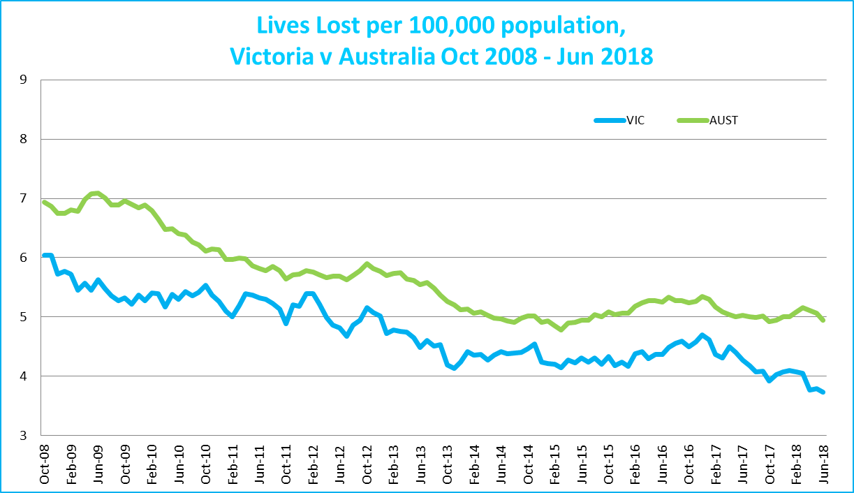

Victoria v Australia – 12 Month Moving Lives Lost Rate

# Booze Bus Random Breath Testing

**Booze-bus Random Breath Tests (12 months to June 2018 vs previous 12 months)**

|  |  |  |  |  |  |  |  |
| --- | --- | --- | --- | --- | --- | --- | --- |
|  | **2018** | **2017** | **2016** | **2017 v 2016** | | **2017 v 2015** | |
| Melbourne | 1,203,695 | 1,019,494 | 992,037 | +184,201 | (+18%) | +211,658 | (+21%) |
| Country | 130,028 | 136,868 | 90,716 | -6,840 | (-5%) | +39,312 | (+43%) |
| Vic Total | 1,333,723 | 1,156,362 | 1,082,753 | +177,361 | (+15%) | +250,970 | (+23%) |

**Booze Bus Random Breath Testing (12 months to June 2018 (monthly totals)**

|  |  |  |  |  |  |  |  |  |  |  |  |  |
| --- | --- | --- | --- | --- | --- | --- | --- | --- | --- | --- | --- | --- |
|  | **2017** |  |  |  |  |  | **2018** |  |  |  |  |  |
|  | **Jul** | **Aug** | **Sep** | **Oct** | **Nov** | **Dec** | **Jan** | **Feb** | **Mar** | **Apr** | **May** | **Jun** |
| Melbourne | 89,786 | 98,917 | 98,907 | 117,207 | 88,467 | 108,748 | 98,546 | 90,559 | 96,738 | 103,691 | 91,213 | 120,916 |
| Country | 4,525 | 4,304 | 8,261 | 12,889 | 14,307 | 15,152 | 10,962 | 16,569 | 6,855 | 10,813 | 15,444 | 9,947 |
| Vic Total | 94,311 | 103,221 | 107,168 | 130,096 | 102,774 | 123,900 | 109,508 | 107,128 | 103,593 | 114,504 | 106,657 | 130,863 |

# Random Drug Testing

**Random Drug Tests (12 months to June 2018 vs previous 12 months)**

|  |  |  |  |  |  |  |  |
| --- | --- | --- | --- | --- | --- | --- | --- |
|  | **2018** | **2017** | **2016** | **2018 v 2017** | | **2018 v 2016** | |
| Victoria | 101,948 | 101,442 | 100,237 | +506 | (+0%) | +1711 | (+2%) |

**12 months to June 2018 (monthly totals)**

|  |  |  |  |  |  |  |  |  |  |  |  |  |
| --- | --- | --- | --- | --- | --- | --- | --- | --- | --- | --- | --- | --- |
|  | **2017** |  |  |  |  |  | **2018** |  |  |  |  |  |
|  | **Jul** | **Aug** | **Sep** | **Oct** | **Nov** | **Dec** | **Jan** | **Feb** | **Mar** | **Apr** | **May** | **Jun** |
| Victoria | 7,260 | 7,067 | 7,233 | 8,125 | 10,614 | 8,809 | 10,699 | 8,629 | 8,704 | 8,562 | 8,671 | 7,575 |

# Mobile Safety Camera Data

**Speed Infringements Issued from Mobile Cameras (monthly totals) Monthly Average = 31,635**

|  |  |  |  |  |  |  |  |  |  |  |  |
| --- | --- | --- | --- | --- | --- | --- | --- | --- | --- | --- | --- |
| **2017** |  |  |  |  |  | **2018** |  |  |  |  |  |
| **Jul** | **Aug** | **Sep** | **Oct** | **Nov** | **Dec** | **Jan** | **Feb** | **Mar** | **Apr** | **May** | **Jun** |
| 31,079 | 29,788 | 28,581 | 33,953 | 28,402 | 21,408 | 39,249 | 32,973 | 32,021 | 34,027 | 36,169 | 31,965 |

**Excessive Speed Infringements (ESI) Issued from Mobile Cameras (monthly totals) Monthly Average = 351**

|  |  |  |  |  |  |  |  |  |  |  |  |
| --- | --- | --- | --- | --- | --- | --- | --- | --- | --- | --- | --- |
| **2017** |  |  |  |  |  | **2018** |  |  |  |  |  |
| **Jul** | **Aug** | **Sep** | **Oct** | **Nov** | **Dec** | **Jan** | **Feb** | **Mar** | **Apr** | **May** | **Jun** |
| 323 | 362 | 272 | 332 | 279 | 272 | 156 | 675 | 334 | 391 | 406 | 404 |

Notes: An ESI is defined as 25km/h over the speed limit except in a 110km/h zone where it is 20km/h over the limit.

# Explanations and References

LGA: Local Government Areas. Crash locations for acute hospitalised claims are assigned to LGA’s based on the crash postcode recorded by Victoria Police. Crash locations for fatal crashes are coded exactly to an LGA by Victoria Police.

Claimants: Refers to people injured in transport accidents who have an accepted claim with the TAC.

Hospitalisation: refers to all hospital admission that occurred within 7 days of accident.

# Useful Internet Sites

TAC Sites

* TAC Safety (Road Safety) [www.tacsafety.com.au](http://www.tacsafety.com.au)
* TAC How safe is your car [www.howsafeisyourcar.com.au](http://www.howsafeisyourcar.com.au)
* TAC How safe is your first car www.howsafeisyourfirstcar.com.au
* TAC Motorcycle Safety Website www.spokes.com.au
* TAC Corporate site [www.tac.vic.gov.au](http://www.tac.vic.gov.au)
* Drivesmart www.drivesmart.vic.gov.au
* Ridesmart www.ridesmartonline.com.au

Victorian Sites:

* VicRoads [www.vicroads.vic.gov.au](http://www.vicroads.vic.gov.au)
* Victoria Police www.police.vic.gov.au
* Parliamentary Road Safety Committee https://www.parliament.vic.gov.au/57th-parliament/rsc
* RACV www.racv.com.au
* Monash University Accident Research Centre [www.monash.edu.au/muarc](http://www.general.monash.edu.au\muarc)
* Cameras Save Lives www.camerassavelives.vic.gov.au
* VicRoads Learner Driver Site www.lsite.vicroads.vic.gov.au/Learners
* Road Safety Education Victoria www.roadsafetyeducation.vic.gov.au

National and Interstate Sites:

* ARRB Transport Research www.arrb.com.au
* Australian Transport Safety Bureau [www.atsb.gov.au](http://www.dot.gov.au/programs/fors/overview.htm)
* Motor Accidents Authority (NSW) www.maa.nsw.gov.au
* Motor Accidents Insurance Board (TAS) www.maib.tas.gov.au
* Motor Accident Commission, Allianz (SA) www.mac.sa.gov.au
* Motor Accidents Compensation, TIO, (NT) www.tiofi.com.au/mac
* Insurance Commission of Western Australia www.icwa.wa.gov.au
* Motor Accident Insurance Commission (QLD) www.maic.qld.gov.au

International Sites:

* National Highway Traffic Safety Admin (USA) [www.nhtsa.dot.gov](http://www.nhtsa.dot.gov)
* Swedish Road and Transport Institute (VTI) [www.vti.se](http://www.vti.se)
* SWOV Institute for Road Safety Research www.swov.nl

Related Sites:

* Alcohol and Drug Foundation [www.adf.org.au](http://www.adf.org.au)**Figures**

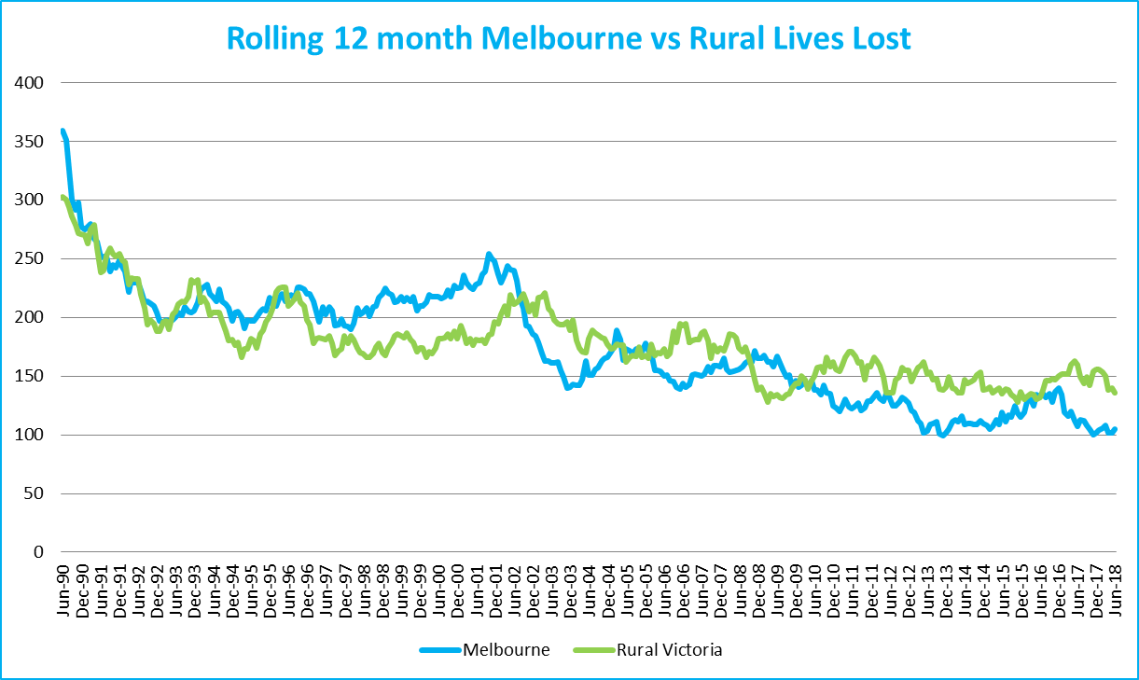

Graph 1a – Melbourne/country lives lost

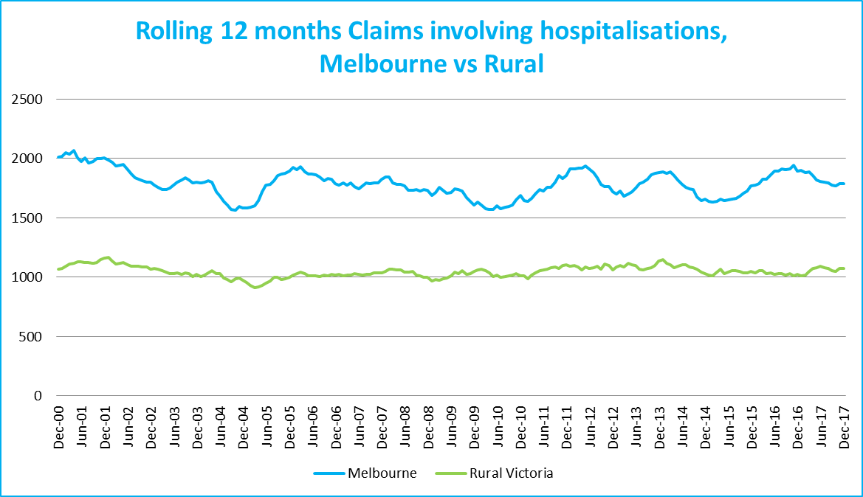

Graph 1b – Melbourne/country Claims involving an acute hospital admission

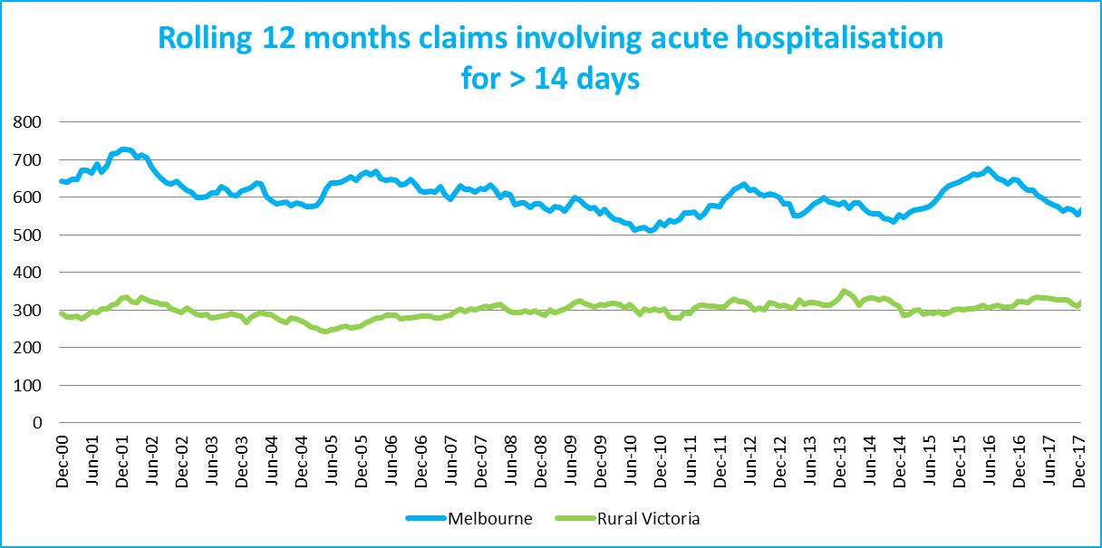

Graph 1c – Melbourne/country Claims involving hospital admission greater than 14 days

# 

# Victorian monthly lives lost since 1951

