

Quarterly Statistics – March 2019


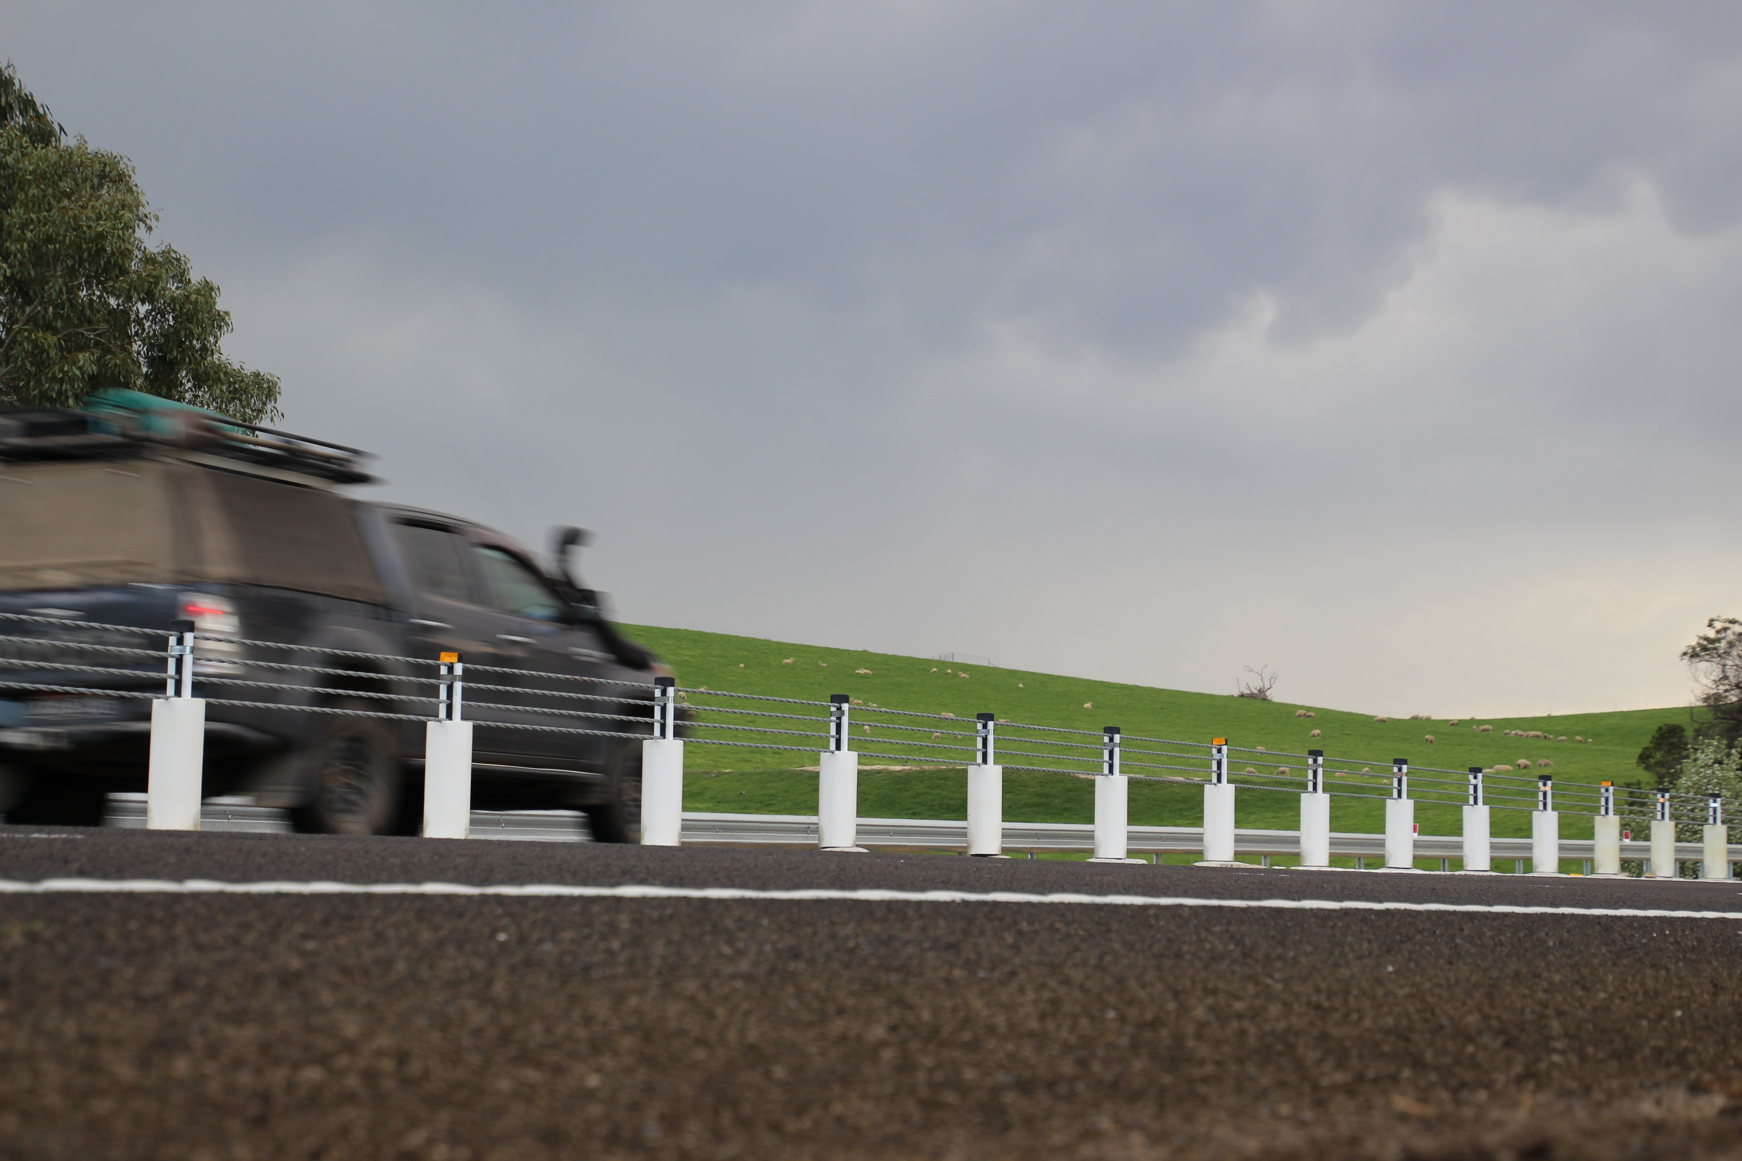

TRANSPORT  ACCIDENT  COMMISSION | 60 Brougham Street  Geelong Vic 3220  PO Box 742  Geelong Vic 3220  Ausdoc DX 216079 Geelong | Telephone 1300 654 329  STD Toll Free 1800 332 556  Fax: 03 9656 9300  www.tac.vic.gov.au  ABN 22 033 947 623

Contents

Status Report 4
Lives lost on Victorian roads 4
Injured claimants who were admitted to hospital within 7 days of accident, (by claim acceptance date – rolling 12 month, to 30 Sep 2018) 5
Lives lost: 12 months to 31 March 2019 6
Injured claimants who were admitted to hospital within 7 days of accident, 12 months to 30 Sep 2018 (claim acceptance date) 10
Lives Lost by Week (2013 to 2019) 12
The National Picture 13
Booze Bus Random Breath Testing 14
Random Drug Testing 14
Mobile Safety Camera Data 14
Explanations and References 15
Useful Internet Sites 16
Victorian monthly lives lost since 1951 19

Notes about the data in this report
- All data provided in this report is the data most recently available at time of production. Fatality data are updated to the end of report month. A 6-month lag applies to TAC claims data.
- Reported data will have one extra day of exposure for leap years.
- Data is subject to revision as additional information about known accidents/claims is received, and as new accident/claim reports are received and processed.

Status Report

Lives lost on Victorian roads

- The rolling 12 month number of lives lost to 31st March 2019 is 238. The rolling 12 month number of lives lost to 31st March 2018 stood at 258 (a decrease of 20).
- 81 people lost their lives year to date to the end of March 2019 on Victorian roads. This compares to 56 lives lost year to date to the end of March 2018 (an increase of 25).

Category | 2019 | 2018 | 2017 | 2019 v 2018 | 2019 v 2017 | 5 Year Average
Lives Lost (Rolling 12 Month Total)
Lives Lost (to March) | 238 | 258 | 268 | -20 | -30 | 254
per 10,000 veh | 0.48 | 0.53 | 0.56 | -0.05 | -0.08 | 0.54
per 100,000 pop | 3.66 | 4.06 | 4.30 | -0.40 | -0.64 | 4.16
Crashes (Rolling 12 Month Total)
Fatal crashes (to March) | 225 | 238 | 257 | -13 | -32 | 238
per 10,000 veh | 0.45 | 0.49 | 0.54 | -0.04 | -0.09 | 0.51
per 100,000 pop | 3.46 | 3.74 | 4.12 | -0.28 | -0.66 | 3.89

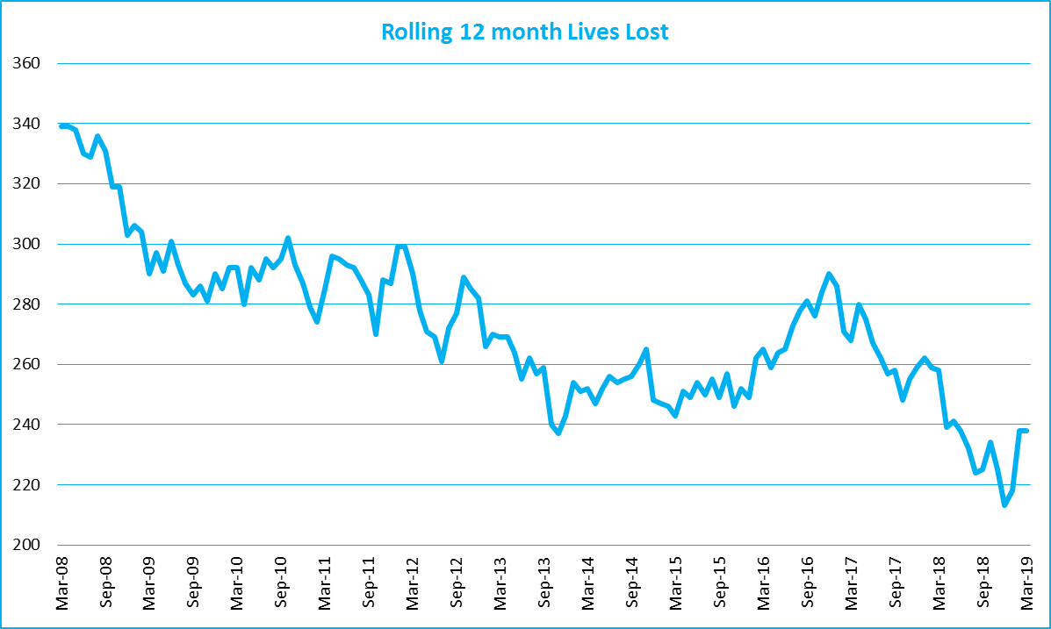

Victoria – Lives Lost, rolling 12 months total

Injured claimants who were admitted to hospital within 7 days of accident, (by claim acceptance date – rolling 12 month, to 30th September 2018)
Category | 2018 | 2017 | 2016 | 2018 v 2017 |  | 2018 v 2016 |  | 5 Year Average
Claims involving hospitalisation over 14 days (Rolling 12 Month Total)
Claims (to September) | 947 | 946 | 1,005 | +1.0 | (+0%) | -58 | (-6%) | 944
per 100,000 pop | 14.7 | 14.9 | 16.4 | -0.2 | (-1%) | -1.7 | (-10%) | 15.6
per 10,000 veh | 1.9 | 2.0 | 2.1 | -0.1 | (-5%) | -0.2 | (-10%) | 2.0
All claims involving hospitalisation (Rolling 12 Month Total)
Claims (to September) | 8,018 | 7,562 | 7,037 | +456 | (+6%) | +981 | (+14%) | 6948
per 100,000 pop | 124.8 | 119.0 | 115.0 | +5.8 | (+5%) | +9.8 | (+9%) | 109.2
per 10,000 veh | 16.2 | 15.7 | 15.0 | +0.6 | (+4%) | +1.2 | (+8%) | 14.2

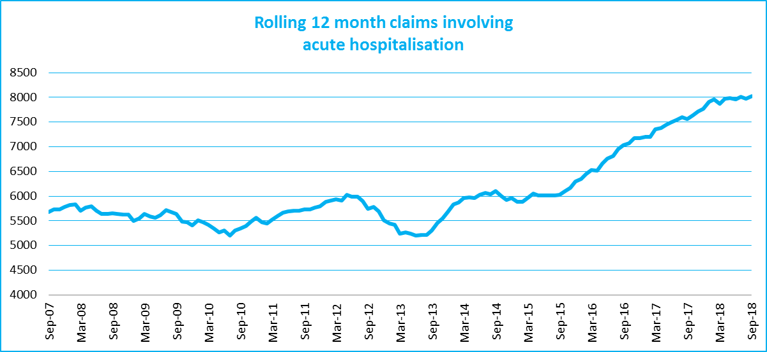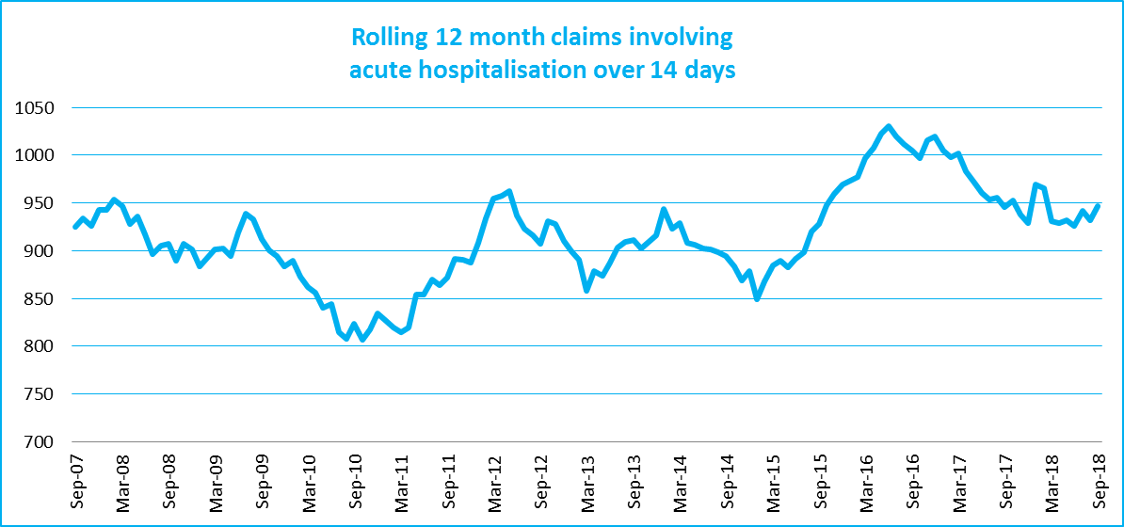

Lives lost: 12 months to 31st March 2019

Category | 2019 | 2018 | 2017 | 2019 v 2018 | 2019 v 2017 | 5 Year Average
Overview
Lives Lost | 238 | 258 | 268 | -20 | -30 | 254
Fatal Crashes | 225 | 238 | 257 | -13 | -32 | 238
Sex
Female | 65 | 69 | 77 | -4 | -12 | 70
Male | 173 | 189 | 191 | -16 | -18 | 185
Road user
Bicyclist | 10 | 11 | 6 | -1 | +4 | 9
Driver | 107 | 125 | 151 | -18 | -44 | 125
Motorcyclist | 47 | 41 | 40 | +6 | +7 | 41
Passenger | 35 | 47 | 36 | -12 | -1 | 43
Pedestrian | 39 | 34 | 35 | +5 | +4 | 37
Location
Melbourne | 106 | 109 | 116 | -3 | -10 | 114
Rural Victoria | 132 | 148 | 152 | -16 | -20 | 141
Age group
0-4 | 2 | 1 | 4 | +1 | -2 | 2
5-15 | 9 | 3 | 4 | +6 | +5 | 5
16-17 | 3 | 4 | 4 | -1 | -1 | 7
18-20 | 13 | 21 | 11 | -8 | +2 | 18
21-25 | 19 | 24 | 27 | -5 | -8 | 24
26-29 | 18 | 13 | 24 | +5 | -6 | 20
30-39 | 39 | 39 | 41 |  | -2 | 37
40-49 | 23 | 38 | 52 | -15 | -29 | 35
50-59 | 33 | 30 | 34 | +3 | -1 | 31
60-69 | 28 | 32 | 24 | -4 | +4 | 28
70+ | 50 | 53 | 42 | -3 | +8 | 47
Accident Type
Intersection
Adjacent direction | 33 | 34 | 28 | -1 | +5 | 31
Opposing direction | 8 | 11 | 5 | -3 | +3 | 9
Mid-block/other
Head on | 30 | 41 | 50 | -11 | -20 | 40
Same direction | 20 | 18 | 23 | +2 | -3 | 18
Manoeuvre/o'taking | 14 | 15 | 10 | -1 | +4 | 14
On path | 2 | 7 | 9 | -5 | -7 | 6
Single vehicle | 88 | 94 | 103 | -6 | -15 | 96
Other (incl peds) | 42 | 36 | 40 | +6 | +2 | 40

Lives Lost: 12 months to 31st March 2019 – Continued

Category | 2019 | 2018 | 2017 | 5 Year Average | Category | 2019 | 20178 | 2017 | 5 Year Average
Local Government Area |  |  |  |  | Local Government Area
ALPINE | 4 | 1 | 0 | 1 | MANSFIELD | 2 | 3 | 3 | 2
ARARAT | 1 | 1 | 1 | 2 | MARIBYRNONG | 3 | 5 | 2 | 2
BALLARAT | 3 | 4 | 7 | 4 | MAROONDAH | 6 | 1 | 2 | 1
BANYULE | 2 | 4 | 1 | 2 | MELBOURNE | 2 | 3 | 4 | 3
BASS COAST | 0 | 2 | 4 | 2 | MELTON | 7 | 3 | 4 | 4
BAW BAW | 4 | 2 | 3 | 2 | MILDURA | 5 | 1 | 2 | 2
BAYSIDE | 1 | 4 | 4 | 3 | MITCHELL | 1 | 5 | 3 | 3
BENALLA | 3 | 3 | 2 | 2 | MOIRA | 4 | 6 | 5 | 4
BOROONDARA | 3 | 3 | 4 | 2 | MONASH | 5 | 6 | 6 | 3
BRIMBANK | 4 | 4 | 11 | 6 | MOONEE VALLEY | 3 | 2 | 4 | 2
BULOKE | 2 | 1 | 2 | 1 | MOORABOOL | 4 | 5 | 7 | 3
CAMPASPE | 1 | 5 | 4 | 4 | MORELAND | 4 | 1 | 6 | 3
CARDINIA | 4 | 9 | 4 | 6 | MORNINGTON PENINSULA | 3 | 4 | 4 | 6
CASEY | 3 | 7 | 9 | 6 | MOUNT ALEXANDER | 2 | 3 | 0 | 2
CENTRAL GOLDFIELDS | 1 | 1 | 1 | 1 | MOYNE | 1 | 2 | 2 | 2
COLAC-OTWAY | 2 | 8 | 3 | 4 | MURRINDINDI | 4 | 6 | 4 | 5
CORANGAMITE | 2 | 3 | 1 | 3 | NILLUMBIK | 2 | 2 | 4 | 2
DAREBIN | 2 | 4 | 0 | 2 | NORTHERN GRAMPIANS | 5 | 3 | 3 | 2
EAST GIPPSLAND | 6 | 8 | 4 | 6 | PORT PHILLIP | 0 | 2 | 0 | 1
FRANKSTON | 1 | 6 | 1 | 3 | PYRENEES | 2 | 4 | 3 | 1
GANNAWARRA | 3 | 4 | 0 | 1 | QUEENSCLIFFE | 0 | 0 | 0 | 0
GLEN EIRA | 0 | 1 | 3 | 1 | SOUTH GIPPSLAND | 7 | 3 | 3 | 4
GLENELG | 5 | 4 | 4 | 4 | SOUTHERN GRAMPIANS | 2 | 1 | 4 | 2
GOLDEN PLAINS | 7 | 4 | 3 | 3 | STONNINGTON | 5 | 1 | 0 | 2
GREATER BENDIGO | 6 | 5 | 5 | 4 | STRATHBOGIE | 2 | 3 | 1 | 3
GREATER DANDENONG | 3 | 6 | 1 | 4 | SURF COAST | 1 | 3 | 2 | 3
GREATER GEELONG | 6 | 8 | 12 | 6 | SWAN HILL | 0 | 1 | 4 | 2
GREATER SHEPPARTON | 7 | 9 | 7 | 6 | TOWONG | 1 | 2 | 1 | 1
HEPBURN | 4 | 2 | 7 | 2 | WANGARATTA | 1 | 3 | 5 | 3
HINDMARSH | 0 | 0 | 0 | 1 | WARRNAMBOOL | 2 | 0 | 1 | 0
HORSHAM | 1 | 1 | 4 | 2 | WEST WIMMERA | 1 | 0 | 1 | 0
HUME | 7 | 3 | 3 | 4 | WHITEHORSE | 1 | 3 | 4 | 3
INDIGO | 2 | 2 | 5 | 3 | WHITTLESEA | 4 | 4 | 5 | 4
KINGSTON | 5 | 4 | 4 | 3 | WODONGA | 0 | 1 | 3 | 2
KNOX | 7 | 1 | 6 | 4 | WYNDHAM | 6 | 3 | 10 | 5
LATROBE | 5 | 3 | 3 | 3 | YARRA | 0 | 2 | 1 | 1
LODDON | 2 | 1 | 2 | 1 | YARRA RANGES | 9 | 8 | 5 | 6
MACEDON RANGES | 6 | 3 | 3 | 4 | YARRIAMBIACK | 0 | 1 | 2 | 1
MANNINGHAM | 2 | 3 | 3 | 2

Injured claimants who were admitted to hospital within 7 days of the accident with a hospital stay of more than 14 days, 12 months to 30th September 2018 (claim acceptance date)

Category | 2018 | 2017 | 2016 | 2018 v 2017 |  | 2018 v 2016 |  | 5 Year Average
Overview
Claims | 947 | 946 | 1,005 | +1 | 0% | -58 | -6% | 944
Sex
Female | 379 | 371 | 422 | +8 | 2% | -43 | -10% | 366
Male | 568 | 575 | 583 | -7 | -1% | -15 | -3% | 530
Road user
Bicyclist | 35 | 35 | 36 |  | 0% | -1 | -3% | 35
Driver | 351 | 327 | 398 | +24 | 7% | -47 | -12% | 339
Motorcyclist | 195 | 194 | 162 | +1 | 1% | +33 | 20% | 171
Passenger | 135 | 137 | 153 | -2 | -1% | -18 | -12% | 133
Pedestrian | 185 | 213 | 217 | -28 | -13% | -32 | -15% | 186
Train/Tram | 12 | 13 | 5 | -1 | -8% | +7 | 140% | 10
Location
Melbourne | 569 | 563 | 645 | +6 | 1% | -76 | -12% | 561
Rural Victoria | 303 | 329 | 307 | -26 | -8% | -4 | -1% | 293
Age group
0-4 | 4 | 2 | 7 | +2 | 100% | -3 | -43% | 3
5-15 | 6 | 8 | 17 | -2 | -25% | -11 | -65% | 12
16-17 | 11 | 14 | 13 | -3 | -21% | -2 | -15% | 12
18-20 | 30 | 52 | 72 | -22 | -42% | -42 | -58% | 48
21-25 | 86 | 94 | 87 | -8 | -9% | -1 | -1% | 82
26-29 | 55 | 57 | 57 | -2 | -4% | -2 | -4% | 52
30-39 | 121 | 126 | 136 | -5 | -4% | -15 | -11% | 114
40-49 | 123 | 107 | 106 | +16 | 15% | 17 | 16% | 108
50-59 | 117 | 124 | 98 | -7 | -6% | 19 | 19% | 108
60-69 | 115 | 113 | 128 | +2 | 2% | -13 | -10% | 107
70+ | 279 | 249 | 284 | +30 | 12% | -5 | -2% | 251
Accident Type
Intersection
Adjacent direction | 81 | 101 | 108 | -20 | -20% | -27 | -25% | 92
Opposing direction | 47 | 54 | 60 | -7 | -13% | -13 | -22% | 54
Mid-block/other
Head on | 47 | 65 | 106 | -18 | -28% | -59 | -56% | 74
Same direction | 61 | 64 | 69 | -3 | -5% | -8 | -12% | 68
Manoeuvre/overtaking | 50 | 46 | 59 | +4 | 9% | -9 | -15% | 49
On path | 26 | 19 | 32 | +7 | 37% | -6 | -19% | 26
Single vehicle | 215 | 242 | 299 | -27 | -11% | -84 | -28% | 246
Other (incl pedestrians) | 420 | 355 | 272 | +65 | 18% | 148 | 54% | 288

Note: Excludes rejected claims and claims for interstate crashes.
Injured claimants who were admitted to hospital within 7 days of the accident with a hospital stay of more than 14 days, 12 months to 30th September 2018 (claim acceptance date) – Continued
Category | 2018 | 2017 | 2016 | 5 Year Average | Category | 2018 | 2017 | 2016 | 5 Year Average
Local Government Area |  |  |  |  | Local Government Area
ALPINE | 4 | 5 | 2 | 3 | MANSFIELD | 8 | 8 | 5 | 4
ARARAT | 1 | 3 | 2 | 4 | MARIBYRNONG | 12 | 17 | 10 | 9
BALLARAT | 13 | 18 | 11 | 12 | MAROONDAH | 7 | 6 | 10 | 5
BANYULE | 13 | 9 | 9 | 7 | MELBOURNE | 40 | 35 | 32 | 25
BASS COAST | 10 | 5 | 4 | 6 | MELTON | 8 | 10 | 12 | 10
BAW BAW | 9 | 11 | 8 | 7 | MILDURA | 10 | 8 | 3 | 4
BAYSIDE | 5 | 14 | 10 | 8 | MITCHELL | 7 | 11 | 8 | 7
BENALLA | 7 | 4 | 3 | 3 | MOIRA | 10 | 10 | 7 | 6
BOROONDARA | 12 | 15 | 12 | 14 | MONASH | 17 | 26 | 21 | 17
BRIMBANK | 19 | 23 | 36 | 22 | MOONEE VALLEY | 19 | 11 | 25 | 14
BULOKE | 2 | 0 | 5 | 2 | MOORABOOL | 5 | 11 | 11 | 8
CAMPASPE | 5 | 14 | 7 | 7 | MORELAND | 30 | 30 | 28 | 21
CARDINIA | 15 | 22 | 16 | 12 | MORNINGTON PENINSULA | 22 | 22 | 31 | 19
CASEY | 30 | 32 | 39 | 24 | MOUNT ALEXANDER | 3 | 0 | 2 | 3
CENTRAL GOLDFIELDS | 4 | 1 | 4 | 1 | MOYNE | 4 | 7 | 3 | 3
COLAC-OTWAY | 6 | 9 | 8 | 7 | MURRINDINDI | 14 | 15 | 7 | 10
CORANGAMITE | 12 | 6 | 3 | 3 | NILLUMBIK | 3 | 4 | 9 | 6
DAREBIN | 18 | 18 | 30 | 15 | NORTHERN GRAMPIANS | 7 | 3 | 3 | 2
EAST GIPPSLAND | 9 | 13 | 8 | 8 | PORT PHILLIP | 12 | 13 | 18 | 13
FRANKSTON | 19 | 13 | 15 | 11 | PYRENEES | 1 | 1 | 2 | 2
GANNAWARRA | 1 | 4 | 2 | 2 | QUEENSCLIFFE | 1 | 0 | 1 | 0
GLEN EIRA | 15 | 7 | 17 | 10 | SOUTH GIPPSLAND | 8 | 6 | 15 | 7
GLENELG | 3 | 2 | 6 | 4 | SOUTHERN GRAMPIANS | 4 | 2 | 3 | 2
GOLDEN PLAINS | 3 | 6 | 9 | 5 | STONNINGTON | 14 | 13 | 14 | 11
GREATER BENDIGO | 22 | 19 | 14 | 10 | STRATHBOGIE | 4 | 5 | 11 | 5
GREATER DANDENONG | 24 | 26 | 27 | 18 | SURF COAST | 7 | 5 | 6 | 4
GREATER GEELONG | 23 | 34 | 17 | 19 | SWAN HILL | 3 | 3 | 8 | 3
GREATER SHEPPARTON | 15 | 22 | 20 | 12 | TOWONG | 3 | 2 | 3 | 2
HEPBURN | 4 | 2 | 3 | 2 | WANGARATTA | 4 | 7 | 6 | 4
HINDMARSH | 0 | 4 | 1 | 1 | WARRNAMBOOL | 1 | 4 | 3 | 3
HOBSONS BAY | 7 | 10 | 5 | 7 | WELLINGTON | 9 | 12 | 7 | 7
HORSHAM | 5 | 1 | 5 | 3 | WEST WIMMERA | 0 | 2 | 0 | 1
HUME | 25 | 28 | 34 | 22 | WHITEHORSE | 21 | 22 | 21 | 15
INDIGO | 3 | 4 | 9 | 4 | WHITTLESEA | 30 | 24 | 33 | 19
KINGSTON | 23 | 15 | 14 | 14 | WODONGA | 3 | 2 | 5 | 3
KNOX | 20 | 20 | 17 | 13 | WYNDHAM | 22 | 21 | 34 | 19
LATROBE | 14 | 4 | 13 | 7 | YARRA | 15 | 11 | 14 | 10
LODDON | 1 | 0 | 3 | 1 | YARRA RANGES | 34 | 29 | 34 | 25
MACEDON RANGES | 9 | 13 | 20 | 10 | YARRIAMBIACK | 2 | 1 | 1 | 0
MANNINGHAM | 18 | 17 | 18 | 11

Note: excludes rejected claims and claims for interstate crashes

Injured claimants who were admitted to hospital within 7 days of accident, 12 months to

30th September 2018 (claim acceptance date)

Category | 2018 | 2017 | 2016 | 2018 v 2017 |  | 2018 v 2016 |  | 5 Year Average
Overview
Claims | 8,018 | 7,562 | 7,037 | +456 | 6% | +981 | 14% | 6948
Sex
Female | 3,479 | 3,264 | 3,086 | +215 | 7% | +393 | 13% | 2,871
Male | 4,529 | 4,289 | 3,937 | +240 | 6% | +592 | 15% | 3,749
Road user
Bicyclist | 542 | 458 | 424 | +84 | 18% | +118 | 28% | 419
Driver | 3,804 | 3,598 | 3,340 | +206 | 6% | +464 | 14% | 3,102
Motorcyclist | 1,361 | 1,274 | 1,166 | +87 | 7% | +195 | 17% | 1,145
Passenger | 1,126 | 1,084 | 1,104 | +42 | 4% | +22 | 2% | 1,026
Pedestrian | 801 | 776 | 724 | +25 | 3% | +77 | 11% | 677
Train/Tram | 47 | 58 | 29 | -11 | -19% | +18 | 62% | 38
Location
Melbourne | 4,680 | 4,589 | 4,686 | +91 | 2% | -6 | 0% | 4,210
Rural Victoria | 2,271 | 2,202 | 1,985 | +69 | 3% | +286 | 14% | 1,905
Age group
0-4 | 62 | 64 | 56 | -2 | -3% | +6 | 11% | 52
5-15 | 227 | 203 | 227 | +24 | 12% |  | 0% | 205
16-17 | 139 | 114 | 131 | +25 | 22% | +8 | 6% | 114
18-20 | 568 | 551 | 540 | +17 | 3% | +28 | 5% | 499
21-25 | 1,017 | 959 | 891 | +58 | 6% | +126 | 14% | 831
26-29 | 684 | 652 | 610 | +32 | 5% | +74 | 12% | 559
30-39 | 1,295 | 1,192 | 1,127 | +103 | 9% | +168 | 15% | 1,049
40-49 | 1,151 | 1,130 | 989 | +21 | 2% | +162 | 16% | 967
50-59 | 1,061 | 1,034 | 853 | +27 | 3% | +208 | 24% | 862
60-69 | 793 | 699 | 700 | +94 | 13% | +93 | 13% | 629
70+ | 1,021 | 964 | 913 | +57 | 6% | +108 | 12% | 862
Accident Type
Intersection
Adjacent direction | 786 | 908 | 906 | -122 | -13% | -120 | -13% | 787
Opposing direction | 428 | 550 | 583 | -122 | -22% | -155 | -27% | 493
Mid-block/other
Head on | 285 | 332 | 380 | -47 | -14% | -95 | -25% | 307
Same direction | 855 | 982 | 1,067 | -127 | -13% | -212 | -20% | 897
Manoeuvre/o'taking | 350 | 360 | 399 | -10 | -3% | -49 | -12% | 341
On path | 224 | 228 | 323 | -4 | -2% | -99 | -31% | 257
Single vehicle | 1,276 | 1,615 | 1,799 | -339 | -21% | -523 | -29% | 1,536
Other (incl peds) | 3,814 | 2,587 | 1,580 | +1227 | 47% | +2234 | 141% | 2,011

Note: excludes rejected claims and claims for interstate crashes
Injured claimants who were admitted to hospital within 7 days of accident, 12 months to
30th September 2018 (claim acceptance date) – Continued

Category | 2017 | 2016 | 2015 | 5 Year Average | Category | 2017 | 2016 | 2015 | 5 Year Average
Local Government Area |  |  |  |  | Local Government Area
ALPINE | 25 | 27 | 25 | 19 | MANSFIELD | 39 | 35 | 40 | 25
ARARAT | 12 | 16 | 15 | 14 | MARIBYRNONG | 100 | 98 | 74 | 58
BALLARAT | 75 | 101 | 104 | 67 | MAROONDAH | 63 | 54 | 69 | 43
BANYULE | 71 | 61 | 58 | 44 | MELBOURNE | 318 | 322 | 348 | 218
BASS COAST | 56 | 30 | 47 | 34 | MELTON | 68 | 80 | 94 | 61
BAW BAW | 56 | 48 | 48 | 39 | MILDURA | 27 | 24 | 31 | 22
BAYSIDE | 75 | 87 | 94 | 63 | MITCHELL | 63 | 74 | 70 | 51
BENALLA | 23 | 23 | 19 | 16 | MOIRA | 34 | 44 | 40 | 28
BOROONDARA | 141 | 137 | 121 | 100 | MONASH | 205 | 203 | 196 | 149
BRIMBANK | 180 | 156 | 136 | 107 | MOONEE VALLEY | 152 | 113 | 150 | 95
BULOKE | 6 | 11 | 9 | 8 | MOORABOOL | 49 | 61 | 53 | 37
CAMPASPE | 43 | 58 | 48 | 34 | MORELAND | 202 | 181 | 168 | 122
CARDINIA | 120 | 138 | 150 | 96 | MORNINGTON PENINSULA | 179 | 178 | 171 | 124
CASEY | 305 | 342 | 352 | 236 | MOUNT ALEXANDER | 23 | 17 | 21 | 19
CENTRAL GOLDFIELDS | 16 | 17 | 15 | 10 | MOYNE | 45 | 29 | 22 | 16
COLAC-OTWAY | 81 | 53 | 44 | 32 | MURRINDINDI | 53 | 75 | 60 | 46
CORANGAMITE | 43 | 45 | 23 | 22 | NILLUMBIK | 32 | 34 | 50 | 30
DAREBIN | 103 | 118 | 113 | 78 | NORTHERN GRAMPIANS | 40 | 16 | 15 | 13
EAST GIPPSLAND | 62 | 67 | 52 | 44 | PORT PHILLIP | 158 | 137 | 142 | 109
FRANKSTON | 148 | 131 | 140 | 99 | PYRENEES | 9 | 12 | 12 | 9
GANNAWARRA | 8 | 14 | 10 | 9 | QUEENSCLIFFE | 9 | 3 | 1 | 1
GLEN EIRA | 132 | 112 | 132 | 87 | SOUTH GIPPSLAND | 35 | 44 | 53 | 31
GLENELG | 32 | 14 | 26 | 14 | SOUTHERN GRAMPIANS | 19 | 13 | 29 | 17
GOLDEN PLAINS | 47 | 59 | 41 | 30 | STONNINGTON | 136 | 130 | 151 | 107
GREATER BENDIGO | 134 | 132 | 107 | 80 | STRATHBOGIE | 37 | 36 | 41 | 28
GREATER DANDENONG | 254 | 260 | 269 | 197 | SURF COAST | 74 | 58 | 56 | 36
GREATER GEELONG | 452 | 389 | 225 | 201 | SWAN HILL | 15 | 16 | 24 | 14
GREATER SHEPPARTON | 88 | 121 | 116 | 73 | TOWONG | 22 | 14 | 20 | 12
HEPBURN | 33 | 23 | 31 | 20 | WANGARATTA | 35 | 27 | 42 | 26
HINDMARSH | 11 | 12 | 8 | 7 | WARRNAMBOOL | 26 | 35 | 29 | 19
HOBSONS BAY | 92 | 71 | 69 | 50 | WELLINGTON | 65 | 65 | 73 | 54
HORSHAM | 31 | 24 | 17 | 16 | WEST WIMMERA | 7 | 7 | 5 | 4
HUME | 261 | 251 | 230 | 164 | WHITEHORSE | 137 | 161 | 136 | 94
INDIGO | 20 | 27 | 27 | 17 | WHITTLESEA | 240 | 228 | 215 | 137
KINGSTON | 135 | 121 | 142 | 104 | WODONGA | 26 | 18 | 34 | 19
KNOX | 129 | 144 | 146 | 98 | WYNDHAM | 165 | 168 | 154 | 120
LATROBE | 68 | 58 | 70 | 44 | YARRA | 112 | 98 | 141 | 87
LODDON | 8 | 9 | 10 | 10 | YARRA RANGES | 180 | 178 | 178 | 131
MACEDON RANGES | 77 | 93 | 74 | 55 | YARRIAMBIACK | 12 | 7 | 3 | 4
MANNINGHAM | 87 | 97 | 97 | 63

Note: excludes rejected claims and claims for interstate crashes

Lives Lost by Week (2014 to 2019)
Week |  |  |  |  |  |  | Cumulative | 12 Month
Ending | 2014 | 2015 | 2016 | 2017 | 2018 | 2019 | 2019 | Moving Total
6-Jan | 0 | 3 | 2 | 2 | 6 | 1 | 1 | 208
13-Jan | 7 | 7 | 4 | 5 | 4 | 8 | 9 | 212
20-Jan | 5 | 5 | 3 | 4 | 3 | 3 | 12 | 212
27-Jan | 9 | 2 | 9 | 5 | 2 | 9 | 21 | 219
3-Feb | 6 | 10 | 5 | 3 | 6 | 6 | 27 | 219
10-Feb | 6 | 4 | 11 | 3 | 2 | 10 | 37 | 227
17-Feb | 7 | 7 | 6 | 5 | 6 | 11 | 48 | 232
24-Feb | 1 | 3 | 8 | 5 | 5 | 7 | 55 | 234
3-Mar | 6 | 4 | 7 | 4 | 4 | 7 | 62 | 237
10-Mar | 10 | 8 | 11 | 3 | 7 | 2 | 64 | 232
17-Mar | 2 | 7 | 7 | 6 | 4 | 7 | 71 | 235
24-Mar | 4 | 1 | 4 | 7 | 4 | 6 | 77 | 237
31-Mar | 8 | 5 | 2 | 5 | 3 | 4 | 81 | 238
7-Apr | 5 | 5 | 0 | 7 | 2
14-Apr | 5 | 4 | 3 | 9 | 0
21-Apr | 2 | 6 | 7 | 9 | 3
28-Apr | 2 | 7 | 3 | 2 | 3
5-May | 3 | 2 | 7 | 5 | 10
12-May | 4 | 7 | 5 | 7 | 6
19-May | 4 | 3 | 6 | 3 | 3
26-May | 7 | 5 | 6 | 2 | 5
2-Jun | 6 | 4 | 6 | 5 | 0
9-Jun | 2 | 5 | 3 | 3 | 3
16-Jun | 2 | 5 | 6 | 2 | 7
23-Jun | 3 | 3 | 5 | 6 | 0
30-Jun | 9 | 9 | 8 | 4 | 2
7-Jul | 6 | 7 | 2 | 7 | 1
14-Jul | 6 | 1 | 5 | 4 | 4
21-Jul | 3 | 3 | 6 | 8 | 6
28-Jul | 4 | 2 | 10 | 2 | 3
4-Aug | 4 | 6 | 6 | 1 | 5
11-Aug | 5 | 5 | 6 | 9 | 2
18-Aug | 6 | 12 | 5 | 8 | 3
25-Aug | 4 | 3 | 10 | 2 | 7
1-Sep | 6 | 5 | 7 | 7 | 2
8-Sep | 6 | 2 | 3 | 7 | 4
15-Sep | 4 | 3 | 4 | 4 | 7
22-Sep | 5 | 3 | 3 | 3 | 3
29-Sep | 2 | 6 | 7 | 3 | 5
6-Oct | 4 | 5 | 1 | 2 | 5
13-Oct | 8 | 5 | 6 | 5 | 5
20-Oct | 0 | 6 | 3 | 5 | 1
27-Oct | 8 | 8 | 9 | 0 | 7
3-Nov | 2 | 4 | 3 | 3 | 7
10-Nov | 5 | 4 | 7 | 10 | 1
17-Nov | 9 | 4 | 4 | 5 | 6
24-Nov | 1 | 3 | 9 | 6 | 9
1-Dec | 12 | 5 | 5 | 8 | 3
8-Dec | 5 | 8 | 7 | 5 | 2
15-Dec | 3 | 2 | 6 | 6 | 5
22-Dec | 2 | 2 | 4 | 8 | 5
29-Dec | 3 | 6 | 6 | 9 | 4
31-Dec | 0 | 1 | 2 | 1 | 1
Total | 248 | 252 | 290 | 259 | 213 | 81

The National Picture
State | Lives Lost (12 months to March)
 | 2019 | 2018 | 2017 | 2016 | 2019 v 2018
NSW | 370 | 406 | 367 | 362 | -36 | (-9%)
VIC | 238 | 258 | 268 | 265 | -20 | (-8%)
QLD | 232 | 256 | 250 | 252 | -24 | (-9%)
SA | 91 | 102 | 84 | 101 | -11 | (-11%)
WA | 169 | 162 | 181 | 171 | +7 | (+4%)
TAS | 30 | 41 | 30 | 34 | -11 | (-27%)
NT | 42 | 38 | 44 | 50 | +4 | (+11%)
ACT | 7 | 5 | 12 | 16 | +2 | (+40%)
AUST TOTAL | 1,179 | 1,268 | 1,236 | 1,251 | -89 | (-7%)
AUST minus VIC | 941 | 1,010 | 968 | 986 | -69 | (-7%)

State | Lives Lost per 10,000 registered vehicles |  |  | Fatalities per 100,000 population
 | (12 months to March) |  |  | (12 months to March)
 | 2018 | 2017 | 2016 | 2018 | 2017 | 2016
NSW | 0.65 | 0.73 | 0.67 | 4.62 | 5.14 | 4.72
VIC | 0.48 | 0.53 | 0.56 | 3.66 | 4.06 | 4.31
QLD | 0.56 | 0.64 | 0.64 | 4.61 | 5.17 | 5.13
SA | 0.64 | 0.73 | 0.61 | 5.23 | 5.91 | 4.90
WA | 0.75 | 0.73 | 0.82 | 6.50 | 6.28 | 7.06
TAS | 0.61 | 0.86 | 0.64 | 5.67 | 7.83 | 5.78
NT | 2.51 | 2.47 | 2.82 | 16.99 | 15.36 | 17.87
ACT | 0.23 | 0.17 | 0.41 | 1.65 | 1.21 | 2.94
AUST TOTAL | 0.61 | 0.67 | 0.66 | 4.70 | 5.13 | 5.08
AUST minus VIC | 0.65 | 0.71 | 0.70 | 5.06 | 5.51 | 5.35

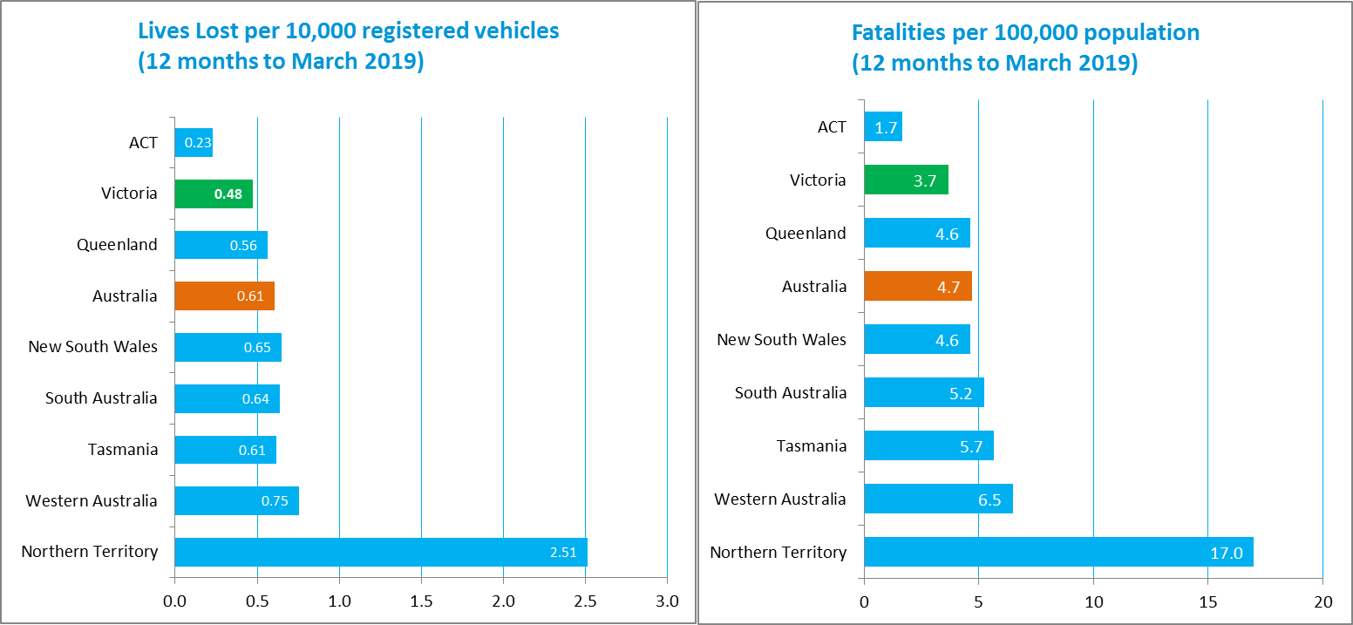

Booze Bus Random Breath Testing

Booze-bus Random Breath Tests (12 months to March 2019 vs previous 12 months)
 | 2019 | 2018 | 2017 | 2019 v 2018 |  | 2019 v 2017
Melbourne | 1,226,599 | 1,143,717 | 1,002,724 | +82882 | (+7%) | +223875 | (+22%)
Country | 115,731 | 142,698 | 128,948 | -26967 | (-19%) | -13217 | (-10%)
Vic Total | 1,342,330 | 1,286,415 | 1,131,672 | +55915 | (+4%) | +210658 | (+19%)

Booze-bus Random Breath Tests (12 months to March 2019 – monthly totals)
 | 2018 |  |  |  |  |  |  |  |  | 2019
 | Apr | May | Jun | Jul | Aug | Sep | Oct | Nov | Dec | Jan | Feb | Mar
Melbourne | 103,691 | 91,213 | 120,916 | 103,223 | 101,598 | 108,825 | 113,012 | 93,870 | 102,860 | 112,856 | 85,590 | 88,945
Country | 10,838 | 15,444 | 9,947 | 7,360 | 7,170 | 5,212 | 8,008 | 11,494 | 11,238 | 10,084 | 9,107 | 9,829
Vic Total | 114,529 | 106,657 | 130,863 | 110,583 | 108,768 | 114,037 | 121,020 | 105,364 | 114,098 | 122,940 | 94,697 | 98,774

Random Drug Testing
Random Drug Tests (12 months to March 2019 vs previous 12 months)
2019 | 2018 | 2017 | 2019 v 2018 |  | 2019 v 2017
140,956 | 103,013 | 95,210 | +37943 | (+37%) | +45746 | (+48%)

Random Drug Tests (12 months to March 2019 – monthly totals)
2018 |  |  |  |  |  |  |  |  |  | 2019
Apr | May | Jun | Jul | Aug | Sep | Oct | Nov | Dec | Jan |  | Feb | Mar
9,096 | 9,172 | 8,651 | 9,224 | 10,129 | 12,000 | 12,400 | 13,622 | 15,855 | 12,905 |  | 12,137 | 15,765

Mobile Safety Camera Data
Speed Infringements issued from Mobile Cameras (12 months to March 2019 - monthly totals)
Monthly Average=30,737
2018 |  |  |  |  |  |  |  |  | 2019
Apr | May | Jun | Jul | Aug | Sep | Oct | Nov | Dec | Jan | Feb | Mar
34,027 | 36,169 | 31,965 | 33,201 | 30,570 | 22,868 | 34,321 | 27,462 | 26,585 | 31,879 | 31,592 | 28,201

Excessive Speed Infringements (ESI) issued from Mobile Cameras (12 months to March 2018 - monthly totals)
Monthly Average=293
2018 |  |  |  |  |  |  |  |  | 2019
Apr | May | Jun | Jul | Aug | Sep | Oct | Nov | Dec | Jan | Feb | Mar
391 | 406 | 404 | 291 | 303 | 199 | 309 | 267 | 218 | 246 | 258 | 220

Notes: An ESI is defined as 25km/h over the speed limit except in a 110km/h zone where it is 20km/h over the limit.

Explanations and References
LGA: Local Government Areas. Crash locations for acute hospitalised claims are assigned to LGA’s based on the crash postcode recorded by Victoria Police. Crash locations for fatal crashes are coded exactly to an LGA by Victoria Police.
Claimants: Refers to people injured in transport accidents who have an accepted claim with the TAC.
Hospitalisation: refers to all hospital admission that occurred within 7 days of accident.

Useful Internet Sites
TAC Sites
- TAC Safety (Road Safety) www.tacsafety.com.au
- TAC How safe is your car www.howsafeisyourcar.com.au
- TAC How safe is your first car www.howsafeisyourfirstcar.com.au
- TAC Motorcycle Safety Website www.spokes.com.au
- TAC Corporate site www.tac.vic.gov.au
- Drivesmart www.drivesmart.vic.gov.au
- Ridesmart www.ridesmartonline.com.au
Victorian Sites:
- VicRoads www.vicroads.vic.gov.au
- Victoria Police www.police.vic.gov.au
- Parliamentary Road Safety Committee https://www.parliament.vic.gov.au/57th-parliament/rsc
- RACV www.racv.com.au
- Monash University Accident Research Centre www.monash.edu.au/muarc
- Cameras Save Lives www.camerassavelives.vic.gov.au
- VicRoads Learner Driver Site www.lsite.vicroads.vic.gov.au/Learners
- Road Safety Education Victoria www.roadsafetyeducation.vic.gov.au
National and Interstate Sites:
- ARRB Transport Research www.arrb.com.au
- Australian Transport Safety Bureau www.atsb.gov.au
- Motor Accidents Authority (NSW) www.maa.nsw.gov.au
- Motor Accidents Insurance Board (TAS) www.maib.tas.gov.au
- Motor Accident Commission, Allianz (SA) www.mac.sa.gov.au
- Motor Accidents Compensation, TIO, (NT) www.tiofi.com.au/mac
- Insurance Commission of Western Australia www.icwa.wa.gov.au
- Motor Accident Insurance Commission (QLD) www.maic.qld.gov.au
International Sites:
- National Highway Traffic Safety Admin (USA) www.nhtsa.dot.gov
- Swedish Road and Transport Institute (VTI) www.vti.se
- SWOV Institute for Road Safety Research www.swov.nl
Related Sites:
- Alcohol and Drug Foundation www.adf.org.au
Figures

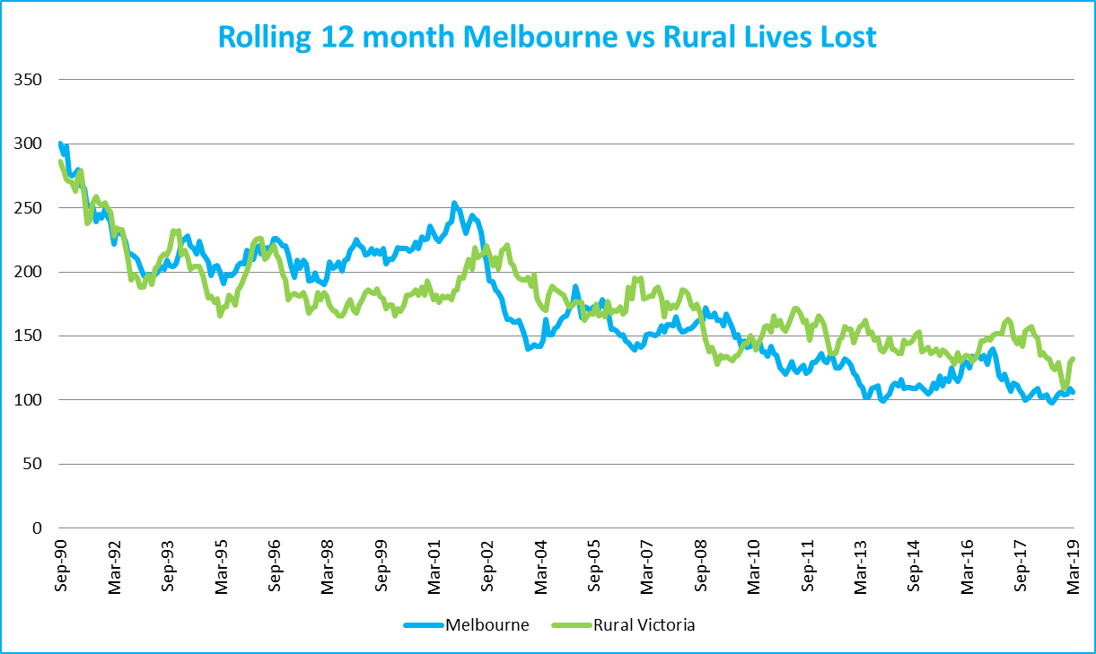
Graph 1a – Melbourne/Rural lives lost

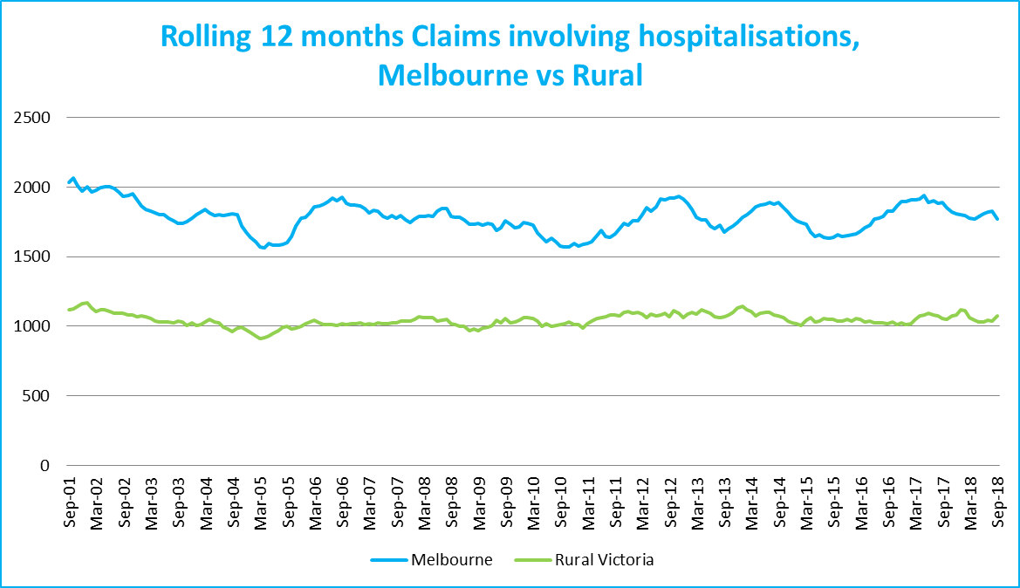???
Graph 1b – Melbourne/Rural claims involving an acute hospital admission

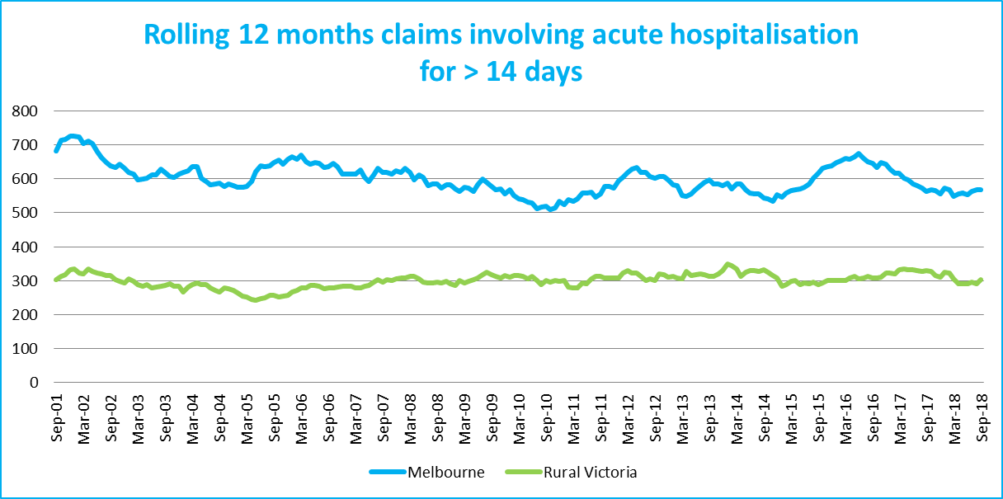
Graph 1c – Melbourne/Rural Claims involving hospital admission greater than 14 days

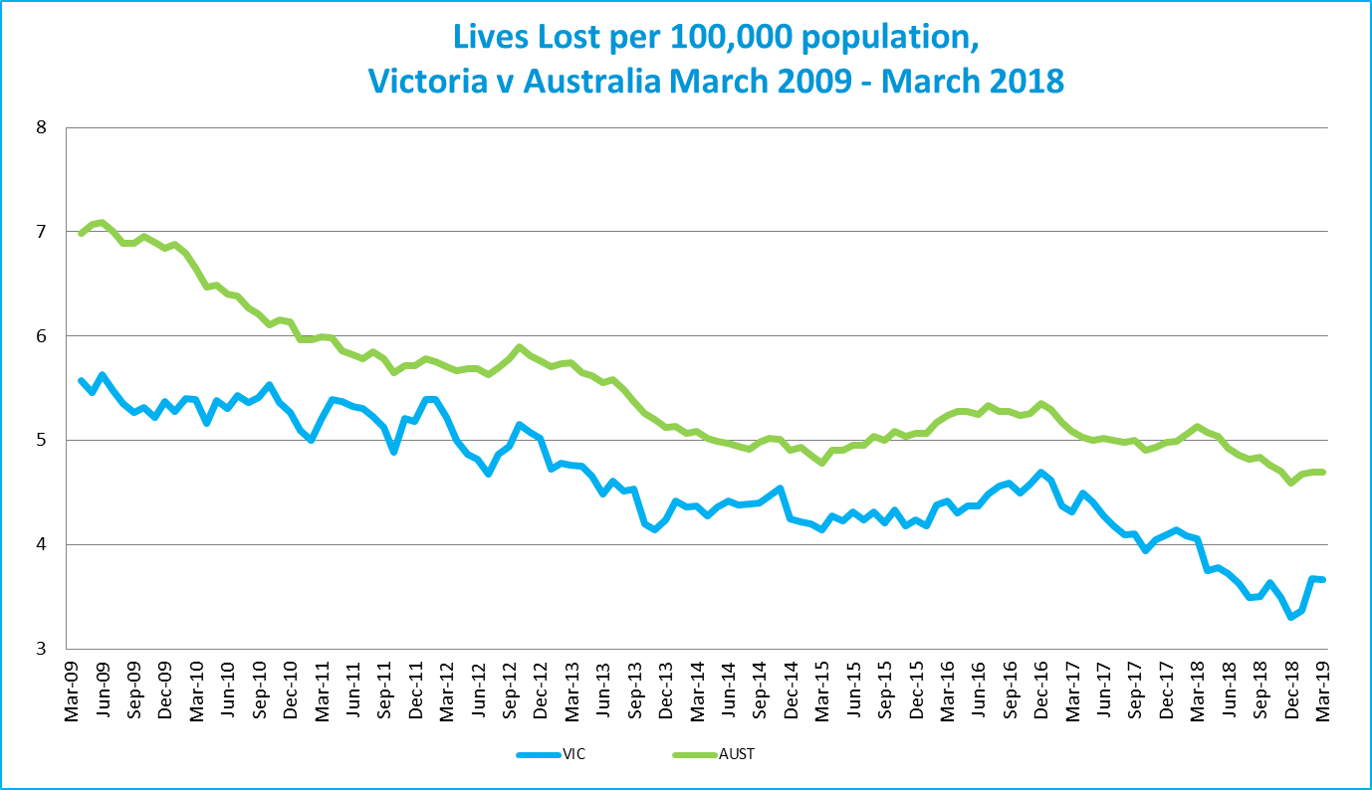
Graph 1d – Victoria/Australia lives lost per 100,000 population

Victorian monthly lives lost since 1951


