

Quarterly Statistics – December 2020


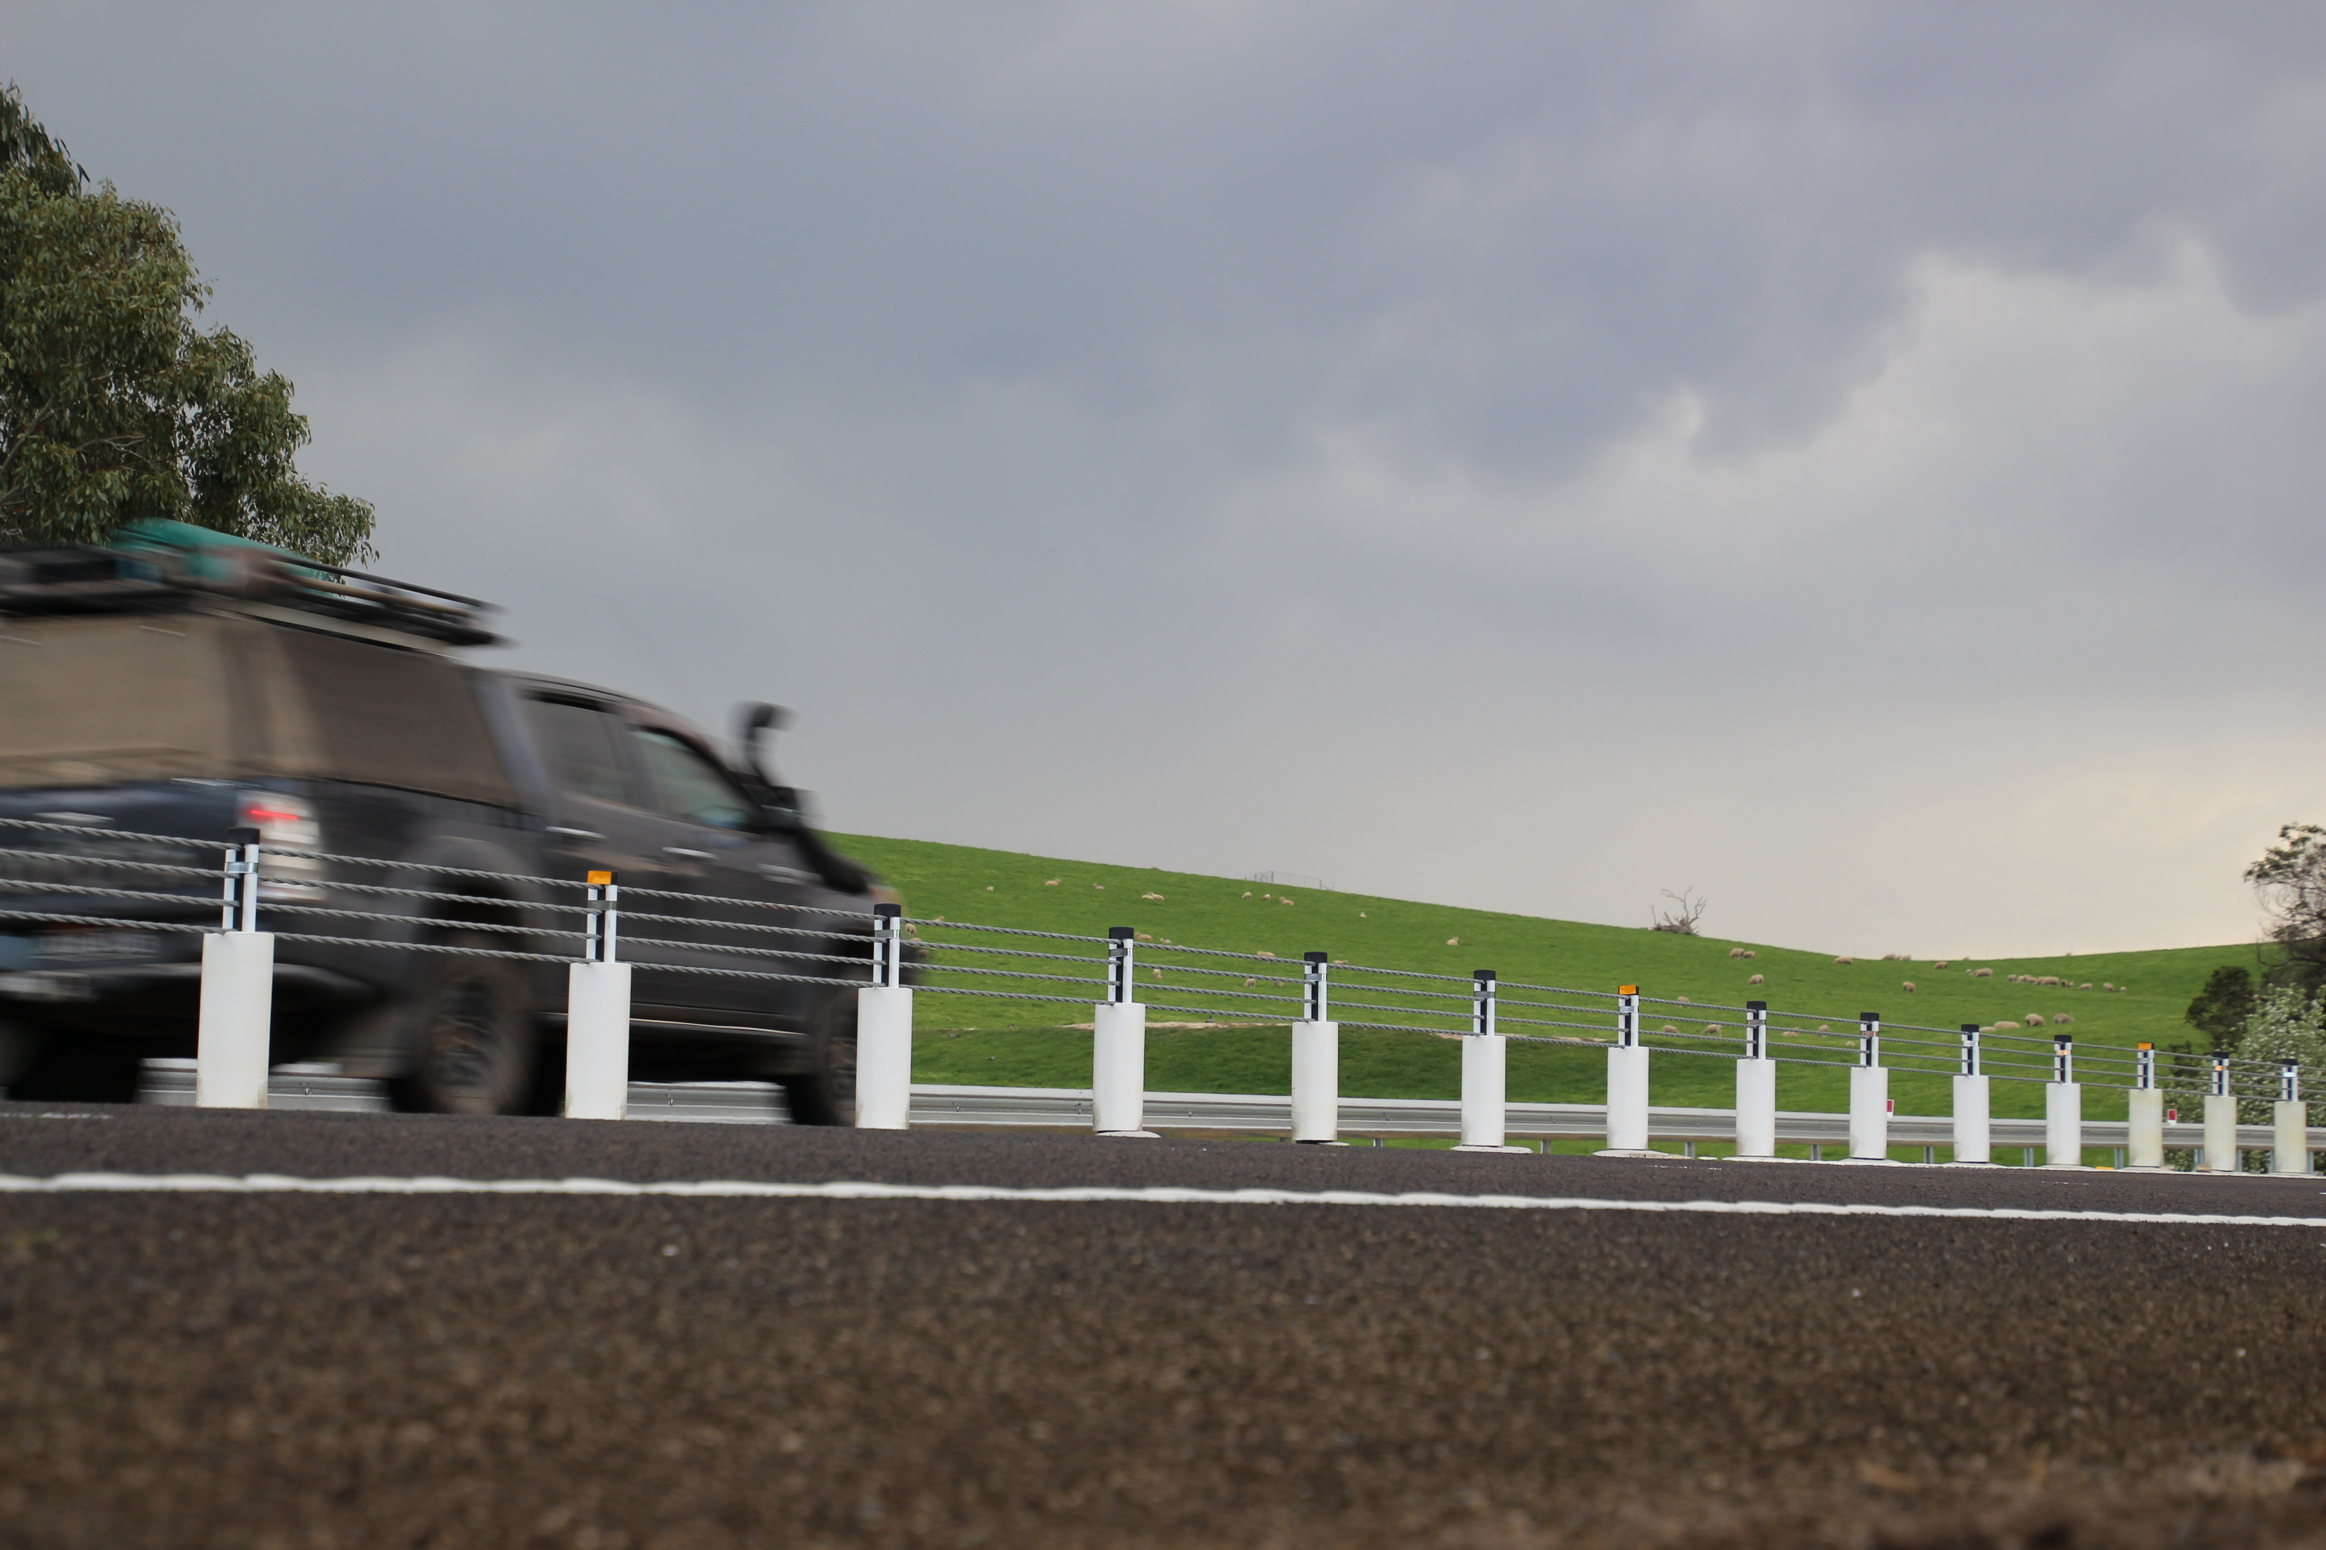

TRANSPORT  ACCIDENT  COMMISSION | 60 Brougham Street  Geelong Vic 3220  PO Box 742  Geelong Vic 3220  Ausdoc DX 216079 Geelong | Telephone 1300 654 329  STD Toll Free 1800 332 556  Fax: 03 9656 9300  www.tac.vic.gov.au  ABN 22 033 947 623

Contents

Status Report 4
Lives lost on Victorian roads 4
Injured claimants who were admitted to hospital within 7 days of accident, rolling 12 month to 30th June 2020 (claim acceptance date) 5
Lives lost: 12 months to 31st December 2020 6
Injured claimants who were admitted to hospital within 7 days of accident, 12 months to 30th June 2020 (claim acceptance date) 10
Lives Lost by Week (2015 to 2020) 12
The National Picture 13
Booze Bus Random Breath Testing 14
Random Drug Testing 14
Mobile Safety Camera Data 14
Explanations and References 15
Useful Internet Sites 16
Victorian monthly lives lost since 1951 20

Notes about the data in this report
- All data provided in this report is the data most recently available at time of production. Fatality data are updated to the end of report month. A 6-month lag applies to TAC claims data.
- Reported data will have one extra day of exposure for leap years.
- Data is subject to revision as additional information about known accidents/claims is received, and as new accident/claim reports are received and processed.

Status Report

Lives lost on Victorian roads

- In a 12-month period from 1st January 2020 to the end of December 2020, 211 people lost their lives compared to 266 people lost their lives during the previous 12-month period from January 2019 to December 2019. This represents 55 less lives lost.

Category | 2020 | 2019 | 2018 | 2020 v 2019 | 2020 v 2018 | 5 Year Average
Lives Lost (Rolling 12 Month Total)
Lives Lost (to December) | 211 | 266 | 213 | -55 | -2 | 248
per 10,000 veh | 0.41 | 0.52 | 0.43 | -0.11 | -0.02 | 0.52
per 100,000 pop | 3.15 | 4.03 | 3.30 | -0.88 | -0.15 | 3.96
Crashes (Rolling 12 Month Total)
Fatal crashes (to December) | 195 | 248 | 202 | -53 | -7 | 232
per 10,000 veh | 0.38 | 0.49 | 0.41 | -0.11 | -0.03 | 0.48
per 100,000 pop | 2.91 | 3.76 | 3.13 | -0.85 | -0.22 | 3.71

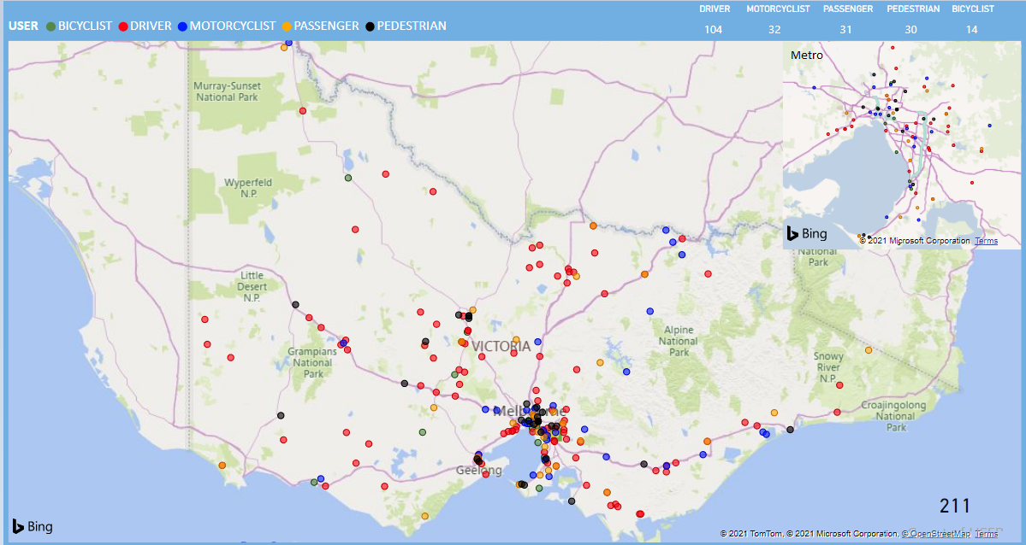
Victoria – Lives Lost, 12 months to December 2020

Injured claimants who were admitted to hospital within 7 days of accident, rolling 12 month to 30th June 2020 (claim acceptance date)
Category | 2020 | 2019 | 2018 | 2020 v 2019 |  | 2020 v 2018 |  | 5 Year Average
Claims involving an hospitalisation over 14 days (Rolling 12 Month Total)
Claims (to June) | 760 | 923 | 924 | -163 | (-18%) | -164 | (-18%) | 919
per 100,000 pop | 11.4 | 14.1 | 14.5 | -2.7 | (-19%) | -3.1 | (-21%) | 15.0
per 10,000 veh | 1.5 | 1.8 | 1.9 | -0.3 | (-17%) | -0.4 | (-21%) | 2.0
All claims involving an hospitalisation (Rolling 12 Month Total)
Claims (to June) | 6,389 | 8,263 | 7,959 | -1874 | (-23%) | -1570 | (-20%) | 7,373
per 100,000 pop | 96.1 | 126.6 | 124.5 | -30.5 | (-24%) | -28.4 | (-23%) | 117.2
per 10,000 veh | 12.5 | 16.5 | 16.2 | -4.0 | (-24%) | -3.7 | (-23%) | 15.3

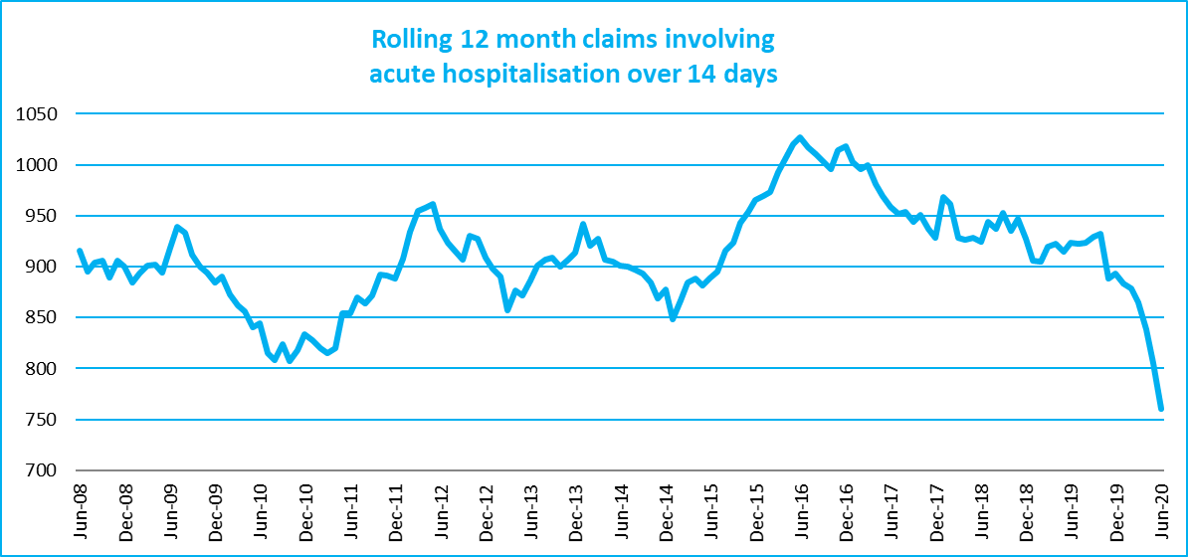

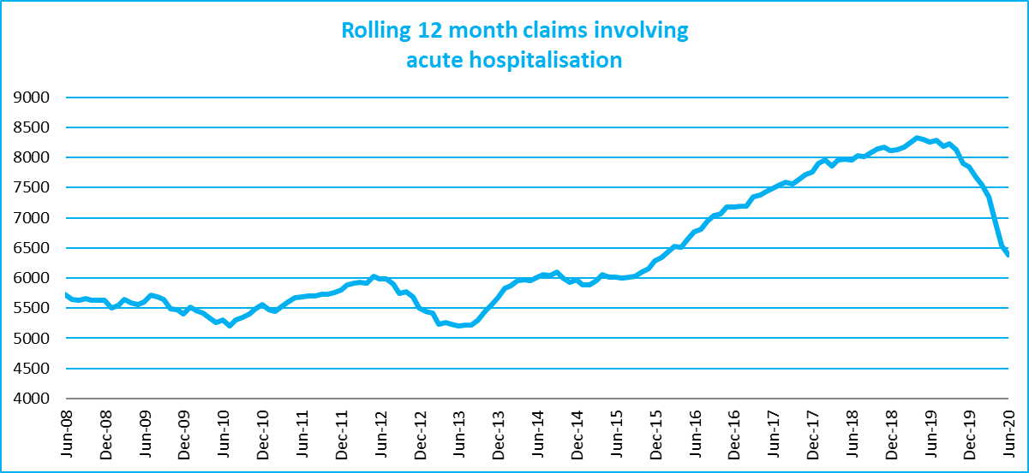

Lives lost: 12 months to 31st December 2020

Category | 2020 | 2019 | 2018 | 2020 v 2019 | 2020 v 2018 | 5 Year Average
Overview
Lives Lost | 211 | 266 | 213 | -55 | -2 | 248
Fatal Crashes | 195 | 248 | 202 | -53 | -7 | 232
Sex
Female | 52 | 68 | 59 | -16 | -7 | 66
Male | 159 | 198 | 154 | -39 | +5 | 182
Road user
Bicyclist | 14 | 11 | 7 | +3 | +7 | 10
Driver | 104 | 114 | 98 | -10 | +6 | 119
Motorcyclist | 32 | 44 | 38 | -12 | -6 | 42
Passenger | 31 | 48 | 33 | -17 | -2 | 39
Pedestrian | 30 | 49 | 37 | -19 | -7 | 37
Location
Melbourne | 85 | 120 | 104 | -35 | -19 | 110
Rural Victoria | 126 | 146 | 109 | -20 | +17 | 137
Age group
0-4 | 3 | 1 | 1 | +2 | +2 | 2
5-15 | 2 | 6 | 8 | -4 | -6 | 5
16-17 | 4 | 6 | 1 | -2 | +3 | 4
18-20 | 9 | 24 | 12 | -15 | -3 | 16
21-25 | 22 | 26 | 16 | -4 | +6 | 24
26-29 | 22 | 20 | 16 | +2 | +6 | 19
30-39 | 40 | 33 | 39 | +7 | +1 | 38
40-49 | 26 | 28 | 20 | -2 | +6 | 34
50-59 | 26 | 30 | 30 | -4 | -4 | 30
60-69 | 21 | 36 | 27 | -15 | -6 | 28
70+ | 36 | 56 | 42 | -20 | -6 | 47
Accident Type
Intersection
Adjacent direction | 21 | 30 | 28 | -9 | -7 | 28
Opposing direction | 10 | 9 | 6 | +1 | +4 | 9
Mid-block/other
Head on | 17 | 42 | 28 | -25 | -11 | 37
Same direction | 24 | 19 | 19 | +5 | +5 | 21
Manoeuvre/o'taking | 14 | 17 | 11 | -3 | +3 | 14
On path | 6 | 5 | 2 | +1 | +4 | 6
Single vehicle | 85 | 88 | 79 | -3 | +6 | 92
Other (incl peds) | 34 | 56 | 40 | -22 | -6 | 41

Lives Lost: 12 months to 31st December 2020 (claim acceptance date) – Continued

Category | 2020 | 2019 | 2018 | 5 Year Average | Category | 2020 | 2019 | 2018 | 5 Year Average
Local Government Area |  |  |  |  | Local Government Area
ALPINE | 1 | 2 | 4 | 1 | MANSFIELD | 1 | 1 | 2 | 2
ARARAT | 0 | 3 | 1 | 2 | MARIBYRNONG | 2 | 2 | 3 | 3
BALLARAT | 2 | 2 | 3 | 4 | MAROONDAH | 1 | 4 | 3 | 2
BANYULE | 2 | 1 | 2 | 2 | MELBOURNE | 3 | 2 | 2 | 3
BASS COAST | 2 | 3 | 0 | 2 | MELTON | 1 | 4 | 6 | 5
BAW BAW | 1 | 4 | 4 | 3 | MILDURA | 3 | 7 | 2 | 3
BAYSIDE | 1 | 0 | 2 | 2 | MITCHELL | 4 | 2 | 1 | 4
BENALLA | 0 | 0 | 3 | 2 | MOIRA | 3 | 4 | 3 | 5
BOROONDARA | 6 | 3 | 4 | 3 | MONASH | 5 | 10 | 4 | 6
BRIMBANK | 1 | 9 | 6 | 7 | MOONEE VALLEY | 1 | 1 | 4 | 2
BULOKE | 2 | 2 | 0 | 1 | MOORABOOL | 2 | 7 | 1 | 4
CAMPASPE | 3 | 3 | 2 | 3 | MORELAND | 0 | 3 | 3 | 3
CARDINIA | 3 | 3 | 7 | 6 | MORNINGTON PENINSULA | 9 | 12 | 2 | 7
CASEY | 4 | 6 | 4 | 7 | MOUNT ALEXANDER | 7 | 2 | 3 | 2
CENTRAL GOLDFIELDS | 3 | 2 | 0 | 1 | MOYNE | 2 | 2 | 1 | 2
COLAC-OTWAY | 1 | 3 | 4 | 4 | MURRINDINDI | 2 | 3 | 4 | 5
CORANGAMITE | 3 | 4 | 1 | 3 | NILLUMBIK | 3 | 1 | 3 | 2
DAREBIN | 5 | 3 | 1 | 3 | NORTHERN GRAMPIANS | 4 | 1 | 7 | 3
EAST GIPPSLAND | 9 | 2 | 5 | 6 | PORT PHILLIP | 2 | 1 | 0 | 1
FRANKSTON | 5 | 6 | 3 | 3 | PYRENEES | 1 | 2 | 1 | 2
GANNAWARRA | 1 | 1 | 3 | 1 | QUEENSCLIFFE | 0 | 0 | 0 | 0
GLEN EIRA | 1 | 3 | 0 | 2 | SOUTH GIPPSLAND | 7 | 5 | 7 | 4
GLENELG | 2 | 3 | 3 | 4 | SOUTHERN GRAMPIANS | 1 | 2 | 1 | 2
GOLDEN PLAINS | 2 | 5 | 2 | 4 | STONNINGTON | 0 | 1 | 4 | 2
GREATER BENDIGO | 6 | 8 | 6 | 6 | STRATHBOGIE | 1 | 1 | 1 | 2
GREATER DANDENONG | 1 | 5 | 2 | 4 | SURF COAST | 0 | 0 | 2 | 2
GREATER GEELONG | 10 | 14 | 5 | 8 | SWAN HILL | 1 | 3 | 1 | 2
GREATER SHEPPARTON | 7 | 7 | 4 | 7 | TOWONG | 0 | 4 | 0 | 2
HEPBURN | 4 | 4 | 4 | 3 | WANGARATTA | 3 | 0 | 2 | 3
HINDMARSH | 0 | 0 | 0 | 1 | WARRNAMBOOL | 3 | 0 | 2 | 1
HORSHAM | 3 | 5 | 2 | 3 | WEST WIMMERA | 3 | 3 | 0 | 1
HUME | 2 | 9 | 8 | 6 | WHITEHORSE | 2 | 1 | 1 | 3
INDIGO | 3 | 1 | 3 | 3 | WHITTLESEA | 5 | 4 | 3 | 4
KINGSTON | 3 | 5 | 3 | 4 | WODONGA | 1 | 1 | 0 | 1
KNOX | 2 | 1 | 7 | 4 | WYNDHAM | 4 | 8 | 4 | 7
LATROBE | 6 | 4 | 4 | 4 | YARRA | 1 | 1 | 1 | 1
LODDON | 2 | 4 | 1 | 2 | YARRA RANGES | 8 | 9 | 7 | 8
MACEDON RANGES | 1 | 7 | 1 | 4 | YARRIAMBIACK | 0 | 1 | 0 | 1
MANNINGHAM | 0 | 2 | 3 | 2

Injured claimants admitted to hospital within 7 days of the accident with a hospital stay of more than 14 days, 12 months to 30th June 2020 (claim acceptance date)

Category |  | 2020 | 2019 | 2018 | 2020 v 2019 |  | 2020 v 2018 |  | 5 Year Average
Overview
Claims |  | 760 | 923 | 924 | -163 | -18% | -164 | -18% | 919
Sex
Female |  | 306 | 377 | 362 | -71 | -19% | -56 | -15% | 374
Male |  | 453 | 546 | 562 | -93 | -17% | -109 | -19% | 544
Road user
Bicyclist |  | 34 | 31 | 37 | +3 | 10% | -3 | -8% | 37
Driver |  | 292 | 342 | 331 | -50 | -15% | -39 | -12% | 343
Motorcyclist |  | 154 | 187 | 189 | -33 | -18% | -35 | -19% | 177
Passenger |  | 103 | 135 | 136 | -32 | -24% | -33 | -24% | 133
Pedestrian |  | 147 | 191 | 195 | -44 | -23% | -48 | -25% | 194
Train/Tram |  | 3 | 12 | 11 | -9 | -75% | -8 | -73% | 8
Location
Melbourne |  | 463 | 542 | 555 | -79 | -15% | -92 | -17% | 564
Rural Victoria |  | 265 | 319 | 292 | -54 | -17% | -27 | -9% | 303
Age group
0-4 |  | 3 | 3 | 4 |  | 0% | -1 | -25% | 4
5-15 |  | 14 | 17 | 8 | -3 | -18% | 6 | 75% | 13
16-17 |  | 13 | 15 | 9 | -2 | -13% | 4 | 44% | 13
18-20 |  | 35 | 46 | 33 | -11 | -24% | 2 | 6% | 47
21-25 |  | 54 | 74 | 94 | -20 | -27% | -40 | -43% | 79
26-29 |  | 43 | 52 | 61 | -9 | -17% | -18 | -30% | 52
30-39 |  | 82 | 104 | 113 | -22 | -21% | -31 | -27% | 114
40-49 |  | 92 | 102 | 104 | -10 | -10% | -12 | -12% | 105
50-59 |  | 89 | 127 | 122 | -38 | -30% | -33 | -27% | 115
60-69 |  | 113 | 105 | 119 | +8 | 8% | -6 | -5% | 116
70+ |  | 222 | 278 | 257 | -56 | -20% | -35 | -14% | 260
Accident Type
Intersection
Adjacent direction |  | 77 | 83 | 79 | -6 | -7% | -2 | -3% | 91
Opposing direction |  | 43 | 54 | 53 | -11 | -20% | -10 | -19% | 56
Mid-block/other
Head on |  | 55 | 71 | 48 | -16 | -23% | 7 | 15% | 70
Same direction |  | 60 | 86 | 54 | -26 | -30% | 6 | 11% | 70
Manoeuvre/o'taking |  | 51 | 44 | 45 | +7 | 16% | 6 | 13% | 49
On path |  | 24 | 23 | 28 | +1 | 4% | -4 | -14% | 25
Single vehicle |  | 221 | 227 | 220 | -6 | -3% | 1 | 0% | 244
Other (incl peds) |  | 229 | 335 | 397 | -106 | -32% | -168 | -42% | 314

Note: excludes rejected claims and claims for interstate crashes.

Injured claimants who were admitted to hospital within 7 days of the accident with a hospital stay of more than 14 days, 12 months to 30th June 2020 (claim acceptance date) – Continued

Category | 2020 | 2019 | 2018 | 5 Year Average | Category | 2020 | 2019 | 2018 | 5 Year Average
Local Government Area |  |  |  |  | Local Government Area
ALPINE | 4 | 8 | 5 | 4 | MANSFIELD | 5 | 4 | 8 | 5
ARARAT | 5 | 3 | 1 | 4 | MARIBYRNONG | 13 | 7 | 19 | 11
BALLARAT | 14 | 20 | 10 | 14 | MAROONDAH | 13 | 8 | 7 | 7
BANYULE | 6 | 11 | 12 | 10 | MELBOURNE | 21 | 27 | 44 | 30
BASS COAST | 4 | 12 | 5 | 7 | MELTON | 4 | 9 | 12 | 11
BAW BAW | 9 | 7 | 11 | 8 | MILDURA | 4 | 9 | 7 | 6
BAYSIDE | 5 | 11 | 7 | 9 | MITCHELL | 10 | 9 | 8 | 8
BENALLA | 2 | 3 | 7 | 4 | MOIRA | 4 | 8 | 14 | 8
BOROONDARA | 14 | 17 | 12 | 14 | MONASH | 15 | 26 | 19 | 22
BRIMBANK | 12 | 21 | 17 | 23 | MOONEE VALLEY | 14 | 11 | 19 | 15
BULOKE | 0 | 5 | 1 | 3 | MOORABOOL | 10 | 4 | 9 | 7
CAMPASPE | 8 | 8 | 4 | 8 | MORELAND | 14 | 30 | 27 | 27
CARDINIA | 15 | 13 | 14 | 14 | MORNINGTON PENINSULA | 24 | 23 | 21 | 22
CASEY | 30 | 23 | 29 | 29 | MOUNT ALEXANDER | 0 | 3 | 3 | 2
CENTRAL GOLDFIELDS | 3 | 6 | 3 | 3 | MOYNE | 7 | 6 | 7 | 4
COLAC-OTWAY | 4 | 6 | 7 | 8 | MURRINDINDI | 8 | 4 | 16 | 11
CORANGAMITE | 1 | 2 | 11 | 5 | NILLUMBIK | 9 | 10 | 4 | 7
DAREBIN | 14 | 17 | 17 | 18 | NORTHERN GRAMPIANS | 3 | 1 | 8 | 3
EAST GIPPSLAND | 7 | 13 | 8 | 10 | PORT PHILLIP | 17 | 7 | 13 | 12
FRANKSTON | 13 | 7 | 17 | 13 | PYRENEES | 3 | 4 | 0 | 2
GANNAWARRA | 3 | 2 | 2 | 2 | QUEENSCLIFFE | 2 | 2 | 1 | 1
GLEN EIRA | 12 | 21 | 15 | 14 | SOUTH GIPPSLAND | 8 | 5 | 7 | 7
GLENELG | 2 | 4 | 3 | 4 | SOUTHERN GRAMPIANS | 5 | 4 | 3 | 3
GOLDEN PLAINS | 5 | 6 | 2 | 6 | STONNINGTON | 2 | 12 | 13 | 12
GREATER BENDIGO | 19 | 20 | 22 | 16 | STRATHBOGIE | 2 | 3 | 2 | 5
GREATER DANDENONG | 23 | 31 | 18 | 22 | SURF COAST | 5 | 4 | 7 | 5
GREATER GEELONG | 29 | 33 | 28 | 23 | SWAN HILL | 4 | 5 | 4 | 4
GREATER SHEPPARTON | 6 | 11 | 14 | 14 | TOWONG | 3 | 4 | 5 | 3
HEPBURN | 4 | 5 | 3 | 3 | WANGARATTA | 6 | 6 | 2 | 5
HINDMARSH | 3 | 0 | 0 | 1 | WARRNAMBOOL | 1 | 4 | 2 | 3
HOBSONS BAY | 8 | 7 | 6 | 7 | WELLINGTON | 11 | 9 | 6 | 8
HORSHAM | 2 | 5 | 4 | 3 | WEST WIMMERA | 0 | 1 | 0 | 1
HUME | 21 | 27 | 24 | 28 | WHITEHORSE | 22 | 23 | 24 | 19
INDIGO | 3 | 4 | 4 | 5 | WHITTLESEA | 22 | 29 | 21 | 25
KINGSTON | 14 | 19 | 18 | 17 | WODONGA | 4 | 3 | 4 | 3
KNOX | 18 | 24 | 20 | 18 | WYNDHAM | 19 | 19 | 19 | 21
LATROBE | 7 | 17 | 8 | 11 | YARRA | 9 | 17 | 11 | 12
LODDON | 4 | 3 | 0 | 1 | YARRA RANGES | 23 | 25 | 34 | 29
MACEDON RANGES | 11 | 11 | 5 | 11 | YARRIAMBIACK | 1 | 3 | 1 | 1
MANNINGHAM | 17 | 10 | 22 | 14

Note: excludes rejected claims and claims for interstate crashes

Injured claimants who were admitted to hospital within 7 days of accident, 12 months to 30th June 2020 (claim acceptance date)

Category | 2020 | 2019 | 2018 | 2020 v 2019 |  | 2020 v 2018 |  | 5 Year Average
Overview
Claims | 6,389 | 8,263 | 7,959 | -1874 | -23% | -1570 | -20% | 7,373
Sex
Female | 2,757 | 3,557 | 3,438 | -800 | -22% | -681 | -20% | 3,196
Male | 3,626 | 4,695 | 4,512 | -1069 | -23% | -886 | -20% | 4,167
Road user
Bicyclist | 434 | 533 | 547 | -99 | -19% | -113 | -21% | 475
Driver | 3,083 | 4,001 | 3,712 | -918 | -23% | -629 | -17% | 3,514
Motorcyclist | 1,065 | 1,413 | 1,352 | -348 | -25% | -287 | -21% | 1,240
Passenger | 881 | 1,192 | 1,143 | -311 | -26% | -262 | -23% | 1,080
Pedestrian | 605 | 793 | 827 | -188 | -24% | -222 | -27% | 735
Train/Tram | 28 | 42 | 51 | -14 | -33% | -23 | -45% | 40
Location
Melbourne | 4,037 | 5,003 | 4,545 | -966 | -19% | -508 | -11% | 4,573
Rural Victoria | 1,962 | 2,383 | 2,200 | -421 | -18% | -238 | -11% | 2,138
Age group
0-4 | 30 | 67 | 71 | -37 | -55% | -41 | -58% | 55
5-15 | 150 | 242 | 238 | -92 | -38% | -88 | -37% | 211
16-17 | 88 | 144 | 135 | -56 | -39% | -47 | -35% | 122
18-20 | 439 | 646 | 558 | -207 | -32% | -119 | -21% | 539
21-25 | 725 | 1,030 | 1,012 | -305 | -30% | -287 | -28% | 908
26-29 | 561 | 663 | 695 | -102 | -15% | -134 | -19% | 629
30-39 | 1,029 | 1,324 | 1,274 | -295 | -22% | -245 | -19% | 1,186
40-49 | 925 | 1,078 | 1,140 | -153 | -14% | -215 | -19% | 1,043
50-59 | 862 | 1,095 | 1,090 | -233 | -21% | -228 | -21% | 969
60-69 | 712 | 811 | 777 | -99 | -12% | -65 | -8% | 737
70+ | 868 | 1,163 | 969 | -295 | -25% | -101 | -10% | 975
Accident Type
Intersection
Adjacent direction | 965 | 959 | 786 | +6 | 1% | +179 | 23% | 902
Opposing direction | 447 | 544 | 458 | -97 | -18% | -11 | -2% | 523
Mid-block/other
Head on | 324 | 333 | 302 | -9 | -3% | +22 | 7% | 333
Same direction | 1,035 | 1,040 | 805 | -5 | 0% | +230 | 29% | 992
Manoeuvre/o'taking | 406 | 339 | 321 | +67 | 20% | +85 | 26% | 369
On path | 210 | 227 | 222 | -17 | -7% | -12 | -5% | 249
Single vehicle | 1,309 | 1,416 | 1,336 | -107 | -8% | -27 | -2% | 1,500
Other (incl peds) | 1,693 | 3,405 | 3,729 | -1712 | -50% | -2036 | -55% | 2,505

Note: excludes rejected claims and claims for interstate crashes
Injured claimants who were admitted to hospital within 7 days of accident, 12 months to
30th June 2020 (claim acceptance date) – Continued

Category | 2020 | 2019 | 2018 | 5 Year Average | Category | 2020 | 2019 | 2018 | 5 Year Average
Local Government Area |  |  |  |  | Local Government Area
ALPINE | 21 | 34 | 29 | 25 | MANSFIELD | 33 | 37 | 41 | 33
ARARAT | 15 | 18 | 9 | 16 | MARIBYRNONG | 86 | 101 | 95 | 79
BALLARAT | 88 | 109 | 73 | 85 | MAROONDAH | 53 | 81 | 57 | 59
BANYULE | 45 | 78 | 65 | 55 | MELBOURNE | 220 | 289 | 319 | 276
BASS COAST | 38 | 53 | 46 | 43 | MELTON | 82 | 90 | 72 | 78
BAW BAW | 65 | 57 | 54 | 46 | MILDURA | 36 | 33 | 21 | 26
BAYSIDE | 74 | 98 | 77 | 80 | MITCHELL | 67 | 70 | 68 | 63
BENALLA | 14 | 31 | 17 | 22 | MOIRA | 41 | 30 | 41 | 34
BOROONDARA | 121 | 151 | 146 | 125 | MONASH | 175 | 193 | 200 | 179
BRIMBANK | 156 | 176 | 174 | 141 | MOONEE VALLEY | 128 | 151 | 139 | 122
BULOKE | 8 | 15 | 2 | 9 | MOORABOOL | 57 | 59 | 55 | 47
CAMPASPE | 33 | 52 | 42 | 43 | MORELAND | 160 | 192 | 198 | 161
CARDINIA | 118 | 115 | 128 | 115 | MORNINGTON PENINSULA | 173 | 199 | 162 | 159
CASEY | 276 | 356 | 310 | 305 | MOUNT ALEXANDER | 19 | 27 | 22 | 21
CENTRAL GOLDFIELDS | 23 | 25 | 15 | 15 | MOYNE | 27 | 34 | 48 | 26
COLAC-OTWAY | 63 | 49 | 81 | 51 | MURRINDINDI | 53 | 60 | 56 | 57
CORANGAMITE | 21 | 31 | 41 | 30 | NILLUMBIK | 42 | 46 | 36 | 39
DAREBIN | 109 | 128 | 96 | 100 | NORTHERN GRAMPIANS | 17 | 19 | 39 | 19
EAST GIPPSLAND | 41 | 54 | 56 | 53 | PORT PHILLIP | 128 | 160 | 149 | 135
FRANKSTON | 138 | 152 | 142 | 129 | PYRENEES | 13 | 18 | 7 | 12
GANNAWARRA | 11 | 13 | 8 | 10 | QUEENSCLIFFE | 4 | 11 | 7 | 4
GLEN EIRA | 126 | 140 | 124 | 113 | SOUTH GIPPSLAND | 39 | 44 | 41 | 37
GLENELG | 18 | 22 | 30 | 20 | SOUTHERN GRAMPIANS | 26 | 24 | 21 | 20
GOLDEN PLAINS | 42 | 44 | 50 | 42 | STONNINGTON | 96 | 150 | 133 | 125
GREATER BENDIGO | 125 | 142 | 141 | 114 | STRATHBOGIE | 30 | 35 | 32 | 33
GREATER DANDENONG | 218 | 324 | 221 | 242 | SURF COAST | 50 | 69 | 70 | 55
GREATER GEELONG | 363 | 449 | 431 | 315 | SWAN HILL | 16 | 22 | 14 | 17
GREATER SHEPPARTON | 59 | 95 | 89 | 91 | TOWONG | 13 | 17 | 24 | 17
HEPBURN | 29 | 34 | 25 | 27 | WANGARATTA | 34 | 40 | 30 | 33
HINDMARSH | 16 | 21 | 6 | 10 | WARRNAMBOOL | 27 | 28 | 30 | 25
HOBSONS BAY | 84 | 85 | 79 | 68 | WELLINGTON | 45 | 83 | 53 | 63
HORSHAM | 35 | 20 | 31 | 23 | WEST WIMMERA | 3 | 2 | 7 | 5
HUME | 232 | 264 | 245 | 219 | WHITEHORSE | 102 | 154 | 145 | 128
INDIGO | 22 | 28 | 20 | 23 | WHITTLESEA | 169 | 237 | 219 | 192
KINGSTON | 129 | 139 | 122 | 120 | WODONGA | 16 | 20 | 28 | 24
KNOX | 103 | 152 | 129 | 124 | WYNDHAM | 189 | 212 | 175 | 154
LATROBE | 59 | 97 | 59 | 63 | YARRA | 91 | 125 | 102 | 107
LODDON | 16 | 20 | 9 | 11 | YARRA RANGES | 156 | 171 | 193 | 162
MACEDON RANGES | 67 | 82 | 67 | 70 | YARRIAMBIACK | 4 | 6 | 13 | 7
MANNINGHAM | 58 | 94 | 93 | 86

Note: excludes rejected claims and claims for interstate crashes

Lives Lost by Week (2015 to 2020)
Week |  |  |  |  |  |  |  | Cumulative | 12 Month
Ending | 2015 | 2016 | 2017 | 2018 | 2019 |  | 2020 | 2020 | Moving Total
05-Jan | 3 | 2 | 1 | 5 | 0 | 5 |  | 5 | 271
12-Jan | 6 | 3 | 5 | 5 | 5 | 4 |  | 9 | 270
19-Jan | 5 | 3 | 5 | 2 | 3 | 4 |  | 13 | 271
26-Jan | 2 | 5 | 4 | 2 | 8 | 3 |  | 16 | 266
02-Feb | 11 | 10 | 3 | 6 | 8 | 9 |  | 25 | 267
09-Feb | 4 | 8 | 4 | 3 | 8 | 4 |  | 29 | 263
16-Feb | 5 | 9 | 3 | 5 | 10 | 7 |  | 36 | 260
23-Feb | 5 | 6 | 6 | 6 | 7 | 4 |  | 40 | 257
01-Mar | 4 | 8 | 4 | 3 | 8 | 1 |  | 41 | 250
08-Mar | 8 | 12 | 3 | 7 | 1 | 4 |  | 45 | 253
15-Mar | 6 | 7 | 6 | 4 | 6 | 10 |  | 55 | 257
22-Mar | 2 | 4 | 4 | 5 | 5 | 9 |  | 64 | 261
29-Mar | 5 | 2 | 9 | 2 | 6 | 1 |  | 65 | 256
05-Apr | 4 | 0 | 3 | 3 | 4 | 8 |  | 73 | 260
12-Apr | 4 | 2 | 12 | 0 | 9 | 0 |  | 73 | 251
19-Apr | 7 | 6 | 6 | 1 | 6 | 1 |  | 74 | 246
26-Apr | 7 | 5 | 6 | 5 | 4 | 9 |  | 83 | 251
03-May | 2 | 5 | 4 | 3 | 6 | 3 |  | 86 | 248
10-May | 6 | 7 | 6 | 13 | 8 | 1 |  | 87 | 241
17-May | 4 | 5 | 4 | 3 | 8 | 5 |  | 92 | 238
24-May | 5 | 7 | 3 | 4 | 6 | 3 |  | 95 | 235
31-May | 4 | 5 | 5 | 1 | 7 | 4 |  | 99 | 232
07-Jun | 5 | 4 | 3 | 3 | 5 | 2 |  | 101 | 229
14-Jun | 5 | 5 | 2 | 6 | 2 | 4 |  | 105 | 231
21-Jun | 3 | 5 | 4 | 1 | 4 | 4 |  | 109 | 231
28-Jun | 5 | 9 | 5 | 2 | 5 | 5 |  | 114 | 231
05-Jul | 10 | 2 | 5 | 1 | 7 | 3 |  | 117 | 227
12-Jul | 2 | 3 | 5 | 4 | 2 | 3 |  | 120 | 228
19-Jul | 3 | 7 | 10 | 6 | 4 | 3 |  | 123 | 227
26-Jul | 2 | 10 | 2 | 3 | 4 | 5 |  | 128 | 228
02-Aug | 6 | 6 | 1 | 2 | 2 | 5 |  | 133 | 231
09-Aug | 4 | 6 | 7 | 4 | 4 | 2 |  | 135 | 229
16-Aug | 10 | 6 | 9 | 3 | 4 | 5 |  | 140 | 230
23-Aug | 6 | 8 | 1 | 7 | 4 | 2 |  | 142 | 228
30-Aug | 5 | 9 | 8 | 3 | 3 | 3 |  | 145 | 228
06-Sep | 2 | 2 | 7 | 4 | 4 | 4 |  | 149 | 228
13-Sep | 3 | 3 | 5 | 7 | 4 | 4 |  | 153 | 228
20-Sep | 2 | 5 | 3 | 3 | 6 | 1 |  | 154 | 223
27-Sep | 7 | 6 | 3 | 3 | 2 | 1 |  | 155 | 222
04-Oct | 4 | 1 | 2 | 5 | 5 | 6 |  | 161 | 223
11-Oct | 6 | 7 | 4 | 7 | 6 | 2 |  | 163 | 219
18-Oct | 5 | 3 | 6 | 1 | 6 | 7 |  | 170 | 220
25-Oct | 9 | 9 | 0 | 4 | 4 | 9 |  | 179 | 225
01-Nov | 4 | 3 | 2 | 9 | 8 | 2 |  | 181 | 219
08-Nov | 4 | 2 | 10 | 2 | 4 | 4 |  | 185 | 219
15-Nov | 4 | 8 | 5 | 3 | 4 | 5 |  | 190 | 220
22-Nov | 2 | 9 | 6 | 11 | 5 | 5 |  | 195 | 220
29-Nov | 6 | 4 | 9 | 4 | 4 | 3 |  | 198 | 219
06-Dec | 7 | 9 | 4 | 2 | 4 | 3 |  | 201 | 218
13-Dec | 3 | 5 | 6 | 3 | 6 | 3 |  | 204 | 215
20-Dec | 1 | 5 | 7 | 6 | 7 | 3 |  | 207 | 211
27-Dec | 5 | 5 | 10 | 4 | 1 | 4 |  | 211 | 214
31-Dec | 3 | 3 | 2 | 2 | 3
Total | 252 | 290 | 259 | 213 | 266 | 211

The National Picture
State | Lives Lost (12 months to December)
 | 2020 | 2019 | 2018 | 2017 | 2020 v 2019
NSW | 298 | 353 | 347 | 389 | -55 | (-16%)
VIC | 211 | 266 | 213 | 259 | -55 | (-21%)
QLD | 277 | 219 | 245 | 247 | +58 | (+26%)
SA | 93 | 114 | 80 | 100 | -21 | (-18%)
WA | 154 | 163 | 159 | 161 | -9 | (-6%)
TAS | 36 | 29 | 33 | 34 | +7 | (+24%)
NT | 31 | 35 | 50 | 31 | -4 | (-11%)
ACT | 7 | 6 | 9 | 5 | +1 | (+17%)
AUST TOTAL | 1,107 | 1,185 | 1,136 | 1,226 | -78 | (-7%)
AUST minus VIC | 896 | 919 | 923 | 967 | -23 | (-3%)

State | Lives Lost per 10,000 registered vehicles |  |  | Fatalities per 100,000 population
 | (12 months to December) |  |  | (12 months to December)
 | 2020 | 2019 | 2018 | 2020 | 2019 | 2018
NSW | 0.51 | 0.62 | 0.61 | 3.65 | 4.36 | 4.34
VIC | 0.41 | 0.52 | 0.43 | 3.15 | 4.03 | 3.30
QLD | 0.59 | 0.51 | 0.60 | 5.35 | 4.30 | 4.89
SA | 0.32 | 0.62 | 0.56 | 5.26 | 6.51 | 4.61
WA | 0.67 | 0.72 | 0.71 | 5.79 | 6.22 | 6.13
TAS | 0.70 | 0.58 | 0.68 | 6.66 | 5.43 | 6.25
NT | 1.94 | 2.17 | 3.08 | 12.60 | 14.24 | 20.22
ACT | 0.22 | 0.19 | 0.29 | 1.62 | 1.41 | 2.14
AUST TOTAL | 0.56 | 0.60 | 0.59 | 4.31 | 4.67 | 4.55
AUST minus VIC | 0.61 | 0.63 | 0.64 | 4.72 | 4.90 | 4.98

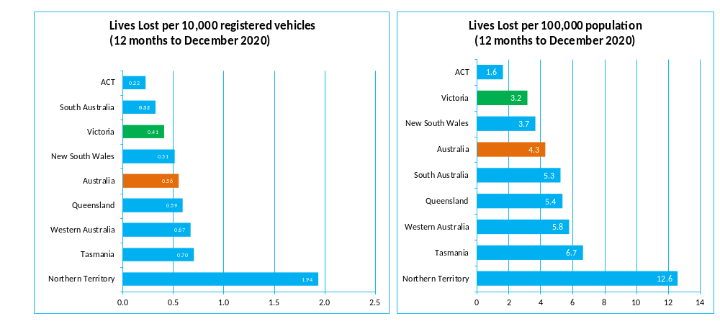

Booze Bus Random Breath Testing
Booze-bus Random Breath Tests (12 months to March 2020 vs previous 12 months)
 | 2020 | 2019 | 2018 | 2020 v 2019 |  | 2020 v 2018
Melbourne | 1,025,495 | 1,226,599 | 1,143,717 | -201,104 | (-16%) | -118,222 | (-10%)
Country | 183,858 | 115,731 | 142,698 | +68,127 | (+59%) | +41,160 | (+29%)
Vic Total | 1,209,353 | 1,342,330 | 1,286,415 | -132,977 | (-10%) | -77,062 | (-6%)

12 months to March 2020 (monthly totals)
 | 2019 |  |  |  |  |  |  |  |  | 2020
 | Apr | May | Sep | Jul | Aug | Sep | Oct | Nov | Dec | Jan | Feb | Mar
Melbourne | 79,988 | 84,478 | 101,799 | 98,380 | 102,592 | 96,574 | 89,177 | 88,460 | 82,298 | 62,544 | 103,896 | 35,309
Country | 19,119 | 14,068 | 10,318 | 5,826 | 11,098 | 12,571 | 17,551 | 25,867 | 16,566 | 15,206 | 23,588 | 12,080
Vic Total | 99,107 | 98,546 | 112,117 | 104,206 | 113,690 | 109,145 | 106,728 | 114,327 | 98,864 | 77,750 | 127,484 | 47,389

Random Drug Testing
Random Drug Tests (12 months to March 2020 vs previous 12 months)
 | 2020 | 2019 | 2018 | 2020 v 2019 |  | 2020 v 2018
Victoria | 161,283 | 122,730 | 102,551 | +38553 | (+31%) | +58732 | (+57%)
12 months to March 2020 - (monthly totals)
 | 2019 |  |  |  |  |  |  |  |  | 2020
 | Apr | May | Sep | Jul | Aug | Sep | Oct | Nov | Dec | Jan | Feb | Mar
Victoria | 17,337 | 19,571 | 15,441 | 13,817 | 18,692 | 15,244 | 12,181 | 12,646 | 11,000 | 9,157 | 7,904 | 8,293

Mobile Safety Camera Data
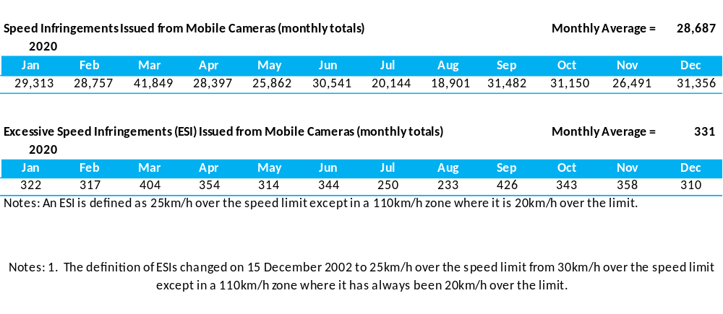

Explanations and References
LGA: Local Government Areas. Crash locations for acute hospitalised claims are assigned to LGA’s based on the crash postcode recorded by Victoria Police. Crash locations for fatal crashes are coded exactly to an LGA by Victoria Police.
Claimants: Refers to people injured in transport accidents who have an accepted claim with the TAC.
Hospitalisation: refers to all hospital admission that occurred within 7 days of accident.

Useful Internet Sites
TAC Sites
- TAC Safety (Road Safety) www.tacsafety.com.au
- TAC How safe is your car www.howsafeisyourcar.com.au
- TAC How safe is your first car www.howsafeisyourfirstcar.com.au
- TAC Motorcycle Safety Website www.spokes.com.au
- TAC Corporate site www.tac.vic.gov.au
- Drivesmart www.drivesmart.vic.gov.au
- Ridesmart www.ridesmartonline.com.au
Victorian Sites:
- VicRoads www.vicroads.vic.gov.au
- Victoria Police www.police.vic.gov.au
- Parliamentary Road Safety Committee https://www.parliament.vic.gov.au/57th-parliament/rsc
- RACV www.racv.com.au
- Monash University Accident Research Centre www.monash.edu.au/muarc
- Cameras Save Lives www.camerassavelives.vic.gov.au
- VicRoads Learner Driver Site www.lsite.vicroads.vic.gov.au/Learners
- Road Safety Education Victoria www.roadsafetyeducation.vic.gov.au
National and Interstate Sites:
- ARRB Transport Research www.arrb.com.au
- Australian Transport Safety Bureau www.atsb.gov.au
- Motor Accidents Authority (NSW) www.maa.nsw.gov.au
- Motor Accidents Insurance Board (TAS) www.maib.tas.gov.au
- Motor Accident Commission, Allianz (SA) www.mac.sa.gov.au
- Motor Accidents Compensation, TIO, (NT) www.tiofi.com.au/mac
- Insurance Commission of Western Australia www.icwa.wa.gov.au
- Motor Accident Insurance Commission (QLD) www.maic.qld.gov.au
International Sites:
- National Highway Traffic Safety Admin (USA) www.nhtsa.dot.gov
- Swedish Road and Transport Institute (VTI) www.vti.se
- SWOV Institute for Road Safety Research www.swov.nl
Related Sites:
- Alcohol and Drug Foundation www.adf.org.au
Figures
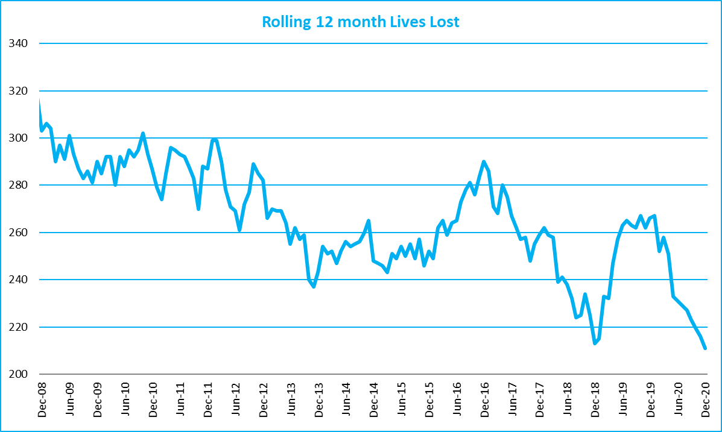
Victoria – Lives Lost, rolling 12 months total

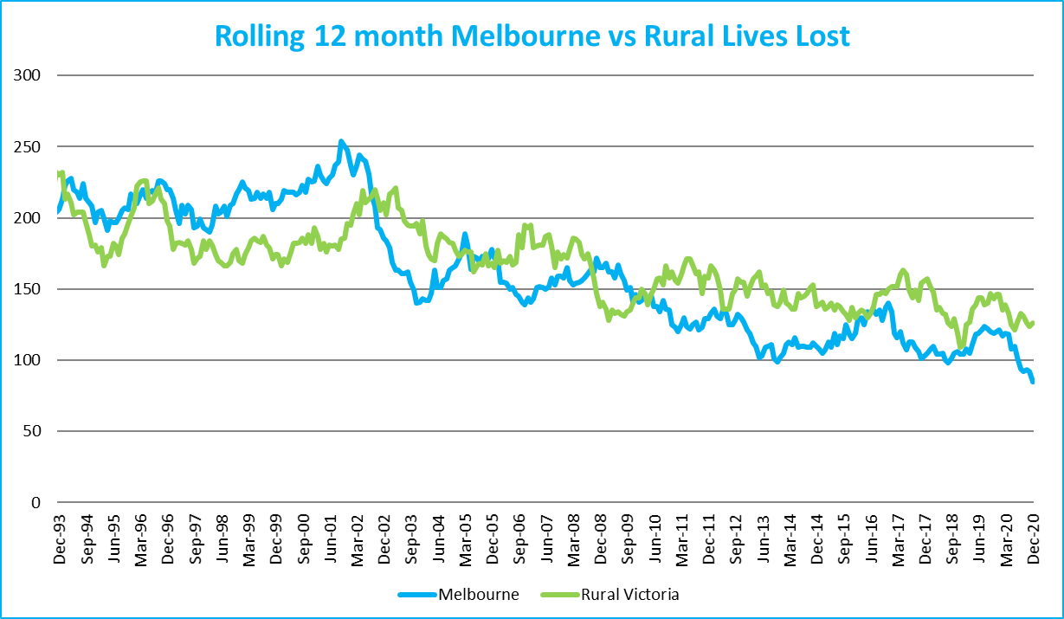

Graph 1a – Melbourne/Rural lives lost

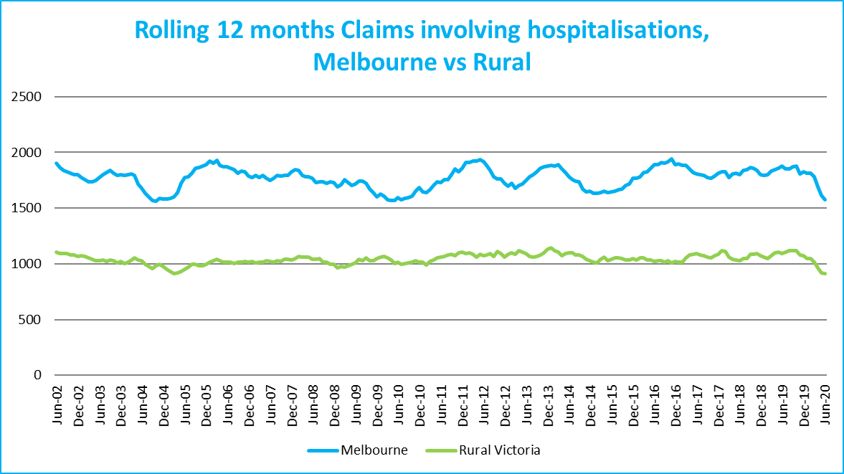
Graph 1b – Melbourne/Rural claims involving an acute hospital admission

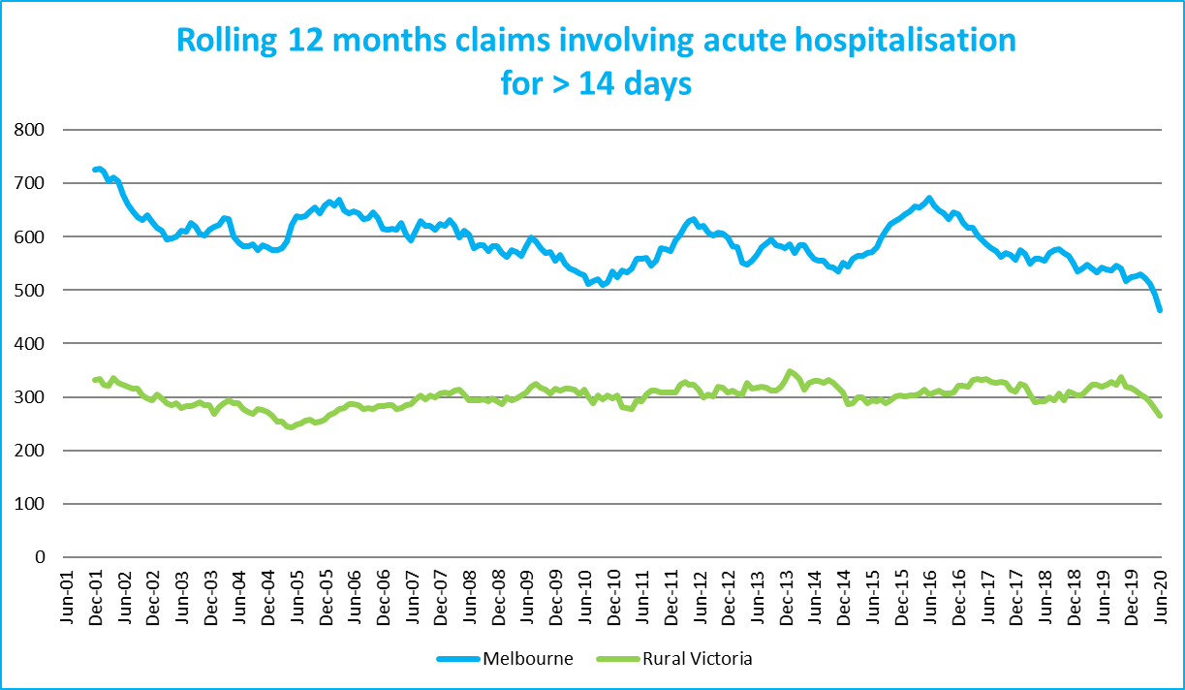
Graph 1c – Melbourne/Rural Claims involving hospital admission greater than 14 days

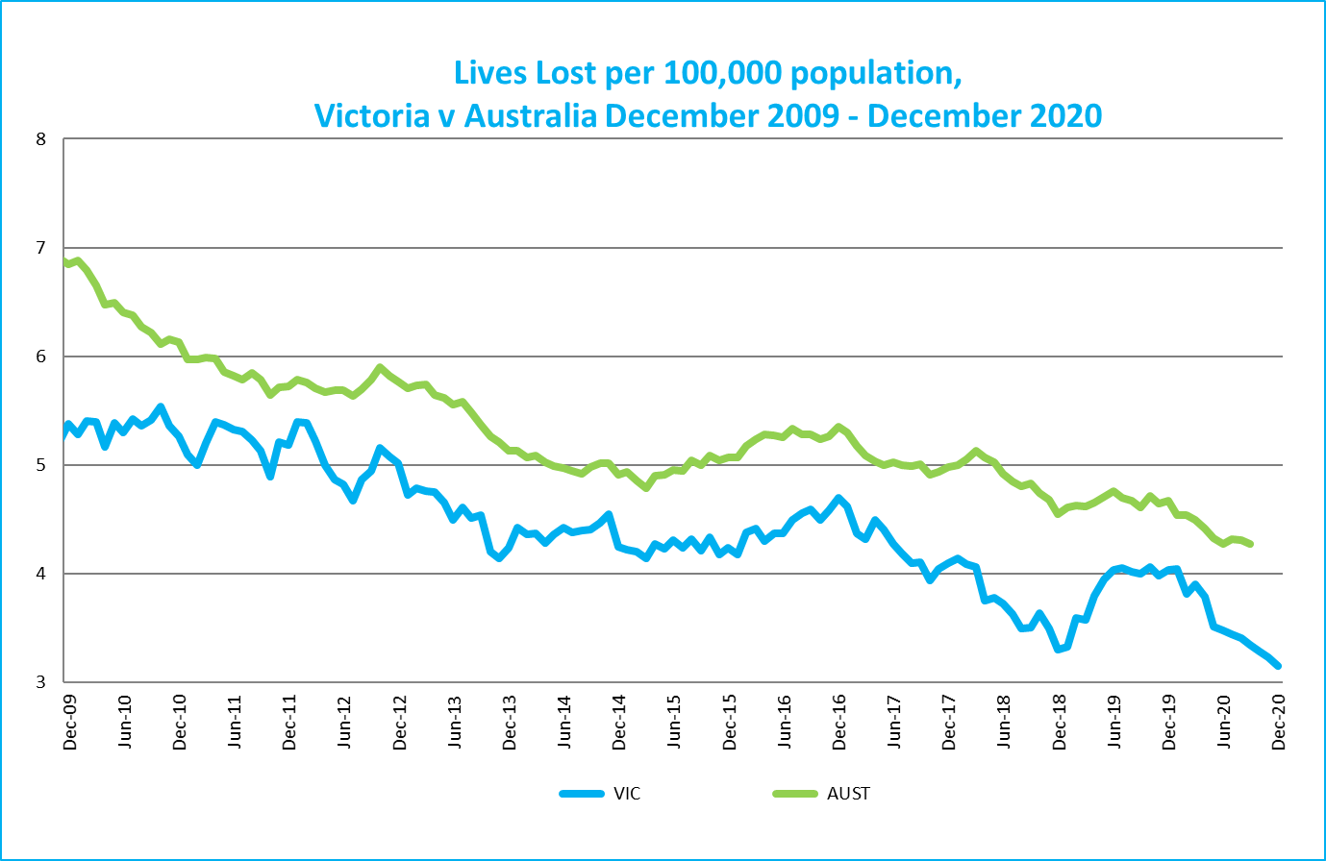
Graph 1d – Victoria/Australia lives lost per 100,000 population

Victorian monthly lives lost since 1951


