

TAC road safety

Quarterly statistics

March 2021

Contents

Status Report 3

Lives lost: Rolling 12 months 5

Injured claimants admitted to hospital within 7 days of the accident with a hospital stay of more than 14 days 7

Injured claimants who were admitted to hospital within 7 days of accident 9

The national picture 12

Booze bus random breath testing 12

International Road Safety Comparison 14

Explanations and references 16

Useful websites 17

Victorian monthly lives lost since 1951 21

Notes about the data in this report

* All data provided in this report is the data most recently available at time of production. Fatality data updated to the end of report month. A 6-month lag applies to TAC claims data.
* Reported data will have one extra day of exposure for leap years.
* Data is subject to revision as additional information about known accidents/claims is received, and as new accident/claim reports are received and processed.

# Status Report

## Lives lost on Victorian roads

* In a 12-month period from 1st April 2020 to the end of March 2021, 207 people lost their lives compared to 258 people lost their lives during the previous 12-month period from April 2019 to March 2020. This represents 51 less lives lost.

|  |  |  |  |  |  |  |
| --- | --- | --- | --- | --- | --- | --- |
| **Category** | **2021** | **2020** | **2019** | **2021 v 2020** | **2021 v 2019** | **5 Year Average** |
|  |  |  |  |  |  |  |
| **Lives Lost (Rolling 12 Month Total)** |  |  |  |  |  |  |
| **Lives Lost (to March)** | **207** | **258** | **232** | **-51** | **-25** | **245** |
| per 10,000 veh | 0.40 | 0.51 | 0.46 | -0.11 | -0.06 | 0.51 |
| per 100,000 pop | 3.08 | 3.90 | 3.57 | -0.82 | -0.49 | 3.89 |
|  |  |  |  |  |  |  |
| **Crashes (Rolling 12 Month Total)** |  |  |  |  |  |  |
| **Fatal crashes (to March)** | **192** | **240** | **219** | **-48** | **-27** | **229** |
| per 10,000 veh | 0.37 | 0.47 | 0.44 | -0.10 | -0.07 | 0.48 |
| per 100,000 pop | 2.86 | 3.63 | 3.37 | -0.77 | -0.51 | 3.65 |

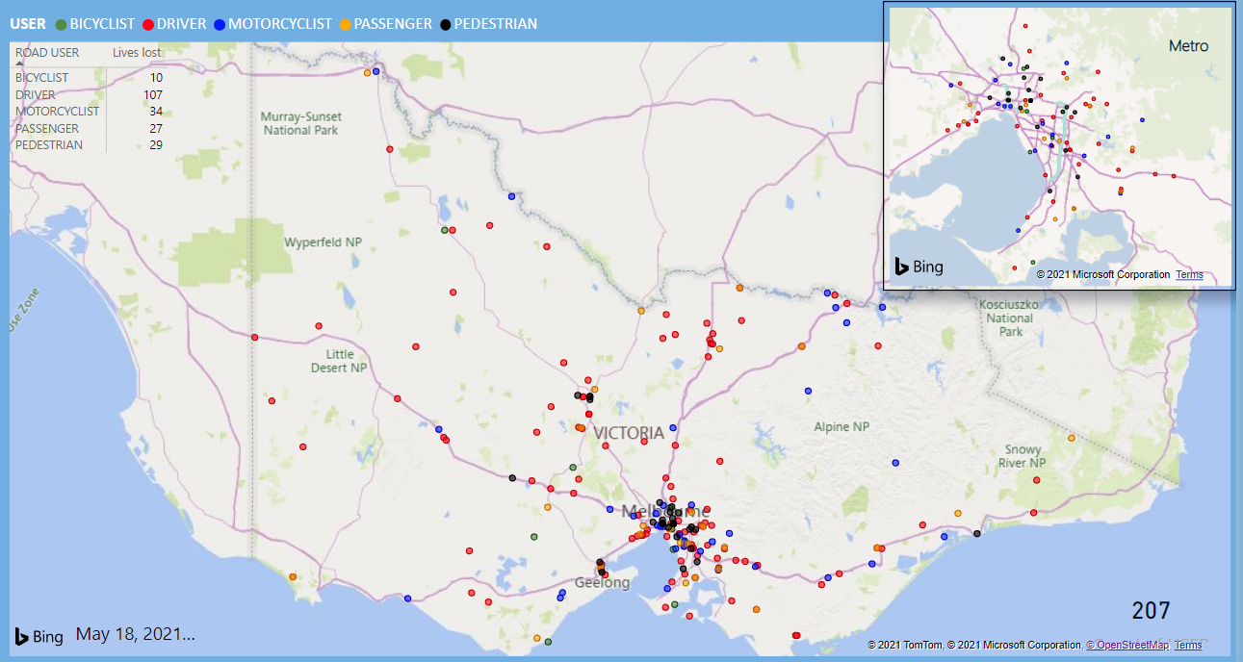

Victoria – Lives Lost, 12 months to March 2021

## Injured claimants who were admitted to hospital within 7 days of accident

Rolling 12 month to 30th September 2020 (claim acceptance date)

|  |  |  |  |  |  |  |  |  |
| --- | --- | --- | --- | --- | --- | --- | --- | --- |
| **Category** | **2020** | **2019** | **2018** | **2020 v 2019** | | **2020 v 2018** | | **5 Year Average** |
|  |  |  |  |  |  |  |  |  |
| **Claims involving an hospitalisation over 14 days (Rolling 12 Month Total)** | | | | | |  |  |  |
| **Claims (to September)** | **669** | **935** | **953** | **-266** | **(-28%)** | **-284** | **(-30%)** | **901** |
| per 100,000 pop | 10.0 | 14.2 | 14.8 | -4.2 | (-30%) | -4.8 | (-32%) | 14.8 |
| per 10,000 veh | 1.3 | 1.9 | 1.9 | -0.6 | (-32%) | -0.6 | (-32%) | 1.9 |
|  |  |  |  |  |  |  |  |  |
| **All claims involving an hospitalisation (Rolling 12 Month Total)** | | | | | | | | |
| **Claims (to September)** | **5,975** | **8,297** | **8,089** | **-2322** | **(-28%)** | **-2114** | **(-26%)** | **7391** |
| per 100,000 pop | 89.6 | 126.4 | 125.9 | -36.8 | (-29%) | -36.3 | (-29%) | 117.5 |
| per 10,000 veh | 11.6 | 16.4 | 16.4 | -4.8 | (-29%) | -4.8 | (-29%) | 15.3 |

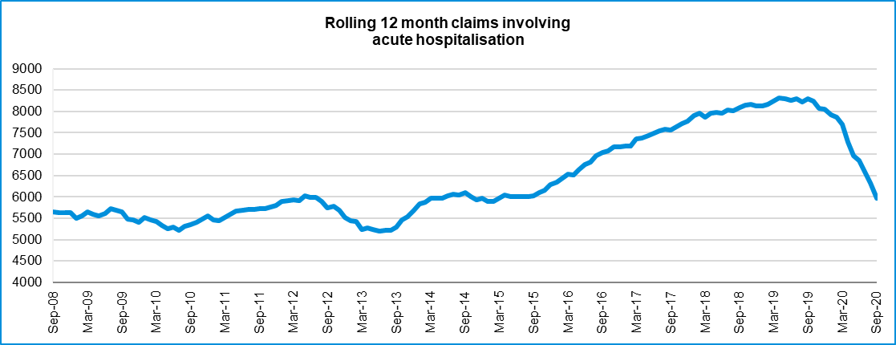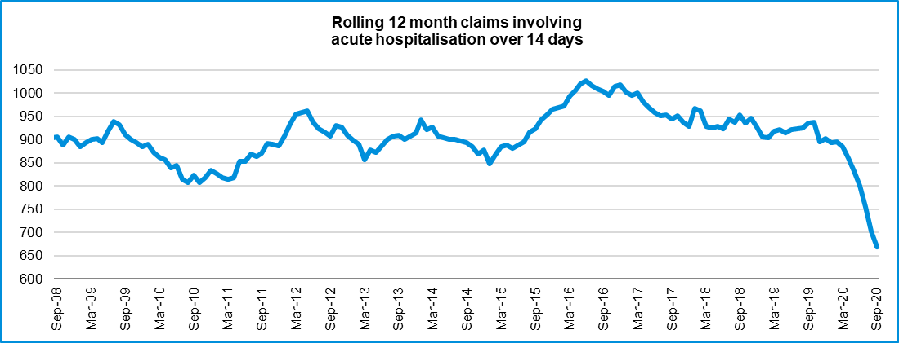

# Lives lost: Rolling 12 months

|  |  |  |  |  |  |  |
| --- | --- | --- | --- | --- | --- | --- |
| 12 months to 31st March 2021 | |  |  |  |  |  |
| **Category** | **2021** | **2020** | **2019** | **2021 v 2020** | **2021 v 2019** | **5 Year Average** |
|  |  |  |  |  |  |  |
| **Overview** |  |  |  |  |  |  |
| Lives Lost | 207 | 258 | 232 | -51 | -25 | 245 |
| Fatal Crashes | 192 | 240 | 219 | -48 | -27 | 229 |
|  |  |  |  |  |  |  |
| **Sex** |  |  |  |  |  |  |
| Female | 50 | 66 | 64 | -16 | -14 | 65 |
| Male | 157 | 192 | 168 | -35 | -11 | 179 |
|  |  |  |  |  |  |  |
| **Road user** |  |  |  |  |  |  |
| Bicyclist | 10 | 13 | 10 | -3 | 0 | 10 |
| Driver | 107 | 114 | 102 | -7 | +5 | 120 |
| Motorcyclist | 34 | 37 | 46 | -3 | -12 | 40 |
| Passenger | 27 | 46 | 35 | -19 | -8 | 38 |
| Pedestrian | 29 | 48 | 39 | -19 | -10 | 37 |
|  |  |  |  |  |  |  |
| **Location** |  |  |  |  |  |  |
| Melbourne | 93 | 119 | 105 | -26 | -12 | 109 |
| Rural Victoria | 114 | 139 | 127 | -25 | -13 | 136 |
|  |  |  |  |  |  |  |
| **Age group** |  |  |  |  |  |  |
| 0-4 | 3 | 1 | 2 | +2 | +1 | 2 |
| 5-15 | 2 | 5 | 9 | -3 | -7 | 5 |
| 16-17 | 5 | 4 | 3 | +1 | +2 | 4 |
| 18-20 | 6 | 21 | 13 | -15 | -7 | 14 |
| 21-25 | 19 | 28 | 18 | -9 | +1 | 23 |
| 26-29 | 23 | 23 | 18 |  | +5 | 20 |
| 30-39 | 36 | 39 | 38 | -3 | -2 | 39 |
| 40-49 | 29 | 29 | 21 |  | +8 | 34 |
| 50-59 | 24 | 27 | 31 | -3 | -7 | 29 |
| 60-69 | 21 | 30 | 28 | -9 | -7 | 27 |
| **70+** | 37 | 51 | 50 | -14 | -13 | 47 |
|  |  |  |  |  |  |  |
| **Accident Type** |  |  |  |  |  |  |
| **Intersection** |  |  |  |  |  |  |
| Adjacent direction | 19 | 31 | 33 | -12 | -14 | 29 |
| Opposing direction | 8 | 12 | 8 | -4 | 0 | 9 |
| **Mid-block/other** |  |  |  |  |  |  |
| Head on | 22 | 36 | 29 | -14 | -7 | 36 |
| Same direction | 25 | 15 | 22 | +10 | +3 | 21 |
| Manoeuvre/o'taking | 10 | 18 | 14 | -8 | -4 | 13 |
| On path | 7 | 4 | 2 | +3 | +5 | 6 |
| Single vehicle | 86 | 85 | 82 | +1 | +4 | 90 |
| Other (incl peds) | 30 | 57 | 42 | -27 | -12 | 41 |

### Lives Lost: 12 months to 31st March 2021 (claim acceptance date) – Continued

|  |  |  |  |  |  |  |  |  |  |
| --- | --- | --- | --- | --- | --- | --- | --- | --- | --- |
| **Category** | **2021** | **2020** | **2019** | **5 Year Average** | **Category** | **2021** | **2020** | **2019** | **5 Year Average** |
|  |  |  |  |  |  |  |  |  |  |
| **Local Government Area** |  |  |  |  | **Local Government Area** |  |  |  |  |
| ALPINE | 1 | 2 | 3 | 1 | MANSFIELD | 0 | 1 | 2 | 2 |
| ARARAT | 0 | 3 | 1 | 2 | MARIBYRNONG | 2 | 2 | 3 | 2 |
| BALLARAT | 2 | 2 | 3 | 3 | MAROONDAH | 2 | 1 | 6 | 2 |
| BANYULE | 2 | 0 | 2 | 1 | MELBOURNE | 4 | 2 | 2 | 2 |
| BASS COAST | 2 | 4 | 0 | 2 | MELTON | 2 | 2 | 7 | 4 |
| BAW BAW | 2 | 4 | 4 | 3 | MILDURA | 3 | 5 | 5 | 3 |
| BAYSIDE | 1 | 0 | 1 | 2 | MITCHELL | 4 | 3 | 1 | 3 |
| BENALLA | 0 | 0 | 3 | 2 | MOIRA | 2 | 4 | 4 | 4 |
| BOROONDARA | 7 | 2 | 3 | 2 | MONASH | 4 | 10 | 5 | 6 |
| BRIMBANK | 1 | 9 | 4 | 7 | MOONEE VALLEY | 0 | 2 | 3 | 2 |
| BULOKE | 3 | 1 | 1 | 1 | MOORABOOL | 2 | 3 | 4 | 4 |
| CAMPASPE | 4 | 2 | 2 | 3 | MORELAND | 1 | 1 | 4 | 2 |
| CARDINIA | 11 | 3 | 4 | 5 | MORNINGTON PENINSULA | 5 | 17 | 3 | 7 |
| CASEY | 7 | 7 | 3 | 6 | MOUNT ALEXANDER | 6 | 4 | 2 | 2 |
| CENTRAL GOLDFIELDS | 1 | 3 | 1 | 1 | MOYNE | 0 | 3 | 1 | 2 |
| COLAC-OTWAY | 2 | 3 | 1 | 3 | MURRINDINDI | 1 | 3 | 4 | 4 |
| CORANGAMITE | 3 | 4 | 2 | 2 | NILLUMBIK | 3 | 0 | 2 | 2 |
| DAREBIN | 1 | 7 | 2 | 3 | NORTHERN GRAMPIANS | 3 | 2 | 6 | 3 |
| EAST GIPPSLAND | 7 | 3 | 6 | 5 | PORT PHILLIP | 1 | 2 | 0 | 1 |
| FRANKSTON | 2 | 9 | 1 | 4 | PYRENEES | 1 | 2 | 1 | 2 |
| GANNAWARRA | 1 | 0 | 3 | 1 | QUEENSCLIFFE | 0 | 0 | 0 | 0 |
| GLEN EIRA | 0 | 4 | 0 | 2 | SOUTH GIPPSLAND | 4 | 6 | 7 | 4 |
| GLENELG | 2 | 0 | 4 | 2 | SOUTHERN GRAMPIANS | 0 | 2 | 2 | 2 |
| GOLDEN PLAINS | 2 | 0 | 7 | 3 | STONNINGTON | 0 | 0 | 5 | 1 |
| GREATER BENDIGO | 8 | 7 | 6 | 5 | STRATHBOGIE | 0 | 1 | 2 | 2 |
| GREATER DANDENONG | 6 | 4 | 3 | 3 | SURF COAST | 2 | 0 | 1 | 1 |
| GREATER GEELONG | 7 | 15 | 5 | 8 | SWAN HILL | 2 | 3 | 0 | 2 |
| GREATER SHEPPARTON | 8 | 5 | 6 | 6 | TOWONG | 1 | 3 | 1 | 1 |
| HEPBURN | 2 | 5 | 4 | 4 | WANGARATTA | 3 | 0 | 1 | 2 |
| HINDMARSH | 1 | 0 | 0 | 0 | WARRNAMBOOL | 1 | 3 | 2 | 1 |
| HOBSONS BAY | 2 | 0 | 2 | 1 | WELLINGTON | 5 | 2 | 2 | 3 |
| HORSHAM | 1 | 7 | 1 | 3 | WEST WIMMERA | 3 | 3 | 1 | 1 |
| HUME | 3 | 9 | 7 | 5 | WHITEHORSE | 2 | 1 | 1 | 2 |
| INDIGO | 4 | 1 | 2 | 2 | WHITTLESEA | 4 | 3 | 4 | 3 |
| KINGSTON | 3 | 4 | 5 | 4 | WODONGA | 1 | 1 | 0 | 1 |
| KNOX | 1 | 1 | 7 | 3 | WYNDHAM | 5 | 6 | 6 | 6 |
| LATROBE | 3 | 7 | 5 | 4 | YARRA | 2 | 1 | 0 | 1 |
| LODDON | 2 | 4 | 2 | 2 | YARRA RANGES | 8 | 8 | 8 | 6 |
| MACEDON RANGES | 1 | 2 | 6 | 3 | YARRIAMBIACK | 1 | 1 | 0 | 1 |
| MANNINGHAM | 1 | 2 | 2 | 2 |  |  |  |  |  |

# Injured claimants admitted to hospital within 7 days of the accident with a hospital stay of more than 14 days

12 months to 30th September 2020 (claim acceptance date)

|  |  |  |  |  |  |  |  |  |
| --- | --- | --- | --- | --- | --- | --- | --- | --- |
| **Category** | **2020** | **2019** | **2018** | **2020 v 2019** | | **2020 v 2018** | | **5 Year Average** |
|  |  |  |  |  |  |  |  |  |
| **Overview** |  |  |  |  |  |  |  |  |
| Claims | 669 | 935 | 953 | -266 | -28% | -284 | -30% | 849 |
|  |  |  |  |  |  |  |  |  |
| Sex |  |  |  |  |  |  |  |  |
| **Female** | 245 | 392 | 384 | -147 | -38% | -139 | **-36%** | 339 |
| Male | 423 | 543 | 569 | -120 | -22% | -146 | -26% | 509 |
|  |  |  |  |  |  |  |  |  |
| Road user |  |  |  |  |  |  |  |  |
| **Bicyclist** | 34 | 33 | 36 | +1 | 3% | -2 | **-6%** | 32 |
| Driver | 255 | 356 | 351 | -101 | -28% | -96 | -27% | 317 |
| Motorcyclist | 160 | 179 | 193 | -19 | -11% | -33 | -17% | 171 |
| Passenger | 83 | 133 | 139 | -50 | -38% | -56 | -40% | 121 |
| Pedestrian | 115 | 198 | 193 | -83 | -42% | -78 | -40% | 176 |
| Train/Tram | 2 | 11 | 11 | -9 | -82% | -9 | -82% | 8 |
|  |  |  |  |  |  |  |  |  |
| **Location** |  |  |  |  |  |  |  |  |
| Melbourne | 391 | 548 | 577 | -157 | -29% | -186 | -32% | 512 |
| Rural Victoria | 249 | 327 | 307 | -78 | -24% | -58 | -19% | 287 |
|  |  |  |  |  |  |  |  |  |
| **Age group** |  |  |  |  |  |  |  |  |
| 0-4 | 3 | 5 | 4 | -2 | -40% | -1 | -25% | 4 |
| 5-15 | 10 | 16 | 13 | -6 | -38% | -3 | -23% | 11 |
| 16-17 | 13 | 13 | 11 |  | 0% | 2 | 18% | 12 |
| 18-20 | 30 | 50 | 30 | -20 | -40% | 0 | 0% | 44 |
| 21-25 | 55 | 73 | 86 | -18 | -25% | -31 | -36% | 74 |
| 26-29 | 46 | 45 | 55 | +1 | 2% | -9 | -16% | 49 |
| 30-39 | 77 | 103 | 120 | -26 | -25% | -43 | -36% | 104 |
| 40-49 | 88 | 96 | 122 | -8 | -8% | -34 | -28% | 99 |
| 50-59 | 82 | 132 | 117 | -50 | -38% | -35 | -30% | 105 |
| 60-69 | 92 | 128 | 115 | -36 | -28% | -23 | -20% | 110 |
| 70+ | 173 | 274 | 280 | -101 | -37% | -107 | -38% | 236 |
|  |  |  |  |  |  |  |  |  |
|  |  |  |  |  |  |  |  |  |
| **Accident Type** |  |  |  |  |  |  |  |  |
| **Intersection** |  |  |  |  |  |  |  |  |
| Adjacent direction | 79 | 75 | 83 | +4 | 5% | -4 | -5% | 84 |
| Opposing direction | 31 | 62 | 50 | -31 | -50% | -19 | -38% | 49 |
| **Mid-block/other** |  |  |  |  |  |  |  |  |
| Head on | 45 | 81 | 48 | -36 | -44% | -3 | -6% | 63 |
| Same direction | 57 | 75 | 69 | -18 | -24% | -12 | -17% | 65 |
| Manoeuvre/o'taking | 45 | 46 | 49 | -1 | -2% | -4 | -8% | 46 |
| On path | 18 | 29 | 28 | -11 | -38% | -10 | -36% | 24 |
| Single vehicle | 210 | 229 | 224 | -19 | -8% | -14 | -6% | 223 |
| Other (incl peds) | 184 | 338 | 402 | -154 | -46% | -218 | -54% | 296 |

Note: excludes rejected claims and claims for interstate crashes.

## Injured claimants who were admitted to hospital within 7 days of the accident with a hospital stay of more than 14 days

12 months to 30th September 2020 (claim acceptance date) – Continued

|  |  |  |  |  |  |  |  |  |  |
| --- | --- | --- | --- | --- | --- | --- | --- | --- | --- |
| **Category** | **2020** | **2019** | **2018** | **5 Year Average** | **Category** | **2020** | **2019** | **2018** | **5 Year Average** |
|  |  |  |  |  |  |  |  |  |  |
| **Local Government Area** | |  |  |  | **Local Government Area** | |  |  |  |
| ALPINE | 4 | 10 | 4 | 4 | MANSFIELD | 5 | 5 | 8 | 5 |
| ARARAT | 3 | 5 | 1 | 2 | MARIBYRNONG | 7 | 10 | 13 | 10 |
| BALLARAT | 11 | 20 | 14 | 12 | MAROONDAH | 11 | 9 | 7 | 6 |
| BANYULE | 6 | 8 | 13 | 7 | MELBOURNE | 24 | 25 | 39 | 26 |
| BASS COAST | 2 | 9 | 10 | 6 | MELTON | 4 | 9 | 11 | 8 |
| BAW BAW | 8 | 7 | 9 | 6 | MILDURA | 4 | 5 | 10 | 5 |
| BAYSIDE | 2 | 14 | 4 | 8 | MITCHELL | 12 | 8 | 7 | 6 |
| BENALLA | 1 | 3 | 7 | 3 | MOIRA | 4 | 12 | 10 | 8 |
| BOROONDARA | 11 | 19 | 12 | 11 | MONASH | 11 | 28 | 17 | 17 |
| BRIMBANK | 8 | 22 | 19 | 17 | MOONEE VALLEY | 12 | 12 | 19 | 12 |
| BULOKE | 0 | 4 | 2 | 2 | MOORABOOL | 7 | 7 | 5 | 6 |
| CAMPASPE | 12 | 8 | 5 | 6 | MORELAND | 13 | 26 | 30 | 22 |
| CARDINIA | 11 | 15 | 15 | 12 | MORNINGTON PENINSULA | 18 | 24 | 22 | 18 |
| CASEY | 25 | 25 | 31 | 24 | MOUNT ALEXANDER | 0 | 3 | 3 | 1 |
| CENTRAL GOLDFIELDS | 3 | 5 | 4 | 2 | MOYNE | 5 | 7 | 4 | 4 |
| COLAC-OTWAY | 4 | 5 | 6 | 5 | MURRINDINDI | 5 | 7 | 14 | 8 |
| CORANGAMITE | 3 | 2 | 12 | 5 | NILLUMBIK | 6 | 14 | 3 | 6 |
| DAREBIN | 10 | 18 | 19 | 16 | NORTHERN GRAMPIANS | 2 | 2 | 7 | 3 |
| EAST GIPPSLAND | 10 | 12 | 9 | 8 | PORT PHILLIP | 14 | 10 | 12 | 10 |
| FRANKSTON | 8 | 9 | 19 | 11 | PYRENEES | 2 | 4 | 1 | 2 |
| GANNAWARRA | 3 | 2 | 1 | 2 | QUEENSCLIFFE | 2 | 2 | 1 | 1 |
| GLEN EIRA | 9 | 22 | 17 | 12 | SOUTH GIPPSLAND | 6 | 7 | 8 | 6 |
| GLENELG | 2 | 4 | 3 | 3 | SOUTHERN GRAMPIANS | 4 | 4 | 4 | 2 |
| GOLDEN PLAINS | 5 | 5 | 3 | 5 | STONNINGTON | 6 | 9 | 14 | 8 |
| GREATER BENDIGO | 16 | 21 | 22 | 14 | STRATHBOGIE | 6 | 1 | 4 | 3 |
| GREATER DANDENONG | 18 | 29 | 24 | 20 | SURF COAST | 7 | 4 | 7 | 4 |
| GREATER GEELONG | 28 | 39 | 23 | 21 | SWAN HILL | 5 | 5 | 3 | 4 |
| GREATER SHEPPARTON | 9 | 6 | 17 | 11 | TOWONG | 3 | 4 | 4 | 3 |
| HEPBURN | 4 | 5 | 4 | 3 | WANGARATTA | 3 | 6 | 5 | 5 |
| HINDMARSH | 3 | 0 | 0 | 1 | WARRNAMBOOL | 5 | 4 | 1 | 2 |
| HOBSONS BAY | 6 | 8 | 7 | 6 | WELLINGTON | 9 | 8 | 9 | 7 |
| HORSHAM | 1 | 6 | 4 | 3 | WEST WIMMERA | 0 | 1 | 0 | 1 |
| HUME | 21 | 25 | 25 | 21 | WHITEHORSE | 18 | 25 | 22 | 18 |
| INDIGO | 3 | 5 | 3 | 4 | WHITTLESEA | 20 | 22 | 30 | 20 |
| KINGSTON | 12 | 16 | 23 | 12 | WODONGA | 2 | 6 | 3 | 3 |
| KNOX | 17 | 25 | 20 | 16 | WYNDHAM | 21 | 16 | 23 | 17 |
| LATROBE | 7 | 13 | 14 | 8 | YARRA | 12 | 12 | 16 | 10 |
| LODDON | 2 | 5 | 1 | 2 | YARRA RANGES | 22 | 25 | 34 | 22 |
| MACEDON RANGES | 6 | 12 | 9 | 9 | YARRIAMBIACK | 1 | 2 | 2 | 1 |
| MANNINGHAM | 8 | 17 | 17 | 13 |  |  |  |  |  |

Note: excludes rejected claims and claims for interstate crashes

# Injured claimants who were admitted to hospital within 7 days of accident

12 months to 30th September 2020 (claim acceptance date)

|  |  |  |  |  |  |  |  |  |
| --- | --- | --- | --- | --- | --- | --- | --- | --- |
| **Category** | **2020** | **2019** | **2018** | **2020 v 2019** | | **2020 v 2018** | | **5 Year Average** |
|  |  |  |  |  |  |  |  |  |
| **Overview** |  |  |  |  |  |  |  |  |
| Claims | 5,975 | 8,297 | 8,089 | -2322 | -28% | -2114 | -26% | 7,044 |
|  |  |  |  |  |  |  |  |  |
| **Sex** |  |  |  |  |  |  |  |  |
| Female | 2,481 | 3,599 | 3,509 | -1118 | -31% | -1028 | -29% | 3,038 |
| Male | 3,485 | 4,688 | 4,570 | -1203 | -26% | -1085 | -24% | 3,997 |
|  |  |  |  |  |  |  |  |  |
| **Road user** |  |  |  |  |  |  |  |  |
| Bicyclist | 441 | 526 | 542 | -85 | -16% | -101 | -19% | 457 |
| Driver | 2,867 | 4,031 | 3,824 | -1164 | -29% | -957 | -25% | 3,371 |
| Motorcyclist | 1,048 | 1,408 | 1,364 | -360 | -26% | -316 | -23% | 1,194 |
| Passenger | 792 | 1,207 | 1,152 | -415 | -34% | -360 | -31% | 1,015 |
| Pedestrian | 505 | 822 | 821 | -317 | -39% | -316 | -38% | 695 |
| Train/Tram | 30 | 35 | 46 | -5 | -14% | -16 | -35% | 39 |
|  |  |  |  |  |  |  |  |  |
| **Location** |  |  |  |  |  |  |  |  |
| Melbourne | 3,719 | 5,001 | 4,731 | -1282 | -26% | -1012 | -21% | 4,312 |
| Rural Victoria | 1,932 | 2,455 | 2,304 | -523 | -21% | -372 | -16% | 2,074 |
|  |  |  |  |  |  |  |  |  |
| **Age group** |  |  |  |  |  |  |  |  |
| 0-4 | 35 | 61 | 69 | -26 | -43% | -34 | -49% | 54 |
| 5-15 | 132 | 231 | 246 | -99 | -43% | -114 | -46% | 195 |
| 16-17 | 103 | 129 | 140 | -26 | -20% | -37 | -26% | 116 |
| 18-20 | 420 | 624 | 574 | -204 | -33% | -154 | -27% | 519 |
| 21-25 | 695 | 999 | 1,030 | -304 | -30% | -335 | -33% | 871 |
| 26-29 | 531 | 693 | 686 | -162 | -23% | -155 | -23% | 602 |
| 30-39 | 984 | 1,341 | 1,296 | -357 | -27% | -312 | -24% | 1,131 |
| 40-49 | 870 | 1,080 | 1,160 | -210 | -19% | -290 | -25% | 999 |
| 50-59 | 806 | 1,128 | 1,067 | -322 | -29% | -261 | -24% | 935 |
| 60-69 | 661 | 844 | 793 | -183 | -22% | -132 | -17% | 707 |
| 70+ | 738 | 1,167 | 1,028 | -429 | -37% | -290 | -28% | 914 |
|  |  |  |  |  |  |  |  |  |
| **Accident Type** |  |  |  |  |  |  |  |  |
| **Intersection** |  |  |  |  |  |  |  |  |
| Adjacent direction | 970 | 976 | 812 | -6 | -1% | +158 | 19% | 867 |
| Opposing direction | 409 | 576 | 444 | -167 | -29% | -35 | -8% | 487 |
| **Mid-block/other** |  |  |  |  |  |  |  |  |
| Head on | 271 | 378 | 298 | -107 | -28% | -27 | -9% | 312 |
| Same direction | 972 | 1,047 | 884 | -75 | -7% | +88 | 10% | 940 |
| Manoeuvre/o'taking | 410 | 337 | 350 | +73 | 22% | +60 | 17% | 349 |
| On path | 226 | 229 | 233 | -3 | -1% | -7 | -3% | 236 |
| Single vehicle | 1,347 | 1,421 | 1,314 | -74 | -5% | +33 | 3% | 1,407 |
| Other (incl peds) | 1,370 | 3,333 | 3,754 | -1963 | -59% | -2384 | -64% | 2,447 |

Note: excludes rejected claims and claims for interstate crashes

## Injured claimants who were admitted to hospital within 7 days of accident

12 months to 30th September 2020 (claim acceptance date) – Continued

|  |  |  |  |  |  |  |  |  |  |
| --- | --- | --- | --- | --- | --- | --- | --- | --- | --- |
| **Category** | **2020** | **2019** | **2018** | **5 Year Average** | **Category** | **2020** | **2019** | **2018** | **5 Year Average** |
|  |  |  |  |  |  |  |  |  |  |
| **Local Government Area** | |  |  |  | **Local Government Area** | |  |  |  |
| ALPINE | 24 | 41 | 25 | 22 | MANSFIELD | 30 | 44 | 39 | 30 |
| ARARAT | 16 | 19 | 12 | 12 | MARIBYRNONG | 65 | 98 | 103 | 72 |
| BALLARAT | 87 | 119 | 77 | 74 | MAROONDAH | 55 | 72 | 65 | 49 |
| BANYULE | 38 | 69 | 73 | 50 | MELBOURNE | 200 | 270 | 317 | 236 |
| BASS COAST | 33 | 49 | 56 | 35 | MELTON | 77 | 95 | 70 | 61 |
| BAW BAW | 67 | 61 | 56 | 40 | MILDURA | 40 | 30 | 28 | 21 |
| BAYSIDE | 73 | 100 | 75 | 66 | MITCHELL | 75 | 77 | 63 | 54 |
| BENALLA | 9 | 28 | 23 | 17 | MOIRA | 34 | 47 | 34 | 31 |
| BOROONDARA | 95 | 166 | 140 | 106 | MONASH | 138 | 215 | 208 | 153 |
| BRIMBANK | 148 | 182 | 182 | 123 | MOONEE VALLEY | 116 | 145 | 155 | 105 |
| BULOKE | 4 | 15 | 6 | 8 | MOORABOOL | 52 | 57 | 49 | 40 |
| CAMPASPE | 41 | 50 | 44 | 37 | MORELAND | 137 | 199 | 203 | 143 |
| CARDINIA | 117 | 121 | 121 | 98 | MORNINGTON PENINSULA | 160 | 194 | 181 | 135 |
| CASEY | 280 | 355 | 309 | 256 | MOUNT ALEXANDER | 20 | 22 | 24 | 15 |
| CENTRAL GOLDFIELDS | 19 | 29 | 16 | 15 | MOYNE | 30 | 32 | 45 | 25 |
| COLAC-OTWAY | 61 | 61 | 81 | 46 | MURRINDINDI | 44 | 64 | 53 | 48 |
| CORANGAMITE | 27 | 34 | 44 | 28 | NILLUMBIK | 39 | 54 | 32 | 32 |
| DAREBIN | 96 | 140 | 104 | 89 | NORTHERN GRAMPIANS | 18 | 21 | 40 | 17 |
| EAST GIPPSLAND | 44 | 49 | 62 | 43 | PORT PHILLIP | 119 | 155 | 159 | 112 |
| FRANKSTON | 125 | 156 | 150 | 109 | PYRENEES | 13 | 18 | 9 | 10 |
| GANNAWARRA | 11 | 11 | 8 | 8 | QUEENSCLIFFE | 4 | 8 | 9 | 4 |
| GLEN EIRA | 121 | 139 | 134 | 97 | SOUTH GIPPSLAND | 38 | 54 | 36 | 35 |
| GLENELG | 18 | 22 | 32 | 17 | SOUTHERN GRAMPIANS | 34 | 26 | 19 | 16 |
| GOLDEN PLAINS | 45 | 46 | 47 | 37 | STONNINGTON | 100 | 145 | 135 | 103 |
| GREATER BENDIGO | 118 | 152 | 140 | 98 | STRATHBOGIE | 35 | 35 | 37 | 27 |
| GREATER DANDENONG | 210 | 310 | 254 | 208 | SURF COAST | 57 | 66 | 74 | 48 |
| GREATER GEELONG | 331 | 459 | 453 | 295 | SWAN HILL | 22 | 21 | 15 | 14 |
| GREATER SHEPPARTON | 72 | 81 | 90 | 75 | TOWONG | 12 | 15 | 24 | 14 |
| HEPBURN | 27 | 33 | 33 | 23 | WANGARATTA | 32 | 45 | 35 | 28 |
| HINDMARSH | 13 | 18 | 11 | 9 | WARRNAMBOOL | 27 | 30 | 26 | 23 |
| HOBSONS BAY | 70 | 87 | 94 | 60 | WELLINGTON | 50 | 73 | 69 | 52 |
| HORSHAM | 25 | 32 | 30 | 19 | WEST WIMMERA | 3 | 3 | 7 | 4 |
| HUME | 215 | 251 | 268 | 190 | WHITEHORSE | 73 | 169 | 139 | 116 |
| INDIGO | 18 | 29 | 22 | 20 | WHITTLESEA | 163 | 206 | 243 | 171 |
| KINGSTON | 127 | 137 | 134 | 100 | WODONGA | 20 | 23 | 28 | 19 |
| KNOX | 99 | 151 | 128 | 105 | WYNDHAM | 185 | 223 | 173 | 133 |
| LATROBE | 65 | 103 | 74 | 58 | YARRA | 88 | 120 | 114 | 88 |
| LODDON | 11 | 24 | 9 | 10 | YARRA RANGES | 148 | 178 | 180 | 130 |
| MACEDON RANGES | 50 | 74 | 78 | 61 | YARRIAMBIACK | 6 | 5 | 12 | 5 |
| MANNINGHAM | 42 | 99 | 88 | 72 |  |  |  |  |  |

Note: excludes rejected claims and claims for interstate crashes **Lives lost by week (2016 to 2021)**

|  |  |  |  |  |  |  |  |  |
| --- | --- | --- | --- | --- | --- | --- | --- | --- |
| **Week Ending** | **2016** | **2017** | **2018** | **2019** | **2020** | **2021** | **2021** | **12 month Moving Total** |
| 03-Jan | 2 | 0 | 4 | 0 | 5 | 3 | 3 | 209 |
| 10-Jan | 3 | 5 | 6 | 5 | 3 | 1 | 4 | 207 |
| 17-Jan | 3 | 6 | 2 | 3 | 5 | 0 | 4 | 202 |
| 24-Jan | 3 | 4 | 2 | 7 | 2 | 6 | 10 | 206 |
| 31-Jan | 10 | 2 | 6 | 8 | 9 | 4 | 14 | 201 |
| 07-Feb | 6 | 4 | 3 | 9 | 5 | 6 | 20 | 202 |
| 14-Feb | 12 | 3 | 4 | 9 | 6 | 6 | 26 | 202 |
| 21-Feb | 6 | 6 | 7 | 4 | 5 | 4 | 30 | 201 |
| 28-Feb | 9 | 5 | 2 | 12 | 1 | 6 | 36 | 206 |
| 07-Mar | 9 | 3 | 5 | 0 | 4 | 10 | 46 | 212 |
| 14-Mar | 9 | 5 | 7 | 5 | 9 | 4 | 50 | 207 |
| 21-Mar | 5 | 5 | 3 | 7 | 10 | 5 | 55 | 202 |
| 28-Mar | 1 | 7 | 4 | 6 | 1 | 7 | 62 | 208 |
| 04-Apr | 1 | 4 | 3 | 3 | 7 |  |  |  |
| 11-Apr | 1 | 12 | 0 | 10 | 1 |  |  |  |
| 18-Apr | 7 | 7 | 1 | 6 | 1 |  |  |  |
| 25-Apr | 4 | 6 | 5 | 4 | 9 |  |  |  |
| 02-May | 5 | 3 | 3 | 3 | 2 |  |  |  |
| 09-May | 7 | 7 | 13 | 9 | 2 |  |  |  |
| 16-May | 5 | 4 | 3 | 9 | 5 |  |  |  |
| 23-May | 5 | 2 | 3 | 6 | 2 |  |  |  |
| 30-May | 8 | 6 | 2 | 7 | 5 |  |  |  |
| 06-Jun | 4 | 2 | 1 | 4 | 1 |  |  |  |
| 13-Jun | 5 | 3 | 8 | 3 | 5 |  |  |  |
| 20-Jun | 5 | 4 | 1 | 5 | 4 |  |  |  |
| 27-Jun | 8 | 4 | 2 | 4 | 4 |  |  |  |
| 04-Jul | 2 | 5 | 1 | 7 | 4 |  |  |  |
| 11-Jul | 3 | 5 | 3 | 3 | 3 |  |  |  |
| 18-Jul | 7 | 9 | 5 | 2 | 3 |  |  |  |
| 25-Jul | 11 | 4 | 5 | 5 | 5 |  |  |  |
| 01-Aug | 6 | 0 | 2 | 3 | 4 |  |  |  |
| 08-Aug | 5 | 7 | 4 | 3 | 3 |  |  |  |
| 15-Aug | 7 | 9 | 3 | 5 | 4 |  |  |  |
| 22-Aug | 8 | 2 | 6 | 3 | 2 |  |  |  |
| 29-Aug | 8 | 8 | 4 | 4 | 3 |  |  |  |
| 05-Sep | 3 | 6 | 4 | 3 | 4 |  |  |  |
| 12-Sep | 3 | 6 | 3 | 5 | 4 |  |  |  |
| 19-Sep | 5 | 3 | 7 | 4 | 1 |  |  |  |
| 26-Sep | 5 | 3 | 2 | 3 | 0 |  |  |  |
| 03-Oct | 2 | 2 | 5 | 6 | 7 |  |  |  |
| 10-Oct | 6 | 4 | 7 | 6 | 3 |  |  |  |
| 17-Oct | 4 | 6 | 2 | 5 | 6 |  |  |  |
| 24-Oct | 7 | 0 | 3 | 4 | 7 |  |  |  |
| 31-Oct | 5 | 1 | 7 | 9 | 4 |  |  |  |
| 07-Nov | 2 | 11 | 5 | 3 | 3 |  |  |  |
| 14-Nov | 7 | 5 | 2 | 5 | 5 |  |  |  |
| 21-Nov | 5 | 4 | 12 | 5 | 3 |  |  |  |
| 28-Nov | 9 | 11 | 3 | 4 | 4 |  |  |  |
| 05-Dec | 9 | 3 | 3 | 4 | 2 |  |  |  |
| 12-Dec | 5 | 5 | 3 | 5 | 4 |  |  |  |
| 19-Dec | 5 | 7 | 5 | 7 | 4 |  |  |  |
| 26-Dec | 2 | 11 | 5 | 1 | 5 |  |  |  |
| 31-Dec | 6 | 3 | 2 | 4 | 1 |  |  |  |
| Total | 290 | 259 | 213 | 266 | 211 | 62 |  |  |

# Booze bus random breath testing

**Booze-bus Random Breath Tests (12 months to March 2020 vs previous 12 months)**

|  |  |  |  |  |  |  |  |
| --- | --- | --- | --- | --- | --- | --- | --- |
|  | **2020** | **2019** | **2018** | **2019 v 2018** | | **2019 v 2017** | |
| Melbourne | 1,025,495 | 1,226,599 | 1,143,717 | -201104 | (-16%) | -118222 | (-10%) |
| Country | 183,858 | 115,731 | 142,698 | +68127 | (+59%) | +41160 | (+29%) |
| Vic Total | 1,209,353 | 1,342,330 | 1,286,415 | -132977 | (-10%) | -77062 | (-6%) |

**12 months to March 2020 (monthly totals)**

|  |  |  |  |  |  |  |  |  |  |  |  |  |
| --- | --- | --- | --- | --- | --- | --- | --- | --- | --- | --- | --- | --- |
|  | **2019** |  |  |  |  |  |  |  |  | **2020** |  |  |
|  | **Apr** | **May** | **Sep** | **Jul** | **Aug** | **Sep** | **Oct** | **Nov** | **Dec** | **Jan** | **Feb** | **Mar** |
| Melbourne | 79,988 | 84,478 | 101,799 | 98,380 | 102,592 | 96,574 | 89,177 | 88,460 | 82,298 | 62,544 | 103,896 | 35,309 |
| Country | 19,119 | 14,068 | 10,318 | 5,826 | 11,098 | 12,571 | 17,551 | 25,867 | 16,566 | 15,206 | 23,588 | 12,080 |
| Vic Total | 99,107 | 98,546 | 112,117 | 104,206 | 113,690 | 109,145 | 106,728 | 114,327 | 98,864 | 77,750 | 127,484 | 47,389 |

**Random Drug Testing**

**Random Drug Tests (12 months to March 2020 vs previous 12 months)**

|  |  |  |  |  |  |  |  |
| --- | --- | --- | --- | --- | --- | --- | --- |
|  | **2020** | **2019** | **2018** | **2020 v 2019** | | **2020 v 2018** | |
| Victoria | 161,283 | 122,730 | 102,551 | 38,553 | 31% | 58,732 | 57% |

|  |  |  |  |  |  |  |  |  |  |  |  |  |
| --- | --- | --- | --- | --- | --- | --- | --- | --- | --- | --- | --- | --- |
| **12 months to March 2020 (monthly totals)** | | | | | | | |  |  |  |  |  |
|  | **2019** |  |  |  |  |  |  |  |  | **2020** |  |  |
|  | **Apr** | **May** | **Jun** | **Jul** | **Aug** | **Sep** | **Oct** | **Nov** | **Dec** | **Jan** | **Feb** | **Mar** |
| Victoria | 17,337 | 19,571 | 15,441 | 13,817 | 18692 | 15,244 | 12181 | 12646 | 11,000 | 9,157 | 7,904 | 8,293 |

|  |  |  |  |
| --- | --- | --- | --- |
| **Speed Infringements Issued from Mobile Cameras (monthly totals)** |  | **Monthly Average =** | **27,147** |

**Mobile Safety Camera Data**

|  |  |  |  |  |  |  |  |  |  |  |  |
| --- | --- | --- | --- | --- | --- | --- | --- | --- | --- | --- | --- |
| **2020** |  |  |  |  |  |  |  |  | **2021** |  |  |
| **Apr** | **May** | **Jun** | **Jul** | **Aug** | **Sep** | **Oct** | **Nov** | **Dec** | **Jan** | **Feb** | **Mar** |
| 28,397 | 25,862 | 30,541 | 20,144 | 18,901 | 31,482 | 31,150 | 26,491 | 31,356 | 32,224 | 33,995 | 34,267 |

|  |  |  |  |  |  |  |  |  |  |  |  |  |  |  |  |
| --- | --- | --- | --- | --- | --- | --- | --- | --- | --- | --- | --- | --- | --- | --- | --- |
| **Excessive Speed Infringements (ESI) Issued from Mobile Cameras (monthly totals)** | | | | | | | | | **Monthly Average =** | | | | **409** | | |
| **2020** |  |  |  |  |  |  |  |  | | **2021** |  | | |  | |
| **Apr** | **May** | **Jun** | **Jul** | **Aug** | **Sep** | **Oct** | **Nov** | **Dec** | | **Jan** | **Feb** | | | **Mar** | |
| 354 | 314 | 344 | 250 | 233 | 426 | 343 | 358 | 310 | | 583 | 625 | | | 762 | |
| Notes: An ESI is defined as 25km/h over the speed limit except in a 110km/h zone where it is 20km/h over the limit. | | | | | | | | | | | |  | | |
| Notes: 1. The definition of ESIs changed on 15 December 2002 to 25km/h over the speed limit from 30km/h over the speed limit except in a 110km/h zone where it has always been 20km/h over the limit. | | | | | | | | | | | | | | |

# The national picture

|  |  |  |  |  |  |  |
| --- | --- | --- | --- | --- | --- | --- |
| **State** | **Lives Lost (12 months to September)** | | | | |  |
|  | **2021** | **2020** | **2019** | **2018** | **2021 v 2020** | |
| NSW | 292 | 324 | 361 | 406 | -32 | (-10%) |
| VIC | 207 | 258 | 232 | 258 | -51 | (-20%) |
| QLD | 304 | 219 | 229 | 256 | +85 | (+39%) |
| SA | 95 | 114 | 91 | 102 | -19 | (-17%) |
| WA | 165 | 151 | 167 | 161 | +14 | (+9%) |
| TAS | 25 | 36 | 29 | 41 | -11 | (-31%) |
| NT | 30 | 34 | 42 | 38 | -4 | (-12%) |
| ACT | 11 | 5 | 7 | 5 | +6 | (+120%) |
| AUST TOTAL | 1,129 | 1,141 | 1,158 | 1,267 | -12 | (-1%) |
| AUST minus VIC | 922 | 883 | 926 | 1,009 | +39 | (+4%) |

|  |  |  |  |  |  |  |
| --- | --- | --- | --- | --- | --- | --- |
| **State** | **Lives Lost per 10,000 registered vehicles** | | | **Fatalities per 100,000 population** | | |
|  | **(12 months to June)** | | | **(12 months to June)** | | |
|  | **2021** | **2020** | **2019** | **2021** | **2020** | **2019** |
| NSW | 0.50 | 0.56 | 0.64 | 4.00 | 4.51 | 4.76 |
| VIC | 0.40 | 0.51 | 0.46 | 3.90 | 3.57 | 3.50 |
| QLD | 0.64 | 0.50 | 0.56 | 4.28 | 4.55 | 5.05 |
| SA | 0.30 | 0.54 | 0.64 | 6.49 | 5.23 | 4.85 |
| WA | 0.72 | 0.67 | 0.75 | 5.74 | 6.42 | 6.60 |
| TAS | 0.49 | 0.72 | 0.59 | 6.72 | 5.48 | 7.03 |
| NT | 1.88 | 2.11 | 2.59 | 13.83 | 17.01 | 18.19 |
| ACT | 0.35 | 0.16 | 0.23 | 1.17 | 1.66 | 2.15 |
| AUST TOTAL | 0.56 | 0.58 | 0.60 | 4.48 | 4.62 | 4.83 |
| AUST minus VIC | 0.62 | 0.60 | 0.64 | 4.69 | 4.98 | 5.29 |

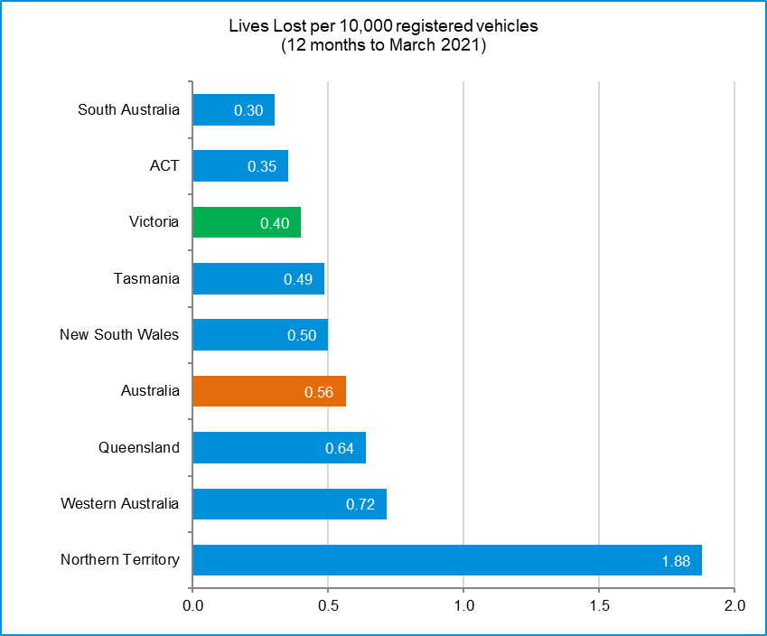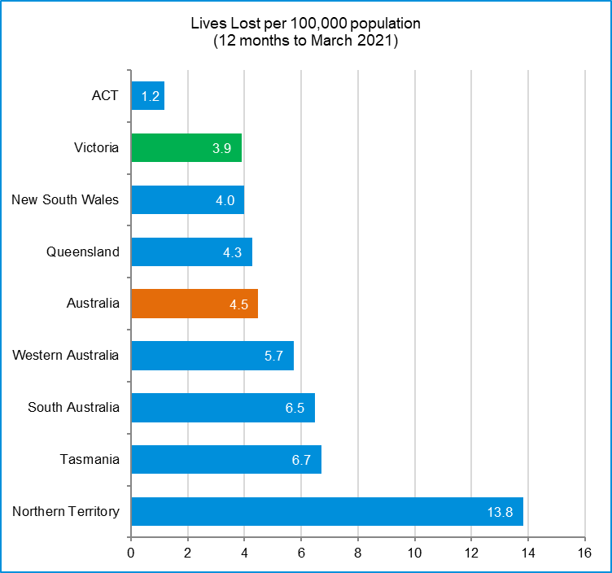

# International Road Safety Comparison

Selected OECD countries, Australia and Victoria, 1990, 2000, 2010, 2015 to 2018

**Lives lost rate per 100,000 population**

|  |  |  |  |  |  |  |  |
| --- | --- | --- | --- | --- | --- | --- | --- |
| **Countries** | **1990** | **2000** | **2010** | **2015** | **2016** | **2017** | **2018** |
| Australia | 13.7 | 9.5 | 6.1 | 5.1 | 5.3 | 5.0 | 4.5 |
| Canada | 14.3 | 9.5 | 6.6 | 5.3 | 5.3 | 5.1 | 4.9 |
| New Zealand | 21.5 | 12.0 | 8.6 | 6.9 | 7.0 | 7.9 | 7.7 |
| Norway | 7.8 | 7.6 | 4.3 | 2.3 | 2.6 | 2.0 | 2.0 |
| Sweden | 9.0 | 6.7 | 2.8 | 2.6 | 2.7 | 2.5 | 3.2 |
| Switzerland | 13.8 | 8.2 | 4.2 | 3.1 | 2.6 | 2.7 | 2.7 |
| United Kingdom | 9.4 | 6.1 | 3.0 | 2.8 | 2.8 | 2.8 | 2.8 |
| United States | 17.9 | 14.9 | 10.7 | 11.1 | 11.7 | 11.5 | 11.2 |
| Victoria | 12.5 | 8.7 | 5.3 | 4.2 | 4.7 | 4.1 | 3.3 |

**Lives lost rate per100 million vehicle kilometres travelled (VKT)**

|  |  |  |  |  |  |  |  |
| --- | --- | --- | --- | --- | --- | --- | --- |
| **Countries** | **1990** | **2000** | **2010** | **2015** | **2016** | **2017** | **2018** |
| Australia | 1.4 | 0.9 | 0.6 | 0.5 | 0.5 | 0.5 | 0.4 |
| Canada | - | 0.9 | 0.7 | 0.5 | 0.5 | 0.5 | 0.5 |
| New Zealand | - | 1.4 | 0.9 | 0.7 | 0.7 | 0.8 | 0.8 |
| Norway | 1.2 | 1.0 | 0.5 | 0.3 | 0.3 | 0.2 | 0.2 |
| Sweden | 1.2 | 0.9 | 0.3 | 0.3 | 0.3 | 0.3 | 0.4 |
| Switzerland | 1.9 | 1.1 | 0.5 | 0.4 | 0.3 | 0.3 | 0.3 |
| United Kingdom | - | - | - | - | - | - | - |
| United States | 1.3 | 0.9 | 0.7 | 0.7 | 0.7 | 0.7 | 0.7 |
| Victoria | 1.2 | 0.8 | 0.5 | 0.4 | 0.4 | 0.4 | 0.3 |

|  |  |  |  |
| --- | --- | --- | --- |
| **Lives lost rate per 10,000 registered vehicles** |  |  |  |

|  |  |  |  |  |  |  |  |
| --- | --- | --- | --- | --- | --- | --- | --- |
| **Countries** | **1990** | **2000** | **2010** | **2015** | **2016** | **2017** | **2018** |
| Australia | 2.3 | 1.5 | 0.8 | 0.7 | 0.7 | 0.7 | 0.6 |
| Canada | 2.3 | 1.6 | 1.0 | 0.8 | 0.8 | 0.8 | 0.7 |
| New Zealand | 3.3 | 1.8 | 1.2 | 0.9 | 0.9 | 1.0 | 0.9 |
| Norway | 1.4 | 1.2 | 0.6 | 0.3 | 0.3 | 0.3 | 0.3 |
| Sweden | 1.7 | 1.2 | 0.5 | 0.4 | 0.4 | 0.4 | 0.5 |
| Switzerland | 2.2 | 1.2 | 0.6 | 0.4 | 0.4 | 0.4 | 0.4 |
| United Kingdom | 2.1 | 1.2 | 0.5 | 0.5 | 0.5 | 0.5 | 0.5 |
| United States | 2.4 | 1.9 | 1.3 | 1.3 | 1.3 | 1.3 | 1.2 |
| Victoria | 2.1 | 1.2 | 0.7 | 0.6 | 0.6 | 0.5 | 0.4 |

Lives lost rate per 100,000 **population** - OECD countries, 2018

Source: ABS 2020a, Australian Road Deaths Database and IRTAD 2020

# Explanations and references

**LGA:** Local Government Areas. Crash locations for acute hospitalised claims are assigned to LGA’s based on the crash postcode recorded by Victoria Police. Crash locations for fatal crashes are coded exactly to an LGA by Victoria Police.

**Claimants:** Refers to people injured in transport accidents who have an accepted claim with the TAC.

**Hospitalisation:** refers to all hospital admission that occurred within 7 days of accident.

# Useful websites

TAC Sites

* TAC Safety (Road Safety) [www.tacsafety.com.au](http://www.tacsafety.com.au)
* TAC How safe is your car [www.howsafeisyourcar.com.au](http://www.howsafeisyourcar.com.au)
* TAC How safe is your first car www.howsafeisyourfirstcar.com.au
* TAC Motorcycle Safety Website www.spokes.com.au
* TAC Corporate site [www.tac.vic.gov.au](http://www.tac.vic.gov.au)
* Drivesmart www.drivesmart.vic.gov.au
* Ridesmart www.ridesmartonline.com.au

Victorian Sites

* VicRoads [www.vicroads.vic.gov.au](http://www.vicroads.vic.gov.au)
* Victoria Police www.police.vic.gov.au
* Parliamentary Road Safety Committee https://www.parliament.vic.gov.au/57th-parliament/rsc
* RACV www.racv.com.au
* Monash University Accident Research Centre [www.monash.edu.au/muarc](http://www.general.monash.edu.au\muarc)
* Cameras Save Lives www.camerassavelives.vic.gov.au
* VicRoads Learner Driver Site www.lsite.vicroads.vic.gov.au/Learners
* Road Safety Education Victoria www.roadsafetyeducation.vic.gov.au

National and Interstate Sites

* ARRB Transport Research www.arrb.com.au
* Australian Transport Safety Bureau [www.atsb.gov.au](http://www.dot.gov.au/programs/fors/overview.htm)
* Motor Accidents Authority (NSW) www.maa.nsw.gov.au
* Motor Accidents Insurance Board (TAS) www.maib.tas.gov.au
* Motor Accident Commission, Allianz (SA) www.mac.sa.gov.au
* Motor Accidents Compensation, TIO, (NT) www.tiofi.com.au/mac
* Insurance Commission of Western Australia www.icwa.wa.gov.au
* Motor Accident Insurance Commission (QLD) www.maic.qld.gov.au

International Sites

* National Highway Traffic Safety Admin (USA) [www.nhtsa.dot.gov](http://www.nhtsa.dot.gov)
* Swedish Road and Transport Institute (VTI) [www.vti.se](http://www.vti.se)
* SWOV Institute for Road Safety Research www.swov.nl

Related Sites

* Alcohol and Drug Foundation [www.adf.org.au](http://www.adf.org.au)**Figures**

Victoria – Lives Lost, rolling 12 months total

Graph 1a – Melbourne/Rural lives lost

Graph 1b – Melbourne/Rural claims involving acute hospitalisations

Graph 1c – Melbourne/Rural Claims involving hospital admission greater than 14 days

Graph 1d – Victoria/Australia lives lost per 100,000 population

# Victorian monthly lives lost since 1951

