Towards_ZERO_LOGO_REV_RGB.ai



**Quarterly Statistics –** **MARCH 2018**

**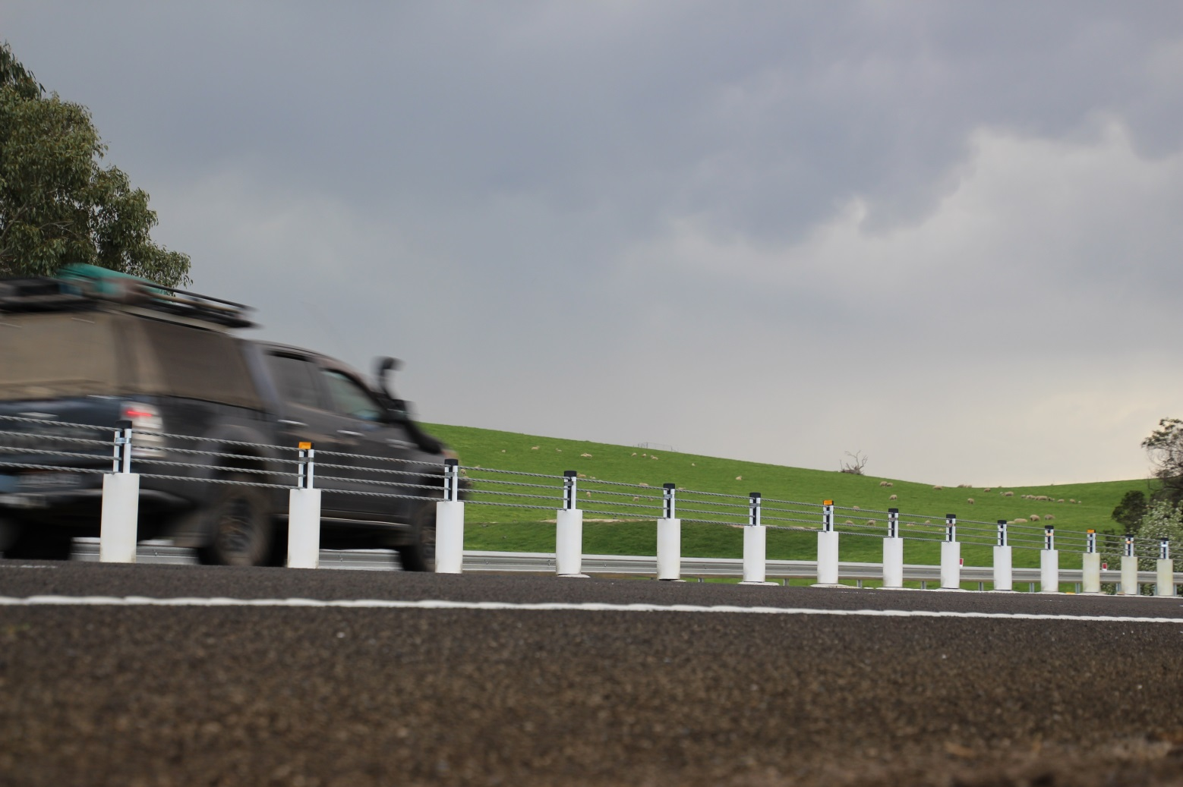**

|  |  |  |
| --- | --- | --- |
| **TRANSPORT ACCIDENT COMMISSION** | **60 Brougham Street Geelong Vic 3220**  **PO Box 742 Geelong Vic 3220**  **Ausdoc DX 216079 Geelong** | **Telephone 1300 654 329 STD Toll Free 1800 332 556 Fax: 03 9656 9300**  **www.tac.vic.gov.au ABN 22 033 947 623** |

**Contents**

[Status Report 4](#_Toc513535266)

[Lives lost on Victorian roads 4](#_Toc513535267)

[Injured claimants who were admitted to hospital within 7 days of accident, (by claim acceptance date – rolling 12 month, to 30th September 2017) 5](#_Toc513535268)

[Lives lost: 12 months to 31st March 2018 6](#_Toc513535269)

[Injured claimants who were admitted to hospital within 7 days of accident, 12 months to 30th September (claim acceptance date) 10](#_Toc513535270)

[Lives Lost by Week (2013 to 2018) 12](#_Toc513535271)

[The National Picture 13](#_Toc513535272)

[Booze Bus Random Breath Testing 14](#_Toc513535273)

[Random Drug Testing 14](#_Toc513535274)

[Mobile Safety Camera Data 14](#_Toc513535275)

[Explanations and References 15](#_Toc513535276)

[Useful Internet Sites 16](#_Toc513535277)

[Victorian monthly lives lost since 1951 19](#_Toc513535278)

Notes about the data in this report

* All data provided in this report is the data most recently available at time of production. Fatality data are updated to the end of report month. A 6-month lag applies to TAC claims data.
* Reported data will have one extra day of exposure for leap years.
* Data is subject to revision as additional information about known accidents/claims is received, and as new accident/claim reports are received and processed.

# Status Report

## Lives lost on Victorian roads

* The rolling 12 month number of lives lost to 31st March 2018 is 259. The rolling 12 month number of lives lost to 31st March 2017 stood at 268 (a decrease of 9).
* 58 people lost their lives year to date to the end of March 2018 on Victorian roads. This compares to 57 lives lost year to date to the end of March 2017.
* February and March 2018 had lowest number of lives lost since 1952.

|  |  |  |  |  |  |  |
| --- | --- | --- | --- | --- | --- | --- |
| **Category** | **2018** | **2017** | **2016** | **2018 v 2017** | **2018 v 2016** | **5 Year Average** |
|  |  |  |  |  |  |  |
| **Lives Lost (Rolling 12 Month Total)** | |  |  |  |  |  |
| **Lives Lost (to March)** | **259** | **268** | **265** | **-9** | **-6** | **257** |
| per 10,000 veh | 0.53 | 0.56 | 0.57 | -0.03 | -0.04 | 0.56 |
| per 100,000 pop | 4.07 | 4.30 | 4.41 | -0.22 | -0.34 | 4.33 |
|  |  |  |  |  |  |  |
| **Crashes (Rolling 12 Month Total)** | |  |  |  |  |  |
| **Fatal crashes (to March)** | **240** | **258** | **248** | **-18** | **-8** | **239** |
| per 10,000 veh | 0.49 | 0.54 | 0.53 | -0.05 | -0.04 | 0.51 |
| per 100,000 pop | 3.77 | 4.14 | 4.13 | -0.36 | -0.36 | 3.94 |

**Victoria – Lives Lost, rolling 12 months total**

## Injured claimants who were admitted to hospital within 7 days of accident, (by claim acceptance date – rolling 12 month, to 30th September 2017)

|  |  |  |  |  |  |  |  |  |
| --- | --- | --- | --- | --- | --- | --- | --- | --- |
| **Category** | **2017** | **2016** | **2015** | **2017v 2016** | | **2017 v 2015** | | **5 Year Average** |
|  |  |  |  |  |  |  |  |  |
| **Claims involving hospitalisation over 14 days (Rolling 12 Month Total)** | | | | | |  |  |  |
|  |  |  |  |  |  |  |  |  |
| **Claims (to September)** | **944** | **1,006** | **930** | **-62.0** | **(-6%)** | **+14** | **(+2%)** | **892** |
| per 100,000 pop | 14.9 | 16.4 | 15.7 | -1.6 | (-10%) | -0.9 | (-5%) | 14.0 |
| per 10,000 veh | 2.0 | 2.1 | 2.0 | -0.2 | (-8%) | -0.1 | (-3%) | 1.9 |
|  |  |  |  |  |  |  |  |  |
| **All claims involving hospitalisation (Rolling 12 Month Total)** | | | | |  |  |  |  |
|  |  |  |  |  |  |  |  |  |
| **Claims (to September)** | **7,560** | **7,039** | **6,030** | **+521** | **(+7%)** | **+1530** | **(+25%)** | **6,162** |
| per 100,000 pop | 119.0 | 115.0 | 101.9 | +4.0 | (+3%) | +17.1 | (+17%) | 97.0 |
| per 10,000 veh | 15.7 | 15.0 | 13.1 | +0.7 | (+5%) | +2.5 | (+19%) | 12.8 |

# Lives lost: 12 months to 31st March 2018

|  |  |  |  |  |  |  |
| --- | --- | --- | --- | --- | --- | --- |
| **Category** | **2018** | **2017** | **2016** | **2018 v 2017** | **2018 v 2016** | **5 Year Average** |
|  |  |  |  |  |  |  |
| **Overview** |  |  |  |  |  |  |
| Lives Lost | 259 | 268 | 265 | -9 | -6 | 257 |
| Fatal Crashes | 240 | 257 | 248 | -17 | -8 | 238 |
|  |  |  |  |  |  |  |
| **Sex** |  |  |  |  |  |  |
| Female | 69 | 77 | 76 | -8 | -7 | 74 |
| Male | 189 | 191 | 189 | -2 | 0 | 183 |
|  |  |  |  |  |  |  |
| **Road user** |  |  |  |  |  |  |
| Bicyclist | 12 | 6 | 12 | +6 | 0 | 9 |
| Driver | 127 | 151 | 124 | -24 | +3 | 127 |
| Motorcyclist | 41 | 40 | 44 | +1 | -3 | 38 |
| Passenger | 46 | 36 | 54 | +10 | -8 | 46 |
| Pedestrian | 33 | 35 | 31 | -2 | +2 | 37 |
|  |  |  |  |  |  |  |
| **Location** |  |  |  |  |  |  |
| Melbourne | 108 | 116 | 130 | -8 | -22 | 115 |
| Rural Victoria | 150 | 152 | 135 | -2 | +15 | 142 |
|  |  |  |  |  |  |  |
| **Age group** |  |  |  |  |  |  |
| 0-4 | 1 | 4 | 1 | -3 | 0 | 2 |
| 5-15 | 3 | 4 | 4 | -1 | -1 | 5 |
| 16-17 | 4 | 4 | 16 |  | -12 | 7 |
| 18-20 | 21 | 11 | 32 | +10 | -11 | 19 |
| 21-25 | 24 | 27 | 16 | -3 | +8 | 24 |
| 26-29 | 13 | 24 | 20 | -11 | -7 | 19 |
| 30-39 | 39 | 41 | 29 | -2 | +10 | 35 |
| 40-49 | 38 | 52 | 35 | -14 | +3 | 38 |
| 50-59 | 31 | 34 | 32 | -3 | -1 | 31 |
| 60-69 | 31 | 24 | 27 | +7 | +4 | 28 |
| 70+ | 52 | 42 | 53 | +10 | -1 | 49 |
|  |  |  |  |  |  |  |
| **Accident Type** |  |  |  |  |  |  |
| **Intersection** |  |  |  |  |  |  |
| Adjacent direction | 34 | 28 | 34 | +6 | 0 | 33 |
| Opposing direction | 12 | 5 | 10 | +7 | +2 | 8 |
| **Mid-block/other** |  |  |  |  |  |  |
| Head on | 40 | 50 | 47 | -10 | -7 | 43 |
| Same direction | 19 | 23 | 17 | -4 | +2 | 16 |
| Manoeuvre/o'taking | 15 | 10 | 19 | +5 | -4 | 13 |
| On path | 7 | 9 | 3 | -2 | +4 | 6 |
| Single vehicle | 95 | 103 | 102 | -8 | -7 | 97 |
| Other (incl peds) | 37 | 40 | 33 | -3 | +4 | 41 |

# 

**Lives Lost: 12 months to 31st March 2018 – Continued**

|  |  |  |  |  |  |  |  |  |  |
| --- | --- | --- | --- | --- | --- | --- | --- | --- | --- |
| **Category** | **2018** | **2017** | **2016** | **5 Year Average** | **Category** | **2018** | **2017** | **2016** | **5 Year Average** |
|  |  |  |  |  |  |  |  |  |  |
| **Local Government Area** |  |  |  |  | **Local Government Area** |  |  |  |  |
| ALPINE | 1 | 0 | 0 | 1 | MANSFIELD | 3 | 3 | 2 | 2 |
| ARARAT | 1 | 1 | 3 | 1 | MARIBYRNONG | 5 | 2 | 4 | 2 |
| BALLARAT | 4 | 7 | 2 | 4 | MAROONDAH | 1 | 2 | 1 | 1 |
| BANYULE | 4 | 1 | 2 | 1 | MELBOURNE | 3 | 4 | 1 | 3 |
| BASS COAST | 2 | 4 | 0 | 2 | MELTON | 3 | 4 | 5 | 5 |
| BAW BAW | 3 | 3 | 2 | 3 | MILDURA | 1 | 2 | 5 | 3 |
| BAYSIDE | 4 | 4 | 0 | 3 | MITCHELL | 6 | 3 | 4 | 3 |
| BENALLA | 3 | 2 | 4 | 2 | MOIRA | 6 | 5 | 6 | 4 |
| BOROONDARA | 3 | 4 | 2 | 3 | MONASH | 5 | 6 | 4 | 3 |
| BRIMBANK | 4 | 11 | 8 | 6 | MOONEE VALLEY | 2 | 4 | 0 | 2 |
| BULOKE | 1 | 2 | 2 | 2 | MOORABOOL | 5 | 7 | 3 | 3 |
| CAMPASPE | 5 | 4 | 4 | 4 | MORELAND | 1 | 6 | 1 | 3 |
| CARDINIA | 8 | 4 | 11 | 5 | MORNINGTON PENINSULA | 4 | 4 | 14 | 6 |
| CASEY | 7 | 9 | 7 | 6 | MOUNT ALEXANDER | 3 | 0 | 2 | 2 |
| CENTRAL GOLDFIELDS | 1 | 1 | 1 | 2 | MOYNE | 2 | 2 | 0 | 2 |
| COLAC-OTWAY | 8 | 3 | 2 | 2 | MURRINDINDI | 7 | 4 | 5 | 5 |
| CORANGAMITE | 3 | 1 | 4 | 4 | NILLUMBIK | 2 | 4 | 2 | 2 |
| DAREBIN | 4 | 0 | 5 | 2 | NORTHERN GRAMPIANS | 3 | 3 | 1 | 2 |
| EAST GIPPSLAND | 8 | 4 | 9 | 5 | PORT PHILLIP | 2 | 0 | 2 | 1 |
| FRANKSTON | 6 | 1 | 3 | 2 | PYRENEES | 4 | 3 | 0 | 1 |
| GANNAWARRA | 4 | 0 | 0 | 1 | QUEENSCLIFFE | 0 | 0 | 0 | 0 |
| GLEN EIRA | 1 | 3 | 2 | 2 | SOUTH GIPPSLAND | 3 | 3 | 6 | 4 |
| GLENELG | 4 | 4 | 2 | 3 | SOUTHERN GRAMPIANS | 1 | 4 | 2 | 1 |
| GOLDEN PLAINS | 4 | 3 | 4 | 2 | STONNINGTON | 1 | 0 | 2 | 2 |
| GREATER BENDIGO | 5 | 5 | 4 | 4 | STRATHBOGIE | 3 | 1 | 5 | 3 |
| GREATER DANDENONG | 6 | 1 | 7 | 3 | SURF COAST | 3 | 2 | 4 | 2 |
| GREATER GEELONG | 8 | 12 | 4 | 6 | SWAN HILL | 1 | 4 | 2 | 2 |
| GREATER SHEPPARTON | 9 | 7 | 7 | 5 | TOWONG | 2 | 1 | 0 | 0 |
| HEPBURN | 2 | 7 | 0 | 2 | WANGARATTA | 3 | 5 | 4 | 3 |
| HINDMARSH | 0 | 0 | 2 | 1 | WARRNAMBOOL | 0 | 1 | 1 | 1 |
| HORSHAM | 1 | 4 | 4 | 2 | WEST WIMMERA | 0 | 1 | 0 | 0 |
| HUME | 3 | 3 | 6 | 4 | WHITEHORSE | 3 | 4 | 2 | 3 |
| INDIGO | 2 | 5 | 2 | 3 | WHITTLESEA | 4 | 5 | 3 | 4 |
| KINGSTON | 4 | 4 | 4 | 4 | WODONGA | 1 | 3 | 2 | 2 |
| KNOX | 1 | 6 | 6 | 4 | WYNDHAM | 3 | 10 | 8 | 5 |
| LATROBE | 3 | 3 | 6 | 4 | YARRA | 2 | 1 | 2 | 1 |
| LODDON | 1 | 2 | 2 | 1 | YARRA RANGES | 8 | 5 | 12 | 6 |
| MACEDON RANGES | 3 | 3 | 6 | 4 | YARRIAMBIACK | 1 | 2 | 0 | 1 |
| MANNINGHAM | 3 | 3 | 1 | 1 |  |  |  |  |  |

**Injured claimants who were admitted to hospital within 7 days of the accident with a hospital stay of more than 14 days, 12 months to 30th September (claim acceptance date)**

|  |  |  |  |  |  |  |  |  |
| --- | --- | --- | --- | --- | --- | --- | --- | --- |
| **Category** | **2017** | **2016** | **2015** | **2017 v 2016** | | **2017 v 2015** | | **5 Year Average** |
|  |  |  |  |  |  |  |  |  |
| **Overview** |  |  |  |  |  |  |  |  |
| Claims | 944 | 1,006 | 930 | -62 | -6% | +14 | 2% | 892 |
|  |  |  |  |  |  |  |  |  |
| **Sex** |  |  |  |  |  |  |  |  |
| Female | 370 | 422 | 402 | -52 | -12% | -32 | -8% | 368 |
| Male | 574 | 584 | 527 | -10 | -2% | +47 | 9% | 524 |
|  |  |  |  |  |  |  |  |  |
| **Road user** |  |  |  |  |  |  |  |  |
| Bicyclist | 35 | 36 | 40 | -1 | -3% | -5 | -13% | 34 |
| Driver | 326 | 399 | 344 | -73 | -18% | -18 | -5% | 345 |
| Motorcyclist | 192 | 162 | 187 | +30 | 19% | +5 | 3% | 160 |
| Passenger | 138 | 150 | 146 | -12 | -8% | -8 | -5% | 135 |
| Pedestrian | 213 | 213 | 185 |  | 0% | +28 | 15% | 190 |
| Train/Tram | 11 | 5 | 10 | +6 | 120% | +1 | 10% | 7 |
|  |  |  |  |  |  |  |  |  |
| **Location** |  |  |  |  |  |  |  |  |
| Melbourne | 560 | 646 | 618 | -86 | -13% | -58 | -9% | 563 |
| Rural Victoria | 328 | 307 | 289 | +21 | 7% | 39 | 13% | 299 |
|  |  |  |  |  |  |  |  |  |
| **Age group** |  |  |  |  |  |  |  |  |
| 0-4 | 2 | 7 | 4 | -5 | -71% | -2 | -50% | 3 |
| 5-15 | 9 | 17 | 18 | -8 | -47% | -9 | -50% | 13 |
| 16-17 | 14 | 13 | 13 | +1 | 8% | 1 | 8% | 13 |
| 18-20 | 53 | 72 | 44 | -19 | -26% | 9 | 20% | 55 |
| 21-25 | 94 | 87 | 81 | +7 | 8% | 13 | 16% | 81 |
| 26-29 | 57 | 57 | 57 |  | 0% | 0 | 0% | 49 |
| 30-39 | 126 | 136 | 98 | -10 | -7% | 28 | 29% | 110 |
| 40-49 | 107 | 107 | 120 |  | 0% | -13 | -11% | 106 |
| 50-59 | 123 | 98 | 125 | +25 | 26% | -2 | -2% | 106 |
| 60-69 | 113 | 128 | 106 | -15 | -12% | 7 | 7% | 107 |
| 70+ | 246 | 284 | 264 | -38 | -13% | -18 | -7% | 250 |
|  |  |  |  |  |  |  |  |  |
|  |  |  |  |  |  |  |  |  |
| **Accident Type** |  |  |  |  |  |  |  |  |
| **Intersection** |  |  |  |  |  |  |  |  |
| Adjacent direction | 100 | 108 | 101 | -8 | -7% | -1 | -1% | 102 |
| Opposing direction | 54 | 59 | 61 | -5 | -8% | -7 | -11% | 57 |
| **Mid-block/other** |  |  |  |  |  |  |  |  |
| Head on | 62 | 106 | 83 | -44 | -42% | -21 | -25% | 79 |
| Same direction | 63 | 69 | 98 | -6 | -9% | -35 | -36% | 70 |
| Manoeuvre/overtaking | 44 | 60 | 54 | -16 | -27% | -10 | -19% | 52 |
| On path | 17 | 31 | 33 | -14 | -45% | -16 | -48% | 25 |
| Single vehicle | 231 | 294 | 269 | -63 | -21% | -38 | -14% | 247 |
| Other (incl pedestrians) | 373 | 279 | 231 | +94 | 34% | 142 | 61% | 259 |

Note: Excludes rejected claims and claims for interstate crashes.

**Injured claimants who were admitted to hospital within 7 days of the accident with a hospital stay of more than 14 days, 12 months to 30th September (claim acceptance date) – Continued**

|  |  |  |  |  |  |  |  |  |  |
| --- | --- | --- | --- | --- | --- | --- | --- | --- | --- |
| **Category** | **2017** | **2016** | **2015** | **5 Year Average** | **Category** | **2017** | **2016** | **2015** | **5 Year Average** |
|  |  |  |  |  |  |  |  |  |  |
| **Local Government Area** | |  |  |  | **Local Government Area** | |  |  |  |
| ALPINE | 5 | 2 | 5 | 2 | MANSFIELD | 8 | 5 | 2 | 3 |
| ARARAT | 3 | 2 | 10 | 5 | MARIBYRNONG | 17 | 10 | 12 | 7 |
| BALLARAT | 18 | 11 | 15 | 12 | MAROONDAH | 6 | 10 | 6 | 5 |
| BANYULE | 9 | 9 | 11 | 8 | MELBOURNE | 35 | 32 | 34 | 24 |
| BASS COAST | 5 | 4 | 11 | 7 | MELTON | 10 | 12 | 21 | 10 |
| BAW BAW | 11 | 8 | 8 | 6 | MILDURA | 8 | 3 | 5 | 5 |
| BAYSIDE | 14 | 10 | 8 | 7 | MITCHELL | 11 | 8 | 6 | 7 |
| BENALLA | 4 | 3 | 6 | 3 | MOIRA | 10 | 7 | 6 | 6 |
| BOROONDARA | 15 | 12 | 21 | 15 | MONASH | 25 | 21 | 24 | 16 |
| BRIMBANK | 23 | 36 | 34 | 20 | MOONEE VALLEY | 11 | 25 | 21 | 16 |
| BULOKE | 0 | 5 | 4 | 3 | MOORABOOL | 11 | 11 | 7 | 7 |
| CAMPASPE | 14 | 7 | 9 | 6 | MORELAND | 30 | 28 | 28 | 21 |
| CARDINIA | 22 | 16 | 14 | 10 | MORNINGTON PENINSULA | 22 | 31 | 25 | 20 |
| CASEY | 32 | 39 | 32 | 24 | MOUNT ALEXANDER | 0 | 2 | 5 | 4 |
| CENTRAL GOLDFIELDS | 1 | 4 | 1 | 3 | MOYNE | 7 | 3 | 2 | 3 |
| COLAC-OTWAY | 9 | 8 | 10 | 7 | MURRINDINDI | 15 | 7 | 17 | 8 |
| CORANGAMITE | 6 | 3 | 5 | 4 | NILLUMBIK | 4 | 9 | 11 | 6 |
| DAREBIN | 17 | 30 | 16 | 15 | NORTHERN GRAMPIANS | 3 | 3 | 2 | 3 |
| EAST GIPPSLAND | 13 | 8 | 11 | 6 | PORT PHILLIP | 13 | 18 | 17 | 13 |
| FRANKSTON | 13 | 15 | 20 | 11 | PYRENEES | 1 | 2 | 2 | 1 |
| GANNAWARRA | 4 | 2 | 2 | 2 | QUEENSCLIFFE | 0 | 1 | 0 | 0 |
| GLEN EIRA | 7 | 17 | 14 | 14 | SOUTH GIPPSLAND | 6 | 15 | 8 | 6 |
| GLENELG | 2 | 6 | 6 | 4 | SOUTHERN GRAMPIANS | 2 | 3 | 2 | 3 |
| GOLDEN PLAINS | 6 | 9 | 5 | 5 | STONNINGTON | 13 | 14 | 15 | 11 |
| GREATER BENDIGO | 19 | 14 | 12 | 11 | STRATHBOGIE | 5 | 11 | 7 | 6 |
| GREATER DANDENONG | 26 | 27 | 15 | 19 | SURF COAST | 5 | 6 | 5 | 4 |
| GREATER GEELONG | 34 | 17 | 21 | 19 | SWAN HILL | 3 | 8 | 5 | 3 |
| GREATER SHEPPARTON | 22 | 20 | 9 | 10 | TOWONG | 1 | 3 | 1 | 2 |
| HEPBURN | 2 | 3 | 5 | 3 | WANGARATTA | 7 | 6 | 6 | 4 |
| HINDMARSH | 4 | 1 | 1 | 1 | WARRNAMBOOL | 4 | 3 | 2 | 3 |
| HOBSONS BAY | 10 | 5 | 12 | 7 | WELLINGTON | 12 | 7 | 8 | 6 |
| HORSHAM | 1 | 5 | 3 | 3 | WEST WIMMERA | 2 | 0 | 1 | 1 |
| HUME | 28 | 34 | 35 | 22 | WHITEHORSE | 22 | 21 | 18 | 14 |
| INDIGO | 4 | 9 | 5 | 3 | WHITTLESEA | 24 | 33 | 30 | 20 |
| KINGSTON | 15 | 14 | 25 | 16 | WODONGA | 2 | 5 | 5 | 4 |
| KNOX | 20 | 17 | 16 | 12 | WYNDHAM | 22 | 35 | 20 | 20 |
| LATROBE | 4 | 13 | 14 | 9 | YARRA | 9 | 14 | 15 | 11 |
| LODDON | 0 | 3 | 1 | 1 | YARRA RANGES | 29 | 34 | 37 | 26 |
| MACEDON RANGES | 13 | 20 | 6 | 10 | YARRIAMBIACK | 1 | 1 | 0 | 1 |
| MANNINGHAM | 17 | 18 | 11 | 10 |  |  |  |  |  |

Note: excludes rejected claims and claims for interstate crashes

# 

# Injured claimants who were admitted to hospital within 7 days of accident, 12 months to 30th September (claim acceptance date)

|  |  |  |  |  |  |  |  |  |
| --- | --- | --- | --- | --- | --- | --- | --- | --- |
| **Category** | **2017** | **2016** | **2015** | **2017 v 2016** | | **2017 v 2015** | | **5 Year Average** |
|  |  |  |  |  |  |  |  |  |
| **Overview** |  |  |  |  |  |  |  |  |
| Claims | 7,560 | 7,039 | 6,030 | +521 | 7% | +1530 | 25% | 6,162 |
|  |  |  |  |  |  |  |  |  |
| **Sex** |  |  |  |  |  |  |  |  |
| Female | 3,263 | 3,086 | 2,612 | +177 | 6% | +651 | 25% | 2,638 |
| Male | 4,288 | 3,939 | 3,411 | +349 | 9% | +877 | 26% | 3,516 |
|  |  |  |  |  |  |  |  |  |
| **Road user** |  |  |  |  |  |  |  |  |
| Bicyclist | 458 | 424 | 388 | +34 | 8% | +70 | 18% | 389 |
| Driver | 3,600 | 3,342 | 2,754 | +258 | 8% | +846 | 31% | 2,854 |
| Motorcyclist | 1,269 | 1,166 | 1,092 | +103 | 9% | +177 | 16% | 1,077 |
| Passenger | 1,079 | 1,097 | 1,014 | -18 | -2% | +65 | 6% | 989 |
| Pedestrian | 774 | 719 | 606 | +55 | 8% | +168 | 28% | 646 |
| Train/Tram | 58 | 29 | 31 | +29 | 100% | +27 | 87% | 34 |
|  |  |  |  |  |  |  |  |  |
| **Location** |  |  |  |  |  |  |  |  |
| Melbourne | 4,588 | 4,687 | 4,042 | -99 | -2% | +546 | 14% | 4,041 |
| Rural Victoria | 2,201 | 1,985 | 1,758 | +216 | 11% | +443 | 25% | 1,807 |
|  |  |  |  |  |  |  |  |  |
| **Age group** |  |  |  |  |  |  |  |  |
| 0-4 | 64 | 56 | 41 | +8 | 14% | +23 | 56% | 50 |
| 5-15 | 201 | 227 | 230 | -26 | -11% | -29 | -13% | 192 |
| 16-17 | 114 | 131 | 106 | -17 | -13% | +8 | 8% | 104 |
| 18-20 | 551 | 540 | 459 | +11 | 2% | +92 | 20% | 485 |
| 21-25 | 958 | 891 | 706 | +67 | 8% | +252 | 36% | 768 |
| 26-29 | 654 | 610 | 484 | +44 | 7% | +170 | 35% | 508 |
| 30-39 | 1,192 | 1,128 | 957 | +64 | 6% | +235 | 25% | 957 |
| 40-49 | 1,129 | 990 | 879 | +139 | 14% | +250 | 28% | 908 |
| 50-59 | 1,032 | 853 | 789 | +179 | 21% | +243 | 31% | 788 |
| 60-69 | 698 | 700 | 554 | -2 | 0% | +144 | 26% | 576 |
| 70+ | 967 | 913 | 825 | +54 | 6% | +142 | 17% | 824 |
|  |  |  |  |  |  |  |  |  |
| **Accident Type** |  |  |  |  |  |  |  |  |
| **Intersection** |  |  |  |  |  |  |  |  |
| Adjacent direction | 901 | 907 | 774 | -6 | -1% | +127 | 16% | 799 |
| Opposing direction | 547 | 582 | 519 | -35 | -6% | +28 | 5% | 508 |
| **Mid-block/other** |  |  |  |  |  |  |  |  |
| Head on | 329 | 380 | 279 | -51 | -13% | +50 | 18% | 309 |
| Same direction | 975 | 1,067 | 913 | -92 | -9% | +62 | 7% | 884 |
| Manoeuvre/overtaking | 361 | 400 | 352 | -39 | -10% | +9 | 3% | 338 |
| On path | 222 | 321 | 296 | -99 | -31% | -74 | -25% | 262 |
| Single vehicle | 1,500 | 1,710 | 1,710 | -210 | -12% | -210 | -12% | 1,545 |
| Other (incl pedestrians) | 2,725 | 1,672 | 1,187 | +1053 | 63% | +1538 | 130% | 1,517 |

Note: excludes rejected claims and claims for interstate crashes

**Injured claimants who were admitted to hospital within 7 days of accident, 12 months to 30th September (claim acceptance date) – Continued**

|  |  |  |  |  |  |  |  |  |  |
| --- | --- | --- | --- | --- | --- | --- | --- | --- | --- |
| **Category** | **2017** | **2016** | **2015** | **5 Year Average** | **Category** | **2017** | **2016** | **2015** | **5 Year Average** |
|  |  |  |  |  |  |  |  |  |  |
| **Local Government Area** |  |  |  |  | **Local Government Area** | | |  |  |
| ALPINE | 27 | 25 | 23 | 22 | MANSFIELD | 35 | 40 | 21 | 25 |
| ARARAT | 16 | 15 | 25 | 15 | MARIBYRNONG | 98 | 74 | 77 | 55 |
| BALLARAT | 101 | 104 | 69 | 65 | MAROONDAH | 54 | 69 | 58 | 44 |
| BANYULE | 61 | 58 | 39 | 43 | MELBOURNE | 322 | 348 | 238 | 205 |
| BASS COAST | 30 | 47 | 60 | 37 | MELTON | 80 | 94 | 90 | 61 |
| BAW BAW | 48 | 48 | 46 | 40 | MILDURA | 24 | 31 | 30 | 26 |
| BAYSIDE | 87 | 94 | 72 | 60 | MITCHELL | 73 | 70 | 60 | 49 |
| BENALLA | 24 | 19 | 32 | 16 | MOIRA | 43 | 40 | 32 | 27 |
| BOROONDARA | 137 | 121 | 138 | 102 | MONASH | 203 | 196 | 192 | 148 |
| BRIMBANK | 155 | 136 | 143 | 104 | MOONEE VALLEY | 113 | 150 | 118 | 95 |
| BULOKE | 11 | 9 | 10 | 7 | MOORABOOL | 60 | 53 | 34 | 35 |
| CAMPASPE | 58 | 48 | 39 | 29 | MORELAND | 181 | 168 | 151 | 116 |
| CARDINIA | 138 | 150 | 109 | 88 | MORNINGTON PENINSULA | 178 | 171 | 154 | 113 |
| CASEY | 342 | 352 | 297 | 217 | MOUNT ALEXANDER | 17 | 21 | 29 | 21 |
| CENTRAL GOLDFIELDS | 17 | 15 | 7 | 10 | MOYNE | 29 | 22 | 15 | 15 |
| COLAC-OTWAY | 53 | 44 | 40 | 28 | MURRINDINDI | 75 | 60 | 59 | 45 |
| CORANGAMITE | 45 | 23 | 25 | 19 | NILLUMBIK | 34 | 50 | 45 | 30 |
| DAREBIN | 118 | 113 | 85 | 74 | NORTHERN GRAMPIANS | 16 | 15 | 16 | 13 |
| EAST GIPPSLAND | 67 | 52 | 69 | 43 | PORT PHILLIP | 137 | 142 | 145 | 105 |
| FRANKSTON | 131 | 140 | 141 | 95 | PYRENEES | 12 | 12 | 12 | 8 |
| GANNAWARRA | 14 | 10 | 10 | 9 | QUEENSCLIFFE | 3 | 1 | 1 | 1 |
| GLEN EIRA | 111 | 132 | 104 | 88 | SOUTH GIPPSLAND | 44 | 53 | 22 | 30 |
| GLENELG | 14 | 26 | 16 | 15 | SOUTHERN GRAMPIANS | 13 | 29 | 20 | 21 |
| GOLDEN PLAINS | 59 | 41 | 27 | 24 | STONNINGTON | 131 | 151 | 139 | 107 |
| GREATER BENDIGO | 132 | 107 | 108 | 71 | STRATHBOGIE | 36 | 41 | 39 | 26 |
| GREATER DANDENONG | 259 | 269 | 238 | 193 | SURF COAST | 58 | 56 | 41 | 32 |
| GREATER GEELONG | 390 | 225 | 230 | 166 | SWAN HILL | 16 | 24 | 19 | 12 |
| GREATER SHEPPARTON | 123 | 116 | 76 | 61 | TOWONG | 14 | 20 | 16 | 12 |
| HEPBURN | 23 | 31 | 30 | 23 | WANGARATTA | 27 | 42 | 36 | 25 |
| HINDMARSH | 12 | 8 | 6 | 6 | WARRNAMBOOL | 35 | 29 | 18 | 17 |
| HOBSONS BAY | 71 | 69 | 69 | 48 | WELLINGTON | 64 | 73 | 70 | 53 |
| HORSHAM | 24 | 17 | 28 | 15 | WEST WIMMERA | 7 | 5 | 4 | 4 |
| HUME | 251 | 230 | 192 | 143 | WHITEHORSE | 162 | 136 | 96 | 86 |
| INDIGO | 26 | 27 | 20 | 15 | WHITTLESEA | 227 | 215 | 156 | 123 |
| KINGSTON | 121 | 142 | 136 | 106 | WODONGA | 18 | 34 | 28 | 21 |
| KNOX | 144 | 146 | 105 | 87 | WYNDHAM | 168 | 155 | 140 | 115 |
| LATROBE | 58 | 70 | 53 | 48 | YARRA | 99 | 141 | 118 | 89 |
| LODDON | 9 | 10 | 15 | 10 | YARRA RANGES | 178 | 178 | 176 | 127 |
| MACEDON RANGES | 93 | 74 | 63 | 52 | YARRIAMBIACK | 7 | 3 | 9 | 4 |
| MANNINGHAM | 97 | 97 | 81 | 58 |  |  |  |  |  |

Note: excludes rejected claims and claims for interstate crashes

# Lives Lost by Week (2013 to 2018)

|  |  |  |  |  |  |  |  |  |
| --- | --- | --- | --- | --- | --- | --- | --- | --- |
| **Week** |  |  |  |  |  |  | **Cumulative** | **12 Month** |
| **Ending** | **2013** | **2014** | **2015** | **2016** | **2017** | **2018** | **2018** | **Moving Total** |
| 7-Jan | 3 | 0 | 5 | 2 | 2 | 7 | 7 | 263 |
| 14-Jan | 2 | 8 | 6 | 5 | 6 | 4 | 11 | 261 |
| 21-Jan | 5 | 5 | 5 | 2 | 4 | 2 | 13 | 259 |
| 28-Jan | 4 | 8 | 7 | 11 | 4 | 4 | 17 | 259 |
| 4-Feb | 6 | 8 | 6 | 4 | 3 | 4 | 21 | 260 |
| 11-Feb | 7 | 4 | 4 | 10 | 3 | 5 | 26 | 262 |
| 18-Feb | 4 | 7 | 6 | 7 | 6 | 7 | 33 | 263 |
| 25-Feb | 7 | 2 | 3 | 9 | 4 | 3 | 36 | 262 |
| 4-Mar | 1 | 5 | 4 | 10 | 5 | 4 | 40 | 261 |
| 11-Mar | 5 | 10 | 11 | 9 | 3 | 7 | 47 | 265 |
| 18-Mar | 5 | 3 | 4 | 5 | 5 | 4 | 51 | 264 |
| 25-Mar | 10 | 3 | 2 | 4 | 9 | 4 | 55 | 259 |
| 1-Apr | 5 | 8 | 4 | 1 | 3 | 3 | 58 | 259 |
| 8-Apr | 3 | 7 | 5 | 1 | 7 |  |  |  |
| 15-Apr | 4 | 4 | 5 | 4 | 10 |  |  |  |
| 22-Apr | 5 | 1 | 6 | 5 | 8 |  |  |  |
| 29-Apr | 5 | 2 | 6 | 5 | 2 |  |  |  |
| 6-May | 6 | 3 | 2 | 6 | 5 |  |  |  |
| 13-May | 3 | 4 | 8 | 5 | 7 |  |  |  |
| 20-May | 0 | 5 | 4 | 6 | 3 |  |  |  |
| 27-May | 3 | 7 | 3 | 7 | 3 |  |  |  |
| 3-Jun | 10 | 5 | 4 | 4 | 4 |  |  |  |
| 10-Jun | 3 | 3 | 5 | 5 | 3 |  |  |  |
| 17-Jun | 1 | 2 | 7 | 5 | 2 |  |  |  |
| 24-Jun | 5 | 2 | 2 | 5 | 7 |  |  |  |
| 1-Jul | 2 | 10 | 9 | 7 | 3 |  |  |  |
| 8-Jul | 4 | 5 | 6 | 3 | 7 |  |  |  |
| 15-Jul | 7 | 6 | 1 | 5 | 5 |  |  |  |
| 22-Jul | 5 | 3 | 3 | 6 | 8 |  |  |  |
| 29-Jul | 3 | 5 | 3 | 10 | 1 |  |  |  |
| 5-Aug | 8 | 4 | 6 | 6 | 3 |  |  |  |
| 12-Aug | 1 | 4 | 7 | 7 | 7 |  |  |  |
| 19-Aug | 5 | 6 | 9 | 8 | 7 |  |  |  |
| 26-Aug | 5 | 4 | 4 | 11 | 2 |  |  |  |
| 2-Sep | 4 | 6 | 4 | 1 | 8 |  |  |  |
| 9-Sep | 6 | 6 | 2 | 4 | 8 |  |  |  |
| 16-Sep | 2 | 4 | 4 | 4 | 2 |  |  |  |
| 23-Sep | 4 | 6 | 4 | 4 | 3 |  |  |  |
| 30-Sep | 7 | 3 | 4 | 5 | 3 |  |  |  |
| 7-Oct | 3 | 3 | 7 | 3 | 3 |  |  |  |
| 14-Oct | 2 | 7 | 4 | 7 | 6 |  |  |  |
| 21-Oct | 3 | 0 | 5 | 3 | 3 |  |  |  |
| 28-Oct | 4 | 8 | 9 | 6 | 0 |  |  |  |
| 4-Nov | 8 | 2 | 3 | 3 | 3 |  |  |  |
| 11-Nov | 5 | 7 | 4 | 7 | 12 |  |  |  |
| 18-Nov | 2 | 7 | 5 | 5 | 5 |  |  |  |
| 25-Nov | 8 | 3 | 2 | 8 | 9 |  |  |  |
| 2-Dec | 3 | 10 | 5 | 9 | 3 |  |  |  |
| 9-Dec | 7 | 5 | 9 | 4 | 6 |  |  |  |
| 16-Dec | 12 | 3 | 1 | 7 | 5 |  |  |  |
| 23-Dec | 9 | 2 | 3 | 2 | 9 |  |  |  |
| 30-Dec | 2 | 3 | 5 | 8 | 9 |  |  |  |
| 31-Dec | 0 | 0 | 0 | 0 | 0 |  |  |  |
| **Total** | **243** | **248** | **252** | **290** | **258** | **58** |  |  |

# The National Picture

|  |  |  |  |  |  |  |  |  |  |  |  |  |
| --- | --- | --- | --- | --- | --- | --- | --- | --- | --- | --- | --- | --- |
| **State** | | **Lives Lost (12 months to March)** | | | | | | | | |  | |
|  | | **2018** | **2017** | **2016** | | **2015** | | | **2018 v 2017** | | | |
| NSW | | 412 | 367 | 362 | | 295 | | | +45 | | (+12%) | |
| VIC | | 258 | 268 | 265 | | 243 | | | -10 | | (-4%) | |
| QLD | | 256 | 250 | 252 | | 218 | | | +6 | | (+2%) | |
| SA | | 103 | 84 | 101 | | 103 | | | +19 | | (+23%) | |
| WA | | 161 | 181 | 171 | | 184 | | | -20 | | (-11%) | |
| TAS | | 43 | 30 | 34 | | 39 | | | +13 | | (+43%) | |
| NT | | 38 | 44 | 50 | | 38 | | | -6 | | (-14%) | |
| ACT | | 5 | 12 | 16 | | 7 | | | -7 | | (-58%) | |
| AUST TOTAL | | 1,276 | 1,236 | 1,251 | | 1,127 | | | +40 | | (+3%) | |
| AUST minus VIC | | 1,018 | 968 | 986 | | 884 | | | +50 | | (+5%) | |
|  | |  |  |  | |  | | |  | |  | |
|  | |  |  |  | |  | | |  | |  | |
|  | **12 months to March** | | | | | | | | | | |
| **State** | **Lives Lost per 10,000 registered vehicles** | | | | | | **Fatalities per 100,000 population** | | | | |
|  | **(12 months to September)** | | | | | | **(12 months to September)** | | | | |
|  | **2018** | | **2017** | | **2016** | | **2018** | **2017** | | **2016** | |
| NSW | 0.74 | | 0.67 | | 0.68 | | 5.22 | 4.72 | | 4.73 | |
| VIC | 0.53 | | 0.56 | | 0.57 | | 4.06 | 4.31 | | 4.41 | |
| QLD | 0.64 | | 0.64 | | 0.66 | | 5.17 | 5.13 | | 5.25 | |
| SA | 0.74 | | 0.61 | | 0.74 | | 5.97 | 4.90 | | 6.01 | |
| WA | 0.72 | | 0.82 | | 0.78 | | 6.23 | 7.06 | | 5.93 | |
| TAS | 0.90 | | 0.64 | | 0.75 | | 8.24 | 5.79 | | 6.58 | |
| NT | 2.47 | | 2.82 | | 3.19 | | 15.43 | 17.90 | | 20.43 | |
| ACT | 0.17 | | 0.41 | | 0.56 | | 1.23 | 2.80 | | 3.98 | |
| AUST TOTAL | 0.67 | | 0.66 | | 0.69 | | 5.18 | 5.09 | | 5.24 | |
| AUST minus VIC | 0.72 | | 0.70 | | 0.72 | | 5.57 | 5.35 | | 5.51 | |

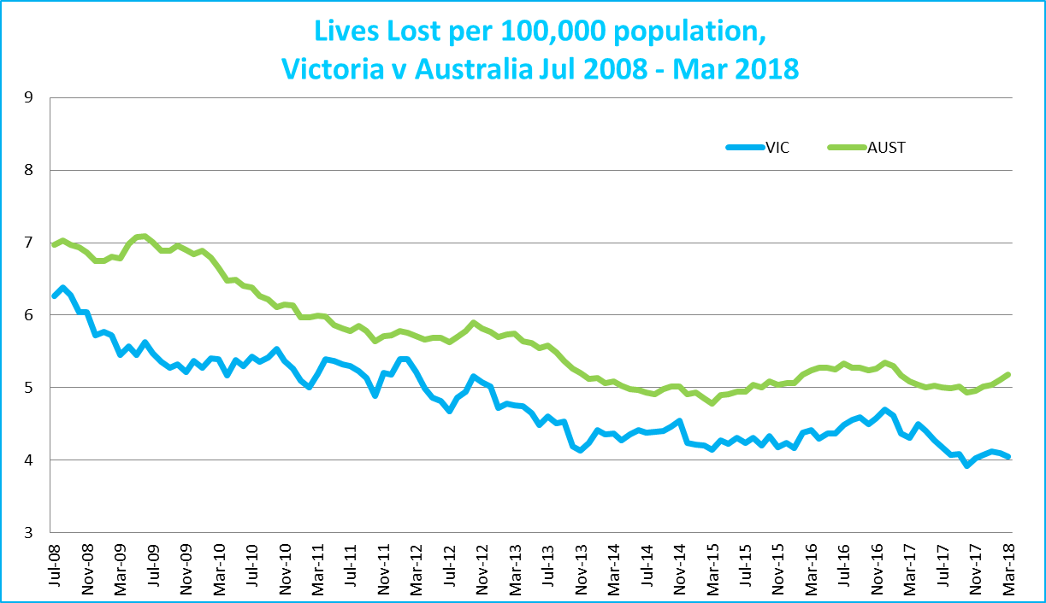

Victoria v Australia – 12 Month Moving Lives Lost Rate

# Booze Bus Random Breath Testing

**Booze Bus Random Breath Testing (12 months to March 2018 (monthly totals)**

|  |  |  |  |  |  |  |  |  |  |  |  |  |
| --- | --- | --- | --- | --- | --- | --- | --- | --- | --- | --- | --- | --- |
|  | **2017** |  |  |  |  |  |  |  |  | **2018** |  |  |
|  | **Apr** | **May** | **Jun** | **Jul** | **Aug** | **Sep** | **Oct** | **Nov** | **Dec** | **Jan** | **Feb** | **Mar** |
| Melbourne | 83,566 | 83,363 | 88,913 | 89,786 | 98,917 | 98,907 | 117,207 | 88,467 | 108,748 | 98,546 | 90,559 | 96,738 |
| Country | 19,820 | 18,261 | 10,793 | 4,525 | 4,304 | 8,261 | 12,889 | 14,307 | 15,152 | 10,962 | 16,569 | 6,855 |
| Vic Total | 103,386 | 101,624 | 99,706 | 94,311 | 103,221 | 107,168 | 130,096 | 102,774 | 123,900 | 109,508 | 107,128 | 103,593 |

# Random Drug Testing

|  |  |  |  |  |  |  |  |  |  |  |  |  |  |  |  |  |  |  |  |  |  |  |  |  |  |
| --- | --- | --- | --- | --- | --- | --- | --- | --- | --- | --- | --- | --- | --- | --- | --- | --- | --- | --- | --- | --- | --- | --- | --- | --- | --- |
| **Random Drug Tests (12 months to March 2018 vs previous 12 months)** | | | | | | | | | | | | | | | |  | |  | |  | |  | |  |  |
|  | | | | **2018** | | **2017** | | **2016** | | **2018 v 2017** | | | | **2018 v 2016** | | | |  | |  | |  | |  |  |
| Victoria | | | | 102,424 | | 95,210 | | 110,527 | | +7214 | | (+8%) | | -8103 | | (-7%) | |  | |  | |  | |  |  |
|  | | | |  | |  | |  | |  | |  | |  | |  | |  | |  | |  | |  |  |
| **12 months to March 2018 (monthly totals)** | | | | | | | | | | | |  | |  | |  | |  | |  | |  | |  |  |
|  | **2017** |  |  | |  | |  | |  | |  | |  | |  | | **2018** | |  | |  | |
|  | **Apr** | **May** | **Jun** | | **Jul** | | **Aug** | | **Sep** | | **Oct** | | **Nov** | | **Dec** | | **Jan** | | **Feb** | | **Mar** | |
| Victoria | 8,766 | 7,972 | 9,369 | | 7,260 | | 7,067 | | 7,233 | | 8,125 | | 10,614 | | 8,809 | | 10,492 | | 8,347 | | 8,370 | |

# 

# Mobile Safety Camera Data

|  |  |  |  |  |  |  |  |  |  |  |  |  |  |  |  |  |  |  |  |  |  |  |  |  |  |  |  |  |  |  |  |  |  |  |  |  |  |  |  |  |  |  |  |  |  |  |  |
| --- | --- | --- | --- | --- | --- | --- | --- | --- | --- | --- | --- | --- | --- | --- | --- | --- | --- | --- | --- | --- | --- | --- | --- | --- | --- | --- | --- | --- | --- | --- | --- | --- | --- | --- | --- | --- | --- | --- | --- | --- | --- | --- | --- | --- | --- | --- | --- |
| **Speed Infringements Issued from Mobile Cameras (monthly totals) Monthly Average = 30,909**   |  |  |  |  |  |  |  |  |  |  |  |  | | --- | --- | --- | --- | --- | --- | --- | --- | --- | --- | --- | --- | | **2017** |  |  |  |  |  |  |  |  | **2018** |  |  | | **Apr** | **May** | **Jun** | **Jul** | **Aug** | **Sep** | **Oct** | **Nov** | **Dec** | **Jan** | **Feb** | **Mar** | | 31,176 | 34,445 | 27,838 | 31,079 | 29,788 | 28,581 | 33,953 | 28,402 | 21,408 | 39,249 | 32,973 | 32,021 | | | | | | | | | | | | |
|  | | | | | | | | |  | |  |
|  |  |  |  |  |  |  |  |  |  |  |  |
| **Excessive Speed Infringements (ESI) Issued from Mobile Cameras (monthly totals) Monthly Average = 338** | | | | | | | | | | | |
| **2017** |  |  |  |  |  |  |  |  | **2018** |  |  |
| **Apr** | **May** | **Jun** | **Jul** | **Aug** | **Sep** | **Oct** | **Nov** | **Dec** | **Jan** | **Feb** | **Mar** |
| 330 | 405 | 315 | 323 | 362 | 272 | 332 | 279 | 272 | 156 | 675 | 334 |
| Notes: An ESI is defined as 25km/h over the speed limit except in a 110km/h zone where it is 20km/h over the limit. | | | | | | | | | | |  |

# Explanations and References

LGA: Local Government Areas. Crash locations for acute hospitalised claims are assigned to LGA’s based on the crash postcode recorded by Victoria Police. Crash locations for fatal crashes are coded exactly to an LGA by Victoria Police.

Claimants: Refers to people injured in transport accidents who have an accepted claim with the TAC.

Hospitalisation: refers to all hospital admission that occurred within 7 days of accident.

# Useful Internet Sites

TAC Sites

* TAC Safety (Road Safety) [www.tacsafety.com.au](http://www.tacsafety.com.au)
* TAC How safe is your car [www.howsafeisyourcar.com.au](http://www.howsafeisyourcar.com.au)
* TAC How safe is your first car www.howsafeisyourfirstcar.com.au
* TAC Motorcycle Safety Website www.spokes.com.au
* TAC Corporate site [www.tac.vic.gov.au](http://www.tac.vic.gov.au)
* Drivesmart www.drivesmart.vic.gov.au
* Ridesmart www.ridesmartonline.com.au

Victorian Sites:

* VicRoads [www.vicroads.vic.gov.au](http://www.vicroads.vic.gov.au)
* Victoria Police www.police.vic.gov.au
* Parliamentary Road Safety Committee https://www.parliament.vic.gov.au/57th-parliament/rsc
* RACV www.racv.com.au
* Monash University Accident Research Centre [www.monash.edu.au/muarc](http://www.general.monash.edu.au\muarc)
* Cameras Save Lives www.camerassavelives.vic.gov.au
* VicRoads Learner Driver Site www.lsite.vicroads.vic.gov.au/Learners
* Road Safety Education Victoria www.roadsafetyeducation.vic.gov.au

National and Interstate Sites:

* ARRB Transport Research www.arrb.com.au
* Australian Transport Safety Bureau [www.atsb.gov.au](http://www.dot.gov.au/programs/fors/overview.htm)
* Motor Accidents Authority (NSW) www.maa.nsw.gov.au
* Motor Accidents Insurance Board (TAS) www.maib.tas.gov.au
* Motor Accident Commission, Allianz (SA) www.mac.sa.gov.au
* Motor Accidents Compensation, TIO, (NT) www.tiofi.com.au/mac
* Insurance Commission of Western Australia www.icwa.wa.gov.au
* Motor Accident Insurance Commission (QLD) www.maic.qld.gov.au

International Sites:

* National Highway Traffic Safety Admin (USA) [www.nhtsa.dot.gov](http://www.nhtsa.dot.gov)
* Swedish Road and Transport Institute (VTI) [www.vti.se](http://www.vti.se)
* SWOV Institute for Road Safety Research www.swov.nl

Related Sites:

* Alcohol and Drug Foundation [www.adf.org.au](http://www.adf.org.au)**Figures**

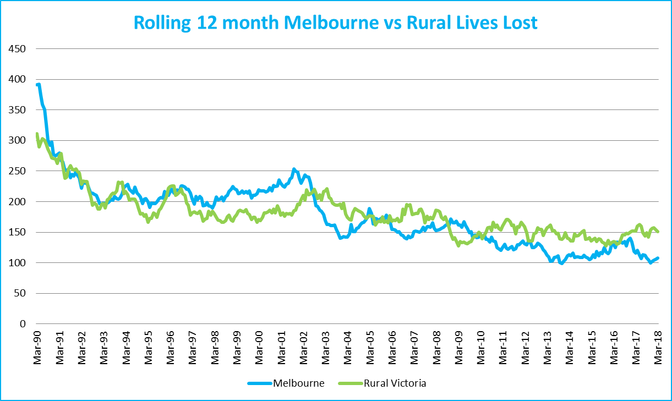

Graph 1a – Melbourne/country lives lost

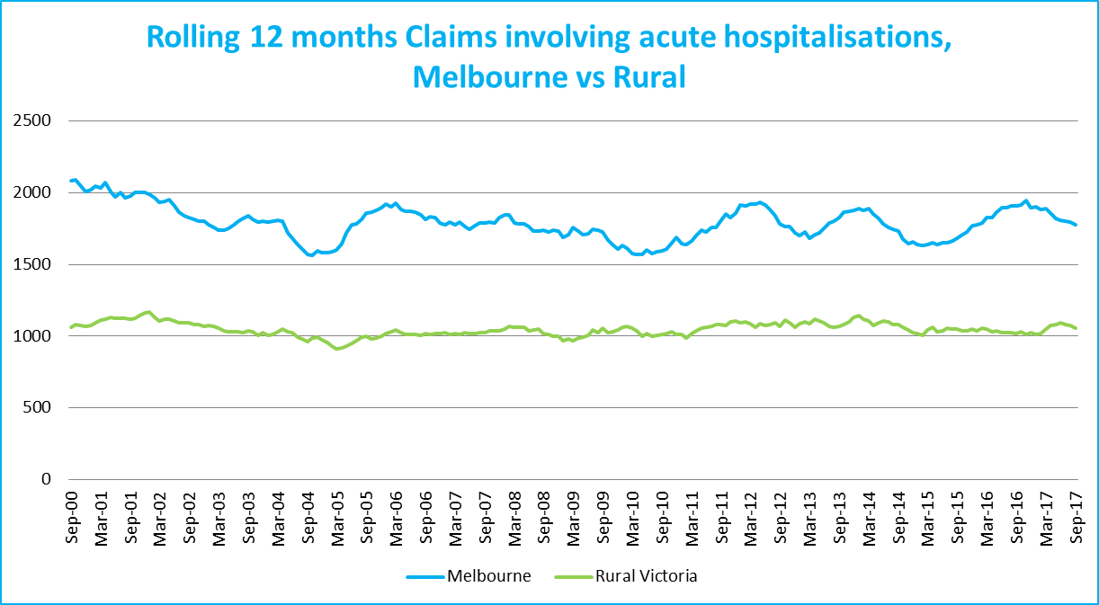

Graph 1b – Melbourne/country Claims involving an acute hospital admission

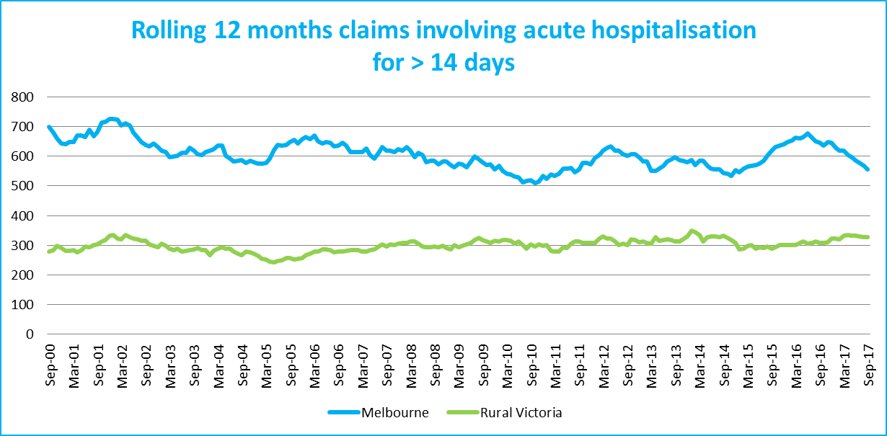

Graph 1c – Melbourne/country Claims involving hospital admission greater than 14 days

# 

# Victorian monthly lives lost since 1951

