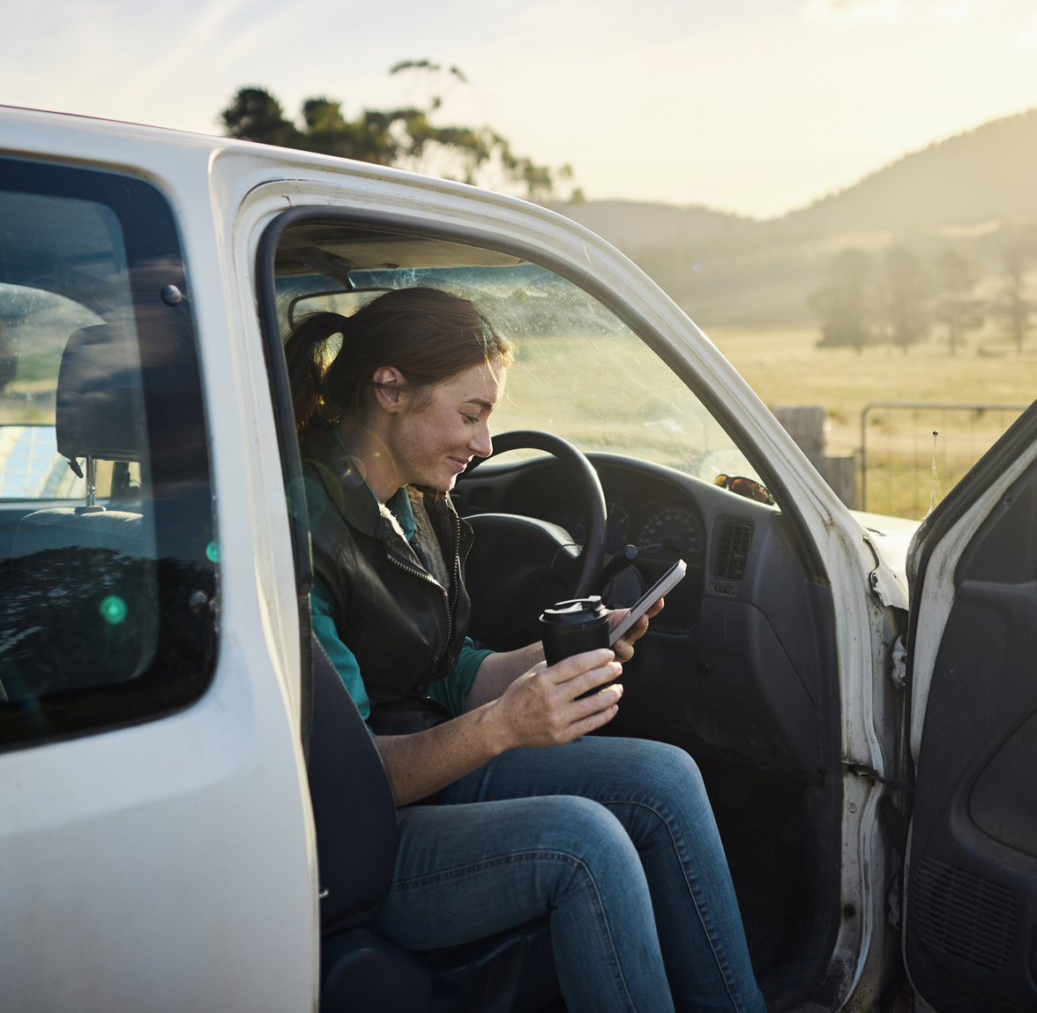



Road Safety Monitor
2025 Report
Prepared for Transport Accident Commission
Ref: 5198A | May 2026

Wallis acknowledges that we work upon the traditional lands of the Wurundjeri People and pay our respect to elders past, present and emerging. We extend that respect to all Aboriginal and Torres Strait Islander peoples. | Lotjpa Iyawa “Yarning as One”  Artwork by Luke and Siena Tieri bayadherra.com.au

Accreditations
ISO 27001: ISO 27001 is the highest standard for information security management systems, providing you with assurance that Wallis systems, processes and people are keeping your data safe.  ISO 20252: ISO 20252 is the international standard for market, opinion and social research, and ensures all stages of the research project are delivered to a quality that can be relied upon.  The Research Society Corporate member: The Research Society is Australia's largest research and insights community. Members have access to the latest industry knowledge, tools, quality assurances and professional standards.  ADIA Trust Mark Research Organisation: The Australian Data and Insights Association (ADIA) is the peak industry body for data, insights and research organisations in Australia. ADIA Trust Mark research organisations are compliant with the highest ethical, quality and privacy standards.  Australian Achiever Awards: The Australian Achiever Awards recognises the customer service excellence of Australian companies. Wallis has been awarded a high commendation every year since the inception of these awards in 1999.  Cyber security: Wallis is an acknowledged leader in data protection and privacy. Our system is regularly subjected to external penetration testing and we are a Privacy Awareness Week supporter – committed to sharing our knowledge with others. Wallis is also active member of the Australian Cyber Security Centre (ACSC) Partnership Program.  B Corporation: Wallis has been certified by B Lab Australia and New Zealand having shown that we meet high standards of social and environmental performance, transparency, and accountability. At Wallis, our approach to corporate social responsibility reflects our mission - to have a positive impact on society. | 

Table of Contents
Executive Summary i
1 Introduction 1
1.1 Background and objectives 1
1.2 Research objectives 2
1.3 Reading this report 2
2 Behaviours at a glance 5
3 Detailed Findings 6
3.1 Prevalence of risk-increasing road behaviours 6
3.2 Driving Behaviour Index 9
3.3 Demographics and the DBI 11
3.4 Speeding 12
3.5 Drink driving 23
3.6 Distracted driving 32
3.7 Tired driving 38
3.8 Drug driving 44
3.9 Seatbelt use 49
3.10 Other driving behaviours 56
3.11 Transport use 59
3.12 Enforcement 63
3.13 Towards Zero 68
4 Research methodology 69
Appendix 1: Dangerous Behaviour Index (DBI) 73
Appendix 2: Subgroup Reporting 76
Appendix 3: RSM Questionnaire 79
Appendix 4: RSM Question list by quarter 81
Appendix 5: Data Analysis 83

List of Figures
Figure 1 Prevalence of risk-increasing road behaviours 6
Figure 2 Number of risk-increasing road behaviours performed 8
Figure 3 Driving Behaviour Index Summary Distribution 9
Figure 4 Driving Behaviour Index – percentiles and mean by year 10
Figure 5 DBI demographics Mean Over time 11
Figure 6 Prevalence of intentional speeding behaviours 12
Figure 7 Frequency of intentionally speeding 3 km/h over the limit (%) 13
Figure 8 Frequency of intentionally speeding 10 km/h over the limit (%) 13
Figure 9 Low-level speeding (3 km/h+) by year: ‘ever’ at any speed limit (%) 14
Figure 10 High-level speeding (10 km/h+) by year: ‘ever’ at any speed limit (%) 14
Figure 11 Intentional Speeding: 3 km/h+ over time by demographic subgroup: % ‘ever’, in any zone 16
Figure 12 Intentional Speeding: 10km/h+ over time by demographic subgroup: % ‘ever’, in any zone 17
Figure 13 Sometimes have to drive over the speed limit (% agree 4–5) 18
Figure 14 Embarrassment being caught speeding by speeding behaviours (% 4–5 ‘embarrassed’) 19
Figure 15 Perceived danger of speeding by speeding behaviour 20
Figure 16 Speeding penalties are ‘revenue raising’ by speeding behaviour (% agree (4–5)) 20
Figure 17 Perceived enforcement risk by speeding behaviour (% feel they are likely (4–5) to get caught) 21
Figure 18 Support and opposition for reducing residential road speed limit from 50 km/h to 40 km/h 22
Figure 19 Support and opposition for reducing narrow country roads speed limit from 100 km/h to 80 km/h 22
Figure 20 Prevalence of drinking and drink driving 23
Figure 21 Frequency of drinking and driving (%) 24
Figure 22 Alcohol use by year: ‘ever’ (%) 24
Figure 23 Drink driving when over the legal BAC limit by year: ‘ever’ (%) 24
Figure 24 Drink driving when under, might have been over and over by quarter and year ‘ever’ (%) 25
Figure 25 Prevalence of drinking and driving behaviours among demographics 25
Figure 26 Drinking alcohol over time by demographic subgroup: % ‘ever’, in any zone 27
Figure 27 Driving over the legal BAC limit, in any zone 28
Figure 28 Perceived control over drink driving 30
Figure 29 Perceived danger of drink driving at different BAC levels among drink driving categories 30
Figure 30 Social norms (% embarrassed 4-5) towards drink driving among drink driving categories 31
Figure 31 Prevalence of hand-held mobile phones use while driving 32
Figure 32 Frequency of activities performed on mobile phones while driving (%) 32
Figure 33 Hand-held mobile phone use while driving by year: ‘ever’ (%) 33
Figure 34 Hand-held mobile phone use by demographic characteristics: ‘ever’ (%) over time 34
Figure 35 Perceived danger of using a hand-held mobile phone while driving 36
Figure 36 Social norms for using a hand-held mobile phone while driving 36
Figure 37 Perceived enforcement risk by hand-held mobile phone use categories 37
Figure 38 Prevalence of tired driving 38
Figure 39 Frequency of tired driving 38
Figure 40 Driving while quite tired and very tired by year: ‘ever’ (%) 39
Figure 41 Driving while quite tired over time by demographic subgroup (% ever) 40
Figure 42 Driving while very tired over time by demographic subgroup: net (% ever) 41
Figure 43 Perceived control over tired driving (% agree) 43
Figure 44 Perceived danger of driving while very tired 43
Figure 45 Prevalence of illegal drug use and drug driving 44
Figure 46 Drug driving by year: ‘ever’ (%) 44
Figure 47 Illegal drug use by demographic subgroup over time: net (% ever) 46
Figure 48 Perceived enforcement risk among drug driving categories 48
Figure 49 Prevalence of seatbelt noncompliance among drivers and passengers 49
Figure 50 Noncompliance with seatbelt use by year: ‘ever’ (%) 49
Figure 51 Driver non-compliance with seatbelt use by year: ‘ever’ (%) 51
Figure 52 Passenger non-compliance with seatbelt use by year: ‘ever’ (%) 52
Figure 53 Perceived enforcement risk among seatbelt wearing categories (% likely) 53
Figure 54 Risk perceptions of traveling in a car without wearing a seatbelt 54
Figure 55 Perceived control over seatbelt use 54
Figure 56 Social norms towards seatbelt use 55
Figure 57 Frequency of transport mode use 59
Figure 58 Prevalence of E-device use 60
Figure 59 Days per week driving a vehicle for commuting 61
Figure 60 Days per week driving a vehicle for work-related purposes besides commuting 62
Figure 61 Suggested changes to make Victorian roads safer 62
Figure 62 Crash prevalence 63
Figure 63 Prevalence of being caught speeding 63
Figure 64 Prevalence of being pulled over by the police 64
Figure 65 Prevalence of being caught using mobile phone while driving 64
Figure 66 Prevalence of being caught not wearing seatbelt at all / incorrectly 65
Figure 67 Perceived enforcement risk of breaking road rules 66
Figure 68 Caught speeding by intentional speeding categories 66
Figure 69 Pulled over for breath test by drinking and drink driving categories 66
Figure 70 Caught using mobile phone by distracted driving categories 67
Figure 71 Caught not wearing a seatbelt by seatbelt categories 67
Figure 72 Support for Toward Zero (%) 68
Figure 73 Achievable number of lives lost in a single year 68

List of Tables
Table 1 Significance reporting example table 3
Table 2 Overall prevalence (%) of behaviour combinations and relative prevalence overlay 7
Table 3 Prevalence of speeding among demographics 15
Table 4 Speeding behaviour by DBI membership 18
Table 5 Drink driving behaviour by DBI membership 29
Table 6 Hand-held mobile phone use among demographics 33
Table 7 Distracted driving behaviour by DBI Membership 35
Table 8 Prevalence of tired driving among demographics 39
Table 9 Tired driving behaviour by DBI membership 42
Table 10 Prevalence of illegal drug use among demographics 45
Table 11 Prevalence of drug driving among demographics 45
Table 12 Drug use and drug driving by DBI membership 47
Table 13 Prevalence of noncompliance with seatbelt use among demographics 50
Table 14 Seatbelt use by DBI membership 53
Table 15 Safety-conscious driving behaviours (% ‘always’) by year 56
Table 16 Unsafe driving behaviours (% ‘never’) by year 56
Table 17 Agreement with road safety statements by year 57
Table 18 Perceived danger of driving behaviours by year 57
Table 19 Perceived control by year 57
Table 20 Social norms by year 58
Table 21 Prevalence of transport use among demographics 60
Table 22 Prevalence of E–device use among demographics 61
Table 23 Enforcement experiences over time 65
Table 24 Fieldwork schedule 70
Table 25 Sample performance 71
Table 26 DBI Summary of Values 74

Executive Summary
The Road Safety Monitor (RSM) survey was first conducted in 2001. Since inception, it has continuously tracked Victorians’ road behaviours and attitudes.
Key behavioural trends

Speeding
In 2025, two–thirds (66%) of drivers had intentionally driven 3 km/h or more above the posted speed limit, while one quarter (27%) had intentionally driven 10 km/h or more above the posted speed limit. The prevalence of both behaviours remains similar since 2022 (64% and 26% respectively).

Drinking alcohol and drink driving
Reported alcohol consumption over the past 12-months retained prevalence since 2024 (68%, compared to 69% in 2025). Illegal drink driving within the same time-period retained prevalence of 2% across both years.

Distracted driving
Driving while using a handheld mobile phone was consistent with previous years. Half (50%) reported using a handheld mobile phone while driving in the past month.

Tired driving
In 2025, one-in-five drove ‘while very tired’ (22%) in the past 12 months which is consistent with previous years. A majority (62%) drove ‘while quite tired’; a similar prevalence to 2024 (60%).

Seatbelt use
There was a slight increase in driver and passenger seatbelt noncompliance in 2024 compared to previous years.
In 2025, 3.3% reported driving without a seatbelt in the past 12 months, a small increase from 2024 (3.0%) and since 2022 (2.2%). Fewer (4.1%) reported having travelled as a passenger while not wearing a seatbelt, versus 4.7% in 2024.

Drug driving
Both illegal drug use (4%) and driving after using illegal drugs (1%) were of similar prevalence to prior years.

Driving Behaviour Index (DBI)
The Driving Behaviour Index (DBI) is a summary of scores assigned to each respondent on all risk-increasing road behaviours covered in the RSM.
In 2025, DBI scores saw no marked shifts from 2024, indicating a similar prevalence of risk-increasing road behaviours.
Other trends

Enforcement
In 2025, half (49%) of drivers reported experiencing at least one driving interaction with police in the past 12 months. Being pulled over for breath and drug-tests and being caught for speeding was stable with previous years.

Introduction

Background and objectives
This section provides background to this report, including the research objectives and methodology.

The TAC and road safety
The Transport Accident Commission (TAC) is a government-owned organisation which was established in Victoria in 1986 through the Transport Accident Act (1986). Funding for the TAC is derived from vehicle registrations fees collected by VicRoads. The TAC has three main roles, each of which is directed towards reducing the impact of adverse health effects caused by traffic accidents:
1 | To improve  road safety | 2 | To improve the State’s trauma system | 3 | To support those who have been injured on  Victorian roads
The focus of the Road Safety Monitor (RSM) is largely on the first role – promoting road safety. This important role is somewhat atypical of organisations that administer compensation schemes, but the TAC has been successful in promoting road safety. The most visible aspects of this role for the public are the social public education efforts, which have been on air in Victoria since 1989. However, promoting road safety is a collaborative process involving the TAC, Department of Transport and Planning, Department of Justice and Community Safety, and Victoria Police, as well as many other organisations including research institutes, health organisations, industry, and other government departments at all levels. This work involves understanding the many facets and trends in road safety in Victoria, determining interventions that balance mobility and safety to benefit road users, and implementing these interventions.

Road fatalities and interventions over time
Before the establishment of the TAC, one of the most significant road safety interventions introduced was compulsory seatbelts in 1970. At that time, there were 1,061 road deaths in Victoria – the highest ever recorded. Following this intervention, random breath tests were introduced in 1976, red light cameras in 1983, and speed cameras in 1986.
Since its establishment, the TAC has had a role in implementing or supporting a range of road safety interventions. These interventions range from funding infrastructure and enforcement initiatives to providing education through advertising campaigns, sponsorships and education programs.

Lives lost
Road safety continues to be a pressing issue for Victoria. Lives lost increased by 3.9% in 2025 from 2024 (291 compared to 284 lives lost). This increase reversed the prior year’s decrease - 296 lives were lost in 2023. The 2025 toll of 291 is above the 2020–2024 five-year average of 269 lives lost annually.

Victorian Road Safety Strategy 2021–2030
Looking beyond 2020, the ‘Victorian Road Safety Strategy 2021–2030’ is designed to reduce and eventually eliminate the unacceptable loss of life on Victoria’s roads. It aims to halve lives lost and reduce serious injuries by 2030.
The focus of the Strategy is on creating a safe road environment and supporting road users to make safe choices by:
- ensuring all Victorians are safe and feel safe, on and around our roads
- seeing progressive reduction in fatalities and serious injuries from road trauma over the next 10 years
- embedding a culture of road safety within the Victorian community
- delivering initiatives that have an immediate impact while also preparing for future changes to road safety technology.
The Strategy also acknowledges that road safety is complex and that it takes a collective response from government agencies, the TAC’s industry partners, and the Victorian community to deliver safer roads.

Research objectives
The primary research objectives of the  RSM are to: |  |  | In addition, the secondary objectives of  the RSM are to:
 | Monitor road safety behaviour and the factors which influence behaviour, including attitudes and social norms. |  |  | Profile those who are model road users and those who are at risk on Victorian roads.
 | Identify behaviours and attitudes that are relevant to road safety. |  |  | Provide evidence to assist with the evaluation of road safety programs.

Reading this report

Rounding and multiple response questions
The sums of percentages in tables have been rounded to the nearest integer. This means that in some tables the total may add to 99% or 101% rather than 100%. This is due to rounding and is not an error.
Where questions allow multiple responses from respondents, the sum of response percentages may add to more than 100%. In these cases, the total percentage reflects the average number of responses per respondent. i.e., a multiple response question which adds to a total of 243% has an average of 2.43 responses per respondent.

Time series reporting
Due to substantial changes to the questionnaire instrument in 2022, time-series reporting should be interpreted with caution. There were changes to the wording of all time-series questions. Notes have been placed on time-series charts to indicate where comparisons to 2016–2021 data should be treated with caution.

Subgroup reporting
There is subgroup reporting throughout the report by gender, age and location (per ABS Section of State [SOS] definitions). Note that location subgroups were changed in 2017. Until 2016, location was defined as either ‘Melbourne’ or ‘Elsewhere in Victoria’. From 2017 locations have been defined per ABS SOS definitions. There is also subgroup reporting that classifies respondents according to their self-reported road safety related behaviours. Subgroup definitions can be found in Appendix 2:
Subgroup Reporting of this report.

Statistical significance and question codes
The data in this report have been tested for statistical significance, typically between subgroups. Tests are conducted between the subgroup and the total excluding the subgroup and are at the 95% confidence interval, unless stated otherwise. A multiple comparison correction (see Appendix 5) has been used to adjust the statistical significance where several comparisons are made in the one table. Significance testing where comparisons to prior dates or periods are made use comparisons only to the nearest period, e.g. (2024 against 2023, Q1 against Q2).
To illustrate, in Table 1, a blue arrow indicates that males were significantly more likely to have drunk alcohol and driven. Similarly, a red arrow indicates that those in Major Urban areas were significantly less likely to have drunk alcohol and driven, relative to drivers in other locations.
Information below each table shows question numbers as codes. An example is provided in Table 1 below where DB3ABC references question numbers in the questionnaire.
Table 1 Significance reporting example table
Column % |  | Age group |  |  |  | Gender |  | Location
Column % | Total | 18–25 | 26–39 | 40–60 | 61–90 | Male | Female | Major Urban | Other Urban | Rural
NET had alcohol and had driven | 42% | 35% | 43% | 46% | 39% | 47% ↑ | 37% ↓ | 40% ↓ | 48% ↑ | 47%
Had driven when confident was under | 41% | 32% ↓ | 42% | 46% ↑ | 39% | 47% ↑ | 36% ↓ | 39% ↓ | 47% ↑ | 46%
Had driven when might have been over | 9% | 11% | 9% | 8% | 8% | 11% ↑ | 7% ↓ | 9% | 11% | 10%
Had driven when over | 3% | 5% | 3% | 3% | 3% | 4% | 2% | 3% | 4% | 3%
Base | 2220 | 346 | 483 | 737 | 654 | 1067 | 1153 | 1086 | 746 | 388
DB3ABC In the last 12 months, how often did you [drink and drive behaviour]?
Base: Drivers (excl. Prefer not to say, Don’t know, and Not answered) (n=2,220)

Sample
The sample was drawn from the VicRoads Registration and Licencing Database. Only Victorians with a licence (either learners’ permit, probationary or full licence for any vehicle type) or a registration in their name (car, motorbike or trailer) were included in the sample population. However, this sample is likely highly representative for the adult Victorian population, as close to nine in ten Victorians (87%) aged 18 or over had a driving permit at some stage, or had a vehicle registered in their name. Weighting was used to correct for sampling design (see Section 4: Research methodology of this report).

Base descriptions
Throughout this report, different ‘base’ descriptions are used. A ‘base’ refers to the sample, or subsample of respondents who were included in the statistical computations for a question.
It should be noted that most of the RSM report focuses on a subset of the total sample, referred to as ‘Drivers’. ‘Drivers’ are considered those who self-reported having driven a vehicle (i.e. a car or heavy vehicle) in the 12 months prior to their completion of the survey. In 2024, ‘Drivers’ made up 98% of the final sample.
Where bases note that ‘all respondents’ were included, this refers to the entire sample. ‘All respondents’ are incorporated only in survey questions where driving is not a pre-requisite to answering the question or for the analysis being conducted.
Where other base descriptions occur, e.g. ‘Employed Drivers’, these refer to a further subset of the sample, e.g. where only those employed and who drive, are relevant to the reported prevalence rates.

Behaviours at a glance
Prevalence |  |  | Key findings
 | Drink driving |  | Two percent of respondents had driven over their legal BAC in the past three months, which represents a downward trend from previous years.  The perceived risk of crashing due to drink–driving and the influence of social norms over drink driving were factors associated with reduced drink driving.
 | Over their legal BAC | 2%
 | Speeding |  | While a quarter of respondents reported intentionally driving 10 km/h or more over the speed limit in the previous three months, two-thirds reported driving 3 km/h or more over the speed limit.  Driving at 3 km/h or more above the limit was perceived by respondents as a normalised behaviour and comparatively low–risk in terms of safety.  Driving at 10 km/h above the limit was perceived to be a less acceptable behaviour, and typically, a behaviour with a higher safety risk.
 | 10 km/h+ over the limit | 27%
 | 3 km/h+ over the limit | 66%
 | Distracted driving |  | About half of respondents admitted to having used a mobile phone in their hand while driving in the previous month.  This was despite the activity being perceived as high-risk and socially unacceptable among those who do the behaviour.
 | Used mobile phone in hand | 50%
 | Tired driving |  | One-in-five respondents had driven while very tired in the previous 12 months (so tired they struggled to keep their eyes open).  Respondents who avoided fatigued driving understood the high perceived crash risk and had higher levels of perceived control over the behaviour.
 | Had driven while very tired | 22%
 | Drug driving |  | One percent of respondents reported driving after using illegal drugs in the past three months.  Drug driving was seen by almost all respondents as highly dangerous. However, the perceived danger among those who used illegal drugs, and had driven after using illegal drugs, was lower.
 | Used illegal drugs  and had driven | 1%
 | Seatbelt use |  | Traveling without a seatbelt was a low prevalence behaviour and was slightly more common as a passenger than as a driver.  The perceived risk of enforcement among those who had driven without a seatbelt was similar to the average driver.
 | Had driven without a seatbelt | 3%
 | Passenger without a seatbelt | 4%

Detailed Findings
This section includes three introductory chapters providing an overview of behaviours and attitudes. Subsequent chapters provide more detailed analysis of the following behaviours: speeding, drink driving, distracted driving, tired driving, drug driving, seatbelt use, and transport use. The remaining chapters in this section examine road enforcement and the TAC’s Toward Zero key metrics.

Prevalence of risk-increasing road behaviours
Figure 1 shows the risk-increasing road behaviours conducted by respondents. It does not show how often respondents engaged in these behaviours. The frequency of driver behaviours are covered in more detail in the driving behaviour chapters.
In 2025, the most prevalent risk-increasing road behaviours were intentional speeding, driving while tired and driving while distracted. Around two-thirds of respondents intentionally exceeded the speed limit in the past 3 months (66%). A further six in ten drove while quite tired over the past 12 months. In the past month, half (50%) reported driving while using a mobile phone in their hands.
The least common risk-increasing road behaviours were driving after using illegal drugs (1%), driving over the legal BAC (2%), and travelling without a seatbelt as a driver (3%) and passenger (4%).
Figure 1 Prevalence of risk-increasing road behaviours
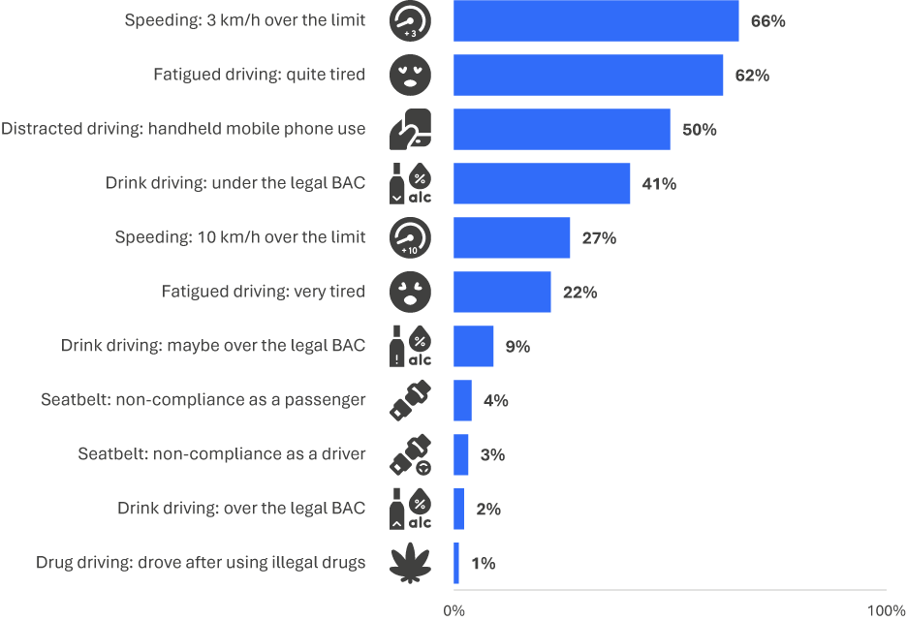
DB1 In the past month, how often did you use a mobile phone in your hand while driving to [mobile phone use behaviour]?
DB2 In the past three months, how often did you intentionally drive 3 km/h or more above the limit in the following [speed limit zone]?
DB4 In the past three months, how often did you intentionally drive 10 km/h or more above the limit in the following [speed limit zone]?
DB3 In the past 12 months, how often did you [driving behaviour]?
Base: (1) Drivers (n=2,337 to 2,365), (2) All respondents (Passenger without a seatbelt only) (n=2,408).
Figure 2 shows which behaviours are done by the same drivers Comparisons are made between the percentage of the population who do one behaviour (in the rows) and also do another behaviour (in columns). Cells where behaviours and behavioural categories align are marked `—`.
In 2025 the most common behaviour combinations were:
Intentionally speeding 3 km/h or more and driving while quite tired (47.4%)
Mobile phone use and intentionally speeding 3 km/h or more (40.2%)
Driving while quite tired and mobile phone use (38.2%).
Figure 2 also highlights the degree of relative prevalence using table-cell highlighting. Cell highlighting is used to indicate which behaviours occur at rates 50% or higher to under 75% with light blue. Bold-blue cell-highlighting indicates that two behaviours occur at rates 75% or higher.
Behaviours that pair most are intentionally speeding 3 km/h or more above the limit and driving while quite tired. Both of these behaviours had between 75% and 100% coverage in each driving behaviour. Mobile phone use also had at least 50% coverage on each driving behaviour, and 75% or more coverage on 6 of 10 measures compared.
Intentionally speeding 10 km/h or more also has high presence among several less-common behaviours. The figure highlights that speeding 50% coverage on 4 of a possible 9 other behaviours and at least 75% coverage on two of these.
Table 2 Overall prevalence (%) of behaviour combinations and relative prevalence overlay
Prev % | Total | Speed 3km/h+ | Speed 10km/h+ | Drink (under) | Drink (maybe over) | Drink (over) | Mobile phone | Quite  tired | Very  tired | No seatbelt (driver) | No seatbelt (psgr) | Drug driving
Speed 3km/h+ | 65.9 | — | — | 32.0 | 8.2 | 2.3 | 40.2 | 47.4 | 18.2 | 2.9 | 3.4 | 1.1
Speed 10km/h+ | 26.8 | — | — | 14.3 | 4.3 | 1.7 | 19.5 | 21.6 | 10.0 | 2.0 | 2.6 | 0.8
Drink (under) | 41.0 | 32.0 | 14.3 | — | — | — | 26.1 | 32.9 | 12.7 | 2.0 | 1.9 | 0.6
Drink (maybe over) | 9.2 | 8.2 | 4.3 | — | — | — | 7.5 | 8.3 | 4.1 | 1.1 | 1.0 | 0.6
Drink (over) | 2.3 | 2.3 | 1.7 | — | — | — | 2.0 | 2.1 | 1.4 | 0.7 | 0.6 | 0.5
Mobile phone | 50.0 | 40.2 | 19.5 | 26.1 | 7.5 | 2.0 | — | 38.2 | 15.6 | 2.5 | 3.1 | 1.0
Quite tired | 62.2 | 47.4 | 21.6 | 32.9 | 8.3 | 2.1 | 38.2 | — | — | 3.0 | 3.5 | 1.0
Very tired | 22.4 | 18.2 | 10.0 | 12.7 | 4.1 | 1.4 | 15.6 | — | — | 1.6 | 1.7 | 0.4
No seatbelt (driver) | 3.3 | 2.9 | 2.0 | 2.0 | 1.1 | 0.7 | 2.5 | 3.0 | 1.6 | — | — | 0.2
No seatbelt (psgr) | 4.0 | 3.4 | 2.6 | 1.9 | 1.0 | 0.6 | 3.1 | 3.5 | 1.7 | — | — | 0.2
Drug driving | 1.1 | 1.1 | 0.8 | 0.6 | 0.6 | 0.5 | 1.0 | 1.0 | 0.4 | 0.2 | 0.2 | —
Cell highlighting is used to indicate which behaviours occur at rates =>50% & <75% (light blue) / 75%+ = bold blue
DB1 In the past month, how often did you use a mobile phone in your hand while driving to [mobile phone use behaviour]?
DB2 In the past three months, how often did you intentionally drive 3 km/h or more above the limit in the following [speed limit zone]?
DB4 In the past three months, how often did you intentionally drive 10 km/h or more above the limit in the following [speed limit zone]?
DB3 In the past 12 months, how often did you [driving behaviour]?
Base: 2025 Drivers (n=2,365);

Drivers could report up to eleven risk-increasing road behaviours. Nearly nine in ten drivers (87%) reported at least one behaviour, similar in prevalence since 2022.
Half of drivers (50%) reported one to three behaviours, with an average of three across all drivers. Two in five drivers (37%) reported four or more behaviours.
Figure 2 Number of risk-increasing road behaviours performed
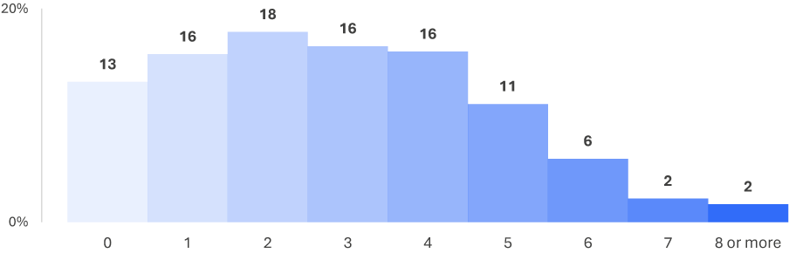
DB1 In the past month, how often did you use a mobile phone in your hand while driving to [mobile phone use behaviour]?
DB2 In the past three months, how often did you intentionally drive 3 km/h or more above the limit in the following [speed limit zone]?
DB4 In the past three months, how often did you intentionally drive 10 km/h or more above the limit in the following [speed limit zone]?
DB3 In the past 12 months, how often did you [driving behaviour]?
Base: Drivers (excl. Prefer not to say, Don’t know, and Not answered) (n=2,365)

Driving Behaviour Index
Level of risk varies by driving behaviour type and how often it occurs. A composite variable, the Driving Behaviour Index (DBI), captures this variation.
The DBI summarises drivers’ behaviour on a scale from 0 to 100, where 0 indicates no risk-increasing behaviours and 100 indicates all behaviours at the maximum reported frequency. Details on the index construction are provided in Appendix 1.
In this section, DBI distribution is interrogated. We compare scores over time, explore where these changes occurred, and which demographic characteristics shaped the distribution in 2025 and in previous years.

Driving Behaviour Index Distribution
Figure 3 shows the distribution and percentiles of DBI scores in 2025. Across the spectrum of DBIs, the 25th percentile (Q1) of drivers had DBIs of 5.3 or lower. The median DBI was 13.2, showing that 50% of drivers had a DBI of 13.2 or lower. The 75th percentile (Q3) of drivers had DBIs of up to 21.1, while the 95th percentile of drivers had DBIs of up to 34.2.
Figure 3 Driving Behaviour Index Summary Distribution
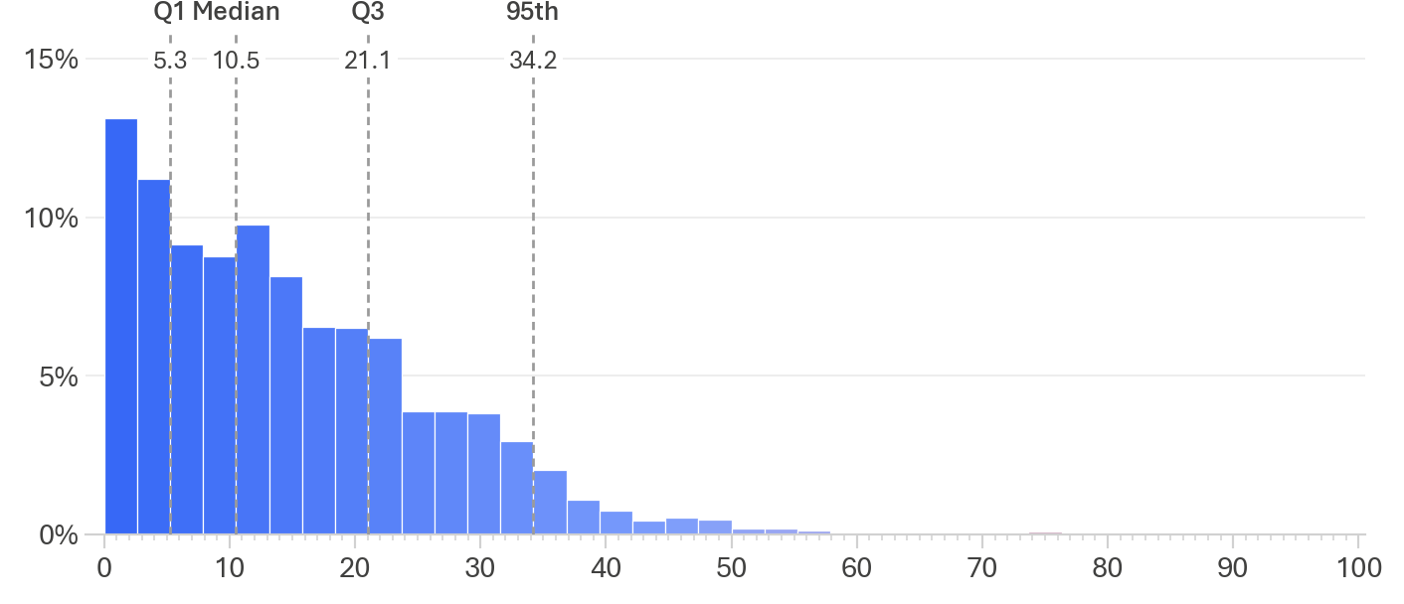
Driving Behaviour Index
Base: Drivers (excl. Prefer not to say, Don’t know, and Not answered) 2025 (n=2,365)

In Figure 4, we compare the DBI mean per year from 2023 to 2025. Between 2023 and 2025, no significant changes were observed between any two years, and on a fitted linear-trend line.
Figure 4 Driving Behaviour Index – percentiles and mean by year
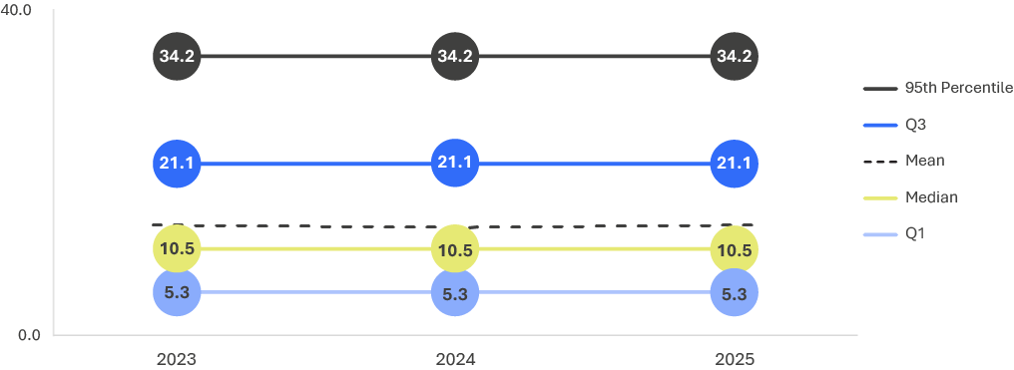
Driving Behaviour Index
Base: Drivers (excl. Prefer not to say, Don’t know, and Not answered) 2023 to 2025: (n=2,365-2,503)
Trend test: Survey-weighted linear regression of DBI score by quarter.

Demographics and the DBI
This section explores how demographics and the DBI have changed over time.
Figure 5 shows that overall, DBI has remained stable across demographic groups between 2023 and 2025. The fitted linear trend (dotted line) between 2023 and 2025 highlighted that there were no significant changes in any subgroup between 2023 and 2025.
Figure 5 DBI demographics Mean Over time
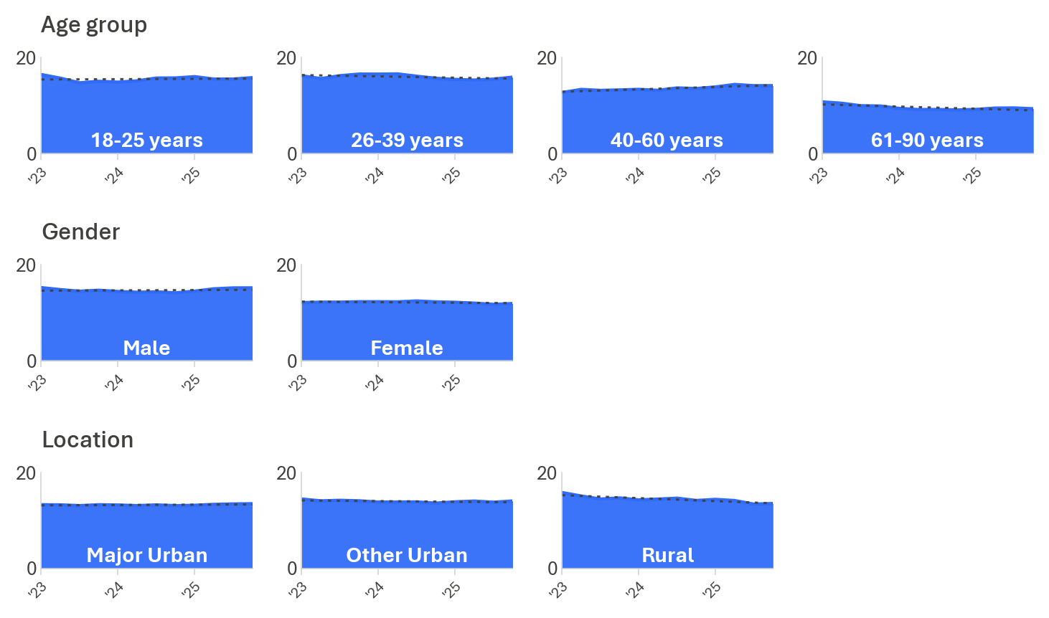

Driving Behaviour Index
Base: Drivers (excl. Prefer not to say, Don’t know, and Not answered), 2023 to 2025, 4-quarter rolling average.
*Trend test: survey-weighted linear regression of DBI score by quarter.

Speeding
This section aims to understand the prevalence of speeding in Victoria through survey responses. The chapter explores respondents’ attitudes and beliefs on speeding. It reviews behaviours, the risk profile of drivers related to speeding, and how speeding behaviours can be explained.
The RSM report defines speeding as intentionally driving above the speed limit.

Prevalence of intentional speeding
In the RSM for 2025, there were eight questions that asked how frequently respondents intentionally drove above the speed limit in the past three months. The questions covered two speeding levels, driving 3 km/h and 10 km/h (or more) above the speed limit. For each speeding level, respondents were asked how often they drove over the speed limit in 40, 50, 60 and 100 km/h speed limit zones.
Figure 6 shows the proportion of respondents who reported driving over the speed limit in the past three months.
In 2025, two-thirds of drivers (66%) had driven 3 km/h or more above the posted limit in any of the four speed limit zones. A quarter (27%) of drivers had driven 10 km/h or more above the same posted speed limits.
Figure 6 Prevalence of intentional speeding behaviours
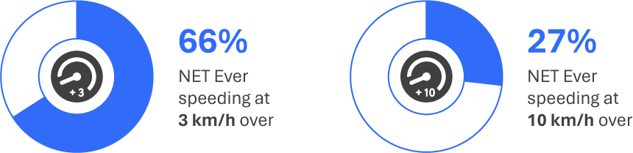
DB2 In the last three months, how often did you intentionally drive 3 km/h or more above the limit in the following [speed limit zone]?
Base: Drivers (excl. Prefer not to say, Don’t know, and Not answered) (n=2,344)
DB4 In the last three months, how often did you intentionally drive 10 km/h or more above the limit in the following [speed limit zone]?
Base: Drivers (excl. Prefer not to say, Don’t know, and Not answered) (n=2,335)
The prevalence of driving of intentional low-level speeding (3km/h or more above the limit) increased as speed limit zones increased. As shown in Figure 7, low-level speeding was most prevalent in 100 km/h zones (54%), followed by 60 km/h zones (50%), and least prevalent in 40 km/h zones (42%).
- Overall, the frequency of low-level speeding was most commonly reported between ‘rarely’ (30%) and ‘sometimes’ (27%).
- Drivers more commonly reported low-level speeding ‘sometimes’ on roads with higher speed limits. In 40 km/h zones, more than one in ten (13%) had driven 3 km/h above the limit ‘sometimes’, while in 100 km/h zones, one-in-five (20%) had driven 3 km/h above the limit ‘sometimes’.
Figure 7 Frequency of intentionally speeding 3 km/h over the limit (%)
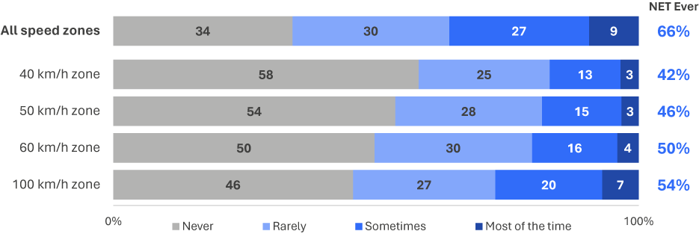
DB2 In the last three months, how often did you intentionally drive 3 km/h or more above the limit in the following [speed limit zone]?
Base: Drivers (excl. Prefer not to say, Don’t know, and Not answered) (n=2,325-2,344)
Figure 8 shows that the prevalence of high-level speeding (10 km/h or more above the limit) was highest in 100 km/h zones (22%), followed by 60 km/h zones (15%) and 50 km/h zones (13%), and was lowest in 40 km/h zones (12%).
- Across all speeding zones combined, those who had driven over the speed limit by 10 km/h or more mainly did so ‘rarely’ (17%).
- Intentional speeding 10 km/h over the limit was conducted mostly ‘rarely’ across 40 km/h, 50 km/h and 60 km/h speed zones - in 40 km/h zones it was done ‘rarely’ by 9%, and in 50 km/h and 60 km/h zones by one-in-nine ‘rarely’ (11% at 50 km/h and 60 km/h).
- In 100 km/h zones, most of those who intentionally engaged in high-level speeding did so ‘rarely’ (14%). However, the percentage of drivers speeding 10 km/h above the limit ‘sometimes’ (6%) was double those speeding 10 km/h above the limit ‘sometimes’ at other speed limits (2% at 40km/h and 50km/h, and 3% at 60km/h).
Figure 8 Frequency of intentionally speeding 10 km/h over the limit (%)
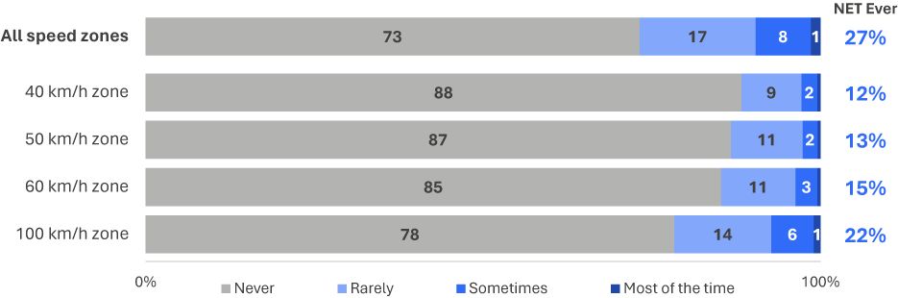
DB4 In the last three months, how often did you intentionally drive 10km/h or more above the limit in the following [speed limit zone]?
Base: Drivers (excl. Prefer not to say, Don’t know, and Not answered) (n=2,313-2,335)

Figure 9 shows the historical trend for intentionally engaging in low-level speeding. Low-level speeding is defined as ‘ever driving over the speed limit by 3 km/h or more over the past three months’. Results from 2022 cannot be directly compared to previous years because before 2022, the lowest frequency respondents could select was ‘some of the time’, whereas from 2022, respondents could also select ‘rarely’. Additionally, before 2022, only two speed limits were included (60 km/h and 100 km/h). A third speed limit was added in 2022 (50 km/h) and a fourth limit was added in 2023 (40 km/h).
Over time, there has been a noticeable shift in low-level speeding behaviour. This prevalence remained stable until 2021, when it increased to 55%. Although the changes in measurement must be considered, the increase in low-level speeding appears to have continued in 2022 and then appears to have stabilised at 64% in 2023. Between 2022 and 2025, no differences were significant at both the overall level and between any two years.
Figure 9 Low-level speeding (3 km/h+) by year: ‘ever’ at any speed limit (%)
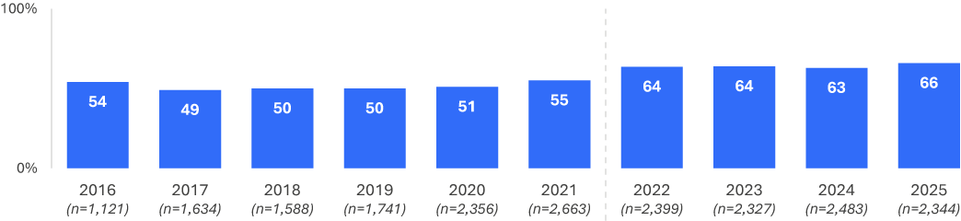
DB2ABC In the last three months, how often did you intentionally drive 3km/h or more above the limit in the following [speed limit zone]?
Base: Drivers (excl. Prefer not to say, Don’t know, and Not answered)
Figure 10 shows the historical trend for intentionally engaging in high-level speeding at 10 km/h or more above the posted speed limit.
Since 2022, prevalence of high-level speeding has been similar, at 27% in 2025, 26% in 2024, 25% in 2023 and 26% in 2022. As with low-level speeding, between 2022 and 2025, no differences were significant at both the overall level and between any two years.
Figure 10 High-level speeding (10 km/h+) by year: ‘ever’ at any speed limit (%)
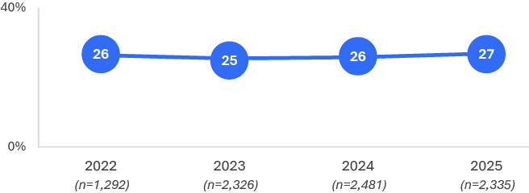
DB4 In the last three months, how often did you intentionally drive 10 km/h or more above the limit in the following [speed limit zone]?
Base: Drivers (excl. Prefer not to say, Don’t know, and Not answered)

Demographic characteristics
Across demographic groups, males were more likely to have intentionally driven over the limit by both 3 km/h (71%) and 10 km/h or more (33%), than females (61% and 21%), as shown in Table 3. Based on age, those aged 26-39 were most likely to have sped by 3 km/h (69%) and by 10 km/h (31%), while those aged 61–90 were least likely to have driven over the speed limit by 3 km/h (56%) and 10 km/h (20%).
Table 3 Prevalence of speeding among demographics
Column % |  | Age group |  |  |  | Gender |  | Location
Column % | Total | 18–25 | 26–39 | 40–60 | 61–90 | Male | Female | Major Urban | Other Urban | Rural
Had driven 3 km/h over the limit | 66% | 68% | 69% | 69% | 56% ↓ | 71% ↑ | 61% | 66% ↓ | 67% | 62%
Had driven 10 km/h over the limit | 27% | 29% | 31% ↑ | 28% | 20% ↓ | 33% ↑ | 21% ↓ | 26% | 30% | 27%
Base | 2,335 | 315 | 636 | 786 | 598 | 1,203 | 1,132 | 1,173 | 839 | 323
DB2 In the last three months, how often did you intentionally drive 3 km/h or more above the limit in the following [speed limit zone]?
DB4 In the last three months, how often did you intentionally drive 10 km/h or more above the limit in the following [speed limit zone]?
Base: Drivers (excl. Prefer not to say, Don’t know, and Not answered)

Intentional Speeding – Demographic subgroups over time
This section examines the rate of drivers who say they intentionally drove both 3 km/h (or more) over the limit and 10 km/h (or more) over the limit.
For speeding behaviours, results have been aggregated into a net: ‘ever’ figure for each. These are taken from each of the different speed limits, then merged into a single variable that shows the proportion of people who intentionally drove over the speed limit in any of the four measured zones. Results shown are aggregated by year, for each demographic group, using rolling averages of 4 quarters at a time, from 2022, to 2025. Each row in the figures show the difference over time per demographic subgroup. A dotted line of best-fit shows trend fit to the area over time.

Speeding 3 km/h or more over the limit
The primary trends up seen in 2025 are for male drivers (71% in 2025 versus 67% in 2024), and major urban drivers between 2025 and 2022. The primary trend down in 2025 is for drivers from rural areas (62% in 2025 versus 72% in 2022).
To assist with anchoring numbers within the figure, 2025 and 2022 are noted below. Note that differences are reported here for visual purposes only:

Age Groups
18-25: 68% in 2025, compared with 65% in 2022
26-39: 69% in 2025, compared with 64% in 2022
40-60: 69% in 2025, compared with 67% in 2022
61-90: 56% in 2025, compared with 58% in 2022.

Gender
Male: 71% in 2025, compared with 67% in 2022
Female: 61% in 2025, compared with 60% in 2022.

Region
Major Urban: 66% in 2025, compared with 62% in 2022
Other Urban: 67% in 2025, compared with 66% in 2022
Rural: 62% in 2025, compared with 72% in 2022.
Figure 11 Intentional Speeding: 3 km/h+ over time by demographic subgroup: % ‘ever’, in any zone
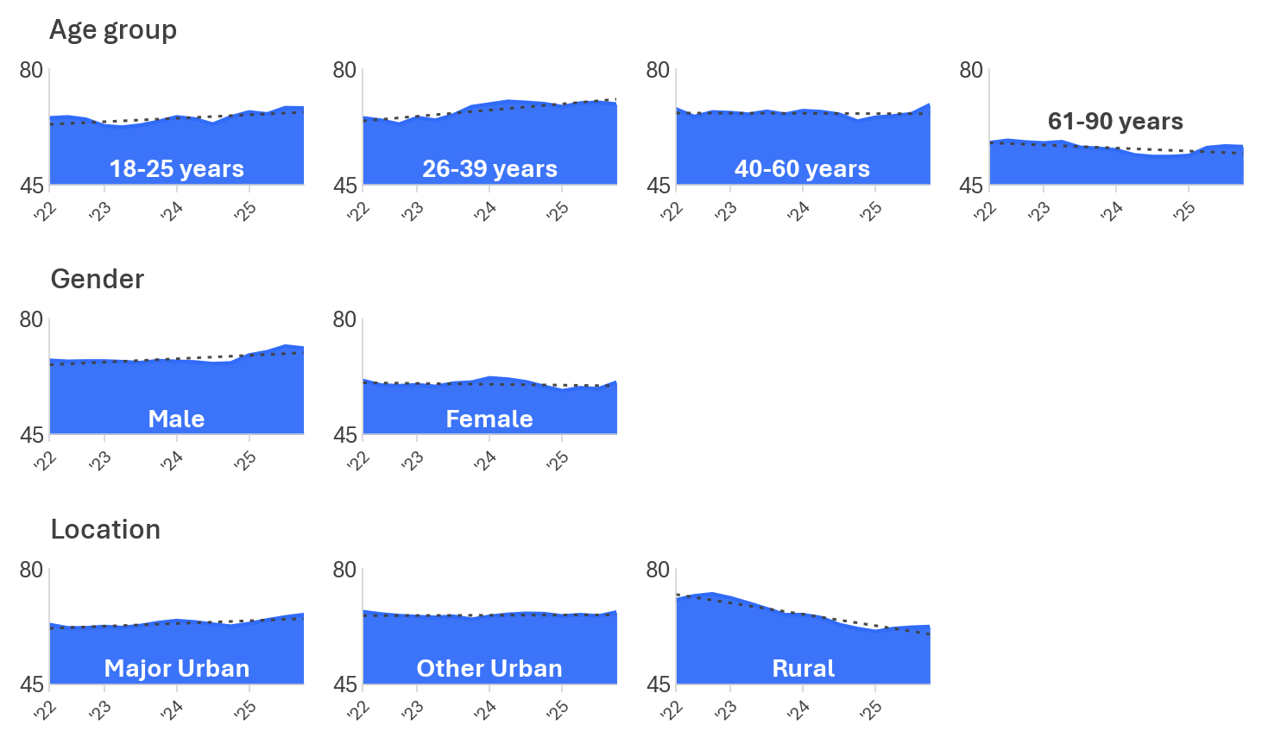
DB2 Max frequency of 3 km/h + speeding in all speed limit zones.
Base: Drivers (2022 to 2025); Range lowest to highest n across years.
Age group: 18-25 (n=308-423); 26-39 (n=537-749); 40-60 (n=756-795); 61-90 (n=555-681)
Gender: Male (n=1,135-1,223); Female (n=1,136-1,260)
Location: Major Urban (n=1,176-1,290); Other Urban (n=768-843); Rural (n=326-413)Question text: DB2ABCD Max frequency of 3 km/h speeding in all speed limit zones

Intentional Speeding: 10 km/h or more over the limit
The most notable subgroup movements are an upward trend in prevalence among drivers aged 26 to 39 and Other Urban drivers, and a downward shift among Rural drivers.
To assist with anchoring numbers within the figure, 2025 and 2022 are noted below. Note that differences are reported here for visual purposes only:

Age group
18-25: 29% in 2025, compared with 29% in 2022
26-39: 31% in 2025, compared with 25% in 2022
40-60: 28% in 2025, compared with 31% in 2022
61-90: 20% in 2025, compared with 20% in 2022.

Gender
Male: 33% in 2025, compared with 31% in 2022
Female: 21% in 2025, compared with 22% in 2022.

Location
Major Urban: 26% in 2025, compared with 26% in 2022
Other Urban: 30% in 2025, compared with 25% in 2022
Rural: 27% in 2025, compared with 34% in 2022.
Figure 12 Intentional Speeding: 10km/h+ over time by demographic subgroup: % ‘ever’, in any zone
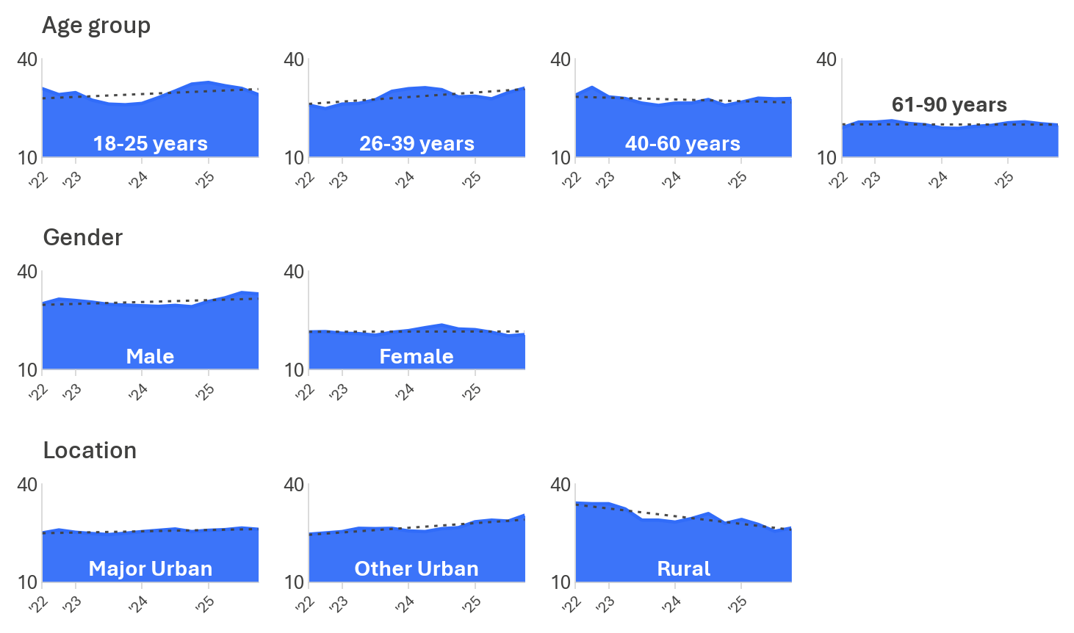

DB4 Max frequency of 10 km/h speeding in all speed limit zones. *Results begin from Q3 2022.
Base: Drivers (2022 to 2025); Range lowest to highest n across years.
Age group: 18-25 (n=244-423); 26-39 (n=282-749); 40-60 (n=432-786); 61-90 (n=334-667)
Gender: Male (n=641-1,221); Female (n=651-1,260)
Location: Major Urban (n=651-1,290); Other Urban (n=424-841); Rural (n=217-360)

DBI profile
This section explores the relationship between DBI and speeding behaviours. This provides an overview of how dangerous speeders were on average, across all dangerous driving behaviours.
To analyse speeding as a behaviour, respondents were categorised by their most extreme speeding behaviour at any limit for this section. This means that if respondents exceeded the speed limit by 3 km/h in any zone, they were categorised as a speeder at 3 km/h (low-level), and if they exceeded the speed limit by 10 km/h in any of the zones, they were then categorised as a speeder at 10 km/h (high-level). If respondents did not speed in any of the limits, they were categorised as someone who did not speed.
As shown in Table 4, over half of respondents who had driven 10 km/h over the speed limit had very high or extremely high DBIs, (combined, 57%). Comparatively, those who had driven 3 km/h over the limit were more likely to be in the ‘high’ (34%) or ‘medium’ (28%) DBI categories. However, those who did not speed at either level, had a much higher tendency to be in the ‘low’ (25%) DBI category.
This demonstrates a moderate relationship between high-level speeding and the propensity to engage in other dangerous driving behaviours.
Table 4 Speeding behaviour by DBI membership
Row % | Low | Medium | High | Very High | Extremely High
10 km/h over the speed limit | 0% ↓ | 4% ↓ | 39% ↑ | 43% ↑ | 14% ↑
3 km/h over the speed limit | 25% ↓ | 28% ↑ | 34% ↑ | 12% ↓ | 1% ↓
Did not speed | 68% ↑ | 19% | 12% ↓ | 1% ↓ | 0% ↓
Total | 33% | 19% | 27% | 17% | 4%
Base | 761 | 434 | 653 | 406 | 111
DBI Summary
Base: Drivers (excl. Prefer not to say, Don’t know, and Not answered)

Behavioural insights
To explore factors potentially related to speeding behaviour, we asked participants a series of questions about their:
perceived control over speeding
perceptions of the danger associated with speeding
social norms around speeding enforcement
attitudes toward speed enforcement
perceived risk of encountering enforcement
self-perceptions of how safe they are as a driver.

Perceived control
To assess respondents’ level of perceived control over speeding, they were asked to what extent they agreed (4–5) or disagreed (1–2) with the statement ‘sometimes I have to drive over the speed limit’. Respondents were also provided with a neutral option (3).
Those who drove 10 km/h over the limit were nearly three times as likely to agree that they sometimes have to drive over the speed limit than those who drove 3 km/h over the speed limit (11% vs 4%), and nearly six times more likely than non-speeders to agree (11% vs 2%).
Figure 13 Sometimes have to drive over the speed limit (% agree 4–5)
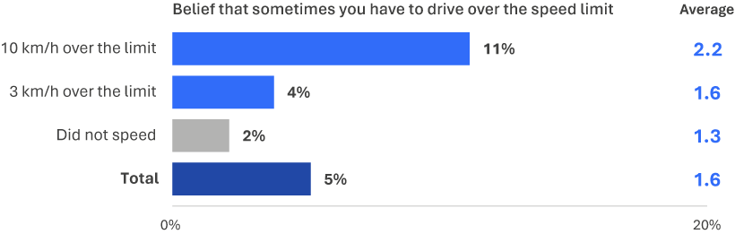
PC1C To what extent do you agree or disagree that sometimes you have to drive over the speed limit? (Scale from 1 – strongly disagree to 5 – strongly agree)
Base: Drivers (excl. Prefer not to say, Don’t know, and Not answered) (n=2,305)

Social norms
To assess perceptions of subjective social norms, respondents were asked two questions on their perceived level of embarrassment if they told their friends that they had been caught: ‘speeding at 63 km/h in a 60 km/h zone’ and ‘speeding at 70 km/h in a 60 km/h zone. Questions were answered on a scale from 1 (not at all embarrassed) to 5 (extremely embarrassed).
The impacts of speeding-related social norms also differed between those who were low-level and high-level speeders. High-level speeders were less likely than low-level speeders to feel embarrassed to tell their friends they had been caught driving marginally (3 km/h) or substantially (10 km/h) over the speed limit in a 60 km/h zone (16% vs 25% for speeding at 63 km/h, 35% vs 54% for speeding at 70 km/h).
Those who were non-speeders were affected more by social norms than speeders at both high (10 km/h over) and low (3 km/h over) levels. The proportion of non-speeders who would feel embarrassed (rated 4 or 5) telling their friends they had been caught driving 3 km/h or 10 km/h over the limit in a 60 km/h zone is about double the proportion of high-level speeders (42% vs 16% for speeding at 63 km/h, 68% vs 35% for speeding at 70 km/h).
Figure 14 Embarrassment being caught speeding by speeding behaviours (% 4–5 ‘embarrassed’)
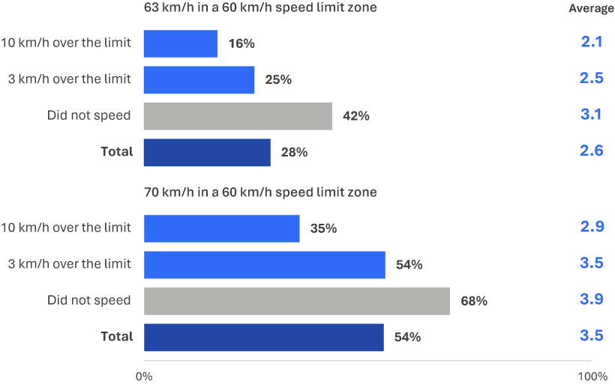
ACC1A How embarrassed would you be to tell your friends that you had been caught driving 63 km/h in a 60 km/h zone?
Base: Drivers (excl. Prefer not to say, Don’t know, and Not answered) (n=2,271)
ACC1B How embarrassed would you be to tell your friends that you had been caught driving 70 km/h in a 60 km/h zone?
(Scale from 1 ‘not at all embarrassed’ to 5 ‘extremely embarrassed’)
Base: Drivers (excl. Prefer not to say, Don’t know, and Not answered) (n=2,268)

Perceived danger
Respondents were asked to rate their perceived level of danger while ‘speeding at 63 km/h in a 60 km/h zone’ and ‘speeding at 110 km/h in a 100 km/h zone’. Questions were answered on a scale from 0 (not at all dangerous) to 10 (extremely dangerous). Averages (means) have been reported on this question.
Respondents who had driven at least 10 km/h over the limit rated the danger of speeding lowest among the groups. Speeding 3 km/h over the limit in a 60 km/h zone saw an average rating among this group of 3.7 out of 10, while those who did not speed rated this as substantially more dangerous (6.1). A more extreme difference was observed in the perceptions of how dangerous it is to drive at 110 km/h in a 100 km/h zone. Those who had driven 10 km/h or more over the limit rated this behaviour as 5.1 out of 10 on average, versus those who did not speed, rating this behaviour as 7.7 out of 10 on average.
Figure 15 Perceived danger of speeding by speeding behaviour
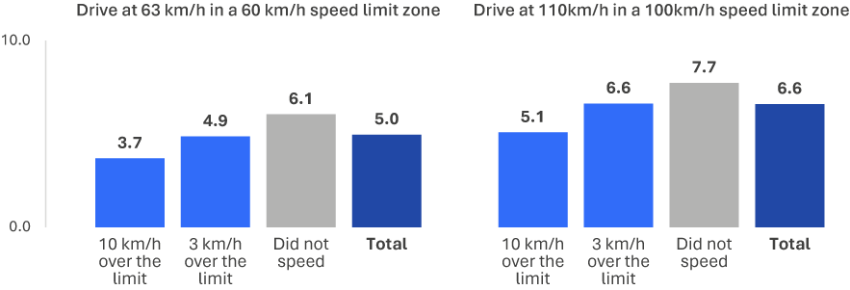
RI1 How dangerous do you think it is to[…]? (scale from 0 ‘not at all dangerous’ to 10 ‘extremely dangerous’)
Base: Drivers (excl. Prefer not to say, Don’t know, and Not answered) (n=2,317-2,331)

Attitudes toward enforcement
Attitudes towards speeding-related enforcement were mixed, with high-level speeders being the most likely to display cynical attitudes about the purpose of speeding enforcement and those who did not speed being the least likely to display cynical attitudes.
To gauge attitudes toward speeding enforcement, respondents were asked the extent to which they agree (4 or 5) or disagree (1 or 2) with the statement ‘speeding penalties are just revenue raising’. Respondents were also provided with a neutral option (3).
As shown in Figure 16, two in five respondents (38%) agreed that speeding penalties are just ‘revenue raising’. There was a clear relationship between speeding behaviour and agreement with this statement, with respondents who reported greater levels of speeding behaviour more likely to agree with this statement. Those who drove 10 km/h over the limit (47%) were most likely to agree with this sentiment, while those who did not speed were least likely (30%).
Figure 16 Speeding penalties are ‘revenue raising’ by speeding behaviour (% agree (4–5))
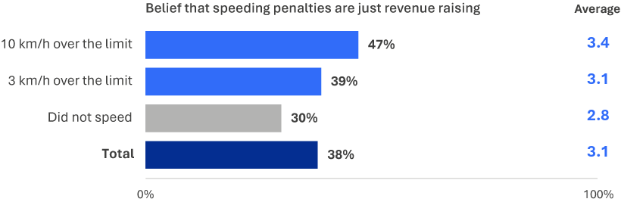
ATD1A The following are some statements about the state of driving in Victoria. Please tell us the extent to which you agree or disagree that speeding penalties are just revenue raising? (Scale from 1 – strongly disagree to 5 – strongly agree)
Base: Drivers (excl. Prefer not to say, Don’t know, and Not answered) (n=2,280)

Perceived enforcement risk
On average, speeders perceived a lower likelihood of being caught by police for road rule violations than non-speeders. Low-level and high-level speeders displayed a similar level of perceived risk regarding general police enforcement.
Respondents were asked how likely they believe they are to get caught by the police for breaking any road rule on a scale of 1 to 5, where 1 was not at all likely, and 5 was extremely likely. One-third of both low-level (32%) and high-level (29%) speeders believed that they were likely to be caught. Non-speeders (41%) were most likely to believe they would be likely to get caught.
Figure 17 Perceived enforcement risk by speeding behaviour (% feel they are likely (4–5) to get caught)
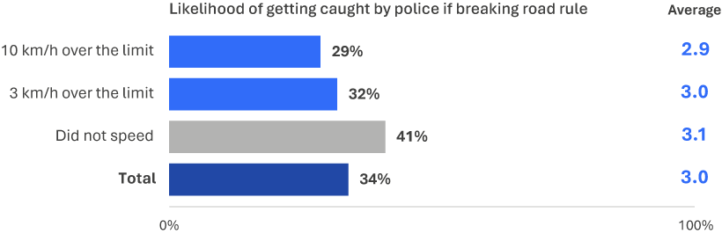
EN2 How likely do you believe you are to get caught by police if you are breaking any road rule at any given time? (% likely)
(Scale from 1 ‘not at all likely’ to 5 ‘extremely likely’)
Base: Drivers (excl. Prefer not to say, Don’t know, and Not answered) (n=2,165)

Other speeding-related findings
This section explores other speeding-related findings that were captured in the RSM, with a particular focus on support and opposition toward hypothetical policy changes. Respondents were asked whether they would support, oppose or be neutral (on a scale of one to five, where 5 was strongly oppose and 5 was strongly support) toward hypothetical policy changes relating to reducing residential speed limits from 50 km/h to 40 km/h and reducing narrow country road speeds from 100 km/h to 80 km/h.
On balance, drivers did not support a reduction of the residential speed limit from 50 km/h to 40 km/h (26% supported, 52% opposed and 23% were neutral). However, drivers were more favourable towards the hypothetical lowering of the speed limit on narrow country roads (46% supported, 37% opposed and 18% were neutral).
Drivers who exceeded the speed limit, especially at high levels, were more likely to oppose reduced speed limits than non-speeders. High-level speeders were least likely to support the hypothetical 10 km/h speed limit reduction to 40 km/h on residential roads, with about one-in-five (19%) supporting it, whereas about one quarter (23%) of low-level speeders and over a third (34%) of non-speeders supported this hypothetical reduction. One third of high-level speeders (33%) and more than two-in-five low-level speeders (46%) were more likely to support the hypothetical 20 km/h speed limit reduction on narrow country roads, compared to more than half (55%) of non-speeders.
Figure 18 Support and opposition for reducing residential road speed limit from 50 km/h to 40 km/h
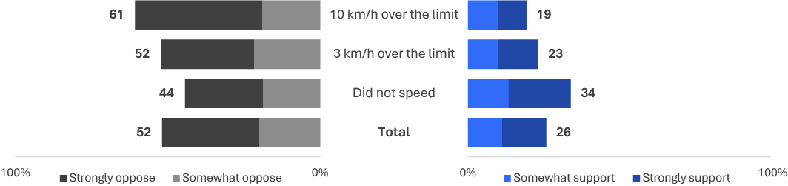
DFC1A In terms of changes to current policy and regulations, how strongly would you oppose or support the following hypothetical scenarios with current road rules… the default speed limit on residential roads being changed from 50 km/h to 40 km/h?
Base: Drivers (excl. Prefer not to say, Don’t know, and Not answered) (n=2,309)
Figure 19 Support and opposition for reducing narrow country roads speed limit from 100 km/h to 80 km/h
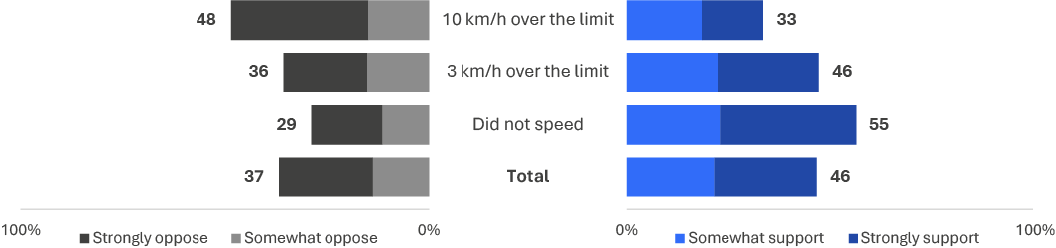
DFC1B In terms of changes to current policy and regulations, how strongly would you oppose or support the following hypothetical scenarios with current road rules… the default speed limit on narrow country roads being changed from 100 km/h to 80 km/h?
Base: Drivers (excl. Prefer not to say, Don’t know, and Not answered) (n=2,311)

Drink driving
This section explores alcohol consumption, driving after drinking, and attitudes towards drink driving in the community.

Prevalence of drinking and drink driving
In the RSM for 2025, there were four questions that asked how frequently respondents consumed alcohol and drove after drinking in the past 12 months. One question covered alcohol consumption overall. Three questions covered driving after drinking at different levels: when respondents were confident they were under the legal BAC limit, when they might have been over the BAC limit, and when they were over the BAC limit.
Figure 20 shows the proportion of respondents who reported driving after drinking in the past 12 months.
In 2025, more than two-thirds of respondents (69%) had consumed alcohol in the past 12 months. Driving after drinking when confidently under the legal BAC limit had the highest prevalence (41%), followed by driving when respondents might have been over the legal BAC limit (9%), and driving when they were over the BAC limit (2%).
Figure 20 Prevalence of drinking and drink driving
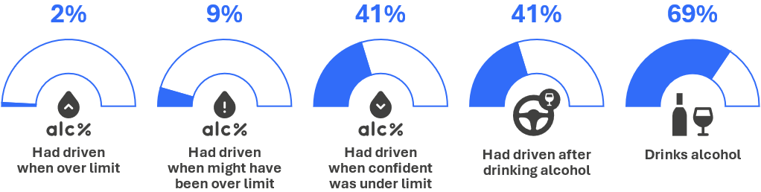
DK1 In the last 12 months, on average, how often did you have an alcoholic drink of any kind?
Base: All respondents (n=2,333)
DB3ABC In the last 12 months, how often did you [drink driving behaviour]?
Base: Drivers (excl. Prefer not to say, Don’t know, and Not answered) (n=2,325-2,331)
Most of those who drove after drinking alcohol when confident of being under the legal BAC limit reported doing this behaviour ‘rarely’ (20%) or ‘sometimes’ (16%). Driving when respondents might have been or were over the legal BAC limit was most commonly done rarely (8% and 2% respectively).
Figure 21 Frequency of drinking and driving (%)
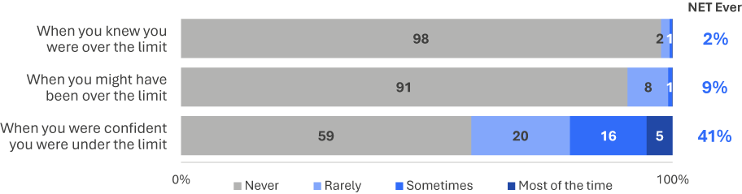
DB3ABC In the last 12 months, how often did you…?
Base: Drivers (excl. Prefer not to say, Don’t know, and Not answered) (n=2,325)
Figure 22 shows the historical trend for alcohol consumption.
The trend indicates that alcohol consumption retained similar prevalence over the past six years. It increased from 76% in 2017 to 78% in 2019 then decreased from 2020 onwards, to 69% in 2025.
Figure 22 Alcohol use by year: ‘ever’ (%)
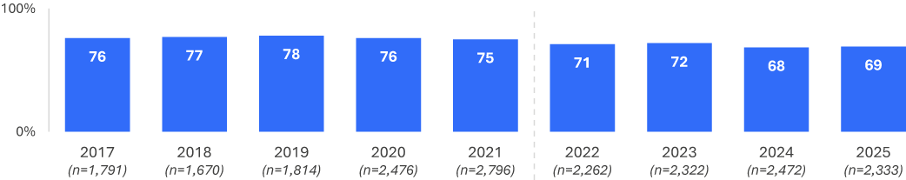
DK1 In the last 12 months, on average, how often did you have an alcoholic drink of any kind?
Base: Drivers (excl. Prefer not to say, Don’t know, and Not answered)
Note: Due to substantial changes in instrument design, any data changes between 2021 and 2022 should be interpreted with caution.
Figure 23 shows the prevalence of driving over the legal BAC limit since 2017. Prevalence decreased from 6% in 2017 to 5% in 2018 and remained consistent up to 2020. It decreased again in 2022 and 2023 (both 3%), falling to 2% in 2024 and 2025.
Figure 23 Drink driving when over the legal BAC limit by year: ‘ever’ (%)
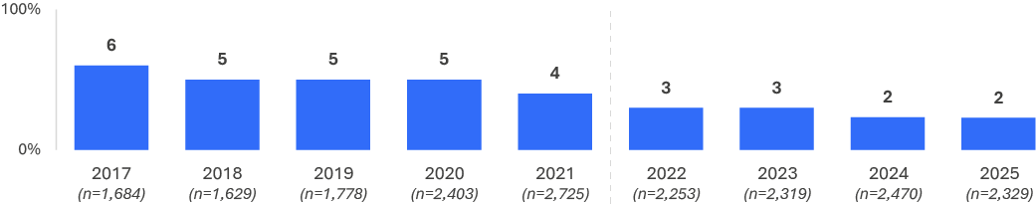
DB3A In the last 12 months, how often did you drive a vehicle when you knew you were over your legal blood alcohol limit?
Base: Drivers (excl. Prefer not to say, Don’t know, and Not answered)
Note: Due to a break in the time-series data between 2021 and 2022, any inferences drawn from the data during this period should be interpreted with caution.
Figure 24 shows the prevalence of driving after drinking when under, might have been over and over the legal BAC limit since 2022. Two in five respondents said they had driven when confident they were under the legal BAC limit (41%), compared to 9% who had driven when they might have been and 2% who had driven when over the legal BAC.
The prevalence of driving when confident of being under the legal BAC limit was the same in 2022 (41%) as 2025 (41%). Driving when respondents ‘might have been over the limit’ had the same prevalence in 2022 (9%) as 2025 (9%).
Figure 24 Drink driving when under, might have been over and over by quarter and year ‘ever’ (%)
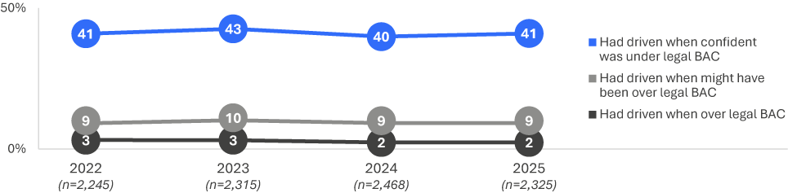
DB3ABC In the last 12 months, how often did you drive a vehicle when you [knew you were over][might have been over][were confident you were under] your legal blood alcohol limit?
Base: Drivers (excl. Prefer not to say, Don’t know, and Not answered)

Demographic characteristics
Across demographic groups, males and those aged 40 to 59 had the highest propensity to engage in drink driving behaviour.
- Males were more likely than females to report driving when they were under the legal BAC limit (46% vs 36%), when they might have been over the limit (12% vs 7%), and when they were over the limit (4% vs 1%).
- Almost half of those aged 40 to 60 (46%) reported driving after drinking alcohol compared to about a quarter (28%) of those aged 18 to 25.
Figure 25 Prevalence of drinking and driving behaviours among demographics
Column % |  | Age group |  |  |  | Gender |  | Location
Column % | Total | 18–25 | 26–39 | 40–60 | 61–90 | Male | Female | Major Urban | Other Urban | Rural
NET had drunk alcohol and had driven | 41% | 28% ↓ | 43% | 46% ↑ | 39% | 47% ↑ | 36% ↓ | 41% | 44% | 42%
Had driven when confident was under | 41% | 26% ↓ | 43% | 46% ↑ | 39% | 46% ↑ | 36% ↓ | 40% | 43% | 41%
Had driven when might have been over | 9% | 10% | 9% | 11% | 7% | 12% ↑ | 7% ↓ | 9% | 10% | 10%
Had driven when over | 2% | 2% | 3% | 3% | 2% | 4% ↑ | 1% ↓ | 2% | 3% | 3%
Base | 2,325 | 315 | 633 | 777 | 600 | 1,192 | 1,133 | 1,175 | 829 | 321
DB3ABC In the last 12 months, how often did you [drink and drive behaviour]?
Base: Drivers (excl. Prefer not to say, Don’t know, and Not answered)

Drinking alcohol and drink driving – Demographic subgroups over time

Results shown are aggregated by year, for each demographic group, using rolling averages of 4 quarters at a time, from 2022, to 2025. Each row in the figures show the difference over time per demographic subgroup. A dotted line of best-fit shows trend fit to the area over time.

Drinking alcohol
The largest decrease in 2025 is among drivers from Rural areas (65% in 2025 compared with 77% in 2022).
Each row in Figure 26 shows the difference over time per demographic subgroup. To assist with anchoring numbers within the figure, 2025 and 2022 are noted below. Note that differences are reported here for visual purposes only:

Age Groups
18-25: 74% in 2025, compared with 76% in 2022
26-39: 65% in 2025, compared with 71% in 2022
40-60: 72% in 2025, compared with 71% in 2022
61-90: 68% in 2025, compared with 68% in 2022.

Gender
Male: 73% in 2025, compared with 74% in 2022
Female: 65% in 2025, compared with 69% in 2022.

Region
Major Urban: 69% in 2025, compared with 70% in 2022
Other Urban: 74% in 2025, compared with 75% in 2022
Rural: 65% in 2025, compared with 77% in 2022.
Figure 26 Drinking alcohol over time by demographic subgroup: % ‘ever’, in any zone
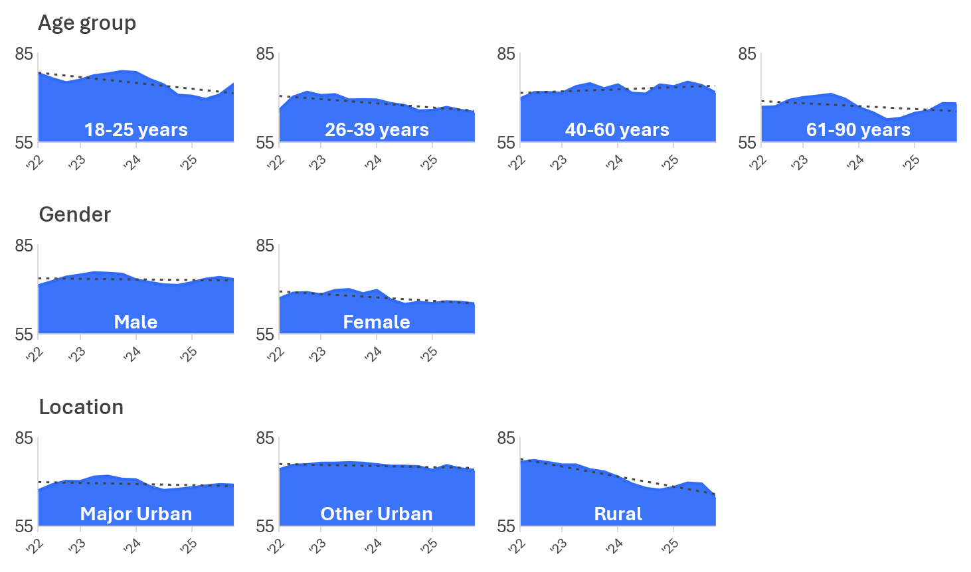

DK1 In the last 12 months, on average, how often did you drink alcohol?
Base: Drivers (2022 to 2025); Range lowest to highest n across years.
Age group: 18-25 (n=315-430); 26-39 (n=488-747); 40-60 (n=748-781); 61-90 (n=544-657)
Gender: Male (n=1,080-1,225); Female (n=1,135-1,247)
Location: Major Urban (n=1,111-1,291); Other Urban (n=755-835); Rural (n=322-396)

Drink driving, over the BAC limit
The trend down from 2022 to 2025 is clearest among those aged 18-25, 61-90, and females.
Each row in Figure 27 shows the difference over time per demographic subgroup.
Proportions in 2022 and 2025 are noted per subgroup below. To assist with anchoring numbers within the figure, 2025 and 2022 are noted below. Note that differences are reported here for visual purposes only:

Age group
18-25: 2% in 2025, compared with 5% in 2022
26-39: 3% in 2025, compared with 3% in 2022
40-60: 3% in 2025, compared with 3% in 2022
61-90: 2% in 2025, compared with 3% in 2022.

Gender
Male: 4% in 2025, compared with 4% in 2022
Female: 1% in 2025, compared with 2% in 2022.

Location
Major Urban: 2% in 2025, compared with 3% in 2022
Other Urban: 3% in 2025, compared with 4% in 2022
Rural: 3% in 2025, compared with 3% in 2022.
Figure 27 Driving over the legal BAC limit, in any zone
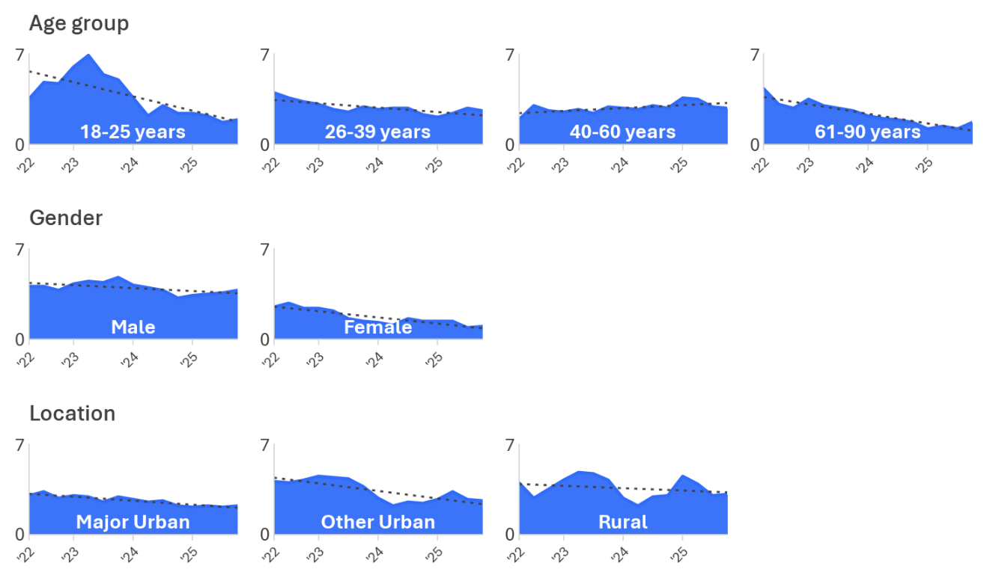

DB3 In the last 12 months, how often did you drive a vehicle when you knew you were over your legal blood alcohol limit?
Base: Drivers (2022 to 2025); Range lowest to highest n across years.
Age group: 18-25 (n=315-430); 26-39 (n=486-747); 40-60 (n=746-779); 61-90 (n=542-653)
Gender: Male (n=1,074-1,223); Female (n=1,134-1,247)
Location: Major Urban (n=1,108-1,291); Other Urban (n=752-834); Rural (n=321-393)

DBI profile
The relationship between DBI and drink-driving behaviour.
Respondents were asked how frequently they had driven when: confident they were under the legal limit; they might have been over the legal limit; and they were definitely over the legal limit. Four categories were derived: non-drinkers; those who don’t drink, those who didn’t drink and drive, those who did drink and drive only when under the legal limit, and those who did drink and drive when they might have been or were over the legal limit. Where respondents reported multiple behaviours, they were classified in the most severe category. Categories are reported across the full sample of respondents.
Table 5 shows a relationship between DBI and drink driving:
- A high proportion of respondents who drove when they might have been or were over the limit were in the very high (39%) and extremely high (23%) DBI categories.
- Respondents who drove only when confident they were under the limit were overrepresented in the high (38%) and very high (25%) categories.
- Respondents who did not drink and drive were overrepresented in the low DBI category (48%) and underrepresented in the very high (10%) and extremely high (2%) categories.
- Respondents who did not drink were overrepresented in the low category (53%) and underrepresented in the high (18%), very high (7%), and extremely high (2%) categories.
Driving after drinking at any level was associated with higher DBIs when compared with those who did not drink and drive and those who did not drink. Respondents who drove when they might have been or were over the legal limit had the highest DBI levels.
Table 5 Drink driving behaviour by DBI membership
Row % | Low | Medium | High | Very High | Extremely High
Had driven when might have been/were over the limit | 1% ↓ | 4% ↓ | 33% | 39% ↑ | 23% ↑
Had driven when under the limit | 12% ↓ | 23% ↑ | 38% ↑ | 25% ↑ | 3%
Did not drink and drive | 48% ↑ | 19% | 22% ↓ | 10% ↓ | 2% ↓
Does not drink | 53% ↑ | 18% | 21% ↓ | 7% ↓ | 2% ↓
Total | 33% | 18% | 28% | 17% | 4%
Base | 744 | 423 | 649 | 406 | 111
DBI Summary
Base: Drivers (excl. Prefer not to say, Don’t know, and Not answered)

Behavioural insights
To explore factors related to drink-driving behaviour, participants were asked a set of questions about:
their perceived control over drinking and driving
their perceptions of the dangers associated with drinking and driving
the social norms of their group regarding drinking and driving.

Perceived control
Respondents indicated their agreement (4 to 5) or disagreement (1 to 2) with the statement ‘sometimes I have to drive, even if I might be over the legal BAC’ on a five-point scale including a neutral midpoint (3).
Overall, 1% agreed with the statement. Respondents who had driven when they might have been or were over the limit reported worse perceived control (average of 1.6) than all other groups (average of 1.1). Strong disagreement was also less common in this group (58%) compared with 93% to 95% in other categories.
Figure 28 Perceived control over drink driving
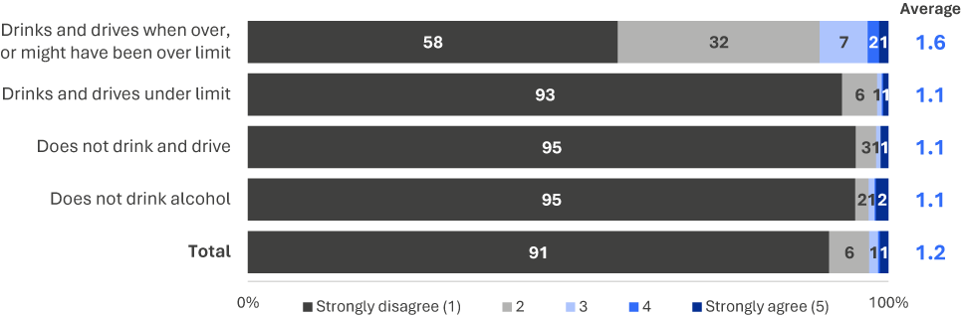
PC1B To what extent do you agree or disagree that sometimes you have to drive even though you might be over your legal BAC? (% agree)
(Scale from 1 – strongly disagree to 5 – strongly agree)
Base: Drivers (excl. Prefer not to say, Don’t know, and Not answered) (n=2,227)

Perceived danger
Respondents rated how dangerous it is to drive with a BAC over 0.05 and to drive soon after one standard drink on an 11-point scale (0 being ‘not at all dangerous’ and 10 being ‘extremely dangerous’).
Driving with a BAC over 0.05 was rated less dangerous by respondents who had driven when they might have been or were over the BAC limit (7.6) than by those who drove only when under the limit (8.7), those who did not drink and drive (8.7), and those who did not drink (9.0).
Driving soon after one standard drink was rated less dangerous than driving with a BAC over 0.05. Danger ratings were lowest among those who had driven when they might have been or were over the limit (3.4), followed by those who drove only when under the limit (4.3), those who did not drink and drive (6.3), and those who did not drink (7.6).
Figure 29 Perceived danger of drink driving at different BAC levels among drink driving categories
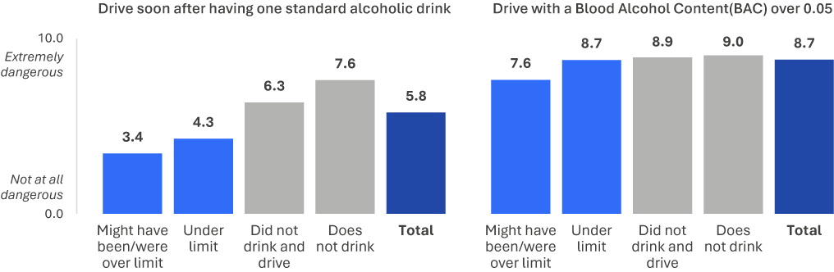
RI1C How dangerous do you think it is to drive with a BAC over 0.05? (scale from 0 ‘not at all dangerous’ to 10 ‘extremely dangerous’)
Base: Drivers (excl. Prefer not to say, Don’t know, and Not answered) (n=2,283)
RI1B How dangerous do you think it is to drive soon after having one standard alcoholic drink? (scale from 0 ‘not at all dangerous’ to 10 ‘extremely dangerous’)
Base: Drivers (excl. Prefer not to say, Don’t know, and Not answered) (n=2,270)

Social norms
Respondents indicated how embarrassed they would feel telling friends or family they had been caught driving over the legal limit.
Embarrassment was most common among those who drove only when confident they were under the limit (93%). Those who had driven when they might have been or were over the limit were less likely to report embarrassment (84%).
Figure 30 Social norms (% embarrassed 4-5) towards drink driving among drink driving categories
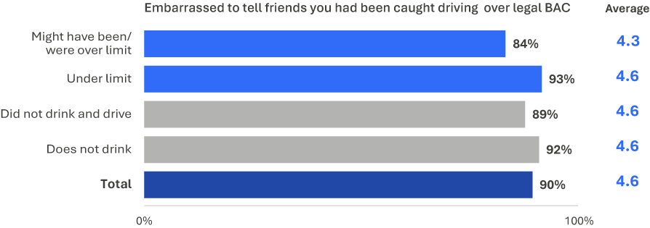
ACC1C How embarrassed would you be to tell your friends that you had been caught driving over your legal BAC? (% embarrassed)
(Scale from 1 ‘not at all embarrassed’ to 5 ‘extremely embarrassed’)
Base: Drivers (excl. Prefer not to say, Don’t know, and Not answered) (n=2,095)

Distracted driving
This section explores distracted driving, specifically the use of hand-held mobile phones while driving.

Prevalence of illegal mobile phone use while driving
In the RSM for 2025, there were three questions that asked how frequently in the past month respondents drove while using a hand-held mobile phone. The questions covered three activities: making or receiving a call, sending or reading a message, and interacting with an app.
Figure 31 shows the proportion of respondents who reported using a hand-held mobile phone while driving in the past month.
In 2025, half of drivers (50%) had used a hand-held mobile phone while driving for any purpose. Interacting with an app (46%) was almost twice as prevalent as making or receiving a call (24%) or sending or reading a message (24%).
Figure 31 Prevalence of hand-held mobile phones use while driving
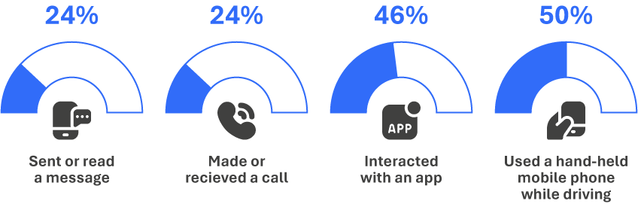
DB1 In the last month, how often did you use a mobile phone in your hand while driving to [mobile phone use behaviour]?
Base: Drivers (excl. Prefer not to say, Don’t know, and Not answered) (n=2,330-2,338)
Interacting with an app was the most common and most frequent hand-held mobile phone behaviour. One quarter of respondents (26%) reported doing so ‘sometimes’ (20%) or more often (6%). This is around three times the proportion who reported making or receiving a call (8%) or sending or reading a message (8%) at least ‘sometimes’.
Figure 32 Frequency of activities performed on mobile phones while driving (%)
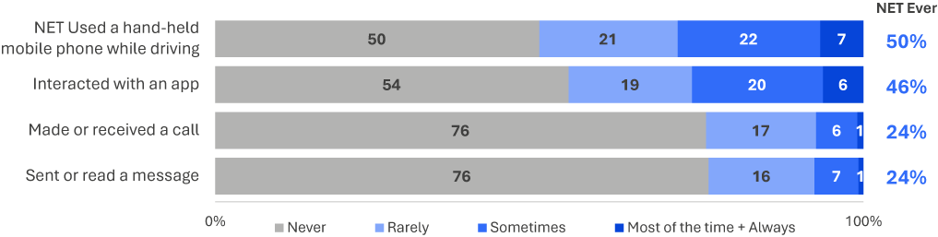
DB1ABC In the last month, how often did you use a mobile phone in your hand while driving to [mobile phone use behaviour]?
Base: Drivers (excl. Prefer not to say, Don’t know, and Not answered) (n=2,330-2,338)
Figure 33 shows use of a hand-held mobile phone while driving since 2022. The prevalence (50%) was similar in 2025 as 2022 (52%).
Figure 33 Hand-held mobile phone use while driving by year: ‘ever’ (%)
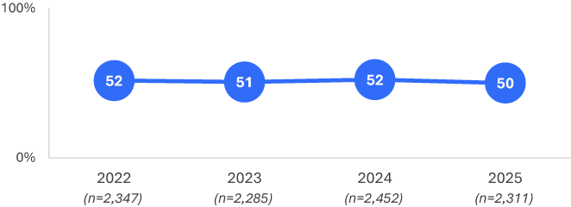
DB1 In the last month, how often did you use a mobile phone in your hand while driving to [mobile phone use behaviour]?
Base: Drivers (excl. Prefer not to say, Don’t know, and Not answered)

Demographic characteristics
Drivers aged 26 to 39 were most likely to report using a hand-held mobile phone while driving (61%). They were almost twice as likely as drivers aged 61 to 90 (32%) to use a phone while driving. They were more likely to report every type of phone use. After those aged 26 to 39 (33%), drivers aged 18 to 25 were next most likely to make or receive a call while driving (30%). Drivers aged over 60 were the least likely to report any type of hand-held mobile phone use.
Table 6 Hand-held mobile phone use among demographics
NET Ever % |  | Age group |  |  |  | Gender |  | Location
NET Ever % | Total | 18–25 | 26–39 | 40–60 | 61–90 | Male | Female | Major Urban | Other Urban | Rural
Used a handheld mobile phone for any reason | 50% | 56% | 61% ↑ | 53% | 32% ↓ | 52% | 48% | 50% | 49% | 49%
Make or receive a call | 24% | 30% | 33% ↑ | 26% | 10% ↓ | 25% | 23% | 24% | 24% | 25%
Send or read a message | 24% | 29% | 32% ↑ | 26% | 10% ↓ | 24% | 23% | 24% | 23% | 21%
Interact with an app | 46% | 53% | 57% ↑ | 47% | 28% ↓ | 47% | 44% | 46% | 46% | 43%
Base | 2,311 | 311 | 629 | 777 | 594 | 1,195 | 1,116 | 1,160 | 831 | 320
DB1 In the last month, how often did you use a mobile phone in your hand while driving to [mobile phone use behaviour]?
Base: Drivers (excl. Prefer not to say, Don’t know, and Not answered)

Distracted Driving – Demographics over time
This section looks at how the proportion of drivers who used a handheld phone while driving has changed across demographic subgroups from 2022 to 2025.
The trend shows up clearest among females. The remaining groups did not show a change large enough to stand out. Comparing the prevalence rate among females from 2022 (54%) to 2025 (48%) highlights a longer time-period of the trend, with some lumps over time.

The prevalence rate per subgroup in 2025 and 2022 are noted for each subgroup below. Note that differences are reported here for visual purposes only:

Age group
18-25: 56% in 2025, compared with 63% in 2022
26-39: 61% in 2025, compared with 63% in 2022
40-60: 53% in 2025, compared with 54% in 2022
61-90: 32% in 2025, compared with 31% in 2022.

Gender
Male: 52% in 2025, compared with 50% in 2022
Female: 48% in 2025, compared with 54% in 2022.

Location
Major Urban: 50% in 2025, compared with 52% in 2022
Other Urban: 49% in 2025, compared with 49% in 2022
Rural: 49% in 2025, compared with 52% in 2022.
Figure 34 Hand-held mobile phone use by demographic characteristics: ‘ever’ (%) over time
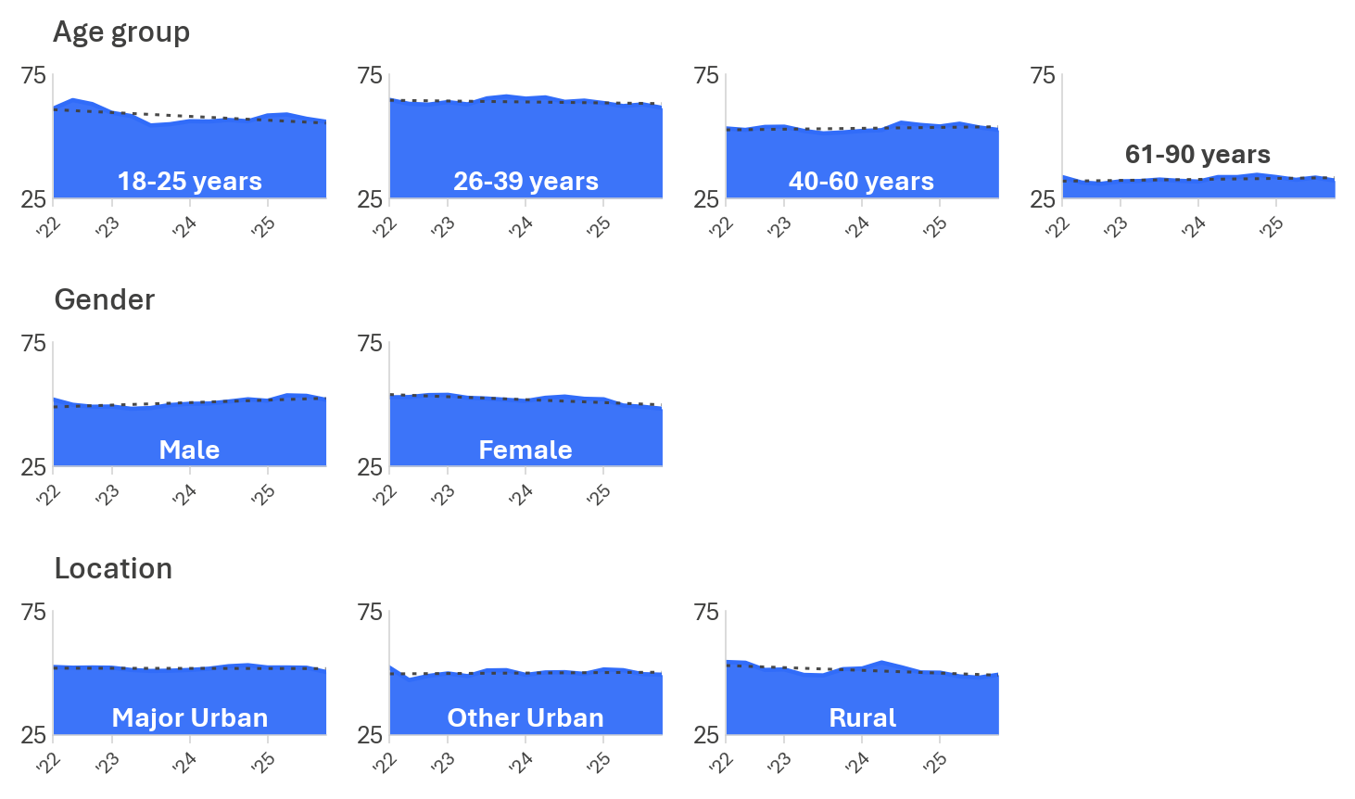
DB1ABC Max frequency of using a handheld mobile phone while driving for all uses
Base: Drivers (2022 to 2025); Range lowest to highest n across years.
Age group: 18-25 (n=307-423); 26-39 (n=534-750); 40-60 (n=755-793); 61-90 (n=557-686)
Gender: Male (n=1,133-1,227); Female (n=1,131-1,258)
Location: Major Urban (n=1,176-1,292); Other Urban (n=765-841); Rural (n=323-411)

DBI profile
This section explores the relationship between DBI and hand-held mobile phone use while driving. It examines how the likely drivers who used a phone were to also engage in other risk-increasing behaviours, and how frequently.
Responses to the mobile phone usage questions were combined: drivers who used a hand-held mobile phone while driving and those who did not.
Table 7 shows that 76% of respondents who used a hand-held mobile phone while driving recorded high (33%), very high (31%) or extremely high (8%) DBIs, compared with 47% overall.
Drivers who did not use a hand-held mobile phone recorded no instances of an extremely high DBI. They were also less likely than the overall to record a very high DBI (3% compared with 17%) or a high DBI (18% compared with 27%).
These results indicate that hand-held mobile phone use while driving is associated with a higher likelihood of other risk-increasing behaviours. Non-use of hand-held mobile phones is associated with markedly lower likelihood of other risk-increasing behaviours.
Table 7 Distracted driving behaviour by DBI Membership
Row % | Low | Medium | High | Very High | Extremely High
Used hand-held mobile phone while driving | 8% ↓ | 16% ↓ | 37% ↑ | 31% ↑ | 8% ↑
Did not use mobile phone while driving | 59% ↑ | 20% ↑ | 18% ↓ | 3% ↓ | 0% ↓
Total | 33% | 18% | 27% | 17% | 4%
Base | 746 | 428 | 648 | 405 | 110
DBI Summary
Base: Drivers (excl. Prefer not to say, Don’t know, and Not answered)

Behavioural insights
To explore factors related to distracted driving, respondents were asked about:
perceived danger of using a mobile phone while driving
social norms about using a hand-held mobile phone while driving.
The relationship between hand-held mobile phone use, perceived enforcement risk and self-rated driving safety was also examined.

Perceived danger
Respondents rated how dangerous it is to glance at a mobile phone for a few seconds while driving on an 11 point scale, from ‘not at all dangerous’ (0) to ‘extremely dangerous’ (10).
Those who used a hand-held mobile phone while driving rated this behaviour as less dangerous than those who did not use a hand-held mobile phone while driving (7.2 compared with 8.5).
Figure 35 Perceived danger of using a hand-held mobile phone while driving
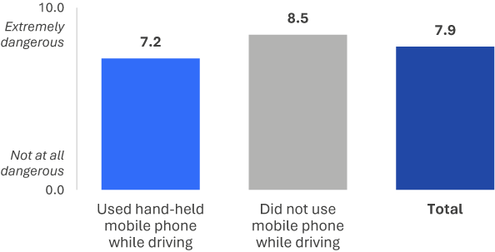
RI1G How dangerous do you think it is to glance at a mobile phone for a couple of seconds while actively driving? (Scale from 0 ‘not at all dangerous’ to 10 ‘extremely dangerous’)
Base: Drivers (excl. Prefer not to say, Don’t know, and Not answered) (n=2,305)

Social norms
Respondents were asked how embarrassed they would feel telling friends they had been caught using a hand-held mobile phone while driving.
Most drivers indicated they would feel embarrassed telling friends they had been caught using a mobile phone illegally while driving. Those who reported phone use while driving reported a lower level of embarrassment.
Almost two thirds (63%) of respondents who used a hand-held mobile phone while driving would feel embarrassed, compared with 83% of those who did not.
Figure 36 Social norms for using a hand-held mobile phone while driving
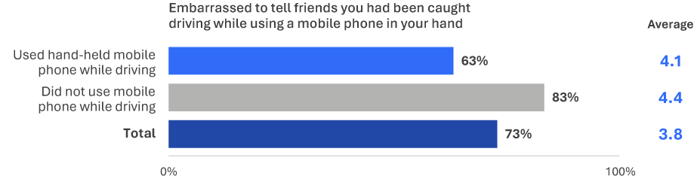
ACC1D How embarrassed would you be to tell your friends that you had been caught while using a mobile phone in your hand? (Scale from 1 ‘not at all embarrassed’ to 5 ‘extremely embarrassed’). Chart shows percentage of drivers who responded 4 to 5 on the scale.
Base: Drivers (excl. Prefer not to say, Don’t know, and Not answered) (n=2,194)

Perceived risk of enforcement
Respondents rated how likely they believed they were to be caught by police for breaking any road rule at any time.
Perceived likelihood of being caught by police for breaking any road rule was lower among those who used a hand-held mobile phone while driving.
Three in ten respondents (31%) who used a hand-held mobile phone while driving believed they were likely to be caught, compared with 38% of those who had not used a hand-held mobile phone while driving.
Figure 37 Perceived enforcement risk by hand-held mobile phone use categories
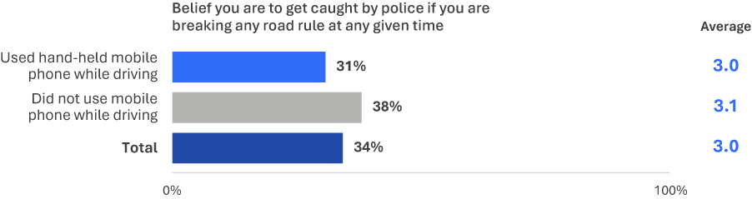
EN2 How likely do you believe you are to get caught by police if you are breaking any road rule at any given time? (Scale from 1 ‘not at all likely’ to 5 ‘extremely likely’) Chart shows percentage of drivers who responded 4 to 5 on the scale.
Base: Drivers (excl. Prefer not to say, Don’t know, and Not answered) (n=2,144)

Tired driving
This section explores tired driving behaviours, measures taken to avoid tired driving, and why people drive when tired.

Prevalence of tired driving
In the RSM for 2025, there were two questions that asked how frequently respondents drove while tired in the past 12 months. The questions covered two tiredness levels: driving while 'quite tired' and driving while 'very tired, so tired one cannot open their eyes'.
Figure 38 shows the proportion of drivers who reported driving while tired in the past 12 months.
In 2025, almost two-thirds of drivers (62%) had driven while quite tired. Around one in five (22%) had driven while very tired; about one third of the prevalence of driving while quite tired.
Figure 38 Prevalence of tired driving
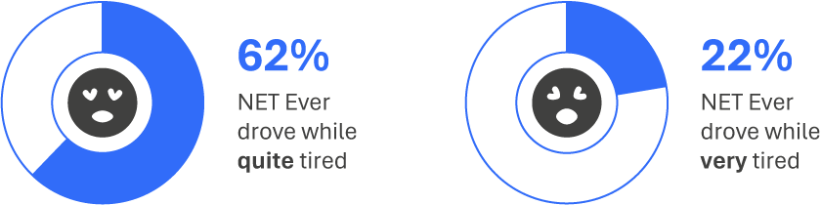
DB3GH In the last 12 months, how often did you [tired driving behaviour]?
Base: Drivers (excl. Prefer not to say, Don’t know, and Not answered) (n=2,359)
Driving while ‘very tired’ was done less frequently than driving while ‘quite tired’. Of the 62% who had driven while quite tired, more than one quarter did so ‘sometimes’ (25%) or more often (2%). Of the 22% who had driven while very tired, only 3% did so ‘sometimes’.
Figure 39 Frequency of tired driving
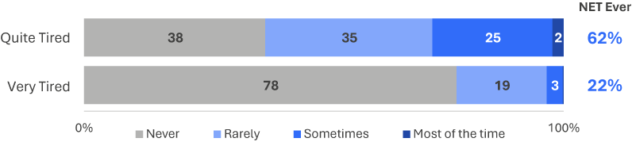
DB3GH In the last 12 months, how often did you drive while [quite/very] tired]?
Base: Drivers (excl. Prefer not to say, Don’t know, and Not answered) (n=2,359)
Figure 40 shows driving while quite tired and very tired since 2022. The proportion who had driven while quite tired decreased from 66% in 2022 to 60% in 2024, similar in prevalence in 2025 (62%).
Figure 40 Driving while quite tired and very tired by year: ‘ever’ (%)
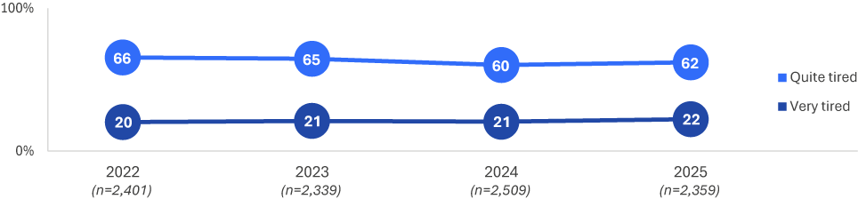
DB3GH In the last 12 months, how often did you [tired driving behaviour]?
Base: Drivers (excl. Prefer not to say, Don’t know, and Not answered)

Demographic characteristics
Young drivers were more likely to drive while tired than older drivers. Driving while tired was more common among males than females.
- Drivers aged 18 to 25 (69%) and 26 to 39 (70%) were more likely than those aged 61 to 90 (47%) to drive while quite tired.
- Drivers aged 18 to 25 (31%) and 26 to 39 (28%) were more likely than those aged 61 to 90 (11%) to have driven while very tired.
- Males were more likely than females to have driven while very tired (25% compared with 20%) and quite tired (66% compared with 58%).
Table 8 Prevalence of tired driving among demographics
NET Ever % |  | Age group |  |  |  | Gender |  | Location
NET Ever % | Total | 18–25 | 26–39 | 40–60 | 61–90 | Male | Female | Major Urban | Other Urban | Rural
Drive while very tired | 22% | 31% ↑ | 28% ↑ | 23% | 11% ↓ | 25% ↑ | 20% ↓ | 22% | 23% | 24%
Drive while quite tired | 62% | 69% ↑ | 70% ↑ | 65% | 47% ↓ | 66% ↑ | 58% ↓ | 62% | 64% | 61%
Base | 2,359 | 318 | 639 | 793 | 609 | 1,213 | 1,146 | 1,184 | 850 | 325
DB3GH In the last 12 months, how often did you [tired driving behaviour]?
Base: Drivers (excl. Prefer not to say, Don’t know, and Not answered)

Driving tired – demographic subgroups over time
This section examines the rate of drivers who drive while tired. The measures combine drivers who reported being quite tired and drivers who reported being very tired. Results shown are aggregated by year, for each demographic group, using rolling averages of 4 quarters at a time, from 2022 to 2025.
Driving while quite tired
The strongest downward movement in 2025 is among drivers from Rural areas. Other downward trends in subgroup prevalence can be seen in age groups 18-25 and 40-60, and among female drivers.
The prevalence rate per subgroup in 2025 and 2022 are noted for each subgroup below. Note that differences are reported here for visual purposes only:

Age Groups
18-25: 69% in 2025, compared with 74% in 2022
26-39: 70% in 2025, compared with 73% in 2022
40-60: 65% in 2025, compared with 72% in 2022
61-90: 47% in 2025, compared with 45% in 2022.

Gender
Male: 66% in 2025, compared with 69% in 2022
Female: 58% in 2025, compared with 63% in 2022.

Region
Major Urban: 62% in 2025, compared with 64% in 2022
Other Urban: 64% in 2025, compared with 68% in 2022
Rural: 61% in 2025, compared with 73% in 2022.
Figure 41 Driving while quite tired over time by demographic subgroup (% ever)
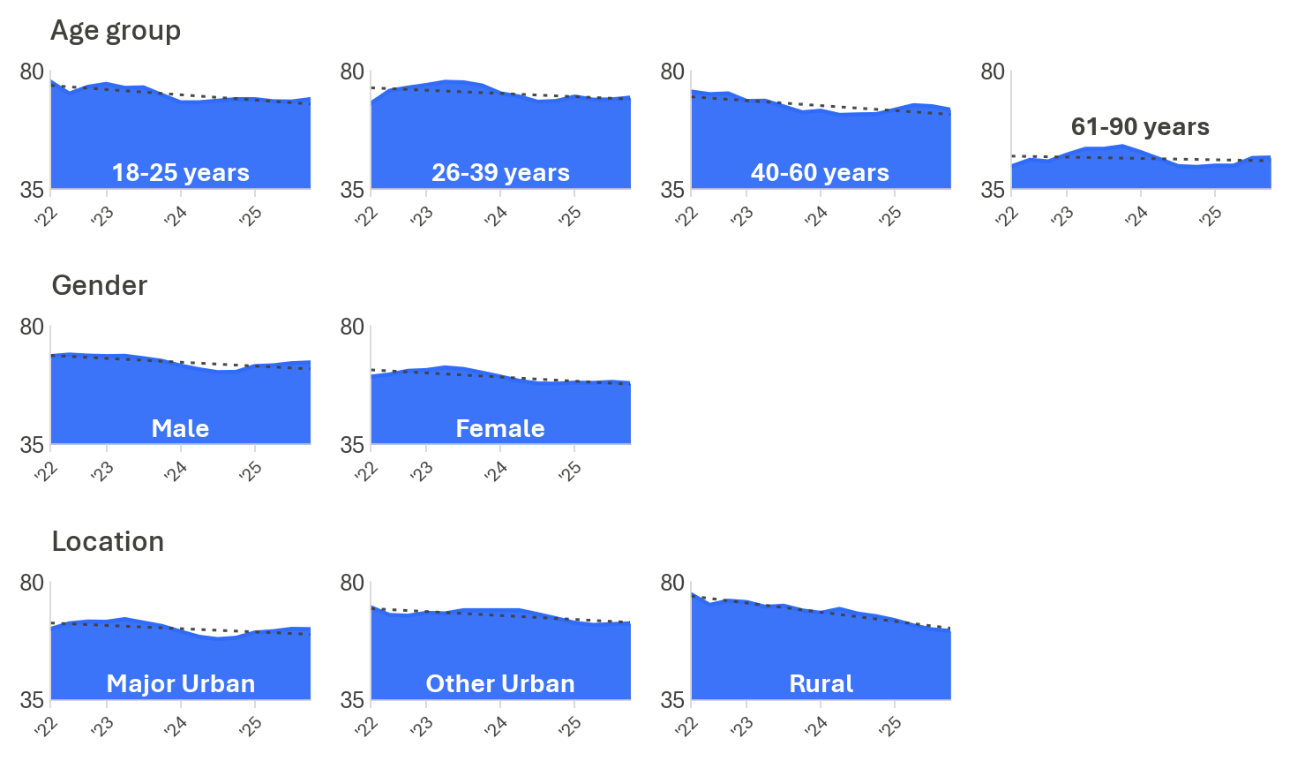

Driving while very tired
The prevalence of driving while very tired is largely steady. The most notable subgroup movements are an upward shift among drivers aged 26 to 39 and 40-60, and a downward shift among Rural drivers.
The prevalence rate per subgroup in 2025 and 2022 are noted for each subgroup below. Note that differences are reported here for visual purposes only:

Age group
18-25: 29% in 2025, compared with 29% in 2022
26-39: 31% in 2025, compared with 25% in 2022
40-60: 28% in 2025, compared with 31% in 2022
61-90: 20% in 2025, compared with 20% in 2022.

Gender
Male: 33% in 2025, compared with 31% in 2022
Female: 21% in 2025, compared with 22% in 2022.

Location
Major Urban: 26% in 2025, compared with 26% in 2022
Other Urban: 30% in 2025, compared with 25% in 2022
Rural: 27% in 2025, compared with 34% in 2022.
Figure 42 Driving while very tired over time by demographic subgroup: net (% ever)
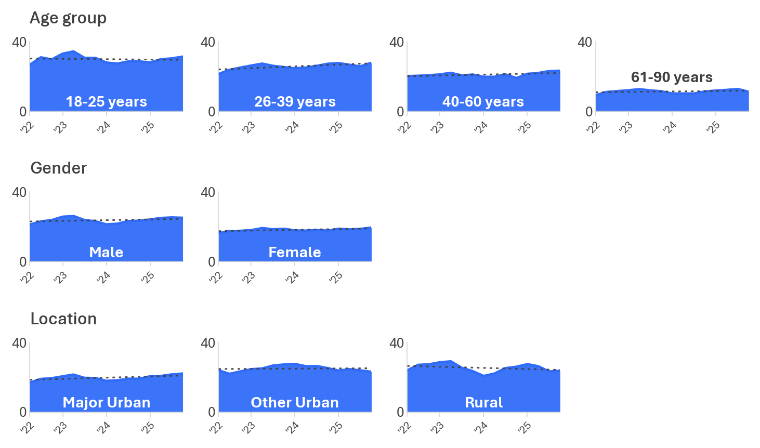

DBI profile
This section examines the relationship between DBI and tired driving. It outlines how likely and how often those who had driven while quite tired, or very tired, engaged in other dangerous driving behaviours.
Responses were grouped by their most severe behaviours related to tired driving: those who did not drive tired, those who drove while quite tired only, and those who drove while very tired.
Drivers who had driven while very tired had a substantially higher overall risk profile. Those who had driven while quite tired had a slightly higher, mixed risk profile.
Among those who had driven while very tired, 38% recorded a very high DBI and 14% an extremely high DBI. Those who had driven while quite tired were most commonly in the high DBI category (36%) and were less common in the extremely high category (2%). Eight in ten (83%) of those who did not drive while tired recorded low (55%) or medium (28%) DBI scores.
Driving while very tired is strongly associated with higher likelihood of other dangerous driving behaviours. Not driving while tired is associated with substantially lower likelihood of these behaviours.
Table 9 Tired driving behaviour by DBI membership
Row % | Low | Medium | High | Very High | Extremely High
Had driven while very tired | 0% ↓ | 15% ↓ | 33% ↑ | 38% ↑ | 14% ↑
Had driven while quite tired | 23% ↓ | 21% ↑ | 36% ↑ | 18% | 2% ↓
Did not drive while tired | 65% ↑ | 18% | 15% ↓ | 2% ↓ | 0% ↓
Total | 33% | 19% | 27% | 17% | 4%
Base | 758 | 434 | 650 | 406 | 111
DBI Summary
Base: Drivers (excl. Prefer not to say, Don’t know, and Not answered)

Behavioural insights
This section explores reasons why people drive while tired. Respondents were asked about:
perceived control over tired driving
- perceived danger of tired driving
- self-perceived safe driving

Perceived control over fatigued driving
Perceived control over tired driving was measured by agreement with the statement: ‘sometimes you have to drive, even if you are very tired’, rated from strongly disagree (1) to strongly agree (5).
Two in five (41%) of those who had driven while very tired agreed that sometimes they have to drive even if very tired. This compares with 13% of those who had driven while quite tired and 4% of those who had not driven while tired.
Figure 43 Perceived control over tired driving (% agree)
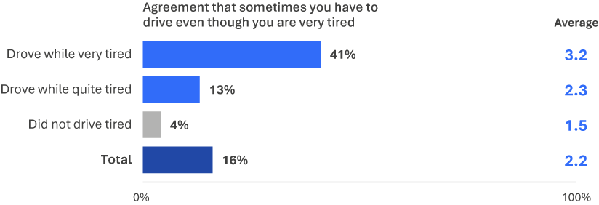
PC1A To what extent do you agree or disagree that sometimes you have to drive even though you are very tired? (Scale from 1 – strongly disagree to 5 – strongly agree)
Base: Drivers (excl. Prefer not to say, Don’t know, and Not answered) (n=2,284)

Perceived danger of fatigued driving
Respondents rated how dangerous it is to drive while very tired on an 11 point scale from ‘not at all dangerous’ (0) to ‘extremely dangerous’ (10).
Those who had not driven while tired rated how dangerous it is the highest (8.8), followed by those who had driven while quite tired (7.7) and those who had driven while very tired (7.2).
Figure 44 Perceived danger of driving while very tired
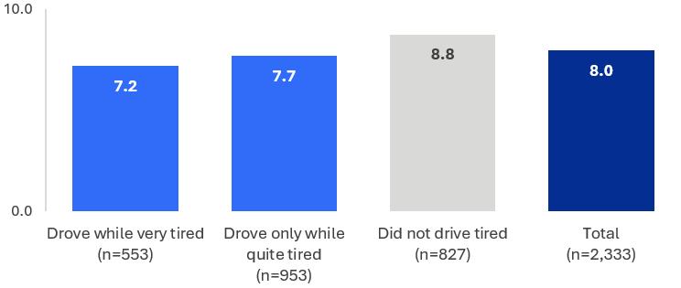
RI1F How dangerous do you think it is to drive while very tired? (scale from 0 ‘not at all dangerous’ to 10 ‘extremely dangerous’)
Base: Drivers (excl. Prefer not to say, Don’t know, and Not answered) (n=2,333)

Drug driving
This section explores illegal drug usage, drug driving behaviour, and attitudes towards drug driving in the community.

Prevalence of illegal drug use and drug driving
In the RSM for 2025, there were two questions that asked how frequently respondents used illegal drugs and drove after using illegal drugs in the past 12 months. The first question covered illegal drug use overall. The second asked respondents who had used illegal drugs how often they had driven after doing so.
Figure 45 shows the proportion of respondents who reported illegal drug use and drug driving in the past 12 months.
In 2025, 4% of respondents had used illegal drugs in the past 12 months. A smaller proportion (1.1%) had driven a vehicle after using illegal drugs
Figure 45 Prevalence of illegal drug use and drug driving
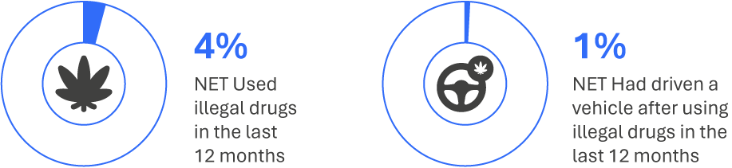
DG1 In the last 12 months, how often did you illegally use drugs?
Base: All respondents (n=2,375)
DB3D In the last 12 months, how often did you drive a vehicle after using illegal drugs?
Base: Drivers (excl. Prefer not to say, Don’t know, and Not answered) (n=2,334)
*DB3D has been re-based to include all drivers to measure the overall prevalence of drug-driving
Figure 46 shows the drug driving over time since 2022. The prevalence of drug driving was similar in 2025 (1.1%) as 2024 (0.9%).
Figure 46 Drug driving by year: ‘ever’ (%)
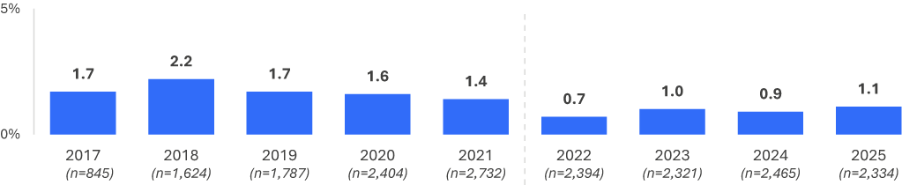
DB3D In the last 12 months, how often did you drive a vehicle after using illegal drugs?
Base: Drivers (excl. Prefer not to say, Don’t know, and Not answered) n=2,334
Note: Due to substantial changes in survey instrument design and metric measurement, changes in prevalence between 2021 and 2022/23 should be interpreted with caution.

Demographic characteristics
Illegal drug use was more prevalent among respondents aged 18 to 25 and 26 to 39.
- Respondents aged 26 to 39 (7%) were most likely to have used illegal drugs, most commonly less often than monthly (5%).
- Males (6%) were more likely than females (3%) to have used illegal drugs.
Table 10 Prevalence of illegal drug use among demographics
Column % |  | Age group |  |  |  | Gender |  | Location
Column % | Total | 18–25 | 26–39 | 40–60 | 61–90 | Male | Female | Major Urban | Other Urban | Rural
I have never illegally used drugs | 87% | 88% | 79% ↓ | 84% | 96% ↑ | 85% | 88% | 86% | 87% | 91%
Not in last 12 months, but did illegally use drugs more than 12 months ago | 9% | 6% | 14% ↑ | 12% ↑ | 2% ↓ | 9% | 9% | 9% | 9% | 5% ↓
Less often than monthly | 3% | 4% | 5% ↑ | 3% | 1% ↓ | 4% | 2% | 3% | 3% | 3%
Monthly | 1% | 2% ↑ | 1% | 0% ↓ | 1% | 1% | 0% | 1% | 0% | 1%
Weekly | 0% | 0% | 0% | 1% | 0% | 1% ↑ | 0% ↓ | 0% | 1% | 0%
Daily | 0% | 0% | 0% | 0% | 0% | 0% | 0% | 0% | 0% | 0%
NET: In last 12 months | 4% | 6% | 7% ↑ | 4% | 2% ↓ | 6% ↑ | 3% ↓ | 4% | 4% | 4%
Base | 2,375 | 327 | 643 | 789 | 616 | 1,221 | 1,154 | 1,197 | 850 | 328
DG1. In the last 12 months, how often did you illegally use drugs?
Base: Drivers (excl. Prefer not to say, Don’t know, and Not answered)
Drug driving prevalence was similar across all demographic groups, ranging between 0.4% and 1.9% across groups.
Table 11 Prevalence of drug driving among demographics
Column % |  | Age group |  |  |  | Gender |  | Location
Column % | Total | 18–25 | 26–39 | 40–60 | 61–90 | Male | Female | Major Urban | Other Urban | Rural
NET: Used drugs and had driven | 1.1% | 1.3% | 1.9% | 0.9% | 0.4% | 1.7% | 0.5% | 1.1% | 1.3% | 0.8%
Base | 2,334 | 315 | 628 | 784 | 607 | 1,198 | 1,136 | 1,171 | 838 | 325
DB3D In the last 12 months, how often did you drive a vehicle after using illegal drugs?
Base: Drivers (excl. Prefer not to say, Don’t know, and Not answered) and Drug Driving

Drug use – Demographic subgroups over time
This section examines the rates of illegal drug use. Drug driving has been omitted from this analysis due to having unreliable base sizes for comparison between demographic groups over time. Results shown are aggregated by year, for each demographic group, using rolling averages of 4 quarters at a time, from 2022 to 2025.
The downward movement shows up most clearly among 18 to 25 year olds and 40 to 60 year olds and males. The remaining groups did not show a change large enough to stand out.
The prevalence rate per subgroup in 2025 and 2022 are noted for each subgroup below. Note that differences are reported here for visual purposes only:

Age group
18-25: 6% in 2025, compared with 10% in 2022
26-39: 6% in 2025, compared with 8% in 2022
40-60: 4% in 2025, compared with 5% in 2022
61-90: 2% in 2025, compared with 1% in 2022.

Gender
Male: 6% in 2025, compared with 8% in 2022
Female: 3% in 2025, compared with 3% in 2022.

Location
Major Urban: 4% in 2025, compared with 6% in 2022
Other Urban: 4% in 2025, compared with 3% in 2022
Rural: 4% in 2025, compared with 5% in 2022.
Figure 47 Illegal drug use by demographic subgroup over time: net (% ever)
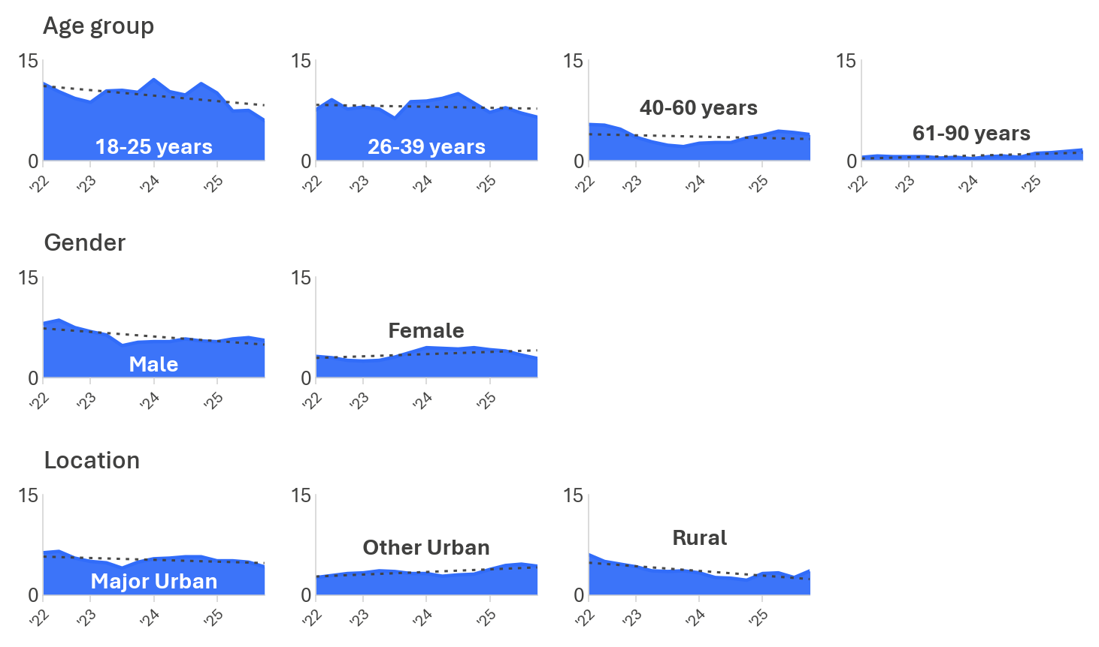

DG1 In the last 12 months, on average, how often did you illegally use drugs?
Base: Drivers (2022 to 2025); Range lowest to highest n across years.
Age group: 18-25 (n=312-420); 26-39 (n=531-736); 40-60 (n=755-798); 61-90 (n=559-683)
Gender: Male (n=1,133-1,220); Female (n=1,136-1,250)
Location: Major Urban (n=1,171-1,283); Other Urban (n=764-842); Rural (n=325-413)

DBI profile
This section explores the relationship between DBI and drug use and drug driving. It outlines how likely and how frequently those who used drugs, or used drugs and drove, engaged in other dangerous driving behaviours.
Respondents were categorised into three groups: those who used drugs and had driven, those who used drugs but did not drive after, and those who did not use drugs at all.
Respondents who used drugs and had driven were more likely to have extremely high DBI (49%), compared with the total incidence of 4%. Those who used drugs but did not drive also recorded elevated DBI levels, with 70% combined in the high (32%) or very high (37%) categories.
Using drugs, even without driving after use, was associated with higher engagement in other dangerous driving behaviours. Driving after using drugs showed a stronger relationship with these behaviours.
Table 12 Drug use and drug driving by DBI membership
Row % | Low | Medium | High | Very High | Extremely High
Used drugs and had driven | 0% ↓ | 0% ↓ | 3% ↓ | 37% ↑ | 60% ↑
Used drugs but did not drive after | 10% ↓ | 12% | 34% | 32% ↑ | 12% ↑
Did not use drugs | 35% ↑ | 19% ↑ | 28% | 16% ↓ | 3% ↓
Total | 34% | 18% | 27% | 17% | 4%
Base | 752 | 427 | 645 | 402 | 109
DBI Summary
Base: Drivers (excl. Prefer not to say, Don’t know, and Not answered)

Behavioural insights
This section explores drug driving by perceived enforcement risk and self-assessment as a safe driver.

Perceived enforcement risk
Respondents rated how likely they believed they were to be caught by police for breaking any road rule on a 5 point scale, from not at all likely (1) and extremely likely (5). This was compared with respondents’ drug driving behaviour.
As shown in Figure 48, respondents who used illegal drugs and had driven (13%) were least likely to believe they would be caught by police for breaking any road rule. Those who did not use illegal drugs (35%) were most likely to believe they would be caught, followed by those who did not drive after using illegal drugs (32%).
Figure 48 Perceived enforcement risk among drug driving categories
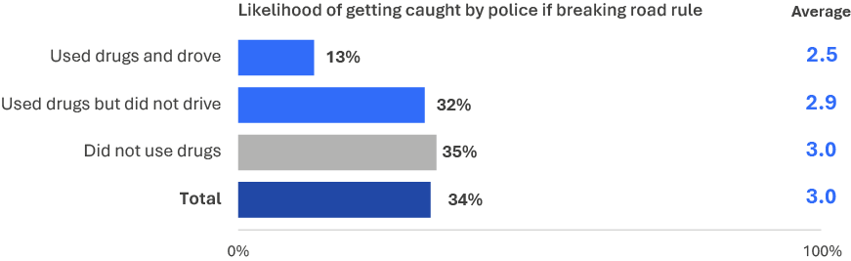
EN2 How likely do you believe you are to get caught by police if you are breaking any road rule at any given time? (Scale from 1 ‘not at all likely’ to 5 ‘extremely likely’)
Base: Drivers (excl. Prefer not to say, Don’t know, and Not answered) (n=2,141)

Seatbelt use
This section explores seatbelt use among drivers and passengers.

Prevalence of seatbelt use
Two seatbelt compliance scenarios were explored in this survey. Drivers were asked how often they had driven without wearing a seatbelt. All respondents were asked how often they had travelled as a passenger without wearing a seatbelt.
Almost all respondents used a seatbelt. Overall, only 3.3% of drivers reported driving without a seatbelt, and 4.1% of respondents reported travelling as a passenger without a seatbelt. A smaller proportion (1.9%) reported not wearing a seatbelt both as a driver and as a passenger.
Figure 49 Prevalence of seatbelt noncompliance among drivers and passengers
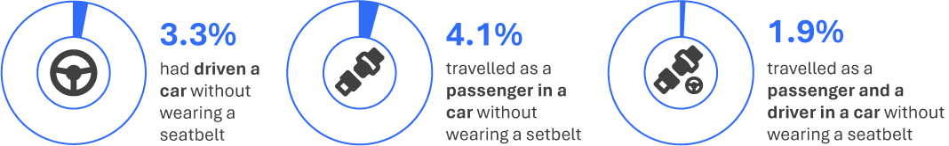
DB3E In the last 12 months, how often did you travel in a car without wearing a seatbelt?
Base: Drivers (excl. Prefer not to say, Don’t know, and Not answered) (n=2,361)
DB3F In the last 12 months, how often did you travel in a car as a passenger without wearing a seatbelt?
Base: All respondents (n=2,408)
Figure 50 shows seatbelt noncompliance over time since 2017. Non-compliance has varied since 2022, although the year on year changes for both drivers and passengers are not significant.
Figure 50 Noncompliance with seatbelt use by year: ‘ever’ (%)
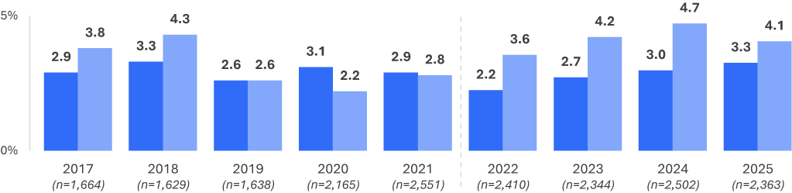
Driver
Passenger

DB3E In the last 12 months, how often did you travel in a car without wearing a seatbelt?
Base: Drivers (excl. Prefer not to say, Don’t know, and Not answered)
DB3F In the last 12 months, how often did you travel in a car as a passenger without wearing a seatbelt?
Base: All respondents

Demographic characteristics
Seatbelt noncompliance varied across demographic groups.
- A higher proportion of respondents in rural areas drove without a seatbelt (6.7%) than respondents in major urban areas (2.8%).
- Respondents aged 18 to 25 were most likely to drive (4.3%) or travel as a passenger (9.3%) without a seatbelt.
- Respondents aged 61 to 90 were least likely to drive (2.9%) or travel as a passenger (2.3%) without a seatbelt.
Table 13 Prevalence of noncompliance with seatbelt use among demographics
Column % |  |  | Age group |  |  |  | Gender |  | Location
Column % | Total | 18–25 |  | 26–39 | 40–60 | 61–90 | Male | Female | Major Urban | Other Urban | Rural
Drive a car while not wearing a seatbelt | 3.3% | 4.3% |  | 3.5% | 3.0% | 2.9% | 3.6% | 2.9% | 2.8% | 3.7% | 6.7% ↑
Travel as a passenger while not wearing  a seatbelt | 4.1% | 9.3% ↑ |  | 4.7% | 3.0% | 2.3% | 4.0% | 4.2% | 3.9% | 4.7% | 4.7%
Had driven car and travelled as passenger without a seatbelt | 1.9% | 2.9% |  | 2.4% | 1.8% | 1.2% | 1.9% | 1.9% | 1.7% | 2.3% | 3.3%
Base | 2,363 | 320 |  | 641 | 793 | 609 | 1,216 | 1,147 | 1,188 | 850 | 325
DB3E In the last 12 months, how often did you travel in a car without wearing a seatbelt?
Base: Drivers (excl. Prefer not to say, Don’t know, and Not answered)
DB3F In the last 12 months, how often did you travel in a car as a passenger without wearing a seatbelt?
Base: All respondents

Seatbelt use – Demographic subgroups over time
This section looks at how the proportion of seatbelt non-compliance, among drivers, and among all respondents as a passenger, has changed across demographic subgroups between 2022 to 2025. Results shown are aggregated by year, for each demographic group, using rolling averages of 4 quarters at a time, from 2022 to 2025.

Driving without a seatbelt
Travelling without a seatbelt as the driver has no clear trends among the subgroups. Prevalence rates have not been consistent in general.
The prevalence rate per subgroup in 2025 and 2022 are noted for each subgroup below. Note that differences are reported here for visual purposes only:

Age group
18-25: 4% in 2025, compared with 4% in 2022.
26-39: 3% in 2025, compared with 2% in 2022.
40-60: 3% in 2025, compared with 3% in 2022.
61-90: 3% in 2025, compared with 1% in 2022.

Gender
Male: 4% in 2025, compared with 3% in 2022.
Female: 3% in 2025, compared with 2% in 2022.

Location
Major Urban: 3% in 2025, compared with 2% in 2022.
Other Urban: 4% in 2025, compared with 3% in 2022.
Rural: 7% in 2025, compared with 6% in 2022.
Figure 51 Driver non-compliance with seatbelt use by year: ‘ever’ (%)
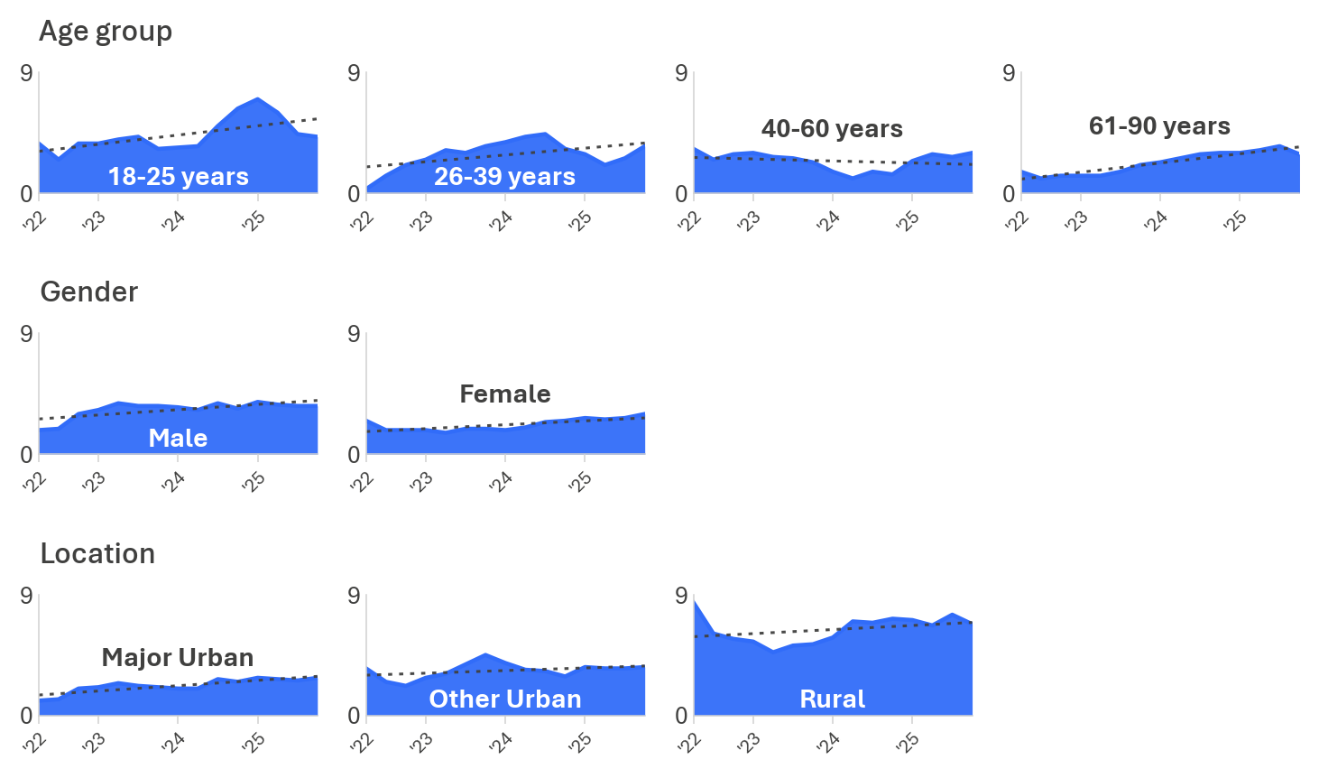

DB3 In the last 12 months, how often did you travel in a car without wearing a seatbelt?
Base: Drivers (2022 to 2025); Range lowest to highest n across years.
Age group: 18-25 (n=315-433); 26-39 (n=538-754); 40-60 (n=761-800); 61-90 (n=559-675)
Gender: Male (n=1,141-1,240); Female (n=1,146-1,267)
Location: Major Urban (n=1,185-1,305); Other Urban (n=767-852); Rural (n=326-416)

Passenger without a seatbelt
The significant and consistent upward trends are seen in 61 to 90 year olds and males – although differences are not large. Other groups had less consistent (and non-significant) trends over time.

The prevalence rate per subgroup in 2025 and 2022 are noted for each subgroup below. Note that differences are reported here for visual purposes only:

Age group
18-25: 9% in 2025, compared with 9% in 2022
26-39: 5% in 2025, compared with 4% in 2022
40-60: 3% in 2025, compared with 3% in 2022
61-90: 2% in 2025, compared with 1% in 2022.

Gender
Male: 4% in 2025, compared with 3% in 2022
Female: 4% in 2025, compared with 4% in 2022.

Location
Major Urban: 4% in 2025, compared with 3% in 2022.
Other Urban: 5% in 2025, compared with 4% in 2022.
Rural: 5% in 2025, compared with 5% in 2022.
Figure 52 Passenger non-compliance with seatbelt use by year: ‘ever’ (%)
DB3 In the last 12 months, how often did you travel in a car as a passenger without wearing a seatbelt?
Base: All respondents (2022 to 2025); Range lowest to highest n across years.
Age group: 18-25 (n=315-434); 26-39 (n=539-755); 40-60 (n=761-800); 61-90 (n=556-675)
Gender: Male (n=1,142-1,241); Female (n=1,146-1,265)
Location: Major Urban (n=1,185-1,307); Other Urban (n=767-850); Rural (n=325-417)

DBI profile
This section examines the relationship between DBI and seatbelt use. Respondents were grouped into two categories: those who always wore a seatbelt as a driver and passenger, and those who did not (either as a driver, passenger, or both).
Seatbelt noncompliance was strongly associated with other dangerous driving behaviours. As shown in Table 14, respondents who did not always wear a seatbelt were more likely to have very high (36%) and extremely high (34%) DBIs. Those who always wore a seatbelt were more likely to have low (35%), and medium (19%) DBIs, and less likely to have very high (16%) or extremely high (17%) DBIs compared with the general population.
Table 14 Seatbelt use by DBI membership
Row % | Low | Medium | High | Very High | Extremely High
Did not wear a seatbelt as a passenger and/or driver | 0% ↓ | 6% ↓ | 24% | 36% ↑ | 34% ↑
Always wore a seatbelt | 35% ↑ | 19% ↑ | 28% | 16% ↓ | 2% ↓
Total | 33% | 19% | 27% | 17% | 4%
Base | 758 | 434 | 652 | 406 | 110
DBI Summary
Base: Drivers (excl. Prefer not to say, Don’t know, and Not answered)

Behavioural insights
While respondents were not asked directly about why they do not always wear a seatbelt, some insights can be found by analysing how seatbelt wearing behaviour relates to other measures. This demonstrated that perceived enforcement risk and self-perceptions of safe driving differed slightly between those who always wear a seatbelt and those who did not always wear one.
Seatbelt behaviour was also analysed alongside perceived enforcement risk and self-perceptions of safe driving. Respondents rated how likely they believed they were to be caught by police for breaking any road rule on a 5 point scale, from not at all likely (1) to extremely likely (5).
One third (32%) of those who did not always wear a seatbelt believed they were likely to be caught by police for breaking any road rule, a similar proportion among those who always wore a seatbelt (34%).
Figure 53 Perceived enforcement risk among seatbelt wearing categories (% likely)
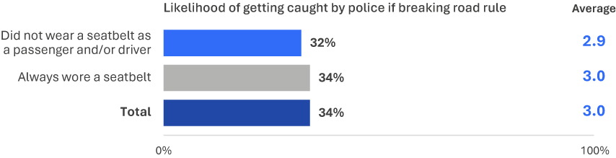
EN2 How likely do you believe you are to get caught by police if you are breaking any road rule at any given time? (Scale from 1 ‘not at all likely’ to 5 ‘extremely likely’). Chart shows percentage of drivers who responded 4 to 5 on the scale.
Base: Drivers (excl. Prefer not to say, Don’t know, and Not answered) (n=2,160)

Drivers rated how dangerous they believe it is to travel in a car without a seatbelt, on a scale from 0 to 10, with 10 indicating a rating of ‘extremely dangerous’. As shown in Figure 54, those who always wore a seatbelt (9.0) rated not wearing a seatbelt as more dangerous on average than those who did not wear a seatbelt (7.3).
Figure 54 Risk perceptions of traveling in a car without wearing a seatbelt
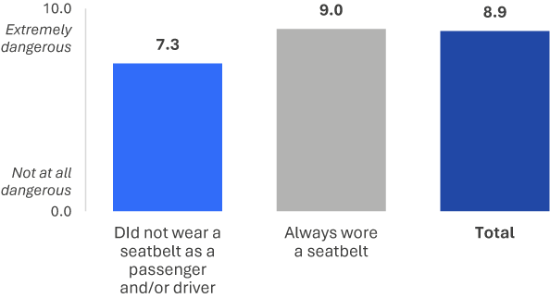
RI1_M How dangerous do you think it is to travel in a car without a seatbelt? (Scale from 0 ‘not at all dangerous’ to 10 ‘extremely dangerous’).
Base: Drivers (excl. Prefer not to say, Don’t know, and Not answered) – 2025 (n=2,337)
Drivers indicated their agreement with the statement that ‘sometimes you have to travel in a car without wearing a seatbelt’ on a 5 point scale. Only 1% of respondents who always wore a seatbelt agreed with this compared to 6% of respondents who did not wear a seatbelt (6%).
Figure 55 Perceived control over seatbelt use
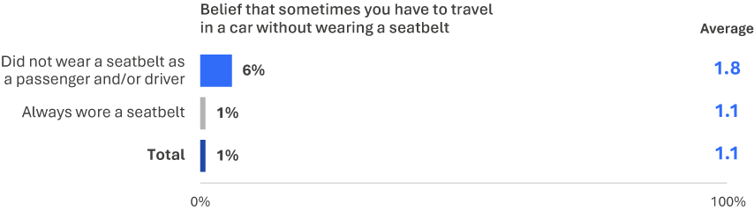
PC1 To what extent do you agree or disagree that sometimes you have to travel in a car without wearing a seatbelt? (Scale from 1 ‘strongly disagree’ to 5 ‘strongly agree’).
Base: Drivers (excl. Prefer not to say, Don’t know, and Not answered), 2025 (n=2,308)

Drivers rated how embarrassed they would feel telling friends they had been caught driving without a seatbelt on a 5-point scale. As shown in Figure 56, embarrassment was more common among those who always wore a seatbelt (83%) than among those who did not wear a seatbelt (55%).
Figure 56 Social norms towards seatbelt use
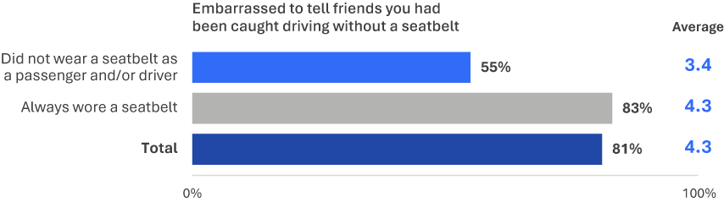
ACC1 How embarrassed would you be to tell your friends that you had been caught driving while not wearing a seatbelt? (Scale from 1 ‘not at all embarrassed’ to 5 ‘completely embarrassed’).
Base: Drivers (excl. Prefer not to say, Don’t know, and Not answered), 2025 (n=2,224)

Other driving behaviours
This section examines behaviours not included in the DBI that provide additional insight into everyday driving.

Safety-conscious driving behaviour
Respondents reported how often they engage in a range of behaviours on the road. Table 15 shows the proportion who reported ‘always’ engaging in safety-conscious behaviours over time.
The proportion of respondents who always leave their car at home when planning to drink (70%) was similar in prevalence to previous years.
Table 15 Safety-conscious driving behaviours (% ‘always’) by year
 | 2022 | 2023 | 2024 | 2025
Leave the car at home when you know you are going to drink | 71% | 70% | 70% | 70%
Base | 2,402 | 2,319 | 2,486 | 2,329
PND1 How often do you […]?
Base: Drivers (excl. Prefer not to say, Don’t know, and Not answered)
Table 16 shows the proportion of respondents who reported ‘never’ engaging in unsafe driving behaviours over time. Both behaviours were similar in prevalence to previous years, with 69% of respondents reporting they never tailgate other vehicles and 72% reporting they never run red lights.
Table 16 Unsafe driving behaviours (% ‘never’) by year
 | 2022 | 2023 | 2024 | 2025
Tailgate other vehicles | 69% | 72% | 70% | 69%
Run red lights, either intentionally or unintentionally | 70% | 72% | 74% | 72%
Base | 2,402 | 2,336 | 2,485 | 2,334
PND1 How often do you […]?
Base: Drivers (excl. Prefer not to say, Don’t know, and Not answered)

Trends in underlying DBI Contributors over time
Respondents indicated their level of agreement with statements on a range of road safety topics.
Table 17 shows that agreement with the statement “speeding penalties are just revenue raising” increased from 32% in 2022 to 40% and was similar in prevalence at 38% in 2025.
Agreement with “most injuries and fatalities on the road are caused by reckless drivers” increased from 66% in 2022 to 74% in 2024 and was similar in prevalence in 2025.
In 2025, 18% of respondents agreed that “there should be fewer restrictions on drivers”, similar to 19% in 2024.
Table 17 Agreement with road safety statements by year
NET: Agree (%) | 2022 | 2023 | 2024 | 2025
Most injuries and fatalities on the road are caused by reckless drivers | 66% ↓ | 71% | 74% ↑ | 74% ↑
Speeding penalties are just revenue raising | 32% ↓ | 35% | 40% ↑ | 38%
There should be fewer restrictions on drivers* | - | 15% | 19% | 18%
Base | 2,329 | 2,245 | 2,427 | 2,294
ATD1 To what extent do you agree or disagree that […]? (Scale from 1 ‘strongly disagree’ to 5 ‘strongly agree’)
Base: Drivers (excl. Prefer not to say, Don’t know, and Not answered)
Respondents rated how dangerous selected driving behaviours are on a scale from 0 to 10, where 0 indicates “not at all dangerous” and 10 indicates “extremely dangerous”.
Table 18 shows that perceived danger of driving at 63 km/h in a 60 km/h zone increased to 5.0 in 2025, from 4.6 in 2024.
Perceived danger of driving with a blood alcohol content over 0.05 decreased to 8.7 in 2025, from 8.9 in 2024.
Perceived danger of driving soon after one standard alcoholic drink (5.7), driving while very tired (8.0), and glancing at a mobile phone while driving (7.9) retained similar levels in 2025 compared with 2024. Perceived danger of driving at 110 km/h in a 100 km/h zone also remained unchanged at 6.6 since 2023.
Table 18 Perceived danger of driving behaviours by year
Average (0-10) | 2022 | 2023 | 2024 | 2025
Drive at 63 km/h in a 60 km/h speed limit zone | 4.6 ↓ | 4.8 | 4.6 | 5.0 ↑
Drive with a Blood Alcohol Content (BAC) over 0.05 | 9.0 ↑ | 9.0 | 8.9 | 8.7 ↓
Drive soon after having one standard alcoholic drink | 5.4 ↓ | 5.4 ↓ | 5.8 ↑ | 5.7 ↑
Drive while very tired | 8.5 ↑ | 8.4 ↑ | 8.1 ↓ | 8.0 ↓
Glance at a mobile phone for a couple of seconds while actively driving | 8.4 ↑ | 8.3 ↑ | 8.0 ↓ | 7.9 ↓
Drive at 110km/h in a 100km/h speed limit zone | - | 6.6 | 6.6 | 6.6
Base | 2,410 | 2,339 | 2,507 | 2,337
RI1 How dangerous do you think it is to […]? (Scale from 0 ‘not at all dangerous’ to 10 ‘extremely dangerous’)
Base: Drivers (excl. Prefer not to say, Don’t know, and Not answered)
Respondents rated their perceived control over engaging in certain behaviours on a 5 point agreement scale, from ‘strongly disagree’ (1) to ‘strongly agree’ (5).
Table 19 shows that perceived control for driving while very tired and driving over the legal BAC have been similar since 2022.
Table 19 Perceived control by year
Average (1-5) | 2022 | 2023 | 2024 | 2025
Drive even though you are very tired | 2.1 | 2.1 | 2.1 | 2.2
Drive even though you might be over your legal BAC | 1.1 | 1.2 | 1.1 | 1.2
Drive over the speed limit | 1.7 ↑ | 1.7 | 1.6 ↓ | 1.6
Travel in a car without wearing a seatbelt | - | - | 1.1 | 1.1
Base | 2,355 | 2,284 | 2,467 | 2,310
PC1 To what extent do you agree or disagree that sometimes you have to […]? (Scale from 1 ‘strongly disagree’ to 5 ‘strongly agree’)
Base: Drivers (excl. Prefer not to say, Don’t know, and Not answered)
Respondents rated how embarrassed they would feel telling friends or relatives they had been caught performing an illegal driving behaviour on a 5 point scale, from “not at all embarrassed” (1) to “completely embarrassed” (5).
Table 20 shows that reported embarrassment for most behaviours were similar in 2025 compared with previous years.
Table 20 Social norms by year
Average (1-5) | 2022 | 2023 | 2024 | 2025
63 km/h in a 60 km/h speed limit zone | 2.5 | 2.6 | 2.6 | 2.6
70 km/h in a 60 km/h speed limit zone | 3.7 ↑ | 3.7 | 3.6 | 3.5 ↓
Over your legal BAC | 4.6 | 4.7 | 4.6 | 4.6
While using a mobile phone in your hand | 4.1 ↓ | 4.2 | 4.2 ↑ | 4.1
While not wearing a seatbelt | - | - | 4.4 | 4.3
Base | 2,390 | 2,316 | 2,492 | 2,271
ACC1 How embarrassed would you be to tell your friends and family that you had been caught by police […]? (Scale from 1 ‘not at all embarrassed’ to 5 ‘completely embarrassed’)
Base: Drivers (excl. Prefer not to say, Don’t know, and Not answered)

Transport use
This section explores how people travel on the road by using various vehicles and other means of transportation.

Modes of transport
Although driving a car remained the primary mode of transport used by Victorians, several other modes of transport were widely used.
Respondents reported how often they had travelled by six transport modes in the past 12 months. These included private transport modes (car, bicycle, heavy vehicle, or motorcycle) and shared transport modes (public transport, taxi, Uber or similar service).
Driving a car was the most prevalent transport mode (98%) and the most frequently used, with 93% reporting use once a week or more. Other personal transport modes were used less often. Around one third (32%) of respondents rode a bicycle and 7% rode a motorcycle. Five per cent drove a heavy vehicle, making this the least used transport mode among respondents.
Public transport was used by four in five respondents (79%), with one in five (20%) using it weekly. Taxi, Uber or similar services were used by three quarters of respondents (73%), with 5% reporting weekly use.
Figure 57 Frequency of transport mode use
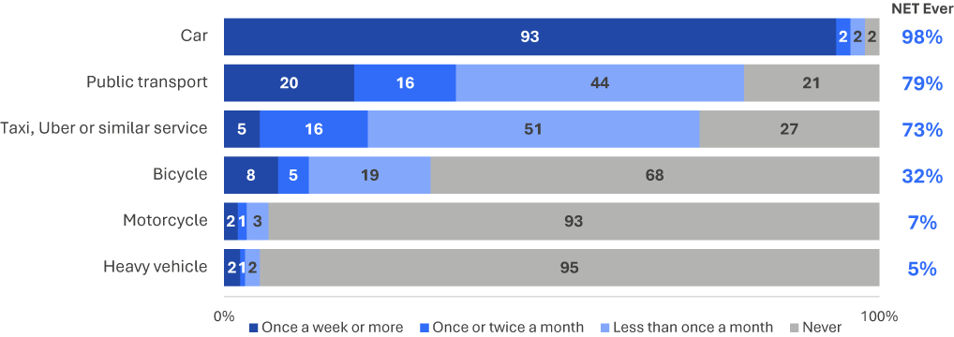
M2ABCD How often did you drive/ride each of the following [transport modes] on the road in the last 12 months?
M1AB How often did you go somewhere by each of the following [transport modes] in the last 12 months?
Base: All respondents (n=2,240-2,409)
*Numbers below 3% have been omitted from this figure.

E-rideable devices have gained popularity in recent years, although their use on Victorian roads remained low. Six per cent reported using an e-scooter and 6% reported using an e-bike in the past year, while 0.3% reported using an e-skateboard.
Figure 58 Prevalence of E-device use
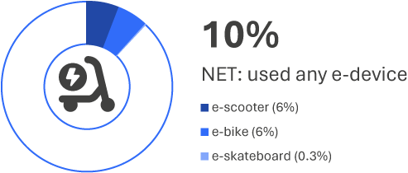
M3 Did you ride any of the following [e-devices] on the road in the last 12 months?
Base: All respondents (n=2,379)

Demographic characteristics
- Car use was consistent across most demographic groups, with an overall prevalence of 98%. Prevalence was slightly higher among those aged 40 to 60 (99%) and those living in rural areas (99%).
- Around one-third of respondents rode a bicycle (32%). Bicycle use was more common among males (41%) than females (22%) and higher among those aged 40 to 60 (39%).
- Motorcycle use (7%) was more common among males (12%) than females (2%). It was also more common among respondents living in rural areas (11%) compared with those in major urban areas (6%).
- Heavy vehicle driving (5%) was more common among males (9%) than females (2%), and among respondents living in rural areas (17%) compared with those in major urban areas (3%).
- Shared transport services (73%) were more commonly used by respondents aged 18 to 25 (84%) and 26 to 39 (84%), and by those living in major urban areas (77%). Public transport use (79%) was more common among respondents in major urban areas (83%) and among those aged 18 to 25 (89%) and 26 to 39 (84%).
Table 21 Prevalence of transport use among demographics
Column % |  | Age group |  |  |  | Gender |  | Location
Column % | Total | 18–25 | 26–39 | 40–60 | 61–90 | Male | Female | Major Urban | Other Urban | Rural
A car | 98% | 95% ↓ | 97% | 99% ↑ | 98% | 98% | 98% | 98% | 99% | 99%
Public transport | 79% | 89% ↑ | 84% ↑ | 81% | 67% ↓ | 81% | 78% | 83% ↑ | 71% ↓ | 64% ↓
Taxi, Uber or similar service | 73% | 84% ↑ | 84% ↑ | 72% | 55% ↓ | 74% | 71% | 77% ↑ | 61% ↓ | 57% ↓
Bicycle | 32% | 33% | 34% | 39% ↑ | 18% ↓ | 41% ↑ | 22% ↓ | 32% | 31% | 24% ↓
Heavy vehicle | 5% | 6% | 7% | 5% | 4% | 9% ↑ | 2% ↓ | 3% ↓ | 11% ↑ | 17% ↑
Motorcycle | 7% | 7% | 9% | 7% | 4% ↓ | 12% ↑ | 2% ↓ | 6% ↓ | 8% | 11% ↑
Base | 2,409 | 331 | 657 | 799 | 622 | 1,239 | 1,170 | 1,216 | 863 | 330
M2ABCD How often did you drive/ride each of the following [transport modes] on the road in the last 12 months?
M1AB How often did you go somewhere by each of the following [transport modes] in the last 12 months?
Base: All respondents
Use of e-rideable devices was more common among younger respondents. E-scooter use was most common among those aged 18 to 25 (17%), followed by those aged 26 to 39 (9%), compared with the overall prevalence of 6%. E-scooters were also more commonly used by males (8%) than females (4%). Overall, 22% of respondents aged 18 to 25 had used an e-device on the road, compared with 10% across all respondents.
Table 22 Prevalence of E–device use among demographics
Column % |  | Age group |  |  |  | Gender |  | Location
Column % | Total | 18–25 | 26–39 | 40–60 | 61–90 | Male | Female | Major Urban | Other Urban | Rural
NET: Any e–device | 10% | 22% ↑ | 13% ↑ | 7% ↓ | 5% ↓ | 13% ↑ | 8% ↓ | 11% | 9% | 6%
An e-scooter | 6% | 17% ↑ | 9% ↑ | 3% ↓ | 1% ↓ | 8% ↑ | 4% ↓ | 6% | 5% | 4%
An e-bike | 6% | 11% ↑ | 5% | 5% | 4% | 7% | 5% | 6% | 5% | 4%
An e-skateboard | 0% | 1% | 1% | 0% | 0% | 0% | 0% | 0% | 0% | 0%
Base | 2,379 | 330 | 655 | 793 | 601 | 1,225 | 1,154 | 1,205 | 855 | 319
M3 Did you ride any of the following [transport modes] on the road in the last 12 months?
Base: All respondents

Driving for work
Respondents reported how many days per week they commuted to work or study by driving a vehicle. Employed drivers commuted by vehicle an average of 3.9 days per week. The most common frequency was five days per week (36%).
Figure 59 Days per week driving a vehicle for commuting
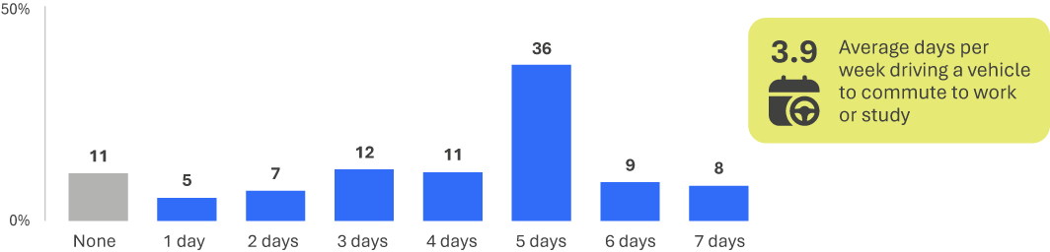
W0 How many days per week do you commute to work or study driving a vehicle?
Base: Employed drivers (n=1,573)

Among respondents who were employed and had driven a vehicle, 16% reported driving five days per week for work-related purposes other than commuting. This equated to an average of 2.5 days per week among employed drivers.
Figure 60 Days per week driving a vehicle for work-related purposes besides commuting
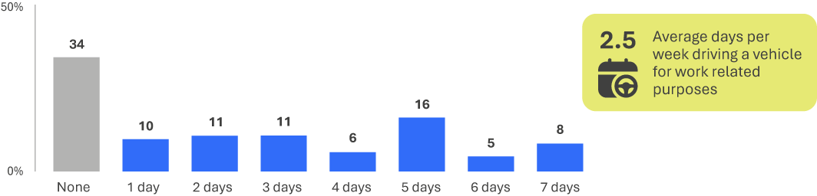
W1 How many days per week do you drive for work related purposes aside from commuting?
Base: Employed drivers (n=1,556)

Suggestions for changes to Victorian roads
Respondents also described, in their own words, what could be done to make Victorian roads safer. Enforcement (34%) and road infrastructure and signage (33%) were mentioned most often.
Figure 61 Suggested changes to make Victorian roads safer
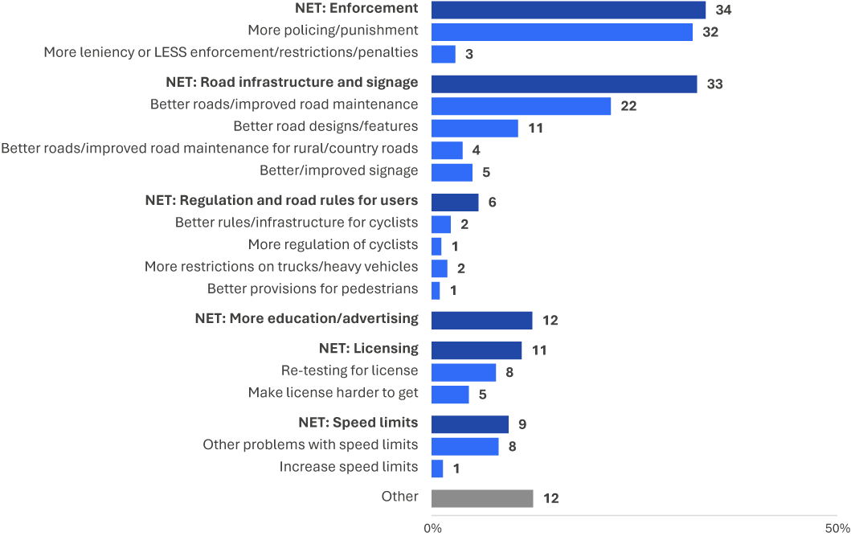
TOP1 What do you think should be done to make Victorian road safer?
Base: All respondents (n=2,411)

Crash prevalence
Five per cent of respondents reported being involved in a road crash in the past five years where someone was injured.
Figure 62 Crash prevalence
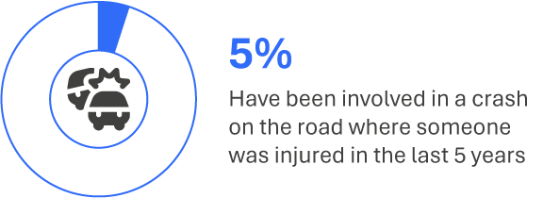
VS4 In the last five years, have you been involved in any crashes on the road as a driver or rider where someone was injured?
Base: All respondents (n=2,348)

Enforcement
Enforcement mitigates dangerous driving behaviour through intervening to reduce road trauma. The RSM asks respondents about their interactions with police, whether they have been caught speeding or pulled over by the police. The RSM also asks respondents how likely they believe they are to be caught if they break a road rule at any time.

Prevalence of interactions with enforcement
To measure the prevalence of enforcement related to illegal driving behaviours, respondents reported their interactions with police and enforcement cameras in the past 12 months.
Being caught for speeding was uncommon, with 12% of drivers and riders reporting they had been caught in the past 12 months. Most were caught only by a speed camera (10%), with fewer caught only by a patrol car (2%). Fewer than one per cent (0.4%) reported being caught by both a speed camera and a patrol car.
Figure 63 Prevalence of being caught speeding
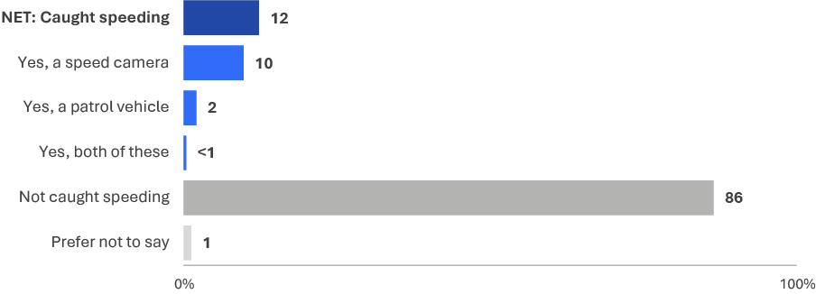
EN1 Have you been caught speeding in the last 12 months by a speed camera, a patrol car or both of these?
Base: Drivers (excl. Not answered) or riders (n=2,349)
Respondents also reported whether they had been pulled over by police in the past 12 months for a breath test, drug test, or another reason.
Being pulled over for a breath test was the most common interaction with police, reported by two in five respondents (42%). Being pulled over for a drug test (8%) or another reason (1%) was less common.
Figure 64 Prevalence of being pulled over by the police
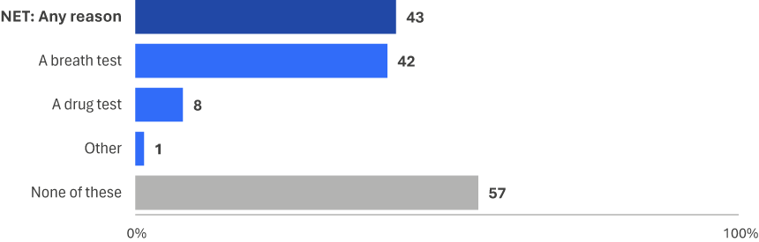
EN3 In the last 12 months, have you been pulled over by police for any of the following reasons?
Base: Drivers (excl. Prefer not to say, Don’t know, and Not answered) or riders (n=2,334)
On March 31st, 2023, mobile phone and seatbelt detection cameras were introduced in Victoria. Beginning 2025, the RSM begun monitoring the reported prevalence of drivers being caught driving while using a mobile phone by these cameras or police patrol vehicles. The question was asked separately for seatbelt detection.
The results show that prevalence of being caught was low, with around 1% of respondents reporting having been caught by a mobile phone detection camera. Although, fewer than 1% reported that they were caught by a police patrol vehicle.
Figure 65 Prevalence of being caught using mobile phone while driving
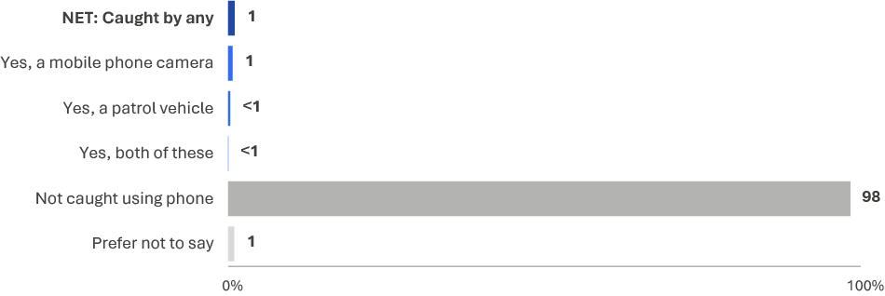
EN5 Have you been caught using a mobile phone while driving in the last 12 months by a mobile phone detection camera, a patrol vehicle or both of these?
Base: Drivers (excl. Not answered) or riders (n=2,352)

Considering reported prevalence of being caught not wearing a seatbelt correctly or at all, less than 1% reported being caught by a seatbelt detection camera and less than 1% reported being caught by a police patrol vehicle. While these proportions are very low, in absolute terms respondents were more likely to report being caught by a mobile detection camera than a police patrol vehicle.
Across both conditions for seatbelts/mobile phone detection questions, being caught by a detection camera was more prevalent overall than being caught by police patrol vehicles.
Figure 66 Prevalence of being caught not wearing seatbelt at all / incorrectly
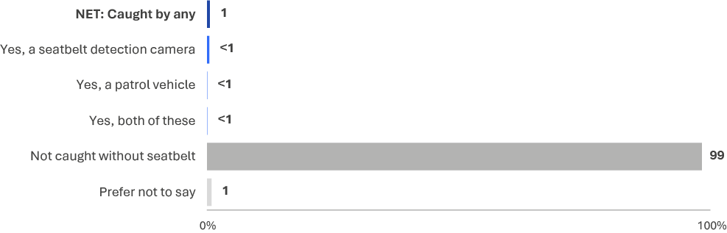
EN6 Have you been caught not wearing a seatbelt, at all or correctly, in the last 12 months by a seatbelt detection camera, a patrol vehicle or both of these?
Base: All respondents (excl. Not answered) (n=2,393)
Table 23 shows trends in experiences with enforcement since 2022. In 2025, 49% of respondents reported an enforcement experience, compared with a similar 50% in 2024.
Table 23 Enforcement experiences over time
Column % | 2022 | 2023 | 2024 | 2025
NET: Any enforcement experience | 44% | 48% | 50% | 49%
A breath test | 34% | 40% ↑ | 41% | 42%
Caught speeding | 16% | 14% | 15% | 12%
A drug test | 6% | 10% ↑ | 9% | 8%
Other | 3% | 2% | 2% | 1%
Base | 2,405 | 2,326 | 2,484 | 2,337
EN1 Have you been caught speeding in the last 12 months by a speed camera, a patrol car or both of these?
EN3 In the last 12 months, have you been pulled over by police for any of the following reasons?
Base: Drivers (excl. Prefer not to say, Don’t know, and Not answered) or riders
The proportion of respondents who thought it was likely they would be caught by police for breaking a road rule was similar to those who thought it was not likely they would not be caught.
Respondents rated how likely they believed they were to be caught by police for breaking a road rule at any given time on a 5-point scale, from ‘not at all likely’ (1) to ‘extremely likely’ (5). Responses were grouped into unlikely (1 or 2) and likely (4 or 5).
One third (34%) of respondents said it was unlikely they would be caught by police for breaking a road rule at any time - a similar proportion said it was likely (33%).
Figure 67 Perceived enforcement risk of breaking road rules
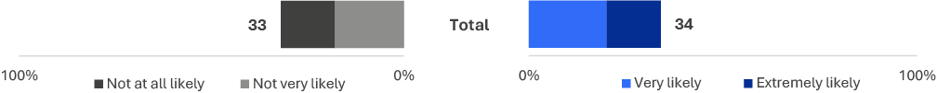
EN2 How likely do you believe you are to get caught by police if you are breaking any road rule at any given time?
Base: Drivers (excl. Prefer not to say, Don’t know, and Not answered) (n=2,168)

Behavioural insights
This section explores the interactions between dangerous driving behaviours, perceived enforcement risk and enforcement incidence.
Among respondents who intentionally drove over the speed limit in the past 12 months, those who drove 10 km/h or more above the limit were more likely to have been caught speeding (18%) than those who drove 3 km/h or more above the limit (13%) and those who did not speed (7%).
Figure 68 Caught speeding by intentional speeding categories
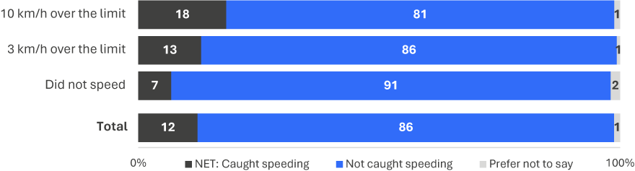
EN1 Have you been caught speeding in the last 12 months by a speed camera, a patrol car or both of these?
Base: Drivers (excl. Not answered) (n=2,346)
Figure 69 displays a comparison of drinking and drink driving segments and the rate at which they reported having been pulled over for a breath test. Those who reported driving when they might have been or were over the limit (46%) and those who reported driving when under the limit (51%) were more likely to have been pulled over than those who did not drive after drinking and those who did not drink alcohol.
Figure 69 Pulled over for breath test by drinking and drink driving categories
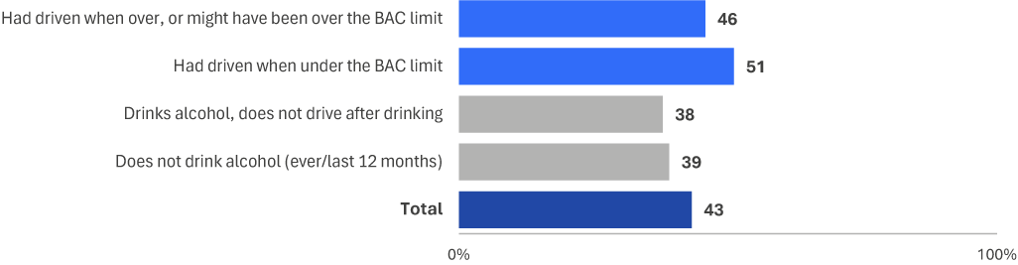
EN3 In the last 12 months, have you been pulled over by police for any of the following reasons?
Base: Drivers (excl. Prefer not to say, Don’t know, and Not answered) n=2,303
Contrasting those who use mobile phones while driving and those who did not reveals a small minority (<1%) who reported not using a mobile phone while driving in the past month who had been caught in the past 12 months.
Figure 70 Caught using mobile phone by distracted driving categories
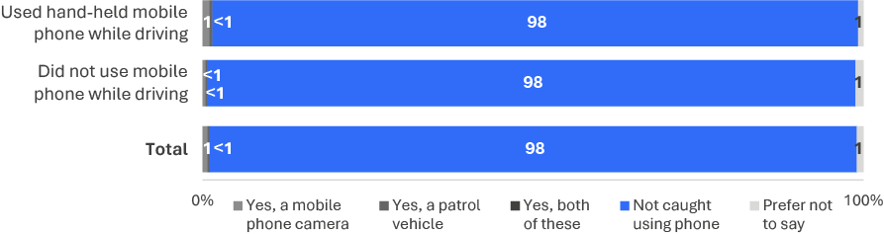
EN5 Have you been caught speeding in the last 12 months by a speed camera, a patrol car or both of these?
Base: Drivers (excl Not answered) (n=2,324)
Contrasting results between those who reported not wearing a seatbelt in the past 12 months, and those who reported always wearing one – shows that around 3% were caught not wearing a seatbelt by a seatbelt detection camera.
Figure 71 Caught not wearing a seatbelt by seatbelt categories
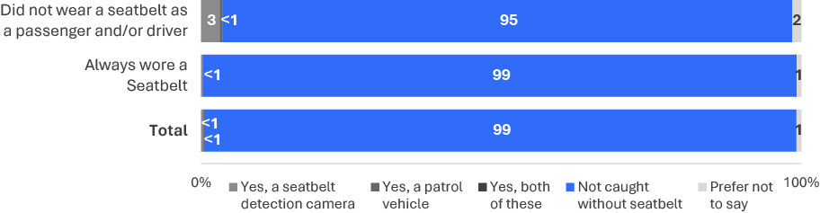
EN6 Have you been caught not wearing a seatbelt, at all or correctly, in the last 12 months by a seatbelt detection camera, a patrol vehicle or both of these?
Base: Drivers (excl. Not answered) (n=2,350)

Towards Zero
In pursuit of TAC's objective to eliminate fatal crashes, TAC has collaborated with various governmental organisations to implement a range of road safety education initiatives and campaigns. These endeavours are aimed at realising the ultimate goal of zero fatalities and severe injuries.

Support for Toward Zero
Respondents reported whether they believed Victoria should aim for zero road deaths. Four in five respondents (80%) believed Victoria should aim for zero fatal crashes, while 12% did not think this should be the goal. The remainder (8%) were uncertain.
Figure 72 Support for Toward Zero (%)
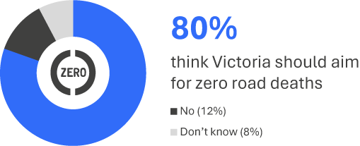
TZ1 In 2002 there were 397 lives lost on Victorian roads, and last year 297 people were killed. Do you think Victoria should aim for zero road deaths?
Base: All respondents n=2,374
Respondents reported what they believed could be achieved over the next 30 years in terms of the number of lives lost in a single year. Half (49%) considered a target of fewer than twenty lives lost each year to be achievable. Just one in seven (14%) believed zero lives could be lost.
Figure 73 Achievable number of lives lost in a single year
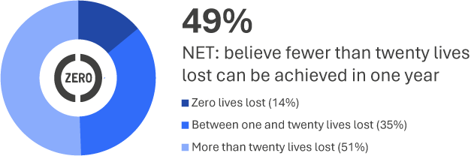
TZ8 Within the next 30 years, which of the following do you think can be achieved in one year?
Base: All respondents n=2,399

Research methodology

Sample and weighting
The sample for the survey is drawn from the VicRoads Registration and Licensing Database. It includes Victorians with a licence (either learners’ permit or full licence for any vehicle type) or a registration in their name (car, motorbike or trailer). The number of people approached from key demographic groups was scaled to proportions in the general population, and has a correction applied for known response rates from previous waves of the survey. After the first phase of sampling, sampling effort was boosted in regional areas to enable adequate subgroup comparisons based on region.
Weighting by location, age and gender was then applied to correct the sample to the known licence holder population as derived from the VicRoads Registration and Licencing Database.
Rim weighting was used to correct for sampling design, which includes correcting for a regional boost component of this research, which was used to allow for adequate subgroup comparisons based on region. After weighting the data back to the Victorian Population, the weighting efficiency was 79% (meaning there was an effective base size of 2,080 from a sample of 2,578 respondents).

Changes in methodology
This report contains some time series that cover periods in which the RSM employed different methodologies, dependent upon current research practice and available sample sources. In summary, the different methodologies employed over time included:
- 2001–2007: The RSM was conducted entirely via telephone;
- 2008–2009: After a successful pilot in 2007, an online component was introduced to the study in 2008. This was run in combination with telephone;
- 2010–2013: The VicRoads registration and licencing database was made available to the TAC for research purposes, which allowed a refinement of the research methodology. From 2010 participation in the survey was allowed via paper, online or telephone;
- 2014–2015: A pulse survey was included to provide two measures per annum;
- 2016: The RSM was refined through a pilot phase over the first half of the year, with a view to moving to continuous tracking;
- 2017–2025: Continuous tracking with seven waves conducted over four quarters.
The current report includes data collected in all quarters of 2025. Quarterly measures are taken using a modular questionnaire to address road safety themes as well as maintain regular results for core measures.

Questionnaire
Respondents are mailed a questionnaire pack including a Primary Approach Letter (PAL) which allows hard copy or online completion. The PAL advises the sample member of:
- The purpose of the survey
- Eligibility
- How they were selected and where their contact details were sourced from
- Privacy details
- How to complete the survey
- Relevant dates such as the date that telephone calling will commence and the date that the survey closes
- Contact details including an email address and 1800 number
- Details of the prize draw including: that entry to the prize draw is voluntary, the number of prizes available, the amount and nature of the prize and the closing date for a separate ‘early bird’ prize draw and the date that the prize draw will be drawn.

Reminder SMS/letter
Two reminder SMS and one reminder letter were sent to each member of the sample who had not completed the survey in each wave. Following the initial mail/SMS approaches, a computer-assisted telephone interview (CATI) phase targeted non-responders with a valid phone number to maximise response.

Prize draw
All respondents are offered the opportunity to enter two prize draws, the main prize draw for $1,000, and an additional ‘early completion’ prize draw for $500. Prizes are paid as either an Electronic Funds Transfer to a nominated bank account or as a GiftPay eGift card, as selected by the winner(s).

Fieldwork
Table 24 Fieldwork schedule
 |  | Fieldwork Start | Fieldwork End
Quarter 1 | Wave 1 + 2 | 16 January 2025 | 31 March 2025
Quarter 2 | Wave 1 + 2 | 10 April 2025 | 30 June 2025
Quarter 3 | Wave 1 + 2 | 10 July 2025 | 30 September 2025
Quarter 4 | Wave 1 | 21 October 2025 | 15 December 2025

Sample performance
The 2025 survey period is comprised of responses from Victorians sampled from the VicRoads Registration and Licencing Database. In total, 7,000 people were selected from the database and invited to take part in the survey. This led to an overall cooperation rate of 34%.
Table 25 shows the response rate by key demographics overall and by mode. Consistent with previous iterations of the RSM, the response rate was generally higher among females (37%) compared to males (32%) and also higher among those aged 61-90 (47%). Overall response rate did not differ noticeably based on location category.
With regard to modes of survey completion, those aged 61-90 were more inclined to complete the survey via hardcopy while other age groups had a higher tendency to complete the survey online. The relative likelihood of completing the survey via hardcopy differed by location category, being highest for other urban (38%) and rural respondents (38%) and lowest for respondents from major urban areas (29%).
Table 25 Sample performance
 |  | Sample Loaded | Completed Surveys | Response Rate | Online | Paper | Telephone
 |  | # | # | Row % | Row % | Row % | Row %
 | Total | 7,000 | 2,414 | 34% | 60% | 33% | 7%
Gender | Male | 3,876 | 1,243 | 32% | 61% | 30% | 9%
Gender | Female | 3,124 | 1,171 | 37% | 58% | 36% | 6%
Age | 18–25 | 1,276 | 331 | 26% | 72% | 17% | 11%
Age | 26–39 | 2,200 | 657 | 30% | 78% | 14% | 8%
Age | 40–60 | 2,196 | 800 | 36% | 63% | 30% | 7%
Age | 61-90 | 1,328 | 626 | 47% | 29% | 66% | 5%
Location | Major Urban | 3,712 | 1,219 | 33% | 64% | 29% | 7%
Location | Other Urban | 2,364 | 865 | 37% | 54% | 38% | 8%
Location | Rural | 924 | 330 | 36% | 57% | 34% | 9%

01
Appendix
Dangerous Behaviour
Index (DBI)

Appendix 1:
Dangerous Behaviour Index (DBI)
This index is based on the frequency of engaging in behaviours which elevate risk of a crash while driving. The behaviours include drug driving, drink driving, speeding, distracted driving, tired/fatigued driving, and travelling without a seatbelt. The DBI provides an overall metric demonstrating a driver’s relative level of risk when compared to other drivers surveyed for the RSM.
As behaviours do not have the same level of risk, behaviours are weighted differently in their contribution to the DBI. These weights are somewhat arbitrary, as the precise contribution to the level of risk a driver experiences is unknown. Implicit in the construction of this index is the compounding contribution to overall risk of performing more behaviours more frequently. However, the development of refined risk weighting is a possible direction for future development of the DBI.
The DBI is dependent on the behaviour questions which are included in each wave of the RSM. As these change over time, the calculation of the DBI and thus the distribution of scores on the index changes over time.
There are key breaks in time-periods due to design changes within the RSM which result in alternate DBI calculations, these are:
- 2016 to 2021: Historical period
- 2022 Q2: New DBI which did not include driving 10 km/h over the speed limit
- 2022 Q3 onwards: New DBI including driving 10 km/h over the speed limit
The table below denotes the construction of values from the DBI

How the DBI is scored
- Value range:
  - From 2022 Q3: 0 to 38 (multiplied by 2.631 to scale to 100)
  - Note for 2025: Due to the significant focus on trends when comparing the DBI this year, 2022 has been excluded from DBI-related analysis due to the first quarter (Q2-2022) not including measures for intentional speeding of 10 km/h+ and having an inconsistent margin of error when compared with all other years of data collection.
Table 26 DBI Summary of Values
Behaviour | Variable | None | Low frequency |  | Moderate frequency |  | High frequency |  | Max score
Value |  | Never (1) /  Not applicable (97) / Not asked (NaN) | Rarely  (2) |  | Sometimes  (3) |  | Most of the time (4) / always (5)
Drug driving | db3_d | 0 | 4 |  | 6 |  | 8 |  | 8
Driving when definitely under the BAC | db3_c | 0 | 1 |  | 2 |  | 2
Driving while under the BAC (might have been over) | db3_b | 0 | 2 |  | 3 |  | 4
Driving while over the BAC | db3_a | 0 | 4 |  | 6 |  | 8
Composite: Drink driving |  | 0 |  | Highest value from drink driving |  |  |  |  |  | 8
Speeding 3 km/h (max in any speed zone) | db2_max | 0 |  | 1 |  | 2 |  | 3
Speeding 10 km/h (max in any speed zone) | db4_max | 0 |  | 4 |  | 5 |  | 6
Composite: Speeding |  | 0 |  | Highest value from speeding |  |  |  |  |  | 6
Composite: Distractions | db1_max | 0 |  | 1 |  | 3 |  | 6 |  | 6
Driving while quite tired | db3_g | 0 |  | 1 |  | 2 |  | 2
Driving while very tired | db3_h | 0 |  | 3 |  | 4 |  | 5
Composite: Fatigue |  | 0 |  | Highest value from fatigue |  |  |  |  |  | 5
Seatbelt as driver | db3_e | 0 |  | 3 |  | 4 |  | 5
Seatbelt as passenger | db3_f | 0 |  | 3 |  | 4 |  | 5
Composite: Seatbelt |  | 0 |  | Highest value from seatbelts (exclusive) |  |  |  |  |  | 5

02
Appendix
Subgroup Reporting

Appendix 2:
Subgroup Reporting
Location sub-groups were changed in 2017. Until 2016, location was defined as either ‘Melbourne’ or ‘Elsewhere in Victoria’. From 2017, however, locations have been defined per ABS SOS definitions. The table below indicates how these locations are now defined.
 | Major Urban  Major Urban represents a combination of all urban centres with a population of 100,000 or more (for example, Melbourne, Geelong, Ballarat).
 | Other Urban  Other Urban represents a combination of all urban centres with a population between 1,000 and 99,999 (for example, Warrnambool, Sale, Benalla).
 | Rural  Rural represents the remainder of State/Territory and includes Bounded Localities (centres with population of between 200 and 999 (e.g. Taradale, Venus Bay, Fish Creek) and smaller centres.
In addition to demographic variables used to analyse differences between groups, results are regularly shown for seven driving behaviour sub-groups. The following table explains how each of these groups has been derived.
 | Speeding  Intentionally exceeding the posted speed limit by 3 km/h (DB2A, DB2B, DB2C, or DB2D) or 10 km/h (DB4A, DB4B, DB4C, or DB4D) ‘Always’, ‘Most of the time’, ‘Sometimes’ or ‘Rarely’.
Drinking and drink driving
Driving a vehicle when definitely over the legal blood alcohol limit (DB3A), when might have been over the limit (DB3B), or when confident being under the limit (DB3C) is ‘Always’, ‘Most of the time’, ‘Sometimes’ or ‘Rarely’. Drinking alcohol is defined as (DB3A, DB3B, and DB3C – Never) and DK1 is ‘Less often than monthly’, ‘Monthly’, ‘Weekly’, or ‘Daily’.
 | Drug driving  Driving after using illegal drugs (DB3D) is ‘Always’, ‘Most of the time’, ‘Sometimes’ or ‘Rarely’. Used illegal drugs is DB3D – Never and DG1 is ‘Less often than monthly’, ‘Monthly’, ‘Weekly’, or ‘Daily’.
 | Mobile phone use  Using a hand-held mobile phone while driving to make or answer calls, send or read messages, or interact with an app (DB1A, DB1B, DB1C) is ‘Always’, ‘Most of the time’, ‘Sometimes’ or ‘Rarely’.
Driving fatigued
Driving when feeling quite tired or very tired (DB3G, DB3H) is ‘Always’, ‘Most of the time’, ‘Sometimes’ or ‘Rarely’.
 | Noncompliance with seatbelt use  Driving a car or travelling in a car as a passenger without wearing a seatbelt (DB3E, DB3F) is ‘Always’, ‘Most of the time’, ‘Sometimes’ or ‘Rarely’.

03
Appendix
RSM Questionnaire

Appendix 3:
RSM Questionnaire

04
Appendix
RSM 2025 Question list by quarter

Appendix 4:
RSM Question list by quarter

05
Appendix
Data Analysis

Appendix 5:
Data Analysis

Significance testing – methods used
The RSM report uses Q research software to compute statistical analyses. The details of the tests used throughout are noted below.
Further details on these procedures can be found at https://wiki.q-researchsoftware.com/.

Correlational analysis of categorical data
For correlational analyses of categorical data, Pearson's Chi-Square for Canonical Correlation Analysis is applied (e.g. driving behaviours by age groups or location). The test statistic is:
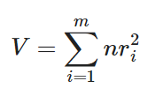
Where n is the effective sample size,
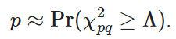

Tests of association between categorical variables
For tests of association between categorical variables, Pearson's Chi-Square Test of Independence is applied. The test statistic is:
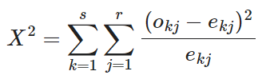
where:
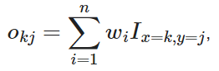
w_{i} is the calibrated weight of the ith of n observations,
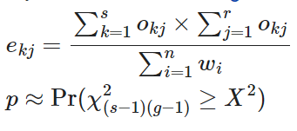
For 2x2 tables, Second Order Rao-Scott Test of Independence is applied (e.g. comparisons between gender in relation to a driving behaviour). The standard error for these tables is computed using Taylor series linearisation.

ANOVA (F-Tests)
ANOVA (F-Tests) are used where numerical data are compared across between one categorical and one numeric variable (e.g. perceived danger questions – RI1). The test statistic is:
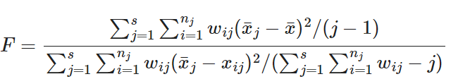
where:
 is the value of the ith of n_{j} observations in the jth of s groups,
 is the average in the in the jth group,
is the overall average
 is the calibrated weight,
and, F is evaluated using the F-distribution with j – 1 and 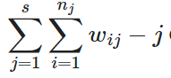 degrees of freedom.

Weighting Effects
Taylor series linearisation is applied in the RSM data to approximate the impact of different weights on survey responses and increase the accuracy of significance testing. This approximated impact is then factored into significance testing calculations.

Multiple Comparison Corrections
False discovery rate (q = 0.05) is used to address issues with multiple comparisons where rows or columns are compared within a table.

Data quality assurance procedures
The VicRoads Registration and Licensing database is a robust database given its ties to in-person validation of identity. In addition, invitations to the RSM are sent via an in-person letter to sample members’ registered home address.
Data protections include:
- A closed survey link (i.e. only a person who receives a link issued by Wallis can complete the survey once)
- Geolocation IP-blocking (preventing geographically foreign IPs from entering and completing the survey)
- Sample cleaning, including household-level de-duplication.
- Database fatal-washing every 6 months (conducted by the TAC).

Data checking procedures include:
Given that the RSM is an incentivised survey, data quality assurance checks are carried out at the end of quarterly collection cycles.
- Checks for egregious straight-lining behaviour (e.g. selecting all multiple response options, responding with the same frequency in scale grids)
- Overly fast online survey completion (speeding)
- Consistently non-sensical or appearing as AI or similar, generated verbatim responses.

