
Road Safety Statistics

June 2026

Table of contents

Notes about the data in this report 3
1. Status Report 4
1.1 Lives lost on Victorian Roads 4
1.2 Injured claimants who were admitted to hospital within 7 days of the accident. 5
2. Lives Lost: Rolling 12 months 6
2.1 Demographics and accident type 6
2.2 Local government area 7
3. Injured claimants admitted to hospital within 7 days of the accident with a hospital stay of more than 14 days 8
3.1 Demographics and accident type 8
3.2 Local government area 9
4. Injured claimants admitted to hospital within 7 days of accident 10
4.1 Demographics and accident type 10
4.2 Local government area 11
5. Mobile Safety Camera Data 12
5.1 Speed Infringements Issued from Mobile Cameras (monthly totals) 12
5.2 Excessive Speed Infringements (ESI) Issued from Mobile Cameras (monthly totals) 12
6. The National Picture – Interstate Comparison 13
6.1 Lives lost 13
6.2 Lives lost per 10,000 registered vehicles and per 100,000 population. 13
7. International Road Safety Comparison 14
7.1 Lives lost rate per 100,000 population 14
7.2 Lives lost rate per 100 million vehicle kilometres travelled (VKT) 14
7.3 Lives lost rate per 10,000 registered vehicles 14
8. Lives lost rate per 100,000 population - OECD countries, 2024. 15
9. Useful websites 16
10. Graphs of Lives Lost and Hospitalised Claims 17
11. Victorian monthly lives lost since 1951 19

Notes about the data in this report

- All data provided in this report are the data most recently available at time of production. Fatality data are updated to the end of the report month. A 6-month lag applies to hospitalised TAC claims data.
- Reporting of the hospitalised claims data is based on the accident date and excludes rejected claims and those involving interstate crashes.
- Reported data will have one extra day of exposure for leap years.
- Data are subject to revision as additional information about known accidents/claims is received, and as new accident/claim reports are received and processed.
- Crash locations for hospitalised claims are assigned to Local Government Areas based on the crash postcode recorded by Victoria Police. Crash locations for fatal crashes are coded exactly to a Local Government Area assigned by Victoria Police.
- Claimants refer to people injured in transport accidents who have an accepted claim with the TAC.
- Hospitalisation refers to any hospital admission that occurred within seven days of the accident.

  - Report prepared by:
Road Safety Division, Transport Accident Commission.

Status Report
In the 12-month period from 1 July 2025 to 30 June 2026, 267 people lost their lives, compared with 296 during the same period the previous year (1 July 2024 to 30 June 2025). This represents a decrease of 29 lives lost.

1.1 Lives lost on Victorian Roads

Category | 2026 | 2025 | 2024 | 2026 v 2025 | 2026 v 2024 | 5-Year Average
Lives Lost (Rolling 12 Month Total)
Lives Lost (to June) | 267 | 296 | 287 | -29 | -20 | 272
per 10,000 vehicles | 0.46 | 0.53 | 0.52 | -0.07 | -0.06 | 0.49
per 100,000 population | 3.73 | 4.22 | 4.18 | -0.48 | -0.44 | 3.94
Crashes (Rolling 12 Month Total)
Fatal crashes (to June) | 248 | 279 | 265 | -31 | -17 | 254
per 10,000 vehicles | 0.43 | 0.50 | 0.48 | -0.07 | -0.05 | 0.46
per 100,000 population | 3.48 | 3.98 | 3.86 | -0.50 | -0.38 | 3.68

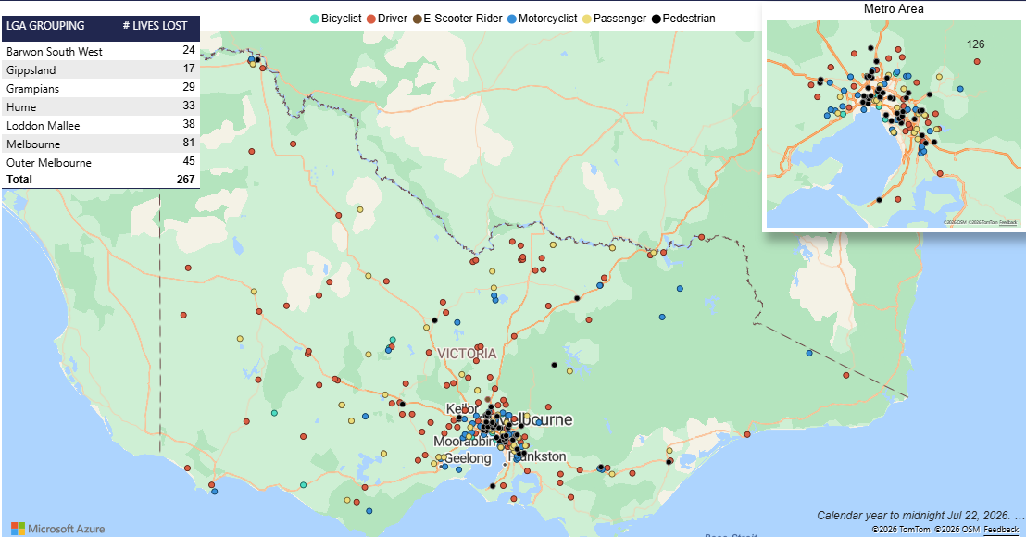

Victoria – Lives Lost, July 2025 to June 2026

1.2 Injured claimants who were admitted to hospital within 7 days of the accident.
Rolling 12 months to 31st December (accident date)

Category | 2025 | 2024 | 2023 | 2025 v 2024 |  | 2025 v 2023 |  | 5-Year Average
Claims hospitalised within 7 days and staying over 14 days (Rolling 12 Month Total)
Claims (to December) | 739 | 673 | 685 | +66 | (+10%) | +54 | (+8%) | 666
per 10,000 vehicles | 1.30 | 1.21 | 1.26 | +0.09 | (+7%) | 0.04 | (+3%) | 1.18
per 100,000 population | 10.45 | 9.68 | 10.08 | +0.76 | (+8%) | 0.37 | (+4%) | 9.42
All claims hospitalised within 7 days (Rolling 12 Month Total)
Claims (to December) | 5,914 | 5,294 | 5,696 | +620 | (+12%) | 218 | (+4%) | 5,576
per 10,000 vehicles | 10.38 | 9.51 | 10.48 | +0.87 | (+9%) | -0.11 | (-1%) | 10.22
per 100,000 population | 83.60 | 76.16 | 83.80 | +7.43 | (+10%) | -0.20 | (-0%) | 81.42

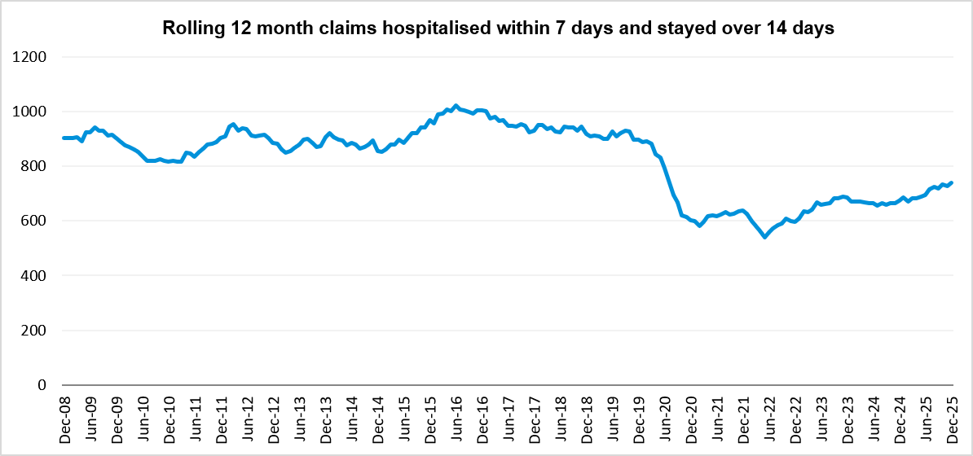

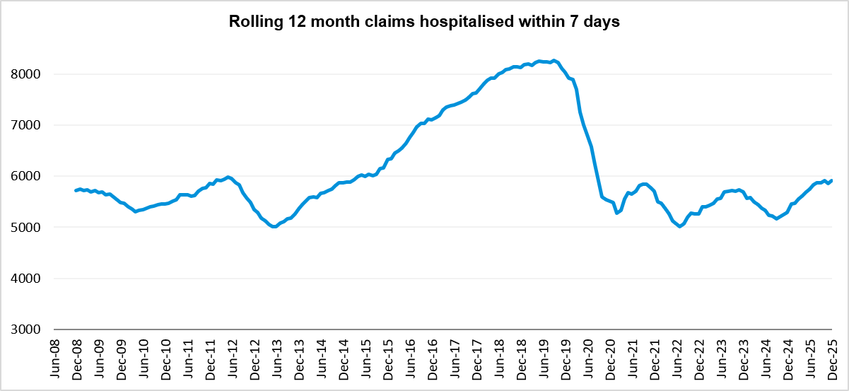

Lives Lost: Rolling 12 months

2.1 Demographics and accident type
12 months to 30th June

Category |  | 2026 | 2025 | 2024 | 2026 v 2025 | 2026 v 2024 | 5-Year Average
Overview | Lives Lost | 267 | 296 | 287 | -29 | -20 | 272
Overview | Fatal Crashes | 248 | 279 | 265 | -31 | -17 | 254
Sex | Female | 74 | 71 | 80 | +3 | -6 | 74
Sex | Male | 193 | 225 | 207 | -32 | -14 | 198
Road user | Bicyclist | 11 | 10 | 8 | +1 | +3 | 11
Road user | Driver | 113 | 131 | 116 | -18 | -3 | 117
Road user | E-Scooter | 1 | 4 | 3 | -3 | -2 | -
Road user | Motorcyclist | 43 | 67 | 64 | -24 | -21 | 54
Road user | Passenger | 51 | 34 | 41 | +17 | +10 | 44
Road user | Pedestrian | 48 | 50 | 55 | -2 | -7 | 45
Location | Melbourne | 126 | 134 | 123 | -8 | +3 | 123
Location | Rural Victoria | 141 | 162 | 164 | -21 | -23 | 149
Age group | 0-4 | 2 | 3 | 3 | -1 | -1 | 3
Age group | 5-15 | 11 | 8 | 10 | +3 | +1 | 8
Age group | 16-17 | 9 | 5 | 5 | +4 | +4 | 6
Age group | 18-20 | 15 | 18 | 22 | -3 | -7 | 20
Age group | 21-25 | 23 | 29 | 18 | -6 | +5 | 23
Age group | 26-29 | 21 | 20 | 20 | +1 | +1 | 21
Age group | 30-39 | 45 | 50 | 41 | -5 | +4 | 41
Age group | 40-49 | 26 | 33 | 35 | -7 | -9 | 31
Age group | 50-59 | 30 | 38 | 41 | -8 | -11 | 33
Age group | 60-69 | 22 | 35 | 32 | -13 | -10 | 31
Age group | 70+ | 62 | 57 | 60 | 5 | 2 | 55
Accident Type -Intersection | Adjacent direction | 32 | 35 | 37 | -3 | -5 | 34
Accident Type -Intersection | Opposing direction | 13 | 12 | 15 | +1 | -2 | 12
Accident Type -  Mid-block/other | Head on | 36 | 51 | 34 | -15 | +2 | 36
Accident Type -  Mid-block/other | Same direction | 17 | 20 | 19 | -3 | -2 | 21
Accident Type -  Mid-block/other | Manoeuvre/o'taking | 13 | 12 | 13 | +1 | 0 | 12
Accident Type -  Mid-block/other | On path | 8 | 8 | 3 | 0 | +5 | 6
Accident Type -  Mid-block/other | Single vehicle | 94 | 112 | 112 | -18 | -18 | 104
Accident Type -  Mid-block/other | Other (incl peds) | 53 | 46 | 54 | +7 | -1 | 46

2.2 Local government area
12 months to 30th June

Category | 2026 | 2025 | 2024 | 5-Year Average | Category | 2026 | 2025 | 2024 | 5-Year Average
Local Government Area |  |  |  |  | Local Government Area
ALPINE | 1 | 2 | 1 | 1 | MANSFIELD | 0 | 2 | 8 | 2
ARARAT | 6 | 6 | 1 | 2 | MARIBYRNONG | 5 | 2 | 2 | 1
BALLARAT | 5 | 6 | 2 | 3 | MAROONDAH | 0 | 2 | 3 | 2
BANYULE | 0 | 0 | 1 | 1 | MELBOURNE | 5 | 5 | 3 | 4
BASS COAST | 1 | 2 | 5 | 2 | MELTON | 8 | 5 | 5 | 4
BAW BAW | 2 | 7 | 6 | 6 | MERRI-BEK | 5 | 3 | 1 | 2
BAYSIDE | 1 | 1 | 0 | 0 | MILDURA | 9 | 0 | 5 | 2
BENALLA | 2 | 1 | 3 | 1 | MITCHELL | 5 | 3 | 8 | 5
BOROONDARA | 4 | 5 | 2 | 2 | MOIRA | 10 | 5 | 4 | 5
BRIMBANK | 3 | 7 | 5 | 7 | MONASH | 9 | 4 | 6 | 4
BULOKE | 3 | 2 | 3 | 2 | MOONEE VALLEY | 1 | 1 | 3 | 2
CAMPASPE | 6 | 6 | 6 | 5 | MOORABOOL | 3 | 1 | 5 | 2
CARDINIA | 0 | 10 | 5 | 7 | MORNINGTON PENINSULA | 2 | 4 | 5 | 5
CASEY | 10 | 8 | 13 | 10 | MOUNT ALEXANDER | 1 | 0 | 0 | 1
CENTRAL GOLDFIELDS | 4 | 1 | 0 | 0 | MOYNE | 2 | 9 | 3 | 4
COLAC-OTWAY | 3 | 6 | 1 | 3 | MURRINDINDI | 2 | 3 | 4 | 3
CORANGAMITE | 5 | 6 | 1 | 4 | NILLUMBIK | 3 | 3 | 3 | 2
DAREBIN | 2 | 4 | 1 | 2 | NORTHERN GRAMPIANS | 2 | 0 | 2 | 2
EAST GIPPSLAND | 3 | 7 | 4 | 4 | PORT PHILLIP | 1 | 1 | 2 | 2
FRANKSTON | 0 | 4 | 4 | 3 | PYRENEES | 1 | 1 | 1 | 1
GANNAWARRA | 1 | 1 | 1 | 1 | QUEENSCLIFFE | 0 | 0 | 0 | 0
GLEN EIRA | 2 | 0 | 3 | 2 | SOUTH GIPPSLAND | 2 | 2 | 2 | 3
GLENELG | 3 | 4 | 3 | 3 | SOUTHERN GRAMPIANS | 3 | 3 | 0 | 2
GOLDEN PLAINS | 4 | 8 | 1 | 3 | STONNINGTON | 0 | 4 | 3 | 2
GREATER BENDIGO | 5 | 4 | 8 | 5 | STRATHBOGIE | 1 | 5 | 5 | 4
GREATER DANDENONG | 6 | 7 | 9 | 5 | SURF COAST | 0 | 7 | 4 | 3
GREATER GEELONG | 8 | 5 | 5 | 7 | SWAN HILL | 0 | 1 | 3 | 1
GREATER SHEPPARTON | 2 | 9 | 10 | 7 | TOWONG | 2 | 1 | 2 | 2
HEPBURN | 2 | 2 | 9 | 3 | WANGARATTA | 3 | 4 | 4 | 3
HINDMARSH | 1 | 4 | 0 | 1 | WARRNAMBOOL | 0 | 1 | 1 | 1
HOBSONS BAY | 1 | 6 | 2 | 3 | WELLINGTON | 3 | 6 | 4 | 5
HORSHAM | 2 | 3 | 1 | 2 | WEST WIMMERA | 2 | 2 | 1 | 1
HUME | 12 | 3 | 5 | 4 | WHITEHORSE | 3 | 2 | 3 | 2
INDIGO | 2 | 4 | 7 | 3 | WHITTLESEA | 7 | 12 | 2 | 6
KINGSTON | 4 | 1 | 7 | 2 | WODONGA | 3 | 2 | 1 | 1
KNOX | 11 | 5 | 4 | 3 | WYNDHAM | 8 | 12 | 8 | 7
LATROBE | 6 | 3 | 7 | 5 | YARRA | 2 | 1 | 2 | 2
LODDON | 2 | 0 | 2 | 2 | YARRA RANGES | 7 | 11 | 8 | 7
MACEDON RANGES | 7 | 5 | 5 | 3 | YARRIAMBIACK | 1 | 0 | 4 | 1
MANNINGHAM | 4 | 1 | 3 | 2

Injured claimants admitted to hospital within 7 days of the accident with a hospital stay of more than 14 days

3.1 Demographics and accident type
12 months to 31st December

Category |  | 2025 | 2024 | 2023 | 2025 v 2024  Number Percent |  | 2025 v 2023  Number Percent |  | 5-Year Average
Overview | Claims | 739 | 673 | 685 | +66 | 10% | 54 | 8% | 666
Sex | Female | 280 | 245 | 258 | +35 | 14% | 22 | 9% | 247
Sex | Male | 445 | 425 | 423 | +20 | 5% | 22 | 5% | 415
Road user | Bicyclist | 28 | 36 | 27 | -8 | -22% | 1 | 4% | 31
Road user | Driver | 264 | 268 | 248 | -4 | -1% | 16 | 6% | 249
Road user | Motorcyclist | 152 | 146 | 165 | +6 | 4% | -13 | -8% | 143
Road user | Passenger | 105 | 91 | 72 | +14 | 15% | 33 | 46% | 84
Road user | Pedestrian | 155 | 117 | 156 | +38 | 32% | -1 | -1% | 141
Road user | Train/Tram | 2 | 5 | 2 | -3 | -60% | 0 | 0% | 4
Location | Melbourne | 455 | 414 | 427 | +41 | 10% | 28 | 7% | 415
Location | Rural Victoria | 282 | 255 | 250 | +27 | 11% | 32 | 13% | 256
Age group | 0-4 | 1 | 1 | 0 | 0 | 0% | 1 | - | 1
Age group | 5-15 | 12 | 7 | 14 | +5 | 71% | -2 | -14% | 10
Age group | 16-17 | 16 | 16 | 10 | 0 | 0% | 6 | 60% | 13
Age group | 18-20 | 41 | 29 | 37 | +12 | 41% | 4 | 11% | 33
Age group | 21-25 | 56 | 57 | 54 | -1 | -2% | 2 | 4% | 53
Age group | 26-29 | 43 | 37 | 37 | +6 | 16% | 6 | 16% | 39
Age group | 30-39 | 103 | 87 | 78 | +16 | 18% | 25 | 32% | 88
Age group | 40-49 | 73 | 85 | 85 | -12 | -14% | -12 | -14% | 76
Age group | 50-59 | 93 | 83 | 100 | +10 | 12% | -7 | -7% | 85
Age group | 60-69 | 107 | 81 | 78 | +26 | 32% | 29 | 37% | 85
Age group | 70+ | 194 | 190 | 192 | +4 | 2% | 2 | 1% | 183
Accident Type -Intersection | Adjacent direction | 101 | 81 | 86 | +20 | 25% | 15 | 17% | 80
Accident Type -Intersection | Opposing direction | 39 | 42 | 38 | -3 | -7% | 1 | 3% | 43
Accident Type -  Mid-block/other | Head on | 71 | 73 | 61 | -2 | -3% | 10 | 16% | 58
Accident Type -  Mid-block/other | Same direction | 81 | 77 | 55 | +4 | 5% | 26 | 47% | 60
Accident Type -  Mid-block/other | Manoeuvre/o’taking | 52 | 49 | 40 | +3 | 6% | 12 | 30% | 44
Accident Type -  Mid-block/other | On path | 15 | 21 | 28 | -6 | -29% | -13 | -46% | 24
Accident Type -  Mid-block/other | Single vehicle | 181 | 186 | 176 | -5 | -3% | 5 | 3% | 175
Accident Type -  Mid-block/other | Other (incl peds) | 199 | 144 | 201 | +55 | 38% | -2 | -1% | 183

3.2 Local government area
12 months to 31st December

Category | 2025 | 2024 | 2023 | 5-Year Average | Category | 2025 | 2024 | 2023 | 5-Year Average
Local Government Area |  |  |  |  | Local Government Area
ALPINE | 2 | 1 | 3 | 3 | MANSFIELD | 3 | 8 | 2 | 4
ARARAT | 4 | 3 | 1 | 3 | MARIBYRNONG | 9 | 12 | 7 | 10
BALLARAT | 18 | 15 | 16 | 14 | MAROONDAH | 9 | 10 | 4 | 7
BANYULE | 5 | 10 | 4 | 8 | MELBOURNE | 19 | 24 | 19 | 21
BASS COAST | 5 | 6 | 10 | 7 | MELTON | 23 | 15 | 17 | 15
BAW BAW | 7 | 12 | 8 | 8 | MERRI-BEK | 20 | 19 | 18 | 17
BAYSIDE | 8 | 11 | 4 | 7 | MILDURA | 9 | 9 | 4 | 7
BENALLA | 3 | 6 | 2 | 4 | MITCHELL | 9 | 10 | 9 | 8
BOROONDARA | 13 | 11 | 12 | 10 | MOIRA | 11 | 8 | 11 | 9
BRIMBANK | 19 | 24 | 19 | 22 | MONASH | 15 | 5 | 23 | 13
BULOKE | 1 | 1 | 4 | 2 | MOONEE VALLEY | 8 | 9 | 7 | 9
CAMPASPE | 9 | 3 | 4 | 5 | MOORABOOL | 6 | 10 | 8 | 8
CARDINIA | 8 | 16 | 13 | 13 | MORNINGTON PENINSULA | 15 | 12 | 15 | 14
CASEY | 31 | 21 | 15 | 21 | MOUNT ALEXANDER | 2 | 2 | 2 | 4
CENTRAL GOLDFIELDS | 1 | 3 | 1 | 2 | MOYNE | 5 | 4 | 4 | 4
COLAC-OTWAY | 7 | 7 | 4 | 6 | MURRINDINDI | 7 | 6 | 4 | 5
CORANGAMITE | 9 | 7 | 5 | 6 | NILLUMBIK | 6 | 7 | 6 | 6
DAREBIN | 13 | 15 | 16 | 16 | NORTHERN GRAMPIANS | 3 | 6 | 4 | 3
EAST GIPPSLAND | 11 | 4 | 21 | 10 | PORT PHILLIP | 13 | 11 | 9 | 11
FRANKSTON | 11 | 8 | 9 | 8 | PYRENEES | 0 | 2 | 1 | 2
GANNAWARRA | 1 | 3 | 2 | 2 | QUEENSCLIFFE | 0 | 0 | 0 | 0
GLEN EIRA | 11 | 5 | 6 | 6 | SOUTH GIPPSLAND | 4 | 6 | 5 | 5
GLENELG | 1 | 1 | 4 | 2 | SOUTHERN GRAMPIANS | 6 | 1 | 2 | 3
GOLDEN PLAINS | 5 | 6 | 3 | 4 | STONNINGTON | 13 | 11 | 7 | 11
GREATER BENDIGO | 15 | 17 | 16 | 14 | STRATHBOGIE | 1 | 3 | 5 | 4
GREATER DANDENONG | 15 | 21 | 26 | 19 | SURF COAST | 3 | 3 | 5 | 3
GREATER GEELONG | 39 | 26 | 18 | 28 | SWAN HILL | 0 | 2 | 3 | 3
GREATER SHEPPARTON | 11 | 10 | 10 | 11 | TOWONG | 4 | 1 | 5 | 3
HEPBURN | 3 | 3 | 6 | 4 | WANGARATTA | 8 | 2 | 3 | 3
HINDMARSH | 0 | 0 | 1 | 1 | WARRNAMBOOL | 2 | 2 | 2 | 2
HOBSONS BAY | 5 | 7 | 10 | 7 | WELLINGTON | 8 | 3 | 6 | 7
HORSHAM | 5 | 0 | 4 | 4 | WEST WIMMERA | 1 | 0 | 2 | 2
HUME | 34 | 29 | 16 | 24 | WHITEHORSE | 12 | 14 | 18 | 14
INDIGO | 4 | 2 | 2 | 3 | WHITTLESEA | 28 | 17 | 24 | 19
KINGSTON | 18 | 12 | 16 | 14 | WODONGA | 5 | 2 | 5 | 4
KNOX | 13 | 7 | 14 | 12 | WYNDHAM | 16 | 19 | 20 | 17
LATROBE | 10 | 12 | 6 | 9 | YARRA | 13 | 10 | 10 | 9
LODDON | 3 | 7 | 2 | 4 | YARRA RANGES | 21 | 15 | 30 | 20
MACEDON RANGES | 9 | 10 | 3 | 6 | YARRIAMBIACK | 1 | 0 | 2 | 1
MANNINGHAM | 11 | 7 | 13 | 9

Injured claimants admitted to hospital within 7 days of accident

4.1 Demographics and accident type
12 months to 31st December

Category |  | 2025 | 2024 | 2023 | 2025v 2024  Number Percent |  | 2025 v 2023 Number Percent |  | 5-Year Average
Overview | Claims | 5,914 | 5,294 | 5,696 | +620 | 12% | +218 | 4% | 5,576
Sex | Female | 2,303 | 2,103 | 2,296 | +200 | 10% | +7 | 0% | 2,255
Sex | Male | 3,450 | 3,146 | 3,371 | +304 | 10% | +79 | 2% | 3,270
Road user | Bicyclist | 385 | 391 | 400 | -6 | -2% | -15 | -4% | 387
Road user | Driver | 2,602 | 2,397 | 2,643 | +205 | 9% | -41 | -2% | 2,593
Road user | Motorcyclist | 1,168 | 1,030 | 1,081 | +138 | 13% | +87 | 8% | 1,036
Road user | Passenger | 835 | 749 | 757 | +86 | 11% | +78 | 10% | 762
Road user | Pedestrian | 650 | 510 | 628 | +140 | 27% | +22 | 4% | 591
Road user | Train/Tram | 19 | 14 | 20 | +5 | 36% | -1 | -5% | 19
Location | Melbourne | 3,845 | 3,329 | 3,709 | +516 | 16% | +136 | 4% | 3,592
Location | Rural Victoria | 2,025 | 1,911 | 1,936 | +114 | 6% | +89 | 5% | 1,911
Age group | 0-4 | 30 | 18 | 27 | +12 | 67% | +3 | 11% | 28
Age group | 5-15 | 177 | 149 | 170 | +28 | 19% | +7 | 4% | 159
Age group | 16-17 | 119 | 90 | 96 | +29 | 32% | +23 | 24% | 99
Age group | 18-20 | 431 | 372 | 357 | +59 | 16% | +74 | 21% | 373
Age group | 21-25 | 608 | 578 | 601 | +30 | 5% | +7 | 1% | 599
Age group | 26-29 | 435 | 442 | 439 | -7 | -2% | -4 | -1% | 443
Age group | 30-39 | 963 | 928 | 911 | +35 | 4% | +52 | 6% | 949
Age group | 40-49 | 778 | 694 | 787 | +84 | 12% | -9 | -1% | 747
Age group | 50-59 | 815 | 693 | 814 | +122 | 18% | +1 | 0% | 767
Age group | 60-69 | 682 | 603 | 649 | +79 | 13% | +33 | 5% | 633
Age group | 70+ | 876 | 727 | 845 | +149 | 20% | +31 | 4% | 779
Accident Type -Intersection | Adjacent direction | 1,021 | 858 | 872 | +163 | 19% | +149 | 17% | 868
Accident Type -Intersection | Opposing direction | 438 | 463 | 492 | -25 | -5% | -54 | -11% | 461
Accident Type -  Mid-block/other | Head on | 349 | 324 | 318 | +25 | 8% | +31 | 10% | 311
Accident Type -  Mid-block/other | Same direction | 1,061 | 888 | 932 | +173 | 19% | +129 | 14% | 927
Accident Type -  Mid-block/other | Manoeuvre/o'taking | 384 | 367 | 365 | +17 | 5% | +19 | 5% | 373
Accident Type -  Mid-block/other | On path | 255 | 242 | 256 | +13 | 5% | -1 | 0% | 266
Accident Type -  Mid-block/other | Single vehicle | 1,224 | 1,269 | 1,325 | -45 | -4% | -101 | -8% | 1,274
Accident Type -  Mid-block/other | Other (incl peds) | 1,182 | 883 | 1,136 | +299 | 34% | +46 | 4% | 1,094

4.2 Local government area
12 months to 31st December

Category | 2025 | 2024 | 2023 | 5-Year Average | Category | 2025 | 2024 | 2023 | 5-Year Average
Local Government Area |  |  |  |  | Local Government Area
ALPINE | 28 | 17 | 31 | 26 | MANSFIELD | 38 | 32 | 21 | 29
ARARAT | 13 | 15 | 10 | 13 | MARIBYRNONG | 87 | 80 | 56 | 75
BALLARAT | 84 | 81 | 100 | 91 | MAROONDAH | 55 | 48 | 32 | 46
BANYULE | 43 | 40 | 34 | 40 | MELBOURNE | 234 | 225 | 231 | 218
BASS COAST | 47 | 39 | 38 | 37 | MELTON | 177 | 146 | 149 | 145
BAW BAW | 60 | 69 | 63 | 63 | MERRI-BEK | 158 | 143 | 132 | 138
BAYSIDE | 85 | 71 | 70 | 74 | MILDURA | 54 | 45 | 33 | 36
BENALLA | 10 | 17 | 17 | 14 | MITCHELL | 75 | 69 | 69 | 66
BOROONDARA | 100 | 87 | 89 | 88 | MOIRA | 40 | 40 | 33 | 34
BRIMBANK | 190 | 165 | 157 | 174 | MONASH | 139 | 100 | 144 | 128
BULOKE | 3 | 8 | 21 | 10 | MOONEE VALLEY | 115 | 90 | 93 | 99
CAMPASPE | 40 | 31 | 36 | 36 | MOORABOOL | 62 | 73 | 69 | 67
CARDINIA | 97 | 99 | 127 | 114 | MORNINGTON PENINSULA | 132 | 144 | 145 | 140
CASEY | 305 | 250 | 285 | 284 | MOUNT ALEXANDER | 27 | 19 | 27 | 22
CENTRAL GOLDFIELDS | 11 | 15 | 11 | 12 | MOYNE | 35 | 39 | 36 | 34
COLAC-OTWAY | 61 | 66 | 46 | 58 | MURRINDINDI | 67 | 37 | 56 | 48
CORANGAMITE | 56 | 30 | 34 | 34 | NILLUMBIK | 43 | 33 | 29 | 33
DAREBIN | 86 | 82 | 86 | 81 | NORTHERN GRAMPIANS | 19 | 20 | 20 | 17
EAST GIPPSLAND | 51 | 41 | 56 | 47 | PORT PHILLIP | 129 | 103 | 122 | 122
FRANKSTON | 104 | 105 | 112 | 103 | PYRENEES | 4 | 19 | 13 | 14
GANNAWARRA | 14 | 7 | 7 | 11 | QUEENSCLIFFE | 1 | 1 | 0 | 1
GLEN EIRA | 100 | 73 | 95 | 91 | SOUTH GIPPSLAND | 29 | 29 | 32 | 29
GLENELG | 21 | 13 | 21 | 19 | SOUTHERN GRAMPIANS | 16 | 13 | 8 | 12
GOLDEN PLAINS | 63 | 46 | 34 | 44 | STONNINGTON | 129 | 121 | 124 | 121
GREATER BENDIGO | 96 | 131 | 96 | 102 | STRATHBOGIE | 14 | 14 | 25 | 23
GREATER DANDENONG | 190 | 154 | 200 | 196 | SURF COAST | 84 | 82 | 71 | 72
GREATER GEELONG | 360 | 382 | 359 | 379 | SWAN HILL | 4 | 8 | 11 | 11
GREATER SHEPPARTON | 70 | 56 | 53 | 60 | TOWONG | 13 | 15 | 17 | 14
HEPBURN | 25 | 21 | 33 | 24 | WANGARATTA | 24 | 27 | 42 | 27
HINDMARSH | 7 | 9 | 10 | 8 | WARRNAMBOOL | 19 | 18 | 23 | 20
HOBSONS BAY | 75 | 61 | 62 | 65 | WELLINGTON | 58 | 42 | 58 | 51
HORSHAM | 18 | 10 | 16 | 16 | WEST WIMMERA | 2 | 2 | 5 | 4
HUME | 231 | 219 | 210 | 218 | WHITEHORSE | 82 | 61 | 69 | 70
INDIGO | 11 | 19 | 16 | 17 | WHITTLESEA | 158 | 154 | 195 | 157
KINGSTON | 117 | 108 | 113 | 116 | WODONGA | 16 | 15 | 26 | 23
KNOX | 86 | 67 | 88 | 86 | WYNDHAM | 131 | 103 | 156 | 133
LATROBE | 62 | 53 | 50 | 50 | YARRA | 84 | 68 | 95 | 82
LODDON | 17 | 18 | 15 | 15 | YARRA RANGES | 118 | 95 | 149 | 126
MACEDON RANGES | 80 | 54 | 54 | 57 | YARRIAMBIACK | 10 | 3 | 7 | 8
MANNINGHAM | 65 | 33 | 59 | 46

Mobile Safety Camera Data

5.1 Speed Infringements Issued from Mobile Cameras (monthly totals)

Year: 2025 Year: 2026
Jul | Aug | Sep | Oct | Nov | Dec | Jan | Feb | Mar | Apr | May | Jun | Average
58,154 | 36,543 | 38,631 | 53,406 | 37,791 | 46,575 | 50,002 | 42,803 | 45,865 | 42,291 | 40,932 | 36,253 | 44,104

5.2 Excessive Speed Infringements (ESI) Issued from Mobile Cameras (monthly totals)

Year: 2025 Year: 2026
Jul | Aug | Sep | Oct | Nov | Dec | Jan | Feb | Mar | Apr | May | Jun | Average
346 | 268 | 312 | 391 | 256 | 359 | 367 | 330 | 279 | 327 | 296 | 292 | 319

Notes: ESI refers to ≥25 km/h over the posted speed limit (or ≥20 km/h in a 110 km/h zone). January 2025 includes an industrial action period.

The National Picture – Interstate Comparison

6.1 Lives lost
12 months to 30th June

State | 2026 | 2025 | 2024 | 2023 | 2025 v 2024  Number Percent
New South Wales | 347 | 345 | 338 | 290 | +2 | (+1%)
Victoria | 267 | 296 | 287 | 266 | -29 | (-10%)
Queensland | 323 | 293 | 296 | 273 | +30 | (+10%)
South Australia | 109 | 84 | 100 | 93 | +25 | (+30%)
Western Australia | 194 | 199 | 176 | 176 | -5 | (-3%)
Tasmania | 35 | 47 | 27 | 39 | -12 | (-26%)
Northern Territory | 32 | 51 | 55 | 31 | -19 | (-37%)
Australian Capital Territory | 15 | 8 | 8 | 10 | +7 | (+88%)
Australia | 1,322 | 1,323 | 1,287 | 1,163 | -1 | (-0%)
Australia minus Victoria | 1,055 | 1,027 | 1,000 | 897 | +28 | (+3%)

6.2 Lives lost per 10,000 registered vehicles and per 100,000 population.
12 months to 30th June

State | Lives Lost per 10,000 registered vehicles  2026 2025 2024 |  |  | Lives Lost per 100,000 population  2026 2025 2024
New South Wales | 0.53 | 0.54 | 0.54 | 4.01 | 4.04 | 4.01
Victoria | 0.46 | 0.53 | 0.52 | 3.73 | 4.22 | 4.18
Queensland | 0.64 | 0.60 | 0.63 | 5.64 | 5.21 | 5.37
South Australia | 0.65 | 0.51 | 0.63 | 5.69 | 4.44 | 5.35
Western Australia | 0.72 | 0.76 | 0.70 | 6.28 | 6.61 | 6.00
Tasmania | 0.63 | 0.86 | 0.50 | 6.07 | 8.17 | 4.70
Northern Territory | 1.85 | 2.98 | 3.28 | 12.03 | 19.42 | 21.22
Australian Capital Territory | 0.43 | 0.23 | 0.24 | 3.07 | 1.66 | 1.68
Australia | 0.58 | 0.59 | 0.60 | 4.74 | 4.83 | 4.78
Australia minus Victoria | 0.66 | 0.65 | 0.64 | 5.09 | 5.04 | 4.99

International Road Safety Comparison
Selected OECD countries, Australia, and Victoria 2000, 2010, 2015, 2020, 2021, 2022, 2023 and 2024

7.1 Lives lost rate per 100,000 population
Countries | 2000 | 2010 | 2015 | 2020 | 2021 | 2022 | 2023 | 2024
Australia | 7.7 | 5.1 | 5.1 | 4.3 | 4.4 | 4.5 | 4.7 | 4.8
Canada | 16.4 | 10.2 | 5.3 | 4.6 | 4.6 | 5.0 | 4.9 | -
New Zealand | 8.6 | 5.5 | 6.9 | 6.3 | 6.3 | 7.3 | 6.6 | 5.5
Norway | 7.6 | 4.3 | 2.3 | 1.7 | 1.5 | 2.1 | 2.0 | 1.6
Sweden | 6.7 | 2.8 | 2.7 | 2.0 | 2.0 | 2.2 | 2.2 | 2.0
Switzerland | 9.3 | 4.6 | 3.1 | 2.6 | 2.3 | 2.7 | 2.7 | 2.8
United Kingdom | 8.3 | 4.2 | 2.8 | 2.3 | 2.4 | 2.6 | 2.5 | 2.4
United States | 12.0 | 8.6 | 11.1 | 11.8 | 12.9 | 12.7 | 12.2 | -

7.2 Lives lost rate per 100 million vehicle kilometres travelled (VKT)
Countries | 2000 | 2010 | 2015 | 2020 | 2021 | 2022 | 2023 | 2024
Australia | 0.9 | 0.6 | 0.5 | 0.5 | 0.5 | 0.5 | 0.5 | 0.5
Canada | 0.9 | 0.7 | 0.5 | 0.5 | 0.4 | 0.5 | 0.5 | N/A
New Zealand | 1.4 | 0.9 | 0.7 | 0.7 | 0.7 | 0.8 | 0.7 | 0.6
Norway | 1.0 | 0.5 | 0.3 | 0.2 | 0.2 | 0.3 | 0.2 | 0.2
Sweden | 0.9 | 0.3 | 0.3 | 0.3 | 0.3 | 0.3 | 0.3 | 0.3
Switzerland | 1.1 | 0.5 | 0.4 | 0.4 | 0.3 | 0.4 | 0.4 | 0.4
United Kingdom | - | - | 0.3 | 0.4 | 0.3 | 0.3 | 0.3 | 0.3
United States | 0.9 | 0.7 | 0.7 | 0.8 | 0.8 | 0.8 | 0.8 | N/A

7.3 Lives lost rate per 10,000 registered vehicles
Countries | 2000 | 2010 | 2015 | 2020 | 2021 | 2022 | 2023 | 2024
Australia | 2.5 | 0.9 | 0.7 | 0.6 | 0.6 | 0.6 | 0.6 | 0.6
Canada | - | - | 0.8 | - | - | - | - | -
New Zealand | 5.0 | 1.4 | 0.9 | - | - | - | - | -
Norway | 1.8 | 0.3 | 0.3 | 0.2 | 0.2 | 0.3 | 0.3 | 0.2
Sweden | 1.2 | 0.5 | 0.4 | 0.4 | 0.3 | 0.4 | 0.4 | 0.3
Switzerland | 2.2 | 0.7 | 0.4 | 0.3 | 0.4 | 0.4 | 0.4 | 0.4
United Kingdom | 1.2 | 0.5 | 0.5 | - | - | - | - | -
United States | - | - | 1.3 | - | - | - | - | -
* Source: https://www.bitre.gov.au/sites/default/files/documents/international_comparisons_2022.pdf
* https://datahub.roadsafety.gov.au/progress-reporting/international-comparisons
* 2020-2024: OECD Data Explorer • Transport safety indicators
* Data for some countries were unavailable (-) at the time of OECD publication. Data for certain countries may also be provisional or estimated for 2024 and/or earlier years; refer to the OECD source metadata for country-specific availability, revisions, and status information.

Lives lost rate per 100,000 population - OECD countries, 2024.

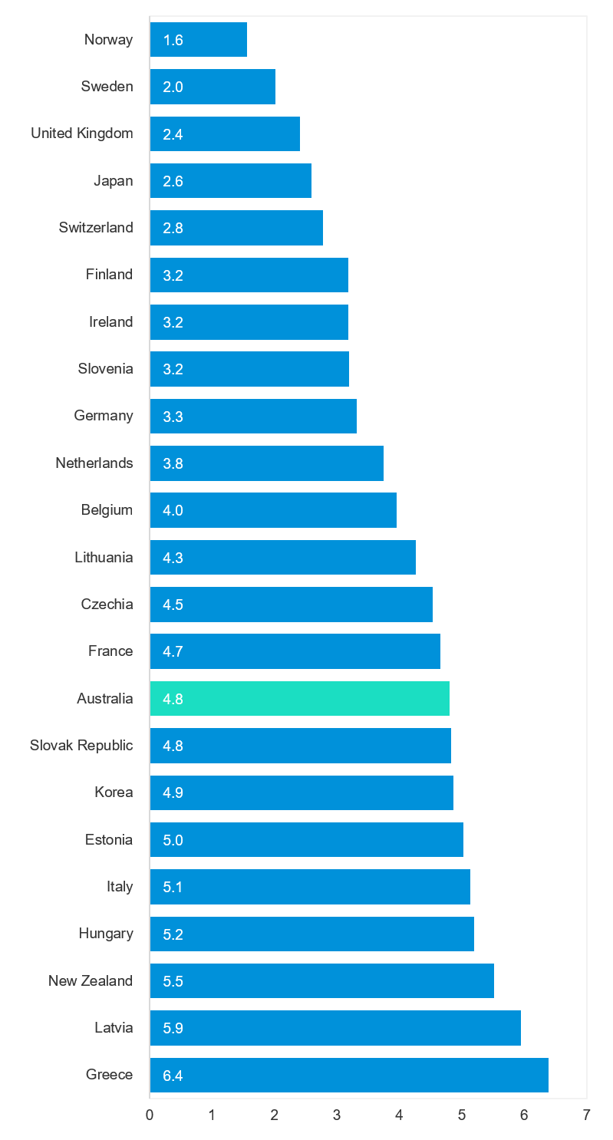
* Data for Austria, Canada, Chile, Denmark, Iceland, Israel, Luxembourg, Poland, Portugal, Spain and United States were unavailable at the time of OECD publication.

Useful websites

TAC Sites
- TAC Safety (Road Safety) tacsafety.com.au
- TAC How safe is your car howsafeisyourcar.com.au
- TAC Campaigns road-safety/campaigns
- TAC Motorcycle Safety Website spokes.com.au
- TAC Corporate site tac.vic.gov.au
- TAC Road Safety Grant Program tac-road-safety-grant-program
- TAC Road to Zero Education roadtozero.vic.gov.au

Victorian Sites
- VicRoads vicroads.vic.gov.au
- Transport Victoria transport.vic.gov.au
- Victoria Police police.vic.gov.au
- myLearners website mylearners.vic.gov.au
- Road Safety Education Victoria roadsafetyeducation.vic.gov.au
- Cameras Save Lives camerassavelives.vic.gov.au
- Victorian Government open data data.vic.gov.au
- Victorian road trauma statistics road-trauma-statistics
- RACV racv.com.au
- Monash University Accident Research Centre monash.edu.au/muarc

National and Interstate Sites
- National Transport Research Organisation ntro.org.au
- Australian Transport Safety Bureau atsb.gov.au
- State Insurance Regulatory Authority (NSW) sira.nsw.gov.au
- Motor Accidents Insurance Board (TAS) maib.tas.gov.au
- Motor Accident Commission, Allianz (SA) ctp.sa.gov.au
- Motor Accidents Compensation, TIO, (NT) tiofi.com.au/mac
- Insurance Commission of Western Australia icwa.wa.gov.au
- Motor Accident Insurance Commission (QLD) maic.qld.gov.au

International Sites
- National Highway Traffic Safety Admin (USA) nhtsa.dot.gov
- Swedish Road and Transport Institute (VTI) vti.se
- SWOV Institute for Road Safety Research swov
- Bureau of Infrastructure and Transport Research Eco bitre.gov.au

Related Sites
- Alcohol and Drug Foundation adf.org.au

Graphs of Lives Lost and Hospitalised Claims

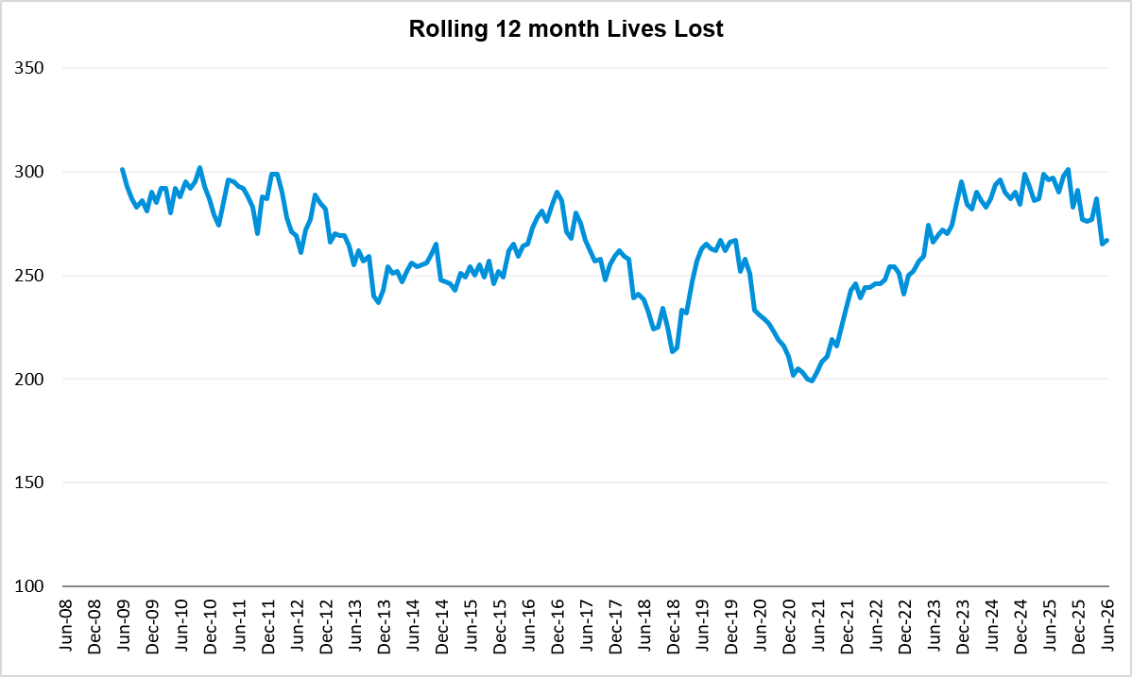

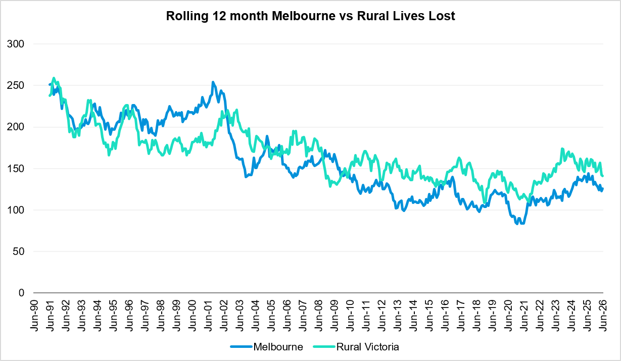

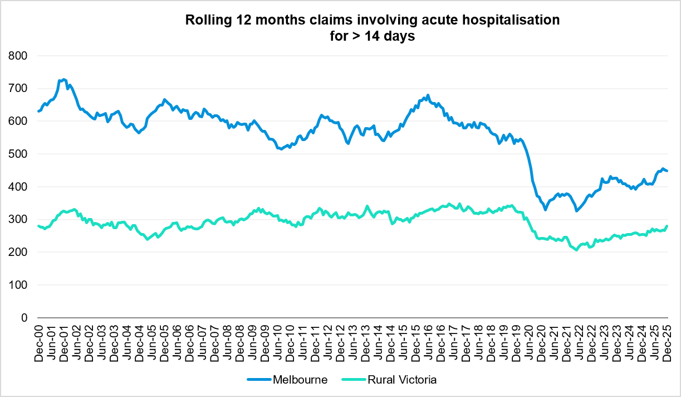

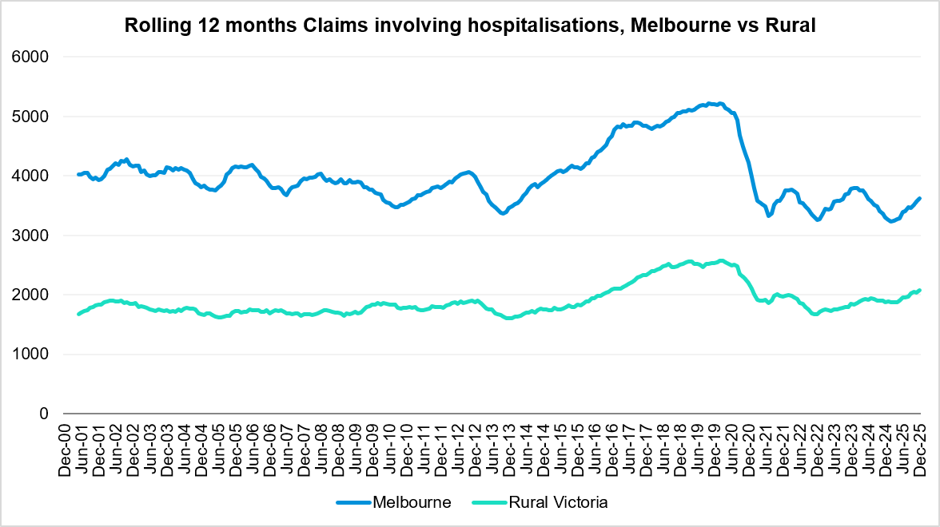

Victorian monthly lives lost since 1951
Year | Jan | Feb | Mar | Apr | May | Jun | Jul | Aug | Sep | Oct | Nov | Dec | Total
1951 |  |  |  |  |  |  | 61 | 59 | 52 | 38 | 29 | 41
1952 | 45 | 40 | 54 | 61 | 54 | 69 | 67 | 55 | 44 | 44 | 31 | 20 | 584
1953 | 23 | 28 | 54 | 58 | 49 | 42 | 50 | 37 | 44 | 27 | 36 | 32 | 480
1954 | 44 | 42 | 28 | 60 | 55 | 36 | 63 | 33 | 25 | 52 | 30 | 41 | 509
1955 | 44 | 36 | 45 | 55 | 48 | 56 | 64 | 44 | 44 | 32 | 40 | 40 | 548
1956 | 34 | 48 | 51 | 67 | 53 | 65 | 71 | 47 | 39 | 39 | 44 | 48 | 606
1957 | 50 | 41 | 46 | 58 | 52 | 54 | 57 | 53 | 51 | 46 | 32 | 49 | 589
1958 | 50 | 38 | 42 | 58 | 54 | 41 | 54 | 53 | 57 | 40 | 57 | 52 | 596
1959 | 50 | 57 | 61 | 50 | 75 | 55 | 42 | 48 | 52 | 55 | 63 | 63 | 671
1960 | 49 | 53 | 57 | 76 | 70 | 70 | 67 | 62 | 61 | 77 | 52 | 66 | 760
1961 | 63 | 57 | 68 | 74 | 58 | 68 | 78 | 82 | 59 | 62 | 60 | 65 | 794
1962 | 65 | 41 | 76 | 78 | 72 | 80 | 70 | 77 | 62 | 53 | 64 | 70 | 808
1963 | 67 | 56 | 65 | 85 | 66 | 68 | 77 | 55 | 55 | 58 | 61 | 67 | 780
1964 | 73 | 71 | 78 | 71 | 83 | 89 | 80 | 89 | 67 | 66 | 62 | 75 | 904
1965 | 63 | 64 | 86 | 88 | 80 | 87 | 79 | 69 | 81 | 77 | 68 | 87 | 929
1966 | 75 | 59 | 75 | 103 | 74 | 86 | 87 | 80 | 75 | 66 | 90 | 85 | 955
1967 | 61 | 79 | 91 | 97 | 81 | 71 | 59 | 67 | 70 | 68 | 60 | 83 | 887
1968 | 70 | 78 | 86 | 78 | 73 | 76 | 73 | 77 | 72 | 80 | 81 | 105 | 949
1969 | 79 | 68 | 79 | 87 | 86 | 77 | 87 | 83 | 87 | 83 | 94 | 101 | 1011
1970 | 85 | 84 | 106 | 80 | 87 | 88 | 110 | 106 | 78 | 95 | 68 | 74 | 1061
1971 | 83 | 75 | 77 | 68 | 76 | 86 | 85 | 72 | 78 | 73 | 74 | 76 | 923
1972 | 61 | 62 | 75 | 82 | 75 | 71 | 98 | 85 | 83 | 62 | 80 | 81 | 915
1973 | 75 | 75 | 95 | 85 | 64 | 66 | 61 | 85 | 89 | 88 | 66 | 86 | 935
1974 | 56 | 62 | 81 | 60 | 70 | 73 | 67 | 62 | 53 | 70 | 80 | 72 | 806
1975 | 67 | 65 | 87 | 73 | 97 | 94 | 57 | 75 | 69 | 66 | 71 | 89 | 910
1976 | 79 | 78 | 88 | 78 | 69 | 79 | 60 | 70 | 82 | 78 | 77 | 100 | 938
1977 | 65 | 71 | 89 | 79 | 65 | 79 | 70 | 91 | 68 | 74 | 96 | 107 | 954
1978 | 75 | 54 | 95 | 63 | 64 | 69 | 68 | 77 | 65 | 84 | 83 | 72 | 869
1979 | 63 | 60 | 86 | 75 | 45 | 64 | 66 | 75 | 69 | 79 | 72 | 93 | 847
1980 | 48 | 55 | 66 | 59 | 47 | 56 | 60 | 53 | 45 | 58 | 61 | 49 | 657
1981 | 69 | 60 | 58 | 61 | 74 | 65 | 61 | 63 | 68 | 71 | 59 | 57 | 766
1982 | 55 | 53 | 59 | 59 | 67 | 45 | 47 | 71 | 53 | 69 | 65 | 66 | 709
1983 | 42 | 59 | 53 | 63 | 62 | 61 | 65 | 51 | 59 | 43 | 54 | 52 | 664
1984 | 65 | 48 | 58 | 50 | 56 | 48 | 46 | 50 | 71 | 53 | 55 | 58 | 658
1985 | 56 | 47 | 50 | 65 | 75 | 50 | 51 | 50 | 58 | 61 | 56 | 64 | 683

Year | Jan | Feb | Mar | Apr | May | Jun | Jul | Aug | Sep | Oct | Nov | Dec | Total
1986 | 56 | 50 | 70 | 69 | 59 | 53 | 42 | 54 | 54 | 52 | 59 | 51 | 669
1987 | 62 | 43 | 57 | 52 | 63 | 59 | 62 | 49 | 62 | 61 | 55 | 80 | 705
1988 | 49 | 58 | 69 | 54 | 79 | 50 | 54 | 52 | 64 | 59 | 43 | 70 | 701
1989 | 76 | 65 | 80 | 59 | 67 | 73 | 52 | 65 | 82 | 50 | 41 | 66 | 776
1990 | 48 | 44 | 55 | 39 | 56 | 64 | 41 | 34 | 48 | 35 | 40 | 44 | 548
1991 | 45 | 39 | 70 | 30 | 34 | 29 | 44 | 47 | 41 | 36 | 35 | 53 | 503
1992 | 34 | 33 | 34 | 47 | 33 | 29 | 23 | 27 | 28 | 38 | 30 | 40 | 396
1993 | 27 | 40 | 37 | 39 | 44 | 33 | 33 | 27 | 34 | 39 | 43 | 40 | 436
1994 | 36 | 31 | 44 | 35 | 27 | 33 | 29 | 37 | 17 | 27 | 32 | 30 | 378
1995 | 38 | 35 | 26 | 33 | 34 | 41 | 27 | 34 | 34 | 32 | 38 | 46 | 418
1996 | 40 | 47 | 35 | 38 | 28 | 29 | 30 | 35 | 49 | 24 | 33 | 30 | 418
1997 | 36 | 25 | 30 | 30 | 40 | 22 | 39 | 26 | 26 | 29 | 39 | 35 | 377
1998 | 29 | 29 | 32 | 36 | 31 | 22 | 40 | 19 | 37 | 36 | 49 | 30 | 390
1999 | 32 | 31 | 35 | 35 | 34 | 24 | 35 | 26 | 28 | 38 | 29 | 37 | 384
2000 | 32 | 26 | 46 | 32 | 39 | 32 | 33 | 29 | 36 | 29 | 44 | 29 | 407
2001 | 44 | 30 | 31 | 32 | 31 | 41 | 34 | 37 | 35 | 51 | 41 | 37 | 444
2002 | 32 | 31 | 45 | 31 | 45 | 32 | 27 | 25 | 31 | 30 | 31 | 37 | 397
2003 | 21 | 41 | 36 | 28 | 31 | 28 | 20 | 23 | 23 | 24 | 24 | 31 | 330
2004 | 32 | 22 | 30 | 30 | 46 | 28 | 27 | 26 | 22 | 28 | 25 | 27 | 343
2005 | 33 | 27 | 47 | 21 | 29 | 23 | 30 | 25 | 25 | 33 | 17 | 36 | 346
2006 | 24 | 37 | 23 | 23 | 27 | 23 | 25 | 22 | 43 | 20 | 31 | 39 | 337
2007 | 23 | 23 | 32 | 25 | 26 | 28 | 28 | 20 | 23 | 37 | 26 | 41 | 332
2008 | 28 | 20 | 37 | 25 | 25 | 20 | 27 | 27 | 18 | 25 | 26 | 25 | 303
2009 | 31 | 18 | 23 | 32 | 19 | 30 | 19 | 21 | 14 | 28 | 21 | 34 | 290
2010 | 26 | 25 | 23 | 20 | 31 | 26 | 26 | 18 | 17 | 35 | 12 | 28 | 287
2011 | 18 | 20 | 34 | 31 | 30 | 24 | 25 | 14 | 12 | 22 | 30 | 27 | 287
2012 | 30 | 20 | 25 | 19 | 23 | 22 | 18 | 25 | 17 | 33 | 25 | 22 | 282
2013 | 14 | 24 | 24 | 19 | 18 | 13 | 24 | 20 | 19 | 15 | 23 | 30 | 243
2014 | 25 | 21 | 25 | 14 | 23 | 17 | 22 | 21 | 20 | 19 | 28 | 13 | 248
2015 | 24 | 20 | 22 | 22 | 21 | 22 | 18 | 26 | 14 | 27 | 17 | 19 | 252
2016 | 21 | 33 | 25 | 16 | 26 | 23 | 26 | 31 | 17 | 22 | 25 | 25 | 290
2017 | 17 | 18 | 22 | 28 | 21 | 15 | 21 | 26 | 18 | 12 | 32 | 29 | 259
2018 | 20 | 15 | 21 | 9 | 23 | 12 | 15 | 18 | 19 | 21 | 23 | 17 | 213
2019 | 22 | 33 | 20 | 24 | 33 | 18 | 17 | 16 | 18 | 26 | 18 | 21 | 266
2020 | 23 | 18 | 26 | 17 | 15 | 16 | 15 | 14 | 14 | 22 | 15 | 16 | 211
2021 | 14 | 21 | 24 | 14 | 14 | 20 | 20 | 17 | 22 | 19 | 24 | 25 | 234
2022 | 23 | 24 | 17 | 19 | 14 | 22 | 20 | 19 | 28 | 19 | 21 | 15 | 241

Year | Jan | Feb | Mar | Apr | May | Jun | Jul | Aug | Sep | Oct | Nov | Dec | Total
2023 | 32 | 26 | 22 | 21 | 29 | 14 | 23 | 22 | 26 | 23 | 32 | 25 | 295
2024 | 21 | 24 | 30 | 17 | 26 | 18 | 30 | 24 | 20 | 20 | 35 | 19 | 284
2025 | 36 | 18 | 23 | 18 | 38 | 15 | 31 | 17 | 28 | 23 | 17 | 27 | 291
2026 | 22 | 17 | 24 | 28 | 16 | 17 |  |  |  |  |  |  | 124
Average | 45 | 42 | 51 | 48 | 48 | 46 | 47 | 45 | 45 | 46 | 46 | 50 | 560
Maximum | 85 | 84 | 106 | 103 | 97 | 94 | 110 | 106 | 89 | 95 | 96 | 107 | 1,061
Minimum | 14 | 15 | 17 | 9 | 14 | 12 | 15 | 14 | 12 | 12 | 12 | 13 | 211
Avg 10 years | 23 | 23 | 23 | 19 | 24 | 18 | 21 | 21 | 20 | 21 | 24 | 22 | 258
Max 10 years | 36 | 33 | 30 | 28 | 38 | 23 | 31 | 31 | 28 | 27 | 35 | 29 | 295
Min 10 years | 14 | 15 | 17 | 9 | 14 | 12 | 15 | 14 | 14 | 12 | 15 | 15 | 211
Avg 5 years | 25 | 23 | 23 | 18 | 24 | 18 | 25 | 20 | 25 | 21 | 26 | 22 | 269
Max 5 years | 36 | 26 | 30 | 21 | 38 | 22 | 31 | 24 | 28 | 23 | 35 | 27 | 295
Min 5 years | 14 | 18 | 17 | 14 | 14 | 14 | 20 | 17 | 20 | 19 | 17 | 15 | 234

- END OF REPORT -

