
Road Safety Statistics

June 2025

Table of contents

Notes about the data in this report 3
1. Status Report 4
1.1 Lives lost on Victorian Roads 4
1.2 Injured claimants who were admitted to hospital within 7 days of accident 5
2. Lives Lost: Rolling 12 months 6
2.1 Lives Lost: 12 months to 30th June 7
3. Injured claimants admitted to hospital within 7 days of the accident with a hospital stay of more than 14 days 8
3.1 By local government area. 9
4. Injured claimants admitted to hospital within 7 days of accident. 10
4.1 By local government area. 11
5. Lives Lost by Week (2020 to 2025). 12
6. Mobile Safety Camera Data. 14
6.1 Speed Infringements Issued from Mobile Cameras (monthly totals) 14
6.2 Excessive Speed Infringements (ESI) Issued from Mobile Cameras (monthly totals) 14
7. The National Picture – Interstate Comparison 15
7.1 Lives lost (12 months to December) 15
7.2 Lives lost per 10,000 registered vehicles and per 100,000 population. 15
8. International Road Safety Comparison 16
8.1 Lives lost rate per 100,000 population selected OECD Countries 16
8.2 Lives lost rate per 100 million vehicle kilometres travelled (VKT) 16
8.3 Lives lost rate per 10,000 registered vehicles 16
9. Lives lost rate per 100,000 population - OECD countries, 2023. 17
10. Useful websites 18
11. Graphs of Lives Lost and Hospitalised Claims 19
12. Victorian monthly lives lost since 1951 21

Notes about the data in this report

- All data provided in this report is the data most recently available at time of production. Fatality data updated to the end of report month. A 6-month lag applies to hospitalised TAC claims data.
- Reporting of the hospitalised claims data is based on the claim acceptance date and excludes rejected claims and those involving interstate crashes.
- Reported data will have one extra day of exposure for leap years.
- Data is subject to revision as additional information about known accidents/claims is received, and as new accident/claim reports are received and processed.
- Crash locations for hospitalised claims are assigned to Local Government Areas based on the crash postcode recorded by Victoria Police. Crash locations for fatal crashes are coded exactly to a Local Government Area assigned by Victoria Police.
- Claimants refer to people injured in transport accidents who have an accepted claim with the TAC.
- Hospitalisation refers to all hospital admission that occurred within 7 days of accident.

  - Report prepared by:
Road Safety Division, Transport Accident Commission.

Status Report
In the 12-month period from 1 July 2024 to 30 June 2025, 296 people lost their lives, compared to 287 during the same period the previous year (1 July 2023 to 30 June 2024). This represents an increase of 9 lives lost.

1.1 Lives lost on Victorian Roads

Category | 2025 | 2024 | 2023 | 2025 v 2024 | 2025 v 2023 | 5-Year Average
Lives Lost (Rolling 12 Month Total)
Lives Lost (to June) | 296 | 287 | 266 | +9 | +30 | 260
per 10,000 vehicles | 0.53 | 0.52 | 0.50 | +0.01 | +0.03 | 0.56
per 100,000 population | 4.19 | 4.16 | 3.96 | +0.03 | +0.23 | 4.33
Crashes (Rolling 12 Month Total)
Fatal crashes (to June) | 279 | 265 | 247 | +14 | +32 | 243
per 10,000 vehicles | 0.50 | 0.48 | 0.46 | +0.02 | +0.04 | 0.44
per 100,000 population | 3.95 | 3.84 | 3.68 | +0.11 | +0.27 | 3.52
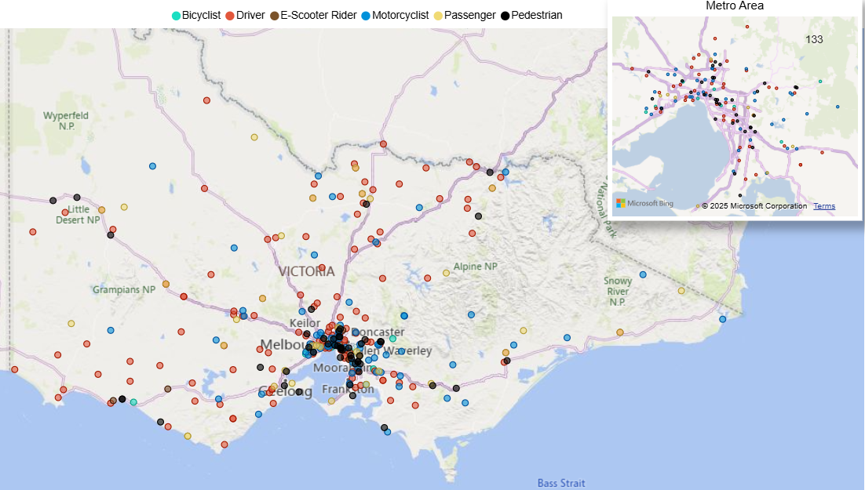

Victoria – Lives Lost, July 2024 to June 2025

1.2 Injured claimants who were admitted to hospital within 7 days of accident.
Rolling 12 months to 31st December (claim acceptance date)

Category | 2024 | 2023 | 2022 | 2024 v 2023 |  | 2024 v 2022 |  | 5-Year Average
Claims hospitalise within 7 days and staying over 14 days (Rolling 12 Month Total)
Claims (to December) | 675 | 657 | 603 | +18 | (+3%) | +72 | (+12%) | 635
per 10,000 vehicles | 1.18 | 1.21 | 1.14 | -0.03 | (-2%) | +0.04 | (+4%) | 1.24
per 100,000 population | 9.41 | 9.64 | 9.11 | -0.23 | (-2%) | +0.30 | (+3%) | 9.76
All claims hospitalised within 7 days (Rolling 12 Month Total)
Claims (to December) | 5,299 | 5,496 | 5,287 | -197 | (-4%) | +12 | (+0%) | 5,464
per 10,000 vehicles | 9.51 | 10.10 | 10.00 | -0.59 | (-6%) | -0.49 | (-5%) | 10.77
per 100,000 population | 75.90 | 80.70 | 79.90 | -4.80 | (-6%) | -4.00 | (-5%) | 84.88

Lives Lost: Rolling 12 months
12 months to 30th June

Category |  | 2025 | 2024 | 2023 | 2025 v 2024 | 2025 v 2023 | 5-Year Average
Overview | Lives Lost | 296 | 287 | 266 | +9 | +30 | 260
Overview | Fatal Crashes | 279 | 265 | 247 | +14 | +32 | 243
Sex | Female | 71 | 80 | 79 | -9 | -8 | 70
Sex | Male | 225 | 207 | 186 | +18 | +39 | 190
Road user | Bicyclist | 10 | 8 | 11 | +2 | -1 | 10
Road user | Driver | 132 | 116 | 117 | +16 | +15 | 116
Road user | Motorcyclist | 66 | 64 | 50 | +2 | +16 | 53
Road user | Passenger | 34 | 41 | 51 | -7 | -17 | 38
Road user | Pedestrian | 50 | 55 | 35 | -5 | +15 | 41
Location | Melbourne | 133 | 123 | 120 | +10 | +13 | 114
Location | Rural Victoria | 163 | 164 | 146 | -1 | +17 | 145
Age group | 0-4 | 3 | 3 | 3 |  | 0 | 3
Age group | 5-15 | 8 | 10 | 6 | -2 | +2 | 6
Age group | 16-17 | 5 | 5 | 4 |  | +1 | 6
Age group | 18-20 | 18 | 22 | 21 | -4 | -3 | 19
Age group | 21-25 | 29 | 18 | 29 | +11 | 0 | 24
Age group | 26-29 | 20 | 20 | 24 |  | -4 | 20
Age group | 30-39 | 51 | 41 | 41 | +10 | +10 | 39
Age group | 40-49 | 33 | 35 | 30 | -2 | +3 | 30
Age group | 50-59 | 37 | 41 | 31 | -4 | +6 | 32
Age group | 60-69 | 35 | 32 | 27 | +3 | +8 | 31
Age group | 70+ | 57 | 60 | 50 | -3 | 7 | 49
Accident Type -Intersection | Adjacent direction | 35 | 37 | 42 | -2 | -7 | 32
Accident Type -Intersection | Opposing direction | 12 | 15 | 11 | -3 | +1 | 11
Accident Type -  Mid-block/other | Head on | 51 | 34 | 32 | +17 | +19 | 33
Accident Type -  Mid-block/other | Same direction | 19 | 19 | 21 | 0 | -2 | 21
Accident Type -  Mid-block/other | Manoeuvre/o'taking | 12 | 13 | 13 | -1 | -1 | 11
Accident Type -  Mid-block/other | On path | 8 | 3 | 8 | +5 | 0 | 5
Accident Type -  Mid-block/other | Single vehicle | 113 | 112 | 102 | +1 | +11 | 104
Accident Type -  Mid-block/other | Other (incl peds) | 46 | 54 | 37 | -8 | +9 | 42

2.1 Lives Lost: 12 months to 30th June

Category | 2024 | 2023 | 2022 | 5-Year Average | Category | 2024 | 2023 | 2022 | 5-Year Average
Local Government Area |  |  |  |  | Local Government Area
ALPINE | 2 | 1 | 1 | 1 | MANSFIELD | 2 | 8 | 1 | 2
ARARAT | 6 | 1 | 0 | 1 | MARIBYRNONG | 2 | 2 | 2 | 1
BALLARAT | 6 | 2 | 1 | 2 | MAROONDAH | 2 | 3 | 2 | 2
BANYULE | 0 | 1 | 3 | 2 | MELBOURNE | 5 | 3 | 3 | 3
BASS COAST | 2 | 5 | 5 | 2 | MELTON | 5 | 5 | 2 | 4
BAW BAW | 7 | 6 | 5 | 4 | MERRI-BEK | 3 | 1 | 4 | 2
BAYSIDE | 1 | 0 | 0 | 0 | MILDURA | 0 | 5 | 2 | 3
BENALLA | 1 | 3 | 1 | 1 | MITCHELL | 3 | 8 | 5 | 5
BOROONDARA | 5 | 2 | 2 | 2 | MOIRA | 5 | 4 | 13 | 5
BRIMBANK | 7 | 5 | 10 | 6 | MONASH | 4 | 6 | 7 | 5
BULOKE | 2 | 3 | 1 | 2 | MOONEE VALLEY | 1 | 3 | 4 | 2
CAMPASPE | 6 | 6 | 7 | 5 | MOORABOOL | 1 | 5 | 2 | 3
CARDINIA | 10 | 5 | 2 | 6 | MORNINGTON PENINSULA | 4 | 5 | 4 | 6
CASEY | 8 | 13 | 14 | 9 | MOUNT ALEXANDER | 0 | 0 | 1 | 2
CENTRAL GOLDFIELDS | 1 | 0 | 1 | 1 | MOYNE | 9 | 3 | 3 | 2
COLAC-OTWAY | 6 | 1 | 3 | 3 | MURRINDINDI | 3 | 4 | 5 | 3
CORANGAMITE | 6 | 1 | 5 | 3 | NILLUMBIK | 3 | 3 | 0 | 2
DAREBIN | 4 | 1 | 3 | 2 | NORTHERN GRAMPIANS | 0 | 2 | 2 | 3
EAST GIPPSLAND | 6 | 4 | 2 | 4 | PORT PHILLIP | 1 | 2 | 2 | 2
FRANKSTON | 4 | 4 | 5 | 4 | PYRENEES | 1 | 1 | 2 | 1
GANNAWARRA | 1 | 1 | 2 | 1 | QUEENSCLIFFE | 0 | 0 | 0 | 0
GLEN EIRA | 0 | 3 | 2 | 2 | SOUTH GIPPSLAND | 2 | 2 | 5 | 4
GLENELG | 4 | 3 | 1 | 2 | SOUTHERN GRAMPIANS | 3 | 0 | 6 | 2
GOLDEN PLAINS | 8 | 1 | 3 | 2 | STONNINGTON | 4 | 3 | 0 | 1
GREATER BENDIGO | 5 | 8 | 3 | 6 | STRATHBOGIE | 5 | 5 | 4 | 3
GREATER DANDENONG | 7 | 9 | 1 | 4 | SURF COAST | 7 | 4 | 0 | 1
GREATER GEELONG | 5 | 5 | 11 | 8 | SWAN HILL | 1 | 3 | 0 | 1
GREATER SHEPPARTON | 9 | 10 | 12 | 7 | TOWONG | 0 | 2 | 2 | 1
HEPBURN | 2 | 9 | 0 | 4 | WANGARATTA | 3 | 4 | 3 | 3
HINDMARSH | 4 | 0 | 0 | 0 | WARRNAMBOOL | 1 | 1 | 1 | 2
HOBSONS BAY | 6 | 2 | 4 | 2 | WELLINGTON | 7 | 4 | 6 | 4
HORSHAM | 3 | 1 | 1 | 2 | WEST WIMMERA | 2 | 1 | 2 | 1
HUME | 3 | 5 | 4 | 4 | WHITEHORSE | 2 | 3 | 2 | 2
INDIGO | 4 | 7 | 1 | 3 | WHITTLESEA | 12 | 2 | 8 | 5
KINGSTON | 1 | 7 | 0 | 3 | WODONGA | 3 | 1 | 2 | 1
KNOX | 5 | 4 | 3 | 2 | WYNDHAM | 12 | 8 | 9 | 6
LATROBE | 3 | 7 | 6 | 5 | YARRA | 1 | 2 | 4 | 2
LODDON | 0 | 2 | 2 | 2 | YARRA RANGES | 11 | 8 | 11 | 7
MACEDON RANGES | 5 | 5 | 3 | 3 | YARRIAMBIACK | 0 | 4 | 2 | 1
MANNINGHAM | 1 | 3 | 3 | 1

Injured claimants admitted to hospital within 7 days of the accident with a hospital stay of more than 14 days
12 months to 31st December

Category |  | 2024 | 2023 | 2022 | 2024 v 2023  Number Percent |  | 2024 v 2022  Number Percent |  | 5-Year Average
Overview | Claims | 675 | 657 | 603 | +18 | 3% | 72 | 12% | 635
Sex | Female | 241 | 253 | 214 | -12 | -5% | 27 | 13% | 231
Sex | Male | 431 | 400 | 388 | +31 | 8% | 43 | 11% | 402
Road user | Bicyclist | 35 | 27 | 32 | +8 | 30% | 3 | 9% | 32
Road user | Driver | 271 | 235 | 227 | +36 | 15% | 44 | 19% | 241
Road user | Motorcyclist | 149 | 156 | 122 | -7 | -4% | 27 | 22% | 141
Road user | Passenger | 86 | 68 | 66 | +18 | 26% | 20 | 30% | 76
Road user | Pedestrian | 116 | 152 | 145 | -36 | -24% | -29 | -20% | 131
Road user | Train/Tram | 3 | 3 | 5 |  | 0% | -2 | -40% | 4
Location | Melbourne | 356 | 397 | 370 | -41 | -10% | -14 | -4% | 369
Location | Rural Victoria | 233 | 242 | 209 | -9 | -4% | 24 | 11% | 231
Age group | 0-4 | 1 | 0 | 1 | +1 | - | 0 | 0% | 2
Age group | 5-15 | 8 | 13 | 9 | -5 | -38% | -1 | -11% | 10
Age group | 16-17 | 16 | 9 | 11 | +7 | 78% | 5 | 45% | 13
Age group | 18-20 | 30 | 34 | 25 | -4 | -12% | 5 | 20% | 30
Age group | 21-25 | 55 | 55 | 43 |  | 0% | 12 | 28% | 50
Age group | 26-29 | 37 | 37 | 30 |  | 0% | 7 | 23% | 39
Age group | 30-39 | 90 | 74 | 90 | +16 | 22% | 0 | 0% | 84
Age group | 40-49 | 89 | 82 | 75 | +7 | 9% | 14 | 19% | 77
Age group | 50-59 | 85 | 95 | 70 | -10 | -11% | 15 | 21% | 81
Age group | 60-69 | 79 | 74 | 73 | +5 | 7% | 6 | 8% | 78
Age group | 70+ | 185 | 184 | 176 | +1 | 1% | 9 | 5% | 172
Accident Type -Intersection | Adjacent direction | 80 | 85 | 61 | -5 | -6% | 19 | 31% | 71
Accident Type -Intersection | Opposing direction | 42 | 37 | 49 | +5 | 14% | -7 | -14% | 41
Accident Type –  Mid-block/other | Head on | 74 | 59 | 48 | +15 | 25% | 26 | 54% | 52
Accident Type –  Mid-block/other | Same direction | 79 | 51 | 42 | +28 | 55% | 37 | 88% | 54
Accident Type –  Mid-block/other | Manoeuvre/o’taking | 51 | 36 | 42 | +15 | 42% | 9 | 21% | 40
Accident Type –  Mid-block/other | On path | 22 | 26 | 25 | -4 | -15% | -3 | -12% | 25
Accident Type –  Mid-block/other | Single vehicle | 187 | 168 | 147 | +19 | 11% | 40 | 27% | 179
Accident Type –  Mid-block/other | Other (incl peds) | 140 | 195 | 189 | -55 | -28% | -49 | -26% | 173

3.1 By local government area.
12 months to 31st December

Category | 2024 | 2023 | 2022 | 5-Year Average | Category | 2024 | 2023 | 2022 | 5-Year Average
Local Government Area |  |  |  |  | Local Government Area
ALPINE | 2 | 3 | 4 | 3 | MANSFIELD | 6 | 2 | 4 | 3
ARARAT | 2 | 0 | 4 | 1 | MARIBYRNONG | 9 | 8 | 11 | 7
BALLARAT | 14 | 18 | 10 | 11 | MAROONDAH | 7 | 3 | 4 | 5
BANYULE | 5 | 4 | 11 | 5 | MELBOURNE | 19 | 17 | 18 | 16
BASS COAST | 5 | 11 | 7 | 5 | MELTON | 10 | 12 | 12 | 7
BAW BAW | 12 | 4 | 6 | 4 | MERRI-BEK | 18 | 18 | 13 | 12
BAYSIDE | 8 | 4 | 7 | 4 | MILDURA | 10 | 3 | 2 | 3
BENALLA | 6 | 2 | 6 | 2 | MITCHELL | 7 | 11 | 6 | 8
BOROONDARA | 8 | 9 | 5 | 7 | MOIRA | 8 | 11 | 5 | 5
BRIMBANK | 17 | 17 | 17 | 13 | MONASH | 6 | 24 | 15 | 12
BULOKE | 2 | 3 | 1 | 1 | MOONEE VALLEY | 13 | 8 | 15 | 9
CAMPASPE | 3 | 5 | 5 | 5 | MOORABOOL | 11 | 5 | 9 | 5
CARDINIA | 7 | 13 | 12 | 11 | MORNINGTON PENINSULA | 11 | 12 | 15 | 11
CASEY | 18 | 14 | 26 | 16 | MOUNT ALEXANDER | 2 | 2 | 5 | 3
CENTRAL GOLDFIELDS | 3 | 2 | 2 | 2 | MOYNE | 6 | 4 | 1 | 2
COLAC-OTWAY | 6 | 3 | 5 | 4 | MURRINDINDI | 5 | 4 | 4 | 3
CORANGAMITE | 5 | 5 | 3 | 3 | NILLUMBIK | 3 | 5 | 4 | 4
DAREBIN | 15 | 14 | 14 | 11 | NORTHERN GRAMPIANS | 5 | 4 | 2 | 2
EAST GIPPSLAND | 2 | 20 | 6 | 9 | PORT PHILLIP | 14 | 9 | 7 | 8
FRANKSTON | 3 | 8 | 8 | 6 | PYRENEES | 3 | 0 | 0 | 1
GANNAWARRA | 4 | 2 | 1 | 2 | QUEENSCLIFFE | 0 | 0 | 0 | 0
GLEN EIRA | 6 | 4 | 2 | 4 | SOUTH GIPPSLAND | 5 | 6 | 4 | 4
GLENELG | 1 | 4 | 4 | 2 | SOUTHERN GRAMPIANS | 0 | 2 | 0 | 1
GOLDEN PLAINS | 2 | 3 | 4 | 3 | STONNINGTON | 10 | 9 | 15 | 8
GREATER BENDIGO | 20 | 17 | 12 | 13 | STRATHBOGIE | 3 | 4 | 2 | 3
GREATER DANDENONG | 16 | 23 | 9 | 15 | SURF COAST | 1 | 4 | 3 | 3
GREATER GEELONG | 22 | 19 | 27 | 20 | SWAN HILL | 3 | 1 | 0 | 2
GREATER SHEPPARTON | 9 | 9 | 7 | 10 | TOWONG | 1 | 4 | 2 | 2
HEPBURN | 5 | 6 | 3 | 3 | WANGARATTA | 2 | 2 | 1 | 1
HINDMARSH | 0 | 1 | 0 | 1 | WARRNAMBOOL | 4 | 2 | 5 | 3
HOBSONS BAY | 6 | 8 | 6 | 5 | WELLINGTON | 2 | 6 | 5 | 6
HORSHAM | 0 | 4 | 4 | 2 | WEST WIMMERA | 0 | 2 | 0 | 0
HUME | 26 | 15 | 21 | 15 | WHITEHORSE | 18 | 19 | 18 | 13
INDIGO | 2 | 3 | 3 | 3 | WHITTLESEA | 10 | 24 | 22 | 16
KINGSTON | 14 | 14 | 11 | 10 | WODONGA | 3 | 5 | 6 | 3
KNOX | 7 | 14 | 12 | 12 | WYNDHAM | 20 | 20 | 15 | 16
LATROBE | 10 | 7 | 6 | 7 | YARRA | 10 | 10 | 4 | 6
LODDON | 4 | 1 | 4 | 2 | YARRA RANGES | 16 | 25 | 15 | 16
MACEDON RANGES | 5 | 4 | 8 | 4 | YARRIAMBIACK | 0 | 2 | 1 | 1
MANNINGHAM | 6 | 13 | 6 | 7

Injured claimants admitted to hospital within 7 days of accident
12 months to 31st December

Category |  | 2024 | 2023 | 2022 | 2024 v 2023  Number Percent |  | 2024 v 2022 Number Percent |  | 5-Year Average
Overview | Claims | 5,299 | 5,496 | 5,287 | -197 | -4% | +12 | 0% | 5,464
Sex | Female | 2,108 | 2,218 | 2,220 | -110 | -5% | -112 | -5% | 2,228
Sex | Male | 3,147 | 3,252 | 3,058 | -105 | -3% | +89 | 3% | 3,218
Road user | Bicyclist | 398 | 377 | 352 | +21 | 6% | +46 | 13% | 394
Road user | Driver | 2,405 | 2,556 | 2,516 | -151 | -6% | -111 | -4% | 2,605
Road user | Motorcyclist | 1,029 | 1,041 | 924 | -12 | -1% | +105 | 11% | 991
Road user | Passenger | 746 | 713 | 710 | +33 | 5% | +36 | 5% | 730
Road user | Pedestrian | 510 | 619 | 617 | -109 | -18% | -107 | -17% | 551
Road user | Train/Tram | 12 | 19 | 29 | -7 | -37% | -17 | -59% | 18
Location | Melbourne | 2,751 | 3,537 | 3,397 | -786 | -22% | -646 | -19% | 3,350
Location | Rural Victoria | 1,528 | 1,778 | 1,664 | -250 | -14% | -136 | -8% | 1,736
Age group | 0-4 | 17 | 28 | 24 | -11 | -39% | -7 | -29% | 29
Age group | 5-15 | 150 | 168 | 139 | -18 | -11% | +11 | 8% | 147
Age group | 16-17 | 86 | 95 | 82 | -9 | -9% | +4 | 5% | 92
Age group | 18-20 | 375 | 342 | 317 | +33 | 10% | +58 | 18% | 370
Age group | 21-25 | 579 | 573 | 553 | +6 | 1% | +26 | 5% | 606
Age group | 26-29 | 443 | 416 | 406 | +27 | 6% | +37 | 9% | 449
Age group | 30-39 | 937 | 880 | 929 | +57 | 6% | +8 | 1% | 940
Age group | 40-49 | 700 | 768 | 711 | -68 | -9% | -11 | -2% | 748
Age group | 50-59 | 688 | 786 | 722 | -98 | -12% | -34 | -5% | 749
Age group | 60-69 | 599 | 629 | 641 | -30 | -5% | -42 | -7% | 604
Age group | 70+ | 725 | 811 | 763 | -86 | -11% | -38 | -5% | 731
Accident Type -Intersection | Adjacent direction | 845 | 851 | 736 | -6 | -1% | +109 | 15% | 819
Accident Type -Intersection | Opposing direction | 448 | 484 | 463 | -36 | -7% | -15 | -3% | 453
Accident Type -  Mid-block/other | Head on | 331 | 308 | 278 | +23 | 7% | +53 | 19% | 296
Accident Type -  Mid-block/other | Same direction | 906 | 888 | 837 | +18 | 2% | +69 | 8% | 871
Accident Type -  Mid-block/other | Manoeuvre/o'taking | 368 | 345 | 348 | +23 | 7% | +20 | 6% | 374
Accident Type -  Mid-block/other | On path | 247 | 242 | 260 | +5 | 2% | -13 | -5% | 268
Accident Type -  Mid-block/other | Single vehicle | 1,274 | 1,256 | 1,207 | +18 | 1% | +67 | 6% | 1,313
Accident Type -  Mid-block/other | Other (incl peds) | 880 | 1,122 | 1,158 | -242 | -22% | -278 | -24% | 1,070

4.1 By local government area.
12 months to 31st December

Category | 2024 | 2023 | 2022 | 5-Year Average | Category | 2024 | 2023 | 2022 | 5-Year Average
Local Government Area |  |  |  |  | Local Government Area
ALPINE | 18 | 26 | 29 | 22 | MANSFIELD | 26 | 20 | 25 | 21
ARARAT | 8 | 11 | 11 | 9 | MARIBYRNONG | 66 | 51 | 64 | 51
BALLARAT | 82 | 102 | 84 | 78 | MAROONDAH | 32 | 27 | 39 | 32
BANYULE | 31 | 31 | 44 | 30 | MELBOURNE | 164 | 188 | 179 | 148
BASS COAST | 32 | 38 | 34 | 28 | MELTON | 86 | 95 | 109 | 71
BAW BAW | 53 | 54 | 58 | 47 | MERRI-BEK | 128 | 129 | 131 | 105
BAYSIDE | 55 | 58 | 69 | 54 | MILDURA | 39 | 31 | 10 | 25
BENALLA | 13 | 13 | 17 | 10 | MITCHELL | 45 | 61 | 42 | 49
BOROONDARA | 72 | 93 | 83 | 73 | MOIRA | 31 | 31 | 24 | 26
BRIMBANK | 130 | 137 | 170 | 122 | MONASH | 81 | 148 | 138 | 113
BULOKE | 8 | 17 | 7 | 7 | MOONEE VALLEY | 110 | 114 | 119 | 95
CAMPASPE | 23 | 38 | 29 | 31 | MOORABOOL | 46 | 51 | 73 | 40
CARDINIA | 71 | 119 | 100 | 94 | MORNINGTON PENINSULA | 116 | 158 | 129 | 116
CASEY | 196 | 276 | 276 | 236 | MOUNT ALEXANDER | 17 | 23 | 19 | 16
CENTRAL GOLDFIELDS | 16 | 13 | 7 | 12 | MOYNE | 26 | 28 | 28 | 19
COLAC-OTWAY | 54 | 37 | 61 | 41 | MURRINDINDI | 33 | 44 | 45 | 33
CORANGAMITE | 26 | 35 | 16 | 21 | NILLUMBIK | 13 | 27 | 24 | 23
DAREBIN | 62 | 82 | 74 | 61 | NORTHERN GRAMPIANS | 21 | 24 | 9 | 14
EAST GIPPSLAND | 30 | 54 | 36 | 38 | PORT PHILLIP | 112 | 124 | 116 | 101
FRANKSTON | 72 | 97 | 78 | 79 | PYRENEES | 9 | 6 | 15 | 8
GANNAWARRA | 7 | 7 | 13 | 9 | QUEENSCLIFFE | 0 | 1 | 1 | 2
GLEN EIRA | 66 | 83 | 86 | 79 | SOUTH GIPPSLAND | 21 | 31 | 26 | 26
GLENELG | 13 | 25 | 15 | 17 | SOUTHERN GRAMPIANS | 10 | 13 | 9 | 13
GOLDEN PLAINS | 29 | 26 | 31 | 28 | STONNINGTON | 108 | 106 | 118 | 86
GREATER BENDIGO | 113 | 91 | 83 | 80 | STRATHBOGIE | 18 | 25 | 19 | 20
GREATER DANDENONG | 129 | 200 | 167 | 170 | SURF COAST | 52 | 51 | 45 | 45
GREATER GEELONG | 290 | 323 | 368 | 289 | SWAN HILL | 7 | 11 | 10 | 12
GREATER SHEPPARTON | 44 | 46 | 45 | 47 | TOWONG | 13 | 15 | 9 | 10
HEPBURN | 25 | 43 | 38 | 26 | WANGARATTA | 26 | 40 | 19 | 20
HINDMARSH | 10 | 9 | 8 | 7 | WARRNAMBOOL | 27 | 23 | 21 | 19
HOBSONS BAY | 46 | 54 | 62 | 49 | WELLINGTON | 34 | 51 | 30 | 38
HORSHAM | 7 | 15 | 19 | 17 | WEST WIMMERA | 2 | 5 | 1 | 4
HUME | 198 | 202 | 211 | 170 | WHITEHORSE | 62 | 79 | 58 | 60
INDIGO | 12 | 15 | 14 | 14 | WHITTLESEA | 121 | 204 | 169 | 135
KINGSTON | 92 | 104 | 102 | 94 | WODONGA | 16 | 27 | 37 | 24
KNOX | 58 | 83 | 98 | 81 | WYNDHAM | 104 | 178 | 141 | 138
LATROBE | 43 | 60 | 44 | 51 | YARRA | 60 | 100 | 95 | 69
LODDON | 11 | 12 | 13 | 9 | YARRA RANGES | 84 | 132 | 113 | 107
MACEDON RANGES | 39 | 49 | 59 | 40 | YARRIAMBIACK | 3 | 4 | 8 | 5
MANNINGHAM | 26 | 58 | 35 | 35

Lives Lost by Week (2020 to 2025)

Week Ending | 2020 | 2021 | 2022 | 2023 | 2024 | 2025 | Cumulative 2025 | 12-month moving total
05-Jan | 5 | 3 | 5 | 5 | 3 | 4 | 4 | 285
12-Jan | 4 | 1 | 7 | 7 | 5 | 9 | 13 | 289
19-Jan | 4 | 1 | 4 | 5 | 8 | 7 | 20 | 288
26-Jan | 3 | 6 | 3 | 8 | 3 | 9 | 29 | 294
02-Feb | 9 | 3 | 6 | 12 | 4 | 9 | 38 | 299
09-Feb | 4 | 8 | 6 | 7 | 5 | 2 | 40 | 296
16-Feb | 7 | 6 | 9 | 4 | 7 | 3 | 43 | 292
23-Feb | 4 | 1 | 2 | 6 | 4 | 4 | 47 | 292
02-Mar | 1 | 7 | 6 | 7 | 8 | 10 | 57 | 294
09-Mar | 4 | 9 | 3 | 6 | 9 | 8 | 65 | 293
16-Mar | 10 | 3 | 0 | 3 | 5 | 2 | 67 | 290
23-Mar | 9 | 5 | 7 | 2 | 6 | 1 | 68 | 285
30-Mar | 1 | 6 | 5 | 8 | 7 | 9 | 77 | 287
06-Apr | 8 | 5 | 4 | 3 | 5 | 4 | 81 | 286
13-Apr | 0 | 2 | 7 | 5 | 7 | 6 | 87 | 285
20-Apr | 1 | 4 | 5 | 9 | 2 | 4 | 91 | 287
27-Apr | 9 | 3 | 3 | 4 | 3 | 4 | 95 | 288
04-May | 3 | 3 | 2 | 6 | 3 | 5 | 100 | 290
11-May | 1 | 5 | 4 | 3 | 7 | 6 | 106 | 289
18-May | 5 | 3 | 4 | 5 | 6 | 13 | 119 | 296
25-May | 3 | 2 | 4 | 4 | 3 | 9 | 128 | 302
01-Jun | 4 | 1 | 1 | 12 | 8 | 6 | 134 | 300
08-Jun | 2 | 3 | 6 | 3 | 5 | 2 | 136 | 297
15-Jun | 4 | 5 | 4 | 3 | 6 | 5 | 141 | 296
22-Jun | 4 | 6 | 8 | 1 | 3 | 3 | 144 | 296
29-Jun | 5 | 4 | 3 | 6 | 3 | 4 | 148 | 297
06-Jul | 3 | 8 | 6 | 7 | 6
13-Jul | 3 | 4 | 3 | 3 | 10
20-Jul | 3 | 5 | 5 | 5 | 4
27-Jul | 5 | 3 | 6 | 5 | 7
03-Aug | 5 | 3 | 1 | 4 | 6
10-Aug | 2 | 3 | 5 | 6 | 5
17-Aug | 5 | 4 | 6 | 2 | 6
24-Aug | 1 | 5 | 3 | 6 | 5
31-Aug | 3 | 4 | 5 | 7 | 6
Continued…
Week Ending | 2020 | 2021 | 2022 | 2023 | 2024 | 2025 | Cumulative 2025 | 12-month moving total
07-Sep | 4 | 2 | 8 | 5 | 4
14-Sep | 4 | 8 | 4 | 6 | 6
21-Sep | 1 | 4 | 10 | 8 | 5
28-Sep | 1 | 4 | 4 | 5 | 3
05-Oct | 7 | 7 | 3 | 6 | 2
12-Oct | 2 | 3 | 7 | 3 | 2
19-Oct | 6 | 2 | 3 | 5 | 7
26-Oct | 9 | 8 | 5 | 9 | 5
02-Nov | 2 | 3 | 3 | 2 | 7
09-Nov | 4 | 9 | 6 | 12 | 8
16-Nov | 4 | 3 | 3 | 8 | 9
23-Nov | 4 | 4 | 5 | 7 | 10
30-Nov | 3 | 8 | 7 | 5 | 3
07-Dec | 3 | 2 | 4 | 4 | 9
14-Dec | 3 | 8 | 2 | 5 | 5
21-Dec | 5 | 3 | 2 | 7 | 6
28-Dec | 4 | 8 | 5 | 8 | 1
31-Dec | 1 | 4 | 2 | 1 | 2
Total | 211 | 234 | 241 | 295 | 284 | 148

Mobile Safety Camera Data

6.1 Speed Infringements Issued from Mobile Cameras (monthly totals)

Year: 2024 Year: 2025
Jul | Aug | Sep | Oct | Nov | Dec | Jan | Feb | Mar | Apr | May | Jun | Average
48,650 | 39,671 | 26,921 | 510 | 432 | 702 | 3,620 | 53,466 | 80,223 | 74,247 | 64,340 | 45,932 | 36,560

6.2 Excessive Speed Infringements (ESI) Issued from Mobile Cameras (monthly totals)

Year: 2024 Year: 2025
Jul | Aug | Sep | Oct | Nov | Dec | Jan | Feb | Mar | Apr | May | Jun | Average
414 | 303 | 271 | 365 | 282 | 497 | 450 | 399 | 324 | 377 | 323 | 350 | 363

Notes: An ESI is defined as 25km/h over the speed limit except in a 110km/h zone where it is 20km/h over the limit.

The National Picture – Interstate Comparison

7.1 Lives lost (12 months to June)

State | 2025 | 2024 | 2023 | 2022 | 2025 v 2024  Number Percent
New South Wales | 363 | 339 | 290 | 280 | +24 | (+7%)
Victoria | 296 | 287 | 266 | 244 | +9 | (+3%)
Queensland | 296 | 296 | 273 | 292 |  | (0%)
South Australia | 84 | 100 | 93 | 85 | -16 | (-16%)
Western Australia | 197 | 176 | 176 | 155 | +21 | (+12%)
Tasmania | 47 | 27 | 39 | 52 | +20 | (+74%)
Northern Territory | 51 | 55 | 31 | 45 | -4 | (-7%)
Australian Capital Territory | 8 | 8 | 10 | 15 |  | (0%)
Australia | 1,218 | 1,313 | 1,164 | 1,168 | -95 | (-7%)
Australia minus Victoria | 922 | 1,026 | 898 | 924 | -104 | (-10%)

7.2 Lives lost per 10,000 registered vehicles and per 100,000 population (12 months to June).

State | Lives Lost per 10,000 registered vehicles  2024 2023 2022 |  |  | Lives Lost per 100,000 population  2024 2023 2022
New South Wales | 0.56 | 0.54 | 0.47 | 4.24 | 4.03 | 3.52
Victoria | 0.53 | 0.52 | 0.50 | 4.19 | 4.16 | 3.96
Queensland | 0.60 | 0.63 | 0.60 | 5.24 | 5.36 | 5.06
South Australia | 0.51 | 0.63 | 0.60 | 4.44 | 5.36 | 5.07
Western Australia | 0.75 | 0.70 | 0.73 | 6.55 | 6.02 | 6.21
Tasmania | 0.86 | 0.50 | 0.73 | 8.15 | 4.70 | 6.82
Northern Territory | 2.98 | 3.28 | 1.87 | 19.89 | 21.67 | 12.18
Australian Capital Territory | 0.23 | 0.24 | 0.30 | 1.67 | 1.70 | 2.17
Australia | 0.55 | 0.61 | 0.55 | 4.43 | 4.88 | 4.42
Australia minus Victoria | 0.58 | 0.66 | 0.58 | 4.51 | 5.12 | 4.58

International Road Safety Comparison
Selected OECD countries, Australia, and Victoria 2000, 2010, 2015, 2020, 2021, 2022 and 2023

8.1 Lives lost rate per 100,000 population selected OECD Countries
Countries | 2000 | 2010 | 2015 | 2020 | 2021 | 2022 | 2023
Australia | 7.7 | 5.1 | 5.1 | 4.3 | 4.3 | 4.6 | 4.8
Canada | 16.4 | 10.2 | 5.3 | 4.5 | 4.8 | 5.0 | 4.8
New Zealand | 8.6 | 5.5 | 6.9 | 6.2 | 6.2 | 7.3 | 6.5
Norway | 7.6 | 4.3 | 2.3 | 1.7 | 1.5 | 2.1 | 2.0
Sweden | 6.7 | 2.8 | 2.7 | 2.0 | 2.0 | 2.2 | 2.2
Switzerland | 9.3 | 4.6 | 3.1 | 2.6 | 2.3 | 2.7 | 2.7
United Kingdom | 8.3 | 4.2 | 2.8 | 2.3 | 2.4 | 2.6 | 2.5
United States | 12.0 | 8.6 | 11.1 | 11.8 | 12.9 | 12.8 | 12.2

8.2 Lives lost rate per 100 million vehicle kilometres travelled (VKT)
Countries | 2000 | 2010 | 2015 | 2020 | 2021 | 2022 | 2023
Australia | 9.5 | 0.6 | 0.5 | 0.5 | 0.5 | 0.5 | -
Canada | 9.5 | 0.7 | 0.5 | 0.5 | 0.4 | 0.5 | 0.5
New Zealand | 12 | 0.9 | 0.7 | 0.7 | 0.7 | 0.8 | 0.7
Norway | 7.6 | 0.5 | 0.3 | 0.2 | 0.2 | 0.3 | 0.2
Sweden | 6.7 | 0.3 | 0.3 | 0.3 | 0.3 | 0.3 | 0.3
Switzerland | 8.3 | 0.5 | 0.4 | 0.4 | 0.3 | 0.4 | 0.4
United Kingdom | - | - | - | 0.4 | 0.3 | 0.3 | -
United States | 14.9 | 0.7 | 0.7 | 0.8 | 0.8 | 0.8 | 0.8

8.3 Lives lost rate per 10,000 registered vehicles
Countries | 2000 | 2010 | 2015 | 2020 | 2021 | 2022 | 2023
Australia | 2.5 | 0.9 | 0.7 | 0.6 | 0.6 | 0.6 | 0.6
Canada | - | - | 0.8 | - | - | - | -
New Zealand | 5 | 1.4 | 0.9 | - | - | - | -
Norway | 1.8 | 0.3 | 0.3 | 0.2 | 0.2 | 0.3 | 0.3
Sweden | 1.2 | 0.5 | 0.4 | 0.3 | 0.3 | 0.4 | 0.4
Switzerland | 2.2 | 0.7 | 0.4 | 0.4 | 0.3 | 0.4 | 0.4
United Kingdom | 1.2 | 0.5 | 0.5 | - | - | - | -
United States | - | - | 1.3 | - | - | - | -
* Source: https://www.bitre.gov.au/sites/default/files/documents/international_comparisons_2022.pdf
* https://datahub.roadsafety.gov.au/progress-reporting/international-comparisons
* 2020-2023: OECD Data Explorer • Transport safety indicators

Lives lost rate per 100,000 population - OECD countries, 2023.

Useful websites

TAC Sites
- TAC Safety (Road Safety) tacsafety.com.au
- TAC How safe is your car howsafeisyourcar.com.au
- TAC Campaigns road-safety/tac-campaigns
- TAC Motorcycle Safety Website spokes.com.au
- TAC Corporate site tac.vic.gov.au
- TAC Road Safety Grant Program tac-road-safety-grant-program
- TAC Road to Zero Education roadtozero.vic.gov.au

Victorian Sites
- VicRoads vicroads.vic.gov.au
- Transport Victoria transport.vic.gov.au
- Victoria Police police.vic.gov.au
- myLearners website mylearners.vic.gov.au
- Road Safety Education Victoria roadsafetyeducation.vic.gov.au
- Cameras Save Lives camerassavelives.vic.gov.au
- Victorian Government open data data.vic.gov.au
- Victorian road trauma statistics road-trauma-statistics
- RACV racv.com.au
- Monash University Accident Research Centre monash.edu.au/muarc

National and Interstate Sites
- National Transport Research Organisation ntro.org.au
- Australian Transport Safety Bureau atsb.gov.au
- State Insurance Regulatory Authority (NSW) sira.nsw.gov.au
- Motor Accidents Insurance Board (TAS) maib.tas.gov.au
- Motor Accident Commission, Allianz (SA) ctp.sa.gov.au
- Motor Accidents Compensation, TIO, (NT) tiofi.com.au/mac
- Insurance Commission of Western Australia icwa.wa.gov.au
- Motor Accident Insurance Commission (QLD) maic.qld.gov.au

International Sites
- National Highway Traffic Safety Admin (USA) nhtsa.dot.gov
- Swedish Road and Transport Institute (VTI) vti.se
- SWOV Institute for Road Safety Research swov.nl
- Bureau of Infrastructure and Transport Research Eco bitre.gov.au

Related Sites
- Alcohol and Drug Foundation adf.org.au

Graphs of Lives Lost and Hospitalised Claims
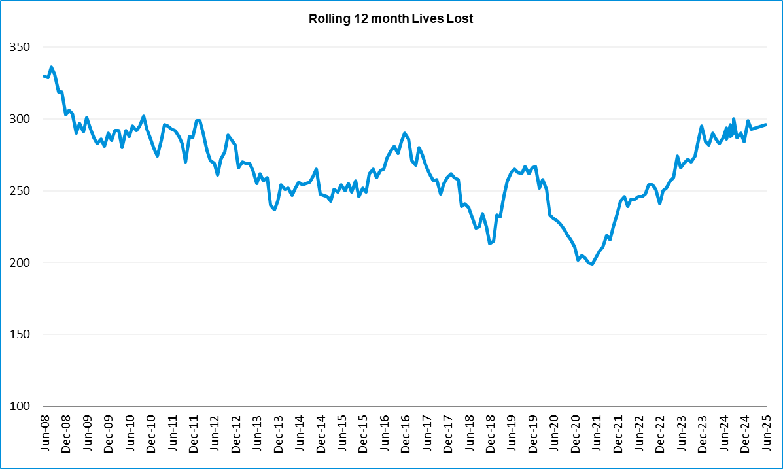

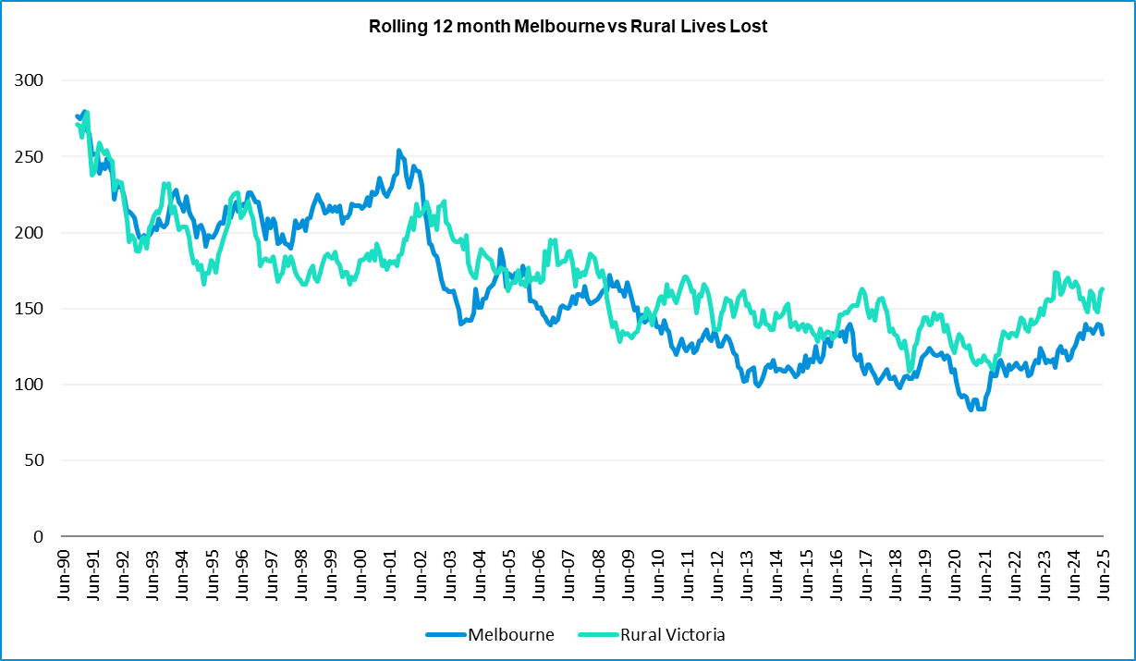

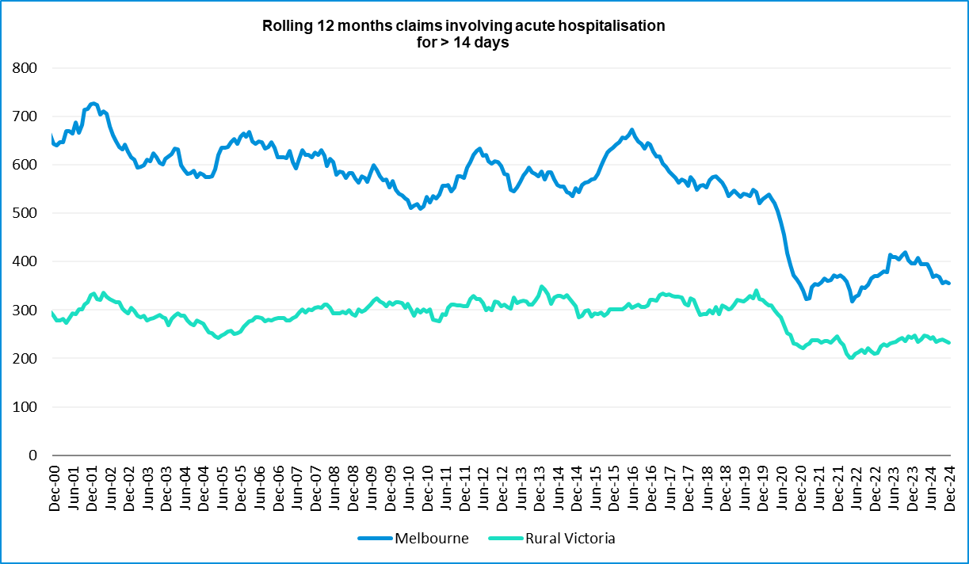

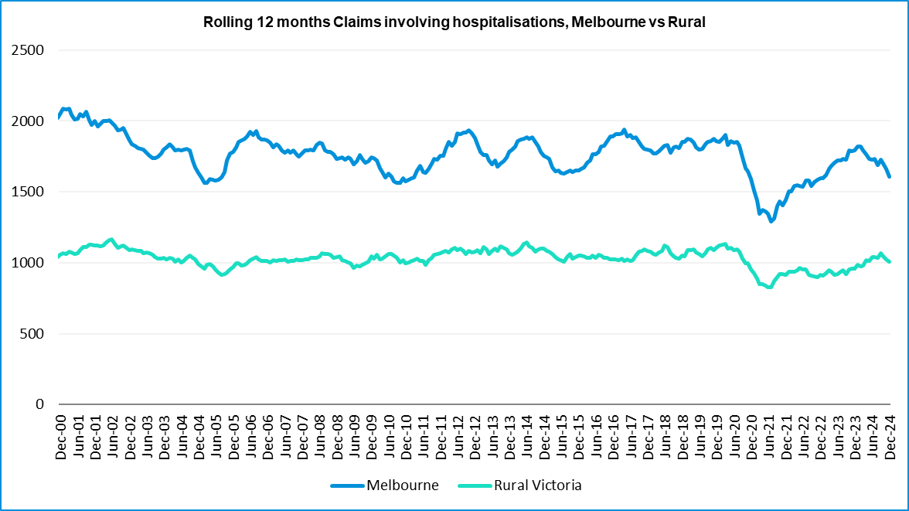

Victorian monthly lives lost since 1951
Year | Jan | Feb | Mar | Apr | May | Jun | Jul | Aug | Sep | Oct | Nov | Dec | Total
1951 |  |  |  |  |  |  | 61 | 59 | 52 | 38 | 29 | 41
1952 | 45 | 40 | 54 | 61 | 54 | 69 | 67 | 55 | 44 | 44 | 31 | 20 | 584
1953 | 23 | 28 | 54 | 58 | 49 | 42 | 50 | 37 | 44 | 27 | 36 | 32 | 480
1954 | 44 | 42 | 28 | 60 | 55 | 36 | 63 | 33 | 25 | 52 | 30 | 41 | 509
1955 | 44 | 36 | 45 | 55 | 48 | 56 | 64 | 44 | 44 | 32 | 40 | 40 | 548
1956 | 34 | 48 | 51 | 67 | 53 | 65 | 71 | 47 | 39 | 39 | 44 | 48 | 606
1957 | 50 | 41 | 46 | 58 | 52 | 54 | 57 | 53 | 51 | 46 | 32 | 49 | 589
1958 | 50 | 38 | 42 | 58 | 54 | 41 | 54 | 53 | 57 | 40 | 57 | 52 | 596
1959 | 50 | 57 | 61 | 50 | 75 | 55 | 42 | 48 | 52 | 55 | 63 | 63 | 671
1960 | 49 | 53 | 57 | 76 | 70 | 70 | 67 | 62 | 61 | 77 | 52 | 66 | 760
1961 | 63 | 57 | 68 | 74 | 58 | 68 | 78 | 82 | 59 | 62 | 60 | 65 | 794
1962 | 65 | 41 | 76 | 78 | 72 | 80 | 70 | 77 | 62 | 53 | 64 | 70 | 808
1963 | 67 | 56 | 65 | 85 | 66 | 68 | 77 | 55 | 55 | 58 | 61 | 67 | 780
1964 | 73 | 71 | 78 | 71 | 83 | 89 | 80 | 89 | 67 | 66 | 62 | 75 | 904
1965 | 63 | 64 | 86 | 88 | 80 | 87 | 79 | 69 | 81 | 77 | 68 | 87 | 929
1966 | 75 | 59 | 75 | 103 | 74 | 86 | 87 | 80 | 75 | 66 | 90 | 85 | 955
1967 | 61 | 79 | 91 | 97 | 81 | 71 | 59 | 67 | 70 | 68 | 60 | 83 | 887
1968 | 70 | 78 | 86 | 78 | 73 | 76 | 73 | 77 | 72 | 80 | 81 | 105 | 949
1969 | 79 | 68 | 79 | 87 | 86 | 77 | 87 | 83 | 87 | 83 | 94 | 101 | 1011
1970 | 85 | 84 | 106 | 80 | 87 | 88 | 110 | 106 | 78 | 95 | 68 | 74 | 1061
1971 | 83 | 75 | 77 | 68 | 76 | 86 | 85 | 72 | 78 | 73 | 74 | 76 | 923
1972 | 61 | 62 | 75 | 82 | 75 | 71 | 98 | 85 | 83 | 62 | 80 | 81 | 915
1973 | 75 | 75 | 95 | 85 | 64 | 66 | 61 | 85 | 89 | 88 | 66 | 86 | 935
1974 | 56 | 62 | 81 | 60 | 70 | 73 | 67 | 62 | 53 | 70 | 80 | 72 | 806
1975 | 67 | 65 | 87 | 73 | 97 | 94 | 57 | 75 | 69 | 66 | 71 | 89 | 910
1976 | 79 | 78 | 88 | 78 | 69 | 79 | 60 | 70 | 82 | 78 | 77 | 100 | 938
1977 | 65 | 71 | 89 | 79 | 65 | 79 | 70 | 91 | 68 | 74 | 96 | 107 | 954
1978 | 75 | 54 | 95 | 63 | 64 | 69 | 68 | 77 | 65 | 84 | 83 | 72 | 869
1979 | 63 | 60 | 86 | 75 | 45 | 64 | 66 | 75 | 69 | 79 | 72 | 93 | 847
1980 | 48 | 55 | 66 | 59 | 47 | 56 | 60 | 53 | 45 | 58 | 61 | 49 | 657
1981 | 69 | 60 | 58 | 61 | 74 | 65 | 61 | 63 | 68 | 71 | 59 | 57 | 766
1982 | 55 | 53 | 59 | 59 | 67 | 45 | 47 | 71 | 53 | 69 | 65 | 66 | 709
1983 | 42 | 59 | 53 | 63 | 62 | 61 | 65 | 51 | 59 | 43 | 54 | 52 | 664
1984 | 65 | 48 | 58 | 50 | 56 | 48 | 46 | 50 | 71 | 53 | 55 | 58 | 658
1985 | 56 | 47 | 50 | 65 | 75 | 50 | 51 | 50 | 58 | 61 | 56 | 64 | 683

Year | Jan | Feb | Mar | Apr | May | Jun | Jul | Aug | Sep | Oct | Nov | Dec | Total
1986 | 56 | 50 | 70 | 69 | 59 | 53 | 42 | 54 | 54 | 52 | 59 | 51 | 669
1987 | 62 | 43 | 57 | 52 | 63 | 59 | 62 | 49 | 62 | 61 | 55 | 80 | 705
1988 | 49 | 58 | 69 | 54 | 79 | 50 | 54 | 52 | 64 | 59 | 43 | 70 | 701
1989 | 76 | 65 | 80 | 59 | 67 | 73 | 52 | 65 | 82 | 50 | 41 | 66 | 776
1990 | 48 | 44 | 55 | 39 | 56 | 64 | 41 | 34 | 48 | 35 | 40 | 44 | 548
1991 | 45 | 39 | 70 | 30 | 34 | 29 | 44 | 47 | 41 | 36 | 35 | 53 | 503
1992 | 34 | 33 | 34 | 47 | 33 | 29 | 23 | 27 | 28 | 38 | 30 | 40 | 396
1975 | 67 | 65 | 87 | 73 | 97 | 94 | 57 | 75 | 69 | 66 | 71 | 89 | 910
1976 | 79 | 78 | 88 | 78 | 69 | 79 | 60 | 70 | 82 | 78 | 77 | 100 | 938
1977 | 65 | 71 | 89 | 79 | 65 | 79 | 70 | 91 | 68 | 74 | 96 | 107 | 954
1978 | 75 | 54 | 95 | 63 | 64 | 69 | 68 | 77 | 65 | 84 | 83 | 72 | 869
1979 | 63 | 60 | 86 | 75 | 45 | 64 | 66 | 75 | 69 | 79 | 72 | 93 | 847
1980 | 48 | 55 | 66 | 59 | 47 | 56 | 60 | 53 | 45 | 58 | 61 | 49 | 657
1981 | 69 | 60 | 58 | 61 | 74 | 65 | 61 | 63 | 68 | 71 | 59 | 57 | 766
1982 | 55 | 53 | 59 | 59 | 67 | 45 | 47 | 71 | 53 | 69 | 65 | 66 | 709
1983 | 42 | 59 | 53 | 63 | 62 | 61 | 65 | 51 | 59 | 43 | 54 | 52 | 664
1984 | 65 | 48 | 58 | 50 | 56 | 48 | 46 | 50 | 71 | 53 | 55 | 58 | 658
1985 | 56 | 47 | 50 | 65 | 75 | 50 | 51 | 50 | 58 | 61 | 56 | 64 | 683
1986 | 56 | 50 | 70 | 69 | 59 | 53 | 42 | 54 | 54 | 52 | 59 | 51 | 669
1987 | 62 | 43 | 57 | 52 | 63 | 59 | 62 | 49 | 62 | 61 | 55 | 80 | 705
1988 | 49 | 58 | 69 | 54 | 79 | 50 | 54 | 52 | 64 | 59 | 43 | 70 | 701
1989 | 76 | 65 | 80 | 59 | 67 | 73 | 52 | 65 | 82 | 50 | 41 | 66 | 776
1990 | 48 | 44 | 55 | 39 | 56 | 64 | 41 | 34 | 48 | 35 | 40 | 44 | 548
1991 | 45 | 39 | 70 | 30 | 34 | 29 | 44 | 47 | 41 | 36 | 35 | 53 | 503
1992 | 34 | 33 | 34 | 47 | 33 | 29 | 23 | 27 | 28 | 38 | 30 | 40 | 396
1993 | 27 | 40 | 37 | 39 | 44 | 33 | 33 | 27 | 34 | 39 | 43 | 40 | 436
1994 | 36 | 31 | 44 | 35 | 27 | 33 | 29 | 37 | 17 | 27 | 32 | 30 | 378
1995 | 38 | 35 | 26 | 33 | 34 | 41 | 27 | 34 | 34 | 32 | 38 | 46 | 418
1996 | 40 | 47 | 35 | 38 | 28 | 29 | 30 | 35 | 49 | 24 | 33 | 30 | 418
1997 | 36 | 25 | 30 | 30 | 40 | 22 | 39 | 26 | 26 | 29 | 39 | 35 | 377
1998 | 29 | 29 | 32 | 36 | 31 | 22 | 40 | 19 | 37 | 36 | 49 | 30 | 390
1999 | 32 | 31 | 35 | 35 | 34 | 24 | 35 | 26 | 28 | 38 | 29 | 37 | 384
2000 | 32 | 26 | 46 | 32 | 39 | 32 | 33 | 29 | 36 | 29 | 44 | 29 | 407
2001 | 44 | 30 | 31 | 32 | 31 | 41 | 34 | 37 | 35 | 51 | 41 | 37 | 444
2002 | 32 | 31 | 45 | 31 | 45 | 32 | 27 | 25 | 31 | 30 | 31 | 37 | 397
2003 | 21 | 41 | 36 | 28 | 31 | 28 | 20 | 23 | 23 | 24 | 24 | 31 | 330
2004 | 32 | 22 | 30 | 30 | 46 | 28 | 27 | 26 | 22 | 28 | 25 | 27 | 343

Year | Jan | Feb | Mar | Apr | May | Jun | Jul | Aug | Sep | Oct | Nov | Dec | Total
2005 | 33 | 27 | 47 | 21 | 29 | 23 | 30 | 25 | 25 | 33 | 17 | 36 | 346
2006 | 24 | 37 | 23 | 23 | 27 | 23 | 25 | 22 | 43 | 20 | 31 | 39 | 337
2007 | 23 | 23 | 32 | 25 | 26 | 28 | 28 | 20 | 23 | 37 | 26 | 41 | 332
2008 | 28 | 20 | 37 | 25 | 25 | 20 | 27 | 27 | 18 | 25 | 26 | 25 | 303
2009 | 31 | 18 | 23 | 32 | 19 | 30 | 19 | 21 | 14 | 28 | 21 | 34 | 290
2010 | 26 | 25 | 23 | 20 | 31 | 26 | 26 | 18 | 17 | 35 | 12 | 28 | 287
2011 | 18 | 20 | 34 | 31 | 30 | 24 | 25 | 14 | 12 | 22 | 30 | 27 | 287
2012 | 30 | 20 | 25 | 19 | 23 | 22 | 18 | 25 | 17 | 33 | 25 | 22 | 282
2013 | 14 | 24 | 24 | 19 | 18 | 13 | 24 | 20 | 19 | 15 | 23 | 30 | 243
2014 | 25 | 21 | 25 | 14 | 23 | 17 | 22 | 21 | 20 | 19 | 28 | 13 | 248
2015 | 24 | 20 | 22 | 22 | 21 | 22 | 18 | 26 | 14 | 27 | 17 | 19 | 252
2016 | 21 | 33 | 25 | 16 | 26 | 23 | 26 | 31 | 17 | 22 | 25 | 25 | 290
2017 | 17 | 18 | 22 | 28 | 21 | 15 | 21 | 26 | 18 | 12 | 32 | 29 | 259
2018 | 20 | 15 | 21 | 9 | 23 | 12 | 15 | 18 | 19 | 21 | 23 | 17 | 213
2019 | 22 | 33 | 20 | 24 | 33 | 18 | 17 | 16 | 18 | 26 | 18 | 21 | 266
2020 | 23 | 18 | 26 | 17 | 15 | 16 | 15 | 14 | 14 | 22 | 15 | 16 | 211
2021 | 14 | 21 | 24 | 14 | 14 | 20 | 20 | 17 | 22 | 19 | 24 | 25 | 234
2022 | 23 | 24 | 17 | 19 | 14 | 22 | 20 | 19 | 28 | 19 | 21 | 15 | 241
2023 | 32 | 26 | 22 | 21 | 29 | 14 | 23 | 22 | 26 | 23 | 32 | 25 | 295
2024 | 21 | 24 | 30 | 17 | 26 | 18 | 30 | 24 | 20 | 20 | 35 | 19 | 284
2025 | 36 | 18 | 23 | 19 | 38 | 14 |  |  |  |  |  |  | 148
Average | 45 | 43 | 51 | 48 | 49 | 46 | 47 | 46 | 45 | 46 | 46 | 50 | 564
Maximum | 85 | 84 | 106 | 103 | 97 | 94 | 110 | 106 | 89 | 95 | 96 | 107 | 1,061
Minimum | 14 | 15 | 17 | 9 | 14 | 12 | 15 | 14 | 12 | 12 | 12 | 13 | 211
Avg 10 years | 22 | 23 | 23 | 19 | 22 | 18 | 21 | 21 | 20 | 21 | 24 | 21 | 251
Max 10 years | 32 | 33 | 30 | 28 | 33 | 23 | 30 | 31 | 28 | 27 | 32 | 29 | 295
Min 10 years | 14 | 15 | 17 | 9 | 14 | 12 | 15 | 14 | 14 | 12 | 15 | 13 | 211
Ave 5 years | 23 | 23 | 24 | 18 | 20 | 18 | 22 | 18 | 22 | 22 | 22 | 20 | 249
Max 5 years | 32 | 26 | 30 | 21 | 29 | 22 | 30 | 22 | 28 | 26 | 32 | 25 | 295
Min 5 years | 14 | 18 | 17 | 14 | 14 | 14 | 15 | 14 | 14 | 19 | 15 | 15 | 211

- END OF REPORT -

