

Quarterly Statistics – December 2017


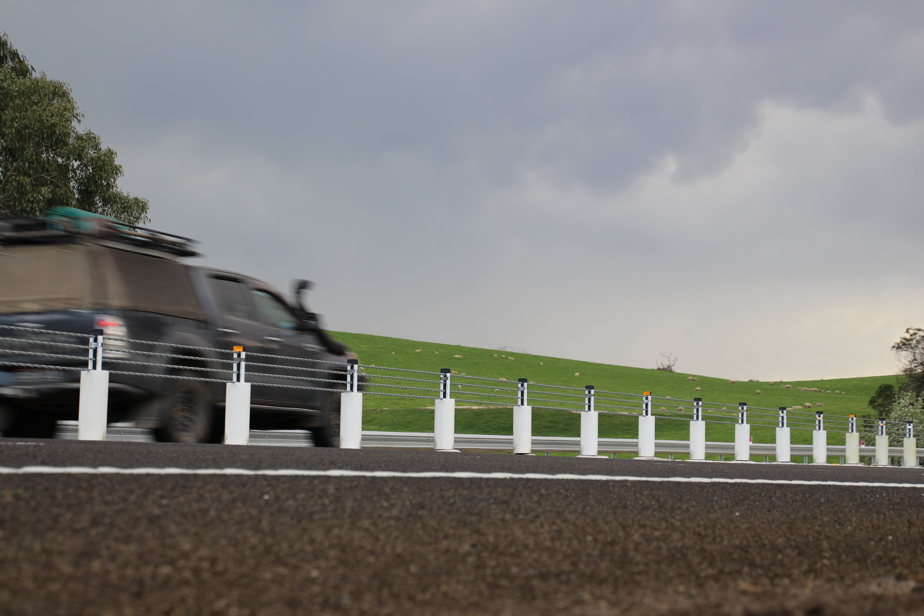

TRANSPORT  ACCIDENT  COMMISSION | 60 Brougham Street  Geelong Vic 3220  PO Box 742  Geelong Vic 3220  Ausdoc DX 216079 Geelong | Telephone 1300 654 329  STD Toll Free 1800 332 556  Fax: 03 9656 9300  www.tac.vic.gov.au  ABN 22 033 947 623

Contents

Status Report 4
Lives lost on Victorian roads 4
Injured claimants who were admitted to hospital within 7 days of accident, (by claim acceptance date – rolling 12 month, to 30th June 2017) 5
Lives lost: 12 months to 31st December 2017 6
Injured claimants who were admitted to hospital within 7 days of accident, 12 months to 30th June 2017 (claim acceptance date) 10
Lives Lost by Week (2012 to 2017) 12
The National Picture 13
Booze Bus Random Breath Testing 14
Random Drug Testing 14
Mobile Safety Camera Data 14
Explanations and References 15
Useful Internet Sites 16
Victorian monthly lives lost since 1951 18

Notes about the data in this report
- All data provided in this report is the data most recently available at time of production. Fatality data are updated to the end of report month. A 6-month lag applies to TAC claims data.
- Reported data will have one extra day of exposure for leap years.
- Data is subject to revision as additional information about known accidents/claims is received, and as new accident/claim reports are received and processed.

Status Report

Lives lost on Victorian roads
- In 2017, 259 people lost their lives on Victorian roads. This is 31 less lives lost than in 2016 when 290 people lost their lives.

Category | 2017 | 2016 | 2015 | 2017 v 2016 | 2017 v 2015 | 5 Year Average
Lives Lost (Rolling 12 Month Total)
Lives Lost (to December) | 259 | 290 | 252 | -31 | +7 | 258
per 10,000 veh | 0.53 | 0.61 | 0.55 | -0.08 | -0.02 | 0.57
per 100,000 pop | 4.09 | 4.69 | 4.24 | -0.60 | -0.15 | 4.36
Crashes (Rolling 12 Month Total)
Fatal crashes (to December) | 240 | 275 | 231 | -35 | +9 | 239
per 10,000 veh | 0.50 | 0.58 | 0.50 | -0.08 | 0.00 | 0.52
per 100,000 pop | 3.81 | 4.47 | 3.89 | -0.66 | -0.08 | 4.04

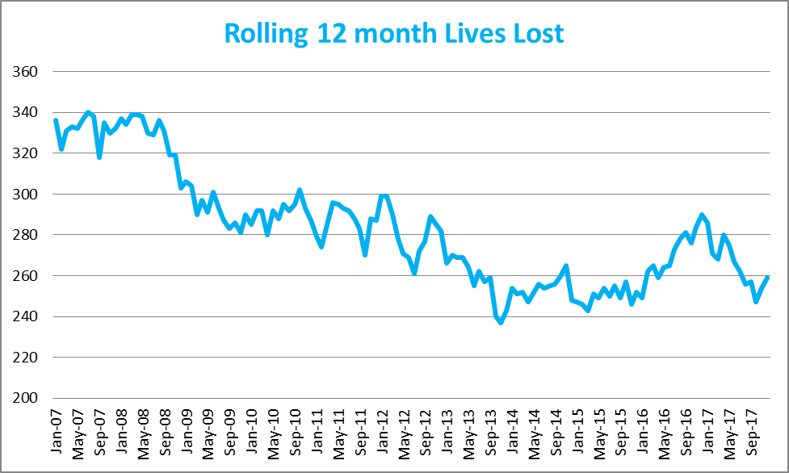
Victoria – Lives Lost, rolling 12 months total

Injured claimants who were admitted to hospital within 7 days of accident, (by claim acceptance date – rolling 12 month, to 30th June 2017)
Category | 2017 | 2016 | 2015 | 2017 v 2016 |  | 2017 v 2015 |  | 5 Year Average
Claims involving hospitalisation over 14 days (Rolling 12 Month Total)
Claims (to June) | 955 | 1,031 | 893 | -76.0 | (-7%) | +62 | (+7%) | 934
per 100,000 pop | 15.2 | 17.0 | 15.2 | -1.8 | (-11%) | 0.0 | (+0%) | 15.7
per 10,000 veh | 2.0 | 2.2 | 2.0 | -0.2 | (-9%) | 0.0 | (+0%) | 2.0
All claims involving hospitalisation (Rolling 12 Month Total)
Claims (to June) | 7,499 | 6,765 | 6,013 | +734 | (+11%) | +1486 | (+25%) | 6,301
per 100,000 pop | 119.1 | 111.6 | 102.0 | +7.5 | (+7%) | +17.1 | (+17%) | 107.0
per 10,000 veh | 15.7 | 14.5 | 13.1 | +1.2 | (+8%) | +2.6 | (+19%) | 13.9

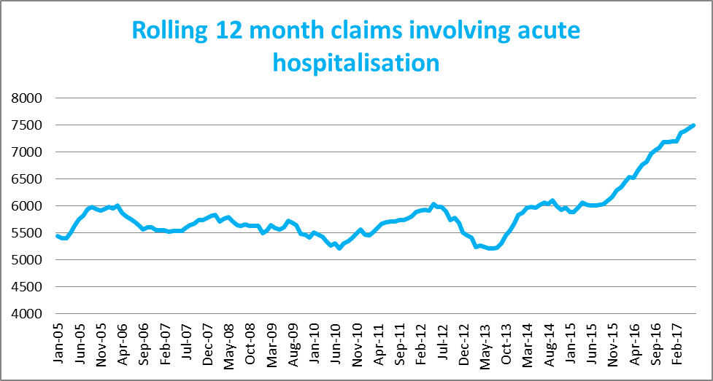
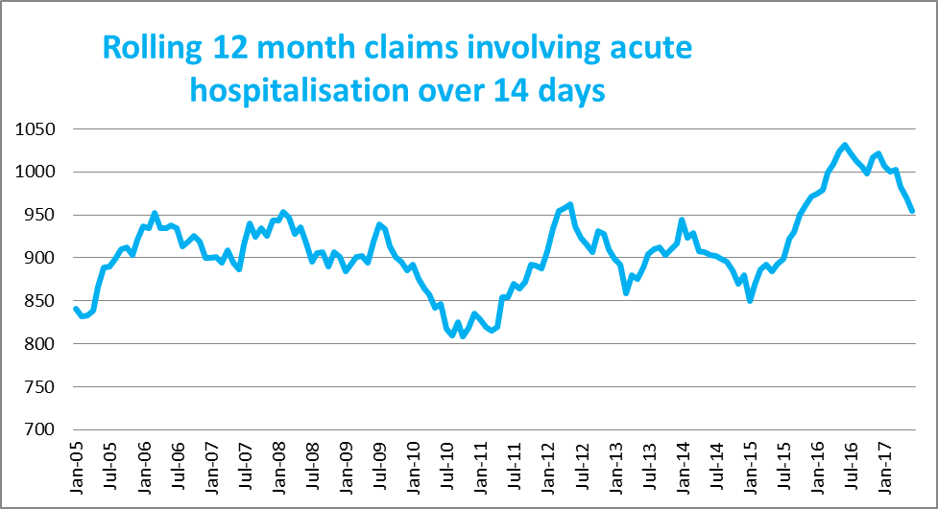

Lives lost: 12 months to 31st December 2017
Category | 2017 | 2016 | 2015 | 2017 v 2016 | 2017 v 2015 | 5 Year Average
Overview
Lives Lost | 259 | 290 | 252 | -31 | +7 | 258
Fatal Crashes | 240 | 275 | 231 | -35 | +9 | 239
Sex
Female | 69 | 81 | 73 | -12 | -4 | 75
Male | 190 | 209 | 179 | -19 | +11 | 183
Road user
Bicyclist | 12 | 8 | 10 | +4 | +2 | 9
Driver | 130 | 150 | 122 | -20 | +8 | 127
Motorcyclist | 38 | 56 | 30 | -18 | +8 | 39
Passenger | 48 | 36 | 57 | +12 | -9 | 46
Pedestrian | 31 | 40 | 33 | -9 | -2 | 37
Location
Melbourne | 102 | 140 | 115 | -38 | -13 | 114
Rural Victoria | 157 | 150 | 137 | +7 | +20 | 145
Age group
0-4 | 2 | 3 | 2 | -1 | 0 | 2
5-15 | 3 | 4 | 3 | -1 | 0 | 5
16-17 | 5 | 6 | 15 | -1 | -10 | 7
18-20 | 21 | 16 | 25 | +5 | -4 | 19
21-25 | 27 | 28 | 18 | -1 | +9 | 25
26-29 | 15 | 24 | 24 | -9 | -9 | 20
30-39 | 36 | 40 | 30 | -4 | +6 | 35
40-49 | 42 | 53 | 38 | -11 | +4 | 38
50-59 | 28 | 35 | 28 | -7 | 0 | 30
60-69 | 27 | 30 | 23 | -3 | +4 | 28
70+ | 52 | 50 | 46 | +2 | +6 | 49
Accident Type
Intersection
Adjacent direction | 36 | 26 | 34 | +10 | +2 | 33
Opposing direction | 11 | 7 | 12 | +4 | -1 | 8
Mid-block/other
Head on | 39 | 59 | 40 | -20 | -1 | 43
Same direction | 22 | 22 | 11 | 0 | +11 | 17
Manoeuvre/overtaking | 13 | 14 | 16 | -1 | -3 | 13
On path | 6 | 10 | 4 | -4 | +2 | 6
Single vehicle | 97 | 110 | 99 | -13 | -2 | 98
Other (incl pedestrians) | 35 | 42 | 36 | -7 | -1 | 41

Lives Lost: 12 months to 31st December 2017 – Continued

Category | 2017 | 2016 | 2015 | 5 Year Average | Category | 2017 | 2016 | 2015 | 5 Year Average
Local Government Area |  |  |  |  | Local Government Area
ALPINE | 0 | 0 | 0 | 1 | MANSFIELD | 2 | 4 | 1 | 3
ARARAT | 1 | 3 | 2 | 2 | MARIBYRNONG | 6 | 1 | 4 | 3
BALLARAT | 4 | 7 | 3 | 4 | MAROONDAH | 1 | 2 | 2 | 2
BANYULE | 3 | 1 | 3 | 2 | MELBOURNE | 4 | 4 | 4 | 4
BASS COAST | 3 | 3 | 0 | 3 | MELTON | 4 | 3 | 6 | 5
BAW BAW | 2 | 5 | 1 | 4 | MILDURA | 1 | 3 | 4 | 3
BAYSIDE | 5 | 2 | 2 | 3 | MITCHELL | 5 | 4 | 8 | 4
BENALLA | 5 | 0 | 4 | 2 | MOIRA | 8 | 4 | 6 | 4
BOROONDARA | 1 | 4 | 2 | 3 | MONASH | 6 | 6 | 3 | 4
BRIMBANK | 4 | 15 | 3 | 7 | MOONEE VALLEY | 1 | 4 | 2 | 3
BULOKE | 2 | 1 | 2 | 2 | MOORABOOL | 6 | 6 | 2 | 4
CAMPASPE | 6 | 2 | 4 | 5 | MORELAND | 0 | 6 | 3 | 4
CARDINIA | 6 | 7 | 8 | 6 | MORNINGTON PENINSULA | 4 | 10 | 8 | 7
CASEY | 8 | 10 | 5 | 6 | MOUNT ALEXANDER | 2 | 0 | 2 | 2
CENTRAL GOLDFIELDS | 1 | 2 | 0 | 2 | MOYNE | 2 | 1 | 2 | 2
COLAC-OTWAY | 5 | 3 | 4 | 3 | MURRINDINDI | 5 | 5 | 8 | 5
CORANGAMITE | 3 | 3 | 4 | 4 | NILLUMBIK | 0 | 5 | 2 | 2
DAREBIN | 4 | 2 | 3 | 3 | NORTHERN GRAMPIANS | 2 | 2 | 1 | 3
EAST GIPPSLAND | 9 | 5 | 9 | 6 | PORT PHILLIP | 2 | 0 | 2 | 2
FRANKSTON | 4 | 3 | 1 | 3 | PYRENEES | 6 | 1 | 0 | 1
GANNAWARRA | 3 | 0 | 0 | 1 | QUEENSCLIFFE | 0 | 0 | 0 | 0
GLEN EIRA | 1 | 4 | 1 | 2 | SOUTH GIPPSLAND | 3 | 3 | 4 | 4
GLENELG | 3 | 3 | 6 | 3 | SOUTHERN GRAMPIANS | 3 | 3 | 1 | 2
GOLDEN PLAINS | 6 | 1 | 5 | 2 | STONNINGTON | 1 | 0 | 4 | 2
GREATER BENDIGO | 6 | 5 | 5 | 6 | STRATHBOGIE | 4 | 1 | 4 | 3
GREATER DANDENONG | 7 | 1 | 6 | 4 | SURF COAST | 2 | 3 | 3 | 3
GREATER GEELONG | 7 | 11 | 4 | 8 | SWAN HILL | 2 | 3 | 1 | 3
GREATER SHEPPARTON | 8 | 8 | 9 | 7 | TOWONG | 2 | 1 | 1 | 1
HEPBURN | 2 | 6 | 0 | 3 | WANGARATTA | 4 | 5 | 2 | 4
HINDMARSH | 1 | 0 | 3 | 1 | WARRNAMBOOL | 0 | 1 | 1 | 1
HOBSONS BAY | 1 | 2 | 5 | 2 | WELLINGTON | 6 | 5 | 3 | 4
HORSHAM | 1 | 3 | 4 | 3 | WEST WIMMERA | 0 | 1 | 0 | 1
HUME | 1 | 4 | 6 | 6 | WHITEHORSE | 3 | 5 | 3 | 3
INDIGO | 1 | 7 | 1 | 4 | WHITTLESEA | 3 | 6 | 3 | 5
KINGSTON | 5 | 4 | 4 | 5 | WODONGA | 1 | 4 | 1 | 2
KNOX | 1 | 6 | 5 | 4 | WYNDHAM | 6 | 10 | 5 | 7
LATROBE | 5 | 5 | 2 | 5 | YARRA | 1 | 3 | 0 | 1
LODDON | 1 | 2 | 2 | 1 | YARRA RANGES | 7 | 7 | 11 | 7
MACEDON RANGES | 4 | 2 | 7 | 5 | YARRIAMBIACK | 1 | 2 | 0 | 1
MANNINGHAM | 2 | 4 | 0 | 2 | UNKNOWN | 1 | 0 | 0 | 0

Injured claimants who were admitted to hospital within 7 days of the accident with a hospital stay of more than 14 days, 12 months to 30th June (claim acceptance date)

Category | 2017 | 2016 | 2015 | 2017 v 2016 |  | 2017 v 2015 |  | 5 Year Average
Overview
Claims | 955 | 1,031 | 893 | -76 | -7% | +62 | 7% | 934
Sex
Female | 401 | 427 | 381 | -26 | -6% | +20 | 5% | 389
Male | 554 | 604 | 510 | -50 | -8% | +44 | 9% | 545
Road user
Bicyclist | 33 | 49 | 34 | -16 | -33% | -1 | -3% | 36
Driver | 359 | 394 | 343 | -35 | -9% | +16 | 5% | 370
Motorcyclist | 181 | 174 | 177 | +7 | 4% | +4 | 2% | 165
Passenger | 131 | 150 | 144 | -19 | -13% | -13 | -9% | 141
Pedestrian | 214 | 214 | 174 |  | 0% | +40 | 23% | 195
Train/Tram | 8 | 6 | 12 | +2 | 33% | -4 | -33% | 7
Location
Melbourne | 581 | 677 | 575 | -96 | -14% | 6 | 1% | 592
Rural Victoria | 332 | 306 | 294 | +26 | 8% | 38 | 13% | 316
Age group
0-4 | 5 | 4 | 4 | +1 | 25% | 1 | 25% | 3
5-15 | 11 | 18 | 17 | -7 | -39% | -6 | -35% | 13
16-17 | 14 | 13 | 12 | +1 | 8% | 2 | 17% | 13
18-20 | 57 | 66 | 41 | -9 | -14% | 16 | 39% | 58
21-25 | 89 | 85 | 79 | +4 | 5% | 10 | 13% | 84
26-29 | 47 | 59 | 55 | -12 | -20% | -8 | -15% | 49
30-39 | 132 | 137 | 104 | -5 | -4% | 28 | 27% | 118
40-49 | 116 | 111 | 114 | +5 | 5% | 2 | 2% | 115
50-59 | 119 | 115 | 110 | +4 | 3% | 9 | 8% | 110
60-69 | 120 | 125 | 104 | -5 | -4% | 16 | 15% | 112
70+ | 245 | 298 | 253 | -53 | -18% | -8 | -3% | 259
Accident Type
Intersection
Adjacent direction | 93 | 118 | 97 | -25 | -21% | -4 | -4% | 109
Opposing direction | 56 | 71 | 52 | -15 | -21% | 4 | 8% | 60
Mid-block/other
Head on | 78 | 97 | 87 | -19 | -20% | -9 | -10% | 87
Same direction | 70 | 76 | 90 | -6 | -8% | -20 | -22% | 77
Manoeuvre/overtaking | 46 | 59 | 50 | -13 | -22% | -4 | -8% | 56
On path | 18 | 32 | 37 | -14 | -44% | -19 | -51% | 26
Single vehicle | 238 | 300 | 264 | -62 | -21% | -26 | -10% | 258
Other (incl pedestrians) | 356 | 278 | 216 | +78 | 28% | 140 | 65% | 262

Note: Excludes rejected claims and claims for interstate crashes.
Injured claimants who were admitted to hospital within 7 days of the accident with a hospital stay of more than 14 days, 12 months to 30th June 2017 (claim acceptance date) – Continued

Category | 2017 | 2016 | 2015 | 5 Year Average | Category | 2017 | 2016 | 2015 | 5 Year Average
Local Government Area |  |  |  |  | Local Government Area
ALPINE | 5 | 1 | 5 | 2 | MANSFIELD | 12 | 2 | 2 | 3
ARARAT | 3 | 4 | 10 | 6 | MARIBYRNONG | 11 | 11 | 10 | 10
BALLARAT | 16 | 17 | 11 | 13 | MAROONDAH | 9 | 6 | 5 | 5
BANYULE | 9 | 12 | 8 | 9 | MELBOURNE | 30 | 34 | 35 | 29
BASS COAST | 5 | 6 | 10 | 9 | MELTON | 8 | 17 | 16 | 14
BAW BAW | 10 | 6 | 9 | 8 | MILDURA | 8 | 4 | 5 | 6
BAYSIDE | 13 | 9 | 9 | 9 | MITCHELL | 11 | 6 | 6 | 9
BENALLA | 3 | 5 | 4 | 4 | MOIRA | 10 | 4 | 5 | 7
BOROONDARA | 14 | 16 | 22 | 19 | MONASH | 23 | 30 | 16 | 20
BRIMBANK | 25 | 40 | 27 | 25 | MOONEE VALLEY | 13 | 24 | 20 | 19
BULOKE | 0 | 6 | 5 | 3 | MOORABOOL | 10 | 9 | 10 | 7
CAMPASPE | 14 | 7 | 9 | 7 | MORELAND | 31 | 26 | 30 | 25
CARDINIA | 19 | 18 | 13 | 13 | MORNINGTON PENINSULA | 25 | 32 | 25 | 26
CASEY | 31 | 48 | 26 | 28 | MOUNT ALEXANDER | 0 | 4 | 3 | 5
CENTRAL GOLDFIELDS | 1 | 4 | 1 | 3 | MOYNE | 4 | 1 | 3 | 3
COLAC-OTWAY | 8 | 8 | 11 | 7 | MURRINDINDI | 13 | 10 | 16 | 10
CORANGAMITE | 7 | 3 | 5 | 4 | NILLUMBIK | 6 | 10 | 11 | 7
DAREBIN | 24 | 22 | 19 | 17 | NORTHERN GRAMPIANS | 5 | 0 | 2 | 2
EAST GIPPSLAND | 16 | 8 | 10 | 9 | PORT PHILLIP | 15 | 18 | 19 | 14
FRANKSTON | 19 | 13 | 16 | 12 | PYRENEES | 1 | 2 | 2 | 1
GANNAWARRA | 2 | 2 | 3 | 3 | QUEENSCLIFFE | 0 | 1 | 0 | 1
GLEN EIRA | 10 | 16 | 12 | 15 | SOUTH GIPPSLAND | 9 | 13 | 9 | 6
GLENELG | 4 | 5 | 6 | 5 | SOUTHERN GRAMPIANS | 2 | 3 | 4 | 4
GOLDEN PLAINS | 6 | 10 | 4 | 6 | STONNINGTON | 12 | 17 | 14 | 13
GREATER BENDIGO | 16 | 15 | 10 | 13 | STRATHBOGIE | 6 | 11 | 6 | 9
GREATER DANDENONG | 23 | 30 | 15 | 23 | SURF COAST | 7 | 5 | 4 | 4
GREATER GEELONG | 28 | 18 | 26 | 25 | SWAN HILL | 4 | 6 | 6 | 3
GREATER SHEPPARTON | 22 | 19 | 10 | 12 | TOWONG | 1 | 3 | 1 | 2
HEPBURN | 2 | 3 | 6 | 3 | WANGARATTA | 7 | 7 | 7 | 6
HINDMARSH | 5 | 0 | 1 | 1 | WARRNAMBOOL | 4 | 3 | 2 | 4
HOBSONS BAY | 10 | 6 | 12 | 9 | WELLINGTON | 15 | 8 | 8 | 7
HORSHAM | 1 | 5 | 5 | 4 | WEST WIMMERA | 2 | 1 | 1 | 2
HUME | 30 | 36 | 32 | 26 | WHITEHORSE | 23 | 17 | 19 | 17
INDIGO | 3 | 12 | 2 | 4 | WHITTLESEA | 31 | 33 | 22 | 24
KINGSTON | 14 | 19 | 25 | 19 | WODONGA | 1 | 6 | 4 | 5
KNOX | 18 | 20 | 13 | 17 | WYNDHAM | 28 | 31 | 25 | 23
LATROBE | 6 | 12 | 14 | 11 | YARRA | 10 | 15 | 14 | 12
LODDON | 1 | 2 | 2 | 2 | YARRA RANGES | 30 | 38 | 34 | 29
MACEDON RANGES | 15 | 18 | 9 | 12 | YARRIAMBIACK | 1 | 1 | 0 | 1
MANNINGHAM | 17 | 13 | 11 | 13

Note: excludes rejected claims and claims for interstate crashes

Injured claimants who were admitted to hospital within 7 days of accident, 12 months to 30th June 2017 (claim acceptance date)

Category | 2017 | 2016 | 2015 | 2017 v 2016 |  | 2017 v 2015 |  | 5 Year Average
Overview
Claims | 7,499 | 6,765 | 6,013 | +734 | 11% | +1486 | 25% | 6,301
Sex
Female | 3,269 | 2,965 | 2,590 | +304 | 10% | +679 | 26% | 2,701
Male | 4,222 | 3,786 | 3,415 | +436 | 12% | +807 | 24% | 3,593
Road user
Bicyclist | 432 | 429 | 396 | +3 | 1% | +36 | 9% | 401
Driver | 3,642 | 3,140 | 2,710 | +502 | 16% | +932 | 34% | 2,923
Motorcyclist | 1,228 | 1,145 | 1,099 | +83 | 7% | +129 | 12% | 1,085
Passenger | 1,051 | 1,108 | 1,032 | -57 | -5% | +19 | 2% | 1,023
Pedestrian | 772 | 665 | 636 | +107 | 16% | +136 | 21% | 670
Train/Tram | 53 | 24 | 32 | +29 | 121% | +21 | 66% | 33
Location
Melbourne | 4,748 | 4,532 | 4,053 | +216 | 5% | +695 | 17% | 4,171
Rural Victoria | 2,213 | 1,928 | 1,732 | +285 | 15% | +481 | 28% | 1,881
Age group
0-4 | 59 | 49 | 47 | +10 | 20% | +12 | 26% | 51
5-15 | 198 | 226 | 227 | -28 | -12% | -29 | -13% | 202
16-17 | 114 | 130 | 99 | -16 | -12% | +15 | 15% | 107
18-20 | 546 | 509 | 472 | +37 | 7% | +74 | 16% | 504
21-25 | 946 | 825 | 712 | +121 | 15% | +234 | 33% | 783
26-29 | 652 | 578 | 492 | +74 | 13% | +160 | 33% | 512
30-39 | 1,212 | 1,090 | 924 | +122 | 11% | +288 | 31% | 982
40-49 | 1,126 | 945 | 916 | +181 | 19% | +210 | 23% | 931
50-59 | 974 | 823 | 780 | +151 | 18% | +194 | 25% | 796
60-69 | 704 | 681 | 541 | +23 | 3% | +163 | 30% | 588
70+ | 968 | 909 | 803 | +59 | 6% | +165 | 21% | 846
Accident Type
Intersection
Adjacent direction | 887 | 916 | 720 | -29 | -3% | +167 | 23% | 824
Opposing direction | 561 | 587 | 499 | -26 | -4% | +62 | 12% | 529
Mid-block/other
Head on | 350 | 351 | 298 | -1 | 0% | +52 | 17% | 327
Same direction | 1,055 | 1,020 | 924 | +35 | 3% | +131 | 14% | 920
Manoeuvre/overtaking | 371 | 415 | 332 | -44 | -11% | +39 | 12% | 354
On path | 264 | 306 | 303 | -42 | -14% | -39 | -13% | 271
Single vehicle | 1,518 | 1,724 | 1,735 | -206 | -12% | -217 | -13% | 1,609
Other (incl pedestrians) | 2,493 | 1,446 | 1,202 | +1047 | 72% | +1291 | 107% | 1,467

Note: excludes rejected claims and claims for interstate crashes
Injured claimants who were admitted to hospital within 7 days of accident, 12 months to 30th June 2017 (claim acceptance date) – Continued

Category | 2017 | 2016 | 2015 | 5 Year Average | Category | 2017 | 2016 | 2015 | 5 Year Average
Local Government Area |  |  |  |  | Local Government Area
ALPINE | 27 | 21 | 25 | 27 | MANSFIELD | 37 | 39 | 18 | 30
ARARAT | 22 | 13 | 27 | 16 | MARIBYRNONG | 88 | 75 | 73 | 66
BALLARAT | 104 | 104 | 67 | 79 | MAROONDAH | 64 | 62 | 55 | 51
BANYULE | 56 | 59 | 52 | 53 | MELBOURNE | 312 | 331 | 249 | 240
BASS COAST | 26 | 51 | 56 | 45 | MELTON | 89 | 86 | 83 | 70
BAW BAW | 54 | 38 | 50 | 50 | MILDURA | 25 | 34 | 25 | 32
BAYSIDE | 85 | 101 | 69 | 67 | MITCHELL | 88 | 55 | 60 | 55
BENALLA | 24 | 21 | 30 | 17 | MOIRA | 40 | 40 | 29 | 32
BOROONDARA | 138 | 122 | 131 | 117 | MONASH | 213 | 193 | 196 | 170
BRIMBANK | 158 | 136 | 149 | 132 | MOONEE VALLEY | 127 | 139 | 125 | 112
BULOKE | 11 | 11 | 11 | 10 | MOORABOOL | 50 | 49 | 42 | 44
CAMPASPE | 55 | 45 | 42 | 36 | MORELAND | 185 | 149 | 168 | 132
CARDINIA | 138 | 145 | 109 | 98 | MORNINGTON PENINSULA | 197 | 166 | 150 | 135
CASEY | 355 | 353 | 270 | 243 | MOUNT ALEXANDER | 17 | 23 | 27 | 24
CENTRAL GOLDFIELDS | 20 | 11 | 12 | 13 | MOYNE | 23 | 17 | 21 | 16
COLAC-OTWAY | 61 | 38 | 41 | 29 | MURRINDINDI | 73 | 57 | 64 | 55
CORANGAMITE | 46 | 23 | 27 | 24 | NILLUMBIK | 39 | 47 | 47 | 35
DAREBIN | 130 | 104 | 93 | 87 | NORTHERN GRAMPIANS | 17 | 15 | 18 | 16
EAST GIPPSLAND | 72 | 56 | 62 | 56 | PORT PHILLIP | 147 | 137 | 163 | 120
FRANKSTON | 142 | 136 | 126 | 112 | PYRENEES | 12 | 13 | 11 | 9
GANNAWARRA | 10 | 13 | 14 | 13 | QUEENSCLIFFE | 2 | 2 | 0 | 2
GLEN EIRA | 124 | 123 | 106 | 101 | SOUTH GIPPSLAND | 45 | 45 | 28 | 32
GLENELG | 21 | 20 | 17 | 17 | SOUTHERN GRAMPIANS | 14 | 28 | 22 | 25
GOLDEN PLAINS | 55 | 41 | 25 | 27 | STONNINGTON | 122 | 156 | 149 | 124
GREATER BENDIGO | 117 | 121 | 95 | 92 | STRATHBOGIE | 35 | 43 | 39 | 34
GREATER DANDENONG | 265 | 290 | 219 | 218 | SURF COAST | 60 | 60 | 29 | 36
GREATER GEELONG | 361 | 221 | 212 | 195 | SWAN HILL | 19 | 23 | 17 | 14
GREATER SHEPPARTON | 122 | 106 | 74 | 70 | TOWONG | 13 | 20 | 14 | 15
HEPBURN | 27 | 31 | 30 | 27 | WANGARATTA | 29 | 41 | 38 | 31
HINDMARSH | 12 | 8 | 7 | 8 | WARRNAMBOOL | 31 | 25 | 19 | 22
HOBSONS BAY | 75 | 69 | 67 | 59 | WELLINGTON | 74 | 71 | 78 | 63
HORSHAM | 25 | 27 | 22 | 19 | WEST WIMMERA | 10 | 4 | 3 | 4
HUME | 254 | 220 | 189 | 161 | WHITEHORSE | 174 | 122 | 94 | 100
INDIGO | 28 | 29 | 17 | 21 | WHITTLESEA | 241 | 190 | 146 | 143
KINGSTON | 126 | 151 | 139 | 127 | WODONGA | 23 | 35 | 25 | 26
KNOX | 154 | 125 | 110 | 99 | WYNDHAM | 160 | 149 | 158 | 135
LATROBE | 73 | 54 | 54 | 54 | YARRA | 122 | 125 | 116 | 100
LODDON | 8 | 8 | 16 | 11 | YARRA RANGES | 169 | 180 | 175 | 153
MACEDON RANGES | 90 | 74 | 62 | 60 | YARRIAMBIACK | 5 | 4 | 10 | 4
MANNINGHAM | 99 | 91 | 77 | 69

Note: excludes rejected claims and claims for interstate crashes

Lives Lost by Week (2012 to 2017)
Week |  |  |  |  |  |  | Cumulative | 12 Month
Ending | 2012 | 2013 | 2014 | 2015 | 2016 | 2017 | 2017 | Moving Total
1-Jan | 1 | 0 | 0 | 2 | 1 | 0 | 0 | 289
8-Jan | 3 | 3 | 2 | 2 | 1 | 2 | 2 | 290
15-Jan | 9 | 2 | 6 | 7 | 5 | 7 | 9 | 292
22-Jan | 7 | 6 | 6 | 4 | 3 | 4 | 13 | 293
29-Jan | 9 | 3 | 7 | 8 | 11 | 4 | 17 | 286
5-Feb | 4 | 7 | 9 | 6 | 3 | 2 | 19 | 285
12-Feb | 2 | 6 | 4 | 3 | 13 | 3 | 22 | 275
19-Feb | 10 | 4 | 6 | 6 | 4 | 6 | 28 | 277
26-Feb | 4 | 7 | 2 | 3 | 11 | 5 | 33 | 271
5-Mar | 1 | 1 | 5 | 5 | 9 | 4 | 37 | 266
12-Mar | 4 | 6 | 11 | 11 | 9 | 4 | 41 | 261
19-Mar | 12 | 7 | 3 | 3 | 5 | 5 | 46 | 261
26-Mar | 4 | 7 | 5 | 2 | 3 | 8 | 54 | 266
2-Apr | 7 | 5 | 7 | 4 | 1 | 3 | 57 | 268
9-Apr | 6 | 3 | 5 | 5 | 1 | 9 | 66 | 276
16-Apr | 2 | 4 | 4 | 7 | 7 | 8 | 74 | 277
23-Apr | 6 | 6 | 1 | 4 | 3 | 9 | 83 | 283
30-Apr | 2 | 4 | 2 | 6 | 5 | 2 | 85 | 280
7-May | 10 | 6 | 4 | 3 | 7 | 4 | 89 | 277
14-May | 2 | 3 | 4 | 8 | 3 | 7 | 96 | 281
21-May | 5 | 0 | 5 | 4 | 6 | 3 | 99 | 278
28-May | 5 | 4 | 6 | 2 | 7 | 7 | 106 | 278
4-Jun | 4 | 9 | 6 | 5 | 4 | 0 | 106 | 274
11-Jun | 6 | 3 | 2 | 6 | 6 | 4 | 110 | 272
18-Jun | 4 | 2 | 2 | 5 | 5 | 2 | 112 | 269
25-Jun | 7 | 4 | 3 | 3 | 7 | 7 | 119 | 269
2-Jul | 4 | 2 | 10 | 9 | 5 | 4 | 123 | 268
9-Jul | 2 | 5 | 7 | 5 | 2 | 6 | 129 | 272
16-Jul | 4 | 7 | 3 | 2 | 7 | 5 | 134 | 270
23-Jul | 5 | 5 | 5 | 2 | 7 | 7 | 141 | 270
30-Jul | 5 | 2 | 3 | 6 | 8 | 1 | 142 | 263
6-Aug | 2 | 8 | 4 | 3 | 7 | 4 | 146 | 260
13-Aug | 4 | 2 | 6 | 8 | 7 | 7 | 153 | 260
20-Aug | 5 | 4 | 6 | 10 | 6 | 6 | 159 | 260
27-Aug | 10 | 8 | 3 | 3 | 11 | 6 | 165 | 255
3-Sep | 5 | 1 | 5 | 3 | 2 | 7 | 172 | 260
10-Sep | 4 | 6 | 6 | 2 | 3 | 6 | 178 | 263
17-Sep | 6 | 3 | 4 | 4 | 4 | 2 | 180 | 261
24-Sep | 4 | 6 | 6 | 6 | 4 | 4 | 184 | 261
1-Oct | 2 | 4 | 3 | 4 | 5 | 2 | 186 | 258
8-Oct | 8 | 3 | 4 | 7 | 5 | 3 | 189 | 256
15-Oct | 10 | 2 | 6 | 3 | 5 | 5 | 194 | 256
22-Oct | 8 | 3 | 1 | 6 | 4 | 3 | 197 | 255
29-Oct | 5 | 5 | 7 | 8 | 6 | 0 | 197 | 249
5-Nov | 5 | 8 | 2 | 2 | 4 | 9 | 206 | 254
12-Nov | 7 | 4 | 9 | 4 | 6 | 6 | 212 | 254
19-Nov | 7 | 3 | 5 | 5 | 4 | 5 | 217 | 255
26-Nov | 5 | 9 | 3 | 3 | 8 | 10 | 227 | 257
3-Dec | 8 | 3 | 12 | 5 | 10 | 3 | 230 | 250
10-Dec | 7 | 6 | 3 | 8 | 4 | 6 | 236 | 252
17-Dec | 4 | 11 | 4 | 1 | 7 | 4 | 240 | 249
24-Dec | 4 | 9 | 1 | 4 | 1 | 12 | 252 | 260
31-Dec | 6 | 2 | 3 | 5 | 8 | 7 | 259 | 259
Total | 282 | 243 | 248 | 252 | 290 | 259

The National Picture
State | Lives Lost (12 months to December)
 | 2017 | 2016 | 2015 | 2014 | 2017 v 2016
NSW | 247 | 380 | 350 | 307 | -133 | (-35%)
VIC | 259 | 290 | 252 | 248 | -31 | (-11%)
QLD | 248 | 251 | 243 | 223 | -3 | (-1%)
SA | 101 | 86 | 102 | 108 | +15 | (+17%)
WA | 161 | 196 | 161 | 182 | -35 | (-18%)
TAS | 36 | 36 | 33 | 36 |  | (0%)
NT | 31 | 45 | 49 | 39 | -14 | (-31%)
ACT | 5 | 11 | 15 | 10 | -6 | (-55%)
AUST TOTAL | 1,088 | 1,295 | 1,205 | 1,153 | -207 | (-16%)
AUST minus VIC | 829 | 1,005 | 953 | 905 | -176 | (-18%)
State | Lives Lost per 10,000 registered vehicles |  |  | Fatalities per 100,000 population
 | (12 months to December) |  |  | (12 months to December)
 | 2017 | 2016 | 2015 | 2017 | 2016 | 2015
NSW | 0.44 | 0.70 | 0.66 | 3.14 | 4.91 | 4.59
VIC | 0.53 | 0.61 | 0.55 | 4.10 | 4.69 | 4.24
QLD | 0.62 | 0.64 | 0.64 | 5.03 | 5.18 | 5.08
SA | 0.72 | 0.63 | 0.75 | 5.86 | 5.02 | 6.11
WA | 0.72 | 0.89 | 0.73 | 6.24 | 7.66 | 5.38
TAS | 0.76 | 0.78 | 0.73 | 6.91 | 6.96 | 6.39
NT | 2.01 | 2.87 | 3.14 | 12.60 | 18.31 | 20.05
ACT | 0.17 | 0.38 | 0.53 | 1.22 | 2.53 | 3.84
AUST TOTAL | 0.57 | 0.70 | 0.66 | 4.43 | 5.35 | 5.07
AUST minus VIC | 0.59 | 0.73 | 0.70 | 4.55 | 5.57 | 5.34

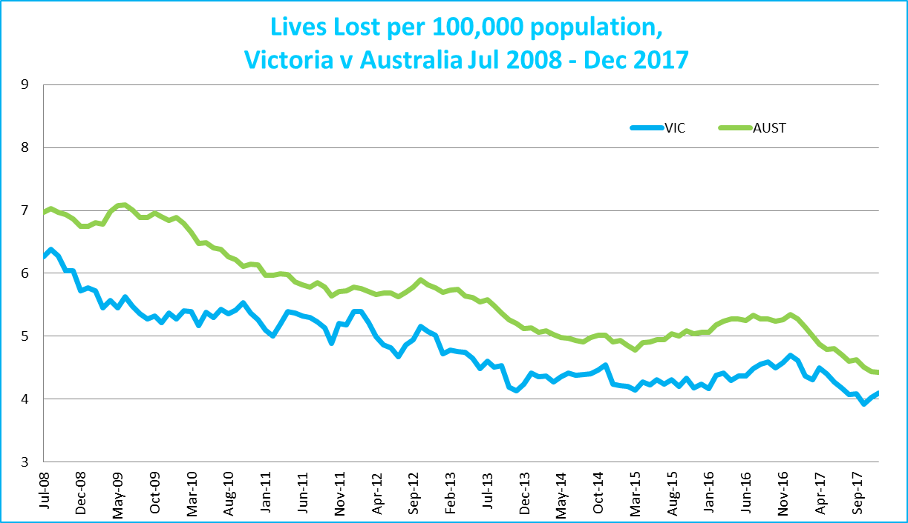
Victoria v Australia – 12 Month Moving Lives Lost Rate

Booze Bus Random Breath Testing
12 months to December 2017 (monthly totals)
 | 2017
 | Jan | Feb | Mar | Apr | May | Jun | Jul | Aug | Sep | Oct | Nov | Dec
Melbourne | 93,277 | 96,341 | 83,713 | 83,566 | 83,363 | 88,913 | 89,786 | 98,917 | 98,907 | 117,207 | 88,467 | 108,748
Country | 7,061 | 7,572 | 5,230 | 19,820 | 18,261 | 10,793 | 4,525 | 4,304 | 8,261 | 12,889 | 14,307 | 15,152
Vic Total | 100,338 | 103,913 | 88,943 | 103,386 | 101,624 | 99,706 | 94,311 | 103,221 | 107,168 | 130,096 | 102,774 | 123,900

Random Drug Testing
Random Drug Tests (12 months to December 2017 vs previous 12 months)

 | 2017 | 2016 | 2015 | 2017 v 2016 |  | 2017 v 2015
Victoria | 100,231 | 94,905 | 106,440 | +5326 | (+6%) | -6209 | (-6%)
12 months to December 2017 (monthly totals)
 | 2017
 | Jan | Feb | Mar | Apr | May | Jun | Jul | Aug | Sep | Oct | Nov | Dec
Victoria | 8,984 | 6,177 | 10,141 | 8,766 | 7,972 | 9,369 | 7,246 | 7,055 | 7,184 | 8,060 | 10,542 | 8,735

Mobile Safety Camera Data
Speed Infringements Issued from Mobile Cameras (monthly totals)
 |  |  |  |  |  |  |  | Monthly Average = |  |  | 30,241
2017
Jan | Feb | Mar | Apr | May | Jun | Jul | Aug | Sep | Oct | Nov | Dec
32,310 | 30,732 | 33,179 | 31,176 | 34,445 | 27,838 | 31,079 | 29,788 | 28,581 | 33,953 | 28,402 | 21,408
Excessive Speed Infringements (ESI) Issued from Mobile Cameras (monthly totals)
 |  |  |  |  |  |  | Monthly Average = |  |  |  | 324
2017
Jan | Feb | Mar | Apr | May | Jun | Jul | Aug | Sep | Oct | Nov | Dec
305 | 335 | 354 | 330 | 405 | 315 | 323 | 362 | 272 | 332 | 279 | 272
Notes: An ESI is defined as 25km/h over the speed limit except in a 110km/h zone where it is 20km/h over the limit.

Explanations and References
LGA: Local Government Areas. Crash locations for acute hospitalised claims are assigned to LGA’s based on the crash postcode recorded by Victoria Police. Crash locations for fatal crashes are coded exactly to an LGA by Victoria Police.
Claimants: Refers to people injured in transport accidents who have an accepted claim with the TAC.
Hospitalisation: refers to all hospital admission that occurred within 7 days of accident.

Useful Internet Sites
TAC Sites
- TAC Safety (Road Safety) www.tacsafety.com.au
- TAC How safe is your car www.howsafeisyourcar.com.au
- TAC How safe is your first car www.howsafeisyourfirstcar.com.au
- TAC Motorcycle Safety Website www.spokes.com.au
- TAC Corporate site www.tac.vic.gov.au
- Drivesmart www.drivesmart.vic.gov.au
- Ridesmart www.ridesmartonline.com.au
Victorian Sites:
- VicRoads www.vicroads.vic.gov.au
- Victoria Police www.police.vic.gov.au
- Parliamentary Road Safety Committee https://www.parliament.vic.gov.au/57th-parliament/rsc
- RACV www.racv.com.au
- Monash University Accident Research Centre www.monash.edu.au/muarc
- Cameras Save Lives www.camerassavelives.vic.gov.au
- VicRoads Learner Driver Site www.lsite.vicroads.vic.gov.au/Learners
- Road Safety Education Victoria www.roadsafetyeducation.vic.gov.au
National and Interstate Sites:
- ARRB Transport Research www.arrb.com.au
- Australian Transport Safety Bureau www.atsb.gov.au
- Motor Accidents Authority (NSW) www.maa.nsw.gov.au
- Motor Accidents Insurance Board (TAS) www.maib.tas.gov.au
- Motor Accident Commission, Allianz (SA) www.mac.sa.gov.au
- Motor Accidents Compensation, TIO, (NT) www.tiofi.com.au/mac
- Insurance Commission of Western Australia www.icwa.wa.gov.au
- Motor Accident Insurance Commission (QLD) www.maic.qld.gov.au
International Sites:
- National Highway Traffic Safety Admin (USA) www.nhtsa.dot.gov
- Swedish Road and Transport Institute (VTI) www.vti.se
- SWOV Institute for Road Safety Research www.swov.nl
Related Sites:
- Alcohol and Drug Foundation www.adf.org.au
Figures
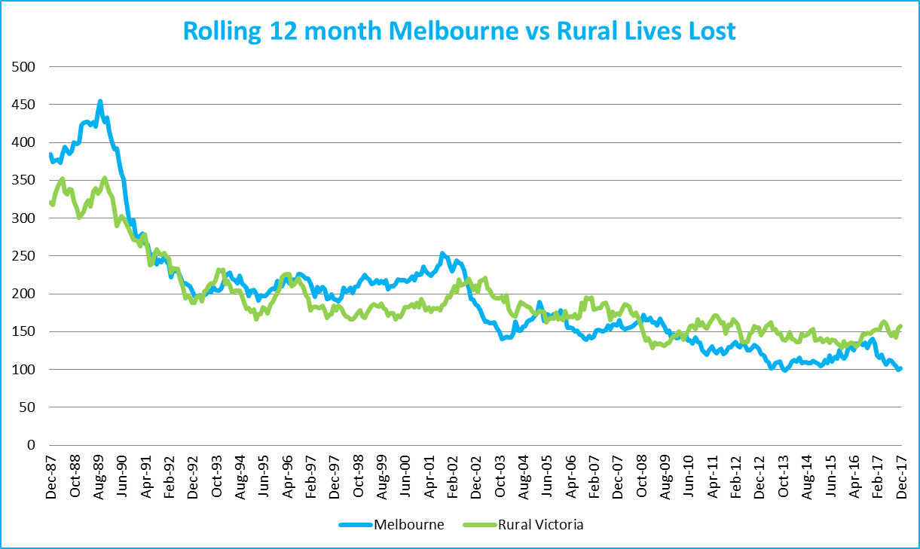
Graph 1a – Melbourne/country lives lost
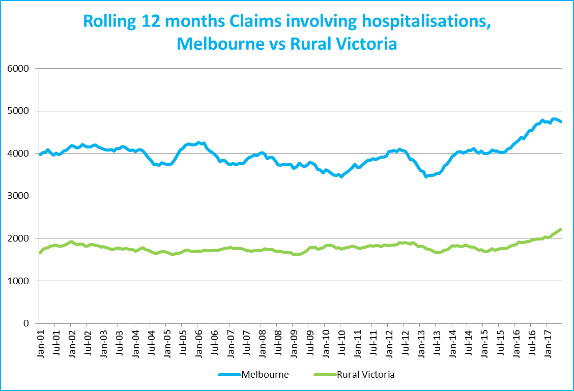
Graph 1b – Melbourne/country Claims involving an acute hospital admission

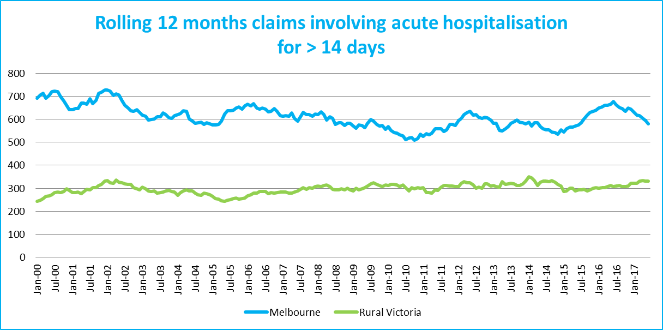
Graph 1c – Melbourne/country Claims involving hospital admission greater than 14 days

Victorian monthly lives lost since 1951



