Your client’s privacy
The TAC will retain the information provided and may use or disclose it to make further inquiries or assist in the ongoing management of the claim or any claim for common law damages. The TAC may also be required by law to disclose this information.
Without this information, the TAC may be unable to determine entitlements or assess whether treatment is reasonable and may not be able to approve further benefits and treatment.

1. Client details
Claim number |  | Date of birth |  | Date of accident
Click or tap here to enter text. |  | DD / MM / YYYY |  | DD / MM / YYYY
Client name
Click or tap here to enter text.
Client address
Click or tap here to enter text.
Suburb: Click or tap here to enter text. | Post code XXXX
Contact person |  | Contact person phone number
Click or tap here to enter text. |  | Click or tap here to enter text.
Client email
Click or tap here to enter text.
 |  | Date of assessment |  | Date of report
 |  | DD / MM / YYYY |  | DD / MM / YYYY

2. Background information
2(A). Please outline the injuries this client sustained in their transport accident (include any complications from injuries, e.g. epilepsy)
Click or tap here to enter text.
2(B). Pre accident injuries and illnesses
Click or tap here to enter text.
2(C). Current non-accident related injuries or illnesses
Click or tap here to enter text.
2(D). Client’s current physical functional status (i.e. transfers, indoor/outdoor mobility, upper and lower limb function, balance, splinting, equipment required, such as hoists, manual or powered wheelchairs)
Click or tap here to enter text.

3. Request details
Modifications to the client’s own vehicle | Choose Yes or No.

Contribution to a standard vehicle and modifications | Choose Yes or No.

Contribution to a modified wheelchair accessible van | Choose Yes or No.

4. Client’s anticipated driving status
Client as a driver | Choose Yes or No.

Client as a passenger | Choose Yes or No.

Client as a driver and passenger | Choose Yes or No.

Client as a passenger now, with potential to drive in the future | Choose Yes or No.
If client is a driver:
Licence category (specify, e.g. car, motorcycle) |  | Click or tap here to enter text.

Current licence | Choose Yes or No.

If yes, are there restrictions imposed? | Choose Yes or No.
If this client has a restricted licence, please provide details of those restrictions.
Click or tap here to enter text.

Has this client had a driving assessment since their injury? | Choose Yes or No.

If yes, what is the date of their last driving assessment? | DD / MM / YYYY

If no, are they required to have a driving assessment? | Choose Yes or No.
If there has been an OT driving assessment completed, please attach a copy of the Occupational therapy driving assessment report and VicRoads Medical Report Form.
Any additional comments
Click or tap here to enter text.
If client is a passenger:
If this client is a passenger only, please comment on who will be driving the vehicle, have they been consulted and if training requirements exist?
Click or tap here to enter text.

5. Current/pre accident vehicle
In order for the TAC to determine reasonable contribution, please outline the details of the client’s existing or pre accident vehicle or other vehicles client has access to. Please complete the following:
 | Client’s current vehicle | Client’s pre accident vehicle
Make & model (e.g. Holden Commodore) | Click or tap here to enter text. | Click or tap here to enter text.
Variant/Badge (e.g. Omega, SV6) | Click or tap here to enter text. | Click or tap here to enter text.
Year of manufacture | Click or tap here to enter text. | Click or tap here to enter text.
Current kilometres | Click or tap here to enter text. kms | Click or tap here to enter text. kms
Registration plate | Click or tap here to enter text. | Click or tap here to enter text.
Engine capacity (1.5L, 2.0L) | Click or tap here to enter text. L | Click or tap here to enter text. L
Type of transmission (auto or manual) | Click or tap here to enter text. | Click or tap here to enter text.
Fuel type (diesel/petrol/hybrid) | Click or tap here to enter text. | Click or tap here to enter text.
Year of purchase | Click or tap here to enter text. | Click or tap here to enter text.

Other vehicles that the client has access to (family members, work vehicles etc.)
Make & model (eg. Holden Commodore) | Click or tap here to enter text. | Click or tap here to enter text.
Variant/Badge (eg. Omega, SV6) | Click or tap here to enter text. | Click or tap here to enter text.
Year of manufacture | Click or tap here to enter text. | Click or tap here to enter text.
Current kilometres | Click or tap here to enter text. kms | Click or tap here to enter text. kms
Registration plate | Click or tap here to enter text. | Click or tap here to enter text.
Engine capacity (1.5L, 2.0L) | Click or tap here to enter text. L | Click or tap here to enter text. L
Type of transmission (auto or manual) | Click or tap here to enter text. | Click or tap here to enter text.
Fuel type (diesel/petrol/hybrid) | Click or tap here to enter text. | Click or tap here to enter text.
Year of purchase | Click or tap here to enter text. | Click or tap here to enter text.

How often does this client have access to these vehicles? If access to these vehicles is limited, please outline the reasons why.
Click or tap here to enter text.

Is the above vehicle currently available for this client’s use and suitable for modifications? | Choose Yes or No.
If no, please provide rationale below
Click or tap here to enter text.

6. Transport needs
Please indicate other people/items required to be transported in this vehicle now and in the future.
Please indicate whether equipment items will adequately fit in available space in proposed vehicle. Please include predicted needs
if client’s needs are expected to change in the future. Consider equipment that has been provided / awaiting prescription or is yet to
be investigated.
 | Current status | Anticipated future status
People (number and relationship of people who would be using the vehicle apart from the client) | Click or tap here to enter text. | Click or tap here to enter text.
Equipment (e.g. ramps, wheelchair, scooter, mobile hoist, gait aids) | Click or tap here to enter text. | Click or tap here to enter text.
Other | Click or tap here to enter text. | Click or tap here to enter text.

7. Client’s wheelchair specifications
If applicable, please outline the details of all wheelchairs the client will be seated in when travelling or transferring from/into vehicle
Manual (folding/rigid frame) | Choose Yes or No.

Power | Choose Yes or No.

Type & model | Click or tap here to enter text.
Wheelchair footprint
Overall dimensions when client sitting in wheelchair in usual travel posture and with accessories / medical equipment attached.
Include diagram if appropriate
Type and model | Manual wheelchair | Power wheelchair | 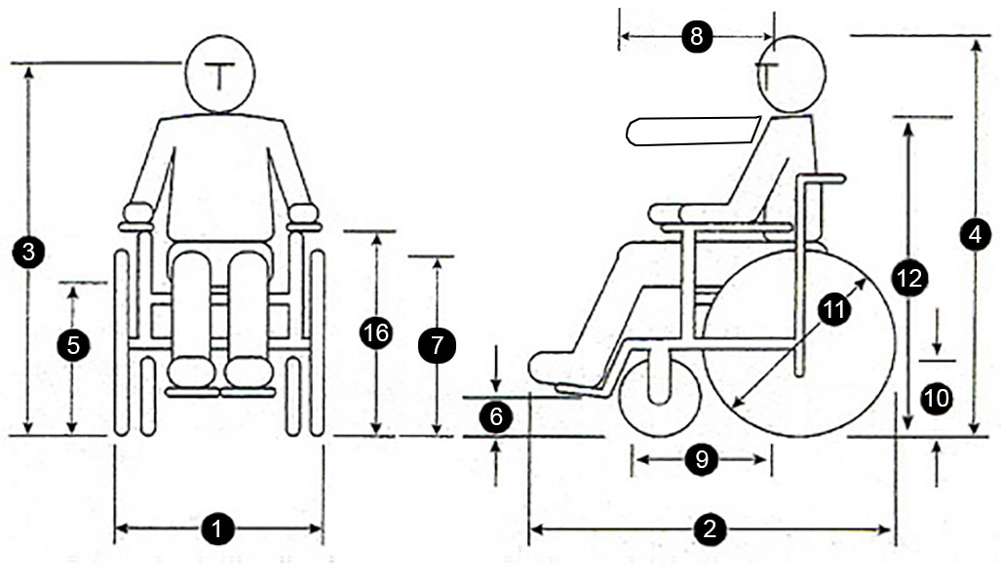
- Chair width | mm. mm | mm. mm
- Chair length | mm. mm | mm. mm
- Floor to eye height | mm. mm | mm. mm
- Floor to top of head | mm. mm | mm. mm
- Floor to seat height | mm. mm | mm. mm
- Floor to  footplate height | mm. mm | mm. mm
- Floor to knee height | mm. mm | mm. mm
- Arm extension | mm. mm | mm. mm
- Thigh length | mm. mm | mm. mm
- Castor (front)  wheel size | mm. mm | mm. mm
- Back wheel size/e-motion wheel size | mm. mm | mm. mm
- Floor to shoulder height | mm. mm | mm. mm
- Headrest fitted? | Yes or No. | Yes or No.
- Chair weight | kg. kg | kg. kg
- Combined weight  in chair | kg. kg | kg. kg
- Floor to armrest height | mm. mm | mm. mm
- Is the chair suitable  to have a docking  pin fitted? | Yes or No. | Yes or No.

Is client’s current vehicle/car able to have recommended adaptive equipment and structural modifications installed? | Yes or No.

8. Recommended vehicle modifications/vehicle
Please outline rationale for all recommendations
When travelling in the vehicle, recommended seating arrangement for this client is to be: |  | Comments
Driver seated in wheelchair | Yes or No. | Click or tap here to enter text.
Driver seated in vehicle seat | Yes or No. | Click or tap here to enter text.
Passenger seated in wheelchair | Yes or No. | Click or tap here to enter text.
Passenger seated in vehicle seat | Yes or No. | Click or tap here to enter text.

 | Detailed recommendations and clinical justification
- Wheelchair access into vehicle and within vehicle (ramp/hoist, door openings, rear/side entry, required clearance dimensions) | Click or tap here to enter text.
- Vehicle seating arrangements (i.e. Where will client sit in vehicle? Other seats required in vehicle? Where does this client wish to sit in the vehicle?) | Click or tap here to enter text.
- Is specific seating required? (i.e. seat belts,  special seats, head supports) | Click or tap here to enter text.
- Are modified vehicle controls required?  (e.g. left foot accelerator, hand controls) | Click or tap here to enter text. kms
- What wheelchair restraints and seatbelt requirements are you recommending?  (e.g. docking station/tie downs) | Click or tap here to enter text.
- Are specific vehicle options required?  (e.g. transmission type) | Click or tap here to enter text. L
- Other | Click or tap here to enter text.
- Are there other optional extras that this client would like that are not clinically essential? Have you discussed with this client that they may be asked to pay for these optional extras? (e.g. metallic paint) | Click or tap here to enter text.
- If equipment is to be transported, please comment on how it is to be loaded and stowed. (e.g. Can this client load equipment with the help of hoists/lifts? Will a carer be required to load and stow equipment?) | Click or tap here to enter text.

Are you requesting the TAC to contribute to a new vehicle / second-hand vehicle? | Choose Yes or No.

9. Alternate vehicle/cars and modifications
Please provide details of all vehicles that have been considered as a part of this assessment process.
Please ensure quotes are itemised.
Click or tap here to enter text.
Outline the most appropriate make and model of vehicle to meet the client’s transport needs. Provide details and clinical justification for your recommendation and include client’s preference. Include itemised quotes for both vehicle purchase and modifications.
Click or tap here to enter text.

10. Vehicle availability
Have you discussed with this client, their family and carers, the need to ensure that the proposed vehicle is | Choose Yes or No.
readily available for client use (i.e. the vehicle must be free for use and readily accessible when needed)?
Comments
Click or tap here to enter text.

11. Vehicle access at home
What parking options are available at this client’s home for the proposed vehicle? Has an appropriate location for the vehicle
been established?
Comments
Click or tap here to enter text.
What are the spatial dimensions of the area where loading and unloading will occur, and external dimensions of the proposed vehicle? Is there room for safe loading and unloading, and wheelchair access around the parked vehicle?
Comments
Click or tap here to enter text.
What is the height of the existing garage / car port? Will the proposed vehicle have adequate clearance, including when the tail gate
is fully open?
Comments
Click or tap here to enter text.
Is it recommended that the vehicle will reverse or front in to the parking / loading area?
Comments
Click or tap here to enter text.
Does the parking area allow for this client to load and exit the vehicle in an undercover area? Is undercover loading and exit
clinically required?
Comments
Click or tap here to enter text.
What is the condition (surface, gradient, drainage etc.) of the current parking area and driveway, and is it anticipated that access to the proposed vehicle would require any structural modification to this area?
Comments
Click or tap here to enter text.

12. Insurance / registration
Has the client been made aware that he/she will be required to pay for the following? Do they indicate that they understand this?
Comprehensive insurance and any excess incurred by client/carers in case of an accident | Choose Yes or No.

TAC levy / registration fee | Choose Yes or No.

Any additional options to the vehicle not required due to transport accident injuries | Choose Yes or No.

Maintenance and repair of vehicle | Choose Yes or No.

Fuel | Choose Yes or No.
Additional notes
Click or tap here to enter text.

Client authorisation
Have you discussed this Vehicle Needs and Modifications Assessment Report with the client or the | Choose Yes or No.
client’s representative?
Has the client or the client’s representative consented to supply the TAC with the personal and | Choose Yes or No.
health information collected?

Provider details
Provider name, address and phone number
Use practice stamp where possible
 |  | Qualifications
 |  | Click or tap here to enter text.
 |  | Days/hours available |  | Date
 |  | Click or tap here to enter text. |  | DD / MM / YYYY
 |  | Signature
Two signature options:
- Insert image (jpg/png) of signature in field above and submit by email.
- Print the form, sign by hand, scan and submit by email.

