Stage One EOI Competition Entry Requirements
Stage One: Submission EOI Questions
You are required to answer a series of questions. Please answer in the text box underneath each question then save and upload as a PDF as your Stage One submission. You must answer all questions for your submission to be considered.

Topic 1 - Target User Groups (2-part question)
- Nominate the target user groups in priority order from 1 to 4, with 1 being the highest priority.

Cyclists (non-powered)
Drivers/Passengers
Powered Two Wheelers
Pedestrians

2) For your highest priority road user group, provide justification for your selection including some narrative supporting the reasons for your priority order.
(100 words or less)

Topic 2 – Design Options (4-part question)
1) Treatment Selection – prioritise these from worst to best
Consistent with the Project Cycle in Figure 2 of the Brief, there is a need to select appropriate treatments. In this case, you have been given a range of concept designs for treatments options (images below that are in random order), and while considering all the real-world project information, you are asked to prioritise these from worst to best. Using the title on each image, order from 1 – 9, 1 being the worst and 9 being the best. Re-ordering of the images is not required in your response (just use the text box below).

2) Beside each design, provide a very brief reason for ranking these treatments
(30 words or less per concept design)

- [title + reason for ranking]
- –
- –
- –
- –
- –
- –
- –
- –

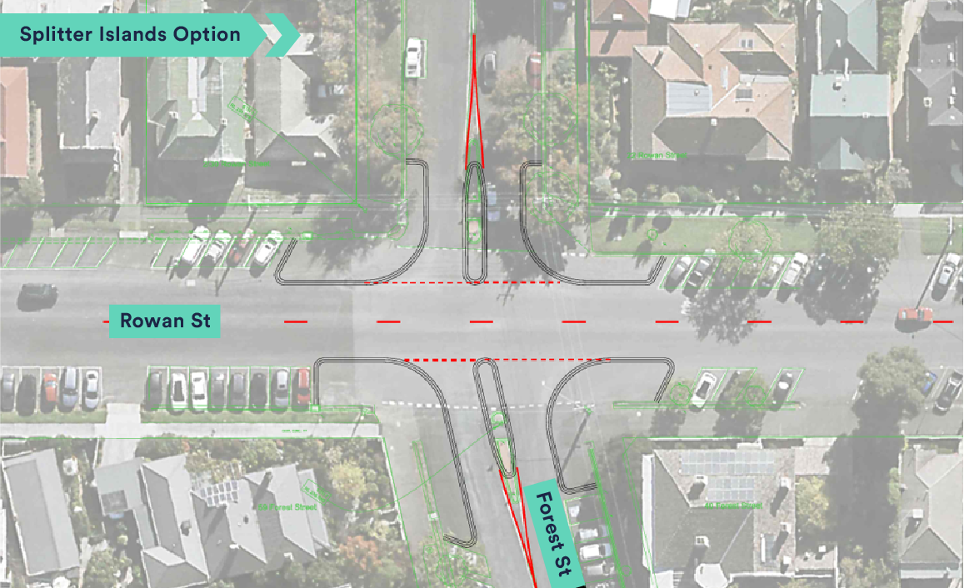

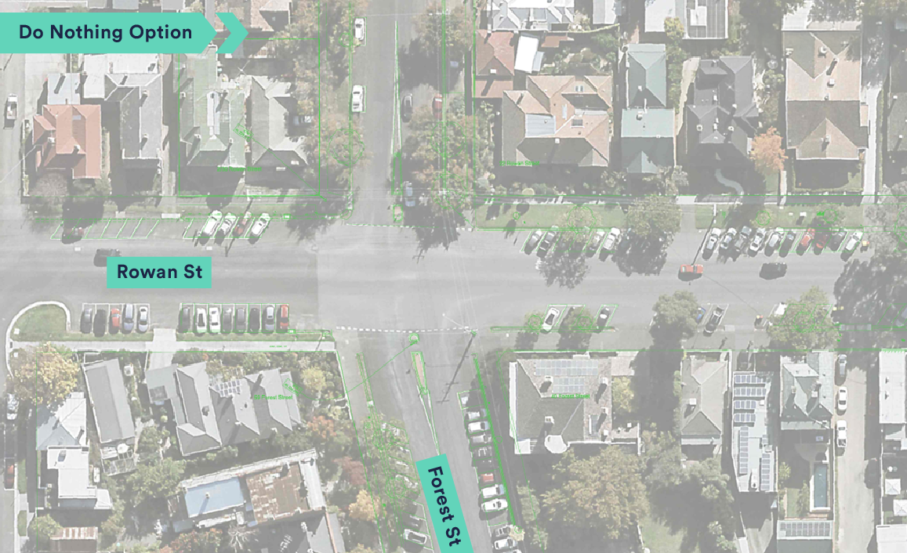
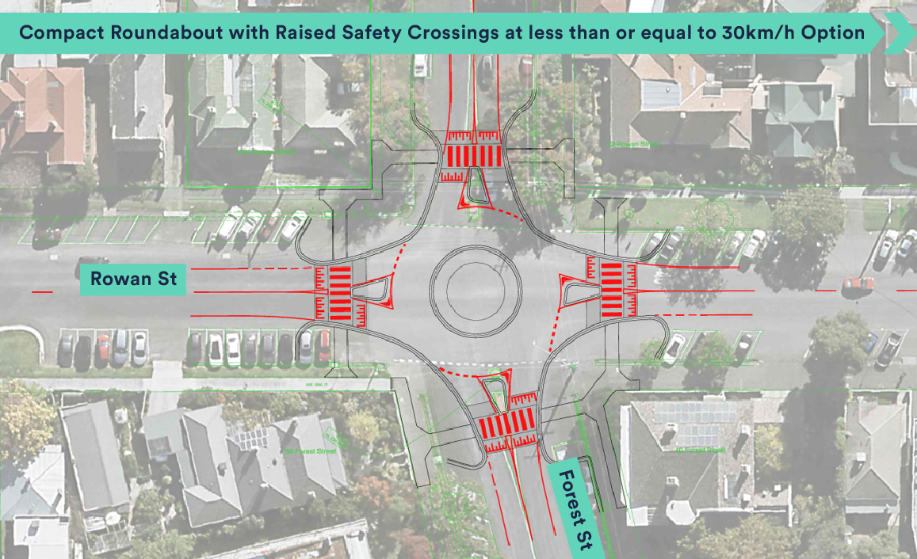
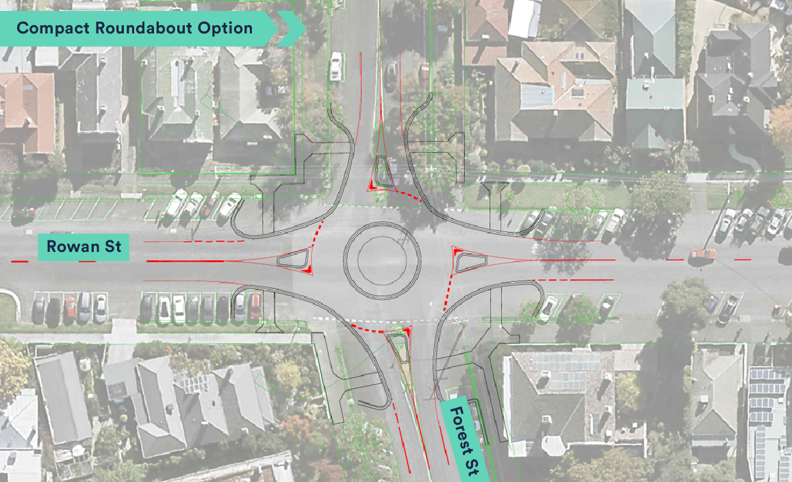

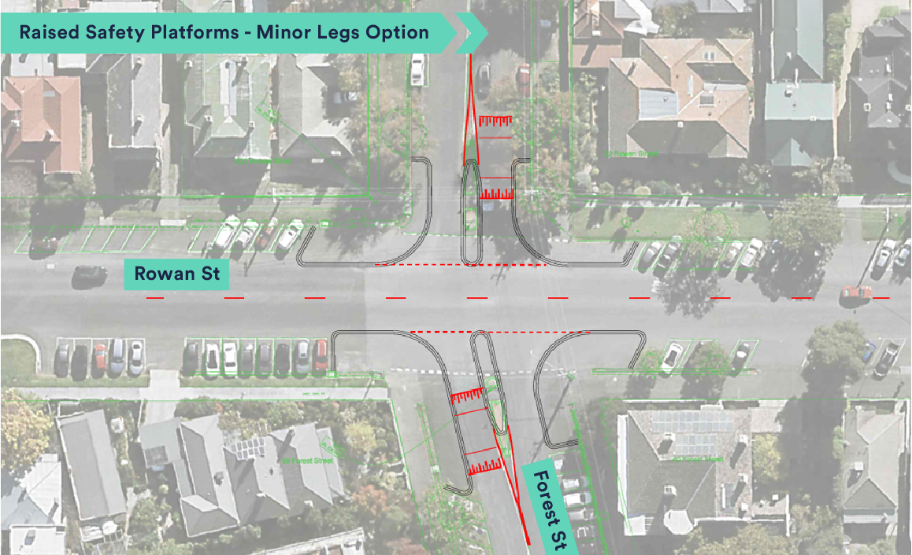
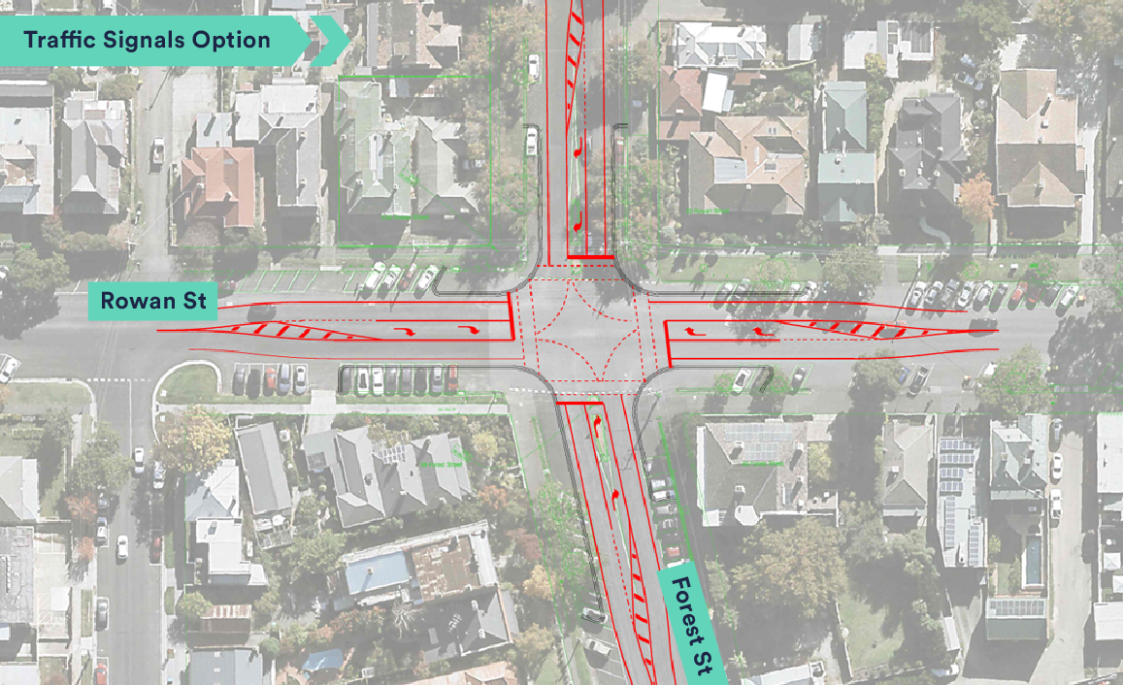
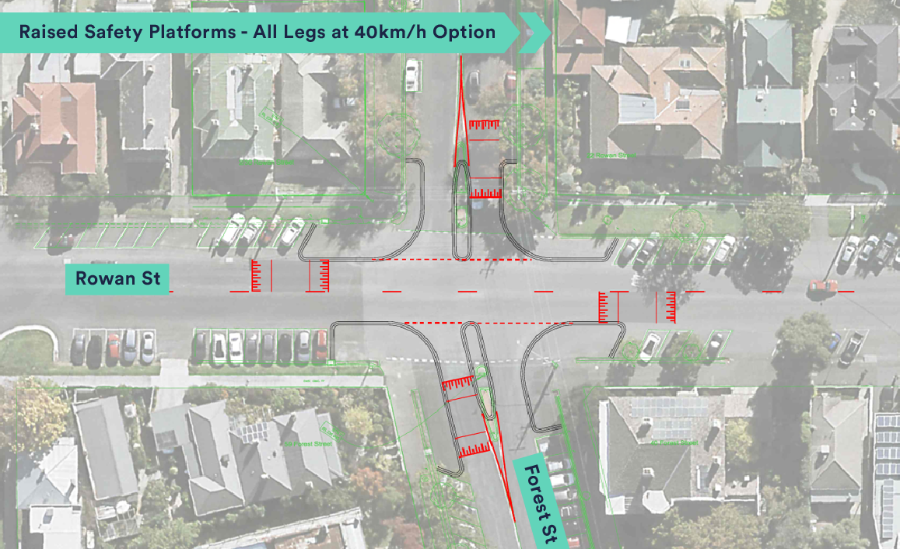

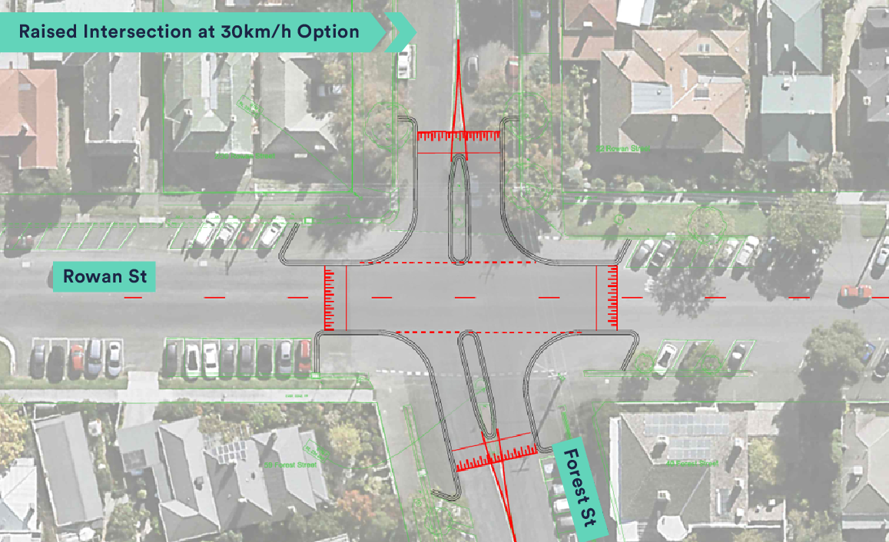
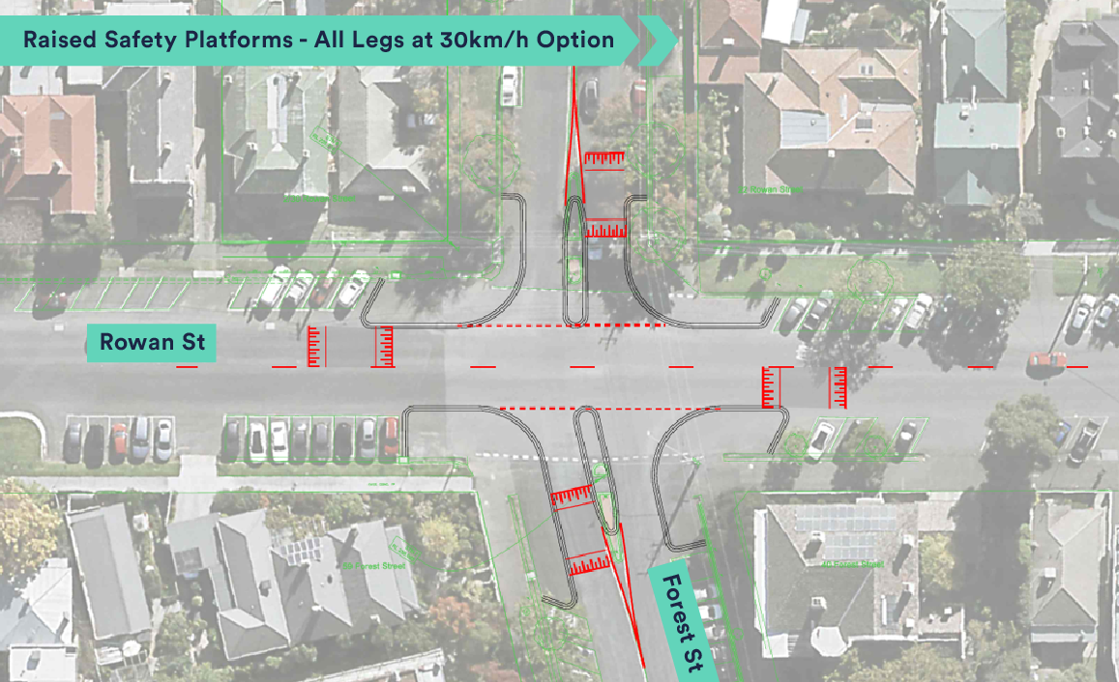

3) Nominate your preferred concept design. Briefly describe the technical benefits of this design solution.
(100 words or less)

4) Briefly describe the benefits for the community in simple terms.
(100 words or less)

Topic 3 – Safe System Alignment
How will your preferred concept design virtually eliminate the potential for serious injury for the target road user groups?
(400 words or less, graphics and/or tables are permitted)

