
Road Safety Monitor
2023 Report

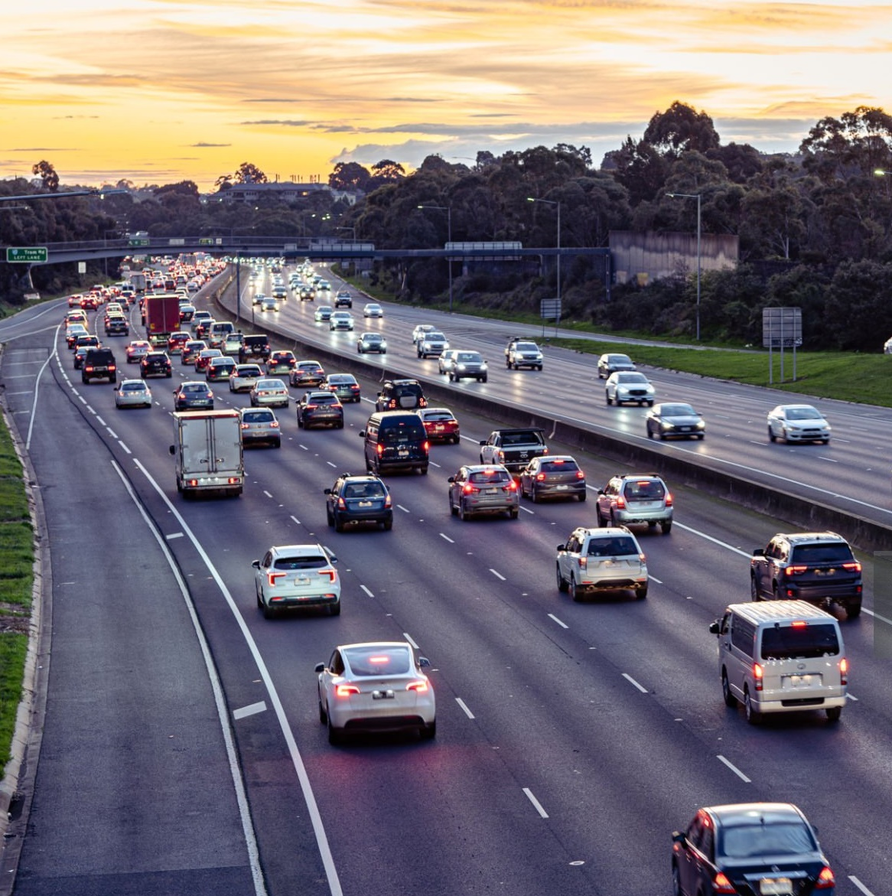


Ref: 4985 | August 2024
Prepared for
Transport Accident Commission (TAC)
Ref: 4985 | August 2024

 | Accreditations
ISO 27001: ISO 27001 is the highest standard for information security management systems, providing you with assurance that Wallis systems, processes and people are keeping your data safe.
ISO 20252: ISO 20252 is the international standard for market, opinion and social research, and ensures all stages of the research project are delivered to a quality that can be relied upon.
The Research Society member: The Research Society is Australia's largest research and insights community. Members have access to the latest industry knowledge, tools, quality assurances and professional standards.
ADIA Trust Mark Research Organisation: The Australian Data and Insights Association (ADIA) is the peak industry body for data, insights and research organisations in Australia. ADIA Trust Mark research organisations are compliant with the highest ethical, quality and privacy standards.
Australian Achiever Awards: The Australian Achiever Awards recognises the customer service excellence of Australian companies. Wallis has been awarded a high commendation every year since the inception of these awards in 1999.
Cyber security: Wallis is an acknowledged leader in data protection and privacy. Our system is regularly subjected to external penetration testing and we are a Privacy Awareness Week supporter – committed to sharing our knowledge with others. Wallis is also active member of the Australian Cyber Security Centre (ACSC) Partnership Program.
B Corporation: Wallis has been certified by B Lab Australia and New Zealand having shown that we meet high standards of social and environmental performance, transparency, and accountability. At Wallis, our approach to corporate social responsibility reflects our mission – to have a positive impact on society.

Wallis acknowledges that we are on the traditional lands of the Wurundjeri People and pay our respect to elders past and present. We extend that respect to all Aboriginal and Torres Strait Islander peoples.

Table of Contents
Executive Summary i
Summary of Findings i
1 Introduction 1
1.1 Background and objectives 1
1.2 Research objectives 2
1.3 Reading this report 3
2 Behaviours at a glance 5
3 Detailed Findings 6
3.1 Prevalence of heightened-risk driving behaviours 7
3.2 Driving Behaviour Index 9
3.3 Speeding 16
3.4 Drink driving 28
3.5 Distracted driving 38
3.6 Tired driving 45
3.7 Drug driving 51
3.8 Seatbelt use 56
3.9 Transport use 60
3.10 Enforcement 66
3.11 Towards Zero 70
4 Research methodology 71

Appendix 1 Driving Behaviour Index
Appendix 2 Subgroup reporting
Appendix 3 RSM Questionnaire
Appendix 5 Data analysis

List of Figures
Figure 1 Prevalence of heightened-risk driving behaviours 7
Figure 2 Number of heightened-risk driving behaviours performed by drivers 8
Figure 3 Driver Behaviour Index summary 9
Figure 4 Selected DBI Demographic Skews ‘Low’ vs ‘Extremely High’ 12
Figure 5 Proportion of ‘Extremely high’ DBIs by behaviours engaged in 13
Figure 6 Safety-conscious driving behaviours (% ‘always’) 14
Figure 7 Unsafe driving behaviours (% ‘never’) 14
Figure 8 Prevalence of intentional speeding behaviours 16
Figure 9 Frequency of intentionally speeding 3km/h over the limit (%) 17
Figure 10 Frequency of intentionally speeding 10km/h over the limit (%) 17
Figure 11 Low-level speeding (3 km/h+) by year: ‘ever’ at any speed limit (%) 18
Figure 12 High-level speeding (10 km/h+) by quarter & year: ‘ever’ at any speed limit (%) 18
Figure 13 Prevalence of speeding at 3 km/h by demographic interactions 19
Figure 14 Perceived danger of low-level speeding at different speed limits (average score 0–10) 21
Figure 15 Sometimes have to drive over the speed limit (% agree 4–5) 22
Figure 16 Likelihood of feeling embarrassed for being caught speeding at different levels (% said they would be embarrassed (4–5)) 23
Figure 17 Speeding penalties are ‘revenue raising’ by speeding behaviour (% agree (4–5)) 24
Figure 18 Perceived enforcement risk by speeding behaviour (% feel they are likely (4–5) to get caught) 25
Figure 19 Self-perceptions of driving safely by speeding behaviour (average score 1–5) 25
Figure 20 Support and opposition for reducing residential road speed limit from 50 km/h to 40 km/h 26
Figure 21 Support and opposition for reducing narrow country roads speed limit from 100 km/h to 80 km/h 26
Figure 22 Support and opposition for more areas such as shopping strips with high pedestrian traffic becoming 40 km/h zones 27
Figure 24 Prevalence of drinking and drink driving* 28
Figure 25 Frequency of drinking and driving (%) 29
Figure 26 Alcohol use by year: ‘ever’ (%) 29
Figure 27 Drink driving when over the legal BAC limit by year: ‘ever’ (%) 30
Figure 28 Drink driving when under, might have been over and over by quarter and year ‘ever’ (%) 30
Figure 29 Perceived control over drink driving 34
Figure 30 Perceived danger of drink driving at different BAC levels among drink driving categories 35
Figure 31 Social norms (% embarrassed 4-5) towards drink driving among drink driving categories 36
Figure 32 Perceived enforcement risk (% likely (4-5) to be caught) among drink driving categories 37
Figure 33 Self-perceptions of driving safely among drink driving categories 37
Figure 34 Prevalence of hand-held mobile phones use while driving 38
Figure 35 Frequency of activities performed on mobile phones while driving (%) 39
Figure 36 Hand-held mobile phone use while driving by year: ‘sometimes’ or more often (%) 39
Figure 37 Prevalence of mobile phone use by demographic interactions 40
Figure 38 Perceived danger of using a hand-held mobile phone while driving 42
Figure 39 Social norms for using a hand-held mobile phone while driving 43
Figure 40 Perceived enforcement risk by hand-held mobile phone use categories 43
Figure 41 Self-perceptions of driving safely by hand-held mobile phone use categories 44
Figure 42 Mobile phone apps used while driving 44
Figure 43 Prevalence of tired driving 45
Figure 44 Frequency of driving tired 45
Figure 45 Driving while quite tired and very tired by year: ‘ever’ (%) 46
Figure 46 Perceived control over tired driving (% agree) 49
Figure 47 Perceived danger of driving while very tired 50
Figure 48 Self-perceptions of driving safely by tired driving categories 50
Figure 49 Prevalence of illegal drug use and drug driving 51
Figure 50 Drug driving by year: ‘ever’ (%) 51
Figure 51 Perceived danger of driving soon after using cannabis 54
Figure 52 Perceived enforcement risk among drug driving categories 55
Figure 53 Self-perceptions of driving safely among drug driving categories 55
Figure 54 Prevalence of seatbelt noncompliance among drivers and passengers 56
Figure 55 Noncompliance with seatbelt use by year: ‘ever’ (%) 57
Figure 56 Perceived enforcement risk among seatbelt wearing categories (% likely) 58
Figure 57 Self-perceptions of driving safely among seatbelt wearing categories 59
Figure 58 Frequency of transport mode use 60
Figure 59 Prevalence of E-device use 61
Figure 60 Days per week driving a vehicle for commuting 63
Figure 61 Days per week driving a vehicle for work-related purposes besides commuting 63
Figure 62 Suggested changes to make Victorian roads safer 64
Figure 63 Crash prevalence 65
Figure 64 Prevalence of being caught speeding 66
Figure 65 Prevalence of being pulled over by the police 67
Figure 66 Perceived enforcement risk of breaking road rules 67
Figure 67 Caught speeding by intentional speeding categories 68
Figure 68 Pulled over for breath test by drink driving categories 68
Figure 69 Perceived enforcement risk by enforcement experience (NET: Likely (4-5) %) 69
Figure 70 Support for Toward Zero (%) 70
Figure 71 Achievable number of lives lost in a single year 70

List of Tables
Table 1 Significance reporting example table 3
Table 2 DBI percentiles and changes by year 10
Table 3 DBI Membership by selected demographic factors 11
Table 4 Safety-conscious and unsafe driving behaviours by DBI Membership 15
Table 5 Prevalence of speeding among demographics 19
Table 6 Speeding behaviour by DBI Membership 20
Table 7 Prevalence of drinking and driving behaviours among demographics 31
Table 8 Prevalence of driving after drinking under the legal BAC by demographic interactions 32
Table 9 Drink driving behaviour by DBI Membership 33
Table 10 Hand-held mobile phone use among demographics 40
Table 11 Distracted driving behaviour by DBI Membership 41
Table 12 Prevalence of tired driving among demographics 46
Table 13 Prevalence of driving quite tired by demographic interactions 47
Table 14 Prevalence of driving very tired by demographic interactions 47
Table 15 Tired driving behaviour by DBI Membership 48
Table 16 Prevalence of illegal drug use among demographics 52
Table 17 Prevalence of drug driving among demographics 52
Table 18 Drug driving and drug use behaviour by DBI Membership 53
Table 19 Prevalence of noncompliance with seatbelt use among demographics 57
Table 20 Tired driving behaviour by DBI Membership 58
Table 21 Prevalence of transport use among demographics 61
Table 22 Prevalence of E–device use among demographics 62
Table 23 Fieldwork schedule 72
Table 24 Sample performance 74

Executive Summary
The Road Safety Monitor (RSM) was first conducted in 2001 and has continuously tracked community attitudes over this time. In 2022, the RSM questionnaire was redeveloped to provide more nuance around road user attitudes and behaviour. Given these changes, the RSM report in 2023 now focuses on differences between 2022 and 2023.

Key trends in 2023
Speeding
Intentionally exceeding the speed limit remained consistent between 2022 and 2023, with a majority of drivers reporting low–level speeding at some time in the previous three months. Speeding behaviour continues to be more prevalent in higher speed limit zones.
In both 2023 and 2022, just under two–thirds of respondents (64%) drove 3 km/h or more over the speed limit, while a quarter of respondents in 2023 (25%) and 2022 (26%) drove 10 km/h or more over the speed limit. Speeding in 100 km/h zones was most common (3 km/h or more: 51% and 10 km/h or more: 21%), while speeding in 40 km/h was least common (3 km/h or more: 38% and 10 km/h or more: 9%).
Drinking and Drink Driving
While the majority of Victorians have consumed alcohol in the past 12 months (72%), there has been some decline from the peak recorded in 2019 (78%). The change may be in part due to a change in how this metric is determined.
Drink driving when over the legal BAC limit in the previous 12 months steadily declined from a high of 6% in 2017 to now 3% in 2023.
Considering other drink driving behaviour over a 12–month period, 43% of respondents reported driving after drinking when they were confidently under their BAC limit and 10% drive when they ‘might have been over’.
Distracted driving
Driving while using a handheld mobile phone continues to be a relatively high prevalence risky driving behaviour. About half (51%) of respondents reported using a handheld mobile phone while driving at some time in the past week to interact with an app (46%), make or receive a call (25%), or send or read a message (23%). Navigation (92%) and music (62%) were the most apps used while driving.
Considering ‘regular’ use of a handheld mobile phone while driving (‘sometimes’ or more frequent), 29% did so in 2023. The incidence of this behaviour has remained at a similar level since 2019 (31%). Before 2019, a decrease had been observed with 37% reporting this behaviour in 2016.
Tired Driving
Tired driving remains a prevalent behaviour, although driving when very tired is less prevalent. Two–thirds of respondents in 2022 (66%) and 2023 (65%) drove while “quite tired” in the last 12 months, while one–fifth in 2022 (20%) and in 2023 (21%) drove while “very tired, so tired they struggled to keep their eyes open”.
Drug Driving
Drug driving is a very low prevalence behaviour. Only 1.0% of respondents in 2023 and in 2022 reported doing this in the last 12 months. Before 2022, the highest prevalence of this behaviour was 2.2%.
Seatbelt Non–use
Non–compliance with seatbelt use increased slightly, however, remains largely in line with previous years’ results. In 2023, 4.2% reported not wearing a seatbelt as a passenger in the last 12 months, while 2.7% reported not wearing a seatbelt as a driver, compared to 3.6% and 2.3% respectively in 2022.
Behavioural Insights
Insights relating to dangerous driving behaviours have been core to the RSM since 2022. The Driver Behaviour Index (DBI) provides a single metric that describes the overall level of risky driving behaviour in Victoria’s driving population.
Although the prevalence of high–risk behaviours remained consistent with 2022, the reported frequency of performing these high–risk behaviours increased. This resulted in a higher DBI score being recorded for the 95th percentile. This means there was a higher level of risk associated with the highest–risk drivers than was the case in 2022.

Summary of Findings

Overview of risky driving behaviour
In the RSM, respondents were asked to what extent they perform 11 heightened–risk behaviours while driving. Most engaged in one or more heightened–risk behaviour (86%), while more than a third engaged in four or more behaviours (36%). Among drivers, more than half reported driving:
- while quite tired (65%)
- over the speed limit by 3 km/h or more (64%)
- while using a handheld mobile phone (51%).
A substantial minority engaged in risker behaviours such as driving after drinking when under the legal BAC (43%), driving 10 km/h over the speed limit (25%), or driving while very tired (21%).
Extremely risky behaviours tended to have much lower prevalence, with 10% driving when they ‘might’ have been over their legal BAC and 3% who drove when they were over their legal BAC. A small percentage travelled as a passenger while not wearing a seatbelt (4%) or drove a vehicle while not wearing a seatbelt (3%). One percent drove after using illegal drugs.
Driving Behaviour Index
A Driving Behaviour Index was developed in 2022 to explore tendencies towards high–risk behaviour among drivers. The index is a scale from 0 to 100, accounting for the relative severity of driving behaviours and frequency of behaviours to determine a respondent’s score. A higher score indicates higher risk. The median DBI in 2023 was 13 with 18% of drivers having a DBI of 26 or higher, which was a substantial increase from 2022 (12%).
Compared to those with lower DBI scores, drivers with high DBI scores were more likely to be truck drivers, motorcycle riders, commercial van drivers, aged 18–39, living in rural areas, male, and users of e–devices for transport on the road.
Speed and speed limits
Speeding was one of the most prevalent risky behaviours on the roads, although most intentional speeding behaviour was low–level and infrequent. Considering the level of speeding, although 64% of respondents reported driving 3 km/h or more over the speed limit, the percentage that reported driving 10 km/h or more over the speed limit was 25%.
Respondents were most likely to exceed the speed limit on 100 km/h roads. However, the extent to which drivers ever exceeded the speed limit was similar across 40 km/h (38%) 50 km/h (44%), 60 km/h (47%) and 100 km/h roads (51%).
Considering the frequency of speeding in 100 km/h speed limit zones, 49% never did, while 25% did so ‘rarely’, 20% ‘sometimes’ and 7% ‘most of the time’.
As the frequency scale and number of speed limits respondents were asked to consider in relation to speeding behaviour changed in 2022 compared to previous years, the time series results are not directly comparable. However, we note that an increasing trend in speeding was observed across 2020 (51%), 2021 (55%), and 2022 (64%), which has steadied in 2023 (64%).
Respondents who drove over the speed limit, compared to those who did not, tended to be more open to risk, perceived the risk of speeding as lower, had a lower self–perception that they could avoid speeding, and would feel less embarrassed if they were caught speeding. These differences were more marked among respondents who engaged in high–level speeding compared to those who speed at low levels.
A sizable minority of respondents agreed that ‘speeding penalties are just revenue raising’ (35%), a belief that was more prevalent among those who exceeded the speed limit by 10 km/h or more.
There was no consensus among respondents for hypothetical speed limit changes. There is majority support for areas such as shopping strips with high pedestrian traffic becoming 40 km/h zones (59%) and close to half (46%) support reducing speed limits on narrow country roads from 100 km/h to 80 km/h while more than half (53%) oppose reducing speed limits on residential streets from 50 km/h to 40 km/h.
Respondents who drove 10 km/h or more over the limit were three times more likely to have an ‘extremely high’ DBI compared to other respondents.
Drink driving
Most respondents reported having consumed alcohol in the last 12 months (72%) and close to half of drivers (44%) had driven a vehicle after drinking alcohol. Continuing from the 2022 RSM redesign, three levels of drink driving were explored; driving after drinking when confident the driver’s BAC level was below the legal limit (43%), driving when the driver might have been over the legal BAC limit (10%) and driving when definitely over the legal BAC limit (3%).
While there have been some changes to methodology used to determine illegal drink driving, the overall trend suggests that intentionally driving while over the legal BAC is declining. However, many drivers drove after drinking alcohol, rather than separating drinking and driving. Moreover, 10% drove close enough to their legal BAC that they were unsure whether they were over their limit or not.
Driving after drinking any alcohol was most prevalent among males and respondents living in rural Victoria. Males were more likely than females to have driven near, or over, the legal BAC, but otherwise this behaviour was similar across demographic groups.
The risks of drink driving were well understood by drivers, although there was a substantial difference in the perceived risk of driving soon after having one drink (5.6 out of 10) compared to driving when over a BAC of 0.05 (9.0 out of 10). Respondents who drove when they might have been or were over the limit were substantially less likely to perceive driving over a BAC of 0.05 (7.9 vs 9.0 out of 10) as dangerous. This same group was also substantially less likely to perceive as dangerous driving soon after one drink (3.6 vs 5.6 out of 10).
Although respondents who drove when near, or over, their legal BAC were similarly likely to believe that ‘sometimes you have to drive even though you might be over your legal BAC’ compared to those who did not drink and drive (2% vs 1%) – the vast majority believed they have control as to whether they drink and drive.
Drink driving enforcement not only carries financial and licensing weight, but social weight as well. Nearly all respondents reported that they would be embarrassed if caught drink driving when over the limit (92%). However, respondents who drove when under the limit (94%) were most likely to be embarrassed if caught, while those who drove when they were or might have been over were least likely (84%).
Those who drove after drinking were less likely to believe they could get caught for breaking road rules. While just over third of all respondents (36%) believed they were likely to get caught, just 19% of those who drove when they might have been or were over the limit believed they were likely.
Respondents who drove when they might have been or were over the limit were over five times as likely to have an ‘extremely high’ DBI compared to other respondents.

Drug Driving
Use of illegal drugs is a low incidence behaviour (4.6%) and driving after using illegal drugs is lower still (1.0%). While drug–use slightly decreased from 2022 (5.2%), driving after using illegal drugs has increased, albeit slightly, from 0.8%.
Reported drug driving was substantially higher among those aged 26–39 (2.5%), while among those aged 40–60 (0.2%) and 61–90 (0.5%), rates were lower.
Respondents who drive after using illegal drugs perceived the danger of doing so as lower than those who do not drive after using illegal drugs (6.3 vs 9.0 out of 10). Similarly, those who used illegal drugs but did not drive afterward (7.3) also perceived a lower danger of the behaviour.
Respondents who drove after using illegal drugs were also less likely to perceive that they will be caught for breaking road rules (19% vs 37% of those who do not drive after using illegal drugs). Those who used illegal drugs but did not drive after (25%) were also less likely to perceive that they would be caught for doing so.
Respondents who drove after using illegal drugs were also over nine times more likely to have an ‘extremely high’ DBI compared to other respondents.
Distractions
Just over half (51%) of drivers used a mobile phone in their hand while driving. The most common type of handheld use of a mobile phone while driving was ‘interaction with an app’ (46%), followed by ‘making or receiving a call’ (25%) and ‘sending or receiving a message’ (23%). Considering the frequency of interactions with apps, 6% did this ‘most of the time’, while 20% did this ‘sometimes’ and 20% ‘rarely’.
Compared to 2022, the prevalence of driving while using a mobile phone in–hand ‘sometimes’ or more often was similar and remained in–line with results from 2019 through to 2021.
Mobile phone use was more prevalent among drivers aged 26 to 39 than it was among older drivers (66% vs 51% among those aged 40–60 and 33% among those aged 61–90).
Driving while using a mobile phone was generally considered a high–risk behaviour, with respondents who drove while holding a mobile phone rating the danger at 7.8 out of 10 compared to 8.8 among those who did not.
Respondents who drove while using a mobile phone were less likely to feel embarrassed if caught (67% vs 85% of those who did not drive while holding a mobile phone). They were also less likely to believe they would be caught for breaking road rules (33% vs 40% of those who did not drive while holding a mobile phone).
Respondents who drove distracted were also twice as likely to have an ‘extremely high’ DBI compared to other respondents.
Fatigue
Measures of fatigued driving were updated substantially in the 2022 RSM, with this design continuing into 2023. Measures were separated into driving while ‘quite tired’ and ‘very tired’. Respondents were provided with explanatory text for ‘very tired’ indicating that this was a state where they were ‘struggling to keep your eyes open’. While 65% of drivers reported driving ‘quite tired’, this declined to 21% for ‘very tired’. Considering the frequency of driving when ‘very tired’, 4% do this ‘sometimes’ and 17% do this ‘rarely’.
The prevalence of driving while ‘very tired’ was highest among drivers aged 18–25 (32%) and decreased with age, with 21% of respondents aged 40–60 years reporting driving in this state and 12% of those aged 61–90. Driving while ‘very tired’ was also more prevalent among males (23% vs 19% of females) and those living in Other Urban Victoria (27% vs 20% in Major Urban areas).
Respondents who drove while ‘very tired’ (40%) were 10 times more likely to believe they ‘have to drive’ than those who did not drive while ‘very tired’, or ‘quite tired’ (4%). They also perceived driving while ‘very tired’ as less risky than drivers who drove while ‘quite tired’ (8.4) and did not drive tired (9.2).
Respondents who drove while very tired were also over three times more likely to have an ‘extremely high’ DBI compared to other respondents.
Seatbelts
The vast majority of drivers and passengers always wear a seatbelt when driving or travelling in a car. A low 2.7% reported driving a car without a seatbelt, and 4.2% reported travelling in a car as a passenger while not wearing a seatbelt.
Driving while not wearing a seatbelt was most common among male respondents (3.7%), those living in Rural Victoria (5.3%) and Other Urban Victoria (4.6%). Travelling as a passenger while not wearing a seatbelt was most common among respondents aged 18–25 (7.7%).
Respondents who drove or were passengers without a seatbelt were also seven times more likely to have an ‘extremely high’ DBI compared to other respondents.
Enforcement
One–in–seven (15%) drivers reported having been caught speeding in the previous 12 months, a similar result from 2022 (16%). Being breath–tested remains similar to 2022, 33% were breath tested (vs 34% in 2022). Drug–testing, however, increased to 7% (vs 3% in 2022).
Perceptions of police presence remained similar, with 17% believing there are more police on the road compared to 15% in 2022.
Respondents who engaged in illegal driving behaviour were more likely to be penalised, with 23% of drivers who have intentionally exceeded the speed limit by 10 km/h receiving a speeding penalty compared to 10% among those who claimed to never intentionally exceed the speed limit. Similarly, drivers who drove after drinking alcohol when they might have been, or were, over their legal BAC were more likely to have been breathalysed (40%) than those who did not drink and drive (31%) and did not drink (28%).
Transport
Considering both road transport and alternative transport (aside from walking), the most common way respondents travelled was by car (97%), with 92% who drove at least weekly. Over three-quarters (76%) of respondents used public transport, although this mode was less frequently used with 18% doing so weekly. Taxis and commercial ride share were also used by a majority (67%), with 4% using these services weekly. Motorcycles (7%) and heavy vehicles (6%) were used by a minority of respondents.
About one third (32%) of respondents rode a bicycle on the road, with 8% doing so weekly. Respondents were asked whether they used an e-device for transport. One-in-seven (13%) use e-devices, with 3% using an e-bike and 7% using an e-scooter, and now, 4% using an e-skateboard. The percentage of respondents using e-devices increased slightly from 2022 (10%) and was largely driven by increased use of e-skateboards, previously used by less than one percent.

Introduction

Background and objectives
This section provides background to this report, including the research objectives and methodology.

The TAC and road safety
The Transport Accident Commission (TAC) is a government-owned organisation which was established in Victoria in 1986 through the Transport Accident Act (1986). Funding for the TAC is derived from vehicle registrations fees collected by VicRoads. The TAC has three main roles, each of which is directed towards reducing the impact of adverse health effects caused by traffic accidents:
 | To improve road safety |  | To improve the State’s trauma system |  | To support those who have been injured on Victorian roads
The focus of the Road Safety Monitor (RSM) is largely on the first role – promoting road safety. This important role is somewhat atypical of organisations that administer compensation schemes, but the TAC has been very successful in promoting road safety. The most visible aspects of this role for the public are the social public education efforts, which have been on air in Victoria since 1989. However, promoting road safety is a collaborative process involving the TAC, Department of Transport and Planning, Department of Justice and Community Safety, and Victoria Police, as well as many other organisations including research institutes, health organisations, industry, and other government departments at all levels. This work involves understanding the many facets of and trends in road safety in Victoria, determining interventions that balance mobility and safety to benefit road users, and implementing these interventions.

Road fatalities and interventions over time
Before the establishment of the TAC, one of the most significant road safety interventions introduced was compulsory seatbelts in 1970. At that time, there were 1,061 road deaths in Victoria – the highest ever recorded. Following this intervention, random breath tests were introduced in 1976, red light cameras in 1983, and speed cameras in 1986.
The TAC still invests in strategies that promote safe driving by drivers and motorcycle riders. However, the TAC is also delivering safer roads through promotion and support for Victoria Police activities, increased partnership with VicRoads, and through the Safe System Road Infrastructure Program (SSRIP). The primary initiatives of SSRIP include flexible barriers on the sides and centres of roads in high-risk locations and audio tactile line markings. These initiatives are part of the Towards Zero strategy, which is discussed in the next section.

Lives lost
Road safety continues to be a pressing issue for Victoria. Although significant reductions in lives lost on Victorian roads have been achieved over time. Over 2023, 295 lives were lost on Victorian roads due to road trauma – the highest number of fatalities since 296 were recorded in 2008. Lives lost increased 22% from 2022 (241 lives lost), and it is substantially higher than the 2018–2022 five-year average of 233 lives lost annually.

Victorian Road Safety Strategy 2021–2030
Looking beyond 2020, the ‘Victorian Road Safety Strategy 2021–2030’ is designed to reduce and eventually eliminate the unacceptable loss of life on Victoria’s roads. It aims to halve lives lost and reduce serious injuries by 2030.
The focus of the Strategy is on creating a safe road environment and supporting road users to make safe choices by:
- ensuring all Victorians are safe and feel safe, on and around our roads
- seeing progressive reduction in fatalities and serious injuries from road trauma over the next 10 years
- embedding a culture of road safety within the Victorian community
- delivering initiatives that have an immediate impact while also preparing for future changes to road safety technology.
The Strategy also acknowledges that road safety is complex and that it takes a collective response from government agencies, the TAC’s industry partners, and the Victorian community to deliver safer roads.

Research objectives
The primary research objectives of the RSM are to:
 | Monitor road safety behaviour and the factors which influence behaviour, including attitudes and social norms.
 | Identify behaviours and attitudes that are relevant to road safety.
In addition, the secondary objectives of the RSM are to:
 | Profile those who are model road users and those who are at risk on Victorian roads.
 | Provide evidence to assist with the evaluation of road safety programs.

Reading this report

Rounding and multiple response questions
The sums of percentages in tables have been rounded to the nearest integer. This means that in some tables the total may add to 99% or 101% rather than 100%. This is due to rounding and is not an error.
Where questions allow multiple responses from respondents, the sum of response percentages may add to more than 100%. In these cases, the total percentage reflects the average number of responses per respondent. i.e., a multiple response question which adds to a total of 243% has an average of 2.43 responses per respondent.

Time series reporting
Due to substantial changes to the questionnaire instrument in 2022, time-series reporting should be interpreted with caution. There were changes to the wording of all time-series questions. Notes have been placed on time-series charts to indicate their lack of direct comparability to 2016–2021 data.

Subgroup reporting
There is subgroup reporting throughout the report by gender, age and location (per ABS SOS definitions). Note that location subgroups were changed in 2017. Until 2016, location was defined as either ‘Melbourne’ or ‘Elsewhere in Victoria’. From 2017, however, locations have been defined per ABS SOS definitions. There is also subgroup reporting that groups respondents according to their self-reported behaviours. Subgroup definitions can be found in Appendix 2 of this report.
Statistical significance and question codes
The data in this report have been tested for statistical significance, typically between subgroups. Tests are conducted between the subgroup and the total excluding the subgroup and are at the 95% confidence interval, unless stated otherwise. A multiple comparison correction (see Appendix 5) has been used to adjust the statistical significance where several comparisons are made in the one table. Significance testing where comparisons to prior dates or periods are made use comparisons only to the nearest period, e.g. (2023 against 2022, Q1 against Q2).
To illustrate, in Table 1 below, a blue arrow indicates that males were significantly more likely to have drunk alcohol and drove. Similarly, a red arrow indicates that those in Major Urban areas were significantly less likely to have drunk alcohol and drove, relative to drivers in other locations.
Information below each table shows question numbers as codes. An example is provided in Table 1 below where DB3ABC references question numbers in the questionnaire.
Table 1 Significance reporting example table
Column % |  | Age group |  |  |  | Gender |  | Location
Column % | Total | 18–25 | 26–39 | 40–60 | 61–90 | Male | Female | Major Urban | Other Urban | Rural
NET had drunk alcohol and drove | 42% | 35% | 43% | 46% | 39% | 47% ↑ | 37% ↓ | 40% ↓ | 48% ↑ | 47%
Drove when confident was under | 41% | 32% ↓ | 42% | 46% ↑ | 39% | 47% ↑ | 36% ↓ | 39% ↓ | 47% ↑ | 46%
Drove when might have been over | 9% | 11% | 9% | 8% | 8% | 11% ↑ | 7% ↓ | 9% | 11% | 10%
Drove when over | 3% | 5% | 3% | 3% | 3% | 4% | 2% | 3% | 4% | 3%
Column n | 2220 | 346 | 483 | 737 | 654 | 1067 | 1153 | 1086 | 746 | 388
DB3ABC In the last 12 months, how often did you [drink and drive behaviour]?
Base: Drivers (n=2,220)

Sample
The sample was drawn from the VicRoads Registration and Licencing Database. Only Victorians with a licence (either learners’ permit, probational or full licence for any vehicle type) or a registration in their name (car, motorbike or trailer) were included in the sample population. However, this sample is likely highly representative for the adult Victorian population, as close to nine in ten Victorians (87%) aged 18 or over had a driving permit at some stage, or had a vehicle registered in their name. Weighting was used to correct for sampling design (see Section 4 – Research methodology of this report).

Base descriptions
Throughout this report, different ‘base’ descriptions are used. A ‘base’ refers to the sample, or subsample of respondents who were included in the statistical computations for a question.
It should be noted that most of the RSM report focuses on a subset of the total sample, referred to as ‘Drivers’. ‘Drivers’ are considered those who self-reported having driven a vehicle (i.e. a car or heavy vehicle) in the 12 months prior to their completion of the survey. In 2023, ‘Drivers’ made up 98% of the final sample.
Where bases note that ‘all respondents’ were included, this refers to the entire sample. ‘All respondents’ are incorporated only in survey questions where driving is not a pre-requisite to answering the question or for the analysis being conducted.
Where other base descriptions occur, e.g. ‘Employed Drivers’, these refer to a further subset of the sample where only those employed and who drive are relevant to the reported prevalence rates.

Behaviours at a glance
 |  | % Prevalence | Key findings
Drink driving
 | Over the  legal BAC | 3% | Three percent of respondents drove over their legal BAC in the past three months, which represents a downward trend from previous years.  The perceived risk of crashing due to drink–driving and the influence of social norms over drink driving were factors associated with reduced drink driving.
Speeding
 | 10 km/h+ over  the limit | 25% | While a quarter of respondents reported intentionally driving 10 km/h or more over the speed limit in the previous three months, two-thirds reported driving 3 km/h or more over the speed limit.  Driving at 3 km/h or more above the limit was perceived by respondents as a normalised behaviour and comparatively low–risk in terms of safety.  In contrast, driving at 10 km/h above the limit was perceived to be a less acceptable behaviour, and typically, a behaviour with a higher safety risk.
 | 3 km/h+ over  the limit | 64%
Distracted driving
 | Used mobile phone in hand | 51% | About half of respondents admitted to having used a mobile phone in their hand while driving in the previous month.  While this activity was perceived as high-risk and socially unacceptable among those who do the behaviour, this perception did not lead to reduced distraction from mobile devices.
Tired driving
 | Drove while  very tired | 20% | One-in-five respondents drove while very tired in the previous 12 months (so tired they struggled to keep their eyes open).  Respondents who avoided fatigued driving understood the high perceived crash risk and had higher levels of perceived control over the behaviour.
Drug driving
 | Used illegal drugs and drove | 1% | Fewer than one percent of respondents reported driving after using illegal drugs in the past three months.  Drug driving was seen by almost all respondents as highly dangerous. However, the perceived danger among those who used illegal drugs, and drove after using illegal drugs, was lower.
Seatbelt use
 | Drove without  a seatbelt | 3% | Traveling without a seatbelt was a low prevalence behaviour and was slightly more common as a passenger than as a driver.  The perceived risk of enforcement among those who drove without a seatbelt was similar to the average driver.
 | Passenger without a seatbelt | 4%

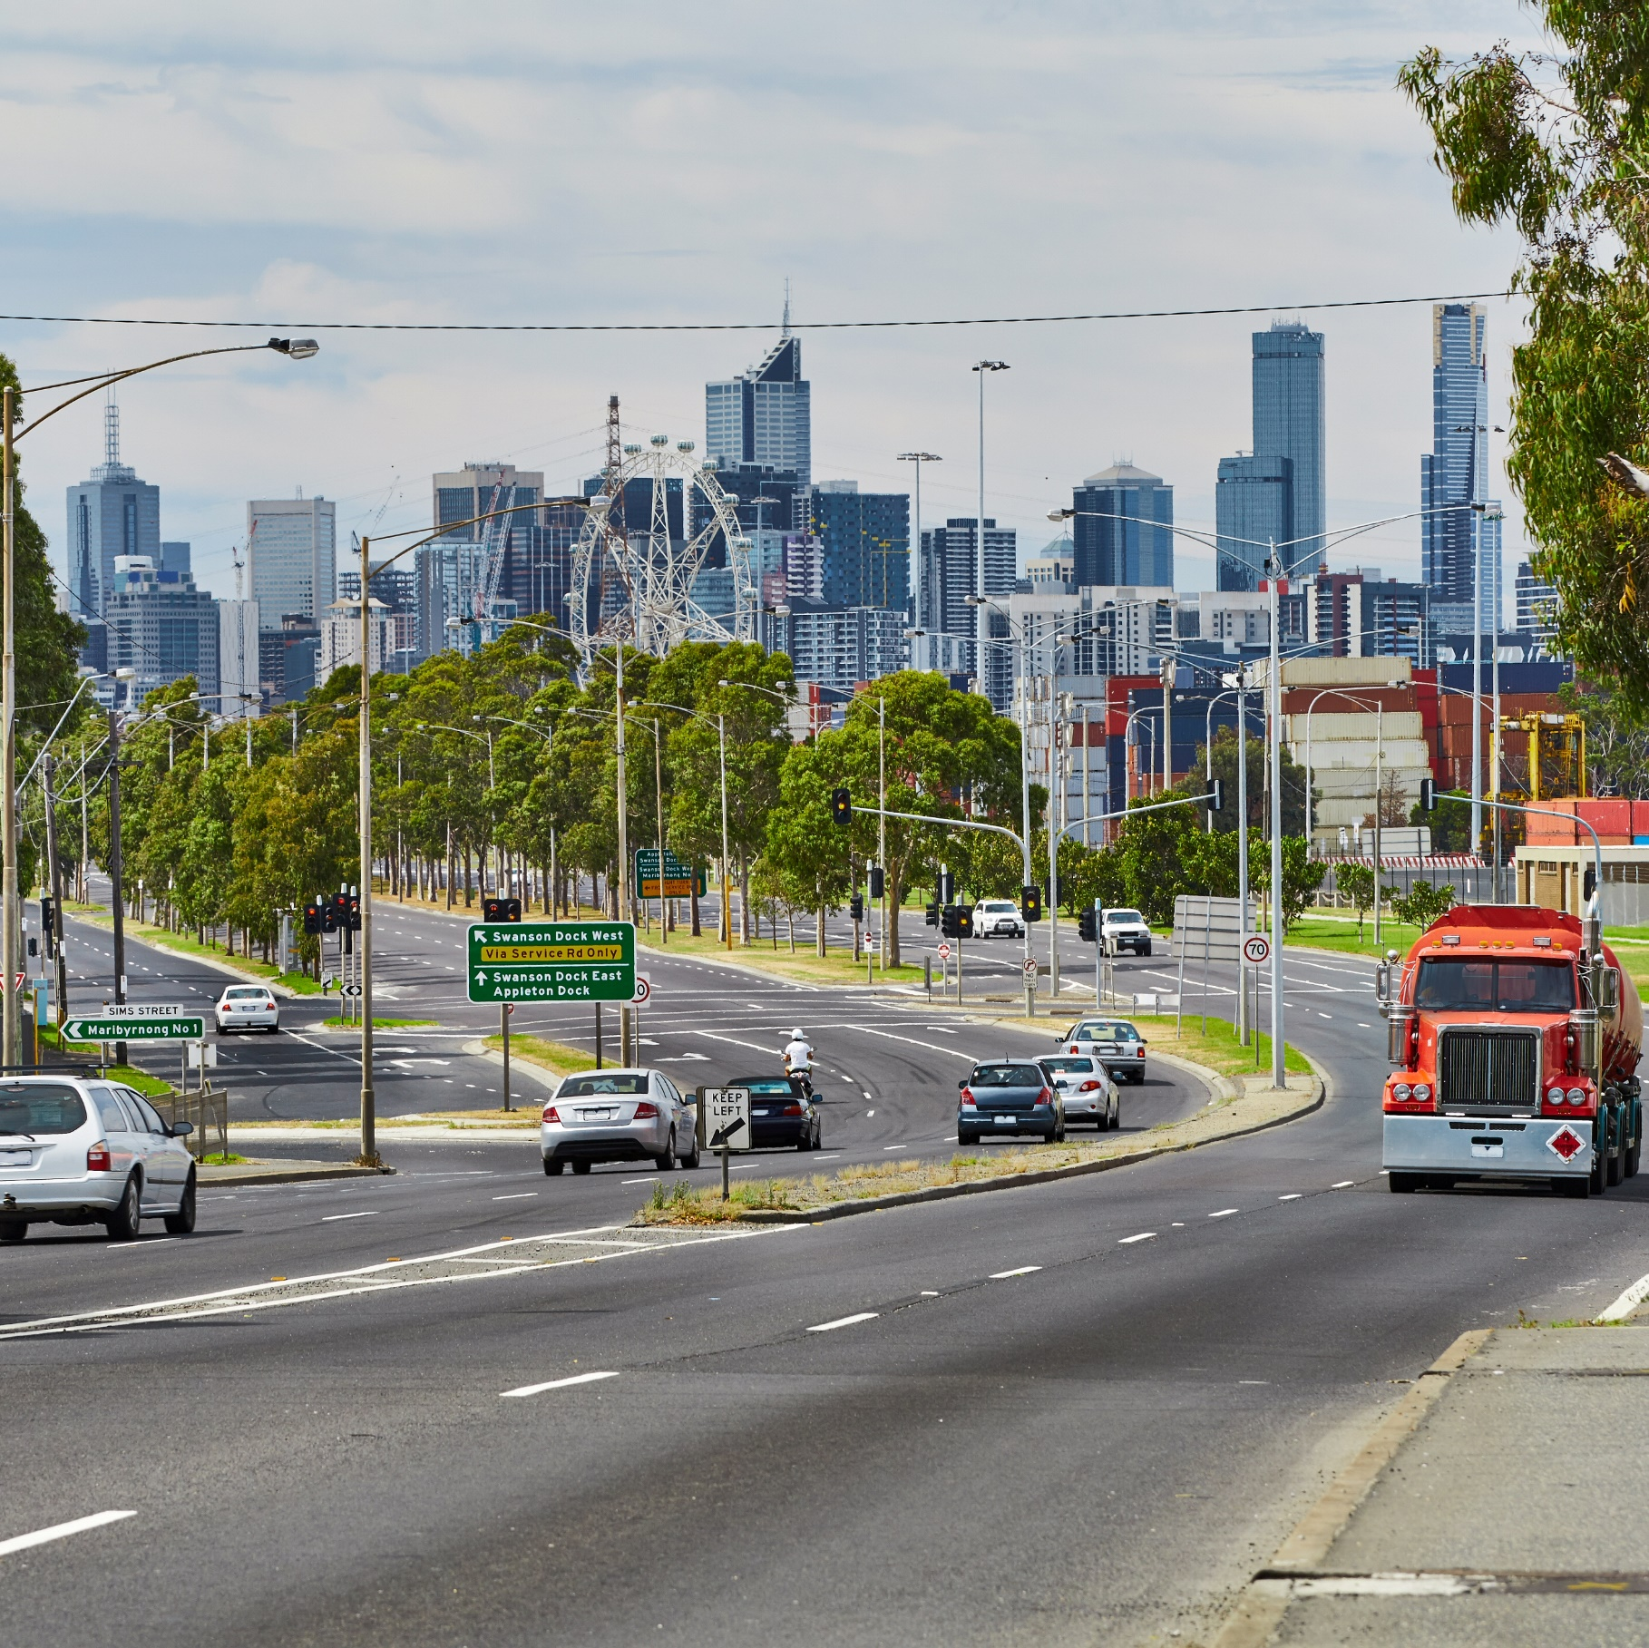
Detailed Findings
3 Detailed Findings

This section includes two introductory chapters providing an overview of behaviours and attitudes.
Subsequent chapters provide more detailed analysis of the following behaviours: speeding, drink driving, distracted driving, tired driving, drug driving, seatbelt use, and transport use. The remaining chapters in this section examine road enforcement and the TAC’s Toward Zero key metrics.

Prevalence of heightened-risk driving behaviours
Figure 1 provides a snapshot of key heightened-risk driving behaviours that were done by respondents. This chart does not indicate how frequently respondents did these behaviours. More detail on the prevalence and frequency of various behaviours can be found in the dedicated driving behaviour chapters.
Overall, more than half of respondents reported that they drove while quite tired (65%), drove 3 km/h or more over the speed limit (64%) or drove while holding a mobile phone in their hand (51%). Fewer than 5% of respondents travelled as a passenger while not wearing a seatbelt (4%), drove while over their legal BAC (3%), drove while not wearing a seatbelt (3%) or drove after using illegal drugs (1%).
Figure 1 Prevalence of heightened-risk driving behaviours
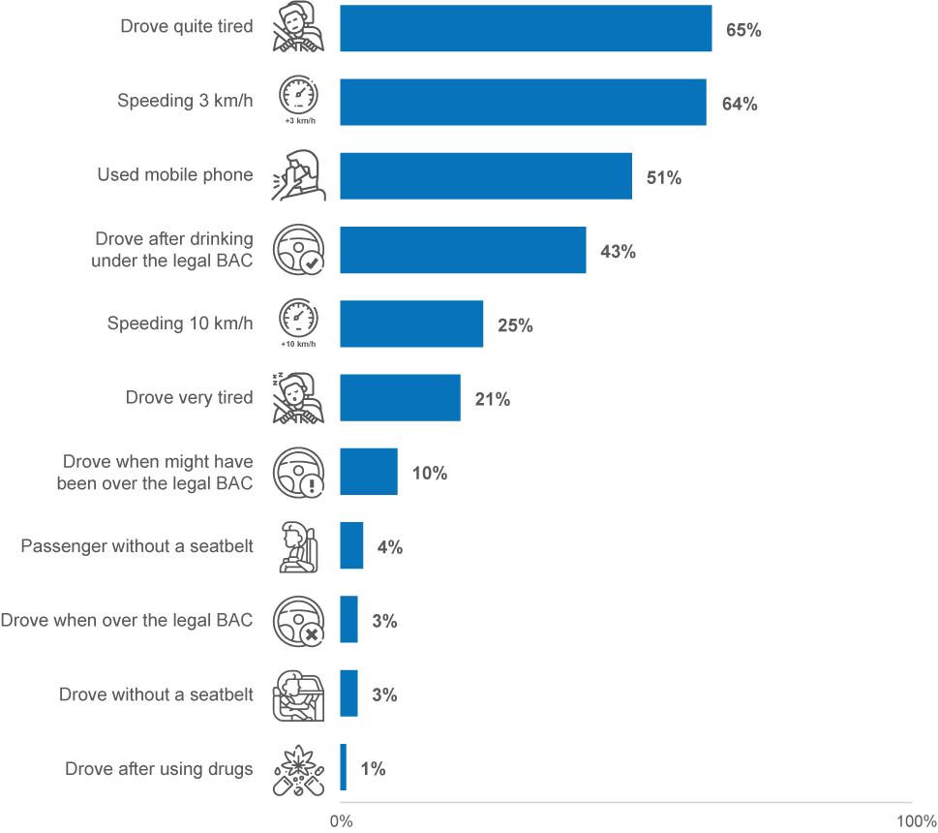
DB1 In the last month, how often did you use a mobile phone in your hand while driving to [mobile phone use behaviour]?
DB2 In the last three months, how often did you intentionally drive 3km/h or more above the limit in the following [speed limit zone]?
DB4 In the last three months, how often did you intentionally drive 10km/h or more above the limit in the following [speed limit zone]?
DB3 In the last 12 months, how often did you [driving behaviour]?
Base: Drivers (n=2,373)

It was possible for drivers to report up to eleven of these heightened-risk behaviours, and the results indicate that the majority of drivers engaged in risky driving.
In 2022, 12% of drivers reported engaging in none of the 11 behaviours, while in 2023, the percentage who did not do any of these behaviours increased slightly to 14%.
In 2023, about half (51%) of drivers engaged in between one and three behaviours, with an average of three behaviours among all drivers. More than a third (36%) of drivers reported conducting four or more behaviours.
Figure 2 Number of heightened-risk driving behaviours performed by drivers
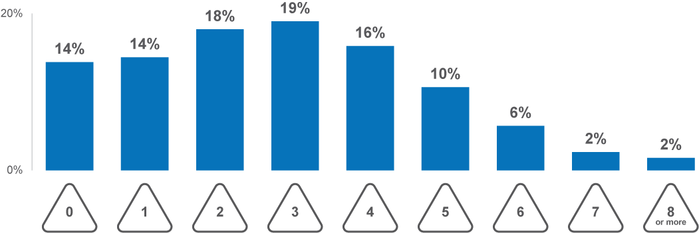
DB1 In the last month, how often did you use a mobile phone in your hand while driving to [mobile phone use behaviour]?
DB2 In the last three months, how often did you intentionally drive 3km/h or more above the limit in the following [speed limit zone]?
DB4 In the last three months, how often did you intentionally drive 10km/h or more above the limit in the following [speed limit zone]?
DB3 In the last 12 months, how often did you [driving behaviour]?
Base: Drivers (n=2,373)

Driving Behaviour Index
As the potential level of risk varies for different types of driving behaviour and frequency with which they are engaged in, a composite variable has been developed which takes this variance into consideration.
The Driving Behaviour Index (DBI) summarises the level of risk for drivers’ behaviours on a scale between 0 and 100, with 0 describing someone who does not conduct any dangerous behaviours at all, and 100 describing someone who conducts all listed dangerous behaviours at the maximum reportable frequency. For detailed information about the construction of this index, refer to Appendix 1.
Figure 3 shows the distribution and percentiles of respondents’ DBI scores in 2023. Overall, the 25% of respondents had DBI scores of 5 or lower, 50% had scores of 13 or lower, 75% had scores of 21 or lower, and 95% had scores of 37 or lower.
Figure 3 Driver Behaviour Index summary
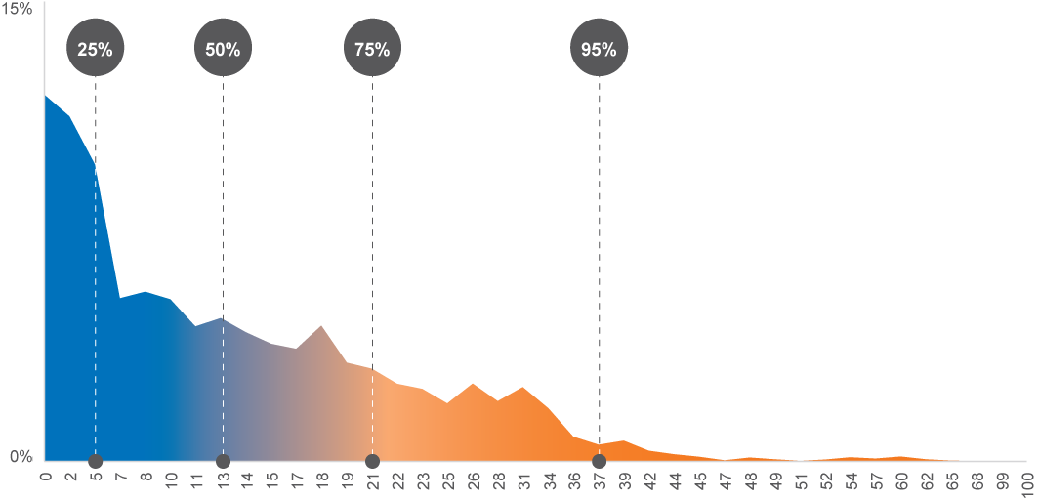
Driver Behaviour Index
Base: Drivers (n=2,373)
Table 2 shows that in 2023 the 75th and 95th percentiles for the DBI increased. However, as noted in Section 3.1, the overall number of drivers having performed dangerous driving behaviours decreased from 2022 to 2023.
This change in DBI percentile cutoffs indicates that either the frequency of driving dangerously increased among fewer drivers between 2022 and 2023, or that the dangerous driving behaviours acted on were more severe.
It was found that the overall frequency of engaging in dangerous driving behaviours was consistent between 2022 and 2023, ruling this out as an explanation for the above finding. However, more severe dangerous driving behaviours (e.g. drink driving over the limit, drug driving) were more common in 2023 than 2022, which accounted for the increase in 75th and 95th DBI percentiles.

Table 2 DBI percentiles and changes by year
DBI score | 2022 | 2023 | Change in score  2022 to 2023
25th percentile | 5 | 5 | 0
50th percentile | 13 | 13 | 0
75th percentile | 19 | 21 | +2
95th percentile | 34 | 37 | +3
Column n | 2,421 | 2,373 | –
Driver Behaviour Index
Base: Drivers

Profile of DBI levels
Understanding the profile of those with high DBI levels gives an overview of the characteristics of drivers who have lower or higher risk. In this section, attributes which vary among respondents with different DBI levels are shown (Table 3).
Participants were categorized into five groups based on their DBI score, from low through to extremely high, using the baseline DBI percentiles obtained in 2022 (see Table 2). The findings show that those disproportionately represented in the ‘extremely high’ (drivers with scores of 34 and above) category compared to the ‘low’ category were:
- Male
- Aged 18 to 39
- Living in a rural location
- Those who had driven a motorcycle or heavy vehicle
- Users of Taxi, Uber or similar services
- Drivers of e-devices (i.e. e-bikes, e-scooters, or e-skateboards) on the road
- Drivers of an SUV or 4WD, Ute, Truck or Commercial Van
- Drivers of 10,000 km per year or more, and especially, drivers of 20,000 km per year or more
Comparatively, those who were less likely to be in the ‘extremely high’ category compared to the ‘low’ category, were:
- Female
- Aged 60+
- Those who did not drive an e–device on the road
- Drivers of under 5,000 km per year.

Table 3 DBI Membership by selected demographic factors
Column % |  | Low | Medium | High | Very High | Extremely High
Gender | Male | 46% | 43% ↓ | 50% | 52% | 72% ↑
Gender | Female | 54% | 57% ↑ | 50% | 48% | 28% ↓
Age | 18–25 | 13% | 11% | 12% | 13% | 25% ↑
Age | 26–39 | 21% ↓ | 21% ↓ | 27% | 38% ↑ | 39% ↑
Age | 40–59 | 31% | 37% | 36% | 34% | 26%
Age | 60+ | 35% ↑ | 32% ↑ | 25% | 16% ↓ | 10% ↓
Location | Major Urban | 78% | 77% | 77% | 76% | 69%
Location | Other Urban | 14% | 15% | 15% | 16% | 18%
Location | Rural | 8% | 8% | 8% | 8% | 13% ↑
Transport modes used | A car | 97% ↓ | 100% | 100% | 100% | 100%
Transport modes used | A motorcycle | 4% ↓ | 5% | 8% | 11% ↑ | 9%
Transport modes used | A heavy vehicle | 6% | 5% | 5% | 7% | 13% ↑
Transport modes used | A bicycle | 21% ↓ | 32% | 37% | 39% ↑ | 36%
Transport modes used | Public transport | 65% ↓ | 75% | 79% | 82% ↑ | 83%
Transport modes used | A taxi, Uber or similar service | 49% ↓ | 66% | 69% | 80% ↑ | 83% ↑
E-device use | NET: Any e-device | 9% ↓ | 12% | 12% | 15% | 30% ↑
E-device use | None of the above | 90% | 88% | 88% | 85% | 70% ↓
Main vehicle description | Car / Station wagon | 67% | 60% | 61% | 64% | 53%
Main vehicle description | SUV / 4WD | 24% ↓ | 33% | 32% | 34% | 40%
Main vehicle description | Ute / Pickup | 6% | 6% | 7% | 11% | 18% ↑
Main vehicle description | Truck | 2% | 1% | 3% | 3% | 7% ↑
Main vehicle description | Motorcycle / Scooter | 1% | 2% | 2% | 4% ↑ | 1%
Main vehicle description | Commercial van | 1% | 1% | 1% | 1% | 5% ↑
Kilometres driven in past year | 0 to 4,999 km | 44% ↑ | 28% | 21% ↓ | 17% ↓ | 9% ↓
Kilometres driven in past year | 5,000 to <10,000 km | 28% | 29% | 26% | 24% | 17%
Kilometres driven in past year | 10,000 to <20,000 km | 20% ↓ | 27% | 32% | 37% ↑ | 42% ↑
Kilometres driven in past year | 20,000 km+ | 8% ↓ | 17% | 21% | 23% ↑ | 32% ↑
Driver Behaviour Index
Base: Drivers (n=2,373)
To aid in comparing the propensities of engagement in dangerous driving behaviours, ratios of group membership between ‘low’ and ‘extremely high’ were computed (Figure 4). This computation assists in understanding the extent of difference between demographics in their propensity to engage in dangerous driving.
Groups that were most disproportionate in the ‘very high’ DBI category compared to the ‘low’ category were:
- Those driving 20,000 km or more per year
- Those driving a commercial van
- Those driving a utility vehicle or truck.
Figure 4 Selected DBI Demographic Skews ‘Low’ vs ‘Extremely High’
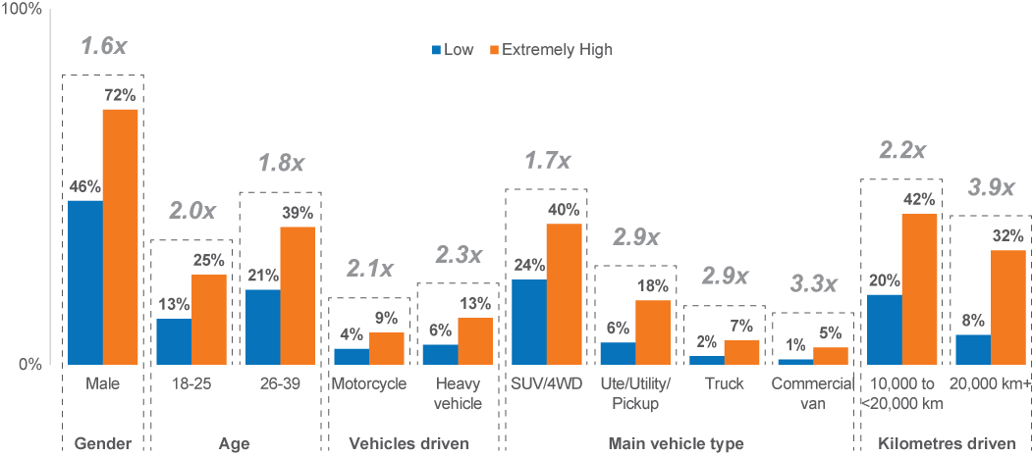
Driver Behaviour Index
Base: Drivers (n=2,373)

Level of dangerous behaviour overlap
This section explores whether dangerous driving behaviours have intersections with one another. Particularly, this section examines whether any particular dangerous behaviours are more strongly linked to having an ‘extremely high’ DBI. For example, what proportion of people who drive without a seatbelt have an extremely high DBI (Figure 5).
Note that for this analysis, respondents were categorised into their “worst” behaviour in each set of similar behaviours (i.e. drug use, alcohol use, speeding, and fatigue). For example, those who used drugs and drove were not also categorised as those who used illegal drugs. Similarly, those who drove while over or might have been over the legal BAC limit, were not also categorised as those who drove while confident they were under the limit or those who drink alcohol.
The following groups showed a high likelihood of having an ‘extremely high’ DBI, relative to likelihood in the overall sample (5%):
- People who drove after using illegal drugs (9.6 times more likely to have an Extremely high DBI)
- People who did not wear a seatbelt as a driver and/or passenger (6.8x)
- People who drove when they might have been or were over the legal BAC limit (5.3x)
- People who drove while very tired (3.3x)
- People who used illegal drugs but did not drive after (3.0x)
- People who drove 10 km/h or more over the speed limit (3.0x)
- People who used a hand-held mobile phone while driving (2.0x)

Figure 5 Proportion of ‘Extremely high’ DBIs by behaviours engaged in
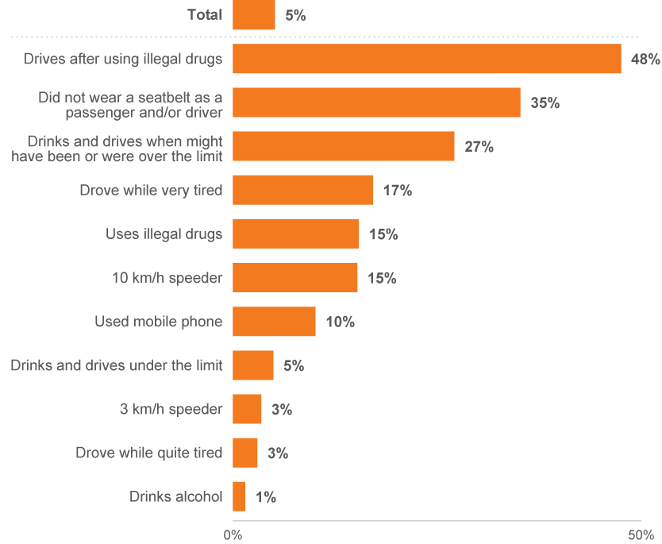
Driver Behaviour Index
Base: Drivers (n=2,373)

Other driving behaviours
In this section, we examine several behaviours that are unrelated to the DBI but provide additional insight into the everyday driving behaviours that people engage in. These include other dangerous driving behaviours, as well as other safety-conscious driving behaviours. For the purposes of this section, these are contrasted against respondents’ DBI scores to provide a more tangible understanding of other tendencies dangerous drivers have on the road.
Respondents were asked a series of questions about how frequently they conduct a variety of negative and positive behaviours on the road.
Figure 6 highlights the percentage of respondents who said they ‘always’ engaged in different safety-conscious driving behaviours. Six in ten respondents always left the car at home when they knew they were going to drink (61%) and left at least 1.5 metres between their vehicle and cyclists (60%). Just one-third (34%) always avoided driving if they were too tired.
Figure 6 Safety-conscious driving behaviours (% ‘always’)
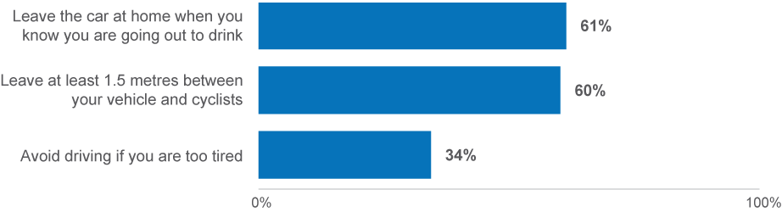
PND1B,C,F How often do you [ITEM]?
Base: Drivers (n=2,274)
Figure 7 highlights the percentage of respondents who ‘never’ performed unsafe driving behaviours. Around seven in ten respondents never tailgated other vehicles (72%) or ran red lights (71%).
Figure 7 Unsafe driving behaviours (% ‘never’)
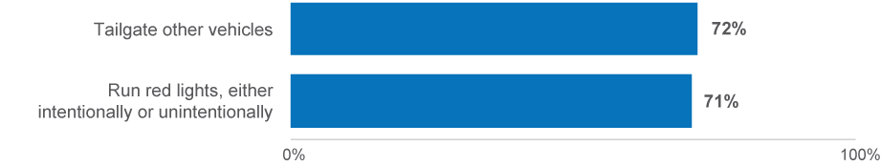
PND1D,E How often do you [ITEM]?
Base: Drivers (n=2,323)
Contrasting the prevalence of road-safety conscious behaviours between DBI score categories reveals that these behaviours were often highly correlated with illegal driving behaviours.
As shown in Table 4, those with extremely high DBIs were:
- Less likely to have always avoided driving if they were too tired, compared to those with low DBIs (10% vs 67%)
- Less likely than those with low DBIs to have always left their car at home if they knew they were going to drink (29% vs 80%)
- Less likely as those with low DBIs to have never tailgated other vehicles (40% vs 91%)
- Less likely to have never run red lights (44% vs 88%) and to have always left 1.5 metres between themselves and cyclists in speed zones above 60km/h compared to those with low DBIs (40% vs 76%).
Table 4 Safety-conscious and unsafe driving behaviours by DBI Membership
Column % |  | DBI Membership
Column % | Total | Low | Medium | High | Very High | Extremely  High
Safety-conscious driving behaviours (% always)
Leave the car at home when you know you are going out to drink | 61% | 80% ↑ | 67% ↑ | 61% | 52% ↓ | 29% ↓
Leave at least 1.5 metres between your vehicle and cyclists | 60% | 76% ↑ | 63% | 57% | 52% ↓ | 40% ↓
Avoid driving if you are too tired | 34% | 67% ↑ | 40% ↑ | 27% ↓ | 15% ↓ | 10% ↓
Unsafe driving behaviours (% never)
Tailgate other vehicles | 72% | 91% ↑ | 79% ↑ | 68% | 58% ↓ | 40% ↓
Run red lights, either intentionally or unintentionally | 71% | 88% ↑ | 75% | 70% | 62% ↓ | 44% ↓
PND1B,C,D,E,F How often do you [ITEM]?
Base: Drivers (n=2,323)

Speeding

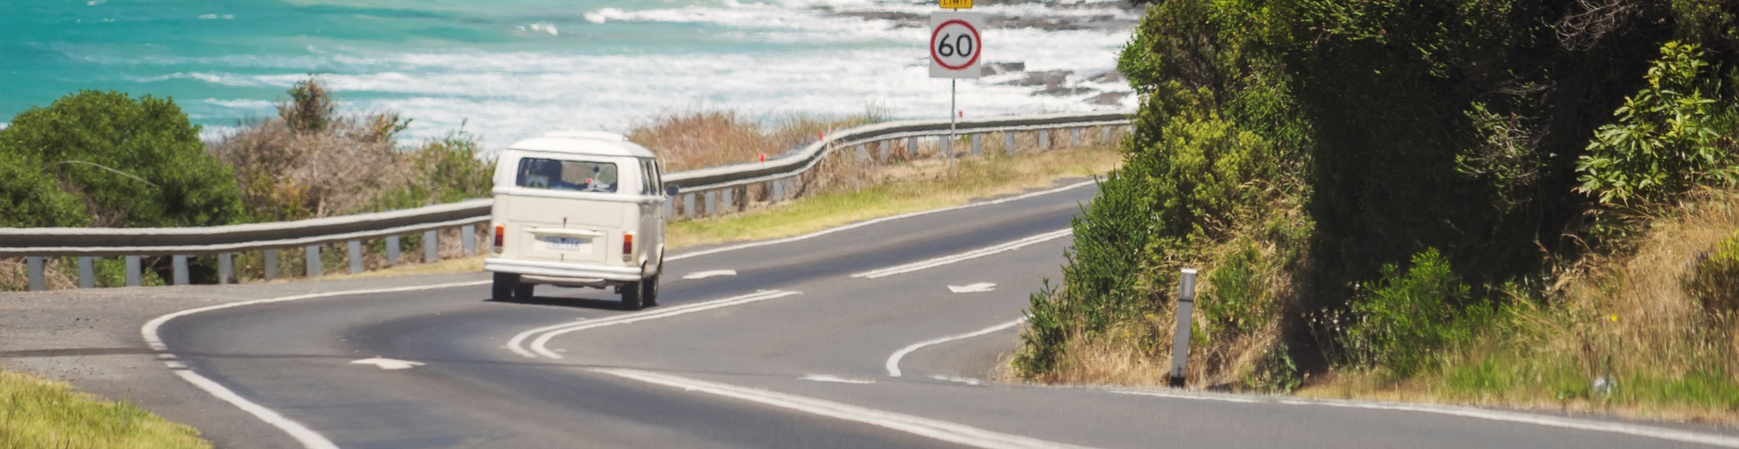
3.3 Speeding
This section aims to understand the prevalence of speeding in the community, attitudes, beliefs, and behaviours towards speeding, the risk profile of drivers relating to speeding and how speeding behaviours can be explained.

Prevalence of intentional speeding
In the RSM for 2023, there were several questions that asked how frequently respondents exceeded the speed limit. These were separated into categories of different speeding zones, and different speeding levels. In terms of zones where people speed, the RSM asked how often people exceeded the speed limit in 40 km/h zones, 50 km/h zones, 60 km/h zones, and 100 km/h zones. In terms of speeding levels, the RSM asked how often they exceeded the speed limit by 3 km/h or more in the four speed limit zones, and if they did speed 3 km/h or more over the limit in those zones, they were asked how often they sped 10 km/h over the limit in those zones.
Considering the prevalence of speeding across all four speed limit zones, low-level speeding was more than twice as prevalent as high-level speeding. Just under two-thirds of drivers (64%) drove 3 km/h or more above the posted limit in any of the three speed limit zones, whereas a quarter (25%) of all drivers also drove 10 km/h or more above the same posted speed limits.
Figure 8 Prevalence of intentional speeding behaviours
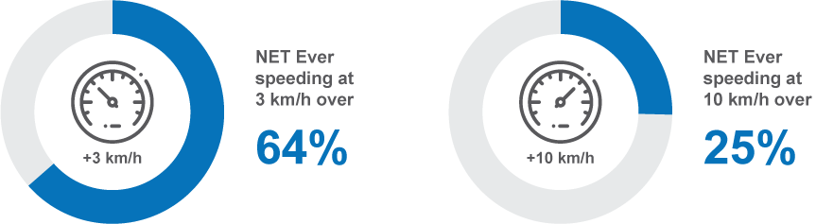
DB2 In the last three months, how often did you intentionally drive 3km/h or more above the limit in the following [speed limit zone]?
DB4 In the last three months, how often did you intentionally drive 10km/h or more above the limit in the following [speed limit zone]?
Base: Drivers n=2,328
Drivers’ propensity to engage in low-level speeding increased on roads with higher speed limits. As shown in Figure 9, driving 3 km/h above the limit was most prevalent in 100 km/h zones (51%), followed by 60 km/h zones (47%), and was least prevalent in 40 km/h zones (38%).
- Across all speeding zones combined, those who drove over the speed limit by 3 km/h or more were most likely to have done so ‘sometimes’ (26%) or ‘rarely’ (29%).
- The frequency of low-level speeding also increased on roads with higher speed limits. In 40 km/h zones, one in ten (11%) drove 3 km/h above the limit ‘sometimes’, while in 100 km/h zones, one in five (20%) drove 3 km/h above the limit ‘sometimes’.

Figure 9 Frequency of intentionally speeding 3km/h over the limit (%)
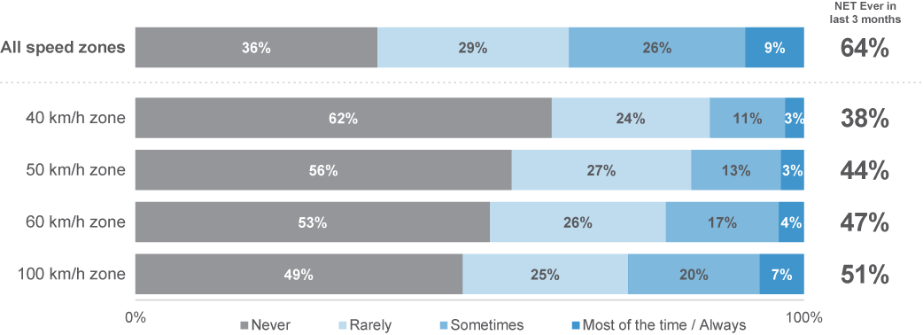
DB2 In the last three months, how often did you intentionally drive 3km/h or more above the limit in the following [speed limit zone]?
Base: Drivers n=2,328
Similarly, drivers’ tendency to engage in high-level speeding also increased on roads with higher speed limits (Figure 10). For instance, the prevalence of driving 10 km/h above the limit was highest in 100 km/h zones (21%), followed by 60 km/h zones (14%) and 50 km/h zones (12%), and was lowest in 40 km/h zones (13%).
- Across all speeding zones combined, those who drove over the speed limit by 10 km/h or more were most likely to have done so ‘rarely’ (16%)
- This was similar across 40 km/h, 50 km/h and 60 km/h speed zones, with intentional speeding 10 km/h over the limit in 40 km/h zones done ‘rarely’ by 7%, and in 50 km/h and 60 km/h zones by one in ten ‘rarely’ (9% at 50 km/h, 11% at 60 km/h).
- In 100 km/h zones, most of those who intentionally engaged in high-level speeding did so ‘rarely’ (14%), however, a substantial minority compared to speeding at other speed limits did so ‘sometimes’ (6%).
Figure 10 Frequency of intentionally speeding 10km/h over the limit (%)
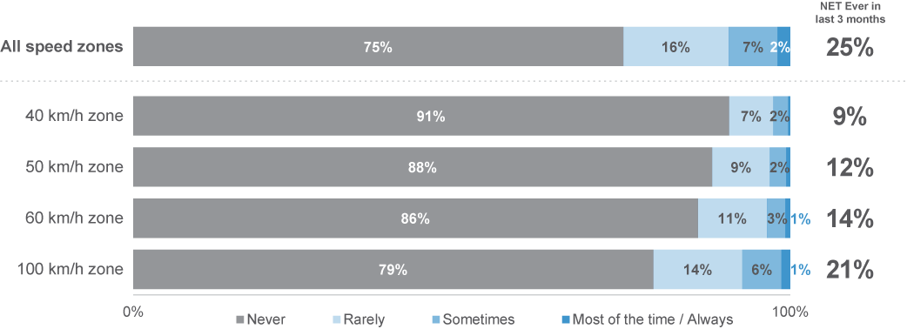
DB4 In the last three months, how often did you intentionally drive 10km/h or more above the limit in the following [speed limit zone]?
Base: Drivers n=2,328

Figure 11 shows the historical trend for intentionally engaging in low-level speeding. Low-level speeding is defined as ‘ever driving over the speed limit by 3 km/h or more over the past three months’. It is important to note that results from 2022 cannot be directly compared to previous years. Before 2022, the lowest frequency respondents could select was ‘some of the time’, whereas from 2022, respondents could select ‘rarely’. Additionally, before 2022, only two speed limits were included (60 km/h and 100 km/h). A third speed limit was added in 2022 (50 km/h) and a fourth limit was added in 2023 (40 km/h).
Over time, there has been a noticeable shift in low-level speeding behaviour. The percentage of respondents reporting low-level speeding decreased from 54% in 2016 to 49% in 2017. This prevalence remained stable until 2021, where an increase to 55% was recorded. Although the changes in measurement must be considered, the increase in low-level speeding appears to have continued into 2022, and appears to have stabilised at 64% in 2023.
Figure 11 Low-level speeding (3 km/h+) by year: ‘ever’ at any speed limit (%)
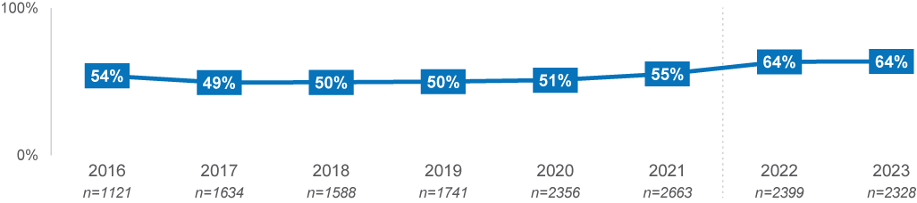
DB2ABC In the last three months, how often did you intentionally drive 3km/h or more above the limit in the following [speed limit zone]?
Base: Drivers
Figure 12 shows the historical trend for intentionally engaging in high-level speeding, that is, speeding at 10 km/h or more above the posted speed limit. Data were not obtained for this measure before Q3, 2022 in the RSM. The results display the yearly recorded result for 2022, as well as the trend line across the quarters where this data was collected up until Q4, 2023.
Over time, high-level speeding has remained relatively stable, with the 2022 result being 26% overall, and the 2023 result being 25%. One noteworthy exception to this trend is that the prevalence of high-level speeding increased to 28% in Q4, 2023, up from 23% in Q3.
Figure 12 High-level speeding (10 km/h+) by quarter & year: ‘ever’ at any speed limit (%)
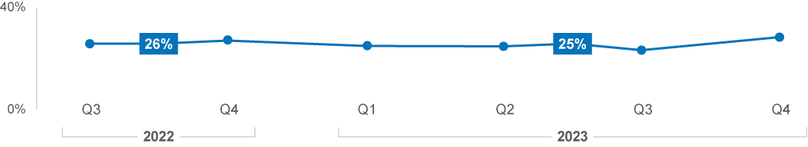
DB4 In the last three months, how often did you intentionally drive 3km/h or more above the limit in the following [speed limit zone]?
Base: Drivers (2023, n=2,328)

Demographic characteristics
Across demographic groups, males were more likely to have sped intentionally over the limit by both 3 km/h (67%) and 10 km/h or more (30%), compared to females (61% and 21%), as shown in Table 5. Additionally, those aged 26–39 were more likely to have sped by 10 km/h (30%), while those aged 61–90 were less likely to have sped by 3 km/h an hour (56%) and 10 km/h (20%).
Table 5 Prevalence of speeding among demographics
Column % |  | Age group |  |  |  | Gender |  | Location
Column % | Total | 18–25 | 26–39 | 40–60 | 61–90 | Male | Female | Major Urban | Other Urban | Rural
Drove 3 km/h over the limit | 64% | 64% | 68% | 66% | 56% ↓ | 67% ↑ | 61% ↓ | 63% | 65% | 66%
Drove 10 km/h over the limit | 25% | 26% | 30% ↑ | 26% | 20% ↓ | 30% ↑ | 21% ↓ | 25% | 27% | 29%
Base | 2328 | 308 | 590 | 763 | 667 | 1136 | 1192 | 1200 | 768 | 360
DB2 In the last three months, how often did you intentionally drive 3km/h or more above the limit in the following [speed limit zone]?
DB4 In the last three months, how often did you intentionally drive 10km/h or more above the limit in the following [speed limit zone]?
Base: Drivers n=2,328

Speeding – Demographic Interactions
This section details demographic groups with higher, moderate, and lower propensities to engage in speeding. The analysis uses classification and regression decision trees (CART) to identify the demographic characteristics of those most likely to speed. The intent is to provide more nuanced demographic findings; however, some reported subgroups identify smaller subsets of the overall population and should be interpreted with caution.
The results in this section are a summary of the full analysis. They serve to highlight high or low propensity groups and are shown against the population average to indicate the relative difference in propensity.
Low-level speeding
Low-level speeding was most prevalent among males aged 18–60 (70%). Females in the same age group sped at similar proportions to the average respondent (63%). Those aged 61–90, irrespective of gender and location, were least likely to have sped at low levels (56%).
Figure 13 Prevalence of speeding at 3 km/h by demographic interactions
Prevalence |  | Propensity | Age | Gender | Location | %
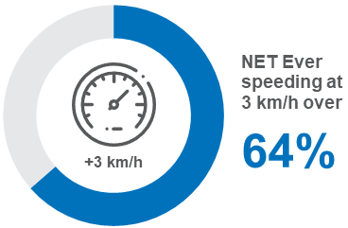 |  | Higher | 18–60 | Male | All | 70
 |  | Moderate | 18–60 | Female | All | 63
 |  | Lower | 61–90 | All | All | 56
DB2 In the last three months, how often did you intentionally drive 3 km/h or more above the limit in the following [speed limit zone]?
Base: Drivers (n=2,328) (3km/h over)
High-level speeding
There were no significant differences for high level speeding beyond what was found in the discrete demographic comparisons (Table 5).

DBI Profile
This section explores the relationship between DBI and speeding behaviours. This provides an overview of how dangerous speeders were on average, across all dangerous driving behaviours.
To analyse speeding as a behaviour, respondents were categorised by their most extreme speeding behaviour at any limit for this section. This means that if respondents exceeded the speed limit by 3 km/h in any zone, they were categorised as a speeder at 3 km/h an hour (low-level), and if they exceeded the speed limit by 10 km/h in any of the zones, they were then categorised as a speeder at 10km/h an hour (high-level). If respondents did not speed in any of the limits, they were categorised as someone who did not speed.
As shown in Table 6, seven in ten respondents who drove 10 km/h over the speed limit had very high or extremely high DBIs. Comparatively, those who drove 3 km/h over the limit were more likely to be in the ‘medium’ or ‘high’ DBI categories. However, those who did not speed at either level, were disproportionately in the ‘low’ or ‘medium’ DBI categories.
This demonstrates a strong relationship between high-level speeding and the propensity to engage in other dangerous driving behaviours.
Table 6 Speeding behaviour by DBI Membership
Row % | Low | Medium | High | Very High | Extremely  High
10 km/h over the speed limit | 0% ↓ | 3% ↓ | 26% | 56% ↑ | 15% ↑
3 km/h over the speed limit | 5% ↓ | 31% ↑ | 36% ↑ | 25% | 3% ↓
Did not speed | 54% ↑ | 31% ↑ | 12% ↓ | 3% ↓ | 0% ↓
Total | 22% | 24% | 24% | 24% | 5%
Column n | 511 | 554 | 578 | 590 | 140
DBI Summary
Base: Drivers n=2,373

Behavioural Insights
To explore factors potentially related to speeding behaviour, we asked participants a series of questions about:
- their perceived control over speeding
- their perceived perceptions of the danger associated with speeding
- the impact of social norms on speeding prevalence
- their attitudes toward speed enforcement
- their perceived risk of encountering enforcement
- their self-perceptions of how safe they are as a driver
Perceived danger
Respondents were provided a scale of between 0 and 10 to describe the danger of various driving behaviours, where 0 was not at all dangerous and 10 was extremely dangerous. The average scores for different groups of respondents are presented below.
Those who were non-speeders perceived speeding in any zone to be more dangerous than speeders. Those who sped at 10 km/h or more also tended to perceive speeding as less dangerous than those who sped at 3 km/h.
- The difference between high-level speeders (4.9), low-level (6.6) and non-speeders (7.7) was most apparent when considering risk perceptions of driving 10 km/h over the limit in a 100 km/h zone.
- In comparison, there was a smaller difference between the speeding behaviour segments in risk perceptions of low-level speeding (3 km/h over the limit at both 60 km /h and 40 km/h zones.
Figure 14 Perceived danger of low-level speeding at different speed limits (average score 0–10)
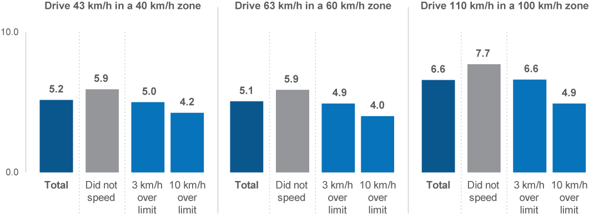
RI1AHI How dangerous do you think it is to drive at [x km/h in an x km/h zone]? (Scale from 0 ‘not at all dangerous’ to 10 ‘extremely dangerous’)
Base: Drivers (1,071 – 2,232)

Perceived control
To assess respondents’ level of perceived control over speeding, they were asked to what extent they agreed (4–5) or disagreed (1–2) with the statement ‘sometimes I have to drive over the speed limit’. Respondents were also provided with a neutral option (3).
Those who were high-level speeders were more than three times as likely to agree that they sometimes have to drive over the speed limit than those who were low-level speeders (16% vs 5%), and eight times more likely than non-speeders to agree (17% vs 2%).
Figure 15 Sometimes have to drive over the speed limit (% agree 4–5)
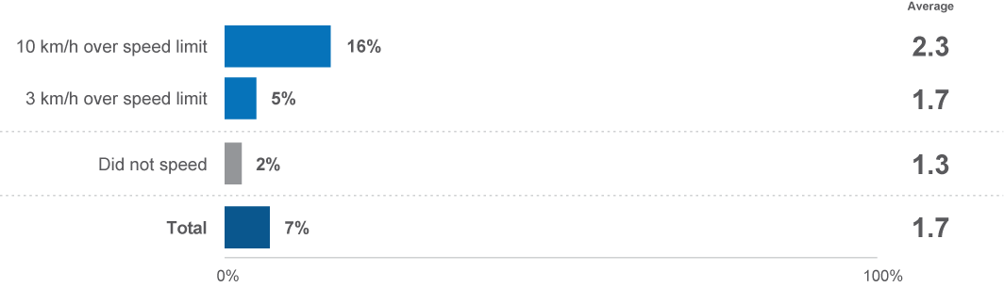
PC1C To what extent do you agree or disagree that sometimes you have to drive over the speed limit? (Scale from 1 – strongly disagree to 5 – strongly agree)
Base: Drivers (n=2,271)

Social norms
To assess the impact of social norms on respondents’ perceptions, two questions asked respondents their perceived level of embarrassment if they told their friends that they had been caught: ‘speeding at 63 km/h in a 60 km/h zone’ and ‘speeding at 70 km/h in a 60 km/h zone. Questions were answered on a scale from 1 (not at all embarrassed) to 5 (extremely embarrassed).
The impacts of speeding-related social norms also differed between those who were low-level and high-level speeders. High-level speeders were less likely than low-level speeders to feel embarrassed to tell their friends they had been caught driving marginally or substantially over the speed limit in a 60 km/h zone (15% vs 28% for speeding at 63 km/h, 41% vs 61% for speeding at 70 km/h).
Those who were non-speeders were affected more by social norms than speeders (at both high and low levels). The proportion of non-speeders who would feel embarrassed (rated 4–5) telling their friends they had been caught driving 3 km/h or 10 km/h over the limit in a 60 km/h zone is about double the proportion of high-level speeders (42% vs 15% for speeding at 63 km/h, 70% vs 41% for speeding at 70 km/h).
Figure 16 Likelihood of feeling embarrassed for being caught speeding at different levels (% said they would be embarrassed (4–5))
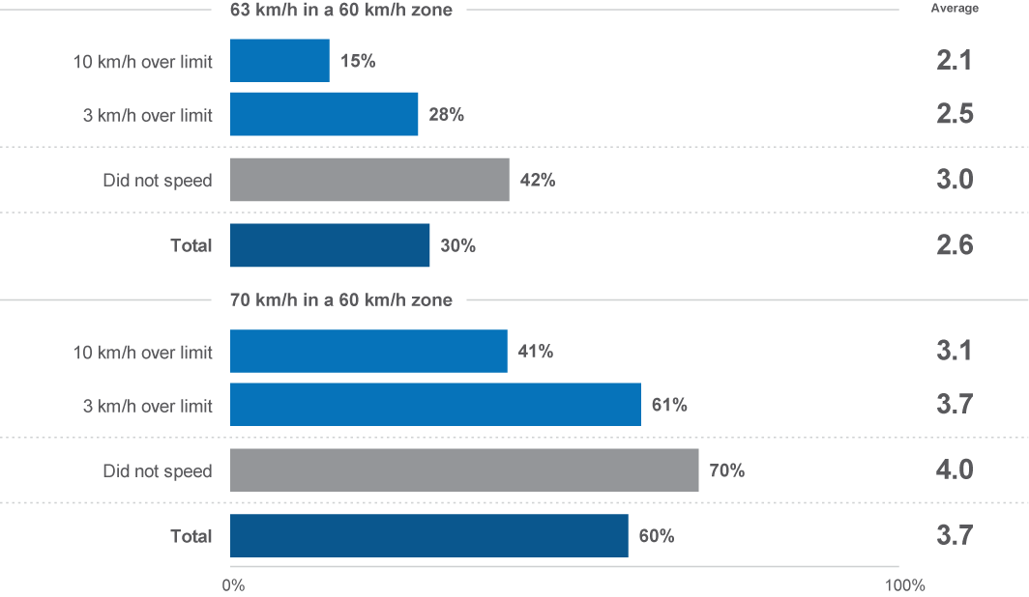
ACC1A How embarrassed would you be to tell your friends that you had been caught driving 63 km/h in a 60 km/h zone?
ACC1B How embarrassed would you be to tell your friends that you had been caught driving 70 km/h in a 60 km/h zone?
(Scale from 1 ‘not at all embarrassed’ to 5 ‘extremely embarrassed’)
Base: Drivers (n=2,329)

Attitudes toward enforcement
Attitudes towards speeding-related enforcement were mixed, with high-level speeders being the most likely to display cynical attitudes about the purpose of speeding enforcement and those who did not speed being the least likely.
To gauge attitudes toward speeding enforcement, respondents were asked to what extent they agree (4–5) or disagree (1–2) with the statement ‘speeding penalties are just revenue raising’. Respondents were also provided with a neutral option (3).
Overall, around one-third of all respondents (35%) agreed with the sentiment. Considering respondents’ speeding behaviours, high-level speeders (42%) were most likely to agree with this sentiment, while non-speeders were least likely (30%).
Figure 17 Speeding penalties are ‘revenue raising’ by speeding behaviour (% agree (4–5))
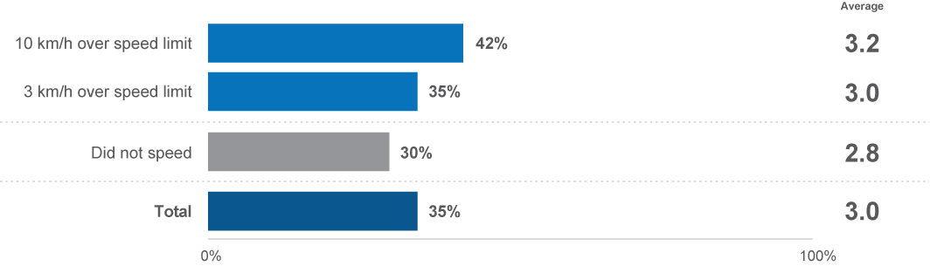
ATD1A The following are some statements about the state of driving in Victoria. Please tell us the extent to which you agree or disagree that speeding penalties are just revenue raising? (Scale from 1 – strongly disagree to 5 – strongly agree)
Base: Drivers (n=2,271)

Perceived enforcement risk
On average, speeders perceived a lower likelihood of being caught by police for violating road rules than non-speeders. The perceived enforcement risk between low-level and high-level speeders was similar.
To understand the perceived risk of enforcement, respondents were asked how likely they believe they are to get caught by the police for breaking any road rule on a scale of 1 to 5, where 1 was not at all likely, and 5 was extremely likely.
About one-third of both low-level (35%) and high-level (30%) speeders believed that they were likely to be caught. Among non-speeders, more than four in ten (42%) believed they would be likely to be caught.
Figure 18 Perceived enforcement risk by speeding behaviour (% feel they are likely (4–5) to get caught)
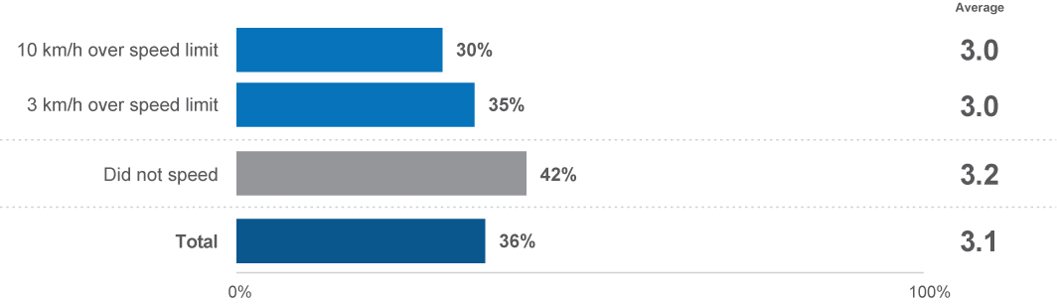
EN2 How likely do you believe you are to get caught by police if you are breaking any road rule at any given time? (% likely)
(Scale from 1 ‘not at all likely’ to 5 ‘extremely likely’)
Base: Drivers (n=2,198)
Self-perceptions of driving safely
Overall, self-perceptions of driving safely were similar among those who are speeders and non-speeders.
To understand drivers’ self-perceptions of their safety on the road, respondents were asked on a 5–point scale, with 5 being ‘very safe’, and 1 being ‘not at all safe’.
High-level speeders (4.3) were slightly less likely than low-level speeders (4.5) to perceive themselves as safe drivers. Low-level speeders rated their driving safety slightly lower than non-speeders (4.5 vs. 4.6).
Figure 19 Self-perceptions of driving safely by speeding behaviour (average score 1–5)
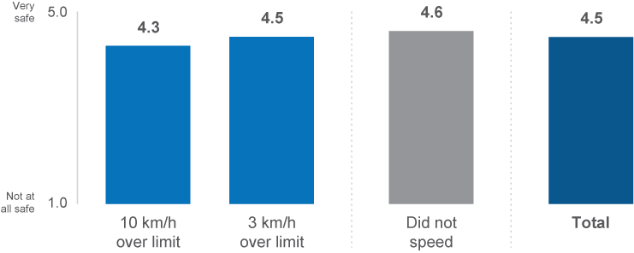
OB1 How safe a driver would you say you are? (Scale from 1 ‘not at all safe’ to 5 ‘very safe’)
Base: Drivers (n=2,300)

Other speeding-related findings
This section explores other speeding-related findings that were captured in the RSM, with a particular focus on support and opposition toward hypothetical policy changes. Respondents were asked whether they would support, oppose or be ambivalent toward hypothetical policy changes relating to reducing residential speed limits from 50 km/h to 40 km/h and reducing narrow country road speeds from 100 km/h to 80 km/h.
On balance, drivers did not support a reduction of the residential speed limit from 50 km/h to 40 km/h (27% supported, 53% opposed and 20% were neutral). However, drivers were more favourable towards the hypothetical lowering of the speed limit on narrow country roads (46% supported, 36% opposed and 15% were neutral).
Drivers who exceeded the speed limit, especially at high levels, were more likely to oppose reduced speed limits than non-speeders. High-level speeders were least likely to support the hypothetical 10 km/h speed limit reduction on residential roads to 40 km/h, with fewer than one in five (18%) supporting it, whereas a quarter (25%) of low-level speeders and over one-third (35%) of non-speeders supported this hypothetical reduction. Similarly, high-level speeders were also half as likely as non-speeders to support the hypothetical 20 km/h speed limit reduction on narrow country roads, with only about one third (32%) of high-level speeders in favour of the change, compared to half (48%) of low-level speeders and over half (54%) of non-speeders.
Figure 20 Support and opposition for reducing residential road speed limit from 50 km/h to 40 km/h
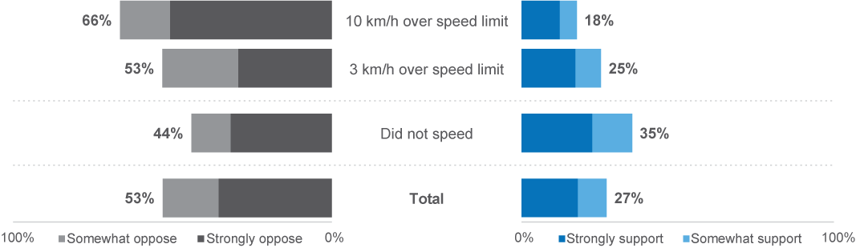
DFC1A In terms of changes to current policy and regulations, how strongly would you oppose or support the following hypothetical scenarios with current road rules… the default speed limit on residential roads being changed from 50 km/h to 40 km/h?
Base: Drivers (n=575)
Figure 21 Support and opposition for reducing narrow country roads speed limit from 100 km/h to 80 km/h
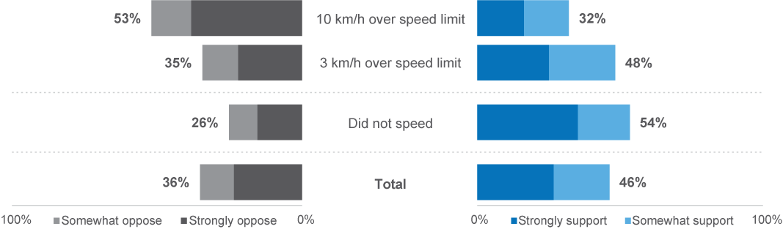
DFC1B In terms of changes to current policy and regulations, how strongly would you oppose or support the following hypothetical scenarios with current road rules… the default speed limit on narrow country roads being changed from 100 km/h to 80 km/h?
Base: Drivers (n=577)
In the 2023 RSM, a new hypothetical policy changes were rated by respondents, changing areas with high pedestrian traffic to 40 km/h zones.
Overall, six in ten (59%) of respondents supported changing the speed limit in areas with high pedestrian traffic to 40 km/h. While those who drove 10 km/h or more over the limit were less likely to support this change than others, they were still mostly neutral (23%) or in support (52%).
Figure 22 Support and opposition for more areas such as shopping strips with high pedestrian traffic becoming 40 km/h zones
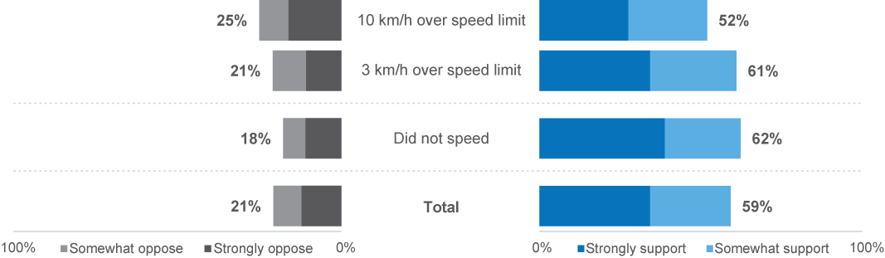
DFC1D In terms of changes to current policy and regulations, how strongly would you oppose or support the following hypothetical scenarios with current road rules… more areas such as shopping strips with high pedestrian traffic becoming 40km/h zones
Base: Drivers (n=1,751)


Drink driving
3.4 Drink driving

This section explores alcohol consumption, driving after drinking, and attitudes towards drink driving in the community.

Prevalence of drinking and drink driving
To understand the prevalence of drinking and drink driving behaviour in the community, respondents were first asked how often they consumed any alcoholic drinks. Those who consume alcohol were then asked to indicate how often they drove after drinking in three scenarios: where they were sure they were under the legal BAC limit, when they might have been over the BAC limit, and when they were certain they were over the BAC limit. Please note, the results have been re-proportioned to include respondents who did not drink alcohol in the drink–driving scenario calculations for an overall survey population measurement.
About three-quarters (72%) of respondents had consumed any alcohol in the previous 12 months.
Considering the prevalence of drink driving behaviour across all three scenarios, legal drink driving had the highest prevalence (driving after drinking alcohol when confident of being under the legal BAC limit: 43%). One-in-ten respondents drove when they might have been over the legal BAC limit (10%), and a smaller percentage drove when they were certain they were over the legal BAC limit (3%).
Figure 23 Prevalence of drinking and drink driving*
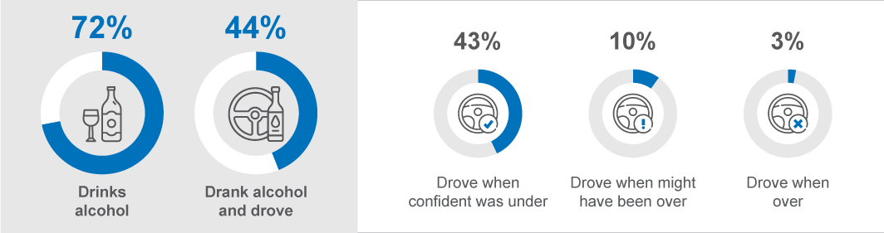
DK1 In the last 12 months, on average, how often did you have an alcoholic drink of any kind?
Base: All respondents (n=2,325)
DB3ABC In the last 12 months, how often did you [drink and drive behaviour]?
Base: Drivers (n=2,306)
*Results for drinking and driving are reproportioned to the entire population of driver respondents

Considering the frequency of drinking alcohol and driving, driving after drinking when confident under the legal BAC limit was common. Driving after drinking, when people might have been or were over the legal BAC, was less common. As well as being the most prevalent drink driving behaviour, driving under the legal BAC limit is also the most frequent behaviour. Most of those who engaged in this behaviour did so ‘rarely’ (20%) or ‘sometimes’ (16%), whereas driving when ‘might have been over’ or ‘definitely over’ the legal BAC tended to be reported as ‘rare’ occurrences (9% and 3% respectively).
Figure 24 Frequency of drinking and driving (%)
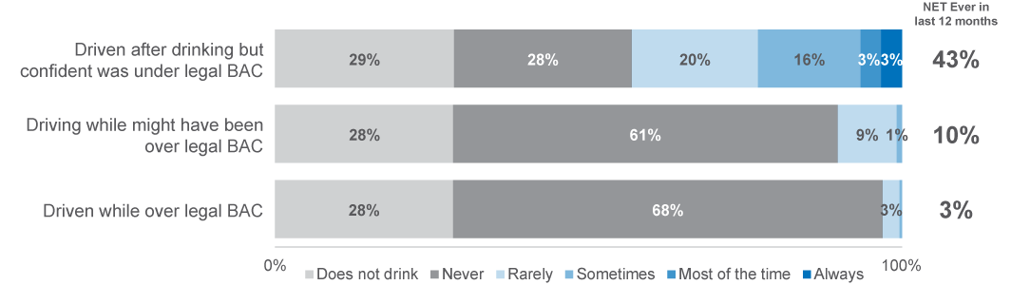
DB3ABC In the last 12 months, how often did you…?
Base: Drivers (n=2,306)
Figure 25 shows the historical trend for alcohol consumption. It is important to note that results from 2022 and 2023 cannot be directly compared to previous years due to a change in how this question was asked.
Alcohol consumption has been relatively stable over the past six years. The prevalence of alcohol consumption among respondents increased from 76% in 2016 to 78% in 2019. However, it has gradually declined since then, and is at 72% in 2023.
Figure 25 Alcohol use by year: ‘ever’ (%)
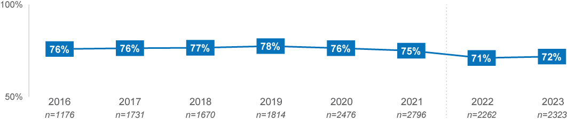
DK1 In the last 12 months, on average, how often did you have an alcoholic drink of any kind?
Base: All respondents
Note: Due to substantial changes in instrument design, any data changes between 2021 and 2022 should be interpreted with caution.

Figure 26 shows the time series for the frequency of driving over the legal BAC limit between 2016 and 2022. The overall incidence of drink driving remained consistent from 2016 (5%) to 2020 (5%), with exception to 2017 (6%). Although a downward trend seemed to be occurring since 2017, results stabilised in 2023, with 3% of driver respondents drink driving while over their legal BAC limit.
Figure 26 Drink driving when over the legal BAC limit by year: ‘ever’ (%)
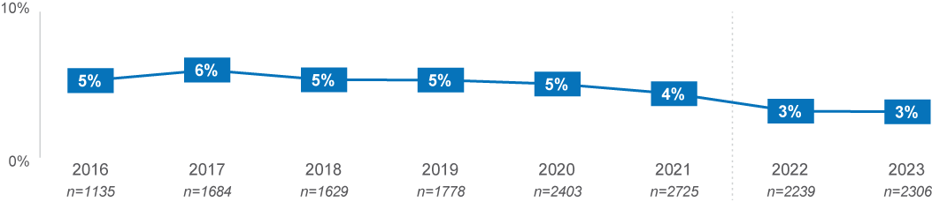
DB3A In the last 12 months, how often did you drive a vehicle when you knew you were over your legal blood alcohol limit?
Base: Drivers
Note: Due to a break in the time-series data between 2021 and 2022, any inferences drawn from the data during this period should be interpreted with caution.
Figure 27 shows the prevalence of driving after drinking for each quarter since Q3, 2022. The prevalence of drink driving while under the legal BAC limit remained consistent between 2022 (45%) and 2023 (43%), with Q1, 2023 recording the lowest prevalence (40%) and the highest prevalence recorded in 2023, Q2 (45%). Similarly, driving when respondents ‘might have been over the limit’ had consistent results between 2022 (9%) and 2023 (10%), with the lowest prevalence recorded in Q4, 2022 (8%) and highest prevalence recorded in Q1 and Q2, 2023 (11%). Driving while over the legal BAC also remained consistent across quarters and years, with 3% of respondents in both 2022 and 2023 having conducted this behaviour. Considering quarterly results for driving over the legal BAC, the lowest prevalence was recorded in Q3, 2023 (2%), and the highest in Q1, 2023 (4%).
Figure 27 Drink driving when under, might have been over and over by quarter and year ‘ever’ (%)
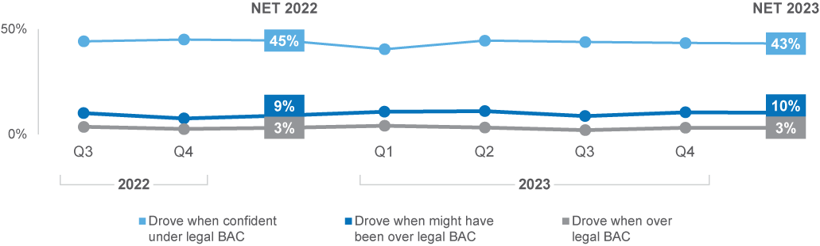
DB3ABC In the last 12 months, how often did you drive a vehicle when you [knew you were over][might have been over][were confident you were under] your legal blood alcohol limit?
Base: Drivers

Demographic Characteristics
Across demographic groups, males, respondents living in rural areas, and those aged 40 to 60 had the highest propensity to engage in drink driving behaviour.
- Males were more likely than females to report driving when they were under the legal BAC limit (48% vs 39%), when they might have been over the limit (14% vs 7%), and when they were over the limit (5% vs 1%).
- Those aged 40–60 (48%) were more likely than those aged 18–25 (29%) to report having driven after drinking alcohol. However, across all age groups, driving when over the limit was most common among those aged 18–25 (5% vs 3%).
- Respondents in Rural (51%) areas were more likely than those in Major Urban (43%) areas to report having driven after drinking alcohol
Table 7 Prevalence of drinking and driving behaviours among demographics
Column % |  | Age group |  |  |  | Gender |  | Location
Column % | Total | 18–25 | 26–39 | 40–60 | 61–90 | Male | Female | Major Urban | Other Urban | Rural
NET had drunk alcohol and drove | 44% | 29% ↓ | 44% | 48% ↑ | 46% | 49% ↑ | 39% ↓ | 43% | 46% | 51% ↑
Drove when confident was under | 43% | 27% ↓ | 44% | 47% ↑ | 45% | 48% ↑ | 39% ↓ | 42% | 44% | 51% ↑
Drove when might have been over | 10% | 10% | 12% | 9% | 11% | 14% ↑ | 7% ↓ | 10% | 12% | 11%
Drove when over | 3% | 5% | 3% | 3% | 3% | 5% ↑ | 1% ↓ | 3% | 4% | 4%
Column n | 2306 | 312 | 588 | 758 | 650 | 1124 | 1182 | 1197 | 756 | 354
DB3ABC In the last 12 months, how often did you [drink and drive behaviour]?
Base: Drivers (n=2,306)

Drink driving – Demographic Interactions
This section details demographic groups with higher, moderate, and lower propensities to engage in speeding. The analysis uses classification and regression decision trees (CART) to identify the demographic characteristics of those most likely to drink and drive. The intent is to provide more nuanced demographic findings, although it is worth noting that the reported subgroups will tend towards smaller subsets of the overall population.
The results in this section are a summary of the full analysis and serve to highlight high or low propensity groups and are shown against the population average to indicate the relative difference in propensity.

Driving after drinking when ‘confident they were under the legal limit’
Driving after drinking was most common among males aged 26–90 (50%), in comparison to females, who aligned more closely with the average (41%). Those aged 18–25 had similarly low levels of legal drink driving (27%), irrespective of gender and location.
Table 8 Prevalence of driving after drinking under the legal BAC by demographic interactions
Prevalence among the average driver | Propensity | Age | Gender | Location | %
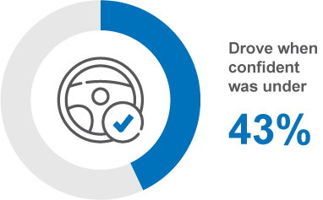 | Higher | 26–90 | Male | All | 50
 | Moderate | 26–90 | Female | All | 41
 | Lower | 18–25 | All | All | 27
DB3C In the last 12 months, how often did you drive a vehicle after drinking alcohol when you were confident you were under the legal blood alcohol limit?
Note: Respondents of different ages (particularly under age 22), and with different restrictions, will have different interpretations of what the legal blood alcohol limit is. Their specific legal BAC was not stated for respondents answering this question.
Base: Drivers (n=2,290)

DBI Profile
This section explores the relationship between DBI and drink driving behaviours. This provides an overview of how dangerous those who drove after drinking were on average, across all dangerous driving behaviours.
There were several questions that asked how frequently respondents drove while under the influence of alcohol. These questions were separated into categories of severity. They were asked whether, and how frequently, they drove when they were: ‘confident they were under the legal limit’, ‘might have been over the legal limit’, and ‘definitely were over the legal limit’.
For the purposes of this section and the next, drink-driving behaviour has been separated into four distinct categories. The four categories are: those who don’t drink, those who didn’t drink and drive, those who did drink and drive only when under the legal limit, and those who did drink and drive when they might have been or were over the legal limit. For example, a person who reported having driven when they were confident they were below the limit, and having driven when they knew they were when they knew they were over the limit, were assigned to the more severe latter category. These categories are also examined across the full sample of respondents.
Table 9 shows that the majority of respondents who drove when they might have been or were over the limit had DBIs in the very high (45%) or the extremely high (27%) category. Those who drove after drinking when they were confident that they were under the limit had higher representation than drivers in total in the high (29%) and very high (35%) DBI categories. Those who did not drink and drive, and those that did not drink were similar in their risk profiles, and on average, had lower risk profiles than drivers in total.
These results demonstrate a strong relationship between any type of driving after drinking and the propensity to engage in other dangerous driving behaviours. In particular, driving when over the limit, or when might have been over the limit. The results also demonstrate that driving when over the limit, or might have been over the limit, are behaviours that correspond to much higher risk profiles on average.
Table 9 Drink driving behaviour by DBI Membership
Row % | Low | Medium | High | Very High | Extremely  High
Drove when might have been/were over the limit | 0% ↓ | 9% ↓ | 19% | 45% ↑ | 27% ↑
Drove when under the limit | 5% ↓ | 26% | 29% ↑ | 35% ↑ | 5%
Did not drink and drive | 30% ↑ | 27% | 24% | 18% ↓ | 1% ↓
Does not drink | 39% ↑ | 25% | 22% | 13% ↓ | 1% ↓
Total | 21% | 24% | 25% | 25% | 5%
Column n | 461 | 539 | 566 | 581 | 139
DBI Summary
Base: Drivers (n=2,286)

Behavioural Insights
To explore factors potentially related to drink-driving behaviour, participants were asked a set of questions about:
- their perceived control over drinking and driving
- their perceptions of the dangers associated with drinking and driving
- the social norms of their group regarding drinking and driving
- their level of support or opposition toward lowering the legal BAC limit.
Perceived control
Although the vast majority of respondents believed they had control over driving and drinking, perceived control over the drinking and driving was somewhat lower among those who drove when they might have been or were over the legal limit.
To assess perceived control over drink driving, respondents were asked the extent to which they agree (4–5) or disagree (1–2) with the statement ‘sometimes I have to drive, even if I might be over the legal BAC’. Respondents were also provided with a neutral response option (3).
Overall, 97% of respondents disagreed that they might have to drive when they were over the legal BAC limit, and hence perceived that they had control over this behaviour. However, those who had been drink driving while they might have been, or were, over the limit had a lower level of perceived control; their average rating was 1.6 out of 5, compared with 1.1 out of 5 in all other groups. Additionally, the strength of disagreement was lower in this group, with 58% strongly disagreeing among versus 94% to 95% in the other categories.
Figure 28 Perceived control over drink driving
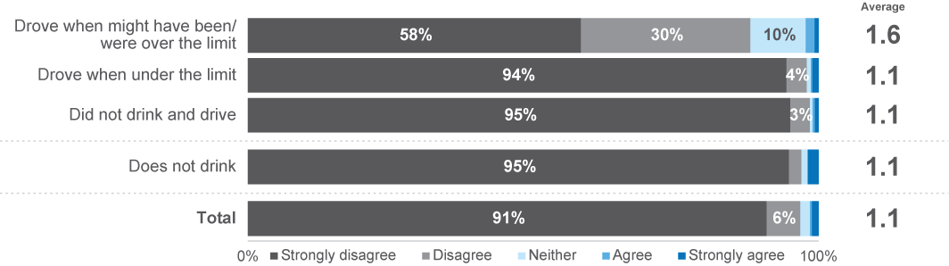
PC1B To what extent do you agree or disagree that sometimes you have to drive even though you might be over your legal BAC? (% agree)
(Scale from 1 – strongly disagree to 5 – strongly agree)
Base: Drivers (n=2,197)

Perceived danger
Driving with BAC over the legal limit is perceived to be high-risk relative to other dangerous driving behaviours among most respondents.
To assess perceived danger, respondents were asked to rate how dangerous it is to drive with a BAC over 0.05, or to drive soon after one drink. Responses were made on an 11–point scale, with 0 being ‘not at all dangerous’ and 10 being ‘extremely dangerous’. The average scores for different groups of respondents are presented below.
The level of perceived risk for driving with a BAC over 0.05 was smaller for people who drove when they might have been or were over the limit (7.9), compared to those who drove only while under the limit (9.1), those who did not drink and drive (9.1) and those who did not drink (9.4).
Driving soon after consuming one standard alcoholic drink was perceived to be less risky compared to driving over the legal BAC limit. Similar to previous results, this behaviour was perceived as less risky by those who drove when they might have been or were over the limit (3.6), compared to people who drove when under the limit (4.1), those who did not drive after drinking (6.3), and those who did not drink at (7.4).
Figure 29 Perceived danger of drink driving at different BAC levels among drink driving categories
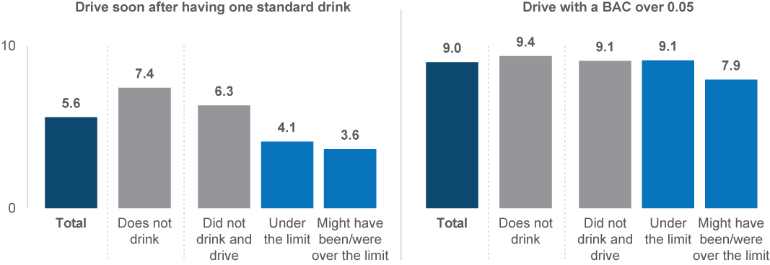
RI1C How dangerous do you think it is to drive with a BAC over 0.05? (scale from 0 ‘not at all dangerous’ to 10 ‘extremely dangerous’)
RI1B How dangerous do you think it is to drive soon after having one standard alcoholic drink? (scale from 0 ‘not at all dangerous’ to 10 ‘extremely dangerous’)
Base: Drivers (n=2,234)

Social norms
To assess social norms related to drink driving, respondents were asked how embarrassed they would feel to tell their friends or family that they had been caught driving while over the legal limit.
The highest levels of embarrassment were reported by people who drove when they were confident that they were under the limit, compared with other cohorts. Those who had driven when they might have been or were over the limit were less likely to report they would be embarrassed (84%).
Figure 30 Social norms (% embarrassed 4-5) towards drink driving among drink driving categories
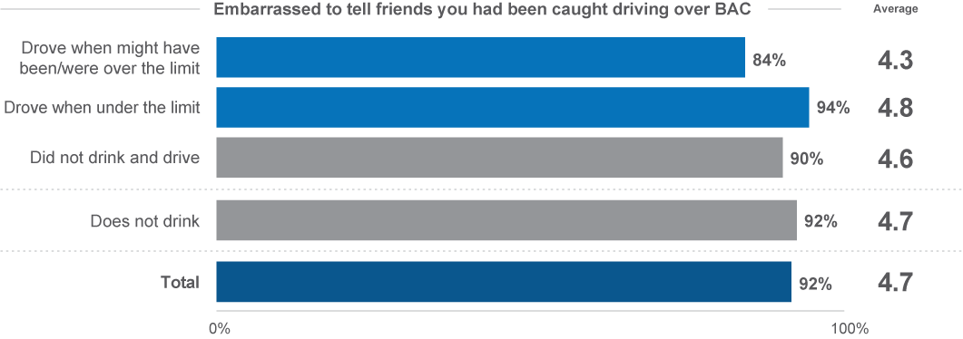
ACC1C How embarrassed would you be to tell your friends that you had been caught driving over your legal BAC? (% embarrassed)
(Scale from 1 ‘not at all embarrassed’ to 5 ‘extremely embarrassed’)
Base: Drivers (n=2,076)

Perceived risk of enforcement
To understand the perceived risk of enforcement, respondents were asked how likely they believe they are to get caught by the police for breaking any road rule at any given time.
Those who drove after drinking perceived themselves as less likely on average to get caught by the police for breaking any road rules, compared with those who did not drink and drive and did not drink. Just two in ten (19%) of those who drove when they might have been or were over the limit believed they were likely to be caught, compared to 28% of those who drove when under the limit . In contrast, among those who did not drink and drive, 43% believed they were likely to be caught and among those who do not drink, 46% believed they were likely to be caught.
Figure 31 Perceived enforcement risk (% likely (4-5) to be caught) among drink driving categories
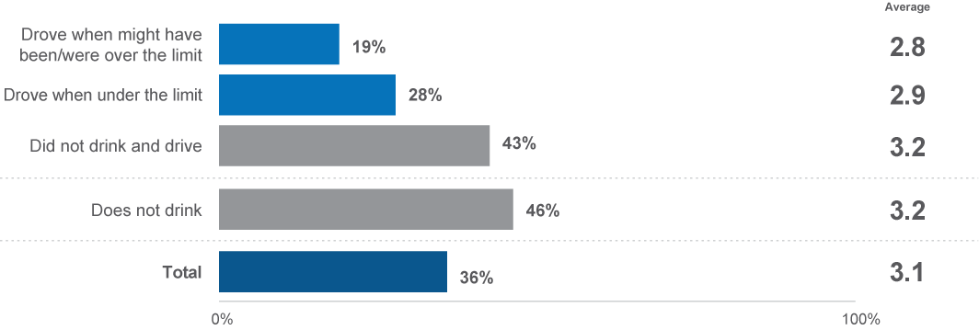
EN2 How likely do you believe you are to get caught by police if you are breaking any road rule at any given time? (Scale from 1 ‘not at all likely’ to 5 ‘extremely likely’)
Base: Drivers (n=2,139)
Self-perceptions of driving safely
Respondents were asked to consider how safe they are as a driver, on a scale of 1 (not at all safe) to 5 (very safe).
Considering drink driving behaviours, those who drove when they might have been or were over the legal limit rated their driving safety lower than others, at an average of 4.2 out of 5. All other respondents rated their driving safety at an average of 4.5 out of 5.
Figure 32 Self-perceptions of driving safely among drink driving categories
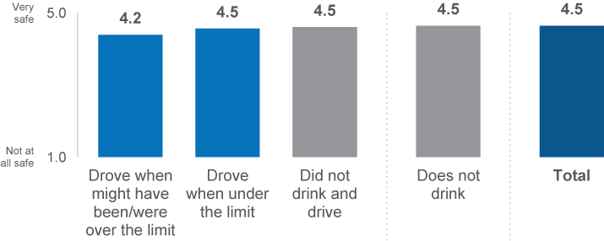
OB1 How safe a driver would you say you are? (scale from 1 ‘not at all safe’ to 5 ‘very safe’)
Base: Drivers (n=2,230)

Distracted driving


3.5 Distracted driving
This section explores distracted driving, specifically the use of hand-held mobile phones while driving.

Prevalence of illegal mobile phone use
The prevalence of illegal mobile phone use was measured by asking respondents how frequently they drove while using a mobile phone in their hand to ‘make or receive a call’, ‘send or read a message’, or ‘interact with an app’ in the past month.
Interacting with an app while driving was almost twice as prevalent as making phone calls or messaging while driving. Overall, over half (51%) of respondents drove while using a mobile phone in their hands for any purpose. Almost half of respondents used a mobile phone while driving to ‘interact with an app’ (46%), while a quarter ‘made or received a call’ (25%) or ‘sent or read a text message’ (23%).
Figure 33 Prevalence of hand-held mobile phones use while driving
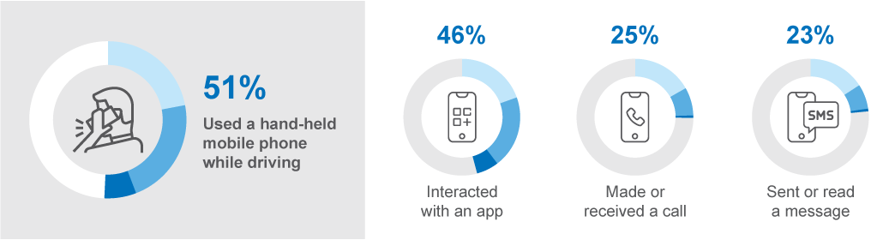
DB1 In the last month, how often did you use a mobile phone in your hand while driving to [mobile phone use behaviour]?
Base: Drivers (n=2,328)

‘Interacting with an app’ not only had the highest prevalence but also the highest frequency among the mobile phone activities. Just over a quarter of drivers (26%) interacted with an app (such as navigation, music or something else) while driving ‘sometimes’ or more frequently, which is nearly three times of the number of drivers who reported ‘making or receiving a call’ (9%) or ‘sending or reading a message’ (8%) ‘sometimes’ or more frequently.
Figure 34 Frequency of activities performed on mobile phones while driving (%)
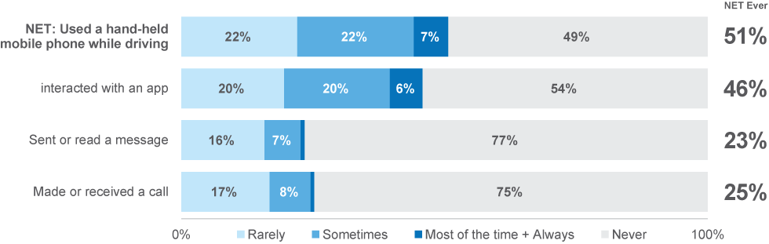
DB1 In the last month, how often did you use a mobile phone in your hand while driving to [mobile phone use behaviour]?
Base: Drivers (n=2,328)
Figure 35 shows the time series for using a hand-held mobile phone at least ‘sometimes’ while driving between 2016 and 2023. Over time, the use of a hand-held mobile phone while driving shows a downward trend. The prevalence of this driving behaviour was highest in 2016 at 37%; since then, it has declined incrementally to 29% in 2020, and remained at this level in 2023. However, it should be noted that 2022 and 2023 data are not directly comparable to previous data, so similarity with 2020 and 2021 is only indicative.
Figure 35 Hand-held mobile phone use while driving by year: ‘sometimes’ or more often (%)
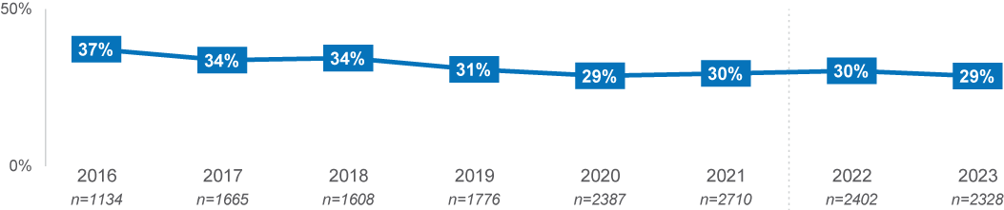
DB1 In the last month, how often did you use a mobile phone in your hand while driving to [mobile phone use behaviour]?
Base: Drivers
Note: Due to substantial changes in instrument design, data changes between 2021 and 2022/2023 should be interpreted with caution

Demographic characteristics
Across demographics groups, drivers aged 26–39 were most likely to have used a hand-held mobile phone while driving. Drivers aged 26–39 (66%) were twice as likely as those aged 61–90 (33%) to drive while using a hand-held mobile phone for any purpose. Drivers aged 26–39 were also more likely to have used a hand-held mobile phone across all types of phone usage.
Table 10 Hand-held mobile phone use among demographics
NET Ever % |  | Age group |  |  |  | Gender |  | Location
NET Ever % | Total | 18–25 | 26–39 | 40–60 | 61–90 | Male | Female | Major Urban | Other Urban | Rural
Used a handheld mobile phone for any reason | 51% | 55% | 66% ↑ | 51% | 33% ↓ | 50% | 52% | 51% | 51% | 51%
Interact with an app | 25% | 29% | 36% ↑ | 27% | 11% ↓ | 26% | 25% | 25% | 27% | 27%
Make or receive a call | 23% | 27% | 34% ↑ | 25% | 9% ↓ | 23% | 24% | 24% | 23% | 22%
Send or read a message | 46% | 51% | 61% ↑ | 45% | 28% ↓ | 45% | 47% | 46% | 46% | 45%
Column n | 2328 | 307 | 588 | 757 | 665 | 1127 | 1185 | 1188 | 763 | 361
DB1 In the last month, how often did you use a mobile phone in your hand while driving to [mobile phone use behaviour]?
Base: Drivers

Distracted Driving – Demographic Interactions
Used a mobile phone in hand while driving
As indicated in the discrete demographic breakdowns, driving while using a hand-held mobile phone was most prevalent among those aged 26–39.
- Among those aged 26–39, females residing in rural or other urban areas (other than major urban) used a mobile phone in their hand while driving most (83%).
- Males residing in other urban areas (69%) and females in major urban areas (68%) aged 26–39 were the next most prevalent users of hand-held mobile phones while driving.
- Among those aged 26–39, the lowest prevalence users were males residing in major urban and rural areas (60%) – although, it should be noted that this group was still higher than the average driver (52%).
Figure 36 Prevalence of mobile phone use by demographic interactions
Prevalence among the average driver | Propensity | Age | Gender | Location | %
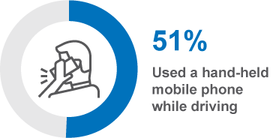 | Higher | 26–39 | Female | Rural / Other Urban | 83
 | Higher | 26–39 | Male | Other Urban | 69
 | Higher | 26–39 | Female | Major Urban | 68
 | Higher | 26–39 | Male | Major Urban / Rural | 60
DB1 In the last month, how often did you use a mobile phone in your hand while driving to [mobile phone use behaviour]?
Base: Drivers (n=2,328)

DBI Profile
This section explores the relationship between DBI and distracted driving behaviours. This provides an overview of how likely and frequently those who drove while distracted enacted other dangerous driving behaviours.
There were several questions that asked how frequently respondents drove while using a mobile phone in their hand that have been combined into a single dichotomous variable: respondents that used a mobile phone in their hand while driving, and those who did not.
Table 11 shows that 51% of respondents who drove distracted had a ‘very high’ (41%) or ‘extremely high’ (10%) DBI. In contrast, less than 1% of respondents who did not use a mobile phone while driving were in the ‘extremely high’ category.
These results indicate that using a hand-held mobile phone while driving corresponds more-so with a high or ‘very high’ risk profile than an ‘extremely high’ risk profile, and that not using a mobile phone corresponds more with a ‘low’ or ‘medium’ risk profile.
Table 11 Distracted driving behaviour by DBI Membership
Row % | Low | Medium | High | Very High | Extremely  High
Used mobile phone while driving | 3% ↓ | 17% ↓ | 28% ↑ | 41% ↑ | 10% ↑
Did not use mobile phone while driving | 40% ↑ | 31% ↑ | 21% ↓ | 8% ↓ | 0% ↓
Total | 21% | 24% | 25% | 25% | 5%
Column n | 483 | 548 | 573 | 584 | 140
DBI Summary
Base: Drivers (n=2,328)

Behavioural Insights
To explore factors potentially related to distracted driving (using a handheld mobile phone while driving), two questions were asked to respondents about:
- their perceptions of the danger associated with using a mobile phone while driving
- the social norms of their group regarding driving while using a handheld mobile phone
We also explore the relationship between distracted driving behaviours and general road safety enforcement risk, and self-perceptions of driving safety.

Perceived danger
Respondents were asked to rate how dangerous it is to glance at a mobile phone for a couple of seconds while actively driving on an 11–point scale, with 0 being ‘not at all dangerous’ and 10 being ‘extremely dangerous’. The average scores for different groups of respondents are presented below.
Those who had driven while using a hand-held mobile phone tended to rate the danger of glancing at a mobile phone while driving as less dangerous than those who had not driven while using a hand–held mobile phone (7.8 vs 8.8).
Figure 37 Perceived danger of using a hand-held mobile phone while driving
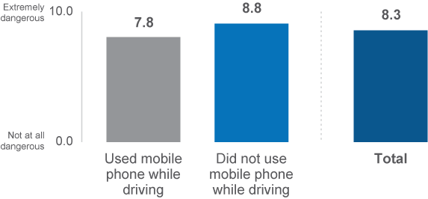
RI1G How dangerous do you think it is to glance at a mobile phone for a couple of seconds while actively driving? (Scale from 0 ‘not at all dangerous’ to 10 ‘extremely dangerous’)
Base: Drivers (n=2,294)

Social Norms
Most drivers reported that they would feel embarrassed informing their friends that they had been caught using a mobile phone illegally while driving, but this social influence was felt to a lesser extent among those who do use a phone illegally while driving.
To assess these social norms, respondents were asked how embarrassed they would feel to tell their friends or family that they had been caught using a mobile phone in their hand while driving.
Two thirds of those who drove while using a hand-held mobile phone (67%) would be embarrassed to tell their friends that they had been caught driving with a phone in their hand, compared to 85% of those who did not drive while using a hand-held mobile phone.
Figure 38 Social norms for using a hand-held mobile phone while driving
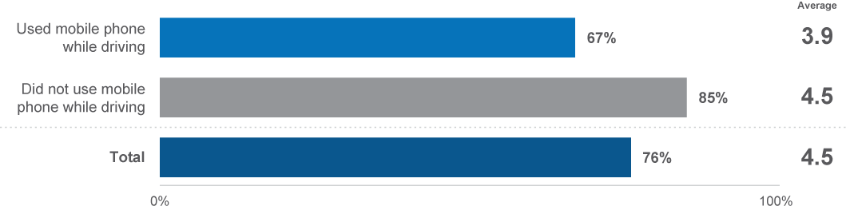
ACC1D How embarrassed would you be to tell your friends that you had been caught while using a mobile phone in your hand? (Scale from 1 ‘not at all embarrassed’ to 5 ‘extremely embarrassed’)
Base: Drivers (n=2,225)
Perceived risk of enforcement
The perceived likelihood of being caught by police for breaking any road rule was lower among those who drove while using a hand-held mobile phone than it was among those who had not driven while using a hand-held mobile phone.
To understand the perceived risk of enforcement, respondents were asked how likely it is that they would get caught by the police for breaking any road rule at any given time.
One-third (33%) of respondents who drove while using a hand-held mobile phone believed they would be likely to get caught, compared to 40% of those who did not drive while using a hand-held mobile phone.
Figure 39 Perceived enforcement risk by hand-held mobile phone use categories
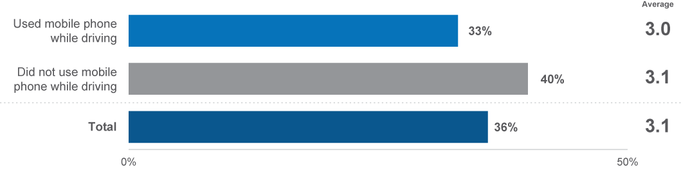
EN2 How likely do you believe you are to get caught by police if you are breaking any road rule at any given time? (Scale from 1 ‘not at all likely’ to 5 ‘extremely likely’)
Base: Drivers (n=2,271)
Self-perceptions of driving safely
Respondents who drove while using a hand-held mobile phone rated themselves as less safe drivers than those did not drive using a hand-held mobile.
To understand drivers’ self-perceptions of how safe they are as a driver, respondents were asked on a 5–point scale how safe they are as a driver, with 5 being ‘very safe’, and 1 being ‘not at all safe’.
Self-perceptions of driving safely were lower among respondents who drove while using a hand–held mobile phone (average of 4.4) compared to those who did not (4.6).
Figure 40 Self-perceptions of driving safely by hand-held mobile phone use categories
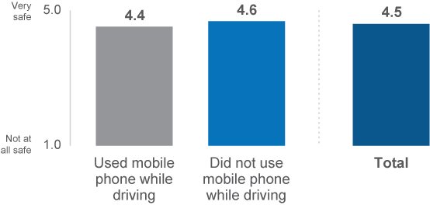
OB1 How safe a driver would you say you are? (Scale from 1 ‘not at all safe’ to 5 ‘very safe’)
Base: Drivers (n=2,270)

Other distracted driving findings
Respondents who reported using a mobile phone in their hand while driving and interacting with an app were asked what types of apps they interacted with.
Nearly all (92%) reported having used a map or navigation app, while six in ten (61%) used a music app. Far fewer, (11%) reported having used a messaging app while driving.
Figure 41 Mobile phone apps used while driving
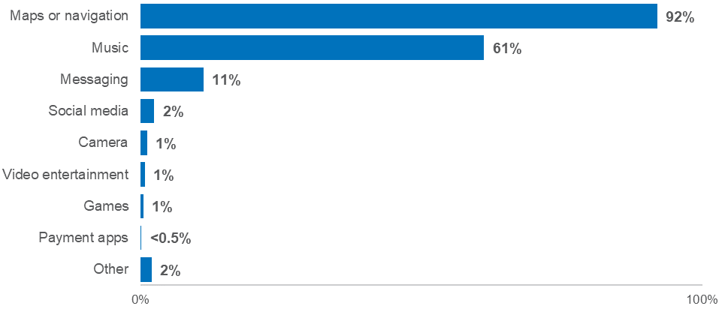
DB1X What type of apps did you interact with while driving
Base: Used a mobile phone to interact with an app (n=502)

Tired driving

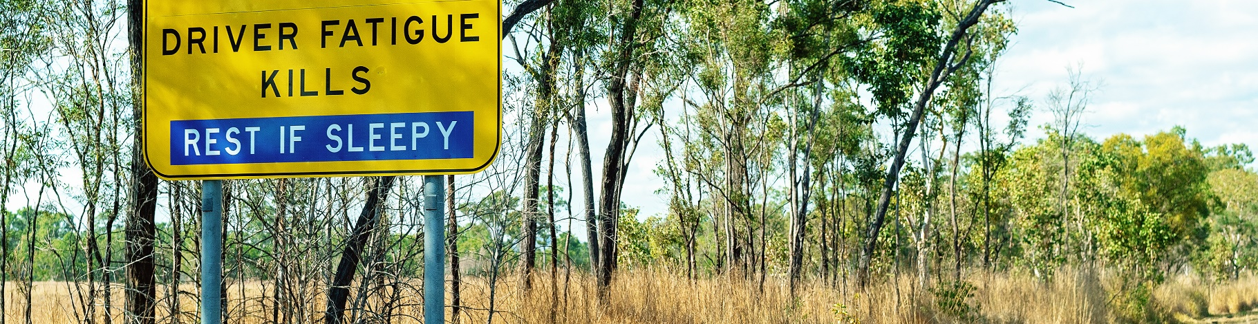
3.6 Tired driving
This section explores tired driving behaviours, measures taken to avoid tired driving, and why people drive when tired.

Prevalence of tired driving
Driving while tired is explored with consideration of different levels of tiredness: driving while ‘quite tired’, and driving while ‘very tired, so tired one cannot open their eyes’. Drivers were asked how often they drove while feeling quite tired (moderate level of fatigue) or very tired (high level of fatigue) in the last 12 months.
The prevalence of driving at all in the last 12 months with a moderate level of fatigue was more than three times higher than that of driving with a high level of fatigue – two thirds (65%) of respondents reported driving while ‘quite’ tired, whereas one in five (21%) drove while ‘very’ tired.
Figure 42 Prevalence of tired driving
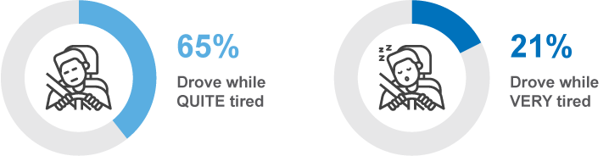
DB3GH In the last 12 months, how often did you [tired driving behaviour]?
Base: Drivers (n=2,339)
The frequency of driving ‘very tired’ is lower than the frequency of driving while ‘quite tired’. Among the two-thirds (65%) of drivers who drove while feeling ‘quite’ tired, almost half do so ‘sometimes’ or more frequently (27%). In comparison, among the 21% of the drivers who drove while ‘very’ tired, only one-in-five (4% out of 20%) do so ‘sometimes’.
Figure 43 Frequency of driving tired
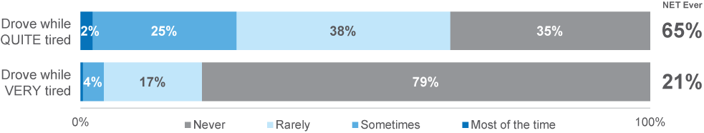
DB3GH In the last 12 months, how often did you [tired driving behaviour]?
Base: Drivers (n=2,339)

Figure 44 shows the historical trend for driving while ‘very tired’ and ‘quite tired’. Since 2022, there have been no marked shifts in the prevalence of driving while quite tired and very tired.
Considering the shifts by quarter, the lowest proportion of respondents who drove while ‘very tired’ was recorded in quarter 3, 2023, with 16% of respondents. In contrast, the highest proportion of respondents who drove while ‘very tired’ was quarter 1, 2023, with 25% of respondents.
Driving while ‘quite tired’ remained relatively consistent across all quarters.
Figure 44 Driving while quite tired and very tired by year: ‘ever’ (%)
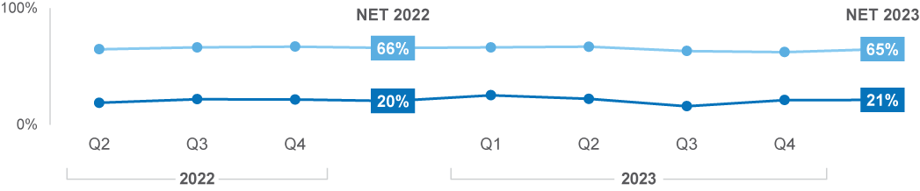
DB3GH In the last 12 months, how often did you [tired driving behaviour]?
Base: Drivers
Note: Due to a substantial change in instrument design and metric measurement, any data changes between 2021 and 2022 should be interpreted with caution.

Demographic characteristics
Propensity to drive while being either quite or very tired deceased with age, especially among those aged 61–90. Driving while very tired was more prevalent among those living in other urban locations and males compared to other drivers.
- Drivers aged 18–25 (72%), and 26–39 (75%) were more likely than those aged 61–90 (51%) to drive while quite tired.
- Drivers aged 18–25 (32%) and 26–39 (26%) were also more likely than those aged 61–90 (12%) to have driven while very tired.
- Drivers in other urban areas were more likely than those in major urban areas to have driven while very tired (27% vs 20%) and while quite tired (69% vs 64%).
- Males (23%) were more likely than females (19%) to have driven while very tired, however, were similar in their propensity to drive quite tired.
Table 12 Prevalence of tired driving among demographics
Column % |  | Age group |  |  |  | Gender |  | Location
Column % | Total | 18–25 | 26–39 | 40–60 | 61–90 | Male | Female | Major Urban | Other Urban | Rural
Drove while very tired | 21% | 32% ↑ | 26% ↑ | 21% | 12% ↓ | 23% ↑ | 19% ↓ | 20% ↓ | 27% ↑ | 24%
Drove while quite tired | 65% | 72% ↑ | 75% ↑ | 65% | 51% ↓ | 67% | 63% | 64% ↓ | 69% ↑ | 69%
Column n | 2328 | 311 | 594 | 765 | 658 | 1136 | 1192 | 1207 | 764 | 357
DB3GH In the last 12 months, how often did you [tired driving behaviour]?
Base: Drivers (n=2,328)

Driving Tired – Demographic Interactions
Driving while ‘quite tired’
Considering the interactions between demographic features of respondents, driving while quite tired was most prevalent among those aged 40–59 in other urban and rural areas (76%), and those aged 18–39 in general (74%). Those aged 40–59 in major urban areas (61%) were less likely than those the same age in other urban and rural areas to have driven while quite tired. Only 51% of those aged 61–90 had driven while quite tired, which did not differ significantly by gender or location.
Table 13 Prevalence of driving quite tired by demographic interactions
Prevalence among the average driver | Propensity | Age | Gender | Location | %
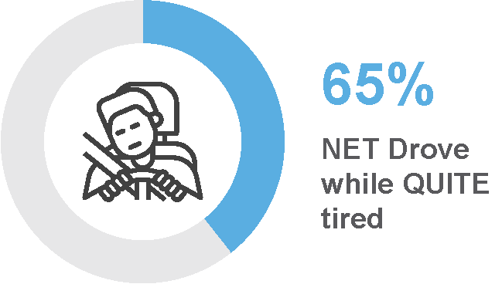 | Higher | 40–59 | All | Other Urban / Rural | 76
 | Higher | 18–39 | All | All | 74
 | Moderate | 40–59 | All | Major Urban | 61
 | Lower | 61–90 | All | All | 51
DB3G In the last 12 months, how often did you [tired driving behaviour]?
Base: Drivers (n=2,339)
Driving while ‘very tired’
Considering combinations of key demographic characteristics, driving while very tired was most prevalent among males aged 18–59 in other urban / rural areas (37%), and females aged 26–59 in other urban areas (35%).
Among the lower prevalence groups, those aged 61–90 of any gender in major urban locations (10%), and females in other urban and rural areas (11%) were least likely to drive while very tired.
Table 14 Prevalence of driving very tired by demographic interactions
Prevalence among the average driver | Propensity | Age | Gender | Location | %
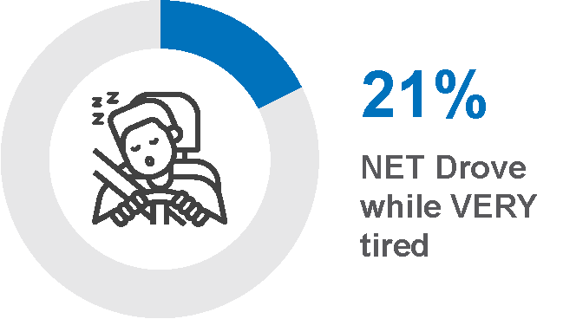 | Higher | 18–59 | Male | Other Urban / Rural | 37
 | Higher | 26–59 | Female | Other Urban | 35
 | Lower | 61–90 | All | Major Urban | 10
 | Lower | 61–90 | Female | Other Urban / Rural | 11
DB3H In the last 12 months, how often did you drive while very tired, so tired you struggled to keep your eyes open?
Base: Drivers (n=2,330)

DBI Profile
This section explores the relationship between DBI and tired driving behaviours. This provides an overview of how likely and frequently those who drove while very tired, or quite tired, were to engage in other dangerous driving behaviours.
There were two questions that asked how frequently respondents drove while quite tired, and very tired. For the purposes of this section, respondents have been separated into their most severe behaviours when it comes to tired driving. These segments are, in order of severity, those who did not drive tired at all, those who only drove while quite tired, and those who drove while very tired.
Overall, those who drove while very tired had a substantially higher risk profile in general, while those who drove while quite tired had a slightly higher, but mixed, risk profile.
Among those who drove while ‘very tired’, 66% had very high (49%) or extremely high (17%) risk profiles. In contrast, those who drove while ‘quite tired’ were split somewhat equally between ‘medium’ (29%), ‘high’ (32%), and ‘very high’ (27%) risk profiles. However, over three-quarters (76%) of those who did not drive while tired had ‘low’ (50%) or medium (26%) risk profiles.
These results indicate that not driving while tired has a strong association with lower propensity to engage in other dangerous driving behaviours.
Table 15 Tired driving behaviour by DBI Membership
Row % | Low | Medium | High | Very High | Extremely  High
Drove while very tired | 0% ↓ | 10% ↓ | 24% | 49% ↑ | 17% ↑
Drove while quite tired | 9% ↓ | 29% ↑ | 32% ↑ | 27% ↑ | 3% ↓
Did not drive while tired | 50% ↑ | 26% | 16% ↓ | 7% ↓ | 1% ↓
Total | 21% | 24% | 25% | 25% | 5%
Column n | 485 | 550 | 577 | 589 | 140
DBI Summary
Base: Drivers (n=2,328)

Behavioural Insights
In this section, some potential reasons as to why people drive while tired are explored. The parameters measured for this section include:
- perceived control over fatigued driving
- perceptions of the danger associated with fatigued driving
- self-perceptions of how safe their driving is.

Perceived control over fatigued driving
Four in ten (40%) of those who drove while very tired agreed that sometimes they have to drive even if they are very tired. In contrast, 16% of those who drove while quite tired agreed, and just 4% who did not drive while tired agreed with this statement.
To assess respondents’ perceived control over tired driving, respondents were asked to what extent they agree or disagree with the statement ‘sometimes you have to drive, even if you are very tired’ from 1 – strongly disagree to 5 – strongly agree.
Figure 45 Perceived control over tired driving (% agree)
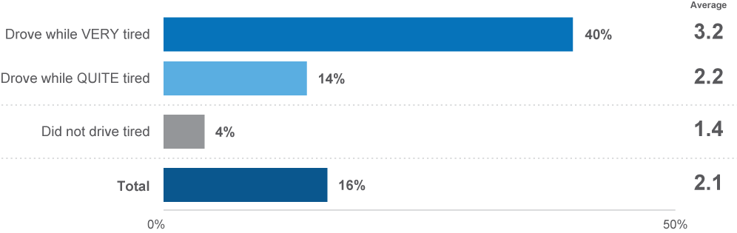
PC1A To what extent do you agree or disagree that sometimes you have to drive even though you are very tired? (Scale from 1 – strongly disagree to 5 – strongly agree)
Base: Drivers (n=2,255)

Perceived danger of fatigued driving
Respondents were asked to rate how dangerous it is to drive while very tired, on an 11–point scale, with 0 being ‘not at all dangerous’ and 10 being ‘extremely dangerous’. The average scores for different groups of respondents are presented below.
Respondents who did not drive while tired at all (9.2) perceived the danger of driving while very tired as higher than those who drove while quite tired (8.4) and very tired (7.5).
Figure 46 Perceived danger of driving while very tired
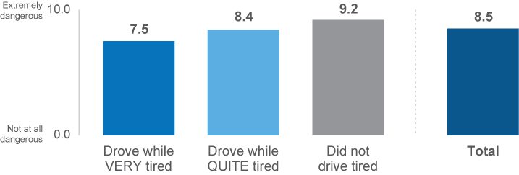
RI1F How dangerous do you think it is to drive while very tired? (scale from 0 ‘not at all dangerous’ to 10 ‘extremely dangerous’)
Base: Drivers (n=2,316)

Self-perceptions of driving safely
Respondents who drove while tired perceived themselves as less-safe drivers than those who did not drive while tired.
To understand drivers’ self-perceptions of how safe they are as a driver, respondents were asked on a 5–point scale how safe they are as a driver, with 5 being ‘very safe’, and 1 being ‘not at all safe’.
When asked to rate how safe they believe they are as a driver, respondents who had not driven while tried rated themselves at 4.6, higher than respondents who had driven while quite tired (4.5) or those who had driven while very tired (4.2).
Figure 47 Self-perceptions of driving safely by tired driving categories
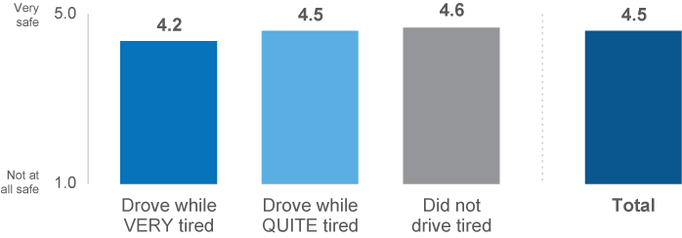
OB1 How safe a driver would you say you are? (scale from 1 ‘not at all safe’ to 5 ‘very safe’)
Base: Drivers (n=2,287)

Drug driving


3.7 Drug driving
This section explores illegal drug usage, drug driving behaviour, and attitudes towards drug driving in the community.

Prevalence of illegal drug use and drug driving
Illegal drug use has a low prevalence in the community, and the prevalence of driving a vehicle after using illegal drugs is lower.
Prevalence was measured by asking how often respondents illegally used drugs in the last 12 months. Drivers who reported having illegally used drugs were then asked how often they drove a vehicle after using illegal drugs in the last 12 months*.
Fewer than one-in-twenty (4.6%) respondents used illegal drugs in the past 12 months, while a small percentage of drivers (1%) reported that they had driven a vehicle after using illegal drugs.
Figure 48 Prevalence of illegal drug use and drug driving
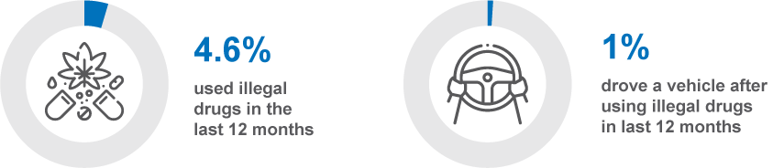
DG1 In the last 12 months, how often did you illegally use drugs?
Base: All respondents (n=2,328)
DB3D In the last 12 months, how often did you drive a vehicle after using illegal drugs?
Base: Drivers (n=2,327)
*DB3D has been re-based to include all drivers to measure the overall prevalence of drug-driving
Figure 49 shows the time series for drug driving between 2017 and 2022. There has been a consistent downward trend in drug driving behaviour since 2018. The prevalence of drug driving decreased from a peak of 2.2% in 2018 to a similarly low rate recorded in 2022 (0.8%) to 1.0% in 2023.
Figure 49 Drug driving by year: ‘ever’ (%)
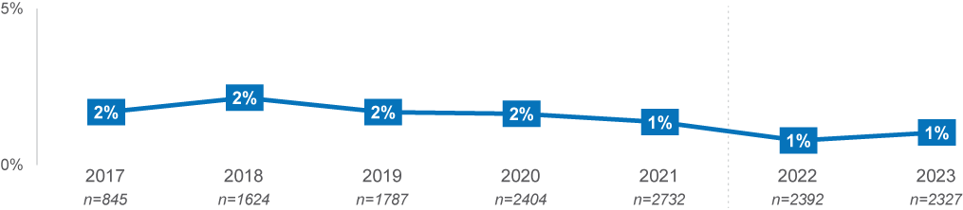
DB3D In the last 12 months, how often did you drive a vehicle after using illegal drugs?
Base: Drivers
Note: Due to substantial changes in survey instrument design and metric measurement, changes in prevalence between 2021 and 2022/23 should be interpreted with caution.

Demographic characteristics
Across demographic groups, illegal drug use was more prevalent among those aged 18–25 and 26–39.
- Those aged 18–25 (11%) and 26–39 (9%) were most likely to have used illegal drugs, with use being most common less often than monthly (8% and 6%) or monthly (3% and 2%).
Table 16 Prevalence of illegal drug use among demographics
Column % |  | Age group |  |  |  | Gender |  | Location
Column % | Total | 18–25 | 26–39 | 40–60 | 61–90 | Male | Female | Major Urban | Other Urban | Rural
NET: Not in last 12 months / never | 95% | 89% ↓ | 91% ↓ | 98% ↑ | 100% ↑ | 95% | 96% | 95% | 97% | 96%
I have never illegally used drugs | 86% | 81% ↓ | 79% ↓ | 86% | 97% ↑ | 85% | 88% | 86% | 88% | 89%
Not in last 12 months, but did illegally use drugs more than 12 months ago | 9% | 8% | 12% ↑ | 11% ↑ | 3% ↓ | 9% | 9% | 9% | 8% | 8%
Less often than monthly | 3% | 8% ↑ | 6% ↑ | 2% ↓ | 0% ↓ | 3% | 3% | 3% | 2% | 3%
Monthly | 1% | 3% ↑ | 2% ↑ | 0% ↓ | 0% ↓ | 1% | 1% | 1% | 1% | 0%
Weekly | 0% | 0% | 1% | 0% | 0% | 1% | 0% | 0% | 0% | 0%
Daily | 0% | 0% ↑ | 0% | 0% | 0% | 0% | 0% | 0% | 0% | 0%
NET: Ever | 5% | 11% ↑ | 9% ↑ | 2% ↓ | 0% ↓ | 5% | 4% | 5% | 3% | 4%
Column n | 2328 | 312 | 590 | 760 | 666 | 1134 | 1194 | 1205 | 764 | 359
DG1 In the last 12 months, how often did you illegally use drugs?
Base: Drivers (n=2,328)
Although there are apparent differences in prevalence of drug driving among different demographic groups – for instance, this behaviour appeared to be higher among those aged under 60 years, among males and among those living in rural Victoria – only those aged 26–39 (2.5%) were significantly more likely than the average respondent (1.0%) to have used illegal drugs and drove.
Table 17 Prevalence of drug driving among demographics
Column % |  | Age group |  |  |  |  | Gender |  | Location
Column % | Total | 18–25 | 26–39 | 40–60 | 61–90 | Male |  | Female | Major Urban | Other Urban | Rural
NET: Used drugs & drove | 1.0% | 1.2% | 2.5% ↑ | 0.2% ↓ | 0.5% | 1.4% |  | 0.7% | 1.2% | 0.7% | 0.6%
Column n | 2327 | 311 | 590 | 760 | 666 | 1133 |  | 1194 | 1204 | 764 | 359
DB3D In the last 12 months, how often did you drive a vehicle after using illegal drugs?
Base: Drivers

DBI Profile
This section explores the relationship between DBI and drug use and drug driving behaviours. This provides an overview of how likely and frequently those who used drugs, and used drugs and drove were to engage in other dangerous behaviours.
For this section and the following, respondents have been categorised into 3 distinct behaviours. These categories are, those who used drugs and drove, those who used drugs but did not drive after using them, and those who did not use drugs at all.
Those who used drugs and drove were more likely to have an ‘extremely high’ DBI, with nearly half (48%) fitting this group. Although those who used drugs and drove were much more likely to be in the ‘extremely high’, many of those who used drugs and did not drive were also more likely to have fit in the ‘very high’ (43%) or ‘extremely high’ (15%) DBI categories.
These results suggest that using drugs has a strong relationship with engagement in other dangerous driving behaviours, and that driving after using drugs has an exceptionally strong relationship with engaging in other dangerous driving behaviours.
Table 18 Drug driving and drug use behaviour by DBI Membership
Row % | Low | Medium | High | Very High | Extremely  High
Used drugs and drove | 0% ↓ | 0% ↓ | 23% | 30% | 48% ↑
Used drugs but did not drive after | 4% ↓ | 13% | 25% | 43% ↑ | 15% ↑
Did not use drugs | 23% ↑ | 25% ↑ | 25% | 24% ↓ | 4% ↓
Total | 22% | 24% | 25% | 25% | 5%
Column n | 488 | 547 | 571 | 583 | 139
DBI Summary
Base: Drivers (n=2,328)

Behavioural Insights
This section explores drug driving behaviour by responses to questions about perceived risk of driving after using cannabis, and general questions about enforcement risk and self-assessment as a safe driver.
Overall, those who used illegal drugs and drove perceived drug driving to be less risky, both in terms of enforcement and crash risk, compared to other drivers. Those who used illegal drugs but did not drive perceived themselves as less-safe drivers than the average respondent and those who used drugs and drove.
Perceived danger of drug driving
Respondents were asked to rate how dangerous it is to drive after using illegal drugs, on an 11–point scale, with 0 being ‘not at all dangerous’ and 10 being ‘extremely dangerous’. The average scores for different groups of respondents are presented below.
Respondents who used illegal drugs (7.3) and drove after using them (6.3) perceived driving after using cannabis as substantially less dangerous than those who did not use illegal drugs (9.1).
Figure 50 Perceived danger of driving soon after using cannabis
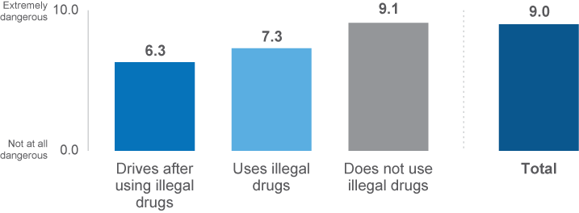
RI1 How dangerous do you think it is to drive soon after using cannabis? (Scale from 0 ‘not at all dangerous’ to 10 ‘extremely dangerous’)
Base: Drivers (n=2,009)
Perceived enforcement risk
To understand the perceived risk of enforcement, respondents were asked how likely they believe they are to get caught by the police for breaking any road rule on a scale of 1 to 5, where 1 was not at all likely, and 5 was extremely likely.
As shown in Figure 51, respondents who used illegal drugs (25%), and those who used illegal drugs and drove (19%), were less likely to believe that they would be caught by police for breaking any road rule, relative to those who did not use illegal drugs (37%).

Figure 51 Perceived enforcement risk among drug driving categories
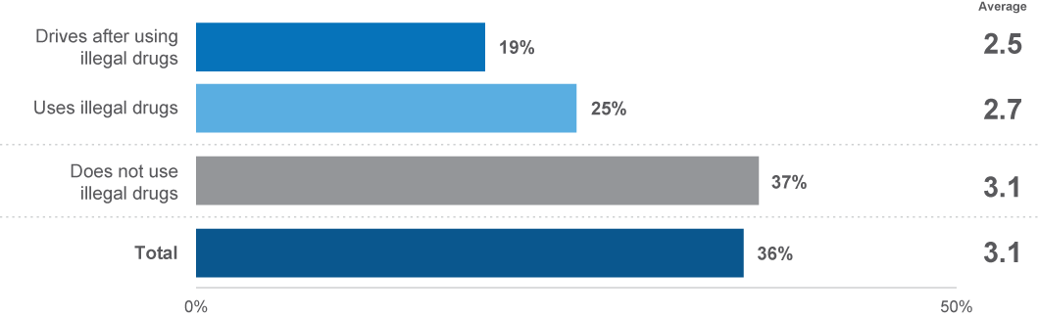
EN2 How likely do you believe you are to get caught by police if you are breaking any road rule at any given time? (Scale from 1 ‘not at all likely’ to 5 ‘extremely likely’)
Base: Drivers (n=2,173)
Self-perceptions of driving safely
To understand drivers’ self-perceptions of how safe they are as a driver, respondents were asked on a 5–point scale how safe they are as a driver, with 5 being ‘very safe’, and 1 being ‘not at all safe’.
Those who used illegal drugs and drove (4.5) perceived themselves as similarly safe drivers compared to those who did not use illegal drugs (4.5). Those who used illegal drugs and did not drive, however, perceived themselves to be relatively less-safe drivers (4.2).
Figure 52 Self-perceptions of driving safely among drug driving categories
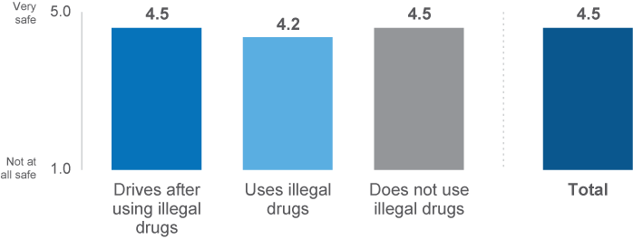
OB1 How safe a driver would you say you are? (Scale from 1 ‘not at all safe’ to 5 ‘very safe’)
Base: Drivers (n=2,271)

Seatbelt use

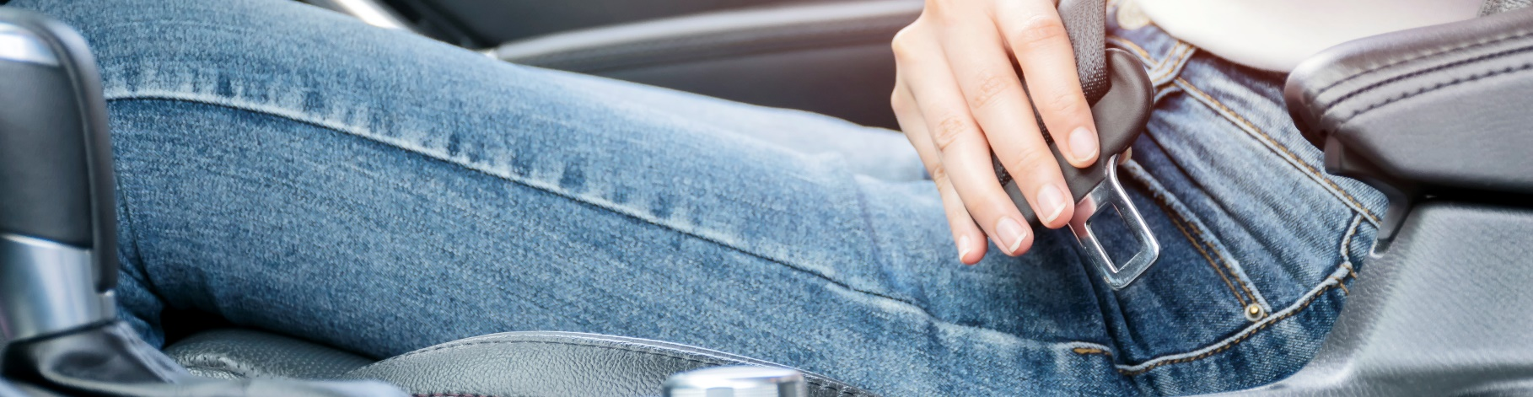
3.8 Seatbelt use
This section explores seatbelt use among drivers and passengers.

Prevalence of seatbelt use
Two seatbelt compliance scenarios were examined in this survey. Drivers were asked how often they drove a vehicle while not wearing a seatbelt and all respondents were asked how often they travelled in a car as a passenger while not wearing a seatbelt.
The prevalence of seatbelt use was high. Less than three percent of drivers drove without wearing a seatbelt (2.7%), while 4.2% of all respondents travelled as passengers without a seatbelt on. Just 1.4% of drivers did not wear a seatbelt while travelling in a car as both a driver and passenger.
Figure 53 Prevalence of seatbelt noncompliance among drivers and passengers
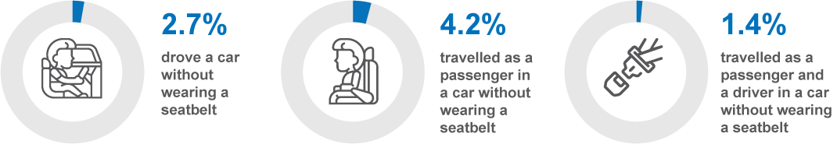
DB3E In the last 12 months, how often did you travel in a car without wearing a seatbelt?
Base: Drivers (n=2,338)
DB3F In the last 12 months, travel in a car as a passenger without wearing a seatbelt?
Base: All respondents (n=2,395)

Figure 54 displays the historical trend for seatbelt noncompliance among both drivers and passengers, indicating small fluctuations over the years. Between 2016 and 2021, the prevalence of driving without a seatbelt remained at about 3%. A small decline to 2.3% in 2022 is the lowest result across the past seven years, however, this has increased slightly to 2.7% in 2023. The prevalence of travelling in a car as a passenger without wearing a seatbelt declined from 4.2% in 2016 to 2.6% in 2019, with low reported levels maintained to 2021. However, in 2022, the result for driving without a seatbelt decreased, while the result for passengers not wearing a seatbelt increased. In 2023, not wearing a seatbelt as a driver increased to 2.7% and not wearing a seatbelt increased to 4.2%.
Figure 54 Noncompliance with seatbelt use by year: ‘ever’ (%)
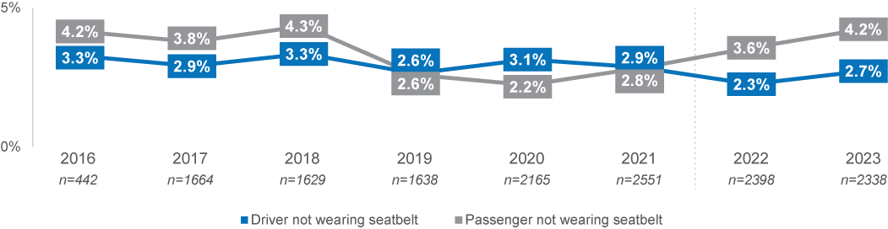
DB3E In the last 12 months, how often did you travel in a car without wearing a seatbelt?
DB3F In the last 12 months, Travel in a car as a passenger without wearing a seatbelt?
Base: All respondents
Note: Due to a substantial change in instrument design and metric measurement, any data changes between 2021 and 2022 should be interpreted with caution

Demographic characteristics
Those living in rural and other urban areas had the highest prevalence of driving while not wearing a seatbelt, and those aged 18–25 were the most likely to travel as passengers while not wearing a seatbelt. Respondents in rural areas were more likely than those in major urban areas to drive while not wearing a seatbelt (5.3% vs 2.1%). Those aged 18–25 (3.2%) and those in rural areas (3.1%) were most likely to have travelled as a driver and passenger without a seatbelt.
Table 19 Prevalence of noncompliance with seatbelt use among demographics
Column % |  | Age group |  |  |  |  | Gender |  | Location
Column % | Total |  | 18–25 | 26–39 | 40–60 | 61–90 | Male | Female | Major Urban | Other Urban | Rural
Drive a car while not wearing a seatbelt | 2.7% |  | 3.5% | 3.5% | 2.3% | 2.1% | 3.7% ↑ | 1.8% ↓ | 2.1% ↓ | 4.6% ↑ | 5.3% ↑
Travel as a passenger while not wearing a seatbelt | 4.2% |  | 7.7% ↑ | 5.1% | 3.3% | 2.9% | 4.7% | 3.8% | 4.2% | 3.8% | 5.5%
Drove car and travelled as passenger without a seatbelt | 1.4% |  | 3.2% ↑ | 1.8% | 0.6% ↓ | 1.1% | 1.7% | 1.0% | 1.1% | 1.7% | 3.1% ↑
Column n | 2395 |  | 327 | 610 | 779 | 679 | 1167 | 1228 | 1253 | 781 | 361
DB3E In the last 12 months, how often did you travel in a car without wearing a seatbelt?
DB3F In the last 12 months, Travel in a car as a passenger without wearing a seatbelt?
Base: All respondents

DBI Profile
This section explores the relationship between DBI and seatbelt use.
For this section and the following, respondents have been categorised into 2 distinct segments, those who always wore a seatbelt as a passenger and driver, and those who did not, either as a passenger, driver or both.
Overall, these results indicate that seatbelt non-use is strongly related to other dangerous driving behaviours. As shown in Table 20, those who did not always wear a seatbelt were considerably more likely to have ‘very high’ (42%) and ‘extremely high’ (35%) DBIs. In contrast, those who always wore a seatbelt were similar to drivers in total in their DBI membership proportions, since always wearing a seatbelt is a common behaviour.
Table 20 Tired driving behaviour by DBI Membership
Row % | Low | Medium | High | Very High | Extremely  High
Travelled without a seatbelt as a driver and/or passenger | 0% ↓ | 8% ↓ | 15% ↓ | 42% ↑ | 35% ↑
Always wore a seatbelt | 23% ↑ | 25% ↑ | 25% ↑ | 23% ↓ | 3% ↓
Total | 22% | 24% | 24% | 24% | 5%
Column n | 499 | 549 | 576 | 589 | 140
DBI Summary
Base: Drivers (n=2,328)

Behavioural Insights
While respondents were not asked directly about why they do not always wear a seatbelt, some insights can be gained by exploring how seatbelt wearing behaviour relates to other measures. These analyses showed that perceived enforcement risk and self-perceptions of safe driving differed slightly among those who always wear a seatbelt versus those who did not always wear one.
To understand the perceived risk of enforcement, respondents were asked how likely they believe they are to get caught by the police for breaking any road rule on a scale of 1 to 5, where 1 was not at all likely, and 5 was extremely likely.
Drivers who did not always wear a seatbelt were less likely to believe that they will be caught by police if breaking a road rule, compared to drivers who did always wear a seatbelt (31% vs 37%).
Figure 55 Perceived enforcement risk among seatbelt wearing categories (% likely)
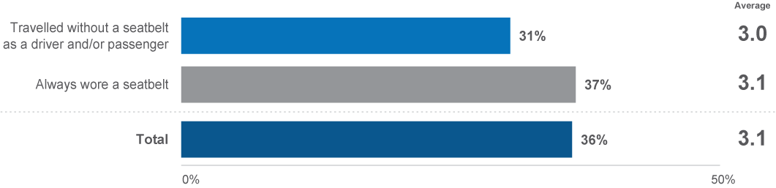
EN2 How likely do you believe you are to get caught by police if you are breaking any road rule at any given time? (Scale from 1 ‘not at all likely’ to 5 ‘extremely likely’)
Base: Drivers (n=2,049)

To understand drivers’ self-perceptions of how safe they are as a driver, respondents were asked on a 5–point scale how safe they are as a driver, with 5 being ‘very safe’, and 1 being ‘not at all safe’.
Drivers who did not always wear a seatbelt had some understanding of their elevated level of risk and perceived themselves as less safe drivers when compared to those who always wore a seatbelt (4.1 vs 4.5).
Figure 56 Self-perceptions of driving safely among seatbelt wearing categories
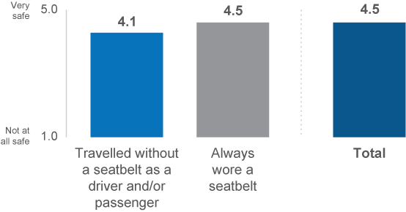
OB1 How safe a driver would you say you are?.(Scale from 1 ‘not at all safe’ to 5 ‘very safe’)
Base: Drivers (n=2,142)

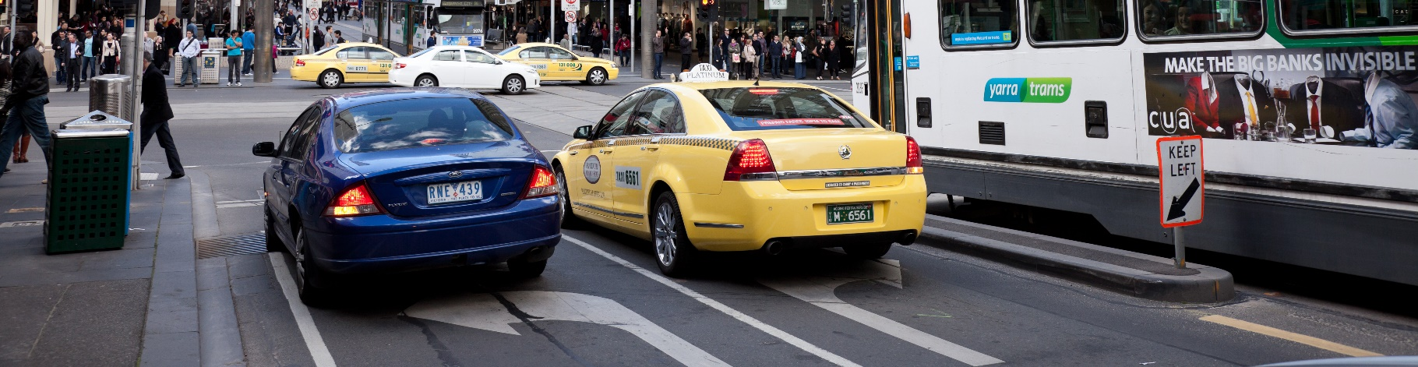
Transport use
3.9 Transport use

This section explores how people travel on the road by using various vehicles and other means of transportation.

Modes of Transport
Although driving a car remained the primary mode of transport used by Victorians, several other modes of transport are widespread.
To explore trends in transport usage, respondents were asked how often they travel by six transport modes in the last 12 months, including private transport modes (car, bicycle, heavy vehicle, or motorcycle), and shared transport modes (public transport, taxi, Uber or similar service). Driving a car was the most prevalent and frequently used transport mode (97%). Most respondents drove a car at least once a week (92%), with a small minority driving once or twice a month (2%) or less than once a month (2%). Other personal transport modes were used to a lesser extent, with about a third riding a bicycle (32%) and one-in-fourteen riding a motorcycle (7%). Driving a heavy vehicle was the mode of transport least used by respondents (6%).
Considering shared and public transport, nearly three quarters used public transport (76%), with one-in-six having used it weekly (18%). About two-thirds used commercial rideshare (67%), with 4% having used these services weekly.
Figure 57 Frequency of transport mode use
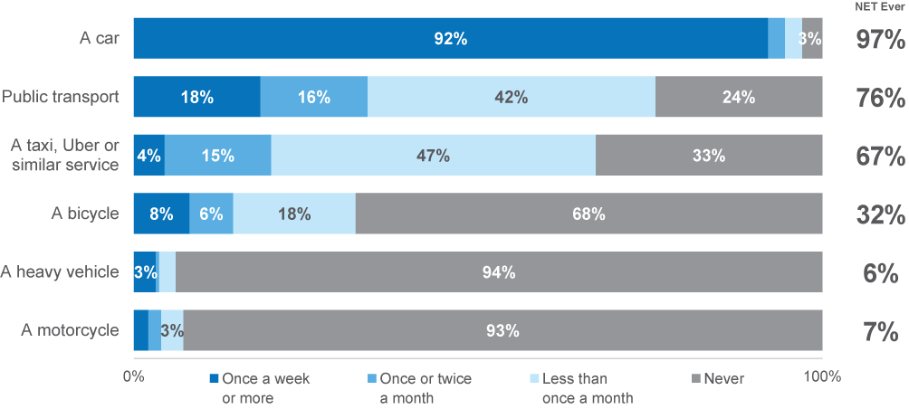
M2ABCD How often did you drive/ride each of the following [transport modes] on the road in the last 12 months?
M1AB How often did you go somewhere by each of the following [transport modes] in the last 12 months?
Base: All respondents (n=2,415)

E-ridable devices have gained popularity over the past few years but their usage on Victoria’s roads remains low; only one in fourteen respondents reported having used an e-scooter (7%), and fewer an e-skateboard (4%) or an e-bike (3%) in the past year.
Figure 58 Prevalence of E-device use
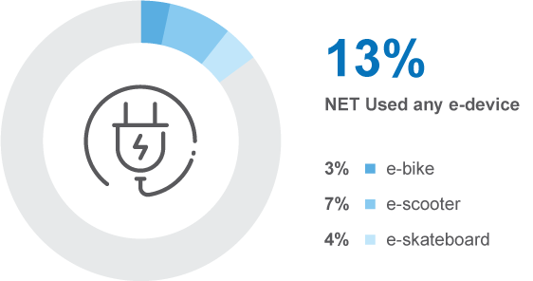
M3 Did you ride any of the following [e-devices] on the road in the last 12 months?
Base: All respondents (n=2,421)

Demographic characteristics
Car usage was similar across most demographic groups, with an overall prevalence of 97%, but there was a slightly higher prevalence in those living in rural areas (99%). Around one third of respondents used a bicycle (32%), but usage was more common in males (38%) than females (27%), and was higher in those aged 26–39 (39%) and those aged 40–60 (36%). Motorcycle usage was also more common in males (11%) than in females (3%), and higher among those aged 40–60 (9%) compared to other age groups. Heavy vehicle driving was more prevalent in males (10%) compared to females (2%), and those living in other urban (9%) and rural areas (15%) compared to major urban areas (5%).
Shared transport modes were more commonly used by respondents aged 18–39, and those residing in major urban areas. Public transportation use was more prevalent in major urban areas (79%), and among those aged 18–25 (89%) and 26–39 (83%) compared to the overall prevalence of 76%. Taxi or other commercial ride share services were more likely to be used in major urban areas (71%), and among those aged 18–25 (82%) and 26–39 (78%) versus the overall prevalence of 67%.
Table 21 Prevalence of transport use among demographics
Column % |  |  | Age group |  |  | Gender |  | Location
Column % | Total | 18–25 | 26–39 | 40–60 | 61–90 | Male | Female | Major Urban | Other Urban | Rural
A car | 97% | 96% | 98% | 97% | 97% | 97% | 97% | 97% ↓ | 98% | 99% ↑
A motorcycle | 7% | 6% | 6% | 9% ↑ | 6% | 11% ↑ | 3% ↓ | 7% | 8% | 10%
A heavy vehicle | 6% | 3% | 6% | 7% | 6% | 10% ↑ | 2% ↓ | 5% ↓ | 9% ↑ | 15% ↑
A bicycle | 32% | 32% | 39% ↑ | 36% ↑ | 20% ↓ | 38% ↑ | 27% ↓ | 32% | 33% | 32%
Public transport | 76% | 89% ↑ | 83% ↑ | 75% | 62% ↓ | 76% | 75% | 79% ↑ | 66% ↓ | 61% ↓
A taxi, Uber or similar service | 67% | 82% ↑ | 78% ↑ | 68% | 46% ↓ | 68% | 66% | 71% ↑ | 56% ↓ | 53% ↓
Column n | 2415 | 327 | 612 | 789 | 687 | 1175 | 1240 | 1264 | 786 | 365
M2ABCD How often did you drive/ride each of the following [transport modes] on the road in the last 12 months?
M1AB How often did you go somewhere by each of the following [transport modes] in the last 12 months?
Base: All respondents
In general, individuals who used an e-device as a mode of transportation were younger. E-scooter usage was most prevalent in people aged 18–25 (17%), followed by people aged 26–39 (10%), compared to the overall prevalence of 7%. E-skateboard users were also more prevalent among 18–25s (13%) and 26–39s (6%) than the overall sample (4%). Moreover, e–scooters were more often used by males (9% vs. 6% of females). Overall, those aged 18–25 were twice as likely (26%) to have used an e–device on the road compared to the average respondent (13%).
Table 22 Prevalence of E–device use among demographics
Column % |  | Age group |  |  |  | Gender |  | Location
Column % | Total | 18–25 | 26–39 | 40–60 | 61–90 | Male | Female | Major Urban | Other Urban | Rural
NET: Any e–device | 13% | 26% ↑ | 15% | 8% ↓ | 10% | 14% | 11% | 13% | 13% | 12%
An e-bike | 3% | 2% | 3% | 2% ↓ | 6% ↑ | 4% | 3% | 3% | 4% | 5%
An e-scooter | 7% | 17% ↑ | 10% ↑ | 5% ↓ | 3% ↓ | 9% ↑ | 6% ↓ | 8% | 7% | 5%
An e-skateboard | 4% | 13% ↑ | 6% ↑ | 3% ↓ | 0% ↓ | 5% | 4% | 5% | 4% | 2%
None of the above | 87% | 74% ↓ | 85% | 92% ↑ | 90% | 86% | 89% | 87% | 86% | 88%
Column n | 2421 | 327 | 612 | 789 | 693 | 1178 | 1243 | 1266 | 790 | 365
M3 Did you ride any of the following [transport modes] on the road in the last 12 months?
Base: All respondents

Driving for Work
Respondents were asked how many days per week they commute to work or study driving a vehicle.
On average, employed drivers drove an average of 3.5 days per week to work or study. Most commonly, people drove 5 days per week (29%) or 1 day per week (27%).
Figure 59 Days per week driving a vehicle for commuting
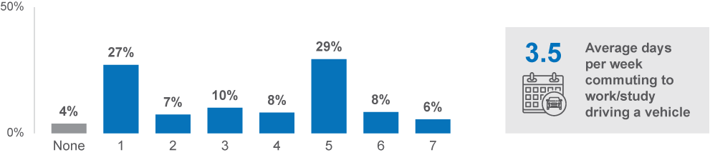
W0 How many days per week do you commute to work or study driving a vehicle?
Base: Employed drivers, n=1,429
Among respondents who were employed and drive, about two-thirds (68%) drove a vehicle for other work-related purposes. However, this was done most frequently one day per week (29%).
Figure 60 Days per week driving a vehicle for work-related purposes besides commuting
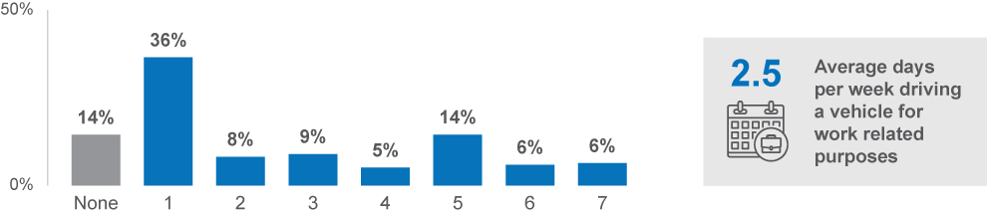
W1 How many days per week do you drive for work related purposes?
Base: Employed drivers, n=1,345

Suggestions for changes to Victorian Roads
Respondents were asked to describe, in their own words, what could be done to make Victorian roads safer. Among the 58% who provided a response, road infrastructure and signage (34%), enforcement (26%), and regulations and rules for road users (13%) were mentioned most often.
Figure 61 Suggested changes to make Victorian roads safer
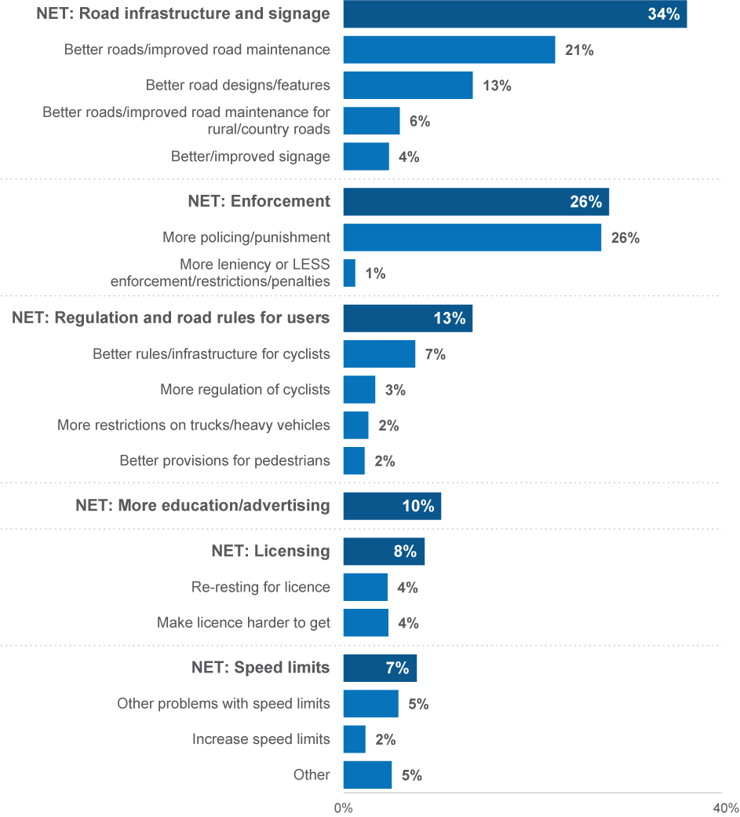
TOP1 What do you think should be done to make Victorian road safer?
Base: Provided a response, n=1,416

Crash prevalence
One-in-twenty (5%) respondents reported that they had been involved in a crash on the road where someone was injured in the last 5 years.
Figure 62 Crash prevalence
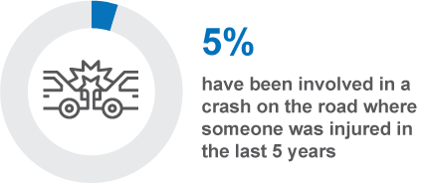
VS4 In the last 5 years, have you been in a crash on the road where someone was injured?
Base: All respondents (n=2,342)

Enforcement


3.10 Enforcement
The role of enforcement in mitigating dangerous driving behaviour has long been established as a core intervention to reduce road trauma. The RSM asks respondents about their interactions with police, whether they have been caught speeding and whether they have been pulled over by the police. Additionally, the RSM asks respondents how likely they believe they are to be caught if they break a road rule at any time.

Prevalence of interactions with enforcement
To understand the prevalence of police enforcement regarding illegal driving behaviours, respondents were asked about their interactions with police and enforcement cameras in the last 12 months.
The prevalence of being caught for speeding was relatively low, with 15% of drivers and riders being caught in the last 12 months, while the reported prevalence of intentionally speeding at least 3 km/h over the limit in the past 3 months was 64% and the prevalence of speeding 10 km/h or more over the limit was 25%. However, the prevalence of being caught for speeding remained higher than in 2021 when 11% was recorded.
Those caught speeding were most likely to be caught by a speed camera (12%), while being caught by a patrol car was rare in comparison (2%). One per cent reported being caught by both a speed camera and a patrol car.
Figure 63 Prevalence of being caught speeding
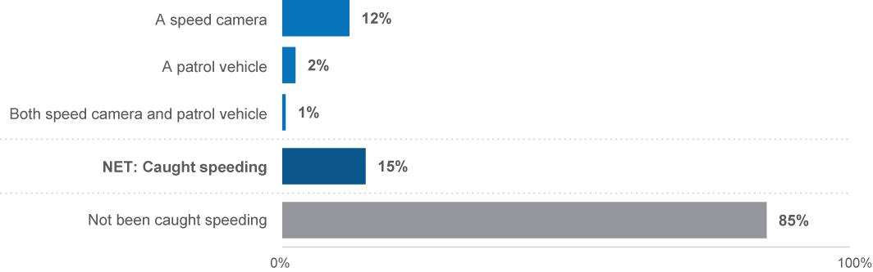
EN1 Have you been caught speeding in the last 12 months by a speed camera, a patrol car or both of these?
Base: Drivers or riders (n=2,319)

Respondents were presented with options to report whether they had been pulled over by police in the last 12 months for a breath test, drug test, or for another reason.
The most common reason for being pulled over by police was for a breath test. One third (32%) were pulled over for a breath test, whereas being pulled over for a drug test (7%) or another reason (2%) were less common. These results were similar to 2022 where 32% were pulled over for a breath test and 6% were pulled over for a drug test.
Figure 64 Prevalence of being pulled over by the police
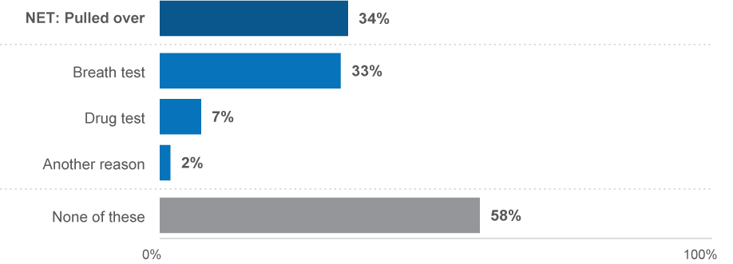
EN3 In the last 12 months, have you been pulled over by police for any of the following reasons?
Base: Drivers or riders (n=2,153)
The proportions of drivers who thought they were likely to be caught by the police for breaking the road rules at any time was about the same as the proportion that thought it was unlikely.
Respondents were asked how likely they believe they would be to get caught by the police for breaking a road rule at any given time on a 5–point scale, where 1 was ‘not at all likely’ and 5 was ‘extremely likely’. Results for this question have been condensed to unlikely (1–2) and likely (4–5).
The results showed that a third respectively said they would be unlikely (32%), and likely (36%) to be caught by the police for breaking any road rule at any time.
Figure 65 Perceived enforcement risk of breaking road rules
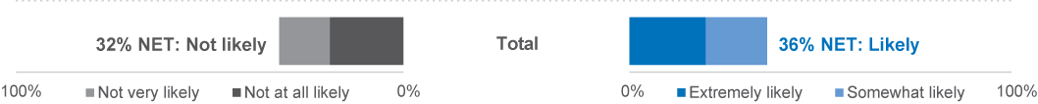
EN2 How likely do you believe you are to get caught by police if you are breaking any road rule at any given time?
Base: Drivers (n=2,198)

Behavioural insights
This section explores the interactions between dangerous driving behaviours, perceived enforcement risk and enforcement incidence.
Examining the enforcement prevalence among those who intentionally drove over the speed limit in the last 12 months reveals that those who sped at 10 km/h or more above the limit (23%) were more likely to be caught for speeding than those who sped at 3 km/h above the limit (14%) and those who did not intentionally speed (10%).
Figure 66 Caught speeding by intentional speeding categories
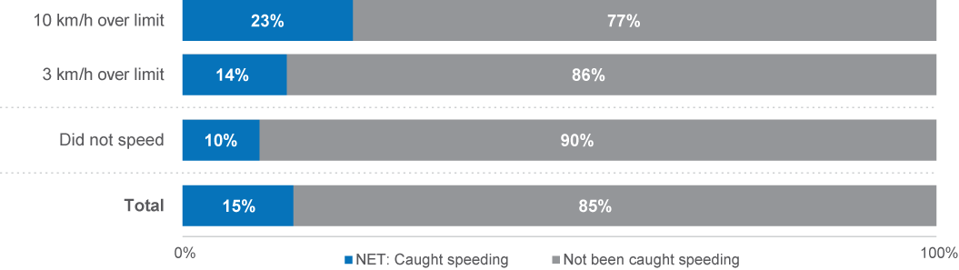
EN1 Have you been caught speeding in the last 12 months by a speed camera, a patrol car or both of these?
Base: Drivers n=2,319
Examining those who drove after drinking in the last 12 months reveals that those who drove after drinking when they might have been or were over the limit (40%) were the most likely to have been pulled over for a breath test.
Figure 67 Pulled over for breath test by drink driving categories
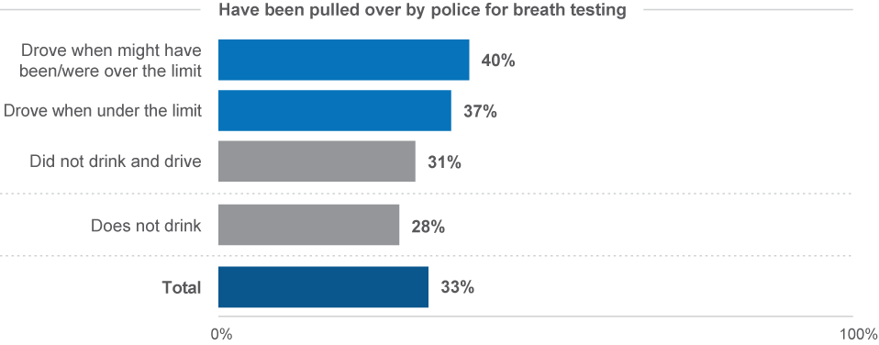
EN3 In the last 12 months, have you been pulled over by police for any of the following reasons?
Base: Drivers (n=2,286)

Examining perceived enforcement risk together with experience with enforcement showed that being caught or pulled over had a substantial impact on how likely respondents felt they were to get caught by police. This result is different to the corresponding results in 2022, which did not find a relationship between perceived enforcement risk and being caught speeding or pulled over by police.
Those who were caught by both a speed camera and a patrol vehicle believed they were more likely to get caught (4.2 / 5.0) versus those only caught by a speeding camera (3.1 / 5.0), and those who had not been caught speeding (3.0 / 5.0).
Additionally, those who were pulled over for a breath test (3.2), or pulled over for another reason (3.8), were more likely to believe they would be likely get caught.
These results indicate that being caught speeding by a patrol vehicle, and both a speed camera and patrol vehicle have marked impacts on people’s perceived risk of enforcement. Additionally, being pulled over for drug, breath tests, or other reasons have some impact on perceived enforcement risk.
Figure 68 Perceived enforcement risk by enforcement experience (NET: Likely (4-5) %)
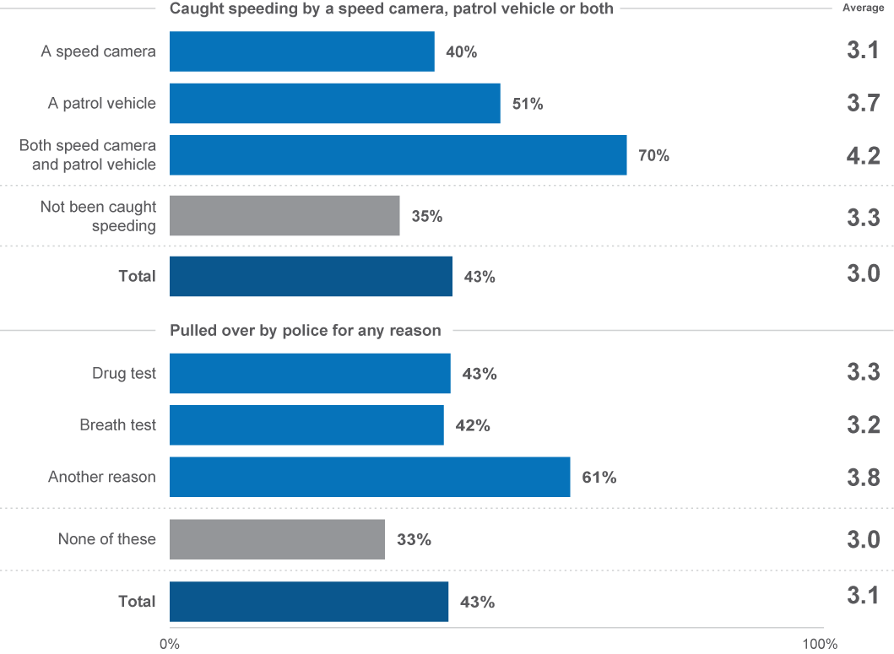
EN2 How likely do you believe you are to get caught by police if you are breaking any road rule at any given time (1 = not likely at all, 5 = extremely likely)?
EN1 Have you been caught speeding in the last 12 months by a speed camera, a patrol car or both of these?
EN3 In the last 12 months, have you been pulled over by police for any of the following reasons?
Base: Drivers n=2,019

Towards Zero


3.11 Towards Zero
In pursuit of TAC's objective to eliminate fatal crashes, TAC has collaborated with various governmental organisations to implement a range of road safety education initiatives and campaigns. These endeavours are aimed at realising the ultimate goal of zero fatalities and severe injuries.

Support for Toward Zero
Respondents were asked whether they think Victoria should aim for zero road deaths. Three quarters of respondents (76%) believed that the goal of zero fatal crashes should be aimed for, and around one in seven (15%) did not think Victoria should aim for zero road deaths.
Figure 69 Support for Toward Zero (%)
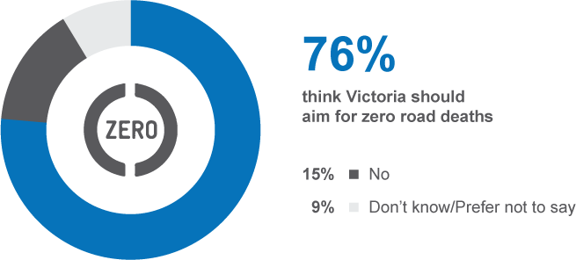
TZ1 In 2002 there were 397 lives lost on Victorian roads, and last year 232 people were killed. Do you think Victoria should aim for zero road deaths?
Base: All respondents n=2,418
Respondents were then asked about their perceptions of what could be accomplished over the next 30 years in terms of the number of lives lost annually, with options ranging from zero fatalities to more than twenty. Half (49%) of respondents regarded fewer than twenty lives lost to be achievable. However, just one in seven (13%) considered zero lives lost to be attainable.
Figure 70 Achievable number of lives lost in a single year
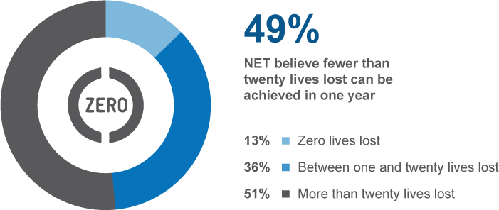
TZ8 Within the next 30 years, which of the following do you think can be achieved in one year?
Base: All respondents n=2,410

Research methodology

Sample and weighting
The sample for the survey is drawn from the VicRoads Registration and Licensing Database and includes Victorians with a licence (either learners’ permit or full licence for any vehicle type) or a registration in their name (car, motorbike or trailer). The number of people approached from key demographic groups was scaled to proportions in the general population, and has a correction applied for known response rates from previous waves of the survey. After the first phase of sampling, sampling effort was boosted in regional areas to enable adequate subgroup comparisons based on region.
Weighting by location, age and gender is then applied to correct the sample to the known licence holder population as derived from the VicRoads Registration and Licencing Database.
Rim weighting was used to correct for sampling design, which includes correcting for a regional boost component of this research, which is used to allow for adequate subgroup comparisons based on region. After weighting the data back to the Victorian Population, the weighting efficiency was 81% (meaning there was an effective base size of 1,955 from a sample of 2,421 respondents).

Changes in methodology
This report contains some time series that cover periods in which the RSM employed different methodologies, dependent upon current research practice and available sample sources. In summary, the different methodologies employed over time included:
- 2001–2007: The RSM was conducted entirely via telephone;
- 2008–2009: After the conduct of a successful pilot in 2007, an online component was introduced to the study in 2008. This was run in combination with telephone;
- 2010–2013: The VicRoads registration and licencing database was made available to the TAC for research purposes, which allowed a refinement of the research methodology. From 2010 participation in the survey was allowed via paper, online or telephone;
- 2014–2015: A pulse survey was included to provide two measures per annum;
- 2016: The RSM was refined through a pilot phase over the first half of the year, with a view to moving to continuous tracking;
- 2017–2023: Continuous tracking with seven waves conducted over four quarters.
The current report includes data collected in all quarters of 2023. Quarterly measures are taken using a modular questionnaire to address road safety themes as well as maintain regular results for core measures.

Questionnaire
Respondents are mailed a questionnaire pack including a Primary Approach Letter (PAL) which allows hard copy or online completion. The PAL advises the sample member of:
- The purpose of the survey
- Eligibility
- How they were selected and where their contact details were sourced from
- Privacy details
- How to complete the survey
- Relevant dates such as the date that telephone calling will commence and the date that the survey closes
- Contact details including an email address and 1800 number
- Details of the prize draw including: that entry to the prize draw is voluntary, the number of prizes available, the amount and nature of the prize and the closing date for a separate ‘early bird’ prize draw and the date that the prize draw will be drawn.

Reminder SMS/letter
Two reminder SMS and one reminder letter were sent to each member of the sample who had not completed the survey in each wave. Following the initial mail/SMS approaches a computer-assisted telephone interview (CATI) phase targeted non-responders with a valid phone number in order to maximise response.

Prize draw
All respondents are offered the opportunity to enter two prize draws, the main prize draw for $1,000, and an additional ‘early completion’ prize draw for $500, Prizes will be paid as either an Electronic Funds Transfer to a nominated bank account or as a GiftPay eGift card, as selected by the winner(s).

Fieldwork
The survey was launched in seven waves over the course of 2023.
Table 23 Fieldwork schedule
 |  | Fieldwork Start | Fieldwork End
Quarter 1 | Wave 1 + 2 | 16 January | 31 March
Quarter 2 | Wave 1 + 2 | 13 April | 20 July
Quarter 3 | Wave 1 + 2 | 17 July | 28 September
Quarter 4 | Wave 1 | 23 October | 6 December

Sample performance
The 2023 survey period is comprised of responses from Victorians sampled from the VicRoads Registration and Licencing Database. In total, 6,987 people were selected from the database and invited to take part in the survey. This led to an overall cooperation rate of 35%.

Table 24 shows the response rate by key demographics overall and by mode for each quarter. Consistent with previous iterations of the RSM, response was generally higher among females and those aged over 40 years, and particularly those aged 61 to 90. With regard to the mode of completion, those aged 61 to 90 were more inclined to complete the survey via hard copy while others had a higher tendency to complete the survey online.

Table 24 Sample performance
 |  | Sample Loaded | Completed Surveys | Response Rate | Online | Paper | Telephone
 |  | # | # | Row % |  | Row %
 | Total | 6,987 | 2,421 | 35% | 56% | 36% | 9%
Gender | Male | 3,845 | 1,178 | 31% | 56% | 33% | 11%
Gender | Female | 3,142 | 1,243 | 40% | 55% | 38% | 7%
Age | 18–25 | 1,216 | 327 | 27% | 70% | 18% | 12%
Age | 26–39 | 2,137 | 612 | 29% | 74% | 15% | 10%
Age | 40–60 | 2,289 | 789 | 34% | 59% | 32% | 9%
Age | 61–90 | 1,345 | 693 | 52% | 29% | 66% | 5%
Location | Major Urban | 3,699 | 1,266 | 34% | 60% | 31% | 9%
Location | Other Urban | 2,293 | 790 | 34% | 50% | 41% | 9%
Location | Rural | 995 | 365 | 37% | 50% | 41% | 9%


Appendix 1
Dangerous Behaviour Index (DBI)

This index is based on the frequency of engaging in behaviours which elevate risk of a crash while driving. The behaviours include drug driving, drink driving, speeding, distracted driving, tired/fatigued driving, and travelling without a seatbelt. The DBI provides an overall metric demonstrating a driver’s relative level of risk when compared to other drivers surveyed for the RSM.
As behaviours do not have the same level of risk, some behaviours are upweighted and some are down weighted in terms of their contribution to the DBI. These weights are at present somewhat arbitrary, as the contribution to the level of risk a driver experiences is unknown. Implicit in the construction of this index is the compounding contribution to overall risk of performing more behaviours more frequently. However, the development of refined risk weighting is a possible direction for future development of the DBI.
It is important to note that the DBI is dependent on the behaviour questions which are included in each wave of the RSM. As these change over time, the calculation of the DBI and thus the distribution of scores on the index does change over time.
There are key breaks in time-periods due to design changes within the RSM which result in alternate DBI calculations, these are:
- 2016 to 2021: Historical period
- 2022 Q2: New DBI excluding driving 10 km/h over the speed limit
- 2022 Q3 onwards: New DBI including driving 10 km/h over the speed limit
The table below denotes the construction of values from the DBI

How the DBI is scored
- Value range:
  - 2022 Q2: 0 to 34 (multiplied by 2.948 to scale to 100) *speeding behaviour has less weight
  - From 2022 Q3: 0 to 37 (multiplied by 2.703 to scale to 100)

Table 1 DBI Summary of Values
Behaviour | Variable | None | Low frequency | Moderate frequency | High frequency | Max score
Value |  | Never (1) / Not applicable (97) / Not asked (NaN) | Rarely (2) | Sometimes (3) | Most of the time (4) / always (5)
Drug driving | db3_d | 0 | 4 | 6 | 8 | 8
Driving when definitely under the BAC | db3_c | 0 | 1 | 2 | 2
Driving while under the BAC (might have been over) | db3_b | 0 | 2 | 3 | 4
Driving while over the BAC | db3_a | 0 | 4 | 6 | 8
Composite: Drink driving |  | 0 | Highest value from drink driving |  |  | 8
Speeding 3 km/h (max in any speed zone) | db2_max | 0 | 1 | 2 | 3
Speeding 10 km/h (max in any speed zone) | db4_max | 0 | 4 | 5 | 6
Composite: Speeding |  | 0 | Highest value from speeding |  |  | 6
Composite: Distractions | db1_max | 0 | 1 | 3 | 6 | 6
Driving while quite tired | db3_g | 0 | 1 | 2 | 2
Driving while very tired | db3_h | 0 | 3 | 4 | 5
Composite: Fatigue |  | 0 | Highest value from fatigue |  |  | 5
Seatbelt as driver | db3_e | 0 | 3 | 4 | 5
Seatbelt as passenger | db3_f | 0 | 3 | 4 | 5
Composite: Seatbelt |  | 0 | Highest value from seatbelts (exclusive) |  |  | 5

Appendix 2
Subgroup reporting

Location sub-groups were changed in 2017. Until 2016, location was defined as either ‘Melbourne’ or ‘Elsewhere in Victoria’. From 2017, however, locations have been defined per ABS SOS definitions. The table below indicates how these locations are now defined.
 | Major Urban  Major Urban represents a combination of all urban centres with a population of 100,000 or more (for example, Melbourne, Geelong, Ballarat).
 | Other Urban  Other Urban represents a combination of all urban centres with a population between 1,000 and 99,999 (for example, Warrnambool, Sale, Benalla).
 | Rural  Rural represents the remainder of State/Territory and includes Bounded Localities (centres with population of between 200 and 999 (e.g. Taradale, Venus Bay, Fish Creek) and smaller centres.

In addition to demographic variables used to analyse differences between groups, results are regularly shown for seven driving behaviour sub-groups. The following table explains how each of these groups has been derived.
Speeding
Intentionally exceeding the posted speed limit by 3 km/h (DB2A, DB2B, DB2C, or DB2D) or 10 km/h (DB4A, DB4B, DB4C, or DB4D) ‘Always’, ‘Most of the time’, ‘Sometimes’ or ‘Rarely’.
Drinking and drink driving
Driving a vehicle when definitely over the legal blood alcohol limit (DB3A), when might have been over the limit (DB3B), or when confident being under the limit (DB3C) is ‘Always’, ‘Most of the time’, ‘Sometimes’ or ‘Rarely’. Drinking alcohol is defined as (DB3A, DB3B, and DB3C – Never) and DK1 is ‘Less often than monthly’, ‘Monthly’, ‘Weekly’, or ‘Daily’.
Drug driving
Driving after using illegal drugs (DB3D) is ‘Always’, ‘Most of the time’, ‘Sometimes’ or ‘Rarely’. Used illegal drugs is DB3D – Never and DG1 is ‘Less often than monthly’, ‘Monthly’, ‘Weekly’, or ‘Daily’.
Mobile phone use
Using a hand-held mobile phone while driving to make or answer calls, send or read messages, or interact with an app (DB1A, DB1B, DB1C) is ‘Always’, ‘Most of the time’, ‘Sometimes’ or ‘Rarely’.
Driving fatigued
Driving when feeling quite tired or very tired (DB3G, DB3H) is ‘Always’, ‘Most of the time’, ‘Sometimes’ or ‘Rarely’.
Noncompliance with seatbelt use
Driving a car or travelling in a car as a passenger without wearing a seatbelt (DB3E, DB3F) is ‘Always’, ‘Most of the time’, ‘Sometimes’ or ‘Rarely’.

Appendix 3
RSM Questionnaire

TAC Road Safety Monitor Questionnaire
2024 Quarter 1 (Jan-Mar)

Final Questionnaire

Mode legend:
Blue text indicates CATI only instruction / text
Green text indicates Online only instruction / text
Pink text indicates Online only Hover text instruction / text
Orange text indicates Hardcopy only instruction† / text
†Note on hardcopy instructions, where there is no Hardcopy instruction available, please refer to online instruction.

INTRODUCTION - CATI
Good morning/afternoon/evening. I’m <name> from Wallis Social Research calling on behalf of the TAC (Transport Accident Commission). We are just following up on a letter we sent to <NAME>. Would they be available at the moment?
[IF MOBILE PHONE: I realise I’m calling you on your mobile, can I just check that it's okay to talk at the moment and that you're not driving? IF DRIVING OR NOT SAFE, MAKE APPOINTMENT]
RE-INTRODUCE IF NECESSARY.
We recently posted a survey to you about road safety. We are conducting this survey on behalf of the TAC. Do you recall receiving this?
IF YES: PROBE FOR WHETHER HAS BEEN COMPLETED HARD COPY OR ONLINE OR NO ACTION
IF NO/DON’T KNOW: CONTINUE TO NEXT SCREEN TO INTRODUCE PHONE SURVEY OR OFFER ONLINE SURVEY LINK
The survey is voluntary. It takes about 30 minutes over the phone. Are you able to participate, either now or at a more convenient time?
The TAC gave us your contact details so we can conduct this survey.
IF NECESSARY: We’d really appreciate your assistance, as we’d like to ensure all Victorian’s views are included. We are offering all people who complete it by phone, online or paper the chance to win an $1000 which can be collected as an Electronic Funds transfer or an eGiftCard.
IF NECESSARY: Wallis works within the Australian Privacy Act which means that all personal information that we collect and store is protected. You can find out more in our Privacy Policy which is available on our website www.wallis.social/privacy.
01 CONTINUE (START SURVEY)
02 Wants to do online – provide link via email or text GO TO L1
42 Will do online – already has link GO TO APT
41 Soft Call Back GO TO APT
46 Hard Appointment GO TO APT
80 Update details
04 Respondent not available during survey period
12 Physically unable to take part in the survey
71 Respondent deceased
10 Refused (Respondent)
13 Refused (Household)
91 Refused – Add to Do Not Call List
11 Language difficulties
07 Wrong number
SC Not in Victoria
61 Not residential number
20 Already completed the questionnaire (hardcopy)

SENDING LINK
L1 Would you like us to send that to you via email or text?

- Email
- SMS

L2 Can I please confirm…

- Your name:
- IF L1=01: Your email address:
- IF L1=02: Your mobile number:
POST L2 GO TO APT

IN SURVEY EMAIL & SMS TEXT
Email
Subject: TAC Road Safety Research – Requested email (ID: <PIN>)
Dear [FNAME],
Thank you for speaking with one of our interviewers earlier regarding the research we are doing on behalf of the TAC about road safety. As requested, please find below a link to the survey below:
[SURVEY LINK]
Just to remind you, the information you provide is entirely confidential and the email address you have provided will not be used for any purpose other than sending this link.
We understand your time is valuable and we appreciate your participation. One of our interviewers may contact you by phone if you don’t complete the survey in the next couple of days.
If you require any assistance with the survey contact Wallis on 1800 113 444 or email roadsafetysurvey@wallisgroup.com.au quoting your ID number [PIN] and the project number 4951.
Regards,
Wallis Social Research

SMS
Hi [FName], please go to [SURVEY LINK] to complete the Road Safety Survey. For more info call Wallis on 1800113444

INTRODUCTION – ONLINE
SURVEY NAME: TAC Road Safety Survey
Thank-you for your interest in this confidential survey. Wallis Social Research is conducting this survey on behalf of the TAC (Transport Accident Commission). Your participation is voluntary, and greatly valued. The information collected in the survey will be used to improve road safety in Victoria.
The survey takes around 15 minutes to complete.
Your details were provided to us by the TAC from the VicRoads database of all registered and licenced drivers and riders for the purpose of conducting this survey. Please note, any information and opinions you provide are entirely confidential and any personalised information, such as your contact details, will be separated from your survey answers.
Our privacy policy can be found at https://www.wallis.social/privacy
More information regarding the study can be found here, or you can contact the TAC on 1300 654 329.
You can check our social research credentials at https://researchsociety.com.au/publicationsresources/confirm-a-research-company
If you need to speak to someone for support, you can contact Road Trauma Support Services in Victoria on 1300 367 797, or if you need urgent help, you can call LifeLine on 13 11 14.
As you move through the survey please do not use your browser "forward" and "back" buttons - instead, use the buttons at the bottom of each screen.
Please click "Next" to begin.

INTRODUCTION – HARDCOPY
[IN HARD COPY TEMPLATE]

MONITORING QUESTION
MONITOR With your permission, the call will be recorded and may be monitored for quality control purposes. If you do not want the call to be recorded or monitored, please say so now.
DO NOT READ OUT
01 Recording and monitoring allowed
02 Recording or monitoring NOT allowed

TABLE OF FILTERS
FILTER NAME | FILTER DEPENDENCIES
DRIVER | IF M2A=02-08 OR M2C=02-08
RIDER | IF M2B=02-08
DRIVER OR RIDER | IF M2A=02-08 OR M2B=02-08 OR M2C=02-08
NON-DRIVER | IF M2A AND M2B AND M2C=01
EXCLUDED | IF M2A AND M2B AND M2C=88
CAR DRIVER | IF VH1=01-03
CRASH | IF VS4=01
BORN OVERSEAS | IF D1=97
EMPLOYED | IF D4=01-03
DRIVE FOR WORK | IF W1=01-07

SECTION 1 Introduction

SECTION 2: GETTING AROUND
M2_INT The following questions are about how often you do a number of things when driving, riding, or getting about in the last 12 months.

Note: Please provide the answer that best describes how often you do these things. We understand it can be difficult to be exact.
[DE ONLY] IF HARDCOPY: IF M2A and M2B AND M2c not answered (code 88) then exclude survey, else CONTINUE.
M2 How often did you drive each of the following on the road in the last 12 months?
ITEMS; display as grid online & hardcopy
A A car
C A heavy vehicle (e.g. semi-trailers, B-double freight trucks, road trains etc.)
RESPONSE SET;
READ OUT FIRST TIME AND PROMPT IF NECESSARY / Please select one option per row / Please tick one box per row
01 Never
02 Once in the last six months or less often
03 Every couple of months
04 About once a month
05 About once a fortnight
06 About once a week
07 2-4 days a week
08 5-7 days a week
88 [DE ONLY] Not answered

M2 How often did you ride each of the following on the road in the last 12 months?
ITEMS; display as grid online & hardcopy
B A motorcycle
D A bicycle
RESPONSE SET;
READ OUT FIRST TIME AND PROMPT IF NECESSARY / Please select one option per row / Please tick one box per row
01 Never
02 Once in the last six months or less often
03 Every couple of months
04 About once a month
05 About once a fortnight
06 About once a week
07 2-4 days a week
08 5-7 days a week
88 [DE ONLY] Not answered
IF M2A=02-08 OR M2C=02-08, DRIVER
IF M2B=02-08, RIDER
IF M2A OR M2C=02-08 AND M2B=02-08, DRIVER OR RIDER
if m2a and m2b and m2c=88, excluded
if m2a and m2b and m2c=01, non-driver

M3 Did you ride any of the following on the road in the last 12 months?
response set; MULTICODE
READ OUT – PAUSE FOR YES/NO / Please select all that apply / Please tick all that apply
01 An e-bike
02 An e-scooter
03 An e-skateboard
97 None of the above
88 [DE ONLY] Not answered

M1 Now thinking about other ways you travel… How often did you go somewhere by each of the following in the last 12 months?
ITEMS; display as grid online & hardcopy
A Public transport
B A taxi, Uber or similar service

RESPONSE SET;
READ OUT FIRST TIME AND PROMPT IF NECESSARY / Please select one option per row / Please tick one box per row
01 Never
02 Once in the last six months or less often
03 Every couple of months
04 About once a month
05 About once a fortnight
06 About once a week
07 2-4 days a week
08 5-7 days a week
88 [DE ONLY]: Not answered

PRE_VH1 IF DRIVER OR RIDER, continue. ELSE, GO TO DB3F.
If you mentioned at Question M2A, M2B or M2C that you drive a car or heavy vehicle, or ride a motorcycle on the road > Continue to Question VH1.
If you do not drive a car, heavy vehicle or a motorcycle on the road > Go to DB3F.
VH1 What type of vehicle or vehicles do you mostly drive on the road?
response set; MULTICODE
READ OUT / Please select all that apply / Please tick all that apply
01 Car / Station wagon
02 SUV / 4WD
03 Ute / Utility / Pickup
04 Truck
05 Motorcycle / Scooter
06 Commercial van
07 Bus
95 Other (specify / please specify)
88 [DE ONLY]: Not answered

VEHICLE SAFETY
prevs4 IF VH1=01-95 continue. ELSE, GO TO db_int.

VS4 In the last five years, have you been involved in any crashes on the road as a driver or rider where someone was injured?
PROMPT IF NECESSARY / Please select one option below / Please tick one box only
01 Yes
02 No
98 (DO NOT READ) Prefer not to say
88 [DE ONLY]: Not answered
IF VS4=01 POST NOTE
If you need to speak to someone for support, you can contact BeyondBlue on 1300 22 4636, or if you need urgent help, you can call LifeLine on 13 11 14. Alternative support can be provided by the Road Trauma Support Services in Victoria on 1300 367 797.

INSERT LIFELINE NUMBER AND rtss number SPIEL HERE FROM END of survey as well IF vs4=01 or 98.

SECTION 3: BEHAVIOURS
Key behaviours
DB_INT The next questions are about behaviour that may be illegal, such as speeding, drink and drug driving etc. Although you may decline to answer these questions if you do not feel comfortable answering them, please remember all your answers are confidential and will not be linked back to you.

DB1 In the last month, how often did you use a mobile phone in your hand while driving to [ITEM]?

ITEMS; DISPLAY AS GRID HARDCOPY
A make or receive a call
B send or read a message
C interact with an app such as navigation, music or something else

RESPONSE SET;
Would you say…?
READ OUT FIRST TIME AND PROMPT IF NECESSARY / Please select one option below / Please tick one box per row
- Never
- Rarely
- Sometimes
- Most of the time
- Always
97 (DO NOT READ) Not applicable (have not driven / no mobile phone)
98 (DO NOT READ) Prefer not to say
88 [DE ONLY]: Not answered

DB2 In the last three months, how often did you intentionally drive 3km/h or more above the limit in the following…
ITEMS; DISPLAY AS GRID ONLINE & HARDCOPY
A 50km/h zone
B 60km/h zone
C 100km/h zone

RESPONSE SET;
Would you say…?
READ OUT FIRST TIME AND PROMPT IF NECESSARY / Please select one option per row / Please tick one box per row
- Never
- Rarely
- Sometimes
- Most of the time
- Always
97 (DO NOT READ) Not applicable (have not driven / not in these circumstances)
98 (DO NOT READ) Prefer not to say
88 [DE ONLY]: Not answered

DB4 In the last three months, how often did you intentionally drive 10km/h or more above the limit in the following…
ITEMS; DISPLAY AS GRID ONLINE & HARDCOPY
A [IF DB2A=02-05] 50km/h zone
B [IF DB2B=02-05] 60km/h zone
C [IF DB2C=02-05] 100km/h zone

RESPONSE SET;
Would you say…?
READ OUT FIRST TIME AND PROMPT IF NECESSARY / Please select one option per row / Please tick one box per row
- Never
- Rarely
- Sometimes
- Most of the time
- Always
97 (DO NOT READ) Not applicable (have not driven / not in these circumstances)
98 (DO NOT READ) Prefer not to say
88 [DE ONLY]: Not answered

DK1 In the last 12 months, on average, how often did you drink alcohol? Would that be…

NOTE: We are referring to all occasions you have drunk any alcohol, not only drinking before driving.

READ OUT / Please select one option below / Please tick one box only

97 I have never had alcohol
01 Not in the last 12 months, but I did drink alcohol more than 12 months ago
02 Less often than monthly
03 Monthly
04 Weekly
05 Daily
98 (DO NOT READ) Prefer not to say
88 [DE ONLY]: Not answered

DG1 In the last 12 months, on average, how often did you illegally use drugs? Would that be…

NOTE: We are referring to all occasions you illegally used drugs, not only illegally using drugs before driving.

IF NECESSARY: Remember that your responses will be completely confidential
READ OUT / Please select one option below / Please tick one box only

97 I have never illegally used drugs
01 Not in the last 12 months, but I did illegally use drugs more than 12 months ago
02 Less often than monthly
03 Monthly
04 Weekly
05 Daily
98 (DO NOT READ) Prefer not to say
88 [DE ONLY]: Not answered

DB3 In the last 12 months, how often did you [ITEM]?
ITEMS; display as grid hardcopy
A [ASK DRIVERS OR RIDERS AND IF DK1=02-05]: Drive a vehicle when you knew you were over your legal blood alcohol limit
B [ASK DRIVERS OR RIDERS AND IF DK1=02-05]: Drive a vehicle when you might have been over your legal blood alcohol limit
C [ASK DRIVERS OR RIDERS AND IF DK1=02-05]: Drive a vehicle after drinking alcohol when you were confident you were under the legal blood alcohol limit?
D [ASK DRIVERS OR RIDERS AND IF DG1=02-05]: Drive a vehicle after using illegal drugs
E [ASK DRIVERS OR RIDERS]: Travel in a car without wearing a seatbelt
F [ASK ALL]: Travel in a car as a passenger without wearing a seatbelt
G [ASK DRIVERS OR RIDERS]: Drive while quite tired
H [ASK DRIVERS OR RIDERS]: Drive while very tired, so tired you struggled to keep your eyes open

RESPONSE SET;
READ OUT FIRST TIME AND PROMPT IF NECESSARY / Please select one option below / Please tick one box per row
- Never
- Rarely
- Sometimes
- Most of the time
- Always
97 (DO NOT READ) Not applicable (have not driven / not in these circumstances)
98 (DO NOT READ) Prefer not to say
88 [DE ONLY]: Not answered

PRE_PC1 IF DRIVER OR RIDER, CONTINUE, ELSE GO TO RI1.
If you mentioned at Question M2A, M2B or M2C that you drive a car or heavy vehicle, or ride a motorcycle on the road > Continue to Question PC1.
If you mentioned at Question M2A, M2B or M2C that you do not drive a car or heavy vehicle, or ride a motorcycle on the road > Continue to Question RI1.
Perceived control
PC1 [On a scale of 1 to 5, where 1 is ‘Strongly disagree’, and 5 is ‘Strongly agree’…] To what extent do you agree or disagree that sometimes you [ITEM]?
ITEMS; display as grid hardcopy
A have to drive even though you are very tired
B have to drive even though you might be over your legal BAC
C have to drive over the speed limit

RESPONSE SET;
PROMPT IF NECESSARY / Please select one option below / Please select one option per row
01 1- ‘Strongly disagree’
02-04
05 5 – ‘Strongly agree’
99 (DO NOT READ) Don’t know
98 (DO NOT READ) Prefer not to say
88 [DE ONLY]: Not answered

Positive & Negative Driving
PND1 How often do you [ITEM]?
ITEMS; DISPLAY AS GRID HARDCOPY
AA Leave your mobile phone out-of-sight while driving
AB Leave your phone mounted while driving
B Avoid driving if you are too tired
C Leave the car at home when you know you are going out to drink
D Tailgate other vehicles
E Run red lights, either intentionally or unintentionally
F Leave at least 1.5 metres between your vehicle and cyclists in speed limit zones above 60km/h
RESPONSE SET;
READ OUT FIRST TIME AND PROMPT IF NECESSARY / Please select one option below / Please tick one box per row
- Never
- Rarely
- Sometimes
- Most of the time
- Always
97 Not applicable
99 (DO NOT READ) Don’t know
98 (DO NOT READ) Prefer not to say
88 [DE ONLY]: Not answered

Overall Behaviours
OB1 How safe a driver would you say you are? Please answer on a scale from 1-to-5, where 1 is ‘Not at all safe’, and 5 is ‘Very safe’.
PROMPT IF NECESSARY / Please select one option below / Please tick one box only
01 01 – ‘Not at all safe’
02-04
05 05 – ‘Very safe’
99 (DO NOT READ) Don’t know
88 [DE ONLY]: Not answered

Perception of danger
RI1 [We would like you to think about / Now please consider] how dangerous it is to do a range of activities on the roads. Please think about someone doing these things in what you think is a typical setting.

[Using a scale where 0 is ‘Not at all dangerous’, and 10 is ‘Extremely dangerous’, h/H]ow dangerous do you think it is to [ITEM]?
ITEMS; Display as grid hardcopy
A Drive at 63 km/h in a 60 km/h speed limit zone
B Drive at 103 km/h in a 100 km/h speed limit zone
C Drive with a Blood Alcohol Content (BAC) over 0.05 (point oh five)
D Drive soon after having one standard alcoholic drink
E Drive soon after using cannabis
F Drive while very tired
G Glance at a mobile phone for a couple of seconds while actively driving
RESPONSE SET;
PROMPT IF NECESSARY / Please select one option below / Please tick one box per row
00 0 – ‘Not at all dangerous’
01-09
10 10 – ‘Extremely dangerous’
99 (DO NOT READ) Don’t know
88 [DE ONLY]: Not answered

Social norms
ACC1 Imagine you were caught for any of the following road safety offences, even if they are things you wouldn’t normally do.

[Using a scale of 1-5 where 1 is not at all embarrassed and 5 is completely embarrassed, h/H]ow embarrassed would you be to tell your friends that you had been caught driving [ITEM]?
ITEMS; Display as grid hardcopy
A 63 km/h in a 60 km/h speed limit zone
B 70 km/h in a 60 km/h speed limit zone
C over your legal BAC
D while using a mobile phone in your hand

RESPONSE SET;
PROMPT IF NECESSARY / Please select one option below / Please tick one box per row

01 1 - ‘Not at all embarrassed’
02-04
05 5 - ‘Completely embarrassed’
97 (DO NOT READ) Not applicable
88 [DE ONLY]: Not answered

Attitudes
ATD1 The following are some statements about the state of driving in Victoria.

[On a scale of 1-to-5, where 1 is ‘Strongly disagree’, and 5 is ‘Strongly agree’, to what extent do you agree or disagree / Please tell us the extent to which you agree or disagree] that [ITEM]?
ITEMS; display as grid hardcopy
X wire rope barriers should be installed on more regional roads
W mobile phone and seatbelt cameras should operate in Victoria
A speeding penalties are just revenue raising
C there should be fewer restrictions on drivers, people will always get hurt on the road
D most injuries and fatalities on the road are caused by reckless drivers
G Victoria should have greater separation between cyclists and drivers
RESPONSE SET;
PROMPT IF NECESSARY/ Please select one option per row / Please tick one box per row

01 1 – ‘Strongly disagree’
02-04
05 5 – ‘Strongly agree’
99 (DO NOT READ) Don’t know
98 (DO NOT READ) Prefer not to say
88 [DE ONLY]: Not answered

Towards Zero

TZ_INT Please/We would like you to now think about the number of people killed each year on Victorian roads due to crashes.

TZ1 In 2002 there were 397 lives lost on Victorian roads, and last year 232 people were killed. Do you think Victoria should aim for zero road deaths?

PROMPT IF NECESSARY / Please select one option below / Please tick one box below

01 Yes
02 No
99 (DO NOT READ OUT) Don’t know
98 (DO NOT READ OUT) Refused / Rather not say
88 [DE ONLY]: Not answered

TZ8 Within the next 30 years, which of the following do you think can be achieved in one year?

READ OUT / Please select one option below / Please tick one box below

01 Zero lives lost
02 Between one and twenty lives lost, or
03 More than twenty lives lost
88 [DE ONLY]: Not answered

Desire for regulatory change
DFC1 In terms of changes to current policy and regulations, how strongly would you oppose or support the following hypothetical scenarios with current road rules [where 1 is ‘Strongly oppose’, and 5 is ‘Strongly support’]?
Items; display as grid ONLINE & HARDCOPY
A The default speed limit on residential roads being changed from 50 km/h to 40 km/h
B The default speed limit on narrow country roads being changed from 100 km/h to 80 km/h
Response set;
PROMPT IF NECESSARY/ Please select one option per row / Please tick one box per row

01 1 – ‘Strongly oppose’
02-04
05 5 – ‘Strongly support’
99 (DO NOT READ) Don’t know
98 (DO NOT READ) Prefer not to say
88 [DE ONLY]: Not answered

Enforcement
PRE_en1 IF DRIVER OR RIDER, continue. ELSE, GO TO ss1.
If you mentioned at Question M2A, M2B or M2C that you drive a car or heavy vehicle, or ride a motorcycle on the road > Continue to Question EN1.
If you do not drive a car, heavy vehicle or a motorcycle on the road > Go to Question SS1.
EN1 Have you been caught speeding in the last 12 months by a speed camera, a patrol car or both of these?
PROMPT IF NECESSARY / Please select one option below / Please tick one box only
01 Yes, a speed camera
02 Yes, a patrol car
03 Yes, both of these
97 No, I have not been caught speeding in the last 12 months
98 (DO NOT READ) Prefer not to say
88 [DE ONLY]: Not answered

EN2 [Using a scale of 1-to-5, where 1 is ‘Not at all likely’, and 5 is ‘Extremely likely’, h/H]ow likely do you believe you are to get caught by police if you are breaking any road rule at any given time?
PROMPT IF NECESSARY / Please select one option below / Please tick one box only
01 1 – ‘Not at all likely’
02-04
05 5 – ‘Extremely likely’
99 (DO NOT READ) Don’t know
88 [DE ONLY]: Not answered

EN3 In the last 12 months, have you been pulled over by police for any of the following reasons?

IF NECESSARY: Please note that your answers are completely confidential
response set; MULTICODE
READ OUT – PAUSE FOR YES/NO / Please select all that apply / Please tick all that apply
01 a breath test
02 a drug test
03 some other reason (Specify)
97 (DO NOT READ) None of these
98 (DO NOT READ) Prefer not to say
88 [DE ONLY]: Not answered

Driving states
DS1 When you are driving, how often do you feel [ITEM]?
ITEMS; display as grid online & hardcopy
A Anxious
B Stressed
C Frustrated
E Attentive
RESPONSE SET; RANDOMISE CATI & CAWI
READ OUT FIRST TIME AND PROMPT IF NECESSARY / Please select one option below / Please tick one box per row
- Never
- Rarely
- Sometimes
- Most of the time
- Always
99 (DO NOT READ) Don’t know
88 [DE ONLY]: Not answered

Sensation seeking
SS1 Please think about the extent to which the following statements describe you. [Please use a scale of 1-to-5, where 1 is ‘Does not describe me at all’, and 5 is ‘Describes me perfectly’]

To what extent does this statement describe you?
ITEMS; display as grid online & hardcopy
B I would like to take off on a trip with no pre-planned routes or timetables
C I get restless when I spend too much time at home
F I would like to try bungee jumping
G I like wild parties
H I would love to have new and exciting experiences, even if they are illegal
RESPONSE SET;
PROMPT IF NECESSARY / Please select one option per row / Please tick one box per row

01 1 – ‘Does not describe me at all’
02-04
05 5 – ‘Describes me perfectly’
99 (DO NOT READ) Don’t know
98 (DO NOT READ) Prefer not to say
88 [DE ONLY]: Not answered

TOP1 What do you think should be done to make Victorian roads safer?

95 RECORD VERBATIM / Please type your answer in the box, providing as much detail as you can / Please write in the box below
99 (DO NOT READ) Don’t know
98 (DO NOT READ) Prefer not to say
88 [DE ONLY]: Not answered

Demographics
PRE_D0 IF DRIVER OR RIDER, CONTINUE, ELSE GO TO D1
If you mentioned at Question M2A, M2B or M2C that you drive a car or heavy vehicle, or ride a motorcycle on the road > Continue to Question D0.
If you do not drive a car, heavy vehicle or a motorcycle on the road > Go to Question D1A.
D0 In the past year, how many kilometres have you driven? If you are unsure, an estimate is okay.
PROMPT IF NECESSARY / Please select one option below / Please tick one box only
01 0 - 4,999 (0 to 96km per week)
02 5,000 - 9,999 (97 to 192km per week)
03 10,000 -14,999 (193 to 288km per week)
04 15,000 -19,999 (289 to 385km per week)
05 20,000 - 29,999 (386 to 577km per week)
06 30,000+ (578km+ per week)
88 [DE ONLY]: Not answered

D1A Do you speak a language other than English at home?
PROMPT IF NECESSARY / Please select one option below / Please tick one box only
01 No
02 Yes
98 (DO NOT READ) Prefer not to say
88 [DE ONLY]: Not answered

D3 What is the postcode of the area you live in?

01 <ALLOW 4-DIGITS> SPECIFY / Please enter postcode below / Write in postcode
98 (DO NOT READ) Prefer not to say
88 [DE ONLY]: Not answered

D4 What is your current employment status?
PROMPT IF NECESSARY / Please select one option below / Please tick one box only
01 Employed full-time
02 Employed part-time or casual
03 Self-employed
04 Student (not working)
05 Unemployed
06 Home duties
07 Retired
95 Other (specify / please specify)
98 (DO NOT READ) Prefer not to say
88 [DE ONLY]: Not answered

PRED5 if d4=01,02 or 03 (employed), continue. else, go to PREW0.
If you ticked ‘Employed full-time’, ‘Employed part-time or casual’, or ‘Self-employed’ > continue to Question D5.
Otherwise, go to Question D7.

D5 How would you describe your main PAID occupation?
Note: Your main paid occupation is the one you work the most hours.

E.g. Foreman at workshop / Tax advisor / Retail manager / Sous Chef / Short order cook.
PROBE FULLY
95 RECORD VERBATIM / Please type your answer in the box, providing as much detail as you can / Please write in the box below
88 [DE ONLY]: Not answered

D6 How many hours do you work in an average week?
PROMPT FOR ESTIMATE ONCE
<ALLOW NUMBER <168> SPECIFY / Please specify number of hours per week
88 [DE ONLY]: Not answered

PREW0 if employed, and driver or rider, continue. else, go to D7.
If you mentioned at Question M2A that you drive a car, or at Question M2B that you drive a motorcycle on the road, or at Question M2C that you drive a heavy vehicle > Continue to Question W0.
Otherwise, go to Question D7.

W0 How many days per week do you usually drive a vehicle to commute to work or study?
PROMPT IF NECESSARY / Please select one option below / Please write in the number of days per week below
<ALLOW NUMBER (0-7)>

98 (DO NOT READ) Prefer not to say
88 [DE ONLY]: Not answered

W1 How many days per week do you usually drive a vehicle for work related purposes aside from commuting?
PROMPT IF NECESSARY / Please select one option below / Please write in the number of days per week below
<ALLOW NUMBER (0-7)>

98 (DO NOT READ) Prefer not to say
88 [DE ONLY]: Not answered

PREW2 IF W1=01-07 (drive for work), continue. else, go to d7.
If you specified that you drive a vehicle for work related purposes between 1 and 7 days a week aside from commuting purposes > Continue to Question W2.
Otherwise, go to Question D7.
W2 What type of driving do you do for work?
PROMPT IF NECESSARY / Please select one option below / Please tick one box only
01 Food delivery
02 Commercial ride share (e.g. Taxi, Uber, Didi, Ola etc)
03 Transport of goods
04 Travelling to different work locations (meetings, site visits)
05 Mobile services (e.g. maintenance, locksmith, doctor, emergency services)
95 Other (specify / please specify)
98 (DO NOT READ) Prefer not to say
88 [DE ONLY]: Not answered

D7 Do you have any children?

PROMPT IF NECESSARY / Please select one option below / Please tick one box only

01 Yes
02 No
98 (DO NOT READ) Prefer not to say
88 [DE ONLY]: Not answered

pred8 D7=01, continue. else, go to D9.
If you ticked ‘Yes’ at Question D7 > Continue to Question D8.
Otherwise, go to Question D9.
D8 Which of the following do you have?
RESPONSE SET; MULTIcode
READ OUT – PAUSE FOR YES/NO / Please select all that apply / Please tick all boxes that apply
01 Children who are not yet old enough to drive
02 Children who are learning to drive (L-Plates)
03 Children who are on their P-Plates
97 None of [these / the above]
98 (DO NOT READ) Prefer not to say
88 [DE ONLY]: Not answered

D9 What is the highest level of education you have completed?
PROMPT IF NECESSARY / Please select one option below / Please tick one box only
01 University degree or higher (Bachelor/Post-graduate degree / Graduate diploma)
02 TAFE / Technical college (Certificate / Diploma / Advanced diploma)
03 Completed high school (Completed Year 12 / Form 6)
04 Did not complete high school (Left before Year 12 / Form 6)
98 (DO NOT READ) Prefer not to say
88 [DE ONLY]: Not answered

FUTURE RESEARCH AND PRIZE DRAW
MORE Would you be interested in participating in other road safety related research conducted by the TAC?
01 Yes
02 No GO TO PRIZE

ASK MORE2 IF MORE = 01 “Yes”
MORE2 Your survey data will be stored in a de-identified format and your answers will remain confidential. Please note, Wallis will keep your contact details separately from your survey answers but may need to link them briefly so we can contact the appropriate people for specific TAC projects. Is this still okay?
01 Yes
02 No

PRIZE Would you like to enter the draw to win an eGiftCard prize of $1000? It will be drawn on the 14th of April 2023 at the Wallis office in Camberwell.
01 Yes, I would like to enter the prize draw
02 No, I would not be interested in the prize draw
ASK CONTACT_DETAILS IF MORE2 OR PRIZE = 01 “Yes”
CONTACT_DETAILS Can I get your details in case we need to contact you regarding <further research / the prize draw / further research or the prize draw>? Winning individuals will be notified by phone and in writing when contact details are available.
ENTER NAME
ENTER PHONE NUMBER
ENTER EMAIL ADDRESS (PROGRAMMER NOTE: ALLOW NON-RESPONSE IF RESPONDENT DOES NOT HAVE EMAIL OR DOES NOT WANT TO PROVIDE IT)
INTERVIEWER NOTE: IF RESPONDENT DOES NOT HAVE AN EMAIL OR DOES NOT WANT TO PROVIDE ONE, CLICK ENTER

CLOSE
That is the end of this survey, thank you for your time. This research is carried out in compliance with the Privacy Act, and the information you provided will be used for research purposes only.
[My name is <INT_NAME> from Wallis Social Research and this survey was undertaken / This survey was undertaken by Wallis Social Research] on behalf of the Transport Accident Commission.
If you require any further information about the survey or if you’d like to find out how we manage your personal information, you can call Wallis on 1800 113 444 or view the Wallis Privacy Policy at www.wallis.social/privacy.
Please click next to submit your answers
If any of the survey themes or questions made you feel distressed or uncomfortable I can give you the phone numbers for support.
Road Trauma Services for non-urgent support: 1300 22 4636
Lifeline for immediate support: 13 11 14
If you need to speak to someone for non-urgent support, you can contact Road Trauma Support Services in Victoria on 1300 367 797, or if you need urgent support, you can call LifeLine on 13 11 14.

Appendix 4
Data analysis

Significance testing – methods used
The RSM report uses Q research software to compute statistical analyses. The details of the tests used throughout are noted below.
Further details on these procedures can be found at https://wiki.q-researchsoftware.com/.

Correlational analysis of categorical data
For correlational analyses of categorical data, Pearson's Chi-Square for Canonical Correlation Analysis is applied (e.g. driving behaviours by age groups or location). The test statistic is:
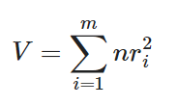
Where n is the effective sample size,
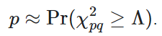

Tests of association between categorical variables
For tests of association between categorical variables, Pearson's Chi-Square Test of Independence is applied. The test statistic is:
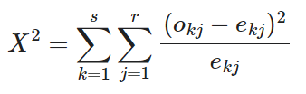
where:
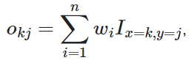
w_{i} is the calibrated weight of the ith of n observations,
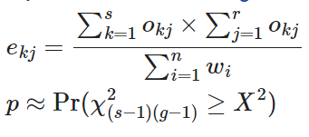
For 2x2 tables, Second Order Rao-Scott Test of Independence is applied (e.g. comparisons between gender in relation to a driving behaviour). The standard error for these tables is computed using Taylor series linearisation.
ANOVA (F-Tests)
ANOVA (F-Tests) are used where numerical data are compared across between one categorical and one numeric variable (e.g. perceived danger questions – RI1). The test statistic is:
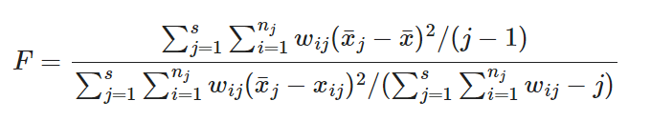

Where:
- is the value of the ith of n_{j} observations in the jth of s groups,
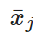is the average in the in the jth group,
is the overall average
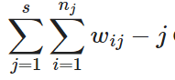
- is the calibrated weight,
and, F is evaluated using the F-distribution with j – 1 and degrees of freedom.

Weighting Effects
Taylor series linearisation is applied in the RSM data to approximate the impact of different weights on survey responses and increase the accuracy of significance testing. This approximated impact is then factored into significance testing calculations.
Multiple Comparison Corrections
False discovery rate (q = 0.05) is used to address issues with multiple comparisons where rows or columns are compared within a table.

Data quality assurance procedures
The VicRoads Registration and Licensing database is a robust database given its ties to in-person validation of identity. In addition, invitations to the RSM are sent via an in-person letter to sample members’ registered home address.
Data protections include:
- A closed survey link (i.e. only a person who receives a link issued by Wallis can complete the survey once)
- Geolocation IP-blocking (preventing geographically foreign IPs from entering and completing the survey)
- Sample cleaning, including household-level de-duplication.
- Database fatal-washing every 6 months (conducted by the TAC).
Data checking procedures include:
Given that the RSM is an incentivised survey, data quality assurance checks are carried out at the end of quarterly collection cycles.
- Checks for egregious straight-lining behaviour (e.g. selecting all multiple response options, responding with the same frequency in scale grids)
- Overly fast online survey completion (speeding)
- Consistently non-sensical or appearing as AI or similar, generated verbatim responses.

