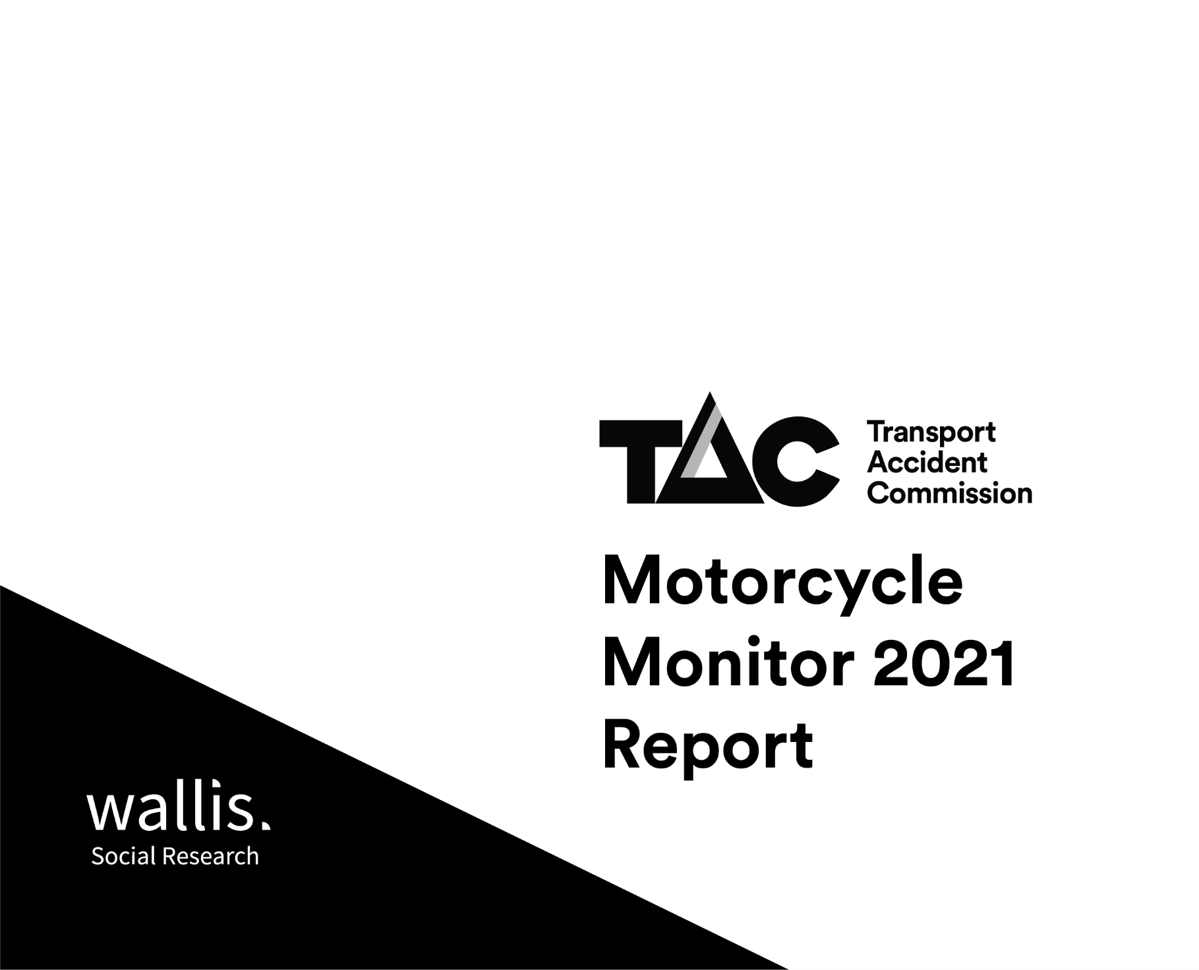

Report prepared for:
Jodi Page-Smith
Road Safety Research Analyst
Community Relations
Transport Accident Commission (TAC)
60 Brougham Street
Geelong 3220
 | Accreditations
Wallis Social Research achieved accreditation to the International Standard ISO20252 in September 2007. The Company is committed to maintaining administrative and operational procedures which comply with these accreditation requirements and to improving its performance in all aspects of the service it delivers to its customers.
In 2020 Wallis sought and attained certification to ISO 27001. This is the highest standard for information and data security. Wallis made the strategic decision to become certified to ISO 27001 because we recognise the absolute necessity for our clients to be assured that their data is secure. Wallis is one of the first research companies in Australia to achieve certification to this standard.
Wallis is an active participant in the market research industry, with senior staff making significant contributions to the Research Society (TRS) and the Australian Data and Insights Association (ADIA). As such we actively pursue the ethical objectives of the industry.
In addition to having attained the highest Industry accreditation, Wallis also participates in the Australian Achiever Awards, which recognises the customer service excellence of Australian companies. The Company has been awarded a high commendation every year since the inception of these awards in 1999.
Wallis is an acknowledged leader in data protection and privacy. Our system is regularly subjected to external penetration testing and we are a Privacy Awareness Week supporter – committed to sharing our knowledge with others. Wallis is also active member of the Australian Cyber Security Centre (ACSC) Partnership Program.

Executive summary

This Motorcycle Monitor report presents the findings collected in Motorcycle Monitor surveys over the course of 2021. These surveys cover a wide range of topics including travelling habits, learning to ride, riding activity, attitudes to speeding, impaired riding, motorcycle ownership, protective clothing and crash history.
Riding activity
Six in ten (62%) of respondents have ridden a motorcycle at least once in the last 12 months. A further 7% of respondents had ridden an electric device (e.g. e-scooter, e-skateboard or e-bike).
More than half of respondents (53%) are ‘active riders’, who ride ‘regularly’ or ‘occasionally’ or have ‘returned to riding from a break’, while a third (38%) are ‘lapsed riders’ who have not ridden, but may do so in the future. The remainder (9%) are ‘former riders’ who have no intention of riding again. Considering frequency of riding, about one in seven (15%) ride a motorcycle more than once a week and 2% ride an electric device more than once a week.
Training and skills
The majority of motorcyclists who have ridden in the last 12 months stay up-to-date with their skills, with two-thirds (66%) ever ‘brushing up on their skills’. The top three resources used to brush up on skills are ‘friends or family’ (55%), YouTube (42%) and ‘a motorcycling website’ (28%). Just over half (55%) of motorcyclists who have ridden in the last 12 months agree that they would like more information on ‘how to stay safe while riding on the road’.
Perceived risk and risky behaviour
Riding with an illegal blood alcohol content level is and riding while very drowsy are considered the most dangerous riding behaviours (98% and 92% respectively rate this behaviour between 7-10 on a 0-10 point scale where 10 is extremely dangerous). A smaller percentage (83%), think taking your eyes off the road for two seconds while riding is dangerous.
The understanding of the issue of fatigued riding is underscored with 95% of motorcyclists who have ridden in the last 12 months agreeing that ‘the only remedy for fatigue while riding is to stop riding and rest’.
While a small percentage of Active Riders who drink alcohol have ridden while over their legal BAC in the last 12 months (2%) a substantially higher percentage have ridden after drinking, but when they thought they were under their legal BAC (27%).
Relating to speeding, only about half of motorcyclists believe it is dangerous to ride a few kms an hour over the limit in both 60 km/h and 100 km/h speed zones (45% and 49% respectively). In all previous years driving over the limit in a 60km/h zone was perceived to be more dangerous than 100km/h zones, representing a flip in attitudes
About four-in-ten motorcyclists who have ridden in the last 12 months report exceeding the speed limit in a 60 km/h zone (41%) and likewise in a 100 km/h zone (45%). About one-in-five (18%) agree that ‘I ride over the speed limit if I’m sure I’ll get away with it’.
Protective clothing
Nearly all Active Riders wear a helmet ‘all the time’ (96%), with 72% always wearing a full-face helmet, 11% wearing an open-face helmet and the remainder (17%) alternating between the two types. Other protective gear is worn by the majority ‘all the time’, but to a lesser extent (riding gloves 81%; riding jacket 70%; boots 68%; riding pants 55%). On average, Active Riders wear 3.7 items of protective clothing ‘all the time’.
Nearly nine-in-ten (86%) of riders agree that ‘I think motorcyclists should always wear motorcycle clothing’, similar to 2020 (88%).
Enforcement
One in five (15%) Active Riders had been breath tested when riding their motorcycle in the past 12 months in 2021, the smallest recorded percentage in the history of this research. A smaller percentage had been randomly drug tested in the last 12 months 5%, consistent with 2019 and 2020.

Table of Contents
2 Introduction 1
2.1 Background 1
2.2 Objectives 2
2.3 Reading this report 2
3 Detailed findings 5
3.1 How people get around 5
3.2 Learning to ride and riding skills 13
3.3 Riding Activity 22
3.4 Perception of danger associated with riding behaviours 38
3.5 Speed limit related behaviours and attitudes 39
3.6 Impaired riding 43
3.7 Enforcement 45
3.8 Motorcycle/Scooter Ownership 49
3.9 Motorcycle Clothing 53
3.10 Motorcycle Crash History 57
3.11 Improving Rider Safety 58
4 Summary of findings 60
5 Methodology 63

List of Figures
Figure 1 Definitions of subgroups 3
Figure 2 Where people ride e-bikes, e-scooters or e-skateboards 8
Figure 3 Percentage of time spent riding a motorcycle vs driving a car (2012 – 2021) 9
Figure 4 Time spent riding a motorcycle vs driving a car by selected sub-groups 10
Figure 5 Agreement ‘Drivers don’t understand…’ (2013 – 2021) 11
Figure 6 Agreement ‘Most drivers are unaware of motorcyclists…’ (2017 – 2021) 12
Figure 7 Type of motorcycle licence held (2012 – 2021) 13
Figure 8 Motorcycle licence type by age 14
Figure 9 Age that full or probationary licence was obtained (2012 – 2021) 16
Figure 10 Age that learners permit was received (2012 – 2021) 17
Figure 11 Frequency of brushing up on skills 19
Figure 12 Reasons for attending motorcycle training 21
Figure 13 When last motorcycle training course was attended 21
Figure 14 Riding activity segments (2013 – 2021) 22
Figure 15 Riding activity segments by selected rider characteristics 23
Figure 16 Riding activity in the last 12 months (2012– 2021) 24
Figure 17 Riding activity in the last 12 months by age and licence type 24
Figure 18 Riding activity in the last 12 months by engine capacity of main motorcycle 25
Figure 19 Types of breaks from riding (2013 – 2021) 26
Figure 20 Duration of most recent break from riding (2013 - 2021) 27
Figure 21 Likelihood of lapsed riders riding again 27
Figure 22 Reasons why motorcyclists have not ridden in the last 12 months (2013 – 2021) 29
Figure 23 Active Riders by riding purpose (2012 – 2021) 30
Figure 24 Combinations of riding purposes among Active Riders 31
Figure 25 Shares of riding purposes for Active Riders 33
Figure 26 km/month ridden in last 12 months for any purpose (2012 – 2021) 34
Figure 27 km/month ridden in last 12 months by engine capacity of main motorcycle 35
Figure 28 km/month ridden in last 12 months by riding purpose 35
Figure 29 Hours/month spent riding off-road (2017 – 2021) 36
Figure 30 Level of agreement with ‘the only remedy for fatigue’ statement (2013 – 2021) 36
Figure 31 Rating of danger for three behaviours 37
Figure 32 Perception of danger associated with riding behaviours 38
Figure 33 Perception of danger associated with riding a few km/h over the speed limit 40
Figure 34 Level of agreement with ‘I ride over the speed limit…’ statement (2012 – 2021) 41
Figure 35 Perception of danger associated with riding under the influence 44
Figure 36 Speed that should be allowed in a 60km/h zone (2012 – 2021) 45
Figure 37 Speed that should be allowed in a 100 km/h zone (2012 – 2021) 46
Figure 38 Percentage of Active Riders who are breath tested (2015 – 2021) 48
Figure 39 Awareness of motorcycle safety features (2012 – 2021) 51
Figure 40 Usage of protective motorcycle clothing 53
Figure 41 Agreement that motorcyclists should always wear protective clothing (2017-2021) 56
Figure 42 Motorcycle crash history (2012 – 2021) 57
Figure 43 Information on how to stay safe riding on the road 58

List of Tables
Table 1 Ways of getting around apart from driving or riding 5
Table 2 Frequency of driving or riding 6
Table 3 Frequency of riding a motorcycle (2017 – 2021) 6
Table 4 Frequency of driving or riding a motorcycle by demographic 7
Table 5 Frequency of riding an e-bike, e-scooter or e-skateboard by demographic 7
Table 6 Age when started to ride a motorcycle 15
Table 7 Self-perception of riding ability 18
Table 8 Resources used to brush up on skills 20
Table 9 Likelihood of lapsed riders riding again by demographic 28
Table 10 Riding purpose by demographic 32
Table 11 Shares of Active Rider riding purposes by demographic 33
Table 12 Shares of Active Rider riding purposes by motorcycle characteristic 34
Table 13 Talked on a mobile phone using headphones while riding 37
Table 14 Frequency of intentionally riding above the limit in a 60km/h zone (2017 – 2021) 39
Table 15 Frequency of intentionally riding above the limit in a 100km/h zone (2017 – 2021) 39
Table 16 Agreement with ‘I ride over the speed limit…’ statement by demographic 42
Table 17 Agreement with ‘I ride over the speed limit…’ statement by engine capacity 42
Table 18 Percentage of Active Riders who drink alcohol and ride after drinking 43
Table 19 Percentage of Active Riders who drink alcohol and ride after drinking 44
Table 20 Speed that should be allowed in a 60km/h by demographic 46
Table 21 Speed that should be allowed in a 100km/h zone by demographic 47
Table 22 Whether pulled over by police in last 12 months (2013 – 2021) 47
Table 23 Main motorcycle type by selected rider characteristics 49
Table 24 Engine size of main motorcycle by selected rider characteristics 50
Table 25 Engine size of main motorcycle by rider purpose 50
Table 26 Awareness, desire for and possession of motorcycle safety features 52
Table 27 Number of items worn all the time when riding 54
Table 28 Number of items worn all the time or most of the time when riding 54
Table 29 Type of helmet used 55
Table 30 Receiving assistance after crashing 57
Table 31 Importance of assistance for recovery 58
Table 32 Suggestions to improve rider safety (2017 – 2021) 59
Table 33 Key Fieldwork Figures 63
Table 34 Sample attributes and population comparisons 64

Introduction
This section provides background to the report, including the research objectives.

Background
The Transport Accident Commission (TAC) is a government-owned organisation which was established in Victoria in 1986 through the Transport Accident Act (1986). Funding for the TAC is derived from vehicle registration fees collected by VicRoads. The TAC has three main roles, each of which is geared towards reducing the impact of adverse health effects caused by traffic accidents:
 | To promote  road safety |  | To improve the State’s trauma system |  | To support those who  have been injured on Victorian roads
Conducted annually on behalf of the Transport Accident Commission (TAC) since 2012, the focus of the Motorcycle Monitor (MM) is largely on the first role – promoting road safety. The findings are used to help understand Victorian motorcyclists’ experiences on the roads and their behaviours and attitudes relating to this issue. The purpose is to gain a representative view of the motorcycle rider population.
Motorcyclist fatalities comprise a substantial minority of lives lost on Victorian roads. In 2021, 43 motorcyclists lost their lives (18.5% of all 232 fatalities). This proportion is quite a bit higher than in 2020, where 32 of 211 fatalities (15%) were motorcyclists. Motorcyclists are overrepresented in road fatalities, with only 5% of road users reporting that they ever ride a motorcycle.
The importance of motorcyclist road safety is illustrated by examining motorcyclists’ road deaths in Victoria over time, with the rate of reduction in deaths experienced among those driving cars has not being matched by the reduction in deaths among those riding motorcycles. While there has been a reduction in the number of motorcyclist road deaths in Victoria from over 60 per year in the late 1980s to 43 in 2021, the percentage of Victorian road deaths occurring among those riding motorcycles versus other types of vehicle has remained higher than about 9% in the late 1980s. For instance, in 2020, 15% of road deaths were motorcyclists and in 2021, 18.5% of road deaths were motorcyclists.
The methodology used for the Motorcycle Monitor is described in Section 5 of this report.

Objectives
The objectives of the Motorcycle Monitor are to explore the characteristics of the Victorian motorcycle rider population in terms of their:
- Riding behaviours, including types of riding, frequency and distances ridden
- Attitudes towards and behaviours regarding speeding on motorcycles
- Attitudes towards and behaviours regarding drinking and riding and police enforcement
- Motorcycle ownership
- Use of and attitudes towards protective motorcycle clothing
- Awareness and use of motorcycle safety features
- Crash history
- Demographic characteristics.
The 2021 questionnaire mirrors the objectives and includes sections relating to: how people get around, learning to ride, riding activity, belief and attitudes to speed and safety, random breath and drug testing, motorcycle and scooter ownership, protective motorcycle clothing, motorcycle crash history and improving rider safety. The questionnaire is provided in Appendix 3.
In addition to exploring the characteristics of the Victorian motorcycle rider population in 2021, where appropriate, this report also describes changes in rider attitudes and characteristics compared to previous years.

Reading this report

Statistical tests in the report
The data in this report have been tested for statistical significance, typically between subgroups. Tests are conducted between the subgroup and the total excluding the subgroup and are at the 95% confidence interval unless stated otherwise. A multiple comparison correction has been used to adjust the statistical significance where several comparisons are made in the one table.
Tests for sub-groups are ‘group vs all others’ (e.g. 18-25 years vs all other ages). Tests for time series are conducted against the previous period only (e.g. 2021 vs 2020).

Notes on rounding, question response types and base sizes
In many cases percentages have been rounded to the nearest integer. This means that there may be some instances where percentages of each response, even for a single response question, may not add to 100%, but rather may add to 99% or 101%. This is due to rounding and is not an error.
Where questions allow multiple responses from respondents, the base size may add to more than 100% as the total number of responses exceeds the base size. In these cases, the total percentage reflects the average number of responses per respondent, i.e. a multiple response question which adds to a total of 243% has an average of 2.43 responses per respondent.

Subgroup reporting
Victorians who have a motorcycle licence and/or motorcycle registered in their name are eligible to participate in this research. Where results are based on this group, they are referred to as total respondents. In addition, throughout this report reference is made to a variety of subgroups. Figure 1 describes how the subgroup definitions have been determined.
Figure 1 Definitions of subgroups

Locations
Major  Urban |  | Major Urban represents a combination of all Urban Centres with a population of 100,000 or more (for example, Melbourne, Geelong, Ballarat).
Other  Urban |  | Other Urban represents a combination of all Urban Centres with a population between 1,000 and 99,999 (for example, Warrnambool, Sale, Benalla).
Rural  Balance |  | Rural Balance represents the Remainder of State/Territory and includes Bounded Localities (centres with population of between 200 and 999 (for example, Taradale, Venus Bay, Fish Creek) and smaller centres.

Rider activity segments
Active Riders |  | Those who have ridden in the last 12 months and/or have started riding again after a break.
Lapsed Riders |  | Those who have stopped riding but may decide to ride again in the future, or have not ridden in the last 12 months but still consider themselves to be regular riders.
Former Riders |  | Those who have stopped riding and do not intend to ride again.

Immediate riding history
Ridden in  the last 12 months |  | Those who have ridden a motorcycle in the last 12 months (either on or off-road).
Not ridden in the last 12 months but may do so in the future |  | Those who have stopped riding and may decide to ride in the future.

Rider purpose
If a respondent has ridden for any of the purposes below, they are then placed in that category (respondents can be allocated to more than one category).
Commuting |  | Those who ride for commuting purposes (going to work, study, shops) are Commuters.
Recreating On-road |  | Those who ride recreationally on-road (public roads, highways, freeways) are referred to as Recreational On-road Riders.
Recreation Off-road |  | Those who ride recreationally off-road (tracks in national parks or on private property) are referred to as Recreational Off-road Riders.

Licence status
Full Licence Holders |  | Those who have a full licence.
Probationary Licence Holders |  | Those who have a probationary licence.
Learner Permit Holders |  | Those who have a learner permit.

Detailed findings

How people get around
Respondents were asked how frequently they get around by public transport, taxis, walking and travelling by car or motorcycle as a passenger. They were also asked how often they use the following types of vehicles on the road: motorcycles, cars, heavy vehicles, and bicycles.

Ways of getting around apart from driving or riding
As shown in Table 1, apart from driving or riding themselves, total respondents are most likely to get around more than once a week by walking (41%) or as passengers on a motorcycle or in a car (33%). Respondents are less likely to get around more than once a week on public transport (8%) or by taking a taxi or similar (1%).
Table 1 Ways of getting around apart from driving or riding

Column % | Taking public transport | Taking a taxi or similar (e.g. Uber) | Go somewhere by walking | Travelling in a car or on a motorbike as a passenger
NET: Ever | 69 ↓ | 68 ↓ | 89 ↑ | 94 ↑
More than once a week | 8 ↓ | 1 ↓ | 41 ↑ | 33 ↑
Every one or two weeks | 6 ↓ | 6 ↓ | 23 ↑ | 31 ↑
About once a month | 7 | 9 | 8 | 11
Less than once a month | 48 ↑ | 52 ↑ | 17 ↓ | 19 ↓
Never | 31 ↑ | 32 ↑ | 11 ↓ | 6 ↓
Column n | 925 | 920 | 922 | 930
M1. - Thinking about ways you get around, apart from driving or riding yourself, how often do you go somewhere by…?
Total sample; Weighted sample; total n=920-930. Figures may not add to 100% due to rounding.
 Indicates statistically significant difference compared to respondents not in that category

Frequency of driving or riding by type of vehicle
As shown in Table 2, among total respondents, a large majority (93%) drive a car more than once a week, which is significantly greater than those riding a motorcycle on the road more than once a week (15%), riding a bicycle on the road more than once a week (10%) or driving a heavy vehicle on the road more than once a week (9%).
Table 2 Frequency of driving or riding

Column % | Motorcycle | Car | Heavy vehicle | Bicycle  (on the road)
NET: Ever | 72 ↑ | 99 ↑ | 30 ↓ | 59 ↓
More than once a week | 15 ↓ | 93 ↑ | 9 ↓ | 10 ↓
Every one or two weeks | 15 ↑ | 4 ↓ | 3 ↓ | 15 ↑
About once a month | 10 ↑ | 0 ↓ | 2 ↓ | 10 ↑
Less than once a month | 33 ↑ | 1 ↓ | 15 ↓ | 25 ↑
Never | 28 ↓ | 1 ↓ | 70 ↑ | 41 ↑
Column n | 932 | 932 | 920 | 921
M2. - How often, if ever, do you drive or ride the following on the road…
Total sample; Weighted sample; total n=920-932. Figures may not add to 100% due to rounding
 Indicates statistically significant difference compared to respondents not in that category
As shown in Table 3, among total respondents, seven in ten (72%) ride a motorcycle on the road, and one in seven (15%) do so more than once a week. Compared to 2020, significantly fewer (15%) respondents ride a motorcycle every one or two weeks.
Table 3 Frequency of riding a motorcycle (2017 – 2021)

Column % | 2017 | 2018 | 2019 | 2020 | 2021
NET: Ever | 66 | 65 | 70 | 72 | 72
More than once a week | 14 | 16 | 14 | 15 | 15
Every one or two weeks | 8 | 17 ↑ | 17 | 20 | 15 ↓
About once a month | 8 | 7 | 9 | 8 | 10
Less than once a month | 36 | 26 ↓ | 30 | 29 | 33
Never | 34 | 35 | 30 | 28 | 28
Column n | 1020 | 961 | 964 | 1026 | 932
M2. - How often, if ever, do you drive or ride the following (Motorcycles) on the road…
Total sample; Weighted sample; 2017 base n=1019, 2018 base n=961, 2019 base n=964, 2020 base n=1026, 2021 base n=932
Figures may not add to 100% due to rounding
 Indicates statistically significant difference compared to respondents not in that category

As shown in Table 4, among total respondents, those aged 18-25 (90%) are more likely to ride a motorcycle than those aged 40+ (72%).
Table 4 Frequency of driving or riding a motorcycle by demographic

Column % | Total | Male | Female | 18 - 25 | 26 - 39 | 18-39 | 40+ | Major Urban | Other Urban | Rural Balance
NET: Ever | 72 | 74 ↑ | 63 ↓ | 90 ↑ | 71 | 74 | 72 | 72 | 72 | 73
More than once a week | 15 | 15 | 10 | 35 ↑ | 17 | 20 ↑ | 13 ↓ | 16 | 13 | 13
Every one or two weeks | 15 | 16 | 9 | 29 ↑ | 12 | 15 | 15 | 14 | 16 | 15
About once a month | 10 | 9 | 13 | 8 | 10 | 10 | 10 | 9 | 11 | 9
Less than once a month | 33 | 34 | 30 | 18 ↓ | 32 | 30 | 35 | 33 | 32 | 36
Never | 28 | 26 ↓ | 37 ↑ | 10 ↓ | 29 | 26 | 28 | 28 | 28 | 27
Column n | 932 | 753 | 179 | 154 | 210 | 364 | 568 | 522 | 274 | 136
M2. - How often, if ever, do you drive or ride the following on the road…
Total sample; Weighted sample; total n=932. Figures may not add to 100% due to rounding
 Indicates statistically significant difference compared to respondents not in that category
As shown in Table 4 5, among total respondents, fewer than one in ten (7%) have ever ridden an e-bike, e-scooter or e-skateboard.
Table 5 Frequency of riding an e-bike, e-scooter or e-skateboard by demographic

Column % | Total | Male | Female | 18 - 25 | 26 - 39 | 40+ | Major Urban | Other Urban | Rural Balance
NET: Ever | 7 | 6 | 11 | 7 | 5 | 7 | 8 | 6 | 2
More than once a week | 2 | 1 ↓ | 6 ↑ | 2 | 2 | 1 | 2 | 1 | 1
Every one or two weeks | 2 | 2 | 1 | 2 | 0 ↓ | 2 | 3 ↑ | 1 | 0
About once a month | 1 | 0 | 1 | 2 | 0 | 1 | 1 | 1 | 0
Less than once a month | 3 | 3 | 3 | 1 | 3 | 3 | 2 | 4 | 1
Never | 93 | 94 | 89 | 93 | 95 | 93 | 92 | 94 | 98
Column n | 918 | 744 | 174 | 154 | 208 | 557 | 517 | 267 | 134
M2E. - How often, if ever, do you ride an e-bike, e-scooter or e-skateboard?
Total sample; Weighted sample; 2021 total n=918. Figures may not add to 100% due to rounding
 Indicates statistically significant difference compared to respondents not in that category

As shown in Figure 2 , most e-device riders ride on both the road and footpath (42%), or on the road (37%).
Figure 2 Where people ride e-bikes, e-scooters or e-skateboards

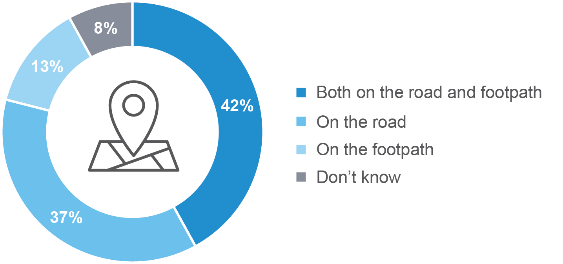

M3. - How often, if ever, do you ride an e-bike, e-scooter or e-skateboard?
Electric device riders sample; Weighted sample; 2021 total n=63. Figures may not add to 100% due to rounding
 Indicates statistically significant difference compared to respondents not in that category
As shown in Figure 2 , most e-device riders started riding more than a year ago, however a sizeable minority started in the last 6 months (24%) and between 6 months to a year ago (20%).
Figure 3 When people started riding e-bikes, e-scooters or e-skateboards

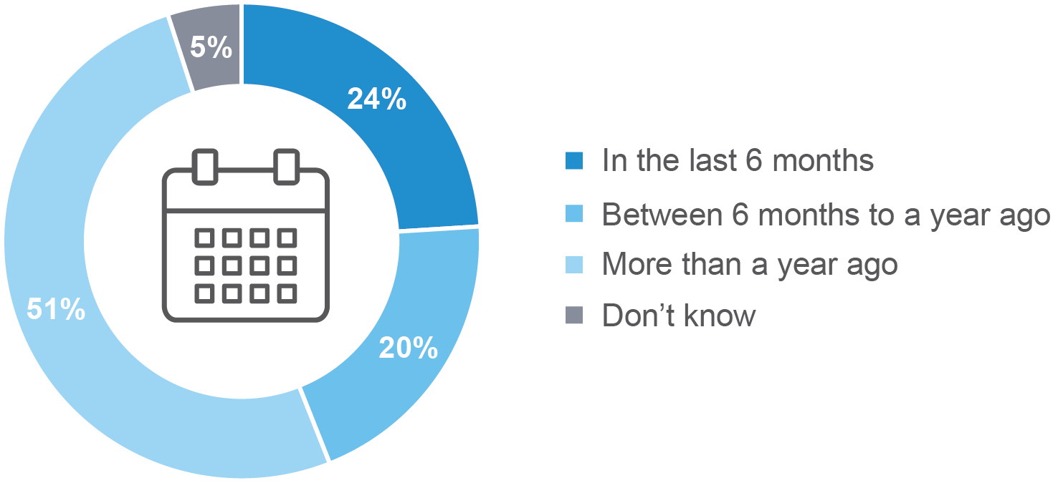

M4. - When did you start riding the e-bike, e-scooter or e-skateboard?
Electric device riders sample; Weighted sample; 2021 total n=63. Figures may not add to 100% due to rounding
 Indicates statistically significant difference compared to respondents not in that category

As shown in Figure 3, respondents who had ridden in the last 12 months were asked what percentage of the time they ride a motorcycle as opposed to drive a car. One in ten (11%) ride their motorcycle more than they drive a car.
Three in four respondents (76%) indicated they ride their motorcycle 20% or less of the time instead of driving a car. These findings remain mostly unchanged between 2012 and 2021.
Figure 3 Percentage of time spent riding a motorcycle vs driving a car (2012 – 2021)
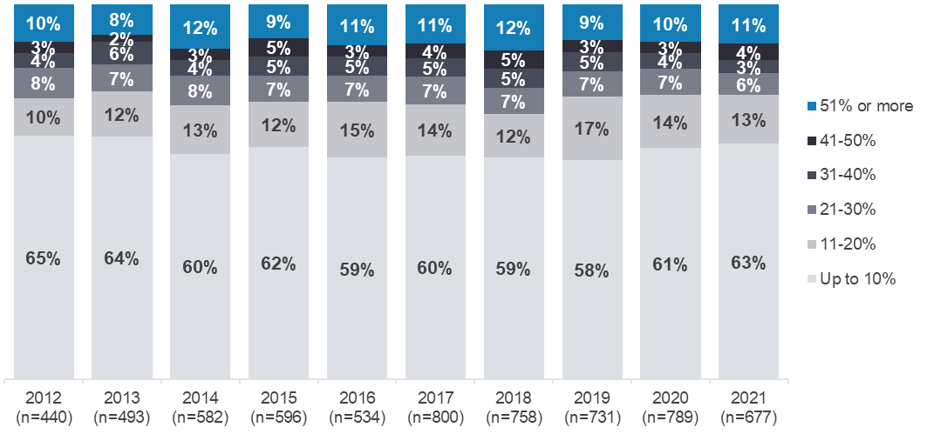
R3. - Thinking about your time spent riding and driving over the last 12 months, approximately what percentage of the time would you say you rode a motorcycle (on or off-road) as opposed to drove a car?
Filter: Ridden in the last 12 months; Weighted; 2012 base n=440, 2013 base n=493, 2014 base n=582, 2015 base n=596, 2016 base n=534, 2017 base n=800, 2018 base n=758, 2019 base n=731, 2020 base n=789, 2021 base n=677
Figures may not add to 100% due to rounding

As shown in Figure 4, respondents who have ridden in the last 12 months and are aged 18-25 (50%) ride their motorcycle more than 20% of the time. This percentage is substantially higher than for respondents aged 26-39 (24%) and respondents aged 40 and over (22%).
Figure 4 Time spent riding a motorcycle vs driving a car by selected sub-groups
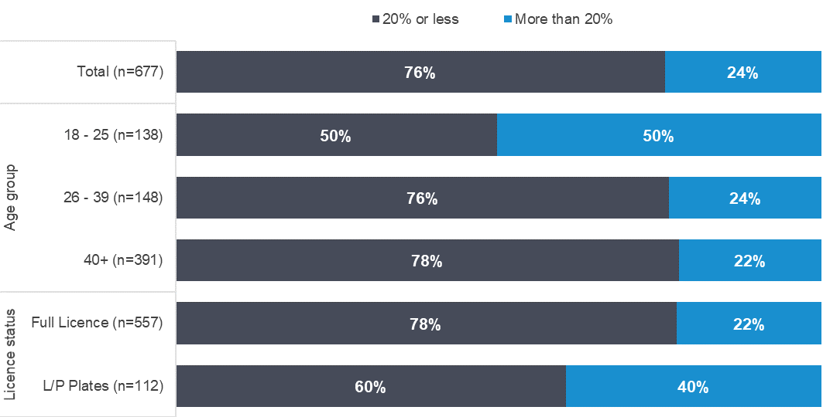
R3. - Thinking about your time spent riding and driving over the last 12 months, approximately what percentage of the time would you say you rode a motorcycle (on or off-road) as opposed to drove a car?
Filter: Ridden in the last 12 months; Weighted; Base n=677
Figures may not add to 100% due to rounding

Drivers’ perception of motorcyclists
Motorcyclists who have ridden in the last 12 months were asked about how they think drivers perceive motorcyclists.

Perception of driver understanding of motorcyclists’ experience
As shown in Figure 5, the large majority of respondents who have ridden in the last 12 months agree that ‘drivers don’t understand what it is like to be a motorcyclist’ (61% strongly agree and 32% somewhat agree with the statement).
Figure 5 Agreement ‘Drivers don’t understand…’ (2013 – 2021)
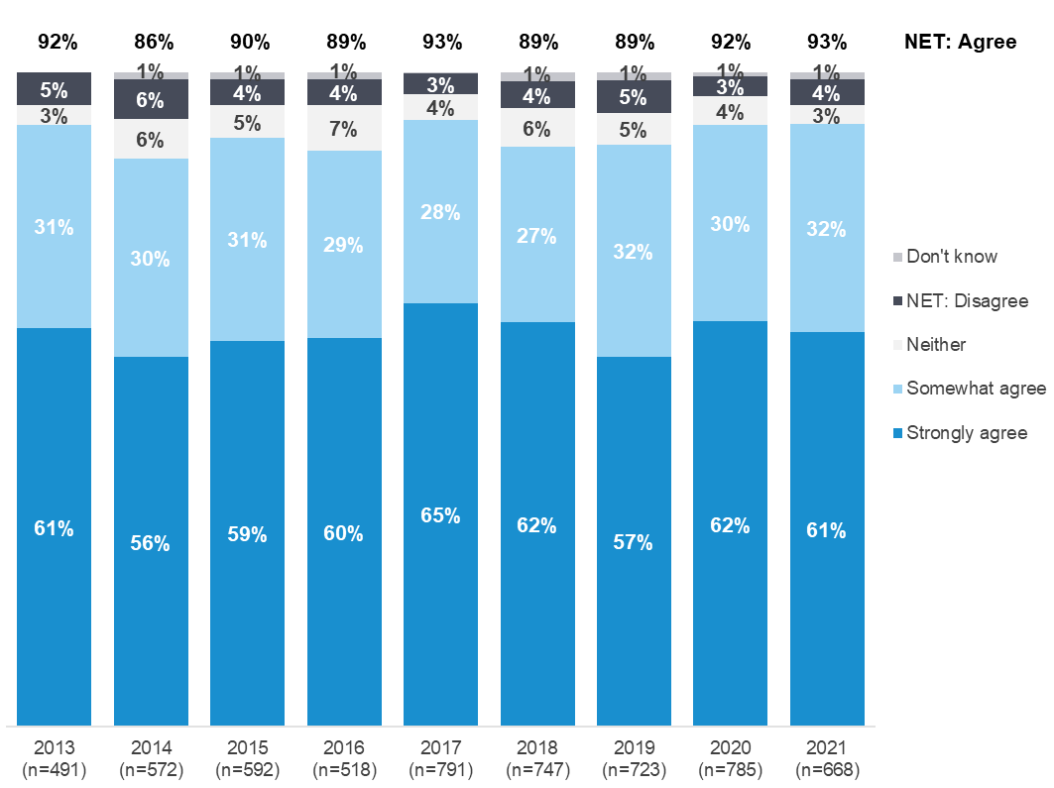
AT7. - To what extent do you agree or disagree with the following statements – Drivers don't understand what it is like to be a motorcyclist?
Base: Those who have ridden in the last 12 months;
Weighted sample; 2013 base n=491; 2014 base n=572; 2015 base n=592; 2016 base n=518; 2017 base n=791; 2018 base n=748; 2019 base n=723, 2020 base n=783, 2021 base n=668
Figures may not add to 100% due to rounding

Perception of driver awareness of motorcyclists
As shown in Figure 6, when asked whether they thought ‘most drivers are unaware of motorcyclists when they are driving’, over four-fifths of respondents who have ridden in the last 12 months (89%) agree, with 41% agreeing strongly and 47% somewhat agreeing. This result as a whole is largely unchanged since 2017.
There are no significant differences by age or gender.
Figure 6 Agreement ‘Most drivers are unaware of motorcyclists…’ (2017 – 2021)
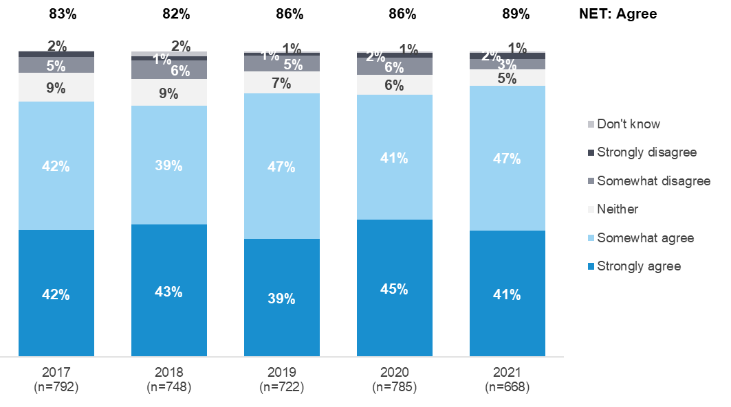
AT9. - To what extent do you agree or disagree with the following statements - Most drivers are unaware of motorcyclists when they are driving?
Base: Those who have ridden in the last 12 months;
Weighted sample; 2017 base n=792, 2018 base n=749, 2019 base n=723, 2020 base n=785, 2021 base n=668.
Figures may not add to 100% due to rounding

Learning to ride and riding skills
Respondents were asked questions relating to learning to ride, including about their licence or permit, their attitudes to training courses their views of their own riding ability.

Type of motorcycle licence held
As shown in Figure 7, among total respondents, most hold a full licence (91%). A minority hold either a probationary licence (P-Plates) (4%) or a learner’s permit (3%), while 2% have no licence.
Figure 7 Type of motorcycle licence held (2012 – 2021)
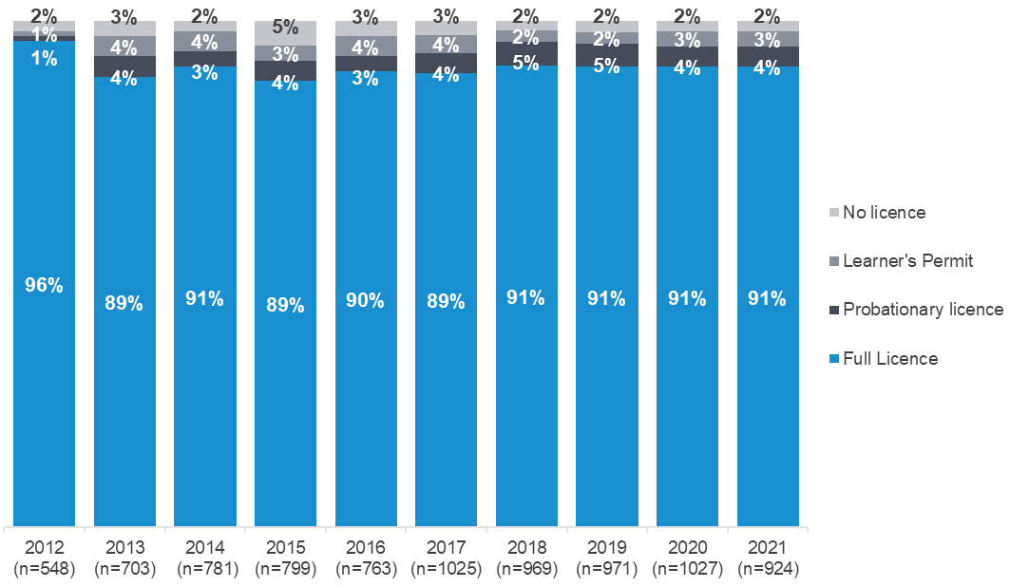
LIC1. - Do you have a motorcycle licence?
Total 2021 sample; Weighted sample; total n=924
Figures may not add to 100% due to rounding

As shown in Figure 8, the percentage of total respondents holding a full licence varies significantly by age. While 96% of those aged 40 or over have a full licence, as do 83% of those aged 26-39, only 39% of those aged 18-25 have a full licence. Among those aged 18-25, 27% have a probationary licence and 29% hold learner permits.
Figure 8 Motorcycle licence type by age
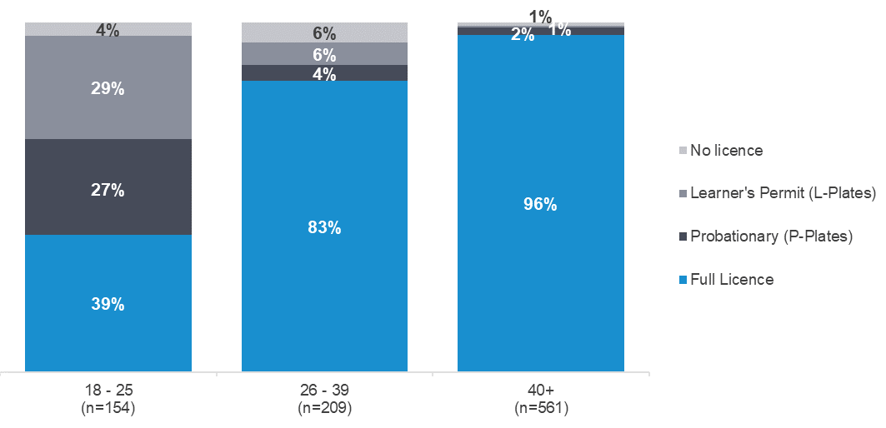
LIC1. - Do you have a motorcycle licence?
Total sample; Weighted sample; total n=924
Figures may not add to 100% due to rounding

Age when started riding a motorcycle
All respondents were asked at what age they started riding a motorcycle. The majority started riding between the ages of 11-17 years (32%) or 18-25 years (32%). A sizable minority (16%) started riding when aged 10 or younger while a similar proportion started riding when aged older than 25 years (14% aged 26-39 years and 6% aged 40 or older). The age at which riders start riding varies by demographic and type of riding:
- Females are more likely than males to start riding when older, with 38% of females starting riding aged 26 or older versus 17% of males.
- Respondents living outside Major Urban areas are most likely to start riding aged 10 or younger (24% vs 10% of those living in Major Urban areas).
- Off-road (35%) riders are more likely than Recreational (18%) riders and Commuters (17%) to start riding when aged 10 or younger.
Table 6 Age when started to ride a motorcycle

Column % | Total | Male | Female | Major Urban | Other Urban | Rural Balance | Other Urban + Rural Balance | Commuter | Recreational | Off-road
Up to 10 years | 16 | 17 ↑ | 8 ↓ | 10 ↓ | 20 | 34 ↑ | 24 ↑ | 17 | 18 | 35 ↑
11-17 years | 32 | 34 ↑ | 21 ↓ | 30 | 38 | 28 | 35 | 34 | 36 | 39 ↑
18-25 years | 32 | 32 | 33 | 38 ↑ | 28 | 20 ↓ | 26 ↓ | 28 | 28 ↓ | 18 ↓
26-39 years | 14 | 13 ↓ | 21 ↑ | 16 | 9 ↓ | 15 | 11 | 14 | 11 | 6 ↓
40 years or older | 6 | 4 ↓ | 17 ↑ | 6 | 6 | 2 | 5 | 6 | 7 | 2 ↓
26-39 years + 40 years or older | 19 | 17 ↓ | 38 ↑ | 22 ↑ | 15 | 18 | 16 ↓ | 20 | 18 | 8 ↓
Column n | 929 | 751 | 178 | 522 | 272 | 135 | 407 | 427 | 543 | 277
L1 At what age did you start riding a motorcycle?
Total sample; Weighted sample; base n=929
Figures may not add to 100% due to rounding

Obtaining a motorcycle licence
As shown in Figure 9, the majority (61%) of full and probationary licence holders were aged between 18 and 25 years when they obtained their obtained their licence. A further 22% obtained their licence between the ages of 26 and 39 and 10% when aged 40 and older.
The results from the 2021 survey are similar to earlier waves of this research.
Figure 9 Age that full or probationary licence was obtained (2012 – 2021)
LIC2. - How old were you when you got your motorcycle licence?
Filter: Full and probationary licence only/ no longer hold a licence; Weighted sample; 2012 base n=501, 2013 base n=555, 2014 base n=692, 2015 base n=722, 2016 base n=652, 2017 base n=966, 2018 base n=922, 2019 base n=913, 2020 base n=956, 2021 base n=848
Figures may not add to 100% due to rounding

As shown in Figure 10, just over one-third (36%) of those with a learner permit obtained it aged 24 years or younger, while half (50%) obtained it between the ages of 25 and 39.
Figure 10 Age that learners permit was received (2012 – 2021)
LIC3. - How old were you when you got your motorcycle learner’s permit?
Filter: Learner licence only; Weighted sample; 2012 base n=22, 2013 base n=117, 2014 base n=79, 2015 base n=83, 2016 base n=56, 2017 base n=40, 2018 base: n=29, 2019 base: n=31, 2020 base n=46, 2021 base n=49
Figures may not add to 100% due to rounding

Self-perception of riding ability
As shown in Table 7, among all respondents, many have a favourable view of their own riding ability. They are more likely to think of themselves as being a ‘better rider’ (49%) than a ‘worse rider’ (7%) compared to ‘the average rider on Victorian roads’. Two in five (39%) consider themselves ‘an about average rider’. Considering demographic differences in perceived riding ability:
- Those aged 18-25 are the most likely age group to consider themselves ‘better riders’ (61%)
- Males are more likely than females (52% vs 27%) to consider themselves to be ‘better riders’ than the average rider on Victorian roads.
Table 7 Self-perception of riding ability

Column % | Total | Male | Female | 18 - 25 | 26 - 39 | 40+ | Major Urban | Other Urban | Rural Balance
NET: Better rider | 49 | 52 ↑ | 27 ↓ | 65 ↑ | 51 | 47 | 50 | 46 | 49
NET: Worse rider | 7 | 6 | 10 | 6 | 7 | 6 | 7 | 6 | 5
A much better rider | 8 | 9 ↑ | 2 ↓ | 13 | 6 | 9 | 7 | 11 | 7
A better rider | 20 | 21 ↑ | 10 ↓ | 20 | 20 | 20 | 20 | 19 | 21
A slightly better rider | 20 | 21 | 15 | 32 ↑ | 25 | 18 ↓ | 22 | 17 | 21
An about average rider | 39 | 38 ↓ | 49 ↑ | 28 ↓ | 34 | 41 ↑ | 37 | 41 | 41
A slightly worse rider | 4 | 4 | 7 | 5 | 6 | 4 | 5 | 3 | 3
A worse rider | 2 | 2 | 2 | 1 | 1 | 2 | 1 | 3 | 2
A much worse rider | 1 | 0 | 2 | 1 | 1 | 0 | 1 | 0 | 0
Don't know | 6 | 5 ↓ | 14 ↑ | 0 ↓ | 8 | 5 | 6 | 6 | 5
Column n | 932 | 753 | 179 | 154 | 210 | 568 | 522 | 274 | 136
L5. - Thinking about how you compare to the average rider on Victorian roads, would you say you are…
Total sample; Weighted sample; total n=932. Figures may not add to 100% due to rounding.
 Indicates statistically significant difference compared to respondents not in that category

Brushing up on skills
Riders who had ridden in the last 12 months were asked how frequently they brush up on their riding skills and which resources they had used to brush up on skills.

Frequency of brushing up on skills
Considering the percentage of motorcyclists who ever brush up on their skills, as shown in Figure 11, one-in-three (33%) never brush up on their skills, while two-thirds (66%) do so at least occasionally. One-in-twenty (5%) report brushing up on their skills at least once a week, while 14% do so between once a month and once a fortnight. Considering differences in brushing up on skills among riders:
- Riders aged 18-25 are most likely to brush up on their skills at least once a month (55% vs 24% of all riders).
Figure 11 Frequency of brushing up on skills

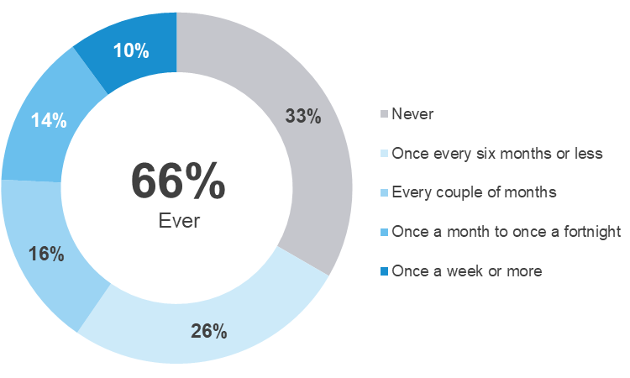

L4 How frequently do you brush up your motorcycle skills to keep up to date with riding?
Filter: Those who have ridden in the last 12 months; Weighted sample; Base n=676
Figures may not add to 100% due to rounding

Resources used to brush up on skills
Motorcyclists who ever brush up on their skills were asked which resources they use to do this. As shown in
Table 8, the top three resources used are ‘friends or family’ (55%), YouTube (42%) and ‘a motorcycling website’ (28%). There are a number of differences in the resources different types of riders use to brush up on their skills. There include:
- Motorcyclists aged 18-25 (63%) and 26-39 (64%) are most likely to turn to ‘friends and family’ to brush up on their skills
- Motorcyclists aged 18-25 (74%) are more likely to use ‘YouTube’ to brush up on their skills
Table 8 Resources used to brush up on skills

Column % | Total | 18 - 25 | 26 - 39 | 40+ | Major Urban | Other Urban | Rural Balance | Commuter | Recreational | Off-road
Friends or family | 55 | 63 | 64 | 51 ↓ | 54 | 54 | 63 | 48 ↓ | 54 | 64 ↑
YouTube | 42 | 74 ↑ | 46 | 37 ↓ | 49 ↑ | 32 ↓ | 40 | 49 ↑ | 47 ↑ | 43
A motorcycling website | 28 | 31 | 30 | 26 | 32 | 22 | 24 | 34 ↑ | 31 ↑ | 23
Magazines or books | 21 | 17 | 13 ↓ | 24 ↑ | 20 | 25 | 13 | 21 | 21 | 20
A riding school | 13 | 17 | 13 | 12 | 15 | 8 | 14 | 15 | 14 | 9 ↓
Another website | 8 | 13 | 3 ↓ | 10 | 9 | 6 | 11 | 10 | 8 | 7
Somewhere else | 17 | 6 ↓ | 14 | 20 | 16 | 18 | 22 | 18 | 17 | 20
Column n | 478 | 114 | 111 | 253 | 260 | 147 | 71 | 309 | 394 | 212
L4B - Which of the following resources do you use to brush up on your skills?
Filter: Ever brushes up on skills; Weighted sample; total n=478. Figures may not add to 100% due to rounding
 Indicates statistically significant difference compared to respondents not in that category

Motorcycle training
Respondents who had ridden in in the past 12 months were asked about motorcycle training they have ever attended and how long ago their most recent training was. They were also asked whether they agree or disagree that motorcyclists returning to riding after a break should have to undertake training.

Reasons for attending motorcycle training
Three-quarters (76%) of respondents who had ridden in the past 12 months had ever attended motorcycle training, with the most common reason being assistance in ‘getting a learner’s permit or licence’ (62%). Other training purposes included ‘improving your road riding skills’ (23%), ‘improving your racing skills’ (8%) and ‘learning to ride a specific type of motorcycle’ (7%).
Figure 12 Reasons for attending motorcycle training
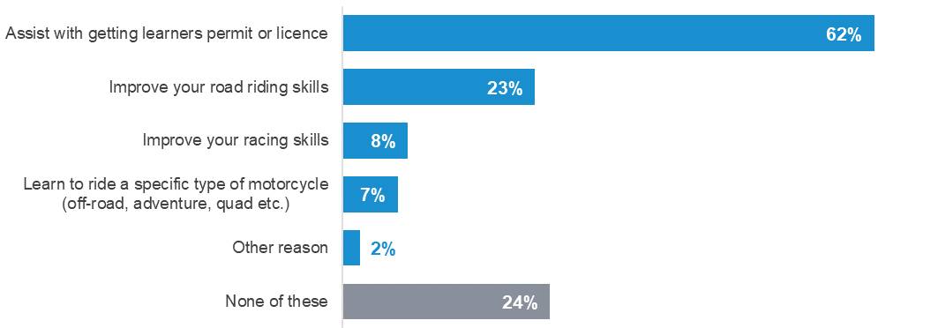
L6 Have you ever attended a motorcycle rider training course for any of the following reasons?
Filter: Those who have ridden in the last 12 months; Weighted sample; Base n=677
Figures may not add to 100% due to rounding

When last motorcycle training course was attended
About four-in-ten (38%) of motorcyclists who have ever attended motorcycle training have done so in the last five years, with about one-in-ten (11%) having done so in the past year.
Figure 13 When last motorcycle training course was attended
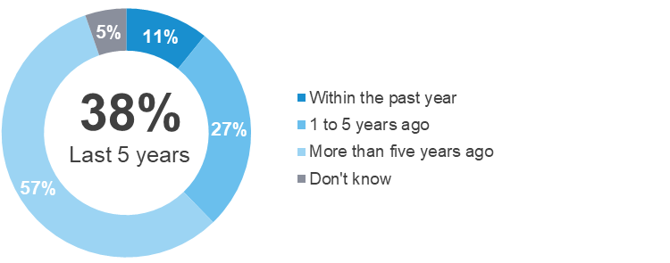
L7 How long ago did you most recently attend a motorcycle training course?
Filter: Ever attended motorcycle training; Weighted sample; Base n=602
Figures may not add to 100% due to rounding

Riding Activity
Respondents were asked a number of questions about their level of riding activity, and if they are active riders, their purposes for riding.

Riding activity segments
As shown in Figure 14, respondents have been allocated to three segments based on their riding history and recent riding behaviours:
- Active Riders – those who have never had a break and ride regularly and/or have started riding again after a break
- Lapsed Riders – those who have stopped riding but may decide to ride again in the future, or have not ridden in the last 12 months but still consider themselves to be regular riders; or
- Former Riders – those who have stopped riding and do not intend to ride again.
Just over half of respondents (53%) are Active Riders, just over one-third (38%) of respondents are Lapsed Riders, and a smaller percentage (9%) are Former Riders.
Figure 14 Riding activity segments (2013 – 2021)
R4. - Which of the following best describes your motorcycle riding history?
R1. - Have you ridden a motorcycle in the last 12 months (either on or off-road)?
All respondents; Weighted, n=933
Figures may not add to 100% due to rounding

Figure 15 shows the riding activity status by demographic and licence type. Groups with a high prevalence of Active Riders include:
- Those aged 18-25 (84% vs 51% among those aged 26 to 39 and 52% among those aged 40+); and
- Probationary or learner permit holders (87% vs 52% among those with full licences).
- Worryingly, 23% of those with no licence are Active riders.
Figure 15 Riding activity segments by selected rider characteristics
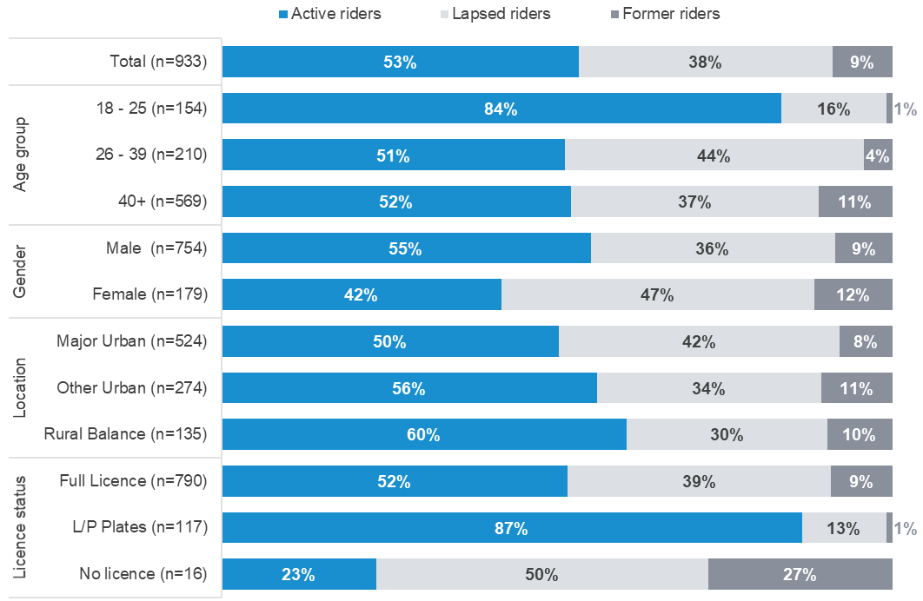
R4. - Which of the following best describes your motorcycle riding history?
R1. - Have you ridden a motorcycle in the last 12 months (either on or off-road)?
Filter: excludes never ridden a motorcycle; Weighted sample; Base n=933
Figures may not add to 100% due to rounding

Riding activity in the last 12 months
As shown in Figure 16, among all respondents, around two-thirds (62%) indicate they have ridden a motorcycle in the last 12 months.
Figure 16 Riding activity in the last 12 months (2012– 2021)
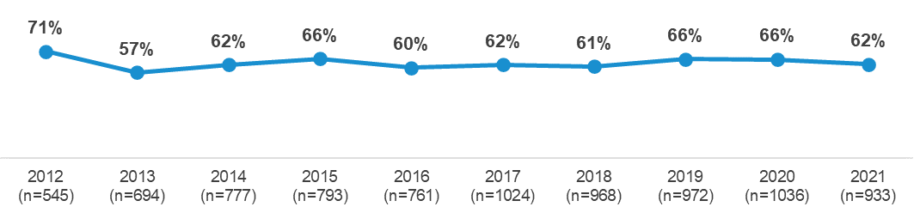
R1. - Have you ridden a motorcycle in the last 12 months (either on or off-road)?
Filter: excludes never ridden a motorcycle; Total sample; Weighted sample; 2021 base n=933
As shown in Figure 17, respondents aged between 18 and 25 (89%), and those on learner permits or with probationary licences (93%), are more likely than riders with full licences (61%) and those over 40 years (59%) to have ridden (either on- or off-road) in the last 12 months.
Figure 17 Riding activity in the last 12 months by age and licence type
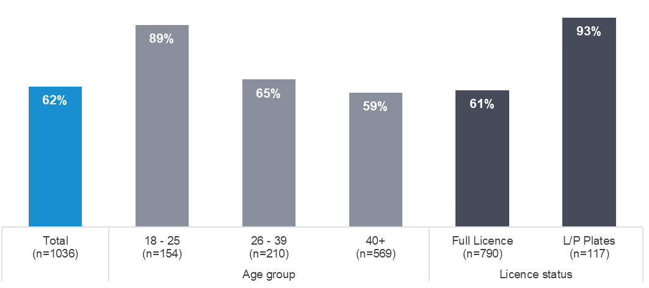
R1. - Have you ridden a motorcycle in the last 12 months (either on or off-road)?
Filter: excludes never ridden a motorcycle; Weighted sample; Base n=933

Respondents with motorcycles with an engine capacity of 250cc or smaller were also less likely to have ridden in the last 12 months (56%) than those who had a motorcycle with an engine capacity of 251cc or larger (73%).
Figure 18 Riding activity in the last 12 months by engine capacity of main motorcycle
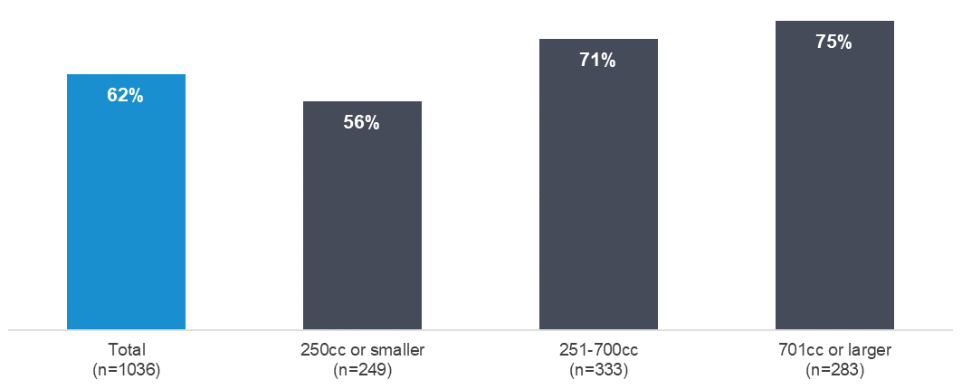
R1. - Have you ridden a motorcycle in the last 12 months (either on or off-road)?
Filter: excludes never ridden a motorcycle; Weighted sample; Base n=933

Riding breaks
As shown in Figure 19, among all respondents, just over half (53%) are currently riding (Active Riders) and their riding histories are:
- Never had a break from riding and ride regularly (15%)
- Never had a break from riding but only ride occasionally (20%)
- Had a break from riding and have started riding again (18%).
Four-in-ten (38%) have ‘stopped riding but may decide to ride again in the future’ while 9% have ‘stopped riding and have no intention of riding in the future’.
Figure 19 Types of breaks from riding (2013 – 2021)
R4. - Which of the following best describes your motorcycle riding history?
Total sample; Weighted; 2013 base n=692; 2014 base n=776, 2015 base n=798, 2016 base n=762, 2017 base n=1024, 2018 base n=971, 2019 base n=970 2017 base n=1024, 2018 base n=971, 2019 base n=970, 2020 base = 1,037, 2021 base n=933
Figures may not add to 100% due to rounding

Duration of most recent break from riding
As shown in Figure 20, 62% of respondents who have taken a break but have started riding again have done so after a break of three years or longer.
Figure 20 Duration of most recent break from riding (2013 - 2021)
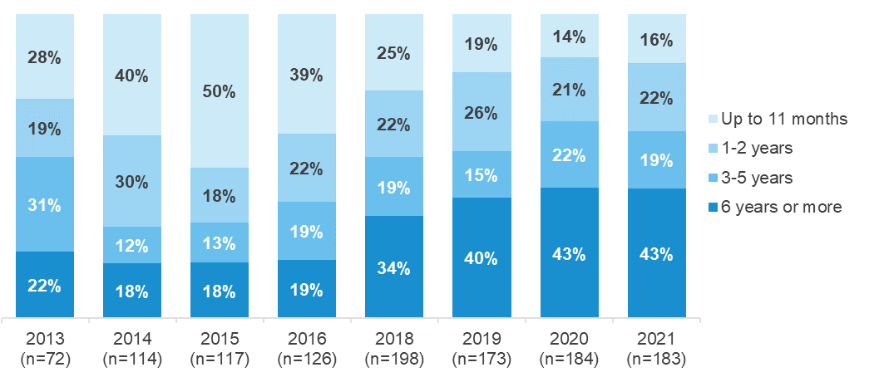
R5. - Approximately, how long was the most recent break?
Filter: Had a break from riding but started riding again
Weighted; 2013 base n=72; 2014 base n=114, 2015 base n=117, 2016 base n=126, 2017 base n=214, 2018 base n=198, 2019 base n=173, 2020 base n=184, 2021 base n=183
Figures may not add to 100% due to rounding

Likelihood of lapsed riders riding again
Lapsed Riders were asked about their likelihood of riding again. As shown in Figure 21, Lapsed Riders were most likely to indicate that they are likely to ride again (48%). Around one-third (35%) are neither likely or unlikely, and 14% rate the likelihood at 0 to 3 (on a zero to ten scale where zero is ‘extremely unlikely and ten is ‘extremely likely’).
Figure 21 Likelihood of lapsed riders riding again
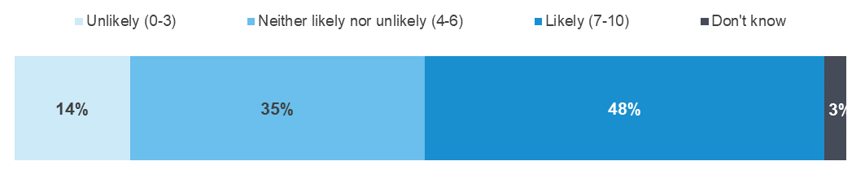
R6. - What is the likelihood that you will ride again in the future?
Base: Lapsed Riders; Weighted sample; Base n=240
Figures may not add to 100% due to rounding

As shown in Table 9, Lapsed Riders aged 18-25 (85% rated their likelihood as 7 out of 10 or higher) are the most likely to indicate they are likely to ride again.
Table 9 Likelihood of lapsed riders riding again by demographic

Column % | Total | Male | Female | 18 - 25 | 26 - 39 | 18-39 | 40+ | Major Urban | Other Urban | Rural Balance
Average | 6.5 | 6.5 | 6.2 | 8.7 | 6.7 | 6.9 | 6.3 | 6.7 | 5.9 ↓ | 6.4
Unlikely (0-3) | 14 | 13 | 16 | 4 | 14 | 13 | 14 | 12 | 20 | 11
Neither likely nor unlikely (4-6) | 35 | 35 | 35 | 11 | 30 | 28 | 38 | 34 | 33 | 48
Likely (7-10) | 48 | 49 | 43 | 85 | 53 | 55 | 45 | 53 | 40 | 39
Don't know | 3 | 2 | 5 | 0 | 4 | 4 | 2 | 1 ↓ | 7 ↑ | 3
Column n | 240 | 177 | 63 | 25 | 68 | 93 | 147 | 150 | 59 | 31
R6. - What is the likelihood that you will ride again in the future?
Base: Lapsed Riders; Weighted sample; Base n=240
 Indicates statistically significant difference compared to respondents not in that category
*Note: Small sample sizes
Figures may not add to 100% due to rounding

Reasons for no longer riding a motorcycle
As shown in Figure 22, among those who have not ridden in the last 12 months, the most mentioned reasons for not riding are ‘no longer own a motorcycle’ (70%) and ‘family commitments/change in lifestyle’ (25%), followed by preferring to use other modes of travel (17%).
Figure 22 Reasons why motorcyclists have not ridden in the last 12 months (2013 – 2021)
R2. - What are the main reasons why you haven't ridden a motorcycle in the last 12 months? Multiple responses
Filter: Not ridden in last 12 months
Weighted; 2012 base n=89, 2013 base n=164; 2014 base n=163, 2015 base n=143, 2016 base n=165, base n=189, 2018 base n=179, 2019 base n=233, 2020 base n=237, 2021 base n=252

Characteristics of Active Riders
Active Riders were asked approximately what percentage of the time they ride in the following categories, excluding any riding they might have done for work purposes:
- Commuting purposes (going to work, study, shops)
- Recreation on-road (public roads, highways, freeways), and
- Recreation off-road (tracks in national parks or on private property).
If a respondent has ridden for any of the purposes above, they are then placed in that category (respondents can be allocated to more than one category).
As shown in Figure 23, Active Riders are most likely to be Recreational On-road Riders (77%), remaining relatively stable since 2012.
Figure 23 Active Riders by riding purpose (2012 – 2021)
TYPA/B/C. - Approximately what percentage of the time did you ride in the following categories excluding any riding you might do for work purposes?
Filter: Active riders; Weighted; 2012 base n=354; 2013 base n=399; 2014 base n=495; 2015 base n=473; 2016 base n=470, 2017 base n=746, 2018 base n=692, 2019 base n=659, 2020 base n=726, 2021 base n=628
Note: Does not add to 100% as respondents could ride with more than one purpose

Figure 24 shows combinations of riding purposes. The most common combination of riding purposes is among those who both commute and ride recreationally on-road (37%). One-in-five (21%) ride for all three purposes.
Figure 24 Combinations of riding purposes among Active Riders
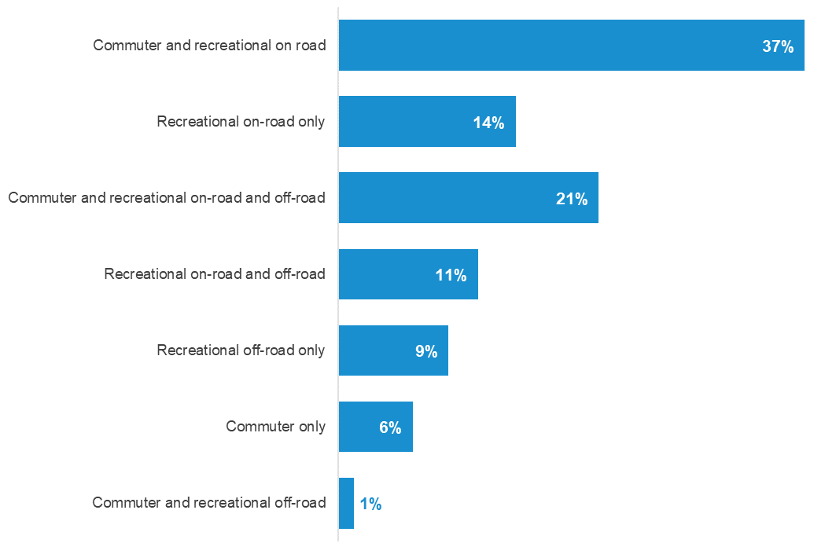
TYPA/B/C. - Approximately what percentage of the time did you ride in the following categories excluding any riding you might do for work purposes?
Filter: Active riders; Weighted sample; 2021 base n=587
Figures may not add to 100% due to rounding

As shown in Table 10, there are several differences by demographic among Active Riders, including:
- Those aged 18-39 are most likely to be ride for all three purposes (30% of 18-39 year olds vs 17% of those aged 40 and older)
- Those aged 40 and older are more likely than younger riders to only ride recreationally (17% versus 8% of 18-39 year olds)
- Males are more likely than females to ride for commuting and recreational on-road purposes (39% vs 23%) or for all three purposes (22% vs 9%)
- Females are more likely than males to ride only for commuting (15% vs. 5%) or recreational on-road (23% vs 13%).
Table 10 Riding purpose by demographic

Column % | Total | Male | Female | 18 - 25 | 26 - 39 | 18-39 | 40+ | Major Urban | Other Urban | Rural Balance
Commuter and recreational on road | 37 | 39 ↑ | 23 ↓ | 45 | 33 | 36 | 38 | 42 ↑ | 34 | 26
Recreational on-road only | 14 | 13 ↓ | 23 ↑ | 6 ↓ | 8 | 8 ↓ | 17 ↑ | 15 | 14 | 12
Commuter and recreational on-road and off-road | 21 | 22 ↑ | 9 ↓ | 24 | 31 ↑ | 30 ↑ | 17 ↓ | 19 | 23 | 23
Recreational on-road and off-road | 11 | 11 | 16 | 8 | 10 | 10 | 12 | 6 ↓ | 14 | 24 ↑
Recreational off-road only | 9 | 8 | 14 | 9 | 9 | 9 | 9 | 7 | 11 | 11
Commuter only | 6 | 5 ↓ | 15 ↑ | 8 | 6 | 7 | 6 | 9 ↑ | 2 ↓ | 3
Commuter and recreational off-road | 1 | 1 | 0 | 1 | 2 | 1 | 1 | 0 ↓ | 3 | 1
Column n | 587 | 499 | 88 | 123 | 125 | 248 | 339 | 322 | 177 | 88
TYPA/B/C. - Approximately what percentage of the time did you ride in the following categories excluding any riding you might do for work purposes?
Filter: Active riders; Weighted; Base n=587
 Indicates statistically significant difference compared to respondents not in that category
Note: Does not add to 100% due to riders being able to do multiple types of riding

As shown in Figure 25, Active Riders spend more time riding their motorcycles for ‘recreational on-road’ purposes (48%) than for commuting (30%) or ‘recreational off-road’ (23%) purposes.
Figure 25 Shares of riding purposes for Active Riders

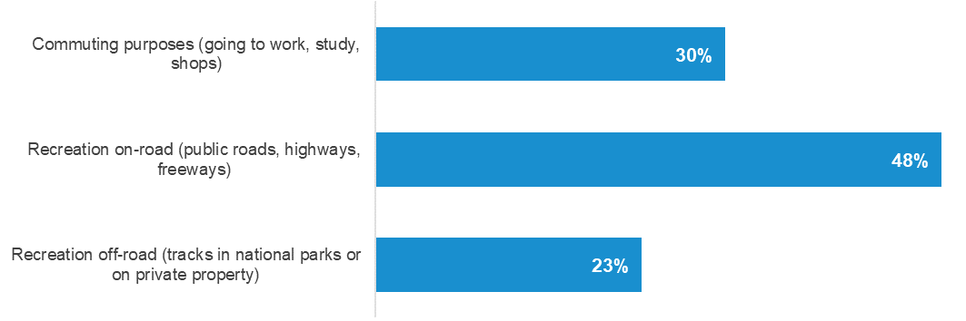
TYPA/B/C. - Approximately what percentage of the time did you ride in the following categories excluding any riding you might do for work purposes?
Filter: Active riders; Weighted; Base n=587
Figures may not add to 100% due to rounding
As shown in Table 11, there are several differences in riding purpose by demographic among the Active Riders, including:
- Those aged 18-25 are most likely to ride for commuting purposes (43%)
- Those aged 40 and over are more likely to spend time riding ‘recreationally on road’ (54%) than younger riders (34% for 18-39 age group)
- Those in Major Urban areas are more likely to spend time riding for commuting purposes (35%) than those from elsewhere in Victoria and are less likely to spend time riding ‘recreationally off-road’ (16%).
Table 11 Shares of Active Rider riding purposes by demographic

Average | Total | Male | Female | 18 - 25 | 26 - 39 | 18-39 | 40+ | Major Urban | Other Urban | Rural Balance
Commuting purposes  (going to work, study, shops) | 30 | 30 | 27 | 43 ↑ | 36 ↑ | 38 ↑ | 26 ↓ | 35 ↑ | 24 ↓ | 22 ↓
Recreation on-road  (public roads, highways, freeways) | 48 | 48 | 47 | 36 ↓ | 34 ↓ | 34 ↓ | 54 ↑ | 49 | 50 | 40 ↓
Recreation off-road  (tracks in national parks or on private property) | 23 | 22 | 26 | 21 | 30 ↑ | 28 ↑ | 20 ↓ | 16 ↓ | 26 | 38 ↑
Column n | 587 | 499 | 88 | 123 | 125 | 248 | 339 | 322 | 177 | 88
TYPA/B/C. - Approximately what percentage of the time did you ride in the following categories excluding any riding you might do for work purposes?
Filter: Active riders; Weighted; Base n=587
 Indicates statistically significant difference compared to respondents not in that category
Figures may not add to 100% due to rounding
As shown in Table 12, among Active Riders there are also differences in riding purpose by motorcycle ownership and motorcycle engine capacity, including:
- Active Riders with larger engine capacity motorcycles (701cc and over) are more likely to spend time riding recreationally on-road (69%), whereas those with less powerful engine capacities are more likely to spend time riding recreationally off-road than those with larger engine capacities (250cc or smaller: 32%; 251-700cc: 34% versus 701cc or larger: 7%).
Table 12 Shares of Active Rider riding purposes by motorcycle characteristic

Average | Total | 250cc or smaller | 251-700cc | 701cc or larger | 251-700cc + 701cc or larger
Commuting purposes (going to work, study, shops) | 30 | 42 ↑ | 28 | 24 ↓ | 26 ↓
Recreation on-road (public roads, highways, freeways) | 48 | 26 ↓ | 38 ↓ | 69 ↑ | 55 ↑
Recreation off-road (tracks in national parks or on private property) | 23 | 32 ↑ | 34 ↑ | 7 ↓ | 19 ↓
Column n | 587 | 133 | 228 | 218 | 446
TYPA/B/C. - Approximately what percentage of the time did you ride in the following categories excluding any riding you might do for work purposes?
Filter: Active riders AND excluding commuter/ recreational riding response error; Weighted; Base n=587
 Indicates statistically significant difference compared to respondents not in that category
Figures may not add to 100% due to rounding

Distances ridden in the last 12 months
As shown in Figure 26, when estimating the distance they had ridden on a motorcycle for any reason in the last 12 months, respondents who have ridden in the last 12 months are most likely to mention up to 100 km per month (33%) followed by 101-500 km per month (28%). Figure 26, below, shows findings for the period 2012 to 2021.
Figure 26 km/month ridden in last 12 months for any purpose (2012 – 2021)
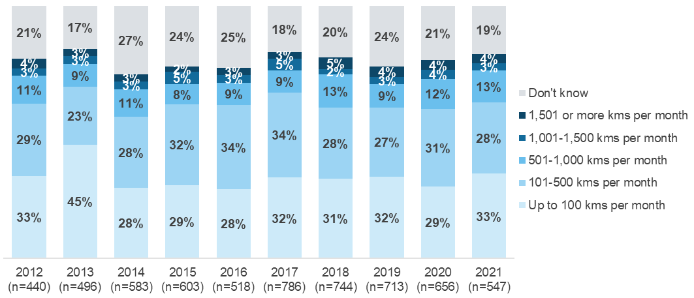
RID1A/B/C. - Thinking now about how many kilometres you rode ON ANY motorcycle on the road for any reason over the last 12 months… (Per week; per month or per year)
Filter: Ridden in the last 12 months; Weighted; 2012 base n=440; 2013 base n=496; 2014 base n=583; 2015 base n=603; 2016 base n=518; 2017 base n=770; 2018 base n=728, 2019 base n=699, 2020 base n=656, 2021 base n=547
Figures may not add to 100% due to rounding
As shown in Figure 27, the average distance ridden on a motorcycle by respondents who have ridden in the last 12 months is 389km per month and the median distance ridden is 200km.
Figure 27 also shows the distance ridden by engine capacity of the respondent’s main motorcycle. Respondents with an engine capacity of 701cc or larger are likely to ride further each month (average distance of 448km per month).
Figure 27 km/month ridden in last 12 months by engine capacity of main motorcycle
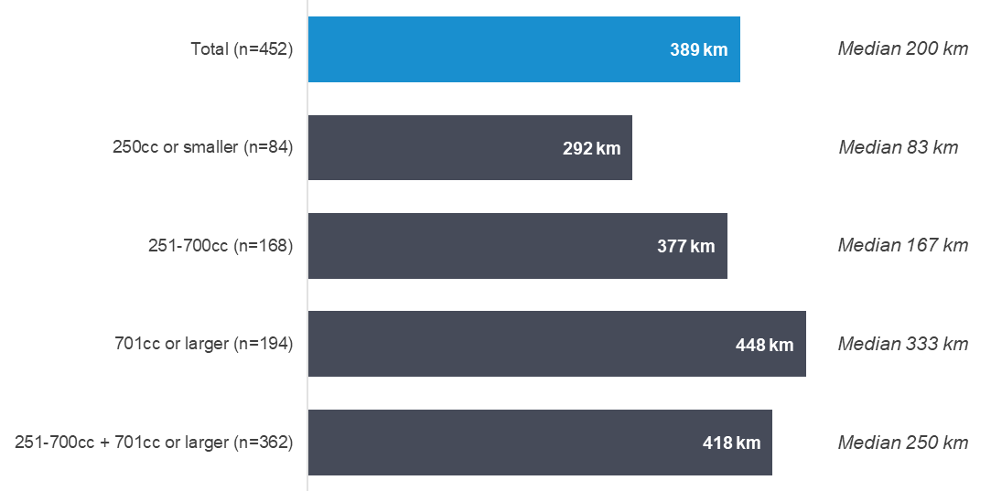
(Median km per month to the right of bar)
RID1A/B/C. - In the last 12 months, how many kilometres did you ride ON ANY motorcycle on the road for any reason?
Filter: Ridden in the last 12 months: Weighted; Base n=452

Average distance ridden for commuting, on-road and off-road recreational purposes among active riders
Figure 28 below shows average and median distances ridden per month by riding purpose among those who have ridden in the last 12 months. The chart shows that those who Commute ride a significantly longer average distance than the average rider.
Figure 28 km/month ridden in last 12 months by riding purpose
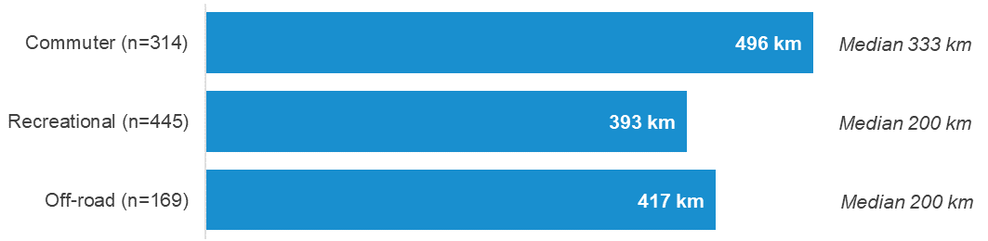
(Median km per month to the right of bar)
RID1A/B/C. - In the last 12 months, how many kilometres did you ride ON ANY motorcycle on the road for any reason?
Filter: If ridden in the last 12 months; Weighted; Base n=448
Figure 29 shows the numbers of hours ridden off-road among respondents who have ridden in the last 12 months. Just over half (56%) reported that they had ridden zero hours off-road or were unsure. This is a return to a similar result from previous years (54% in 2019), after a significant increase in 2020 (61%). Around one- quarter (27%) ride, on average, up to 8 hours per month off-road, a further 10% ride between 8 and 20 hours and 7% ride off-road more than 20 hours on average each month.
Figure 29 Hours/month spent riding off-road (2017 – 2021)
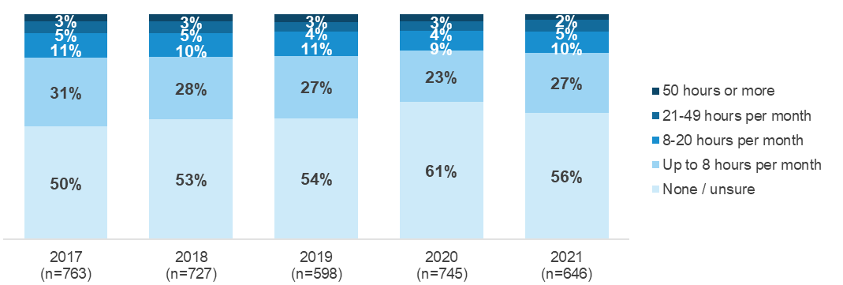
RID2A/B/C- Thinking now about how many hours you rode on any motorcycle off-road for any reason over the last 12 months? An approximate number is OK.
Filter: If ridden in the last 12 months
Weighted; 2017 base n=763; 2018 base n=727, 2019 base n=598, 2020 base n=745, 2021 base n=646
Figures may not add to 100% due to rounding

Riding risk factors
Respondents who have ridden in the last 12 months were asked to what extent they agreed with a statement concerning fatigue. As shown in Figure 30, the large majority (95%) agreed or strongly agreed that ‘the only remedy for fatigue while riding is to stop riding and rest’, with 84% ‘strongly agreeing’. This finding has been consistent over the period 2013 to 2021.
Figure 30 Level of agreement with ‘the only remedy for fatigue’ statement (2013 – 2021)
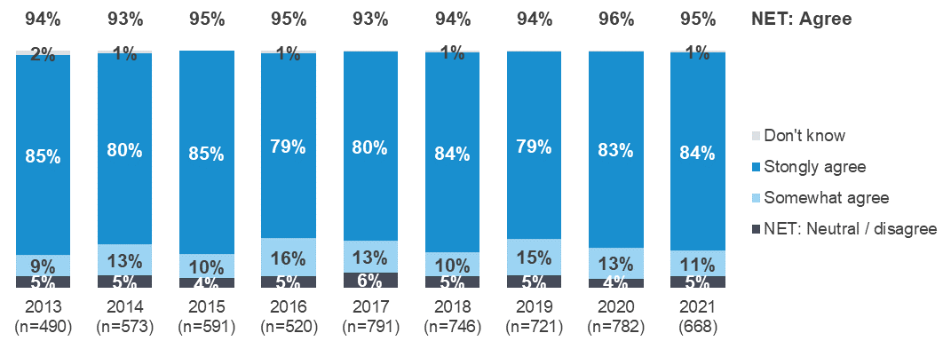
AT5. - Agreement/disagreement with statements about fatigue
Weighted; 2013 base n=490; 2014 base n=573; 2015 base n=591; 2016 base n=520; 2017 base n=791; 2018 base n=747; 2019 base n=721; 2020 base n=780; 2021 base n=668 / Neutral and don’t know responses not shown)
Figures may not add to 100% due to rounding
Active Riders were asked to rate how dangerous they think three behaviours are by rating each behaviour on an eleven-point scale where 0 was not at all dangerous and 10 was extremely dangerous.
As shown in Figure 31, the vast majority provided a rating of seven or above for all the scenarios:
- 98% for riding with an illegal blood alcohol content
- 92% for riding while very drowsy
- 83% for taking your eyes off the road for two seconds while riding.
Figure 31 Rating of danger for three behaviours
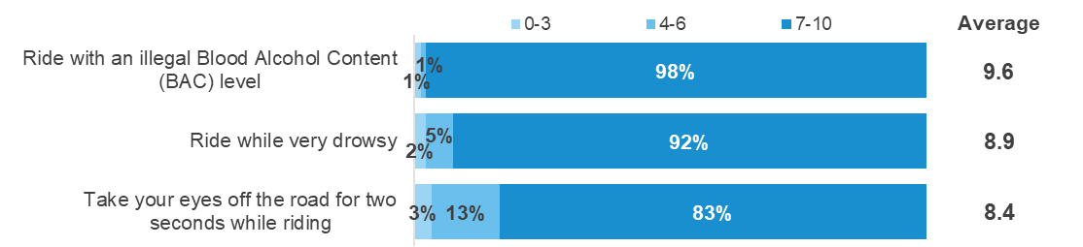
DAN1-6. - Using a scale where 0 is “not at all dangerous” and 10 is “extremely dangerous”
how dangerous do you think it is to…
Active riders only; Weighted; 2021 base n=597
Figures may not add to 100% due to rounding
Respondents who have ridden in the last 12 months were also asked how often they have talked on a mobile phone using headphones while riding. As shown in Table 13, 9% indicate that they have done so. Those aged under 40 (13%) were more likely to indicate they ever do this, compared to only 7% of those 40 and over. Those living in rural areas (97%) are more likely to have never done this.
Table 13 Talked on a mobile phone using headphones while riding

Column % | Total | Male | Female | 18 - 25 | 26 - 39 | 18-39 | 40+ | Major Urban | Other Urban | Rural Balance
NET: Ever | 9 | 9 | 5 | 13 | 13 | 13 | 7 | 11 | 8 | 3 ↓
All of the time | 0 | 0 | 0 | 3 ↑ | 0 | 1 | 0 | 0 | 1 | 0
Most of the time  (More than half but not all) | 1 | 1 | 1 | 2 | 0 | 1 | 1 | 1 | 1 | 0
About half the time (50%) | 0 | 0 | 0 | 1 | 0 | 0 | 0 | 0 | 0 | 0
Some of the time (Less than half but not never) | 7 | 7 | 5 | 8 | 12 ↑ | 11 ↑ | 5 ↓ | 9 | 6 | 3
None of the time | 91 | 91 | 95 | 87 | 87 | 87 | 93 | 89 | 92 | 97 ↑
Column n | 664 | 560 | 104 | 137 | 147 | 284 | 380 | 361 | 199 | 104
BEHC Talked on a mobile phone using headphones while riding
Filter: Ridden in the past 12 months; Weighted; 2021 base n=664
 Indicates statistically significant difference compared to respondents not in that category

Perception of danger associated with riding behaviours
Figure 32 shows Active Riders’ perception of danger associated with riding a few kilometres over the speed limit together with the perception of danger associated with three other behaviours. Almost half of active riders provided a rating between 7 and 10 of the danger of riding a few kilometres over the speed limit in a 60 km/h zone (45%) and a 100 km/h zone (49%).
As show in in Figure 32, Active Riders do not consider riding a few kilometres over the speed limit to be as dangerous as:
- Riding with an illegal BAC (98%)
- Riding while drowsy (92%)
- Taking your eyes off the road for two seconds (83%)
- Riding a motorcycle for a short trip without protective gear (80%).
Figure 32 Perception of danger associated with riding behaviours
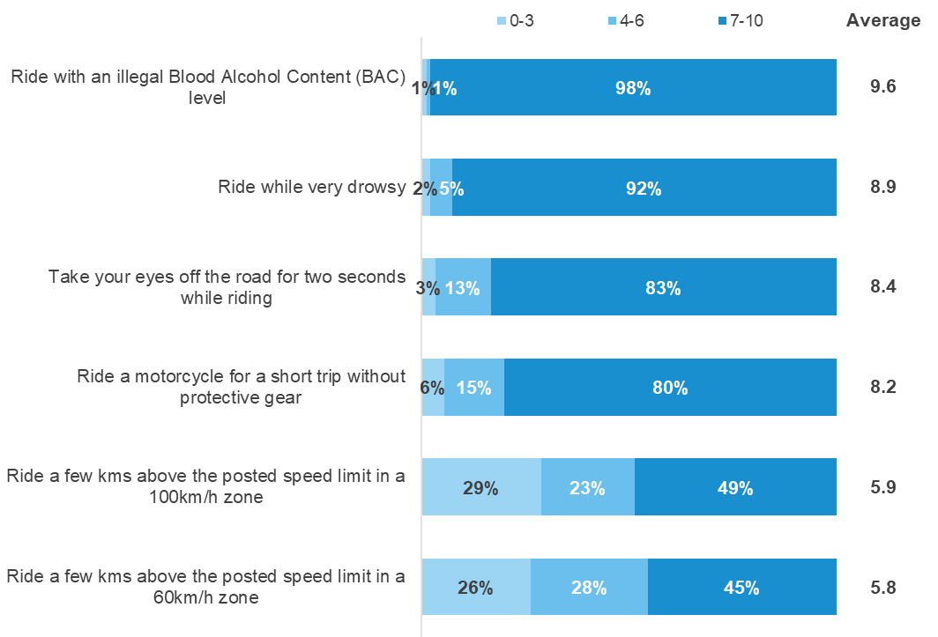
DAN1-DAN6. - Using a scale where 0 is “not at all dangerous” and 10 is “extremely dangerous” how dangerous do you think it is to …
Active riders only; Weighted; 2021 base n=592-597
Figures may not add to 100% due to rounding

Speed limit related behaviours and attitudes
This section presents findings relating to rider attitudes and behaviour regarding speed limits.

Speeding behaviour
As shown in Table 14, in 2021, around two-in-five respondents who have ridden in the last 12 months (41%) say they had intentionally ridden above the speed limit in a 60 km/h zone, even if by only a few kilometres per hour, in the last three months.
Table 14 Frequency of intentionally riding above the limit in a 60km/h zone (2017 – 2021)

Column % | 2017 | 2018 | 2019 | 2020 | 2021
NET: Ever | 40 | 44 | 45 | 39 | 41
All of the time | 1 | 1 | 1 | 0 | 0
Most of the time (More than half but not all) | 4 | 3 | 5 | 3 | 5
About half the time (50%) | 7 | 6 | 6 | 5 | 6
Some of the time (Less than half but not never) | 29 | 34 | 33 | 30 | 30
None of the time | 57 | 54 | 53 | 57 | 56
Don't know | 3 | 2 | 2 | 3 | 2
Column n | 790 | 748 | 722 | 782 | 663
BEH1. - How often have you intentionally ridden above the speed limit in a 60km/h zone, even if by only a few kms per hour, in the last three months? Base: Ridden in the last 12 months - Weighted; 2015 base n=591; 2016 base n=520; 2017 base n=790; 2018 base n=748, 2019 base n=722, 2020 base n=782, 2021 base n=663
 Indicates statistically significant difference compared to respondents not in that category
Figures may not add to 100% due to rounding
As shown in Table 15, in 2021, 45% of respondents who have ridden in the last 12 months reported intentionally riding above the speed limit in a 100 km/h zone in the last three months.
Table 15 Frequency of intentionally riding above the limit in a 100km/h zone (2017 – 2021)

Column % | 2017 | 2018 | 2019 | 2020 | 2021
NET: Ever | 48 | 48 | 51 | 42 ↓ | 45
All of the time | 1 | 1 | 3 | 1 | 1
Most of the time (More than half but not all) | 7 | 4 | 6 | 5 | 9 ↑
About half the time (50%) | 6 | 5 | 6 | 6 | 6
Some of the time (Less than half but not never) | 34 | 38 | 36 | 30 | 29
None of the time | 49 | 51 | 48 | 55 ↑ | 53
Don't know | 3 | 1 | 1 | 3 | 2
Column n | 789 | 747 | 723 | 782 | 662
BEH2. - Intentionally ridden above the speed limit in a 100km/h zone, even if by only a few km's per hour?
Base: Ridden in the last 12 months - Weighted; 2017 base n=789; 2018 base n=747, 2019 base n=723, 2020 base n=782, 2021 base n=662
 Indicates statistically significant difference compared to respondents not in that category
Figures may not add to 100% due to rounding

Attitudes towards speeding
This section presents findings relating to the perceived danger of riding over the speed limit and the extent to which riders would like to exceed the speed limit.

Perceptions of danger associated with riding over the speed limit
Active Riders were asked how dangerous they thought it was to ride a few kilometres above the posted speed limit, using a 0 to 10 scale where 0 was ‘not at all dangerous’ and 10 was ‘extremely dangerous’.
As shown in Figure 33, Around half (45%) of Active Riders rate riding a few kilometres above the posted speed limit in a 60 km/h zone as dangerous (defined as a rating of 7 to 10 on the 11-point scale). The perception of danger for a 100 km/h speed limit zone is similar, with about half (49%) considering exceeding the speed limit dangerous.
More than a quarter of Active Riders rated between 0 and 3 (on an 11 point scale from 0-10) that riding a few kms above the posted speed limit is dangerous (26% for 60km/h and 29% for 100km/h)
Other analysis shows that those from other urban areas are more likely than those from major urban areas to rate riding above the posted speed as dangerous for 60 km/h zones (56% vs 37%) and 60 km/h zones. Those from Major Urban areas are also more likely than other groups of active riders to rated riding above the speed limit in a 60km/h zone (32%) and 100km/h zone (33%) as not dangerous (rated between 0 and 3).
No differences from other subgroups were noted.
Figure 33 Perception of danger associated with riding a few km/h over the speed limit
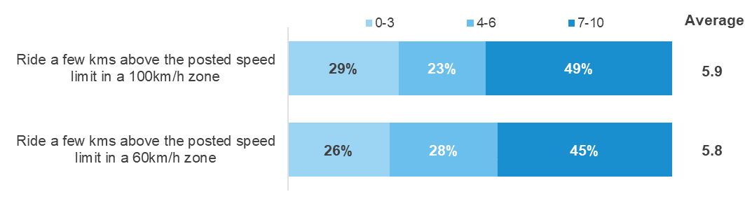
DAN1 & DAN2. - Using a scale where 0 is “not at all dangerous” and 10 is “extremely dangerous” how dangerous do you think it is to…
Active riders only; Weighted; 2021 base n=592-593
Figures may not add to 100% due to rounding

Preference to ride over the speed limit
Respondents who have ridden in the last 12 months were asked to what extent they agreed with the statement ‘I ride over the speed limit if I’m sure I’ll get away with it’.
As shown in Figure 34 one-in-five (18%) agree or strongly agree with this statement. This represents a steady decline from 2018, where agreement was at its highest (26%).
Figure 34 Level of agreement with ‘I ride over the speed limit…’ statement (2012 – 2021)
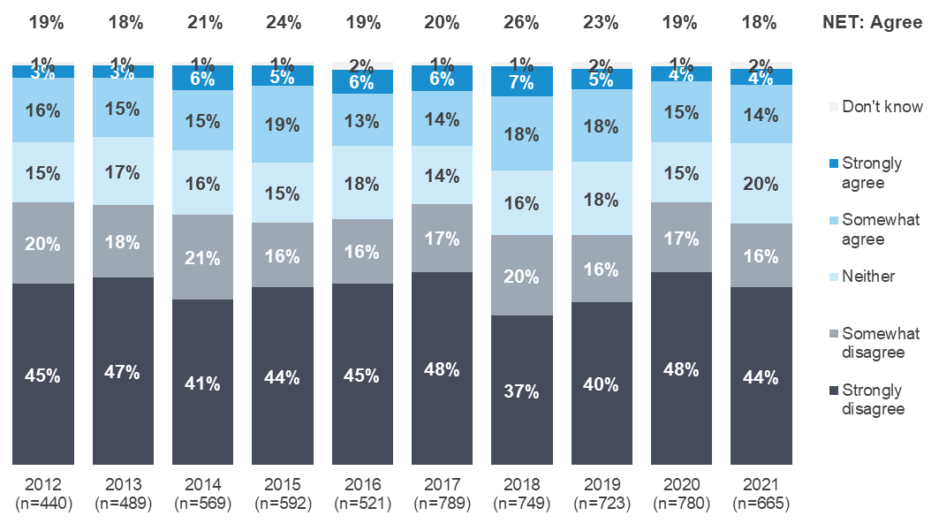
AT1. - To what extent do you agree or disagree with the following statement? I ride over the speed limit if I’m sure I’ll get away with it.
Base: Ridden in the last 12 months - Weighted; 2012 base n=440; 2013 base n=489; 2014 base n=569; 2015 base n=592; 2016 base n=521; 2017 base n=789; 2018 base: n=749; 2019 base n=723; 2020 base n=780; 2021 base n=665. Figures may not add to 100% due to rounding.

As shown in Table 16, those aged 18 to 25 are more likely to show a preference for speeding than the average rider, with 26% agreeing compared to 18% for the average rider, due to higher levels of selecting somewhat agree.
Table 16 Agreement with ‘I ride over the speed limit…’ statement by demographic

Column % | Total | Male | Female | 18 - 25 | 26 - 39 | 18-39 | 40+ | Major Urban | Other Urban | Rural Balance
NET: Agree | 18 | 18 | 19 | 26 ↑ | 19 | 20 | 17 | 19 | 18 | 15
NET: Disagree | 60 | 59 | 62 | 61 | 55 | 56 | 62 | 59 | 59 | 64
Strongly agree | 4 | 4 | 5 | 4 | 5 | 4 | 4 | 4 | 5 | 1 ↓
Somewhat agree | 14 | 14 | 14 | 22 ↑ | 14 | 16 | 13 | 15 | 13 | 14
Neither | 20 | 20 | 19 | 12 | 25 | 22 | 19 | 20 | 20 | 21
Somewhat disagree | 16 | 16 | 13 | 15 | 17 | 17 | 15 | 20 ↑ | 8 ↓ | 16
Strongly disagree | 44 | 43 | 49 | 46 | 37 | 39 | 46 | 39 ↓ | 51 ↑ | 49
Don't know | 2 | 2 | 0 | 0 | 2 | 2 | 2 | 2 | 2 | 0
Column n | 665 | 561 | 104 | 137 | 147 | 284 | 381 | 360 | 201 | 104
AT1. - To what extent do you agree or disagree with the following statement? I ride over the speed limit if I’m sure I’ll get away with it.
Base: Ridden in the last 12 months - Weighted; Base n=665
 Indicates statistically significant difference compared to respondents not in that category
Figures may not add to 100% due to rounding
As shown in Table 17, owners of motorcycles with an engine capacity of 250cc or smaller are more likely than the average rider to disagree with ‘I ride over the speed limit if I’m sure I’ll get away with it’.
Table 17 Agreement with ‘I ride over the speed limit…’ statement by engine capacity

Column % | Total | 250cc or smaller | 251-700cc | 701cc or larger | 251-700cc +  701cc or larger
NET: Agree | 18 | 18 | 17 | 21 | 19
NET: Disagree | 60 | 70 ↑ | 57 | 53 | 55 ↓
Strongly agree | 4 | 5 | 4 | 3 | 4
Somewhat agree | 14 | 13 | 13 | 18 | 15
Neither | 20 | 13 ↓ | 22 | 24 | 23 ↑
Somewhat disagree | 16 | 18 | 15 | 14 | 15
Strongly disagree | 44 | 52 | 42 | 39 | 41
Don't know | 2 | 0 | 4 ↑ | 1 | 3
Column n | 665 | 155 | 263 | 232 | 495
AT1. - To what extent do you agree or disagree with the following statement? I ride over the speed limit if I’m sure I’ll get away with it.
Base: Ridden in the last 12 months - Weighted; Base n=665
 Indicates statistically significant difference compared to respondents not in that category
Figures may not add to 100% due to rounding

Impaired riding
This section presents findings regarding drinking alcohol prior to riding behaviour and the perception of the level of danger associated with riding over the legal BAC.

Riding under and over the legal BAC
Table 18 shows the percentage of Active Riders who drink alcohol and have ridden in the past year while over the legal BAC, and the percentage who have ridden after drinking, but when they thought or knew they were under the legal BAC.
A small minority of Active Riders who drink alcohol (2%) said that they had ridden their motorcycle when they knew or thought they were over the legal BAC.
A greater proportion of Active Riders who drink alcohol (27%) indicate they had ridden a motorcycle after drinking alcohol when they knew or thought they were under the blood alcohol limit. This is a similar percentage to that reported in 2020 (24%).
Among Active Riders who drink alcohol, males (2%) were more likely than females (0%) to have ridden a motorcycle when they knew or thought they were over their legal blood alcohol limit. Those aged under 40 years were also more likely to have engaged in this behaviour (5% of those aged 18-25 and 3% of those aged 26-39 versus 2% of those aged 40 and over).
Continuing to consider Active Riders who drink alcohol, males (29%) were also more likely to have ridden a motorcycle when they knew or thought they were under their legal blood alcohol limit compared to females (9%).
Table 18 Percentage of Active Riders who drink alcohol and ride after drinking

Column % | Total | Male | Female | 18 - 25 | 26 - 39 | 18-39 | 40+ | Major Urban | Other Urban | Rural Balance
When you knew or thought you were over your legal blood alcohol limit, even slightly? (i.e. 0 or 0.05 BAC) | 2 | 2 | 0 | 5 ↑ | 3 | 3 | 2 | 3 | 0 ↓ | 3
After drinking alcohol when you knew or thought you were under the legal blood alcohol limit | 27 | 29 ↑ | 9 ↓ | 20 | 31 | 28 | 26 | 29 | 25 | 24
Column n | 499 | 429 | 70 | 100 | 104 | 204 | 295 | 271 | 151 | 77
ALCA. - Ridden a motorcycle when you knew or thought you were over your legal blood alcohol limit, even slightly? (i.e. 0 or 0.05 BAC)?
ALCB. - Ridden a motorcycle after drinking alcohol when you knew or thought you were under the legal blood alcohol limit?
Filter: Active riders who drink alcohol; Weighted; Base n=499
 Indicates statistically significant difference compared to respondents not in that category
Figures may not add to 100% due to rounding

Considering riding after a number of alcoholic drinks
Table 18 shows that under half of Active Riders who drink alcohol (48%) indicate that they would not have any drinks before riding, while one-in-four (26%) would have one drink and still consider riding, and a further quarter (25%) would have two drinks. Very few (2%) claim they would have three drinks or more and still consider riding.
Males (26%) are more likely than females (14%) to consider riding after two drinks. Those aged 18 to 25 are more likely than all groups to say they would not ride after drinking any alcohol (65%).
Table 19 Percentage of Active Riders who drink alcohol and ride after drinking

Column % | Total | Male | Female | 18 - 25 | 26 - 39 | 18-39 | 40+ | Major Urban | Other Urban | Rural Balance
One | 26 | 26 | 30 | 15 ↓ | 31 | 28 | 26 | 27 | 27 | 21
Two | 25 | 26 ↑ | 14 ↓ | 18 | 29 | 26 | 24 | 22 | 25 | 30
Three or more | 2 | 2 | 0 | 2 | 1 | 1 | 2 | 1 | 1 | 4
I would not ride after drinking any alcohol | 48 | 47 | 56 | 65 ↑ | 39 | 44 | 49 | 49 | 46 | 44
Column n | 559 | 479 | 80 | 111 | 125 | 236 | 323 | 302 | 170 | 87
ALC2. - What is the highest number of standard alcoholic drinks would you have and still consider riding?
Base: Active Riders only who drink alcohol; Weighted; 2021 base n=559
Figures may not add to 100% due to rounding

Perception of danger associated with riding with an illegal BAC
Active Riders were asked to rate how dangerous it is to ride under the influence of alcohol. As shown in Figure 35, nearly all Active Riders (98%) provided a rating of seven or above (on a zero to 10 scale, where 10 is extremely dangerous) for the danger associated with riding with an illegal Blood Alcohol Content.
Figure 35 Perception of danger associated with riding under the influence
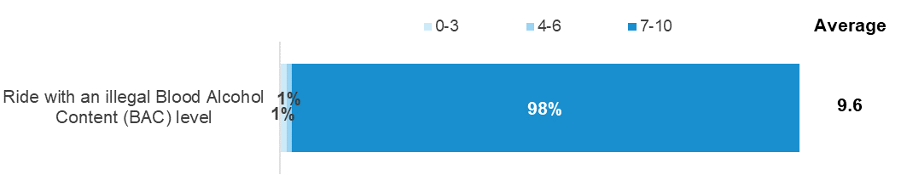
DAN3. - Using a scale where 0 is “not at all dangerous” and 10 is “extremely dangerous” how dangerous do you think it is to ride with an illegal Blood Alcohol Content (BAC) level
Active riders only; Weighted; 2021 base n=596
Figures may not add to 100% due to rounding

Enforcement
This section covers expectations regarding enforcement tolerance for exceeding the speed limit, sentiment towards point-to-point speed cameras and engagement with police while riding.

Attitudes towards enforcement of speed limits

Enforcement tolerance in 60 km/h speed limit zones
Figure 36 shows how the belief among Active Riders in a ‘zero tolerance’ approach to speeding has declined from 63% in 2012 to 40% in 2021. The percentage who believe in a ‘zero tolerance’ approach has remained at about four-in-ten since 2016.
Over half of Active Riders (56%) say that people should be allowed to ride over a 60 km/h speed limit without being booked for speeding, with 7% saying that people should be allowed to ride at speeds of 67km/h or above.
Figure 36 Speed that should be allowed in a 60km/h zone (2012 – 2021)
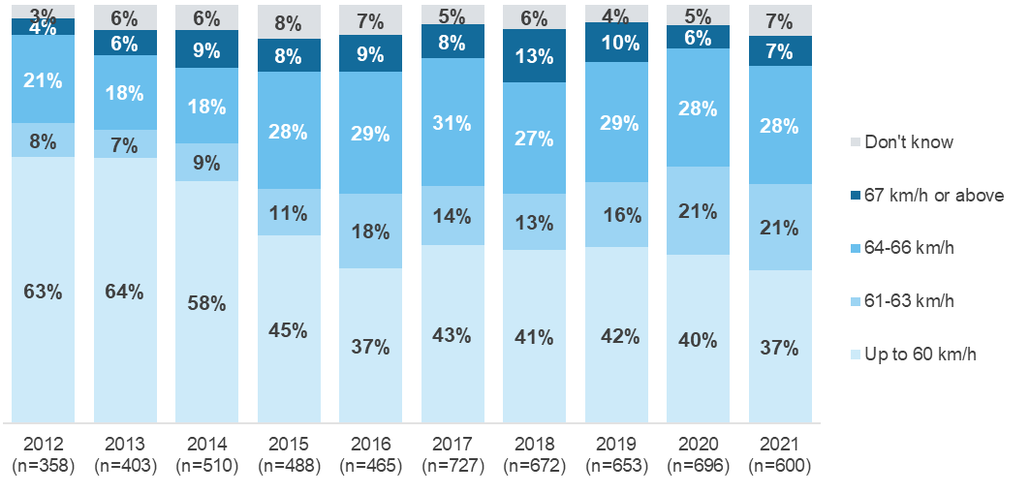
SPE2. - How fast should people be allowed to ride a motorcycle in a 60km/h zone without being booked for speeding?
Filter: Active riders; Weighted; 2012 base n=358; 2013 base n=403; 2014 base n=510; 2015 base n=488; 2016 base n=465; 2017 base n=727, 2018 base n=680, 2019 base n=653, 2020 base n=696, 2021 base n=600
Figures may not add to 100% due to rounding

Table 20 shows the speeds Active Riders say people should be allowed to ride over in a 60 km/h zone without being booked. Those aged 40 or more (42%) are more likely than younger age groups (18-39, 24%) to show belief in a ‘zero tolerance’ approach to speeding, as are active riders living in rural areas (51%) compared to those living in major urban areas (31%).
Table 20 Speed that should be allowed in a 60km/h by demographic

Column % | Total | Male | Female | 18 - 25 | 26 - 39 | 18-39 | 40+ | Major Urban | Other Urban | Rural Balance
0 + 60 | 37 | 37 | 35 | 24 ↓ | 24 ↓ | 24 ↓ | 42 ↑ | 31 ↓ | 40 | 51 ↑
61-63 km/h | 21 | 20 | 24 | 24 | 27 | 26 ↑ | 18 ↓ | 17 | 27 ↑ | 18
64-66 km/h | 28 | 29 | 22 | 34 | 31 | 31 | 27 | 33 ↑ | 23 | 24
67 km/h or above | 7 | 7 | 6 | 10 | 11 | 11 ↑ | 5 ↓ | 9 | 6 | 2 ↓
Don't know | 7 | 7 | 13 | 8 | 7 | 7 | 7 | 10 ↑ | 4 | 5
Column n | 600 | 508 | 92 | 124 | 125 | 249 | 351 | 326 | 182 | 92
SPE2. - How fast should people be allowed to ride a motorcycle in a 60km/h zone without being booked for speeding?
Filter: Active riders; Weighted; base n=600
 Indicates statistically significant difference compared to respondents not in that category
Figures may not add to 100% due to rounding

Enforcement tolerance in 100 km/h speed limit zones
Active Riders were also asked at what speed they think people should be allowed to ride in a 100 km/h zone without being booked for speeding. As shown in Figure 37, there has been relatively little change over the last five years (in fact, since 2016). This follows a downward trend from 2012 to 2016 where the percentage of riders saying that people should only be allowed to ride up to 100 km/h in a 100 km/h zone without being booked steadily decreased. While the percentage talking a ‘zero tolerance’ approach remains low compared to pre-2016, the percentage of Active Riders who say that people should be allowed to ride at 101-105km/h remained elevated (32%) following an increase from 24% in 2019 to 33% in 2020.
Figure 37 Speed that should be allowed in a 100 km/h zone (2012 – 2021)
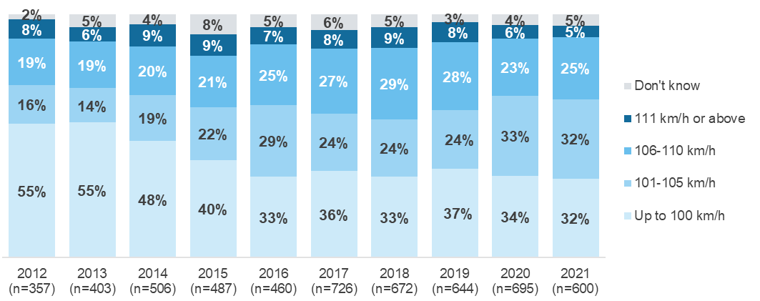
SPE4 - How fast should people be allowed to ride a motorcycle in a 100km/h zone without being booked for speeding?
Filter: Active riders; Weighted; 2012 base n=357; 2013 base n=403; 2014 base n=506; 2015 base n=487; 2016 base n=460; 2017 base n=726; 2018 base n=672, 2019 base n=644, 2020 base n=695, 2021 base n=600
Excludes respondent error
Figures may not add to 100% due to rounding
As shown in Table 21, those aged 40 or more (37%) are more likely than those under 40 (21%) to show belief in a ‘zero tolerance’ approach to speeding in a 100 km/h zone, as are those in rural areas (45%) compared to active riders in major urban areas (28%). Those in urban areas are most likely to nominate a speed of 106-110 km/h.
Table 21 Speed that should be allowed in a 100km/h zone by demographic

Column % | Total | Male | Female | 18 - 25 | 26 - 39 | 18-39 | 40+ | Major Urban | Other Urban | Rural Balance
100 | 32 | 32 | 34 | 21 ↓ | 21 ↓ | 21 ↓ | 37 ↑ | 28 ↓ | 34 | 45 ↑
101-105 km/h | 32 | 32 | 35 | 44 ↑ | 41 | 41 ↑ | 28 ↓ | 30 | 39 ↑ | 27
106-110 km/h | 25 | 26 | 20 | 22 | 29 | 27 | 25 | 30 ↑ | 19 ↓ | 20
111 km/h or above | 5 | 5 ↑ | 1 ↓ | 7 | 3 | 4 | 5 | 5 | 5 | 3
Don't know | 5 | 5 ↓ | 11 ↑ | 7 | 6 | 7 | 5 | 7 | 3 | 5
Column n | 600 | 508 | 92 | 124 | 125 | 249 | 351 | 326 | 182 | 92
SPE4 - How fast should people be allowed to ride a motorcycle in a 100km/h zone without being booked for speeding?
Weighted; 2021 base n=600
 Indicates statistically significant difference compared to respondents not in that category
Excluding respondent error
Figures may not add to 100% due to rounding

Frequency of being pulled over by police in the last 12 months
As shown in Table 22, about one in eight Active Riders (13%) have been pulled over by police in the last 12 months.
Table 22 Whether pulled over by police in last 12 months (2013 – 2021)

Column % | 2017 | 2018 | 2019 | 2020 | 2021
Yes | 16 | 17 | 14 | 17 | 13
No | 83 | 83 | 85 | 83 | 87
Don't know / Refused | 1 | 1 | 1 | 0 | 0
Column n | 727 | 675 | 647 | 697 | 598
POL1. - Have you been pulled over by police for any reason while riding your motorcycle in the last 12 months?
Filter: Active riders; Weighted; 2012 base n=359; 2013 base n=506; 2014 base n=404; 2015 base n=486; 2016 base n=467; 2017 base n=725, 2018 base n=675, 2019 base n=647, 2020 base n=697, 2021 base n=598
 Indicates statistically significant differences between 2019 and 2020 only
Figures may not add to 100% due to rounding

Random Breath and Drug Testing
As shown in Figure 38, 15% of Active Riders had been breath tested when riding their motorcycle in the past 12 months – continuing on a downward trend since 2018. This is likely an impact of riding less due to COVID-19 restrictions.
Drug-testing prevalence remains similar to prior years, at 5% prevalence.
Figure 38 Percentage of Active Riders who are breath tested (2015 – 2021)
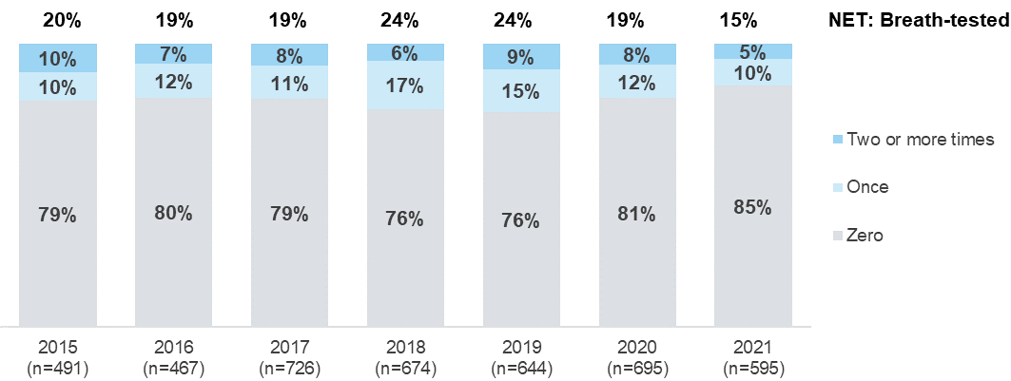
POLB. - In the last 12 months, how many times, if any have you been breath-tested when riding your motorcycle
Filter: Active riders; Weighted; 2021 base n=595

Motorcycle/Scooter Ownership
This section presents findings relating to the type of motorcycles respondents had at home, and respondents’ awareness, desire for and possession of various safety features.

Details of motorcycle ridden most often
Respondents were asked about the type of motorcycle they ride and its engine capacity.

Main motorcycle type
As shown Table 23, Active Riders are most likely to ride either off road bikes/trail bikes (mentioned by 25%), cruisers (22%), sports bikes (20%) or sports tourers (12%).
There are several differences by demographic, including:
- Females are more likely to ride scooters (19% vs 7% among males), but less likely to ride sports bikes (7% vs 20% among males)
- Those aged 40 or over are less likely to ride sports bikes (17% vs 27% among those aged under 40), but more likely to ride sports tourers (15% vs 7%)
- Those in Major Urban areas:
  - Were more likely to ride sports bikes (28% vs 20%)
  - But less likely to ride off road bikes/trail bikes (16% vs 25%)
- Those in Other Urban and Rural Balance areas:
  - Were more likely to ride off road bikes/trail bikes (31% Other Urban; 41% Rural Balance vs 25%)
Table 23 Main motorcycle type by selected rider characteristics

Column % | Total | Male | Female | 18 - 25 | 26 - 39 | 18-39 | 40+ | Major Urban | Other Urban | Rural Balance
Cruiser | 22 | 22 | 26 | 18 | 22 | 21 | 23 | 21 | 25 | 23
Off road bike/trail bike | 25 | 25 | 24 | 19 | 27 | 25 | 24 | 16 ↓ | 31 ↑ | 41 ↑
Sports bike | 20 | 21 ↑ | 7 ↓ | 41 ↑ | 23 | 27 ↑ | 17 ↓ | 28 ↑ | 11 ↓ | 10
Sports tourer | 12 | 13 | 6 | 1 ↓ | 8 | 7 ↓ | 15 ↑ | 11 | 13 | 13
Dual sport | 5 | 5 | 5 | 7 | 3 | 4 | 5 | 5 | 5 | 1 ↓
Scooter | 8 | 7 ↓ | 19 ↑ | 8 | 6 | 6 | 9 | 10 | 8 | 2 ↓
Other road bike | 4 | 4 ↓ | 9 ↑ | 7 | 6 | 6 | 4 | 5 | 2 ↓ | 6
Other | 3 | 3 | 2 | 0 | 4 | 3 | 3 | 2 | 4 | 5
Column n | 617 | 526 | 91 | 125 | 131 | 256 | 361 | 340 | 187 | 90
MC1. - Thinking about the one motorcycle you ride most often. What type of motorcycle is it?
Filter: Base: Active rider ; Weighted sample; base n=617
Figures may not add to 100% due to rounding

Engine size of main motorcycle
As shown in Table 24, motorcycles that are ridden most often by Active Riders are most likely to have engine sizes of 701cc and over (39%) ahead of those with a reported engine size of 251-700cc (36%) and those with a reported engine size of up to 250cc (25%).
Those with the more powerful 701cc and over engines are significantly more likely to be aged 40 and over (48% vs 7% of 18-25 year olds and 22% of 26-39 year olds) or males (41% compares to 21% of females).
Table 24 Engine size of main motorcycle by selected rider characteristics

Column % | Total | Male | Female | 18 - 25 | 26 - 39 | 18-39 | 40+ | Major Urban | Other Urban | Rural Balance
Up to 250cc | 25 | 23 ↓ | 47 ↑ | 36 ↑ | 27 | 29 | 23 | 25 | 26 | 25
251-700cc | 36 | 36 | 31 | 55 ↑ | 52 ↑ | 53 ↑ | 28 ↓ | 37 | 33 | 35
701cc and over | 39 | 41 ↑ | 21 ↓ | 7 ↓ | 22 ↓ | 18 ↓ | 48 ↑ | 37 | 41 | 40
Don't know | 0 | 0 | 1 | 1 | 0 | 0 | 0 | 1 | 0 | 0
Column n | 620 | 529 | 91 | 127 | 130 | 257 | 363 | 339 | 189 | 92
MC5 - What capacity is the engine?
Filter: Active riders; Weighted sample; Base n=620
 Indicates statistically significant difference compared to respondents not in that category
Figures may not add to 100% due to rounding
As shown in Table 25, Off-road Riders are the least likely to have engine sizes of 701+cc (28%).
Table 25 Engine size of main motorcycle by rider purpose

Column % | Total | Commuter | Recreational | Off-road
Up to 250cc | 25 | 25 | 19 ↓ | 29
251-700cc | 36 | 33 | 34 | 43 ↑
701cc and over | 39 | 42 | 47 ↑ | 28 ↓
Don't know | 0 | 0 | 0 | 0
Column n | 620 | 395 | 490 | 243
MC5 - What capacity is the engine?
Filter: Active riders; Weighted sample; Base n=620
 Indicates statistically significant difference compared to respondents not in that category
Figures may not add to 100% due to rounding

Awareness of motorcycle safety features
Active Riders were asked whether they had heard of a number of safety features currently available on some motorcycles and/or clothing. As shown in Figure 39, the most common features respondents had heard of were ABS (88%) and traction control (74%). In 2021 there was a significant drop in awareness of Motorcycle to vehicle communication (22% from 35% in 2020).
Figure 39 Awareness of motorcycle safety features (2012 – 2021)
FEA. - Have you heard of any of the following motorcycle safety features?
Filter: Active riders; Weighted sample; 2012 base n=359; 2013 base n=405; 2014 base n=511; 2015 base n=491; 2016 base n=468; 2017 base n=565, 2018 base n=672, 2019 base n=307, 2020 base n=516, 2021 base n=597

Motorcycle safety features desired for next motorcycle
Active Riders, whose most ridden motorcycle is for road use, were asked which of the safety features they were aware of in the previous question (Figure 39) they would want for their next motorcycle.
As shown in Table 26, the most common features Active Riders would like on their next motorcycle are ABS (78%) and traction control (66%), the same as 2019. This was followed by and motorcycle stability control (58%) and Motorcycle to vehicle communication (42%). In 2020 and 2021 Active Riders were not asked about motorcycle blind spot warning sensor, or low tyre pressure indicators. Motorcycle to vehicle communication was a new safety feature included in 2020.
Active Riders, whose most ridden motorcycle is for road use, were asked if they had a number of safety features currently available on some motorcycles. These safety features were the same used in the previous two questions.
Over four-in-ten (43%) have none of these features on their current road bike. The most common features Active Riders do have on their motorcycle are ABS (53%), traction control (25%) and Motorcycle Stability Control (14%). Notably, no motorcycle riders surveyed have motorcycle to vehicle communication (0% 2021 vs 6% 2020). There is a notable gap in the presence of features on current motorcycles and the desire to have these features on a new motorcycle. Also notably, is the lack of desire to have a speed limiter function (52% aware vs. 19% would like to have on next bike) on their bikes, however, this is steadily climbing from 14% in 2018 to 19% in 2021.
Table 26 Awareness, desire for and possession of motorcycle safety features

Column % | Aware of the feature | Would like to have  on next bike | Have feature  on current bike
ABS (Anti-lock braking system) | 88 | 78 | 53
Traction control | 74 | 66 | 25
Motorcycle Stability Control | 53 | 58 | 14
Speed limiter function | 52 | 19 | 7
Motorcycle to vehicle communication | 22 | 42 | 0
My bike has none of these features | - | - | 43
I don't want any of these features on my next bike | - | 11 | -
I have heard of none of these features | 8 | - | -
Column n | 597 | 419 | 417
FEA - Have you heard of any of the following motorcycle safety features?
FEA3 - Which of these safety features would you want for your next motorcycle?
FEA2 - Which of these safety features do you have on the road motorbike you ride most often?
Filter: Active riders whose most ridden motorcycle is for road use. Weighted sample; base n=xxx

Motorcycle Clothing
This section presents findings relating to wearing protective motorcycle gear when riding a motorcycle, the type of helmet worn, and attitudes towards motorcycle safety clothing.

Protective gear usage
Active Riders were asked how often they wore protective gear when riding a motorcycle. As shown in Figure 40, a majority wear the following gear all the time: any helmet (96%), motorcycle riding gloves (81%), a motorcycle riding jacket (70%), any type of boots (68%). Just over half (55%) of Active Riders wear motorcycle riding pants all the time.
Females are more likely than males to wear any type of boots ‘all the time’ (80% vs 67%).
Active Riders from Major Urban areas are also more likely to wear these three items ‘all the time’: any helmet (99% vs 96%), riding gloves (87% vs 81%), a riding jacket (75% vs 70%).
Figure 40 Usage of protective motorcycle clothing
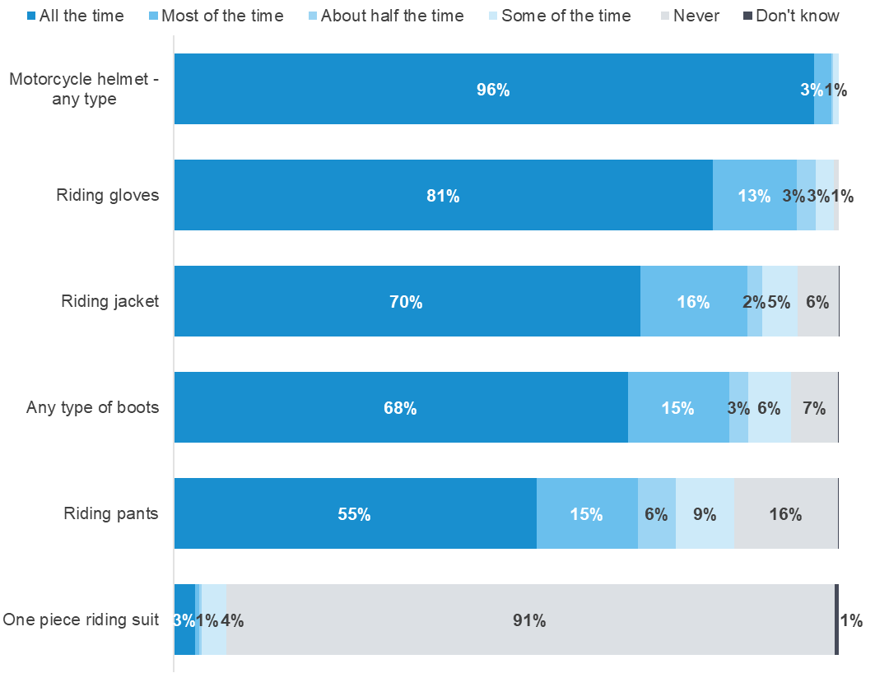
MS1-6. - When riding a motorcycle, how often do you wear the following items of protective motorcycle clothing?
Filter: Active riders; Weighted sample; 2021 Base n=546
Figures may not add to 100% due to rounding

As shown in Table 27, on average, Active Riders wore 3.7 pieces of protective clothing ‘all the time’. About four in ten (43%) wear five or more items ‘all the time’ and a further one in five (22%) wear four items ‘all the time’. Active Riders aged 18 to 25 wear less protective gear on average (3.3 vs 3.7).
Active Riders who ride a motorcycle with a 250cc or lower capacity engine wear a lower number of protective items ‘all the time’ compared to Active Riders who ride motorcycles with an engine capacity of more than 250cc (2.9 vs 3.9).
Table 27 Number of items worn all the time when riding

Column % | Total | 250cc  or smaller | 251-700cc | 701cc  or larger | 18 – 25 | 26 – 39 | 40+
No items are worn all the time | 2 | 4 | 2 | 1 | 2 | 2 | 2
1 item | 10 | 20 ↑ | 8 | 5 ↓ | 10 | 3 ↓ | 12 ↑
2 items | 11 | 14 | 9 | 10 | 20 ↑ | 14 | 9 ↓
3 items | 17 | 22 | 17 | 15 | 20 | 17 | 17
4 items | 18 | 22 | 17 | 15 | 19 | 26 ↑ | 15
5 or more items | 43 | 18 ↓ | 48 | 54 ↑ | 29 ↓ | 37 | 46 ↑
Average | 3.7 | 2.9 ↓ | 3.8 | 4.0 ↑ | 3.3 ↓ | 3.7 | 3.7
Column n | 599 | 135 | 232 | 222 | 123 | 126 | 350
MS - When riding a motorcycle, how often do you wear the following items of protective motorcycle clothing?
Filter: Active riders only; Weighted sample; 2021 Base n=599
Figures may not add to 100% due to rounding
Active Riders who ride a motorcycle with a 250cc or lower capacity engine wear a lower number of protective items ‘all or most of the time’ compared to Active Riders who ride motorcycles with an engine capacity of more than 701cc (3.6 vs 4.6). Those aged 18 – 25 wear less protective gear on average than those aged 40+ (3.9 vs 4.4).
Table 28 Number of items worn all the time or most of the time when riding

Column % | Total | 250cc  or smaller | 251-700cc | 701cc  or larger | 18 – 25 | 26 – 39 | 40+
No items are worn all or most of the time | 0 | 1 | 1 | 0 | 2 ↑ | 0 | 0
1 item | 3 | 7 ↑ | 2 | 1 ↓ | 4 | 3 | 3
2 items | 4 | 9 ↑ | 3 | 1 ↓ | 5 | 6 | 3
3 items | 12 | 21 ↑ | 12 | 7 ↓ | 22 ↑ | 12 | 11
4 items | 22 | 34 ↑ | 18 | 19 | 20 | 24 | 22
5 or more items | 58 | 28 ↓ | 64 | 72 ↑ | 47 ↓ | 55 | 61
Average | 4.3 | 3.6 ↓ | 4.4 | 4.6 ↑ | 3.9 ↓ | 4.2 | 4.4 ↑
Column n | 599 | 135 | 232 | 222 | 123 | 126 | 350
MS - When riding a motorcycle, how often do you wear the following items of protective motorcycle clothing? (most of/all the time)
Filter: Active riders only; Weighted sample; 2021 Base n=599
 Indicates statistically significant difference compared to respondents not in that category
Figures may not add to 100% due to rounding

Type of helmet used
As shown in Table 29, Active Riders were asked what type of motorcycle helmet they wear when riding a motorcycle. The majority wear a full-faced helmet all the time (72%), while smaller percentages wear both types of helmets (17%) or an open-faced helmet all of the time (11%).
Active Riders who ride a cruiser type of motorcycle were least likely to wear a full-faced helmet (50%), with riders of this type of motorcycle more likely to wear an open-faced helmet (19%) or both types of helmet (31%).
Active riders in major urban locations (77%) are more likely that those living in Rural Balance areas (53%) to wear a full-face helmet ‘all the time’.
About half of Active Riders who ride a scooter wear a full-faced helmet (50%), with the remainder either wearing an open-faced helmet (31%) or both types of helmet (19%).
Table 29 Type of helmet used

Column % | Total | Male | Female | 18 - 25 | 26 - 39 | 40+ | Major Urban | Other Urban | Rural Balance
Wear full face helmet all the time | 72 | 72 | 71 | 76 | 78 | 70 | 77 ↑ | 72 | 53 ↓
Wear open face helmet all the time | 11 | 11 | 8 | 9 | 10 | 11 | 9 | 12 | 18
Both, wear an open face helmet some of the time and a full face helmet some of the time | 17 | 17 | 21 | 15 | 13 | 19 | 14 | 17 | 29 ↑
Column n | 595 | 506 | 89 | 122 | 127 | 346 | 324 | 180 | 91
MS2 - Thinking about the type of helmet you wear when riding a motorcycle, do you wear a full face helmet or an open face helmet, or both?
Filter: Active riders; Weighted sample; 2021 Base n=595
 Indicates statistically significant difference compared to respondents not in that category
Figures may not add to 100% due to rounding

Attitude statement about motorcycle safety clothing
Respondents who have ridden in the last 12 months were asked to what extent they agreed ‘I think motorcyclists should always wear motorcycle clothing’. As shown in Figure 41, about nine in ten (86%) agree with this statement, similar to 2020 (88%).
Figure 41 Agreement that motorcyclists should always wear protective clothing (2017-2021)
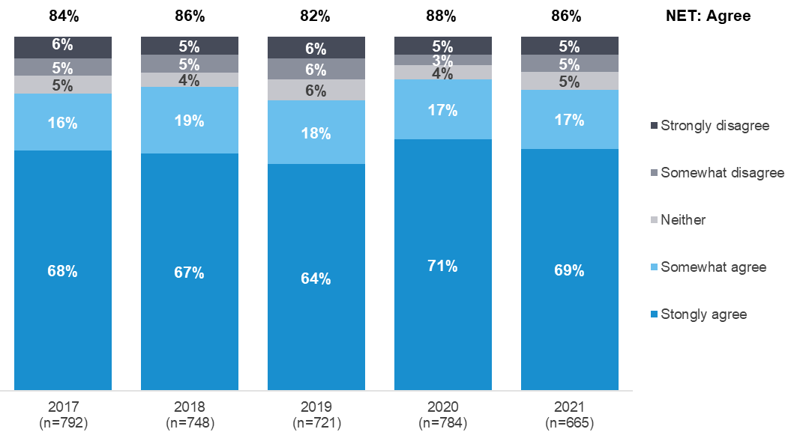
ATB - To what extent do you agree or disagree with the following statement. I think motorcyclists should always wear motorcycle clothing (jacket, pants, boots and gloves) while riding
Filter: Ridden in the last 12 months; Weighted sample; Base n=665
Figures may not add to 100% due to rounding

Motorcycle Crash History
Respondents were asked whether they had crashed while riding a motorcycle, whether they had required medical treatment after their most recent crash, and whether they had received assistance after a crash.

Crash history
Respondents were asked whether they had ever crashed while riding a motorcycle, excluding dropping their bike while stationary and not including any crashes that may have occurred during motorcycle sport. As shown in Figure 42, among total respondents, under half (42%) indicate that they ever had a crash.
Males are more likely to have had a crash than females (45% vs 20%). Respondents aged 40 years and older were also more likely to have a crash compared to those under 40 (44% vs 36%).
Figure 42 Motorcycle crash history (2012 – 2021)
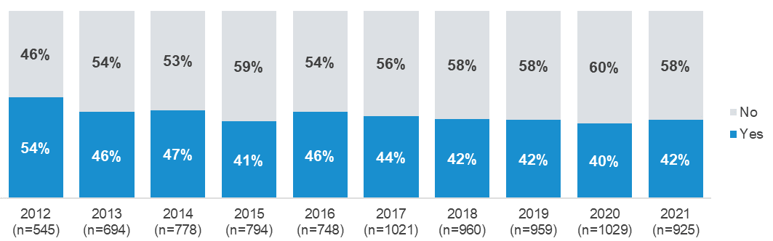
MC7 - Have you ever had a crash while riding a motorcycle, not including dropping your bike while stationary and not including a crash that occurred while participating in motorcycle sport?
Filter: Total sample (exclusing refused); Weighted sample; 2012 base n=545; 2013 base n=694; 2014 base n=778; 2015 base n=794; 2016 base n=748; 2017 base n=1021; 2018 base n=960, 2019 base n=959, 2020 base n=1,029, 2021 base n=925
Figures may not add to 100% due to rounding

Receiving assistance after crashing
Respondents who have had a crash while riding a motorcycle were asked if they received assistance from someone they were riding with. As shown in Table 30, more than a third had received assistance after a crash (35%).
Receiving assistance was agnostic of rider type and activity, with all segments reporting having been helped similarly.
Table 30 Receiving assistance after crashing

Column % | Total | Active riders | Lapsed riders | Former riders | Commuter | Recreational | Off-road
Yes | 35 | 35 | 35 | 36 | 28 | 33 | 42
No | 65 | 65 | 65 | 64 | 72 | 67 | 58
Column n | 374 | 258 | 99 | 17 | 168 | 228 | 125
CRA9. - Have you ever received assistance from someone you were riding with after crashing your motorcycle?
Filter: Ever experienced crash; Weighted sample; Base n=374
 Indicates statistically significant difference compared to respondents not in that category
As shown in Table 31, respondents who had been assisted were asked how important the assistance was in their recovery. Just over half (52%) indicated the assistance was very important for their recovery, while 20% indicated that it was not at all important. Off-road riders are least likely to suggest assistance was very important (30%), while Lapsed riders are most likely to suggest assistance was very important (74%).
Table 31 Importance of assistance for recovery

Column % | Total | Active riders | Lapsed riders | Former riders | Commuter | Recreational | Off-road
Very important | 52 | 39 ↓ | 74 ↑ | 42 | 42 | 41 ↓ | 30 ↓
Moderately important | 23 | 30 | 19 | 0 | 26 | 30 | 37 ↑
Not at all important | 20 | 27 | 7 ↓ | 35 | 27 | 23 | 26
Don't know | 4 | 4 | 0 | 23 | 4 | 7 | 8
Column n | 145 | 100 | 38 | 7 | 52 | 82 | 55
CRA10 - How important was that assistance in your recovery?
Filter: Ever experienced crash and received assistance; Weighted sample; Base n=145
 Indicates statistically significant difference compared to respondents not in that category

Improving Rider Safety
This section presents findings relating to the desire to find out more about being a safe motorcyclists and respondent suggestions to improve motorcyclist safety.

Information on how to stay safe
Respondents who have ridden in the last 12 months were asked whether they agreed or disagreed with the statement ‘I would like more information on how to stay safe while riding on the road”. As shown in Figure 43, over half of respondents (55%) somewhat agreed or strongly agreed with this statement, while only 15% somewhat disagreed or strongly disagreed.
Sentiments are similar among all demographics and rider types regarding looking for information.
Figure 43 Information on how to stay safe riding on the road
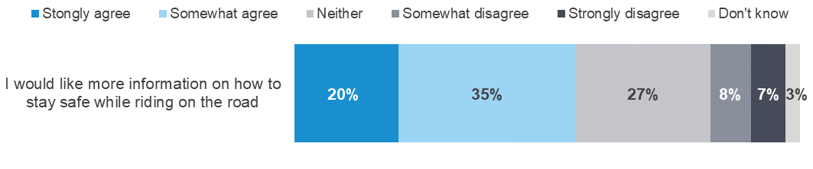
ATM - To what extent do you agree or disagree with the following statement… I would like more information on how to stay safe while riding on the road?
Filter: Ridden in the past 12 months; Weighted sample; base n=667

Respondent suggestions for improving rider safety
All respondents were asked (unprompted) if they would like to make any suggestions about what the TAC could do to improve rider safety. As shown on the following page in Table 32, the most common themes related to safety ‘being up to the individual/riders are responsible for their own actions/none’ (27%), followed by ‘improve road user awareness/ education’ (21%). This remains largely unchanged from 2017.
Decreasing in suggestions are awareness campaigns / continuing the advertising (9% in 2020 vs 5% in 2021) and removing wire rope crash barriers / wire barriers can kill (6% in 2018 vs 2% in 2021).
Table 32 Suggestions to improve rider safety (2017 – 2021)

Column % | 2017 | 2018 | 2019 | 2020 | 2021
None / it’s up to the individual / riders are responsible for their own actions | 27 | 23 | 21 | 23 | 27
Improve road user awareness /education  (include training in motorcycle and push bike safety/sharing the road etc) | 12 | 16 | 17 | 18 | 21
Awareness campaigns / continue the advertising | 3 | 4 | 6 | 9 | 5 ↓
Maintain the roads / fix defects / remove pot holes / clean up after road works | 5 | 5 | 5 | 7 ↑ | 9
Remove wire rope crash barriers / wire barriers can kill | 2 | 6 ↑ | 6 | 4 ↓ | 2 ↓
Make the wearing of protective clothing mandatory | 4 | 3 | 3 | 3 | 2
More/improved car driver training | 4 | 3 | 3 | 3 | 2
Improve road design / consider road safety in road design | 0 | 1 | 2 ↑ | 2 | 2
Make the wearing of high visibility vests and jackets mandatory | 4 | 2 | 3 | 2 | 2
Comprehensive learner rider courses / more supervised training | 3 | 3 | 3 | 2 | 4
Column n | 1028 | 971 | 972 | 1037 | 933
D6. - Would you like to make any suggestions to the TAC about what they can do to improve rider safety?
Total Sample Weighted; Base 2021 n=1,028
 Indicates statistically significant difference compared to respondents not in that category

Summary of findings

Travelling habits
Apart from driving or riding themselves, respondents who have a motorcycle licence and/or a motorcycle registered in their name (‘total respondents’) are most likely to get around on a regular basis by walking (with 41% travelling this way more than once a week) or as passengers on a motorcycle or car (33%). Fewer than 1 in 10 (8%) catch public transport more than once a week and just 1% take a taxi or similar more than once a week.
Most of these same respondents (93%) drive a car more than once a week, which is substantially higher in prevalence than the likelihood of riding their motorcycle more than once per week (15%).
In 2021, respondents were asked whether they ride an e-bike, e-scooter or e-skateboard, where they ride these and when they started riding. A total of 7% have ever ridden an e-bike, e-scooter or e-skateboard, with 2% riding one of these more than once a week. Predominantly, electric device riders ride on both the road and footpath (42%), but a sizable proportion only ride them on the road (37%). The majority electric device riders started riding more than a year ago (51%), however, 24% started riding in the last 6 months.

Learning to ride
The vast majority of total respondents have a full motorcycle licence (91%). As in prior reports, far fewer 18-25-year-olds have their full licence (39%) and are more likely to have a learner’s licence (29%) or probationary licence (27%).

Skills and training
Interestingly, or perhaps worryingly, self-perceptions of driving ability are substantially higher among 18-25s, of whom two-thirds (65%) believe they are better than the average rider, compared to perceptions of the average rider where just under half (49%) believe they are better than the average rider.
Considering the extent to which riders brush up on their skills, two-thirds (66%) ever brush up on their skills while 33% never do. Riders aged 18-25 are most likely to brush up on their skills ‘at least once a month’ (55% vs 24% of all riders), however, brushing up for 18-25s tends to involve accessing YouTube more-so than older riders (74% vs 42% of all riders) or friends and family (63%).
Three-quarters (76%) of motorcyclists have ever attended some motorcycle training. The main reason for attending motorcycle training is assistance in ‘getting a learners permit or licence’ (62%) followed by ‘improving your road riding skills’ (23%). Four-in-ten (38%) of those who had attended training did so in the last five years.

Riding activity and attitudes
Slightly over six in ten total respondents (62%) indicate they had ridden a motorcycle in the last 12 months, which is slightly less than reported in 2019 and 2020 (66%).
Similar to 2019, 53% of total respondents are either regular or occasional riders or have started riding again after a break. These respondents are defined as Active Riders. Nearly two-fifths (38%) indicate that, although they had stopped riding, they might ride again in the future. These respondents are defined as Lapsed Riders. Those who had stopped riding and did not intend to return to riding comprise 9% of respondents. They are defined as Former Riders. Apart from no longer owning a motorcycle (70%), the main reasons Former Riders give for ceasing riding are family commitments or a change in lifestyle (mentioned by 25%), prefer to use other transport (17%) or that they are too busy (7%).
Active Riders are more likely to ride recreationally on-road (77% of Active Riders do so) than commute (60%) or ride recreationally off-road (39%). On average, Commuters ride more per month (496km) than Recreational On-roader Riders (393km) or Recreational Off-road riders (417km).
The vast majority of respondents who have ridden in the last 12 months (95%) agree that ‘the only remedy for fatigue while riding is to stop riding and rest’, with 84% ‘strongly agreeing’. This percentage has remained relatively stable over the years.
Nearly all Active Riders (98%) rate riding with an illegal blood alcohol content level as highly dangerous (7-10 on a 0-10 point scale where 10 is extremely dangerous), and 92% indicate that riding while very drowsy is highly dangerous. A smaller, although still substantial percentage (83%), think ‘taking your eyes off the road for two seconds while riding is highly dangerous’.
Active riders were asked if they had ever talked on a mobile phone while riding and a majority said they had never done this (91%). However, those who had (9%) were significantly more likely to be respondents aged 18-25 years (13%).

Attitudes towards speeding and speeding behaviour
Respondents who have ridden a motorcycle in the last 12 months were asked to what extent they agreed with the statement ‘I ride over the speed limit if I’m sure I’ll get away with it’. One-in-five agree with this statement (18%). This has decreased from a spike in 2018, where 26% agreed with the statement.
Around two-in-five of respondents who have ridden a motorcycle in the last 12 months (41%) indicate they had intentionally ridden above the speed limit in a 60km/h zone in the last three months. A similar proportion of respondents who have ridden a motorcycle in the last 12 months (45%) indicate they had intentionally ridden above the speed limit in a 100km/h zone, in the last three months. Although frequency of riding over the speed limit is higher in 100km/h zones, the danger is perceived to be higher for 100km/h zones than 60km/h zones (49% vs 45% rated as dangerous).
Over half of Active Riders (56%) believe they should be allowed to ride over the 60 km/h speed limit without being booked. Similarly, in recent years there has been a shift towards Active Riders believing there should be more leeway to ride over the speed limit in 100km/h zones. In 2012 and 2013 55% Active Riders believed there should be no leeway (i.e. up to 100km/h). This percentage has declined further, to 32% in 2021.

Random breath and drug testing
Just over one in seven (15%) Active Riders had been breath tested when riding their motorcycle in the past 12 months in 2021, representing the biggest decline in recent years. A smaller percentage had been randomly drug tested in the last 12 months (5%). This remains stable from 2017 (4%) and 2018 (4%).
As was the case in 2020, only a small minority of Active Riders (2%) who indicate that they had ridden their motorcycle when they knew or thought they were possibly over the legal blood alcohol limit. A higher proportion of Active Riders said they had ridden a motorcycle when they knew or thought they were under the legal blood alcohol limit (27%).
Active Riders overwhelmingly believe that it is more dangerous to ride under the influence of alcohol (98%) than to: ride while very drowsy (92%), take your eyes off the road for two seconds while riding (83%), ride a motorcycle for a short trip without protective gear (80%), ride a few kms above the posted speed limit in a 100km/h zone (49%) and above the speed limit in a 60km/h zone (45%).

Just under half of Active Riders who drink alcohol (48%) indicate that they would not have any drinks before riding, while one-in-four (26%) would have one drink and still consider riding, and a further one in four (25%) would have two drinks. Very few (2%) claim they would have three drinks or more and still consider riding.

Motorcycle/scooter ownership
The most common bikes used are off road (25%), cruiser (22%), sports bike (20%), and sports tourer (12%).
Motorcycles that are ridden most often by Active Riders are most likely to have engine sizes of 701+cc (39%) ahead of those with an engine size of 251-700cc (36%) or of 250cc (25%).
The most common safety features Active Riders whose most ridden motorcycle is for road use have on their motorcycle are ABS (53%), traction control (25%) and Motorcycle Stability Control (14%).

Protective motorcycle clothing
Active Riders were asked how often they wore protective gear when riding a motorcycle. A majority wear the following gear all the time: any helmet (96%), motorcycle riding gloves (81%), a motorcycle riding jacket (70%) and any type of boots (68%). About half of respondents (55%) wear motorcycle riding pants all the time. Wearing of any type of boots has declined from 76% (all of the time) in 2020.
About seven-in-ten Active Riders (72%) wear a full-faced helmet all the time, while smaller percentages wear a full-faced helmet some of the time and a open-faced helmet some of the time (17%), or an open-faced helmet all of the time (11%).

Motorcycle crash history
As was the case in previous years, under half of total respondents (42%) indicated they had had a crash.
Slightly over a third of respondents who had ever experienced a crash had received assistance from someone they were riding with after a crash (35%).
Respondents who had received assistance after a crash were asked how important this was to their recovery. Just over half (52%) indicated that the assistance was ‘very important’ to their recovery.

Suggestions for improving road safety
Over half (55%) of respondents who have ridden in the last 12 months agree that they would like more information on how to stay safe while riding on the road. One in five (20%) strongly agree.
The most mentioned suggestions to improve road safety related to respondents believing riders are responsible for their own actions. However, improved education and training for both drivers and motorcyclists and maintaining/fixing the roads were also common.
When considering respondent suggestions for improving road safety in 2021, suggestions around awareness campaigns / advertising were less prevalent.

Methodology

Data Collection
The Motorcycle Monitor was conducted using a similar methodology in 2021 as since 2014, and was a multimode project, with respondents having the option to complete the survey in hard copy, over the telephone, or online. Since 2017 the survey has been run continuously, with data collected across four quarters in seven waves. Prior to this, the survey was run annually as a point-in-time survey.
The survey was conducted in two waves per quarter, except in the Oct-Dec quarter where one wave was conducted to accommodate the holiday season. All respondents were sent a Primary Approach Letter (PAL) and hard copy of the questionnaire, which invited them to go online and complete the survey or fill the hard copy in and return it to Wallis in a reply-paid envelope.
Reminder SMS and letters were sent about two weeks after the initial mail out to those who had not completed the survey at that stage. Those who had not yet completed the questionnaire online, or had not yet completed a hard copy questionnaire, were telephoned about three weeks after the initial mail out and asked whether they would like to complete the questionnaire online or over the telephone.
Key fieldwork figures are contained in Table 33 Key Fieldwork Figuresbelow.
Table 33 Key Fieldwork Figures

 | 2017 |  | 2018 |  | 2019 |  | 2020 |  | 2021
 | n= | % of mail-out | n= | % of mail-out | n= | % of mail-out | n= | % of mail-out | n= | % of mail-out
Mail-out 1 - Survey invitation | 2770 | 100% | 2443 | 100% | 2540 | 100% | 2532 | 100% | 2540 | 100%
Mail-out 2 - Survey reminder | 1946 | 70% | 2064 | 84% | 2100 | 83% | 1995 | 79% | 2139 | 84%
SMS | 1498 | 54% | 1456 | 60% | 1378 | 54% | 2108 | 83% | 3527 | 139%
TOTAL Survey completions online | 420 | 15% | 502 | 21% | 542 | 21% | 585 | 23% | 581 | 62%
TOTAL Survey completions hardcopy | 397 | 14% | 347 | 14% | 308 | 12% | 318 | 13% | 246 | 26%
TOTAL Survey completions phone | 210 | 8% | 122 | 5% | 122 | 5% | 134 | 5% | 107 | 11%
TOTAL Completions | 1027 | 37% | 971 | 40% | 972 | 38% | 1037 | 41% | 934 | 37%

Sampling
The entire sample was sourced from the VicRoads Registration and Licencing database (supplied by the TAC). A random selection of 2,540 Victorians who had a motorcycle licence and/or motorcycle registered in their name was drawn from the database. Victorians who held either a Learners’ or Probationary motorcycle licence were overrepresented in the sample to ensure there was sufficient numbers in these groups to analyse and report on. Victorians who had a motorcycle registered in their name as well as a licence were also oversampled as members of this group are more likely to be active riders.

Response rates
The overall response rate for the study was 37% compared to 41% in 2020, 38% in 2019, 40% in 2018, 37% in 2017, 32% in 2016, 34% in 2015, 33% in 2014 and 30% in 2013.
Altogether 934 people completed the survey, of which 61% completed it online, 27% completed it on hard copy, and 12% completed it via telephone.

Weighting
The results were weighted by registration and licence status, age, location and licence type. This was done so that the responses received reflected the characteristics of the Victorian motorcyclist population. The weighting scheme that was developed was based on motorcycle licence and registration population statistics from the VicRoads database.
The effect of the weighting is illustrated in Table 34 below.
Table 34 Sample attributes and population comparisons

Sample attributes and population figures | % of mailout | % of completions (unweighted) | % in population
Registration and licence status
Both registration and licence | 58% | 64% | 39%
Registration or licence only | 42% | 36% | 61%
Licence type
Full motorcycle licence | 82% | 86% | 91%
Learner or probationary licence | 15% | 13% | 7%
No Licence | 2% | 2% | 2%
Gender
Male | 84% | 81% | 87%
Female | 16% | 19% | 13%
Age
18-25 | 19% | 16% | 4%
26-39 | 28% | 22% | 24%
40+ | 53% | 61% | 72%
Location
Major Urban | 58% | 56% | 57%
Other Urban | 29% | 29% | 31%
Rural Balance | 13% | 15% | 12%

Road Safety Monitor 2020
i.e. a person should be booked even if they exceed the speed limit by only one km/h

