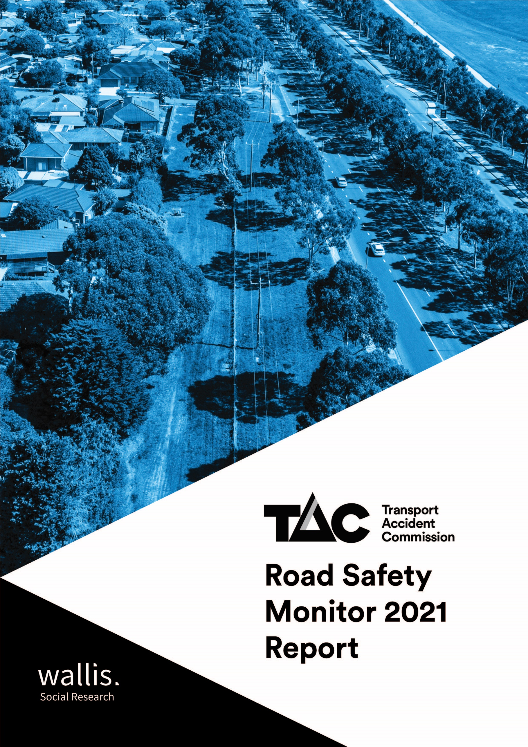

Report prepared for:
Jodi Page-Smith
Road Safety Research Analyst
Community Relations
Transport Accident Commission (TAC)
60 Brougham Street
Geelong 3220
 | Accreditations
Wallis Social Research achieved accreditation to the International Standard ISO20252 in September 2007. The Company is committed to maintaining administrative and operational procedures which comply with these accreditation requirements and to improving its performance in all aspects of the service it delivers to its customers.
In 2020 Wallis sought and attained certification to ISO 27001. This is the highest standard for information and data security. Wallis made the strategic decision to become certified to ISO 27001 because we recognise the absolute necessity for our clients to be assured that their data is secure. Wallis is one of the first research companies in Australia to achieve certification to this standard.
Wallis is an active participant in the market research industry, with senior staff making significant contributions to the Research Society (TRS) and the Australian Data and Insights Association (ADIA). As such we actively pursue the ethical objectives of the industry.
In addition to having attained the highest Industry accreditation, Wallis also participates in the Australian Achiever Awards, which recognises the customer service excellence of Australian companies. The Company has been awarded a high commendation every year since the inception of these awards in 1999.
Wallis is an acknowledged leader in data protection and privacy. Our system is regularly subjected to external penetration testing and we are a Privacy Awareness Week supporter – committed to sharing our knowledge with others. Wallis is also active member of the Australian Cyber Security Centre (ACSC) Partnership Program.

Executive summary

The 2021 Road Safety Monitor (RSM) report presents the findings collected in RSM surveys over the course of 2021. As in 2020, this year was marked by the COVID-19 pandemic and travel restrictions imposed by the lockdowns in response to COVID-19. It was the first year of the ‘Road Safety Action Plan 2021-2023’. The ‘Victorian Road Safety Strategy 2021-2030’ aims to halve the number of lives lost and serious injury on Victoria’s roads by 2030.
The 2021 RSM continues to include additional regional sample to address the overrepresentation of regional Victorians in road trauma statistics and an acknowledgement of the different driving and lifestyle experiences of those living in regional Victoria.
Key trends in 2021
Travel patterns
The travel patterns reported in 2021 differ in comparison to 2020, with respondents driving less distance, more at night. Respondents continue to report driving stressed less than they did in 2019. While active modes of transport (walking or cycling) were maintained, respondents continue to travel less by public transport. These patterns are illustrated by the following findings:
- While nearly as many respondents reported driving weekly in 2021 as 2020 (93% vs 92%), they drove fewer kilometres in (10,758 km in 2021 vs 11,552 km in 2020). Both years are lower than reported pre-COVID-19 (13,297 km average over 2017-19).
- Night-time driving increased, with respondents more likely to drive between the hours of 10pm and 6am at least once per week in 2021 than in 2020 (24% vs 20%).
- Fewer respondents report driving stressed at least weekly compared to 2019 (27% in 2021 and 29% in 2020 vs 34% in 2019).
- Weekly use of public transport is lower in 2021 (16%) than in 2020 (21%). However, riding a bicycle on the roads at least once per week remained unchanged at 10% in 2021 and about six-in-ten go somewhere by walking at least one a week (58% in 2021 vs 60% in 2020).
Questions about travelling via electric personal transport were introduced 2021. One in twenty (5%) respondents ever travelled by these modes, with half using them on both the footpath and road (49%). Nearly half (46%) started using their e-device in the last year.
Police enforcement
Respondents reported seeing fewer police on the road compared to the same time last year (24% believe there are fewer police on the road in 2021 vs 16% in 2020).
Fewer interactions with police were reported in 2021 compared to 2020. A third of respondents (33% vs 51% in 2020) report being breath-tested and about one in twenty (4%) report being drug tested (vs 6% in 2020).
Compared to 2020, respondents are less likely to agree that ‘seeing police on the road makes me feel safer’ (60% vs 65% in 2020).
Perception of danger
Driving behaviours such as driving while over the legal BAC (an average rating of 9.6 out of 10), driving while using a handheld mobile phone (9.2) and driving while very tired (8.9) continue to be perceived as having a high level of danger. In contrast, exceeding the speed limit by a few kilometres in a 60 km/h zone (5.7) or a 100 km/h zone (6.0) and driving a short time after having one alcoholic drink (5.5) are perceived to be less dangerous.
Driving behaviours
The incidence of intentionally speeding in a 60 km/h zone (42% vs 39% in 2020) and in a 100 km/h zone (45% vs 40% in 2020) have both increased.
Over four in ten respondents (45%) report driving while feeling drowsy – a substantial increase from 2020 (38%).
The incidence of self-reported driving over the legal BAC in the past 12 months (4% of respondents) remained consistent in 2021 with previous years. Continuing a positive downward trend, driving while under the legal BAC also remains stable, with 43% driving under the legal BAC (41% in 2020).
Three in ten respondents (29%) used their phone illegally in the last 3 months. The percentage of drivers using their phone hand-held while driving has declined substantially, from 37% in 2016 to 29% in 2021.
Table of Contents
1 Introduction 1
1.1 Background and objectives 1
1.2 Research objectives 2
1.3 Reading this report 3
2 Key shifts between 2020 and 2021 6
2.1 Travel 6
2.2 Drink driving 7
2.3 Enforcement 7
2.4 Hand-held mobile phone use while driving 9
3 Impact of COVID-19 10
3.1 Travel patterns and COVID-19 10
3.2 Driving behaviours and COVID-19 12
4 Detailed Findings 13
4.1 How people get around 13
4.2 Driving behaviour 21
4.3 Vehicle ownership 24
4.4 Road user attitudes and behaviours 27
4.5 Speeding 32
4.6 Impaired driving 42
4.7 Fatigue 48
4.8 Distractions 49
4.9 Pedestrian distractions 51
4.10 Police enforcement 54
4.11 Social norms 57
4.12 Infrastructure 59
4.13 Towards zero 60
4.14 Crashes 63
4.15 Seatbelts 66
4.16 Cycling 68
4.17 General attitudes to transport and road safety 69
5 Summary of findings 74
5.1 How people get around 74
5.2 Vehicle ownership 74
5.3 Driving behaviour 75
5.4 Speeding 75
5.5 Drugs and alcohol 76
5.6 Fatigue 76
5.7 Distractions 76
5.8 Pedestrian distractions 77
5.9 Enforcement 77
5.10 Social norms 77
5.11 Infrastructure 77
5.12 Towards zero 78
5.13 Crashes 78
5.14 Seatbelts 78
5.15 Cycling 78
5.16 General attitudes to transport and road safety 78
6 Research methodology 80

Appendix 1 Question list for 2021 RSM
Appendix 2 Reminder letter
Appendix 3 Example questionnaire (hard copy and Primary Approach Letter)

List of Figures
Figure 1 Driving while under the legal BAC after drinking alcohol (2020 vs 2021) 7
Figure 2 Number of police on the road compared to the same time last year (2020 vs 2021) 7
Figure 3 Interactions with police (2020 vs 2021) 8
Figure 4 Perceptions of police (% agree) (2020 vs 2021) 8
Figure 5 Use of a hand-held mobile phone while driving (2016 to 2021) 9
Figure 6 How people get around 13
Figure 7 Frequency of driving among the 18-25 age group 14
Figure 8 Type of vehicle usually driven infographic 26
Figure 9 Perceived danger – incidence matrix 31
Figure 10 Perceptions of Danger (speeding highlighted) 32
Figure 11 Definition of speeding by year 34
Figure 12 Intentionally driving over the speed limit in a 60 km/h zone over time by year 35
Figure 13 Intentionally driving over the speed limit in a 100 km/h zone over time 35
Figure 14 Driving over the speed limit 60 km/h infographic 36
Figure 15 Driving over the speed limit 100 km/h infographic 36
Figure 16 Driving over the speed limit 100 km/h infographic 37
Figure 17 Attitudes towards speeding 38
Figure 18 Caught speeding by year 41
Figure 19 Use of drugs and alcohol by year 42
Figure 20 Pedestrian distractions on a mobile phone 53
Figure 21 Effectiveness of police in catching someone while driving illegally 54
Figure 22 Frequency of friends engaging dangerous driving 57
Figure 23 Support for road safety infrastructure 59
Figure 24 Lowest achievable number of lives lost in one year over the next 30 years 61
Figure 25 Community understanding of the number of road fatalities per year 62
Figure 26 Community understanding of the number of serious injuries per year 62
Figure 27 Main cause of serious injury and loss of life in Victoria 64
Figure 28 Someone Injured in a car crash to the point of going to hospital by year 65
Figure 29 Agreement with statements relating to cyclists 68
Figure 30 Attitudes towards speeding statements 69
Figure 31 Relative importance of issues relating to roads and transport 72

List of Tables
Table 1 Significance reporting example table 5
Table 2 Weekly travel by mode by quarter in 2021 11
Table 3 Distance travelled by quarter in 2021 11
Table 4 Driving behaviours by year and by quarter in 2021 12
Table 5 Frequency of driving a car – gender by age 14
Table 6 Frequency of riding a motorcycle on the road by demographic 15
Table 7 Frequency of riding a bicycle on the road by demographic 15
Table 8 Frequency of driving a heavy vehicle on the road by demographic 16
Table 9 Frequency of going somewhere by public transport by demographic 17
Table 10 Frequency of taking a commercial ride share by demographic 18
Table 11 Frequency of walking by demographic 18
Table 12 Frequency of travelling in a car or on a motorbike as a passenger by demographic 19
Table 13 Frequency of travelling on an e-device by demographic 19
Table 14 Where people usually ride their e-devices by demographic 20
Table 15 When people started riding their e-device by demographic 20
Table 16 Frequency of commuting to and from work in a car by demographic 21
Table 17 Frequency of driving between 10pm and 6am by demographic 22
Table 18 Frequency of driving while feeling stressed by demographic 23
Table 19 Frequency of driving while feeling stressed by behaviour (18-60 years) by behaviour 23
Table 20 Bought a car in the last 12 months by demographic 24
Table 21 Most important things when buying a car by demographic 25
Table 22 Type of vehicle usually driven by demographic 25
Table 23 Perceptions of danger 27
Table 24 Perception of danger by demographic 28
Table 25 Perception of the danger of speeding by demographic 33
Table 26 Perception of the danger of speeding by behaviour 33
Table 27 Attitudes towards speeding (net agree %) by year 39
Table 28 Attitudes towards speeding by demographic 39
Table 29 Attitudes towards speeding by behaviour 40
Table 30 Caught speeding in the past 12 months by demographic 41
Table 31 Use of alcohol and recreational drugs by demographic 42
Table 32 Use of alcohol and recreational drugs by behaviour 43
Table 33 Illegal drink driving by demographic 44
Table 34 Legal drink driving by demographic 45
Table 35 Number of drinks by demographic 46
Table 36 Use of recreational drugs by demographic 47
Table 37 Frequency of driving after using recreational drugs by year 47
Table 38 How often driven while very tired in the past three months by demographic 48
Table 39 Use of a mobile phone while driving (ever) by demographic 50
Table 40 Frequency of crossing the street with headphones by demographic 51
Table 41 Frequency of crossing the street looking at a mobile phone by demographic 51
Table 42 What distracts pedestrians by demographic 52
Table 43 Near misses due to pedestrian distractions by demographic 53
Table 44 Perception of police effectiveness by demographic 54
Table 45 Perceptions of police by demographic 55
Table 46 Perceptions of police by behaviour 55
Table 47 Perception of police presence by demographic 56
Table 48 Interaction with police on the roads (NET and frequency) 56
Table 49 Frequency of friends engaging dangerous driving by demographic 58
Table 50 Frequency of friends engaging dangerous driving by behaviour 58
Table 51 Belief that Victoria should aim for zero by demographic 60
Table 52 Lowest number of lives lost within one year by demographic 61
Table 53 Involvement in crash in the last five years by demographic 63
Table 54 Involvement in crash in the past five years by behaviour 63
Table 55 Change in behaviour after a crash by demographic 65
Table 56 Wearing seatbelts while driving by demographic 66
Table 57 Wearing seatbelts while driving by behaviour 66
Table 58 Wearing a seatbelt while travelling in a vehicle as passenger by demographic 67
Table 59 Wearing a seatbelt while travelling in a vehicle as passenger by behaviour 67
Table 60 Attitudes towards travel speed by demographic 70
Table 61 Attitudes towards travel speed by behaviour 70
Table 62 Attitudes towards quality of driving by demographic 71
Table 63 Attitudes towards quality of driving by behaviour 71
Table 64 Perceived importance of the quality of the road and transport system by demographic 72
Table 65 Perceived importance of the access to transport options by demographic 73
Table 66 Perceived importance of quality of life issues and the environment by demographic 73
Table 67 Fieldwork schedule 82
Table 68 Sample performance 83

Introduction

Background and objectives
This section provides background to this report, including the research objectives and methodology.

The TAC and road safety
The Transport Accident Commission (TAC) is a government-owned organisation which was established in Victoria in 1986 through the Transport Accident Act (1986). Funding for the TAC is derived from vehicle registrations fees collected by VicRoads. The TAC has three main roles, each of which is directed towards reducing the impact of adverse health effects caused by traffic accidents:
 | To improve  road safety |  | To improve the State’s trauma system |  | To support those who  have been injured on Victorian roads
The focus of the Road Safety Monitor (RSM) is largely on the first role – promoting road safety. This important role is somewhat atypical of organisations that administer compensation schemes, but the TAC has been very successful in promoting road safety. The most visible aspect of this role for the public is the social public education efforts, which have been on air in Victoria since 1989. However, promoting road safety is a collaborative process involving the TAC, VicRoads, Department of Justice and Victoria Police, as well as many other organisations including research institutes, health organisations, industry, and other government departments at all levels. This work involves understanding the many facets of and trends in road safety in Victoria, determining interventions that balance mobility and safety to benefit road users, and implementing these interventions.

Road fatalities and interventions over time
Prior to the establishment of the TAC, one of the most significant road safety interventions introduced was compulsory seatbelts in 1970. At that time, there were 1,061 road deaths in Victoria - the highest ever recorded. Following this intervention, random breath tests were introduced in 1976, red light cameras in 1983, and speed cameras in 1986.
The TAC still invests in strategies that promote safe driving by drivers and motorcycle riders. However, the TAC is also delivering safer roads through promotion and support for Victoria Police activities, increased partnership with VicRoads, and through the Safe System Road Infrastructure Program (SSRIP). The primary initiatives of SSRIP include flexible barriers on the sides and centres of roads in high-risk locations and audio tactile line markings. These initiatives are part of the Towards Zero strategy, which is discussed in the next section.

Lives lost
Road safety continues to be a pressing issue for Victoria. Although significant reductions in lives lost on Victorian roads have been achieved over time, 2016 saw the largest increase in lives lost since 2001. In 2016 292 people were killed, up from 252 in 2015 – an increase of 16% overall.
In 2017, the number of lives lost fell to 259 – below the 2012-2016 five-year average of 263 lives lost per year. In 2018, there was a further reduction in the number of lives lost, with 213 lives lost that year.
There was an increase in the number of lives lost in 2019, with 266 deaths recorded on Victorian roads. This was a 25% increase on 2018 and above the five-year average of 252 for 2014-2018. Fatalities were higher in the first half of the year with 150 occurring between January and June versus 116 between July and December.
Over 2021, 232 lives were lost on Victorian roads due to road trauma. While this number has increased 10% from 2020 (211 lives lost), it is below the 2016-2020 five-year average of 248 lives lost annually.
Victorian Road Safety Strategy 2021-2030
Looking beyond 2020, the ‘Victorian Road Safety Strategy 2021-2030’ is designed to reduce and eventually eliminate the unacceptable loss of life on Victoria’s roads. It aims to halve lives lost and reduce serious injuries by 2030.
The focus of the Strategy is on creating a safe road environment and supporting road users to make safe choices by:
- ensuring all Victorians are safe and feel safe, on and around our roads
- seeing progressive reduction in fatalities and serious injuries from road trauma over the next 10 years
- embedding a culture of road safety within the Victorian community
- delivering initiatives that have an immediate impact while also preparing for future changes to road safety technology.
The Strategy also acknowledges that road safety is complex and that it takes a collective response from government agencies, the TAC’s industry partners, and the Victorian community to deliver safer roads.

Research objectives
The primary research objectives of the RSM are to:
 | Monitor road safety behaviour and the factors which influence behaviour, including attitudes and social norms.
 | Identify behaviours and attitudes that are relevant to road safety.
In addition, the secondary objectives of the RSM are to:
 | Profile those who are model road users and those who are at risk on Victorian roads.
 | Provide evidence to assist with the evaluation of road safety programs.

Reading this report

Rounding and multiple response questions
The sums of percentages in tables have been rounded to the nearest integer. This means that in some tables the total may add to 99% or 101% rather than 100%. This is due to rounding and is not an error.
Where questions allow multiple responses from respondents, the sum of response percentages may add to more than 100%. In these cases, the total percentage reflects the average number of responses per respondent. i.e., a multiple response question which adds to a total of 243% has an average of 2.43 responses per respondent.

Time series reporting
The profile for Victorians in scope to participate in the RSM changed in 2012. Prior to 2012, only drivers aged 18-60 years who held a current drivers’ licence were eligible to participate in the study. From 2012, Victorians aged 18-90 are eligible to take part. To allow valid comparison with pre-2013 data where a time series is presented, results for surveys since 2012 are filtered to respondents aged 18-60 years who have a valid driving licence. Elsewhere, results are presented for the total sample.

Sub-group reporting
Location sub-groups were changed in 2017. Until 2016, location was defined as either ‘Melbourne’ or ‘Elsewhere in Victoria’. From 2017, however, locations have been defined per ABS SOS definitions. The table below indicates how these locations are now defined.
Major  Urban |  | Major Urban represents a combination of all Urban Centres with a population of 100,000 or more (for example, Melbourne, Geelong, Ballarat).
Other  Urban |  | Other Urban represents a combination of all Urban Centres with a population between 1,000 and 99,999 (for example, Warrnambool, Sale, Benalla).
Rural  Balance |  | Rural Balance represents the Remainder of State/Territory and includes Bounded Localities (centres with population of between 200 and 999 (for example, Taradale, Venus Bay, Fish Creek) and smaller centres.
In addition to demographic variables used to analyse differences between groups, results are regularly shown for five driving behaviour sub-groups. The following table explains how each of these groups has been derived. Codes refer to the questions in the question list provided in Appendix 1.
Speeding |  | Frequently exceeds the posted speed limit, even if only by a few km/h (DB1A or DB1B) is ‘All of the time’, ‘Most of the time’, ‘Half of the time’ or ‘Some of the time’.
Drink driving |  | Answered ‘Yes’ to DK3: In the last 12 months, have you driven a car when you knew or thought you were over your legal blood alcohol limit, even slightly?
Mobile phone use |  | Makes or answers calls, or writes or reads text messages (DB2C, DB2D, DB2E or DB2F) is ‘All of the time’, ‘Most of the time’, ‘Half of the time’ or ‘Some of the time’.
Driving fatigued |  | Drives when feeling very tired (DB2G) ‘All of the time’, ‘Most of the time’, ‘Half of the time’ or ‘Some of the time’.
Involvement in an accident |  | Answered ‘Yes’ to CR1: In the last five years, have you been involved in any crashes on the road as a driver or rider?

Statistical significance and question codes
The data in this report have been tested for statistical significance, typically between subgroups. Tests are conducted between the subgroup and the total excluding the subgroup and are at the 95% confidence interval, unless stated otherwise. A multiple comparison correction has been used to adjust the statistical significance where several comparisons are made in the one table.
To illustrate, in Table 1 below, the blue arrow indicates that males aged 40-60 are significantly more likely to drive their car at least weekly. Similarly, the red arrow indicates that males aged 18-25 are significantly less likely to drive their car at least weekly.
Information below each table shows question numbers as codes. An example is provided in Table 1 below where M2A references question numbers in the questionnaire.
Table 1 Significance reporting example table

Column % |  | Male |  |  |  | Female
Column % | Total | 18 - 25 | 26 - 39 | 40 - 60 | 61 - 90 | 18 - 25 | 26 - 39 | 40 - 60 | 61 - 90
At least weekly | 93 | 85 ↓ | 93 | 96 ↑ | 95 | 85 ↓ | 89 | 95 ↑ | 94
At least monthly | 2 | 5 | 3 | 2 | 2 | 5 | 2 | 2 | 1
Less than monthly | 2 | 7 ↑ | 2 | 1 | 1 ↓ | 2 | 3 | 1 | 1
NET: Ever drive a car | 97 | 97 | 98 | 99 ↑ | 97 | 93 ↓ | 94 ↓ | 99 | 96
Never drive a car | 3 | 3 | 2 | 1 ↓ | 3 | 7 ↑ | 6 ↑ | 1 | 4
Sample size | 2805 | 233 | 324 | 470 | 343 | 193 | 349 | 513 | 380
M2A - How often do you drive a car?
Total sample; Weighted sample; base n = 2805
Blue up arrows (↑) and red down arrows (↓) indicate statistically significant difference compared to respondents not in that category.
Figures may not add to 100% due to rounding

Weighting
The sample for the survey is drawn from the VicRoads Registration and Licensing Database and has a correction applied for known response rates of the previous waves of the survey. Therefore, the profile of the sample is generally very close to the Victorian population. Weighting by location, age and gender is then applied to correct the sample to the known licence holder population as derived from the VicRoads Registration and Licencing Database.
The weighting efficiency is 82% (meaning there is an effective base of 2,058 from a sample of 2,505 respondents).

Key shifts between 2020 and 2021
This section discusses key shifts in attitudes and behaviours measured in the RSM from 2020 to 2021.

Travel
From a road safety perspective, the COVID-19 restrictions caused a range of changes in travel patterns. We cover these changes in more detail in Section 3. However, the key trends recorded in the RSM, at a glance, are:
- Driving at all in a week remained stable with 2020 (93% in 2021 vs 92% in 2020).
- Driving distance has decreased by around 19%* in 2021 at an average of 10,758km versus the average of 2017 and 2019 at an average of 13,297km, and 6%* between 2020 (11,552km on average) and 2021.
- Night-time driving (between the hours of 10pm and 6pm) at least once per week increased from 20% in 2020 to 24% in 2021.
- Driving while feeling stressed at least once a week remained stable at 27% (vs 29% in 2020) but lower than 2019 (34%).
- Travelling in a car as a passenger at least once per week remained stable with 2020 (55% in 2021 and 2020).
- Taking public transport at least once per week declined from 21% in 2020 to 16% in 2021.
- Riding a bicycle on the road at least weekly remained stable with 2020 (10% in both 2020 and 2021).
While these shifts may seem small, they are recorded over the entire year and have historically been stable year-on-year. The results indicate that over 2021 Victorians still drove, but drove less distance, drove more at night-time and were driving stressed less often. Victorians were also less likely to take public transport.

*Note: Percentages for driving distance are assumptions based on averages of ranges of kilometres travelled per year, e.g. 0-4,999km was averaged to 2500km, 5,000-9,999 was averaged to 7,500km.

Drink driving
The incidence of self-reported drink driving in 2021 (4%) is relatively stable compared to 2020 (5%). However, as shown in Figure 1, among all drivers the rate of ‘legal drink driving’ (driving under a person’s legal BAC after drinking alcohol) remained stable 43% in 2021 (vs 41% in 2020).
Figure 1 Driving while under the legal BAC after drinking alcohol (2020 vs 2021)
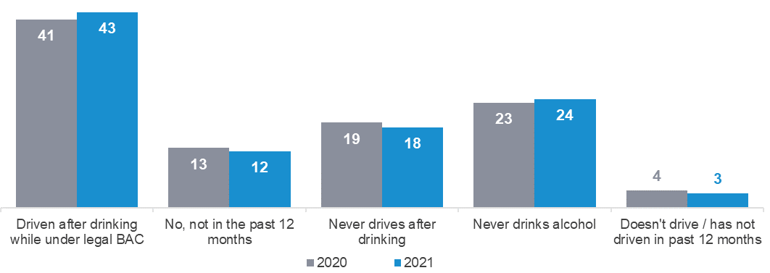
DK8 - In the last 12 months, have you driven a car after drinking alcohol when you knew or thought you were under the legal blood alcohol limit?
Filter: Total sample; Weighted sample; 2020 base n=1927; 2021 base n=2057

Enforcement
As shown in Figure 2, respondents reported a decrease in the number of police on the road in 2021 compared to 2020, with the percentage of respondents reporting ‘fewer police on the road’ increasing to 24% from 16% (in both 2019 and 2020). The percentage of respondents reporting ‘the same number of police compared to this time last year’ further decreased to 31% (36% in 2020 and 43% in 2019). About one in five respondents (22%) report more police on the road in 2021 versus a quarter (24%) in 2020 (and 20% in 2018).
Figure 2 Number of police on the road compared to the same time last year (2020 vs 2021)
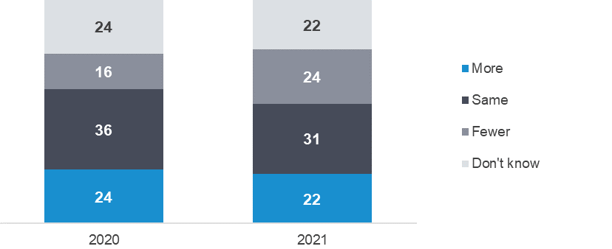
POL1: Do you believe that compared to this time last year, there are fewer, more or the same number of police on the roads?
Total sample; weighted data; 2020 base n=1200; 2021 base n=1374
Along with the perceived decrease in the number of police present on the road, as shown in Figure 3, respondents were also less likely to report having interactions with police. The percentage of respondents reporting they had been pulled over, breath tested, or drug tested declined from 55% in 2020 to 38% in 2021. Being pulled over for any reason decreased (24% in 2021 vs 30% in 2020), while being breath tested declined (33% in 2021 vs 51% in 2020) and being drug tested declined (4% in 2021 vs 6% in 2020).
Figure 3 Interactions with police (2020 vs 2021)
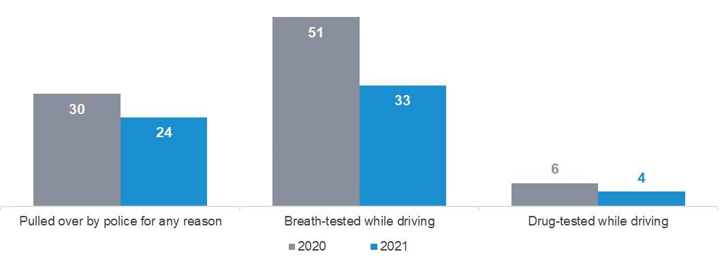
EN3 In the past 12 months, how many times have you been…
Drivers; weighted data; 2020 base n=1156; 2021 base n=1323
Perceptions of police enforcement changed from 2020 to 2021. As shown in Figure 4, while there was an increase in agreement with the statement that ‘Enforcing speed limits just raises revenue and doesn’t make our roads safer’ (29% in 2021 vs 25% in 2020), agreement that ‘Seeing police on the roads makes me feel safer’ declined (60% in 2021 vs 65% in 2020).
Further analysis shows that this change in perception of police enforcement is most prevalent among those aged 18-39 years. Among this age group, agreement with the statement that ‘Seeing police on the roads makes me feel safer’ declined from just under six in ten (58%) in 2020 to half (51%) in 2021.
Figure 4 Perceptions of police (% agree) (2020 vs 2021)
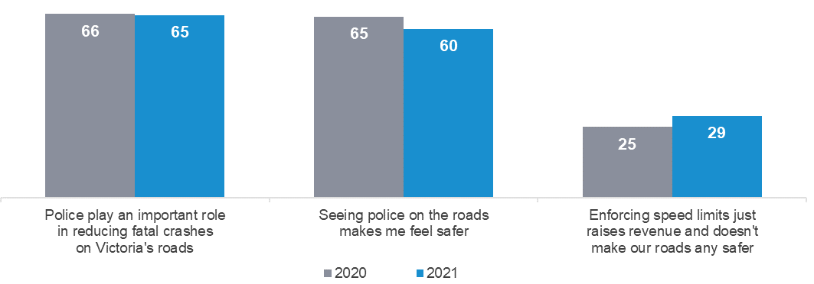
EN2 to what extent do you agree or disagree with the following statements…
Total sample; weighted data; 2020 base n=1192; 2021 base n=1373

Hand-held mobile phone use while driving
While use of a hand-held mobile phone while driving is slightly higher in 2021 (29%) compared to 2020 (28%), this behaviour exhibits a long-term downwards trend. As shown in Figure 5, reported use of a hand-held mobile phone while driving is at 29% in 2021. In 2016, 37% of drivers reported using a hand-held mobile phone while driving. Incremental declines year-on-year have led to lower incidence of this driving behaviour compared to five years ago.
Drivers still use mobile phones while driving but are less likely to use them hand-held. Considering ‘answering a call behaviour’ for example, they are more likely to answer a call via Bluetooth (63%) than by picking up their mobile phone (12%).
Figure 5 Use of a hand-held mobile phone while driving (2016 to 2021)
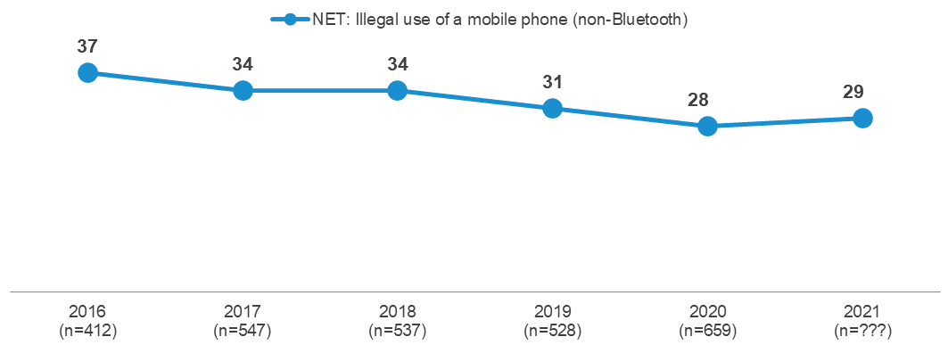
2021
(n=788)
DB2ABCD In the past three months, how often did you X (Any of Some / Half / Most / All the time)
NET: Read a text message while driving, answer a call with a hand-held phone while driving, write and send a text message while driving, make a call with a hand-held phone while driving, use a messaging app while driving.
Filter: Drivers; weighted sample

Impact of COVID-19 in 2021
The COVID-19 pandemic maintained its significant impact on how people travelled in Victoria over 2021. Four (4) separate lockdowns occurred in 2021 for varying lengths of time. The first of which occurred in February, from February 12th to February 17th in 2021 in Quarter 1, a total of 5 days. Another lockdown occurred between May 27th and June 10th in Quarter 2, a total of 14 days. In Quarter 3, another lockdown occurred, between July 15th to July 26th which totalled 12 days. A final lockdown occurred between Quarter 3 and Quarter 4, with a lockdown time of 78 days, between August 5th and October 21st.
This section examines travel and behaviour by quarter over 2021 to highlight any notable patterns which may be the result of COVID-19 lockdowns. Additionally, specific questions relating to the pandemic are reported.
The following summarises the approximate correlation between lockdowns and quarters over 2021:
- Quarter 1 (Jan-Mar): Snap lockdown for 5 days in February
- Quarter 2 (Apr-Jun): Snap lockdown for 14 days between late May and early June
- Quarter 3 (Jul-Sep): Snap lockdown for 12 days between mid and late July.
- Quarter 3/4 (Aug-Dec): Snap lockdown for a lengthy period of 78 days between Quarter 3 and 4.
It is important to bear in mind that for many questions in the RSM, respondents are asked to consider time periods such as the previous three months or the previous twelve months. As such, activities may encompass periods greater than that in which they are reported.

Travel patterns and COVID-19
This section includes news questions relating to the number of days commuting to work and an analysis of travel patterns over 2021.

Commuting since COVID-19
Respondents who are working were asked how many days per week they are currently travelling to work and own many days they normally travel to work. Just over half (51%) are travelling the same as they usually do, while less than half (47%) are travelling on fewer days and 3% are travelling on more days.
Considering the impact of lockdown on the number of commuting days, respondents were also asked whether they currently had restrictions on their travel due to COVID-19 lockdowns. The percentage travelling to work fewer days per week was 57% while currently under lockdown restrictions and 36% when there was no lockdown restriction. While under lockdown restrictions, 44% did not travel to work versus 24% when there were no restrictions.
Considering the change in commuting days by occupation, professionals and associate professionals were most likely to commute less (60%). Professions most likely to continue to commute the same number of days as usual include technicians and trade workers (92%), machinery operators and drivers (84%), and labourers and related workers (77%).

Travel mode and distance
Table 2 on the next page shows the weekly use of a range of transport modes by quarter over 2021. With regard to using these modes of transport at all in a given week, most remained stable throughout the year. The only significant difference observed is that driving a heavy vehicle decreased to 2% in Jul-Sep, while the first two quarters of 2021 remained stable at 5%.
Table 2 Weekly travel by mode by quarter in 2021

Column % | Q1 - Jan to  March | Q2 - April to  June | Q3 - July to September | Q4 - October to December
Drive a car | 93 | 93 | 92 | 92
Walk | 56 | 58 | 59 | 60
Travel in a car or on a motorbike as a passenger | 58 | 54 | 53 | 56
Take public transport | 15 | 18 | 16 | 16
Ride a bicycle (on the road) | 10 | 10 | 9 | 11
Take a taxi or similar (e.g. Uber) | 4 | 5 | 3 | 3
Drive a heavy vehicle | 5 | 5 | 2 ↓ | 3
Ride a motorcycle (on the road) | 3 | 2 | 3 | 3
Sample size | 710 | 712 | 722 | 662
M1A-D / M2A-D: How often do you (go somewhere by)…
Total sample; Weighted sample; base n= from 662 to 722
Blue up arrows (↑) and red down arrows (↓) indicate statistically significant difference compared to respondents not in that category.
Figures may not add to 100% due to rounding
Respondents were also asked how many kilometres they have driven in the previous year. In Oct-Dec 2021, driving declined steeply, with significantly fewer annual kilometres reported than in both Q1 and Q2 of 2021.
Findings from both Table 2 and Table 3 indicate that the same amount of people are driving cars, however, the distance they are travelling is far less than prior to COVID.
Table 3 Distance travelled by quarter in 2021

 | Q1 - Jan to  March | Q2 - April to  June | Q3 - July to September | Q4 - October to December
Average km driven | 11,512 ↑ | 11,714 ↑ | 11,010 | 8,610 ↓
Sample size | 705 | 705 | 717 | 643
D0: In the past year, how many kilometres have you driven?
Filter: Drivers; Weighted sample; base n=from 643 to 717
Blue up arrows (↑) and red down arrows (↓) indicate statistically significant difference compared to respondents not in that category.
Figures may not add to 100% due to rounding

Driving behaviours and COVID-19
There were differences observed in risky driving behaviour over 2021, shown in Table 4.
- Incidence of speeding overall has increased in 2021 relative to 2020 and 2019, with 55% admitting to intentionally speeding at either 60km/h or 100km/h. Speeding remained consistently higher in 2021 than 2020 and 2019 across all quarters, with quarter 2 (Q2) having the highest recorded incidence of speeding in the year.
- Incidence of mobile phone use remained consistent across 2021. This follows a similar trend of illegal mobile phone use being less common each year. While the pandemic may have had some impact on these results, this does follow a patterned decrease since 2016.
- Illegal drink driving remains at a similar rate of incidence in 2021, at 4% overall.
- Legal drink driving (driving under the legal limit) remains similarly low in incidence (43%), following a historic low in legal drink driving reported in 2020 (41%). It is reasonable to hypothesise with the lockdown restrictions in place, particularly in Q3/Q4 where the longest lockdown of the year occurred, legal drink driving incidence decreased beyond normal levels pre-COVID.
- Driving fatigued was substantially higher in 2021, with consistently high levels across the year. Given that 2020 did not experience this bump, this may be a wider trend occurring, but not related to COVID.
Table 4 Driving behaviours by year and by quarter in 2021

Column % | 2019 | 2020 | 2021 | Q1 – Jan -  Mar | Q2 – Apr -  Jun | Q3 - July -Sep | Q4 – Oct -Dec
Speeding | 49 | 50 | 55 ↑ | 53 | 59 | 56 | 53
Illegal mobile phone use | 31 | 28 ↓ | 29 ↓ | 28 | 29 | 30 | 27
Drink driving (illegal) | 5 | 5 | 4 | 5 | 4 | 5 | 4
Drink driving (legal) | 49 | 41 ↓ | 43 | 45 | - | 44 | 40
Driving fatigued | 37 | 38 | 45 ↑ | 44 | 48 | 46 | 42
Sample size | 1835 | 2505 | 2816 | 712 | 716 | 723 | 665
Derived behaviours (DB1/DB2/DK3/DK8)*Note: Drink driving (legal) was not asked in Q2 2021.
Total sample; Weighted sample;
Blue up arrows (↑) and red down arrows (↓) indicate statistically significant difference compared to respondents not in that category.
Figures may not add to 100% due to rounding

Detailed Findings

How people get around
Respondents were asked how frequently they get around by various means of transportation. The categories are how often they use various vehicles on the road and how often they use other means of transportation such as:
 |  |  |  | 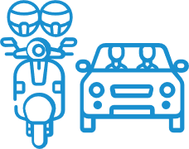
 | Public transport | Commercial  ride share | Walking | Passenger in a car or motorbike

Frequency of vehicle transportation compared to other transportation
As shown in Figure 6, the form of transportation used most often, by a large margin, is driving a car (used weekly by 93% of respondents), followed by walking (58%), travelling in a car or on a motorbike as a passenger (55%), or taking public transport (16%). Smaller percentages make at least weekly use of riding a bicycle (10%), catching a commercial ride share (taxi or similar) (4%), driving a heavy vehicle (4%), or riding a motorcycle on the road (3%).
Figure 6 How people get around
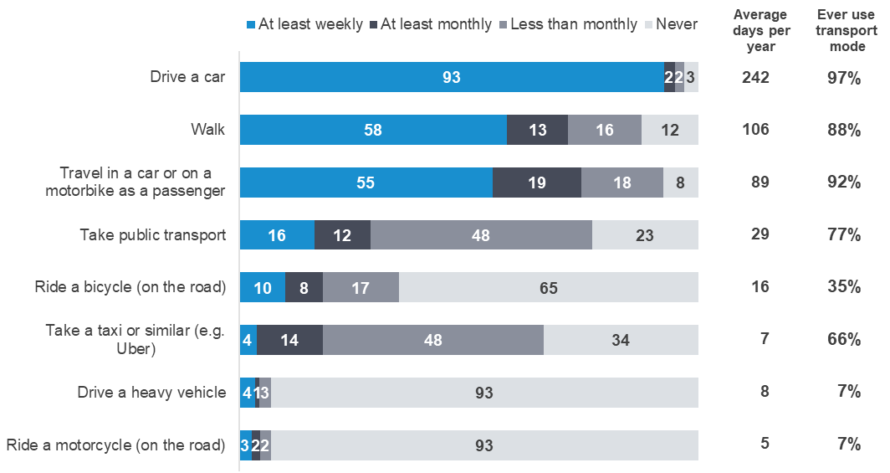
M1A-D / M2A-D: How often do you (go somewhere by)…
Total sample; Weighted sample; base n= from 2705 to 2805
Figures may not add to 100% due to rounding

Vehicle transportation
This section examines how usage of vehicle transportation (cars, motorcycles, heavy vehicles and bicycles) varies by demographic.

Driving a car
The vast majority of respondents (97%) ever drive a car, and 93% drive at least weekly. Table 5 shows the frequency of driving a car by gender and age.
Table 5 Frequency of driving a car – gender by age

Column % |  | Male |  |  |  | Female
Column % | Total | 18 - 25 | 26 - 39 | 40 - 60 | 61 - 90 | 18 - 25 | 26 - 39 | 40 - 60 | 61 - 90
At least weekly | 93 | 85 ↓ | 93 | 96 ↑ | 95 | 85 ↓ | 89 | 95 ↑ | 94
At least monthly | 2 | 5 | 3 | 2 | 2 | 5 | 2 | 2 | 1
Less than monthly | 2 | 7 ↑ | 2 | 1 | 1 ↓ | 2 | 3 | 1 | 1
NET: Ever drive a car | 97 | 97 | 98 | 99 ↑ | 97 | 93 ↓ | 94 ↓ | 99 | 96
Never drive a car | 3 | 3 | 2 | 1 ↓ | 3 | 7 ↑ | 6 ↑ | 1 | 4
Sample size | 2805 | 233 | 324 | 470 | 343 | 193 | 349 | 513 | 380
M2A - How often do you drive a car?
Total sample; Weighted sample; base n = 2805
Blue up arrows (↑) and red down arrows (↓) indicate statistically significant difference compared to respondents not in that category.
Figures may not add to 100% due to rounding
Those aged 18-25 are the least likely to drive at least weekly (85%) compared to older respondents aged between 40-90 (96% of males, 95% of females). Both males and females in this age group have lower frequency of weekly driving, as shown in Figure 7.
Figure 7 Proportion of 18-25 age group who drive weekly by gender
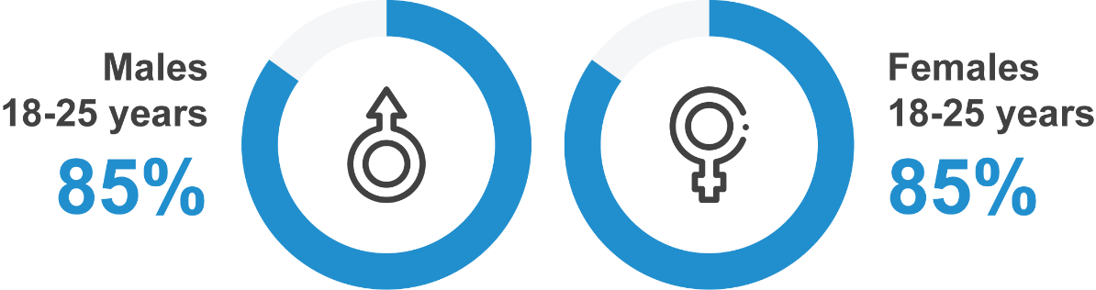
M2A - How often do you drive a car?
Total sample; Weighted sample; Males 18-25 base n = 233; Females 18-25 base n = 193

Riding a motorcycle on the road
In 2021, just under one in ten respondents (7%) ever ride a motorcycle on the road. The majority of active motorcyclists are male (11% of males vs 3% of females), and riding a motorcycle is most common among those aged 40 to 60 (9%). The frequency of motorcycle riding is also higher in Rural Balance areas (12%) than in Major Urban areas (6%).
Table 6 Frequency of riding a motorcycle on the road by demographic

Column % |  | Age |  |  |  | Gender |  | Location
Column % | Total | 18 - 25 | 26 - 39 | 40 - 60 | 61 - 90 | Male | Female | Major Urban | Other Urban | Rural Balance
At least weekly | 3 | 2 | 3 | 3 | 2 | 4 ↑ | 1 ↓ | 3 | 2 | 4
At least monthly | 2 | 1 | 2 | 3 | 2 | 3 ↑ | 0 ↓ | 2 | 2 | 2
Less than monthly | 2 | 2 | 2 | 3 | 2 | 4 ↑ | 1 ↓ | 2 ↓ | 3 | 6 ↑
NET: Ever ride a motorcycle | 7 | 5 | 7 | 9 | 6 | 11 ↑ | 3 ↓ | 6 ↓ | 8 | 12 ↑
Never | 93 | 95 | 93 | 91 | 94 | 89 ↓ | 97 ↑ | 94 ↑ | 92 | 88 ↓
Sample size | 2707 | 424 | 666 | 965 | 652 | 1323 | 1384 | 1341 | 918 | 448
M2B - How often, if ever, do you ride a motorcycle on the road?
Total sample; Weighted sample; base n=2707
Blue up arrows (↑) and red down arrows (↓) indicate statistically significant difference compared to respondents not in that category.
Figures may not add to 100% due to rounding

Riding a bicycle on the road
Over one in three respondents (35%) said they ever ride a bicycle on the road. One in ten (10%) ride once a week or more, and they are more likely to be males (14% vs 6% of females).
Those who ever ride a bicycle on the road are more likely to be male (45% of males vs 25% of females), aged 40 to 60 years old (43% vs 35% overall). Additionally, respondents aged 40 to 60 are also more likely to ride a bicycle on the road for all frequencies of riding.
Table 7 Frequency of riding a bicycle on the road by demographic

Column % |  | Age |  |  |  | Gender |  | Location
Column % | Total | 18 - 25 | 26 - 39 | 40 - 60 | 61 - 90 | Male | Female | Major Urban | Other Urban | Rural Balance
At least weekly | 10 | 7 ↓ | 12 ↑ | 12 ↑ | 6 ↓ | 14 ↑ | 6 ↓ | 10 | 10 | 10
At least monthly | 8 | 6 | 8 | 10 ↑ | 5 ↓ | 11 ↑ | 6 ↓ | 8 | 8 | 7
Less than monthly | 17 | 21 ↑ | 16 | 20 ↑ | 9 ↓ | 20 ↑ | 14 ↓ | 17 | 16 | 16
NET: Ever ride a bicycle | 35 | 34 | 37 | 43 ↑ | 20 ↓ | 45 ↑ | 25 ↓ | 35 | 34 | 33
Never | 65 | 66 | 63 | 57 ↓ | 80 ↑ | 55 ↓ | 75 ↑ | 65 | 66 | 67
Sample size | 2705 | 424 | 667 | 964 | 650 | 1322 | 1383 | 1339 | 917 | 449
M2D - How often, if ever, do you ride a bicycle on the road?
Total sample; Weighted sample, base n=2705
Blue up arrows (↑) and red down arrows (↓) indicate statistically significant difference compared to respondents not in that category.
Figures may not add to 100% due to rounding.

Driving a heavy vehicle on the road
About one in fourteen respondents (7%) say they ever drive a heavy vehicle on the road. Nearly half of these respondents (4% of all respondents) drive a heavy vehicle at least weekly.
Those who ever drive heavy vehicles on the road are more likely to be male (13% of males vs 2% of females) and to live in Rural Balance areas (17%) or Other Urban areas (14%).
Those who drive heavy vehicles on the road at least weekly are also more likely to be aged 40-60 (5%) and to be male (7% of males vs 1% of females). Respondents living in Major Urban areas are less likely to drive heavy vehicles at least weekly (3%) than respondents in Other Urban (6%) or Rural Balance (8%) areas.
Table 8 Frequency of driving a heavy vehicle on the road by demographic

Column % |  | Age |  |  |  | Gender |  | Location
Column % | Total | 18 - 25 | 26 - 39 | 40 - 60 | 61 - 90 | Male | Female | Major Urban | Other Urban | Rural Balance
At least weekly | 4 | 2 | 4 | 5 ↑ | 2 | 7 ↑ | 1 ↓ | 3 ↓ | 6 ↑ | 8 ↑
At least monthly | 1 | 1 | 0 ↓ | 1 | 1 | 2 ↑ | 0 ↓ | 1 ↓ | 1 | 3 ↑
Less than monthly | 3 | 1 | 2 | 3 | 3 | 4 ↑ | 1 ↓ | 1 ↓ | 6 ↑ | 6 ↑
NET: Ever drive a heavy vehicle | 7 | 4 ↓ | 6 | 9 ↑ | 7 | 13 ↑ | 2 ↓ | 4 ↓ | 14 ↑ | 17 ↑
Never | 93 | 96 ↑ | 94 | 91 ↓ | 93 | 87 ↓ | 98 ↑ | 96 ↑ | 86 ↓ | 83 ↓
Sample size | 2707 | 424 | 664 | 963 | 656 | 1325 | 1382 | 1339 | 919 | 449
M2D - How often, if ever, do you drive a heavy vehicle on the road?
Total sample; Weighted sample; base n=2707
Blue up arrows (↑) and red down arrows (↓) indicate statistically significant difference compared to respondents not in that category.
Figures may not add to 100% due to rounding.

Other transportation
In this section we describe to what extent respondents use other types of transportation such as public transport, taxis, walking, or travelling as a passenger in a car or on a motorcycle.

Public transport
As shown in Table 9 below, the majority of respondents (77%) use public transport. About one in five (16%) use public transport weekly. Usage declines with age, both in terms of using public transport at all and frequency of use. Respondents aged 18-25 (88%) are more likely to ever use public transport, with over a third (31%) using it at least weekly. In contrast, those aged 61-90 years (67%) are less likely to take public transport and less than one in ten (9%) of this age group using it at least weekly.
Public transport usage is also more common in Major Urban areas (82%) than in the rest of Victoria (65% in Other Urban areas and 59% in Rural Balance areas). Also, more respondents in Major Urban areas (20%) use public transport at least weekly than respondents in Other Urban areas (5%) and Rural Balance areas (5%).
Table 9 Frequency of going somewhere by public transport by demographic

Column % |  | Age |  |  |  | Gender |  | Location
Column % | Total | 18 - 25 | 26 - 39 | 40 - 60 | 61 - 90 | Male | Female | Major Urban | Other Urban | Rural Balance
At least weekly | 16 | 31 ↑ | 21 ↑ | 13 ↓ | 8 ↓ | 18 | 15 | 20 ↑ | 5 ↓ | 5 ↓
At least monthly | 12 | 21 ↑ | 12 | 11 | 10 | 15 ↑ | 10 ↓ | 14 ↑ | 7 ↓ | 5 ↓
Less than monthly | 48 | 36 ↓ | 48 | 53 ↑ | 48 | 45 ↓ | 51 ↑ | 47 ↓ | 53 ↑ | 49
NET: Ever take public transport | 77 | 88 ↑ | 80 ↑ | 76 | 67 ↓ | 78 | 76 | 82 ↑ | 65 ↓ | 59 ↓
Never | 23 | 12 ↓ | 20 ↓ | 24 | 33 ↑ | 22 | 24 | 18 ↓ | 35 ↑ | 41 ↑
Sample size | 2742 | 424 | 667 | 967 | 684 | 1342 | 1400 | 1355 | 932 | 455
M1A - Thinking about ways you get around, apart from driving or riding yourself, how often do you go somewhere by taking public transport?
Total sample; Weighted sample; base n=2742
Blue up arrows (↑) and red down arrows (↓) indicate statistically significant difference compared to respondents not in that category.
Figures may not add to 100% due to rounding.

Commercial ride share
As shown in Table 10 below, in 2021 two-thirds of respondents (66%) indicate they use taxis or other commercial ride share. Respondents in Major Urban areas (71%) are more likely to use this type of transport than respondents in Other Urban (54%) or Rural Balance (48%) areas. Further, males (70%) are more likely to use a commercial ride share than females (63%).
However, only one in twenty (4%) take a taxi or similar at least weekly. Younger people aged 18-25 (28%) and 26-39 (19%) are more likely to take taxis or similar at least monthly, as are those living in Major Urban areas (17%).
Table 10 Frequency of taking a commercial ride share by demographic

Column % |  | Age |  |  |  | Gender |  | Location
Column % | Total | 18 - 25 | 26 - 39 | 40 - 60 | 61 - 90 | Male | Female | Major Urban | Other Urban | Rural Balance
At least weekly | 4 | 9 ↑ | 6 ↑ | 2 ↓ | 2 ↓ | 5 | 3 | 5 ↑ | 1 ↓ | 1 ↓
At least monthly | 14 | 28 ↑ | 19 ↑ | 13 | 4 ↓ | 16 ↑ | 12 ↓ | 17 ↑ | 7 ↓ | 5 ↓
Less than monthly | 48 | 42 ↓ | 52 ↑ | 54 ↑ | 39 ↓ | 49 | 47 | 49 ↑ | 46 | 42 ↓
NET: Ever use rideshare | 66 | 79 ↑ | 76 ↑ | 68 | 45 ↓ | 70 ↑ | 63 ↓ | 71 ↑ | 54 ↓ | 48 ↓
Never | 34 | 21 ↓ | 24 ↓ | 32 | 55 ↑ | 30 ↓ | 37 ↑ | 29 ↓ | 46 ↑ | 52 ↑
Sample size | 2723 | 425 | 666 | 964 | 668 | 1328 | 1395 | 1348 | 928 | 447
M1B - How often do you go somewhere by taking a taxi or similar (e.g. Uber)?
Total sample; Weighted sample; base n=2723
Blue up arrows (↑) and red down arrows (↓) indicate statistically significant difference compared to respondents not in that category.
Figures may not add to 100% due to rounding.

Walking
Nearly all respondents go somewhere by walking (88%), and over half (58%) do so at least weekly. Those living in Rural Balance areas (77%) are less likely to ever go somewhere by walking than those based in Major Urban areas (90%). Respondents in Major Urban areas (61%) are more likely than respondents in Other Urban (54%) or Rural Balance (46%) areas to go somewhere by walking at least weekly.
Respondents aged 26-39 and 40-60 (90%) are more likely to ever go somewhere by walking than people aged 61-90 (81%). Respondents aged 18-25 are least likely to walk somewhere at least weekly.
Table 11 Frequency of walking by demographic

Column % |  | Age |  |  |  | Gender |  | Location
Column % | Total | 18 - 25 | 26 - 39 | 40 - 60 | 61 - 90 | Male | Female | Major Urban | Other Urban | Rural Balance
At least weekly | 58 | 51 ↓ | 63 ↑ | 60 | 55 | 58 | 59 | 61 ↑ | 54 ↓ | 46 ↓
At least monthly | 13 | 18 ↑ | 13 | 13 | 11 | 13 | 13 | 13 | 15 | 12
Less than monthly | 16 | 19 | 14 | 17 | 15 | 16 | 16 | 16 | 16 | 18
NET: Ever go somewhere by walking | 88 | 89 | 90 ↑ | 90 ↑ | 81 ↓ | 87 | 88 | 90 ↑ | 85 ↓ | 77 ↓
Never | 12 | 11 | 10 ↓ | 10 ↓ | 19 ↑ | 13 | 12 | 10 ↓ | 15 ↑ | 23 ↑
Sample size | 2739 | 425 | 669 | 970 | 675 | 1336 | 1403 | 1352 | 935 | 452
M1C - How often do you go somewhere by walking?
Total sample; Weighted sample; base n=2739
Blue up arrows (↑) and red down arrows (↓) indicate statistically significant difference compared to respondents not in that category.
Figures may not add to 100% due to rounding.

Travelling in a car or motorcycle as a passenger
As shown in Table 12, the large majority of respondents (92%) said they ever travel in a car or motorcycle as a passenger, and over half (55%) do so at least weekly.
Respondents aged 18-25 and 26-39 (61%) are more likely than respondents aged 60-90 (50%) to travel as a passenger at least weekly. Females (63%) are also more likely than males (47%) to travel as a passenger at least weekly.
Table 12 Frequency of travelling in a car or on a motorbike as a passenger by demographic

Column % |  | Age |  |  |  | Gender |  | Location
Column % | Total | 18 - 25 | 26 - 39 | 40 - 60 | 61 - 90 | Male | Female | Major Urban | Other Urban | Rural Balance
At least weekly | 55 | 61 ↑ | 60 ↑ | 53 | 50 ↓ | 47 ↓ | 63 ↑ | 54 | 59 | 55
At least monthly | 19 | 23 | 18 | 20 | 18 | 21 | 18 | 20 | 19 | 17
Less than monthly | 18 | 10 ↓ | 15 | 20 | 23 ↑ | 23 ↑ | 13 ↓ | 18 | 16 | 20
NET: Ever | 92 | 95 | 93 | 92 | 90 | 90 ↓ | 94 ↑ | 92 | 93 | 93
Never | 8 | 5 | 7 | 8 | 10 | 10 ↑ | 6 ↓ | 8 | 7 | 7
Sample size | 2783 | 426 | 671 | 981 | 705 | 1358 | 1425 | 1367 | 951 | 465
M1D - How often do you travel in a car or on a motorbike as a passenger?
Total sample; Weighted sample; n=2783
Blue up arrows (↑) and red down arrows (↓) indicate statistically significant difference compared to respondents not in that category / Figures may not add to 100% due to rounding.

Travelling via e-device
As shown in Table 13, one in twenty respondents (5%) ever drive an e-device.
There are no significant differences in likelihood to ever use an e-device by demographic.
Table 13 Frequency of travelling on an e-device by demographic
Column % |  | Age |  |  |  | Gender |  | Location
Column % | Total | 18 - 25 | 26 - 39 | 40 - 60 | 61 - 90 | Male | Female | Major Urban | Other Urban | Rural Balance
At least weekly | 2 | 1 | 2 | 2 | 2 | 2 | 2 | 2 | 2 | 2
At least monthly | 1 | 2 | 1 | 1 | 1 | 1 | 1 | 1 | 1 | 1
Less than monthly | 2 | 3 | 2 | 2 | 1 ↓ | 2 | 2 | 2 | 1 | 1
NET: Ever | 5 | 6 | 4 | 5 | 3 | 5 | 4 | 5 | 4 | 4
Never | 95 | 94 | 96 | 95 | 97 | 95 | 96 | 95 | 96 | 96
Sample size | 2693 | 424 | 662 | 962 | 645 | 1316 | 1377 | 1336 | 913 | 444
M2E - How often, if ever, do you ride an e-bike, e-scooter or e-skateboard?
Total sample; Weighted sample; n=2693
Blue up arrows (↑) and red down arrows (↓) indicate statistically significant difference compared to respondents not in that category / Figures may not add to 100% due to rounding.

As shown in Table 14, indicatively (due to small sample sizes), a number of demographic differences exist with regard to where people ride their e-devices. Those aged 26-39 are more likely to drive their e-device only on a footpath, while those aged 40-60 are more likely to ride on both the footpath and the road (67%). Females (37%) are more likely than males (17%) to ride on the footpath.

Table 14 Where people usually ride their e-devices by demographic

Column % |  | Age |  |  |  | Gender |  | Location
Column % | Total | 18 - 25 | 26 - 39 | 40 - 60 | 61 - 90 | Male | Female | Major Urban | Other Urban | Rural Balance
On the footpath | 26 | 29 | 48 ↑ | 12 ↓ | 24 | 17 ↓ | 37 ↑ | 26 | 28 | 21
On the road | 21 | 19 | 18 | 21 | 29 | 28 | 13 | 18 | 23 | 48 ↑
Both | 49 | 37 | 29 | 67 ↑ | 47 | 51 | 47 | 51 | 49 | 26
Don’t know | 4 | 14 | 5 | 0 | 0 | 4 | 4 | 4 | 0 | 5
Sample size | 117 | 21* | 27* | 45 | 24* | 70 | 47 | 63 | 35 | 19*
M4 - Where do you usually ride an e-bike, e-scooter or e-skateboard?
Rides an e-device; Weighted; n=117
Blue up arrows (↑) and red down arrows (↓) indicate statistically significant difference compared to respondents not in that category / Figures may not add to 100% due to rounding.
*Interpret with caution, small sample size
As shown in Table 18, indicatively (due to small sample sizes), there are few demographic differences with regard to when people started riding their e-device. Males (61%) are more likely than females (36%) to have started riding their e-device more than a year ago.
Table 15 When people started riding their e-device by demographic

Column % |  | Age |  |  |  | Gender |  | Location
Column % | Total | 18 - 25 | 26 - 39 | 40 - 60 | 61 - 90 | Male | Female | Major Urban | Other Urban | Rural Balance
In the last 6 months | 28 | 40 | 31 | 20 | 32 | 21 | 37 | 28 | 36 | 15
Between 6 months to a year ago | 18 | 18 | 20 | 15 | 20 | 16 | 20 | 16 | 25 | 21
More than a year ago | 50 | 36 | 42 | 62 | 48 | 61 ↑ | 36 ↓ | 51 | 40 | 59
Don’t know | 4 | 6 | 7 | 3 | 0 | 2 | 7 | 5 | 0 | 6
Sample size | 117 | 21* | 27* | 45 | 25* | 70 | 48 | 63 | 36 | 19*
M5 - When did you start riding the e-bike, e-scooter or e-skateboard?
Rides an e-device; Weighted; n=118
Blue up arrows (↑) and red down arrows (↓) indicate statistically significant difference compared to respondents not in that category / Figures may not add to 100% due to rounding.
*Interpret with caution, small sample size

Driving behaviour
This section examines the general driving behaviour of respondents, including frequency of commuting, night-time driving and feeling stressed while driving.

Commuting to and from work in a car
As shown in Table 16, about three-quarter respondents who are currently working commute to and from work in a car at least weekly (77%), while about nine in ten (88%) ever commute.
Commuting by car is most common among those living in Other Urban areas (94%). Those respondents are also more likely to commute to and from work by car at least weekly (87%) than respondents living in Major Urban areas (74%).
Table 16 Frequency of commuting to and from work in a car by demographic

Column % |  | Age |  |  |  | Gender |  | Location
Column % | Total | 18 - 25 | 26 - 39 | 40 - 60 | 61 - 90 | Male | Female | Major Urban | Other Urban | Rural Balance
Less than monthly | 6 | 5 | 7 | 6 | 4 | 6 | 6 | 7 ↑ | 3 ↓ | 2 ↓
At least monthly | 5 | 5 | 5 | 4 | 4 | 4 | 5 | 5 | 4 | 3
At least weekly | 77 | 83 | 74 | 77 | 78 | 77 | 77 | 74 ↓ | 87 ↑ | 85 ↑
NET: Ever commute to and from work in a car | 88 | 93 | 87 | 88 | 86 | 88 | 88 | 86 ↓ | 94 ↑ | 90
Never commute to and from work in a car | 12 | 7 | 13 | 12 | 14 | 12 | 12 | 14 ↑ | 6 ↓ | 10
Sample size | 1878 | 292 | 570 | 817 | 199 | 964 | 914 | 935 | 622 | 321
M3 Thinking about your driving, how often do you commute to and from work in a car?
Filter: Driver, currently working; Weighted sample; base=1878
Blue up arrows (↑) and red down arrows (↓) indicate statistically significant difference compared to respondents not in that category. Figures may not add to 100% due to rounding.

Driving between 10pm and 6am

As shown in Table 17, about three quarter of respondents (77%) said they ever drive at night between 10pm and 6am, with nearly a quarter (24%) doing so at least weekly. Respondents aged between 61-90 are less likely to drive at night (60%) compared to respondents aged under 60 (82%).
Other analysis shows that respondents who are more likely to drive between 10pm and 6am at least weekly include:
- Those aged 18-25 (42% vs 13% aged 61-90)
- Respondents who have driven fatigued (33% vs 18% of those who have not driven fatigued)
- Respondents who have driven over the speed limit (29% vs 19% of those who have not driven over the speed limit)
- Respondents who used a mobile phone illegally while driving (31% vs 22% who have not used a mobile phone illegally while driving)
- Respondents who have been involved in a crash (32% vs 23% among those who have not been involved in a crash)
Table 17 Frequency of driving between 10pm and 6am by demographic

Column % |  | Age |  |  |  | Gender |  | Location
Column % | Total | 18 - 25 | 26 - 39 | 40 - 60 | 61 - 90 | Male | Female | Major Urban | Other Urban | Rural Balance
Less than monthly | 37 | 19 ↓ | 37 | 45 ↑ | 37 | 34 ↓ | 41 ↑ | 37 | 37 | 40
At least monthly | 15 | 22 ↑ | 14 | 16 | 10 ↓ | 16 | 14 | 14 | 16 | 17
At least weekly | 24 | 42 ↑ | 30 ↑ | 21 ↓ | 13 ↓ | 31 ↑ | 18 ↓ | 25 | 24 | 23
NET: Ever drive between 10pm and 6am | 77 | 83 ↑ | 82 ↑ | 81 ↑ | 60 ↓ | 81 ↑ | 73 ↓ | 76 | 77 | 80
Never drive between 10pm and 6am | 23 | 17 ↓ | 18 ↓ | 19 ↓ | 40 ↑ | 19 ↓ | 27 ↑ | 24 | 23 | 20
Sample size | 1670 | 251 | 390 | 618 | 411 | 835 | 835 | 800 | 581 | 289
M3 How often do you drive between the hours of 10pm and 6am?
Filter: Driver; Weighted sample; base n=1670
Blue up arrows (↑) and red down arrows (↓) indicate statistically significant difference compared to respondents not in that category
Figures may not add to 100% due to rounding.

How often people feel stressed while driving
As shown in Table 18, most respondents (69%) said they have ever felt stressed when driving, with a third (27%) driving while feeling stressed at least weekly. Respondents aged between 18-60 (75%) are more likely to feel stressed when driving compared to those aged 61-90 (49%). More females (74%) than males (64%) have felt stressed when driving. Respondents living in Major Urban areas (70%) are more likely to feel stressed when driving than those living in Rural Balance areas (61%).
Table 18 Frequency of driving while feeling stressed by demographic

Column % |  | Age |  |  |  | Gender |  | Location
Column % | Total | 18 - 25 | 26 - 39 | 40 - 60 | 61 - 90 | Male | Female | Major Urban | Other Urban | Rural Balance
At least weekly | 27 | 33 | 32 | 30 | 14 ↓ | 25 | 29 | 28 | 26 | 24
At least monthly | 14 | 18 | 17 | 15 | 9 | 14 | 15 | 15 | 12 | 11
Less than monthly | 27 | 24 | 28 | 28 | 25 | 24 ↓ | 30 ↑ | 27 | 28 | 25
NET: Ever feel stressed when driving | 69 | 75 ↑ | 77 ↑ | 73 ↑ | 49 ↓ | 64 ↓ | 74 ↑ | 70 ↑ | 66 | 61 ↓
Never feel stressed when driving | 31 | 25 ↓ | 23 ↓ | 27 ↓ | 51 ↑ | 36 ↑ | 26 ↓ | 30 ↓ | 34 | 39 ↑
Sample size | 1338 | 211 | 316 | 487 | 324 | 679 | 659 | 646 | 461 | 231
M3 – How often do you feel stressed when you are driving?
Filter: Driver; Weighted sample; base=1338
Blue up arrows (↑) and red down arrows (↓) indicate statistically significant difference compared to respondents not in that category.
Figures may not add to 100% due to rounding.
As shown in Table 19, drivers aged 18-60 who speed (78%) or drive while fatigued (81%) are more likely to report that they ever feel stressed while driving (75% of all drivers aged 18-60). Other analysis shows that respondents who drove while fatigued (81%) are more likely to say that they feel stressed while driving than respondents who did not drive while fatigued (69%). Further, driving while feeling stressed at least weekly is more common among those who drove while fatigued (40%) than those who have not driven while fatigued (23%).
Table 19 Frequency of driving while feeling stressed by behaviour (18-60 years) by behaviour

Column % |  | Speeding |  | Drink driving |  | Mobile phone use |  | Driving fatigued |  | Involvement in a crash
Column % | Total | Yes | No | Yes | No | Yes | No | Yes | No | Yes | No
At least weekly | 31 | 31 | 32 | 33 | 31 | 32 | 31 | 40 ↑ | 23 ↓ | 37 | 30
At least monthly | 16 | 16 | 16 | 22 | 16 | 17 | 16 | 17 | 15 | 17 | 16
Less than monthly | 28 | 31 ↑ | 22 ↓ | 22 | 28 | 31 | 26 | 24 ↓ | 31 ↑ | 21 | 29
NET: Ever feel stressed when driving | 75 | 78 ↑ | 70 ↓ | 77 | 75 | 80 ↑ | 72 ↓ | 81 ↑ | 69 ↓ | 75 | 75
Never feel stressed when driving | 25 | 22 ↓ | 30 ↑ | 23 | 25 | 20 ↓ | 28 ↑ | 19 ↓ | 31 ↑ | 25 | 25
Sample size | 1014 | 603 | 382 | 56 | 958 | 358 | 656 | 549 | 448 | 167 | 843
M3 – How often do you feel stressed when you are driving?
Filter: Driver aged 18-60; Weighted sample; base=1014
Blue up arrows (↑) and red down arrows (↓) indicate statistically significant difference compared to respondents not in that category
Figures may not add to 100% due to rounding.
Respondents who ever drive while feeling stressed were asked how often they feel stressed due to driving conditions, personal thoughts and work-related thoughts. Overall, 39% of drivers feel stressed while driving at least once a week for one of these reasons. The primary cause of stress was driving conditions (31% experience this weekly). A smaller percentage reported feeling stressed at least once a week by work related thoughts (20%) or personal thoughts (15%). Drivers aged 40-60 years old were most likely to report feeling stressed at least once a week for any of these reasons (45%) and those aged 61 years and older were least likely (28%).

Vehicle ownership
The following section discusses vehicle purchasing behaviour and the types of vehicles respondents drive.

Car purchasing
As is shown in Table 20, one in five respondents (20%) who drive a car or ride a motorcycle bought a car in the last 12 months, with new car purchases (8%) being less likely than used car purchases (12%). More males (22%) than females (17%) have purchased a car. Further, respondents living in Rural Balance areas (24%) are more likely to have purchased a car in the last 12 months than respondents in Major Urban areas (18%).
There is a consistent decline in the percentage of respondents who bought a car by age, decreasing from 25% among those aged 18-25 to 13% among those aged 61-90. This decline also occurs for the purchase of a used car (20% for those aged 18-25, declining to 5% among those aged 61-90). However, those aged 18-25 were the least likely to have purchased a new car (5%).
Table 20 Bought a car in the last 12 months by demographic

Column % |  | Age |  |  |  | Gender |  | Location
Column % | Total | 18 - 25 | 26 - 39 | 40 - 60 | 61 - 90 | Male | Female | Major Urban | Other Urban | Rural Balance
Yes, a new car | 8 | 5 | 9 | 9 | 7 | 9 | 7 | 7 | 9 | 10
Yes, a used car | 12 | 20 ↑ | 14 ↑ | 11 | 5 ↓ | 13 | 10 | 11 | 13 | 14
NET: Purchased a car | 20 | 25 ↑ | 23 ↑ | 19 | 13 ↓ | 22 ↑ | 17 ↓ | 18 ↓ | 22 | 24 ↑
No, I haven't bought a car in the past 12 months | 80 | 75 ↓ | 77 ↓ | 81 | 87 ↑ | 78 ↓ | 83 ↑ | 82 ↑ | 78 | 76 ↓
Sample size | 2710 | 406 | 648 | 970 | 686 | 1336 | 1374 | 1314 | 934 | 462
VH4 - In the last 12 months, have you bought a car, either new or used?
Filter: Driver or motorcycle rider; Weighted sample; base=2710
Blue up arrows (↑) and red down arrows (↓) indicate statistically significant difference compared to respondents not in that category.
Figures may not add to 100% due to rounding.

As shown in the Table 21, when buying a car, respondents aged over 60 are more likely than other age groups to be interested in vehicle safety features (74%) and in reliability/low maintenance cost (69%), and less concerned about the look and design of the car (16%) and in-car systems (6%). In contrast, young respondents aged between 18-25 years old (37%) perceived in-car systems (navigation, entertainment, Bluetooth) to be of higher importance.
Males (22%) are more likely to be interested in power and performance of the car than females (11%).
Table 21 Most important things when buying a car by demographic

Column % |  | Age |  |  |  | Gender |  | Location
Column % | Total | 18 - 25 | 26 - 39 | 40 - 60 | 61 - 90 | Male | Female | Major Urban | Other Urban | Rural Balance
Vehicle Safety features | 70 | 66 | 66 | 72 | 74 | 66 | 74 | 71 | 68 | 71
Fuel economy | 54 | 53 | 58 | 47 | 62 | 54 | 54 | 54 | 53 | 62
Reliability/low maintenance costs | 56 | 42 | 52 | 56 | 69 ↑ | 61 | 52 | 57 | 53 | 58
The look and design of the car | 33 | 37 | 37 | 40 | 16 ↓ | 34 | 32 | 34 | 30 | 36
Passenger and/or cargo space | 29 | 24 | 26 | 32 | 31 | 25 | 33 | 27 | 40 ↑ | 23
Reputation of brand | 24 | 16 | 20 | 30 | 26 | 23 | 26 | 24 | 25 | 23
In-car system (navigation, entertainment, Bluetooth) | 16 | 37 ↑ | 19 | 12 | 6 ↓ | 14 | 17 | 17 | 15 | 10
Power and performance | 17 | 25 | 22 | 11 | 15 | 22 ↑ | 11 ↓ | 17 | 17 | 18
Sample size | 336 | 50 | 84 | 110 | 92 | 160 | 176 | 151 | 127 | 58
VH7 - Three most important things to you when deciding which car to buy?
Filter: Driver; Weighted sample; base=336
Blue up arrows (↑) and red down arrows (↓) indicate statistically significant difference compared to respondents not in that category.
Figures may not add to 100% due to rounding.

Type of vehicle usually driven
As shown in Table 22, about two-thirds of respondents (59%) who drive a vehicle or ride a motorcycle usually drive a car, while 32% drive a SUV/4WD and 6% drive a ute or similar.
Table 22 Type of vehicle usually driven by demographic

Column % |  | Age |  |  |  | Gender |  | Location
Column % | Total | 18 - 25 | 26 - 39 | 40 - 60 | 61 - 90 | Male | Female | Major Urban | Other Urban | Rural Balance
Car / Station wagon | 59 | 78 ↑ | 60 | 50 ↓ | 59 | 55 ↓ | 63 ↑ | 63 ↑ | 51 ↓ | 43 ↓
SUV / 4WD | 32 | 14 ↓ | 31 | 38 ↑ | 33 | 28 ↓ | 35 ↑ | 30 ↓ | 35 | 39 ↑
Ute / Utility / Pickup | 6 | 5 | 5 | 8 ↑ | 5 | 11 ↑ | 2 ↓ | 4 ↓ | 10 ↑ | 14 ↑
Truck | 1 | 1 | 1 | 1 | 0 | 2 ↑ | 0 ↓ | 1 | 1 | 1
Motorcycle | 0 | 0 | 1 | 0 | 1 | 1 ↑ | 0 ↓ | 0 | 0 | 1
Commercial van | 1 | 1 | 1 | 1 | 1 | 2 ↑ | 0 ↓ | 1 | 2 | 1
Bus | 0 | 0 | 0 | 0 | 0 | 0 ↑ | 0 ↓ | 0 | 0 | 0
Other | 1 | 0 | 1 | 1 | 1 | 1 ↑ | 0 ↓ | 1 | 1 | 2
Sample size | 2654 | 402 | 640 | 950 | 662 | 1298 | 1356 | 1298 | 908 | 448
VH1 - What type of vehicle do you usually drive?
Filter: Driver; Weighted sample; base=2654
Blue up arrows (↑) and red down arrows (↓) indicate statistically significant difference compared to respondents not in that category.
Figures may not add to 100% due to rounding.

In addition, as shown in Figure 8:
- Drivers aged 18-25 are more likely to drive ‘cars’ (78% vs 50% among drivers aged 40-60)
- Drivers aged 40-60 are more likely to drive SUVs (38% vs 14% among drivers aged 18-25 years)
- Utes are almost exclusively driven by males (11% vs 2% of females) and are more likely to be driven in Rural Balance areas (14%) than in Major Urban areas (4%).
Furthermore (and not shown in the below figure):
- Females (63%) are more likely to drive cars (63% vs 55% for males) and SUV (35% vs 28% for males).
- Cars are mostly driven in Major Urban areas (63%) than Rural Balance areas (43%), and SUVs are more often driven in Rural Balance areas (39%) than Major Urban areas (30%).
Figure 8 Type of vehicle usually driven infographic
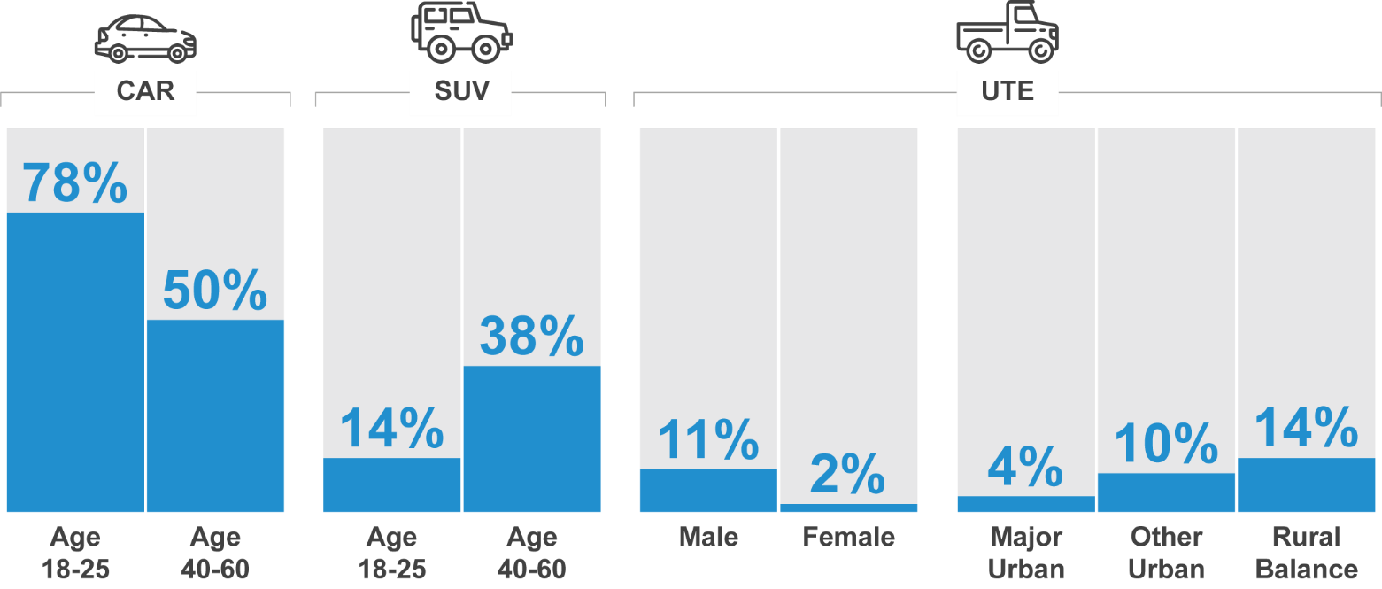
VH1 - What type of vehicle do you usually drive?
Filter: Driver; Weighted sample; base=2654
Blue up arrows (↑) and red down arrows (↓) indicate statistically significant difference compared to respondents not in that category.
Figures may not add to 100% due to rounding.

Road user attitudes and behaviours
The following section details respondents’ attitudes towards driving and road safety and their behaviour.

Perceived level of danger in road-user behaviours
Respondents were asked to consider a range of road-user behaviours and to rate how dangerous they thought each was on a scale of 0 “not at all dangerous” to 10 “extremely dangerous”. A similar set of statements regarding perceptions of danger were asked in previous surveys. In Table 23, results are shown for the years 2016 to 2021 for all statements that were asked in 2021. Numbers in the table and the following text are mean ratings derived from the eleven-point scale from 0 to 10.
The behaviours described by these statements include driving while impaired by alcohol, driving while very tired, driving while using a mobile phone, speeding, and cycling.
Three behaviours continue to be perceived by respondents to be of very high risk:
- Driving with an illegal B.A.C. (9.6)
- Driving while using a handheld mobile phone (9.2)
- Driving while very tired (8.9)
Riding bicycles, speeding behaviours and driving after drinking one alcoholic drink continue to be rated by respondents as the least dangerous of the behaviours they were asked to rate. However, low-level speeding (5.7 for above 60km/h, 6.0 for above 100km/h) and cycling on country roads (5.8) were perceived to be less dangerous compared to previous years combined.
Table 23 Perceptions of danger

Average | 2016 | 2017 | 2018 | 2019 | 2020 | 2021
Drive with an illegal Blood Alcohol Content (BAC) level | 9.5 | 9.5 | 9.5 | 9.5 | 9.6 ↑ | 9.6
Drive while using a handheld mobile phone | 9.1 | 9.0 | 9.1 | 9.1 | 9.2 | 9.2
Drive while very drowsy | 9.2 | 9.2 | 9.2 | 9.2 | 9.0 ↓ | 8.9
Ride a bicycle on urban roads | - | 6.8 | 6.8 | 6.0 ↓ | 6.5 | 6.5
Ride a bicycle on sealed country roads | - | 6.0 | 6.3 | 6.8 | 6.9 | 5.8 ↓
Drive a few kilometres above the posted speed limit in a 100km/h zone | 6.2 | 6.2 | 6.1 | 6.1 | 6.3 | 6.0 ↓
Drive a few kilometres above the posted speed limit in a 60km/h zone | 6.2 | 6.1 | 6.0 | 5.9 | 6.0 | 5.7 ↓
Drive a short time after having one alcoholic drink | 5.7 | 5.7 | 5.7 | 5.6 | 5.7 | 5.5
Sample size | 1180 | 1721 | 1661 | 1825 | 2479 | 2792
DAN1 Using a scale where 0 is “Not at all dangerous” and 10 is “Extremely dangerous”, how dangerous do you think it is to… (activity)
Total sample (statements are not asked in every quarter), weighted sample
* wording of ‘driving while very tired’ was ‘driving while very drowsy’ prior to 2020 Apr-Jun quarter

Table 24 below shows the level of perceived danger of each behaviour in 2021 by demographic. Respondents aged 61-90 (9.6) are more likely to consider driving while using a handheld mobile phone as extremely dangerous than young respondents 18-25 (8.6). Females perceive the danger of all activities (except riding a bicycle on sealed country roads) higher than males. Driving a few kilometres above the posted speed limit in a
60 km/h zone is more likely to be perceived as dangerous in Rural Balance areas (6.1) and in Other Urban Areas (6.0) than in Major Urban areas (5.5).
Table 24 Perception of danger by demographic

Average |  | Age |  |  |  | Gender |  | Location
Average | Total | 18 - 25 | 26 - 39 | 40 - 60 | 61 - 90 | Male | Female | Major Urban | Other Urban | Rural Balance
Drive with an illegal Blood Alcohol Content (BAC) level | 9.6 | 9.5 | 9.6 | 9.6 | 9.7 | 9.5 ↓ | 9.7 ↑ | 9.6 | 9.6 | 9.5
Drive while using a handheld mobile phone | 9.2 | 8.6 ↓ | 9.0 | 9.2 | 9.6 ↑ | 9.0 ↓ | 9.3 ↑ | 9.1 | 9.2 | 9.3
Drive while very drowsy | 8.9 | 8.6 ↓ | 8.8 | 9.0 | 9.1 ↑ | 8.8 ↓ | 9.0 ↑ | 8.9 | 9.0 | 9.0
Ride a bicycle on urban roads | 6.5 | 5.9 ↓ | 6.5 | 6.6 | 6.8 ↑ | 6.3 ↓ | 6.8 ↑ | 6.5 | 6.5 | 6.5
Ride a bicycle on sealed country roads | 5.8 | 5.1 ↓ | 5.4 ↓ | 5.8 | 6.7 ↑ | 5.7 | 5.8 | 5.7 ↓ | 6.1 ↑ | 6.1
Drive a few kilometres above the posted speed limit in a 100km/h zone | 6.0 | 5.7 | 5.8 | 5.8 | 6.4 ↑ | 5.4 ↓ | 6.5 ↑ | 5.9 | 6.0 | 6.1
Drive a few kilometres above the posted speed limit in a 60km/h zone | 5.7 | 5.1 ↓ | 5.5 | 5.7 | 6.2 ↑ | 5.4 ↓ | 5.9 ↑ | 5.5 ↓ | 6.0 ↑ | 6.1 ↑
Drive a short time after having one alcoholic drink | 5.5 | 5.7 | 5.5 | 5.2 ↓ | 5.7 | 5.0 ↓ | 5.9 ↑ | 5.5 | 5.3 | 5.4
Sample size | 2792 | 425 | 671 | 981 | 719 | 1364 | 1428 | 1366 | 958 | 469
Mean scores are shown as a heat map where the lowest value is white and the highest value is blue.
DAN1 Using a scale where 0 is “Not at all dangerous” and 10 is “Extremely dangerous”, how dangerous do you think it is to…
Total sample weighted sample
Blue up arrows (↑) and red down arrows (↓) indicate statistically significant difference compared to respondents not in that category.

The following section examines the perceived level of danger by additional respondent characteristics.
 | Drink driving
Respondents consider drink driving to be the most dangerous driving behaviour – in particular, driving with an illegal B.A.C (9.6). The following groups have a lower perception of danger for drink driving:
- Males (9.5 vs 9.7 among females)
However, respondents do not consider having only one alcoholic drink a short time before they drive as particularly dangerous (5.5). Having one alcoholic drink is considered more dangerous among females (5.9) than males (5.0).
 | Driving while very tired
Driving while very tired is also perceived to be a dangerous activity (8.9), although to a lesser extent than driving with an illegal B.A.C. (9.6).
Certain groups have a lower perception of danger for driving very tired, including:
- Those aged 18-25 (8.6 vs 9.1 among those aged between 61-90)
- Males (8.8 vs 9.0 among females).
 | Driving while using a hand-held mobile phone
Driving while using a handheld mobile phone (9.2) is also considered to be dangerous. Respondents who have a lower perception of danger for driving while using a handheld phone include:
- Those aged 18-25 (8.6 vs 9.6 among those aged between 61-90)
- Males (9.0 vs 9.3 among females)

 | Speeding
Respondents were asked how dangerous they believe it is to exceed the speed limit by a few kilometres per hour in a 60 km/h zone and in a 100 km/h zone. Compared to drink or driving very tired, or driving while using a hand-held mobile phone, the perceived danger of driving a few kilometres over the speed limit is lower for both a 60 km/h zone (5.7) and a 100 km/h zone (6.0). The differences across groups include the following:
- Males are less likely to think speeding a few kilometres above the limit is dangerous in both 60 km/h zones (5.4 vs 5.9 among females) and 100 km/h zones (5.4 vs 6.5 among females).
- Respondents in Major Urban areas are less likely to think speeding in a 60 km/h zone is dangerous (5.5 vs. 6.0 for those in other urban areas and 6.1 in rural areas), as are those aged between 18-25 (5.1 vs 6.2 among those aged between 61-90).
- Respondents who exceed the speed limit are less likely to think speeding a few kilometres above the limit is dangerous in both 60 km/h zones (5.2 vs 6.3among those who do not exceed speed limits) and 100 km/h zones (5.1 vs 7.0).
 | Cycling
Respondents were also asked how dangerous they believe it is to ride a bicycle on urban roads and to ride a bicycle on sealed country roads. The perceived danger of riding a bicycle on urban roads (6.5) is greater than the perceived danger of riding a bicycle on sealed country roads (5.8).
- Respondents aged 18-25 are less likely to perceive riding a bicycle on urban roads (5.9 vs. 6.8 for those aged 61-90) and sealed country roads as dangerous (5.1 vs. 6.7 for those aged 61-90)
- Males (6.3) are less likely to rate riding a bicycle on urban roads as dangerous compared to females (6.8)

The relationship between perceived danger and incidence
The findings above regarding perceptions of danger often showed a lower perceived danger among respondents who engage in that behaviour. This is further illustrated in Figure 9 below, which shows perception of danger and likelihood of engaging in that behaviour in a matrix.
Behaviours such as low-level speeding (in both 60 km/h and 100 km/h zones) and crossing the street while looking at a mobile phone have relatively high incidence and are perceived to be less dangerous than other behaviours.
Driving while over the legal BAC is the behaviour with the highest perceived danger and the lowest incidence.
Behaviours related to mobile phone use have relatively moderate incidence but driving while using a hand-held mobile phone is perceived as more dangerous than crossing the street while looking at a mobile phone.
Driving while very drowsy has high incidence and are perceived to be very dangerous.
Figure 9 Perceived danger – incidence matrix
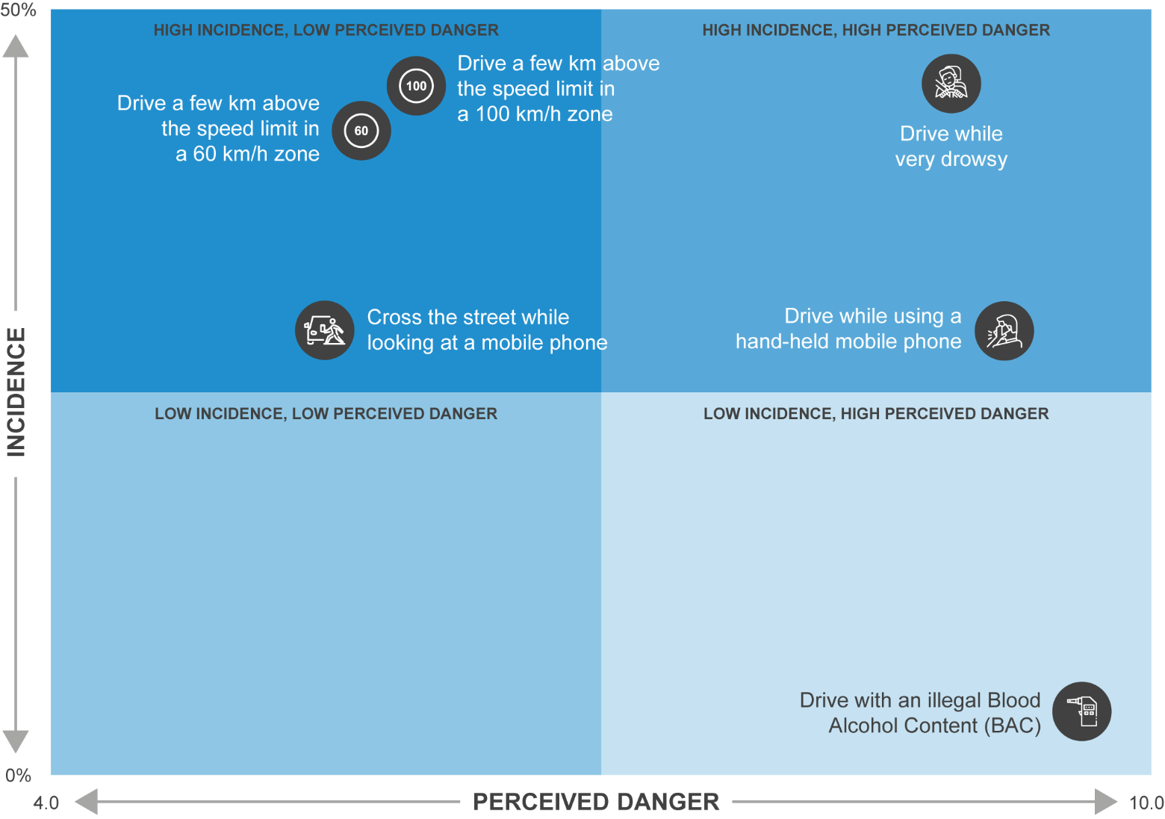

Speeding

Perceptions of the danger of speeding
In Figure 10 below, respondents’ perceived level of danger from driving a few kilometres over the speed limit (highlighted in blue) are compared with the perceived level of danger associated with other behaviours, such as driving with an illegal BAC, driving while very tired, or riding a bicycle on urban roads.
Respondents were asked to rate the perceived level of danger of someone performing each activity in a typical setting on an eleven-point scale from 0 to 10 where 0 is “not at all dangerous” and 10 is “extremely dangerous”. Numbers in the table and the following text are mean ratings out of 10.
Respondents do consider driving with an illegal blood alcohol content as more dangerous than behaviours such as driving while very tired or driving while using a handheld mobile phone.
However, the perceived level of danger from driving a few kilometres over the 100 km/h speed limit is greater than that of that of driving a few kilometres over the 60 km/h speed limit.
Figure 10 Perceptions of Danger (speeding highlighted)
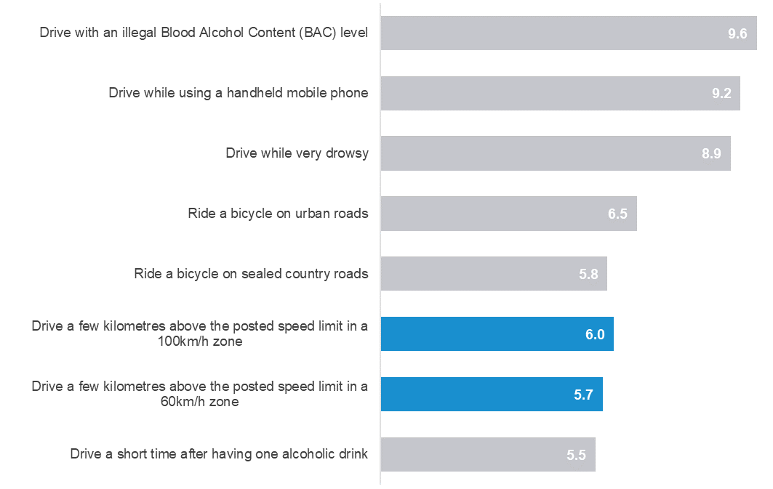
DAN1 Using a scale where 0 is “Not at all dangerous” and 10 is “Extremely dangerous”, how dangerous do you think it is to:
Total sample; Weighted; base n = from 1325 to 2792

Table 25 shows the perceived level of danger of driving a few kilometres over the speed limit (for both 60 km/h and 100 km/h zones) among respondents by demographic. Key findings include:
- Males perceive less danger in driving a few kilometres over the speed limit (5.4 for both 60 km/h and 100 km/h zones) than females (5.9 and 6.5 respectively).
- Respondents living in Rural Balance areas (6.1) and Other Urban areas (6.0) perceive the danger of driving a few kilometres per hour above the speed limit in a 60 km/h to be higher than respondents living in Major Urban areas (5.5).
- The perceived level of danger is lowest among those aged 18-25 (5.1 for 60 km/h and 5.7 for 100 km/h zones) and highest among those aged 60-90 (6.2 and 6.4 respectively). It should be noted that those aged 18-25 are not significantly different from the average driver in their perceptions of driving above the posted speed limit in a 100km/h zone, however.
Table 25 Perception of the danger of speeding by demographic

Average |  |  | Age |  |  |  | Gender |  | Location
Average | Total | 18 - 25 |  | 26 - 39 | 40 - 60 | 61 - 90 | Male | Female | Major Urban | Other Urban | Rural Balance
Drive a few kilometres above the posted speed limit in a 60km/h zone | 5.7 | 5.1 ↓ |  | 5.5 | 5.7 | 6.2 ↑ | 5.4 ↓ | 5.9 ↑ | 5.5 ↓ | 6.0 ↑ | 6.1 ↑
Drive a few kilometres above the posted speed limit in a 100km/h zone | 6.0 | 5.7 |  | 5.8 | 5.8 | 6.4 ↑ | 5.4 ↓ | 6.5 ↑ | 5.9 | 6.0 | 6.1
Sample size | 2783 | 423 |  | 669 | 981 | 710 | 1361 | 1422 | 1361 | 956 | 468
DAN1A/B Using a scale where 0 is ‘Not at all dangerous’ and 10 is ‘Extremely dangerous’, how dangerous do you think it is to drive a few kilometres above the posted speed limit in a [60km/h/100km/h] zone
Filter: Total sample; weighted sample
Blue up arrows (↑) and red down arrows (↓) indicate statistically significant difference compared to respondents not in that category
Figures may not add to 100% due to rounding
As shown in Table 26, respondents who engage in illegal behaviours (Speeding, Drink driving and Mobile phone use – see Section 1.3 for definitions) are less likely to perceive that driving a few kilometres over the speed limit is dangerous. For convenience, respondents in the speeding behaviour sub-group will be referred to in this report as ‘speeders’ and other respondents as ‘non-speeders’.
Most noticeably, speeders (5.2) are less likely than non-speeders (6.3) to perceive that driving a few kilometres over the speed limit in a 60 km/h zone is dangerous. The difference is even greater for 100 km/h zones (5.1 for speeders vs 7.0 for non-speeders).
Among all sub-groups (demographic and behavioural), non-speeders (7.0) have the highest rating for the perceived level of danger for driving over the speed limit.
Table 26 Perception of the danger of speeding by behaviour

Average |  | Speeding |  | Drink driving |  | Mobile phone use |  | Driving fatigued |  | Involvement in a crash
Average | Total | Yes | No | Yes | No | Yes | No | Yes | No | Yes | No
Drive a few kilometres above the posted speed limit in a 60km/h zone | 5.7 | 5.2 ↓ | 6.3 ↑ | 4.7 ↓ | 5.7 ↑ | 4.9 ↓ | 6.0 ↑ | 5.3 ↓ | 5.9 ↑ | 5.6 | 5.7
Drive a few kilometres above the posted speed limit in a 100km/h zone | 6.0 | 5.1 ↓ | 7.0 ↑ | 4.7 ↓ | 6.0 ↑ | 5.0 ↓ | 6.3 ↑ | 5.5 ↓ | 6.3 ↑ | 5.9 | 6.0
Sample size | 2783 | 1498 | 1144 | 123 | 2583 | 786 | 1921 | 1267 | 1396 | 411 | 2357
DAN1A/B Using a scale where 0 is ‘Not at all dangerous’ and 10 is ‘Extremely dangerous’, how dangerous do you think it is to drive a few kilometres above the posted speed limit in a [60km/h/100km/h] zone
Filter: Total sample; weighted sample
Blue up arrows (↑) and red down arrows (↓) indicate statistically significant difference compared to respondents not in that category
Figures may not add to 100% due to rounding

Definition of speeding
To understand how road users define speeding, respondents were asked to indicate how fast they think people should be allowed to drive in 60 km/h and 100 km/h speed zones without being booked for speeding. The results in this section are restricted to respondents aged 18-60 with a drivers’ licence to allow valid comparisons over time. (See Section 1.3 for further explanation.)
As shown in Figure 11, many respondents report that drivers should be allowed to drive up to 5 km/h over the speed limit in both 60 km/h and 100 km/h zones (87% and 64% respectively).
There has, however, been an increase in the percentage of respondents who report that drivers should be allowed to drive more than 5 km/h over the speed limit in 100 km/h zones. In 2013, 24% of respondents reported that drivers should be allowed to exceed 105 km/h in 100 km/h zones. In 2017, the percentage had risen to 35%. This belief has been maintained and has risen to 36% in 2021. In contrast, no trend is evident for 60 km/h zones.
Similar to in 2020, additional analysis shows that males (17% in 2021 vs. 16% in 2020) are more likely than females (6% in 2021 vs. 8% in 2020) to report that drivers should be allowed to drive faster than at 65 km/h in a 60 km/h zone. The difference is greater for 100 km/h zones; (41% in 2021 and 2020 of males) report that drivers should be allowed to exceed 105 km/h in a 100 km/h zone compared with 27% of females in 2021 vs. 29% in 2020.
Further, those in Major Urban areas are more likely than those in Other Urban areas (although, not Rural Balance areas) to believe that people should be able to drive more than 65km/h in 60km/h zones (13% Major Urban vs. 7% Other Urban), and that people should be able to drive more than 105km/h in 100km/h zones (36% Major Urban vs. 27% Other Urban).
Figure 11 Definition of speeding by year
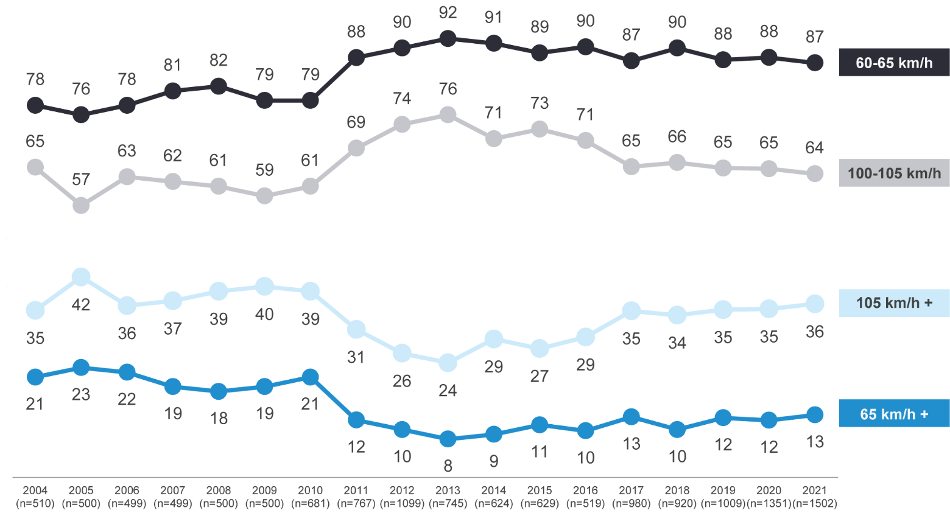
DAN2- How fast should people be allowed to drive in a 60km/h zone without being booked for speeding?
Filter: Aged 18-60 years who could specify a number and not below 60km/h
DAN3 - How fast should people be allowed to drive in a 100km/h zone without being booked for speeding?
Filter: Aged 18-60 years who could specify a number and not below 100km/h
Figures may not add to 100% due to rounding

Intentionally driving over the speed limit
Respondents were asked how often they intentionally drove above the posted speed limit in the last three months. Note that in contrast to Section 4.5.2, these questions were asked of all respondents aged 18-90 with a drivers’ licence.
As shown in Figure 12, nearly two thirds of respondents (58%) report never intentionally speeding in a 60 km/h zone. Since 2016, the percentage of respondents reporting that they never intentionally speed has increased from 57% to 61% in 2020, and slightly dropped to 58% in 2021.
Figure 12 Intentionally driving over the speed limit in a 60 km/h zone over time by year
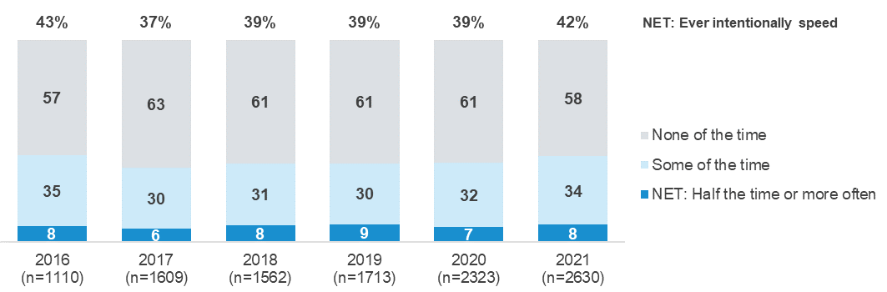
DB1 In the past three months, how often did you intentionally drive above the limit in a 60 km/h zone, even if by only a few km's per hour? (fine) by Year of interview (Date)
Filter: Drivers; Weighted sample; base=2630
Figures may not add to 100% due to rounding
As shown in Figure 13, the findings are similar for intentionally speeding in 100 km/h zones. Since 2016, the percentage of respondents reporting that they never intentionally speed has increased from 55% to 60% in 2020, and decreased slightly to 55% in 2021.
Figure 13 Intentionally driving over the speed limit in a 100 km/h zone over time
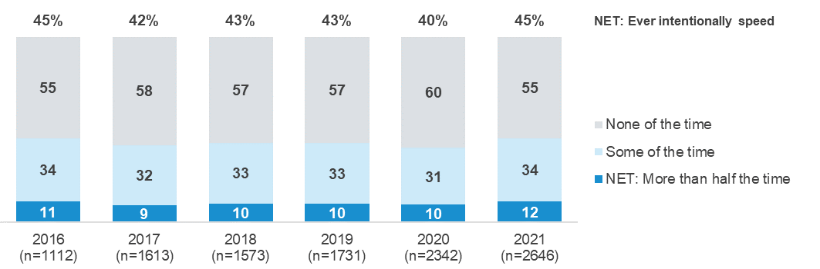
DB1 In the past three months, how often did you intentionally drive above the limit in a 100km/h zone, even if by only a few km's per hour?
Weighted sample; base=2646; Filter: Drivers
Figures may not add to 100% due to rounding
As shown in Figure 14, the reported likelihood to drive above the 60km/hr speed limit is greater among younger respondents and males, as described below:
- Respondents aged 18-39 (54%) are more likely than respondents aged 40 and over (35%) to ever speed in 60 km/h zones.
- Males (47%) are more likely than females (38%) to ever speed in 60 km/h zones.
Figure 14 Driving over the speed limit 60 km/h infographic
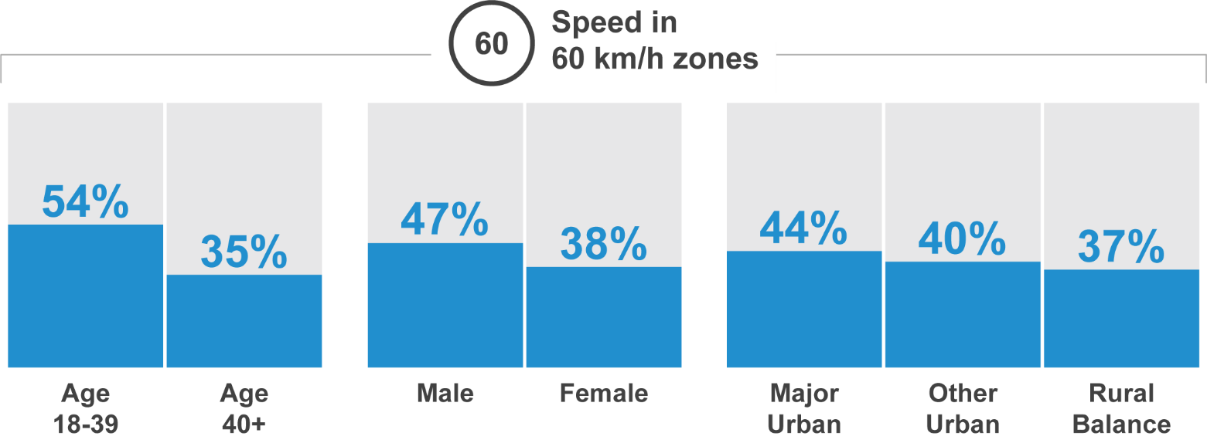
As shown in Figure 15, the reported likelihood to drive above the 100km/hr speed limit is also greater among younger respondents and males, as described below:
- In 100 km/h zones, respondents aged 18-39 (51%) and 40-60 (48%) are more likely than respondents aged 60 and over (33%) to ever speed.
- In 100 km/h zones, males (52%) are more likely than females (39%) to ever speed.
- In 100 km/h zones, respondents in Other Urban areas (53%) and Rural Balance areas (49%) are more likely than respondents in Major Urban areas (43%) to ever speed.
Figure 15 Driving over the speed limit 100 km/h infographic
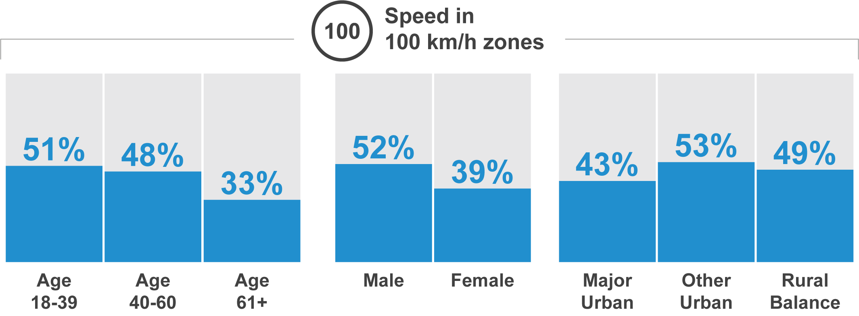
Other analysis (Figure 16) shows that respondents who are more likely to intentionally exceed the speed limit are also more likely to engage in other illegal behaviours such as using mobile phones while driving or driving fatigued. Specifically, there is a positive but weak correlation between engagement in low-level speeding and mobile phone use (r=.26), meaning that respondents who intentionally drive exceeding the 100km/h speed limit are also more likely to use mobile phone while driving. Similarly, a positive but weak correlation was observed between engagement in speeding and fatigued driving (r=.22), suggesting that those who intentionally drive above the speed limit in a 100km/h zone are more likely to drive while fatigued.
Figure 16 Correlation of Dangerous Driving Behaviours

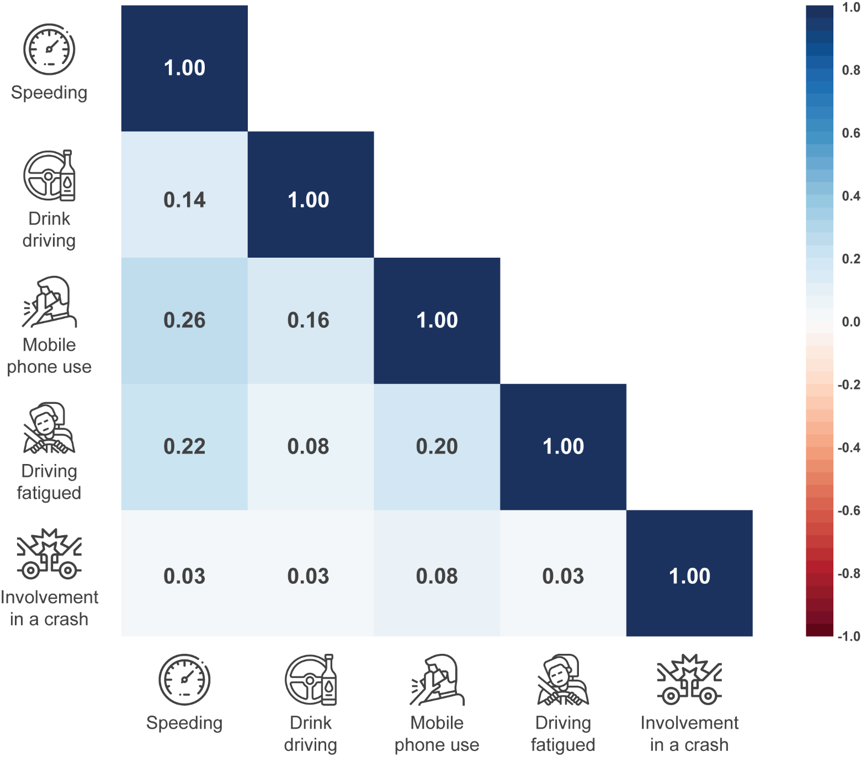

Attitudes towards speeding
Respondents were asked to rate the extent to which they agreed or disagreed with a battery of statements about speeding using a five-point scale where 1 is ‘strongly disagree and 5 is ‘strongly agree’. Numbers in Figure 17 and the following text are the percentages of respondents who have a drivers’ licence who nominated a point on the scale.
A majority of respondents (63%) report feeling guilty when they speed, and six in ten respondents (59%) feel uncomfortable when driving over the speed limit. Almost half of respondents (49%) report that they sometimes drive under the speed limit to reduce the chance of having an accident. Less than one in twenty respondents (4%) agree with the statements ‘I enjoy speeding’.
Further analysis shows that attitudes to speeding differ by demographic. For example, a higher percentage of females hold, and a higher percentage of those aged 61-90 hold somewhat stronger views regarding speeding. For example:
- Females (69%) are more likely to agree than males (57%) with the statement ‘I feel guilty if I speed’.
- Females (65%) are more likely to agree than males (50%) with the statement ‘I feel uncomfortable when I drive over the speed limit’.
- Those aged 61-90 (71%) are more likely than those aged 18-25 (45%) to agree with the statement ‘I feel uncomfortable when I drive over the speed limit’.
Figure 17 Attitudes towards speeding
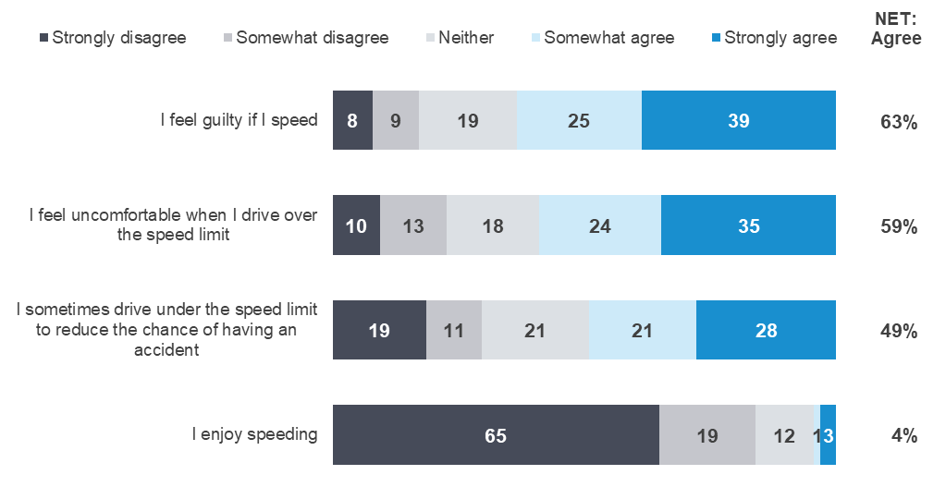
SP1 - The following are some statements some people believe about speeding and speed limits. On a scale of 1 to 5, where 1 is “Strongly disagree” and 5 is “Strongly agree”, (to what extent do you agree or disagree / please tell us the extent to which you agree or disagree) with the following statements…
Weighted sample; base=from 652 to1332; Filter: Drivers, excludes don’t know and non-response
Figures may not add to 100% due to rounding,

Table 27 shows changes in drivers’ attitudes towards speeding since 2016. In 2021 more than two thirds of respondents (63%) agree that ‘I feel guilty if I speed, and slightly fewer respondents 58% agree that they “feel uncomfortable when driving over the speed limit”. Almost half of respondents (49%) report that they ‘sometimes drive under the speed limit to reduce the chance of having an accident’. Less than one in twenty respondents (4%) agree with the statements ‘I enjoy speeding’.
Table 27 Attitudes towards speeding (net agree %) by year

Column % | 2016 |  | 2017 |  | 2018 |  | 2019 |  | 2020 |  | 2021
I sometimes drive under the speed limit to reduce the chance of having an accident | 52 |  | 48 |  | 53 ↑ |  | 52 |  | 49 |  | 49
I feel guilty if I speed |  | 63 |  | 63 |  | 67 |  | 63 |  | 69 |  | 63
I feel uncomfortable when I drive over the speed limit |  |  |  |  |  |  |  | 59 |  | 66 ↑ |  | 58 ↓
I enjoy speeding | 5 |  | 5 |  | 6 |  | 5 |  | 7 |  | 4
Sample size |  | 1125 |  | 1645 |  | 1589 |  | 852 |  | 1184 |  | 1353
SP1 - Attitudes towards speeding statements (Summary)
Weighted sample: T
As shown in Table 28, more females (69%) than males (57%) agree with the statement ‘I feel guilty if I speed’. There is a similar percentage difference between females (65%) and males (50%) who agree with the statement ‘I feel uncomfortable when I drive over the speed limit”.
Respondents aged 18-25 (45%) are the least likely to agree with the statement that ‘I feel uncomfortable when I drive over the speed limit’, whereas 71% of respondents aged 61-90 agree.
Table 28 Attitudes towards speeding by demographic

Column % |  | Age |  |  |  | Gender |  | Location
Column % | Total | 18 - 25 | 26 - 39 | 40 - 60 | 61 - 90 | Male | Female | Major Urban | Other Urban | Rural Balance
I sometimes drive under the speed limit to reduce the chance of having an accident | 49 | 62 | 41 | 50 | 49 | 50 | 48 | 49 | 53 | 44
I feel guilty if I speed | 63 | 64 | 58 | 67 | 64 | 57 ↓ | 69 ↑ | 63 | 62 | 67
I feel uncomfortable when I drive over the speed limit | 58 | 45 ↓ | 55 | 56 | 71 ↑ | 50 ↓ | 65 ↑ | 58 | 56 | 58
I enjoy speeding | 4 | 5 | 3 | 5 | 5 | 6 | 3 | 4 | 5 | 5
Sample size | 1353 | 195 | 331 | 481 | 346 | 649 | 704 | 662 | 466 | 225
SP1 - Attitudes towards speeding statements (Summary)
Weighted sample: base n = 1353

Table 29 shows attitudes towards speeding by driving behaviour. Speeders are less likely to agree with the first three attitudes in Table 29, and the agreement gaps are larger between speeders and non-speeders for statements (“I feel guilty if I speed” and “I feel uncomfortable when I drive over the speed limit”). Respondents who have engaged in all four categories of unsafe or illegal driving behaviour (the first four columns of Table 29) are less likely to agree with the statement ‘I feel uncomfortable when I drive over the speed limit’.
Table 29 Attitudes towards speeding by behaviour

Column % |  | Speeding |  | Drink driving |  | Mobile phone use |  | Driving fatigued |  | Involvement in a crash
Column % | Total | Yes | No | Yes | No | Yes | No | Yes | No | Yes | No
I sometimes drive under the speed limit to reduce the chance of having an accident | 49 | 46 | 54 | 49 | 49 | 42 ↓ | 52 ↑ | 45 | 53 | 42 | 50
I feel guilty if I speed | 63 | 56 ↓ | 76 ↑ | 48 | 64 | 51 ↓ | 69 ↑ | 60 | 67 | 63 | 63
I feel uncomfortable when I drive over the speed limit | 58 | 45 ↓ | 75 ↑ | 27 ↓ | 59 ↑ | 43 ↓ | 64 ↑ | 52 ↓ | 63 ↑ | 53 | 59
I enjoy speeding | 4 | 4 | 5 | 2 | 5 | 4 | 5 | 5 | 4 | 7 | 4
Sample size | 1353 | 755 | 570 | 57 | 1296 | 394 | 959 | 618 | 716 | 195 | 1150
SP1 - Attitudes towards speeding statements (% Agree) by BANNER – Behaviours
Weighted sample; base n = from 642 to 1353

Caught speeding
Respondents aged 18-60 who are licence holders were asked if they had been caught speeding in the last twelve months. Figure 18 below shows that the percentage of respondents who reported being caught speeding has declined from 2014 to 2017 but has since remained unchanged at 13%.
Figure 18 Caught speeding by year
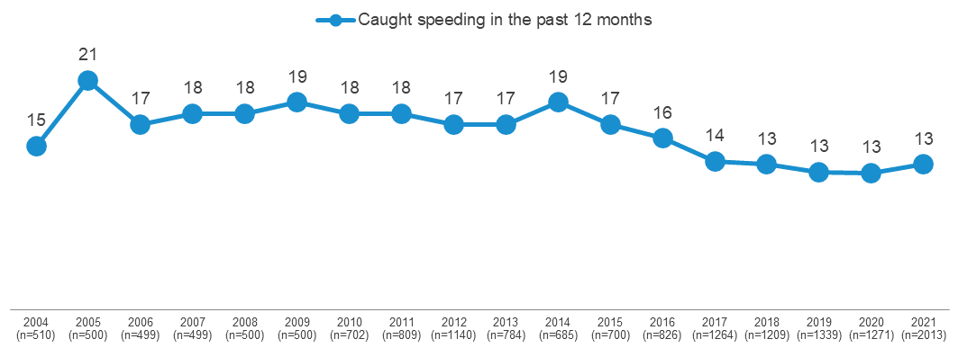
SP2 - Have you been caught speeding in the last 12 months?
Filter: Licence holders aged 18-60 with a valid response
Table 30 shows the incidence of being caught speeding by demographic. Males (14%) are more likely to have been caught speeding in the last twelve months than females (9%). Respondents aged 61-90 (8%) are the least likely to have been caught speeding compared to other age groups.
Table 30 Caught speeding in the past 12 months by demographic

Column % |  | Age |  |  |  | Gender |  | Location
Column % | Total | 18 - 25 | 26 - 39 | 40 - 60 | 61 - 90 | Male | Female | Major Urban | Other Urban | Rural Balance
Yes | 11 | 13 | 12 | 13 | 8 ↓ | 14 ↑ | 9 ↓ | 12 | 11 | 9
No | 89 | 87 | 88 | 87 | 92 ↑ | 86 ↓ | 91 ↑ | 88 | 89 | 91
Sample size | 2708 | 406 | 643 | 964 | 695 | 1329 | 1379 | 1307 | 938 | 463
SP2 - Have you been caught speeding in the last 12 months?
Filter: Licence holders; base n=2708
Blue up arrows (↑) and red down arrows (↓) indicate statistically significant difference compared to respondents not in that category
Figures may not add to 100% due to rounding.

Impaired driving

Use of drugs and alcohol
Respondents were asked whether they drink alcohol and if they had used recreational drugs in the last 12 months. Figure 19 below is filtered to respondents aged 18-60 who are licence holders to allow valid comparisons over time. Figure 19 shows that, filtered to these respondents, about four in five respondents (77%) ever drink alcohol, while about one in ten respondents (9%) have used recreational drugs in the last twelve months. Rates of alcohol and drug use have remained similar since 2015.
Figure 19 Use of drugs and alcohol by year
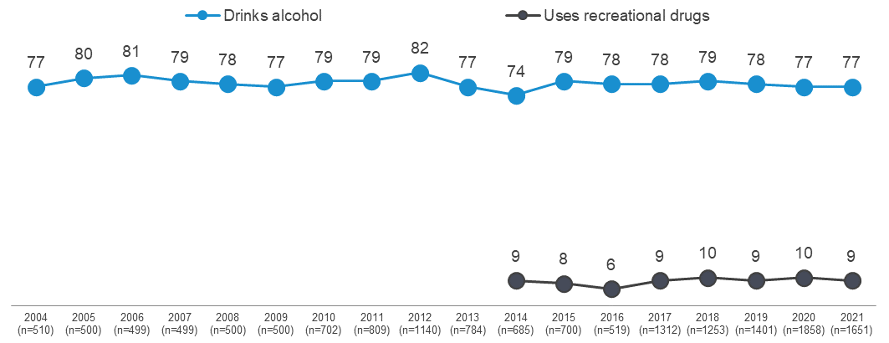
DK2 - Do you ever drink alcohol?
DG3 - In the last 12 months, have you used recreational drugs (for example, methamphetamine, ice, marijuana etc.)?
Filter: Licence holders aged 18-60 with a valid response; base n=1651
* Note: 'Drug use' was introduced in 2014
Table 31 shows results for all drivers by demographic. Among all drivers, more males (79%) than females (72%) report they drink alcohol.
Usage of recreational drugs is higher among respondents aged 18-25 (17%) than among those aged 26-39 (9%) and 40-60 (6%) or 61-90 (2%).
Table 31 Use of alcohol and recreational drugs by demographic

Column % |  | Age |  |  |  | Gender |  | Location
Column % | Total | 18 - 25 | 26 - 39 | 40 - 60 | 61 - 90 | Male | Female | Major Urban | Other Urban | Rural Balance
Drinks alcohol | 75 | 78 | 75 | 79 ↑ | 68 ↓ | 79 ↑ | 72 ↓ | 74 | 79 ↑ | 74
Uses recreational drugs | 7 | 17 ↑ | 9 | 6 | 2 ↓ | 8 | 7 | 8 | 6 | 5
Sample size | 2796 | 423 | 671 | 983 | 719 | 1363 | 1433 | 1367 | 961 | 468
DK2 - Do you ever drink alcohol?
DG3 - In the last 12 months, have you used recreational drugs (for example, methamphetamine, ice, marijuana etc.)?
Blue up arrows (↑) and red down arrows (↓) indicate statistically significant difference compared to respondents not in that category.
Filter: Driver with a valid response; base n=2796
Figures may not add to 100% due to rounding

As shown in Table 32, drivers who engage in illegal behaviours such as drink driving, or who have been involved in a crash, (see Section 1.3 for definitions) are more likely to drink alcohol and use recreational drugs. For example:
- Speeders (82%) are more likely to report ever drinking alcohol than non-speeders (68%).
- Respondents who drink drive are more likely to use recreational drugs (23%) than respondents who do not drink drive (7%).
- Respondents who have been involved in a crash in the last five years are more likely to have used recreational drugs (10%) than those who have not (7%).
Table 32 Use of alcohol and recreational drugs by behaviour

Column % |  | Speeding |  | Drink driving |  | Mobile phone use |  | Driving fatigued |  | Involvement in a crash
Column % | Total | Yes | No | Yes | No | Yes | No | Yes | No | Yes | No
Drinks alcohol | 75 | 82 ↑ | 68 ↓ | 100 ↑ | 74 ↓ | 85 ↑ | 72 ↓ | 79 ↑ | 73 ↓ | 76 | 75
Uses recreational drugs | 7 | 11 ↑ | 3 ↓ | 23 ↑ | 7 ↓ | 15 ↑ | 4 ↓ | 10 ↑ | 5 ↓ | 11 ↑ | 7 ↓
Sample size | 2796 | 1503 | 1150 | 123 | 2596 | 786 | 1934 | 1269 | 1403 | 409 | 2371
DK2 - Do you ever drink alcohol?
DG3 - In the last 12 months, have you used recreational drugs (for example, methamphetamine, ice, marijuana etc.)?
Blue up arrows (↑) and red down arrows (↓) indicate statistically significant difference compared to respondents not in that category
Filter: Drivers with a valid response; base=2796
Figures may not add to 100% due to rounding.

Drink driving

Incidence of illegal drink driving
As shown in Table 33, in the last 12 months, 3% of respondents reported having been a passenger when they thought the driver was over the BAC limit.
Among respondents who drive, 4% report they had driven a car when they thought they were over their legal BAC limit.
Few meaningful differences exist by demographic category as it pertains to illegal drink driving.
Table 33 Illegal drink driving by demographic

Column % |  | Age |  |  |  | Gender |  | Location
Column % | Total | 18 - 25 | 26 - 39 | 40 - 60 | 61 - 90 | Male | Female | Major Urban | Other Urban | Rural Balance
Been a passenger in a car when the driver was over their legal BAC | 3 | 4 | 4 | 3 | 1 ↓ | 3 | 3 | 3 | 3 | 2
Sample size | 2703 | 416 | 646 | 947 | 694 | 1307 | 1396 | 1309 | 935 | 459
Driven when over legal BAC | 4 | 5 | 4 | 5 | 4 | 5 | 4 | 4 | 5 | 5
Sample Size | 2725 | 403 | 647 | 972 | 703 | 1341 | 1384 | 1318 | 942 | 465
DK1 - In the last 12 months, have you been a passenger in a car when you knew or thought the driver was over their legal blood alcohol limit?
DK3 In the last 12 months, have you driven a car when you knew or thought you were over your legal blood alcohol limit, even slightly?
Total sample; Weighted; base n = 2703-2625

Legal drink driving
Respondents were asked whether they have driven after drinking alcohol, but while they believed they were under their legal blood alcohol limit. As shown in Table 34, four in ten respondents (43%) report driving after drinking when they believed they were under their legal blood alcohol limit. This behaviour is most common among those aged 40-60 (53%), those living in Other Urban areas and males (47%).
Respondents aged 18-25 (42%) are the most likely to ‘never drive after drinking’ and respondents aged 40-60 (12%) are the least likely.
Table 34 Legal drink driving by demographic

Column % |  | Age |  |  |  | Gender |  | Location
Column % | Total | 18 - 25 | 26 - 39 | 40 - 60 | 61 - 90 | Male | Female | Major Urban | Other Urban | Rural Balance
Driven after drinking while under legal BAC | 43 | 26 ↓ | 46 | 53 ↑ | 35 ↓ | 47 ↑ | 39 ↓ | 42 | 48 ↑ | 42
NET: Has not driven after drinking alcohol in past 12 months | 57 | 74 ↑ | 54 | 47 ↓ | 65 ↑ | 53 ↓ | 61 ↑ | 58 | 52 ↓ | 58
No, not in the past 12 months | 12 | 6 ↓ | 12 | 12 | 16 ↑ | 13 | 12 | 13 | 11 | 13
Never drives after drinking | 18 | 42 ↑ | 14 ↓ | 12 ↓ | 15 | 18 | 18 | 18 | 18 | 16
Never drinks alcohol | 24 | 20 | 23 | 22 | 30 ↑ | 20 ↓ | 27 ↑ | 24 | 21 | 27
Doesn't drive / has not driven in past 12 months | 3 | 5 | 4 | 1 ↓ | 4 | 2 ↓ | 4 ↑ | 4 ↑ | 2 | 1 ↓
Sample size | 2057 | 307 | 485 | 742 | 523 | 1001 | 1056 | 1016 | 705 | 336
DK8 - In the last 12 months, have you driven a car after drinking alcohol when you knew or thought you were under the legal blood alcohol limit?
Filter: Total sample; Weighted sample; base n=2057
Blue up arrows (↑) and red down arrows (↓) indicate statistically significant difference compared to respondents not in that category
Figures may not add to 100% due to rounding

Number of drinks
Nearly one in five respondents (21%) of those who drive and drink alcohol say they would not drive after drinking alcohol. About a quarter (26%) would have a maximum of one drink and consider driving. Just under half (48%) would still consider driving after drinking two or more alcoholic drinks. Considering differences by demographic:
- Respondents aged between 18-25 (51%) are most likely to say would not drive after drinking at all.
- Females (31%) are more likely than males (21%) to say that they would have a maximum of one drink and still consider driving. Males (61%) are more likely females (46%) to consider driving after two or more drinks.
- Two thirds of respondents aged between 40-60 (64%) would consider driving after two or more drinks.
Table 35 Number of drinks by demographic

Column % |  | Age |  |  |  | Gender |  | Location
Column % | Total | 18 - 25 | 26 - 39 | 40 - 60 | 61 - 90 | Male | Female | Major Urban | Other Urban | Rural Balance
Would not drive after drinking | 21 | 51 ↑ | 16 ↓ | 13 ↓ | 19 | 18 | 23 | 21 | 20 | 20
One drink | 26 | 17 ↓ | 27 | 23 | 35 ↑ | 21 ↓ | 31 ↑ | 25 | 30 | 26
NET: Two or more drinks | 53 | 32 ↓ | 57 | 64 ↑ | 46 ↓ | 61 ↑ | 46 ↓ | 54 | 50 | 54
Two drinks | 48 | 29 ↓ | 52 | 57 ↑ | 42 ↓ | 53 ↑ | 43 ↓ | 49 | 46 | 46
Three or more drinks | 5 | 3 | 5 | 7 | 4 | 7 ↑ | 3 ↓ | 5 | 4 | 8
Sample size | 1526 | 234 | 360 | 583 | 349 | 784 | 742 | 736 | 546 | 244
DK5 What is the highest number of alcoholic drinks you would have and still consider driving.
Filter: Driver/ Drink alcohol; Weighted sample; base n=1526
Blue up arrows (↑) and red down arrows (↓) indicate statistically significant difference compared to respondents not in that category.
Figures may not add to 100% due to rounding.

Drug driving

Recreational drugs used in the total community
Respondents who used recreational drugs in the last 12 months are most likely to have used cannabis/marijuana (5.6%) or stimulants (2.5%) such as ecstasy, methamphetamine/ice, speed or cocaine. Recreational drug use is highest among those aged 18-25, with 17.3% reporting they have used recreational drugs in the past 12 months.
Table 36 Use of recreational drugs by demographic

Column % |  | Age |  |  |  | Gender |  | Location
Column % | Total | 18 - 25 | 26 - 39 | 40 - 60 | 61 - 90 | Male | Female | Major Urban | Other Urban | Rural Balance
NET: Used recreational drugs in the last 12 months | 7.4 | 17.3 ↑ | 9.2 | 6.1 | 1.8 ↓ | 8.3 | 6.6 | 7.9 | 6.4 | 4.9
Cannabis / marijuana | 5.6 | 14.3 ↑ | 7.0 | 4.5 | 0.7 ↓ | 6.6 ↑ | 4.6 ↓ | 6.2 ↑ | 4.1 ↓ | 3.2 ↓
Stimulants (Ecstasy, MDMA, ice, meth, speed, cocaine, etc.) | 2.5 | 7.4 ↑ | 3.4 | 1.3 ↓ | 0.4 ↓ | 2.5 | 2.4 | 2.7 | 2.0 | 1.2
Hallucinogens (LSD, acid, magic mushrooms, etc.) | 1.3 | 4.3 ↑ | 0.9 | 0.9 | 0.4 ↓ | 1.5 | 1.1 | 1.5 | 0.8 | 0.2
Opioids (Heroin, morphine, etc.) | 0.1 | 0.0 | 0.2 | 0.1 | 0.0 | 0.0 | 0.1 | 0.1 | 0.1 | 0.0
Prescription medications for non-medical purposes (codeine, pseudoephedrine, dexamphetamine, benzodiazepines etc.) | 1.8 | 4.4 ↑ | 1.7 | 1.4 | 0.9 | 1.6 | 2.0 | 1.8 | 1.9 | 1.3
Other | 0.1 | 0.3 | 0.0 | 0.0 | 0.1 | 0.1 | 0.0 | 0.1 | 0.0 | 0.2
Sample size | 2816 | 426 | 674 | 987 | 729 | 1376 | 1440 | 1378 | 966 | 472
DG3 - In the last 12 months, which of the following recreational drugs have you used?
Weighted sample; base n=2816
Figures may not add to 100% due to rounding.

Driving after using recreational drugs
As shown in Table 37, in 2021, the percentage of respondents who are drivers who drive after taking drugs is 1.4%, which is the lowest since 2017.
Additional analysis shows that a higher percentage of respondents who are aged 18 to 25 (3.5%) report driving after taking recreational drugs than those aged 40-90 (0.3%).
Table 37 Frequency of driving after using recreational drugs by year

 | Column % | 2017 | 2018 | 2019 | 2020 | 2021
 | NET: Driven after using recreational drugs | 1.5 | 2.2 | 1.7 | 1.7 | 1.4
 | Once in the last 12 months | 0.5 | 1.0 ↑ | 0.5 | 0.5 | 0.3
 | Twice in the last 12 months | 0.3 | 0.3 | 0.4 | 0.3 | 0.3
 | 3 to 5 times in the last 12 months | 0.2 | 0.3 | 0.3 | 0.5 | 0.4
 | 6 to 10 times in the last 12 months | 0.2 | 0.2 | 0.2 | 0.1 | 0.1
 | More than 10 times in the last 12 months | 0.2 | 0.4 | 0.3 | 0.2 | 0.3
 | Not at all in the last 12 months | 6.7 | 5.9 | 5.8 | 6.3 | 5.7
 | Does not use recreational drugs or does not drive | 91.8 | 91.9 | 92.4 | 92.0 | 92.9
Sample size |  | 1250 | 1515 | 1745 | 2335 | 2664
DG4 In the last 12 months, how often have you driven a vehicle, or ridden a motorbike, after using recreational drugs?
Filter: Drivers with a valid response; base n=2664
Figures may not add to 100% due to rounding

Fatigue
Respondents who drive a vehicle or ride a motorcycle were asked how often they have driven while feeling very tired. As shown in Table 38, over a third of respondents (45%) report that they have driven while very tired in the past three months. The incidence of driving while very tired is higher among younger respondents aged 18-25 (59%) and 26-39 (52%) compared to the older respondents.
Table 38 How often driven while very tired in the past three months by demographic

Column % |  | Age group |  |  |  | Gender |  | Location
Column % | Total | 18 - 25 | 26 - 39 | 40 - 60 | 61 - 90 | Male | Female | Rural Balance | Other Urban
NET: Ever | 45 | 59 ↑ | 52 ↑ | 46 | 28 ↓ | 44 | 46 | 52 ↑ | 50 ↑
Half the time or more often | 5 | 11 ↑ | 7 ↑ | 3 ↓ | 1 ↓ | 4 | 5 | 5 | 6
Some of the time | 40 | 48 ↑ | 45 ↑ | 43 | 27 ↓ | 40 | 40 | 47 ↑ | 44 ↑
None of the time | 55 | 41 ↓ | 48 ↓ | 54 | 72 ↑ | 56 | 54 | 48 ↓ | 50 ↓
Sample size | 2685 | 401 | 632 | 968 | 684 | 1319 | 1366 | 458 | 931
DB2E In the past three months, how often did you drive when feeling very tired? *changed from ‘drowsy’ in 2020 Q2 (Apr-Jun)
Filter: Driver; weighted sample; base n=2685
Blue up arrows (↑) and red down arrows (↓) indicate statistically significant difference compared to respondents not in that category.
Figures may not add to 100% due to rounding.

Distractions
Respondents were asked how frequently they engaged in behaviours using their mobile phones while driving. Overall, seven in ten (72%) of respondents who drive have used a mobile phone at all (legally or illegally). While a majority of respondents had answered a call (65%) or made a call (56%) using Bluetooth while driving. Considering illegal (hand-held) use of mobile phones, respondents are more likely to have used their phone in response to an incoming call or text than decide to instigate communication with someone while driving. For instance, to use a mobile phone hand-held to read a text (23%) or answer a call (12%), rather than write and send a message (10%) or make a call with hand-held phone (8%) while driving.
Overall, a sizable minority (29%) used a handheld mobile phone while driving. Additional analysis also suggests that illegal use of mobile phones has declined over time from 37% (ever) in 2016 to now, 29%.
Figure 9 Mobile phone usage while driving
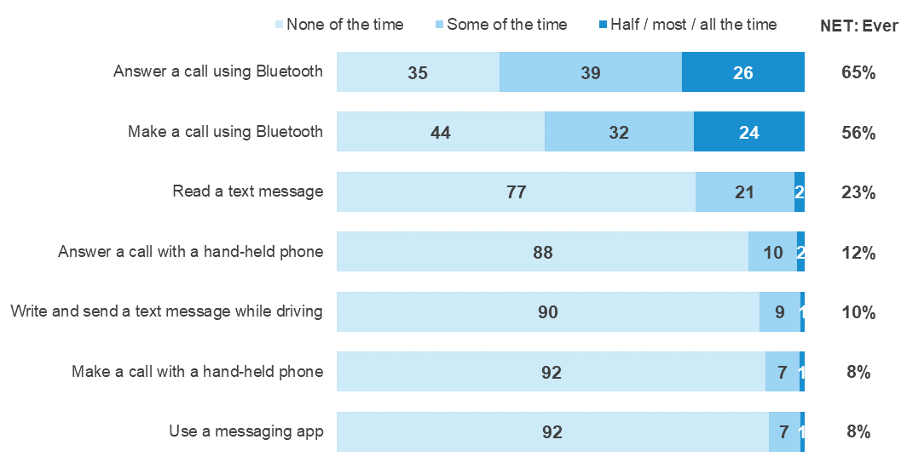
DB2ABCD In the past three months, how often did you X (Any of Some / Half / Most / All the time)
Filter: Driver; weighted sample; base n=2148
Figures may not add to 100% due to rounding

As shown in Table 39 on the next page, legal and illegal use of a mobile phone shows marked differences by demographic. For instance:
- Mobile phone usage (both legal and illegal) is higher among those aged 26-39 (83%) and 40-60 (80%) than among those aged 61-90 (49%).
- Respondents aged 26-39 (42%) and 18-25 (37%) are more likely to use mobile phones illegally than drivers 60-91 years old (11%).
Table 39 Use of a mobile phone while driving (ever) by demographic

Column % |  | Age |  |  |  | Gender |  | Location
Column % | Total | 18 - 25 | 26 - 39 | 40 - 60 | 61 - 90 | Male | Female | Major Urban | Other Urban | Rural Balance
NET: Used a mobile phone at all while driving (including Bluetooth) | 72 | 71 | 83 ↑ | 80 ↑ | 49 ↓ | 72 | 72 | 73 | 70 | 73
NET: Legal use of mobile phone (Bluetooth) | 66 | 63 | 75 ↑ | 75 ↑ | 46 ↓ | 67 | 66 | 67 | 65 | 65
Answer a call using Bluetooth | 65 | 62 | 74 ↑ | 74 ↑ | 45 ↓ | 66 | 65 | 66 | 65 | 64
Make a call using Bluetooth | 56 | 55 | 67 ↑ | 65 ↑ | 29 ↓ | 56 | 55 | 57 | 52 | 54
NET: Illegal use of a mobile phone (non-Bluetooth) | 29 | 37 ↑ | 42 ↑ | 30 | 11 ↓ | 31 | 28 | 30 | 26 | 34
Read a text message | 23 | 31 ↑ | 34 ↑ | 23 | 8 ↓ | 24 | 23 | 24 | 20 | 26
Answer a call with a hand-held phone | 12 | 14 | 16 ↑ | 13 | 5 ↓ | 14 ↑ | 10 ↓ | 12 | 12 | 16 ↑
Write and send a text message while driving | 10 | 13 | 17 ↑ | 9 | 1 ↓ | 10 | 9 | 10 | 8 | 12
Make a call with a hand-held phone | 8 | 11 | 13 ↑ | 8 | 2 ↓ | 9 | 8 | 8 | 8 | 11
Use a messaging app | 8 | 15 ↑ | 14 ↑ | 5 ↓ | 1 ↓ | 8 | 7 | 8 | 6 | 8
Sample size | 2703 | 405 | 644 | 970 | 689 | 1329 | 1377 | 1308 | 933 | 462
DB2ABCD - In the past three months, how often did you….
Filter: Driver; Weighted sample; base n=2703
Blue up arrows (↑) and red down arrows (↓) indicate statistically significant difference compared to respondents not in that category.
Figures may not add to 100% due to rounding.

Pedestrian distractions
Respondents were asked several questions concerning the frequency and causes of pedestrian distractions.

Frequency of pedestrian distractions
Respondents were asked how often they crossed the street while listening to headphones in the last three months. About two in five (37%) respondents report having done so in the last three months.
As shown in Table 40, eleven per cent (11%) of respondents listen to headphones when they cross the street at least half the time. Younger respondents are more likely to listen to headphones while crossing the street; respondents aged 18-25 (31%) report listening at least half the time, compared to 17% of those aged 26-39, 6% of those aged 40-60 and none of those aged over 60. Respondents living in Major Urban areas (43%) are more likely to have done so in the last 3 months compared to Other Urban areas (21%) and Rural Balance areas (19%).
Table 40 Frequency of crossing the street with headphones by demographic

Column % |  | Age |  |  |  | Gender |  | Location
Column % | Total | 18 - 25 | 26 - 39 | 40 - 60 | 61 - 90 | Male | Female | Major Urban | Other Urban | Rural Balance
NET: Ever | 37 | 66 ↑ | 53 ↑ | 33 | 7 ↓ | 33 | 41 | 43 ↑ | 21 ↓ | 19 ↓
All / Most / Half the time | 11 | 31 ↑ | 17 ↑ | 6 ↓ | 0 ↓ | 12 | 10 | 13 ↑ | 7 | 7
Some of the time | 26 | 35 | 36 ↑ | 28 | 6 ↓ | 21 ↓ | 31 ↑ | 31 ↑ | 14 ↓ | 11 ↓
None of the time | 61 | 32 ↓ | 46 ↓ | 66 | 91 ↑ | 64 | 58 | 55 ↓ | 79 ↑ | 81 ↑
Don't know | 1 | 2 | 1 | 1 | 2 | 2 | 1 | 2 | 0 | 0
Sample size | 716 | 114 | 176 | 253 | 173 | 355 | 361 | 349 | 237 | 130
PED1 In the last three months, how often did you cross the street while listening to headphones (calls, music, podcasts etc.)?
Weighted sample; base n=716
Blue up arrows (↑) and red down arrows (↓) indicate statistically significant difference compared to respondents not in that category.
Figures may not add to 100% due to rounding.
Respondents were asked how often they crossed the street while looking at a mobile phone in the last three months. As shown in Table 41, about one-third of respondents (29%) report having done so in the last three months, while about one in twenty (4%) report having done so at least half the time. Respondents aged 18-25 (51%) and 26-39 (46%), and those who live in Major Urban areas (30%) are most likely to have crossed a road in the previous three months while looking at a mobile phone.
Table 41 Frequency of crossing the street looking at a mobile phone by demographic

Column % |  | Age |  |  |  | Gender |  | Location
Column % | Total | 18 - 25 | 26 - 39 | 40 - 60 | 61 - 90 | Male | Female | Major Urban | Other Urban | Rural Balance
NET: Ever | 29 | 51 ↑ | 46 ↑ | 22 ↓ | 7 ↓ | 31 | 27 | 30 | 26 | 25
All / Most / Half the time | 4 | 8 | 10 ↑ | 1 ↓ | 1 | 5 | 4 | 5 ↑ | 1 ↓ | 4
Some of the time | 25 | 43 ↑ | 36 ↑ | 20 | 6 ↓ | 26 | 23 | 25 | 25 | 22
None of the time | 70 | 48 ↓ | 53 ↓ | 78 ↑ | 92 ↑ | 68 | 72 | 69 | 73 | 75
Don't know | 1 | 1 | 1 | 1 | 1 | 1 | 1 | 1 | 1 | 0
Sample size | 716 | 114 | 176 | 253 | 173 | 355 | 361 | 349 | 237 | 130
PED1 In the last three months, how often did you cross the street while looking at a mobile phone?
Weighted sample; base n=716
Blue up arrows (↑) and red down arrows (↓) indicate statistically significant difference compared to respondents not in that category.
Figures may not add to 100% due to rounding.

Causes of pedestrian distraction
Respondents were asked whether they had been distracted by a range of things while walking around. As shown in Table 42, respondents are most likely to have been distracted by the actions of other road users (45%), their own thoughts that are not related to what they are doing (40%), mobile phones (33%), other pedestrians (31%), and signs on the road (15%). Older respondents are least likely to report having been distracted by something, with 44% reporting ‘none of the above’ among respondents aged 61-90.
Table 42 What distracts pedestrians by demographic

Column % |  | Age |  |  |  | Gender |  | Location
Column % | Total | 18 - 25 | 26 - 39 | 40 - 60 | 61 - 90 | Male | Female | Major Urban | Other Urban | Rural Balance
None of the above | 29 | 17 ↓ | 19 ↓ | 32 | 44 ↑ | 27 | 30 | 26 ↓ | 33 | 42 ↑
Actions of other road users (e.g. drivers, motorcyclists or cyclists) | 45 | 56 ↑ | 55 ↑ | 36 ↓ | 39 | 47 | 42 | 45 | 46 | 40
Your own thoughts/thinking about something not related to what you are doing | 40 | 52 ↑ | 50 ↑ | 38 | 22 ↓ | 39 | 40 | 42 ↑ | 32 ↓ | 31 ↓
Mobile phone | 33 | 43 ↑ | 53 ↑ | 25 ↓ | 15 ↓ | 32 | 34 | 37 ↑ | 23 ↓ | 20 ↓
People you are walking with or other pedestrians | 31 | 54 ↑ | 35 | 26 | 19 ↓ | 33 | 29 | 32 | 28 | 25
Signs on the road (e.g. street signs, roadworks, billboards) | 15 | 22 | 17 | 12 | 12 | 16 | 14 | 15 | 15 | 13
GPS/Map | 9 | 14 | 12 | 8 | 5 | 11 | 8 | 10 | 5 | 8
Don't know | 2 | 2 | 1 | 3 | 3 | 2 | 3 | 2 | 3 | 2
Other | 1 | 0 | 1 | 1 | 1 | 0 | 1 | 1 | 0 | 0
Sample size | 711 | 114 | 176 | 252 | 169 | 353 | 358 | 348 | 235 | 128
PED2 In the last week, have you been DISTRACTED by any of the following while you were walking around?
Weighted sample; base n=711
Blue up arrows (↑) and red down arrows (↓) indicate statistically significant difference compared to respondents not in that category.
Figures may not add to 100% due to rounding.

Distractions while using mobile phones
Respondents who report that they were distracted by their mobile phone while walking were asked what they were using on their mobile phone that was distracting them. As shown in Figure 20, respondents report they were most likely to be distracted by either messages (47%) or phone calls (37%).
Figure 20 Pedestrian distractions on a mobile phone
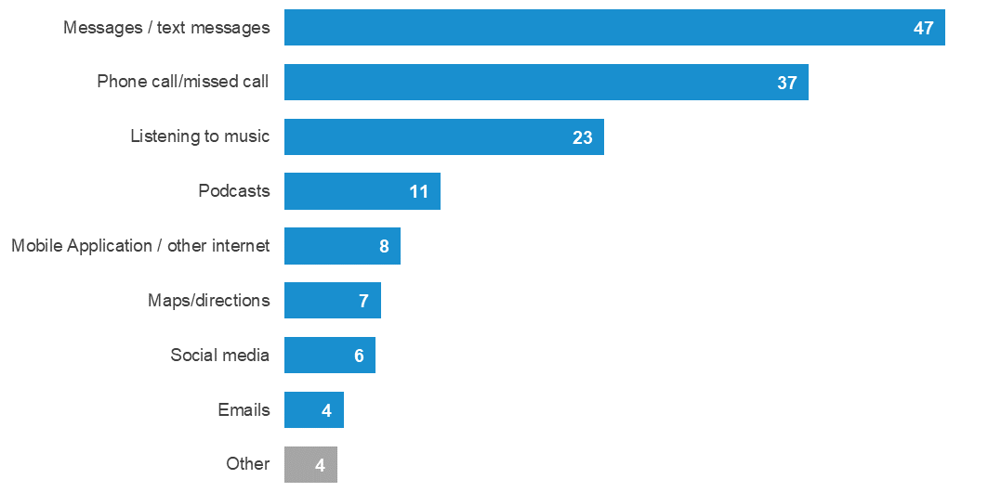
PED3 What was distracting you on your phone?
Filter: Distracted by mobile phone (at PED2); Weighted sample; base n=102
Figures may not add to 100% due to rounding.

Near misses due to pedestrian distractions
As shown in Table 43, one in ten respondents (11%) report ever having a ‘near miss’ with a vehicle because they were distracted when walking. Younger respondents aged 18-25 (19%) and 26-39 (18%) are more likely to have experienced near misses due to distractions compared to the older respondents aged 40-60 (7%) and 61-90 (6%).
Table 43 Near misses due to pedestrian distractions by demographic

Column % |  | Age |  |  |  | Gender |  | Location
Column % | Total | 18 - 25 | 26 - 39 | 40 - 60 | 61 - 90 | Male | Female | Major Urban | Other Urban | Rural Balance
Yes | 11 | 19 ↑ | 18 ↑ | 7 ↓ | 6 ↓ | 12 | 11 | 11 | 15 | 7
No | 89 | 81 ↓ | 82 ↓ | 93 ↑ | 94 ↑ | 88 | 89 | 89 | 85 | 93
Sample size | 706 | 114 | 176 | 250 | 166 | 351 | 355 | 345 | 232 | 129
PED4 Have you ever had a 'near miss', where you were almost hit by a vehicle, when you were walking because you were distracted?
Weighted sample; base n=706
Blue up arrows (↑) and red down arrows (↓) indicate statistically significant difference compared to respondents not in that category
Figures may not add to 100% due to rounding.

Police enforcement

Avoiding being caught
Views were polarised regarding how easy or difficult it is for people to be caught drink driving, driving over the speed limit, drug driving or using a mobile phone when driving.
As shown in Figure 21, over two thirds of respondents (66%) say the police are effective in catching drivers who are driving above posted speed limit or the legal BAC level. Only about half of respondents (50%) say the police are effective in catching drivers who are using illegal drugs.
The findings do not vary significantly by demographic or by category of risky driving behaviour.
Figure 21 Effectiveness of police in catching someone while driving illegally
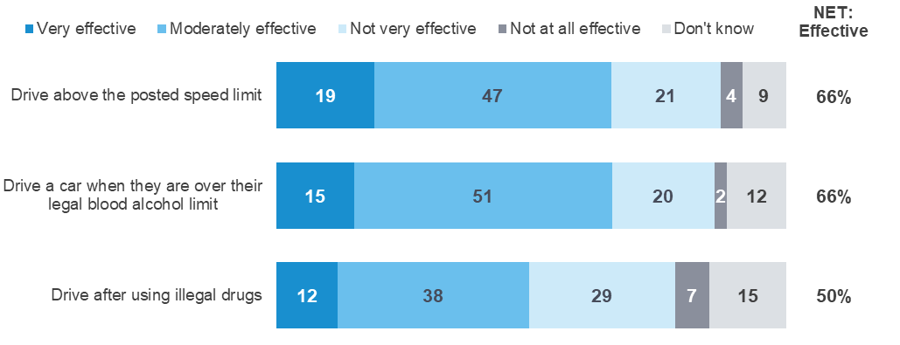
EN8 - Effectiveness of police in catching someone who drives.
Weighted sample; base n = from 1367 to 1371
As shown in the Table 44, respondents aged 18-25 (56%) report that police are less likely to be effective in catching people driving above the posted speed limit compared to the average respondent.
The findings do not vary significantly by other demographic or by category of risky driving behaviour.
Table 44 Perception of police effectiveness by demographic

Column % |  | Age |  |  |  | Gender |  | Location
Column % | Total | 18 - 25 | 26 - 39 | 40 - 60 | 61 - 90 | Male | Female | Major Urban | Other Urban | Rural Balance
Drive above the posted speed limit | 66 | 56 ↓ | 67 | 68 | 68 | 68 | 64 | 65 | 68 | 68
Drive a car when they are over their legal blood alcohol limit | 66 | 65 | 62 | 68 | 67 | 67 | 65 | 65 | 64 | 72
Drive after using illegal drugs | 50 | 51 | 50 | 49 | 49 | 50 | 49 | 49 | 49 | 53
Sample size | 1371 | 204 | 334 | 486 | 347 | 671 | 700 | 685 | 466 | 220
EN8 - Effectiveness police in catching someone who drives - (% Very / moderately effective)
Weighted sample; base n=1371

Perceptions of police
Respondents were asked whether they agreed or disagreed with three statements regarding police and police enforcement. Overall, attitudes to police enforcement among respondents are positive, with the majority agreeing that:
- ‘Police play an important role in reducing fatal crashes on Victoria’s roads’ (65% of respondents)
- ‘Seeing police on the roads makes me feel safer’ (60% of all respondents, and 72% of respondents aged 61-90 compared to 42% among those aged 18 – 25 and 55% among those aged 26 – 39)
About three in ten (29%) respondents agree that enforcing speed limits just raises revenue and does not make our roads any safer.
Table 45 Perceptions of police by demographic

Column % |  | Age |  |  |  | Gender |  |  | Location
Column % | Total | 18 - 25 | 26 - 39 | 40 - 60 | 61 - 90 |  | Male | Female |  | Major Urban | Other Urban | Rural Balance
Police play an important role in reducing fatal crashes on Victoria's roads | 65 | 58 | 66 | 67 | 66 |  | 66 | 65 |  | 65 | 66 | 66
Seeing police on the roads makes me feel safer | 60 | 42 ↓ | 55 ↓ | 64 | 72 ↑ |  | 60 | 61 |  | 60 | 61 | 65
Enforcing speed limits just raises revenue and doesn't make our roads any safer | 29 | 25 | 32 | 27 | 32 |  | 32 | 27 |  | 29 | 29 | 33
Sample size | 1373 | 205 | 334 | 487 | 347 |  | 672 | 701 |  | 687 | 467 | 220
EN2 - Enforcement (attitudes towards police (agreement))
Weighted sample: base n=1373
As shown in Table 46, there is a pattern of more negative views of police among those who engage in risky behaviour - in particular, among those who drink drive. Among those who drink drive only 46% indicate that seeing police on the roads makes them feel safer compared to 58% of speeders, 54% of those who drive fatigued, and 51% of illegal mobile phone users. These findings compare to 60% of all respondents who say that seeing police on the road makes them feel safer.
Both Speeders (32%, compared to non-speeders 26%) and those who drink drive (46%) are more likely to agree that enforcing speed limits just raises revenue and doesn’t make our roads any safer.
Table 46 Perceptions of police by behaviour

Column % |  | Speeding |  | Drink driving |  | Mobile phone use |  | Driving fatigued |  | Involvement in a crash
Column % | Total | Yes | No | Yes | No | Yes | No | Yes | No | Yes | No
Police play an important role in reducing fatal crashes on Victoria's roads | 65 | 63 ↓ | 69 ↑ | 57 | 66 | 60 ↓ | 68 ↑ | 61 ↓ | 69 ↑ | 64 | 66
Seeing police on the roads makes me feel safer | 60 | 58 ↓ | 66 ↑ | 46 ↓ | 62 ↑ | 51 ↓ | 65 ↑ | 54 ↓ | 67 ↑ | 57 | 61
Enforcing speed limits just raises revenue and doesn't make our roads any safer | 29 | 32 ↑ | 26 ↓ | 46 ↑ | 29 ↓ | 31 | 29 | 33 ↑ | 26 ↓ | 30 | 29
Sample size | 1373 | 720 | 586 | 62 | 1275 | 380 | 958 | 601 | 711 | 195 | 1168
EN2 - Enforcement (attitudes towards police (agreement))
Weighted sample: base n=1373

Perception of police presence
In Jan-Mar 2021 and Oct-Dec 2021, respondents were asked whether they believe there are fewer, more or the same number of police on the roads compared to the same time a year ago. About a third of respondents (31%) say that the number of police on the roads has not changed, while about a quarter (22%) say there are more police on the roads. Only 24% say there are less police on the roads and about a quarter (22%) are unsure as to whether there has been a change or not.
The perception that there are more police on the road has increased from 2018 (16%) to 2019 (20%) and 2020 (24%), with a slight decrease in 2021 (22%).The perception of a change in the number of police on the roads differs by age: 18-25 year olds (35%) are more likely to say the number of police on the roads has increased, while only 17% of 61-90 year olds are likely to say that the number has increased.
Table 47 Perception of police presence by demographic

Column % |  | Age |  |  |  | Gender |  | Location
Column % | Total | 18 - 25 | 26 - 39 | 40 - 60 | 61 - 90 | Male | Female | Major Urban | Other Urban | Rural Balance
More | 22 | 35 ↑ | 26 | 18 ↓ | 17 ↓ | 25 ↑ | 19 ↓ | 23 | 22 | 19
Same | 31 | 26 | 39 ↑ | 31 | 26 | 34 | 29 | 29 ↓ | 36 ↑ | 40 ↑
Fewer | 24 | 17 ↓ | 17 ↓ | 28 ↑ | 31 ↑ | 22 | 27 | 25 | 25 | 20
Don't know | 22 | 21 | 19 | 23 | 26 | 19 ↓ | 25 ↑ | 23 ↑ | 18 ↓ | 21
Sample size | 1374 | 205 | 334 | 487 | 348 | 673 | 701 | 689 | 466 | 219
POL1 Do you believe that compared to this time last year, there are fewer, more or the same number of police on the roads?
Weighted sample: base n = 1374

Interaction with police on the roads
Respondents were asked how often they had interactions with police on the road, including being pulled over, breath-tested or drug-tested.
Breath testing is the most common interaction with more than half of drivers (33%) reporting they had a breath test while driving in the past 12 months. The next most common interaction was being pulled over by police for any reason (24%), followed by being drug-testing while driving (4%).
Table 48 Interaction with police on the roads (NET and frequency)

Row % | Not at all in the past 12 months | NET: At all | Once in the past 12 months | Twice in the past 12 months | Three or more times in the past 12 months | Don't  know | Sample  size
Pulled over by police for any reason | 75 ↓ | 24 ↑ | 16 | 6 | 3 ↑ | 1 | 1329
Breath-tested while driving | 67 ↓ | 33 ↑ | 22 ↑ | 8 ↑ | 2 | 1 | 1330
Drug-tested while driving | 96 ↑ | 4 ↓ | 3 ↓ | 1 ↓ | 0 ↓ | 0 | 1328
EN3 In the past 12 months, how many times have you been X (Summary)
Weighted sample. base n = from 1328 to 1330

Social norms
A new section was added to the RSM in 2019 (and continued in 2021) that asked how often respondents thought their friends or family engage in illegal or dangerous driving behaviour. The following three behaviours were presented to respondents:
- Intentionally driving above the posted speed limit in a 60 km/h zone
- Driving while drowsy
- Intentionally driving while over their legal BAC.
As shown in Figure 22, more than half of respondents (66%) think that friends or family have ever intentionally driven above the speed limit in a 60km/hr zone. A similar percentage (65%) think they have ever driven while very tired. In contrast, a smaller percentage (18%) think they intentionally drive while over their legal BAC.
However, between 12% and 15% of respondents say they ‘don’t know’ how often friends or family engage in the three behaviours.
Figure 22 Frequency of friends engaging dangerous driving
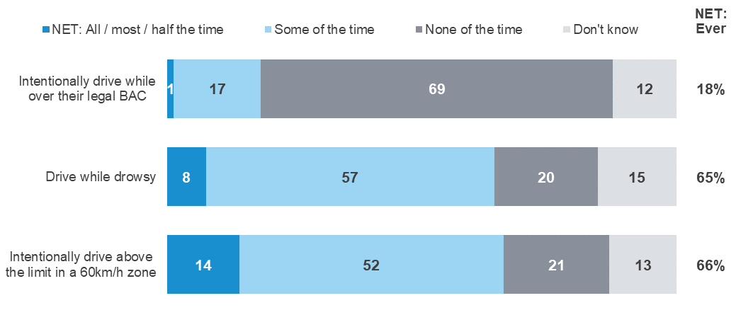
DB4 Now thinking about how your friends drive, how do you think your friends would…
Weighted sample; base from n=1315 to 1318

As shown in Table 49, the percentage of respondents who think that friends or family intentionally drive over the speed limit in a 60 km/h zone is highest for respondents aged 18-25 (79%) and declines with age; respondents aged 61-90 (51%) are least likely to think that their friends and family ever engage in this behaviour. A similar trend is evident for respondents who think their friends or family drive while drowsy; 79% of those aged 18-25, decreasing to 49% of those aged 61-90. Those aged 18-25 are also more likely than the average respondent to believe their friends/family intentionally drive while over their legal BAC.
Table 49 Frequency of friends engaging dangerous driving by demographic

Column % |  | Age |  |  |  | Gender |  | Location
Column % | Total | 18 - 25 | 26 - 39 | 40 - 60 | 61 - 90 | Male | Female | Major Urban | Other Urban | Rural Balance
Intentionally drive above the limit in a 60km/h zone | 65 | 79 ↑ | 76 ↑ | 61 ↓ | 51 ↓ | 66 | 65 | 66 | 63 | 65
Drive while drowsy | 64 | 79 ↑ | 73 ↑ | 62 | 49 ↓ | 62 | 66 | 63 | 68 | 66
Intentionally drive while over their legal BAC | 18 | 26 ↑ | 20 | 16 | 14 | 18 | 18 | 17 ↓ | 21 | 25 ↑
Sample size | 1355 | 217 | 333 | 473 | 334 | 673 | 682 | 683 | 437 | 236
DB4 How often you think friends/family would…
Weighted sample; base n=1355
As shown in Table 50, respondents who engage in illegal or dangerous driving behaviour themselves (described in the column headings) are more likely to think their friends or family ever engage in the three behaviours described above (shown in the row labels). This finding is consistent across all illegal or dangerous behaviours. Respondents who have been involved in a crash (74%, compared to those who have not 64%) are more likely to think their friends or family ever engaged in speeding in a 60km/h zone.
Table 50 Frequency of friends engaging dangerous driving by behaviour

Column % |  | Speeding |  | Drink driving |  | Mobile phone use |  | Driving fatigued |  | Involvement in a crash
Column % | Total | Yes | No | Yes | No | Yes | No | Yes | No | Yes | No
Intentionally drive above the limit in a 60km/h zone | 65 | 81 ↑ | 46 ↓ | 81 ↑ | 65 ↓ | 78 ↑ | 61 ↓ | 76 ↑ | 58 ↓ | 74 ↑ | 64 ↓
Drive while drowsy | 64 | 74 ↑ | 51 ↓ | 77 | 64 | 80 ↑ | 58 ↓ | 87 ↑ | 45 ↓ | 70 | 63
Intentionally drive while over their legal BAC | 18 | 23 ↑ | 11 ↓ | 51 ↑ | 17 ↓ | 29 ↑ | 14 ↓ | 27 ↑ | 11 ↓ | 20 | 18
Sample size | 1355 | 760 | 536 | 55 | 1263 | 377 | 941 | 649 | 650 | 188 | 1157
DB4 Now thinking about how your friends drive, how often do you think your friends would…
Total sample; Weighted sample; base n=1355
Figures may not add to 100% due to rounding

Infrastructure
Respondents were asked the extent to which they supported or opposed the building of more infrastructure of five types: centreline rumble strips, barriers (both centreline and roadside).
As shown in Figure 23, respondents are most supportive of a further roll-out of centreline rumble strips, with support at 93%. Seven in ten respondents (73%) ‘completely support’ building more centreline rumble strips.
Of the other infrastructure types considered, both centreline and roadside barriers had the next highest level of support. Flexible roadside barriers are supported by eight in ten respondents (85%) with more than half (56%) ‘completely’ supporting this type of infrastructure. Building more centreline barriers has a similar percentage of support with eight in ten (83%) supportive of building more, and over half of respondents (56%) ‘completely’ supporting this.
Figure 23 Support for road safety infrastructure
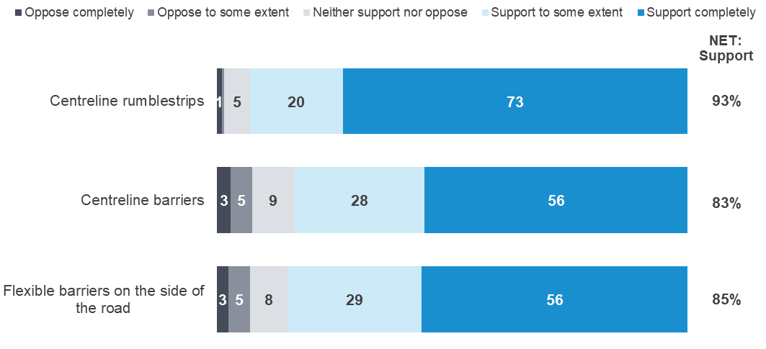
P1_Support for infrastructure (summary)
Weighted sample; base n = from 672 to 682;

Towards zero

Reaching zero

Belief that Victoria should aim for zero lives lost
Respondents were asked whether Victoria should aim for zero road deaths. A majority of respondents (79%) say that Victoria should aim for zero road deaths.
Belief that Victoria should aim for zero road deaths is highest among:
- Respondents aged 18-25 years old (81% vs 77% of 61–90-year-olds)
- Females (82% vs 76% of males)
- Respondents living in Other Urban areas (81% vs Major Urban: 79% and Rural Balance: 77%).
Table 51 Belief that Victoria should aim for zero by demographic

Column % |  | Age |  |  |  | Gender |  | Location
Column % | Total | 18 - 25 | 26 - 39 | 40 - 60 | 61 - 90 | Male | Female | Major Urban | Other Urban | Rural Balance
Yes | 79 | 81 | 79 | 79 | 77 | 76 ↓ | 82 ↑ | 79 | 81 | 77
No | 13 | 11 | 14 | 13 | 14 | 17 ↑ | 10 ↓ | 13 | 14 | 15
Don't know | 7 | 7 | 6 | 7 | 7 | 6 | 7 | 7 | 4 ↓ | 8
Sample size | 2062 | 313 | 504 | 722 | 523 | 1007 | 1055 | 1031 | 690 | 341
TZ1 Should Victoria aim for zero road deaths?
Filter: All respondents excl. refused and not answered; Weighted sample; base n=2062
Blue up arrows (↑) and red down arrows (↓) indicate statistically significant difference compared to respondents not in that category.
Figures may not add to 100% due to rounding.

Lowest number of lives lost on Victorian roads in the next 30 years
Respondents were asked what they thought the lowest number of lives lost in a single year could be achieved within the next 30 years. Respondents were given options of zero lives lost, between one and twenty lives lost or more than twenty. The results are shown in Figure 24.
Overall, about half of respondents (51%) think that, within the next 30 years, twenty or fewer lives will be lost on Victorian roads. The remaining 49% believe that more than 20 lives will be lost each year. Only 12% of respondents think that zero lives lost could be achieved in a year within the next 30 years.
Figure 24 Lowest achievable number of lives lost in one year over the next 30 years
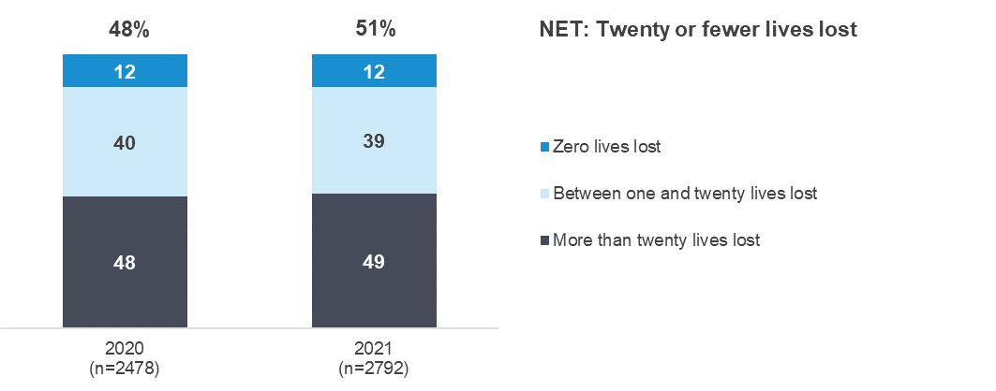
TZ8 Within the next 30 years, which of the following do you think can be achieved in one year?
Filter: All respondents excl. refused and not answered; weighted sample; base n= 2792
As shown in Table 52, belief regarding the lowest loss of life on the road that can be achieved in one year, within the next 30 years, varies by demographic. Respondents aged 18-25 (62%) and those aged 26-39 (58%) are most likely to think that Victoria could achieve a year with fewer than 20 lives lost within the next 30 years. Those aged over 60 years (42%) are the least likely. Females (55%) are also more likely to think that fewer than 20 lives lost could be achieved within the next 30 years than males (47%).
Table 52 Lowest number of lives lost within one year by demographic

Column % |  | Age |  |  |  | Gender |  | Location
Column % | Total | 18 - 25 | 26 - 39 | 40 - 60 | 61 - 90 | Male | Female | Major Urban | Other Urban | Rural Balance
Zero lives lost | 12 | 9 | 16 ↑ | 13 | 8 ↓ | 12 | 12 | 12 | 12 | 12
Between one and twenty lives lost | 39 | 53 ↑ | 42 | 34 ↓ | 33 ↓ | 34 ↓ | 43 ↑ | 40 ↑ | 35 | 34
NET: Zero / Twenty or fewer lives lost | 51 | 62 ↑ | 58 ↑ | 47 ↓ | 42 ↓ | 47 ↓ | 55 ↑ | 52 ↑ | 47 ↓ | 46
More than twenty lives lost | 49 | 38 ↓ | 42 ↓ | 53 ↑ | 58 ↑ | 53 ↑ | 45 ↓ | 48 ↓ | 53 ↑ | 54
Sample size | 2792 | 426 | 671 | 979 | 716 | 1369 | 1423 | 1366 | 957 | 469
TZ8 Within the next 30 years, which of the following do you think can be achieved in one year
Filter: All respondents excl. refused and not answered; weighted sample; base n=2792
Blue up arrows (↑) and red down arrows (↓) indicate statistically significant difference compared to respondents not in that category
Figures may not add to 100% due to rounding

Community understanding of the number of fatalities and serious injuries on Victorian roads
Since Oct-Dec 2018, respondents have been asked how many people they believed die each year due to crashes on Victorian roads. There is a wide range of responses. Only 8% of respondents give a response of between 201 and 250, which is close to the actual number of fatalities in 2021 (232). About one in ten respondents (12%) say there are less than 100 deaths each year due to crashes while 15% say there are more than 300 deaths per year. Nearly a third of respondents (34%) say they ‘don’t know’.
Figure 25 Community understanding of the number of road fatalities per year
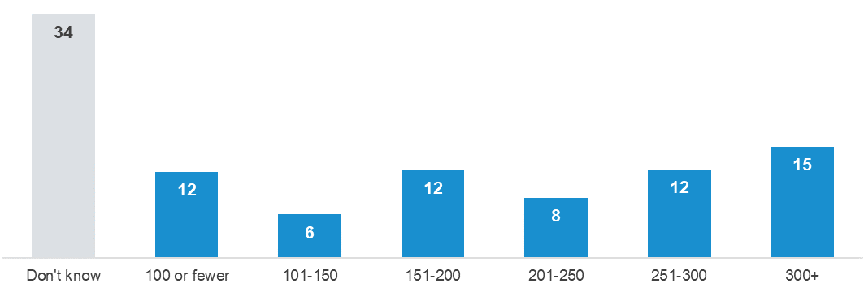
TZ6 How many people do you believe die each year due to crashes on Victorian roads?
Filter: All respondents excl. refused and not answered; Weighted sample; base n=2669
Respondents were also asked how many people they believed were seriously injured last year due to crashes on Victorian roads. Many respondents (40%) were unable to provide an answer. The remainder of responses were split somewhat equally between the categories.
Figure 26 Community understanding of the number of serious injuries per year
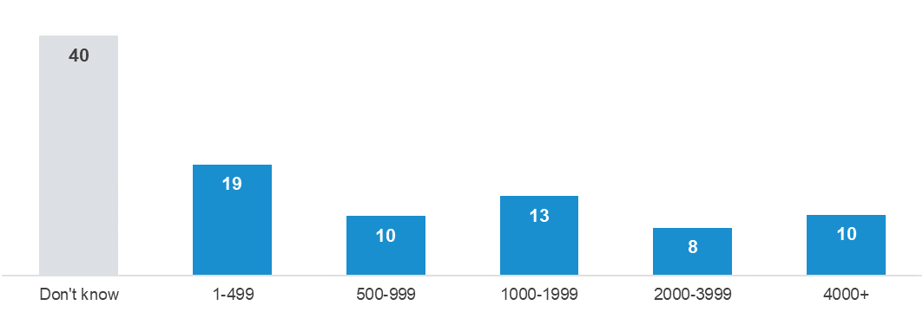
TZ11 How many serious injuries as a result of traffic crashes do you believe happened last year on Victorian roads?
Filter: All respondents excl. refused and not answered; Weighted sample; base n=1736

Crashes
This section discusses the frequency of being involved in a crash on the road as a driver or rider (in the last five years) and subsequent changes in behaviour.

Involvement in a crash in the past five years
As shown in Table 53, almost one in five respondents (16%) report that they had been involved in any crashes on the road as a driver or rider in the last five years. Younger drivers aged 18-25 (21%) are the most likely to have been involved in any crashes on the road as a driver or rider in the last five years. There is a consistent decline, by age, in the percentage of respondents who have been involved in a crash; respondents aged 61-90 (12%) are the least likely to have been involved in a crash in the last five years.
Additionally, crashes are more likely to have happened to those residing in Major Urban areas (17%) than other areas (13% in Other Urban areas, and 12% in Rural Balance areas).
Table 53 Involvement in crash in the last five years by demographic

Column % |  | Age |  |  |  | Gender |  | Location
Column % | Total | 18 - 25 | 26 - 39 | 40 - 60 | 61 - 90 | Male | Female | Major Urban | Other Urban | Rural Balance
Yes | 16 | 21 ↑ | 19 ↑ | 13 ↓ | 12 ↓ | 17 | 15 | 17 ↑ | 13 ↓ | 12 ↓
No | 84 | 79 ↓ | 81 ↓ | 87 ↑ | 88 ↑ | 83 | 85 | 83 ↓ | 87 ↑ | 88 ↑
Sample size | 2797 | 423 | 669 | 980 | 725 | 1367 | 1430 | 1362 | 965 | 470
CR1 - In the last five years, have you been involved in any crashes on the road as a driver or rider?
Filter: Driver; Weighted sample; base n=2797
Blue up arrows (↑) and red down arrows (↓) indicate statistically significant difference compared to respondents not in that category.
Figures may not add to 100% due to rounding.
As shown in Table 54, respondents who engage in dangerous or illegal behaviours such as illegal mobile phone use (see Section 1.3 for definitions) (20%) are also more likely to have been involved in any crashes on the road in the last five years than non-users (14%). Respondents who don't drive after using recreational drugs (15%, 30% for those who engage in drug driving) are less likely to be involved in crashes.
Table 54 Involvement in crash in the past five years by behaviour

Column % |  | Speeding |  | Drink driving |  | Mobile phone use |  | Driving fatigued |  | Drug Driving
Column % | Total | Yes | No | Yes | No | Yes | No | Yes | No | Yes | No
Yes | 16 | 17 | 14 | 21 | 15 | 20 ↑ | 14 ↓ | 17 | 15 | 30 | 15 ↓
No | 84 | 83 | 86 | 79 | 85 | 80 ↓ | 86 ↑ | 83 | 85 | 70 | 85 ↑
Sample size | 2797 | 1501 | 1151 | 123 | 2598 | 783 | 1939 | 1267 | 1406 | 39 | 2545
CR1 - In the last five years, have you been involved in any crashes on the road as a driver or rider?
Filter: Driver; Weighted sample; base n=2797
Blue up arrows (↑) and red down arrows (↓) indicate statistically significant difference compared to respondents not in that category.
Figures may not add to 100% due to rounding.

As shown in Figure 29, respondents say that the main causes of serious injury and loss of life on Victorian roads are distractions (41%), impaired driving (33%) and speeding (32%).
Figure 27 Main cause of serious injury and loss of life in Victoria
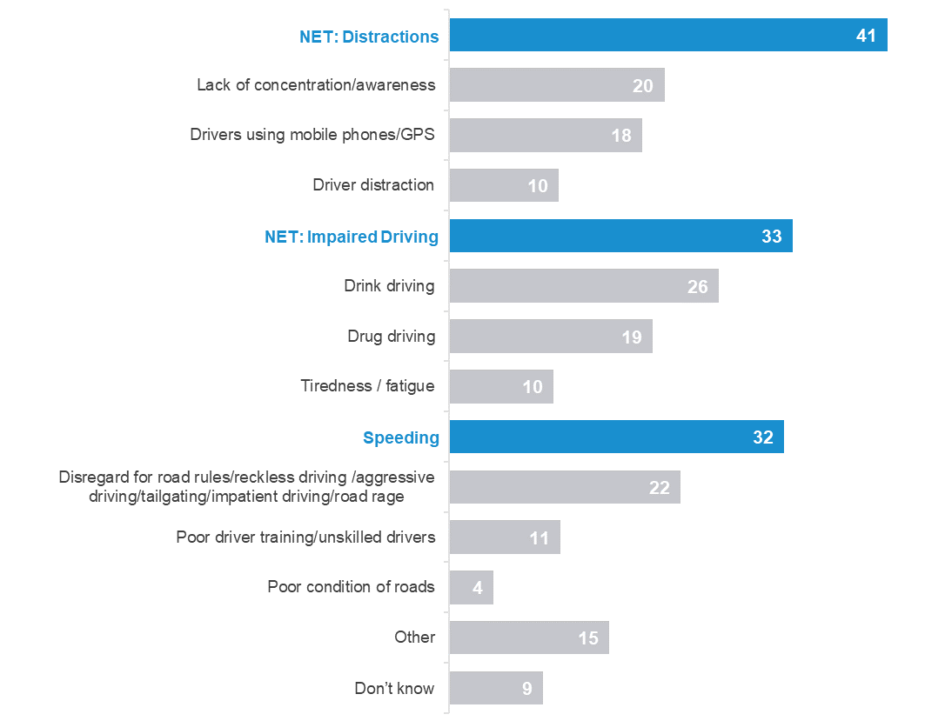
TOP1 - What do you think is the main cause of serious injury and loss of life on Victorian roads?
Weighted sample; base n = 2717

Injury requiring hospitalisation
As shown in Figure 28, respondents who had been involved in a crash in the past five years were asked whether anyone was injured to the point where they needed to go to the hospital. Two percent (2%) say they were involved in a crash resulting in injury requiring hospitalisation and a further one in seven (14%) were involved in a crash that did not result in injury requiring hospitalisation (in the last five years).
Figure 28 Someone Injured in a car crash to the point of going to hospital by year
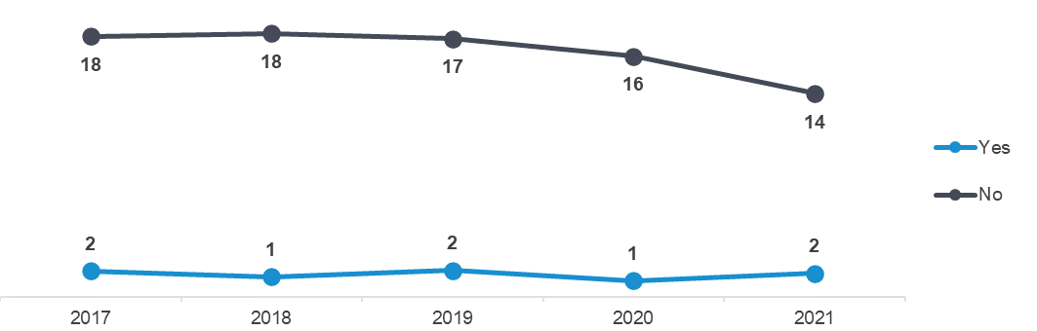
CR2 Was anyone involved in any of the crash(es) injured to the point where they needed to go to hospital?
Total Sample; Weighted sample; base n=2,814

Change in behaviour after a crash
As shown in Table 55, respondents who had been in a crash were asked whether they had changed how they drive or ride since the crash. Over half of respondents (60%) indicate that they had changed how they drive or ride. Females (70%) report to be more likely to change after crashes than males (48%). Respondents aged 40-60 (36%) are the least likely to change the way they drive or ride, while respondents in other age groups are almost twice as likely to change after crashes.
Also, other analysis shows that there are no differences by driving behaviour.
Table 55 Change in behaviour after a crash by demographic

Column % |  | Age |  |  |  | Gender |  | Location
Column % | Total | 18 - 25 | 26 - 39 | 40 - 60 | 61 - 90 | Male | Female | Major Urban | Other Urban | Rural Balance
Yes | 60 | 70 | 68 | 36 ↓ | 70 | 48 ↓ | 70 ↑ | 63 | 46 | 60
No | 36 | 16 | 28 | 64 ↑ | 30 | 49 ↑ | 24 ↓ | 31 | 50 | 40
Don't know | 5 | 14 | 4 | 0 | 0 | 3 | 6 | 5 | 4 | 0
Sample size | 108 | 26* | 36 | 30 | 16* | 50 | 58 | 51 | 37 | 20*
CR3 - Since the crash, have you changed how you drive or ride?
Filter: Involved in a crash in the past five years; Weighted sample; base n=108
Blue up arrows (↑) and red down arrows (↓) indicate statistically significant difference compared to respondents not in that category.
Figures may not add to 100% due to rounding.
*Note: Base sizes <30 risk a high degree of interpretation error, take inferences from these with caution.

Seatbelts

Wearing of seatbelts when driving a vehicle fitted with them
As shown in Table 56 almost all drivers (97%) report wearing a seatbelt ‘all the time’ in the last three months when driving. There are no significant differences in the likelihood of wearing a seatbelt by age, gender or location.
Table 56 Wearing seatbelts while driving by demographic

Column % |  | Age |  |  |  | Gender |  | Location
Column % | Total | 18 - 25 | 26 - 39 | 40 - 60 | 61 - 90 | Male | Female | Major Urban | Other Urban | Rural Balance
None / Some / Half / Most of the time | 3 | 4 | 4 | 2 | 3 | 3 | 2 | 3 | 3 | 4
All of the time | 97 | 96 | 96 | 98 | 97 | 97 | 98 | 97 | 97 | 96
Sample size | 2710 | 404 | 648 | 969 | 689 | 1331 | 1379 | 1309 | 938 | 463
DB3 Thinking about the past three months, how often did you wear a seatbelt when driving a car?
Weighted sample; base n=2710
Blue up arrows (↑) and red down arrows (↓) indicate statistically significant difference compared to respondents not in that category.
Figures may not add to 100% due to rounding.
As shown in Table 60, respondents who have driven while over their legal BAC in the last 12 months (‘drink drivers’: 93%) are less likely to wear a seatbelt all of the time while driving compared to respondents who do not ‘drink drive’ (97%). Respondents who have involved in crashes (96%, compared to those who have not 98%) are less likely to wear a seatbelt all of the time while driving.
Table 57 Wearing seatbelts while driving by behaviour

Column % |  | Speeding |  | Drink driving |  | Mobile phone use |  | Driving fatigued |  | Involvement in a crash
Column % | Total | Yes | No | Yes | No | Yes | No | Yes | No | Yes | No
None / Some / Half / Most of the time | 3 | 3 | 3 | 7 ↑ | 3 ↓ | 4 | 2 | 3 | 3 | 4 ↑ | 2 ↓
All of the time | 97 | 97 | 97 | 93 ↓ | 97 ↑ | 96 | 98 | 97 | 97 | 96 ↓ | 98 ↑
Sample size | 2710 | 1497 | 1149 | 123 | 2584 | 785 | 1923 | 1264 | 1401 | 402 | 2294
DB3 Thinking about the past three months, how often did you wear a seatbelt when driving a car?
Weighted sample; base n=2710
Blue up arrows (↑) and red down arrows (↓) indicate statistically significant difference compared to respondents not in that category.
Figures may not add to 100% due to rounding.

Wearing of seatbelts when a passenger
As shown in Table 61 almost all respondents (97%) always wear a seatbelt when they are a passenger in a car or other vehicle. There are no significant differences by demographic.
Table 58 Wearing a seatbelt while travelling in a vehicle as passenger by demographic

Column % |  | Age |  |  |  | Gender |  | Location
Column % | Total | 18 - 25 | 26 - 39 | 40 - 60 | 61 - 90 | Male | Female | Major Urban | Other Urban | Rural Balance
None / Some / Half / Most of the time | 3 | 5 | 3 | 2 | 2 | 3 | 3 | 3 | 2 | 3
All of the time | 97 | 95 | 97 | 98 | 98 | 97 | 97 | 97 | 98 | 97
Sample size | 2631 | 410 | 636 | 931 | 654 | 1268 | 1363 | 1284 | 907 | 440
DB3 Thinking about the past three months, how often did you wear a seatbelt when you were a passenger in a car or other vehicle fitted with seatbelts?
Weighted sample; base n=2631
Blue up arrows (↑) and red down arrows (↓) indicate statistically significant difference compared to respondents not in that category.
Figures may not add to 100% due to rounding.
As shown in Table 56, while travelling in a vehicle as a passenger, respondents who don’t drink drive (97%) are more likely than those who do (93%) to wear a seatbelt all of the time. Respondents who haven’t be involved in a crash (98%) are also more likely than those who have (96%) to wear a seatbelt when travelling as a passenger.
Table 59 Wearing a seatbelt while travelling in a vehicle as passenger by behaviour

Column % |  | Speeding |  | Drink driving |  | Mobile phone use |  | Driving fatigued |  | Involvement in a crash
Column % | Total | Yes | No | Yes | No | Yes | No | Yes | No | Yes | No
None / Some / Half / Most of the time | 3 | 3 | 3 | 7 ↑ | 3 ↓ | 4 | 2 | 3 | 3 | 4 ↑ | 2 ↓
All of the time | 97 | 97 | 97 | 93 ↓ | 97 ↑ | 96 | 98 | 97 | 97 | 96 ↓ | 98 ↑
Sample size | 2710 | 1497 | 1149 | 123 | 2584 | 785 | 1923 | 1264 | 1401 | 402 | 2294
DB3 Thinking about the past three months, how often did you wear a seatbelt when you were a passenger in a car or other vehicle fitted with seatbelts?
Weighted sample; base n=2710
Blue up arrows (↑) and red down arrows (↓) indicate statistically significant difference compared to respondents not in that category
Figures may not add to 100% due to rounding.

Cycling
As shown in Figure 29, respondents are more likely to have a positive view of the interactions between cyclists and drivers, but a polarized view of cyclists. For example,
- Respondents are more likely to agree that cyclists and drivers show each other courtesy on the roads (64% vs 12% who disagree).
- Agreement regarding the statement that cyclists are predictable in traffic is polarized, with slightly more people saying they disagree (35%) than agree (29%), and about two in five (36%) are uncertain.
Those in Major Urban areas are more likely to agree that cyclists and drivers show each other courtesy on the roads (66% vs. 60% Other Urban and 57% Rural Balance).
Figure 29 Agreement with statements relating to cyclists
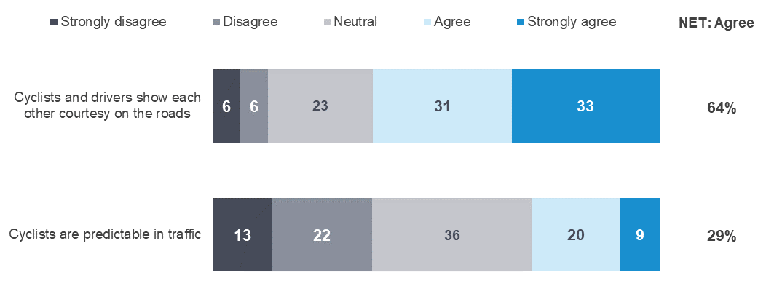
CYC1DE/CYC2CD - On a scale of 1 to 5, where 1 is “Strongly disagree” and 5 is “Strongly agree”, to what extent do you
Agree or disagree with the following statements
Filter: Total sample; base n = from 1037 to 1311

General attitudes to transport and road safety

Level of agreement with statements relating to roads and transport
Respondents were asked to consider three statements relating to attitudes and experiences concerning roads and transport, and to rate to what extent they agreed using a five-point scale of 1 “strongly disagree” to 5 “strongly agree”. The topics covered by these statements included attitudes to speed while driving and thoughts on the quality of driving. These questions were asked of a random sub-set of respondents.
As shown in Figure 30 Attitudes towards speeding statements, respondents’ attitudes relating to the importance of various facets of road safety align with some of the principles underpinning Towards Zero. More than nine in ten respondents (93%) agree with the statement that ‘I believe a safe journey is more important than a quick journey’ and 86% agree with the statement ‘Even good drivers make mistakes’. However, less than two thirds of respondents (59%) agree with the statement that ‘How people drive is more important than road design in saving lives’.
Figure 30 Attitudes towards speeding statements
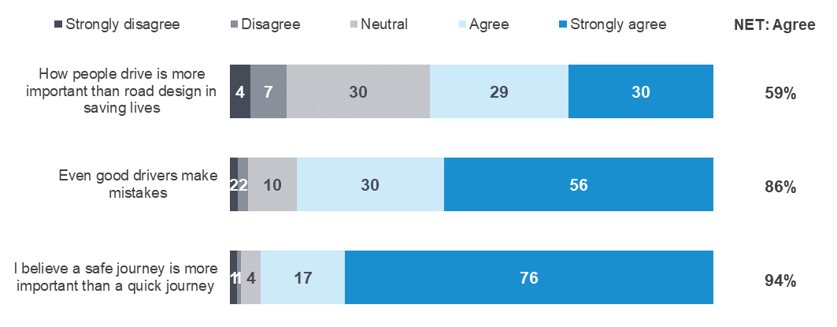
TZ4 - The following statements are about a broad range of attitudes and experiences relating to roads and transport. Please
state the extent to which you agree or disagree with these statements where 1 is “Strongly disagree” and 5 is “Strongly Agree”
Total sample; Weighted sample; base n= from 2700 to 2796
Figures may not add to 100% due to rounding

Attitudes towards travel speed
One statement concerning attitudes towards travel speed was also presented to respondents. Respondents were asked to rate the extent to which they agreed or disagreed with the statement using a five-point scale where 1 is ‘strongly disagree and 5 is ‘strongly agree’. Numbers in Table 60 and the following text are the percentages of respondents who nominated a point on the scale.
Respondents strongly agree (4.7) with the statement that ‘I believe a safe journey is more important than a quick journey’. Respondents aged 61-90 years are most likely to agree with this statement (4.8) than younger drivers, with drivers aged 18-25 (4.5) least likely to agree. Females (4.7) are more likely than males (4.6) to agree with the statement that safe journey is more important than a quick journey.
Table 60 Attitudes towards travel speed by demographic

Average |  | Age |  |  |  | Gender |  | Location
Average | Total | 18 - 25 | 26 - 39 | 40 - 60 | 61 - 90 | Male | Female | Major Urban | Other Urban | Rural Balance
I believe a safe journey is more important than a quick journey | 4.7 | 4.5 | 4.6 | 4.6 | 4.8 | 4.6 | 4.7 | 4.7 | 4.7 | 4.7
Sample size | 2796 | 424 | 672 | 981 | 722 | 1367 | 1429 | 1368 | 960 | 469
TZ4 - The following statements are about a broad range of attitudes and experiences relating to roads and transport. Please state the extent to which you agree or disagree with these statements where 1 is “Strongly disagree” and 5 is “Strongly Agree”
Total sample; Weighted sample: base n= 2796
Blue up arrows (↑) and red down arrows (↓) indicate statistically significant difference compared to respondents not in that category
As shown in Table 61, respondents who ever speed (4.5), drink drive (4.4), use a mobile phone illegally while driving (4.5) or drive fatigued (4.6) agree to a lesser extent than those who do not engage in these behaviours that ‘I believe a safe journey is more important than a quick journey’, which is rated at 4.7 by all respondents (rated at 4.8 for those who don’t speed).

Table 61 Attitudes towards travel speed by behaviour

Average |  | Speeding |  | Drink driving |  | Mobile phone use |  | Driving fatigued |  | Involvement in a crash
Average | Total | Yes | No | Yes | No | Yes | No | Yes | No | Yes | No
I believe a safe journey is more important than a quick journey | 4.7 | 4.5 ↓ | 4.8 ↑ | 4.4 ↓ | 4.7 ↑ | 4.5 ↓ | 4.7 ↑ | 4.6 ↓ | 4.7 ↑ | 4.7 | 4.7
Sample size | 2708 | 1496 | 1143 | 123 | 2585 | 784 | 1924 | 1267 | 1394 | 402 | 2296
TZ4 - The following statements are about a broad range of attitudes and experiences relating to roads and transport. Please state the extent to which you agree or disagree with these statements where 1 is “Strongly disagree” and 5 is “Strongly Agree”
Weighted sample;
Blue up arrows (↑) and red down arrows (↓) indicate statistically significant difference compared to respondents not in that category

Quality of driving
Two statements concerning attitudes about the quality of respondents’ driving were also presented to respondents, using the same agree/disagree scale described in the previous section.
As shown in Table 62, most respondents agree (4.4) that ‘Even good drivers make mistakes’, Respondents aged 18-25 (4.5) are the most likely to agree with this statement. Fewer respondents (3.7) agree with the statement ‘How people drive is more important than road design in saving lives’. In contrast to the first statement, respondents aged 61-90 (4.1) are the most likely to agree.
Table 62 Attitudes towards quality of driving by demographic

Average |  | Age |  |  |  | Gender |  | Location
Average | Total | 18 - 25 | 26 - 39 | 40 - 60 | 61 - 90 | Male | Female | Major Urban | Other Urban | Rural Balance
How people drive is more important than road design in saving lives | 3.7 | 3.6 | 3.7 | 3.6 | 4.0 | 3.8 | 3.7 | 3.7 | 3.7 | 3.9
Even good drivers make mistakes | 4.4 | 4.5 | 4.4 | 4.3 | 4.3 | 4.4 | 4.4 | 4.4 | 4.4 | 4.4
Sample size | 2796 | 424 | 672 | 981 | 722 | 1367 | 1429 | 1368 | 960 | 469
TZ4 - The following statements are about a broad range of attitudes and experiences relating to roads and transport. Please state the extent to which you agree or disagree with these statements where 1 is “Strongly disagree” and 5 is “Strongly Agree”
Total sample; Weighted sample; base n=2796
Blue up arrows (↑) and red down arrows (↓) indicate statistically significant difference compared to respondents not in that category
As shown in Table 63, drivers who ever speed (3.7), drink drive illegally (3.5), use a hand-held mobile phone (3.5), respondents who drive while fatigued (3.7) are less likely to agree with the statement ‘How people drive is more important than road design in saving lives’ compared to those who do not speed (3.8), who do not drink drive (3.7), who do not use a hand-held mobile phone while driving (3.8), and those who don’t drive while fatigued (3.8).
Table 63 Attitudes towards quality of driving by behaviour

Average |  | Speeding |  | Drink driving |  | Mobile phone use |  | Driving fatigued |  | Involvement in a crash
Average | Total | Yes | No | Yes | No | Yes | No | Yes | No | Yes | No
Even good drivers make mistakes | 4.4 | 4.4 | 4.3 | 4.4 | 4.4 | 4.4 | 4.3 | 4.4 ↑ | 4.3 ↓ | 4.4 | 4.4
How people drive is more important than road design in saving lives | 3.7 | 3.7 ↓ | 3.8 ↑ | 3.5 ↓ | 3.7 ↑ | 3.5 ↓ | 3.8 ↑ | 3.7 ↓ | 3.8 ↑ | 3.7 | 3.7
Sample size | 2708 | 1496 | 1143 | 123 | 2585 | 784 | 1924 | 1267 | 1394 | 402 | 2296
TZ4 - Attitudes towards quality of driving (numeric)
Weighted sample
Blue up arrows (↑) and red down arrows (↓) indicate statistically significant difference compared to respondents not in that category

Perceived importance of statements relating to roads and transport
Respondents were asked to rate the importance of four statements related to transport and road safety by using a five-point scale where 1 was “not at all important” and 5 was “extremely important”. Numbers in the following tables and text are mean ratings out of 5, except for the percentages shown in Figure 31. The topics covered by these statements included the quality of the road and transport system, having access to different transport options, and attitudes to quality of life in nearby streets and the environment.
Figure 31 Relative importance of issues relating to roads and transport
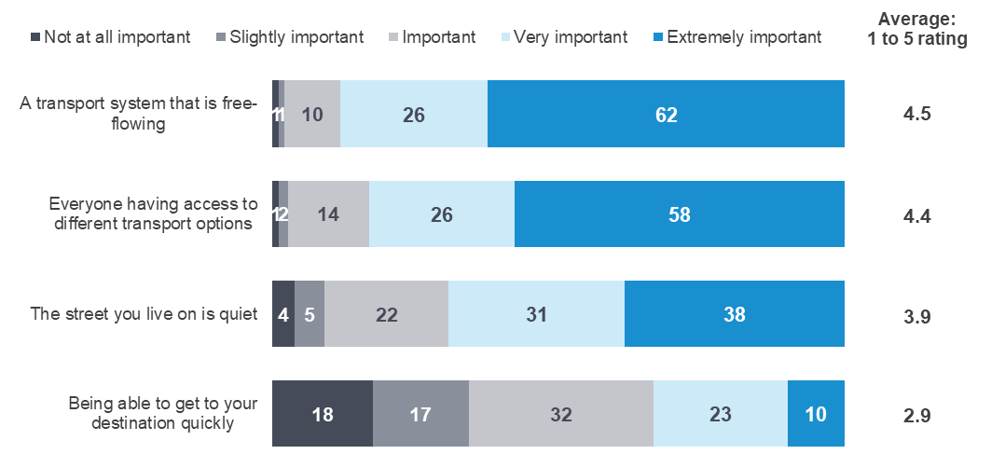
TZ5 - On a scale of 1 to 5, where 1 is “Not at all important”, and 5 is “Extremely important”, how important are the following things to you?
Total sample; Weighted sample; base n= from 692 to 707
Figures may not add to 100% due to rounding

Quality of the road and transport system
As shown in Figure 31, respondents say that the quality of the transport and road systems to be very important – with ‘a transport system that is free flowing’ (4.5) being considered extremely important by about two thirds of respondents (62%). Respondents’ views are more polarised concerning the statement ‘Being able to get to your destination quickly’ is important (2.9).
There are no significant demographic differences relating to the perceived importance of quality of road and transport system.
Table 64 Perceived importance of the quality of the road and transport system by demographic

Average |  | Age |  |  |  | Gender |  | Location
Average | Total | 18 - 25 | 26 - 39 | 40 - 60 | 61 - 90 | Male | Female | Major Urban | Other Urban | Rural Balance
A transport system that is free-flowing | 4.5 | 4.4 | 4.4 | 4.5 | 4.6 | 4.5 | 4.5 | 4.5 | 4.5 | 4.4
Being able to get to your destination quickly | 2.9 | 3.2 | 3.1 | 2.9 | 2.6 | 2.9 | 2.9 | 3.0 | 2.7 | 2.5
Sample size | 707 | 96 | 170 | 250 | 192 | 330 | 377 | 346 | 256 | 105
TZ5 - On a scale of 1 to 5, where 1 is “Not at all important”, and 5 is “Extremely important”, how important are the following things to you?
Total sample; Weighted sample; base n = from 692 to 707
Blue up arrows (↑) and red down arrows (↓) indicate statistically significant difference compared to respondents not in that category

Access to transport options
As shown in Table 65, about two thirds of the respondents (58%) state that it is extremely important for everyone to have access to different transport options, with an average score of 4.4. However, there are no significant demographic differences regarding the perceived importance of access to transport options.
Table 65 Perceived importance of the access to transport options by demographic

Average |  | Age |  |  |  | Gender |  | Location
Average | Total | 18 - 25 | 26 - 39 | 40 - 60 | 61 - 90 | Male | Female | Major Urban | Other Urban | Rural Balance
Everyone having access to different transport options | 4.4 | 4.4 | 4.4 | 4.3 | 4.4 | 4.3 | 4.4 | 4.4 | 4.2 | 4.2
Sample size | 707 | 96 | 170 | 250 | 192 | 330 | 377 | 346 | 256 | 105
TZ5 - On a scale of 1 to 5, where 1 is “Not at all important”, and 5 is “Extremely important”, how important are the following things to you?
Total sample; Weighted sample; base n=707
Blue up arrows (↑) and red down arrows (↓) indicate statistically significant difference compared to respondents not in that category

Quality of life and environment
As shown in table 71, close to two in five respondents (38%) perceived the statement ‘the street you live on is quiet’ as extremely important (3.9).
Table 66 Perceived importance of quality of life issues and the environment by demographic

Average |  | Age |  |  |  | Gender |  | Location
Average | Total | 18 - 25 | 26 - 39 | 40 - 60 | 61 - 90 | Male | Female | Major Urban | Other Urban | Rural Balance
The street you live on is quiet | 3.9 | 3.7 | 3.9 | 4.0 | 4.1 | 3.9 | 4.0 | 4.0 | 3.9 | 3.7
Sample size | 707 | 96 | 170 | 250 | 192 | 330 | 377 | 346 | 256 | 105
TZ5 - On a scale of 1 to 5, where 1 is “Not at all important”, and 5 is “Extremely important”, how important are the following things to you?
Total sample; Weighted sample; base n=707
Blue up arrows (↑) and red down arrows (↓) indicate statistically significant difference compared to respondents not in that category.

Summary of findings

How people get around
Frequency of driving and riding differs by age, gender and location.
While the majority of respondents (93%) drive a car at least weekly, respondents aged 18-25 are less likely to drive weekly (85% compared to 93% for all age groups). Females aged 18-25 (93%) and 26-39 (94%) are less likely to ever drive a car compared to younger males in the same age groups (97% and 98% respectively).
One in ten respondents (7%) ever ride a motorcycle on the road. Riding a motorcycle is more common amongst males (11% vs 3% of females) and in Rural Balance (12%) compared to Major Urban (6%) areas.
Over a third of respondents ride a bicycle on the road.
Over one in three of respondents (35%) ride a bicycle on the road, with one in ten (10%) doing so at least weekly. Cycling is more frequent among males (45% vs 25% of females) and among those aged 40-60 (43% vs 35% for all age groups combined).
Respondents in Rural Balance areas are the most likely to drive a heavy vehicle.
One in fourteen respondents (7%) ever drive a heavy vehicle on the road. The frequency of ever driving a heavy vehicle on the road is highest in Rural Balance areas (17%) and lowest in Major Urban areas (4%). Frequency of ever driving heavy vehicles is higher among males (13%) than females (2%).
Younger people and those living in Major Urban areas are most likely to use alternative transport.
Nearly eight in ten respondents (77%) ever use public transport. However, fewer than one in five respondents (16%) use public transport weekly. Weekly public transport users are most likely to be aged 18-25 years (31%) or to live in Major Urban areas (20%). The percentage of respondents who ever use commercial ride share (such as taxis or Uber) is lower than public transport (66%). About one in twenty (4%) use commercial ride share at least weekly. Younger respondents aged 18-25 (31%) and those living in Major Urban areas (20%) are the most likely to use commercial ride share at least weekly

Vehicle ownership
One in five respondents have purchased a new or used car in the past 12 months.
One in five respondents (20%) report that they had bought a car in the past 12 months, with respondents being more likely to buy a used car (12%). Those aged 18-25 years (25%) are more likely to purchase a car than older age groups, especially used cars (20%). When buying a car, respondents aged 18-25 are more interested in in-car systems (e.g. Bluetooth, sound systems), whereas respondents aged 61-90 place more value on vehicle safety features (74%).

Driving behaviour
Most respondents in paid employment commute to work by car.
About eight in ten of respondents (77%) in paid employment commute to work by car at least once a week.
Most respondents ever drive between 10pm and 6am, but young respondents do so more frequently.
About three quarters of respondents (77%) ever drive between 10pm and 6am, with about a quarter of all respondents (24%) doing so weekly. Driving between 10pm and 6am is most common among respondents aged 18-25 (36%).
Female drivers are more likely to feel stressed when driving than male drivers.
About seven in ten respondent drivers (69%) ever feel stressed while driving. Female drivers (74% compared to 64% of males) and those living in Major Urban areas (70% compared to 61% of those in Rural Balance areas) are more likely to ever feel stressed while driving.

Speeding
The perceived danger of driving above the posted speed limit is lower than for most other activities.
The perception of danger associated with driving a few kilometres over the posted speed limit is rated at 5.7 for a 60 km/h zone and 6.0 for a 100 km/h zone (on a 0-10 point scale). These ratings are lower than for riding a bicycle on urban roads (6.5), driving while very drowsy (8.9), driving while using a handheld mobile phone (9.2), or driving with an illegal BAC level (9.6). The danger of low-level speeding is rated lower by males (5.4 for both 60 km/h zones and 100 km/h zones) and those aged 18-25 (5.1 for 60 km/h zones and 5.7 for 100 km/h zones).
Most drivers feel guilty if they speed.
More than six in ten respondents (63%) agree that they feel guilty if they speed. A minority of drivers (4%) agree that they enjoy speeding. Just under half of drivers (49%) agree that they sometimes drive under the speed limit to reduce the chance of having an accident.
Most respondents do not drive above the speed limits.
While about six in ten respondents never drive above the speed limit (58% in a 60 km/h zone and 55% in a 100 km/h zone), a sizable minority do intentionally speed. One in ten respondents (12%) intentionally drive above the speed limit half the time or more often in a 100 km/h zone and slightly fewer (8%) do so in a 60km/h zone.
The percentage of drivers caught speeding has remained stable since 2018.
The percentage of drivers who report they have been caught speeding in the last twelve months declined from 19% in 2014 to 14% in 2017. Since then, the percentage of drivers caught speeding has remained constant at 13%.

Drugs and alcohol
Alcohol and drug usage is highest among males and younger age groups.
More than three quarters of drivers aged 18-60 years (77%) ever drink alcohol and 9% have used recreational drugs in the last twelve months. Among all drivers, males (79%) are more likely to ever drink alcohol than females (72%). Usage of recreational drugs in the last twelve months is higher among drivers aged 18-25 (17%) and 26-39 (9%) and lower among those aged 40-60 (6%) and 61-90 (2%).
About one in twenty drivers have driven while over their legal BAC in the past 12 months.
A minority of (4%) drivers report driving over their legal BAC in the past 12 months. About four in ten (43%) respondents report driving after drinking when they believed they were under their legal BAC and this behaviour is most likely among those aged 40-60 (53%) and males (47%). Drivers aged 18-25 are most likely to ‘never drive after drinking’ (42%). Fewer than 2% of respondents report driving or riding after taking recreational drugs
About one in ten (9%) respondents have used recreational drugs in the last 12 months. Demographically, recreational drug use is highest among those aged 18-25 (17%).

Fatigue
Respondents perceive driving while very tired to be dangerous.
The perceived level of danger associated with driving while very tired is rated at 8.9 (on a 0-10 point scale) This rating is the third highest for the activities measured and falls between ‘riding a bicycle on urban roads’ (6.5) and driving ‘while using a handheld mobile phone’ (9.2).
Driving while feeling very tired is prevalent among young drivers.
Over four in ten drivers (45%) reported driving while very tired in the past three months. Younger drivers aged 18-25 (59%) are the most likely to report driving while feeling very tired in the past three months, and one in ten (11%) do so half the time or more often.

Distractions
Illegal mobile phone usage has declined since 2016.
About seven in ten respondents (72%) used a mobile phone, including Bluetooth, while driving in the past three months. While two-thirds of drivers (66%) either made or answered a call legally using Bluetooth in the last three months, more than a quarter (29%) used a mobile phone illegally. There has been a decline in the percentage of drivers using a mobile phone illegally in the past few years, from 37% in 2016 to 29% in 2021.
Reading a text message while driving (23%) remains the most common illegal activity. Other uses of a mobile phone while driving are lower, answering a call using a hand-held (12%), writing and sending a text message (10%) and making a call (8%).

Pedestrian distractions
One-third of respondents crossed a street while listening to headphones.
Almost four in ten respondents (37%) report ever crossing the street while listening to headphones in the last three months. Eleven per cent (11%) do this at least half the time when they cross the street. Younger respondents aged 18-25 (31%) are most likely to do so at least half the time, compared to 6% of those aged 40-60 and none of those aged over 60.
About three in ten of respondents have crossed the street while looking at a mobile phone.
Close to three in ten respondents (29%) have crossed the street while looking at a mobile phone in the last three months. Respondents aged 18-25 (51%) and aged 26-39 (46%) are more likely to have done so than respondents aged 40-60 (22%) or 61-90 (7%).
The pedestrian environment provides a range of distractions which can lead to risky situations.
About three in ten respondents (29%) have been distracted by a mobile phone while they were walking around in the last week. However, the most common distractions were the ‘actions of other road users’ (45%) and ‘own thoughts or thinking about something not related to what you are doing’ (40%). One in ten respondents (11%) have had a ‘near-miss’ where they were almost hit by a vehicle while walking because they were distracted and it is more often experienced by younger respondents aged 18-39 (19%) than older respondents aged 40-90 (7%).

Enforcement
Police are more effective at catching speeders and drink drivers than drug drivers.
About two thirds of respondents (66%) say that Police are effective at catching people who drive above the posted limit or drive when they are over their legal BAC (66%). Half (50%) say they are effective at catching people who drive after using illegal drugs.
Respondents tend to hold positive attitudes towards police.
Two-thirds of respondents (65%) agree that police ‘play an important role in reducing fatal crashes’, and a similar percentage (60%) agree that ‘seeing police on the road makes them feel safer’. However, three in ten respondents (29%) agree that ‘enforcing speed limits just raises revenue and does not make our roads any safer’. Respondents aged 61-90 (72%) are the most likely to agree that seeing police on the roads make them feel safer.

Social norms
Respondents are more likely to think their friends speed than drive very tired or drive over their legal BAC.
Six in ten respondents (65%) think their friends/family ever intentionally drive above the limit in a 60 km/h zone, with 14% thinking they do this half the time or more often. About two thirds respondents (64%) think their friends/family ever drive while very tired, although only 8% believe they do this half the time or more often. Around one in six (18%) think their friends/family ever drive while over their legal BAC.

Infrastructure
Respondents are supportive of building road safety infrastructure.
Respondents are most supportive of further roll-out of centreline rumble strips, with support at 93%. Building more flexible roadside barriers is supported by eight in ten respondents (85%) while centreline barriers has a similar level of support with eight in ten respondents (83%) supportive.

Towards zero
Respondents support achieving zero road deaths
About eight in ten respondents (79%) say that Victoria should aim for zero road deaths. Females (82%) are more likely to support this goal than males (76%).
Only 12% of respondents think zero lives lost in one year can be achieved (within the next 30 years).
One in eight respondents (12%) say that zero lives lost in one year can be achieved (within the next 30 years), while more than a third (39%) say that between one and twenty lives will be lost. Overall, about half (51%) say that in the next 30 years, a year where fewer than twenty lives are lost can be achieved. The remaining half (49%) say that more than 20 lives will be lost each year for the next 30 years.
Respondents have a poor understanding of the number of fatalities on our roads.
When asked how many people they believe die each year due to crashes on Victorian roads, over three in ten respondents (34%) were unable to provide an estimate. There was a wide range of responses, with only 8% giving a number between 201 and 250, which is close to the actual number of fatalities in 2021 (232).

Crashes
Two-thirds of drivers who report being involved in a crash in the past five years as a driver or rider report changing their behaviour as a result
Roughly one in six (16%) said they were involved in a crash on the road as a driver or rider in the past five years. Six in ten (60%) of those involved in a crash in the last five years said that they had changed how they drive or ride as a result. Additionally, females (70%) are more likely to change their driving or riding behaviours compared to males (48%) after crashes. Younger drivers are the most likely to have been involved in any crashes on the road as a driver or rider. Drivers aged 18-25 years (21%) and 26-39 (19%) are more likely to have had a crash than those aged 60-91 (12%).

Seatbelts
Almost all respondents wear a seatbelt all the time while driving or as a passenger.
Nearly all respondents (97%) wear a seatbelt all the time while driving in the last three months or as passenger in the car or other vehicle. Respondents aged 18-25 (95%) are less likely to wear a seatbelt all the time when travelling as a passenger than older respondents (98%).

Cycling
Respondents agree that cyclists and drivers show each other courtesy on the roads.
Respondents are more likely to agree (64%) than disagree (12%) that cyclists and drivers show each other courtesy on the roads. However, polarizing views are observed towards the statement that ‘cyclists are predictable in traffic’ (35% disagree and 29% agree).

General attitudes to transport and road safety
Respondents agree that a safe journey is more important than a quick journey.
Most respondents (93%) agree that a safe journey is more important than a quick journey.
Respondents agree that even good drivers make mistakes.
Nearly nine in ten respondents (86%) agree that ‘Even good drivers make mistakes.’ However, more than half of respondents (59%) also agree that ‘How people drive is more important than road design in saving lives.’

Research methodology
This report contains some time series that cover periods in which the RSM employed different methodologies, dependent upon current research practice and available sample sources. In summary, the different methodologies employed over time included:
- 2001-2007: The RSM was conducted entirely via telephone;
- 2008-2009: After the conduct of a successful pilot in 2007, an online component was introduced to the study in 2008. This was run in combination with telephone;
- 2010-2013: The VicRoads registration and licencing database was made available to the TAC for research purposes, which allowed a refinement of the research methodology. From 2010 participation in the survey was allowed via paper, online or telephone;
- 2014-2015: A pulse survey was included to provide two measures per annum;
- 2016: The RSM was refined through a pilot phase over the first half of the year, with a view to moving to continuous tracking.
- 2017-2021: Continuous tracking with seven waves conducted over four quarters.
The current report includes data collected in quarters 1, 2, 3 and 4 in 2021. Quarterly measures are taken using a modular questionnaire to address road safety themes as well as maintain regular results for core measures.
The core features of the current methodology are as follows:
Sample is drawn from the VicRoads Registration and Licencing Database. Only Victorians with a licence (either learners’ permit or full licence for any vehicle type) or a registration in their name (car, motorbike or trailer) are included in the sample population. However, this sample is likely one of the most complete sample sources for the adult Victorian population – as close to nine in ten Victorians (87%) aged 18 or over has had a driving permit at some stage, or has a vehicle registered in their name.
Respondents are mailed a questionnaire pack including a Primary Approach Letter (PAL) which allows hard copy or online completion. The PAL advises the sample member of:
- The purpose of the survey
- Eligibility
- How they were selected and where their contact details were sourced from
- Privacy details
- How to complete the survey
- Relevant dates such as the date that telephone calling will commence and the date that the survey closes
- Contact details including an email address and 1800 number
- Details of the prize draw including; that entry to the prize draw is voluntary, the number of prizes available, the amount and nature of the prize and the closing date for a separate ‘early bird’ prize draw and the date that the prize draw will be drawn.

Reminder SMS/letter
Two reminder SMS and one reminder letter were sent to each sample member who had not completed the survey. Following the initial mail/SMS approaches a CATI phase targeted non-responders with a valid phone number in order to maximise response.

Prize draw
All respondents are offered the opportunity to enter two prize draws, the main prize draw for $1,000, and an additional ‘early completion’ prize draw for $500, Prizes will be paid as either an Electronic Funds Transfer to a nominated bank account or as a GiftPay eGift card, as selected by the winner(s).

Fieldwork
The survey was launched in eight waves over the course of 2021. The fieldwork schedule is shown in Table 67 on the following page.

Table 67 Fieldwork schedule

 |  | Fieldwork  Start | Fieldwork  End
Quarter 1 | Wave 1 + 2 | 27 Jan | 29 Mar
Quarter 2 | Wave 1 + 2 | 23 Apr | 15 Jun
Quarter 3 | Wave 1 + 2 | 16 Jul | 13 Sep
Quarter 4 | Wave 1 | 14 Oct | 19 Nov

Sample performance
The 2021 survey period is comprised of responses from Victorians sampled from the VicRoads Registration and Licencing Database. In total, 7,500 people were selected from the database and invited to take part in the survey. This leads to an overall cooperation rate of 38%.
Table 68 shows the response rate by key demographics overall and by mode for each quarter. Consistent with previous iterations of the RSM, response was generally higher among those aged over 40 years, and particularly those aged 61 to 90.
With regard to the mode of completion, those aged 61 to 90 were more inclined to complete the survey via hard copy.
Table 68 Sample performance

 |  | Sample Loaded | Completed Surveys | Response Rate | Online | Paper | Telephone
 |  | # | # | % | Row %
 | Total | 7500 | 2,816 | 38 | 58 | 36 | 7
Gender | Male | 4026 | 1376 | 34 | 57 | 35 | 8 ↑
Gender | Female | 3474 | 1440 | 41 | 58 | 37 | 5 ↓
Age | 18-25 | 1344 | 426 | 32 | 72 ↑ | 19 ↓ | 9 ↑
Age | 26-39 | 2128 | 674 | 32 | 73 ↑ | 19 ↓ | 8 ↑
Age | 40-60 | 2504 | 987 | 39 | 61 ↑ | 33 | 5
Age | 61-90 | 1524 | 729 | 48 | 31 ↓ | 64 ↑ | 5 ↓
Location | Major Urban | 3656 | 1378 | 38 | 63 ↑ | 30 ↓ | 7
Location | Other Urban | 2614 | 966 | 37 | 54 ↓ | 39 ↑ | 6
Location | Rural Balance | 1230 | 472 | 38 | 48 ↓ | 45 ↑ | 7

