

TAC Road Safety
Quarterly Statistics
December 2021

Contents

Status Report 3
Lives lost: Rolling 12 months 5
Injured claimants admitted to hospital within 7 days of the accident with a hospital stay of more than 14 days 7
Injured claimants who were admitted to hospital within 7 days of accident 9
Booze Bus Random Breath Testing 12
The National Picture 13
International Road Safety Comparison 14
Lives lost rate per 100,000 population - OECD countries, 2019 15
Useful websites 17
Graphs of Lives Lost and Hospitalised Claims 18
Victorian monthly lives lost since 1951 20

Notes about the data in this report
- All data provided in this report is the data most recently available at time of production. Fatality data updated to the end of report month. A 6-month lag applies to TAC claims data.
- Reported data will have one extra day of exposure for leap years.
- Data is subject to revision as additional information about known accidents/claims is received, and as new accident/claim reports are received and processed.

Status Report

Lives lost on Victorian roads
- In a 12-month period from 1st January 2021 to the end of December 2021, 232 people lost their lives compared to 211 people lives lost during the previous 12-month period from January 2020 to the end of December 2020. This represents 21 more lives lost.

Category | 2021 | 2020 | 2019 | 2021 v 2020 | 2021 v 2019 | 5 Year Average
Lives Lost (Rolling 12 Month Total)
Lives Lost (to December) | 232 | 211 | 266 | +21 | -34 | 236
per 10,000 vehicles | 0.45 | 0.41 | 0.52 | +0.04 | -0.08 | 0.48
per 100,000 population | 3.49 | 3.15 | 4.03 | +0.34 | -0.54 | 3.69
Crashes (Rolling 12 Month Total)
Fatal crashes (to December) | 214 | 195 | 248 | +19 | -34 | 220
per 10,000 vehicles | 0.41 | 0.38 | 0.49 | +0.03 | -0.08 | 0.45
per 100,000 population | 3.22 | 2.91 | 3.76 | +0.31 | -0.54 | 3.46

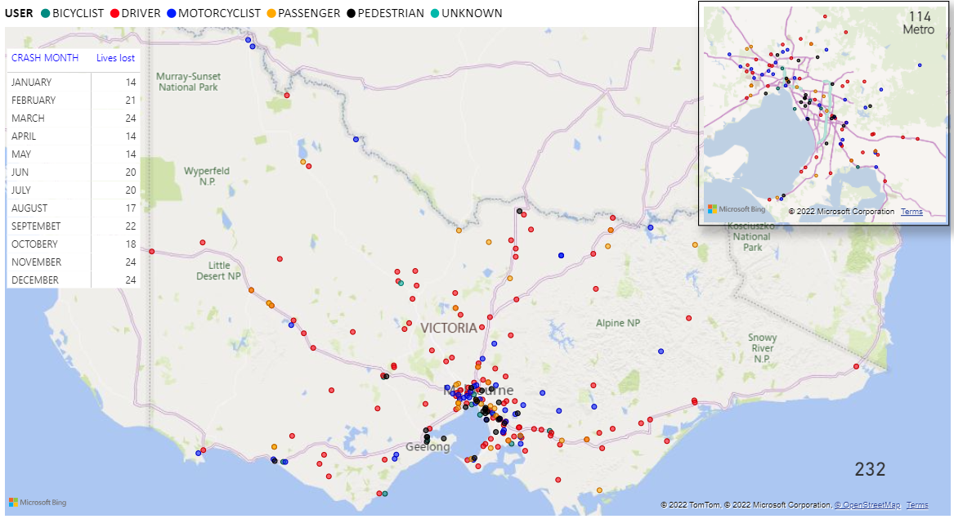
Victoria – Lives Lost, 12 months to December 2021

Injured claimants who were admitted to hospital within 7 days of accident
Rolling 12 month to 30th of June (claim acceptance date)
Category | 2021 | 2020 | 2019 | 2021 v 2020 |  | 2021 v 2019 |  | 5 Year Average
Claims involving an hospitalisation over 14 days (Rolling 12 Month Total)
Claims (to June) | 593 | 799 | 921 | -206 | (-26%) | -328 | (-36%) | 839
per 10,000 veh | 1.1 | 1.6 | 1.8 | -0.6 | (-35%) | -0.7 | (-39%) | 1.8
per 100,000 pop | 8.8 | 12.0 | 14.1 | -4.7 | (-35%) | -5.5 | (-39%) | 13.6
All claims involving an hospitalisation (Rolling 12 Month Total)
Claims (to June) | 5,630 | 6,860 | 8,260 | -1230 | (-18%) | -2630 | (-32%) | 7,240
per 10,000 veh | 10.8 | 13.4 | 16.4 | -4.9 | (-32%) | -6.3 | (-38%) | 14.8
per 100,000 pop | 83.5 | 103.4 | 126.5 | -37.7 | (-32%) | -48.5 | (-38%) | 113.5

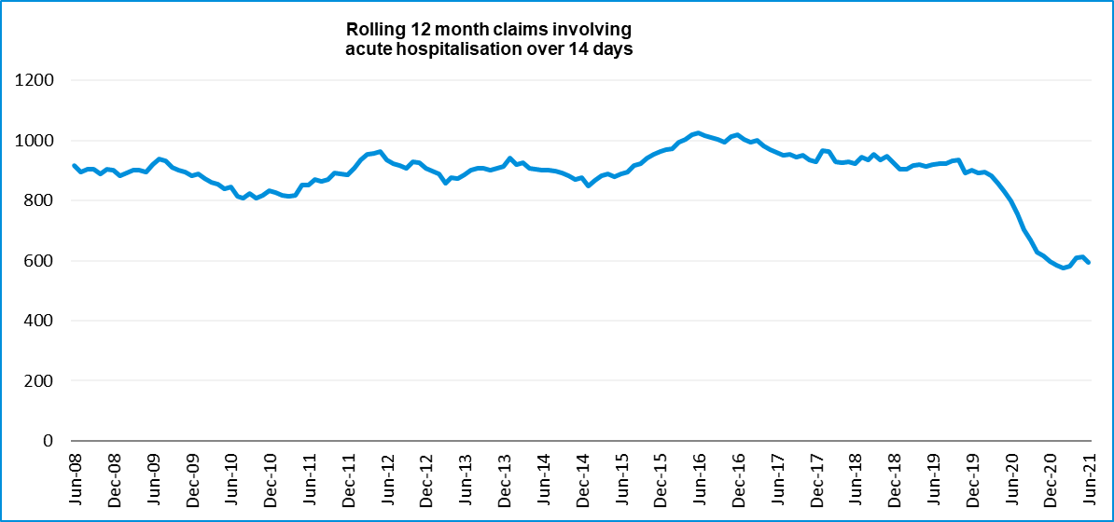

Lives lost: Rolling 12 months

12 months to 31st December 2021
Category | 2021 | 2020 | 2019 | 2021 v 2020 | 2021 v 2019 | 5 Year Average
Overview
Lives Lost | 232 | 211 | 266 | +21 | -34 | 236
Fatal Crashes | 214 | 195 | 248 | +19 | -34 | 220
Sex
Female | 64 | 52 | 68 | +12 | -4 | 62
Male | 168 | 159 | 198 | +9 | -30 | 174
Road user
Bicyclist | 11 | 14 | 11 | -3 | 0 | 11
Driver | 114 | 104 | 114 | +10 | 0 | 112
Motorcyclist | 43 | 32 | 44 | +11 | -1 | 39
Passenger | 35 | 31 | 48 | +4 | -13 | 39
Pedestrian | 28 | 30 | 49 | -2 | -21 | 35
Location
Melbourne | 114 | 85 | 120 | +29 | -6 | 105
Rural Victoria | 118 | 126 | 146 | -8 | -28 | 131
Age group
0-4 | 4 | 3 | 1 | +1 | +3 | 2
5-15 | 5 | 2 | 6 | +3 | -1 | 5
16-17 | 8 | 4 | 6 | +4 | +2 | 5
18-20 | 12 | 9 | 24 | +3 | -12 | 16
21-25 | 23 | 22 | 26 | +1 | -3 | 23
26-29 | 18 | 22 | 20 | -4 | -2 | 18
30-39 | 31 | 40 | 33 | -9 | -2 | 36
40-49 | 27 | 26 | 28 | +1 | -1 | 29
50-59 | 25 | 26 | 30 | -1 | -5 | 28
60-69 | 32 | 21 | 36 | +11 | -4 | 28
70+ | 44 | 36 | 56 | 8 | -12 | 46
Accident Type
Intersection
Adjacent direction | 23 | 21 | 30 | +2 | -7 | 28
Opposing direction | 10 | 10 | 9 | 0 | +1 | 9
Mid-block/other
Head on | 32 | 17 | 42 | +15 | -10 | 32
Same direction | 23 | 24 | 19 | -1 | +4 | 21
Manoeuvre/o'taking | 9 | 14 | 17 | -5 | -8 | 13
On path | 3 | 6 | 5 | -3 | -2 | 4
Single vehicle | 102 | 85 | 88 | +17 | +14 | 90
Other (incl peds) | 30 | 34 | 56 | -4 | -26 | 39

Lives Lost: 12 months to 31st DECEMBER 2021
Category | 2021 | 2020 | 2019 | 5 Year Average | Category | 2021 | 2020 | 2019 | 5 Year Average
Local Government Area |  |  |  |  | Local Government Area
ALPINE | 0 | 1 | 2 | 1 | MANSFIELD | 0 | 1 | 1 | 2
ARARAT | 1 | 0 | 3 | 2 | MARIBYRNONG | 0 | 2 | 2 | 3
BALLARAT | 3 | 2 | 2 | 4 | MAROONDAH | 2 | 1 | 4 | 2
BANYULE | 1 | 2 | 1 | 2 | MELBOURNE | 5 | 3 | 2 | 3
BASS COAST | 0 | 2 | 3 | 2 | MELTON | 8 | 1 | 4 | 4
BAW BAW | 8 | 1 | 4 | 3 | MILDURA | 2 | 3 | 7 | 3
BAYSIDE | 1 | 1 | 0 | 2 | MITCHELL | 7 | 4 | 2 | 3
BENALLA | 2 | 0 | 0 | 2 | MOIRA | 3 | 3 | 4 | 4
BOROONDARA | 1 | 6 | 3 | 4 | MONASH | 5 | 5 | 10 | 6
BRIMBANK | 6 | 1 | 9 | 7 | MOONEE VALLEY | 2 | 1 | 1 | 2
BULOKE | 2 | 2 | 2 | 1 | MOORABOOL | 2 | 2 | 7 | 4
CAMPASPE | 3 | 3 | 3 | 3 | MORELAND | 0 | 0 | 3 | 2
CARDINIA | 14 | 3 | 3 | 5 | MORNINGTON PENINSULA | 9 | 9 | 12 | 7
CASEY | 14 | 4 | 6 | 6 | MOUNT ALEXANDER | 2 | 7 | 2 | 3
CENTRAL GOLDFIELDS | 0 | 3 | 2 | 2 | MOYNE | 4 | 2 | 2 | 2
COLAC-OTWAY | 3 | 1 | 3 | 3 | MURRINDINDI | 2 | 2 | 3 | 4
CORANGAMITE | 3 | 3 | 4 | 3 | NILLUMBIK | 2 | 3 | 1 | 2
DAREBIN | 2 | 5 | 3 | 3 | NORTHERN GRAMPIANS | 5 | 4 | 1 | 3
EAST GIPPSLAND | 4 | 9 | 2 | 6 | PORT PHILLIP | 0 | 2 | 1 | 1
FRANKSTON | 2 | 5 | 6 | 4 | PYRENEES | 2 | 1 | 2 | 2
GANNAWARRA | 0 | 1 | 1 | 2 | QUEENSCLIFFE | 0 | 0 | 0 | 0
GLEN EIRA | 3 | 1 | 3 | 2 | SOUTH GIPPSLAND | 2 | 7 | 5 | 5
GLENELG | 2 | 2 | 3 | 3 | SOUTHERN GRAMPIANS | 0 | 1 | 2 | 2
GOLDEN PLAINS | 1 | 2 | 5 | 3 | STONNINGTON | 2 | 0 | 1 | 1
GREATER BENDIGO | 5 | 6 | 8 | 6 | STRATHBOGIE | 2 | 1 | 1 | 2
GREATER DANDENONG | 5 | 1 | 5 | 3 | SURF COAST | 2 | 0 | 0 | 1
GREATER GEELONG | 6 | 10 | 14 | 9 | SWAN HILL | 2 | 1 | 3 | 2
GREATER SHEPPARTON | 3 | 7 | 7 | 7 | TOWONG | 2 | 0 | 4 | 1
HEPBURN | 1 | 4 | 4 | 4 | WANGARATTA | 3 | 3 | 0 | 3
HINDMARSH | 1 | 0 | 0 | 0 | WARRNAMBOOL | 3 | 3 | 0 | 1
HOBSONS BAY | 3 | 2 | 0 | 1 | WELLINGTON | 5 | 3 | 2 | 4
HORSHAM | 4 | 3 | 5 | 3 | WEST WIMMERA | 1 | 3 | 3 | 1
HUME | 6 | 2 | 9 | 5 | WHITEHORSE | 1 | 2 | 1 | 2
INDIGO | 3 | 3 | 1 | 3 | WHITTLESEA | 4 | 5 | 4 | 4
KINGSTON | 2 | 3 | 5 | 4 | WODONGA | 0 | 1 | 1 | 1
KNOX | 1 | 2 | 1 | 3 | WYNDHAM | 6 | 4 | 8 | 6
LATROBE | 4 | 6 | 4 | 5 | YARRA | 2 | 1 | 1 | 1
LODDON | 3 | 2 | 4 | 2 | YARRA RANGES | 4 | 8 | 9 | 8
MACEDON RANGES | 3 | 1 | 7 | 3 | YARRIAMBIACK | 1 | 0 | 1 | 1
MANNINGHAM | 0 | 0 | 2 | 2

Injured claimants admitted to hospital within 7 days of the accident with a hospital stay of more than 14 days
12 months to 30th June 2021 (claim acceptance date, excludes rejected claims and claims for interstate crashes.)
Category | 2021 | 2020 | 2019 | 2021 v 2020 |  | 2021 v 2020 |  | 5 Year Average
Overview
Claims | 593 | 799 | 921 | -206 | -26% | -328 | -36% | 839
Sex
Female | 211 | 321 | 377 | -110 | -34% | -166 | -44% | 334
Male | 382 | 478 | 544 | -96 | -20% | -162 | -30% | 505
Road user
Bicyclist | 29 | 37 | 30 | -8 | -22% | -1 | -3% | 33
Driver | 223 | 303 | 341 | -80 | -26% | -118 | -35% | 312
Motorcyclist | 134 | 166 | 187 | -32 | -19% | -53 | -28% | 172
Passenger | 72 | 110 | 138 | -38 | -35% | -66 | -48% | 118
Pedestrian | 116 | 154 | 191 | -38 | -25% | -75 | -39% | 174
Train/Tram | 5 | 4 | 12 | +1 | 25% | -7 | -58% | 8
Location
Melbourne | 336 | 480 | 542 | -144 | -30% | -206 | -38% | 500
Rural Victoria | 227 | 284 | 319 | -57 | -20% | -92 | -29% | 291
Age group
0-4 | 3 | 4 | 3 | -1 | -25% | 0 | 0% | 4
5-15 | 4 | 15 | 17 | -11 | -73% | -13 | -76% | 11
16-17 | 11 | 14 | 15 | -3 | -21% | -4 | -27% | 13
18-20 | 30 | 37 | 46 | -7 | -19% | -16 | -35% | 41
21-25 | 51 | 58 | 74 | -7 | -12% | -23 | -31% | 73
26-29 | 45 | 43 | 52 | +2 | 5% | -7 | -13% | 50
30-39 | 81 | 86 | 104 | -5 | -6% | -23 | -22% | 103
40-49 | 69 | 99 | 102 | -30 | -30% | -33 | -32% | 98
50-59 | 74 | 92 | 127 | -18 | -20% | -53 | -42% | 107
60-69 | 81 | 120 | 105 | -39 | -33% | -24 | -23% | 109
70+ | 144 | 231 | 276 | -87 | -38% | -132 | -48% | 231
Accident Type
Intersection
Adjacent direction | 68 | 80 | 83 | -12 | -15% | -15 | -18% | 81
Opposing direction | 24 | 44 | 55 | -20 | -45% | -31 | -56% | 47
Mid-block/other
Head on | 36 | 56 | 70 | -20 | -36% | -34 | -49% | 58
Same direction | 48 | 63 | 85 | -15 | -24% | -37 | -44% | 65
Manoeuvre/o'taking | 44 | 54 | 44 | -10 | -19% | 0 | 0% | 47
On path | 18 | 26 | 23 | -8 | -31% | -5 | -22% | 23
Single vehicle | 183 | 237 | 228 | -54 | -23% | -45 | -20% | 224
Other (incl peds) | 172 | 239 | 333 | -67 | -28% | -161 | -48% | 294

Injured claimants who were admitted to hospital within 7 days of the accident with a hospital stay of more than 14 days

12 months to 30th June 2021 (claim acceptance date, excludes rejected claims and claims for interstate crashes.) – Continued
Category | 2021 | 2020 | 2019 | 5 Year Average | Category | 2021 | 2020 | 2019 | 5 Year Average
Local Government Area |  |  |  |  | Local Government Area
ALPINE | 5 | 6 | 8 | 5 | MANSFIELD | 6 | 6 | 4 | 6
ARARAT | 0 | 5 | 3 | 3 | MARIBYRNONG | 6 | 13 | 7 | 11
BALLARAT | 15 | 14 | 20 | 14 | MAROONDAH | 8 | 13 | 8 | 8
BANYULE | 5 | 6 | 10 | 8 | MELBOURNE | 21 | 22 | 29 | 29
BASS COAST | 4 | 4 | 12 | 6 | MELTON | 6 | 4 | 9 | 8
BAW BAW | 1 | 9 | 7 | 8 | MILDURA | 3 | 4 | 9 | 6
BAYSIDE | 2 | 6 | 11 | 8 | MITCHELL | 11 | 10 | 9 | 8
BENALLA | 2 | 2 | 3 | 3 | MOIRA | 9 | 6 | 8 | 8
BOROONDARA | 12 | 14 | 17 | 13 | MONASH | 8 | 16 | 26 | 19
BRIMBANK | 16 | 12 | 21 | 18 | MOONEE VALLEY | 7 | 15 | 11 | 14
BULOKE | 2 | 0 | 5 | 2 | MOORABOOL | 3 | 10 | 4 | 7
CAMPASPE | 5 | 10 | 8 | 8 | MORELAND | 11 | 15 | 30 | 24
CARDINIA | 13 | 16 | 13 | 14 | MORNINGTON PENINSULA | 11 | 24 | 22 | 21
CASEY | 15 | 30 | 23 | 28 | MOUNT ALEXANDER | 8 | 0 | 3 | 1
CENTRAL GOLDFIELDS | 3 | 3 | 6 | 3 | MOYNE | 1 | 7 | 6 | 5
COLAC-OTWAY | 6 | 4 | 6 | 6 | MURRINDINDI | 2 | 9 | 4 | 9
CORANGAMITE | 4 | 1 | 2 | 5 | NILLUMBIK | 6 | 9 | 10 | 7
DAREBIN | 11 | 14 | 17 | 18 | NORTHERN GRAMPIANS | 2 | 3 | 1 | 3
EAST GIPPSLAND | 10 | 8 | 13 | 9 | PORT PHILLIP | 10 | 18 | 7 | 13
FRANKSTON | 4 | 13 | 7 | 12 | PYRENEES | 2 | 3 | 4 | 2
GANNAWARRA | 3 | 3 | 2 | 2 | QUEENSCLIFFE | 0 | 2 | 2 | 1
GLEN EIRA | 5 | 14 | 21 | 14 | SOUTH GIPPSLAND | 3 | 8 | 5 | 7
GLENELG | 0 | 2 | 4 | 3 | SOUTHERN GRAMPIANS | 2 | 5 | 4 | 3
GOLDEN PLAINS | 1 | 5 | 6 | 6 | STONNINGTON | 11 | 2 | 12 | 9
GREATER BENDIGO | 16 | 20 | 20 | 17 | STRATHBOGIE | 5 | 3 | 3 | 4
GREATER DANDENONG | 20 | 23 | 31 | 23 | SURF COAST | 4 | 5 | 4 | 5
GREATER GEELONG | 23 | 31 | 33 | 25 | SWAN HILL | 3 | 5 | 5 | 5
GREATER SHEPPARTON | 16 | 8 | 11 | 13 | TOWONG | 0 | 3 | 4 | 3
HEPBURN | 7 | 4 | 5 | 3 | WANGARATTA | 0 | 6 | 6 | 5
HINDMARSH | 0 | 3 | 0 | 2 | WARRNAMBOOL | 3 | 2 | 4 | 3
HOBSONS BAY | 6 | 9 | 7 | 7 | WELLINGTON | 9 | 11 | 9 | 9
HORSHAM | 0 | 2 | 5 | 3 | WEST WIMMERA | 0 | 0 | 1 | 1
HUME | 15 | 22 | 27 | 25 | WHITEHORSE | 11 | 23 | 23 | 21
INDIGO | 7 | 3 | 4 | 4 | WHITTLESEA | 14 | 22 | 29 | 24
KINGSTON | 13 | 14 | 19 | 14 | WODONGA | 3 | 4 | 3 | 3
KNOX | 15 | 19 | 24 | 18 | WYNDHAM | 19 | 19 | 19 | 20
LATROBE | 11 | 8 | 17 | 9 | YARRA | 8 | 11 | 17 | 12
LODDON | 1 | 5 | 3 | 2 | YARRA RANGES | 20 | 24 | 25 | 26
MACEDON RANGES | 5 | 11 | 11 | 11 | YARRIAMBIACK | 1 | 1 | 3 | 1
MANNINGHAM | 7 | 18 | 10 | 15

Injured claimants who were admitted to hospital within 7 days of accident
12 months to 30th June 2021 (claim acceptance date, excludes rejected claims and claims for interstate crashes.)
Category | 2021 | 2020 | 2019 | 2021 v 2020 |  | 2021 v 2019 |  | 5 Year Average
Overview
Claims | 5,630 | 6,860 | 8,260 | -1230 | -18% | -2630 | -32% | 7,240
Sex
Female | 2,287 | 2,956 | 3,558 | -669 | -23% | -1271 | -36% | 3,100
Male | 3,333 | 3,898 | 4,691 | -565 | -14% | -1358 | -29% | 4,131
Road user
Bicyclist | 427 | 461 | 531 | -34 | -7% | -104 | -20% | 480
Driver | 2,722 | 3,318 | 4,000 | -596 | -18% | -1278 | -32% | 3,477
Motorcyclist | 1,082 | 1,147 | 1,413 | -65 | -6% | -331 | -23% | 1,246
Passenger | 712 | 946 | 1,199 | -234 | -25% | -487 | -41% | 1,014
Pedestrian | 501 | 634 | 796 | -133 | -21% | -295 | -37% | 706
Train/Tram | 12 | 31 | 42 | -19 | -61% | -30 | -71% | 38
Location
Melbourne | 3,475 | 4,246 | 5,005 | -771 | -18% | -1530 | -31% | 4,404
Rural Victoria | 1,919 | 2,193 | 2,383 | -274 | -12% | -464 | -19% | 2,182
Age group
0-4 | 38 | 36 | 67 | +2 | 6% | -29 | -43% | 54
5-15 | 148 | 167 | 242 | -19 | -11% | -94 | -39% | 199
16-17 | 93 | 99 | 144 | -6 | -6% | -51 | -35% | 117
18-20 | 424 | 472 | 646 | -48 | -10% | -222 | -34% | 529
21-25 | 660 | 775 | 1,030 | -115 | -15% | -370 | -36% | 885
26-29 | 493 | 608 | 662 | -115 | -19% | -169 | -26% | 621
30-39 | 979 | 1,101 | 1,324 | -122 | -11% | -345 | -26% | 1,178
40-49 | 785 | 993 | 1,078 | -208 | -21% | -293 | -27% | 1,025
50-59 | 749 | 941 | 1,095 | -192 | -20% | -346 | -32% | 970
60-69 | 584 | 768 | 811 | -184 | -24% | -227 | -28% | 729
70+ | 677 | 900 | 1,161 | -223 | -25% | -484 | -42% | 935
Accident Type
Intersection
Adjacent direction | 943 | 1,046 | 953 | -103 | -10% | -10 | -1% | 923
Opposing direction | 414 | 481 | 555 | -67 | -14% | -141 | -25% | 497
Mid-block/other
Head on | 265 | 341 | 332 | -76 | -22% | -67 | -20% | 319
Same direction | 929 | 1,095 | 1,043 | -166 | -15% | -114 | -11% | 987
Manoeuvre/o'taking | 386 | 439 | 339 | -53 | -12% | +47 | 14% | 370
On path | 217 | 229 | 227 | -12 | -5% | -10 | -4% | 234
Single vehicle | 1,302 | 1,430 | 1,419 | -128 | -9% | -117 | -8% | 1,428
Other (incl peds) | 1,174 | 1,799 | 3,392 | -625 | -35% | -2218 | -65% | 2,482

Injured claimants who were admitted to hospital within 7 days of accident

12 months to 30th June 2021 (claim acceptance date, excludes rejected claims and claims for interstate crashes.) – Continued
Category | 2021 | 2020 | 2019 | 5 Year Average | Category | 2021 | 2020 | 2019 | 5 Year Average
Local Government Area |  |  |  |  | Local Government Area
ALPINE | 30 | 26 | 34 | 25 | MANSFIELD | 35 | 37 | 37 | 35
ARARAT | 13 | 15 | 18 | 14 | MARIBYRNONG | 55 | 92 | 101 | 83
BALLARAT | 117 | 91 | 109 | 87 | MAROONDAH | 45 | 58 | 81 | 58
BANYULE | 39 | 48 | 77 | 57 | MELBOURNE | 158 | 228 | 291 | 270
BASS COAST | 37 | 42 | 53 | 40 | MELTON | 59 | 87 | 90 | 74
BAW BAW | 45 | 75 | 57 | 52 | MILDURA | 45 | 42 | 33 | 28
BAYSIDE | 66 | 77 | 98 | 78 | MITCHELL | 63 | 79 | 70 | 67
BENALLA | 11 | 16 | 31 | 19 | MOIRA | 34 | 50 | 30 | 37
BOROONDARA | 98 | 122 | 151 | 122 | MONASH | 141 | 182 | 193 | 176
BRIMBANK | 134 | 166 | 176 | 147 | MOONEE VALLEY | 101 | 134 | 151 | 125
BULOKE | 6 | 8 | 15 | 8 | MOORABOOL | 29 | 59 | 59 | 50
CAMPASPE | 46 | 37 | 52 | 42 | MORELAND | 109 | 170 | 192 | 166
CARDINIA | 110 | 129 | 115 | 118 | MORNINGTON PENINSULA | 144 | 179 | 199 | 163
CASEY | 316 | 292 | 356 | 301 | MOUNT ALEXANDER | 22 | 20 | 27 | 19
CENTRAL GOLDFIELDS | 17 | 24 | 25 | 18 | MOYNE | 13 | 36 | 34 | 30
COLAC-OTWAY | 49 | 70 | 49 | 57 | MURRINDINDI | 33 | 55 | 60 | 56
CORANGAMITE | 32 | 24 | 31 | 31 | NILLUMBIK | 31 | 43 | 46 | 38
DAREBIN | 58 | 113 | 128 | 105 | NORTHERN GRAMPIANS | 22 | 19 | 19 | 20
EAST GIPPSLAND | 57 | 47 | 54 | 51 | PORT PHILLIP | 142 | 130 | 160 | 132
FRANKSTON | 98 | 141 | 152 | 130 | PYRENEES | 7 | 13 | 18 | 12
GANNAWARRA | 10 | 12 | 13 | 10 | QUEENSCLIFFE | 4 | 4 | 11 | 5
GLEN EIRA | 104 | 135 | 140 | 117 | SOUTH GIPPSLAND | 37 | 43 | 44 | 41
GLENELG | 23 | 23 | 22 | 21 | SOUTHERN GRAMPIANS | 16 | 34 | 24 | 21
GOLDEN PLAINS | 35 | 45 | 44 | 44 | STONNINGTON | 122 | 98 | 150 | 117
GREATER BENDIGO | 106 | 136 | 142 | 117 | STRATHBOGIE | 32 | 37 | 35 | 32
GREATER DANDENONG | 236 | 233 | 324 | 240 | SURF COAST | 78 | 51 | 69 | 56
GREATER GEELONG | 359 | 381 | 449 | 346 | SWAN HILL | 16 | 19 | 22 | 18
GREATER SHEPPARTON | 72 | 77 | 95 | 88 | TOWONG | 12 | 13 | 17 | 16
HEPBURN | 30 | 29 | 34 | 27 | WANGARATTA | 21 | 39 | 40 | 33
HINDMARSH | 5 | 16 | 21 | 12 | WARRNAMBOOL | 24 | 32 | 28 | 28
HOBSONS BAY | 51 | 88 | 85 | 72 | WELLINGTON | 59 | 57 | 83 | 61
HORSHAM | 23 | 35 | 20 | 23 | WEST WIMMERA | 6 | 4 | 2 | 5
HUME | 193 | 242 | 264 | 227 | WHITEHORSE | 77 | 107 | 154 | 128
INDIGO | 16 | 22 | 28 | 23 | WHITTLESEA | 130 | 175 | 237 | 198
KINGSTON | 137 | 136 | 139 | 121 | WODONGA | 30 | 21 | 20 | 22
KNOX | 108 | 106 | 153 | 120 | WYNDHAM | 163 | 202 | 212 | 163
LATROBE | 83 | 89 | 97 | 69 | YARRA | 70 | 102 | 125 | 104
LODDON | 6 | 17 | 20 | 12 | YARRA RANGES | 138 | 168 | 171 | 156
MACEDON RANGES | 43 | 68 | 82 | 70 | YARRIAMBIACK | 10 | 4 | 6 | 6
MANNINGHAM | 42 | 63 | 94 | 79

Lives lost by week (2016 to 2021)
Week Ending | 2016 | 2017 | 2018 | 2019 | 2020 | 2021 | 2021 Cumulative | 12 month Moving Total
03-Jan | 2 | 0 | 4 | 0 | 5 | 2 | 2 | 209
10-Jan | 3 | 5 | 6 | 5 | 3 | 2 | 4 | 207
17-Jan | 3 | 6 | 2 | 3 | 5 |  | 4 | 202
24-Jan | 3 | 4 | 2 | 7 | 2 | 5 | 9 | 206
31-Jan | 10 | 2 | 6 | 8 | 9 | 5 | 14 | 201
07-Feb | 6 | 4 | 3 | 9 | 5 | 5 | 19 | 202
14-Feb | 12 | 3 | 4 | 9 | 6 | 7 | 26 | 202
21-Feb | 6 | 6 | 7 | 4 | 5 | 3 | 29 | 201
28-Feb | 9 | 5 | 2 | 12 | 1 | 6 | 35 | 206
07-Mar | 9 | 3 | 5 | 0 | 4 | 9 | 44 | 212
14-Mar | 9 | 5 | 7 | 5 | 9 | 4 | 48 | 207
21-Mar | 5 | 5 | 3 | 7 | 10 | 5 | 53 | 202
28-Mar | 1 | 7 | 4 | 6 | 1 | 4 | 57 | 207
04-Apr | 1 | 4 | 3 | 3 | 7 | 7 | 64 | 206
11-Apr | 1 | 12 | 0 | 10 | 1 | 2 | 66 | 207
18-Apr | 7 | 7 | 1 | 6 | 1 | 3 | 69 | 210
25-Apr | 4 | 6 | 5 | 4 | 9 | 3 | 72 | 203
02-May | 5 | 3 | 3 | 3 | 2 | 2 | 74 | 204
09-May | 7 | 7 | 13 | 9 | 2 | 6 | 80 | 207
16-May | 5 | 4 | 3 | 9 | 5 | 4 | 84 | 206
23-May | 5 | 2 | 3 | 6 | 2 | 2 | 86 | 206
30-May | 8 | 6 | 2 | 7 | 5 | 1 | 87 | 202
06-Jun | 4 | 2 | 1 | 4 | 1 | 2 | 89 | 203
13-Jun | 5 | 3 | 8 | 3 | 5 | 6 | 95 | 204
20-Jun | 5 | 4 | 1 | 5 | 4 | 3 | 98 | 205
27-Jun | 8 | 4 | 2 | 4 | 4 | 5 | 103 | 205
04-Jul | 2 | 5 | 1 | 7 | 4 | 10 | 113 | 210
11-Jul | 3 | 5 | 3 | 3 | 3 | 2 | 115 | 210
18-Jul | 7 | 9 | 5 | 2 | 3 | 5 | 120 | 212
25-Jul | 11 | 4 | 5 | 5 | 5 | 4 | 124 | 210
01-Aug | 6 | 0 | 2 | 3 | 4 | 3 | 127 | 210
08-Aug | 5 | 7 | 4 | 3 | 3 | 3 | 130 | 210
15-Aug | 7 | 9 | 3 | 5 | 4 | 4 | 134 | 213
22-Aug | 8 | 2 | 6 | 3 | 2 | 6 | 140 | 217
29-Aug | 8 | 8 | 4 | 4 | 3 | 3 | 143 | 218
05-Sep | 3 | 6 | 4 | 3 | 4 | 3 | 146 | 217
12-Sep | 3 | 6 | 3 | 5 | 4 | 6 | 152 | 219
19-Sep | 5 | 3 | 7 | 4 | 1 | 6 | 158 | 225
26-Sep | 5 | 3 | 2 | 3 | 0 | 2 | 160 | 227
03-Oct | 2 | 2 | 5 | 6 | 7 | 9 | 169 | 228
10-Oct | 6 | 4 | 7 | 6 | 3 | 3 | 172 | 229
17-Oct | 4 | 6 | 2 | 5 | 6 | 2 | 174 | 230
24-Oct | 7 | 0 | 3 | 4 | 7 | 7 | 181 | 231
31-Oct | 5 | 1 | 7 | 9 | 4 | 3 | 184 | 232
07-Nov | 2 | 11 | 5 | 3 | 3 | 7 | 191 | 233
14-Nov | 7 | 5 | 2 | 5 | 5 | 5 | 196 | 234
21-Nov | 5 | 4 | 12 | 5 | 3 | 2 | 198 | 235
28-Nov | 9 | 11 | 3 | 4 | 4 | 7 | 205 | 236
05-Dec | 9 | 3 | 3 | 4 | 2 | 4 | 209 | 237
12-Dec | 5 | 5 | 3 | 5 | 4 | 7 | 216 | 238
19-Dec | 5 | 7 | 5 | 7 | 4 | 5 | 221 | 239
26-Dec | 2 | 11 | 5 | 1 | 5 | 5 | 226 | 240
31-Dec | 6 | 3 | 2 | 4 | 1 | 6 | 232 | 241
Total | 290 | 259 | 213 | 266 | 211 | 232

Booze Bus Random Breath Testing
Booze-bus Random Breath Tests (12 months to March 2020 vs previous 12 months)
 | 2020 | 2019 | 2018 | 2020 v 2019 |  | 2020 v 2018
Melbourne | 1,025,495 | 1,226,599 | 1,143,717 | -201104 | (-16%) | -118222 | (-10%)
Country | 183,858 | 115,731 | 142,698 | +68127 | (+59%) | +41160 | (+29%)
Vic Total | 1,209,353 | 1,342,330 | 1,286,415 | -132977 | (-10%) | -77062 | (-6%)

12 months to March 2020 (monthly totals)
 | 2019 |  |  |  |  |  |  |  |  | 2020
 | Apr | May | Sep | Jul | Aug | Sep | Oct | Nov | Dec | Jan | Feb | Mar
Melbourne | 79,988 | 84,478 | 101,799 | 98,380 | 102,592 | 96,574 | 89,177 | 88,460 | 82,298 | 62,544 | 103,896 | 35,309
Country | 19,119 | 14,068 | 10,318 | 5,826 | 11,098 | 12,571 | 17,551 | 25,867 | 16,566 | 15,206 | 23,588 | 12,080
Vic Total | 99,107 | 98,546 | 112,117 | 104,206 | 113,690 | 109,145 | 106,728 | 114,327 | 98,864 | 77,750 | 127,484 | 47,389

Random Drug Testing
Random Drug Tests (12 months to March 2020 vs previous 12 months)
 | 2020 | 2019 | 2018 | 2020 v 2019 |  | 2020 v 2018
Victoria | 161,283 | 122,730 | 102,551 | 38,553 | 31% | 58,732 | 57%

12 months to March 2020 (monthly totals)
 | 2019 |  |  |  |  |  |  |  |  | 2020
 | Apr | May | Jun | Jul | Aug | Sep | Oct | Nov | Dec | Jan | Feb | Mar
Victoria | 17,337 | 19,571 | 15,441 | 13,817 | 18,692 | 15,244 | 12,181 | 12,646 | 11,000 | 9,157 | 7,904 | 8,293

Speed Infringements Issued from Mobile Cameras (monthly totals) |  | Monthly Average = | 52,590
Mobile Safety Camera Data
2021
Jan | Feb | Mar | Apr | May | Jun | Jul | Aug | Sep | Oct | Nov | Dec
74,973 | 60,602 | 51,605 | 52,014 | 57,526 | 66,303 | 46,363 | 35,495 | 35,824 | 43,627 | 49,583 | 57,169

Excessive Speed Infringements (ESI) Issued from Mobile Cameras (monthly totals) |  |  |  |  |  |  |  |  | Monthly Average = |  |  |  | 565
2021
Jan | Feb | Mar | Apr | May | Jun | Jul | Aug | Sep |  | Oct | Nov |  |  | Dec
583 | 625 | 762 | 476 | 608 | 698 | 588 | 436 | 427 |  | 526 | 488 |  |  | 563
Notes: An ESI is defined as 25km/h over the speed limit except in a 110km/h zone where it is 20km/h over the limit.

Notes: 1. The definition of ESIs changed on 15 December 2002 to 25km/h over the speed limit from 30km/h over the speed limit except in a 110km/h zone where it has always been 20km/h over the limit.

The National Picture
State | Lives Lost (12 months to December)
 | 2021 | 2020 | 2019 | 2018 | 2021 v 2020
New South Wales | 271 | 284 | 353 | 347 | -13 | (-5%)
Victoria | 232 | 211 | 266 | 213 | +21 | (+10%)
Queensland | 274 | 278 | 219 | 245 | -4 | (-1%)
South Australia | 99 | 93 | 114 | 80 | +6 | (+6%)
Western Australia | 166 | 155 | 163 | 159 | +11 | (+7%)
Tasmania | 35 | 37 | 29 | 33 | -2 | (-5%)
Northern Territory | 35 | 31 | 35 | 50 | +4 | (+13%)
Australian Capital Territory | 11 | 7 | 6 | 9 | +4 | (+57%)
AUST TOTAL | 1,123 | 1,096 | 1,185 | 1,136 | +27 | (+2%)
Australia minus Victoria | 891 | 885 | 919 | 923 | +6 | (+1%)

State | Lives Lost per 10,000 registered vehicles |  |  | Fatalities per 100,000 population
 | (12 months to December) |  |  | (12 months to December)
 | 2021 | 2020 | 2019 | 2021 | 2020 | 2019
New South Wales | 0.46 | 0.49 | 0.62 | 3.31 | 3.48 | 4.36
Victoria | 0.45 | 0.41 | 0.52 | 3.49 | 3.15 | 4.03
Queensland | 0.65 | 0.63 | 0.51 | 5.25 | 5.37 | 4.30
South Australia | 0.92 | 0.46 | 0.62 | 5.58 | 5.26 | 6.51
Western Australia | 0.71 | 0.68 | 0.72 | 6.19 | 5.82 | 6.22
Tasmania | 0.67 | 0.72 | 0.58 | 6.46 | 6.84 | 5.43
Northern Territory | 2.14 | 1.92 | 2.17 | 14.21 | 12.60 | 14.24
Australian Capital Territory | 0.34 | 0.22 | 0.19 | 2.54 | 1.62 | 1.41
Australia Total | 0.55 | 0.55 | 0.60 | 4.36 | 4.27 | 4.67
Australia minus Victoria | 0.59 | 0.60 | 0.63 | 4.67 | 4.66 | 4.90

International Road Safety Comparison
Selected OECD countries, Australia and Victoria, 1990, 2000, 2010, 2015 to 2019

Lives lost rate per 100,000 population
Countries | 1990 | 2000 | 2010 | 2015 | 2016 | 2017 | 2018 | 2019
Australia | 13.7 | 9.5 | 6.1 | 5.1 | 5.3 | 5.0 | 4.5 | 4.7
Canada | 14.3 | 9.5 | 6.6 | 5.3 | 5.3 | 5.1 | 5.2 | 4.7
New Zealand | 21.5 | 12.0 | 8.6 | 6.9 | 6.9 | 7.9 | 7.7 | 7.1
Norway | 7.8 | 7.6 | 4.3 | 2.3 | 2.6 | 2.0 | 2.0 | 2.0
Sweden | 9.0 | 6.7 | 2.8 | 2.6 | 2.7 | 2.5 | 3.2 | 2.2
Switzerland | 13.8 | 8.2 | 4.2 | 3.1 | 2.6 | 2.7 | 2.7 | 2.2
United Kingdom | 9.4 | 6.1 | 3.0 | 2.8 | 2.8 | 2.8 | 2.8 | 2.7
United States | 17.9 | 14.9 | 10.7 | 11.1 | 11.7 | 11.5 | 11.2 | 11.0
Victoria | 12.5 | 8.7 | 5.3 | 4.2 | 4.7 | 4.1 | 3.3 | 4.0

Lives lost rate per100 million vehicle kilometres travelled (VKT)
Countries | 1990 | 2000 | 2010 | 2015 | 2016 | 2017 | 2018 | 2019
Australia | 1.4 | 0.9 | 0.6 | 0.5 | 0.5 | 0.5 | 0.4 | 0.4
Canada | - | 0.9 | 0.7 | 0.5 | 0.5 | 0.5 | 0.5 | 0.4
New Zealand | - | 1.4 | 0.9 | 0.7 | 0.7 | 0.8 | 0.8 | 0.7
Norway | 1.2 | 1.0 | 0.5 | 0.3 | 0.3 | 0.2 | 0.2 | 0.2
Sweden | 1.2 | 0.9 | 0.3 | 0.3 | 0.3 | 0.3 | 0.4 | 0.3
Switzerland | 1.9 | 1.1 | 0.5 | 0.4 | 0.3 | 0.3 | 0.3 | 0.3
United Kingdom | - | - | - | - | - | - | - | -
United States | 1.3 | 0.9 | 0.7 | 0.7 | 0.7 | 0.7 | 0.7 | 0.7
Victoria | 1.2 | 0.8 | 0.5 | 0.4 | 0.4 | 0.4 | 0.3 | 0.4

Lives lost rate per 10,000 registered vehicles

Countries | 1990 | 2000 | 2010 | 2015 | 2016 | 2017 | 2018 | 2019
Australia | 2.3 | 1.5 | 0.8 | 0.7 | 0.7 | 0.7 | 0.6 | 0.6
Canada | 2.3 | 1.6 | 1.0 | 0.8 | 0.8 | 0.8 | 0.7 | 0.7
New Zealand | 3.3 | 1.8 | 1.2 | 0.9 | 0.9 | 1.0 | 0.9 | 0.9
Norway | 1.4 | 1.2 | 0.6 | 0.3 | 0.3 | 0.3 | 0.3 | 0.3
Sweden | 1.7 | 1.2 | 0.5 | 0.4 | 0.4 | 0.4 | 0.5 | 0.3
Switzerland | 2.2 | 1.2 | 0.6 | 0.4 | 0.4 | 0.4 | 0.4 | 0.3
United Kingdom | 2.1 | 1.2 | 0.5 | 0.5 | 0.5 | 0.5 | 0.5 | 0.5
United States | 2.4 | 1.9 | 1.3 | 1.3 | 1.3 | 1.3 | 1.2 | 1.2
Victoria | 2.1 | 1.2 | 0.7 | 0.6 | 0.6 | 0.5 | 0.4 | 0.5

Lives lost rate per 100,000 population - OECD countries, 2019
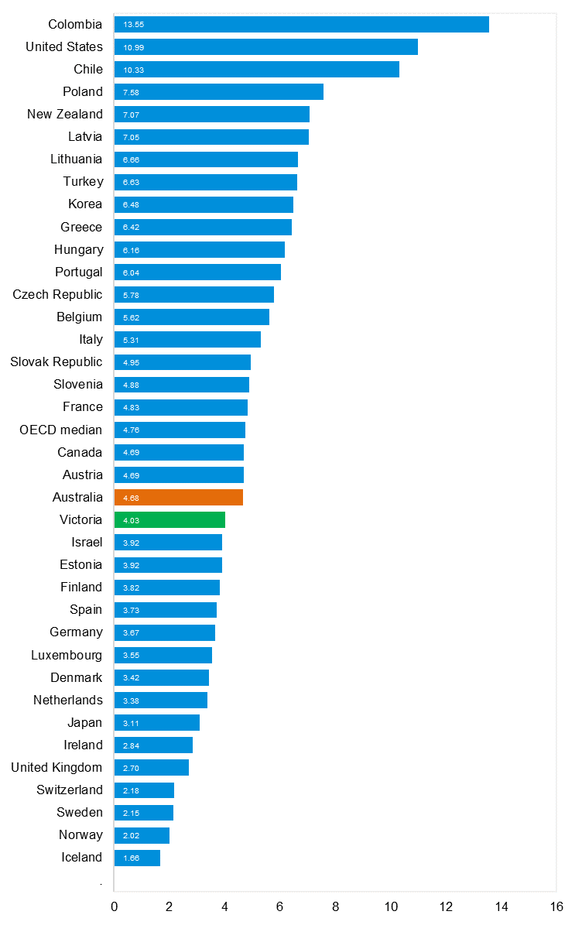
Source: Bureau of Infrastructure and Transport Research Economics

Explanations and references
LGA: Local Government Areas. Crash locations for acute hospitalised claims are assigned to LGA’s based on the crash postcode recorded by Victoria Police. Crash locations for fatal crashes are coded exactly to an LGA by Victoria Police.
Claimants: Refers to people injured in transport accidents who have an accepted claim with the TAC.
Hospitalisation: refers to all hospital admission that occurred within 7 days of accident.

Useful websites
TAC Sites
- TAC Safety (Road Safety) www.tacsafety.com.au
- TAC How safe is your car www.howsafeisyourcar.com.au
- TAC How safe is your first car www.howsafeisyourfirstcar.com.au
- TAC Motorcycle Safety Website www.spokes.com.au
- TAC Corporate site www.tac.vic.gov.au
- Drivesmart www.drivesmart.vic.gov.au
- Ridesmart www.ridesmartonline.com.au

Victorian Sites
- VicRoads www.vicroads.vic.gov.au
- Victoria Police www.police.vic.gov.au
- Parliamentary Road Safety Committee https://www.parliament.vic.gov.au/57th-parliament/rsc
- RACV www.racv.com.au
- Monash University Accident Research Centre www.monash.edu.au/muarc
- Cameras Save Lives www.camerassavelives.vic.gov.au
- VicRoads Learner Driver Site www.lsite.vicroads.vic.gov.au/Learners
- Road Safety Education Victoria www.roadsafetyeducation.vic.gov.au

National and Interstate Sites
- ARRB Transport Research www.arrb.com.au
- Australian Transport Safety Bureau www.atsb.gov.au
- Motor Accidents Authority (NSW) www.maa.nsw.gov.au
- Motor Accidents Insurance Board (TAS) www.maib.tas.gov.au
- Motor Accident Commission, Allianz (SA) www.mac.sa.gov.au
- Motor Accidents Compensation, TIO, (NT) www.tiofi.com.au/mac
- Insurance Commission of Western Australia www.icwa.wa.gov.au
- Motor Accident Insurance Commission (QLD) www.maic.qld.gov.au

International Sites
- National Highway Traffic Safety Admin (USA) www.nhtsa.dot.gov
- Swedish Road and Transport Institute (VTI) www.vti.se
- SWOV Institute for Road Safety Research www.swov.nl

Related Sites
- Alcohol and Drug Foundation www.adf.org.au

Graphs of Lives Lost and Hospitalised Claims

Victorian monthly lives lost since 1951

