

TAC Road Safety
Quarterly Statistics
June 2021

Contents

Status Report 3
Lives lost: Rolling 12 months 5
Injured claimants admitted to hospital within 7 days of the accident with a hospital stay of more than 14 days 7
Injured claimants who were admitted to hospital within 7 days of accident 9
Booze bus random breath testing 12
The National Picture 13
International Road Safety Comparison 14
Lives lost rate per 100,000 population - OECD countries, 2019 15
Useful websites 17
GRAPHS OF LIVES LOST AND HOSPITALISED CLAIMS 18
Victorian monthly lives lost since 1951 21

Notes about the data in this report
- All data provided in this report is the data most recently available at time of production. Fatality data updated to the end of report month. A 6-month lag applies to TAC claims data.
- Reported data will have one extra day of exposure for leap years.
- Data is subject to revision as additional information about known accidents/claims is received, and as new accident/claim reports are received and processed.

Status Report

Lives lost on Victorian roads
- In a 12-month period from 1st July 2020 to the end of June 2021, 206 people lost their lives compared to 231 people lives lost during the previous 12-month period from July 2019 to June 2020. This represents 25 less lives lost.

Category | 2021 | 2020 | 2019 | 2021 v 2020 | 2021 v 2019 | 5 Year Average
Lives Lost (Rolling 12 Month Total)
Lives Lost (to June) | 206 | 231 | 263 | -25 | -57 | 241
per 10,000 vehicles | 0.40 | 0.45 | 0.52 | -0.05 | -0.12 | 0.50
per 100,000 population | 3.05 | 3.48 | 4.03 | -0.43 | -1.98 | 3.83
Crashes (Rolling 12 Month Total)
Fatal crashes (to June) | 196 | 212 | 248 | -16 | -52 | 226
per 10,000 vehicles | 0.38 | 0.41 | 0.49 | -0.03 | -0.11 | 0.47
per 100,000 population | 2.94 | 3.19 | 3.80 | -0.25 | -0.86 | 3.59

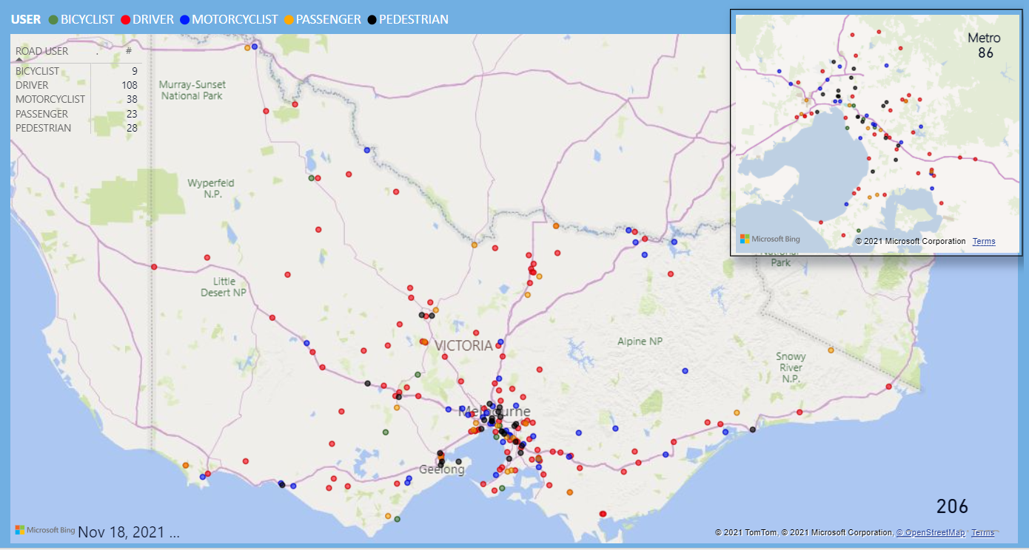
Victoria – Lives Lost, 12 months to June 2021

Injured claimants who were admitted to hospital within 7 days of accident
Rolling 12 month to 31st of December (claim acceptance date)

Category | 2020 | 2019 | 2018 | 2020 v 2019 |  | 2020 v 2018 |  | 5 Year Average
Claims involving an hospitalisation over 14 days (Rolling 12 Month Total)
Claims (to December) | 598 | 901 | 927 | -303 | (-34%) | -329 | (-35%) | 901
per 100,000 population | 8.9 | 13.7 | 14.3 | -4.8 | (-35%) | -5.4 | (-39%) | 14.4
per 10,000 vehicles | 1.2 | 1.8 | 1.9 | -0.6 | (-35%) | -0.7 | (-39%) | 1.9
All claims involving an hospitalisation (Rolling 12 Month Total)
Claims (to December) | 5,451 | 8,044 | 8,123 | -2593 | (-32%) | -2672 | (-33%) | 7391
per 100,000 population | 81.4 | 122.0 | 125.7 | -40.6 | (-31%) | -44.3 | (-37%) | 116.4
per 10,000 vehicles | 10.6 | 15.9 | 16.3 | -5.3 | (-33%) | -5.9 | (-37%) | 15.2

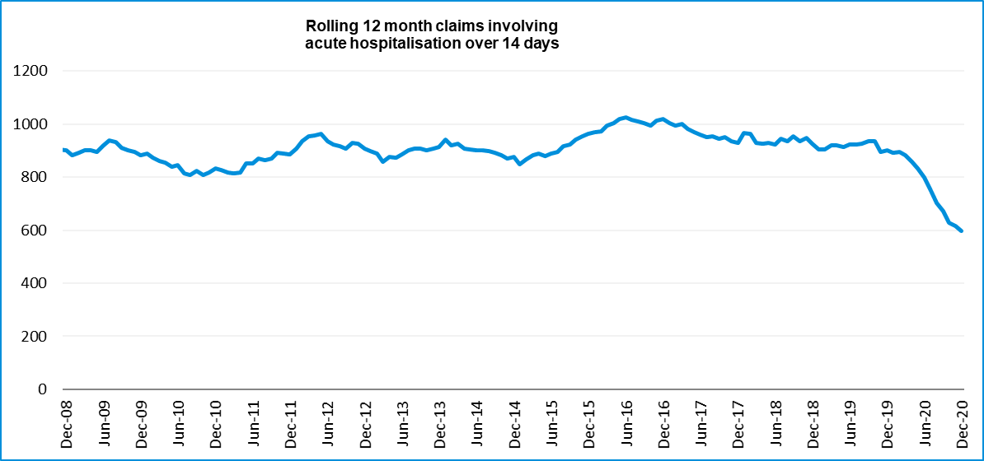

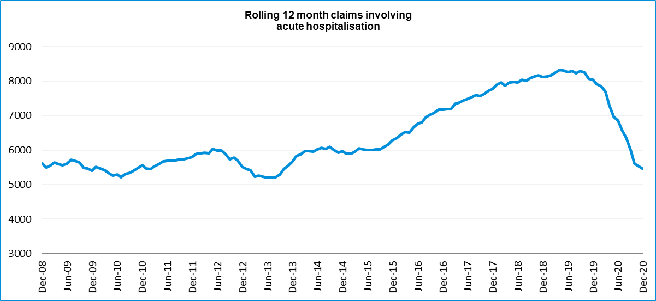

Lives lost: Rolling 12 months
12 months to 30 June 2021
Category | 2021 | 2020 | 2019 | 2021 v 2020 | 2021 v 2019 | 5 Year Average
Overview
Lives Lost | 206 | 231 | 263 | -25 | -57 | 241
Fatal Crashes | 196 | 212 | 248 | -16 | -52 | 226
Sex
Female | 51 | 61 | 69 | -10 | -18 | 64
Male | 155 | 170 | 194 | -15 | -39 | 177
Road user
Bicyclist | 9 | 13 | 12 | -4 | -3 | 10
Driver | 108 | 107 | 112 | +1 | -4 | 117
Motorcyclist | 38 | 33 | 49 | +5 | -11 | 40
Passenger | 23 | 37 | 44 | -14 | -21 | 37
Pedestrian | 28 | 41 | 46 | -13 | -18 | 37
Location
Melbourne | 85 | 110 | 119 | -25 | -34 | 105
Rural Victoria | 121 | 121 | 144 |  | -23 | 136
Age group
0-4 | 4 | 1 | 2 | +3 | +2 | 2
5-15 | 2 | 3 | 10 | -1 | -8 | 4
16-17 | 5 | 3 | 4 | +2 | +1 | 4
18-20 | 9 | 14 | 19 | -5 | -10 | 15
21-25 | 24 | 25 | 20 | -1 | +4 | 24
26-29 | 20 | 23 | 23 | -3 | -3 | 20
30-39 | 33 | 42 | 37 | -9 | -4 | 38
40-49 | 24 | 27 | 27 | -3 | -3 | 31
50-59 | 23 | 24 | 31 | -1 | -8 | 29
60-69 | 27 | 29 | 28 | -2 | -1 | 28
70+ | 35 | 40 | 61 | -5 | -26 | 47
Accident Type
Intersection
Adjacent direction | 23 | 25 | 31 | -2 | -8 | 29
Opposing direction | 8 | 11 | 10 | -3 | -2 | 9
Mid-block/other
Head on | 20 | 28 | 40 | -8 | -20 | 34
Same direction | 19 | 20 | 20 | -1 | -1 | 20
Manoeuvre/o'taking | 9 | 17 | 16 | -8 | -7 | 13
On path | 3 | 8 | 1 | -5 | +2 | 5
Single vehicle | 92 | 76 | 95 | +16 | -3 | 90
Other (incl peds) | 32 | 46 | 50 | -14 | -18 | 41

Lives Lost: 12 months to 30TH JUNE 2021
Category | 2021 | 2020 | 2019 | 5 Year Average | Category | 2021 | 2020 | 2019 | 5 Year Average
Local Government Area |  |  |  |  | Local Government Area
ALPINE | 1 | 1 | 3 | 1 | MANSFIELD | 0 | 1 | 2 | 2
ARARAT | 1 | 1 | 3 | 2 | MARIBYRNONG | 1 | 2 | 3 | 3
BALLARAT | 4 | 2 | 2 | 3 | MAROONDAH | 1 | 2 | 5 | 2
BANYULE | 1 | 1 | 2 | 2 | MELBOURNE | 4 | 1 | 2 | 2
BASS COAST | 1 | 1 | 3 | 2 | MELTON | 3 | 2 | 7 | 4
BAW BAW | 5 | 4 | 3 | 3 | MILDURA | 3 | 2 | 8 | 3
BAYSIDE | 0 | 1 | 1 | 2 | MITCHELL | 6 | 3 | 1 | 3
BENALLA | 0 | 0 | 2 | 2 | MOIRA | 2 | 4 | 2 | 4
BOROONDARA | 2 | 6 | 4 | 3 | MONASH | 5 | 7 | 8 | 6
BRIMBANK | 3 | 6 | 5 | 7 | MOONEE VALLEY | 0 | 2 | 2 | 2
BULOKE | 3 | 0 | 2 | 1 | MOORABOOL | 3 | 2 | 5 | 4
CAMPASPE | 2 | 2 | 4 | 3 | MORELAND | 1 | 0 | 4 | 2
CARDINIA | 13 | 4 | 4 | 5 | MORNINGTON PENINSULA | 9 | 10 | 9 | 7
CASEY | 5 | 8 | 4 | 6 | MOUNT ALEXANDER | 4 | 6 | 1 | 2
CENTRAL GOLDFIELDS | 1 | 2 | 2 | 1 | MOYNE | 2 | 2 | 2 | 2
COLAC-OTWAY | 3 | 3 | 0 | 3 | MURRINDINDI | 1 | 2 | 5 | 4
CORANGAMITE | 4 | 1 | 5 | 2 | NILLUMBIK | 2 | 2 | 2 | 2
DAREBIN | 1 | 7 | 1 | 3 | NORTHERN GRAMPIANS | 2 | 3 | 1 | 3
EAST GIPPSLAND | 8 | 3 | 7 | 5 | PORT PHILLIP | 1 | 2 | 0 | 1
FRANKSTON | 1 | 8 | 3 | 4 | PYRENEES | 3 | 0 | 3 | 2
GANNAWARRA | 1 | 0 | 3 | 1 | QUEENSCLIFFE | 0 | 0 | 0 | 0
GLEN EIRA | 1 | 3 | 1 | 2 | SOUTH GIPPSLAND | 4 | 5 | 7 | 4
GLENELG | 4 | 0 | 4 | 2 | SOUTHERN GRAMPIANS | 0 | 2 | 2 | 2
GOLDEN PLAINS | 2 | 0 | 7 | 3 | STONNINGTON | 1 | 0 | 4 | 1
GREATER BENDIGO | 5 | 7 | 6 | 6 | STRATHBOGIE | 1 | 1 | 2 | 2
GREATER DANDENONG | 5 | 3 | 4 | 3 | SURF COAST | 2 | 0 | 1 | 1
GREATER GEELONG | 7 | 14 | 8 | 9 | SWAN HILL | 3 | 1 | 2 | 2
GREATER SHEPPARTON | 8 | 4 | 6 | 6 | TOWONG | 1 | 2 | 2 | 1
HEPBURN | 1 | 6 | 3 | 4 | WANGARATTA | 0 | 3 | 1 | 3
HINDMARSH | 1 | 0 | 0 | 0 | WARRNAMBOOL | 2 | 3 | 2 | 1
HOBSONS BAY | 2 | 1 | 2 | 1 | WELLINGTON | 4 | 4 | 1 | 4
HORSHAM | 1 | 6 | 2 | 3 | WEST WIMMERA | 1 | 4 | 2 | 1
HUME | 2 | 8 | 7 | 5 | WHITEHORSE | 1 | 2 | 1 | 2
INDIGO | 4 | 0 | 3 | 2 | WHITTLESEA | 4 | 4 | 3 | 4
KINGSTON | 3 | 2 | 7 | 4 | WODONGA | 1 | 1 | 0 | 1
KNOX | 1 | 1 | 5 | 3 | WYNDHAM | 4 | 5 | 7 | 6
LATROBE | 2 | 8 | 4 | 5 | YARRA | 1 | 1 | 1 | 1
LODDON | 3 | 2 | 4 | 2 | YARRA RANGES | 6 | 7 | 9 | 7
MACEDON RANGES | 2 | 2 | 6 | 3 | YARRIAMBIACK | 1 | 1 | 0 | 1
MANNINGHAM | 0 | 2 | 2 | 2

Injured claimants admitted to hospital within 7 days of the accident with a hospital stay of more than 14 days
12 months to 31st^{st} December 2020 (claim acceptance date, excludes rejected claims and claims for interstate crashes.)
Category | 2020 | 2019 | 2018 | 2020 v 2019 |  | 2020 v 2018 |  | 5 Year Average
Overview
Claims | 598 | 901 | 927 | -303 | -34% | -329 | -35% | 874
Sex
Female | 211 | 368 | 396 | -157 | -43% | -185 | -47% | 350
Male | 386 | 533 | 531 | -147 | -28% | -145 | -27% | 524
Road user
Bicyclist | 33 | 31 | 31 | +2 | 6% | 2 | 6% | 34
Driver | 226 | 354 | 347 | -128 | -36% | -121 | -35% | 327
Motorcyclist | 146 | 178 | 181 | -32 | -18% | -35 | -19% | 177
Passenger | 69 | 121 | 148 | -52 | -43% | -79 | -53% | 125
Pedestrian | 108 | 184 | 182 | -76 | -41% | -74 | -41% | 182
Train/Tram | 0 | 11 | 9 | -11 | -100% | -9 | -100% | 8
Location
Melbourne | 353 | 528 | 550 | -175 | -33% | -197 | -36% | 526
Rural Victoria | 224 | 323 | 306 | -99 | -31% | -82 | -27% | 297
Age group
0-4 | 3 | 3 | 4 |  | 0% | -1 | -25% | 4
5-15 | 9 | 14 | 15 | -5 | -36% | -6 | -40% | 11
16-17 | 14 | 12 | 12 | +2 | 17% | 2 | 17% | 13
18-20 | 28 | 50 | 30 | -22 | -44% | -2 | -7% | 46
21-25 | 47 | 72 | 89 | -25 | -35% | -42 | -47% | 76
26-29 | 44 | 41 | 51 | +3 | 7% | -7 | -14% | 51
30-39 | 82 | 102 | 95 | -20 | -20% | -13 | -14% | 108
40-49 | 74 | 96 | 120 | -22 | -23% | -46 | -38% | 102
50-59 | 73 | 109 | 126 | -36 | -33% | -53 | -42% | 107
60-69 | 72 | 141 | 98 | -69 | -49% | -26 | -27% | 113
70+ | 152 | 261 | 287 | -109 | -42% | -135 | -47% | 244
Accident Type
Intersection
Adjacent direction | 69 | 76 | 86 | -7 | -9% | -17 | -20% | 87
Opposing direction | 25 | 50 | 54 | -25 | -50% | -29 | -54% | 49
Mid-block/other
Head on | 44 | 74 | 45 | -30 | -41% | -1 | -2% | 65
Same direction | 53 | 73 | 74 | -20 | -27% | -21 | -28% | 67
Manoeuvre/o'taking | 36 | 51 | 40 | -15 | -29% | -4 | -10% | 47
On path | 12 | 34 | 23 | -22 | -65% | -11 | -48% | 24
Single vehicle | 195 | 238 | 220 | -43 | -18% | -25 | -11% | 232
Other (incl peds) | 164 | 305 | 385 | -141 | -46% | -221 | -57% | 303

Injured claimants who were admitted to hospital within 7 days of the accident with a hospital stay of more than 14 days

12 months to 31st December 2020 (claim acceptance date, excludes rejected claims and claims for interstate crashes.) – Continued
Category | 2020 | 2019 | 2018 | 5 Year Average | Category | 2020 | 2019 | 2018 | 5 Year Average
Local Government Area |  |  |  |  | Local Government Area
ALPINE | 3 | 11 | 3 | 4 | MANSFIELD | 6 | 4 | 9 | 5
ARARAT | 1 | 7 | 1 | 3 | MARIBYRNONG | 8 | 10 | 8 | 10
BALLARAT | 12 | 16 | 18 | 13 | MAROONDAH | 10 | 11 | 5 | 7
BANYULE | 5 | 7 | 11 | 7 | MELBOURNE | 19 | 25 | 27 | 27
BASS COAST | 1 | 9 | 11 | 6 | MELTON | 4 | 8 | 11 | 8
BAW BAW | 3 | 10 | 10 | 7 | MILDURA | 4 | 5 | 6 | 5
BAYSIDE | 2 | 10 | 7 | 8 | MITCHELL | 11 | 9 | 8 | 7
BENALLA | 1 | 4 | 4 | 3 | MOIRA | 5 | 8 | 9 | 8
BOROONDARA | 8 | 16 | 13 | 11 | MONASH | 5 | 27 | 20 | 18
BRIMBANK | 7 | 22 | 16 | 18 | MOONEE VALLEY | 7 | 13 | 18 | 13
BULOKE | 2 | 2 | 4 | 2 | MOORABOOL | 5 | 8 | 5 | 6
CAMPASPE | 9 | 11 | 5 | 7 | MORELAND | 11 | 27 | 30 | 23
CARDINIA | 11 | 13 | 15 | 12 | MORNINGTON PENINSULA | 16 | 25 | 20 | 19
CASEY | 23 | 28 | 29 | 25 | MOUNT ALEXANDER | 1 | 2 | 4 | 1
CENTRAL GOLDFIELDS | 4 | 5 | 3 | 2 | MOYNE | 3 | 8 | 3 | 5
COLAC-OTWAY | 4 | 2 | 7 | 5 | MURRINDINDI | 5 | 9 | 8 | 9
CORANGAMITE | 3 | 1 | 8 | 5 | NILLUMBIK | 6 | 15 | 4 | 6
DAREBIN | 10 | 19 | 19 | 17 | NORTHERN GRAMPIANS | 1 | 4 | 4 | 3
EAST GIPPSLAND | 14 | 10 | 11 | 8 | PORT PHILLIP | 10 | 12 | 11 | 11
FRANKSTON | 6 | 9 | 13 | 11 | PYRENEES | 2 | 3 | 2 | 2
GANNAWARRA | 3 | 1 | 2 | 2 | QUEENSCLIFFE | 2 | 2 | 0 | 1
GLEN EIRA | 8 | 17 | 18 | 12 | SOUTH GIPPSLAND | 5 | 7 | 7 | 6
GLENELG | 1 | 4 | 4 | 3 | SOUTHERN GRAMPIANS | 3 | 6 | 3 | 3
GOLDEN PLAINS | 3 | 7 | 3 | 5 | STONNINGTON | 8 | 7 | 12 | 9
GREATER BENDIGO | 15 | 21 | 21 | 15 | STRATHBOGIE | 5 | 2 | 4 | 3
GREATER DANDENONG | 18 | 22 | 30 | 21 | SURF COAST | 2 | 9 | 6 | 5
GREATER GEELONG | 28 | 32 | 27 | 22 | SWAN HILL | 5 | 6 | 3 | 4
GREATER SHEPPARTON | 9 | 4 | 17 | 12 | TOWONG | 1 | 6 | 1 | 3
HEPBURN | 2 | 6 | 5 | 3 | WANGARATTA | 2 | 5 | 6 | 5
HINDMARSH | 3 | 0 | 0 | 1 | WARRNAMBOOL | 4 | 5 | 1 | 3
HOBSONS BAY | 5 | 7 | 8 | 6 | WELLINGTON | 8 | 8 | 10 | 8
HORSHAM | 1 | 5 | 4 | 3 | WEST WIMMERA | 0 | 0 | 1 | 1
HUME | 22 | 23 | 29 | 22 | WHITEHORSE | 17 | 29 | 21 | 19
INDIGO | 3 | 3 | 6 | 4 | WHITTLESEA | 18 | 24 | 28 | 21
KINGSTON | 11 | 16 | 21 | 13 | WODONGA | 2 | 6 | 3 | 3
KNOX | 15 | 21 | 23 | 16 | WYNDHAM | 20 | 15 | 24 | 18
LATROBE | 7 | 11 | 16 | 8 | YARRA | 10 | 12 | 11 | 11
LODDON | 2 | 5 | 1 | 2 | YARRA RANGES | 25 | 23 | 33 | 23
MACEDON RANGES | 7 | 12 | 11 | 10 | YARRIAMBIACK | 1 | 2 | 1 | 1
MANNINGHAM | 8 | 15 | 15 | 14

Injured claimants who were admitted to hospital within 7 days of accident
12 months to 31st December 2020 (claim acceptance date, excludes rejected claims and claims for interstate crashes.)
Category | 2020 | 2019 | 2018 | 2020 v 2019 |  | 2020 v 2018 |  | 5 Year Average
Overview
Claims | 5,451 | 8,044 | 8,123 | -2593 | -32% | -2672 | -33% | 7,311
Sex
Female | 2,184 | 3,535 | 3,498 | -1351 | -38% | -1314 | -38% | 3,144
Male | 3,257 | 4,500 | 4,617 | -1243 | -28% | -1360 | -29% | 4,158
Road user
Bicyclist | 423 | 519 | 522 | -96 | -18% | -99 | -19% | 480
Driver | 2,641 | 3,899 | 3,912 | -1258 | -32% | -1271 | -32% | 3,501
Motorcyclist | 1,008 | 1,366 | 1,378 | -358 | -26% | -370 | -27% | 1,250
Passenger | 686 | 1,148 | 1,142 | -462 | -40% | -456 | -40% | 1,047
Pedestrian | 459 | 773 | 802 | -314 | -41% | -343 | -43% | 716
Train/Tram | 19 | 37 | 47 | -18 | -49% | -28 | -60% | 39
Location
Melbourne | 3,435 | 4,890 | 4,769 | -1455 | -30% | -1334 | -28% | 4,484
Rural Victoria | 1,782 | 2,403 | 2,329 | -621 | -26% | -547 | -23% | 2,160
Age group
0-4 | 33 | 48 | 74 | -15 | -31% | -41 | -55% | 55
5-15 | 121 | 217 | 240 | -96 | -44% | -119 | -50% | 203
16-17 | 92 | 123 | 140 | -31 | -25% | -48 | -34% | 120
18-20 | 404 | 567 | 599 | -163 | -29% | -195 | -33% | 540
21-25 | 649 | 940 | 1,043 | -291 | -31% | -394 | -38% | 903
26-29 | 479 | 700 | 660 | -221 | -32% | -181 | -27% | 623
30-39 | 926 | 1,318 | 1,274 | -392 | -30% | -348 | -27% | 1,175
40-49 | 789 | 1,075 | 1,163 | -286 | -27% | -374 | -32% | 1,039
50-59 | 739 | 1,077 | 1,065 | -338 | -31% | -326 | -31% | 969
60-69 | 556 | 873 | 790 | -317 | -36% | -234 | -30% | 735
70+ | 663 | 1,106 | 1,075 | -443 | -40% | -412 | -38% | 949
Accident Type
Intersection
Adjacent direction | 904 | 1,020 | 831 | -116 | -11% | +73 | 9% | 912
Opposing direction | 387 | 539 | 473 | -152 | -28% | -86 | -18% | 508
Mid-block/other
Head on | 259 | 371 | 277 | -112 | -30% | -18 | -6% | 324
Same direction | 865 | 1,105 | 933 | -240 | -22% | -68 | -7% | 983
Manoeuvre/o'taking | 395 | 377 | 321 | +18 | 5% | +74 | 23% | 370
On path | 207 | 222 | 227 | -15 | -7% | -20 | -9% | 244
Single vehicle | 1,294 | 1,418 | 1,313 | -124 | -9% | -19 | -1% | 1,473
Other (incl peds) | 1,140 | 2,992 | 3,748 | -1852 | -62% | -2608 | -70% | 2,499

Injured claimants who were admitted to hospital within 7 days of accident

12 months to 31st December 2020 (claim acceptance date, excludes rejected claims and claims for interstate crashes.) – Continued
Category | 2020 | 2019 | 2018 | 5 Year Average | Category | 2020 | 2019 | 2018 | 5 Year Average
Local Government Area |  |  |  |  | Local Government Area
ALPINE | 22 | 40 | 29 | 23 | MANSFIELD | 25 | 47 | 43 | 32
ARARAT | 10 | 23 | 12 | 14 | MARIBYRNONG | 60 | 101 | 99 | 76
BALLARAT | 81 | 113 | 89 | 79 | MAROONDAH | 50 | 72 | 71 | 52
BANYULE | 31 | 64 | 70 | 53 | MELBOURNE | 156 | 261 | 306 | 249
BASS COAST | 25 | 55 | 57 | 38 | MELTON | 70 | 99 | 76 | 67
BAW BAW | 65 | 57 | 52 | 43 | MILDURA | 46 | 32 | 29 | 23
BAYSIDE | 69 | 94 | 78 | 70 | MITCHELL | 67 | 76 | 68 | 58
BENALLA | 11 | 25 | 21 | 17 | MOIRA | 36 | 42 | 35 | 33
BOROONDARA | 78 | 155 | 154 | 113 | MONASH | 134 | 215 | 195 | 162
BRIMBANK | 132 | 186 | 171 | 132 | MOONEE VALLEY | 88 | 158 | 146 | 114
BULOKE | 6 | 12 | 9 | 8 | MOORABOOL | 41 | 61 | 58 | 44
CAMPASPE | 37 | 41 | 47 | 39 | MORELAND | 120 | 188 | 209 | 151
CARDINIA | 110 | 119 | 124 | 104 | MORNINGTON PENINSULA | 148 | 200 | 187 | 146
CASEY | 281 | 325 | 336 | 270 | MOUNT ALEXANDER | 14 | 21 | 30 | 17
CENTRAL GOLDFIELDS | 23 | 27 | 15 | 15 | MOYNE | 19 | 44 | 32 | 28
COLAC-OTWAY | 46 | 67 | 67 | 51 | MURRINDINDI | 43 | 61 | 55 | 50
CORANGAMITE | 21 | 37 | 32 | 30 | NILLUMBIK | 39 | 53 | 37 | 35
DAREBIN | 77 | 147 | 106 | 96 | NORTHERN GRAMPIANS | 16 | 24 | 24 | 19
EAST GIPPSLAND | 51 | 40 | 65 | 46 | PORT PHILLIP | 108 | 152 | 161 | 121
FRANKSTON | 108 | 153 | 146 | 117 | PYRENEES | 11 | 18 | 11 | 11
GANNAWARRA | 12 | 9 | 11 | 8 | QUEENSCLIFFE | 2 | 10 | 6 | 5
GLEN EIRA | 118 | 128 | 142 | 103 | SOUTH GIPPSLAND | 37 | 53 | 31 | 37
GLENELG | 14 | 22 | 34 | 19 | SOUTHERN GRAMPIANS | 32 | 26 | 15 | 17
GOLDEN PLAINS | 42 | 50 | 46 | 40 | STONNINGTON | 100 | 129 | 141 | 109
GREATER BENDIGO | 102 | 154 | 137 | 105 | STRATHBOGIE | 30 | 39 | 33 | 29
GREATER DANDENONG | 206 | 287 | 270 | 217 | SURF COAST | 61 | 63 | 68 | 50
GREATER GEELONG | 317 | 426 | 466 | 313 | SWAN HILL | 24 | 18 | 18 | 15
GREATER SHEPPARTON | 53 | 83 | 95 | 80 | TOWONG | 8 | 18 | 23 | 15
HEPBURN | 23 | 36 | 36 | 25 | WANGARATTA | 24 | 47 | 40 | 31
HINDMARSH | 8 | 22 | 8 | 10 | WARRNAMBOOL | 20 | 33 | 28 | 26
HOBSONS BAY | 61 | 90 | 88 | 65 | WELLINGTON | 43 | 63 | 78 | 55
HORSHAM | 21 | 33 | 35 | 21 | WEST WIMMERA | 3 | 4 | 7 | 4
HUME | 203 | 262 | 260 | 204 | WHITEHORSE | 74 | 150 | 142 | 121
INDIGO | 16 | 23 | 31 | 22 | WHITTLESEA | 145 | 201 | 248 | 181
KINGSTON | 127 | 140 | 137 | 108 | WODONGA | 26 | 24 | 21 | 20
KNOX | 97 | 138 | 145 | 111 | WYNDHAM | 184 | 219 | 174 | 142
LATROBE | 83 | 89 | 82 | 61 | YARRA | 67 | 132 | 109 | 95
LODDON | 10 | 21 | 12 | 10 | YARRA RANGES | 155 | 182 | 158 | 138
MACEDON RANGES | 48 | 70 | 78 | 64 | YARRIAMBIACK | 7 | 4 | 10 | 5
MANNINGHAM | 39 | 90 | 83 | 74

Lives lost by week (2016 to 2021)
Week Ending | 2016 | 2017 | 2018 | 2019 | 2020 | 2021 | 2021 Cumulative | 12 month Moving Total
03-Jan | 2 | 0 | 4 | 0 | 5 | 4 | 4 | 209
10-Jan | 3 | 5 | 6 | 5 | 3 | 1 | 5 | 207
17-Jan | 3 | 6 | 2 | 3 | 5 | 0 | 5 | 202
24-Jan | 3 | 4 | 2 | 7 | 2 | 6 | 11 | 206
31-Jan | 10 | 2 | 6 | 8 | 9 | 4 | 15 | 201
07-Feb | 6 | 4 | 3 | 9 | 5 | 6 | 21 | 202
14-Feb | 12 | 3 | 4 | 9 | 6 | 6 | 27 | 202
21-Feb | 6 | 6 | 7 | 4 | 5 | 4 | 31 | 201
28-Feb | 9 | 5 | 2 | 12 | 1 | 6 | 37 | 206
07-Mar | 9 | 3 | 5 | 0 | 4 | 10 | 47 | 212
14-Mar | 9 | 5 | 7 | 5 | 9 | 4 | 51 | 207
21-Mar | 5 | 5 | 3 | 7 | 10 | 5 | 56 | 202
28-Mar | 1 | 7 | 4 | 6 | 1 | 5 | 61 | 207
04-Apr | 1 | 4 | 3 | 3 | 7 | 6 | 67 | 206
11-Apr | 1 | 12 | 0 | 10 | 1 | 2 | 69 | 207
18-Apr | 7 | 7 | 1 | 6 | 1 | 4 | 73 | 210
25-Apr | 4 | 6 | 5 | 4 | 9 | 2 | 75 | 203
02-May | 5 | 3 | 3 | 3 | 2 | 3 | 78 | 204
09-May | 7 | 7 | 13 | 9 | 2 | 5 | 83 | 207
16-May | 5 | 4 | 3 | 9 | 5 | 4 | 87 | 206
23-May | 5 | 2 | 3 | 6 | 2 | 2 | 89 | 206
30-May | 8 | 6 | 2 | 7 | 5 | 1 | 90 | 202
06-Jun | 4 | 2 | 1 | 4 | 1 | 2 | 92 | 203
13-Jun | 5 | 3 | 8 | 3 | 5 | 6 | 98 | 204
20-Jun | 5 | 4 | 1 | 5 | 4 | 5 | 103 | 205
27-Jun | 8 | 4 | 2 | 4 | 4 | 4 | 107 | 205
04-Jul | 2 | 5 | 1 | 7 | 4
11-Jul | 3 | 5 | 3 | 3 | 3
18-Jul | 7 | 9 | 5 | 2 | 3
25-Jul | 11 | 4 | 5 | 5 | 5
01-Aug | 6 | 0 | 2 | 3 | 4
08-Aug | 5 | 7 | 4 | 3 | 3
15-Aug | 7 | 9 | 3 | 5 | 4
22-Aug | 8 | 2 | 6 | 3 | 2
29-Aug | 8 | 8 | 4 | 4 | 3
05-Sep | 3 | 6 | 4 | 3 | 4
12-Sep | 3 | 6 | 3 | 5 | 4
19-Sep | 5 | 3 | 7 | 4 | 1
26-Sep | 5 | 3 | 2 | 3 | 0
03-Oct | 2 | 2 | 5 | 6 | 7
10-Oct | 6 | 4 | 7 | 6 | 3
17-Oct | 4 | 6 | 2 | 5 | 6
24-Oct | 7 | 0 | 3 | 4 | 7
31-Oct | 5 | 1 | 7 | 9 | 4
07-Nov | 2 | 11 | 5 | 3 | 3
14-Nov | 7 | 5 | 2 | 5 | 5
21-Nov | 5 | 4 | 12 | 5 | 3
28-Nov | 9 | 11 | 3 | 4 | 4
05-Dec | 9 | 3 | 3 | 4 | 2
12-Dec | 5 | 5 | 3 | 5 | 4
19-Dec | 5 | 7 | 5 | 7 | 4
26-Dec | 2 | 11 | 5 | 1 | 5
31-Dec | 6 | 3 | 2 | 4 | 1
Total | 290 | 259 | 213 | 266 | 211

Booze bus random breath testing
Booze-bus Random Breath Tests (12 months to March 2020 vs previous 12 months)
 | 2020 | 2019 | 2018 | 2020 v 2019 |  | 2020 v 2018
Melbourne | 1,025,495 | 1,226,599 | 1,143,717 | -201104 | (-16%) | -118222 | (-10%)
Country | 183,858 | 115,731 | 142,698 | +68127 | (+59%) | +41160 | (+29%)
Vic Total | 1,209,353 | 1,342,330 | 1,286,415 | -132977 | (-10%) | -77062 | (-6%)

12 months to March 2020 (monthly totals)
 | 2019 |  |  |  |  |  |  |  |  | 2020
 | Apr | May | Sep | Jul | Aug | Sep | Oct | Nov | Dec | Jan | Feb | Mar
Melbourne | 79,988 | 84,478 | 101,799 | 98,380 | 102,592 | 96,574 | 89,177 | 88,460 | 82,298 | 62,544 | 103,896 | 35,309
Country | 19,119 | 14,068 | 10,318 | 5,826 | 11,098 | 12,571 | 17,551 | 25,867 | 16,566 | 15,206 | 23,588 | 12,080
Vic Total | 99,107 | 98,546 | 112,117 | 104,206 | 113,690 | 109,145 | 106,728 | 114,327 | 98,864 | 77,750 | 127,484 | 47,389

Random Drug Testing
Random Drug Tests (12 months to March 2020 vs previous 12 months)
 | 2020 | 2019 | 2018 | 2020 v 2019 |  | 2020 v 2018
Victoria | 161,283 | 122,730 | 102,551 | 38,553 | 31% | 58,732 | 57%

12 months to March 2020 (monthly totals)
 | 2019 |  |  |  |  |  |  |  |  | 2020
 | Apr | May | Jun | Jul | Aug | Sep | Oct | Nov | Dec | Jan | Feb | Mar
Victoria | 17,337 | 19,571 | 15,441 | 13,817 | 18692 | 15,244 | 12181 | 12646 | 11,000 | 9,157 | 7,904 | 8,293

Speed Infringements Issued from Mobile Cameras (monthly totals) |  | Monthly Average = | 38,523
Mobile Safety Camera Data
2020 |  |  |  |  |  | 2021
Jul | Aug | Sep | Oct | Nov | Dec | Jan | Feb | Mar | Apr | May | Jun
20,144 | 18,901 | 31,482 | 31,150 | 26,491 | 31,356 | 74,973 | 60,602 | 51,605 | 52,014 | 57,526 | 66,303

Excessive Speed Infringements (ESI) Issued from Mobile Cameras (monthly totals) |  |  |  |  |  |  |  |  | Monthly Average = |  |  |  | 473
2020 |  |  |  |  |  | 2021
Jul | Aug | Sep | Oct | Nov | Dec | Jan | Feb | Mar |  | Apr | May |  |  | Jun
250 | 233 | 426 | 343 | 358 | 310 | 583 | 625 | 762 |  | 476 | 608 |  |  | 698
Notes: An ESI is defined as 25km/h over the speed limit except in a 110km/h zone where it is 20km/h over the limit.

Notes: 1. The definition of ESIs changed on 15 December 2002 to 25km/h over the speed limit from 30km/h over the speed limit except in a 110km/h zone where it has always been 20km/h over the limit.

The National Picture
State | Lives Lost (12 months to June)
 | 2021 | 2020 | 2019 | 2018 | 2021 v 2020
NSW | 294 | 315 | 358 | 386 | -21 | (-7%)
VIC | 206 | 231 | 263 | 238 | -25 | (-11%)
QLD | 294 | 237 | 227 | 246 | +57 | (+24%)
SA | 101 | 99 | 103 | 99 | +2 | (+2%)
WA | 168 | 140 | 171 | 166 | +28 | (+20%)
TAS | 34 | 30 | 32 | 35 | +4 | (+13%)
NT | 37 | 31 | 37 | 42 | +6 | (+19%)
ACT | 11 | 5 | 6 | 7 | +6 | (+120%)
AUST TOTAL | 1,145 | 1,088 | 1,197 | 1,219 | +57 | (+5%)
AUST minus VIC | 939 | 857 | 934 | 981 | +82 | (+10%)

State | Lives Lost per 10,000 registered vehicles |  |  | Fatalities per 100,000 population
 | (12 months to June) |  |  | (12 months to June)
 | 2021 | 2020 | 2019 | 2021 | 2020 | 2019
NSW | 0.50 | 0.55 | 0.63 | 3.58 | 3.88 | 4.45
VIC | 0.40 | 0.45 | 0.52 | 3.05 | 3.48 | 4.03
QLD | 0.68 | 0.53 | 0.55 | 5.64 | 4.62 | 4.49
SA | 0.65 | 0.42 | 0.72 | 5.68 | 5.62 | 5.91
WA | 0.73 | 0.62 | 0.76 | 6.26 | 5.30 | 6.55
TAS | 0.66 | 0.59 | 0.65 | 6.25 | 5.58 | 6.02
NT | 2.28 | 1.93 | 2.29 | 15.04 | 12.61 | 15.01
ACT | 0.35 | 0.16 | 0.19 | 2.54 | 1.17 | 1.42
AUST TOTAL | 0.57 | 0.55 | 0.61 | 4.43 | 4.26 | 4.75
AUST minus VIC | 0.63 | 0.58 | 0.65 | 4.92 | 4.54 | 5.01

International Road Safety Comparison
Selected OECD countries, Australia and Victoria, 1990, 2000, 2010, 2015 to 2019

Lives lost rate per 100,000 population
Countries | 1990 | 2000 | 2010 | 2015 | 2016 | 2017 | 2018 | 2019
Australia | 13.7 | 9.5 | 6.1 | 5.1 | 5.3 | 5.0 | 4.5 | 4.7
Canada | 14.3 | 9.5 | 6.6 | 5.3 | 5.3 | 5.1 | 5.2 | 4.7
New Zealand | 21.5 | 12.0 | 8.6 | 6.9 | 6.9 | 7.9 | 7.7 | 7.1
Norway | 7.8 | 7.6 | 4.3 | 2.3 | 2.6 | 2.0 | 2.0 | 2.0
Sweden | 9.0 | 6.7 | 2.8 | 2.6 | 2.7 | 2.5 | 3.2 | 2.2
Switzerland | 13.8 | 8.2 | 4.2 | 3.1 | 2.6 | 2.7 | 2.7 | 2.2
United Kingdom | 9.4 | 6.1 | 3.0 | 2.8 | 2.8 | 2.8 | 2.8 | 2.7
United States | 17.9 | 14.9 | 10.7 | 11.1 | 11.7 | 11.5 | 11.2 | 11.0
Victoria | 12.5 | 8.7 | 5.3 | 4.2 | 4.7 | 4.1 | 3.3 | 4.0

Lives lost rate per100 million vehicle kilometres travelled (VKT)
Countries | 1990 | 2000 | 2010 | 2015 | 2016 | 2017 | 2018 | 2019
Australia | 1.4 | 0.9 | 0.6 | 0.5 | 0.5 | 0.5 | 0.4 | 0.4
Canada | - | 0.9 | 0.7 | 0.5 | 0.5 | 0.5 | 0.5 | 0.4
New Zealand | - | 1.4 | 0.9 | 0.7 | 0.7 | 0.8 | 0.8 | 0.7
Norway | 1.2 | 1.0 | 0.5 | 0.3 | 0.3 | 0.2 | 0.2 | 0.2
Sweden | 1.2 | 0.9 | 0.3 | 0.3 | 0.3 | 0.3 | 0.4 | 0.3
Switzerland | 1.9 | 1.1 | 0.5 | 0.4 | 0.3 | 0.3 | 0.3 | 0.3
United Kingdom | - | - | - | - | - | - | - | -
United States | 1.3 | 0.9 | 0.7 | 0.7 | 0.7 | 0.7 | 0.7 | 0.7
Victoria | 1.2 | 0.8 | 0.5 | 0.4 | 0.4 | 0.4 | 0.3 | 0.4

Lives lost rate per 10,000 registered vehicles

Countries | 1990 | 2000 | 2010 | 2015 | 2016 | 2017 | 2018 | 2019
Australia | 2.3 | 1.5 | 0.8 | 0.7 | 0.7 | 0.7 | 0.6 | 0.6
Canada | 2.3 | 1.6 | 1.0 | 0.8 | 0.8 | 0.8 | 0.7 | 0.7
New Zealand | 3.3 | 1.8 | 1.2 | 0.9 | 0.9 | 1.0 | 0.9 | 0.9
Norway | 1.4 | 1.2 | 0.6 | 0.3 | 0.3 | 0.3 | 0.3 | 0.3
Sweden | 1.7 | 1.2 | 0.5 | 0.4 | 0.4 | 0.4 | 0.5 | 0.3
Switzerland | 2.2 | 1.2 | 0.6 | 0.4 | 0.4 | 0.4 | 0.4 | 0.3
United Kingdom | 2.1 | 1.2 | 0.5 | 0.5 | 0.5 | 0.5 | 0.5 | 0.5
United States | 2.4 | 1.9 | 1.3 | 1.3 | 1.3 | 1.3 | 1.2 | 1.2
Victoria | 2.1 | 1.2 | 0.7 | 0.6 | 0.6 | 0.5 | 0.4 | 0.5

Lives lost rate per 100,000 population - OECD countries, 2019
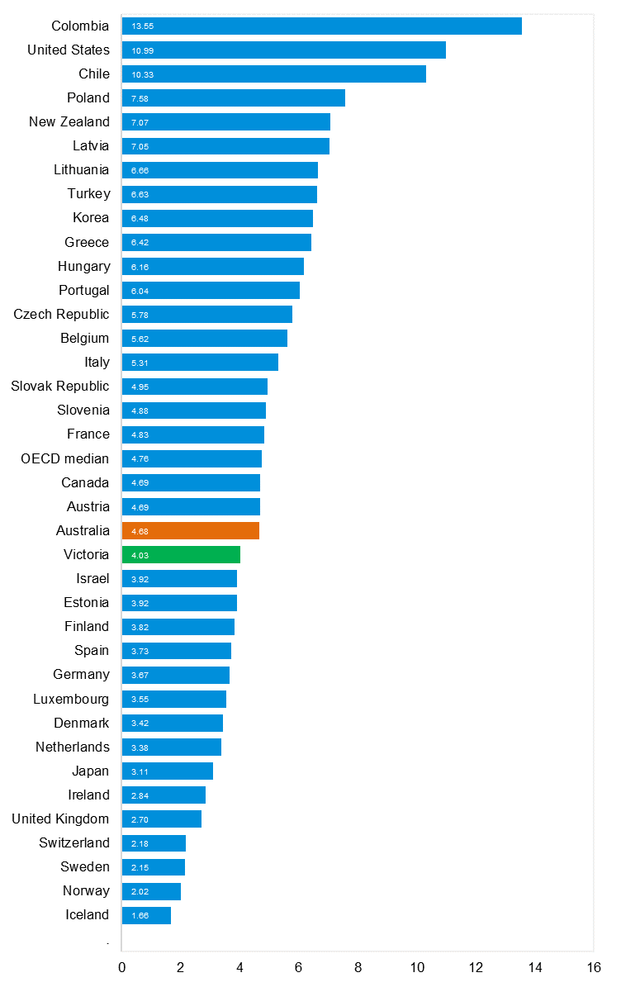
Source: Bureau of Infrastructure and Transport Research Economics

Explanations and references
LGA: Local Government Areas. Crash locations for acute hospitalised claims are assigned to LGA’s based on the crash postcode recorded by Victoria Police. Crash locations for fatal crashes are coded exactly to an LGA by Victoria Police.
Claimants: Refers to people injured in transport accidents who have an accepted claim with the TAC.
Hospitalisation: refers to all hospital admission that occurred within 7 days of accident.

Useful websites
TAC Sites
- TAC Safety (Road Safety) www.tacsafety.com.au
- TAC How safe is your car www.howsafeisyourcar.com.au
- TAC How safe is your first car www.howsafeisyourfirstcar.com.au
- TAC Motorcycle Safety Website www.spokes.com.au
- TAC Corporate site www.tac.vic.gov.au
- Drivesmart www.drivesmart.vic.gov.au
- Ridesmart www.ridesmartonline.com.au

Victorian Sites
- VicRoads www.vicroads.vic.gov.au
- Victoria Police www.police.vic.gov.au
- Parliamentary Road Safety Committee https://www.parliament.vic.gov.au/57th-parliament/rsc
- RACV www.racv.com.au
- Monash University Accident Research Centre www.monash.edu.au/muarc
- Cameras Save Lives www.camerassavelives.vic.gov.au
- VicRoads Learner Driver Site www.lsite.vicroads.vic.gov.au/Learners
- Road Safety Education Victoria www.roadsafetyeducation.vic.gov.au

National and Interstate Sites
- ARRB Transport Research www.arrb.com.au
- Australian Transport Safety Bureau www.atsb.gov.au
- Motor Accidents Authority (NSW) www.maa.nsw.gov.au
- Motor Accidents Insurance Board (TAS) www.maib.tas.gov.au
- Motor Accident Commission, Allianz (SA) www.mac.sa.gov.au
- Motor Accidents Compensation, TIO, (NT) www.tiofi.com.au/mac
- Insurance Commission of Western Australia www.icwa.wa.gov.au
- Motor Accident Insurance Commission (QLD) www.maic.qld.gov.au

International Sites
- National Highway Traffic Safety Admin (USA) www.nhtsa.dot.gov
- Swedish Road and Transport Institute (VTI) www.vti.se
- SWOV Institute for Road Safety Research www.swov.nl

Related Sites
- Alcohol and Drug Foundation www.adf.org.au

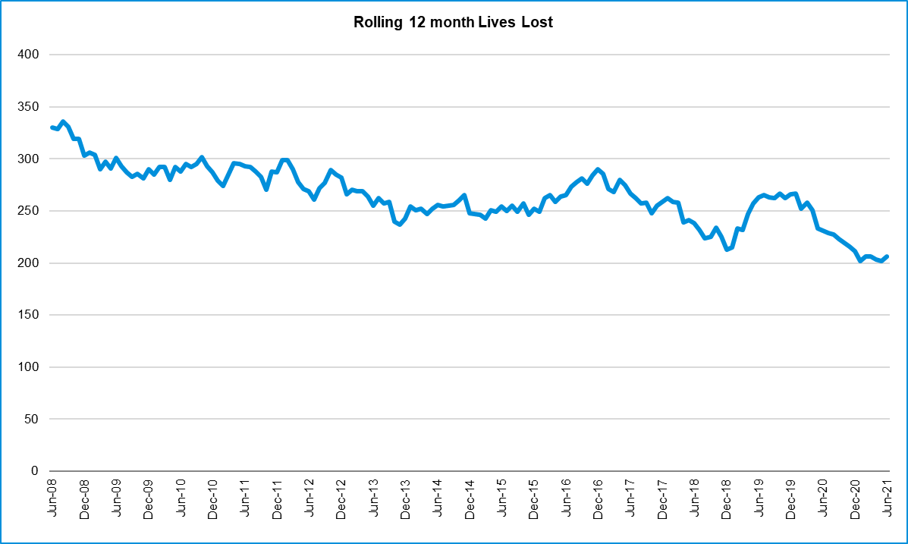
GRAPHS OF LIVES LOST AND HOSPITALISED CLAIMS

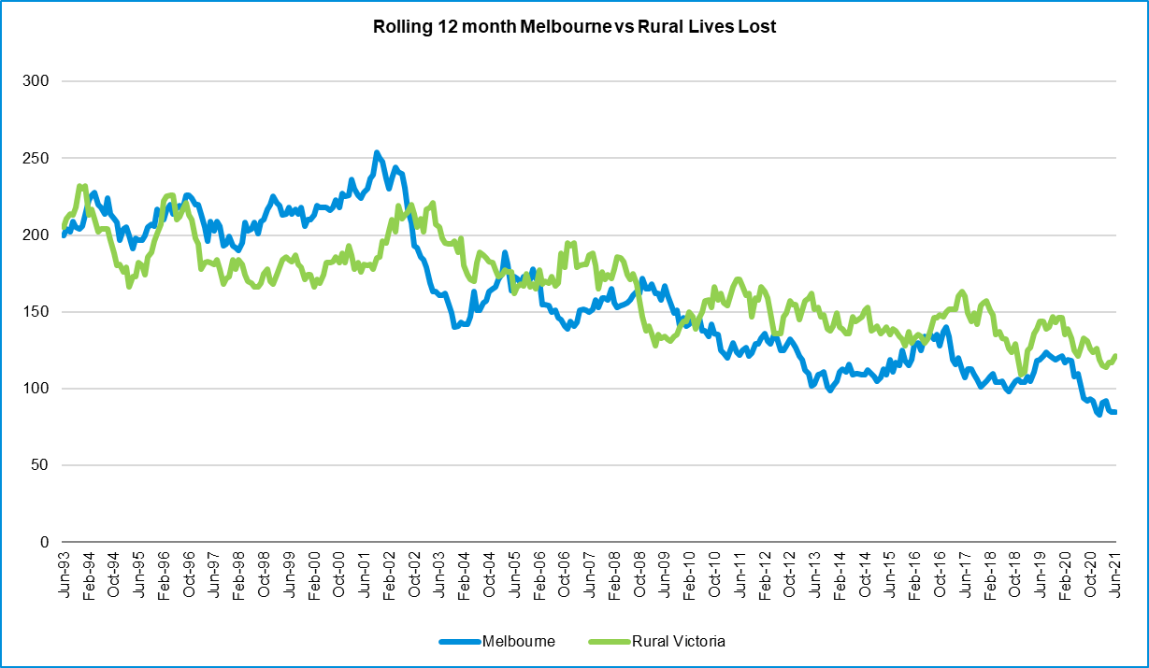

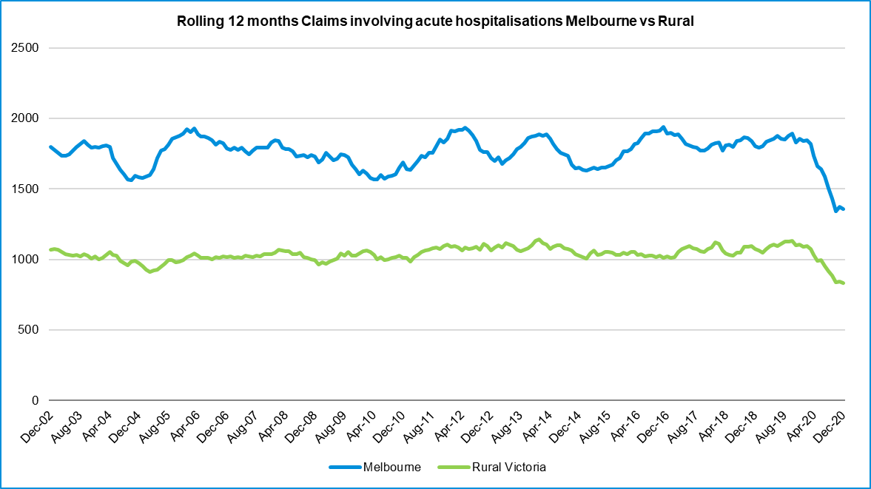
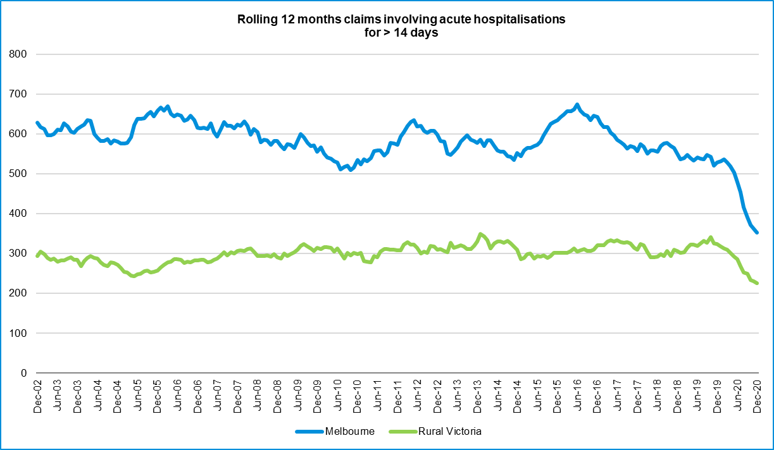

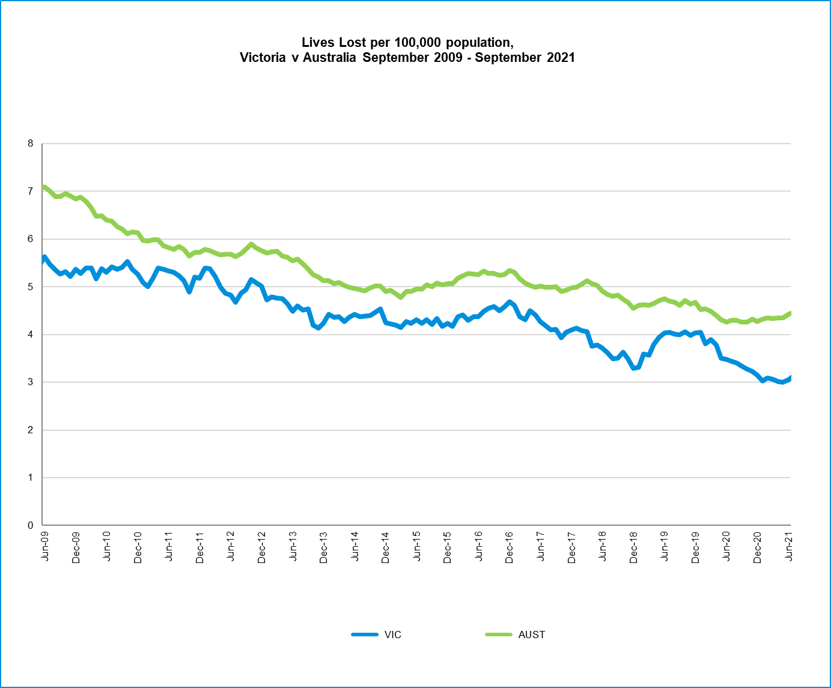

Victorian monthly lives

