

TAC Road Safety Quarterly Statistics
September 2021



Contents

Status Report 3
Lives lost: Rolling 12 months 5
Injured claimants admitted to hospital within 7 days of the accident with a hospital stay of more than 14 days 7
Injured claimants who were admitted to hospital within 7 days of
accident 9
Booze bus random breath testing 12
The National Picture 13
International Road Safety Comparison 14
Lives lost rate per 100,000 population - OECD countries, 2019 15
Useful websites 17
GRAPHS OF LIVES LOST AND HOSPITALISED CLAIMS 18
Victorian monthly lives lost since 1951 21

Notes about the data in this report
- All data provided in this report is the data most recently available at time of production. Fatality data updated to the end of report month. A 6-month lag applies to TAC claims data.
- Reported data will have one extra day of exposure for leap years.
- Data is subject to revision as additional information about known accidents/claims is received, and as new accident/claim reports are received and processed.

Status Report

LIVES LOST ON VICTORIAN ROADS
- In a 12-month period from 1st October 2020 to the end of September 2021, 227 people lost their lives compared to 223 people lives lost during the previous 12-month period from October 2019 to September 2020. This represents 4 more lives lost.

Category | 2021 | 2020 | 2019 | 2021 v  2020 | 2021 v  2019 | 5 Year Average
Lives Lost (Rolling 12 Month Total)
Lives Lost (to September) | 227 | 223 | 262 | +4 | -35 | 239
per 10,000 vehicles | 0.44 | 0.43 | 0.52 | +0.01 | -0.08 | 0.49
per 100,000 population | 3.35 | 3.34 | 3.99 | +0.01 | -0.64 | 3.76
Crashes (Rolling 12 Month Total)
Fatal crashes (to September) | 212 | 207 | 243 | +5 | -31 | 223
per 10,000 vehicles | 0.41 | 0.40 | 0.48 | +0.01 | -0.07 | 0.46
per 100,000 population | 3.13 | 3.10 | 3.70 | +0.03 | -0.57 | 3.53

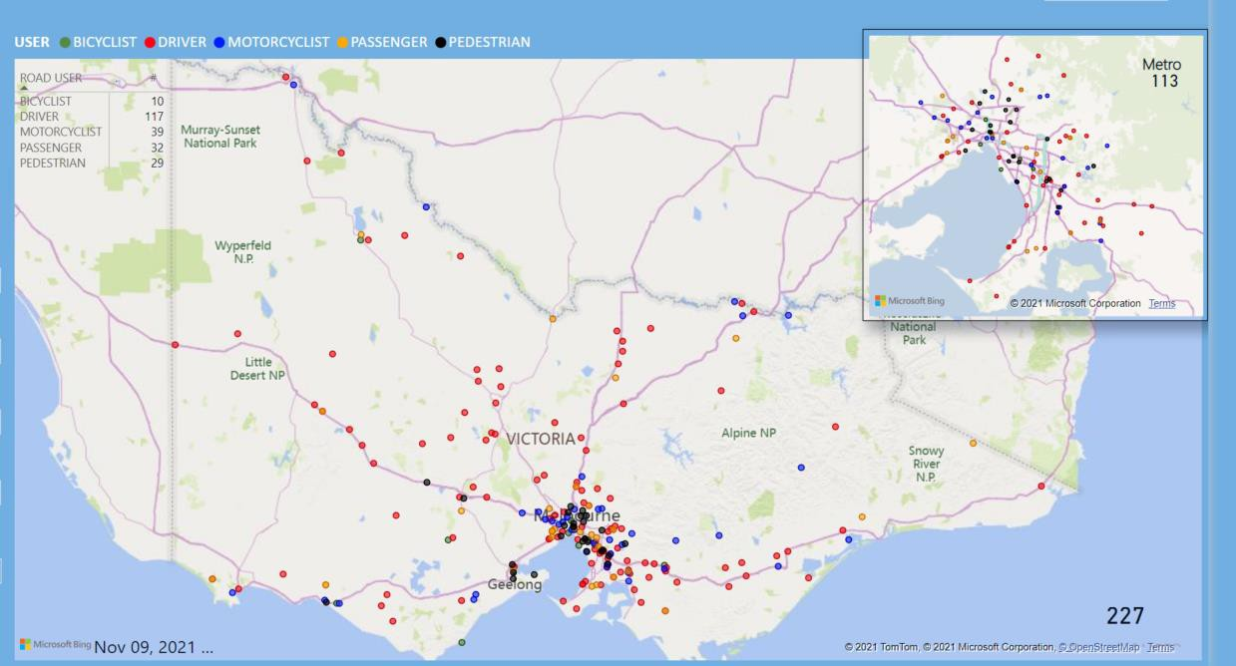

Victoria – Lives Lost, 12 months to September 2021

INJURED CLAIMANTS WHO WERE ADMITTED TO HOSPITAL WITHIN 7 DAYS OF ACCIDENT
Rolling 12 month to 31st of March (claim acceptance date)

Category | 2021 | 2020 | 2019 | 2021 v 2020 | 2021 v 2019 | 5 Year Average

Claims involving an hospitalisation over 14 days
(Rolling 12 Month Total)
Claims (to March) | 580 | 883 | 918 | -303 | (-34%) | -338 | (-37%) | 862
per 100,000 population | 8.6 | 13.3 | 14.1 | -4.7 | (-35%) | -5.5 | (-39%) | 14.0
per 10,000 vehicles | 1.1 | 1.7 | 1.8 | -0.6 | (-35%) | -0.7 | (-39%) | 1.8
All claims involving an hospitalisation (Rolling 12 Month Total)
Claims (to March) | 5,273 | 7,691 | 8,248 | -2418 | (-31%) | -2975 | (-36%) | 7,284
per 100,000 population | 78.5 | 116.2 | 127.0 | -37.7 | (-32%) | -48.5 | (-38%) | 115.0
per 10,000 vehicles | 10.2 | 15.1 | 16.5 | -4.9 | (-32%) | -6.3 | (-38%) | 15.0

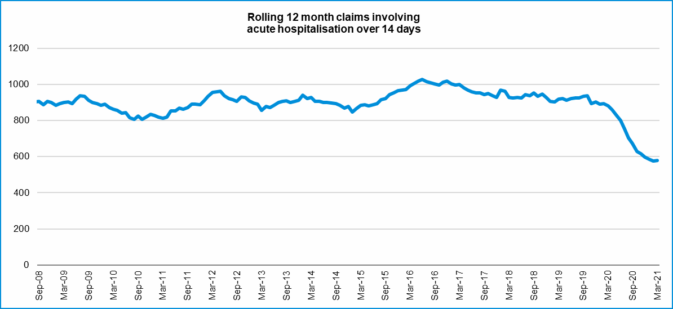

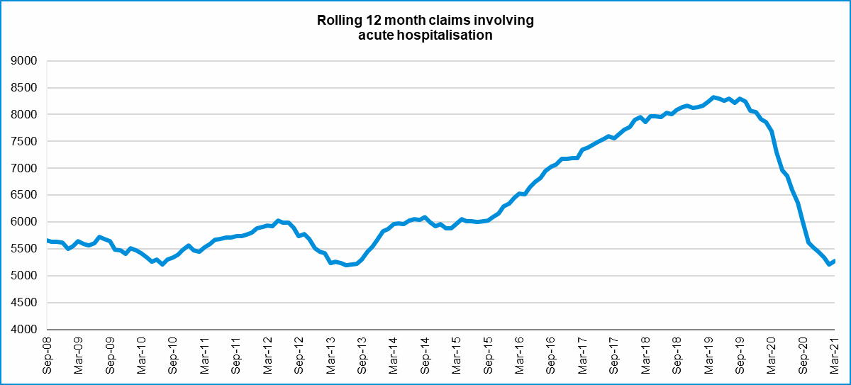

Lives lost: Rolling 12 months
12 months to 30 September 2021

Category | 2021 | 2020 | 2019 | 2021 v 2020 | 2021 v 2019 | 5 Year Average
Overview
Lives Lost | 227 | 223 | 262 | +4 | -35 | 238
Fatal Crashes | 212 | 207 | 243 | +5 | -31 | 223
Sex
Female | 59 | 53 | 71 | +6 | -12 | 63
Male | 168 | 170 | 191 | -2 | -23 | 175
Road user
Bicyclist | 10 | 14 | 12 | -4 | -2 | 11
Driver | 116 | 110 | 105 | +6 | +11 | 114
Motorcyclist | 39 | 34 | 46 | +5 | -7 | 39
Passenger | 33 | 30 | 50 | +3 | -17 | 38
Pedestrian | 29 | 35 | 49 | -6 | -20 | 36
Location
Melbourne | 113 | 92 | 122 | +21 | -9 | 107
Rural Victoria | 114 | 131 | 140 | -17 | -26 | 131
Age group
0-4 | 3 | 3 | 1 |  | +2 | 2
5-15 | 4 | 2 | 8 | +2 | -4 | 5
16-17 | 9 | 3 | 6 | +6 | +3 | 4
18-20 | 11 | 11 | 24 |  | -13 | 15
21-25 | 23 | 22 | 25 | +1 | -2 | 23
26-29 | 18 | 27 | 21 | -9 | -3 | 19
30-39 | 30 | 43 | 29 | -13 | +1 | 37
40-49 | 28 | 26 | 25 | +2 | +3 | 30
50-59 | 27 | 25 | 30 | +2 | -3 | 28
60-69 | 30 | 29 | 31 | +1 | -1 | 29
70+ | 44 | 32 | 61 | 12 | -17 | 46
Accident Type
Intersection
Adjacent direction | 22 | 24 | 26 | -2 | -4 | 28
Opposing direction | 14 | 10 | 10 | +4 | +4 | 9
Mid-block/other
Head on | 20 | 24 | 42 | -4 | -22 | 31
Same direction | 27 | 22 | 18 | +5 | +9 | 21
Manoeuvre/o'taking | 10 | 13 | 16 | -3 | -6 | 13
On path | 3 | 7 | 3 | -4 | 0 | 5
Single vehicle | 99 | 85 | 91 | +14 | +8 | 91
Other (incl peds) | 32 | 38 | 56 | -6 | -24 | 39

LIVES LOST: 12 MONTHS TO 30TH SEPTEMBER 2021

Category | 2021 | 2020 | 2019 | 5 Year Average | Category | 2021 | 2020 | 2019 | 5 Year Average
Local Government Area |  |  |  |  | Local Government Area
ALPINE | 0 | 2 | 1 | 1 | MANSFIELD | 0 | 1 | 1 | 2
ARARAT | 1 | 1 | 2 | 2 | MARIBYRNONG | 1 | 1 | 3 | 3
BALLARAT | 2 | 3 | 3 | 4 | MAROONDAH | 2 | 1 | 4 | 2
BANYULE | 2 | 1 | 1 | 2 | MELBOURNE | 7 | 0 | 2 | 2
BASS COAST | 1 | 1 | 3 | 2 | MELTON | 5 | 1 | 4 | 4
BAW BAW | 7 | 2 | 5 | 3 | MILDURA | 3 | 3 | 7 | 3
BAYSIDE | 1 | 1 | 1 | 2 | MITCHELL | 6 | 3 | 2 | 3
BENALLA | 0 | 0 | 2 | 2 | MOIRA | 0 | 4 | 4 | 4
BOROONDARA | 1 | 6 | 5 | 4 | MONASH | 5 | 5 | 11 | 6
BRIMBANK | 4 | 3 | 6 | 7 | MOONEE VALLEY | 1 | 2 | 2 | 2
BULOKE | 3 | 1 | 2 | 1 | MOORABOOL | 3 | 2 | 5 | 4
CAMPASPE | 1 | 3 | 3 | 3 | MORELAND | 1 | 0 | 4 | 2
CARDINIA | 15 | 3 | 4 | 5 | MORNINGTON PENINSULA | 8 | 12 | 8 | 7
CASEY | 12 | 5 | 6 | 6 | MOUNT ALEXANDER | 3 | 7 | 2 | 3
CENTRAL GOLDFIELDS | 1 | 2 | 2 | 1 | MOYNE | 2 | 2 | 2 | 2
COLAC-OTWAY | 2 | 4 | 0 | 3 | MURRINDINDI | 0 | 2 | 3 | 4
CORANGAMITE | 3 | 3 | 4 | 3 | NILLUMBIK | 3 | 2 | 2 | 2
DAREBIN | 1 | 5 | 3 | 3 | NORTHERN GRAMPIANS | 4 | 4 | 1 | 3
EAST GIPPSLAND | 6 | 6 | 6 | 5 | PORT PHILLIP | 1 | 2 | 0 | 1
FRANKSTON | 0 | 8 | 4 | 4 | PYRENEES | 3 | 0 | 3 | 2
GANNAWARRA | 1 | 0 | 3 | 1 | QUEENSCLIFFE | 0 | 0 | 0 | 0
GLEN EIRA | 2 | 2 | 2 | 2 | SOUTH GIPPSLAND | 2 | 7 | 3 | 5
GLENELG | 4 | 0 | 4 | 2 | SOUTHERN GRAMPIANS | 0 | 2 | 2 | 2
GOLDEN PLAINS | 3 | 0 | 6 | 3 | STONNINGTON | 1 | 0 | 3 | 1
GREATER BENDIGO | 4 | 10 | 5 | 6 | STRATHBOGIE | 2 | 1 | 1 | 2
GREATER DANDENONG | 6 | 3 | 4 | 3 | SURF COAST | 2 | 0 | 1 | 1
GREATER GEELONG | 6 | 14 | 9 | 9 | SWAN HILL | 3 | 0 | 3 | 2
GREATER SHEPPARTON | 5 | 5 | 7 | 6 | TOWONG | 1 | 2 | 2 | 1
HEPBURN | 0 | 6 | 2 | 4 | WANGARATTA | 2 | 3 | 0 | 3
HINDMARSH | 1 | 0 | 0 | 0 | WARRNAMBOOL | 5 | 3 | 2 | 1
HOBSONS BAY | 4 | 1 | 1 | 1 | WELLINGTON | 6 | 3 | 1 | 4
HORSHAM | 1 | 5 | 3 | 3 | WEST WIMMERA | 1 | 4 | 2 | 1
HUME | 5 | 5 | 7 | 5 | WHITEHORSE | 1 | 2 | 1 | 2
INDIGO | 3 | 1 | 3 | 3 | WHITTLESEA | 6 | 4 | 2 | 4
KINGSTON | 3 | 2 | 7 | 4 | WODONGA | 1 | 0 | 1 | 1
KNOX | 1 | 2 | 3 | 3 | WYNDHAM | 3 | 5 | 9 | 6
LATROBE | 3 | 6 | 5 | 5 | YARRA | 1 | 1 | 1 | 1
LODDON | 3 | 1 | 5 | 2 | YARRA RANGES | 7 | 6 | 10 | 7
MACEDON RANGES | 2 | 1 | 7 | 3 | YARRIAMBIACK | 1 | 1 | 0 | 1
MANNINGHAM | 0 | 1 | 2 | 2

Injured claimants admitted to hospital within 7 days of the accident with a hospital stay of more than 14 days
12 months to 31stst March 2021 (claim acceptance date, excludes rejected claims and claims for interstate crashes.)

Category | 2021 | 2020 | 2019 | 2021 v 2020 |  | 2021 v 2020 |  | 5 Year Average
Overview
Claims | 580 | 883 | 918 | -303 | -34% | -338 | -37% | 862
Sex
Female | 205 | 367 | 380 | -162 | -44% | -175 | -46% | 344
Male | 375 | 515 | 538 | -140 | -27% | -163 | -30% | 518
Road user
Bicyclist | 29 | 36 | 32 | -7 | -19% | -3 | -9% | 33
Driver | 229 | 339 | 332 | -110 | -32% | -103 | -31% | 326
Motorcyclist | 137 | 168 | 190 | -31 | -18% | -53 | -28% | 174
Passenger | 62 | 131 | 137 | -69 | -53% | -75 | -55% | 122
Pedestrian | 104 | 176 | 194 | -72 | -41% | -90 | -46% | 176
Train/Tram | 2 | 8 | 10 | -6 | -75% | -8 | -80% | 8
Location
Melbourne | 324 | 529 | 546 | -205 | -39% | -222 | -41% | 513
Rural Victoria | 232 | 309 | 314 | -77 | -25% | -82 | -26% | 298
Age group
0-4 | 3 | 3 | 3 |  | 0% | 0 | 0% | 4
5-15 | 5 | 14 | 17 | -9 | -64% | -12 | -71% | 11
16-17 | 9 | 15 | 14 | -6 | -40% | -5 | -36% | 12
18-20 | 26 | 39 | 46 | -13 | -33% | -20 | -43% | 42
21-25 | 53 | 61 | 82 | -8 | -13% | -29 | -35% | 75
26-29 | 43 | 47 | 52 | -4 | -9% | -9 | -17% | 51
30-39 | 77 | 96 | 99 | -19 | -20% | -22 | -22% | 106
40-49 | 74 | 96 | 105 | -22 | -23% | -31 | -30% | 101
50-59 | 72 | 103 | 131 | -31 | -30% | -59 | -45% | 107
60-69 | 84 | 132 | 103 | -48 | -36% | -19 | -18% | 114
70+ | 134 | 277 | 266 | -143 | -52% | -132 | -50% | 238
Accident Type
Intersection
Adjacent direction | 59 | 85 | 85 | -26 | -31% | -26 | -31% | 84
Opposing direction | 25 | 43 | 59 | -18 | -42% | -34 | -58% | 48
Mid-block/other
Head on | 39 | 71 | 53 | -32 | -45% | -14 | -26% | 63
Same direction | 52 | 71 | 79 | -19 | -27% | -27 | -34% | 67
Manoeuvre/o'taking | 43 | 56 | 38 | -13 | -23% | 5 | 13% | 49
On path | 13 | 35 | 18 | -22 | -63% | -5 | -28% | 25
Single vehicle | 192 | 241 | 230 | -49 | -20% | -38 | -17% | 230
Other (incl peds) | 157 | 281 | 356 | -124 | -44% | -199 | -56% | 297

INJURED CLAIMANTS WHO WERE ADMITTED TO HOSPITAL WITHIN 7 DAYS OF THE ACCIDENT WITH A HOSPITAL STAY OF MORE THAN 14 DAYS

12 months to 31st March 2021 (claim acceptance date, excludes rejected claims and claims for interstate crashes.) – Continued

Category | 2021 | 2020 | 2019 | 5 Year Average | Category | 2021 | 2020 | 2019 | 5 Year Average
Local Government Area |  |  |  |  | Local Government Area
ALPINE | 5 | 7 | 10 | 5 | MANSFIELD | 7 | 5 | 6 | 6
ARARAT | 0 | 7 | 2 | 3 | MARIBYRNONG | 6 | 12 | 8 | 11
BALLARAT | 13 | 16 | 20 | 13 | MAROONDAH | 8 | 14 | 5 | 7
BANYULE | 5 | 7 | 10 | 8 | MELBOURNE | 13 | 26 | 26 | 28
BASS COAST | 1 | 7 | 10 | 6 | MELTON | 3 | 7 | 7 | 8
BAW BAW | 3 | 10 | 9 | 7 | MILDURA | 5 | 4 | 8 | 6
BAYSIDE | 3 | 8 | 9 | 8 | MITCHELL | 10 | 11 | 8 | 8
BENALLA | 1 | 4 | 3 | 3 | MOIRA | 9 | 8 | 5 | 8
BOROONDARA | 14 | 15 | 15 | 12 | MONASH | 7 | 22 | 23 | 19
BRIMBANK | 10 | 16 | 21 | 18 | MOONEE VALLEY | 6 | 14 | 14 | 13
BULOKE | 2 | 0 | 6 | 2 | MOORABOOL | 4 | 9 | 4 | 7
CAMPASPE | 8 | 9 | 8 | 8 | MORELAND | 13 | 20 | 34 | 23
CARDINIA | 13 | 16 | 11 | 13 | MORNINGTON PENINSULA | 10 | 27 | 19 | 21
CASEY | 23 | 24 | 26 | 26 | MOUNT ALEXANDER | 6 | 1 | 3 | 1
CENTRAL GOLDFIELDS | 4 | 3 | 4 | 3 | MOYNE | 2 | 7 | 5 | 5
COLAC-OTWAY | 6 | 3 | 7 | 6 | MURRINDINDI | 3 | 9 | 4 | 9
CORANGAMITE | 4 | 1 | 4 | 5 | NILLUMBIK | 7 | 10 | 8 | 6
DAREBIN | 13 | 15 | 20 | 17 | NORTHERN GRAMPIANS | 2 | 4 | 2 | 3
EAST GIPPSLAND | 13 | 9 | 14 | 9 | PORT PHILLIP | 9 | 15 | 11 | 12
FRANKSTON | 4 | 10 | 8 | 12 | PYRENEES | 3 | 3 | 3 | 2
GANNAWARRA | 3 | 2 | 2 | 2 | QUEENSCLIFFE | 0 | 3 | 1 | 1
GLEN EIRA | 7 | 14 | 19 | 13 | SOUTH GIPPSLAND | 3 | 8 | 6 | 7
GLENELG | 0 | 3 | 4 | 3 | SOUTHERN GRAMPIANS | 3 | 4 | 5 | 3
GOLDEN PLAINS | 2 | 8 | 3 | 5 | STONNINGTON | 9 | 5 | 12 | 9
GREATER BENDIGO | 16 | 23 | 18 | 16 | STRATHBOGIE | 5 | 2 | 3 | 4
GREATER DANDENONG | 16 | 24 | 34 | 22 | SURF COAST | 4 | 8 | 4 | 5
GREATER GEELONG | 27 | 30 | 32 | 24 | SWAN HILL | 5 | 5 | 5 | 4
GREATER SHEPPARTON | 9 | 6 | 15 | 12 | TOWONG | 0 | 4 | 3 | 3
HEPBURN | 4 | 5 | 4 | 3 | WANGARATTA | 2 | 4 | 7 | 5
HINDMARSH | 0 | 3 | 0 | 2 | WARRNAMBOOL | 4 | 4 | 2 | 3
HOBSONS BAY | 7 | 6 | 9 | 6 | WELLINGTON | 6 | 10 | 11 | 9
HORSHAM | 1 | 4 | 3 | 3 | WEST WIMMERA | 0 | 0 | 1 | 1
HUME | 17 | 22 | 30 | 24 | WHITEHORSE | 12 | 30 | 22 | 21
INDIGO | 4 | 3 | 6 | 4 | WHITTLESEA | 16 | 26 | 27 | 23
KINGSTON | 9 | 18 | 20 | 14 | WODONGA | 3 | 6 | 1 | 3
KNOX | 15 | 24 | 22 | 18 | WYNDHAM | 18 | 21 | 20 | 20
LATROBE | 11 | 10 | 17 | 9 | YARRA | 5 | 13 | 14 | 12
LODDON | 3 | 4 | 2 | 2 | YARRA RANGES | 20 | 30 | 27 | 25
MACEDON RANGES | 6 | 11 | 12 | 10 | YARRIAMBIACK | 0 | 2 | 2 | 1
MANNINGHAM | 6 | 18 | 15 | 14

Injured claimants who were admitted to hospital within 7 days of accident
12 months to 31st of March 2021 (claim acceptance date, excludes rejected claims and claims for interstate crashes.)

Category | 2021 | 2020 | 2019 | 2021 v 2020 |  | 2021 v 2019 |  | 5 Year Average
Overview
Claims | 5,273 | 7,691 | 8,248 | -2418 | -31% | -2975 | -36% | 7,284
Sex
Female | 2,078 | 3,398 | 3,546 | -1320 | -39% | -1468 | -41% | 3,124
Male | 3,185 | 4,287 | 4,692 | -1102 | -26% | -1507 | -32% | 4,151
Road user
Bicyclist | 420 | 486 | 542 | -66 | -14% | -122 | -23% | 481
Driver | 2,558 | 3,722 | 4,005 | -1164 | -31% | -1447 | -36% | 3,493
Motorcyclist | 1,030 | 1,278 | 1,409 | -248 | -19% | -379 | -27% | 1,251
Passenger | 654 | 1,092 | 1,151 | -438 | -40% | -497 | -43% | 1,033
Pedestrian | 438 | 731 | 807 | -293 | -40% | -369 | -46% | 710
Train/Tram | 9 | 44 | 41 | -35 | -80% | -32 | -78% | 38
Location
Melbourne | 3,256 | 4,742 | 4,962 | -1486 | -31% | -1706 | -34% | 4,449
Rural Victoria | 1,806 | 2,382 | 2,327 | -576 | -24% | -521 | -22% | 2,173
Age group
0-4 | 30 | 44 | 72 | -14 | -32% | -42 | -58% | 54
5-15 | 119 | 191 | 242 | -72 | -38% | -123 | -51% | 201
16-17 | 86 | 118 | 138 | -32 | -27% | -52 | -38% | 119
18-20 | 412 | 507 | 643 | -95 | -19% | -231 | -36% | 536
21-25 | 646 | 890 | 1,051 | -244 | -27% | -405 | -39% | 898
26-29 | 464 | 669 | 661 | -205 | -31% | -197 | -30% | 622
30-39 | 873 | 1,241 | 1,318 | -368 | -30% | -445 | -34% | 1,173
40-49 | 745 | 1,080 | 1,118 | -335 | -31% | -373 | -33% | 1,034
50-59 | 725 | 1,021 | 1,086 | -296 | -29% | -361 | -33% | 969
60-69 | 564 | 849 | 797 | -285 | -34% | -233 | -29% | 737
70+ | 609 | 1,081 | 1,122 | -472 | -44% | -513 | -46% | 941
Accident Type
Intersection
Adjacent direction | 892 | 1,050 | 913 | -158 | -15% | -21 | -2% | 914
Opposing direction | 364 | 521 | 530 | -157 | -30% | -166 | -31% | 506
Mid-block/other
Head on | 267 | 360 | 315 | -93 | -26% | -48 | -15% | 326
Same direction | 841 | 1,140 | 1,013 | -299 | -26% | -172 | -17% | 988
Manoeuvre/o'taking | 403 | 414 | 322 | -11 | -3% | +81 | 25% | 373
On path | 198 | 239 | 215 | -41 | -17% | -17 | -8% | 241
Single vehicle | 1,250 | 1,473 | 1,368 | -223 | -15% | -118 | -9% | 1,448
Other (incl peds) | 1,058 | 2,494 | 3,572 | -1436 | -58% | -2514 | -70% | 2,488

INJURED CLAIMANTS WHO WERE ADMITTED TO HOSPITAL WITHIN 7 DAYS OF ACCIDENT

12 months to 31st March 2021 (claim acceptance date, excludes rejected claims and claims for interstate crashes.) – Continued

Category | 2021 | 2020 | 2019 | 5 Year Average | Category | 2021 | 2020 | 2019 | 5 Year Average
Local Government Area |  |  |  |  | Local Government Area
ALPINE | 24 | 29 | 37 | 25 | MANSFIELD | 31 | 45 | 37 | 34
ARARAT | 10 | 23 | 12 | 14 | MARIBYRNONG | 48 | 101 | 109 | 81
BALLARAT | 100 | 111 | 95 | 84 | MAROONDAH | 51 | 66 | 78 | 56
BANYULE | 26 | 61 | 74 | 56 | MELBOURNE | 131 | 258 | 300 | 262
BASS COAST | 27 | 55 | 51 | 39 | MELTON | 55 | 100 | 80 | 72
BAW BAW | 58 | 63 | 60 | 47 | MILDURA | 47 | 39 | 27 | 25
BAYSIDE | 76 | 87 | 91 | 74 | MITCHELL | 62 | 82 | 70 | 63
BENALLA | 10 | 20 | 28 | 18 | MOIRA | 35 | 50 | 24 | 34
BOROONDARA | 91 | 138 | 152 | 117 | MONASH | 138 | 205 | 195 | 169
BRIMBANK | 123 | 182 | 185 | 141 | MOONEE VALLEY | 84 | 149 | 157 | 121
BULOKE | 6 | 10 | 14 | 8 | MOORABOOL | 29 | 63 | 59 | 47
CAMPASPE | 40 | 41 | 52 | 41 | MORELAND | 101 | 181 | 210 | 161
CARDINIA | 103 | 130 | 122 | 113 | MORNINGTON PENINSULA | 140 | 188 | 199 | 156
CASEY | 285 | 311 | 340 | 285 | MOUNT ALEXANDER | 20 | 22 | 27 | 18
CENTRAL GOLDFIELDS | 20 | 26 | 21 | 17 | MOYNE | 15 | 39 | 36 | 29
COLAC-OTWAY | 46 | 78 | 48 | 55 | MURRINDINDI | 32 | 61 | 59 | 55
CORANGAMITE | 33 | 30 | 35 | 30 | NILLUMBIK | 34 | 48 | 44 | 37
DAREBIN | 58 | 130 | 126 | 102 | NORTHERN GRAMPIANS | 21 | 20 | 23 | 19
EAST GIPPSLAND | 54 | 46 | 59 | 49 | PORT PHILLIP | 120 | 144 | 159 | 127
FRANKSTON | 94 | 157 | 137 | 125 | PYRENEES | 10 | 15 | 14 | 11
GANNAWARRA | 7 | 15 | 12 | 10 | QUEENSCLIFFE | 1 | 8 | 9 | 5
GLEN EIRA | 104 | 135 | 135 | 110 | SOUTH GIPPSLAND | 33 | 51 | 37 | 40
GLENELG | 18 | 21 | 30 | 20 | SOUTHERN GRAMPIANS | 15 | 35 | 21 | 21
GOLDEN PLAINS | 38 | 47 | 47 | 42 | STONNINGTON | 99 | 129 | 149 | 115
GREATER BENDIGO | 104 | 147 | 133 | 111 | STRATHBOGIE | 25 | 45 | 27 | 31
GREATER DANDENONG | 220 | 276 | 296 | 230 | SURF COAST | 66 | 69 | 60 | 54
GREATER GEELONG | 322 | 402 | 462 | 330 | SWAN HILL | 18 | 21 | 20 | 17
GREATER SHEPPARTON | 62 | 85 | 88 | 84 | TOWONG | 10 | 14 | 23 | 16
HEPBURN | 31 | 28 | 37 | 26 | WANGARATTA | 27 | 43 | 37 | 32
HINDMARSH | 6 | 19 | 15 | 11 | WARRNAMBOOL | 22 | 34 | 29 | 27
HOBSONS BAY | 57 | 88 | 88 | 69 | WELLINGTON | 52 | 62 | 80 | 58
HORSHAM | 24 | 32 | 24 | 22 | WEST WIMMERA | 5 | 5 | 2 | 5
HUME | 184 | 266 | 271 | 218 | WHITEHORSE | 68 | 142 | 143 | 125
INDIGO | 19 | 22 | 28 | 22 | WHITTLESEA | 133 | 190 | 249 | 192
KINGSTON | 137 | 140 | 141 | 116 | WODONGA | 29 | 23 | 18 | 21
KNOX | 94 | 125 | 153 | 117 | WYNDHAM | 168 | 220 | 192 | 154
LATROBE | 83 | 88 | 92 | 65 | YARRA | 58 | 127 | 120 | 101
LODDON | 10 | 18 | 17 | 11 | YARRA RANGES | 140 | 185 | 172 | 149
MACEDON RANGES | 42 | 76 | 81 | 68 | YARRIAMBIACK | 7 | 4 | 10 | 5
MANNINGHAM | 36 | 83 | 95 | 78

LIVES LOST BY WEEK (2016 TO 2021)

Week Ending |  |  |  |  |  | 2021  Cumulative |  | 12 month Moving Total
2016 | 2017 | 2018 | 2019 | 2020 | 2021 |  |  | 12 month Moving Total
03-Jan | 2 | 0 | 4 | 0 | 5 | 4 | 4 | 209
10-Jan | 3 | 5 | 6 | 5 | 3 | 1 | 5 | 207
17-Jan | 3 | 6 | 2 | 3 | 5 | 0 | 5 | 202
24-Jan | 3 | 4 | 2 | 7 | 2 | 6 | 11 | 206
31-Jan | 10 | 2 | 6 | 8 | 9 | 4 | 15 | 201
07-Feb | 6 | 4 | 3 | 9 | 5 | 6 | 21 | 202
14-Feb | 12 | 3 | 4 | 9 | 6 | 6 | 27 | 202
21-Feb | 6 | 6 | 7 | 4 | 5 | 4 | 31 | 201
28-Feb | 9 | 5 | 2 | 12 | 1 | 6 | 37 | 206
07-Mar | 9 | 3 | 5 | 0 | 4 | 10 | 47 | 212
14-Mar | 9 | 5 | 7 | 5 | 9 | 4 | 51 | 207
21-Mar | 5 | 5 | 3 | 7 | 10 | 5 | 56 | 202
28-Mar | 1 | 7 | 4 | 6 | 1 | 5 | 61 | 207
04-Apr | 1 | 4 | 3 | 3 | 7 | 6 | 67 | 206
11-Apr | 1 | 12 | 0 | 10 | 1 | 2 | 69 | 207
18-Apr | 7 | 7 | 1 | 6 | 1 | 4 | 73 | 210
25-Apr | 4 | 6 | 5 | 4 | 9 | 2 | 75 | 203
02-May | 5 | 3 | 3 | 3 | 2 | 3 | 78 | 204
09-May | 7 | 7 | 13 | 9 | 2 | 5 | 83 | 207
16-May | 5 | 4 | 3 | 9 | 5 | 4 | 87 | 206
23-May | 5 | 2 | 3 | 6 | 2 | 2 | 89 | 206
30-May | 8 | 6 | 2 | 7 | 5 | 1 | 90 | 202
06-Jun | 4 | 2 | 1 | 4 | 1 | 2 | 92 | 203
13-Jun | 5 | 3 | 8 | 3 | 5 | 6 | 98 | 204
20-Jun | 5 | 4 | 1 | 5 | 4 | 5 | 103 | 205
27-Jun | 8 | 4 | 2 | 4 | 4 | 4 | 107 | 205
04-Jul | 2 | 5 | 1 | 7 | 4 | 9 | 116 | 210
11-Jul | 3 | 5 | 3 | 3 | 3 | 3 | 119 | 210
18-Jul | 7 | 9 | 5 | 2 | 3 | 5 | 124 | 212
25-Jul | 11 | 4 | 5 | 5 | 5 | 3 | 127 | 210
01-Aug | 6 | 0 | 2 | 3 | 4 | 4 | 131 | 210
08-Aug | 5 | 7 | 4 | 3 | 3 | 3 | 134 | 210
15-Aug | 7 | 9 | 3 | 5 | 4 | 7 | 141 | 213
22-Aug | 8 | 2 | 6 | 3 | 2 | 6 | 147 | 217
29-Aug | 8 | 8 | 4 | 4 | 3 | 4 | 151 | 218
05-Sep | 3 | 6 | 4 | 3 | 4 | 3 | 154 | 217
12-Sep | 3 | 6 | 3 | 5 | 4 | 6 | 160 | 219
19-Sep | 5 | 3 | 7 | 4 | 1 | 7 | 167 | 225
26-Sep | 5 | 3 | 2 | 3 | 0 | 2 | 169 | 227
03-Oct | 2 | 2 | 5 | 6 | 7
10-Oct | 6 | 4 | 7 | 6 | 3
17-Oct | 4 | 6 | 2 | 5 | 6
24-Oct | 7 | 0 | 3 | 4 | 7
31-Oct | 5 | 1 | 7 | 9 | 4
07-Nov | 2 | 11 | 5 | 3 | 3
14-Nov | 7 | 5 | 2 | 5 | 5
21-Nov | 5 | 4 | 12 | 5 | 3
28-Nov | 9 | 11 | 3 | 4 | 4
05-Dec | 9 | 3 | 3 | 4 | 2
12-Dec | 5 | 5 | 3 | 5 | 4
19-Dec | 5 | 7 | 5 | 7 | 4
26-Dec | 2 | 11 | 5 | 1 | 5
31-Dec | 6 | 3 | 2 | 4 | 1
Total | 290 | 259 | 213 | 266 | 211 | 169

Booze bus random breath testing

Booze-bus Random Breath Tests (12 months to March 2020 vs previous 12 months)

 | 2020 | 2019 | 2018 | 2020 v 2019 |  | 2020 v 2018
Melbourne | 1,025,495 | 1,226,599 | 1,143,717 | -201104 | (-16%) | -118222 | (-10%)
Country | 183,858 | 115,731 | 142,698 | +68127 | (+59%) | +41160 | (+29%)
Vic Total | 1,209,353 | 1,342,330 | 1,286,415 | -132977 | (-10%) | -77062 | (-6%)

12 months to March 2020 (monthly totals)

 | 2019 |  |  |  |  |  |  |  |  | 2020
 | Apr | May | Sep | Jul | Aug | Sep | Oct | Nov | Dec | Jan | Feb | Mar
Melbourne | 79,988 | 84,478 | 101,799 | 98,380 | 102,592 | 96,574 | 89,177 | 88,460 | 82,298 | 62,544 | 103,896 | 35,309
Country | 19,119 | 14,068 | 10,318 | 5,826 | 11,098 | 12,571 | 17,551 | 25,867 | 16,566 | 15,206 | 23,588 | 12,080
Vic Total | 99,107 | 98,546 | 112,117 | 104,206 | 113,690 | 109,145 | 106,728 | 114,327 | 98,864 | 77,750 | 127,484 | 47,389

Random Drug Testing
Random Drug Tests (12 months to March 2020 vs previous 12 months)

 | 2020 | 2019 | 2018 | 2020 v 2019 |  | 2020 v 2018
Victoria | 161,283 | 122,730 | 102,551 | 38,553 | 31% | 58,732 | 57%

12 months to March 2020 (monthly totals)
 | 2019 |  |  |  |  |  |  |  |  | 2020
 | Apr | May | Jun | Jul | Aug | Sep | Oct | Nov | Dec | Jan | Feb | Mar
Victoria | 17,337 | 19,571 | 15,441 | 13,817 | 18692 | 15,244 | 12181 | 12646 | 11,000 | 9,157 | 7,904 | 8,293

Mobile Safety Camera Data

Speed Infringements Issued from Mobile Cameras (monthly totals) |  |  |  |  |  |  |  |  | Monthly Average = |  | 47,475
2020 |  |  | 2021 |  |  |  |  |  | 2021
Oct | Nov | Dec | Jan | Feb | Mar | Apr | May | Jun | Jul | Aug | Sep
31,150 | 26,491 | 31,356 | 74,973 | 60,602 | 51,605 | 52,014 | 57,526 | 66,303 | 46,363 | 35,495 | 35,824

Excessive Speed Infringements (ESI) Issued from Mobile Cameras (monthly totals) Monthly Average = 518
2020 2021 2021
Oct Nov Dec Jan Feb Mar Apr May Jun Jul Aug Sep
343 358 310 583 625 762 476 608 698 588 436 427
Notes: An ESI is defined as 25km/h over the speed limit except in a 110km/h zone where it is 20km/h over the limit.
Notes: 1. The definition of ESIs changed on 15 December 2002 to 25km/h over the speed limit from 30km/h over the speed limit except in a 110km/h zone where it has always been 20km/h over the limit.

The National Picture
Lives Lost per 10,000 registered vehicles (12 months to September 2021)
Tasmania
0.77
South Australia
0.78
Northern Territory
2.27
0.0
0.5
1.0
1.5
2.0
2.5
Lives Lost per 100,000 population (12 months to September 2021)
Western Australia
6.2
Tasmania
Northern Territory
15.0
0
2
4
6
8
10
12
14
16
7.3

State |  | Lives Lost (12 months to September)
 | 2021 | 2020 | 2019 | 2018 | 2021 v 2020
NSW | 269 | 309 | 342 | 379 | -40 | (-13%)
VIC | 227 | 223 | 262 | 225 | +4 | (+2%)
QLD | 285 | 249 | 216 | 252 | +36 | (+14%)
SA | 103 | 98 | 105 | 84 | +5 | (+5%)
WA | 168 | 139 | 167 | 171 | +29 | (+21%)
TAS | 40 | 32 | 30 | 35 | +8 | (+25%)
NT | 37 | 33 | 37 | 45 | +4 | (+12%)
ACT | 11 | 7 | 5 | 9 | +4 | (+57%)
AUST TOTAL | 1,138 | 1,090 | 1,164 | 1,200 | +48 | (+4%)
AUST minus VIC | 911 | 867 | 902 | 975 | +44 | (+5%)

State | Lives Lost per 10,000 registered vehicles |  |  | Fatalities per 100,000 population
 | (12 months to September) |  |  | (12 months to September)
 | 2021 | 2020 | 2019 | 2021 | 2020 | 2019
NSW | 0.46 | 0.53 | 0.60 | 3.27 | 3.79 | 4.24
VIC | 0.44 | 0.44 | 0.52 | 3.35 | 3.34 | 3.99
QLD | 0.67 | 0.56 | 0.51 | 5.45 | 4.83 | 4.26
SA | 0.78 | 0.43 | 0.66 | 5.78 | 5.55 | 6.01
WA | 0.72 | 0.61 | 0.75 | 6.24 | 5.24 | 6.46
TAS | 0.77 | 0.63 | 0.61 | 7.34 | 5.94 | 5.63
NT | 2.27 | 2.05 | 2.23 | 15.04 | 13.42 | 14.62
ACT | 0.34 | 0.22 | 0.16 | 2.53 | 1.63 | 1.18
AUST TOTAL | 0.56 | 0.55 | 0.60 | 4.39 | 4.26 | 4.61
AUST minus VIC | 0.61 | 0.59 | 0.62 | 4.75 | 4.58 | 4.83

ACT | 0.34 |  |  |  |  | ACT | 2. |  | 5
Victoria | 0.44 |  |  |  |  | New South Wales |  |  | 3.3
New South Wales | 0.46 |  |  |  |  | Victoria |  |  | 3.4
Australia | 0.56 |  |  |  |  | Australia |  |  |  | 4.8
Queensland | 0.67 |  |  |  |  | Queensland |  |  |  | 5.5
Western Australia | 0.72 |  |  |  |  | South Australia |  |  |  | 5.8

International Road Safety Comparison
Selected OECD countries, Australia and Victoria, 1990, 2000, 2010, 2015 to 2019

Lives lost rate per 100,000 population

Countries | 1990 | 2000 | 2010 | 2015 | 2016 | 2017 | 2018 | 2019
Australia | 13.7 | 9.5 | 6.1 | 5.1 | 5.3 | 5.0 | 4.5 | 4.7
Canada | 14.3 | 9.5 | 6.6 | 5.3 | 5.3 | 5.1 | 5.2 | 4.7
New Zealand | 21.5 | 12.0 | 8.6 | 6.9 | 6.9 | 7.9 | 7.7 | 7.1
Norway | 7.8 | 7.6 | 4.3 | 2.3 | 2.6 | 2.0 | 2.0 | 2.0
Sweden | 9.0 | 6.7 | 2.8 | 2.6 | 2.7 | 2.5 | 3.2 | 2.2
Switzerland | 13.8 | 8.2 | 4.2 | 3.1 | 2.6 | 2.7 | 2.7 | 2.2
United Kingdom | 9.4 | 6.1 | 3.0 | 2.8 | 2.8 | 2.8 | 2.8 | 2.7
United States | 17.9 | 14.9 | 10.7 | 11.1 | 11.7 | 11.5 | 11.2 | 11.0
Victoria | 12.5 | 8.7 | 5.3 | 4.2 | 4.7 | 4.1 | 3.3 | 4.0

Lives lost rate per100 million vehicle kilometres travelled (VKT)

Countries | 1990 | 2000 | 2010 | 2015 | 2016 | 2017 | 2018 | 2019
Australia | 1.4 | 0.9 | 0.6 | 0.5 | 0.5 | 0.5 | 0.4 | 0.4
Canada | - | 0.9 | 0.7 | 0.5 | 0.5 | 0.5 | 0.5 | 0.4
New Zealand | - | 1.4 | 0.9 | 0.7 | 0.7 | 0.8 | 0.8 | 0.7
Norway | 1.2 | 1.0 | 0.5 | 0.3 | 0.3 | 0.2 | 0.2 | 0.2
Sweden | 1.2 | 0.9 | 0.3 | 0.3 | 0.3 | 0.3 | 0.4 | 0.3
Switzerland | 1.9 | 1.1 | 0.5 | 0.4 | 0.3 | 0.3 | 0.3 | 0.3
United Kingdom | - | - | - | - | - | - | - | -
United States | 1.3 | 0.9 | 0.7 | 0.7 | 0.7 | 0.7 | 0.7 | 0.7
Victoria | 1.2 | 0.8 | 0.5 | 0.4 | 0.4 | 0.4 | 0.3 | 0.4

Lives lost rate per 10,000 registered vehicles

Countries | 1990 | 2000 | 2010 | 2015 | 2016 | 2017 | 2018 | 2019
Australia | 2.3 | 1.5 | 0.8 | 0.7 | 0.7 | 0.7 | 0.6 | 0.6
Canada | 2.3 | 1.6 | 1.0 | 0.8 | 0.8 | 0.8 | 0.7 | 0.7
New Zealand | 3.3 | 1.8 | 1.2 | 0.9 | 0.9 | 1.0 | 0.9 | 0.9
Norway | 1.4 | 1.2 | 0.6 | 0.3 | 0.3 | 0.3 | 0.3 | 0.3
Sweden | 1.7 | 1.2 | 0.5 | 0.4 | 0.4 | 0.4 | 0.5 | 0.3
Switzerland | 2.2 | 1.2 | 0.6 | 0.4 | 0.4 | 0.4 | 0.4 | 0.3
United Kingdom | 2.1 | 1.2 | 0.5 | 0.5 | 0.5 | 0.5 | 0.5 | 0.5
United States | 2.4 | 1.9 | 1.3 | 1.3 | 1.3 | 1.3 | 1.2 | 1.2
Victoria | 2.1 | 1.2 | 0.7 | 0.6 | 0.6 | 0.5 | 0.4 | 0.5

Lives lost rate per 100,000 population - OECD countries, 2019

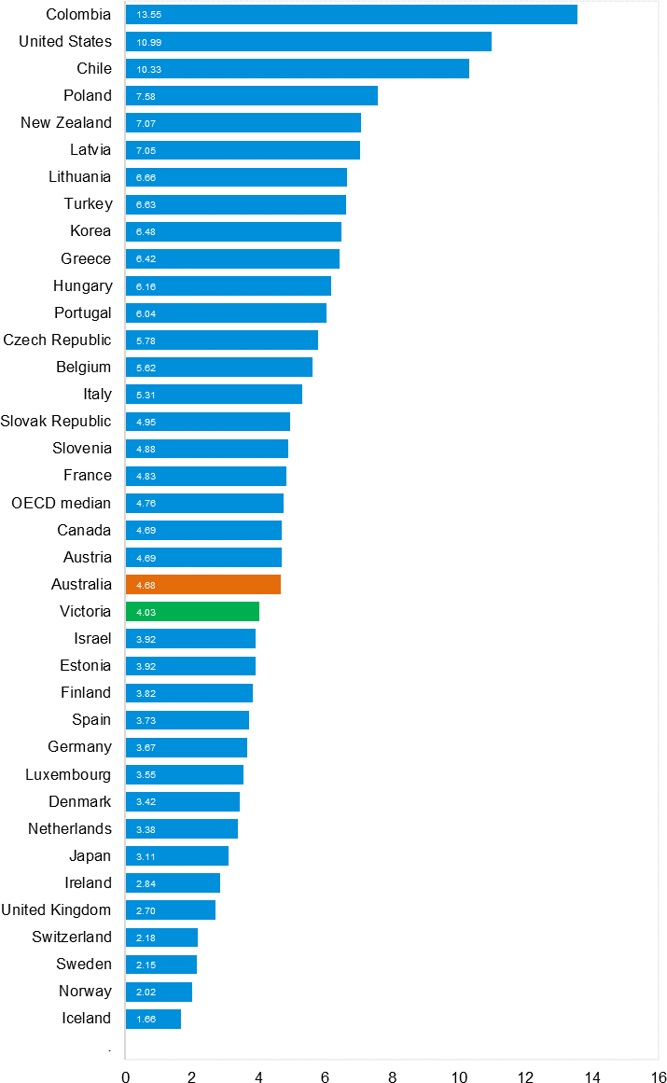
Source: Bureau of Infrastructure and Transport Research Economics

Explanations and references

LGA: Local Government Areas. Crash locations for acute hospitalised claims are assigned to LGA’s based on the crash postcode recorded by Victoria Police. Crash locations for fatal crashes are coded exactly to an LGA by Victoria Police.
Claimants: Refers to people injured in transport accidents who have an accepted claim with the TAC.
Hospitalisation: refers to all hospital admission that occurred within 7 days of accident.

Useful websites

TAC Sites
- TAC Safety (Road Safety) www.tacsafety.com.au
- TAC How safe is your car www.howsafeisyourcar.com.au
- TAC How safe is your first car www.howsafeisyourfirstcar.com.au
- TAC Motorcycle Safety Website www.spokes.com.au
- TAC Corporate site www.tac.vic.gov.au
- Drivesmart www.drivesmart.vic.gov.au
- Ridesmart www.ridesmartonline.com.au

Victorian Sites

- VicRoads www.vicroads.vic.gov.au
- Victoria Police www.police.vic.gov.au
- Parliamentary Road Safety Committee https://www.parliament.vic.gov.au/57th-parliament/rsc
- RACV www.racv.com.au
- Monash University Accident Research Centre www.monash.edu.au/muarc
- Cameras Save Lives www.camerassavelives.vic.gov.au
- VicRoads Learner Driver Site www.lsite.vicroads.vic.gov.au/Learners
- Road Safety Education Victoria www.roadsafetyeducation.vic.gov.au

National and Interstate Sites

- ARRB Transport Research www.arrb.com.au
- Australian Transport Safety Bureau www.atsb.gov.au
- Motor Accidents Authority (NSW) www.maa.nsw.gov.au
- Motor Accidents Insurance Board (TAS) www.maib.tas.gov.au
- Motor Accident Commission, Allianz (SA) www.mac.sa.gov.au
- Motor Accidents Compensation, TIO, (NT) www.tiofi.com.au/mac
- Insurance Commission of Western Australia www.icwa.wa.gov.au
- Motor Accident Insurance Commission (QLD) www.maic.qld.gov.au

International Sites
- National Highway Traffic Safety Admin (USA) www.nhtsa.dot.gov
- Swedish Road and Transport Institute (VTI) www.vti.se
- SWOV Institute for Road Safety Research www.swov.nl

Related Sites

- Alcohol and Drug Foundation www.adf.org.au

GRAPHS OF LIVES LOST AND HOSPITALISED CLAIMS
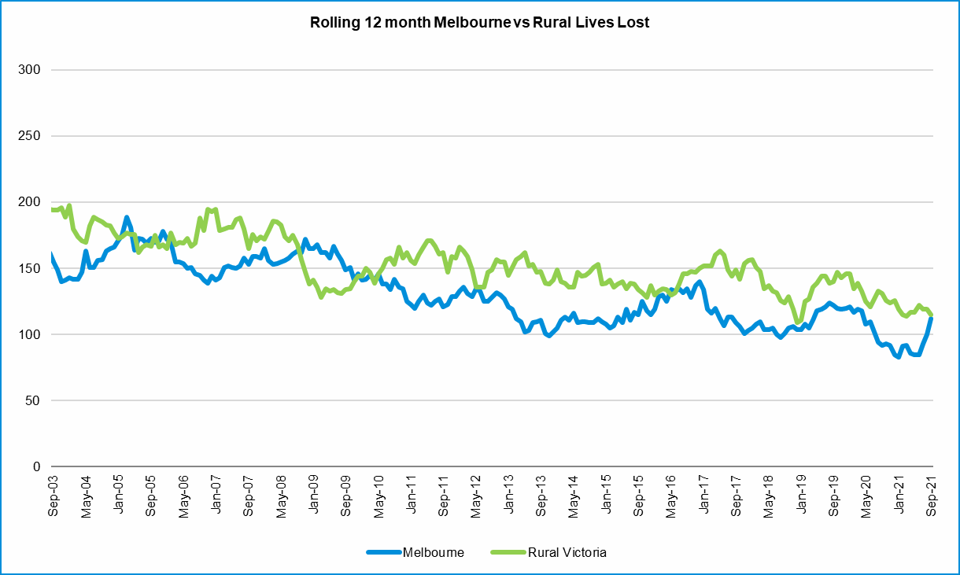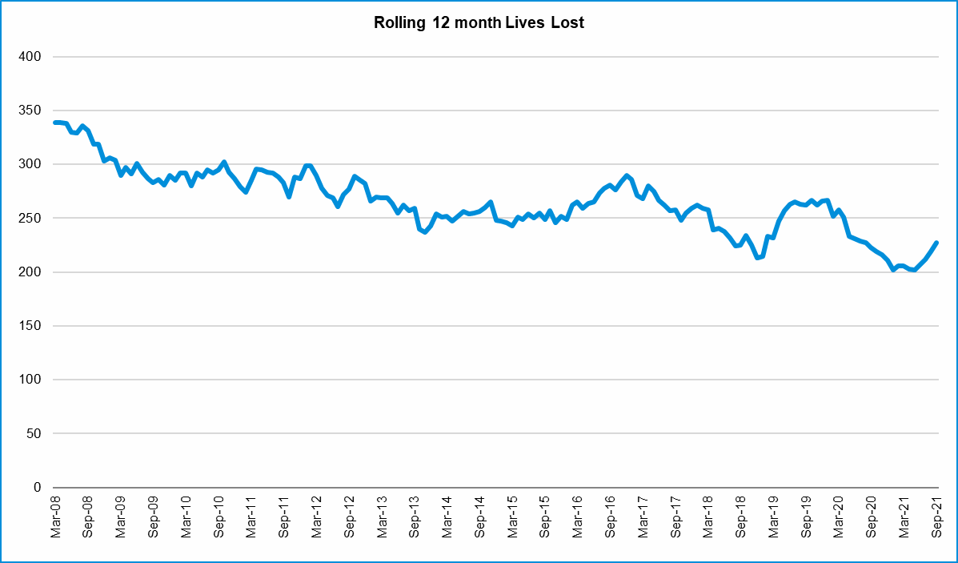

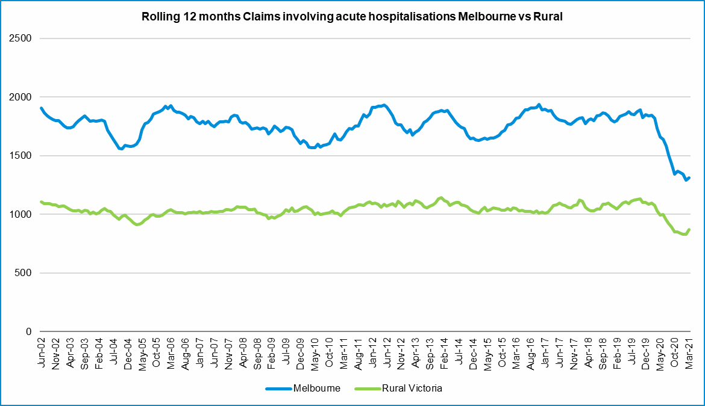

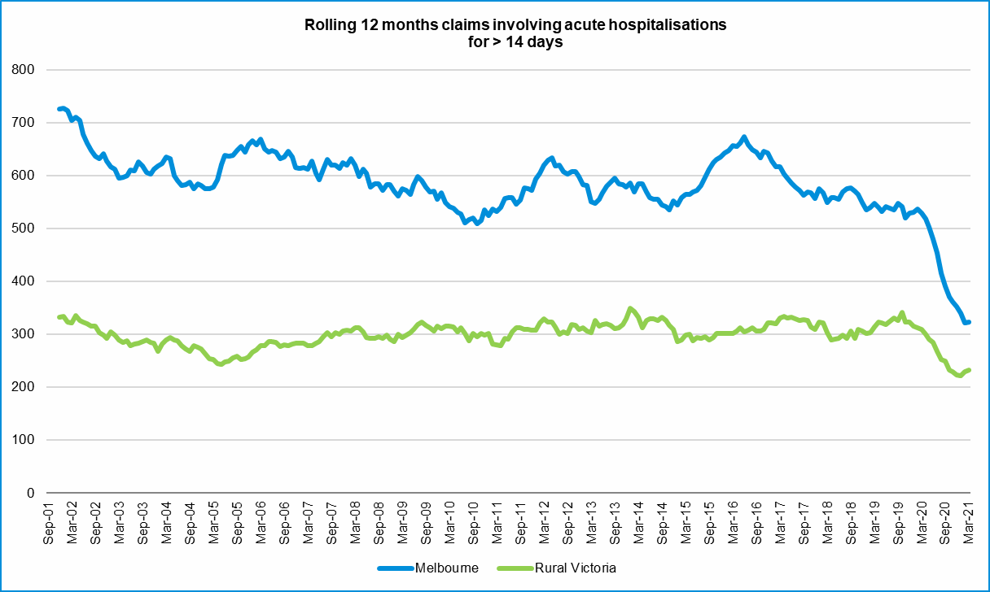

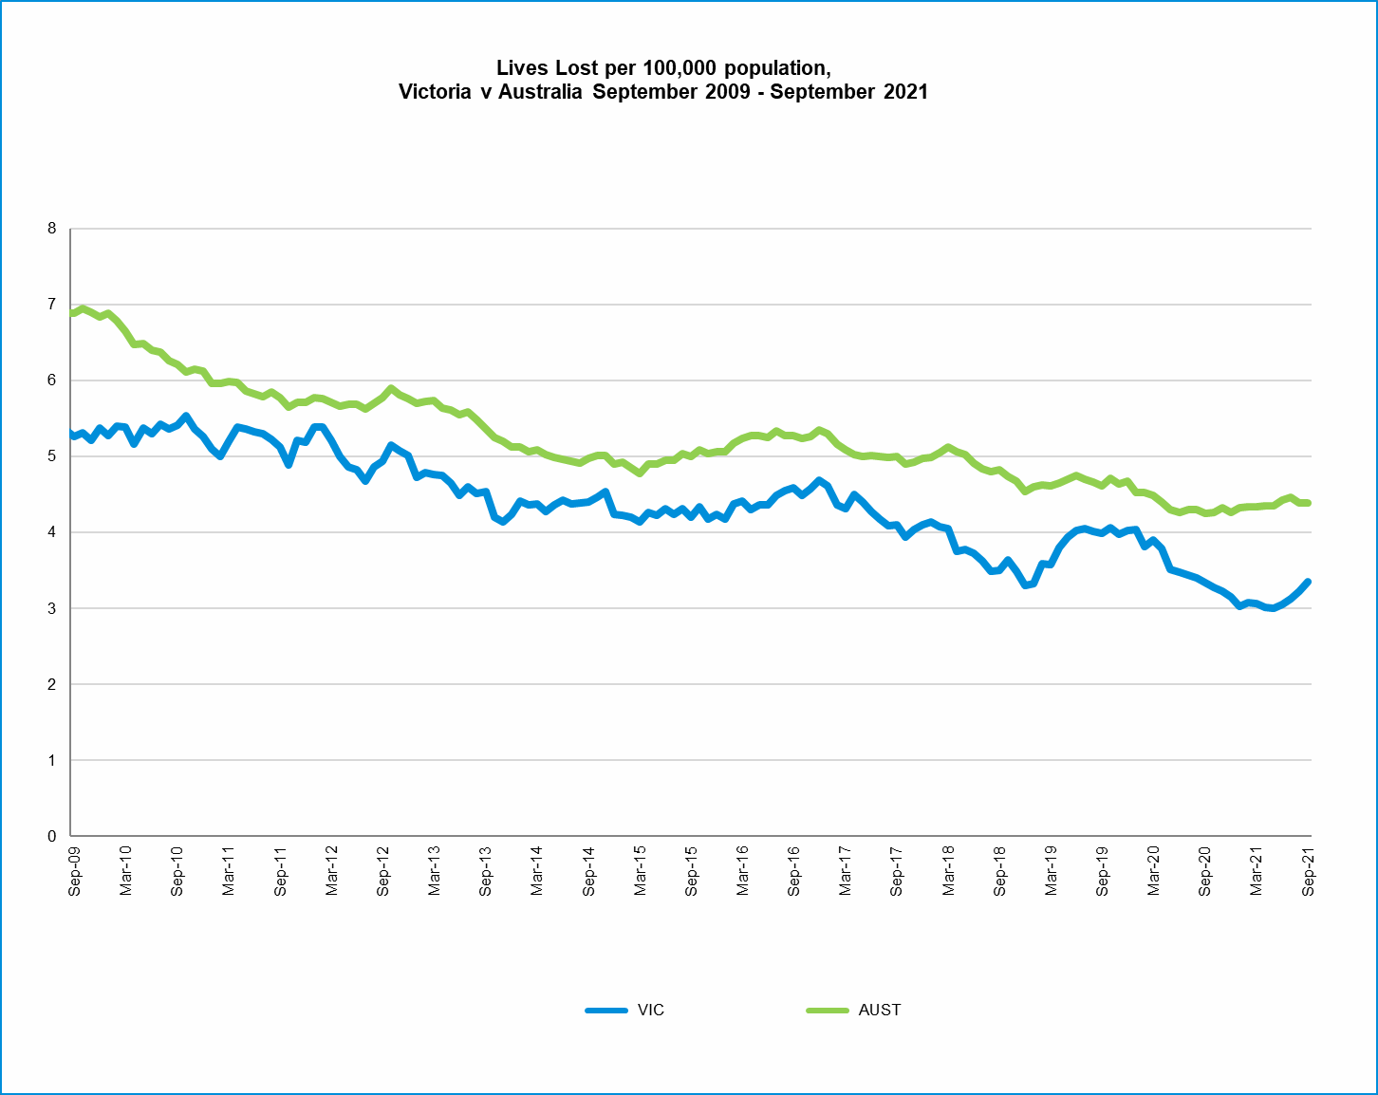

Victorian monthly lives lost since 1951

Year | Jan | Feb | Mar | Apr | May | Jun | Jul | Aug | Sep | Oct | Nov | Dec | Total
1951 |  |  |  |  |  |  | 61 | 59 | 52 | 38 | 29 | 41
1952 | 45 | 40 | 54 | 61 | 54 | 69 | 67 | 55 | 44 | 44 | 31 | 20 | 584
1953 | 23 | 28 | 54 | 58 | 49 | 42 | 50 | 37 | 44 | 27 | 36 | 32 | 480
1954 | 44 | 42 | 28 | 60 | 55 | 36 | 63 | 33 | 25 | 52 | 30 | 41 | 509
1955 | 44 | 36 | 45 | 55 | 48 | 56 | 64 | 44 | 44 | 32 | 40 | 40 | 548
1956 | 34 | 48 | 51 | 67 | 53 | 65 | 71 | 47 | 39 | 39 | 44 | 48 | 606
1957 | 50 | 41 | 46 | 58 | 52 | 54 | 57 | 53 | 51 | 46 | 32 | 49 | 589
1958 | 50 | 38 | 42 | 58 | 54 | 41 | 54 | 53 | 57 | 40 | 57 | 52 | 596
1959 | 50 | 57 | 61 | 50 | 75 | 55 | 42 | 48 | 52 | 55 | 63 | 63 | 671
1960 | 49 | 53 | 57 | 76 | 70 | 70 | 67 | 62 | 61 | 77 | 52 | 66 | 760
1961 | 63 | 57 | 68 | 74 | 58 | 68 | 78 | 82 | 59 | 62 | 60 | 65 | 794
1962 | 65 | 41 | 76 | 78 | 72 | 80 | 70 | 77 | 62 | 53 | 64 | 70 | 808
1963 | 67 | 56 | 65 | 85 | 66 | 68 | 77 | 55 | 55 | 58 | 61 | 67 | 780
1964 | 73 | 71 | 78 | 71 | 83 | 89 | 80 | 89 | 67 | 66 | 62 | 75 | 904
1965 | 63 | 64 | 86 | 88 | 80 | 87 | 79 | 69 | 81 | 77 | 68 | 87 | 929
1966 | 75 | 59 | 75 | 103 | 74 | 86 | 87 | 80 | 75 | 66 | 90 | 85 | 955
1967 | 61 | 79 | 91 | 97 | 81 | 71 | 59 | 67 | 70 | 68 | 60 | 83 | 887
1968 | 70 | 78 | 86 | 78 | 73 | 76 | 73 | 77 | 72 | 80 | 81 | 105 | 949
1969 | 79 | 68 | 79 | 87 | 86 | 77 | 87 | 83 | 87 | 83 | 94 | 101 | 1011
1970 | 85 | 84 | 106 | 80 | 87 | 88 | 110 | 106 | 78 | 95 | 68 | 74 | 1061
1971 | 83 | 75 | 77 | 68 | 76 | 86 | 85 | 72 | 78 | 73 | 74 | 76 | 923
1972 | 61 | 62 | 75 | 82 | 75 | 71 | 98 | 85 | 83 | 62 | 80 | 81 | 915
1973 | 75 | 75 | 95 | 85 | 64 | 66 | 61 | 85 | 89 | 88 | 66 | 86 | 935
1974 | 56 | 62 | 81 | 60 | 70 | 73 | 67 | 62 | 53 | 70 | 80 | 72 | 806
1975 | 67 | 65 | 87 | 73 | 97 | 94 | 57 | 75 | 69 | 66 | 71 | 89 | 910
1976 | 79 | 78 | 88 | 78 | 69 | 79 | 60 | 70 | 82 | 78 | 77 | 100 | 938
1977 | 65 | 71 | 89 | 79 | 65 | 79 | 70 | 91 | 68 | 74 | 96 | 107 | 954
1978 | 75 | 54 | 95 | 63 | 64 | 69 | 68 | 77 | 65 | 84 | 83 | 72 | 869
1979 | 63 | 60 | 86 | 75 | 45 | 64 | 66 | 75 | 69 | 79 | 72 | 93 | 847
1980 | 48 | 55 | 66 | 59 | 47 | 56 | 60 | 53 | 45 | 58 | 61 | 49 | 657
1981 | 69 | 60 | 58 | 61 | 74 | 65 | 61 | 63 | 68 | 71 | 59 | 57 | 766
1982 | 55 | 53 | 59 | 59 | 67 | 45 | 47 | 71 | 53 | 69 | 65 | 66 | 709
1983 | 42 | 59 | 53 | 63 | 62 | 61 | 65 | 51 | 59 | 43 | 54 | 52 | 664
1984 | 65 | 48 | 58 | 50 | 56 | 48 | 46 | 50 | 71 | 53 | 55 | 58 | 658
1985 | 56 | 47 | 50 | 65 | 75 | 50 | 51 | 50 | 58 | 61 | 56 | 64 | 683
1986 | 56 | 50 | 70 | 69 | 59 | 53 | 42 | 54 | 54 | 52 | 59 | 51 | 669
1987 | 62 | 43 | 57 | 52 | 63 | 59 | 62 | 49 | 62 | 61 | 55 | 80 | 705
1988 | 49 | 58 | 69 | 54 | 79 | 50 | 54 | 52 | 64 | 59 | 43 | 70 | 701
1989 | 76 | 65 | 80 | 59 | 67 | 73 | 52 | 65 | 82 | 50 | 41 | 66 | 776
1990 | 48 | 44 | 55 | 39 | 56 | 64 | 41 | 34 | 48 | 35 | 40 | 44 | 548
1991 | 45 | 39 | 70 | 30 | 34 | 29 | 44 | 47 | 41 | 36 | 35 | 53 | 503
1992 | 34 | 33 | 34 | 47 | 33 | 29 | 23 | 27 | 28 | 38 | 30 | 40 | 396
1993 | 27 | 40 | 37 | 39 | 44 | 33 | 33 | 27 | 34 | 39 | 43 | 40 | 436
1994 | 36 | 31 | 44 | 35 | 27 | 33 | 29 | 37 | 17 | 27 | 32 | 30 | 378
1995 | 38 | 35 | 26 | 33 | 34 | 41 | 27 | 34 | 34 | 32 | 38 | 46 | 418
1996 | 40 | 47 | 35 | 38 | 28 | 29 | 30 | 35 | 49 | 24 | 33 | 30 | 418
1997 | 36 | 25 | 30 | 30 | 40 | 22 | 39 | 26 | 26 | 29 | 39 | 35 | 377
1998 | 29 | 29 | 32 | 36 | 31 | 22 | 40 | 19 | 37 | 36 | 49 | 30 | 390
1999 | 32 | 31 | 35 | 35 | 34 | 24 | 35 | 26 | 28 | 38 | 29 | 37 | 384
2000 | 32 | 26 | 46 | 32 | 39 | 32 | 33 | 29 | 36 | 29 | 44 | 29 | 407
2001 | 44 | 30 | 31 | 32 | 31 | 41 | 34 | 37 | 35 | 51 | 41 | 37 | 444
2002 | 32 | 31 | 45 | 31 | 45 | 32 | 27 | 25 | 31 | 30 | 31 | 37 | 397
2003 | 21 | 41 | 36 | 28 | 31 | 28 | 20 | 23 | 23 | 24 | 24 | 31 | 330
2004 | 32 | 22 | 30 | 30 | 46 | 28 | 27 | 26 | 22 | 28 | 25 | 27 | 343
2005 | 33 | 27 | 47 | 21 | 29 | 23 | 30 | 25 | 25 | 33 | 17 | 36 | 346
2006 | 24 | 37 | 23 | 23 | 27 | 23 | 25 | 22 | 43 | 20 | 31 | 39 | 337
2007 | 23 | 23 | 32 | 25 | 26 | 28 | 28 | 20 | 23 | 37 | 26 | 41 | 332
2008 | 28 | 20 | 37 | 25 | 25 | 20 | 27 | 27 | 18 | 25 | 26 | 25 | 303
2009 | 31 | 18 | 23 | 32 | 19 | 30 | 19 | 21 | 14 | 28 | 21 | 34 | 290
2010 | 26 | 25 | 23 | 20 | 31 | 26 | 26 | 18 | 17 | 35 | 12 | 28 | 287
2011 | 18 | 20 | 34 | 31 | 30 | 24 | 25 | 14 | 12 | 22 | 30 | 27 | 287
2012 | 30 | 20 | 25 | 19 | 23 | 22 | 18 | 25 | 17 | 33 | 25 | 22 | 282
2013 | 14 | 24 | 24 | 19 | 18 | 13 | 24 | 20 | 19 | 15 | 23 | 30 | 243
2014 | 25 | 21 | 25 | 14 | 23 | 17 | 22 | 21 | 20 | 19 | 28 | 13 | 248
2015 | 24 | 20 | 22 | 22 | 21 | 22 | 18 | 26 | 14 | 27 | 17 | 19 | 252
2016 | 21 | 33 | 25 | 16 | 26 | 23 | 26 | 31 | 17 | 22 | 25 | 25 | 290
2017 | 17 | 18 | 22 | 28 | 21 | 15 | 21 | 26 | 18 | 12 | 32 | 29 | 259
2018 | 20 | 15 | 21 | 9 | 23 | 12 | 15 | 18 | 19 | 21 | 23 | 17 | 213
2019 | 22 | 33 | 20 | 24 | 33 | 18 | 17 | 16 | 18 | 26 | 18 | 21 | 266
2020 | 23 | 18 | 26 | 17 | 15 | 16 | 15 | 14 | 14 | 22 | 15 | 16 | 211
2021 | 14 | 22 | 26 | 14 | 14 | 21 | 20 | 21 | 22 |  |  |  | 174
Ave | 46 | 44 | 53 | 50 | 50 | 48 | 48 | 47 | 46 | 47 | 47 | 52 | 587
Max | 85 | 84 | 106 | 103 | 97 | 94 | 110 | 106 | 89 | 95 | 96 | 107 | 1,061
Min | 14 | 15 | 20 | 9 | 14 | 12 | 15 | 14 | 12 | 12 | 12 | 13 | 213
AVE 10 years | 21 | 22 | 24 | 20 | 23 | 18 | 20 | 21 | 17 | 22 | 24 | 22 | 255
Max 10 years | 30 | 33 | 34 | 31 | 33 | 24 | 26 | 31 | 20 | 33 | 32 | 30 | 290
Min 10 years | 14 | 15 | 20 | 9 | 15 | 12 | 15 | 14 | 12 | 12 | 15 | 13 | 211
Ave 5 years | 21 | 23 | 23 | 19 | 24 | 17 | 19 | 21 | 17 | 21 | 23 | 22 | 248
Max 5 years | 23 | 33 | 26 | 28 | 33 | 23 | 26 | 31 | 19 | 26 | 32 | 29 | 290
Min 5 years | 17 | 15 | 20 | 9 | 15 | 12 | 15 | 14 | 14 | 12 | 15 | 16 | 211

