

TAC Road Safety
Quarterly Statistics
June 2022

Contents

Status Report 3
Lives lost: Rolling 12 months 5
Injured claimants admitted to hospital within 7 days of the accident with a hospital stay of more than 14 days 7
Injured claimants who were admitted to hospital within 7 days of accident 9
Booze Bus Random Breath Testing 12
The National Picture 13
International Road Safety Comparison 14
Lives lost rate per 100,000 population - OECD countries, 2019 15
Useful websites 17
Graphs of Lives Lost and Hospitalised Claims 18
Victorian monthly lives lost since 1951 20

Notes about the data in this report
- All data provided in this report is the data most recently available at time of production. Fatality data updated to the end of report month. A 6-month lag applies to TAC claims data.
- Reported data will have one extra day of exposure for leap years.
- Data is subject to revision as additional information about known accidents/claims is received, and as new accident/claim reports are received and processed.

Status Report

Lives lost on Victorian roads
- In a 12-month period from 1st July 2021 to the end of June 2022, 246 people lost their lives compared to 203 lives lost during the previous 12-month period from July 2020 to the end of June 2021. This represents 43 more lives lost (21% increase)

Category | 2022 | 2021 | 2020 | 2022 v 2021 | 2022 v 2020 | 5 Year Average
Lives Lost (Rolling 12 Month Total)
Lives Lost (to June) | 246 | 203 | 231 | +43 | +15 | 236
per 10,000 veh | 0.47 | 0.39 | 0.45 | +0.08 | +0.02 | 0.47
per 100,000 pop | 3.74 | 3.01 | 3.48 | +0.73 | +0.26 | 3.63
Crashes (Rolling 12 Month Total)
Fatal crashes (to June) | 229 | 195 | 212 | +34 | +17 | 221
per 10,000 veh | 0.43 | 0.37 | 0.41 | +0.06 | +0.02 | 0.44
per 100,000 pop | 3.48 | 2.89 | 3.19 | +0.59 | +0.29 | 3.39

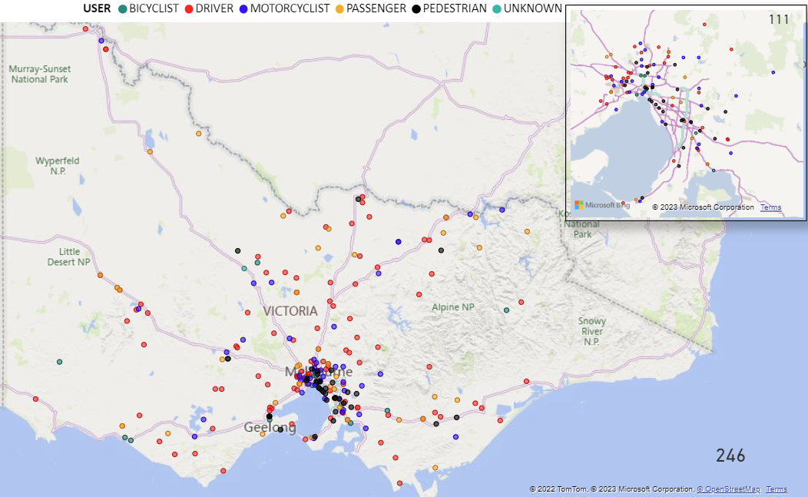

Victoria – Lives Lost, 12 months to June 2022

Injured claimants who were admitted to hospital within 7 days of accident
Rolling 12 month to 31st of December (claim acceptance date)
Category | 2021 | 2020 | 2019 | 2021 v 20201 |  | 2021 v 2019 |  | 5 Year Average
Claims involving an hospitalisation over 14 days (Rolling 12 Month Total)
Claims (to December) | 645 | 598 | 899 | +47 | (+8%) | -254 | (-28%) | 799
per 10,000 veh | 1.2 | 1.2 | 1.8 | +0.1 | (+7%) | -0.5 | (-30%) | 1.7
per 100,000 pop | 9.9 | 8.9 | 13.6 | +0.9 | (+10%) | -3.8 | (-28%) | 12.9
All claims involving an hospitalisation (Rolling 12 Month Total)
Claims (to December) | 5,787 | 5,451 | 8,043 | +336 | (+6%) | -2256 | (-28%) | 7,033
per 10,000 veh | 11.1 | 10.6 | 15.9 | 0.5 | (+5%) | -4.8 | (-30%) | 14.4
per 100,000 pop | 88.4 | 81.4 | 122.0 | 7.0 | (+9%) | -33.6 | (-28%) | 111.0
 |  |  |  |  |  | 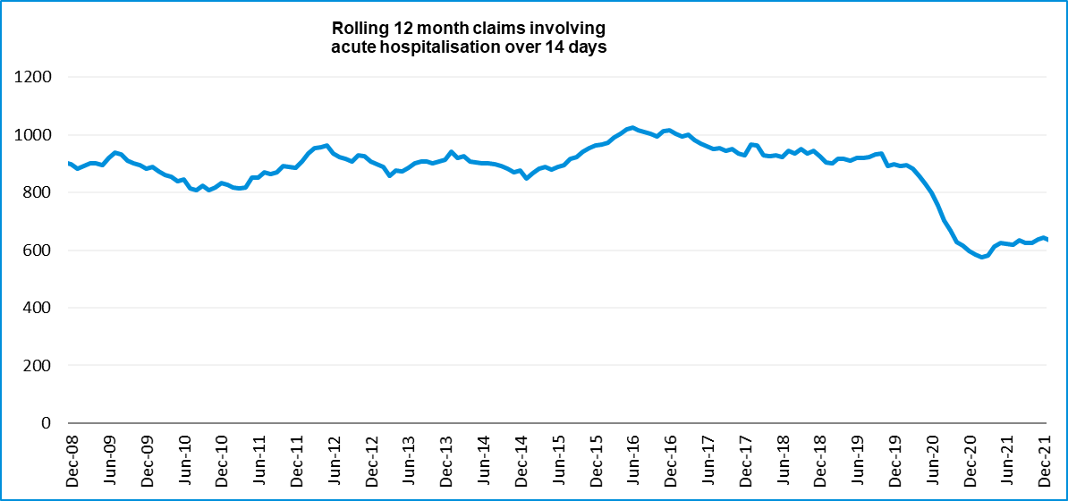

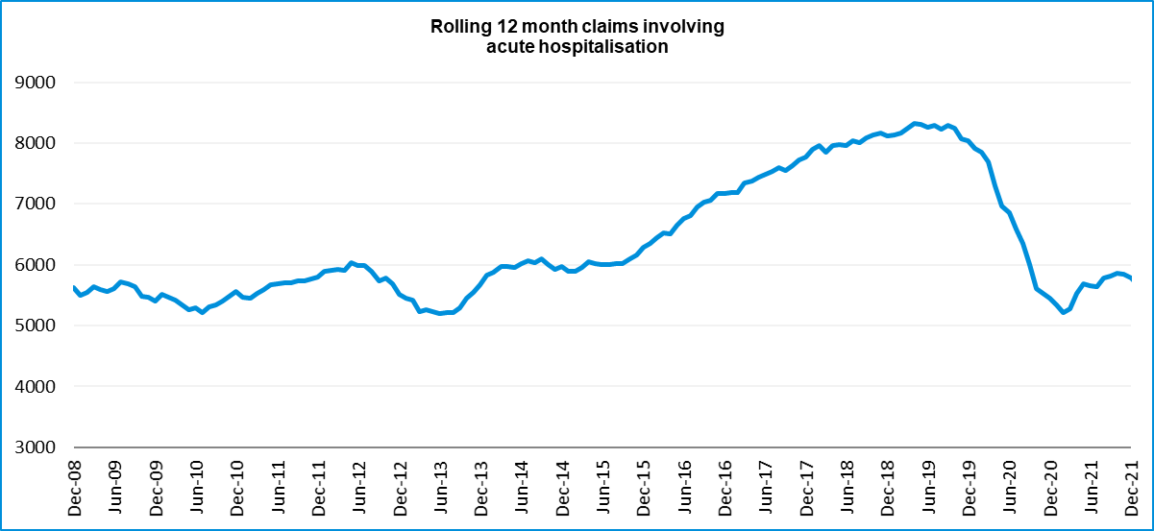

Lives lost: Rolling 12 months

12 months to 30th JUNE 2022
Category | 2022 | 2021 | 2020 | 2022 v 2021 | 2022 v 2020 | 5 Year Average
Overview
Lives Lost | 246 | 203 | 231 | +43 | +15 | 236
Fatal Crashes | 229 | 195 | 212 | +34 | +17 | 221
Sex
Female | 68 | 50 | 61 | +18 | +7 | 63
Male | 178 | 153 | 170 | +25 | +8 | 173
Road user
Bicyclist | 14 | 9 | 13 | +5 | +1 | 11
Driver | 106 | 107 | 107 | -1 | -1 | 109
Motorcyclist | 45 | 38 | 33 | +7 | +12 | 40
Passenger | 42 | 23 | 37 | +19 | +5 | 38
Pedestrian | 38 | 26 | 41 | +12 | -3 | 37
Location
Melbourne | 111 | 84 | 110 | +27 | +1 | 106
Rural Victoria | 135 | 119 | 121 | +16 | +14 | 130
Age group
0-4 | 3 | 4 | 1 | -1 | +2 | 2
5-15 | 6 | 2 | 3 | +4 | +3 | 5
16-17 | 9 | 5 | 3 | +4 | +6 | 5
18-20 | 23 | 9 | 14 | +14 | +9 | 16
21-25 | 18 | 24 | 25 | -6 | -7 | 22
26-29 | 18 | 19 | 23 | -1 | -5 | 19
30-39 | 29 | 32 | 42 | -3 | -13 | 36
40-49 | 30 | 24 | 27 | +6 | +3 | 29
50-59 | 27 | 23 | 24 | +4 | +3 | 28
60-69 | 37 | 26 | 29 | +11 | +8 | 30
70+ | 44 | 35 | 40 | 9 | 4 | 45
Accident Type
Intersection
Adjacent direction | 23 | 23 | 25 | 0 | -2 | 27
Opposing direction | 9 | 8 | 11 | +1 | -2 | 10
Mid-block/other
Head on | 29 | 19 | 28 | +10 | +1 | 31
Same direction | 29 | 19 | 20 | +10 | +9 | 22
Manoeuvre/o'taking | 10 | 9 | 17 | +1 | -7 | 13
On path | 4 | 4 | 8 | 0 | -4 | 5
Single vehicle | 100 | 91 | 76 | +9 | +24 | 88
Other (incl peds) | 42 | 30 | 46 | +12 | -4 | 41

Lives Lost: 12 months to 3o^{th} JUNE 2022
Category | 2022 | 2021 | 2020 | 5 Year Average | Category | 2022 | 2021 | 2020 | 5 Year Average
Local Government Area |  |  |  |  | Local Government Area
ALPINE | 2 | 1 | 1 | 2 | MANSFIELD | 1 | 0 | 1 | 1
ARARAT | 1 | 1 | 1 | 1 | MARIBYRNONG | 0 | 1 | 2 | 3
BALLARAT | 4 | 4 | 2 | 4 | MAROONDAH | 2 | 1 | 2 | 2
BANYULE | 2 | 1 | 1 | 2 | MELBOURNE | 7 | 4 | 1 | 2
BASS COAST | 0 | 1 | 1 | 0 | MELTON | 7 | 3 | 2 | 4
BAW BAW | 5 | 5 | 4 | 5 | MILDURA | 4 | 3 | 2 | 3
BAYSIDE | 0 | 1 | 1 | 0 | MITCHELL | 5 | 6 | 3 | 3
BENALLA | 2 | 0 | 0 | 2 | MOIRA | 5 | 2 | 4 | 4
BOROONDARA | 0 | 2 | 6 | 0 | MONASH | 2 | 5 | 7 | 6
BRIMBANK | 9 | 3 | 6 | 9 | MOONEE VALLEY | 2 | 0 | 2 | 1
BULOKE | 1 | 3 | 0 | 1 | MOORABOOL | 2 | 3 | 2 | 3
CAMPASPE | 7 | 2 | 2 | 7 | MORELAND | 3 | 0 | 0 | 1
CARDINIA | 6 | 13 | 4 | 6 | MORNINGTON PENINSULA | 5 | 9 | 10 | 7
CASEY | 12 | 4 | 8 | 12 | MOUNT ALEXANDER | 1 | 4 | 6 | 3
CENTRAL GOLDFIELDS | 0 | 1 | 2 | 0 | MOYNE | 3 | 1 | 2 | 2
COLAC-OTWAY | 4 | 3 | 3 | 4 | MURRINDINDI | 5 | 1 | 2 | 3
CORANGAMITE | 4 | 4 | 1 | 4 | NILLUMBIK | 2 | 2 | 2 | 2
DAREBIN | 1 | 1 | 7 | 1 | NORTHERN GRAMPIANS | 7 | 2 | 3 | 3
EAST GIPPSLAND | 2 | 8 | 3 | 2 | PORT PHILLIP | 3 | 1 | 2 | 1
FRANKSTON | 2 | 1 | 8 | 2 | PYRENEES | 0 | 3 | 0 | 2
GANNAWARRA | 0 | 1 | 0 | 0 | QUEENSCLIFFE | 0 | 0 | 0 | 0
GLEN EIRA | 3 | 1 | 3 | 3 | SOUTH GIPPSLAND | 4 | 4 | 5 | 4
GLENELG | 1 | 4 | 0 | 1 | SOUTHERN GRAMPIANS | 1 | 0 | 2 | 1
GOLDEN PLAINS | 2 | 2 | 0 | 2 | STONNINGTON | 1 | 1 | 0 | 1
GREATER BENDIGO | 7 | 5 | 7 | 7 | STRATHBOGIE | 4 | 1 | 1 | 2
GREATER DANDENONG | 4 | 5 | 3 | 4 | SURF COAST | 1 | 2 | 0 | 1
GREATER GEELONG | 10 | 7 | 14 | 10 | SWAN HILL | 1 | 3 | 1 | 2
GREATER SHEPPARTON | 2 | 8 | 4 | 2 | TOWONG | 2 | 1 | 2 | 1
HEPBURN | 3 | 1 | 6 | 3 | WANGARATTA | 5 | 0 | 3 | 2
HINDMARSH | 0 | 1 | 0 | 0 | WARRNAMBOOL | 2 | 2 | 3 | 1
HOBSONS BAY | 3 | 2 | 1 | 3 | WELLINGTON | 6 | 4 | 4 | 3
HORSHAM | 4 | 1 | 6 | 4 | WEST WIMMERA | 0 | 1 | 4 | 1
HUME | 8 | 3 | 8 | 8 | WHITEHORSE | 2 | 1 | 2 | 1
INDIGO | 2 | 4 | 0 | 2 | WHITTLESEA | 7 | 4 | 4 | 3
KINGSTON | 2 | 3 | 2 | 2 | WODONGA | 2 | 1 | 1 | 1
KNOX | 1 | 1 | 1 | 1 | WYNDHAM | 7 | 4 | 5 | 5
LATROBE | 5 | 2 | 8 | 5 | YARRA | 4 | 1 | 1 | 1
LODDON | 2 | 3 | 2 | 2 | YARRA RANGES | 4 | 6 | 7 | 7
MACEDON RANGES | 3 | 2 | 2 | 3 | YARRIAMBIACK | 0 | 1 | 1 | 1
MANNINGHAM | 1 | 0 | 2 | 1

Injured claimants admitted to hospital within 7 days of the accident with a hospital stay of more than 14 days
12 months to 31st December 2021 (claim acceptance date, excludes rejected claims and claims for interstate crashes.)
Category | 2021 | 2020 | 2019 | 2021 v 2019 |  | 2021 v 2019 |  | 5 Year Average
Overview
Claims | 645 | 598 | 899 | +47 | 8% | -254 | -28% | 799
Sex
Female | 238 | 211 | 367 | +27 | 13% | -129 | -35% | 313
Male | 407 | 387 | 532 | +20 | 5% | -125 | -23% | 487
Road user
Bicyclist | 32 | 33 | 31 | -1 | -3% | 1 | 3% | 34
Driver | 241 | 227 | 353 | +14 | 6% | -112 | -32% | 296
Motorcyclist | 134 | 146 | 178 | -12 | -8% | -44 | -25% | 167
Passenger | 89 | 72 | 122 | +17 | 24% | -33 | -27% | 113
Pedestrian | 132 | 108 | 184 | +24 | 22% | -52 | -28% | 163
Train/Tram | 8 | 0 | 11 | +8 | - | -3 | -27% | 8
Location
Melbourne | 368 | 353 | 528 | +15 | 4% | -160 | -30% | 471
Rural Victoria | 247 | 224 | 322 | +23 | 10% | -75 | -23% | 282
Age group
0-4 | 3 | 3 | 3 |  | 0% | 0 | 0% | 4
5-15 | 10 | 9 | 14 | +1 | 11% | -4 | -29% | 11
16-17 | 14 | 14 | 12 |  | 0% | 2 | 17% | 13
18-20 | 35 | 28 | 50 | +7 | 25% | -15 | -30% | 38
21-25 | 52 | 47 | 72 | +5 | 11% | -20 | -28% | 70
26-29 | 47 | 44 | 41 | +3 | 7% | 6 | 15% | 49
30-39 | 83 | 82 | 102 | +1 | 1% | -19 | -19% | 97
40-49 | 65 | 74 | 96 | -9 | -12% | -31 | -32% | 91
50-59 | 84 | 73 | 109 | +11 | 15% | -25 | -23% | 102
60-69 | 91 | 72 | 141 | +19 | 26% | -50 | -35% | 106
70+ | 161 | 152 | 259 | +9 | 6% | -98 | -38% | 219
Accident Type
Intersection
Adjacent direction | 69 | 60 | 72 | +9 | 15% | -3 | -4% | 77
Opposing direction | 46 | 30 | 52 | +16 | 53% | -6 | -12% | 47
Mid-block/other
Head on | 34 | 44 | 74 | -10 | -23% | -40 | -54% | 52
Same direction | 46 | 50 | 70 | -4 | -8% | -24 | -34% | 60
Manoeuvre/o'taking | 42 | 33 | 49 | +9 | 27% | -7 | -14% | 43
On path | 31 | 21 | 37 | +10 | 48% | -6 | -16% | 27
Single vehicle | 195 | 201 | 244 | -6 | -3% | -49 | -20% | 219
Other (incl peds) | 182 | 159 | 301 | +23 | 14% | -119 | -40% | 275

Injured claimants who were admitted to hospital within 7 days of the accident with a hospital stay of more than 14 days

12 months to 31st December 2021 (claim acceptance date, excludes rejected claims and claims for interstate crashes.) – Continued
Category | 2021 | 2020 | 2019 | 5 Year Average | Category | 2021 | 2020 | 2019 | 5 Year Average
Local Government Area |  |  |  |  | Local Government Area
ALPINE | 6 | 3 | 11 | 4 | MANSFIELD | 4 | 6 | 4 | 5
ARARAT | 0 | 1 | 7 | 2 | MARIBYRNONG | 7 | 8 | 10 | 10
BALLARAT | 14 | 12 | 16 | 13 | MAROONDAH | 8 | 10 | 11 | 7
BANYULE | 7 | 5 | 7 | 7 | MELBOURNE | 23 | 19 | 25 | 23
BASS COAST | 7 | 1 | 9 | 5 | MELTON | 6 | 4 | 8 | 6
BAW BAW | 6 | 3 | 10 | 7 | MILDURA | 8 | 4 | 5 | 5
BAYSIDE | 4 | 2 | 10 | 6 | MITCHELL | 7 | 11 | 9 | 7
BENALLA | 1 | 1 | 4 | 3 | MOIRA | 7 | 5 | 8 | 7
BOROONDARA | 12 | 8 | 16 | 11 | MONASH | 13 | 5 | 27 | 15
BRIMBANK | 22 | 7 | 22 | 13 | MOONEE VALLEY | 13 | 7 | 13 | 10
BULOKE | 0 | 2 | 2 | 2 | MOORABOOL | 7 | 5 | 8 | 5
CAMPASPE | 6 | 9 | 10 | 7 | MORELAND | 16 | 11 | 27 | 18
CARDINIA | 16 | 11 | 13 | 12 | MORNINGTON PENINSULA | 12 | 16 | 25 | 16
CASEY | 16 | 23 | 28 | 22 | MOUNT ALEXANDER | 9 | 1 | 2 | 1
CENTRAL GOLDFIELDS | 4 | 4 | 5 | 3 | MOYNE | 1 | 3 | 8 | 4
COLAC-OTWAY | 8 | 4 | 2 | 5 | MURRINDINDI | 1 | 5 | 9 | 8
CORANGAMITE | 3 | 3 | 1 | 4 | NILLUMBIK | 4 | 6 | 15 | 6
DAREBIN | 14 | 10 | 19 | 13 | NORTHERN GRAMPIANS | 2 | 1 | 4 | 3
EAST GIPPSLAND | 5 | 14 | 10 | 10 | PORT PHILLIP | 13 | 10 | 12 | 9
FRANKSTON | 5 | 6 | 9 | 9 | PYRENEES | 2 | 2 | 3 | 1
GANNAWARRA | 3 | 3 | 1 | 2 | QUEENSCLIFFE | 0 | 2 | 2 | 1
GLEN EIRA | 6 | 8 | 17 | 11 | SOUTH GIPPSLAND | 5 | 5 | 7 | 5
GLENELG | 1 | 1 | 4 | 2 | SOUTHERN GRAMPIANS | 2 | 3 | 6 | 3
GOLDEN PLAINS | 5 | 3 | 7 | 4 | STONNINGTON | 9 | 8 | 7 | 8
GREATER BENDIGO | 14 | 15 | 21 | 16 | STRATHBOGIE | 4 | 5 | 2 | 3
GREATER DANDENONG | 23 | 18 | 22 | 19 | SURF COAST | 3 | 2 | 9 | 4
GREATER GEELONG | 24 | 28 | 32 | 24 | SWAN HILL | 3 | 5 | 6 | 4
GREATER SHEPPARTON | 24 | 9 | 4 | 9 | TOWONG | 1 | 1 | 6 | 2
HEPBURN | 5 | 2 | 6 | 3 | WANGARATTA | 1 | 2 | 5 | 4
HINDMARSH | 0 | 3 | 0 | 1 | WARRNAMBOOL | 3 | 4 | 5 | 3
HOBSONS BAY | 6 | 5 | 7 | 6 | WELLINGTON | 12 | 8 | 8 | 7
HORSHAM | 3 | 1 | 5 | 2 | WEST WIMMERA | 0 | 0 | 0 | 0
HUME | 14 | 22 | 23 | 19 | WHITEHORSE | 5 | 17 | 29 | 18
INDIGO | 6 | 3 | 3 | 3 | WHITTLESEA | 14 | 18 | 24 | 18
KINGSTON | 11 | 11 | 16 | 13 | WODONGA | 1 | 2 | 6 | 3
KNOX | 17 | 15 | 21 | 16 | WYNDHAM | 23 | 20 | 15 | 16
LATROBE | 15 | 7 | 11 | 7 | YARRA | 8 | 10 | 12 | 9
LODDON | 1 | 2 | 5 | 2 | YARRA RANGES | 13 | 25 | 23 | 22
MACEDON RANGES | 2 | 7 | 12 | 7 | YARRIAMBIACK | 1 | 1 | 2 | 1
MANNINGHAM | 8 | 8 | 15 | 12

Injured claimants who were admitted to hospital within 7 days of accident
12 months to 31st December 2021 (claim acceptance date, excludes rejected claims and claims for interstate crashes.)
Category | 2021 | 2020 | 2019 | 2021 v 2020 |  | 2021 v 2019 |  | 5 Year Average
Overview
Claims | 5,787 | 5,451 | 8,043 | +336 | 6% | -2256 | -28% | 7,033
Sex
Female | 2,405 | 2,185 | 3,536 | +220 | 10% | -1131 | -32% | 2,992
Male | 3,376 | 3,258 | 4,498 | +118 | 4% | -1122 | -25% | 4,034
Road user
Bicyclist | 418 | 423 | 519 | -5 | -1% | -101 | -19% | 478
Driver | 2,818 | 2,643 | 3,895 | +175 | 7% | -1077 | -28% | 3,378
Motorcyclist | 1,032 | 1,008 | 1,367 | +24 | 2% | -335 | -25% | 1,223
Passenger | 772 | 691 | 1,157 | +81 | 12% | -385 | -33% | 985
Pedestrian | 550 | 459 | 774 | +91 | 20% | -224 | -29% | 675
Train/Tram | 12 | 18 | 38 | -6 | -33% | -26 | -68% | 34
Location
Melbourne | 3,623 | 3,435 | 4,890 | +188 | 5% | -1267 | -26% | 4,262
Rural Victoria | 1,928 | 1,782 | 2,403 | +146 | 8% | -475 | -20% | 2,139
Age group
0-4 | 42 | 33 | 48 | +9 | 27% | -6 | -13% | 52
5-15 | 157 | 121 | 217 | +36 | 30% | -60 | -28% | 190
16-17 | 106 | 92 | 123 | +14 | 15% | -17 | -14% | 116
18-20 | 411 | 404 | 567 | +7 | 2% | -156 | -28% | 509
21-25 | 670 | 649 | 940 | +21 | 3% | -270 | -29% | 860
26-29 | 500 | 479 | 700 | +21 | 4% | -200 | -29% | 598
30-39 | 1,025 | 926 | 1,318 | +99 | 11% | -293 | -22% | 1,156
40-49 | 773 | 789 | 1,075 | -16 | -2% | -302 | -28% | 986
50-59 | 813 | 739 | 1,077 | +74 | 10% | -264 | -25% | 955
60-69 | 596 | 556 | 873 | +40 | 7% | -277 | -32% | 708
70+ | 694 | 663 | 1,105 | +31 | 5% | -411 | -37% | 903
Accident Type
Intersection
Adjacent direction | 862 | 811 | 997 | +51 | 6% | -135 | -14% | 878
Opposing direction | 459 | 408 | 542 | +51 | 13% | -83 | -15% | 493
Mid-block/other
Head on | 283 | 277 | 389 | +6 | 2% | -106 | -27% | 315
Same direction | 934 | 801 | 1,072 | +133 | 17% | -138 | -13% | 932
Manoeuvre/o'taking | 415 | 392 | 346 | +23 | 6% | +69 | 20% | 371
On path | 314 | 273 | 264 | +41 | 15% | +50 | 19% | 265
Single vehicle | 1,380 | 1,420 | 1,467 | -40 | -3% | -87 | -6% | 1,433
Other (incl peds) | 1,140 | 1,069 | 2,966 | +71 | 7% | -1826 | -62% | 2,347

Injured claimants who were admitted to hospital within 7 days of accident

12 months to 31st December 2021 (claim acceptance date, excludes rejected claims and claims for interstate crashes.) – Continued
Category | 2021 | 2020 | 2019 | 5 Year Average | Category | 2021 | 2020 | 2019 | 5 Year Average
Local Government Area |  |  |  |  | Local Government Area
ALPINE | 27 | 22 | 40 | 24 | MANSFIELD | 35 | 25 | 47 | 29
ARARAT | 13 | 10 | 23 | 11 | MARIBYRNONG | 70 | 60 | 101 | 71
BALLARAT | 118 | 81 | 113 | 74 | MAROONDAH | 40 | 50 | 72 | 48
BANYULE | 39 | 31 | 64 | 46 | MELBOURNE | 189 | 156 | 261 | 214
BASS COAST | 36 | 25 | 55 | 34 | MELTON | 71 | 70 | 99 | 63
BAW BAW | 52 | 65 | 57 | 47 | MILDURA | 36 | 46 | 32 | 27
BAYSIDE | 69 | 69 | 94 | 66 | MITCHELL | 64 | 67 | 76 | 56
BENALLA | 10 | 11 | 25 | 16 | MOIRA | 36 | 36 | 42 | 31
BOROONDARA | 100 | 78 | 155 | 104 | MONASH | 133 | 134 | 215 | 148
BRIMBANK | 154 | 132 | 186 | 132 | MOONEE VALLEY | 139 | 88 | 158 | 104
BULOKE | 7 | 6 | 12 | 7 | MOORABOOL | 35 | 41 | 61 | 41
CAMPASPE | 48 | 37 | 40 | 36 | MORELAND | 133 | 120 | 188 | 139
CARDINIA | 131 | 110 | 119 | 96 | MORNINGTON PENINSULA | 136 | 148 | 200 | 137
CASEY | 323 | 281 | 325 | 254 | MOUNT ALEXANDER | 21 | 14 | 21 | 17
CENTRAL GOLDFIELDS | 18 | 23 | 27 | 17 | MOYNE | 17 | 19 | 44 | 27
COLAC-OTWAY | 54 | 46 | 67 | 51 | MURRINDINDI | 29 | 43 | 61 | 47
CORANGAMITE | 30 | 21 | 37 | 26 | NILLUMBIK | 19 | 39 | 53 | 33
DAREBIN | 56 | 77 | 147 | 87 | NORTHERN GRAMPIANS | 18 | 16 | 24 | 20
EAST GIPPSLAND | 48 | 51 | 40 | 44 | PORT PHILLIP | 143 | 108 | 152 | 114
FRANKSTON | 101 | 108 | 153 | 109 | PYRENEES | 6 | 11 | 18 | 10
GANNAWARRA | 11 | 12 | 9 | 9 | QUEENSCLIFFE | 4 | 2 | 10 | 5
GLEN EIRA | 92 | 118 | 128 | 102 | SOUTH GIPPSLAND | 33 | 37 | 53 | 34
GLENELG | 27 | 14 | 22 | 17 | SOUTHERN GRAMPIANS | 13 | 32 | 26 | 18
GOLDEN PLAINS | 32 | 42 | 51 | 38 | STONNINGTON | 93 | 100 | 129 | 101
GREATER BENDIGO | 111 | 102 | 154 | 107 | STRATHBOGIE | 26 | 30 | 39 | 27
GREATER DANDENONG | 260 | 206 | 287 | 203 | SURF COAST | 66 | 61 | 63 | 53
GREATER GEELONG | 396 | 317 | 426 | 326 | SWAN HILL | 15 | 24 | 18 | 15
GREATER SHEPPARTON | 86 | 53 | 83 | 68 | TOWONG | 11 | 8 | 18 | 13
HEPBURN | 24 | 23 | 36 | 23 | WANGARATTA | 15 | 24 | 47 | 27
HINDMARSH | 5 | 8 | 22 | 10 | WARRNAMBOOL | 28 | 20 | 33 | 23
HOBSONS BAY | 59 | 61 | 90 | 63 | WELLINGTON | 63 | 43 | 63 | 49
HORSHAM | 27 | 21 | 33 | 22 | WEST WIMMERA | 7 | 3 | 4 | 3
HUME | 215 | 203 | 262 | 196 | WHITEHORSE | 79 | 74 | 150 | 106
INDIGO | 20 | 16 | 23 | 19 | WHITTLESEA | 142 | 145 | 201 | 162
KINGSTON | 123 | 127 | 140 | 104 | WODONGA | 28 | 26 | 24 | 19
KNOX | 115 | 97 | 138 | 104 | WYNDHAM | 168 | 184 | 219 | 149
LATROBE | 65 | 83 | 89 | 63 | YARRA | 72 | 67 | 132 | 81
LODDON | 8 | 10 | 21 | 10 | YARRA RANGES | 119 | 155 | 182 | 138
MACEDON RANGES | 41 | 48 | 70 | 56 | YARRIAMBIACK | 8 | 7 | 4 | 6
MANNINGHAM | 40 | 39 | 90 | 63

Lives lost by week (2017 to 2022)
Week Ending | 2017 | 2018 | 2019 | 2020 | 2021 | 2022 | 2022 Cumulative | 12 month Moving Total
02-Jan | 0 | 2 | 0 | 5 | 2 | 2 | 2 | 236
09-Jan | 3 | 8 | 3 | 3 | 2 | 7 | 9 | 240
16-Jan | 8 | 2 | 4 | 5 | 0 | 6 | 15 | 245
23-Jan | 3 | 2 | 7 | 2 | 5 | 3 | 18 | 244
30-Jan | 3 | 6 | 8 | 8 | 5 | 4 | 22 | 242
06-Feb | 3 | 3 | 9 | 5 | 5 | 9 | 31 | 247
13-Feb | 3 | 2 | 10 | 5 | 7 | 6 | 37 | 246
20-Feb | 6 | 7 | 4 | 7 | 3 | 3 | 40 | 245
27-Feb | 6 | 3 | 10 | 1 | 6 | 6 | 46 | 246
06-Mar | 3 | 5 | 2 | 3 | 9 | 3 | 49 | 242
13-Mar | 5 | 8 | 4 | 7 | 4 | 2 | 51 | 238
20-Mar | 5 | 3 | 8 | 10 | 5 | 6 | 57 | 239
27-Mar | 7 | 4 | 6 | 4 | 4 | 5 | 62 | 239
03-Apr | 4 | 1 | 3 | 7 | 7 | 4 | 66 | 236
10-Apr | 9 | 2 | 8 | 1 | 2 | 7 | 73 | 241
17-Apr | 9 | 1 | 5 | 1 | 3 | 3 | 76 | 241
24-Apr | 7 | 5 | 6 | 9 | 3 | 4 | 80 | 243
01-May | 3 | 3 | 4 | 1 | 2 | 3 | 83 | 243
08-May | 5 | 11 | 8 | 3 | 6 | 3 | 86 | 240
15-May | 6 | 5 | 7 | 5 | 4 | 2 | 88 | 238
22-May | 2 | 2 | 8 | 2 | 2 | 8 | 96 | 244
29-May | 6 | 3 | 7 | 4 | 1 |  | 96 | 243
05-Jun | 1 | 1 | 4 | 2 | 2 | 6 | 102 | 247
12-Jun | 3 | 7 | 4 | 3 | 6 | 4 | 106 | 245
19-Jun | 5 | 2 | 5 | 5 | 3 | 6 | 112 | 249
26-Jun | 4 | 2 | 3 | 3 | 5 | 5 | 117 | 249
03-Jul | 5 | 1 | 7 | 6 | 10
10-Jul | 5 | 3 | 3 | 2 | 2
17-Jul | 9 | 5 | 3 | 4 | 5
24-Jul | 4 | 4 | 5 | 4 | 4
31-Jul | 0 | 3 | 3 | 3 | 3
07-Aug | 4 | 4 | 3 | 4 | 3
14-Aug | 10 | 3 | 3 | 3 | 4
21-Aug | 4 | 6 | 4 | 4 | 6
28-Aug | 8 | 4 | 4 | 2 | 3
04-Sep | 6 | 3 | 1 | 2 | 3
11-Sep | 5 | 3 | 6 | 5 | 6
18-Sep | 3 | 8 | 6 | 2 | 6
25-Sep | 4 | 2 | 3 | 1 | 2
02-Oct | 2 | 5 | 4 | 6 | 9
09-Oct | 4 | 6 | 8 | 4 | 3
16-Oct | 4 | 3 | 5 | 4 | 2
23-Oct | 2 | 3 | 4 | 8 | 8
30-Oct | 1 | 7 | 8 | 5 | 3
06-Nov | 10 | 5 | 4 | 3 | 7
13-Nov | 5 | 2 | 5 | 3 | 5
20-Nov | 5 | 10 | 5 | 5 | 2
27-Nov | 9 | 5 | 3 | 3 | 7
04-Dec | 4 | 3 | 5 | 2 | 4
11-Dec | 6 | 3 | 3 | 5 | 7
18-Dec | 6 | 5 | 7 | 4 | 5
25-Dec | 10 | 5 | 3 | 5 | 5
31-Dec | 5 | 2 | 4 | 1 | 6
Total | 259 | 213 | 266 | 211 | 233 | 117

Booze Bus Random Breath Testing
Booze-bus Random Breath Tests (12 months to March 2020 vs previous 12 months)
 | 2020 | 2019 | 2018 | 2020 v 2019 |  | 2020 v 2018
Melbourne | 1,025,495 | 1,226,599 | 1,143,717 | -201104 | (-16%) | -118222 | (-10%)
Country | 183,858 | 115,731 | 142,698 | +68127 | (+59%) | +41160 | (+29%)
Vic Total | 1,209,353 | 1,342,330 | 1,286,415 | -132977 | (-10%) | -77062 | (-6%)

12 months to March 2020 (monthly totals)
 | 2019 |  |  |  |  |  |  |  |  | 2020
 | Apr | May | Sep | Jul | Aug | Sep | Oct | Nov | Dec | Jan | Feb | Mar
Melbourne | 79,988 | 84,478 | 101,799 | 98,380 | 102,592 | 96,574 | 89,177 | 88,460 | 82,298 | 62,544 | 103,896 | 35,309
Country | 19,119 | 14,068 | 10,318 | 5,826 | 11,098 | 12,571 | 17,551 | 25,867 | 16,566 | 15,206 | 23,588 | 12,080
Vic Total | 99,107 | 98,546 | 112,117 | 104,206 | 113,690 | 109,145 | 106,728 | 114,327 | 98,864 | 77,750 | 127,484 | 47,389

Random Drug Testing
Random Drug Tests (12 months to March 2020 vs previous 12 months)
 | 2020 | 2019 | 2018 | 2020 v 2019 |  | 2020 v 2018
Victoria | 161,283 | 122,730 | 102,551 | 38,553 | 31% | 58,732 | 57%

12 months to March 2020 (monthly totals)
 | 2019 |  |  |  |  |  |  |  |  | 2020
 | Apr | May | Jun | Jul | Aug | Sep | Oct | Nov | Dec | Jan | Feb | Mar
Victoria | 17,337 | 19,571 | 15,441 | 13,817 | 18,692 | 15,244 | 12,181 | 12,646 | 11,000 | 9,157 | 7,904 | 8,293

Speed Infringements Issued from Mobile Cameras (monthly totals) |  | Monthly Average = | 51,437
Mobile Safety Camera Data
2021 |  |  |  |  |  |  |  |  | 2022
Apr | May | Jun | Jul | Aug | Sep | Oct | Nov | Dec | Jan | Feb | Mar
52,014 | 57,526 | 66,303 | 46,363 | 35,495 | 35,824 | 43,627 | 49,583 | 57,169 | 59,355 | 56,128 | 57,853

Excessive Speed Infringements (ESI) Issued from Mobile Cameras (monthly totals) |  |  |  |  |  |  |  |  | Monthly Average = |  |  |  | 537
2021 |  |  |  |  |  |  |  |  |  | 2022
Apr | May | Jun | Jul | Aug | Sep | Oct | Nov | Dec |  | Jan | Feb |  |  | Mar
476 | 608 | 698 | 588 | 436 | 427 | 526 | 488 | 563 |  | 551 | 531 |  |  | 548
Notes: An ESI is defined as 25km/h over the speed limit except in a 110km/h zone where it is 20km/h over the limit.

Notes: 1. The definition of ESIs changed on 15 December 2002 to 25km/h over the speed limit from 30km/h over the speed limit except in a 110km/h zone where it has always been 20km/h over the limit.

The National Picture
State | Lives Lost (12 months to June)
 | 2022 | 2021 | 2020 | 2019 | 2022 v 2021
New South Wales | 283 | 287 | 314 | 358 | -4 | (-1%)
Victoria | 246 | 203 | 231 | 263 | +43 | (+21%)
Queensland | 293 | 296 | 237 | 227 | -3 | (-1%)
South Australia | 85 | 99 | 99 | 103 | -14 | (-14%)
Western Australia | 155 | 169 | 140 | 171 | -14 | (-8%)
Tasmania | 52 | 32 | 31 | 32 | +20 | (+63%)
Northern Territory | 45 | 37 | 31 | 37 | +8 | (+22%)
Australian Capital Territory | 15 | 11 | 5 | 6 | +4 | (+36%)
AUST TOTAL | 1,174 | 1,134 | 1,088 | 1,197 | +40 | (+4%)
Australia minus Victoria | 928 | 931 | 857 | 934 | -3 | (-0%)
State | Lives Lost per 10,000 registered vehicles |  |  | Fatalities per 100,000 population
 | (12 months to June) |  |  | (12 months to June)
 | 2022 | 2021 | 2020 | 2022 | 2021 | 2020
New South Wales | 0.47 | 0.48 | 0.54 | 3.48 | 3.53 | 3.89
Victoria | 0.47 | 0.39 | 0.45 | 3.74 | 3.01 | 3.48
Queensland | 0.66 | 0.68 | 0.53 | 5.56 | 5.70 | 4.62
South Australia | 0.56 | 0.67 | 0.69 | 4.69 | 5.50 | 5.56
Western Australia | 0.66 | 0.73 | 0.62 | 5.60 | 6.18 | 0.95
Tasmania | 1.00 | 0.63 | 0.61 | 9.13 | 5.66 | 5.56
Northern Territory | 2.74 | 2.27 | 1.93 | 17.80 | 14.86 | 12.47
Australian Capital Territory | 0.46 | 0.35 | 0.16 | 3.30 | 2.43 | 1.12
Australia Total | 0.57 | 0.56 | 0.55 | 4.54 | 4.42 | 4.27
Australia minus Victoria | 0.61 | 0.62 | 0.58 | 4.82 | 4.87 | 4.53
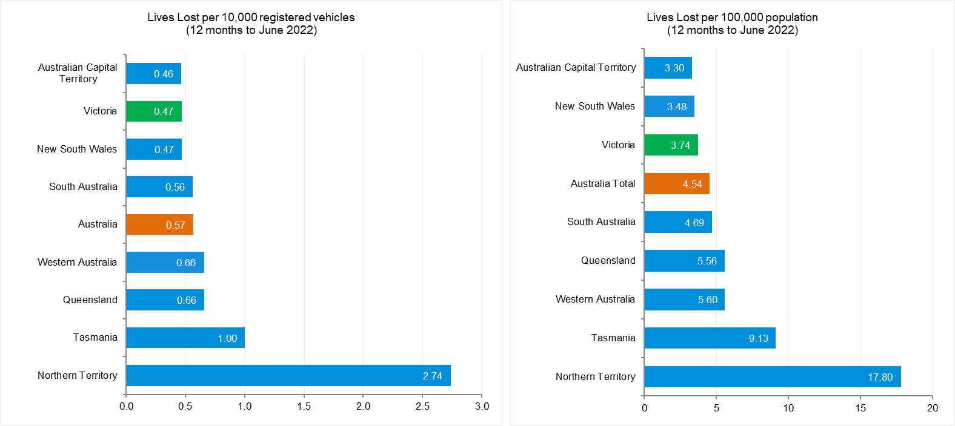

Source: Road Deaths Australia | Bureau of Infrastructure and Transport Research Economics (bitre.gov.au)

International Road Safety Comparison
Selected OECD countries, Australia and Victoria, 2000, 2010, 2015 to 2020

Lives lost rate per 100,000 population
Countries | 2000 | 2010 | 2015 | 2016 | 2017 | 2018 | 2019 | 2020
Australia | 9.5 | 6.1 | 5.1 | 5.4 | 5.0 | 4.5 | 4.7 | 4.3
Canada | 9.5 | 6.6 | 5.3 | 5.2 | 5.1 | 5.2 | 4.7 | 4.6
New Zealand | 12.0 | 8.6 | 6.9 | 7.0 | 7.9 | 7.7 | 7.1 | 6.0
Norway | 7.6 | 4.3 | 2.3 | 2.6 | 2.0 | 2.0 | 2.0 | 1.7
Sweden | 6.7 | 2.8 | 2.7 | 2.7 | 2.5 | 3.2 | 2.2 | 2.0
Switzerland | 8.2 | 4.2 | 3.1 | 2.6 | 2.7 | 2.7 | 2.2 | 2.6
United Kingdom | 6.1 | 3.0 | 2.8 | 2.8 | 2.8 | 2.8 | 2.7 | 2.3
United States | 14.9 | 10.7 | 11.1 | 11.7 | 11.5 | 11.3 | 11.1 | 11.8
Victoria | 8.7 | 5.3 | 4.2 | 4.7 | 4.1 | 3.3 | 4.1 | 3.2

Lives lost rate per100 million vehicle kilometres travelled (VKT)
Countries | 2000 | 2010 | 2015 | 2016 | 2017 | 2018 | 2019 | 2020
Australia | 0.9 | 0.6 | 0.5 | 0.5 | 0.5 | 0.4 | 0.5 | 0.4
Canada | 0.9 | 0.7 | 0.5 | 0.5 | 0.5 | 0.5 | 0.4 | 0.5
New Zealand | 1.4 | 0.9 | 0.7 | 0.7 | 0.8 | 0.8 | 0.7 | 0.7
Norway | 1.0 | 0.5 | 0.3 | 0.3 | 0.2 | 0.2 | 0.2 | 0.2
Sweden | 0.9 | 0.3 | 0.3 | 0.3 | 0.3 | 0.4 | 0.3 | 0.3
Switzerland | 1.1 | 0.5 | 0.4 | 0.3 | 0.3 | 0.3 | 0.3 | 0.4
United Kingdom | - | - | 0.3 | 0.3 | 0.3 | 0.3 | 0.3 | 0.3
United States | 0.9 | 0.7 | 0.7 | 0.7 | 0.7 | 0.7 | 0.7 | 0.8
Victoria | 0.8 | 0.5 | 0.4 | 0.4 | 0.4 | 0.3 | 0.4 | 0.3

Lives lost rate per 10,000 registered vehicles

Countries | 2000 | 2010 | 2015 | 2016 | 2017 | 2018 | 2019 | 2020
Australia | 1.5 | 0.8 | 0.7 | 0.7 | 0.7 | 0.6 | 0.6 | 0.6
Canada | 1.6 | 1.0 | 0.8 | 0.8 | 0.8 | 0.8 | 0.7 | 0.7
New Zealand | 1.8 | 1.2 | 0.9 | 0.9 | 1.0 | 1.0 | 0.8 | 0.7
Norway | 1.2 | 0.6 | 0.3 | 0.3 | 0.3 | 0.3 | 0.3 | 0.2
Sweden | 1.2 | 0.5 | 0.4 | 0.4 | 0.4 | 0.5 | 0.3 | 0.3
Switzerland | 1.2 | 0.6 | 0.4 | 0.4 | 0.4 | 0.4 | 0.3 | 0.4
United Kingdom | 1.2 | 0.5 | 0.5 | 0.5 | 0.5 | 0.5 | 0.5 | 0.4
United States | 1.9 | 1.3 | 1.3 | 1.3 | 1.3 | 1.2 | 1.2 | 1.3
Victoria | 1.2 | 0.7 | 0.6 | 0.6 | 0.5 | 0.4 | 0.5 | 0.4
Source: ABS 2022a, IRTAD 2022

Lives lost rate per 100,000 population - OECD countries, 2020

Source: Bureau of Infrastructure and Transport Research Economics

Explanations and references
LGA: Local Government Areas. Crash locations for acute hospitalised claims are assigned to LGA’s based on the crash postcode recorded by Victoria Police. Crash locations for fatal crashes are coded exactly to an LGA by Victoria Police.
Claimants: Refers to people injured in transport accidents who have an accepted claim with the TAC.
Hospitalisation: refers to all hospital admission that occurred within 7 days of accident.

Useful websites
TAC Sites
- TAC Safety (Road Safety) www.tacsafety.com.au
- TAC How safe is your car www.howsafeisyourcar.com.au
- TAC How safe is your first car www.howsafeisyourfirstcar.com.au
- TAC Motorcycle Safety Website www.spokes.com.au
- TAC Corporate site www.tac.vic.gov.au
- Drivesmart www.drivesmart.vic.gov.au
- Ridesmart www.ridesmartonline.com.au

Victorian Sites
- VicRoads www.vicroads.vic.gov.au
- Victoria Police www.police.vic.gov.au
- Parliamentary Road Safety Committee https://www.parliament.vic.gov.au/57th-parliament/rsc
- RACV www.racv.com.au
- Monash University Accident Research Centre www.monash.edu.au/muarc
- Cameras Save Lives www.camerassavelives.vic.gov.au
- VicRoads Learner Driver Site www.lsite.vicroads.vic.gov.au/Learners
- Road Safety Education Victoria www.roadsafetyeducation.vic.gov.au

National and Interstate Sites
- ARRB Transport Research www.arrb.com.au
- Australian Transport Safety Bureau www.atsb.gov.au
- Motor Accidents Authority (NSW) www.maa.nsw.gov.au
- Motor Accidents Insurance Board (TAS) www.maib.tas.gov.au
- Motor Accident Commission, Allianz (SA) www.mac.sa.gov.au
- Motor Accidents Compensation, TIO, (NT) www.tiofi.com.au/mac
- Insurance Commission of Western Australia www.icwa.wa.gov.au
- Motor Accident Insurance Commission (QLD) www.maic.qld.gov.au

International Sites
- National Highway Traffic Safety Admin (USA) www.nhtsa.dot.gov
- Swedish Road and Transport Institute (VTI) www.vti.se
- SWOV Institute for Road Safety Research www.swov.nl

Related Sites
- Alcohol and Drug Foundation www.adf.org.au

Graphs of Lives Lost and Hospitalised Claims

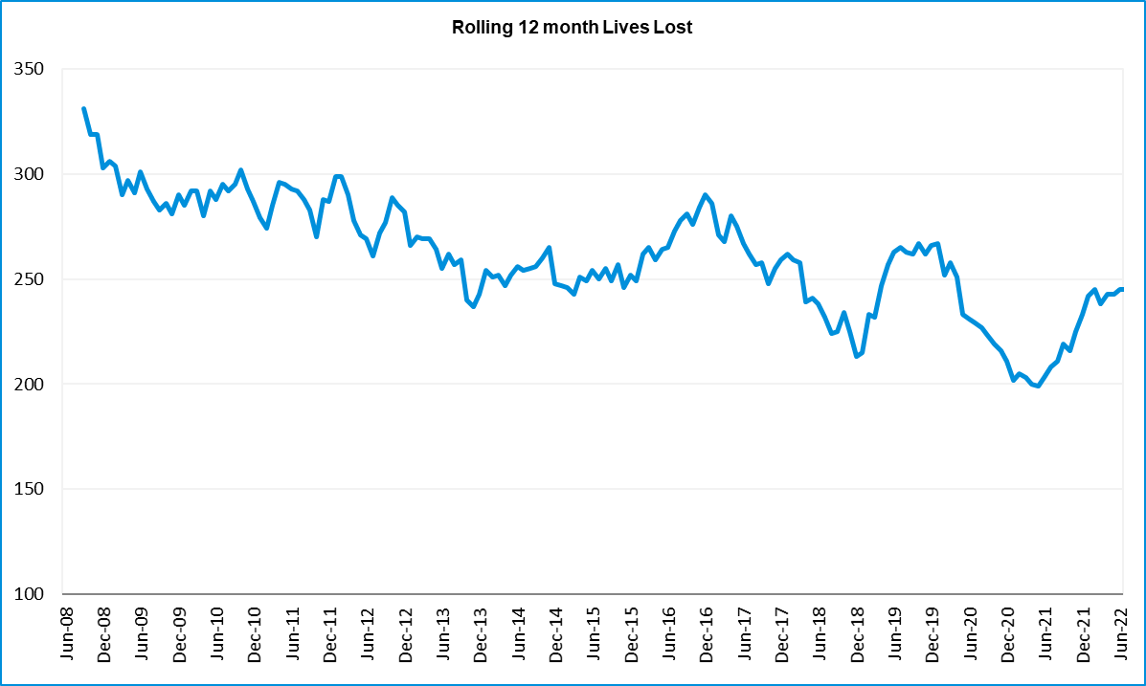

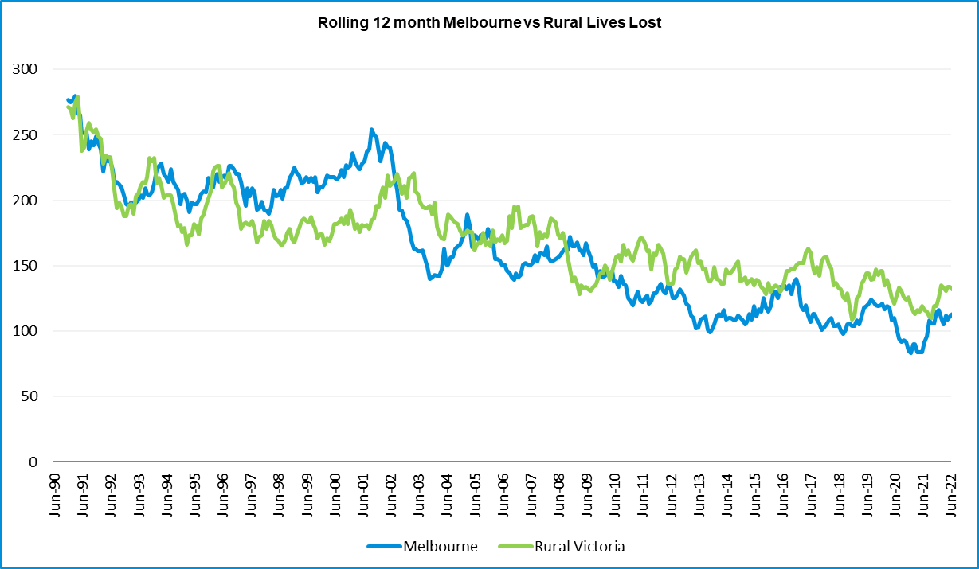

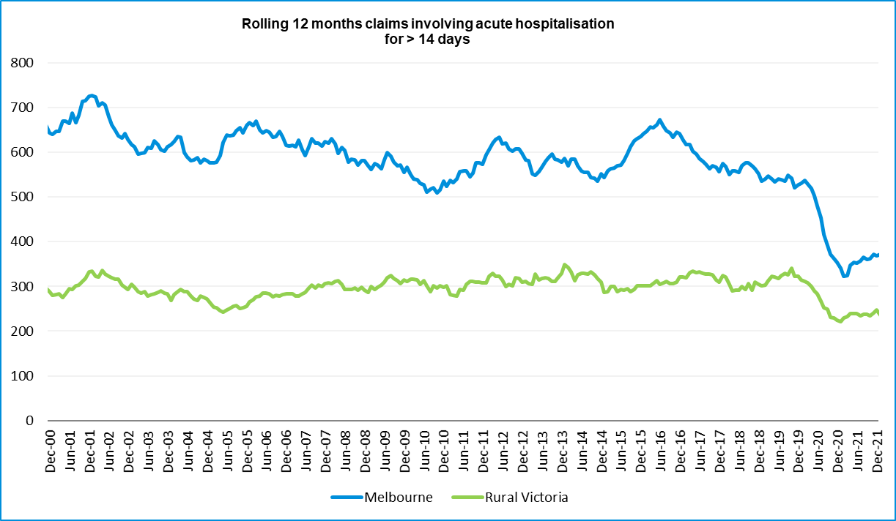

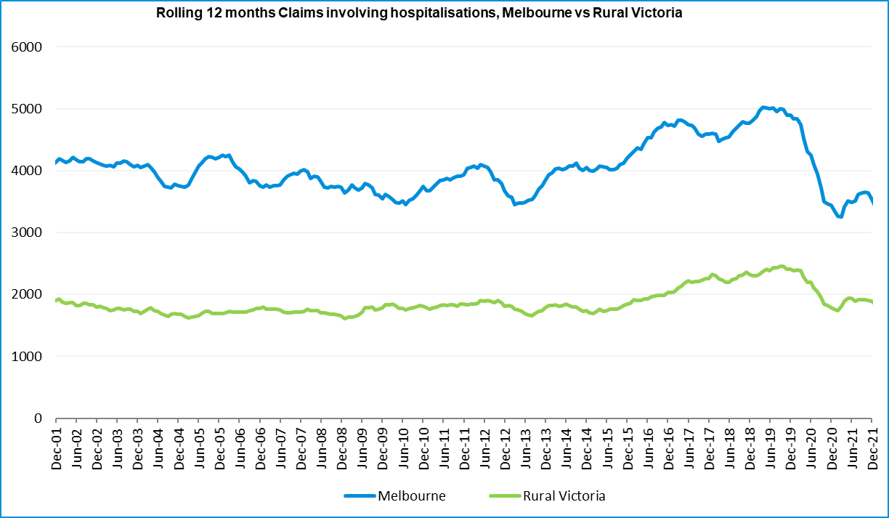

Victorian monthly lives lost since 1951

