
Road Safety Statistics

December 2024

Table of contents

Notes about the data in this report 3
1. Status Report 4
1.1 Lives lost on Victorian Roads 4
1.2 Injured claimants who were admitted to hospital within 7 days of accident. 5
2. Lives Lost: Rolling 12 months. 6
2.1 Demographics and accident type 6
2.2 Local government area 7
3. Injured claimants admitted to hospital within 7 days of the accident with a hospital stay of more than 14 days. 8
3.1 Demographics and accident type 8
3.2 Local government area 9
4. Injured claimants admitted to hospital within 7 days of accident. 10
4.1 Demographics and accident type 10
4.2 Local government area 11
5. Mobile Safety Camera Data. 12
5.1 Speed Infringements Issued from Mobile Cameras (monthly totals) 12
5.2 Excessive Speed Infringements (ESI) Issued from Mobile Cameras (monthly totals) 12
6. The National Picture – Interstate Comparison 13
6.1 Lives lost 13
6.2 Lives lost per 10,000 registered vehicles and per 100,000 population. 13
7. International Road Safety Comparison 14
7.1 Lives lost rate per 100,000 population 14
7.2 Lives lost rate per 100 million vehicle kilometres travelled (VKT) 14
7.3 Lives lost rate per 10,000 registered vehicles 14
8. Lives lost rate per 100,000 population - OECD countries, 2022. 15
9. Useful websites 16
10. Graphs of Lives Lost and Hospitalised Claims 17
11. Victorian monthly lives lost since 1951 19

Notes about the data in this report

- All data provided in this report is the data most recently available at time of production. Fatality data updated to the end of report month. A 6-month lag applies to hospitalised TAC claims data.
- Reporting of the hospitalised claims data is based on the claim acceptance date and excludes rejected claims and those involving interstate crashes.
- Reported data will have one extra day of exposure for leap years.
- Data is subject to revision as additional information about known accidents/claims is received, and as new accident/claim reports are received and processed.
- Crash locations for acute hospitalised claims are assigned to Local Government Areas based on the crash postcode recorded by Victoria Police. Crash locations for fatal crashes are coded exactly to a Local Government Area assigned by Victoria Police.
- Claimants refers to people injured in transport accidents who have an accepted claim with the TAC.
- Hospitalisation refers to all hospital admission that occurred within 7 days of accident.

  - Report prepared by:
Road Safety Division, Transport Accident Commission.

Status Report
In the 12-month period from 1st January 2024 to 31st December 2024, 284 people lost their lives, compared to 295 lives lost during the same period in 2023. This represents 11 fewer lives lost.

1.1 Lives lost on Victorian Roads

Category | 2024 | 2023 | 2022 | 2024 v 2023 | 2024 v 2022 | 5-Year Average
Lives Lost (Rolling 12 Month Total)
Lives Lost (to December) | 284 | 295 | 241 | -11 | +43 | 253
per 10,000 vehicles | 0.51 | 0.54 | 0.45 | -0.03 | +0.06 | 0.48
per 100,000 population | 4.07 | 4.33 | 3.64 | -0.26 | +0.43 | 3.82
Crashes (Rolling 12 Month Total)
Fatal crashes (to December) | 271 | 261 | 239 | +10 | +32 | 236
per 10,000 vehicles | 0.49 | 0.48 | 0.45 | +0.01 | +0.04 | 0.44
per 100,000 population | 3.88 | 3.83 | 3.61 | +0.05 | +0.27 | 3.47
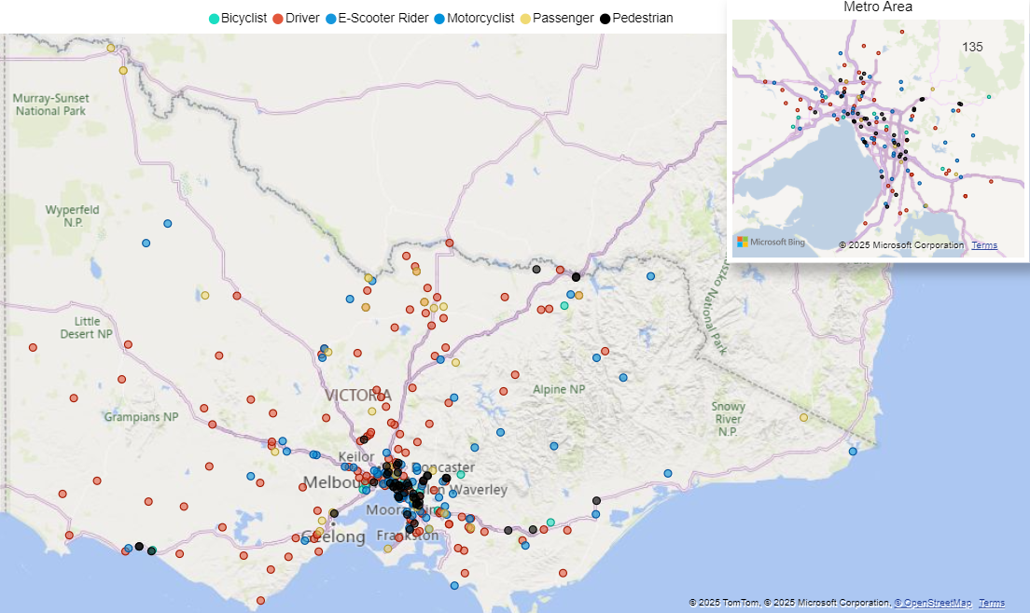
Victoria – Lives Lost, January to December 2024

1.2 Injured claimants who were admitted to hospital within 7 days of accident.
Rolling 12 months to 30th June (claim acceptance date)

Category | 2024 | 2023 | 2022 | 2024 v 2023 |  | 2024 v 2022 |  | 5-Year Average
Claims involving an acute hospitalisation over 14 days (Rolling 12 Month Total)
Claims (to June) | 647 | 665 | 559 | -18 | (-3%) | +88 | (+16%) | 658
per 10,000 vehicles | 1.18 | 1.24 | 1.06 | -0.06 | (-5%) | 0.1 | (+11%) | 1.30
per 100,000 population | 9.40 | 9.90 | 8.49 | -0.50 | (-5%) | 0.9 | (+11%) | 10.21
All claims involving an acute hospitalisation (Rolling 12 Month Total)
Claims (to June) | 5,239 | 5,606 | 5,101 | -367 | (-7%) | +138 | (+3%) | 5,694
per 10,000 vehicles | 9.54 | 10.50 | 9.70 | -0.96 | (-9%) | -0.2 | (-2%) | 11.46
per 100,000 population | 75.95 | 83.50 | 77.50 | -7.55 | (-9%) | -1.6 | (-2%) | 89.88

Lives Lost: Rolling 12 months.

2.1 Demographics and accident type
12 months to 31st December

Category |  | 2024 | 2023 | 2022 | 2024 v 2023 | 2024 v 2022 | 5-Year Average
Overview | Lives Lost | 284 | 295 | 241 | -11 | +43 | 253
Overview | Fatal Crashes | 271 | 261 | 239 | +10 | +32 | 236
Sex | Female | 76 | 89 | 61 | -13 | +15 | 68
Sex | Male | 208 | 206 | 179 | +2 | +29 | 184
Road user | Bicyclist | 12 | 8 | 12 | +4 | 0 | 12
Road user | Driver | 127 | 128 | 101 | -1 | +26 | 115
Road user | Motorcyclist | 63 | 50 | 56 | +13 | +7 | 49
Road user | Passenger | 30 | 62 | 27 | -32 | +3 | 37
Road user | Pedestrian | 48 | 44 | 43 | +4 | +5 | 39
Location | Melbourne | 136 | 122 | 106 | +14 | +30 | 113
Location | Rural Victoria | 148 | 173 | 135 | -25 | +13 | 140
Age group | 0-4 | 2 | 4 | 3 | -2 | -1 | 3
Age group | 5-15 | 10 | 8 | 4 | +2 | +6 | 6
Age group | 16-17 | 3 | 7 | 3 | -4 | 0 | 5
Age group | 18-20 | 22 | 25 | 20 | -3 | +2 | 18
Age group | 21-25 | 28 | 27 | 19 | +1 | +9 | 24
Age group | 26-29 | 16 | 27 | 22 | -11 | -6 | 21
Age group | 30-39 | 43 | 46 | 33 | -3 | +10 | 39
Age group | 40-49 | 32 | 28 | 34 | +4 | -2 | 30
Age group | 50-59 | 41 | 31 | 32 | +10 | +9 | 31
Age group | 60-69 | 32 | 35 | 31 | -3 | +1 | 30
Age group | 70+ | 55 | 57 | 40 | -2 | 15 | 47
Accident Type -Intersection | Adjacent direction | 35 | 50 | 29 | -15 | +6 | 32
Accident Type -Intersection | Opposing direction | 12 | 11 | 12 | +1 | 0 | 11
Accident Type -  Mid-block/other | Head on | 35 | 39 | 27 | -4 | +8 | 30
Accident Type -  Mid-block/other | Same direction | 19 | 18 | 26 | +1 | -7 | 22
Accident Type -  Mid-block/other | Manoeuvre/o'taking | 17 | 13 | 10 | +4 | +7 | 13
Accident Type -  Mid-block/other | On path | 3 | 5 | 7 | -2 | -4 | 5
Accident Type -  Mid-block/other | Single vehicle | 121 | 113 | 83 | +8 | +38 | 101
Accident Type -  Mid-block/other | Other (incl peds) | 42 | 46 | 47 | -4 | -5 | 40

2.2 Local government area
12 months to 31st December

Category | 2024 | 2023 | 2022 | 5-Year Average | Category | 2024 | 2023 | 2022 | 5-Year Average
Local Government Area |  |  |  |  | Local Government Area
ALPINE | 1 | 0 | 3 | 1 | MANSFIELD | 3 | 5 | 2 | 2
ARARAT | 3 | 0 | 1 | 1 | MARIBYRNONG | 1 | 1 | 2 | 1
BALLARAT | 5 | 1 | 4 | 2 | MAROONDAH | 3 | 2 | 2 | 2
BANYULE | 0 | 3 | 2 | 2 | MELBOURNE | 5 | 4 | 2 | 3
BASS COAST | 2 | 6 | 3 | 2 | MELTON | 6 | 2 | 4 | 3
BAW BAW | 7 | 7 | 2 | 4 | MERRI-BEK | 2 | 2 | 5 | 1
BAYSIDE | 1 | 0 | 0 | 0 | MILDURA | 3 | 2 | 5 | 3
BENALLA | 1 | 3 | 0 | 1 | MITCHELL | 7 | 4 | 6 | 4
BOROONDARA | 3 | 2 | 1 | 2 | MOIRA | 5 | 12 | 6 | 5
BRIMBANK | 6 | 6 | 11 | 6 | MONASH | 6 | 6 | 4 | 5
BULOKE | 2 | 3 | 0 | 2 | MOONEE VALLEY | 3 | 4 | 1 | 2
CAMPASPE | 8 | 6 | 8 | 4 | MOORABOOL | 3 | 3 | 2 | 2
CARDINIA | 11 | 4 | 5 | 6 | MORNINGTON PENINSULA | 4 | 6 | 4 | 7
CASEY | 10 | 14 | 9 | 9 | MOUNT ALEXANDER | 0 | 0 | 1 | 2
CENTRAL GOLDFIELDS | 0 | 0 | 1 | 1 | MOYNE | 7 | 4 | 1 | 2
COLAC-OTWAY | 3 | 0 | 6 | 3 | MURRINDINDI | 4 | 3 | 7 | 3
CORANGAMITE | 1 | 3 | 6 | 3 | NILLUMBIK | 2 | 2 | 1 | 2
DAREBIN | 4 | 2 | 1 | 2 | NORTHERN GRAMPIANS | 1 | 3 | 3 | 3
EAST GIPPSLAND | 4 | 3 | 2 | 4 | PORT PHILLIP | 3 | 0 | 5 | 2
FRANKSTON | 5 | 7 | 0 | 4 | PYRENEES | 1 | 1 | 1 | 1
GANNAWARRA | 0 | 1 | 2 | 1 | QUEENSCLIFFE | 0 | 0 | 0 | 0
GLEN EIRA | 3 | 2 | 1 | 2 | SOUTH GIPPSLAND | 2 | 3 | 5 | 4
GLENELG | 2 | 3 | 2 | 2 | SOUTHERN GRAMPIANS | 1 | 6 | 0 | 2
GOLDEN PLAINS | 5 | 3 | 1 | 1 | STONNINGTON | 4 | 1 | 0 | 1
GREATER BENDIGO | 6 | 8 | 4 | 6 | STRATHBOGIE | 4 | 7 | 4 | 3
GREATER DANDENONG | 9 | 4 | 4 | 3 | SURF COAST | 8 | 2 | 1 | 1
GREATER GEELONG | 2 | 11 | 10 | 9 | SWAN HILL | 0 | 3 | 1 | 2
GREATER SHEPPARTON | 10 | 14 | 6 | 6 | TOWONG | 1 | 2 | 2 | 2
HEPBURN | 2 | 7 | 2 | 3 | WANGARATTA | 2 | 5 | 2 | 3
HINDMARSH | 0 | 0 | 0 | 0 | WARRNAMBOOL | 2 | 1 | 1 | 2
HOBSONS BAY | 2 | 3 | 4 | 2 | WELLINGTON | 6 | 3 | 7 | 4
HORSHAM | 2 | 0 | 1 | 3 | WEST WIMMERA | 2 | 2 | 0 | 1
HUME | 5 | 4 | 5 | 5 | WHITEHORSE | 4 | 3 | 1 | 2
INDIGO | 6 | 5 | 0 | 2 | WHITTLESEA | 8 | 5 | 8 | 5
KINGSTON | 6 | 2 | 1 | 2 | WODONGA | 2 | 1 | 3 | 1
KNOX | 4 | 2 | 2 | 1 | WYNDHAM | 4 | 11 | 6 | 7
LATROBE | 4 | 6 | 6 | 5 | YARRA | 2 | 3 | 5 | 2
LODDON | 0 | 3 | 2 | 2 | YARRA RANGES | 9 | 11 | 7 | 7
MACEDON RANGES | 6 | 3 | 3 | 2 | YARRIAMBIACK | 2 | 4 | 0 | 1
MANNINGHAM | 1 | 4 | 3 | 2

Injured claimants admitted to hospital within 7 days of the accident with a hospital stay of more than 14 days.

3.1 Demographics and accident type
12 months to 30th June

Category |  | 2024 | 2023 | 2022 | 2024 v 2023  Number Percent |  | 2024 v 2022  Number Percent |  | 5-Year Average
Overview | Claims | 647 | 665 | 559 | -18 | -3% | 88 | 16% | 658
Sex | Female | 238 | 246 | 207 | -8 | -3% | 31 | 15% | 247
Sex | Male | 404 | 417 | 352 | -13 | -3% | 52 | 15% | 410
Road user | Bicyclist | 30 | 29 | 30 | +1 | 3% | 0 | 0% | 31
Road user | Driver | 254 | 229 | 219 | +25 | 11% | 35 | 16% | 250
Road user | Motorcyclist | 146 | 154 | 114 | -8 | -5% | 32 | 28% | 142
Road user | Passenger | 74 | 73 | 64 | +1 | 1% | 10 | 16% | 82
Road user | Pedestrian | 130 | 162 | 121 | -32 | -20% | 9 | 7% | 138
Road user | Train/Tram | 5 | 2 | 6 | +3 | 150% | -1 | -17% | 4
Location | Melbourne | 378 | 410 | 327 | -32 | -8% | 51 | 16% | 390
Location | Rural Victoria | 241 | 233 | 211 | +8 | 3% | 30 | 14% | 241
Age group | 0-4 | 0 | 0 | 3 | . | . | -3 | -100% | 2
Age group | 5-15 | 6 | 15 | 8 | -9 | -60% | -2 | -25% | 10
Age group | 16-17 | 11 | 11 | 11 |  | 0% | 0 | 0% | 12
Age group | 18-20 | 32 | 33 | 26 | -1 | -3% | 6 | 23% | 32
Age group | 21-25 | 60 | 46 | 42 | +14 | 30% | 18 | 43% | 52
Age group | 26-29 | 40 | 32 | 36 | +8 | 25% | 4 | 11% | 39
Age group | 30-39 | 73 | 95 | 73 | -22 | -23% | 0 | 0% | 82
Age group | 40-49 | 82 | 72 | 71 | +10 | 14% | 11 | 15% | 79
Age group | 50-59 | 81 | 100 | 63 | -19 | -19% | 18 | 29% | 83
Age group | 60-69 | 81 | 68 | 80 | +13 | 19% | 1 | 1% | 87
Age group | 70+ | 181 | 193 | 146 | -12 | -6% | 35 | 24% | 180
Accident Type -Intersection | Adjacent direction | 89 | 70 | 67 | +19 | 27% | 22 | 33% | 72
Accident Type -Intersection | Opposing direction | 46 | 43 | 46 | +3 | 7% | 0 | 0% | 43
Accident Type –  Mid-block/other | Head on | 71 | 50 | 41 | +21 | 42% | 30 | 73% | 51
Accident Type –  Mid-block/other | Same direction | 69 | 46 | 42 | +23 | 50% | 27 | 64% | 53
Accident Type –  Mid-block/other | Manoeuvre/o’taking | 39 | 44 | 37 | -5 | -11% | 2 | 5% | 41
Accident Type –  Mid-block/other | On path | 22 | 25 | 27 | -3 | -12% | -5 | -19% | 27
Accident Type –  Mid-block/other | Single vehicle | 151 | 180 | 133 | -29 | -16% | 18 | 14% | 183
Accident Type –  Mid-block/other | Other (incl peds) | 160 | 207 | 166 | -47 | -23% | -6 | -4% | 188

3.2 Local government area
12 months to 30th June

Category | 2024 | 2023 | 2022 | 5-Year Average | Category | 2024 | 2023 | 2022 | 5-Year Average
Local Government Area |  |  |  |  | Local Government Area
ALPINE | 1 | 3 | 5 | 4 | MANSFIELD | 5 | 6 | 0 | 4
ARARAT | 1 | 4 | 0 | 2 | MARIBYRNONG | 7 | 12 | 9 | 8
BALLARAT | 18 | 12 | 11 | 11 | MAROONDAH | 4 | 6 | 4 | 7
BANYULE | 4 | 8 | 9 | 6 | MELBOURNE | 21 | 16 | 16 | 16
BASS COAST | 5 | 10 | 6 | 5 | MELTON | 13 | 16 | 5 | 6
BAW BAW | 8 | 8 | 7 | 5 | MERRI-BEK | 19 | 16 | 17 | 13
BAYSIDE | 5 | 5 | 6 | 4 | MILDURA | 7 | 3 | 7 | 4
BENALLA | 4 | 4 | 3 | 3 | MITCHELL | 10 | 8 | 5 | 7
BOROONDARA | 7 | 7 | 6 | 8 | MOIRA | 8 | 8 | 5 | 6
BRIMBANK | 19 | 16 | 18 | 13 | MONASH | 12 | 26 | 7 | 13
BULOKE | 3 | 1 | 1 | 1 | MOONEE VALLEY | 11 | 10 | 17 | 10
CAMPASPE | 4 | 5 | 7 | 5 | MOORABOOL | 12 | 7 | 6 | 5
CARDINIA | 11 | 10 | 14 | 11 | MORNINGTON PENINSULA | 12 | 18 | 9 | 13
CASEY | 21 | 20 | 18 | 17 | MOUNT ALEXANDER | 1 | 5 | 2 | 3
CENTRAL GOLDFIELDS | 3 | 4 | 2 | 2 | MOYNE | 6 | 4 | 1 | 3
COLAC-OTWAY | 3 | 2 | 7 | 4 | MURRINDINDI | 4 | 3 | 3 | 4
CORANGAMITE | 4 | 3 | 4 | 2 | NILLUMBIK | 3 | 5 | 4 | 5
DAREBIN | 12 | 18 | 13 | 12 | NORTHERN GRAMPIANS | 4 | 3 | 1 | 2
EAST GIPPSLAND | 8 | 16 | 4 | 8 | PORT PHILLIP | 15 | 8 | 8 | 9
FRANKSTON | 6 | 7 | 7 | 6 | PYRENEES | 1 | 0 | 0 | 1
GANNAWARRA | 2 | 2 | 2 | 2 | QUEENSCLIFFE | 0 | 0 | 0 | 0
GLEN EIRA | 6 | 2 | 4 | 5 | SOUTH GIPPSLAND | 6 | 5 | 5 | 4
GLENELG | 3 | 2 | 4 | 2 | SOUTHERN GRAMPIANS | 1 | 1 | 0 | 2
GOLDEN PLAINS | 5 | 1 | 7 | 3 | STONNINGTON | 9 | 13 | 13 | 8
GREATER BENDIGO | 19 | 12 | 13 | 13 | STRATHBOGIE | 6 | 3 | 1 | 3
GREATER DANDENONG | 19 | 18 | 13 | 15 | SURF COAST | 3 | 2 | 4 | 4
GREATER GEELONG | 22 | 26 | 25 | 21 | SWAN HILL | 3 | 0 | 2 | 2
GREATER SHEPPARTON | 9 | 8 | 13 | 9 | TOWONG | 3 | 1 | 3 | 1
HEPBURN | 7 | 5 | 2 | 4 | WANGARATTA | 0 | 2 | 2 | 2
HINDMARSH | 0 | 1 | 0 | 1 | WARRNAMBOOL | 3 | 4 | 6 | 3
HOBSONS BAY | 5 | 8 | 4 | 6 | WELLINGTON | 5 | 3 | 8 | 6
HORSHAM | 2 | 4 | 5 | 2 | WEST WIMMERA | 1 | 1 | 0 | 0
HUME | 19 | 18 | 24 | 16 | WHITEHORSE | 20 | 22 | 12 | 14
INDIGO | 2 | 5 | 2 | 3 | WHITTLESEA | 18 | 19 | 18 | 15
KINGSTON | 18 | 9 | 8 | 9 | WODONGA | 4 | 4 | 5 | 3
KNOX | 5 | 16 | 12 | 14 | WYNDHAM | 18 | 19 | 15 | 15
LATROBE | 6 | 10 | 8 | 7 | YARRA | 8 | 9 | 5 | 7
LODDON | 4 | 4 | 1 | 2 | YARRA RANGES | 23 | 22 | 9 | 16
MACEDON RANGES | 4 | 6 | 6 | 6 | YARRIAMBIACK | 1 | 2 | 0 | 1
MANNINGHAM | 9 | 11 | 3 | 8

Injured claimants admitted to hospital within 7 days of accident.

4.1 Demographics and accident type
12 months to 30th June

Category |  | 2024 | 2023 | 2022 | 2024 v 2023  Number Percent |  | 2024 v 2022 Number Percent |  | 5-Year Average
Overview | Claims | 5,239 | 5,606 | 5,101 | -367 | -7% | +138 | 3% | 5,694
Sex | Female | 2,124 | 2,319 | 2,112 | -195 | -8% | +12 | 1% | 2,362
Sex | Male | 3,085 | 3,268 | 2,986 | -183 | -6% | +99 | 3% | 3,318
Road user | Bicyclist | 400 | 374 | 351 | +26 | 7% | +49 | 14% | 403
Road user | Driver | 2,392 | 2,648 | 2,494 | -256 | -10% | -102 | -4% | 2,739
Road user | Motorcyclist | 993 | 988 | 911 | +5 | 1% | +82 | 9% | 1,004
Road user | Passenger | 714 | 750 | 667 | -36 | -5% | +47 | 7% | 766
Road user | Pedestrian | 557 | 653 | 528 | -96 | -15% | +29 | 5% | 577
Road user | Train/Tram | 17 | 24 | 15 | -7 | -29% | +2 | 13% | 20
Location | Melbourne | 3,186 | 3,661 | 3,263 | -475 | -13% | -77 | -2% | 3,571
Location | Rural Victoria | 1,743 | 1,746 | 1,615 | -3 | 0% | +128 | 8% | 1,846
Age group | 0-4 | 23 | 26 | 28 | -3 | -12% | -5 | -18% | 30
Age group | 5-15 | 151 | 176 | 119 | -25 | -14% | +32 | 27% | 153
Age group | 16-17 | 82 | 95 | 93 | -13 | -14% | -11 | -12% | 93
Age group | 18-20 | 369 | 332 | 316 | +37 | 11% | +53 | 17% | 383
Age group | 21-25 | 561 | 574 | 584 | -13 | -2% | -23 | -4% | 632
Age group | 26-29 | 419 | 408 | 426 | +11 | 3% | -7 | -2% | 471
Age group | 30-39 | 859 | 966 | 894 | -107 | -11% | -35 | -4% | 961
Age group | 40-49 | 713 | 753 | 690 | -40 | -5% | +23 | 3% | 788
Age group | 50-59 | 730 | 772 | 732 | -42 | -5% | -2 | 0% | 786
Age group | 60-69 | 590 | 652 | 579 | -62 | -10% | +11 | 2% | 635
Age group | 70+ | 742 | 852 | 640 | -110 | -13% | +102 | 16% | 763
Accident Type -Intersection | Adjacent direction | 851 | 780 | 778 | +71 | 9% | +73 | 9% | 841
Accident Type -Intersection | Opposing direction | 483 | 469 | 411 | +14 | 3% | +72 | 18% | 460
Accident Type -  Mid-block/other | Head on | 335 | 287 | 250 | +48 | 17% | +85 | 34% | 302
Accident Type -  Mid-block/other | Same direction | 847 | 890 | 800 | -43 | -5% | +47 | 6% | 887
Accident Type -  Mid-block/other | Manoeuvre/o'taking | 361 | 361 | 349 |  | 0% | +12 | 3% | 379
Accident Type -  Mid-block/other | On path | 237 | 264 | 298 | -27 | -10% | -61 | -20% | 275
Accident Type -  Mid-block/other | Single vehicle | 1,202 | 1,295 | 1,157 | -93 | -7% | +45 | 4% | 1,333
Accident Type -  Mid-block/other | Other (incl peds) | 923 | 1,260 | 1,058 | -337 | -27% | -135 | -13% | 1,216

4.2 Local government area
12 months to 30th June

Category | 2024 | 2023 | 2022 | 5-Year Average | Category | 2024 | 2023 | 2022 | 5-Year Average
Local Government Area |  |  |  |  | Local Government Area
ALPINE | 24 | 26 | 27 | 22 | MANSFIELD | 20 | 25 | 22 | 25
ARARAT | 9 | 12 | 10 | 10 | MARIBYRNONG | 65 | 69 | 64 | 58
BALLARAT | 110 | 83 | 93 | 79 | MAROONDAH | 19 | 36 | 37 | 37
BANYULE | 32 | 38 | 31 | 33 | MELBOURNE | 188 | 191 | 166 | 154
BASS COAST | 27 | 37 | 30 | 30 | MELTON | 100 | 110 | 87 | 69
BAW BAW | 47 | 70 | 51 | 48 | MERRI-BEK | 133 | 131 | 136 | 112
BAYSIDE | 62 | 63 | 72 | 57 | MILDURA | 41 | 17 | 22 | 26
BENALLA | 17 | 14 | 11 | 11 | MITCHELL | 59 | 47 | 43 | 48
BOROONDARA | 83 | 93 | 76 | 79 | MOIRA | 27 | 22 | 35 | 28
BRIMBANK | 136 | 169 | 147 | 125 | MONASH | 110 | 159 | 113 | 125
BULOKE | 20 | 8 | 7 | 6 | MOONEE VALLEY | 106 | 121 | 129 | 98
CAMPASPE | 34 | 36 | 32 | 31 | MOORABOOL | 53 | 73 | 43 | 42
CARDINIA | 103 | 99 | 119 | 94 | MORNINGTON PENINSULA | 142 | 156 | 116 | 122
CASEY | 234 | 267 | 281 | 238 | MOUNT ALEXANDER | 26 | 18 | 11 | 15
CENTRAL GOLDFIELDS | 14 | 13 | 11 | 13 | MOYNE | 33 | 30 | 24 | 21
COLAC-OTWAY | 51 | 43 | 58 | 45 | MURRINDINDI | 38 | 47 | 30 | 34
CORANGAMITE | 23 | 28 | 24 | 22 | NILLUMBIK | 14 | 30 | 23 | 26
DAREBIN | 66 | 94 | 63 | 69 | NORTHERN GRAMPIANS | 18 | 20 | 9 | 14
EAST GIPPSLAND | 36 | 55 | 30 | 38 | PORT PHILLIP | 121 | 132 | 102 | 103
FRANKSTON | 80 | 91 | 83 | 85 | PYRENEES | 9 | 15 | 7 | 9
GANNAWARRA | 6 | 13 | 11 | 9 | QUEENSCLIFFE | 0 | 1 | 1 | 2
GLEN EIRA | 77 | 90 | 83 | 84 | SOUTH GIPPSLAND | 19 | 38 | 24 | 30
GLENELG | 17 | 21 | 17 | 17 | SOUTHERN GRAMPIANS | 11 | 17 | 6 | 15
GOLDEN PLAINS | 24 | 30 | 34 | 30 | STONNINGTON | 97 | 132 | 85 | 89
GREATER BENDIGO | 101 | 80 | 99 | 87 | STRATHBOGIE | 23 | 26 | 15 | 23
GREATER DANDENONG | 171 | 187 | 198 | 177 | SURF COAST | 58 | 49 | 45 | 46
GREATER GEELONG | 337 | 343 | 370 | 296 | SWAN HILL | 9 | 8 | 19 | 12
GREATER SHEPPARTON | 55 | 47 | 46 | 52 | TOWONG | 18 | 10 | 8 | 9
HEPBURN | 32 | 48 | 26 | 27 | WANGARATTA | 34 | 26 | 20 | 22
HINDMARSH | 12 | 7 | 4 | 6 | WARRNAMBOOL | 30 | 17 | 26 | 20
HOBSONS BAY | 44 | 72 | 57 | 55 | WELLINGTON | 45 | 36 | 33 | 38
HORSHAM | 12 | 16 | 21 | 19 | WEST WIMMERA | 2 | 4 | 3 | 3
HUME | 200 | 215 | 219 | 178 | WHITEHORSE | 70 | 78 | 64 | 69
INDIGO | 15 | 18 | 18 | 15 | WHITTLESEA | 168 | 193 | 158 | 133
KINGSTON | 109 | 109 | 94 | 97 | WODONGA | 26 | 25 | 37 | 23
KNOX | 69 | 102 | 102 | 86 | WYNDHAM | 145 | 164 | 150 | 141
LATROBE | 42 | 65 | 36 | 55 | YARRA | 84 | 95 | 80 | 71
LODDON | 15 | 14 | 9 | 10 | YARRA RANGES | 119 | 125 | 99 | 109
MACEDON RANGES | 55 | 44 | 51 | 43 | YARRIAMBIACK | 6 | 4 | 6 | 5
MANNINGHAM | 39 | 50 | 29 | 38

Mobile Safety Camera Data.

5.1 Speed Infringements Issued from Mobile Cameras (monthly totals)

Year: 2023 Year: 2024
Jul | Aug | Sep | Oct | Nov | Dec | Jan | Feb | Mar | Apr | May | Jun | Average
45,899 | 48,066 | 43,739 | 50,331 | 45,895 | 41,752 | 43,597 | 48,353 | 39,067 | 41,368 | 45,272 | 33,643 | 43,915

5.2 Excessive Speed Infringements (ESI) Issued from Mobile Cameras (monthly totals)

Year: 2023 Year: 2024
Jul | Aug | Sep | Oct | Nov | Dec | Jan | Feb | Mar | Apr | May | Jun | Average
388 | 377 | 289 | 470 | 374 | 338 | 339 | 377 | 288 | 321 | 379 | 331 | 356

ESI refers to ≥25 km/h over the posted speed limit (or ≥20 km/h in a 110 km/h zone).

The National Picture – Interstate Comparison

6.1 Lives lost
12 months to 31st December

State | 2024 | 2023 | 2022 | 2021 | 2024 v 2023  Number Percent
New South Wales | 340 | 340 | 281 | 275 | - | (0%)
Victoria | 284 | 295 | 241 | 232 | -11 | (-4%)
Queensland | 302 | 277 | 297 | 277 | +25 | (+9%)
South Australia | 90 | 117 | 71 | 99 | -27 | (-23%)
Western Australia | 185 | 159 | 175 | 166 | +26 | (+16%)
Tasmania | 32 | 36 | 51 | 35 | -4 | (-11%)
Northern Territory | 60 | 31 | 52 | 35 | +29 | (+94%)
Australian Capital Territory | 11 | 4 | 18 | 11 | +7 | (+175%)
Australia | 1,227 | 1,267 | 1,171 | 1,130 | -40 | (-3%)
Australia minus Victoria | 943 | 972 | 930 | 898 | -29 | (-3%)

6.2 Lives lost per 10,000 registered vehicles and per 100,000 population.
12 months to 31st December

State | Lives Lost per 10,000 registered vehicles  2024 2023 2022 |  |  | Lives Lost per 100,000 population  2024 2023 2022
New South Wales | 0.54 | 0.55 | 0.46 | 4.01 | 4.08 | 3.45
Victoria | 0.51 | 0.54 | 0.45 | 4.07 | 4.33 | 3.64
Queensland | 0.63 | 0.60 | 0.66 | 5.41 | 5.07 | 5.58
South Australia | 0.56 | 0.75 | 0.46 | 4.79 | 6.32 | 3.90
Western Australia | 0.72 | 0.64 | 0.73 | 6.24 | 5.52 | 6.28
Tasmania | 0.59 | 0.67 | 0.97 | 5.56 | 6.29 | 8.92
Northern Territory | 3.53 | 1.86 | 3.15 | 23.52 | 12.28 | 20.28
Australian Capital Territory | 0.32 | 0.12 | 0.55 | 2.32 | 0.86 | 3.94
Australia | 0.56 | 0.59 | 0.56 | 4.51 | 4.76 | 4.51
Australia minus Victoria | 0.60 | 0.63 | 0.61 | 4.66 | 4.90 | 4.80

International Road Safety Comparison
Selected OECD countries, Australia, and Victoria 2000, 2010, 2015, 2020, 2021 and 2022

7.1 Lives lost rate per 100,000 population
Countries | 2000 | 2010 | 2015 | 2020 | 2021 | 2022
Australia | 7.7 | 5.1 | 5.1 | 4.3 | 4.3 | 4.5
Canada | 16.4 | 10.2 | 5.3 | 4.6 | 4.6 | -
New Zealand | 8.6 | 5.5 | 6.9 | 6.2 | 6.2 | 7.3
Norway | 7.6 | 4.3 | 2.3 | 1.7 | 1.5 | 2.1
Sweden | 6.7 | 2.8 | 2.7 | 2.0 | 2.0 | 2.2
Switzerland | 9.3 | 4.6 | 3.1 | 2.6 | 2.3 | 2.8
United Kingdom | 8.3 | 4.2 | 2.8 | 2.3 | 2.4 | 2.6
United States | 12 | 8.6 | 11.1 | 11.8 | 12.9 | 12.8
Victoria | 8.5 | 5.3 | 4.2 | 3.2 | 3.3 | 3.6

7.2 Lives lost rate per 100 million vehicle kilometres travelled (VKT)
Countries | 2000 | 2010 | 2015 | 2020 | 2021 | 2022
Australia | 9.5 | 0.6 | 0.5 | 0.5 | 0.5 | 0.5
Canada | 9.5 | 0.7 | 0.5 | 0.5 | 0.4 | -
New Zealand | 12 | 0.9 | 0.7 | 0.7 | 0.7 | -
Norway | 7.6 | 0.5 | 0.3 | 0.2 | 0.2 | 0.3
Sweden | 6.7 | 0.3 | 0.3 | 0.3 | 0.3 | 0.3
Switzerland | 8.3 | 0.5 | 0.4 | 0.4 | 0.3 | -
United Kingdom | - | - | - | - | - | -
United States | 14.9 | 0.7 | 0.7 | 0.8 | 0.9 | -
Victoria | - | 0.5 | 0.4 | 0.3 | 0.4

7.3 Lives lost rate per 10,000 registered vehicles
Countries | 2000 | 2010 | 2015 | 2020 | 2021 | 2022
Australia | 2.5 | 0.9 | 0.7 | 0.6 | 0.6 | 0.6
Canada | - | - | 0.8 | 0.7 | 0.7 | -
New Zealand | 5 | 1.4 | 0.9 | 0.8 | 0.8 | 1.0
Norway | 1.8 | 0.3 | 0.3 | 0.2 | 0.2 | 0.3
Sweden | 1.2 | 0.5 | 0.4 | 0.3 | 0.3 | 0.4
Switzerland | 2.2 | 0.7 | 0.4 | 0.4 | 0.3 | 0.4
United Kingdom | 1.2 | 0.5 | 0.5 | 0.4 | 0.4 | 0.4
United States | - | - | 1.3 | 1.3 | 1.4 | -
Victoria | 0.9 | 0.7 | 0.6 | 0.4 | 0.4 | 0.5
* Source: https://www.bitre.gov.au/sites/default/files/documents/international_comparisons_2022.pdf
* https://datahub.roadsafety.gov.au/progress-reporting/international-comparisons

Lives lost rate per 100,000 population - OECD countries, 2022.

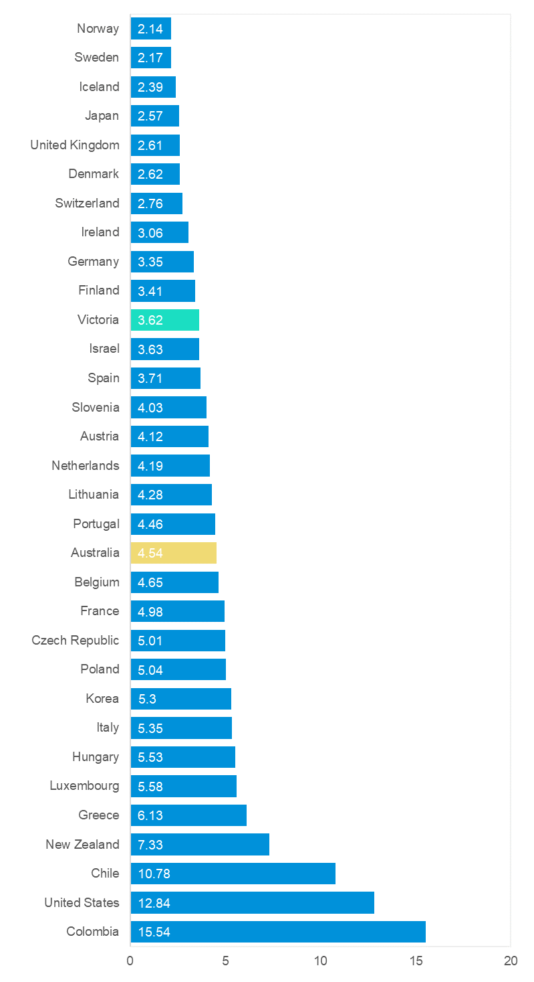

Useful websites

TAC Sites
- TAC Safety (Road Safety) tacsafety.com.au
- TAC How safe is your car howsafeisyourcar.com.au
- TAC How safe is your first car howsafeisyourfirstcar.com.au
- TAC Motorcycle Safety Website spokes.com.au
- TAC Corporate site tac.vic.gov.au
- Drivesmart drivesmart.vic.gov.au
- Ridesmart ridesmartonline.com.au

Victorian Sites
- VicRoads vicroads.vic.gov.au
- Victoria Police police.vic.gov.au
- Parliamentary Road Safety Committee parliament.vic.gov.au/57th-parliament/rsc
- RACV racv.com.au
- Monash University Accident Research Centre monash.edu.au/muarc
- Cameras Save Lives camerassavelives.vic.gov.au
- VicRoads Learner Driver Site lsite.vicroads.vic.gov.au/Learners
- Road Safety Education Victoria roadsafetyeducation.vic.gov.au

National and Interstate Sites
- ARRB Transport Research arrb.com.au
- Australian Transport Safety Bureau atsb.gov.au
- Motor Accidents Authority (NSW) maa.nsw.gov.au
- Motor Accidents Insurance Board (TAS) maib.tas.gov.au
- Motor Accident Commission, Allianz (SA) mac.sa.gov.au
- Motor Accidents Compensation, TIO, (NT) tiofi.com.au/mac
- Insurance Commission of Western Australia icwa.wa.gov.au
- Motor Accident Insurance Commission (QLD) maic.qld.gov.au

International Sites
- National Highway Traffic Safety Admin (USA) nhtsa.dot.gov
- Swedish Road and Transport Institute (VTI) vti.se
- SWOV Institute for Road Safety Research swov.nl

Related Sites
- Alcohol and Drug Foundation adf.org.au

Graphs of Lives Lost and Hospitalised Claims
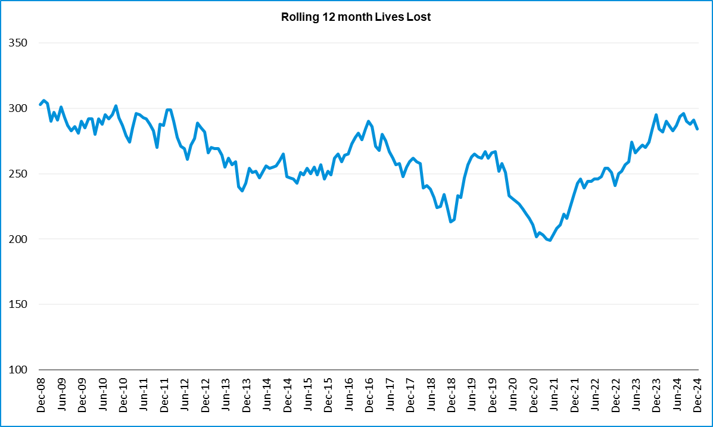

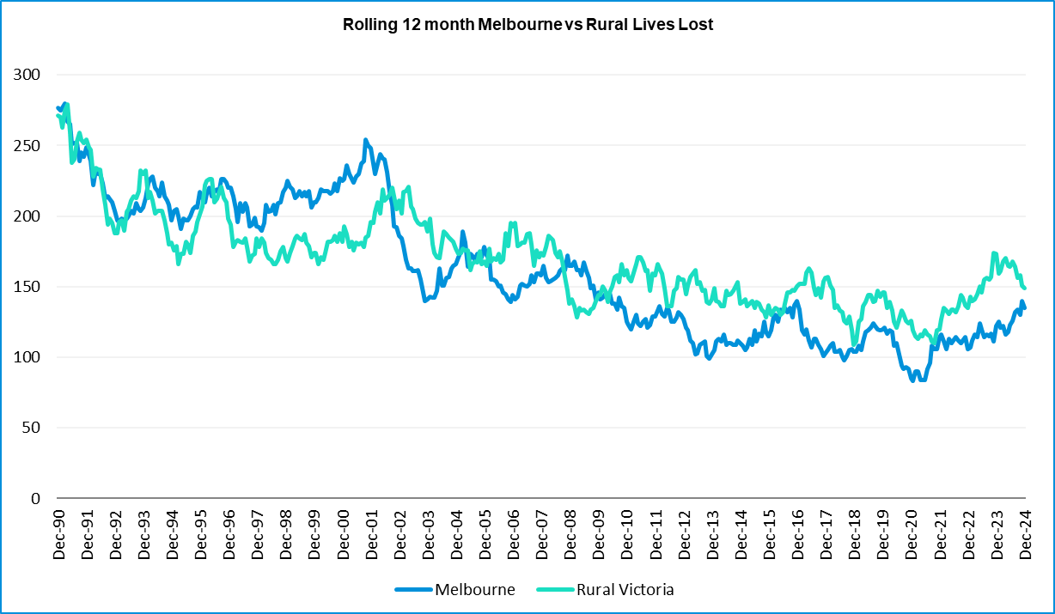

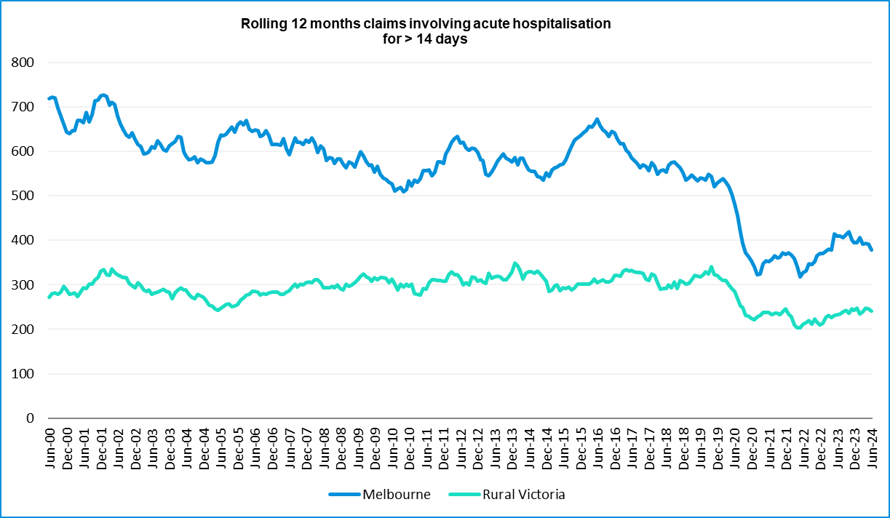

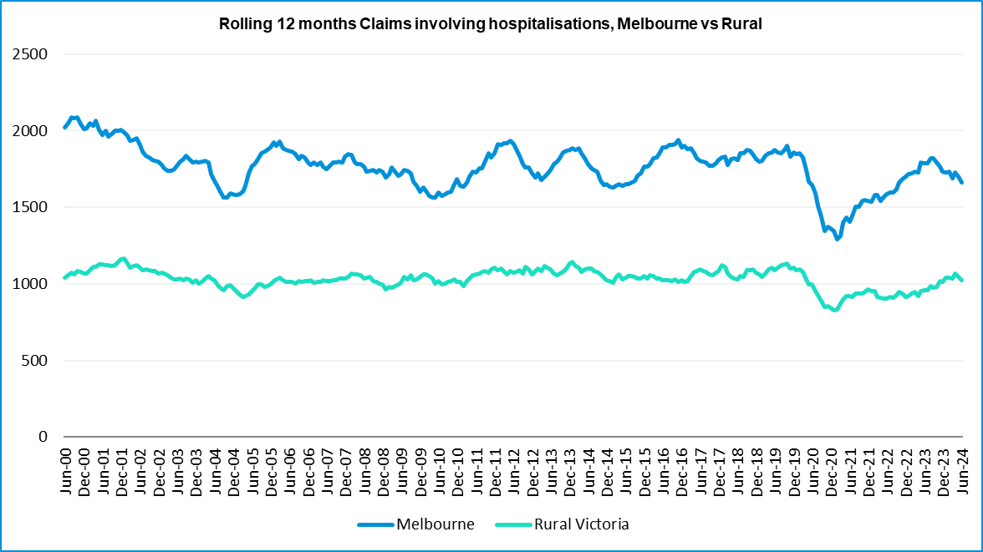

Victorian monthly lives lost since 1951
Year | Jan | Feb | Mar | Apr | May | Jun | Jul | Aug | Sep | Oct | Nov | Dec | Total
1951 |  |  |  |  |  |  | 61 | 59 | 52 | 38 | 29 | 41
1952 | 45 | 40 | 54 | 61 | 54 | 69 | 67 | 55 | 44 | 44 | 31 | 20 | 584
1953 | 23 | 28 | 54 | 58 | 49 | 42 | 50 | 37 | 44 | 27 | 36 | 32 | 480
1954 | 44 | 42 | 28 | 60 | 55 | 36 | 63 | 33 | 25 | 52 | 30 | 41 | 509
1955 | 44 | 36 | 45 | 55 | 48 | 56 | 64 | 44 | 44 | 32 | 40 | 40 | 548
1956 | 34 | 48 | 51 | 67 | 53 | 65 | 71 | 47 | 39 | 39 | 44 | 48 | 606
1957 | 50 | 41 | 46 | 58 | 52 | 54 | 57 | 53 | 51 | 46 | 32 | 49 | 589
1958 | 50 | 38 | 42 | 58 | 54 | 41 | 54 | 53 | 57 | 40 | 57 | 52 | 596
1959 | 50 | 57 | 61 | 50 | 75 | 55 | 42 | 48 | 52 | 55 | 63 | 63 | 671
1960 | 49 | 53 | 57 | 76 | 70 | 70 | 67 | 62 | 61 | 77 | 52 | 66 | 760
1961 | 63 | 57 | 68 | 74 | 58 | 68 | 78 | 82 | 59 | 62 | 60 | 65 | 794
1962 | 65 | 41 | 76 | 78 | 72 | 80 | 70 | 77 | 62 | 53 | 64 | 70 | 808
1963 | 67 | 56 | 65 | 85 | 66 | 68 | 77 | 55 | 55 | 58 | 61 | 67 | 780
1964 | 73 | 71 | 78 | 71 | 83 | 89 | 80 | 89 | 67 | 66 | 62 | 75 | 904
1965 | 63 | 64 | 86 | 88 | 80 | 87 | 79 | 69 | 81 | 77 | 68 | 87 | 929
1966 | 75 | 59 | 75 | 103 | 74 | 86 | 87 | 80 | 75 | 66 | 90 | 85 | 955
1967 | 61 | 79 | 91 | 97 | 81 | 71 | 59 | 67 | 70 | 68 | 60 | 83 | 887
1968 | 70 | 78 | 86 | 78 | 73 | 76 | 73 | 77 | 72 | 80 | 81 | 105 | 949
1969 | 79 | 68 | 79 | 87 | 86 | 77 | 87 | 83 | 87 | 83 | 94 | 101 | 1011
1970 | 85 | 84 | 106 | 80 | 87 | 88 | 110 | 106 | 78 | 95 | 68 | 74 | 1061
1971 | 83 | 75 | 77 | 68 | 76 | 86 | 85 | 72 | 78 | 73 | 74 | 76 | 923
1972 | 61 | 62 | 75 | 82 | 75 | 71 | 98 | 85 | 83 | 62 | 80 | 81 | 915
1973 | 75 | 75 | 95 | 85 | 64 | 66 | 61 | 85 | 89 | 88 | 66 | 86 | 935
1974 | 56 | 62 | 81 | 60 | 70 | 73 | 67 | 62 | 53 | 70 | 80 | 72 | 806
1975 | 67 | 65 | 87 | 73 | 97 | 94 | 57 | 75 | 69 | 66 | 71 | 89 | 910
1976 | 79 | 78 | 88 | 78 | 69 | 79 | 60 | 70 | 82 | 78 | 77 | 100 | 938
1977 | 65 | 71 | 89 | 79 | 65 | 79 | 70 | 91 | 68 | 74 | 96 | 107 | 954
1978 | 75 | 54 | 95 | 63 | 64 | 69 | 68 | 77 | 65 | 84 | 83 | 72 | 869
1979 | 63 | 60 | 86 | 75 | 45 | 64 | 66 | 75 | 69 | 79 | 72 | 93 | 847
1980 | 48 | 55 | 66 | 59 | 47 | 56 | 60 | 53 | 45 | 58 | 61 | 49 | 657
1981 | 69 | 60 | 58 | 61 | 74 | 65 | 61 | 63 | 68 | 71 | 59 | 57 | 766
1982 | 55 | 53 | 59 | 59 | 67 | 45 | 47 | 71 | 53 | 69 | 65 | 66 | 709
1983 | 42 | 59 | 53 | 63 | 62 | 61 | 65 | 51 | 59 | 43 | 54 | 52 | 664
1984 | 65 | 48 | 58 | 50 | 56 | 48 | 46 | 50 | 71 | 53 | 55 | 58 | 658
1985 | 56 | 47 | 50 | 65 | 75 | 50 | 51 | 50 | 58 | 61 | 56 | 64 | 683

Year | Jan | Feb | Mar | Apr | May | Jun | Jul | Aug | Sep | Oct | Nov | Dec | Total
1986 | 56 | 50 | 70 | 69 | 59 | 53 | 42 | 54 | 54 | 52 | 59 | 51 | 669
1987 | 62 | 43 | 57 | 52 | 63 | 59 | 62 | 49 | 62 | 61 | 55 | 80 | 705
1988 | 49 | 58 | 69 | 54 | 79 | 50 | 54 | 52 | 64 | 59 | 43 | 70 | 701
1989 | 76 | 65 | 80 | 59 | 67 | 73 | 52 | 65 | 82 | 50 | 41 | 66 | 776
1990 | 48 | 44 | 55 | 39 | 56 | 64 | 41 | 34 | 48 | 35 | 40 | 44 | 548
1991 | 45 | 39 | 70 | 30 | 34 | 29 | 44 | 47 | 41 | 36 | 35 | 53 | 503
1992 | 34 | 33 | 34 | 47 | 33 | 29 | 23 | 27 | 28 | 38 | 30 | 40 | 396
1993 | 27 | 40 | 37 | 39 | 44 | 33 | 33 | 27 | 34 | 39 | 43 | 40 | 436
1994 | 36 | 31 | 44 | 35 | 27 | 33 | 29 | 37 | 17 | 27 | 32 | 30 | 378
1995 | 38 | 35 | 26 | 33 | 34 | 41 | 27 | 34 | 34 | 32 | 38 | 46 | 418
1996 | 40 | 47 | 35 | 38 | 28 | 29 | 30 | 35 | 49 | 24 | 33 | 30 | 418
1997 | 36 | 25 | 30 | 30 | 40 | 22 | 39 | 26 | 26 | 29 | 39 | 35 | 377
1998 | 29 | 29 | 32 | 36 | 31 | 22 | 40 | 19 | 37 | 36 | 49 | 30 | 390
1999 | 32 | 31 | 35 | 35 | 34 | 24 | 35 | 26 | 28 | 38 | 29 | 37 | 384
2000 | 32 | 26 | 46 | 32 | 39 | 32 | 33 | 29 | 36 | 29 | 44 | 29 | 407
2001 | 44 | 30 | 31 | 32 | 31 | 41 | 34 | 37 | 35 | 51 | 41 | 37 | 444
2002 | 32 | 31 | 45 | 31 | 45 | 32 | 27 | 25 | 31 | 30 | 31 | 37 | 397
2003 | 21 | 41 | 36 | 28 | 31 | 28 | 20 | 23 | 23 | 24 | 24 | 31 | 330
2004 | 32 | 22 | 30 | 30 | 46 | 28 | 27 | 26 | 22 | 28 | 25 | 27 | 343
2005 | 33 | 27 | 47 | 21 | 29 | 23 | 30 | 25 | 25 | 33 | 17 | 36 | 346
2006 | 24 | 37 | 23 | 23 | 27 | 23 | 25 | 22 | 43 | 20 | 31 | 39 | 337
2007 | 23 | 23 | 32 | 25 | 26 | 28 | 28 | 20 | 23 | 37 | 26 | 41 | 332
2008 | 28 | 20 | 37 | 25 | 25 | 20 | 27 | 27 | 18 | 25 | 26 | 25 | 303
2009 | 31 | 18 | 23 | 32 | 19 | 30 | 19 | 21 | 14 | 28 | 21 | 34 | 290
2010 | 26 | 25 | 23 | 20 | 31 | 26 | 26 | 18 | 17 | 35 | 12 | 28 | 287
2011 | 18 | 20 | 34 | 31 | 30 | 24 | 25 | 14 | 12 | 22 | 30 | 27 | 287
2012 | 30 | 20 | 25 | 19 | 23 | 22 | 18 | 25 | 17 | 33 | 25 | 22 | 282
2013 | 14 | 24 | 24 | 19 | 18 | 13 | 24 | 20 | 19 | 15 | 23 | 30 | 243
2014 | 25 | 21 | 25 | 14 | 23 | 17 | 22 | 21 | 20 | 19 | 28 | 13 | 248
2015 | 24 | 20 | 22 | 22 | 21 | 22 | 18 | 26 | 14 | 27 | 17 | 19 | 252
2016 | 21 | 33 | 25 | 16 | 26 | 23 | 26 | 31 | 17 | 22 | 25 | 25 | 290
2017 | 17 | 18 | 22 | 28 | 21 | 15 | 21 | 26 | 18 | 12 | 32 | 29 | 259
2018 | 20 | 15 | 21 | 9 | 23 | 12 | 15 | 18 | 19 | 21 | 23 | 17 | 213
2019 | 22 | 33 | 20 | 24 | 33 | 18 | 17 | 16 | 18 | 26 | 18 | 21 | 266
2020 | 23 | 18 | 26 | 17 | 15 | 16 | 15 | 14 | 14 | 22 | 15 | 16 | 211
2021 | 14 | 21 | 24 | 14 | 14 | 20 | 20 | 17 | 22 | 19 | 24 | 25 | 234
2022 | 23 | 24 | 17 | 19 | 14 | 22 | 20 | 19 | 28 | 19 | 21 | 15 | 241

Year | Jan | Feb | Mar | Apr | May | Jun | Jul | Aug | Sep | Oct | Nov | Dec | Total
2023 | 32 | 26 | 22 | 21 | 29 | 14 | 23 | 22 | 26 | 23 | 32 | 25 | 295
2024 | 21 | 24 | 30 | 17 | 26 | 18 | 30 | 24 | 20 | 20 | 35 | 19 | 284
Average | 45 | 43 | 51 | 49 | 49 | 47 | 47 | 46 | 45 | 46 | 46 | 50 | 564
Maximum | 85 | 84 | 106 | 103 | 97 | 94 | 110 | 106 | 89 | 95 | 96 | 107 | 1,061
Minimum | 14 | 15 | 17 | 9 | 14 | 12 | 15 | 14 | 12 | 12 | 12 | 13 | 211
Avg 10 years | 22 | 23 | 22 | 18 | 22 | 18 | 20 | 21 | 20 | 21 | 24 | 21 | 251
Max 10 years | 32 | 33 | 26 | 28 | 33 | 23 | 26 | 31 | 28 | 27 | 32 | 29 | 295
Min 10 years | 14 | 15 | 17 | 9 | 14 | 12 | 15 | 14 | 14 | 12 | 15 | 13 | 211
Ave 5 years | 23 | 24 | 22 | 19 | 21 | 18 | 19 | 18 | 22 | 22 | 22 | 20 | 249
Max 5 years | 32 | 33 | 26 | 24 | 33 | 22 | 23 | 22 | 28 | 26 | 32 | 25 | 295
Min 5 years | 14 | 18 | 17 | 14 | 14 | 14 | 15 | 14 | 14 | 19 | 15 | 15 | 211

- END OF REPORT -

