
Road Safety Statistics

June 2024

Table of contents

Notes about the data in this report 3
1. Status Report 4
1.1 Lives lost on Victorian Roads 4
1.2 Injured claimants who were admitted to hospital within 7 days of accident 5
2. Lives Lost: Rolling 12 months 6
2.1 Lives Lost: 12 months to 30th June 7
3. Injured claimants admitted to hospital within 7 days of the accident with a hospital stay of more than 14 days 8
3.1 By local government area. 9
4. Injured claimants admitted to hospital within 7 days of accident. 10
4.1 By local government area. 11
5. Lives Lost by Week (2019 to 2024). 12
6. Mobile Safety Camera Data. 14
6.1 Speed Infringements Issued from Mobile Cameras (monthly totals) 14
6.2 Excessive Speed Infringements (ESI) Issued from Mobile Cameras (monthly totals) 14
7. The National Picture – Interstate Comparison 15
7.1 Lives lost (12 months to June) 15
7.2 Lives lost per 10,000 registered vehicles and per 100,000 population (12 months to June). 15
8. International Road Safety Comparison 16
8.1 Lives lost rate per 100,000 population selected OECD Countries 16
8.2 Lives lost rate per 100 million vehicle kilometres travelled (VKT) 16
8.3 Lives lost rate per 10,000 registered vehicles 16
9. Lives lost rate per 100,000 population - OECD countries, 2022. 17
10. Useful websites 18
11. Graphs of Lives Lost and Hospitalised Claims 19
12. Victorian monthly lives lost since 1951 21

Notes about the data in this report

- All data provided in this report is the data most recently available at time of production. Fatality data updated to the end of report month. A 6-month lag applies to hospitalised TAC claims data.
- Reporting of the hospitalised claims data is based on the claim acceptance date and excludes rejected claims and those involving interstate crashes.
- Reported data will have one extra day of exposure for leap years.
- Data is subject to revision as additional information about known accidents/claims is received, and as new accident/claim reports are received and processed.
- Crash locations for acute hospitalised claims are assigned to Local Government Areas based on the crash postcode recorded by Victoria Police. Crash locations for fatal crashes are coded exactly to a Local Government Area assigned by Victoria Police.
- Claimants refers to people injured in transport accidents who have an accepted claim with the TAC.
- Hospitalisation refers to all hospital admission that occurred within 7 days of accident.

  - Report prepared by:
Road Safety Division, Transport Accident Commission.

Status Report
In the 12-month period from 1st July 2023 to 30th June 2024, 289 people lost their lives, compared to 266 lives lost during the previous 12-month period from July 2022 to the end of June 2023. This represents 23 more lives lost.

1.1 Lives lost on Victorian Roads

Category | 2024 | 2023 | 2022 | 2024 v 2023 | 2024 v 2022 | 5 Year Average
Lives Lost (Rolling 12 Month Total)
Lives Lost (to June) | 289 | 266 | 246 | +23 | +43 | 247
per 10,000 vehicles | 0.53 | 0.50 | 0.47 | +0.03 | +0.06 | 0.47
per 100,000 population | 4.18 | 3.96 | 3.74 | +0.22 | +0.44 | 3.71
Crashes (Rolling 12 Month Total)
Fatal crashes (to June) | 267 | 247 | 229 | +20 | +38 | 230
per 10,000 vehicles | 0.49 | 0.46 | 0.43 | +0.03 | +0.06 | 0.44
per 100,000 population | 3.86 | 3.68 | 3.48 | +0.18 | +0.38 | 3.45

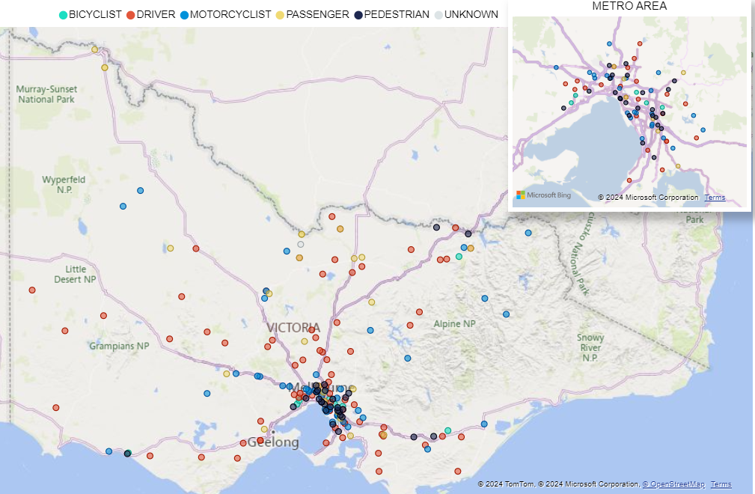

Victoria – Lives Lost, 12 months to June 2024

1.2 Injured claimants who were admitted to hospital within 7 days of accident.
Rolling 12 months to 31st December (claim acceptance date)

Category | 2023 | 2022 | 2021 | 2023 v 2022 |  | 2023 v 2022 |  | 5 Year Average
Claims involving an acute hospitalisation over 14 days (Rolling 12 Month Total)
Claims (to December) | 655 | 605 | 644 | +50 | (+8%) | +11 | (+2%) | 680
per 10,000 vehicles | 1.21 | 1.14 | 1.23 | +0.07 | (+6%) | 0.0 | (-2%) | 1.36
per 100,000 population | 9.61 | 9.14 | 9.84 | +0.47 | (+5%) | -0.2 | (-2%) | 10.67
All claims involving an acute hospitalisation (Rolling 12 Month Total)
Claims (to December) | 5,473 | 5,289 | 5,792 | +184 | (+3%) | -319 | (-6%) | 6,010
per 10,000 vehicles | 10.13 | 9.96 | 11.10 | +0.17 | (+2%) | -1.0 | (-9%) | 12.12
per 100,000 population | 80.34 | 79.93 | 88.45 | +0.41 | (+1%) | -8.1 | (-9%) | 94.69

Lives Lost: Rolling 12 months.
12 months to 30th June

Category |  | 2024 | 2023 | 2012 | 2024 v 2023 | 2024 v 2022 | 5 Year Average
Overview | Lives Lost | 289 | 266 | 246 | +23 | +43 | 247
Overview | Fatal Crashes | 267 | 247 | 229 | +20 | +38 | 230
Sex | Female | 80 | 79 | 68 | +1 | +12 | 68
Sex | Male | 208 | 186 | 178 | +22 | +30 | 179
Road user | Bicyclist | 8 | 11 | 14 | -3 | -6 | 11
Road user | Driver | 117 | 117 | 106 | 0 | +11 | 111
Road user | Motorcyclist | 67 | 52 | 45 | +15 | +22 | 47
Road user | Passenger | 41 | 51 | 42 | -10 | -1 | 39
Road user | Pedestrian | 56 | 35 | 37 | +21 | +19 | 39
Location | Melbourne | 125 | 120 | 112 | +5 | +13 | 110
Location | Rural Victoria | 164 | 146 | 134 | +18 | +30 | 137
Age group | 0-4 | 3 | 3 | 3 | 0 | 0 | 3
Age group | 5-15 | 10 | 6 | 6 | +4 | +4 | 5
Age group | 16-17 | 5 | 4 | 9 | +1 | -4 | 5
Age group | 18-20 | 22 | 21 | 23 | +1 | -1 | 18
Age group | 21-25 | 18 | 29 | 18 | -11 | 0 | 23
Age group | 26-29 | 20 | 24 | 18 | -4 | +2 | 21
Age group | 30-39 | 42 | 41 | 29 | +1 | +13 | 37
Age group | 40-49 | 36 | 30 | 30 | +6 | +6 | 29
Age group | 50-59 | 41 | 31 | 27 | +10 | +14 | 29
Age group | 60-69 | 32 | 27 | 37 | +5 | -5 | 30
Age group | 70+ | 60 | 50 | 44 | 10 | 16 | 46
Accident Type -Intersection | Adjacent direction | 37 | 42 | 23 | -5 | +14 | 30
Accident Type -Intersection | Opposing direction | 15 | 11 | 9 | +4 | +6 | 11
Accident Type -  Mid-block/other | Head on | 35 | 32 | 29 | +3 | +6 | 29
Accident Type -  Mid-block/other | Same direction | 19 | 21 | 29 | -2 | -10 | 22
Accident Type -  Mid-block/other | Manoeuvre/o'taking | 13 | 13 | 10 | 0 | +3 | 12
Accident Type -  Mid-block/other | On path | 3 | 8 | 4 | -5 | -1 | 5
Accident Type -  Mid-block/other | Single vehicle | 112 | 102 | 100 | +10 | +12 | 96
Accident Type -  Mid-block/other | Other (incl peds) | 55 | 37 | 42 | +18 | +13 | 42

2.1 Lives Lost: 12 months to 30th June

Category | 2024 | 2023 | 2022 | 5 Year Average | Category | 2024 | 2023 | 2022 | 5 Year Average
Local Government Area |  |  |  |  | Local Government Area
ALPINE | 1 | 1 | 2 | 1 | MANSFIELD | 8 | 1 | 1 | 1
ARARAT | 1 | 0 | 1 | 1 | MARIBYRNONG | 2 | 2 | 0 | 1
BALLARAT | 2 | 1 | 4 | 2 | MAROONDAH | 3 | 2 | 2 | 2
BANYULE | 1 | 3 | 2 | 2 | MELBOURNE | 2 | 3 | 7 | 3
BASS COAST | 5 | 5 | 0 | 2 | MELTON | 5 | 2 | 7 | 3
BAW BAW | 6 | 5 | 5 | 4 | MERRI-BEK | 1 | 4 | 3 | 2
BAYSIDE | 1 | 0 | 0 | 0 | MILDURA | 5 | 2 | 4 | 3
BENALLA | 2 | 1 | 2 | 1 | MITCHELL | 8 | 5 | 5 | 4
BOROONDARA | 2 | 2 | 0 | 3 | MOIRA | 4 | 13 | 5 | 5
BRIMBANK | 5 | 10 | 9 | 6 | MONASH | 6 | 7 | 2 | 5
BULOKE | 3 | 1 | 1 | 1 | MOONEE VALLEY | 3 | 4 | 2 | 2
CAMPASPE | 6 | 7 | 7 | 4 | MOORABOOL | 5 | 2 | 2 | 3
CARDINIA | 5 | 2 | 6 | 5 | MORNINGTON PENINSULA | 5 | 4 | 5 | 7
CASEY | 13 | 14 | 12 | 8 | MOUNT ALEXANDER | 0 | 1 | 1 | 3
CENTRAL GOLDFIELDS | 0 | 1 | 0 | 1 | MOYNE | 3 | 3 | 3 | 2
COLAC-OTWAY | 1 | 3 | 4 | 3 | MURRINDINDI | 4 | 5 | 5 | 3
CORANGAMITE | 1 | 5 | 4 | 4 | NILLUMBIK | 3 | 0 | 2 | 1
DAREBIN | 1 | 3 | 1 | 3 | NORTHERN GRAMPIANS | 2 | 2 | 7 | 3
EAST GIPPSLAND | 4 | 2 | 2 | 3 | PORT PHILLIP | 2 | 2 | 3 | 2
FRANKSTON | 4 | 5 | 2 | 4 | PYRENEES | 1 | 2 | 0 | 2
GANNAWARRA | 1 | 2 | 0 | 1 | QUEENSCLIFFE | 0 | 0 | 0 | 0
GLEN EIRA | 3 | 2 | 3 | 2 | SOUTH GIPPSLAND | 2 | 5 | 4 | 4
GLENELG | 3 | 1 | 1 | 2 | SOUTHERN GRAMPIANS | 0 | 6 | 1 | 2
GOLDEN PLAINS | 1 | 3 | 2 | 3 | STONNINGTON | 3 | 0 | 1 | 1
GREATER BENDIGO | 8 | 3 | 7 | 5 | STRATHBOGIE | 5 | 4 | 4 | 2
GREATER DANDENONG | 9 | 1 | 4 | 3 | SURF COAST | 4 | 0 | 1 | 1
GREATER GEELONG | 5 | 11 | 10 | 10 | SWAN HILL | 3 | 0 | 1 | 1
GREATER SHEPPARTON | 10 | 12 | 2 | 6 | TOWONG | 2 | 2 | 2 | 2
HEPBURN | 9 | 0 | 3 | 2 | WANGARATTA | 5 | 3 | 5 | 2
HINDMARSH | 0 | 0 | 0 | 0 | WARRNAMBOOL | 1 | 1 | 2 | 2
HOBSONS BAY | 2 | 4 | 3 | 2 | WELLINGTON | 4 | 6 | 6 | 4
HORSHAM | 1 | 1 | 4 | 3 | WEST WIMMERA | 1 | 2 | 0 | 2
HUME | 5 | 4 | 8 | 5 | WHITEHORSE | 3 | 2 | 2 | 1
INDIGO | 7 | 1 | 2 | 2 | WHITTLESEA | 3 | 8 | 7 | 5
KINGSTON | 6 | 0 | 2 | 2 | WODONGA | 1 | 2 | 2 | 1
KNOX | 4 | 3 | 1 | 2 | WYNDHAM | 9 | 9 | 7 | 6
LATROBE | 7 | 6 | 5 | 4 | YARRA | 3 | 4 | 4 | 2
LODDON | 2 | 2 | 2 | 2 | YARRA RANGES | 8 | 11 | 4 | 7
MACEDON RANGES | 5 | 3 | 3 | 3 | YARRIAMBIACK | 4 | 2 | 0 | 1
MANNINGHAM | 3 | 3 | 1 | 1

Injured claimants admitted to hospital within 7 days of the accident with a hospital stay of more than 14 days.
12 months to 31st December

Category |  | 2023 | 2022 | 2021 | 2023 v 2022  Number Per cent |  | 2023 v 2021  Number Per cent |  | 5 Year Average
Overview | Claims | 655 | 605 | 644 | +50 | 8% | 11 | 2% | 680
Sex | Female | 254 | 214 | 237 | +40 | 19% | 17 | 7% | 256
Sex | Male | 398 | 390 | 407 | +8 | 2% | -9 | -2% | 423
Road user | Bicyclist | 28 | 32 | 32 | -4 | -13% | -4 | -13% | 31
Road user | Driver | 234 | 228 | 243 | +6 | 3% | -9 | -4% | 260
Road user | Motorcyclist | 155 | 124 | 133 | +31 | 25% | 22 | 17% | 145
Road user | Passenger | 67 | 65 | 91 | +2 | 3% | -24 | -26% | 84
Road user | Pedestrian | 151 | 145 | 131 | +6 | 4% | 20 | 15% | 144
Road user | Train/Tram | 3 | 5 | 8 | -2 | -40% | -5 | -63% | 5
Location | Melbourne | 399 | 371 | 368 | +28 | 8% | 31 | 8% | 404
Location | Rural Victoria | 238 | 210 | 246 | +28 | 13% | -8 | -3% | 248
Age group | 0-4 | 0 | 1 | 3 | -1 | -100% | -3 | -100% | 2
Age group | 5-15 | 13 | 9 | 10 | +4 | 44% | 3 | 30% | 11
Age group | 16-17 | 9 | 11 | 14 | -2 | -18% | -5 | -36% | 12
Age group | 18-20 | 34 | 25 | 35 | +9 | 36% | -1 | -3% | 34
Age group | 21-25 | 54 | 43 | 52 | +11 | 26% | 2 | 4% | 54
Age group | 26-29 | 37 | 30 | 47 | +7 | 23% | -10 | -21% | 40
Age group | 30-39 | 72 | 91 | 83 | -19 | -21% | -11 | -13% | 86
Age group | 40-49 | 81 | 75 | 64 | +6 | 8% | 17 | 27% | 78
Age group | 50-59 | 97 | 70 | 84 | +27 | 39% | 13 | 15% | 87
Age group | 60-69 | 74 | 74 | 91 | 0 | 0% | -17 | -19% | 90
Age group | 70+ | 184 | 176 | 161 | +8 | 5% | 23 | 14% | 186
Accident Type -Intersection | Adjacent direction | 96 | 62 | 68 | +34 | 55% | 28 | 41% | 72
Accident Type -Intersection | Opposing direction | 31 | 48 | 45 | -17 | -35% | -14 | -31% | 41
Accident Type –  Mid-block/other | Head on | 61 | 48 | 35 | +13 | 27% | 26 | 74% | 52
Accident Type –  Mid-block/other | Same direction | 61 | 45 | 48 | +16 | 36% | 13 | 27% | 55
Accident Type –  Mid-block/other | Manoeuvre/o’taking | 36 | 41 | 40 | -5 | -12% | -4 | -10% | 40
Accident Type –  Mid-block/other | On path | 21 | 26 | 31 | -5 | -19% | -10 | -32% | 27
Accident Type –  Mid-block/other | Single vehicle | 155 | 146 | 195 | +9 | 6% | -40 | -21% | 188
Accident Type –  Mid-block/other | Other (incl peds) | 194 | 189 | 182 | +5 | 3% | 12 | 7% | 205

3.1 By local government area.
12 months to 31st December

Category | 2023 | 2022 | 2021 | 5 Year Average | Category | 2023 | 2022 | 2021 | 5 Year Average
Local Government Area |  |  |  |  | Local Government Area
ALPINE | 3 | 4 | 6 | 5 | MANSFIELD | 2 | 4 | 4 | 4
ARARAT | 0 | 4 | 0 | 2 | MARIBYRNONG | 8 | 11 | 7 | 7
BALLARAT | 17 | 10 | 14 | 11 | MAROONDAH | 3 | 4 | 8 | 7
BANYULE | 4 | 11 | 7 | 6 | MELBOURNE | 17 | 18 | 23 | 17
BASS COAST | 11 | 7 | 7 | 5 | MELTON | 12 | 12 | 6 | 6
BAW BAW | 4 | 6 | 6 | 5 | MERRI-BEK | 18 | 13 | 16 | 14
BAYSIDE | 4 | 7 | 4 | 5 | MILDURA | 3 | 2 | 8 | 4
BENALLA | 2 | 6 | 1 | 2 | MITCHELL | 11 | 6 | 7 | 7
BOROONDARA | 9 | 5 | 12 | 8 | MOIRA | 11 | 5 | 7 | 5
BRIMBANK | 17 | 17 | 22 | 14 | MONASH | 24 | 15 | 13 | 12
BULOKE | 3 | 1 | 0 | 1 | MOONEE VALLEY | 8 | 15 | 13 | 10
CAMPASPE | 5 | 5 | 6 | 6 | MOORABOOL | 5 | 9 | 7 | 6
CARDINIA | 13 | 12 | 16 | 11 | MORNINGTON PENINSULA | 11 | 15 | 12 | 14
CASEY | 14 | 26 | 16 | 19 | MOUNT ALEXANDER | 2 | 5 | 9 | 4
CENTRAL GOLDFIELDS | 2 | 2 | 4 | 3 | MOYNE | 4 | 1 | 1 | 3
COLAC-OTWAY | 3 | 5 | 8 | 4 | MURRINDINDI | 4 | 4 | 1 | 4
CORANGAMITE | 5 | 3 | 3 | 2 | NILLUMBIK | 5 | 4 | 4 | 6
DAREBIN | 14 | 14 | 14 | 12 | NORTHERN GRAMPIANS | 3 | 2 | 2 | 2
EAST GIPPSLAND | 20 | 6 | 5 | 7 | PORT PHILLIP | 9 | 7 | 13 | 9
FRANKSTON | 8 | 8 | 5 | 6 | PYRENEES | 0 | 0 | 2 | 1
GANNAWARRA | 2 | 1 | 3 | 2 | QUEENSCLIFFE | 0 | 0 | 0 | 1
GLEN EIRA | 4 | 2 | 6 | 7 | SOUTH GIPPSLAND | 6 | 4 | 5 | 4
GLENELG | 4 | 4 | 1 | 2 | SOUTHERN GRAMPIANS | 2 | 0 | 2 | 2
GOLDEN PLAINS | 2 | 4 | 5 | 4 | STONNINGTON | 9 | 15 | 9 | 8
GREATER BENDIGO | 17 | 12 | 14 | 13 | STRATHBOGIE | 4 | 2 | 4 | 3
GREATER DANDENONG | 25 | 10 | 23 | 15 | SURF COAST | 4 | 3 | 3 | 3
GREATER GEELONG | 19 | 27 | 24 | 23 | SWAN HILL | 1 | 0 | 3 | 3
GREATER SHEPPARTON | 9 | 8 | 23 | 9 | TOWONG | 3 | 2 | 1 | 2
HEPBURN | 6 | 3 | 5 | 3 | WANGARATTA | 2 | 1 | 1 | 2
HINDMARSH | 1 | 0 | 0 | 1 | WARRNAMBOOL | 2 | 5 | 3 | 3
HOBSONS BAY | 8 | 6 | 6 | 5 | WELLINGTON | 6 | 5 | 12 | 7
HORSHAM | 4 | 4 | 3 | 3 | WEST WIMMERA | 2 | 0 | 0 | 0
HUME | 15 | 21 | 14 | 16 | WHITEHORSE | 19 | 18 | 5 | 14
INDIGO | 3 | 3 | 6 | 3 | WHITTLESEA | 24 | 22 | 14 | 16
KINGSTON | 14 | 11 | 11 | 10 | WODONGA | 5 | 6 | 1 | 3
KNOX | 13 | 12 | 17 | 14 | WYNDHAM | 21 | 15 | 23 | 15
LATROBE | 7 | 6 | 15 | 8 | YARRA | 10 | 4 | 8 | 7
LODDON | 1 | 4 | 1 | 2 | YARRA RANGES | 25 | 15 | 13 | 16
MACEDON RANGES | 4 | 8 | 2 | 6 | YARRIAMBIACK | 2 | 1 | 1 | 1
MANNINGHAM | 14 | 6 | 8 | 7

Injured claimants admitted to hospital within 7 days of accident.
12 months to 31st December 2023

Category |  | 2023 | 2022 | 2021 | 2023 v 2022  Number Per cent |  | 2023 v 2021 Number Per cent |  | 5 Year Average
Overview | Claims | 5,473 | 5,289 | 5,792 | +184 | 3% | -319 | -6% | 6,010
Sex | Female | 2,204 | 2,220 | 2,408 | -16 | -1% | -204 | -8% | 2,510
Sex | Male | 3,244 | 3,060 | 3,378 | +184 | 6% | -134 | -4% | 3,488
Road user | Bicyclist | 378 | 350 | 419 | +28 | 8% | -41 | -10% | 418
Road user | Driver | 2,543 | 2,517 | 2,858 | +26 | 1% | -315 | -11% | 2,917
Road user | Motorcyclist | 1,038 | 925 | 999 | +113 | 12% | +39 | 4% | 1,042
Road user | Passenger | 702 | 710 | 781 | -8 | -1% | -79 | -10% | 811
Road user | Pedestrian | 615 | 617 | 548 | -2 | 0% | +67 | 12% | 603
Road user | Train/Tram | 19 | 28 | 12 | -9 | -32% | +7 | 58% | 23
Location | Melbourne | 3,531 | 3,391 | 3,626 | +140 | 4% | -95 | -3% | 3,775
Location | Rural Victoria | 1,760 | 1,665 | 1,931 | +95 | 6% | -171 | -9% | 1,908
Age group | 0-4 | 28 | 24 | 42 | +4 | 17% | -14 | -33% | 35
Age group | 5-15 | 168 | 137 | 157 | +31 | 23% | +11 | 7% | 160
Age group | 16-17 | 94 | 83 | 107 | +11 | 13% | -13 | -12% | 100
Age group | 18-20 | 341 | 318 | 411 | +23 | 7% | -70 | -17% | 408
Age group | 21-25 | 571 | 552 | 674 | +19 | 3% | -103 | -15% | 677
Age group | 26-29 | 410 | 406 | 500 | +4 | 1% | -90 | -18% | 499
Age group | 30-39 | 873 | 931 | 1,026 | -58 | -6% | -153 | -15% | 1,015
Age group | 40-49 | 765 | 710 | 772 | +55 | 8% | -7 | -1% | 822
Age group | 50-59 | 786 | 722 | 812 | +64 | 9% | -26 | -3% | 827
Age group | 60-69 | 627 | 643 | 597 | -16 | -2% | +30 | 5% | 659
Age group | 70+ | 810 | 763 | 694 | +47 | 6% | +116 | 17% | 807
Accident Type -Intersection | Adjacent direction | 957 | 796 | 861 | +161 | 20% | +96 | 11% | 884
Accident Type -Intersection | Opposing direction | 431 | 432 | 458 | -1 | 0% | -27 | -6% | 454
Accident Type -  Mid-block/other | Head on | 290 | 277 | 286 | +13 | 5% | +4 | 1% | 304
Accident Type -  Mid-block/other | Same direction | 925 | 854 | 934 | +71 | 8% | -9 | -1% | 915
Accident Type -  Mid-block/other | Manoeuvre/o'taking | 357 | 332 | 414 | +25 | 8% | -57 | -14% | 367
Accident Type -  Mid-block/other | On path | 207 | 241 | 316 | -34 | -14% | -109 | -34% | 260
Accident Type -  Mid-block/other | Single vehicle | 1,115 | 1,181 | 1,392 | -66 | -6% | -277 | -20% | 1,320
Accident Type -  Mid-block/other | Other (incl peds) | 1,191 | 1,176 | 1,131 | +15 | 1% | +60 | 5% | 1,505

4.1 By local government area.
12 months to 31st December 2023

Category | 2023 | 2022 | 2021 | 5 Year Average | Category | 2023 | 2022 | 2021 | 5 Year Average
Local Government Area |  |  |  |  | Local Government Area
ALPINE | 25 | 29 | 27 | 24 | MANSFIELD | 20 | 25 | 35 | 27
ARARAT | 11 | 11 | 13 | 11 | MARIBYRNONG | 51 | 64 | 71 | 60
BALLARAT | 101 | 84 | 118 | 81 | MAROONDAH | 27 | 39 | 40 | 42
BANYULE | 31 | 44 | 39 | 37 | MELBOURNE | 188 | 179 | 189 | 163
BASS COAST | 38 | 34 | 36 | 31 | MELTON | 94 | 109 | 71 | 71
BAW BAW | 54 | 58 | 52 | 48 | MERRI_BEK | 129 | 131 | 133 | 118
BAYSIDE | 58 | 69 | 69 | 62 | MILDURA | 31 | 10 | 36 | 25
BENALLA | 13 | 17 | 10 | 13 | MITCHELL | 61 | 42 | 64 | 50
BOROONDARA | 93 | 83 | 100 | 86 | MOIRA | 30 | 24 | 36 | 28
BRIMBANK | 137 | 169 | 154 | 131 | MONASH | 147 | 138 | 132 | 126
BULOKE | 17 | 7 | 7 | 6 | MOONEE VALLEY | 114 | 119 | 139 | 101
CAMPASPE | 38 | 29 | 48 | 31 | MOORABOOL | 51 | 73 | 35 | 42
CARDINIA | 119 | 100 | 131 | 95 | MORNINGTON PENINSULA | 158 | 129 | 136 | 125
CASEY | 275 | 276 | 323 | 245 | MOUNT ALEXANDER | 22 | 19 | 21 | 16
CENTRAL GOLDFIELDS | 13 | 7 | 18 | 15 | MOYNE | 28 | 28 | 17 | 22
COLAC-OTWAY | 37 | 61 | 54 | 46 | MURRINDINDI | 44 | 45 | 29 | 37
CORANGAMITE | 35 | 16 | 30 | 21 | NILLUMBIK | 27 | 24 | 19 | 28
DAREBIN | 82 | 73 | 56 | 72 | NORTHERN GRAMPIANS | 23 | 9 | 18 | 14
EAST GIPPSLAND | 54 | 36 | 48 | 36 | PORT PHILLIP | 124 | 116 | 143 | 106
FRANKSTON | 97 | 78 | 100 | 91 | PYRENEES | 6 | 15 | 6 | 10
GANNAWARRA | 7 | 13 | 11 | 9 | QUEENSCLIFFE | 1 | 1 | 4 | 3
GLEN EIRA | 83 | 84 | 93 | 87 | SOUTH GIPPSLAND | 31 | 26 | 33 | 30
GLENELG | 25 | 15 | 27 | 16 | SOUTHERN GRAMPIANS | 13 | 9 | 13 | 16
GOLDEN PLAINS | 25 | 31 | 32 | 31 | STONNINGTON | 105 | 117 | 93 | 92
GREATER BENDIGO | 91 | 83 | 111 | 92 | STRATHBOGIE | 25 | 19 | 26 | 23
GREATER DANDENONG | 199 | 166 | 260 | 190 | SURF COAST | 51 | 45 | 66 | 48
GREATER GEELONG | 317 | 368 | 396 | 310 | SWAN HILL | 11 | 10 | 15 | 14
GREATER SHEPPARTON | 46 | 46 | 85 | 55 | TOWONG | 13 | 9 | 12 | 9
HEPBURN | 43 | 38 | 24 | 25 | WANGARATTA | 40 | 19 | 15 | 21
HINDMARSH | 9 | 8 | 5 | 9 | WARRNAMBOOL | 23 | 21 | 28 | 20
HOBSONS BAY | 54 | 62 | 59 | 56 | WELLINGTON | 51 | 30 | 63 | 41
HORSHAM | 15 | 19 | 27 | 21 | WEST WIMMERA | 5 | 1 | 7 | 3
HUME | 202 | 211 | 215 | 181 | WHITEHORSE | 79 | 58 | 79 | 74
INDIGO | 15 | 14 | 23 | 15 | WHITTLESEA | 202 | 169 | 142 | 134
KINGSTON | 104 | 102 | 123 | 101 | WODONGA | 24 | 37 | 28 | 24
KNOX | 83 | 98 | 115 | 93 | WYNDHAM | 178 | 141 | 169 | 146
LATROBE | 60 | 44 | 65 | 58 | YARRA | 100 | 95 | 74 | 75
LODDON | 11 | 13 | 8 | 11 | YARRA RANGES | 132 | 113 | 119 | 117
MACEDON RANGES | 49 | 59 | 41 | 46 | YARRIAMBIACK | 4 | 8 | 8 | 5
MANNINGHAM | 59 | 35 | 40 | 42

Lives Lost by Week (2019 to 2024).

Week Ending | 2019 | 2020 | 2021 | 2022 | 2023 | 2024 | Cumulative 2024 | 12 month moving total
7-Jan | 2 | 8 | 3 | 9 | 9 | 4 | 4 | 290
14-Jan | 5 | 4 | 1 | 4 | 4 | 8 | 12 | 294
21-Jan | 3 | 3 | 2 | 5 | 7 | 5 | 17 | 292
28-Jan | 9 | 3 | 7 | 3 | 8 | 4 | 21 | 288
4-Feb | 9 | 10 | 4 | 8 | 9 | 7 | 28 | 286
11-Feb | 5 | 4 | 8 | 6 | 9 | 4 | 32 | 281
18-Feb | 11 | 7 | 3 | 5 | 3 | 5 | 37 | 283
25-Feb | 9 | 1 | 3 | 6 | 5 | 5 | 42 | 283
3-Mar | 4 | 3 | 7 | 3 | 7 | 8 | 50 | 284
10-Mar | 4 | 7 | 9 | 2 | 6 | 9 | 59 | 287
17-Mar | 7 | 11 | 4 | 5 | 4 | 3 | 62 | 286
24-Mar | 5 | 3 | 3 | 6 | 2 | 7 | 69 | 291
31-Mar | 3 | 4 | 8 | 3 | 7 | 6 | 75 | 290
7-Apr | 9 | 5 | 3 | 6 | 3 | 8 | 83 | 295
14-Apr | 6 | 0 | 3 | 4 | 5 | 3 | 86 | 293
21-Apr | 4 | 9 | 2 | 4 | 9 | 3 | 89 | 287
28-Apr | 4 | 2 | 3 | 4 | 4 | 3 | 92 | 286
5-May | 8 | 3 | 6 | 3 | 6 | 4 | 96 | 284
12-May | 9 | 2 | 4 | 2 | 3 | 6 | 102 | 287
19-May | 8 | 5 | 3 | 7 | 7 | 7 | 109 | 287
26-May | 6 | 4 | 1 | 1 | 4 | 5 | 114 | 288
2-Jun | 4 | 1 | 2 | 5 | 12 | 6 | 120 | 282
9-Jun | 4 | 3 | 6 | 4 | 1 | 6 | 126 | 287
16-Jun | 6 | 5 | 1 | 6 | 3 | 6 | 132 | 290
23-Jun | 1 | 4 | 6 | 5 | 2 | 2 | 134 | 290
30-Jun | 6 | 6 | 8 | 3 | 5 | 4 | 138 | 289
7-Jul | 5 | 1 | 4 | 6 | 7
14-Jul | 3 | 2 | 5 | 5 | 3
21-Jul | 5 | 3 | 5 | 6 | 5
28-Jul | 3 | 6 | 2 | 3 | 6
4-Aug | 3 | 5 | 2 | 3 | 5
11-Aug | 4 | 1 | 4 | 4 | 5
18-Aug | 4 | 6 | 8 | 5 | 2
25-Aug | 3 | 1 | 2 | 4 | 5
1-Sep | 2 | 3 | 3 | 7 | 7

Week Ending | 2019 | 2020 | 2021 | 2022 | 2023 | 2024 | Cumulative 2024 | 12 month moving total
8-Sep | 5 | 4 | 2 | 6 | 7
15-Sep | 5 | 3 | 10 | 5 | 5
22-Sep | 5 | 1 | 1 | 9 | 8
29-Sep | 4 | 5 | 10 | 5 | 4
6-Oct | 4 | 3 | 3 | 2 | 7
13-Oct | 9 | 6 | 3 | 7 | 4
20-Oct | 3 | 6 | 5 | 4 | 6
27-Oct | 7 | 6 | 5 | 4 | 6
3-Nov | 4 | 2 | 4 | 5 | 3
10-Nov | 5 | 4 | 9 | 3 | 11
17-Nov | 4 | 5 | 2 | 5 | 8
24-Nov | 5 | 4 | 5 | 7 | 8
1-Dec | 3 | 1 | 6 | 3 | 4
8-Dec | 5 | 5 | 6 | 4 | 4
15-Dec | 5 | 3 | 6 | 1 | 6
22-Dec | 6 | 4 | 2 | 5 | 8
29-Dec | 4 | 4 | 10 | 4 | 6
31-Dec | 0 | 0 | 0 | 0 | 1
Total | 266 | 211 | 234 | 241 | 295 | 138

Mobile Safety Camera Data.

6.1 Speed Infringements Issued from Mobile Cameras (monthly totals)

Year: 2023
Jan | Feb | Mar | Apr | May | Jun | Jul | Aug | Sep | Oct | Nov | Dec | Average
51,173 | 48,127 | 52,743 | 40,736 | 50,014 | 48,026 | 46,241 | 49,434 | 44,382 | 48,027 | 45,780 | 41,729 | 47,201

6.2 Excessive Speed Infringements (ESI) Issued from Mobile Cameras (monthly totals)

Year: 2023
Jan | Feb | Mar | Apr | May | Jun | Jul | Aug | Sep | Oct | Nov | Dec | Average
372 | 319 | 388 | 273 | 407 | 394 | 388 | 377 | 289 | 470 | 374 | 338 | 336

Notes: An ESI is defined as 25km/h over the speed limit except in a 110km/h zone where it is 20km/h over the limit.

The National Picture – Interstate Comparison

7.1 Lives lost (12 months to June)

State | 2024 | 2023 | 2022 | 2021 | 2024 v 2023  Number Per cent
New South Wales | 361 | 290 | 280 | 287 | +71 | (+24%)
Victoria | 289 | 266 | 244 | 203 | +23 | (+9%)
Queensland | 296 | 273 | 292 | 296 | +23 | (+8%)
South Australia | 101 | 93 | 85 | 99 | +8 | (+9%)
Western Australia | 175 | 176 | 155 | 169 | -1 | (-1%)
Tasmania | 28 | 39 | 52 | 32 | -11 | (-28%)
Northern Territory | 55 | 31 | 45 | 37 | +24 | (+77%)
Australian Capital Territory | 8 | 10 | 15 | 11 | -2 | (-20%)
Australia | 1,313 | 1,164 | 1,168 | 1,134 | +149 | (+13%)
Australia minus Victoria | 1,024 | 898 | 924 | 931 | +126 | (+14%)

7.2 Lives lost per 10,000 registered vehicles and per 100,000 population (12 months to June).

State | Lives Lost per 10,000 registered vehicles  2024 2023 2022 |  |  | Lives Lost per 100,000 population  2024 2023 2022
New South Wales | 0.58 | 0.47 | 0.46 | 4.28 | 3.52 | 3.45
Victoria | 0.52 | 0.49 | 0.46 | 4.18 | 3.96 | 3.71
Queensland | 0.62 | 0.59 | 0.66 | 5.35 | 5.06 | 5.54
South Australia | 0.63 | 0.60 | 0.56 | 5.41 | 5.07 | 4.69
Western Australia | 0.70 | 0.72 | 0.66 | 5.98 | 6.21 | 5.60
Tasmania | 0.51 | 0.73 | 1.00 | 4.88 | 6.82 | 9.13
Northern Territory | 3.28 | 1.87 | 2.74 | 21.95 | 12.18 | 17.80
Australian Capital Territory | 0.24 | 0.30 | 0.46 | 1.70 | 2.17 | 3.30
Australia | 0.61 | 0.55 | 0.57 | 4.87 | 4.42 | 4.52
Australia minus Victoria | 0.66 | 0.58 | 0.61 | 5.11 | 4.58 | 4.80

International Road Safety Comparison
Selected OECD countries, Australia, and Victoria 2000, 2010, 2015, 2020, 2021 and 2022

8.1 Lives lost rate per 100,000 population selected OECD Countries
Countries | 2000 | 2010 | 2015 | 2020 | 2021 | 2022
Australia | 7.7 | 5.1 | 5.1 | 4.3 | 4.3 | 4.5
Canada | 16.4 | 10.2 | 5.3 | 4.6 | 4.6 | -
New Zealand | 8.6 | 5.5 | 6.9 | 6.2 | 6.2 | 7.3
Norway | 7.6 | 4.3 | 2.3 | 1.7 | 1.5 | 2.1
Sweden | 6.7 | 2.8 | 2.7 | 2.0 | 2.0 | 2.2
Switzerland | 9.3 | 4.6 | 3.1 | 2.6 | 2.3 | 2.8
United Kingdom | 8.3 | 4.2 | 2.8 | 2.3 | 2.4 | 2.6
United States | 12 | 8.6 | 11.1 | 11.8 | 12.9 | 12.8
Victoria | 8.5 | 5.3 | 4.2 | 3.2 | 3.3 | 3.6

8.2 Lives lost rate per 100 million vehicle kilometres travelled (VKT)
Countries | 2000 | 2010 | 2015 | 2020 | 2021 | 2022
Australia | 9.5 | 0.6 | 0.5 | 0.5 | 0.5 | 0.5
Canada | 9.5 | 0.7 | 0.5 | 0.5 | 0.4 | -
New Zealand | 12 | 0.9 | 0.7 | 0.7 | 0.7 | -
Norway | 7.6 | 0.5 | 0.3 | 0.2 | 0.2 | 0.3
Sweden | 6.7 | 0.3 | 0.3 | 0.3 | 0.3 | 0.3
Switzerland | 8.3 | 0.5 | 0.4 | 0.4 | 0.3 | -
United Kingdom | - | - | - | - | - | -
United States | 14.9 | 0.7 | 0.7 | 0.8 | 0.9 | -
Victoria | - | 0.5 | 0.4 | 0.3 | 0.4

8.3 Lives lost rate per 10,000 registered vehicles
Countries | 2000 | 2010 | 2015 | 2020 | 2021 | 2022
Australia | 2.5 | 0.9 | 0.7 | 0.6 | 0.6 | 0.6
Canada | - | - | 0.8 | 0.7 | 0.7 | -
New Zealand | 5 | 1.4 | 0.9 | 0.8 | 0.8 | 1.0
Norway | 1.8 | 0.3 | 0.3 | 0.2 | 0.2 | 0.3
Sweden | 1.2 | 0.5 | 0.4 | 0.3 | 0.3 | 0.4
Switzerland | 2.2 | 0.7 | 0.4 | 0.4 | 0.3 | 0.4
United Kingdom | 1.2 | 0.5 | 0.5 | 0.4 | 0.4 | 0.4
United States | - | - | 1.3 | 1.3 | 1.4 | -
Victoria | 0.9 | 0.7 | 0.6 | 0.4 | 0.4 | 0.5
* Source: https://www.bitre.gov.au/sites/default/files/documents/international_comparisons_2022.pdf

Lives lost rate per 100,000 population - OECD countries, 2022.

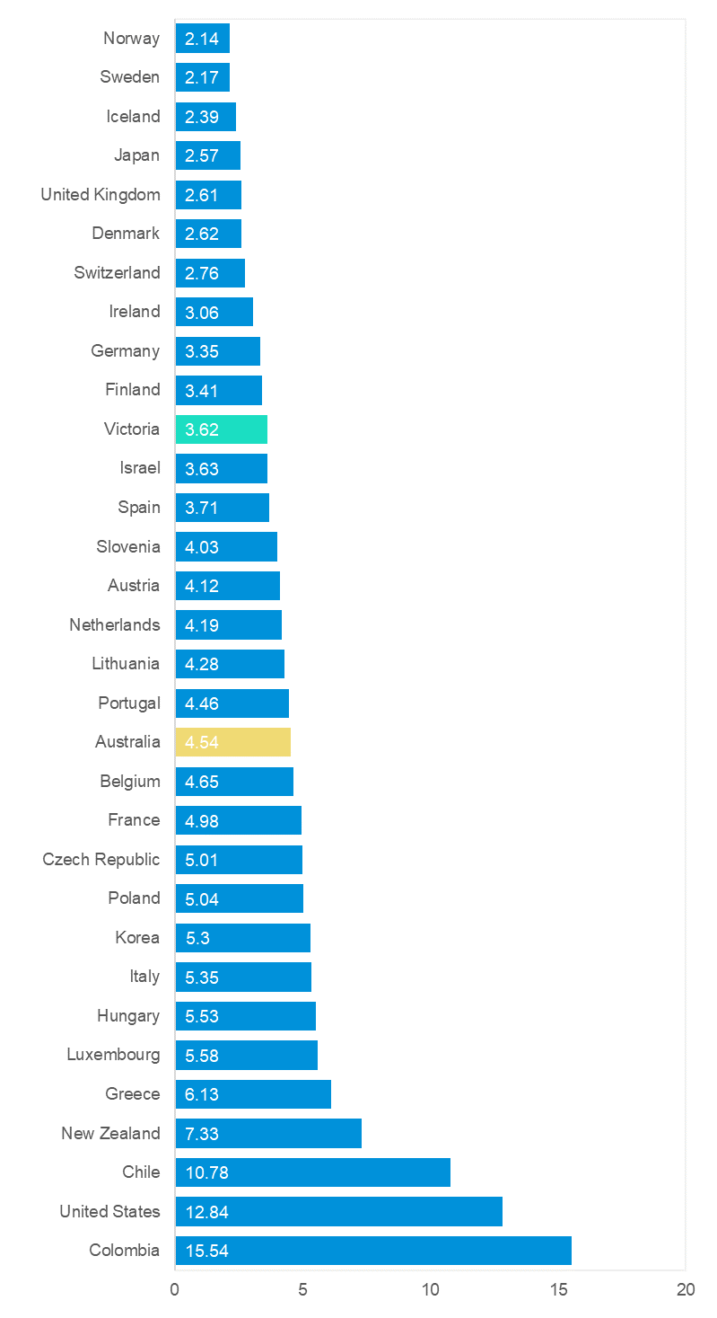

Useful websites

TAC Sites
- TAC Safety (Road Safety) tacsafety.com.au
- TAC How safe is your car howsafeisyourcar.com.au
- TAC How safe is your first car howsafeisyourfirstcar.com.au
- TAC Motorcycle Safety Website spokes.com.au
- TAC Corporate site tac.vic.gov.au
- Drivesmart drivesmart.vic.gov.au
- Ridesmart ridesmartonline.com.au

Victorian Sites
- VicRoads vicroads.vic.gov.au
- Victoria Police police.vic.gov.au
- Parliamentary Road Safety Committee parliament.vic.gov.au/57th-parliament/rsc
- RACV racv.com.au
- Monash University Accident Research Centre monash.edu.au/muarc
- Cameras Save Lives camerassavelives.vic.gov.au
- VicRoads Learner Driver Site lsite.vicroads.vic.gov.au/Learners
- Road Safety Education Victoria roadsafetyeducation.vic.gov.au

National and Interstate Sites
- ARRB Transport Research arrb.com.au
- Australian Transport Safety Bureau atsb.gov.au
- Motor Accidents Authority (NSW) maa.nsw.gov.au
- Motor Accidents Insurance Board (TAS) maib.tas.gov.au
- Motor Accident Commission, Allianz (SA) mac.sa.gov.au
- Motor Accidents Compensation, TIO, (NT) tiofi.com.au/mac
- Insurance Commission of Western Australia icwa.wa.gov.au
- Motor Accident Insurance Commission (QLD) maic.qld.gov.au

International Sites
- National Highway Traffic Safety Admin (USA) nhtsa.dot.gov
- Swedish Road and Transport Institute (VTI) vti.se
- SWOV Institute for Road Safety Research swov.nl

Related Sites
- Alcohol and Drug Foundation adf.org.au

Graphs of Lives Lost and Hospitalised Claims

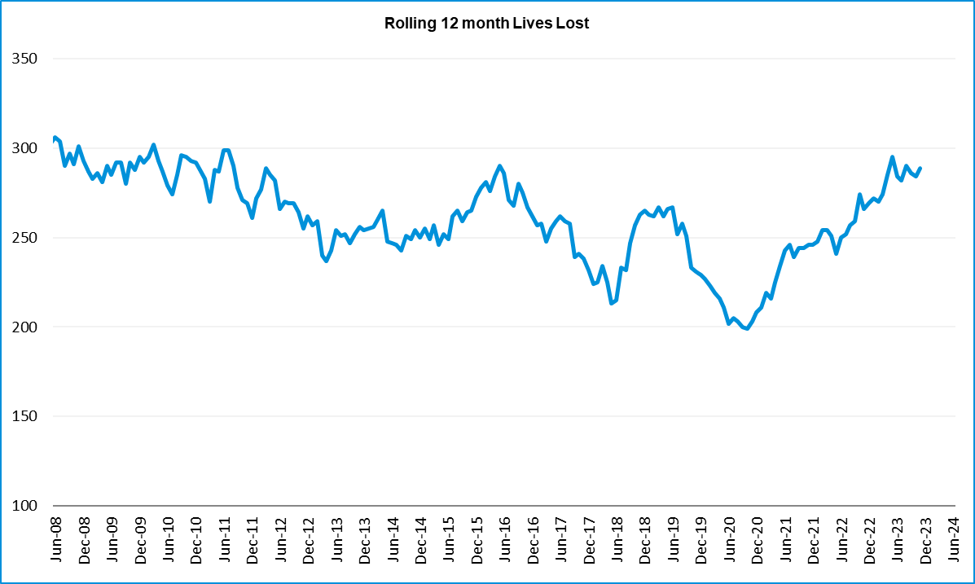

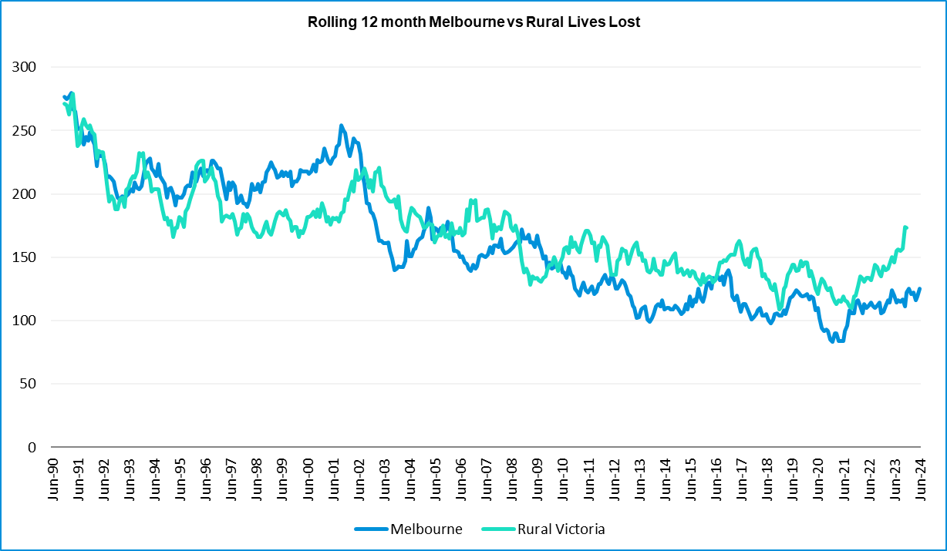

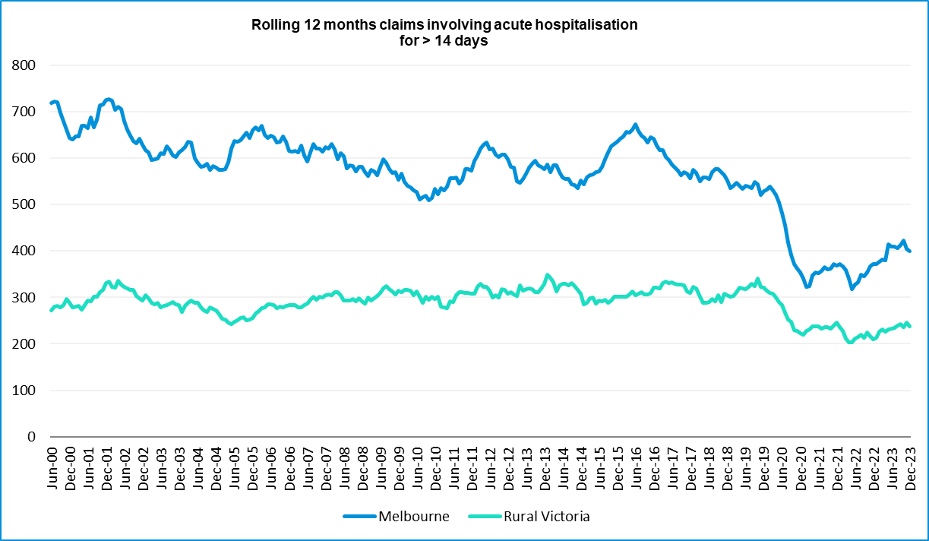

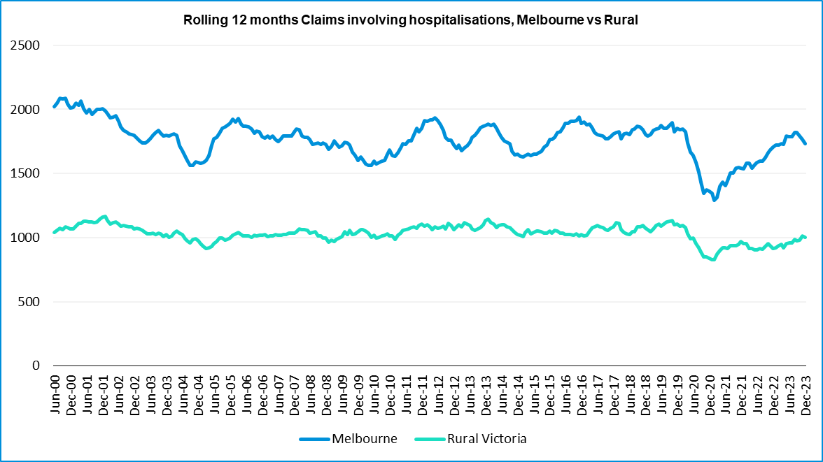

Victorian monthly lives lost since 1951
Year | Jan | Feb | Mar | Apr | May | Jun | Jul | Aug | Sep | Oct | Nov | Dec | Total
1951 |  |  |  |  |  |  | 61 | 59 | 52 | 38 | 29 | 41
1952 | 45 | 40 | 54 | 61 | 54 | 69 | 67 | 55 | 44 | 44 | 31 | 20 | 584
1953 | 23 | 28 | 54 | 58 | 49 | 42 | 50 | 37 | 44 | 27 | 36 | 32 | 480
1954 | 44 | 42 | 28 | 60 | 55 | 36 | 63 | 33 | 25 | 52 | 30 | 41 | 509
1955 | 44 | 36 | 45 | 55 | 48 | 56 | 64 | 44 | 44 | 32 | 40 | 40 | 548
1956 | 34 | 48 | 51 | 67 | 53 | 65 | 71 | 47 | 39 | 39 | 44 | 48 | 606
1957 | 50 | 41 | 46 | 58 | 52 | 54 | 57 | 53 | 51 | 46 | 32 | 49 | 589
1958 | 50 | 38 | 42 | 58 | 54 | 41 | 54 | 53 | 57 | 40 | 57 | 52 | 596
1959 | 50 | 57 | 61 | 50 | 75 | 55 | 42 | 48 | 52 | 55 | 63 | 63 | 671
1960 | 49 | 53 | 57 | 76 | 70 | 70 | 67 | 62 | 61 | 77 | 52 | 66 | 760
1961 | 63 | 57 | 68 | 74 | 58 | 68 | 78 | 82 | 59 | 62 | 60 | 65 | 794
1962 | 65 | 41 | 76 | 78 | 72 | 80 | 70 | 77 | 62 | 53 | 64 | 70 | 808
1963 | 67 | 56 | 65 | 85 | 66 | 68 | 77 | 55 | 55 | 58 | 61 | 67 | 780
1964 | 73 | 71 | 78 | 71 | 83 | 89 | 80 | 89 | 67 | 66 | 62 | 75 | 904
1965 | 63 | 64 | 86 | 88 | 80 | 87 | 79 | 69 | 81 | 77 | 68 | 87 | 929
1966 | 75 | 59 | 75 | 103 | 74 | 86 | 87 | 80 | 75 | 66 | 90 | 85 | 955
1967 | 61 | 79 | 91 | 97 | 81 | 71 | 59 | 67 | 70 | 68 | 60 | 83 | 887
1968 | 70 | 78 | 86 | 78 | 73 | 76 | 73 | 77 | 72 | 80 | 81 | 105 | 949
1969 | 79 | 68 | 79 | 87 | 86 | 77 | 87 | 83 | 87 | 83 | 94 | 101 | 1011
1970 | 85 | 84 | 106 | 80 | 87 | 88 | 110 | 106 | 78 | 95 | 68 | 74 | 1061
1971 | 83 | 75 | 77 | 68 | 76 | 86 | 85 | 72 | 78 | 73 | 74 | 76 | 923
1972 | 61 | 62 | 75 | 82 | 75 | 71 | 98 | 85 | 83 | 62 | 80 | 81 | 915
1973 | 75 | 75 | 95 | 85 | 64 | 66 | 61 | 85 | 89 | 88 | 66 | 86 | 935
1974 | 56 | 62 | 81 | 60 | 70 | 73 | 67 | 62 | 53 | 70 | 80 | 72 | 806
1975 | 67 | 65 | 87 | 73 | 97 | 94 | 57 | 75 | 69 | 66 | 71 | 89 | 910
1976 | 79 | 78 | 88 | 78 | 69 | 79 | 60 | 70 | 82 | 78 | 77 | 100 | 938
1977 | 65 | 71 | 89 | 79 | 65 | 79 | 70 | 91 | 68 | 74 | 96 | 107 | 954
1978 | 75 | 54 | 95 | 63 | 64 | 69 | 68 | 77 | 65 | 84 | 83 | 72 | 869
1979 | 63 | 60 | 86 | 75 | 45 | 64 | 66 | 75 | 69 | 79 | 72 | 93 | 847
1980 | 48 | 55 | 66 | 59 | 47 | 56 | 60 | 53 | 45 | 58 | 61 | 49 | 657
1981 | 69 | 60 | 58 | 61 | 74 | 65 | 61 | 63 | 68 | 71 | 59 | 57 | 766
1982 | 55 | 53 | 59 | 59 | 67 | 45 | 47 | 71 | 53 | 69 | 65 | 66 | 709
1983 | 42 | 59 | 53 | 63 | 62 | 61 | 65 | 51 | 59 | 43 | 54 | 52 | 664
1984 | 65 | 48 | 58 | 50 | 56 | 48 | 46 | 50 | 71 | 53 | 55 | 58 | 658
1985 | 56 | 47 | 50 | 65 | 75 | 50 | 51 | 50 | 58 | 61 | 56 | 64 | 683

Year | Jan | Feb | Mar | Apr | May | Jun | Jul | Aug | Sep | Oct | Nov | Dec | Total
1986 | 56 | 50 | 70 | 69 | 59 | 53 | 42 | 54 | 54 | 52 | 59 | 51 | 669
1987 | 62 | 43 | 57 | 52 | 63 | 59 | 62 | 49 | 62 | 61 | 55 | 80 | 705
1988 | 49 | 58 | 69 | 54 | 79 | 50 | 54 | 52 | 64 | 59 | 43 | 70 | 701
1989 | 76 | 65 | 80 | 59 | 67 | 73 | 52 | 65 | 82 | 50 | 41 | 66 | 776
1990 | 48 | 44 | 55 | 39 | 56 | 64 | 41 | 34 | 48 | 35 | 40 | 44 | 548
1991 | 45 | 39 | 70 | 30 | 34 | 29 | 44 | 47 | 41 | 36 | 35 | 53 | 503
1992 | 34 | 33 | 34 | 47 | 33 | 29 | 23 | 27 | 28 | 38 | 30 | 40 | 396
1975 | 67 | 65 | 87 | 73 | 97 | 94 | 57 | 75 | 69 | 66 | 71 | 89 | 910
1976 | 79 | 78 | 88 | 78 | 69 | 79 | 60 | 70 | 82 | 78 | 77 | 100 | 938
1977 | 65 | 71 | 89 | 79 | 65 | 79 | 70 | 91 | 68 | 74 | 96 | 107 | 954
1978 | 75 | 54 | 95 | 63 | 64 | 69 | 68 | 77 | 65 | 84 | 83 | 72 | 869
1979 | 63 | 60 | 86 | 75 | 45 | 64 | 66 | 75 | 69 | 79 | 72 | 93 | 847
1980 | 48 | 55 | 66 | 59 | 47 | 56 | 60 | 53 | 45 | 58 | 61 | 49 | 657
1981 | 69 | 60 | 58 | 61 | 74 | 65 | 61 | 63 | 68 | 71 | 59 | 57 | 766
1982 | 55 | 53 | 59 | 59 | 67 | 45 | 47 | 71 | 53 | 69 | 65 | 66 | 709
1983 | 42 | 59 | 53 | 63 | 62 | 61 | 65 | 51 | 59 | 43 | 54 | 52 | 664
1984 | 65 | 48 | 58 | 50 | 56 | 48 | 46 | 50 | 71 | 53 | 55 | 58 | 658
1985 | 56 | 47 | 50 | 65 | 75 | 50 | 51 | 50 | 58 | 61 | 56 | 64 | 683
1986 | 56 | 50 | 70 | 69 | 59 | 53 | 42 | 54 | 54 | 52 | 59 | 51 | 669
1987 | 62 | 43 | 57 | 52 | 63 | 59 | 62 | 49 | 62 | 61 | 55 | 80 | 705
1988 | 49 | 58 | 69 | 54 | 79 | 50 | 54 | 52 | 64 | 59 | 43 | 70 | 701
1989 | 76 | 65 | 80 | 59 | 67 | 73 | 52 | 65 | 82 | 50 | 41 | 66 | 776
1990 | 48 | 44 | 55 | 39 | 56 | 64 | 41 | 34 | 48 | 35 | 40 | 44 | 548
1991 | 45 | 39 | 70 | 30 | 34 | 29 | 44 | 47 | 41 | 36 | 35 | 53 | 503
1992 | 34 | 33 | 34 | 47 | 33 | 29 | 23 | 27 | 28 | 38 | 30 | 40 | 396
1993 | 27 | 40 | 37 | 39 | 44 | 33 | 33 | 27 | 34 | 39 | 43 | 40 | 436
1994 | 36 | 31 | 44 | 35 | 27 | 33 | 29 | 37 | 17 | 27 | 32 | 30 | 378
1995 | 38 | 35 | 26 | 33 | 34 | 41 | 27 | 34 | 34 | 32 | 38 | 46 | 418
1996 | 40 | 47 | 35 | 38 | 28 | 29 | 30 | 35 | 49 | 24 | 33 | 30 | 418
1997 | 36 | 25 | 30 | 30 | 40 | 22 | 39 | 26 | 26 | 29 | 39 | 35 | 377
1998 | 29 | 29 | 32 | 36 | 31 | 22 | 40 | 19 | 37 | 36 | 49 | 30 | 390
1999 | 32 | 31 | 35 | 35 | 34 | 24 | 35 | 26 | 28 | 38 | 29 | 37 | 384
2000 | 32 | 26 | 46 | 32 | 39 | 32 | 33 | 29 | 36 | 29 | 44 | 29 | 407
2001 | 44 | 30 | 31 | 32 | 31 | 41 | 34 | 37 | 35 | 51 | 41 | 37 | 444
2002 | 32 | 31 | 45 | 31 | 45 | 32 | 27 | 25 | 31 | 30 | 31 | 37 | 397
2003 | 21 | 41 | 36 | 28 | 31 | 28 | 20 | 23 | 23 | 24 | 24 | 31 | 330
2004 | 32 | 22 | 30 | 30 | 46 | 28 | 27 | 26 | 22 | 28 | 25 | 27 | 343

Year | Jan | Feb | Mar | Apr | May | Jun | Jul | Aug | Sep | Oct | Nov | Dec | Total
2005 | 33 | 27 | 47 | 21 | 29 | 23 | 30 | 25 | 25 | 33 | 17 | 36 | 346
2006 | 24 | 37 | 23 | 23 | 27 | 23 | 25 | 22 | 43 | 20 | 31 | 39 | 337
2007 | 23 | 23 | 32 | 25 | 26 | 28 | 28 | 20 | 23 | 37 | 26 | 41 | 332
2008 | 28 | 20 | 37 | 25 | 25 | 20 | 27 | 27 | 18 | 25 | 26 | 25 | 303
2009 | 31 | 18 | 23 | 32 | 19 | 30 | 19 | 21 | 14 | 28 | 21 | 34 | 290
2010 | 26 | 25 | 23 | 20 | 31 | 26 | 26 | 18 | 17 | 35 | 12 | 28 | 287
2011 | 18 | 20 | 34 | 31 | 30 | 24 | 25 | 14 | 12 | 22 | 30 | 27 | 287
2012 | 30 | 20 | 25 | 19 | 23 | 22 | 18 | 25 | 17 | 33 | 25 | 22 | 282
2013 | 14 | 24 | 24 | 19 | 18 | 13 | 24 | 20 | 19 | 15 | 23 | 30 | 243
2014 | 25 | 21 | 25 | 14 | 23 | 17 | 22 | 21 | 20 | 19 | 28 | 13 | 248
2015 | 24 | 20 | 22 | 22 | 21 | 22 | 18 | 26 | 14 | 27 | 17 | 19 | 252
2016 | 21 | 33 | 25 | 16 | 26 | 23 | 26 | 31 | 17 | 22 | 25 | 25 | 290
2017 | 17 | 18 | 22 | 28 | 21 | 15 | 21 | 26 | 18 | 12 | 32 | 29 | 259
2018 | 20 | 15 | 21 | 9 | 23 | 12 | 15 | 18 | 19 | 21 | 23 | 17 | 213
2019 | 22 | 33 | 20 | 24 | 33 | 18 | 17 | 16 | 18 | 26 | 18 | 21 | 266
2020 | 23 | 18 | 26 | 17 | 15 | 16 | 15 | 14 | 14 | 22 | 15 | 16 | 211
2021 | 14 | 21 | 24 | 14 | 14 | 20 | 20 | 17 | 22 | 19 | 24 | 25 | 234
2022 | 23 | 24 | 17 | 19 | 14 | 22 | 20 | 19 | 28 | 19 | 21 | 15 | 241
2023 | 32 | 26 | 22 | 21 | 29 | 14 | 23 | 22 | 26 | 23 | 32 | 25 | 295
2024 | 21 | 24 | 30 | 17 | 27 | 19
Average | 45 | 43 | 51 | 49 | 49 | 47 | 48 | 47 | 46 | 46 | 46 | 51 | 572
Maximum | 85 | 84 | 106 | 103 | 97 | 94 | 110 | 106 | 89 | 95 | 96 | 107 | 1,061
Minimum | 14 | 15 | 17 | 9 | 14 | 12 | 15 | 14 | 12 | 12 | 12 | 13 | 211
Avg 10 years | 22 | 23 | 23 | 18 | 22 | 17 | 20 | 21 | 20 | 20 | 23 | 21 | 250
Max 10 years | 32 | 33 | 26 | 28 | 33 | 23 | 26 | 31 | 28 | 27 | 32 | 30 | 295
Min 10 years | 14 | 15 | 17 | 9 | 14 | 12 | 15 | 14 | 14 | 12 | 15 | 13 | 211
Ave 5 years | 23 | 24 | 22 | 19 | 21 | 18 | 19 | 18 | 22 | 22 | 22 | 20 | 249
Max 5 years | 32 | 33 | 26 | 24 | 33 | 22 | 23 | 22 | 28 | 26 | 32 | 25 | 295
Min 5 years | 14 | 18 | 17 | 14 | 14 | 14 | 15 | 14 | 14 | 19 | 15 | 15 | 211

- END OF REPORT -

